UNLOCK IQ INSTITUTE
Realize Your True Potential
Aryabhatta Maths Olympiad (AMO)
Level 1 — Practice Paper 3
CLASS 3

Questions | 45 multiple-choice questions
Marks | 100
Time | 60 minutes
Section I | 40 questions × 2 marks = 80 marks
Section II | 5 Star Questions × 4 marks = 20 marks
Negative marking | No negative marking
Calculator | Not allowed
Chapters | Number System · Operations · Fractions, Decimals & Percentages · Geometry · Mensuration · Applied Mathematics · Mathematical Reasoning

Hello, friend!
• Every question has four answer choices: (A), (B), (C) and (D). Only one is correct.
• Read each question and look at its picture carefully. Then mark your answer on the answer sheet at the end.
• Section I has 40 questions of 2 marks each. Section II has 5 Star Questions of 4 marks each.
• There is no negative marking, so try every question.
• Do not use a calculator. You may do rough work on a separate sheet.
• All figures are not necessarily drawn to scale unless stated.

For parents and teachers
Print or view this paper in colour. Pictures are part of the questions.
Parts follow the AMO syllabus chapters. Chapters 4, 7 and 8 are not part of the Class 3 syllabus, so the chapter numbers shown in the Part headings have gaps.
The answer sheet and the answer key are at the end. Remove only the answer key before the child begins.

Name: | School: | Roll No.:

SECTION I 40 questions × 2 marks each
Part 1 — Number System (Syllabus Chapter 1)
Q1. Charu writes the number "four thousand six" in figures. How many zeros does she write?
(A) 0 | (B) 1 | (C) 2 | (D) 3

Q2. In 5,273, which digit has the place value 200?
(A) 5 | (B) 7 | (C) 3 | (D) 2

Q3. A card in a board game shows the Roman numeral XLVI. Which number is this?
(A) 64 | (B) 44 | (C) 66 | (D) 46

Q4. These numbers are in order, smallest first. Which number can fill the blank?
7,480, 7,495, ___, 7,520
(A) 7,508 | (B) 7,525 | (C) 7,058 | (D) 7,490

Q5. How many different 4-digit numbers have 9 thousands, 9 hundreds and 9 tens?
(A) 1 | (B) 9 | (C) 10 | (D) 27

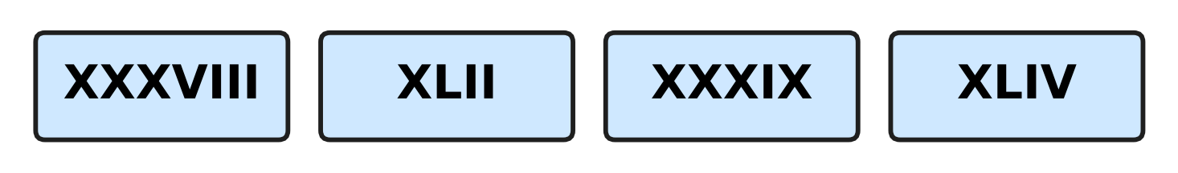
Q6. Look at the four cards. Which Roman numeral stands for the greatest number?
(A) XXXVIII | (B) XLIV | (C) XXXIX | (D) XLII

Part 2 — Operations & Number Properties (Syllabus Chapter 2)
Q7. Workers pick 3,468 mangoes on Monday and 2,754 mangoes on Tuesday. How many mangoes do they pick in all?
(A) 5,112 | (B) 6,122 | (C) 6,212 | (D) 6,222

Q8. A museum prints 8,000 tickets. It sells 5,364 of them. How many tickets are left?
(A) 2,636 | (B) 2,746 | (C) 3,364 | (D) 3,636

Q9. Which number fills the blank?
7 × ___ = 84
(A) 13 | (B) 77 | (C) 11 | (D) 12

Q10. Which number fills the blank?
47 ÷ 6 = 7 remainder ___
(A) 5 | (B) 6 | (C) 42 | (D) 1

Q11. A two-digit number has 4 as its tens digit. When it is multiplied by 6, the answer is 258. What is its ones digit?
(A) 2 | (B) 3 | (C) 8 | (D) 4

Q12. A postman has 8 bundles of 26 letters each. He delivers 120 letters. How many letters does he still have?
(A) 88 | (B) 98 | (C) 208 | (D) 328

Q13. Ken packs paper planes in boxes of 6. He fills some boxes and has 4 planes left over. He folds 2 more planes and packs again. How many planes are left over now?
(A) 0 | (B) 2 | (C) 4 | (D) 6

Part 3 — Fractions, Decimals & Percentages (Syllabus Chapter 3)
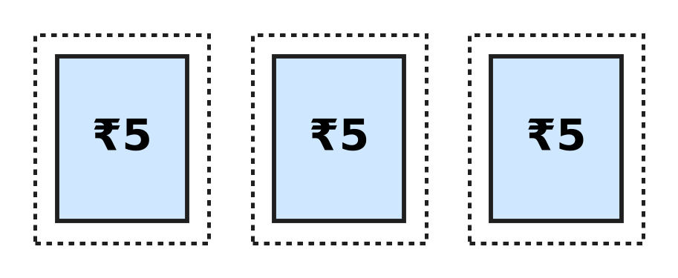
Q14. Vidya tears the 3 stamps in the picture off a full sheet. All the stamps on the sheet are the same size. These 3 stamps are $\frac{3}{10}$ of the full sheet. How many stamps were on the full sheet?
(A) 7 | (B) 10 | (C) 13 | (D) 30

Q15. A fraction is improper when its top number is equal to or bigger than its bottom number. Which is the smallest improper fraction with 9 as its bottom number?
(A) $\frac{1}{9}$ | (B) $\frac{9}{9}$ | (C) $\frac{8}{9}$ | (D) $\frac{10}{9}$

Q16. Which fraction fills the blank?
$\frac{11}{12}$ − ___ = $\frac{4}{12}$
(A) $\frac{15}{12}$ | (B) $\frac{8}{12}$ | (C) $\frac{4}{12}$ | (D) $\frac{7}{12}$

Q17. Which fraction fills the blank?
1 whole − ___ = $\frac{5}{11}$
(A) $\frac{6}{11}$ | (B) $\frac{5}{11}$ | (C) $\frac{11}{11}$ | (D) $\frac{4}{11}$

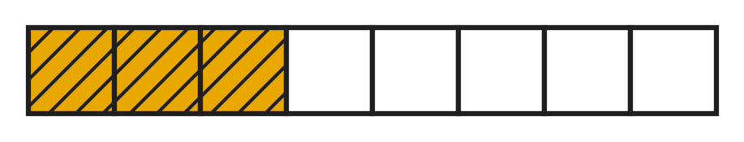
Q18. The shaded part of the bar in the picture shows how much of a honey jar the bees fill on Monday. On Tuesday they fill $\frac{2}{8}$ of the jar more than on Monday. How much of the jar do they fill in the two days together?
(A) $\frac{8}{8}$ | (B) $\frac{6}{8}$ | (C) $\frac{7}{8}$ | (D) $\frac{5}{8}$

Part 4 — Geometry (Syllabus Chapter 5)
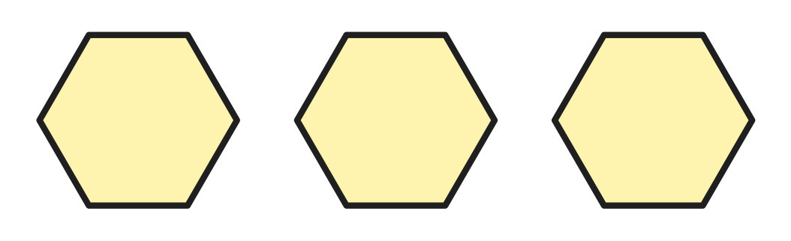
Q19. Rhea cuts the 3 separate hexagons in the picture out of card. How many corners do they have in all?
(A) 6 | (B) 15 | (C) 18 | (D) 24

Q20. Which number fills the blank?
A cube has 6 faces, 8 corners and ___ edges.
(A) 14 | (B) 12 | (C) 10 | (D) 16

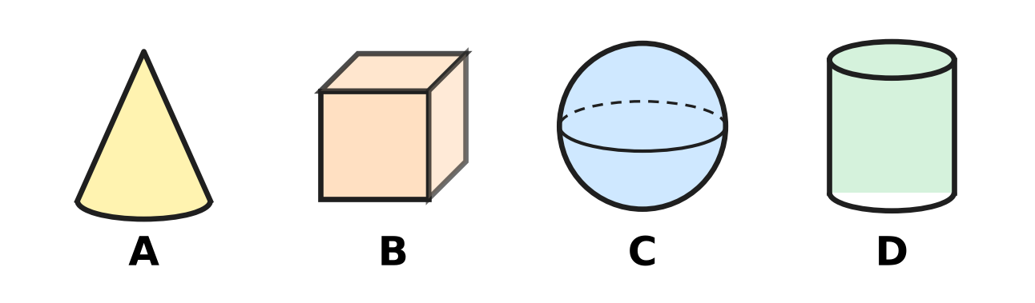
Q21. Which picture shows a solid with 2 flat faces and 1 curved face?
(A) Picture A | (B) Picture B
(C) Picture C | (D) Picture D

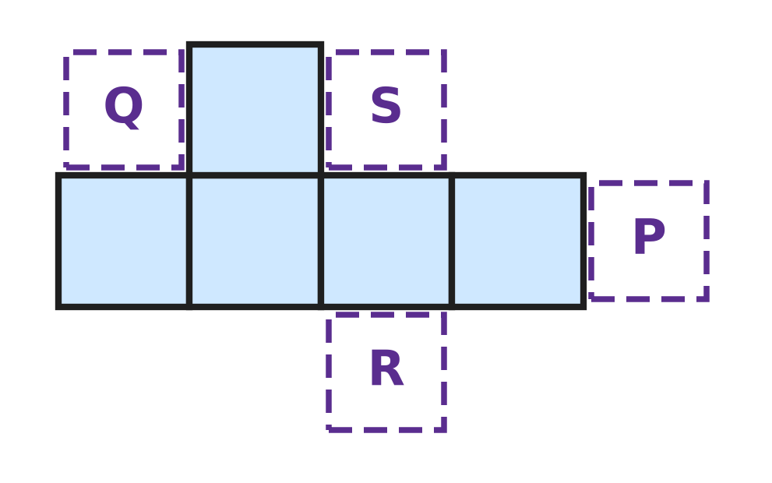
Q22. The 5 shaded squares in the figure are part of the net of a cube. One more square is added at P, Q, R or S. Which place gives a net that folds into a cube?
(A) P | (B) Q | (C) R | (D) S

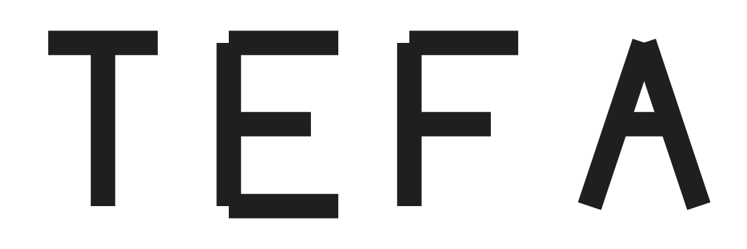
Q23. Kavin cuts the four capital letters in the picture out of card. Which letter has NO line of symmetry?
(A) T | (B) E | (C) F | (D) A

Part 5 — Mensuration (Syllabus Chapter 6)
Q24. Which number fills the blank?
407 cm = 4 m ___ cm
(A) 70 | (B) 47 | (C) 3 | (D) 7

Q25. A sack holds 2 kg 300 g of grain. How many more grams of grain are needed to make 3 kg?
(A) 70 g | (B) 300 g | (C) 700 g | (D) 1,700 g

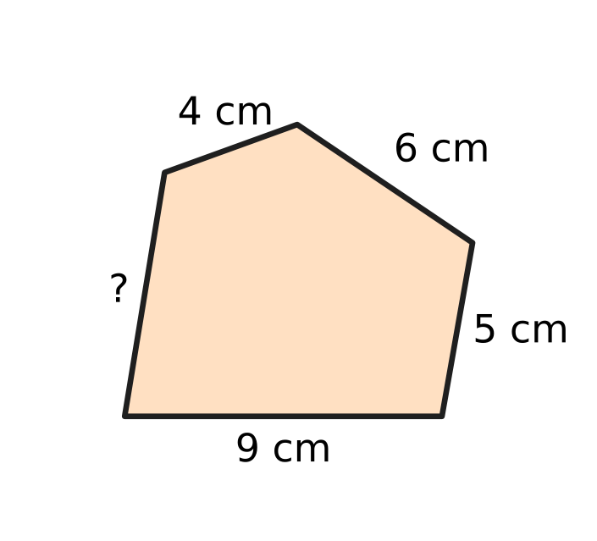
Q26. The perimeter of the five-sided shape in the figure is 31 cm. How long is the side marked "?"
(A) 5 cm | (B) 7 cm | (C) 24 cm | (D) 55 cm

Q27. A clay pot holds 3 L of water. Juhi pours out 750 mL, two times. How much water is left in the pot?
(A) 1 L 500 mL | (B) 2 L 250 mL
(C) 750 mL | (D) 1 L 750 mL

Part 6 — Applied Mathematics (Syllabus Chapter 9)
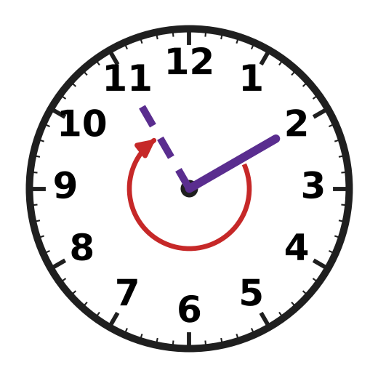
Q28. Only the minute hand is shown on the clock. It moves from the 2 to the 11, as the arrow shows. How many minutes go by?
(A) 9 minutes | (B) 40 minutes
(C) 45 minutes | (D) 55 minutes

Q29. Running practice on the school track starts at 4:45 PM and ends at 6:10 PM. How long does the practice last?
(A) 1 hour 15 minutes | (B) 1 hour 25 minutes
(C) 1 hour 35 minutes | (D) 2 hours 35 minutes

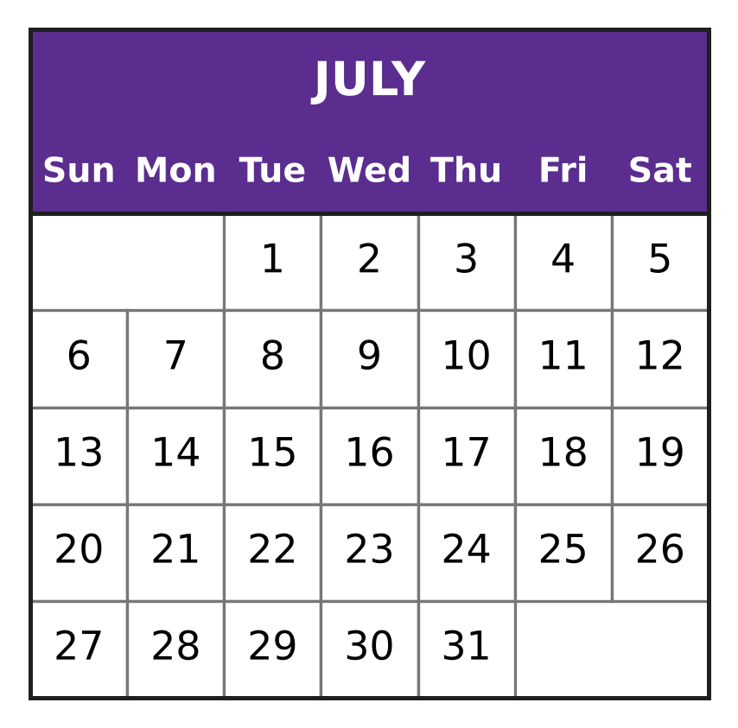
Q30. Look at the calendar. A boat fair at the harbour starts on 9 July. It ends 11 days later. On which date does it end?
(A) 18 July | (B) 19 July | (C) 20 July | (D) 21 July

Q31. One bus ticket costs ₹12. Lalit has ₹99. What is the greatest number of tickets he can buy?
(A) 10 | (B) 7 | (C) 8 | (D) 9

Q32. Vishal plants a mango seed on 22 August. The seed sprouts on 6 September. How many days after planting does it sprout?
(A) 16 days | (B) 28 days | (C) 14 days | (D) 15 days

Q33. On a museum visit, Avni buys 3 guidebooks of the same price. She pays ₹500 and gets ₹140 back. What is the price of one guidebook?
(A) ₹120 | (B) ₹140 | (C) ₹180 | (D) ₹360

Part 7 — Mathematical Reasoning & Problem-Solving (Syllabus Chapter 10)
Q34. In the sum 1A + A = 24, the letter A stands for the same digit both times. Here 1A is a two-digit number. Which digit is A?
(A) 7 | (B) 6 | (C) 4 | (D) 2

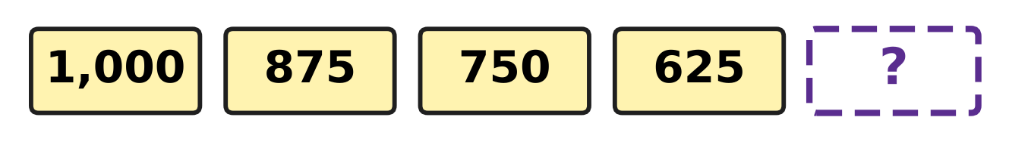
Q35. Look at the number pattern in the picture. Which number goes in the box?
(A) 475 | (B) 500 | (C) 525 | (D) 600

Q36. A wall clock shop sells half of its clocks in a sale. There are 18 clocks left. How many clocks did the shop have before the sale?
(A) 9 | (B) 20 | (C) 27 | (D) 36

Q37. The same rule takes each number in the picture to the next one. Which number is hidden? | 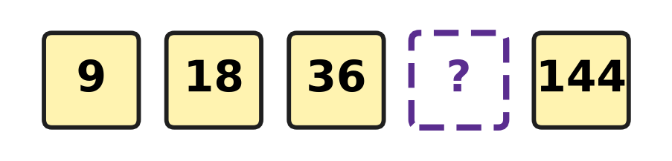
  (A) 54 | (B) 45 | (C) 72 | (D) 90

Q38. The letters A and B hide two digits. A + B = 11 and A − B = 5. Which digit does A hide?
(A) 3 | (B) 5 | (C) 6 | (D) 8

Q39. Nirav has some coins in his piggy bank. He doubles them, then spends 6 coins and then gets 10 more. Now he has 40 coins. How many coins did he have at first?
(A) 18 | (B) 22 | (C) 36 | (D) 72

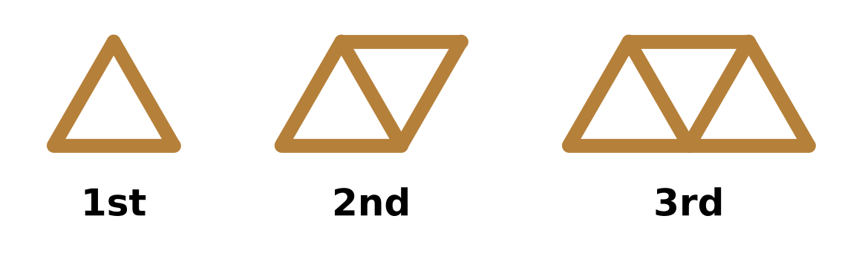
Q40. Look at the shapes made of sticks. Each new shape has one more triangle. Which shape in this pattern uses exactly 25 sticks?
(A) the 8th shape | (B) the 12th shape
(C) the 13th shape | (D) the 24th shape

SECTION II — Star Questions 5 questions × 4 marks each
Q41. In the 4-digit number A,6A3 the letter A stands for the same digit both times. The place value of the first A is 4,950 more than the place value of the second A. What is the number? [4 marks]
(A) 4,643 | (B) 5,653 | (C) 6,663 | (D) 9,693

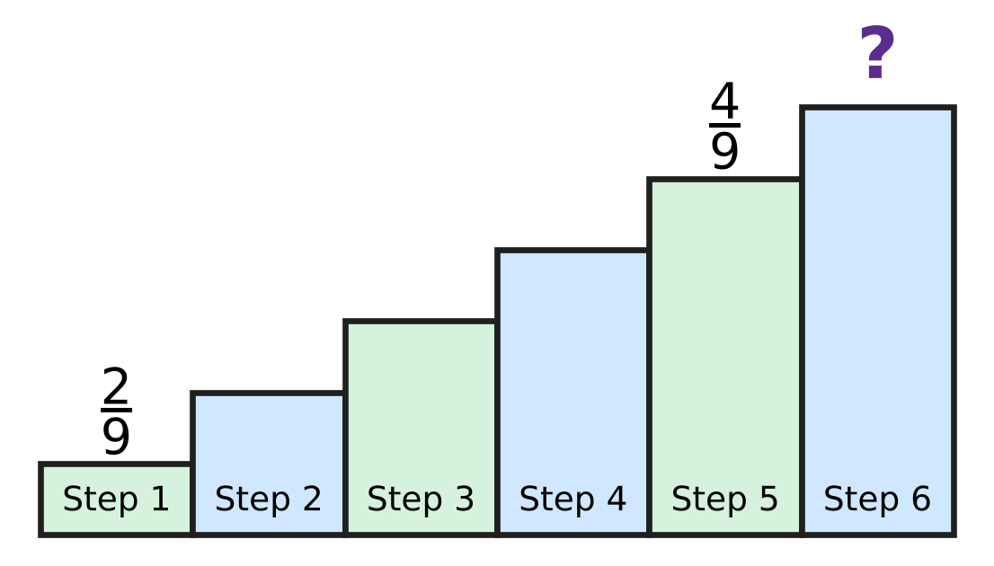
Q42. Look at the staircase in the picture. A fraction is written on each of its 6 steps. Step 1 has $\frac{2}{9}$ and Step 5 has $\frac{4}{9}$. The fractions on any three steps next to each other add up to 1 whole. Which fraction is on Step 6? [4 marks]
(A) $\frac{2}{9}$ | (B) $\frac{3}{9}$ | (C) $\frac{5}{9}$ | (D) $\frac{6}{9}$

Q43. A letter reaches Hemant on Friday, 4 July. It was posted 8 days before that day. It was written 6 days before it was posted. On which day and date was it written? [4 marks]
(A) Thursday, 26 June | (B) Saturday, 28 June
(C) Friday, 21 June | (D) Friday, 20 June

Q44. The rounds of a board game contest are numbered in Roman numerals. Each round lasts 25 minutes, and the next round starts at once. At 2:40 PM round XIV starts. At what time does round XVII start? [4 marks]
(A) 3:55 PM | (B) 3:30 PM | (C) 3:15 PM | (D) 4:20 PM

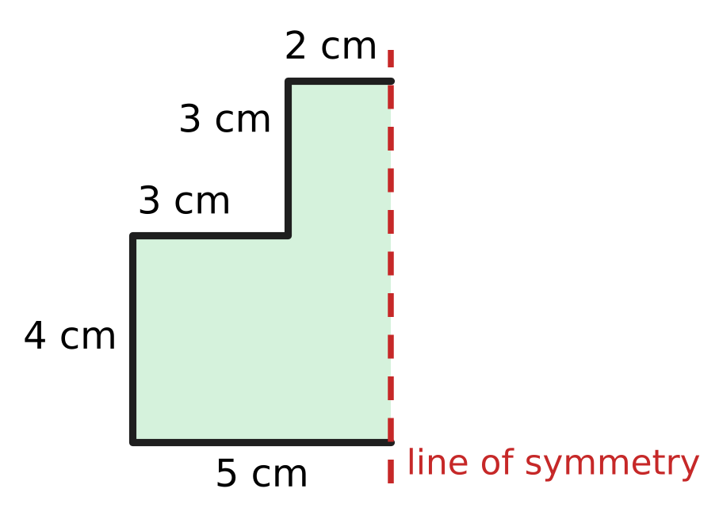
Q45. The figure shows one half of a paper shape. The dotted line is the line of symmetry of the whole shape. What is the perimeter of the whole shape? [4 marks]
(A) 17 cm | (B) 24 cm | (C) 34 cm | (D) 41 cm

Answer Sheet AMO Level 1 · Class 3 · Practice Paper 3
Name: | School: | Roll No.:
Shade or tick one circle for each question.
1. Ⓐ Ⓑ Ⓒ Ⓓ | 16. Ⓐ Ⓑ Ⓒ Ⓓ | 31. Ⓐ Ⓑ Ⓒ Ⓓ
2. Ⓐ Ⓑ Ⓒ Ⓓ | 17. Ⓐ Ⓑ Ⓒ Ⓓ | 32. Ⓐ Ⓑ Ⓒ Ⓓ
3. Ⓐ Ⓑ Ⓒ Ⓓ | 18. Ⓐ Ⓑ Ⓒ Ⓓ | 33. Ⓐ Ⓑ Ⓒ Ⓓ
4. Ⓐ Ⓑ Ⓒ Ⓓ | 19. Ⓐ Ⓑ Ⓒ Ⓓ | 34. Ⓐ Ⓑ Ⓒ Ⓓ
5. Ⓐ Ⓑ Ⓒ Ⓓ | 20. Ⓐ Ⓑ Ⓒ Ⓓ | 35. Ⓐ Ⓑ Ⓒ Ⓓ
6. Ⓐ Ⓑ Ⓒ Ⓓ | 21. Ⓐ Ⓑ Ⓒ Ⓓ | 36. Ⓐ Ⓑ Ⓒ Ⓓ
7. Ⓐ Ⓑ Ⓒ Ⓓ | 22. Ⓐ Ⓑ Ⓒ Ⓓ | 37. Ⓐ Ⓑ Ⓒ Ⓓ
8. Ⓐ Ⓑ Ⓒ Ⓓ | 23. Ⓐ Ⓑ Ⓒ Ⓓ | 38. Ⓐ Ⓑ Ⓒ Ⓓ
9. Ⓐ Ⓑ Ⓒ Ⓓ | 24. Ⓐ Ⓑ Ⓒ Ⓓ | 39. Ⓐ Ⓑ Ⓒ Ⓓ
10. Ⓐ Ⓑ Ⓒ Ⓓ | 25. Ⓐ Ⓑ Ⓒ Ⓓ | 40. Ⓐ Ⓑ Ⓒ Ⓓ
11. Ⓐ Ⓑ Ⓒ Ⓓ | 26. Ⓐ Ⓑ Ⓒ Ⓓ | 41. Ⓐ Ⓑ Ⓒ Ⓓ
12. Ⓐ Ⓑ Ⓒ Ⓓ | 27. Ⓐ Ⓑ Ⓒ Ⓓ | 42. Ⓐ Ⓑ Ⓒ Ⓓ
13. Ⓐ Ⓑ Ⓒ Ⓓ | 28. Ⓐ Ⓑ Ⓒ Ⓓ | 43. Ⓐ Ⓑ Ⓒ Ⓓ
14. Ⓐ Ⓑ Ⓒ Ⓓ | 29. Ⓐ Ⓑ Ⓒ Ⓓ | 44. Ⓐ Ⓑ Ⓒ Ⓓ
15. Ⓐ Ⓑ Ⓒ Ⓓ | 30. Ⓐ Ⓑ Ⓒ Ⓓ | 45. Ⓐ Ⓑ Ⓒ Ⓓ
Q41–Q45 are Section II Star Questions (4 marks each).
For the parent or teacher
Section I correct: ______ / 40 × 2 = ______ marks Section II correct: ______ / 5 × 4 = ______ marks
Correct: ______ / 45 Score: ______ / 100
Answer Key and Solutions AMO Level 1 · Class 3 · Practice Paper 3
Quick answers
1 C | 6 B | 11 B | 16 D | 21 D | 26 B | 31 C | 36 D | 41 B
2 D | 7 D | 12 A | 17 A | 22 C | 27 A | 32 D | 37 C | 42 B
3 D | 8 A | 13 A | 18 A | 23 C | 28 C | 33 A | 38 D | 43 D
4 A | 9 D | 14 B | 19 C | 24 D | 29 B | 34 A | 39 A | 44 A
5 C | 10 A | 15 B | 20 B | 25 C | 30 C | 35 B | 40 B | 45 C
Solutions
Q | Part · level | Answer | Why?
1 | Part 1 · Ch1 · Easy | (C) 2 | Four thousand six is 4,006: 4 thousands, 0 hundreds, 0 tens and 6 ones. It has 2 zeros.
2 | Part 1 · Ch1 · Easy | (D) 2 | In 5,273 the digit 2 is in the hundreds place, so its place value is 2 × 100 = 200.
3 | Part 1 · Ch1 · Easy | (D) 46 | X before L means 50 − 10 = 40. Then VI is 6. So XLVI = 40 + 6 = 46.
4 | Part 1 · Ch1 · Easy | (A) 7,508 | The blank must be greater than 7,495 and smaller than 7,520. Only 7,508 fits.
5 | Part 1 · Ch1 · Medium | (C) 10 | The first three digits are fixed: 9,99_. The ones digit can be any of 0, 1, 2, …, 9. That gives 10 numbers, from 9,990 to 9,999.
6 | Part 1 · Ch1 · Medium | (B) XLIV | XXXVIII = 38, XLII = 42, XXXIX = 39 and XLIV = 44. The greatest number is 44, which is XLIV.
7 | Part 2 · Ch2 · Easy | (D) 6,222 | Ones: 8 + 4 = 12. Tens: 6 + 5 + 1 = 12. Hundreds: 4 + 7 + 1 = 12. Thousands: 3 + 2 + 1 = 6. The total is 6,222.
8 | Part 2 · Ch2 · Easy | (A) 2,636 | Count up from 5,364: 36 more makes 5,400, 600 more makes 6,000, and 2,000 more makes 8,000. 36 + 600 + 2,000 = 2,636.
9 | Part 2 · Ch2 · Easy | (D) 12 | 7 × 10 = 70, 7 × 11 = 77 and 7 × 12 = 84. So the blank is 12.
10 | Part 2 · Ch2 · Easy | (A) 5 | 7 × 6 = 42. From 42 to 47 is 5, so the remainder is 5.
11 | Part 2 · Ch2 · Medium | (B) 3 | 40 × 6 = 240, and 258 − 240 = 18. Since 3 × 6 = 18, the ones digit is 3: 43 × 6 = 258.
12 | Part 2 · Ch2 · Medium | (A) 88 | He has 8 × 26 = 208 letters in all. Then 208 − 120 = 88 letters are left.
13 | Part 2 · Ch2 · Medium | (A) 0 | The 4 planes left over and the 2 new planes make 6 planes. These fill one more box of 6, so no plane is left over.
14 | Part 3 · Ch3 · Easy | (B) 10 | Three-tenths means 3 of 10 equal parts. Each stamp is one-tenth of the sheet, so the full sheet had 10 stamps.
15 | Part 3 · Ch3 · Easy | (B) $\frac{9}{9}$ | A fraction is improper when its top number is equal to or bigger than its bottom number. The smallest such top number is 9, so the answer is nine-ninths, which is one whole.
16 | Part 3 · Ch3 · Easy | (D) $\frac{7}{12}$ | The bottom numbers are the same, so look at the tops: 11 − 7 = 4. The blank is seven-twelfths.
17 | Part 3 · Ch3 · Medium | (A) $\frac{6}{11}$ | One whole is eleven-elevenths. 11 − 6 = 5, so six-elevenths must be taken away to leave five-elevenths.
18 | Part 3 · Ch3 · Medium | (A) $\frac{8}{8}$ | On Monday the bees fill three-eighths. On Tuesday they fill 3 + 2 = 5 eighths. Together that is 3 + 5 = 8 eighths, which is the whole jar.
19 | Part 4 · Ch5 · Easy | (C) 18 | A hexagon has 6 corners. So 3 hexagons have 3 × 6 = 18 corners.
20 | Part 4 · Ch5 · Easy | (B) 12 | A cube has 4 edges round the top, 4 edges round the bottom and 4 upright edges. 4 + 4 + 4 = 12.
21 | Part 4 · Ch5 · Easy | (D) Picture D | Picture D is a cylinder. It has a flat circle at each end and one curved face between them.
22 | Part 4 · Ch5 · Medium | (C) R | The row of 4 squares wraps round the cube. One square above the row makes the top, so the last square must be below the row to make the bottom. That place is R.
23 | Part 4 · Ch5 · Medium | (C) F | T and A match when folded along an upright middle line. E matches when folded along a line across its middle. F has no fold line, so F has no line of symmetry.
24 | Part 5 · Ch6 · Easy | (D) 7 | There are 100 cm in 1 m, so 400 cm make 4 m. That leaves 7 cm: 407 cm = 4 m 7 cm.
25 | Part 5 · Ch6 · Easy | (C) 700 g | In grams, 3 kg is 3,000 g and 2 kg 300 g is 2,300 g. Then 3,000 − 2,300 = 700, so 700 g more are needed.
26 | Part 5 · Ch6 · Medium | (B) 7 cm | The four sides that are given add up to 9 + 5 + 6 + 4 = 24 cm. The last side is 31 − 24 = 7 cm.
27 | Part 5 · Ch6 · Medium | (A) 1 L 500 mL | Two pours are 750 mL + 750 mL = 1,500 mL. The pot holds 3 L = 3,000 mL, and 3,000 mL − 1,500 mL = 1,500 mL, which is 1 L 500 mL.
28 | Part 6 · Ch9 · Easy | (C) 45 minutes | From 2 to 11 the hand makes 9 jumps, and each jump is 5 minutes. 9 × 5 = 45 minutes.
29 | Part 6 · Ch9 · Easy | (B) 1 hour 25 minutes | From 4:45 PM to 5:45 PM is 1 hour. From 5:45 PM to 6:10 PM is 15 + 10 = 25 minutes. The practice lasts 1 hour 25 minutes.
30 | Part 6 · Ch9 · Easy | (C) 20 July | Count on 11 days from 9 July: 9 + 11 = 20. The fair ends on 20 July.
31 | Part 6 · Ch9 · Easy | (C) 8 | Since 8 × ₹12 = ₹96 and 9 × ₹12 = ₹108, he can buy 8 tickets and has ₹3 left.
32 | Part 6 · Ch9 · Medium | (D) 15 days | August has 31 days, so from 22 August to 31 August is 9 days. Then 6 more days in September: 9 + 6 = 15 days.
33 | Part 6 · Ch9 · Medium | (A) ₹120 | The 3 guidebooks cost ₹500 − ₹140 = ₹360. One guidebook costs ₹360 ÷ 3 = ₹120.
34 | Part 7 · Ch10 · Easy | (A) 7 | Try digits: 16 + 6 = 22 is too small and 17 + 7 = 24 fits. So the hidden digit is 7.
35 | Part 7 · Ch10 · Easy | (B) 500 | Each number is 125 less than the one before: 1,000, 875, 750, 625. Then 625 − 125 = 500.
36 | Part 7 · Ch10 · Easy | (D) 36 | The 18 clocks left are the other half. So before the sale the shop had 18 + 18 = 36 clocks.
37 | Part 7 · Ch10 · Easy | (C) 72 | Each number is double the one before. Double 36 is 72, and double 72 is 144, which fits.
38 | Part 7 · Ch10 · Medium | (D) 8 | The two digits add up to 11 and differ by 5: they are 8 and 3, since 8 + 3 = 11 and 8 − 3 = 5. So the letter A hides 8 and B hides 3.
39 | Part 7 · Ch10 · Medium | (A) 18 | Work backwards from 40: take away the 10 to get 30, give back the 6 to get 36, then halve to get 18. Check: 18 → 36 → 30 → 40.
40 | Part 7 · Ch10 · Medium | (B) the 12th shape | The sticks go 3, 5, 7: one stick plus 2 sticks for each triangle. Then 25 − 1 = 24 and 24 ÷ 2 = 12, so it is the 12th shape.
41 | Section II · Ch1 + Ch10 · Hard | (B) 5,653 | The first A is worth A thousands and the second A is worth A tens. A = 5 gives 5,000 − 50 = 4,950, while A = 4 gives 3,960 and A = 6 gives 5,940. So the number is 5,653.
42 | Section II · Ch3 + Ch10 · Hard | (B) $\frac{3}{9}$ | Steps 1, 2, 3 and Steps 2, 3, 4 both make 1 whole, so Step 4 is the same as Step 1: $\frac{2}{9}$. Steps 4, 5, 6 make 1 whole, so Step 6 is 1 whole − $\frac{2}{9}$ − $\frac{4}{9}$ = $\frac{3}{9}$.
43 | Section II · Ch9 + Ch10 · Hard | (D) Friday, 20 June | The letter was written 8 + 6 = 14 days before 4 July. These 14 days are exactly 2 weeks, so the day is again a Friday. June has 30 days, so 4 days back is 30 June and 10 more days back is 20 June.
44 | Section II · Ch1 + Ch9 · Hard | (A) 3:55 PM | XIV is 14 and XVII is 17. Rounds 14, 15 and 16 must finish first: 3 × 25 = 75 minutes, which is 1 hour 15 minutes. 2:40 PM + 1 hour 15 minutes = 3:55 PM.
45 | Section II · Ch5 + Ch6 · Hard | (C) 34 cm | The five sides shown are 5 + 4 + 3 + 3 + 2 = 17 cm. The other half has the same sides, and the dotted line is inside the shape. So the perimeter is 17 + 17 = 34 cm.

