UNLOCK IQ INSTITUTE
Realize Your True Potential
Aryabhatta Maths Olympiad (AMO)
Level 1 — Practice Paper 4
CLASS 3

Questions | 45 multiple-choice questions
Marks | 100
Time | 60 minutes
Section I | 40 questions × 2 marks = 80 marks
Section II | 5 Star Questions × 4 marks = 20 marks
Negative marking | No negative marking
Calculator | Not allowed
Chapters | Number System · Operations · Fractions, Decimals & Percentages · Geometry · Mensuration · Applied Mathematics · Mathematical Reasoning

Hello, friend!
• Every question has four answer choices: (A), (B), (C) and (D). Only one is correct.
• Read each question and look at its picture carefully. Then mark your answer on the answer sheet at the end.
• Section I has 40 questions of 2 marks each. Section II has 5 Star Questions of 4 marks each.
• There is no negative marking, so try every question.
• Do not use a calculator. You may do rough work on a separate sheet.
• All figures are not necessarily drawn to scale unless stated.

For parents and teachers
Print or view this paper in colour. Pictures are part of the questions.
Parts follow the AMO syllabus chapters. Chapters 4, 7 and 8 are not part of the Class 3 syllabus, so the chapter numbers shown in the Part headings have gaps.
The answer sheet and the answer key are at the end. Remove only the answer key before the child begins.

Name: | School: | Roll No.:

SECTION I 40 questions × 2 marks each
Part 1 — Number System (Syllabus Chapter 1)
Q1. A plant nursery has 3 thousand saplings in its field, 4 hundred in trays and 6 on a table. How many saplings does it have in all?
(A) 3,046 | (B) 346 | (C) 3,406 | (D) 3,460

Q2. A zoo sold 2,940 tickets in a week. In this number, what is the face value of the digit 9?
(A) 900 | (B) 100 | (C) 90 | (D) 9

Q3. Kriti reads page 34 of an old storybook. Its page numbers are printed in Roman numerals. Which numeral is printed on this page?
(A) XXIV | (B) XXXIV | (C) XXXIIII | (D) XXXVI

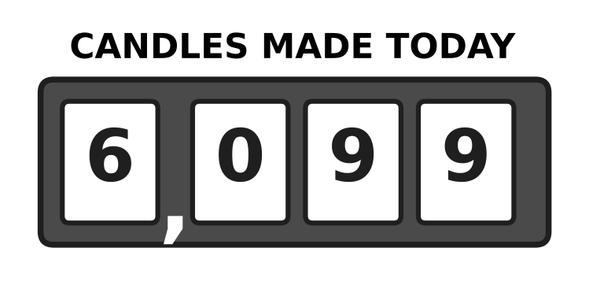
Q4. Look at the counter of a candle-making machine. It makes one more candle. Which number does the counter show now?
(A) 6,100 | (B) 6,109 | (C) 7,000 | (D) 6,010

Q5. Neel has three letter cards that show XVI. He puts the same three cards in a different order to make a smaller number. Which number does he make?
(A) 16 | (B) 6 | (C) 4 | (D) 14

Q6. At a school fair, every ticket with a number greater than 2,996 and less than 3,003 wins a prize. How many tickets win a prize?
(A) 7 | (B) 6 | (C) 8 | (D) 5

Part 2 — Operations & Number Properties (Syllabus Chapter 2)
Q7. A milk dairy fills 1,250 bottles on Friday. On Saturday it fills 1,375 more bottles than on Friday. How many bottles does it fill on Saturday?
(A) 3,875 | (B) 2,525 | (C) 2,625 | (D) 125

Q8. A school collected 4,020 bottle caps in March and 2,685 bottle caps in April. How many fewer caps did it collect in April than in March?
(A) 1,335 | (B) 1,435 | (C) 2,665 | (D) 6,705

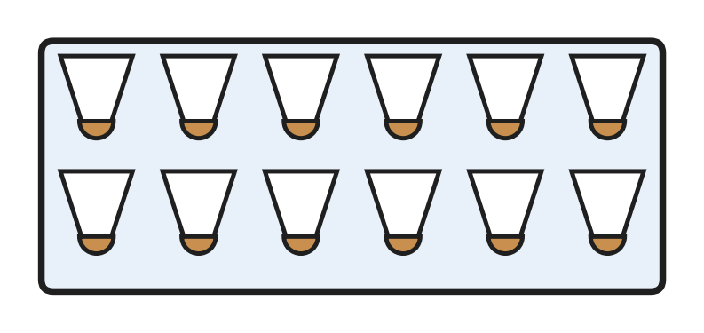
Q9. Look at the full box of shuttlecocks. A badminton club has 7 boxes like this, all full. How many shuttlecocks does the club have?
(A) 72 | (B) 96 | (C) 19 | (D) 84

Q10. A shop has 59 umbrellas. It puts 8 umbrellas in each stand and fills as many stands as it can. How many umbrellas are left over?
(A) 7 | (B) 51 | (C) 3 | (D) 8

Q11. A cook gets 7 crates of apples with 36 apples in each crate. Then 8 bad apples are thrown away. How many good apples are left?
(A) 224 | (B) 244 | (C) 260 | (D) 252

Q12. A nursery plants 156 saplings in 6 equal rows. Later, 4 saplings in each row dry up. How many saplings are left in each row?
(A) 26 | (B) 22 | (C) 132 | (D) 30

Q13. There are 52 children at a school assembly. Each bench seats 6 children. What is the smallest number of benches needed so that every child has a seat?
(A) 6 | (B) 8 | (C) 9 | (D) 4

Part 3 — Fractions, Decimals & Percentages (Syllabus Chapter 3)
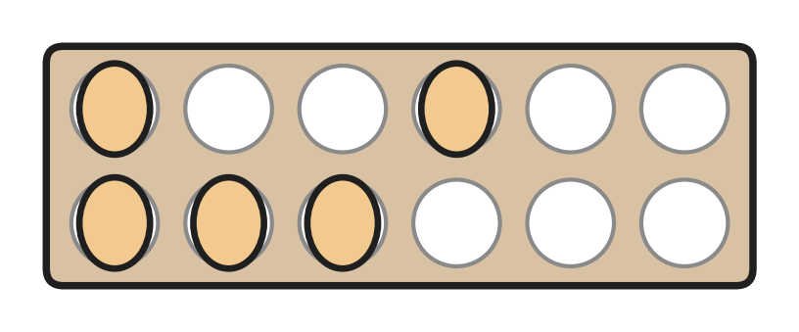
Q14. Look at the egg tray. All its cups are the same size. What fraction of the cups have an egg in them?
(A) $\frac{7}{12}$ | (B) $\frac{12}{5}$ | (C) $\frac{5}{7}$ | (D) $\frac{5}{12}$

Q15. A wooden plank is $\frac{5}{4}$ m long. Which of these is true about its length?
(A) It is more than 1 m. | (B) It is exactly 1 m.
(C) It is exactly 5 m. | (D) It is less than 1 m.

Q16. Vivek adds $\frac{2}{9}$ + $\frac{5}{9}$ and writes $\frac{7}{18}$. His answer is wrong. What is the correct answer?
(A) $\frac{3}{9}$ | (B) $\frac{8}{9}$ | (C) $\frac{7}{9}$ | (D) $\frac{10}{9}$

Q17. A cook has $\frac{5}{8}$ cup of sugar. Biscuits need $\frac{6}{8}$ cup, pudding needs $\frac{3}{8}$ cup, jam needs $\frac{7}{8}$ cup and a cake needs $\frac{9}{8}$ cups. Which one can she make with the sugar she has?
(A) cake | (B) jam
(C) biscuits | (D) pudding

Q18. Four bottles of the same size are full of water. From bottle P, $\frac{5}{8}$ of the water is drunk. From bottle Q, $\frac{3}{8}$ is drunk, from R $\frac{7}{8}$ and from S $\frac{6}{8}$. Which bottle now has the second most water left?
(A) bottle P | (B) bottle Q
(C) bottle R | (D) bottle S

Part 4 — Geometry (Syllabus Chapter 5)
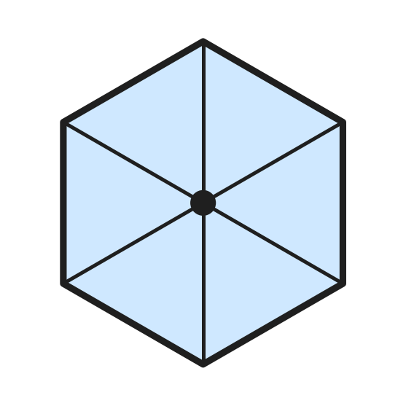
Q19. Look at the open umbrella seen from above. Its edge is made of straight sides. What is the name of this flat shape?
(A) hexagon | (B) triangle
(C) rectangle | (D) pentagon

Q20. Leah cuts open an empty tin can, which is a cylinder, and lays the pieces flat to make its net. Which flat shapes make the net?
(A) 1 circle and 1 rectangle | (B) 2 circles and 1 rectangle
(C) 2 circles and 2 rectangles | (D) 6 rectangles

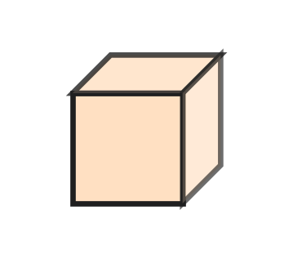
Q21. Look at the wooden cube. Sanjay paints every face in a different colour. How many colours does he need?
(A) 6 | (B) 4 | (C) 8 | (D) 12

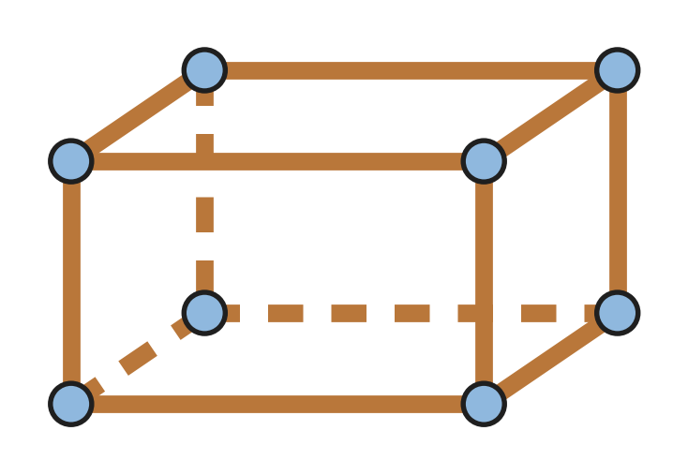
Q22. Look at the frame of a cuboid. Manu uses one stick for each edge and one clay ball for each corner. How many more sticks than clay balls does he use?
(A) 20 | (B) 12 | (C) 8 | (D) 4

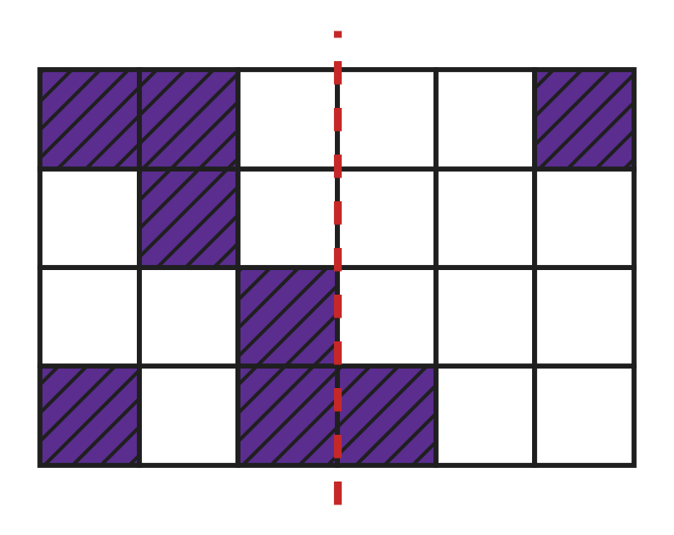
Q23. Look at the grid. The dotted line must become a line of symmetry of the shaded pattern. How many more small squares must be shaded on the right side?
(A) 5 | (B) 2 | (C) 4 | (D) 6

Part 5 — Mensuration (Syllabus Chapter 6)
Q24. Which of these is best measured in millilitres (mL)?
(A) the water in a swimming pool | (B) a teaspoon of honey
(C) the water in a full bucket | (D) the milk in a dairy tank

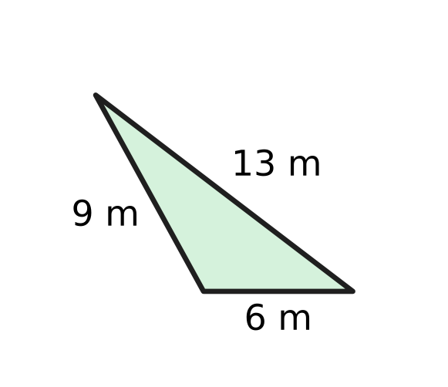
Q25. Look at the three-sided flower bed. A fence goes once all the way round it. How long is the fence?
(A) 19 m | (B) 22 m | (C) 28 m | (D) 15 m

Q26. A recipe needs 1 kg 250 g of flour. The jar in the kitchen has only 800 g of flour. How many more grams of flour are needed?
(A) 450 g | (B) 200 g | (C) 550 g | (D) 2,050 g

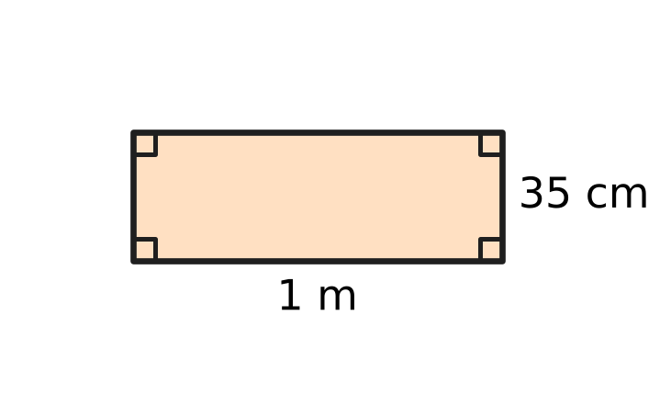
Q27. A carpenter makes the rectangular wooden frame in the picture. He fixes a strip all the way round its edge. How long is the strip?
(A) 135 cm | (B) 72 cm | (C) 170 cm | (D) 270 cm

Part 6 — Applied Mathematics (Syllabus Chapter 9)
Q28. A ferry trip across the river takes 1 hour 20 minutes. How many minutes is that?
(A) 120 minutes | (B) 80 minutes
(C) 70 minutes | (D) 21 minutes

Q29. An art class starts a big wall painting in October. The painting is finished 5 months later. In which month is it finished?
(A) December | (B) April
(C) March | (D) February

Q30. Three friends buy a badminton net together for ₹270. They share the cost equally. How much does each friend pay?
(A) ₹810 | (B) ₹90 | (C) ₹135 | (D) ₹70

Q31. Class 3 visits the zoo on 6 June. The next class visits exactly 2 weeks later. On which date does the next class visit?
(A) 20 June | (B) 13 June | (C) 8 June | (D) 26 June

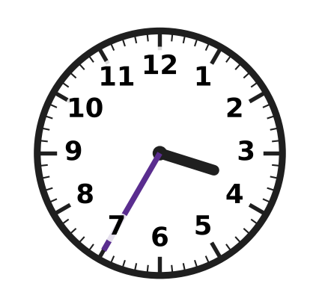
Q32. The clock shows the time when Ojas reaches the river jetty in the afternoon. The ferry leaves at 4:10. How many minutes does he wait?
(A) 25 minutes | (B) 45 minutes
(C) 75 minutes | (D) 35 minutes

Q33. At a bookshop sale, every book costs ₹60. For every 2 books you pay for, you get 1 more book free. Nidhi takes home 6 books. How much does she pay?
(A) ₹180 | (B) ₹300 | (C) ₹360 | (D) ₹240

Part 7 — Mathematical Reasoning & Problem-Solving (Syllabus Chapter 10)
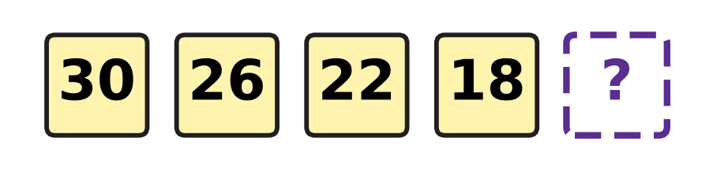
Q34. A candle burns down in a pattern. The picture shows its height in centimetres at the end of each hour. Which number comes next?
(A) 4 | (B) 16 | (C) 14 | (D) 12

Q35. Find the digit A that makes A0 − A = 63 true. In A0, A is the tens digit and 0 is the ones digit.
(A) 7 | (B) 3 | (C) 8 | (D) 6

Q36. At a school fair, 12 children leave a puppet show and nobody new comes in. Now 35 children are watching. How many were watching before?
(A) 37 | (B) 47 | (C) 23 | (D) 57

Q37. Hugo paints numbers on the steps of a hill path: 4, 7, 2, 4, 7, 2, and so on in the same order. Which number is on the 11th step?
(A) 4 | (B) 3 | (C) 7 | (D) 2

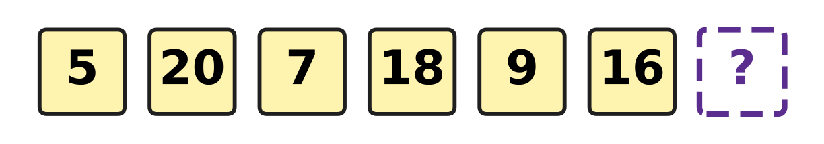
Q38. The numbers on the lockers of a badminton hall follow the pattern in the picture. Which number is on the next locker?
(A) 18 | (B) 23 | (C) 14 | (D) 11

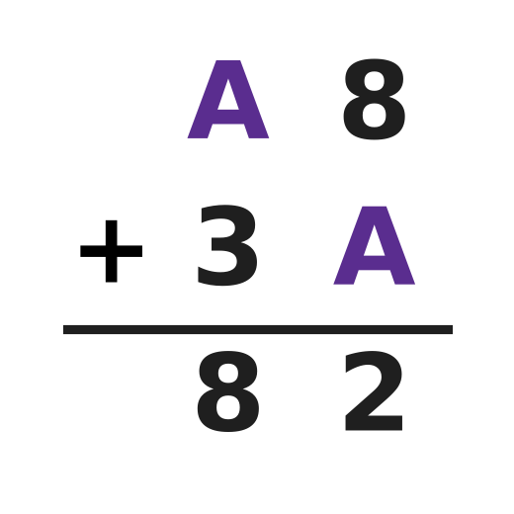
Q39. Look at the column addition in the picture. A hides one digit, and it is the same digit in both numbers. Find A.
(A) 2 | (B) 4 | (C) 6 | (D) 5

Q40. An art teacher puts all her crayons equally into 4 boxes. Then she takes 6 crayons out of one box. That box now has 9 crayons. How many crayons did she put into the boxes?
(A) 60 | (B) 42 | (C) 15 | (D) 36

SECTION II — Star Questions 5 questions × 4 marks each
Q41. Chetan thinks of a number. He doubles it and then adds X. He gets XLVIII. He writes every number in Roman numerals. Which number did he think of? [4 marks]
(A) XIX | (B) XIV | (C) XXXVIII | (D) XXIX

Q42. A jug is full of milk. Some milk is used in the morning. At noon, half of the milk left in the jug is used. In the evening, $\frac{3}{12}$ of the jug is used. Now $\frac{2}{12}$ of the jug is left. What fraction of the jug was used in the morning? [4 marks]
(A) $\frac{5}{12}$ | (B) $\frac{7}{12}$ | (C) $\frac{10}{12}$ | (D) $\frac{2}{12}$

Q43. On a mountain hike, Garima walks up for 1 hour 35 minutes and rests at the top for 25 minutes. Walking down takes her 50 minutes less than walking up. She is back at the start at 1:10 PM. At what time did she start? [4 marks]
(A) 9:35 AM | (B) 3:55 PM
(C) 10:25 AM | (D) 10:50 AM

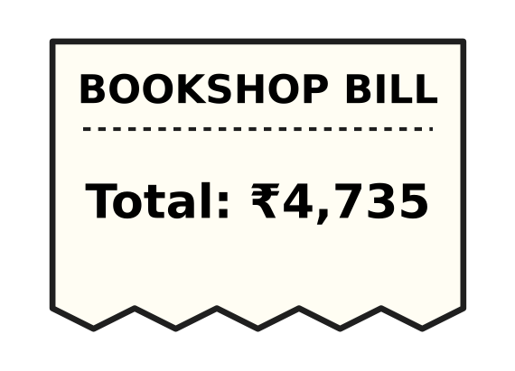
Q44. Look at the bill. By mistake, the shopkeeper swaps the hundreds digit and the tens digit when he asks for the money. How much less does the customer pay? [4 marks]
(A) ₹400 | (B) ₹360 | (C) ₹40 | (D) ₹440

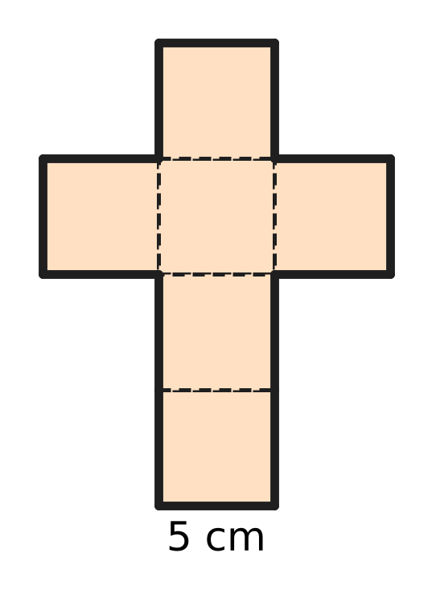
Q45. The picture shows the net of a cube. Every edge of the cube is 5 cm long. What is the perimeter of the whole net? [4 marks]
(A) 120 cm | (B) 70 cm | (C) 60 cm | (D) 30 cm

Answer Sheet AMO Level 1 · Class 3 · Practice Paper 4
Name: | School: | Roll No.:
Shade or tick one circle for each question.
1. Ⓐ Ⓑ Ⓒ Ⓓ | 16. Ⓐ Ⓑ Ⓒ Ⓓ | 31. Ⓐ Ⓑ Ⓒ Ⓓ
2. Ⓐ Ⓑ Ⓒ Ⓓ | 17. Ⓐ Ⓑ Ⓒ Ⓓ | 32. Ⓐ Ⓑ Ⓒ Ⓓ
3. Ⓐ Ⓑ Ⓒ Ⓓ | 18. Ⓐ Ⓑ Ⓒ Ⓓ | 33. Ⓐ Ⓑ Ⓒ Ⓓ
4. Ⓐ Ⓑ Ⓒ Ⓓ | 19. Ⓐ Ⓑ Ⓒ Ⓓ | 34. Ⓐ Ⓑ Ⓒ Ⓓ
5. Ⓐ Ⓑ Ⓒ Ⓓ | 20. Ⓐ Ⓑ Ⓒ Ⓓ | 35. Ⓐ Ⓑ Ⓒ Ⓓ
6. Ⓐ Ⓑ Ⓒ Ⓓ | 21. Ⓐ Ⓑ Ⓒ Ⓓ | 36. Ⓐ Ⓑ Ⓒ Ⓓ
7. Ⓐ Ⓑ Ⓒ Ⓓ | 22. Ⓐ Ⓑ Ⓒ Ⓓ | 37. Ⓐ Ⓑ Ⓒ Ⓓ
8. Ⓐ Ⓑ Ⓒ Ⓓ | 23. Ⓐ Ⓑ Ⓒ Ⓓ | 38. Ⓐ Ⓑ Ⓒ Ⓓ
9. Ⓐ Ⓑ Ⓒ Ⓓ | 24. Ⓐ Ⓑ Ⓒ Ⓓ | 39. Ⓐ Ⓑ Ⓒ Ⓓ
10. Ⓐ Ⓑ Ⓒ Ⓓ | 25. Ⓐ Ⓑ Ⓒ Ⓓ | 40. Ⓐ Ⓑ Ⓒ Ⓓ
11. Ⓐ Ⓑ Ⓒ Ⓓ | 26. Ⓐ Ⓑ Ⓒ Ⓓ | 41. Ⓐ Ⓑ Ⓒ Ⓓ
12. Ⓐ Ⓑ Ⓒ Ⓓ | 27. Ⓐ Ⓑ Ⓒ Ⓓ | 42. Ⓐ Ⓑ Ⓒ Ⓓ
13. Ⓐ Ⓑ Ⓒ Ⓓ | 28. Ⓐ Ⓑ Ⓒ Ⓓ | 43. Ⓐ Ⓑ Ⓒ Ⓓ
14. Ⓐ Ⓑ Ⓒ Ⓓ | 29. Ⓐ Ⓑ Ⓒ Ⓓ | 44. Ⓐ Ⓑ Ⓒ Ⓓ
15. Ⓐ Ⓑ Ⓒ Ⓓ | 30. Ⓐ Ⓑ Ⓒ Ⓓ | 45. Ⓐ Ⓑ Ⓒ Ⓓ
Q41–Q45 are Section II Star Questions (4 marks each).
For the parent or teacher
Section I correct: ______ / 40 × 2 = ______ marks Section II correct: ______ / 5 × 4 = ______ marks
Correct: ______ / 45 Score: ______ / 100
Answer Key and Solutions AMO Level 1 · Class 3 · Practice Paper 4
Quick answers
1 C | 6 B | 11 B | 16 C | 21 A | 26 A | 31 A | 36 B | 41 A
2 D | 7 C | 12 B | 17 D | 22 D | 27 D | 32 D | 37 C | 42 D
3 B | 8 A | 13 C | 18 A | 23 C | 28 B | 33 D | 38 D | 43 C
4 A | 9 D | 14 D | 19 A | 24 B | 29 C | 34 C | 39 B | 44 B
5 D | 10 C | 15 A | 20 B | 25 C | 30 B | 35 A | 40 A | 45 B
Solutions
Q | Part · level | Answer | Why?
1 | Part 1 · Ch1 · Easy | (C) 3,406 | 3 thousands, 4 hundreds, 0 tens and 6 ones make 3,000 + 400 + 6 = 3,406.
2 | Part 1 · Ch1 · Easy | (D) 9 | The face value of a digit is the digit itself, so it is 9. Its place value is 900.
3 | Part 1 · Ch1 · Easy | (B) XXXIV | 34 = 30 + 4. 30 is XXX and 4 is IV (1 before 5), so 34 is XXXIV.
4 | Part 1 · Ch1 · Easy | (A) 6,100 | One more than 6,099 is 6,100, because 99 + 1 = 100.
5 | Part 1 · Ch1 · Medium | (D) 14 | XVI is 16. The only other correct numeral with X, V and I is XIV, which is 10 + 4 = 14.
6 | Part 1 · Ch1 · Medium | (B) 6 | The winning numbers are 2,997, 2,998, 2,999, 3,000, 3,001 and 3,002. That is 6 tickets.
7 | Part 2 · Ch2 · Easy | (C) 2,625 | Saturday has 1,375 more than Friday: 1,250 + 1,375 = 2,625.
8 | Part 2 · Ch2 · Easy | (A) 1,335 | 4,020 − 2,685 = 1,335. Check by adding back: 1,335 + 2,685 = 4,020.
9 | Part 2 · Ch2 · Easy | (D) 84 | One box holds 12 shuttlecocks. 7 boxes hold 7 × 12 = 84 shuttlecocks.
10 | Part 2 · Ch2 · Easy | (C) 3 | 59 ÷ 8 = 7 remainder 3, because 7 × 8 = 56. So 3 umbrellas are left over.
11 | Part 2 · Ch2 · Medium | (B) 244 | 7 × 36 = 252 apples. 8 are thrown away, so 252 − 8 = 244 good apples are left.
12 | Part 2 · Ch2 · Medium | (B) 22 | 156 ÷ 6 = 26 saplings in each row. 26 − 4 = 22 are left in each row.
13 | Part 2 · Ch2 · Medium | (C) 9 | 52 ÷ 6 = 8 remainder 4. 8 benches are full and 4 children still need a seat, so 8 + 1 = 9 benches are needed.
14 | Part 3 · Ch3 · Easy | (D) $\frac{5}{12}$ | The tray has 12 equal cups and 5 of them have eggs. So $\frac{5}{12}$ of the cups have an egg.
15 | Part 3 · Ch3 · Easy | (A) It is more than 1 m. | $\frac{4}{4}$ m is one whole metre. $\frac{5}{4}$ m is one quarter more than that, so it is more than 1 m. It is an improper fraction.
16 | Part 3 · Ch3 · Easy | (C) $\frac{7}{9}$ | For like fractions, add the top numbers and keep the bottom number: 2 + 5 = 7, so the answer is $\frac{7}{9}$. Vivek wrongly added the bottom numbers too.
17 | Part 3 · Ch3 · Medium | (D) pudding | She has 5 eighths of a cup. Only pudding needs less: $\frac{3}{8}$ is less than $\frac{5}{8}$. The other three need 6, 7 and 9 eighths.
18 | Part 3 · Ch3 · Medium | (A) bottle P | Water left: P $\frac{3}{8}$, Q $\frac{5}{8}$, R $\frac{1}{8}$, S $\frac{2}{8}$. In order, Q has the most and P has the second most.
19 | Part 4 · Ch5 · Easy | (A) hexagon | The edge of the umbrella has 6 straight sides and 6 corners. A flat shape with 6 sides is a hexagon.
20 | Part 4 · Ch5 · Easy | (B) 2 circles and 1 rectangle | A cylinder has 2 flat round faces and 1 curved face. The curved face opens out into a rectangle. So the net has 2 circles and 1 rectangle.
21 | Part 4 · Ch5 · Easy | (A) 6 | A cube has 6 faces. One colour for each face makes 6 colours.
22 | Part 4 · Ch5 · Medium | (D) 4 | A cuboid has 12 edges and 8 corners. He uses 12 sticks and 8 clay balls. 12 − 8 = 4.
23 | Part 4 · Ch5 · Medium | (C) 4 | The left side has 6 shaded squares, so the right side needs 6 matching squares. 2 are already shaded. 6 − 2 = 4 more are needed.
24 | Part 5 · Ch6 · Easy | (B) a teaspoon of honey | Millilitres are used for very small amounts. A teaspoon holds only about 5 mL. The other three hold many litres.
25 | Part 5 · Ch6 · Easy | (C) 28 m | The perimeter is the sum of all the sides: 13 + 9 + 6 = 28 m.
26 | Part 5 · Ch6 · Medium | (A) 450 g | 1 kg 250 g = 1,250 g. Then 1,250 g − 800 g = 450 g more are needed.
27 | Part 5 · Ch6 · Medium | (D) 270 cm | 1 m = 100 cm. The perimeter is 100 + 35 + 100 + 35 = 270 cm.
28 | Part 6 · Ch9 · Easy | (B) 80 minutes | 1 hour = 60 minutes. 60 + 20 = 80 minutes.
29 | Part 6 · Ch9 · Easy | (C) March | Count on 5 months from October: November, December, January, February, March.
30 | Part 6 · Ch9 · Easy | (B) ₹90 | ₹270 ÷ 3 = ₹90, because 3 × 90 = 270.
31 | Part 6 · Ch9 · Easy | (A) 20 June | 2 weeks are 14 days. 6 + 14 = 20, so the next visit is on 20 June.
32 | Part 6 · Ch9 · Medium | (D) 35 minutes | The clock shows 3:35. From 3:35 to 4:00 is 25 minutes, and from 4:00 to 4:10 is 10 minutes. 25 + 10 = 35 minutes.
33 | Part 6 · Ch9 · Medium | (D) ₹240 | Every group of 3 books has 2 paid books and 1 free book. 6 books are 2 such groups, so she pays for 4 books. 4 × ₹60 = ₹240.
34 | Part 7 · Ch10 · Easy | (C) 14 | Each number is 4 less than the one before: 30, 26, 22, 18. Then 18 − 4 = 14.
35 | Part 7 · Ch10 · Easy | (A) 7 | A0 − A is 9 groups of A, so 9 × A = 63 and A = 7. Check: 70 − 7 = 63.
36 | Part 7 · Ch10 · Easy | (B) 47 | Undo the step: 35 + 12 = 47. Check: 47 − 12 = 35.
37 | Part 7 · Ch10 · Easy | (C) 7 | The numbers 4, 7, 2 repeat in groups of 3. Steps 10, 11 and 12 make the fourth group: 4, 7, 2. So the 11th step has 7.
38 | Part 7 · Ch10 · Medium | (D) 11 | Look at every second number. 5, 7, 9 go up by 2, and 20, 18, 16 go down by 2. The next number belongs to 5, 7, 9, so it is 11.
39 | Part 7 · Ch10 · Medium | (B) 4 | In the ones, 8 + A must end in 2, so 8 + A = 12 and A = 4. Check: 48 + 34 = 82.
40 | Part 7 · Ch10 · Medium | (A) 60 | Work backwards: the box had 9 + 6 = 15 crayons before. All 4 boxes had the same, so she put 15 × 4 = 60 crayons into the boxes.
41 | Section II · Ch1 + Ch10 · Hard | (A) XIX | XLVIII is 48 and X is 10. Work backwards: 48 − 10 = 38, and half of 38 is 19. In Roman numerals 19 is XIX.
42 | Section II · Ch3 + Ch10 · Hard | (D) $\frac{2}{12}$ | Work backwards. Before the evening there was $\frac{2}{12}$ + $\frac{3}{12}$ = $\frac{5}{12}$. Before noon there was twice that, $\frac{10}{12}$. So the morning used $\frac{12}{12}$ − $\frac{10}{12}$ = $\frac{2}{12}$.
43 | Section II · Ch9 + Ch10 · Hard | (C) 10:25 AM | Walking down takes 1 hour 35 minutes − 50 minutes = 45 minutes. In all: 1 hour 35 minutes + 25 minutes + 45 minutes = 2 hours 45 minutes. Going back 2 hours 45 minutes from 1:10 PM gives 10:25 AM.
44 | Section II · Ch1 + Ch9 · Hard | (B) ₹360 | The shopkeeper asks for ₹4,375. The hundreds go down by 400 and the tens go up by 40, so the customer pays ₹4,735 − ₹4,375 = ₹360 less.
45 | Section II · Ch5 + Ch6 · Hard | (B) 70 cm | Walk round the outside of the net and count the sides of the small squares: there are 14. Each is 5 cm long, so the perimeter is 14 × 5 = 70 cm.

