UNLOCK IQ INSTITUTE
Realize Your True Potential
Aryabhatta Maths Olympiad (AMO)
Level 1 — Practice Paper 5
CLASS 3

Questions | 45 multiple-choice questions
Marks | 100
Time | 60 minutes
Section I | 40 questions × 2 marks = 80 marks
Section II | 5 Star Questions × 4 marks = 20 marks
Negative marking | No negative marking
Calculator | Not allowed
Chapters | Number System · Operations · Fractions, Decimals & Percentages · Geometry · Mensuration · Applied Mathematics · Mathematical Reasoning

Hello, friend!
• Every question has four answer choices: (A), (B), (C) and (D). Only one is correct.
• Read each question and look at its picture carefully. Then mark your answer on the answer sheet at the end.
• Section I has 40 questions of 2 marks each. Section II has 5 Star Questions of 4 marks each.
• There is no negative marking, so try every question.
• Do not use a calculator. You may do rough work on a separate sheet.
• All figures are not necessarily drawn to scale unless stated.

For parents and teachers
Print or view this paper in colour. Pictures are part of the questions.
Parts follow the AMO syllabus chapters. Chapters 4, 7 and 8 are not part of the Class 3 syllabus, so the chapter numbers shown in the Part headings have gaps.
The answer sheet and the answer key are at the end. Remove only the answer key before the child begins.

Name: | School: | Roll No.:

SECTION I 40 questions × 2 marks each
Part 1 — Number System (Syllabus Chapter 1)
Q1. Which of these numbers has the same digit in the thousands place and in the tens place?
(A) 4,145 | (B) 3,383 | (C) 2,272 | (D) 5,515

Q2. Zubin tries to list the number of visitors to a science exhibition on four days, from fewest to most: 2,009, 2,090, 2,909, 2,900. Which two numbers must change places?
(A) 2,909 and 2,900 | (B) 2,009 and 2,090
(C) 2,009 and 2,900 | (D) 2,090 and 2,909

Q3. The buttons in a lift are marked with Roman numerals. Isha gets in at floor XVIII and wants to go up 4 floors. Which button should she press?
(A) XXI | (B) XIV | (C) XXIV | (D) XXII

Q4. How do we read the number 6,040?
(A) six thousand forty | (B) six thousand four
(C) six hundred forty | (D) six thousand four hundred

Q5. Which number is the same as 23 hundreds, 14 tens and 6 ones?
(A) 376 | (B) 2,320 | (C) 2,346 | (D) 2,446

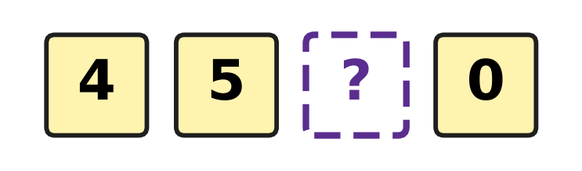
Q6. Look at the four digit cards. They make a 4-digit number, and one digit is hidden. The number is greater than 4,571. What is the smallest digit that can be hidden?
(A) 6 | (B) 7 | (C) 8 | (D) 9

Part 2 — Operations & Number Properties (Syllabus Chapter 2)
Q7. Two numbers add up to 6,000. One of them is 2,450. What is the other number?
(A) 3,550 | (B) 8,450 | (C) 3,650 | (D) 4,550

Q8. How much greater is 7 × 12 than 7 × 11?
(A) 1 | (B) 19 | (C) 12 | (D) 7

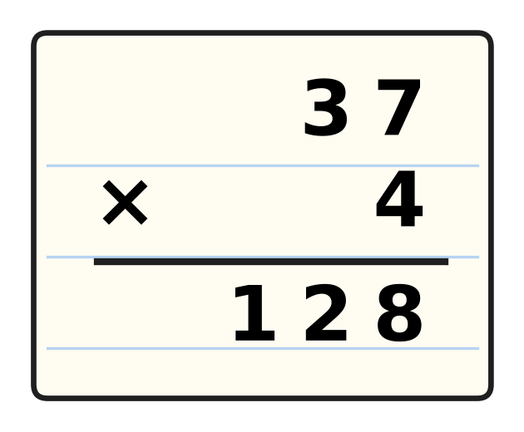
Q9. Look at the multiplication. Suresh forgot to add the number he carried. What is the correct answer?
(A) 148 | (B) 158 | (C) 138 | (D) 1,228

Q10. Deepak works out 46 ÷ 7 = 6 remainder 4. Which of these should he work out to check his answer?
(A) 7 × 4 + 6 | (B) 6 × 4 + 7
(C) 7 × 6 + 4 | (D) 7 + 6 + 4

Q11. Lata shares her stickers equally among 6 friends. Each friend gets 8 stickers and 3 stickers are left over. How many stickers did she have?
(A) 48 | (B) 17 | (C) 45 | (D) 51

Q12. One morning, 1,680 passengers leave an airport and 925 passengers arrive. Then there are 2,745 passengers at the airport. How many were there at the start?
(A) 5,350 | (B) 4,425 | (C) 3,500 | (D) 1,990

Q13. Two numbers are multiplied and the answer is 72. The same two numbers are added and the answer is 17. Which two numbers are they?
(A) 8 and 9 | (B) 7 and 10
(C) 4 and 18 | (D) 6 and 12

Part 3 — Fractions, Decimals & Percentages (Syllabus Chapter 3)
Q14. Each slice is $\frac{1}{4}$ of a pizza. Tanmay eats 5 slices. What fraction of a pizza does he eat?
(A) $\frac{1}{5}$ | (B) $\frac{4}{5}$ | (C) $\frac{5}{8}$ | (D) $\frac{5}{4}$

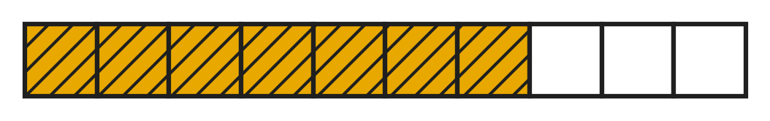
Q15. Look at the bar. Ana rubs out the shading on 4 of the shaded parts. What fraction of the bar is shaded then?
(A) $\frac{3}{10}$ | (B) $\frac{11}{10}$ | (C) $\frac{6}{10}$ | (D) $\frac{4}{10}$

Q16. Which of these fractions lies between $\frac{4}{11}$ and $\frac{8}{11}$?
(A) $\frac{3}{11}$ | (B) $\frac{9}{11}$ | (C) $\frac{6}{11}$ | (D) $\frac{4}{11}$

Q17. Which list shows the fractions in order from the smallest to the greatest?
(A) $\frac{7}{7}$, $\frac{2}{7}$, $\frac{5}{7}$, $\frac{9}{7}$
(B) $\frac{2}{7}$, $\frac{5}{7}$, $\frac{9}{7}$, $\frac{7}{7}$
(C) $\frac{9}{7}$, $\frac{7}{7}$, $\frac{5}{7}$, $\frac{2}{7}$
(D) $\frac{2}{7}$, $\frac{5}{7}$, $\frac{7}{7}$, $\frac{9}{7}$

Q18. Three different fractions are in order from the smallest to the greatest: $\frac{2}{9}$, $\frac{?}{9}$, $\frac{7}{9}$. How many different top numbers can be hidden by the question mark?
(A) 3 | (B) 4 | (C) 5 | (D) 6

Part 4 — Geometry (Syllabus Chapter 5)
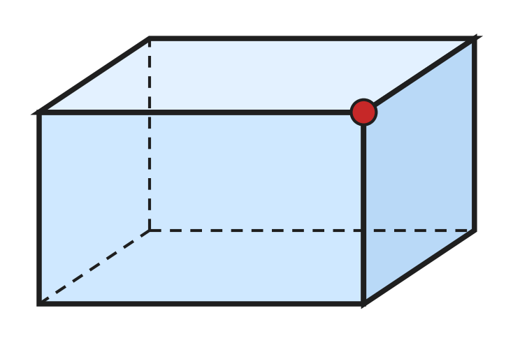
Q19. Look at the cuboid. How many edges meet at the corner marked with a dot?
(A) 2 | (B) 3 | (C) 4 | (D) 12

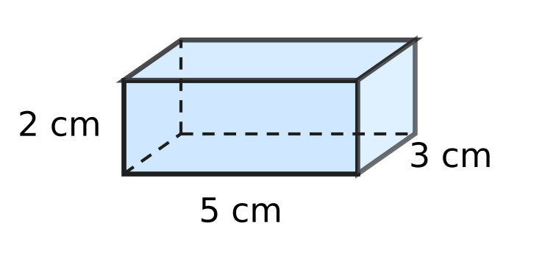
Q20. Look at the box. Lavina cuts it open to make a net of 6 rectangles. How many of the rectangles are 5 cm long and 3 cm wide?
(A) 1 | (B) 2 | (C) 4 | (D) 6

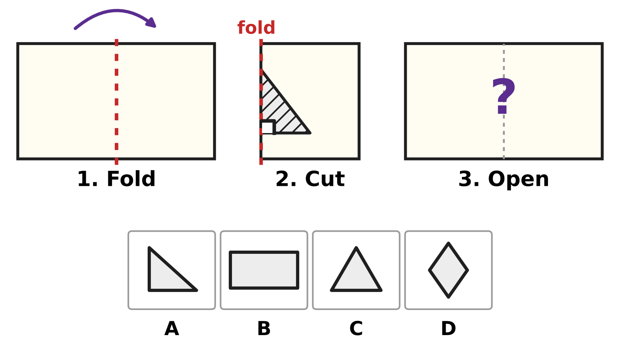
Q21. Look at the steps. Rani folds a paper along the dotted line. She cuts out the shaded triangle. One side of the cut is on the fold. The bottom side makes a square corner with the fold. Then she opens the paper. Which picture shows the hole she sees?
(A) Picture A | (B) Picture B
(C) Picture C | (D) Picture D

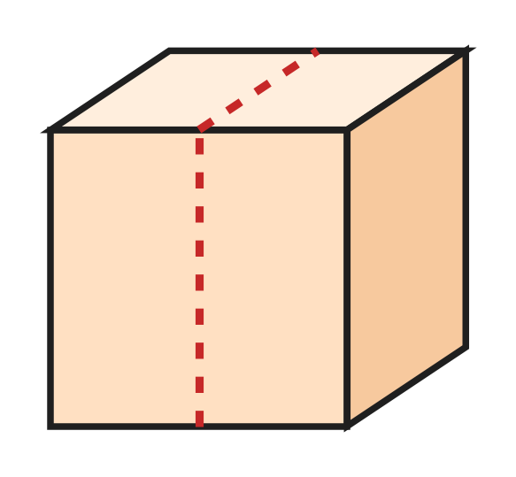
Q22. Look at the picture. Sohan cuts the cube into two equal cuboids along the dotted line. How many faces do the two cuboids have in all?
(A) 6 | (B) 7 | (C) 8 | (D) 12

Q23. Heena draws three flat shapes. Together they have 13 sides. One is a triangle and one is a square. What is the third shape?
(A) circle | (B) pentagon
(C) hexagon | (D) rectangle

Part 5 — Mensuration (Syllabus Chapter 6)
Q24. A tub on the roof collects 1 L 250 mL of rain on Monday and 750 mL on Tuesday. How much rain does it collect in all?
(A) 1,000 mL | (B) 1,900 mL
(C) 2,000 mL | (D) 2,750 mL

Q25. A slide in the playground is for children who are at least 125 cm tall. Yash is 1 m 32 cm tall. By how many centimetres is he taller than 125 cm?
(A) 7 cm | (B) 17 cm | (C) 93 cm | (D) 257 cm

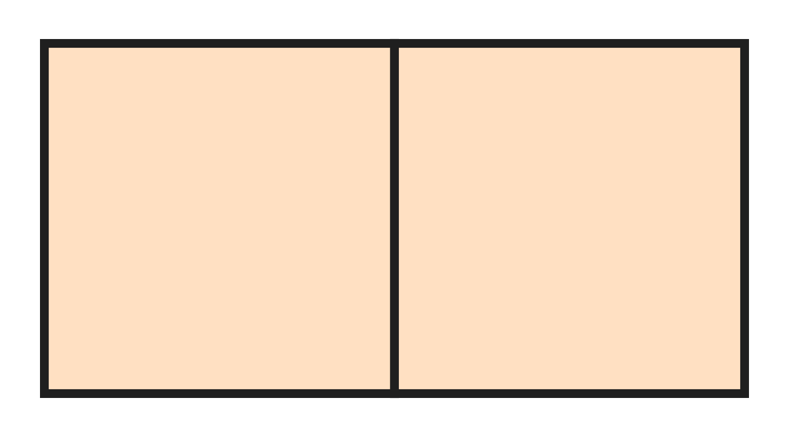
Q26. A square floor tile has a perimeter of 80 cm. Hana puts two such tiles side by side, as in the picture. What is the perimeter of the rectangle they make?
(A) 100 cm | (B) 120 cm | (C) 140 cm | (D) 160 cm

Q27. A rope is 3 m long. It is cut into 6 equal pieces. How long is each piece?
(A) 2 cm | (B) 5 cm | (C) 18 cm | (D) 50 cm

Part 6 — Applied Mathematics (Syllabus Chapter 9)
Q28. On a clock at the airport, the short hand is between 4 and 5. The long hand is on 9. What time does the clock show?
(A) 4:09 | (B) 4:45 | (C) 5:45 | (D) 9:20

Q29. A music class is 45 minutes long. It ends at 5:15 PM. At what time does it start?
(A) 4:15 PM | (B) 4:30 PM | (C) 4:45 PM | (D) 6:00 PM

Q30. The school play is on a Friday. Tickets go on sale 9 days before the play. On which day of the week do tickets go on sale?
(A) Sunday | (B) Thursday
(C) Tuesday | (D) Wednesday

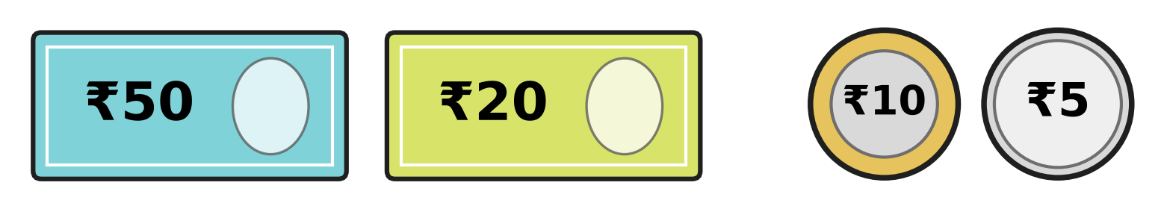
Q31. Look at the money Parth has. A bouquet at the flower shop costs ₹100. How much more money does Parth need to buy it?
(A) ₹15 | (B) ₹25 | (C) ₹85 | (D) ₹185

Q32. A plane takes off at 10:45 AM. It lands at 1:20 PM on the same day. How long is the flight?
(A) 1 hour 35 minutes | (B) 2 hours 35 minutes
(C) 3 hours 35 minutes | (D) 9 hours 25 minutes

Q33. Ivan has ₹200. He buys 3 tickets for the school play at ₹35 each. With the money left, he buys balloons at ₹9 each. How many balloons can he buy at most?
(A) 10 | (B) 11 | (C) 22 | (D) 95

Part 7 — Mathematical Reasoning & Problem-Solving (Syllabus Chapter 10)
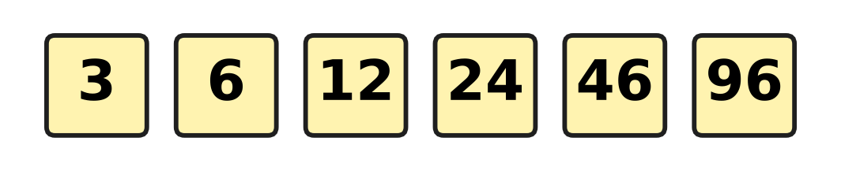
Q34. Look at the number pattern. Each number should be double the number before it, but one number is wrong. Which number is wrong?
(A) 12 | (B) 24 | (C) 46 | (D) 96

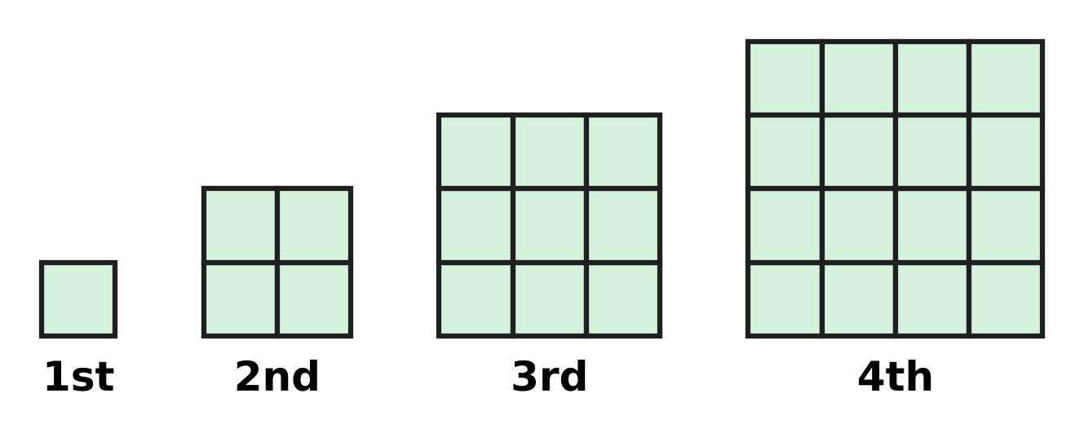
Q35. Look at the squares made of floor tiles. They grow in the same way each time. How many tiles will the 6th square have?
(A) 24 | (B) 25 | (C) 36 | (D) 49

Q36. The letter C hides a digit greater than zero. C × C gives the same answer as C + C. Which digit is C?
(A) 1 | (B) 2 | (C) 3 | (D) 4

Q37. Usha counts back in sevens: 100, 93, 86, 79, and so on. What is the first number she says that is less than 50?
(A) 37 | (B) 44 | (C) 49 | (D) 51

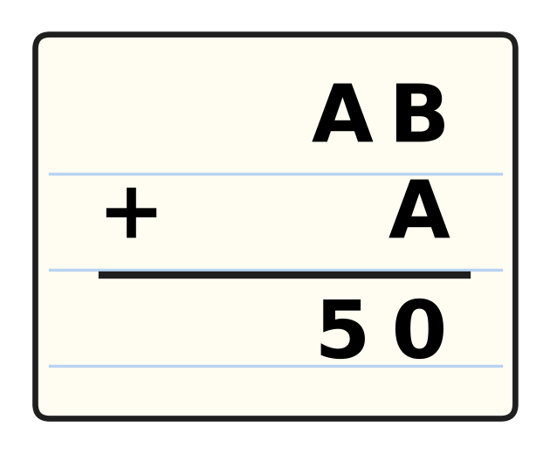
Q38. Look at the sum. The letters A and B hide two different digits. The same letter always hides the same digit. Which digit is B?
(A) 0 | (B) 4 | (C) 5 | (D) 6

Q39. What comes next in this number pattern?
5, 10, 8, 16, 14, 28, ___
(A) 26 | (B) 30 | (C) 42 | (D) 56

Q40. A hot-air balloon rises 250 m, comes down 120 m and then rises 75 m. Now it is 630 m above the ground. How high was it at the start?
(A) 185 m | (B) 205 m | (C) 425 m | (D) 835 m

SECTION II — Star Questions 5 questions × 4 marks each
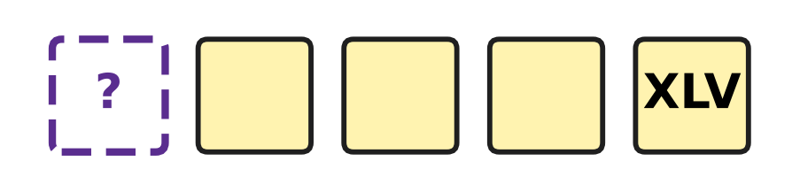
Q41. Look at the five tiles. The numbers on them go up by VII each time. The 5th tile shows XLV. Which Roman numeral is on the 1st tile? [4 marks]
(A) X | (B) XXXVIII | (C) XXIV | (D) XVII

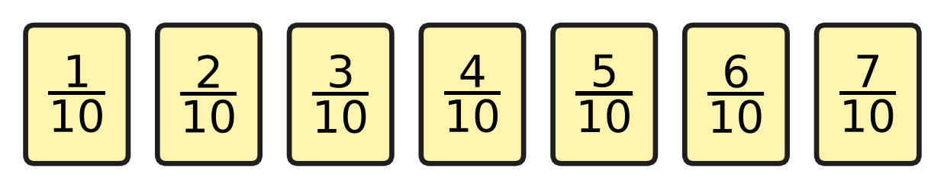
Q42. Look at the seven fraction cards. Sarika picks two different cards and adds their fractions. The same two cards in any order count as one pair. How many different pairs give a sum greater than one whole? [4 marks]
(A) 3 | (B) 4 | (C) 5 | (D) 8

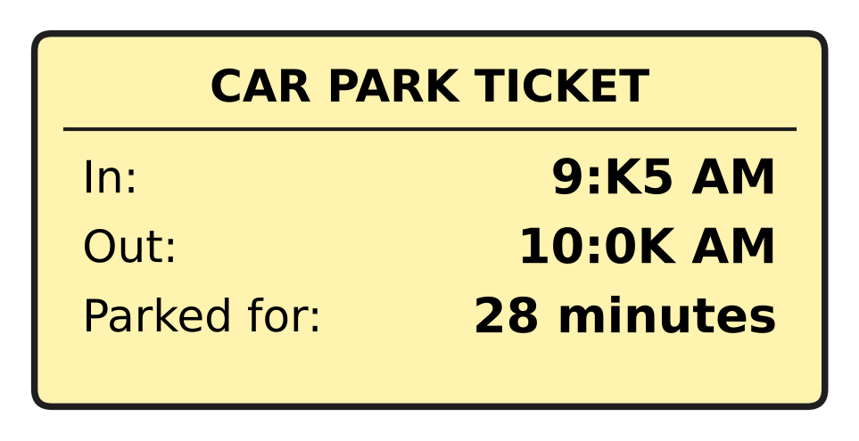
Q43. Look at the car park ticket. The letter K hides the same digit in both times. The car was parked for 28 minutes. At what time did it come in? [4 marks]
(A) 9:15 AM | (B) 9:25 AM | (C) 9:35 AM | (D) 9:45 AM

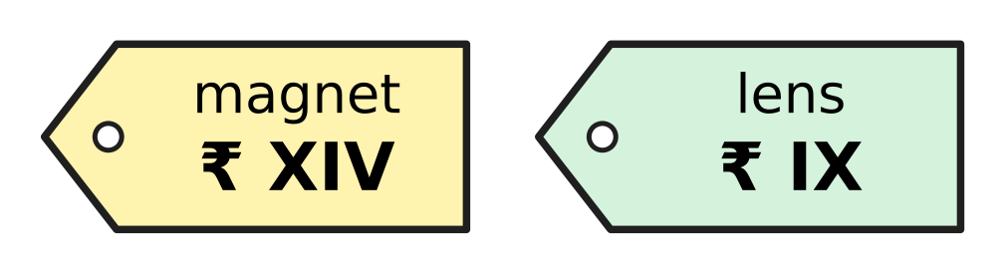
Q44. A stall at a science exhibition writes its prices in Roman numerals. Look at the price tags. Zoya buys 2 magnets and 1 lens and pays ₹50. How much change does she get? [4 marks]
(A) ₹11 | (B) ₹13 | (C) ₹27 | (D) ₹37

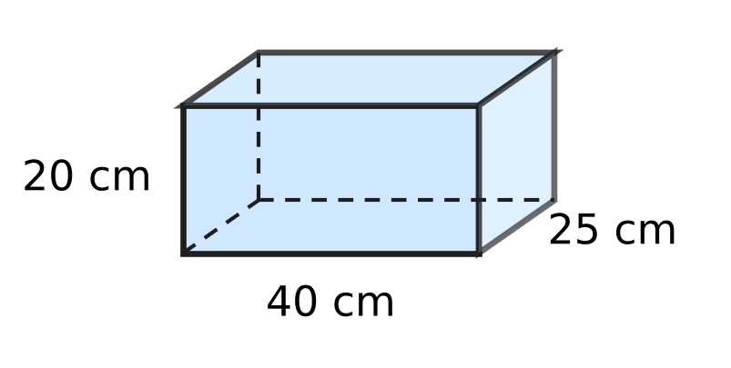
Q45. Look at the box. It is a cuboid. Tarun sticks tape along every edge of the box, with no overlaps. How much tape does he use in all? [4 marks]
(A) 1 m 70 cm | (B) 2 m 55 cm
(C) 2 m 60 cm | (D) 3 m 40 cm

Answer Sheet AMO Level 1 · Class 3 · Practice Paper 5
Name: | School: | Roll No.:
Shade or tick one circle for each question.
1. Ⓐ Ⓑ Ⓒ Ⓓ | 16. Ⓐ Ⓑ Ⓒ Ⓓ | 31. Ⓐ Ⓑ Ⓒ Ⓓ
2. Ⓐ Ⓑ Ⓒ Ⓓ | 17. Ⓐ Ⓑ Ⓒ Ⓓ | 32. Ⓐ Ⓑ Ⓒ Ⓓ
3. Ⓐ Ⓑ Ⓒ Ⓓ | 18. Ⓐ Ⓑ Ⓒ Ⓓ | 33. Ⓐ Ⓑ Ⓒ Ⓓ
4. Ⓐ Ⓑ Ⓒ Ⓓ | 19. Ⓐ Ⓑ Ⓒ Ⓓ | 34. Ⓐ Ⓑ Ⓒ Ⓓ
5. Ⓐ Ⓑ Ⓒ Ⓓ | 20. Ⓐ Ⓑ Ⓒ Ⓓ | 35. Ⓐ Ⓑ Ⓒ Ⓓ
6. Ⓐ Ⓑ Ⓒ Ⓓ | 21. Ⓐ Ⓑ Ⓒ Ⓓ | 36. Ⓐ Ⓑ Ⓒ Ⓓ
7. Ⓐ Ⓑ Ⓒ Ⓓ | 22. Ⓐ Ⓑ Ⓒ Ⓓ | 37. Ⓐ Ⓑ Ⓒ Ⓓ
8. Ⓐ Ⓑ Ⓒ Ⓓ | 23. Ⓐ Ⓑ Ⓒ Ⓓ | 38. Ⓐ Ⓑ Ⓒ Ⓓ
9. Ⓐ Ⓑ Ⓒ Ⓓ | 24. Ⓐ Ⓑ Ⓒ Ⓓ | 39. Ⓐ Ⓑ Ⓒ Ⓓ
10. Ⓐ Ⓑ Ⓒ Ⓓ | 25. Ⓐ Ⓑ Ⓒ Ⓓ | 40. Ⓐ Ⓑ Ⓒ Ⓓ
11. Ⓐ Ⓑ Ⓒ Ⓓ | 26. Ⓐ Ⓑ Ⓒ Ⓓ | 41. Ⓐ Ⓑ Ⓒ Ⓓ
12. Ⓐ Ⓑ Ⓒ Ⓓ | 27. Ⓐ Ⓑ Ⓒ Ⓓ | 42. Ⓐ Ⓑ Ⓒ Ⓓ
13. Ⓐ Ⓑ Ⓒ Ⓓ | 28. Ⓐ Ⓑ Ⓒ Ⓓ | 43. Ⓐ Ⓑ Ⓒ Ⓓ
14. Ⓐ Ⓑ Ⓒ Ⓓ | 29. Ⓐ Ⓑ Ⓒ Ⓓ | 44. Ⓐ Ⓑ Ⓒ Ⓓ
15. Ⓐ Ⓑ Ⓒ Ⓓ | 30. Ⓐ Ⓑ Ⓒ Ⓓ | 45. Ⓐ Ⓑ Ⓒ Ⓓ
Q41–Q45 are Section II Star Questions (4 marks each).
For the parent or teacher
Section I correct: ______ / 40 × 2 = ______ marks Section II correct: ______ / 5 × 4 = ______ marks
Correct: ______ / 45 Score: ______ / 100
Answer Key and Solutions AMO Level 1 · Class 3 · Practice Paper 5
Quick answers
1 A | 6 C | 11 D | 16 C | 21 C | 26 B | 31 A | 36 B | 41 D
2 A | 7 A | 12 C | 17 D | 22 D | 27 D | 32 B | 37 B | 42 B
3 D | 8 D | 13 A | 18 B | 23 C | 28 B | 33 A | 38 D | 43 C
4 A | 9 A | 14 D | 19 B | 24 C | 29 B | 34 C | 39 A | 44 B
5 D | 10 C | 15 A | 20 B | 25 A | 30 D | 35 C | 40 C | 45 D
Solutions
Q | Part · level | Answer | Why?
1 | Part 1 · Ch1 · Easy | (A) 4,145 | In 4,145 the thousands digit is 4 and the tens digit is 4. In the other numbers these two digits are different.
2 | Part 1 · Ch1 · Easy | (A) 2,909 and 2,900 | The numbers 2,900 and 2,909 have the same thousands, hundreds and tens. In the ones place 0 is less than 9, so 2,900 must come before 2,909.
3 | Part 1 · Ch1 · Easy | (D) XXII | XVIII is 18. Then 18 + 4 = 22, and 22 is written XXII.
4 | Part 1 · Ch1 · Easy | (A) six thousand forty | The number 6,040 has 6 thousands, 0 hundreds, 4 tens and 0 ones. It is read as six thousand forty.
5 | Part 1 · Ch1 · Medium | (D) 2,446 | Here, 23 hundreds = 2,300 and 14 tens = 140. So 2,300 + 140 + 6 = 2,446.
6 | Part 1 · Ch1 · Medium | (C) 8 | The thousands and hundreds are the same, so compare the tens. With 7 the number is 4,570, which is less than 4,571. With 8 it is 4,580, which is greater.
7 | Part 2 · Ch2 · Easy | (A) 3,550 | The other number is 6,000 − 2,450 = 3,550. Check: 3,550 + 2,450 = 6,000.
8 | Part 2 · Ch2 · Easy | (D) 7 | There is one more 7 in 7 × 12 than in 7 × 11. So it is 7 greater: 84 − 77 = 7.
9 | Part 2 · Ch2 · Easy | (A) 148 | First, 7 × 4 = 28: write 8 and carry 2. Next, 3 × 4 = 12, and 12 + 2 = 14. The answer is 148.
10 | Part 2 · Ch2 · Easy | (C) 7 × 6 + 4 | Here, 6 groups of 7 make 42, and the 4 left over make 46. So 7 × 6 + 4 = 46 checks the answer.
11 | Part 2 · Ch2 · Medium | (D) 51 | Lata shared 6 × 8 = 48 stickers, and 3 were left over. She had 48 + 3 = 51.
12 | Part 2 · Ch2 · Medium | (C) 3,500 | Undo the steps: 2,745 − 925 = 1,820, and 1,820 + 1,680 = 3,500.
13 | Part 2 · Ch2 · Medium | (A) 8 and 9 | Here, 8 × 9 = 72 and 8 + 9 = 17. No other pair does both.
14 | Part 3 · Ch3 · Easy | (D) $\frac{5}{4}$ | Tanmay eats 5 slices of one quarter each, which is 5/4. This is an improper fraction: one whole pizza and one more quarter.
15 | Part 3 · Ch3 · Easy | (A) $\frac{3}{10}$ | There are 7 of the 10 parts shaded. Then 7/10 − 4/10 = 3/10.
16 | Part 3 · Ch3 · Easy | (C) $\frac{6}{11}$ | The bottom numbers are the same, so compare the top numbers. The top number 6 is more than 4 and less than 8, so the fraction is 6/11.
17 | Part 3 · Ch3 · Medium | (D) 2/7, 5/7, 7/7, 9/7 | The bottom numbers are the same, so order the top numbers: 2, 5, 7, 9. The fraction 9/7 is more than one whole, so it comes last.
18 | Part 3 · Ch3 · Medium | (B) 4 | The top number must be more than 2 and less than 7. It can be 3, 4, 5 or 6. That is 4 numbers.
19 | Part 4 · Ch5 · Easy | (B) 3 | At every corner of a cuboid, 3 edges meet: across, down and back.
20 | Part 4 · Ch5 · Easy | (B) 2 | The top and the bottom faces are both 5 cm by 3 cm, so there are 2.
21 | Part 4 · Ch5 · Easy | (C) Picture C | The cut triangle is mirrored across the fold. Its bottom side makes a square corner with the fold, so the bottom side and its mirror image make one straight line. The hole is one big triangle, as in Picture C. It would be a diamond only if the corner away from the fold were halfway up.
22 | Part 4 · Ch5 · Medium | (D) 12 | Each piece is a cuboid, and every cuboid has 6 faces. So 6 + 6 = 12.
23 | Part 4 · Ch5 · Medium | (C) hexagon | The third shape has 13 − 3 − 4 = 6 sides, and a shape with 6 sides is a hexagon.
24 | Part 5 · Ch6 · Easy | (C) 2,000 mL | First, 1 L 250 mL = 1,250 mL. Then 1,250 mL + 750 mL = 2,000 mL, which is 2 L.
25 | Part 5 · Ch6 · Easy | (A) 7 cm | Yash is 1 m 32 cm = 132 cm tall. Then 132 cm − 125 cm = 7 cm.
26 | Part 5 · Ch6 · Medium | (B) 120 cm | Each side is 80 ÷ 4 = 20 cm. The rectangle is 40 cm by 20 cm, so its perimeter is 40 + 20 + 40 + 20 = 120 cm.
27 | Part 5 · Ch6 · Medium | (D) 50 cm | The rope is 3 m = 300 cm long. Then 300 ÷ 6 = 50, so each piece is 50 cm long.
28 | Part 6 · Ch9 · Easy | (B) 4:45 | The short hand has passed 4, so the hour is 4. The long hand on 9 means 9 × 5 = 45 minutes. The time is 4:45.
29 | Part 6 · Ch9 · Easy | (B) 4:30 PM | Back 15 minutes to 5:00 PM, then 30 minutes more to 4:30 PM.
30 | Part 6 · Ch9 · Easy | (D) Wednesday | Going back 7 days from a Friday gives a Friday again. Going back 2 more days gives a Wednesday.
31 | Part 6 · Ch9 · Easy | (A) ₹15 | ₹50 + ₹20 + ₹10 + ₹5 = ₹85. He needs ₹100 − ₹85 = ₹15 more.
32 | Part 6 · Ch9 · Medium | (B) 2 hours 35 minutes | From 10:45 AM to 12:45 PM is 2 hours. From 12:45 PM to 1:20 PM is 35 minutes. The flight is 2 hours 35 minutes.
33 | Part 6 · Ch9 · Medium | (A) 10 | He has ₹200 − 3 × ₹35 = ₹95 left. Then 10 balloons cost ₹90 and 11 balloons cost ₹99, so he can buy 10.
34 | Part 7 · Ch10 · Easy | (C) 46 | Double 24 is 48, not 46. With 48 the pattern is 3, 6, 12, 24, 48, 96.
35 | Part 7 · Ch10 · Easy | (C) 36 | The squares have 1 × 1, 2 × 2, 3 × 3 and 4 × 4 tiles, so the 6th has 6 × 6 = 36 tiles.
36 | Part 7 · Ch10 · Easy | (B) 2 | Try the digits: 2 × 2 = 4 and 2 + 2 = 4. No other digit from 1 to 9 works.
37 | Part 7 · Ch10 · Easy | (B) 44 | She says 100, 93, 86, 79, 72, 65, 58, 51, 44. The number 51 is still more than 50, so the first number less than 50 is 44.
38 | Part 7 · Ch10 · Medium | (D) 6 | In the ones place, B + A ends in 0, so B + A = 10 and 1 is carried. In the tens place, A + 1 = 5, so A is 4 and B is 6.
39 | Part 7 · Ch10 · Medium | (A) 26 | The rule is double, then take away 2, in turn. Next: 28 − 2 = 26.
40 | Part 7 · Ch10 · Medium | (C) 425 m | Undo: 630 − 75 = 555, 555 + 120 = 675, 675 − 250 = 425 m.
41 | Section II · Ch1 + Ch10 · Hard | (D) XVII | XLV is 45 and VII is 7. The 1st tile is 4 jumps back: 45 − 4 × 7 = 45 − 28 = 17, which is XVII.
42 | Section II · Ch3 + Ch10 · Hard | (B) 4 | The top numbers must add to more than 10: 4 + 7, 5 + 6, 5 + 7, 6 + 7. That is 4 pairs. (3 + 7 = 10 is not more.)
43 | Section II · Ch9 + Ch10 · Hard | (C) 9:35 AM | The car leaves after 10:00, so 9:K5 + 28 minutes passes 10:00. Try K = 3: 9:35 AM + 25 minutes = 10:00 AM, and 3 minutes more is 10:03 AM. So K is 3, and it came in at 9:35 AM.
44 | Section II · Ch1 + Ch9 · Hard | (B) ₹13 | XIV is 14 and IX is 9. Cost: 2 × ₹14 + ₹9 = ₹37. Change: ₹50 − ₹37 = ₹13.
45 | Section II · Ch5 + Ch6 · Hard | (D) 3 m 40 cm | A cuboid has 12 edges, 4 of each length. He uses 4 × (40 + 25 + 20) cm = 340 cm = 3 m 40 cm.

