UNLOCK IQ INSTITUTE
Realize Your True Potential
Aryabhatta Maths Olympiad (AMO)
Level 1 — Practice Paper 1
CLASS 4

Questions | 45 multiple-choice questions
Marks | 100
Time | 60 minutes
Section I | 40 questions × 2 marks = 80 marks
Section II | 5 Star Questions × 4 marks = 20 marks
Negative marking | No negative marking
Calculator | Not allowed
Chapters | Number System · Operations · Fractions, Decimals & Percentages · Geometry · Mensuration · Data Handling · Applied Mathematics · Mathematical Reasoning

Hello, friend!
• Every question has four answer choices: (A), (B), (C) and (D). Only one is correct.
• Read each question and look at its picture carefully. Then mark your answer on the answer sheet at the end.
• Section I has 40 questions of 2 marks each. Section II has 5 Star Questions of 4 marks each.
• There is no negative marking, so try every question.
• Do not use a calculator. You may do rough work on a separate sheet.
• All figures are not necessarily drawn to scale unless stated.

For parents and teachers
Print or view this paper in colour. Pictures are part of the questions.
Parts follow the AMO syllabus chapters. Chapters 4 and 7 are not part of the Class 4 syllabus, so the chapter numbers shown in the Part headings have gaps.
The answer sheet and the answer key are at the end. Remove only the answer key before the child begins.

Name: | School: | Roll No.:

SECTION I 40 questions × 2 marks each
Part 1 — Number System (Syllabus Chapter 1)
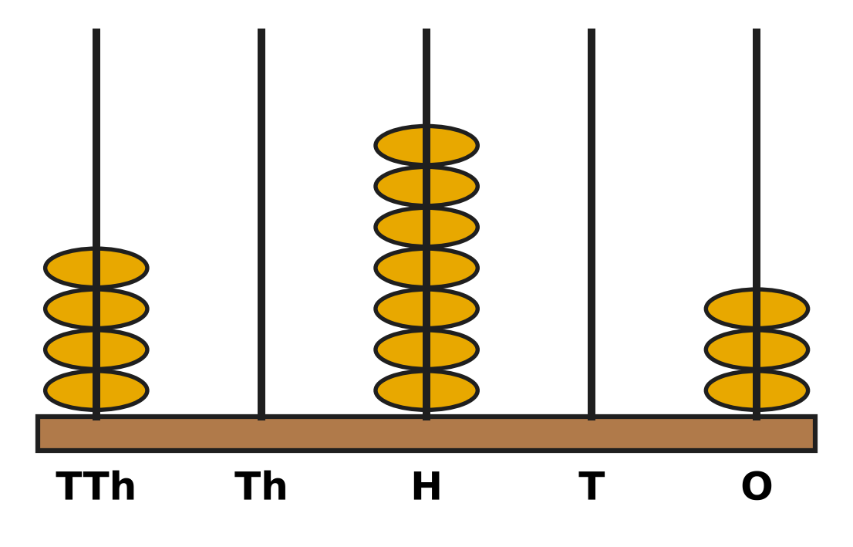
Q1. Look at the abacus. The rods show ten thousands, thousands, hundreds, tens and ones. Which number does the abacus show?
(A) 40,703 | (B) 40,730 | (C) 4,073 | (D) 47,030

Q2. The pages of Vani's photo album are numbered with Roman numerals, starting from I. The last page is numbered LXXIV. How many pages does the album have?
(A) 76 | (B) 64 | (C) 84 | (D) 74

Q3. Five digit cards show 3, 0, 8, 5 and 1. Each card is used once to make a 5-digit number. What is the greatest number that can be made?
(A) 85,310 | (B) 10,358 | (C) 83,510 | (D) 85,301

Q4. In the number 64,215, the digit 4 is changed to 9. The other digits stay the same. By how much does the number increase?
(A) 5 | (B) 5,000 | (C) 500 | (D) 50,000

Q5. The numbers increase by 1,100 each time: 45,600; 46,700; 47,800; 48,900; … What is the 6th number?
(A) 51,100 | (B) 52,200 | (C) 50,600 | (D) 50,000

Part 2 — Operations & Number Properties (Syllabus Chapter 2)
Q6. Which of these gives the same answer as 36,482 + 27,159? You do not need to work out the total.
(A) 27,195 + 36,482 | (B) 36,482 − 27,159
(C) 36,248 + 27,159 | (D) 27,159 + 36,482

Q7. An apple orchard picked 52,300 apples this season. It sold 27,845 of them. How many apples were not sold?
(A) 80,145 | (B) 24,455 | (C) 35,545 | (D) 25,455

Q8. A bakery has 1,060 buns. It puts 8 buns in each box. How many boxes can it fill completely?
(A) 122 | (B) 133 | (C) 142 | (D) 132

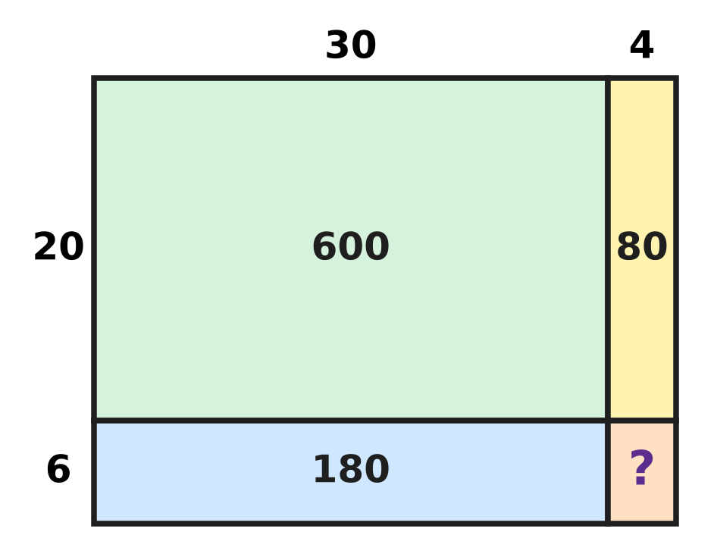
Q9. The picture splits 34 × 26 into four parts: 34 = 30 + 4 and 26 = 20 + 6. Three parts show their products. What is 34 × 26?
(A) 704 | (B) 884 | (C) 804 | (D) 860

Q10. Kartik estimates 48 × 31 by rounding each number to the nearest ten first. By how much is his estimate more than the exact answer?
(A) 12 | (B) 1,488 | (C) 60 | (D) 1,500

Part 3 — Fractions, Decimals & Percentages (Syllabus Chapter 3)
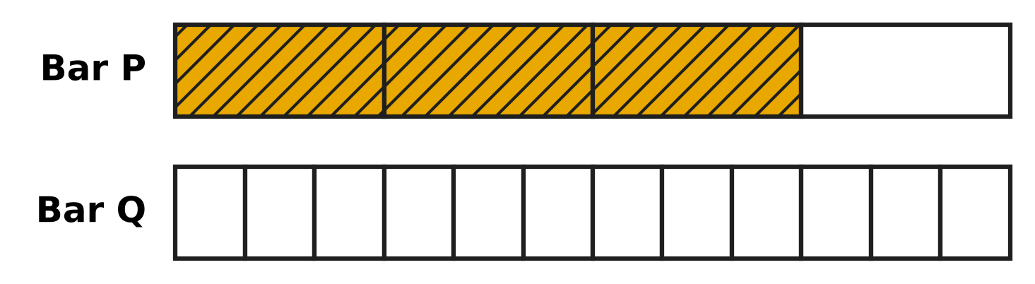
Q11. Look at the picture. Bar P and Bar Q are the same size. Bar P is cut into 4 equal parts and Bar Q into 12 equal parts. How many parts of Bar Q must be shaded so that both bars show the same fraction?
(A) 8 | (B) 6 | (C) 9 | (D) 3

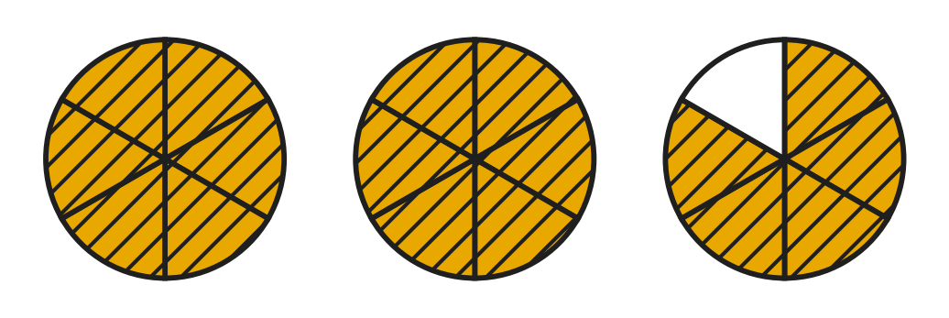
Q12. Look at the picture. Each cake is cut into 6 equal pieces. The shaded pieces are left over. Which improper fraction tells how many cakes are left over?
(A) $\frac{18}{6}$ | (B) $\frac{7}{6}$ | (C) $\frac{12}{6}$ | (D) $\frac{17}{6}$

Q13. A rainwater tank is $\frac{5}{6}$ full. Then $\frac{1}{3}$ of the whole tank is used for the garden. What part of the tank is still full?
(A) $\frac{2}{3}$ | (B) $\frac{1}{2}$ | (C) $\frac{1}{3}$ | (D) $\frac{1}{4}$

Q14. Which fraction is NOT equal to $\frac{2}{3}$?
(A) $\frac{6}{8}$ | (B) $\frac{6}{9}$ | (C) $\frac{8}{12}$ | (D) $\frac{4}{6}$

Q15. In a science class there are four jugs of the same size. Jug 1 is $\frac{3}{4}$ full of water, Jug 2 is $\frac{2}{3}$ full, Jug 3 is $\frac{5}{6}$ full and Jug 4 is $\frac{7}{12}$ full. Which jug has the most water?
(A) Jug 1 | (B) Jug 2 | (C) Jug 3 | (D) Jug 4

Q16. Farah lets out $\frac{1}{4}$ of her full kite string. Then she lets out another $\frac{3}{8}$ of the full string. What fraction of the string is still on the reel?
(A) $\frac{2}{3}$ | (B) $\frac{1}{8}$ | (C) $\frac{3}{8}$ | (D) $\frac{5}{8}$

Part 4 — Geometry (Syllabus Chapter 5)
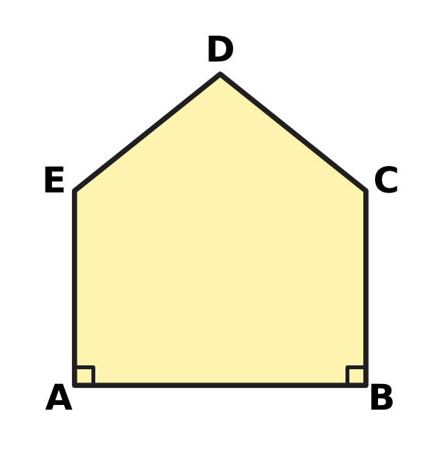
Q17. The picture shows the outline of a notice board ABCDE. The corners at A and B are right angles. Which side is parallel to side BC?
(A) Side AE | (B) Side DE | (C) Side AB | (D) Side CD

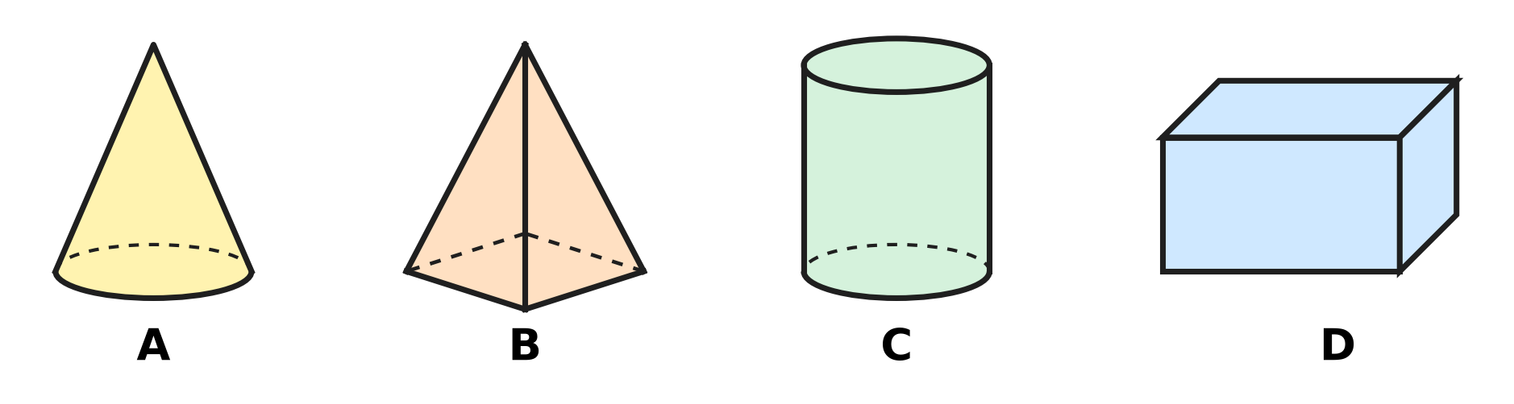
Q18. Look at the four solids standing on a table. Which solid looks like a circle from the top and like a rectangle from the front?
(A) Picture A | (B) Picture B
(C) Picture C | (D) Picture D

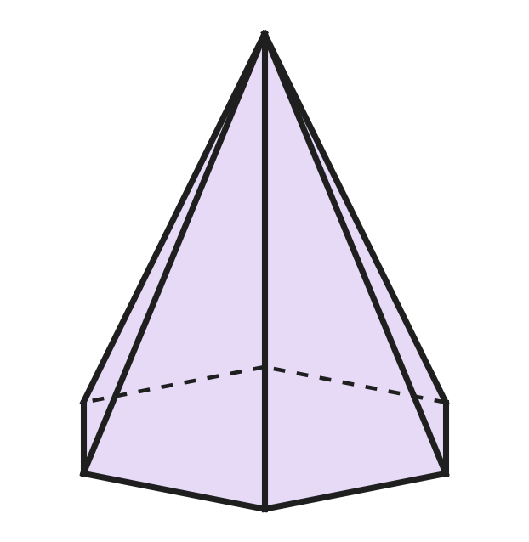
Q19. The picture shows a pyramid whose base has 6 sides. Dashed lines are edges at the back. How many edges does the pyramid have?
(A) 6 | (B) 12 | (C) 18 | (D) 7

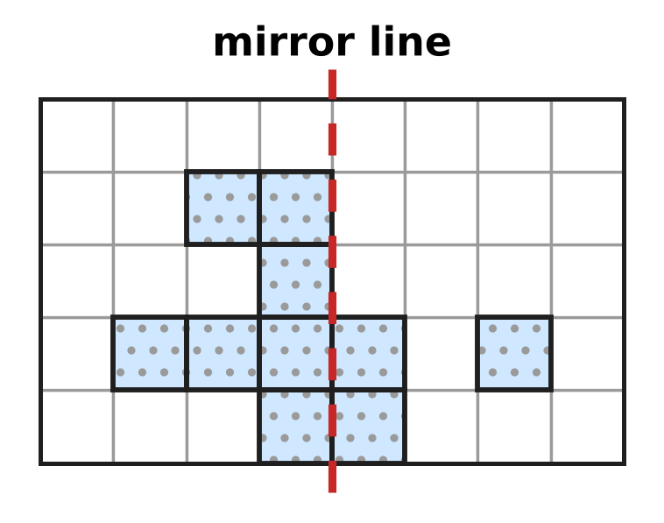
Q20. Look at the grid. Some squares are shaded. What is the smallest number of extra squares to shade so that both sides of the dashed mirror line match?
(A) 5 | (B) 3 | (C) 7 | (D) 4

Part 5 — Mensuration (Syllabus Chapter 6)
Q21. A rectangular swimming pool is 25 m long and 12 m wide. What is the perimeter of the pool?
(A) 300 m | (B) 62 m | (C) 37 m | (D) 74 m

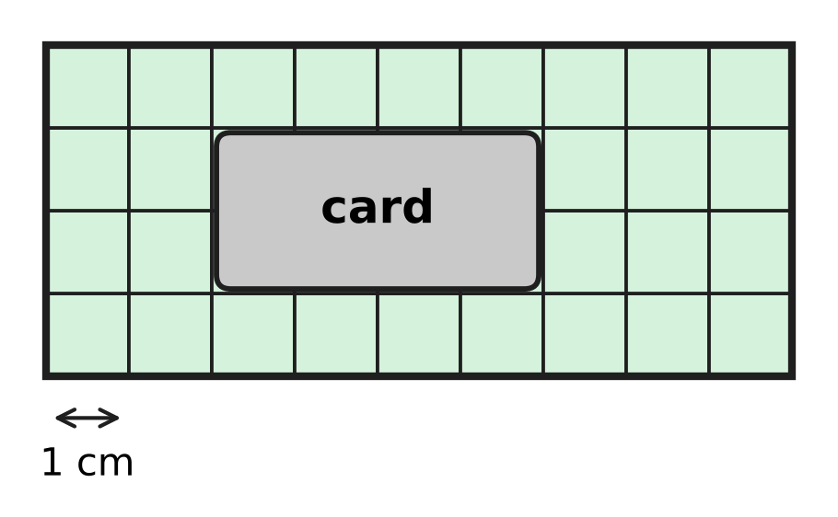
Q22. Look at the picture. A rectangle is made of 1 cm squares, but a card hides some of them. What is the area of the whole rectangle?
(A) 36 sq cm | (B) 26 sq cm | (C) 28 sq cm | (D) 13 sq cm

Q23. A bag of hen feed on a farm weighs 2 kg 75 g. How many grams is that?
(A) 2,750 g | (B) 2,075 g | (C) 275 g | (D) 2,705 g

Q24. Which of these lengths is the longest?
(A) 2,019 m | (B) 2 km 90 m
(C) 2,100 m | (D) 2 km 9 m

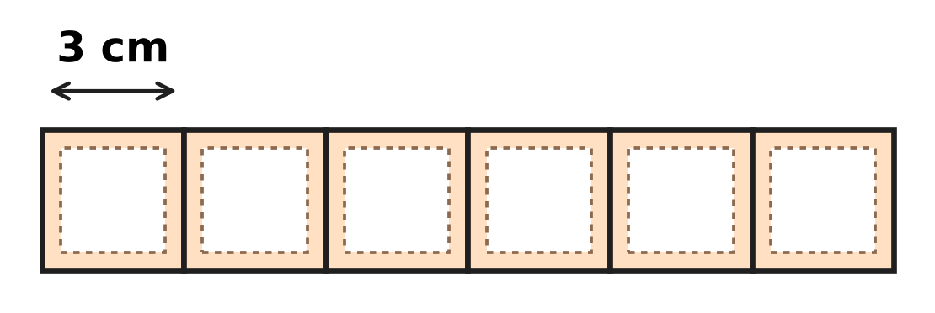
Q25. Look at the picture. Six square stamps, each of side 3 cm, are placed side by side in a row with no gaps. What is the perimeter of the long strip they make?
(A) 36 cm | (B) 42 cm | (C) 54 cm | (D) 72 cm

Q26. On a bicycle trip, Ishan rides 4 km 750 m before lunch and 3 km 600 m after lunch. How much farther must he ride to make 10 km in all?
(A) 1 km 650 m | (B) 8 km 350 m
(C) 2 km 350 m | (D) 2 km 650 m

Part 6 — Data Handling, Statistics & Probability (Syllabus Chapter 8)
Picture for Q27 and Q28
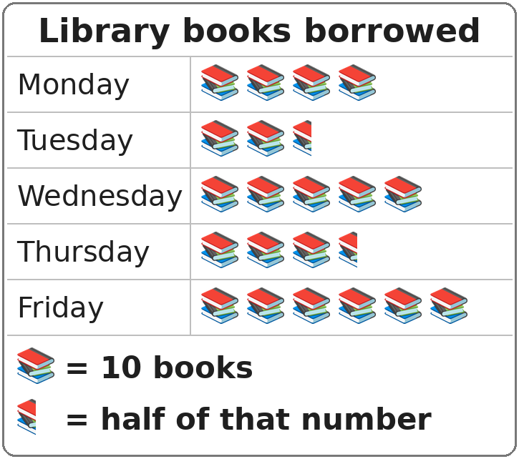
Q27. Look at the pictograph. How many books were borrowed on Thursday?
(A) 25 | (B) 30 | (C) 35 | (D) 40

Picture for Q27 and Q28
Q28. Look at the pictograph. How many books were borrowed on the five days altogether?
(A) 21 | (B) 220 | (C) 200 | (D) 210

Part 7 — Applied Mathematics (Syllabus Chapter 9)
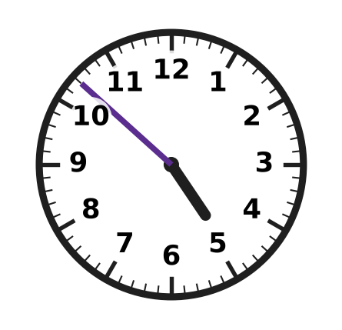
Q29. Look at the clock. What time does it show?
(A) 4:42 | (B) 4:57 | (C) 4:52 | (D) 5:52

Q30. Naveen's school bus leaves his stop at 7:48 in the morning. The ride takes 35 minutes. At what time does the bus reach school?
(A) 8:23 | (B) 8:33 | (C) 7:23 | (D) 8:13

Q31. In a certain year, 5 March is a Friday. What day of the week is 26 March?
(A) Thursday | (B) Saturday | (C) Monday | (D) Friday

Q32. Madhu buys 6 tickets for a puppet show. Each ticket costs ₹45. How much does she pay?
(A) ₹260 | (B) ₹270 | (C) ₹51 | (D) ₹240

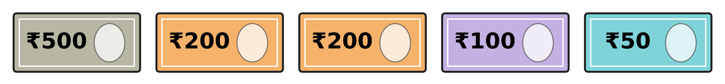
Q33. The picture shows all the money Arun has. At a stationery shop he buys 3 sketch books. Each sketch book costs ₹185. How much money does he have left?
(A) ₹495 | (B) ₹295 | (C) ₹865 | (D) ₹555

Q34. Shreya and her 3 friends buy a cake for ₹388 and some juice for ₹140 for a class party. The four children share the whole cost equally. How much does each child pay?
(A) ₹97 | (B) ₹132 | (C) ₹176 | (D) ₹528

Part 8 — Mathematical Reasoning & Problem-Solving (Syllabus Chapter 10)
Q35. Find the missing number: 120, 108, 96, ___, 72, 60
(A) 86 | (B) 84 | (C) 82 | (D) 94

Q36. Jars of marbles stand on a shelf. They are numbered from 14 to 40, one number on each jar. Every jar with an even number holds red marbles. How many jars hold red marbles?
(A) 27 | (B) 13 | (C) 20 | (D) 14

Q37. Nila sows bean seeds in her vegetable garden on 20 April. She picks the first beans on 12 May. How many days later is that? (April has 30 days.)
(A) 32 | (B) 23 | (C) 22 | (D) 21

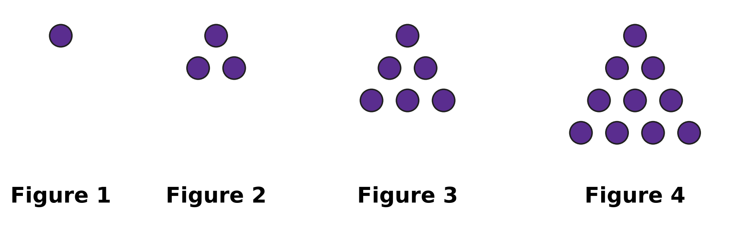
Q38. Look at the pattern of dots. Each new figure has one more row of dots at the bottom than the figure before it. How many dots will Figure 7 have?
(A) 21 | (B) 22 | (C) 28 | (D) 36

Q39. How many of the numbers from 1 to 50 have at least one digit 3?
(A) 14 | (B) 10 | (C) 5 | (D) 15

Q40. A class has a spelling test every 12 days. The first test is on a Monday. On which day of the week is the 5th test?
(A) Friday | (B) Tuesday | (C) Saturday | (D) Sunday

SECTION II — Star Questions 5 questions × 4 marks each
Q41. Think of all the fractions with denominator (bottom number) 12 that are greater than $\frac{1}{3}$ and less than $\frac{3}{4}$. How many of them are in simplest form? [4 marks]
(A) 4 | (B) 2 | (C) 1 | (D) 3

Q42. In a certain year, 1 March is a Thursday. March has 31 days. In March, Advait saves ₹15 every Saturday and ₹10 every Wednesday. How much does he save in March? [4 marks]
(A) ₹100 | (B) ₹110 | (C) ₹115 | (D) ₹125

Q43. The numbers 1 to 100 are written in Roman numerals. How many of them use exactly two letters? (For example, XV for 15 uses two letters.) [4 marks]
(A) 8 | (B) 10 | (C) 11 | (D) 12

Q44. Laksh starts a jigsaw puzzle at 7:45 a.m. He works for 1$\frac{1}{4}$ hours, rests for $\frac{1}{3}$ hour, and then works for another $\frac{5}{6}$ hour. At what time does he finish? [4 marks]
(A) 9:50 | (B) 10:00 | (C) 10:10 | (D) 10:20

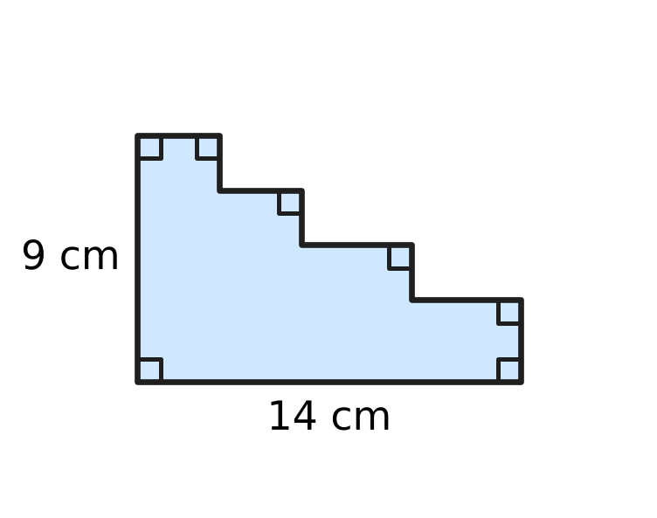
Q45. Look at the card. Its bottom side is 14 cm and its left side is 9 cm. All the other sides are parallel to one of these two sides, and their lengths are not given. What is the perimeter of the card? [4 marks]
(A) 23 cm | (B) 46 cm | (C) 40 cm | (D) 126 cm

Answer Sheet AMO Level 1 · Class 4 · Practice Paper 1
Name: | School: | Roll No.:
Shade or tick one circle for each question.
1. Ⓐ Ⓑ Ⓒ Ⓓ | 16. Ⓐ Ⓑ Ⓒ Ⓓ | 31. Ⓐ Ⓑ Ⓒ Ⓓ
2. Ⓐ Ⓑ Ⓒ Ⓓ | 17. Ⓐ Ⓑ Ⓒ Ⓓ | 32. Ⓐ Ⓑ Ⓒ Ⓓ
3. Ⓐ Ⓑ Ⓒ Ⓓ | 18. Ⓐ Ⓑ Ⓒ Ⓓ | 33. Ⓐ Ⓑ Ⓒ Ⓓ
4. Ⓐ Ⓑ Ⓒ Ⓓ | 19. Ⓐ Ⓑ Ⓒ Ⓓ | 34. Ⓐ Ⓑ Ⓒ Ⓓ
5. Ⓐ Ⓑ Ⓒ Ⓓ | 20. Ⓐ Ⓑ Ⓒ Ⓓ | 35. Ⓐ Ⓑ Ⓒ Ⓓ
6. Ⓐ Ⓑ Ⓒ Ⓓ | 21. Ⓐ Ⓑ Ⓒ Ⓓ | 36. Ⓐ Ⓑ Ⓒ Ⓓ
7. Ⓐ Ⓑ Ⓒ Ⓓ | 22. Ⓐ Ⓑ Ⓒ Ⓓ | 37. Ⓐ Ⓑ Ⓒ Ⓓ
8. Ⓐ Ⓑ Ⓒ Ⓓ | 23. Ⓐ Ⓑ Ⓒ Ⓓ | 38. Ⓐ Ⓑ Ⓒ Ⓓ
9. Ⓐ Ⓑ Ⓒ Ⓓ | 24. Ⓐ Ⓑ Ⓒ Ⓓ | 39. Ⓐ Ⓑ Ⓒ Ⓓ
10. Ⓐ Ⓑ Ⓒ Ⓓ | 25. Ⓐ Ⓑ Ⓒ Ⓓ | 40. Ⓐ Ⓑ Ⓒ Ⓓ
11. Ⓐ Ⓑ Ⓒ Ⓓ | 26. Ⓐ Ⓑ Ⓒ Ⓓ | 41. Ⓐ Ⓑ Ⓒ Ⓓ
12. Ⓐ Ⓑ Ⓒ Ⓓ | 27. Ⓐ Ⓑ Ⓒ Ⓓ | 42. Ⓐ Ⓑ Ⓒ Ⓓ
13. Ⓐ Ⓑ Ⓒ Ⓓ | 28. Ⓐ Ⓑ Ⓒ Ⓓ | 43. Ⓐ Ⓑ Ⓒ Ⓓ
14. Ⓐ Ⓑ Ⓒ Ⓓ | 29. Ⓐ Ⓑ Ⓒ Ⓓ | 44. Ⓐ Ⓑ Ⓒ Ⓓ
15. Ⓐ Ⓑ Ⓒ Ⓓ | 30. Ⓐ Ⓑ Ⓒ Ⓓ | 45. Ⓐ Ⓑ Ⓒ Ⓓ
Q41–Q45 are Section II Star Questions (4 marks each).
For the parent or teacher
Section I correct: ______ / 40 × 2 = ______ marks Section II correct: ______ / 5 × 4 = ______ marks
Correct: ______ / 45 Score: ______ / 100
Answer Key and Solutions AMO Level 1 · Class 4 · Practice Paper 1
Quick answers
1 A | 6 D | 11 C | 16 C | 21 D | 26 A | 31 D | 36 D | 41 B
2 D | 7 B | 12 D | 17 A | 22 A | 27 C | 32 B | 37 C | 42 C
3 A | 8 D | 13 B | 18 C | 23 B | 28 D | 33 A | 38 C | 43 D
4 B | 9 B | 14 A | 19 B | 24 C | 29 C | 34 B | 39 A | 44 C
5 A | 10 A | 15 C | 20 D | 25 B | 30 A | 35 B | 40 D | 45 B
Solutions
Q | Part · level | Answer | Why?
1 | Part 1 · Ch1 · Easy | (A) 40,703 | There are 4 ten thousands, 0 thousands, 7 hundreds, 0 tens and 3 ones, so the number is 40,703.
2 | Part 1 · Ch1 · Easy | (D) 74 | L = 50, XX = 20 and IV = 4. So LXXIV = 50 + 20 + 4 = 74 pages.
3 | Part 1 · Ch1 · Easy | (A) 85,310 | Place the digits from the biggest to the smallest: 8, 5, 3, 1, 0. The greatest number is 85,310.
4 | Part 1 · Ch1 · Easy | (B) 5,000 | The 4 is in the thousands place. Changing it to 9 adds 5 thousands: 69,215 − 64,215 = 5,000.
5 | Part 1 · Ch1 · Medium | (A) 51,100 | Keep adding 1,100: 48,900 → 50,000 (5th) → 51,100 (6th).
6 | Part 2 · Ch2 · Easy | (D) 27,159 + 36,482 | Changing the order of the two numbers in a sum does not change the answer (commutative property).
7 | Part 2 · Ch2 · Easy | (B) 24,455 | Not sold: 52,300 − 27,845 = 24,455 apples.
8 | Part 2 · Ch2 · Easy | (D) 132 | Divide: 1,060 ÷ 8 = 132 remainder 4. So 132 boxes are full and 4 buns are left over.
9 | Part 2 · Ch2 · Medium | (B) 884 | The missing part is 4 × 6 = 24. So 34 × 26 = 600 + 80 + 180 + 24 = 884.
10 | Part 2 · Ch2 · Medium | (A) 12 | Estimate: 50 × 30 = 1,500. Exact: 48 × 31 = 1,488. The difference is 1,500 − 1,488 = 12.
11 | Part 3 · Ch3 · Easy | (C) 9 | $\frac{3}{4}$ = $\frac{9}{12}$, because the top and bottom are both multiplied by 3. So 9 parts must be shaded.
12 | Part 3 · Ch3 · Easy | (D) $\frac{17}{6}$ | Left over: 2 whole cakes and 5 pieces = 2$\frac{5}{6}$ = (2 × 6 + 5) sixths = $\frac{17}{6}$.
13 | Part 3 · Ch3 · Medium | (B) $\frac{1}{2}$ | $\frac{1}{3}$ = $\frac{2}{6}$. Then $\frac{5}{6}$ − $\frac{2}{6}$ = $\frac{3}{6}$ = $\frac{1}{2}$.
14 | Part 3 · Ch3 · Easy | (A) $\frac{6}{8}$ | $\frac{4}{6}$, $\frac{6}{9}$ and $\frac{8}{12}$ are $\frac{2}{3}$ with top and bottom multiplied by 2, 3 and 4. $\frac{6}{8}$ = $\frac{3}{4}$, which is not $\frac{2}{3}$.
15 | Part 3 · Ch3 · Medium | (C) Jug 3 | In twelfths: $\frac{9}{12}$, $\frac{8}{12}$, $\frac{10}{12}$ and $\frac{7}{12}$. The greatest is $\frac{10}{12}$ = $\frac{5}{6}$, so Jug 3 has the most water.
16 | Part 3 · Ch3 · Medium | (C) $\frac{3}{8}$ | $\frac{1}{4}$ + $\frac{3}{8}$ = $\frac{2}{8}$ + $\frac{3}{8}$ = $\frac{5}{8}$ let out. Left on the reel: 1 − $\frac{5}{8}$ = $\frac{3}{8}$.
17 | Part 4 · Ch5 · Easy | (A) Side AE | AE and BC are both perpendicular to AB, so they never meet: AE is parallel to BC.
18 | Part 4 · Ch5 · Easy | (C) Picture C | The cylinder looks like a circle from the top and a rectangle from the front.
19 | Part 4 · Ch5 · Medium | (B) 12 | There are 6 edges round the base and 6 edges going up to the top point: 6 + 6 = 12.
20 | Part 4 · Ch5 · Medium | (D) 4 | The mirror images of the 7 left squares are needed on the right. Of these, 3 are already shaded, so 7 − 3 = 4 more.
21 | Part 5 · Ch6 · Easy | (D) 74 m | Perimeter = 2 × (25 + 12) = 2 × 37 = 74 m.
22 | Part 5 · Ch6 · Easy | (A) 36 sq cm | The rectangle is 9 squares long and 4 squares wide. Area = 9 × 4 = 36 sq cm.
23 | Part 5 · Ch6 · Easy | (B) 2,075 g | Since 2 kg = 2,000 g, 2 kg 75 g = 2,000 g + 75 g = 2,075 g.
24 | Part 5 · Ch6 · Easy | (C) 2,100 m | Change to metres: 2 km 90 m = 2,090 m and 2 km 9 m = 2,009 m. Compare these with 2,019 m and 2,100 m. The longest is 2,100 m.
25 | Part 5 · Ch6 · Medium | (B) 42 cm | The strip is 6 × 3 = 18 cm long and 3 cm wide. Perimeter = 2 × (18 + 3) = 42 cm.
26 | Part 5 · Ch6 · Medium | (A) 1 km 650 m | So far: 4 km 750 m + 3 km 600 m = 8 km 350 m. Then 10 km − 8 km 350 m = 1 km 650 m.
27 | Part 6 · Ch8 · Easy | (C) 35 | Thursday has 3 and a half pictures. So 3 × 10 + 5 = 35 books.
28 | Part 6 · Ch8 · Medium | (D) 210 | There are 4 + 2½ + 5 + 3½ + 6 = 21 pictures. So 21 × 10 = 210 books.
29 | Part 7 · Ch9 · Easy | (C) 4:52 | The hour hand has not yet reached 5, so the hour is 4. The minute hand is 2 marks after 10 (50 minutes): 4:52.
30 | Part 7 · Ch9 · Easy | (A) 8:23 | Adding 12 minutes to 7:48 gives 8:00. The other 23 minutes give 8:23.
31 | Part 7 · Ch9 · Easy | (D) Friday | From 5 March to 26 March is 21 days, which is exactly 3 weeks. So 26 March is also a Friday.
32 | Part 7 · Ch9 · Easy | (B) ₹270 | She pays 6 × ₹45 = ₹270.
33 | Part 7 · Ch9 · Medium | (A) ₹495 | He has ₹500 + ₹200 + ₹200 + ₹100 + ₹50 = ₹1,050. The books cost 3 × ₹185 = ₹555. Left: ₹1,050 − ₹555 = ₹495.
34 | Part 7 · Ch9 · Medium | (B) ₹132 | The whole cost is ₹388 + ₹140 = ₹528. Shared by 4 children: ₹528 ÷ 4 = ₹132 each.
35 | Part 8 · Ch10 · Easy | (B) 84 | Each number is 12 less than the one before: 96 − 12 = 84, and 84 − 12 = 72.
36 | Part 8 · Ch10 · Easy | (D) 14 | The even numbers from 14 to 40 are 14, 16, 18, …, 40. That is 7 in 14 to 26 and 7 in 28 to 40: 14 jars.
37 | Part 8 · Ch10 · Easy | (C) 22 | From 20 April to 30 April is 10 days. Then 12 more days to 12 May. So 10 + 12 = 22 days.
38 | Part 8 · Ch10 · Medium | (C) 28 | The jumps are +2, +3, +4, so next come +5, +6, +7: 10 → 15 → 21 → 28 dots.
39 | Part 8 · Ch10 · Medium | (A) 14 | Ending in 3: 3, 13, 23, 33, 43 (5 numbers). In the thirties: 30 to 39 (10 numbers). The number 33 is in both lists, so 5 + 10 − 1 = 14.
40 | Part 8 · Ch10 · Medium | (D) Sunday | From the 1st to the 5th test there are 4 gaps: 4 × 12 = 48 days. Since 48 = 42 + 6, move 6 days on from Monday: Sunday.
41 | Section II · Ch3 + Ch10 · Hard | (B) 2 | $\frac{1}{3}$ = $\frac{4}{12}$ and $\frac{3}{4}$ = $\frac{9}{12}$. The fractions between are $\frac{5}{12}$, $\frac{6}{12}$, $\frac{7}{12}$, $\frac{8}{12}$. $\frac{6}{12}$ = $\frac{1}{2}$ and $\frac{8}{12}$ = $\frac{2}{3}$, so only $\frac{5}{12}$ and $\frac{7}{12}$ are in simplest form: 2.
42 | Section II · Ch9 + Ch10 · Hard | (C) ₹115 | Saturdays: 3, 10, 17, 24, 31 (5 days). Wednesdays: 7, 14, 21, 28 (4 days). He saves 5 × ₹15 + 4 × ₹10 = ₹75 + ₹40 = ₹115.
43 | Section II · Ch1 + Ch10 · Hard | (D) 12 | Two letters: II, IV, VI, IX (2, 4, 6, 9); XI, XV, XX (11, 15, 20); XL (40); LI, LV, LX (51, 55, 60); XC (90). That is 12 numbers.
44 | Section II · Ch3 + Ch9 · Hard | (C) 10:10 | 1$\frac{1}{4}$ h = 75 min, $\frac{1}{3}$ h = 20 min, $\frac{5}{6}$ h = 50 min. Total 145 min = 2 h 25 min. Then 7:45 + 2 h 25 min = 10:10.
45 | Section II · Ch5 + Ch6 · Hard | (B) 46 cm | The flat sides of the steps are parallel to the bottom and add up to 14 cm. The upright sides add up to 9 cm. Perimeter = 2 × (14 + 9) = 46 cm.

