UNLOCK IQ INSTITUTE
Realize Your True Potential
Aryabhatta Maths Olympiad (AMO)
Level 1 — Practice Paper 2
CLASS 4

Questions | 45 multiple-choice questions
Marks | 100
Time | 60 minutes
Section I | 40 questions × 2 marks = 80 marks
Section II | 5 Star Questions × 4 marks = 20 marks
Negative marking | No negative marking
Calculator | Not allowed
Chapters | Number System · Operations · Fractions, Decimals & Percentages · Geometry · Mensuration · Data Handling · Applied Mathematics · Mathematical Reasoning

Hello, friend!
• Every question has four answer choices: (A), (B), (C) and (D). Only one is correct.
• Read each question and look at its picture carefully. Then mark your answer on the answer sheet at the end.
• Section I has 40 questions of 2 marks each. Section II has 5 Star Questions of 4 marks each.
• There is no negative marking, so try every question.
• Do not use a calculator. You may do rough work on a separate sheet.
• All figures are not necessarily drawn to scale unless stated.

For parents and teachers
Print or view this paper in colour. Pictures are part of the questions.
Parts follow the AMO syllabus chapters. Chapters 4 and 7 are not part of the Class 4 syllabus, so the chapter numbers shown in the Part headings have gaps.
The answer sheet and the answer key are at the end. Remove only the answer key before the child begins.

Name: | School: | Roll No.:

SECTION I 40 questions × 2 marks each
Part 1 — Number System (Syllabus Chapter 1)
Q1. Which of these is the number sixty thousand four hundred eight?
(A) 60,408 | (B) 64,008 | (C) 6,408 | (D) 60,480

Q2. Which of these Roman numerals stands for the greatest number?
(A) LXXXVIII | (B) XLIX | (C) LXXIX | (D) XCI

Q3. Look at this: 70,000 + 4,000 + ___ + 6 = 74,056. Which number goes in the blank?
(A) 50 | (B) 500 | (C) 5,000 | (D) 5

Q4. Which of these numbers is greater than 45,099 and less than 45,190?
(A) 45,019 | (B) 45,109 | (C) 45,910 | (D) 45,200

Q5. Look at the pattern: 4,750; 5,500; 6,250; 7,000; … It goes on in the same way. Which of these numbers will also appear in the pattern?
(A) 9,500 | (B) 8,000 | (C) 9,250 | (D) 9,000

Part 2 — Operations & Number Properties (Syllabus Chapter 2)
Q6. A train carried 27,648 passengers in May and 35,795 passengers in June. How many passengers did it carry in the two months altogether?
(A) 63,443 | (B) 62,443 | (C) 63,343 | (D) 8,147

Q7. A craft room has 2,184 beads. The beads are put equally into 6 boxes. How many beads are in each box?
(A) 346 | (B) 364 | (C) 354 | (D) 1,092

Q8. Which of these statements is NOT true?
(A) 345 + 678 = 678 + 345 | (B) (8 × 5) × 7 = 8 × (5 × 7)
(C) 24 × 15 = 15 × 24 | (D) 96 − 32 = 32 − 96

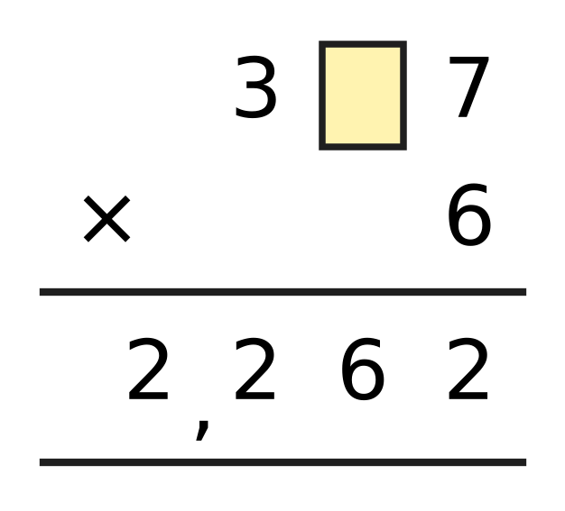
Q9. Tejas worked out the multiplication in the picture. One digit is hidden under the yellow box. Which digit is hidden?
(A) 6 | (B) 8 | (C) 7 | (D) 2

Q10. A fruit market sold 18,642 kg of mangoes and 23,481 kg of bananas this season. Akash rounds each number to the nearest thousand and then adds. What answer does he get?
(A) 42,000 kg | (B) 43,000 kg
(C) 41,000 kg | (D) 42,123 kg

Part 3 — Fractions, Decimals & Percentages (Syllabus Chapter 3)
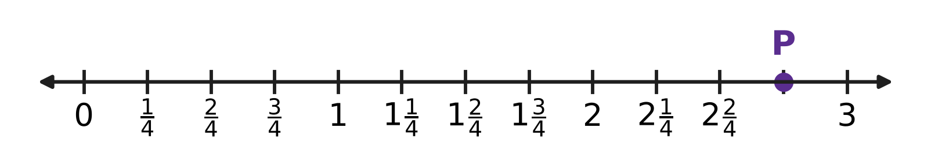
Q11. Look at the number line. The space between two whole numbers is split into 4 equal parts. Which mixed number does point P show?
(A) $3\frac{3}{4}$ | (B) $2\frac{1}{4}$ | (C) $1\frac{3}{4}$ | (D) $2\frac{3}{4}$

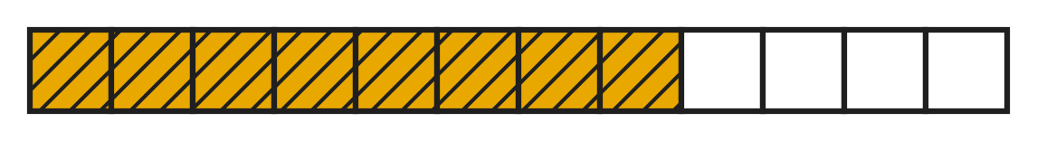
Q12. Look at the picture. A ribbon is cut into 12 equal pieces. Jaya uses the shaded pieces. What fraction of the whole ribbon does she use? Give the answer in simplest form.
(A) $\frac{2}{4}$ | (B) $\frac{3}{2}$ | (C) $\frac{2}{3}$ | (D) $\frac{1}{3}$

Q13. Which of these mixed numbers is equal to $\frac{35}{8}$?
(A) $5\frac{3}{8}$ | (B) $4\frac{3}{8}$ | (C) $4\frac{5}{8}$ | (D) $3\frac{3}{8}$

Q14. Pallavi paints $\frac{1}{3}$ of a fence on Monday. She paints $\frac{1}{6}$ of the same fence on Tuesday. What part of the fence has she painted in the two days?
(A) $\frac{2}{6}$ | (B) $\frac{1}{6}$ | (C) $\frac{1}{2}$ | (D) $\frac{2}{9}$

Q15. A bottle holds $1\frac{1}{2}$ L of juice. Anya pours out $\frac{3}{4}$ L of it. How much juice is left in the bottle?
(A) $\frac{1}{4}$ L | (B) $2\frac{1}{4}$ L | (C) $1\frac{1}{4}$ L | (D) $\frac{3}{4}$ L

Q16. Find the two missing numbers:
$\frac{3}{9}$ = $\frac{1}{?}$
$\frac{3}{9}$ = $\frac{?}{12}$
What is the sum of the two missing numbers?
(A) 7 | (B) 6 | (C) 8 | (D) 9

Part 4 — Geometry (Syllabus Chapter 5)
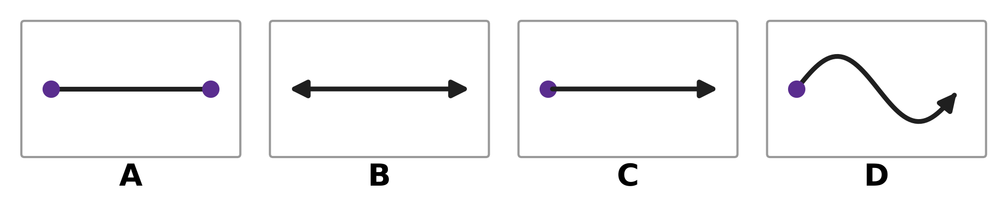
Q17. Look at the four pictures. A dot shows an end point. An arrow shows that the line continues without end in that direction. Which picture shows a ray?
(A) Picture A | (B) Picture B
(C) Picture C | (D) Picture D

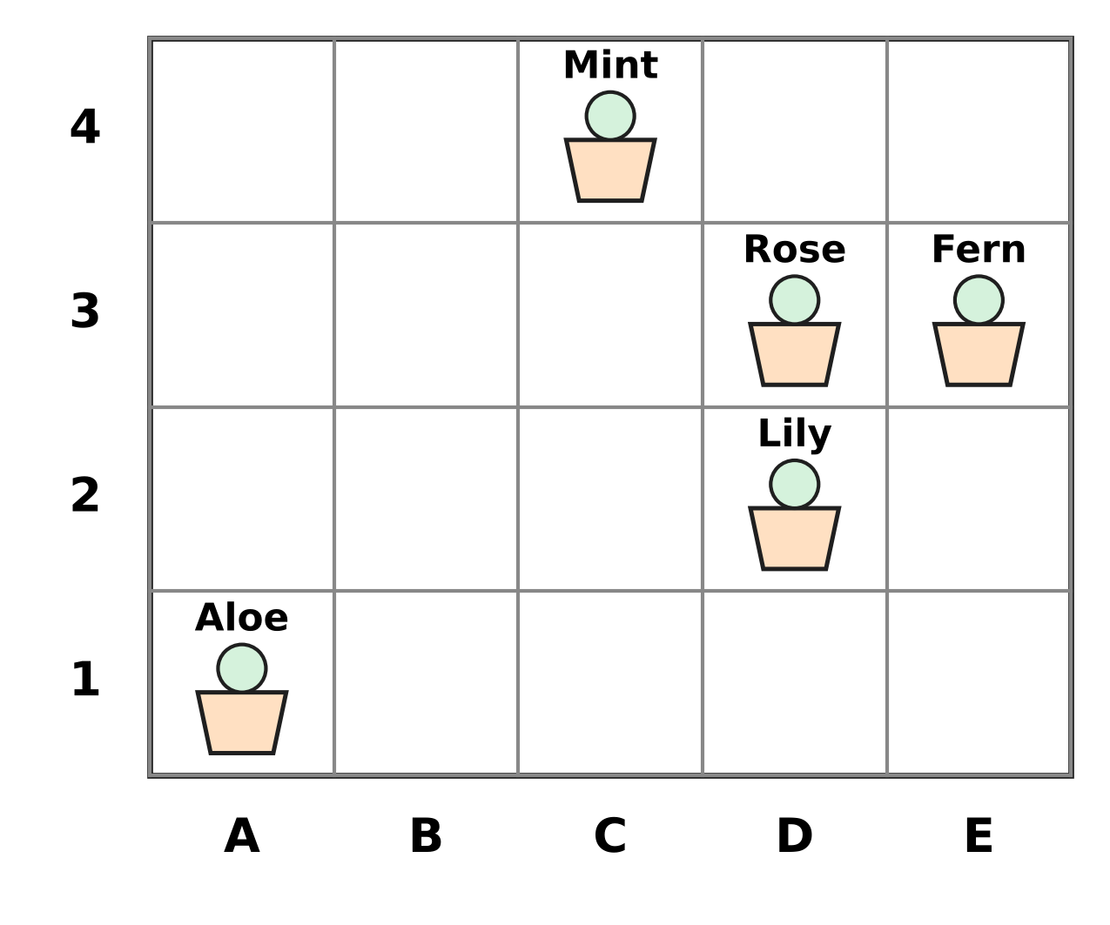
Q18. The picture shows pots in the school garden on a grid. A position is written as (column letter, row number). Which plant is in the pot at (D, 3)?
(A) Fern | (B) Rose | (C) Lily | (D) Mint

Q19. For every prism and pyramid, faces + vertices − edges = 2. Which of these could be the numbers of faces, vertices and edges of a prism or a pyramid?
(A) 6 faces, 6 vertices, 12 edges | (B) 5 faces, 6 vertices, 8 edges
(C) 7 faces, 10 vertices, 14 edges | (D) 7 faces, 10 vertices, 15 edges

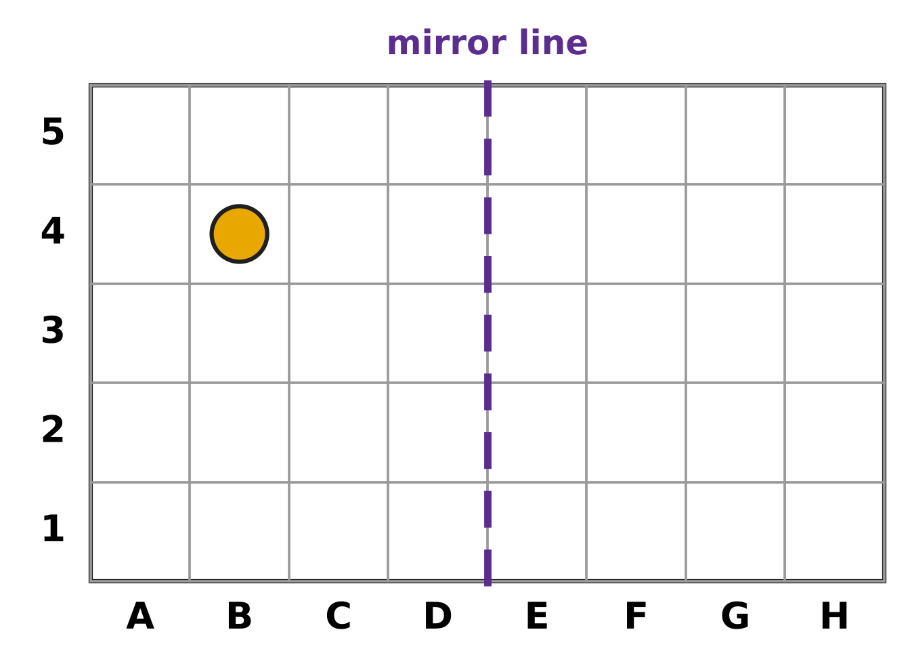
Q20. Look at the grid. A position is written as (column letter, row number), so the dot is at (B, 4). Where is the mirror image of the dot in the dashed mirror line?
(A) (F, 4) | (B) (H, 4) | (C) (G, 4) | (D) (E, 4)

Part 5 — Mensuration (Syllabus Chapter 6)
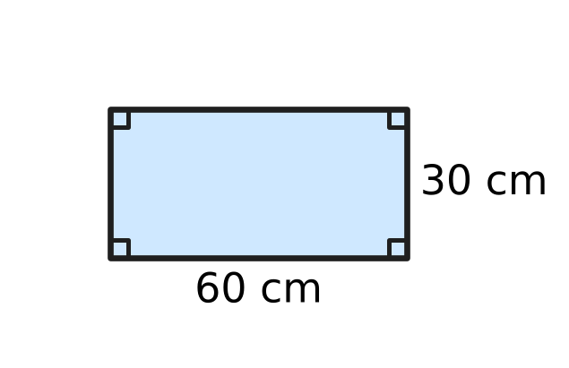
Q21. The picture shows the base of a rectangular fish tank. It is 60 cm long and 30 cm wide. What is the area of the base?
(A) 1,800 sq cm | (B) 18,000 sq cm
(C) 90 sq cm | (D) 180 sq cm

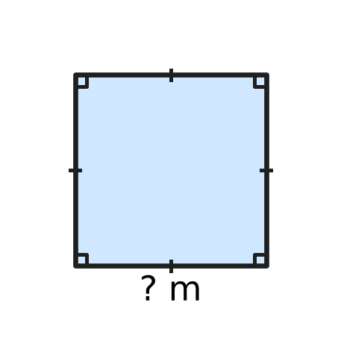
Q22. Look at the picture of a square sandpit in a playground. Its perimeter is 36 m. How long is each side?
(A) 144 m | (B) 9 m | (C) 6 m | (D) 18 m

Q23. Which of these is the same as 4,050 g?
(A) 4 kg 50 g | (B) 4 kg 5 g
(C) 40 kg 50 g | (D) 4 kg 500 g

Q24. A bucket holds 5 L of water. Lena uses 1 L 350 mL of it to wash her bicycle. How much water is left in the bucket?
(A) 4 L 350 mL | (B) 3 L 650 mL
(C) 6 L 350 mL | (D) 4 L 650 mL

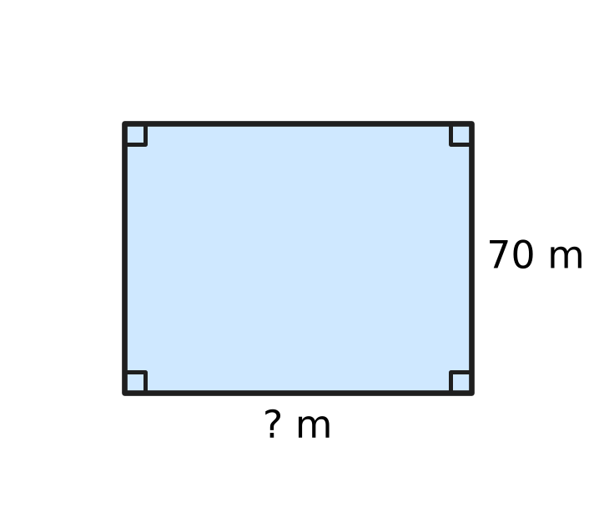
Q25. Look at the picture of a rectangular ground for sports day. Its perimeter is 320 m and it is 70 m wide. How long is the ground?
(A) 160 m | (B) 180 m | (C) 250 m | (D) 90 m

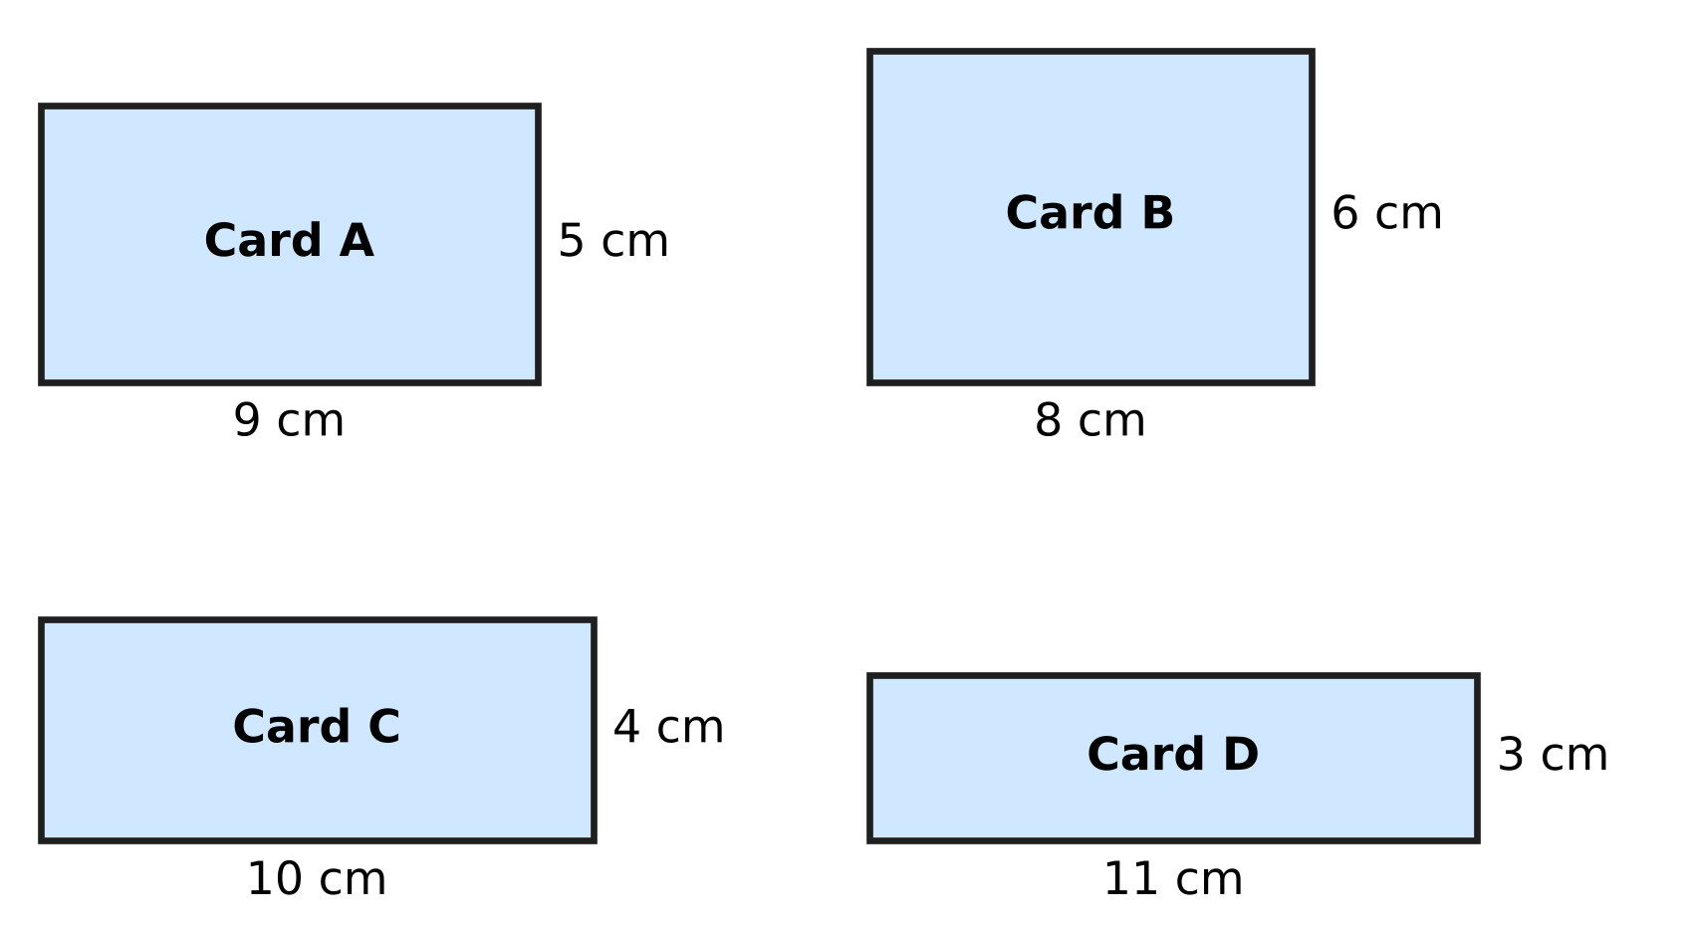
Q26. Four rectangular name cards for classroom desks are shown. All four cards have the same perimeter, 28 cm. Which card has the greatest area?
(A) Card A | (B) Card B | (C) Card C | (D) Card D

Part 6 — Data Handling, Statistics & Probability (Syllabus Chapter 8)
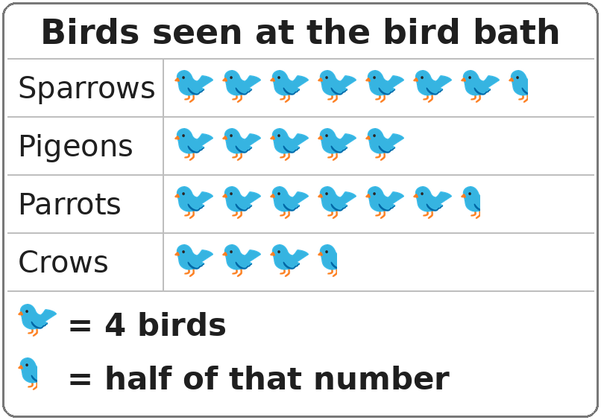
Q27. Look at the pictograph. One whole bird picture stands for 4 birds. How many parrots were seen?
(A) 24 | (B) 28 | (C) 26 | (D) 6

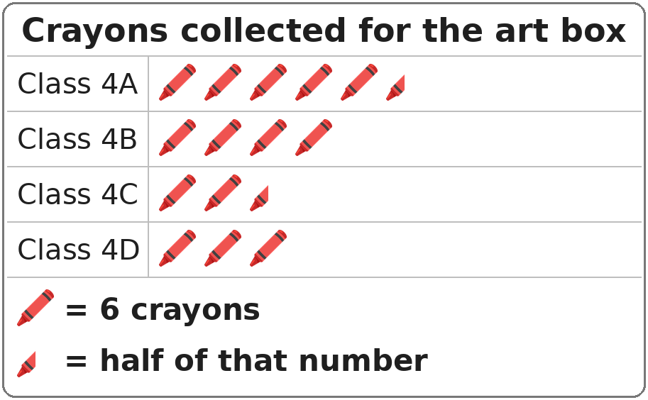
Q28. Look at the pictograph. One whole crayon picture stands for 6 crayons. How many more crayons did Class 4A collect than Class 4C?
(A) 48 | (B) 3 | (C) 21 | (D) 18

Part 7 — Applied Mathematics (Syllabus Chapter 9)
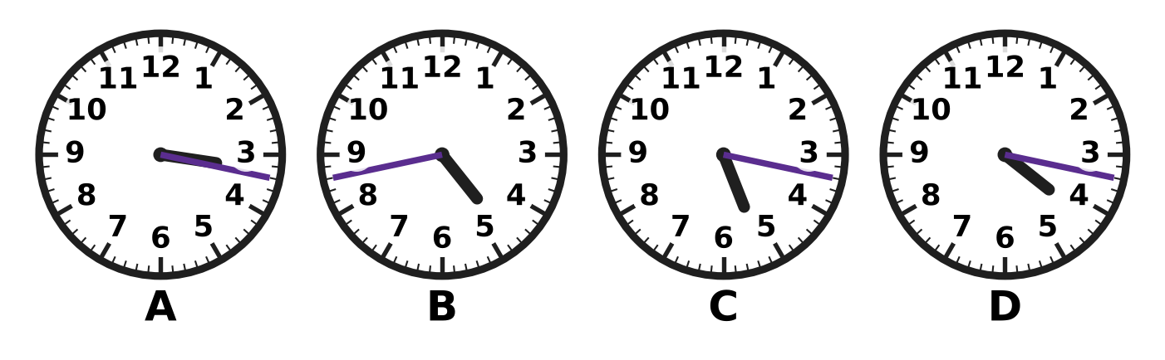
Q29. Look at the four clocks. Which clock shows 4:17?
(A) Picture A | (B) Picture B
(C) Picture C | (D) Picture D

Q30. A film show in the school hall starts at 9:47 in the morning. It ends at 11:25 the same morning. How long is the show?
(A) 1 hour 42 minutes | (B) 2 hours 22 minutes
(C) 1 hour 38 minutes | (D) 2 hours 38 minutes

Q31. On a nature walk, the first group of children sets off at 9:50 a.m. After that, a new group sets off every 25 minutes. At what time does the 3rd group set off?
(A) 10:40 | (B) 11:05 | (C) 10:00 | (D) 10:15

Q32. A box of 8 paint brushes costs ₹472. All the brushes cost the same. What is the price of one paint brush?
(A) ₹464 | (B) ₹59 | (C) ₹49 | (D) ₹69

Irfan's toy-shop bill
Toy | Price of one (₹) | Number bought
Puzzle | 145 | 2
Ball | 85 | 3
Yo-yo | 38 | 4

Q33. Use the table. Irfan pays for all these toys with two ₹500 notes. How much change does he get?
(A) ₹455 | (B) ₹303 | (C) ₹697 | (D) ₹732

Q34. In one year, 15 April is a Saturday. April has 30 days. What day of the week is 15 May of that year?
(A) Tuesday | (B) Sunday | (C) Monday | (D) Saturday

Part 8 — Mathematical Reasoning & Problem-Solving (Syllabus Chapter 10)
Q35. What number comes next? 2, 5, 10, 17, 26, ___
(A) 37 | (B) 36 | (C) 35 | (D) 39

Q36. The boxes on a shoe rack are numbered 1 to 45. Every box whose number is a multiple of 4 holds sports shoes. How many boxes hold sports shoes?
(A) 10 | (B) 12 | (C) 22 | (D) 11

Q37. Today is a Thursday. Rekha's swimming test is 50 days from today. On which day of the week is the test?
(A) Thursday | (B) Friday
(C) Saturday | (D) Wednesday

Q38. Find the missing number: 1, 2, 3, 5, 8, 13, ___, 34
(A) 21 | (B) 18 | (C) 19 | (D) 26

Q39. The 75 lockers in a school corridor are numbered 1 to 75. Each sticker shows one digit. How many stickers are needed to number all the lockers?
(A) 132 | (B) 150 | (C) 139 | (D) 141

Q40. A table-tennis club has 5 players. Each player plays exactly one game against every other player. How many games are played in all?
(A) 4 | (B) 20 | (C) 10 | (D) 25

SECTION II — Star Questions 5 questions × 4 marks each
Q41. Look at the pattern: $\frac{1}{12}$, $\frac{1}{6}$, $\frac{1}{4}$, $\frac{1}{3}$, … It goes on in the same way. What is the sum of the next two fractions in the pattern? [4 marks]
(A) $1\frac{1}{2}$ | (B) $1\frac{1}{12}$ | (C) $\frac{11}{12}$ | (D) $\frac{5}{6}$

Q42. A month has 30 days. It has five Thursdays but only four Fridays. On which day of the week is the 26th of this month? [4 marks]
(A) Wednesday | (B) Sunday
(C) Saturday | (D) Monday

Q43. How many 5-digit numbers have digits that add up to 3? For example, 10,020 is one of them, because 1 + 0 + 0 + 2 + 0 = 3. [4 marks]
(A) 15 | (B) 11 | (C) 10 | (D) 14

Q44. Grapes cost ₹96 per kg. Gaurav buys $1\frac{1}{4}$ kg in the morning and $2\frac{1}{2}$ kg in the evening. He pays for all of it with one ₹500 note. How much change does he get? [4 marks]
(A) ₹180 | (B) ₹212 | (C) ₹360 | (D) ₹140

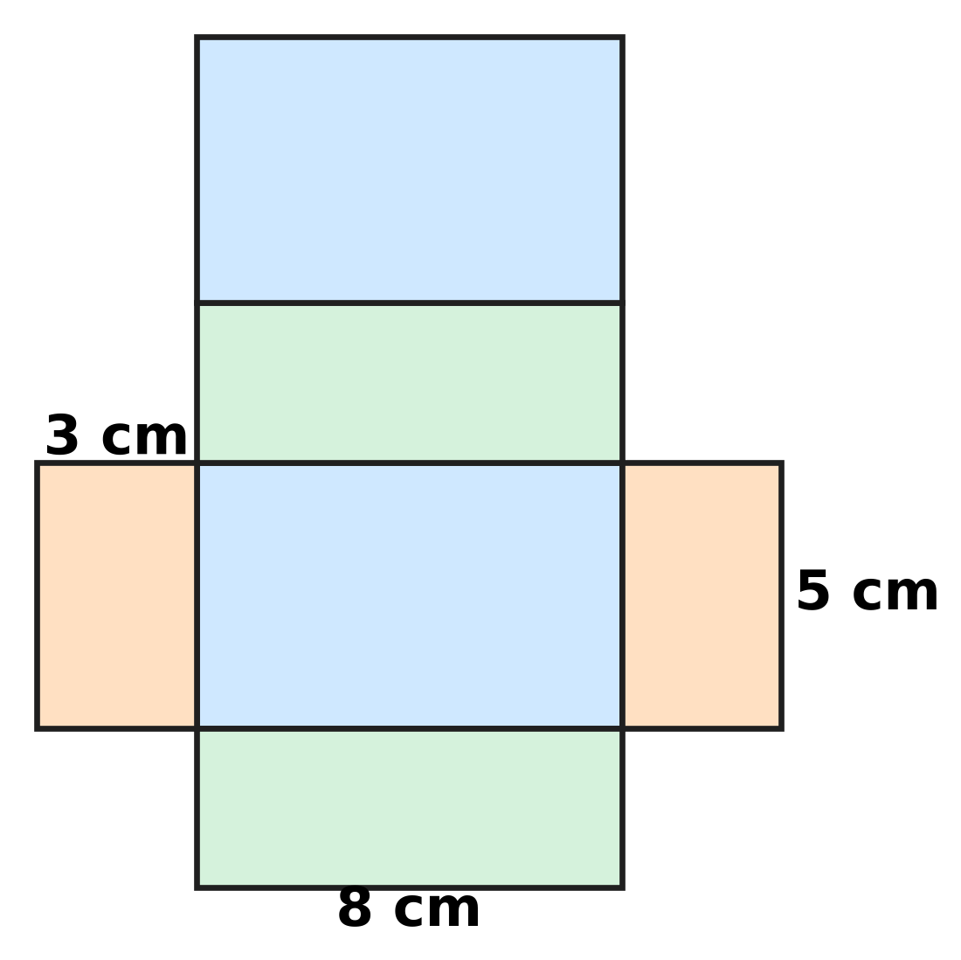
Q45. The picture shows the net of a closed box shaped like a cuboid. Only three lengths are marked. How much card (area) is used to make the net? [4 marks]
(A) 79 sq cm | (B) 128 sq cm
(C) 118 sq cm | (D) 158 sq cm

Answer Sheet AMO Level 1 · Class 4 · Practice Paper 2
Name: | School: | Roll No.:
Shade or tick one circle for each question.
1. Ⓐ Ⓑ Ⓒ Ⓓ | 16. Ⓐ Ⓑ Ⓒ Ⓓ | 31. Ⓐ Ⓑ Ⓒ Ⓓ
2. Ⓐ Ⓑ Ⓒ Ⓓ | 17. Ⓐ Ⓑ Ⓒ Ⓓ | 32. Ⓐ Ⓑ Ⓒ Ⓓ
3. Ⓐ Ⓑ Ⓒ Ⓓ | 18. Ⓐ Ⓑ Ⓒ Ⓓ | 33. Ⓐ Ⓑ Ⓒ Ⓓ
4. Ⓐ Ⓑ Ⓒ Ⓓ | 19. Ⓐ Ⓑ Ⓒ Ⓓ | 34. Ⓐ Ⓑ Ⓒ Ⓓ
5. Ⓐ Ⓑ Ⓒ Ⓓ | 20. Ⓐ Ⓑ Ⓒ Ⓓ | 35. Ⓐ Ⓑ Ⓒ Ⓓ
6. Ⓐ Ⓑ Ⓒ Ⓓ | 21. Ⓐ Ⓑ Ⓒ Ⓓ | 36. Ⓐ Ⓑ Ⓒ Ⓓ
7. Ⓐ Ⓑ Ⓒ Ⓓ | 22. Ⓐ Ⓑ Ⓒ Ⓓ | 37. Ⓐ Ⓑ Ⓒ Ⓓ
8. Ⓐ Ⓑ Ⓒ Ⓓ | 23. Ⓐ Ⓑ Ⓒ Ⓓ | 38. Ⓐ Ⓑ Ⓒ Ⓓ
9. Ⓐ Ⓑ Ⓒ Ⓓ | 24. Ⓐ Ⓑ Ⓒ Ⓓ | 39. Ⓐ Ⓑ Ⓒ Ⓓ
10. Ⓐ Ⓑ Ⓒ Ⓓ | 25. Ⓐ Ⓑ Ⓒ Ⓓ | 40. Ⓐ Ⓑ Ⓒ Ⓓ
11. Ⓐ Ⓑ Ⓒ Ⓓ | 26. Ⓐ Ⓑ Ⓒ Ⓓ | 41. Ⓐ Ⓑ Ⓒ Ⓓ
12. Ⓐ Ⓑ Ⓒ Ⓓ | 27. Ⓐ Ⓑ Ⓒ Ⓓ | 42. Ⓐ Ⓑ Ⓒ Ⓓ
13. Ⓐ Ⓑ Ⓒ Ⓓ | 28. Ⓐ Ⓑ Ⓒ Ⓓ | 43. Ⓐ Ⓑ Ⓒ Ⓓ
14. Ⓐ Ⓑ Ⓒ Ⓓ | 29. Ⓐ Ⓑ Ⓒ Ⓓ | 44. Ⓐ Ⓑ Ⓒ Ⓓ
15. Ⓐ Ⓑ Ⓒ Ⓓ | 30. Ⓐ Ⓑ Ⓒ Ⓓ | 45. Ⓐ Ⓑ Ⓒ Ⓓ
Q41–Q45 are Section II Star Questions (4 marks each).
For the parent or teacher
Section I correct: ______ / 40 × 2 = ______ marks Section II correct: ______ / 5 × 4 = ______ marks
Correct: ______ / 45 Score: ______ / 100
Answer Key and Solutions AMO Level 1 · Class 4 · Practice Paper 2
Quick answers
1 A | 6 A | 11 D | 16 A | 21 A | 26 B | 31 A | 36 D | 41 C
2 D | 7 B | 12 C | 17 C | 22 B | 27 C | 32 B | 37 B | 42 B
3 A | 8 D | 13 B | 18 B | 23 A | 28 D | 33 B | 38 A | 43 A
4 B | 9 C | 14 C | 19 D | 24 B | 29 D | 34 C | 39 D | 44 D
5 C | 10 A | 15 D | 20 C | 25 D | 30 C | 35 A | 40 C | 45 D
Solutions
Q | Part · level | Answer | Why?
1 | Part 1 · Ch1 · Easy | (A) 60,408 | Sixty thousand is 60,000; four hundred eight is 408. Together they make 60,408.
2 | Part 1 · Ch1 · Easy | (D) XCI | XCI = 90 + 1 = 91, LXXXVIII = 88, LXXIX = 79 and XLIX = 49. The greatest is XCI = 91.
3 | Part 1 · Ch1 · Easy | (A) 50 | 74,056 has 0 hundreds and 5 tens, so the missing part is 5 tens = 50.
4 | Part 1 · Ch1 · Easy | (B) 45,109 | 45,109 has 1 hundred, so it is more than 45,099 and less than 45,190. 45,019 is too small; 45,200 and 45,910 are too big.
5 | Part 1 · Ch1 · Medium | (C) 9,250 | Each number is 750 more than the one before: 7,000, 7,750, 8,500, 9,250, … So 9,250 appears; 8,000, 9,000 and 9,500 do not.
6 | Part 2 · Ch2 · Easy | (A) 63,443 | 27,648 + 35,795 = 63,443.
7 | Part 2 · Ch2 · Easy | (B) 364 | 2,184 ÷ 6 = 364, because 364 × 6 = 2,184.
8 | Part 2 · Ch2 · Easy | (D) 96 − 32 = 32 − 96 | 96 − 32 = 64, but 32 − 96 cannot be 64. Subtraction is not commutative; the other three are true.
9 | Part 2 · Ch2 · Medium | (C) 7 | 2,262 ÷ 6 = 377, and 377 × 6 = 2,262. So the hidden digit is 7.
10 | Part 2 · Ch2 · Medium | (A) 42,000 kg | 18,642 rounds to 19,000 (hundreds digit 6) and 23,481 rounds to 23,000 (hundreds digit 4). 19,000 + 23,000 = 42,000 kg.
11 | Part 3 · Ch3 · Easy | (D) $2\frac{3}{4}$ | P is 3 small parts after 2, and each part is one quarter. So P is at 2 and three quarters.
12 | Part 3 · Ch3 · Easy | (C) $\frac{2}{3}$ | She uses 8 of 12 pieces, which is 8/12. Dividing top and bottom by 4 gives 2/3.
13 | Part 3 · Ch3 · Easy | (B) $4\frac{3}{8}$ | 35 ÷ 8 = 4 remainder 3, so 35/8 = 4 wholes and 3 eighths.
14 | Part 3 · Ch3 · Easy | (C) $\frac{1}{2}$ | 1/3 = 2/6. Then 2/6 + 1/6 = 3/6 = 1/2 of the fence.
15 | Part 3 · Ch3 · Medium | (D) $\frac{3}{4}$ L | 1 1/2 L = 6/4 L. Then 6/4 − 3/4 = 3/4 L is left.
16 | Part 3 · Ch3 · Medium | (A) 7 | 3/9 = 1/3 (divide top and bottom by 3). 1/3 = 4/12 (multiply top and bottom by 4). The missing numbers are 3 and 4, and 3 + 4 = 7.
17 | Part 4 · Ch5 · Easy | (C) Picture C | A ray is straight, has one end point and goes on without end in one direction. Picture C shows this.
18 | Part 4 · Ch5 · Easy | (B) Rose | Go across to column D, then up to row 3. The pot there holds the Rose.
19 | Part 4 · Ch5 · Medium | (D) 7 faces, 10 vertices, 15 edges | Only 7 + 10 − 15 = 2. The other sets give 0, 3 and 3, so they cannot belong to a prism or a pyramid. A prism with a 5-sided end really has 7 faces, 10 vertices and 15 edges.
20 | Part 4 · Ch5 · Medium | (C) (G, 4) | The mirror line lies between columns D and E. The dot in column B is 3 columns to its left (B, C, D). Its image is 3 columns to the right (E, F, G), in the same row: (G, 4).
21 | Part 5 · Ch6 · Easy | (A) 1,800 sq cm | Area = length × breadth = 60 × 30 = 1,800 sq cm.
22 | Part 5 · Ch6 · Easy | (B) 9 m | A square has 4 equal sides. Side = 36 ÷ 4 = 9 m.
23 | Part 5 · Ch6 · Easy | (A) 4 kg 50 g | 1 kg = 1,000 g. So 4,050 g = 4,000 g + 50 g = 4 kg 50 g.
24 | Part 5 · Ch6 · Easy | (B) 3 L 650 mL | 5 L = 4 L 1,000 mL. Then 4 L 1,000 mL − 1 L 350 mL = 3 L 650 mL.
25 | Part 5 · Ch6 · Medium | (D) 90 m | Length + width = 320 ÷ 2 = 160 m. Length = 160 − 70 = 90 m.
26 | Part 5 · Ch6 · Medium | (B) Card B | Areas: A 9 × 5 = 45, B 8 × 6 = 48, C 10 × 4 = 40, D 11 × 3 = 33 sq cm. Card B has the greatest area.
27 | Part 6 · Ch8 · Easy | (C) 26 | Parrots have 6 and a half pictures. 6 × 4 = 24 and half a picture = 2, so 24 + 2 = 26.
28 | Part 6 · Ch8 · Medium | (D) 18 | Class 4A: 5 and a half pictures = 30 + 3 = 33. Class 4C: 2 and a half pictures = 12 + 3 = 15. 33 − 15 = 18.
29 | Part 7 · Ch9 · Easy | (D) Picture D | At 4:17 the hour hand is just past 4 and the minute hand is 2 marks past 3 (15 + 2 = 17 minutes). Picture D shows this.
30 | Part 7 · Ch9 · Medium | (C) 1 hour 38 minutes | 9:47 to 10:00 is 13 minutes; 10:00 to 11:25 is 1 hour 25 minutes. Total 1 hour 38 minutes.
31 | Part 7 · Ch9 · Easy | (A) 10:40 | The 3rd group sets off 2 gaps after the first: 2 × 25 = 50 minutes. 9:50 + 50 minutes = 10:40.
32 | Part 7 · Ch9 · Easy | (B) ₹59 | ₹472 ÷ 8 = ₹59, because 59 × 8 = 472.
33 | Part 7 · Ch9 · Medium | (B) ₹303 | Cost = 145 × 2 + 85 × 3 + 38 × 4 = 290 + 255 + 152 = ₹697. Change = 1,000 − 697 = ₹303.
34 | Part 7 · Ch9 · Medium | (C) Monday | From 15 April to 15 May is 30 days = 4 weeks + 2 days. Saturday + 2 days = Monday.
35 | Part 8 · Ch10 · Easy | (A) 37 | The jumps are 3, 5, 7, 9; the next jump is 11. 26 + 11 = 37.
36 | Part 8 · Ch10 · Easy | (D) 11 | The multiples of 4 up to 45 are 4, 8, 12, …, 44. That is 44 ÷ 4 = 11 boxes.
37 | Part 8 · Ch10 · Easy | (B) Friday | 50 = 7 × 7 + 1, so 50 days is 7 weeks and 1 day. Thursday + 1 day = Friday.
38 | Part 8 · Ch10 · Medium | (A) 21 | Each number is the sum of the two numbers before it: 8 + 13 = 21, and 13 + 21 = 34 checks.
39 | Part 8 · Ch10 · Medium | (D) 141 | Lockers 1 to 9 need 9 stickers. Lockers 10 to 75 are 66 numbers with 2 digits each: 132 stickers. 9 + 132 = 141.
40 | Part 8 · Ch10 · Medium | (C) 10 | The first player plays 4 games, the second 3 new games, the third 2, the fourth 1. 4 + 3 + 2 + 1 = 10 games.
41 | Section II · Ch3 + Ch10 · Hard | (C) $\frac{11}{12}$ | Write each fraction in twelfths. The pattern is 1/12, 2/12, 3/12, 4/12. Each fraction is 1/12 more than the one before, so the next two are 5/12 and 6/12. 5/12 + 6/12 = 11/12.
42 | Section II · Ch9 + Ch10 · Hard | (B) Sunday | 30 days = 4 weeks + 2 days, so only the days of the 1st and 2nd come five times. Thursday must be one of them but Friday not, so the 1st is Wednesday and the 2nd Thursday. The 26th is 25 days later = 3 weeks + 4 days: Wednesday + 4 days = Sunday.
43 | Section II · Ch1 + Ch10 · Hard | (A) 15 | First digit 3: only 30,000 (1). First digit 2: a 1 in one of the other 4 places (4). First digit 1: a 2 in one of 4 places (4), or two 1s in 2 of 4 places (6). 1 + 4 + 4 + 6 = 15.
44 | Section II · Ch3 + Ch9 · Hard | (D) ₹140 | 1 1/4 + 2 1/2 = 3 3/4 kg. Cost = 3 × 96 + 3/4 of 96 = 288 + 72 = ₹360. Change = 500 − 360 = ₹140.
45 | Section II · Ch5 + Ch6 · Hard | (D) 158 sq cm | The faces are two 8 × 5, two 8 × 3 and two 5 × 3 rectangles. Area = 2 × (40 + 24 + 15) = 158 sq cm.

