UNLOCK IQ INSTITUTE
Realize Your True Potential
Aryabhatta Maths Olympiad (AMO)
Level 1 — Practice Paper 3
CLASS 4

Questions | 45 multiple-choice questions
Marks | 100
Time | 60 minutes
Section I | 40 questions × 2 marks = 80 marks
Section II | 5 Star Questions × 4 marks = 20 marks
Negative marking | No negative marking
Calculator | Not allowed
Chapters | Number System · Operations · Fractions, Decimals & Percentages · Geometry · Mensuration · Data Handling · Applied Mathematics · Mathematical Reasoning

Hello, friend!
• Every question has four answer choices: (A), (B), (C) and (D). Only one is correct.
• Read each question and look at its picture carefully. Then mark your answer on the answer sheet at the end.
• Section I has 40 questions of 2 marks each. Section II has 5 Star Questions of 4 marks each.
• There is no negative marking, so try every question.
• Do not use a calculator. You may do rough work on a separate sheet.
• All figures are not necessarily drawn to scale unless stated.

For parents and teachers
Print or view this paper in colour. Pictures are part of the questions.
Parts follow the AMO syllabus chapters. Chapters 4 and 7 are not part of the Class 4 syllabus, so the chapter numbers shown in the Part headings have gaps.
The answer sheet and the answer key are at the end. Remove only the answer key before the child begins.

Name: | School: | Roll No.:

SECTION I 40 questions × 2 marks each
Part 1 — Number System (Syllabus Chapter 1)
Q1. The three numbers below are in counting order. Which number goes in the blank?
___, 60,000, 60,001
(A) 60,002 | (B) 59,000 | (C) 50,000 | (D) 59,999

Q2. The rooms of a museum are numbered in Roman numerals. Which label should be on the door of Room 49?
(A) XLIX | (B) IL | (C) XLVIIII | (D) XXXXIX

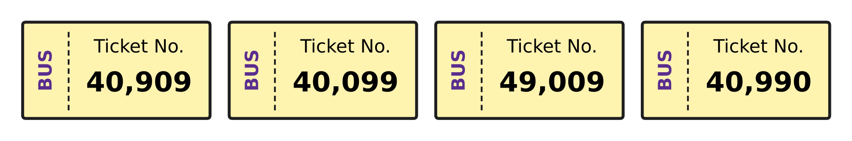
Q3. Look at the four bus tickets. Which ticket number is the smallest?
(A) 40,909 | (B) 40,099 | (C) 49,009 | (D) 40,990

Ten thousands | Thousands | Hundreds | Tens | Ones
4 | 13 | 0 | 5 | 0

Q4. Use the table. It shows 4 ten thousands, 13 thousands, 0 hundreds, 5 tens and 0 ones. Which number does it show?
(A) 53,005 | (B) 53,050 | (C) 43,050 | (D) 53,500

Q5. In this pattern, the same number is added each time.
23,180; ___; ___; 26,780
Which number goes in the first blank?
(A) 24,380 | (B) 24,980 | (C) 24,180 | (D) 25,580

Part 2 — Operations & Number Properties (Syllabus Chapter 2)
Q6. Which number goes in the blank to make both sides equal?
(14 × 5) × 6 = 14 × (5 × ___)
(A) 14 | (B) 70 | (C) 6 | (D) 30

Q7. Which number goes in the blank?
63,475 + ___ = 1,00,000
(A) 47,635 | (B) 36,535 | (C) 36,524 | (D) 36,525

Q8. A printing machine prints 168 posters every hour. How many posters does it print in 7 hours?
(A) 726 | (B) 1,166 | (C) 175 | (D) 1,176

Q9. A number is divided by 7. The quotient is 1,206 and the remainder is 5. What is the number?
(A) 8,447 | (B) 8,442 | (C) 8,437 | (D) 1,211

Q10. Harsh counts the mangoes picked in an orchard. He rounds his count to the nearest hundred and gets 4,300. Which of these could be his exact count?
(A) 4,238 | (B) 4,281 | (C) 4,372 | (D) 4,030

Part 3 — Fractions, Decimals & Percentages (Syllabus Chapter 3)
Q11. Which number goes in the box to make the two fractions equal?
$\frac{5}{6}$ = $\frac{20}{□}$
(A) 21 | (B) 30 | (C) 24 | (D) 26

Q12. Which number goes in the box?
$3\frac{2}{5}=\frac{□}{5}$
(A) 17 | (B) 15 | (C) 32 | (D) 11

Q13. Like fractions have the same denominator (bottom number). Which pair shows like fractions?
(A) $\frac{1}{2}$ and $\frac{2}{4}$ | (B) $\frac{5}{6}$ and $\frac{6}{5}$
(C) $\frac{2}{9}$ and $\frac{7}{9}$ | (D) $\frac{3}{8}$ and $\frac{3}{10}$

Q14. Sahil wrote $\frac{2}{9}$ + $\frac{1}{3}$ = $\frac{3}{12}$. His answer is wrong. What is the correct sum?
(A) $\frac{5}{12}$ | (B) $\frac{5}{9}$ | (C) $\frac{4}{9}$ | (D) $\frac{3}{9}$

Q15. Which number goes in the box?
$\frac{1}{4}+\frac{□}{12}=\frac{5}{6}$
(A) 2 | (B) 4 | (C) 9 | (D) 7

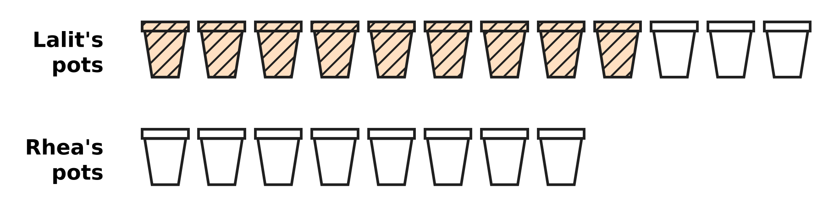
Q16. Look at the picture. Lalit has painted 9 of his 12 clay pots (shaded). Rhea paints the same fraction of her 8 pots. How many pots does Rhea paint?
(A) 4 | (B) 6 | (C) 3 | (D) 5

Part 4 — Geometry (Syllabus Chapter 5)
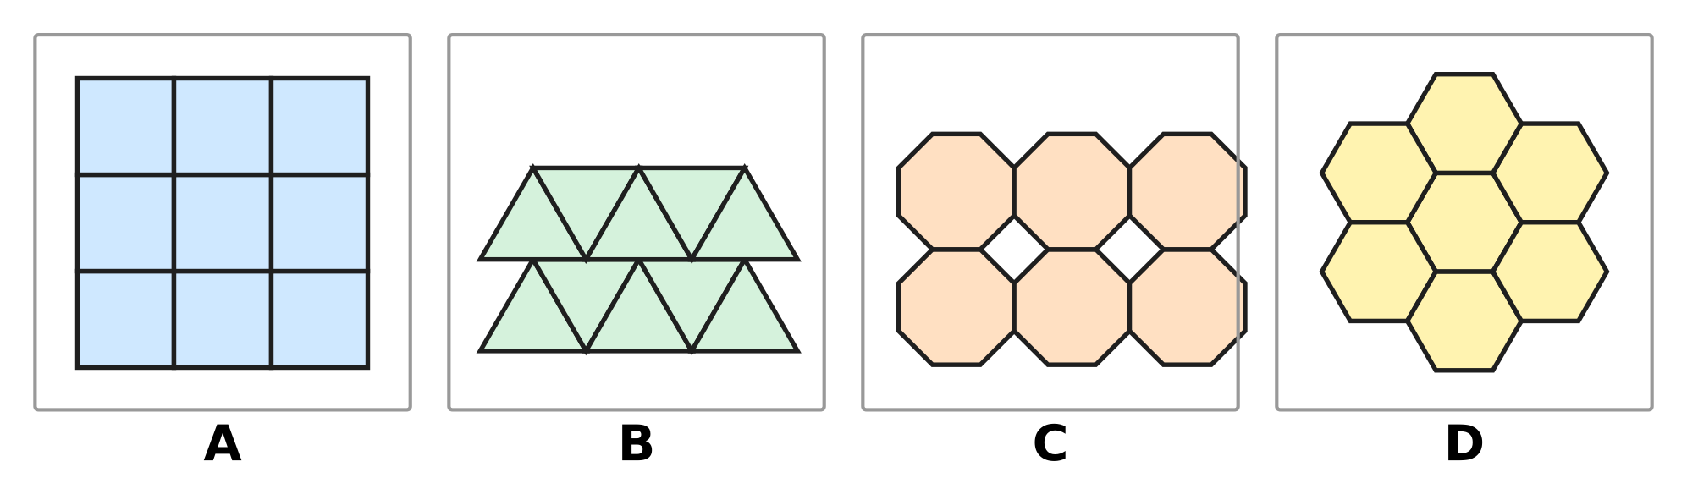
Q17. In each picture, copies of one shape are fitted together. In which picture do the copies leave gaps between them?
(A) Picture A | (B) Picture B
(C) Picture C | (D) Picture D

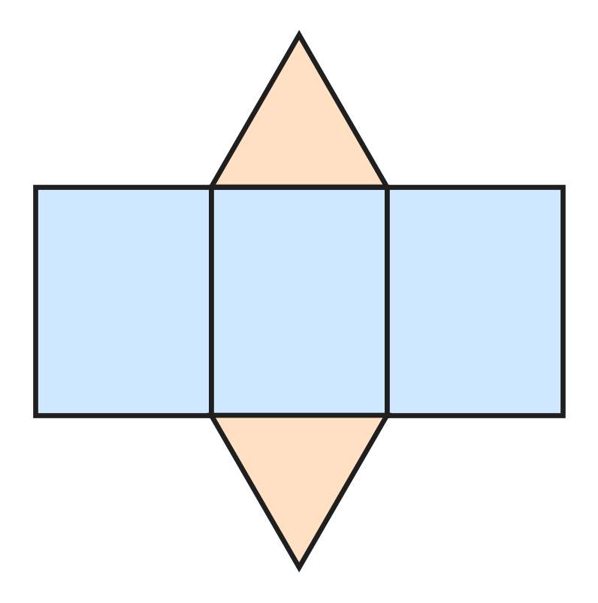
Q18. Look at the net. It has 3 rectangles and 2 triangles. It is folded along the lines to make a solid. Which solid is made?
(A) Triangular prism | (B) Square pyramid
(C) Triangular pyramid | (D) Cuboid

Q19. Lines p, q and r are drawn on a flat sheet of paper. Line q is perpendicular to line p. Line r is perpendicular to line q, and r is a different line from p. What is always true about lines p and r?
(A) They meet each other on line q. | (B) They cross each other.
(C) They are perpendicular. | (D) They are parallel.

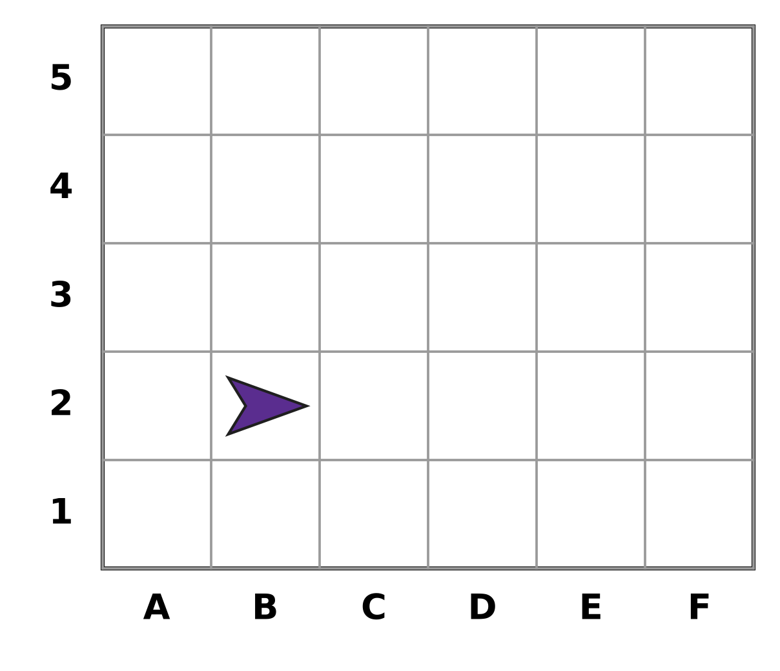
Q20. Look at the grid. A position is written as (column letter, row number). A paper plane is at (B, 2). It moves 3 squares to the right and then 2 squares up. Where is it now?
(A) (D, 5) | (B) (D, 3) | (C) (E, 4) | (D) (4, E)

Part 5 — Mensuration (Syllabus Chapter 6)
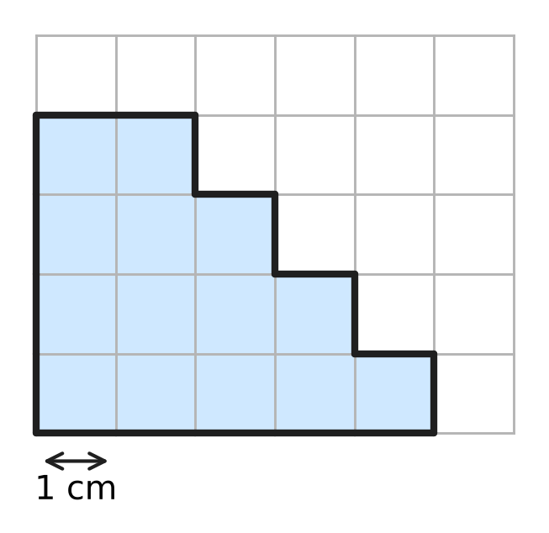
Q21. Look at the shaded shape on the grid of 1 cm squares. What is its area?
(A) 14 sq cm | (B) 13 sq cm | (C) 20 sq cm | (D) 18 sq cm

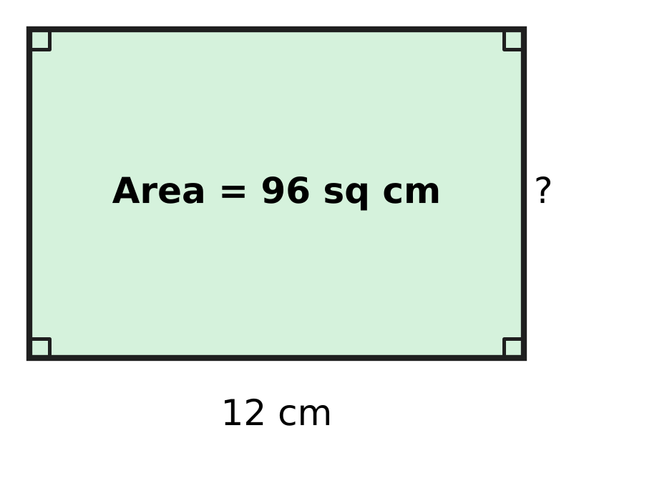
Q22. Look at the picture of a rectangular sheet of stamps at a post office. Its area is 96 sq cm and its length is 12 cm. What is its width?
(A) 24 cm | (B) 36 cm | (C) 84 cm | (D) 8 cm

Q23. A jug in the school canteen holds 3 L of milk. How many glasses of 250 mL each can be filled from a full jug?
(A) 6 | (B) 24 | (C) 12 | (D) 120

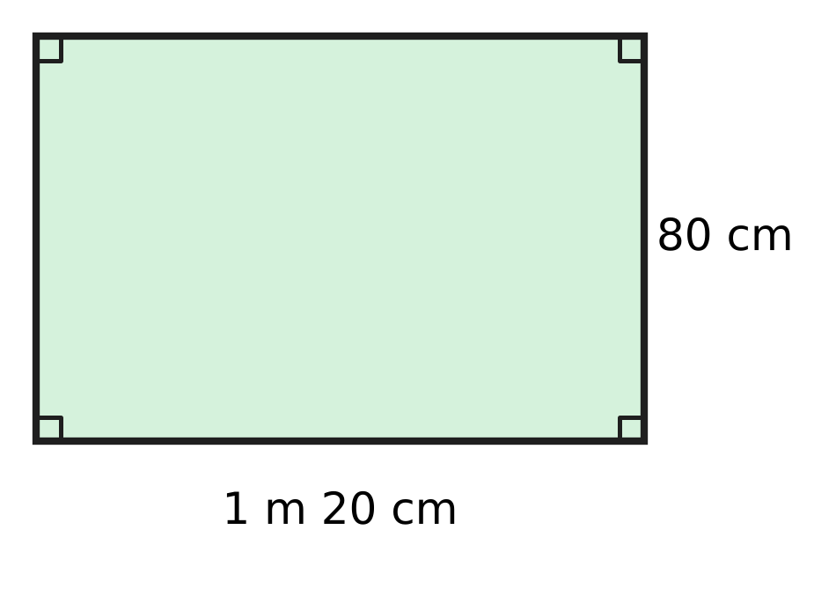
Q24. Look at the picture of a rectangular notice board. What is its perimeter in centimetres?
(A) 320 cm | (B) 400 cm | (C) 200 cm | (D) 184 cm

Q25. A square board for a board game has a perimeter of 140 cm. What is its area?
(A) 1,225 sq cm | (B) 4,900 sq cm
(C) 560 sq cm | (D) 140 sq cm

Q26. A boat in a harbour uses 2 L 350 mL of fuel on each trip. How much fuel does it use on 4 trips?
(A) 8 L 400 mL | (B) 9 L 350 mL
(C) 9 L 400 mL | (D) 8 L 350 mL

Part 6 — Data Handling, Statistics & Probability (Syllabus Chapter 8)
Picture for Q27 and Q28
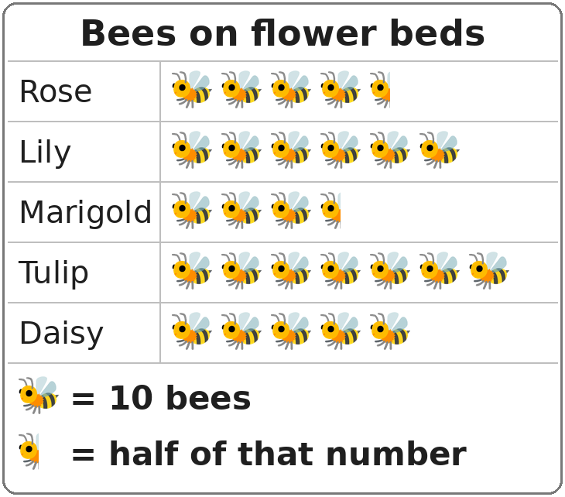
Q27. Look at the pictograph. On which flower bed were 35 bees seen?
(A) Daisy | (B) Rose | (C) Lily | (D) Marigold

Picture for Q27 and Q28
Q28. Look at the pictograph. A new row is added for a Poppy bed. The Poppy bed had 25 fewer bees than the bed with the most bees. How many bee pictures should be drawn for the Poppy bed?
(A) 2 and a half | (B) 4 and a half
(C) 5 | (D) 4

Part 7 — Applied Mathematics (Syllabus Chapter 9)
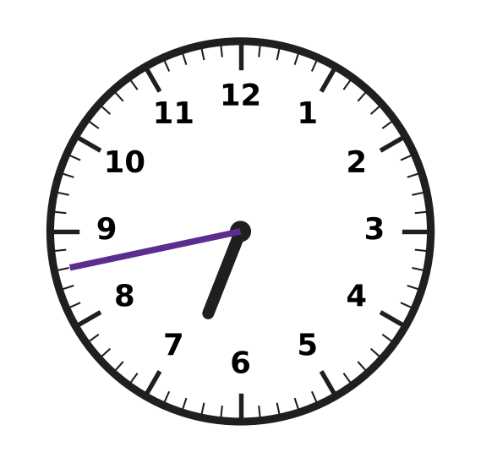
Q29. Look at the clock. Which of these is the time it shows?
(A) 43 minutes to 7 | (B) 17 minutes to 6
(C) 17 minutes to 7 | (D) 18 minutes to 7

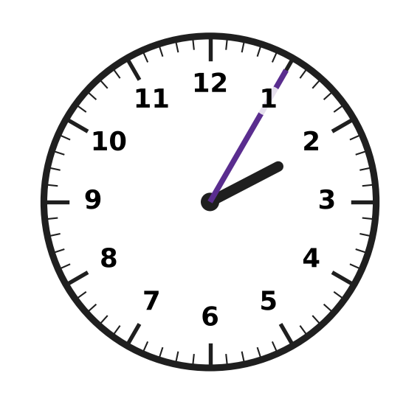
Q30. A drawing class ended in the afternoon at the time shown on the clock. The class lasted 50 minutes. At what time did it start?
(A) 2:55 | (B) 1:15 | (C) 1:55 | (D) 1:05

Q31. A karate class meets every Saturday. In one month, the second Saturday is the 10th. On which date is the fourth Saturday of that month?
(A) 20th | (B) 17th | (C) 31st | (D) 24th

Q32. Entry to a swimming pool costs ₹35 for an adult and ₹20 for a child. Ankit, aged 9, goes with his mother, his father and his two younger sisters. How much do the 5 entry tickets cost?
(A) ₹130 | (B) ₹175 | (C) ₹145 | (D) ₹110

Q33. Charu buys 3 tiffin boxes of the same price. She pays with a ₹500 note and gets ₹65 back. What is the price of one tiffin box?
(A) ₹145 | (B) ₹188 | (C) ₹435 | (D) ₹155

Q34. Workers start unloading sacks of grain from a truck at 11:40 in the morning. They finish at 2:15 in the afternoon. How long do they take?
(A) 2 hours 25 minutes | (B) 9 hours 25 minutes
(C) 3 hours 35 minutes | (D) 2 hours 35 minutes

Part 8 — Mathematical Reasoning & Problem-Solving (Syllabus Chapter 10)
Q35. Which number comes next in the pattern?
1, 3, 9, 27, ___
(A) 54 | (B) 36 | (C) 81 | (D) 45

Q36. How many two-digit numbers have digits that add up to 5?
(A) 4 | (B) 5 | (C) 6 | (D) 3

Q37. June has 30 days. Which date goes in the blank?
25 June + 14 days = ___
(A) 7 July | (B) 9 July | (C) 8 July | (D) 10 July

Q38. Which number comes next in the pattern?
4, 9, 7, 12, 10, 15, ___
(A) 17 | (B) 20 | (C) 13 | (D) 18

Q39. Bhavna wants to put exactly ₹20 into her piggy bank using only ₹5 coins and ₹2 coins. She may use only one kind of coin if she likes. In how many different ways can she do it?
(A) 4 | (B) 5 | (C) 2 | (D) 3

Q40. In a certain year, 1 January is a Monday. January has 31 days and February has 28 days that year. On which day of the week is 1 March?
(A) Thursday | (B) Friday
(C) Monday | (D) Wednesday

SECTION II — Star Questions 5 questions × 4 marks each
Q41. Juhi has five cards: $\frac{1}{2}$, $\frac{1}{3}$, $\frac{1}{4}$, $\frac{1}{6}$ and $\frac{1}{12}$. She picks two different cards and adds the fractions. How many of the possible pairs give a sum LESS than $\frac{1}{2}$? [4 marks]
(A) 4 | (B) 6 | (C) 3 | (D) 5

Q42. Vidya's watch goes 4 minutes further ahead every 24 hours. She sets it to the correct time at 8:00 a.m. on Tuesday, 4 March. On which day will the watch first be 60 minutes fast at 8:00 a.m.? [4 marks]
(A) Tuesday, 19 March | (B) Wednesday, 19 March
(C) Saturday, 29 March | (D) Tuesday, 18 March

Q43. The number 38,183 reads the same from left to right and from right to left. How many 5-digit numbers greater than 37,000 and less than 40,000 read the same both ways? [4 marks]
(A) 3 | (B) 10 | (C) 30 | (D) 300

Q44. Hemant counts the money in his shop's cash box. Of this money, $\frac{1}{3}$ is in ₹20 notes and $\frac{1}{4}$ is in ₹10 coins. The rest is ₹350, all in ₹50 notes. How many ₹20 notes are there? [4 marks]
(A) 7 | (B) 21 | (C) 28 | (D) 14

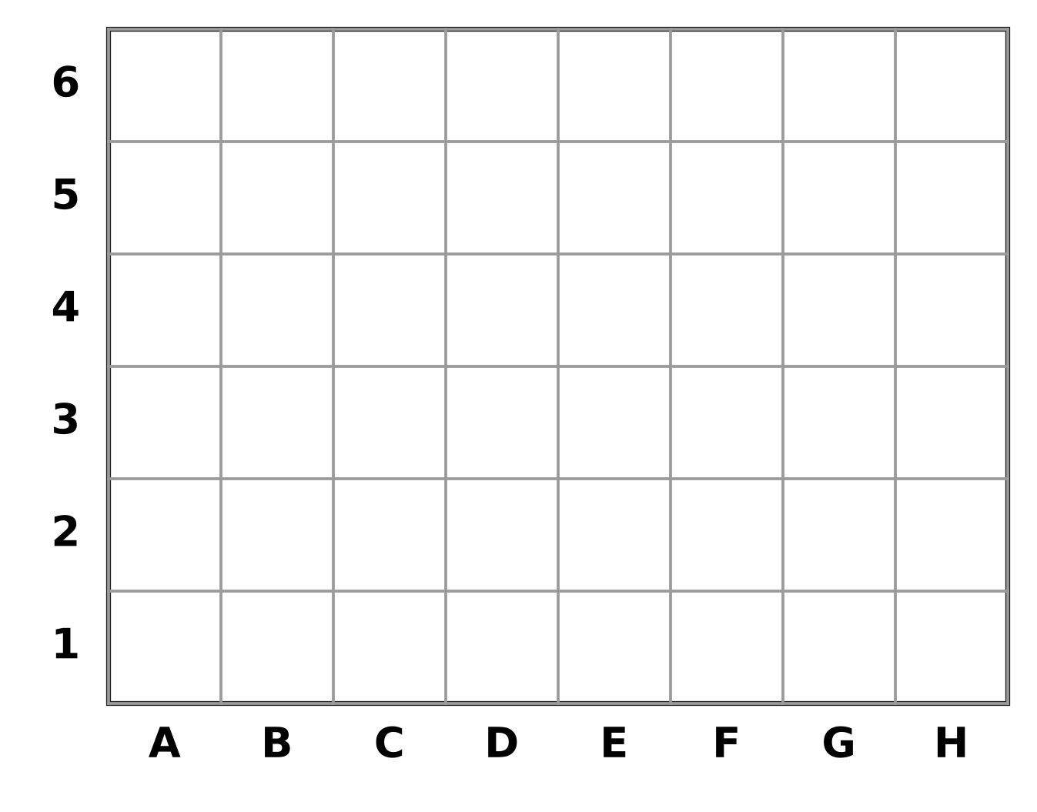
Q45. Look at the grid. Each square is 2 cm by 2 cm. Ella shades the squares in columns B to F and rows 2 to 5. She leaves the four corner squares of this block unshaded. What is the area of the shaded part? [4 marks]
(A) 76 sq cm | (B) 80 sq cm | (C) 32 sq cm | (D) 64 sq cm

Answer Sheet AMO Level 1 · Class 4 · Practice Paper 3
Name: | School: | Roll No.:
Shade or tick one circle for each question.
1. Ⓐ Ⓑ Ⓒ Ⓓ | 16. Ⓐ Ⓑ Ⓒ Ⓓ | 31. Ⓐ Ⓑ Ⓒ Ⓓ
2. Ⓐ Ⓑ Ⓒ Ⓓ | 17. Ⓐ Ⓑ Ⓒ Ⓓ | 32. Ⓐ Ⓑ Ⓒ Ⓓ
3. Ⓐ Ⓑ Ⓒ Ⓓ | 18. Ⓐ Ⓑ Ⓒ Ⓓ | 33. Ⓐ Ⓑ Ⓒ Ⓓ
4. Ⓐ Ⓑ Ⓒ Ⓓ | 19. Ⓐ Ⓑ Ⓒ Ⓓ | 34. Ⓐ Ⓑ Ⓒ Ⓓ
5. Ⓐ Ⓑ Ⓒ Ⓓ | 20. Ⓐ Ⓑ Ⓒ Ⓓ | 35. Ⓐ Ⓑ Ⓒ Ⓓ
6. Ⓐ Ⓑ Ⓒ Ⓓ | 21. Ⓐ Ⓑ Ⓒ Ⓓ | 36. Ⓐ Ⓑ Ⓒ Ⓓ
7. Ⓐ Ⓑ Ⓒ Ⓓ | 22. Ⓐ Ⓑ Ⓒ Ⓓ | 37. Ⓐ Ⓑ Ⓒ Ⓓ
8. Ⓐ Ⓑ Ⓒ Ⓓ | 23. Ⓐ Ⓑ Ⓒ Ⓓ | 38. Ⓐ Ⓑ Ⓒ Ⓓ
9. Ⓐ Ⓑ Ⓒ Ⓓ | 24. Ⓐ Ⓑ Ⓒ Ⓓ | 39. Ⓐ Ⓑ Ⓒ Ⓓ
10. Ⓐ Ⓑ Ⓒ Ⓓ | 25. Ⓐ Ⓑ Ⓒ Ⓓ | 40. Ⓐ Ⓑ Ⓒ Ⓓ
11. Ⓐ Ⓑ Ⓒ Ⓓ | 26. Ⓐ Ⓑ Ⓒ Ⓓ | 41. Ⓐ Ⓑ Ⓒ Ⓓ
12. Ⓐ Ⓑ Ⓒ Ⓓ | 27. Ⓐ Ⓑ Ⓒ Ⓓ | 42. Ⓐ Ⓑ Ⓒ Ⓓ
13. Ⓐ Ⓑ Ⓒ Ⓓ | 28. Ⓐ Ⓑ Ⓒ Ⓓ | 43. Ⓐ Ⓑ Ⓒ Ⓓ
14. Ⓐ Ⓑ Ⓒ Ⓓ | 29. Ⓐ Ⓑ Ⓒ Ⓓ | 44. Ⓐ Ⓑ Ⓒ Ⓓ
15. Ⓐ Ⓑ Ⓒ Ⓓ | 30. Ⓐ Ⓑ Ⓒ Ⓓ | 45. Ⓐ Ⓑ Ⓒ Ⓓ
Q41–Q45 are Section II Star Questions (4 marks each).
For the parent or teacher
Section I correct: ______ / 40 × 2 = ______ marks Section II correct: ______ / 5 × 4 = ______ marks
Correct: ______ / 45 Score: ______ / 100
Answer Key and Solutions AMO Level 1 · Class 4 · Practice Paper 3
Quick answers
1 D | 6 C | 11 C | 16 B | 21 A | 26 C | 31 D | 36 B | 41 A
2 A | 7 D | 12 A | 17 C | 22 D | 27 D | 32 A | 37 B | 42 B
3 B | 8 D | 13 C | 18 A | 23 C | 28 B | 33 A | 38 C | 43 C
4 B | 9 A | 14 B | 19 D | 24 B | 29 C | 34 D | 39 D | 44 D
5 A | 10 B | 15 D | 20 C | 25 A | 30 B | 35 C | 40 A | 45 D
Solutions
Q | Part · level | Answer | Why?
1 | Part 1 · Ch1 · Easy | (D) 59,999 | The number just before 60,000 is 60,000 − 1 = 59,999.
2 | Part 1 · Ch1 · Easy | (A) XLIX | We write 49 = 40 + 9 = XL + IX = XLIX.
3 | Part 1 · Ch1 · Easy | (B) 40,099 | All four begin with 4. Then 40,099 has the smallest digits in the thousands and hundreds places, so it is the smallest.
4 | Part 1 · Ch1 · Medium | (B) 53,050 | The 13 thousands make 1 ten thousand + 3 thousands. So the number is 40,000 + 13,000 + 50 = 53,050.
5 | Part 1 · Ch1 · Medium | (A) 24,380 | From 23,180 to 26,780 there are 3 equal jumps: 3,600 ÷ 3 = 1,200. The first blank is 23,180 + 1,200 = 24,380.
6 | Part 2 · Ch2 · Easy | (C) 6 | Grouping does not change a product: (14 × 5) × 6 = 14 × (5 × 6). The blank is 6.
7 | Part 2 · Ch2 · Easy | (D) 36,525 | The blank is 1,00,000 − 63,475 = 36,525. Check: 63,475 + 36,525 = 1,00,000.
8 | Part 2 · Ch2 · Easy | (D) 1,176 | The machine prints 168 × 7 = 1,176 posters.
9 | Part 2 · Ch2 · Medium | (A) 8,447 | The number = 7 × 1,206 + 5 = 8,442 + 5 = 8,447.
10 | Part 2 · Ch2 · Medium | (B) 4,281 | The count 4,281 is between 4,250 and 4,349, so it rounds to 4,300. The others round to 4,200, 4,400 and 4,000.
11 | Part 3 · Ch3 · Easy | (C) 24 | Since 5 × 4 = 20, the bottom must also be multiplied by 4: 6 × 4 = 24.
12 | Part 3 · Ch3 · Easy | (A) 17 | Three wholes = 15 fifths. Then 15 fifths + 2 fifths = 17 fifths, so the blank is 17.
13 | Part 3 · Ch3 · Easy | (C) 2/9 and 7/9 | $\frac{2}{9}$ and $\frac{7}{9}$ both have the denominator 9, so they are like fractions.
14 | Part 3 · Ch3 · Easy | (B) $\frac{5}{9}$ | $\frac{1}{3}$ = $\frac{3}{9}$. So the sum is $\frac{2}{9}$ + $\frac{3}{9}$ = $\frac{5}{9}$.
15 | Part 3 · Ch3 · Medium | (D) 7 | $\frac{1}{4}$ = $\frac{3}{12}$ and $\frac{5}{6}$ = $\frac{10}{12}$. Then 10 − 3 = 7, so the blank is 7.
16 | Part 3 · Ch3 · Medium | (B) 6 | Painting 9 out of 12 is the same as 3 out of 4. Rhea has 8 pots, which is 2 groups of 4, so she paints 2 × 3 = 6 pots.
17 | Part 4 · Ch5 · Easy | (C) Picture C | Squares, triangles and hexagons fit together with no gaps. The octagons leave small square gaps between them.
18 | Part 4 · Ch5 · Easy | (A) Triangular prism | Two triangle ends joined by three rectangles make a triangular prism.
19 | Part 4 · Ch5 · Medium | (D) They are parallel. | Both p and r make a square corner with q, so they point the same way and never meet. They are parallel.
20 | Part 4 · Ch5 · Medium | (C) (E, 4) | Moving 3 squares right of column B gives column E. Moving 2 squares up from row 2 gives row 4. So it is at (E, 4).
21 | Part 5 · Ch6 · Easy | (A) 14 sq cm | Counting the squares row by row: 5 + 4 + 3 + 2 = 14 squares, so the area is 14 sq cm.
22 | Part 5 · Ch6 · Easy | (D) 8 cm | Area = length × width, so width = 96 ÷ 12 = 8 cm.
23 | Part 5 · Ch6 · Easy | (C) 12 | The jug holds 3 L = 3,000 mL. Then 3,000 ÷ 250 = 12 glasses.
24 | Part 5 · Ch6 · Easy | (B) 400 cm | The length is 1 m 20 cm = 120 cm. Perimeter = 2 × (120 + 80) = 400 cm.
25 | Part 5 · Ch6 · Medium | (A) 1,225 sq cm | Side = 140 ÷ 4 = 35 cm. Area = 35 × 35 = 1,225 sq cm.
26 | Part 5 · Ch6 · Medium | (C) 9 L 400 mL | For 4 trips: 2 L × 4 = 8 L and 350 mL × 4 = 1,400 mL = 1 L 400 mL. Total = 9 L 400 mL.
27 | Part 6 · Ch8 · Easy | (D) Marigold | Here 35 bees = 3 whole pictures (30) and a half picture (5). The Marigold row has 3 and a half pictures.
28 | Part 6 · Ch8 · Medium | (B) 4 and a half | The most is Tulip with 7 × 10 = 70 bees. Poppy had 70 − 25 = 45 bees. That is 45 ÷ 10 = 4 and a half pictures.
29 | Part 7 · Ch9 · Easy | (C) 17 minutes to 7 | The clock shows 6:43. There are 60 − 43 = 17 minutes left before 7, so it is 17 minutes to 7.
30 | Part 7 · Ch9 · Easy | (B) 1:15 | The clock shows 2:05. Going back 50 minutes from 2:05 gives 1:15 (5 minutes back to 2:00, then 45 more minutes back).
31 | Part 7 · Ch9 · Easy | (D) 24th | Saturdays are 7 days apart. The fourth Saturday is the 10 + 7 + 7 = 24th.
32 | Part 7 · Ch9 · Easy | (A) ₹130 | There are 2 adults: 2 × ₹35 = ₹70. Ankit and his sisters are 3 children: 3 × ₹20 = ₹60. Total = ₹130.
33 | Part 7 · Ch9 · Medium | (A) ₹145 | The 3 boxes cost ₹500 − ₹65 = ₹435. One box = ₹435 ÷ 3 = ₹145.
34 | Part 7 · Ch9 · Medium | (D) 2 hours 35 minutes | From 11:40 to 12:00 noon is 20 minutes. From 12:00 to 2:15 is 2 hours 15 minutes. Total = 2 hours 35 minutes.
35 | Part 8 · Ch10 · Easy | (C) 81 | Each number is 3 times the one before. 27 × 3 = 81.
36 | Part 8 · Ch10 · Easy | (B) 5 | The numbers are 14, 23, 32, 41 and 50. That is 5 numbers.
37 | Part 8 · Ch10 · Easy | (B) 9 July | From 25 June, 5 days reach 30 June. Then 14 − 5 = 9 more days reach 9 July.
38 | Part 8 · Ch10 · Medium | (C) 13 | The pattern adds 5, then takes away 2, again and again. After 15 comes 15 − 2 = 13.
39 | Part 8 · Ch10 · Medium | (D) 3 | Use 0, 2 or 4 ₹5 coins: 10 ₹2 coins; 2 ₹5 and 5 ₹2 coins; 4 ₹5 coins. An odd number of ₹5 coins leaves an odd amount. So 3 ways.
40 | Part 8 · Ch10 · Medium | (A) Thursday | From 1 January to 1 March is 31 + 28 = 59 days. As 59 days = 8 weeks + 3 days, Monday + 3 days = Thursday.
41 | Section II · Ch3 + Ch10 · Hard | (A) 4 | Any pair with $\frac{1}{2}$ is too big. $\frac{1}{3}$ + $\frac{1}{4}$ = $\frac{7}{12}$ is too big and $\frac{1}{3}$ + $\frac{1}{6}$ = $\frac{1}{2}$ is not less. The pairs $\frac{1}{3}$ + $\frac{1}{12}$ = $\frac{5}{12}$, $\frac{1}{4}$ + $\frac{1}{6}$ = $\frac{5}{12}$, $\frac{1}{4}$ + $\frac{1}{12}$ = $\frac{4}{12}$ and $\frac{1}{6}$ + $\frac{1}{12}$ = $\frac{3}{12}$ are less. So 4 pairs.
42 | Section II · Ch9 + Ch10 · Hard | (B) Wednesday, 19 March | The watch must get 60 minutes ahead, which takes 60 ÷ 4 = 15 days. So the day is 15 days after 4 March, which is 19 March. As 15 days = 2 weeks + 1 day, Tuesday + 1 day = Wednesday.
43 | Section II · Ch1 + Ch10 · Hard | (C) 30 | The number must start with 37, 38 or 39 and end with 73, 83 or 93. The middle digit can be any of 10 digits. So 3 × 10 = 30 numbers.
44 | Section II · Ch3 + Ch9 · Hard | (D) 14 | $\frac{1}{3}$ + $\frac{1}{4}$ = $\frac{7}{12}$, so the rest is $\frac{5}{12}$ of the money. This $\frac{5}{12}$ is ₹350, so $\frac{1}{12}$ is ₹70 and the whole is ₹840. So $\frac{1}{3}$ of ₹840 = ₹280, and ₹280 ÷ ₹20 = 14 notes.
45 | Section II · Ch5 + Ch6 · Hard | (D) 64 sq cm | Columns B to F are 5 columns and rows 2 to 5 are 4 rows: 20 squares. Leaving out 4 corners gives 16 squares. Each is 2 × 2 = 4 sq cm, so the area is 16 × 4 = 64 sq cm.

