UNLOCK IQ INSTITUTE
Realize Your True Potential
Aryabhatta Maths Olympiad (AMO)
Level 1 — Practice Paper 4
CLASS 4

Questions | 45 multiple-choice questions
Marks | 100
Time | 60 minutes
Section I | 40 questions × 2 marks = 80 marks
Section II | 5 Star Questions × 4 marks = 20 marks
Negative marking | No negative marking
Calculator | Not allowed
Chapters | Number System · Operations · Fractions, Decimals & Percentages · Geometry · Mensuration · Data Handling · Applied Mathematics · Mathematical Reasoning

Hello, friend!
• Every question has four answer choices: (A), (B), (C) and (D). Only one is correct.
• Read each question and look at its picture carefully. Then mark your answer on the answer sheet at the end.
• Section I has 40 questions of 2 marks each. Section II has 5 Star Questions of 4 marks each.
• There is no negative marking, so try every question.
• Do not use a calculator. You may do rough work on a separate sheet.
• All figures are not necessarily drawn to scale unless stated.

For parents and teachers
Print or view this paper in colour. Pictures are part of the questions.
Parts follow the AMO syllabus chapters. Chapters 4 and 7 are not part of the Class 4 syllabus, so the chapter numbers shown in the Part headings have gaps.
The answer sheet and the answer key are at the end. Remove only the answer key before the child begins.

Name: | School: | Roll No.:

SECTION I 40 questions × 2 marks each
Part 1 — Number System (Syllabus Chapter 1)
Q1. A bookshop sold 40,075 books in one year. How is the number 40,075 read?
(A) Forty thousand seven hundred five | (B) Four thousand seventy-five
(C) Forty thousand seventy-five | (D) Forty thousand seven hundred fifty

Q2. Which of these is NOT a correctly written Roman numeral?
(A) LXXXIX | (B) XLVI | (C) XCIV | (D) VC

Q3. What is the place value of the digit 8 in 47,860?
(A) 800 | (B) 8,000 | (C) 8 | (D) 80

Q4. Start at 99,000 and subtract 250 each time: 99,000; 98,750; 98,500; 98,250 and so on. What is the first number less than 97,000?
(A) 96,500 | (B) 97,250 | (C) 97,000 | (D) 96,750

Q5. A factory makes 36,500 buttons. It packs them in packets of 100 buttons each. Then it packs 10 packets into each carton. How many cartons can be filled completely?
(A) 36 | (B) 365 | (C) 3 | (D) 3,650

Part 2 — Operations & Number Properties (Syllabus Chapter 2)
Q6. A hall has 24 rows of chairs. There are 36 chairs in each row. How many chairs are there in all?
(A) 60 | (B) 216 | (C) 864 | (D) 844

Q7. A farm packs 4,150 eggs into boxes. Each box holds 6 eggs. As many boxes as possible are filled. How many eggs are left over?
(A) 4 | (B) 2 | (C) 691 | (D) 692

Q8. How much more than 46,358 is 70,000?
(A) 24,642 | (B) 36,358 | (C) 23,642 | (D) 23,652

Q9. Zara was asked to divide a number by 8. By mistake, she multiplied the number by 8 and got 5,120. What is the correct answer?
(A) 640 | (B) 80 | (C) 5,112 | (D) 800

Q10. A shop gets 18 boxes of bulbs. Each box has 45 bulbs. In one month, the shop sells 597 of these bulbs. How many of these bulbs are left?
(A) 387 | (B) 313 | (C) 1,407 | (D) 213

Part 3 — Fractions, Decimals & Percentages (Syllabus Chapter 3)
Q11. Which of these fractions is already in its simplest form?
(A) $\frac{6}{9}$ | (B) $\frac{5}{12}$ | (C) $\frac{4}{10}$ | (D) $\frac{9}{12}$

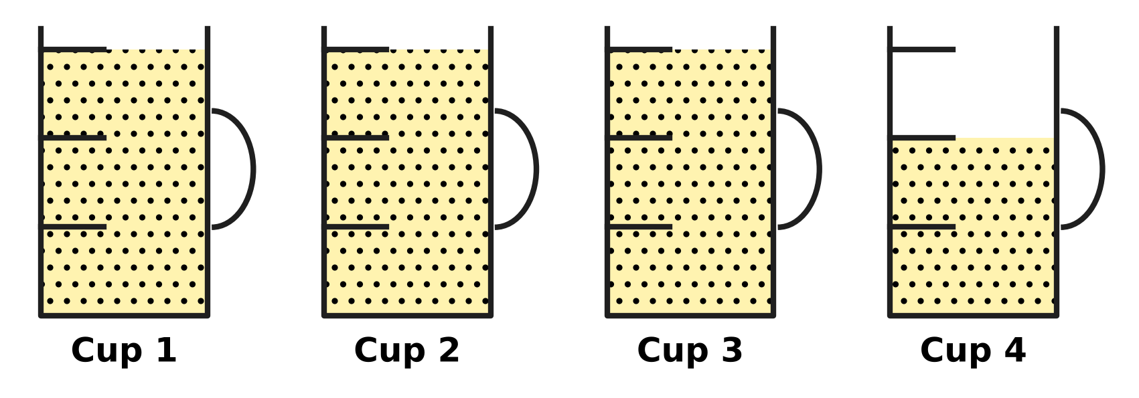
Q12. Look at the picture. A full measuring cup holds one cup of flour. Each cup is marked in three equal parts. How many cups of flour are there in all?
(A) $3\frac{2}{3}$ | (B) $3\frac{1}{3}$ | (C) $4\frac{2}{3}$ | (D) $2\frac{2}{3}$

Q13. Which of these fractions is the greatest?
(A) $\frac{2}{5}$ | (B) $\frac{2}{7}$ | (C) $\frac{2}{9}$ | (D) $\frac{2}{3}$

Q14. What is $\frac{7}{10}$ − $\frac{1}{5}$? Give the answer in its simplest form.
(A) $\frac{6}{10}$ | (B) $\frac{6}{5}$ | (C) $\frac{1}{2}$ | (D) $\frac{9}{10}$

Q15. On a mountain hike, Manu walks $2\frac{1}{3}$ km before lunch and $1\frac{3}{4}$ km after lunch. How far does he walk in all?
(A) $3\frac{1}{12}$ km | (B) $4\frac{5}{12}$ km | (C) $4\frac{1}{12}$ km | (D) $3\frac{4}{7}$ km

Q16. A fraction is equal to $\frac{2}{3}$. Its numerator (top number) and denominator (bottom number) add up to 20. What is the fraction?
(A) $\frac{8}{12}$ | (B) $\frac{12}{8}$ | (C) $\frac{6}{9}$ | (D) $\frac{4}{6}$

Part 4 — Geometry (Syllabus Chapter 5)
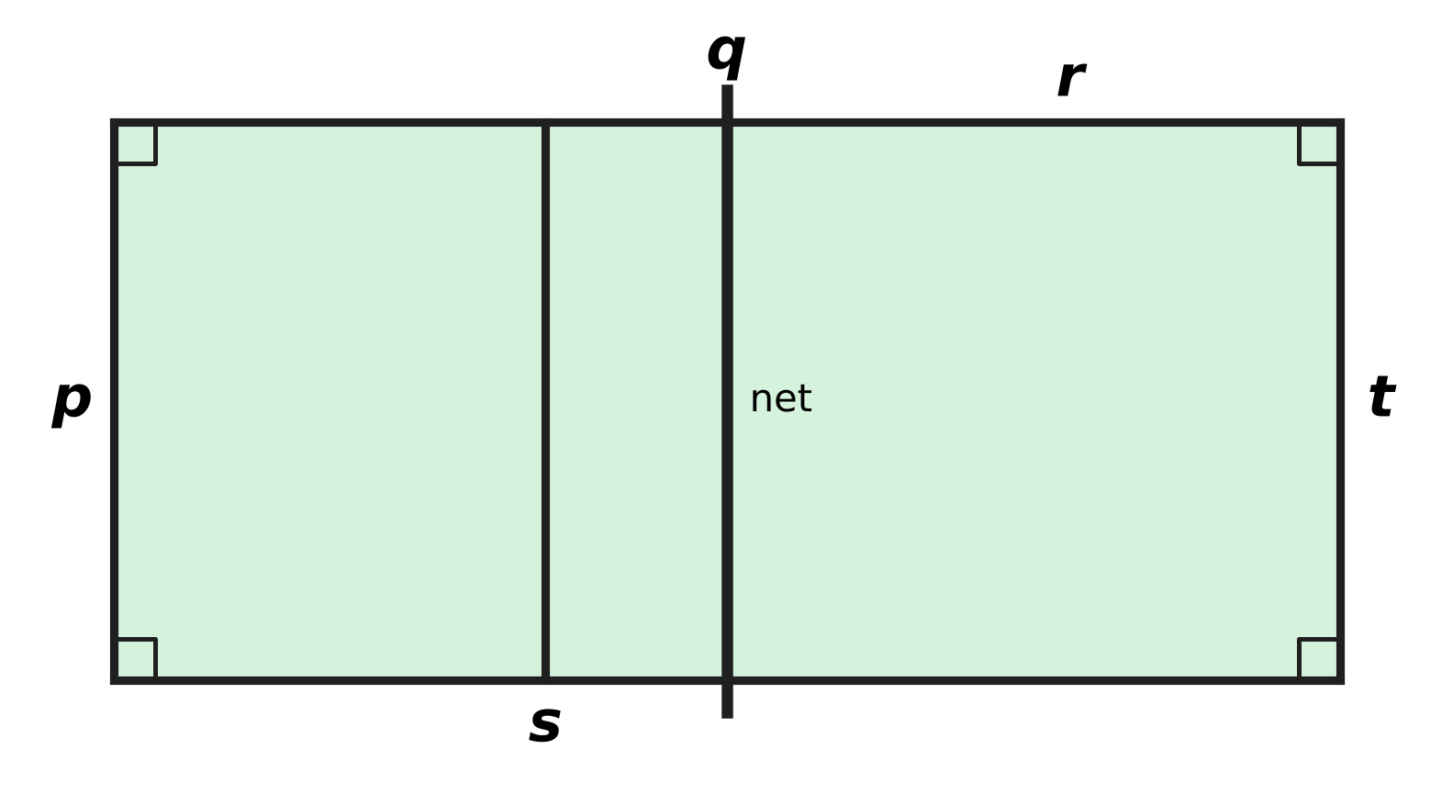
Q17. The picture shows some lines of a badminton court. The court is a rectangle. Which line is perpendicular to line p?
(A) Line t | (B) Line r | (C) Line s | (D) Line q

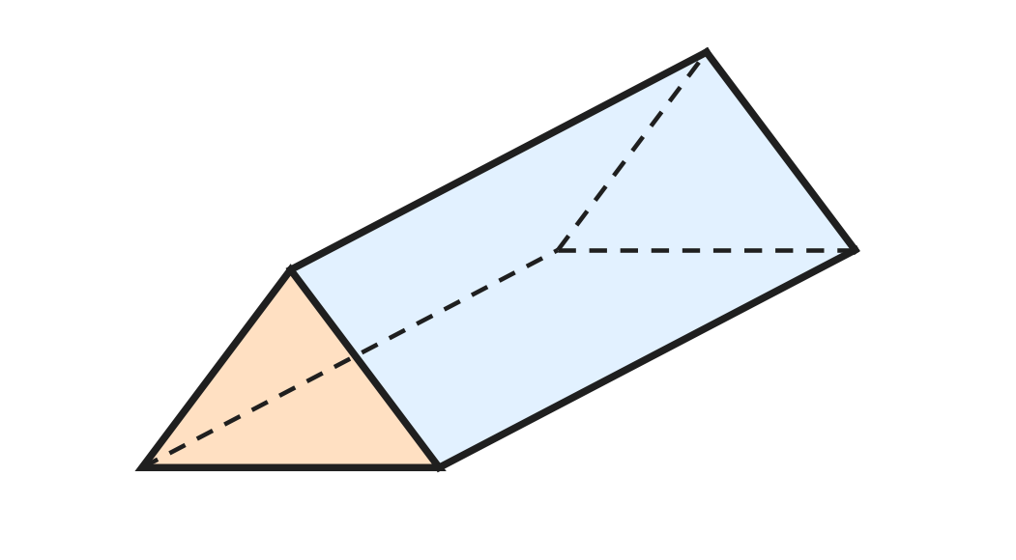
Q18. A crayon box is shaped like a triangular prism, as in the picture. Dashed lines are edges at the back. How many faces does the box have?
(A) 3 | (B) 9 | (C) 6 | (D) 5

Q19. A prism has 18 edges. How many faces does it have?
(A) 12 | (B) 8 | (C) 7 | (D) 6

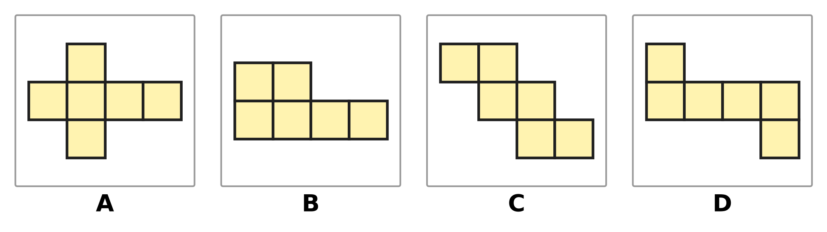
Q20. Each picture is made of 6 equal squares. Which picture is NOT a net of a cube?
(A) Picture A | (B) Picture B
(C) Picture C | (D) Picture D

Part 5 — Mensuration (Syllabus Chapter 6)
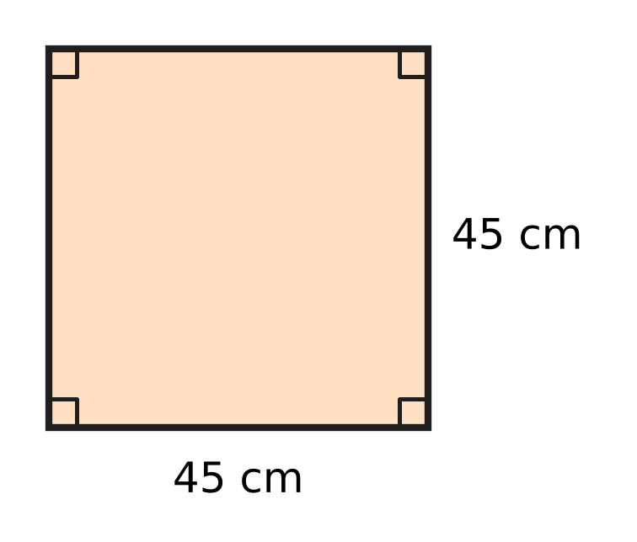
Q21. The picture shows the square top of a wooden shelf. Each side is 45 cm long. What is the area of the top?
(A) 90 sq cm | (B) 1,825 sq cm
(C) 180 sq cm | (D) 2,025 sq cm

Q22. An empty suitcase weighs 1 kg 650 g. Clothes weighing 875 g are packed in it. How much does the suitcase weigh now?
(A) 2 kg 525 g | (B) 2 kg 425 g
(C) 1 kg 525 g | (D) 2 kg 625 g

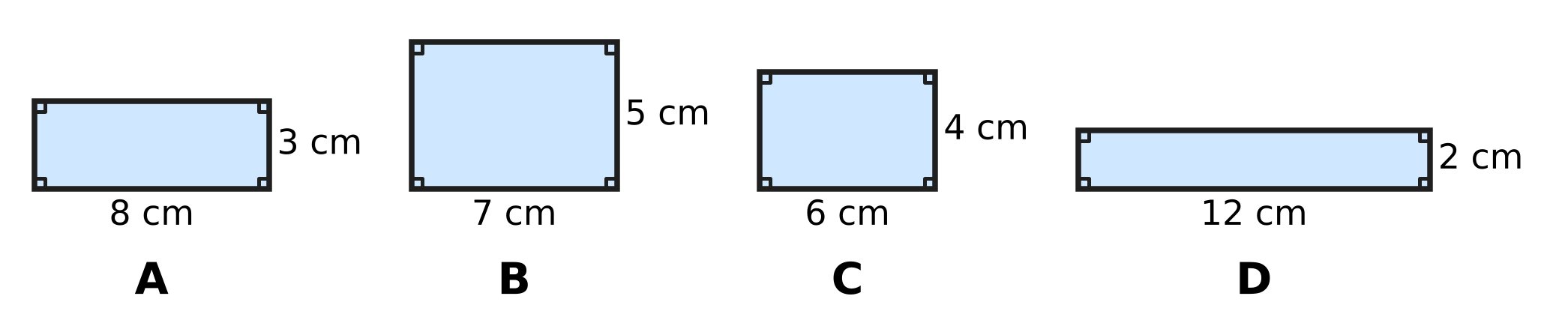
Q23. Look at the four rectangles. Which rectangle has a perimeter of 24 cm?
(A) Picture A | (B) Picture B
(C) Picture C | (D) Picture D

Q24. A metal pipe 3 m 60 cm long is cut into pieces of 40 cm each. How many pieces are there?
(A) 90 | (B) 15 | (C) 9 | (D) 7

Q25. A school stage is a rectangle 2 m long and 1 m 50 cm wide. It is fully covered with square tiles of side 25 cm. How many tiles are needed?
(A) 28 | (B) 48 | (C) 14 | (D) 32

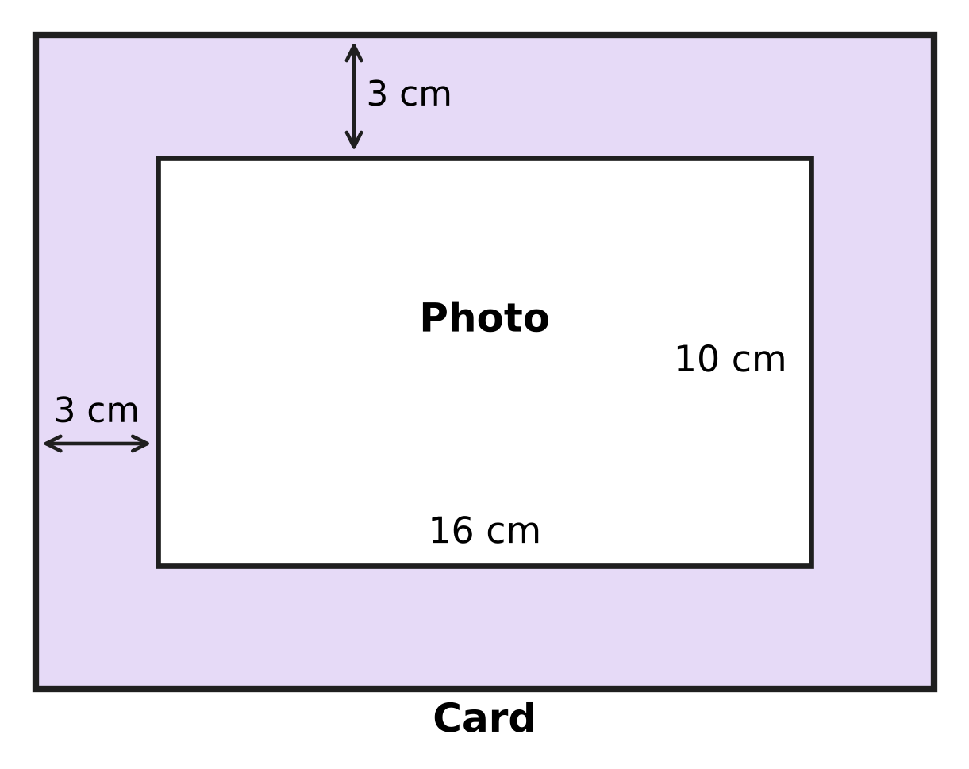
Q26. Look at the picture. A photo 16 cm long and 10 cm wide is pasted on a rectangular card. The card shows a border 3 cm wide on every side. What is the perimeter of the card?
(A) 64 cm | (B) 38 cm | (C) 76 cm | (D) 52 cm

Part 6 — Data Handling, Statistics & Probability (Syllabus Chapter 8)
Picture for Q27 and Q28
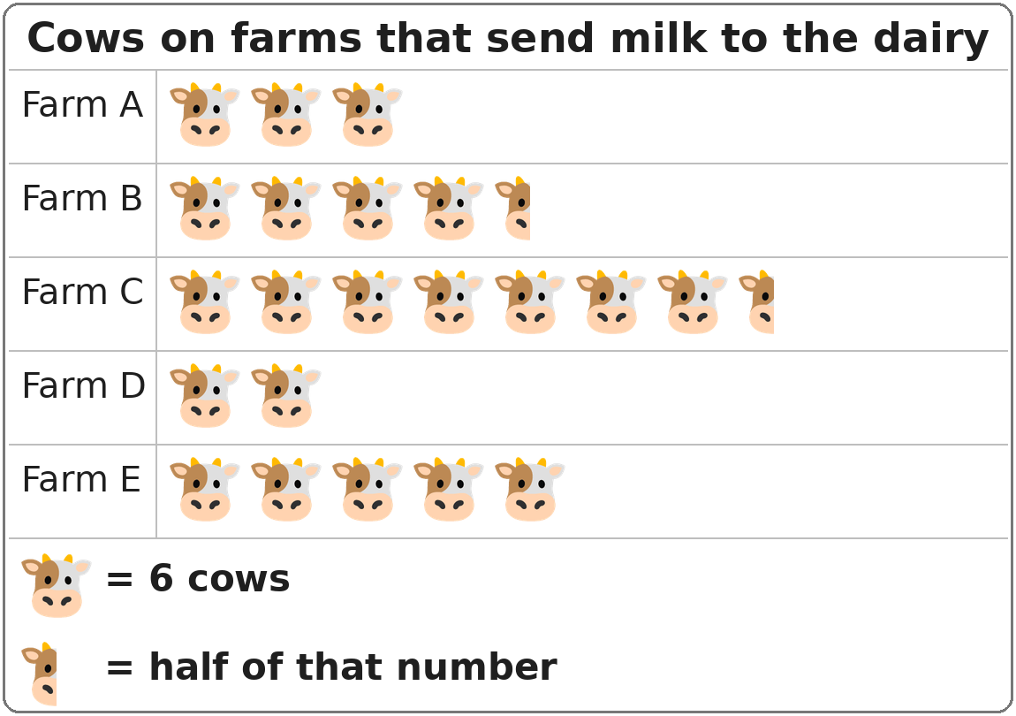
Q27. Look at the pictograph. How many cows are there on Farm B?
(A) 26 | (B) 24 | (C) 30 | (D) 27

Picture for Q27 and Q28
Q28. Look at the pictograph. Which two farms together have exactly as many cows as Farm C?
(A) Farm A and Farm B | (B) Farm B and Farm D
(C) Farm D and Farm E | (D) Farm A and Farm E

Part 7 — Applied Mathematics (Syllabus Chapter 9)
Q29. A film lasts 135 minutes. How long is the film in hours and minutes?
(A) 2 hours 35 minutes | (B) 2 hours 15 minutes
(C) 1 hour 15 minutes | (D) 1 hour 35 minutes

Q30. The 20th day of a month is a Saturday. On which day of the week does the month begin?
(A) Monday | (B) Thursday | (C) Sunday | (D) Tuesday

Q31. A family buys a table fan for ₹2,700. They pay with 3 notes of ₹500 and some notes of ₹100. How many ₹100 notes do they use?
(A) 27 | (B) 22 | (C) 12 | (D) 24

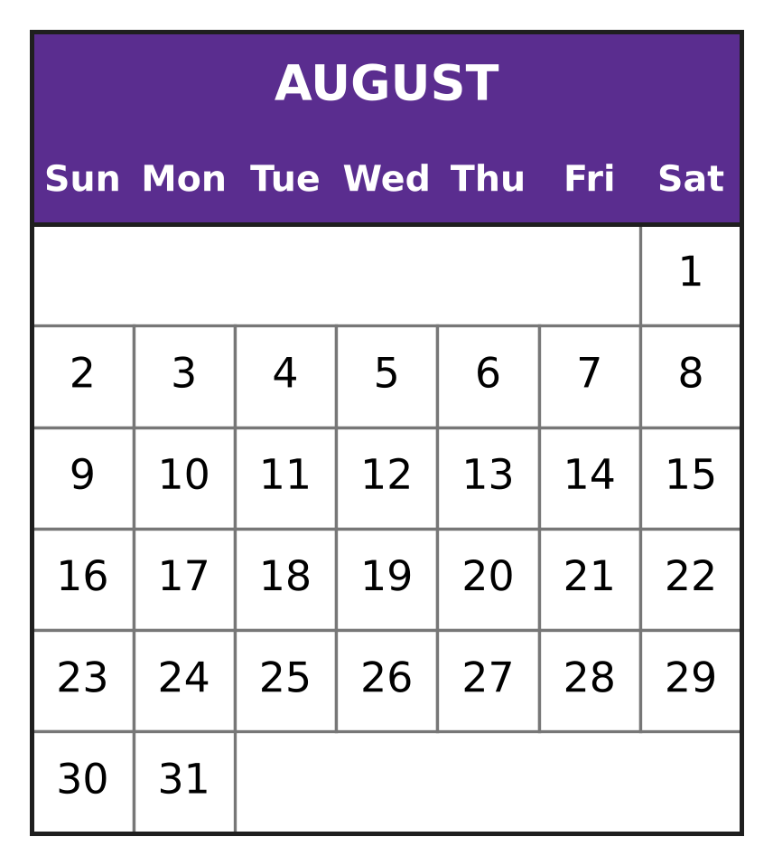
Q32. Look at the calendar for August. August has 31 days. What day of the week is 3 September of the same year?
(A) Monday | (B) Tuesday
(C) Wednesday | (D) Thursday

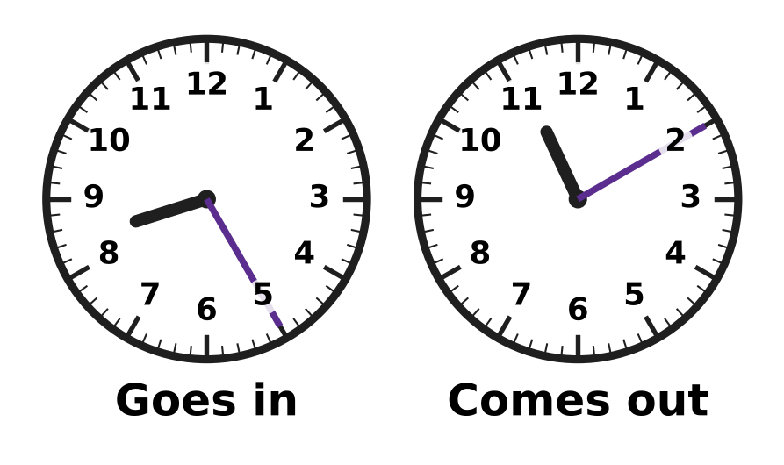
Q33. Vihaan visits a zoo one morning. The clocks show when he goes in and when he comes out. How long is he at the zoo?
(A) 2 hours 45 minutes | (B) 2 hours 15 minutes
(C) 3 hours 15 minutes | (D) 3 hours 45 minutes

Q34. At a plant nursery, Eva buys 4 saplings at ₹65 each and one clay pot for ₹90. She pays with a ₹500 note. How much change does she get?
(A) ₹345 | (B) ₹150 | (C) ₹170 | (D) ₹350

Part 8 — Mathematical Reasoning & Problem-Solving (Syllabus Chapter 10)
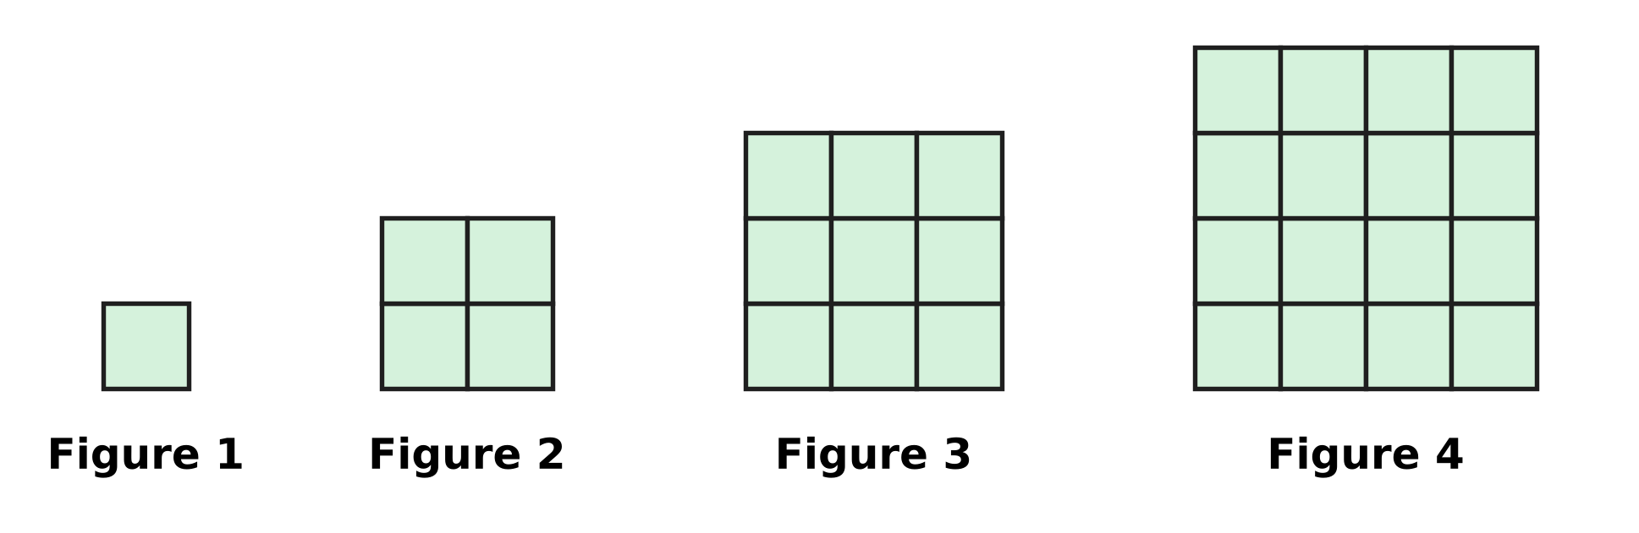
Q35. Look at the figures made of square tiles. The pattern goes on in the same way. Which figure will have 81 tiles?
(A) Figure 27 | (B) Figure 8
(C) Figure 10 | (D) Figure 9

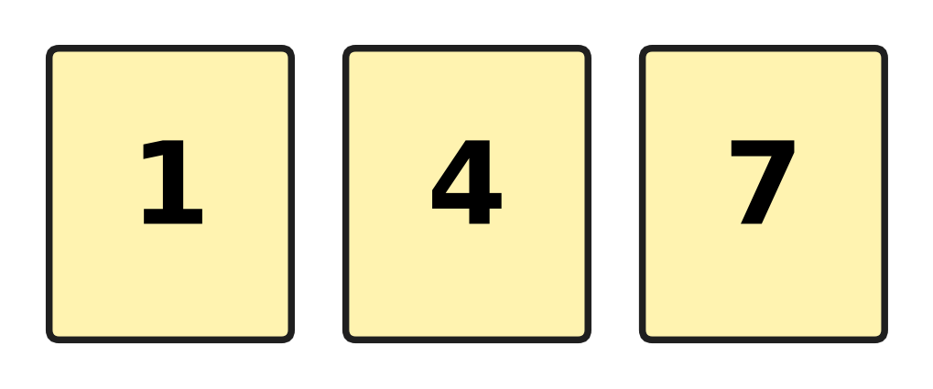
Q36. Ojas has the three cards shown. He makes 2-digit numbers by putting two different cards side by side. How many different 2-digit numbers can he make?
(A) 9 | (B) 3 | (C) 6 | (D) 4

Q37. How many days are there in July, August and September put together?
(A) 91 | (B) 90 | (C) 93 | (D) 92

Q38. Which number comes next in the series?
3, 7, 15, 31, 63, ___
(A) 111 | (B) 126 | (C) 127 | (D) 95

Q39. The hooks of a coat rack are numbered from 10 to 40. Kiara ties a tag on every hook whose tens digit is greater than its ones digit. For example, she ties a tag on hook 21. How many hooks get a tag?
(A) 10 | (B) 7 | (C) 4 | (D) 6

Q40. A month begins on a Friday and also ends on a Friday. How many days does this month have?
(A) 29 | (B) 30 | (C) 28 | (D) 31

SECTION II — Star Questions 5 questions × 4 marks each
Q41. On the morning of Monday, 3 March, a can of lamp oil is $\frac{5}{6}$ full. From Monday to Saturday, the lamps use $\frac{1}{12}$ of a full can each day. No oil is used on Sundays. On which day does the can become empty? [4 marks]
(A) Thursday, 13 March | (B) Friday, 7 March
(C) Saturday, 15 March | (D) Wednesday, 12 March

Q42. The first river ferry of the day leaves at 6:20 a.m. After that, a ferry leaves every 40 minutes. The last ferry of the day must leave no later than 1:00 p.m. How many ferries leave in the day? [4 marks]
(A) 12 | (B) 9 | (C) 10 | (D) 11

Q43. Use each of the digits 4, 9, 0, 5 and 1 exactly once to make a 5-digit number. Which of these numbers, made in this way, is closest to 50,000? [4 marks]
(A) 50,419 | (B) 49,150 | (C) 50,149 | (D) 49,510

Q44. Sonal and Chetan buy a gift together. Sonal pays $\frac{5}{12}$ of the price and Chetan pays the rest. Chetan pays ₹70 more than Sonal. Chetan pays his share with a ₹500 note. How much change does Chetan get? [4 marks]
(A) ₹80 | (B) ₹255 | (C) ₹325 | (D) ₹10

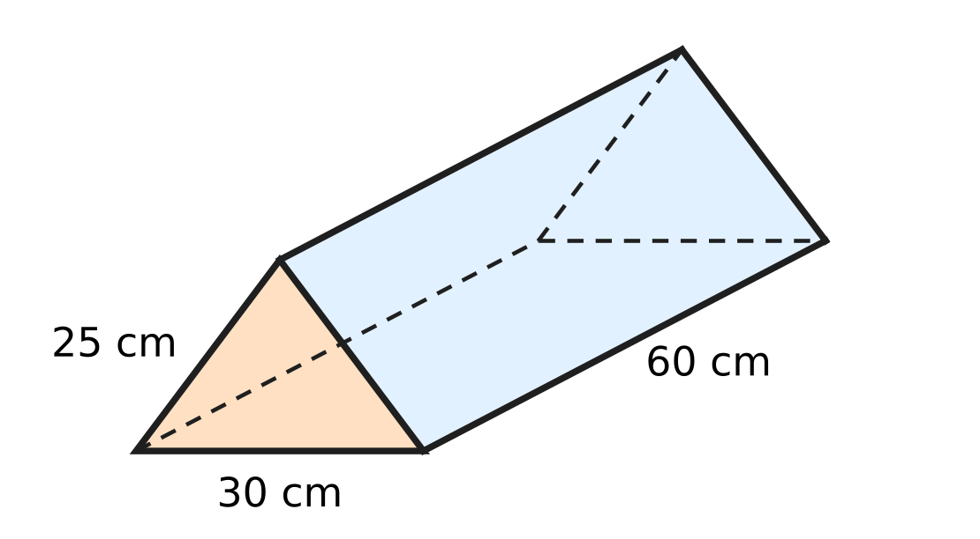
Q45. The picture shows a wire model of a triangular prism. Wire runs along every edge. Each triangle end has sides 25 cm, 25 cm and 30 cm. Each of the three long edges is 60 cm. The model is made from a 4 m piece of wire. How much wire is left over? [4 marks]
(A) 340 cm | (B) 120 cm | (C) 140 cm | (D) 60 cm

Answer Sheet AMO Level 1 · Class 4 · Practice Paper 4
Name: | School: | Roll No.:
Shade or tick one circle for each question.
1. Ⓐ Ⓑ Ⓒ Ⓓ | 16. Ⓐ Ⓑ Ⓒ Ⓓ | 31. Ⓐ Ⓑ Ⓒ Ⓓ
2. Ⓐ Ⓑ Ⓒ Ⓓ | 17. Ⓐ Ⓑ Ⓒ Ⓓ | 32. Ⓐ Ⓑ Ⓒ Ⓓ
3. Ⓐ Ⓑ Ⓒ Ⓓ | 18. Ⓐ Ⓑ Ⓒ Ⓓ | 33. Ⓐ Ⓑ Ⓒ Ⓓ
4. Ⓐ Ⓑ Ⓒ Ⓓ | 19. Ⓐ Ⓑ Ⓒ Ⓓ | 34. Ⓐ Ⓑ Ⓒ Ⓓ
5. Ⓐ Ⓑ Ⓒ Ⓓ | 20. Ⓐ Ⓑ Ⓒ Ⓓ | 35. Ⓐ Ⓑ Ⓒ Ⓓ
6. Ⓐ Ⓑ Ⓒ Ⓓ | 21. Ⓐ Ⓑ Ⓒ Ⓓ | 36. Ⓐ Ⓑ Ⓒ Ⓓ
7. Ⓐ Ⓑ Ⓒ Ⓓ | 22. Ⓐ Ⓑ Ⓒ Ⓓ | 37. Ⓐ Ⓑ Ⓒ Ⓓ
8. Ⓐ Ⓑ Ⓒ Ⓓ | 23. Ⓐ Ⓑ Ⓒ Ⓓ | 38. Ⓐ Ⓑ Ⓒ Ⓓ
9. Ⓐ Ⓑ Ⓒ Ⓓ | 24. Ⓐ Ⓑ Ⓒ Ⓓ | 39. Ⓐ Ⓑ Ⓒ Ⓓ
10. Ⓐ Ⓑ Ⓒ Ⓓ | 25. Ⓐ Ⓑ Ⓒ Ⓓ | 40. Ⓐ Ⓑ Ⓒ Ⓓ
11. Ⓐ Ⓑ Ⓒ Ⓓ | 26. Ⓐ Ⓑ Ⓒ Ⓓ | 41. Ⓐ Ⓑ Ⓒ Ⓓ
12. Ⓐ Ⓑ Ⓒ Ⓓ | 27. Ⓐ Ⓑ Ⓒ Ⓓ | 42. Ⓐ Ⓑ Ⓒ Ⓓ
13. Ⓐ Ⓑ Ⓒ Ⓓ | 28. Ⓐ Ⓑ Ⓒ Ⓓ | 43. Ⓐ Ⓑ Ⓒ Ⓓ
14. Ⓐ Ⓑ Ⓒ Ⓓ | 29. Ⓐ Ⓑ Ⓒ Ⓓ | 44. Ⓐ Ⓑ Ⓒ Ⓓ
15. Ⓐ Ⓑ Ⓒ Ⓓ | 30. Ⓐ Ⓑ Ⓒ Ⓓ | 45. Ⓐ Ⓑ Ⓒ Ⓓ
Q41–Q45 are Section II Star Questions (4 marks each).
For the parent or teacher
Section I correct: ______ / 40 × 2 = ______ marks Section II correct: ______ / 5 × 4 = ______ marks
Correct: ______ / 45 Score: ______ / 100
Answer Key and Solutions AMO Level 1 · Class 4 · Practice Paper 4
Quick answers
1 C | 6 C | 11 B | 16 A | 21 D | 26 C | 31 C | 36 C | 41 A
2 D | 7 A | 12 A | 17 B | 22 A | 27 D | 32 D | 37 D | 42 D
3 A | 8 C | 13 D | 18 D | 23 B | 28 A | 33 A | 38 C | 43 C
4 D | 9 B | 14 C | 19 B | 24 C | 29 B | 34 B | 39 B | 44 B
5 A | 10 D | 15 C | 20 B | 25 B | 30 A | 35 D | 40 A | 45 D
Solutions
Q | Part · level | Answer | Why?
1 | Part 1 · Ch1 · Easy | (C) Forty thousand seventy-five | The number 40,075 is 40 thousands and 75 ones, so it is read as forty thousand seventy-five.
2 | Part 1 · Ch1 · Easy | (D) VC | V is never written before a bigger letter to take it away, so VC is wrong. The number 95 is written XCV.
3 | Part 1 · Ch1 · Easy | (A) 800 | In 47,860, the digit 8 is in the hundreds place, so its place value is 8 × 100 = 800.
4 | Part 1 · Ch1 · Easy | (D) 96,750 | Each number is 250 less than the one before: … 97,250; 97,000; 96,750. The first one below 97,000 is 96,750.
5 | Part 1 · Ch1 · Medium | (A) 36 | Packets = 36,500 ÷ 100 = 365. Full cartons = 365 ÷ 10 = 36 (5 packets are left over).
6 | Part 2 · Ch2 · Easy | (C) 864 | Chairs = 24 × 36 = 24 × 30 + 24 × 6 = 720 + 144 = 864.
7 | Part 2 · Ch2 · Easy | (A) 4 | Here 4,150 ÷ 6 = 691 remainder 4. So 691 boxes are full and 4 eggs are left over.
8 | Part 2 · Ch2 · Easy | (C) 23,642 | Difference = 70,000 − 46,358 = 23,642. Check: 46,358 + 23,642 = 70,000.
9 | Part 2 · Ch2 · Medium | (B) 80 | The number is 5,120 ÷ 8 = 640. The correct answer is 640 ÷ 8 = 80.
10 | Part 2 · Ch2 · Medium | (D) 213 | Bulbs in all = 18 × 45 = 810. Bulbs left = 810 − 597 = 213.
11 | Part 3 · Ch3 · Easy | (B) $\frac{5}{12}$ | The numbers 5 and 12 have no common factor other than 1, so $\frac{5}{12}$ cannot be simplified. The others become $\frac{2}{3}$, $\frac{2}{5}$ and $\frac{3}{4}$.
12 | Part 3 · Ch3 · Easy | (A) $3\frac{2}{3}$ | Cups 1, 2 and 3 are full (3 cups) and Cup 4 is $\frac{2}{3}$ full, so there are $3\frac{2}{3}$ cups in all.
13 | Part 3 · Ch3 · Easy | (D) $\frac{2}{3}$ | All four have 2 parts on top. The fewer the equal parts in a whole, the bigger each part, so $\frac{2}{3}$ is the greatest.
14 | Part 3 · Ch3 · Medium | (C) $\frac{1}{2}$ | $\frac{1}{5}$ = $\frac{2}{10}$. So $\frac{7}{10}$ − $\frac{2}{10}$ = $\frac{5}{10}$ = $\frac{1}{2}$.
15 | Part 3 · Ch3 · Medium | (C) $4\frac{1}{12}$ km | $\frac{1}{3}$ + $\frac{3}{4}$ = $\frac{4}{12}$ + $\frac{9}{12}$ = $\frac{13}{12}$ = $1\frac{1}{12}$. So 2 + 1 + $1\frac{1}{12}$ = $4\frac{1}{12}$ km.
16 | Part 3 · Ch3 · Medium | (A) $\frac{8}{12}$ | Here 2 + 3 = 5 and 20 = 5 × 4. So multiply top and bottom by 4: $\frac{8}{12}$, and 8 + 12 = 20.
17 | Part 4 · Ch5 · Easy | (B) Line r | Line r meets line p at a square corner, so it is perpendicular to p. Lines q, s and t are parallel to p.
18 | Part 4 · Ch5 · Easy | (D) 5 | A triangular prism has 2 triangle faces and 3 rectangle faces: 2 + 3 = 5 faces.
19 | Part 4 · Ch5 · Medium | (B) 8 | A prism has 3 edges for each side of its end shape, so the end has 18 ÷ 3 = 6 sides. Faces = 6 side faces + 2 ends = 8.
20 | Part 4 · Ch5 · Medium | (B) Picture B | In Picture B, four squares form a 2 by 2 block, so two squares would land on the same face when folded. The other three fold into a cube.
21 | Part 5 · Ch6 · Easy | (D) 2,025 sq cm | Area of a square = side × side = 45 × 45 = 2,025 sq cm.
22 | Part 5 · Ch6 · Easy | (A) 2 kg 525 g | Total = 1,650 g + 875 g = 2,525 g = 2 kg 525 g.
23 | Part 5 · Ch6 · Easy | (B) Picture B | Perimeter = 2 × (length + breadth). For Picture B: 2 × (7 + 5) = 24 cm. The others give 22 cm, 20 cm and 28 cm.
24 | Part 5 · Ch6 · Easy | (C) 9 | Length = 3 m 60 cm = 360 cm. Pieces = 360 ÷ 40 = 9.
25 | Part 5 · Ch6 · Medium | (B) 48 | Along the length: 200 ÷ 25 = 8 tiles. Along the width: 150 ÷ 25 = 6 tiles. Tiles = 8 × 6 = 48.
26 | Part 5 · Ch6 · Medium | (C) 76 cm | The card is 16 + 3 + 3 = 22 cm long and 10 + 3 + 3 = 16 cm wide. Perimeter = 2 × (22 + 16) = 76 cm.
27 | Part 6 · Ch8 · Easy | (D) 27 | Farm B has 4 and a half pictures. That is 4 × 6 = 24 cows plus half of 6 = 3 cows, so 27 cows.
28 | Part 6 · Ch8 · Medium | (A) Farm A and Farm B | Farm C has 7 and a half × 6 = 45 cows. Farm A (18) + Farm B (27) = 45. No other pair makes 45.
29 | Part 7 · Ch9 · Easy | (B) 2 hours 15 minutes | Here 135 minutes = 60 + 60 + 15 minutes = 2 hours 15 minutes.
30 | Part 7 · Ch9 · Easy | (A) Monday | The 1st is 19 days before the 20th. Since 19 = 14 + 5, go back 5 days from Saturday: Monday.
31 | Part 7 · Ch9 · Easy | (C) 12 | Three notes of ₹500 make ₹1,500. Then ₹2,700 − ₹1,500 = ₹1,200, which is 12 notes of ₹100.
32 | Part 7 · Ch9 · Easy | (D) Thursday | The calendar shows 31 August is a Monday. So 1 September is a Tuesday, 2 September a Wednesday and 3 September a Thursday.
33 | Part 7 · Ch9 · Medium | (A) 2 hours 45 minutes | He goes in at 8:25 and comes out at 11:10. 8:25 to 9:00 is 35 minutes and 9:00 to 11:10 is 2 hours 10 minutes, so he is there for 2 hours 45 minutes.
34 | Part 7 · Ch9 · Medium | (B) ₹150 | Bill = 4 × ₹65 + ₹90 = ₹260 + ₹90 = ₹350. Change = ₹500 − ₹350 = ₹150.
35 | Part 8 · Ch10 · Easy | (D) Figure 9 | Figure 1 has 1 × 1 tiles, Figure 2 has 2 × 2, and so on. Since 9 × 9 = 81, Figure 9 has 81 tiles.
36 | Part 8 · Ch10 · Easy | (C) 6 | The numbers are 14, 17, 41, 47, 71 and 74. That is 6 numbers.
37 | Part 8 · Ch10 · Easy | (D) 92 | July has 31 days, August has 31 days and September has 30 days. Total = 31 + 31 + 30 = 92.
38 | Part 8 · Ch10 · Medium | (C) 127 | Each number is double the one before, plus 1: 63 × 2 + 1 = 127.
39 | Part 8 · Ch10 · Medium | (B) 7 | Tens digit 1: 10. Tens digit 2: 20, 21. Tens digit 3: 30, 31, 32. Tens digit 4: 40. That is 1 + 2 + 3 + 1 = 7 hooks.
40 | Part 8 · Ch10 · Medium | (A) 29 | The last day is 7, 14, 21 or 28 days after the 1st. A month has 28 to 31 days, so the last day is the 29th: the month has 29 days.
41 | Section II · Ch3 + Ch10 · Hard | (A) Thursday, 13 March | $\frac{5}{6}$ = $\frac{10}{12}$, so the oil lasts for 10 days of use. Monday 3 to Saturday 8 March uses 6 days. Sunday 9 March is skipped, and 10 to 13 March uses 4 more. It is empty on Thursday, 13 March.
42 | Section II · Ch9 + Ch10 · Hard | (D) 11 | From 6:20 a.m. to 1:00 p.m. is 6 hours 40 minutes = 400 minutes. There are 400 ÷ 40 = 10 gaps, so 10 ferries leave after the first one: 11 ferries (the last leaves at 1:00 p.m.).
43 | Section II · Ch1 + Ch10 · Hard | (C) 50,149 | The closest number above 50,000 is 50,149 (149 more). The closest below is 49,510 (490 less). Since 149 < 490, 50,149 is the closest.
44 | Section II · Ch3 + Ch9 · Hard | (B) ₹255 | Chetan pays $\frac{7}{12}$, so he pays $\frac{2}{12}$ = $\frac{1}{6}$ of the price more than Sonal. $\frac{1}{6}$ of the price is ₹70, so the price is ₹420. Chetan pays $\frac{7}{12}$ of ₹420 = ₹245 and gets ₹500 − ₹245 = ₹255.
45 | Section II · Ch5 + Ch6 · Hard | (D) 60 cm | Each triangle end uses 30 + 25 + 25 = 80 cm, so two ends use 160 cm. The 3 long edges use 3 × 60 = 180 cm. Total = 340 cm. The wire is 4 m = 400 cm, so 400 − 340 = 60 cm is left.

