UNLOCK IQ INSTITUTE
Realize Your True Potential
Aryabhatta Maths Olympiad (AMO)
Level 1 — Practice Paper 5
CLASS 4

Questions | 45 multiple-choice questions
Marks | 100
Time | 60 minutes
Section I | 40 questions × 2 marks = 80 marks
Section II | 5 Star Questions × 4 marks = 20 marks
Negative marking | No negative marking
Calculator | Not allowed
Chapters | Number System · Operations · Fractions, Decimals & Percentages · Geometry · Mensuration · Data Handling · Applied Mathematics · Mathematical Reasoning

Hello, friend!
• Every question has four answer choices: (A), (B), (C) and (D). Only one is correct.
• Read each question and look at its picture carefully. Then mark your answer on the answer sheet at the end.
• Section I has 40 questions of 2 marks each. Section II has 5 Star Questions of 4 marks each.
• There is no negative marking, so try every question.
• Do not use a calculator. You may do rough work on a separate sheet.
• All figures are not necessarily drawn to scale unless stated.

For parents and teachers
Print or view this paper in colour. Pictures are part of the questions.
Parts follow the AMO syllabus chapters. Chapters 4 and 7 are not part of the Class 4 syllabus, so the chapter numbers shown in the Part headings have gaps.
The answer sheet and the answer key are at the end. Remove only the answer key before the child begins.

Name: | School: | Roll No.:

SECTION I 40 questions × 2 marks each
Part 1 — Number System (Syllabus Chapter 1)
Q1. I am a 5-digit number. My ten thousands digit is 8, my hundreds digit is 5 and my ones digit is 3. All my other digits are 0. What number am I?
(A) 85,003 | (B) 80,530 | (C) 8,503 | (D) 80,503

Q2. Which Roman numeral stands for the number exactly halfway between XL and LX?
(A) L | (B) C | (C) XLV | (D) XX

Q3. In May, 49,560 cars used a big car park. In June, 1,000 more cars used it than in May. How many cars used the car park in June?
(A) 49,660 | (B) 59,560 | (C) 50,560 | (D) 49,570

Q4. What is the greatest 5-digit even number in which all five digits are different?
(A) 98,746 | (B) 98,764 | (C) 99,998 | (D) 98,765

Q5. In a number pattern, each number is 2,500 less than the number before it. The 5th number of the pattern is 41,000. What is the 1st number?
(A) 43,500 | (B) 31,000 | (C) 51,000 | (D) 53,500

Part 2 — Operations & Number Properties (Syllabus Chapter 2)
Q6. Tarun added 38,476 + 25,839 and got 63,315. He forgot to carry once, so his answer is wrong. What is the correct sum?
(A) 64,315 | (B) 12,637 | (C) 64,215 | (D) 54,315

Q7. Group the numbers in a helpful way and find 25 × 37 × 4.
(A) 370 | (B) 37,000 | (C) 925 | (D) 3,700

Q8. A fishing boat brings back 3,456 fish. They are packed equally into 9 boxes. How many fish go into each box?
(A) 374 | (B) 384 | (C) 31,104 | (D) 3,447

Q9. Myra rounds a whole number to the nearest thousand and gets 27,000. What is the greatest number she could have started with?
(A) 27,500 | (B) 27,999 | (C) 26,500 | (D) 27,499

Q10. It is given that 36 × 47 = 1,692. Without multiplying again, what is 36 × 48?
(A) 1,740 | (B) 1,739 | (C) 1,728 | (D) 1,693

Part 3 — Fractions, Decimals & Percentages (Syllabus Chapter 3)
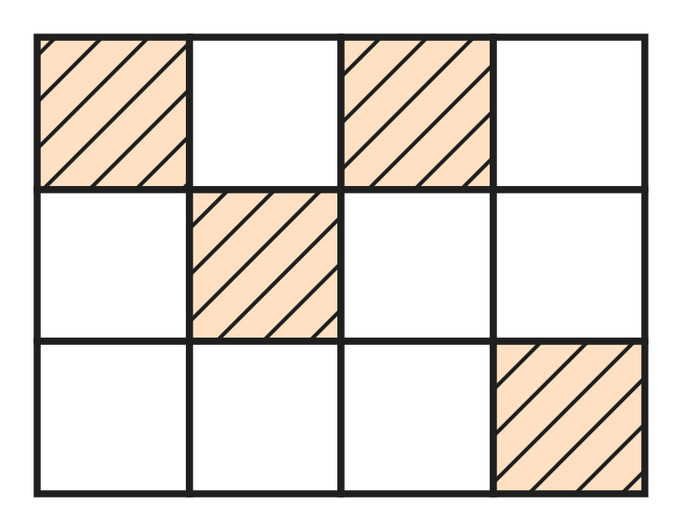
Q11. Look at the picture of a floor made of 12 equal square tiles. Some tiles are coloured. How many MORE tiles must be coloured so that $\frac{3}{4}$ of the floor is coloured?
(A) 5 | (B) 3 | (C) 9 | (D) 8

Q12. Which improper fraction is equal to the mixed number $4\frac{2}{3}$?
(A) $\frac{10}{3}$ | (B) $\frac{11}{3}$ | (C) $\frac{14}{3}$ | (D) $\frac{12}{3}$

Q13. On a rainy day, it rained for $\frac{1}{6}$ hour in the morning and for $\frac{5}{12}$ hour in the evening. What fraction of an hour did it rain in total?
(A) $\frac{7}{12}$ hour | (B) $\frac{6}{12}$ hour
(C) $\frac{3}{12}$ hour | (D) $\frac{6}{18}$ hour

Q14. Which fraction is greater than $\frac{1}{2}$ and less than $\frac{3}{4}$?
(A) $\frac{7}{8}$ | (B) $\frac{3}{8}$ | (C) $\frac{5}{6}$ | (D) $\frac{5}{8}$

Q15. A tea stall used $1\frac{3}{4}$ L of milk in the morning. Now $2\frac{1}{2}$ L of milk is left. How much milk did it have at the start?
(A) $3\frac{4}{6}$ L | (B) $4\frac{1}{4}$ L | (C) $3\frac{1}{4}$ L | (D) $\frac{3}{4}$ L

Q16. At an ice-cream stall, one scoop is $\frac{1}{12}$ of a tub. There are $2\frac{1}{3}$ tubs of ice-cream left. How many full scoops can be served?
(A) 25 | (B) 7 | (C) 28 | (D) 24

Part 4 — Geometry (Syllabus Chapter 5)
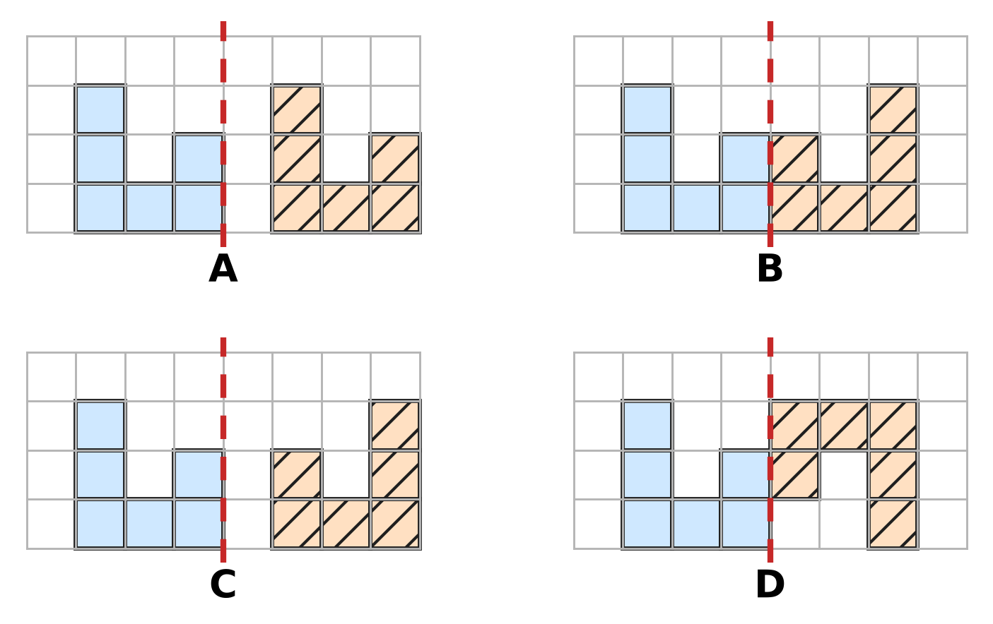
Q17. In each picture, the blue shape is on the left of the dashed mirror line. Which picture shows its correct mirror image on the right?
(A) Picture A | (B) Picture B
(C) Picture C | (D) Picture D

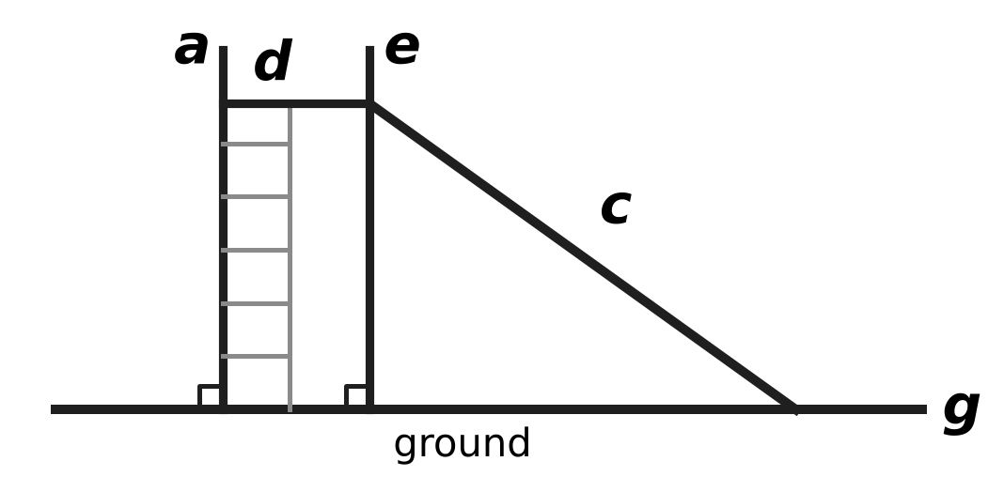
Q18. The picture shows a playground slide. Imagine that each marked line continues in both directions. Which line meets the ground line g but is NOT perpendicular to it?
(A) Line d | (B) Line c | (C) Line a | (D) Line e

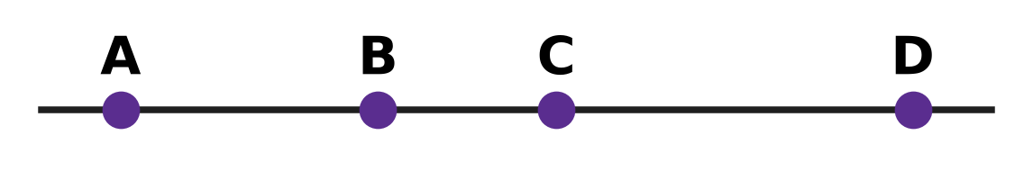
Q19. Look at the four points A, B, C and D on a straight line. How many different line segments have two of these points as their end points?
(A) 3 | (B) 4 | (C) 12 | (D) 6

Q20. Hana's solid has as many faces as vertices. It has 10 edges. For such solids, faces + vertices = edges + 2. How many faces does Hana's solid have?
(A) 6 | (B) 5 | (C) 12 | (D) 4

Part 5 — Mensuration (Syllabus Chapter 6)
Q21. The road between two villages is 3 km 40 m long. How many metres long is the road?
(A) 3,040 m | (B) 3,400 m | (C) 30,040 m | (D) 340 m

Q22. A cook shares 5 kg of rice equally into 4 bags. How much rice goes into each bag?
(A) 1 kg 500 g | (B) 1 kg 250 g
(C) 1 kg 200 g | (D) 1 kg 25 g

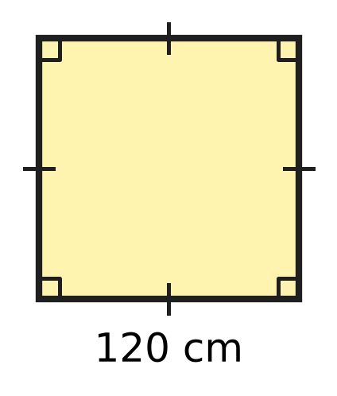
Q23. The floor of a hot-air balloon basket is a square with side 120 cm, as in the picture. What is the perimeter of the floor?
(A) 2 m 40 cm | (B) 48 m
(C) 4 m 8 cm | (D) 4 m 80 cm

Q24. A sports ground is a rectangle 45 m long and 28 m wide. What is its area?
(A) 73 sq m | (B) 146 sq m
(C) 1,260 sq m | (D) 1,160 sq m

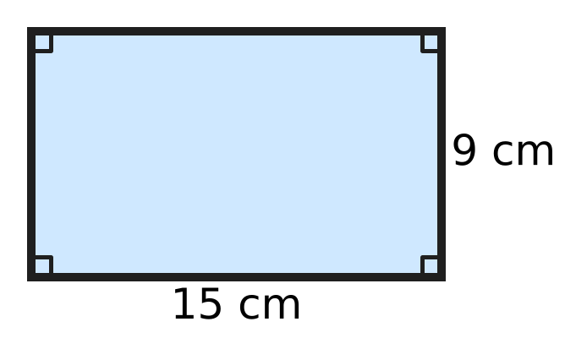
Q25. A piece of wire is bent to make the rectangle in the picture. It is then opened and bent again to make a square, using all the wire. How long is each side of the square?
(A) 24 cm | (B) 6 cm | (C) 48 cm | (D) 12 cm

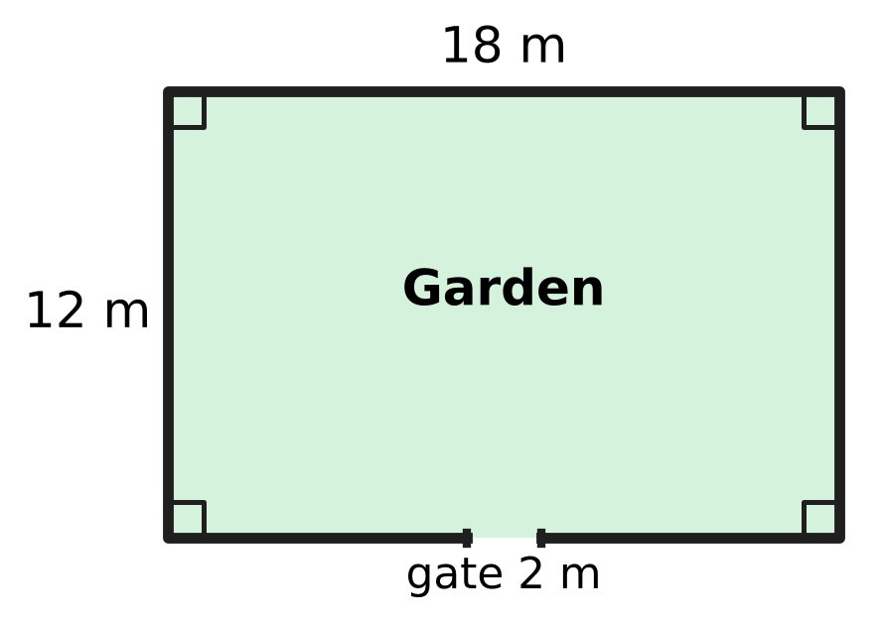
Q26. A fence goes all around the rectangular garden in the picture, except for a gate 2 m wide. How long is the fence?
(A) 58 m | (B) 56 m | (C) 60 m | (D) 28 m

Part 6 — Data Handling, Statistics & Probability (Syllabus Chapter 8)
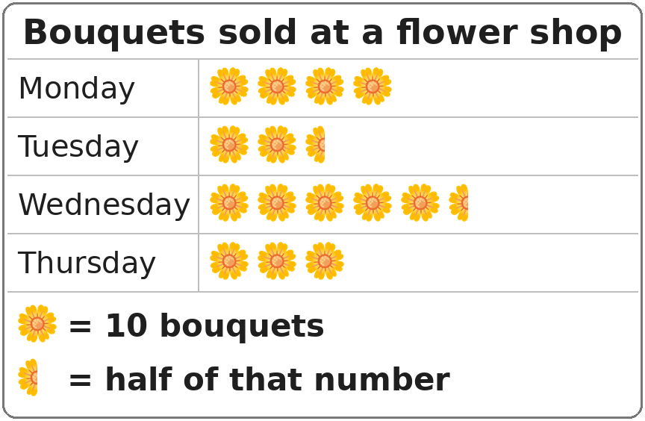
Q27. Look at the pictograph. How many bouquets were sold on Wednesday?
(A) 50 | (B) 55 | (C) 60 | (D) 6

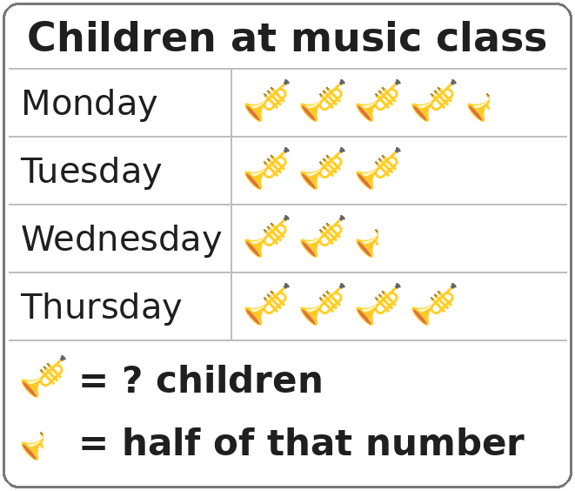
Q28. Look at the pictograph. The number in its key is missing. On Thursday, 24 children came to music class. How many children came on Monday?
(A) 30 | (B) 18 | (C) 27 | (D) 24

Part 7 — Applied Mathematics (Syllabus Chapter 9)
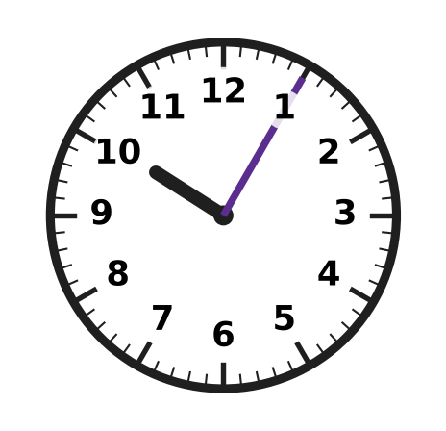
Q29. Dhruv's clock is 7 minutes fast. It shows the time in the picture. What is the correct time?
(A) 10:58 | (B) 9:58 | (C) 9:05 | (D) 10:12

Q30. A football practice starts when the minute hand of the school clock points to 3. It ends later in the same hour, when the minute hand points to 10. How many minutes does the practice last?
(A) 7 minutes | (B) 50 minutes
(C) 35 minutes | (D) 25 minutes

Q31. Yash has saved ₹428. The school bag he wants costs ₹615. How much more money does he need to buy the bag?
(A) ₹197 | (B) ₹1,043 | (C) ₹213 | (D) ₹187

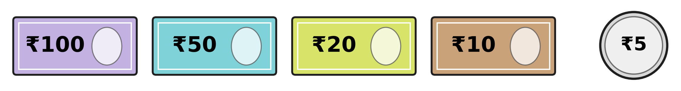
Q32. Isha has many notes and coins of each kind shown. She pays exactly ₹235 for a lunch box, using as few notes and coins as possible. How many notes and coins does she use?
(A) 5 | (B) 4 | (C) 6 | (D) 7

Q33. The lift in a building is checked on the last Friday of every month. This year, 1 December is a Monday, and December has 31 days. On which date is the lift checked in December?
(A) 19 December | (B) 26 December
(C) 31 December | (D) 29 December

Q34. A ticket for the school play costs ₹30 for a child and ₹50 for an adult. Zubin buys 4 child tickets and some adult tickets. He pays ₹420 in all. How many adult tickets does he buy?
(A) 14 | (B) 10 | (C) 8 | (D) 6

Part 8 — Mathematical Reasoning & Problem-Solving (Syllabus Chapter 10)
Q35. Which number comes next? 96, 48, 24, 12, ___
(A) 4 | (B) 0 | (C) 6 | (D) 8

Q36. Usha reads every page of a book from page 27 to page 64, including both these pages. How many pages does she read?
(A) 38 | (B) 37 | (C) 91 | (D) 36

Q37. How many weeks and days are there in 75 days?
(A) 11 weeks 2 days | (B) 10 weeks 5 days
(C) 10 weeks 4 days | (D) 7 weeks 5 days

Q38. What is the missing first number in this pattern? ___, 14, 20, 28, 38, 50
(A) 6 | (B) 12 | (C) 8 | (D) 10

Q39. Thirty cards are numbered 1 to 30. A card gets a star if its number is a multiple of 3 or a multiple of 5. How many cards get a star?
(A) 14 | (B) 10 | (C) 6 | (D) 16

Q40. A science exhibition is open for 12 days in a row. Its last day is Tuesday, 14 October. Both the first and the last days are counted. On which day of the week did it open?
(A) Thursday | (B) Sunday | (C) Friday | (D) Saturday

SECTION II — Star Questions 5 questions × 4 marks each
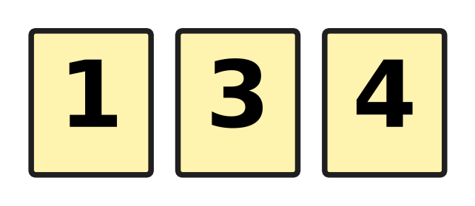
Q41. Heena has the three cards in the picture. She uses all three to make a mixed number, such as $3\frac{1}{4}$. One card is the whole number. The other two make a fraction less than 1. What is the difference between the greatest and smallest mixed numbers she can make? [4 marks]
(A) $3\frac{7}{12}$ | (B) $2\frac{7}{12}$ | (C) $1\frac{1}{12}$ | (D) $3\frac{5}{12}$

Q42. Kian's plane takes off at 10:45 p.m. on Tuesday, 30 September. The flight takes 9 hours 35 minutes. When does the plane land? [4 marks]
(A) 8:20 p.m. on Tuesday, 30 September | (B) 7:20 a.m. on Wednesday, 1 October
(C) 8:20 a.m. on Thursday, 2 October | (D) 8:20 a.m. on Wednesday, 1 October

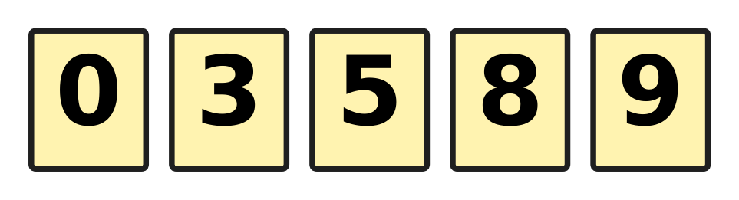
Q43. All five cards in the picture are put in a row to show a 5-digit number. A number cannot start with 0. How many different 5-digit numbers can be made that are even and greater than 85,000? [4 marks]
(A) 16 | (B) 12 | (C) 24 | (D) 18

Q44. Lata's summer holiday starts on 20 May. She spends $\frac{2}{5}$ of all the holiday days at her grandmother's house. Then she spends $\frac{1}{6}$ of the remaining days at a sports camp. The last 15 days are at home. May has 31 days. On which date does her holiday end? [4 marks]
(A) 6 June | (B) 13 June | (C) 18 June | (D) 19 June

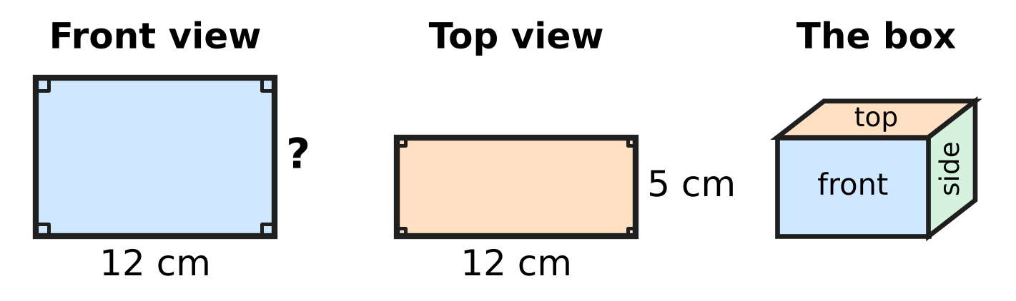
Q45. The picture shows a box shaped like a cuboid, with its front view and top view. The perimeter of the front view is 44 cm. What is the area of the side view of the box? [4 marks]
(A) 120 sq cm | (B) 60 sq cm | (C) 50 sq cm | (D) 110 sq cm

Answer Sheet AMO Level 1 · Class 4 · Practice Paper 5
Name: | School: | Roll No.:
Shade or tick one circle for each question.
1. Ⓐ Ⓑ Ⓒ Ⓓ | 16. Ⓐ Ⓑ Ⓒ Ⓓ | 31. Ⓐ Ⓑ Ⓒ Ⓓ
2. Ⓐ Ⓑ Ⓒ Ⓓ | 17. Ⓐ Ⓑ Ⓒ Ⓓ | 32. Ⓐ Ⓑ Ⓒ Ⓓ
3. Ⓐ Ⓑ Ⓒ Ⓓ | 18. Ⓐ Ⓑ Ⓒ Ⓓ | 33. Ⓐ Ⓑ Ⓒ Ⓓ
4. Ⓐ Ⓑ Ⓒ Ⓓ | 19. Ⓐ Ⓑ Ⓒ Ⓓ | 34. Ⓐ Ⓑ Ⓒ Ⓓ
5. Ⓐ Ⓑ Ⓒ Ⓓ | 20. Ⓐ Ⓑ Ⓒ Ⓓ | 35. Ⓐ Ⓑ Ⓒ Ⓓ
6. Ⓐ Ⓑ Ⓒ Ⓓ | 21. Ⓐ Ⓑ Ⓒ Ⓓ | 36. Ⓐ Ⓑ Ⓒ Ⓓ
7. Ⓐ Ⓑ Ⓒ Ⓓ | 22. Ⓐ Ⓑ Ⓒ Ⓓ | 37. Ⓐ Ⓑ Ⓒ Ⓓ
8. Ⓐ Ⓑ Ⓒ Ⓓ | 23. Ⓐ Ⓑ Ⓒ Ⓓ | 38. Ⓐ Ⓑ Ⓒ Ⓓ
9. Ⓐ Ⓑ Ⓒ Ⓓ | 24. Ⓐ Ⓑ Ⓒ Ⓓ | 39. Ⓐ Ⓑ Ⓒ Ⓓ
10. Ⓐ Ⓑ Ⓒ Ⓓ | 25. Ⓐ Ⓑ Ⓒ Ⓓ | 40. Ⓐ Ⓑ Ⓒ Ⓓ
11. Ⓐ Ⓑ Ⓒ Ⓓ | 26. Ⓐ Ⓑ Ⓒ Ⓓ | 41. Ⓐ Ⓑ Ⓒ Ⓓ
12. Ⓐ Ⓑ Ⓒ Ⓓ | 27. Ⓐ Ⓑ Ⓒ Ⓓ | 42. Ⓐ Ⓑ Ⓒ Ⓓ
13. Ⓐ Ⓑ Ⓒ Ⓓ | 28. Ⓐ Ⓑ Ⓒ Ⓓ | 43. Ⓐ Ⓑ Ⓒ Ⓓ
14. Ⓐ Ⓑ Ⓒ Ⓓ | 29. Ⓐ Ⓑ Ⓒ Ⓓ | 44. Ⓐ Ⓑ Ⓒ Ⓓ
15. Ⓐ Ⓑ Ⓒ Ⓓ | 30. Ⓐ Ⓑ Ⓒ Ⓓ | 45. Ⓐ Ⓑ Ⓒ Ⓓ
Q41–Q45 are Section II Star Questions (4 marks each).
For the parent or teacher
Section I correct: ______ / 40 × 2 = ______ marks Section II correct: ______ / 5 × 4 = ______ marks
Correct: ______ / 45 Score: ______ / 100
Answer Key and Solutions AMO Level 1 · Class 4 · Practice Paper 5
Quick answers
1 D | 6 A | 11 A | 16 C | 21 A | 26 A | 31 D | 36 A | 41 B
2 A | 7 D | 12 C | 17 B | 22 B | 27 B | 32 A | 37 B | 42 D
3 C | 8 B | 13 A | 18 B | 23 D | 28 C | 33 B | 38 D | 43 A
4 B | 9 D | 14 D | 19 D | 24 C | 29 B | 34 D | 39 A | 44 C
5 C | 10 C | 15 B | 20 A | 25 D | 30 C | 35 C | 40 C | 45 C
Solutions
Q | Part · level | Answer | Why?
1 | Part 1 · Ch1 · Easy | (D) 80,503 | The number is 80,000 + 500 + 3 = 80,503.
2 | Part 1 · Ch1 · Easy | (A) L | XL = 40 and LX = 60. The number halfway between them is 50, which is L.
3 | Part 1 · Ch1 · Easy | (C) 50,560 | Adding 1,000 raises the thousands: 49 thousands + 1 thousand = 50 thousands, so 50,560.
4 | Part 1 · Ch1 · Medium | (B) 98,764 | To make it as large as possible, use 9, 8, 7 and 6 in the first four places. The last digit must be even and not used yet; 8 and 6 are used, so it is 4. The number is 98,764.
5 | Part 1 · Ch1 · Medium | (C) 51,000 | From the 5th number back to the 1st there are 4 jumps: 41,000 + 4 × 2,500 = 51,000.
6 | Part 2 · Ch2 · Easy | (A) 64,315 | The correct sum is 38,476 + 25,839 = 64,315. Tarun lost the carry into the thousands place.
7 | Part 2 · Ch2 · Easy | (D) 3,700 | Group 25 and 4 first: 25 × 4 = 100, and 37 × 100 = 3,700.
8 | Part 2 · Ch2 · Easy | (B) 384 | Each box gets 3,456 ÷ 9 = 384 fish.
9 | Part 2 · Ch2 · Medium | (D) 27,499 | Numbers from 26,500 to 27,499 round to 27,000. The greatest is 27,499.
10 | Part 2 · Ch2 · Medium | (C) 1,728 | Here 36 × 48 is one more group of 36 than 36 × 47: 1,692 + 36 = 1,728.
11 | Part 3 · Ch3 · Easy | (A) 5 | $\frac{3}{4}$ of 12 tiles = 9 tiles. There are 4 coloured tiles, so 9 − 4 = 5 more.
12 | Part 3 · Ch3 · Easy | (C) $\frac{14}{3}$ | In 4 wholes there are 12 thirds, and 12 + 2 = 14 thirds, so $\frac{14}{3}$.
13 | Part 3 · Ch3 · Easy | (A) $\frac{7}{12}$ hour | $\frac{1}{6}$ = $\frac{2}{12}$, and $\frac{2}{12}$ + $\frac{5}{12}$ = $\frac{7}{12}$.
14 | Part 3 · Ch3 · Easy | (D) $\frac{5}{8}$ | $\frac{1}{2}$ = $\frac{4}{8}$ and $\frac{3}{4}$ = $\frac{6}{8}$, and $\frac{5}{8}$ lies between them.
15 | Part 3 · Ch3 · Medium | (B) $4\frac{1}{4}$ L | Start = used + left = $1\frac{3}{4}$ + $2\frac{1}{2}$ = $4\frac{1}{4}$ L.
16 | Part 3 · Ch3 · Medium | (C) 28 | $2\frac{1}{3}$ = $\frac{7}{3}$ = $\frac{28}{12}$, so 28 scoops.
17 | Part 4 · Ch5 · Easy | (B) Picture B | In a mirror image each square is the same distance from the mirror line, on the other side. Only Picture B shows this; the others are slid across, one square too far, or upside down.
18 | Part 4 · Ch5 · Easy | (B) Line c | Lines a and e make square corners with g, and line d is parallel to g. Only the slide, line c, meets g at a slant.
19 | Part 4 · Ch5 · Medium | (D) 6 | The segments are AB, AC, AD, BC, BD and CD: 6 in all.
20 | Part 4 · Ch5 · Medium | (A) 6 | Faces + Vertices = 10 + 2 = 12. They are equal, so there are 6 faces (a pyramid with a 5-sided base).
21 | Part 5 · Ch6 · Easy | (A) 3,040 m | Since 3 km = 3,000 m, the road is 3,000 m + 40 m = 3,040 m.
22 | Part 5 · Ch6 · Easy | (B) 1 kg 250 g | Change 5 kg to 5,000 g. Then 5,000 ÷ 4 = 1,250 g = 1 kg 250 g.
23 | Part 5 · Ch6 · Easy | (D) 4 m 80 cm | Perimeter = 4 × 120 cm = 480 cm = 4 m 80 cm.
24 | Part 5 · Ch6 · Easy | (C) 1,260 sq m | Area = 45 × 28 = 1,260 sq m.
25 | Part 5 · Ch6 · Medium | (D) 12 cm | Wire = 2 × (15 + 9) = 48 cm. Each side of the square = 48 ÷ 4 = 12 cm.
26 | Part 5 · Ch6 · Medium | (A) 58 m | Perimeter = 2 × (18 + 12) = 60 m. Leave out the gate: 60 − 2 = 58 m.
27 | Part 6 · Ch8 · Easy | (B) 55 | Wednesday has 5 whole flowers (50 bouquets) and half a flower (5 bouquets), so 55 bouquets.
28 | Part 6 · Ch8 · Medium | (C) 27 | Thursday has 4 trumpets for 24 children, so 1 trumpet = 6 children. Monday has 4½ trumpets: 24 + 3 = 27 children.
29 | Part 7 · Ch9 · Easy | (B) 9:58 | The clock shows 10:05. Going back 7 minutes gives 9:58.
30 | Part 7 · Ch9 · Easy | (C) 35 minutes | From the 3 to the 10 the minute hand moves 7 numbers, and each number is 5 minutes: 7 × 5 = 35 minutes.
31 | Part 7 · Ch9 · Easy | (D) ₹187 | Money needed = ₹615 − ₹428 = ₹187.
32 | Part 7 · Ch9 · Easy | (A) 5 | ₹235 = ₹100 + ₹100 + ₹20 + ₹10 + ₹5, which is 5 notes and coins.
33 | Part 7 · Ch9 · Medium | (B) 26 December | Since 1 December is a Monday, 5 December is a Friday. The Fridays are 5, 12, 19 and 26. The last is 26 December.
34 | Part 7 · Ch9 · Medium | (D) 6 | The 4 child tickets cost 4 × ₹30 = ₹120. Then ₹420 − ₹120 = ₹300, and ₹300 ÷ ₹50 = 6 adult tickets.
35 | Part 8 · Ch10 · Easy | (C) 6 | Each number is half of the one before it. Half of 12 is 6.
36 | Part 8 · Ch10 · Easy | (A) 38 | From page 27 to page 64 there are 64 − 27 = 37 jumps, and counting both end pages gives 37 + 1 = 38 pages.
37 | Part 8 · Ch10 · Easy | (B) 10 weeks 5 days | Here 10 weeks = 70 days, and 75 − 70 = 5. So 75 days = 10 weeks 5 days.
38 | Part 8 · Ch10 · Medium | (D) 10 | The jumps are 6, 8, 10, 12, so the jump before 6 is 4. The first number is 14 − 4 = 10.
39 | Part 8 · Ch10 · Medium | (A) 14 | Multiples of 3: 10. Multiples of 5: 6. Cards 15 and 30 are in both lists, so 10 + 6 − 2 = 14.
40 | Part 8 · Ch10 · Medium | (C) Friday | The first day is 11 days before the last: 14 − 11 = 3 October. Since 11 days = 1 week + 4 days, it opened 4 days before Tuesday, which is Friday.
41 | Section II · Ch3 + Ch10 · Hard | (B) $2\frac{7}{12}$ | She can make $1\frac{3}{4}$, $3\frac{1}{4}$ and $4\frac{1}{3}$. $4\frac{1}{3}$ − $1\frac{3}{4}$ = $\frac{52}{12}$ − $\frac{21}{12}$ = $\frac{31}{12}$ = $2\frac{7}{12}$.
42 | Section II · Ch9 + Ch10 · Hard | (D) 8:20 a.m. on Wednesday, 1 October | From 10:45 p.m., 1 hour 15 minutes takes us to midnight. That leaves 9 hours 35 minutes − 1 hour 15 minutes = 8 hours 20 minutes, so the plane lands at 8:20 a.m. the next day. The day after Tuesday, 30 September is Wednesday, 1 October.
43 | Section II · Ch1 + Ch10 · Hard | (A) 16 | Starting with 9: the last digit is 0 or 8, and the middle 3 digits can be arranged in 6 ways: 12. Starting with 8: the second digit must be 5 or 9 and the last digit 0, with 2 ways each: 4. Total 16.
44 | Section II · Ch3 + Ch9 · Hard | (C) 18 June | The last 15 days are $\frac{5}{6}$ of the days left, so 18 days were left. These 18 days are $\frac{3}{5}$ of the holiday, so the holiday is 30 days. There are 12 days in May (20 to 31 May) and 18 days in June, so the last day is 18 June.
45 | Section II · Ch5 + Ch6 · Hard | (C) 50 sq cm | Front view: 2 × (12 + height) = 44, so height = 10 cm. The top view shows the width, 5 cm. The side view is 5 cm by 10 cm, so its area is 50 sq cm.

