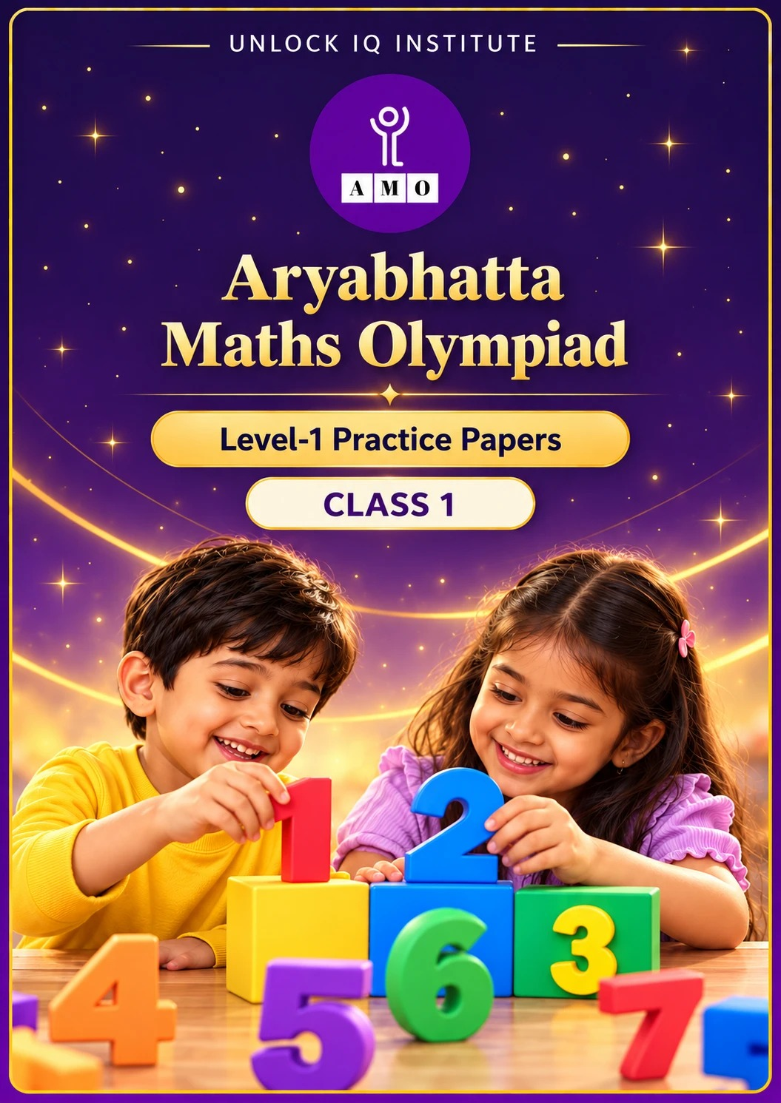
Five full practice papers · with answer keys & detailed solutions
Name: ____________________ | Class & Section: ________________
Roll No.: ________________ | School: ____________________
City: ____________________ | Date: ____________________

Published by Unlock IQ Institute Pvt. Ltd.
Register for Olympiads: www.aryabhattamathsolympiad.com/student-registration

ARYABHATTA MATHS OLYMPIAD
Level 1
PRACTICE PAPER-1
CLASS 1
Total Questions | 45 multiple-choice questions
Total Marks | 100
Time | 60 minutes
Section I | 40 questions × 2 marks = 80 marks
Section II | 5 Star Questions × 4 marks = 20 marks
Negative Marking | No negative marking
Calculator | Not allowed
Chapters | Number System · Operations · Geometry · Applied Mathematics · Mathematical Reasoning

👋 Hello, friend! How to do this paper:
⭐ Every question has four answer choices: (A), (B), (C) and (D). Only one is correct.
⭐ Read each question and look at its picture carefully. Then mark your answer on the answer sheet at the end.
⭐ Section I has 40 questions of 2 marks each. Section II has 5 Star Questions of 4 marks each.
⭐ There is no negative marking, so try every question.
⭐ Do not use a calculator. You may do rough work on a separate sheet.
⭐ All figures are not necessarily drawn to scale unless stated.

For parents and teachers
• Print or view this paper in colour. Pictures are part of the questions.
• You may read a question aloud to the child, exactly as printed. Please do not explain it or point to an answer choice.
• Parts follow the AMO syllabus chapters. Chapters 3, 4, 6, 7 and 8 are not part of the Class 1 syllabus, so the chapter numbers shown in the Part headings have gaps.
• The answer sheet and the answer key are at the end. Remove only the answer key before the child begins.

SECTION I 40 questions × 2 marks each
Part 1 — Number System (Syllabus Chapter 1)
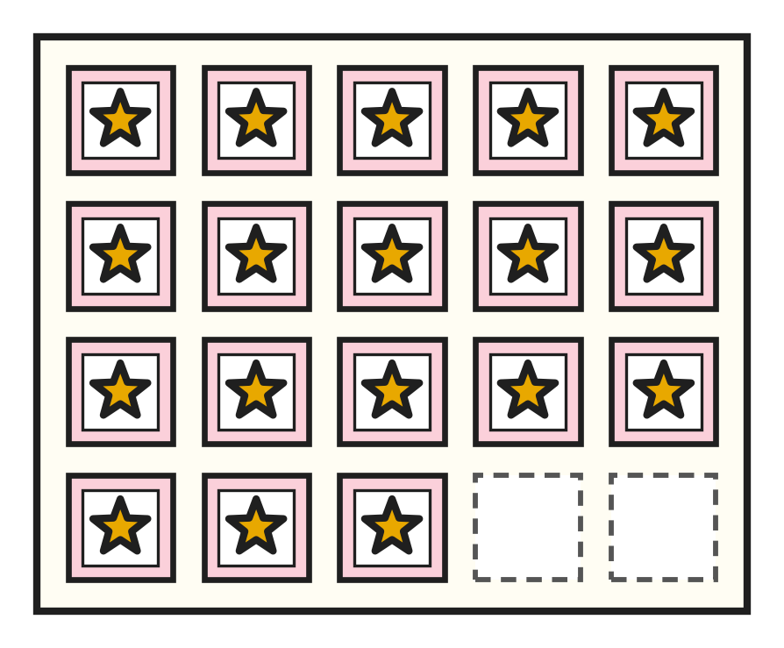
Q1. Look at the stamp page. How many stamps are on it?
(A) 17 | (B) 20 | (C) 81 | (D) 18

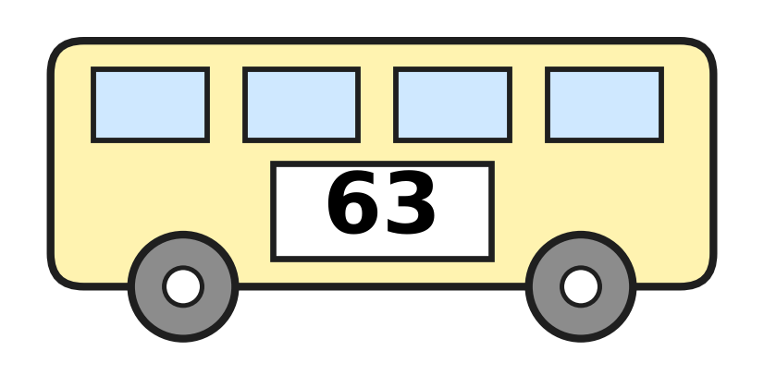
Q2. Look at the number on the school bus. What is its number name?
(A) sixty-three | (B) sixteen
(C) sixty | (D) thirty-six

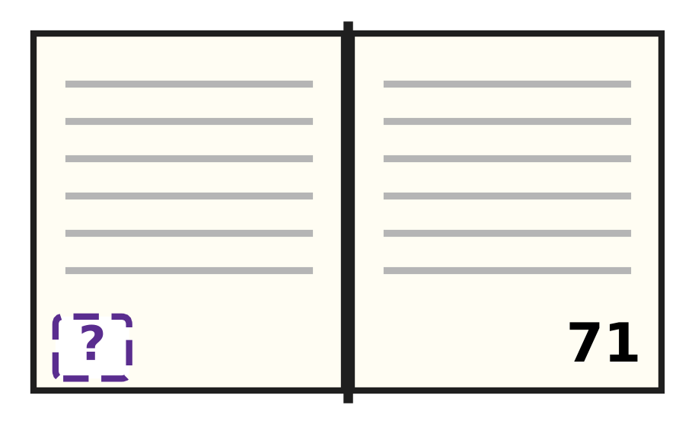
Q3. Look at Reena's open book. The right page is page 71. What is the number of the left page?
(A) 69 | (B) 61 | (C) 72 | (D) 70

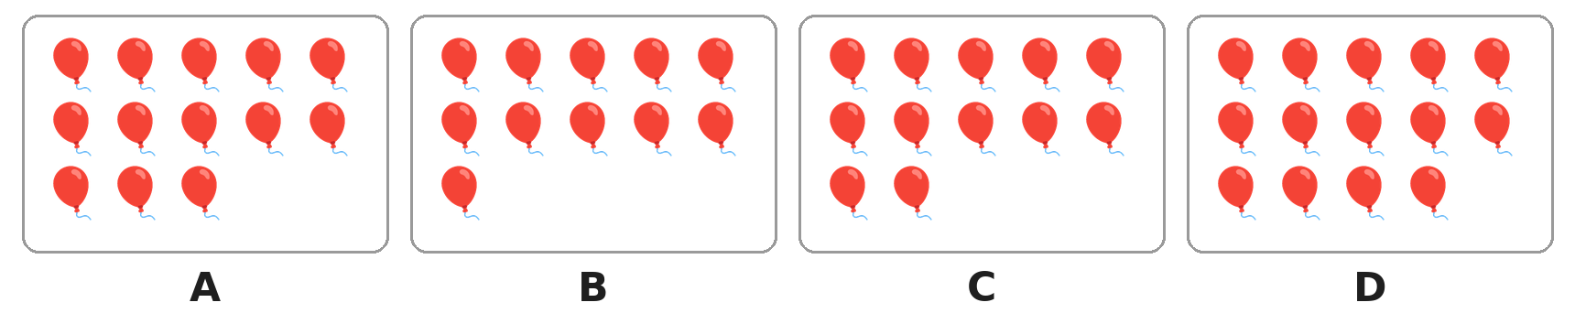
Q4. Look at the four pictures. Which picture has the smallest number of balloons?
(A) Picture A | (B) Picture B
(C) Picture C | (D) Picture D

Q5. Which number has 6 as its ones digit?
(A) 65 | (B) 61 | (C) 60 | (D) 16

Q6. Shreya counts in tens: 10, 20, 30, and so on. Which number does she say just after 70?
(A) 80 | (B) 90 | (C) 60 | (D) 71

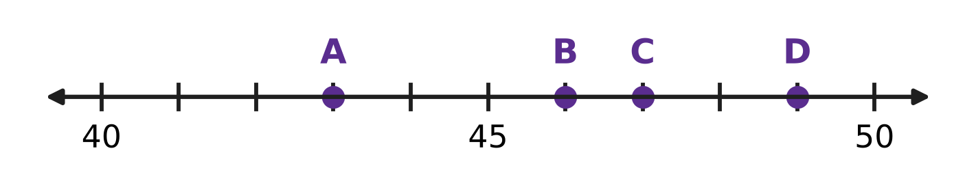
Q7. Look at the number line. Which dot shows the number 47?
(A) Dot A | (B) Dot B | (C) Dot C | (D) Dot D

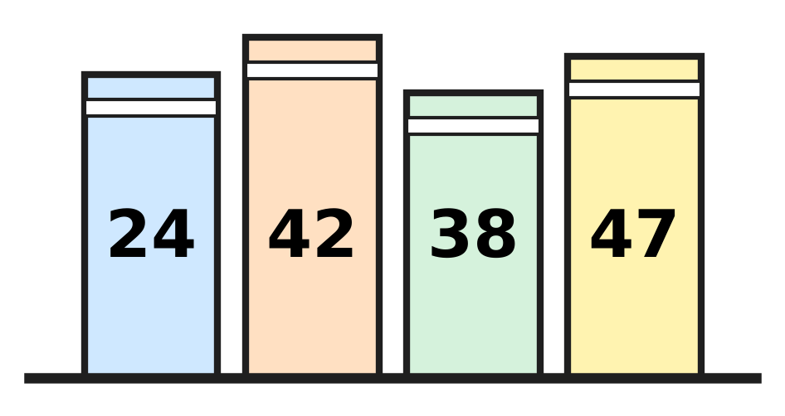
Q8. Look at the books. Which two books should swap places so that the numbers are in order, smallest first?
(A) 42 and 47 | (B) 24 and 38
(C) 42 and 38 | (D) 24 and 47

Q9. Which number has more tens than ones?
(A) 38 | (B) 52 | (C) 66 | (D) 47

Q10. The sign > means "is greater than". The sign < means "is smaller than". Which one is correct?
(A) 58 > 85 | (B) 70 < 17 | (C) 46 > 64 | (D) 39 < 93

Q11. Navya has 58 marbles. She puts 10 marbles in each jar. How many jars will be full?
(A) 13 | (B) 8 | (C) 5 | (D) 6

Q12. A number has the same ones digit as 46. It has one more ten than 46. Which number is it?
(A) 56 | (B) 47 | (C) 36 | (D) 57

Part 2 — Operations & Number Properties (Syllabus Chapter 2)
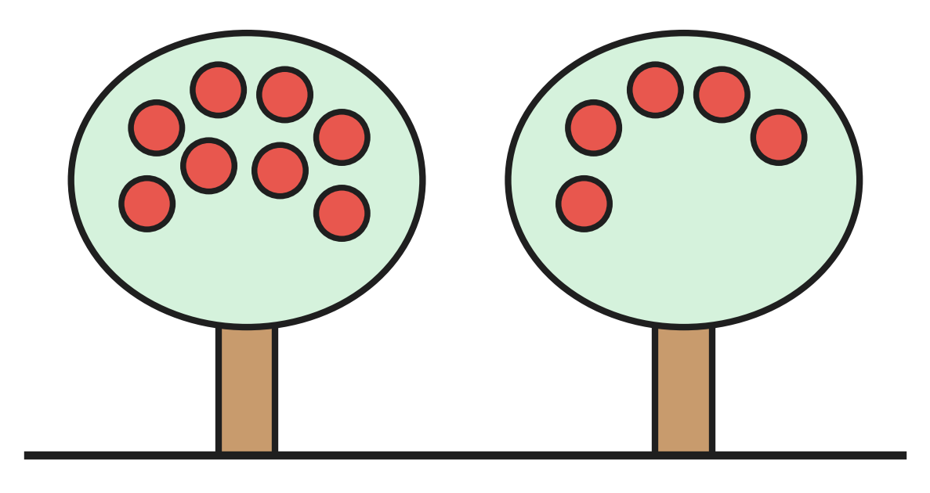
Q13. Look at the two apple trees. How many apples are on the trees in all?
(A) 3 | (B) 13 | (C) 8 | (D) 12

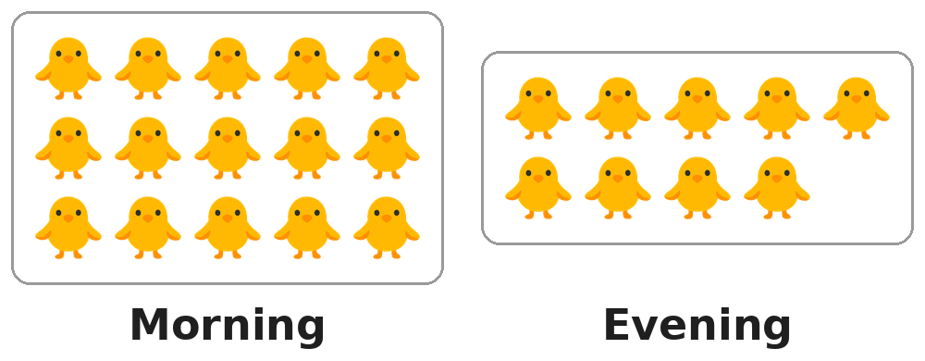
Q14. Look at the two pictures of a farm. In the morning there are 15 chicks. In the evening there are 9. How many chicks have gone away?
(A) 6 | (B) 7 | (C) 9 | (D) 5

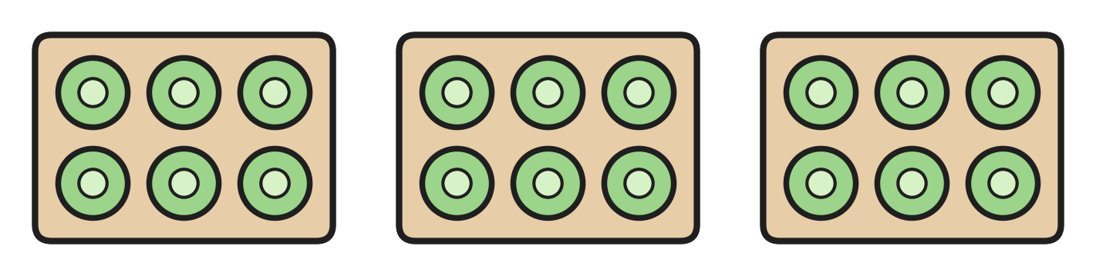
Q15. Look at the vegetable garden. Each bed has 6 cabbages. How many cabbages are there in all?
(A) 9 | (B) 12 | (C) 16 | (D) 18

Q16. There are 6 children in the swimming pool. Then 8 more children jump in. How many children are in the pool now?
(A) 2 | (B) 13 | (C) 14 | (D) 16

Q17. There are 18 children on a bicycle trip. Then 5 of them stop to rest. How many children are still riding?
(A) 5 | (B) 13 | (C) 23 | (D) 12

Q18. Which number is 2 less than 20?
(A) 19 | (B) 18 | (C) 12 | (D) 22

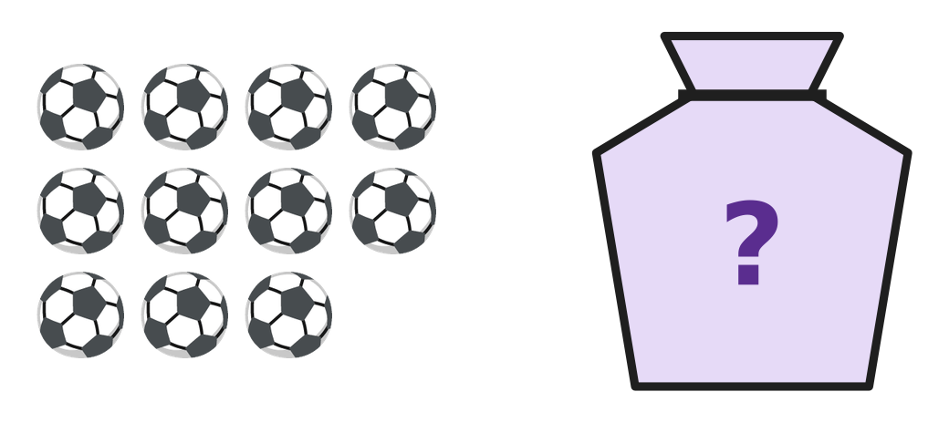
Q19. Jack has 17 balls. The picture shows 11 of them. The other balls are in the bag. How many balls are in the bag?
(A) 6 | (B) 11 | (C) 7 | (D) 5

Q20. Madhu knows that 7 + 8 = 15. What is 15 − 8?
(A) 23 | (B) 6 | (C) 7 | (D) 8

Q21. Arun ties 6 red bows, 4 blue bows and 3 yellow bows on the tail of his kite. How many bows does he tie in all?
(A) 7 | (B) 14 | (C) 10 | (D) 13

Q22. A rainwater tank holds 20 buckets of water. Amma uses 6 buckets for the garden and 5 buckets for washing. How many buckets of water are left in the tank?
(A) 14 | (B) 9 | (C) 11 | (D) 15

Part 3 — Geometry (Syllabus Chapter 5)
Q23. Kai looks at the wheel of his bicycle from the side. Which shape does he see?
(A) Circle | (B) Square
(C) Triangle | (D) Rectangle

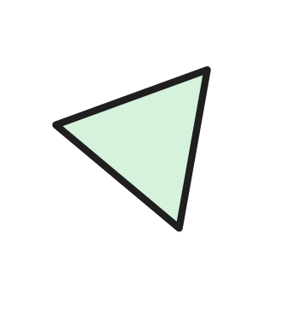
Q24. Look at the shape. How many straight sides does it have?
(A) 0 | (B) 2 | (C) 4 | (D) 3

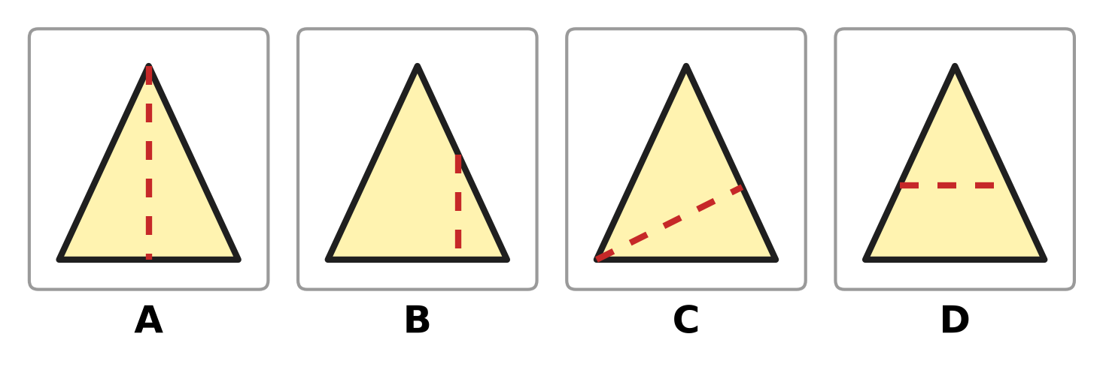
Q25. Look at the four paper triangles. In which picture does the dotted line cut the triangle into two parts of the same size and shape?
(A) Picture A | (B) Picture B
(C) Picture C | (D) Picture D

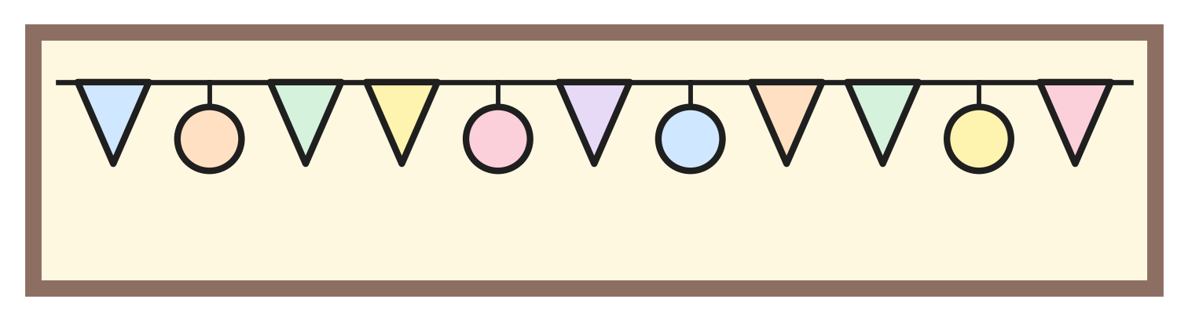
Q26. Look at the string of shapes on the notice board. How many of the shapes have no corners?
(A) 7 | (B) 3 | (C) 4 | (D) 11

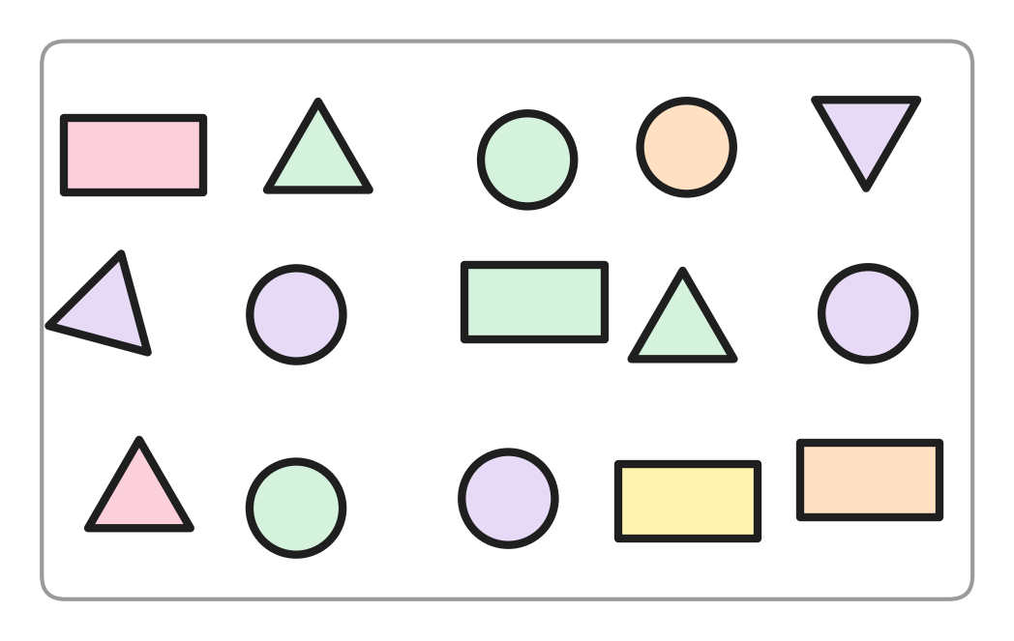
Q27. Look at the shapes in the box. How many more circles than rectangles are there?
(A) 6 | (B) 1 | (C) 4 | (D) 2

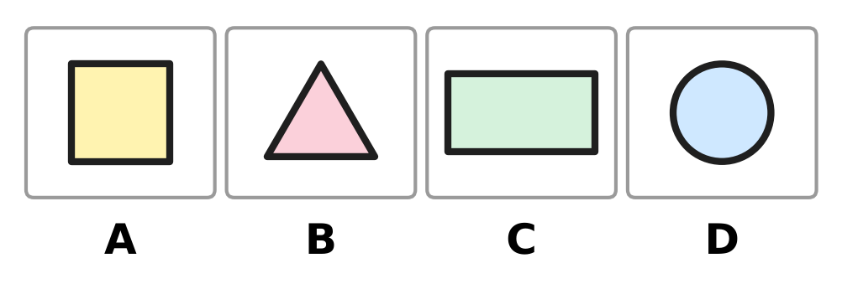
Q28. Look at the four shapes. My shape has 4 corners. Two of its sides are long and two are short. Which picture shows my shape?
(A) Picture A | (B) Picture B
(C) Picture C | (D) Picture D

Part 4 — Applied Mathematics (Syllabus Chapter 9)
Q29. Which of these is NOT a month of the year?
(A) Monday | (B) March | (C) June | (D) May

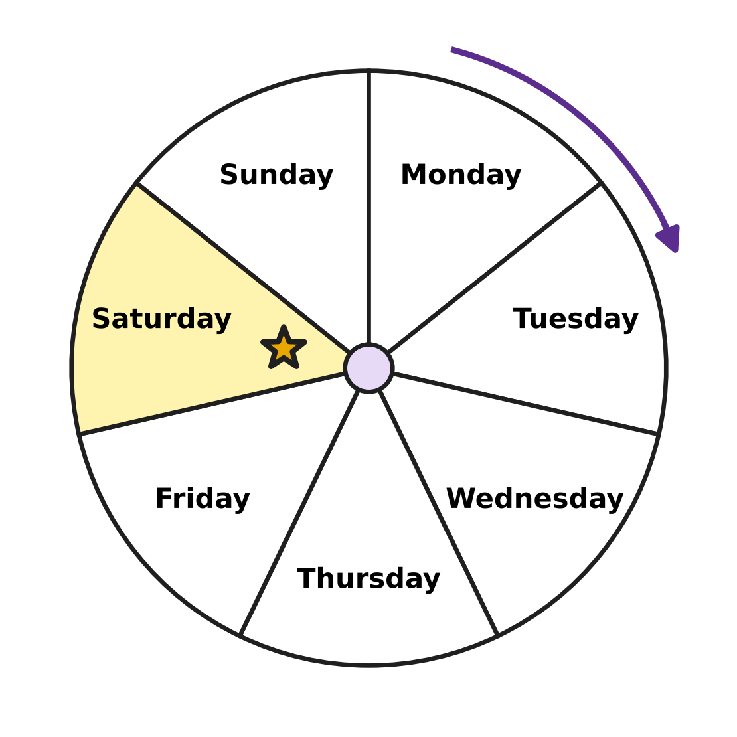
Q30. Look at the week wheel. The days go round the way the arrow shows. Which day comes just after the day with the star?
(A) Friday | (B) Monday
(C) Sunday | (D) Saturday

Q31. Which of these is worth less than a ₹5 coin?
(A) ₹10 note | (B) ₹2 coin
(C) ₹10 coin | (D) ₹20 note

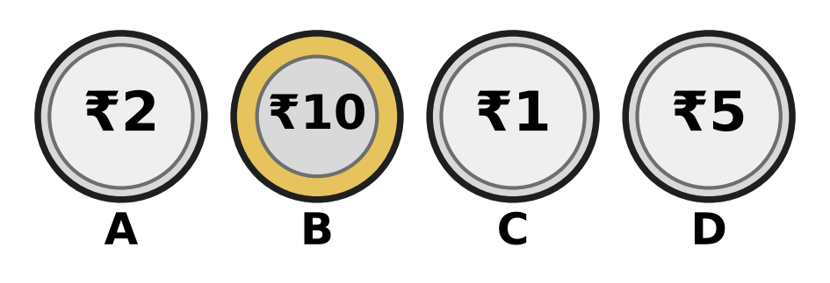
Q32. Look at the coins. Which coin is worth the same as a ₹10 note?
(A) Picture A | (B) Picture B
(C) Picture C | (D) Picture D

Q33. Farah reads a library book on 3 days, one after the other. The first day is Tuesday. Which is the last day?
(A) Sunday | (B) Wednesday
(C) Thursday | (D) Friday

Q34. Which list shows three months in the order they come in the year?
(A) January, March, February | (B) September, October, November
(C) May, April, June | (D) June, August, July

Part 5 — Mathematical Reasoning & Problem-Solving (Syllabus Chapter 10)

Q35. Look at the pictures. Star, balloon, car and fish repeat again and again in the same order. Which picture goes in the box?
(A) Car | (B) Balloon | (C) Fish | (D) Star

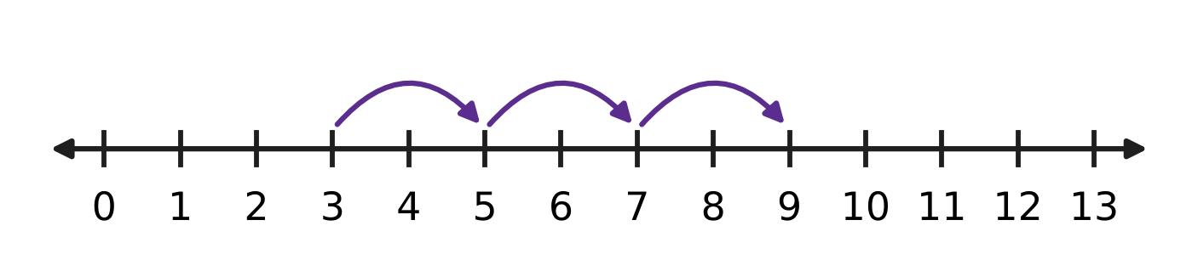
Q36. Look at the hops on the number line. Each hop is the same size. Where will the next hop land?
(A) 10 | (B) 13 | (C) 12 | (D) 11

Q37. Three of these numbers come one after the other. Which number does NOT belong with them?
(A) 19 | (B) 15 | (C) 16 | (D) 14

Q38. Look at the pattern of triangles and circles. It goes on in the same way. How many circles come next, before the next triangle?
(A) 6 | (B) 5 | (C) 1 | (D) 4

Q39. Vani makes a number pattern. It starts at 9. Each new number is 2 more. What is the fourth number in her pattern?
(A) 13 | (B) 11 | (C) 15 | (D) 17

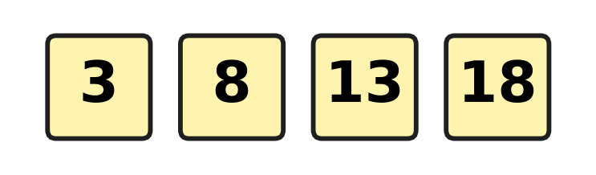
Q40. Look at the number pattern. What is added each time?
(A) 6 | (B) 4 | (C) 10 | (D) 5

SECTION II — Star Questions 5 questions × 4 marks each
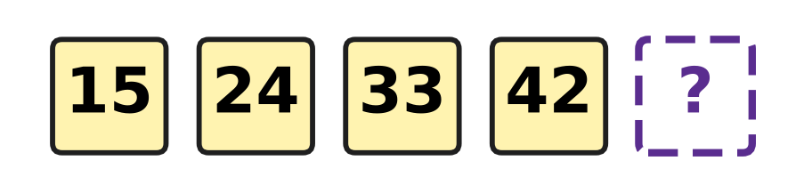
Q41. Look at the number pattern. See how the tens digit and the ones digit change each time. Which number comes next? [4 marks]
(A) 51 | (B) 43 | (C) 41 | (D) 52

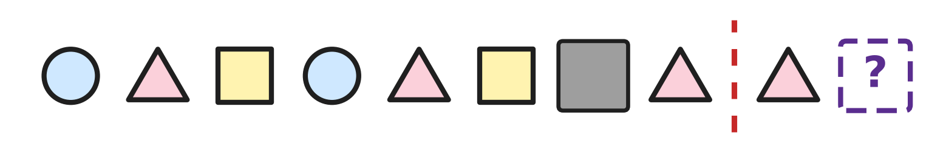
Q42. The shapes on the left of the red line make a pattern. A grey card hides one shape. If you fold the paper on the red line, each shape on the right lands on a matching shape on the left. Which shape goes in the box? [4 marks]
(A) Rectangle | (B) Triangle
(C) Circle | (D) Square

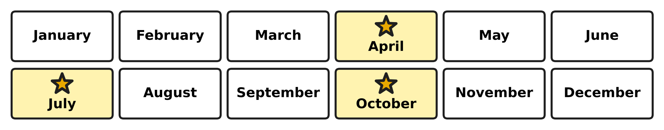
Q43. A water tank is cleaned in the starred months on the chart. The gap between cleanings is always the same. After October, in which month will the tank be cleaned next? [4 marks]
(A) December | (B) March
(C) February | (D) January

Q44. From Monday to Saturday, Samar saves a ₹10 note each day. He also saves a ₹2 coin on Wednesday and another ₹2 coin on Friday. How much money does he save in all? [4 marks]
(A) ₹54 | (B) ₹64 | (C) ₹74 | (D) ₹62

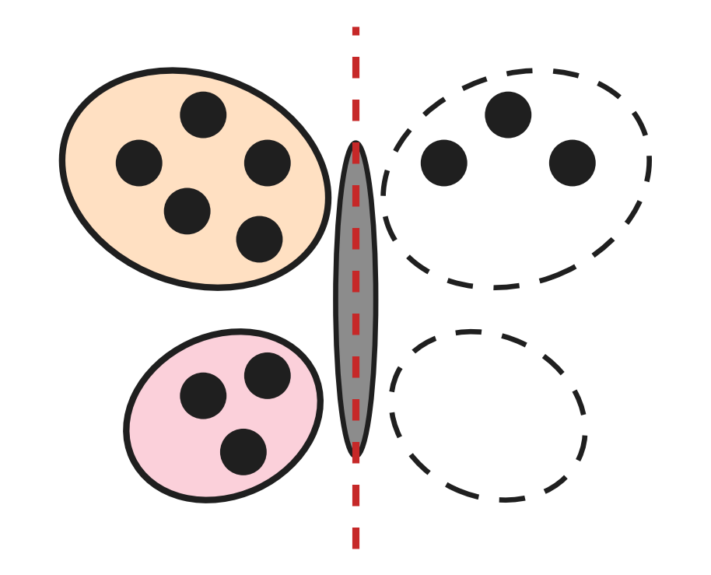
Q45. The butterfly must look the same on both sides of its body. How many more spots must be drawn on it? [4 marks]
(A) 2 | (B) 5 | (C) 8 | (D) 16

Answer Sheet AMO Level 1 · Class 1 · Practice Paper 1
Name: | School: | Roll No.:
Shade or tick one circle for each question.
1. Ⓐ Ⓑ Ⓒ Ⓓ | 16. Ⓐ Ⓑ Ⓒ Ⓓ | 31. Ⓐ Ⓑ Ⓒ Ⓓ
2. Ⓐ Ⓑ Ⓒ Ⓓ | 17. Ⓐ Ⓑ Ⓒ Ⓓ | 32. Ⓐ Ⓑ Ⓒ Ⓓ
3. Ⓐ Ⓑ Ⓒ Ⓓ | 18. Ⓐ Ⓑ Ⓒ Ⓓ | 33. Ⓐ Ⓑ Ⓒ Ⓓ
4. Ⓐ Ⓑ Ⓒ Ⓓ | 19. Ⓐ Ⓑ Ⓒ Ⓓ | 34. Ⓐ Ⓑ Ⓒ Ⓓ
5. Ⓐ Ⓑ Ⓒ Ⓓ | 20. Ⓐ Ⓑ Ⓒ Ⓓ | 35. Ⓐ Ⓑ Ⓒ Ⓓ
6. Ⓐ Ⓑ Ⓒ Ⓓ | 21. Ⓐ Ⓑ Ⓒ Ⓓ | 36. Ⓐ Ⓑ Ⓒ Ⓓ
7. Ⓐ Ⓑ Ⓒ Ⓓ | 22. Ⓐ Ⓑ Ⓒ Ⓓ | 37. Ⓐ Ⓑ Ⓒ Ⓓ
8. Ⓐ Ⓑ Ⓒ Ⓓ | 23. Ⓐ Ⓑ Ⓒ Ⓓ | 38. Ⓐ Ⓑ Ⓒ Ⓓ
9. Ⓐ Ⓑ Ⓒ Ⓓ | 24. Ⓐ Ⓑ Ⓒ Ⓓ | 39. Ⓐ Ⓑ Ⓒ Ⓓ
10. Ⓐ Ⓑ Ⓒ Ⓓ | 25. Ⓐ Ⓑ Ⓒ Ⓓ | 40. Ⓐ Ⓑ Ⓒ Ⓓ
11. Ⓐ Ⓑ Ⓒ Ⓓ | 26. Ⓐ Ⓑ Ⓒ Ⓓ | 41. Ⓐ Ⓑ Ⓒ Ⓓ
12. Ⓐ Ⓑ Ⓒ Ⓓ | 27. Ⓐ Ⓑ Ⓒ Ⓓ | 42. Ⓐ Ⓑ Ⓒ Ⓓ
13. Ⓐ Ⓑ Ⓒ Ⓓ | 28. Ⓐ Ⓑ Ⓒ Ⓓ | 43. Ⓐ Ⓑ Ⓒ Ⓓ
14. Ⓐ Ⓑ Ⓒ Ⓓ | 29. Ⓐ Ⓑ Ⓒ Ⓓ | 44. Ⓐ Ⓑ Ⓒ Ⓓ
15. Ⓐ Ⓑ Ⓒ Ⓓ | 30. Ⓐ Ⓑ Ⓒ Ⓓ | 45. Ⓐ Ⓑ Ⓒ Ⓓ
Q41–Q45 are Section II Star Questions (4 marks each).
For the parent or teacher
Section I correct: ______ / 40 × 2 = ______ marks Section II correct: ______ / 5 × 4 = ______ marks
Correct: ______ / 45 Score: ______ / 100
Answer Key and Solutions AMO Level 1 · Class 1 · Practice Paper 1
Quick answers
1 D | 6 A | 11 C | 16 C | 21 D | 26 C | 31 B | 36 D | 41 A
2 A | 7 C | 12 A | 17 B | 22 B | 27 D | 32 B | 37 A | 42 C
3 D | 8 C | 13 B | 18 B | 23 A | 28 C | 33 C | 38 B | 43 D
4 B | 9 B | 14 A | 19 A | 24 D | 29 A | 34 B | 39 C | 44 B
5 D | 10 D | 15 D | 20 C | 25 A | 30 C | 35 A | 40 D | 45 B
Solutions
Q | Part · level | Answer | Why?
1 | Part 1 · Ch1 · Easy | (D) 18 | There are 3 full rows of 5 stamps and 3 more: 5, 10, 15, then 16, 17, 18.
2 | Part 1 · Ch1 · Easy | (A) sixty-three | 63 has 6 tens and 3 ones. It is read as sixty-three.
3 | Part 1 · Ch1 · Easy | (D) 70 | The left page comes just before the right page. The number just before 71 is 70.
4 | Part 1 · Ch1 · Easy | (B) Picture B | The pictures have 13, 11, 12 and 14 balloons. 11 is the smallest number, so Picture B has the fewest.
5 | Part 1 · Ch1 · Easy | (D) 16 | 16 is 1 ten and 6 ones. In 61, 60 and 65 the 6 is the tens digit.
6 | Part 1 · Ch1 · Easy | (A) 80 | 70 is 7 tens. One more ten makes 8 tens, which is 80. So after 70 she says 80.
7 | Part 1 · Ch1 · Easy | (C) Dot C | Count on from 45: the next marks are 46 and 47. Dot C is 2 steps after 45, so it shows 47.
8 | Part 1 · Ch1 · Medium | (C) 42 and 38 | The order should be 24, 38, 42, 47. Only 42 and 38 are in the wrong places, so they swap.
9 | Part 1 · Ch1 · Medium | (B) 52 | 52 has 5 tens and 2 ones, and 5 is more than 2. The other numbers do not have more tens than ones.
10 | Part 1 · Ch1 · Medium | (D) 39 < 93 | 39 has 3 tens and 93 has 9 tens, so 39 is smaller than 93. The other three are wrong.
11 | Part 1 · Ch1 · Medium | (C) 5 | 58 is 5 tens and 8 ones. So 5 jars are full and 8 marbles are left over.
12 | Part 1 · Ch1 · Medium | (A) 56 | 46 has 4 tens and 6 ones. One more ten makes 5 tens and 6 ones, which is 56.
13 | Part 2 · Ch2 · Easy | (B) 13 | One tree has 8 apples and the other has 5. 8 + 5 = 13.
14 | Part 2 · Ch2 · Easy | (A) 6 | 15 − 9 = 6, so 6 chicks have gone away.
15 | Part 2 · Ch2 · Easy | (D) 18 | 3 beds of 6 cabbages: 6 + 6 + 6 = 18.
16 | Part 2 · Ch2 · Easy | (C) 14 | 6 + 8 = 14 children.
17 | Part 2 · Ch2 · Easy | (B) 13 | 18 − 5 = 13 children are still riding.
18 | Part 2 · Ch2 · Easy | (B) 18 | 2 less than 20 means 20 − 2, which is 18.
19 | Part 2 · Ch2 · Medium | (A) 6 | 11 and how many more make 17? 17 − 11 = 6, so 6 balls are in the bag.
20 | Part 2 · Ch2 · Medium | (C) 7 | 7 and 8 make 15. So when 8 is taken from 15, 7 is left.
21 | Part 2 · Ch2 · Medium | (D) 13 | 6 + 4 = 10, and 10 + 3 = 13 bows.
22 | Part 2 · Ch2 · Medium | (B) 9 | 20 − 6 = 14. Then 14 − 5 = 9 buckets are left.
23 | Part 3 · Ch5 · Easy | (A) Circle | A wheel is round with no corners, so its shape is a circle.
24 | Part 3 · Ch5 · Easy | (D) 3 | The shape is a triangle. It has 3 straight sides.
25 | Part 3 · Ch5 · Easy | (A) Picture A | In Picture A the dotted line goes down the middle, so the two parts have the same size and shape. In the other pictures the parts do not match.
26 | Part 3 · Ch5 · Easy | (C) 4 | A circle has no corners. There are 4 circles on the string. The 7 triangles have 3 corners each.
27 | Part 3 · Ch5 · Medium | (D) 2 | There are 6 circles and 4 rectangles. 6 is 2 more than 4.
28 | Part 3 · Ch5 · Medium | (C) Picture C | The square and the rectangle have 4 corners. The square has 4 equal sides, so the shape with two long and two short sides is the rectangle.
29 | Part 4 · Ch9 · Easy | (A) Monday | Monday is a day of the week. March, May and June are months.
30 | Part 4 · Ch9 · Easy | (C) Sunday | The star is on Saturday. The day just after Saturday is Sunday.
31 | Part 4 · Ch9 · Easy | (B) ₹2 coin | 2 is less than 5, so a ₹2 coin is worth less than a ₹5 coin. The others are worth ₹10 or ₹20.
32 | Part 4 · Ch9 · Easy | (B) Picture B | The coin in Picture B is a ₹10 coin. It is worth the same as a ₹10 note.
33 | Part 4 · Ch9 · Medium | (C) Thursday | The three days are Tuesday, Wednesday and Thursday. The last day is Thursday.
34 | Part 4 · Ch9 · Medium | (B) Sep, Oct, Nov | September, October and November come one after another. In each other list two months are swapped.
35 | Part 5 · Ch10 · Easy | (A) Car | The order is star, balloon, car, fish, again and again. After a balloon comes a car.
36 | Part 5 · Ch10 · Easy | (D) 11 | The hops land on 5, 7 and 9, going up by 2 each time. The next hop lands on 11.
37 | Part 5 · Ch10 · Easy | (A) 19 | 14, 15, 16 come one after the other. After 16 come 17 and 18, so 19 is the odd one out.
38 | Part 5 · Ch10 · Medium | (B) 5 | Between the triangles there are 1, 2, 3 and then 4 circles. Each group has one more, so 5 circles come next.
39 | Part 5 · Ch10 · Medium | (C) 15 | The pattern is 9, 11, 13, 15. The fourth number is 15.
40 | Part 5 · Ch10 · Medium | (D) 5 | From 3 to 8 is 5 more, from 8 to 13 is 5 more, and from 13 to 18 is 5 more.
41 | Section II · Ch1 + Ch10 · Hard | (A) 51 | The tens digit goes up by one: 1, 2, 3, 4, then 5. The ones digit goes down by one: 5, 4, 3, 2, then 1. The next number is 51.
42 | Section II · Ch5 + Ch10 · Hard | (C) Circle | The pattern is circle, triangle, square, again and again, so a circle is under the grey card. Folding on the dotted line puts the box on that card, so the box has a circle.
43 | Section II · Ch9 + Ch10 · Hard | (D) January | From April to July is 3 months, and from July to October is 3 months. Three months after October is January.
44 | Section II · Ch1 + Ch9 · Hard | (B) ₹64 | Monday to Saturday is 6 days: 10, 20, 30, 40, 50, 60. The two ₹2 coins make ₹4. 6 tens and 4 ones make ₹64.
45 | Section II · Ch2 + Ch5 · Hard | (B) 5 | Top wings: 5 spots on the left and 3 on the right, so 2 more. Bottom wings: 3 on the left and none on the right, so 3 more. 2 + 3 = 5.

ARYABHATTA MATHS OLYMPIAD
Level 1
PRACTICE PAPER-2
CLASS 1
Total Questions | 45 multiple-choice questions
Total Marks | 100
Time | 60 minutes
Section I | 40 questions × 2 marks = 80 marks
Section II | 5 Star Questions × 4 marks = 20 marks
Negative Marking | No negative marking
Calculator | Not allowed
Chapters | Number System · Operations · Geometry · Applied Mathematics · Mathematical Reasoning

👋 Hello, friend! How to do this paper:
⭐ Every question has four answer choices: (A), (B), (C) and (D). Only one is correct.
⭐ Read each question and look at its picture carefully. Then mark your answer on the answer sheet at the end.
⭐ Section I has 40 questions of 2 marks each. Section II has 5 Star Questions of 4 marks each.
⭐ There is no negative marking, so try every question.
⭐ Do not use a calculator. You may do rough work on a separate sheet.
⭐ All figures are not necessarily drawn to scale unless stated.

For parents and teachers
• Print or view this paper in colour. Pictures are part of the questions.
• You may read a question aloud to the child, exactly as printed. Please do not explain it or point to an answer choice.
• Parts follow the AMO syllabus chapters. Chapters 3, 4, 6, 7 and 8 are not part of the Class 1 syllabus, so the chapter numbers shown in the Part headings have gaps.
• The answer sheet and the answer key are at the end. Remove only the answer key before the child begins.

SECTION I 40 questions × 2 marks each
Part 1 — Number System (Syllabus Chapter 1)
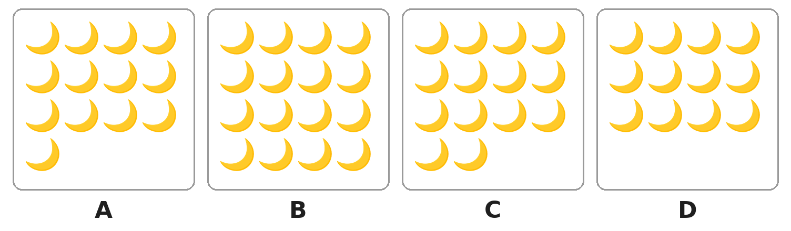
Q1. Look at the boxes. Which box has exactly 14 moons?
(A) Box A | (B) Box B | (C) Box C | (D) Box D

Q2. A toy shop packs balls in bags of 10. Which number of balls fills the bags with no balls left over?
(A) 16 | (B) 26 | (C) 60 | (D) 61

Q3. Which number name matches its number correctly?
(A) forty-seven = 74 | (B) seventy = 17
(C) seventeen = 70 | (D) seventy-four = 74

Q4. Which of these numbers has the same tens digit as 47?
(A) 27 | (B) 43 | (C) 57 | (D) 74

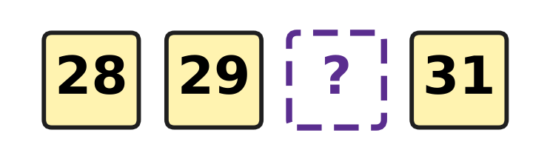
Q5. Look at the number cards. They are in order. Which number is hidden?
(A) 20 | (B) 30 | (C) 39 | (D) 40

Q6. One fish tank has 53 fish. Another tank has 35 fish. Which of these shows this correctly?
(A) 53 > 35 | (B) 53 < 35 | (C) 53 = 35 | (D) 35 > 53

Q7. Which of these numbers is greater than 70?
(A) 71 | (B) 17 | (C) 69 | (D) 67

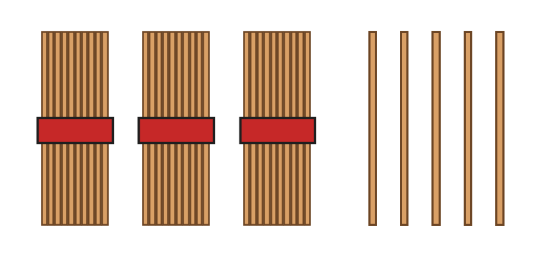
Q8. Look at the picture. Each bundle has 10 sticks. Veena adds 2 more bundles. How many sticks are there now?
(A) 35 | (B) 37 | (C) 45 | (D) 55

Q9. Which of these numbers stays the same when its two digits swap places?
(A) 34 | (B) 40 | (C) 43 | (D) 44

Q10. Three of these are the number 52. Which one is NOT 52?
(A) 5 tens and 2 ones | (B) 2 tens and 5 ones
(C) fifty-two | (D) 50 and 2 more

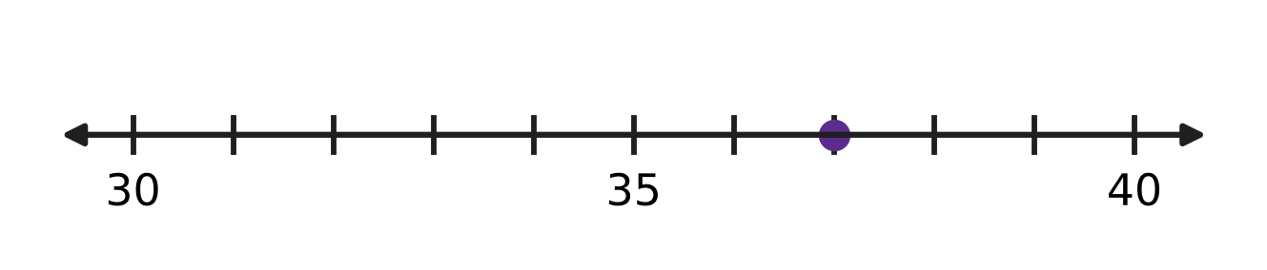
Q11. Look at the number line. Which number is at the dot?
(A) 32 | (B) 36 | (C) 37 | (D) 38

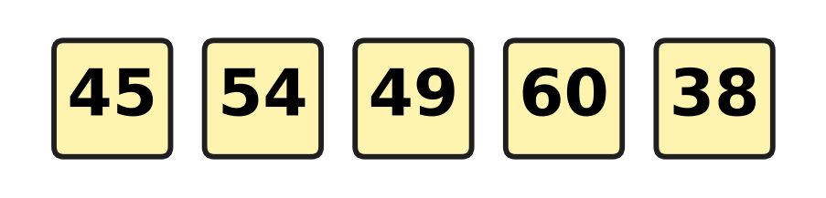
Q12. Look at the five number cards. How many of the numbers are less than 50?
(A) 2 | (B) 3 | (C) 4 | (D) 5

Part 2 — Operations & Number Properties (Syllabus Chapter 2)
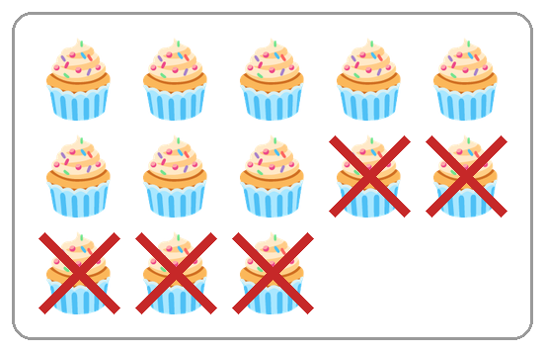
Q13. Look at the cupcakes. The crossed-out ones were eaten. Which take-away matches the picture?
(A) 8 − 5 | (B) 13 + 5 | (C) 13 − 4 | (D) 13 − 5

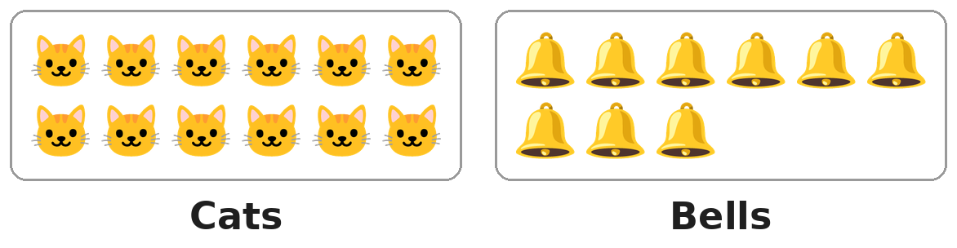
Q14. Look at the picture. Each cat needs one bell. How many more bells are needed?
(A) 3 | (B) 4 | (C) 9 | (D) 21

Q15. Which number goes in the blank?
13 + ___ = 13
(A) 0 | (B) 1 | (C) 13 | (D) 26

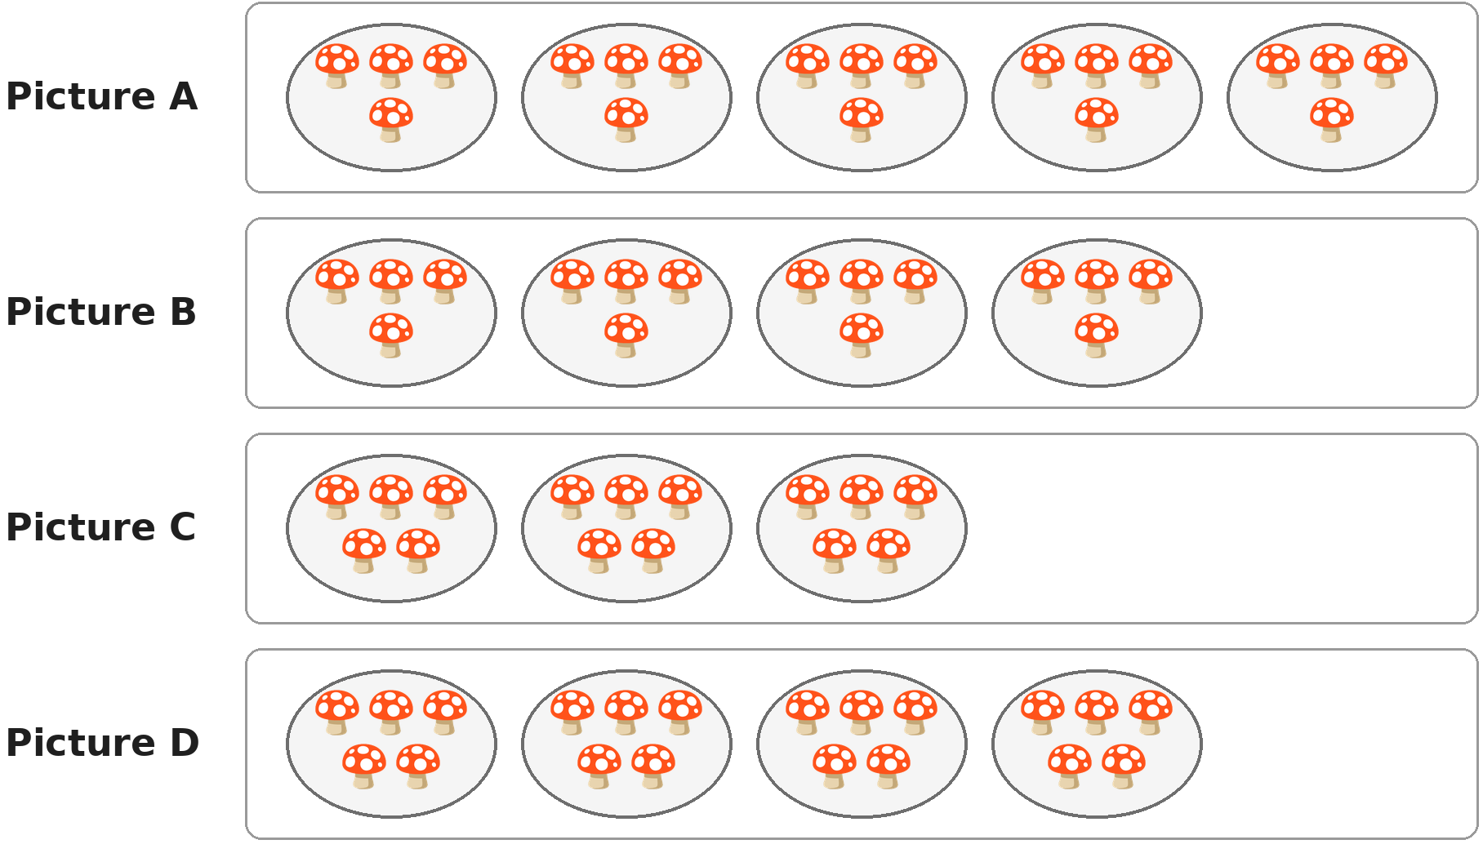
Q16. Look at the plates of mushrooms. Which picture shows 4 plates with 5 mushrooms on each plate?
(A) Picture A | (B) Picture B
(C) Picture C | (D) Picture D

Q17. A fence has 16 boards. Girish has painted 9 of them. How many boards are left to paint?
(A) 7 | (B) 8 | (C) 9 | (D) 25

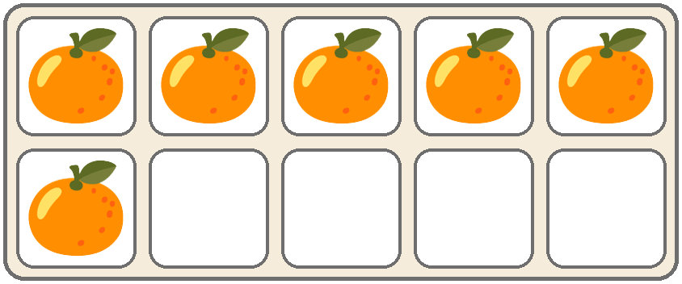
Q18. Look at the tray at a fruit market. A full tray holds 10 oranges. How many more oranges will fill it?
(A) 4 | (B) 5 | (C) 6 | (D) 16

Q19. We know that 9 + 5 = 14. Which of these number sentences is also true?
(A) 14 + 9 = 5 | (B) 5 + 14 = 9
(C) 9 − 5 = 14 | (D) 14 − 5 = 9

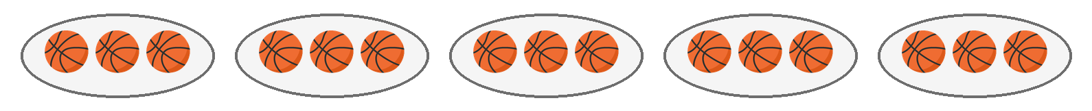
Q20. Look at the picture. Each tray has 3 balls. Jai takes away one full tray. How many balls are left?
(A) 9 | (B) 12 | (C) 14 | (D) 15

Q21. Geeta needs 13 beads for a necklace. She has 4 red beads and 5 blue beads. How many more beads does she need?
(A) 4 | (B) 8 | (C) 9 | (D) 22

Q22. Only one of these is right. Which one?
(A) 17 − 4 = 12 | (B) 9 + 6 = 14
(C) 8 + 7 = 15 | (D) 14 − 6 = 9

Part 3 — Geometry (Syllabus Chapter 5)
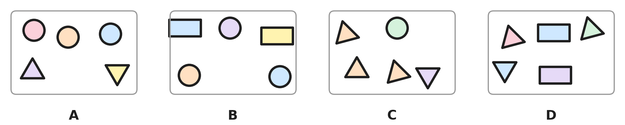
Q23. Look at the four pictures. Which picture has exactly 3 triangles?
(A) Picture A | (B) Picture B
(C) Picture C | (D) Picture D

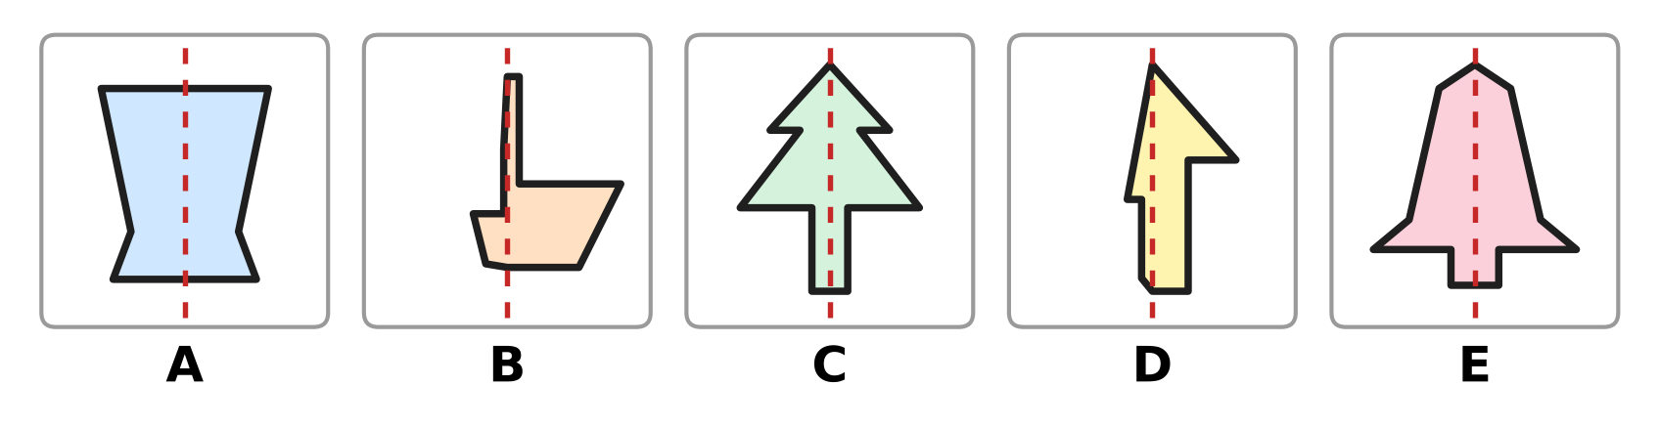
Q24. Look at the five pictures. How many of them are the same on both sides of the dotted line?
(A) 2 | (B) 3 | (C) 4 | (D) 5

Q25. Which of these is true for a rectangle?
(A) It has 4 corners. | (B) It is round.
(C) It has 3 sides. | (D) It has no corners.

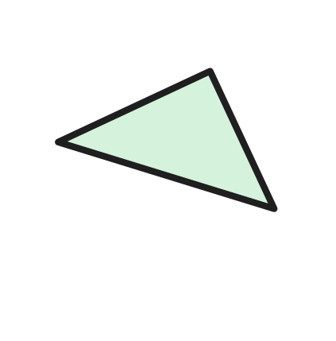
Q26. A shape card is turned, as in the picture. What is the name of the shape?
(A) Rectangle | (B) Circle
(C) Square | (D) Triangle

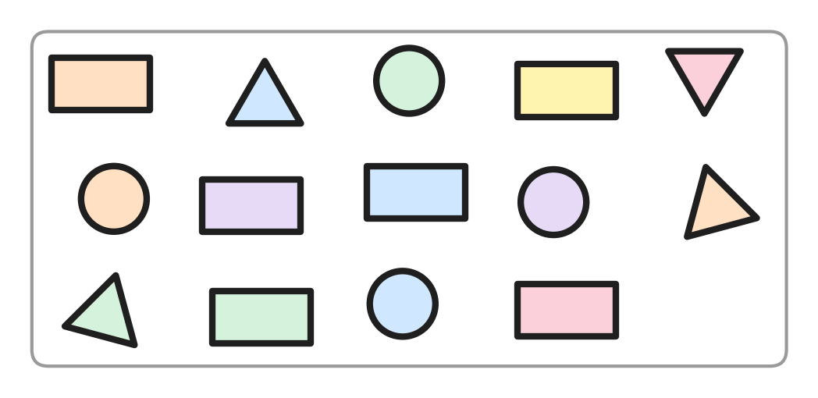
Q27. Look at the picture. Count each kind of shape. Which two kinds of shapes have the same count?
(A) Triangles and rectangles | (B) Circles and rectangles
(C) Circles and triangles | (D) Squares and circles

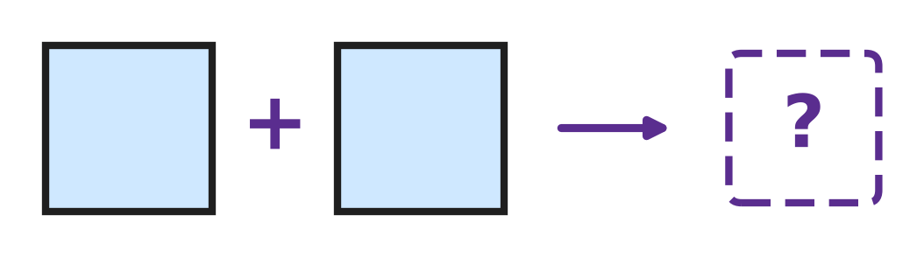
Q28. Look at the picture. Sumit joins two squares of the same size along one full side. Which shape does he make?
(A) A bigger square | (B) A rectangle
(C) A triangle | (D) A circle

Part 4 — Applied Mathematics (Syllabus Chapter 9)
Q29. Which of these shows two days that come one after the other?
(A) Thursday and Saturday | (B) Friday and Saturday
(C) Sunday and Tuesday | (D) Monday and Wednesday

Q30. Tanya says the months in order: January, February, April, May. Which month did she leave out?
(A) March | (B) December
(C) July | (D) June

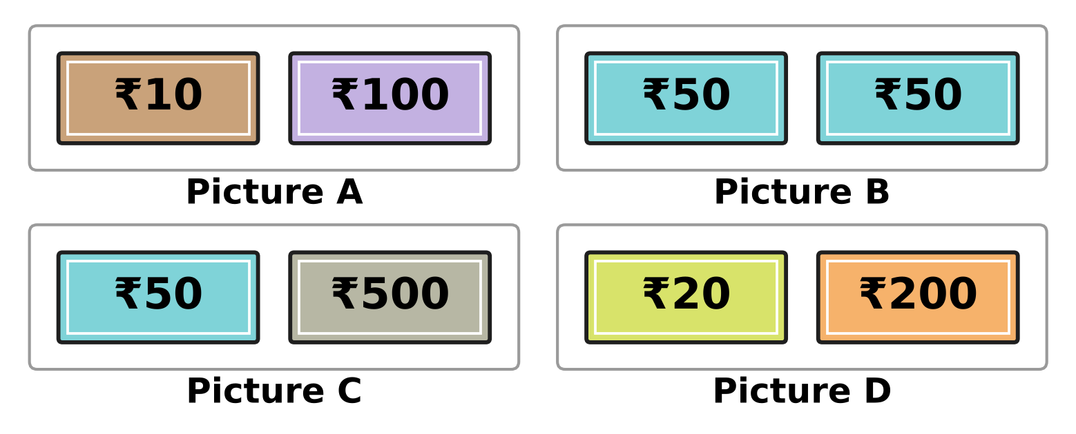
Q31. Look at the notes. Which picture shows two notes of the same value?
(A) Picture A | (B) Picture B
(C) Picture C | (D) Picture D

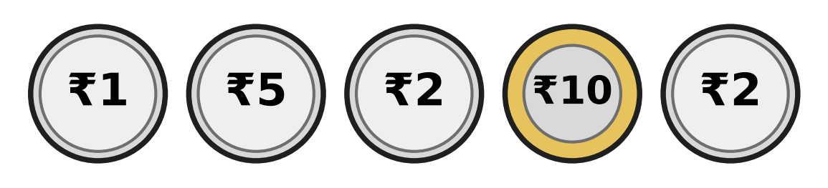
Q32. Look at the five coins. Kush keeps the two coins that are worth the most. Which coins does he keep?
(A) ₹2 and ₹2 | (B) ₹2 and ₹10
(C) ₹5 and ₹10 | (D) ₹1 and ₹5

Q33. Which of these months comes first in the year?
(A) November | (B) August
(C) May | (D) March

Q34. An aquarium is open every day from Tuesday to Sunday. On which day of the week is it closed?
(A) Monday | (B) Tuesday
(C) Saturday | (D) Sunday

Part 5 — Mathematical Reasoning & Problem-Solving (Syllabus Chapter 10)

Q35. Look at the pattern of big and small shapes. Which shape goes in the box?
(A) A big square | (B) A small square
(C) A big circle | (D) A small circle

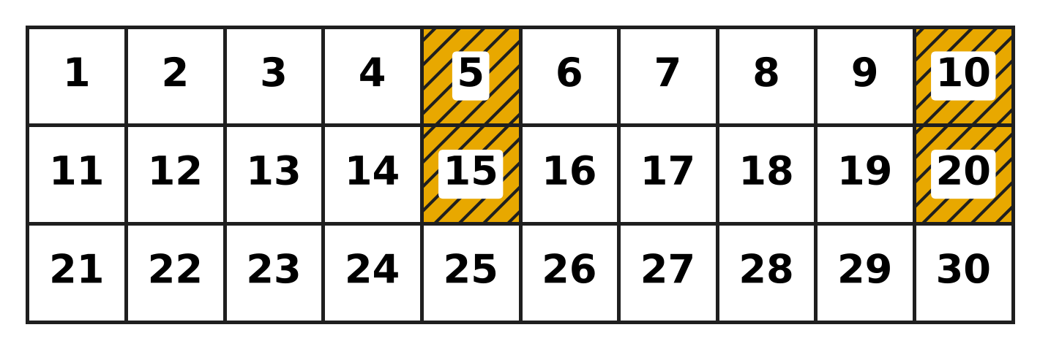
Q36. Look at the number chart. The shaded numbers follow a pattern. Which number will be shaded next?
(A) 21 | (B) 24 | (C) 25 | (D) 30

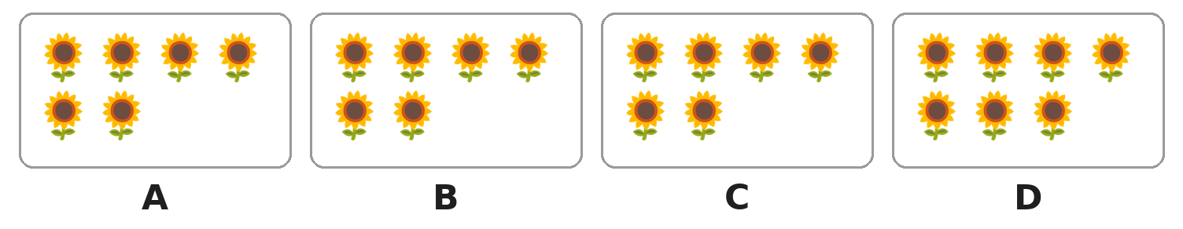
Q37. Look at the boxes of sunflowers. One box has a different number from the other three. Which box is it?
(A) Box A | (B) Box B | (C) Box C | (D) Box D

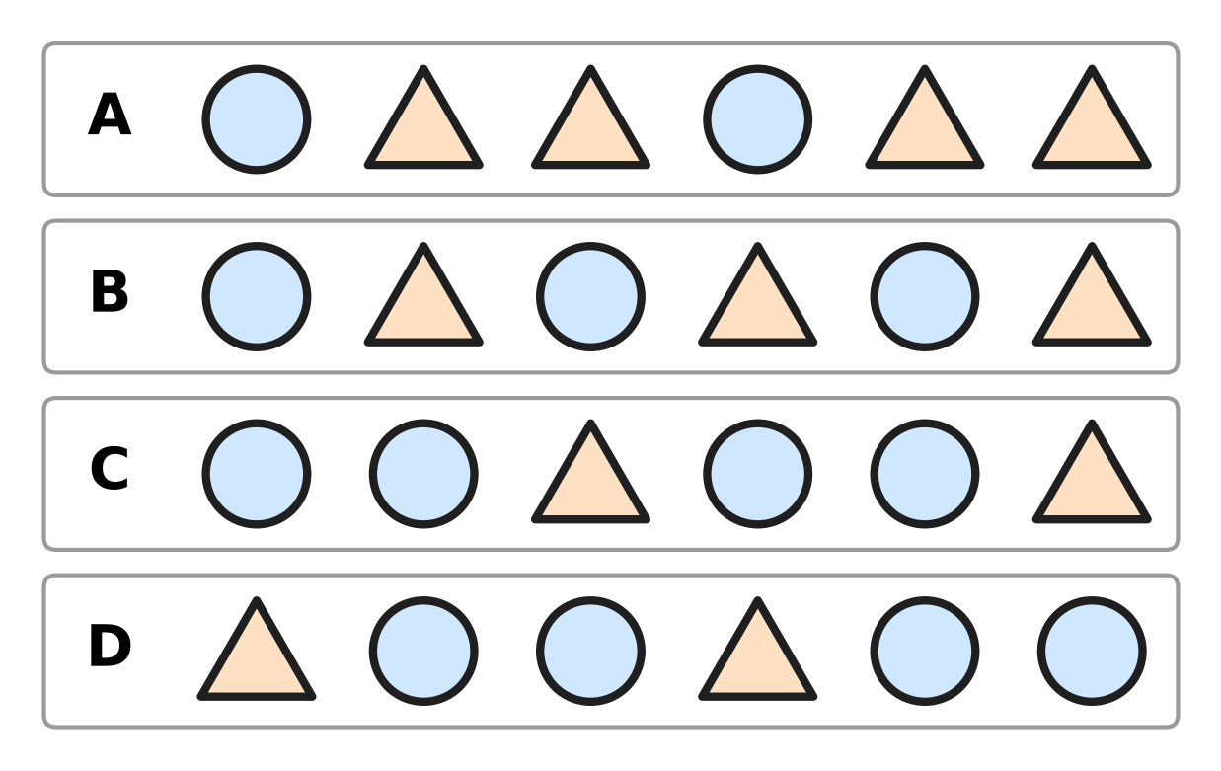
Q38. Look at the four rows. Which row repeats circle, triangle, triangle?
(A) Row A | (B) Row B
(C) Row C | (D) Row D

Q39. Which of these patterns counts back by 2 each time?
(A) 12, 9, 6, 3 | (B) 12, 10, 8, 6
(C) 12, 11, 10, 9 | (D) 6, 8, 10, 12

Q40. Mahi counts by twos from 2. Tejas counts by fives from 5. Which of these numbers do both of them say?
(A) 12 | (B) 15 | (C) 20 | (D) 25

SECTION II — Star Questions 5 questions × 4 marks each
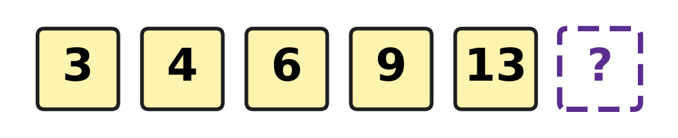
Q41. Look at the number pattern. Each jump is 1 more than the jump before. How many tens and ones does the next number have? [4 marks]
(A) 1 ten and 4 ones | (B) 8 tens and 1 one
(C) 1 ten and 7 ones | (D) 1 ten and 8 ones

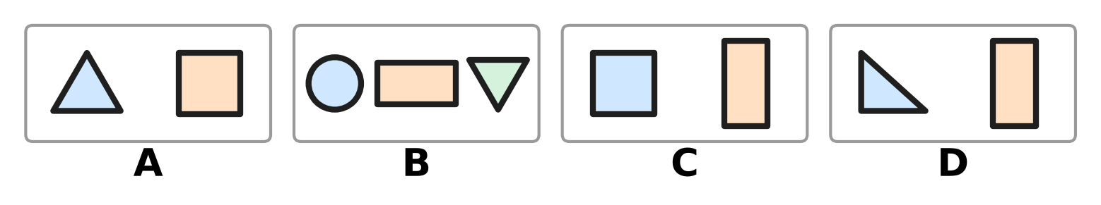
Q42. Look at the four pictures. Count all the corners in each picture. Which picture has a different number of corners from the other three? [4 marks]
(A) Picture A | (B) Picture B
(C) Picture C | (D) Picture D

Q43. Yuvan counts by tens: 10, 20, 30, and so on up to 100. For how many of these numbers is there an Indian rupee note? [4 marks]
(A) 3 | (B) 4 | (C) 6 | (D) 10

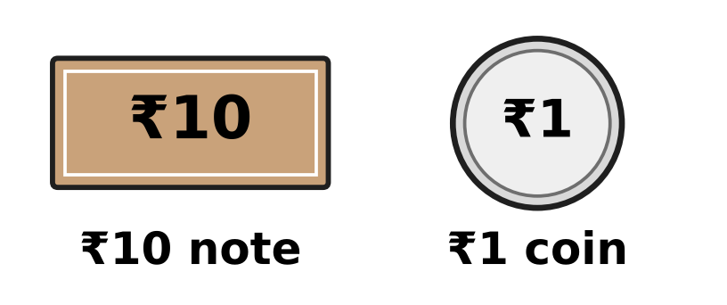
Q44. Look at the picture. Pihu pays the exact amount using only these two kinds of money. Which amount needs the smallest number of notes and coins in all? [4 marks]
(A) ₹19 | (B) ₹27 | (C) ₹31 | (D) ₹50

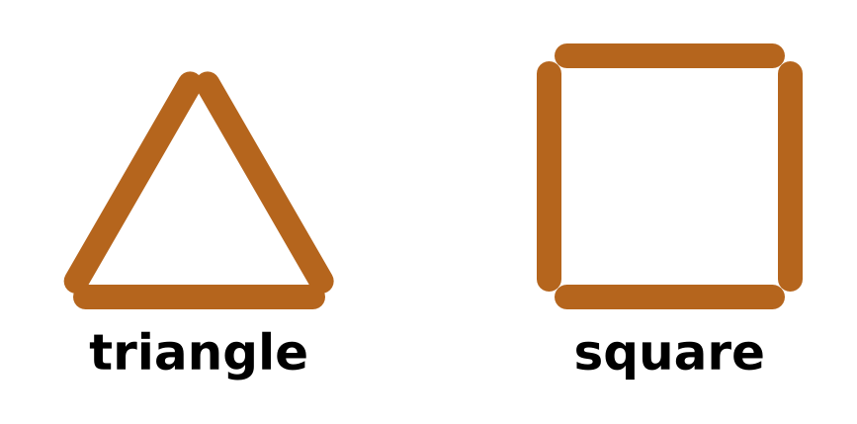
Q45. Look at the picture. Akash makes shapes like these, with one stick for each side. Which of these uses exactly 10 sticks? [4 marks]
(A) 3 triangles | (B) 2 squares
(C) 2 triangles and 1 square | (D) 1 triangle and 2 squares

Answer Sheet AMO Level 1 · Class 1 · Practice Paper 2
Name: | School: | Roll No.:
Shade or tick one circle for each question.
1. Ⓐ Ⓑ Ⓒ Ⓓ | 16. Ⓐ Ⓑ Ⓒ Ⓓ | 31. Ⓐ Ⓑ Ⓒ Ⓓ
2. Ⓐ Ⓑ Ⓒ Ⓓ | 17. Ⓐ Ⓑ Ⓒ Ⓓ | 32. Ⓐ Ⓑ Ⓒ Ⓓ
3. Ⓐ Ⓑ Ⓒ Ⓓ | 18. Ⓐ Ⓑ Ⓒ Ⓓ | 33. Ⓐ Ⓑ Ⓒ Ⓓ
4. Ⓐ Ⓑ Ⓒ Ⓓ | 19. Ⓐ Ⓑ Ⓒ Ⓓ | 34. Ⓐ Ⓑ Ⓒ Ⓓ
5. Ⓐ Ⓑ Ⓒ Ⓓ | 20. Ⓐ Ⓑ Ⓒ Ⓓ | 35. Ⓐ Ⓑ Ⓒ Ⓓ
6. Ⓐ Ⓑ Ⓒ Ⓓ | 21. Ⓐ Ⓑ Ⓒ Ⓓ | 36. Ⓐ Ⓑ Ⓒ Ⓓ
7. Ⓐ Ⓑ Ⓒ Ⓓ | 22. Ⓐ Ⓑ Ⓒ Ⓓ | 37. Ⓐ Ⓑ Ⓒ Ⓓ
8. Ⓐ Ⓑ Ⓒ Ⓓ | 23. Ⓐ Ⓑ Ⓒ Ⓓ | 38. Ⓐ Ⓑ Ⓒ Ⓓ
9. Ⓐ Ⓑ Ⓒ Ⓓ | 24. Ⓐ Ⓑ Ⓒ Ⓓ | 39. Ⓐ Ⓑ Ⓒ Ⓓ
10. Ⓐ Ⓑ Ⓒ Ⓓ | 25. Ⓐ Ⓑ Ⓒ Ⓓ | 40. Ⓐ Ⓑ Ⓒ Ⓓ
11. Ⓐ Ⓑ Ⓒ Ⓓ | 26. Ⓐ Ⓑ Ⓒ Ⓓ | 41. Ⓐ Ⓑ Ⓒ Ⓓ
12. Ⓐ Ⓑ Ⓒ Ⓓ | 27. Ⓐ Ⓑ Ⓒ Ⓓ | 42. Ⓐ Ⓑ Ⓒ Ⓓ
13. Ⓐ Ⓑ Ⓒ Ⓓ | 28. Ⓐ Ⓑ Ⓒ Ⓓ | 43. Ⓐ Ⓑ Ⓒ Ⓓ
14. Ⓐ Ⓑ Ⓒ Ⓓ | 29. Ⓐ Ⓑ Ⓒ Ⓓ | 44. Ⓐ Ⓑ Ⓒ Ⓓ
15. Ⓐ Ⓑ Ⓒ Ⓓ | 30. Ⓐ Ⓑ Ⓒ Ⓓ | 45. Ⓐ Ⓑ Ⓒ Ⓓ
Q41–Q45 are Section II Star Questions (4 marks each).
For the parent or teacher
Section I correct: ______ / 40 × 2 = ______ marks Section II correct: ______ / 5 × 4 = ______ marks
Correct: ______ / 45 Score: ______ / 100
Answer Key and Solutions AMO Level 1 · Class 1 · Practice Paper 2
Quick answers
1 C | 6 A | 11 C | 16 D | 21 A | 26 D | 31 B | 36 C | 41 D
2 C | 7 A | 12 B | 17 A | 22 C | 27 C | 32 C | 37 D | 42 C
3 D | 8 D | 13 D | 18 A | 23 D | 28 B | 33 D | 38 A | 43 B
4 B | 9 D | 14 A | 19 D | 24 B | 29 B | 34 A | 39 B | 44 C
5 B | 10 B | 15 A | 20 B | 25 A | 30 A | 35 D | 40 C | 45 C
Solutions
Q | Part · level | Answer | Why?
1 | Part 1 · Ch1 · Easy | (C) Box C | Box C has three rows of 4 moons and 2 more moons. Counting on from 12 gives 13, 14. So Box C has 14 moons.
2 | Part 1 · Ch1 · Easy | (C) 60 | 60 is 6 tens and 0 ones, so it fills 6 bags with no ball left. The numbers 16, 26 and 61 have 6, 6 and 1 loose ones.
3 | Part 1 · Ch1 · Easy | (D) seventy-four = 74 | Seventy-four is 7 tens and 4 ones, which is 74. Forty-seven is 47, seventeen is 17 and seventy is 70.
4 | Part 1 · Ch1 · Easy | (B) 43 | The tens digit of 47 is 4. The number 43 also has 4 tens. The numbers 27, 57 and 74 have 2, 5 and 7 tens.
5 | Part 1 · Ch1 · Easy | (B) 30 | The number just after 29 is 30, and 30 is just before 31. The hidden number is 30.
6 | Part 1 · Ch1 · Easy | (A) 53 > 35 | 53 has 5 tens and 35 has only 3 tens. So 53 is greater than 35, written 53 > 35.
7 | Part 1 · Ch1 · Easy | (A) 71 | 70 has 7 tens and 0 ones. 71 has 7 tens and 1 one, so it is greater. The numbers 67, 69 and 17 have fewer tens.
8 | Part 1 · Ch1 · Medium | (D) 55 | The picture shows 3 bundles and 5 sticks, which is 35. Two more bundles make 5 tens. 5 tens and 5 ones is 55.
9 | Part 1 · Ch1 · Medium | (D) 44 | 44 has 4 tens and 4 ones, so swapping the digits gives 44 again. The others change: 34 becomes 43, 43 becomes 34 and 40 becomes 4.
10 | Part 1 · Ch1 · Medium | (B) 2 tens and 5 ones | 2 tens and 5 ones make 25, not 52. The other three all mean 52.
11 | Part 1 · Ch1 · Medium | (C) 37 | The dot is two steps after 35. Counting on from 35 gives 36, then 37. The dot is at 37.
12 | Part 1 · Ch1 · Medium | (B) 3 | 45, 49 and 38 have fewer than 5 tens, so they are less than 50. The numbers 54 and 60 are greater. That makes 3 numbers.
13 | Part 2 · Ch2 · Easy | (D) 13 − 5 | There are 13 cupcakes in all and 5 are crossed out. The take-away is 13 − 5, which leaves 8.
14 | Part 2 · Ch2 · Easy | (A) 3 | There are 12 cats and 9 bells. 12 − 9 = 3, so 3 more bells are needed.
15 | Part 2 · Ch2 · Easy | (A) 0 | Adding 0 keeps a number the same. 13 + 0 = 13, so the blank is 0.
16 | Part 2 · Ch2 · Easy | (D) Picture D | Picture D has 4 plates, and every plate has 5 mushrooms. Picture A has 5 plates of 4, Picture B has 4 plates of 4 and Picture C has 3 plates of 5.
17 | Part 2 · Ch2 · Easy | (A) 7 | 16 − 9 = 7. So 7 boards are left to paint.
18 | Part 2 · Ch2 · Easy | (A) 4 | The tray has 6 oranges and 4 empty boxes. 6 + 4 = 10, so 4 more oranges will fill it.
19 | Part 2 · Ch2 · Medium | (D) 14 − 5 = 9 | The three numbers are 9, 5 and 14. Taking 5 away from 14 leaves 9, so 14 − 5 = 9 is true.
20 | Part 2 · Ch2 · Medium | (B) 12 | 5 trays of 3 make 3, 6, 9, 12, 15 balls. One tray of 3 goes away, so 15 − 3 = 12 balls are left.
21 | Part 2 · Ch2 · Medium | (A) 4 | She has 4 + 5 = 9 beads. She needs 13 − 9 = 4 more beads.
22 | Part 2 · Ch2 · Medium | (C) 8 + 7 = 15 | 8 + 7 = 15 is right. The others should be 9 + 6 = 15, 17 − 4 = 13 and 14 − 6 = 8.
23 | Part 3 · Ch5 · Easy | (D) Picture D | Picture D has 3 triangles and 2 rectangles. Picture A has 2 triangles, Picture B has none and Picture C has 4.
24 | Part 3 · Ch5 · Easy | (B) 3 | Pictures A, C and E match when folded along the dotted line. In Pictures B and D the left half is smaller. So 3 pictures are the same on both sides.
25 | Part 3 · Ch5 · Easy | (A) It has 4 corners. | A rectangle has 4 straight sides and 4 corners. A triangle has 3 sides, and a circle is round with no corners.
26 | Part 3 · Ch5 · Easy | (D) Triangle | The shape has 3 straight sides and 3 corners. It is a triangle, even when it is turned.
27 | Part 3 · Ch5 · Medium | (C) Circles and triangles | There are 4 circles, 4 triangles and 6 rectangles. The circles and the triangles are equal in number.
28 | Part 3 · Ch5 · Medium | (B) A rectangle | The new shape has 4 corners, with 2 long sides and 2 short sides. That is a rectangle.
29 | Part 4 · Ch9 · Easy | (B) Friday and Saturday | Saturday comes just after Friday. Each of the other pairs has one day in between.
30 | Part 4 · Ch9 · Easy | (A) March | The order is January, February, March, April, May. She left out March.
31 | Part 4 · Ch9 · Easy | (B) Picture B | Picture B has two ₹50 notes. The other pictures have ₹10 and ₹100, ₹50 and ₹500, and ₹20 and ₹200, which are different.
32 | Part 4 · Ch9 · Easy | (C) ₹5 and ₹10 | From least to most the coins are ₹1, ₹2, ₹2, ₹5, ₹10. The two worth the most are ₹5 and ₹10.
33 | Part 4 · Ch9 · Medium | (D) March | In the year the order is March, May, August, November. March comes earliest.
34 | Part 4 · Ch9 · Medium | (A) Monday | Tuesday, Wednesday, Thursday, Friday, Saturday and Sunday are six days. The only day left in the week is Monday.
35 | Part 5 · Ch10 · Easy | (D) A small circle | The pattern repeats big circle, small circle, big square, small square. After a big circle comes a small circle.
36 | Part 5 · Ch10 · Easy | (C) 25 | The shaded numbers are 5, 10, 15, 20. Each is 5 more than the one before, so the next is 25.
37 | Part 5 · Ch10 · Easy | (D) Box D | Boxes A, B and C have 6 sunflowers each. Box D has 7 sunflowers, so it is the odd one out.
38 | Part 5 · Ch10 · Medium | (A) Picture A | Row A goes circle, triangle, triangle, and then the same three shapes again. Row B repeats two shapes, and Rows C and D have two circles together.
39 | Part 5 · Ch10 · Medium | (B) 12, 10, 8, 6 | 12, 10, 8, 6 goes down by 2 each time. The others go back by 1, forward by 2 and back by 3.
40 | Part 5 · Ch10 · Medium | (C) 20 | Mahi says 2, 4, 6, and so on up to 20. Tejas says 5, 10, 15, 20. Both say 20. Only Mahi says 12, and only Tejas says 15 and 25.
41 | Section II · Ch1 + Ch10 · Hard | (D) 1 ten and 8 ones | The jumps are 1, 2, 3, 4, so the next jump is 5. 13 + 5 = 18, and 18 is 1 ten and 8 ones.
42 | Section II · Ch5 + Ch10 · Hard | (C) Picture C | Picture A has 3 + 4 = 7 corners. Picture B has 0 + 4 + 3 = 7. Picture C has 4 + 4 = 8. Picture D has 3 + 4 = 7. Only Picture C has a different number.
43 | Section II · Ch9 + Ch10 · Hard | (B) 4 | He says 10, 20, 30, 40, 50, 60, 70, 80, 90, 100. There are notes of ₹10, ₹20, ₹50 and ₹100 only. That is 4 numbers.
44 | Section II · Ch1 + Ch9 · Hard | (C) ₹31 | ₹19 needs 1 note and 9 coins (10 in all). ₹27 needs 2 notes and 7 coins (9). ₹31 needs 3 notes and 1 coin (4). ₹50 needs 5 notes. The fewest is 4, for ₹31.
45 | Section II · Ch2 + Ch5 · Hard | (C) 2 triangles and 1 square | A triangle needs 3 sticks and a square needs 4. 3 + 3 + 4 = 10 sticks. 3 triangles need 9 sticks, 2 squares need 8, and 1 triangle and 2 squares need 11.

ARYABHATTA MATHS OLYMPIAD
Level 1
PRACTICE PAPER-3
CLASS 1
Total Questions | 45 multiple-choice questions
Total Marks | 100
Time | 60 minutes
Section I | 40 questions × 2 marks = 80 marks
Section II | 5 Star Questions × 4 marks = 20 marks
Negative Marking | No negative marking
Calculator | Not allowed
Chapters | Number System · Operations · Geometry · Applied Mathematics · Mathematical Reasoning

👋 Hello, friend! How to do this paper:
⭐ Every question has four answer choices: (A), (B), (C) and (D). Only one is correct.
⭐ Read each question and look at its picture carefully. Then mark your answer on the answer sheet at the end.
⭐ Section I has 40 questions of 2 marks each. Section II has 5 Star Questions of 4 marks each.
⭐ There is no negative marking, so try every question.
⭐ Do not use a calculator. You may do rough work on a separate sheet.
⭐ All figures are not necessarily drawn to scale unless stated.

For parents and teachers
• Print or view this paper in colour. Pictures are part of the questions.
• You may read a question aloud to the child, exactly as printed. Please do not explain it or point to an answer choice.
• Parts follow the AMO syllabus chapters. Chapters 3, 4, 6, 7 and 8 are not part of the Class 1 syllabus, so the chapter numbers shown in the Part headings have gaps.
• The answer sheet and the answer key are at the end. Remove only the answer key before the child begins.

SECTION I 40 questions × 2 marks each
Part 1 — Number System (Syllabus Chapter 1)
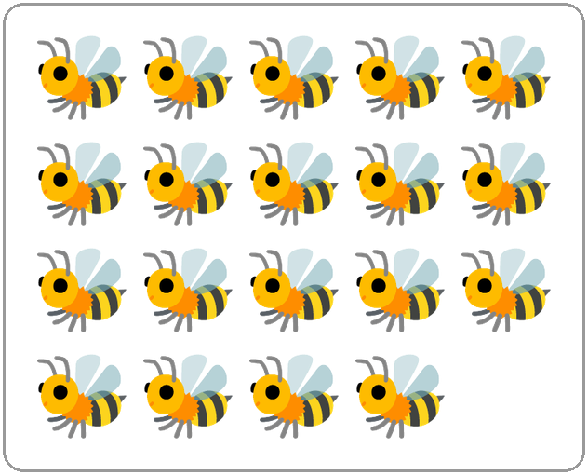
Q1. Look at the picture. Which number name tells how many bees there are?
(A) nineteen | (B) eighteen
(C) fifteen | (D) ninety

Q2. Which word fills the blank?
The number name of 73 is seventy-___.
(A) ten | (B) thirty | (C) seven | (D) three

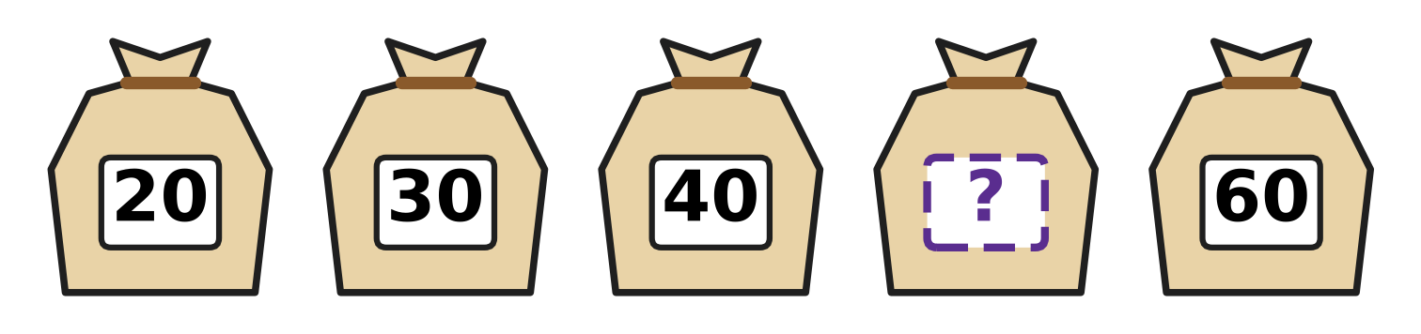
Q3. The sacks of grain in the picture are numbered in tens. Which number is hidden?
(A) 50 | (B) 70 | (C) 41 | (D) 45

Q4. Which number fills the blank?
The number that is 1 more than 79 is ___.
(A) 78 | (B) 80 | (C) 89 | (D) 90

Q5. Which number fills the blank?
The number 67 is 6 tens and ___ ones.
(A) 1 | (B) 6 | (C) 13 | (D) 7

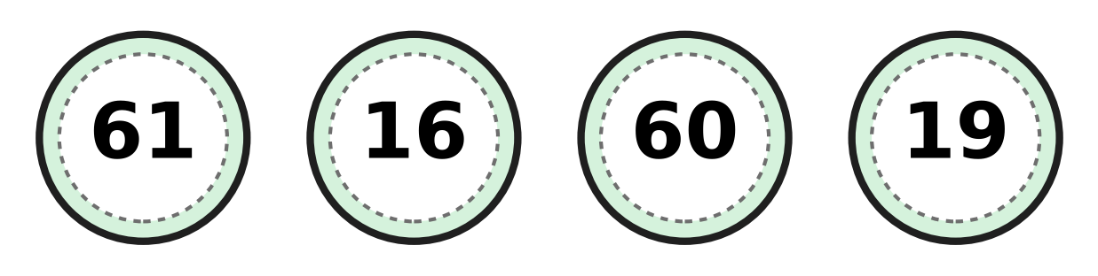
Q6. Look at the four canteen tokens. Which token has the smallest number?
(A) 16 | (B) 61 | (C) 19 | (D) 60

Q7. In 74, what does the digit 7 stand for?
(A) 74 tens | (B) 4 tens | (C) 7 ones | (D) 7 tens

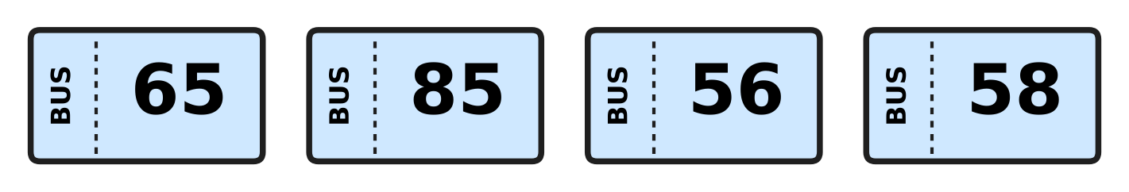
Q8. Look at the four bus tickets. Daksh puts their numbers in order, smallest first. Which number comes third?
(A) 65 | (B) 85 | (C) 56 | (D) 58

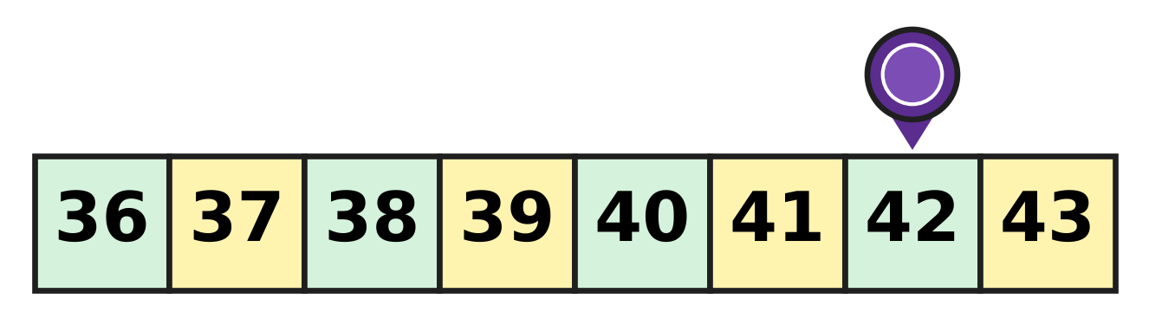
Q9. Look at the game track. The counter is on 42. It moves back 4 squares, to a smaller number. On which number does it stop?
(A) 37 | (B) 38 | (C) 39 | (D) 46

Q10. Sakshi writes the number with 5 tens and 2 ones. Then she swaps its two digits. Which number does she get?
(A) 25 | (B) 52 | (C) 20 | (D) 7

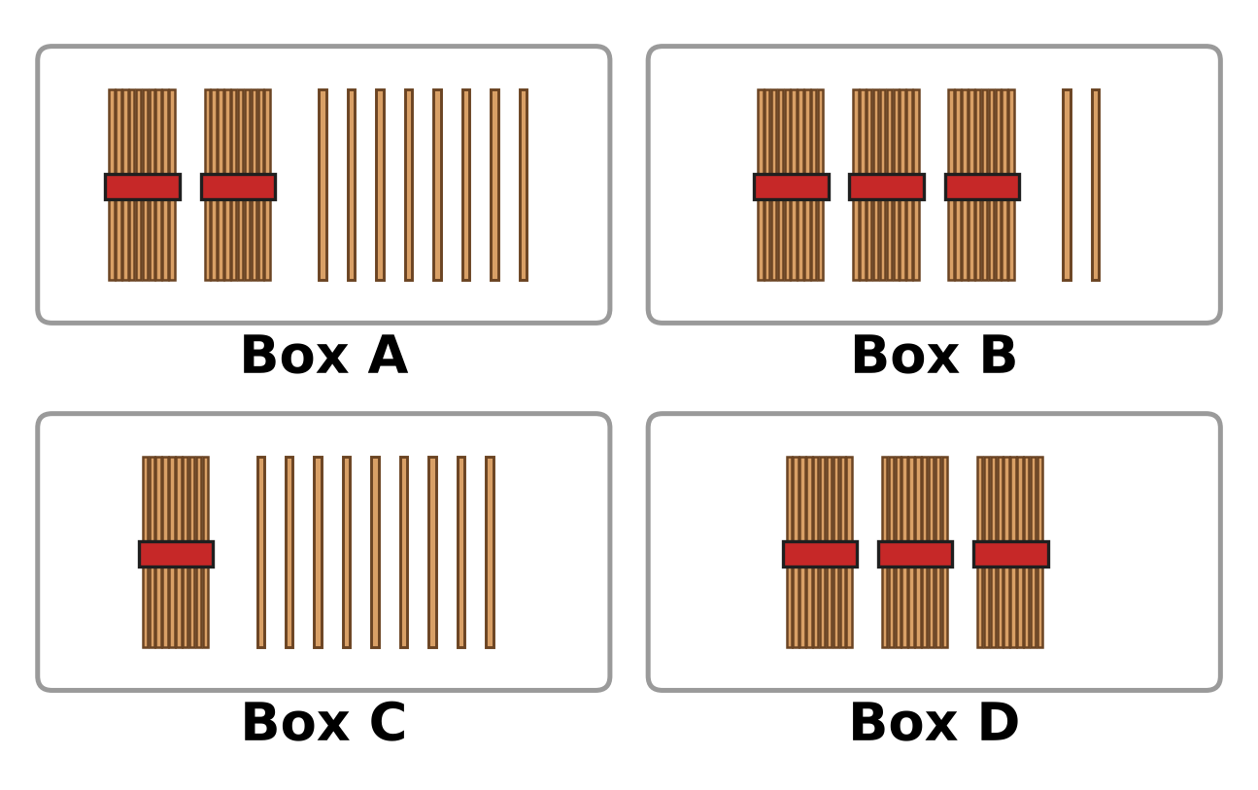
Q11. Each box shows bundles of ten sticks. Some boxes also have loose sticks. Which box shows the greatest number?
(A) Box A | (B) Box B | (C) Box C | (D) Box D

Q12. Which of these is greater than 78?
(A) 6 tens and 9 ones | (B) 7 tens
(C) 7 tens and 7 ones | (D) 8 tens

Part 2 — Operations & Number Properties (Syllabus Chapter 2)
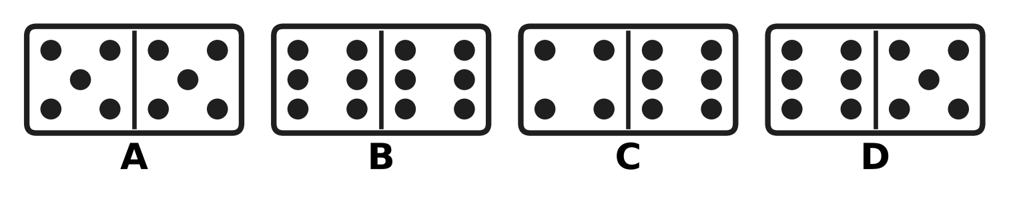
Q13. Look at the dominoes. Which domino has 11 dots in all?
(A) Picture A | (B) Picture B
(C) Picture C | (D) Picture D

Q14. Juhi folds 8 paper planes. Sahil also folds 8. How many paper planes do they fold in all?
(A) 16 | (B) 88 | (C) 18 | (D) 8

Q15. Hemant the postman has 19 letters in his bag. He delivers 7 letters. How many letters are left in the bag?
(A) 11 | (B) 12 | (C) 13 | (D) 26

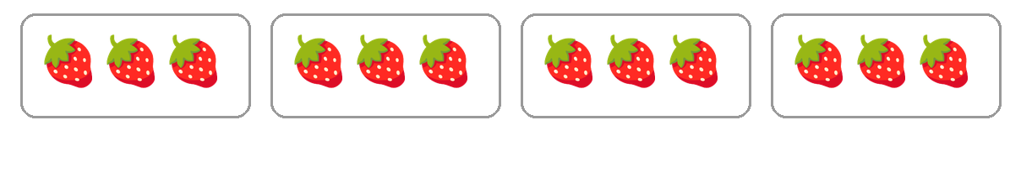
Q16. Look at the boxes of strawberries. Which number fills the blank?
There are ___ groups of 3 strawberries.
(A) 7 | (B) 3 | (C) 12 | (D) 4

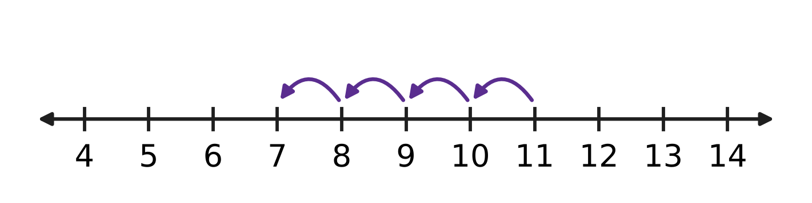
Q17. The hops on the number line show a take-away. Which number fills the blank?
11 − ___ = 7
(A) 3 | (B) 4 | (C) 5 | (D) 18

Q18. Which number fills the blank?
10 + ___ = 17
(A) 17 | (B) 27 | (C) 1 | (D) 7

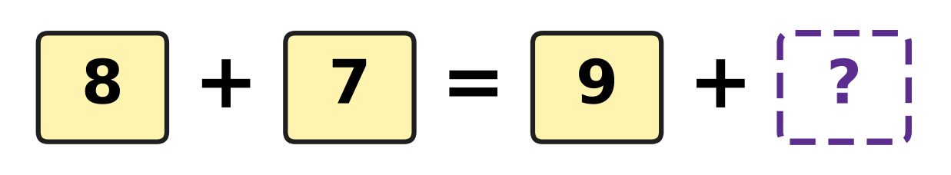
Q19. Look at the number cards. The two sides of the = sign must be equal. Which number goes in the box with the question mark?
(A) 6 | (B) 7 | (C) 15 | (D) 24

Q20. Which take-away gives 9?
(A) 18 − 9 | (B) 16 − 6 | (C) 19 − 9 | (D) 17 − 9

Q21. Some mangoes hang on a tree. Then 5 mangoes fall down. Now 11 mangoes are on the tree. How many mangoes were on the tree at first?
(A) 6 | (B) 11 | (C) 15 | (D) 16

Q22. Bharat makes 15 clay pots. Nina makes 11 clay pots. How many more pots does Bharat make than Nina?
(A) 4 | (B) 5 | (C) 15 | (D) 26

Part 3 — Geometry (Syllabus Chapter 5)
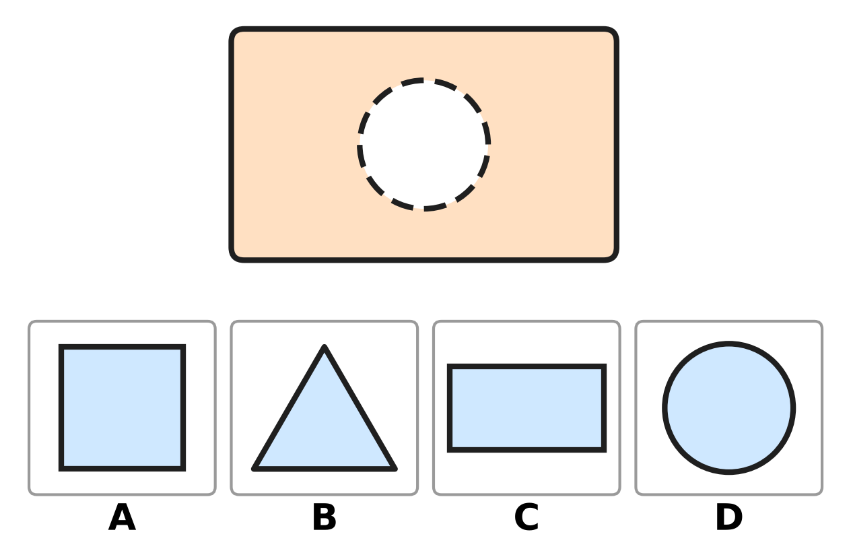
Q23. A piece is missing from the board at the top. Which picture shows the piece that fits the hole?
(A) Picture A | (B) Picture B
(C) Picture C | (D) Picture D

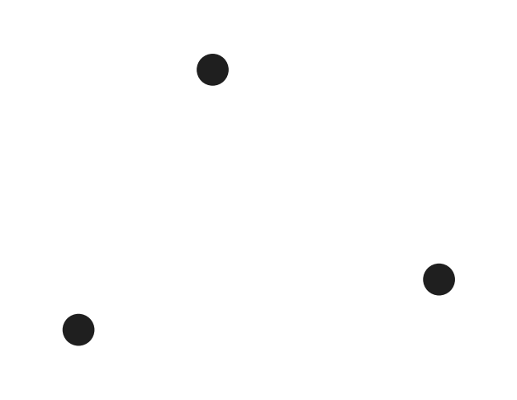
Q24. Sneha joins the three dots in the picture with straight lines to make a shape. How many sides does her shape have?
(A) 0 | (B) 3 | (C) 4 | (D) 6

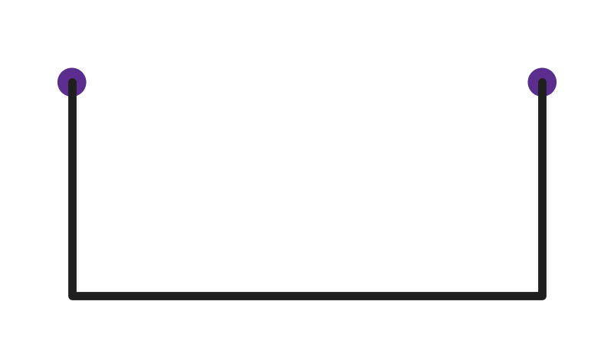
Q25. Three sides of a shape are drawn. Tushar joins the two dots with a straight line to close the shape. Which shape does he get?
(A) triangle | (B) circle
(C) square | (D) rectangle

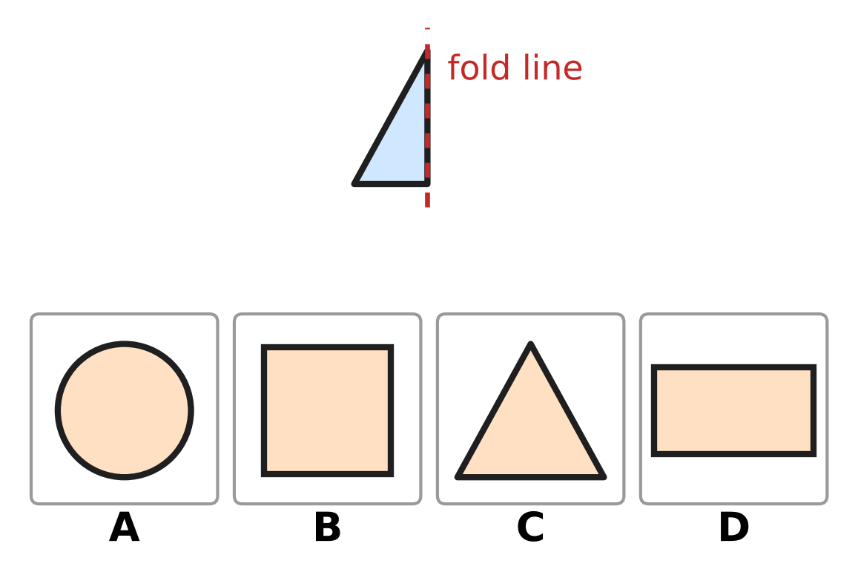
Q26. Half of a shape is drawn next to a fold line. The other half is the same, on the other side of the fold line. Which picture shows the whole shape?
(A) Picture A | (B) Picture B
(C) Picture C | (D) Picture D

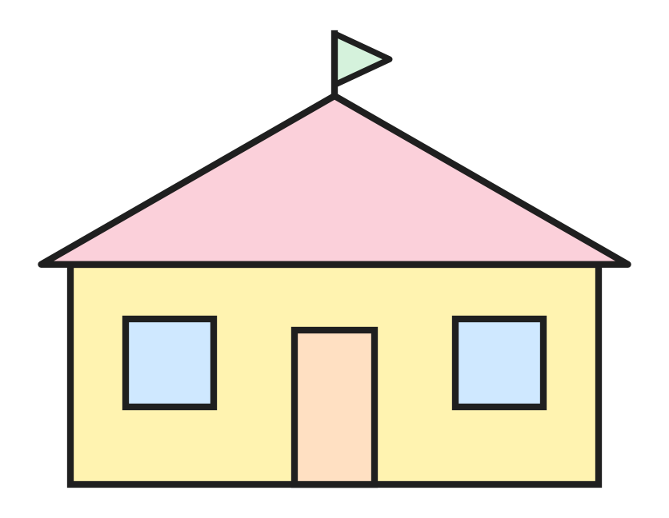
Q27. This picture of a house is made of shapes. Which shape is NOT in the picture?
(A) circle | (B) rectangle
(C) triangle | (D) square

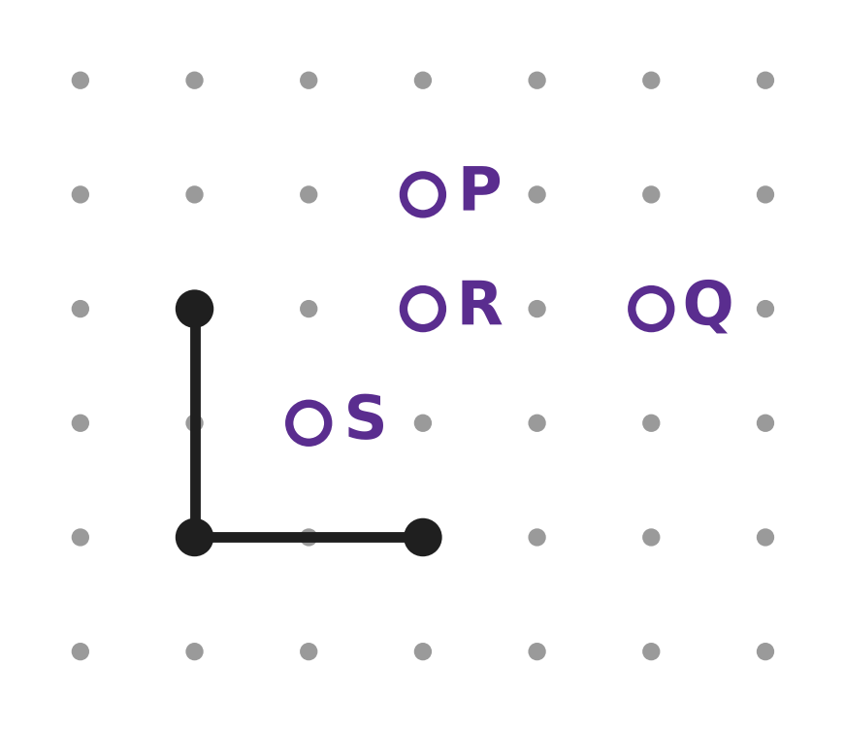
Q28. Two sides of a square are drawn on dot paper. Which letter marks the fourth corner of the square?
(A) P | (B) Q | (C) R | (D) S

Part 4 — Applied Mathematics (Syllabus Chapter 9)
Q29. Tomorrow is Saturday. Which day is today?
(A) Sunday | (B) Thursday
(C) Monday | (D) Friday

Q30. Which number fills the blank?
One year has ___ months.
(A) 7 | (B) 10 | (C) 12 | (D) 30

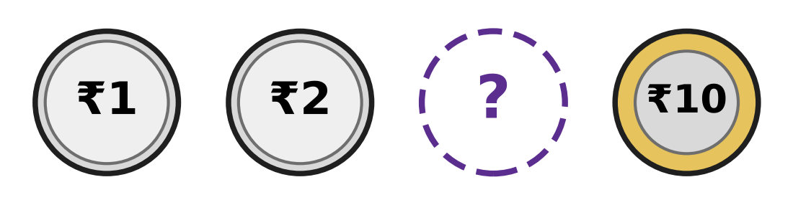
Q31. The coins in the picture are in order, from the least value to the greatest. Which coin is hidden?
(A) ₹1 | (B) ₹2 | (C) ₹5 | (D) ₹20

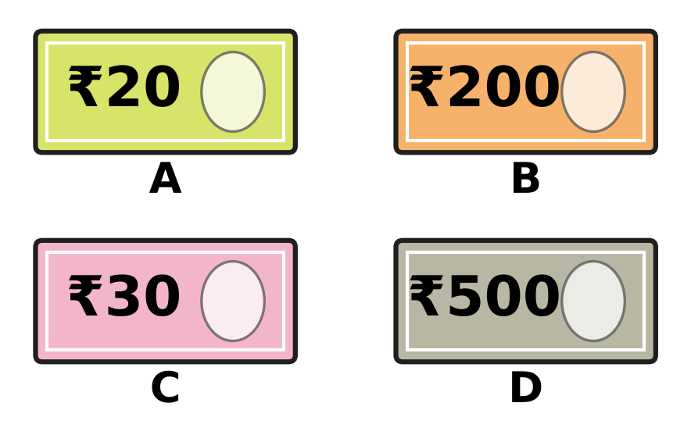
Q32. Look at the four pictures. Three of them show Indian notes. Which picture is NOT an Indian note?
(A) Picture A | (B) Picture B
(C) Picture C | (D) Picture D

Q33. Vinita goes to school every day from Monday to Friday. Which is the middle day of these school days?
(A) Wednesday | (B) Tuesday
(C) Friday | (D) Thursday

Q34. How many months of the year come after September?
(A) 2 | (B) 3 | (C) 4 | (D) 9

Part 5 — Mathematical Reasoning & Problem-Solving (Syllabus Chapter 10)
Q35. Ken counts back in fives: 40, 35, 30, 25. Which number does he say next?
(A) 15 | (B) 20 | (C) 24 | (D) 30

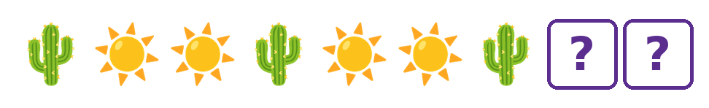
Q36. The pictures make a pattern. Which two pictures come next, in this order?
(A)  | (B)  | (C)  | (D) 

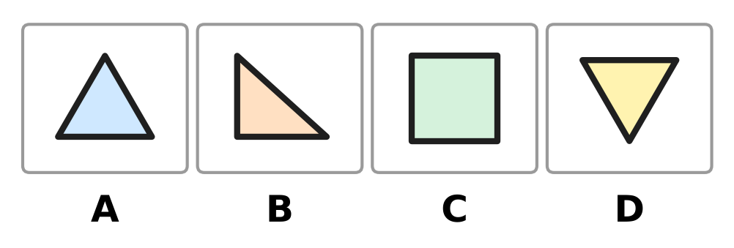
Q37. Three of the four shapes are alike. Each of them has 3 corners. Which picture does NOT belong with them?
(A) Picture A | (B) Picture B
(C) Picture C | (D) Picture D

Q38. Look at the pattern: 7, 17, 27, 37.
It goes on in the same way. Which of these numbers will also be in the pattern?
(A) 40 | (B) 57 | (C) 70 | (D) 73

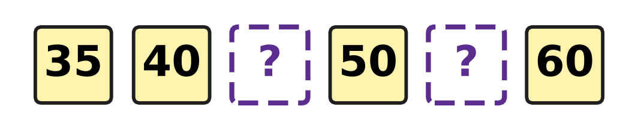
Q39. The numbers in the picture make a pattern. Which two numbers are hidden?
(A) 42 and 52 | (B) 45 and 55
(C) 41 and 51 | (D) 45 and 65

Q40. Look at the tens in these numbers. Three of them have the same number of tens. Which number does NOT belong with them?
(A) 62 | (B) 64 | (C) 46 | (D) 68

SECTION II — Star Questions 5 questions × 4 marks each
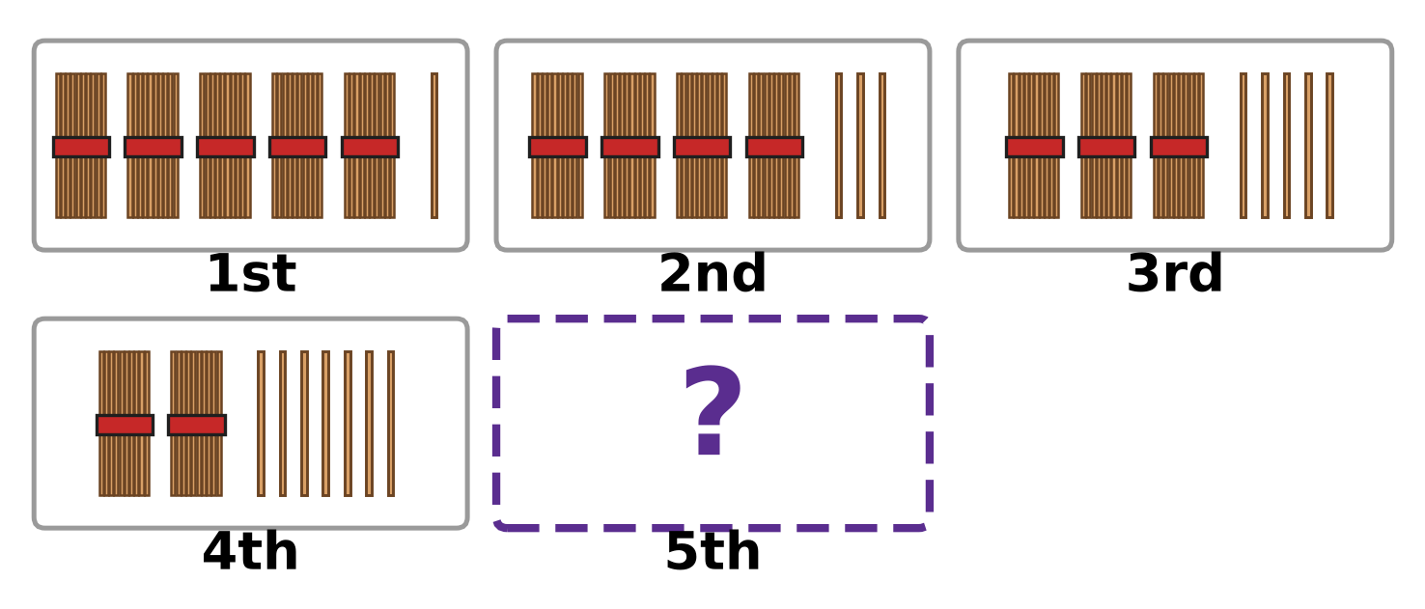
Q41. Each box shows a number as bundles of ten and loose sticks. The boxes follow a pattern. Which number does the 5th box show? [4 marks]
(A) 17 | (B) 19 | (C) 29 | (D) 91

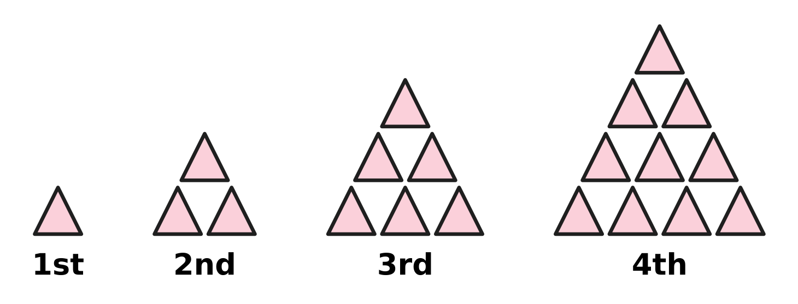
Q42. Look at the stacks of triangles. Each new stack has one more row at the bottom. How many triangles will the 5th stack have? [4 marks]
(A) 5 | (B) 14 | (C) 15 | (D) 20

Q43. Nora saves ₹10 in January, ₹20 in February, ₹30 in March and ₹40 in April. The pattern goes on. In which month does she save ₹70? [4 marks]
(A) June | (B) July | (C) August | (D) May

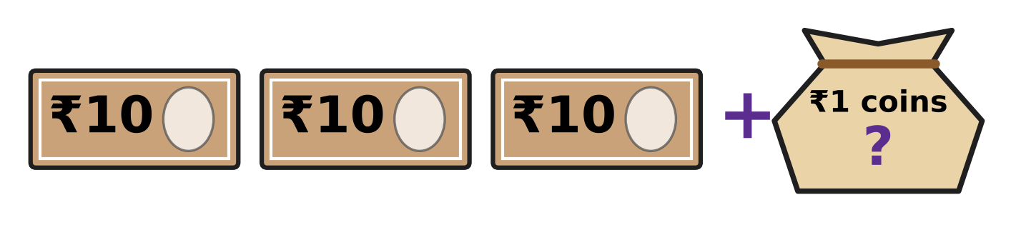
Q44. Saira has ₹42 in all. She has the 3 notes in the picture, and the rest is in ₹1 coins. How many ₹1 coins does she have? [4 marks]
(A) 2 | (B) 4 | (C) 12 | (D) 39

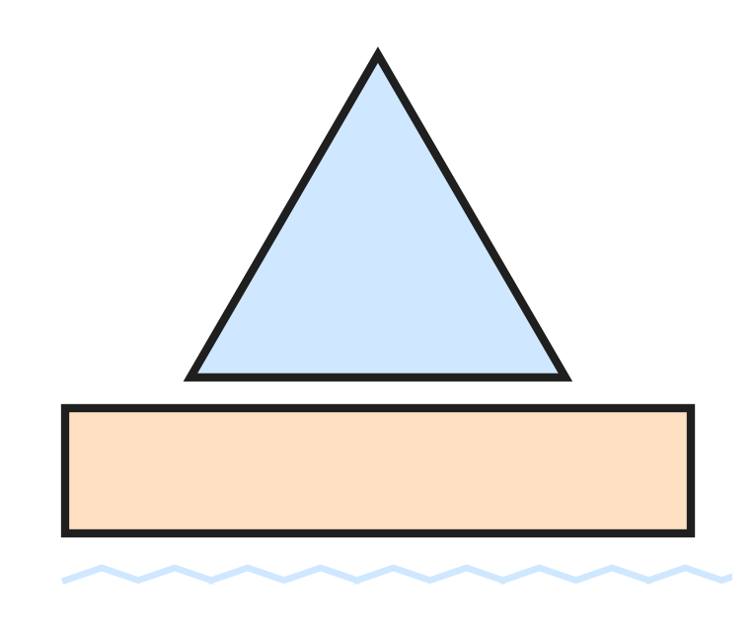
Q45. Look at the toy boat. Lalit counts all the sides and all the corners of its two shapes. What total does he get? [4 marks]
(A) 7 | (B) 8 | (C) 14 | (D) 16

Answer Sheet AMO Level 1 · Class 1 · Practice Paper 3
Name: | School: | Roll No.:
Shade or tick one circle for each question.
1. Ⓐ Ⓑ Ⓒ Ⓓ | 16. Ⓐ Ⓑ Ⓒ Ⓓ | 31. Ⓐ Ⓑ Ⓒ Ⓓ
2. Ⓐ Ⓑ Ⓒ Ⓓ | 17. Ⓐ Ⓑ Ⓒ Ⓓ | 32. Ⓐ Ⓑ Ⓒ Ⓓ
3. Ⓐ Ⓑ Ⓒ Ⓓ | 18. Ⓐ Ⓑ Ⓒ Ⓓ | 33. Ⓐ Ⓑ Ⓒ Ⓓ
4. Ⓐ Ⓑ Ⓒ Ⓓ | 19. Ⓐ Ⓑ Ⓒ Ⓓ | 34. Ⓐ Ⓑ Ⓒ Ⓓ
5. Ⓐ Ⓑ Ⓒ Ⓓ | 20. Ⓐ Ⓑ Ⓒ Ⓓ | 35. Ⓐ Ⓑ Ⓒ Ⓓ
6. Ⓐ Ⓑ Ⓒ Ⓓ | 21. Ⓐ Ⓑ Ⓒ Ⓓ | 36. Ⓐ Ⓑ Ⓒ Ⓓ
7. Ⓐ Ⓑ Ⓒ Ⓓ | 22. Ⓐ Ⓑ Ⓒ Ⓓ | 37. Ⓐ Ⓑ Ⓒ Ⓓ
8. Ⓐ Ⓑ Ⓒ Ⓓ | 23. Ⓐ Ⓑ Ⓒ Ⓓ | 38. Ⓐ Ⓑ Ⓒ Ⓓ
9. Ⓐ Ⓑ Ⓒ Ⓓ | 24. Ⓐ Ⓑ Ⓒ Ⓓ | 39. Ⓐ Ⓑ Ⓒ Ⓓ
10. Ⓐ Ⓑ Ⓒ Ⓓ | 25. Ⓐ Ⓑ Ⓒ Ⓓ | 40. Ⓐ Ⓑ Ⓒ Ⓓ
11. Ⓐ Ⓑ Ⓒ Ⓓ | 26. Ⓐ Ⓑ Ⓒ Ⓓ | 41. Ⓐ Ⓑ Ⓒ Ⓓ
12. Ⓐ Ⓑ Ⓒ Ⓓ | 27. Ⓐ Ⓑ Ⓒ Ⓓ | 42. Ⓐ Ⓑ Ⓒ Ⓓ
13. Ⓐ Ⓑ Ⓒ Ⓓ | 28. Ⓐ Ⓑ Ⓒ Ⓓ | 43. Ⓐ Ⓑ Ⓒ Ⓓ
14. Ⓐ Ⓑ Ⓒ Ⓓ | 29. Ⓐ Ⓑ Ⓒ Ⓓ | 44. Ⓐ Ⓑ Ⓒ Ⓓ
15. Ⓐ Ⓑ Ⓒ Ⓓ | 30. Ⓐ Ⓑ Ⓒ Ⓓ | 45. Ⓐ Ⓑ Ⓒ Ⓓ
Q41–Q45 are Section II Star Questions (4 marks each).
For the parent or teacher
Section I correct: ______ / 40 × 2 = ______ marks Section II correct: ______ / 5 × 4 = ______ marks
Correct: ______ / 45 Score: ______ / 100
Answer Key and Solutions AMO Level 1 · Class 1 · Practice Paper 3
Quick answers
1 A | 6 A | 11 B | 16 D | 21 D | 26 C | 31 C | 36 C | 41 B
2 D | 7 D | 12 D | 17 B | 22 A | 27 A | 32 C | 37 C | 42 C
3 A | 8 A | 13 D | 18 D | 23 D | 28 C | 33 A | 38 B | 43 B
4 B | 9 B | 14 A | 19 A | 24 B | 29 D | 34 B | 39 B | 44 C
5 D | 10 A | 15 B | 20 A | 25 D | 30 C | 35 B | 40 C | 45 C
Solutions
Q | Part · level | Answer | Why?
1 | Part 1 · Ch1 · Easy | (A) nineteen | There are three rows of 5 and 4 more: 5, 10, 15, then 16, 17, 18, 19. The number 19 is nineteen.
2 | Part 1 · Ch1 · Easy | (D) three | 73 is 7 tens and 3 ones. We say seventy for 7 tens and three for 3 ones: seventy-three.
3 | Part 1 · Ch1 · Easy | (A) 50 | Counting in tens: 20, 30, 40, 50, 60. The hidden number is 50.
4 | Part 1 · Ch1 · Easy | (B) 80 | The number just after 79 is 80. So 1 more than 79 is 80.
5 | Part 1 · Ch1 · Easy | (D) 7 | 67 has 6 in the tens place and 7 in the ones place. So it is 6 tens and 7 ones.
6 | Part 1 · Ch1 · Easy | (A) 16 | 16 and 19 have 1 ten, and 60 and 61 have 6 tens. Of 16 and 19, the number 16 has fewer ones. So 16 is the smallest.
7 | Part 1 · Ch1 · Easy | (D) 7 tens | In 74, the digit 7 is on the left, in the tens place. It stands for 7 tens.
8 | Part 1 · Ch1 · Medium | (A) 65 | In order, smallest first, the numbers are 56, 58, 65, 85. The third number is 65.
9 | Part 1 · Ch1 · Medium | (B) 38 | Count back 4 squares from 42: 41, 40, 39, 38. The counter stops on 38.
10 | Part 1 · Ch1 · Medium | (A) 25 | 5 tens and 2 ones make 52. With the digits swapped, the number is 25.
11 | Part 1 · Ch1 · Medium | (B) Box B | Box A shows 28, Box B shows 32, Box C shows 19 and Box D shows 30. The greatest number is 32, in Box B.
12 | Part 1 · Ch1 · Medium | (D) 8 tens | 8 tens make 80, and 80 is greater than 78. The others are 70, 77 and 69, which are all less than 78.
13 | Part 2 · Ch2 · Easy | (D) Picture D | Picture D has 6 dots and 5 dots. 6 + 5 = 11.
14 | Part 2 · Ch2 · Easy | (A) 16 | 8 + 8 = 16. They fold 16 paper planes in all.
15 | Part 2 · Ch2 · Easy | (B) 12 | Letters are taken out of the bag, so we take away. 19 − 7 = 12.
16 | Part 2 · Ch2 · Easy | (D) 4 | Each box is one group of 3 strawberries. There are 4 boxes, so there are 4 groups of 3.
17 | Part 2 · Ch2 · Easy | (B) 4 | The hops start at 11 and end at 7. There are 4 hops, so 11 − 4 = 7.
18 | Part 2 · Ch2 · Easy | (D) 7 | 17 is 1 ten and 7 ones. So 10 + 7 = 17.
19 | Part 2 · Ch2 · Medium | (A) 6 | 8 + 7 = 15. To make 15 from 9, add 6. So 9 + 6 = 15.
20 | Part 2 · Ch2 · Medium | (A) 18 − 9 | 18 − 9 = 9. The other sums give 8, 10 and 10.
21 | Part 2 · Ch2 · Medium | (D) 16 | Put the fallen mangoes back: 11 + 5 = 16. There were 16 mangoes at first.
22 | Part 2 · Ch2 · Medium | (A) 4 | Count on from 11 to 15: that takes 4 steps. 15 − 11 = 4.
23 | Part 3 · Ch5 · Easy | (D) Picture D | The hole is round with no corners, so it is a circle. The circle is in Picture D.
24 | Part 3 · Ch5 · Easy | (B) 3 | Each dot is a corner. Three corners joined by straight lines make a triangle, which has 3 sides.
25 | Part 3 · Ch5 · Easy | (D) rectangle | The new line makes a fourth side. The shape has 2 long sides and 2 short sides, so it is a rectangle.
26 | Part 3 · Ch5 · Easy | (C) Picture C | The half has one slanting side. With the same half on the other side, the two slanting sides meet at the top and make a triangle.
27 | Part 3 · Ch5 · Medium | (A) circle | The roof and the flag are triangles, the windows are squares, and the wall and the door are rectangles. There is no circle.
28 | Part 3 · Ch5 · Medium | (C) R | All 4 sides of a square have the same length. Each drawn side goes 2 spaces from dot to dot. So the last corner is 2 spaces straight up from the right end of the bottom side. That is the dot marked R.
29 | Part 4 · Ch9 · Easy | (D) Friday | Tomorrow is the day after today. The day just before Saturday is Friday.
30 | Part 4 · Ch9 · Easy | (C) 12 | The months run from January to December. Count them: there are 12 months in one year.
31 | Part 4 · Ch9 · Easy | (C) ₹5 | Our coins are ₹1, ₹2, ₹5, ₹10 and ₹20. The coin between ₹2 and ₹10 is the ₹5 coin.
32 | Part 4 · Ch9 · Easy | (C) Picture C | Our notes are ₹10, ₹20, ₹50, ₹100, ₹200 and ₹500. There is no ₹30 note, so Picture C is not an Indian note.
33 | Part 4 · Ch9 · Medium | (A) Wednesday | The school days are Monday, Tuesday, Wednesday, Thursday and Friday. Wednesday has two days before it and two days after it.
34 | Part 4 · Ch9 · Medium | (B) 3 | After September come October, November and December. That is 3 months.
35 | Part 5 · Ch10 · Easy | (B) 20 | Each number is 5 less than the one before: 40, 35, 30, 25. Then 5 less than 25 is 20.
36 | Part 5 · Ch10 · Easy | (C) | The part that repeats is cactus, sun, sun. After the last cactus come two suns.
37 | Part 5 · Ch10 · Easy | (C) Picture C | The shapes in Pictures A, B and D each have 3 corners. The shape in Picture C has 4 corners, so it is the odd one out.
38 | Part 5 · Ch10 · Medium | (B) 57 | Each number is 10 more than the one before, so every number ends in 7: 47, 57, 67 and so on. Of the four numbers, only 57 ends in 7.
39 | Part 5 · Ch10 · Medium | (B) 45 and 55 | The numbers go up by 5 each time: 35, 40, 45, 50, 55, 60. The hidden numbers are 45 and 55.
40 | Part 5 · Ch10 · Medium | (C) 46 | 62, 64 and 68 all have 6 tens. 46 has 4 tens, so it is the odd one out.
41 | Section II · Ch1 + Ch10 · Hard | (B) 19 | The boxes show 51, 43, 35 and 27. Each time there is 1 bundle fewer and 2 more loose sticks. The 5th box has 1 ten and 9 ones, which is 19.
42 | Section II · Ch5 + Ch10 · Hard | (C) 15 | The stacks have 1, 3, 6 and 10 triangles. The 5th stack gets a new row of 5 triangles, so it has 10 + 5 = 15.
43 | Section II · Ch9 + Ch10 · Hard | (B) July | The money goes up by ₹10 each month: May ₹50, June ₹60, July ₹70. She saves ₹70 in July.
44 | Section II · Ch1 + Ch9 · Hard | (C) 12 | The 3 notes of ₹10 make ₹30. From 30 to 42 is 1 ten and 2 ones, which is 12. She has 12 coins of ₹1.
45 | Section II · Ch2 + Ch5 · Hard | (C) 14 | The triangle has 3 sides and 3 corners. The rectangle has 4 sides and 4 corners. 3 + 3 + 4 + 4 = 14.

ARYABHATTA MATHS OLYMPIAD
Level 1
PRACTICE PAPER-4
CLASS 1
Total Questions | 45 multiple-choice questions
Total Marks | 100
Time | 60 minutes
Section I | 40 questions × 2 marks = 80 marks
Section II | 5 Star Questions × 4 marks = 20 marks
Negative Marking | No negative marking
Calculator | Not allowed
Chapters | Number System · Operations · Geometry · Applied Mathematics · Mathematical Reasoning

👋 Hello, friend! How to do this paper:
⭐ Every question has four answer choices: (A), (B), (C) and (D). Only one is correct.
⭐ Read each question and look at its picture carefully. Then mark your answer on the answer sheet at the end.
⭐ Section I has 40 questions of 2 marks each. Section II has 5 Star Questions of 4 marks each.
⭐ There is no negative marking, so try every question.
⭐ Do not use a calculator. You may do rough work on a separate sheet.
⭐ All figures are not necessarily drawn to scale unless stated.

For parents and teachers
• Print or view this paper in colour. Pictures are part of the questions.
• You may read a question aloud to the child, exactly as printed. Please do not explain it or point to an answer choice.
• Parts follow the AMO syllabus chapters. Chapters 3, 4, 6, 7 and 8 are not part of the Class 1 syllabus, so the chapter numbers shown in the Part headings have gaps.
• The answer sheet and the answer key are at the end. Remove only the answer key before the child begins.

SECTION I 40 questions × 2 marks each
Part 1 — Number System (Syllabus Chapter 1)
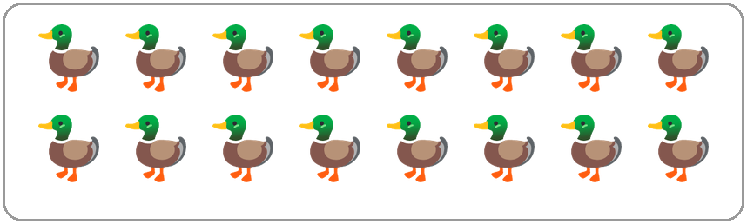
Q1. Look at the picture. How many ducks are there?
(A) 8 | (B) 16 | (C) 18 | (D) 14

Q2. The pages of a book are numbered 1, 2, 3 and so on. Which is the first page number that has two digits?
(A) 9 | (B) 10 | (C) 11 | (D) 20

Q3. Candles come in packs of 10. Chetan buys 7 packs. How many candles does he buy?
(A) 60 | (B) 17 | (C) 7 | (D) 70

Q4. Imran climbed 73 steps on a hike. Zara climbed more steps than Imran. How many steps could Zara have climbed?
(A) 78 | (B) 63 | (C) 70 | (D) 37

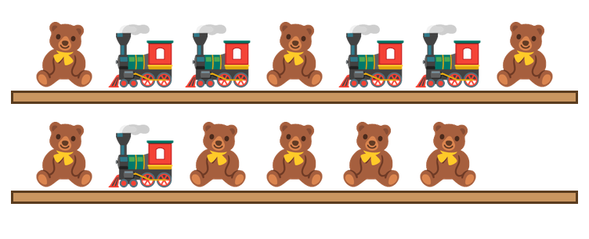
Q5. Look at the toys on the wooden shelves. How many teddy bears are there?
(A) 13 | (B) 7 | (C) 5 | (D) 8

Q6. Zoo cages are numbered in order. The parrots live in the cage between cage 59 and cage 61. What is the number of their cage?
(A) 62 | (B) 60 | (C) 50 | (D) 58

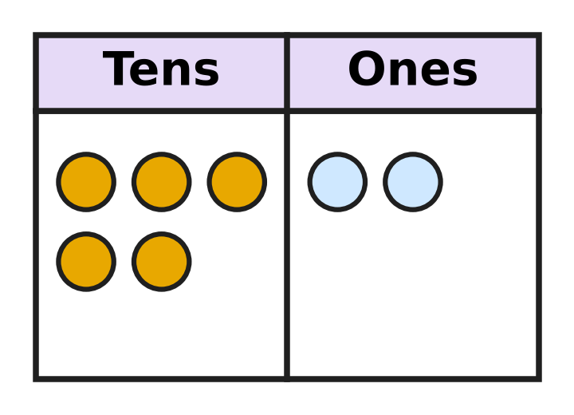
Q7. Look at the counters on the board. Each counter in the tens column is one ten. Which number does the board show?
(A) 7 | (B) 52 | (C) 25 | (D) 50

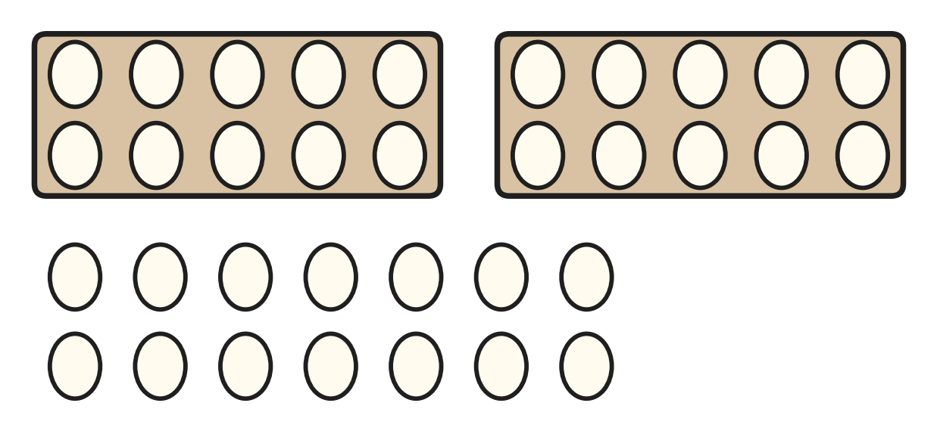
Q8. A full tray holds 10 eggs. Look at the full trays and the loose eggs in the picture. How many eggs are there in all?
(A) 44 | (B) 16 | (C) 24 | (D) 34

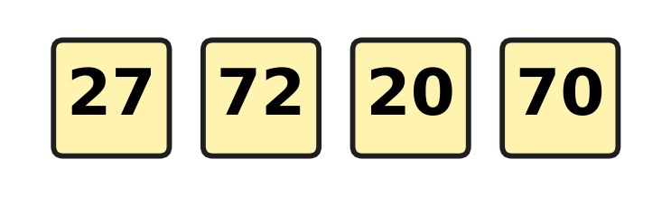
Q9. Four children wear these number cards. They stand in a row from the greatest number to the smallest. Which row is correct?
(A) 70, 72, 27, 20 | (B) 27, 72, 70, 20
(C) 72, 70, 27, 20 | (D) 20, 27, 70, 72

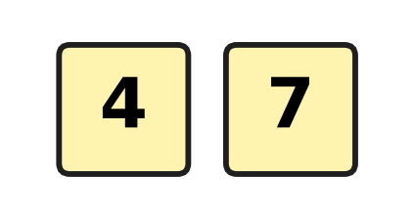
Q10. Kiara has two digit cards. She uses both cards to make a number. What is the greatest number she can make?
(A) 74 | (B) 77 | (C) 47 | (D) 11

Q11. Which number can go in the blank to make this true?
67 > ___
(A) 76 | (B) 59 | (C) 68 | (D) 70

Q12. Which number has 8 tens?
(A) eight | (B) twenty-eight
(C) eighteen | (D) eighty-one

Part 2 — Operations & Number Properties (Syllabus Chapter 2)
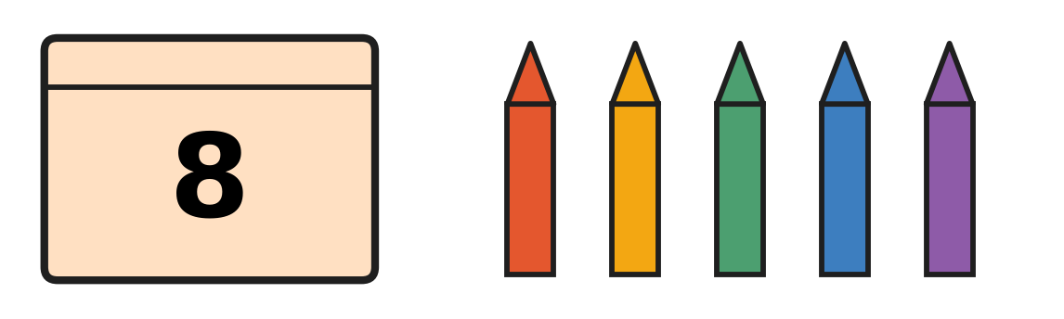
Q13. The closed box has 8 crayons inside. Look at the crayons outside the box. How many crayons are there in all?
(A) 13 | (B) 5 | (C) 14 | (D) 12

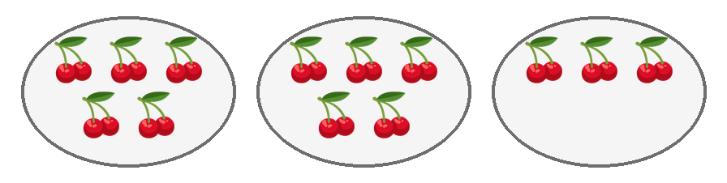
Q14. Look at the plates. Each picture shows a bunch of cherries. Komal wants 5 bunches on every plate. How many more bunches does she need?
(A) 3 | (B) 5 | (C) 2 | (D) 13

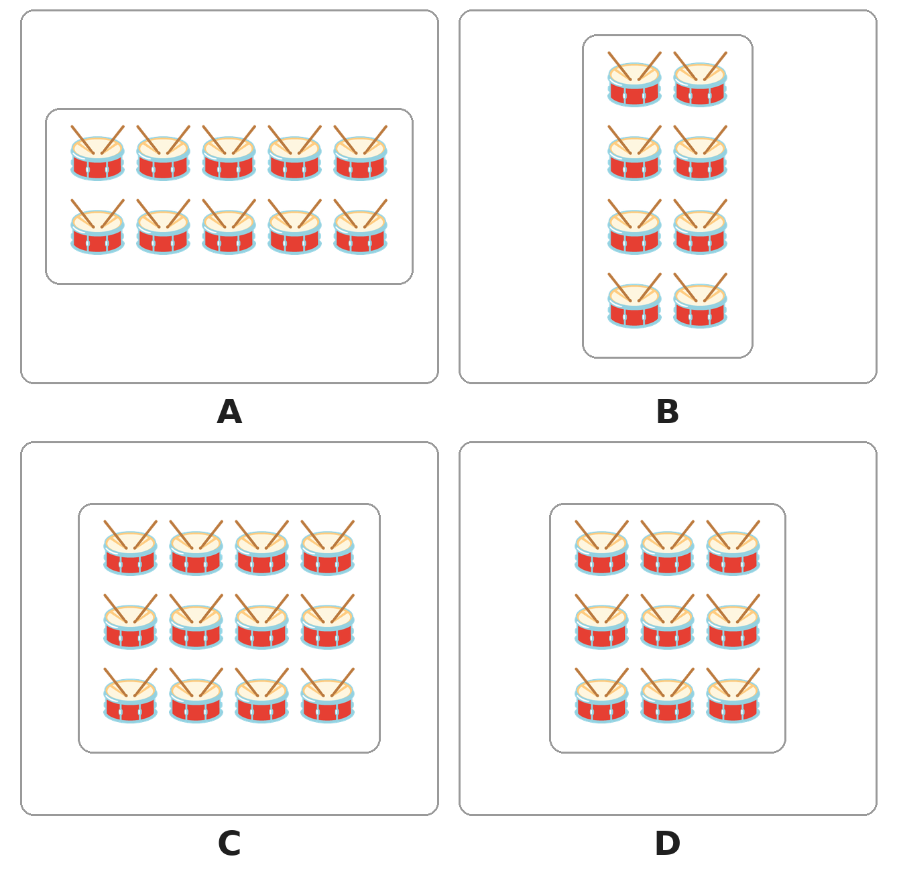
Q15. Look at the four boxes of drums. The drums in each box are in equal rows. Which box has the most drums?
(A) Box A | (B) Box B | (C) Box C | (D) Box D

Q16. Ojas adds 6 + 9 and gets 15. Rima adds 9 + 6. What answer does Rima get?
(A) 14 | (B) 3 | (C) 16 | (D) 15

Q17. Sonal bakes 12 buns. Her friends eat 5 of them. Which of these tells how many buns are left?
(A) 12 − 5 | (B) 12 + 5 | (C) 5 + 5 | (D) 12 − 12

Q18. A dairy van carries 19 milk cans. It leaves 13 cans at a shop. How many cans are still in the van?
(A) 5 | (B) 6 | (C) 32 | (D) 13

Q19. A plant shop has 12 small plants. Then 7 more plants arrive. After that, 5 plants are sold. How many plants does the shop have now?
(A) 19 | (B) 12 | (C) 14 | (D) 7

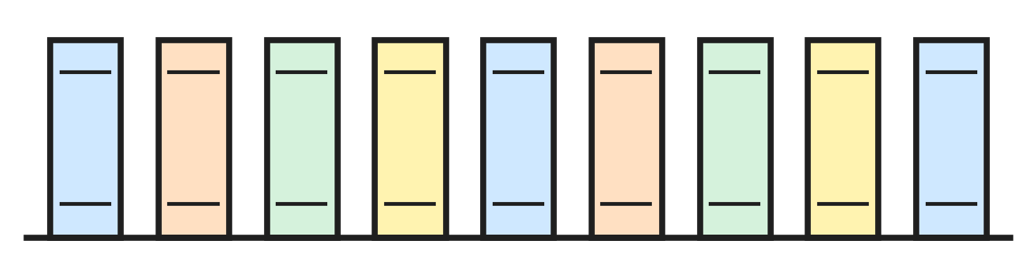
Q20. A bookshop had 13 copies of a story book. Some copies were sold. The picture shows the copies left. How many copies were sold?
(A) 4 | (B) 5 | (C) 9 | (D) 22

Q21. Which of these gives the greatest answer?
(A) 6 + 6 | (B) 7 + 8 | (C) 9 + 5 | (D) 20 − 4

Q22. A soup needs 6 tomatoes. It needs 3 more potatoes than tomatoes. How many tomatoes and potatoes does it need in all?
(A) 18 | (B) 12 | (C) 15 | (D) 9

Part 3 — Geometry (Syllabus Chapter 5)
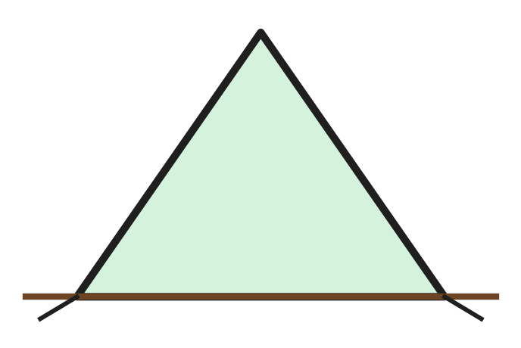
Q23. Ayaan puts up a tent on a mountain hike. Look at the front of his tent. Which shape is it?
(A) a square | (B) a triangle
(C) a circle | (D) a rectangle

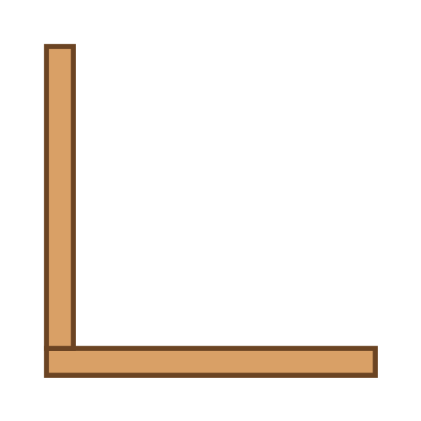
Q24. Neel has joined 2 planks, as in the picture. He wants a closed square frame, one plank for each side. How many more planks does he need?
(A) 3 | (B) 4 | (C) 2 | (D) 6

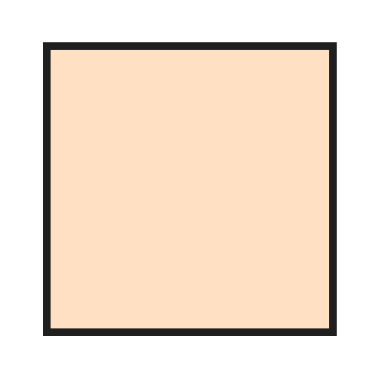
Q25. Look at the top of a square table. One lamp is put at each corner. How many lamps are on the table?
(A) 4 | (B) 5 | (C) 8 | (D) 3

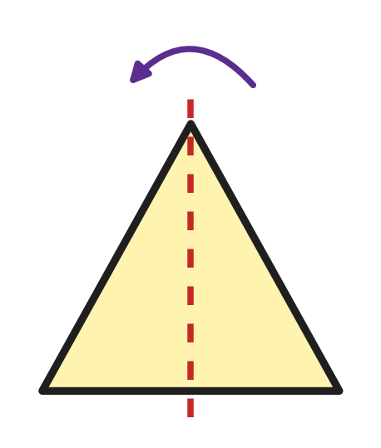
Q26. Leah folds this paper triangle along the dotted line. One half lies exactly on the other. Which shape is the folded paper?
(A) 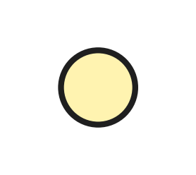 | (B) 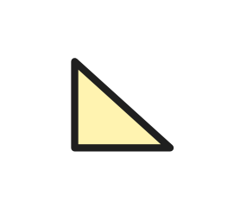 | (C) 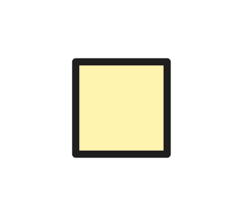 | (D) 

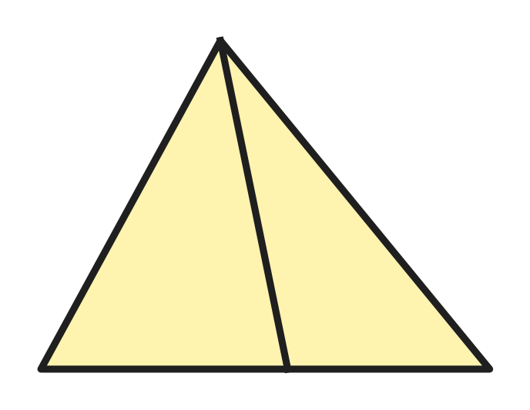
Q27. Look at the picture. How many triangles are there in all? Count triangles of every size.
(A) 5 | (B) 6 | (C) 2 | (D) 3

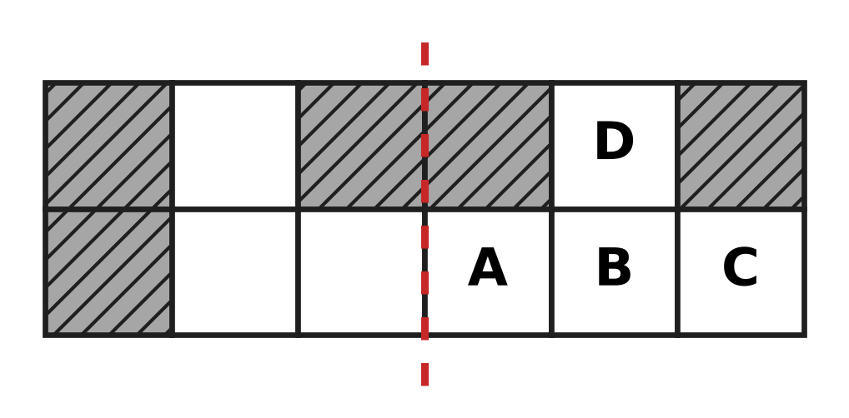
Q28. Look at the picture. One more box must be coloured so that both sides of the dotted line are the same. Which box is it?
(A) A | (B) B | (C) C | (D) D

Part 4 — Applied Mathematics (Syllabus Chapter 9)
Q29. An elephant at the zoo gets a bath on Tuesday and on Thursday. Which day comes between these two days?
(A) Wednesday | (B) Monday
(C) Saturday | (D) Friday

Q30. A new year begins with January. Which month comes just before January?
(A) February | (B) March
(C) December | (D) November

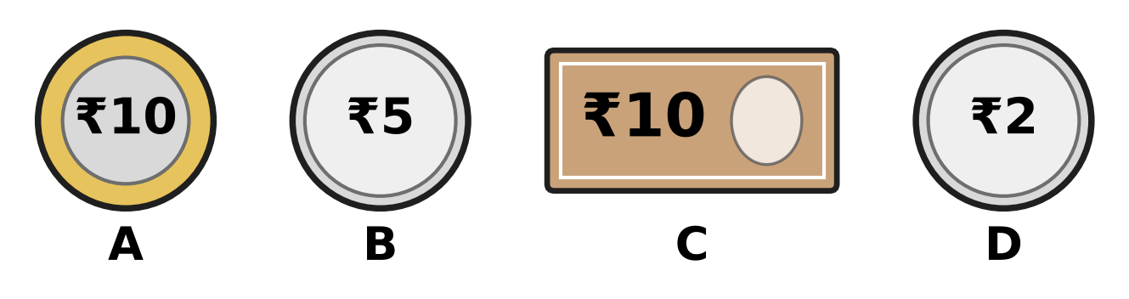
Q31. Look at the pictures of money. Three of them are coins. Which picture shows a note?
(A) Picture A | (B) Picture B
(C) Picture C | (D) Picture D

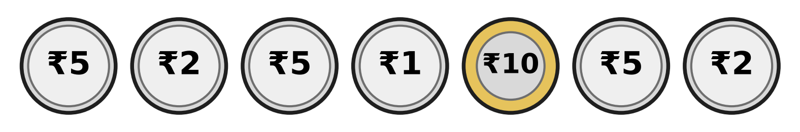
Q32. Look at the coins. How many ₹5 coins are there?
(A) 5 | (B) 3 | (C) 7 | (D) 2

Q33. Chitra feeds her small plant on a Tuesday. She feeds it again 7 days later. On which day is that?
(A) Wednesday | (B) Saturday
(C) Monday | (D) Tuesday

Q34. Vinay says the months of the year in order. Which month does he say fifth?
(A) May | (B) April | (C) June | (D) March

Part 5 — Mathematical Reasoning & Problem-Solving (Syllabus Chapter 10)
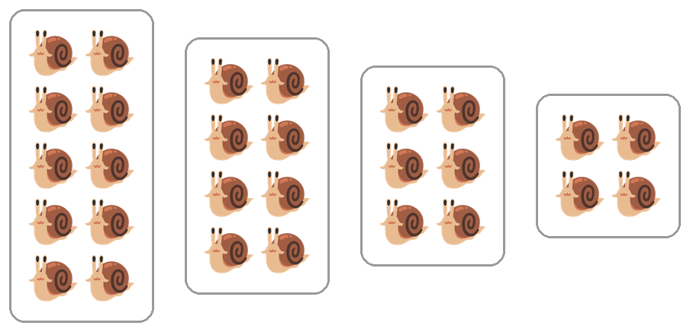
Q35. Look at the boxes of snails. The number of snails changes in a pattern. How many snails will the next box have?
(A) 4 | (B) 2 | (C) 3 | (D) 6

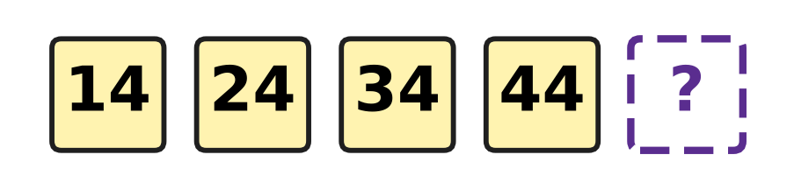
Q36. Look at the numbers on the cards. They make a pattern. Which number comes next?
(A) 64 | (B) 45 | (C) 54 | (D) 49

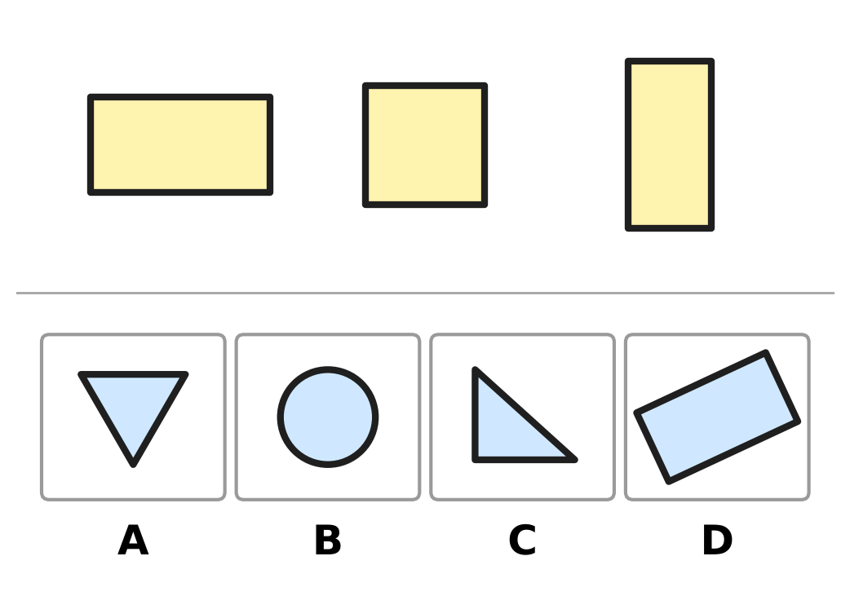
Q37. The three shapes at the top belong together: they have the same number of corners. Which picture shows one more shape that belongs with them?
(A) Picture A | (B) Picture B
(C) Picture C | (D) Picture D

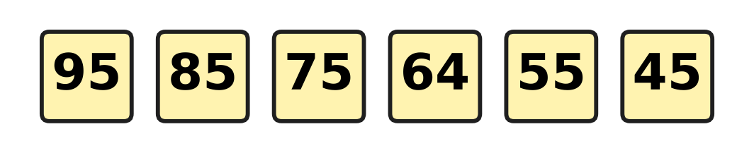
Q38. Look at the number cards. They count back in the same way each time. One card has a wrong number. Which number is wrong?
(A) 85 | (B) 75 | (C) 55 | (D) 64

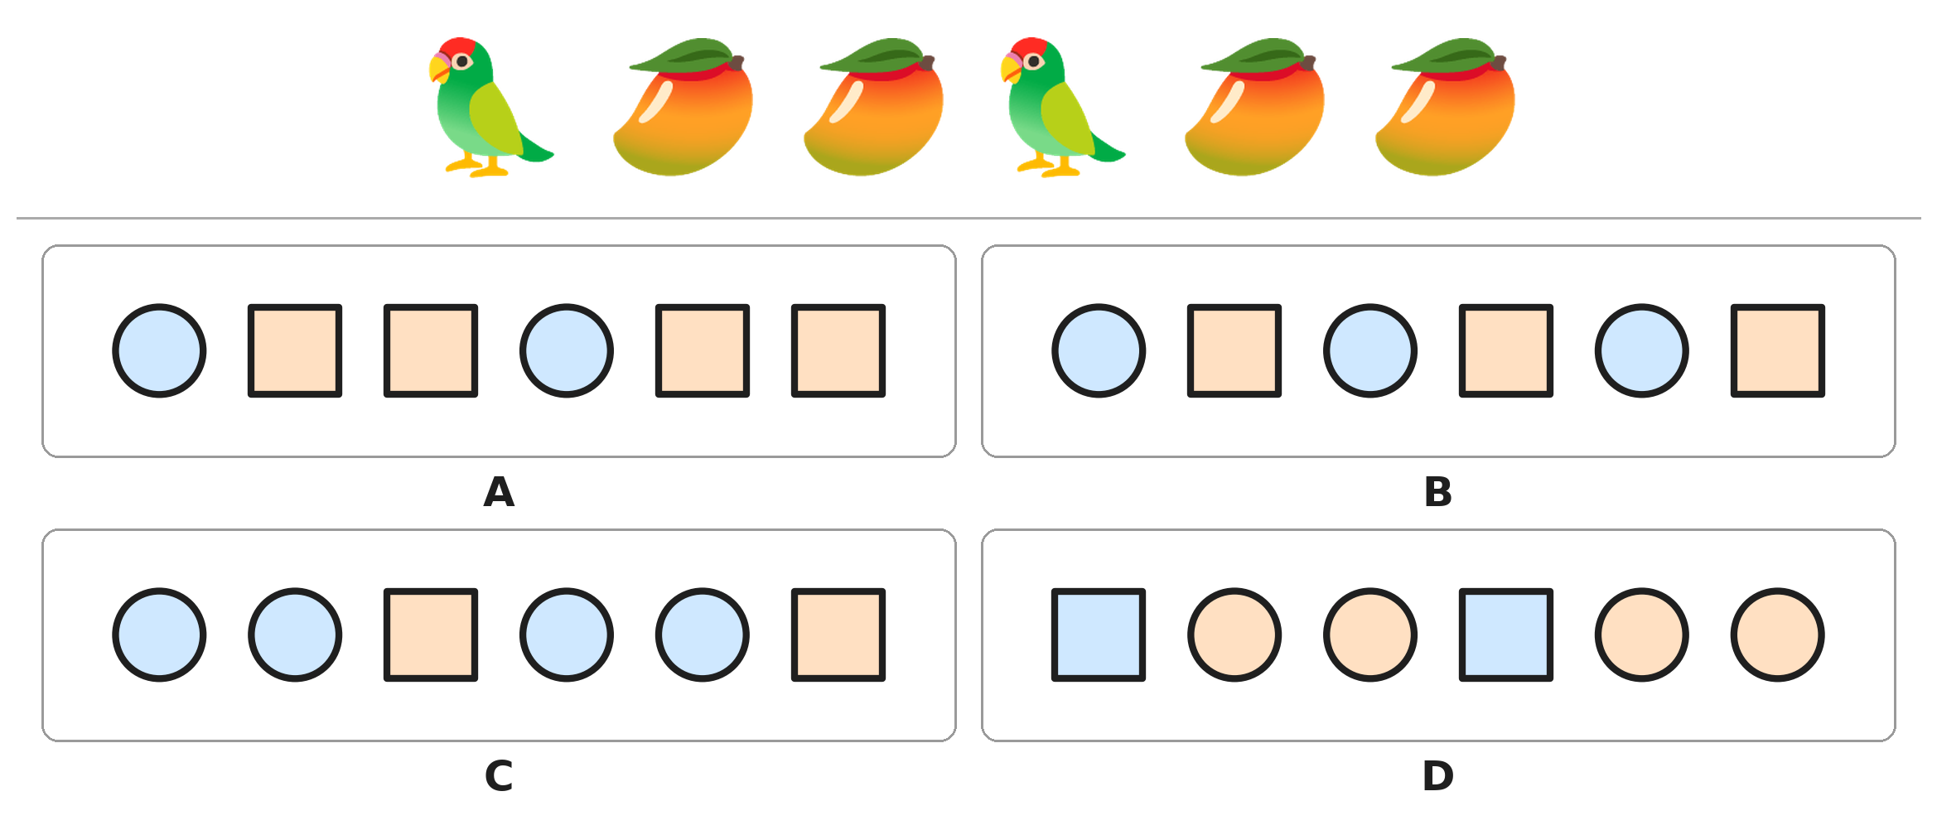
Q39. Look at the pattern of parrots and mangoes. Circles stand for parrots and squares stand for mangoes. Which picture shows the same pattern?
(A) Picture A | (B) Picture B
(C) Picture C | (D) Picture D

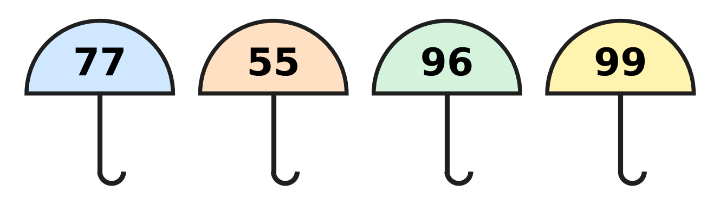
Q40. Look at the numbers on the umbrellas. In three numbers, the tens digit and the ones digit are the same. Which number does NOT belong with them?
(A) 77 | (B) 55 | (C) 96 | (D) 99

SECTION II — Star Questions 5 questions × 4 marks each
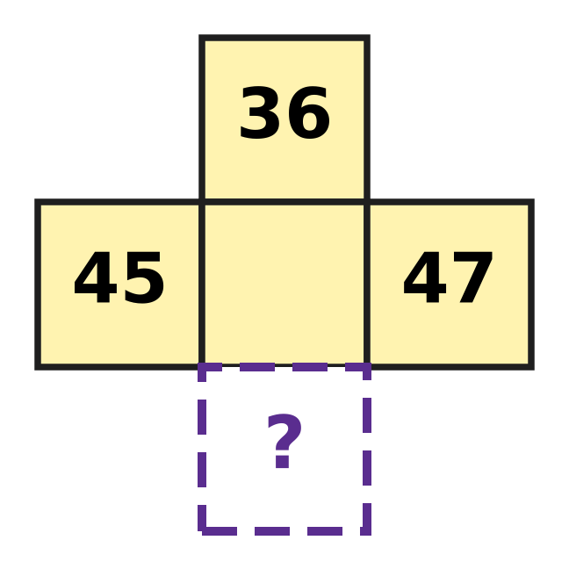
Q41. This piece is cut from a 1 to 100 number chart. The middle number has rubbed off. First find it. Then find the number in the ? box below it. [4 marks]
(A) 55 | (B) 56 | (C) 46 | (D) 57

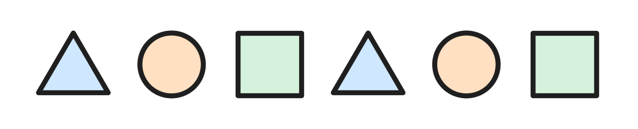
Q42. Eva prints shapes in a pattern, as in the picture. She goes on until the row has 11 shapes. How many triangles are in the row then? [4 marks]
(A) 4 | (B) 5 | (C) 3 | (D) 2

Q43. Rosa plays badminton on Monday, Tuesday, Thursday and Sunday. She plays 1 day later, then 2 days later, then 3 days later. Each time she waits one more day. On which day does she play next? [4 marks]
(A) Friday | (B) Wednesday
(C) Monday | (D) Thursday

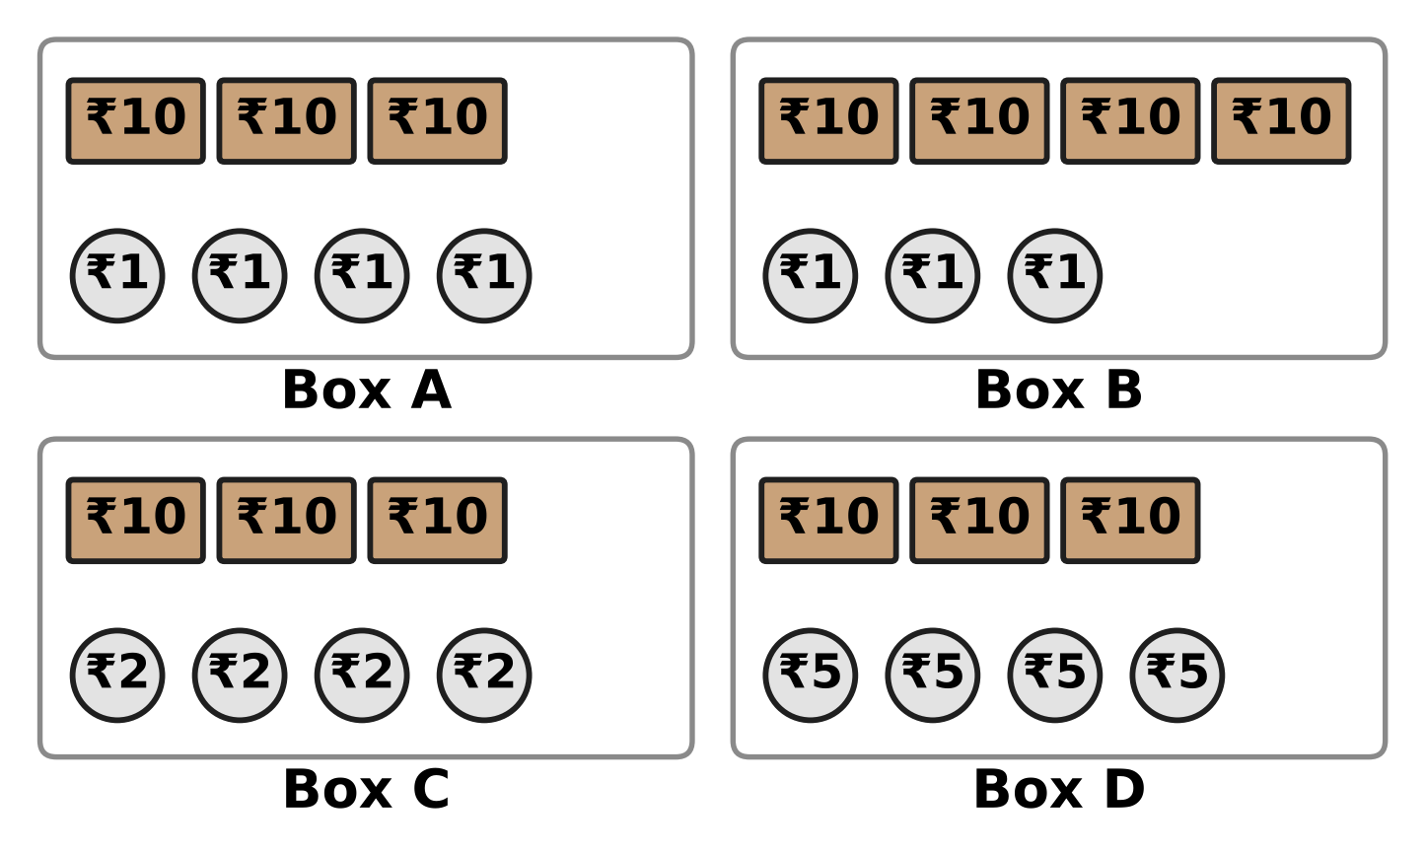
Q44. A story book costs thirty-four rupees. Each box has some notes and coins. Which box has exactly this much money? [4 marks]
(A) Box A | (B) Box B | (C) Box C | (D) Box D

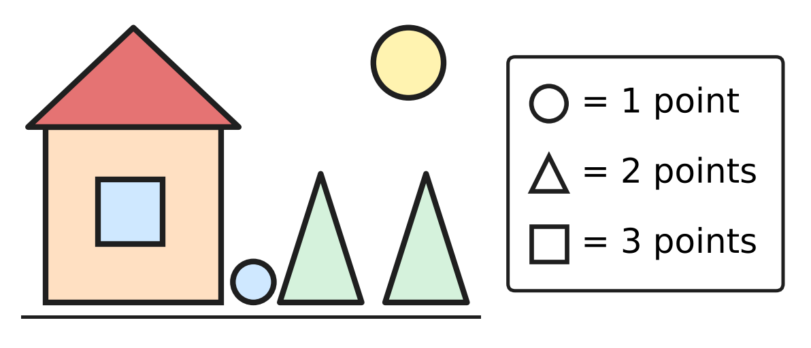
Q45. Vihaan makes this picture with circles, triangles and squares. Each shape gets the points shown in the box. How many points does his picture get? [4 marks]
(A) 7 | (B) 11 | (C) 15 | (D) 14

Answer Sheet AMO Level 1 · Class 1 · Practice Paper 4
Name: | School: | Roll No.:
Shade or tick one circle for each question.
1. Ⓐ Ⓑ Ⓒ Ⓓ | 16. Ⓐ Ⓑ Ⓒ Ⓓ | 31. Ⓐ Ⓑ Ⓒ Ⓓ
2. Ⓐ Ⓑ Ⓒ Ⓓ | 17. Ⓐ Ⓑ Ⓒ Ⓓ | 32. Ⓐ Ⓑ Ⓒ Ⓓ
3. Ⓐ Ⓑ Ⓒ Ⓓ | 18. Ⓐ Ⓑ Ⓒ Ⓓ | 33. Ⓐ Ⓑ Ⓒ Ⓓ
4. Ⓐ Ⓑ Ⓒ Ⓓ | 19. Ⓐ Ⓑ Ⓒ Ⓓ | 34. Ⓐ Ⓑ Ⓒ Ⓓ
5. Ⓐ Ⓑ Ⓒ Ⓓ | 20. Ⓐ Ⓑ Ⓒ Ⓓ | 35. Ⓐ Ⓑ Ⓒ Ⓓ
6. Ⓐ Ⓑ Ⓒ Ⓓ | 21. Ⓐ Ⓑ Ⓒ Ⓓ | 36. Ⓐ Ⓑ Ⓒ Ⓓ
7. Ⓐ Ⓑ Ⓒ Ⓓ | 22. Ⓐ Ⓑ Ⓒ Ⓓ | 37. Ⓐ Ⓑ Ⓒ Ⓓ
8. Ⓐ Ⓑ Ⓒ Ⓓ | 23. Ⓐ Ⓑ Ⓒ Ⓓ | 38. Ⓐ Ⓑ Ⓒ Ⓓ
9. Ⓐ Ⓑ Ⓒ Ⓓ | 24. Ⓐ Ⓑ Ⓒ Ⓓ | 39. Ⓐ Ⓑ Ⓒ Ⓓ
10. Ⓐ Ⓑ Ⓒ Ⓓ | 25. Ⓐ Ⓑ Ⓒ Ⓓ | 40. Ⓐ Ⓑ Ⓒ Ⓓ
11. Ⓐ Ⓑ Ⓒ Ⓓ | 26. Ⓐ Ⓑ Ⓒ Ⓓ | 41. Ⓐ Ⓑ Ⓒ Ⓓ
12. Ⓐ Ⓑ Ⓒ Ⓓ | 27. Ⓐ Ⓑ Ⓒ Ⓓ | 42. Ⓐ Ⓑ Ⓒ Ⓓ
13. Ⓐ Ⓑ Ⓒ Ⓓ | 28. Ⓐ Ⓑ Ⓒ Ⓓ | 43. Ⓐ Ⓑ Ⓒ Ⓓ
14. Ⓐ Ⓑ Ⓒ Ⓓ | 29. Ⓐ Ⓑ Ⓒ Ⓓ | 44. Ⓐ Ⓑ Ⓒ Ⓓ
15. Ⓐ Ⓑ Ⓒ Ⓓ | 30. Ⓐ Ⓑ Ⓒ Ⓓ | 45. Ⓐ Ⓑ Ⓒ Ⓓ
Q41–Q45 are Section II Star Questions (4 marks each).
For the parent or teacher
Section I correct: ______ / 40 × 2 = ______ marks Section II correct: ______ / 5 × 4 = ______ marks
Correct: ______ / 45 Score: ______ / 100
Answer Key and Solutions AMO Level 1 · Class 1 · Practice Paper 4
Quick answers
1 B | 6 B | 11 B | 16 D | 21 D | 26 B | 31 C | 36 C | 41 B
2 B | 7 B | 12 D | 17 A | 22 C | 27 D | 32 B | 37 D | 42 A
3 D | 8 D | 13 A | 18 B | 23 B | 28 C | 33 D | 38 D | 43 D
4 A | 9 C | 14 C | 19 C | 24 C | 29 A | 34 A | 39 A | 44 A
5 D | 10 A | 15 C | 20 A | 25 A | 30 C | 35 B | 40 C | 45 D
Solutions
Q | Part · level | Answer | Why?
1 | Part 1 · Ch1 · Easy | (B) 16 | There are 8 ducks in each row. 8 and 8 more make 16 ducks.
2 | Part 1 · Ch1 · Easy | (B) 10 | The numbers 1 to 9 have one digit. The next number, 10, has two digits.
3 | Part 1 · Ch1 · Easy | (D) 70 | Count in tens, one ten for each pack: 10, 20, 30, 40, 50, 60, 70.
4 | Part 1 · Ch1 · Easy | (A) 78 | Zara's number must be greater than 73. Only 78 is greater than 73.
5 | Part 1 · Ch1 · Easy | (D) 8 | Count only the teddy bears, not the trains. There are 8 teddy bears.
6 | Part 1 · Ch1 · Easy | (B) 60 | The numbers go 59, 60, 61. The number between 59 and 61 is 60.
7 | Part 1 · Ch1 · Easy | (B) 52 | The board shows 5 tens and 2 ones. That makes 52.
8 | Part 1 · Ch1 · Medium | (D) 34 | The 2 trays hold 20 eggs. Count on the 14 loose eggs from 20 to reach 34.
9 | Part 1 · Ch1 · Medium | (C) 72, 70, 27, 20 | 72 and 70 have 7 tens; 27 and 20 have only 2 tens. The row is 72, 70, 27, 20.
10 | Part 1 · Ch1 · Medium | (A) 74 | She can make 47 or 74. 74 has more tens, so it is the greatest.
11 | Part 1 · Ch1 · Medium | (B) 59 | The missing number must be less than 67. Only 59 is less than 67.
12 | Part 1 · Ch1 · Medium | (D) eighty-one | Eighty-one is 81: 8 tens and 1 one. Eighteen is 18 and twenty-eight is 28.
13 | Part 2 · Ch2 · Easy | (A) 13 | Start at 8 and count on 5 crayons: 9, 10, 11, 12, 13. So 8 + 5 = 13.
14 | Part 2 · Ch2 · Easy | (C) 2 | The first two plates have 5 bunches each. The last plate has 3 bunches. 3 and 2 more make 5, so she needs 2 more bunches.
15 | Part 2 · Ch2 · Easy | (C) Box C | Box A has 10, Box B has 8, Box C has 12 and Box D has 9 drums. Box C has 3 rows of 4, which is 12, the most.
16 | Part 2 · Ch2 · Easy | (D) 15 | The order of adding does not matter. 6 + 9 = 15 and 9 + 6 = 15.
17 | Part 2 · Ch2 · Easy | (A) 12 − 5 | Buns are eaten, so we take away: 12 − 5. That leaves 7 buns.
18 | Part 2 · Ch2 · Easy | (B) 6 | 19 − 13 = 6. So 6 cans are still in the van.
19 | Part 2 · Ch2 · Medium | (C) 14 | 12 + 7 = 19. Then 19 − 5 = 14. The shop has 14 plants.
20 | Part 2 · Ch2 · Medium | (A) 4 | 9 copies are left. 13 − 9 = 4, so 4 copies were sold.
21 | Part 2 · Ch2 · Medium | (D) 20 − 4 | 7 + 8 = 15, 9 + 5 = 14, 20 − 4 = 16 and 6 + 6 = 12. The greatest answer is 16.
22 | Part 2 · Ch2 · Medium | (C) 15 | Potatoes: 6 + 3 = 9. Tomatoes and potatoes together: 6 + 9 = 15.
23 | Part 3 · Ch5 · Easy | (B) a triangle | The front of the tent has 3 straight sides and 3 corners. It is a triangle.
24 | Part 3 · Ch5 · Easy | (C) 2 | A square has 4 sides. 2 planks are there, so 2 more planks are needed.
25 | Part 3 · Ch5 · Easy | (A) 4 | A square has 4 corners. One lamp at each corner makes 4 lamps.
26 | Part 3 · Ch5 · Easy | (B) | The two halves are the same, so the folded paper is one half. It has 3 straight sides and 3 corners, so it is still a triangle.
27 | Part 3 · Ch5 · Medium | (D) 3 | There are 2 small triangles. Together they make 1 big triangle. 2 + 1 = 3 triangles.
28 | Part 3 · Ch5 · Medium | (C) C | Fold along the dotted line. The coloured box in the bottom left corner lands on box C.
29 | Part 4 · Ch9 · Easy | (A) Wednesday | The days go Tuesday, Wednesday, Thursday. Wednesday is between Tuesday and Thursday.
30 | Part 4 · Ch9 · Easy | (C) December | December is the last month of a year. After December, the new year begins with January.
31 | Part 4 · Ch9 · Easy | (C) Picture C | Coins are round and made of metal. Notes are made of paper. Picture C shows the ₹10 note.
32 | Part 4 · Ch9 · Easy | (B) 3 | Look for the coins with the number 5 on them. There are 3 such coins.
33 | Part 4 · Ch9 · Medium | (D) Tuesday | A week has 7 days. Counting 7 days on from Tuesday brings us back to Tuesday.
34 | Part 4 · Ch9 · Medium | (A) May | January, February, March, April, May. The fifth month is May.
35 | Part 5 · Ch10 · Easy | (B) 2 | The boxes have 10, 8, 6 and 4 snails. Each box has 2 fewer than the box before. 4 − 2 = 2.
36 | Part 5 · Ch10 · Easy | (C) 54 | Each number is 10 more than the one before: 14, 24, 34, 44. Then 44 + 10 = 54.
37 | Part 5 · Ch10 · Easy | (D) Picture D | All three shapes at the top have 4 sides and 4 corners. Picture D is a rectangle, turned a little, with 4 sides and 4 corners too.
38 | Part 5 · Ch10 · Medium | (D) 64 | The cards count back in tens: 95, 85, 75, 65, 55, 45. The card with 64 should say 65, so 64 is wrong.
39 | Part 5 · Ch10 · Medium | (A) Picture A | Parrot, mango, mango becomes circle, square, square. Only Picture A repeats circle, square, square.
40 | Part 5 · Ch10 · Medium | (C) 96 | 77, 55 and 99 are each made of two same digits. 96 has two different digits, so it does not belong.
41 | Section II · Ch1 + Ch10 · Hard | (B) 56 | The middle number is 46, between 45 and 47. Going down one row adds 10, so the box below 46 is 56.
42 | Section II · Ch5 + Ch10 · Hard | (A) 4 | The row repeats triangle, circle, square. The 1st, 4th, 7th and 10th shapes are triangles. That is 4 triangles.
43 | Section II · Ch9 + Ch10 · Hard | (D) Thursday | She plays 1 day, then 2 days, then 3 days later. Next it is 4 days after Sunday: Monday, Tuesday, Wednesday, Thursday.
44 | Section II · Ch1 + Ch9 · Hard | (A) Box A | Thirty-four is 3 tens and 4 ones. Box A has three ₹10 notes and four ₹1 coins, which is ₹34.
45 | Section II · Ch2 + Ch5 · Hard | (D) 14 | There are 2 squares, 3 triangles and 2 circles. Points: 3 + 3 + 2 + 2 + 2 + 1 + 1 = 14.

ARYABHATTA MATHS OLYMPIAD
Level 1
PRACTICE PAPER-5
CLASS 1
Total Questions | 45 multiple-choice questions
Total Marks | 100
Time | 60 minutes
Section I | 40 questions × 2 marks = 80 marks
Section II | 5 Star Questions × 4 marks = 20 marks
Negative Marking | No negative marking
Calculator | Not allowed
Chapters | Number System · Operations · Geometry · Applied Mathematics · Mathematical Reasoning

👋 Hello, friend! How to do this paper:
⭐ Every question has four answer choices: (A), (B), (C) and (D). Only one is correct.
⭐ Read each question and look at its picture carefully. Then mark your answer on the answer sheet at the end.
⭐ Section I has 40 questions of 2 marks each. Section II has 5 Star Questions of 4 marks each.
⭐ There is no negative marking, so try every question.
⭐ Do not use a calculator. You may do rough work on a separate sheet.
⭐ All figures are not necessarily drawn to scale unless stated.

For parents and teachers
• Print or view this paper in colour. Pictures are part of the questions.
• You may read a question aloud to the child, exactly as printed. Please do not explain it or point to an answer choice.
• Parts follow the AMO syllabus chapters. Chapters 3, 4, 6, 7 and 8 are not part of the Class 1 syllabus, so the chapter numbers shown in the Part headings have gaps.
• The answer sheet and the answer key are at the end. Remove only the answer key before the child begins.

SECTION I 40 questions × 2 marks each
Part 1 — Number System (Syllabus Chapter 1)
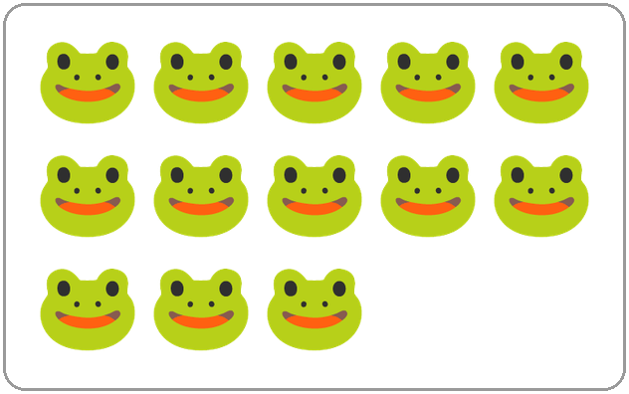
Q1. Tarun says there are 15 frogs in the picture. He is wrong. Count the frogs. How many are there?
(A) 13 | (B) 14 | (C) 15 | (D) 16

Q2. Which number name comes just after twenty-nine?
(A) twenty-eight | (B) forty
(C) thirty-one | (D) thirty

Q3. Lavina lives in house number 72. What is the ones digit of her house number?
(A) 2 | (B) 7 | (C) 9 | (D) 70

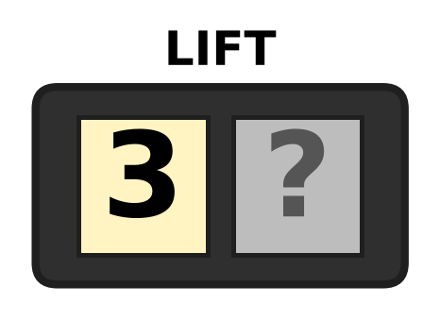
Q4. Look at the lift display. One digit cannot be seen. The floor number is greater than 38. Which digit is hidden?
(A) 6 | (B) 7 | (C) 8 | (D) 9

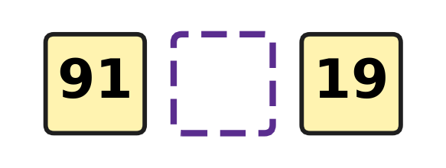
Q5. Look at the two number cards. Which sign goes in the empty box between them?
(A) + | (B) = | (C) < | (D) >

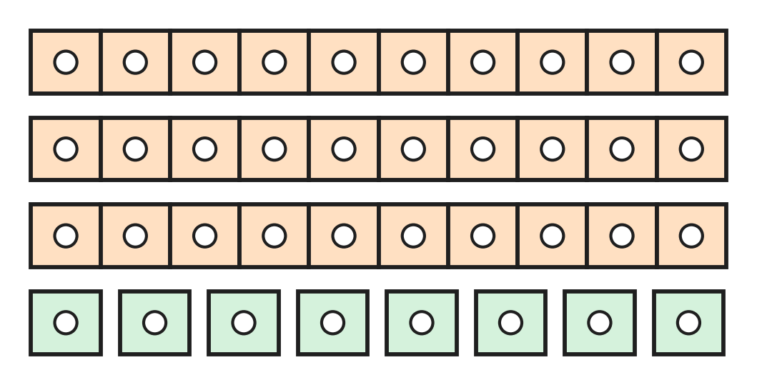
Q6. Look at the tickets for the school play. Each long strip has 10 tickets. How many tickets are there in all?
(A) 11 | (B) 30 | (C) 38 | (D) 83

Q7. How many tens are there in 90?
(A) 10 | (B) 19 | (C) 0 | (D) 9

Q8. Sohan thinks of a number. It has 4 ones. It has 2 more tens than ones. What is Sohan's number?
(A) 24 | (B) 46 | (C) 64 | (D) 66

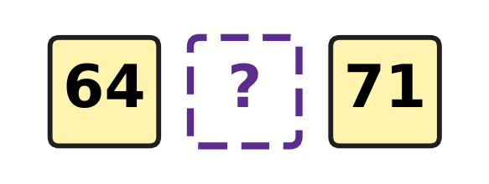
Q9. Look at the three cards. They are in order from smallest to greatest. Which number can be on the middle card?
(A) 46 | (B) 63 | (C) 72 | (D) 68

Q10. Car park spaces are numbered in order: 27, 28, 92, 30, 31. One number is painted wrongly. Which number should it be?
(A) 26 | (B) 29 | (C) 32 | (D) 39

Q11. Kian hears the number fifteen and writes 50. Which number should he write?
(A) 55 | (B) 51 | (C) 5 | (D) 15

Q12. How many numbers come between 37 and 42?
(A) 3 | (B) 4 | (C) 5 | (D) 6

Part 2 — Operations & Number Properties (Syllabus Chapter 2)
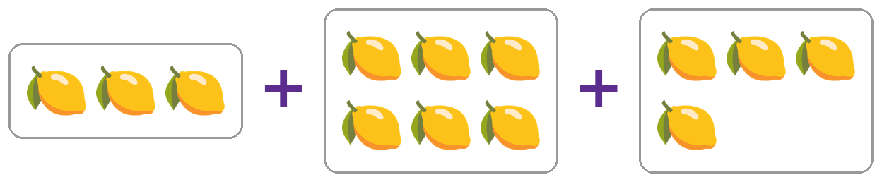
Q13. Look at the three trays of lemons. How many lemons are there in all?
(A) 9 | (B) 12 | (C) 13 | (D) 14

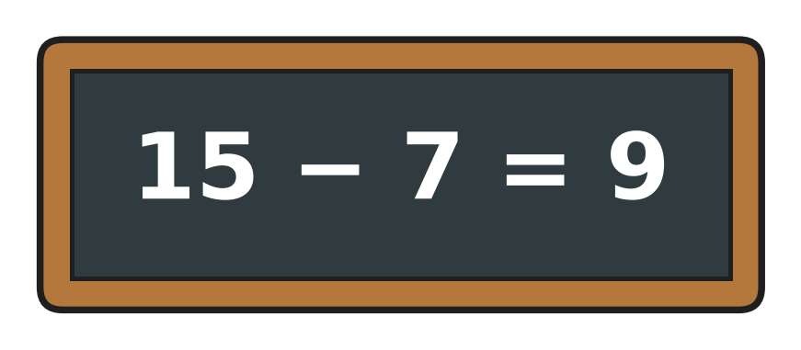
Q14. Look at the slate. The answer Ivan wrote is wrong. What is the correct answer?
(A) 8 | (B) 7 | (C) 9 | (D) 22

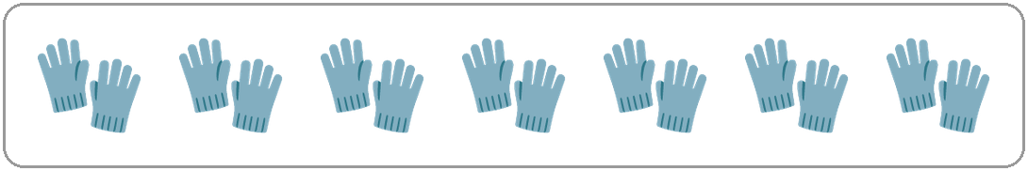
Q15. Look at the picture. Each pair has 2 gloves. How many gloves are there in all?
(A) 7 | (B) 9 | (C) 14 | (D) 16

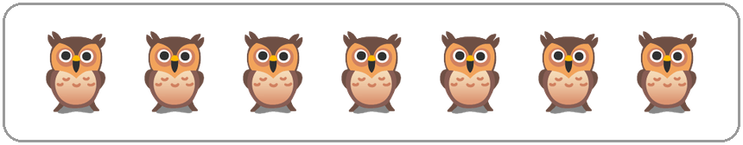
Q16. Look at the owls in the picture. All of them fly away. How many owls are left?
(A) 0 | (B) 1 | (C) 7 | (D) 14

Q17. There are 7 planes at the airport. Then 5 more planes land. How many planes are at the airport now?
(A) 2 | (B) 11 | (C) 12 | (D) 13

Q18. A tea stall has 15 clean cups. People use 6 of the cups. How many clean cups are left?
(A) 8 | (B) 9 | (C) 10 | (D) 21

Q19. There are 18 children in the playground. Some children go home. Now 11 children are still playing. How many children went home?
(A) 29 | (B) 6 | (C) 8 | (D) 7

Q20. Rani thought of a number. She took away 6 and got 7. What was her number?
(A) 1 | (B) 12 | (C) 13 | (D) 14

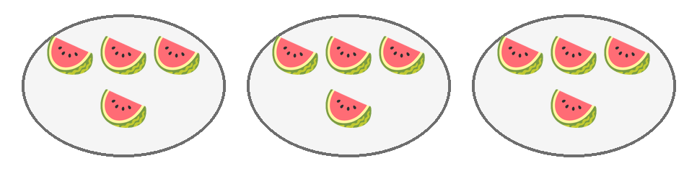
Q21. Look at the plates of watermelon slices. Mum puts one more plate with the same number of slices on the table. How many slices are there now?
(A) 12 | (B) 13 | (C) 16 | (D) 20

Q22. I am a number. Add me to myself and you get 14. Which number am I?
(A) 7 | (B) 8 | (C) 12 | (D) 14

Part 3 — Geometry (Syllabus Chapter 5)
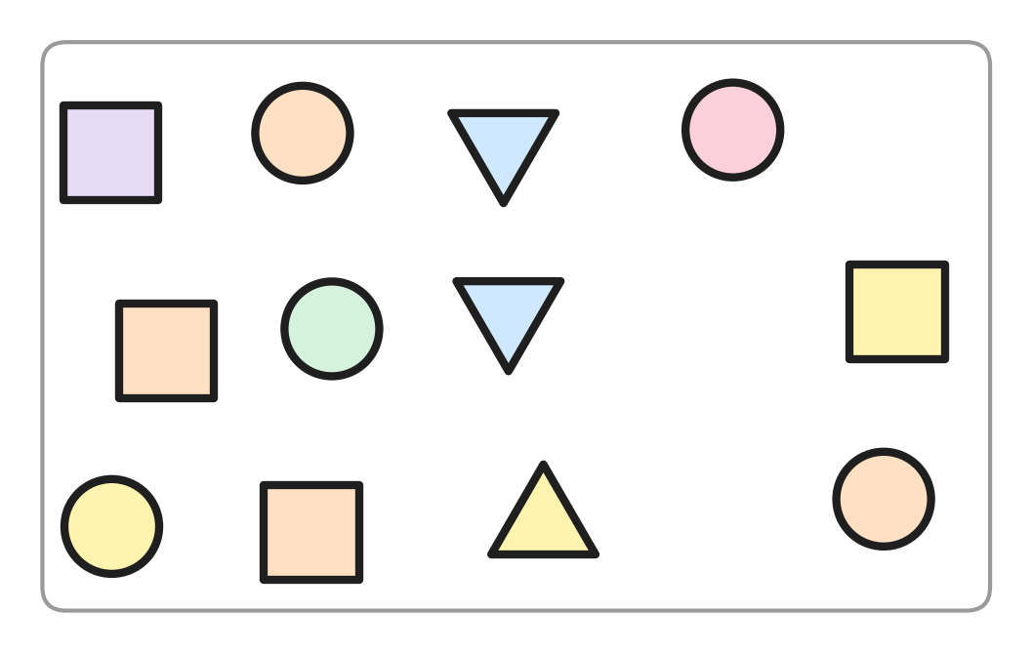
Q23. Look at the picture. How many squares are there?
(A) 4 | (B) 5 | (C) 9 | (D) 12

Q24. I have no corners and no straight sides. Which shape am I?
(A) triangle | (B) circle
(C) rectangle | (D) square

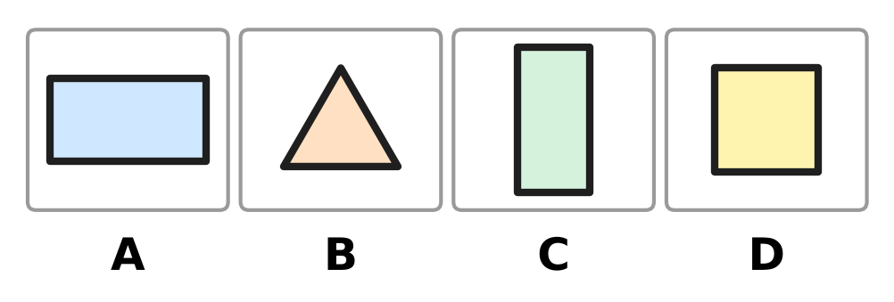
Q25. Look at the shapes. Which picture shows a square?
(A) Picture A | (B) Picture B
(C) Picture C | (D) Picture D

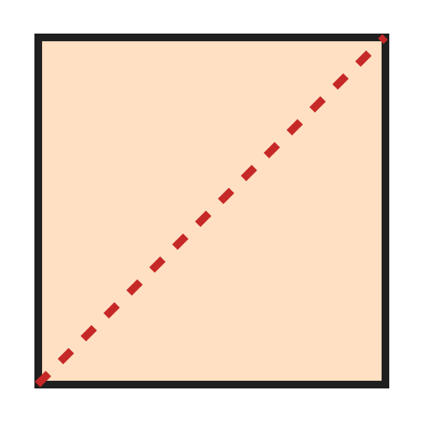
Q26. Look at the picture. A square floor tile is cut along the dotted line. What are the two pieces?
(A) two triangles | (B) two squares
(C) two circles | (D) two rectangles

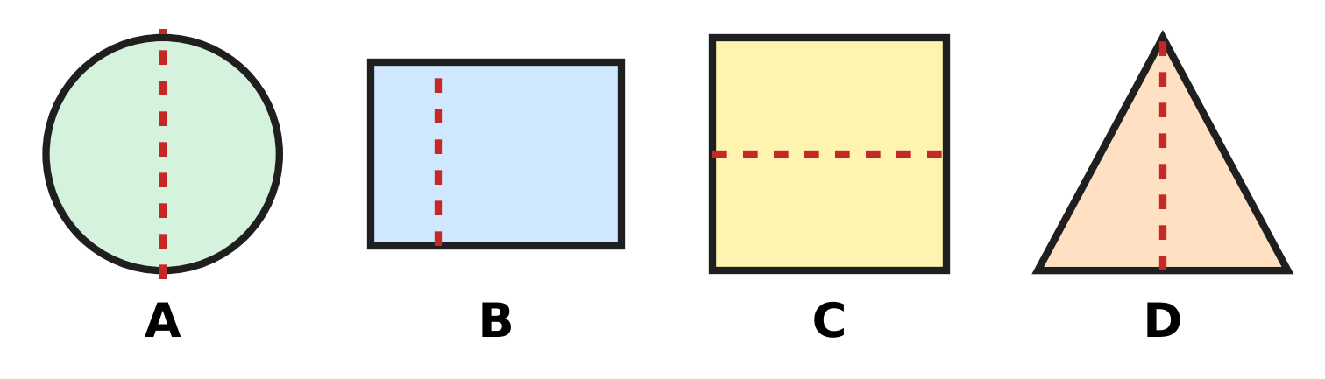
Q27. Look at the four shapes. Each has a dotted line. In which picture does the dotted line NOT cut the shape into two halves that match?
(A) Picture A | (B) Picture B
(C) Picture C | (D) Picture D

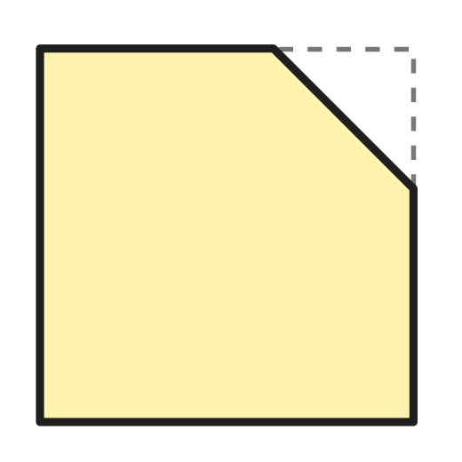
Q28. Jatin cuts one corner off a square paper with one straight cut. Look at the picture. How many corners does the paper have now?
(A) 3 | (B) 4 | (C) 5 | (D) 7

Part 4 — Applied Mathematics (Syllabus Chapter 9)
Q29. A hot-air balloon show is two days after Friday. On which day is the show?
(A) Saturday | (B) Monday
(C) Wednesday | (D) Sunday

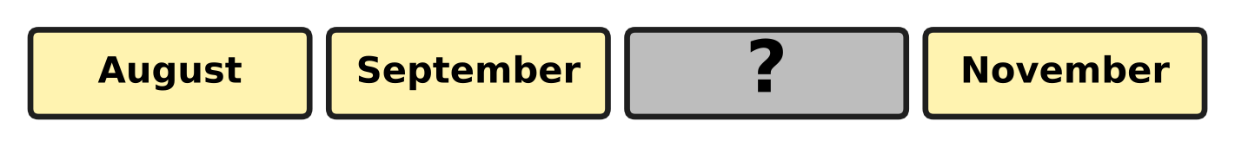
Q30. Look at the month cards. They are in order. One card is turned over. Which month is on it?
(A) October | (B) December
(C) June | (D) July

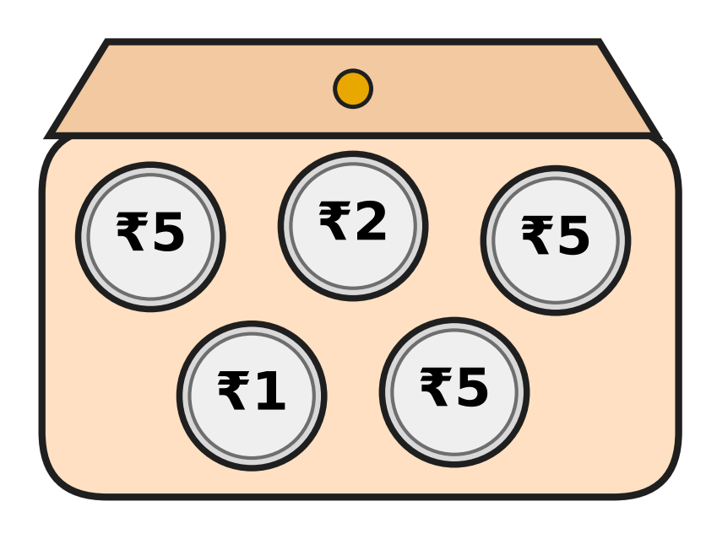
Q31. Look at the coins in Pari's purse. Which of these coins does Pari NOT have?
(A) ₹1 | (B) ₹2 | (C) ₹5 | (D) ₹10

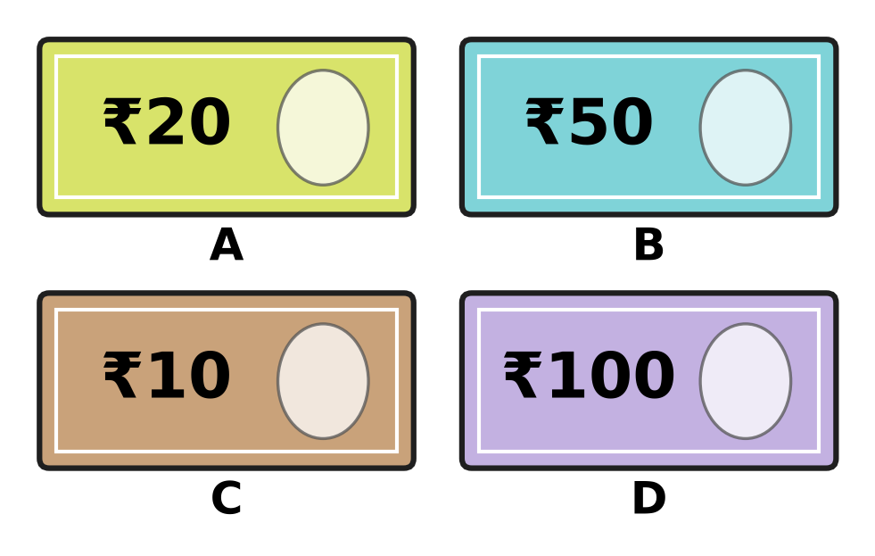
Q32. Hana has a fifty-rupee note. Which picture shows her note?
(A) Picture A | (B) Picture B
(C) Picture C | (D) Picture D

Q33. Myra writes down the rainfall every month from June to September. For how many months does she write it down?
(A) 3 | (B) 4 | (C) 5 | (D) 9

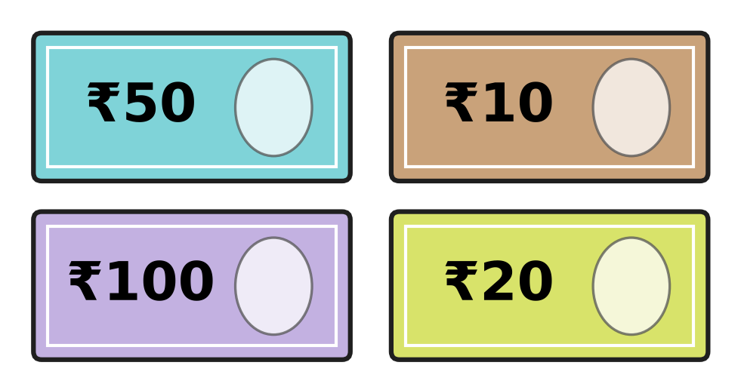
Q34. Look at the notes. Dhruv puts them in order from the smallest amount to the biggest. Which note comes second?
(A) ₹10 | (B) ₹20 | (C) ₹50 | (D) ₹100

Part 5 — Mathematical Reasoning & Problem-Solving (Syllabus Chapter 10)
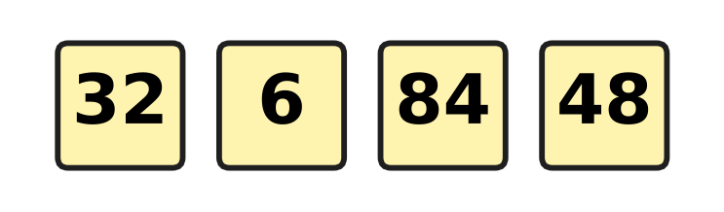
Q35. Look at the four number cards. Count the digits in each number. Which number has a different number of digits from the others?
(A) 6 | (B) 32 | (C) 48 | (D) 84

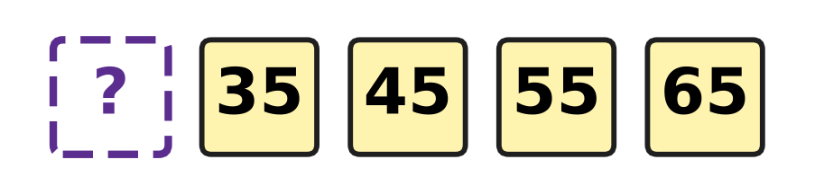
Q36. Look at the number pattern. The numbers grow by the same amount each time. Which number is hidden at the start?
(A) 25 | (B) 30 | (C) 34 | (D) 75


Q37. Look at the shape pattern. One shape is covered by the box. Which shape is under the box?
(A) triangle | (B) circle
(C) square | (D) rectangle

Q38. Nakul counts back in twos: 19, 17, 15, 13, and so on. He stops at 1. Which of these numbers does he NOT say?
(A) 3 | (B) 5 | (C) 6 | (D) 9

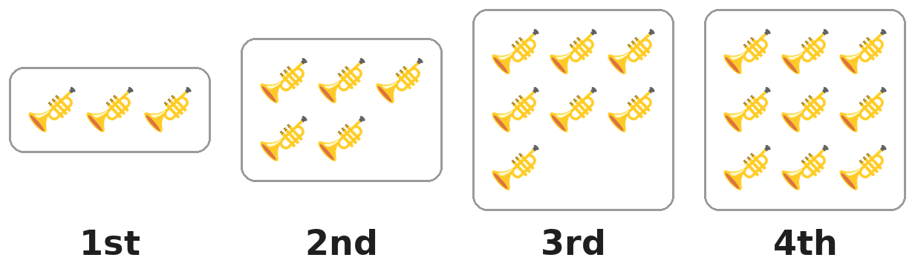
Q39. The groups of trumpets grow in a pattern. Which group will have 13 trumpets?
(A) the 13th group | (B) the 7th group
(C) the 5th group | (D) the 6th group

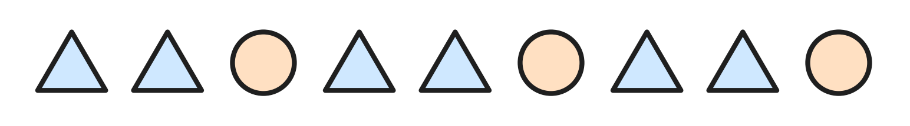
Q40. Look at the shape pattern. It is made by repeating one small group of shapes, starting from the left. Which group is it?
(A) 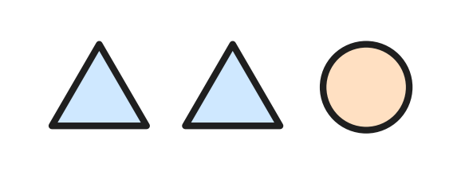 | (B) 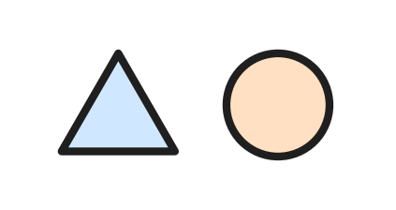
(C) 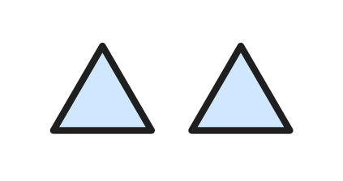 | (D) 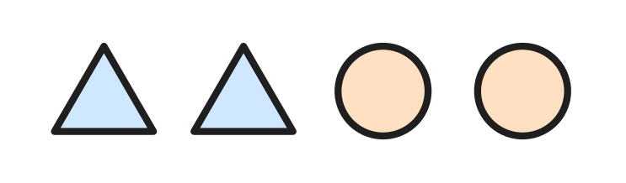

SECTION II — Star Questions 5 questions × 4 marks each
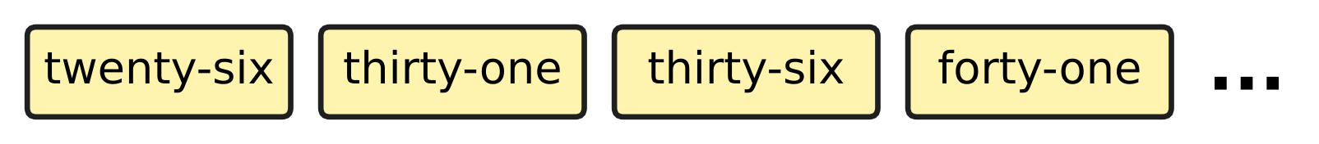
Q41. Look at the number cards. Ryan goes on with this pattern. He stops at the first number that is more than 60. At which number does he stop? [4 marks]
(A) 56 | (B) 60 | (C) 61 | (D) 66

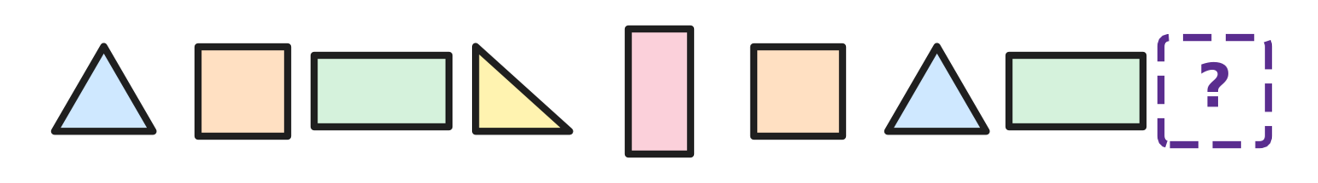
Q42. Look at the shapes. Count the corners of each shape. The numbers of corners repeat in a pattern. How many corners must the next shape have? [4 marks]
(A) 0 | (B) 3 | (C) 4 | (D) 7

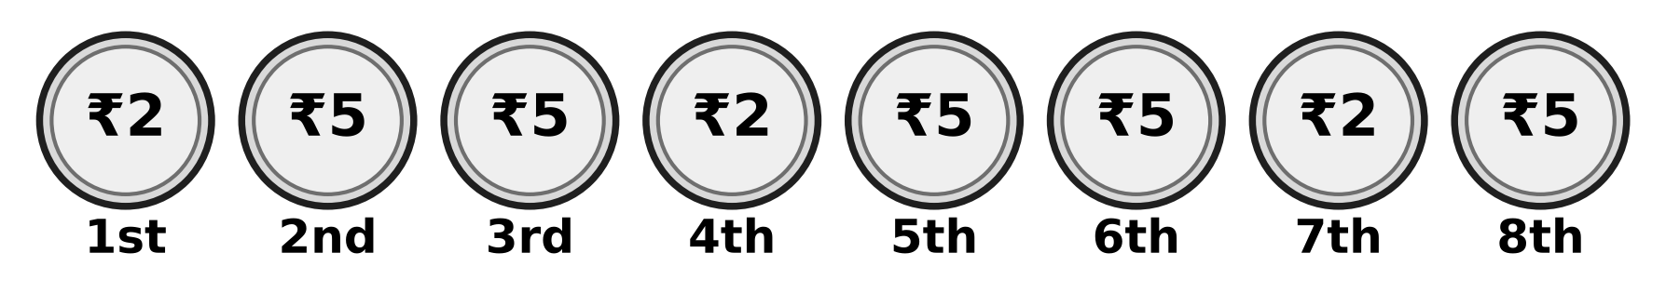
Q43. Look at the row of coins. The pattern goes on in the same way. How much is the 10th coin worth? [4 marks]
(A) ₹1 | (B) ₹2 | (C) ₹5 | (D) ₹10

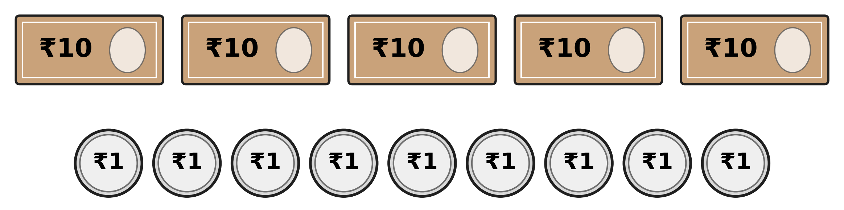
Q44. Look at the money on the table. Zubin puts 2 notes of ₹10 and 4 coins of ₹1 in his pocket. How much money is still on the table? [4 marks]
(A) ₹24 | (B) ₹35 | (C) ₹53 | (D) ₹59

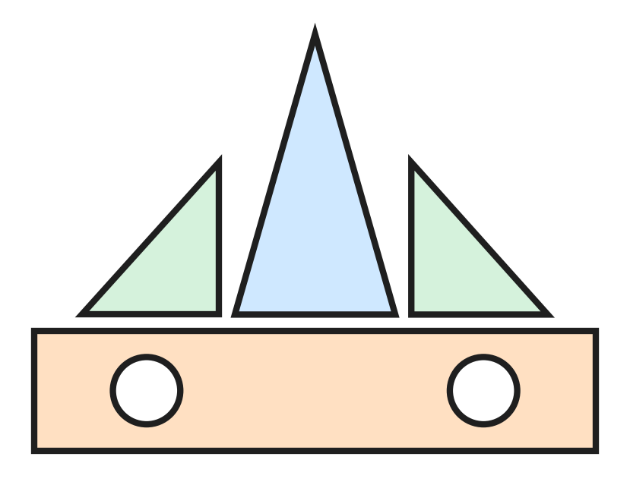
Q45. Look at the boat made of shape blocks. Varsha has 11 triangle blocks. She makes 2 boats like this one. How many triangle blocks are left? [4 marks]
(A) 5 | (B) 6 | (C) 7 | (D) 8

Answer Sheet AMO Level 1 · Class 1 · Practice Paper 5
Name: | School: | Roll No.:
Shade or tick one circle for each question.
1. Ⓐ Ⓑ Ⓒ Ⓓ | 16. Ⓐ Ⓑ Ⓒ Ⓓ | 31. Ⓐ Ⓑ Ⓒ Ⓓ
2. Ⓐ Ⓑ Ⓒ Ⓓ | 17. Ⓐ Ⓑ Ⓒ Ⓓ | 32. Ⓐ Ⓑ Ⓒ Ⓓ
3. Ⓐ Ⓑ Ⓒ Ⓓ | 18. Ⓐ Ⓑ Ⓒ Ⓓ | 33. Ⓐ Ⓑ Ⓒ Ⓓ
4. Ⓐ Ⓑ Ⓒ Ⓓ | 19. Ⓐ Ⓑ Ⓒ Ⓓ | 34. Ⓐ Ⓑ Ⓒ Ⓓ
5. Ⓐ Ⓑ Ⓒ Ⓓ | 20. Ⓐ Ⓑ Ⓒ Ⓓ | 35. Ⓐ Ⓑ Ⓒ Ⓓ
6. Ⓐ Ⓑ Ⓒ Ⓓ | 21. Ⓐ Ⓑ Ⓒ Ⓓ | 36. Ⓐ Ⓑ Ⓒ Ⓓ
7. Ⓐ Ⓑ Ⓒ Ⓓ | 22. Ⓐ Ⓑ Ⓒ Ⓓ | 37. Ⓐ Ⓑ Ⓒ Ⓓ
8. Ⓐ Ⓑ Ⓒ Ⓓ | 23. Ⓐ Ⓑ Ⓒ Ⓓ | 38. Ⓐ Ⓑ Ⓒ Ⓓ
9. Ⓐ Ⓑ Ⓒ Ⓓ | 24. Ⓐ Ⓑ Ⓒ Ⓓ | 39. Ⓐ Ⓑ Ⓒ Ⓓ
10. Ⓐ Ⓑ Ⓒ Ⓓ | 25. Ⓐ Ⓑ Ⓒ Ⓓ | 40. Ⓐ Ⓑ Ⓒ Ⓓ
11. Ⓐ Ⓑ Ⓒ Ⓓ | 26. Ⓐ Ⓑ Ⓒ Ⓓ | 41. Ⓐ Ⓑ Ⓒ Ⓓ
12. Ⓐ Ⓑ Ⓒ Ⓓ | 27. Ⓐ Ⓑ Ⓒ Ⓓ | 42. Ⓐ Ⓑ Ⓒ Ⓓ
13. Ⓐ Ⓑ Ⓒ Ⓓ | 28. Ⓐ Ⓑ Ⓒ Ⓓ | 43. Ⓐ Ⓑ Ⓒ Ⓓ
14. Ⓐ Ⓑ Ⓒ Ⓓ | 29. Ⓐ Ⓑ Ⓒ Ⓓ | 44. Ⓐ Ⓑ Ⓒ Ⓓ
15. Ⓐ Ⓑ Ⓒ Ⓓ | 30. Ⓐ Ⓑ Ⓒ Ⓓ | 45. Ⓐ Ⓑ Ⓒ Ⓓ
Q41–Q45 are Section II Star Questions (4 marks each).
For the parent or teacher
Section I correct: ______ / 40 × 2 = ______ marks Section II correct: ______ / 5 × 4 = ______ marks
Correct: ______ / 45 Score: ______ / 100
Answer Key and Solutions AMO Level 1 · Class 1 · Practice Paper 5
Quick answers
1 A | 6 C | 11 D | 16 A | 21 C | 26 A | 31 D | 36 A | 41 C
2 D | 7 D | 12 B | 17 C | 22 A | 27 B | 32 B | 37 B | 42 C
3 A | 8 C | 13 C | 18 B | 23 A | 28 C | 33 B | 38 C | 43 B
4 D | 9 D | 14 A | 19 D | 24 B | 29 D | 34 B | 39 D | 44 B
5 D | 10 B | 15 C | 20 C | 25 D | 30 A | 35 A | 40 A | 45 A
Solutions
Q | Part · level | Answer | Why?
1 | Part 1 · Ch1 · Easy | (A) 13 | There are two rows of 5 frogs and 3 more frogs. 5 and 5 make 10, and 3 more make 13.
2 | Part 1 · Ch1 · Easy | (D) thirty | Twenty-nine is 29. The number just after 29 is 30, which is thirty.
3 | Part 1 · Ch1 · Easy | (A) 2 | 72 has 7 tens and 2 ones. The ones digit is 2.
4 | Part 1 · Ch1 · Easy | (D) 9 | The tens digit is 3, so the ones digit must be more than 8. Only 9 works: 39 is greater than 38.
5 | Part 1 · Ch1 · Easy | (D) > | 91 has 9 tens and 19 has only 1 ten, so 91 is greater than 19. The sign is >.
6 | Part 1 · Ch1 · Easy | (C) 38 | There are 3 strips of ten and 8 single tickets. 3 tens and 8 ones make 38.
7 | Part 1 · Ch1 · Easy | (D) 9 | Count in tens: 10, 20, 30, 40, 50, 60, 70, 80, 90. That is 9 tens.
8 | Part 1 · Ch1 · Medium | (C) 64 | The number has 4 ones and 4 + 2 = 6 tens. 6 tens and 4 ones make 64.
9 | Part 1 · Ch1 · Medium | (D) 68 | The middle number must be greater than 64 and less than 71. Only 68 fits.
10 | Part 1 · Ch1 · Medium | (B) 29 | In order the numbers go 27, 28, 29, 30, 31. The space painted 92 should be 29: its two digits were swapped.
11 | Part 1 · Ch1 · Medium | (D) 15 | Fifteen is 1 ten and 5 ones, which is 15. The number 50 is fifty.
12 | Part 1 · Ch1 · Medium | (B) 4 | The numbers are 38, 39, 40 and 41. That is 4 numbers.
13 | Part 2 · Ch2 · Easy | (C) 13 | 3 + 6 = 9, and 9 + 4 = 13.
14 | Part 2 · Ch2 · Easy | (A) 8 | 15 − 7: take away 5 to reach 10, then 2 more to reach 8.
15 | Part 2 · Ch2 · Easy | (C) 14 | Count in twos, once for each pair: 2, 4, 6, 8, 10, 12, 14.
16 | Part 2 · Ch2 · Easy | (A) 0 | There are 7 owls. When all 7 fly away, 7 − 7 = 0 owls are left.
17 | Part 2 · Ch2 · Easy | (C) 12 | 7 + 5: 7 and 3 make 10, and 2 more make 12.
18 | Part 2 · Ch2 · Easy | (B) 9 | 15 − 6 = 9.
19 | Part 2 · Ch2 · Medium | (D) 7 | 18 take away how many leaves 11? 18 − 11 = 7, so 7 children went home.
20 | Part 2 · Ch2 · Medium | (C) 13 | Put the 6 back: 7 + 6 = 13.
21 | Part 2 · Ch2 · Medium | (C) 16 | Each plate has 4 slices. 3 plates have 4 + 4 + 4 = 12 slices, and one more plate makes 12 + 4 = 16.
22 | Part 2 · Ch2 · Medium | (A) 7 | 7 + 7 = 14, so the number is 7.
23 | Part 3 · Ch5 · Easy | (A) 4 | Count only the shapes with 4 equal sides and 4 corners. There are 4 squares.
24 | Part 3 · Ch5 · Easy | (B) circle | A circle is round and has no corners.
25 | Part 3 · Ch5 · Easy | (D) Picture D | A square has 4 sides that are all the same length. Picture D is the square.
26 | Part 3 · Ch5 · Easy | (A) two triangles | Each piece has 3 straight sides and 3 corners, so the pieces are two triangles.
27 | Part 3 · Ch5 · Medium | (B) Picture B | The circle, the square and the triangle are cut through the middle, so their two sides are the same. In Picture B the line is near one end of the rectangle, so the two sides are not the same.
28 | Part 3 · Ch5 · Medium | (C) 5 | The cut removes 1 corner and makes 2 new corners. Count the corners in the picture: there are 5.
29 | Part 4 · Ch9 · Easy | (D) Sunday | The day after Friday is Saturday. The day after Saturday is Sunday.
30 | Part 4 · Ch9 · Easy | (A) October | The months go August, September, October, November. The turned card is October.
31 | Part 4 · Ch9 · Easy | (D) ₹10 | Pari has ₹5, ₹2 and ₹1 coins. She has no ₹10 coin.
32 | Part 4 · Ch9 · Easy | (B) Picture B | Fifty is written as 50. The note in Picture B is the ₹50 note.
33 | Part 4 · Ch9 · Medium | (B) 4 | The months are June, July, August and September. That is 4 months.
34 | Part 4 · Ch9 · Medium | (B) ₹20 | From least to most the notes are ₹10, ₹20, ₹50, ₹100. The second note is ₹20.
35 | Part 5 · Ch10 · Easy | (A) 6 | 32, 84 and 48 are written with two digits. 6 has only one digit, so it is the odd one out.
36 | Part 5 · Ch10 · Easy | (A) 25 | Each number is 10 more than the one before. 10 less than 35 is 25.
37 | Part 5 · Ch10 · Easy | (B) circle | The pattern repeats square, circle, circle. After a square comes a circle, so the covered shape is a circle.
38 | Part 5 · Ch10 · Medium | (C) 6 | Nakul says 19, 17, 15, 13, 11, 9, 7, 5, 3, 1. He never says 6.
39 | Part 5 · Ch10 · Medium | (D) the 6th group | The groups have 3, 5, 7, 9 trumpets, 2 more each time. The 5th group has 11 and the 6th group has 13.
40 | Part 5 · Ch10 · Medium | (A) | The row is triangle, triangle, circle, then triangle, triangle, circle again. The group that repeats is triangle, triangle, circle.
41 | Section II · Ch1 + Ch10 · Hard | (C) 61 | The numbers are 26, 31, 36, 41, so each is 5 more. Next come 46, 51, 56 and 61. 61 is the first number more than 60.
42 | Section II · Ch5 + Ch10 · Hard | (C) 4 | The corners go 3, 4, 4, then 3, 4, 4, then 3, 4. The group 3, 4, 4 repeats, so the next shape must have 4 corners.
43 | Section II · Ch9 + Ch10 · Hard | (B) ₹2 | The coins repeat ₹2, ₹5, ₹5. The 9th coin is ₹5 and the 10th coin starts the group again, so it is ₹2.
44 | Section II · Ch1 + Ch9 · Hard | (B) ₹35 | 3 notes of ₹10 and 5 coins of ₹1 are still on the table. 3 tens and 5 ones make ₹35.
45 | Section II · Ch2 + Ch5 · Hard | (A) 5 | One boat has 3 triangles: 1 big and 2 small. 2 boats use 3 + 3 = 6, and 11 − 6 = 5 are left.

