UNLOCK IQ INSTITUTE
Realize Your True Potential
Aryabhatta Maths Olympiad (AMO)
Level 1 — Practice Paper 1
CLASS 11

Questions | 45 multiple-choice questions
Marks | 100
Time | 60 minutes
Section I | 40 questions × 2 marks = 80 marks
Section II | 5 Star Questions × 4 marks = 20 marks
Negative marking | No negative marking
Calculator | Not allowed
Chapters | Number System · Algebra · Geometry · Trigonometry · Data Handling · Applied Mathematics · Mathematical Reasoning

Instructions to candidates
• This paper has 45 multiple-choice questions. Each question has four answer choices, of which exactly one is correct.
• Section I (Q1–Q40) carries 2 marks per question. Section II (Q41–Q45) carries 4 marks per question.
• There is no negative marking. Unanswered questions score zero.
• Calculators are not permitted. Rough work may be done on a separate sheet.
• Mark your answers on the answer sheet at the end of the paper.
• All figures are not necessarily drawn to scale unless stated.

For parents and teachers
Print or view this paper in colour. Pictures are part of the questions.
Parts follow the AMO syllabus chapters. Chapters 2, 3 and 6 are not part of the Class 11 syllabus, so the chapter numbers shown in the Part headings have gaps.
The answer sheet and the answer key are at the end. Remove only the answer key before the student begins.

Name: | School: | Roll No.:

SECTION I 40 questions × 2 marks each
Part 1 — Number System (Syllabus Chapter 1)
Q1. Which of these is equal to −i?
(A) $i^{75}$ | (B) $i^{50}$ | (C) $i^{100}$ | (D) $i^{81}$

Q2. In the Argand diagram, the point P represents the complex number z. Which point represents $\overline{z}$, the conjugate of z? | 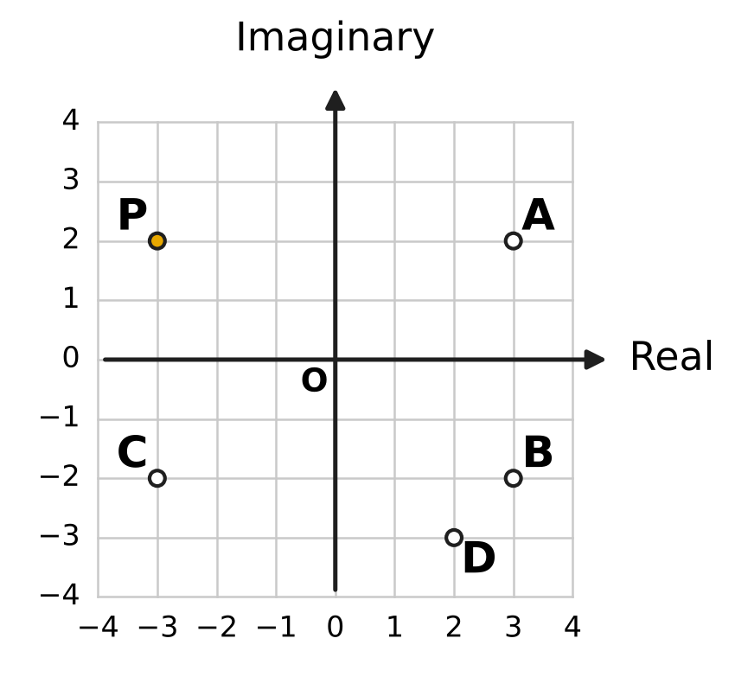
  (A) Point A | (B) Point B | (C) Point C | (D) Point D

Q3. If z = 5 − 2i, what is the value of $z\overline{z}$?
(A) $\sqrt{29}$ | (B) 29
(C) 21 | (D) 10

Q4. For which real number k does the product (k + 2i)(1 + 3i) have real part 0?
(A) $\frac{2}{3}$ | (B) $−\frac{2}{3}$ | (C) −6 | (D) 6

Q5. What is the principal argument of $\frac{3+i}{1+2i}$, taking the principal argument in the interval −π < θ ≤ π?
(A) $−\frac{π}{4}$ | (B) $\frac{π}{4}$ | (C) $\frac{7π}{4}$ | (D) $\frac{3π}{4}$

Part 2 — Algebra (Syllabus Chapter 4)
Q6. How many terms of the geometric progression 4, 12, 36, 108, … are less than 10,000?
(A) 9 | (B) 7 | (C) 8 | (D) 4

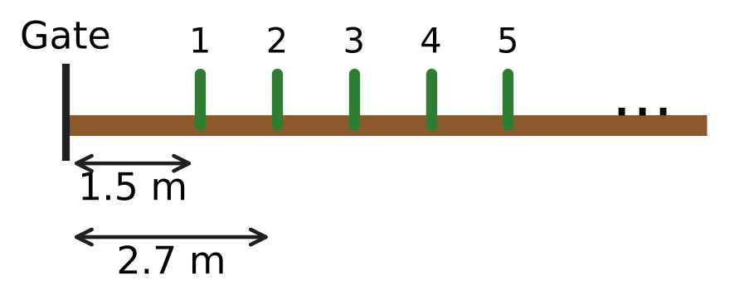
Q7. Uday puts bean stakes in a straight line along a vegetable bed, with equal gaps between them. The figure shows the distances of the first two stakes from the gate. How far is the 25th stake from the gate?
(A) 31.5 m | (B) 28.8 m | (C) 29.1 m | (D) 30.3 m

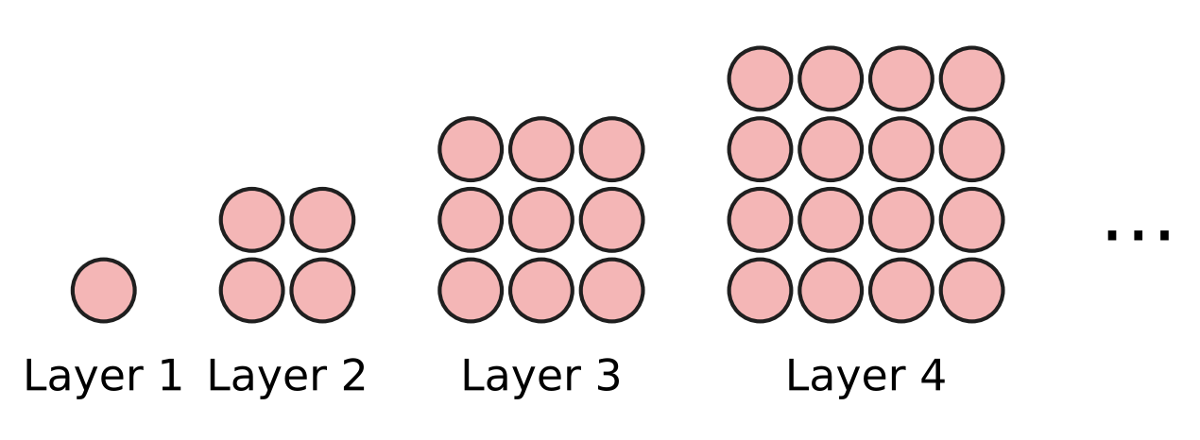
Q8. At an apple orchard, apples are stacked in a square pyramid. Seen from above, the layers from the top are 1 × 1, 2 × 2, 3 × 3, 4 × 4, … apples, as shown. How many apples are there in a pyramid with 12 layers?
(A) 144 | (B) 650 | (C) 78 | (D) 6,084

Q9. What is the fourth term in the expansion of (x² + 2)⁷?
(A) 280x⁸ | (B) 560x⁶ | (C) 84x¹⁰ | (D) 35x⁸

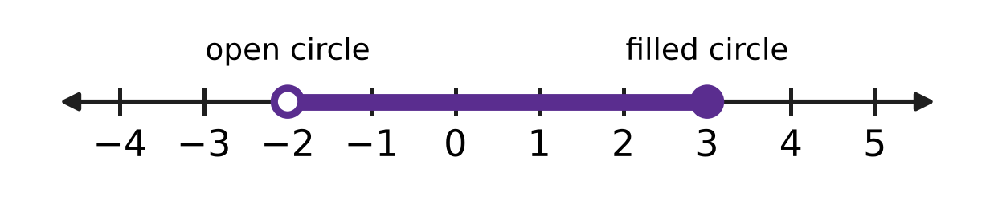
Q10. The number line shows all the solutions of an inequality in x. The open circle means the number is left out; the filled circle means it is included. Which inequality has exactly these solutions?
(A) −4 < 2x ≤ 3 | (B) −5 < 2x − 1 ≤ 5
(C) −5 < 1 − 2x ≤ 5 | (D) −3 < 2x − 1 ≤ 7

Q11. A ball is dropped from a height of 12 m. Each time it hits the ground, it bounces up to $\frac{1}{4}$ of the height it has just fallen, as shown. If it goes on bouncing like this for ever, what is the total distance it travels up and down? | 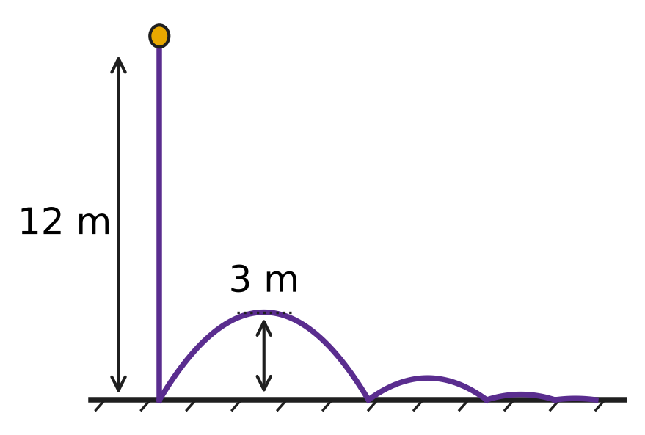
  (A) 18 m | (B) 32 m | (C) 16 m | (D) 20 m

Q12. What is the value of ${(\sqrt{2}+1)}^{4}+{(\sqrt{2}−1)}^{4}$?
(A) $17+12\sqrt{2}$ | (B) 10
(C) 34 | (D) $24\sqrt{2}$

Q13. The counting numbers are written in rows as shown. Row 1 has one number, and each row has one number more than the row above it. What is the sum of the numbers in row 10? | 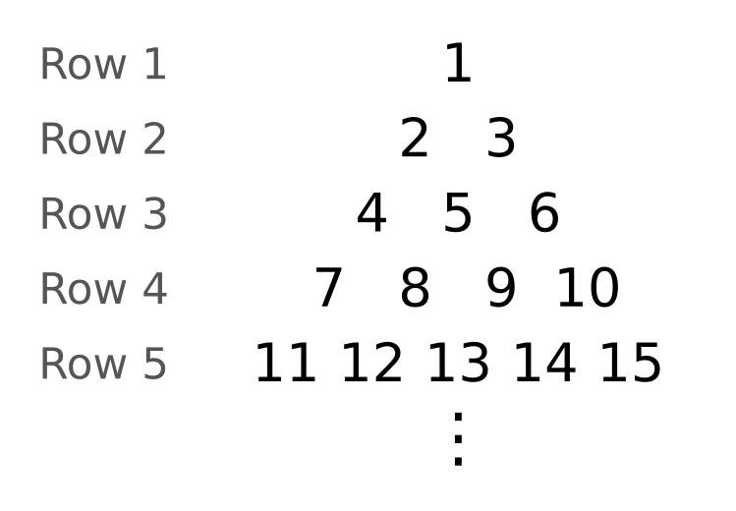
  (A) 505 | (B) 55 | (C) 550 | (D) 495

Q14. Three numbers are in geometric progression. Their product is 216 and their sum is 21. What is the largest of the three numbers?
(A) 6 | (B) 12 | (C) 24 | (D) 18

Part 3 — Geometry (Syllabus Chapter 5)
Q15. The line in the figure passes through the two marked grid points. What is its equation? | 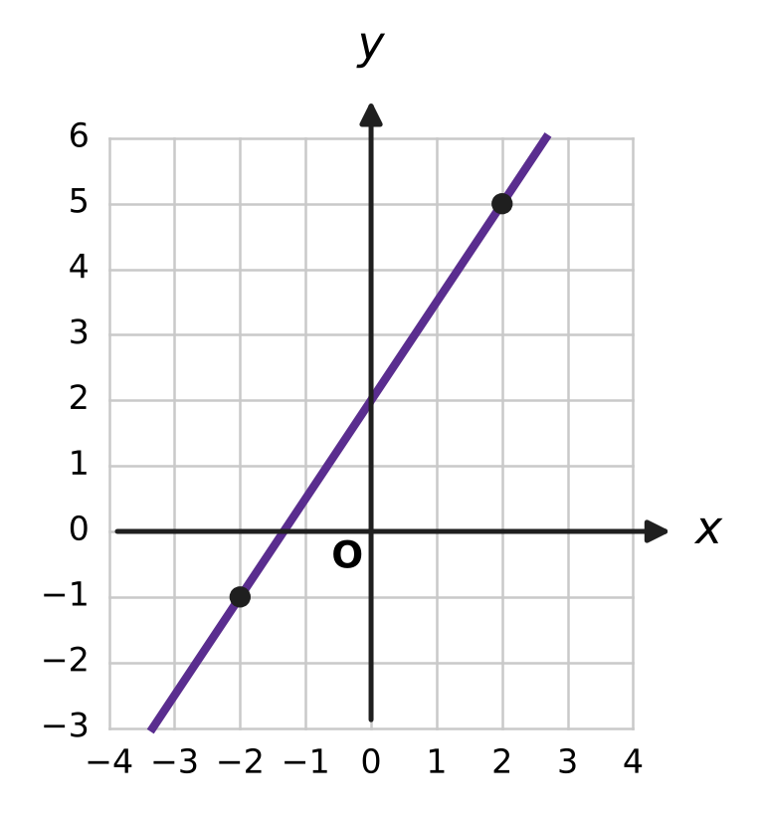
  (A) 3x + 2y + 8 = 0 | (B) 3x − 2y − 4 = 0
  (C) 2x − 3y + 1 = 0 | (D) 3x − 2y + 4 = 0

Q16. A line passes through the point (−2, 3) and makes an angle of 135° with the positive direction of the x-axis. At which point does it cross the y-axis?
(A) (1, 0) | (B) (0, −1) | (C) (0, 1) | (D) (0, 5)

Q17. The line through the points (1, k) and (3, 8) is parallel to the line 5x − 2y + 1 = 0. What is the value of k?
(A) $\frac{44}{5}$ | (B) 13 | (C) $\frac{36}{5}$ | (D) 3

Q18. Triangle ABC is drawn on the grid, with its corners at grid points. The dashed segment is perpendicular to BC. How long is the perpendicular from A to BC? | 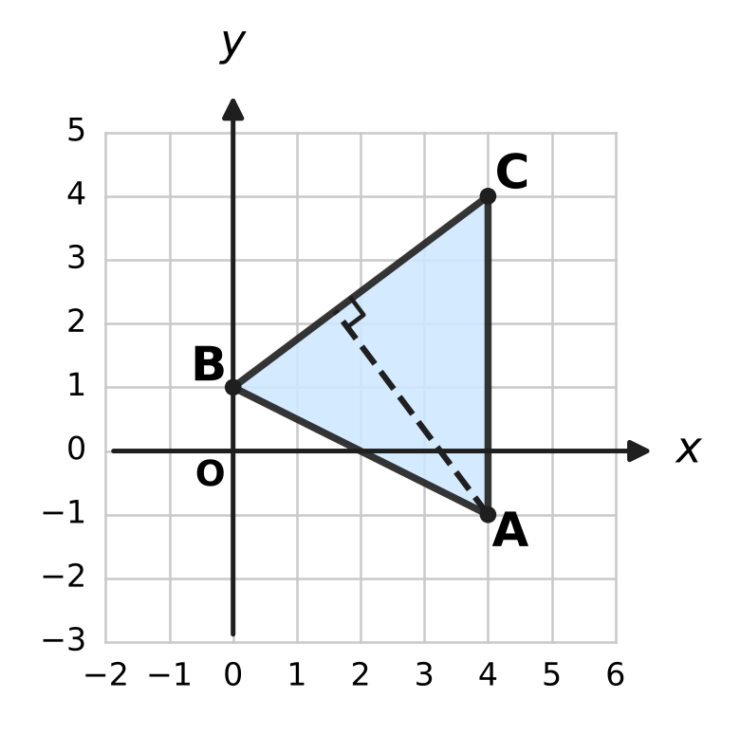
  (A) 4 units | (B) 5 units
  (C) $\frac{12}{5}$ units | (D) 20 units

Q19. A line through the origin has a positive slope and makes an acute angle of 45° with the line y = 4x. What is its slope?
(A) 3 | (B) $\frac{5}{3}$ | (C) $\frac{3}{5}$ | (D) 5

Part 4 — Trigonometry & Heights and Distances (Syllabus Chapter 7)
Q20. The circle has centre O and radius 1. The angle from the positive x-axis to OP, measured anticlockwise, is 210°, as shown. What are the coordinates of P? | 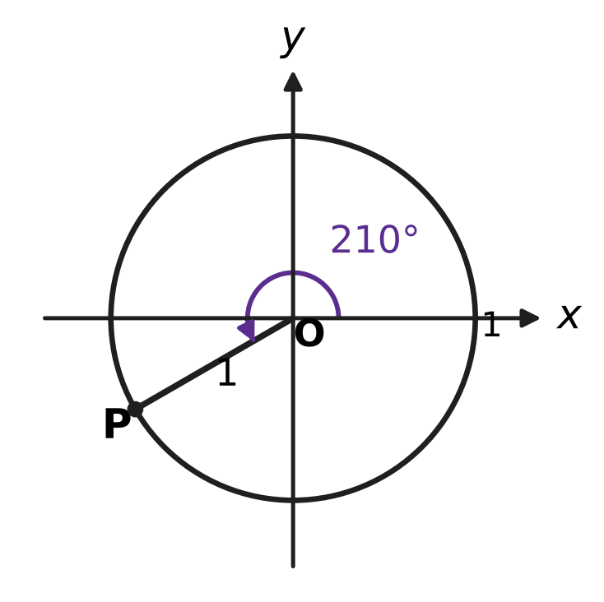
  (A) (√3/2, −1/2) | (B) (−√3/2, −1/2)
  (C) (−√3/2, 1/2) | (D) (−1/2, −√3/2)

Q21. What is the value of sin 80° cos 20° − cos 80° sin 20°?
(A) $\frac{\sqrt{3}}{2}$ | (B) 1
(C) $−\frac{\sqrt{3}}{2}$ | (D) $\frac{1}{2}$

Q22. Which of these is a simpler form of cos⁴A − sin⁴A?
(A) sin 2A | (B) cos² 2A | (C) 1 | (D) cos 2A

Q23. What is the value of cos 20° + cos 100° + cos 140°?
(A) $\frac{1}{2}$ cos 20° | (B) 2 cos 20°
(C) 0 | (D) 1

Q24. A notice board hangs on a classroom wall. Its lower edge is 0.5 m above Leela's eye level and the board is 1.5 m tall, as shown. Leela stands 2 m from the wall. The board makes an angle θ at her eye. What is tan θ? | 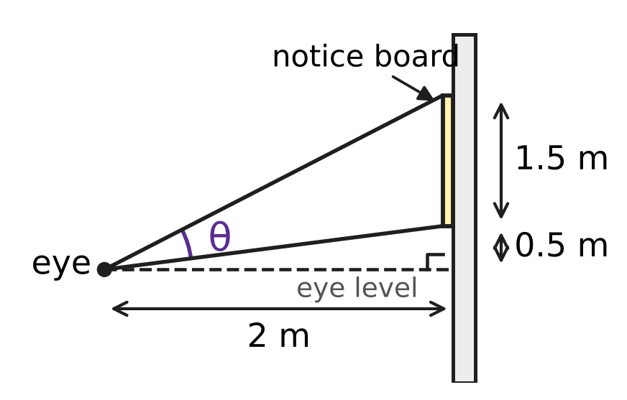
  (A) $\frac{5}{3}$ | (B) $\frac{3}{5}$ | (C) $\frac{5}{4}$ | (D) $\frac{3}{4}$

Part 5 — Data Handling, Statistics & Probability (Syllabus Chapter 8)
Q25. In her stamp collection, Mia has 5 different stamps and also 3 identical copies of one other stamp. In how many different ways can she arrange all 8 stamps in a row?
(A) 120 | (B) 6,720 | (C) 56 | (D) 40,320

Q26. The figure shows a cube with its 8 vertices marked. How many different triangles have all three corners at vertices of the cube? | 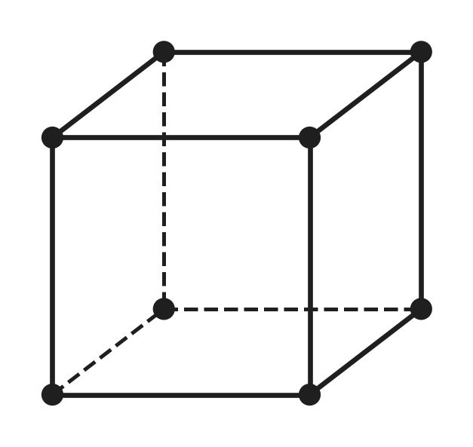
  (A) 168 | (B) 24 | (C) 28 | (D) 56

Q27. The spinner shown has 3 equal sectors, and one of them is shaded. It is spun 3 times. What is the probability that it stops on the shaded sector exactly once? | 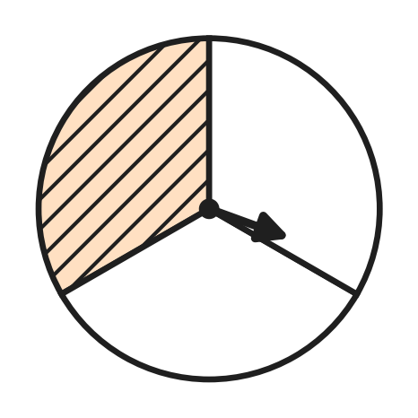
  (A) $\frac{4}{9}$ | (B) $\frac{4}{27}$ | (C) $\frac{8}{27}$ | (D) $\frac{1}{3}$

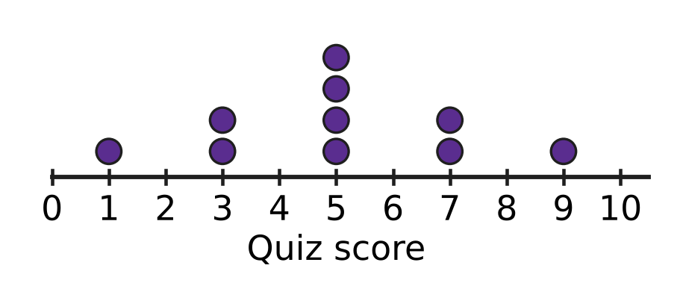
Q28. The dot plot in the figure shows the scores of 10 students in a short quiz. Each dot stands for one student. What is the variance of the scores?
(A) 48 | (B) 29.8 | (C) 4.8 | (D) 9.6

Q29. Six swimmers, including Ira and Arnav, are each given one of the 6 lanes of a swimming pool, numbered 1 to 6 across the pool. In how many ways can the lanes be given out if there is exactly one lane between Ira's lane and Arnav's lane?
(A) 240 | (B) 48 | (C) 96 | (D) 192

Q30. The variance of 2, 4, 6, 8, 10 is 8. What is the variance of 13, 16, 19, 22, 25?
(A) 18 | (B) 8 | (C) 12 | (D) 28

Q31. On any school day, the probability that the school bus is late is $\frac{1}{5}$, independently of other days. What is the probability that the bus is late on at most one of the next 4 school days?
(A) $\frac{113}{625}$ | (B) $\frac{64}{125}$ | (C) $\frac{512}{625}$ | (D) $\frac{256}{625}$

Part 6 — Applied Mathematics (Syllabus Chapter 9)
Q32. Naveen buys a school bag at a stationery shop. The price before tax is ₹1,400, and GST of 18% is charged. The sale is within one state, so the GST is shared equally as CGST and SGST. How much CGST does Naveen pay?
(A) ₹1,526 | (B) ₹126 | (C) ₹252 | (D) ₹63

Q33. A bakery bakes x trays of buns and y trays of biscuits each morning. The shaded region on the grid shows all the plans its oven time and flour allow, with x ≥ 0 and y ≥ 0. Which two other inequalities describe the shaded region? | 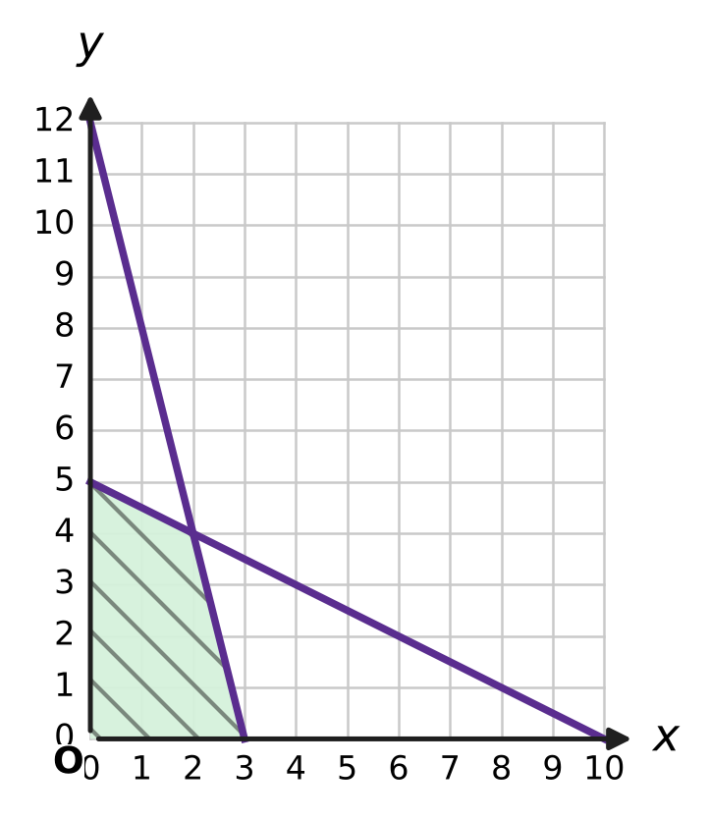
  (A) x + 4y ≤ 12 and 2x + y ≤ 10 | (B) 4x + y ≤ 12 and x + 2y ≤ 10
  (C) 4x + y ≥ 12 and x + 2y ≤ 10 | (D) x + y ≤ 12 and x + y ≤ 10

Q34. Two inlet pipes can fill an empty rainwater tank in 4 hours and 6 hours on their own. A drain pipe can empty the full tank in 12 hours. All three pipes are opened together when the tank is empty. How long does the tank take to fill?
(A) 2 hours | (B) 6 hours
(C) 3 hours | (D) 2.4 hours

Q35. Farah takes a loan of ₹8,200 to buy a bicycle. Interest of 5% a year is charged on the balance outstanding. She clears the loan with two equal instalments of ₹4,410, one at the end of each year. How much of the second instalment is interest?
(A) ₹410 | (B) ₹310 | (C) ₹205 | (D) ₹210

Part 7 — Mathematical Reasoning & Problem-Solving (Syllabus Chapter 10)
Q36. A glass jar holds 5 red, 7 blue and 9 green marbles. Advait takes marbles out one at a time without looking. What is the least number he must take out to be sure of having 4 marbles of the same colour?
(A) 10 | (B) 12 | (C) 13 | (D) 9

Q37. In a class of 30 students, every student borrowed at least one book from the school library this month, and 70 books were borrowed in all. What is the greatest number of books that one student could have borrowed?
(A) 40 | (B) 69 | (C) 41 | (D) 3

Q38. Shreya wants to prove that n² + n + 1 is even for every natural number n. She shows correctly that if k² + k + 1 is even, then (k + 1)² + (k + 1) + 1 is also even. Which statement is true?
(A) The claim is false: n² + n + 1 is odd for every natural number n.
(B) The claim is true for every even n, because n² + n is then even.
(C) The claim is true for every n ≥ 2, because the proof can start at n = 2.
(D) The claim is true for every natural number n, because the step is correct.

Q39. The numbers 1, 2, 3, …, 10 are written on the board. In one move, any two of the numbers, say a and b, are rubbed out and the single number a + b − 1 is written in their place. After 9 moves only one number is left. What is that number?
(A) 64 | (B) 46 | (C) 55 | (D) 45

Q40. On a windy day, 13 identical kites are shared among 5 children so that every child gets at least 2 kites. In how many ways can this be done?
(A) 495 | (B) 125 | (C) 15 | (D) 35

SECTION II — Star Questions 5 questions × 4 marks each
Q41. A geometric progression has every term a whole number from 100 to 1,000 (both included), and each term is greater than the term before it. What is the greatest possible number of terms in such a progression? [4 marks]
(A) 7 | (B) 6 | (C) 5 | (D) 4

Q42. Navya and Kartik take turns to throw a fair die, and Navya throws first. The first person to throw a six wins, and the game then stops. What is the probability that Navya wins? [4 marks]
(A) $\frac{6}{11}$ | (B) $\frac{5}{11}$ | (C) $\frac{1}{2}$ | (D) $\frac{1}{6}$

Q43. Let z = 1 + i. What is the value of z + z² + z³ + … + z⁸? [4 marks]
(A) −15 + 15i | (B) −17 + 17i
(C) 15 − 15i | (D) 16 − 16i

Q44. The line L: x − 2y + 4 = 0 meets the y-axis at A. The line is turned anticlockwise through 45° about A, as shown. At which point does the new line meet the x-axis? [4 marks] | 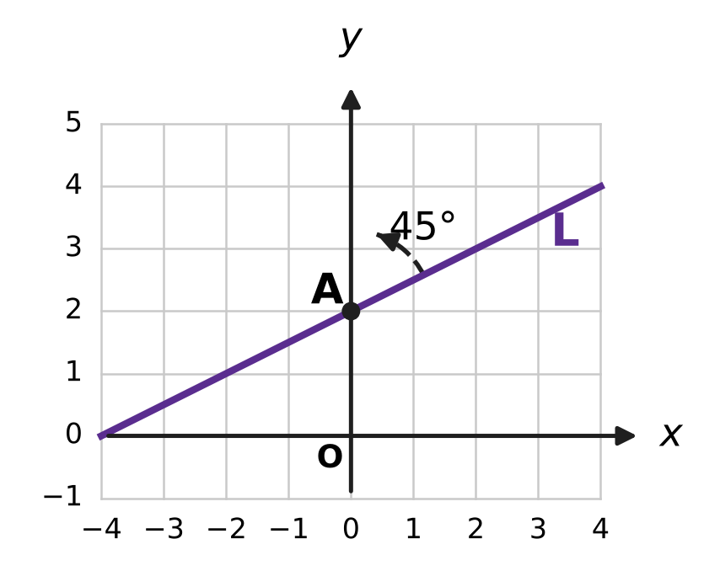
  (A) (1, 0) | (B) (6, 0)
  (C) (−4/3, 0) | (D) (−2/3, 0)

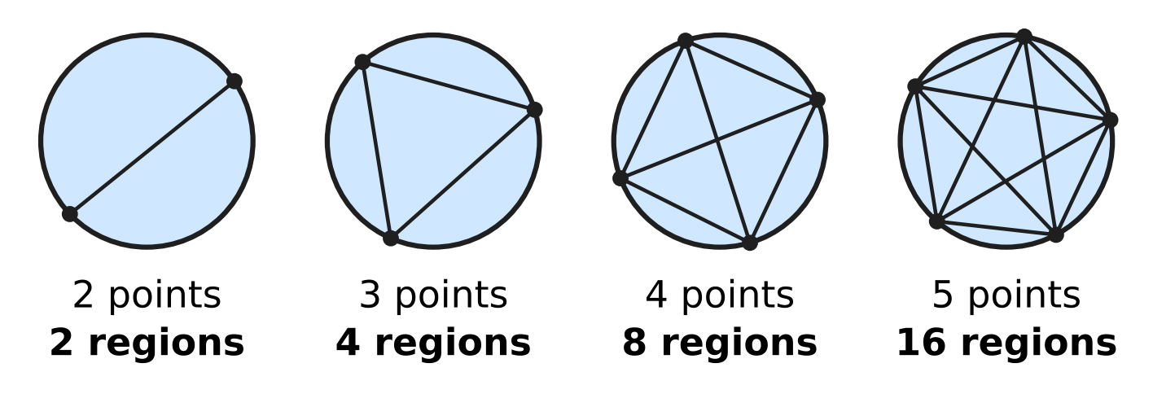
Q45. Points are marked on a circle and every two of them are joined by a straight chord. The points are placed so that no three chords pass through the same point inside the circle. The figure shows the number of regions inside the circle for 2, 3, 4 and 5 points. How many regions are there for 6 points? [4 marks]
(A) 32 | (B) 31 | (C) 16 | (D) 57

Answer Sheet AMO Level 1 · Class 11 · Practice Paper 1
Name: | School: | Roll No.:
Shade or tick one circle for each question.
1. Ⓐ Ⓑ Ⓒ Ⓓ | 16. Ⓐ Ⓑ Ⓒ Ⓓ | 31. Ⓐ Ⓑ Ⓒ Ⓓ
2. Ⓐ Ⓑ Ⓒ Ⓓ | 17. Ⓐ Ⓑ Ⓒ Ⓓ | 32. Ⓐ Ⓑ Ⓒ Ⓓ
3. Ⓐ Ⓑ Ⓒ Ⓓ | 18. Ⓐ Ⓑ Ⓒ Ⓓ | 33. Ⓐ Ⓑ Ⓒ Ⓓ
4. Ⓐ Ⓑ Ⓒ Ⓓ | 19. Ⓐ Ⓑ Ⓒ Ⓓ | 34. Ⓐ Ⓑ Ⓒ Ⓓ
5. Ⓐ Ⓑ Ⓒ Ⓓ | 20. Ⓐ Ⓑ Ⓒ Ⓓ | 35. Ⓐ Ⓑ Ⓒ Ⓓ
6. Ⓐ Ⓑ Ⓒ Ⓓ | 21. Ⓐ Ⓑ Ⓒ Ⓓ | 36. Ⓐ Ⓑ Ⓒ Ⓓ
7. Ⓐ Ⓑ Ⓒ Ⓓ | 22. Ⓐ Ⓑ Ⓒ Ⓓ | 37. Ⓐ Ⓑ Ⓒ Ⓓ
8. Ⓐ Ⓑ Ⓒ Ⓓ | 23. Ⓐ Ⓑ Ⓒ Ⓓ | 38. Ⓐ Ⓑ Ⓒ Ⓓ
9. Ⓐ Ⓑ Ⓒ Ⓓ | 24. Ⓐ Ⓑ Ⓒ Ⓓ | 39. Ⓐ Ⓑ Ⓒ Ⓓ
10. Ⓐ Ⓑ Ⓒ Ⓓ | 25. Ⓐ Ⓑ Ⓒ Ⓓ | 40. Ⓐ Ⓑ Ⓒ Ⓓ
11. Ⓐ Ⓑ Ⓒ Ⓓ | 26. Ⓐ Ⓑ Ⓒ Ⓓ | 41. Ⓐ Ⓑ Ⓒ Ⓓ
12. Ⓐ Ⓑ Ⓒ Ⓓ | 27. Ⓐ Ⓑ Ⓒ Ⓓ | 42. Ⓐ Ⓑ Ⓒ Ⓓ
13. Ⓐ Ⓑ Ⓒ Ⓓ | 28. Ⓐ Ⓑ Ⓒ Ⓓ | 43. Ⓐ Ⓑ Ⓒ Ⓓ
14. Ⓐ Ⓑ Ⓒ Ⓓ | 29. Ⓐ Ⓑ Ⓒ Ⓓ | 44. Ⓐ Ⓑ Ⓒ Ⓓ
15. Ⓐ Ⓑ Ⓒ Ⓓ | 30. Ⓐ Ⓑ Ⓒ Ⓓ | 45. Ⓐ Ⓑ Ⓒ Ⓓ
Q41–Q45 are Section II Star Questions (4 marks each).
For the parent or teacher
Section I correct: ______ / 40 × 2 = ______ marks Section II correct: ______ / 5 × 4 = ______ marks
Correct: ______ / 45 Score: ______ / 100
Answer Key and Solutions AMO Level 1 · Class 11 · Practice Paper 1
Quick answers
1 A | 6 C | 11 D | 16 C | 21 A | 26 D | 31 C | 36 A | 41 B
2 C | 7 D | 12 C | 17 D | 22 D | 27 A | 32 B | 37 C | 42 A
3 B | 8 B | 13 A | 18 A | 23 C | 28 C | 33 B | 38 A | 43 C
4 D | 9 A | 14 B | 19 C | 24 B | 29 D | 34 C | 39 B | 44 D
5 A | 10 B | 15 D | 20 B | 25 B | 30 A | 35 D | 40 D | 45 B
Solutions
Q | Part · level | Answer | Why?
1 | Part 1 · Ch1 · Easy | (A) $i^{75}$ | Only the remainder on division by 4 matters: 75 = 4 × 18 + 3, so i⁷⁵ = i³ = −i. (i⁵⁰ = −1, i⁸¹ = i, i¹⁰⁰ = 1.)
2 | Part 1 · Ch1 · Easy | (C) Point C | P is z = −3 + 2i, so z̄ = −3 − 2i: the reflection of P in the real axis, which is point C.
3 | Part 1 · Ch1 · Easy | (B) 29 | z z̄ = (5 − 2i)(5 + 2i) = 25 − 4i² = 25 + 4 = 29, which is |z|².
4 | Part 1 · Ch1 · Medium | (D) 6 | (k + 2i)(1 + 3i) = k + 3ki + 2i + 6i² = (k − 6) + (3k + 2)i. The real part k − 6 = 0 gives k = 6 (the product is then 20i).
5 | Part 1 · Ch1 · Medium | (A) $−\frac{π}{4}$ | Multiply top and bottom by 1 − 2i: (3 + i)(1 − 2i) = 5 − 5i and (1 + 2i)(1 − 2i) = 5, so the number is 1 − i. It lies in the fourth quadrant with tan α = 1, so the argument is −π/4.
6 | Part 2 · Ch4 · Easy | (C) 8 | The nth term is 4 × 3ⁿ⁻¹ < 10,000, so 3ⁿ⁻¹ < 2,500. Since 3⁷ = 2,187 and 3⁸ = 6,561, n − 1 can be at most 7, so 8 terms (the 8th term is 8,748).
7 | Part 2 · Ch4 · Easy | (D) 30.3 m | The distances 1.5, 2.7, … form an AP with common difference 1.2 m. The 25th term is 1.5 + 24 × 1.2 = 30.3 m.
8 | Part 2 · Ch4 · Easy | (B) 650 | Total = 1² + 2² + … + 12² = 12 × 13 × 25 ÷ 6 = 650 apples.
9 | Part 2 · Ch4 · Easy | (A) 280x⁸ | T₄ = T₃₊₁ = C(7, 3) (x²)⁴ × 2³ = 35 × 8 × x⁸ = 280x⁸.
10 | Part 2 · Ch4 · Easy | (B) −5 < 2x − 1 ≤ 5 | The picture shows −2 < x ≤ 3. From −5 < 2x − 1 ≤ 5, add 1 to get −4 < 2x ≤ 6, then halve: −2 < x ≤ 3.
11 | Part 2 · Ch4 · Medium | (D) 20 m | The first fall is 12 m. After that, each bounce is travelled up and down: 2(3 + 0.75 + …) = 2 × 3 ÷ (1 − 1/4) = 8 m. The total is 12 + 8 = 20 m.
12 | Part 2 · Ch4 · Medium | (C) 34 | In the two expansions the terms with odd powers of √2 cancel, and the others double: 2[(√2)⁴ + 6(√2)² + 1] = 2(4 + 12 + 1) = 34.
13 | Part 2 · Ch4 · Medium | (A) 505 | Rows 1 to 9 hold 1 + 2 + … + 9 = 45 numbers, so row 10 is 46, 47, …, 55. Its sum is 10 × (46 + 55) ÷ 2 = 505.
14 | Part 2 · Ch4 · Medium | (B) 12 | Write the numbers as 6/r, 6, 6r (product 6³ = 216). Then 6/r + 6 + 6r = 21 gives 2r² − 5r + 2 = 0, so r = 2 or 1/2: the numbers are 3, 6, 12.
15 | Part 3 · Ch5 · Easy | (D) 3x − 2y + 4 = 0 | The marked points are (−2, −1) and (2, 5), so the slope is 6/4 = 3/2. Then y + 1 = (3/2)(x + 2), which gives 3x − 2y + 4 = 0.
16 | Part 3 · Ch5 · Easy | (C) (0, 1) | The slope is tan 135° = −1. So y − 3 = −(x + 2), that is y = −x + 1, which crosses the y-axis at (0, 1).
17 | Part 3 · Ch5 · Easy | (D) 3 | 5x − 2y + 1 = 0 has slope 5/2. So (8 − k)/(3 − 1) = 5/2, which gives 8 − k = 5 and k = 3.
18 | Part 3 · Ch5 · Medium | (A) 4 units | A = (4, −1), B = (0, 1), C = (4, 4). The line BC is 3x − 4y + 4 = 0, so the distance is |12 + 4 + 4| ÷ √(9 + 16) = 20 ÷ 5 = 4 units.
19 | Part 3 · Ch5 · Medium | (C) $\frac{3}{5}$ | tan 45° = |(m − 4)/(1 + 4m)| = 1. Either m − 4 = 1 + 4m, giving m = −5/3, or m − 4 = −(1 + 4m), giving m = 3/5. The positive slope is 3/5.
20 | Part 4 · Ch7 · Easy | (B) (−√3/2, −1/2) | P = (cos 210°, sin 210°). 210° = 180° + 30° is in the third quadrant, so P = (−cos 30°, −sin 30°) = (−√3/2, −1/2).
21 | Part 4 · Ch7 · Easy | (A) $\frac{\sqrt{3}}{2}$ | sin A cos B − cos A sin B = sin(A − B), so the value is sin(80° − 20°) = sin 60° = √3/2.
22 | Part 4 · Ch7 · Easy | (D) cos 2A | cos⁴A − sin⁴A = (cos²A − sin²A)(cos²A + sin²A) = (cos²A − sin²A) × 1 = cos 2A.
23 | Part 4 · Ch7 · Medium | (C) 0 | cos 100° + cos 140° = 2 cos 120° cos 20° = 2 × (−1/2) cos 20° = −cos 20°. Adding cos 20° gives 0.
24 | Part 4 · Ch7 · Medium | (B) $\frac{3}{5}$ | The top edge is 2 m above eye level, so the angles to the top and bottom have tangents 2/2 = 1 and 0.5/2 = 1/4. tan θ = (1 − 1/4) ÷ (1 + 1 × 1/4) = (3/4) ÷ (5/4) = 3/5.
25 | Part 5 · Ch8 · Easy | (B) 6,720 | There are 8 stamps with 3 alike, so there are 8!/3! = 40,320 ÷ 6 = 6,720 arrangements.
26 | Part 5 · Ch8 · Easy | (D) 56 | No three vertices of a cube lie on one straight line, so every choice of 3 vertices gives a triangle: C(8, 3) = 56.
27 | Part 5 · Ch8 · Easy | (A) $\frac{4}{9}$ | P(exactly 1) = C(3, 1) × (1/3) × (2/3)² = 3 × 4/27 = 4/9.
28 | Part 5 · Ch8 · Easy | (C) 4.8 | The mean is 50 ÷ 10 = 5. The squared deviations add up to 16 + 2 × 4 + 4 × 0 + 2 × 4 + 16 = 48, so the variance is 48 ÷ 10 = 4.8.
29 | Part 5 · Ch8 · Medium | (D) 192 | The lane pairs with one lane between are (1, 3), (2, 4), (3, 5), (4, 6): 4 pairs. Ira and Arnav can take each pair in 2 ways, and the other 4 swimmers in 4! = 24 ways: 4 × 2 × 24 = 192.
30 | Part 5 · Ch8 · Medium | (A) 18 | Each new value is 1.5 × (old value) + 10. Adding 10 does not change the variance, and multiplying by 1.5 multiplies it by 1.5² = 2.25: 8 × 2.25 = 18.
31 | Part 5 · Ch8 · Medium | (C) $\frac{512}{625}$ | P(0 late) + P(1 late) = (4/5)⁴ + 4 × (1/5) × (4/5)³ = 256/625 + 256/625 = 512/625.
32 | Part 6 · Ch9 · Easy | (B) ₹126 | CGST is half of 18%, that is 9%. 9% of ₹1,400 = ₹126.
33 | Part 6 · Ch9 · Easy | (B) 4x + y ≤ 12 and x + 2y ≤ 10 | One line goes through (3, 0) and (0, 12): 4x + y = 12. The other goes through (10, 0) and (0, 5): x + 2y = 10. The origin is in the region, so both are "≤": 4x + y ≤ 12 and x + 2y ≤ 10.
34 | Part 6 · Ch9 · Easy | (C) 3 hours | In one hour: 1/4 + 1/6 − 1/12 = (3 + 2 − 1)/12 = 1/3 of the tank. So the tank fills in 3 hours.
35 | Part 6 · Ch9 · Medium | (D) ₹210 | After year 1 Farah owes 8,200 × 1.05 = ₹8,610; after paying ₹4,410 she owes ₹4,200. Interest in year 2 is 5% of ₹4,200 = ₹210 (and 4,200 + 210 = 4,410 clears the loan).
36 | Part 7 · Ch10 · Easy | (A) 10 | He could take 3 of each colour, 9 marbles, without having 4 alike. The 10th marble must give 4 of one colour.
37 | Part 7 · Ch10 · Easy | (C) 41 | For one student to have as many as possible, each of the other 29 students has just 1 book. That student then has 70 − 29 = 41 books.
38 | Part 7 · Ch10 · Easy | (A) The claim is false: n² + n + 1 is odd for every natural number n. | n² + n = n(n + 1) is a product of two consecutive numbers, so it is even and n² + n + 1 is odd for every n. The step is correct, but there is no true base case to start from (n = 1 gives 3).
39 | Part 7 · Ch10 · Medium | (B) 46 | Each move lowers the total of the numbers on the board by exactly 1. The total starts at 55 and 9 moves are made, so the last number is 55 − 9 = 46, whatever the order.
40 | Part 7 · Ch10 · Medium | (D) 35 | Give each child 2 kites first; 3 kites are left. Sharing 3 identical kites among 5 children: C(3 + 4, 4) = C(7, 4) = 35 ways.
41 | Section II · Ch4 + Ch10 · Hard | (B) 6 | Ratio 3/2 from 128 gives 128, 192, 288, 432, 648, 972: 6 terms. With ratio p/q in lowest terms, n terms need (p/q)ⁿ⁻¹ ≤ 10, and the last term is a multiple of pⁿ⁻¹. For 7 terms, (p/q)⁶ ≤ 10 rules out q = 1 (ratio ≥ 2) and q = 2 ((3/2)⁶ > 11), so q ≥ 3, p ≥ 4 and the last term is at least 4⁶ = 4,096, which is too big.
42 | Section II · Ch4 + Ch8 · Hard | (A) $\frac{6}{11}$ | Navya wins on her 1st, 2nd, 3rd, … throw with probabilities 1/6, (5/6)²(1/6), (5/6)⁴(1/6), … . This is a GP with ratio 25/36, so the sum is (1/6) ÷ (1 − 25/36) = (1/6) × (36/11) = 6/11.
43 | Section II · Ch1 + Ch4 · Hard | (C) 15 − 15i | (1 + i)² = 2i, so (1 + i)⁸ = (2i)⁴ = 16. The GP sum is z(z⁸ − 1)/(z − 1) = (1 + i)(15)/i = 15(1 + i)(−i) = 15 − 15i.
44 | Section II · Ch5 + Ch7 · Hard | (D) (−2/3, 0) | L has slope tan θ = 1/2 and A = (0, 2). The new slope is tan(θ + 45°) = (1/2 + 1)/(1 − 1/2) = 3, so the new line is y = 3x + 2. It meets the x-axis where 3x + 2 = 0, at (−2/3, 0).
45 | Section II · Ch8 + Ch10 · Hard | (B) 31 | Each chord adds one region, and each crossing point inside adds one more. Every 4 points give exactly one crossing, so regions = 1 + C(6, 2) + C(6, 4) = 1 + 15 + 15 = 31, not 32.

