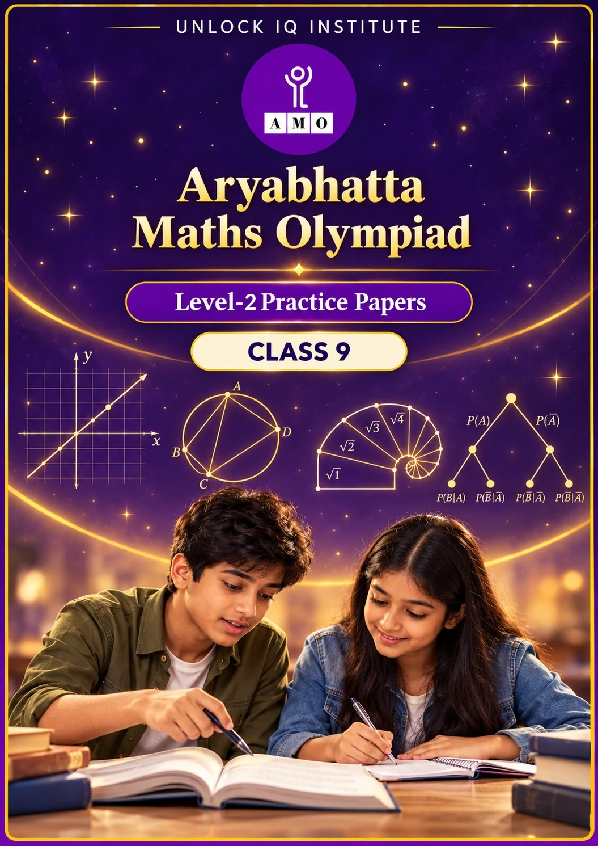
Set 1 · Practice Papers 1–5 · with answer keys & detailed solutions
Name: ____________________ | Class & Section: ________________
Roll No.: ________________ | School: ____________________
City: ____________________ | Date: ____________________

Published by Unlock IQ Institute Pvt. Ltd.
Register for Olympiads: www.aryabhattamathsolympiad.com/student-registration

ARYABHATTA MATHS OLYMPIAD
Level 2
PRACTICE PAPER-1
CLASS 9
Total Questions | 30 multiple-choice questions
Level | Level-2 (final round): every question is Hard
Time | 45 minutes
Arrangement | Parts by chapter; the last Part has mixed problems joining two chapters
Negative Marking | No negative marking
Calculator | Not allowed
Chapters | Number System · Fractions, Decimals & Percentages · Algebra · Geometry · Mensuration · Data Handling, Statistics & Probability · Applied Mathematics · Mathematical Reasoning

Instructions
• Each question has four options, (A) to (D), with exactly one correct answer.
• The questions are grouped in Parts by chapter. The last Part has mixed problems, each joining two chapters.
• Every question is at Level-2 (Hard) standard: expect several steps or a key insight.
• There is no negative marking. Calculators are not allowed; use a separate sheet for rough work.
• Figures are not necessarily drawn to scale unless stated.

For teachers
• Figures are part of the questions and work when printed in black and white.
• Parts follow the AMO syllabus chapters. Chapters 2 and 7 are not part of the Class 9 syllabus, so the chapter numbers shown in the Part headings have gaps.
• The answer sheet and the answer key are at the end. Remove the answer key before the paper is attempted.

Part 1 — Number System (Syllabus Chapter 1)
Q1. Shreya writes 1/7 as a decimal. What is the 100th digit after the decimal point?
(A) 5 | (B) 4 | (C) 2 | (D) 8

Q2. Which of these numbers is irrational?
(A) √2 × √8 | (B) (√3 + 1)² − 2√3
(C) √0.09 | (D) √5 × √20 ÷ √10

Part 2 — Fractions, Decimals & Percentages (Syllabus Chapter 3)
Q3. A machine bought for ₹80,000 loses 25% of its value every year. After how many whole years is it first worth less than ₹30,000?
(A) 3 | (B) 5 | (C) 4 | (D) 6

Q4. Meera mixes 12 kg of rice costing ₹40 per kg with some rice costing ₹55 per kg. The mixture is worth ₹46 per kg. How many kg of the ₹55 rice does she use?
(A) 6 kg | (B) 10 kg | (C) 8 kg | (D) 12 kg

Part 3 — Algebra (Syllabus Chapter 4)
Q5. Two positive numbers x and y satisfy x − y = 3 and xy = 10. What is x⁴ + y⁴?
(A) 841 | (B) 441 | (C) 541 | (D) 641

Q6. Kunal must find (x − y)³ + (y − z)³ + (z − x)³ when x = 7, y = 4 and z = 2, without cubing large numbers. What is the value?
(A) 90 | (B) 0 | (C) −90 | (D) −30

Q7. For which value of k do the equations 2x + 3y = 7 and 6x + ky = 20 have no solution?
(A) 6 | (B) 9 | (C) 3 | (D) 21

Q8. In an arithmetic progression, the 5th term is 17 and the 12th term is 45. Which term is 97?
(A) 24th | (B) 26th | (C) 23rd | (D) 25th

Part 4 — Geometry (Syllabus Chapter 5)
Q9. A(1, 2), B(5, 3) and C(7, 8) are three vertices of parallelogram ABCD, taken in order. What is the length of the diagonal BD?
(A) 6√2 | (B) 5 | (C) √41 | (D) 2√5

Q10. A circle has radius 13 cm. Two parallel chords of lengths 24 cm and 10 cm lie on the same side of the centre. How far apart are the chords?
(A) 17 cm | (B) 7 cm | (C) 14 cm | (D) 5 cm

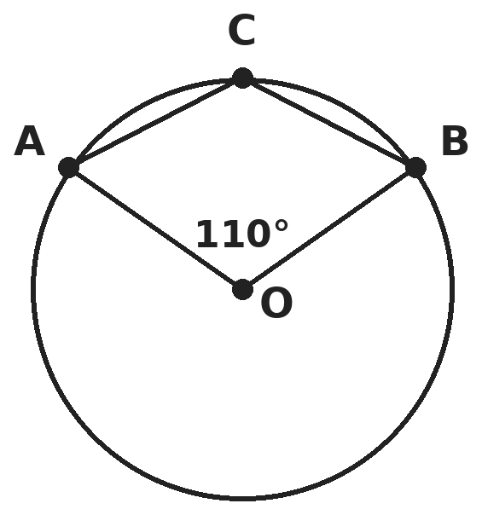
Q11. O is the centre of the circle and angle AOB = 110°. C is a point on the minor arc AB. What is angle ACB?
(A) 55° | (B) 110° | (C) 125° | (D) 70°

Q12. A triangle has vertices (2, 3), (8, 5) and (5, 10). How far is the vertex (5, 10) from the centroid?
(A) 6 | (B) 4 | (C) 2 | (D) 5

Part 5 — Mensuration (Syllabus Chapter 6)
Q13. A triangular plot has sides 13 m, 14 m and 15 m. What is the length of the altitude drawn to the 14 m side?
(A) 12 m | (B) 11.2 m | (C) 6 m | (D) 24 m

Q14. A cone has base radius 7 cm and slant height 25 cm. What is its volume? (Take π = 22/7.)
(A) 3,696 cm³ | (B) 1,232 cm³ | (C) 1,540 cm³ | (D) 1,078 cm³

Q15. A chord subtends a right angle at the centre of a circle of radius 14 cm. What is the area of the smaller segment it cuts off? (Take π = 22/7.)
(A) 154 cm² | (B) 98 cm² | (C) 42 cm² | (D) 56 cm²

Part 6 — Data Handling, Statistics & Probability (Syllabus Chapter 8)
Q16. The numbers 3, 8, 10, 15 and x have equal mean and median. What is the sum of all possible values of x?
(A) 23 | (B) 14 | (C) 27 | (D) 9

Q17. Isha rolls two fair dice. What is the probability that the sum of the two numbers is a prime number?
(A) 5/12 | (B) 1/2 | (C) 7/18 | (D) 1/3

Q18. The mean of 50 numbers was found to be 30. Later it was seen that 45 had been read as 85 and 30 had been read as 3. What is the correct mean?
(A) 30.26 | (B) 29.2 | (C) 29.74 | (D) 30

Part 7 — Applied Mathematics (Syllabus Chapter 9)
Q19. A taxi fare is a fixed charge plus a fixed amount per km. A 5 km ride costs ₹130 and a 12 km ride costs ₹270. What does a 20 km ride cost?
(A) ₹430 | (B) ₹400 | (C) ₹520 | (D) ₹460

Q20. Ravi saves ₹500 in the first month and ₹100 more each month than the month before. In which month does his saving for that month first go above ₹2,000?
(A) 17th | (B) 16th | (C) 15th | (D) 20th

Q21. A delivery drone flies in straight lines from its depot D(0, 0) to A(6, 8), then to B(6, −4), and then back to D. Distances are in km. How far does it fly in all?
(A) 32 km | (B) 22 + √13 km | (C) 28 km | (D) 22 + 2√13 km

Part 8 — Mathematical Reasoning (Syllabus Chapter 10)
Q22. In the shortest solution of the Tower of Hanoi with 7 discs (2⁷ − 1 = 127 moves), the smallest disc moves on every other move, starting with the first. How many times does the smallest disc move?
(A) 63 | (B) 127 | (C) 64 | (D) 32

Q23. Which statement is true, but its converse is false?
(A) If a triangle has three equal sides, it has three equal angles. | (B) If a quadrilateral is a square, its diagonals are equal.
(C) If a whole number n is even, then n² is even. | (D) If a quadrilateral is a parallelogram, its diagonals bisect each other.

Q24. Rule: if a number is even, halve it; if it is odd, multiply by 3 and add 1. Rohan starts at 7 and applies the rule until he reaches 1. How many steps does he take?
(A) 17 | (B) 15 | (C) 11 | (D) 16

Q25. An algorithm takes two whole numbers and repeatedly replaces the larger one by the difference of the two. It stops when the two numbers are equal. Starting with 91 and 35, how many subtractions are made, and what number is left?
(A) 4 subtractions, ending at 7 | (B) 5 subtractions, ending at 14
(C) 5 subtractions, ending at 7 | (D) 6 subtractions, ending at 7

Part 9 — Mixed Problems (each joins two chapters)
Q26. A sequence starts with a₁ = 2 and follows the rule aₙ₊₁ = 2aₙ − 1. What is a₁₀?
(A) 1,025 | (B) 513 | (C) 512 | (D) 257

Q27. A triangle has vertices A(1, 1), B(7, 1) and C(4, 5). What is the length of the altitude from A to the side BC?
(A) 4.8 | (B) 4 | (C) 6 | (D) 2.4

Q28. The points A(1, 2), B(5, 4) and C(k, 8) lie on one straight line. What is k?
(A) 11 | (B) 13 | (C) 7 | (D) 15

Q29. Tanya tosses a fair coin three times. What is the probability that she gets two or more heads one after another?
(A) 3/8 | (B) 1/2 | (C) 1/4 | (D) 5/8

Q30. Riya saves ₹500 in the first month and ₹50 more every month after that. Kabir saves ₹800 every month. In which month does Riya's total savings first become greater than Kabir's?
(A) 14th | (B) 13th | (C) 12th | (D) 7th

Answer Sheet AMO Level 2 · Class 9 · Practice Paper 1
Name: | School: | Roll No.:
Shade or tick one circle for each question.
1. | Ⓐ Ⓑ Ⓒ Ⓓ | 11. | Ⓐ Ⓑ Ⓒ Ⓓ | 21. | Ⓐ Ⓑ Ⓒ Ⓓ
2. | Ⓐ Ⓑ Ⓒ Ⓓ | 12. | Ⓐ Ⓑ Ⓒ Ⓓ | 22. | Ⓐ Ⓑ Ⓒ Ⓓ
3. | Ⓐ Ⓑ Ⓒ Ⓓ | 13. | Ⓐ Ⓑ Ⓒ Ⓓ | 23. | Ⓐ Ⓑ Ⓒ Ⓓ
4. | Ⓐ Ⓑ Ⓒ Ⓓ | 14. | Ⓐ Ⓑ Ⓒ Ⓓ | 24. | Ⓐ Ⓑ Ⓒ Ⓓ
5. | Ⓐ Ⓑ Ⓒ Ⓓ | 15. | Ⓐ Ⓑ Ⓒ Ⓓ | 25. | Ⓐ Ⓑ Ⓒ Ⓓ
6. | Ⓐ Ⓑ Ⓒ Ⓓ | 16. | Ⓐ Ⓑ Ⓒ Ⓓ | 26. | Ⓐ Ⓑ Ⓒ Ⓓ
7. | Ⓐ Ⓑ Ⓒ Ⓓ | 17. | Ⓐ Ⓑ Ⓒ Ⓓ | 27. | Ⓐ Ⓑ Ⓒ Ⓓ
8. | Ⓐ Ⓑ Ⓒ Ⓓ | 18. | Ⓐ Ⓑ Ⓒ Ⓓ | 28. | Ⓐ Ⓑ Ⓒ Ⓓ
9. | Ⓐ Ⓑ Ⓒ Ⓓ | 19. | Ⓐ Ⓑ Ⓒ Ⓓ | 29. | Ⓐ Ⓑ Ⓒ Ⓓ
10. | Ⓐ Ⓑ Ⓒ Ⓓ | 20. | Ⓐ Ⓑ Ⓒ Ⓓ | 30. | Ⓐ Ⓑ Ⓒ Ⓓ

For the parent or teacher
Correct: ______ / 30
Answer Key and Solutions AMO Level 2 · Class 9 · Practice Paper 1
Quick answers
1 D | 6 C | 11 C | 16 C | 21 D | 26 B
2 D | 7 B | 12 B | 17 A | 22 C | 27 A
3 C | 8 D | 13 A | 18 C | 23 B | 28 B
4 C | 9 D | 14 B | 19 A | 24 D | 29 A
5 D | 10 B | 15 D | 20 A | 25 C | 30 A
Solutions
Q | Part · level | Answer | Why?
1 | Part 1 · Ch1 · Hard | (D) 8 | Hint: 1/7 = 0.142857142857… The block of 6 digits repeats.  1/7 = 0.142857 recurring, a block of 6 digits. 100 = 16 × 6 + 4, so the 100th digit is the 4th digit of the block, which is 8.
2 | Part 1 · Ch1 · Hard | (D) √5 × √20 ÷ √10 | Hint: Simplify each one before deciding.  √2 × √8 = √16 = 4. (√3 + 1)² − 2√3 = 3 + 2√3 + 1 − 2√3 = 4. √0.09 = 0.3. √5 × √20 = √100 = 10, and 10 ÷ √10 = √10, which is irrational.
3 | Part 2 · Ch3 · Hard | (C) 4 | Hint: Multiply by 0.75 year after year and watch for the first value below ₹30,000.  80,000 → 60,000 → 45,000 → 33,750 → 25,312.50. After 3 years it is still ₹33,750, so it first drops below ₹30,000 after 4 years. (Taking off ₹20,000 a year would give 3 years.)
4 | Part 2 · Ch3 · Hard | (C) 8 kg | Hint: Each kg of cheap rice is ₹6 below the mix price; each kg of costly rice is ₹9 above it.  The cheap rice is 12 × (46 − 40) = ₹72 below the mix value in total. Each kg of ₹55 rice is ₹9 above. So 9x = 72 and x = 8 kg. Check: 12 × 40 + 8 × 55 = 920 = 20 × 46.
5 | Part 3 · Ch4 · Hard | (D) 641 | Hint: First find x² + y² from (x − y)².  x² + y² = (x − y)² + 2xy = 9 + 20 = 29. Then x⁴ + y⁴ = (x² + y²)² − 2x²y² = 841 − 200 = 641. (841 forgets to subtract 2x²y².)
6 | Part 3 · Ch4 · Hard | (C) −90 | Hint: The three brackets add up to 0. Use a³ + b³ + c³ = 3abc when a + b + c = 0.  Let a = x − y = 3, b = y − z = 2, c = z − x = −5. Then a + b + c = 0, so a³ + b³ + c³ = 3abc = 3 × 3 × 2 × (−5) = −90. Check: 27 + 8 − 125 = −90.
7 | Part 3 · Ch4 · Hard | (B) 9 | Hint: No solution means the lines are parallel but different.  Parallel lines need 2/6 = 3/k, so k = 9. Then the constants give 7/20, which is not 1/3, so the lines are different. With k = 9 there is no solution.
8 | Part 3 · Ch4 · Hard | (D) 25th | Hint: Seven steps of the common difference take 17 to 45.  7d = 45 − 17 = 28, so d = 4. The 1st term is 17 − 4 × 4 = 1, so the nth term is 4n − 3. 4n − 3 = 97 gives n = 25.
9 | Part 4 · Ch5 · Hard | (D) 2√5 | Hint: The diagonals of a parallelogram bisect each other, so A + C = B + D.  The midpoint of AC is (4, 5), which is also the midpoint of BD, so D = (8 − 5, 10 − 3) = (3, 7). BD = √((5 − 3)² + (3 − 7)²) = √20 = 2√5. (6√2 is the other diagonal AC.)
10 | Part 4 · Ch5 · Hard | (B) 7 cm | Hint: The perpendicular from the centre bisects each chord.  For the 24 cm chord: distance² = 13² − 12² = 25, so 5 cm. For the 10 cm chord: 13² − 5² = 144, so 12 cm. On the same side they are 12 − 5 = 7 cm apart. (17 cm is for opposite sides.)
11 | Part 4 · Ch5 · Hard | (C) 125° | Hint: The angle at the centre on the other side (the reflex angle AOB) is 360° − 110°.  C is on the minor arc, so angle ACB is half of the reflex angle AOB: (360° − 110°) ÷ 2 = 125°. (55° is the angle at a point on the major arc.)
12 | Part 4 · Ch5 · Hard | (B) 4 | Hint: The centroid is the average of the three vertices.  Centroid = ((2 + 8 + 5)/3, (3 + 5 + 10)/3) = (5, 6). The distance from (5, 10) to (5, 6) is 4. (It is 2/3 of the median from (5, 10), which has length 6.)
13 | Part 5 · Ch6 · Hard | (A) 12 m | Hint: Find the area with Heron's formula first.  s = 21. Area = √(21 × 8 × 7 × 6) = √7056 = 84 m². Altitude = 2 × 84 ÷ 14 = 12 m. (11.2 m is the altitude to the 15 m side.)
14 | Part 5 · Ch6 · Hard | (B) 1,232 cm³ | Hint: Find the height from the slant height first.  h = √(25² − 7²) = √576 = 24 cm. Volume = ⅓ × 22/7 × 49 × 24 = 1,232 cm³. (3,696 forgets the ⅓; 1,540 uses the slant height.)
15 | Part 5 · Ch6 · Hard | (D) 56 cm² | Hint: Segment = sector − triangle.  Sector = 90/360 × 22/7 × 196 = 154 cm². Triangle = ½ × 14 × 14 = 98 cm². Segment = 154 − 98 = 56 cm².
16 | Part 6 · Ch8 · Hard | (C) 27 | Hint: The median depends on where x sits in the order. Try x < 8, 8 ≤ x ≤ 10 and x > 10.  Mean = (36 + x)/5. If x < 8 the median is 8: (36 + x)/5 = 8 gives x = 4 ✓. If 8 ≤ x ≤ 10 the median is x: 36 + x = 5x gives x = 9 ✓. If x > 10 the median is 10: x = 14 ✓. Sum = 4 + 9 + 14 = 27.
17 | Part 6 · Ch8 · Hard | (A) 5/12 | Hint: List the ways to get 2, 3, 5, 7 and 11.  Sum 2: 1 way, 3: 2 ways, 5: 4 ways, 7: 6 ways, 11: 2 ways. Total 15 of 36 outcomes, so 15/36 = 5/12.
18 | Part 6 · Ch8 · Hard | (C) 29.74 | Hint: Correct the total first, then divide.  Wrong total = 50 × 30 = 1,500. Correct total = 1,500 − 85 − 3 + 45 + 30 = 1,487. Correct mean = 1,487 ÷ 50 = 29.74.
19 | Part 7 · Ch9 · Hard | (A) ₹430 | Hint: The extra 7 km cost ₹140.  Rate = (270 − 130) ÷ 7 = ₹20 per km. Fixed charge = 130 − 5 × 20 = ₹30. Fare for 20 km = 30 + 20 × 20 = ₹430. (₹520 forgets the fixed charge is paid once: 130 × 4.)
20 | Part 7 · Ch9 · Hard | (A) 17th | Hint: The saving in month n is 500 + 100(n − 1).  500 + 100(n − 1) > 2,000 gives n − 1 > 15, so n > 16. In month 16 he saves exactly ₹2,000, which is not above. The first month above ₹2,000 is the 17th.
21 | Part 7 · Ch9 · Hard | (D) 22 + 2√13 km | Hint: Find the three distances separately.  DA = √(36 + 64) = 10 km. AB = 8 − (−4) = 12 km (same x). BD = √(36 + 16) = √52 = 2√13 km. Total = 22 + 2√13 km.
22 | Part 8 · Ch10 · Hard | (C) 64 | Hint: Moves 1, 3, 5, … are made by the smallest disc.  The smallest disc makes the odd-numbered moves 1, 3, 5, …, 127. There are (127 + 1) ÷ 2 = 64 odd numbers from 1 to 127, so it moves 64 times. (63 forgets that the last move, number 127, is odd.)
23 | Part 8 · Ch10 · Hard | (B) If a quadrilateral is a square, its diagonals are equal. | Hint: For each, swap the "if" and "then" parts and look for a counterexample.  Converse of the square statement: "if the diagonals are equal, it is a square" is false — a rectangle has equal diagonals. The other three converses are true: equal angles give equal sides; n² even gives n even; diagonals bisecting each other give a parallelogram.
24 | Part 8 · Ch10 · Hard | (D) 16 | Hint: Write the numbers in order: 7, 22, 11, …  7 → 22 → 11 → 34 → 17 → 52 → 26 → 13 → 40 → 20 → 10 → 5 → 16 → 8 → 4 → 2 → 1. That is 16 steps.
25 | Part 8 · Ch10 · Hard | (C) 5 subtractions, ending at 7 | Hint: Trace the pairs one step at a time.  (91, 35) → (56, 35) → (21, 35) → (21, 14) → (7, 14) → (7, 7). That is 5 subtractions, ending at 7, which is the HCF of 91 and 35.
26 | Part 9 · Mixed · Ch4 + Ch10 · Hard | (B) 513 | Hint: Write the first few terms and compare them with powers of 2.  Terms: 2, 3, 5, 9, 17, 33, … Each term is one more than a power of 2: aₙ = 2ⁿ⁻¹ + 1. So a₁₀ = 2⁹ + 1 = 513.
27 | Part 9 · Mixed · Ch5 + Ch6 · Hard | (A) 4.8 | Hint: Find the area using AB as base, then use BC as base.  With base AB = 6 and height 4 (from y = 1 to y = 5), area = 12. BC = √(3² + 4²) = 5. Altitude from A = 2 × 12 ÷ 5 = 4.8.
28 | Part 9 · Mixed · Ch4 + Ch5 · Hard | (B) 13 | Hint: The slope from A to B must equal the slope from A to C.  Slope of AB = (4 − 2)/(5 − 1) = 1/2. Slope of AC = (8 − 2)/(k − 1) = 6/(k − 1). Setting 6/(k − 1) = 1/2 gives k − 1 = 12, so k = 13. Check: from B to C the rise is 4 and the run is 8, slope 1/2.
29 | Part 9 · Mixed · Ch8 + Ch10 · Hard | (A) 3/8 | Hint: List all 8 outcomes and pick those with HH in them.  Outcomes with HH: HHH, HHT, THH. HTH has two heads but not in a row. So 3 of 8 outcomes: 3/8. (1/2 counts all outcomes with at least two heads.)
30 | Part 9 · Mixed · Ch3 + Ch9 · Hard | (A) 14th | Hint: After n months Riya has 500n + 50 × (0 + 1 + … + (n − 1)).  After n months: Riya has 500n + 50 × n(n − 1)/2 = 500n + 25n(n − 1); Kabir has 800n. Riya is ahead when 25(n − 1) > 300, that is n − 1 > 12. After 13 months they are equal (₹10,400 each), so Riya first has more in the 14th month. (7th is when her monthly saving reaches ₹800.)

ARYABHATTA MATHS OLYMPIAD
Level 2
PRACTICE PAPER-2
CLASS 9
Total Questions | 30 multiple-choice questions
Level | Level-2 (final round): every question is Hard
Time | 45 minutes
Arrangement | Parts by chapter; the last Part has mixed problems joining two chapters
Negative Marking | No negative marking
Calculator | Not allowed
Chapters | Number System · Fractions, Decimals & Percentages · Algebra · Geometry · Mensuration · Data Handling, Statistics & Probability · Applied Mathematics · Mathematical Reasoning

Instructions
• Each question has four options, (A) to (D), with exactly one correct answer.
• The questions are grouped in Parts by chapter. The last Part has mixed problems, each joining two chapters.
• Every question is at Level-2 (Hard) standard: expect several steps or a key insight.
• There is no negative marking. Calculators are not allowed; use a separate sheet for rough work.
• Figures are not necessarily drawn to scale unless stated.

For teachers
• Figures are part of the questions and work when printed in black and white.
• Parts follow the AMO syllabus chapters. Chapters 2 and 7 are not part of the Class 9 syllabus, so the chapter numbers shown in the Part headings have gaps.
• The answer sheet and the answer key are at the end. Remove the answer key before the paper is attempted.

Part 1 — Number System (Syllabus Chapter 1)
Q1. Which fraction in lowest terms equals the recurring decimal 0.2353535… (where 35 repeats)?
(A) 235/999 | (B) 233/999 | (C) 47/198 | (D) 233/990

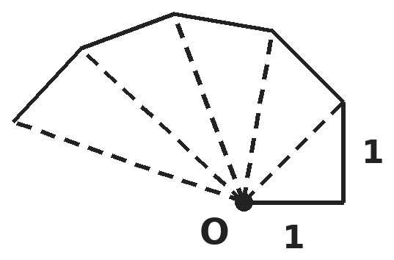
Q2. In the square-root spiral, each new right triangle has a side of 1 unit at right angles to the last hypotenuse, so the hypotenuses are √2, √3, √4, … How many of the first 20 hypotenuses are rational?
(A) 4 | (B) 2 | (C) 3 | (D) 5

Part 2 — Fractions, Decimals & Percentages (Syllabus Chapter 3)
Q3. A car bought for ₹6,00,000 loses 20% of its value in the first year and 15% of its new value in the second year. What is it worth after two years?
(A) ₹4,08,000 | (B) ₹3,90,000 | (C) ₹4,20,000 | (D) ₹4,05,000

Q4. In a class, the girls' average mark is 72 and the boys' average mark is 62. The whole class averages 66. What percentage of the class are girls?
(A) 60% | (B) 40% | (C) 50% | (D) 45%

Part 3 — Algebra (Syllabus Chapter 4)
Q5. Use factorisation to find the value of a² − b² − 2b − 1 when a = 1001 and b = 999.
(A) 2,003 | (B) 1,999 | (C) 4,001 | (D) 2,001

Q6. How many pairs of positive whole numbers (x, y) satisfy 3x + 5y = 52?
(A) 4 | (B) 3 | (C) 2 | (D) 5

Q7. The digits of Om's two-digit number add up to 9. When the digits are reversed, the number increases by 27. What is Om's number?
(A) 63 | (B) 45 | (C) 27 | (D) 36

Q8. A geometric progression has 3rd term 12 and 6th term 96. What is its 8th term?
(A) 384 | (B) 192 | (C) 768 | (D) 288

Part 4 — Geometry (Syllabus Chapter 5)
Q9. What kind of triangle has vertices A(1, 2), B(4, 6) and C(5, −1)?
(A) Equilateral | (B) Obtuse-angled and scalene
(C) Right-angled and isosceles | (D) Acute-angled and isosceles

Q10. A quadrilateral has diagonals of length 10 cm and 14 cm. The midpoints of its four sides are joined in order. What is the perimeter of the shape formed?
(A) 24 cm | (B) 48 cm | (C) 12 cm | (D) 35 cm

Q11. A circle has radius 10 cm. Two chords AB and CD, each 16 cm long, are perpendicular to each other. M and N are their midpoints. What is MN?
(A) 12 cm | (B) 6 cm | (C) 8√2 cm | (D) 6√2 cm

Q12. A(1, 2), B(4, 3) and C(6, 6) are three vertices of the parallelogram ABCD, taken in order. What is its perimeter?
(A) √10 + √13 | (B) 2(√10 + √13) | (C) 2(√13 + √5) | (D) 4√10

Part 5 — Mensuration (Syllabus Chapter 6)
Q13. A cyclic quadrilateral has sides 7 cm, 15 cm, 20 cm and 24 cm. Using Brahmagupta's formula, what is its area?
(A) 264 cm² | (B) 150 cm² | (C) 234 cm² | (D) 336 cm²

Q14. A hemispherical bowl of radius 21 cm is full of buttermilk. It is poured into cylindrical glasses of radius 3.5 cm and height 6 cm. How many glasses are filled? (Take π = 22/7.)
(A) 84 | (B) 42 | (C) 168 | (D) 63

Q15. A square pyramid has base edge 10 cm, and the slant height of each triangular face is 13 cm. What is its volume?
(A) 1,200 cm³ | (B) 400 cm³ | (C) 520 cm³ | (D) 260 cm³

Part 6 — Data Handling, Statistics & Probability (Syllabus Chapter 8)
Q16. A number is picked at random from 1 to 100. What is the probability that it is divisible by 3 or by 5?
(A) 53/100 | (B) 1/2 | (C) 13/25 | (D) 47/100

Q17. In an office, 9 people earn ₹18,000, 10 earn ₹20,000 and the manager earns ₹2,38,000 per month. By how much does the mean salary exceed the median salary?
(A) ₹10,000 | (B) ₹12,000 | (C) ₹2,000 | (D) ₹8,000

Q18. A bag has 3 red and 2 blue balls. Aisha takes out two balls, one after the other, without putting the first back. What is the probability that they are of different colours?
(A) 12/25 | (B) 2/5 | (C) 3/5 | (D) 1/2

Part 7 — Applied Mathematics (Syllabus Chapter 9)
Q19. Sumit's father is now three times as old as Sumit. Five years ago he was four times as old. What will the sum of their ages be five years from now?
(A) 60 | (B) 65 | (C) 75 | (D) 70

Q20. A loan of ₹13,000 is repaid in monthly instalments. The first is ₹400 and each one is ₹200 more than the one before. How many instalments are needed?
(A) 12 | (B) 9 | (C) 10 | (D) 13

Q21. Sneha repays a loan of ₹10,500 by paying ₹100 in the first month, ₹200 in the second month, ₹300 in the third, and so on. In how many months is the loan fully repaid?
(A) 15 | (B) 105 | (C) 14 | (D) 21

Part 8 — Mathematical Reasoning (Syllabus Chapter 10)
Q22. Rahul claims that n² + n + 41 is prime for every whole number n. Which of these values of n is a counterexample?
(A) 40 | (B) 39 | (C) 20 | (D) 1

Q23. Algorithm: take two numbers; while they are different, replace the larger by (larger − smaller). Kiran starts with 91 and 35. How many subtractions does she make before the two numbers become equal?
(A) 4 | (B) 6 | (C) 5 | (D) 7

Q24. In the Sierpinski carpet, a square is cut into 9 equal squares and the middle one is removed. The same is done to every remaining square at each step. How many small squares remain after 3 steps?
(A) 512 | (B) 729 | (C) 64 | (D) 217

Q25. Which statement is a special case of the theorem "The diagonals of a parallelogram bisect each other"?
(A) The diagonals of a trapezium bisect each other. | (B) The diagonals of a rhombus bisect each other.
(C) If the diagonals of a quadrilateral bisect each other, it is a parallelogram. | (D) The diagonals of a rectangle are equal.

Part 9 — Mixed Problems (each joins two chapters)
Q26. The least number of moves for the Tower of Hanoi satisfies M(1) = 1 and M(n) = 2M(n − 1) + 1. Pallavi makes one move every second. How long does she need for 10 discs?
(A) 17 min 4 s | (B) 8 min 31 s | (C) 34 min 7 s | (D) 17 min 3 s

Q27. A circle passes through (0, 0), (8, 0) and (0, 6). What is its area?
(A) 100π | (B) 12.5π | (C) 25π | (D) 50π

Q28. The lines y = 2x + 3 and y = −x + 9 meet at P. What is the area of the triangle formed by these two lines and the x-axis?
(A) 31.5 | (B) 73.5 | (C) 42 | (D) 36.75

Q29. Rahul and Simran take turns tossing a fair coin, Rahul first. The first to get a head wins, and they stop after 4 tosses in all. What is the probability that Simran wins?
(A) 1/4 | (B) 5/16 | (C) 1/2 | (D) 3/8

Q30. At 10% per year, the compound interest on a sum for 2 years is ₹150 more than the simple interest. What is the sum?
(A) ₹1,500 | (B) ₹15,000 | (C) ₹7,500 | (D) ₹30,000

Answer Sheet AMO Level 2 · Class 9 · Practice Paper 2
Name: | School: | Roll No.:
Shade or tick one circle for each question.
1. | Ⓐ Ⓑ Ⓒ Ⓓ | 11. | Ⓐ Ⓑ Ⓒ Ⓓ | 21. | Ⓐ Ⓑ Ⓒ Ⓓ
2. | Ⓐ Ⓑ Ⓒ Ⓓ | 12. | Ⓐ Ⓑ Ⓒ Ⓓ | 22. | Ⓐ Ⓑ Ⓒ Ⓓ
3. | Ⓐ Ⓑ Ⓒ Ⓓ | 13. | Ⓐ Ⓑ Ⓒ Ⓓ | 23. | Ⓐ Ⓑ Ⓒ Ⓓ
4. | Ⓐ Ⓑ Ⓒ Ⓓ | 14. | Ⓐ Ⓑ Ⓒ Ⓓ | 24. | Ⓐ Ⓑ Ⓒ Ⓓ
5. | Ⓐ Ⓑ Ⓒ Ⓓ | 15. | Ⓐ Ⓑ Ⓒ Ⓓ | 25. | Ⓐ Ⓑ Ⓒ Ⓓ
6. | Ⓐ Ⓑ Ⓒ Ⓓ | 16. | Ⓐ Ⓑ Ⓒ Ⓓ | 26. | Ⓐ Ⓑ Ⓒ Ⓓ
7. | Ⓐ Ⓑ Ⓒ Ⓓ | 17. | Ⓐ Ⓑ Ⓒ Ⓓ | 27. | Ⓐ Ⓑ Ⓒ Ⓓ
8. | Ⓐ Ⓑ Ⓒ Ⓓ | 18. | Ⓐ Ⓑ Ⓒ Ⓓ | 28. | Ⓐ Ⓑ Ⓒ Ⓓ
9. | Ⓐ Ⓑ Ⓒ Ⓓ | 19. | Ⓐ Ⓑ Ⓒ Ⓓ | 29. | Ⓐ Ⓑ Ⓒ Ⓓ
10. | Ⓐ Ⓑ Ⓒ Ⓓ | 20. | Ⓐ Ⓑ Ⓒ Ⓓ | 30. | Ⓐ Ⓑ Ⓒ Ⓓ

For the parent or teacher
Correct: ______ / 30
Answer Key and Solutions AMO Level 2 · Class 9 · Practice Paper 2
Quick answers
1 D | 6 B | 11 D | 16 D | 21 C | 26 D
2 C | 7 D | 12 B | 17 A | 22 A | 27 C
3 A | 8 A | 13 C | 18 C | 23 C | 28 D
4 B | 9 C | 14 A | 19 D | 24 A | 29 B
5 D | 10 A | 15 B | 20 C | 25 B | 30 B
Solutions
Q | Part · level | Answer | Why?
1 | Part 1 · Ch1 · Hard | (D) 233/990 | Hint: Let x = 0.23535… Compare 1000x and 10x.  1000x = 235.3535… and 10x = 2.3535… Subtracting: 990x = 233, so x = 233/990, which is already in lowest terms. (47/198 = 235/990 forgets to subtract the 2.)
2 | Part 1 · Ch1 · Hard | (C) 3 | Hint: The first 20 hypotenuses are √2, √3, …, √21.  √n is rational only when n is a perfect square. Among 2 to 21 the squares are 4, 9 and 16. So 3 hypotenuses (2, 3 and 4) are rational.
3 | Part 2 · Ch3 · Hard | (A) ₹4,08,000 | Hint: Multiply by 0.80 and then by 0.85.  6,00,000 × 0.80 = 4,80,000. 4,80,000 × 0.85 = ₹4,08,000. (₹3,90,000 takes 35% off the original price.)
4 | Part 2 · Ch3 · Hard | (B) 40% | Hint: The class average is a weighted average of 72 and 62.  Let a fraction g of the class be girls: 72g + 62(1 − g) = 66, so 10g = 4 and g = 0.4. So 40% are girls. (60% is the share of boys; 50% would give an average of 67.)
5 | Part 3 · Ch4 · Hard | (D) 2,001 | Hint: b² + 2b + 1 = (b + 1)².  a² − (b² + 2b + 1) = a² − (b + 1)² = (a − b − 1)(a + b + 1) = (1001 − 1000)(1001 + 1000) = 1 × 2,001 = 2,001.
6 | Part 3 · Ch4 · Hard | (B) 3 | Hint: 52 − 5y must be a positive multiple of 3.  y = 2 gives x = 14; y = 5 gives x = 9; y = 8 gives x = 4; y = 11 gives x = −1, not positive. Other values of y do not give a multiple of 3. So 3 pairs.
7 | Part 3 · Ch4 · Hard | (D) 36 | Hint: Reversing 10a + b gives 10b + a. The difference is 9(b − a).  9(b − a) = 27, so b − a = 3. With a + b = 9: a = 3, b = 6. The number is 36. Check: 63 − 36 = 27. (63 decreases when reversed.)
8 | Part 3 · Ch4 · Hard | (A) 384 | Hint: Three steps of the ratio take 12 to 96.  r³ = 96 ÷ 12 = 8, so r = 2. The 8th term = 96 × 2² = 384.
9 | Part 4 · Ch5 · Hard | (C) Right-angled and isosceles | Hint: Compare AB², AC² and BC².  AB² = 9 + 16 = 25, AC² = 16 + 9 = 25, BC² = 1 + 49 = 50. AB = AC, and AB² + AC² = BC², so the angle at A is a right angle. The triangle is right-angled and isosceles.
10 | Part 4 · Ch5 · Hard | (A) 24 cm | Hint: By the midpoint theorem, each side of the new shape is half a diagonal.  Two sides are each half of the 10 cm diagonal (5 cm) and two are half of the 14 cm diagonal (7 cm). The shape is a parallelogram with perimeter 2 × (5 + 7) = 24 cm.
11 | Part 4 · Ch5 · Hard | (D) 6√2 cm | Hint: Each chord is 6 cm from the centre O, and OM ⊥ AB, ON ⊥ CD.  OM = ON = √(10² − 8²) = 6 cm. OM is perpendicular to AB and ON to CD; since AB ⊥ CD, OM ⊥ ON. So MN = √(6² + 6²) = 6√2 cm.
12 | Part 4 · Ch5 · Hard | (B) 2(√10 + √13) | Hint: Opposite sides of a parallelogram are equal, so you only need AB and BC.  AB = √(3² + 1²) = √10 and BC = √(2² + 3²) = √13. The perimeter is 2(√10 + √13). (D is (3, 5); √5 is the length of the diagonal BD.)
13 | Part 5 · Ch6 · Hard | (C) 234 cm² | Hint: Area = √((s − a)(s − b)(s − c)(s − d)) with s = half the perimeter.  s = 66/2 = 33. Area = √(26 × 18 × 13 × 9) = √54,756 = 234 cm². (Check: it splits into right triangles 7-24-25 and 15-20-25 with areas 84 and 150.)
14 | Part 5 · Ch6 · Hard | (A) 84 | Hint: Divide the volume of the hemisphere by the volume of one glass.  Bowl = ⅔ × 22/7 × 21³ = 19,404 cm³. Glass = 22/7 × 3.5² × 6 = 231 cm³. 19,404 ÷ 231 = 84 glasses. (168 uses a full sphere.)
15 | Part 5 · Ch6 · Hard | (B) 400 cm³ | Hint: The height, half the base edge and the slant height form a right triangle.  Height = √(13² − 5²) = 12 cm. Volume = ⅓ × 10² × 12 = 400 cm³. (1,200 forgets the ⅓; 260 cm² is the area of the four faces.)
16 | Part 6 · Ch8 · Hard | (D) 47/100 | Hint: Count multiples of 3, add multiples of 5 and take away those counted twice.  Multiples of 3: 33. Multiples of 5: 20. Multiples of 15 (counted twice): 6. Total 33 + 20 − 6 = 47, so the probability is 47/100.
17 | Part 6 · Ch8 · Hard | (A) ₹10,000 | Hint: There are 20 salaries. The median is the average of the 10th and 11th.  Total = 1,62,000 + 2,00,000 + 2,38,000 = 6,00,000, so the mean is ₹30,000. In order, the 10th and 11th salaries are both ₹20,000, so the median is ₹20,000. Difference = ₹10,000. The median describes a typical salary better.
18 | Part 6 · Ch8 · Hard | (C) 3/5 | Hint: Use a tree: red then blue, or blue then red.  P(red, blue) = 3/5 × 2/4 = 6/20. P(blue, red) = 2/5 × 3/4 = 6/20. Total = 12/20 = 3/5. (12/25 assumes the first ball is put back.)
19 | Part 7 · Ch9 · Hard | (D) 70 | Hint: Let Sumit be s now; set up an equation for five years ago.  Father = 3s. Five years ago: 3s − 5 = 4(s − 5), so s = 15 and the father is 45. In five years: 20 + 50 = 70.
20 | Part 7 · Ch9 · Hard | (C) 10 | Hint: After n instalments the total is 400n + 200 × (0 + 1 + 2 + … + (n − 1)).  Total after n instalments = 400n + 200 × n(n − 1)/2 = 400n + 100n(n − 1). For n = 10: 4,000 + 9,000 = 13,000. So 10 instalments.
21 | Part 7 · Ch9 · Hard | (C) 14 | Hint: The total paid after n months is 100 × (1 + 2 + … + n).  After n months she has paid 100 × n(n + 1)/2. We need n(n + 1)/2 = 105, so n(n + 1) = 210 = 14 × 15. The loan is repaid in 14 months. (105 divides ₹10,500 by ₹100 only.)
22 | Part 8 · Ch10 · Hard | (A) 40 | Hint: Look for a value of n that makes the expression a multiple of 41.  For n = 40: 1600 + 40 + 41 = 1681 = 41², which is not prime. For n = 1, 20 and 39 the values 43, 461 and 1601 are prime.
23 | Part 8 · Ch10 · Hard | (C) 5 | Hint: Trace the pairs: (91, 35), (56, 35), …  (91, 35) → (56, 35) → (21, 35) → (21, 14) → (7, 14) → (7, 7). That is 5 subtractions, ending at 7, the HCF of 91 and 35.
24 | Part 8 · Ch10 · Hard | (A) 512 | Hint: Each square becomes 8 squares at every step.  The number of squares is multiplied by 8 each step: 1 → 8 → 64 → 512. (729 = 9³ forgets to remove the middle squares.)
25 | Part 8 · Ch10 · Hard | (B) The diagonals of a rhombus bisect each other. | Hint: A special case applies the same result to a smaller family of shapes.  Every rhombus is a parallelogram, so the result applies to it: a special case. The statement starting "If the diagonals of a quadrilateral bisect each other" is the converse, the rectangle statement is a different property, and the trapezium statement is false.
26 | Part 9 · Mixed · Ch4 + Ch10 · Hard | (D) 17 min 3 s | Hint: Work out M(2), M(3), … and look for the pattern 2ⁿ − 1.  M(n) = 2ⁿ − 1, so M(10) = 1,023 moves = 1,023 seconds = 17 minutes 3 seconds.
27 | Part 9 · Mixed · Ch5 + Ch6 · Hard | (C) 25π | Hint: The angle at (0, 0) is a right angle, so the third side is a diameter.  The triangle has a right angle at the origin, so the side joining (8, 0) and (0, 6) is a diameter of length 10. The radius is 5 and the area is 25π.
28 | Part 9 · Mixed · Ch4 + Ch5 · Hard | (D) 36.75 | Hint: Find P and the two points where the lines cross the x-axis.  2x + 3 = −x + 9 gives x = 2, y = 7, so P = (2, 7). The lines meet the x-axis at x = −1.5 and x = 9: base 10.5. Area = ½ × 10.5 × 7 = 36.75.
29 | Part 9 · Mixed · Ch8 + Ch10 · Hard | (B) 5/16 | Hint: Simran can win on toss 2 or on toss 4.  Simran wins on toss 2 with TH: 1/4. She wins on toss 4 with TTTH: 1/16. Total = 5/16. (Rahul wins with probability 1/2 + 1/8 = 5/8; with 1/16 nobody wins.)
30 | Part 9 · Mixed · Ch3 + Ch9 · Hard | (B) ₹15,000 | Hint: The extra is the interest on the first year's interest.  The difference is 10% of the first year's interest, which is 10% of 10% of the sum, i.e. 1% of the sum. 1% of P = 150, so P = ₹15,000.

ARYABHATTA MATHS OLYMPIAD
Level 2
PRACTICE PAPER-3
CLASS 9
Total Questions | 30 multiple-choice questions
Level | Level-2 (final round): every question is Hard
Time | 45 minutes
Arrangement | Parts by chapter; the last Part has mixed problems joining two chapters
Negative Marking | No negative marking
Calculator | Not allowed
Chapters | Number System · Fractions, Decimals & Percentages · Algebra · Geometry · Mensuration · Data Handling, Statistics & Probability · Applied Mathematics · Mathematical Reasoning

Instructions
• Each question has four options, (A) to (D), with exactly one correct answer.
• The questions are grouped in Parts by chapter. The last Part has mixed problems, each joining two chapters.
• Every question is at Level-2 (Hard) standard: expect several steps or a key insight.
• There is no negative marking. Calculators are not allowed; use a separate sheet for rough work.
• Figures are not necessarily drawn to scale unless stated.

For teachers
• Figures are part of the questions and work when printed in black and white.
• Parts follow the AMO syllabus chapters. Chapters 2 and 7 are not part of the Class 9 syllabus, so the chapter numbers shown in the Part headings have gaps.
• The answer sheet and the answer key are at the end. Remove the answer key before the paper is attempted.

Part 1 — Number System (Syllabus Chapter 1)
Q1. Which of these fractions has a terminating decimal expansion?
(A) 11/30 | (B) 13/24 | (C) 21/150 | (D) 9/14

Q2. To prove √3 is irrational, Divya assumes √3 = p/q, where p and q are whole numbers with no common factor other than 1. Which conclusion gives the contradiction?
(A) p must be an even number | (B) q must be equal to 1
(C) p and q are both multiples of 3 | (D) p² must be equal to q²

Part 2 — Fractions, Decimals & Percentages (Syllabus Chapter 3)
Q3. A lake has 5,000 fish. Model A says it loses 400 fish every year; Model B says it loses 10% of its fish every year. After 2 years, which model predicts fewer fish, and by how many?
(A) Model A, by 150 | (B) Model B, by 150
(C) Model B, by 50 | (D) Both predict 4,200

Q4. A school gives weights of 40% to Maths, 35% to Science and 25% to English. Riya scores 80, 60 and 72. What is her weighted score?
(A) 71 | (B) 70.67 | (C) 72 | (D) 69

Part 3 — Algebra (Syllabus Chapter 4)
Q5. If a + b = 10 and ab = 21, what is a³ + b³?
(A) 1,000 | (B) 433 | (C) 370 | (D) 307

Q6. Temperatures are related by F = (9/5)C + 32. At what temperature do a Celsius thermometer and a Fahrenheit thermometer show the same number?
(A) −40 | (B) 40 | (C) −32 | (D) 0

Q7. For which values of k do the equations kx + 2y = 5 and 3x + y = 1 have exactly one solution?
(A) Every k except 6 | (B) Only k = 6
(C) Every k except 3/2 | (D) No value of k

Q8. A sequence starts 1, 1 and each later term is the sum of the two before it. How many of the first 12 terms are even?
(A) 6 | (B) 3 | (C) 5 | (D) 4

Part 4 — Geometry (Syllabus Chapter 5)
Q9. The opposite corners of a square are at (1, 1) and (5, 4). What is the area of the square?
(A) 12.5 | (B) 25 | (C) 6.25 | (D) 50

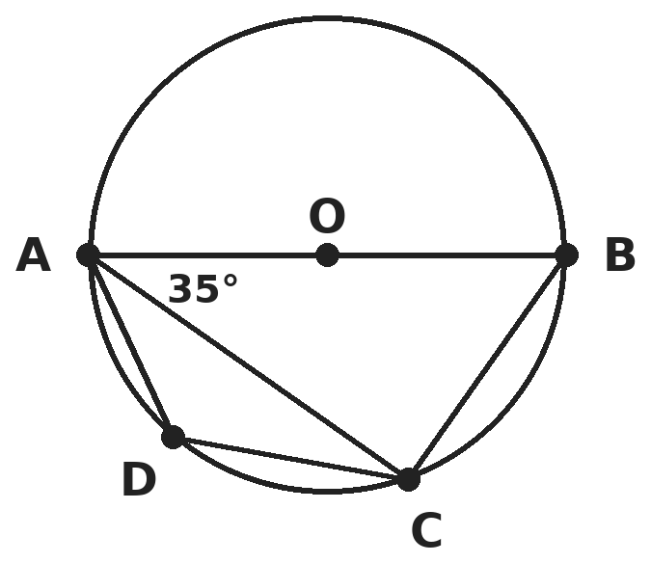
Q10. AB is a diameter of the circle with centre O, and ABCD is a cyclic quadrilateral. Angle BAC = 35°. What is angle ADC?
(A) 55° | (B) 145° | (C) 125° | (D) 90°

Q11. In triangle ABC, AD is a median of length 18 cm and G is the centroid. E is the midpoint of AG. What is the length ED?
(A) 12 cm | (B) 9 cm | (C) 6 cm | (D) 15 cm

Q12. In triangles PQR and XYZ, PQ = XY = 5 cm, QR = YZ = 6 cm and angle R = angle Z = 40°. What can you conclude?
(A) They need not be congruent: two sides and a non-included angle do not fix the triangle | (B) They are congruent by SAS
(C) They are congruent by ASA | (D) They are congruent by RHS

Part 5 — Mensuration (Syllabus Chapter 6)
Q13. A triangle with sides 5 cm, 12 cm and 13 cm is enlarged so that its perimeter becomes 90 cm. What is the area of the enlarged triangle?
(A) 90 cm² | (B) 270 cm² | (C) 810 cm² | (D) 180 cm²

Q14. A hall has 8 cylindrical pillars, each of radius 35 cm and height 4 m. Painting costs ₹12 per m² of curved surface. What is the total cost? (Take π = 22/7.)
(A) ₹105.60 | (B) ₹422.40 | (C) ₹1,689.60 | (D) ₹844.80

Q15. A sphere has volume 38,808 cm³. What is its surface area? (Take π = 22/7.)
(A) 1,386 cm² | (B) 2,772 cm² | (C) 5,544 cm² | (D) 11,088 cm²

Part 6 — Data Handling, Statistics & Probability (Syllabus Chapter 8)
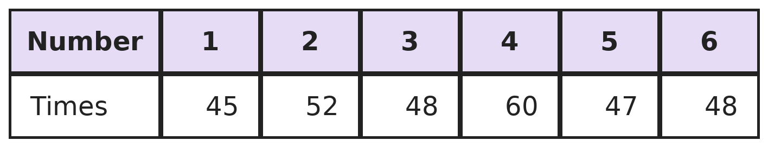
Q16. Harsh rolls a die 300 times and records the results in this table. By how much does his empirical probability of rolling a number greater than 4 differ from the theoretical probability?
(A) 1/30 | (B) 0 | (C) 1/20 | (D) 1/60

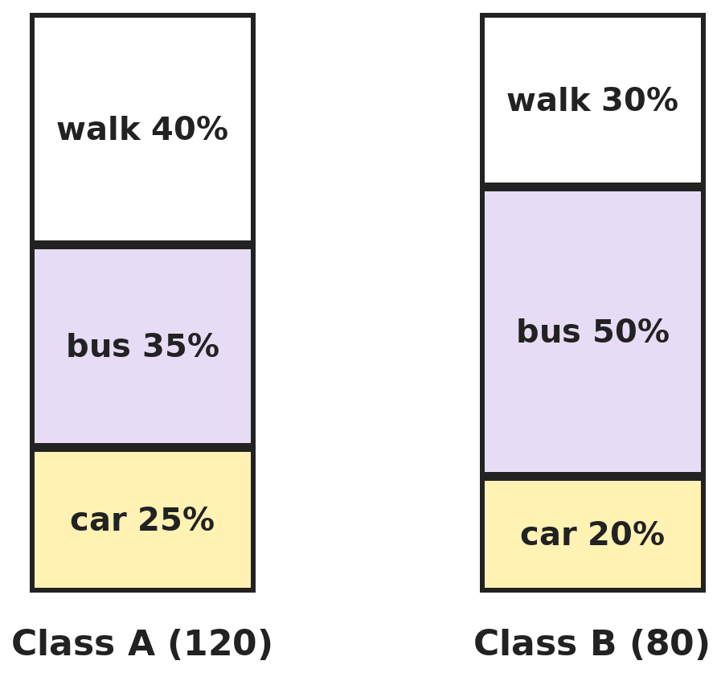
Q17. The 100% stacked bar graph shows how the students of two classes come to school. Class A has 120 students and Class B has 80. What percentage of all 200 students come by bus?
(A) 42.5% | (B) 43% | (C) 40% | (D) 41%

Q18. Five whole numbers have mean 12, median 11 and a single mode 10. The largest is 16. Written in order, what is the 4th number?
(A) 13 | (B) 12 | (C) 14 | (D) 15

Part 7 — Applied Mathematics (Syllabus Chapter 9)
Q19. Phone plan A costs ₹200 a month plus ₹1 per minute. Plan B costs ₹50 a month plus ₹2.50 per minute. For which monthly usage is plan A cheaper?
(A) Fewer than 100 minutes | (B) More than 100 minutes
(C) More than 60 minutes | (D) More than 150 minutes

Q20. Culture A starts with 500 bacteria and doubles every 20 minutes. Culture B starts with 4,000 bacteria and doubles every 40 minutes. After how long are the two cultures the same size?
(A) 3 hours | (B) 1 hour | (C) 4 hours | (D) 2 hours

Q21. On a seating grid (1 unit = 1 m), Neha sits at (2, 3), Priya at (8, 3) and Om at (8, 11). Their teacher stands at the one point that is equally far from all three. How far is the teacher from Priya?
(A) 6 m | (B) 5 m | (C) 4 m | (D) √41 m

Part 8 — Mathematical Reasoning (Syllabus Chapter 10)
Q22. Vivek claims that n² − n + 11 is prime for every whole number n ≥ 1. What is the smallest n that disproves his claim?
(A) 10 | (B) 11 | (C) 12 | (D) 5

Q23. Gita thinks of a whole number from 1 to 100. Yash guesses, and Gita says "higher" or "lower". If Yash always guesses the middle of the numbers still possible, what is the most guesses he could need?
(A) 10 | (B) 6 | (C) 50 | (D) 7

Q24. Lakshya climbs a staircase of 8 steps, taking 1 or 2 steps at a time. In how many different ways can he reach the top?
(A) 21 | (B) 34 | (C) 55 | (D) 16

Q25. Which sentence correctly begins a proof by contradiction that "there is no largest even number"?
(A) Suppose every number is even. | (B) Suppose N is the largest even number.
(C) Suppose N + 2 is an odd number. | (D) Suppose there are only finitely many odd numbers.

Part 9 — Mixed Problems (each joins two chapters)
Q26. The sum 1 + 2 + 3 + … + n is a three-digit number with all three digits the same. What is n?
(A) 36 | (B) 37 | (C) 35 | (D) 18

Q27. A rectangular field has corners at (0, 0), (12, 0), (12, 9) and (0, 9), in metres. A cow is tied at the corner (12, 9) with a 6 m rope. What area of the field can it graze?
(A) 36π m² | (B) 18π m² | (C) 9π m² | (D) 27π m²

Q28. A line passes through (1, 4) and (3, 10). At which point does it meet the line y = −x + 2?
(A) (1/2, 5/2) | (B) (−1/4, 1/4) | (C) (1, 4) | (D) (1/4, 7/4)

Q29. Cards numbered 1, 2 and 3 are shuffled and laid in a row in positions 1, 2 and 3. What is the probability that no card is in the position with its own number?
(A) 1/2 | (B) 1/6 | (C) 1/3 | (D) 2/3

Q30. Meena invests ₹50,000, part at 8% simple interest per year and the rest at 12% simple interest per year. Her total interest for one year is ₹5,400. How much did she invest at 12%?
(A) ₹15,000 | (B) ₹25,000 | (C) ₹35,000 | (D) ₹30,000

Answer Sheet AMO Level 2 · Class 9 · Practice Paper 3
Name: | School: | Roll No.:
Shade or tick one circle for each question.
1. | Ⓐ Ⓑ Ⓒ Ⓓ | 11. | Ⓐ Ⓑ Ⓒ Ⓓ | 21. | Ⓐ Ⓑ Ⓒ Ⓓ
2. | Ⓐ Ⓑ Ⓒ Ⓓ | 12. | Ⓐ Ⓑ Ⓒ Ⓓ | 22. | Ⓐ Ⓑ Ⓒ Ⓓ
3. | Ⓐ Ⓑ Ⓒ Ⓓ | 13. | Ⓐ Ⓑ Ⓒ Ⓓ | 23. | Ⓐ Ⓑ Ⓒ Ⓓ
4. | Ⓐ Ⓑ Ⓒ Ⓓ | 14. | Ⓐ Ⓑ Ⓒ Ⓓ | 24. | Ⓐ Ⓑ Ⓒ Ⓓ
5. | Ⓐ Ⓑ Ⓒ Ⓓ | 15. | Ⓐ Ⓑ Ⓒ Ⓓ | 25. | Ⓐ Ⓑ Ⓒ Ⓓ
6. | Ⓐ Ⓑ Ⓒ Ⓓ | 16. | Ⓐ Ⓑ Ⓒ Ⓓ | 26. | Ⓐ Ⓑ Ⓒ Ⓓ
7. | Ⓐ Ⓑ Ⓒ Ⓓ | 17. | Ⓐ Ⓑ Ⓒ Ⓓ | 27. | Ⓐ Ⓑ Ⓒ Ⓓ
8. | Ⓐ Ⓑ Ⓒ Ⓓ | 18. | Ⓐ Ⓑ Ⓒ Ⓓ | 28. | Ⓐ Ⓑ Ⓒ Ⓓ
9. | Ⓐ Ⓑ Ⓒ Ⓓ | 19. | Ⓐ Ⓑ Ⓒ Ⓓ | 29. | Ⓐ Ⓑ Ⓒ Ⓓ
10. | Ⓐ Ⓑ Ⓒ Ⓓ | 20. | Ⓐ Ⓑ Ⓒ Ⓓ | 30. | Ⓐ Ⓑ Ⓒ Ⓓ

For the parent or teacher
Correct: ______ / 30
Answer Key and Solutions AMO Level 2 · Class 9 · Practice Paper 3
Quick answers
1 C | 6 A | 11 A | 16 D | 21 B | 26 A
2 C | 7 A | 12 A | 17 D | 22 B | 27 C
3 B | 8 D | 13 B | 18 A | 23 D | 28 D
4 A | 9 A | 14 D | 19 B | 24 B | 29 C
5 C | 10 C | 15 C | 20 D | 25 B | 30 C
Solutions
Q | Part · level | Answer | Why?
1 | Part 1 · Ch1 · Hard | (C) 21/150 | Hint: Reduce each fraction to lowest terms first, then look at the prime factors of the denominator.  21/150 = 7/50, and 50 = 2 × 5², so 7/50 = 0.14 terminates. 11/30, 13/24 and 9/14 are in lowest terms with a factor 3 or 7 in the denominator, so they recur. (150 has a factor 3, but it cancels.)
2 | Part 1 · Ch1 · Hard | (C) p and q are both multiples of 3 | Hint: Square both sides: p² = 3q².  p² = 3q², so 3 divides p², hence 3 divides p. Write p = 3m: 9m² = 3q², so q² = 3m² and 3 divides q. Then 3 is a common factor of p and q, which contradicts the assumption.
3 | Part 2 · Ch3 · Hard | (B) Model B, by 150 | Hint: Model A is linear (subtract 400 twice); Model B multiplies by 0.9 twice.  Model A: 5,000 − 800 = 4,200. Model B: 5,000 × 0.9 × 0.9 = 4,050. Model B predicts 150 fewer fish.
4 | Part 2 · Ch3 · Hard | (A) 71 | Hint: Multiply each mark by its weight and add.  0.40 × 80 + 0.35 × 60 + 0.25 × 72 = 32 + 21 + 18 = 71. (70.67 is the ordinary mean, which ignores the weights.)
5 | Part 3 · Ch4 · Hard | (C) 370 | Hint: a³ + b³ = (a + b)³ − 3ab(a + b).  a³ + b³ = 1,000 − 3 × 21 × 10 = 1,000 − 630 = 370. (Check: a and b are 3 and 7, and 27 + 343 = 370.)
6 | Part 3 · Ch4 · Hard | (A) −40 | Hint: Put F = C in the equation.  C = (9/5)C + 32 gives −(4/5)C = 32, so C = −40. Check: (9/5)(−40) + 32 = −72 + 32 = −40.
7 | Part 3 · Ch4 · Hard | (A) Every k except 6 | Hint: There is exactly one solution when the lines are not parallel.  The lines are parallel when k/3 = 2/1, that is k = 6. For k = 6 the constants give 5/1 ≠ 2, so there is no solution. For every other k the lines cross once.
8 | Part 3 · Ch4 · Hard | (D) 4 | Hint: Look at the pattern of odd (O) and even (E) terms.  The pattern is O, O, E, O, O, E, … because odd + odd = even, odd + even = odd. Every 3rd term is even: terms 3, 6, 9, 12. That is 4 terms (2, 8, 34, 144).
9 | Part 4 · Ch5 · Hard | (A) 12.5 | Hint: The distance between the points is a diagonal, not a side.  Diagonal = √(4² + 3²) = 5. For a square, area = ½ × diagonal² = ½ × 25 = 12.5. (25 treats 5 as the side.)
10 | Part 4 · Ch5 · Hard | (C) 125° | Hint: The angle in a semicircle is 90°. Opposite angles of a cyclic quadrilateral add up to 180°.  Angle ACB = 90° (angle in a semicircle), so angle ABC = 180° − 90° − 35° = 55°. ABCD is cyclic, so angle ADC = 180° − 55° = 125°.
11 | Part 4 · Ch5 · Hard | (A) 12 cm | Hint: The centroid divides the median in the ratio 2 : 1.  AG = ⅔ × 18 = 12 cm and GD = 6 cm. E is the midpoint of AG, so EG = 6 cm. ED = EG + GD = 6 + 6 = 12 cm.
12 | Part 4 · Ch5 · Hard | (A) They need not be congruent: two sides and a non-included angle do not fix the triangle | Hint: The equal angle is not between the two equal sides.  The 40° angle is not the angle between PQ and QR, so SAS does not apply. Try to construct it: draw QR = 6 cm and a 40° angle at R. P must lie on the arm of that angle, 5 cm from Q. The circle of radius 5 cm about Q cuts this arm at two different points, because 5 cm is longer than the distance from Q to the arm but shorter than QR. That gives two different triangles, so they need not be congruent.
13 | Part 5 · Ch6 · Hard | (B) 270 cm² | Hint: The perimeter grows 3 times, so every side grows 3 times.  The original perimeter is 30 cm, so the new sides are 15 cm, 36 cm and 39 cm. Since 15² + 36² = 225 + 1,296 = 1,521 = 39², the new triangle is right-angled, and its area is ½ × 15 × 36 = 270 cm². (90 cm² only triples the old area of 30 cm².)
14 | Part 5 · Ch6 · Hard | (D) ₹844.80 | Hint: Change 35 cm to metres before using 2πrh.  Curved surface of one pillar = 2 × 22/7 × 0.35 × 4 = 8.8 m². For 8 pillars: 70.4 m². Cost = 70.4 × 12 = ₹844.80. (₹105.60 is for one pillar.)
15 | Part 5 · Ch6 · Hard | (C) 5,544 cm² | Hint: Find r³ from V = (4/3)πr³.  r³ = 38,808 × 3/4 × 7/22 = 9,261, so r = 21 cm. Surface area = 4 × 22/7 × 21² = 5,544 cm². (2,772 is the curved surface of a hemisphere.)
16 | Part 6 · Ch8 · Hard | (D) 1/60 | Hint: Greater than 4 means 5 or 6. Find both probabilities as sixtieths.  Empirical: 5 or 6 came up 47 + 48 = 95 times, so 95/300 = 19/60. Theoretical: 2 of 6 faces, 1/3 = 20/60. The difference is 1/60. (Counting 4, 5 and 6 would give a different event.)
17 | Part 6 · Ch8 · Hard | (D) 41% | Hint: Turn each bus percentage into a number of students.  Class A: 35% of 120 = 42. Class B: 50% of 80 = 40. Total 82 of 200 = 41%. (42.5% is the plain average of 35% and 50%, which ignores the class sizes.)
18 | Part 6 · Ch8 · Hard | (A) 13 | Hint: The mode 10 must appear at least twice, below the median.  In order a ≤ b ≤ 11 ≤ d ≤ 16. The mode is 10, so a = b = 10. The total is 5 × 12 = 60, so 10 + 10 + 11 + d + 16 = 60 and d = 13.
19 | Part 7 · Ch9 · Hard | (B) More than 100 minutes | Hint: Find where the two costs are equal.  200 + m = 50 + 2.5m gives 1.5m = 150, so m = 100. Beyond 100 minutes plan B rises faster, so plan A is cheaper for more than 100 minutes.
20 | Part 7 · Ch9 · Hard | (D) 2 hours | Hint: Compare the cultures every 40 minutes: A doubles twice in that time, B once.  Every 40 minutes A is multiplied by 4 and B by 2, so A catches up by a factor of 2 each 40 minutes. A must catch up by 4,000 ÷ 500 = 8 = 2³, which takes 3 × 40 = 120 minutes = 2 hours. Check: A = 500 × 2⁶ = 32,000 and B = 4,000 × 2³ = 32,000.
21 | Part 7 · Ch9 · Hard | (B) 5 m | Hint: Check the angle at Priya. Where is the centre of the circle through the three seats?  Neha to Priya is 6 m (horizontal) and Priya to Om is 8 m (vertical), so the angle at Priya is a right angle and Neha to Om is 10 m. The circle through the three points has Neha–Om as a diameter, so its centre is the midpoint (5, 7). Distance to Priya = √(3² + 4²) = 5 m, the radius.
22 | Part 8 · Ch10 · Hard | (B) 11 | Hint: Look for an n that makes every term a multiple of 11.  n = 1 to 10 give 11, 13, 17, 23, 31, 41, 53, 67, 83, 101, all prime. For n = 11: 121 − 11 + 11 = 121 = 11 × 11, not prime. So n = 11 is the smallest counterexample.
23 | Part 8 · Ch10 · Hard | (D) 7 | Hint: Each guess roughly halves the numbers still possible.  After each guess at most half of the remaining numbers are left: 100 → 50 → 25 → 12 → 6 → 3 → 1. In the worst case the 7th guess is needed. 6 guesses are not enough, since 2⁶ − 1 = 63 < 100.
24 | Part 8 · Ch10 · Hard | (B) 34 | Hint: Ways(n) = Ways(n − 1) + Ways(n − 2): the last move is 1 step or 2 steps.  Ways for 1, 2, 3, … steps: 1, 2, 3, 5, 8, 13, 21, 34. So there are 34 ways for 8 steps.
25 | Part 8 · Ch10 · Hard | (B) Suppose N is the largest even number. | Hint: Assume the opposite of what you want to prove.  Assume the opposite: a largest even number N exists. Then N + 2 is even and larger, a contradiction. So no largest even number exists.
26 | Part 9 · Mixed · Ch4 + Ch10 · Hard | (A) 36 | Hint: n(n + 1)/2 = 111 × d = 3 × 37 × d.  n(n + 1)/2 = 111d, so n(n + 1) = 2 × 3 × 37 × d. One of n, n + 1 must be 37 (or a multiple). n = 36: 36 × 37/2 = 666 ✓. n = 37: 703, not a repdigit. So n = 36. Larger n do not work: n = 73 or 74 already gives a sum above 999.
27 | Part 9 · Mixed · Ch5 + Ch6 · Hard | (C) 9π m² | Hint: Inside the field the cow sweeps a quarter of a circle.  The corner is a right angle and the rope (6 m) is shorter than both sides, so the grazed region is a quarter circle of radius 6: ¼ × π × 36 = 9π m².
28 | Part 9 · Mixed · Ch4 + Ch5 · Hard | (D) (1/4, 7/4) | Hint: Find the slope and the y-intercept of the first line.  Slope = (10 − 4)/(3 − 1) = 3, so y = 3x + 1. Solving 3x + 1 = −x + 2 gives 4x = 1, x = 1/4 and y = 7/4. The point is (1/4, 7/4).
29 | Part 9 · Mixed · Ch8 + Ch10 · Hard | (C) 1/3 | Hint: List all 6 orders.  The orders are 123, 132, 213, 231, 312, 321. Only 231 and 312 have no card in its own place. Probability = 2/6 = 1/3.
30 | Part 9 · Mixed · Ch3 + Ch9 · Hard | (C) ₹35,000 | Hint: If all ₹50,000 were at 8%, the interest would be ₹4,000. Where does the extra come from?  At 8% on everything the interest is ₹4,000. Each ₹100 moved to 12% adds ₹4, and the extra is ₹1,400, so ₹1,400 ÷ 4 × 100 = ₹35,000 is at 12% (and ₹15,000 at 8%). Check: 1,200 + 4,200 = 5,400.

ARYABHATTA MATHS OLYMPIAD
Level 2
PRACTICE PAPER-4
CLASS 9
Total Questions | 30 multiple-choice questions
Level | Level-2 (final round): every question is Hard
Time | 45 minutes
Arrangement | Parts by chapter; the last Part has mixed problems joining two chapters
Negative Marking | No negative marking
Calculator | Not allowed
Chapters | Number System · Fractions, Decimals & Percentages · Algebra · Geometry · Mensuration · Data Handling, Statistics & Probability · Applied Mathematics · Mathematical Reasoning

Instructions
• Each question has four options, (A) to (D), with exactly one correct answer.
• The questions are grouped in Parts by chapter. The last Part has mixed problems, each joining two chapters.
• Every question is at Level-2 (Hard) standard: expect several steps or a key insight.
• There is no negative marking. Calculators are not allowed; use a separate sheet for rough work.
• Figures are not necessarily drawn to scale unless stated.

For teachers
• Figures are part of the questions and work when printed in black and white.
• Parts follow the AMO syllabus chapters. Chapters 2 and 7 are not part of the Class 9 syllabus, so the chapter numbers shown in the Part headings have gaps.
• The answer sheet and the answer key are at the end. Remove the answer key before the paper is attempted.

Part 1 — Number System (Syllabus Chapter 1)
Q1. Leena adds the recurring decimals 0.2777… (only the 7 repeats) and 0.1333… (only the 3 repeats). What is the exact sum as a fraction in lowest terms?
(A) 41/99 | (B) 37/90 | (C) 37/99 | (D) 2/5

Q2. For how many whole numbers k from 1 to 100 is √(72k) a rational number?
(A) 10 | (B) 5 | (C) 7 | (D) 14

Part 2 — Fractions, Decimals & Percentages (Syllabus Chapter 3)
Q3. The value of a painting falls by 10% in each of two years and then rises by 21% in the third year. What is the overall change over the three years?
(A) No change | (B) An increase of 1%
(C) A decrease of 0.99% | (D) A decrease of 1.99%

Q4. In a school, 60% of the 200 boys and 75% of the 300 girls passed an exam. What percentage of all the students passed?
(A) 69% | (B) 67.5% | (C) 70% | (D) 72%

Part 3 — Algebra (Syllabus Chapter 4)
Q5. If 2x − 3y = 5 and xy = 2, what is the value of 8x³ − 27y³?
(A) 125 | (B) 485 | (C) 305 | (D) 215

Q6. The polynomial p(x) = x³ + ax² + bx + 6 has p(1) = 0 and p(2) = 0. What is p(3)?
(A) 0 | (B) 6 | (C) −12 | (D) 12

Q7. A show sells adult tickets at ₹60 and child tickets at ₹35. It sells 140 tickets for ₹6,650 in all. How many adult tickets were sold?
(A) 70 | (B) 75 | (C) 65 | (D) 80

Q8. In an arithmetic progression, the 4th term is twice the 1st term, and the 7th term is 36. What is the 10th term?
(A) 60 | (B) 44 | (C) 48 | (D) 52

Part 4 — Geometry (Syllabus Chapter 5)
Q9. Where is the circumcentre of the triangle with vertices A(0, 0), B(6, 0) and C(6, 8)?
(A) (4, 8/3) | (B) (6, 0) | (C) (3, 4) | (D) (2, 2)

Q10. In a circle, a chord of length 16 cm is 6 cm from the centre. How long is a chord of the same circle that is 8 cm from the centre?
(A) 12 cm | (B) 14 cm | (C) 10 cm | (D) 16 cm

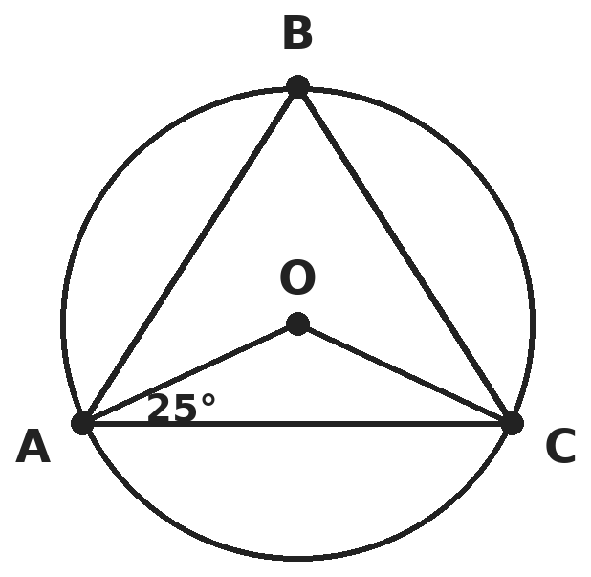
Q11. O is the centre of the circle. A, B and C lie on the circle, with B on the major arc AC. Angle OAC = 25°. What is angle ABC?
(A) 130° | (B) 50° | (C) 65° | (D) 115°

Q12. Which condition on a quadrilateral always makes it a parallelogram?
(A) One pair of opposite sides is parallel and the other pair is equal | (B) Its diagonals are equal
(C) One pair of opposite sides is both equal and parallel | (D) Two pairs of adjacent sides are equal

Part 5 — Mensuration (Syllabus Chapter 6)
Q13. A square pyramid has a base edge of 10 cm and a slant height (from the apex to the middle of a base edge) of 13 cm. What is its volume?
(A) 1,200 cm³ | (B) 520 cm³ | (C) 433⅓ cm³ | (D) 400 cm³

Q14. A conical tent has base radius 7 m and height 24 m. It is made from canvas 2.5 m wide. What length of canvas is needed? (Take π = 22/7; ignore waste.)
(A) 550 m | (B) 110 m | (C) 275 m | (D) 220 m

Q15. The minute hand of a clock is 14 cm long. What area does it sweep from 4:00 to 4:20? (Take π = 22/7.)
(A) 308/3 cm² | (B) 616/3 cm² | (C) 616 cm² | (D) 88/3 cm²

Part 6 — Data Handling, Statistics & Probability (Syllabus Chapter 8)
Q16. A card is drawn at random from a well-shuffled pack of 52 playing cards. What is the probability that it is red or a king?
(A) 15/26 | (B) 1/2 | (C) 8/13 | (D) 7/13

Q17. The mean of 11 numbers is 20. The mean of the first 6 is 18 and the mean of the last 6 is 23. What is the 6th number?
(A) 26 | (B) 21 | (C) 20 | (D) 23

Q18. Spinner A shows 1, 2 or 3 and spinner B shows 1 or 2, each equally likely. Tanvi spins both and multiplies the numbers. What is the probability that the product is even?
(A) 2/3 | (B) 1/2 | (C) 1/3 | (D) 5/6

Part 7 — Applied Mathematics (Syllabus Chapter 9)
Q19. Ayaan has 20 L of a drink that is 25% fruit juice. How many litres of pure juice must he add to make it 40% juice?
(A) 3 L | (B) 5 L | (C) 6 L | (D) 4 L

Q20. A candle burns at a steady rate. It is 30 cm tall at 6:00 PM and 18 cm tall at 9:00 PM. At what time will it burn out?
(A) 12:00 midnight | (B) 1:00 AM
(C) 1:30 AM | (D) 2:30 AM

Q21. Asha saves ₹10 on day 1, ₹20 on day 2, ₹30 on day 3, and so on. After how many days will her total savings be ₹2,100?
(A) 20 | (B) 21 | (C) 14 | (D) 42

Part 8 — Mathematical Reasoning (Syllabus Chapter 10)
Q22. "If two angles are vertically opposite, then they are equal." Which option gives the converse and says correctly whether it is true?
(A) If two angles are equal, then they are vertically opposite — true | (B) If two angles are not equal, then they are not vertically opposite — true
(C) If two angles are not vertically opposite, then they are not equal — false | (D) If two angles are equal, then they are vertically opposite — false

Q23. Kaprekar's routine: arrange the 4 digits in descending order and in ascending order (keeping zeros), and subtract the smaller from the larger. Repeat. Starting from 2111, after how many subtractions do you first reach 6174?
(A) 4 | (B) 5 | (C) 6 | (D) 3

Q24. In the Sierpinski triangle, each shaded triangle is split into 4 equal triangles and the middle one is removed. After which step is less than half of the original area shaded for the first time, and how many shaded triangles are there then?
(A) After step 2, with 9 triangles | (B) After step 3, with 27 triangles
(C) After step 3, with 64 triangles | (D) After step 4, with 81 triangles

Q25. Brahmagupta's formula gives the area of a cyclic quadrilateral with sides a, b, c, d. In which case does it become Heron's formula for a triangle?
(A) When one side, say d, becomes 0 | (B) When all four sides are equal
(C) When the quadrilateral is a rectangle | (D) When the two diagonals are equal

Part 9 — Mixed Problems (each joins two chapters)
Q26. A sequence has t₁ = 3 and tₙ₊₁ = tₙ + 2n for every n ≥ 1. What is t₁₀?
(A) 93 | (B) 101 | (C) 111 | (D) 83

Q27. A circle passes through A(0, 0), B(8, 0) and C(8, 6). What is the area of the part of the circle that lies outside triangle ABC?
(A) 25π − 48 | (B) 25π − 24 | (C) 100π − 24 | (D) 25π

Q28. A right triangle has vertices A(2, 1), B(6, 1) and C(6, 4). The straight line through A and the midpoint of BC is drawn. Where does this line cross the y-axis?
(A) (0, 1/2) | (B) (0, −1/4) | (C) (0, 3/8) | (D) (0, 1/4)

Q29. Two different digits are chosen from 1, 2, 3, 4, 5 to make a two-digit number, all choices being equally likely. What is the probability that the number is divisible by 4?
(A) 1/4 | (B) 3/20 | (C) 6/25 | (D) 1/5

Q30. A course mark is 40% internal assessment and 60% final exam. Rohit scored 70 in the internal assessment. What is the lowest final exam score that gives him an overall mark of at least 76?
(A) 82 | (B) 80 | (C) 76 | (D) 90

Answer Sheet AMO Level 2 · Class 9 · Practice Paper 4
Name: | School: | Roll No.:
Shade or tick one circle for each question.
1. | Ⓐ Ⓑ Ⓒ Ⓓ | 11. | Ⓐ Ⓑ Ⓒ Ⓓ | 21. | Ⓐ Ⓑ Ⓒ Ⓓ
2. | Ⓐ Ⓑ Ⓒ Ⓓ | 12. | Ⓐ Ⓑ Ⓒ Ⓓ | 22. | Ⓐ Ⓑ Ⓒ Ⓓ
3. | Ⓐ Ⓑ Ⓒ Ⓓ | 13. | Ⓐ Ⓑ Ⓒ Ⓓ | 23. | Ⓐ Ⓑ Ⓒ Ⓓ
4. | Ⓐ Ⓑ Ⓒ Ⓓ | 14. | Ⓐ Ⓑ Ⓒ Ⓓ | 24. | Ⓐ Ⓑ Ⓒ Ⓓ
5. | Ⓐ Ⓑ Ⓒ Ⓓ | 15. | Ⓐ Ⓑ Ⓒ Ⓓ | 25. | Ⓐ Ⓑ Ⓒ Ⓓ
6. | Ⓐ Ⓑ Ⓒ Ⓓ | 16. | Ⓐ Ⓑ Ⓒ Ⓓ | 26. | Ⓐ Ⓑ Ⓒ Ⓓ
7. | Ⓐ Ⓑ Ⓒ Ⓓ | 17. | Ⓐ Ⓑ Ⓒ Ⓓ | 27. | Ⓐ Ⓑ Ⓒ Ⓓ
8. | Ⓐ Ⓑ Ⓒ Ⓓ | 18. | Ⓐ Ⓑ Ⓒ Ⓓ | 28. | Ⓐ Ⓑ Ⓒ Ⓓ
9. | Ⓐ Ⓑ Ⓒ Ⓓ | 19. | Ⓐ Ⓑ Ⓒ Ⓓ | 29. | Ⓐ Ⓑ Ⓒ Ⓓ
10. | Ⓐ Ⓑ Ⓒ Ⓓ | 20. | Ⓐ Ⓑ Ⓒ Ⓓ | 30. | Ⓐ Ⓑ Ⓒ Ⓓ

For the parent or teacher
Correct: ______ / 30
Answer Key and Solutions AMO Level 2 · Class 9 · Practice Paper 4
Quick answers
1 B | 6 D | 11 C | 16 D | 21 A | 26 A
2 C | 7 A | 12 C | 17 A | 22 D | 27 B
3 D | 8 C | 13 D | 18 A | 23 B | 28 D
4 A | 9 C | 14 D | 19 B | 24 B | 29 D
5 C | 10 A | 15 B | 20 C | 25 A | 30 B
Solutions
Q | Part · level | Answer | Why?
1 | Part 1 · Ch1 · Hard | (B) 37/90 | Hint: For 0.2777…, compare 100x and 10x: the repeating parts cancel.  x = 0.2777…: 100x − 10x = 27.77… − 2.77… = 25, so x = 25/90. y = 0.1333…: 100y − 10y = 13.33… − 1.33… = 12, so y = 12/90. Sum = 37/90 (= 0.4111…). (37/99 treats both decimals as repeating from the first digit.)
2 | Part 1 · Ch1 · Hard | (C) 7 | Hint: 72 = 36 × 2, so √(72k) = 6√(2k).  √(72k) = 6√(2k) is rational exactly when 2k is a perfect square, i.e. k = 2m². The values are 2, 8, 18, 32, 50, 72, 98: 7 values.
3 | Part 2 · Ch3 · Hard | (D) A decrease of 1.99% | Hint: Multiply the factors 0.9, 0.9 and 1.21.  0.9 × 0.9 × 1.21 = 0.81 × 1.21 = 0.9801, so the value is 98.01% of the start: a decrease of 1.99%. (−10 − 10 + 21 = +1 adds percentages wrongly.)
4 | Part 2 · Ch3 · Hard | (A) 69% | Hint: Weight each percentage by the number of students.  Boys passed: 120. Girls passed: 225. Total 345 out of 500 = 69%. (67.5% is the plain average of 60 and 75, which ignores the different group sizes.)
5 | Part 3 · Ch4 · Hard | (C) 305 | Hint: a³ − b³ = (a − b)³ + 3ab(a − b) with a = 2x and b = 3y.  With a = 2x, b = 3y: a − b = 5 and ab = 6xy = 12. a³ − b³ = 5³ + 3 × 12 × 5 = 125 + 180 = 305.
6 | Part 3 · Ch4 · Hard | (D) 12 | Hint: Write the two conditions as equations in a and b.  p(1) = 7 + a + b = 0 and p(2) = 14 + 4a + 2b = 0, i.e. a + b = −7 and 2a + b = −7. So a = 0, b = −7. p(3) = 27 − 21 + 6 = 12.
7 | Part 3 · Ch4 · Hard | (A) 70 | Hint: If all 140 were child tickets, the takings would be ₹4,900.  140 child tickets would give 140 × 35 = 4,900. Each adult ticket adds ₹25 more. (6,650 − 4,900) ÷ 25 = 1,750 ÷ 25 = 70 adult tickets.
8 | Part 3 · Ch4 · Hard | (C) 48 | Hint: a + 3d = 2a gives a = 3d.  a + 3d = 2a, so a = 3d. Then a + 6d = 9d = 36, so d = 4 and a = 12. The 10th term = 12 + 9 × 4 = 48.
9 | Part 4 · Ch5 · Hard | (C) (3, 4) | Hint: The triangle has a right angle at B.  Angle B is a right angle, so the hypotenuse AC is a diameter of the circumcircle. The circumcentre is the midpoint of AC: (3, 4). (4, 8/3) is the centroid.
10 | Part 4 · Ch5 · Hard | (A) 12 cm | Hint: Find the radius first.  r² = 8² + 6² = 100, so r = 10 cm. A chord 8 cm from the centre has half-length √(100 − 64) = 6, so its length is 12 cm.
11 | Part 4 · Ch5 · Hard | (C) 65° | Hint: Triangle OAC is isosceles (OA = OC).  OA = OC, so angle OCA = 25° and angle AOC = 180° − 50° = 130°. The angle at the circumference is half: angle ABC = 65°.
12 | Part 4 · Ch5 · Hard | (C) One pair of opposite sides is both equal and parallel | Hint: Test each condition against an isosceles trapezium and a kite.  One pair of sides equal and parallel always gives a parallelogram. An isosceles trapezium has one pair parallel and the other pair equal; an isosceles trapezium also has equal diagonals; a kite has two pairs of equal adjacent sides — none of them is a parallelogram in general.
13 | Part 5 · Ch6 · Hard | (D) 400 cm³ | Hint: Find the vertical height using the right triangle formed by the height, half the base edge and the slant height.  Height = √(13² − 5²) = 12 cm. Volume = ⅓ × base area × height = ⅓ × 100 × 12 = 400 cm³. (1,200 forgets the ⅓; 520 uses the slant height.)
14 | Part 5 · Ch6 · Hard | (D) 220 m | Hint: Find the slant height, then the curved surface area.  Slant height = √(7² + 24²) = 25 m. Curved surface = 22/7 × 7 × 25 = 550 m². Length = 550 ÷ 2.5 = 220 m.
15 | Part 5 · Ch6 · Hard | (B) 616/3 cm² | Hint: In 20 minutes the minute hand turns through 120°.  Area = (120/360) × 22/7 × 14² = ⅓ × 616 = 616/3 cm² (about 205.3 cm²). (88/3 cm is the arc length.)
16 | Part 6 · Ch8 · Hard | (D) 7/13 | Hint: Two of the kings are already red.  Red cards: 26. Kings that are not red: 2. Total 28, so the probability is 28/52 = 7/13. (15/26 counts the red kings twice.)
17 | Part 6 · Ch8 · Hard | (A) 26 | Hint: The 6th number belongs to both groups of six.  First six total 108, last six total 138. Together they count the 6th number twice: 108 + 138 = 246 = 220 + 6th number. So the 6th number is 26.
18 | Part 6 · Ch8 · Hard | (A) 2/3 | Hint: The product is odd only when both numbers are odd.  There are 3 × 2 = 6 equally likely outcomes. Odd products need A odd (1 or 3) and B = 1: 2 outcomes. So P(even) = 1 − 2/6 = 2/3.
19 | Part 7 · Ch9 · Hard | (B) 5 L | Hint: The water stays the same: 15 L.  The 15 L of water must be 60% of the new drink, so the new total is 15 ÷ 0.6 = 25 L. He adds 25 − 20 = 5 L of juice. (3 L takes 40% − 25% = 15% of 20 L.)
20 | Part 7 · Ch9 · Hard | (C) 1:30 AM | Hint: Find how many cm it burns per hour.  It burns 12 cm in 3 hours, i.e. 4 cm per hour. From 30 cm at 6 PM it needs 30 ÷ 4 = 7.5 hours, so it burns out at 1:30 AM.
21 | Part 7 · Ch9 · Hard | (A) 20 | Hint: The total after n days is 10 × (1 + 2 + … + n).  10 × n(n + 1)/2 = 2,100 gives n(n + 1) = 420 = 20 × 21. So n = 20 days.
22 | Part 8 · Ch10 · Hard | (D) If two angles are equal, then they are vertically opposite — false | Hint: The converse swaps the "if" part and the "then" part.  The converse is "If two angles are equal, then they are vertically opposite." It is false: the two base angles of an isosceles triangle are equal but not vertically opposite.
23 | Part 8 · Ch10 · Hard | (B) 5 | Hint: 2111 − 1112 = 999, written as 0999.  2111 − 1112 = 0999; 9990 − 0999 = 8991; 9981 − 1899 = 8082; 8820 − 0288 = 8532; 8532 − 2358 = 6174. That is 5 subtractions.
24 | Part 8 · Ch10 · Hard | (B) After step 3, with 27 triangles | Hint: Each step keeps 3/4 of the shaded area and triples the number of shaded triangles.  Shaded area: 3/4, 9/16 = 0.5625, 27/64 ≈ 0.42. So step 3 is the first below one half. The number of shaded triangles goes 3, 9, 27, so there are 27. (64 is the number of small triangles in the grid, shaded or not.)
25 | Part 8 · Ch10 · Hard | (A) When one side, say d, becomes 0 | Hint: A triangle can be thought of as a quadrilateral with one side shrunk away.  Area = √((s − a)(s − b)(s − c)(s − d)). If d = 0 the quadrilateral becomes a triangle, s becomes the triangle's semi-perimeter, and s − d = s gives √(s(s − a)(s − b)(s − c)), which is Heron's formula.
26 | Part 9 · Mixed · Ch4 + Ch10 · Hard | (A) 93 | Hint: t₁₀ = 3 + 2(1 + 2 + … + 9).  Each step adds 2n, so t₁₀ = 3 + 2 × (1 + 2 + … + 9) = 3 + 2 × 45 = 93. (In general tₙ = n² − n + 3.)
27 | Part 9 · Mixed · Ch5 + Ch6 · Hard | (B) 25π − 24 | Hint: Angle B is a right angle, so AC is a diameter.  AC = √(8² + 6²) = 10 is a diameter, so r = 5 and the circle's area is 25π. The triangle's area is ½ × 8 × 6 = 24. Outside the triangle: 25π − 24.
28 | Part 9 · Mixed · Ch4 + Ch5 · Hard | (D) (0, 1/4) | Hint: Find the midpoint of BC, then the slope of the line from A.  Midpoint of BC = (6, 5/2). Slope from A = (5/2 − 1)/(6 − 2) = 3/8. The line is y = (3/8)x + b with 1 = 3/4 + b, so b = 1/4. It crosses the y-axis at (0, 1/4). (3/8 is the slope, not the intercept.)
29 | Part 9 · Mixed · Ch8 + Ch10 · Hard | (D) 1/5 | Hint: There are 5 × 4 = 20 possible numbers.  The multiples of 4 that can be made are 12, 24, 32 and 52 (44 repeats a digit). So the probability is 4/20 = 1/5.
30 | Part 9 · Mixed · Ch3 + Ch9 · Hard | (B) 80 | Hint: Overall = 0.4 × internal + 0.6 × final.  0.4 × 70 = 28, so he needs 0.6 × final ≥ 48, that is final ≥ 80. Check: 28 + 0.6 × 80 = 76. (82 would treat the weights as equal; 76 ignores the weighting.)

ARYABHATTA MATHS OLYMPIAD
Level 2
PRACTICE PAPER-5
CLASS 9
Total Questions | 30 multiple-choice questions
Level | Level-2 (final round): every question is Hard
Time | 45 minutes
Arrangement | Parts by chapter; the last Part has mixed problems joining two chapters
Negative Marking | No negative marking
Calculator | Not allowed
Chapters | Number System · Fractions, Decimals & Percentages · Algebra · Geometry · Mensuration · Data Handling, Statistics & Probability · Applied Mathematics · Mathematical Reasoning

Instructions
• Each question has four options, (A) to (D), with exactly one correct answer.
• The questions are grouped in Parts by chapter. The last Part has mixed problems, each joining two chapters.
• Every question is at Level-2 (Hard) standard: expect several steps or a key insight.
• There is no negative marking. Calculators are not allowed; use a separate sheet for rough work.
• Figures are not necessarily drawn to scale unless stated.

For teachers
• Figures are part of the questions and work when printed in black and white.
• Parts follow the AMO syllabus chapters. Chapters 2 and 7 are not part of the Class 9 syllabus, so the chapter numbers shown in the Part headings have gaps.
• The answer sheet and the answer key are at the end. Remove the answer key before the paper is attempted.

Part 1 — Number System (Syllabus Chapter 1)
Q1. How many fractions of the form n/10, where n is a whole number, lie between √2 and √3?
(A) 3 | (B) 2 | (C) 4 | (D) 1

Q2. What is 0.333… × 0.666… (both recurring) written as a decimal?
(A) 0.18 | (B) 0.222… (recurring)
(C) 0.2 | (D) 0.1999

Part 2 — Fractions, Decimals & Percentages (Syllabus Chapter 3)
Q3. A ball dropped from 10 m rises to 80% of its previous height after each bounce. How high does it rise after the third bounce?
(A) 5.12 m | (B) 4.096 m | (C) 4 m | (D) 6.4 m

Q4. A shop sold 60 pens at ₹12 each and 40 pens at ₹17 each. How many more pens at ₹20 each must it sell so that the average price of all pens sold becomes exactly ₹15?
(A) 25 | (B) 20 | (C) 10 | (D) 30

Part 3 — Algebra (Syllabus Chapter 4)
Q5. A positive number x satisfies x² + 1/x² = 7. What is the value of x³ + 1/x³?
(A) 21 | (B) 27 | (C) 24 | (D) 18

Q6. For how many positive whole numbers m can x² + mx + 12 be factorised as (x + p)(x + q) with whole numbers p and q?
(A) 6 | (B) 4 | (C) 3 | (D) 2

Q7. The length of a spring is a linear function of the load: 15 cm with 2 kg and 21 cm with 5 kg. What is its length with no load?
(A) 13 cm | (B) 11 cm | (C) 9 cm | (D) 15 cm

Q8. Which term of the progression 2, 6, 18, 54, … is 4,374?
(A) 7th | (B) 9th | (C) 6th | (D) 8th

Part 4 — Geometry (Syllabus Chapter 5)
Q9. What kind of quadrilateral has vertices (0, 0), (5, 0), (9, 3) and (4, 3), taken in order, and what is its area?
(A) Square, area 25 | (B) Rhombus, area 30
(C) Rhombus, area 15 | (D) Rectangle, area 15

Q10. Two circles of radii 5 cm and 3 cm cross at two points. Their common chord is 6 cm long. How far apart are the centres?
(A) 8 cm | (B) 4 cm | (C) 2 cm | (D) 5 cm

Q11. A chord of a circle is equal in length to the radius. What angle does it subtend at a point on the major arc?
(A) 60° | (B) 30° | (C) 150° | (D) 45°

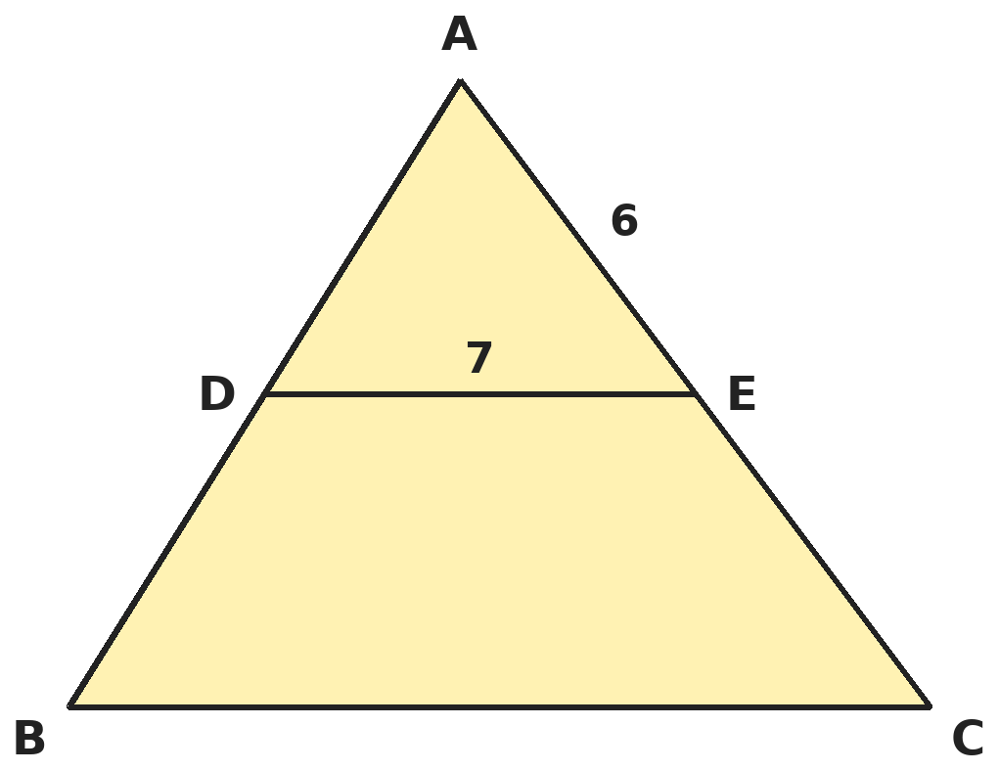
Q12. In triangle ABC, D is the midpoint of AB. A line through D parallel to BC meets AC at E. DE = 7 cm and AE = 6 cm. What is AC + BC?
(A) 13 cm | (B) 20 cm | (C) 26 cm | (D) 33 cm

Part 5 — Mensuration (Syllabus Chapter 6)
Q13. A cylinder, a cone and a hemisphere have the same base radius r. The cylinder and the cone both have height r. What is the ratio of their volumes (cylinder : cone : hemisphere)?
(A) 1 : 3 : 2 | (B) 3 : 2 : 1 | (C) 3 : 1 : 2 | (D) 2 : 1 : 3

Q14. A cylinder of height 10 cm has a curved surface area of 880 cm². What is its volume? (Take π = 22/7.)
(A) 6,160 cm³ | (B) 3,080 cm³ | (C) 12,320 cm³ | (D) 8,800 cm³

Q15. A solid sphere of radius 7 cm is cut into two equal hemispheres. By how much does the total surface area increase? (Take π = 22/7.)
(A) 154 cm² | (B) 616 cm² | (C) 308 cm² | (D) 0 cm²

Part 6 — Data Handling, Statistics & Probability (Syllabus Chapter 8)
Q16. Two fair dice are rolled. What is the probability that the two numbers differ by exactly 2?
(A) 1/6 | (B) 2/9 | (C) 5/18 | (D) 1/9

Q17. The numbers 2, 5, 7, x, 11, 13 are in increasing order and their median is 8. What is their mean?
(A) 47/6 | (B) 8 | (C) 49/6 | (D) 15/2

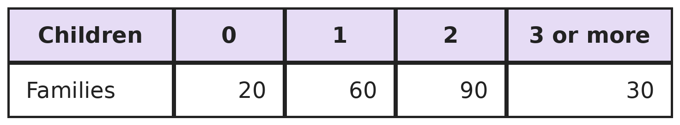
Q18. A survey of 200 families gives this table. A family is chosen at random from those that have at least one child. What is the probability that it has at least 2 children?
(A) 2/3 | (B) 3/5 | (C) 1/2 | (D) 3/4

Part 7 — Applied Mathematics (Syllabus Chapter 9)
Q19. Two cars start 300 km apart. Driving towards each other they meet after 3 hours. Driving in the same direction, the faster one catches the slower after 15 hours. What is the faster car's speed?
(A) 40 km/h | (B) 50 km/h | (C) 80 km/h | (D) 60 km/h

Q20. On a city grid (1 unit = 1 km), a taxi stand is to be built on the main road along the y-axis, equally far (straight-line distance) from pick-up points A(7, 1) and B(−1, −3). Where should it be?
(A) (0, 3) | (B) (0, −1) | (C) (0, 5) | (D) (0, 4)

Q21. Shop A has an average rating of 4.2 from 50 reviews. Shop B has 4.6 from 30 reviews. The two shops merge. What is the average rating over all 80 reviews?
(A) 4.4 | (B) 4.3 | (C) 4.45 | (D) 4.35

Part 8 — Mathematical Reasoning (Syllabus Chapter 10)
Q22. Sneha says, "Every quadrilateral with four equal sides is a square." Which shape is a counterexample?
(A) A square of side 3 cm | (B) A rectangle 3 cm by 5 cm
(C) A rhombus with a 60° angle | (D) A kite with sides 3, 3, 5, 5

Q23. Kabir finds the largest of 16 different numbers by comparing them in pairs, knock-out style: each comparison removes the smaller number. How many comparisons does he need?
(A) 15 | (B) 16 | (C) 8 | (D) 31

Q24. With no lines a plane is 1 region. Each new straight line can cross all earlier lines and add (number of lines so far) regions: R(n) = R(n − 1) + n. What is the largest number of regions 6 lines can make?
(A) 22 | (B) 21 | (C) 16 | (D) 64

Q25. To prove √2 + √3 is irrational, Raghav assumes √2 + √3 = r, a rational number, and squares both sides. What contradiction does he reach?
(A) √2 would equal √3 | (B) r would be negative
(C) 5 would be irrational | (D) √6 would be rational

Part 9 — Mixed Problems (each joins two chapters)
Q26. At a meeting, everyone shakes hands once with everyone else. There are 66 handshakes. How many people are at the meeting?
(A) 12 | (B) 11 | (C) 13 | (D) 33

Q27. A square is drawn inside a circle of radius 14 cm with all four corners on the circle. What is the area inside the circle but outside the square? (Take π = 22/7.)
(A) 616 cm² | (B) 392 cm² | (C) 168 cm² | (D) 224 cm²

Q28. The lines y = x + 1 and y = −x + 5 form a triangle with the x-axis. Where is its centroid?
(A) (2, 3/2) | (B) (2, 1) | (C) (2, 3) | (D) (3, 1)

Q29. A number is chosen at random from 1 to 20. What is the probability that it is a perfect square or a perfect cube?
(A) 3/10 | (B) 1/5 | (C) 1/10 | (D) 1/4

Q30. A van bought for ₹5,00,000 is valued in two ways: Method A takes off ₹1,00,000 each year; Method B takes off 20% of the current value each year. After 2 years, which method gives the higher value, and by how much?
(A) Method A, by ₹20,000 | (B) Both give the same value
(C) Method B, by ₹20,000 | (D) Method B, by ₹40,000

Answer Sheet AMO Level 2 · Class 9 · Practice Paper 5
Name: | School: | Roll No.:
Shade or tick one circle for each question.
1. | Ⓐ Ⓑ Ⓒ Ⓓ | 11. | Ⓐ Ⓑ Ⓒ Ⓓ | 21. | Ⓐ Ⓑ Ⓒ Ⓓ
2. | Ⓐ Ⓑ Ⓒ Ⓓ | 12. | Ⓐ Ⓑ Ⓒ Ⓓ | 22. | Ⓐ Ⓑ Ⓒ Ⓓ
3. | Ⓐ Ⓑ Ⓒ Ⓓ | 13. | Ⓐ Ⓑ Ⓒ Ⓓ | 23. | Ⓐ Ⓑ Ⓒ Ⓓ
4. | Ⓐ Ⓑ Ⓒ Ⓓ | 14. | Ⓐ Ⓑ Ⓒ Ⓓ | 24. | Ⓐ Ⓑ Ⓒ Ⓓ
5. | Ⓐ Ⓑ Ⓒ Ⓓ | 15. | Ⓐ Ⓑ Ⓒ Ⓓ | 25. | Ⓐ Ⓑ Ⓒ Ⓓ
6. | Ⓐ Ⓑ Ⓒ Ⓓ | 16. | Ⓐ Ⓑ Ⓒ Ⓓ | 26. | Ⓐ Ⓑ Ⓒ Ⓓ
7. | Ⓐ Ⓑ Ⓒ Ⓓ | 17. | Ⓐ Ⓑ Ⓒ Ⓓ | 27. | Ⓐ Ⓑ Ⓒ Ⓓ
8. | Ⓐ Ⓑ Ⓒ Ⓓ | 18. | Ⓐ Ⓑ Ⓒ Ⓓ | 28. | Ⓐ Ⓑ Ⓒ Ⓓ
9. | Ⓐ Ⓑ Ⓒ Ⓓ | 19. | Ⓐ Ⓑ Ⓒ Ⓓ | 29. | Ⓐ Ⓑ Ⓒ Ⓓ
10. | Ⓐ Ⓑ Ⓒ Ⓓ | 20. | Ⓐ Ⓑ Ⓒ Ⓓ | 30. | Ⓐ Ⓑ Ⓒ Ⓓ

For the parent or teacher
Correct: ______ / 30
Answer Key and Solutions AMO Level 2 · Class 9 · Practice Paper 5
Quick answers
1 A | 6 C | 11 B | 16 B | 21 D | 26 A
2 B | 7 B | 12 C | 17 A | 22 C | 27 D
3 A | 8 D | 13 C | 18 A | 23 A | 28 B
4 B | 9 C | 14 A | 19 D | 24 A | 29 D
5 D | 10 B | 15 C | 20 C | 25 D | 30 C
Solutions
Q | Part · level | Answer | Why?
1 | Part 1 · Ch1 · Hard | (A) 3 | Hint: √2 ≈ 1.414 and √3 ≈ 1.732.  n/10 must be between 1.414… and 1.732…, so n is 15, 16 or 17 (1.5, 1.6, 1.7). 14/10 = 1.4 is too small and 18/10 = 1.8 too large. So 3 fractions.
2 | Part 1 · Ch1 · Hard | (B) 0.222… (recurring) | Hint: Change both decimals to fractions first.  0.333… = 1/3 and 0.666… = 2/3. The product is 2/9 = 0.222… recurring. (0.18 multiplies only the first digits, 0.3 × 0.6.)
3 | Part 2 · Ch3 · Hard | (A) 5.12 m | Hint: The heights form a geometric progression with ratio 0.8.  After bounces 1, 2, 3 the heights are 8, 6.4 and 5.12 m: 10 × 0.8³ = 5.12 m. (4 m subtracts 20% of 10 m three times.)
4 | Part 2 · Ch3 · Hard | (B) 20 | Hint: Compare the total money with 15 times the total number of pens.  So far: 720 + 680 = ₹1,400 for 100 pens (average ₹14). With k more pens at ₹20: 1,400 + 20k = 15(100 + k), so 5k = 100 and k = 20. Check: 1,800 ÷ 120 = 15.
5 | Part 3 · Ch4 · Hard | (D) 18 | Hint: First find x + 1/x from (x + 1/x)² = x² + 2 + 1/x².  (x + 1/x)² = 7 + 2 = 9, so x + 1/x = 3 (x is positive). Then (x + 1/x)³ = x³ + 1/x³ + 3(x + 1/x), so x³ + 1/x³ = 27 − 9 = 18. (27 forgets to subtract 3(x + 1/x).)
6 | Part 3 · Ch4 · Hard | (C) 3 | Hint: pq = 12 and p + q = m.  Pairs with product 12: (1, 12), (2, 6), (3, 4). They give m = 13, 8 and 7. So 3 values.
7 | Part 3 · Ch4 · Hard | (B) 11 cm | Hint: Find how much it stretches per kg.  3 kg more stretches it 6 cm, so 2 cm per kg (the slope). With no load: 15 − 2 × 2 = 11 cm (the y-intercept).
8 | Part 3 · Ch4 · Hard | (D) 8th | Hint: The nth term is 2 × 3ⁿ⁻¹.  4,374 ÷ 2 = 2,187 = 3⁷. So 3ⁿ⁻¹ = 3⁷ and n = 8.
9 | Part 4 · Ch5 · Hard | (C) Rhombus, area 15 | Hint: Find the four side lengths, then use base × height.  Sides: 5, √(16 + 9) = 5, 5, 5, so all four sides are equal, but the angles are not right angles: a rhombus. Base 5 and height 3 give area 15. (30 multiplies the diagonals √90 and √10 without the ½.)
10 | Part 4 · Ch5 · Hard | (B) 4 cm | Hint: The line of centres is the perpendicular bisector of the common chord.  Half the chord is 3 cm. The big centre is √(25 − 9) = 4 cm from the chord; the small centre is √(9 − 9) = 0 cm from it, i.e. on the chord. So the centres are 4 cm apart.
11 | Part 4 · Ch5 · Hard | (B) 30° | Hint: The chord and two radii form an equilateral triangle.  The chord and the two radii make an equilateral triangle, so the angle at the centre is 60°. A point on the major arc sees half of that: 30°. (A point on the minor arc sees 150°.)
12 | Part 4 · Ch5 · Hard | (C) 26 cm | Hint: By the converse of the midpoint theorem, E is the midpoint of AC.  The line through the midpoint of AB parallel to BC bisects AC, so AC = 2 × 6 = 12 cm, and DE is half of BC, so BC = 14 cm. AC + BC = 26 cm.
13 | Part 5 · Ch6 · Hard | (C) 3 : 1 : 2 | Hint: Write each volume in terms of πr³.  Cylinder: πr² × r = πr³. Cone: ⅓πr² × r = ⅓πr³. Hemisphere: ⅔πr³. Multiplying by 3: 3 : 1 : 2.
14 | Part 5 · Ch6 · Hard | (A) 6,160 cm³ | Hint: Use 2πrh = 880 to find r.  2 × 22/7 × r × 10 = 880 gives r = 14 cm. Volume = 22/7 × 14² × 10 = 6,160 cm³.
15 | Part 5 · Ch6 · Hard | (C) 308 cm² | Hint: The cut makes two new flat faces.  The curved surface is unchanged. The cut adds two flat circles, each of area πr² = 22/7 × 49 = 154 cm². The increase is 2 × 154 = 308 cm². (154 cm² counts only one new face.)
16 | Part 6 · Ch8 · Hard | (B) 2/9 | Hint: List pairs like (1, 3) and (3, 1).  Pairs: (1,3), (2,4), (3,5), (4,6) and their reverses: 8 outcomes of 36. Probability = 8/36 = 2/9.
17 | Part 6 · Ch8 · Hard | (A) 47/6 | Hint: With six numbers the median is the average of the 3rd and 4th.  (7 + x)/2 = 8 gives x = 9. Total = 2 + 5 + 7 + 9 + 11 + 13 = 47, so the mean is 47/6 (about 7.83), not 8.
18 | Part 6 · Ch8 · Hard | (A) 2/3 | Hint: Leave out the 20 families with no children first.  Families with at least one child: 60 + 90 + 30 = 180. Of these, 90 + 30 = 120 have at least 2. Probability = 120/180 = 2/3. (3/5 = 120/200 wrongly keeps the families with no children.)
19 | Part 7 · Ch9 · Hard | (D) 60 km/h | Hint: Towards each other the speeds add; same direction they subtract.  a + b = 300 ÷ 3 = 100 and a − b = 300 ÷ 15 = 20. Adding: 2a = 120, so a = 60 km/h (and b = 40 km/h).
20 | Part 7 · Ch9 · Hard | (C) (0, 5) | Hint: Let the stand be (0, y) and set the two squared distances equal.  (0 − 7)² + (y − 1)² = (0 + 1)² + (y + 3)² gives 49 + y² − 2y + 1 = 1 + y² + 6y + 9, so 40 = 8y and y = 5. Check: both distances are √65 km. ((0, −1) wrongly uses the height of the midpoint of AB.)
21 | Part 7 · Ch9 · Hard | (D) 4.35 | Hint: Use the total of all ratings.  Total = 50 × 4.2 + 30 × 4.6 = 210 + 138 = 348. Average = 348 ÷ 80 = 4.35. (4.4 is the simple average of 4.2 and 4.6.)
22 | Part 8 · Ch10 · Hard | (C) A rhombus with a 60° angle | Hint: A counterexample must have four equal sides but not be a square.  A rhombus with a 60° angle has four equal sides but no right angle, so it is not a square. The rectangle and kite do not have four equal sides, and the square agrees with the claim.
23 | Part 8 · Ch10 · Hard | (A) 15 | Hint: Every number except the largest must lose exactly once.  Each comparison removes one number, and 15 numbers must be removed. So 15 comparisons (8 + 4 + 2 + 1).
24 | Part 8 · Ch10 · Hard | (A) 22 | Hint: R(n) = 1 + (1 + 2 + … + n).  R(6) = 1 + (1 + 2 + 3 + 4 + 5 + 6) = 1 + 21 = 22.
25 | Part 8 · Ch10 · Hard | (D) √6 would be rational | Hint: Squaring gives r² = 5 + 2√6.  r² = 2 + 3 + 2√6, so √6 = (r² − 5)/2. The right side is rational, so √6 would be rational. But √6 is irrational, a contradiction.
26 | Part 9 · Mixed · Ch4 + Ch10 · Hard | (A) 12 | Hint: The handshakes are 1 + 2 + … + (n − 1).  Handshakes = 1 + 2 + … + (n − 1) = n(n − 1)/2 = 66, so n(n − 1) = 132 = 12 × 11. There are 12 people.
27 | Part 9 · Mixed · Ch5 + Ch6 · Hard | (D) 224 cm² | Hint: The diagonal of the square is a diameter.  Circle: 22/7 × 196 = 616 cm². The square's diagonal is 28, so its area is ½ × 28² = 392 cm². Difference = 224 cm².
28 | Part 9 · Mixed · Ch4 + Ch5 · Hard | (B) (2, 1) | Hint: Find the three vertices first.  The lines meet at (2, 3). They meet the x-axis at (−1, 0) and (5, 0). Centroid = ((−1 + 5 + 2)/3, (0 + 0 + 3)/3) = (2, 1).
29 | Part 9 · Mixed · Ch8 + Ch10 · Hard | (D) 1/4 | Hint: 1 is both a square and a cube; count it once.  Squares: 1, 4, 9, 16. Cubes: 1, 8. Together: 1, 4, 8, 9, 16, which is 5 numbers. Probability = 5/20 = 1/4. (3/10 counts 1 twice.)
30 | Part 9 · Mixed · Ch3 + Ch9 · Hard | (C) Method B, by ₹20,000 | Hint: Method B takes 20% of a smaller value in the second year.  Method A: 5,00,000 − 2,00,000 = ₹3,00,000. Method B: 5,00,000 × 0.8 × 0.8 = ₹3,20,000. Method B is higher by ₹20,000.

