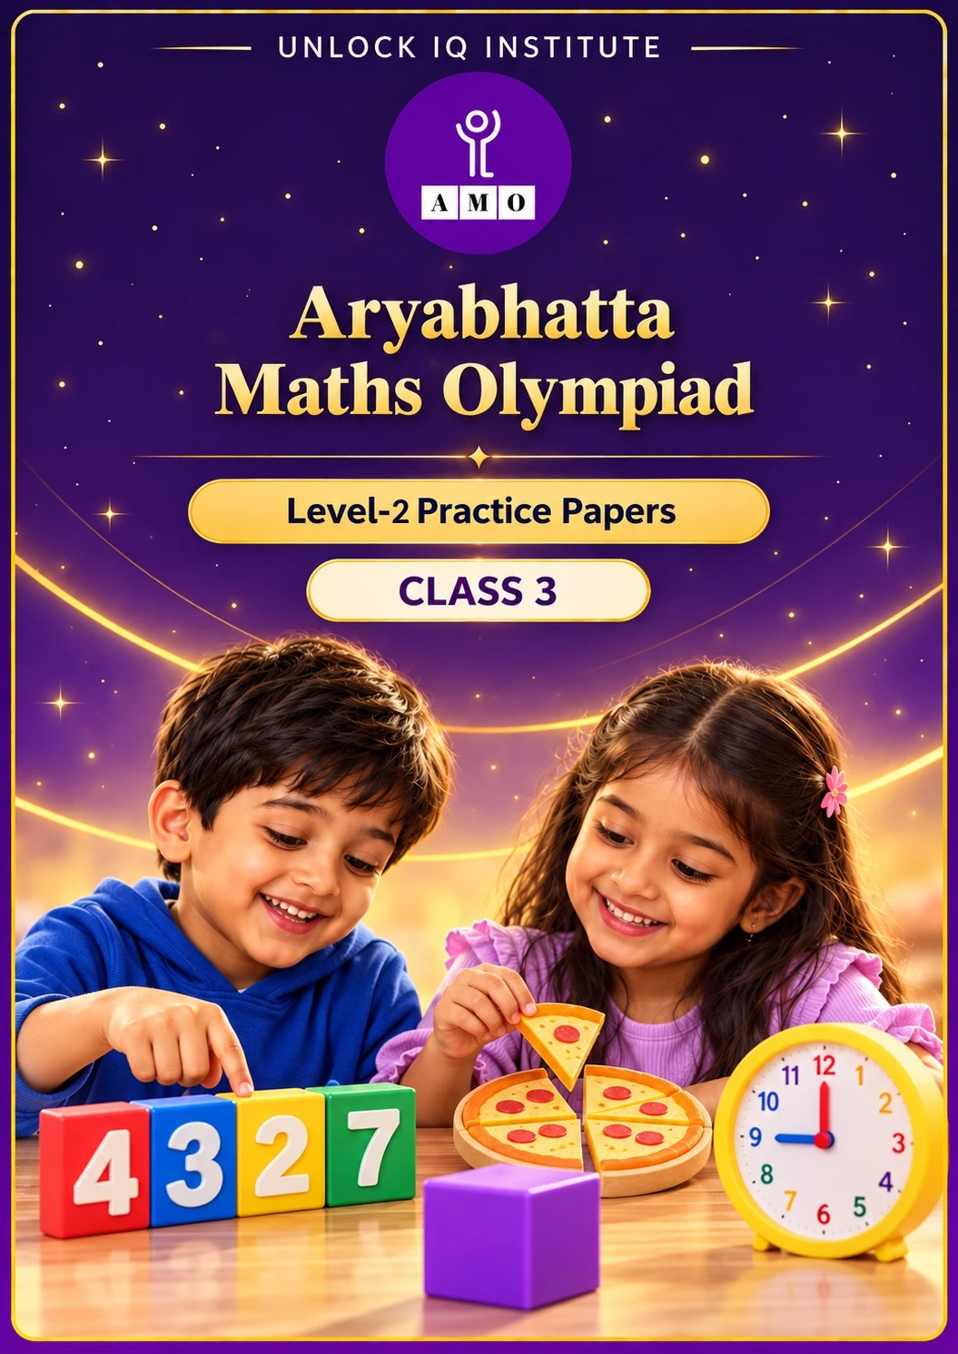
Set 2 · Practice Papers 6–10 · with answer keys & detailed solutions
Name: ____________________ | Class & Section: ________________
Roll No.: ________________ | School: ____________________
City: ____________________ | Date: ____________________

Published by Unlock IQ Institute Pvt. Ltd.
Register for Olympiads: www.aryabhattamathsolympiad.com/student-registration

ARYABHATTA MATHS OLYMPIAD
Level 2
PRACTICE PAPER-6
CLASS 3
Total Questions | 30 multiple-choice questions
Level | Level-2 (final round): every question is Hard
Time | 45 minutes
Section I | 25 questions, each from one chapter
Section II | 5 Star Questions, each joining two chapters
Negative Marking | No negative marking
Calculator | Not allowed
Chapters | Number System · Operations · Fractions · Geometry · Mensuration · Applied Mathematics · Mathematical Reasoning

👋 Hello, friend! How to do this paper:
⭐ Every question has four answer choices: (A), (B), (C) and (D). Only one is correct.
⭐ Read each question and look at its picture carefully. Then mark your answer on the answer sheet at the end.
⭐ This is a Level-2 paper. Every question needs careful thinking, so take your time and check each step.
⭐ Section I has 25 questions. Section II has 5 Star Questions.
⭐ There is no negative marking, so try every question.
⭐ Do not use a calculator. You may do rough work on a separate sheet.
⭐ All figures are not necessarily drawn to scale unless stated.

For parents and teachers
• Pictures are part of the questions. Every picture also works when printed in black and white.
• You may read a question aloud to the child, exactly as printed. Please do not explain it or point to an answer choice.
• Parts follow the AMO syllabus chapters. Chapters 4, 7 and 8 are not part of the Class 3 syllabus, so the chapter numbers shown in the Part headings have gaps.
• The answer sheet and the answer key are at the end. Remove only the answer key before the child begins.

SECTION I 25 questions · every question is Hard
Part 1 — Number System (Syllabus Chapter 1)
Q1. Ekta wants the greatest 4-digit number with all digits odd and different, and 7 in the hundreds place. What is it?
(A) 9777 | (B) 9735 | (C) 7953 | (D) 9753

Q2. Kishore adds 400 to each of these numbers. For which one does the thousands digit change?
(A) 3682 | (B) 3582 | (C) 3482 | (D) 3592

Q3. Aditi writes 38 in Roman numerals. How many symbols does she use?
(A) 5 | (B) 6 | (C) 7 | (D) 8

Q4. How many numbers between 1000 and 2000 have digits that add up to 3?
(A) 4 | (B) 5 | (C) 3 | (D) 6

Part 2 — Operations (Syllabus Chapter 2)
Q5. Two numbers add up to 7250. One of them is 3875. What is the difference between the two numbers?
(A) 3375 | (B) 3875 | (C) 500 | (D) 400

Q6. Each bus has 11 rows of 4 seats and a back row of 6 seats. 160 children go on a picnic in 3 buses. How many children do not get a seat?
(A) 10 | (B) 0 | (C) 16 | (D) 7

Q7. Bela cuts a ribbon 665 cm long into 7 equal pieces. She uses 3 of the pieces. How much ribbon does she use?
(A) 95 cm | (B) 380 cm | (C) 665 cm | (D) 285 cm

Q8. Hitesh has between 20 and 40 marbles. In groups of 7 there are none left over. In groups of 4 there are 3 left over. How many marbles?
(A) 28 | (B) 35 | (C) 21 | (D) 27

Part 3 — Fractions (Syllabus Chapter 3)
Q9. Rekha has a bar with 10 equal pieces. She gives 3/10 of it to Avni and twice as much to Tanya. What fraction is left?
(A) 4/10 | (B) 7/10 | (C) 9/10 | (D) 1/10

Q10. Which is the largest: 5/8 of 16, 3/8 of 24, or 7/8 of 8?
(A) 3/8 of 24 | (B) 7/8 of 8 | (C) 5/8 of 16 | (D) All are equal

Q11. A pizza shop cuts every pizza into 8 slices. It has sold 27/8 pizzas. What fraction of a pizza more must it sell to make 4 whole pizzas?
(A) 3/8 | (B) 4/8 | (C) 13/8 | (D) 5/8

Part 4 — Geometry (Syllabus Chapter 5)
Q12. A box is 4 cm long, 4 cm wide and 7 cm tall. How many of its faces are rectangles that are not squares?
(A) 4 | (B) 6 | (C) 2 | (D) 0

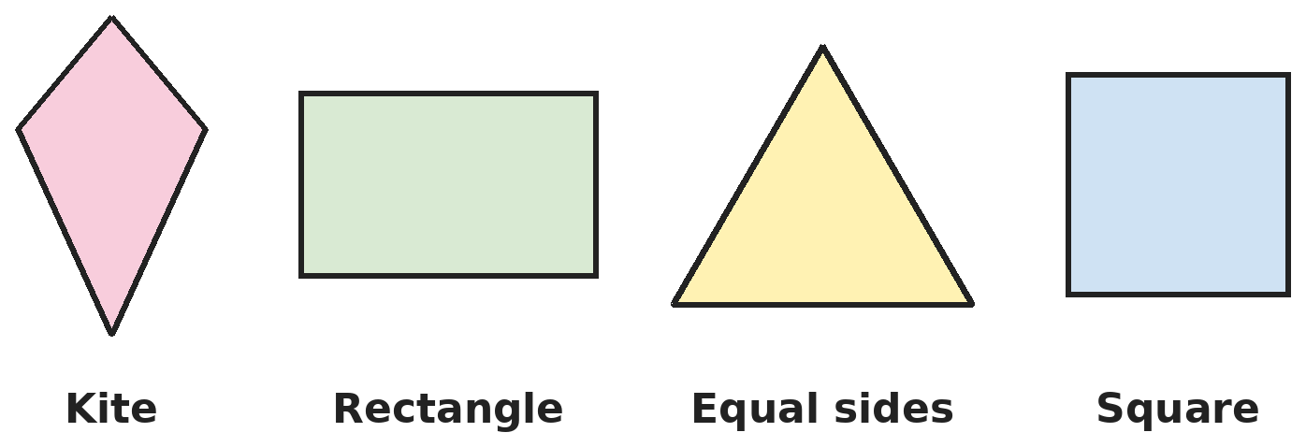
Q13. Neha finds the lines of symmetry of each shape. How many lines of symmetry do the four shapes have altogether?
(A) 8 | (B) 10 | (C) 12 | (D) 9

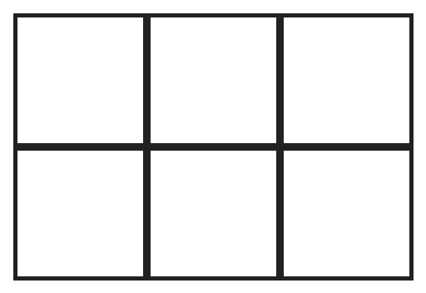
Q14. How many rectangles of all sizes are in this grid? (Squares count as rectangles.)
(A) 6 | (B) 12 | (C) 17 | (D) 18

Part 5 — Mensuration (Syllabus Chapter 6)
Q15. Om puts fence posts round a square garden of side 9 m. There is a post at each corner and every 3 m along the sides. How many posts does he use?
(A) 16 | (B) 12 | (C) 13 | (D) 9

Q16. Shreya drinks 6 glasses of water every day. Each glass holds 250 mL. How much water does she drink in a week?
(A) 1 L 500 mL | (B) 10 L 500 mL | (C) 10 L 50 mL | (D) 9 L 500 mL

Q17. Kartik has a 1 m wire. He bends part of it into a square of side 10 cm. He bends the rest into a triangle with three equal sides, leaving 6 cm spare. How long is each side of the triangle?
(A) 18 cm | (B) 20 cm | (C) 30 cm | (D) 15 cm

Part 6 — Applied Mathematics (Syllabus Chapter 9)
Q18. Ravi starts homework at 4:50 PM. He works for 1 h 25 min, rests for 20 minutes and then works for 35 more minutes. When does he finish?
(A) 6:50 PM | (B) 7:20 PM | (C) 7:10 PM | (D) 6:10 PM

Q19. In one year, 26 January falls on a Sunday. January has 31 days. What day of the week is 26 February?
(A) Sunday | (B) Wednesday | (C) Tuesday | (D) Thursday

Q20. Pens cost ₹15 each, or ₹80 for a box of 6. What is the least Anjali must pay for exactly 14 pens?
(A) ₹200 | (B) ₹190 | (C) ₹210 | (D) ₹240

Q21. Lalit's flight should land at 11:30 PM. It is 2 hours 50 minutes late. When does it land?
(A) 2:20 AM | (B) 2:20 PM | (C) 1:20 AM | (D) 1:50 AM

Part 7 — Mathematical Reasoning (Syllabus Chapter 10)

Q22. Pallavi makes each number from the one before by the same two steps. Which number comes next?
(A) 97 | (B) 130 | (C) 129 | (D) 125


Q23. A and B are digits. What is A + B?
(A) 10 | (B) 11 | (C) 9 | (D) 15

Q24. Sanjay gives half his cards and 3 more to Neha. Then he gives half of what is left and 3 more to Om. Now he has none. How many did he start with?
(A) 12 | (B) 18 | (C) 24 | (D) 15

Q25. Boxes A and B weigh 12 kg together. B and C weigh 15 kg. A and C weigh 13 kg. Which box is the heaviest, and what does it weigh?
(A) B, 7 kg | (B) C, 15 kg | (C) C, 8 kg | (D) B, 8 kg

SECTION II — Star Questions 5 questions · each joins two chapters

Q26. Each number is double the one before, plus 1. What is the first number in the pattern that is more than 1000? [Star]
(A) 1023 | (B) 1024 | (C) 511 | (D) 2047

Q27. A snail climbs 3/10 of a pole each day and slips down 1/10 each night. On which day does it reach the top? [Star]
(A) Day 4 | (B) Day 3 | (C) Day 10 | (D) Day 5

Q28. A school is closed on every Sunday and on the 1st and 3rd Saturday of each month. A month has 30 days and starts on a Friday. How many days is the school closed? [Star]
(A) 6 | (B) 8 | (C) 9 | (D) 5

Q29. A sofa costs ₹9999. Shruti pays only with ₹500 notes, using as few as she can. How many notes does she give, and how much change does she get? [Star]
(A) 19 notes, ₹499 change | (B) 20 notes, no change
(C) 20 notes, ₹1 change | (D) 19 notes, ₹1 change

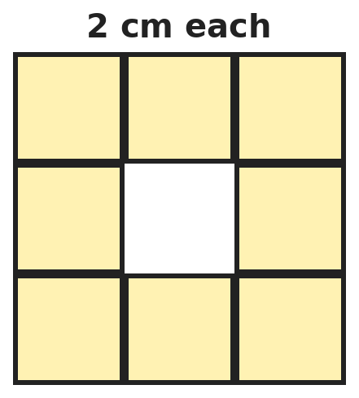
Q30. Nine squares of side 2 cm made a big square. The middle square was taken out. What is the length of the outside edge of the shape plus the edge of the hole? [Star]
(A) 24 cm | (B) 36 cm | (C) 32 cm | (D) 40 cm

Answer Sheet AMO Level 2 · Class 3 · Practice Paper 6
Name: | School: | Roll No.:
Shade or tick one circle for each question.
1. | Ⓐ Ⓑ Ⓒ Ⓓ | 11. | Ⓐ Ⓑ Ⓒ Ⓓ | 21. | Ⓐ Ⓑ Ⓒ Ⓓ
2. | Ⓐ Ⓑ Ⓒ Ⓓ | 12. | Ⓐ Ⓑ Ⓒ Ⓓ | 22. | Ⓐ Ⓑ Ⓒ Ⓓ
3. | Ⓐ Ⓑ Ⓒ Ⓓ | 13. | Ⓐ Ⓑ Ⓒ Ⓓ | 23. | Ⓐ Ⓑ Ⓒ Ⓓ
4. | Ⓐ Ⓑ Ⓒ Ⓓ | 14. | Ⓐ Ⓑ Ⓒ Ⓓ | 24. | Ⓐ Ⓑ Ⓒ Ⓓ
5. | Ⓐ Ⓑ Ⓒ Ⓓ | 15. | Ⓐ Ⓑ Ⓒ Ⓓ | 25. | Ⓐ Ⓑ Ⓒ Ⓓ
6. | Ⓐ Ⓑ Ⓒ Ⓓ | 16. | Ⓐ Ⓑ Ⓒ Ⓓ | 26. | Ⓐ Ⓑ Ⓒ Ⓓ
7. | Ⓐ Ⓑ Ⓒ Ⓓ | 17. | Ⓐ Ⓑ Ⓒ Ⓓ | 27. | Ⓐ Ⓑ Ⓒ Ⓓ
8. | Ⓐ Ⓑ Ⓒ Ⓓ | 18. | Ⓐ Ⓑ Ⓒ Ⓓ | 28. | Ⓐ Ⓑ Ⓒ Ⓓ
9. | Ⓐ Ⓑ Ⓒ Ⓓ | 19. | Ⓐ Ⓑ Ⓒ Ⓓ | 29. | Ⓐ Ⓑ Ⓒ Ⓓ
10. | Ⓐ Ⓑ Ⓒ Ⓓ | 20. | Ⓐ Ⓑ Ⓒ Ⓓ | 30. | Ⓐ Ⓑ Ⓒ Ⓓ
Q26–Q30 are Section II Star Questions. Each joins two chapters.
For the parent or teacher
Section I correct: ______ / 25 Section II correct: ______ / 5
Correct: ______ / 30
Answer Key and Solutions AMO Level 2 · Class 3 · Practice Paper 6
Quick answers
1 D | 6 A | 11 D | 16 B | 21 A | 26 A
2 A | 7 D | 12 A | 17 A | 22 C | 27 D
3 C | 8 B | 13 B | 18 C | 23 B | 28 A
4 D | 9 D | 14 D | 19 B | 24 B | 29 C
5 C | 10 C | 15 B | 20 B | 25 C | 30 C
Solutions
Q | Part · level | Answer | Why?
1 | Part 1 · Ch1 · Hard | (D) 9753 | Hint: Put the largest odd digit first.  Thousands: 9. Hundreds: 7. The largest odd digits left are 5 and 3, so tens 5 and ones 3: 9753. (9777 repeats 7.)
2 | Part 1 · Ch1 · Hard | (A) 3682 | Hint: The hundreds digit must go past 9.  3682 + 400 = 4082: the thousands digit changes from 3 to 4. 3582 + 400 = 3982, 3482 + 400 = 3882 and 3592 + 400 = 3992 all still start with 3.
3 | Part 1 · Ch1 · Hard | (C) 7 | Hint: Write 30 and 8 separately.  30 = XXX (3 symbols) and 8 = VIII (4 symbols). 38 = XXXVIII uses 3 + 4 = 7 symbols.
4 | Part 1 · Ch1 · Hard | (D) 6 | Hint: The first digit is 1, so the other three digits add up to 2.  The last three digits add up to 2: 002, 011, 020, 101, 110, 200. So 1002, 1011, 1020, 1101, 1110, 1200: 6 numbers.
5 | Part 2 · Ch2 · Hard | (C) 500 | Hint: Find the other number first.  The other number is 7250 − 3875 = 3375. The difference is 3875 − 3375 = 500.
6 | Part 2 · Ch2 · Hard | (A) 10 | Hint: Find the seats in one bus first.  One bus: 11 × 4 + 6 = 44 + 6 = 50 seats. Three buses: 150 seats. 160 − 150 = 10 children without a seat.
7 | Part 2 · Ch2 · Hard | (D) 285 cm | Hint: Find the length of one piece.  665 ÷ 7 = 95 cm. 3 pieces: 95 × 3 = 285 cm.
8 | Part 2 · Ch2 · Hard | (B) 35 | Hint: List the multiples of 7 between 20 and 40.  Multiples of 7: 21, 28, 35. In groups of 4: 21 leaves 1, 28 leaves 0, 35 leaves 3. So 35.
9 | Part 3 · Ch3 · Hard | (D) 1/10 | Hint: Twice 3/10 is 6/10.  Avni: 3/10. Tanya: 6/10. Given away: 9/10. Left: 10/10 − 9/10 = 1/10.
10 | Part 3 · Ch3 · Hard | (C) 5/8 of 16 | Hint: Find 1/8 of each number first.  5/8 of 16: 1/8 is 2, so 10. 3/8 of 24: 1/8 is 3, so 9. 7/8 of 8: 1/8 is 1, so 7. The largest is 5/8 of 16.
11 | Part 3 · Ch3 · Hard | (D) 5/8 | Hint: 4 wholes is 32/8.  4 whole pizzas = 4 × 8 = 32 eighths = 32/8. 32/8 − 27/8 = 5/8.
12 | Part 4 · Ch5 · Hard | (A) 4 | Hint: Look at the top and bottom, then the sides.  The top and bottom are 4 cm by 4 cm: squares. The 4 side faces are 4 cm by 7 cm: rectangles that are not squares. So 4.
13 | Part 4 · Ch5 · Hard | (B) 10 | Hint: The triangle has all three sides equal.  Kite: 1. Rectangle: 2. Triangle with equal sides: 3. Square: 4. Total 1 + 2 + 3 + 4 = 10.
14 | Part 4 · Ch5 · Hard | (D) 18 | Hint: Count rectangles 1 row tall, then 2 rows tall.  In one row there are 3 + 2 + 1 = 6 rectangles. 2 rows give 12. Rectangles 2 rows tall: another 6. Total 12 + 6 = 18.
15 | Part 5 · Ch6 · Hard | (B) 12 | Hint: Find the perimeter first. The posts go all the way round.  Perimeter: 4 × 9 = 36 m. Going round, there is one post every 3 m: 36 ÷ 3 = 12 posts. (16 counts each corner twice.)
16 | Part 5 · Ch6 · Hard | (B) 10 L 500 mL | Hint: First find one day in litres and millilitres.  One day: 6 × 250 = 1500 mL = 1 L 500 mL. A week: 7 L and 7 × 500 = 3500 mL. 7 L + 3 L 500 mL = 10 L 500 mL.
17 | Part 5 · Ch6 · Hard | (A) 18 cm | Hint: 1 m = 100 cm. Find the wire used by the square first.  The square uses 4 × 10 = 40 cm. Left: 100 − 40 = 60 cm. Taking off 6 cm spare leaves 54 cm for the triangle. Each side: 54 ÷ 3 = 18 cm.
18 | Part 6 · Ch9 · Hard | (C) 7:10 PM | Hint: Add one part at a time.  4:50 + 1 h 25 min = 6:15 PM. + 20 min = 6:35 PM. + 35 min = 7:10 PM.
19 | Part 6 · Ch9 · Hard | (B) Wednesday | Hint: How many days are there from 26 January to 26 February?  From 26 January to 26 February is 31 days. 31 = 4 weeks + 3 days. Sunday + 3 days = Wednesday.
20 | Part 6 · Ch9 · Hard | (B) ₹190 | Hint: A box is cheaper than 6 single pens (₹90).  2 boxes give 12 pens for ₹160, and 2 single pens cost ₹30: ₹190. Other ways cost more: 1 box + 8 pens = ₹200, 14 single pens = ₹210, 3 boxes = ₹240.
21 | Part 6 · Ch9 · Hard | (A) 2:20 AM | Hint: The time goes past midnight.  11:30 PM + 2 h = 1:30 AM. + 50 min = 2:20 AM the next day.
22 | Part 7 · Ch10 · Hard | (C) 129 | Hint: Double the number, then do one more small step.  5 × 2 − 1 = 9, 9 × 2 − 1 = 17, 17 × 2 − 1 = 33, 33 × 2 − 1 = 65. Next: 65 × 2 − 1 = 129.
23 | Part 7 · Ch10 · Hard | (B) 11 | Hint: Which number in the 9 times table ends in 4?  9 × 6 = 54 is the only product in the 9 times table that ends in 4. So A = 6, B = 5, and A + B = 11.
24 | Part 7 · Ch10 · Hard | (B) 18 | Hint: Before Om, half of his cards was 3.  Before Om: he gave half and 3 more and had 0, so half was 3 and he had 6. Before Neha: he gave half and 3 more and kept 6, so half was 6 + 3 = 9 and he had 18.
25 | Part 7 · Ch10 · Hard | (C) C, 8 kg | Hint: Adding all three pairs counts each box twice.  12 + 15 + 13 = 40 kg is each box counted twice, so A + B + C = 20 kg. C = 20 − 12 = 8 kg, A = 20 − 15 = 5 kg, B = 20 − 13 = 7 kg. C is the heaviest.
26 | Section II · Ch1 + Ch10 · Hard | (A) 1023 | Hint: Keep going: 63, 127, …  31, 63, 127, 255, 511, 1023. 511 is less than 1000 and 1023 is more. So 1023.
27 | Section II · Ch3 + Ch10 · Hard | (D) Day 5 | Hint: Each day and night together it goes up 2/10. Once it reaches the top, it stops.  After 3 days and nights it is at 6/10. On day 4 it climbs 3/10 to 9/10: not the top yet. That night it slips to 8/10. On day 5 it climbs to 11/10, past the top. So it reaches the top on day 5.
28 | Section II · Ch9 + Ch10 · Hard | (A) 6 | Hint: List the Saturdays and Sundays.  Saturdays: 2, 9, 16, 23, 30. The 1st and 3rd are the 2nd and 16th. Sundays: 3, 10, 17, 24. Closed days: 2 + 4 = 6.
29 | Section II · Ch1 + Ch9 · Hard | (C) 20 notes, ₹1 change | Hint: How many ₹500 notes make ₹10000?  19 notes make ₹9500, which is not enough. 20 notes make ₹10000. Change: 10000 − 9999 = ₹1.
30 | Section II · Ch5 + Ch6 · Hard | (C) 32 cm | Hint: Find the outside edge and the edge of the hole.  Outside: the big square has side 6 cm, so 4 × 6 = 24 cm. The hole is a square of side 2 cm: 8 cm. Total 24 + 8 = 32 cm.

ARYABHATTA MATHS OLYMPIAD
Level 2
PRACTICE PAPER-7
CLASS 3
Total Questions | 30 multiple-choice questions
Level | Level-2 (final round): every question is Hard
Time | 45 minutes
Section I | 25 questions, each from one chapter
Section II | 5 Star Questions, each joining two chapters
Negative Marking | No negative marking
Calculator | Not allowed
Chapters | Number System · Operations · Fractions · Geometry · Mensuration · Applied Mathematics · Mathematical Reasoning

👋 Hello, friend! How to do this paper:
⭐ Every question has four answer choices: (A), (B), (C) and (D). Only one is correct.
⭐ Read each question and look at its picture carefully. Then mark your answer on the answer sheet at the end.
⭐ This is a Level-2 paper. Every question needs careful thinking, so take your time and check each step.
⭐ Section I has 25 questions. Section II has 5 Star Questions.
⭐ There is no negative marking, so try every question.
⭐ Do not use a calculator. You may do rough work on a separate sheet.
⭐ All figures are not necessarily drawn to scale unless stated.

For parents and teachers
• Pictures are part of the questions. Every picture also works when printed in black and white.
• You may read a question aloud to the child, exactly as printed. Please do not explain it or point to an answer choice.
• Parts follow the AMO syllabus chapters. Chapters 4, 7 and 8 are not part of the Class 3 syllabus, so the chapter numbers shown in the Part headings have gaps.
• The answer sheet and the answer key are at the end. Remove only the answer key before the child begins.

SECTION I 25 questions · every question is Hard
Part 1 — Number System (Syllabus Chapter 1)
Q1. Amrita adds eight thousand eighty-eight and eight hundred eight. Which number does she get?
(A) 8968 | (B) 16168 | (C) 8896 | (D) 8986

Q2. What is the smallest number Nitin must add to 3847 to get a number whose four digits are all the same?
(A) 607 | (B) 597 | (C) 1597 | (D) 4444

Q3. Which of these is NOT a correct way to write a Roman numeral?
(A) XLV | (B) XXIV | (C) IL | (D) XXXIX

Q4. Rani counts on in 50s, starting from 1275. Which of these numbers will she NOT say?
(A) 2025 | (B) 2075 | (C) 2050 | (D) 1975

Part 2 — Operations (Syllabus Chapter 2)
Q5. A petrol pump had 9000 L of petrol. It sold 2785 L in the morning and 3460 L in the evening. Then a tanker added 1500 L. How much petrol is there now?
(A) 1255 L | (B) 2755 L | (C) 4355 L | (D) 4255 L

Q6. Pari buys 7 packs of 12 stickers. Later she buys 3 more packs of 12. She gives away 4 dozen stickers. How many stickers does she keep?
(A) 72 | (B) 120 | (C) 84 | (D) 108

Q7. Ruhi compares 336 ÷ 6 with 448 ÷ 8. What does she find?
(A) 336 ÷ 6 is larger | (B) 448 ÷ 8 is larger
(C) They are equal | (D) 448 ÷ 8 is double

Q8. When Atul divides a number by 9, he gets 7 with remainder 5. What is the remainder when he divides the same number by 6?
(A) 2 | (B) 5 | (C) 11 | (D) 4

Part 3 — Fractions (Syllabus Chapter 3)
Q9. There are two equal pizzas. Arjun eats 5/8 of one and Diya eats 7/8 of the other. How much pizza is left in all?
(A) 12/8 | (B) 4/8 | (C) 2/8 | (D) 4/16

Q10. In a class, 3/7 of the children chose blue, 2/7 chose black and the rest chose red. 12 children chose red. How many children are in the class?
(A) 84 | (B) 28 | (C) 36 | (D) 42

Q11. Which of these fractions is closest to 1 whole: 8/9, 11/9, 6/9, 12/9?
(A) 11/9 | (B) 8/9 | (C) 6/9 | (D) 12/9

Part 4 — Geometry (Syllabus Chapter 5)
Q12. A cube is painted on all faces. It is cut into 27 equal small cubes, 3 along each edge. How many small cubes have exactly 2 painted faces?
(A) 8 | (B) 6 | (C) 12 | (D) 24

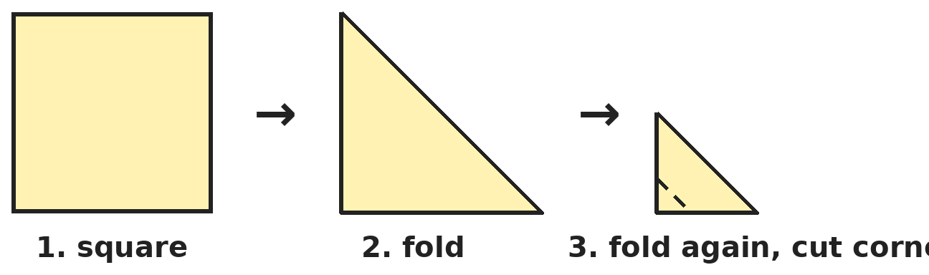
Q13. Pallavi folds a square paper corner to corner to make a triangle, then folds it in half again. She cuts off the square corner of the small triangle. How many holes does she see when she opens it?
(A) 1 | (B) 4 | (C) 2 | (D) 0

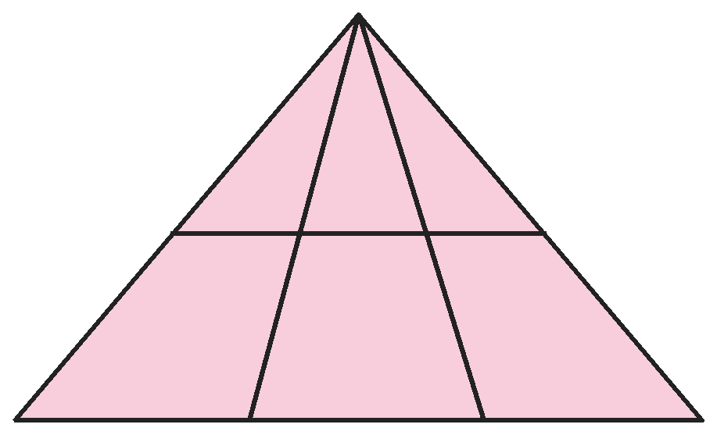
Q14. How many triangles of all sizes are in this picture?
(A) 6 | (B) 10 | (C) 12 | (D) 8

Part 5 — Mensuration (Syllabus Chapter 6)
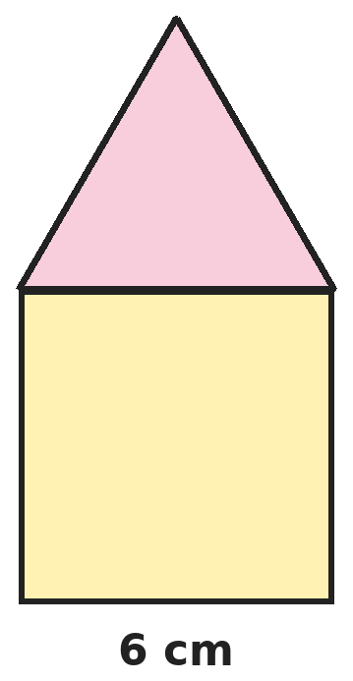
Q15. Jai draws a house: a square of side 6 cm with a triangle of equal sides on top. What is the perimeter of the house shape?
(A) 42 cm | (B) 36 cm | (C) 30 cm | (D) 24 cm

Q16. Which two of these lengths add up to exactly 2 km: 1 km 50 m, 950 m, 1 km 5 m, 1500 m?
(A) 1 km 5 m and 950 m | (B) 1500 m and 1 km 5 m
(C) 1 km 50 m and 1500 m | (D) 1 km 50 m and 950 m

Q17. On a balance, 4 equal books weigh the same as 6 equal notebooks. One notebook weighs 200 g. How much does one book weigh?
(A) 200 g | (B) 300 g | (C) 800 g | (D) 1200 g

Part 6 — Applied Mathematics (Syllabus Chapter 9)
Q18. A race started at 9:47 AM. Gaurav finished at 11:02 AM. How long did he take?
(A) 1 h 55 min | (B) 1 h 15 min | (C) 2 h 15 min | (D) 1 h 25 min

Q19. In a year when February has 28 days, what is the date 100 days after 1 January?
(A) 11 April | (B) 10 April | (C) 9 April | (D) 12 April

Q20. Mother buys 3 kg of rice at ₹48 per kg and 2 L of oil at ₹135 per litre. She pays with a ₹500 note. How much change does she get?
(A) ₹86 | (B) ₹96 | (C) ₹414 | (D) ₹186

Q21. Dhruv watches the hour hand of a clock move from 3 to 7. How many minutes have passed?
(A) 4 | (B) 20 | (C) 400 | (D) 240

Part 7 — Mathematical Reasoning (Syllabus Chapter 10)

Q22. Tanvi's pattern adds a little more each time. Which number comes next?
(A) 22 | (B) 23 | (C) 24 | (D) 25


Q23. Kavya hides the same digit in both boxes. Which digit did she hide?
(A) 6 | (B) 5 | (C) 3 | (D) 4

Q24. A magic tree doubles its apples every night. On the morning of day 6 it has 96 apples. How many did it have on the morning of day 1?
(A) 3 | (B) 6 | (C) 12 | (D) 16

Q25. Isha makes 3-digit numbers using only the digits 1, 2 and 3. A digit may be used more than once, like 113. How many numbers can she make?
(A) 6 | (B) 9 | (C) 18 | (D) 27

SECTION II — Star Questions 5 questions · each joins two chapters
Q26. Naina makes 4-digit numbers using each of 1, 2, 3 and 4 once. How many of them do NOT start with 1? [Star]
(A) 24 | (B) 6 | (C) 12 | (D) 18

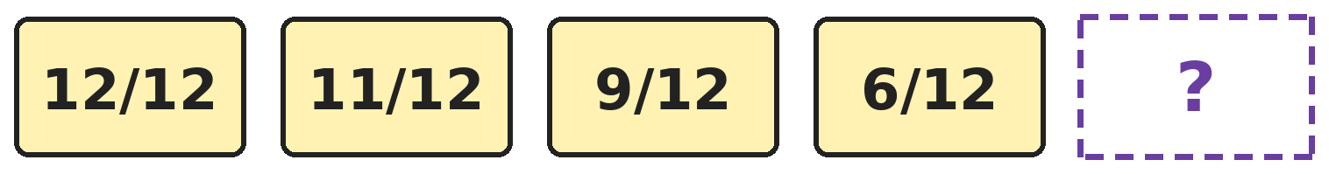
Q27. Sneha's fractions get smaller by a growing amount. Which fraction comes next? [Star]
(A) 3/12 | (B) 2/12 | (C) 1/12 | (D) 0/12

Q28. A clock shows 4 o'clock. What will it show exactly 100 hours later? [Star]
(A) 4 o'clock | (B) 2 o'clock | (C) 8 o'clock | (D) 12 o'clock

Q29. A shopkeeper has four ₹500 notes, seven ₹100 notes, nine ₹10 notes and six ₹1 coins. How much more does he need to have ₹3000? [Star]
(A) ₹204 | (B) ₹304 | (C) ₹2796 | (D) ₹214

Q30. Three cubes with 4 cm edges are joined in a row to make a cuboid. What is the total length of all the edges of the cuboid? [Star]
(A) 144 cm | (B) 48 cm | (C) 96 cm | (D) 80 cm

Answer Sheet AMO Level 2 · Class 3 · Practice Paper 7
Name: | School: | Roll No.:
Shade or tick one circle for each question.
1. | Ⓐ Ⓑ Ⓒ Ⓓ | 11. | Ⓐ Ⓑ Ⓒ Ⓓ | 21. | Ⓐ Ⓑ Ⓒ Ⓓ
2. | Ⓐ Ⓑ Ⓒ Ⓓ | 12. | Ⓐ Ⓑ Ⓒ Ⓓ | 22. | Ⓐ Ⓑ Ⓒ Ⓓ
3. | Ⓐ Ⓑ Ⓒ Ⓓ | 13. | Ⓐ Ⓑ Ⓒ Ⓓ | 23. | Ⓐ Ⓑ Ⓒ Ⓓ
4. | Ⓐ Ⓑ Ⓒ Ⓓ | 14. | Ⓐ Ⓑ Ⓒ Ⓓ | 24. | Ⓐ Ⓑ Ⓒ Ⓓ
5. | Ⓐ Ⓑ Ⓒ Ⓓ | 15. | Ⓐ Ⓑ Ⓒ Ⓓ | 25. | Ⓐ Ⓑ Ⓒ Ⓓ
6. | Ⓐ Ⓑ Ⓒ Ⓓ | 16. | Ⓐ Ⓑ Ⓒ Ⓓ | 26. | Ⓐ Ⓑ Ⓒ Ⓓ
7. | Ⓐ Ⓑ Ⓒ Ⓓ | 17. | Ⓐ Ⓑ Ⓒ Ⓓ | 27. | Ⓐ Ⓑ Ⓒ Ⓓ
8. | Ⓐ Ⓑ Ⓒ Ⓓ | 18. | Ⓐ Ⓑ Ⓒ Ⓓ | 28. | Ⓐ Ⓑ Ⓒ Ⓓ
9. | Ⓐ Ⓑ Ⓒ Ⓓ | 19. | Ⓐ Ⓑ Ⓒ Ⓓ | 29. | Ⓐ Ⓑ Ⓒ Ⓓ
10. | Ⓐ Ⓑ Ⓒ Ⓓ | 20. | Ⓐ Ⓑ Ⓒ Ⓓ | 30. | Ⓐ Ⓑ Ⓒ Ⓓ
Q26–Q30 are Section II Star Questions. Each joins two chapters.
For the parent or teacher
Section I correct: ______ / 25 Section II correct: ______ / 5
Correct: ______ / 30
Answer Key and Solutions AMO Level 2 · Class 3 · Practice Paper 7
Quick answers
1 C | 6 A | 11 B | 16 D | 21 D | 26 D
2 B | 7 C | 12 C | 17 B | 22 B | 27 B
3 C | 8 A | 13 A | 18 B | 23 A | 28 C
4 C | 9 B | 14 C | 19 A | 24 A | 29 A
5 D | 10 D | 15 C | 20 A | 25 D | 30 D
Solutions
Q | Part · level | Answer | Why?
1 | Part 1 · Ch1 · Hard | (C) 8896 | Hint: Write each number name in digits first.  Eight thousand eighty-eight = 8088. Eight hundred eight = 808. 8088 + 808 = 8896.
2 | Part 1 · Ch1 · Hard | (B) 597 | Hint: Find the next number after 3847 with all digits the same.  3333 is smaller than 3847, so the next one is 4444. 4444 − 3847 = 597.
3 | Part 1 · Ch1 · Hard | (C) IL | Hint: I can only come before V or X.  I may be put only before V or X. So IL is not allowed: 49 is written XLIX. XLV = 45, XXIV = 24 and XXXIX = 39 are correct.
4 | Part 1 · Ch1 · Hard | (C) 2050 | Hint: Look at the last two digits of the numbers she says.  She says 1275, 1325, 1375, 1425, … The last two digits are always 75 or 25. 2025, 2075 and 1975 fit, but 2050 ends in 50, so she never says it.
5 | Part 2 · Ch2 · Hard | (D) 4255 L | Hint: Find the total sold first.  Sold: 2785 + 3460 = 6245 L. Left: 9000 − 6245 = 2755 L. After the tanker: 2755 + 1500 = 4255 L.
6 | Part 2 · Ch2 · Hard | (A) 72 | Hint: 7 packs and 3 packs make 10 packs.  She buys 10 packs of 12 = 120 stickers. 4 dozen = 48. 120 − 48 = 72.
7 | Part 2 · Ch2 · Hard | (C) They are equal | Hint: Work out both divisions.  336 ÷ 6 = 56 and 448 ÷ 8 = 56. They are equal.
8 | Part 2 · Ch2 · Hard | (A) 2 | Hint: Find the number first: 9 × 7 + 5.  The number is 9 × 7 + 5 = 68. 68 ÷ 6 = 11 remainder 2.
9 | Part 3 · Ch3 · Hard | (B) 4/8 | Hint: Find what is left of each pizza.  Left from Arjun's pizza: 3/8. Left from Diya's: 1/8. Together 3/8 + 1/8 = 4/8 of a pizza.
10 | Part 3 · Ch3 · Hard | (D) 42 | Hint: What fraction chose red?  Red: 7/7 − 3/7 − 2/7 = 2/7. 2/7 is 12 children, so 1/7 is 6. The class has 7 × 6 = 42 children.
11 | Part 3 · Ch3 · Hard | (B) 8/9 | Hint: 1 whole is 9/9. How far is each one from 9/9?  8/9 is 1/9 away from 9/9. 11/9 is 2/9 away, 6/9 is 3/9 away and 12/9 is 3/9 away. The closest is 8/9.
12 | Part 4 · Ch5 · Hard | (C) 12 | Hint: The corner cubes have 3 painted faces. Look along the edges.  The 8 corner cubes have 3 painted faces. Each of the 12 edges of the big cube has 1 small cube between two corners, and it has exactly 2 painted faces. So 12.
13 | Part 4 · Ch5 · Hard | (A) 1 | Hint: Where in the big square is the square corner of the folded triangle?  The square corner of the folded triangle is the centre of the big square, where both folds cross. Cutting it makes one hole in the middle of the paper.
14 | Part 4 · Ch5 · Hard | (C) 12 | Hint: Each triangle has its top at the top corner and its bottom on the line across or on the bottom side.  Four lines leave the top corner. Any two of them make a triangle with a bottom side: 6 pairs. Each pair works with the line across and with the bottom side: 6 × 2 = 12.
15 | Part 5 · Ch6 · Hard | (C) 30 cm | Hint: The side shared by the square and the triangle is inside the shape.  Outside edges: 3 sides of the square and 2 sides of the triangle, all 6 cm. 5 × 6 = 30 cm. (42 cm wrongly counts the shared side twice.)
16 | Part 5 · Ch6 · Hard | (D) 1 km 50 m and 950 m | Hint: Change everything to metres: 2 km = 2000 m.  1 km 50 m = 1050 m and 1 km 5 m = 1005 m. 1050 + 950 = 2000 m = 2 km. The others: 1005 + 950 = 1955, 1500 + 1005 = 2505, 1050 + 1500 = 2550.
17 | Part 5 · Ch6 · Hard | (B) 300 g | Hint: Find the weight of 6 notebooks.  6 notebooks: 6 × 200 = 1200 g. So 4 books weigh 1200 g, and one book weighs 1200 ÷ 4 = 300 g.
18 | Part 6 · Ch9 · Hard | (B) 1 h 15 min | Hint: Go from 9:47 to 10:00 first.  9:47 to 10:00 is 13 minutes. 10:00 to 11:00 is 1 hour. 11:00 to 11:02 is 2 minutes. Total 1 h 15 min.
19 | Part 6 · Ch9 · Hard | (A) 11 April | Hint: 31 days after 1 January is 1 February.  1 February is 31 days after 1 January. 1 March is 31 + 28 = 59 days after. 1 April is 59 + 31 = 90 days after. 10 more days: 11 April.
20 | Part 6 · Ch9 · Hard | (A) ₹86 | Hint: Find the cost of rice and oil separately.  Rice: 48 × 3 = ₹144. Oil: 135 + 135 = ₹270. Total ₹414. Change: 500 − 414 = ₹86.
21 | Part 6 · Ch9 · Hard | (D) 240 | Hint: The hour hand moves from one number to the next in 1 hour.  From 3 to 7 is 4 hours. 4 × 60 = 240 minutes. (20 minutes would be the minute hand moving from 3 to 7.)
22 | Part 7 · Ch10 · Hard | (B) 23 | Hint: Find the differences.  She adds 1, 2, 3, 4, 5. Next she adds 6: 17 + 6 = 23.
23 | Part 7 · Ch10 · Hard | (A) 6 | Hint: The answer is a number in the thirties.  Only 5 × 6 = 30 and 6 × 6 = 36 are in the thirties. 6 × 6 = 36 has the same digit 6 in both boxes. 5 × 6 = 30 does not.
24 | Part 7 · Ch10 · Hard | (A) 3 | Hint: Halve the number for each night, going back.  From day 1 to day 6 there are 5 nights. Halve 96 five times: 48, 24, 12, 6, 3. So 3 apples.
25 | Part 7 · Ch10 · Hard | (D) 27 | Hint: Each of the three places can be 1, 2 or 3.  Hundreds: 3 choices. Tens: 3 choices. Ones: 3 choices. 3 × 3 × 3 = 27. (6 is the answer only if digits cannot repeat.)
26 | Section II · Ch1 + Ch10 · Hard | (D) 18 | Hint: Count all the numbers, then take away those that start with 1.  All numbers: 4 × 3 × 2 × 1 = 24. Starting with 1: the other three digits can be arranged in 6 ways. 24 − 6 = 18.
27 | Section II · Ch3 + Ch10 · Hard | (B) 2/12 | Hint: She takes away 1/12, then 2/12, then 3/12.  She takes away 1/12, 2/12 and 3/12. Next she takes away 4/12: 6/12 − 4/12 = 2/12.
28 | Section II · Ch9 + Ch10 · Hard | (C) 8 o'clock | Hint: Every 12 hours, the clock shows the same time again.  96 hours is 8 × 12 hours, so after 96 hours it shows 4 o'clock again. 4 more hours: 8 o'clock.
29 | Section II · Ch1 + Ch9 · Hard | (A) ₹204 | Hint: Add up his money first.  2000 + 700 + 90 + 6 = ₹2796. 3000 − 2796 = ₹204.
30 | Section II · Ch5 + Ch6 · Hard | (D) 80 cm | Hint: The cuboid is 12 cm long, 4 cm wide and 4 cm tall.  A cuboid has 4 edges of each length: 4 × 12 = 48, 4 × 4 = 16, 4 × 4 = 16. 48 + 16 + 16 = 80 cm. (144 cm adds the edges of the three separate cubes.)

ARYABHATTA MATHS OLYMPIAD
Level 2
PRACTICE PAPER-8
CLASS 3
Total Questions | 30 multiple-choice questions
Level | Level-2 (final round): every question is Hard
Time | 45 minutes
Section I | 25 questions, each from one chapter
Section II | 5 Star Questions, each joining two chapters
Negative Marking | No negative marking
Calculator | Not allowed
Chapters | Number System · Operations · Fractions · Geometry · Mensuration · Applied Mathematics · Mathematical Reasoning

👋 Hello, friend! How to do this paper:
⭐ Every question has four answer choices: (A), (B), (C) and (D). Only one is correct.
⭐ Read each question and look at its picture carefully. Then mark your answer on the answer sheet at the end.
⭐ This is a Level-2 paper. Every question needs careful thinking, so take your time and check each step.
⭐ Section I has 25 questions. Section II has 5 Star Questions.
⭐ There is no negative marking, so try every question.
⭐ Do not use a calculator. You may do rough work on a separate sheet.
⭐ All figures are not necessarily drawn to scale unless stated.

For parents and teachers
• Pictures are part of the questions. Every picture also works when printed in black and white.
• You may read a question aloud to the child, exactly as printed. Please do not explain it or point to an answer choice.
• Parts follow the AMO syllabus chapters. Chapters 4, 7 and 8 are not part of the Class 3 syllabus, so the chapter numbers shown in the Part headings have gaps.
• The answer sheet and the answer key are at the end. Remove only the answer key before the child begins.

SECTION I 25 questions · every question is Hard
Part 1 — Number System (Syllabus Chapter 1)
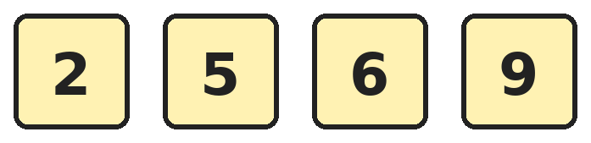
Q1. Prakash makes 4-digit numbers using each card once. How many of his numbers are odd and greater than 6000?
(A) 4 | (B) 6 | (C) 8 | (D) 12

Q2. How much less is 9000 + 70 + 4 than 9000 + 700 + 40?
(A) 676 | (B) 606 | (C) 666 | (D) 766

Q3. Which Roman numeral stands for the number exactly halfway between XXIV and XL?
(A) XXXIV | (B) XXVIII | (C) XXXI | (D) XXXII

Q4. Ayaan wants the smallest odd 4-digit number with all digits different and 3 in the hundreds place. What is it?
(A) 1301 | (B) 1035 | (C) 1307 | (D) 1305

Part 2 — Operations (Syllabus Chapter 2)
Q5. Farm A picked 3248 mangoes. Farm B picked 1567 fewer than Farm A. How many mangoes did the two farms pick together?
(A) 4815 | (B) 4929 | (C) 1681 | (D) 6496

Q6. One flower bed has 12 rows of 12 plants. Another has 11 rows of 11 plants. How many plants are there in the two beds?
(A) 264 | (B) 265 | (C) 46 | (D) 254

Q7. At a market, 783 mangoes are shared equally into 9 baskets. A shop sells 4 of the baskets. How many mangoes are in the baskets left?
(A) 348 | (B) 87 | (C) 435 | (D) 783

Q8. Between 30 and 50 children are at a show. In rows of 6, 5 are left over. In rows of 8, 7 are left over. How many children are there?
(A) 47 | (B) 23 | (C) 41 | (D) 35

Part 3 — Fractions (Syllabus Chapter 3)
Q9. Rohit reads 3/10 of a book on Monday and 4/10 on Tuesday. He has 45 pages left. How many pages are in the book?
(A) 150 | (B) 105 | (C) 450 | (D) 90

Q10. Gita adds four pairs of fractions. Which sum is NOT equal to 1 whole?
(A) 4/9 + 5/9 | (B) 7/12 + 5/12 | (C) 6/10 + 4/10 | (D) 3/8 + 4/8

Q11. Two equal jugs are 5/12 full and 9/12 full. Bhavna pours both into one empty jug of the same size. How much of a jug spills over?
(A) 14/12 | (B) 4/12 | (C) 2/12 | (D) None

Part 4 — Geometry (Syllabus Chapter 5)
Q12. How many more edges does a cube have than a square pyramid?
(A) 3 | (B) 4 | (C) 6 | (D) 0

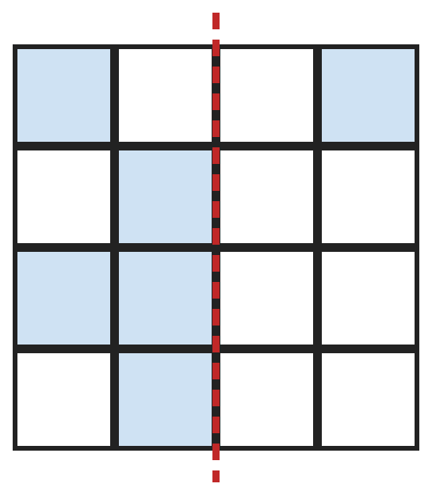
Q13. Yuvraj wants the dotted line to be a line of symmetry. How many more squares must he shade?
(A) 5 | (B) 3 | (C) 4 | (D) 8

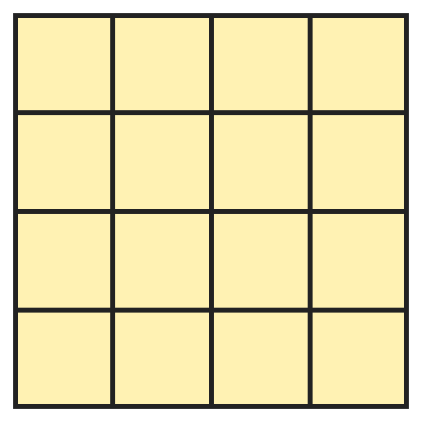
Q14. Harsh draws this 4 by 4 grid. How many squares of all sizes can he find in it?
(A) 16 | (B) 25 | (C) 20 | (D) 30

Part 5 — Mensuration (Syllabus Chapter 6)
Q15. A field is 25 m long and 15 m wide. Tushar walks round it twice and then once more along its length. How far does he walk?
(A) 185 m | (B) 160 m | (C) 200 m | (D) 105 m

Q16. A lift can carry at most 600 kg. 8 children of 35 kg each get in. How many adults of 70 kg each can still get in?
(A) 4 | (B) 5 | (C) 3 | (D) 8

Q17. A cooler holds 18 L of lemon water. Varun fills 75 cups of 200 mL each. How much lemon water is left in the cooler?
(A) 15 L | (B) 4 L | (C) 3 L | (D) 2 L

Part 6 — Applied Mathematics (Syllabus Chapter 9)
Q18. A shop is open from 9:30 AM to 1:15 PM and again from 4:00 PM to 8:45 PM. For how long is it open in all?
(A) 9 h 30 min | (B) 8 h | (C) 8 h 30 min | (D) 11 h 15 min

Q19. Myra's birthday is on 25 March. Today is 18 February, in a year when February has 28 days. In how many days is her birthday?
(A) 36 | (B) 37 | (C) 34 | (D) 35

Q20. Deepak has eight ₹10 coins and twelve ₹5 coins. He buys a ball for ₹95. He shares the money left equally among 3 friends. How much does each friend get?
(A) ₹15 | (B) ₹45 | (C) ₹20 | (D) ₹35

Q21. A bus leaves the stand every 25 minutes, starting at 6:10 AM. At which of these times does a bus leave?
(A) 8:10 AM | (B) 8:15 AM | (C) 8:20 AM | (D) 8:25 AM

Part 7 — Mathematical Reasoning (Syllabus Chapter 10)

Q22. Lavanya's pattern uses two rules in turn. Which number comes next?
(A) 324 | (B) 144 | (C) 210 | (D) 216


Q23. A and B are digits that add up to 7. What is the number AB?
(A) 34 | (B) 43 | (C) 25 | (D) 16

Q24. Kriti thinks of a number. She adds 15, divides by 4 and then takes away 2. She gets 5. What was her number?
(A) 28 | (B) 13 | (C) 43 | (D) 3

Q25. Four friends sit in a row. Siya sits at the left end. Ira is not at an end. Om sits next to Ira, on her right. Raj does not sit next to Siya. Where does Raj sit?
(A) At the right end | (B) Second from the left
(C) Third from the left | (D) Next to Ira

SECTION II — Star Questions 5 questions · each joins two chapters
Q26. How many 4-digit numbers have digits that add up to 35? [Star]
(A) 4 | (B) 1 | (C) 9 | (D) 36

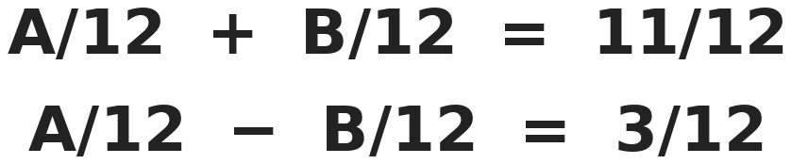
Q27. A and B are whole numbers. What is A? [Star]
(A) 4 | (B) 8 | (C) 7 | (D) 14

Q28. Amit goes to the library every 4 days and Bela every 6 days. Both went on 2 March. On what date will they next both go? [Star]
(A) 26 March | (B) 8 March | (C) 12 March | (D) 14 March

Q29. Shaurya pays ₹2345 using only ₹10 coins and ₹1 coins. He uses as few coins as he can. How many coins does he use? [Star]
(A) 2345 | (B) 234 | (C) 239 | (D) 245

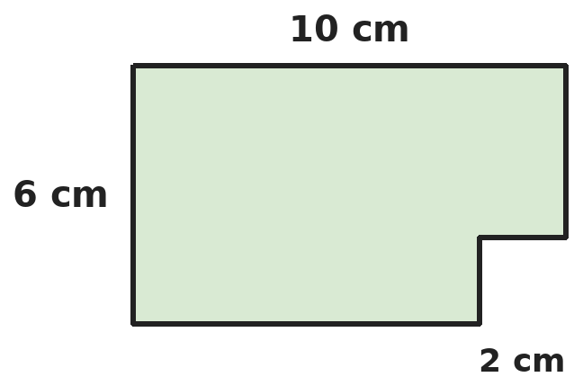
Q30. Kusum cuts a 2 cm square from one corner of a 10 cm by 6 cm rectangle. What is the perimeter of the shape that is left? [Star]
(A) 28 cm | (B) 32 cm | (C) 36 cm | (D) 30 cm

Answer Sheet AMO Level 2 · Class 3 · Practice Paper 8
Name: | School: | Roll No.:
Shade or tick one circle for each question.
1. | Ⓐ Ⓑ Ⓒ Ⓓ | 11. | Ⓐ Ⓑ Ⓒ Ⓓ | 21. | Ⓐ Ⓑ Ⓒ Ⓓ
2. | Ⓐ Ⓑ Ⓒ Ⓓ | 12. | Ⓐ Ⓑ Ⓒ Ⓓ | 22. | Ⓐ Ⓑ Ⓒ Ⓓ
3. | Ⓐ Ⓑ Ⓒ Ⓓ | 13. | Ⓐ Ⓑ Ⓒ Ⓓ | 23. | Ⓐ Ⓑ Ⓒ Ⓓ
4. | Ⓐ Ⓑ Ⓒ Ⓓ | 14. | Ⓐ Ⓑ Ⓒ Ⓓ | 24. | Ⓐ Ⓑ Ⓒ Ⓓ
5. | Ⓐ Ⓑ Ⓒ Ⓓ | 15. | Ⓐ Ⓑ Ⓒ Ⓓ | 25. | Ⓐ Ⓑ Ⓒ Ⓓ
6. | Ⓐ Ⓑ Ⓒ Ⓓ | 16. | Ⓐ Ⓑ Ⓒ Ⓓ | 26. | Ⓐ Ⓑ Ⓒ Ⓓ
7. | Ⓐ Ⓑ Ⓒ Ⓓ | 17. | Ⓐ Ⓑ Ⓒ Ⓓ | 27. | Ⓐ Ⓑ Ⓒ Ⓓ
8. | Ⓐ Ⓑ Ⓒ Ⓓ | 18. | Ⓐ Ⓑ Ⓒ Ⓓ | 28. | Ⓐ Ⓑ Ⓒ Ⓓ
9. | Ⓐ Ⓑ Ⓒ Ⓓ | 19. | Ⓐ Ⓑ Ⓒ Ⓓ | 29. | Ⓐ Ⓑ Ⓒ Ⓓ
10. | Ⓐ Ⓑ Ⓒ Ⓓ | 20. | Ⓐ Ⓑ Ⓒ Ⓓ | 30. | Ⓐ Ⓑ Ⓒ Ⓓ
Q26–Q30 are Section II Star Questions. Each joins two chapters.
For the parent or teacher
Section I correct: ______ / 25 Section II correct: ______ / 5
Correct: ______ / 30
Answer Key and Solutions AMO Level 2 · Class 3 · Practice Paper 8
Quick answers
1 B | 6 B | 11 C | 16 A | 21 B | 26 A
2 C | 7 C | 12 B | 17 C | 22 D | 27 C
3 D | 8 A | 13 C | 18 C | 23 A | 28 D
4 D | 9 A | 14 D | 19 D | 24 B | 29 C
5 B | 10 D | 15 A | 20 A | 25 A | 30 B
Solutions
Q | Part · level | Answer | Why?
1 | Part 1 · Ch1 · Hard | (B) 6 | Hint: The first digit is 6 or 9, and the last digit is 5 or 9.  First digit 6: last digit 5 or 9, and the other two digits can swap: 2 × 2 = 4 numbers. First digit 9: last digit must be 5, and the other two can swap: 2 numbers. Total 6.
2 | Part 1 · Ch1 · Hard | (C) 666 | Hint: Write each one as a number.  9000 + 70 + 4 = 9074. 9000 + 700 + 40 = 9740. 9740 − 9074 = 666.
3 | Part 1 · Ch1 · Hard | (D) XXXII | Hint: Change them to our numbers first.  XXIV = 24 and XL = 40. Halfway between 24 and 40 is 32 (24 + 8 = 32 = 40 − 8). 32 = XXXII.
4 | Part 1 · Ch1 · Hard | (D) 1305 | Hint: Start with 1 and 3, then use the smallest digits that are allowed.  Thousands 1, hundreds 3. Tens: smallest unused digit is 0. Ones must be odd and unused: 1 and 3 are used, so 5. The number is 1305. (1301 repeats 1.)
5 | Part 2 · Ch2 · Hard | (B) 4929 | Hint: Find Farm B first.  Farm B: 3248 − 1567 = 1681. Together: 3248 + 1681 = 4929.
6 | Part 2 · Ch2 · Hard | (B) 265 | Hint: Use the 12 and 11 times tables.  12 × 12 = 144. 11 × 11 = 121. 144 + 121 = 265.
7 | Part 2 · Ch2 · Hard | (C) 435 | Hint: Find the mangoes in one basket.  783 ÷ 9 = 87 in each basket. 9 − 4 = 5 baskets are left: 87 × 5 = 435.
8 | Part 2 · Ch2 · Hard | (A) 47 | Hint: One more child would fill every row of 6 and of 8.  With 1 more child, the number would fit rows of 6 and rows of 8 exactly: 24 or 48. So there are 23 or 47 children. Between 30 and 50: 47. Check: 47 = 6 × 7 + 5 and 47 = 8 × 5 + 7.
9 | Part 3 · Ch3 · Hard | (A) 150 | Hint: What fraction of the book is left?  Read: 3/10 + 4/10 = 7/10. Left: 3/10, which is 45 pages. 1/10 is 15 pages, so the book has 150 pages.
10 | Part 3 · Ch3 · Hard | (D) 3/8 + 4/8 | Hint: A sum is 1 whole when the top number equals the bottom number.  4/9 + 5/9 = 9/9, 7/12 + 5/12 = 12/12, 6/10 + 4/10 = 10/10: all 1 whole. 3/8 + 4/8 = 7/8, which is less than 1 whole.
11 | Part 3 · Ch3 · Hard | (C) 2/12 | Hint: One jug holds 12/12.  Together: 5/12 + 9/12 = 14/12. One jug holds 12/12, so 14/12 − 12/12 = 2/12 spills.
12 | Part 4 · Ch5 · Hard | (B) 4 | Hint: A square pyramid has 4 edges round its base and 4 going up to the tip.  A cube has 12 edges. A square pyramid has 4 + 4 = 8 edges. 12 − 8 = 4.
13 | Part 4 · Ch5 · Hard | (C) 4 | Hint: Each shaded square needs a shaded partner the same distance from the line on the other side.  Left side shaded squares: row 1 col 1, row 2 col 2, row 3 cols 1 and 2, row 4 col 2. Their partners on the right are: row 1 col 4 (already shaded), row 2 col 3, row 3 cols 3 and 4, row 4 col 3. So 4 more.
14 | Part 4 · Ch5 · Hard | (D) 30 | Hint: Count 1 by 1, 2 by 2, 3 by 3 and 4 by 4 squares.  1 by 1: 16. 2 by 2: 9. 3 by 3: 4. 4 by 4: 1. 16 + 9 + 4 + 1 = 30.
15 | Part 5 · Ch6 · Hard | (A) 185 m | Hint: Once round the field is its perimeter.  Once round: 25 + 15 + 25 + 15 = 80 m. Twice: 160 m. Plus one length: 160 + 25 = 185 m.
16 | Part 5 · Ch6 · Hard | (A) 4 | Hint: Find how much weight is left after the children.  Children: 35 × 8 = 280 kg. Left: 600 − 280 = 320 kg. 4 adults weigh 280 kg; 5 adults would weigh 350 kg, which is too much. So 4.
17 | Part 5 · Ch6 · Hard | (C) 3 L | Hint: How many 200 mL cups make 1 L?  1 L = 1000 mL = 5 cups of 200 mL. 75 cups = 75 ÷ 5 = 15 L. Left: 18 − 15 = 3 L.
18 | Part 6 · Ch9 · Hard | (C) 8 h 30 min | Hint: Find each part separately.  9:30 AM to 1:15 PM is 3 h 45 min. 4:00 PM to 8:45 PM is 4 h 45 min. Together 7 h 90 min = 8 h 30 min.
19 | Part 6 · Ch9 · Hard | (D) 35 | Hint: Count the days left in February first.  From 18 February to 28 February is 10 days. Then 25 more days to 25 March. 10 + 25 = 35 days.
20 | Part 6 · Ch9 · Hard | (A) ₹15 | Hint: Find his total money first.  8 × 10 = ₹80 and 12 × 5 = ₹60, total ₹140. After the ball: 140 − 95 = ₹45. Each friend: 45 ÷ 3 = ₹15.
21 | Part 6 · Ch9 · Hard | (B) 8:15 AM | Hint: List the times: 6:10, 6:35, …  6:10, 6:35, 7:00, 7:25, 7:50, 8:15, 8:40. So a bus leaves at 8:15 AM.
22 | Part 7 · Ch10 · Hard | (D) 216 | Hint: Look at 3 → 6 and then 6 → 18.  The rules are × 2, then × 3, in turn: 3 × 2 = 6, 6 × 3 = 18, 18 × 2 = 36, 36 × 3 = 108. Next: 108 × 2 = 216.
23 | Part 7 · Ch10 · Hard | (A) 34 | Hint: Adding 9 makes the tens digit go up by 1 and the ones digit go down by 1.  Adding 9 = adding 10 and taking 1. So B is 1 more than A. Two digits that add up to 7 and differ by 1: 3 and 4. AB = 34. Check: 34 + 9 = 43.
24 | Part 7 · Ch10 · Hard | (B) 13 | Hint: Undo the steps from the end.  Undo − 2: 5 + 2 = 7. Undo ÷ 4: 7 × 4 = 28. Undo + 15: 28 − 15 = 13.
25 | Part 7 · Ch10 · Hard | (A) At the right end | Hint: Ira must be second or third from the left. Try both.  If Ira were third, Om would be at the right end and Raj would be second, next to Siya: not allowed. So Ira is second and Om third. Raj sits at the right end.
26 | Section II · Ch1 + Ch10 · Hard | (A) 4 | Hint: The largest digit sum is 9 + 9 + 9 + 9 = 36.  35 is 1 less than 36, so three digits are 9 and one digit is 8. The 8 can be in any of the 4 places: 8999, 9899, 9989, 9998. So 4.
27 | Section II · Ch3 + Ch10 · Hard | (C) 7 | Hint: A + B = 11 and A − B = 3.  A + B = 11 and A − B = 3. Adding them: A + A = 14, so A = 7 (and B = 4). Check: 7/12 + 4/12 = 11/12 and 7/12 − 4/12 = 3/12.
28 | Section II · Ch9 + Ch10 · Hard | (D) 14 March | Hint: Find the first number that is in both the 4 and the 6 times tables.  Amit: 2, 6, 10, 14 March. Bela: 2, 8, 14 March. They meet again after 12 days, on 14 March.
29 | Section II · Ch1 + Ch9 · Hard | (C) 239 | Hint: How many tens are there in 2345?  2345 has 234 tens and 5 ones. He uses 234 coins of ₹10 and 5 coins of ₹1. 234 + 5 = 239 coins.
30 | Section II · Ch5 + Ch6 · Hard | (B) 32 cm | Hint: The two new edges of the cut replace two pieces of the old edges.  The rectangle had perimeter 10 + 6 + 10 + 6 = 32 cm. The cut takes away 2 cm from one side and 2 cm from the next side, but adds two new edges of 2 cm. So the perimeter is still 32 cm.

ARYABHATTA MATHS OLYMPIAD
Level 2
PRACTICE PAPER-9
CLASS 3
Total Questions | 30 multiple-choice questions
Level | Level-2 (final round): every question is Hard
Time | 45 minutes
Section I | 25 questions, each from one chapter
Section II | 5 Star Questions, each joining two chapters
Negative Marking | No negative marking
Calculator | Not allowed
Chapters | Number System · Operations · Fractions · Geometry · Mensuration · Applied Mathematics · Mathematical Reasoning

👋 Hello, friend! How to do this paper:
⭐ Every question has four answer choices: (A), (B), (C) and (D). Only one is correct.
⭐ Read each question and look at its picture carefully. Then mark your answer on the answer sheet at the end.
⭐ This is a Level-2 paper. Every question needs careful thinking, so take your time and check each step.
⭐ Section I has 25 questions. Section II has 5 Star Questions.
⭐ There is no negative marking, so try every question.
⭐ Do not use a calculator. You may do rough work on a separate sheet.
⭐ All figures are not necessarily drawn to scale unless stated.

For parents and teachers
• Pictures are part of the questions. Every picture also works when printed in black and white.
• You may read a question aloud to the child, exactly as printed. Please do not explain it or point to an answer choice.
• Parts follow the AMO syllabus chapters. Chapters 4, 7 and 8 are not part of the Class 3 syllabus, so the chapter numbers shown in the Part headings have gaps.
• The answer sheet and the answer key are at the end. Remove only the answer key before the child begins.

SECTION I 25 questions · every question is Hard
Part 1 — Number System (Syllabus Chapter 1)
Q1. Tejas writes every number from 1 to 1000. How many times does he write the digit 0?
(A) 189 | (B) 180 | (C) 300 | (D) 192

Q2. Sohan's number is in the 7000s. Its tens digit is 2 more than its hundreds digit. Its ones digit is the sum of its hundreds and tens digits. Its digits add up to 23. What is it?
(A) 7538 | (B) 7385 | (C) 7358 | (D) 7835

Q3. Which number from 1 to 50 needs the most symbols when written in Roman numerals?
(A) 38 | (B) 48 | (C) 28 | (D) 37

Q4. Kush starts at 405 and counts on in thousands: 405, 1405, 2405, … What is the 10th number he says?
(A) 10405 | (B) 9405 | (C) 9505 | (D) 8405

Part 2 — Operations (Syllabus Chapter 2)
Q5. At a two-day mela, 4575 tickets were sold on Saturday. That was 1250 more than on Sunday. How many tickets were sold on the two days?
(A) 10400 | (B) 5825 | (C) 7900 | (D) 3325

Q6. In a shop, 8 boxes of chocolates hold as many chocolates as 12 packs of 6. Every box has the same number. How many chocolates are in one box?
(A) 10 | (B) 6 | (C) 9 | (D) 8

Q7. A train has 9 coaches with the same number of seats, 648 seats in all. 5 coaches are full and the rest are empty. How many seats are empty?
(A) 288 | (B) 360 | (C) 72 | (D) 216

Q8. When Vinay divides 89 by a 1-digit number, he gets 12 with remainder 5. What number did he divide by?
(A) 7 | (B) 8 | (C) 6 | (D) 9

Part 3 — Fractions (Syllabus Chapter 3)
Q9. In a garden, 5/12 of the flowers are roses, 3/12 are lilies and the rest are marigolds. There are 16 more roses than lilies. How many marigolds are there?
(A) 16 | (B) 32 | (C) 96 | (D) 24

Q10. Navya picks the smallest and the largest of 3/11, 8/11, 5/11 and 10/11 and adds them. What does she get?
(A) 11/11 | (B) 13/11 | (C) 13/22 | (D) 15/11

Q11. The minute hand moves from 12 to 4 and then from 4 to 9. What fraction of a full turn must it still move to get back to 12?
(A) 3/12 | (B) 9/12 | (C) 5/12 | (D) 4/12

Part 4 — Geometry (Syllabus Chapter 5)
Q12. Gopal stacks 3 matchboxes on a table, one on top of another. How many faces of the boxes can be seen from all around and above?
(A) 18 | (B) 14 | (C) 13 | (D) 12

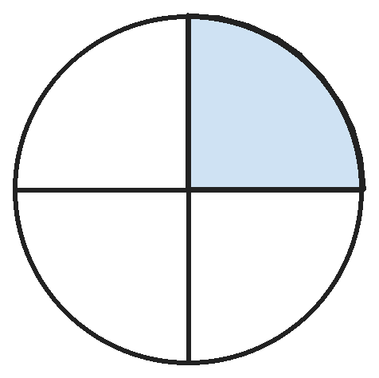
Q13. A circle is cut into 4 equal parts and one part is shaded. How many lines of symmetry does the whole picture have?
(A) 2 | (B) 1 | (C) 4 | (D) 0

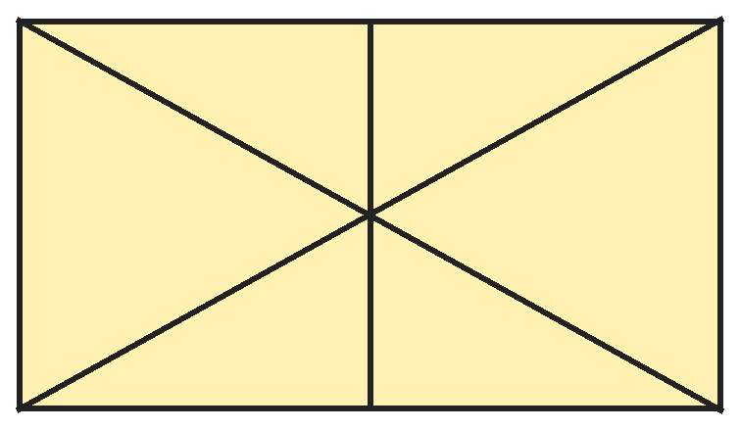
Q14. Sapna draws a rectangle, both corner-to-corner lines and a line down the middle. How many triangles are there?
(A) 10 | (B) 8 | (C) 12 | (D) 14

Part 5 — Mensuration (Syllabus Chapter 6)
Q15. A rectangle is 16 cm long and 4 cm wide. A square has the same perimeter. How long is a side of the square?
(A) 8 cm | (B) 20 cm | (C) 16 cm | (D) 10 cm

Q16. Nikhil's school bag with books weighs 3 kg 600 g. The books weigh 1 kg 850 g. How much does the empty bag weigh?
(A) 1 kg 750 g | (B) 2 kg 250 g | (C) 1 kg 850 g | (D) 5 kg 450 g

Q17. Sita walks from home to school (1 km 350 m), then to the park (875 m), then home (1 km 200 m). How far does she walk?
(A) 3 km 425 m | (B) 2 km 225 m | (C) 3 km 325 m | (D) 4 km 425 m

Part 6 — Applied Mathematics (Syllabus Chapter 9)
Q18. A cake needs 1 hour 50 minutes in the oven. It must be ready by 5:15 PM. What is the latest time Radha can put it in?
(A) 3:35 PM | (B) 4:25 PM | (C) 7:05 PM | (D) 3:25 PM

Q19. Ojasvi's cousin will visit 15 months after November. In which month will the cousin visit?
(A) February | (B) January | (C) March | (D) December

Q20. A football costs ₹275 and a bat costs ₹380. Raju has ₹500 and saves ₹45 every week. After how many weeks can he first buy both?
(A) 3 | (B) 5 | (C) 4 | (D) 15

Q21. A film is 135 minutes long. It starts at 7:50 PM. When does it end?
(A) 9:25 PM | (B) 9:05 PM | (C) 10:15 PM | (D) 10:05 PM

Part 7 — Mathematical Reasoning (Syllabus Chapter 10)

Q22. Each number in Siddharth's pattern comes from the one before by the same two steps. Which number is next?
(A) 120 | (B) 121 | (C) 160 | (D) 81

Q23. A and B are digits, and A is 2 more than B. What is the number ABA?
(A) 242 | (B) 535 | (C) 333 | (D) 424

Q24. Each day Meera spends half of her money and then ₹5 more. After two days she has ₹5 left. How much did she have at the start?
(A) ₹50 | (B) ₹40 | (C) ₹30 | (D) ₹60

Q25. How many 2-digit numbers have digits that multiply to give 12?
(A) 6 | (B) 2 | (C) 4 | (D) 3

SECTION II — Star Questions 5 questions · each joins two chapters
Q26. How many odd 4-digit numbers have digits that add up to 4? [Star]
(A) 6 | (B) 4 | (C) 7 | (D) 10

Q27. A candle is lit at 3 PM. Every hour, 2/12 of the whole candle burns away. At what time is only 2/12 of the candle left? [Star]
(A) 9 PM | (B) 5 PM | (C) 7 PM | (D) 8 PM

Q28. In one month, three Fridays fall on even dates. What day of the week is the 18th of that month? [Star]
(A) Saturday | (B) Friday | (C) Monday | (D) Sunday

Q29. A washing machine costs ₹8640. Ishita gives 17 notes of ₹500 and 1 note of ₹100. How many ₹10 notes must she add to pay exactly? [Star]
(A) 14 | (B) 4 | (C) 40 | (D) 3

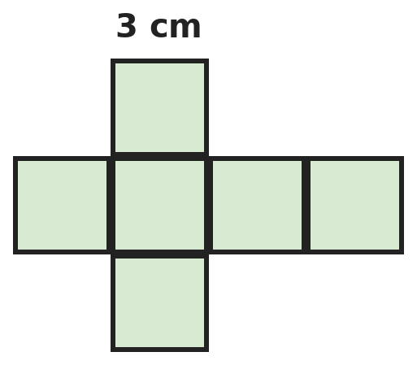
Q30. Mihir draws this cube net using squares of side 3 cm. What is the perimeter of the net? [Star]
(A) 72 cm | (B) 42 cm | (C) 36 cm | (D) 54 cm

Answer Sheet AMO Level 2 · Class 3 · Practice Paper 9
Name: | School: | Roll No.:
Shade or tick one circle for each question.
1. | Ⓐ Ⓑ Ⓒ Ⓓ | 11. | Ⓐ Ⓑ Ⓒ Ⓓ | 21. | Ⓐ Ⓑ Ⓒ Ⓓ
2. | Ⓐ Ⓑ Ⓒ Ⓓ | 12. | Ⓐ Ⓑ Ⓒ Ⓓ | 22. | Ⓐ Ⓑ Ⓒ Ⓓ
3. | Ⓐ Ⓑ Ⓒ Ⓓ | 13. | Ⓐ Ⓑ Ⓒ Ⓓ | 23. | Ⓐ Ⓑ Ⓒ Ⓓ
4. | Ⓐ Ⓑ Ⓒ Ⓓ | 14. | Ⓐ Ⓑ Ⓒ Ⓓ | 24. | Ⓐ Ⓑ Ⓒ Ⓓ
5. | Ⓐ Ⓑ Ⓒ Ⓓ | 15. | Ⓐ Ⓑ Ⓒ Ⓓ | 25. | Ⓐ Ⓑ Ⓒ Ⓓ
6. | Ⓐ Ⓑ Ⓒ Ⓓ | 16. | Ⓐ Ⓑ Ⓒ Ⓓ | 26. | Ⓐ Ⓑ Ⓒ Ⓓ
7. | Ⓐ Ⓑ Ⓒ Ⓓ | 17. | Ⓐ Ⓑ Ⓒ Ⓓ | 27. | Ⓐ Ⓑ Ⓒ Ⓓ
8. | Ⓐ Ⓑ Ⓒ Ⓓ | 18. | Ⓐ Ⓑ Ⓒ Ⓓ | 28. | Ⓐ Ⓑ Ⓒ Ⓓ
9. | Ⓐ Ⓑ Ⓒ Ⓓ | 19. | Ⓐ Ⓑ Ⓒ Ⓓ | 29. | Ⓐ Ⓑ Ⓒ Ⓓ
10. | Ⓐ Ⓑ Ⓒ Ⓓ | 20. | Ⓐ Ⓑ Ⓒ Ⓓ | 30. | Ⓐ Ⓑ Ⓒ Ⓓ
Q26–Q30 are Section II Star Questions. Each joins two chapters.
For the parent or teacher
Section I correct: ______ / 25 Section II correct: ______ / 5
Correct: ______ / 30
Answer Key and Solutions AMO Level 2 · Class 3 · Practice Paper 9
Quick answers
1 D | 6 C | 11 A | 16 A | 21 D | 26 C
2 C | 7 A | 12 C | 17 A | 22 B | 27 D
3 A | 8 A | 13 B | 18 D | 23 D | 28 D
4 B | 9 B | 14 C | 19 A | 24 A | 29 B
5 C | 10 B | 15 D | 20 C | 25 C | 30 B
Solutions
Q | Part · level | Answer | Why?
1 | Part 1 · Ch1 · Hard | (D) 192 | Hint: Count 10 to 99, then each hundred like 100 to 199, then 1000.  10, 20, …, 90: 9 zeros. In each hundred like 100–199: 100 has 2, 101–109 have 9, and 110, 120, …, 190 have 9, so 20. Nine hundreds: 180. 1000 has 3. Total 9 + 180 + 3 = 192.
2 | Part 1 · Ch1 · Hard | (C) 7358 | Hint: Try hundreds digits 1, 2, 3, … and check the total.  Hundreds 3 gives tens 5 and ones 3 + 5 = 8. Digit sum: 7 + 3 + 5 + 8 = 23. The number is 7358. (Hundreds 2 gives 7246 with sum 19; hundreds 4 gives ones 10, which is not a digit.)
3 | Part 1 · Ch1 · Hard | (A) 38 | Hint: Write each option in Roman numerals and count the symbols.  38 = XXXVIII (7 symbols). 48 = XLVIII (6), 28 = XXVIII (6), 37 = XXXVII (6). So 38.
4 | Part 1 · Ch1 · Hard | (B) 9405 | Hint: The 1st number is 405, so the 10th is 9 jumps later.  From the 1st to the 10th number there are 9 jumps of 1000. 405 + 9000 = 9405.
5 | Part 2 · Ch2 · Hard | (C) 7900 | Hint: Sunday sold fewer tickets than Saturday.  Sunday: 4575 − 1250 = 3325. Both days: 4575 + 3325 = 7900.
6 | Part 2 · Ch2 · Hard | (C) 9 | Hint: Work out 12 × 6 first.  12 × 6 = 72 chocolates. 72 ÷ 8 = 9 in each box.
7 | Part 2 · Ch2 · Hard | (A) 288 | Hint: Find the seats in one coach.  648 ÷ 9 = 72 seats per coach. Empty coaches: 9 − 5 = 4. 72 × 4 = 288 empty seats.
8 | Part 2 · Ch2 · Hard | (A) 7 | Hint: Take away the remainder first.  89 − 5 = 84. 84 ÷ 12 = 7, since 12 × 7 = 84. Check: 89 ÷ 7 = 12 remainder 5.
9 | Part 3 · Ch3 · Hard | (B) 32 | Hint: Roses are 2/12 more than lilies.  5/12 − 3/12 = 2/12 is 16 flowers, so 1/12 is 8. Marigolds: 12/12 − 5/12 − 3/12 = 4/12, which is 4 × 8 = 32.
10 | Part 3 · Ch3 · Hard | (B) 13/11 | Hint: Same bottom number, so compare the tops.  Smallest: 3/11. Largest: 10/11. 3/11 + 10/11 = 13/11. The bottom number stays 11.
11 | Part 3 · Ch3 · Hard | (A) 3/12 | Hint: A full turn passes 12 equal gaps between the numbers.  From 12 to 4 is 4/12 of a turn and from 4 to 9 is 5/12. Together 9/12. Still to go: 12/12 − 9/12 = 3/12.
12 | Part 4 · Ch5 · Hard | (C) 13 | Hint: Faces that touch another box or the table cannot be seen.  3 boxes have 3 × 6 = 18 faces. Each of the 2 places where boxes touch hides 2 faces: 4. The bottom face on the table is hidden: 1. 18 − 5 = 13 faces can be seen.
13 | Part 4 · Ch5 · Hard | (B) 1 | Hint: A fold must put the shaded part on top of itself.  A fold through the middle of the shaded part (from its point to the opposite side) puts the shaded part on itself and the other parts on each other. No other fold does, so there is 1 line of symmetry.
14 | Part 4 · Ch5 · Hard | (C) 12 | Hint: Count the 6 small triangles first.  Small triangles: 6. Triangles made of two small ones: the top one and the bottom one, so 2. Each corner-to-corner line cuts the rectangle into 2 big triangles: 4. 6 + 2 + 4 = 12.
15 | Part 5 · Ch6 · Hard | (D) 10 cm | Hint: Find the perimeter of the rectangle.  Rectangle: 16 + 4 + 16 + 4 = 40 cm. Square side: 40 ÷ 4 = 10 cm.
16 | Part 5 · Ch6 · Hard | (A) 1 kg 750 g | Hint: Change to grams: 3600 g and 1850 g.  3600 − 1850 = 1750 g = 1 kg 750 g.
17 | Part 5 · Ch6 · Hard | (A) 3 km 425 m | Hint: Change everything into metres.  1350 + 875 + 1200 = 3425 m = 3 km 425 m.
18 | Part 6 · Ch9 · Hard | (D) 3:25 PM | Hint: Count back from 5:15 PM.  1 hour before 5:15 PM is 4:15 PM. 50 minutes before 4:15 PM is 3:25 PM.
19 | Part 6 · Ch9 · Hard | (A) February | Hint: 12 months after November is November again.  12 months after November is November of the next year. 3 more months: December, January, February.
20 | Part 6 · Ch9 · Hard | (C) 4 | Hint: Find how much more money he needs.  Both cost 275 + 380 = ₹655. He needs 655 − 500 = ₹155 more. 3 weeks give ₹135, not enough. 4 weeks give ₹180, enough. So 4 weeks.
21 | Part 6 · Ch9 · Hard | (D) 10:05 PM | Hint: 135 minutes is 2 hours and some minutes.  135 minutes = 120 + 15 = 2 h 15 min. 7:50 PM + 2 h = 9:50 PM. + 15 min = 10:05 PM.
22 | Part 7 · Ch10 · Hard | (B) 121 | Hint: Multiply by 3, then …  1 × 3 + 1 = 4, 4 × 3 + 1 = 13, 13 × 3 + 1 = 40. Next: 40 × 3 + 1 = 121.
23 | Part 7 · Ch10 · Hard | (D) 424 | Hint: Every column adds A + B.  Each column is A + B = 6. A is 2 more than B, so A = 4 and B = 2. ABA = 424. Check: 424 + 242 = 666.
24 | Part 7 · Ch10 · Hard | (A) ₹50 | Hint: At the start of day 2, half her money was ₹5 + ₹5.  Day 2: after spending half, she had 5 + 5 = ₹10, so she started day 2 with ₹20. Day 1: after spending half, she had 20 + 5 = ₹25, so she started with ₹50.
25 | Part 7 · Ch10 · Hard | (C) 4 | Hint: Which pairs of digits multiply to 12?  12 = 2 × 6 = 3 × 4 (1 × 12 is not two digits). The numbers are 26, 62, 34 and 43. So 4.
26 | Section II · Ch1 + Ch10 · Hard | (C) 7 | Hint: The ones digit must be 1 or 3.  Ones digit 3: the other digits add to 1, so 1003. Ones digit 1: the first three digits add to 3, with the first not 0: 102, 111, 120, 201, 210, 300 give 1021, 1111, 1201, 2011, 2101, 3001. Total 1 + 6 = 7.
27 | Section II · Ch3 + Ch10 · Hard | (D) 8 PM | Hint: How much must burn away?  12/12 − 2/12 = 10/12 must burn. At 2/12 an hour, that takes 5 hours. 3 PM + 5 hours = 8 PM.
28 | Section II · Ch9 + Ch10 · Hard | (D) Sunday | Hint: Fridays are 7 days apart, so even and odd dates take turns.  Fridays go even, odd, even, odd, even. Three even Fridays need five Fridays starting on an even date: 2, 9, 16, 23, 30. So the 16th is a Friday and the 18th is a Sunday.
29 | Section II · Ch1 + Ch9 · Hard | (B) 4 | Hint: Find how much she has given so far.  2 notes of ₹500 make ₹1000, so 16 notes make ₹8000 and 17 notes make ₹8500. Plus ₹100 gives ₹8600. Still needed: 8640 − 8600 = ₹40, which is 4 notes of ₹10.
30 | Section II · Ch5 + Ch6 · Hard | (B) 42 cm | Hint: Count the square sides on the outside edge.  The row of 4 squares shows 3 sides on top, 3 on the bottom and 1 at each end: 8. The top and bottom squares show 3 sides each: 6. That is 14 sides, and 14 × 3 = 42 cm. (72 cm counts all 24 sides.)

ARYABHATTA MATHS OLYMPIAD
Level 2
PRACTICE PAPER-10
CLASS 3
Total Questions | 30 multiple-choice questions
Level | Level-2 (final round): every question is Hard
Time | 45 minutes
Section I | 25 questions, each from one chapter
Section II | 5 Star Questions, each joining two chapters
Negative Marking | No negative marking
Calculator | Not allowed
Chapters | Number System · Operations · Fractions · Geometry · Mensuration · Applied Mathematics · Mathematical Reasoning

👋 Hello, friend! How to do this paper:
⭐ Every question has four answer choices: (A), (B), (C) and (D). Only one is correct.
⭐ Read each question and look at its picture carefully. Then mark your answer on the answer sheet at the end.
⭐ This is a Level-2 paper. Every question needs careful thinking, so take your time and check each step.
⭐ Section I has 25 questions. Section II has 5 Star Questions.
⭐ There is no negative marking, so try every question.
⭐ Do not use a calculator. You may do rough work on a separate sheet.
⭐ All figures are not necessarily drawn to scale unless stated.

For parents and teachers
• Pictures are part of the questions. Every picture also works when printed in black and white.
• You may read a question aloud to the child, exactly as printed. Please do not explain it or point to an answer choice.
• Parts follow the AMO syllabus chapters. Chapters 4, 7 and 8 are not part of the Class 3 syllabus, so the chapter numbers shown in the Part headings have gaps.
• The answer sheet and the answer key are at the end. Remove only the answer key before the child begins.

SECTION I 25 questions · every question is Hard
Part 1 — Number System (Syllabus Chapter 1)
Q1. Reyansh wants the largest 4-digit number that has exactly two 0s and digits that add up to 10. What is it?
(A) 9010 | (B) 9001 | (C) 8200 | (D) 9100

Q2. In 2341, Isha multiplies the face value of 4 by its place value. What does she get?
(A) 160 | (B) 16 | (C) 44 | (D) 1600

Q3. Chapters in a book are numbered XIV, XIX, XXIV, … in a pattern. What is the next chapter number?
(A) XXIX | (B) XXXIV | (C) XXVIII | (D) XXXI

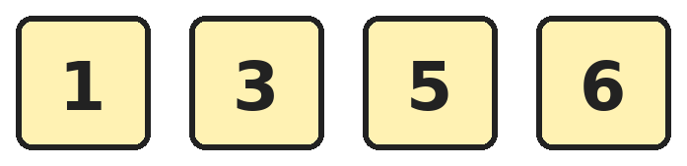
Q4. Hari makes 4-digit numbers using each card once. How many of them are even and greater than 3500?
(A) 2 | (B) 3 | (C) 6 | (D) 4

Part 2 — Operations (Syllabus Chapter 2)
Q5. Leena uses each of the digits 2, 5, 7 and 9 once to make two 2-digit numbers. What is the largest difference she can get between them?
(A) 70 | (B) 68 | (C) 74 | (D) 72

Q6. Both sides are equal. Which number goes in the box?
(A) 13 | (B) 12 | (C) 14 | (D) 52

Q7. Mohit works out four divisions. Which one has the largest answer?
(A) 816 ÷ 8 | (B) 954 ÷ 9 | (C) 609 ÷ 7 | (D) 624 ÷ 6

Q8. A 2-digit number leaves remainder 1 when divided by 2, by 3, by 4, by 5 and by 6. What is the number?
(A) 61 | (B) 31 | (C) 59 | (D) 41

Part 3 — Fractions (Syllabus Chapter 3)
Q9. Arjun has 36 pencils. He gives 2/9 of them to Om and 3/9 of them to Sita. How many more pencils does Sita get than Om?
(A) 12 | (B) 8 | (C) 4 | (D) 20

Q10. Rhea splits a day into 12 blocks of 2 hours. She is at school for 3 blocks, sleeps for 5 blocks and plays for 1 block. What fraction of the day is left?
(A) 9/12 | (B) 4/12 | (C) 3/12 | (D) 2/12

Q11. How many fractions with bottom number 10 are more than 3/10 and less than 9/10?
(A) 6 | (B) 7 | (C) 4 | (D) 5

Part 4 — Geometry (Syllabus Chapter 5)
Q12. Vani has 2 cubes, 1 cone, 3 cylinders and 1 cuboid. How many vertices (corners) do they have altogether?
(A) 24 | (B) 17 | (C) 25 | (D) 29

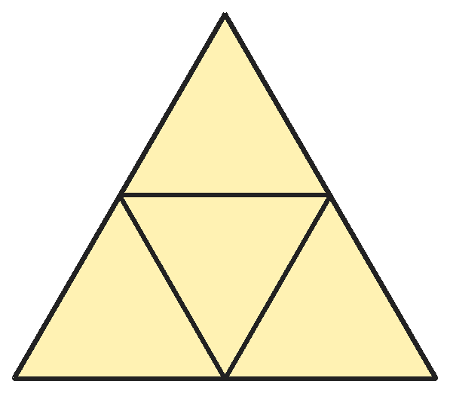
Q13. Advik folds this net of 4 equal triangles along the inside lines to make a closed solid. How many vertices (corners) does the solid have?
(A) 6 | (B) 3 | (C) 5 | (D) 4

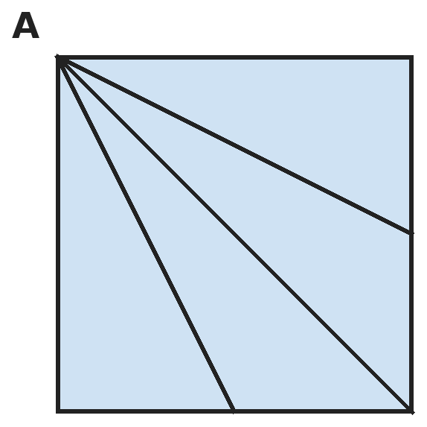
Q14. Three lines are drawn from corner A of a square: to the opposite corner and to the middles of the two far sides. How many triangles are there?
(A) 4 | (B) 5 | (C) 6 | (D) 8

Part 5 — Mensuration (Syllabus Chapter 6)
Q15. A photo is 12 cm long and 8 cm wide. It has a frame 2 cm wide all round it. What is the perimeter of the outside of the frame?
(A) 40 cm | (B) 48 cm | (C) 64 cm | (D) 56 cm

Q16. A bottle has 300 mL of syrup. Om takes 15 mL in the morning and 10 mL at night. For how many days does the bottle last?
(A) 20 | (B) 12 | (C) 10 | (D) 15

Q17. Sneha packs 5 kg of sugar. She fills 6 packets of 500 g, and puts the rest in 250 g packets. How many 250 g packets does she fill?
(A) 4 | (B) 10 | (C) 8 | (D) 12

Part 6 — Applied Mathematics (Syllabus Chapter 9)
Q18. Ravi leaves home at 7:35 AM and reaches school at 8:10 AM. School ends at 1:40 PM and he gets home at 2:15 PM. How long does he spend travelling?
(A) 35 min | (B) 1 h 35 min | (C) 1 h 10 min | (D) 6 h 40 min

Q19. Today is Wednesday. What day of the week will it be 50 days from today?
(A) Wednesday | (B) Friday | (C) Tuesday | (D) Thursday

Q20. A monthly bus pass costs ₹400. A single ticket costs ₹10. Ananya makes 2 trips a day on 22 school days. How much does she save with the pass?
(A) ₹440 | (B) ₹40 | (C) ₹400 | (D) ₹60

Q21. Jaya has a sand timer that runs for 3 minutes. She turns it over again each time it runs out. How many times must it run to measure 1 hour 12 minutes?
(A) 20 | (B) 36 | (C) 24 | (D) 4

Part 7 — Mathematical Reasoning (Syllabus Chapter 10)

Q22. Kiran's numbers go down in a pattern. Which number comes next?
(A) 5 | (B) 6 | (C) 4 | (D) 0

Q23. A and B are digits. A + B = 10 and A × B = 21. A is bigger than B. What is AB − BA?
(A) 46 | (B) 36 | (C) 40 | (D) 34

Q24. Raghav takes a number, doubles it, adds 6, halves the result and then takes away the number he started with. What can you say about his answer?
(A) It is always 6 | (B) It is the starting number
(C) It changes with the number | (D) It is always 3

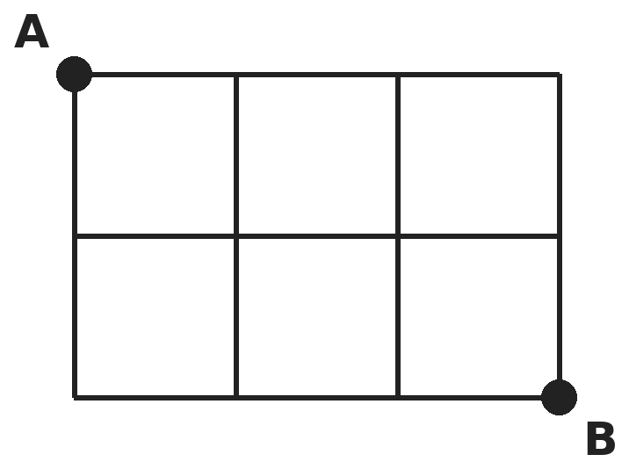
Q25. Sana walks along the lines from A to B, moving only right or down. How many different paths can she take?
(A) 6 | (B) 10 | (C) 5 | (D) 12

SECTION II — Star Questions 5 questions · each joins two chapters
Q26. Ved writes all the numbers from 1000 to 1100. How many times does he write the digit 1? [Star]
(A) 121 | (B) 112 | (C) 122 | (D) 101

Q27. Riya, Meena and Tara share a cake. Riya gets 3/12 of it. Meena gets twice as much as Riya. Tara gets the rest. Who gets the least, and how much? [Star]
(A) Riya and Tara, 3/12 each | (B) Tara, 2/12
(C) Riya, 3/12 only | (D) Meena, 6/12

Q28. A bus leaves every 40 minutes and a train every 60 minutes. Both leave at 6:00 AM. When do they next leave at the same time? [Star]
(A) 8:00 AM | (B) 7:00 AM | (C) 10:00 AM | (D) 6:40 AM

Q29. Neel has nine ₹500 notes, nine ₹100 notes, nine ₹10 notes and nine ₹1 coins. He wants a cycle that costs ₹5500. What is true? [Star]
(A) He has ₹1 extra | (B) He is ₹1 short
(C) He is ₹501 short | (D) He has exactly ₹5500

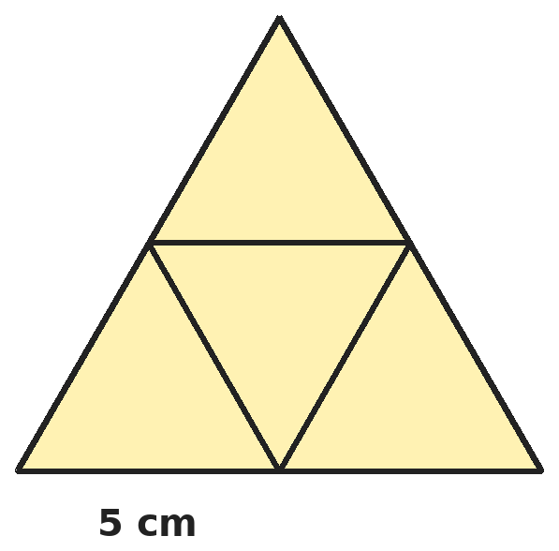
Q30. Four equal triangles, each with three sides of 5 cm, make this big triangle. What is the perimeter of the big triangle? [Star]
(A) 60 cm | (B) 30 cm | (C) 45 cm | (D) 20 cm

Answer Sheet AMO Level 2 · Class 3 · Practice Paper 10
Name: | School: | Roll No.:
Shade or tick one circle for each question.
1. | Ⓐ Ⓑ Ⓒ Ⓓ | 11. | Ⓐ Ⓑ Ⓒ Ⓓ | 21. | Ⓐ Ⓑ Ⓒ Ⓓ
2. | Ⓐ Ⓑ Ⓒ Ⓓ | 12. | Ⓐ Ⓑ Ⓒ Ⓓ | 22. | Ⓐ Ⓑ Ⓒ Ⓓ
3. | Ⓐ Ⓑ Ⓒ Ⓓ | 13. | Ⓐ Ⓑ Ⓒ Ⓓ | 23. | Ⓐ Ⓑ Ⓒ Ⓓ
4. | Ⓐ Ⓑ Ⓒ Ⓓ | 14. | Ⓐ Ⓑ Ⓒ Ⓓ | 24. | Ⓐ Ⓑ Ⓒ Ⓓ
5. | Ⓐ Ⓑ Ⓒ Ⓓ | 15. | Ⓐ Ⓑ Ⓒ Ⓓ | 25. | Ⓐ Ⓑ Ⓒ Ⓓ
6. | Ⓐ Ⓑ Ⓒ Ⓓ | 16. | Ⓐ Ⓑ Ⓒ Ⓓ | 26. | Ⓐ Ⓑ Ⓒ Ⓓ
7. | Ⓐ Ⓑ Ⓒ Ⓓ | 17. | Ⓐ Ⓑ Ⓒ Ⓓ | 27. | Ⓐ Ⓑ Ⓒ Ⓓ
8. | Ⓐ Ⓑ Ⓒ Ⓓ | 18. | Ⓐ Ⓑ Ⓒ Ⓓ | 28. | Ⓐ Ⓑ Ⓒ Ⓓ
9. | Ⓐ Ⓑ Ⓒ Ⓓ | 19. | Ⓐ Ⓑ Ⓒ Ⓓ | 29. | Ⓐ Ⓑ Ⓒ Ⓓ
10. | Ⓐ Ⓑ Ⓒ Ⓓ | 20. | Ⓐ Ⓑ Ⓒ Ⓓ | 30. | Ⓐ Ⓑ Ⓒ Ⓓ
Q26–Q30 are Section II Star Questions. Each joins two chapters.
For the parent or teacher
Section I correct: ______ / 25 Section II correct: ______ / 5
Correct: ______ / 30
Answer Key and Solutions AMO Level 2 · Class 3 · Practice Paper 10
Quick answers
1 D | 6 A | 11 D | 16 B | 21 C | 26 C
2 A | 7 B | 12 C | 17 C | 22 A | 27 A
3 A | 8 A | 13 D | 18 C | 23 B | 28 A
4 B | 9 C | 14 C | 19 D | 24 D | 29 B
5 D | 10 C | 15 D | 20 B | 25 B | 30 B
Solutions
Q | Part · level | Answer | Why?
1 | Part 1 · Ch1 · Hard | (D) 9100 | Hint: The two non-zero digits add up to 10. Put the larger one first.  The two non-zero digits add to 10. For the largest number, use 9 and 1 and put them in the two highest places: 9100.
2 | Part 1 · Ch1 · Hard | (A) 160 | Hint: The face value of 4 is 4. Its place value depends on where it is.  4 is in the tens place, so its place value is 40. Face value × place value = 4 × 40 = 160.
3 | Part 1 · Ch1 · Hard | (A) XXIX | Hint: Change them to our numbers to find the pattern.  XIV = 14, XIX = 19, XXIV = 24: the numbers go up by 5. Next is 29, which is XXIX.
4 | Part 1 · Ch1 · Hard | (B) 3 | Hint: An even number must end in 6.  The number ends in 6. Starting with 5: 5136 and 5316. Starting with 3: it must be more than 3500, so 3516 (3156 is too small). Starting with 1 is too small. Total 3.
5 | Part 2 · Ch2 · Hard | (D) 72 | Hint: Make one number as big as possible and the other as small as possible.  Largest number: 97. Smallest with the digits left: 25. 97 − 25 = 72.
6 | Part 2 · Ch2 · Hard | (A) 13 | Hint: Work out 7 × 8 and take away 4.  7 × 8 = 56. 56 − 4 = 52. 4 × 13 = 52, so the box is 13.
7 | Part 2 · Ch2 · Hard | (B) 954 ÷ 9 | Hint: Do each division.  954 ÷ 9 = 106. 816 ÷ 8 = 102. 609 ÷ 7 = 87. 624 ÷ 6 = 104. The largest is 954 ÷ 9.
8 | Part 2 · Ch2 · Hard | (A) 61 | Hint: Take away 1. The new number fits all five times tables.  The number minus 1 is in the 2, 3, 4, 5 and 6 times tables. The smallest such number is 60, and the next is 120, which is too big. So the number is 61.
9 | Part 3 · Ch3 · Hard | (C) 4 | Hint: First find 1/9 of 36.  1/9 of 36 is 4. Sita gets 1/9 more than Om, which is 4 pencils. (Om 8, Sita 12.)
10 | Part 3 · Ch3 · Hard | (C) 3/12 | Hint: The whole day is 12/12.  Used: 3/12 + 5/12 + 1/12 = 9/12. Left: 12/12 − 9/12 = 3/12.
11 | Part 3 · Ch3 · Hard | (D) 5 | Hint: Do not count 3/10 or 9/10.  They are 4/10, 5/10, 6/10, 7/10 and 8/10. That is 5.
12 | Part 4 · Ch5 · Hard | (C) 25 | Hint: A cone has 1 vertex, its pointed tip. A cylinder has none.  2 cubes: 8 + 8 = 16. Cone: 1. Cylinders: 0. Cuboid: 8. 16 + 1 + 0 + 8 = 25.
13 | Part 4 · Ch5 · Hard | (D) 4 | Hint: The three outer triangles fold up to meet at one point.  The middle triangle is the base. The three outer triangles fold up and meet at a tip. The solid has the 3 corners of the base and 1 tip: 4 vertices. (The 6 corners of the flat net join in pairs and threes.)
14 | Part 4 · Ch5 · Hard | (C) 6 | Hint: Every triangle has a corner at A. Its far side lies on the right side or the bottom side.  Lines from A meet the right side at 3 points (top corner, middle, bottom corner): 3 triangles. They meet the bottom side at 3 points (bottom-right corner, middle, bottom-left corner): 3 triangles. 3 + 3 = 6.
15 | Part 5 · Ch6 · Hard | (D) 56 cm | Hint: The frame adds 2 cm on both sides of each length.  Outside length: 2 + 12 + 2 = 16 cm. Outside width: 2 + 8 + 2 = 12 cm. Perimeter: 16 + 12 + 16 + 12 = 56 cm.
16 | Part 5 · Ch6 · Hard | (B) 12 | Hint: Find how much he takes each day.  Each day: 15 + 10 = 25 mL. 4 days use 100 mL, so 12 days use 300 mL. The bottle lasts 12 days.
17 | Part 5 · Ch6 · Hard | (C) 8 | Hint: 5 kg = 5000 g.  6 × 500 = 3000 g. Left: 5000 − 3000 = 2000 g. 4 packets of 250 g make 1000 g, so 2000 g fills 8 packets.
18 | Part 6 · Ch9 · Hard | (C) 1 h 10 min | Hint: Find each trip separately.  Going: 7:35 to 8:10 is 35 minutes. Coming back: 1:40 to 2:15 is 35 minutes. 35 + 35 = 70 minutes = 1 h 10 min.
19 | Part 6 · Ch9 · Hard | (D) Thursday | Hint: Every 7 days it is Wednesday again.  49 days is 7 weeks, so 49 days from today is a Wednesday. 50 days is one day more: Thursday.
20 | Part 6 · Ch9 · Hard | (B) ₹40 | Hint: Find the number of trips first.  Trips: 2 × 22 = 44. Tickets would cost 44 × 10 = ₹440. With the pass she saves 440 − 400 = ₹40.
21 | Part 6 · Ch9 · Hard | (C) 24 | Hint: Change 1 hour 12 minutes into minutes.  1 hour 12 minutes = 60 + 12 = 72 minutes. 72 ÷ 3 = 24.
22 | Part 7 · Ch10 · Hard | (A) 5 | Hint: Find how much is taken away each time.  He takes away 1, 2, 3, 4. Next he takes away 5: 10 − 5 = 5.
23 | Part 7 · Ch10 · Hard | (B) 36 | Hint: Which two digits multiply to 21?  21 = 3 × 7 and 3 + 7 = 10. A = 7, B = 3. AB − BA = 73 − 37 = 36.
24 | Part 7 · Ch10 · Hard | (D) It is always 3 | Hint: Try it with two different numbers, like 5 and 10.  With 5: 10, 16, 8, 8 − 5 = 3. With 10: 20, 26, 13, 13 − 10 = 3. Halving undoes the doubling, and half of the 6 is 3. So it is always 3.
25 | Part 7 · Ch10 · Hard | (B) 10 | Hint: Write down at each corner how many ways there are to reach it.  Each path has 3 steps right and 2 down, so 5 steps in all. Counting ways to reach each corner (adding the corner above and the corner to the left) gives 1, 1, 1, 1 on the top; 1, 2, 3, 4 in the middle; 1, 3, 6, 10 on the bottom. So 10 paths.
26 | Section II · Ch1 + Ch10 · Hard | (C) 122 | Hint: Count the 1s in each place separately.  Thousands place: all 101 numbers start with 1: 101. Hundreds place: only 1100: 1. Tens place: 1010 to 1019: 10. Ones place: 1001, 1011, …, 1091: 10. Total 101 + 1 + 10 + 10 = 122.
27 | Section II · Ch3 + Ch10 · Hard | (A) Riya and Tara, 3/12 each | Hint: Find Meena's share, then Tara's.  Meena: 6/12. Riya and Meena together: 9/12. Tara: 12/12 − 9/12 = 3/12. Riya and Tara both get 3/12, the least.
28 | Section II · Ch9 + Ch10 · Hard | (A) 8:00 AM | Hint: List the bus times and the train times.  Bus: 6:00, 6:40, 7:20, 8:00. Train: 6:00, 7:00, 8:00. They next leave together at 8:00 AM.
29 | Section II · Ch1 + Ch9 · Hard | (B) He is ₹1 short | Hint: Add up his money.  4500 + 900 + 90 + 9 = ₹5499. The cycle costs ₹5500, so he is ₹1 short.
30 | Section II · Ch5 + Ch6 · Hard | (B) 30 cm | Hint: Each side of the big triangle is made of two small sides.  Each side of the big triangle is 5 + 5 = 10 cm. Perimeter: 3 × 10 = 30 cm. (60 cm adds the sides of all four small triangles.)

