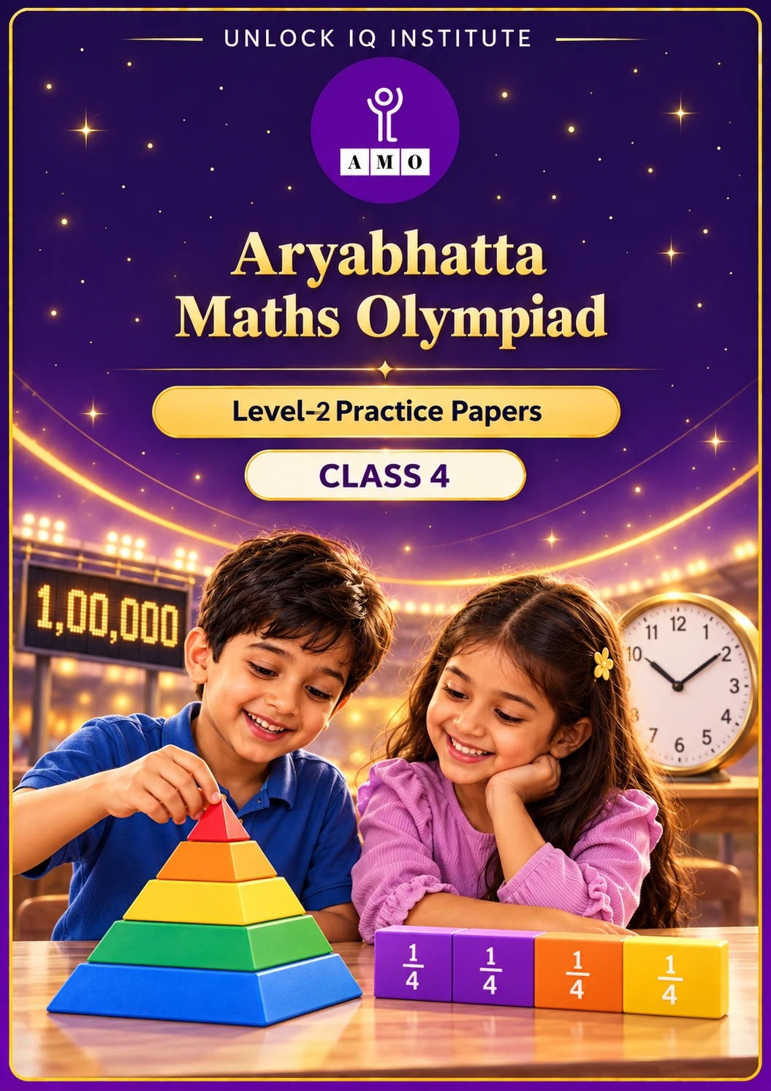
Set 1 · Practice Papers 1–5 · with answer keys & detailed solutions
Name: ____________________ | Class & Section: ________________
Roll No.: ________________ | School: ____________________
City: ____________________ | Date: ____________________

Published by Unlock IQ Institute Pvt. Ltd.
Register for Olympiads: www.aryabhattamathsolympiad.com/student-registration

ARYABHATTA MATHS OLYMPIAD
Level 2
PRACTICE PAPER-1
CLASS 4
Total Questions | 30 multiple-choice questions
Level | Level-2 (final round): every question is Hard
Time | 45 minutes
Section I | 25 questions, each from one chapter
Section II | 5 Star Questions, each joining two chapters
Negative Marking | No negative marking
Calculator | Not allowed
Chapters | Number System · Operations · Fractions & Decimals · Geometry · Mensuration · Data Handling · Applied Mathematics · Mathematical Reasoning

👋 Hello, friend! How to do this paper:
⭐ Every question has four answer choices: (A), (B), (C) and (D). Only one is correct.
⭐ Read each question and look at its picture carefully. Then mark your answer on the answer sheet at the end.
⭐ This is a Level-2 paper. Every question needs careful thinking, so take your time and check each step.
⭐ Section I has 25 questions. Section II has 5 Star Questions.
⭐ There is no negative marking, so try every question.
⭐ Do not use a calculator. You may do rough work on a separate sheet.
⭐ All figures are not necessarily drawn to scale unless stated.

For parents and teachers
• Pictures are part of the questions. Every picture also works when printed in black and white.
• You may read a question aloud to the child, exactly as printed. Please do not explain it or point to an answer choice.
• Parts follow the AMO syllabus chapters. Chapters 4 and 7 are not part of the Class 4 syllabus, so the chapter numbers shown in the Part headings have gaps.
• The answer sheet and the answer key are at the end. Remove only the answer key before the child begins.

SECTION I 25 questions · every question is Hard
Part 1 — Number System (Syllabus Chapter 1)
Q1. Kabir writes the smallest 5-digit number that has five different digits. Ira writes the largest 4-digit number that has four different digits. What is the difference between their numbers?
(A) 1 | (B) 358 | (C) 235 | (D) 2,469

Q2. Ayaan adds the Roman numerals XLIX and XXVI. Which Roman numeral is the answer?
(A) LXXIV | (B) LXV | (C) LXXXV | (D) LXXV

Q3. A palindrome reads the same forwards and backwards, like 23,432. How many palindromes are there between 40,000 and 41,000?
(A) 9 | (B) 11 | (C) 10 | (D) 100

Part 2 — Operations (Syllabus Chapter 2)
Q4. A hall has 48 rows with 36 chairs in each row. During a show, 129 chairs are empty and each of the other chairs has one person. How many people are sitting?
(A) 1,728 | (B) 1,599 | (C) 1,609 | (D) 1,857

Q5. Tanvi makes two 2-digit numbers using each of the digits 2, 3, 4 and 5 once. She multiplies them. What is the largest product she can get?
(A) 2,226 | (B) 1,728 | (C) 1,440 | (D) 2,236

Q6. When Kavya divides a number by 7, the remainder is 3. What is the remainder when she divides double that number by 7?
(A) 6 | (B) 3 | (C) 1 | (D) 0

Part 3 — Fractions & Decimals (Syllabus Chapter 3)
Q7. Rahul has ₹1,200. He spends 1/3 of it on books and 1/4 of it on clothes. How much money is left?
(A) ₹700 | (B) ₹600 | (C) ₹400 | (D) ₹500

Q8. Which of these fractions is the 2nd largest: 3/4, 5/8, 2/3, 7/12?
(A) 2/3 | (B) 5/8 | (C) 3/4 | (D) 7/12

Q9. Shruti has a ribbon 5.2 m long. She cuts off one piece of 1.8 m and another of 2.5 m. How long is the ribbon that is left?
(A) 1.9 m | (B) 4.3 m | (C) 0.9 m | (D) 1.1 m

Q10. Mohit reads for 1/4 of an hour and then draws for 1/3 of an hour. For how many minutes is he busy altogether?
(A) 35 minutes | (B) 25 minutes | (C) 40 minutes | (D) 7 minutes

Part 4 — Geometry (Syllabus Chapter 5)
Q11. Ritu glues a square pyramid onto one face of a cube. The square base of the pyramid fits the face exactly. How many edges does the new solid have?
(A) 20 | (B) 16 | (C) 17 | (D) 12

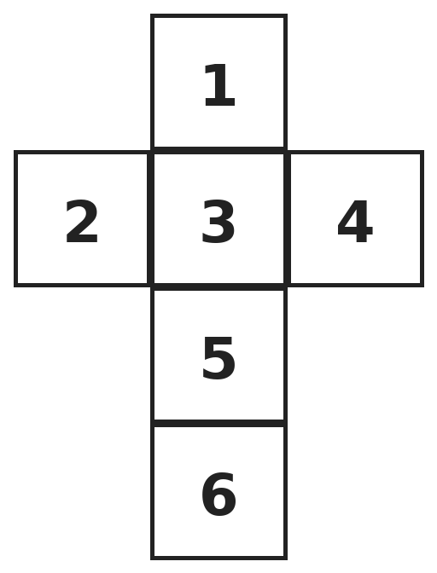
Q12. This net is folded to make a cube. Which number is on the face opposite the face with 3?
(A) 6 | (B) 1 | (C) 5 | (D) 2


Q13. Five points P, Q, R, S and T lie on a straight line. How many different line segments have both end points among these five points?
(A) 10 | (B) 4 | (C) 5 | (D) 20

Part 5 — Mensuration (Syllabus Chapter 6)
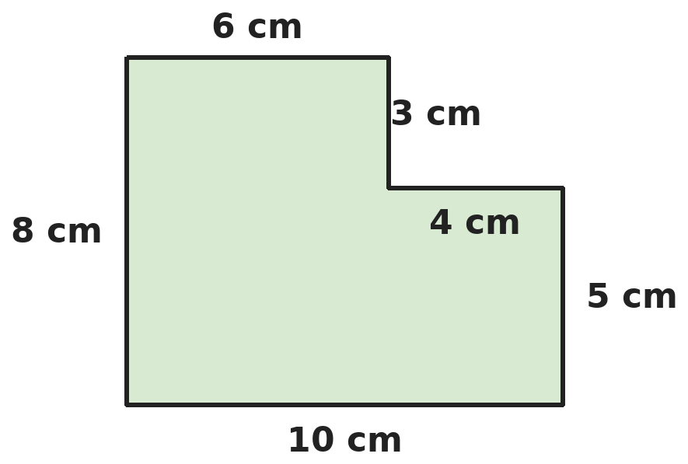
Q14. What is the area of this shape? All corners are square corners.
(A) 80 cm² | (B) 36 cm² | (C) 56 cm² | (D) 68 cm²

Q15. A garden is 20 m long and 15 m wide. A path 2 m wide runs all round the outside of the garden. What is the area of the path?
(A) 156 m² | (B) 140 m² | (C) 456 m² | (D) 70 m²

Q16. Lata bends a wire into a square with sides of 15 cm. She opens it and bends it into a rectangle 20 cm long. What is the area of the rectangle?
(A) 225 cm² | (B) 200 cm² | (C) 300 cm² | (D) 100 cm²

Q17. A jug holds 2 L of juice. Mitali pours 8 glasses with 175 mL in each. How much juice is left in the jug?
(A) 1 L 400 mL | (B) 400 mL | (C) 825 mL | (D) 600 mL

Part 6 — Data Handling (Syllabus Chapter 8)
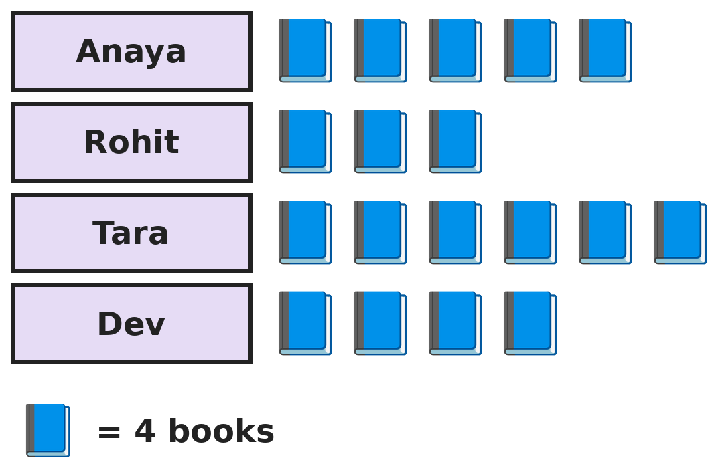
Q18. The pictograph shows the books four children read in a month. How many more books did Tara and Dev read together than Anaya and Rohit together?
(A) 2 | (B) 8 | (C) 16 | (D) 40

Part 7 — Applied Mathematics (Syllabus Chapter 9)
Q19. A train leaves at 10:48 PM. The journey takes 7 hours 35 minutes. At what time does the train arrive?
(A) 6:23 PM | (B) 5:23 AM | (C) 6:23 AM | (D) 6:13 AM

Q20. In a certain year, 5 March is a Sunday. What day of the week is 3 April in that year?
(A) Sunday | (B) Tuesday | (C) Saturday | (D) Monday

Q21. Arjun buys 3 shirts at ₹349 each and 2 trousers at ₹575 each. He pays with ₹2,500. How much change does he get?
(A) ₹303 | (B) ₹1,576 | (C) ₹403 | (D) ₹313

Part 8 — Mathematical Reasoning (Syllabus Chapter 10)

Q22. Look at how much is added each time. Which number comes next?
(A) 40 | (B) 36 | (C) 42 | (D) 44

Q23. A and B stand for digits in the 2-digit number AB. What is the number AB?
(A) 37 | (B) 57 | (C) 47 | (D) 41

Q24. A book has pages numbered 1 to 120. How many page numbers contain the digit 5 at least once?
(A) 22 | (B) 12 | (C) 20 | (D) 21

Q25. Neel thinks of a number. He multiplies it by 3, then subtracts 15, then divides by 4. He gets 30. What was his number?
(A) 35 | (B) 25 | (C) 135 | (D) 45

SECTION II — Star Questions 5 questions · each joins two chapters

Q26. The fractions go up by the same amount each time. Which fraction comes next? [Star]
(A) 1/2 | (B) 2/5 | (C) 5/12 | (D) 1/5

Q27. In a year that is not a leap year, 1 February falls on the same day of the week as the 1st of one of these months. Which month is it? [Star]
(A) January | (B) April | (C) March | (D) December

Q28. How many numbers from 1 to 100 are written with exactly two letters in Roman numerals? For example, 6 is VI. [Star]
(A) 9 | (B) 12 | (C) 10 | (D) 14

Q29. Lavanya practises the sitar for 3/4 of an hour on Monday and 2/3 of an hour on Tuesday. She wants 2 hours in all by Wednesday. She starts on Wednesday at 5:35 PM. When should she stop? [Star]
(A) 6:00 PM | (B) 6:20 PM | (C) 6:10 PM | (D) 7:35 PM

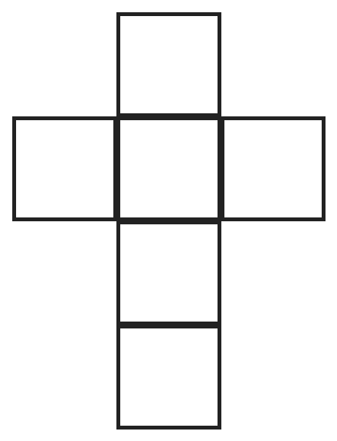
Q30. This net of a cube is made of 6 equal squares. Its area is 54 cm². What is the perimeter of the net? [Star]
(A) 36 cm | (B) 42 cm | (C) 54 cm | (D) 72 cm

Answer Sheet AMO Level 2 · Class 4 · Practice Paper 1
Name: | School: | Roll No.:
Shade or tick one circle for each question.
1. | Ⓐ Ⓑ Ⓒ Ⓓ | 11. | Ⓐ Ⓑ Ⓒ Ⓓ | 21. | Ⓐ Ⓑ Ⓒ Ⓓ
2. | Ⓐ Ⓑ Ⓒ Ⓓ | 12. | Ⓐ Ⓑ Ⓒ Ⓓ | 22. | Ⓐ Ⓑ Ⓒ Ⓓ
3. | Ⓐ Ⓑ Ⓒ Ⓓ | 13. | Ⓐ Ⓑ Ⓒ Ⓓ | 23. | Ⓐ Ⓑ Ⓒ Ⓓ
4. | Ⓐ Ⓑ Ⓒ Ⓓ | 14. | Ⓐ Ⓑ Ⓒ Ⓓ | 24. | Ⓐ Ⓑ Ⓒ Ⓓ
5. | Ⓐ Ⓑ Ⓒ Ⓓ | 15. | Ⓐ Ⓑ Ⓒ Ⓓ | 25. | Ⓐ Ⓑ Ⓒ Ⓓ
6. | Ⓐ Ⓑ Ⓒ Ⓓ | 16. | Ⓐ Ⓑ Ⓒ Ⓓ | 26. | Ⓐ Ⓑ Ⓒ Ⓓ
7. | Ⓐ Ⓑ Ⓒ Ⓓ | 17. | Ⓐ Ⓑ Ⓒ Ⓓ | 27. | Ⓐ Ⓑ Ⓒ Ⓓ
8. | Ⓐ Ⓑ Ⓒ Ⓓ | 18. | Ⓐ Ⓑ Ⓒ Ⓓ | 28. | Ⓐ Ⓑ Ⓒ Ⓓ
9. | Ⓐ Ⓑ Ⓒ Ⓓ | 19. | Ⓐ Ⓑ Ⓒ Ⓓ | 29. | Ⓐ Ⓑ Ⓒ Ⓓ
10. | Ⓐ Ⓑ Ⓒ Ⓓ | 20. | Ⓐ Ⓑ Ⓒ Ⓓ | 30. | Ⓐ Ⓑ Ⓒ Ⓓ
Q26–Q30 are Section II Star Questions. Each joins two chapters.
For the parent or teacher
Section I correct: ______ / 25 Section II correct: ______ / 5
Correct: ______ / 30
Answer Key and Solutions AMO Level 2 · Class 4 · Practice Paper 1
Quick answers
1 B | 6 A | 11 B | 16 B | 21 A | 26 C
2 D | 7 D | 12 A | 17 D | 22 C | 27 C
3 C | 8 A | 13 A | 18 B | 23 C | 28 B
4 B | 9 C | 14 D | 19 C | 24 D | 29 C
5 D | 10 A | 15 A | 20 D | 25 D | 30 B
Solutions
Q | Part · level | Answer | Why?
1 | Part 1 · Ch1 · Hard | (B) 358 | Hint: The smallest 5-digit number with different digits is not 10,000, and the largest 4-digit one is not 9,999.  Kabir's number is 10,234 (digits 1, 0, 2, 3, 4). Ira's number is 9,876. The difference is 10,234 − 9,876 = 358.
2 | Part 1 · Ch1 · Hard | (D) LXXV | Hint: Change both numerals into numbers first. XL is 40 and IX is 9.  XLIX = 40 + 9 = 49 and XXVI = 20 + 6 = 26. 49 + 26 = 75. 75 = 50 + 20 + 5 = LXXV.
3 | Part 1 · Ch1 · Hard | (C) 10 | Hint: The number must start with 4 and 0, so it must end with 0 and 4.  A palindrome between 40,000 and 41,000 looks like 4 0 _ 0 4. The middle digit can be 0 to 9: 40,004, 40,104, …, 40,904. That is 10 palindromes.
4 | Part 2 · Ch2 · Hard | (B) 1,599 | Hint: Find the total number of chairs first.  Chairs: 48 × 36 = 1,728. People: 1,728 − 129 = 1,599.
5 | Part 2 · Ch2 · Hard | (D) 2,236 | Hint: Put the two biggest digits in the tens places. Then try both ways of placing the other two.  The tens digits should be 5 and 4. Then 52 × 43 = 2,236 and 53 × 42 = 2,226. The largest product is 2,236.
6 | Part 2 · Ch2 · Hard | (A) 6 | Hint: Try a number such as 10, which leaves remainder 3 when divided by 7.  The number is some sevens plus 3. Doubling it gives some sevens plus 6, and 6 is less than 7. So the remainder is 6. Example: 10 = 7 + 3, and 20 = 14 + 6.
7 | Part 3 · Ch3 · Hard | (D) ₹500 | Hint: Find 1/3 of ₹1,200 and 1/4 of ₹1,200 separately.  1/3 of ₹1,200 is ₹400. 1/4 of ₹1,200 is ₹300. He spends ₹700, so ₹1,200 − ₹700 = ₹500 is left.
8 | Part 3 · Ch3 · Hard | (A) 2/3 | Hint: Change them all to twenty-fourths.  3/4 = 18/24, 5/8 = 15/24, 2/3 = 16/24 and 7/12 = 14/24. In order from largest: 3/4, 2/3, 5/8, 7/12. The 2nd largest is 2/3.
9 | Part 3 · Ch3 · Hard | (C) 0.9 m | Hint: Add the two pieces first.  The pieces cut off are 1.8 + 2.5 = 4.3 m. The ribbon left is 5.2 − 4.3 = 0.9 m.
10 | Part 3 · Ch3 · Hard | (A) 35 minutes | Hint: An hour has 60 minutes.  1/4 of 60 minutes is 15 minutes. 1/3 of 60 minutes is 20 minutes. 15 + 20 = 35 minutes.
11 | Part 4 · Ch5 · Hard | (B) 16 | Hint: The base edges of the pyramid are the same as the edges of the cube face.  The cube has 12 edges. The pyramid adds only its 4 slanting edges, because its 4 base edges lie on the cube's edges. 12 + 4 = 16. Check: faces 5 + 4 = 9, vertices 8 + 1 = 9, and 9 + 9 − 16 = 2.
12 | Part 4 · Ch5 · Hard | (A) 6 | Hint: In a straight line of squares, faces one square apart become opposite faces.  In the column 1, 3, 5, 6, faces with one square between them are opposite: 1 is opposite 5, and 3 is opposite 6. 2 and 4 are opposite each other.
13 | Part 4 · Ch5 · Hard | (A) 10 | Hint: Count the segments that start at P, then those that start at Q, and so on.  From P: PQ, PR, PS, PT (4). From Q: QR, QS, QT (3). From R: RS, RT (2). From S: ST (1). 4 + 3 + 2 + 1 = 10.
14 | Part 5 · Ch6 · Hard | (D) 68 cm² | Hint: Find the area of the full 10 cm by 8 cm rectangle, then take away the missing corner.  The full rectangle is 10 × 8 = 80 cm². The missing corner is 4 × 3 = 12 cm². The area is 80 − 12 = 68 cm².
15 | Part 5 · Ch6 · Hard | (A) 156 m² | Hint: The garden and the path together make a rectangle 24 m by 19 m.  Garden and path together: 24 × 19 = 456 m². Garden: 20 × 15 = 300 m². Path: 456 − 300 = 156 m².
16 | Part 5 · Ch6 · Hard | (B) 200 cm² | Hint: The length of the wire stays the same.  The wire is 4 × 15 = 60 cm long. The rectangle has length 20 cm, so 2 × 20 = 40 cm is used by the lengths and 20 cm is left for the two widths. Width = 10 cm. Area = 20 × 10 = 200 cm².
17 | Part 5 · Ch6 · Hard | (D) 600 mL | Hint: 1 L = 1,000 mL.  8 × 175 = 1,400 mL is poured. 2 L = 2,000 mL. 2,000 − 1,400 = 600 mL is left.
18 | Part 6 · Ch8 · Hard | (B) 8 | Hint: Compare the number of symbols first, then use the key.  Tara and Dev: 6 + 4 = 10 symbols. Anaya and Rohit: 5 + 3 = 8 symbols. The difference is 2 symbols, and each symbol is 4 books. 2 × 4 = 8 books.
19 | Part 7 · Ch9 · Hard | (C) 6:23 AM | Hint: Add the hours first, then the minutes. Remember that the time passes midnight.  10:48 PM + 7 hours = 5:48 AM. 5:48 + 35 minutes = 6:23 AM (12 minutes to 6:00, then 23 more).
20 | Part 7 · Ch9 · Hard | (D) Monday | Hint: March has 31 days. Count the days from 5 March to 3 April.  From 5 March to 31 March is 26 days, and 3 more days reach 3 April: 29 days in all. 29 = 4 weeks + 1 day. One day after Sunday is Monday.
21 | Part 7 · Ch9 · Hard | (A) ₹303 | Hint: Find the cost of the shirts and the trousers separately.  Shirts: 3 × 349 = ₹1,047. Trousers: 2 × 575 = ₹1,150. Total ₹2,197. Change: 2,500 − 2,197 = ₹303.
22 | Part 8 · Ch10 · Hard | (C) 42 | Hint: The amounts added are 4, 6, 8, …  The pattern adds 4, 6, 8 and 10. Next it adds 12: 30 + 12 = 42.
23 | Part 8 · Ch10 · Hard | (C) 47 | Hint: Three equal numbers add up to 141.  AB + AB + AB is 3 times AB. 141 ÷ 3 = 47. Check: 47 + 47 + 47 = 141. So A = 4 and B = 7.
24 | Part 8 · Ch10 · Hard | (D) 21 | Hint: Count numbers with 5 in the ones place, then 5 in the tens place. Do not count 55 twice.  5 in the ones place: 5, 15, 25, …, 115, which is 12 numbers. 5 in the tens place: 50 to 59, which is 10 numbers. 55 is in both lists. 12 + 10 − 1 = 21.
25 | Part 8 · Ch10 · Hard | (D) 45 | Hint: Work backwards and undo each step.  Undo ÷ 4: 30 × 4 = 120. Undo − 15: 120 + 15 = 135. Undo × 3: 135 ÷ 3 = 45.
26 | Section II · Ch3 + Ch10 · Hard | (C) 5/12 | Hint: Write every fraction as twelfths.  1/12, 2/12, 3/12, 4/12: each time 1/12 is added. Next is 5/12.
27 | Section II · Ch9 + Ch10 · Hard | (C) March | Hint: How many days does February have in such a year?  February has 28 days, which is exactly 4 weeks. So 1 March is the same day of the week as 1 February. January has 31 days, so 1 February is 3 days after 1 January. April and December do not match either.
28 | Section II · Ch1 + Ch10 · Hard | (B) 12 | Hint: Think of II, IV, VI, IX and then do the same with tens.  They are II (2), IV (4), VI (6), IX (9), XI (11), XV (15), XX (20), XL (40), LI (51), LV (55), LX (60) and XC (90). That is 12 numbers.
29 | Section II · Ch3 + Ch9 · Hard | (C) 6:10 PM | Hint: Change each fraction of an hour into minutes.  3/4 of an hour = 45 minutes and 2/3 of an hour = 40 minutes, so 85 minutes are done. 2 hours = 120 minutes, so she needs 35 more minutes. 5:35 PM + 35 minutes = 6:10 PM.
30 | Section II · Ch5 + Ch6 · Hard | (B) 42 cm | Hint: Find the area of one square, and then its side. Then count the outside edges of the net.  Each square has area 54 ÷ 6 = 9 cm², so its side is 3 cm. Going round the net there are 14 square edges. 14 × 3 = 42 cm.

ARYABHATTA MATHS OLYMPIAD
Level 2
PRACTICE PAPER-2
CLASS 4
Total Questions | 30 multiple-choice questions
Level | Level-2 (final round): every question is Hard
Time | 45 minutes
Section I | 25 questions, each from one chapter
Section II | 5 Star Questions, each joining two chapters
Negative Marking | No negative marking
Calculator | Not allowed
Chapters | Number System · Operations · Fractions & Decimals · Geometry · Mensuration · Data Handling · Applied Mathematics · Mathematical Reasoning

👋 Hello, friend! How to do this paper:
⭐ Every question has four answer choices: (A), (B), (C) and (D). Only one is correct.
⭐ Read each question and look at its picture carefully. Then mark your answer on the answer sheet at the end.
⭐ This is a Level-2 paper. Every question needs careful thinking, so take your time and check each step.
⭐ Section I has 25 questions. Section II has 5 Star Questions.
⭐ There is no negative marking, so try every question.
⭐ Do not use a calculator. You may do rough work on a separate sheet.
⭐ All figures are not necessarily drawn to scale unless stated.

For parents and teachers
• Pictures are part of the questions. Every picture also works when printed in black and white.
• You may read a question aloud to the child, exactly as printed. Please do not explain it or point to an answer choice.
• Parts follow the AMO syllabus chapters. Chapters 4 and 7 are not part of the Class 4 syllabus, so the chapter numbers shown in the Part headings have gaps.
• The answer sheet and the answer key are at the end. Remove only the answer key before the child begins.

SECTION I 25 questions · every question is Hard
Part 1 — Number System (Syllabus Chapter 1)
Q1. Which number is made of 4 ten-thousands, 15 hundreds and 23 ones?
(A) 45,123 | (B) 40,523 | (C) 41,523 | (D) 41,723

Q2. Nikhil uses each of the digits 3, 0, 8, 5 and 9 once to make a 5-digit number. What is the largest even number he can make?
(A) 98,503 | (B) 98,530 | (C) 98,350 | (D) 90,358

Q3. Which of these numbers needs the most letters when written in Roman numerals: 88, 79, 98, 100?
(A) 79 | (B) 98 | (C) 88 | (D) 100

Part 2 — Operations (Syllabus Chapter 2)
Q4. Isha must work out 25 × 37 × 4 × 2 without a calculator. She changes the order to make it easy. What is the answer?
(A) 7,400 | (B) 7,040 | (C) 3,700 | (D) 740

Q5. Two numbers that come one after the other multiply to give 2,256. What is their sum?
(A) 95 | (B) 94 | (C) 96 | (D) 97

Q6. What is the largest 3-digit number that leaves a remainder of 5 when divided by 9?
(A) 999 | (B) 995 | (C) 994 | (D) 986

Part 3 — Fractions & Decimals (Syllabus Chapter 3)
Q7. A water tank holds 120 L when full. It is 5/6 full. Then a quarter of a full tank of water is used. How many litres are left?
(A) 100 L | (B) 30 L | (C) 90 L | (D) 70 L

Q8. Four children work out 2/3 + 1/12. Three of them are right, even though their answers look different. Which answer is wrong?
(A) 3/4 | (B) 6/8 | (C) 8/12 | (D) 9/12

Q9. Yash can carry at most 6 kg. He is carrying bags of 2.5 kg, 1.7 kg and 0.8 kg. He picks up one more bag of 1.3 kg. By how much is he now over his limit?
(A) 1 kg | (B) 0.3 kg | (C) 1.3 kg | (D) 0.7 kg

Q10. Kush joins a rope 2 1/4 m long to a rope 1 2/3 m long, end to end. How long is the joined rope?
(A) 3 11/12 m | (B) 3 3/7 m | (C) 3 1/4 m | (D) 4 1/12 m

Part 4 — Geometry (Syllabus Chapter 5)
Q11. A pyramid has 8 edges. What is the number of its faces added to the number of its vertices?
(A) 9 | (B) 10 | (C) 8 | (D) 12

Q12. A big cube is made of 27 small cubes, 3 along each edge. The outside of the big cube is painted. How many small cubes have paint on exactly 2 faces?
(A) 8 | (B) 6 | (C) 24 | (D) 12

Q13. Sapna draws 4 straight lines on a page. No two lines are parallel. What is the largest number of points where two lines cross?
(A) 4 | (B) 6 | (C) 8 | (D) 3

Part 5 — Mensuration (Syllabus Chapter 6)
Q14. Two equal squares each have a perimeter of 48 cm. Gauri puts them side by side to make a rectangle. What is the perimeter of the rectangle?
(A) 72 cm | (B) 96 cm | (C) 84 cm | (D) 48 cm

Q15. A floor is 6 m long and 4 m wide. Square tiles with sides of 50 cm are laid on it with no gaps. How many tiles are needed?
(A) 24 | (B) 96 | (C) 48 | (D) 960

Q16. Om draws rectangles with a perimeter of 30 cm. The length and width are whole numbers of centimetres. What is the largest area he can get?
(A) 54 cm² | (B) 50 cm² | (C) 60 cm² | (D) 56 cm²

Q17. Four children run these distances: 2,050 m, 2 km 5 m, 2.1 km and 2,500 cm. Which distance is the longest?
(A) 2.1 km | (B) 2,050 m | (C) 2 km 5 m | (D) 2,500 cm

Part 6 — Data Handling (Syllabus Chapter 8)
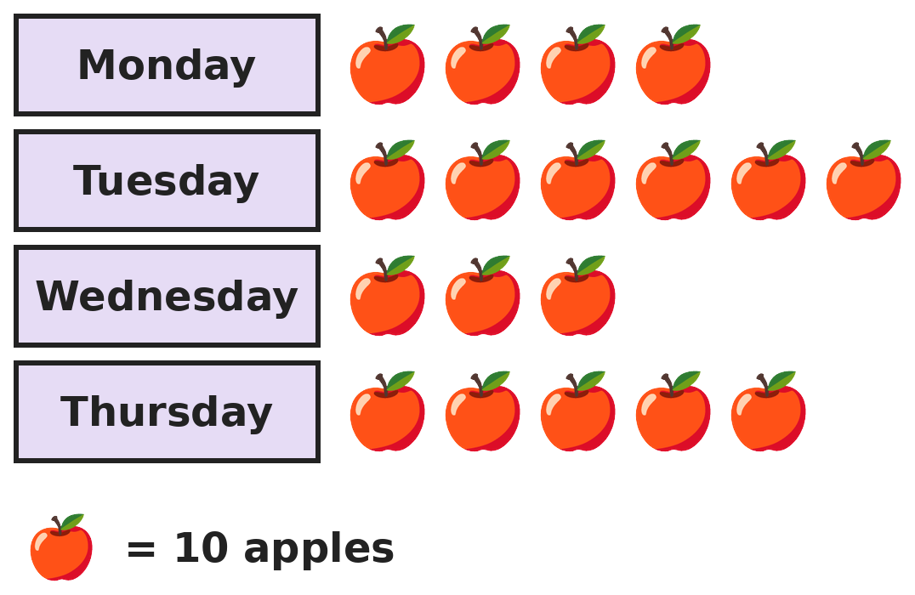
Q18. The pictograph shows apples sold at a fruit stall. Each apple costs ₹6. How much money did the stall get for apples on Tuesday and Thursday together?
(A) ₹110 | (B) ₹66 | (C) ₹660 | (D) ₹1,080

Part 7 — Applied Mathematics (Syllabus Chapter 9)
Q19. A film lasts 2 hours 45 minutes and ends at 6:10 PM. At what time did it start?
(A) 3:35 PM | (B) 4:25 PM | (C) 3:25 PM | (D) 8:55 PM

Q20. In a certain year, 15 August is a Tuesday. What day of the week is 2 October in the same year?
(A) Tuesday | (B) Wednesday | (C) Sunday | (D) Monday

Q21. A shop sells pens at ₹24 each with an offer: buy 2, get 1 free. Pooja needs exactly 10 pens. What is the least she must pay?
(A) ₹144 | (B) ₹240 | (C) ₹168 | (D) ₹192

Part 8 — Mathematical Reasoning (Syllabus Chapter 10)

Q22. Which number comes next in this series?
(A) 49 | (B) 64 | (C) 65 | (D) 66


Q23. A stands for the same digit in both numbers. Which digit is A?
(A) 9 | (B) 8 | (C) 7 | (D) 4

Q24. Six friends meet. Each friend shakes hands once with every other friend. How many handshakes are there?
(A) 30 | (B) 36 | (C) 12 | (D) 15

Q25. Leena makes 3-digit numbers using only the digits 1, 2 and 3. A digit may be used more than once. How many of her numbers have digits that add up to 6?
(A) 7 | (B) 6 | (C) 3 | (D) 9

SECTION II — Star Questions 5 questions · each joins two chapters
Q26. Sneha eats 1/2 of her chocolates. Then she eats 1/3 of the chocolates that are left. Now she has 10 chocolates. How many did she have at the start? [Star]
(A) 30 | (B) 60 | (C) 20 | (D) 45

Q27. Today is Tuesday. What day of the week will it be 1,000 days from today? [Star]
(A) Wednesday | (B) Sunday | (C) Tuesday | (D) Monday

Q28. Siddharth counts back from 1,00,000 in steps of 12,500: 1,00,000, 87,500, 75,000, … What is the 8th number he says? [Star]
(A) 0 | (B) 25,000 | (C) 12,500 | (D) 1,000

Q29. Ruhi gets ₹360 every month. She spends 1/4 of it in the first week and 1/3 of it in the second week, and saves the rest. In how many months will she save ₹1,050? [Star]
(A) 5 months | (B) 6 months | (C) 8 months | (D) 7 months

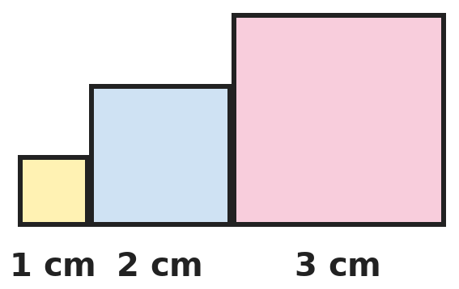
Q30. Squares with sides 1 cm, 2 cm and 3 cm stand side by side on a line. What is the perimeter of the whole shape? [Star]
(A) 24 cm | (B) 18 cm | (C) 20 cm | (D) 22 cm

Answer Sheet AMO Level 2 · Class 4 · Practice Paper 2
Name: | School: | Roll No.:
Shade or tick one circle for each question.
1. | Ⓐ Ⓑ Ⓒ Ⓓ | 11. | Ⓐ Ⓑ Ⓒ Ⓓ | 21. | Ⓐ Ⓑ Ⓒ Ⓓ
2. | Ⓐ Ⓑ Ⓒ Ⓓ | 12. | Ⓐ Ⓑ Ⓒ Ⓓ | 22. | Ⓐ Ⓑ Ⓒ Ⓓ
3. | Ⓐ Ⓑ Ⓒ Ⓓ | 13. | Ⓐ Ⓑ Ⓒ Ⓓ | 23. | Ⓐ Ⓑ Ⓒ Ⓓ
4. | Ⓐ Ⓑ Ⓒ Ⓓ | 14. | Ⓐ Ⓑ Ⓒ Ⓓ | 24. | Ⓐ Ⓑ Ⓒ Ⓓ
5. | Ⓐ Ⓑ Ⓒ Ⓓ | 15. | Ⓐ Ⓑ Ⓒ Ⓓ | 25. | Ⓐ Ⓑ Ⓒ Ⓓ
6. | Ⓐ Ⓑ Ⓒ Ⓓ | 16. | Ⓐ Ⓑ Ⓒ Ⓓ | 26. | Ⓐ Ⓑ Ⓒ Ⓓ
7. | Ⓐ Ⓑ Ⓒ Ⓓ | 17. | Ⓐ Ⓑ Ⓒ Ⓓ | 27. | Ⓐ Ⓑ Ⓒ Ⓓ
8. | Ⓐ Ⓑ Ⓒ Ⓓ | 18. | Ⓐ Ⓑ Ⓒ Ⓓ | 28. | Ⓐ Ⓑ Ⓒ Ⓓ
9. | Ⓐ Ⓑ Ⓒ Ⓓ | 19. | Ⓐ Ⓑ Ⓒ Ⓓ | 29. | Ⓐ Ⓑ Ⓒ Ⓓ
10. | Ⓐ Ⓑ Ⓒ Ⓓ | 20. | Ⓐ Ⓑ Ⓒ Ⓓ | 30. | Ⓐ Ⓑ Ⓒ Ⓓ
Q26–Q30 are Section II Star Questions. Each joins two chapters.
For the parent or teacher
Section I correct: ______ / 25 Section II correct: ______ / 5
Correct: ______ / 30
Answer Key and Solutions AMO Level 2 · Class 4 · Practice Paper 2
Quick answers
1 C | 6 B | 11 B | 16 D | 21 C | 26 A
2 B | 7 D | 12 D | 17 A | 22 C | 27 D
3 C | 8 C | 13 B | 18 C | 23 B | 28 C
4 A | 9 B | 14 A | 19 C | 24 D | 29 D
5 A | 10 A | 15 B | 20 D | 25 A | 30 B
Solutions
Q | Part · level | Answer | Why?
1 | Part 1 · Ch1 · Hard | (C) 41,523 | Hint: 15 hundreds is 1 thousand and 5 hundreds.  4 ten-thousands = 40,000. 15 hundreds = 1,500. 23 ones = 23. 40,000 + 1,500 + 23 = 41,523.
2 | Part 1 · Ch1 · Hard | (B) 98,530 | Hint: An even number must end in 0 or 8. Try both and compare.  Ending in 0, the largest is 98,530. Ending in 8, the largest is 95,308. 98,530 is larger. (98,503 is odd.)
3 | Part 1 · Ch1 · Hard | (C) 88 | Hint: Write each one: for example, 100 is just C.  88 = LXXXVIII (8 letters). 79 = LXXIX (5 letters). 98 = XCVIII (6 letters). 100 = C (1 letter). So 88 needs the most.
4 | Part 2 · Ch2 · Hard | (A) 7,400 | Hint: 25 × 4 = 100.  Group the easy numbers: (25 × 4) × (37 × 2) = 100 × 74 = 7,400.
5 | Part 2 · Ch2 · Hard | (A) 95 | Hint: 50 × 50 = 2,500, so the numbers are a little less than 50.  Try numbers near 47: 47 × 48 = 2,256. Their sum is 47 + 48 = 95.
6 | Part 2 · Ch2 · Hard | (B) 995 | Hint: Find the largest 3-digit number that 9 divides exactly.  999 = 9 × 111, but 999 + 5 is not 3-digit. Go one nine lower: 990 = 9 × 110. 990 + 5 = 995, which is still a 3-digit number.
7 | Part 3 · Ch3 · Hard | (D) 70 L | Hint: Find 5/6 of 120 and 1/4 of 120.  5/6 of 120 L = 100 L. A quarter of 120 L = 30 L. 100 − 30 = 70 L are left.
8 | Part 3 · Ch3 · Hard | (C) 8/12 | Hint: Change 2/3 into twelfths first.  2/3 = 8/12, so 2/3 + 1/12 = 9/12 = 3/4 = 6/8. The answer 8/12 forgot to add the 1/12.
9 | Part 3 · Ch3 · Hard | (B) 0.3 kg | Hint: Add the first three bags carefully. 2.5 + 1.7 is more than 4.  2.5 + 1.7 = 4.2 kg and 4.2 + 0.8 = 5.0 kg. With the new bag: 5.0 + 1.3 = 6.3 kg. That is 6.3 − 6 = 0.3 kg over the limit.
10 | Part 3 · Ch3 · Hard | (A) 3 11/12 m | Hint: Add the whole numbers, then add 1/4 and 2/3 as twelfths.  2 + 1 = 3. 1/4 + 2/3 = 3/12 + 8/12 = 11/12. The rope is 3 11/12 m long.
11 | Part 4 · Ch5 · Hard | (B) 10 | Hint: A pyramid has as many slanting edges as base edges.  8 edges = 4 base edges + 4 slanting edges, so the base is a square. A square pyramid has 5 faces and 5 vertices. 5 + 5 = 10. Check: 5 + 5 − 8 = 2.
12 | Part 4 · Ch5 · Hard | (D) 12 | Hint: Look at the small cube in the middle of each edge of the big cube.  Corner cubes have 3 painted faces. The cube in the middle of each edge has exactly 2. A cube has 12 edges, so 12 small cubes.
13 | Part 4 · Ch5 · Hard | (B) 6 | Hint: Each pair of lines can cross at most once.  Every pair of lines can cross once. The pairs are: 1-2, 1-3, 1-4, 2-3, 2-4 and 3-4. That is 6 pairs, so at most 6 crossing points.
14 | Part 5 · Ch6 · Hard | (A) 72 cm | Hint: Find the side of a square first.  Each side is 48 ÷ 4 = 12 cm. The rectangle is 24 cm by 12 cm. Its perimeter is 2 × (24 + 12) = 72 cm.
15 | Part 5 · Ch6 · Hard | (B) 96 | Hint: How many 50 cm tiles fit along 1 m?  2 tiles fit along each metre. Along 6 m: 12 tiles. Along 4 m: 8 tiles. 12 × 8 = 96 tiles.
16 | Part 5 · Ch6 · Hard | (D) 56 cm² | Hint: Length + width = 15 cm. Try the pairs.  Length + width = 15. The areas are 1 × 14 = 14, 2 × 13 = 26, 3 × 12 = 36, 4 × 11 = 44, 5 × 10 = 50, 6 × 9 = 54 and 7 × 8 = 56. The largest is 56 cm².
17 | Part 5 · Ch6 · Hard | (A) 2.1 km | Hint: Change them all to metres.  2,050 m. 2 km 5 m = 2,005 m. 2.1 km = 2,100 m. 2,500 cm = 25 m. The longest is 2.1 km.
18 | Part 6 · Ch8 · Hard | (C) ₹660 | Hint: Count the symbols for the two days, then use the key.  Tuesday and Thursday: 6 + 5 = 11 symbols = 110 apples. 110 × ₹6 = ₹660.
19 | Part 7 · Ch9 · Hard | (C) 3:25 PM | Hint: Go back 2 hours, then go back 45 minutes.  2 hours before 6:10 PM is 4:10 PM. 45 minutes before 4:10 PM is 3:25 PM.
20 | Part 7 · Ch9 · Hard | (D) Monday | Hint: August has 31 days and September has 30.  From 15 August to 31 August: 16 days. September: 30 days. Then 2 more days. 16 + 30 + 2 = 48 days. 48 = 6 weeks + 6 days. 6 days after Tuesday is Monday.
21 | Part 7 · Ch9 · Hard | (C) ₹168 | Hint: Every 3 pens cost the price of 2.  9 pens come as 3 offers, paying for 6 pens. The 10th pen is paid for too. She pays for 7 pens: 7 × 24 = ₹168.
22 | Part 8 · Ch10 · Hard | (C) 65 | Hint: Look at how much is added each time.  The amounts added are 2, 4, 8, 16: each is double the one before. Next add 32: 33 + 32 = 65. (Each number is also double the last minus 1.)
23 | Part 8 · Ch10 · Hard | (B) 8 | Hint: Look at the ones digits first.  Ones: A + 1 must end in 9, so A = 8. Check: 18 + 81 = 99.
24 | Part 8 · Ch10 · Hard | (D) 15 | Hint: The first friend shakes 5 hands. The second has 4 new handshakes, and so on.  5 + 4 + 3 + 2 + 1 = 15. (6 × 5 = 30 counts every handshake twice.)
25 | Part 8 · Ch10 · Hard | (A) 7 | Hint: Which groups of three digits from 1, 2, 3 add up to 6?  The digits must be 1, 2, 3 (6 orders: 123, 132, 213, 231, 312, 321) or 2, 2, 2 (just 222). 6 + 1 = 7 numbers.
26 | Section II · Ch3 + Ch10 · Hard | (A) 30 | Hint: Work backwards. 10 is what is left after eating 1/3 of the second amount.  After eating 1/3 of the rest, 2/3 of it is left, and 2/3 of it is 10. So the rest was 15. That 15 was half of the start, so she had 30.
27 | Section II · Ch9 + Ch10 · Hard | (D) Monday | Hint: Every 7 days the day of the week repeats.  1,000 = 7 × 142 + 6. After 142 full weeks it is Tuesday again, and 6 more days give Monday.
28 | Section II · Ch1 + Ch10 · Hard | (C) 12,500 | Hint: The 8th number is 7 steps after the 1st.  7 steps of 12,500 make 87,500. 1,00,000 − 87,500 = 12,500.
29 | Section II · Ch3 + Ch9 · Hard | (D) 7 months | Hint: Find how much she saves in one month.  1/4 of 360 = ₹90 and 1/3 of 360 = ₹120. She saves 360 − 210 = ₹150 a month. 150 × 7 = 1,050, so 7 months.
30 | Section II · Ch5 + Ch6 · Hard | (B) 18 cm | Hint: The steps on top add up to the same as one straight side.  The shape is 1 + 2 + 3 = 6 cm wide and 3 cm tall at the highest. Going up the steps on the top adds up to 3 cm, and going across them adds up to 6 cm. Perimeter = 6 + 3 + 6 + 3 = 18 cm.

ARYABHATTA MATHS OLYMPIAD
Level 2
PRACTICE PAPER-3
CLASS 4
Total Questions | 30 multiple-choice questions
Level | Level-2 (final round): every question is Hard
Time | 45 minutes
Section I | 25 questions, each from one chapter
Section II | 5 Star Questions, each joining two chapters
Negative Marking | No negative marking
Calculator | Not allowed
Chapters | Number System · Operations · Fractions & Decimals · Geometry · Mensuration · Data Handling · Applied Mathematics · Mathematical Reasoning

👋 Hello, friend! How to do this paper:
⭐ Every question has four answer choices: (A), (B), (C) and (D). Only one is correct.
⭐ Read each question and look at its picture carefully. Then mark your answer on the answer sheet at the end.
⭐ This is a Level-2 paper. Every question needs careful thinking, so take your time and check each step.
⭐ Section I has 25 questions. Section II has 5 Star Questions.
⭐ There is no negative marking, so try every question.
⭐ Do not use a calculator. You may do rough work on a separate sheet.
⭐ All figures are not necessarily drawn to scale unless stated.

For parents and teachers
• Pictures are part of the questions. Every picture also works when printed in black and white.
• You may read a question aloud to the child, exactly as printed. Please do not explain it or point to an answer choice.
• Parts follow the AMO syllabus chapters. Chapters 4 and 7 are not part of the Class 4 syllabus, so the chapter numbers shown in the Part headings have gaps.
• The answer sheet and the answer key are at the end. Remove only the answer key before the child begins.

SECTION I 25 questions · every question is Hard
Part 1 — Number System (Syllabus Chapter 1)
Q1. In the number 55,505, what is the difference between the greatest place value of a 5 and the smallest place value of a 5?
(A) 49,500 | (B) 0 | (C) 45,000 | (D) 49,995

Q2. Bhavna rounds a whole number to the nearest thousand and gets 46,000. What is the smallest number she could have started with?
(A) 45,000 | (B) 45,501 | (C) 45,500 | (D) 46,499

Q3. Raghav writes the numbers 1 to 20 in Roman numerals. How many times does he write the letter X?
(A) 14 | (B) 12 | (C) 11 | (D) 13

Part 2 — Operations (Syllabus Chapter 2)
Q4. Anand estimates 389 × 7 by rounding 389 to the nearest hundred. By how much is his estimate more than the exact answer?
(A) 11 | (B) 77 | (C) 700 | (D) 2,723

Q5. Hari has to work out 99 × 36 + 99 × 4 without a long multiplication. What is the answer?
(A) 3,564 | (B) 4,000 | (C) 3,996 | (D) 3,960

Q6. Starting at 1,000, Neha subtracts 7 again and again. She stops when the number is less than 7. How many times does she subtract 7?
(A) 143 | (B) 142 | (C) 140 | (D) 141

Part 3 — Fractions & Decimals (Syllabus Chapter 3)
Q7. A pizza is cut into 12 equal slices. Kartik eats 1/4 of the pizza and his sister eats 1/3 of it. How many slices are left?
(A) 7 | (B) 10 | (C) 5 | (D) 2

Q8. Which fraction is exactly halfway between 1/2 and 3/4?
(A) 5/8 | (B) 2/3 | (C) 7/12 | (D) 3/5

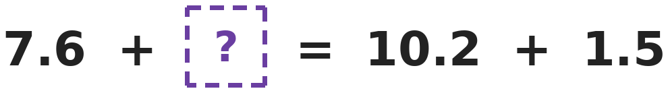
Q9. Sita balances this number sentence so that both sides are equal. Which decimal goes in the box?
(A) 3.1 | (B) 4.1 | (C) 4.9 | (D) 2.6

Q10. A bag has 5 kg of rice. Nandini uses 2 3/8 kg of it. How much rice is left?
(A) 3 5/8 kg | (B) 2 5/8 kg | (C) 3 3/8 kg | (D) 2 3/8 kg

Part 4 — Geometry (Syllabus Chapter 5)
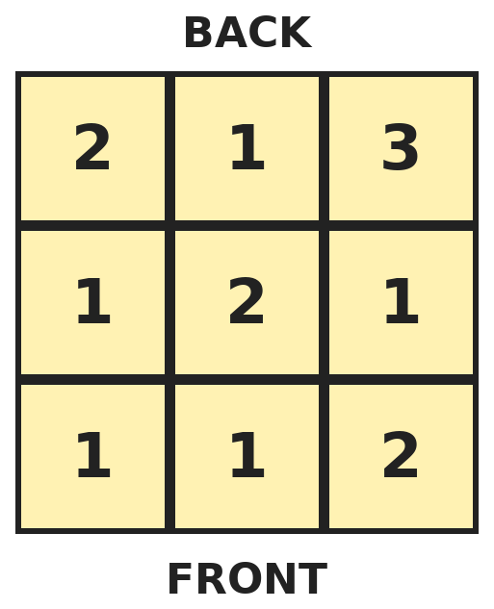
Q11. This plan shows cube towers seen from the top. Each number tells how many cubes are in that tower. How many squares do you see when you look from the front?
(A) 7 | (B) 4 | (C) 14 | (D) 9

Q12. Gita adds the number of faces, edges and vertices of a triangular prism. What total does she get?
(A) 18 | (B) 19 | (C) 15 | (D) 20

Q13. A grid has columns A to H. A mirror line runs down between columns D and E. A dot in column B, row 3 is reflected in the mirror. In which column is its image?
(A) Column F | (B) Column G | (C) Column H | (D) Column E

Part 5 — Mensuration (Syllabus Chapter 6)
Q14. A rectangle is 10 cm long and 6 cm wide. Mahi cuts a 2 cm by 2 cm square out of one corner. What is the perimeter of the shape that is left?
(A) 32 cm | (B) 28 cm | (C) 24 cm | (D) 36 cm

Q15. A wall is 5 m long and 3 m high. It has a door 2 m high and 1 m wide. Painting costs ₹40 for each square metre. What does it cost to paint the wall?
(A) ₹600 | (B) ₹520 | (C) ₹640 | (D) ₹80

Q16. A square field has a perimeter of 400 m. What is its area in square metres?
(A) 10,000 m² | (B) 1,600 m² | (C) 400 m² | (D) 40,000 m²

Q17. Tulsi buys 10 equal apples that weigh 1 kg 800 g altogether. How much do 7 of these apples weigh?
(A) 1 kg 50 g | (B) 1 kg 620 g | (C) 1 kg 200 g | (D) 1 kg 260 g

Part 6 — Data Handling (Syllabus Chapter 8)
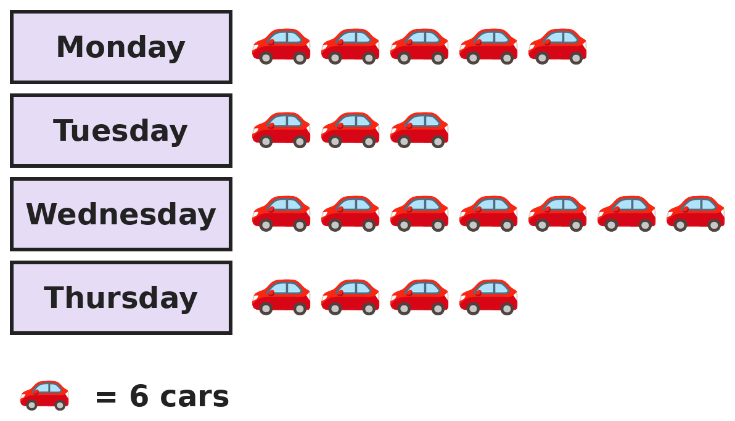
Q18. The pictograph shows cars passing a school gate. How many more cars passed on the two busiest days together than on the two quietest days together?
(A) 5 | (B) 18 | (C) 72 | (D) 30

Part 7 — Applied Mathematics (Syllabus Chapter 9)
Q19. The first bus leaves at 6:10 AM. After that, a bus leaves every 25 minutes. How many buses leave before 9:00 AM?
(A) 7 | (B) 6 | (C) 8 | (D) 9

Q20. In a year that is not a leap year, 1 January is a Monday. What day of the week is 1 March?
(A) Wednesday | (B) Friday | (C) Thursday | (D) Monday

Q21. Kishore has 16 coins worth ₹50 in all. Every coin is either ₹2 or ₹5. How many ₹5 coins does he have?
(A) 10 | (B) 5 | (C) 6 | (D) 8

Part 8 — Mathematical Reasoning (Syllabus Chapter 10)

Q22. Pallavi writes this series of numbers. Which number comes next?
(A) 85 | (B) 86 | (C) 84 | (D) 80

Q23. How many 2-digit numbers have a tens digit that is greater than the ones digit, like 52?
(A) 36 | (B) 54 | (C) 90 | (D) 45

Q24. Ankit climbs a staircase of 5 steps. Each time he goes up either 1 step or 2 steps. In how many different ways can he climb the 5 steps?
(A) 5 | (B) 6 | (C) 10 | (D) 8

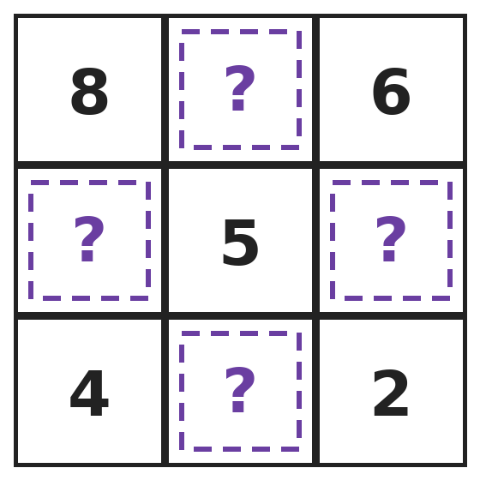
Q25. Every row, column and diagonal of this square adds up to 15. What is the sum of the four hidden numbers?
(A) 15 | (B) 25 | (C) 20 | (D) 30

SECTION II — Star Questions 5 questions · each joins two chapters
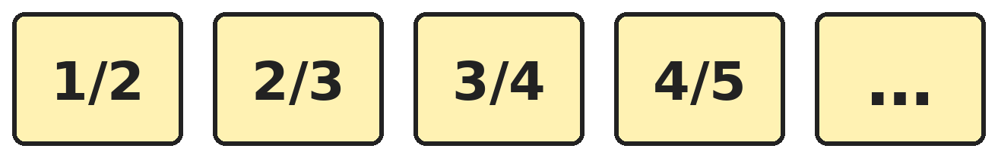
Q26. The fractions follow a pattern. By how much is the 10th fraction less than 1? [Star]
(A) 1/11 | (B) 1/10 | (C) 1/12 | (D) 10/11

Q27. Today is a Saturday. What day of the week was it 75 days ago? [Star]
(A) Thursday | (B) Tuesday | (C) Monday | (D) Sunday

Q28. How many numbers from 99,000 to 99,999 have only odd digits? [Star]
(A) 25 | (B) 100 | (C) 500 | (D) 125

Q29. Ishita studies for 1 1/2 hours on Monday, 2 1/4 hours on Tuesday and 3/4 of an hour on Wednesday. How long does she study in all? [Star]
(A) 4 h 50 min | (B) 3 h 30 min | (C) 4 h 30 min | (D) 4 h 15 min

Q30. Ojas makes a cube-shaped box with no lid from a net of squares. Each edge of the box is 5 cm. How much cardboard does the net use? [Star]
(A) 150 cm² | (B) 125 cm² | (C) 25 cm² | (D) 100 cm²

Answer Sheet AMO Level 2 · Class 4 · Practice Paper 3
Name: | School: | Roll No.:
Shade or tick one circle for each question.
1. | Ⓐ Ⓑ Ⓒ Ⓓ | 11. | Ⓐ Ⓑ Ⓒ Ⓓ | 21. | Ⓐ Ⓑ Ⓒ Ⓓ
2. | Ⓐ Ⓑ Ⓒ Ⓓ | 12. | Ⓐ Ⓑ Ⓒ Ⓓ | 22. | Ⓐ Ⓑ Ⓒ Ⓓ
3. | Ⓐ Ⓑ Ⓒ Ⓓ | 13. | Ⓐ Ⓑ Ⓒ Ⓓ | 23. | Ⓐ Ⓑ Ⓒ Ⓓ
4. | Ⓐ Ⓑ Ⓒ Ⓓ | 14. | Ⓐ Ⓑ Ⓒ Ⓓ | 24. | Ⓐ Ⓑ Ⓒ Ⓓ
5. | Ⓐ Ⓑ Ⓒ Ⓓ | 15. | Ⓐ Ⓑ Ⓒ Ⓓ | 25. | Ⓐ Ⓑ Ⓒ Ⓓ
6. | Ⓐ Ⓑ Ⓒ Ⓓ | 16. | Ⓐ Ⓑ Ⓒ Ⓓ | 26. | Ⓐ Ⓑ Ⓒ Ⓓ
7. | Ⓐ Ⓑ Ⓒ Ⓓ | 17. | Ⓐ Ⓑ Ⓒ Ⓓ | 27. | Ⓐ Ⓑ Ⓒ Ⓓ
8. | Ⓐ Ⓑ Ⓒ Ⓓ | 18. | Ⓐ Ⓑ Ⓒ Ⓓ | 28. | Ⓐ Ⓑ Ⓒ Ⓓ
9. | Ⓐ Ⓑ Ⓒ Ⓓ | 19. | Ⓐ Ⓑ Ⓒ Ⓓ | 29. | Ⓐ Ⓑ Ⓒ Ⓓ
10. | Ⓐ Ⓑ Ⓒ Ⓓ | 20. | Ⓐ Ⓑ Ⓒ Ⓓ | 30. | Ⓐ Ⓑ Ⓒ Ⓓ
Q26–Q30 are Section II Star Questions. Each joins two chapters.
For the parent or teacher
Section I correct: ______ / 25 Section II correct: ______ / 5
Correct: ______ / 30
Answer Key and Solutions AMO Level 2 · Class 4 · Practice Paper 3
Quick answers
1 D | 6 B | 11 A | 16 A | 21 C | 26 A
2 C | 7 C | 12 D | 17 D | 22 A | 27 C
3 A | 8 A | 13 B | 18 D | 23 D | 28 D
4 B | 9 B | 14 A | 19 A | 24 D | 29 C
5 D | 10 B | 15 B | 20 C | 25 C | 30 B
Solutions
Q | Part · level | Answer | Why?
1 | Part 1 · Ch1 · Hard | (D) 49,995 | Hint: Place value depends on where the digit is. Face value is just the digit.  The 5s have place values 50,000, 5,000, 500 and 5. The greatest is 50,000 and the smallest is 5. 50,000 − 5 = 49,995.
2 | Part 1 · Ch1 · Hard | (C) 45,500 | Hint: Numbers from the halfway point upwards round up.  Halfway between 45,000 and 46,000 is 45,500. 45,500 and above round up to 46,000, while 45,499 rounds down to 45,000. So the smallest is 45,500.
3 | Part 1 · Ch1 · Hard | (A) 14 | Hint: Do not forget IX, XIX and XX.  IX and X have one X each (2). XI to XVIII have one X each (8). XIX has two and XX has two (4). 2 + 8 + 4 = 14.
4 | Part 2 · Ch2 · Hard | (B) 77 | Hint: Work out both 400 × 7 and 389 × 7.  Estimate: 400 × 7 = 2,800. Exact: 389 × 7 = 2,723. 2,800 − 2,723 = 77. (Also: 11 × 7 = 77, because 389 is 11 less than 400.)
5 | Part 2 · Ch2 · Hard | (D) 3,960 | Hint: Both parts have 99 × something. Join them.  99 × 36 + 99 × 4 = 99 × (36 + 4) = 99 × 40. 100 × 40 = 4,000, and 99 × 40 is one 40 less: 4,000 − 40 = 3,960.
6 | Part 2 · Ch2 · Hard | (B) 142 | Hint: This is the same as dividing 1,000 by 7.  1,000 ÷ 7 = 142 remainder 6. After 142 subtractions she reaches 6, which is less than 7. So 142 times.
7 | Part 3 · Ch3 · Hard | (C) 5 | Hint: Find 1/4 of 12 and 1/3 of 12.  1/4 of 12 = 3 slices. 1/3 of 12 = 4 slices. 3 + 4 = 7 slices are eaten, so 12 − 7 = 5 are left.
8 | Part 3 · Ch3 · Hard | (A) 5/8 | Hint: Write both fractions as eighths.  1/2 = 4/8 and 3/4 = 6/8. Halfway between 4/8 and 6/8 is 5/8.
9 | Part 3 · Ch3 · Hard | (B) 4.1 | Hint: Work out the right side first.  10.2 + 1.5 = 11.7. Then ? = 11.7 − 7.6 = 4.1.
10 | Part 3 · Ch3 · Hard | (B) 2 5/8 kg | Hint: Write 5 as 4 8/8.  5 = 4 8/8. 4 8/8 − 2 3/8 = 2 5/8 kg.
11 | Part 4 · Ch5 · Hard | (A) 7 | Hint: From the front, each column shows only its tallest tower.  Looking from the front, each column shows its tallest tower. Left column: tallest 2. Middle: tallest 2. Right: tallest 3. 2 + 2 + 3 = 7 squares.
12 | Part 4 · Ch5 · Hard | (D) 20 | Hint: A triangular prism has 2 triangle faces and 3 rectangle faces.  Faces: 2 + 3 = 5. Vertices: 3 on each triangle, 6. Edges: 3 + 3 + 3 = 9. 5 + 9 + 6 = 20. Check: 5 + 6 − 9 = 2.
13 | Part 4 · Ch5 · Hard | (B) Column G | Hint: The image is the same number of columns from the mirror as the dot.  Column B is the 3rd column to the left of the mirror (D, C, B). The image is the 3rd column to the right (E, F, G). So column G, row 3.
14 | Part 5 · Ch6 · Hard | (A) 32 cm | Hint: The two new edges replace the two pieces of edge that were cut away.  The cut takes away 2 cm from the top and 2 cm from the side, but adds two new edges of 2 cm each. The perimeter stays 2 × (10 + 6) = 32 cm.
15 | Part 5 · Ch6 · Hard | (B) ₹520 | Hint: Do not paint the door.  Wall: 5 × 3 = 15 m². Door: 2 × 1 = 2 m². Area to paint: 13 m². Cost: 13 × 40 = ₹520.
16 | Part 5 · Ch6 · Hard | (A) 10,000 m² | Hint: First find the length of one side.  Each side is 400 ÷ 4 = 100 m. Area = 100 × 100 = 10,000 m². (1,600 is wrongly using 400 ÷ 10 = 40 as the side, and 40,000 is 400 × 100.)
17 | Part 5 · Ch6 · Hard | (D) 1 kg 260 g | Hint: Change 1 kg 800 g into grams and find the weight of one apple.  1 kg 800 g = 1,800 g. One apple: 1,800 ÷ 10 = 180 g. 7 apples: 7 × 180 = 1,260 g = 1 kg 260 g.
18 | Part 6 · Ch8 · Hard | (D) 30 | Hint: Find the two days with the most symbols and the two with the fewest.  Busiest: Wednesday 7 and Monday 5, so 12 symbols. Quietest: Tuesday 3 and Thursday 4, so 7 symbols. Difference: 5 symbols = 5 × 6 = 30 cars.
19 | Part 7 · Ch9 · Hard | (A) 7 | Hint: List the times.  6:10, 6:35, 7:00, 7:25, 7:50, 8:15, 8:40. The next one is 9:05, which is after 9:00. So 7 buses.
20 | Part 7 · Ch9 · Hard | (C) Thursday | Hint: Count the days in January and February.  1 March is 31 + 28 = 59 days after 1 January. 59 = 8 weeks + 3 days. 3 days after Monday is Thursday.
21 | Part 7 · Ch9 · Hard | (C) 6 | Hint: If all 16 coins were ₹2 coins, how much would they be worth?  16 coins of ₹2 would make ₹32, which is ₹18 short. Changing a ₹2 coin for a ₹5 coin adds ₹3. 18 ÷ 3 = 6, so 6 coins are ₹5. Check: 6 × 5 + 10 × 2 = 30 + 20 = 50.
22 | Part 8 · Ch10 · Hard | (A) 85 | Hint: Look at how much is taken away each time.  The series takes away 1, 2, 3, 4. Next it takes away 5: 90 − 5 = 85.
23 | Part 8 · Ch10 · Hard | (D) 45 | Hint: Count for each tens digit: with tens digit 3 the ones digit can be 0, 1 or 2.  Tens digit 1: 1 number (10). Tens digit 2: 2 numbers. … Tens digit 9: 9 numbers. 1 + 2 + … + 9 = 45.
24 | Part 8 · Ch10 · Hard | (D) 8 | Hint: Count ways for 1, 2, 3, 4 steps first and look for a pattern.  1 step: 1 way. 2 steps: 2 ways. 3 steps: 3 ways. 4 steps: 5 ways. 5 steps: 3 + 5 = 8 ways, because the last move is either 1 step (from step 4) or 2 steps (from step 3).
25 | Part 8 · Ch10 · Hard | (C) 20 | Hint: Find each hidden number from a row or column that has two numbers given.  Top row: 15 − 8 − 6 = 1. Left column: 15 − 8 − 4 = 3. Right column: 15 − 6 − 2 = 7. Bottom row: 15 − 4 − 2 = 9. 1 + 3 + 7 + 9 = 20.
26 | Section II · Ch3 + Ch10 · Hard | (A) 1/11 | Hint: Each fraction is 1 part short of a whole.  The 10th fraction is 10/11. 1 = 11/11, so it is 1/11 less than 1. (Each fraction in the pattern is one part short of a whole.)
27 | Section II · Ch9 + Ch10 · Hard | (C) Monday | Hint: 75 days is 10 weeks and some days.  75 = 10 × 7 + 5. Ten weeks ago it was Saturday. 5 more days back: Friday, Thursday, Wednesday, Tuesday, Monday.
28 | Section II · Ch1 + Ch10 · Hard | (D) 125 | Hint: The first two digits are already odd. Each of the last three can be 1, 3, 5, 7 or 9.  The last three digits each have 5 choices: 5 × 5 × 5 = 125.
29 | Section II · Ch3 + Ch9 · Hard | (C) 4 h 30 min | Hint: Add the whole hours, then add the fractions.  Whole hours: 1 + 2 = 3. Fractions: 1/2 + 1/4 + 3/4 = 2/4 + 1/4 + 3/4 = 6/4 = 1 1/2. Total 4 1/2 hours = 4 hours 30 minutes.
30 | Section II · Ch5 + Ch6 · Hard | (B) 125 cm² | Hint: A cube has 6 faces, but this box has no lid.  Each face is 5 × 5 = 25 cm². A box with no lid has 5 faces: 5 × 25 = 125 cm².

ARYABHATTA MATHS OLYMPIAD
Level 2
PRACTICE PAPER-4
CLASS 4
Total Questions | 30 multiple-choice questions
Level | Level-2 (final round): every question is Hard
Time | 45 minutes
Section I | 25 questions, each from one chapter
Section II | 5 Star Questions, each joining two chapters
Negative Marking | No negative marking
Calculator | Not allowed
Chapters | Number System · Operations · Fractions & Decimals · Geometry · Mensuration · Data Handling · Applied Mathematics · Mathematical Reasoning

👋 Hello, friend! How to do this paper:
⭐ Every question has four answer choices: (A), (B), (C) and (D). Only one is correct.
⭐ Read each question and look at its picture carefully. Then mark your answer on the answer sheet at the end.
⭐ This is a Level-2 paper. Every question needs careful thinking, so take your time and check each step.
⭐ Section I has 25 questions. Section II has 5 Star Questions.
⭐ There is no negative marking, so try every question.
⭐ Do not use a calculator. You may do rough work on a separate sheet.
⭐ All figures are not necessarily drawn to scale unless stated.

For parents and teachers
• Pictures are part of the questions. Every picture also works when printed in black and white.
• You may read a question aloud to the child, exactly as printed. Please do not explain it or point to an answer choice.
• Parts follow the AMO syllabus chapters. Chapters 4 and 7 are not part of the Class 4 syllabus, so the chapter numbers shown in the Part headings have gaps.
• The answer sheet and the answer key are at the end. Remove only the answer key before the child begins.

SECTION I 25 questions · every question is Hard
Part 1 — Number System (Syllabus Chapter 1)
Q1. Priya finds the number just after the largest 5-digit number. Dev finds the number just before the smallest 5-digit number. What is the difference between their numbers?
(A) 90,000 | (B) 89,999 | (C) 90,001 | (D) 90,002

Q2. Which number is 7 × 10,000 + 15 × 1,000 + 3 × 10?
(A) 85,030 | (B) 71,530 | (C) 75,030 | (D) 85,300

Q3. Shalini works out XC − XL + IX. Which Roman numeral is her answer?
(A) LXI | (B) LIX | (C) XLIX | (D) LIV

Part 2 — Operations (Syllabus Chapter 2)
Q4. A shop packs 2,345 sweets into boxes. Each box holds 8 sweets. How many boxes are needed so that every sweet is packed?
(A) 293 | (B) 290 | (C) 295 | (D) 294

Q5. Rashmi works out 15 × 15 − 14 × 16. What answer should she get?
(A) 1 | (B) 0 | (C) 2 | (D) 15

Q6. Ketan multiplies a number by 9 and gets 6,048. What does he get if he multiplies the same number by 3?
(A) 2,016 | (B) 672 | (C) 2,106 | (D) 18,144

Part 3 — Fractions & Decimals (Syllabus Chapter 3)
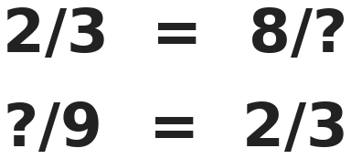
Q7. Shruti fills each box to make two true statements. What is the sum of the two numbers she writes?
(A) 17 | (B) 20 | (C) 18 | (D) 14

Q8. There are 40 students in a class. 3/8 of them are girls. 2/5 of the boys wear glasses. How many boys wear glasses?
(A) 6 | (B) 10 | (C) 15 | (D) 16

Q9. Four children are 1.5 m, 1.3 m, 142 cm and 1 m 38 cm tall. How much taller is the tallest child than the shortest?
(A) 12 cm | (B) 8 cm | (C) 2 cm | (D) 20 cm

Q10. Which of these fractions is closest to 1/2: 3/8, 5/12, 2/3, 3/4?
(A) 3/8 | (B) 5/12 | (C) 2/3 | (D) 3/4

Part 4 — Geometry (Syllabus Chapter 5)
Q11. A prism has 18 edges. How many faces does it have?
(A) 6 | (B) 9 | (C) 8 | (D) 12

Q12. On a dice, opposite faces add up to 7. Three dice are stacked on a table, and the top face shows 5. What is the sum of the faces touching the table or another dice?
(A) 21 | (B) 14 | (C) 9 | (D) 16

Q13. The capital letter E is drawn with 1 upright segment and 3 flat segments. How many pairs of segments are parallel or perpendicular to each other?
(A) 3 | (B) 4 | (C) 5 | (D) 6

Part 5 — Mensuration (Syllabus Chapter 6)
Q14. A square is cut into 4 equal strips, side by side. Each strip has a perimeter of 40 cm. What is the area of the square?
(A) 256 cm² | (B) 100 cm² | (C) 160 cm² | (D) 400 cm²

Q15. A room is 5 m long and 4 m wide. A carpet leaves a border 1 m wide all round it. The carpet costs ₹45 per square metre. What does the carpet cost?
(A) ₹900 | (B) ₹270 | (C) ₹540 | (D) ₹630

Q16. Isha cuts cards 3 cm by 2 cm from a sheet 12 cm by 10 cm. All the cards are cut the same way round. What is the largest number of cards she can cut?
(A) 18 | (B) 20 | (C) 24 | (D) 120

Q17. Bharat joins 4 m 35 cm of cloth to 2 m 80 cm of cloth. Then he cuts off 1 m 50 cm. How much cloth is left?
(A) 5 m 85 cm | (B) 6 m 65 cm | (C) 5 m 65 cm | (D) 5 m 35 cm

Part 6 — Data Handling (Syllabus Chapter 8)
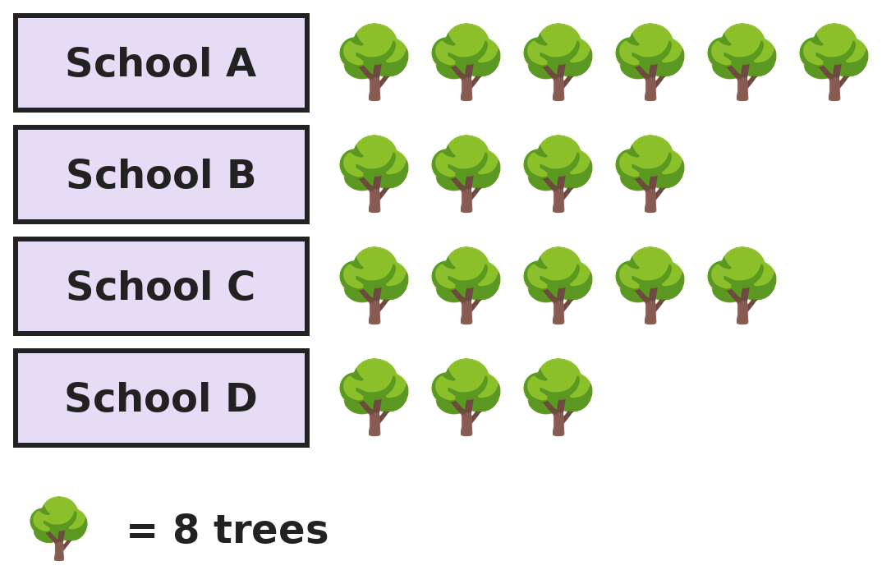
Q18. Each school planned to plant at least 40 trees. The pictograph shows how many they planted. How many schools reached their plan?
(A) 1 | (B) 3 | (C) 2 | (D) 4

Part 7 — Applied Mathematics (Syllabus Chapter 9)
Q19. Anjali's clock gains 3 minutes every hour. She sets it to the right time at 8:00 AM. What time does her clock show when the real time is 8:00 PM?
(A) 8:24 PM | (B) 8:36 PM | (C) 8:03 PM | (D) 9:00 PM

Q20. A month has 31 days and its 1st day is a Saturday. How many Saturdays and Sundays are there in this month altogether?
(A) 10 | (B) 8 | (C) 9 | (D) 11

Q21. Varun saves ₹35 every week. He wants to buy a cycle helmet for ₹1,000. After how many weeks will he first have enough money?
(A) 28 | (B) 30 | (C) 29 | (D) 25

Part 8 — Mathematical Reasoning (Syllabus Chapter 10)

Q22. Komal multiplies to make this series. Which number comes next?
(A) 240 | (B) 600 | (C) 144 | (D) 720

Q23. Riya is taller than Neha but shorter than Kabir. Manav is shorter than Neha but taller than Om. Who is in the middle when all five stand in order of height?
(A) Riya | (B) Manav | (C) Kabir | (D) Neha

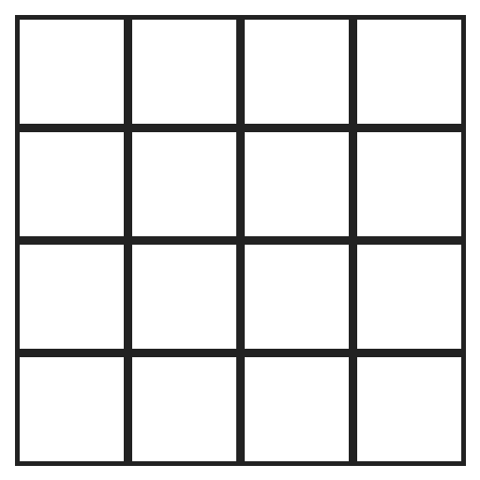
Q24. How many squares of all sizes are there in this 4 by 4 grid?
(A) 16 | (B) 25 | (C) 30 | (D) 20


Q25. A and B are digits, and A + B = 9. What is the number AB?
(A) 72 | (B) 27 | (C) 63 | (D) 81

SECTION II — Star Questions 5 questions · each joins two chapters
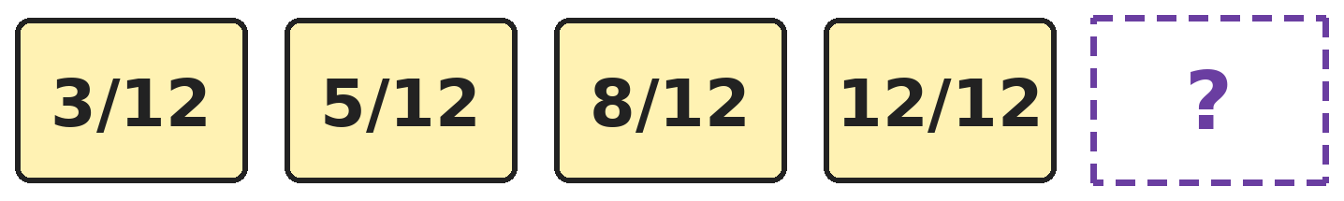
Q26. Look at how much is added each time. Which fraction comes next? [Star]
(A) 1 4/12 | (B) 1 5/12 | (C) 17/24 | (D) 1 1/12

Q27. In a certain year, 1 March is a Monday. How many Mondays are there from 1 March to 31 May, counting both days? [Star]
(A) 14 | (B) 13 | (C) 12 | (D) 15

Q28. Madhav numbers the pages of a book from 1 to 150. How many digits does he write in all? [Star]
(A) 150 | (B) 450 | (C) 330 | (D) 342

Q29. Grandma shares ₹840. Asha gets 1/3, Ravi gets 1/4 and Omkar gets the rest. How much more does Omkar get than Ravi? [Star]
(A) ₹70 | (B) ₹210 | (C) ₹350 | (D) ₹140

Q30. Pari covers a 6 cm by 4 cm rectangle with 2 cm by 1 cm tiles. Then she adds a border 1 cm wide all round it, using the same tiles. How many tiles does the border need? [Star]
(A) 10 | (B) 14 | (C) 12 | (D) 24

Answer Sheet AMO Level 2 · Class 4 · Practice Paper 4
Name: | School: | Roll No.:
Shade or tick one circle for each question.
1. | Ⓐ Ⓑ Ⓒ Ⓓ | 11. | Ⓐ Ⓑ Ⓒ Ⓓ | 21. | Ⓐ Ⓑ Ⓒ Ⓓ
2. | Ⓐ Ⓑ Ⓒ Ⓓ | 12. | Ⓐ Ⓑ Ⓒ Ⓓ | 22. | Ⓐ Ⓑ Ⓒ Ⓓ
3. | Ⓐ Ⓑ Ⓒ Ⓓ | 13. | Ⓐ Ⓑ Ⓒ Ⓓ | 23. | Ⓐ Ⓑ Ⓒ Ⓓ
4. | Ⓐ Ⓑ Ⓒ Ⓓ | 14. | Ⓐ Ⓑ Ⓒ Ⓓ | 24. | Ⓐ Ⓑ Ⓒ Ⓓ
5. | Ⓐ Ⓑ Ⓒ Ⓓ | 15. | Ⓐ Ⓑ Ⓒ Ⓓ | 25. | Ⓐ Ⓑ Ⓒ Ⓓ
6. | Ⓐ Ⓑ Ⓒ Ⓓ | 16. | Ⓐ Ⓑ Ⓒ Ⓓ | 26. | Ⓐ Ⓑ Ⓒ Ⓓ
7. | Ⓐ Ⓑ Ⓒ Ⓓ | 17. | Ⓐ Ⓑ Ⓒ Ⓓ | 27. | Ⓐ Ⓑ Ⓒ Ⓓ
8. | Ⓐ Ⓑ Ⓒ Ⓓ | 18. | Ⓐ Ⓑ Ⓒ Ⓓ | 28. | Ⓐ Ⓑ Ⓒ Ⓓ
9. | Ⓐ Ⓑ Ⓒ Ⓓ | 19. | Ⓐ Ⓑ Ⓒ Ⓓ | 29. | Ⓐ Ⓑ Ⓒ Ⓓ
10. | Ⓐ Ⓑ Ⓒ Ⓓ | 20. | Ⓐ Ⓑ Ⓒ Ⓓ | 30. | Ⓐ Ⓑ Ⓒ Ⓓ
Q26–Q30 are Section II Star Questions. Each joins two chapters.
For the parent or teacher
Section I correct: ______ / 25 Section II correct: ______ / 5
Correct: ______ / 30
Answer Key and Solutions AMO Level 2 · Class 4 · Practice Paper 4
Quick answers
1 C | 6 A | 11 C | 16 B | 21 C | 26 B
2 A | 7 C | 12 D | 17 C | 22 D | 27 A
3 B | 8 B | 13 D | 18 C | 23 D | 28 D
4 D | 9 D | 14 A | 19 B | 24 C | 29 D
5 A | 10 B | 15 B | 20 A | 25 A | 30 C
Solutions
Q | Part · level | Answer | Why?
1 | Part 1 · Ch1 · Hard | (C) 90,001 | Hint: The largest 5-digit number is 99,999 and the smallest is 10,000.  Just after 99,999 is 1,00,000. Just before 10,000 is 9,999. 1,00,000 − 9,999 = 90,001.
2 | Part 1 · Ch1 · Hard | (A) 85,030 | Hint: 15 thousands is 1 ten-thousand and 5 thousands.  70,000 + 15,000 + 30 = 85,030.
3 | Part 1 · Ch1 · Hard | (B) LIX | Hint: XC = 90 and XL = 40.  90 − 40 + 9 = 59. 59 = 50 + 9 = LIX.
4 | Part 2 · Ch2 · Hard | (D) 294 | Hint: Divide, then think about the sweets that are left over.  2,345 ÷ 8 = 293 remainder 1. 293 boxes are full and 1 sweet is left, so one more box is needed: 294 boxes.
5 | Part 2 · Ch2 · Hard | (A) 1 | Hint: Work out each product.  15 × 15 = 225 and 14 × 16 = 224. 225 − 224 = 1.
6 | Part 2 · Ch2 · Hard | (A) 2,016 | Hint: Multiplying by 3 gives one third of multiplying by 9.  The number is 6,048 ÷ 9 = 672. Times 3: 672 × 3 = 2,016. (Or: 9 is 3 × 3, so the answer is 6,048 ÷ 3 = 2,016.)
7 | Part 3 · Ch3 · Hard | (C) 18 | Hint: Multiply the top and bottom of 2/3 by the same number.  2/3 = 8/12, because 2 × 4 = 8 and 3 × 4 = 12. 2/3 = 6/9, because 3 × 3 = 9 and 2 × 3 = 6. 12 + 6 = 18.
8 | Part 3 · Ch3 · Hard | (B) 10 | Hint: Find the number of girls, then the number of boys.  3/8 of 40 = 15 girls, so there are 25 boys. 2/5 of 25 = 10 boys wear glasses.
9 | Part 3 · Ch3 · Hard | (D) 20 cm | Hint: Change all the heights to centimetres.  1.5 m = 150 cm and 1.3 m = 130 cm. 1 m 38 cm = 138 cm. Tallest 150 cm, shortest 130 cm. 150 − 130 = 20 cm.
10 | Part 3 · Ch3 · Hard | (B) 5/12 | Hint: Find how far each fraction is from 1/2.  1/2 = 4/8 = 6/12. 3/8 is 1/8 away. 5/12 is 1/12 away. 2/3 = 4/6 is 1/6 away from 3/6. 3/4 is 1/4 away from 2/4. The smallest gap is 1/12, so 5/12.
11 | Part 4 · Ch5 · Hard | (C) 8 | Hint: A prism has two equal bases. Each base has as many edges as the number of side faces.  Each base with n sides gives n edges, and there are n side edges. 3n = 18, so n = 6: a hexagonal prism. Faces: 2 bases + 6 sides = 8.
12 | Part 4 · Ch5 · Hard | (D) 16 | Hint: The bottom and top faces of each dice are opposite faces.  The bottom dice: its bottom (table) and top touch, which add to 7. The middle dice: top and bottom both touch, 7. The top dice: only the bottom touches, and it is opposite 5, so it is 2. 7 + 7 + 2 = 16.
13 | Part 4 · Ch5 · Hard | (D) 6 | Hint: Count perpendicular pairs and parallel pairs separately.  Each flat segment is perpendicular to the upright one: 3 pairs. The 3 flat segments are parallel to each other: top-middle, top-bottom, middle-bottom, 3 pairs. 3 + 3 = 6.
14 | Part 5 · Ch6 · Hard | (A) 256 cm² | Hint: Call the width of one strip 1 part. Then the side of the square is 4 parts.  Each strip is 4 parts long and 1 part wide. Its perimeter is 4 + 4 + 1 + 1 = 10 parts = 40 cm, so 1 part = 4 cm. The square has side 16 cm and area 16 × 16 = 256 cm².
15 | Part 5 · Ch6 · Hard | (B) ₹270 | Hint: The carpet is 2 m shorter and 2 m narrower than the room.  The carpet is (5 − 2) × (4 − 2) = 3 × 2 = 6 m². Cost: 6 × 45 = ₹270.
16 | Part 5 · Ch6 · Hard | (B) 20 | Hint: Try the 3 cm side along the 12 cm side, then along the 10 cm side.  3 cm along 12 cm: 4 cards, and 2 cm along 10 cm: 5 cards, so 4 × 5 = 20. The other way: 2 cm along 12 cm gives 6, and 3 cm along 10 cm gives 3 (1 cm wasted), so 18. The largest is 20.
17 | Part 5 · Ch6 · Hard | (C) 5 m 65 cm | Hint: 100 cm = 1 m.  4 m 35 cm + 2 m 80 cm = 6 m 115 cm = 7 m 15 cm. 7 m 15 cm − 1 m 50 cm = 5 m 65 cm.
18 | Part 6 · Ch8 · Hard | (C) 2 | Hint: 40 trees is how many symbols?  A: 6 × 8 = 48. B: 4 × 8 = 32. C: 5 × 8 = 40. D: 3 × 8 = 24. A and C reached 40, so 2 schools.
19 | Part 7 · Ch9 · Hard | (B) 8:36 PM | Hint: How many hours are there from 8 AM to 8 PM?  From 8 AM to 8 PM is 12 hours. The clock gains 12 × 3 = 36 minutes. It shows 8:36 PM.
20 | Part 7 · Ch9 · Hard | (A) 10 | Hint: List the dates of the Saturdays, then of the Sundays.  Saturdays: 1, 8, 15, 22, 29 (5). Sundays: 2, 9, 16, 23, 30 (5). 5 + 5 = 10.
21 | Part 7 · Ch9 · Hard | (C) 29 | Hint: Find 35 × 28 and 35 × 29.  35 × 28 = 980, which is not enough. 35 × 29 = 1,015, which is enough. So after 29 weeks.
22 | Part 8 · Ch10 · Hard | (D) 720 | Hint: Look at what each number is multiplied by.  The numbers are multiplied by 2, 3, 4 and 5. Next multiply by 6: 120 × 6 = 720.
23 | Part 8 · Ch10 · Hard | (D) Neha | Hint: Put the children in a line from tallest to shortest.  Kabir is taller than Riya, who is taller than Neha. Neha is taller than Manav, who is taller than Om. From tallest: Kabir, Riya, Neha, Manav, Om. The middle (3rd) is Neha.
24 | Part 8 · Ch10 · Hard | (C) 30 | Hint: Count 1 by 1, 2 by 2, 3 by 3 and 4 by 4 squares.  1 by 1: 16. 2 by 2: 9. 3 by 3: 4. 4 by 4: 1. 16 + 9 + 4 + 1 = 30.
25 | Part 8 · Ch10 · Hard | (A) 72 | Hint: Try the 2-digit numbers whose digits add up to 9.  Try: 81 − 18 = 63, 72 − 27 = 45, 63 − 36 = 27. Only 72 works.
26 | Section II · Ch3 + Ch10 · Hard | (B) 1 5/12 | Hint: The amounts added are 2/12, 3/12, 4/12, …  Adding 2/12, 3/12 and 4/12 gives 5/12, 8/12 and 12/12. Next add 5/12: 12/12 + 5/12 = 17/12 = 1 5/12.
27 | Section II · Ch9 + Ch10 · Hard | (A) 14 | Hint: March has 31 days, April 30 and May 31.  1 March to 31 May is 31 + 30 + 31 = 92 days. 92 = 13 weeks + 1 day. The 13 weeks hold 13 Mondays, and the extra day (31 May) is also a Monday. So 14 Mondays.
28 | Section II · Ch1 + Ch10 · Hard | (D) 342 | Hint: Count 1-digit, 2-digit and 3-digit page numbers separately.  Pages 1–9: 9 digits. Pages 10–99: 90 × 2 = 180 digits. Pages 100–150: 51 × 3 = 153 digits. 9 + 180 + 153 = 342.
29 | Section II · Ch3 + Ch9 · Hard | (D) ₹140 | Hint: Find Asha's and Ravi's shares first.  Asha: 1/3 of 840 = ₹280. Ravi: 1/4 of 840 = ₹210. Omkar: 840 − 280 − 210 = ₹350. 350 − 210 = ₹140.
30 | Section II · Ch5 + Ch6 · Hard | (C) 12 | Hint: Find the area of the border.  With the border, the shape is 8 cm by 6 cm = 48 cm². The border is 48 − 24 = 24 cm². Each tile is 2 cm², so 24 ÷ 2 = 12 tiles.

ARYABHATTA MATHS OLYMPIAD
Level 2
PRACTICE PAPER-5
CLASS 4
Total Questions | 30 multiple-choice questions
Level | Level-2 (final round): every question is Hard
Time | 45 minutes
Section I | 25 questions, each from one chapter
Section II | 5 Star Questions, each joining two chapters
Negative Marking | No negative marking
Calculator | Not allowed
Chapters | Number System · Operations · Fractions & Decimals · Geometry · Mensuration · Data Handling · Applied Mathematics · Mathematical Reasoning

👋 Hello, friend! How to do this paper:
⭐ Every question has four answer choices: (A), (B), (C) and (D). Only one is correct.
⭐ Read each question and look at its picture carefully. Then mark your answer on the answer sheet at the end.
⭐ This is a Level-2 paper. Every question needs careful thinking, so take your time and check each step.
⭐ Section I has 25 questions. Section II has 5 Star Questions.
⭐ There is no negative marking, so try every question.
⭐ Do not use a calculator. You may do rough work on a separate sheet.
⭐ All figures are not necessarily drawn to scale unless stated.

For parents and teachers
• Pictures are part of the questions. Every picture also works when printed in black and white.
• You may read a question aloud to the child, exactly as printed. Please do not explain it or point to an answer choice.
• Parts follow the AMO syllabus chapters. Chapters 4 and 7 are not part of the Class 4 syllabus, so the chapter numbers shown in the Part headings have gaps.
• The answer sheet and the answer key are at the end. Remove only the answer key before the child begins.

SECTION I 25 questions · every question is Hard
Part 1 — Number System (Syllabus Chapter 1)
Q1. How many even numbers are there between 99,900 and 1,00,000? Do not count 99,900 or 1,00,000.
(A) 50 | (B) 48 | (C) 100 | (D) 49

Q2. Naveen's number is 4?,385, with one digit hidden. When it is rounded to the nearest thousand, it becomes 47,000. What is the hidden digit?
(A) 6 | (B) 7 | (C) 8 | (D) 5

Q3. Vidya writes the numbers 1 to 50 in Roman numerals. How many of them contain the letter V?
(A) 5 | (B) 10 | (C) 25 | (D) 20

Part 2 — Operations (Syllabus Chapter 2)
Q4. A book has 1,000 pages. Harini reads 24 pages every day for 4 weeks. How many pages are still left to read?
(A) 904 | (B) 328 | (C) 372 | (D) 428

Q5. Sohan halves 3,600 again and again. He stops as soon as he gets an odd number. How many times does he halve?
(A) 4 | (B) 3 | (C) 5 | (D) 6

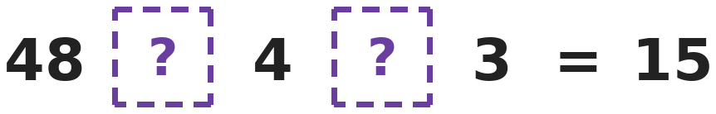
Q6. Which two signs, in order, make this statement true?
(A) ÷ then + | (B) × then ÷ | (C) − then × | (D) ÷ then −

Part 3 — Fractions & Decimals (Syllabus Chapter 3)
Q7. Mitali sleeps for 1/3 of a day, is at school for 1/4 of the day and plays for 1/12 of the day. How many hours of the day are left?
(A) 16 hours | (B) 6 hours | (C) 10 hours | (D) 8 hours

Q8. A glass is 3/4 full and holds 300 mL of water. How much more water is needed to fill it?
(A) 75 mL | (B) 400 mL | (C) 225 mL | (D) 100 mL

Q9. A plant is 9.5 cm tall. Sunita trims 3.8 cm off it. In the next week it grows 2.6 cm. How tall is it now?
(A) 8.7 cm | (B) 8.3 cm | (C) 3.1 cm | (D) 15.9 cm

Q10. Ekta has 29 slices of cake. Each slice is 1/6 of a whole cake. How many cakes is that, as a mixed number?
(A) 5 1/6 | (B) 4 1/6 | (C) 4 5/6 | (D) 3 5/6

Part 4 — Geometry (Syllabus Chapter 5)
Q11. A tent with a floor is shaped like a triangular prism. Kunal draws its net. Which shapes are in the net?
(A) 2 rectangles and 3 triangles | (B) 3 rectangles and 3 triangles
(C) 4 rectangles and 2 triangles | (D) 3 rectangles and 2 triangles

Q12. Ajay draws 5 rays starting from the same point. Any two rays make an angle. How many angles are there?
(A) 10 | (B) 5 | (C) 4 | (D) 20

Q13. A solid has 6 vertices and 9 edges. For solids like this, faces + vertices − edges = 2. Its faces are 2 triangles and some rectangles. How many rectangles?
(A) 5 | (B) 2 | (C) 3 | (D) 4

Part 5 — Mensuration (Syllabus Chapter 6)
Q14. A rectangle is twice as long as it is wide. Its area is 72 cm². What is its perimeter?
(A) 18 cm | (B) 72 cm | (C) 30 cm | (D) 36 cm

Q15. A rectangle is 3 times as long as it is wide. Its perimeter is 64 cm. What is its area?
(A) 128 cm² | (B) 192 cm² | (C) 256 cm² | (D) 48 cm²

Q16. A garden is 25 m long and 18 m wide. Its fence leaves a gap of 4 m for a gate. Fencing costs ₹12 per metre. What is the cost of the fence?
(A) ₹1,032 | (B) ₹1,080 | (C) ₹984 | (D) ₹5,400

Q17. A scooter carries 3 bags of 2 kg 750 g each and one box of 1 kg 400 g. What is the total weight?
(A) 9 kg 650 g | (B) 9 kg 150 g | (C) 7 kg 650 g | (D) 10 kg 650 g

Part 6 — Data Handling (Syllabus Chapter 8)
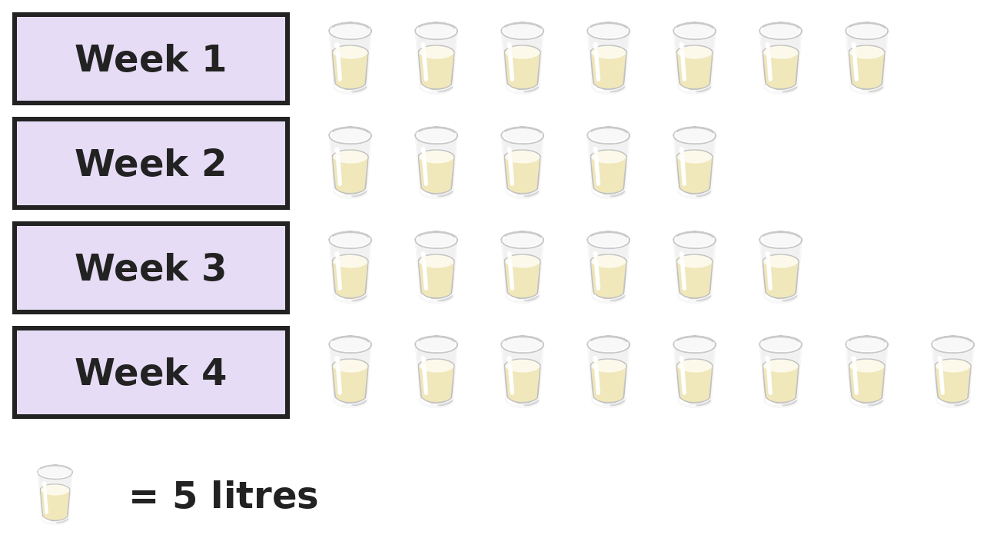
Q18. The pictograph shows the milk a family bought each week. Milk costs ₹54 per litre. How much did the milk cost in Week 2 and Week 3 together?
(A) ₹594 | (B) ₹2,700 | (C) ₹2,970 | (D) ₹3,024

Part 7 — Applied Mathematics (Syllabus Chapter 9)
Q19. School starts at 7:55 AM. There are 8 periods of 40 minutes each and one break of 20 minutes. At what time does school end?
(A) 1:35 PM | (B) 1:15 PM | (C) 12:35 PM | (D) 1:55 PM

Q20. In a year that is not a leap year, 26 January is a Friday. What day of the week is 15 March?
(A) Thursday | (B) Friday | (C) Wednesday | (D) Saturday

Q21. Sameer spends exactly ₹1,000 on sports items. He buys 4 bats at ₹185 each and the rest on balls at ₹26 each. How many balls does he buy?
(A) 9 | (B) 11 | (C) 38 | (D) 10

Part 8 — Mathematical Reasoning (Syllabus Chapter 10)

Q22. In Sakshi's series, each number comes from the two numbers before it. Which number comes next?
(A) 18 | (B) 21 | (C) 20 | (D) 26

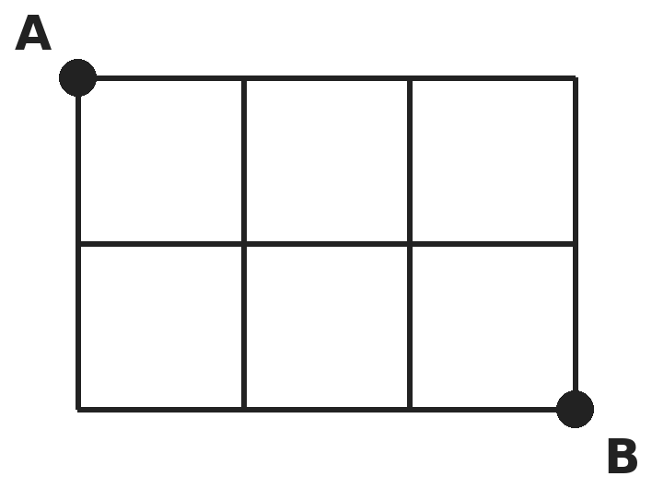
Q23. Hemant walks along the lines from A to B, moving only right or down. How many different paths can he take?
(A) 6 | (B) 10 | (C) 5 | (D) 12

Q24. How many 2-digit numbers have digits that multiply to give 12?
(A) 2 | (B) 6 | (C) 4 | (D) 3

Q25. Amit spends half of his money on a book and then ₹20 on a snack. He has ₹30 left. How much money did he have at the start?
(A) ₹100 | (B) ₹80 | (C) ₹70 | (D) ₹110

SECTION II — Star Questions 5 questions · each joins two chapters
Q26. Hema finds two different whole numbers a and b so that 1/a + 1/b = 1/2. What is a + b? [Star]
(A) 8 | (B) 10 | (C) 9 | (D) 7

Q27. A 12-hour digital clock shows times like 2:22 and 11:11, where every digit is the same. How many such times are there in one whole day? [Star]
(A) 12 | (B) 6 | (C) 10 | (D) 9

Q28. How many 5-digit numbers have digits that add up to 2? [Star]
(A) 4 | (B) 5 | (C) 6 | (D) 10

Q29. A train journey takes 3 hours 20 minutes and starts at 9:40 AM. The train stops for water when 3/4 of the journey time has passed. At what time does it stop? [Star]
(A) 12:40 PM | (B) 11:40 AM | (C) 1:00 PM | (D) 12:10 PM

Q30. The net of a cube has an area of 96 cm². Mayank makes a wire model of the same cube, using wire only along the edges. How much wire does he need? [Star]
(A) 24 cm | (B) 96 cm | (C) 64 cm | (D) 48 cm

Answer Sheet AMO Level 2 · Class 4 · Practice Paper 5
Name: | School: | Roll No.:
Shade or tick one circle for each question.
1. | Ⓐ Ⓑ Ⓒ Ⓓ | 11. | Ⓐ Ⓑ Ⓒ Ⓓ | 21. | Ⓐ Ⓑ Ⓒ Ⓓ
2. | Ⓐ Ⓑ Ⓒ Ⓓ | 12. | Ⓐ Ⓑ Ⓒ Ⓓ | 22. | Ⓐ Ⓑ Ⓒ Ⓓ
3. | Ⓐ Ⓑ Ⓒ Ⓓ | 13. | Ⓐ Ⓑ Ⓒ Ⓓ | 23. | Ⓐ Ⓑ Ⓒ Ⓓ
4. | Ⓐ Ⓑ Ⓒ Ⓓ | 14. | Ⓐ Ⓑ Ⓒ Ⓓ | 24. | Ⓐ Ⓑ Ⓒ Ⓓ
5. | Ⓐ Ⓑ Ⓒ Ⓓ | 15. | Ⓐ Ⓑ Ⓒ Ⓓ | 25. | Ⓐ Ⓑ Ⓒ Ⓓ
6. | Ⓐ Ⓑ Ⓒ Ⓓ | 16. | Ⓐ Ⓑ Ⓒ Ⓓ | 26. | Ⓐ Ⓑ Ⓒ Ⓓ
7. | Ⓐ Ⓑ Ⓒ Ⓓ | 17. | Ⓐ Ⓑ Ⓒ Ⓓ | 27. | Ⓐ Ⓑ Ⓒ Ⓓ
8. | Ⓐ Ⓑ Ⓒ Ⓓ | 18. | Ⓐ Ⓑ Ⓒ Ⓓ | 28. | Ⓐ Ⓑ Ⓒ Ⓓ
9. | Ⓐ Ⓑ Ⓒ Ⓓ | 19. | Ⓐ Ⓑ Ⓒ Ⓓ | 29. | Ⓐ Ⓑ Ⓒ Ⓓ
10. | Ⓐ Ⓑ Ⓒ Ⓓ | 20. | Ⓐ Ⓑ Ⓒ Ⓓ | 30. | Ⓐ Ⓑ Ⓒ Ⓓ
Q26–Q30 are Section II Star Questions. Each joins two chapters.
For the parent or teacher
Section I correct: ______ / 25 Section II correct: ______ / 5
Correct: ______ / 30
Answer Key and Solutions AMO Level 2 · Class 4 · Practice Paper 5
Quick answers
1 D | 6 A | 11 D | 16 C | 21 D | 26 C
2 B | 7 D | 12 A | 17 A | 22 B | 27 A
3 C | 8 D | 13 C | 18 C | 23 B | 28 B
4 B | 9 B | 14 D | 19 A | 24 C | 29 D
5 A | 10 C | 15 B | 20 A | 25 A | 30 D
Solutions
Q | Part · level | Answer | Why?
1 | Part 1 · Ch1 · Hard | (D) 49 | Hint: The first one is 99,902 and the last one is 99,998.  The even numbers are 99,902, 99,904, …, 99,998. Their last two digits go 02, 04, …, 98, which is 49 numbers.
2 | Part 1 · Ch1 · Hard | (B) 7 | Hint: The last three digits are 385. Does that round the thousands up or down?  385 is less than 500, so the number rounds down to its own thousand. The thousands must already be 47,000, so the hidden digit is 7. (46,385 would round to 46,000.)
3 | Part 1 · Ch1 · Hard | (C) 25 | Hint: In 1 to 9, the numbers with V are IV, V, VI, VII and VIII.  In each group of ten (1–9, 11–19, 21–29, 31–39, 41–49) the numbers ending in 4, 5, 6, 7, 8 contain V: 5 numbers. 5 groups × 5 = 25. 10, 20, 30, 40 and 50 have no V.
4 | Part 2 · Ch2 · Hard | (B) 328 | Hint: 4 weeks is 28 days.  4 weeks = 28 days. Pages read: 24 × 28 = 672. Pages left: 1,000 − 672 = 328.
5 | Part 2 · Ch2 · Hard | (A) 4 | Hint: Write each answer.  3,600 → 1,800 → 900 → 450 → 225. 225 is odd. He halved 4 times.
6 | Part 2 · Ch2 · Hard | (A) ÷ then + | Hint: Try each pair of signs.  48 ÷ 4 + 3 = 12 + 3 = 15. The others: 48 × 4 ÷ 3 = 64, 48 − 4 × 3 = 36 and 48 ÷ 4 − 3 = 9.
7 | Part 3 · Ch3 · Hard | (D) 8 hours | Hint: A day has 24 hours.  Sleep: 1/3 of 24 = 8 h. School: 1/4 of 24 = 6 h. Play: 1/12 of 24 = 2 h. 24 − 8 − 6 − 2 = 8 hours.
8 | Part 3 · Ch3 · Hard | (D) 100 mL | Hint: 300 mL is 3 quarters. Find 1 quarter.  3 quarters = 300 mL, so 1 quarter = 100 mL. The glass needs 1 more quarter: 100 mL.
9 | Part 3 · Ch3 · Hard | (B) 8.3 cm | Hint: Subtract first, then add.  9.5 − 3.8 = 5.7 cm. 5.7 + 2.6 = 8.3 cm.
10 | Part 3 · Ch3 · Hard | (C) 4 5/6 | Hint: 6 slices make a whole cake.  29 = 4 × 6 + 5. That is 4 whole cakes and 5 slices left over: 4 5/6 cakes.
11 | Part 4 · Ch5 · Hard | (D) 3 rectangles and 2 triangles | Hint: A triangular prism has two triangle ends.  The two ends are triangles. The prism has 3 side faces, which are rectangles (two sloping walls and the floor). So 3 rectangles and 2 triangles.
12 | Part 4 · Ch5 · Hard | (A) 10 | Hint: Count the pairs of rays.  The first ray pairs with 4 others, the second with 3 new ones, then 2, then 1. 4 + 3 + 2 + 1 = 10 angles.
13 | Part 4 · Ch5 · Hard | (C) 3 | Hint: First find the number of faces.  Faces + 6 − 9 = 2, so faces = 2 + 9 − 6 = 5. Two are triangles, so 5 − 2 = 3 are rectangles. (This is a triangular prism.)
14 | Part 5 · Ch6 · Hard | (D) 36 cm | Hint: Try widths: if the width is 5, the area is 10 × 5 = 50.  Width 6 cm and length 12 cm give 12 × 6 = 72 cm². Perimeter = 2 × (12 + 6) = 36 cm.
15 | Part 5 · Ch6 · Hard | (B) 192 cm² | Hint: Length + width = 32 cm, and the length is 3 widths.  Length + width = 64 ÷ 2 = 32 cm. 3 widths + 1 width = 4 widths = 32, so the width is 8 cm and the length 24 cm. Area = 24 × 8 = 192 cm².
16 | Part 5 · Ch6 · Hard | (C) ₹984 | Hint: Find the perimeter, then take away the gate.  Perimeter = 2 × (25 + 18) = 86 m. Fence = 86 − 4 = 82 m. Cost = 82 × 12 = ₹984.
17 | Part 5 · Ch6 · Hard | (A) 9 kg 650 g | Hint: 1,000 g = 1 kg.  3 bags: 6 kg 2,250 g = 8 kg 250 g. Add the box: 8 kg 250 g + 1 kg 400 g = 9 kg 650 g.
18 | Part 6 · Ch8 · Hard | (C) ₹2,970 | Hint: Count the symbols for the two weeks and change them to litres.  Week 2 and Week 3: 5 + 6 = 11 symbols = 55 litres. 55 × 54 = ₹2,970.
19 | Part 7 · Ch9 · Hard | (A) 1:35 PM | Hint: Find the total time in minutes, then in hours and minutes.  8 × 40 = 320 minutes, plus 20 = 340 minutes = 5 hours 40 minutes. 7:55 AM + 5 hours = 12:55 PM. 12:55 PM + 40 minutes = 1:35 PM.
20 | Part 7 · Ch9 · Hard | (A) Thursday | Hint: Count the days left in January, all of February and the days of March.  27–31 January: 5 days. February: 28 days. 1–15 March: 15 days. 5 + 28 + 15 = 48 days later. 48 = 6 weeks + 6 days. 6 days after Friday is Thursday.
21 | Part 7 · Ch9 · Hard | (D) 10 | Hint: Find the cost of the bats first.  Bats: 4 × 185 = ₹740. Money for balls: 1,000 − 740 = ₹260. Balls: 260 ÷ 26 = 10.
22 | Part 8 · Ch10 · Hard | (B) 21 | Hint: Look at 2, 3 and 5.  Each number is the sum of the two before it: 1 + 1 = 2, 1 + 2 = 3, 2 + 3 = 5, … 8 + 13 = 21.
23 | Part 8 · Ch10 · Hard | (B) 10 | Hint: Each path has 3 moves right and 2 moves down. Choose where the 2 down moves go.  A path has 5 moves: 3 right (R) and 2 down (D). The 2 Ds can be in places 1-2, 1-3, 1-4, 1-5, 2-3, 2-4, 2-5, 3-4, 3-5 or 4-5. That is 10 paths.
24 | Part 8 · Ch10 · Hard | (C) 4 | Hint: Which pairs of digits multiply to 12? Each pair can go in two orders.  Digit pairs: 2 and 6, 3 and 4 (1 and 12 is not allowed, as 12 is not a digit). Numbers: 26, 62, 34, 43. That is 4.
25 | Part 8 · Ch10 · Hard | (A) ₹100 | Hint: Work backwards: undo the snack first.  Before the snack he had 30 + 20 = ₹50. That was half his money, so he started with 50 × 2 = ₹100.
26 | Section II · Ch3 + Ch10 · Hard | (C) 9 | Hint: One of the fractions must be bigger than 1/4.  One fraction must be more than 1/4, so it is 1/3. Then 1/2 − 1/3 = 3/6 − 2/6 = 1/6. So a and b are 3 and 6, and a + b = 9. (1/4 + 1/4 uses the same number twice, and neither fraction can be 1/2, since the other would be 0.)
27 | Section II · Ch9 + Ch10 · Hard | (A) 12 | Hint: List them from 1:11 to 11:11. Then remember AM and PM.  The times are 1:11, 2:22, 3:33, 4:44, 5:55 and 11:11. 6:66 and higher are not times, and 10:00 or 12:22 have different digits. That is 6 in each half of the day, so 12 in a whole day.
28 | Section II · Ch1 + Ch10 · Hard | (B) 5 | Hint: The first digit cannot be 0. Is it 1 or 2?  If the first digit is 2, the number is 20,000. If it is 1, the other 1 can be in any of the 4 other places: 11,000, 10,100, 10,010, 10,001. 1 + 4 = 5.
29 | Section II · Ch3 + Ch9 · Hard | (D) 12:10 PM | Hint: Change 3 hours 20 minutes into minutes.  3 hours 20 minutes = 200 minutes. 3/4 of 200 = 150 minutes = 2 hours 30 minutes. 9:40 AM + 2 h 30 min = 12:10 PM.
30 | Section II · Ch5 + Ch6 · Hard | (D) 48 cm | Hint: Find the area of one face, then the length of one edge.  Each of the 6 faces is 96 ÷ 6 = 16 cm², so each edge is 4 cm. A cube has 12 edges: 12 × 4 = 48 cm.

