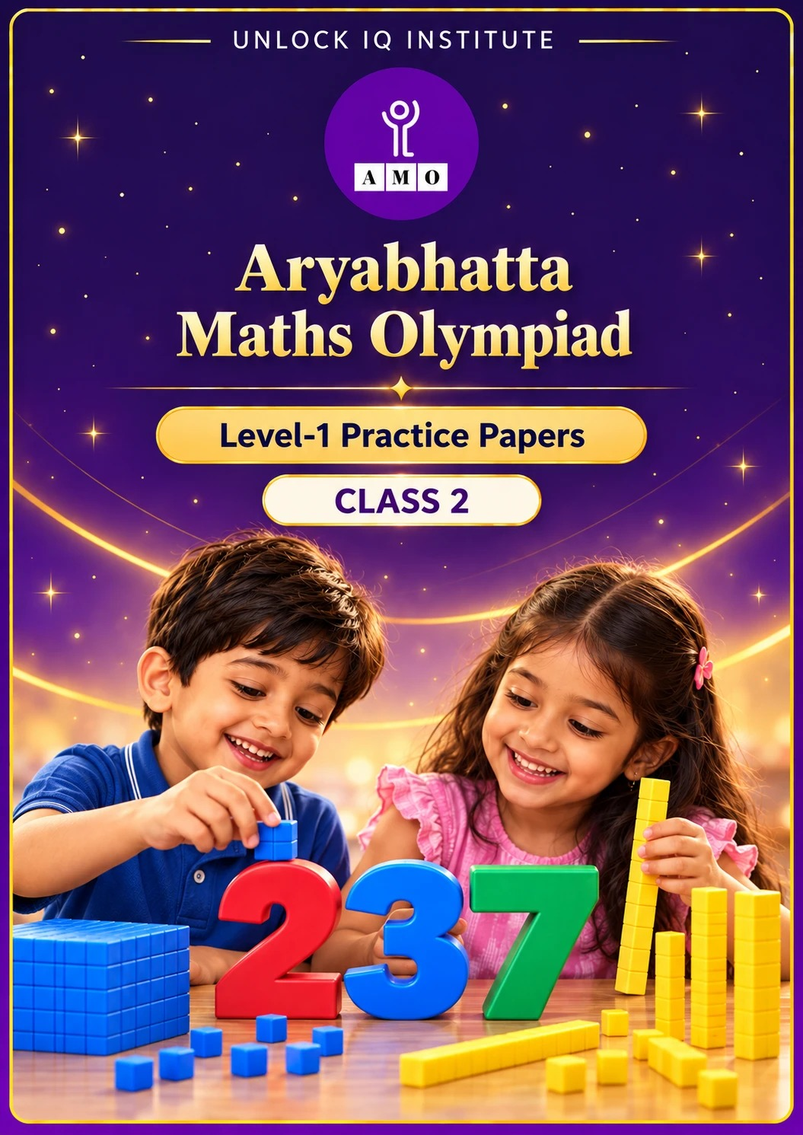
Five full practice papers · with answer keys & detailed solutions
Name: ____________________ | Class & Section: ________________
Roll No.: ________________ | School: ____________________
City: ____________________ | Date: ____________________

Published by Unlock IQ Institute Pvt. Ltd.
Register for Olympiads: www.aryabhattamathsolympiad.com/student-registration
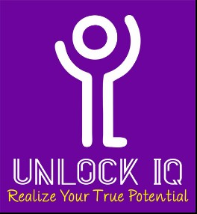
ARYABHATTA MATHS OLYMPIAD
Level 1
PRACTICE PAPER-1
CLASS 2
Total Questions | 45 multiple-choice questions
Total Marks | 100
Time | 60 minutes
Section I | 40 questions × 2 marks = 80 marks
Section II | 5 Star Questions × 4 marks = 20 marks
Negative Marking | No negative marking
Calculator | Not allowed
Chapters | Number System · Operations · Geometry · Applied Mathematics · Mathematical Reasoning

👋 Hello, friend! How to do this paper:
⭐ Every question has four answer choices: (A), (B), (C) and (D). Only one is correct.
⭐ Read each question and look at its picture carefully. Then mark your answer on the answer sheet at the end.
⭐ Section I has 40 questions of 2 marks each. Section II has 5 Star Questions of 4 marks each.
⭐ There is no negative marking, so try every question.
⭐ Do not use a calculator. You may do rough work on a separate sheet.
⭐ All figures are not necessarily drawn to scale unless stated.

For parents and teachers
• Print or view this paper in colour. Pictures are part of the questions.
• You may read a question aloud to the child, exactly as printed. Please do not explain it or point to an answer choice.
• Parts follow the AMO syllabus chapters. Chapters 3, 4, 6, 7 and 8 are not part of the Class 2 syllabus, so the chapter numbers shown in the Part headings have gaps.
• The answer sheet and the answer key are at the end. Remove only the answer key before the child begins.

SECTION I 40 questions × 2 marks each
Part 1 — Number System (Syllabus Chapter 1)
Q1. Vanya counts back in hundreds: 900, 800, 700, and so on. Which of these numbers will she NOT say?
(A) 500 | (B) 800 | (C) 100 | (D) 450

Q2. What is the value of the digit 8 in the number 583?
(A) 83 | (B) 800 | (C) 80 | (D) 8

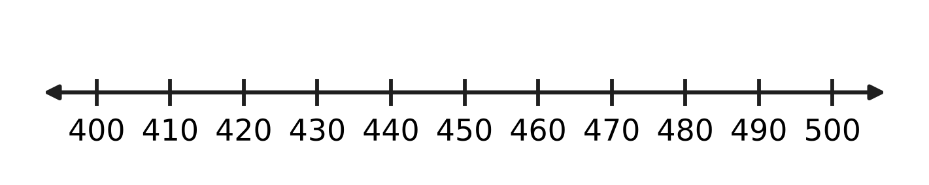
Q3. Look at the number line. The number 467 has no mark of its own. Between which two marks does 467 lie?
(A) 460 and 470 | (B) 400 and 410
(C) 470 and 480 | (D) 440 and 450

Q4. Uday puts all his marbles into 2 glass jars. Both jars get the same number, with none left over. How many marbles can he have?
(A) 135 | (B) 318 | (C) 251 | (D) 407

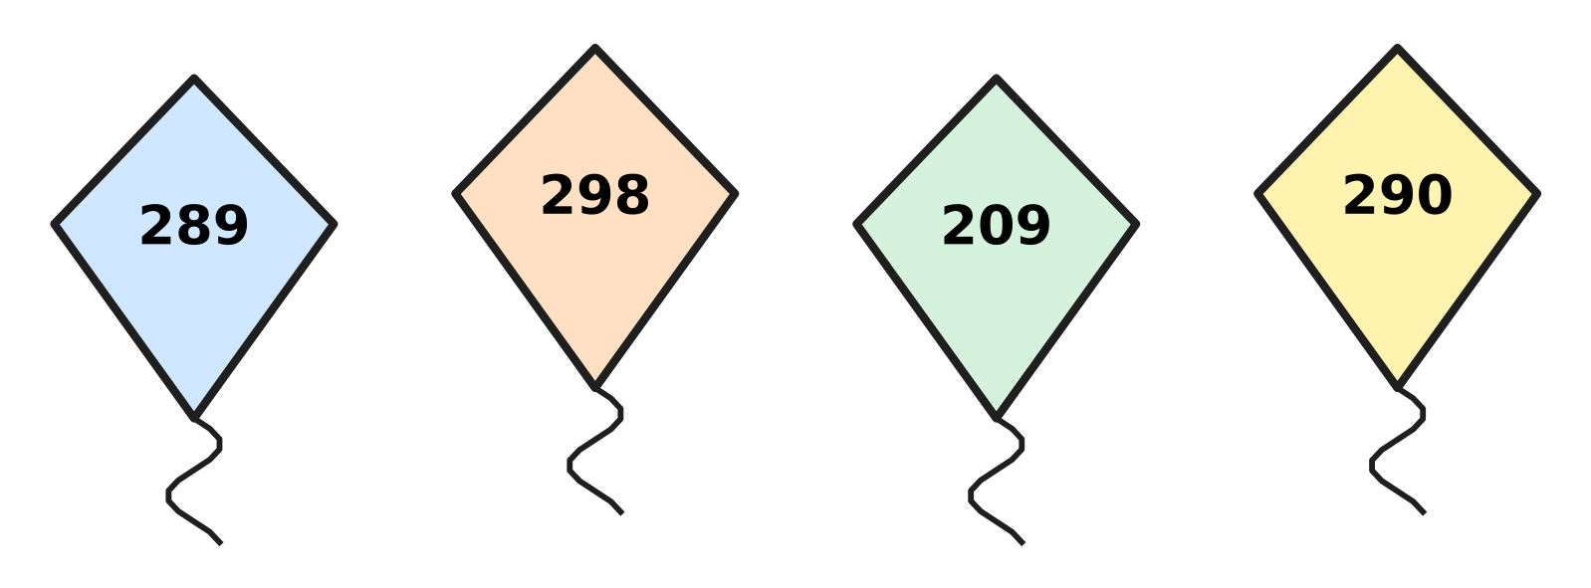
Q5. Look at the four kites. Which kite has the greatest number?
(A) 289 | (B) 290 | (C) 209 | (D) 298

Q6. Write each number name in figures. Which number has 0 in its tens place?
(A) four hundred sixty | (B) four hundred six
(C) four hundred sixteen | (D) four hundred sixty-one

Q7. A number has 5 tens. It is greater than 640 and less than 660. Which of these numbers can it be?
(A) 564 | (B) 645 | (C) 665 | (D) 654

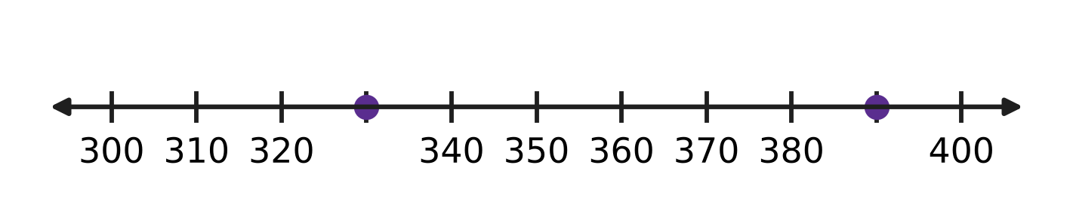
Q8. Look at the number line. The marks go up in equal steps. Which number is exactly halfway between the two dots?
(A) 360 | (B) 370 | (C) 350 | (D) 340

Q9. Which is the greatest even number that is less than 400?
(A) 390 | (B) 400 | (C) 398 | (D) 399

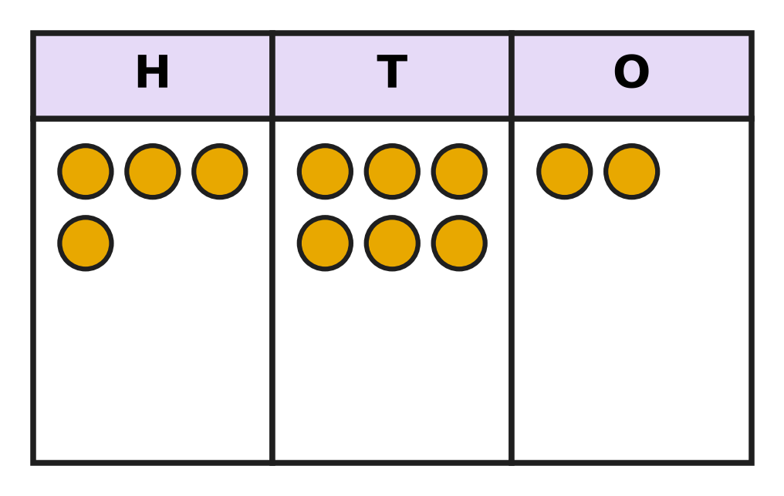
Q10. Look at the place-value chart. It shows 462. Asha puts 3 more counters in the T (tens) column. Which number does the chart show now?
(A) 465 | (B) 432 | (C) 762 | (D) 492

Part 2 — Operations & Number Properties (Syllabus Chapter 2)
Q11. What is 58 + 27?
(A) 85 | (B) 31 | (C) 75 | (D) 715

Q12. A bakery bakes 93 loaves of bread. It sells 57 loaves before noon. How many loaves are left?
(A) 150 | (B) 36 | (C) 46 | (D) 44

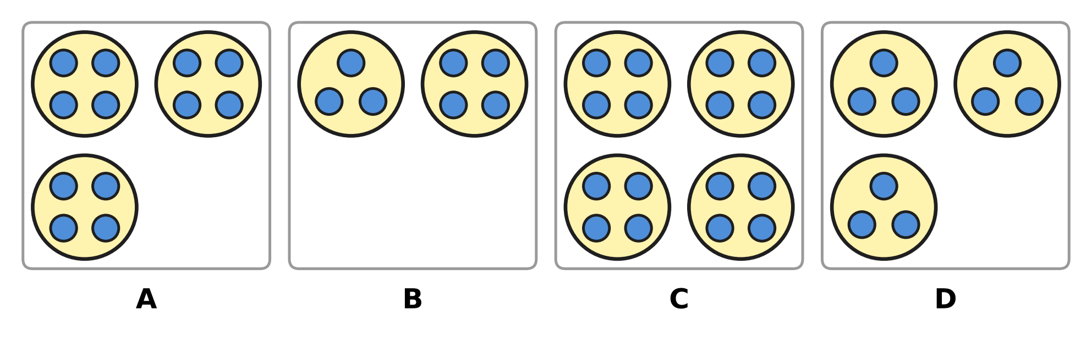
Q13. Look at the four pictures of marbles in rings. Which picture shows 3 × 4?
(A) Picture A | (B) Picture B
(C) Picture C | (D) Picture D

Q14. There are 9 children on a bicycle trip. Each child carries 2 bottles of water. How many bottles do they carry in all?
(A) 20 | (B) 16 | (C) 18 | (D) 11

Q15. A farmer has 14 cows. Half of the cows are in the field. How many cows are in the field?
(A) 7 | (B) 28 | (C) 12 | (D) 6

Q16. Workers in an orchard pick 325 red apples and 148 green apples. How many apples do they pick in all?
(A) 483 | (B) 463 | (C) 473 | (D) 177

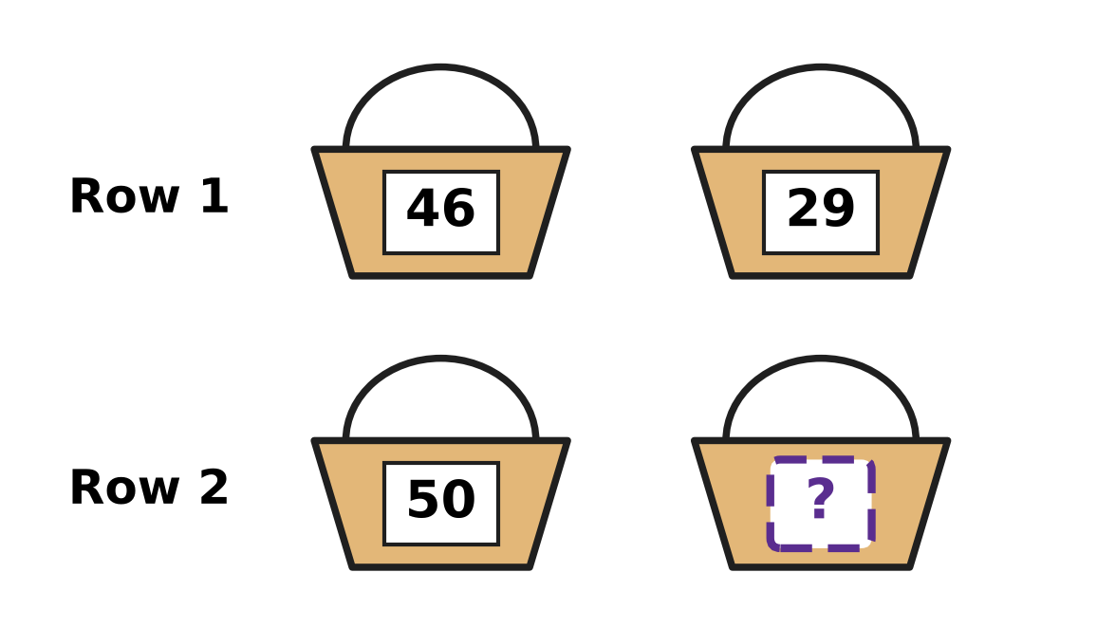
Q17. Look at the baskets. Each basket shows its number of apples. Both rows have the same number of apples in all. How many apples are in the last basket?
(A) 21 | (B) 25 | (C) 75 | (D) 15

Q18. A garden bed has 36 carrot plants in 4 equal rows. How many plants are in each row?
(A) 32 | (B) 40 | (C) 18 | (D) 9

Q19. A red album has 3 pages of 6 stamps each. A blue album has 4 pages of 4 stamps each. How many more stamps are in the red album?
(A) 18 | (B) 3 | (C) 34 | (D) 2

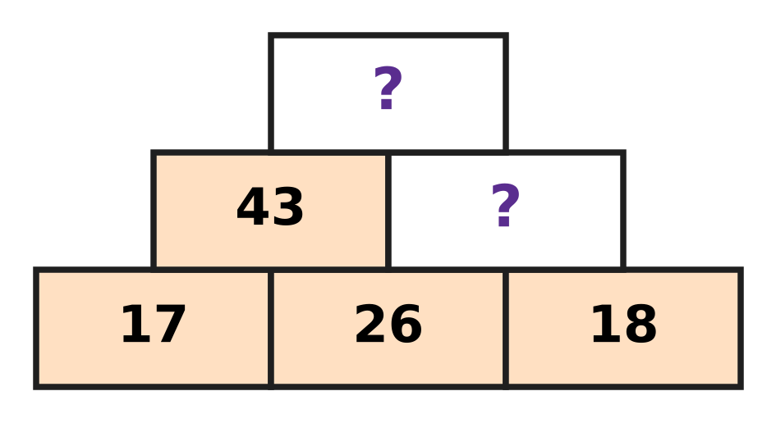
Q20. Look at Farhan's number wall. Each brick is the sum of the two bricks just under it. Which number goes in the top brick?
(A) 77 | (B) 61 | (C) 87 | (D) 44

Part 3 — Geometry (Syllabus Chapter 5)
Q21. Ruhi draws shapes with a ruler, so all her lines are straight. Which shape can she NOT draw?
(A) Square | (B) Circle
(C) Rectangle | (D) Triangle

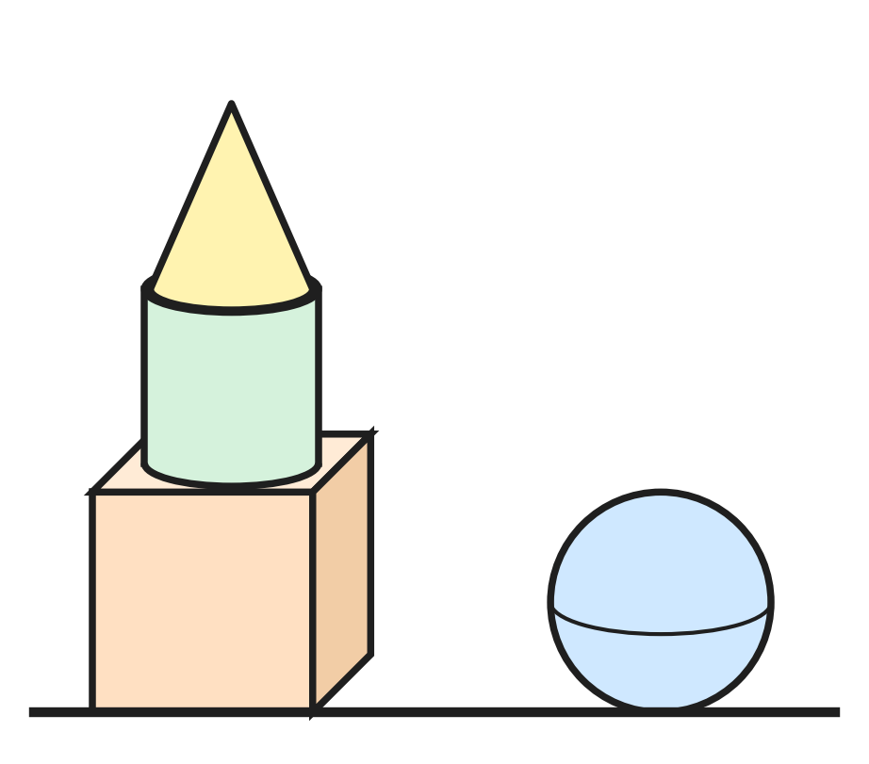
Q22. Look at Swati's solids. Where is the cylinder?
(A) In the middle of the tower | (B) On the floor next to the tower
(C) At the bottom of the tower | (D) At the top of the tower

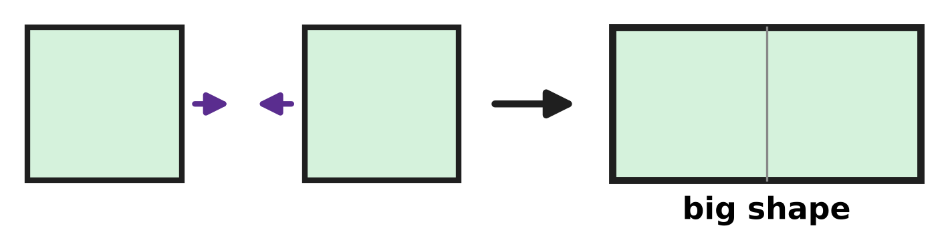
Q23. Two squares of the same size are pushed together. The picture shows the big shape they make. How many corners does the big shape have?
(A) 6 | (B) 8 | (C) 7 | (D) 4

Picture for Q24 and Q27
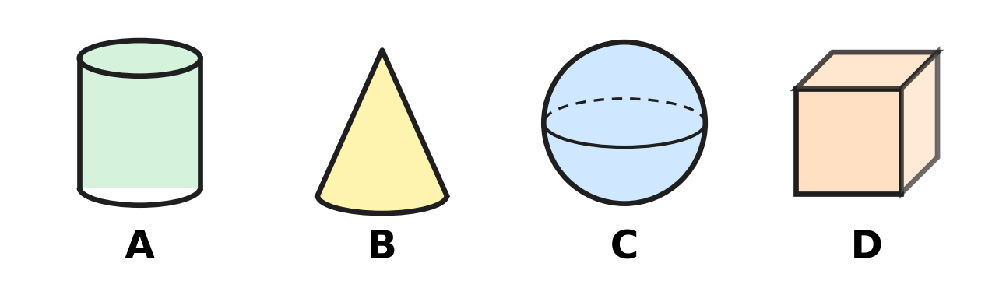
Q24. Look at the four solid shapes. Mona wants the one with no flat part at all. Which one should she pick?
(A) Picture A | (B) Picture B
(C) Picture C | (D) Picture D

Q25. Nila makes 2 triangles and 1 square with straws. Each side is one straw. The shapes do not touch. How many straws does she use?
(A) 3 | (B) 10 | (C) 7 | (D) 9

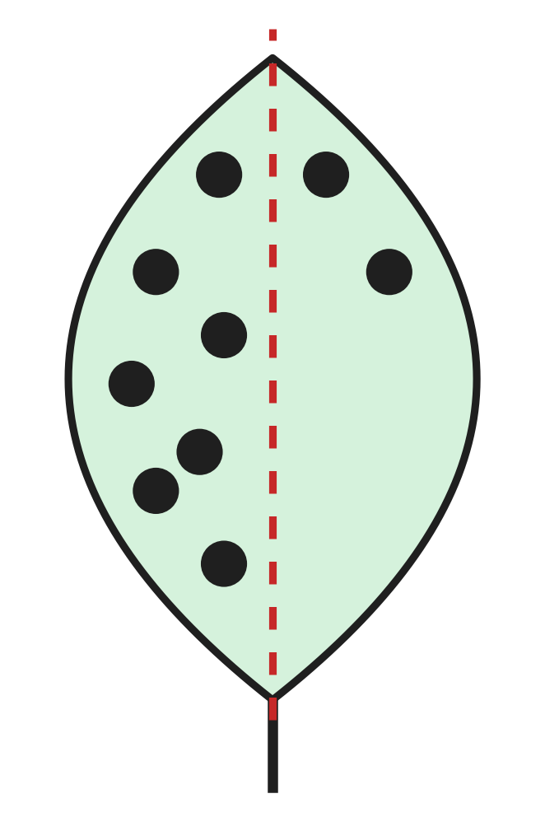
Q26. Look at the paper leaf. The two sides of the dotted line must match exactly. How many more dots must be drawn on the right side?
(A) 5 | (B) 7 | (C) 2 | (D) 9

Picture for Q24 and Q27
Q27. Look at the four solid shapes. Tanuj lays each one on its side and pushes it along the floor. Which one rolls round in a circle?
(A) Picture A | (B) Picture B
(C) Picture C | (D) Picture D

Part 4 — Applied Mathematics (Syllabus Chapter 9)
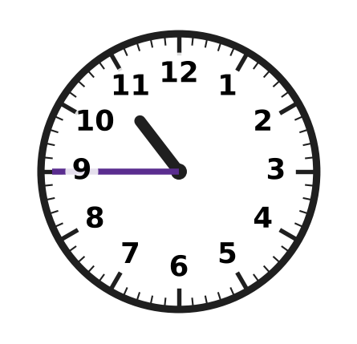
Q28. Look at the clock. What time does it show?
(A) quarter to 10 | (B) 9 o'clock
(C) quarter to 11 | (D) quarter past 11

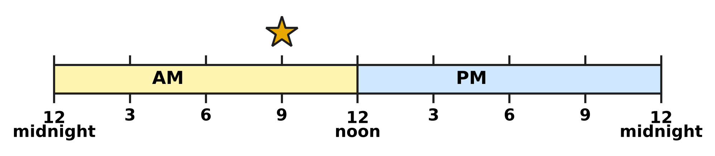
Q29. Look at the time line. It shows one whole day. What time is at the star?
(A) 3 PM | (B) 9 PM | (C) 3 AM | (D) 9 AM

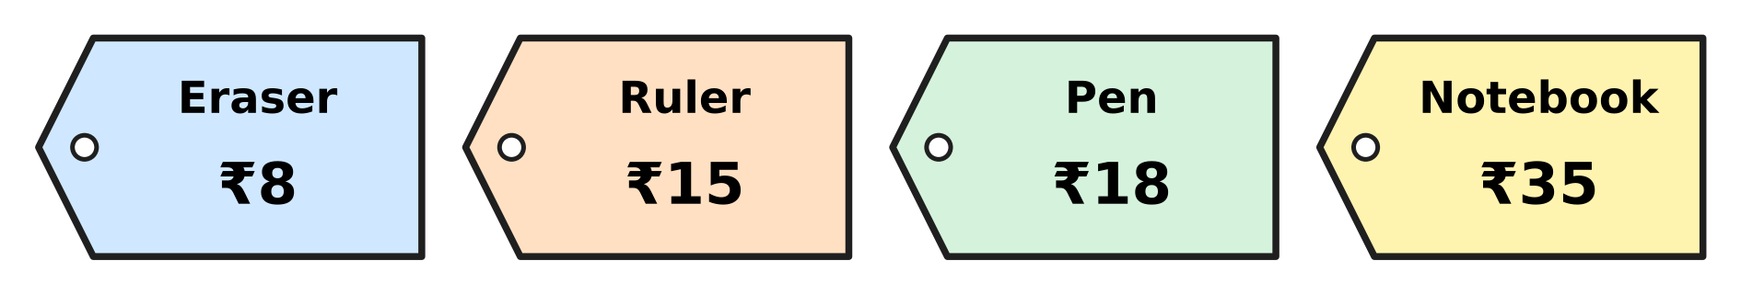
Q30. Look at the price tags in the stationery shop. How much more does the notebook cost than the pen?
(A) ₹27 | (B) ₹17 | (C) ₹23 | (D) ₹53

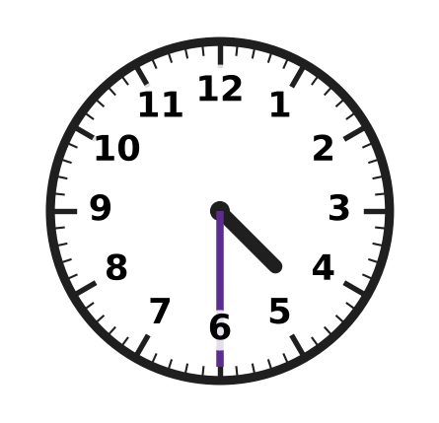
Q31. Look at the clock. It shows when the swimming pool opens in the afternoon. What time is it?
(A) 4:30 PM | (B) 5:30 PM | (C) 4:30 AM | (D) 6:30 PM

Q32. These four times are all on the same morning. Which time comes last?
(A) half past 9 | (B) quarter past 9
(C) quarter to 10 | (D) quarter to 9

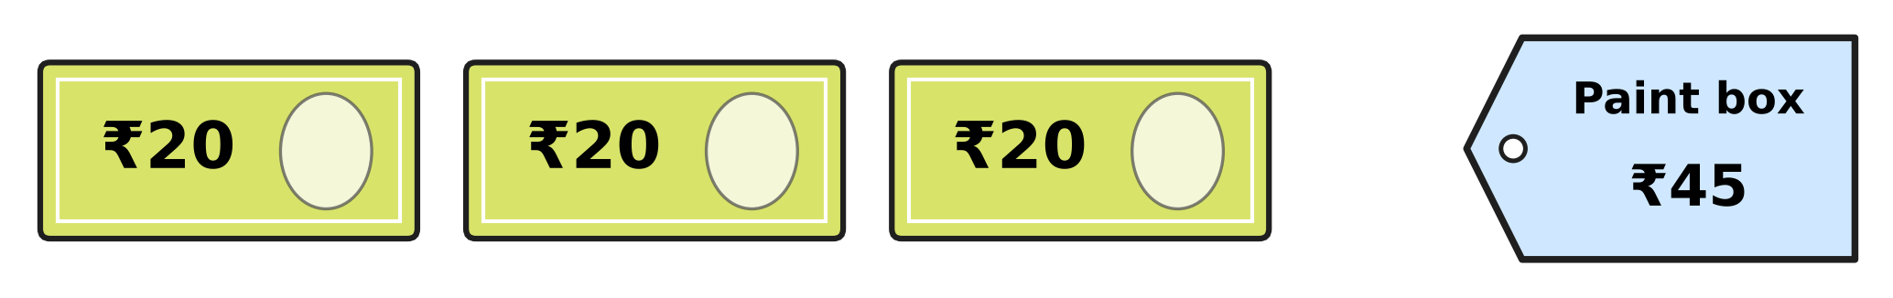
Q33. Look at the picture. Esha has these three notes. She buys the paint box. How much money does she have left?
(A) ₹45 | (B) ₹60 | (C) ₹25 | (D) ₹15

Q34. A bakery opens at 7 AM and closes at 7 PM on the same day. At which of these times is it closed?
(A) 10 PM | (B) 5 PM | (C) 8 AM | (D) 12 noon

Part 5 — Mathematical Reasoning & Problem-Solving (Syllabus Chapter 10)
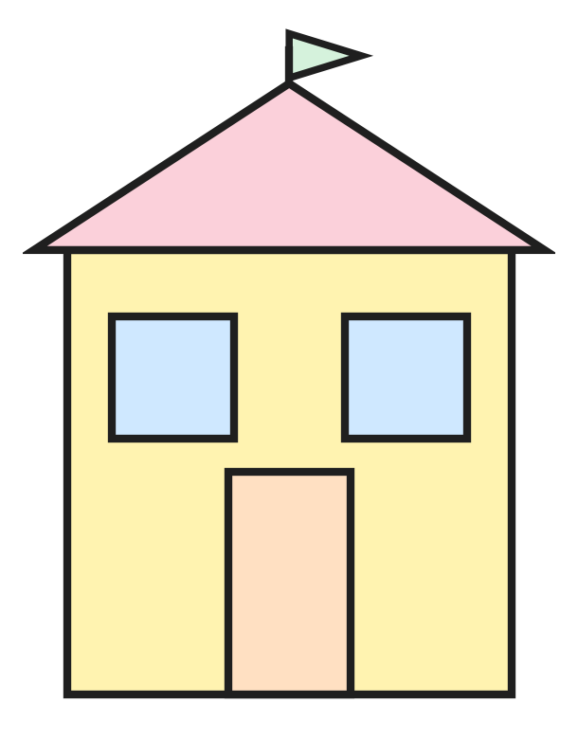
Q35. Look at the drawing of a house. It is made of flat shapes. How many squares are in it?
(A) 4 | (B) 1 | (C) 3 | (D) 2

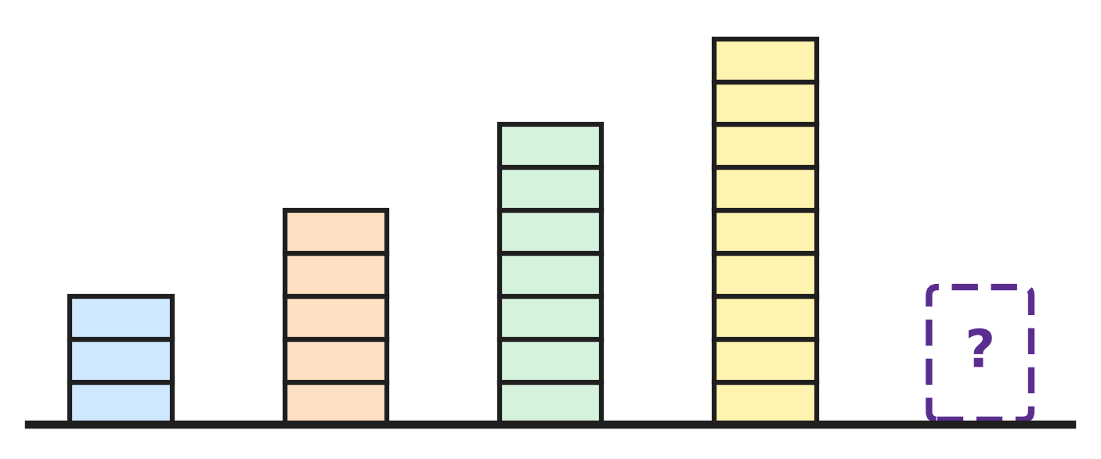
Q36. Look at Laksh's towers. They grow in the same way each time. How many blocks will the next tower have?
(A) 12 | (B) 11 | (C) 10 | (D) 9

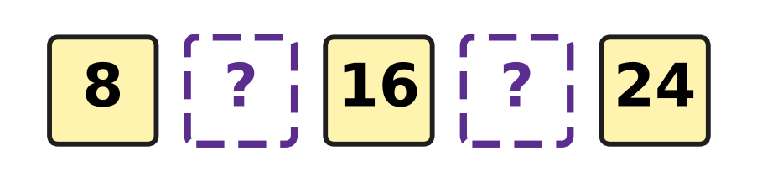
Q37. Look at the row of numbers. Every jump from one number to the next is the same. Which two numbers are missing?
(A) 12 and 18 | (B) 12 and 20
(C) 10 and 20 | (D) 9 and 17

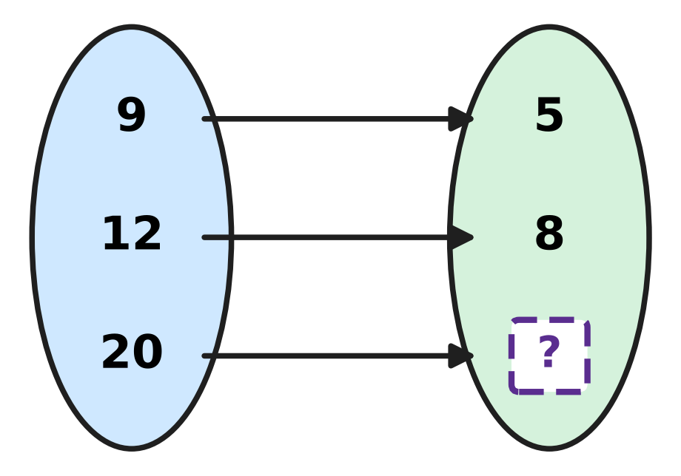
Q38. Look at the arrows. They all follow one rule. Which number is hidden?
(A) 10 | (B) 15 | (C) 24 | (D) 16

Q39. What comes next in this number pattern?
2, 3, 5, 8, 12, ___
(A) 17 | (B) 18 | (C) 20 | (D) 16

Q40. How many numbers from 10 to 30 have the digit 2 in them?
(A) 3 | (B) 12 | (C) 11 | (D) 10

SECTION II — Star Questions 5 questions × 4 marks each
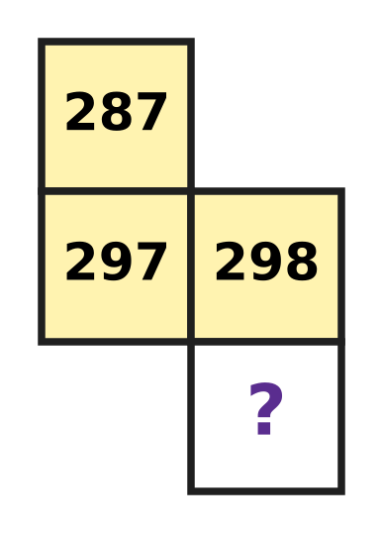
Q41. Look at the piece cut from a number chart. Each row of the chart has 10 numbers in counting order. Which number is hidden? [4 marks]
(A) 208 | (B) 308 | (C) 398 | (D) 299

Q42. One rule gives 2 → 4, 3 → 9 and 5 → 25. What does this rule give for 7? [4 marks]
(A) 49 | (B) 27 | (C) 14 | (D) 35

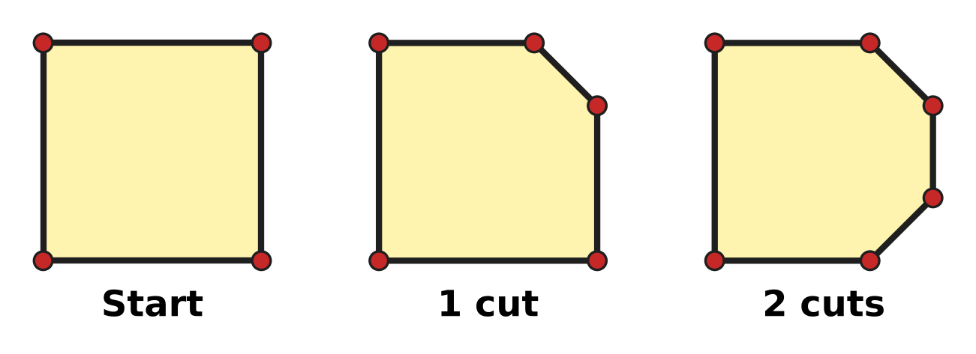
Q43. Look at the pictures. Each cut takes one corner off the paper square. How many corners will it have when all 4 corners are cut off? [4 marks]
(A) 4 | (B) 7 | (C) 0 | (D) 8

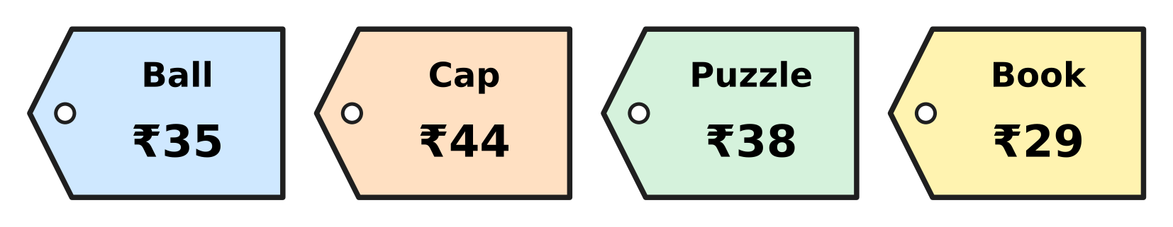
Q44. Look at the price tags. Kai has 20 coins of ₹2 and no other money. He wants to pay the exact price of one thing. Which thing can he buy? [4 marks]
(A) Cap | (B) Ball | (C) Puzzle | (D) Book

Q45. Shaan draws a triangle on the floor. He puts a ₹10 coin on each corner and a ₹2 coin in the middle of each side. He spends ₹20. How much money is left? [4 marks]
(A) ₹36 | (B) ₹12 | (C) ₹16 | (D) ₹28

Answer Sheet AMO Level 1 · Class 2 · Practice Paper 1
Name: | School: | Roll No.:
Shade or tick one circle for each question.
1. Ⓐ Ⓑ Ⓒ Ⓓ | 16. Ⓐ Ⓑ Ⓒ Ⓓ | 31. Ⓐ Ⓑ Ⓒ Ⓓ
2. Ⓐ Ⓑ Ⓒ Ⓓ | 17. Ⓐ Ⓑ Ⓒ Ⓓ | 32. Ⓐ Ⓑ Ⓒ Ⓓ
3. Ⓐ Ⓑ Ⓒ Ⓓ | 18. Ⓐ Ⓑ Ⓒ Ⓓ | 33. Ⓐ Ⓑ Ⓒ Ⓓ
4. Ⓐ Ⓑ Ⓒ Ⓓ | 19. Ⓐ Ⓑ Ⓒ Ⓓ | 34. Ⓐ Ⓑ Ⓒ Ⓓ
5. Ⓐ Ⓑ Ⓒ Ⓓ | 20. Ⓐ Ⓑ Ⓒ Ⓓ | 35. Ⓐ Ⓑ Ⓒ Ⓓ
6. Ⓐ Ⓑ Ⓒ Ⓓ | 21. Ⓐ Ⓑ Ⓒ Ⓓ | 36. Ⓐ Ⓑ Ⓒ Ⓓ
7. Ⓐ Ⓑ Ⓒ Ⓓ | 22. Ⓐ Ⓑ Ⓒ Ⓓ | 37. Ⓐ Ⓑ Ⓒ Ⓓ
8. Ⓐ Ⓑ Ⓒ Ⓓ | 23. Ⓐ Ⓑ Ⓒ Ⓓ | 38. Ⓐ Ⓑ Ⓒ Ⓓ
9. Ⓐ Ⓑ Ⓒ Ⓓ | 24. Ⓐ Ⓑ Ⓒ Ⓓ | 39. Ⓐ Ⓑ Ⓒ Ⓓ
10. Ⓐ Ⓑ Ⓒ Ⓓ | 25. Ⓐ Ⓑ Ⓒ Ⓓ | 40. Ⓐ Ⓑ Ⓒ Ⓓ
11. Ⓐ Ⓑ Ⓒ Ⓓ | 26. Ⓐ Ⓑ Ⓒ Ⓓ | 41. Ⓐ Ⓑ Ⓒ Ⓓ
12. Ⓐ Ⓑ Ⓒ Ⓓ | 27. Ⓐ Ⓑ Ⓒ Ⓓ | 42. Ⓐ Ⓑ Ⓒ Ⓓ
13. Ⓐ Ⓑ Ⓒ Ⓓ | 28. Ⓐ Ⓑ Ⓒ Ⓓ | 43. Ⓐ Ⓑ Ⓒ Ⓓ
14. Ⓐ Ⓑ Ⓒ Ⓓ | 29. Ⓐ Ⓑ Ⓒ Ⓓ | 44. Ⓐ Ⓑ Ⓒ Ⓓ
15. Ⓐ Ⓑ Ⓒ Ⓓ | 30. Ⓐ Ⓑ Ⓒ Ⓓ | 45. Ⓐ Ⓑ Ⓒ Ⓓ
Q41–Q45 are Section II Star Questions (4 marks each).
For the parent or teacher
Section I correct: ______ / 40 × 2 = ______ marks Section II correct: ______ / 5 × 4 = ______ marks
Correct: ______ / 45 Score: ______ / 100
Answer Key and Solutions AMO Level 1 · Class 2 · Practice Paper 1
Quick answers
1 D | 6 B | 11 A | 16 C | 21 B | 26 A | 31 A | 36 B | 41 B
2 C | 7 D | 12 B | 17 B | 22 A | 27 B | 32 C | 37 B | 42 A
3 A | 8 A | 13 A | 18 D | 23 D | 28 C | 33 D | 38 D | 43 D
4 B | 9 C | 14 C | 19 D | 24 C | 29 D | 34 A | 39 A | 44 C
5 D | 10 D | 15 A | 20 C | 25 B | 30 B | 35 C | 40 C | 45 C
Solutions
Q | Part · level | Answer | Why?
1 | Part 1 · Ch1 · Easy | (D) 450 | Counting back in hundreds gives 900, 800, 700, 600, 500, 400, 300, 200, 100. The number 450 is not one of them.
2 | Part 1 · Ch1 · Easy | (C) 80 | The 8 is in the tens place, so its value is 80.
3 | Part 1 · Ch1 · Easy | (A) 460 and 470 | 467 is greater than 460 and less than 470.
4 | Part 1 · Ch1 · Easy | (B) 318 | Only an even number can be shared into 2 equal groups with none left over. 318 ends in 8, so it is even. The other three are odd.
5 | Part 1 · Ch1 · Easy | (D) 298 | All have 2 hundreds. 298 and 290 have the most tens, 9. Then 8 ones is more than 0 ones, so 298 is greatest.
6 | Part 1 · Ch1 · Easy | (B) four hundred six | Four hundred six is 406: 4 hundreds, 0 tens and 6 ones. The others are 460, 416 and 461.
7 | Part 1 · Ch1 · Medium | (D) 654 | 654 has 6 hundreds, 5 tens and 4 ones, and it lies between 640 and 660. The other numbers do not have 5 tens.
8 | Part 1 · Ch1 · Medium | (A) 360 | Each step is 10. The dot after 320 is at 330 and the dot after 380 is at 390. 360 is 30 more than 330 and 30 less than 390, so 360 is halfway.
9 | Part 1 · Ch1 · Medium | (C) 398 | 399 is odd. The number before it, 398, is even.
10 | Part 1 · Ch1 · Medium | (D) 492 | 6 tens and 3 more tens make 9 tens: 492.
11 | Part 2 · Ch2 · Easy | (A) 85 | 8 + 7 = 15: write 5, carry 1. Then 5 + 2 + 1 = 8. Answer: 85.
12 | Part 2 · Ch2 · Easy | (B) 36 | Open a ten: 13 − 7 = 6. Then 8 − 5 = 3 tens. 36 are left.
13 | Part 2 · Ch2 · Easy | (A) Picture A | 3 × 4 means 3 groups of 4. Picture A has 3 rings with 4 marbles in each ring: 4 + 4 + 4 = 12.
14 | Part 2 · Ch2 · Easy | (C) 18 | 9 groups of 2: 9 × 2 = 18 bottles.
15 | Part 2 · Ch2 · Easy | (A) 7 | Half of 14 is 7, because 7 + 7 = 14. So 14 ÷ 2 = 7.
16 | Part 2 · Ch2 · Easy | (C) 473 | Ones: 5 + 8 = 13, write 3 and carry 1. Tens: 2 + 4 + 1 = 7. Hundreds: 3 + 1 = 4. They pick 473 apples.
17 | Part 2 · Ch2 · Medium | (B) 25 | Row 1 has 46 + 29 = 75 apples. Then 75 − 50 = 25.
18 | Part 2 · Ch2 · Medium | (D) 9 | Sharing into 4 equal rows is halving twice. Half of 36 is 18, and half of 18 is 9. So 36 ÷ 4 = 9.
19 | Part 2 · Ch2 · Medium | (D) 2 | 3 × 6 = 18 stamps and 4 × 4 = 16 stamps. 18 − 16 = 2.
20 | Part 2 · Ch2 · Medium | (C) 87 | Middle brick: 26 + 18 = 44. Top brick: 43 + 44 = 87.
21 | Part 3 · Ch5 · Easy | (B) Circle | A circle is round. It has no straight sides, so it cannot be drawn with straight lines only.
22 | Part 3 · Ch5 · Easy | (A) In the middle of the tower | A cylinder has a curved side and a flat circle at each end. It is in the middle of the tower, between the cube and the cone.
23 | Part 3 · Ch5 · Easy | (D) 4 | The big shape is a rectangle. A rectangle has 4 corners. The thin line in the middle only shows where the squares meet.
24 | Part 3 · Ch5 · Easy | (C) Picture C | Picture C is a sphere. It is curved all over, like a ball. The cylinder, the cone and the cube each have a flat part.
25 | Part 3 · Ch5 · Medium | (B) 10 | A triangle has 3 sides and a square has 4: 3 + 3 + 4 = 10.
26 | Part 3 · Ch5 · Medium | (A) 5 | The right side needs 7 dots too. It has 2. 7 − 2 = 5 more.
27 | Part 3 · Ch5 · Medium | (B) Picture B | Picture B is a cone. One end is a point and the other end is wide, so it rolls round in a circle.
28 | Part 4 · Ch9 · Easy | (C) quarter to 11 | The long hand is on 9, so it is quarter to. The short hand is almost at 11, so the time is quarter to 11.
29 | Part 4 · Ch9 · Easy | (D) 9 AM | The star is at the 9 before 12 noon, so it is 9 AM.
30 | Part 4 · Ch9 · Easy | (B) ₹17 | ₹35 − ₹18 = ₹17.
31 | Part 4 · Ch9 · Easy | (A) 4:30 PM | The long hand is on 6 and the short hand is between 4 and 5: half past 4. The afternoon is PM, so it is 4:30 PM.
32 | Part 4 · Ch9 · Medium | (C) quarter to 10 | In order, the times are quarter to 9, quarter past 9, half past 9 and quarter to 10. Quarter to 10 comes last.
33 | Part 4 · Ch9 · Medium | (D) ₹15 | She has ₹20 + ₹20 + ₹20 = ₹60. Then ₹60 − ₹45 = ₹15.
34 | Part 4 · Ch9 · Medium | (A) 10 PM | The bakery is open from 7 in the morning to 7 in the evening. 10 PM is at night, after 7 PM, so it is closed.
35 | Part 5 · Ch10 · Easy | (C) 3 | The big wall is a square and the two windows are squares: 3 squares. The door is a rectangle and the roof and flag are triangles.
36 | Part 5 · Ch10 · Easy | (B) 11 | The towers have 3, 5, 7, 9 blocks: 2 more each time. Next: 11.
37 | Part 5 · Ch10 · Easy | (B) 12 and 20 | Each jump is 4: 8, 12, 16, 20, 24.
38 | Part 5 · Ch10 · Easy | (D) 16 | 9 → 5 and 12 → 8: the rule is "take away 4". 20 − 4 = 16.
39 | Part 5 · Ch10 · Medium | (A) 17 | The jumps are +1, +2, +3, +4, then +5. 12 + 5 = 17.
40 | Part 5 · Ch10 · Medium | (C) 11 | The numbers are 12 and then 20, 21, 22, 23, 24, 25, 26, 27, 28, 29. That is 1 + 10 = 11 numbers.
41 | Section II · Ch1 + Ch10 · Hard | (B) 308 | Going down one row adds 10: 287 is above 297. So the hidden number is 298 + 10. 29 tens and 1 more ten make 30 tens, and 8 ones: 308.
42 | Section II · Ch2 + Ch10 · Hard | (A) 49 | Each number is multiplied by itself: 7 × 7 = 49.
43 | Section II · Ch5 + Ch10 · Hard | (D) 8 | The paper has 4 corners, then 5, then 6: one more after each cut. After 4 cuts there are 4 + 4 = 8 corners.
44 | Section II · Ch1 + Ch9 · Hard | (C) Puzzle | 20 coins of ₹2 are ₹40. ₹2 coins can make only even amounts. ₹38 is even and not more than ₹40, so he can buy the puzzle.
45 | Section II · Ch5 + Ch9 · Hard | (C) ₹16 | A triangle has 3 corners and 3 sides. 3 coins of ₹10 are ₹30 and 3 coins of ₹2 are ₹6: ₹36 in all. ₹36 − ₹20 = ₹16.

ARYABHATTA MATHS OLYMPIAD
Level 1
PRACTICE PAPER-2
CLASS 2
Total Questions | 45 multiple-choice questions
Total Marks | 100
Time | 60 minutes
Section I | 40 questions × 2 marks = 80 marks
Section II | 5 Star Questions × 4 marks = 20 marks
Negative Marking | No negative marking
Calculator | Not allowed
Chapters | Number System · Operations · Geometry · Applied Mathematics · Mathematical Reasoning

👋 Hello, friend! How to do this paper:
⭐ Every question has four answer choices: (A), (B), (C) and (D). Only one is correct.
⭐ Read each question and look at its picture carefully. Then mark your answer on the answer sheet at the end.
⭐ Section I has 40 questions of 2 marks each. Section II has 5 Star Questions of 4 marks each.
⭐ There is no negative marking, so try every question.
⭐ Do not use a calculator. You may do rough work on a separate sheet.
⭐ All figures are not necessarily drawn to scale unless stated.

For parents and teachers
• Print or view this paper in colour. Pictures are part of the questions.
• You may read a question aloud to the child, exactly as printed. Please do not explain it or point to an answer choice.
• Parts follow the AMO syllabus chapters. Chapters 3, 4, 6, 7 and 8 are not part of the Class 2 syllabus, so the chapter numbers shown in the Part headings have gaps.
• The answer sheet and the answer key are at the end. Remove only the answer key before the child begins.

SECTION I 40 questions × 2 marks each
Part 1 — Number System (Syllabus Chapter 1)
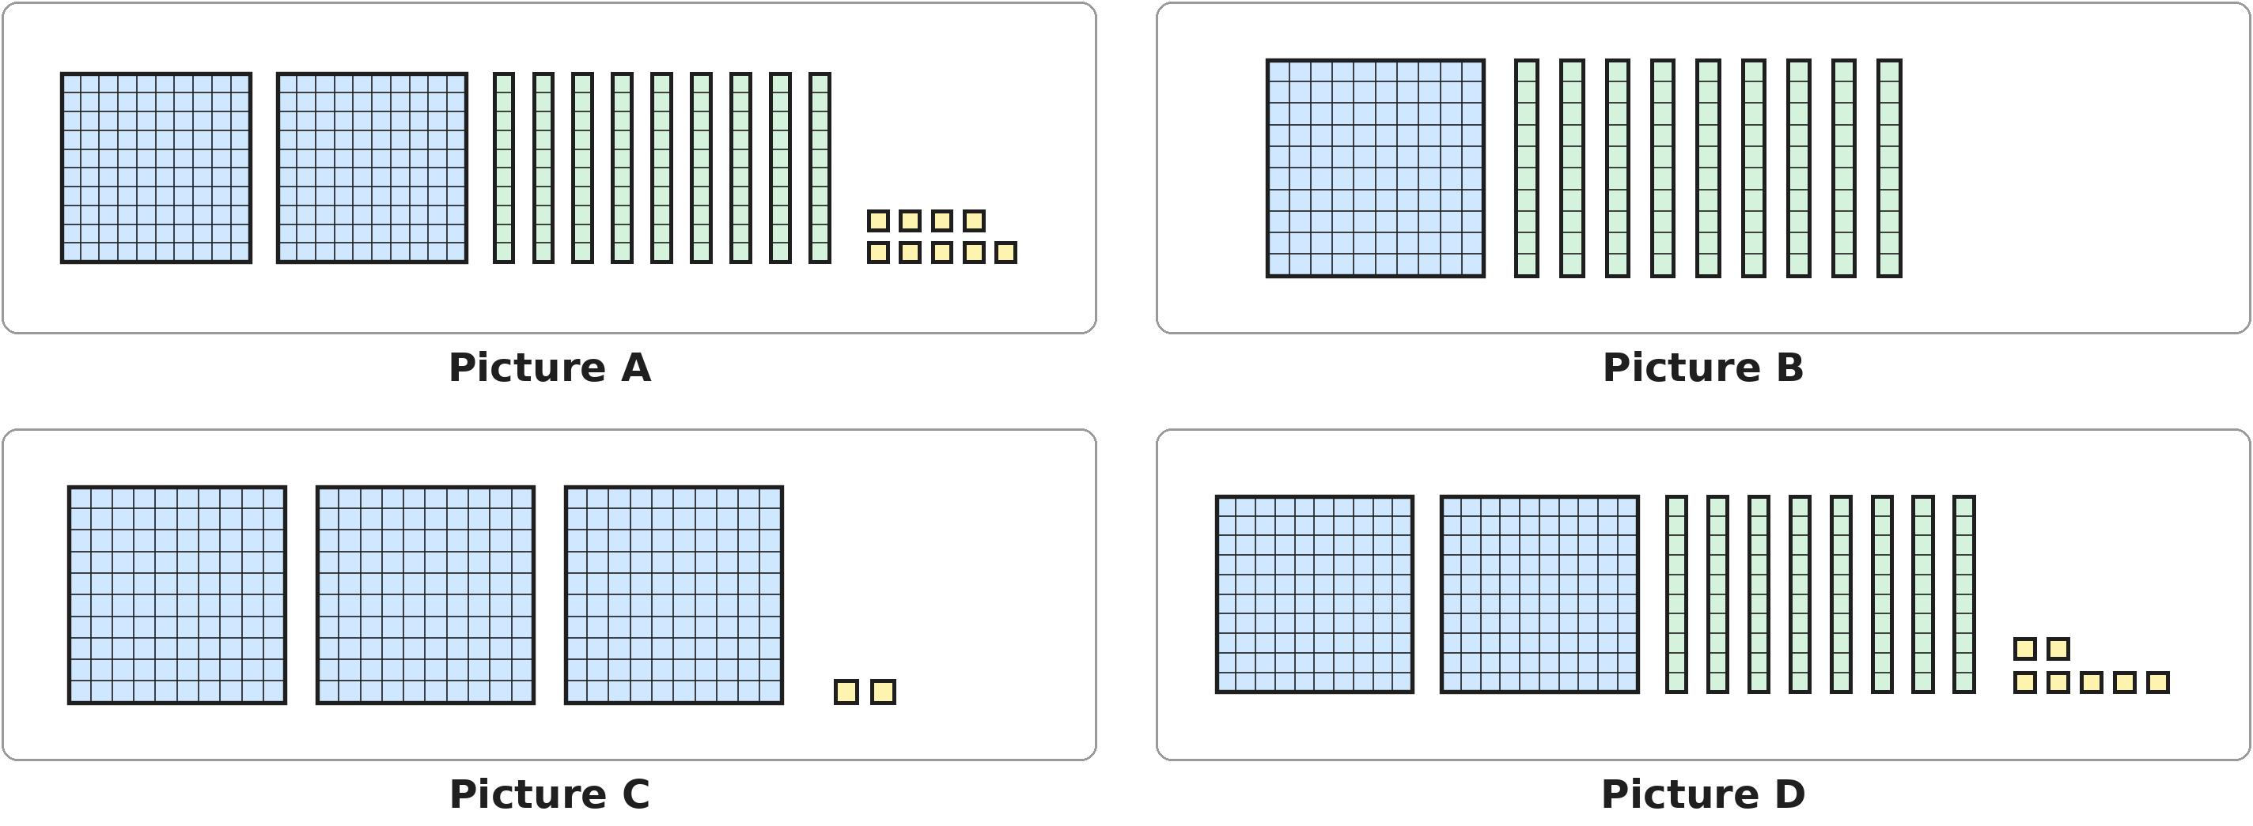
Q1. Look at the blocks. A big square is 1 hundred, a rod is 1 ten and a small square is 1 one. Which picture shows more than 300?
(A) Picture A | (B) Picture B
(C) Picture C | (D) Picture D

Q2. In which of these numbers does the digit 5 stand for 50?
(A) 125 | (B) 152 | (C) 512 | (D) 521

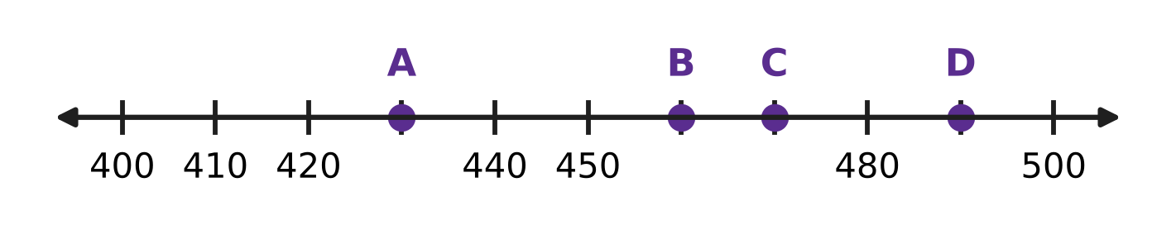
Q3. Look at the number line. The marks go up in tens. Which letter is at 470?
(A) A | (B) B | (C) C | (D) D

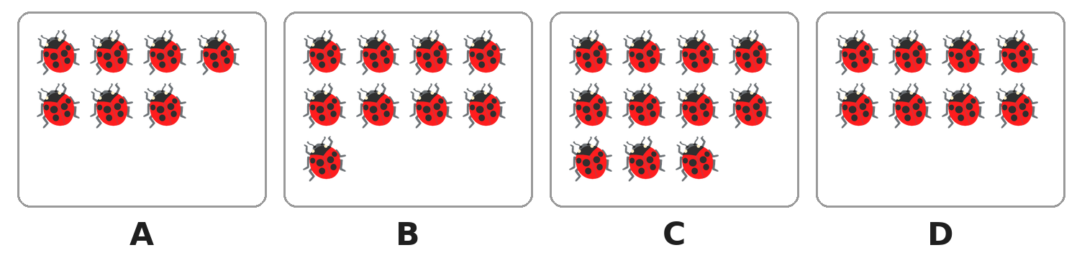
Q4. Look at the boxes of ladybirds. Which box has an even number of ladybirds?
(A) Box A | (B) Box B | (C) Box C | (D) Box D

Q5. Which of these is the number name of 340?
(A) three hundred four | (B) three hundred fourteen
(C) thirty-four | (D) three hundred forty

Q6. Which of these numbers comes between 498 and 503?
(A) 489 | (B) 497 | (C) 501 | (D) 510

Q7. In which of these numbers is the hundreds digit smaller than the tens digit?
(A) 285 | (B) 528 | (C) 825 | (D) 852

Q8. A 3-digit number begins with 47. It is even, and its ones digit is greater than 5. Which of these can be its ones digit?
(A) 4 | (B) 6 | (C) 7 | (D) 9

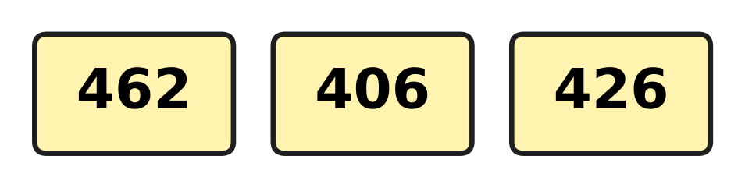
Q9. Look at the three number cards. Which of these shows the numbers from the smallest to the greatest?
(A) 462, 426, 406 | (B) 426, 406, 462
(C) 406, 462, 426 | (D) 406, 426, 462

Q10. Which of these numbers is nearest to 400?
(A) 396 | (B) 403 | (C) 408 | (D) 411

Part 2 — Operations & Number Properties (Syllabus Chapter 2)
Q11. A race on sports day is 100 steps long. Kush has run 64 steps. How many more steps must he run?
(A) 36 | (B) 44 | (C) 46 | (D) 164

Q12. A train has 245 people on it. At the next station, 38 more people get on. How many people are on the train now?
(A) 207 | (B) 273 | (C) 283 | (D) 625

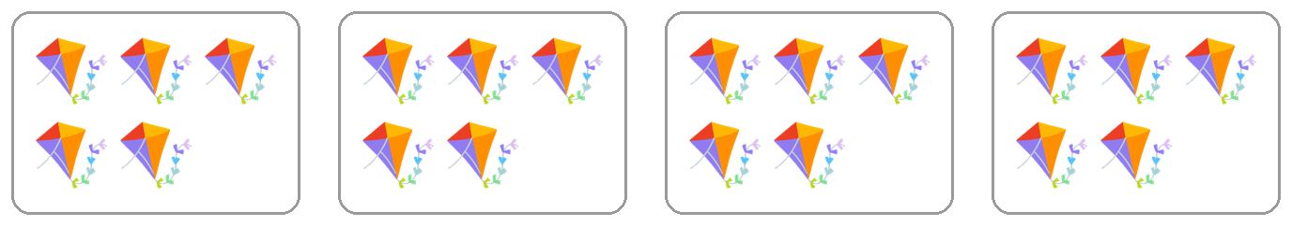
Q13. Look at the boxes of kites. Which of these tells how many kites there are?
(A) 5 × 5 | (B) 4 + 5 | (C) 4 × 4 | (D) 4 × 5

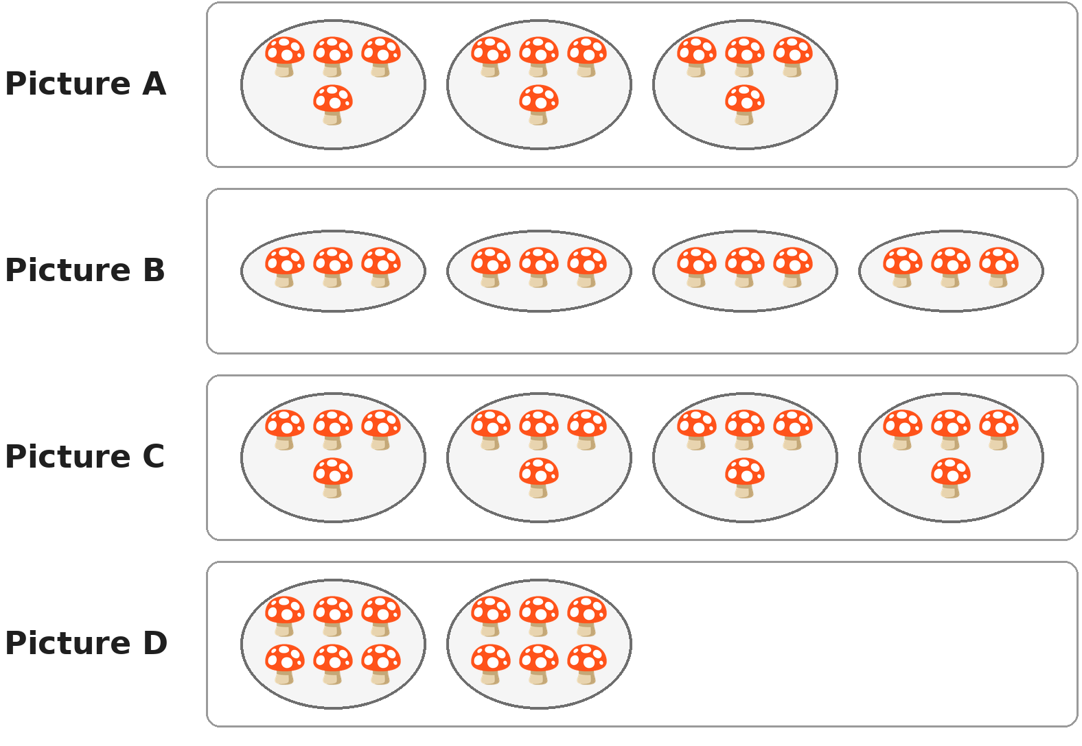
Q14. Look at the plates of mushrooms. Which picture shows 12 mushrooms shared equally among 4 plates?
(A) Picture A | (B) Picture B
(C) Picture C | (D) Picture D

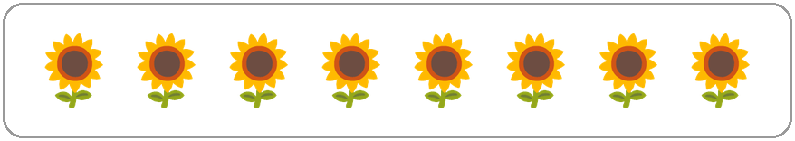
Q15. Look at the plants in a school garden. Each plant needs 3 mugs of water. How many mugs of water do they need in all?
(A) 11 | (B) 21 | (C) 24 | (D) 32

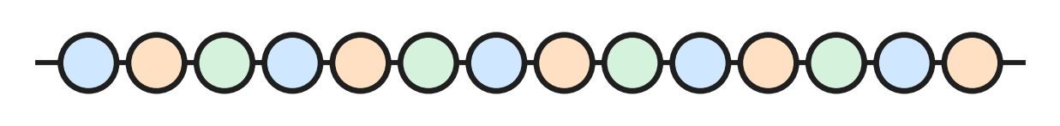
Q16. Look at the string of beads. Luke takes half of the beads off the string. How many beads stay on the string?
(A) 6 | (B) 7 | (C) 12 | (D) 14

Q17. Which of these sums makes exactly 100?
(A) 48 + 42 | (B) 55 + 55 | (C) 73 + 37 | (D) 64 + 36

Q18. Lena has 20 ribbons. She gives 3 ribbons to each of her 4 friends. How many ribbons does she have left?
(A) 8 | (B) 12 | (C) 13 | (D) 17

Q19. Which of these is the same as a quarter of 20?
(A) Half of 20 | (B) Half of 40
(C) A quarter of 16 | (D) Half of 10

Q20. In which of these do you have to open a ten before you can take away the ones?
(A) 63 − 28 | (B) 68 − 23 | (C) 86 − 32 | (D) 38 − 26

Part 3 — Geometry (Syllabus Chapter 5)
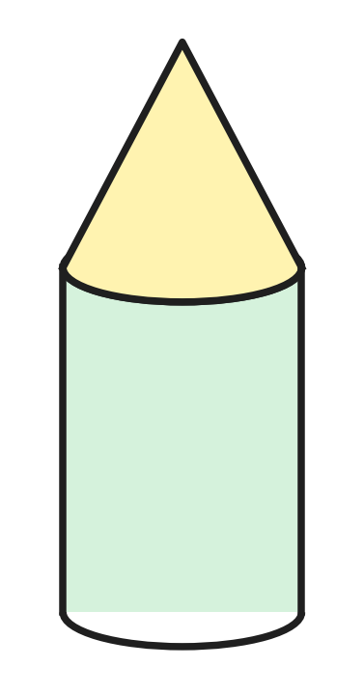
Q21. Look at the toy rocket in a toy shop. It is made of two solids, one on top of the other. Which two solids are they?
(A) A cylinder and a cone | (B) A cylinder and a sphere
(C) A cube and a cone | (D) A cube and a sphere

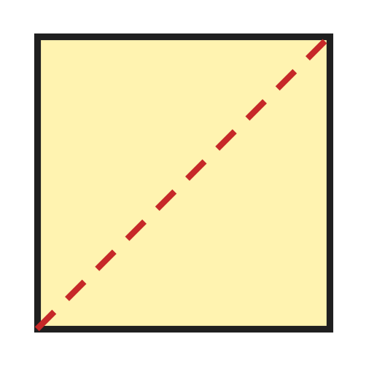
Q22. Look at the square paper. Jaya folds it along the dotted line, so that one half lies on the other. How many corners does the folded shape have?
(A) 2 | (B) 3 | (C) 4 | (D) 6

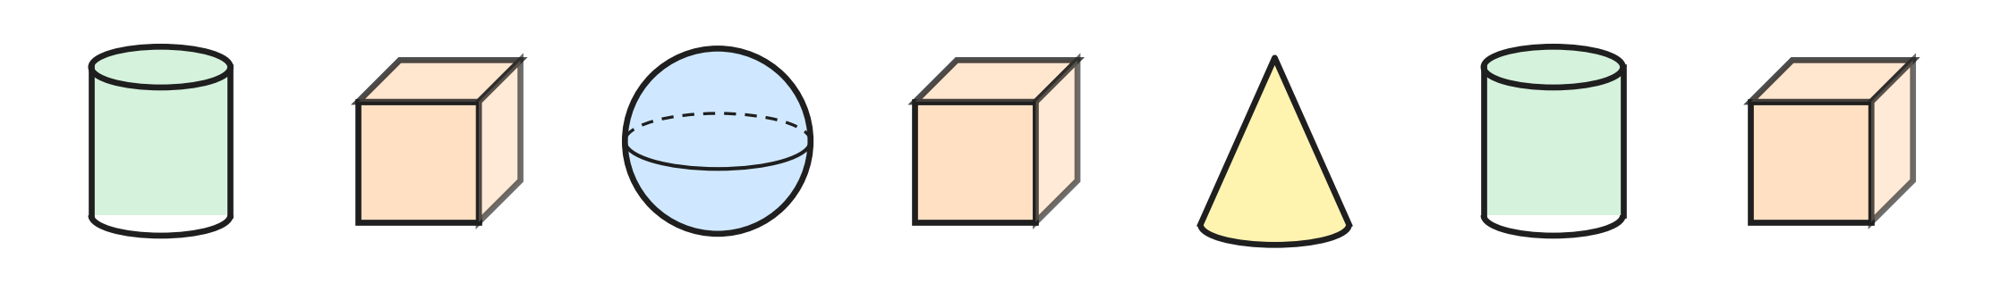
Q23. Look at the solids in a row. How many of them have no curved part at all?
(A) 1 | (B) 3 | (C) 4 | (D) 6

Q24. Ahana puts paint on one flat part of a solid. She presses it on paper. The print is a square. Which solid did she use?
(A) Sphere | (B) Cylinder
(C) Cone | (D) Cube

Q25. I am a flat shape. I have more corners than a circle, but not as many corners as a square. Which shape am I?
(A) Rectangle | (B) Square
(C) Circle | (D) Triangle

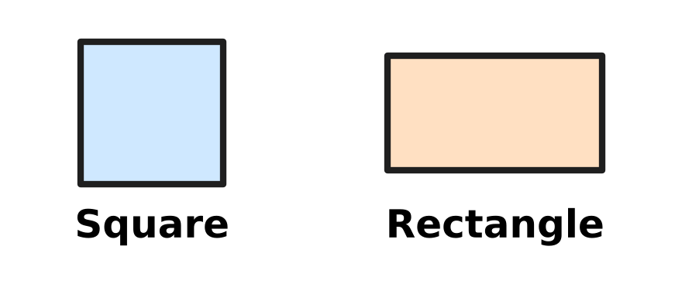
Q26. Look at the square and the rectangle. Which of these is true for the square but NOT for this rectangle?
(A) All 4 sides are equal. | (B) It has 4 corners.
(C) It is a flat shape. | (D) It has 4 straight sides.

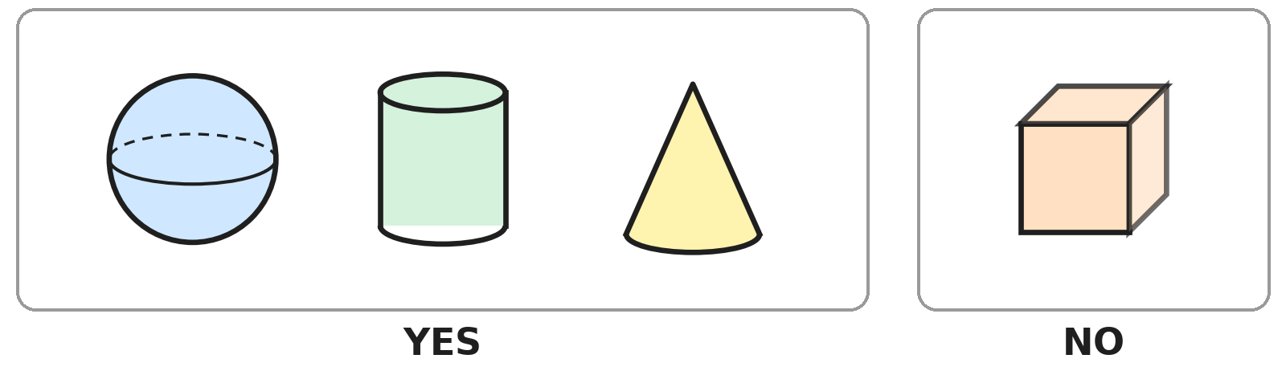
Q27. Look at the two groups of solids. Lokesh sorts them by asking one question. The answer is written under each group. Which question does he ask?
(A) Can it roll?
(B) Does it have a point at the top?
(C) Can it slide?
(D) Is it a solid shape?

Part 4 — Applied Mathematics (Syllabus Chapter 9)
Q28. Simran is sleeping in the middle of the night. Which of these can the time be?
(A) 10 AM | (B) 12 noon | (C) 2 PM | (D) 2 AM

Picture for Q29 and Q33
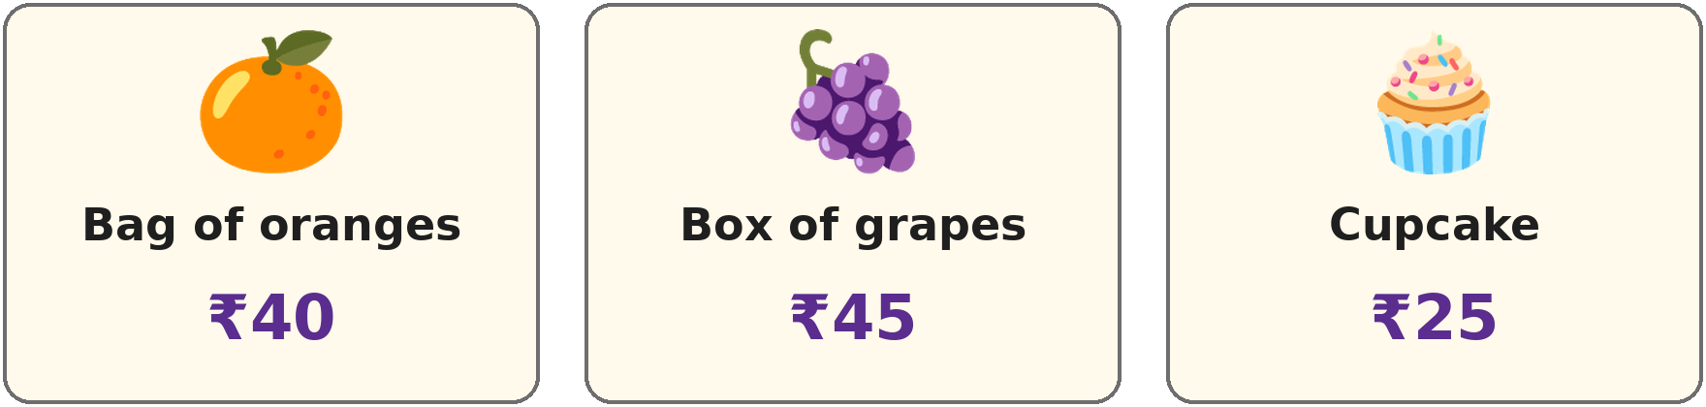
Q29. Look at the price tags at a food stall. Jai buys 2 cupcakes. How much does he pay?
(A) ₹25 | (B) ₹27 | (C) ₹50 | (D) ₹65

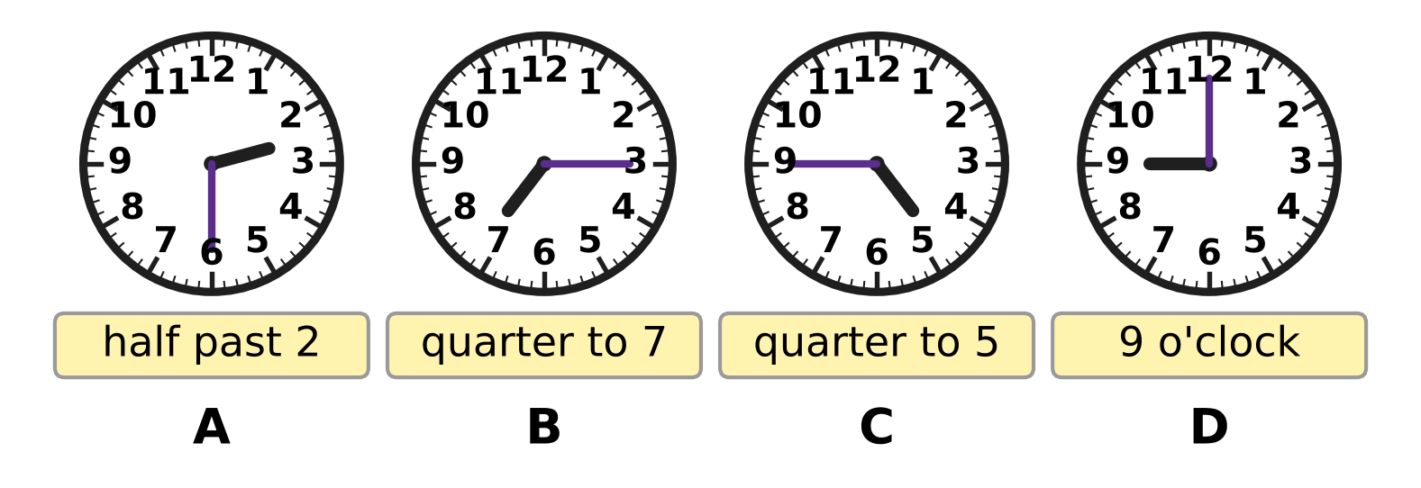
Q30. Look at the clocks. Eric has written a time under each clock. Under which clock has he written the wrong time?
(A) Clock A | (B) Clock B | (C) Clock C | (D) Clock D

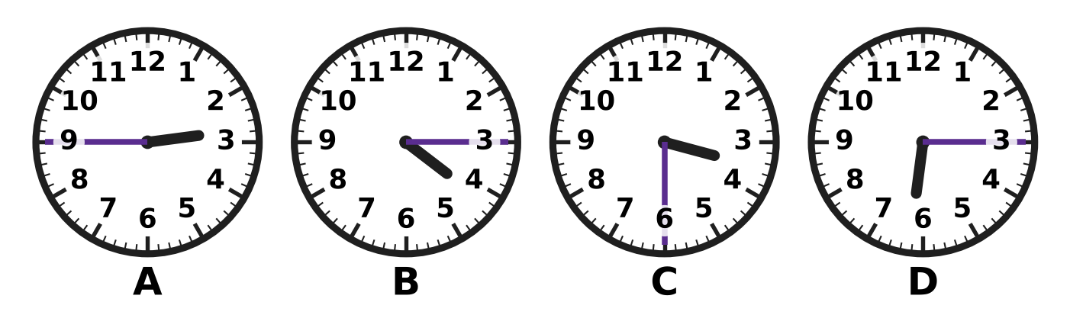
Q31. Look at the four clocks. Which clock shows a time after 3 o'clock but before 4 o'clock?
(A) Clock A | (B) Clock B | (C) Clock C | (D) Clock D

Q32. Which of these is another way to write quarter to 6?
(A) 6:45 | (B) 6:15 | (C) 5:45 | (D) 5:15

Picture for Q29 and Q33
Q33. Look at the price tags. Lucy buys a bag of oranges and a box of grapes. She pays with one note. Which is the smallest note that is enough?
(A) ₹50 note | (B) ₹100 note
(C) ₹200 note | (D) ₹500 note

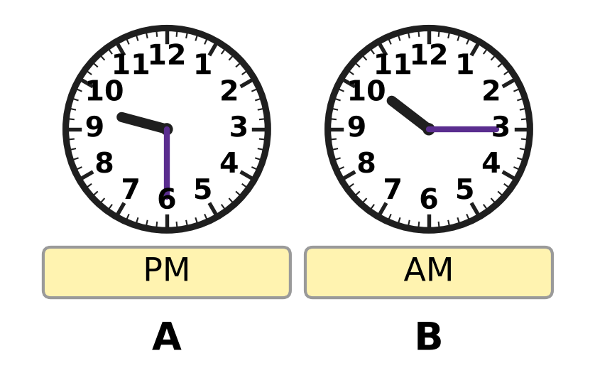
Q34. Look at the two clocks. They show two times on the same day. Which of these times comes first in the day?
(A) half past 9 PM | (B) quarter past 10 PM
(C) half past 9 AM | (D) quarter past 10 AM

Part 5 — Mathematical Reasoning & Problem-Solving (Syllabus Chapter 10)
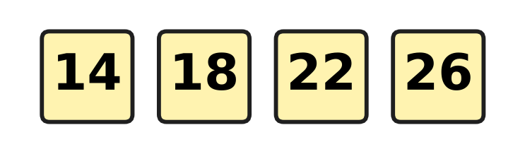
Q35. Look at the number pattern. What is the rule of the pattern?
(A) Add 4 | (B) Take away 4
(C) Add 2 | (D) Add 8

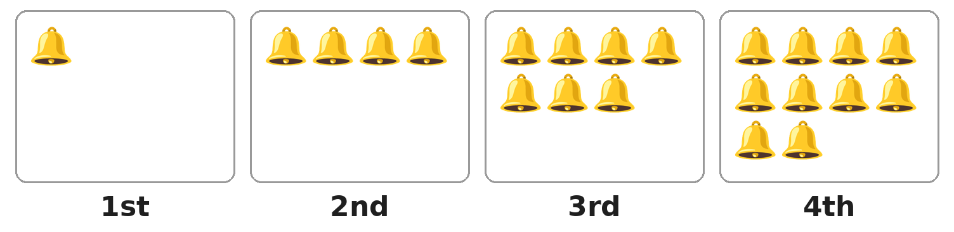
Q36. Look at the boxes of bells. The number of bells grows in the same way each time. Which box will have 16 bells?
(A) 5th box | (B) 6th box | (C) 7th box | (D) 8th box

Q37. A rule changes 3 into 8 and 6 into 11. Which of these follows the same rule?
(A) 5 → 11 | (B) 4 → 8 | (C) 9 → 14 | (D) 8 → 3

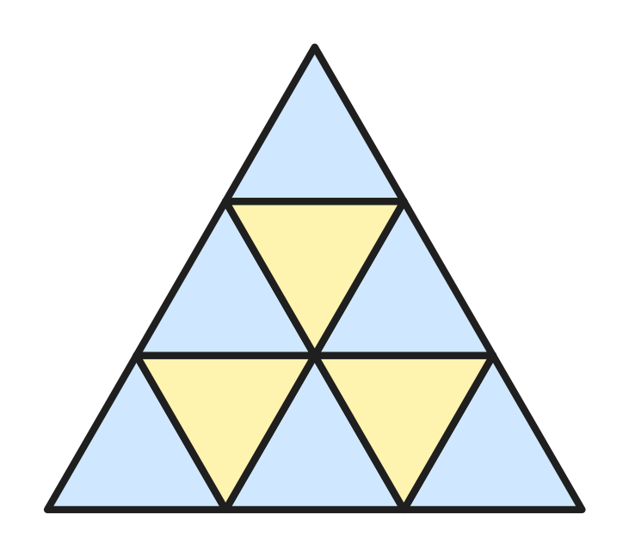
Q38. Look at the big triangle. It is made of small triangles of the same size. How many small triangles are there?
(A) 3 | (B) 6 | (C) 9 | (D) 10

Q39. A fence has 7 posts in a straight row. One board joins each post to the next post. How many boards does the fence have?
(A) 6 | (B) 7 | (C) 8 | (D) 14

Q40. In which of these patterns is every number double the number before it?
(A) 3, 6, 12, 24 | (B) 5, 10, 15, 20
(C) 1, 3, 5, 7 | (D) 2, 4, 6, 8

SECTION II — Star Questions 5 questions × 4 marks each
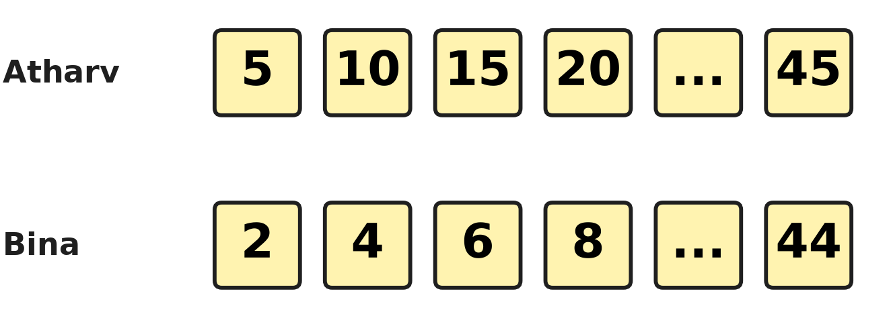
Q41. Look at the picture. Atharv counts in fives from 5 to 45. Bina counts in twos from 2 to 44. How many numbers do Atharv and Bina both say? [4 marks]
(A) 3 | (B) 4 | (C) 5 | (D) 9

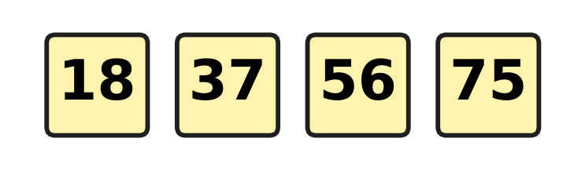
Q42. Look at the number tiles. The jump from each tile to the next is always the same, and the pattern goes on. Which of these numbers will be on the next tile? [4 marks]
(A) 85 | (B) 93 | (C) 94 | (D) 95

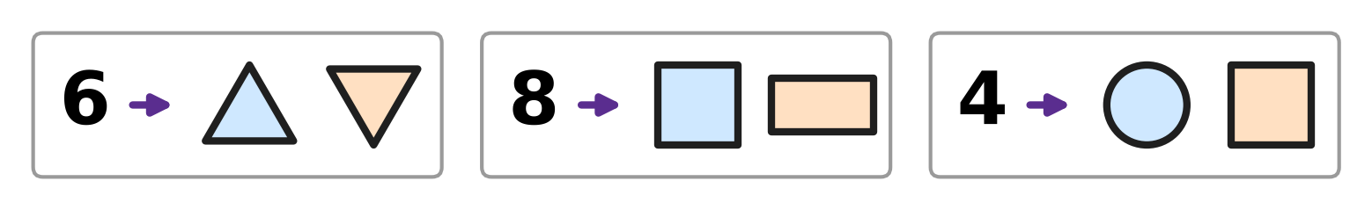
Q43. Look at the three cards. Each number and its two shapes follow the same rule about corners. Which two shapes go with the number 7? [4 marks]
(A) A circle and a triangle | (B) Two triangles
(C) A square and a rectangle | (D) A triangle and a rectangle

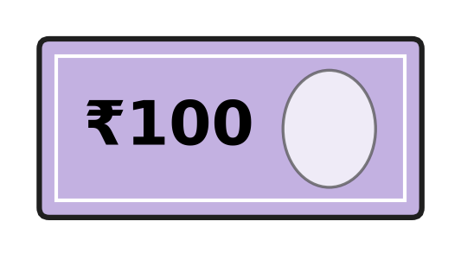
Q44. Mishti has only notes like the one in the picture. She buys a doll for ₹430. She pays with as few notes as she can. How much change does she get? [4 marks]
(A) ₹30 | (B) ₹70 | (C) ₹100 | (D) ₹170

Q45. Look at the clock. It has solids in place of 12, 3, 6 and 9. The long hand points to one solid at quarter past 8 and to another at quarter to 9. Which is true for BOTH solids? [4 marks] | 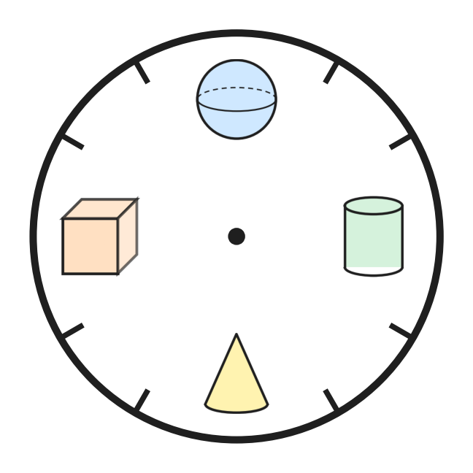
  (A) It has a flat part. | (B) It can roll.
  (C) It has a pointed top. | (D) It has no flat part.
Answer Sheet AMO Level 1 · Class 2 · Practice Paper 2
Name: | School: | Roll No.:
Shade or tick one circle for each question.
1. Ⓐ Ⓑ Ⓒ Ⓓ | 16. Ⓐ Ⓑ Ⓒ Ⓓ | 31. Ⓐ Ⓑ Ⓒ Ⓓ
2. Ⓐ Ⓑ Ⓒ Ⓓ | 17. Ⓐ Ⓑ Ⓒ Ⓓ | 32. Ⓐ Ⓑ Ⓒ Ⓓ
3. Ⓐ Ⓑ Ⓒ Ⓓ | 18. Ⓐ Ⓑ Ⓒ Ⓓ | 33. Ⓐ Ⓑ Ⓒ Ⓓ
4. Ⓐ Ⓑ Ⓒ Ⓓ | 19. Ⓐ Ⓑ Ⓒ Ⓓ | 34. Ⓐ Ⓑ Ⓒ Ⓓ
5. Ⓐ Ⓑ Ⓒ Ⓓ | 20. Ⓐ Ⓑ Ⓒ Ⓓ | 35. Ⓐ Ⓑ Ⓒ Ⓓ
6. Ⓐ Ⓑ Ⓒ Ⓓ | 21. Ⓐ Ⓑ Ⓒ Ⓓ | 36. Ⓐ Ⓑ Ⓒ Ⓓ
7. Ⓐ Ⓑ Ⓒ Ⓓ | 22. Ⓐ Ⓑ Ⓒ Ⓓ | 37. Ⓐ Ⓑ Ⓒ Ⓓ
8. Ⓐ Ⓑ Ⓒ Ⓓ | 23. Ⓐ Ⓑ Ⓒ Ⓓ | 38. Ⓐ Ⓑ Ⓒ Ⓓ
9. Ⓐ Ⓑ Ⓒ Ⓓ | 24. Ⓐ Ⓑ Ⓒ Ⓓ | 39. Ⓐ Ⓑ Ⓒ Ⓓ
10. Ⓐ Ⓑ Ⓒ Ⓓ | 25. Ⓐ Ⓑ Ⓒ Ⓓ | 40. Ⓐ Ⓑ Ⓒ Ⓓ
11. Ⓐ Ⓑ Ⓒ Ⓓ | 26. Ⓐ Ⓑ Ⓒ Ⓓ | 41. Ⓐ Ⓑ Ⓒ Ⓓ
12. Ⓐ Ⓑ Ⓒ Ⓓ | 27. Ⓐ Ⓑ Ⓒ Ⓓ | 42. Ⓐ Ⓑ Ⓒ Ⓓ
13. Ⓐ Ⓑ Ⓒ Ⓓ | 28. Ⓐ Ⓑ Ⓒ Ⓓ | 43. Ⓐ Ⓑ Ⓒ Ⓓ
14. Ⓐ Ⓑ Ⓒ Ⓓ | 29. Ⓐ Ⓑ Ⓒ Ⓓ | 44. Ⓐ Ⓑ Ⓒ Ⓓ
15. Ⓐ Ⓑ Ⓒ Ⓓ | 30. Ⓐ Ⓑ Ⓒ Ⓓ | 45. Ⓐ Ⓑ Ⓒ Ⓓ
Q41–Q45 are Section II Star Questions (4 marks each).
For the parent or teacher
Section I correct: ______ / 40 × 2 = ______ marks Section II correct: ______ / 5 × 4 = ______ marks
Correct: ______ / 45 Score: ______ / 100
Answer Key and Solutions AMO Level 1 · Class 2 · Practice Paper 2
Quick answers
1 C | 6 C | 11 A | 16 B | 21 A | 26 A | 31 C | 36 B | 41 B
2 B | 7 A | 12 C | 17 D | 22 B | 27 A | 32 C | 37 C | 42 C
3 C | 8 B | 13 D | 18 A | 23 B | 28 D | 33 B | 38 C | 43 D
4 D | 9 D | 14 B | 19 D | 24 D | 29 C | 34 D | 39 A | 44 B
5 D | 10 B | 15 C | 20 A | 25 D | 30 B | 35 A | 40 A | 45 A
Solutions
Q | Part · level | Answer | Why?
1 | Part 1 · Ch1 · Easy | (C) Picture C | Picture C has 3 hundreds and 2 ones, which is 302. The others have fewer than 3 hundreds: 299, 190 and 287.
2 | Part 1 · Ch1 · Easy | (B) 152 | In 152 the digit 5 is in the tens place, and 5 tens make 50.
3 | Part 1 · Ch1 · Easy | (C) C | Count on in tens from 450: 460, then 470. The second mark after 450 has the letter C.
4 | Part 1 · Ch1 · Easy | (D) Box D | Box D has 8 ladybirds. They make 4 pairs with none left over, so 8 is even. The numbers 7, 9 and 11 are odd.
5 | Part 1 · Ch1 · Easy | (D) three hundred forty | The number 340 has 3 hundreds and 4 tens, and 4 tens are forty. So the name is three hundred forty.
6 | Part 1 · Ch1 · Easy | (C) 501 | After 498 come 499, 500, 501, 502 and then 503. Only 501 lies between them.
7 | Part 1 · Ch1 · Medium | (A) 285 | In 285 the hundreds digit is 2 and the tens digit is 8, and 2 is smaller than 8. In 528, 825 and 852 the hundreds digit is the bigger one.
8 | Part 1 · Ch1 · Medium | (B) 6 | An even number ends in 0, 2, 4, 6 or 8. Of the answer choices, only 6 is such a digit and greater than 5. The number is 476.
9 | Part 1 · Ch1 · Medium | (D) 406, 426, 462 | All three have 4 hundreds, so compare the tens: 0 tens, 2 tens, 6 tens. The order is 406, 426, 462.
10 | Part 1 · Ch1 · Medium | (B) 403 | From 400, 396 is 4 away, 403 is 3 away, 408 is 8 away and 411 is 11 away. The nearest is 403.
11 | Part 2 · Ch2 · Easy | (A) 36 | Count up from 64: 6 more make 70, and 30 more make 100. So he must run 6 + 30 = 36 more steps.
12 | Part 2 · Ch2 · Easy | (C) 283 | Ones: 5 + 8 = 13, write 3 and carry 1. Tens: 4 + 3 + 1 = 8. Hundreds: 2. So 245 + 38 = 283.
13 | Part 2 · Ch2 · Easy | (D) 4 × 5 | There are 4 boxes, and each box has 5 kites. That is 4 groups of 5, written 4 × 5.
14 | Part 2 · Ch2 · Easy | (B) Picture B | Picture B has 4 plates with 3 mushrooms on each. 4 groups of 3 make 12, so 12 ÷ 4 = 3.
15 | Part 2 · Ch2 · Easy | (C) 24 | There are 8 plants, and 8 groups of 3 make 8 × 3 = 24 mugs.
16 | Part 2 · Ch2 · Easy | (B) 7 | There are 14 beads. Half of 14 is 14 ÷ 2 = 7. So 7 beads come off and 7 stay.
17 | Part 2 · Ch2 · Medium | (D) 64 + 36 | In 64 + 36, the ones 4 + 6 make 10, so carry 1 ten. Tens: 6 + 3 + 1 = 10 tens, which is 100. The other sums make 90, 110 and 110.
18 | Part 2 · Ch2 · Medium | (A) 8 | She gives away 4 × 3 = 12 ribbons. So 20 − 12 = 8 ribbons are left.
19 | Part 2 · Ch2 · Medium | (D) Half of 10 | A quarter of 20 is 20 ÷ 4 = 5. Half of 10 is also 5. The others are 10, 20 and 4.
20 | Part 2 · Ch2 · Medium | (A) 63 − 28 | In 63 − 28 there are only 3 ones, and 8 ones cannot be taken from 3. So one ten is opened to make 13 ones. In the others the top ones digit is big enough.
21 | Part 3 · Ch5 · Easy | (A) A cylinder and a cone | The bottom part has a curved part and flat round ends, so it is a cylinder. The top part has a point, so it is a cone.
22 | Part 3 · Ch5 · Easy | (B) 3 | The dotted line goes from corner to corner. The folded paper is a triangle, and a triangle has 3 corners.
23 | Part 3 · Ch5 · Easy | (B) 3 | Only a cube has no curved part; it has flat parts only. There are 3 cubes in the row, so the answer is 3.
24 | Part 3 · Ch5 · Easy | (D) Cube | Every flat part of a cube is a square, so it prints a square. The flat parts of a cylinder and a cone are circles, and a sphere has no flat part.
25 | Part 3 · Ch5 · Medium | (D) Triangle | A square has 4 corners and a circle has 0. A triangle has 3 corners, which is fewer than 4 and more than 0.
26 | Part 3 · Ch5 · Medium | (A) All 4 sides are equal. | Both shapes are flat and have 4 straight sides and 4 corners. Only the square has all 4 sides equal. The rectangle has 2 long and 2 short sides.
27 | Part 3 · Ch5 · Medium | (A) Can it roll? | The sphere, the cylinder and the cone each have a curved part and can roll. The cube has only flat parts and cannot roll. The question is "Can it roll?".
28 | Part 4 · Ch9 · Easy | (D) 2 AM | AM runs from midnight to noon, so 2 AM is two hours after midnight, in the night. 2 PM, 12 noon and 10 AM are in the daytime.
29 | Part 4 · Ch9 · Easy | (C) ₹50 | One cupcake costs ₹25. Two cupcakes cost ₹25 + ₹25 = ₹50.
30 | Part 4 · Ch9 · Easy | (B) Clock B | Clock B has the long hand on 3 and the short hand just after 7. That is quarter past 7, not quarter to 7. The other three times are right.
31 | Part 4 · Ch9 · Easy | (C) Clock C | Clock C shows half past 3, which is after 3 o'clock and before 4 o'clock. The other clocks show quarter to 3, quarter past 4 and quarter past 6.
32 | Part 4 · Ch9 · Medium | (C) 5:45 | Quarter to 6 comes a quarter of an hour before 6. The hour is still 5, so it is written 5:45.
33 | Part 4 · Ch9 · Medium | (B) ₹100 note | The two things cost ₹40 + ₹45 = ₹85. A ₹50 note is too little. A ₹100 note is enough, and it is the smallest such note.
34 | Part 4 · Ch9 · Medium | (D) quarter past 10 AM | Clock A shows half past 9 PM, at night. Clock B shows quarter past 10 AM, in the morning. Morning comes first, so quarter past 10 AM is earlier.
35 | Part 5 · Ch10 · Easy | (A) Add 4 | The jumps are 18 − 14 = 4, 22 − 18 = 4 and 26 − 22 = 4. Each number is 4 more than the one before, so the rule is add 4.
36 | Part 5 · Ch10 · Easy | (B) 6th box | Each box has 3 more bells than the one before. The 5th box has 10 + 3 = 13 bells and the 6th box has 13 + 3 = 16 bells.
37 | Part 5 · Ch10 · Easy | (C) 9 → 14 | The rule is add 5, because 3 + 5 = 8 and 6 + 5 = 11. Only 9 → 14 follows it, because 9 + 5 = 14.
38 | Part 5 · Ch10 · Easy | (C) 9 | From the top, the rows have 1, 3 and 5 small triangles. So there are 1 + 3 + 5 = 9.
39 | Part 5 · Ch10 · Medium | (A) 6 | The boards are in the gaps between the posts. A row of 7 posts has 6 gaps, so there are 6 boards.
40 | Part 5 · Ch10 · Medium | (A) 3, 6, 12, 24 | In (A), 3 doubled is 6, 6 doubled is 12 and 12 doubled is 24. The other patterns add 5, 2 and 2 each time.
41 | Section II · Ch1 + Ch10 · Hard | (B) 4 | Bina says only even numbers. The even numbers Atharv says are the ones ending in 0: 10, 20, 30 and 40. So both say 4 numbers.
42 | Section II · Ch2 + Ch10 · Hard | (C) 94 | Each jump is 19, because 37 − 18 = 19. The next tile is 75 + 19 = 94. Ones: 5 + 9 = 14, write 4 and carry 1; tens: 7 + 1 + 1 = 9.
43 | Section II · Ch5 + Ch10 · Hard | (D) A triangle and a rectangle | Two triangles have 3 + 3 = 6 corners, a square and a rectangle have 4 + 4 = 8, and a circle and a square have 0 + 4 = 4. So each number is the corners in all. A triangle and a rectangle have 3 + 4 = 7.
44 | Section II · Ch1 + Ch9 · Hard | (B) ₹70 | With 4 notes she has only ₹400, which is less than ₹430. So she pays with 5 notes, which is ₹500. The change is ₹500 − ₹430 = ₹70.
45 | Section II · Ch5 + Ch9 · Hard | (A) It has a flat part. | At quarter past, the long hand points to 3, where the cylinder is. At quarter to, it points to 9, where the cube is. Both have a flat part, but only the cylinder can roll.

ARYABHATTA MATHS OLYMPIAD
Level 1
PRACTICE PAPER-3
CLASS 2
Total Questions | 45 multiple-choice questions
Total Marks | 100
Time | 60 minutes
Section I | 40 questions × 2 marks = 80 marks
Section II | 5 Star Questions × 4 marks = 20 marks
Negative Marking | No negative marking
Calculator | Not allowed
Chapters | Number System · Operations · Geometry · Applied Mathematics · Mathematical Reasoning

👋 Hello, friend! How to do this paper:
⭐ Every question has four answer choices: (A), (B), (C) and (D). Only one is correct.
⭐ Read each question and look at its picture carefully. Then mark your answer on the answer sheet at the end.
⭐ Section I has 40 questions of 2 marks each. Section II has 5 Star Questions of 4 marks each.
⭐ There is no negative marking, so try every question.
⭐ Do not use a calculator. You may do rough work on a separate sheet.
⭐ All figures are not necessarily drawn to scale unless stated.

For parents and teachers
• Print or view this paper in colour. Pictures are part of the questions.
• You may read a question aloud to the child, exactly as printed. Please do not explain it or point to an answer choice.
• Parts follow the AMO syllabus chapters. Chapters 3, 4, 6, 7 and 8 are not part of the Class 2 syllabus, so the chapter numbers shown in the Part headings have gaps.
• The answer sheet and the answer key are at the end. Remove only the answer key before the child begins.

SECTION I 40 questions × 2 marks each
Part 1 — Number System (Syllabus Chapter 1)
Q1. Which number fills the blank?
600 + ___ + 3 = 643
(A) 4 | (B) 40 | (C) 43 | (D) 400

Q2. Which word fills the blank?
714 = seven hundred ___
(A) fourteen | (B) four
(C) forty | (D) forty-one

Q3. Which number is 100 less than 624?
(A) 623 | (B) 614 | (C) 724 | (D) 524

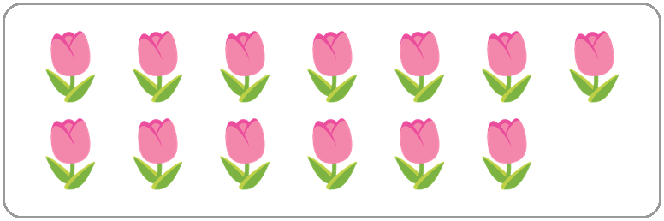
Q4. Count the tulips in the picture. Which of these is true?
(A) There are 13 tulips, and 13 is an odd number.
(B) There are 13 tulips, and 13 is an even number.
(C) There are 12 tulips, and 12 is an even number.
(D) There are 14 tulips, and 14 is an even number.

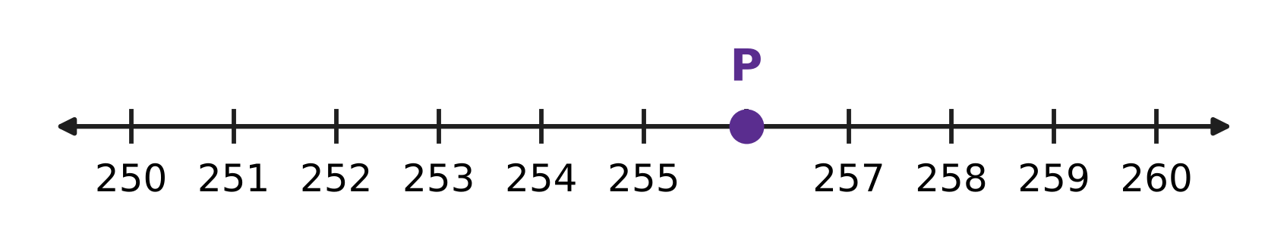
Q5. Look at the number line. The marks go up in ones. Which number is at point P?
(A) 254 | (B) 255 | (C) 256 | (D) 257

Q6. Which of these is true?
(A) 507 > 570 | (B) 507 < 570
(C) 507 = 570 | (D) 570 < 507

Q7. A number has 7 ones, 2 hundreds and 5 tens. Which number is it?
(A) 257 | (B) 275 | (C) 725 | (D) 752

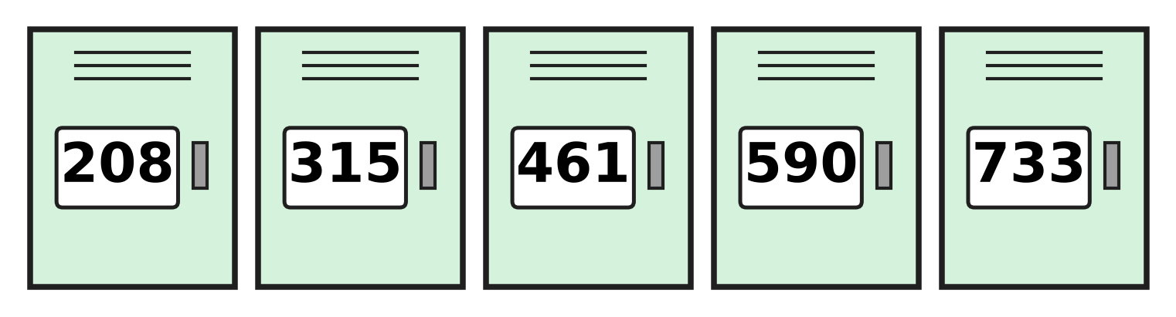
Q8. Look at the five school lockers. How many of them have an odd number?
(A) 1 | (B) 2 | (C) 3 | (D) 5

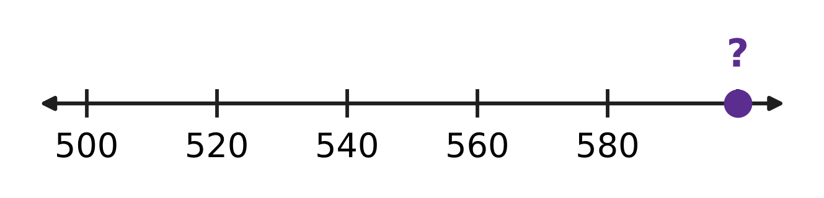
Q9. Look at the number line. The marks go up in equal steps. Which number belongs at the dot with the question mark?
(A) 581 | (B) 590 | (C) 600 | (D) 620

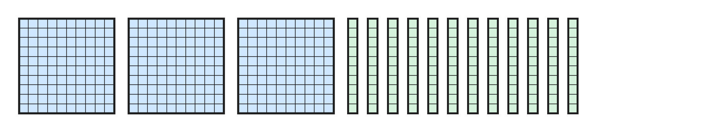
Q10. Mayank has 3 hundred-blocks and 12 ten-rods, as in the picture. Which number do they make?
(A) 312 | (B) 320 | (C) 402 | (D) 420

Part 2 — Operations & Number Properties (Syllabus Chapter 2)
Q11. A beekeeper fills 128 jars of honey in May and 47 jars in June. How many jars does she fill in all?
(A) 81 | (B) 165 | (C) 175 | (D) 598

Q12. A mango tree had 83 mangoes. Some were picked, and now 46 mangoes are left. How many mangoes were picked?
(A) 129 | (B) 43 | (C) 47 | (D) 37

Q13. Which number fills the blank?
6 + 6 + 6 = 3 × ___
(A) 6 | (B) 9 | (C) 3 | (D) 18

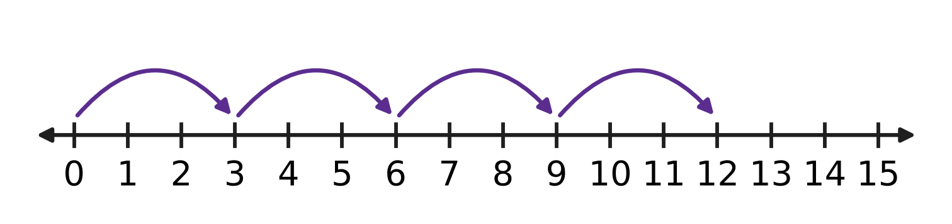
Q14. The hops on the number line start at 0 and are all the same size. Which multiplication fact do the hops show?
(A) 4 × 3 = 12 | (B) 3 × 5 = 15
(C) 4 × 4 = 16 | (D) 3 × 3 = 9

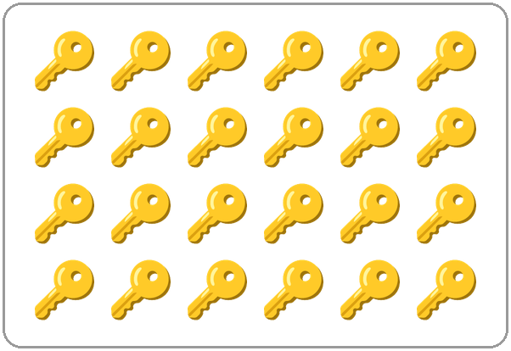
Q15. The picture shows 24 keys. Half of 24 is 12. Which number fills the blank?
A quarter of 24 is ___.
(A) 3 | (B) 4 | (C) 6 | (D) 8

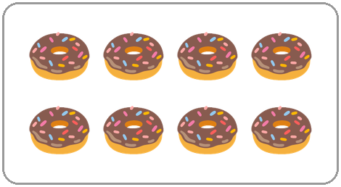
Q16. The picture shows half of the doughnuts that Juhi made. How many doughnuts did she make in all?
(A) 4 | (B) 8 | (C) 10 | (D) 16

Q17. To work out 52 − 37, Lalit first changes 52 into 4 tens and ___ ones. Which number fills the blank?
(A) 2 | (B) 3 | (C) 10 | (D) 12

Q18. In a school canteen, 8 children sit at each of the 3 tables. Another 7 children stand in a line. How many children are there in all?
(A) 31 | (B) 18 | (C) 17 | (D) 24

Q19. Which number fills the blank?
47 + ___ = 80
(A) 23 | (B) 33 | (C) 43 | (D) 127

Q20. A grain store has 457 sacks of rice and 268 sacks of wheat. How many sacks does it have in all?
(A) 615 | (B) 625 | (C) 715 | (D) 725

Part 3 — Geometry (Syllabus Chapter 5)
Q21. Which number fills the blank?
A closed flat shape with 3 straight sides has ___ corners.
(A) 0 | (B) 3 | (C) 4 | (D) 6

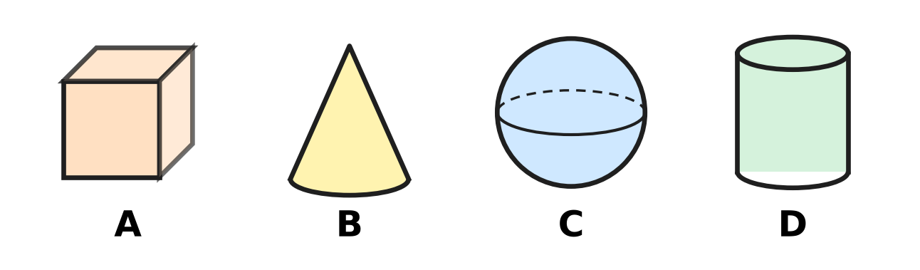
Q22. Which picture shows a solid with a pointed top?
(A) Picture A | (B) Picture B
(C) Picture C | (D) Picture D

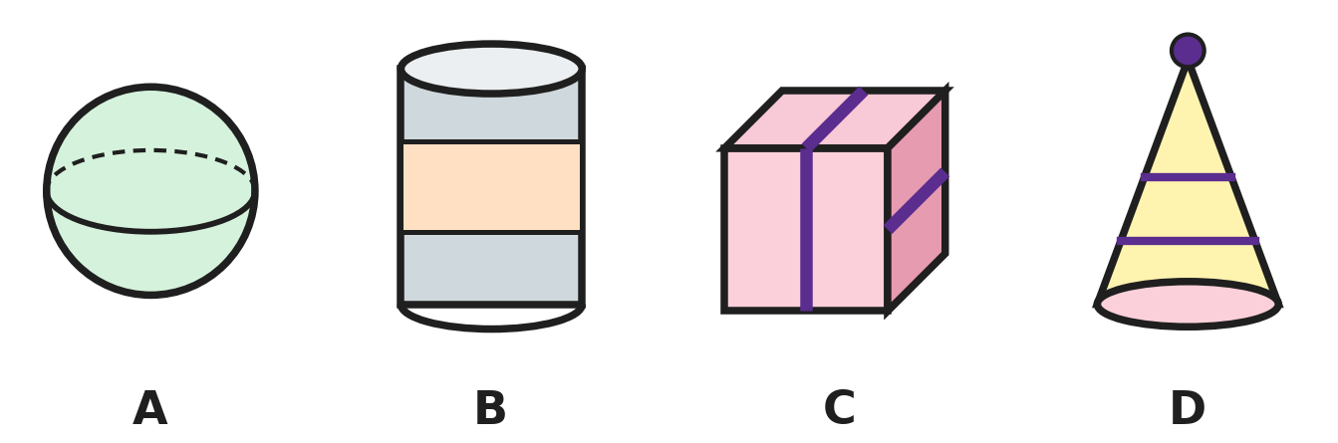
Q23. Which picture shows a thing shaped like a cube?
(A) Picture A | (B) Picture B
(C) Picture C | (D) Picture D

Q24. Which list puts the shapes in order of their corners, from the smallest number of corners to the biggest?
(A) square, triangle, circle | (B) circle, square, triangle
(C) triangle, circle, square | (D) circle, triangle, square

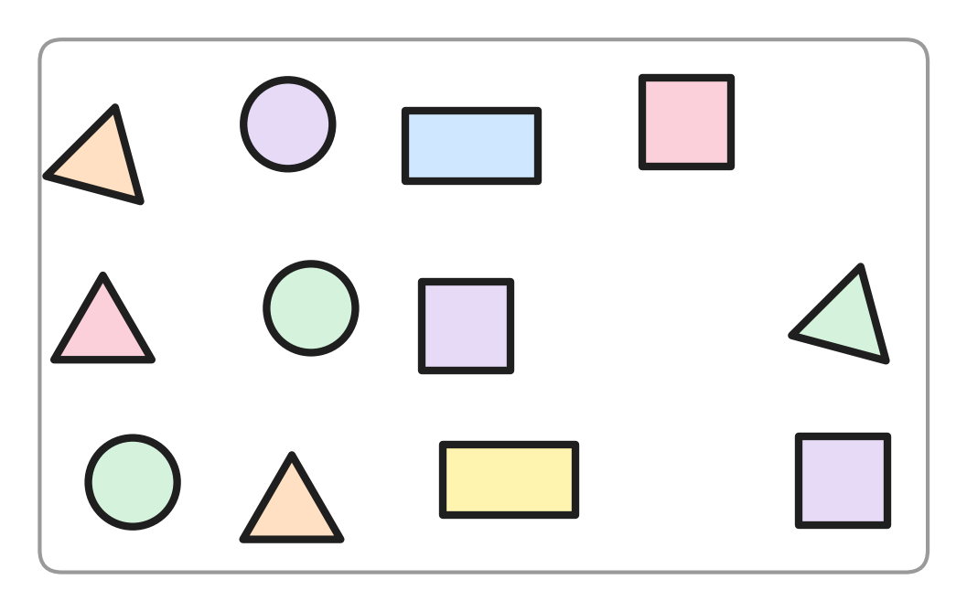
Q25. Hemant has the paper shapes in the picture. He keeps only the shapes that have exactly 4 corners. How many shapes does he keep?
(A) 3 | (B) 4 | (C) 5 | (D) 9

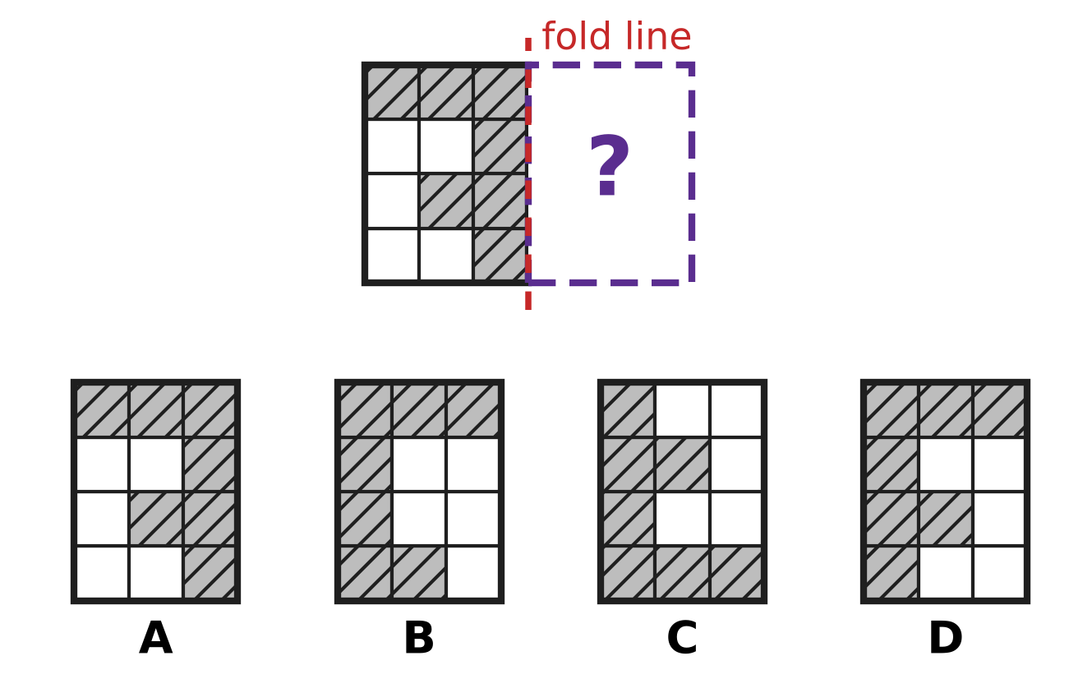
Q26. The design must be the same on both sides of the fold line. Which picture shows the missing right half?
(A) Picture A | (B) Picture B
(C) Picture C | (D) Picture D

Q27. Payal's piggy bank is a cylinder. She stands it up on one flat end and pushes it gently, without tipping it over. What does it do?
(A) It slides. | (B) It rolls straight ahead.
(C) It rolls round in a circle. | (D) It cannot move at all.

Part 4 — Applied Mathematics (Syllabus Chapter 9)
Q28. Vidya eats breakfast at 8 ___ and goes to bed at 9 ___. Which pair fills the two blanks, in order?
(A) PM, AM | (B) PM, PM | (C) AM, AM | (D) AM, PM

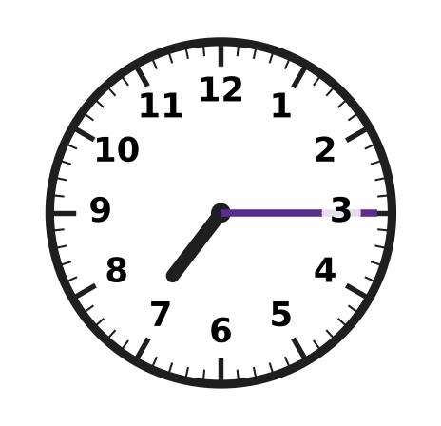
Q29. Look at the clock. Which number fills the blank?
The clock shows quarter past ___.
(A) 3 | (B) 7 | (C) 8 | (D) 15

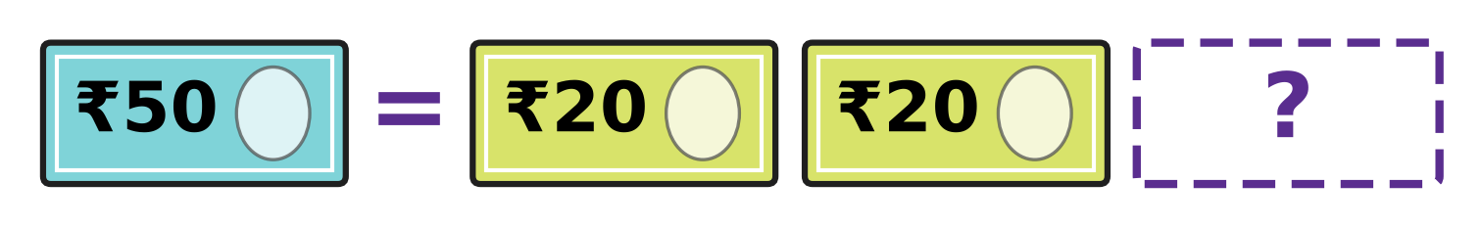
Q30. One ₹50 note has the same value as the three notes on the right in the picture. Which note is hidden?
(A) ₹10 | (B) ₹20 | (C) ₹50 | (D) ₹100

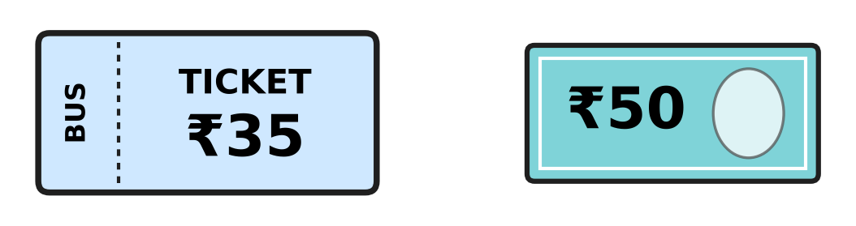
Q31. Ankit buys the bus ticket in the picture. He pays with the ₹50 note. How much change does he get?
(A) ₹5 | (B) ₹15 | (C) ₹25 | (D) ₹85

School canteen price list
Thing | Price
Sandwich | ₹30
Soup | ₹20
Juice | ₹15
Banana | ₹5

Q32. Use the table. How much more do a sandwich and a soup cost together than a juice and a banana together?
(A) ₹20 | (B) ₹30 | (C) ₹50 | (D) ₹70

Q33. A post office letter box is emptied at 7 AM, 11 AM, ___ and 6 PM, in this order, on one day. Which time fills the blank?
(A) 10 AM | (B) 3 AM | (C) 3 PM | (D) 8 PM

Q34. The last bus from the museum leaves at 6:45. Where are the hands of a clock at that time?
(A) Long hand on 9, short hand nearly at 6
(B) Long hand on 7, short hand on 9
(C) Long hand on 9, short hand nearly at 7
(D) Long hand on 3, short hand just after 6

Part 5 — Mathematical Reasoning & Problem-Solving (Syllabus Chapter 10)
Q35. A number pattern starts at 40. Each number is 4 less than the one before. What is the 4th number in the pattern?
(A) 24 | (B) 28 | (C) 32 | (D) 52

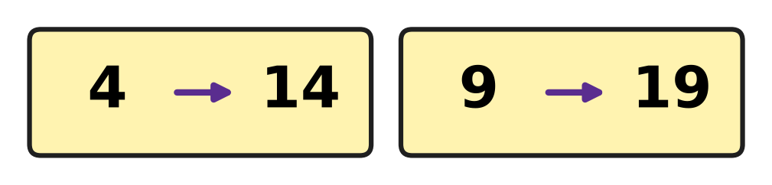
Q36. Both cards in the picture follow one rule. What does the rule do to a number?
(A) doubles the number | (B) adds 1
(C) adds 5 | (D) adds 10

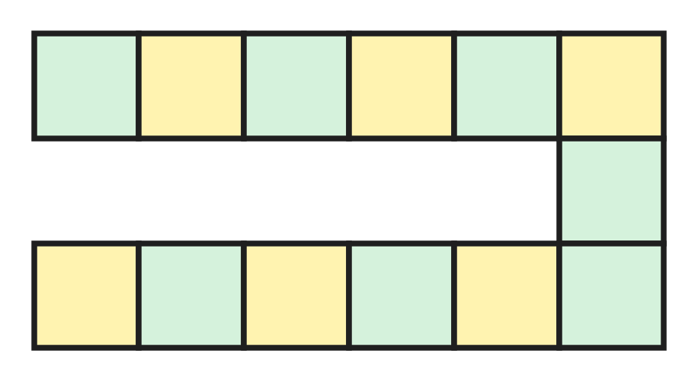
Q37. The picture shows the track of a board game. How many squares does the track have?
(A) 12 | (B) 13 | (C) 14 | (D) 18

Q38. Sakshi starts at 150 and counts on in jumps of 50. How many jumps does she need to reach 400?
(A) 3 | (B) 5 | (C) 6 | (D) 8

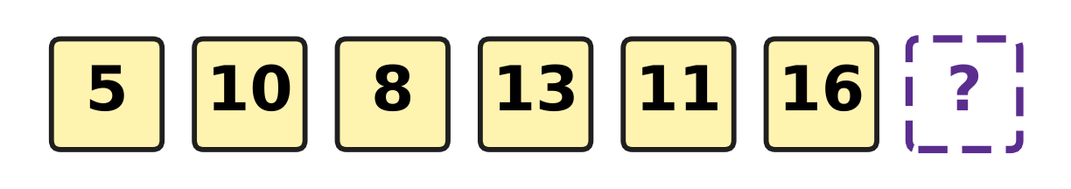
Q39. The numbers go up, then down, then up, then down. Every up jump is the same, and every down jump is the same. Which number goes in the box?
(A) 14 | (B) 18 | (C) 19 | (D) 21

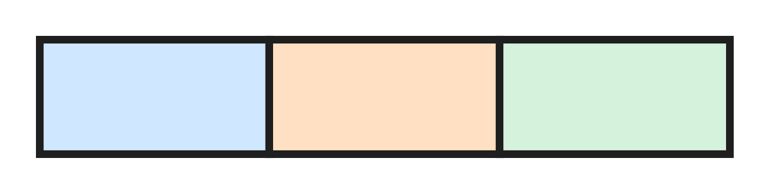
Q40. A long rectangle is divided into 3 boxes by 2 lines, as in the picture. How many rectangles can you find in all? Count big and small ones.
(A) 3 | (B) 4 | (C) 5 | (D) 6

SECTION II — Star Questions 5 questions × 4 marks each
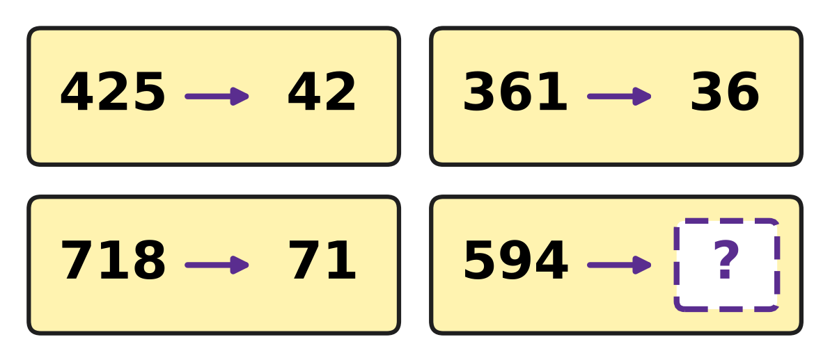
Q41. A rule about hundreds, tens and ones is used on every card in the picture. Which number goes in the box? [4 marks]
(A) 59 | (B) 60 | (C) 90 | (D) 94

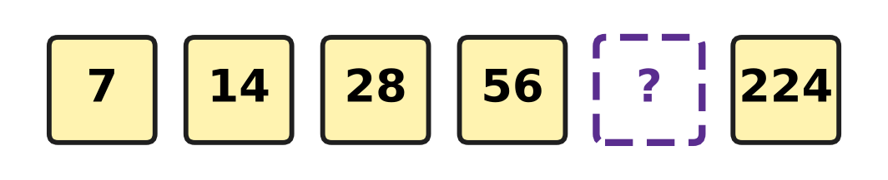
Q42. Every number in the picture is made from the number before it by the same rule. Which number is hidden? [4 marks]
(A) 63 | (B) 84 | (C) 112 | (D) 140

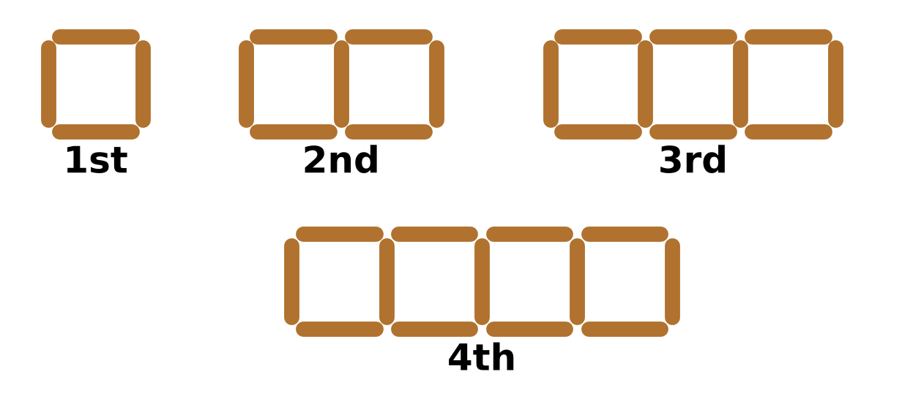
Q43. Daksh makes rows of squares with sticks, as in the picture. Squares side by side share a stick. How many sticks does the 6th shape need? [4 marks]
(A) 16 | (B) 18 | (C) 19 | (D) 24

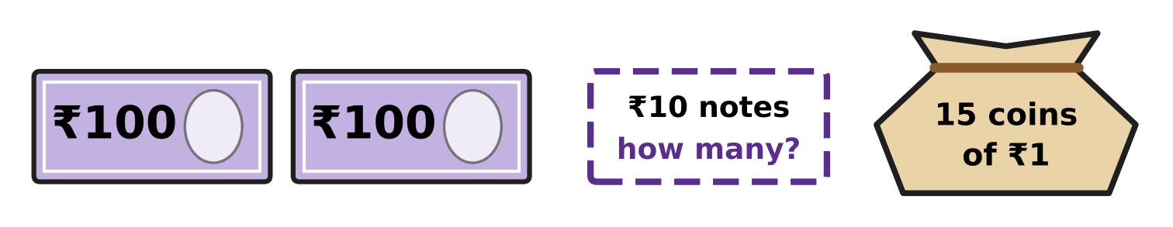
Q44. Vikram has ₹275 in his piggy bank: 2 notes of ₹100, 15 coins of ₹1, and the rest in ₹10 notes. How many ₹10 notes does he have? [4 marks]
(A) 5 | (B) 6 | (C) 7 | (D) 60

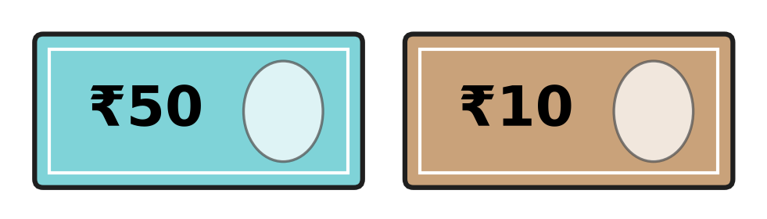
Q45. Ella has only ₹50 and ₹10 notes, like those in the picture. Her notes have 20 corners in all, and together they make ₹130. How many ₹50 notes does she have? [4 marks]
(A) 1 | (B) 2 | (C) 3 | (D) 5

Answer Sheet AMO Level 1 · Class 2 · Practice Paper 3
Name: | School: | Roll No.:
Shade or tick one circle for each question.
1. Ⓐ Ⓑ Ⓒ Ⓓ | 16. Ⓐ Ⓑ Ⓒ Ⓓ | 31. Ⓐ Ⓑ Ⓒ Ⓓ
2. Ⓐ Ⓑ Ⓒ Ⓓ | 17. Ⓐ Ⓑ Ⓒ Ⓓ | 32. Ⓐ Ⓑ Ⓒ Ⓓ
3. Ⓐ Ⓑ Ⓒ Ⓓ | 18. Ⓐ Ⓑ Ⓒ Ⓓ | 33. Ⓐ Ⓑ Ⓒ Ⓓ
4. Ⓐ Ⓑ Ⓒ Ⓓ | 19. Ⓐ Ⓑ Ⓒ Ⓓ | 34. Ⓐ Ⓑ Ⓒ Ⓓ
5. Ⓐ Ⓑ Ⓒ Ⓓ | 20. Ⓐ Ⓑ Ⓒ Ⓓ | 35. Ⓐ Ⓑ Ⓒ Ⓓ
6. Ⓐ Ⓑ Ⓒ Ⓓ | 21. Ⓐ Ⓑ Ⓒ Ⓓ | 36. Ⓐ Ⓑ Ⓒ Ⓓ
7. Ⓐ Ⓑ Ⓒ Ⓓ | 22. Ⓐ Ⓑ Ⓒ Ⓓ | 37. Ⓐ Ⓑ Ⓒ Ⓓ
8. Ⓐ Ⓑ Ⓒ Ⓓ | 23. Ⓐ Ⓑ Ⓒ Ⓓ | 38. Ⓐ Ⓑ Ⓒ Ⓓ
9. Ⓐ Ⓑ Ⓒ Ⓓ | 24. Ⓐ Ⓑ Ⓒ Ⓓ | 39. Ⓐ Ⓑ Ⓒ Ⓓ
10. Ⓐ Ⓑ Ⓒ Ⓓ | 25. Ⓐ Ⓑ Ⓒ Ⓓ | 40. Ⓐ Ⓑ Ⓒ Ⓓ
11. Ⓐ Ⓑ Ⓒ Ⓓ | 26. Ⓐ Ⓑ Ⓒ Ⓓ | 41. Ⓐ Ⓑ Ⓒ Ⓓ
12. Ⓐ Ⓑ Ⓒ Ⓓ | 27. Ⓐ Ⓑ Ⓒ Ⓓ | 42. Ⓐ Ⓑ Ⓒ Ⓓ
13. Ⓐ Ⓑ Ⓒ Ⓓ | 28. Ⓐ Ⓑ Ⓒ Ⓓ | 43. Ⓐ Ⓑ Ⓒ Ⓓ
14. Ⓐ Ⓑ Ⓒ Ⓓ | 29. Ⓐ Ⓑ Ⓒ Ⓓ | 44. Ⓐ Ⓑ Ⓒ Ⓓ
15. Ⓐ Ⓑ Ⓒ Ⓓ | 30. Ⓐ Ⓑ Ⓒ Ⓓ | 45. Ⓐ Ⓑ Ⓒ Ⓓ
Q41–Q45 are Section II Star Questions (4 marks each).
For the parent or teacher
Section I correct: ______ / 40 × 2 = ______ marks Section II correct: ______ / 5 × 4 = ______ marks
Correct: ______ / 45 Score: ______ / 100
Answer Key and Solutions AMO Level 1 · Class 2 · Practice Paper 3
Quick answers
1 B | 6 B | 11 C | 16 D | 21 B | 26 D | 31 B | 36 D | 41 A
2 A | 7 A | 12 D | 17 D | 22 B | 27 A | 32 B | 37 B | 42 C
3 D | 8 C | 13 A | 18 A | 23 C | 28 D | 33 C | 38 B | 43 C
4 A | 9 C | 14 A | 19 B | 24 D | 29 B | 34 C | 39 A | 44 B
5 C | 10 D | 15 C | 20 D | 25 C | 30 A | 35 B | 40 D | 45 B
Solutions
Q | Part · level | Answer | Why?
1 | Part 1 · Ch1 · Easy | (B) 40 | The number 643 is 6 hundreds, 4 tens and 3 ones. The 4 tens stand for 40, so 600 + 40 + 3 = 643.
2 | Part 1 · Ch1 · Easy | (A) fourteen | The number 714 is 7 hundreds and 14 more. We say 14 as fourteen, so 714 is seven hundred fourteen.
3 | Part 1 · Ch1 · Easy | (D) 524 | Taking away 100 makes the hundreds digit 1 less. 624 has 6 hundreds, so the answer has 5 hundreds: 524.
4 | Part 1 · Ch1 · Easy | (A) | There are 13 tulips. Put them in twos: 6 twos and 1 left over, so 13 is odd.
5 | Part 1 · Ch1 · Easy | (C) 256 | The mark before P is 255 and the mark after P is 257. The number between them is 256, so point P is at 256.
6 | Part 1 · Ch1 · Easy | (B) 507 < 570 | Both numbers have 5 hundreds. But 507 has 0 tens and 570 has 7 tens, so 507 is smaller: 507 < 570.
7 | Part 1 · Ch1 · Medium | (A) 257 | Hundreds come first, then tens, then ones: 2 hundreds, 5 tens, 7 ones make 257.
8 | Part 1 · Ch1 · Medium | (C) 3 | A number is odd when its ones digit is 1, 3, 5, 7 or 9. The odd numbers are 315, 461 and 733, so there are 3.
9 | Part 1 · Ch1 · Medium | (C) 600 | Each mark is 20 more than the one before: 500, 520, 540, 560, 580. One more step after 580 is 600.
10 | Part 1 · Ch1 · Medium | (D) 420 | The first 10 ten-rods make 1 more hundred, so there are 4 hundreds and 2 tens. That is 420.
11 | Part 2 · Ch2 · Easy | (C) 175 | Ones: 8 + 7 = 15, write 5 and carry 1. Tens: 2 + 4 + 1 = 7. Hundreds: 1. The total is 175.
12 | Part 2 · Ch2 · Easy | (D) 37 | The picked mangoes are 83 − 46. Change 83 into 7 tens and 13 ones. Ones: 13 − 6 = 7. Tens: 7 − 4 = 3. So 37 mangoes were picked.
13 | Part 2 · Ch2 · Easy | (A) 6 | The number 6 is added 3 times, so the sum is 3 groups of 6: 3 × 6. The blank is 6.
14 | Part 2 · Ch2 · Easy | (A) 4 × 3 = 12 | There are 4 hops, each 3 steps long, and the last hop lands on 12. So the multiplication fact is 4 × 3 = 12.
15 | Part 2 · Ch2 · Easy | (C) 6 | A quarter is half of a half. Half of 24 is 12, and half of 12 is 6.
16 | Part 2 · Ch2 · Easy | (D) 16 | Two equal halves make the whole, and 8 + 8 = 16. So she made 16 doughnuts.
17 | Part 2 · Ch2 · Medium | (D) 12 | One ten is changed into 10 ones. Then 10 ones and 2 ones make 12 ones, so 52 is 4 tens and 12 ones.
18 | Part 2 · Ch2 · Medium | (A) 31 | There are 3 tables of 8, so 3 × 8 = 24 children sit. With 7 more, there are 24 + 7 = 31.
19 | Part 2 · Ch2 · Medium | (B) 33 | Count up from 47: 3 more makes 50, and 30 more makes 80. So the blank is 3 + 30 = 33.
20 | Part 2 · Ch2 · Medium | (D) 725 | Ones: 7 + 8 = 15, write 5 and carry 1. Tens: 5 + 6 + 1 = 12, write 2 and carry 1. Hundreds: 4 + 2 + 1 = 7. The total is 725.
21 | Part 3 · Ch5 · Easy | (B) 3 | A closed shape with 3 straight sides is a triangle. Each pair of sides meets at a corner, so it has 3 corners.
22 | Part 3 · Ch5 · Easy | (B) Picture B | Picture B is a cone. It has a flat circle at the bottom, a curved side and a point at the top.
23 | Part 3 · Ch5 · Easy | (C) Picture C | A cube is a box shape with flat square faces, like a die. The gift box in Picture C is shaped like a cube.
24 | Part 3 · Ch5 · Easy | (D) | A circle has 0 corners, a triangle has 3 and a square has 4. So the order is circle, triangle, square.
25 | Part 3 · Ch5 · Medium | (C) 5 | Squares and rectangles have 4 corners. There are 3 squares and 2 rectangles, so he keeps 3 + 2 = 5 shapes.
26 | Part 3 · Ch5 · Medium | (D) Picture D | Each shaded box on the left must have a partner the same distance from the fold line, in the same row. Only Picture D matches row by row.
27 | Part 3 · Ch5 · Medium | (A) It slides. | Standing on a flat end, the piggy bank rests on a flat part, so it slides. It rolls only when it lies on its curved side.
28 | Part 4 · Ch9 · Easy | (D) AM, PM | Breakfast is in the morning, before noon, so it is 8 AM. Bedtime is at night, after noon, so it is 9 PM.
29 | Part 4 · Ch9 · Easy | (B) 7 | The long hand on 3 means quarter past. The short hand has just passed 7, so the time is quarter past 7.
30 | Part 4 · Ch9 · Easy | (A) ₹10 | ₹20 + ₹20 = ₹40. From ₹40 to ₹50 is ₹10, so the hidden note is a ₹10 note.
31 | Part 4 · Ch9 · Easy | (B) ₹15 | Count up from ₹35: ₹5 more makes ₹40 and ₹10 more makes ₹50. The change is ₹15.
32 | Part 4 · Ch9 · Medium | (B) ₹30 | A sandwich and a soup cost ₹30 + ₹20 = ₹50. A juice and a banana cost ₹15 + ₹5 = ₹20. So they cost ₹50 − ₹20 = ₹30 more.
33 | Part 4 · Ch9 · Medium | (C) 3 PM | The blank must come after 11 AM and before 6 PM. Only 3 PM is after 11 AM and before 6 PM.
34 | Part 4 · Ch9 · Medium | (C) | The time 6:45 is 45 minutes past 6, which is quarter to 7. The long hand points at 9 and the short hand is nearly at 7.
35 | Part 5 · Ch10 · Easy | (B) 28 | The pattern is 40, 36, 32, 28. The 4th number is 28.
36 | Part 5 · Ch10 · Easy | (D) adds 10 | On the cards, 4 + 10 = 14 and 9 + 10 = 19. The rule adds 10 each time.
37 | Part 5 · Ch10 · Easy | (B) 13 | The top row has 6 squares, the bottom row has 6 squares, and 1 square joins them. So there are 6 + 6 + 1 = 13.
38 | Part 5 · Ch10 · Easy | (B) 5 | Count on from 150: 200, 250, 300, 350, 400. That is 5 jumps.
39 | Part 5 · Ch10 · Medium | (A) 14 | The jumps are up 5, down 2, up 5, down 2, up 5. The next jump is down 2, and 16 − 2 = 14.
40 | Part 5 · Ch10 · Medium | (D) 6 | There are 3 small boxes, 2 rectangles made of 2 boxes side by side, and 1 big rectangle made of all 3. So there are 3 + 2 + 1 = 6.
41 | Section II · Ch1 + Ch10 · Hard | (A) 59 | Each card drops the ones digit: 425 gives 42, 361 gives 36 and 718 gives 71 (the number of tens in all). So 594 gives 59, because 594 is 59 tens and 4 ones.
42 | Section II · Ch2 + Ch10 · Hard | (C) 112 | Each number is double the one before: 7 + 7 = 14, 14 + 14 = 28 and 28 + 28 = 56. So the hidden number is 56 + 56 = 112, and 112 + 112 = 224 fits.
43 | Section II · Ch5 + Ch10 · Hard | (C) 19 | The shapes need 4, 7, 10 and 13 sticks. Each new square needs only 3 more sticks, because it shares one side. So the 5th needs 16 and the 6th needs 19.
44 | Section II · Ch1 + Ch9 · Hard | (B) 6 | The ₹100 notes make ₹200 and the coins make ₹15, which is ₹215. That leaves ₹275 − ₹215 = ₹60, and ₹60 is 6 notes of ₹10.
45 | Section II · Ch5 + Ch9 · Hard | (B) 2 | Each note has 4 corners, so 20 corners means 5 notes. Then 2 notes of ₹50 and 3 notes of ₹10 are 5 notes and make ₹100 + ₹30 = ₹130.

ARYABHATTA MATHS OLYMPIAD
Level 1
PRACTICE PAPER-4
CLASS 2
Total Questions | 45 multiple-choice questions
Total Marks | 100
Time | 60 minutes
Section I | 40 questions × 2 marks = 80 marks
Section II | 5 Star Questions × 4 marks = 20 marks
Negative Marking | No negative marking
Calculator | Not allowed
Chapters | Number System · Operations · Geometry · Applied Mathematics · Mathematical Reasoning

👋 Hello, friend! How to do this paper:
⭐ Every question has four answer choices: (A), (B), (C) and (D). Only one is correct.
⭐ Read each question and look at its picture carefully. Then mark your answer on the answer sheet at the end.
⭐ Section I has 40 questions of 2 marks each. Section II has 5 Star Questions of 4 marks each.
⭐ There is no negative marking, so try every question.
⭐ Do not use a calculator. You may do rough work on a separate sheet.
⭐ All figures are not necessarily drawn to scale unless stated.

For parents and teachers
• Print or view this paper in colour. Pictures are part of the questions.
• You may read a question aloud to the child, exactly as printed. Please do not explain it or point to an answer choice.
• Parts follow the AMO syllabus chapters. Chapters 3, 4, 6, 7 and 8 are not part of the Class 2 syllabus, so the chapter numbers shown in the Part headings have gaps.
• The answer sheet and the answer key are at the end. Remove only the answer key before the child begins.

SECTION I 40 questions × 2 marks each
Part 1 — Number System (Syllabus Chapter 1)
Q1. Which number is the same as 600 + 4?
(A) 610 | (B) 604 | (C) 64 | (D) 640

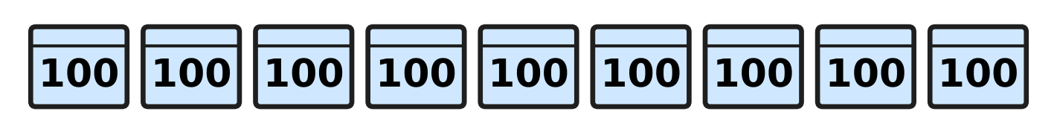
Q2. Look at the picture. Each crate holds 100 bottles. A dairy van takes away 4 full crates. How many bottles are left?
(A) 500 | (B) 600 | (C) 400 | (D) 896

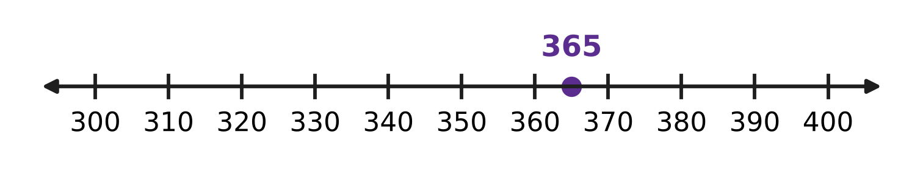
Q3. Look at the number line. The dot shows 365. Which of these numbers is to the left of the dot?
(A) 399 | (B) 356 | (C) 370 | (D) 563

Q4. Which of these numbers is odd and also between 430 and 440?
(A) 433 | (B) 436 | (C) 429 | (D) 443

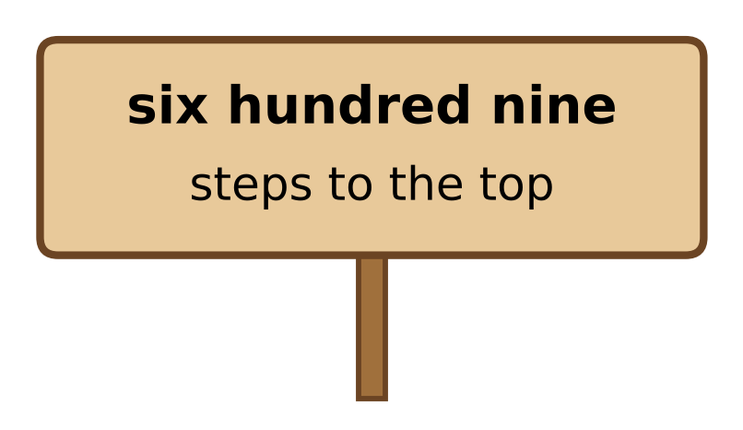
Q5. Look at the sign on a mountain path. Which number shows how many steps are left to the top?
(A) 69 | (B) 609 | (C) 690 | (D) 960

Q6. One bookshop sells 415 books in a week. A second bookshop sells more than that, but fewer than 430. How many books could the second bookshop sell?
(A) 409 | (B) 431 | (C) 427 | (D) 415

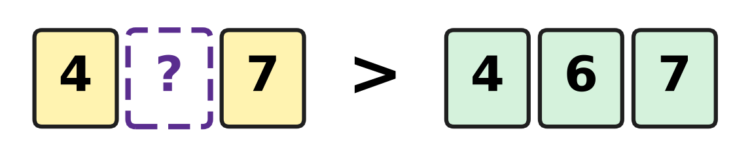
Q7. Look at the number cards. Which digit can go on the blank card to make this true?
(A) 6 | (B) 7 | (C) 3 | (D) 5

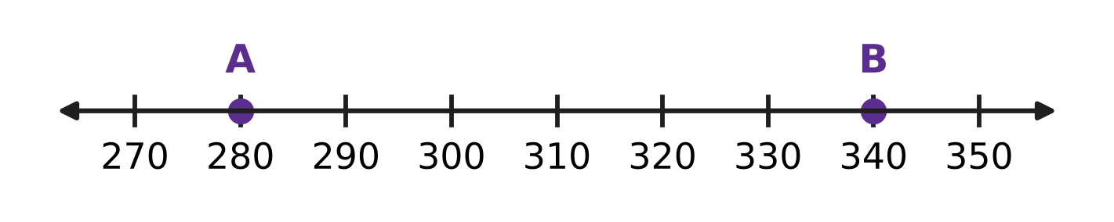
Q8. Look at the number line. How many jumps of 10 are needed to go from A to B?
(A) 6 | (B) 60 | (C) 7 | (D) 5

Q9. A shop has 370 eggs. Each tray holds 10 eggs. How many full trays of 10 eggs can the shop make?
(A) 7 | (B) 30 | (C) 37 | (D) 3

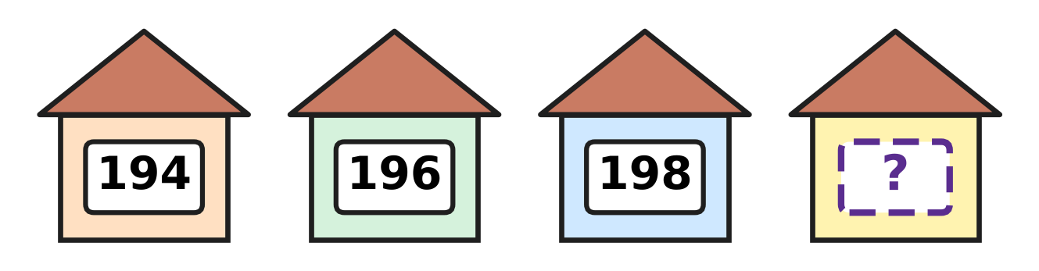
Q10. Look at the houses on one side of a street. Their numbers are even numbers in order. Which number is on the last house?
(A) 202 | (B) 199 | (C) 208 | (D) 200

Part 2 — Operations & Number Properties (Syllabus Chapter 2)
Q11. A zoo had 237 visitors in the morning and 145 visitors in the afternoon. How many visitors came in all?
(A) 372 | (B) 92 | (C) 382 | (D) 482

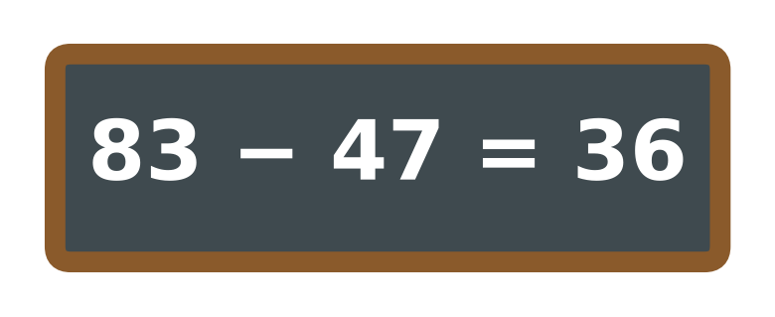
Q12. Look at the slate. Rima wants to check her answer by adding. Which sum should give 83 if she is right?
(A) 83 + 47 | (B) 36 + 47 | (C) 83 + 36 | (D) 47 + 47

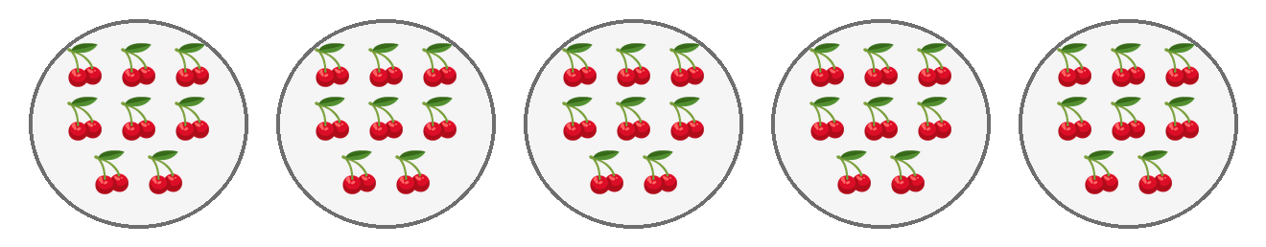
Q13. Look at the picture. Each plate has 8 bunches of cherries. There are 40 bunches in all. One more plate of 8 bunches is added. How many bunches are there now?
(A) 48 | (B) 41 | (C) 46 | (D) 56

Q14. Each umbrella stand holds 7 umbrellas. How many umbrellas do 5 full stands hold?
(A) 12 | (B) 30 | (C) 42 | (D) 35

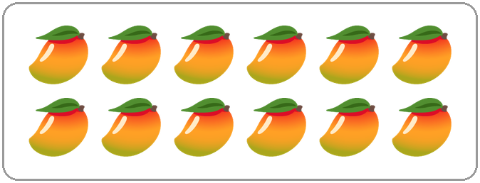
Q15. Look at the mangoes. Sonal shares them equally among 4 friends. Which of these tells how many mangoes each friend gets?
(A) 12 ÷ 4 | (B) 12 × 4 | (C) 12 − 4 | (D) 12 + 4

Q16. A recipe for 2 people needs 16 spoons of flour. How many spoons of flour are needed for 1 person?
(A) 4 | (B) 32 | (C) 8 | (D) 14

Q17. An assembly hall has 125 children. Then 48 children go back to class. After that, 36 other children come in. How many children are in the hall now?
(A) 77 | (B) 41 | (C) 161 | (D) 113

Q18. Sanjay thinks of a number. He adds 135 to it and gets 412. What is his number?
(A) 287 | (B) 277 | (C) 323 | (D) 547

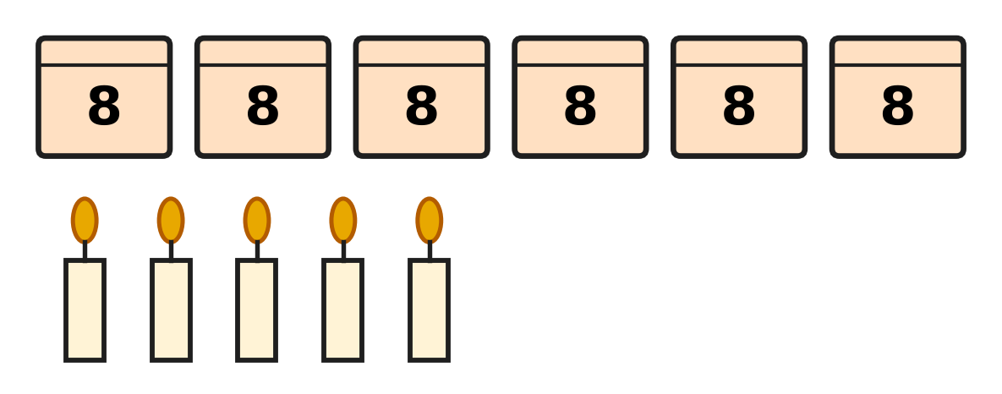
Q19. Look at the picture. Each closed box holds 8 candles. There are also some loose candles. How many candles are there in all?
(A) 13 | (B) 48 | (C) 53 | (D) 19

Q20. Kiara has 48 sweets. She keeps half of them. She shares the other half equally among 4 friends. How many sweets does each friend get?
(A) 24 | (B) 6 | (C) 20 | (D) 12

Part 3 — Geometry (Syllabus Chapter 5)
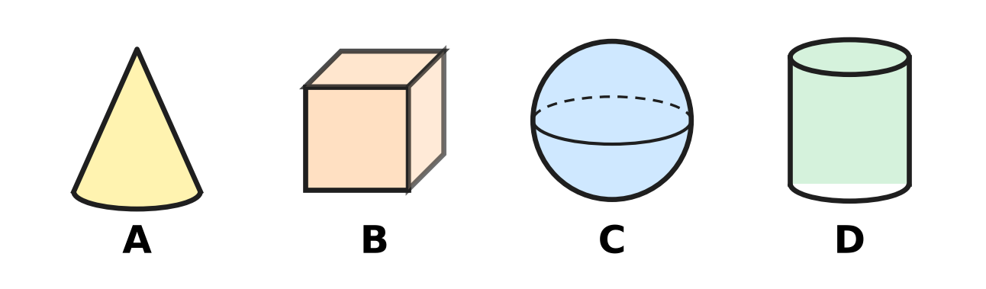
Q21. In a kitchen, dough is rolled flat with a rolling pin. Look at the four solids. Which solid has the same shape as a rolling pin?
(A) Picture A | (B) Picture B
(C) Picture C | (D) Picture D

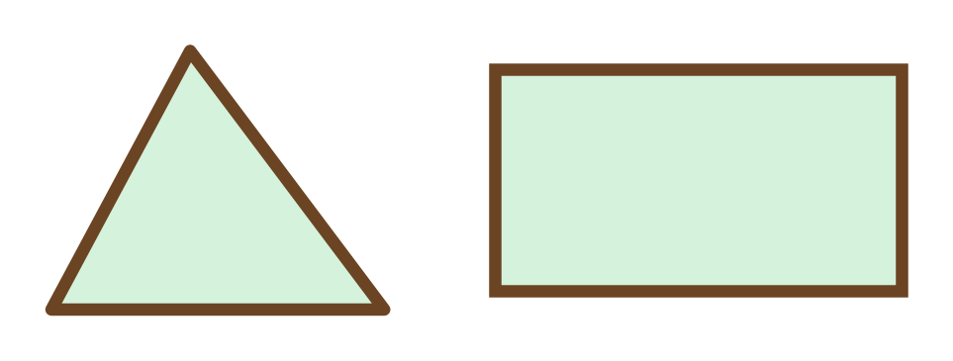
Q22. Look at the two flower beds. How many more corners does the rectangle bed have than the triangle bed?
(A) 1 | (B) 3 | (C) 4 | (D) 7

Q23. Manu joins straight sticks end to end to make a closed flat shape. What is the smallest number of sticks he needs?
(A) 4 | (B) 1 | (C) 2 | (D) 3

Q24. A cube can slide, but it cannot roll. What is the reason?
(A) It is round all over. | (B) It has only flat parts.
(C) It has a point at the top. | (D) It has a curved part.

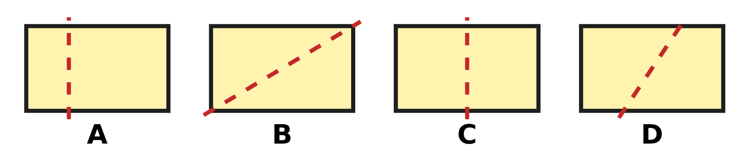
Q25. The same rectangle card is drawn four times. Along which dotted line can it be folded so that the two parts match exactly?
(A) Picture A | (B) Picture B
(C) Picture C | (D) Picture D

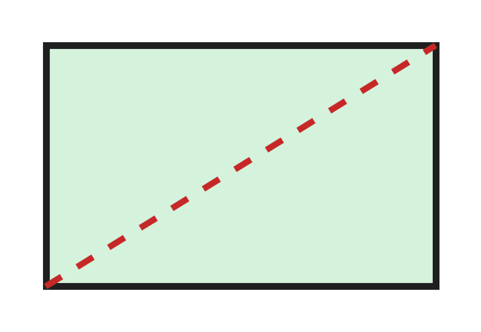
Q26. Look at the rectangle card. Ojas cuts it along the dotted line into two pieces. Which shapes are the two pieces?
(A) two triangles | (B) two squares
(C) two rectangles | (D) a triangle and a rectangle

Solid | Can it roll? | Can it slide?
Cube | No | Yes
Sphere | Yes | No
Cylinder | Yes | Yes
Cone | No | Yes

Q27. Use the table. Vinay tests four solids and writes down what he finds. One row has a mistake. Which row is it?
(A) the cylinder row | (B) the cube row
(C) the cone row | (D) the sphere row

Part 4 — Applied Mathematics (Syllabus Chapter 9)
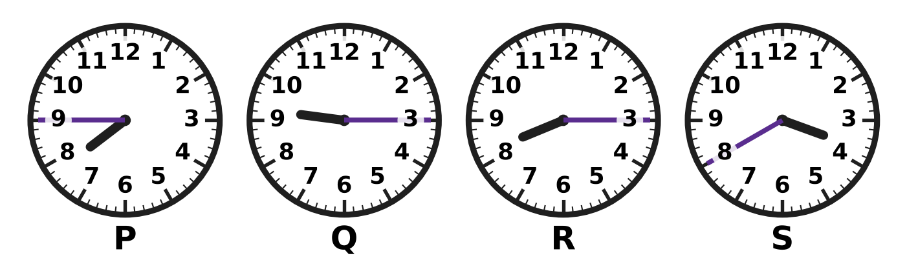
Q28. Look at the four clocks. Which clock shows 8:15?
(A) Clock P | (B) Clock Q | (C) Clock R | (D) Clock S

Q29. A night lamp is switched on at 9 PM. It is switched off at 5 AM. During which part of the day is the lamp on?
(A) the whole day | (B) the afternoon
(C) the morning | (D) the night

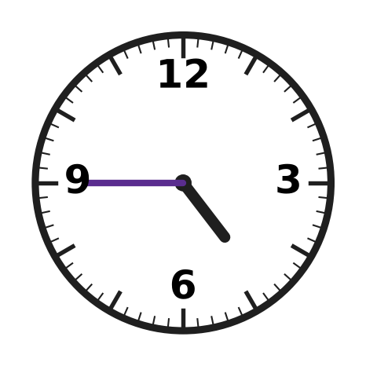
Q30. The clock on the badminton court wall shows only the numbers 12, 3, 6 and 9. Look at the clock. What time does it show?
(A) quarter to 4 | (B) quarter past 9
(C) quarter to 5 | (D) quarter past 4

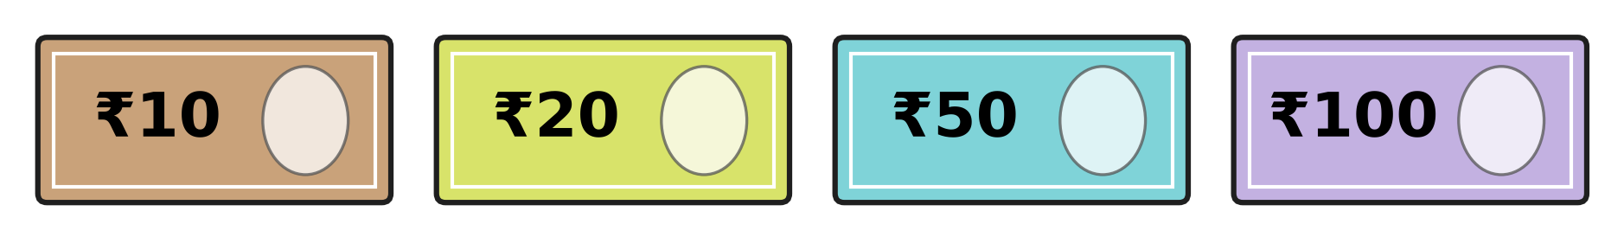
Q31. Look at the four notes. Kriti pays exactly ₹70 with two of them. Which two notes does she use?
(A) ₹50 and ₹10 | (B) ₹20 and ₹10
(C) ₹100 and ₹20 | (D) ₹50 and ₹20

Q32. Zara saves ₹5 every day for 6 days. Then she buys a paint brush for ₹24. How much money does she have left?
(A) ₹30 | (B) ₹6 | (C) ₹11 | (D) ₹19

Q33. A river ferry ticket costs ₹45 for a grown-up and ₹28 for a child. Indu buys one of each with a ₹100 note. What change does she get?
(A) ₹27 | (B) ₹55 | (C) ₹73 | (D) ₹72

Q34. Eggs cost ₹62 and milk costs ₹26. Neel has ₹80. How much more money does he need to buy both?
(A) ₹54 | (B) ₹88 | (C) ₹8 | (D) ₹18

Part 5 — Mathematical Reasoning & Problem-Solving (Syllabus Chapter 10)
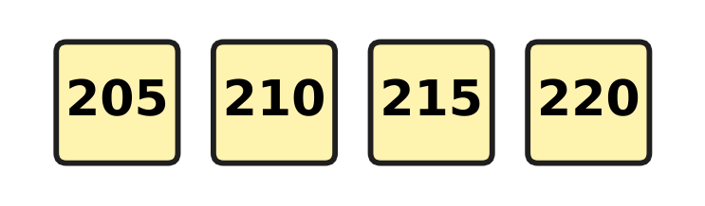
Q35. The stones on a mountain path are numbered in the pattern shown. The pattern goes on. Which of these numbers will also be on a stone?
(A) 242 | (B) 228 | (C) 251 | (D) 235

Day | 1 | 2 | 3 | 4 | 5
Plants sold | 5 | 10 | 20 | 40 | ?

Q36. Use the table. The number of plants sold follows a pattern. How many plants are sold on Day 5?
(A) 60 | (B) 80 | (C) 45 | (D) 50

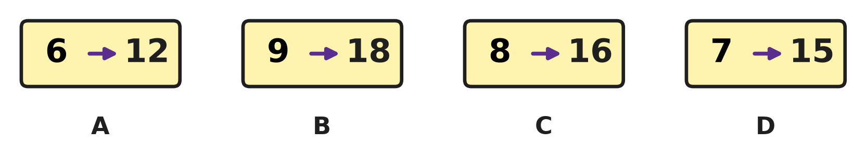
Q37. Look at the picture. On three cards, the second number is made from the first in the same way. Which card does not follow this rule?
(A) Card A | (B) Card B | (C) Card C | (D) Card D

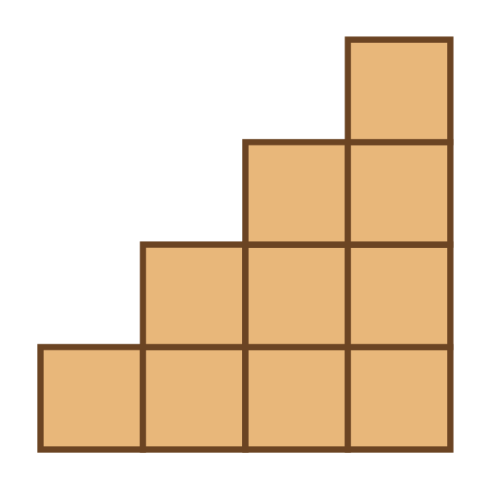
Q38. Ayaan builds stairs with wooden blocks, as in the picture. How many blocks does he use?
(A) 10 | (B) 7 | (C) 4 | (D) 16

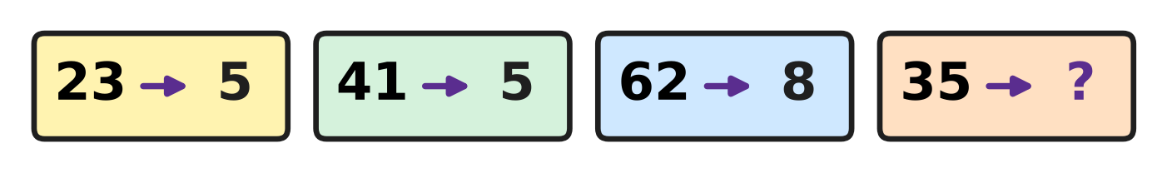
Q39. Look at the cards. One rule turns each number into a smaller number. Which number goes in place of the question mark?
(A) 15 | (B) 2 | (C) 8 | (D) 5

Q40. Four friends meet. Each friend shakes hands with every other friend once. How many handshakes are there in all?
(A) 6 | (B) 8 | (C) 4 | (D) 12

SECTION II — Star Questions 5 questions × 4 marks each
Q41. A rule changes numbers like this: 126 → 621 and 352 → 253. Which of these numbers stays the same when the rule is used? [4 marks]
(A) 544 | (B) 445 | (C) 455 | (D) 454

Q42. Five cows and some ducks have 32 legs in all. A cow has 4 legs and a duck has 2 legs. How many ducks are there? [4 marks]
(A) 3 | (B) 6 | (C) 12 | (D) 27

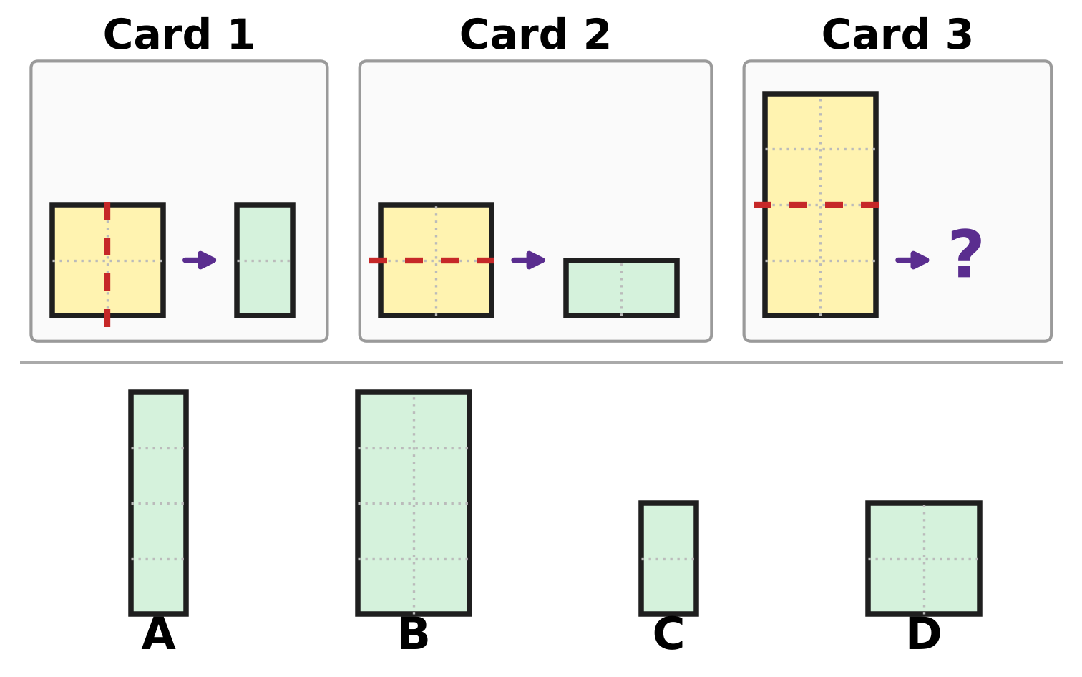
Q43. On Cards 1 and 2, one rule turns the paper on the left into the shape on the right. What does the rule make on Card 3? [4 marks]
(A) Picture A | (B) Picture B
(C) Picture C | (D) Picture D

Cash box | ₹100 notes | ₹10 notes | ₹1 coins
Box A | 3 | 12 | 0
Box B | 4 | 1 | 9
Box C | 2 | 21 | 0
Box D | 4 | 0 | 15

Q44. Use the table. It shows the notes and coins in four cash boxes at a bookshop sale. Which box has the most money? [4 marks]
(A) Box A | (B) Box B | (C) Box C | (D) Box D

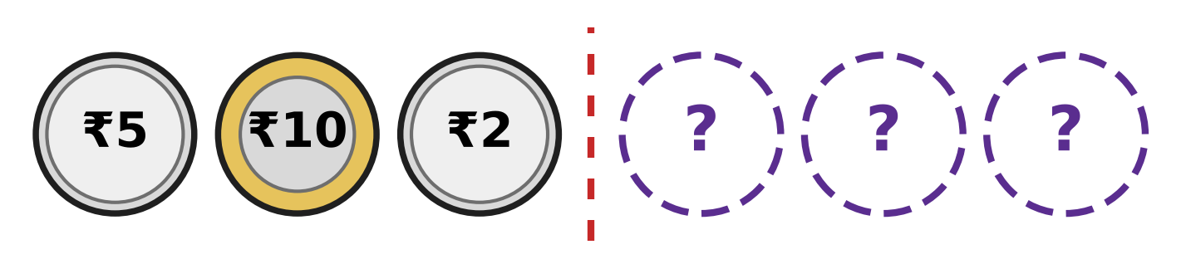
Q45. The row of coins is the same on both sides of the dotted line. Three coins are hidden. How much is the whole row worth? [4 marks]
(A) ₹17 | (B) ₹24 | (C) ₹34 | (D) ₹27

Answer Sheet AMO Level 1 · Class 2 · Practice Paper 4
Name: | School: | Roll No.:
Shade or tick one circle for each question.
1. Ⓐ Ⓑ Ⓒ Ⓓ | 16. Ⓐ Ⓑ Ⓒ Ⓓ | 31. Ⓐ Ⓑ Ⓒ Ⓓ
2. Ⓐ Ⓑ Ⓒ Ⓓ | 17. Ⓐ Ⓑ Ⓒ Ⓓ | 32. Ⓐ Ⓑ Ⓒ Ⓓ
3. Ⓐ Ⓑ Ⓒ Ⓓ | 18. Ⓐ Ⓑ Ⓒ Ⓓ | 33. Ⓐ Ⓑ Ⓒ Ⓓ
4. Ⓐ Ⓑ Ⓒ Ⓓ | 19. Ⓐ Ⓑ Ⓒ Ⓓ | 34. Ⓐ Ⓑ Ⓒ Ⓓ
5. Ⓐ Ⓑ Ⓒ Ⓓ | 20. Ⓐ Ⓑ Ⓒ Ⓓ | 35. Ⓐ Ⓑ Ⓒ Ⓓ
6. Ⓐ Ⓑ Ⓒ Ⓓ | 21. Ⓐ Ⓑ Ⓒ Ⓓ | 36. Ⓐ Ⓑ Ⓒ Ⓓ
7. Ⓐ Ⓑ Ⓒ Ⓓ | 22. Ⓐ Ⓑ Ⓒ Ⓓ | 37. Ⓐ Ⓑ Ⓒ Ⓓ
8. Ⓐ Ⓑ Ⓒ Ⓓ | 23. Ⓐ Ⓑ Ⓒ Ⓓ | 38. Ⓐ Ⓑ Ⓒ Ⓓ
9. Ⓐ Ⓑ Ⓒ Ⓓ | 24. Ⓐ Ⓑ Ⓒ Ⓓ | 39. Ⓐ Ⓑ Ⓒ Ⓓ
10. Ⓐ Ⓑ Ⓒ Ⓓ | 25. Ⓐ Ⓑ Ⓒ Ⓓ | 40. Ⓐ Ⓑ Ⓒ Ⓓ
11. Ⓐ Ⓑ Ⓒ Ⓓ | 26. Ⓐ Ⓑ Ⓒ Ⓓ | 41. Ⓐ Ⓑ Ⓒ Ⓓ
12. Ⓐ Ⓑ Ⓒ Ⓓ | 27. Ⓐ Ⓑ Ⓒ Ⓓ | 42. Ⓐ Ⓑ Ⓒ Ⓓ
13. Ⓐ Ⓑ Ⓒ Ⓓ | 28. Ⓐ Ⓑ Ⓒ Ⓓ | 43. Ⓐ Ⓑ Ⓒ Ⓓ
14. Ⓐ Ⓑ Ⓒ Ⓓ | 29. Ⓐ Ⓑ Ⓒ Ⓓ | 44. Ⓐ Ⓑ Ⓒ Ⓓ
15. Ⓐ Ⓑ Ⓒ Ⓓ | 30. Ⓐ Ⓑ Ⓒ Ⓓ | 45. Ⓐ Ⓑ Ⓒ Ⓓ
Q41–Q45 are Section II Star Questions (4 marks each).
For the parent or teacher
Section I correct: ______ / 40 × 2 = ______ marks Section II correct: ______ / 5 × 4 = ______ marks
Correct: ______ / 45 Score: ______ / 100
Answer Key and Solutions AMO Level 1 · Class 2 · Practice Paper 4
Quick answers
1 B | 6 C | 11 C | 16 C | 21 D | 26 A | 31 D | 36 B | 41 D
2 A | 7 B | 12 B | 17 D | 22 A | 27 C | 32 B | 37 D | 42 B
3 B | 8 A | 13 A | 18 B | 23 D | 28 C | 33 A | 38 A | 43 D
4 A | 9 C | 14 D | 19 C | 24 B | 29 D | 34 C | 39 C | 44 A
5 B | 10 D | 15 A | 20 B | 25 C | 30 C | 35 D | 40 A | 45 C
Solutions
Q | Part · level | Answer | Why?
1 | Part 1 · Ch1 · Easy | (B) 604 | 600 is 6 hundreds and 4 is 4 ones. There are no tens, so the number is 604.
2 | Part 1 · Ch1 · Easy | (A) 500 | There are 9 hundreds. Count back 4 hundreds: 800, 700, 600, 500. So 500 bottles are left.
3 | Part 1 · Ch1 · Easy | (B) 356 | On a number line, smaller numbers are to the left. Only 356 is smaller than 365.
4 | Part 1 · Ch1 · Easy | (A) 433 | 433 ends in 3, so it is odd, and it lies between 430 and 440. The others are even or outside the range.
5 | Part 1 · Ch1 · Easy | (B) 609 | Six hundred nine is 6 hundreds, 0 tens and 9 ones. In figures it is 609.
6 | Part 1 · Ch1 · Easy | (C) 427 | The number must be greater than 415 and less than 430. Only 427 is.
7 | Part 1 · Ch1 · Medium | (B) 7 | Both numbers have 4 hundreds and 7 ones. The tens digit must be more than 6. With 7 the number is 477, and 477 > 467.
8 | Part 1 · Ch1 · Medium | (A) 6 | From A at 280, the jumps land on 290, 300, 310, 320, 330 and 340. That is 6 jumps of 10.
9 | Part 1 · Ch1 · Medium | (C) 37 | 370 is 3 hundreds and 7 tens. 3 hundreds are 30 tens. 30 tens and 7 tens make 37 tens. So there are 37 full trays.
10 | Part 1 · Ch1 · Medium | (D) 200 | Even numbers go up in twos: 194, 196, 198. Two more than 198 is 200.
11 | Part 2 · Ch2 · Easy | (C) 382 | Ones: 7 + 5 = 12, write 2 and carry 1. Tens: 3 + 4 + 1 = 8. Hundreds: 2 + 1 = 3. The total is 382.
12 | Part 2 · Ch2 · Easy | (B) 36 + 47 | Adding back what was taken away gives the starting number. 36 + 47 = 83, so her answer is right.
13 | Part 2 · Ch2 · Easy | (A) 48 | One more plate adds 8 more bunches. 40 + 8 = 48. This is 6 × 8.
14 | Part 2 · Ch2 · Easy | (D) 35 | 5 groups of 7 are 5 × 7 = 35.
15 | Part 2 · Ch2 · Easy | (A) 12 ÷ 4 | Sharing equally is division. 12 mangoes shared among 4 friends is 12 ÷ 4, which is 3 each.
16 | Part 2 · Ch2 · Easy | (C) 8 | One person needs half as much. Half of 16 is 8.
17 | Part 2 · Ch2 · Medium | (D) 113 | 125 − 48 = 77. Then 77 + 36 = 113.
18 | Part 2 · Ch2 · Medium | (B) 277 | Undo the adding: 412 − 135 = 277. Check: 277 + 135 = 412.
19 | Part 2 · Ch2 · Medium | (C) 53 | 6 boxes hold 6 × 8 = 48 candles. With 5 loose candles there are 48 + 5 = 53.
20 | Part 2 · Ch2 · Medium | (B) 6 | Half of 48 is 24. Then 24 ÷ 4 = 6, so each friend gets 6 sweets.
21 | Part 3 · Ch5 · Easy | (D) Picture D | A rolling pin has a long curved side and a flat round end on each side. It is shaped like a cylinder, which is Picture D.
22 | Part 3 · Ch5 · Easy | (A) 1 | A rectangle has 4 corners and a triangle has 3 corners. 4 − 3 = 1 more corner.
23 | Part 3 · Ch5 · Easy | (D) 3 | The closed shape with the smallest number of straight sides is a triangle. It needs 3 sticks.
24 | Part 3 · Ch5 · Easy | (B) It has only flat parts. | A solid rolls on a curved part. A cube has no curved part: all its parts are flat. So it slides but does not roll.
25 | Part 3 · Ch5 · Medium | (C) Picture C | In Picture C the line is in the middle, so the left part lands exactly on the right part. In the other pictures the folded parts do not cover each other.
26 | Part 3 · Ch5 · Medium | (A) two triangles | The cut goes from one corner to the opposite corner. Each piece has 3 straight sides and 3 corners, so both pieces are triangles.
27 | Part 3 · Ch5 · Medium | (C) the cone row | A cone has a curved side, so it can roll on its side. The table says No for rolling, so the cone row is wrong.
28 | Part 4 · Ch9 · Easy | (C) Clock R | 8:15 is quarter past 8: the long hand is on 3 and the short hand is just after 8. Clock R shows this.
29 | Part 4 · Ch9 · Easy | (D) the night | 9 PM is at night and 5 AM is very early the next morning. The lamp is on through the night.
30 | Part 4 · Ch9 · Easy | (C) quarter to 5 | The long hand is on 9 and the short hand is nearly at 5. The time is quarter to 5.
31 | Part 4 · Ch9 · Easy | (D) ₹50 and ₹20 | ₹50 + ₹20 = ₹70. No other two of these notes make ₹70.
32 | Part 4 · Ch9 · Medium | (B) ₹6 | She saves 6 × ₹5 = ₹30. After buying the brush she has ₹30 − ₹24 = ₹6.
33 | Part 4 · Ch9 · Medium | (A) ₹27 | The two tickets cost ₹45 + ₹28 = ₹73. Change: ₹100 − ₹73 = ₹27.
34 | Part 4 · Ch9 · Medium | (C) ₹8 | Total cost: ₹62 + ₹26 = ₹88. He has ₹80, so he needs ₹88 − ₹80 = ₹8 more.
35 | Part 5 · Ch10 · Easy | (D) 235 | The numbers go up in fives: 205, 210, 215, 220, 225, 230, 235. So 235 is on a marker.
36 | Part 5 · Ch10 · Easy | (B) 80 | Each day the number is double the day before: 5, 10, 20, 40. Double 40 is 80.
37 | Part 5 · Ch10 · Easy | (D) Card D | On three cards the second number is double the first: 6 → 12, 9 → 18 and 8 → 16. Double 7 is 14, not 15, so the card 7 → 15 does not follow the rule.
38 | Part 5 · Ch10 · Easy | (A) 10 | The columns have 1, 2, 3 and 4 blocks. 1 + 2 + 3 + 4 = 10 blocks.
39 | Part 5 · Ch10 · Medium | (C) 8 | 2 + 3 = 5, 4 + 1 = 5 and 6 + 2 = 8, so the rule is add the two digits. For 35 the answer is 3 + 5 = 8.
40 | Part 5 · Ch10 · Medium | (A) 6 | Call the friends 1, 2, 3 and 4. The handshakes are 1-2, 1-3, 1-4, 2-3, 2-4 and 3-4. That is 6 handshakes.
41 | Section II · Ch1 + Ch10 · Hard | (D) 454 | The rule swaps the hundreds digit and the ones digit. A number stays the same only if these two digits are equal. 454 becomes 454.
42 | Section II · Ch2 + Ch10 · Hard | (B) 6 | The cows have 5 × 4 = 20 legs. That leaves 32 − 20 = 12 legs for the ducks. 12 ÷ 2 = 6 ducks.
43 | Section II · Ch5 + Ch10 · Hard | (D) Picture D | The rule is: fold the paper along the dotted line. On Card 3 the line goes across the middle, so the paper becomes half as tall: 2 boxes wide and 2 boxes tall, a square.
44 | Section II · Ch1 + Ch9 · Hard | (A) Box A | 12 tens are 1 hundred and 2 tens, so Box A has ₹420. Box B has ₹419, Box C has ₹410 and Box D has ₹415. ₹420 is the most.
45 | Section II · Ch5 + Ch9 · Hard | (C) ₹34 | The hidden coins match the coins on the left: ₹2, ₹10 and ₹5. Each side is worth ₹17. ₹17 + ₹17 = ₹34.

ARYABHATTA MATHS OLYMPIAD
Level 1
PRACTICE PAPER-5
CLASS 2
Total Questions | 45 multiple-choice questions
Total Marks | 100
Time | 60 minutes
Section I | 40 questions × 2 marks = 80 marks
Section II | 5 Star Questions × 4 marks = 20 marks
Negative Marking | No negative marking
Calculator | Not allowed
Chapters | Number System · Operations · Geometry · Applied Mathematics · Mathematical Reasoning

👋 Hello, friend! How to do this paper:
⭐ Every question has four answer choices: (A), (B), (C) and (D). Only one is correct.
⭐ Read each question and look at its picture carefully. Then mark your answer on the answer sheet at the end.
⭐ Section I has 40 questions of 2 marks each. Section II has 5 Star Questions of 4 marks each.
⭐ There is no negative marking, so try every question.
⭐ Do not use a calculator. You may do rough work on a separate sheet.
⭐ All figures are not necessarily drawn to scale unless stated.

For parents and teachers
• Print or view this paper in colour. Pictures are part of the questions.
• You may read a question aloud to the child, exactly as printed. Please do not explain it or point to an answer choice.
• Parts follow the AMO syllabus chapters. Chapters 3, 4, 6, 7 and 8 are not part of the Class 2 syllabus, so the chapter numbers shown in the Part headings have gaps.
• The answer sheet and the answer key are at the end. Remove only the answer key before the child begins.

SECTION I 40 questions × 2 marks each
Part 1 — Number System (Syllabus Chapter 1)
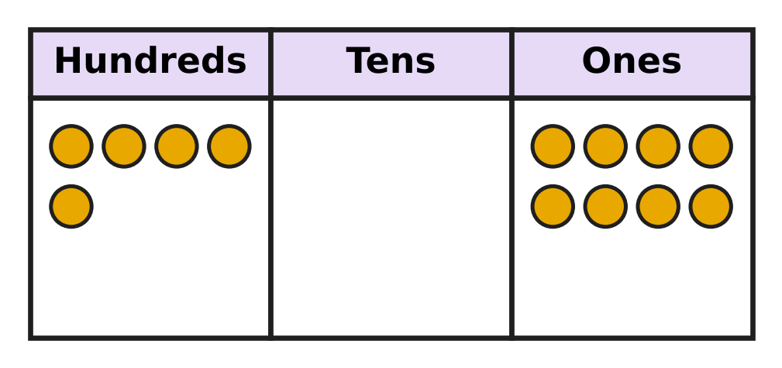
Q1. Look at the place-value chart. Deepa says the number is 58. She is wrong. Which number is it?
(A) 13 | (B) 805 | (C) 580 | (D) 508

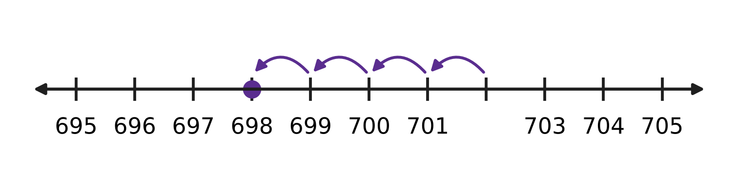
Q2. Look at the number line. Tarun makes 4 hops back and lands on 698. From which number did he start?
(A) 694 | (B) 701 | (C) 702 | (D) 703

Q3. Nakul uses the digits 3, 4 and 7 to make the four numbers below. Which of his numbers is even?
(A) 743 | (B) 437 | (C) 347 | (D) 374

Q4. Isha writes the number nine hundred fifteen in figures. Which digit does she write in the tens place?
(A) 0 | (B) 1 | (C) 5 | (D) 9

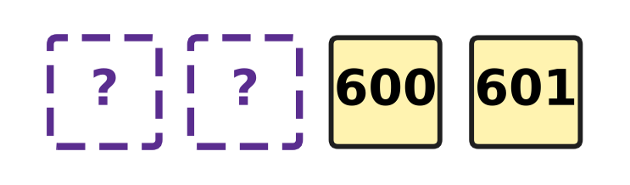
Q5. Look at the number tiles. They are numbered in order. Which two numbers are hidden?
(A) 598 and 599 | (B) 599 and 600
(C) 602 and 603 | (D) 590 and 599

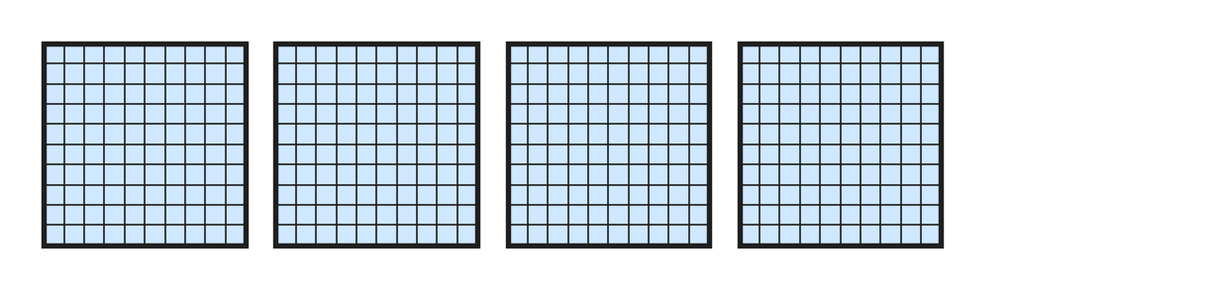
Q6. Look at the hundred-blocks. Each block is 100. How many more hundred-blocks are needed to make 700?
(A) 3 | (B) 4 | (C) 7 | (D) 300

Q7. I am a number. When you add 10 to me, you get 405. Which number am I?
(A) 415 | (B) 404 | (C) 305 | (D) 395

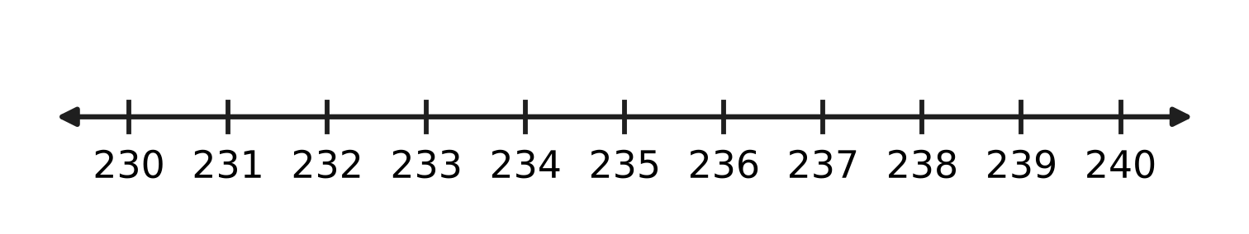
Q8. Look at the number line. How many odd numbers are greater than 230 and less than 240?
(A) 4 | (B) 5 | (C) 6 | (D) 9

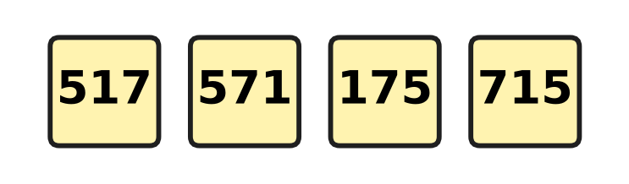
Q9. Four planes have the numbers on these cards. They take off in order, from the smallest number to the greatest. Which plane takes off third?
(A) 571 | (B) 715 | (C) 517 | (D) 175

Q10. Ivan changes just one digit of 417. His new number is 50 more than 417. What is his new number?
(A) 422 | (B) 457 | (C) 467 | (D) 917

Part 2 — Operations & Number Properties (Syllabus Chapter 2)
Q11. A tea stall starts the day with 84 paper cups. At night 37 cups are left. How many cups were used?
(A) 121 | (B) 57 | (C) 53 | (D) 47

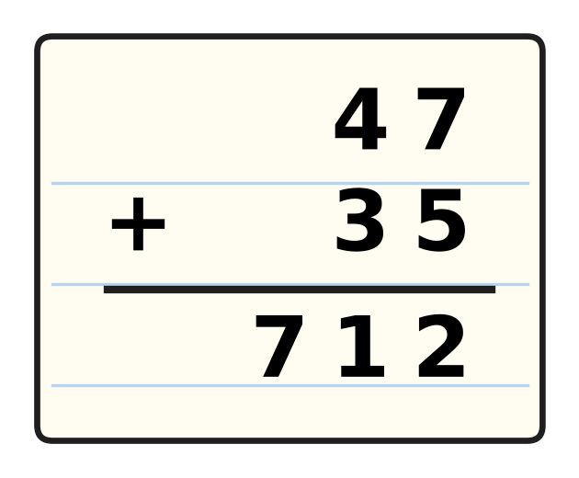
Q12. Look at the sum in the notebook. Tanmay wrote 712, which is wrong. What is the correct answer?
(A) 72 | (B) 92 | (C) 12 | (D) 82

Q13. Which of these is NOT equal to 12?
(A) 3 × 4 | (B) 6 + 6
(C) 3 + 4 | (D) 4 + 4 + 4

Q14. A car park has 96 spaces. Of these, 38 spaces are empty. How do you find the number of spaces that have a car in them?
(A) take 38 away from 96 | (B) add 38 and 38
(C) take 96 away from 38 | (D) add 96 and 38

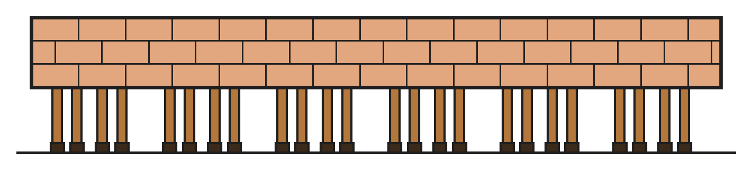
Q15. Look at the picture. Horses stand behind a wall. Only their legs can be seen. Each horse has 4 legs. How many horses are there?
(A) 4 | (B) 6 | (C) 12 | (D) 24

Q16. Three fishing nets hold 26, 18 and 35 fish. How many fish are there in all?
(A) 79 | (B) 89 | (C) 44 | (D) 69

Q17. The school sells 126 tickets for its play. There are 238 tickets left. How many tickets were there at first?
(A) 374 | (B) 112 | (C) 354 | (D) 364

Q18. There are 9 girls and 7 boys on the playground. All of them make 2 equal teams. How many children are in each team?
(A) 7 | (B) 16 | (C) 8 | (D) 4

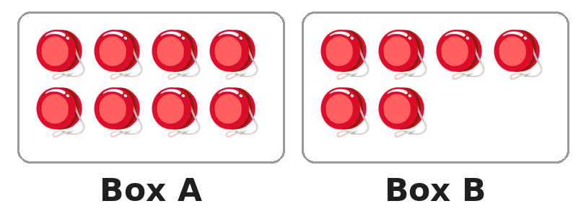
Q19. Look at the two boxes of yo-yos. How many yo-yos must go from Box A to Box B so that both boxes have the same number?
(A) 1 | (B) 2 | (C) 7 | (D) 14

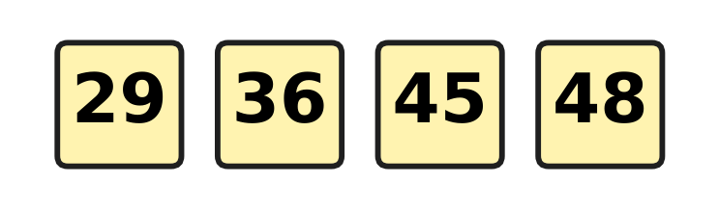
Q20. Look at the four number cards. Which two cards add up to 74?
(A) 36 and 48 | (B) 36 and 45
(C) 29 and 45 | (D) 29 and 48

Part 3 — Geometry (Syllabus Chapter 5)
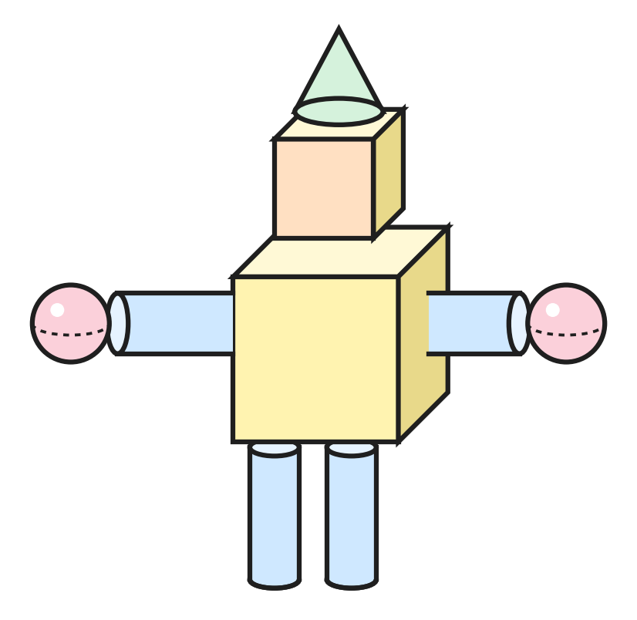
Q21. Look at the toy robot at the science exhibition. It is made of solids. How many cylinders are in it?
(A) 2 | (B) 4 | (C) 6 | (D) 9

Q22. Three of these things have the same solid shape. Which one has a different shape?
(A) a drum | (B) an orange
(C) a ball | (D) a marble

Q23. A flat shape can be drawn on paper. A solid shape can be held in your hand. Which one of these is a flat shape?
(A) cone | (B) sphere | (C) cube | (D) circle

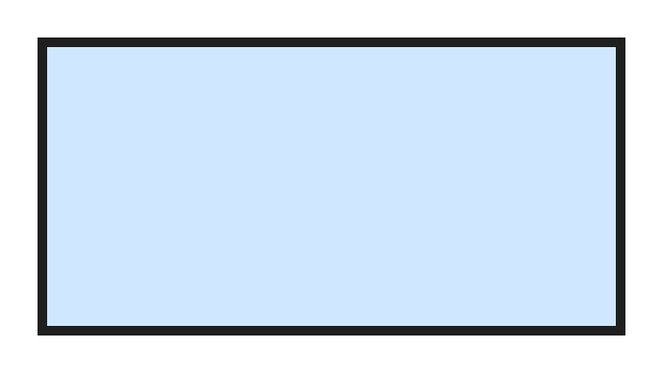
Q24. Look at the flat shape. Which shape is it?
(A) rectangle | (B) triangle
(C) square | (D) circle

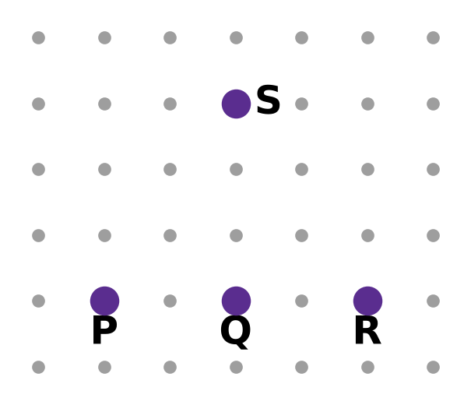
Q25. On the dot paper, Heena joins P to Q to R to S and back to P with straight lines. How many corners does her shape have?
(A) 2 | (B) 3 | (C) 4 | (D) 5

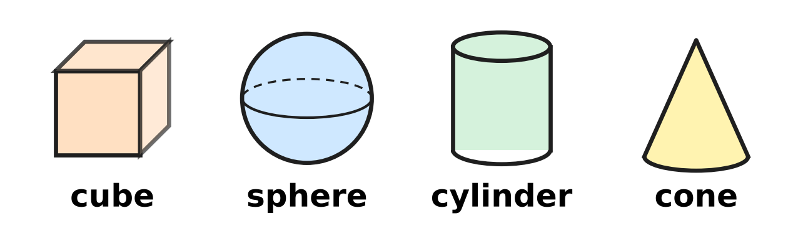
Q26. Look at the four solids. Parth keeps only the solids that have both a flat part and a curved part. Which solids does he keep?
(A) cube and sphere | (B) cube and cylinder
(C) cylinder and cone | (D) sphere and cone

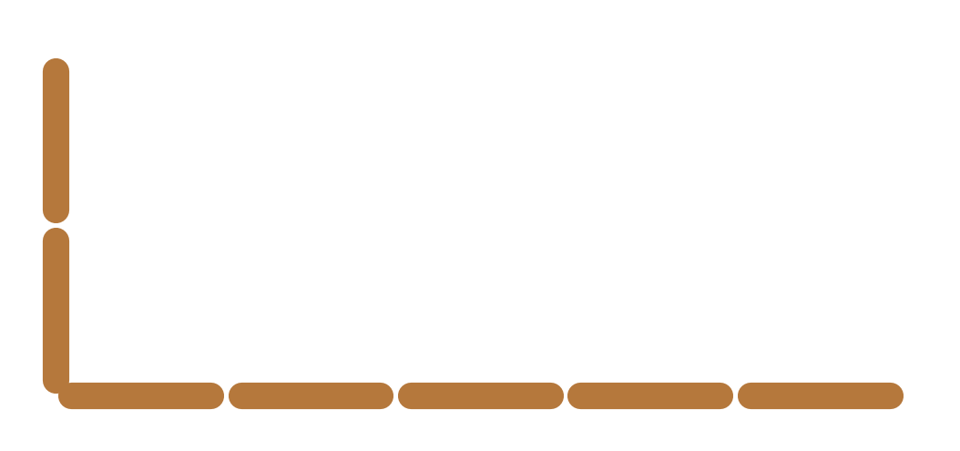
Q27. Lata is making a rectangle with sticks. Look at the picture. She has made one long side and one short side. How many more sticks does she need?
(A) 2 | (B) 5 | (C) 7 | (D) 14

Part 4 — Applied Mathematics (Syllabus Chapter 9)
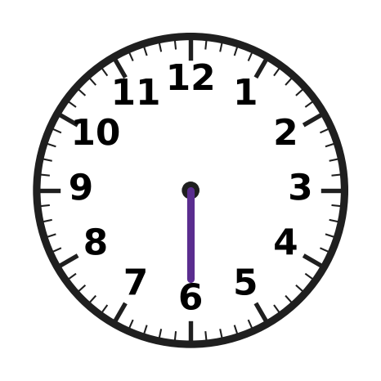
Q28. Look at the clock. Lavina wants it to show half past 9. She has drawn the long hand. Where must she draw the short hand?
(A) exactly on 9 | (B) between 8 and 9
(C) exactly on 6 | (D) between 9 and 10

Q29. Music class starts at 4 o'clock in the afternoon. How do we write this time?
(A) 4 PM | (B) 8 PM | (C) 8 AM | (D) 4 AM

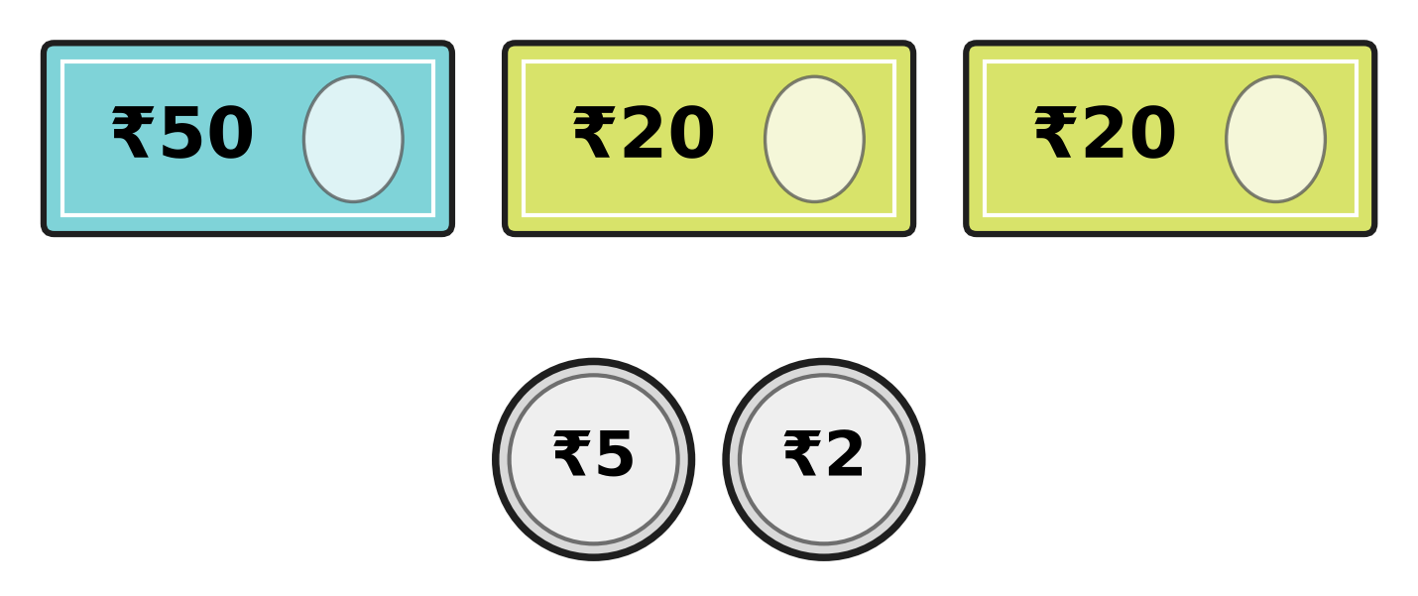
Q30. Look at the notes and coins. How much money is there in all?
(A) ₹77 | (B) ₹92 | (C) ₹95 | (D) ₹97

Q31. Kian pays for an ice-cream with a ₹50 note. He gets ₹12 back. How much does the ice-cream cost?
(A) ₹62 | (B) ₹48 | (C) ₹42 | (D) ₹38

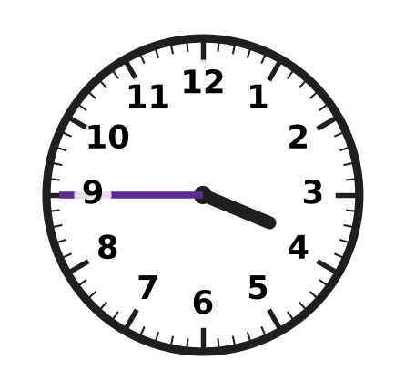
Q32. Look at the clock. Ryan reads it as quarter to 3. He is wrong. What time does the clock show?
(A) quarter past 4 | (B) half past 3
(C) quarter to 4 | (D) quarter past 3

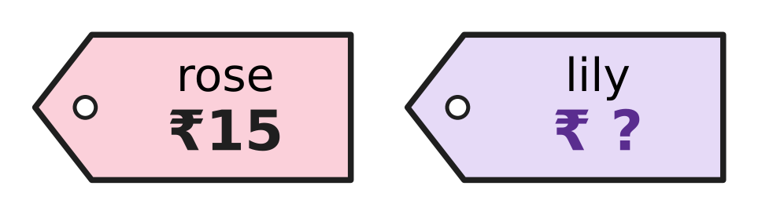
Q33. Look at the price tags. Anjali buys one rose and one lily. She pays ₹50 and gets ₹10 back. How much does the lily cost?
(A) ₹25 | (B) ₹35 | (C) ₹40 | (D) ₹45

Q34. Riya writes four times of the same day: 11 AM, 1 PM, 9 AM and 12 noon. Which of these times comes last in the day?
(A) 9 AM | (B) 11 AM | (C) 12 noon | (D) 1 PM

Part 5 — Mathematical Reasoning & Problem-Solving (Syllabus Chapter 10)
Q35. A lift goes down. It stops at floors 42, 39, 36 and 33. It keeps the same pattern. At which floor does it stop next?
(A) 23 | (B) 29 | (C) 30 | (D) 31

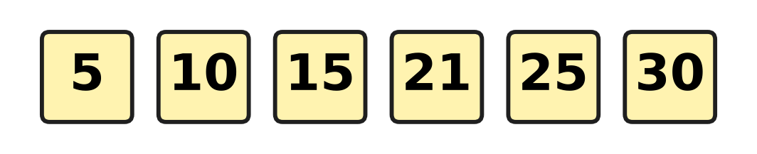
Q36. Look at the number pattern. Every jump should be the same, but one number is wrong. Which number is wrong?
(A) 15 | (B) 21 | (C) 25 | (D) 30

Q37. Jatin sees 3 → 6 and 5 → 10. He says the rule is add 3. He is wrong. Which rule fits both?
(A) double the number | (B) take away 3
(C) halve the number | (D) add 5

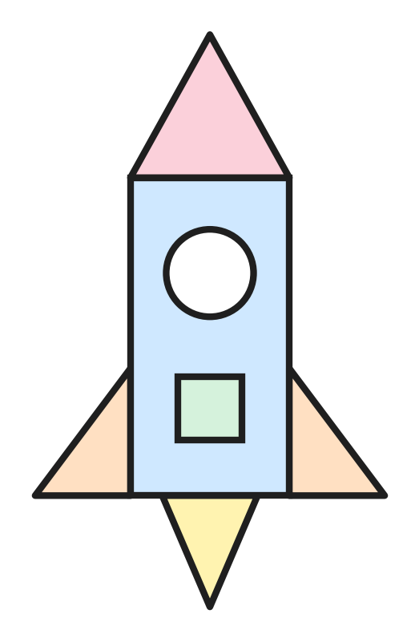
Q38. Look at the rocket. It is made of flat shapes. How many triangles are used?
(A) 3 | (B) 4 | (C) 5 | (D) 7

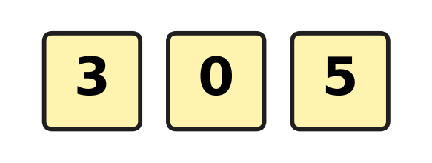
Q39. Look at the three number cards. Myra makes 2-digit numbers with two different cards. A number cannot start with 0. How many different numbers can she make?
(A) 2 | (B) 3 | (C) 4 | (D) 6

Q40. At a science exhibition, the tables are numbered 12, 13, 14 and so on up to 20. How many tables are there?
(A) 8 | (B) 9 | (C) 10 | (D) 20

SECTION II — Star Questions 5 questions × 4 marks each
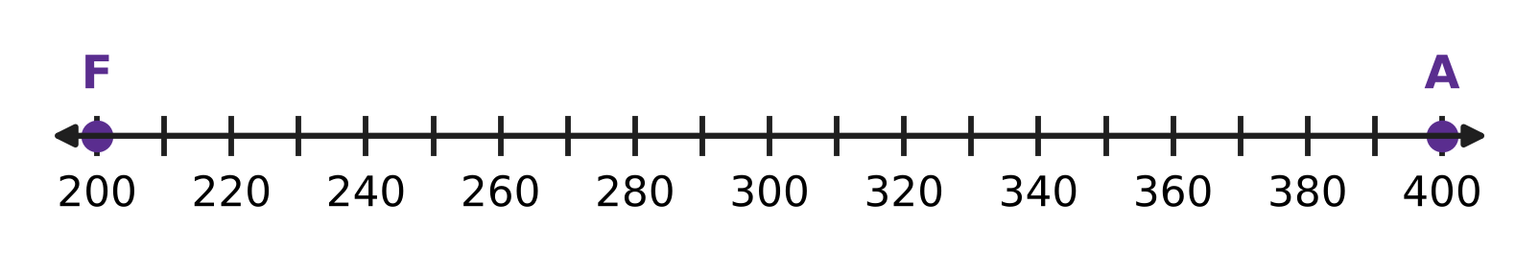
Q41. Look at the number line. A frog starts at F and hops forward 20 at a time. An ant starts at A and hops back 30 at a time. They hop at the same time. On which number do they meet? [4 marks]
(A) 260 | (B) 280 | (C) 300 | (D) 310

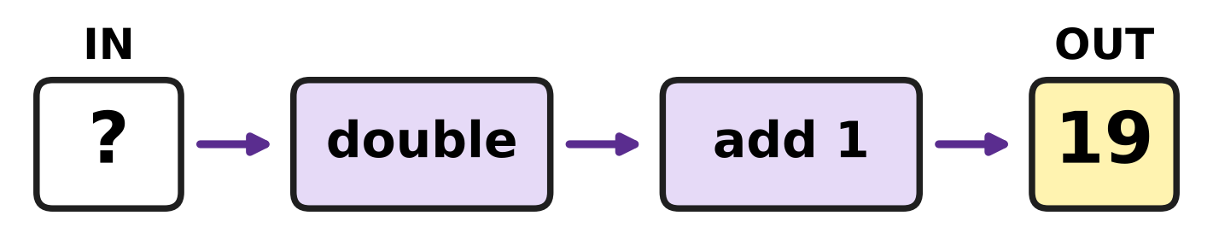
Q42. Look at the number machine. It doubles a number and then adds 1. Sarika puts in a number and 19 comes out. Which number did she put in? [4 marks]
(A) 9 | (B) 10 | (C) 18 | (D) 39

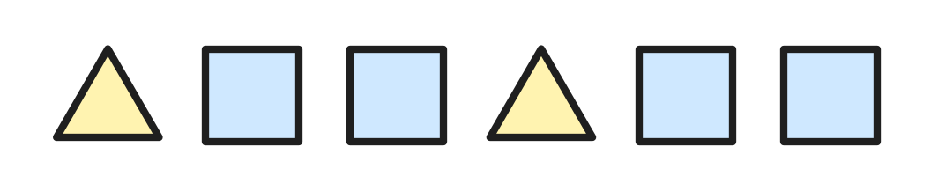
Q43. Look at the shape pattern. It goes on in the same way. Usha counts the corners, shape by shape, from the left. How many shapes has she counted when she reaches 25 corners? [4 marks]
(A) 6 | (B) 7 | (C) 8 | (D) 9

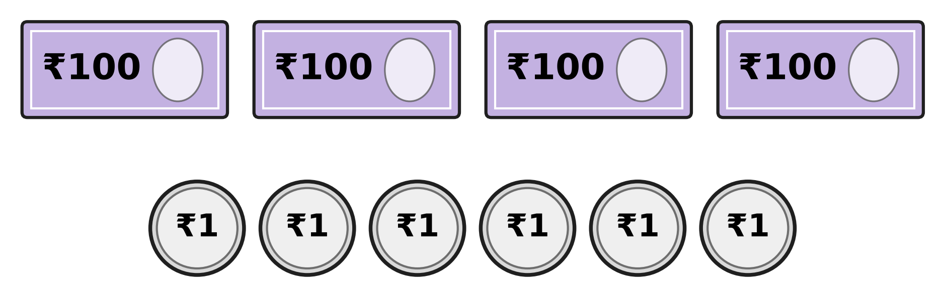
Q44. Look at the money Clara has. She changes one ₹100 note for ₹10 notes. How many notes and coins does she have now in all? [4 marks]
(A) 10 | (B) 13 | (C) 19 | (D) 20

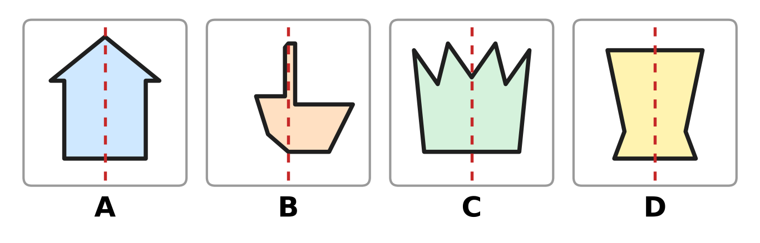
Q45. Look at the four cards. A card that is the same on both sides of the dotted line costs ₹15. Any other card costs ₹10. Zubin buys all four and pays ₹100. How much change does he get? [4 marks]
(A) ₹40 | (B) ₹45 | (C) ₹50 | (D) ₹55

Answer Sheet AMO Level 1 · Class 2 · Practice Paper 5
Name: | School: | Roll No.:
Shade or tick one circle for each question.
1. Ⓐ Ⓑ Ⓒ Ⓓ | 16. Ⓐ Ⓑ Ⓒ Ⓓ | 31. Ⓐ Ⓑ Ⓒ Ⓓ
2. Ⓐ Ⓑ Ⓒ Ⓓ | 17. Ⓐ Ⓑ Ⓒ Ⓓ | 32. Ⓐ Ⓑ Ⓒ Ⓓ
3. Ⓐ Ⓑ Ⓒ Ⓓ | 18. Ⓐ Ⓑ Ⓒ Ⓓ | 33. Ⓐ Ⓑ Ⓒ Ⓓ
4. Ⓐ Ⓑ Ⓒ Ⓓ | 19. Ⓐ Ⓑ Ⓒ Ⓓ | 34. Ⓐ Ⓑ Ⓒ Ⓓ
5. Ⓐ Ⓑ Ⓒ Ⓓ | 20. Ⓐ Ⓑ Ⓒ Ⓓ | 35. Ⓐ Ⓑ Ⓒ Ⓓ
6. Ⓐ Ⓑ Ⓒ Ⓓ | 21. Ⓐ Ⓑ Ⓒ Ⓓ | 36. Ⓐ Ⓑ Ⓒ Ⓓ
7. Ⓐ Ⓑ Ⓒ Ⓓ | 22. Ⓐ Ⓑ Ⓒ Ⓓ | 37. Ⓐ Ⓑ Ⓒ Ⓓ
8. Ⓐ Ⓑ Ⓒ Ⓓ | 23. Ⓐ Ⓑ Ⓒ Ⓓ | 38. Ⓐ Ⓑ Ⓒ Ⓓ
9. Ⓐ Ⓑ Ⓒ Ⓓ | 24. Ⓐ Ⓑ Ⓒ Ⓓ | 39. Ⓐ Ⓑ Ⓒ Ⓓ
10. Ⓐ Ⓑ Ⓒ Ⓓ | 25. Ⓐ Ⓑ Ⓒ Ⓓ | 40. Ⓐ Ⓑ Ⓒ Ⓓ
11. Ⓐ Ⓑ Ⓒ Ⓓ | 26. Ⓐ Ⓑ Ⓒ Ⓓ | 41. Ⓐ Ⓑ Ⓒ Ⓓ
12. Ⓐ Ⓑ Ⓒ Ⓓ | 27. Ⓐ Ⓑ Ⓒ Ⓓ | 42. Ⓐ Ⓑ Ⓒ Ⓓ
13. Ⓐ Ⓑ Ⓒ Ⓓ | 28. Ⓐ Ⓑ Ⓒ Ⓓ | 43. Ⓐ Ⓑ Ⓒ Ⓓ
14. Ⓐ Ⓑ Ⓒ Ⓓ | 29. Ⓐ Ⓑ Ⓒ Ⓓ | 44. Ⓐ Ⓑ Ⓒ Ⓓ
15. Ⓐ Ⓑ Ⓒ Ⓓ | 30. Ⓐ Ⓑ Ⓒ Ⓓ | 45. Ⓐ Ⓑ Ⓒ Ⓓ
Q41–Q45 are Section II Star Questions (4 marks each).
For the parent or teacher
Section I correct: ______ / 40 × 2 = ______ marks Section II correct: ______ / 5 × 4 = ______ marks
Correct: ______ / 45 Score: ______ / 100
Answer Key and Solutions AMO Level 1 · Class 2 · Practice Paper 5
Quick answers
1 D | 6 A | 11 D | 16 A | 21 B | 26 C | 31 D | 36 B | 41 B
2 C | 7 D | 12 D | 17 D | 22 A | 27 C | 32 C | 37 A | 42 A
3 D | 8 B | 13 C | 18 C | 23 D | 28 D | 33 A | 38 B | 43 B
4 B | 9 A | 14 A | 19 A | 24 A | 29 A | 34 D | 39 C | 44 C
5 A | 10 C | 15 B | 20 C | 25 B | 30 D | 35 C | 40 B | 45 B
Solutions
Q | Part · level | Answer | Why?
1 | Part 1 · Ch1 · Easy | (D) 508 | There are 5 hundreds, no tens and 8 ones. The empty tens place needs a zero, so the number is 508.
2 | Part 1 · Ch1 · Easy | (C) 702 | Go forward 4 steps from 698: 699, 700, 701, 702. He started from 702.
3 | Part 1 · Ch1 · Easy | (D) 374 | A number is even when its ones digit is 0, 2, 4, 6 or 8. Only 374 ends in 4.
4 | Part 1 · Ch1 · Easy | (B) 1 | Nine hundred fifteen is 915: 9 hundreds, 1 ten and 5 ones. The tens digit is 1.
5 | Part 1 · Ch1 · Easy | (A) 598 and 599 | Just before 600 comes 599, and just before 599 comes 598. The hidden numbers are 598 and 599.
6 | Part 1 · Ch1 · Easy | (A) 3 | The picture shows 4 hundreds, which is 400. Count on: 500, 600, 700. That is 3 more blocks.
7 | Part 1 · Ch1 · Medium | (D) 395 | 10 less than 405 is 395. Check: 395 and 10 more is 405.
8 | Part 1 · Ch1 · Medium | (B) 5 | The odd numbers are 231, 233, 235, 237 and 239. That is 5 numbers.
9 | Part 1 · Ch1 · Medium | (A) 571 | In order the numbers are 175, 517, 571, 715. The third number is 571.
10 | Part 1 · Ch1 · Medium | (C) 467 | 50 is 5 tens. The tens digit of 417 is 1, and 1 + 5 = 6. So the new number is 467, and 467 − 417 = 50.
11 | Part 2 · Ch2 · Easy | (D) 47 | 84 − 37: regroup 84 as 7 tens and 14 ones. 14 − 7 = 7 and 7 tens − 3 tens = 4 tens. 47 cups were used.
12 | Part 2 · Ch2 · Easy | (D) 82 | 7 + 5 = 12. Write 2 and carry 1 ten. Then 4 + 3 + 1 = 8 tens. The answer is 82.
13 | Part 2 · Ch2 · Easy | (C) 3 + 4 | 3 × 4 means 3 groups of 4, which is 4 + 4 + 4 = 12. 6 + 6 is also 12. But 3 + 4 is only 7.
14 | Part 2 · Ch2 · Easy | (A) take 38 away from 96 | The spaces with cars are what is left when the empty spaces are taken away: 96 − 38.
15 | Part 2 · Ch2 · Easy | (B) 6 | Count the legs in fours: 4, 8, 12, 16, 20, 24. That is 6 fours, so there are 6 horses.
16 | Part 2 · Ch2 · Easy | (A) 79 | Ones: 6 + 8 + 5 = 19, so write 9 and carry 1 ten. Tens: 2 + 1 + 3 + 1 = 7. The total is 79.
17 | Part 2 · Ch2 · Medium | (D) 364 | Put the sold tickets back: 126 + 238 = 364.
18 | Part 2 · Ch2 · Medium | (C) 8 | 9 + 7 = 16 children. 16 shared into 2 equal teams is 8 in each team.
19 | Part 2 · Ch2 · Medium | (A) 1 | There are 8 + 6 = 14 yo-yos, so each box needs 7. Moving 1 yo-yo makes 7 and 7.
20 | Part 2 · Ch2 · Medium | (C) 29 and 45 | 29 + 45: 9 + 5 = 14, write 4 and carry 1 ten. 2 + 4 + 1 = 7 tens. The total is 74.
21 | Part 3 · Ch5 · Easy | (B) 4 | The two legs and the two arms are cylinders. There are 4 cylinders.
22 | Part 3 · Ch5 · Easy | (A) a drum | A ball, an orange and a marble are spheres. A drum is a cylinder, so it is the different one.
23 | Part 3 · Ch5 · Easy | (D) circle | A circle is flat. A cube, a cone and a sphere are solids.
24 | Part 3 · Ch5 · Easy | (A) rectangle | The shape has 4 corners, 2 long sides and 2 short sides. It is a rectangle.
25 | Part 3 · Ch5 · Medium | (B) 3 | P, Q and R lie on one straight line, so Q is not a corner. The corners are P, R and S: 3 corners, so the shape is a triangle.
26 | Part 3 · Ch5 · Medium | (C) cylinder and cone | A cube is flat all over and a sphere is curved all over. The cylinder and the cone have flat circles and a curved side.
27 | Part 3 · Ch5 · Medium | (C) 7 | A rectangle has 2 long sides and 2 short sides. She still needs one long side of 5 sticks and one short side of 2 sticks: 5 + 2 = 7.
28 | Part 4 · Ch9 · Easy | (D) between 9 and 10 | At half past 9 the short hand has moved halfway from 9 towards 10.
29 | Part 4 · Ch9 · Easy | (A) 4 PM | The afternoon comes after 12 noon, so the time is 4 PM.
30 | Part 4 · Ch9 · Easy | (D) ₹97 | 50 + 20 + 20 = 90, and 5 + 2 = 7. In all there is ₹97.
31 | Part 4 · Ch9 · Easy | (D) ₹38 | ₹50 − ₹12 = ₹38. Check: ₹38 + ₹12 = ₹50.
32 | Part 4 · Ch9 · Medium | (C) quarter to 4 | The long hand is on 9, so it is quarter to the next hour. The short hand has passed 3 and is close to 4. The time is quarter to 4.
33 | Part 4 · Ch9 · Medium | (A) ₹25 | She spent ₹50 − ₹10 = ₹40 on both flowers. The lily costs ₹40 − ₹15 = ₹25.
34 | Part 4 · Ch9 · Medium | (D) 1 PM | AM times come before noon and PM times come after noon. 1 PM is the only time after noon, so it is the last.
35 | Part 5 · Ch10 · Easy | (C) 30 | Each stop is 3 floors lower than the one before. 33 − 3 = 30.
36 | Part 5 · Ch10 · Easy | (B) 21 | The numbers go up in fives: 5, 10, 15, 20, 25, 30. So 21 is wrong; it should be 20.
37 | Part 5 · Ch10 · Easy | (A) double the number | 3 + 3 = 6, but 5 + 3 is 8, not 10. Double 3 is 6 and double 5 is 10, so the rule is double the number.
38 | Part 5 · Ch10 · Easy | (B) 4 | There is 1 triangle at the top, 1 on each side and 1 at the bottom. That is 4 triangles.
39 | Part 5 · Ch10 · Medium | (C) 4 | She can make 30, 35, 50 and 53. That is 4 numbers.
40 | Part 5 · Ch10 · Medium | (B) 9 | Count them: 12, 13, 14, 15, 16, 17, 18, 19, 20. That is 9 tables.
41 | Section II · Ch1 + Ch10 · Hard | (B) 280 | Frog: 200, 220, 240, 260, 280. Ant: 400, 370, 340, 310, 280. After 4 hops each, both are on 280.
42 | Section II · Ch2 + Ch10 · Hard | (A) 9 | Work backwards. Take away the 1: 19 − 1 = 18. Then halve: 18 ÷ 2 = 9. Check: double 9 is 18, and 18 + 1 = 19.
43 | Section II · Ch5 + Ch10 · Hard | (B) 7 | The corners add up like this: 3, 7, 11, 14, 18, 22. The 7th shape is a triangle again, and 22 + 3 = 25. So she has counted 7 shapes.
44 | Section II · Ch1 + Ch9 · Hard | (C) 19 | One ₹100 note is the same as ten ₹10 notes. Then she has 3 notes of ₹100, 10 notes of ₹10 and 6 coins: 3 + 10 + 6 = 19.
45 | Section II · Ch5 + Ch9 · Hard | (B) ₹45 | Cards A, C and D are the same on both sides: 3 × ₹15 = ₹45. Card B costs ₹10. The total is ₹55, so the change is ₹100 − ₹55 = ₹45.

