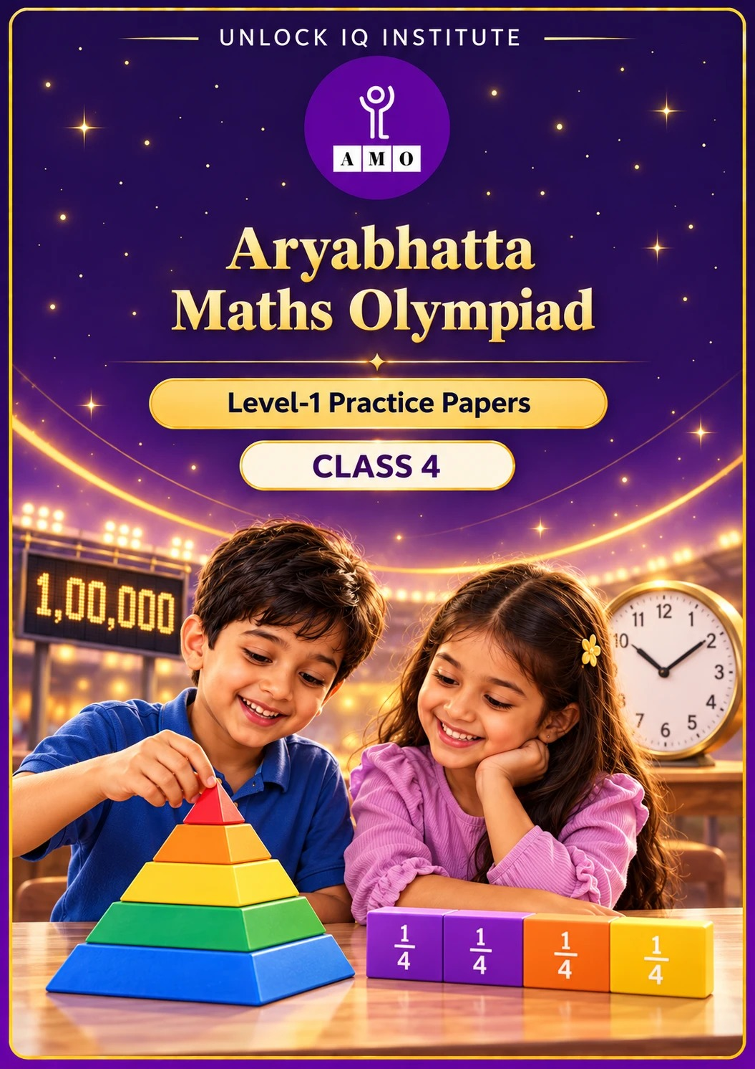
Five full practice papers · with answer keys & detailed solutions
Name: ____________________ | Class & Section: ________________
Roll No.: ________________ | School: ____________________
City: ____________________ | Date: ____________________

Published by Unlock IQ Institute Pvt. Ltd.
Register for Olympiads: www.aryabhattamathsolympiad.com/student-registration

ARYABHATTA MATHS OLYMPIAD
Level 1
PRACTICE PAPER-1
CLASS 4
Total Questions | 45 multiple-choice questions
Total Marks | 100
Time | 60 minutes
Section I | 40 questions × 2 marks = 80 marks
Section II | 5 Star Questions × 4 marks = 20 marks
Negative Marking | No negative marking
Calculator | Not allowed
Chapters | Number System · Operations · Fractions, Decimals & Percentages · Geometry · Mensuration · Data Handling · Applied Mathematics · Mathematical Reasoning

👋 Hello, friend! How to do this paper:
⭐ Every question has four answer choices: (A), (B), (C) and (D). Only one is correct.
⭐ Read each question and look at its picture carefully. Then mark your answer on the answer sheet at the end.
⭐ Section I has 40 questions of 2 marks each. Section II has 5 Star Questions of 4 marks each.
⭐ There is no negative marking, so try every question.
⭐ Do not use a calculator. You may do rough work on a separate sheet.
⭐ All figures are not necessarily drawn to scale unless stated.

For parents and teachers
• Print or view this paper in colour. Pictures are part of the questions.
• Parts follow the AMO syllabus chapters. Chapters 4 and 7 are not part of the Class 4 syllabus, so the chapter numbers shown in the Part headings have gaps.
• The answer sheet and the answer key are at the end. Remove only the answer key before the child begins.

SECTION I 40 questions × 2 marks each
Part 1 — Number System (Syllabus Chapter 1)
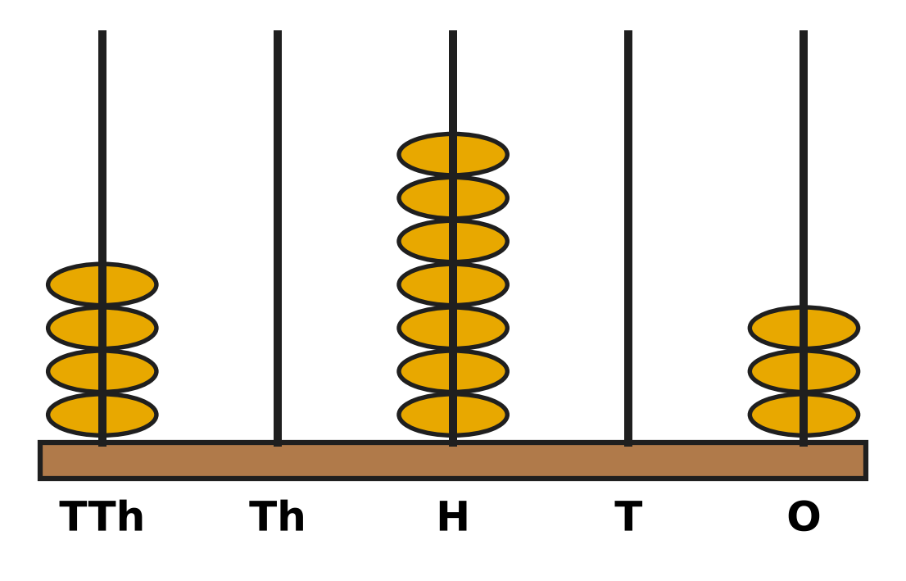
Q1. Look at the abacus. The rods show ten thousands, thousands, hundreds, tens and ones. Which number does the abacus show?
(A) 40,703 | (B) 40,730 | (C) 4,073 | (D) 47,030

Q2. The pages of Vani's photo album are numbered with Roman numerals, starting from I. The last page is numbered LXXIV. How many pages does the album have?
(A) 76 | (B) 64 | (C) 84 | (D) 74

Q3. Five digit cards show 3, 0, 8, 5 and 1. Each card is used once to make a 5-digit number. What is the greatest number that can be made?
(A) 85,310 | (B) 10,358 | (C) 83,510 | (D) 85,301

Q4. In the number 64,215, the digit 4 is changed to 9. The other digits stay the same. By how much does the number increase?
(A) 5 | (B) 5,000 | (C) 500 | (D) 50,000

Q5. The numbers increase by 1,100 each time: 45,600; 46,700; 47,800; 48,900; … What is the 6th number?
(A) 51,100 | (B) 52,200 | (C) 50,600 | (D) 50,000

Part 2 — Operations & Number Properties (Syllabus Chapter 2)
Q6. Which of these gives the same answer as 36,482 + 27,159? You do not need to work out the total.
(A) 27,195 + 36,482 | (B) 36,482 − 27,159
(C) 36,248 + 27,159 | (D) 27,159 + 36,482

Q7. An apple orchard picked 52,300 apples this season. It sold 27,845 of them. How many apples were not sold?
(A) 80,145 | (B) 24,455 | (C) 35,545 | (D) 25,455

Q8. A bakery has 1,060 buns. It puts 8 buns in each box. How many boxes can it fill completely?
(A) 122 | (B) 133 | (C) 142 | (D) 132

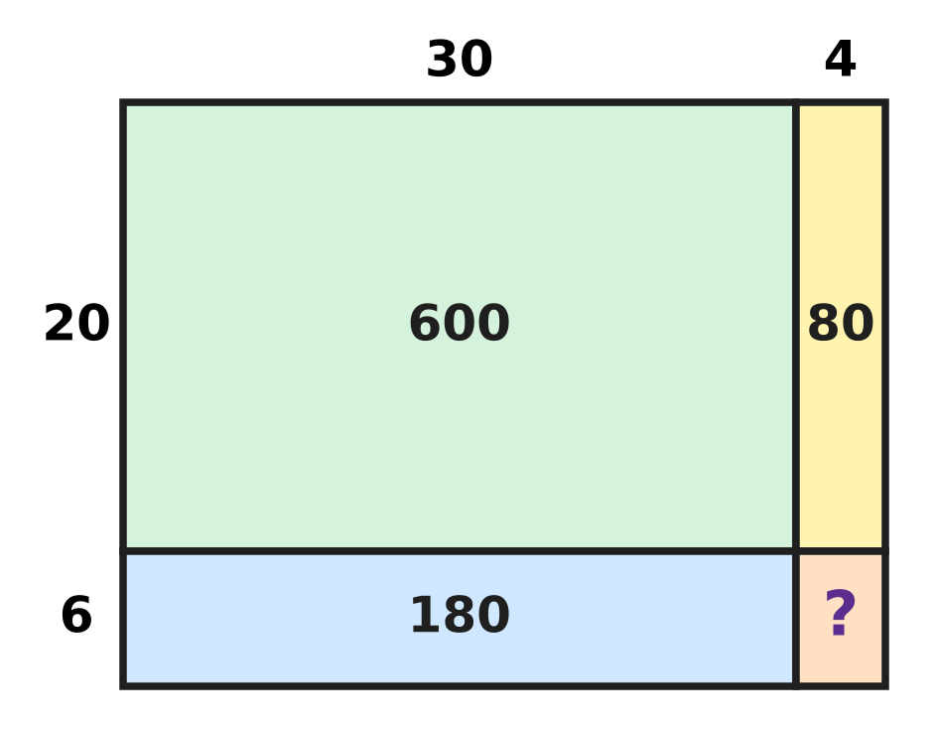
Q9. The picture splits 34 × 26 into four parts: 34 = 30 + 4 and 26 = 20 + 6. Three parts show their products. What is 34 × 26?
(A) 704 | (B) 884 | (C) 804 | (D) 860

Q10. Kartik estimates 48 × 31 by rounding each number to the nearest ten first. By how much is his estimate more than the exact answer?
(A) 12 | (B) 1,488 | (C) 60 | (D) 1,500

Part 3 — Fractions, Decimals & Percentages (Syllabus Chapter 3)
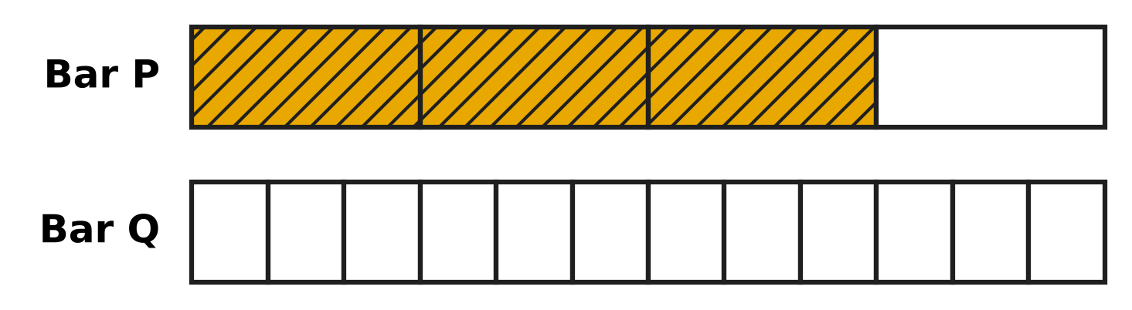
Q11. Look at the picture. Bar P and Bar Q are the same size. Bar P is cut into 4 equal parts and Bar Q into 12 equal parts. How many parts of Bar Q must be shaded so that both bars show the same fraction?
(A) 8 | (B) 6 | (C) 9 | (D) 3

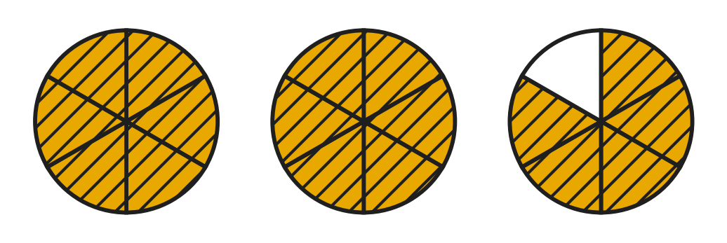
Q12. Look at the picture. Each cake is cut into 6 equal pieces. The shaded pieces are left over. Which improper fraction tells how many cakes are left over?
(A) $\frac{18}{6}$ | (B) $\frac{7}{6}$ | (C) $\frac{12}{6}$ | (D) $\frac{17}{6}$

Q13. A rainwater tank is $\frac{5}{6}$ full. Then $\frac{1}{3}$ of the whole tank is used for the garden. What part of the tank is still full?
(A) $\frac{2}{3}$ | (B) $\frac{1}{2}$ | (C) $\frac{1}{3}$ | (D) $\frac{1}{4}$

Q14. Which fraction is NOT equal to $\frac{2}{3}$?
(A) $\frac{6}{8}$ | (B) $\frac{6}{9}$ | (C) $\frac{8}{12}$ | (D) $\frac{4}{6}$

Q15. In a science class there are four jugs of the same size. Jug 1 is $\frac{3}{4}$ full of water, Jug 2 is $\frac{2}{3}$ full, Jug 3 is $\frac{5}{6}$ full and Jug 4 is $\frac{7}{12}$ full. Which jug has the most water?
(A) Jug 1 | (B) Jug 2 | (C) Jug 3 | (D) Jug 4

Q16. Farah lets out $\frac{1}{4}$ of her full kite string. Then she lets out another $\frac{3}{8}$ of the full string. What fraction of the string is still on the reel?
(A) $\frac{2}{3}$ | (B) $\frac{1}{8}$ | (C) $\frac{3}{8}$ | (D) $\frac{5}{8}$

Part 4 — Geometry (Syllabus Chapter 5)
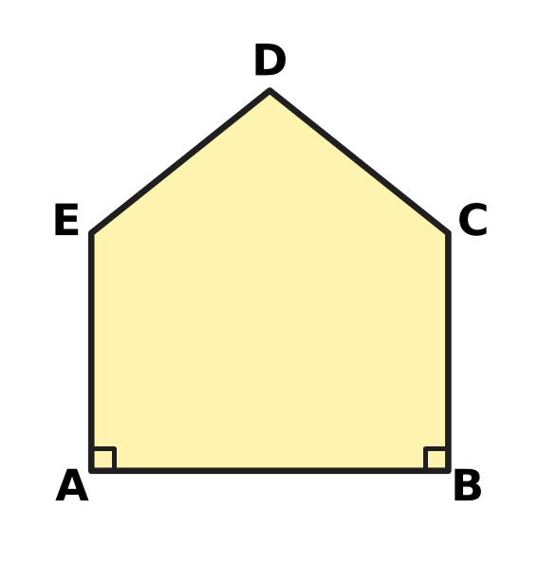
Q17. The picture shows the outline of a notice board ABCDE. The corners at A and B are right angles. Which side is parallel to side BC?
(A) Side AE | (B) Side DE | (C) Side AB | (D) Side CD

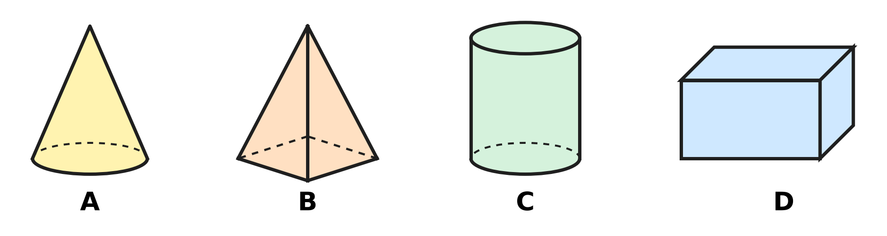
Q18. Look at the four solids standing on a table. Which solid looks like a circle from the top and like a rectangle from the front?
(A) Picture A | (B) Picture B
(C) Picture C | (D) Picture D

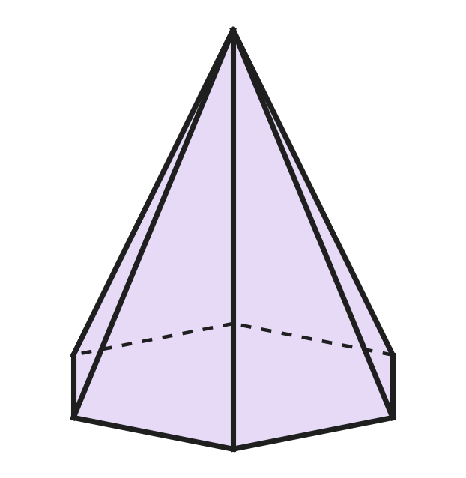
Q19. The picture shows a pyramid whose base has 6 sides. Dashed lines are edges at the back. How many edges does the pyramid have?
(A) 6 | (B) 12 | (C) 18 | (D) 7

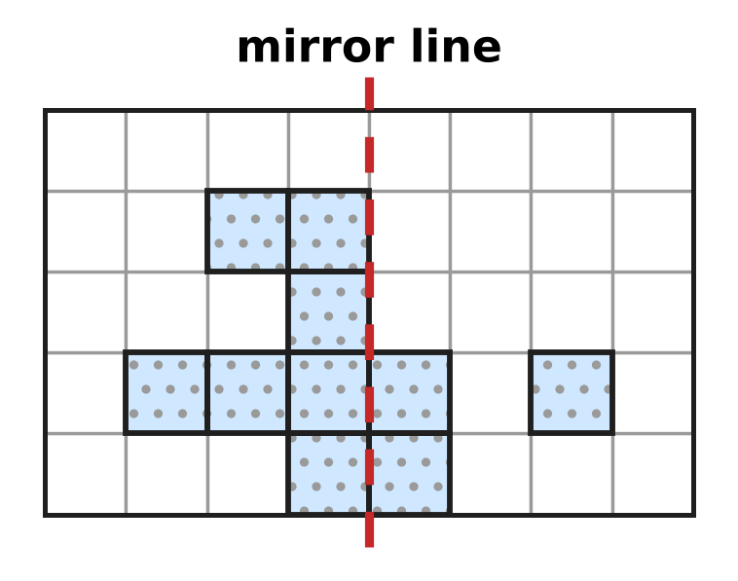
Q20. Look at the grid. Some squares are shaded. What is the smallest number of extra squares to shade so that both sides of the dashed mirror line match?
(A) 5 | (B) 3 | (C) 7 | (D) 4

Part 5 — Mensuration (Syllabus Chapter 6)
Q21. A rectangular swimming pool is 25 m long and 12 m wide. What is the perimeter of the pool?
(A) 300 m | (B) 62 m | (C) 37 m | (D) 74 m

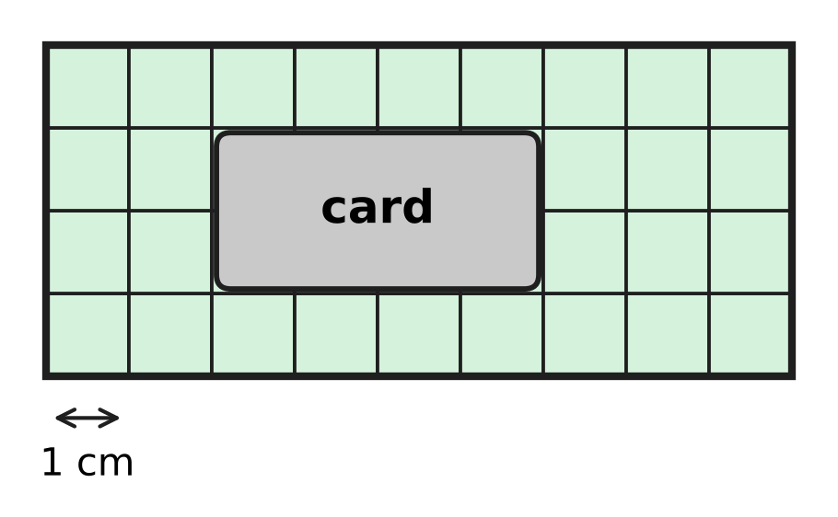
Q22. Look at the picture. A rectangle is made of 1 cm squares, but a card hides some of them. What is the area of the whole rectangle?
(A) 36 sq cm | (B) 26 sq cm | (C) 28 sq cm | (D) 13 sq cm

Q23. A bag of hen feed on a farm weighs 2 kg 75 g. How many grams is that?
(A) 2,750 g | (B) 2,075 g | (C) 275 g | (D) 2,705 g

Q24. Which of these lengths is the longest?
(A) 2,019 m | (B) 2 km 90 m
(C) 2,100 m | (D) 2 km 9 m

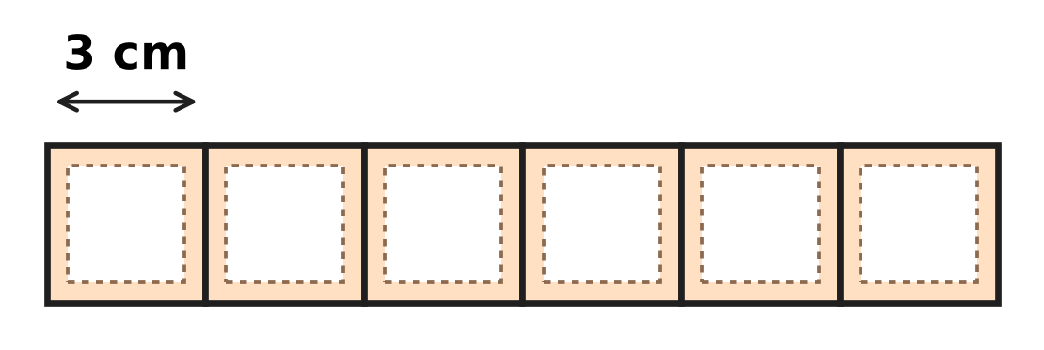
Q25. Look at the picture. Six square stamps, each of side 3 cm, are placed side by side in a row with no gaps. What is the perimeter of the long strip they make?
(A) 36 cm | (B) 42 cm | (C) 54 cm | (D) 72 cm

Q26. On a bicycle trip, Ishan rides 4 km 750 m before lunch and 3 km 600 m after lunch. How much farther must he ride to make 10 km in all?
(A) 1 km 650 m | (B) 8 km 350 m
(C) 2 km 350 m | (D) 2 km 650 m

Part 6 — Data Handling, Statistics & Probability (Syllabus Chapter 8)
Picture for Q27 and Q28
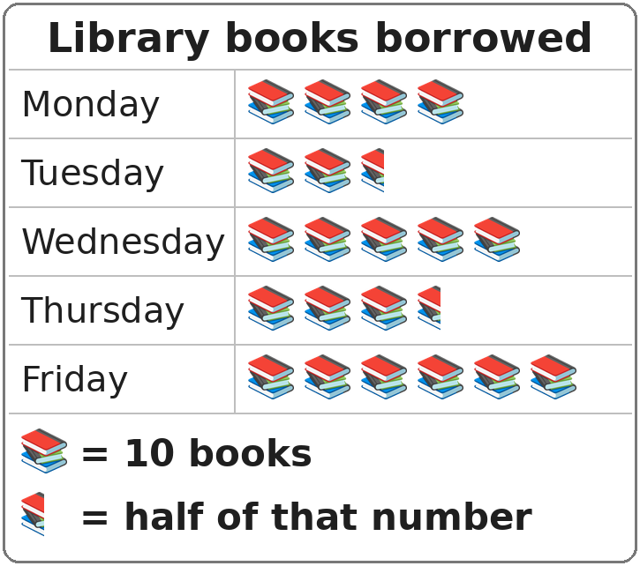
Q27. Look at the pictograph. How many books were borrowed on Thursday?
(A) 25 | (B) 30 | (C) 35 | (D) 40

Picture for Q27 and Q28
Q28. Look at the pictograph. How many books were borrowed on the five days altogether?
(A) 21 | (B) 220 | (C) 200 | (D) 210

Part 7 — Applied Mathematics (Syllabus Chapter 9)
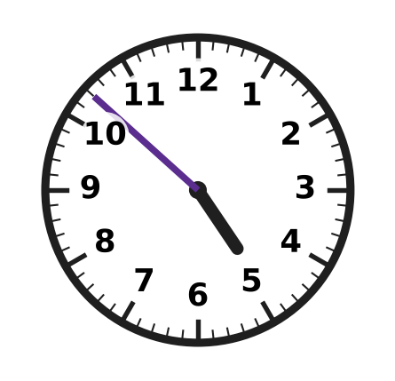
Q29. Look at the clock. What time does it show?
(A) 4:42 | (B) 4:57 | (C) 4:52 | (D) 5:52

Q30. Naveen's school bus leaves his stop at 7:48 in the morning. The ride takes 35 minutes. At what time does the bus reach school?
(A) 8:23 | (B) 8:33 | (C) 7:23 | (D) 8:13

Q31. In a certain year, 5 March is a Friday. What day of the week is 26 March?
(A) Thursday | (B) Saturday | (C) Monday | (D) Friday

Q32. Madhu buys 6 tickets for a puppet show. Each ticket costs ₹45. How much does she pay?
(A) ₹260 | (B) ₹270 | (C) ₹51 | (D) ₹240

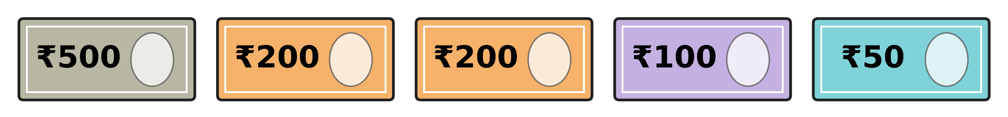
Q33. The picture shows all the money Arun has. At a stationery shop he buys 3 sketch books. Each sketch book costs ₹185. How much money does he have left?
(A) ₹495 | (B) ₹295 | (C) ₹865 | (D) ₹555

Q34. Shreya and her 3 friends buy a cake for ₹388 and some juice for ₹140 for a class party. The four children share the whole cost equally. How much does each child pay?
(A) ₹97 | (B) ₹132 | (C) ₹176 | (D) ₹528

Part 8 — Mathematical Reasoning & Problem-Solving (Syllabus Chapter 10)
Q35. Find the missing number: 120, 108, 96, ___, 72, 60
(A) 86 | (B) 84 | (C) 82 | (D) 94

Q36. Jars of marbles stand on a shelf. They are numbered from 14 to 40, one number on each jar. Every jar with an even number holds red marbles. How many jars hold red marbles?
(A) 27 | (B) 13 | (C) 20 | (D) 14

Q37. Nila sows bean seeds in her vegetable garden on 20 April. She picks the first beans on 12 May. How many days later is that? (April has 30 days.)
(A) 32 | (B) 23 | (C) 22 | (D) 21

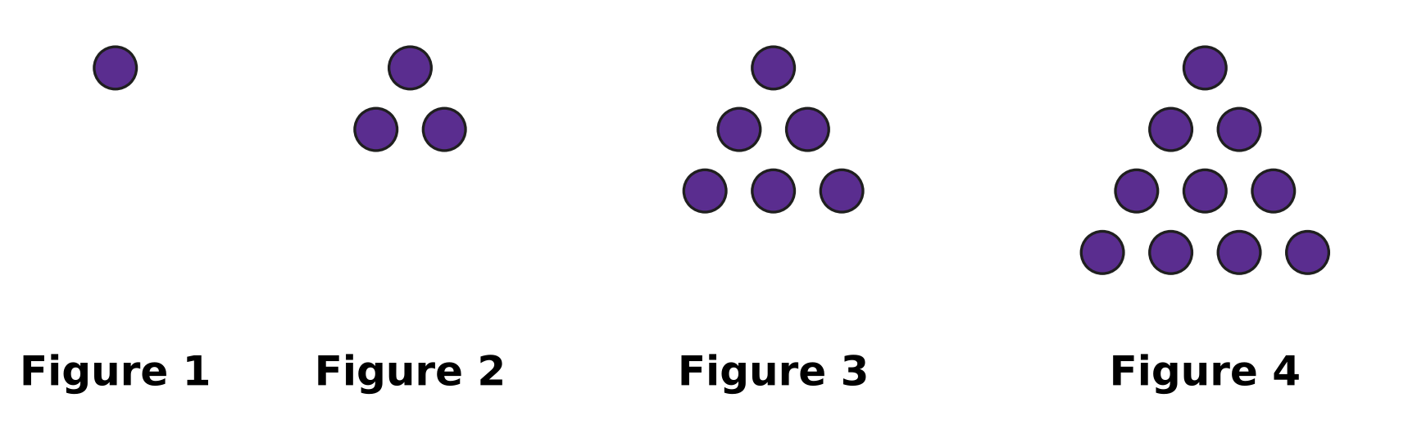
Q38. Look at the pattern of dots. Each new figure has one more row of dots at the bottom than the figure before it. How many dots will Figure 7 have?
(A) 21 | (B) 22 | (C) 28 | (D) 36

Q39. How many of the numbers from 1 to 50 have at least one digit 3?
(A) 14 | (B) 10 | (C) 5 | (D) 15

Q40. A class has a spelling test every 12 days. The first test is on a Monday. On which day of the week is the 5th test?
(A) Friday | (B) Tuesday | (C) Saturday | (D) Sunday

SECTION II — Star Questions 5 questions × 4 marks each
Q41. Think of all the fractions with denominator (bottom number) 12 that are greater than $\frac{1}{3}$ and less than $\frac{3}{4}$. How many of them are in simplest form? [4 marks]
(A) 4 | (B) 2 | (C) 1 | (D) 3

Q42. In a certain year, 1 March is a Thursday. March has 31 days. In March, Advait saves ₹15 every Saturday and ₹10 every Wednesday. How much does he save in March? [4 marks]
(A) ₹100 | (B) ₹110 | (C) ₹115 | (D) ₹125

Q43. The numbers 1 to 100 are written in Roman numerals. How many of them use exactly two letters? (For example, XV for 15 uses two letters.) [4 marks]
(A) 8 | (B) 10 | (C) 11 | (D) 12

Q44. Laksh starts a jigsaw puzzle at 7:45 a.m. He works for 1$\frac{1}{4}$ hours, rests for $\frac{1}{3}$ hour, and then works for another $\frac{5}{6}$ hour. At what time does he finish? [4 marks]
(A) 9:50 | (B) 10:00 | (C) 10:10 | (D) 10:20

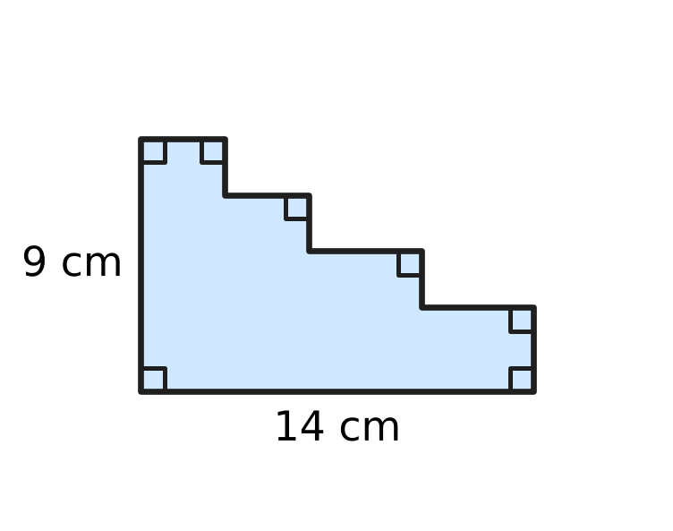
Q45. Look at the card. Its bottom side is 14 cm and its left side is 9 cm. All the other sides are parallel to one of these two sides, and their lengths are not given. What is the perimeter of the card? [4 marks]
(A) 23 cm | (B) 46 cm | (C) 40 cm | (D) 126 cm

Answer Sheet AMO Level 1 · Class 4 · Practice Paper 1
Name: | School: | Roll No.:
Shade or tick one circle for each question.
1. Ⓐ Ⓑ Ⓒ Ⓓ | 16. Ⓐ Ⓑ Ⓒ Ⓓ | 31. Ⓐ Ⓑ Ⓒ Ⓓ
2. Ⓐ Ⓑ Ⓒ Ⓓ | 17. Ⓐ Ⓑ Ⓒ Ⓓ | 32. Ⓐ Ⓑ Ⓒ Ⓓ
3. Ⓐ Ⓑ Ⓒ Ⓓ | 18. Ⓐ Ⓑ Ⓒ Ⓓ | 33. Ⓐ Ⓑ Ⓒ Ⓓ
4. Ⓐ Ⓑ Ⓒ Ⓓ | 19. Ⓐ Ⓑ Ⓒ Ⓓ | 34. Ⓐ Ⓑ Ⓒ Ⓓ
5. Ⓐ Ⓑ Ⓒ Ⓓ | 20. Ⓐ Ⓑ Ⓒ Ⓓ | 35. Ⓐ Ⓑ Ⓒ Ⓓ
6. Ⓐ Ⓑ Ⓒ Ⓓ | 21. Ⓐ Ⓑ Ⓒ Ⓓ | 36. Ⓐ Ⓑ Ⓒ Ⓓ
7. Ⓐ Ⓑ Ⓒ Ⓓ | 22. Ⓐ Ⓑ Ⓒ Ⓓ | 37. Ⓐ Ⓑ Ⓒ Ⓓ
8. Ⓐ Ⓑ Ⓒ Ⓓ | 23. Ⓐ Ⓑ Ⓒ Ⓓ | 38. Ⓐ Ⓑ Ⓒ Ⓓ
9. Ⓐ Ⓑ Ⓒ Ⓓ | 24. Ⓐ Ⓑ Ⓒ Ⓓ | 39. Ⓐ Ⓑ Ⓒ Ⓓ
10. Ⓐ Ⓑ Ⓒ Ⓓ | 25. Ⓐ Ⓑ Ⓒ Ⓓ | 40. Ⓐ Ⓑ Ⓒ Ⓓ
11. Ⓐ Ⓑ Ⓒ Ⓓ | 26. Ⓐ Ⓑ Ⓒ Ⓓ | 41. Ⓐ Ⓑ Ⓒ Ⓓ
12. Ⓐ Ⓑ Ⓒ Ⓓ | 27. Ⓐ Ⓑ Ⓒ Ⓓ | 42. Ⓐ Ⓑ Ⓒ Ⓓ
13. Ⓐ Ⓑ Ⓒ Ⓓ | 28. Ⓐ Ⓑ Ⓒ Ⓓ | 43. Ⓐ Ⓑ Ⓒ Ⓓ
14. Ⓐ Ⓑ Ⓒ Ⓓ | 29. Ⓐ Ⓑ Ⓒ Ⓓ | 44. Ⓐ Ⓑ Ⓒ Ⓓ
15. Ⓐ Ⓑ Ⓒ Ⓓ | 30. Ⓐ Ⓑ Ⓒ Ⓓ | 45. Ⓐ Ⓑ Ⓒ Ⓓ
Q41–Q45 are Section II Star Questions (4 marks each).
For the parent or teacher
Section I correct: ______ / 40 × 2 = ______ marks Section II correct: ______ / 5 × 4 = ______ marks
Correct: ______ / 45 Score: ______ / 100
Answer Key and Solutions AMO Level 1 · Class 4 · Practice Paper 1
Quick answers
1 A | 6 D | 11 C | 16 C | 21 D | 26 A | 31 D | 36 D | 41 B
2 D | 7 B | 12 D | 17 A | 22 A | 27 C | 32 B | 37 C | 42 C
3 A | 8 D | 13 B | 18 C | 23 B | 28 D | 33 A | 38 C | 43 D
4 B | 9 B | 14 A | 19 B | 24 C | 29 C | 34 B | 39 A | 44 C
5 A | 10 A | 15 C | 20 D | 25 B | 30 A | 35 B | 40 D | 45 B
Solutions
Q | Part · level | Answer | Why?
1 | Part 1 · Ch1 · Easy | (A) 40,703 | There are 4 ten thousands, 0 thousands, 7 hundreds, 0 tens and 3 ones, so the number is 40,703.
2 | Part 1 · Ch1 · Easy | (D) 74 | L = 50, XX = 20 and IV = 4. So LXXIV = 50 + 20 + 4 = 74 pages.
3 | Part 1 · Ch1 · Easy | (A) 85,310 | Place the digits from the biggest to the smallest: 8, 5, 3, 1, 0. The greatest number is 85,310.
4 | Part 1 · Ch1 · Easy | (B) 5,000 | The 4 is in the thousands place. Changing it to 9 adds 5 thousands: 69,215 − 64,215 = 5,000.
5 | Part 1 · Ch1 · Medium | (A) 51,100 | Keep adding 1,100: 48,900 → 50,000 (5th) → 51,100 (6th).
6 | Part 2 · Ch2 · Easy | (D) 27,159 + 36,482 | Changing the order of the two numbers in a sum does not change the answer (commutative property).
7 | Part 2 · Ch2 · Easy | (B) 24,455 | Not sold: 52,300 − 27,845 = 24,455 apples.
8 | Part 2 · Ch2 · Easy | (D) 132 | Divide: 1,060 ÷ 8 = 132 remainder 4. So 132 boxes are full and 4 buns are left over.
9 | Part 2 · Ch2 · Medium | (B) 884 | The missing part is 4 × 6 = 24. So 34 × 26 = 600 + 80 + 180 + 24 = 884.
10 | Part 2 · Ch2 · Medium | (A) 12 | Estimate: 50 × 30 = 1,500. Exact: 48 × 31 = 1,488. The difference is 1,500 − 1,488 = 12.
11 | Part 3 · Ch3 · Easy | (C) 9 | $\frac{3}{4}$ = $\frac{9}{12}$, because the top and bottom are both multiplied by 3. So 9 parts must be shaded.
12 | Part 3 · Ch3 · Easy | (D) $\frac{17}{6}$ | Left over: 2 whole cakes and 5 pieces = 2$\frac{5}{6}$ = (2 × 6 + 5) sixths = $\frac{17}{6}$.
13 | Part 3 · Ch3 · Medium | (B) $\frac{1}{2}$ | $\frac{1}{3}$ = $\frac{2}{6}$. Then $\frac{5}{6}$ − $\frac{2}{6}$ = $\frac{3}{6}$ = $\frac{1}{2}$.
14 | Part 3 · Ch3 · Easy | (A) $\frac{6}{8}$ | $\frac{4}{6}$, $\frac{6}{9}$ and $\frac{8}{12}$ are $\frac{2}{3}$ with top and bottom multiplied by 2, 3 and 4. $\frac{6}{8}$ = $\frac{3}{4}$, which is not $\frac{2}{3}$.
15 | Part 3 · Ch3 · Medium | (C) Jug 3 | In twelfths: $\frac{9}{12}$, $\frac{8}{12}$, $\frac{10}{12}$ and $\frac{7}{12}$. The greatest is $\frac{10}{12}$ = $\frac{5}{6}$, so Jug 3 has the most water.
16 | Part 3 · Ch3 · Medium | (C) $\frac{3}{8}$ | $\frac{1}{4}$ + $\frac{3}{8}$ = $\frac{2}{8}$ + $\frac{3}{8}$ = $\frac{5}{8}$ let out. Left on the reel: 1 − $\frac{5}{8}$ = $\frac{3}{8}$.
17 | Part 4 · Ch5 · Easy | (A) Side AE | AE and BC are both perpendicular to AB, so they never meet: AE is parallel to BC.
18 | Part 4 · Ch5 · Easy | (C) Picture C | The cylinder looks like a circle from the top and a rectangle from the front.
19 | Part 4 · Ch5 · Medium | (B) 12 | There are 6 edges round the base and 6 edges going up to the top point: 6 + 6 = 12.
20 | Part 4 · Ch5 · Medium | (D) 4 | The mirror images of the 7 left squares are needed on the right. Of these, 3 are already shaded, so 7 − 3 = 4 more.
21 | Part 5 · Ch6 · Easy | (D) 74 m | Perimeter = 2 × (25 + 12) = 2 × 37 = 74 m.
22 | Part 5 · Ch6 · Easy | (A) 36 sq cm | The rectangle is 9 squares long and 4 squares wide. Area = 9 × 4 = 36 sq cm.
23 | Part 5 · Ch6 · Easy | (B) 2,075 g | Since 2 kg = 2,000 g, 2 kg 75 g = 2,000 g + 75 g = 2,075 g.
24 | Part 5 · Ch6 · Easy | (C) 2,100 m | Change to metres: 2 km 90 m = 2,090 m and 2 km 9 m = 2,009 m. Compare these with 2,019 m and 2,100 m. The longest is 2,100 m.
25 | Part 5 · Ch6 · Medium | (B) 42 cm | The strip is 6 × 3 = 18 cm long and 3 cm wide. Perimeter = 2 × (18 + 3) = 42 cm.
26 | Part 5 · Ch6 · Medium | (A) 1 km 650 m | So far: 4 km 750 m + 3 km 600 m = 8 km 350 m. Then 10 km − 8 km 350 m = 1 km 650 m.
27 | Part 6 · Ch8 · Easy | (C) 35 | Thursday has 3 and a half pictures. So 3 × 10 + 5 = 35 books.
28 | Part 6 · Ch8 · Medium | (D) 210 | There are 4 + 2½ + 5 + 3½ + 6 = 21 pictures. So 21 × 10 = 210 books.
29 | Part 7 · Ch9 · Easy | (C) 4:52 | The hour hand has not yet reached 5, so the hour is 4. The minute hand is 2 marks after 10 (50 minutes): 4:52.
30 | Part 7 · Ch9 · Easy | (A) 8:23 | Adding 12 minutes to 7:48 gives 8:00. The other 23 minutes give 8:23.
31 | Part 7 · Ch9 · Easy | (D) Friday | From 5 March to 26 March is 21 days, which is exactly 3 weeks. So 26 March is also a Friday.
32 | Part 7 · Ch9 · Easy | (B) ₹270 | She pays 6 × ₹45 = ₹270.
33 | Part 7 · Ch9 · Medium | (A) ₹495 | He has ₹500 + ₹200 + ₹200 + ₹100 + ₹50 = ₹1,050. The books cost 3 × ₹185 = ₹555. Left: ₹1,050 − ₹555 = ₹495.
34 | Part 7 · Ch9 · Medium | (B) ₹132 | The whole cost is ₹388 + ₹140 = ₹528. Shared by 4 children: ₹528 ÷ 4 = ₹132 each.
35 | Part 8 · Ch10 · Easy | (B) 84 | Each number is 12 less than the one before: 96 − 12 = 84, and 84 − 12 = 72.
36 | Part 8 · Ch10 · Easy | (D) 14 | The even numbers from 14 to 40 are 14, 16, 18, …, 40. That is 7 in 14 to 26 and 7 in 28 to 40: 14 jars.
37 | Part 8 · Ch10 · Easy | (C) 22 | From 20 April to 30 April is 10 days. Then 12 more days to 12 May. So 10 + 12 = 22 days.
38 | Part 8 · Ch10 · Medium | (C) 28 | The jumps are +2, +3, +4, so next come +5, +6, +7: 10 → 15 → 21 → 28 dots.
39 | Part 8 · Ch10 · Medium | (A) 14 | Ending in 3: 3, 13, 23, 33, 43 (5 numbers). In the thirties: 30 to 39 (10 numbers). The number 33 is in both lists, so 5 + 10 − 1 = 14.
40 | Part 8 · Ch10 · Medium | (D) Sunday | From the 1st to the 5th test there are 4 gaps: 4 × 12 = 48 days. Since 48 = 42 + 6, move 6 days on from Monday: Sunday.
41 | Section II · Ch3 + Ch10 · Hard | (B) 2 | $\frac{1}{3}$ = $\frac{4}{12}$ and $\frac{3}{4}$ = $\frac{9}{12}$. The fractions between are $\frac{5}{12}$, $\frac{6}{12}$, $\frac{7}{12}$, $\frac{8}{12}$. $\frac{6}{12}$ = $\frac{1}{2}$ and $\frac{8}{12}$ = $\frac{2}{3}$, so only $\frac{5}{12}$ and $\frac{7}{12}$ are in simplest form: 2.
42 | Section II · Ch9 + Ch10 · Hard | (C) ₹115 | Saturdays: 3, 10, 17, 24, 31 (5 days). Wednesdays: 7, 14, 21, 28 (4 days). He saves 5 × ₹15 + 4 × ₹10 = ₹75 + ₹40 = ₹115.
43 | Section II · Ch1 + Ch10 · Hard | (D) 12 | Two letters: II, IV, VI, IX (2, 4, 6, 9); XI, XV, XX (11, 15, 20); XL (40); LI, LV, LX (51, 55, 60); XC (90). That is 12 numbers.
44 | Section II · Ch3 + Ch9 · Hard | (C) 10:10 | 1$\frac{1}{4}$ h = 75 min, $\frac{1}{3}$ h = 20 min, $\frac{5}{6}$ h = 50 min. Total 145 min = 2 h 25 min. Then 7:45 + 2 h 25 min = 10:10.
45 | Section II · Ch5 + Ch6 · Hard | (B) 46 cm | The flat sides of the steps are parallel to the bottom and add up to 14 cm. The upright sides add up to 9 cm. Perimeter = 2 × (14 + 9) = 46 cm.

ARYABHATTA MATHS OLYMPIAD
Level 1
PRACTICE PAPER-2
CLASS 4
Total Questions | 45 multiple-choice questions
Total Marks | 100
Time | 60 minutes
Section I | 40 questions × 2 marks = 80 marks
Section II | 5 Star Questions × 4 marks = 20 marks
Negative Marking | No negative marking
Calculator | Not allowed
Chapters | Number System · Operations · Fractions, Decimals & Percentages · Geometry · Mensuration · Data Handling · Applied Mathematics · Mathematical Reasoning

👋 Hello, friend! How to do this paper:
⭐ Every question has four answer choices: (A), (B), (C) and (D). Only one is correct.
⭐ Read each question and look at its picture carefully. Then mark your answer on the answer sheet at the end.
⭐ Section I has 40 questions of 2 marks each. Section II has 5 Star Questions of 4 marks each.
⭐ There is no negative marking, so try every question.
⭐ Do not use a calculator. You may do rough work on a separate sheet.
⭐ All figures are not necessarily drawn to scale unless stated.

For parents and teachers
• Print or view this paper in colour. Pictures are part of the questions.
• Parts follow the AMO syllabus chapters. Chapters 4 and 7 are not part of the Class 4 syllabus, so the chapter numbers shown in the Part headings have gaps.
• The answer sheet and the answer key are at the end. Remove only the answer key before the child begins.

SECTION I 40 questions × 2 marks each
Part 1 — Number System (Syllabus Chapter 1)
Q1. Which of these is the number sixty thousand four hundred eight?
(A) 60,408 | (B) 64,008 | (C) 6,408 | (D) 60,480

Q2. Which of these Roman numerals stands for the greatest number?
(A) LXXXVIII | (B) XLIX | (C) LXXIX | (D) XCI

Q3. Look at this: 70,000 + 4,000 + ___ + 6 = 74,056. Which number goes in the blank?
(A) 50 | (B) 500 | (C) 5,000 | (D) 5

Q4. Which of these numbers is greater than 45,099 and less than 45,190?
(A) 45,019 | (B) 45,109 | (C) 45,910 | (D) 45,200

Q5. Look at the pattern: 4,750; 5,500; 6,250; 7,000; … It goes on in the same way. Which of these numbers will also appear in the pattern?
(A) 9,500 | (B) 8,000 | (C) 9,250 | (D) 9,000

Part 2 — Operations & Number Properties (Syllabus Chapter 2)
Q6. A train carried 27,648 passengers in May and 35,795 passengers in June. How many passengers did it carry in the two months altogether?
(A) 63,443 | (B) 62,443 | (C) 63,343 | (D) 8,147

Q7. A craft room has 2,184 beads. The beads are put equally into 6 boxes. How many beads are in each box?
(A) 346 | (B) 364 | (C) 354 | (D) 1,092

Q8. Which of these statements is NOT true?
(A) 345 + 678 = 678 + 345 | (B) (8 × 5) × 7 = 8 × (5 × 7)
(C) 24 × 15 = 15 × 24 | (D) 96 − 32 = 32 − 96

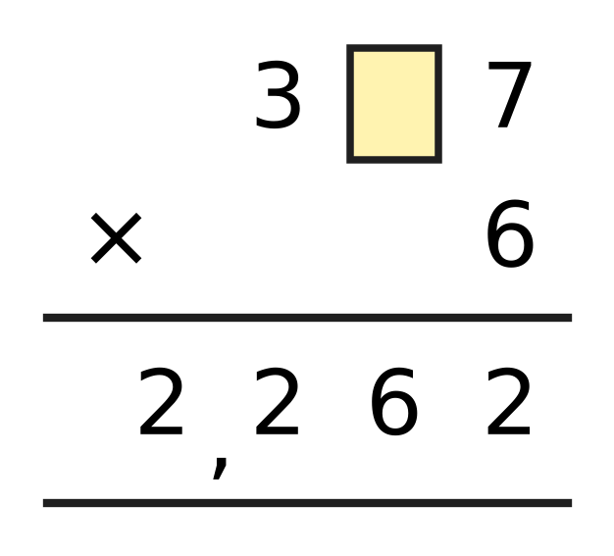
Q9. Tejas worked out the multiplication in the picture. One digit is hidden under the yellow box. Which digit is hidden?
(A) 6 | (B) 8 | (C) 7 | (D) 2

Q10. A fruit market sold 18,642 kg of mangoes and 23,481 kg of bananas this season. Akash rounds each number to the nearest thousand and then adds. What answer does he get?
(A) 42,000 kg | (B) 43,000 kg
(C) 41,000 kg | (D) 42,123 kg

Part 3 — Fractions, Decimals & Percentages (Syllabus Chapter 3)
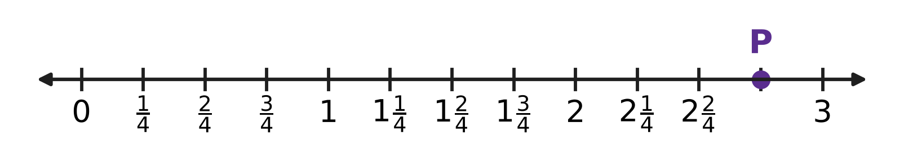
Q11. Look at the number line. The space between two whole numbers is split into 4 equal parts. Which mixed number does point P show?
(A) $3\frac{3}{4}$ | (B) $2\frac{1}{4}$ | (C) $1\frac{3}{4}$ | (D) $2\frac{3}{4}$

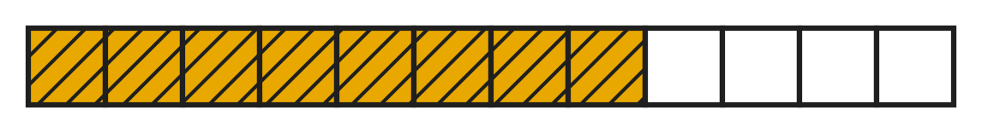
Q12. Look at the picture. A ribbon is cut into 12 equal pieces. Jaya uses the shaded pieces. What fraction of the whole ribbon does she use? Give the answer in simplest form.
(A) $\frac{2}{4}$ | (B) $\frac{3}{2}$ | (C) $\frac{2}{3}$ | (D) $\frac{1}{3}$

Q13. Which of these mixed numbers is equal to $\frac{35}{8}$?
(A) $5\frac{3}{8}$ | (B) $4\frac{3}{8}$ | (C) $4\frac{5}{8}$ | (D) $3\frac{3}{8}$

Q14. Pallavi paints $\frac{1}{3}$ of a fence on Monday. She paints $\frac{1}{6}$ of the same fence on Tuesday. What part of the fence has she painted in the two days?
(A) $\frac{2}{6}$ | (B) $\frac{1}{6}$ | (C) $\frac{1}{2}$ | (D) $\frac{2}{9}$

Q15. A bottle holds $1\frac{1}{2}$ L of juice. Anya pours out $\frac{3}{4}$ L of it. How much juice is left in the bottle?
(A) $\frac{1}{4}$ L | (B) $2\frac{1}{4}$ L | (C) $1\frac{1}{4}$ L | (D) $\frac{3}{4}$ L

Q16. Find the two missing numbers:
$\frac{3}{9}$ = $\frac{1}{?}$
$\frac{3}{9}$ = $\frac{?}{12}$
What is the sum of the two missing numbers?
(A) 7 | (B) 6 | (C) 8 | (D) 9

Part 4 — Geometry (Syllabus Chapter 5)
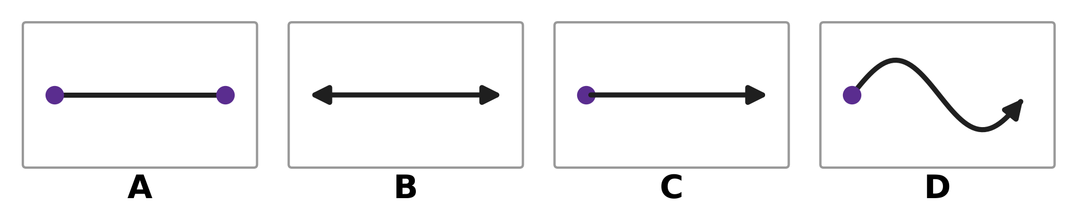
Q17. Look at the four pictures. A dot shows an end point. An arrow shows that the line continues without end in that direction. Which picture shows a ray?
(A) Picture A | (B) Picture B
(C) Picture C | (D) Picture D

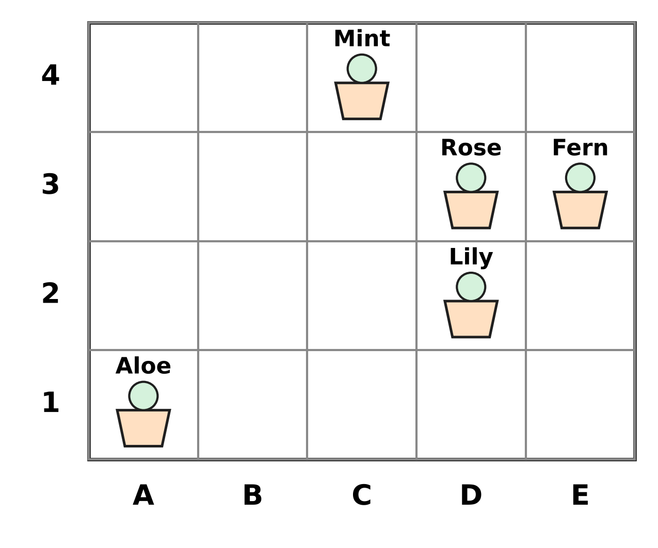
Q18. The picture shows pots in the school garden on a grid. A position is written as (column letter, row number). Which plant is in the pot at (D, 3)?
(A) Fern | (B) Rose | (C) Lily | (D) Mint

Q19. For every prism and pyramid, faces + vertices − edges = 2. Which of these could be the numbers of faces, vertices and edges of a prism or a pyramid?
(A) 6 faces, 6 vertices, 12 edges | (B) 5 faces, 6 vertices, 8 edges
(C) 7 faces, 10 vertices, 14 edges | (D) 7 faces, 10 vertices, 15 edges

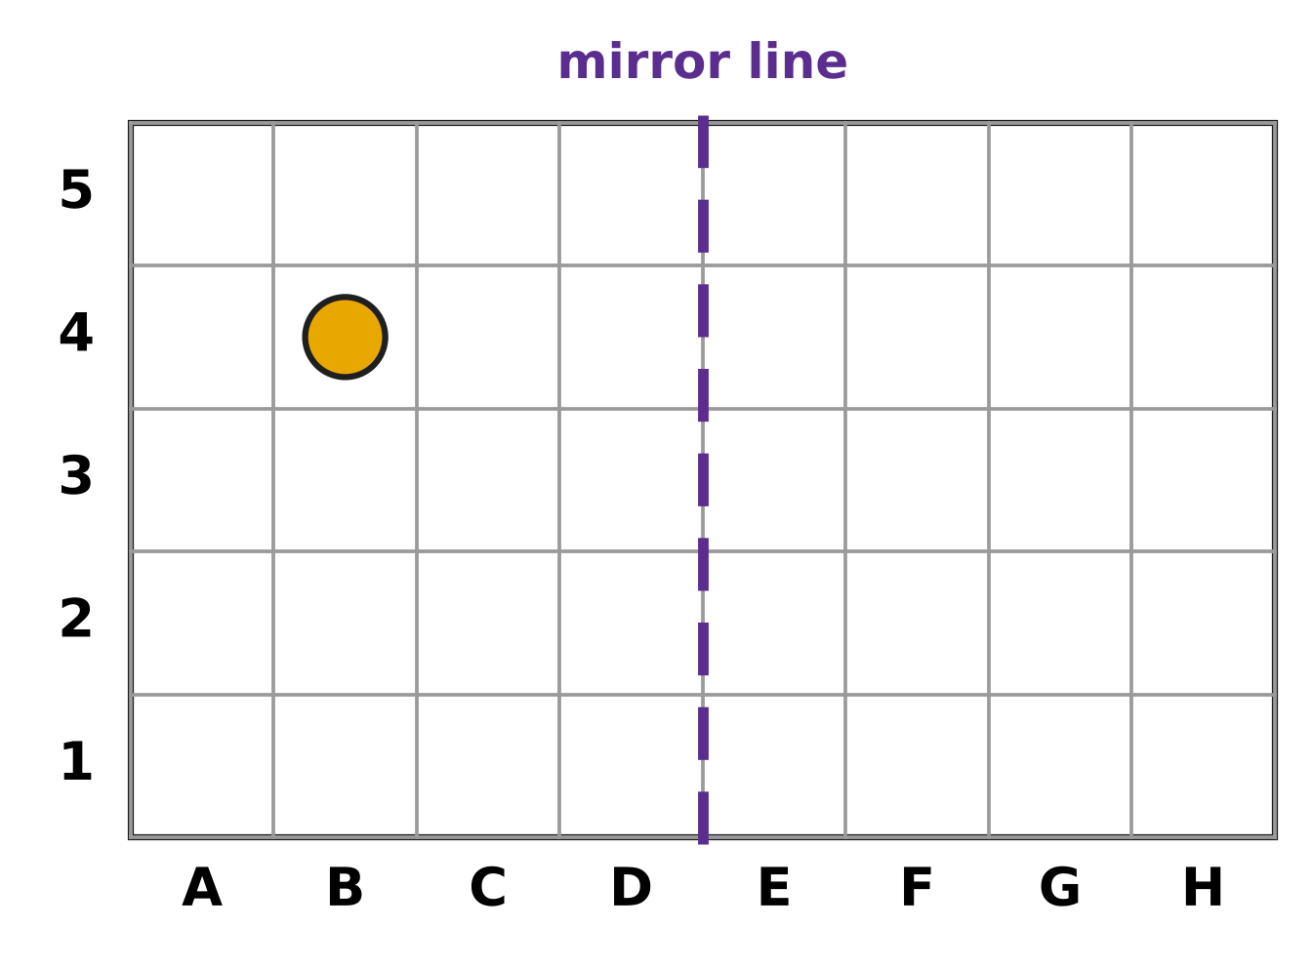
Q20. Look at the grid. A position is written as (column letter, row number), so the dot is at (B, 4). Where is the mirror image of the dot in the dashed mirror line?
(A) (F, 4) | (B) (H, 4) | (C) (G, 4) | (D) (E, 4)

Part 5 — Mensuration (Syllabus Chapter 6)
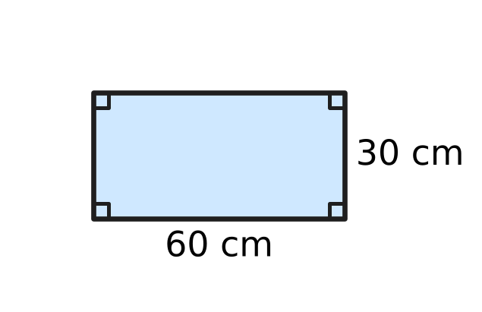
Q21. The picture shows the base of a rectangular fish tank. It is 60 cm long and 30 cm wide. What is the area of the base?
(A) 1,800 sq cm | (B) 18,000 sq cm
(C) 90 sq cm | (D) 180 sq cm

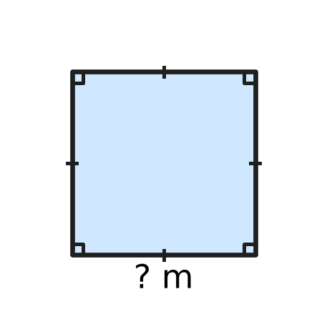
Q22. Look at the picture of a square sandpit in a playground. Its perimeter is 36 m. How long is each side?
(A) 144 m | (B) 9 m | (C) 6 m | (D) 18 m

Q23. Which of these is the same as 4,050 g?
(A) 4 kg 50 g | (B) 4 kg 5 g
(C) 40 kg 50 g | (D) 4 kg 500 g

Q24. A bucket holds 5 L of water. Lena uses 1 L 350 mL of it to wash her bicycle. How much water is left in the bucket?
(A) 4 L 350 mL | (B) 3 L 650 mL
(C) 6 L 350 mL | (D) 4 L 650 mL

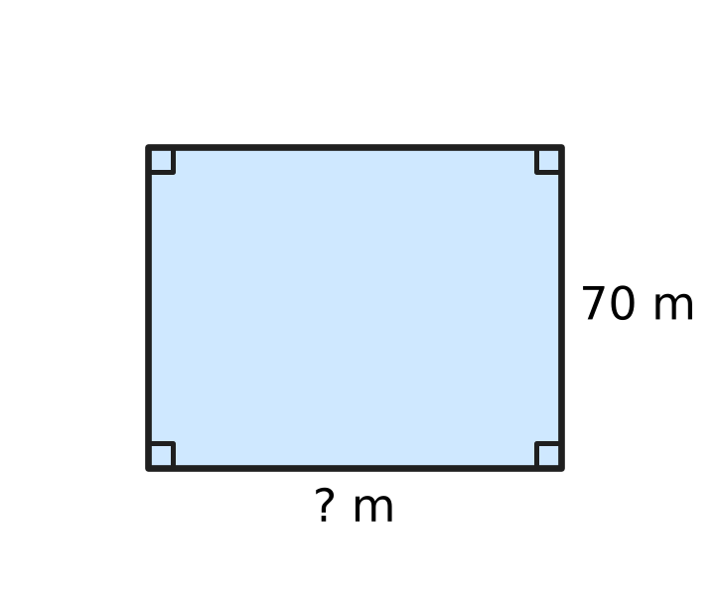
Q25. Look at the picture of a rectangular ground for sports day. Its perimeter is 320 m and it is 70 m wide. How long is the ground?
(A) 160 m | (B) 180 m | (C) 250 m | (D) 90 m

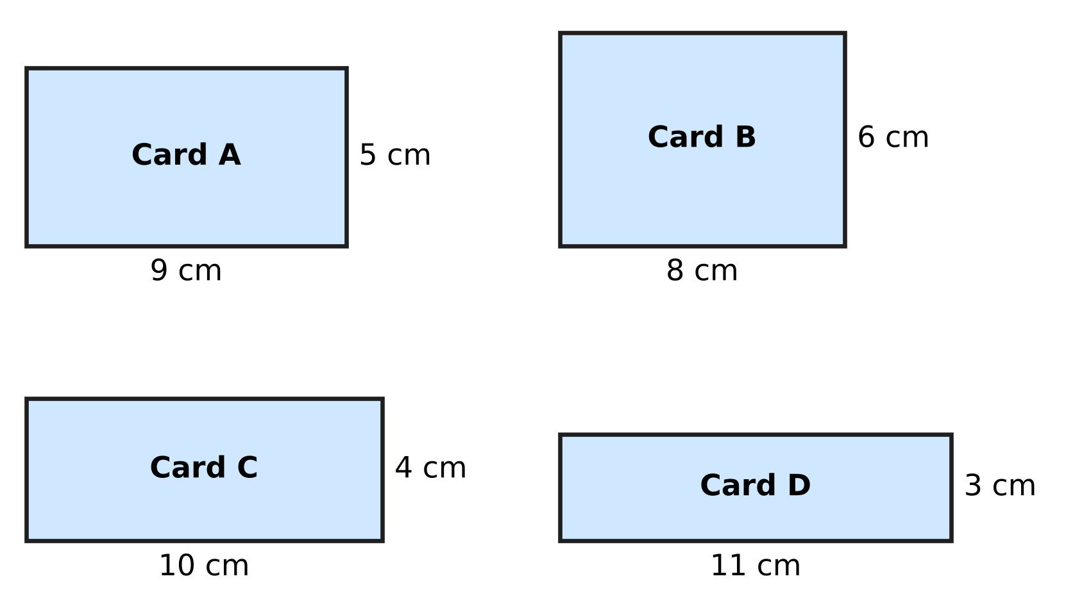
Q26. Four rectangular name cards for classroom desks are shown. All four cards have the same perimeter, 28 cm. Which card has the greatest area?
(A) Card A | (B) Card B | (C) Card C | (D) Card D

Part 6 — Data Handling, Statistics & Probability (Syllabus Chapter 8)
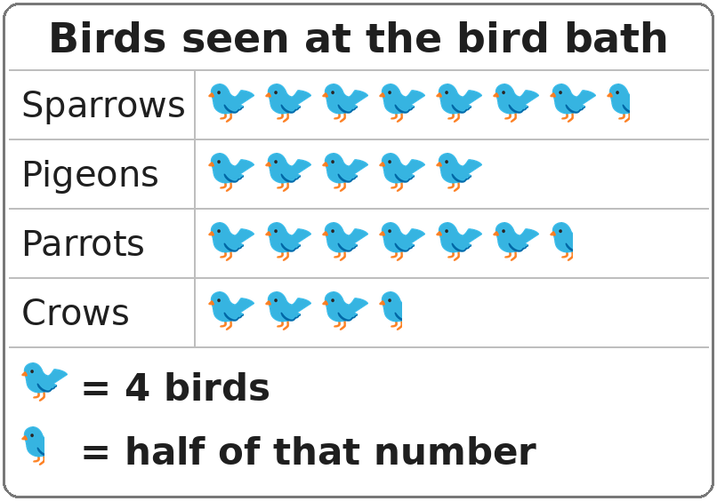
Q27. Look at the pictograph. One whole bird picture stands for 4 birds. How many parrots were seen?
(A) 24 | (B) 28 | (C) 26 | (D) 6

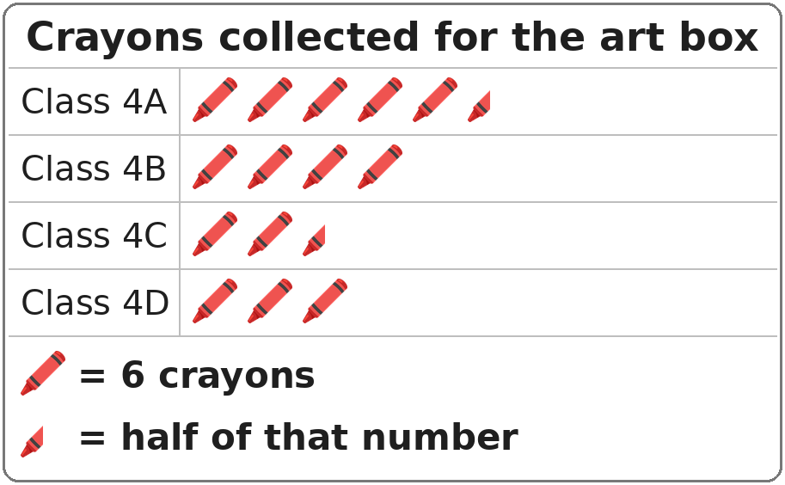
Q28. Look at the pictograph. One whole crayon picture stands for 6 crayons. How many more crayons did Class 4A collect than Class 4C?
(A) 48 | (B) 3 | (C) 21 | (D) 18

Part 7 — Applied Mathematics (Syllabus Chapter 9)
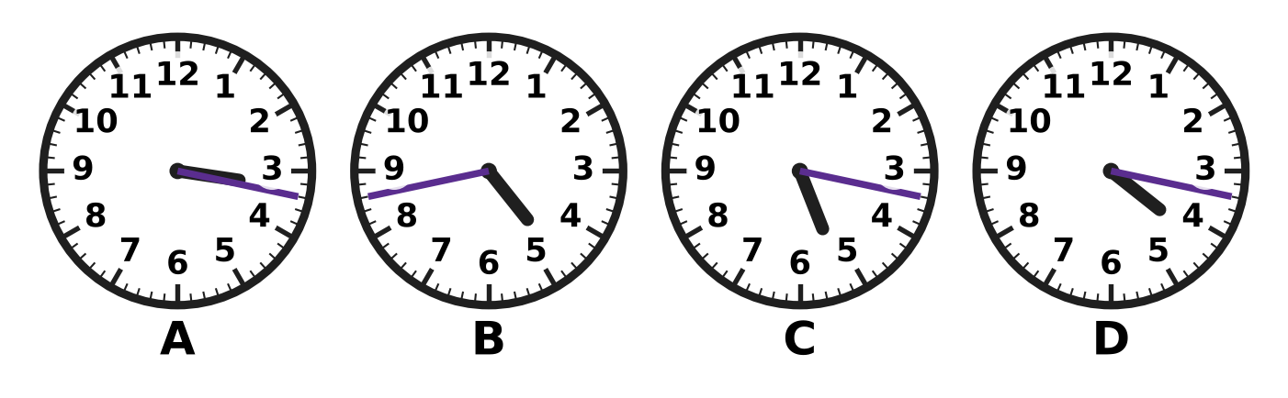
Q29. Look at the four clocks. Which clock shows 4:17?
(A) Picture A | (B) Picture B
(C) Picture C | (D) Picture D

Q30. A film show in the school hall starts at 9:47 in the morning. It ends at 11:25 the same morning. How long is the show?
(A) 1 hour 42 minutes | (B) 2 hours 22 minutes
(C) 1 hour 38 minutes | (D) 2 hours 38 minutes

Q31. On a nature walk, the first group of children sets off at 9:50 a.m. After that, a new group sets off every 25 minutes. At what time does the 3rd group set off?
(A) 10:40 | (B) 11:05 | (C) 10:00 | (D) 10:15

Q32. A box of 8 paint brushes costs ₹472. All the brushes cost the same. What is the price of one paint brush?
(A) ₹464 | (B) ₹59 | (C) ₹49 | (D) ₹69

Irfan's toy-shop bill
Toy | Price of one (₹) | Number bought
Puzzle | 145 | 2
Ball | 85 | 3
Yo-yo | 38 | 4

Q33. Use the table. Irfan pays for all these toys with two ₹500 notes. How much change does he get?
(A) ₹455 | (B) ₹303 | (C) ₹697 | (D) ₹732

Q34. In one year, 15 April is a Saturday. April has 30 days. What day of the week is 15 May of that year?
(A) Tuesday | (B) Sunday | (C) Monday | (D) Saturday

Part 8 — Mathematical Reasoning & Problem-Solving (Syllabus Chapter 10)
Q35. What number comes next? 2, 5, 10, 17, 26, ___
(A) 37 | (B) 36 | (C) 35 | (D) 39

Q36. The boxes on a shoe rack are numbered 1 to 45. Every box whose number is a multiple of 4 holds sports shoes. How many boxes hold sports shoes?
(A) 10 | (B) 12 | (C) 22 | (D) 11

Q37. Today is a Thursday. Rekha's swimming test is 50 days from today. On which day of the week is the test?
(A) Thursday | (B) Friday
(C) Saturday | (D) Wednesday

Q38. Find the missing number: 1, 2, 3, 5, 8, 13, ___, 34
(A) 21 | (B) 18 | (C) 19 | (D) 26

Q39. The 75 lockers in a school corridor are numbered 1 to 75. Each sticker shows one digit. How many stickers are needed to number all the lockers?
(A) 132 | (B) 150 | (C) 139 | (D) 141

Q40. A table-tennis club has 5 players. Each player plays exactly one game against every other player. How many games are played in all?
(A) 4 | (B) 20 | (C) 10 | (D) 25

SECTION II — Star Questions 5 questions × 4 marks each
Q41. Look at the pattern: $\frac{1}{12}$, $\frac{1}{6}$, $\frac{1}{4}$, $\frac{1}{3}$, … It goes on in the same way. What is the sum of the next two fractions in the pattern? [4 marks]
(A) $1\frac{1}{2}$ | (B) $1\frac{1}{12}$ | (C) $\frac{11}{12}$ | (D) $\frac{5}{6}$

Q42. A month has 30 days. It has five Thursdays but only four Fridays. On which day of the week is the 26th of this month? [4 marks]
(A) Wednesday | (B) Sunday
(C) Saturday | (D) Monday

Q43. How many 5-digit numbers have digits that add up to 3? For example, 10,020 is one of them, because 1 + 0 + 0 + 2 + 0 = 3. [4 marks]
(A) 15 | (B) 11 | (C) 10 | (D) 14

Q44. Grapes cost ₹96 per kg. Gaurav buys $1\frac{1}{4}$ kg in the morning and $2\frac{1}{2}$ kg in the evening. He pays for all of it with one ₹500 note. How much change does he get? [4 marks]
(A) ₹180 | (B) ₹212 | (C) ₹360 | (D) ₹140

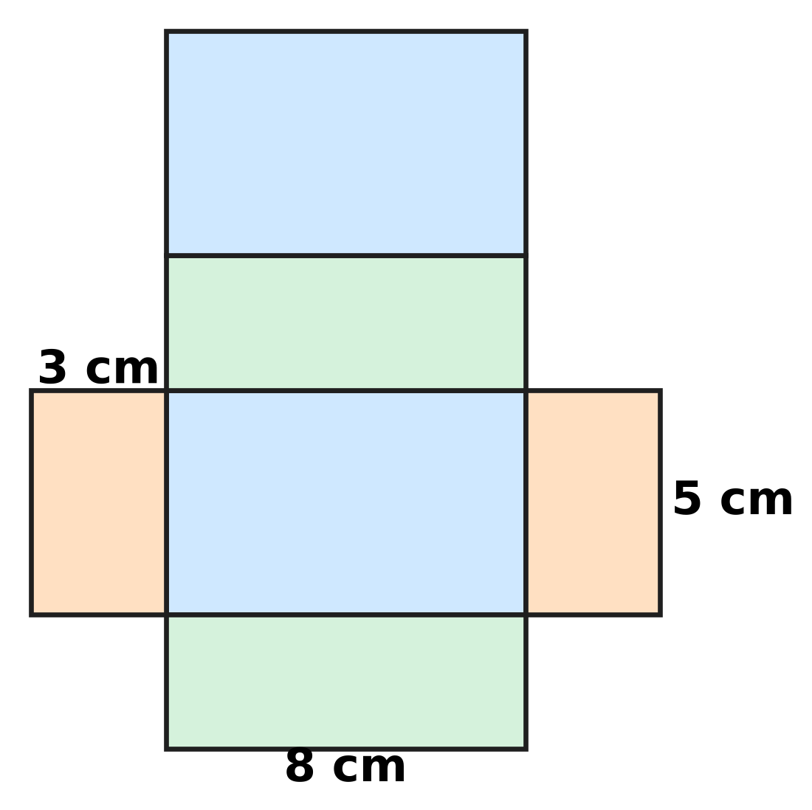
Q45. The picture shows the net of a closed box shaped like a cuboid. Only three lengths are marked. How much card (area) is used to make the net? [4 marks]
(A) 79 sq cm | (B) 128 sq cm
(C) 118 sq cm | (D) 158 sq cm

Answer Sheet AMO Level 1 · Class 4 · Practice Paper 2
Name: | School: | Roll No.:
Shade or tick one circle for each question.
1. Ⓐ Ⓑ Ⓒ Ⓓ | 16. Ⓐ Ⓑ Ⓒ Ⓓ | 31. Ⓐ Ⓑ Ⓒ Ⓓ
2. Ⓐ Ⓑ Ⓒ Ⓓ | 17. Ⓐ Ⓑ Ⓒ Ⓓ | 32. Ⓐ Ⓑ Ⓒ Ⓓ
3. Ⓐ Ⓑ Ⓒ Ⓓ | 18. Ⓐ Ⓑ Ⓒ Ⓓ | 33. Ⓐ Ⓑ Ⓒ Ⓓ
4. Ⓐ Ⓑ Ⓒ Ⓓ | 19. Ⓐ Ⓑ Ⓒ Ⓓ | 34. Ⓐ Ⓑ Ⓒ Ⓓ
5. Ⓐ Ⓑ Ⓒ Ⓓ | 20. Ⓐ Ⓑ Ⓒ Ⓓ | 35. Ⓐ Ⓑ Ⓒ Ⓓ
6. Ⓐ Ⓑ Ⓒ Ⓓ | 21. Ⓐ Ⓑ Ⓒ Ⓓ | 36. Ⓐ Ⓑ Ⓒ Ⓓ
7. Ⓐ Ⓑ Ⓒ Ⓓ | 22. Ⓐ Ⓑ Ⓒ Ⓓ | 37. Ⓐ Ⓑ Ⓒ Ⓓ
8. Ⓐ Ⓑ Ⓒ Ⓓ | 23. Ⓐ Ⓑ Ⓒ Ⓓ | 38. Ⓐ Ⓑ Ⓒ Ⓓ
9. Ⓐ Ⓑ Ⓒ Ⓓ | 24. Ⓐ Ⓑ Ⓒ Ⓓ | 39. Ⓐ Ⓑ Ⓒ Ⓓ
10. Ⓐ Ⓑ Ⓒ Ⓓ | 25. Ⓐ Ⓑ Ⓒ Ⓓ | 40. Ⓐ Ⓑ Ⓒ Ⓓ
11. Ⓐ Ⓑ Ⓒ Ⓓ | 26. Ⓐ Ⓑ Ⓒ Ⓓ | 41. Ⓐ Ⓑ Ⓒ Ⓓ
12. Ⓐ Ⓑ Ⓒ Ⓓ | 27. Ⓐ Ⓑ Ⓒ Ⓓ | 42. Ⓐ Ⓑ Ⓒ Ⓓ
13. Ⓐ Ⓑ Ⓒ Ⓓ | 28. Ⓐ Ⓑ Ⓒ Ⓓ | 43. Ⓐ Ⓑ Ⓒ Ⓓ
14. Ⓐ Ⓑ Ⓒ Ⓓ | 29. Ⓐ Ⓑ Ⓒ Ⓓ | 44. Ⓐ Ⓑ Ⓒ Ⓓ
15. Ⓐ Ⓑ Ⓒ Ⓓ | 30. Ⓐ Ⓑ Ⓒ Ⓓ | 45. Ⓐ Ⓑ Ⓒ Ⓓ
Q41–Q45 are Section II Star Questions (4 marks each).
For the parent or teacher
Section I correct: ______ / 40 × 2 = ______ marks Section II correct: ______ / 5 × 4 = ______ marks
Correct: ______ / 45 Score: ______ / 100
Answer Key and Solutions AMO Level 1 · Class 4 · Practice Paper 2
Quick answers
1 A | 6 A | 11 D | 16 A | 21 A | 26 B | 31 A | 36 D | 41 C
2 D | 7 B | 12 C | 17 C | 22 B | 27 C | 32 B | 37 B | 42 B
3 A | 8 D | 13 B | 18 B | 23 A | 28 D | 33 B | 38 A | 43 A
4 B | 9 C | 14 C | 19 D | 24 B | 29 D | 34 C | 39 D | 44 D
5 C | 10 A | 15 D | 20 C | 25 D | 30 C | 35 A | 40 C | 45 D
Solutions
Q | Part · level | Answer | Why?
1 | Part 1 · Ch1 · Easy | (A) 60,408 | Sixty thousand is 60,000; four hundred eight is 408. Together they make 60,408.
2 | Part 1 · Ch1 · Easy | (D) XCI | XCI = 90 + 1 = 91, LXXXVIII = 88, LXXIX = 79 and XLIX = 49. The greatest is XCI = 91.
3 | Part 1 · Ch1 · Easy | (A) 50 | 74,056 has 0 hundreds and 5 tens, so the missing part is 5 tens = 50.
4 | Part 1 · Ch1 · Easy | (B) 45,109 | 45,109 has 1 hundred, so it is more than 45,099 and less than 45,190. 45,019 is too small; 45,200 and 45,910 are too big.
5 | Part 1 · Ch1 · Medium | (C) 9,250 | Each number is 750 more than the one before: 7,000, 7,750, 8,500, 9,250, … So 9,250 appears; 8,000, 9,000 and 9,500 do not.
6 | Part 2 · Ch2 · Easy | (A) 63,443 | 27,648 + 35,795 = 63,443.
7 | Part 2 · Ch2 · Easy | (B) 364 | 2,184 ÷ 6 = 364, because 364 × 6 = 2,184.
8 | Part 2 · Ch2 · Easy | (D) 96 − 32 = 32 − 96 | 96 − 32 = 64, but 32 − 96 cannot be 64. Subtraction is not commutative; the other three are true.
9 | Part 2 · Ch2 · Medium | (C) 7 | 2,262 ÷ 6 = 377, and 377 × 6 = 2,262. So the hidden digit is 7.
10 | Part 2 · Ch2 · Medium | (A) 42,000 kg | 18,642 rounds to 19,000 (hundreds digit 6) and 23,481 rounds to 23,000 (hundreds digit 4). 19,000 + 23,000 = 42,000 kg.
11 | Part 3 · Ch3 · Easy | (D) $2\frac{3}{4}$ | P is 3 small parts after 2, and each part is one quarter. So P is at 2 and three quarters.
12 | Part 3 · Ch3 · Easy | (C) $\frac{2}{3}$ | She uses 8 of 12 pieces, which is 8/12. Dividing top and bottom by 4 gives 2/3.
13 | Part 3 · Ch3 · Easy | (B) $4\frac{3}{8}$ | 35 ÷ 8 = 4 remainder 3, so 35/8 = 4 wholes and 3 eighths.
14 | Part 3 · Ch3 · Easy | (C) $\frac{1}{2}$ | 1/3 = 2/6. Then 2/6 + 1/6 = 3/6 = 1/2 of the fence.
15 | Part 3 · Ch3 · Medium | (D) $\frac{3}{4}$ L | 1 1/2 L = 6/4 L. Then 6/4 − 3/4 = 3/4 L is left.
16 | Part 3 · Ch3 · Medium | (A) 7 | 3/9 = 1/3 (divide top and bottom by 3). 1/3 = 4/12 (multiply top and bottom by 4). The missing numbers are 3 and 4, and 3 + 4 = 7.
17 | Part 4 · Ch5 · Easy | (C) Picture C | A ray is straight, has one end point and goes on without end in one direction. Picture C shows this.
18 | Part 4 · Ch5 · Easy | (B) Rose | Go across to column D, then up to row 3. The pot there holds the Rose.
19 | Part 4 · Ch5 · Medium | (D) 7 faces, 10 vertices, 15 edges | Only 7 + 10 − 15 = 2. The other sets give 0, 3 and 3, so they cannot belong to a prism or a pyramid. A prism with a 5-sided end really has 7 faces, 10 vertices and 15 edges.
20 | Part 4 · Ch5 · Medium | (C) (G, 4) | The mirror line lies between columns D and E. The dot in column B is 3 columns to its left (B, C, D). Its image is 3 columns to the right (E, F, G), in the same row: (G, 4).
21 | Part 5 · Ch6 · Easy | (A) 1,800 sq cm | Area = length × breadth = 60 × 30 = 1,800 sq cm.
22 | Part 5 · Ch6 · Easy | (B) 9 m | A square has 4 equal sides. Side = 36 ÷ 4 = 9 m.
23 | Part 5 · Ch6 · Easy | (A) 4 kg 50 g | 1 kg = 1,000 g. So 4,050 g = 4,000 g + 50 g = 4 kg 50 g.
24 | Part 5 · Ch6 · Easy | (B) 3 L 650 mL | 5 L = 4 L 1,000 mL. Then 4 L 1,000 mL − 1 L 350 mL = 3 L 650 mL.
25 | Part 5 · Ch6 · Medium | (D) 90 m | Length + width = 320 ÷ 2 = 160 m. Length = 160 − 70 = 90 m.
26 | Part 5 · Ch6 · Medium | (B) Card B | Areas: A 9 × 5 = 45, B 8 × 6 = 48, C 10 × 4 = 40, D 11 × 3 = 33 sq cm. Card B has the greatest area.
27 | Part 6 · Ch8 · Easy | (C) 26 | Parrots have 6 and a half pictures. 6 × 4 = 24 and half a picture = 2, so 24 + 2 = 26.
28 | Part 6 · Ch8 · Medium | (D) 18 | Class 4A: 5 and a half pictures = 30 + 3 = 33. Class 4C: 2 and a half pictures = 12 + 3 = 15. 33 − 15 = 18.
29 | Part 7 · Ch9 · Easy | (D) Picture D | At 4:17 the hour hand is just past 4 and the minute hand is 2 marks past 3 (15 + 2 = 17 minutes). Picture D shows this.
30 | Part 7 · Ch9 · Medium | (C) 1 hour 38 minutes | 9:47 to 10:00 is 13 minutes; 10:00 to 11:25 is 1 hour 25 minutes. Total 1 hour 38 minutes.
31 | Part 7 · Ch9 · Easy | (A) 10:40 | The 3rd group sets off 2 gaps after the first: 2 × 25 = 50 minutes. 9:50 + 50 minutes = 10:40.
32 | Part 7 · Ch9 · Easy | (B) ₹59 | ₹472 ÷ 8 = ₹59, because 59 × 8 = 472.
33 | Part 7 · Ch9 · Medium | (B) ₹303 | Cost = 145 × 2 + 85 × 3 + 38 × 4 = 290 + 255 + 152 = ₹697. Change = 1,000 − 697 = ₹303.
34 | Part 7 · Ch9 · Medium | (C) Monday | From 15 April to 15 May is 30 days = 4 weeks + 2 days. Saturday + 2 days = Monday.
35 | Part 8 · Ch10 · Easy | (A) 37 | The jumps are 3, 5, 7, 9; the next jump is 11. 26 + 11 = 37.
36 | Part 8 · Ch10 · Easy | (D) 11 | The multiples of 4 up to 45 are 4, 8, 12, …, 44. That is 44 ÷ 4 = 11 boxes.
37 | Part 8 · Ch10 · Easy | (B) Friday | 50 = 7 × 7 + 1, so 50 days is 7 weeks and 1 day. Thursday + 1 day = Friday.
38 | Part 8 · Ch10 · Medium | (A) 21 | Each number is the sum of the two numbers before it: 8 + 13 = 21, and 13 + 21 = 34 checks.
39 | Part 8 · Ch10 · Medium | (D) 141 | Lockers 1 to 9 need 9 stickers. Lockers 10 to 75 are 66 numbers with 2 digits each: 132 stickers. 9 + 132 = 141.
40 | Part 8 · Ch10 · Medium | (C) 10 | The first player plays 4 games, the second 3 new games, the third 2, the fourth 1. 4 + 3 + 2 + 1 = 10 games.
41 | Section II · Ch3 + Ch10 · Hard | (C) $\frac{11}{12}$ | Write each fraction in twelfths. The pattern is 1/12, 2/12, 3/12, 4/12. Each fraction is 1/12 more than the one before, so the next two are 5/12 and 6/12. 5/12 + 6/12 = 11/12.
42 | Section II · Ch9 + Ch10 · Hard | (B) Sunday | 30 days = 4 weeks + 2 days, so only the days of the 1st and 2nd come five times. Thursday must be one of them but Friday not, so the 1st is Wednesday and the 2nd Thursday. The 26th is 25 days later = 3 weeks + 4 days: Wednesday + 4 days = Sunday.
43 | Section II · Ch1 + Ch10 · Hard | (A) 15 | First digit 3: only 30,000 (1). First digit 2: a 1 in one of the other 4 places (4). First digit 1: a 2 in one of 4 places (4), or two 1s in 2 of 4 places (6). 1 + 4 + 4 + 6 = 15.
44 | Section II · Ch3 + Ch9 · Hard | (D) ₹140 | 1 1/4 + 2 1/2 = 3 3/4 kg. Cost = 3 × 96 + 3/4 of 96 = 288 + 72 = ₹360. Change = 500 − 360 = ₹140.
45 | Section II · Ch5 + Ch6 · Hard | (D) 158 sq cm | The faces are two 8 × 5, two 8 × 3 and two 5 × 3 rectangles. Area = 2 × (40 + 24 + 15) = 158 sq cm.

ARYABHATTA MATHS OLYMPIAD
Level 1
PRACTICE PAPER-3
CLASS 4
Total Questions | 45 multiple-choice questions
Total Marks | 100
Time | 60 minutes
Section I | 40 questions × 2 marks = 80 marks
Section II | 5 Star Questions × 4 marks = 20 marks
Negative Marking | No negative marking
Calculator | Not allowed
Chapters | Number System · Operations · Fractions, Decimals & Percentages · Geometry · Mensuration · Data Handling · Applied Mathematics · Mathematical Reasoning

👋 Hello, friend! How to do this paper:
⭐ Every question has four answer choices: (A), (B), (C) and (D). Only one is correct.
⭐ Read each question and look at its picture carefully. Then mark your answer on the answer sheet at the end.
⭐ Section I has 40 questions of 2 marks each. Section II has 5 Star Questions of 4 marks each.
⭐ There is no negative marking, so try every question.
⭐ Do not use a calculator. You may do rough work on a separate sheet.
⭐ All figures are not necessarily drawn to scale unless stated.

For parents and teachers
• Print or view this paper in colour. Pictures are part of the questions.
• Parts follow the AMO syllabus chapters. Chapters 4 and 7 are not part of the Class 4 syllabus, so the chapter numbers shown in the Part headings have gaps.
• The answer sheet and the answer key are at the end. Remove only the answer key before the child begins.

SECTION I 40 questions × 2 marks each
Part 1 — Number System (Syllabus Chapter 1)
Q1. The three numbers below are in counting order. Which number goes in the blank?
___, 60,000, 60,001
(A) 60,002 | (B) 59,000 | (C) 50,000 | (D) 59,999

Q2. The rooms of a museum are numbered in Roman numerals. Which label should be on the door of Room 49?
(A) XLIX | (B) IL | (C) XLVIIII | (D) XXXXIX

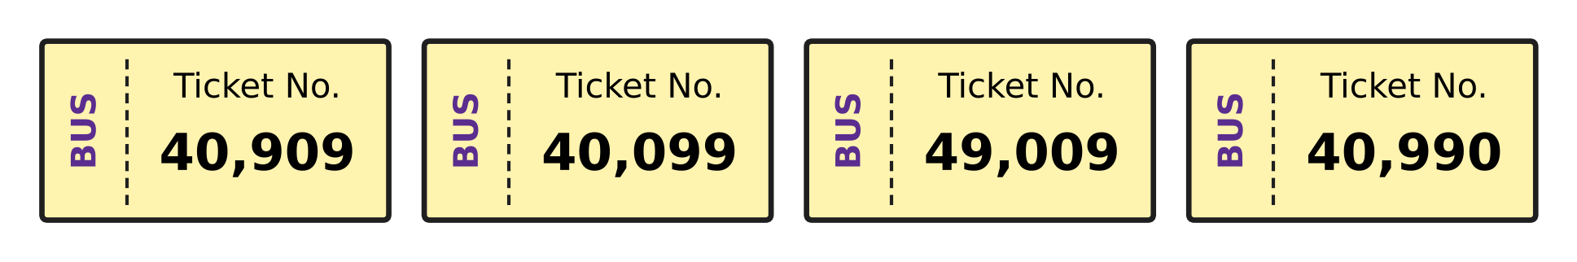
Q3. Look at the four bus tickets. Which ticket number is the smallest?
(A) 40,909 | (B) 40,099 | (C) 49,009 | (D) 40,990

Ten thousands | Thousands | Hundreds | Tens | Ones
4 | 13 | 0 | 5 | 0

Q4. Use the table. It shows 4 ten thousands, 13 thousands, 0 hundreds, 5 tens and 0 ones. Which number does it show?
(A) 53,005 | (B) 53,050 | (C) 43,050 | (D) 53,500

Q5. In this pattern, the same number is added each time.
23,180; ___; ___; 26,780
Which number goes in the first blank?
(A) 24,380 | (B) 24,980 | (C) 24,180 | (D) 25,580

Part 2 — Operations & Number Properties (Syllabus Chapter 2)
Q6. Which number goes in the blank to make both sides equal?
(14 × 5) × 6 = 14 × (5 × ___)
(A) 14 | (B) 70 | (C) 6 | (D) 30

Q7. Which number goes in the blank?
63,475 + ___ = 1,00,000
(A) 47,635 | (B) 36,535 | (C) 36,524 | (D) 36,525

Q8. A printing machine prints 168 posters every hour. How many posters does it print in 7 hours?
(A) 726 | (B) 1,166 | (C) 175 | (D) 1,176

Q9. A number is divided by 7. The quotient is 1,206 and the remainder is 5. What is the number?
(A) 8,447 | (B) 8,442 | (C) 8,437 | (D) 1,211

Q10. Harsh counts the mangoes picked in an orchard. He rounds his count to the nearest hundred and gets 4,300. Which of these could be his exact count?
(A) 4,238 | (B) 4,281 | (C) 4,372 | (D) 4,030

Part 3 — Fractions, Decimals & Percentages (Syllabus Chapter 3)
Q11. Which number goes in the box to make the two fractions equal?
$\frac{5}{6}$ = $\frac{20}{□}$
(A) 21 | (B) 30 | (C) 24 | (D) 26

Q12. Which number goes in the box?
$3\frac{2}{5}=\frac{□}{5}$
(A) 17 | (B) 15 | (C) 32 | (D) 11

Q13. Like fractions have the same denominator (bottom number). Which pair shows like fractions?
(A) $\frac{1}{2}$ and $\frac{2}{4}$ | (B) $\frac{5}{6}$ and $\frac{6}{5}$
(C) $\frac{2}{9}$ and $\frac{7}{9}$ | (D) $\frac{3}{8}$ and $\frac{3}{10}$

Q14. Sahil wrote $\frac{2}{9}$ + $\frac{1}{3}$ = $\frac{3}{12}$. His answer is wrong. What is the correct sum?
(A) $\frac{5}{12}$ | (B) $\frac{5}{9}$ | (C) $\frac{4}{9}$ | (D) $\frac{3}{9}$

Q15. Which number goes in the box?
$\frac{1}{4}+\frac{□}{12}=\frac{5}{6}$
(A) 2 | (B) 4 | (C) 9 | (D) 7

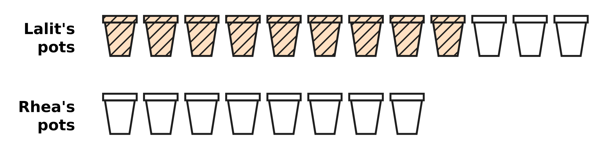
Q16. Look at the picture. Lalit has painted 9 of his 12 clay pots (shaded). Rhea paints the same fraction of her 8 pots. How many pots does Rhea paint?
(A) 4 | (B) 6 | (C) 3 | (D) 5

Part 4 — Geometry (Syllabus Chapter 5)
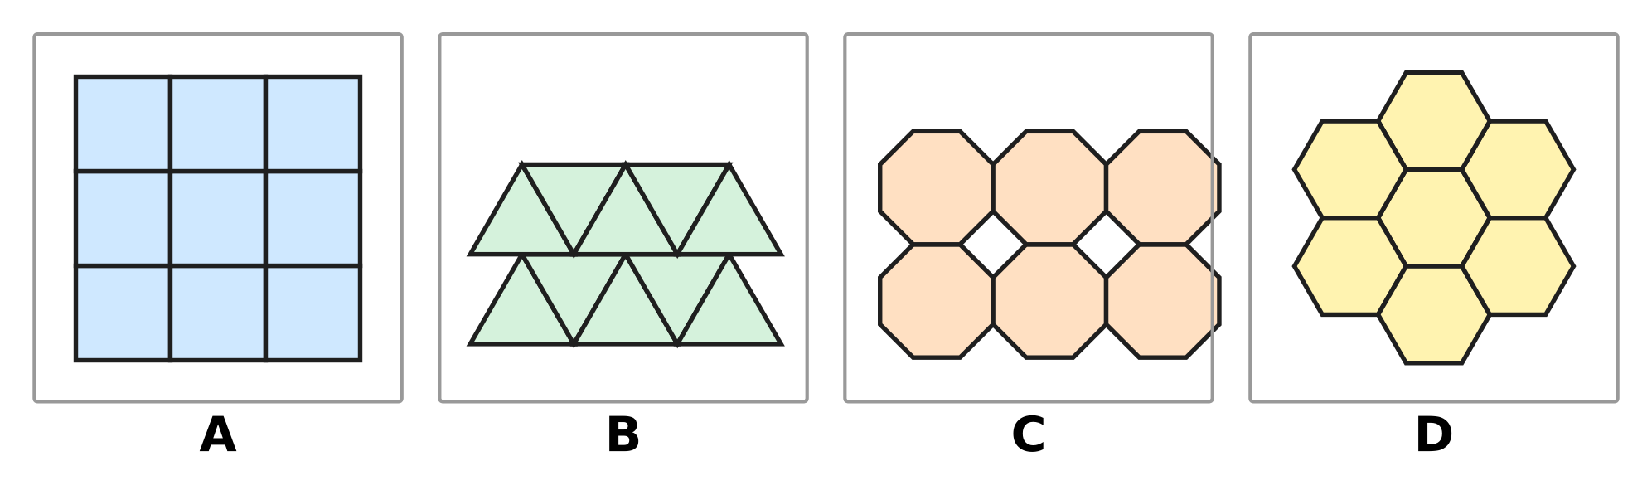
Q17. In each picture, copies of one shape are fitted together. In which picture do the copies leave gaps between them?
(A) Picture A | (B) Picture B
(C) Picture C | (D) Picture D

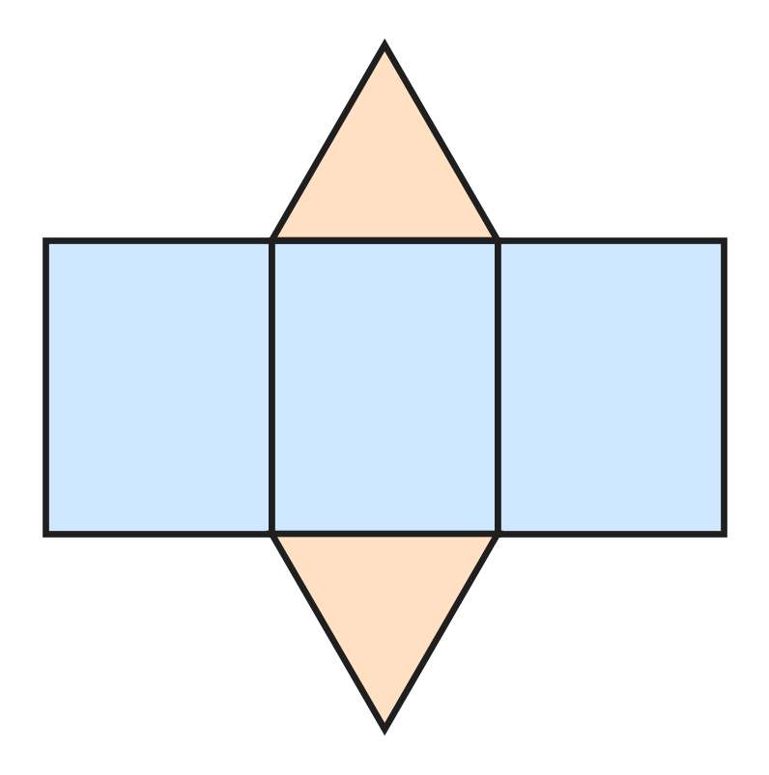
Q18. Look at the net. It has 3 rectangles and 2 triangles. It is folded along the lines to make a solid. Which solid is made?
(A) Triangular prism | (B) Square pyramid
(C) Triangular pyramid | (D) Cuboid

Q19. Lines p, q and r are drawn on a flat sheet of paper. Line q is perpendicular to line p. Line r is perpendicular to line q, and r is a different line from p. What is always true about lines p and r?
(A) They meet each other on line q. | (B) They cross each other.
(C) They are perpendicular. | (D) They are parallel.

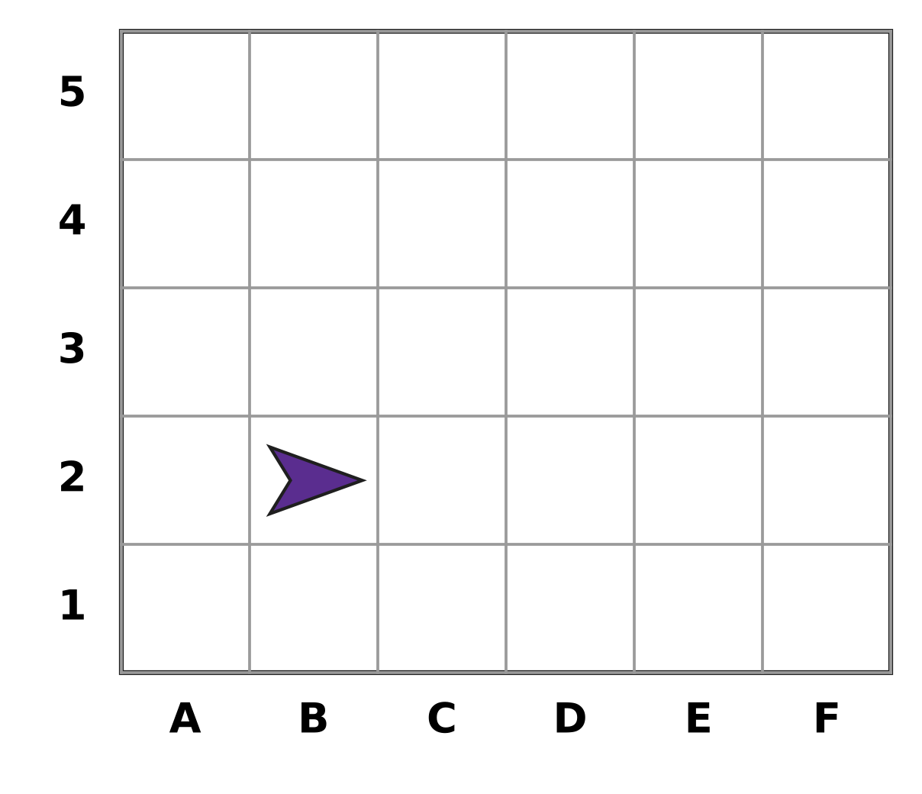
Q20. Look at the grid. A position is written as (column letter, row number). A paper plane is at (B, 2). It moves 3 squares to the right and then 2 squares up. Where is it now?
(A) (D, 5) | (B) (D, 3) | (C) (E, 4) | (D) (4, E)

Part 5 — Mensuration (Syllabus Chapter 6)
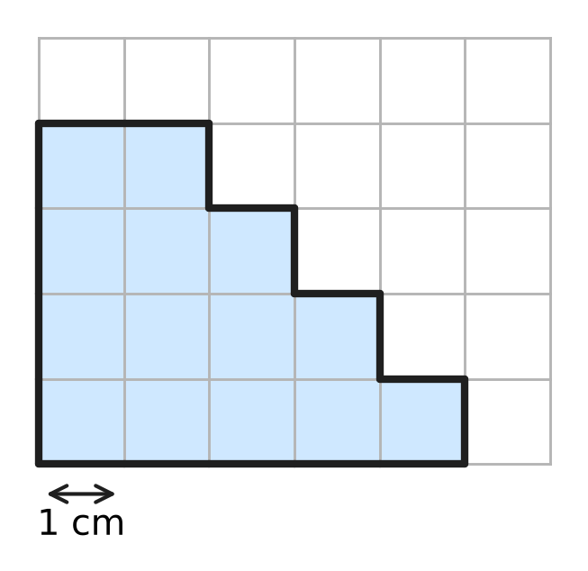
Q21. Look at the shaded shape on the grid of 1 cm squares. What is its area?
(A) 14 sq cm | (B) 13 sq cm | (C) 20 sq cm | (D) 18 sq cm

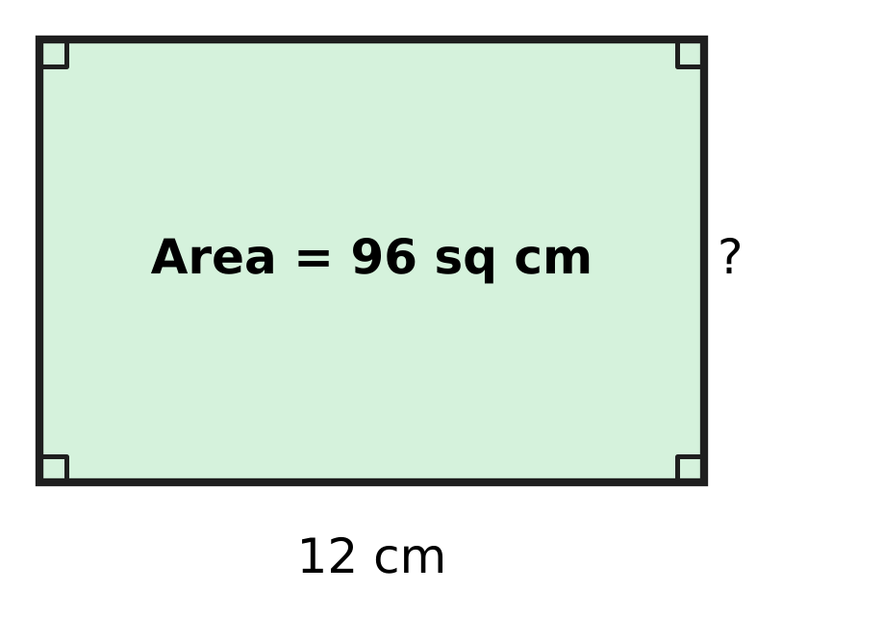
Q22. Look at the picture of a rectangular sheet of stamps at a post office. Its area is 96 sq cm and its length is 12 cm. What is its width?
(A) 24 cm | (B) 36 cm | (C) 84 cm | (D) 8 cm

Q23. A jug in the school canteen holds 3 L of milk. How many glasses of 250 mL each can be filled from a full jug?
(A) 6 | (B) 24 | (C) 12 | (D) 120

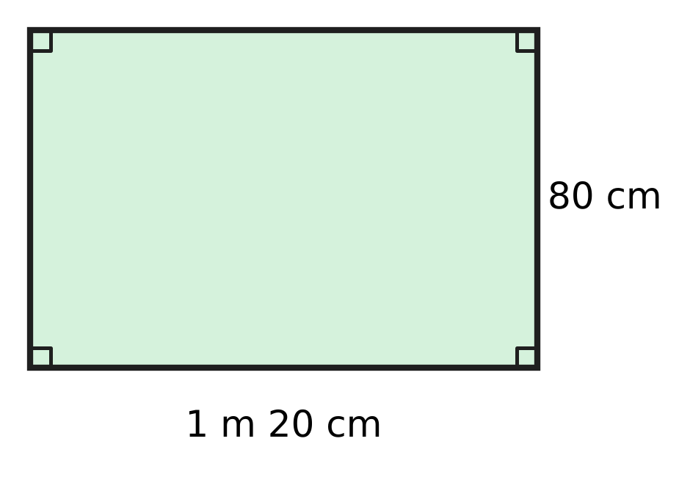
Q24. Look at the picture of a rectangular notice board. What is its perimeter in centimetres?
(A) 320 cm | (B) 400 cm | (C) 200 cm | (D) 184 cm

Q25. A square board for a board game has a perimeter of 140 cm. What is its area?
(A) 1,225 sq cm | (B) 4,900 sq cm
(C) 560 sq cm | (D) 140 sq cm

Q26. A boat in a harbour uses 2 L 350 mL of fuel on each trip. How much fuel does it use on 4 trips?
(A) 8 L 400 mL | (B) 9 L 350 mL
(C) 9 L 400 mL | (D) 8 L 350 mL

Part 6 — Data Handling, Statistics & Probability (Syllabus Chapter 8)
Picture for Q27 and Q28
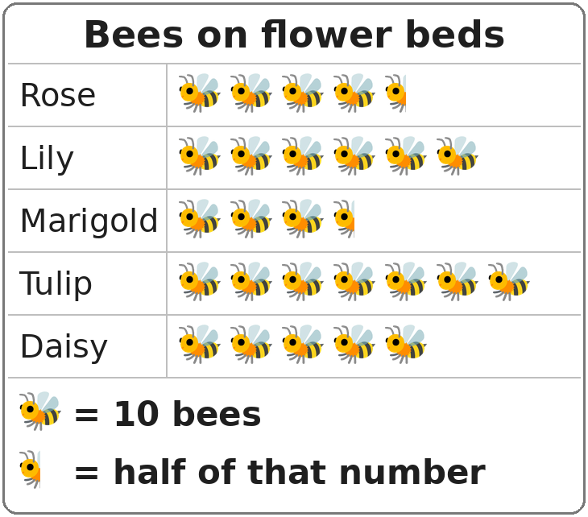
Q27. Look at the pictograph. On which flower bed were 35 bees seen?
(A) Daisy | (B) Rose | (C) Lily | (D) Marigold

Picture for Q27 and Q28
Q28. Look at the pictograph. A new row is added for a Poppy bed. The Poppy bed had 25 fewer bees than the bed with the most bees. How many bee pictures should be drawn for the Poppy bed?
(A) 2 and a half | (B) 4 and a half
(C) 5 | (D) 4

Part 7 — Applied Mathematics (Syllabus Chapter 9)
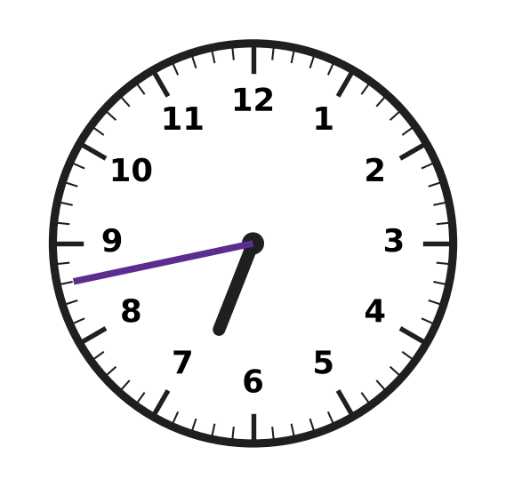
Q29. Look at the clock. Which of these is the time it shows?
(A) 43 minutes to 7 | (B) 17 minutes to 6
(C) 17 minutes to 7 | (D) 18 minutes to 7

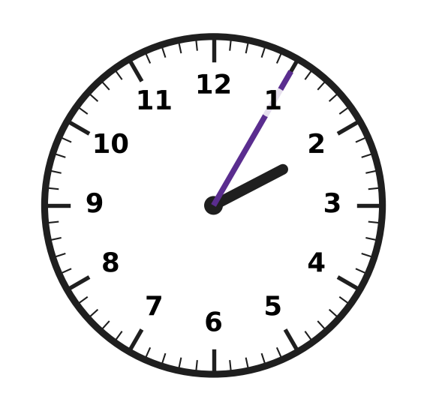
Q30. A drawing class ended in the afternoon at the time shown on the clock. The class lasted 50 minutes. At what time did it start?
(A) 2:55 | (B) 1:15 | (C) 1:55 | (D) 1:05

Q31. A karate class meets every Saturday. In one month, the second Saturday is the 10th. On which date is the fourth Saturday of that month?
(A) 20th | (B) 17th | (C) 31st | (D) 24th

Q32. Entry to a swimming pool costs ₹35 for an adult and ₹20 for a child. Ankit, aged 9, goes with his mother, his father and his two younger sisters. How much do the 5 entry tickets cost?
(A) ₹130 | (B) ₹175 | (C) ₹145 | (D) ₹110

Q33. Charu buys 3 tiffin boxes of the same price. She pays with a ₹500 note and gets ₹65 back. What is the price of one tiffin box?
(A) ₹145 | (B) ₹188 | (C) ₹435 | (D) ₹155

Q34. Workers start unloading sacks of grain from a truck at 11:40 in the morning. They finish at 2:15 in the afternoon. How long do they take?
(A) 2 hours 25 minutes | (B) 9 hours 25 minutes
(C) 3 hours 35 minutes | (D) 2 hours 35 minutes

Part 8 — Mathematical Reasoning & Problem-Solving (Syllabus Chapter 10)
Q35. Which number comes next in the pattern?
1, 3, 9, 27, ___
(A) 54 | (B) 36 | (C) 81 | (D) 45

Q36. How many two-digit numbers have digits that add up to 5?
(A) 4 | (B) 5 | (C) 6 | (D) 3

Q37. June has 30 days. Which date goes in the blank?
25 June + 14 days = ___
(A) 7 July | (B) 9 July | (C) 8 July | (D) 10 July

Q38. Which number comes next in the pattern?
4, 9, 7, 12, 10, 15, ___
(A) 17 | (B) 20 | (C) 13 | (D) 18

Q39. Bhavna wants to put exactly ₹20 into her piggy bank using only ₹5 coins and ₹2 coins. She may use only one kind of coin if she likes. In how many different ways can she do it?
(A) 4 | (B) 5 | (C) 2 | (D) 3

Q40. In a certain year, 1 January is a Monday. January has 31 days and February has 28 days that year. On which day of the week is 1 March?
(A) Thursday | (B) Friday
(C) Monday | (D) Wednesday

SECTION II — Star Questions 5 questions × 4 marks each
Q41. Juhi has five cards: $\frac{1}{2}$, $\frac{1}{3}$, $\frac{1}{4}$, $\frac{1}{6}$ and $\frac{1}{12}$. She picks two different cards and adds the fractions. How many of the possible pairs give a sum LESS than $\frac{1}{2}$? [4 marks]
(A) 4 | (B) 6 | (C) 3 | (D) 5

Q42. Vidya's watch goes 4 minutes further ahead every 24 hours. She sets it to the correct time at 8:00 a.m. on Tuesday, 4 March. On which day will the watch first be 60 minutes fast at 8:00 a.m.? [4 marks]
(A) Tuesday, 19 March | (B) Wednesday, 19 March
(C) Saturday, 29 March | (D) Tuesday, 18 March

Q43. The number 38,183 reads the same from left to right and from right to left. How many 5-digit numbers greater than 37,000 and less than 40,000 read the same both ways? [4 marks]
(A) 3 | (B) 10 | (C) 30 | (D) 300

Q44. Hemant counts the money in his shop's cash box. Of this money, $\frac{1}{3}$ is in ₹20 notes and $\frac{1}{4}$ is in ₹10 coins. The rest is ₹350, all in ₹50 notes. How many ₹20 notes are there? [4 marks]
(A) 7 | (B) 21 | (C) 28 | (D) 14

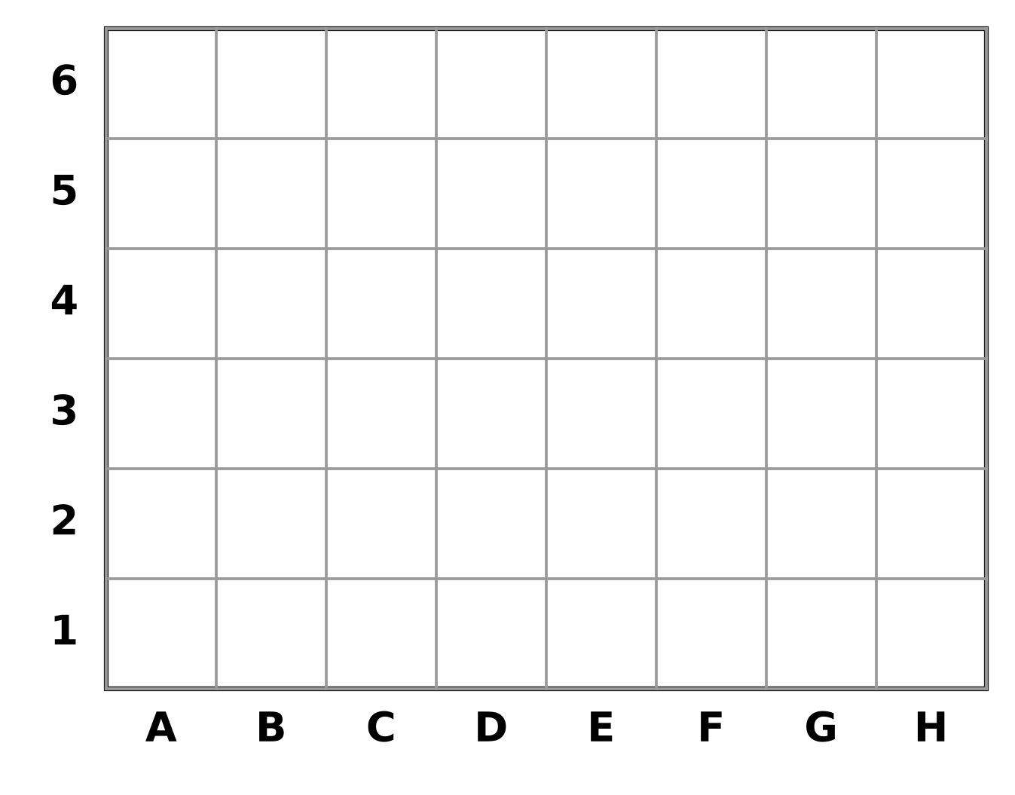
Q45. Look at the grid. Each square is 2 cm by 2 cm. Ella shades the squares in columns B to F and rows 2 to 5. She leaves the four corner squares of this block unshaded. What is the area of the shaded part? [4 marks]
(A) 76 sq cm | (B) 80 sq cm | (C) 32 sq cm | (D) 64 sq cm

Answer Sheet AMO Level 1 · Class 4 · Practice Paper 3
Name: | School: | Roll No.:
Shade or tick one circle for each question.
1. Ⓐ Ⓑ Ⓒ Ⓓ | 16. Ⓐ Ⓑ Ⓒ Ⓓ | 31. Ⓐ Ⓑ Ⓒ Ⓓ
2. Ⓐ Ⓑ Ⓒ Ⓓ | 17. Ⓐ Ⓑ Ⓒ Ⓓ | 32. Ⓐ Ⓑ Ⓒ Ⓓ
3. Ⓐ Ⓑ Ⓒ Ⓓ | 18. Ⓐ Ⓑ Ⓒ Ⓓ | 33. Ⓐ Ⓑ Ⓒ Ⓓ
4. Ⓐ Ⓑ Ⓒ Ⓓ | 19. Ⓐ Ⓑ Ⓒ Ⓓ | 34. Ⓐ Ⓑ Ⓒ Ⓓ
5. Ⓐ Ⓑ Ⓒ Ⓓ | 20. Ⓐ Ⓑ Ⓒ Ⓓ | 35. Ⓐ Ⓑ Ⓒ Ⓓ
6. Ⓐ Ⓑ Ⓒ Ⓓ | 21. Ⓐ Ⓑ Ⓒ Ⓓ | 36. Ⓐ Ⓑ Ⓒ Ⓓ
7. Ⓐ Ⓑ Ⓒ Ⓓ | 22. Ⓐ Ⓑ Ⓒ Ⓓ | 37. Ⓐ Ⓑ Ⓒ Ⓓ
8. Ⓐ Ⓑ Ⓒ Ⓓ | 23. Ⓐ Ⓑ Ⓒ Ⓓ | 38. Ⓐ Ⓑ Ⓒ Ⓓ
9. Ⓐ Ⓑ Ⓒ Ⓓ | 24. Ⓐ Ⓑ Ⓒ Ⓓ | 39. Ⓐ Ⓑ Ⓒ Ⓓ
10. Ⓐ Ⓑ Ⓒ Ⓓ | 25. Ⓐ Ⓑ Ⓒ Ⓓ | 40. Ⓐ Ⓑ Ⓒ Ⓓ
11. Ⓐ Ⓑ Ⓒ Ⓓ | 26. Ⓐ Ⓑ Ⓒ Ⓓ | 41. Ⓐ Ⓑ Ⓒ Ⓓ
12. Ⓐ Ⓑ Ⓒ Ⓓ | 27. Ⓐ Ⓑ Ⓒ Ⓓ | 42. Ⓐ Ⓑ Ⓒ Ⓓ
13. Ⓐ Ⓑ Ⓒ Ⓓ | 28. Ⓐ Ⓑ Ⓒ Ⓓ | 43. Ⓐ Ⓑ Ⓒ Ⓓ
14. Ⓐ Ⓑ Ⓒ Ⓓ | 29. Ⓐ Ⓑ Ⓒ Ⓓ | 44. Ⓐ Ⓑ Ⓒ Ⓓ
15. Ⓐ Ⓑ Ⓒ Ⓓ | 30. Ⓐ Ⓑ Ⓒ Ⓓ | 45. Ⓐ Ⓑ Ⓒ Ⓓ
Q41–Q45 are Section II Star Questions (4 marks each).
For the parent or teacher
Section I correct: ______ / 40 × 2 = ______ marks Section II correct: ______ / 5 × 4 = ______ marks
Correct: ______ / 45 Score: ______ / 100
Answer Key and Solutions AMO Level 1 · Class 4 · Practice Paper 3
Quick answers
1 D | 6 C | 11 C | 16 B | 21 A | 26 C | 31 D | 36 B | 41 A
2 A | 7 D | 12 A | 17 C | 22 D | 27 D | 32 A | 37 B | 42 B
3 B | 8 D | 13 C | 18 A | 23 C | 28 B | 33 A | 38 C | 43 C
4 B | 9 A | 14 B | 19 D | 24 B | 29 C | 34 D | 39 D | 44 D
5 A | 10 B | 15 D | 20 C | 25 A | 30 B | 35 C | 40 A | 45 D
Solutions
Q | Part · level | Answer | Why?
1 | Part 1 · Ch1 · Easy | (D) 59,999 | The number just before 60,000 is 60,000 − 1 = 59,999.
2 | Part 1 · Ch1 · Easy | (A) XLIX | We write 49 = 40 + 9 = XL + IX = XLIX.
3 | Part 1 · Ch1 · Easy | (B) 40,099 | All four begin with 4. Then 40,099 has the smallest digits in the thousands and hundreds places, so it is the smallest.
4 | Part 1 · Ch1 · Medium | (B) 53,050 | The 13 thousands make 1 ten thousand + 3 thousands. So the number is 40,000 + 13,000 + 50 = 53,050.
5 | Part 1 · Ch1 · Medium | (A) 24,380 | From 23,180 to 26,780 there are 3 equal jumps: 3,600 ÷ 3 = 1,200. The first blank is 23,180 + 1,200 = 24,380.
6 | Part 2 · Ch2 · Easy | (C) 6 | Grouping does not change a product: (14 × 5) × 6 = 14 × (5 × 6). The blank is 6.
7 | Part 2 · Ch2 · Easy | (D) 36,525 | The blank is 1,00,000 − 63,475 = 36,525. Check: 63,475 + 36,525 = 1,00,000.
8 | Part 2 · Ch2 · Easy | (D) 1,176 | The machine prints 168 × 7 = 1,176 posters.
9 | Part 2 · Ch2 · Medium | (A) 8,447 | The number = 7 × 1,206 + 5 = 8,442 + 5 = 8,447.
10 | Part 2 · Ch2 · Medium | (B) 4,281 | The count 4,281 is between 4,250 and 4,349, so it rounds to 4,300. The others round to 4,200, 4,400 and 4,000.
11 | Part 3 · Ch3 · Easy | (C) 24 | Since 5 × 4 = 20, the bottom must also be multiplied by 4: 6 × 4 = 24.
12 | Part 3 · Ch3 · Easy | (A) 17 | Three wholes = 15 fifths. Then 15 fifths + 2 fifths = 17 fifths, so the blank is 17.
13 | Part 3 · Ch3 · Easy | (C) 2/9 and 7/9 | $\frac{2}{9}$ and $\frac{7}{9}$ both have the denominator 9, so they are like fractions.
14 | Part 3 · Ch3 · Easy | (B) $\frac{5}{9}$ | $\frac{1}{3}$ = $\frac{3}{9}$. So the sum is $\frac{2}{9}$ + $\frac{3}{9}$ = $\frac{5}{9}$.
15 | Part 3 · Ch3 · Medium | (D) 7 | $\frac{1}{4}$ = $\frac{3}{12}$ and $\frac{5}{6}$ = $\frac{10}{12}$. Then 10 − 3 = 7, so the blank is 7.
16 | Part 3 · Ch3 · Medium | (B) 6 | Painting 9 out of 12 is the same as 3 out of 4. Rhea has 8 pots, which is 2 groups of 4, so she paints 2 × 3 = 6 pots.
17 | Part 4 · Ch5 · Easy | (C) Picture C | Squares, triangles and hexagons fit together with no gaps. The octagons leave small square gaps between them.
18 | Part 4 · Ch5 · Easy | (A) Triangular prism | Two triangle ends joined by three rectangles make a triangular prism.
19 | Part 4 · Ch5 · Medium | (D) They are parallel. | Both p and r make a square corner with q, so they point the same way and never meet. They are parallel.
20 | Part 4 · Ch5 · Medium | (C) (E, 4) | Moving 3 squares right of column B gives column E. Moving 2 squares up from row 2 gives row 4. So it is at (E, 4).
21 | Part 5 · Ch6 · Easy | (A) 14 sq cm | Counting the squares row by row: 5 + 4 + 3 + 2 = 14 squares, so the area is 14 sq cm.
22 | Part 5 · Ch6 · Easy | (D) 8 cm | Area = length × width, so width = 96 ÷ 12 = 8 cm.
23 | Part 5 · Ch6 · Easy | (C) 12 | The jug holds 3 L = 3,000 mL. Then 3,000 ÷ 250 = 12 glasses.
24 | Part 5 · Ch6 · Easy | (B) 400 cm | The length is 1 m 20 cm = 120 cm. Perimeter = 2 × (120 + 80) = 400 cm.
25 | Part 5 · Ch6 · Medium | (A) 1,225 sq cm | Side = 140 ÷ 4 = 35 cm. Area = 35 × 35 = 1,225 sq cm.
26 | Part 5 · Ch6 · Medium | (C) 9 L 400 mL | For 4 trips: 2 L × 4 = 8 L and 350 mL × 4 = 1,400 mL = 1 L 400 mL. Total = 9 L 400 mL.
27 | Part 6 · Ch8 · Easy | (D) Marigold | Here 35 bees = 3 whole pictures (30) and a half picture (5). The Marigold row has 3 and a half pictures.
28 | Part 6 · Ch8 · Medium | (B) 4 and a half | The most is Tulip with 7 × 10 = 70 bees. Poppy had 70 − 25 = 45 bees. That is 45 ÷ 10 = 4 and a half pictures.
29 | Part 7 · Ch9 · Easy | (C) 17 minutes to 7 | The clock shows 6:43. There are 60 − 43 = 17 minutes left before 7, so it is 17 minutes to 7.
30 | Part 7 · Ch9 · Easy | (B) 1:15 | The clock shows 2:05. Going back 50 minutes from 2:05 gives 1:15 (5 minutes back to 2:00, then 45 more minutes back).
31 | Part 7 · Ch9 · Easy | (D) 24th | Saturdays are 7 days apart. The fourth Saturday is the 10 + 7 + 7 = 24th.
32 | Part 7 · Ch9 · Easy | (A) ₹130 | There are 2 adults: 2 × ₹35 = ₹70. Ankit and his sisters are 3 children: 3 × ₹20 = ₹60. Total = ₹130.
33 | Part 7 · Ch9 · Medium | (A) ₹145 | The 3 boxes cost ₹500 − ₹65 = ₹435. One box = ₹435 ÷ 3 = ₹145.
34 | Part 7 · Ch9 · Medium | (D) 2 hours 35 minutes | From 11:40 to 12:00 noon is 20 minutes. From 12:00 to 2:15 is 2 hours 15 minutes. Total = 2 hours 35 minutes.
35 | Part 8 · Ch10 · Easy | (C) 81 | Each number is 3 times the one before. 27 × 3 = 81.
36 | Part 8 · Ch10 · Easy | (B) 5 | The numbers are 14, 23, 32, 41 and 50. That is 5 numbers.
37 | Part 8 · Ch10 · Easy | (B) 9 July | From 25 June, 5 days reach 30 June. Then 14 − 5 = 9 more days reach 9 July.
38 | Part 8 · Ch10 · Medium | (C) 13 | The pattern adds 5, then takes away 2, again and again. After 15 comes 15 − 2 = 13.
39 | Part 8 · Ch10 · Medium | (D) 3 | Use 0, 2 or 4 ₹5 coins: 10 ₹2 coins; 2 ₹5 and 5 ₹2 coins; 4 ₹5 coins. An odd number of ₹5 coins leaves an odd amount. So 3 ways.
40 | Part 8 · Ch10 · Medium | (A) Thursday | From 1 January to 1 March is 31 + 28 = 59 days. As 59 days = 8 weeks + 3 days, Monday + 3 days = Thursday.
41 | Section II · Ch3 + Ch10 · Hard | (A) 4 | Any pair with $\frac{1}{2}$ is too big. $\frac{1}{3}$ + $\frac{1}{4}$ = $\frac{7}{12}$ is too big and $\frac{1}{3}$ + $\frac{1}{6}$ = $\frac{1}{2}$ is not less. The pairs $\frac{1}{3}$ + $\frac{1}{12}$ = $\frac{5}{12}$, $\frac{1}{4}$ + $\frac{1}{6}$ = $\frac{5}{12}$, $\frac{1}{4}$ + $\frac{1}{12}$ = $\frac{4}{12}$ and $\frac{1}{6}$ + $\frac{1}{12}$ = $\frac{3}{12}$ are less. So 4 pairs.
42 | Section II · Ch9 + Ch10 · Hard | (B) Wednesday, 19 March | The watch must get 60 minutes ahead, which takes 60 ÷ 4 = 15 days. So the day is 15 days after 4 March, which is 19 March. As 15 days = 2 weeks + 1 day, Tuesday + 1 day = Wednesday.
43 | Section II · Ch1 + Ch10 · Hard | (C) 30 | The number must start with 37, 38 or 39 and end with 73, 83 or 93. The middle digit can be any of 10 digits. So 3 × 10 = 30 numbers.
44 | Section II · Ch3 + Ch9 · Hard | (D) 14 | $\frac{1}{3}$ + $\frac{1}{4}$ = $\frac{7}{12}$, so the rest is $\frac{5}{12}$ of the money. This $\frac{5}{12}$ is ₹350, so $\frac{1}{12}$ is ₹70 and the whole is ₹840. So $\frac{1}{3}$ of ₹840 = ₹280, and ₹280 ÷ ₹20 = 14 notes.
45 | Section II · Ch5 + Ch6 · Hard | (D) 64 sq cm | Columns B to F are 5 columns and rows 2 to 5 are 4 rows: 20 squares. Leaving out 4 corners gives 16 squares. Each is 2 × 2 = 4 sq cm, so the area is 16 × 4 = 64 sq cm.

ARYABHATTA MATHS OLYMPIAD
Level 1
PRACTICE PAPER-4
CLASS 4
Total Questions | 45 multiple-choice questions
Total Marks | 100
Time | 60 minutes
Section I | 40 questions × 2 marks = 80 marks
Section II | 5 Star Questions × 4 marks = 20 marks
Negative Marking | No negative marking
Calculator | Not allowed
Chapters | Number System · Operations · Fractions, Decimals & Percentages · Geometry · Mensuration · Data Handling · Applied Mathematics · Mathematical Reasoning

👋 Hello, friend! How to do this paper:
⭐ Every question has four answer choices: (A), (B), (C) and (D). Only one is correct.
⭐ Read each question and look at its picture carefully. Then mark your answer on the answer sheet at the end.
⭐ Section I has 40 questions of 2 marks each. Section II has 5 Star Questions of 4 marks each.
⭐ There is no negative marking, so try every question.
⭐ Do not use a calculator. You may do rough work on a separate sheet.
⭐ All figures are not necessarily drawn to scale unless stated.

For parents and teachers
• Print or view this paper in colour. Pictures are part of the questions.
• Parts follow the AMO syllabus chapters. Chapters 4 and 7 are not part of the Class 4 syllabus, so the chapter numbers shown in the Part headings have gaps.
• The answer sheet and the answer key are at the end. Remove only the answer key before the child begins.

SECTION I 40 questions × 2 marks each
Part 1 — Number System (Syllabus Chapter 1)
Q1. A bookshop sold 40,075 books in one year. How is the number 40,075 read?
(A) Forty thousand seven hundred five | (B) Four thousand seventy-five
(C) Forty thousand seventy-five | (D) Forty thousand seven hundred fifty

Q2. Which of these is NOT a correctly written Roman numeral?
(A) LXXXIX | (B) XLVI | (C) XCIV | (D) VC

Q3. What is the place value of the digit 8 in 47,860?
(A) 800 | (B) 8,000 | (C) 8 | (D) 80

Q4. Start at 99,000 and subtract 250 each time: 99,000; 98,750; 98,500; 98,250 and so on. What is the first number less than 97,000?
(A) 96,500 | (B) 97,250 | (C) 97,000 | (D) 96,750

Q5. A factory makes 36,500 buttons. It packs them in packets of 100 buttons each. Then it packs 10 packets into each carton. How many cartons can be filled completely?
(A) 36 | (B) 365 | (C) 3 | (D) 3,650

Part 2 — Operations & Number Properties (Syllabus Chapter 2)
Q6. A hall has 24 rows of chairs. There are 36 chairs in each row. How many chairs are there in all?
(A) 60 | (B) 216 | (C) 864 | (D) 844

Q7. A farm packs 4,150 eggs into boxes. Each box holds 6 eggs. As many boxes as possible are filled. How many eggs are left over?
(A) 4 | (B) 2 | (C) 691 | (D) 692

Q8. How much more than 46,358 is 70,000?
(A) 24,642 | (B) 36,358 | (C) 23,642 | (D) 23,652

Q9. Zara was asked to divide a number by 8. By mistake, she multiplied the number by 8 and got 5,120. What is the correct answer?
(A) 640 | (B) 80 | (C) 5,112 | (D) 800

Q10. A shop gets 18 boxes of bulbs. Each box has 45 bulbs. In one month, the shop sells 597 of these bulbs. How many of these bulbs are left?
(A) 387 | (B) 313 | (C) 1,407 | (D) 213

Part 3 — Fractions, Decimals & Percentages (Syllabus Chapter 3)
Q11. Which of these fractions is already in its simplest form?
(A) $\frac{6}{9}$ | (B) $\frac{5}{12}$ | (C) $\frac{4}{10}$ | (D) $\frac{9}{12}$

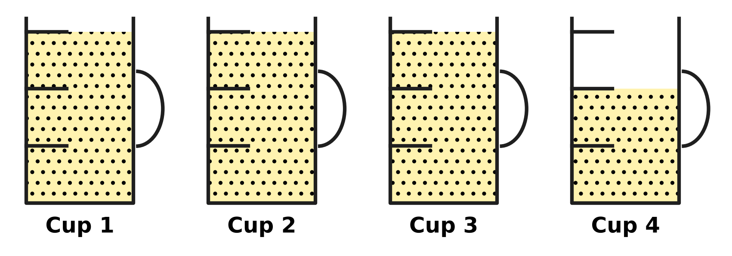
Q12. Look at the picture. A full measuring cup holds one cup of flour. Each cup is marked in three equal parts. How many cups of flour are there in all?
(A) $3\frac{2}{3}$ | (B) $3\frac{1}{3}$ | (C) $4\frac{2}{3}$ | (D) $2\frac{2}{3}$

Q13. Which of these fractions is the greatest?
(A) $\frac{2}{5}$ | (B) $\frac{2}{7}$ | (C) $\frac{2}{9}$ | (D) $\frac{2}{3}$

Q14. What is $\frac{7}{10}$ − $\frac{1}{5}$? Give the answer in its simplest form.
(A) $\frac{6}{10}$ | (B) $\frac{6}{5}$ | (C) $\frac{1}{2}$ | (D) $\frac{9}{10}$

Q15. On a mountain hike, Manu walks $2\frac{1}{3}$ km before lunch and $1\frac{3}{4}$ km after lunch. How far does he walk in all?
(A) $3\frac{1}{12}$ km | (B) $4\frac{5}{12}$ km | (C) $4\frac{1}{12}$ km | (D) $3\frac{4}{7}$ km

Q16. A fraction is equal to $\frac{2}{3}$. Its numerator (top number) and denominator (bottom number) add up to 20. What is the fraction?
(A) $\frac{8}{12}$ | (B) $\frac{12}{8}$ | (C) $\frac{6}{9}$ | (D) $\frac{4}{6}$

Part 4 — Geometry (Syllabus Chapter 5)
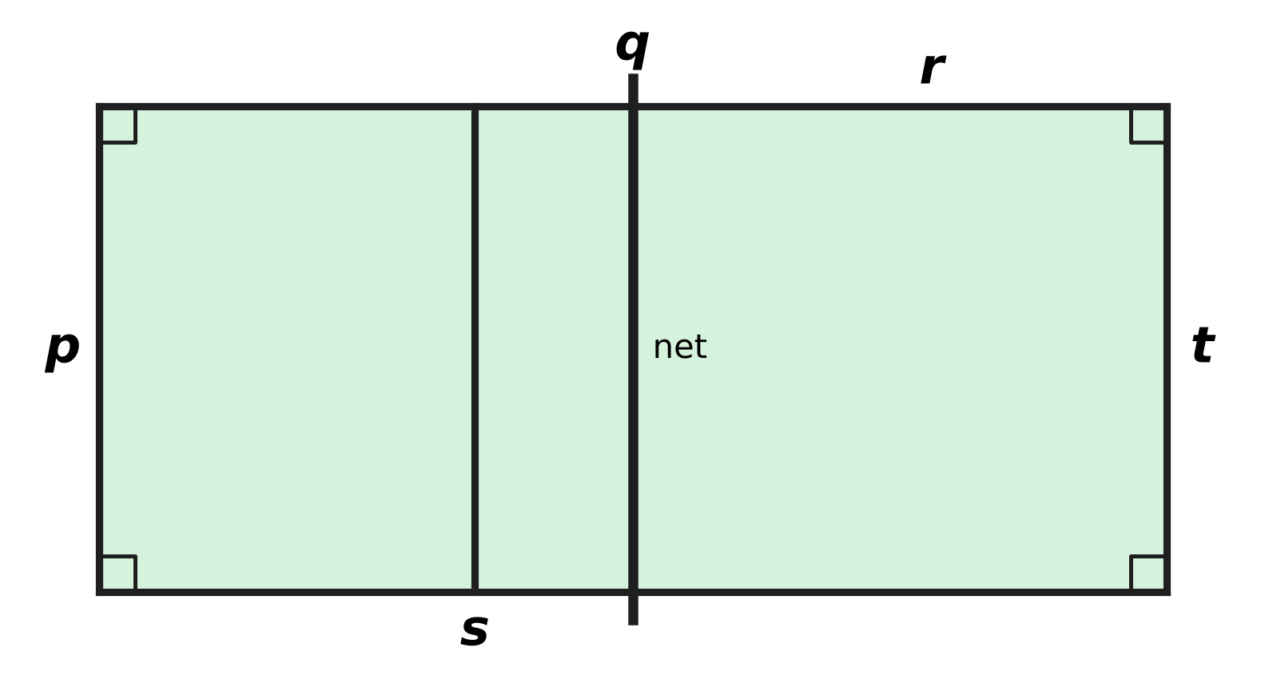
Q17. The picture shows some lines of a badminton court. The court is a rectangle. Which line is perpendicular to line p?
(A) Line t | (B) Line r | (C) Line s | (D) Line q

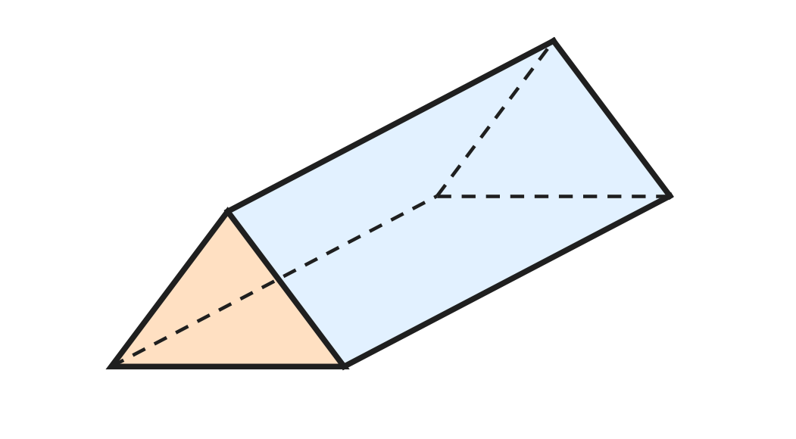
Q18. A crayon box is shaped like a triangular prism, as in the picture. Dashed lines are edges at the back. How many faces does the box have?
(A) 3 | (B) 9 | (C) 6 | (D) 5

Q19. A prism has 18 edges. How many faces does it have?
(A) 12 | (B) 8 | (C) 7 | (D) 6

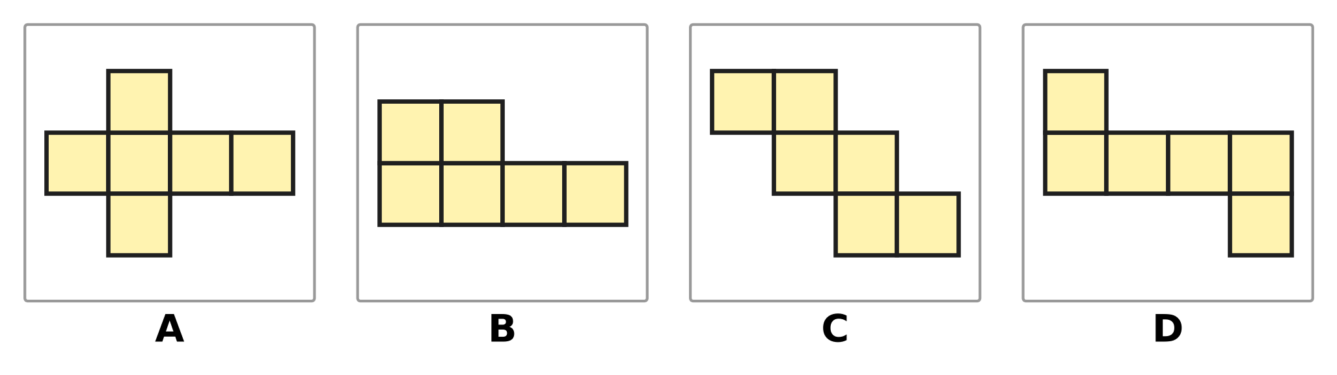
Q20. Each picture is made of 6 equal squares. Which picture is NOT a net of a cube?
(A) Picture A | (B) Picture B
(C) Picture C | (D) Picture D

Part 5 — Mensuration (Syllabus Chapter 6)
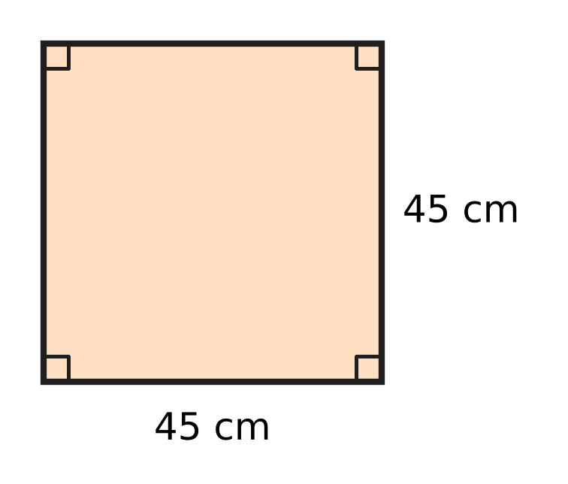
Q21. The picture shows the square top of a wooden shelf. Each side is 45 cm long. What is the area of the top?
(A) 90 sq cm | (B) 1,825 sq cm
(C) 180 sq cm | (D) 2,025 sq cm

Q22. An empty suitcase weighs 1 kg 650 g. Clothes weighing 875 g are packed in it. How much does the suitcase weigh now?
(A) 2 kg 525 g | (B) 2 kg 425 g
(C) 1 kg 525 g | (D) 2 kg 625 g

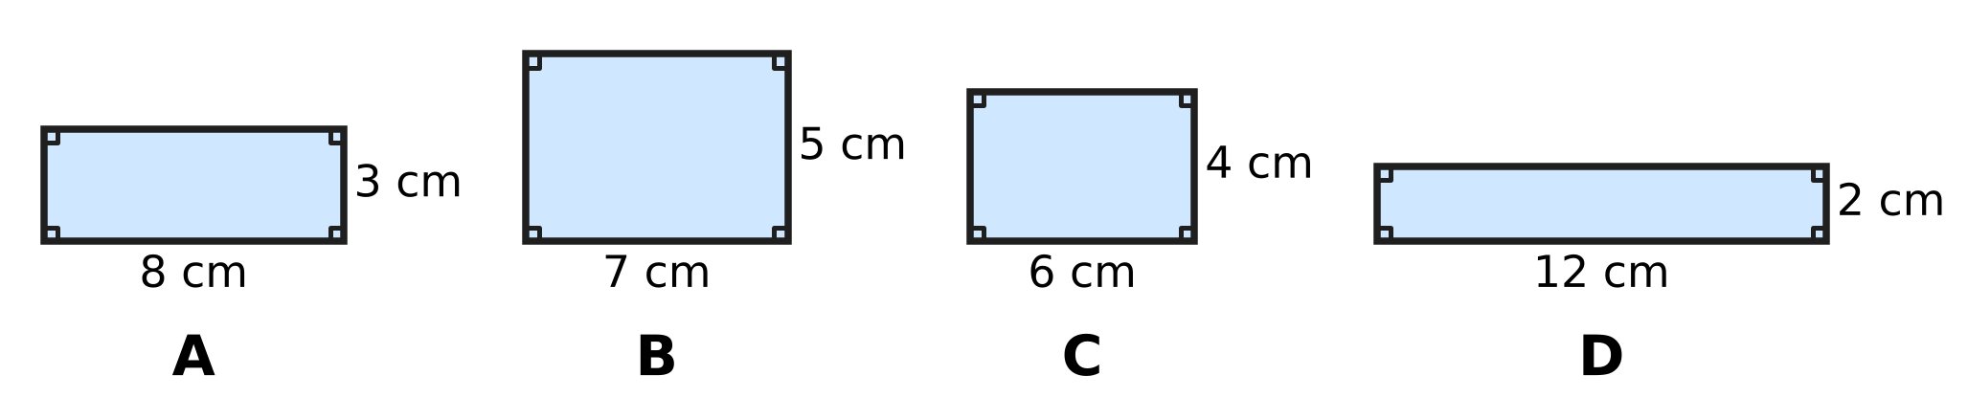
Q23. Look at the four rectangles. Which rectangle has a perimeter of 24 cm?
(A) Picture A | (B) Picture B
(C) Picture C | (D) Picture D

Q24. A metal pipe 3 m 60 cm long is cut into pieces of 40 cm each. How many pieces are there?
(A) 90 | (B) 15 | (C) 9 | (D) 7

Q25. A school stage is a rectangle 2 m long and 1 m 50 cm wide. It is fully covered with square tiles of side 25 cm. How many tiles are needed?
(A) 28 | (B) 48 | (C) 14 | (D) 32

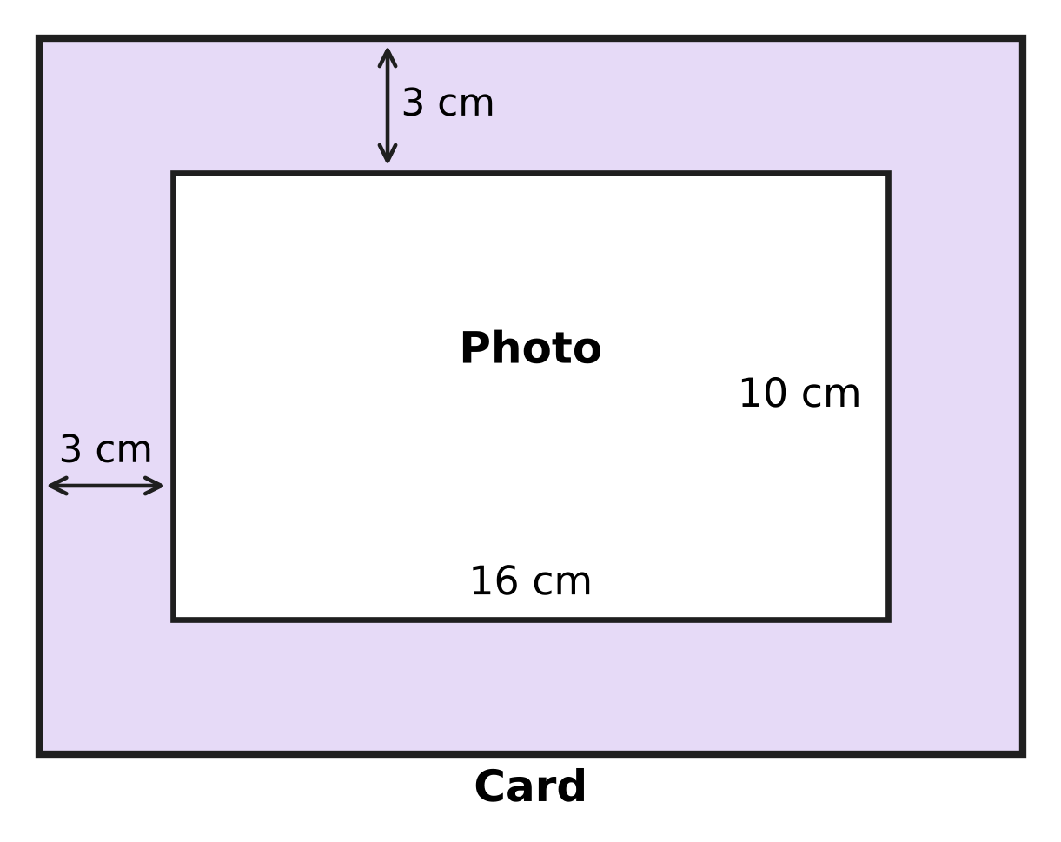
Q26. Look at the picture. A photo 16 cm long and 10 cm wide is pasted on a rectangular card. The card shows a border 3 cm wide on every side. What is the perimeter of the card?
(A) 64 cm | (B) 38 cm | (C) 76 cm | (D) 52 cm

Part 6 — Data Handling, Statistics & Probability (Syllabus Chapter 8)
Picture for Q27 and Q28
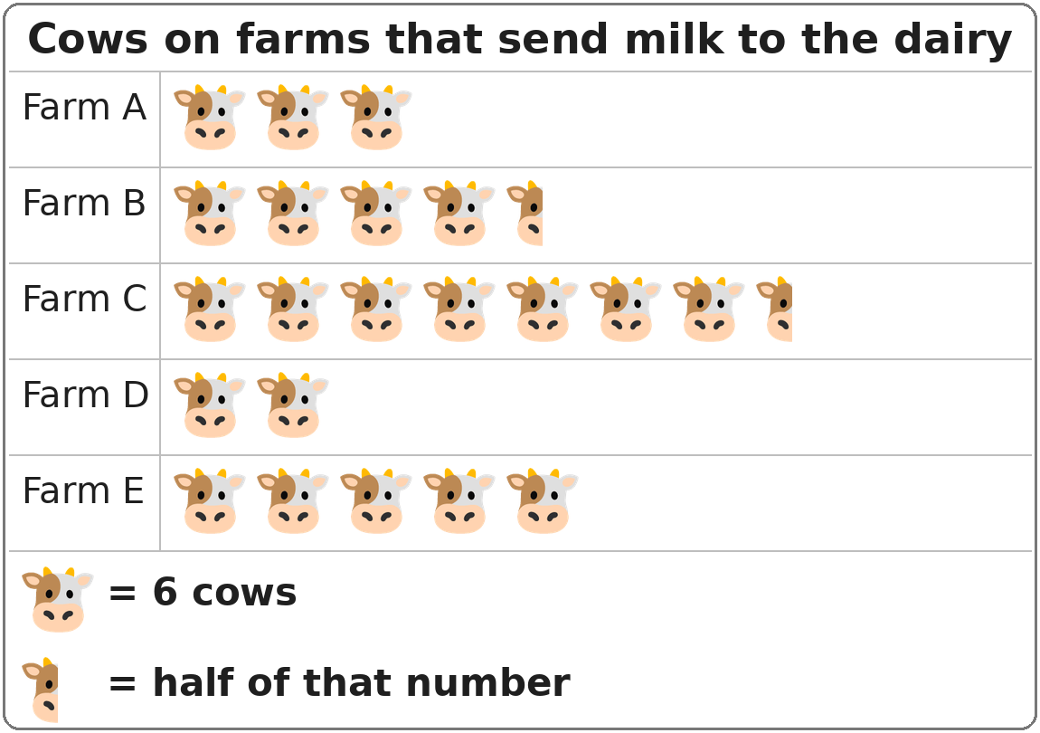
Q27. Look at the pictograph. How many cows are there on Farm B?
(A) 26 | (B) 24 | (C) 30 | (D) 27

Picture for Q27 and Q28
Q28. Look at the pictograph. Which two farms together have exactly as many cows as Farm C?
(A) Farm A and Farm B | (B) Farm B and Farm D
(C) Farm D and Farm E | (D) Farm A and Farm E

Part 7 — Applied Mathematics (Syllabus Chapter 9)
Q29. A film lasts 135 minutes. How long is the film in hours and minutes?
(A) 2 hours 35 minutes | (B) 2 hours 15 minutes
(C) 1 hour 15 minutes | (D) 1 hour 35 minutes

Q30. The 20th day of a month is a Saturday. On which day of the week does the month begin?
(A) Monday | (B) Thursday | (C) Sunday | (D) Tuesday

Q31. A family buys a table fan for ₹2,700. They pay with 3 notes of ₹500 and some notes of ₹100. How many ₹100 notes do they use?
(A) 27 | (B) 22 | (C) 12 | (D) 24

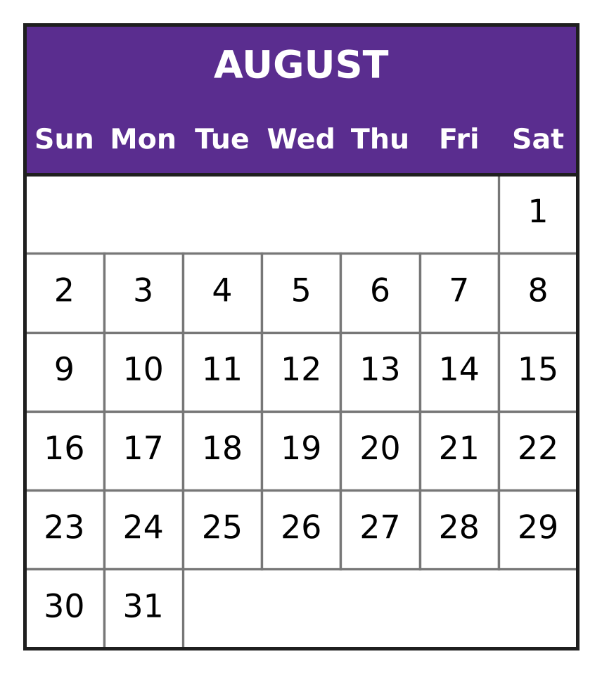
Q32. Look at the calendar for August. August has 31 days. What day of the week is 3 September of the same year?
(A) Monday | (B) Tuesday
(C) Wednesday | (D) Thursday

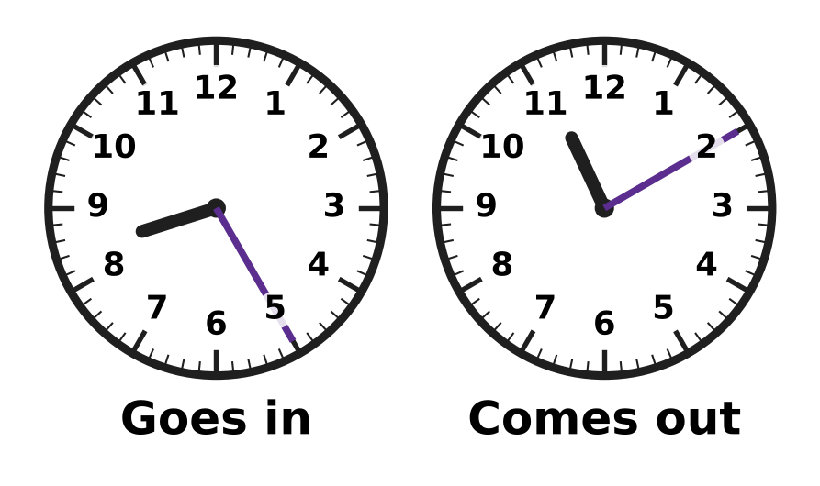
Q33. Vihaan visits a zoo one morning. The clocks show when he goes in and when he comes out. How long is he at the zoo?
(A) 2 hours 45 minutes | (B) 2 hours 15 minutes
(C) 3 hours 15 minutes | (D) 3 hours 45 minutes

Q34. At a plant nursery, Eva buys 4 saplings at ₹65 each and one clay pot for ₹90. She pays with a ₹500 note. How much change does she get?
(A) ₹345 | (B) ₹150 | (C) ₹170 | (D) ₹350

Part 8 — Mathematical Reasoning & Problem-Solving (Syllabus Chapter 10)
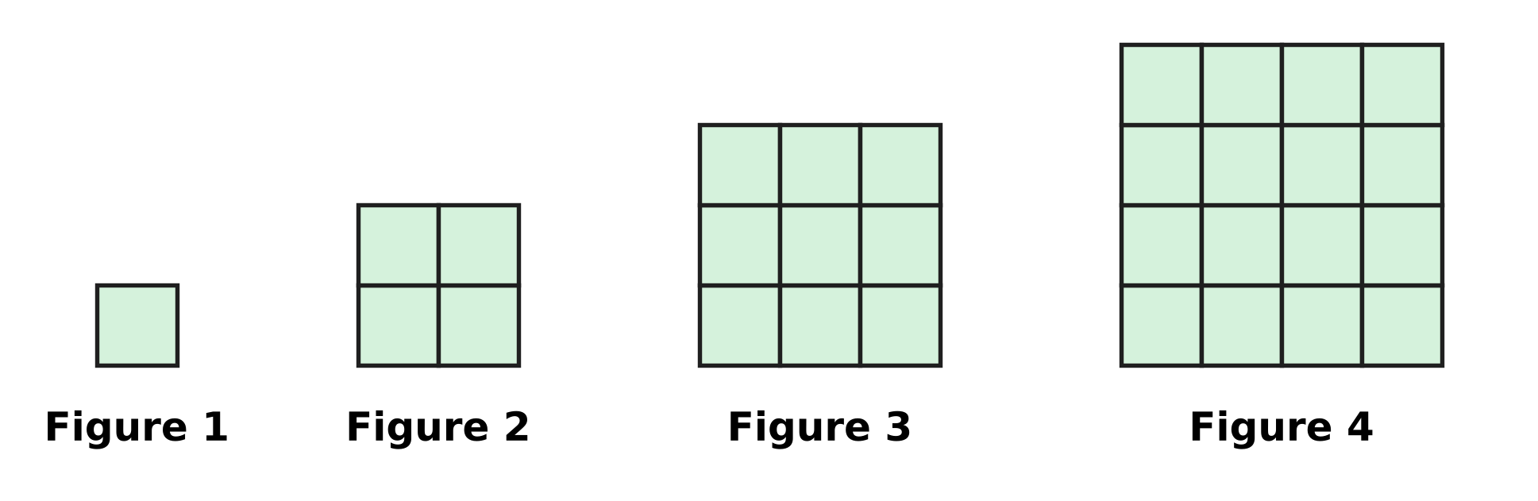
Q35. Look at the figures made of square tiles. The pattern goes on in the same way. Which figure will have 81 tiles?
(A) Figure 27 | (B) Figure 8
(C) Figure 10 | (D) Figure 9

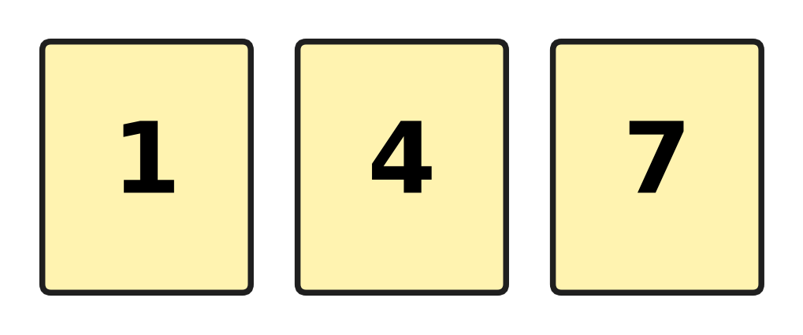
Q36. Ojas has the three cards shown. He makes 2-digit numbers by putting two different cards side by side. How many different 2-digit numbers can he make?
(A) 9 | (B) 3 | (C) 6 | (D) 4

Q37. How many days are there in July, August and September put together?
(A) 91 | (B) 90 | (C) 93 | (D) 92

Q38. Which number comes next in the series?
3, 7, 15, 31, 63, ___
(A) 111 | (B) 126 | (C) 127 | (D) 95

Q39. The hooks of a coat rack are numbered from 10 to 40. Kiara ties a tag on every hook whose tens digit is greater than its ones digit. For example, she ties a tag on hook 21. How many hooks get a tag?
(A) 10 | (B) 7 | (C) 4 | (D) 6

Q40. A month begins on a Friday and also ends on a Friday. How many days does this month have?
(A) 29 | (B) 30 | (C) 28 | (D) 31

SECTION II — Star Questions 5 questions × 4 marks each
Q41. On the morning of Monday, 3 March, a can of lamp oil is $\frac{5}{6}$ full. From Monday to Saturday, the lamps use $\frac{1}{12}$ of a full can each day. No oil is used on Sundays. On which day does the can become empty? [4 marks]
(A) Thursday, 13 March | (B) Friday, 7 March
(C) Saturday, 15 March | (D) Wednesday, 12 March

Q42. The first river ferry of the day leaves at 6:20 a.m. After that, a ferry leaves every 40 minutes. The last ferry of the day must leave no later than 1:00 p.m. How many ferries leave in the day? [4 marks]
(A) 12 | (B) 9 | (C) 10 | (D) 11

Q43. Use each of the digits 4, 9, 0, 5 and 1 exactly once to make a 5-digit number. Which of these numbers, made in this way, is closest to 50,000? [4 marks]
(A) 50,419 | (B) 49,150 | (C) 50,149 | (D) 49,510

Q44. Sonal and Chetan buy a gift together. Sonal pays $\frac{5}{12}$ of the price and Chetan pays the rest. Chetan pays ₹70 more than Sonal. Chetan pays his share with a ₹500 note. How much change does Chetan get? [4 marks]
(A) ₹80 | (B) ₹255 | (C) ₹325 | (D) ₹10

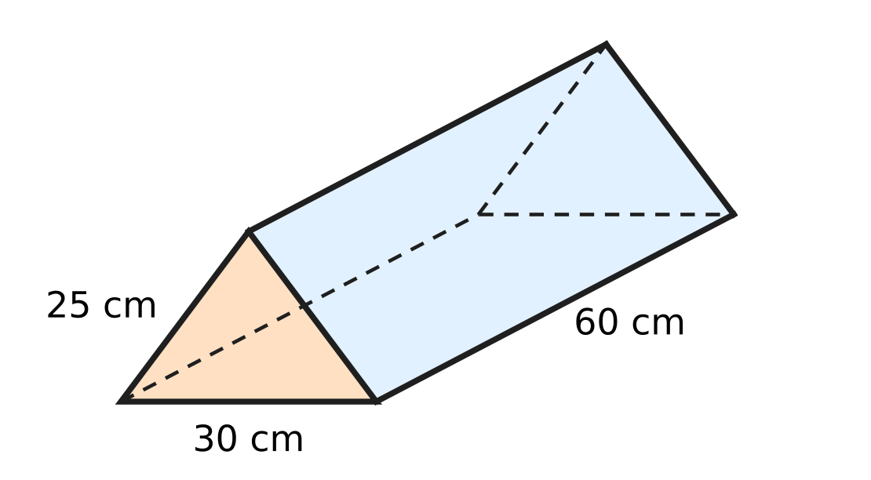
Q45. The picture shows a wire model of a triangular prism. Wire runs along every edge. Each triangle end has sides 25 cm, 25 cm and 30 cm. Each of the three long edges is 60 cm. The model is made from a 4 m piece of wire. How much wire is left over? [4 marks]
(A) 340 cm | (B) 120 cm | (C) 140 cm | (D) 60 cm

Answer Sheet AMO Level 1 · Class 4 · Practice Paper 4
Name: | School: | Roll No.:
Shade or tick one circle for each question.
1. Ⓐ Ⓑ Ⓒ Ⓓ | 16. Ⓐ Ⓑ Ⓒ Ⓓ | 31. Ⓐ Ⓑ Ⓒ Ⓓ
2. Ⓐ Ⓑ Ⓒ Ⓓ | 17. Ⓐ Ⓑ Ⓒ Ⓓ | 32. Ⓐ Ⓑ Ⓒ Ⓓ
3. Ⓐ Ⓑ Ⓒ Ⓓ | 18. Ⓐ Ⓑ Ⓒ Ⓓ | 33. Ⓐ Ⓑ Ⓒ Ⓓ
4. Ⓐ Ⓑ Ⓒ Ⓓ | 19. Ⓐ Ⓑ Ⓒ Ⓓ | 34. Ⓐ Ⓑ Ⓒ Ⓓ
5. Ⓐ Ⓑ Ⓒ Ⓓ | 20. Ⓐ Ⓑ Ⓒ Ⓓ | 35. Ⓐ Ⓑ Ⓒ Ⓓ
6. Ⓐ Ⓑ Ⓒ Ⓓ | 21. Ⓐ Ⓑ Ⓒ Ⓓ | 36. Ⓐ Ⓑ Ⓒ Ⓓ
7. Ⓐ Ⓑ Ⓒ Ⓓ | 22. Ⓐ Ⓑ Ⓒ Ⓓ | 37. Ⓐ Ⓑ Ⓒ Ⓓ
8. Ⓐ Ⓑ Ⓒ Ⓓ | 23. Ⓐ Ⓑ Ⓒ Ⓓ | 38. Ⓐ Ⓑ Ⓒ Ⓓ
9. Ⓐ Ⓑ Ⓒ Ⓓ | 24. Ⓐ Ⓑ Ⓒ Ⓓ | 39. Ⓐ Ⓑ Ⓒ Ⓓ
10. Ⓐ Ⓑ Ⓒ Ⓓ | 25. Ⓐ Ⓑ Ⓒ Ⓓ | 40. Ⓐ Ⓑ Ⓒ Ⓓ
11. Ⓐ Ⓑ Ⓒ Ⓓ | 26. Ⓐ Ⓑ Ⓒ Ⓓ | 41. Ⓐ Ⓑ Ⓒ Ⓓ
12. Ⓐ Ⓑ Ⓒ Ⓓ | 27. Ⓐ Ⓑ Ⓒ Ⓓ | 42. Ⓐ Ⓑ Ⓒ Ⓓ
13. Ⓐ Ⓑ Ⓒ Ⓓ | 28. Ⓐ Ⓑ Ⓒ Ⓓ | 43. Ⓐ Ⓑ Ⓒ Ⓓ
14. Ⓐ Ⓑ Ⓒ Ⓓ | 29. Ⓐ Ⓑ Ⓒ Ⓓ | 44. Ⓐ Ⓑ Ⓒ Ⓓ
15. Ⓐ Ⓑ Ⓒ Ⓓ | 30. Ⓐ Ⓑ Ⓒ Ⓓ | 45. Ⓐ Ⓑ Ⓒ Ⓓ
Q41–Q45 are Section II Star Questions (4 marks each).
For the parent or teacher
Section I correct: ______ / 40 × 2 = ______ marks Section II correct: ______ / 5 × 4 = ______ marks
Correct: ______ / 45 Score: ______ / 100
Answer Key and Solutions AMO Level 1 · Class 4 · Practice Paper 4
Quick answers
1 C | 6 C | 11 B | 16 A | 21 D | 26 C | 31 C | 36 C | 41 A
2 D | 7 A | 12 A | 17 B | 22 A | 27 D | 32 D | 37 D | 42 D
3 A | 8 C | 13 D | 18 D | 23 B | 28 A | 33 A | 38 C | 43 C
4 D | 9 B | 14 C | 19 B | 24 C | 29 B | 34 B | 39 B | 44 B
5 A | 10 D | 15 C | 20 B | 25 B | 30 A | 35 D | 40 A | 45 D
Solutions
Q | Part · level | Answer | Why?
1 | Part 1 · Ch1 · Easy | (C) Forty thousand seventy-five | The number 40,075 is 40 thousands and 75 ones, so it is read as forty thousand seventy-five.
2 | Part 1 · Ch1 · Easy | (D) VC | V is never written before a bigger letter to take it away, so VC is wrong. The number 95 is written XCV.
3 | Part 1 · Ch1 · Easy | (A) 800 | In 47,860, the digit 8 is in the hundreds place, so its place value is 8 × 100 = 800.
4 | Part 1 · Ch1 · Easy | (D) 96,750 | Each number is 250 less than the one before: … 97,250; 97,000; 96,750. The first one below 97,000 is 96,750.
5 | Part 1 · Ch1 · Medium | (A) 36 | Packets = 36,500 ÷ 100 = 365. Full cartons = 365 ÷ 10 = 36 (5 packets are left over).
6 | Part 2 · Ch2 · Easy | (C) 864 | Chairs = 24 × 36 = 24 × 30 + 24 × 6 = 720 + 144 = 864.
7 | Part 2 · Ch2 · Easy | (A) 4 | Here 4,150 ÷ 6 = 691 remainder 4. So 691 boxes are full and 4 eggs are left over.
8 | Part 2 · Ch2 · Easy | (C) 23,642 | Difference = 70,000 − 46,358 = 23,642. Check: 46,358 + 23,642 = 70,000.
9 | Part 2 · Ch2 · Medium | (B) 80 | The number is 5,120 ÷ 8 = 640. The correct answer is 640 ÷ 8 = 80.
10 | Part 2 · Ch2 · Medium | (D) 213 | Bulbs in all = 18 × 45 = 810. Bulbs left = 810 − 597 = 213.
11 | Part 3 · Ch3 · Easy | (B) $\frac{5}{12}$ | The numbers 5 and 12 have no common factor other than 1, so $\frac{5}{12}$ cannot be simplified. The others become $\frac{2}{3}$, $\frac{2}{5}$ and $\frac{3}{4}$.
12 | Part 3 · Ch3 · Easy | (A) $3\frac{2}{3}$ | Cups 1, 2 and 3 are full (3 cups) and Cup 4 is $\frac{2}{3}$ full, so there are $3\frac{2}{3}$ cups in all.
13 | Part 3 · Ch3 · Easy | (D) $\frac{2}{3}$ | All four have 2 parts on top. The fewer the equal parts in a whole, the bigger each part, so $\frac{2}{3}$ is the greatest.
14 | Part 3 · Ch3 · Medium | (C) $\frac{1}{2}$ | $\frac{1}{5}$ = $\frac{2}{10}$. So $\frac{7}{10}$ − $\frac{2}{10}$ = $\frac{5}{10}$ = $\frac{1}{2}$.
15 | Part 3 · Ch3 · Medium | (C) $4\frac{1}{12}$ km | $\frac{1}{3}$ + $\frac{3}{4}$ = $\frac{4}{12}$ + $\frac{9}{12}$ = $\frac{13}{12}$ = $1\frac{1}{12}$. So 2 + 1 + $1\frac{1}{12}$ = $4\frac{1}{12}$ km.
16 | Part 3 · Ch3 · Medium | (A) $\frac{8}{12}$ | Here 2 + 3 = 5 and 20 = 5 × 4. So multiply top and bottom by 4: $\frac{8}{12}$, and 8 + 12 = 20.
17 | Part 4 · Ch5 · Easy | (B) Line r | Line r meets line p at a square corner, so it is perpendicular to p. Lines q, s and t are parallel to p.
18 | Part 4 · Ch5 · Easy | (D) 5 | A triangular prism has 2 triangle faces and 3 rectangle faces: 2 + 3 = 5 faces.
19 | Part 4 · Ch5 · Medium | (B) 8 | A prism has 3 edges for each side of its end shape, so the end has 18 ÷ 3 = 6 sides. Faces = 6 side faces + 2 ends = 8.
20 | Part 4 · Ch5 · Medium | (B) Picture B | In Picture B, four squares form a 2 by 2 block, so two squares would land on the same face when folded. The other three fold into a cube.
21 | Part 5 · Ch6 · Easy | (D) 2,025 sq cm | Area of a square = side × side = 45 × 45 = 2,025 sq cm.
22 | Part 5 · Ch6 · Easy | (A) 2 kg 525 g | Total = 1,650 g + 875 g = 2,525 g = 2 kg 525 g.
23 | Part 5 · Ch6 · Easy | (B) Picture B | Perimeter = 2 × (length + breadth). For Picture B: 2 × (7 + 5) = 24 cm. The others give 22 cm, 20 cm and 28 cm.
24 | Part 5 · Ch6 · Easy | (C) 9 | Length = 3 m 60 cm = 360 cm. Pieces = 360 ÷ 40 = 9.
25 | Part 5 · Ch6 · Medium | (B) 48 | Along the length: 200 ÷ 25 = 8 tiles. Along the width: 150 ÷ 25 = 6 tiles. Tiles = 8 × 6 = 48.
26 | Part 5 · Ch6 · Medium | (C) 76 cm | The card is 16 + 3 + 3 = 22 cm long and 10 + 3 + 3 = 16 cm wide. Perimeter = 2 × (22 + 16) = 76 cm.
27 | Part 6 · Ch8 · Easy | (D) 27 | Farm B has 4 and a half pictures. That is 4 × 6 = 24 cows plus half of 6 = 3 cows, so 27 cows.
28 | Part 6 · Ch8 · Medium | (A) Farm A and Farm B | Farm C has 7 and a half × 6 = 45 cows. Farm A (18) + Farm B (27) = 45. No other pair makes 45.
29 | Part 7 · Ch9 · Easy | (B) 2 hours 15 minutes | Here 135 minutes = 60 + 60 + 15 minutes = 2 hours 15 minutes.
30 | Part 7 · Ch9 · Easy | (A) Monday | The 1st is 19 days before the 20th. Since 19 = 14 + 5, go back 5 days from Saturday: Monday.
31 | Part 7 · Ch9 · Easy | (C) 12 | Three notes of ₹500 make ₹1,500. Then ₹2,700 − ₹1,500 = ₹1,200, which is 12 notes of ₹100.
32 | Part 7 · Ch9 · Easy | (D) Thursday | The calendar shows 31 August is a Monday. So 1 September is a Tuesday, 2 September a Wednesday and 3 September a Thursday.
33 | Part 7 · Ch9 · Medium | (A) 2 hours 45 minutes | He goes in at 8:25 and comes out at 11:10. 8:25 to 9:00 is 35 minutes and 9:00 to 11:10 is 2 hours 10 minutes, so he is there for 2 hours 45 minutes.
34 | Part 7 · Ch9 · Medium | (B) ₹150 | Bill = 4 × ₹65 + ₹90 = ₹260 + ₹90 = ₹350. Change = ₹500 − ₹350 = ₹150.
35 | Part 8 · Ch10 · Easy | (D) Figure 9 | Figure 1 has 1 × 1 tiles, Figure 2 has 2 × 2, and so on. Since 9 × 9 = 81, Figure 9 has 81 tiles.
36 | Part 8 · Ch10 · Easy | (C) 6 | The numbers are 14, 17, 41, 47, 71 and 74. That is 6 numbers.
37 | Part 8 · Ch10 · Easy | (D) 92 | July has 31 days, August has 31 days and September has 30 days. Total = 31 + 31 + 30 = 92.
38 | Part 8 · Ch10 · Medium | (C) 127 | Each number is double the one before, plus 1: 63 × 2 + 1 = 127.
39 | Part 8 · Ch10 · Medium | (B) 7 | Tens digit 1: 10. Tens digit 2: 20, 21. Tens digit 3: 30, 31, 32. Tens digit 4: 40. That is 1 + 2 + 3 + 1 = 7 hooks.
40 | Part 8 · Ch10 · Medium | (A) 29 | The last day is 7, 14, 21 or 28 days after the 1st. A month has 28 to 31 days, so the last day is the 29th: the month has 29 days.
41 | Section II · Ch3 + Ch10 · Hard | (A) Thursday, 13 March | $\frac{5}{6}$ = $\frac{10}{12}$, so the oil lasts for 10 days of use. Monday 3 to Saturday 8 March uses 6 days. Sunday 9 March is skipped, and 10 to 13 March uses 4 more. It is empty on Thursday, 13 March.
42 | Section II · Ch9 + Ch10 · Hard | (D) 11 | From 6:20 a.m. to 1:00 p.m. is 6 hours 40 minutes = 400 minutes. There are 400 ÷ 40 = 10 gaps, so 10 ferries leave after the first one: 11 ferries (the last leaves at 1:00 p.m.).
43 | Section II · Ch1 + Ch10 · Hard | (C) 50,149 | The closest number above 50,000 is 50,149 (149 more). The closest below is 49,510 (490 less). Since 149 < 490, 50,149 is the closest.
44 | Section II · Ch3 + Ch9 · Hard | (B) ₹255 | Chetan pays $\frac{7}{12}$, so he pays $\frac{2}{12}$ = $\frac{1}{6}$ of the price more than Sonal. $\frac{1}{6}$ of the price is ₹70, so the price is ₹420. Chetan pays $\frac{7}{12}$ of ₹420 = ₹245 and gets ₹500 − ₹245 = ₹255.
45 | Section II · Ch5 + Ch6 · Hard | (D) 60 cm | Each triangle end uses 30 + 25 + 25 = 80 cm, so two ends use 160 cm. The 3 long edges use 3 × 60 = 180 cm. Total = 340 cm. The wire is 4 m = 400 cm, so 400 − 340 = 60 cm is left.

ARYABHATTA MATHS OLYMPIAD
Level 1
PRACTICE PAPER-5
CLASS 4
Total Questions | 45 multiple-choice questions
Total Marks | 100
Time | 60 minutes
Section I | 40 questions × 2 marks = 80 marks
Section II | 5 Star Questions × 4 marks = 20 marks
Negative Marking | No negative marking
Calculator | Not allowed
Chapters | Number System · Operations · Fractions, Decimals & Percentages · Geometry · Mensuration · Data Handling · Applied Mathematics · Mathematical Reasoning

👋 Hello, friend! How to do this paper:
⭐ Every question has four answer choices: (A), (B), (C) and (D). Only one is correct.
⭐ Read each question and look at its picture carefully. Then mark your answer on the answer sheet at the end.
⭐ Section I has 40 questions of 2 marks each. Section II has 5 Star Questions of 4 marks each.
⭐ There is no negative marking, so try every question.
⭐ Do not use a calculator. You may do rough work on a separate sheet.
⭐ All figures are not necessarily drawn to scale unless stated.

For parents and teachers
• Print or view this paper in colour. Pictures are part of the questions.
• Parts follow the AMO syllabus chapters. Chapters 4 and 7 are not part of the Class 4 syllabus, so the chapter numbers shown in the Part headings have gaps.
• The answer sheet and the answer key are at the end. Remove only the answer key before the child begins.

SECTION I 40 questions × 2 marks each
Part 1 — Number System (Syllabus Chapter 1)
Q1. I am a 5-digit number. My ten thousands digit is 8, my hundreds digit is 5 and my ones digit is 3. All my other digits are 0. What number am I?
(A) 85,003 | (B) 80,530 | (C) 8,503 | (D) 80,503

Q2. Which Roman numeral stands for the number exactly halfway between XL and LX?
(A) L | (B) C | (C) XLV | (D) XX

Q3. In May, 49,560 cars used a big car park. In June, 1,000 more cars used it than in May. How many cars used the car park in June?
(A) 49,660 | (B) 59,560 | (C) 50,560 | (D) 49,570

Q4. What is the greatest 5-digit even number in which all five digits are different?
(A) 98,746 | (B) 98,764 | (C) 99,998 | (D) 98,765

Q5. In a number pattern, each number is 2,500 less than the number before it. The 5th number of the pattern is 41,000. What is the 1st number?
(A) 43,500 | (B) 31,000 | (C) 51,000 | (D) 53,500

Part 2 — Operations & Number Properties (Syllabus Chapter 2)
Q6. Tarun added 38,476 + 25,839 and got 63,315. He forgot to carry once, so his answer is wrong. What is the correct sum?
(A) 64,315 | (B) 12,637 | (C) 64,215 | (D) 54,315

Q7. Group the numbers in a helpful way and find 25 × 37 × 4.
(A) 370 | (B) 37,000 | (C) 925 | (D) 3,700

Q8. A fishing boat brings back 3,456 fish. They are packed equally into 9 boxes. How many fish go into each box?
(A) 374 | (B) 384 | (C) 31,104 | (D) 3,447

Q9. Myra rounds a whole number to the nearest thousand and gets 27,000. What is the greatest number she could have started with?
(A) 27,500 | (B) 27,999 | (C) 26,500 | (D) 27,499

Q10. It is given that 36 × 47 = 1,692. Without multiplying again, what is 36 × 48?
(A) 1,740 | (B) 1,739 | (C) 1,728 | (D) 1,693

Part 3 — Fractions, Decimals & Percentages (Syllabus Chapter 3)
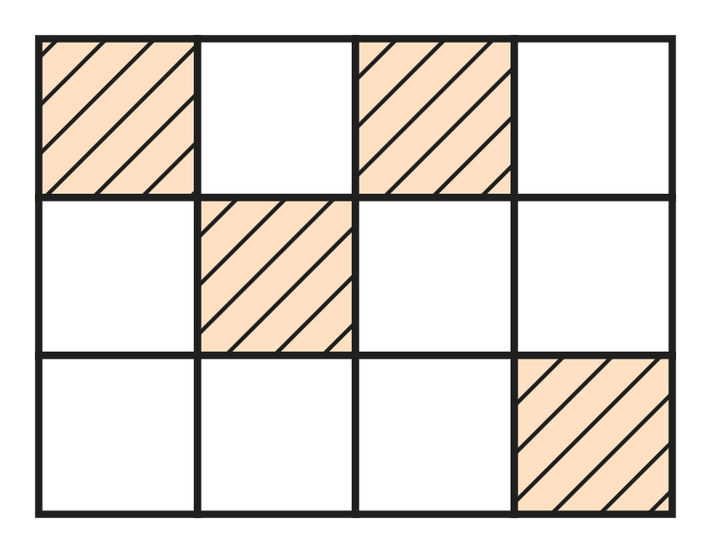
Q11. Look at the picture of a floor made of 12 equal square tiles. Some tiles are coloured. How many MORE tiles must be coloured so that $\frac{3}{4}$ of the floor is coloured?
(A) 5 | (B) 3 | (C) 9 | (D) 8

Q12. Which improper fraction is equal to the mixed number $4\frac{2}{3}$?
(A) $\frac{10}{3}$ | (B) $\frac{11}{3}$ | (C) $\frac{14}{3}$ | (D) $\frac{12}{3}$

Q13. On a rainy day, it rained for $\frac{1}{6}$ hour in the morning and for $\frac{5}{12}$ hour in the evening. What fraction of an hour did it rain in total?
(A) $\frac{7}{12}$ hour | (B) $\frac{6}{12}$ hour
(C) $\frac{3}{12}$ hour | (D) $\frac{6}{18}$ hour

Q14. Which fraction is greater than $\frac{1}{2}$ and less than $\frac{3}{4}$?
(A) $\frac{7}{8}$ | (B) $\frac{3}{8}$ | (C) $\frac{5}{6}$ | (D) $\frac{5}{8}$

Q15. A tea stall used $1\frac{3}{4}$ L of milk in the morning. Now $2\frac{1}{2}$ L of milk is left. How much milk did it have at the start?
(A) $3\frac{4}{6}$ L | (B) $4\frac{1}{4}$ L | (C) $3\frac{1}{4}$ L | (D) $\frac{3}{4}$ L

Q16. At an ice-cream stall, one scoop is $\frac{1}{12}$ of a tub. There are $2\frac{1}{3}$ tubs of ice-cream left. How many full scoops can be served?
(A) 25 | (B) 7 | (C) 28 | (D) 24

Part 4 — Geometry (Syllabus Chapter 5)
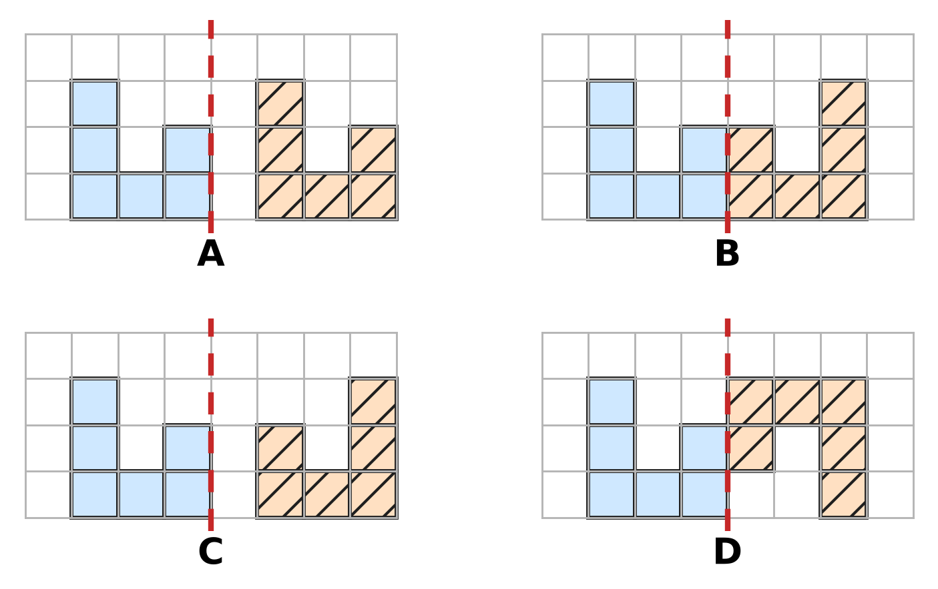
Q17. In each picture, the blue shape is on the left of the dashed mirror line. Which picture shows its correct mirror image on the right?
(A) Picture A | (B) Picture B
(C) Picture C | (D) Picture D

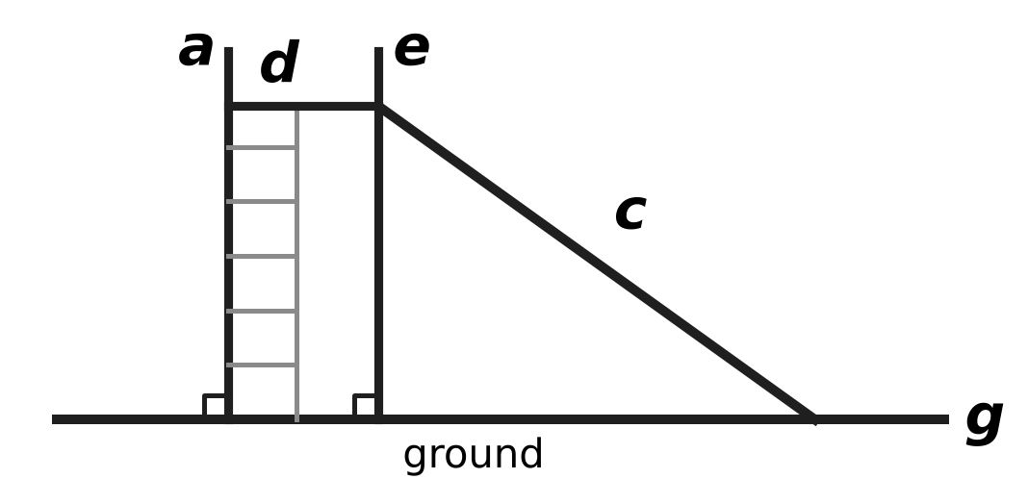
Q18. The picture shows a playground slide. Imagine that each marked line continues in both directions. Which line meets the ground line g but is NOT perpendicular to it?
(A) Line d | (B) Line c | (C) Line a | (D) Line e

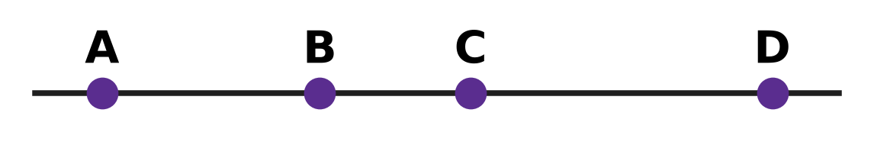
Q19. Look at the four points A, B, C and D on a straight line. How many different line segments have two of these points as their end points?
(A) 3 | (B) 4 | (C) 12 | (D) 6

Q20. Hana's solid has as many faces as vertices. It has 10 edges. For such solids, faces + vertices = edges + 2. How many faces does Hana's solid have?
(A) 6 | (B) 5 | (C) 12 | (D) 4

Part 5 — Mensuration (Syllabus Chapter 6)
Q21. The road between two villages is 3 km 40 m long. How many metres long is the road?
(A) 3,040 m | (B) 3,400 m | (C) 30,040 m | (D) 340 m

Q22. A cook shares 5 kg of rice equally into 4 bags. How much rice goes into each bag?
(A) 1 kg 500 g | (B) 1 kg 250 g
(C) 1 kg 200 g | (D) 1 kg 25 g

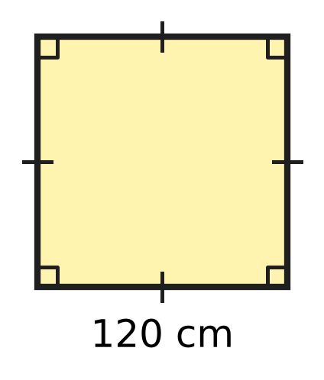
Q23. The floor of a hot-air balloon basket is a square with side 120 cm, as in the picture. What is the perimeter of the floor?
(A) 2 m 40 cm | (B) 48 m
(C) 4 m 8 cm | (D) 4 m 80 cm

Q24. A sports ground is a rectangle 45 m long and 28 m wide. What is its area?
(A) 73 sq m | (B) 146 sq m
(C) 1,260 sq m | (D) 1,160 sq m

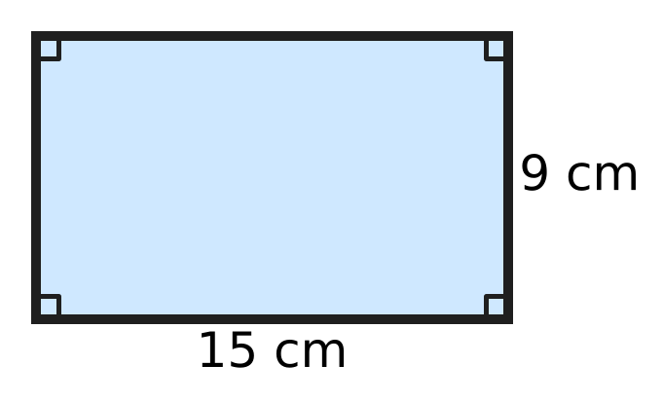
Q25. A piece of wire is bent to make the rectangle in the picture. It is then opened and bent again to make a square, using all the wire. How long is each side of the square?
(A) 24 cm | (B) 6 cm | (C) 48 cm | (D) 12 cm

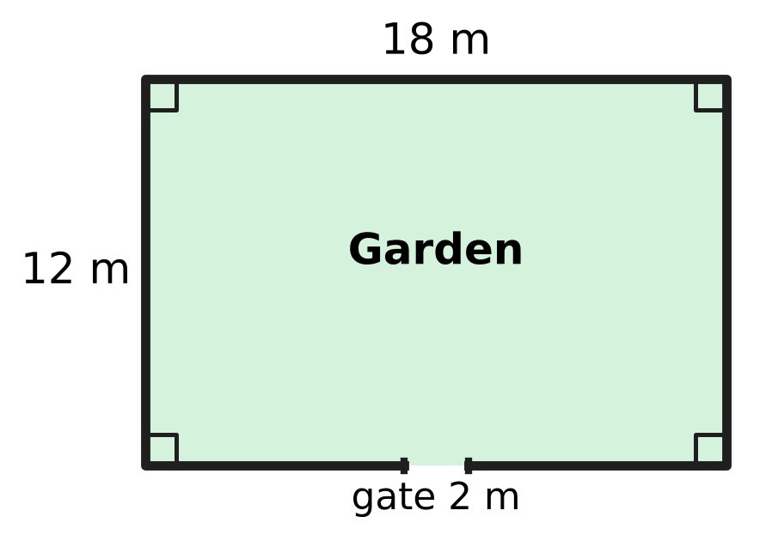
Q26. A fence goes all around the rectangular garden in the picture, except for a gate 2 m wide. How long is the fence?
(A) 58 m | (B) 56 m | (C) 60 m | (D) 28 m

Part 6 — Data Handling, Statistics & Probability (Syllabus Chapter 8)
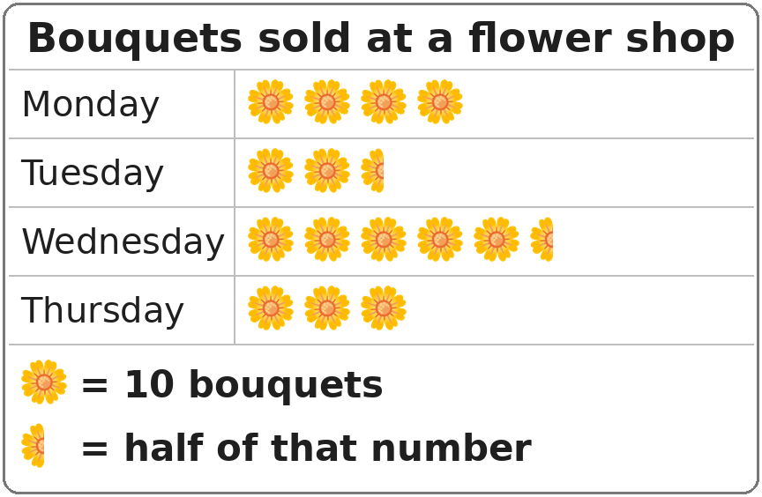
Q27. Look at the pictograph. How many bouquets were sold on Wednesday?
(A) 50 | (B) 55 | (C) 60 | (D) 6

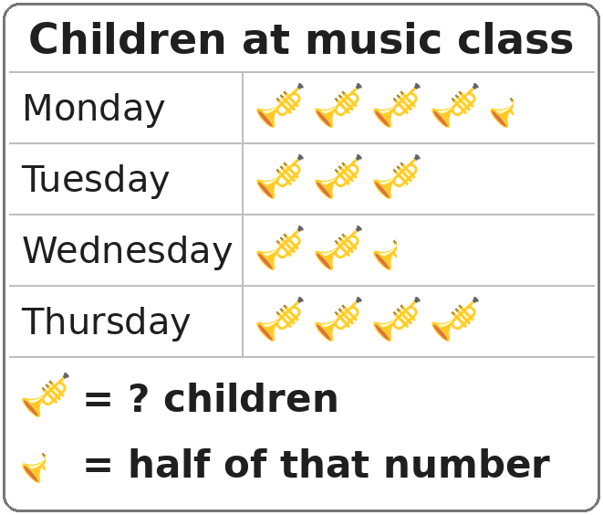
Q28. Look at the pictograph. The number in its key is missing. On Thursday, 24 children came to music class. How many children came on Monday?
(A) 30 | (B) 18 | (C) 27 | (D) 24

Part 7 — Applied Mathematics (Syllabus Chapter 9)
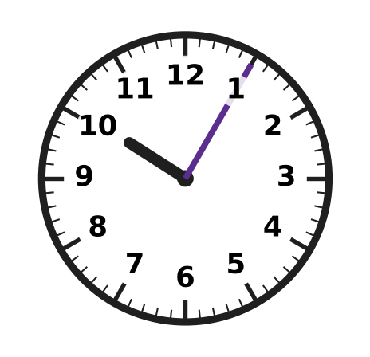
Q29. Dhruv's clock is 7 minutes fast. It shows the time in the picture. What is the correct time?
(A) 10:58 | (B) 9:58 | (C) 9:05 | (D) 10:12

Q30. A football practice starts when the minute hand of the school clock points to 3. It ends later in the same hour, when the minute hand points to 10. How many minutes does the practice last?
(A) 7 minutes | (B) 50 minutes
(C) 35 minutes | (D) 25 minutes

Q31. Yash has saved ₹428. The school bag he wants costs ₹615. How much more money does he need to buy the bag?
(A) ₹197 | (B) ₹1,043 | (C) ₹213 | (D) ₹187

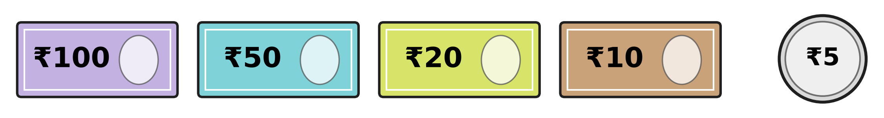
Q32. Isha has many notes and coins of each kind shown. She pays exactly ₹235 for a lunch box, using as few notes and coins as possible. How many notes and coins does she use?
(A) 5 | (B) 4 | (C) 6 | (D) 7

Q33. The lift in a building is checked on the last Friday of every month. This year, 1 December is a Monday, and December has 31 days. On which date is the lift checked in December?
(A) 19 December | (B) 26 December
(C) 31 December | (D) 29 December

Q34. A ticket for the school play costs ₹30 for a child and ₹50 for an adult. Zubin buys 4 child tickets and some adult tickets. He pays ₹420 in all. How many adult tickets does he buy?
(A) 14 | (B) 10 | (C) 8 | (D) 6

Part 8 — Mathematical Reasoning & Problem-Solving (Syllabus Chapter 10)
Q35. Which number comes next? 96, 48, 24, 12, ___
(A) 4 | (B) 0 | (C) 6 | (D) 8

Q36. Usha reads every page of a book from page 27 to page 64, including both these pages. How many pages does she read?
(A) 38 | (B) 37 | (C) 91 | (D) 36

Q37. How many weeks and days are there in 75 days?
(A) 11 weeks 2 days | (B) 10 weeks 5 days
(C) 10 weeks 4 days | (D) 7 weeks 5 days

Q38. What is the missing first number in this pattern? ___, 14, 20, 28, 38, 50
(A) 6 | (B) 12 | (C) 8 | (D) 10

Q39. Thirty cards are numbered 1 to 30. A card gets a star if its number is a multiple of 3 or a multiple of 5. How many cards get a star?
(A) 14 | (B) 10 | (C) 6 | (D) 16

Q40. A science exhibition is open for 12 days in a row. Its last day is Tuesday, 14 October. Both the first and the last days are counted. On which day of the week did it open?
(A) Thursday | (B) Sunday | (C) Friday | (D) Saturday

SECTION II — Star Questions 5 questions × 4 marks each
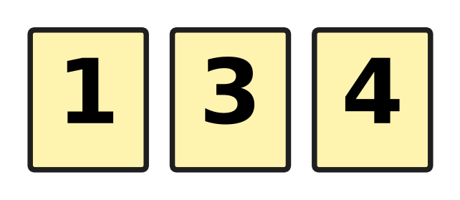
Q41. Heena has the three cards in the picture. She uses all three to make a mixed number, such as $3\frac{1}{4}$. One card is the whole number. The other two make a fraction less than 1. What is the difference between the greatest and smallest mixed numbers she can make? [4 marks]
(A) $3\frac{7}{12}$ | (B) $2\frac{7}{12}$ | (C) $1\frac{1}{12}$ | (D) $3\frac{5}{12}$

Q42. Kian's plane takes off at 10:45 p.m. on Tuesday, 30 September. The flight takes 9 hours 35 minutes. When does the plane land? [4 marks]
(A) 8:20 p.m. on Tuesday, 30 September | (B) 7:20 a.m. on Wednesday, 1 October
(C) 8:20 a.m. on Thursday, 2 October | (D) 8:20 a.m. on Wednesday, 1 October

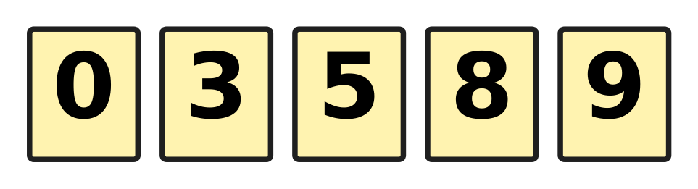
Q43. All five cards in the picture are put in a row to show a 5-digit number. A number cannot start with 0. How many different 5-digit numbers can be made that are even and greater than 85,000? [4 marks]
(A) 16 | (B) 12 | (C) 24 | (D) 18

Q44. Lata's summer holiday starts on 20 May. She spends $\frac{2}{5}$ of all the holiday days at her grandmother's house. Then she spends $\frac{1}{6}$ of the remaining days at a sports camp. The last 15 days are at home. May has 31 days. On which date does her holiday end? [4 marks]
(A) 6 June | (B) 13 June | (C) 18 June | (D) 19 June

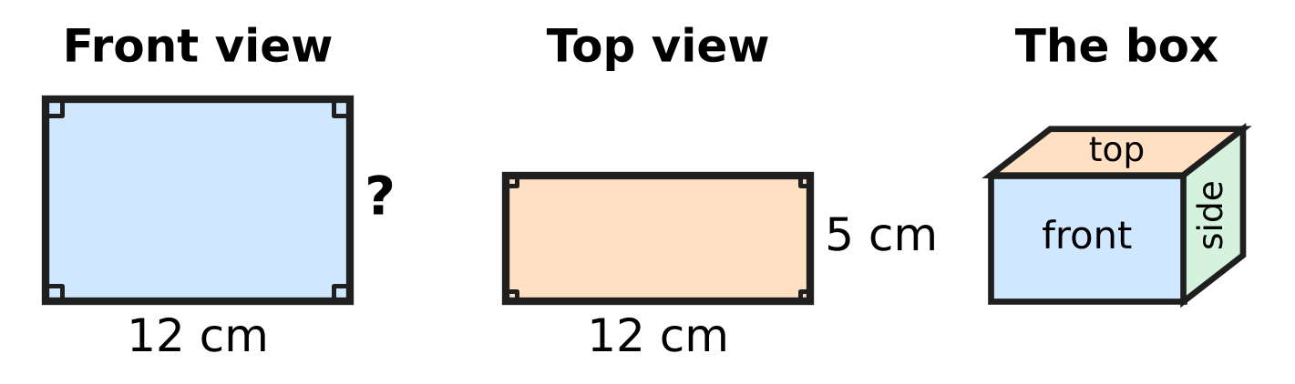
Q45. The picture shows a box shaped like a cuboid, with its front view and top view. The perimeter of the front view is 44 cm. What is the area of the side view of the box? [4 marks]
(A) 120 sq cm | (B) 60 sq cm | (C) 50 sq cm | (D) 110 sq cm

Answer Sheet AMO Level 1 · Class 4 · Practice Paper 5
Name: | School: | Roll No.:
Shade or tick one circle for each question.
1. Ⓐ Ⓑ Ⓒ Ⓓ | 16. Ⓐ Ⓑ Ⓒ Ⓓ | 31. Ⓐ Ⓑ Ⓒ Ⓓ
2. Ⓐ Ⓑ Ⓒ Ⓓ | 17. Ⓐ Ⓑ Ⓒ Ⓓ | 32. Ⓐ Ⓑ Ⓒ Ⓓ
3. Ⓐ Ⓑ Ⓒ Ⓓ | 18. Ⓐ Ⓑ Ⓒ Ⓓ | 33. Ⓐ Ⓑ Ⓒ Ⓓ
4. Ⓐ Ⓑ Ⓒ Ⓓ | 19. Ⓐ Ⓑ Ⓒ Ⓓ | 34. Ⓐ Ⓑ Ⓒ Ⓓ
5. Ⓐ Ⓑ Ⓒ Ⓓ | 20. Ⓐ Ⓑ Ⓒ Ⓓ | 35. Ⓐ Ⓑ Ⓒ Ⓓ
6. Ⓐ Ⓑ Ⓒ Ⓓ | 21. Ⓐ Ⓑ Ⓒ Ⓓ | 36. Ⓐ Ⓑ Ⓒ Ⓓ
7. Ⓐ Ⓑ Ⓒ Ⓓ | 22. Ⓐ Ⓑ Ⓒ Ⓓ | 37. Ⓐ Ⓑ Ⓒ Ⓓ
8. Ⓐ Ⓑ Ⓒ Ⓓ | 23. Ⓐ Ⓑ Ⓒ Ⓓ | 38. Ⓐ Ⓑ Ⓒ Ⓓ
9. Ⓐ Ⓑ Ⓒ Ⓓ | 24. Ⓐ Ⓑ Ⓒ Ⓓ | 39. Ⓐ Ⓑ Ⓒ Ⓓ
10. Ⓐ Ⓑ Ⓒ Ⓓ | 25. Ⓐ Ⓑ Ⓒ Ⓓ | 40. Ⓐ Ⓑ Ⓒ Ⓓ
11. Ⓐ Ⓑ Ⓒ Ⓓ | 26. Ⓐ Ⓑ Ⓒ Ⓓ | 41. Ⓐ Ⓑ Ⓒ Ⓓ
12. Ⓐ Ⓑ Ⓒ Ⓓ | 27. Ⓐ Ⓑ Ⓒ Ⓓ | 42. Ⓐ Ⓑ Ⓒ Ⓓ
13. Ⓐ Ⓑ Ⓒ Ⓓ | 28. Ⓐ Ⓑ Ⓒ Ⓓ | 43. Ⓐ Ⓑ Ⓒ Ⓓ
14. Ⓐ Ⓑ Ⓒ Ⓓ | 29. Ⓐ Ⓑ Ⓒ Ⓓ | 44. Ⓐ Ⓑ Ⓒ Ⓓ
15. Ⓐ Ⓑ Ⓒ Ⓓ | 30. Ⓐ Ⓑ Ⓒ Ⓓ | 45. Ⓐ Ⓑ Ⓒ Ⓓ
Q41–Q45 are Section II Star Questions (4 marks each).
For the parent or teacher
Section I correct: ______ / 40 × 2 = ______ marks Section II correct: ______ / 5 × 4 = ______ marks
Correct: ______ / 45 Score: ______ / 100
Answer Key and Solutions AMO Level 1 · Class 4 · Practice Paper 5
Quick answers
1 D | 6 A | 11 A | 16 C | 21 A | 26 A | 31 D | 36 A | 41 B
2 A | 7 D | 12 C | 17 B | 22 B | 27 B | 32 A | 37 B | 42 D
3 C | 8 B | 13 A | 18 B | 23 D | 28 C | 33 B | 38 D | 43 A
4 B | 9 D | 14 D | 19 D | 24 C | 29 B | 34 D | 39 A | 44 C
5 C | 10 C | 15 B | 20 A | 25 D | 30 C | 35 C | 40 C | 45 C
Solutions
Q | Part · level | Answer | Why?
1 | Part 1 · Ch1 · Easy | (D) 80,503 | The number is 80,000 + 500 + 3 = 80,503.
2 | Part 1 · Ch1 · Easy | (A) L | XL = 40 and LX = 60. The number halfway between them is 50, which is L.
3 | Part 1 · Ch1 · Easy | (C) 50,560 | Adding 1,000 raises the thousands: 49 thousands + 1 thousand = 50 thousands, so 50,560.
4 | Part 1 · Ch1 · Medium | (B) 98,764 | To make it as large as possible, use 9, 8, 7 and 6 in the first four places. The last digit must be even and not used yet; 8 and 6 are used, so it is 4. The number is 98,764.
5 | Part 1 · Ch1 · Medium | (C) 51,000 | From the 5th number back to the 1st there are 4 jumps: 41,000 + 4 × 2,500 = 51,000.
6 | Part 2 · Ch2 · Easy | (A) 64,315 | The correct sum is 38,476 + 25,839 = 64,315. Tarun lost the carry into the thousands place.
7 | Part 2 · Ch2 · Easy | (D) 3,700 | Group 25 and 4 first: 25 × 4 = 100, and 37 × 100 = 3,700.
8 | Part 2 · Ch2 · Easy | (B) 384 | Each box gets 3,456 ÷ 9 = 384 fish.
9 | Part 2 · Ch2 · Medium | (D) 27,499 | Numbers from 26,500 to 27,499 round to 27,000. The greatest is 27,499.
10 | Part 2 · Ch2 · Medium | (C) 1,728 | Here 36 × 48 is one more group of 36 than 36 × 47: 1,692 + 36 = 1,728.
11 | Part 3 · Ch3 · Easy | (A) 5 | $\frac{3}{4}$ of 12 tiles = 9 tiles. There are 4 coloured tiles, so 9 − 4 = 5 more.
12 | Part 3 · Ch3 · Easy | (C) $\frac{14}{3}$ | In 4 wholes there are 12 thirds, and 12 + 2 = 14 thirds, so $\frac{14}{3}$.
13 | Part 3 · Ch3 · Easy | (A) $\frac{7}{12}$ hour | $\frac{1}{6}$ = $\frac{2}{12}$, and $\frac{2}{12}$ + $\frac{5}{12}$ = $\frac{7}{12}$.
14 | Part 3 · Ch3 · Easy | (D) $\frac{5}{8}$ | $\frac{1}{2}$ = $\frac{4}{8}$ and $\frac{3}{4}$ = $\frac{6}{8}$, and $\frac{5}{8}$ lies between them.
15 | Part 3 · Ch3 · Medium | (B) $4\frac{1}{4}$ L | Start = used + left = $1\frac{3}{4}$ + $2\frac{1}{2}$ = $4\frac{1}{4}$ L.
16 | Part 3 · Ch3 · Medium | (C) 28 | $2\frac{1}{3}$ = $\frac{7}{3}$ = $\frac{28}{12}$, so 28 scoops.
17 | Part 4 · Ch5 · Easy | (B) Picture B | In a mirror image each square is the same distance from the mirror line, on the other side. Only Picture B shows this; the others are slid across, one square too far, or upside down.
18 | Part 4 · Ch5 · Easy | (B) Line c | Lines a and e make square corners with g, and line d is parallel to g. Only the slide, line c, meets g at a slant.
19 | Part 4 · Ch5 · Medium | (D) 6 | The segments are AB, AC, AD, BC, BD and CD: 6 in all.
20 | Part 4 · Ch5 · Medium | (A) 6 | Faces + Vertices = 10 + 2 = 12. They are equal, so there are 6 faces (a pyramid with a 5-sided base).
21 | Part 5 · Ch6 · Easy | (A) 3,040 m | Since 3 km = 3,000 m, the road is 3,000 m + 40 m = 3,040 m.
22 | Part 5 · Ch6 · Easy | (B) 1 kg 250 g | Change 5 kg to 5,000 g. Then 5,000 ÷ 4 = 1,250 g = 1 kg 250 g.
23 | Part 5 · Ch6 · Easy | (D) 4 m 80 cm | Perimeter = 4 × 120 cm = 480 cm = 4 m 80 cm.
24 | Part 5 · Ch6 · Easy | (C) 1,260 sq m | Area = 45 × 28 = 1,260 sq m.
25 | Part 5 · Ch6 · Medium | (D) 12 cm | Wire = 2 × (15 + 9) = 48 cm. Each side of the square = 48 ÷ 4 = 12 cm.
26 | Part 5 · Ch6 · Medium | (A) 58 m | Perimeter = 2 × (18 + 12) = 60 m. Leave out the gate: 60 − 2 = 58 m.
27 | Part 6 · Ch8 · Easy | (B) 55 | Wednesday has 5 whole flowers (50 bouquets) and half a flower (5 bouquets), so 55 bouquets.
28 | Part 6 · Ch8 · Medium | (C) 27 | Thursday has 4 trumpets for 24 children, so 1 trumpet = 6 children. Monday has 4½ trumpets: 24 + 3 = 27 children.
29 | Part 7 · Ch9 · Easy | (B) 9:58 | The clock shows 10:05. Going back 7 minutes gives 9:58.
30 | Part 7 · Ch9 · Easy | (C) 35 minutes | From the 3 to the 10 the minute hand moves 7 numbers, and each number is 5 minutes: 7 × 5 = 35 minutes.
31 | Part 7 · Ch9 · Easy | (D) ₹187 | Money needed = ₹615 − ₹428 = ₹187.
32 | Part 7 · Ch9 · Easy | (A) 5 | ₹235 = ₹100 + ₹100 + ₹20 + ₹10 + ₹5, which is 5 notes and coins.
33 | Part 7 · Ch9 · Medium | (B) 26 December | Since 1 December is a Monday, 5 December is a Friday. The Fridays are 5, 12, 19 and 26. The last is 26 December.
34 | Part 7 · Ch9 · Medium | (D) 6 | The 4 child tickets cost 4 × ₹30 = ₹120. Then ₹420 − ₹120 = ₹300, and ₹300 ÷ ₹50 = 6 adult tickets.
35 | Part 8 · Ch10 · Easy | (C) 6 | Each number is half of the one before it. Half of 12 is 6.
36 | Part 8 · Ch10 · Easy | (A) 38 | From page 27 to page 64 there are 64 − 27 = 37 jumps, and counting both end pages gives 37 + 1 = 38 pages.
37 | Part 8 · Ch10 · Easy | (B) 10 weeks 5 days | Here 10 weeks = 70 days, and 75 − 70 = 5. So 75 days = 10 weeks 5 days.
38 | Part 8 · Ch10 · Medium | (D) 10 | The jumps are 6, 8, 10, 12, so the jump before 6 is 4. The first number is 14 − 4 = 10.
39 | Part 8 · Ch10 · Medium | (A) 14 | Multiples of 3: 10. Multiples of 5: 6. Cards 15 and 30 are in both lists, so 10 + 6 − 2 = 14.
40 | Part 8 · Ch10 · Medium | (C) Friday | The first day is 11 days before the last: 14 − 11 = 3 October. Since 11 days = 1 week + 4 days, it opened 4 days before Tuesday, which is Friday.
41 | Section II · Ch3 + Ch10 · Hard | (B) $2\frac{7}{12}$ | She can make $1\frac{3}{4}$, $3\frac{1}{4}$ and $4\frac{1}{3}$. $4\frac{1}{3}$ − $1\frac{3}{4}$ = $\frac{52}{12}$ − $\frac{21}{12}$ = $\frac{31}{12}$ = $2\frac{7}{12}$.
42 | Section II · Ch9 + Ch10 · Hard | (D) 8:20 a.m. on Wednesday, 1 October | From 10:45 p.m., 1 hour 15 minutes takes us to midnight. That leaves 9 hours 35 minutes − 1 hour 15 minutes = 8 hours 20 minutes, so the plane lands at 8:20 a.m. the next day. The day after Tuesday, 30 September is Wednesday, 1 October.
43 | Section II · Ch1 + Ch10 · Hard | (A) 16 | Starting with 9: the last digit is 0 or 8, and the middle 3 digits can be arranged in 6 ways: 12. Starting with 8: the second digit must be 5 or 9 and the last digit 0, with 2 ways each: 4. Total 16.
44 | Section II · Ch3 + Ch9 · Hard | (C) 18 June | The last 15 days are $\frac{5}{6}$ of the days left, so 18 days were left. These 18 days are $\frac{3}{5}$ of the holiday, so the holiday is 30 days. There are 12 days in May (20 to 31 May) and 18 days in June, so the last day is 18 June.
45 | Section II · Ch5 + Ch6 · Hard | (C) 50 sq cm | Front view: 2 × (12 + height) = 44, so height = 10 cm. The top view shows the width, 5 cm. The side view is 5 cm by 10 cm, so its area is 50 sq cm.

