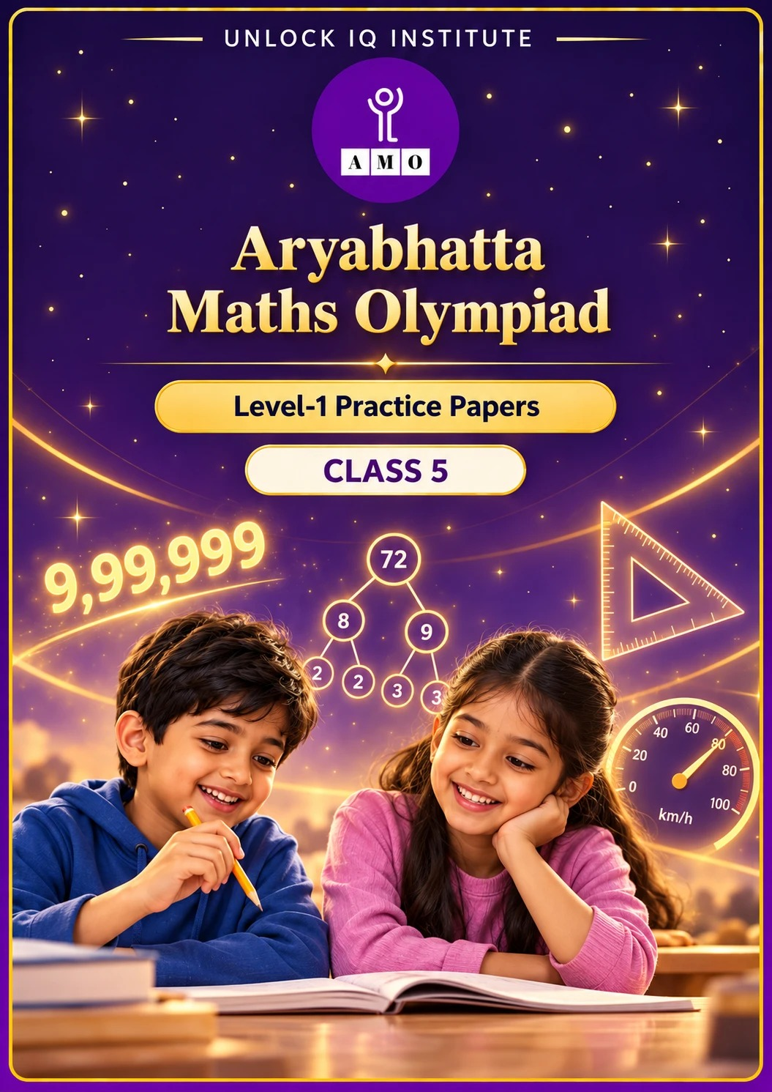
Five full practice papers · with answer keys & detailed solutions
Name: ____________________ | Class & Section: ________________
Roll No.: ________________ | School: ____________________
City: ____________________ | Date: ____________________

Published by Unlock IQ Institute Pvt. Ltd.
Register for Olympiads: www.aryabhattamathsolympiad.com/student-registration

ARYABHATTA MATHS OLYMPIAD
Level 1
PRACTICE PAPER-1
CLASS 5
Total Questions | 45 multiple-choice questions
Total Marks | 100
Time | 60 minutes
Section I | 40 questions × 2 marks = 80 marks
Section II | 5 Star Questions × 4 marks = 20 marks
Negative Marking | No negative marking
Calculator | Not allowed
Chapters | Number System · Operations · Fractions, Decimals & Percentages · Geometry · Mensuration · Data Handling · Applied Mathematics · Mathematical Reasoning

👋 Hello, friend! How to do this paper:
⭐ Every question has four answer choices: (A), (B), (C) and (D). Only one is correct.
⭐ Read each question and look at its picture carefully. Then mark your answer on the answer sheet at the end.
⭐ Section I has 40 questions of 2 marks each. Section II has 5 Star Questions of 4 marks each.
⭐ There is no negative marking, so try every question.
⭐ Do not use a calculator. You may do rough work on a separate sheet.
⭐ All figures are not necessarily drawn to scale unless stated.

For parents and teachers
• Print or view this paper in colour. Pictures are part of the questions.
• Parts follow the AMO syllabus chapters. Chapters 4 and 7 are not part of the Class 5 syllabus, so the chapter numbers shown in the Part headings have gaps.
• The answer sheet and the answer key are at the end. Remove only the answer key before the child begins.

SECTION I 40 questions × 2 marks each
Part 1 — Number System (Syllabus Chapter 1)
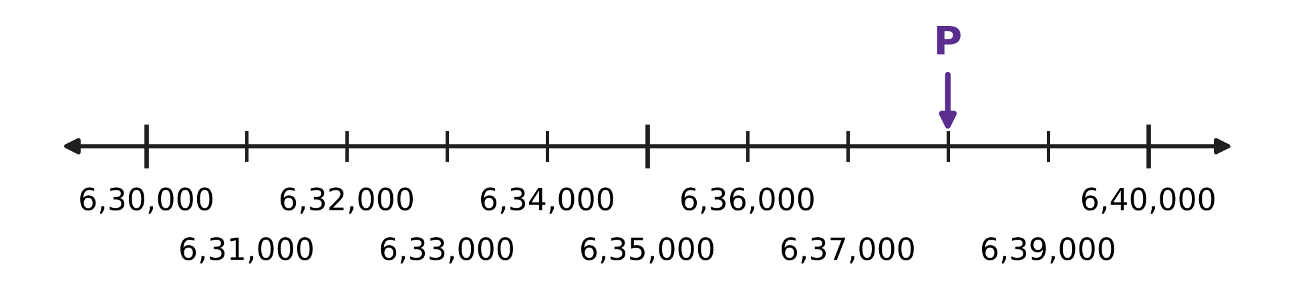
Q1. Look at the number line. All the small steps are equal. Which number does the arrow P point to?
(A) 6,30,800 | (B) 6,37,000 | (C) 6,38,000 | (D) 7,10,000

Q2. The year in which a clock tower was built is carved on it as MCMLXIV. In which year was it built?
(A) 2164 | (B) 1944 | (C) 1966 | (D) 1964

Q3. How many prime numbers are greater than 60 and less than 80?
(A) 5 | (B) 6 | (C) 4 | (D) 3

Q4. Asha has 72 red marbles and 48 blue marbles. She shares them equally among as many jars as possible. Every jar must have the same number of red marbles and the same number of blue marbles. How many marbles will be in each jar?
(A) 5 | (B) 10 | (C) 15 | (D) 24

Q5. A teacher sets out 60 chairs in equal rows. There must be at least 2 rows and at least 2 chairs in each row. Count 6 rows of 10 and 10 rows of 6 as different ways. How many ways are possible?
(A) 12 | (B) 5 | (C) 6 | (D) 10

Part 2 — Operations & Number Properties (Syllabus Chapter 2)
Q6. What is the value of 72 − [5 × (11 − 4) + 9]?
(A) 28 | (B) 46 | (C) 51 | (D) 12

Q7. Ishan wants to work out 46 × 25 + 54 × 25 the quick way. Which expression has the same value?
(A) 46 × 54 × 25 | (B) 46 + 54 × 25
(C) (46 + 25) × (54 + 25) | (D) (46 + 54) × 25

Q8. A stationery shop sold 198 notebooks at ₹42 each. Round 198 to the nearest hundred and ₹42 to the nearest ten. What is the estimated money collected?
(A) ₹800 | (B) ₹8,316 | (C) ₹10,000 | (D) ₹8,000

Q9. Look at these four expressions.
P: 36 + 24 ÷ 4 × 3
Q: (36 + 24) ÷ 4 × 3
R: 36 + 24 ÷ (4 × 3)
S: 36 + (24 ÷ 4) × 3
Which TWO of them have the same value?
(A) Q and R | (B) P and S | (C) P and Q | (D) P and R

Q10. A rainwater tank has 2,970 litres of water. A family uses 48 litres of it each day. Round 2,970 to the nearest thousand and 48 to the nearest ten. About how many days will the water last?
(A) 600 days | (B) 6 days | (C) 60 days | (D) 75 days

Part 3 — Fractions, Decimals & Percentages (Syllabus Chapter 3)
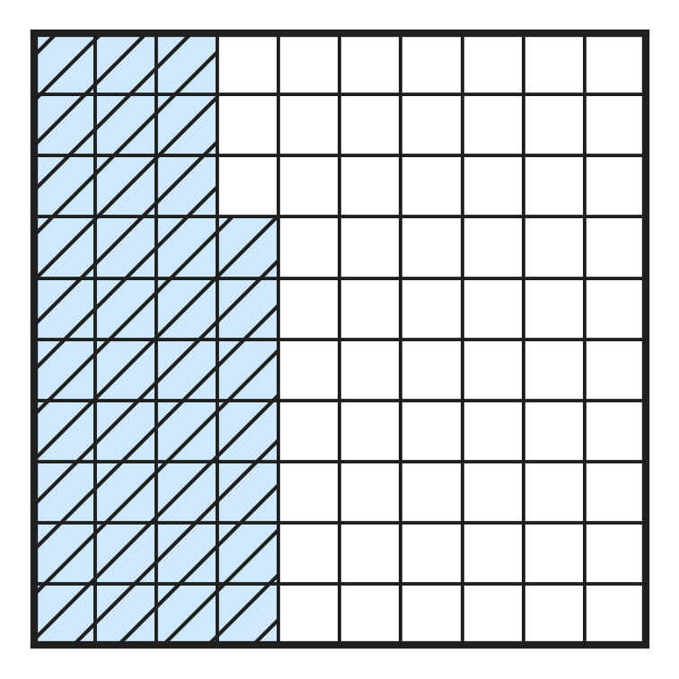
Q11. In the picture, the big square is cut into 100 equal small squares. What part of the big square is shaded, written as a decimal?
(A) 0.37 | (B) 3.7 | (C) 0.73 | (D) 0.63

Q12. Write 0.85 as a fraction in its simplest form.
(A) $\frac{17}{2}$ | (B) $\frac{4}{5}$ | (C) $\frac{8}{5}$ | (D) $\frac{17}{20}$

Q13. On a windy day, 20 kites were flown in a park. Of these, 17 stayed in the air for an hour. What percentage of the kites stayed in the air?
(A) 17% | (B) 85% | (C) 34% | (D) 15%

Q14. An apple orchard has 360 trees. Of these, 20% are young trees. How many young trees are there?
(A) 72 | (B) 288 | (C) 36 | (D) 340

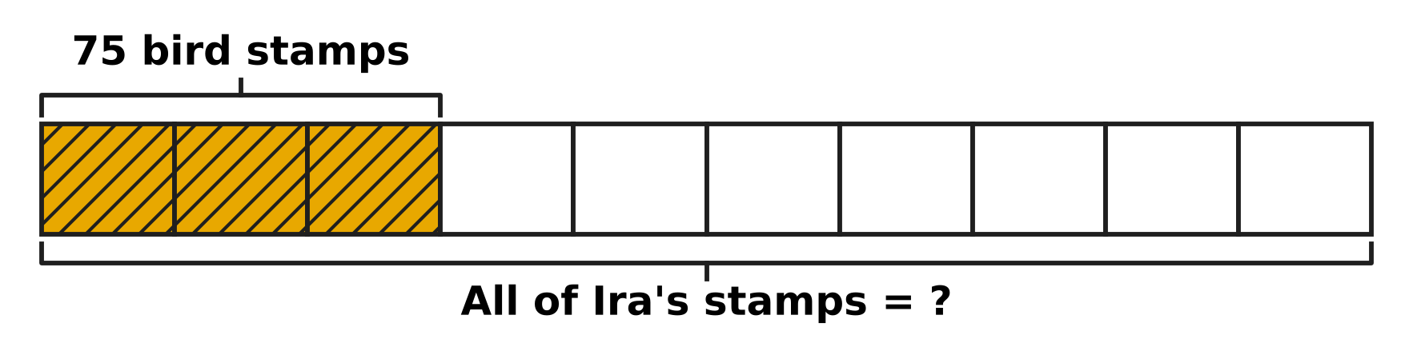
Q15. The bar in the picture shows all of Ira's stamps. It is cut into 10 equal parts, so each part is 10% of her stamps. Her 75 bird stamps are the shaded part. How many stamps does Ira have in all?
(A) 225 | (B) 175 | (C) 250 | (D) 25

Q16. Shreya has a ribbon 3.6 m long. She cuts off $\frac{3}{5}$ m for a card and then 1.25 m for a gift. How long is the ribbon left?
(A) 3.00 m | (B) 2.00 m | (C) 2.05 m | (D) 1.75 m

Part 4 — Geometry (Syllabus Chapter 5)
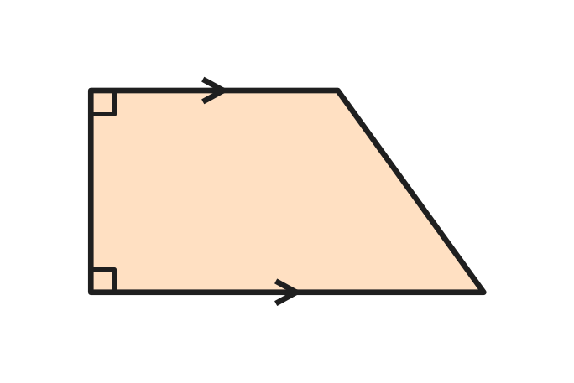
Q17. The picture shows the shape of a classroom notice board. The arrows mark its only pair of parallel sides. Which name fits this shape?
(A) Rectangle | (B) Rhombus
(C) Trapezium | (D) Parallelogram

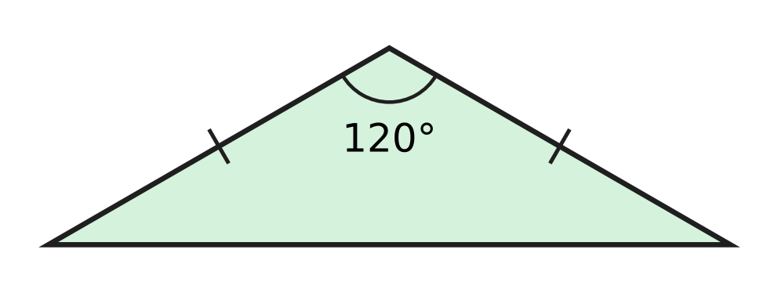
Q18. In the triangle shown, the tick marks show equal sides. Which name describes this triangle?
(A) Obtuse-angled and isosceles | (B) Right-angled and isosceles
(C) Obtuse-angled and scalene | (D) Acute-angled and isosceles

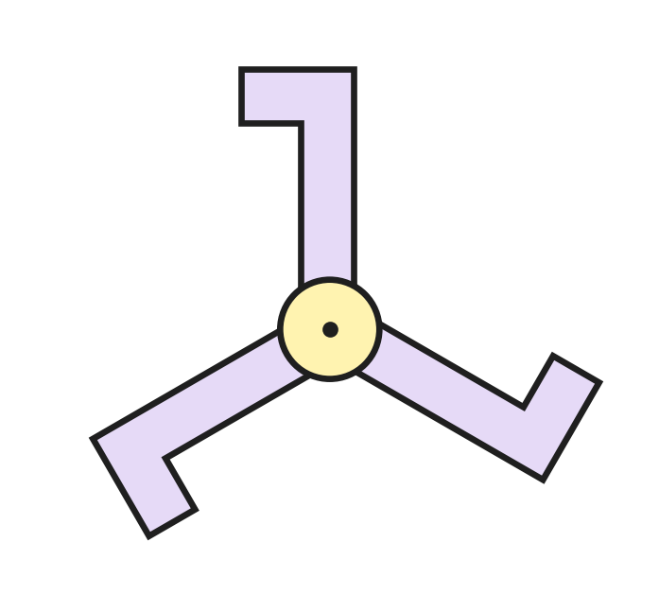
Q19. The design shown is turned about its centre dot. What is its order of rotational symmetry?
(A) 6 | (B) 3 | (C) 2 | (D) 1

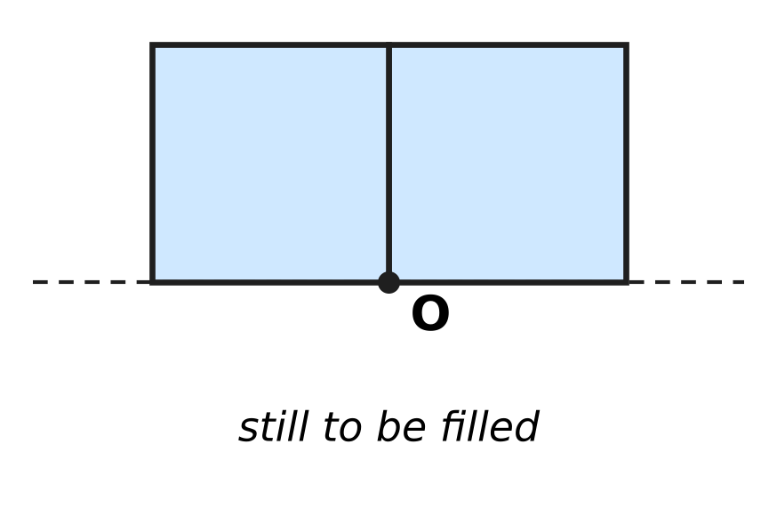
Q20. Look at the picture. Two square tiles sit side by side, and a corner of each meets at point O. Equilateral triangle tiles fill the rest of the space around O, with no gaps and no overlaps. How many triangle tiles meet at O?
(A) 4 | (B) 3 | (C) 6 | (D) 2

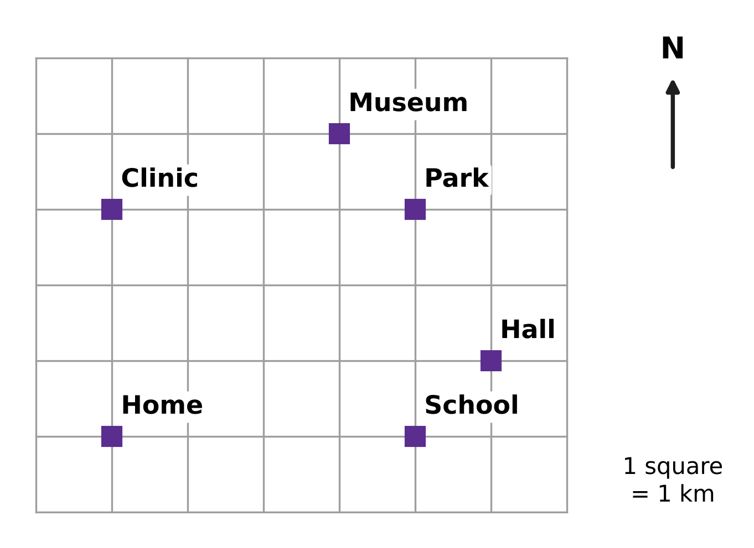
Q21. Look at the map. North is at the top and each square is 1 km. Mia starts at Home, walks 3 km North along the lines and then 4 km East. Where is she now?
(A) School | (B) Clinic | (C) Park | (D) Museum

Part 5 — Mensuration (Syllabus Chapter 6)
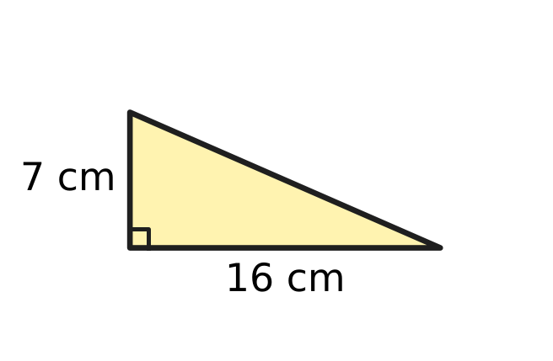
Q22. What is the area of the right-angled triangle shown?
(A) 56 sq cm | (B) 28 sq cm
(C) 112 sq cm | (D) 23 sq cm

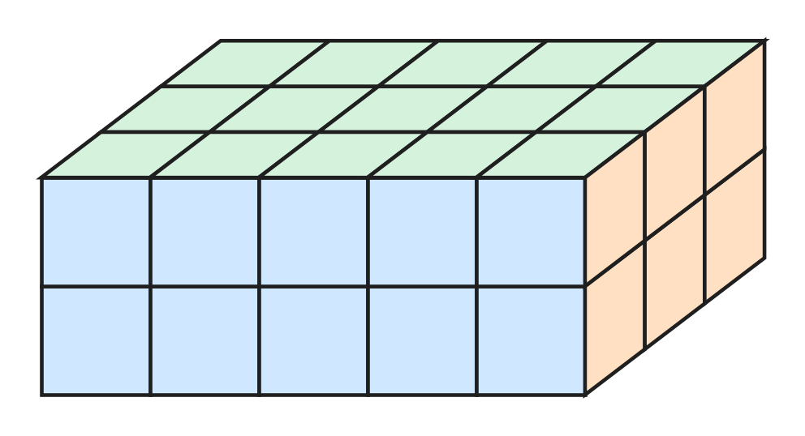
Q23. The solid cuboid shown is made of 1 cm cubes with no gaps inside. What is its volume?
(A) 15 cubic cm | (B) 10 cubic cm
(C) 22 cubic cm | (D) 30 cubic cm

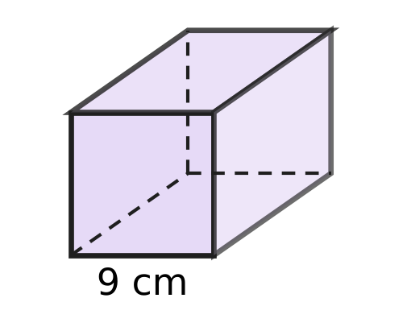
Q24. Viraj has a cube-shaped gift box with edges of 9 cm, as shown. What is the volume of the box?
(A) 81 cubic cm | (B) 108 cubic cm
(C) 27 cubic cm | (D) 729 cubic cm

Q25. A bakery box is packed exactly with cube-shaped cakes. Each cake has edges of 4 cm. The cakes are in 3 layers, and each layer is 5 cakes long and 4 cakes wide. The baker takes out the whole top layer. What volume of the box is now empty?
(A) 320 cubic cm | (B) 1,280 cubic cm
(C) 3,840 cubic cm | (D) 2,560 cubic cm

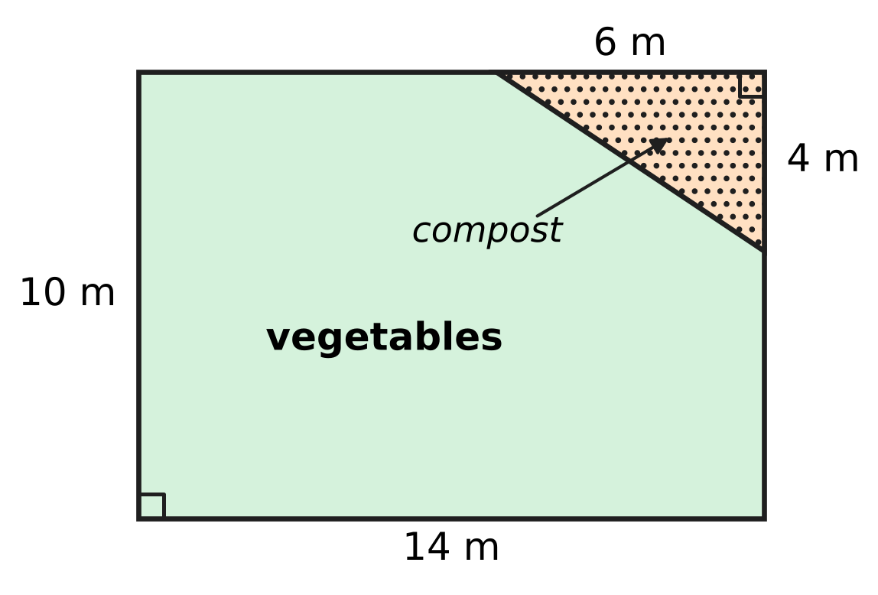
Q26. The plan shows a rectangular vegetable garden. A right-angled triangle in one corner is used for compost. What area is left for vegetables?
(A) 116 sq m | (B) 130 sq m | (C) 128 sq m | (D) 140 sq m

Part 6 — Data Handling, Statistics & Probability (Syllabus Chapter 8)
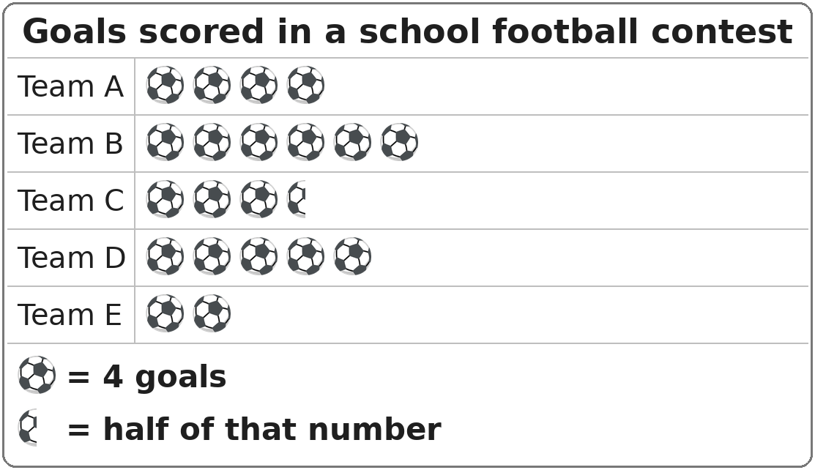
Q27. The pictograph shows the goals scored by five teams in a school football contest. How many more goals did Team B score than Team E?
(A) 16 | (B) 32 | (C) 4 | (D) 24

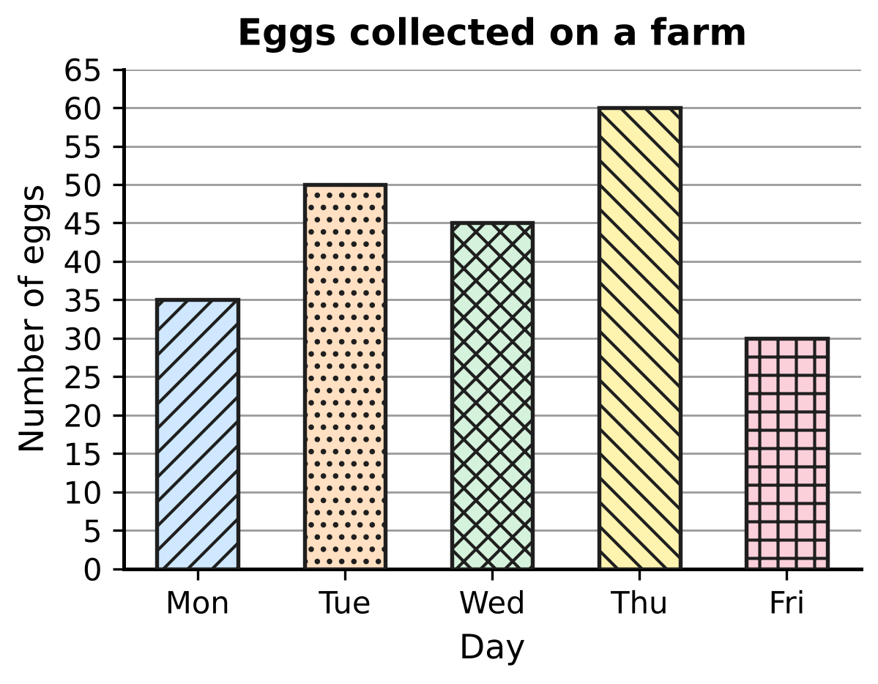
Q28. The bar graph shows the eggs collected from the hens on a farm. What is the total number of eggs collected on the days when more than 40 eggs were collected?
(A) 155 | (B) 110 | (C) 220 | (D) 190

Part 7 — Applied Mathematics (Syllabus Chapter 9)
Q29. In a swimming pool, Leela swam four lengths in 5 minutes 10 seconds. Bela swam the same four lengths in 4 minutes 55 seconds. How many seconds faster was Bela?
(A) 105 seconds | (B) 45 seconds
(C) 15 seconds | (D) 55 seconds

Q30. A snail crawls at a steady speed of 5 metres per hour. How long will it take to crawl 35 metres?
(A) 175 hours | (B) 7 hours
(C) 30 hours | (D) 40 hours

Q31. A bean seed took 2 days 9 hours to sprout. How many hours is that?
(A) 48 hours | (B) 29 hours | (C) 33 hours | (D) 57 hours

Q32. A cheetah runs 360 metres in 15 seconds. What is its speed in metres per second?
(A) 24 metres per second | (B) 25 metres per second
(C) 36 metres per second | (D) 345 metres per second

Q33. Arnav and Esha ride bicycles on the same 20 km route. Arnav rides it in 1 hour 15 minutes without stopping. Esha rides the first 5 km uphill in 1 hour 15 minutes, rests for 30 minutes, and then rides the last 15 km in 45 minutes. Count Esha's rest as part of her time. How much greater is Arnav's average speed than Esha's?
(A) 12 km/h | (B) 4 km/h | (C) 6 km/h | (D) 8 km/h

Q34. A delivery van moves at a steady speed of 54 km/h. How many metres does it travel in one minute?
(A) 3,240 m | (B) 900 m | (C) 54 m | (D) 90 m

Part 8 — Mathematical Reasoning & Problem-Solving (Syllabus Chapter 10)
Q35. What is the next number in the series 3, 12, 48, 192, ___ ?
(A) 384 | (B) 240 | (C) 768 | (D) 576

Q36. The year 2028 is a leap year, and 1 January 2028 is a Saturday. How many Saturdays are there in 2028?
(A) 53 | (B) 48 | (C) 54 | (D) 52

Q37. Without adding, decide which number can be added to 21 + 43 + 65 so that the total is still an odd number.
(A) 39 | (B) 81 | (C) 17 | (D) 54

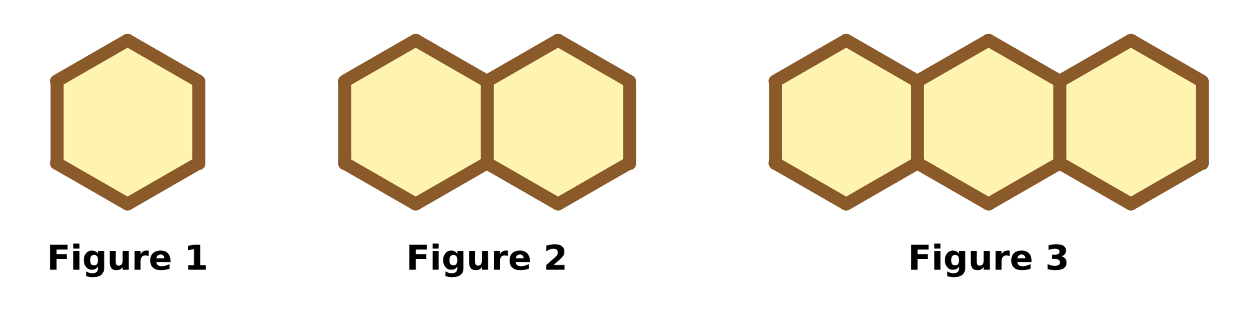
Q38. Kai makes a row of hexagons with sticks, as shown. Each new figure has one more hexagon. How many sticks does he need for Figure 12?
(A) 66 | (B) 72 | (C) 61 | (D) 60

Q39. Navya borrows a book from the school library on 24 May. She must return it exactly 40 days later. On which date must she return it?
(A) 2 July | (B) 3 July | (C) 4 July | (D) 1 July

Q40. Laksh puts counters into 7 boxes. Each box gets an odd number of counters, and no two boxes get the same number. Which of these could be the total number of counters?
(A) 45 | (B) 56 | (C) 63 | (D) 70

SECTION II — Star Questions 5 questions × 4 marks each
Q41. Most numbers have an even number of factors. For example, 12 has the 6 factors 1, 2, 3, 4, 6 and 12. How many whole numbers from 1 to 50 have an odd number of factors? [4 marks]
(A) 6 | (B) 7 | (C) 15 | (D) 25

Q42. A ball is dropped from a height of 256 cm. After each bounce it rises to 75% of the height it fell from. How high does it rise after the 4th bounce? [4 marks]
(A) 64 cm | (B) 81 cm | (C) 108 cm | (D) 192 cm

Q43. Mei draws right-angled triangles. The base is a whole number from 1 cm to 6 cm. The height is a whole number from 1 cm to 5 cm. She draws one triangle for each of the 30 base–height pairs. How many of them have an area that is a whole number of square centimetres? [4 marks]
(A) 9 | (B) 15 | (C) 21 | (D) 27

Q44. Advait and Swati start together from the starting line of a 900 m running track and run around it in the same direction. Advait runs 150 m every minute and Swati runs 100 m every minute. After how many minutes are they next together at the starting line? [4 marks]
(A) 3 minutes | (B) 15 minutes
(C) 18 minutes | (D) 54 minutes

Q45. A school bus usually takes 1 hour 12 minutes to reach school at a speed of 50 km/h. On a rainy day its speed is reduced by 20%. How many minutes longer does the trip take? [4 marks]
(A) 14.4 minutes | (B) 18 minutes
(C) 20 minutes | (D) 90 minutes

Answer Sheet AMO Level 1 · Class 5 · Practice Paper 1
Name: | School: | Roll No.:
Shade or tick one circle for each question.
1. Ⓐ Ⓑ Ⓒ Ⓓ | 16. Ⓐ Ⓑ Ⓒ Ⓓ | 31. Ⓐ Ⓑ Ⓒ Ⓓ
2. Ⓐ Ⓑ Ⓒ Ⓓ | 17. Ⓐ Ⓑ Ⓒ Ⓓ | 32. Ⓐ Ⓑ Ⓒ Ⓓ
3. Ⓐ Ⓑ Ⓒ Ⓓ | 18. Ⓐ Ⓑ Ⓒ Ⓓ | 33. Ⓐ Ⓑ Ⓒ Ⓓ
4. Ⓐ Ⓑ Ⓒ Ⓓ | 19. Ⓐ Ⓑ Ⓒ Ⓓ | 34. Ⓐ Ⓑ Ⓒ Ⓓ
5. Ⓐ Ⓑ Ⓒ Ⓓ | 20. Ⓐ Ⓑ Ⓒ Ⓓ | 35. Ⓐ Ⓑ Ⓒ Ⓓ
6. Ⓐ Ⓑ Ⓒ Ⓓ | 21. Ⓐ Ⓑ Ⓒ Ⓓ | 36. Ⓐ Ⓑ Ⓒ Ⓓ
7. Ⓐ Ⓑ Ⓒ Ⓓ | 22. Ⓐ Ⓑ Ⓒ Ⓓ | 37. Ⓐ Ⓑ Ⓒ Ⓓ
8. Ⓐ Ⓑ Ⓒ Ⓓ | 23. Ⓐ Ⓑ Ⓒ Ⓓ | 38. Ⓐ Ⓑ Ⓒ Ⓓ
9. Ⓐ Ⓑ Ⓒ Ⓓ | 24. Ⓐ Ⓑ Ⓒ Ⓓ | 39. Ⓐ Ⓑ Ⓒ Ⓓ
10. Ⓐ Ⓑ Ⓒ Ⓓ | 25. Ⓐ Ⓑ Ⓒ Ⓓ | 40. Ⓐ Ⓑ Ⓒ Ⓓ
11. Ⓐ Ⓑ Ⓒ Ⓓ | 26. Ⓐ Ⓑ Ⓒ Ⓓ | 41. Ⓐ Ⓑ Ⓒ Ⓓ
12. Ⓐ Ⓑ Ⓒ Ⓓ | 27. Ⓐ Ⓑ Ⓒ Ⓓ | 42. Ⓐ Ⓑ Ⓒ Ⓓ
13. Ⓐ Ⓑ Ⓒ Ⓓ | 28. Ⓐ Ⓑ Ⓒ Ⓓ | 43. Ⓐ Ⓑ Ⓒ Ⓓ
14. Ⓐ Ⓑ Ⓒ Ⓓ | 29. Ⓐ Ⓑ Ⓒ Ⓓ | 44. Ⓐ Ⓑ Ⓒ Ⓓ
15. Ⓐ Ⓑ Ⓒ Ⓓ | 30. Ⓐ Ⓑ Ⓒ Ⓓ | 45. Ⓐ Ⓑ Ⓒ Ⓓ
Q41–Q45 are Section II Star Questions (4 marks each).
For the parent or teacher
Section I correct: ______ / 40 × 2 = ______ marks Section II correct: ______ / 5 × 4 = ______ marks
Correct: ______ / 45 Score: ______ / 100
Answer Key and Solutions AMO Level 1 · Class 5 · Practice Paper 1
Quick answers
1 C | 6 A | 11 A | 16 D | 21 C | 26 C | 31 D | 36 A | 41 B
2 D | 7 D | 12 D | 17 C | 22 A | 27 A | 32 A | 37 D | 42 B
3 A | 8 D | 13 B | 18 A | 23 D | 28 A | 33 D | 38 C | 43 C
4 A | 9 B | 14 A | 19 B | 24 D | 29 C | 34 B | 39 B | 44 C
5 D | 10 C | 15 C | 20 B | 25 B | 30 B | 35 C | 40 C | 45 B
Solutions
Q | Part · level | Answer | Why?
1 | Part 1 · Ch1 · Easy | (C) 6,38,000 | From 6,30,000 to 6,35,000 there are 5 equal steps, so each step is 1,000. P is 8 steps after 6,30,000, at 6,38,000.
2 | Part 1 · Ch1 · Easy | (D) 1964 | M = 1000, CM = 900, LX = 60 and IV = 4. So MCMLXIV = 1000 + 900 + 60 + 4 = 1964.
3 | Part 1 · Ch1 · Easy | (A) 5 | The primes are 61, 67, 71, 73 and 79. That is 5 prime numbers.
4 | Part 1 · Ch1 · Medium | (A) 5 | The most jars = HCF of 72 and 48 = 24. Each jar has 3 red and 2 blue marbles, so 5 marbles.
5 | Part 1 · Ch1 · Medium | (D) 10 | Factors of 60: 1, 2, 3, 4, 5, 6, 10, 12, 15, 20, 30, 60. Leaving out 1 and 60, each of the other 10 factors gives one way to choose the number of rows.
6 | Part 2 · Ch2 · Easy | (A) 28 | Round brackets first: 11 − 4 = 7. Then the square brackets: 5 × 7 + 9 = 44. Finally 72 − 44 = 28.
7 | Part 2 · Ch2 · Easy | (D) (46 + 54) × 25 | 25 is multiplied by both 46 and 54, so 46 × 25 + 54 × 25 = (46 + 54) × 25 = 100 × 25 = 2,500.
8 | Part 2 · Ch2 · Easy | (D) ₹8,000 | 198 rounds to 200 and ₹42 rounds to ₹40. The estimate is 200 × 40 = ₹8,000.
9 | Part 2 · Ch2 · Medium | (B) P and S | P = 36 + 6 × 3 = 54, Q = 15 × 3 = 45, R = 36 + 2 = 38 and S = 36 + 18 = 54. So P and S have the same value, 54.
10 | Part 2 · Ch2 · Medium | (C) 60 days | 2,970 rounds to 3,000 and 48 rounds to 50. 3,000 ÷ 50 = 60, so about 60 days.
11 | Part 3 · Ch3 · Easy | (A) 0.37 | 37 of the 100 squares are shaded: $\frac{37}{100}$ = 0.37.
12 | Part 3 · Ch3 · Easy | (D) $\frac{17}{20}$ | 0.85 = $\frac{85}{100}$. Dividing top and bottom by 5 gives $\frac{17}{20}$.
13 | Part 3 · Ch3 · Easy | (B) 85% | 17 out of 20 = $\frac{17}{20}$ = $\frac{85}{100}$ = 85%.
14 | Part 3 · Ch3 · Easy | (A) 72 | 20% = $\frac{1}{5}$. One-fifth of 360 = 72.
15 | Part 3 · Ch3 · Medium | (C) 250 | 3 parts (30%) = 75 stamps, so 1 part = 25 stamps. 10 parts = 250 stamps.
16 | Part 3 · Ch3 · Medium | (D) 1.75 m | $\frac{3}{5}$ m = 0.6 m. 3.6 − 0.6 = 3.0 m, and 3.0 − 1.25 = 1.75 m.
17 | Part 4 · Ch5 · Easy | (C) Trapezium | A quadrilateral with exactly one pair of parallel sides is a trapezium.
18 | Part 4 · Ch5 · Easy | (A) Obtuse-angled and isosceles | One angle is 120°, which is more than 90°, so it is obtuse-angled. Two sides are equal, so it is isosceles.
19 | Part 4 · Ch5 · Easy | (B) 3 | The design looks the same after turns of 120°, 240° and 360°, so it looks the same 3 times in a full turn: order 3.
20 | Part 4 · Ch5 · Medium | (B) 3 | The squares use 90° + 90° = 180° at O. 360° − 180° = 180° is left, and each triangle corner is 60°, so 180 ÷ 60 = 3 triangles.
21 | Part 4 · Ch5 · Medium | (C) Park | From Home, 3 km North (3 squares up) reaches the Clinic. Then 4 km East (4 squares right) reaches the Park.
22 | Part 5 · Ch6 · Easy | (A) 56 sq cm | Area = $\frac{1}{2}$ × 16 × 7 = 56 sq cm.
23 | Part 5 · Ch6 · Easy | (D) 30 cubic cm | The cuboid is 5 cubes long, 3 cubes deep and 2 cubes high: 5 × 3 × 2 = 30 cubic cm.
24 | Part 5 · Ch6 · Easy | (D) 729 cubic cm | Volume of a cube = side × side × side = 9 × 9 × 9 = 729 cubic cm.
25 | Part 5 · Ch6 · Medium | (B) 1,280 cubic cm | The top layer has 5 × 4 = 20 cakes. Each cake is 4 × 4 × 4 = 64 cubic cm, so the empty space is 20 × 64 = 1,280 cubic cm.
26 | Part 5 · Ch6 · Medium | (C) 128 sq m | Garden: 14 × 10 = 140 sq m. Compost: $\frac{1}{2}$ × 6 × 4 = 12 sq m. Left: 140 − 12 = 128 sq m.
27 | Part 6 · Ch8 · Easy | (A) 16 | Team B has 6 symbols and Team E has 2, so Team B has 4 symbols more. 4 × 4 = 16 goals more.
28 | Part 6 · Ch8 · Medium | (A) 155 | More than 40 eggs on Tuesday (50), Wednesday (45) and Thursday (60). 50 + 45 + 60 = 155 eggs.
29 | Part 7 · Ch9 · Easy | (C) 15 seconds | From 4 minutes 55 seconds it is 5 seconds to 5 minutes, and then 10 seconds more to 5 minutes 10 seconds. 5 + 10 = 15 seconds.
30 | Part 7 · Ch9 · Easy | (B) 7 hours | Time = distance ÷ speed = 35 ÷ 5 = 7 hours.
31 | Part 7 · Ch9 · Easy | (D) 57 hours | 2 days = 2 × 24 = 48 hours. 48 + 9 = 57 hours.
32 | Part 7 · Ch9 · Easy | (A) 24 metres per second | Speed = distance ÷ time = 360 ÷ 15 = 24 metres per second.
33 | Part 7 · Ch9 · Medium | (D) 8 km/h | Arnav: 20 km ÷ 1$\frac{1}{4}$ h = 16 km/h. Esha takes 1$\frac{1}{4}$ h + $\frac{1}{2}$ h + $\frac{3}{4}$ h = 2$\frac{1}{2}$ h, so 20 ÷ 2$\frac{1}{2}$ = 8 km/h. 16 − 8 = 8 km/h.
34 | Part 7 · Ch9 · Medium | (B) 900 m | 54 km = 54,000 m in 60 minutes. 54,000 ÷ 60 = 900 m in one minute.
35 | Part 8 · Ch10 · Easy | (C) 768 | Each number is 4 times the one before it: 192 × 4 = 768.
36 | Part 8 · Ch10 · Easy | (A) 53 | 366 days = 52 weeks + 2 days. The 52 weeks give 52 Saturdays, and the 2 extra days are Saturday and Sunday. So there are 53 Saturdays.
37 | Part 8 · Ch10 · Easy | (D) 54 | 21 + 43 + 65 has three odd numbers, so it is odd. Odd + even = odd, so only the even number 54 keeps the total odd.
38 | Part 8 · Ch10 · Medium | (C) 61 | Figure 1 needs 6 sticks and each new hexagon adds 5 sticks. Figure 12 needs 6 + 11 × 5 = 61 sticks.
39 | Part 8 · Ch10 · Medium | (B) 3 July | 24 May to 31 May is 7 days. 40 − 7 = 33 days are left. June has 30 days, so 3 more days takes us to 3 July.
40 | Part 8 · Ch10 · Medium | (C) 63 | 7 odd numbers add up to an odd total, so 56 and 70 are out. The least total is 1 + 3 + 5 + 7 + 9 + 11 + 13 = 49, so 45 is out. 63 works, for example 1 + 3 + 5 + 7 + 9 + 11 + 27 = 63.
41 | Section II · Ch1 + Ch10 · Hard | (B) 7 | Factors come in pairs (1 × 12, 2 × 6, 3 × 4). A pair has two equal numbers only for a square number, like 6 × 6 = 36. So only square numbers have an odd number of factors: 1, 4, 9, 16, 25, 36, 49, that is 7 numbers.
42 | Section II · Ch3 + Ch10 · Hard | (B) 81 cm | 75% = $\frac{3}{4}$. Heights: 256 × $\frac{3}{4}$ = 192, then 144, then 108, then 81 cm after the 4th bounce.
43 | Section II · Ch6 + Ch10 · Hard | (C) 21 | Area = $\frac{1}{2}$ × base × height is a whole number when base × height is even, so NOT when both are odd. Odd bases: 1, 3, 5; odd heights: 1, 3, 5, giving 3 × 3 = 9 pairs. 30 − 9 = 21.
44 | Section II · Ch1 + Ch9 · Hard | (C) 18 minutes | Advait takes 900 ÷ 150 = 6 minutes a lap; Swati takes 900 ÷ 100 = 9 minutes. Both are at the start line together after LCM(6, 9) = 18 minutes.
45 | Section II · Ch3 + Ch9 · Hard | (B) 18 minutes | Distance = 50 km/h × 1$\frac{1}{5}$ h = 60 km. New speed = 50 − 10 = 40 km/h. New time = 60 ÷ 40 = 1$\frac{1}{2}$ h = 90 min. Extra time = 90 − 72 = 18 minutes.

ARYABHATTA MATHS OLYMPIAD
Level 1
PRACTICE PAPER-2
CLASS 5
Total Questions | 45 multiple-choice questions
Total Marks | 100
Time | 60 minutes
Section I | 40 questions × 2 marks = 80 marks
Section II | 5 Star Questions × 4 marks = 20 marks
Negative Marking | No negative marking
Calculator | Not allowed
Chapters | Number System · Operations · Fractions, Decimals & Percentages · Geometry · Mensuration · Data Handling · Applied Mathematics · Mathematical Reasoning

👋 Hello, friend! How to do this paper:
⭐ Every question has four answer choices: (A), (B), (C) and (D). Only one is correct.
⭐ Read each question and look at its picture carefully. Then mark your answer on the answer sheet at the end.
⭐ Section I has 40 questions of 2 marks each. Section II has 5 Star Questions of 4 marks each.
⭐ There is no negative marking, so try every question.
⭐ Do not use a calculator. You may do rough work on a separate sheet.
⭐ All figures are not necessarily drawn to scale unless stated.

For parents and teachers
• Print or view this paper in colour. Pictures are part of the questions.
• Parts follow the AMO syllabus chapters. Chapters 4 and 7 are not part of the Class 5 syllabus, so the chapter numbers shown in the Part headings have gaps.
• The answer sheet and the answer key are at the end. Remove only the answer key before the child begins.

SECTION I 40 questions × 2 marks each
Part 1 — Number System (Syllabus Chapter 1)
Q1. In which of these numbers does the digit 7 stand for seventy thousand?
(A) 1,57,032 | (B) 2,15,370 | (C) 7,03,215 | (D) 3,70,215

Q2. Which of these is NOT a correctly written Roman numeral?
(A) DIC | (B) XLIX | (C) LXXVI | (D) CDIV

Q3. Which of these numbers is a multiple of both 6 and 15?
(A) 72 | (B) 90 | (C) 21 | (D) 45

Q4. Veena thinks of a two-digit prime number. Its two digits add up to 10. Its tens digit is greater than its ones digit. What is Veena's number?
(A) 82 | (B) 91 | (C) 37 | (D) 73

Q5. The children of a class can sit exactly 4 on every bench, or exactly 6 on every bench, with no child left over. The class has more than 40 and fewer than 55 children. How many children are in the class?
(A) 44 | (B) 42 | (C) 48 | (D) 52

Part 2 — Operations & Number Properties (Syllabus Chapter 2)
Q6. Which of these has the value 20?
(A) 1 + 4 × 4 | (B) 2 + 3 × 4
(C) 36 − 8 × 2 | (D) 50 − 10 ÷ 2

Q7. What is the value of 25 × 79 × 4?
(A) 7,900 | (B) 79,000 | (C) 790 | (D) 1,975

Q8. A fruit market sold 3,870 kg of mangoes on Monday and 2,190 kg on Tuesday. Round each amount to the nearest hundred. About how many more kilograms were sold on Monday than on Tuesday?
(A) 2,000 kg | (B) 1,700 kg | (C) 1,600 kg | (D) 1,680 kg

Q9. What number goes in the blank?
48 ÷ [2 × (___ − 3)] = 4
(A) 15 | (B) 6 | (C) 27 | (D) 9

Q10. It is given that 125 × 48 = 6,000. Using this, what is 125 × 49?
(A) 6,001 | (B) 6,125 | (C) 6,048 | (D) 6,250

Part 3 — Fractions, Decimals & Percentages (Syllabus Chapter 3)
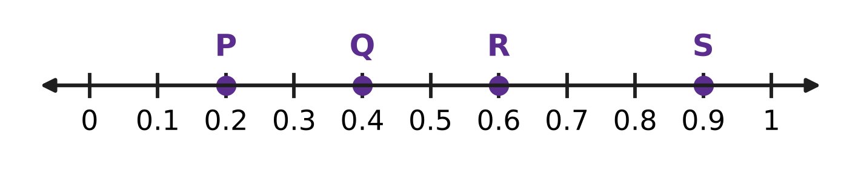
Q11. Look at the number line. Which point shows a number greater than $\frac{1}{4}$ and less than $\frac{1}{2}$?
(A) Point P | (B) Point Q | (C) Point R | (D) Point S

Q12. Rekha uses 75% of a piece of cloth to make a cushion cover. What fraction of the cloth is left?
(A) $\frac{3}{4}$ | (B) $\frac{1}{25}$ | (C) $\frac{1}{4}$ | (D) $\frac{1}{3}$

Q13. Which of these is the largest amount?
(A) 50% of ₹60 | (B) 10% of ₹290
(C) 75% of ₹36 | (D) 25% of ₹100

Q14. A parcel weighs $1\frac{3}{4}$ kg. What is this weight as a decimal?
(A) 1.34 kg | (B) 1.43 kg | (C) 1.3 kg | (D) 1.75 kg

Q15. Which of these lists is in order from the smallest to the largest?
(A) $\frac{3}{8}$, $\frac{2}{5}$, 0.42, 45% | (B) $\frac{3}{8}$, 0.42, $\frac{2}{5}$, 45%
(C) $\frac{2}{5}$, $\frac{3}{8}$, 0.42, 45% | (D) 45%, $\frac{3}{8}$, $\frac{2}{5}$, 0.42

Q16. On sports day, 480 children take part. Of them, 25% run races. Of the remaining children, 40% do the long jump. How many children do the long jump?
(A) 120 | (B) 216 | (C) 144 | (D) 192

Part 4 — Geometry (Syllabus Chapter 5)
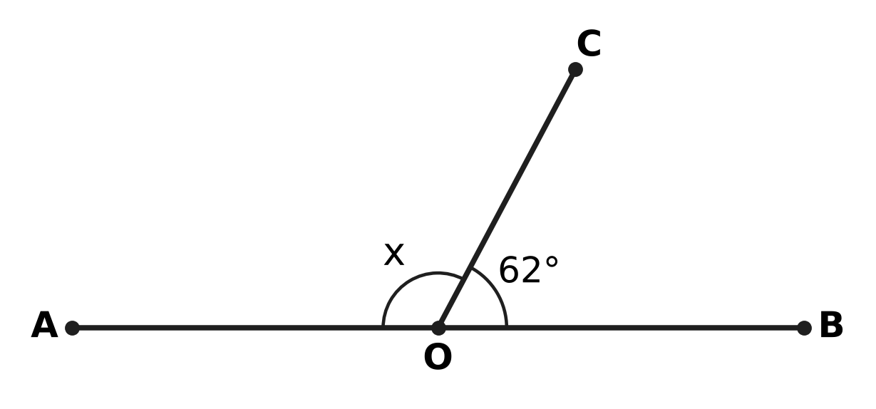
Q17. In the figure, AOB is a straight line and OC is a ray. Angle BOC is 62°. What is the size of angle x?
(A) 298° | (B) 62° | (C) 28° | (D) 118°

Q18. Which of these could be the three angles of a triangle that is both acute-angled and scalene?
(A) 40°, 40°, 100° | (B) 50°, 60°, 70°
(C) 55°, 55°, 70° | (D) 30°, 60°, 90°

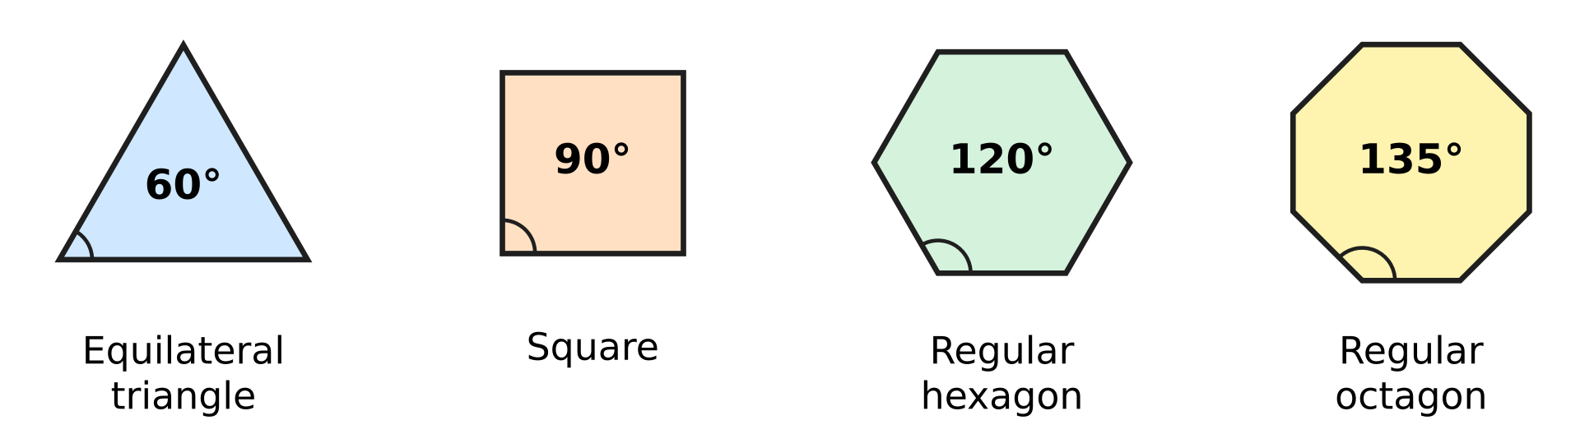
Q19. The picture shows four kinds of regular tiles and the size of each corner angle. Which of these sets of tiles can fit together round one point, with no gaps and no overlaps?
(A) 1 hexagon, 2 squares and 1 triangle | (B) 3 squares and 2 triangles
(C) 2 hexagons and 1 square | (D) 1 octagon and 2 squares

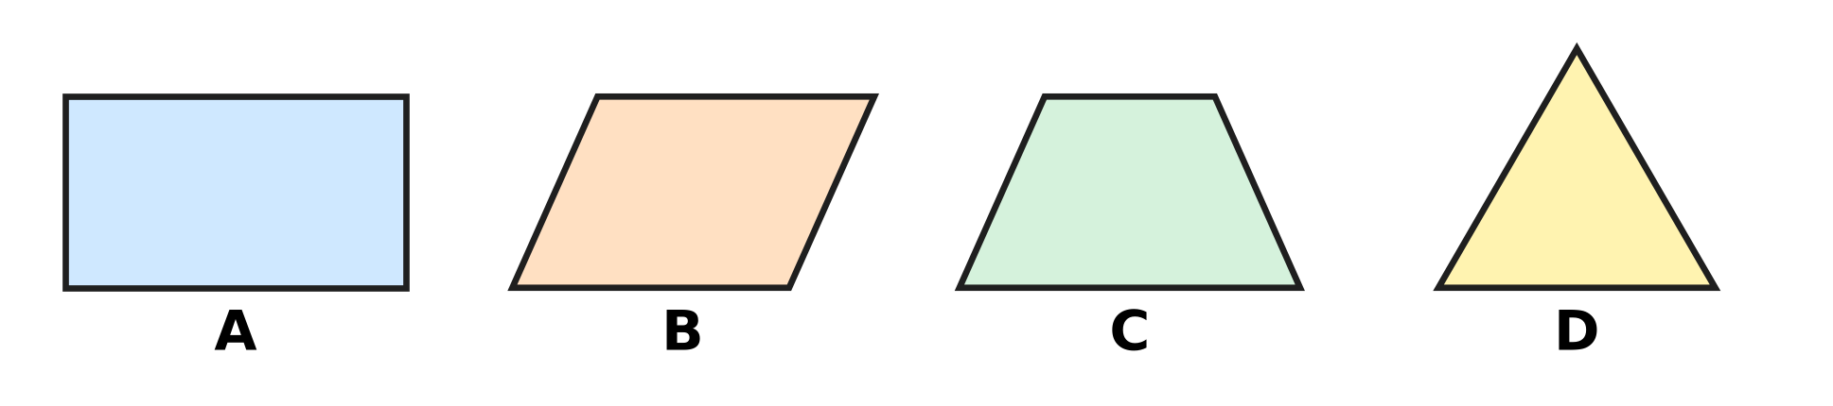
Q20. Look at the four shapes. Which shape has exactly ONE line of symmetry?
(A) Picture A | (B) Picture B
(C) Picture C | (D) Picture D

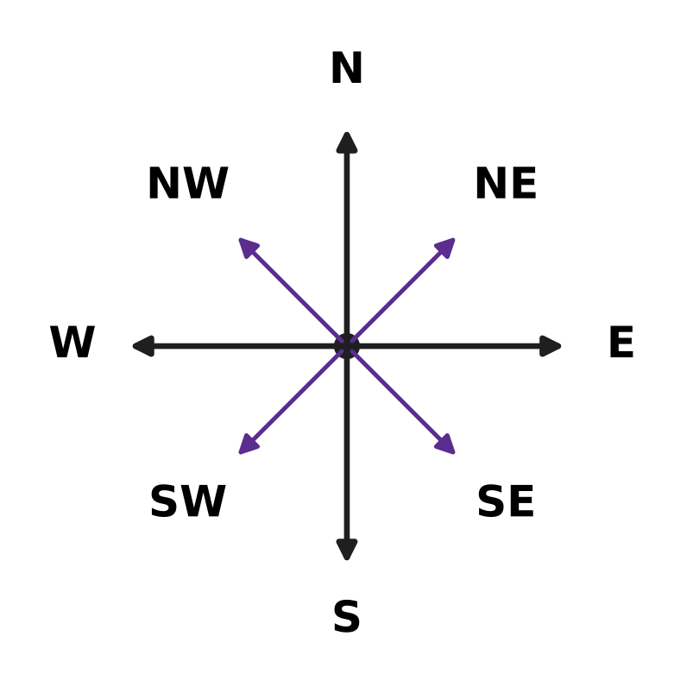
Q21. Look at the compass. Lena stands facing North-East. She turns clockwise through 135°. In which direction is she facing now?
(A) West | (B) South-East
(C) South | (D) South-West

Part 5 — Mensuration (Syllabus Chapter 6)
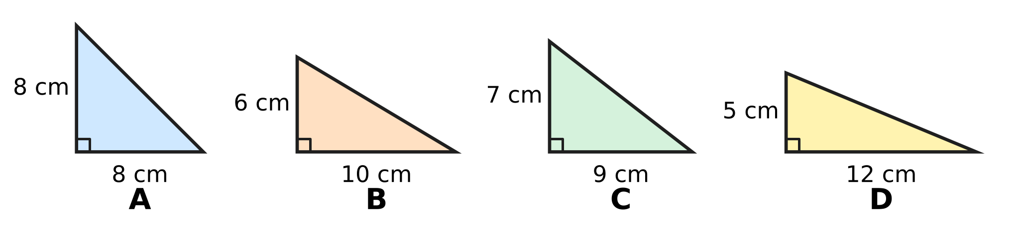
Q22. Each picture shows a triangle with a right angle, and the two sides that meet at the right angle are marked. Which picture has the greatest area?
(A) Picture A | (B) Picture B
(C) Picture C | (D) Picture D

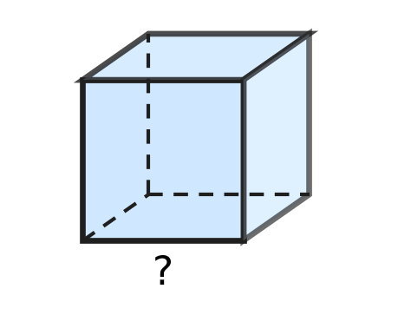
Q23. Kush has a wooden block shaped like a cube, as shown. Its volume is 343 cubic cm. How long is each edge of the block?
(A) 6 cm | (B) 7 cm | (C) 49 cm | (D) 8 cm

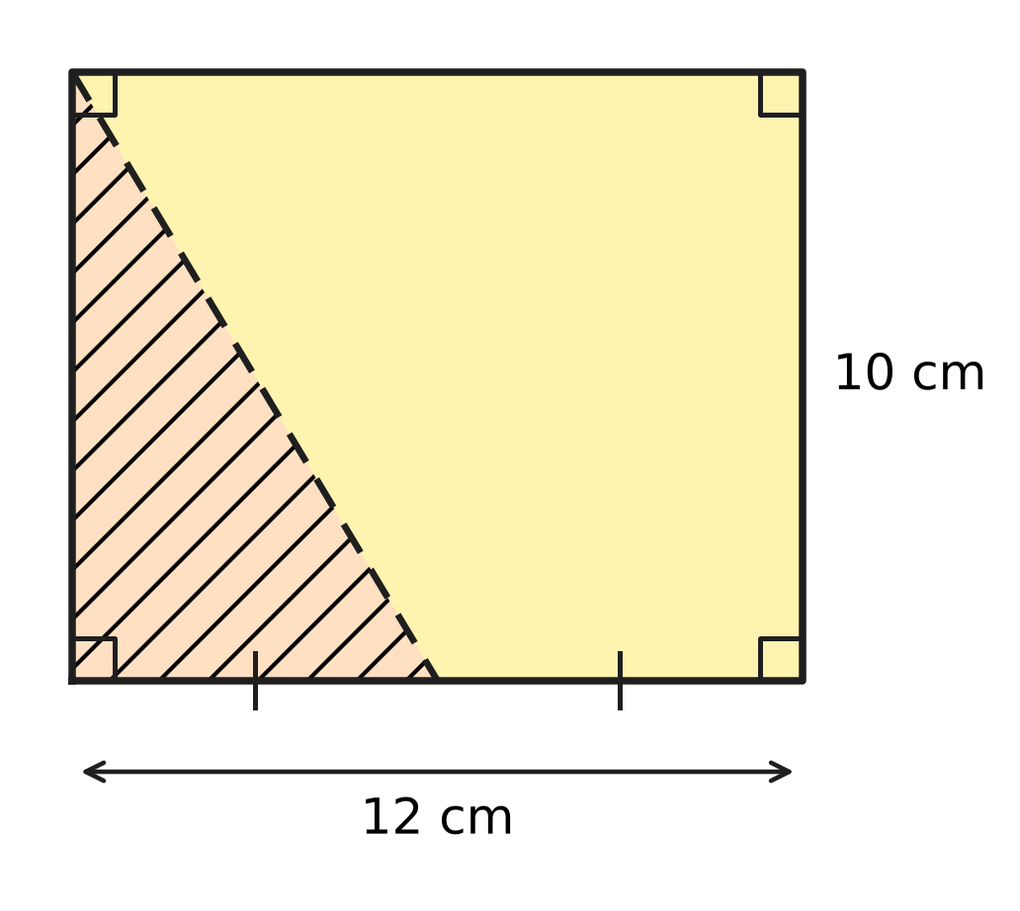
Q24. A rectangular card is 12 cm long and 10 cm wide. It is cut along the dashed line, from a corner to the middle of a long side, as shown. What is the area of the shaded triangle that is cut off?
(A) 90 sq cm | (B) 60 sq cm
(C) 120 sq cm | (D) 30 sq cm

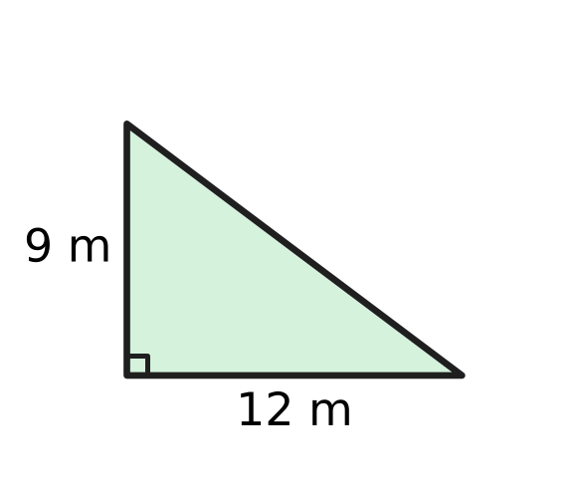
Q25. A corner of a playground is shaped like a right-angled triangle, as shown. It is to be covered with grass. The grass costs ₹20 for each sq m. What is the total cost of the grass?
(A) ₹1,080 | (B) ₹540 | (C) ₹2,160 | (D) ₹420

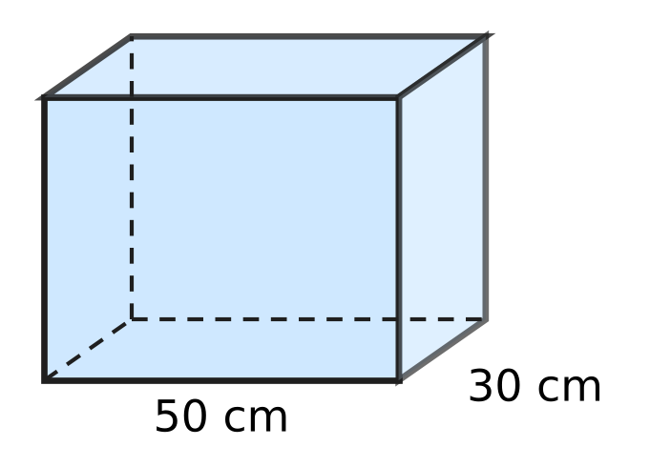
Q26. Pihu's aquarium is a cuboid 50 cm long and 30 cm wide, as shown. The water in it is 24 cm deep. She puts in a stone, which sinks completely, and the water rises to 28 cm. What is the volume of the stone?
(A) 42,000 cubic cm | (B) 6,000 cubic cm
(C) 36,000 cubic cm | (D) 1,500 cubic cm

Part 6 — Data Handling, Statistics & Probability (Syllabus Chapter 8)
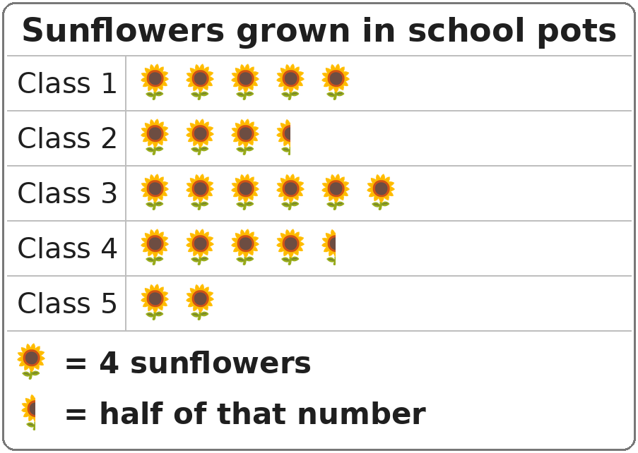
Q27. The pictograph shows the sunflowers grown in pots by five classes. How many sunflowers did Class 4 grow?
(A) 20 | (B) 16 | (C) 9 | (D) 18

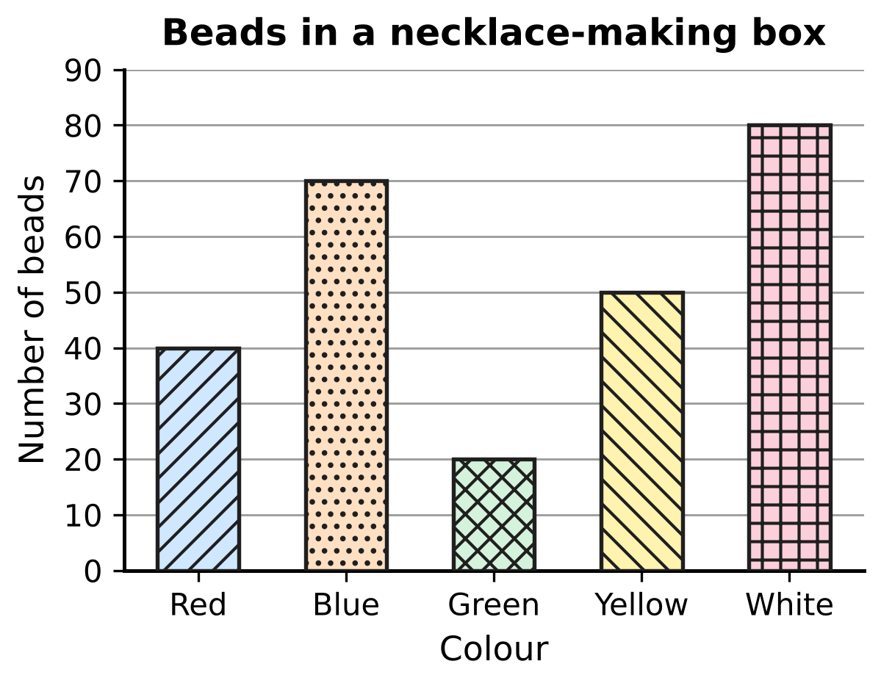
Q28. The bar graph shows the beads of each colour in a box. How many more beads are there of the two most common colours together than of the other three colours together?
(A) 10 | (B) 260 | (C) 40 | (D) 60

Part 7 — Applied Mathematics (Syllabus Chapter 9)
Q29. Which of these is the longest time?
(A) $\frac{1}{8}$ of a day | (B) 200 minutes
(C) 3 hours 10 minutes | (D) 11,400 seconds

Q30. Vijay took 270 minutes to paint a fence. How long is that in hours and minutes?
(A) 4 hours 50 minutes | (B) 3 hours 30 minutes
(C) 4 hours 30 minutes | (D) 2 hours 70 minutes

Flights of four birds
Bird | Distance flown (km) | Time taken (hours)
Eagle | 210 | 7
Swallow | 136 | 4
Parrot | 66 | 2
Crane | 160 | 5

Q31. The table shows how far four birds flew and how long each took. Which bird flew at the greatest speed?
(A) Swallow | (B) Eagle | (C) Parrot | (D) Crane

Q32. In a toy shop, Ahana watches a toy train that moves 35 cm every second. How far does it move in 1 minute?
(A) 95 cm | (B) 3,500 cm | (C) 210 cm | (D) 2,100 cm

Q33. Zoe walked to a picnic spot. The walk took 3 hours. Her average speed for the whole walk was 4 km/h. Which of these could be how she walked?
(A) 6 km/h for 1 hour, then 2 km/h for 2 hours
(B) 4 km/h for 2 hours, then 5 km/h for 1 hour
(C) 3 km/h for 2 hours, then 5 km/h for 1 hour
(D) 5 km/h for 2 hours, then 2 km/h for 1 hour

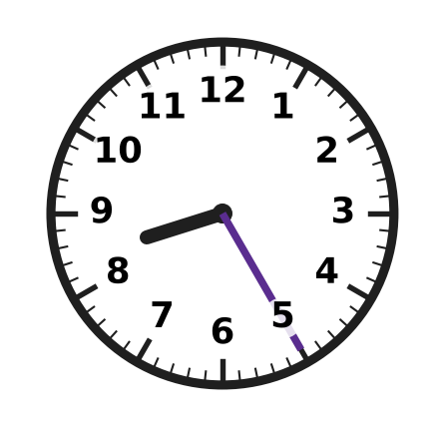
Q34. The clock shows the morning time when a train leaves a station. It travels 225 km at a steady speed of 50 km/h. At what time does it arrive?
(A) 1:25 PM | (B) 1:15 PM | (C) 12:55 PM | (D) 12:25 PM

Part 8 — Mathematical Reasoning & Problem-Solving (Syllabus Chapter 10)
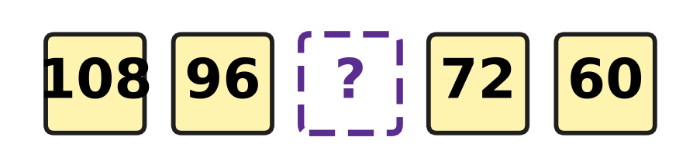
Q35. The numbers in the boxes go down by the same amount each time. Which number goes in the empty box?
(A) 86 | (B) 84 | (C) 78 | (D) 90

Q36. How many leap years are there from the year 1890 to the year 1910 (both years included)?
(A) 4 | (B) 2 | (C) 3 | (D) 5

Q37. Five whole numbers are multiplied together. The answer is an odd number. How many of the five numbers are even?
(A) 4 | (B) 1 | (C) 2 | (D) 0

Q38. In the series 9, 18, 36, 72, 144, …, each number is double the one before. Which term is the first one greater than 500?
(A) 6th term | (B) 7th term | (C) 8th term | (D) 5th term

Q39. Some children sit around a round table. Every boy has a girl on both sides of him. Every girl has a boy on both sides of her. Which of these could be the number of children at the table?
(A) 15 | (B) 9 | (C) 14 | (D) 21

Q40. How many numbers are there in the list 14, 21, 28, 35, …, 245?
(A) 34 | (B) 231 | (C) 33 | (D) 35

SECTION II — Star Questions 5 questions × 4 marks each
Q41. Three different prime numbers add up to 40. What is the largest of the three? [4 marks]
(A) 19 | (B) 31 | (C) 29 | (D) 37

Q42. Atharv pours 12 litres of juice into bottles. Each bottle holds either 0.5 litre or 1.5 litres, and every bottle is filled to the top. No juice is left over. Which of these could be the number of bottles he fills? [4 marks]
(A) 6 | (B) 13 | (C) 9 | (D) 10

Q43. The picture shows a staircase with 4 steps (numbered 1 to 4) made of 1 cm cubes. Step 1 is 1 cube tall, step 2 is 2 cubes tall, and so on. Every step is 3 cubes deep from front to back. Tejas builds a staircase in the same way with 12 steps. What is its volume? [4 marks] | 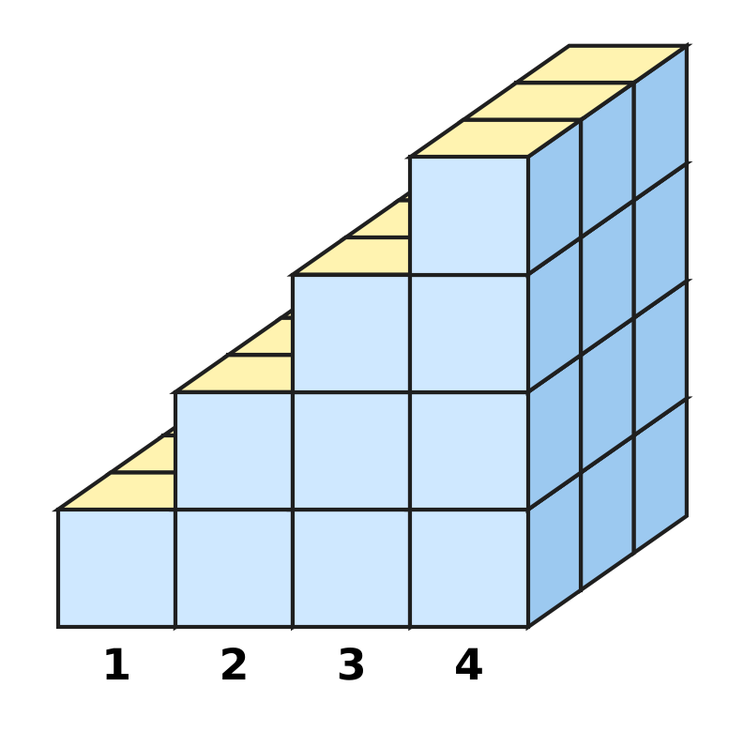
  (A) 432 cubic cm | (B) 216 cubic cm
  (C) 234 cubic cm | (D) 78 cubic cm

Q44. Akash goes on two cycle trips, of 48 km and 64 km, at the same steady speed. The speed is a whole number of km/h, and each trip takes a whole number of hours. The speed is as high as possible. How long do the two trips take altogether? [4 marks]
(A) 7 hours | (B) 14 hours | (C) 28 hours | (D) 4 hours

Q45. Gaurav's family drives 360 km to a hill town. They drive the first 25% of the distance at 60 km/h and the rest at 90 km/h. How long does the whole journey take? [4 marks]
(A) 4 hours 48 minutes | (B) 4 hours 30 minutes
(C) 4 hours | (D) 5 hours 30 minutes

Answer Sheet AMO Level 1 · Class 5 · Practice Paper 2
Name: | School: | Roll No.:
Shade or tick one circle for each question.
1. Ⓐ Ⓑ Ⓒ Ⓓ | 16. Ⓐ Ⓑ Ⓒ Ⓓ | 31. Ⓐ Ⓑ Ⓒ Ⓓ
2. Ⓐ Ⓑ Ⓒ Ⓓ | 17. Ⓐ Ⓑ Ⓒ Ⓓ | 32. Ⓐ Ⓑ Ⓒ Ⓓ
3. Ⓐ Ⓑ Ⓒ Ⓓ | 18. Ⓐ Ⓑ Ⓒ Ⓓ | 33. Ⓐ Ⓑ Ⓒ Ⓓ
4. Ⓐ Ⓑ Ⓒ Ⓓ | 19. Ⓐ Ⓑ Ⓒ Ⓓ | 34. Ⓐ Ⓑ Ⓒ Ⓓ
5. Ⓐ Ⓑ Ⓒ Ⓓ | 20. Ⓐ Ⓑ Ⓒ Ⓓ | 35. Ⓐ Ⓑ Ⓒ Ⓓ
6. Ⓐ Ⓑ Ⓒ Ⓓ | 21. Ⓐ Ⓑ Ⓒ Ⓓ | 36. Ⓐ Ⓑ Ⓒ Ⓓ
7. Ⓐ Ⓑ Ⓒ Ⓓ | 22. Ⓐ Ⓑ Ⓒ Ⓓ | 37. Ⓐ Ⓑ Ⓒ Ⓓ
8. Ⓐ Ⓑ Ⓒ Ⓓ | 23. Ⓐ Ⓑ Ⓒ Ⓓ | 38. Ⓐ Ⓑ Ⓒ Ⓓ
9. Ⓐ Ⓑ Ⓒ Ⓓ | 24. Ⓐ Ⓑ Ⓒ Ⓓ | 39. Ⓐ Ⓑ Ⓒ Ⓓ
10. Ⓐ Ⓑ Ⓒ Ⓓ | 25. Ⓐ Ⓑ Ⓒ Ⓓ | 40. Ⓐ Ⓑ Ⓒ Ⓓ
11. Ⓐ Ⓑ Ⓒ Ⓓ | 26. Ⓐ Ⓑ Ⓒ Ⓓ | 41. Ⓐ Ⓑ Ⓒ Ⓓ
12. Ⓐ Ⓑ Ⓒ Ⓓ | 27. Ⓐ Ⓑ Ⓒ Ⓓ | 42. Ⓐ Ⓑ Ⓒ Ⓓ
13. Ⓐ Ⓑ Ⓒ Ⓓ | 28. Ⓐ Ⓑ Ⓒ Ⓓ | 43. Ⓐ Ⓑ Ⓒ Ⓓ
14. Ⓐ Ⓑ Ⓒ Ⓓ | 29. Ⓐ Ⓑ Ⓒ Ⓓ | 44. Ⓐ Ⓑ Ⓒ Ⓓ
15. Ⓐ Ⓑ Ⓒ Ⓓ | 30. Ⓐ Ⓑ Ⓒ Ⓓ | 45. Ⓐ Ⓑ Ⓒ Ⓓ
Q41–Q45 are Section II Star Questions (4 marks each).
For the parent or teacher
Section I correct: ______ / 40 × 2 = ______ marks Section II correct: ______ / 5 × 4 = ______ marks
Correct: ______ / 45 Score: ______ / 100
Answer Key and Solutions AMO Level 1 · Class 5 · Practice Paper 2
Quick answers
1 D | 6 C | 11 B | 16 C | 21 C | 26 B | 31 A | 36 A | 41 B
2 A | 7 A | 12 C | 17 D | 22 A | 27 D | 32 D | 37 D | 42 D
3 B | 8 B | 13 A | 18 B | 23 B | 28 C | 33 D | 38 B | 43 C
4 D | 9 D | 14 D | 19 A | 24 D | 29 B | 34 C | 39 C | 44 A
5 C | 10 B | 15 A | 20 C | 25 A | 30 C | 35 B | 40 A | 45 B
Solutions
Q | Part · level | Answer | Why?
1 | Part 1 · Ch1 · Easy | (D) 3,70,215 | In 3,70,215 the digits are 3 lakhs and 7 ten-thousands, so the 7 stands for 70,000.
2 | Part 1 · Ch1 · Easy | (A) DIC | I may be taken away only from V and X, so IC is not allowed, and DIC is not a correct Roman numeral.
3 | Part 1 · Ch1 · Easy | (B) 90 | 90 = 6 × 15 and also 15 × 6, so it is a multiple of both. 45 is not a multiple of 6 and 72 is not a multiple of 15.
4 | Part 1 · Ch1 · Medium | (D) 73 | Numbers with digit sum 10 and a bigger tens digit: 91, 82, 73, 64, 55. Only 73 is prime (91 = 7 × 13).
5 | Part 1 · Ch1 · Medium | (C) 48 | The number must be a multiple of the LCM of 4 and 6, which is 12. The only multiple of 12 between 40 and 55 is 48.
6 | Part 2 · Ch2 · Easy | (C) 36 − 8 × 2 | Multiply or divide before adding or subtracting: 36 − 8 × 2 = 36 − 16 = 20. The others: 1 + 4 × 4 = 17, 2 + 3 × 4 = 14 and 50 − 10 ÷ 2 = 45.
7 | Part 2 · Ch2 · Easy | (A) 7,900 | Change the order: 25 × 4 = 100, and 100 × 79 = 7,900.
8 | Part 2 · Ch2 · Easy | (B) 1,700 kg | 3,870 rounds to 3,900 and 2,190 rounds to 2,200. The estimate is 3,900 − 2,200 = 1,700 kg.
9 | Part 2 · Ch2 · Medium | (D) 9 | The square bracket must be 48 ÷ 4 = 12. So the round bracket is 12 ÷ 2 = 6, and the missing number is 6 + 3 = 9.
10 | Part 2 · Ch2 · Medium | (B) 6,125 | 125 × 49 = 125 × 48 + 125 × 1 = 6,000 + 125 = 6,125.
11 | Part 3 · Ch3 · Easy | (B) Point Q | 1/4 = 0.25 and 1/2 = 0.5. Only Q, at 0.4, lies between 0.25 and 0.5.
12 | Part 3 · Ch3 · Easy | (C) $\frac{1}{4}$ | 75% is used, so 100% − 75% = 25% is left. 25% = 25/100 = 1/4.
13 | Part 3 · Ch3 · Easy | (A) 50% of ₹60 | 50% of ₹60 = ₹30, 25% of ₹100 = ₹25, 10% of ₹290 = ₹29 and 75% of ₹36 = ₹27. The largest is ₹30.
14 | Part 3 · Ch3 · Easy | (D) 1.75 kg | 3/4 = 75/100 = 0.75, so 1 3/4 kg = 1.75 kg.
15 | Part 3 · Ch3 · Medium | (A) 3/8, 2/5, 0.42, 45% | 3/8 = 0.375, 2/5 = 0.4, 0.42 and 45% = 0.45. So the order is 3/8, 2/5, 0.42, 45%.
16 | Part 3 · Ch3 · Medium | (C) 144 | 25% of 480 = 120 run races, so 360 remain. 40% of 360 = 144 do the long jump.
17 | Part 4 · Ch5 · Easy | (D) 118° | Angles on a straight line add up to 180°. So x = 180° − 62° = 118°.
18 | Part 4 · Ch5 · Easy | (B) 50°, 60°, 70° | All three angles 50°, 60° and 70° are less than 90°, so it is acute-angled. No two angles are equal, so no two sides are equal: it is scalene.
19 | Part 4 · Ch5 · Easy | (A) 1 hexagon, 2 squares and 1 triangle | The corners round a point must add up to 360°. 120° + 90° + 90° + 60° = 360°, so 1 hexagon, 2 squares and 1 triangle fit exactly.
20 | Part 4 · Ch5 · Medium | (C) Picture C | The trapezium in Picture C has only one line of symmetry, the upright line through the middle of its two parallel sides.
21 | Part 4 · Ch5 · Medium | (C) South | Each step between neighbouring directions is 45°. 135° = 3 steps clockwise: North-East → East → South-East → South.
22 | Part 5 · Ch6 · Easy | (A) Picture A | Areas: A = ½ × 8 × 8 = 32, B = 30, C = 31.5, D = 30 sq cm. Triangle A has the greatest area.
23 | Part 5 · Ch6 · Easy | (B) 7 cm | 7 × 7 × 7 = 49 × 7 = 343, so each edge is 7 cm.
24 | Part 5 · Ch6 · Easy | (D) 30 sq cm | The shaded triangle has sides 6 cm (half of 12 cm) and 10 cm at the right angle. Area = ½ × 6 × 10 = 30 sq cm.
25 | Part 5 · Ch6 · Medium | (A) ₹1,080 | Area = ½ × 12 × 9 = 54 sq m. Cost = 54 × ₹20 = ₹1,080.
26 | Part 5 · Ch6 · Medium | (B) 6,000 cubic cm | The water rises by 28 − 24 = 4 cm. The stone takes the space 50 × 30 × 4 = 6,000 cubic cm.
27 | Part 6 · Ch8 · Easy | (D) 18 | Class 4 has 4 whole symbols and a half: 4 × 4 + 2 = 18 sunflowers.
28 | Part 6 · Ch8 · Medium | (C) 40 | White and Blue: 80 + 70 = 150. Red, Yellow and Green: 40 + 50 + 20 = 110. 150 − 110 = 40.
29 | Part 7 · Ch9 · Easy | (B) 200 minutes | 3 h 10 min = 190 min, 11,400 s = 190 min and 1/8 of a day = 3 h = 180 min. 200 minutes is the longest.
30 | Part 7 · Ch9 · Easy | (C) 4 hours 30 minutes | 270 = 4 × 60 + 30, so 270 minutes = 4 hours 30 minutes.
31 | Part 7 · Ch9 · Easy | (A) Swallow | Speeds: Eagle 30, Swallow 34, Parrot 33 and Crane 32 km/h. The swallow is fastest.
32 | Part 7 · Ch9 · Easy | (D) 2,100 cm | 1 minute = 60 seconds. 35 × 60 = 2,100 cm.
33 | Part 7 · Ch9 · Medium | (D) 5 km/h for 2 hours, then 2 km/h for 1 hour | At an average of 4 km/h for 3 hours she walks 4 × 3 = 12 km. Check each walk: 6 + 2 × 2 = 10 km; 4 × 2 + 5 = 13 km; 3 × 2 + 5 = 11 km; 5 × 2 + 2 × 1 = 12 km. Only the last one fits.
34 | Part 7 · Ch9 · Medium | (C) 12:55 PM | Time = 225 ÷ 50 = 4½ hours = 4 hours 30 minutes. 8:25 AM + 4 h 30 min = 12:55 PM.
35 | Part 8 · Ch10 · Easy | (B) 84 | Each number is 12 less than the one before: 108, 96, 84, 72, 60.
36 | Part 8 · Ch10 · Easy | (A) 4 | The years divisible by 4 are 1892, 1896, 1900, 1904 and 1908. 1900 is not divisible by 400, so it is not a leap year. That leaves 4 leap years.
37 | Part 8 · Ch10 · Easy | (D) 0 | If even one of the numbers is even, the product is even. So none of the five numbers can be even.
38 | Part 8 · Ch10 · Medium | (B) 7th term | The terms are 9, 18, 36, 72, 144, 288, 576. The 7th term, 576, is the first greater than 500.
39 | Part 8 · Ch10 · Medium | (C) 14 | Going round the table the children go boy, girl, boy, girl, … and the last child sits next to the first. So boys and girls are equal in number and the total is even. Only 14 is even.
40 | Part 8 · Ch10 · Medium | (A) 34 | The numbers are 7 × 2, 7 × 3, …, 7 × 35. From 2 to 35 there are 35 − 2 + 1 = 34 numbers.
41 | Section II · Ch1 + Ch10 · Hard | (B) 31 | Three odd primes would add to an odd number, so one prime must be 2. The other two add to 38 and are different primes: only 7 + 31 works (38 − 3 = 35, 38 − 5 = 33, 38 − 11 = 27, 38 − 13 = 25 and 38 − 17 = 21 are not prime, and 19 + 19 repeats a prime). The largest is 31.
42 | Section II · Ch3 + Ch10 · Hard | (D) 10 | 0.5 L = 1 half-litre and 1.5 L = 3 half-litres, both odd numbers. 12 L = 24 half-litres, an even number, so the number of bottles is even and at least 24 ÷ 3 = 8. 10 works: 7 big and 3 small bottles.
43 | Section II · Ch6 + Ch10 · Hard | (C) 234 cubic cm | The front layer has 1 + 2 + 3 + … + 12 = 78 cubes. There are 3 such layers, so 78 × 3 = 234 cubes of 1 cubic cm each: 234 cubic cm.
44 | Section II · Ch1 + Ch9 · Hard | (A) 7 hours | The speed must divide both 48 and 64, so the highest speed is their HCF, 16 km/h. The trips take 48 ÷ 16 = 3 h and 64 ÷ 16 = 4 h, 7 hours in all.
45 | Section II · Ch3 + Ch9 · Hard | (B) 4 hours 30 minutes | 25% of 360 km = 90 km, taking 90 ÷ 60 = 1½ hours. The other 270 km take 270 ÷ 90 = 3 hours. Total 4 hours 30 minutes.

ARYABHATTA MATHS OLYMPIAD
Level 1
PRACTICE PAPER-3
CLASS 5
Total Questions | 45 multiple-choice questions
Total Marks | 100
Time | 60 minutes
Section I | 40 questions × 2 marks = 80 marks
Section II | 5 Star Questions × 4 marks = 20 marks
Negative Marking | No negative marking
Calculator | Not allowed
Chapters | Number System · Operations · Fractions, Decimals & Percentages · Geometry · Mensuration · Data Handling · Applied Mathematics · Mathematical Reasoning

👋 Hello, friend! How to do this paper:
⭐ Every question has four answer choices: (A), (B), (C) and (D). Only one is correct.
⭐ Read each question and look at its picture carefully. Then mark your answer on the answer sheet at the end.
⭐ Section I has 40 questions of 2 marks each. Section II has 5 Star Questions of 4 marks each.
⭐ There is no negative marking, so try every question.
⭐ Do not use a calculator. You may do rough work on a separate sheet.
⭐ All figures are not necessarily drawn to scale unless stated.

For parents and teachers
• Print or view this paper in colour. Pictures are part of the questions.
• Parts follow the AMO syllabus chapters. Chapters 4 and 7 are not part of the Class 5 syllabus, so the chapter numbers shown in the Part headings have gaps.
• The answer sheet and the answer key are at the end. Remove only the answer key before the child begins.

SECTION I 40 questions × 2 marks each
Part 1 — Number System (Syllabus Chapter 1)
Q1. What is the missing part of this expanded form?
4,00,000 + ___ + 6,000 + 50 + 3 = 4,36,053
(A) 36,000 | (B) 3,000 | (C) 30,000 | (D) 3,00,000

Q2. The Roman numeral for 990 is written CM___. What goes in the blank?
(A) LC | (B) CX | (C) LXXXX | (D) XC

Q3. Which number goes in the blank to complete the prime factorisation?
140 = 2 × 2 × ___ × 5
(A) 14 | (B) 70 | (C) 7 | (D) 35

Q4. The product of two numbers is 294. Their HCF is 7. What is their LCM?
(A) 2,058 | (B) 147 | (C) 287 | (D) 42

Q5. Aditi wants to write the smallest 6-digit number in which no digit is repeated. Which number should she write?
(A) 1,23,456 | (B) 1,02,345 | (C) 1,01,234 | (D) 1,00,000

Part 2 — Operations & Number Properties (Syllabus Chapter 2)
Q6. A bus stand sold 289, 312, 198 and 405 tickets on four days. Round each number to the nearest hundred and then add. What is the estimated total?
(A) 1,200 | (B) 1,300 | (C) 1,100 | (D) 1,204

Q7. Which number makes this statement true?
63 × 98 = 63 × 100 − 63 × ___
(A) 98 | (B) 1 | (C) 102 | (D) 2

Q8. Sahil buys 3 sandwiches at ₹18 each and 2 glasses of juice at ₹15 each. He pays with a ₹100 note. Which expression gives his change?
(A) 100 − 3 × 18 + 2 × 15 | (B) 3 × 18 + 2 × 15 − 100
(C) 100 − (3 × 18 + 2 × 15) | (D) 100 − (3 + 2) × (18 + 15)

Q9. Which sign goes in the blank to make the statement true?
[24 ÷ (6 ___ 2)] × (5 − 1) = 12
(A) + | (B) − | (C) × | (D) ÷

Q10. Which of these is NOT equal to 36 × 25?
(A) 9 × 100 | (B) 30 × 25 + 6 × 5
(C) 25 × 30 + 25 × 6 | (D) 36 × 20 + 36 × 5

Part 3 — Fractions, Decimals & Percentages (Syllabus Chapter 3)
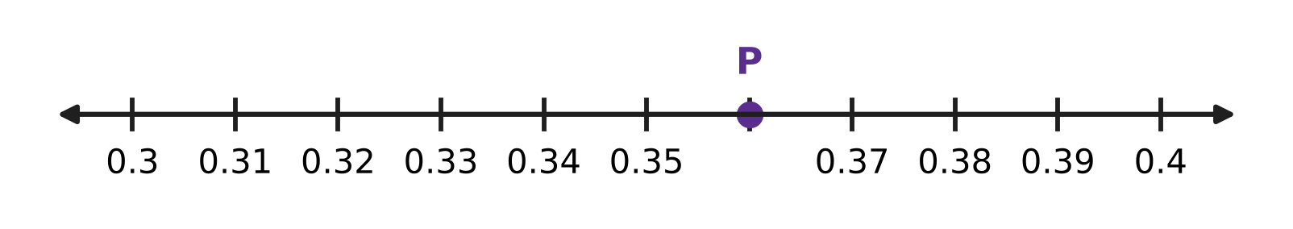
Q11. On the number line, the part from 0.3 to 0.4 is divided into 10 equal steps. Which decimal does point P show?
(A) 0.36 | (B) 0.34 | (C) 3.6 | (D) 0.6

Q12. What number goes in the blank?
0.04 = 1 ÷ ___
(A) 40 | (B) 25 | (C) 4 | (D) 400

Q13. A post office sorted 840 letters in the morning. Of these, 25% were for other cities. How many letters were for other cities?
(A) 420 | (B) 630 | (C) 84 | (D) 210

Q14. Which number goes in the blank?
2.75 + ___ = 4.1
(A) 1.45 | (B) 2.65 | (C) 1.35 | (D) 6.85

Q15. In a paper plane contest, $\frac{3}{5}$ of the planes flew more than 5 m. Half of these planes flew more than 10 m. What percentage of all the planes flew more than 10 m?
(A) 30% | (B) 60% | (C) 10% | (D) 50%

Q16. What number belongs in the blank?
___% of 60 = 15% of 200
(A) 45 | (B) 30 | (C) 15 | (D) 50

Part 4 — Geometry (Syllabus Chapter 5)
Q17. Look at the clock. The minute hand moves clockwise through a quarter turn (one right angle). What time will the clock show then? | 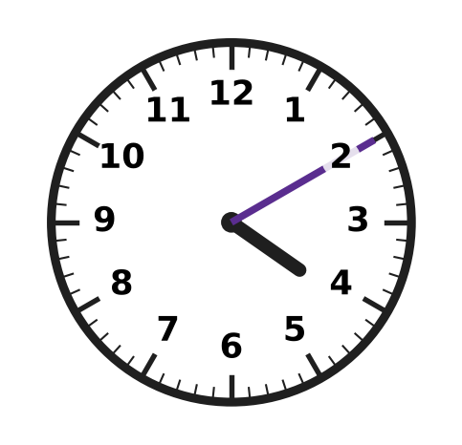
  (A) 4:25 | (B) 3:55 | (C) 4:40 | (D) 7:10

Q18. Look at the grid. Which ONE more square must be shaded so that the dashed line becomes a line of symmetry of the shaded design? | 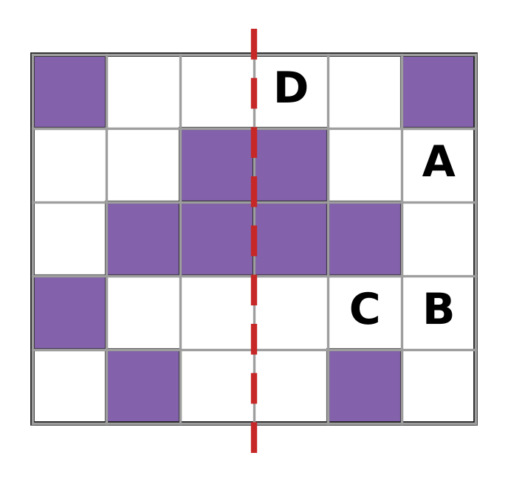
  (A) Square A | (B) Square B | (C) Square C | (D) Square D

Q19. Which statement about quadrilaterals is NOT true?
(A) Every rhombus is a parallelogram. | (B) Every rhombus is a square.
(C) Every rectangle is a parallelogram. | (D) Every square is a rhombus.

Q20. Two angles of a triangle are 35° and 55°. What is the third angle, and what type of triangle is it?
(A) 100°, obtuse-angled | (B) 90°, obtuse-angled
(C) 90°, right-angled | (D) 90°, acute-angled

Q21. The pinwheel in the picture has 6 blades of the same shape and size. It is turned about its centre dot. What is the smallest turn after which it looks exactly the same? | 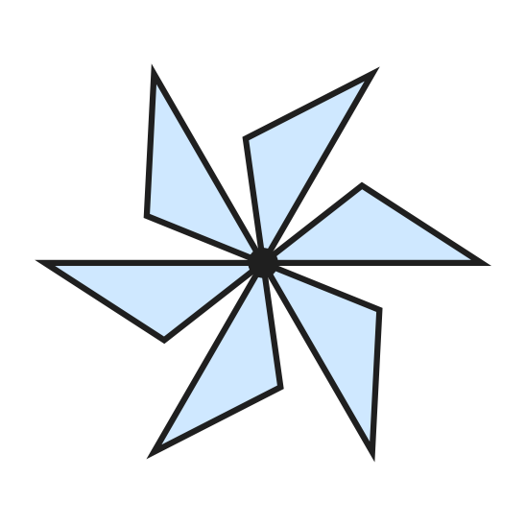
  (A) 180° | (B) 60° | (C) 90° | (D) 30°

Part 5 — Mensuration (Syllabus Chapter 6)
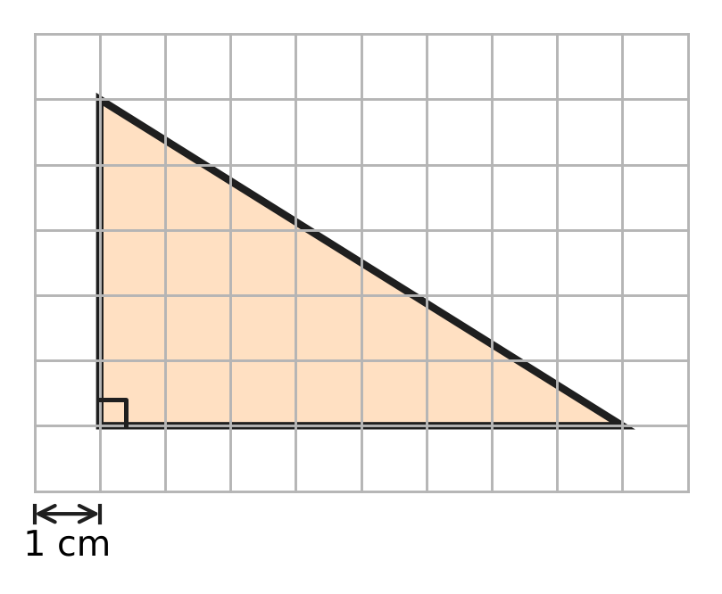
Q22. A right-angled triangle is drawn on a grid of 1 cm squares, as shown. Use the grid to find its area.
(A) 26 sq cm | (B) 40 sq cm | (C) 20 sq cm | (D) 13 sq cm

Q23. Vikram's pencil box is a cuboid 15 cm long, 8 cm wide and 4 cm high, as shown. What is the volume of the box? | 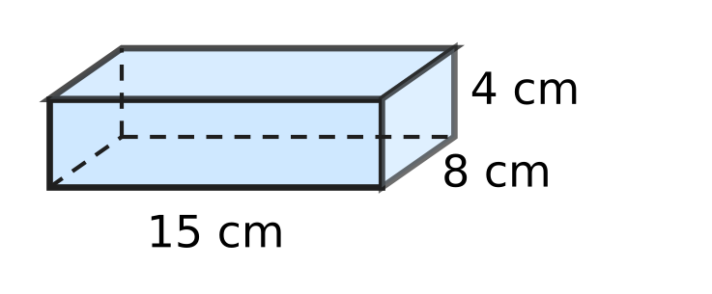
  (A) 480 cubic cm | (B) 120 cubic cm
  (C) 27 cubic cm | (D) 960 cubic cm

Q24. Roshni has four boxes with the measurements given below. Each box is filled to the top with sand. Which box holds the most sand?
(A) 10 cm × 3 cm × 2 cm | (B) 6 cm × 5 cm × 2 cm
(C) 7 cm × 3 cm × 3 cm | (D) 4 cm × 4 cm × 4 cm

Q25. A cuboid tank holds 72 litres of water when full. Inside, it is 60 cm long and 40 cm wide, as shown. How high is it inside? (1 litre = 1,000 cubic cm) | 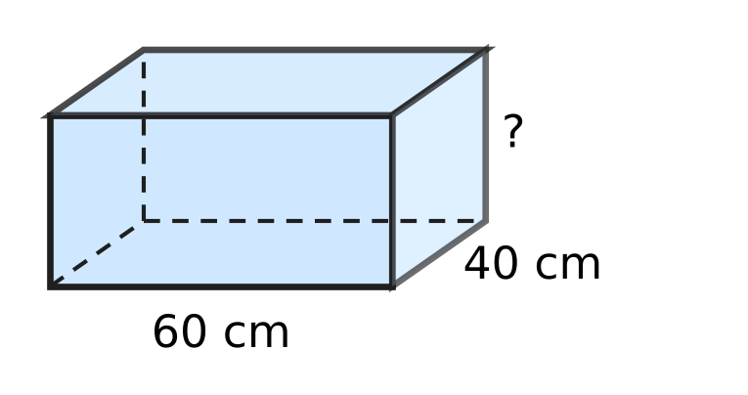
  (A) 300 cm | (B) 720 cm | (C) 3 cm | (D) 30 cm

Q26. The rectangle and the right-angled triangle in the picture have the same area. What is the height of the triangle, marked with a question mark? | 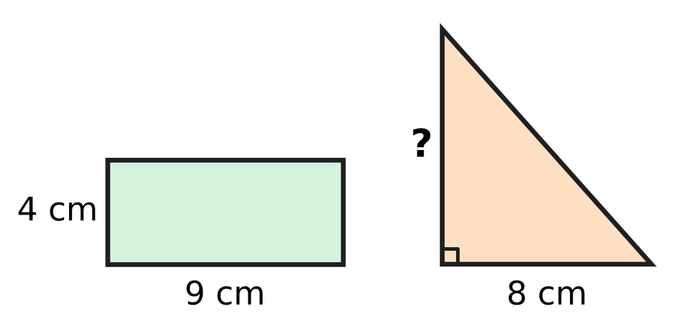
  (A) 9 cm | (B) 18 cm | (C) 6.5 cm | (D) 4.5 cm

Part 6 — Data Handling, Statistics & Probability (Syllabus Chapter 8)
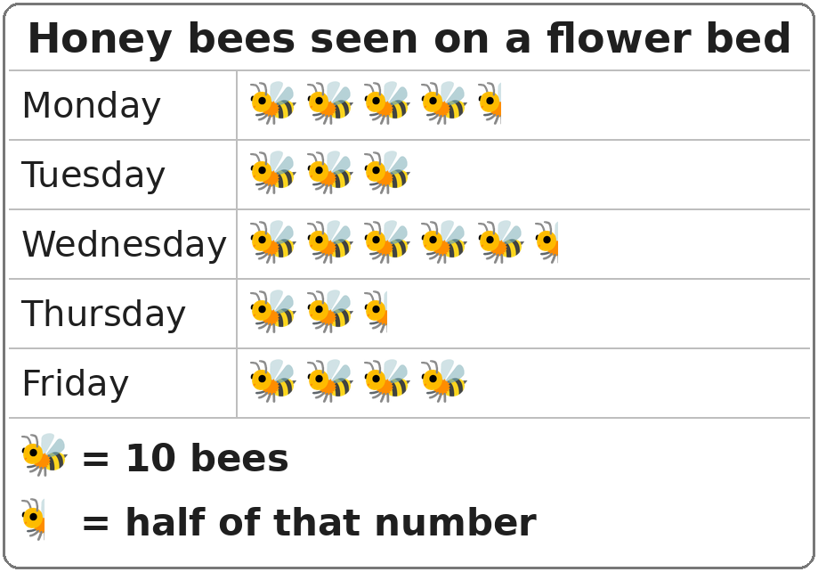
Q27. The pictograph shows the number of honey bees seen on a flower bed on five days. How many bees were seen on the five days altogether?
(A) 150 | (B) 195 | (C) 180 | (D) 210

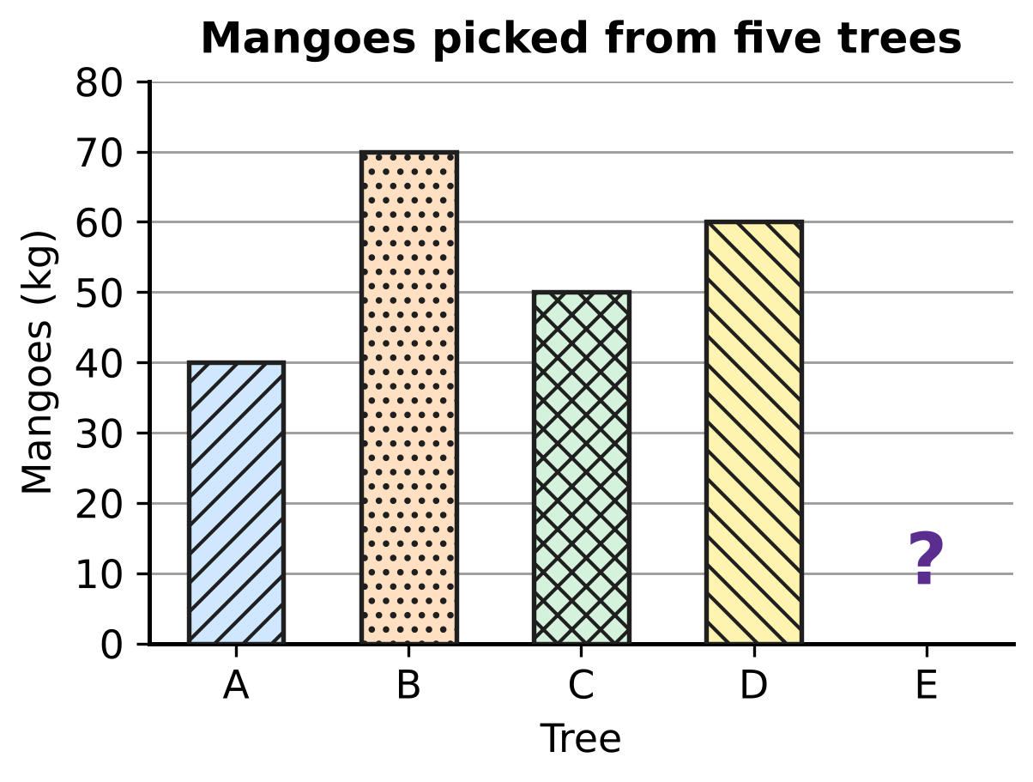
Q28. The bar graph shows the mangoes picked from five trees. The bar for Tree E is missing. Altogether 250 kg of mangoes were picked. How many kilograms of mangoes came from Tree E?
(A) 50 kg | (B) 20 kg | (C) 30 kg | (D) 220 kg

Part 7 — Applied Mathematics (Syllabus Chapter 9)
Q29. Charu's clay pots must dry in the shade for 5 weeks 4 days before they are baked. How many days is that?
(A) 9 days | (B) 39 days | (C) 35 days | (D) 54 days

Q30. Ankit cycles at a steady speed of 16 km/h for 3 hours. How far does he cycle?
(A) 48 km | (B) 19 km | (C) 13 km | (D) 32 km

Q31. How many seconds are there in a quarter of an hour?
(A) 1,500 seconds | (B) 3,600 seconds
(C) 15 seconds | (D) 900 seconds

Q32. Fill in the blank.
48 minutes = ___ hour
(A) 0.48 hour | (B) 0.2 hour
(C) 0.8 hour | (D) 1.25 hour

Q33. At a mill, a machine fills one sack of grain every 40 seconds. It works without a break for 2 hours. How many sacks does it fill?
(A) 180 | (B) 300 | (C) 3 | (D) 90

Q34. A wall clock in Harsh's shop gains 5 seconds every hour. How many minutes does it gain in 12 days?
(A) 1,440 minutes | (B) 24 minutes
(C) 1 minute | (D) 12 minutes

Part 8 — Mathematical Reasoning & Problem-Solving (Syllabus Chapter 10)
Q35. What is the 8th term of the series 6, 13, 20, 27, …?
(A) 48 | (B) 56 | (C) 55 | (D) 62

Q36. What is the missing first term of this series?
___, 15, 75, 375, 1,875
(A) 10 | (B) 5 | (C) 1 | (D) 3

Q37. Which number fits the blank?
"The sum of any ___ odd numbers is always an even number."
(A) 21 | (B) 16 | (C) 9 | (D) 13

Q38. A museum exhibition is open every day from 18 April to 7 June, both days included. For how many days is it open?
(A) 51 days | (B) 52 days | (C) 50 days | (D) 49 days

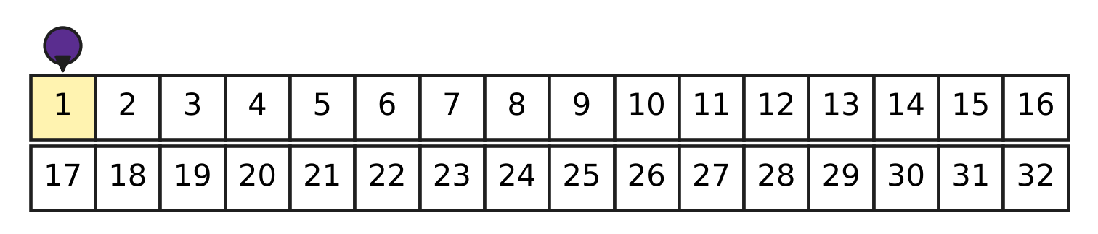
Q39. The picture shows the start of a board game. Veer's counter starts on square 1. In every turn it moves forward exactly 3 squares or exactly 5 squares. On which square could the counter be after 6 turns?
(A) 20 | (B) 30 | (C) 26 | (D) 27

Q40. Which of these numbers is a term of the series 5, 11, 17, 23, …?
(A) 91 | (B) 99 | (C) 89 | (D) 96

SECTION II — Star Questions 5 questions × 4 marks each
Q41. How many factors of 120 are even numbers that are NOT multiples of 4? [4 marks]
(A) 12 | (B) 16 | (C) 8 | (D) 4

Q42. Rhea's piggy bank has only ₹5 coins and ₹2 coins. Of all the coins, 35% are ₹5 coins. There are fewer than 50 coins. The number of ₹2 coins is odd. How much money is in the piggy bank? [4 marks]
(A) ₹35 | (B) ₹61 | (C) ₹122 | (D) ₹79

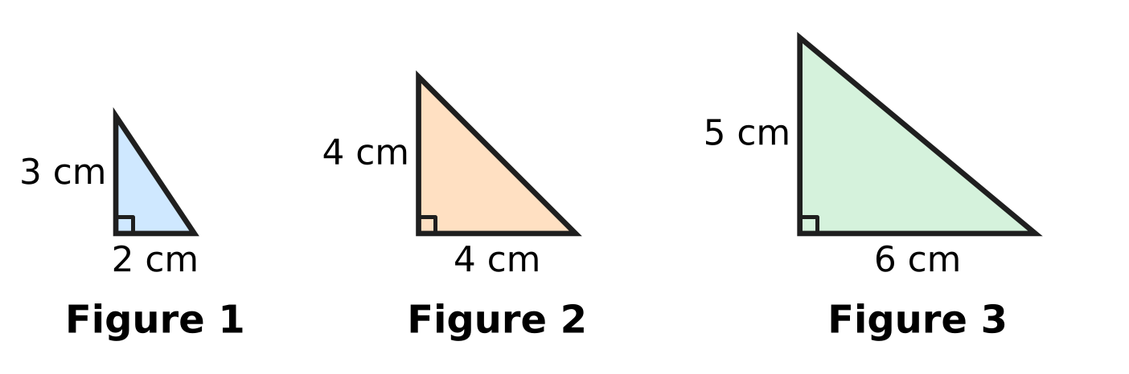
Q43. The picture shows the first three figures of a pattern of right-angled triangles. In each new figure the base is 2 cm longer and the height is 1 cm longer than in the figure before. Which is the first figure whose area is more than 100 sq cm? [4 marks]
(A) Figure 10 | (B) Figure 9
(C) Figure 7 | (D) Figure 8

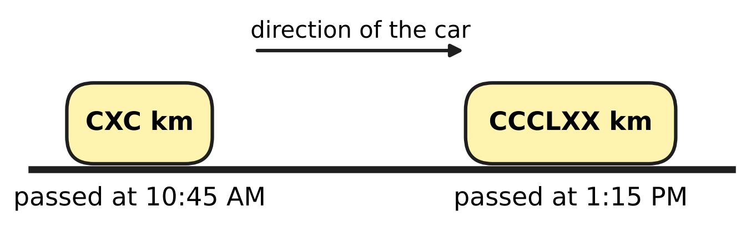
Q44. Nirav's family car drives along a highway at a steady speed. The stones beside the road show the distance from the same city in Roman numerals. The car passes the two stones at the times shown. What is the speed of the car? [4 marks]
(A) 90 km/h | (B) 60 km/h | (C) 72 km/h | (D) 64 km/h

Q45. A fishing boat is out of the harbour for 5 hours. For 20% of this time it stays still while the nets are down. For the rest of the time it moves at a steady speed and covers 48 km. How much greater is its moving speed than its average speed for the whole 5 hours? [4 marks]
(A) 9.6 km/h | (B) 2.4 km/h | (C) 12 km/h | (D) 2 km/h

Answer Sheet AMO Level 1 · Class 5 · Practice Paper 3
Name: | School: | Roll No.:
Shade or tick one circle for each question.
1. Ⓐ Ⓑ Ⓒ Ⓓ | 16. Ⓐ Ⓑ Ⓒ Ⓓ | 31. Ⓐ Ⓑ Ⓒ Ⓓ
2. Ⓐ Ⓑ Ⓒ Ⓓ | 17. Ⓐ Ⓑ Ⓒ Ⓓ | 32. Ⓐ Ⓑ Ⓒ Ⓓ
3. Ⓐ Ⓑ Ⓒ Ⓓ | 18. Ⓐ Ⓑ Ⓒ Ⓓ | 33. Ⓐ Ⓑ Ⓒ Ⓓ
4. Ⓐ Ⓑ Ⓒ Ⓓ | 19. Ⓐ Ⓑ Ⓒ Ⓓ | 34. Ⓐ Ⓑ Ⓒ Ⓓ
5. Ⓐ Ⓑ Ⓒ Ⓓ | 20. Ⓐ Ⓑ Ⓒ Ⓓ | 35. Ⓐ Ⓑ Ⓒ Ⓓ
6. Ⓐ Ⓑ Ⓒ Ⓓ | 21. Ⓐ Ⓑ Ⓒ Ⓓ | 36. Ⓐ Ⓑ Ⓒ Ⓓ
7. Ⓐ Ⓑ Ⓒ Ⓓ | 22. Ⓐ Ⓑ Ⓒ Ⓓ | 37. Ⓐ Ⓑ Ⓒ Ⓓ
8. Ⓐ Ⓑ Ⓒ Ⓓ | 23. Ⓐ Ⓑ Ⓒ Ⓓ | 38. Ⓐ Ⓑ Ⓒ Ⓓ
9. Ⓐ Ⓑ Ⓒ Ⓓ | 24. Ⓐ Ⓑ Ⓒ Ⓓ | 39. Ⓐ Ⓑ Ⓒ Ⓓ
10. Ⓐ Ⓑ Ⓒ Ⓓ | 25. Ⓐ Ⓑ Ⓒ Ⓓ | 40. Ⓐ Ⓑ Ⓒ Ⓓ
11. Ⓐ Ⓑ Ⓒ Ⓓ | 26. Ⓐ Ⓑ Ⓒ Ⓓ | 41. Ⓐ Ⓑ Ⓒ Ⓓ
12. Ⓐ Ⓑ Ⓒ Ⓓ | 27. Ⓐ Ⓑ Ⓒ Ⓓ | 42. Ⓐ Ⓑ Ⓒ Ⓓ
13. Ⓐ Ⓑ Ⓒ Ⓓ | 28. Ⓐ Ⓑ Ⓒ Ⓓ | 43. Ⓐ Ⓑ Ⓒ Ⓓ
14. Ⓐ Ⓑ Ⓒ Ⓓ | 29. Ⓐ Ⓑ Ⓒ Ⓓ | 44. Ⓐ Ⓑ Ⓒ Ⓓ
15. Ⓐ Ⓑ Ⓒ Ⓓ | 30. Ⓐ Ⓑ Ⓒ Ⓓ | 45. Ⓐ Ⓑ Ⓒ Ⓓ
Q41–Q45 are Section II Star Questions (4 marks each).
For the parent or teacher
Section I correct: ______ / 40 × 2 = ______ marks Section II correct: ______ / 5 × 4 = ______ marks
Correct: ______ / 45 Score: ______ / 100
Answer Key and Solutions AMO Level 1 · Class 5 · Practice Paper 3
Quick answers
1 C | 6 A | 11 A | 16 D | 21 B | 26 A | 31 D | 36 D | 41 D
2 D | 7 D | 12 B | 17 A | 22 C | 27 B | 32 C | 37 B | 42 B
3 C | 8 C | 13 D | 18 B | 23 A | 28 C | 33 A | 38 A | 43 A
4 D | 9 A | 14 C | 19 B | 24 D | 29 B | 34 B | 39 D | 44 C
5 B | 10 B | 15 A | 20 C | 25 D | 30 A | 35 C | 40 C | 45 B
Solutions
Q | Part · level | Answer | Why?
1 | Part 1 · Ch1 · Easy | (C) 30,000 | In 4,36,053 the digit 3 is in the ten-thousands place, so the missing part is 30,000.
2 | Part 1 · Ch1 · Easy | (D) XC | Split 990 as 900 + 90. Then 900 is CM and 90 is 100 − 10 = XC, so 990 = CMXC.
3 | Part 1 · Ch1 · Easy | (C) 7 | Since 2 × 2 × 5 = 20 and 140 ÷ 20 = 7, the blank is 7. It is a prime number, so 140 = 2 × 2 × 7 × 5.
4 | Part 1 · Ch1 · Medium | (D) 42 | HCF × LCM = product of the two numbers. So LCM = 294 ÷ 7 = 42.
5 | Part 1 · Ch1 · Medium | (B) 1,02,345 | The first digit must be 1 (it cannot be 0). Then use the smallest unused digits in order: 0, 2, 3, 4, 5, giving 1,02,345.
6 | Part 2 · Ch2 · Easy | (A) 1,200 | Rounding gives 289 → 300, 312 → 300, 198 → 200 and 405 → 400. The estimate is 300 + 300 + 200 + 400 = 1,200.
7 | Part 2 · Ch2 · Easy | (D) 2 | Since 98 = 100 − 2, we get 63 × 98 = 63 × 100 − 63 × 2.
8 | Part 2 · Ch2 · Easy | (C) 100 − (3 × 18 + 2 × 15) | He spends 3 × 18 + 2 × 15 = 54 + 30 = ₹84. The change is 100 − (3 × 18 + 2 × 15) = ₹16.
9 | Part 2 · Ch2 · Medium | (A) + | [24 ÷ (6 ___ 2)] must be 12 ÷ 4 = 3, so (6 ___ 2) must be 8. Only 6 + 2 = 8.
10 | Part 2 · Ch2 · Medium | (B) 30 × 25 + 6 × 5 | Option B gives 30 × 25 + 6 × 5 = 750 + 30 = 780, but 36 × 25 = 900. The 6 must also be multiplied by 25, not by 5.
11 | Part 3 · Ch3 · Easy | (A) 0.36 | Each step is 0.01. P is 6 steps after 0.3, so P shows 0.3 + 0.06 = 0.36.
12 | Part 3 · Ch3 · Easy | (B) 25 | Write 0.04 as 4/100 = 1/25, and 1/25 = 1 ÷ 25.
13 | Part 3 · Ch3 · Easy | (D) 210 | Since 25% = 1/4, the answer is 840 ÷ 4 = 210.
14 | Part 3 · Ch3 · Easy | (C) 1.35 | The blank is 4.10 − 2.75 = 1.35. Check: 2.75 + 1.35 = 4.10.
15 | Part 3 · Ch3 · Medium | (A) 30% | Half of 3/5 is 3/10, and 3/10 = 30/100 = 30%.
16 | Part 3 · Ch3 · Medium | (D) 50 | First, 15% of 200 = 30. Then 30 out of 60 is one half, which is 50%.
17 | Part 4 · Ch5 · Easy | (A) 4:25 | A right angle is a quarter of a full turn. A quarter of 60 minutes is 15 minutes, so 4:10 becomes 4:25.
18 | Part 4 · Ch5 · Easy | (B) Square B | The shaded square in the first column, second row from the bottom, has no partner on the right. Its mirror image across the dashed line is Square B.
19 | Part 4 · Ch5 · Easy | (B) Every rhombus is a square. | A rhombus has four equal sides but its angles need not be right angles, so a rhombus need not be a square. The other three statements are true.
20 | Part 4 · Ch5 · Medium | (C) 90°, right-angled | The third angle is 180° − 35° − 55° = 90°. A triangle with a 90° angle is right-angled.
21 | Part 4 · Ch5 · Medium | (B) 60° | The order of rotational symmetry is 6, so the smallest turn is 360° ÷ 6 = 60°.
22 | Part 5 · Ch6 · Easy | (C) 20 sq cm | The sides at the right angle are 8 cm and 5 cm on the grid. Area = 1/2 × 8 × 5 = 20 sq cm.
23 | Part 5 · Ch6 · Easy | (A) 480 cubic cm | Volume = length × width × height = 15 × 8 × 4 = 480 cubic cm.
24 | Part 5 · Ch6 · Easy | (D) 4 cm × 4 cm × 4 cm | The volumes are 10 × 3 × 2 = 60, 6 × 5 × 2 = 60, 7 × 3 × 3 = 63 and 4 × 4 × 4 = 64 cubic cm. The 4 cm cube holds the most sand.
25 | Part 5 · Ch6 · Medium | (D) 30 cm | The tank holds 72 litres = 72,000 cubic cm. The base is 60 × 40 = 2,400 sq cm, so the height is 72,000 ÷ 2,400 = 30 cm.
26 | Part 5 · Ch6 · Medium | (A) 9 cm | Rectangle area = 9 × 4 = 36 sq cm. For the triangle, 1/2 × 8 × height = 36, so 4 × height = 36 and height = 9 cm.
27 | Part 6 · Ch8 · Easy | (B) 195 | There are 18 whole symbols and 3 half symbols, which make 18 + 1½ = 19½ symbols. So there are 19½ × 10 = 195 bees.
28 | Part 6 · Ch8 · Medium | (C) 30 kg | Trees A to D give 40 + 70 + 50 + 60 = 220 kg. Tree E gave 250 − 220 = 30 kg.
29 | Part 7 · Ch9 · Easy | (B) 39 days | One week has 7 days, so 5 weeks 4 days = 5 × 7 + 4 = 39 days.
30 | Part 7 · Ch9 · Easy | (A) 48 km | Distance = speed × time = 16 × 3 = 48 km.
31 | Part 7 · Ch9 · Easy | (D) 900 seconds | A quarter of an hour is 15 minutes, and 15 × 60 = 900 seconds.
32 | Part 7 · Ch9 · Easy | (C) 0.8 hour | An hour has 60 minutes, so 48 minutes = 48/60 hour = 4/5 hour = 0.8 hour.
33 | Part 7 · Ch9 · Medium | (A) 180 | Two hours = 2 × 60 × 60 = 7,200 seconds. So it fills 7,200 ÷ 40 = 180 sacks.
34 | Part 7 · Ch9 · Medium | (B) 24 minutes | In one day it gains 5 × 24 = 120 seconds. In 12 days it gains 120 × 12 = 1,440 seconds = 1,440 ÷ 60 = 24 minutes.
35 | Part 8 · Ch10 · Easy | (C) 55 | The terms go up by 7. The 8th term is 6 + 7 × 7 = 55.
36 | Part 8 · Ch10 · Easy | (D) 3 | Each term is 5 times the one before (15 × 5 = 75, 75 × 5 = 375). So the first term is 15 ÷ 5 = 3.
37 | Part 8 · Ch10 · Easy | (B) 16 | Odd numbers pair up: odd + odd = even. So an even count of odd numbers, such as 16, always gives an even sum.
38 | Part 8 · Ch10 · Medium | (A) 51 days | April 18 to 30 is 13 days, May has 31 days and June 1 to 7 is 7 days. The total is 13 + 31 + 7 = 51 days.
39 | Part 8 · Ch10 · Medium | (D) 27 | Each move is odd and six odd numbers add up to an even number, so the counter always moves forward an even number of squares and lands on 1 + even = an odd square. Square 27 is odd and can be reached: 3 + 3 + 5 + 5 + 5 + 5 = 26, and 1 + 26 = 27.
40 | Part 8 · Ch10 · Medium | (C) 89 | The terms go up by 6, so every term is 5 more than a multiple of 6. For 89, 89 − 5 = 84 = 6 × 14, so 89 is a term. For 91, 96 and 99, subtracting 5 gives 86, 91 and 94, which are not multiples of 6.
41 | Section II · Ch1 + Ch10 · Hard | (D) 4 | Such a factor is 2 × an odd number. The odd factors of 120 are 1, 3, 5 and 15, so the factors are 2, 6, 10 and 30: four of them.
42 | Section II · Ch3 + Ch10 · Hard | (B) ₹61 | As 35% = 7/20, the number of coins is a multiple of 20: 20 or 40. With 40 coins there are 26 ₹2 coins (even), so there are 20 coins: 7 of ₹5 and 13 of ₹2. Money = 35 + 26 = ₹61.
43 | Section II · Ch6 + Ch10 · Hard | (A) Figure 10 | The bases go 2, 4, 6, … cm and the heights go 3, 4, 5, … cm. Figure 9 has base 18 cm and height 11 cm, so its area is 1/2 × 18 × 11 = 99 sq cm. Figure 10 has base 20 cm and height 12 cm, so its area is 120 sq cm. Figure 10 is the first above 100 sq cm.
44 | Section II · Ch1 + Ch9 · Hard | (C) 72 km/h | CXC = 190 and CCCLXX = 370, so the car went 370 − 190 = 180 km. From 10:45 AM to 1:15 PM is 2 hours 30 minutes = 2.5 hours. Speed = 180 ÷ 2.5 = 72 km/h.
45 | Section II · Ch3 + Ch9 · Hard | (B) 2.4 km/h | The boat is still for 20% of 5 hours = 1 hour, so it moves for 4 hours at 48 ÷ 4 = 12 km/h. Average speed = 48 ÷ 5 = 9.6 km/h. Difference = 12 − 9.6 = 2.4 km/h.

ARYABHATTA MATHS OLYMPIAD
Level 1
PRACTICE PAPER-4
CLASS 5
Total Questions | 45 multiple-choice questions
Total Marks | 100
Time | 60 minutes
Section I | 40 questions × 2 marks = 80 marks
Section II | 5 Star Questions × 4 marks = 20 marks
Negative Marking | No negative marking
Calculator | Not allowed
Chapters | Number System · Operations · Fractions, Decimals & Percentages · Geometry · Mensuration · Data Handling · Applied Mathematics · Mathematical Reasoning

👋 Hello, friend! How to do this paper:
⭐ Every question has four answer choices: (A), (B), (C) and (D). Only one is correct.
⭐ Read each question and look at its picture carefully. Then mark your answer on the answer sheet at the end.
⭐ Section I has 40 questions of 2 marks each. Section II has 5 Star Questions of 4 marks each.
⭐ There is no negative marking, so try every question.
⭐ Do not use a calculator. You may do rough work on a separate sheet.
⭐ All figures are not necessarily drawn to scale unless stated.

For parents and teachers
• Print or view this paper in colour. Pictures are part of the questions.
• Parts follow the AMO syllabus chapters. Chapters 4 and 7 are not part of the Class 5 syllabus, so the chapter numbers shown in the Part headings have gaps.
• The answer sheet and the answer key are at the end. Remove only the answer key before the child begins.

SECTION I 40 questions × 2 marks each
Part 1 — Number System (Syllabus Chapter 1)
Q1. Which of these is the number eight lakh six thousand forty, written in figures?
(A) 8,60,040 | (B) 8,06,040 | (C) 8,00,640 | (D) 8,06,400

Q2. Which of these Roman numerals stands for the greatest number?
(A) DCCCLXXX | (B) CMIV | (C) DCCCXCIX | (D) CMXL

Q3. Which of these numbers is a prime number?
(A) 83 | (B) 57 | (C) 91 | (D) 87

Q4. Kriti writes down all the factors of 28 except 28 itself. Then she adds them. What total does she get?
(A) 21 | (B) 56 | (C) 27 | (D) 28

Q5. Two lamps on a gate are switched on at the same moment, and they both flash at once. After that, one lamp flashes every 9 seconds and the other every 12 seconds. Do not count the first flash. How many times do they flash together in the next $2\frac{1}{2}$ minutes?
(A) 4 | (B) 1 | (C) 5 | (D) 7

Part 2 — Operations & Number Properties (Syllabus Chapter 2)
Q6. Which of these statements is true?
(A) 18 − 6 = 6 − 18 | (B) 18 × 6 = 6 × 18
(C) 18 ÷ 6 = 6 ÷ 18 | (D) (18 ÷ 6) ÷ 3 = 18 ÷ (6 ÷ 3)

Q7. An egg farm sends 389 trays of eggs to shops. Each tray holds 30 eggs. Which is the best estimate of the number of eggs sent?
(A) 1,200 | (B) 12,000 | (C) 9,000 | (D) 1,20,000

Q8. Using the correct order of operations, work out 30 − 12 ÷ 3 × 2.
(A) 22 | (B) 12 | (C) 3 | (D) 28

Q9. In the school assembly, the children stand in 8 rows of 24. Then 3 children leave each row. The children who stay are put into 12 equal rows. How many children are in each new row?
(A) 21 | (B) 168 | (C) 16 | (D) 14

Q10. Use a property of numbers to work out 99 × 37 + 37 quickly. What is the answer?
(A) 3,700 | (B) 3,663 | (C) 3,737 | (D) 3,626

Part 3 — Fractions, Decimals & Percentages (Syllabus Chapter 3)
Q11. Look at the picture. The circle is divided into 8 equal slices. How much of the circle is shaded, written as a percentage? | 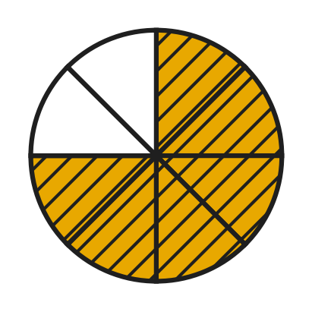
  (A) 60% | (B) 75% | (C) 6% | (D) 25%

Q12. Noor's cake recipe needs $\frac{4}{5}$ kg of flour. Her kitchen scale shows weights as decimals. What reading should she look for?
(A) 0.45 kg | (B) 0.08 kg | (C) 0.8 kg | (D) 0.4 kg

Q13. What is the value of the digit 7 in the number 46.07?
(A) 0.7 | (B) 70 | (C) 7 | (D) 0.07

Q14. A rope is 1 m long. Sanjay paints 35% of its length red. How long is the red part?
(A) 3.5 cm | (B) 35 cm | (C) 350 cm | (D) 65 cm

Q15. In a bookshop sale, the price of every storybook is reduced by 25%. A storybook cost ₹240 before the sale. What is its price in the sale?
(A) ₹180 | (B) ₹300 | (C) ₹60 | (D) ₹215

Q16. A small zoo has 80 animals. Of these, 30% are birds, and 0.45 of all the animals are mammals. All the others are reptiles. How many reptiles are there?
(A) 44 | (B) 25 | (C) 56 | (D) 20

Part 4 — Geometry (Syllabus Chapter 5)
Q17. The clock shows 5 o'clock. What kind of angle do the two hands make? | 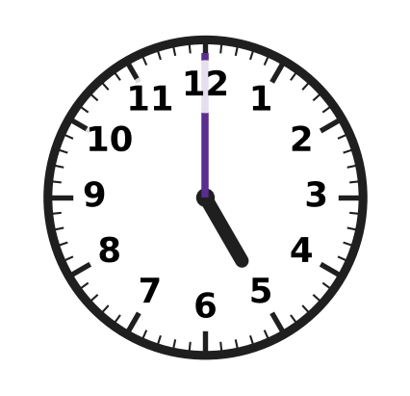
  (A) Acute angle | (B) Right angle
  (C) Obtuse angle | (D) Straight angle

Q18. The picture shows a rectangle 6 cm long and 3 cm wide. How many lines of symmetry does it have? | 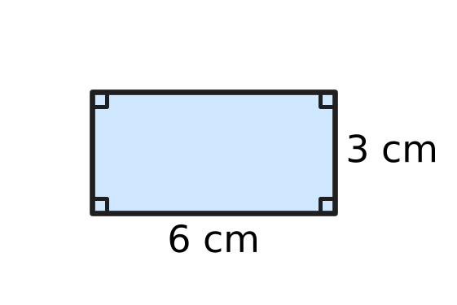
  (A) 0 | (B) 1 | (C) 2 | (D) 4

Q19. In the quadrilateral ABCD shown in the picture, three of the angles are marked. What is the size of angle x? | 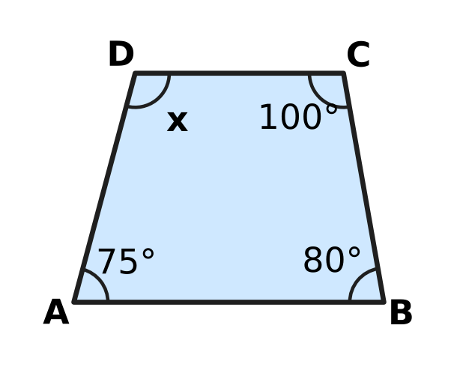
  (A) 255° | (B) 105° | (C) 95° | (D) 205°

Q20. The picture shows an open umbrella seen from above. Its 8 ribs are equally spaced around the centre. What is the smaller angle between rib P and rib Q? | 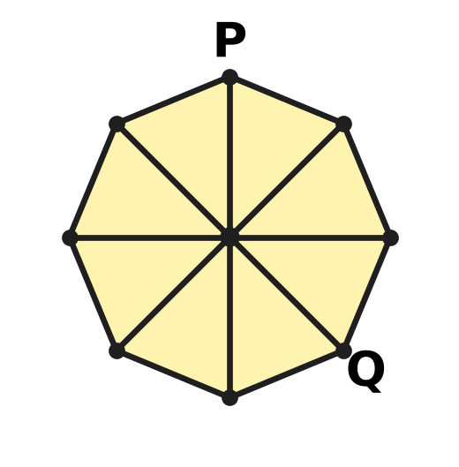
  (A) 90° | (B) 180° | (C) 135° | (D) 45°

Q21. In triangle ABC in the picture, the tick marks show that AB = AC. Angle B is 70°. What is the size of angle A? | 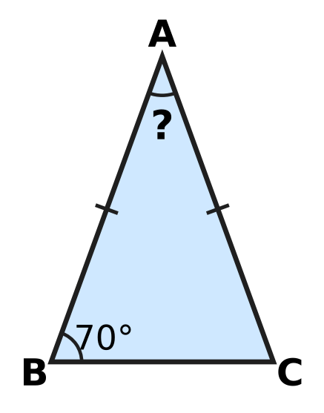
  (A) 70° | (B) 110° | (C) 55° | (D) 40°

Part 5 — Mensuration (Syllabus Chapter 6)
Q22. A paper label is cut in the shape shown in the picture. Its 6 cm and 8 cm edges meet at a right angle. What is the area of the label? | 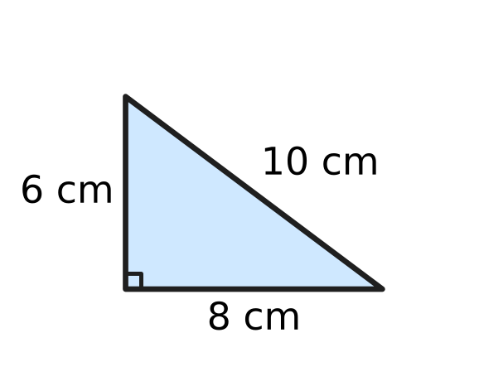
  (A) 30 sq cm | (B) 40 sq cm | (C) 24 sq cm | (D) 48 sq cm

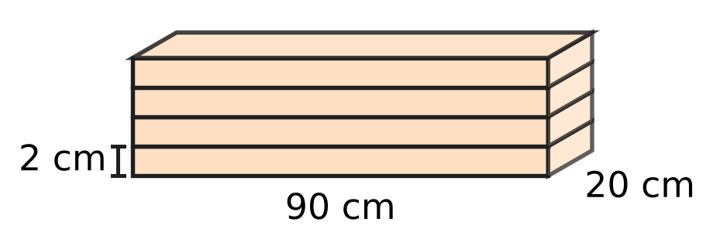
Q23. Four wooden shelf boards are stacked flat, one on top of another, as shown. Each board is 90 cm long, 20 cm wide and 2 cm thick. What is the volume of the whole stack?
(A) 14,400 cubic cm | (B) 1,800 cubic cm
(C) 7,200 cubic cm | (D) 3,600 cubic cm

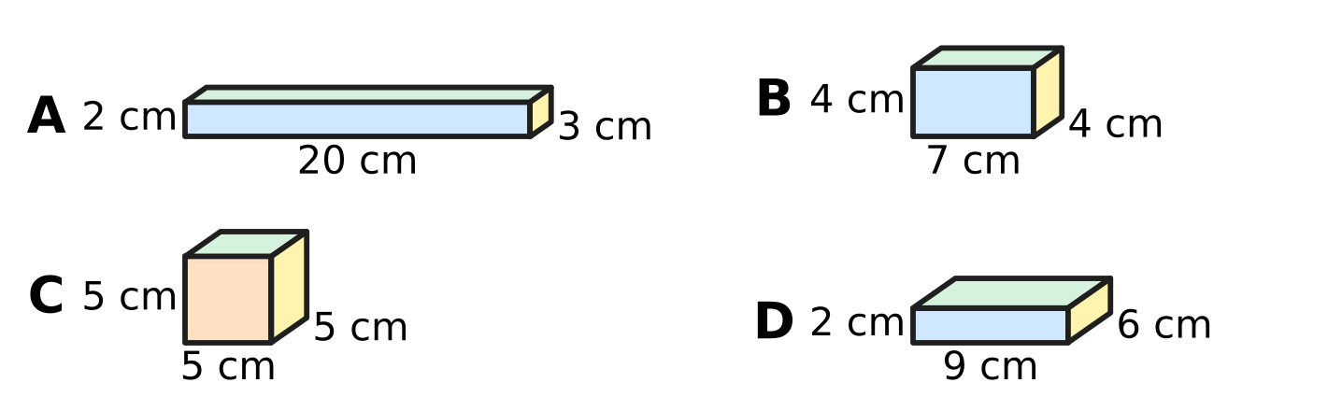
Q24. Zara has the four solid wooden blocks shown, with their lengths, widths and heights. Which block has the greatest volume?
(A) Block A | (B) Block B | (C) Block C | (D) Block D

Q25. The picture shows two solid cubes of clay. The small cube has edges of 3 cm and the big cube has edges of 6 cm. How many times as much clay as the small cube does the big cube have? | 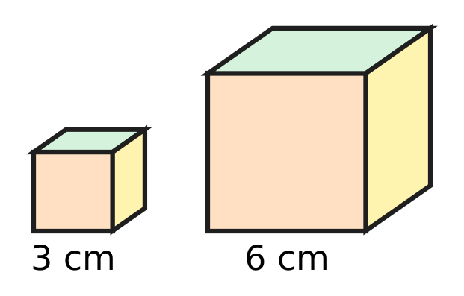
  (A) 6 times | (B) 8 times | (C) 4 times | (D) 2 times

Q26. In art class, Kiara cuts a rectangular card 12 cm long and 8 cm wide into identical right-angled triangles like the shaded one in the picture. The sides at the right angle are 3 cm and 4 cm. No card is wasted. How many triangles does she get? | 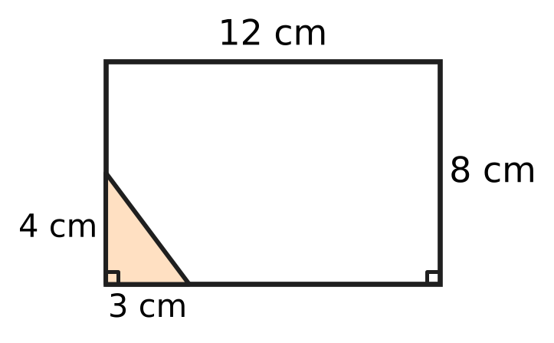
  (A) 16 | (B) 8 | (C) 32 | (D) 96

Part 6 — Data Handling, Statistics & Probability (Syllabus Chapter 8)
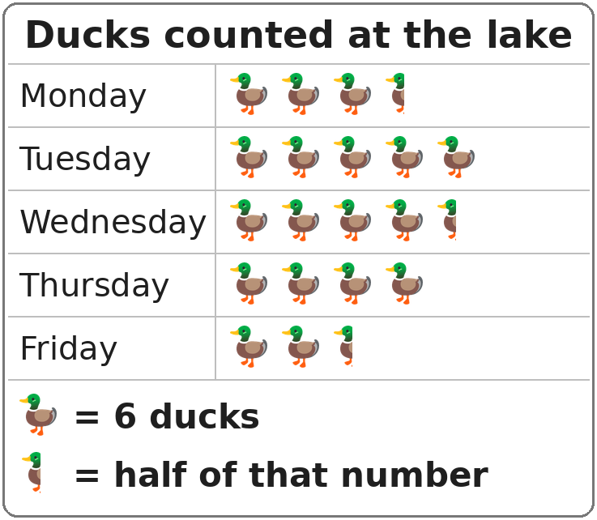
Q27. The pictograph shows the ducks counted at a lake on five mornings. On which morning were 27 ducks counted?
(A) Thursday | (B) Monday
(C) Wednesday | (D) Tuesday

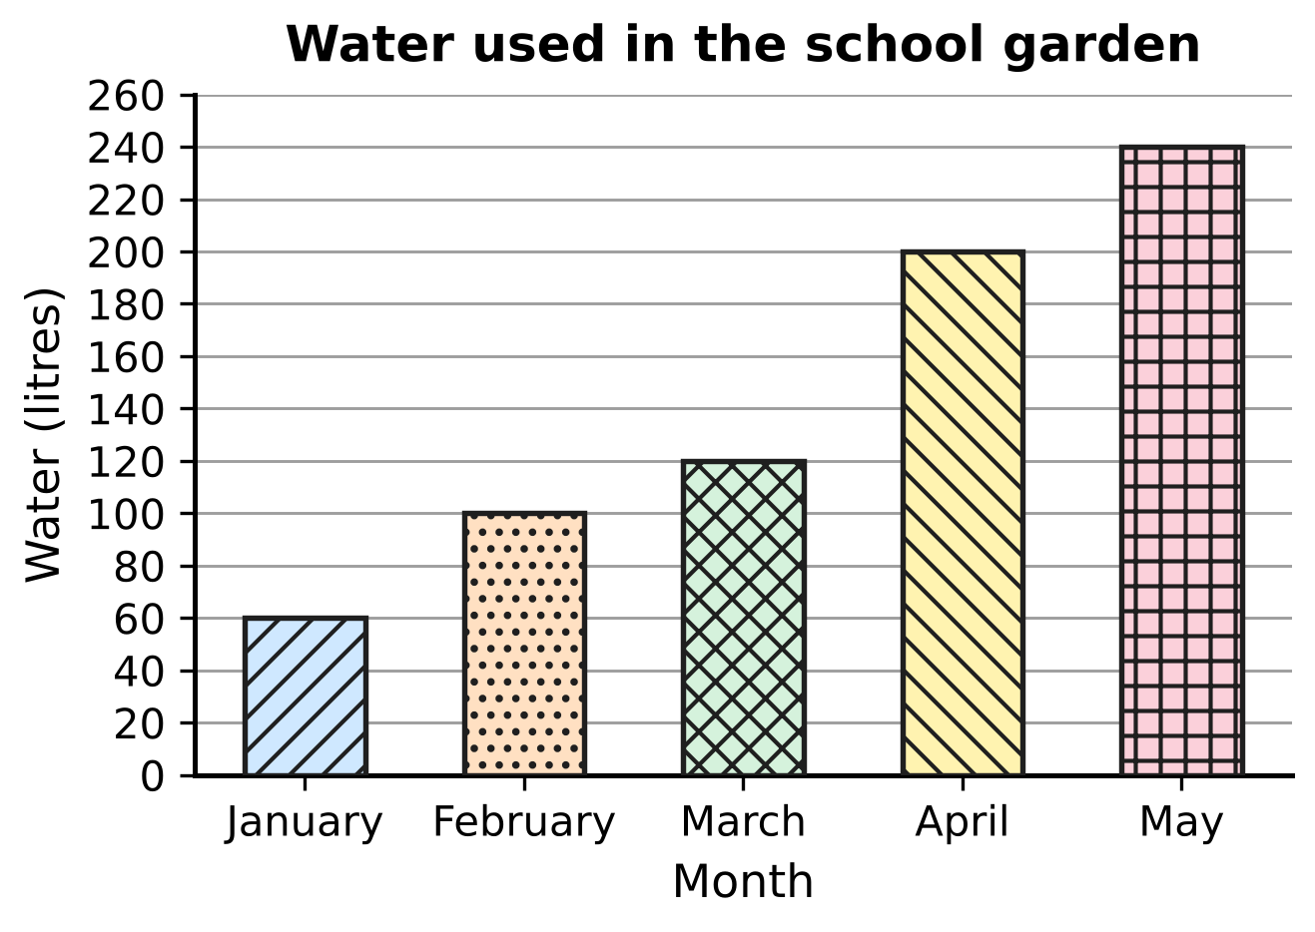
Q28. The bar graph shows the water used in a school garden in five months. How much more water was used in the month with the most water than in January and February together?
(A) 140 litres | (B) 400 litres
(C) 180 litres | (D) 80 litres

Part 7 — Applied Mathematics (Syllabus Chapter 9)
Q29. How many hours are there in 2 weeks?
(A) 48 hours | (B) 168 hours
(C) 336 hours | (D) 140 hours

Q30. A class visit to a science park lasts 2.5 hours. How many minutes is that?
(A) 150 minutes | (B) 120 minutes
(C) 170 minutes | (D) 250 minutes

Q31. Which of these is the same speed as 30 km/h?
(A) 30 km every minute | (B) 1 km every 2 minutes
(C) 1 km every 30 minutes | (D) 2 km every minute

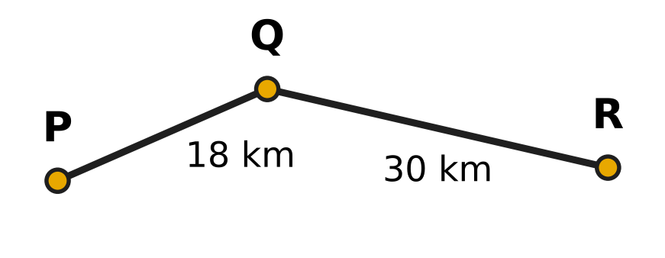
Q32. The picture shows a cycle route from village P to village R through village Q. Rehan cycles from P to R along this route at a steady 12 km/h. How long does he take?
(A) 2 hours 30 minutes | (B) 5 hours
(C) 1 hour 30 minutes | (D) 4 hours

Q33. A boat on a still lake goes 24 km from Jetty A to Jetty B at a steady 12 km/h. It then comes back the same way to Jetty A. For the whole round trip, its average speed must be 16 km/h. At what steady speed must it come back?
(A) 8 km/h | (B) 24 km/h | (C) 48 km/h | (D) 20 km/h

Q34. Tia's robot lawn mower moves forward 6 m every 5 minutes while it cuts the grass. At this speed, how long does it take to cut a strip 90 m long?
(A) 18 minutes | (B) 1 hour 30 minutes
(C) 1 hour 15 minutes | (D) 15 minutes

Part 8 — Mathematical Reasoning & Problem-Solving (Syllabus Chapter 10)
Q35. In a badminton knockout contest, 64 players play in Round 1. After each round, half of the players are out. How many players play in Round 5?
(A) 4 | (B) 16 | (C) 8 | (D) 2

Q36. Chetan thinks of an odd number. Which of these steps ALWAYS gives an even number?
(A) Multiply it by 5 | (B) Add 4 to it
(C) Double it and then add 1 | (D) Add 7 to it

Q37. In which list is each number found by multiplying the number before it by the same fixed number each time?
(A) 7, 21, 35, 49, 63 | (B) 7, 21, 63, 189, 567
(C) 7, 21, 42, 70, 105 | (D) 7, 21, 63, 105, 147

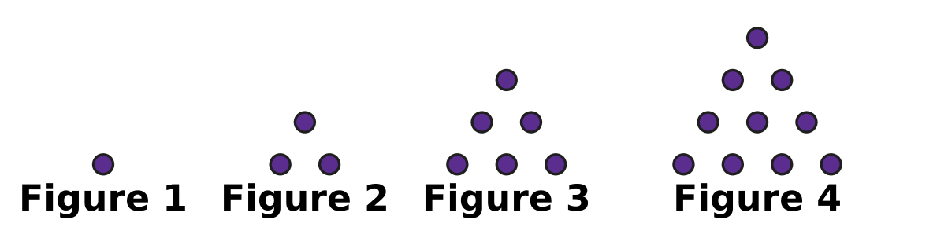
Q38. Look at the pattern of dots. Each figure has one more row than the figure before it. How many dots are there in Figure 8?
(A) 22 | (B) 28 | (C) 36 | (D) 45

Q39. Rupa writes the numbers 1 to 9 in order in a row. She puts a + sign or a − sign in every gap between two numbers, and then works out the answer. Which of these could her answer be?
(A) 10 | (B) 0 | (C) 20 | (D) 15

Q40. In a year of 365 days, 1 January is a Monday. Which other month of that year also begins on a Monday?
(A) October | (B) August | (C) March | (D) July

SECTION II — Star Questions 5 questions × 4 marks each
Q41. There are 100 cards numbered 1 to 100. Vihaan picks out every card whose number is odd and is a multiple of 3 or 5 (or both). How many cards does he pick out? [4 marks]
(A) 21 | (B) 24 | (C) 47 | (D) 27

Q42. At a plant nursery, saplings are set out in 8 rows. Row 1 has 6 saplings, row 2 has 10, row 3 has 14, and each row has 4 more saplings than the row before it. Of all the saplings, 25% are mango saplings. How many mango saplings are there? [4 marks]
(A) 40 | (B) 44 | (C) 12 | (D) 120

Q43. A cuboid 10 cm long, 6 cm wide and 6 cm high is built from dark and light cubes with edges of 2 cm. Any two cubes that share a face have different colours. The picture shows the bottom layer. The colours alternate in this way through all three layers. What is the total volume of all the dark cubes? [4 marks] | 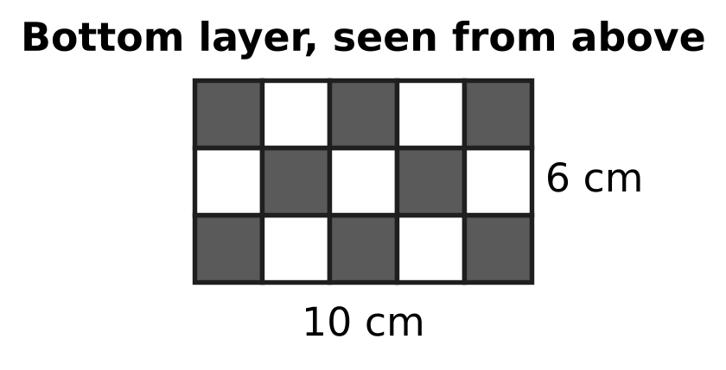
  (A) 176 cubic cm | (B) 180 cubic cm
  (C) 23 cubic cm | (D) 184 cubic cm

Q44. A mountain trail is 20 km long. There is a marker at every kilometre, numbered 1, 2, 3, …, 20 from the start. Omar walks the trail at a steady 4 km/h. He rests for 10 minutes at every marker with a prime number, and nowhere else. How long does he take to walk the whole trail? [4 marks]
(A) 5 hours | (B) 6 hours 10 minutes
(C) 6 hours 20 minutes | (D) 6 hours 30 minutes

Q45. A milk van leaves the dairy at 5:45 a.m. on its 48 km delivery route. It drives at a steady speed without stopping. At 6:30 a.m. it has covered $\frac{5}{8}$ of the route. At what time does it finish the route? [4 marks]
(A) 7:42 a.m. | (B) 6:57 a.m.
(C) 7:45 a.m. | (D) 7:15 a.m.

Answer Sheet AMO Level 1 · Class 5 · Practice Paper 4
Name: | School: | Roll No.:
Shade or tick one circle for each question.
1. Ⓐ Ⓑ Ⓒ Ⓓ | 16. Ⓐ Ⓑ Ⓒ Ⓓ | 31. Ⓐ Ⓑ Ⓒ Ⓓ
2. Ⓐ Ⓑ Ⓒ Ⓓ | 17. Ⓐ Ⓑ Ⓒ Ⓓ | 32. Ⓐ Ⓑ Ⓒ Ⓓ
3. Ⓐ Ⓑ Ⓒ Ⓓ | 18. Ⓐ Ⓑ Ⓒ Ⓓ | 33. Ⓐ Ⓑ Ⓒ Ⓓ
4. Ⓐ Ⓑ Ⓒ Ⓓ | 19. Ⓐ Ⓑ Ⓒ Ⓓ | 34. Ⓐ Ⓑ Ⓒ Ⓓ
5. Ⓐ Ⓑ Ⓒ Ⓓ | 20. Ⓐ Ⓑ Ⓒ Ⓓ | 35. Ⓐ Ⓑ Ⓒ Ⓓ
6. Ⓐ Ⓑ Ⓒ Ⓓ | 21. Ⓐ Ⓑ Ⓒ Ⓓ | 36. Ⓐ Ⓑ Ⓒ Ⓓ
7. Ⓐ Ⓑ Ⓒ Ⓓ | 22. Ⓐ Ⓑ Ⓒ Ⓓ | 37. Ⓐ Ⓑ Ⓒ Ⓓ
8. Ⓐ Ⓑ Ⓒ Ⓓ | 23. Ⓐ Ⓑ Ⓒ Ⓓ | 38. Ⓐ Ⓑ Ⓒ Ⓓ
9. Ⓐ Ⓑ Ⓒ Ⓓ | 24. Ⓐ Ⓑ Ⓒ Ⓓ | 39. Ⓐ Ⓑ Ⓒ Ⓓ
10. Ⓐ Ⓑ Ⓒ Ⓓ | 25. Ⓐ Ⓑ Ⓒ Ⓓ | 40. Ⓐ Ⓑ Ⓒ Ⓓ
11. Ⓐ Ⓑ Ⓒ Ⓓ | 26. Ⓐ Ⓑ Ⓒ Ⓓ | 41. Ⓐ Ⓑ Ⓒ Ⓓ
12. Ⓐ Ⓑ Ⓒ Ⓓ | 27. Ⓐ Ⓑ Ⓒ Ⓓ | 42. Ⓐ Ⓑ Ⓒ Ⓓ
13. Ⓐ Ⓑ Ⓒ Ⓓ | 28. Ⓐ Ⓑ Ⓒ Ⓓ | 43. Ⓐ Ⓑ Ⓒ Ⓓ
14. Ⓐ Ⓑ Ⓒ Ⓓ | 29. Ⓐ Ⓑ Ⓒ Ⓓ | 44. Ⓐ Ⓑ Ⓒ Ⓓ
15. Ⓐ Ⓑ Ⓒ Ⓓ | 30. Ⓐ Ⓑ Ⓒ Ⓓ | 45. Ⓐ Ⓑ Ⓒ Ⓓ
Q41–Q45 are Section II Star Questions (4 marks each).
For the parent or teacher
Section I correct: ______ / 40 × 2 = ______ marks Section II correct: ______ / 5 × 4 = ______ marks
Correct: ______ / 45 Score: ______ / 100
Answer Key and Solutions AMO Level 1 · Class 5 · Practice Paper 4
Quick answers
1 B | 6 B | 11 B | 16 D | 21 D | 26 A | 31 B | 36 D | 41 B
2 D | 7 B | 12 C | 17 C | 22 C | 27 C | 32 D | 37 B | 42 A
3 A | 8 A | 13 D | 18 C | 23 A | 28 D | 33 B | 38 C | 43 D
4 D | 9 D | 14 B | 19 B | 24 C | 29 C | 34 C | 39 D | 44 C
5 A | 10 A | 15 A | 20 C | 25 B | 30 A | 35 A | 40 A | 45 B
Solutions
Q | Part · level | Answer | Why?
1 | Part 1 · Ch1 · Easy | (B) 8,06,040 | Eight lakh = 8,00,000, six thousand = 6,000 and forty = 40. Together they make 8,06,040.
2 | Part 1 · Ch1 · Easy | (D) CMXL | CMXL = 900 + 40 = 940, CMIV = 904, DCCCXCIX = 899 and DCCCLXXX = 880. The greatest is 940.
3 | Part 1 · Ch1 · Easy | (A) 83 | 91 = 7 × 13, 87 = 3 × 29 and 57 = 3 × 19 are composite. 83 has no factor other than 1 and 83, so it is prime.
4 | Part 1 · Ch1 · Medium | (D) 28 | The factors of 28 are 1, 2, 4, 7, 14 and 28. Leaving out 28: 1 + 2 + 4 + 7 + 14 = 28.
5 | Part 1 · Ch1 · Medium | (A) 4 | The LCM of 9 and 12 is 36, so they flash together every 36 seconds. 2½ minutes = 150 seconds, and 36, 72, 108, 144 are 4 times.
6 | Part 2 · Ch2 · Easy | (B) 18 × 6 = 6 × 18 | Numbers can be swapped in a multiplication (18 × 6 = 6 × 18 = 108), but not in a subtraction or a division. A division also cannot be regrouped: (18 ÷ 6) ÷ 3 = 1, but 18 ÷ (6 ÷ 3) = 9.
7 | Part 2 · Ch2 · Easy | (B) 12,000 | The number 389 is about 400, and 400 × 30 = 12,000. (The exact number, 11,670, is close to this.)
8 | Part 2 · Ch2 · Easy | (A) 22 | ÷ and × are done from left to right before −: 12 ÷ 3 = 4, 4 × 2 = 8, and 30 − 8 = 22.
9 | Part 2 · Ch2 · Medium | (D) 14 | [8 × (24 − 3)] ÷ 12 = [8 × 21] ÷ 12 = 168 ÷ 12 = 14 children in each new row.
10 | Part 2 · Ch2 · Medium | (A) 3,700 | 99 × 37 + 37 = 99 × 37 + 1 × 37 = (99 + 1) × 37 = 100 × 37 = 3,700.
11 | Part 3 · Ch3 · Easy | (B) 75% | Here 6 of the 8 equal parts are shaded: 6/8 = 3/4 = 75/100 = 75%.
12 | Part 3 · Ch3 · Easy | (C) 0.8 kg | 4/5 = 8/10 = 0.8, so the scale should show 0.8 kg.
13 | Part 3 · Ch3 · Easy | (D) 0.07 | In 46.07 the 0 is in the tenths place and the 7 is in the hundredths place, so its value is 7/100 = 0.07.
14 | Part 3 · Ch3 · Easy | (B) 35 cm | 1 m = 100 cm, and 35% means 35 out of every 100. So 35 cm of the rope is red.
15 | Part 3 · Ch3 · Medium | (A) ₹180 | 25% of ₹240 = ₹60 (one quarter). The sale price is ₹240 − ₹60 = ₹180.
16 | Part 3 · Ch3 · Medium | (D) 20 | Birds: 30% of 80 = 24. Mammals: 0.45 × 80 = 36. Reptiles: 80 − 24 − 36 = 20.
17 | Part 4 · Ch5 · Easy | (C) Obtuse angle | Each hour mark is 30°, so at 5 o'clock the hands make 5 × 30° = 150°. This is more than 90° and less than 180°, so it is obtuse.
18 | Part 4 · Ch5 · Easy | (C) 2 | Folding along the line through the middles of the long sides, or of the short sides, makes the halves match. A diagonal fold does not, so there are 2 lines.
19 | Part 4 · Ch5 · Easy | (B) 105° | The angles of a quadrilateral add up to 360°. x = 360° − (75° + 80° + 100°) = 360° − 255° = 105°.
20 | Part 4 · Ch5 · Medium | (C) 135° | The 8 equal gaps make 360°, so each gap is 360° ÷ 8 = 45°. From P to Q there are 3 gaps: 3 × 45° = 135°.
21 | Part 4 · Ch5 · Medium | (D) 40° | AB = AC, so the angles opposite them, B and C, are equal: both are 70°. Angle A = 180° − 70° − 70° = 40°.
22 | Part 5 · Ch6 · Easy | (C) 24 sq cm | Use the two sides that meet at the right angle: ½ × 8 × 6 = 24 sq cm. The 10 cm side is not needed.
23 | Part 5 · Ch6 · Easy | (A) 14,400 cubic cm | The stack is a cuboid 90 cm long, 20 cm wide and 4 × 2 = 8 cm high. Volume = 90 × 20 × 8 = 14,400 cubic cm.
24 | Part 5 · Ch6 · Easy | (C) Block C | Volumes: A = 20 × 3 × 2 = 120, B = 7 × 4 × 4 = 112, C = 5 × 5 × 5 = 125 and D = 9 × 6 × 2 = 108 cubic cm. The cube C has the greatest volume.
25 | Part 5 · Ch6 · Medium | (B) 8 times | Small cube: 3 × 3 × 3 = 27 cubic cm. Big cube: 6 × 6 × 6 = 216 cubic cm. 216 ÷ 27 = 8 times.
26 | Part 5 · Ch6 · Medium | (A) 16 | Card: 12 × 8 = 96 sq cm. One triangle: ½ × 3 × 4 = 6 sq cm. 96 ÷ 6 = 16 triangles. They really fit: the card holds 4 × 2 = 8 rectangles of 3 cm by 4 cm, and each rectangle splits into 2 triangles.
27 | Part 6 · Ch8 · Easy | (C) Wednesday | Each symbol stands for 6 ducks, so half a symbol is 3. 27 = 4 × 6 + 3, which is 4½ symbols: Wednesday.
28 | Part 6 · Ch8 · Medium | (D) 80 litres | The most water was used in May: 240 litres. January and February together: 60 + 100 = 160 litres. 240 − 160 = 80 litres.
29 | Part 7 · Ch9 · Easy | (C) 336 hours | 2 weeks = 14 days, and 14 × 24 = 336 hours.
30 | Part 7 · Ch9 · Easy | (A) 150 minutes | 1 hour = 60 minutes, so 2.5 hours = 2 × 60 + 30 = 150 minutes.
31 | Part 7 · Ch9 · Easy | (B) 1 km every 2 minutes | Going 30 km in 60 minutes is the same as 1 km in 60 ÷ 30 = 2 minutes.
32 | Part 7 · Ch9 · Easy | (D) 4 hours | The route is 18 + 30 = 48 km. Time = 48 ÷ 12 = 4 hours.
33 | Part 7 · Ch9 · Medium | (B) 24 km/h | The round trip is 48 km, so at 16 km/h it must take 48 ÷ 16 = 3 hours. Going took 24 ÷ 12 = 2 hours, so coming back takes 1 hour: 24 ÷ 1 = 24 km/h.
34 | Part 7 · Ch9 · Medium | (C) 1 hour 15 minutes | 90 ÷ 6 = 15, so the mower needs 15 lots of 5 minutes = 75 minutes = 1 hour 15 minutes.
35 | Part 8 · Ch10 · Easy | (A) 4 | 64 → 32 → 16 → 8 → 4. Round 5 has 4 players.
36 | Part 8 · Ch10 · Easy | (D) Add 7 to it | Odd + odd = even, so adding 7 always gives an even number. Odd + 4 is odd, odd × 5 is odd, and an even number + 1 is odd.
37 | Part 8 · Ch10 · Easy | (B) 7, 21, 63, 189, 567 | 7 × 3 = 21, 21 × 3 = 63, 63 × 3 = 189, 189 × 3 = 567: each number is 3 times the one before. The other lists add at some step.
38 | Part 8 · Ch10 · Medium | (C) 36 | The dots are 1, 3, 6, 10, … and Figure n adds a row of n dots. Figure 8: 10 + 5 + 6 + 7 + 8 = 36.
39 | Part 8 · Ch10 · Medium | (D) 15 | 1 + 2 + … + 9 = 45 is odd. Changing a + into a − takes away twice that number, which is even, so the answer is always odd. Only 15 is odd (for example, 1 + 2 + 3 + 4 + 5 − 6 + 7 + 8 − 9 = 15).
40 | Part 8 · Ch10 · Medium | (A) October | From 1 January to 1 October there are 31 + 28 + 31 + 30 + 31 + 30 + 31 + 31 + 30 = 273 days = 39 weeks exactly, so 1 October is also a Monday. No other month gives a whole number of weeks.
41 | Section II · Ch1 + Ch10 · Hard | (B) 24 | Odd multiples of 3: 3, 9, …, 99 = 17. Odd multiples of 5: 5, 15, …, 95 = 10. Odd multiples of both (15, 45, 75) are counted twice, so 17 + 10 − 3 = 24.
42 | Section II · Ch3 + Ch10 · Hard | (A) 40 | The rows have 6, 10, 14, 18, 22, 26, 30 and 34 saplings, which add up to 160. 25% of 160 = 40 mango saplings.
43 | Section II · Ch6 + Ch10 · Hard | (D) 184 cubic cm | There are 5 × 3 × 3 = 45 cubes. The layers have 8, 7 and 8 dark cubes (the colours swap in the middle layer), so 23 are dark. Each cube is 2 × 2 × 2 = 8 cubic cm: 23 × 8 = 184 cubic cm.
44 | Section II · Ch1 + Ch9 · Hard | (C) 6 hours 20 minutes | Walking: 20 ÷ 4 = 5 hours. The prime markers are 2, 3, 5, 7, 11, 13, 17 and 19, so 8 rests of 10 minutes = 1 hour 20 minutes. Total 6 hours 20 minutes.
45 | Section II · Ch3 + Ch9 · Hard | (B) 6:57 a.m. | From 5:45 to 6:30 is 45 minutes, and 5/8 of 48 km = 30 km, so the speed is 40 km/h. The other 18 km takes 18 ÷ 40 = 0.45 hour = 27 minutes, so it finishes at 6:57 a.m.

ARYABHATTA MATHS OLYMPIAD
Level 1
PRACTICE PAPER-5
CLASS 5
Total Questions | 45 multiple-choice questions
Total Marks | 100
Time | 60 minutes
Section I | 40 questions × 2 marks = 80 marks
Section II | 5 Star Questions × 4 marks = 20 marks
Negative Marking | No negative marking
Calculator | Not allowed
Chapters | Number System · Operations · Fractions, Decimals & Percentages · Geometry · Mensuration · Data Handling · Applied Mathematics · Mathematical Reasoning

👋 Hello, friend! How to do this paper:
⭐ Every question has four answer choices: (A), (B), (C) and (D). Only one is correct.
⭐ Read each question and look at its picture carefully. Then mark your answer on the answer sheet at the end.
⭐ Section I has 40 questions of 2 marks each. Section II has 5 Star Questions of 4 marks each.
⭐ There is no negative marking, so try every question.
⭐ Do not use a calculator. You may do rough work on a separate sheet.
⭐ All figures are not necessarily drawn to scale unless stated.

For parents and teachers
• Print or view this paper in colour. Pictures are part of the questions.
• Parts follow the AMO syllabus chapters. Chapters 4 and 7 are not part of the Class 5 syllabus, so the chapter numbers shown in the Part headings have gaps.
• The answer sheet and the answer key are at the end. Remove only the answer key before the child begins.

SECTION I 40 questions × 2 marks each
Part 1 — Number System (Syllabus Chapter 1)
Q1. When 1,000 is added to a number, the answer is 5,00,560. What is the number?
(A) 4,99,560 | (B) 5,00,460 | (C) 5,01,560 | (D) 4,90,560

Q2. What is the smallest whole number that must be added to 247 so that the answer is a multiple of 9?
(A) 5 | (B) 2 | (C) 13 | (D) 4

Q3. The picture shows a card 20 cm long and 15 cm wide. Many such cards are laid side by side, all the same way round, with no gaps or overlaps, to make a square. What is the side of the smallest such square? | 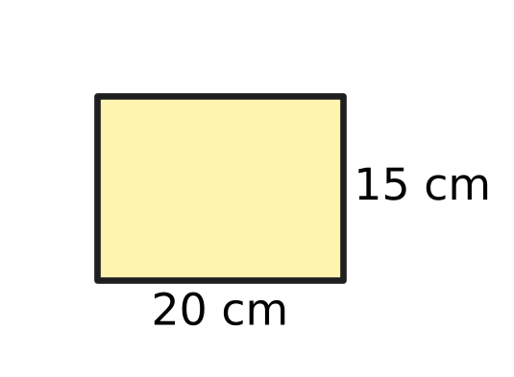
  (A) 35 cm | (B) 300 cm | (C) 60 cm | (D) 5 cm

Q4. Nakul has the four cards shown. He uses all four cards, each once, to make a correct Roman numeral. What is the smallest number he can make? | 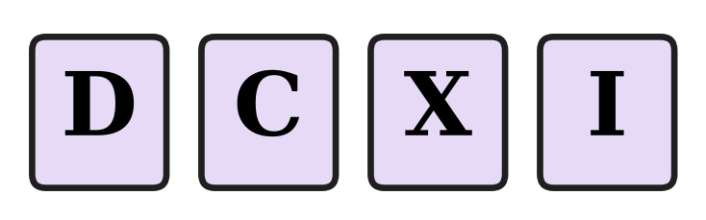
  (A) 611 | (B) 609 | (C) 411 | (D) 409

Q5. Which of these numbers has the greatest number of factors?
(A) 36 | (B) 49 | (C) 48 | (D) 42

Part 2 — Operations & Number Properties (Syllabus Chapter 2)
Q6. Tarun worked out 40 − 4 × 5 + 3 from left to right and got 183. What is the correct value?
(A) 17 | (B) 180 | (C) 8 | (D) 23

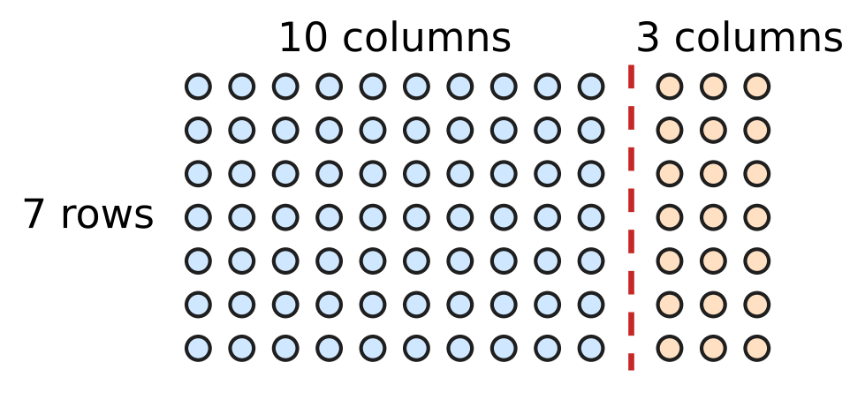
Q7. Deepa wants to find 7 × 13. She splits the dots along the dashed line, as shown. Which expression matches her picture?
(A) 7 × 10 + 7 × 3 | (B) 7 + 10 × 3
(C) 7 × 10 × 3 | (D) 7 × 10 + 3

Q8. The number of visitors to a science exhibition, rounded to the nearest hundred, was 4,700. Which of these could be the exact number of visitors?
(A) 4,605 | (B) 4,649 | (C) 4,651 | (D) 4,760

Q9. The numbers 2, 5 and 8 are written in the three boxes shown, one number in each box. What is the greatest value the expression can have? | 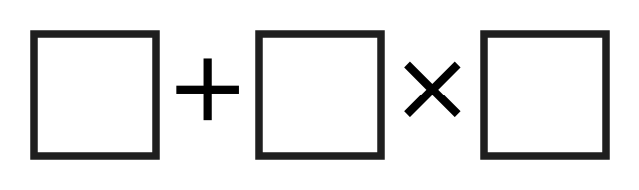
  (A) 42 | (B) 80 | (C) 56 | (D) 21

Q10. Two classes collected 46 kg and 37 kg of waste paper. Ivan rounds each amount to the nearest ten and then adds. Pari adds first and then rounds the total to the nearest ten. How much greater is Ivan's estimate than Pari's?
(A) 3 kg | (B) 10 kg | (C) 0 kg | (D) 7 kg

Part 3 — Fractions, Decimals & Percentages (Syllabus Chapter 3)
Q11. A slide in the playground is 2.4 m long. Which mixed number shows this length?
(A) $2\frac{1}{25}$ m | (B) $2\frac{1}{4}$ m | (C) $2\frac{4}{5}$ m | (D) $2\frac{2}{5}$ m

Q12. In a music class test, 0.4 of the marks are for singing. What percentage of the marks are for singing?
(A) 40% | (B) 60% | (C) 4% | (D) 0.4%

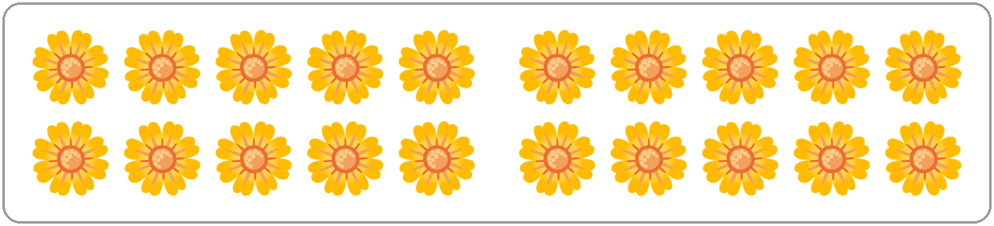
Q13. Usha's flower shop has the flowers shown in the picture. She uses 30% of them in a bouquet. How many flowers does she use?
(A) 14 | (B) 10 | (C) 3 | (D) 6

Q14. A tea stall uses 0.15 L of milk for each cup of tea. How much milk does it use for 20 cups?
(A) 30 L | (B) 3 L | (C) 1.5 L | (D) 0.3 L

Q15. In one week, 28 mm of rain fell in a town. This was 40% of the rain that fell in the whole month. How much rain fell in the whole month?
(A) 11.2 mm | (B) 112 mm | (C) 70 mm | (D) 68 mm

Q16. Which fraction is greater than 0.6 and less than 0.7?
(A) $\frac{3}{5}$ | (B) $\frac{7}{10}$ | (C) $\frac{11}{20}$ | (D) $\frac{13}{20}$

Part 4 — Geometry (Syllabus Chapter 5)
Q17. The picture shows a five-sided shape with the size of each of its angles. How many of these angles are obtuse? | 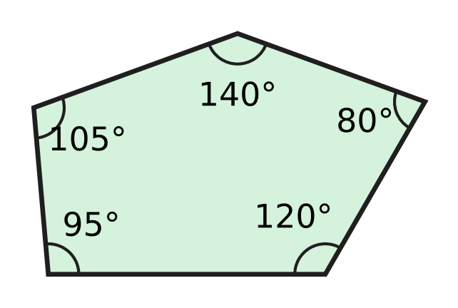
  (A) 1 | (B) 3 | (C) 4 | (D) 5

Q18. Kian cuts a square card along the dashed diagonal, as shown. What kind of triangle is each piece? | 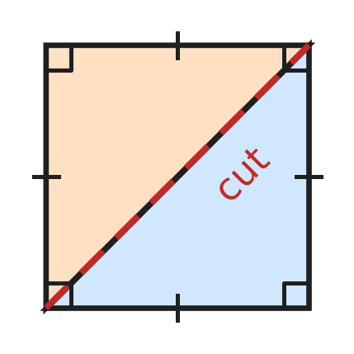
  (A) Right-angled and isosceles | (B) Obtuse-angled and isosceles
  (C) Right-angled and scalene | (D) Acute-angled and equilateral

Q19. Look at the map of a school. North is at the top. In which direction is the car park from the hall? | 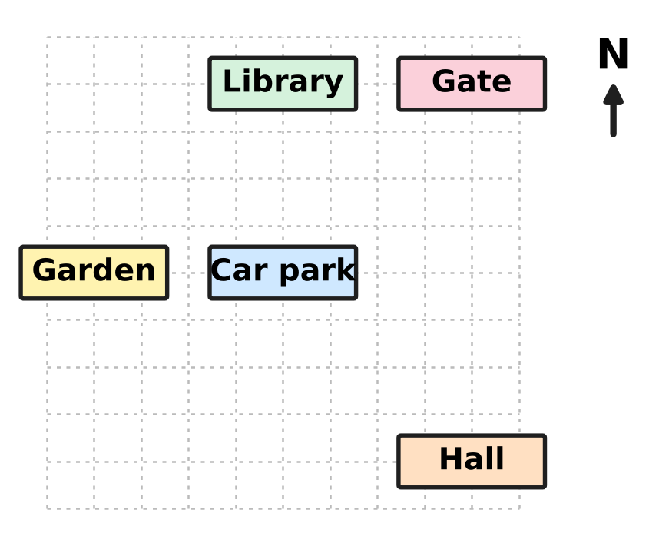
  (A) South-East | (B) North-West
  (C) North-East | (D) West

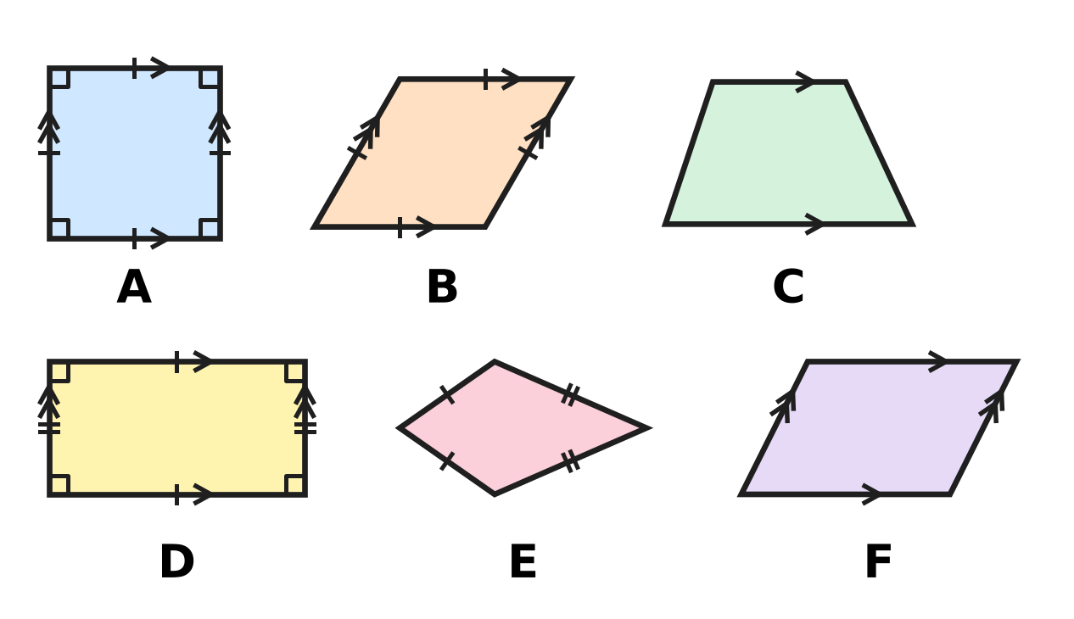
Q20. Look at the six shapes. Arrows show parallel sides, ticks show equal sides and small squares show right angles. A parallelogram is any four-sided shape with two pairs of parallel sides. How many of the shapes are parallelograms?
(A) 1 | (B) 2 | (C) 3 | (D) 4

Q21. A floor is tiled with regular octagons and squares, as shown. At each corner point, like the dot, two octagons and one square meet with no gaps. What is the size of each angle of a regular octagon? | 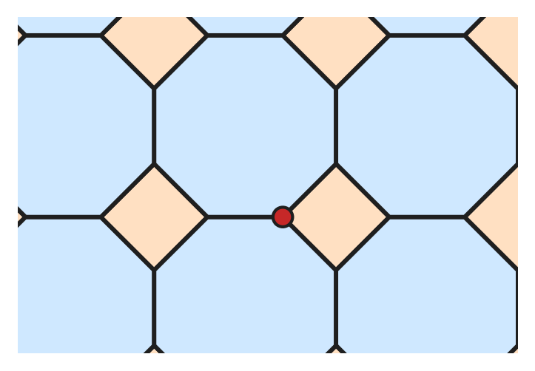
  (A) 270° | (B) 108° | (C) 135° | (D) 120°

Part 5 — Mensuration (Syllabus Chapter 6)
Q22. At Parth's ice-cream stall, a brick of ice cream is a cuboid 15 cm long and 10 cm wide, as shown. It holds 1,200 cubic cm of ice cream. How tall is it? | 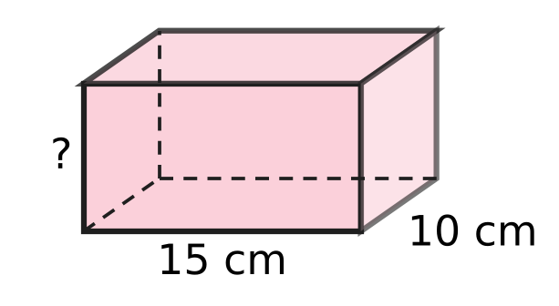
  (A) 80 cm | (B) 8 cm | (C) 120 cm | (D) 48 cm

Q23. Box A is a cuboid with a volume of 640 cubic cm. Box B has the same length and the same width as Box A, but it is twice as tall. What is the volume of Box B?
(A) 640 cubic cm | (B) 1,280 cubic cm
(C) 2,560 cubic cm | (D) 5,120 cubic cm

Q24. Which of these calculations finds how many sq cm the triangle in the picture covers? | 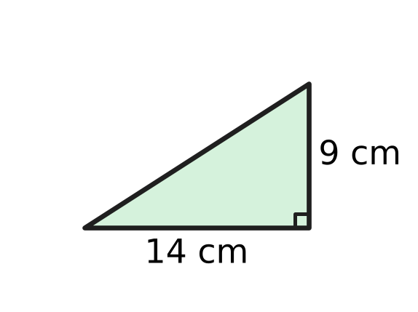
  (A) ½ × (14 + 9) | (B) 2 × (14 + 9)
  (C) ½ × 14 × 9 | (D) 14 × 9

Q25. The picture shows the sail of a model boat. Its two shorter edges measure 0.5 m and 30 cm. Find the area of the sail in sq cm. | 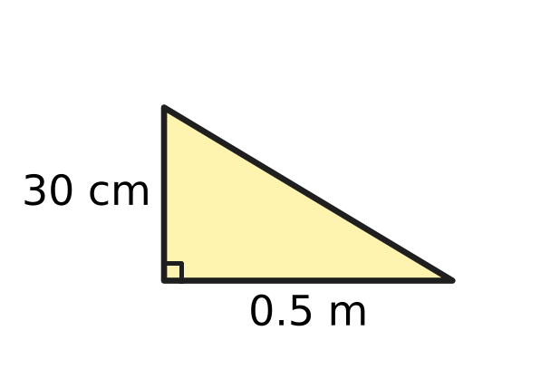
  (A) 750 sq cm | (B) 7.5 sq cm
  (C) 75 sq cm | (D) 1,500 sq cm

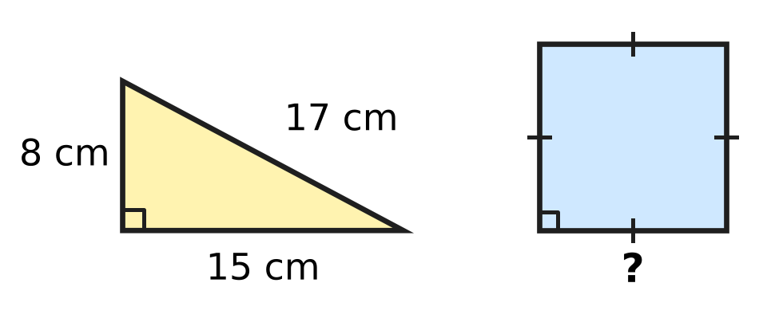
Q26. A piece of wire is bent to make the right-angled triangle shown. It is then straightened and bent to make the square. How much greater is the area of the square than the area of the triangle?
(A) 100 sq cm | (B) 20 sq cm
(C) 60 sq cm | (D) 40 sq cm

Part 6 — Data Handling, Statistics & Probability (Syllabus Chapter 8)
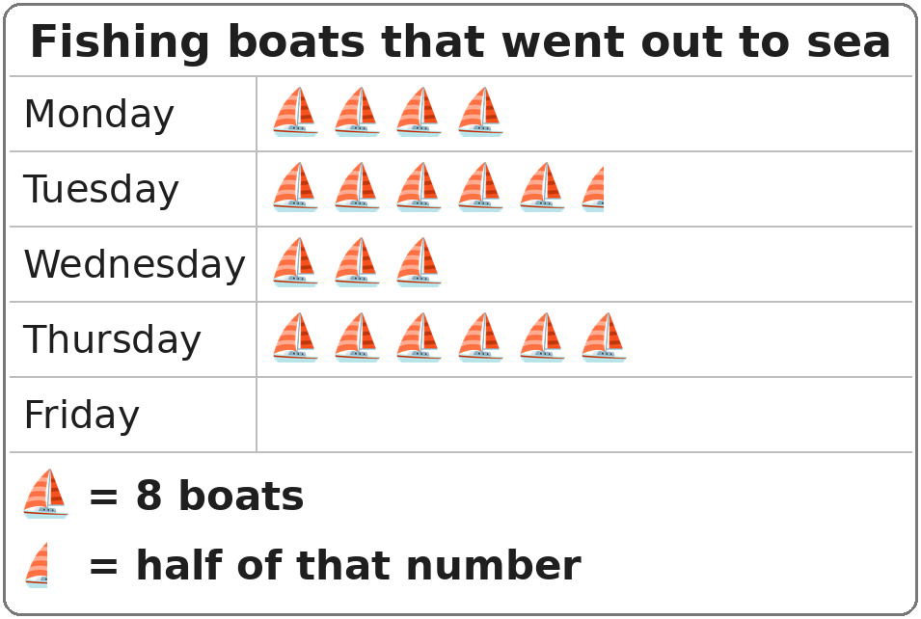
Q27. In the pictograph, the row for Friday has not been drawn yet. On Friday, 28 fishing boats went out. How many symbols should be drawn for Friday?
(A) 7 symbols | (B) $3\frac{1}{2}$ symbols
(C) 4 symbols | (D) 3 symbols

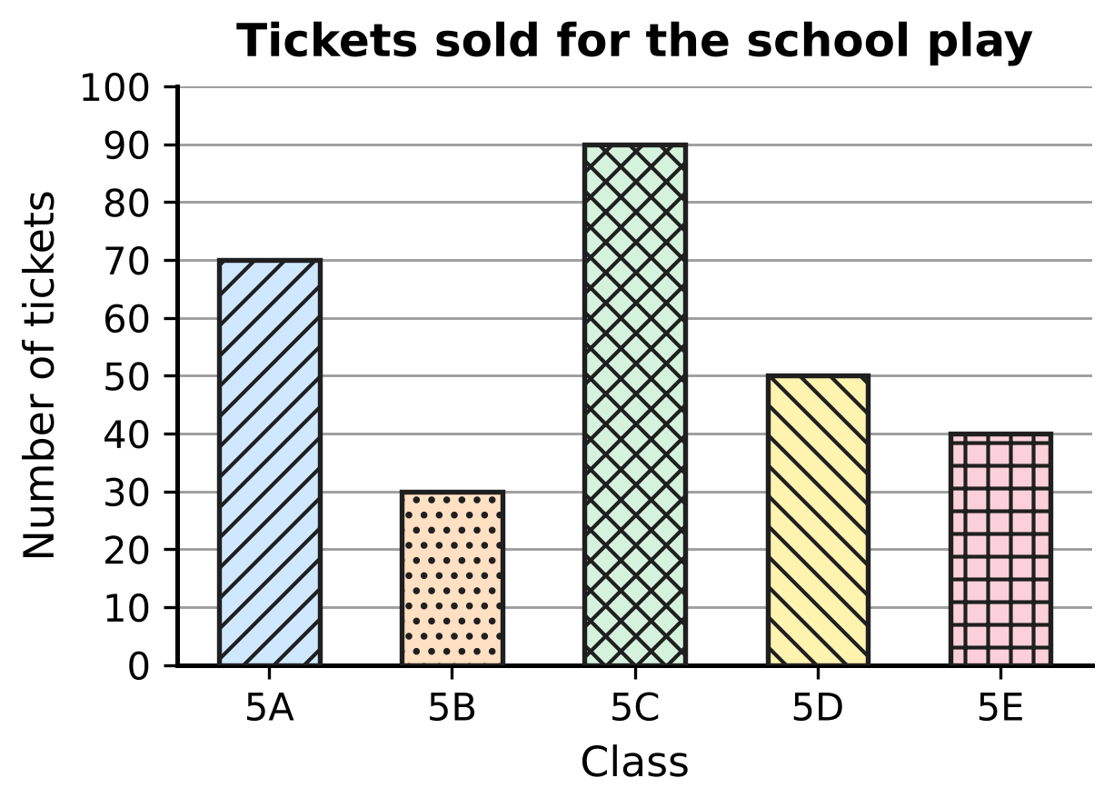
Q28. The bar graph shows the tickets sold by five classes for the school play. Which two classes together sold exactly as many tickets as Class 5C?
(A) 5D and 5E | (B) 5A and 5E
(C) 5A and 5B | (D) 5B and 5D

Part 7 — Applied Mathematics (Syllabus Chapter 9)
Q29. A torch battery lasts for 1,000 hours. How long is that in days and hours?
(A) 42 days | (B) 41 days 6 hours
(C) 16 days 40 hours | (D) 41 days 16 hours

Q30. Four cars each make one journey at a steady speed. Which journey takes the longest time?
(A) 150 km at 60 km/h | (B) 90 km at 45 km/h
(C) 120 km at 40 km/h | (D) 54 km at 36 km/h

Q31. Which of these is NOT the same length of time as half a day?
(A) 12 hours | (B) 43,200 seconds
(C) 1,200 minutes | (D) 720 minutes

Q32. A plane takes off at 9:50 p.m. and lands at 6:15 a.m. the next morning. How long is the flight?
(A) 3 hours 35 minutes | (B) 8 hours 25 minutes
(C) 7 hours 25 minutes | (D) 8 hours 35 minutes

Q33. A lift moves at a steady speed of 2 m per second. Without stopping, it goes up from a floor 6 m above the ground to a floor 54 m above the ground. How long does this take?
(A) 30 seconds | (B) 96 seconds
(C) 27 seconds | (D) 24 seconds

Q34. A school bus makes a trip in two parts. The whole trip takes 1 hour 30 minutes at an average speed of 40 km/h. The first part is 36 km long. How long is the second part?
(A) 24 km | (B) 4 km | (C) 96 km | (D) 16 km

Part 8 — Mathematical Reasoning & Problem-Solving (Syllabus Chapter 10)
Q35. In this series, each number from the 3rd on is the sum of the two numbers just before it. Which number is missing?
4, 6, 10, 16, ___, 42
(A) 24 | (B) 26 | (C) 29 | (D) 32

Q36. When two whole numbers that are next to each other (like 6 and 7) are multiplied, which of these can NEVER be the answer?
(A) 132 | (B) 105 | (C) 90 | (D) 56

Q37. Look at the series 1, 5, 25, 125, 600 and 3,125. Each number should be the number before it multiplied by the same number. One number is wrong. Which is it?
(A) 600 | (B) 125 | (C) 3,125 | (D) 25

Q38. In an arithmetic series, the same number is added each time. The 3rd term is 20 and the 7th term is 44. What is the 1st term?
(A) 12 | (B) 14 | (C) 8 | (D) 2

Q39. A month has 31 days. It has five Fridays, five Saturdays and five Sundays. On which day of the week does the month begin?
(A) Thursday | (B) Saturday | (C) Sunday | (D) Friday

Q40. Yash has eleven cards numbered 1 to 11. He takes away one card. He then puts the other ten cards into two groups with equal totals. How many different cards could he have taken away?
(A) 1 | (B) 5 | (C) 6 | (D) 11

SECTION II — Star Questions 5 questions × 4 marks each
Q41. Lata uses each of the digits 0, 2, 4, 5, 7 and 9 exactly once to make 6-digit numbers. She makes the greatest possible ODD number and the smallest possible EVEN number. What is the difference between these two numbers? [4 marks]
(A) 7,70,841 | (B) 7,48,413 | (C) 7,69,626 | (D) 7,68,411

Q42. A water plant grows on a pond. Each day, the part of the pond it covers doubles. The pond is fully covered on day 24. On which day was 12.5% of the pond covered? [4 marks]
(A) Day 16 | (B) Day 22 | (C) Day 21 | (D) Day 3

Q43. Clara stacks cubes to make a tower. The top cube has edges of 1 cm, and each cube below has edges 1 cm longer than the cube on it. The picture shows a tower of 3 cubes, which is 6 cm tall. Clara builds such a tower that is 15 cm tall. What is its total volume? [4 marks] | 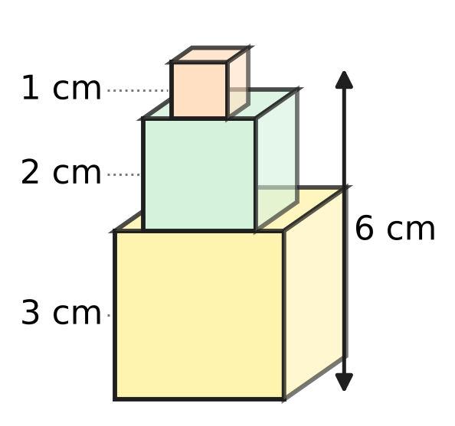
  (A) 225 cubic cm | (B) 100 cubic cm
  (C) 3,375 cubic cm | (D) 55 cubic cm

Q44. The dashboard in the picture shows the total distance a car has travelled. This number reads the same from left to right and from right to left. The car then drives at a steady speed. Exactly 2 hours later, the dashboard first shows another number that reads the same both ways. What is the car's speed? [4 marks] | 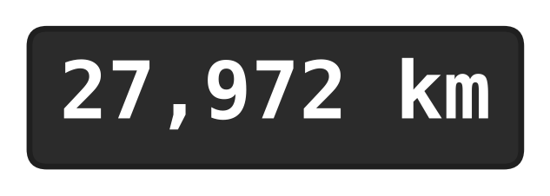
  (A) 110 km/h | (B) 55 km/h | (C) 5 km/h | (D) 50 km/h

Q45. Before a hot-air balloon flight, its fuel tank is $\frac{3}{10}$ full. A pump adds 5% of a full tank every 6 minutes. How long does it take to fill the tank to the top? [4 marks]
(A) 1 hour 24 minutes | (B) 1 hour 40 minutes
(C) 2 hours | (D) 36 minutes

Answer Sheet AMO Level 1 · Class 5 · Practice Paper 5
Name: | School: | Roll No.:
Shade or tick one circle for each question.
1. Ⓐ Ⓑ Ⓒ Ⓓ | 16. Ⓐ Ⓑ Ⓒ Ⓓ | 31. Ⓐ Ⓑ Ⓒ Ⓓ
2. Ⓐ Ⓑ Ⓒ Ⓓ | 17. Ⓐ Ⓑ Ⓒ Ⓓ | 32. Ⓐ Ⓑ Ⓒ Ⓓ
3. Ⓐ Ⓑ Ⓒ Ⓓ | 18. Ⓐ Ⓑ Ⓒ Ⓓ | 33. Ⓐ Ⓑ Ⓒ Ⓓ
4. Ⓐ Ⓑ Ⓒ Ⓓ | 19. Ⓐ Ⓑ Ⓒ Ⓓ | 34. Ⓐ Ⓑ Ⓒ Ⓓ
5. Ⓐ Ⓑ Ⓒ Ⓓ | 20. Ⓐ Ⓑ Ⓒ Ⓓ | 35. Ⓐ Ⓑ Ⓒ Ⓓ
6. Ⓐ Ⓑ Ⓒ Ⓓ | 21. Ⓐ Ⓑ Ⓒ Ⓓ | 36. Ⓐ Ⓑ Ⓒ Ⓓ
7. Ⓐ Ⓑ Ⓒ Ⓓ | 22. Ⓐ Ⓑ Ⓒ Ⓓ | 37. Ⓐ Ⓑ Ⓒ Ⓓ
8. Ⓐ Ⓑ Ⓒ Ⓓ | 23. Ⓐ Ⓑ Ⓒ Ⓓ | 38. Ⓐ Ⓑ Ⓒ Ⓓ
9. Ⓐ Ⓑ Ⓒ Ⓓ | 24. Ⓐ Ⓑ Ⓒ Ⓓ | 39. Ⓐ Ⓑ Ⓒ Ⓓ
10. Ⓐ Ⓑ Ⓒ Ⓓ | 25. Ⓐ Ⓑ Ⓒ Ⓓ | 40. Ⓐ Ⓑ Ⓒ Ⓓ
11. Ⓐ Ⓑ Ⓒ Ⓓ | 26. Ⓐ Ⓑ Ⓒ Ⓓ | 41. Ⓐ Ⓑ Ⓒ Ⓓ
12. Ⓐ Ⓑ Ⓒ Ⓓ | 27. Ⓐ Ⓑ Ⓒ Ⓓ | 42. Ⓐ Ⓑ Ⓒ Ⓓ
13. Ⓐ Ⓑ Ⓒ Ⓓ | 28. Ⓐ Ⓑ Ⓒ Ⓓ | 43. Ⓐ Ⓑ Ⓒ Ⓓ
14. Ⓐ Ⓑ Ⓒ Ⓓ | 29. Ⓐ Ⓑ Ⓒ Ⓓ | 44. Ⓐ Ⓑ Ⓒ Ⓓ
15. Ⓐ Ⓑ Ⓒ Ⓓ | 30. Ⓐ Ⓑ Ⓒ Ⓓ | 45. Ⓐ Ⓑ Ⓒ Ⓓ
Q41–Q45 are Section II Star Questions (4 marks each).
For the parent or teacher
Section I correct: ______ / 40 × 2 = ______ marks Section II correct: ______ / 5 × 4 = ______ marks
Correct: ______ / 45 Score: ______ / 100
Answer Key and Solutions AMO Level 1 · Class 5 · Practice Paper 5
Quick answers
1 A | 6 D | 11 D | 16 D | 21 C | 26 D | 31 C | 36 B | 41 D
2 A | 7 A | 12 A | 17 C | 22 B | 27 B | 32 B | 37 A | 42 C
3 C | 8 C | 13 D | 18 A | 23 B | 28 A | 33 D | 38 C | 43 A
4 D | 9 A | 14 B | 19 B | 24 C | 29 D | 34 A | 39 D | 44 B
5 C | 10 B | 15 C | 20 D | 25 A | 30 C | 35 B | 40 B | 45 A
Solutions
Q | Part · level | Answer | Why?
1 | Part 1 · Ch1 · Easy | (A) 4,99,560 | Work backwards: 5,00,560 − 1,000 = 4,99,560.
2 | Part 1 · Ch1 · Easy | (A) 5 | Since 247 = 27 × 9 + 4, the next multiple of 9 is 28 × 9 = 252. So 5 must be added.
3 | Part 1 · Ch1 · Easy | (C) 60 cm | The side must be a multiple of both 20 and 15. The smallest common multiple (LCM) is 60, so the square is 60 cm.
4 | Part 1 · Ch1 · Medium | (D) 409 | Putting a smaller symbol before a bigger one subtracts: CD = 400 and IX = 9. So CDIX = 409 is the smallest; the other correct numerals are CDXI = 411, DXCI = 591, DCIX = 609 and DCXI = 611.
5 | Part 1 · Ch1 · Medium | (C) 48 | Count the factors: 36 has 9, 42 has 8, 48 has 10 (1, 2, 3, 4, 6, 8, 12, 16, 24, 48) and 49 has 3. So 48 has the most.
6 | Part 2 · Ch2 · Easy | (D) 23 | Multiply first: 4 × 5 = 20. Then from left to right: 40 − 20 + 3 = 23.
7 | Part 2 · Ch2 · Easy | (A) 7 × 10 + 7 × 3 | The left part has 7 × 10 dots and the right part has 7 × 3 dots, so 7 × 13 = 7 × 10 + 7 × 3 = 91.
8 | Part 2 · Ch2 · Easy | (C) 4,651 | Numbers from 4,650 to 4,749 round to 4,700. Only 4,651 is in this range.
9 | Part 2 · Ch2 · Medium | (A) 42 | Multiplication is done first, so the two larger numbers should be multiplied: 2 + 5 × 8 = 2 + 40 = 42.
10 | Part 2 · Ch2 · Medium | (B) 10 kg | Ivan: 50 + 40 = 90 kg. Pari: 46 + 37 = 83, which rounds to 80 kg. The difference is 10 kg.
11 | Part 3 · Ch3 · Easy | (D) $2\frac{2}{5}$ m | Here, 0.4 = 4/10 = 2/5, so 2.4 m = 2 2/5 m.
12 | Part 3 · Ch3 · Easy | (A) 40% | Here, 0.4 = 40/100 = 40%.
13 | Part 3 · Ch3 · Easy | (D) 6 | There are 20 flowers, and 30% of 20 = 20 × 30/100 = 6 flowers.
14 | Part 3 · Ch3 · Easy | (B) 3 L | Milk used = 0.15 × 20 = 0.15 × 2 × 10 = 0.3 × 10 = 3 L.
15 | Part 3 · Ch3 · Medium | (C) 70 mm | Here, 40% is 28 mm, so 10% is 28 ÷ 4 = 7 mm and 100% is 7 × 10 = 70 mm.
16 | Part 3 · Ch3 · Medium | (D) $\frac{13}{20}$ | As a decimal, 13/20 = 65/100 = 0.65, which is between 0.6 and 0.7. The others are 0.6, 0.7 and 0.55.
17 | Part 4 · Ch5 · Easy | (C) 4 | An obtuse angle is more than 90° and less than 180°: 95°, 105°, 120° and 140° are obtuse; 80° is acute. That is 4.
18 | Part 4 · Ch5 · Easy | (A) Right-angled and isosceles | Each piece keeps one corner of the square (a right angle) and two equal sides of the square. So it is right-angled and isosceles.
19 | Part 4 · Ch5 · Easy | (B) North-West | From the hall, the car park is up (North) and to the left (West) by the same amount, so it is to the North-West.
20 | Part 4 · Ch5 · Medium | (D) 4 | A parallelogram has two pairs of parallel sides. The square (A), the rhombus (B), the rectangle (D) and shape F all do, so 4 shapes are parallelograms.
21 | Part 4 · Ch5 · Medium | (C) 135° | The angles at a point add up to 360°. The square gives 90°, so the two octagon angles make 360° − 90° = 270°, and each is 270° ÷ 2 = 135°.
22 | Part 5 · Ch6 · Easy | (B) 8 cm | Volume = length × width × height, so height = 1,200 ÷ (15 × 10) = 1,200 ÷ 150 = 8 cm.
23 | Part 5 · Ch6 · Easy | (B) 1,280 cubic cm | Volume = length × width × height. Only the height is doubled, so the volume doubles: 640 × 2 = 1,280 cubic cm.
24 | Part 5 · Ch6 · Easy | (C) ½ × 14 × 9 | Area of a right-angled triangle = ½ × the two sides at the right angle = ½ × 14 × 9 (= 63 sq cm).
25 | Part 5 · Ch6 · Medium | (A) 750 sq cm | First, 0.5 m = 50 cm. Then area = ½ × 50 × 30 = 750 sq cm.
26 | Part 5 · Ch6 · Medium | (D) 40 sq cm | Perimeter = 8 + 15 + 17 = 40 cm, so the square's side is 10 cm and its area is 100 sq cm. The triangle's area is ½ × 8 × 15 = 60 sq cm. Difference = 40 sq cm.
27 | Part 6 · Ch8 · Easy | (B) $3\frac{1}{2}$ symbols | Each symbol stands for 8 boats. Then 28 ÷ 8 = 3 remainder 4, and 4 boats is half a symbol. So 3½ symbols.
28 | Part 6 · Ch8 · Medium | (A) 5D and 5E | Class 5C sold 90 tickets. Class 5D sold 50 and Class 5E sold 40, and 50 + 40 = 90. No other pair makes 90.
29 | Part 7 · Ch9 · Easy | (D) 41 days 16 hours | One day = 24 hours. Then 1,000 ÷ 24 = 41 remainder 16, so 1,000 hours = 41 days 16 hours.
30 | Part 7 · Ch9 · Easy | (C) 120 km at 40 km/h | Time = distance ÷ speed: 120 ÷ 40 = 3 hours, 150 ÷ 60 = 2½ hours, 54 ÷ 36 = 1½ hours and 90 ÷ 45 = 2 hours. The longest is 3 hours.
31 | Part 7 · Ch9 · Easy | (C) 1,200 minutes | Half a day is 12 hours, which is 12 × 60 = 720 minutes, or 720 × 60 = 43,200 seconds. But 1,200 minutes is 20 hours.
32 | Part 7 · Ch9 · Easy | (B) 8 hours 25 minutes | From 9:50 p.m. to midnight is 2 hours 10 minutes, and from midnight to 6:15 a.m. is 6 hours 15 minutes. Total 8 hours 25 minutes.
33 | Part 7 · Ch9 · Medium | (D) 24 seconds | Distance = 54 − 6 = 48 m. Time = 48 ÷ 2 = 24 seconds.
34 | Part 7 · Ch9 · Medium | (A) 24 km | Whole distance = average speed × time = 40 × 1½ = 60 km. Second part = 60 − 36 = 24 km.
35 | Part 8 · Ch10 · Easy | (B) 26 | The missing number is 10 + 16 = 26, and the check 16 + 26 = 42 works.
36 | Part 8 · Ch10 · Easy | (B) 105 | Of two numbers next to each other, one is always even, so the product is always even. The number 105 is odd, so it can never be the answer.
37 | Part 8 · Ch10 · Easy | (A) 600 | Each number is 5 times the one before: 1, 5, 25, 125, 625, 3,125. So 600 is wrong; it should be 625.
38 | Part 8 · Ch10 · Medium | (C) 8 | From the 3rd to the 7th term there are 4 jumps: (44 − 20) ÷ 4 = 6. Going back two jumps from the 3rd term: 20 − 12 = 8.
39 | Part 8 · Ch10 · Medium | (D) Friday | A month of 31 days = 4 weeks + 3 days, so the first three days of the month each come five times. These are Friday, Saturday and Sunday, so the month begins on a Friday.
40 | Part 8 · Ch10 · Medium | (B) 5 | The total 1 + 2 + … + 11 = 66 is even. Taking away an odd card leaves an odd total, which cannot be split equally. Each even card (2, 4, 6, 8, 10) leaves an even total that can be split (for example, without 2: 11 + 10 + 8 + 3 = 32), so 5 cards.
41 | Section II · Ch1 + Ch10 · Hard | (D) 7,68,411 | Greatest odd: the ones digit must be 5, 7 or 9; use the smallest, 5, and keep 9, 7, 4, 2, 0 in front: 9,74,205. Smallest even: start 2, 0 and end in 4: 2,05,794. Difference = 7,68,411.
42 | Section II · Ch3 + Ch10 · Hard | (C) Day 21 | Here, 12.5% = 1/8. Going back one day halves the cover: day 24 full, day 23 half, day 22 a quarter, day 21 one-eighth. So day 21.
43 | Section II · Ch6 + Ch10 · Hard | (A) 225 cubic cm | Since 1 + 2 + 3 + 4 + 5 = 15, there are 5 cubes. Volume = 1 + 8 + 27 + 64 + 125 = 225 cubic cm.
44 | Section II · Ch1 + Ch9 · Hard | (B) 55 km/h | The next number after 27,972 that reads the same both ways is 28,082. The car went 110 km in 2 hours, so its speed is 110 ÷ 2 = 55 km/h.
45 | Section II · Ch3 + Ch9 · Hard | (A) 1 hour 24 minutes | $\frac{3}{10}$ = 30%, so 70% is still needed. That is 70 ÷ 5 = 14 lots of 6 minutes = 84 minutes = 1 hour 24 minutes.

