UNLOCK IQ INSTITUTE
Realize Your True Potential
Aryabhatta Maths Olympiad (AMO)
Level 1 — Practice Paper 1
CLASS 5

Questions | 45 multiple-choice questions
Marks | 100
Time | 60 minutes
Section I | 40 questions × 2 marks = 80 marks
Section II | 5 Star Questions × 4 marks = 20 marks
Negative marking | No negative marking
Calculator | Not allowed
Chapters | Number System · Operations · Fractions, Decimals & Percentages · Geometry · Mensuration · Data Handling · Applied Mathematics · Mathematical Reasoning

Hello, friend!
• Every question has four answer choices: (A), (B), (C) and (D). Only one is correct.
• Read each question and look at its picture carefully. Then mark your answer on the answer sheet at the end.
• Section I has 40 questions of 2 marks each. Section II has 5 Star Questions of 4 marks each.
• There is no negative marking, so try every question.
• Do not use a calculator. You may do rough work on a separate sheet.
• All figures are not necessarily drawn to scale unless stated.

For parents and teachers
Print or view this paper in colour. Pictures are part of the questions.
Parts follow the AMO syllabus chapters. Chapters 4 and 7 are not part of the Class 5 syllabus, so the chapter numbers shown in the Part headings have gaps.
The answer sheet and the answer key are at the end. Remove only the answer key before the child begins.

Name: | School: | Roll No.:

SECTION I 40 questions × 2 marks each
Part 1 — Number System (Syllabus Chapter 1)
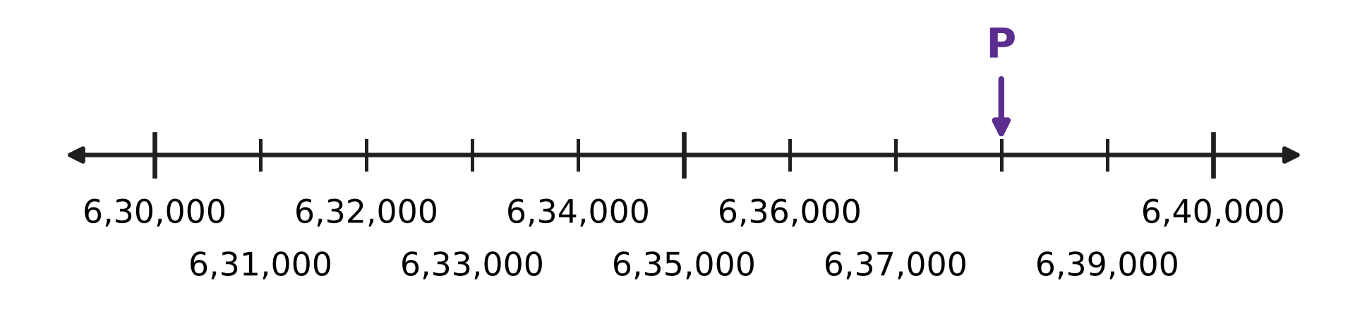
Q1. Look at the number line. All the small steps are equal. Which number does the arrow P point to?
(A) 6,30,800 | (B) 6,37,000 | (C) 6,38,000 | (D) 7,10,000

Q2. The year in which a clock tower was built is carved on it as MCMLXIV. In which year was it built?
(A) 2164 | (B) 1944 | (C) 1966 | (D) 1964

Q3. How many prime numbers are greater than 60 and less than 80?
(A) 5 | (B) 6 | (C) 4 | (D) 3

Q4. Asha has 72 red marbles and 48 blue marbles. She shares them equally among as many jars as possible. Every jar must have the same number of red marbles and the same number of blue marbles. How many marbles will be in each jar?
(A) 5 | (B) 10 | (C) 15 | (D) 24

Q5. A teacher sets out 60 chairs in equal rows. There must be at least 2 rows and at least 2 chairs in each row. Count 6 rows of 10 and 10 rows of 6 as different ways. How many ways are possible?
(A) 12 | (B) 5 | (C) 6 | (D) 10

Part 2 — Operations & Number Properties (Syllabus Chapter 2)
Q6. What is the value of 72 − [5 × (11 − 4) + 9]?
(A) 28 | (B) 46 | (C) 51 | (D) 12

Q7. Ishan wants to work out 46 × 25 + 54 × 25 the quick way. Which expression has the same value?
(A) 46 × 54 × 25 | (B) 46 + 54 × 25
(C) (46 + 25) × (54 + 25) | (D) (46 + 54) × 25

Q8. A stationery shop sold 198 notebooks at ₹42 each. Round 198 to the nearest hundred and ₹42 to the nearest ten. What is the estimated money collected?
(A) ₹800 | (B) ₹8,316 | (C) ₹10,000 | (D) ₹8,000

Q9. Look at these four expressions.
P: 36 + 24 ÷ 4 × 3
Q: (36 + 24) ÷ 4 × 3
R: 36 + 24 ÷ (4 × 3)
S: 36 + (24 ÷ 4) × 3
Which TWO of them have the same value?
(A) Q and R | (B) P and S | (C) P and Q | (D) P and R

Q10. A rainwater tank has 2,970 litres of water. A family uses 48 litres of it each day. Round 2,970 to the nearest thousand and 48 to the nearest ten. About how many days will the water last?
(A) 600 days | (B) 6 days | (C) 60 days | (D) 75 days

Part 3 — Fractions, Decimals & Percentages (Syllabus Chapter 3)
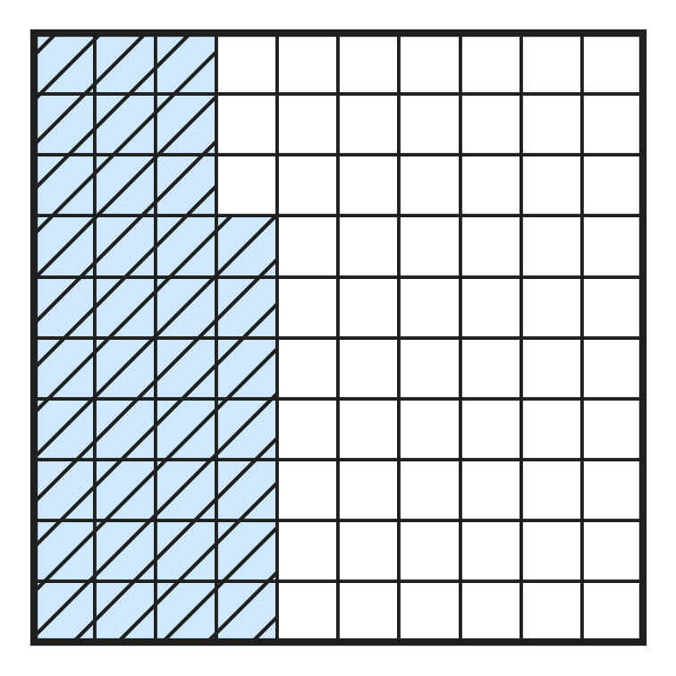
Q11. In the picture, the big square is cut into 100 equal small squares. What part of the big square is shaded, written as a decimal?
(A) 0.37 | (B) 3.7 | (C) 0.73 | (D) 0.63

Q12. Write 0.85 as a fraction in its simplest form.
(A) $\frac{17}{2}$ | (B) $\frac{4}{5}$ | (C) $\frac{8}{5}$ | (D) $\frac{17}{20}$

Q13. On a windy day, 20 kites were flown in a park. Of these, 17 stayed in the air for an hour. What percentage of the kites stayed in the air?
(A) 17% | (B) 85% | (C) 34% | (D) 15%

Q14. An apple orchard has 360 trees. Of these, 20% are young trees. How many young trees are there?
(A) 72 | (B) 288 | (C) 36 | (D) 340

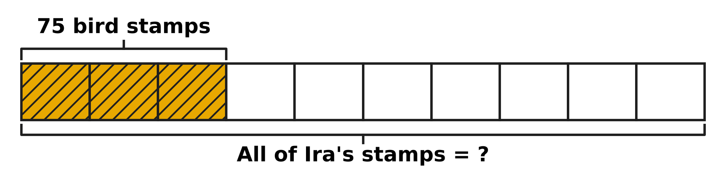
Q15. The bar in the picture shows all of Ira's stamps. It is cut into 10 equal parts, so each part is 10% of her stamps. Her 75 bird stamps are the shaded part. How many stamps does Ira have in all?
(A) 225 | (B) 175 | (C) 250 | (D) 25

Q16. Shreya has a ribbon 3.6 m long. She cuts off $\frac{3}{5}$ m for a card and then 1.25 m for a gift. How long is the ribbon left?
(A) 3.00 m | (B) 2.00 m | (C) 2.05 m | (D) 1.75 m

Part 4 — Geometry (Syllabus Chapter 5)
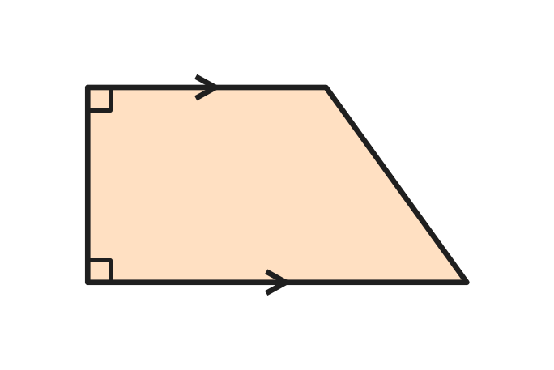
Q17. The picture shows the shape of a classroom notice board. The arrows mark its only pair of parallel sides. Which name fits this shape?
(A) Rectangle | (B) Rhombus
(C) Trapezium | (D) Parallelogram

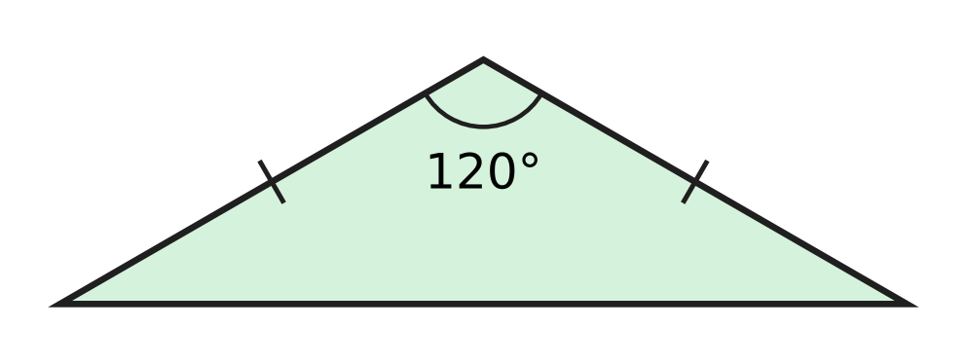
Q18. In the triangle shown, the tick marks show equal sides. Which name describes this triangle?
(A) Obtuse-angled and isosceles | (B) Right-angled and isosceles
(C) Obtuse-angled and scalene | (D) Acute-angled and isosceles

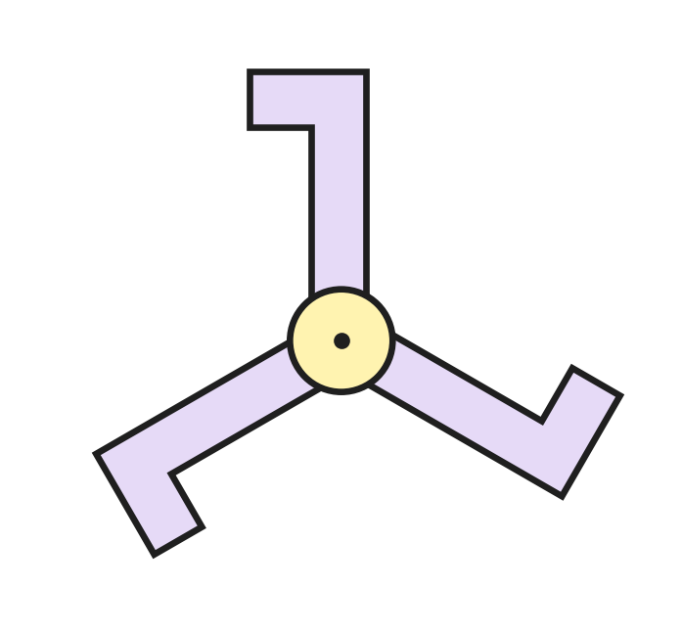
Q19. The design shown is turned about its centre dot. What is its order of rotational symmetry?
(A) 6 | (B) 3 | (C) 2 | (D) 1

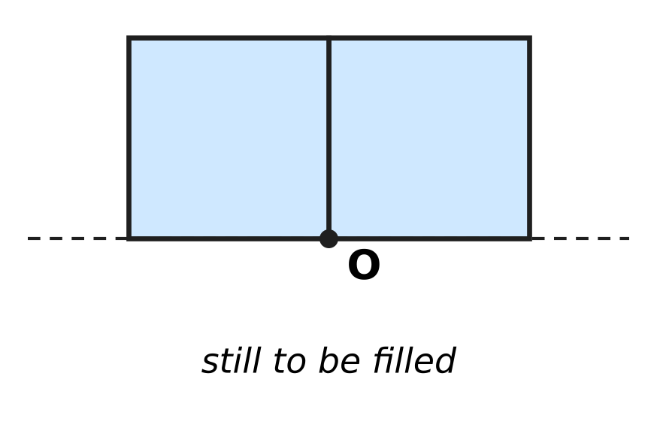
Q20. Look at the picture. Two square tiles sit side by side, and a corner of each meets at point O. Equilateral triangle tiles fill the rest of the space around O, with no gaps and no overlaps. How many triangle tiles meet at O?
(A) 4 | (B) 3 | (C) 6 | (D) 2

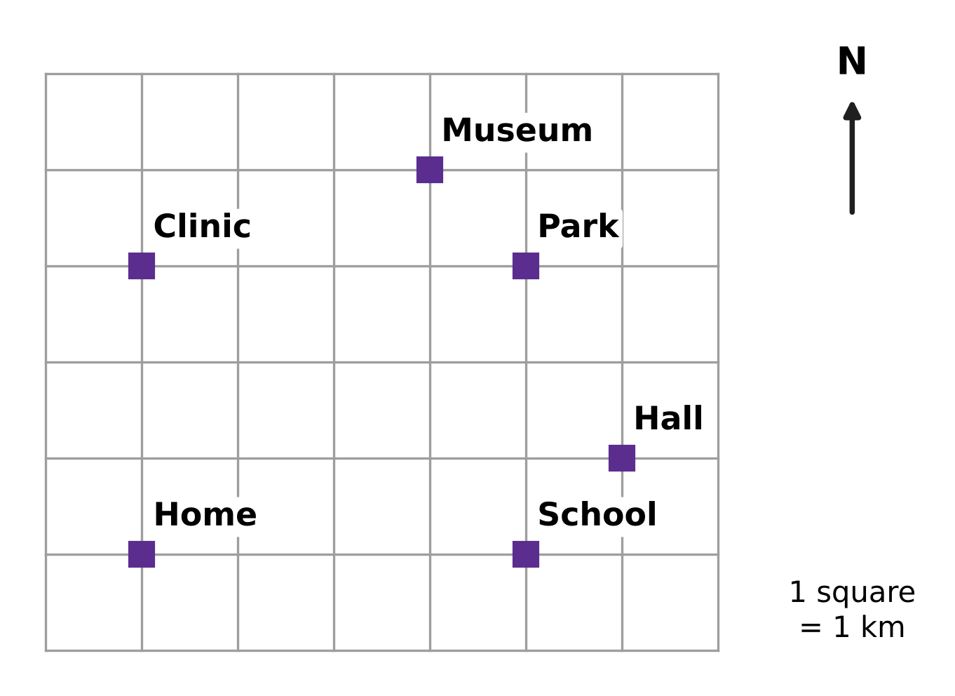
Q21. Look at the map. North is at the top and each square is 1 km. Mia starts at Home, walks 3 km North along the lines and then 4 km East. Where is she now?
(A) School | (B) Clinic | (C) Park | (D) Museum

Part 5 — Mensuration (Syllabus Chapter 6)
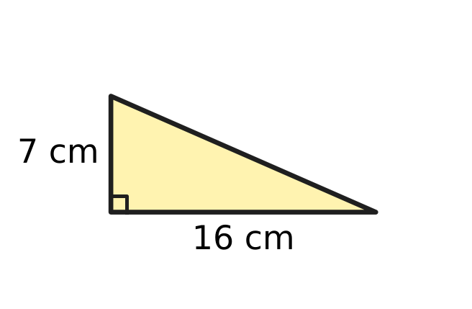
Q22. What is the area of the right-angled triangle shown?
(A) 56 sq cm | (B) 28 sq cm
(C) 112 sq cm | (D) 23 sq cm

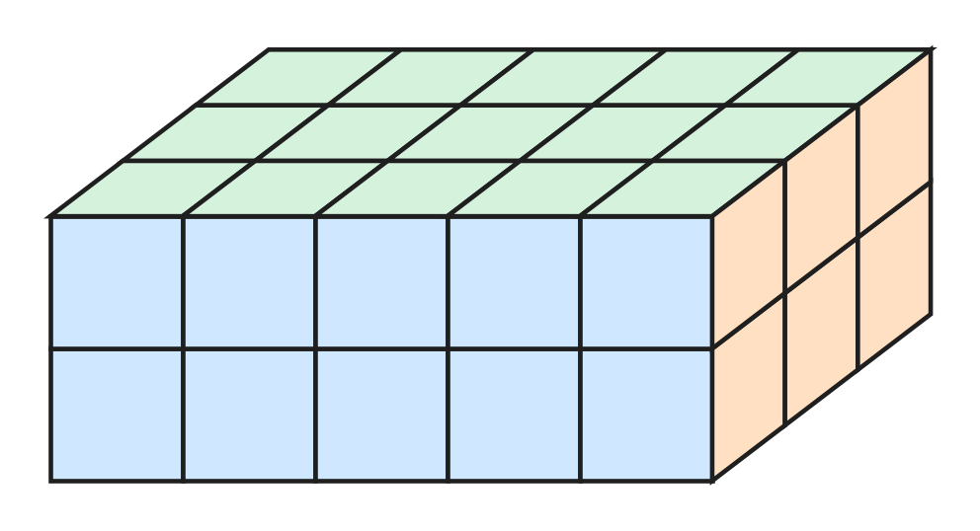
Q23. The solid cuboid shown is made of 1 cm cubes with no gaps inside. What is its volume?
(A) 15 cubic cm | (B) 10 cubic cm
(C) 22 cubic cm | (D) 30 cubic cm

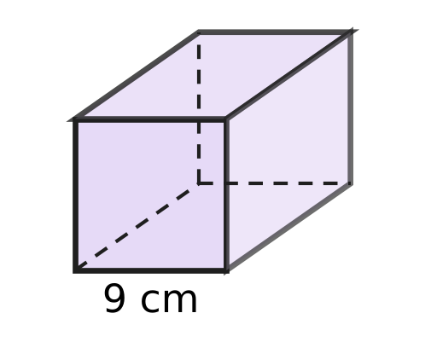
Q24. Viraj has a cube-shaped gift box with edges of 9 cm, as shown. What is the volume of the box?
(A) 81 cubic cm | (B) 108 cubic cm
(C) 27 cubic cm | (D) 729 cubic cm

Q25. A bakery box is packed exactly with cube-shaped cakes. Each cake has edges of 4 cm. The cakes are in 3 layers, and each layer is 5 cakes long and 4 cakes wide. The baker takes out the whole top layer. What volume of the box is now empty?
(A) 320 cubic cm | (B) 1,280 cubic cm
(C) 3,840 cubic cm | (D) 2,560 cubic cm

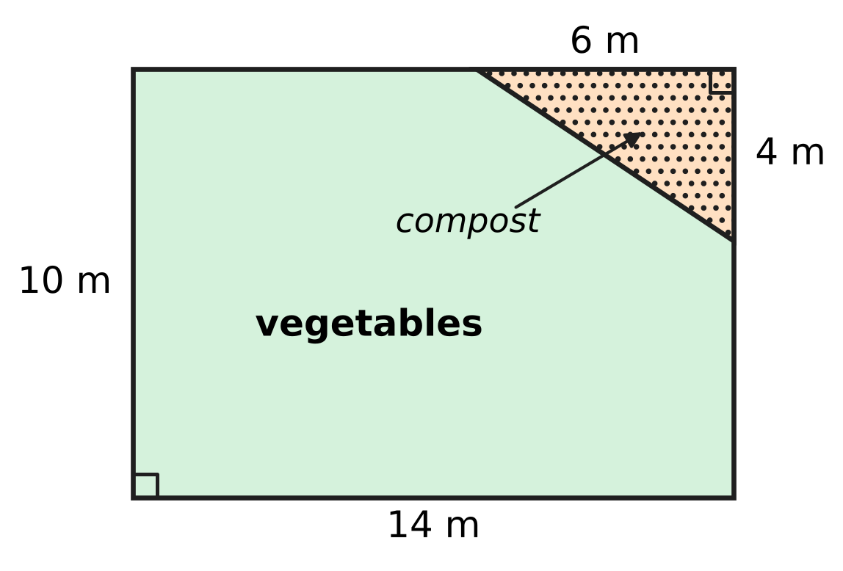
Q26. The plan shows a rectangular vegetable garden. A right-angled triangle in one corner is used for compost. What area is left for vegetables?
(A) 116 sq m | (B) 130 sq m | (C) 128 sq m | (D) 140 sq m

Part 6 — Data Handling, Statistics & Probability (Syllabus Chapter 8)
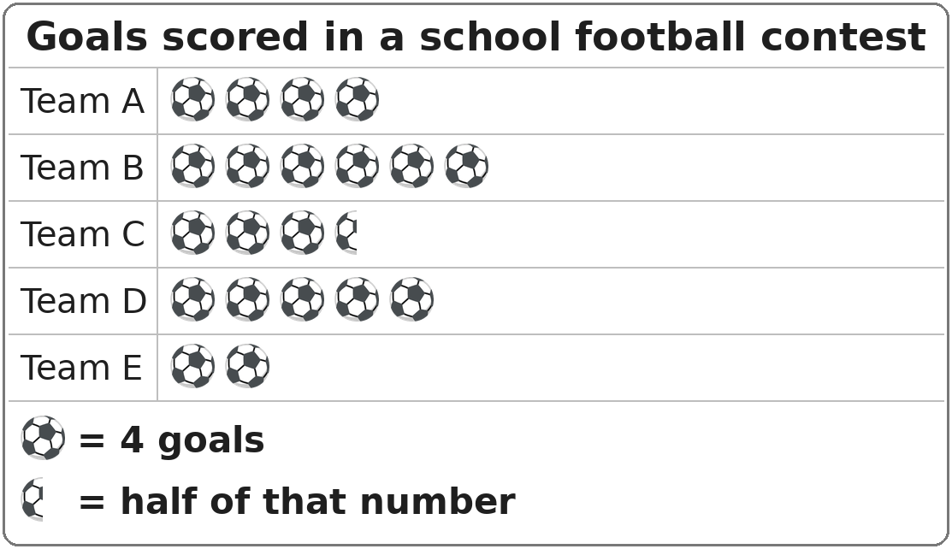
Q27. The pictograph shows the goals scored by five teams in a school football contest. How many more goals did Team B score than Team E?
(A) 16 | (B) 32 | (C) 4 | (D) 24

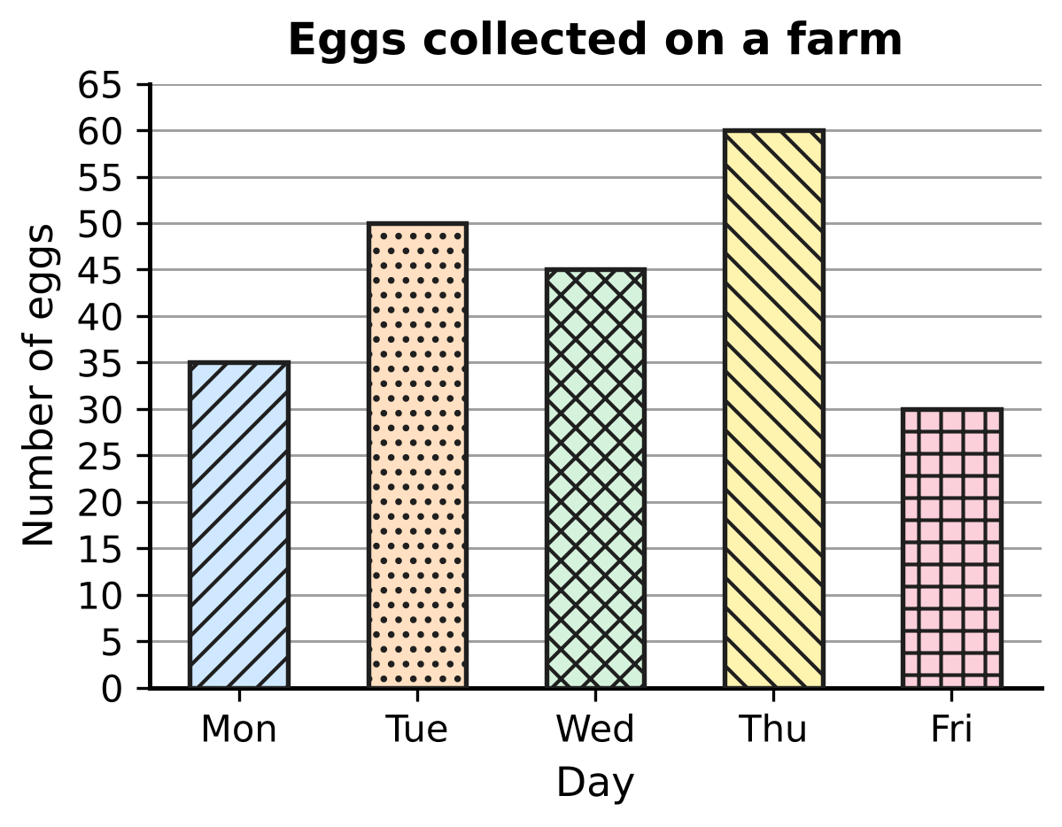
Q28. The bar graph shows the eggs collected from the hens on a farm. What is the total number of eggs collected on the days when more than 40 eggs were collected?
(A) 155 | (B) 110 | (C) 220 | (D) 190

Part 7 — Applied Mathematics (Syllabus Chapter 9)
Q29. In a swimming pool, Leela swam four lengths in 5 minutes 10 seconds. Bela swam the same four lengths in 4 minutes 55 seconds. How many seconds faster was Bela?
(A) 105 seconds | (B) 45 seconds
(C) 15 seconds | (D) 55 seconds

Q30. A snail crawls at a steady speed of 5 metres per hour. How long will it take to crawl 35 metres?
(A) 175 hours | (B) 7 hours
(C) 30 hours | (D) 40 hours

Q31. A bean seed took 2 days 9 hours to sprout. How many hours is that?
(A) 48 hours | (B) 29 hours | (C) 33 hours | (D) 57 hours

Q32. A cheetah runs 360 metres in 15 seconds. What is its speed in metres per second?
(A) 24 metres per second | (B) 25 metres per second
(C) 36 metres per second | (D) 345 metres per second

Q33. Arnav and Esha ride bicycles on the same 20 km route. Arnav rides it in 1 hour 15 minutes without stopping. Esha rides the first 5 km uphill in 1 hour 15 minutes, rests for 30 minutes, and then rides the last 15 km in 45 minutes. Count Esha's rest as part of her time. How much greater is Arnav's average speed than Esha's?
(A) 12 km/h | (B) 4 km/h | (C) 6 km/h | (D) 8 km/h

Q34. A delivery van moves at a steady speed of 54 km/h. How many metres does it travel in one minute?
(A) 3,240 m | (B) 900 m | (C) 54 m | (D) 90 m

Part 8 — Mathematical Reasoning & Problem-Solving (Syllabus Chapter 10)
Q35. What is the next number in the series 3, 12, 48, 192, ___ ?
(A) 384 | (B) 240 | (C) 768 | (D) 576

Q36. The year 2028 is a leap year, and 1 January 2028 is a Saturday. How many Saturdays are there in 2028?
(A) 53 | (B) 48 | (C) 54 | (D) 52

Q37. Without adding, decide which number can be added to 21 + 43 + 65 so that the total is still an odd number.
(A) 39 | (B) 81 | (C) 17 | (D) 54

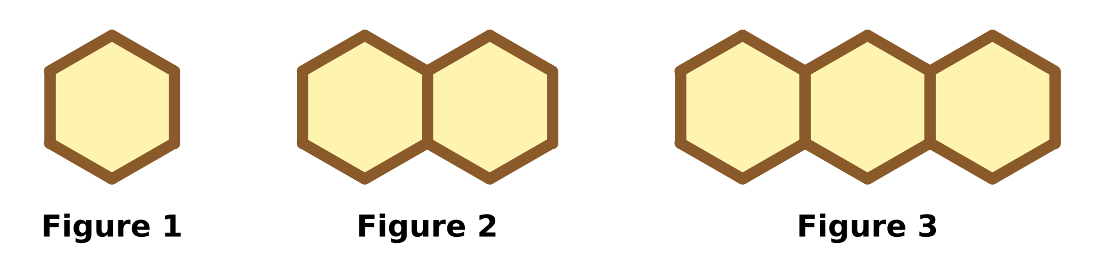
Q38. Kai makes a row of hexagons with sticks, as shown. Each new figure has one more hexagon. How many sticks does he need for Figure 12?
(A) 66 | (B) 72 | (C) 61 | (D) 60

Q39. Navya borrows a book from the school library on 24 May. She must return it exactly 40 days later. On which date must she return it?
(A) 2 July | (B) 3 July | (C) 4 July | (D) 1 July

Q40. Laksh puts counters into 7 boxes. Each box gets an odd number of counters, and no two boxes get the same number. Which of these could be the total number of counters?
(A) 45 | (B) 56 | (C) 63 | (D) 70

SECTION II — Star Questions 5 questions × 4 marks each
Q41. Most numbers have an even number of factors. For example, 12 has the 6 factors 1, 2, 3, 4, 6 and 12. How many whole numbers from 1 to 50 have an odd number of factors? [4 marks]
(A) 6 | (B) 7 | (C) 15 | (D) 25

Q42. A ball is dropped from a height of 256 cm. After each bounce it rises to 75% of the height it fell from. How high does it rise after the 4th bounce? [4 marks]
(A) 64 cm | (B) 81 cm | (C) 108 cm | (D) 192 cm

Q43. Mei draws right-angled triangles. The base is a whole number from 1 cm to 6 cm. The height is a whole number from 1 cm to 5 cm. She draws one triangle for each of the 30 base–height pairs. How many of them have an area that is a whole number of square centimetres? [4 marks]
(A) 9 | (B) 15 | (C) 21 | (D) 27

Q44. Advait and Swati start together from the starting line of a 900 m running track and run around it in the same direction. Advait runs 150 m every minute and Swati runs 100 m every minute. After how many minutes are they next together at the starting line? [4 marks]
(A) 3 minutes | (B) 15 minutes
(C) 18 minutes | (D) 54 minutes

Q45. A school bus usually takes 1 hour 12 minutes to reach school at a speed of 50 km/h. On a rainy day its speed is reduced by 20%. How many minutes longer does the trip take? [4 marks]
(A) 14.4 minutes | (B) 18 minutes
(C) 20 minutes | (D) 90 minutes

Answer Sheet AMO Level 1 · Class 5 · Practice Paper 1
Name: | School: | Roll No.:
Shade or tick one circle for each question.
1. Ⓐ Ⓑ Ⓒ Ⓓ | 16. Ⓐ Ⓑ Ⓒ Ⓓ | 31. Ⓐ Ⓑ Ⓒ Ⓓ
2. Ⓐ Ⓑ Ⓒ Ⓓ | 17. Ⓐ Ⓑ Ⓒ Ⓓ | 32. Ⓐ Ⓑ Ⓒ Ⓓ
3. Ⓐ Ⓑ Ⓒ Ⓓ | 18. Ⓐ Ⓑ Ⓒ Ⓓ | 33. Ⓐ Ⓑ Ⓒ Ⓓ
4. Ⓐ Ⓑ Ⓒ Ⓓ | 19. Ⓐ Ⓑ Ⓒ Ⓓ | 34. Ⓐ Ⓑ Ⓒ Ⓓ
5. Ⓐ Ⓑ Ⓒ Ⓓ | 20. Ⓐ Ⓑ Ⓒ Ⓓ | 35. Ⓐ Ⓑ Ⓒ Ⓓ
6. Ⓐ Ⓑ Ⓒ Ⓓ | 21. Ⓐ Ⓑ Ⓒ Ⓓ | 36. Ⓐ Ⓑ Ⓒ Ⓓ
7. Ⓐ Ⓑ Ⓒ Ⓓ | 22. Ⓐ Ⓑ Ⓒ Ⓓ | 37. Ⓐ Ⓑ Ⓒ Ⓓ
8. Ⓐ Ⓑ Ⓒ Ⓓ | 23. Ⓐ Ⓑ Ⓒ Ⓓ | 38. Ⓐ Ⓑ Ⓒ Ⓓ
9. Ⓐ Ⓑ Ⓒ Ⓓ | 24. Ⓐ Ⓑ Ⓒ Ⓓ | 39. Ⓐ Ⓑ Ⓒ Ⓓ
10. Ⓐ Ⓑ Ⓒ Ⓓ | 25. Ⓐ Ⓑ Ⓒ Ⓓ | 40. Ⓐ Ⓑ Ⓒ Ⓓ
11. Ⓐ Ⓑ Ⓒ Ⓓ | 26. Ⓐ Ⓑ Ⓒ Ⓓ | 41. Ⓐ Ⓑ Ⓒ Ⓓ
12. Ⓐ Ⓑ Ⓒ Ⓓ | 27. Ⓐ Ⓑ Ⓒ Ⓓ | 42. Ⓐ Ⓑ Ⓒ Ⓓ
13. Ⓐ Ⓑ Ⓒ Ⓓ | 28. Ⓐ Ⓑ Ⓒ Ⓓ | 43. Ⓐ Ⓑ Ⓒ Ⓓ
14. Ⓐ Ⓑ Ⓒ Ⓓ | 29. Ⓐ Ⓑ Ⓒ Ⓓ | 44. Ⓐ Ⓑ Ⓒ Ⓓ
15. Ⓐ Ⓑ Ⓒ Ⓓ | 30. Ⓐ Ⓑ Ⓒ Ⓓ | 45. Ⓐ Ⓑ Ⓒ Ⓓ
Q41–Q45 are Section II Star Questions (4 marks each).
For the parent or teacher
Section I correct: ______ / 40 × 2 = ______ marks Section II correct: ______ / 5 × 4 = ______ marks
Correct: ______ / 45 Score: ______ / 100
Answer Key and Solutions AMO Level 1 · Class 5 · Practice Paper 1
Quick answers
1 C | 6 A | 11 A | 16 D | 21 C | 26 C | 31 D | 36 A | 41 B
2 D | 7 D | 12 D | 17 C | 22 A | 27 A | 32 A | 37 D | 42 B
3 A | 8 D | 13 B | 18 A | 23 D | 28 A | 33 D | 38 C | 43 C
4 A | 9 B | 14 A | 19 B | 24 D | 29 C | 34 B | 39 B | 44 C
5 D | 10 C | 15 C | 20 B | 25 B | 30 B | 35 C | 40 C | 45 B
Solutions
Q | Part · level | Answer | Why?
1 | Part 1 · Ch1 · Easy | (C) 6,38,000 | From 6,30,000 to 6,35,000 there are 5 equal steps, so each step is 1,000. P is 8 steps after 6,30,000, at 6,38,000.
2 | Part 1 · Ch1 · Easy | (D) 1964 | M = 1000, CM = 900, LX = 60 and IV = 4. So MCMLXIV = 1000 + 900 + 60 + 4 = 1964.
3 | Part 1 · Ch1 · Easy | (A) 5 | The primes are 61, 67, 71, 73 and 79. That is 5 prime numbers.
4 | Part 1 · Ch1 · Medium | (A) 5 | The most jars = HCF of 72 and 48 = 24. Each jar has 3 red and 2 blue marbles, so 5 marbles.
5 | Part 1 · Ch1 · Medium | (D) 10 | Factors of 60: 1, 2, 3, 4, 5, 6, 10, 12, 15, 20, 30, 60. Leaving out 1 and 60, each of the other 10 factors gives one way to choose the number of rows.
6 | Part 2 · Ch2 · Easy | (A) 28 | Round brackets first: 11 − 4 = 7. Then the square brackets: 5 × 7 + 9 = 44. Finally 72 − 44 = 28.
7 | Part 2 · Ch2 · Easy | (D) (46 + 54) × 25 | 25 is multiplied by both 46 and 54, so 46 × 25 + 54 × 25 = (46 + 54) × 25 = 100 × 25 = 2,500.
8 | Part 2 · Ch2 · Easy | (D) ₹8,000 | 198 rounds to 200 and ₹42 rounds to ₹40. The estimate is 200 × 40 = ₹8,000.
9 | Part 2 · Ch2 · Medium | (B) P and S | P = 36 + 6 × 3 = 54, Q = 15 × 3 = 45, R = 36 + 2 = 38 and S = 36 + 18 = 54. So P and S have the same value, 54.
10 | Part 2 · Ch2 · Medium | (C) 60 days | 2,970 rounds to 3,000 and 48 rounds to 50. 3,000 ÷ 50 = 60, so about 60 days.
11 | Part 3 · Ch3 · Easy | (A) 0.37 | 37 of the 100 squares are shaded: $\frac{37}{100}$ = 0.37.
12 | Part 3 · Ch3 · Easy | (D) $\frac{17}{20}$ | 0.85 = $\frac{85}{100}$. Dividing top and bottom by 5 gives $\frac{17}{20}$.
13 | Part 3 · Ch3 · Easy | (B) 85% | 17 out of 20 = $\frac{17}{20}$ = $\frac{85}{100}$ = 85%.
14 | Part 3 · Ch3 · Easy | (A) 72 | 20% = $\frac{1}{5}$. One-fifth of 360 = 72.
15 | Part 3 · Ch3 · Medium | (C) 250 | 3 parts (30%) = 75 stamps, so 1 part = 25 stamps. 10 parts = 250 stamps.
16 | Part 3 · Ch3 · Medium | (D) 1.75 m | $\frac{3}{5}$ m = 0.6 m. 3.6 − 0.6 = 3.0 m, and 3.0 − 1.25 = 1.75 m.
17 | Part 4 · Ch5 · Easy | (C) Trapezium | A quadrilateral with exactly one pair of parallel sides is a trapezium.
18 | Part 4 · Ch5 · Easy | (A) Obtuse-angled and isosceles | One angle is 120°, which is more than 90°, so it is obtuse-angled. Two sides are equal, so it is isosceles.
19 | Part 4 · Ch5 · Easy | (B) 3 | The design looks the same after turns of 120°, 240° and 360°, so it looks the same 3 times in a full turn: order 3.
20 | Part 4 · Ch5 · Medium | (B) 3 | The squares use 90° + 90° = 180° at O. 360° − 180° = 180° is left, and each triangle corner is 60°, so 180 ÷ 60 = 3 triangles.
21 | Part 4 · Ch5 · Medium | (C) Park | From Home, 3 km North (3 squares up) reaches the Clinic. Then 4 km East (4 squares right) reaches the Park.
22 | Part 5 · Ch6 · Easy | (A) 56 sq cm | Area = $\frac{1}{2}$ × 16 × 7 = 56 sq cm.
23 | Part 5 · Ch6 · Easy | (D) 30 cubic cm | The cuboid is 5 cubes long, 3 cubes deep and 2 cubes high: 5 × 3 × 2 = 30 cubic cm.
24 | Part 5 · Ch6 · Easy | (D) 729 cubic cm | Volume of a cube = side × side × side = 9 × 9 × 9 = 729 cubic cm.
25 | Part 5 · Ch6 · Medium | (B) 1,280 cubic cm | The top layer has 5 × 4 = 20 cakes. Each cake is 4 × 4 × 4 = 64 cubic cm, so the empty space is 20 × 64 = 1,280 cubic cm.
26 | Part 5 · Ch6 · Medium | (C) 128 sq m | Garden: 14 × 10 = 140 sq m. Compost: $\frac{1}{2}$ × 6 × 4 = 12 sq m. Left: 140 − 12 = 128 sq m.
27 | Part 6 · Ch8 · Easy | (A) 16 | Team B has 6 symbols and Team E has 2, so Team B has 4 symbols more. 4 × 4 = 16 goals more.
28 | Part 6 · Ch8 · Medium | (A) 155 | More than 40 eggs on Tuesday (50), Wednesday (45) and Thursday (60). 50 + 45 + 60 = 155 eggs.
29 | Part 7 · Ch9 · Easy | (C) 15 seconds | From 4 minutes 55 seconds it is 5 seconds to 5 minutes, and then 10 seconds more to 5 minutes 10 seconds. 5 + 10 = 15 seconds.
30 | Part 7 · Ch9 · Easy | (B) 7 hours | Time = distance ÷ speed = 35 ÷ 5 = 7 hours.
31 | Part 7 · Ch9 · Easy | (D) 57 hours | 2 days = 2 × 24 = 48 hours. 48 + 9 = 57 hours.
32 | Part 7 · Ch9 · Easy | (A) 24 metres per second | Speed = distance ÷ time = 360 ÷ 15 = 24 metres per second.
33 | Part 7 · Ch9 · Medium | (D) 8 km/h | Arnav: 20 km ÷ 1$\frac{1}{4}$ h = 16 km/h. Esha takes 1$\frac{1}{4}$ h + $\frac{1}{2}$ h + $\frac{3}{4}$ h = 2$\frac{1}{2}$ h, so 20 ÷ 2$\frac{1}{2}$ = 8 km/h. 16 − 8 = 8 km/h.
34 | Part 7 · Ch9 · Medium | (B) 900 m | 54 km = 54,000 m in 60 minutes. 54,000 ÷ 60 = 900 m in one minute.
35 | Part 8 · Ch10 · Easy | (C) 768 | Each number is 4 times the one before it: 192 × 4 = 768.
36 | Part 8 · Ch10 · Easy | (A) 53 | 366 days = 52 weeks + 2 days. The 52 weeks give 52 Saturdays, and the 2 extra days are Saturday and Sunday. So there are 53 Saturdays.
37 | Part 8 · Ch10 · Easy | (D) 54 | 21 + 43 + 65 has three odd numbers, so it is odd. Odd + even = odd, so only the even number 54 keeps the total odd.
38 | Part 8 · Ch10 · Medium | (C) 61 | Figure 1 needs 6 sticks and each new hexagon adds 5 sticks. Figure 12 needs 6 + 11 × 5 = 61 sticks.
39 | Part 8 · Ch10 · Medium | (B) 3 July | 24 May to 31 May is 7 days. 40 − 7 = 33 days are left. June has 30 days, so 3 more days takes us to 3 July.
40 | Part 8 · Ch10 · Medium | (C) 63 | 7 odd numbers add up to an odd total, so 56 and 70 are out. The least total is 1 + 3 + 5 + 7 + 9 + 11 + 13 = 49, so 45 is out. 63 works, for example 1 + 3 + 5 + 7 + 9 + 11 + 27 = 63.
41 | Section II · Ch1 + Ch10 · Hard | (B) 7 | Factors come in pairs (1 × 12, 2 × 6, 3 × 4). A pair has two equal numbers only for a square number, like 6 × 6 = 36. So only square numbers have an odd number of factors: 1, 4, 9, 16, 25, 36, 49, that is 7 numbers.
42 | Section II · Ch3 + Ch10 · Hard | (B) 81 cm | 75% = $\frac{3}{4}$. Heights: 256 × $\frac{3}{4}$ = 192, then 144, then 108, then 81 cm after the 4th bounce.
43 | Section II · Ch6 + Ch10 · Hard | (C) 21 | Area = $\frac{1}{2}$ × base × height is a whole number when base × height is even, so NOT when both are odd. Odd bases: 1, 3, 5; odd heights: 1, 3, 5, giving 3 × 3 = 9 pairs. 30 − 9 = 21.
44 | Section II · Ch1 + Ch9 · Hard | (C) 18 minutes | Advait takes 900 ÷ 150 = 6 minutes a lap; Swati takes 900 ÷ 100 = 9 minutes. Both are at the start line together after LCM(6, 9) = 18 minutes.
45 | Section II · Ch3 + Ch9 · Hard | (B) 18 minutes | Distance = 50 km/h × 1$\frac{1}{5}$ h = 60 km. New speed = 50 − 10 = 40 km/h. New time = 60 ÷ 40 = 1$\frac{1}{2}$ h = 90 min. Extra time = 90 − 72 = 18 minutes.

