UNLOCK IQ INSTITUTE
Realize Your True Potential
Aryabhatta Maths Olympiad (AMO)
Level 1 — Practice Paper 2
CLASS 5

Questions | 45 multiple-choice questions
Marks | 100
Time | 60 minutes
Section I | 40 questions × 2 marks = 80 marks
Section II | 5 Star Questions × 4 marks = 20 marks
Negative marking | No negative marking
Calculator | Not allowed
Chapters | Number System · Operations · Fractions, Decimals & Percentages · Geometry · Mensuration · Data Handling · Applied Mathematics · Mathematical Reasoning

Hello, friend!
• Every question has four answer choices: (A), (B), (C) and (D). Only one is correct.
• Read each question and look at its picture carefully. Then mark your answer on the answer sheet at the end.
• Section I has 40 questions of 2 marks each. Section II has 5 Star Questions of 4 marks each.
• There is no negative marking, so try every question.
• Do not use a calculator. You may do rough work on a separate sheet.
• All figures are not necessarily drawn to scale unless stated.

For parents and teachers
Print or view this paper in colour. Pictures are part of the questions.
Parts follow the AMO syllabus chapters. Chapters 4 and 7 are not part of the Class 5 syllabus, so the chapter numbers shown in the Part headings have gaps.
The answer sheet and the answer key are at the end. Remove only the answer key before the child begins.

Name: | School: | Roll No.:

SECTION I 40 questions × 2 marks each
Part 1 — Number System (Syllabus Chapter 1)
Q1. In which of these numbers does the digit 7 stand for seventy thousand?
(A) 1,57,032 | (B) 2,15,370 | (C) 7,03,215 | (D) 3,70,215

Q2. Which of these is NOT a correctly written Roman numeral?
(A) DIC | (B) XLIX | (C) LXXVI | (D) CDIV

Q3. Which of these numbers is a multiple of both 6 and 15?
(A) 72 | (B) 90 | (C) 21 | (D) 45

Q4. Veena thinks of a two-digit prime number. Its two digits add up to 10. Its tens digit is greater than its ones digit. What is Veena's number?
(A) 82 | (B) 91 | (C) 37 | (D) 73

Q5. The children of a class can sit exactly 4 on every bench, or exactly 6 on every bench, with no child left over. The class has more than 40 and fewer than 55 children. How many children are in the class?
(A) 44 | (B) 42 | (C) 48 | (D) 52

Part 2 — Operations & Number Properties (Syllabus Chapter 2)
Q6. Which of these has the value 20?
(A) 1 + 4 × 4 | (B) 2 + 3 × 4
(C) 36 − 8 × 2 | (D) 50 − 10 ÷ 2

Q7. What is the value of 25 × 79 × 4?
(A) 7,900 | (B) 79,000 | (C) 790 | (D) 1,975

Q8. A fruit market sold 3,870 kg of mangoes on Monday and 2,190 kg on Tuesday. Round each amount to the nearest hundred. About how many more kilograms were sold on Monday than on Tuesday?
(A) 2,000 kg | (B) 1,700 kg | (C) 1,600 kg | (D) 1,680 kg

Q9. What number goes in the blank?
48 ÷ [2 × (___ − 3)] = 4
(A) 15 | (B) 6 | (C) 27 | (D) 9

Q10. It is given that 125 × 48 = 6,000. Using this, what is 125 × 49?
(A) 6,001 | (B) 6,125 | (C) 6,048 | (D) 6,250

Part 3 — Fractions, Decimals & Percentages (Syllabus Chapter 3)
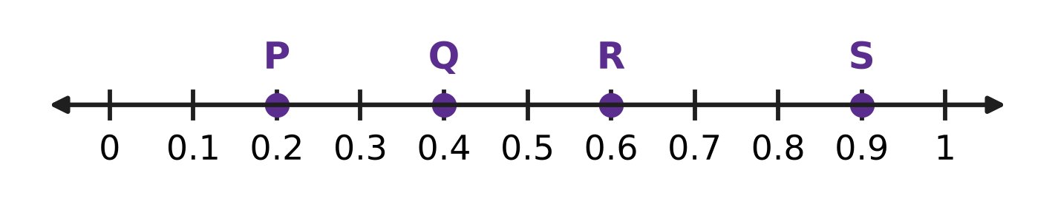
Q11. Look at the number line. Which point shows a number greater than $\frac{1}{4}$ and less than $\frac{1}{2}$?
(A) Point P | (B) Point Q | (C) Point R | (D) Point S

Q12. Rekha uses 75% of a piece of cloth to make a cushion cover. What fraction of the cloth is left?
(A) $\frac{3}{4}$ | (B) $\frac{1}{25}$ | (C) $\frac{1}{4}$ | (D) $\frac{1}{3}$

Q13. Which of these is the largest amount?
(A) 50% of ₹60 | (B) 10% of ₹290
(C) 75% of ₹36 | (D) 25% of ₹100

Q14. A parcel weighs $1\frac{3}{4}$ kg. What is this weight as a decimal?
(A) 1.34 kg | (B) 1.43 kg | (C) 1.3 kg | (D) 1.75 kg

Q15. Which of these lists is in order from the smallest to the largest?
(A) $\frac{3}{8}$, $\frac{2}{5}$, 0.42, 45% | (B) $\frac{3}{8}$, 0.42, $\frac{2}{5}$, 45%
(C) $\frac{2}{5}$, $\frac{3}{8}$, 0.42, 45% | (D) 45%, $\frac{3}{8}$, $\frac{2}{5}$, 0.42

Q16. On sports day, 480 children take part. Of them, 25% run races. Of the remaining children, 40% do the long jump. How many children do the long jump?
(A) 120 | (B) 216 | (C) 144 | (D) 192

Part 4 — Geometry (Syllabus Chapter 5)
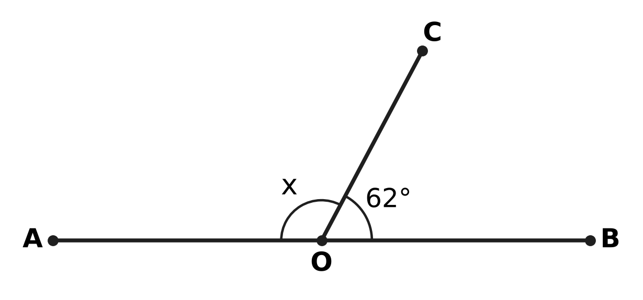
Q17. In the figure, AOB is a straight line and OC is a ray. Angle BOC is 62°. What is the size of angle x?
(A) 298° | (B) 62° | (C) 28° | (D) 118°

Q18. Which of these could be the three angles of a triangle that is both acute-angled and scalene?
(A) 40°, 40°, 100° | (B) 50°, 60°, 70°
(C) 55°, 55°, 70° | (D) 30°, 60°, 90°

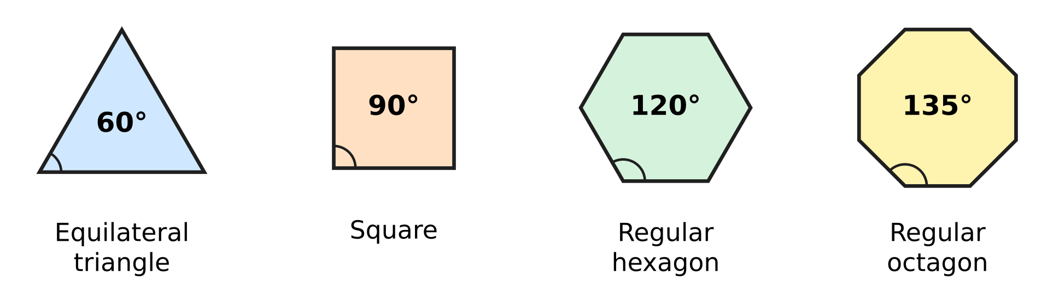
Q19. The picture shows four kinds of regular tiles and the size of each corner angle. Which of these sets of tiles can fit together round one point, with no gaps and no overlaps?
(A) 1 hexagon, 2 squares and 1 triangle | (B) 3 squares and 2 triangles
(C) 2 hexagons and 1 square | (D) 1 octagon and 2 squares

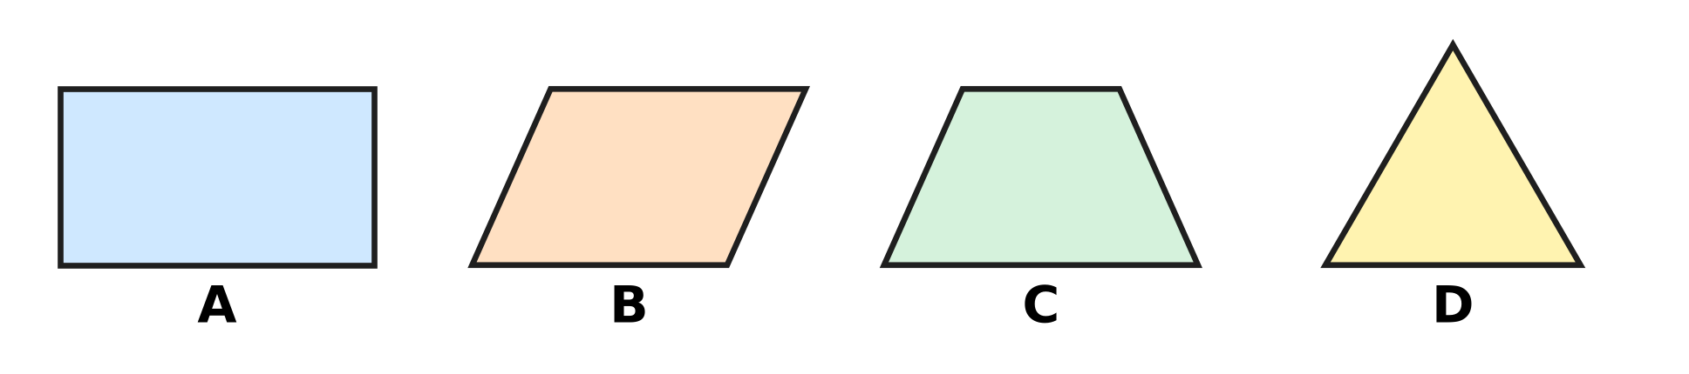
Q20. Look at the four shapes. Which shape has exactly ONE line of symmetry?
(A) Picture A | (B) Picture B
(C) Picture C | (D) Picture D

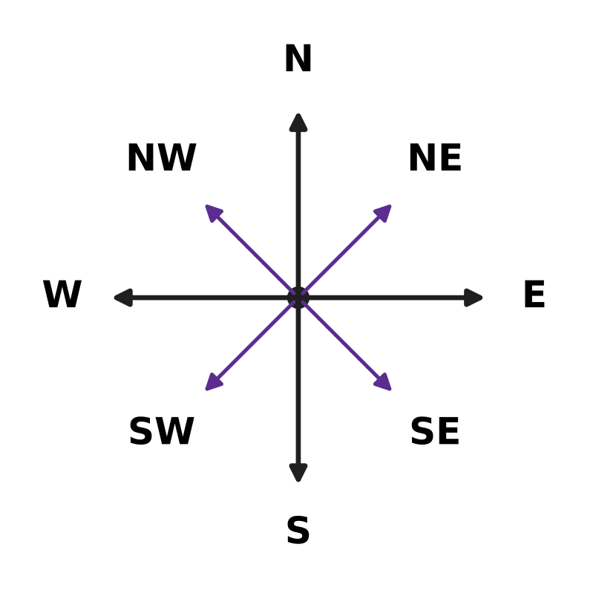
Q21. Look at the compass. Lena stands facing North-East. She turns clockwise through 135°. In which direction is she facing now?
(A) West | (B) South-East
(C) South | (D) South-West

Part 5 — Mensuration (Syllabus Chapter 6)
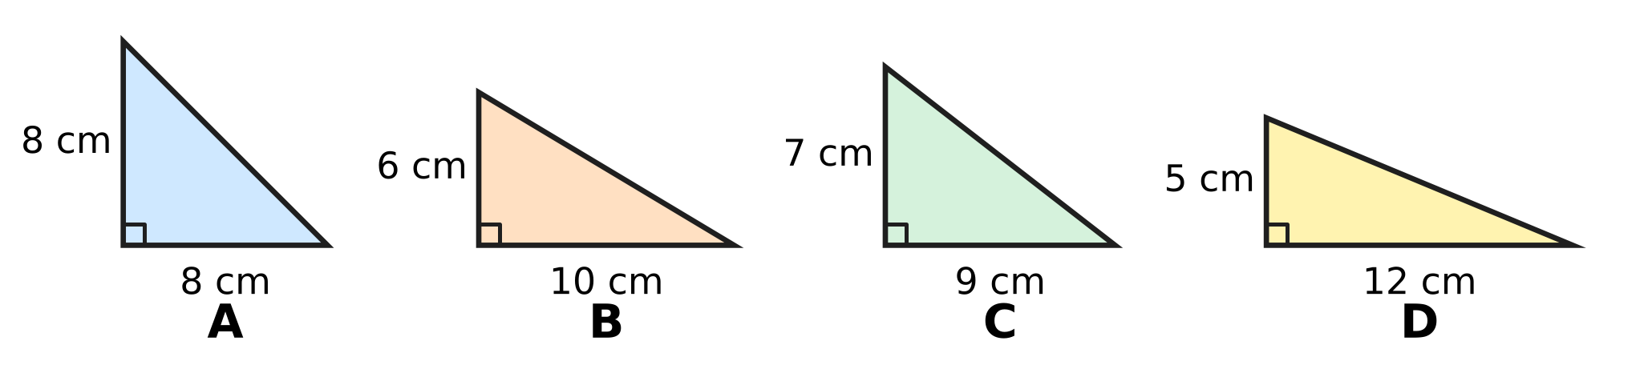
Q22. Each picture shows a triangle with a right angle, and the two sides that meet at the right angle are marked. Which picture has the greatest area?
(A) Picture A | (B) Picture B
(C) Picture C | (D) Picture D

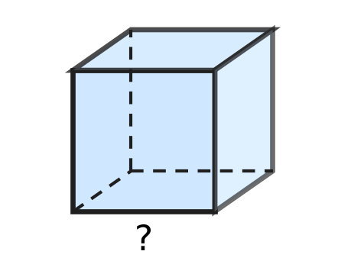
Q23. Kush has a wooden block shaped like a cube, as shown. Its volume is 343 cubic cm. How long is each edge of the block?
(A) 6 cm | (B) 7 cm | (C) 49 cm | (D) 8 cm

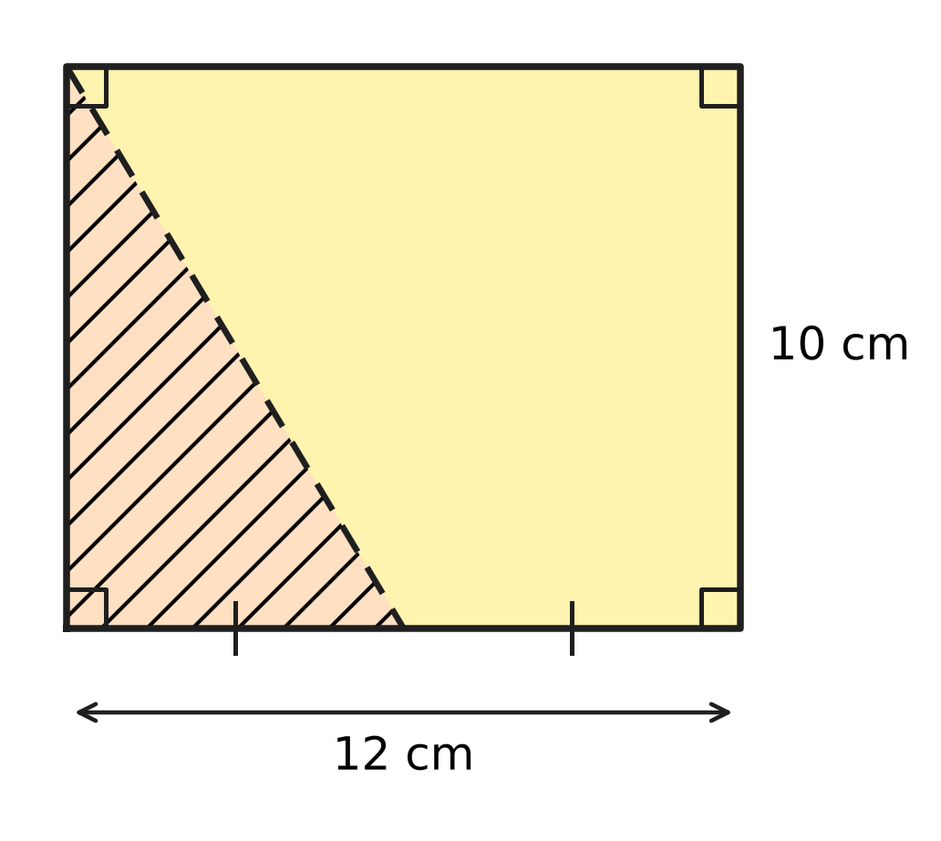
Q24. A rectangular card is 12 cm long and 10 cm wide. It is cut along the dashed line, from a corner to the middle of a long side, as shown. What is the area of the shaded triangle that is cut off?
(A) 90 sq cm | (B) 60 sq cm
(C) 120 sq cm | (D) 30 sq cm

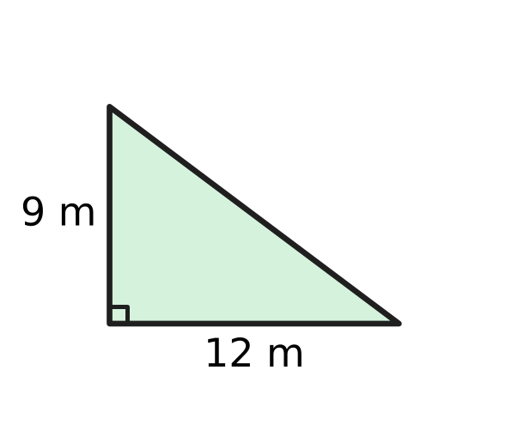
Q25. A corner of a playground is shaped like a right-angled triangle, as shown. It is to be covered with grass. The grass costs ₹20 for each sq m. What is the total cost of the grass?
(A) ₹1,080 | (B) ₹540 | (C) ₹2,160 | (D) ₹420

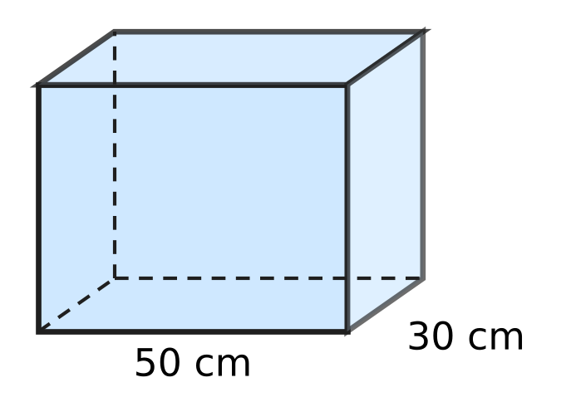
Q26. Pihu's aquarium is a cuboid 50 cm long and 30 cm wide, as shown. The water in it is 24 cm deep. She puts in a stone, which sinks completely, and the water rises to 28 cm. What is the volume of the stone?
(A) 42,000 cubic cm | (B) 6,000 cubic cm
(C) 36,000 cubic cm | (D) 1,500 cubic cm

Part 6 — Data Handling, Statistics & Probability (Syllabus Chapter 8)
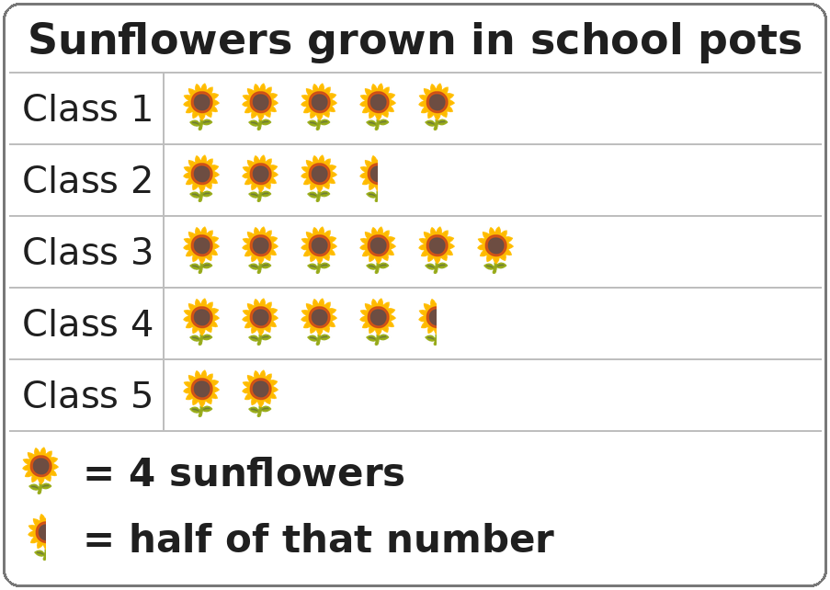
Q27. The pictograph shows the sunflowers grown in pots by five classes. How many sunflowers did Class 4 grow?
(A) 20 | (B) 16 | (C) 9 | (D) 18

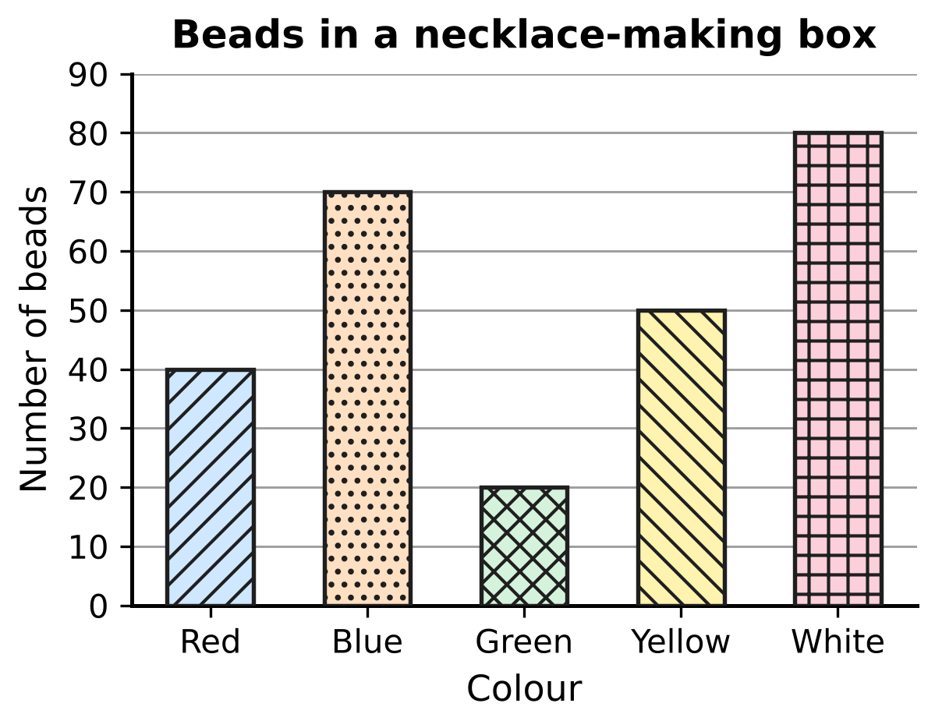
Q28. The bar graph shows the beads of each colour in a box. How many more beads are there of the two most common colours together than of the other three colours together?
(A) 10 | (B) 260 | (C) 40 | (D) 60

Part 7 — Applied Mathematics (Syllabus Chapter 9)
Q29. Which of these is the longest time?
(A) $\frac{1}{8}$ of a day | (B) 200 minutes
(C) 3 hours 10 minutes | (D) 11,400 seconds

Q30. Vijay took 270 minutes to paint a fence. How long is that in hours and minutes?
(A) 4 hours 50 minutes | (B) 3 hours 30 minutes
(C) 4 hours 30 minutes | (D) 2 hours 70 minutes

Flights of four birds
Bird | Distance flown (km) | Time taken (hours)
Eagle | 210 | 7
Swallow | 136 | 4
Parrot | 66 | 2
Crane | 160 | 5

Q31. The table shows how far four birds flew and how long each took. Which bird flew at the greatest speed?
(A) Swallow | (B) Eagle | (C) Parrot | (D) Crane

Q32. In a toy shop, Ahana watches a toy train that moves 35 cm every second. How far does it move in 1 minute?
(A) 95 cm | (B) 3,500 cm | (C) 210 cm | (D) 2,100 cm

Q33. Zoe walked to a picnic spot. The walk took 3 hours. Her average speed for the whole walk was 4 km/h. Which of these could be how she walked?
(A) 6 km/h for 1 hour, then 2 km/h for 2 hours
(B) 4 km/h for 2 hours, then 5 km/h for 1 hour
(C) 3 km/h for 2 hours, then 5 km/h for 1 hour
(D) 5 km/h for 2 hours, then 2 km/h for 1 hour

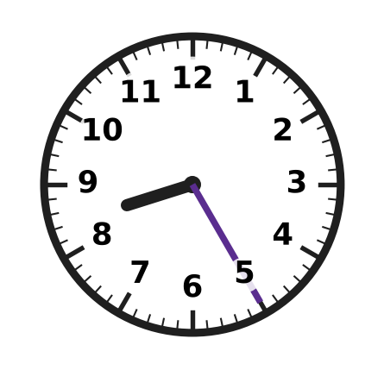
Q34. The clock shows the morning time when a train leaves a station. It travels 225 km at a steady speed of 50 km/h. At what time does it arrive?
(A) 1:25 PM | (B) 1:15 PM | (C) 12:55 PM | (D) 12:25 PM

Part 8 — Mathematical Reasoning & Problem-Solving (Syllabus Chapter 10)
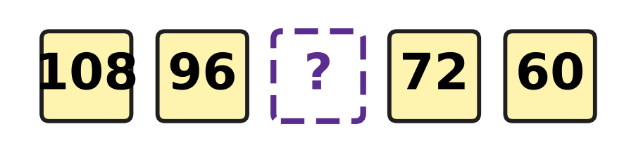
Q35. The numbers in the boxes go down by the same amount each time. Which number goes in the empty box?
(A) 86 | (B) 84 | (C) 78 | (D) 90

Q36. How many leap years are there from the year 1890 to the year 1910 (both years included)?
(A) 4 | (B) 2 | (C) 3 | (D) 5

Q37. Five whole numbers are multiplied together. The answer is an odd number. How many of the five numbers are even?
(A) 4 | (B) 1 | (C) 2 | (D) 0

Q38. In the series 9, 18, 36, 72, 144, …, each number is double the one before. Which term is the first one greater than 500?
(A) 6th term | (B) 7th term | (C) 8th term | (D) 5th term

Q39. Some children sit around a round table. Every boy has a girl on both sides of him. Every girl has a boy on both sides of her. Which of these could be the number of children at the table?
(A) 15 | (B) 9 | (C) 14 | (D) 21

Q40. How many numbers are there in the list 14, 21, 28, 35, …, 245?
(A) 34 | (B) 231 | (C) 33 | (D) 35

SECTION II — Star Questions 5 questions × 4 marks each
Q41. Three different prime numbers add up to 40. What is the largest of the three? [4 marks]
(A) 19 | (B) 31 | (C) 29 | (D) 37

Q42. Atharv pours 12 litres of juice into bottles. Each bottle holds either 0.5 litre or 1.5 litres, and every bottle is filled to the top. No juice is left over. Which of these could be the number of bottles he fills? [4 marks]
(A) 6 | (B) 13 | (C) 9 | (D) 10

Q43. The picture shows a staircase with 4 steps (numbered 1 to 4) made of 1 cm cubes. Step 1 is 1 cube tall, step 2 is 2 cubes tall, and so on. Every step is 3 cubes deep from front to back. Tejas builds a staircase in the same way with 12 steps. What is its volume? [4 marks] | 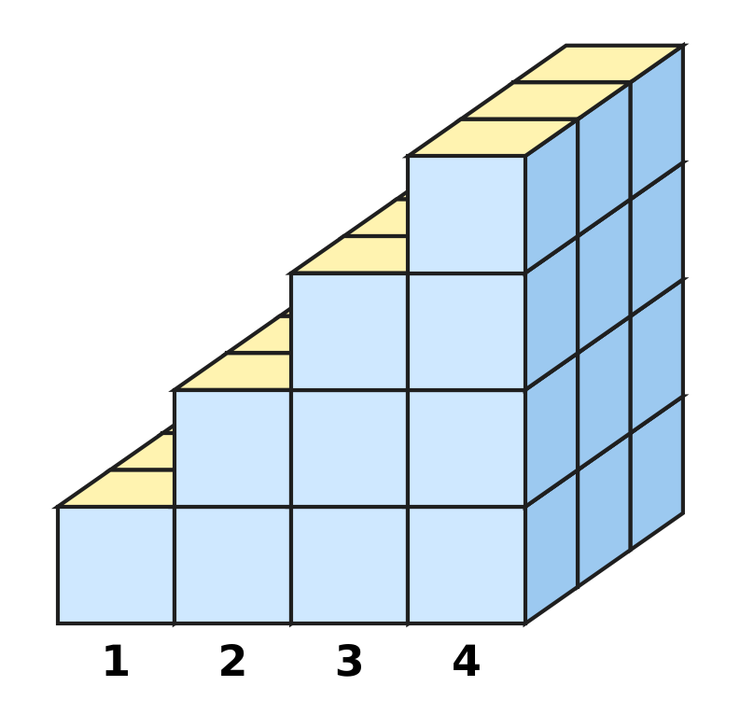
  (A) 432 cubic cm | (B) 216 cubic cm
  (C) 234 cubic cm | (D) 78 cubic cm

Q44. Akash goes on two cycle trips, of 48 km and 64 km, at the same steady speed. The speed is a whole number of km/h, and each trip takes a whole number of hours. The speed is as high as possible. How long do the two trips take altogether? [4 marks]
(A) 7 hours | (B) 14 hours | (C) 28 hours | (D) 4 hours

Q45. Gaurav's family drives 360 km to a hill town. They drive the first 25% of the distance at 60 km/h and the rest at 90 km/h. How long does the whole journey take? [4 marks]
(A) 4 hours 48 minutes | (B) 4 hours 30 minutes
(C) 4 hours | (D) 5 hours 30 minutes

Answer Sheet AMO Level 1 · Class 5 · Practice Paper 2
Name: | School: | Roll No.:
Shade or tick one circle for each question.
1. Ⓐ Ⓑ Ⓒ Ⓓ | 16. Ⓐ Ⓑ Ⓒ Ⓓ | 31. Ⓐ Ⓑ Ⓒ Ⓓ
2. Ⓐ Ⓑ Ⓒ Ⓓ | 17. Ⓐ Ⓑ Ⓒ Ⓓ | 32. Ⓐ Ⓑ Ⓒ Ⓓ
3. Ⓐ Ⓑ Ⓒ Ⓓ | 18. Ⓐ Ⓑ Ⓒ Ⓓ | 33. Ⓐ Ⓑ Ⓒ Ⓓ
4. Ⓐ Ⓑ Ⓒ Ⓓ | 19. Ⓐ Ⓑ Ⓒ Ⓓ | 34. Ⓐ Ⓑ Ⓒ Ⓓ
5. Ⓐ Ⓑ Ⓒ Ⓓ | 20. Ⓐ Ⓑ Ⓒ Ⓓ | 35. Ⓐ Ⓑ Ⓒ Ⓓ
6. Ⓐ Ⓑ Ⓒ Ⓓ | 21. Ⓐ Ⓑ Ⓒ Ⓓ | 36. Ⓐ Ⓑ Ⓒ Ⓓ
7. Ⓐ Ⓑ Ⓒ Ⓓ | 22. Ⓐ Ⓑ Ⓒ Ⓓ | 37. Ⓐ Ⓑ Ⓒ Ⓓ
8. Ⓐ Ⓑ Ⓒ Ⓓ | 23. Ⓐ Ⓑ Ⓒ Ⓓ | 38. Ⓐ Ⓑ Ⓒ Ⓓ
9. Ⓐ Ⓑ Ⓒ Ⓓ | 24. Ⓐ Ⓑ Ⓒ Ⓓ | 39. Ⓐ Ⓑ Ⓒ Ⓓ
10. Ⓐ Ⓑ Ⓒ Ⓓ | 25. Ⓐ Ⓑ Ⓒ Ⓓ | 40. Ⓐ Ⓑ Ⓒ Ⓓ
11. Ⓐ Ⓑ Ⓒ Ⓓ | 26. Ⓐ Ⓑ Ⓒ Ⓓ | 41. Ⓐ Ⓑ Ⓒ Ⓓ
12. Ⓐ Ⓑ Ⓒ Ⓓ | 27. Ⓐ Ⓑ Ⓒ Ⓓ | 42. Ⓐ Ⓑ Ⓒ Ⓓ
13. Ⓐ Ⓑ Ⓒ Ⓓ | 28. Ⓐ Ⓑ Ⓒ Ⓓ | 43. Ⓐ Ⓑ Ⓒ Ⓓ
14. Ⓐ Ⓑ Ⓒ Ⓓ | 29. Ⓐ Ⓑ Ⓒ Ⓓ | 44. Ⓐ Ⓑ Ⓒ Ⓓ
15. Ⓐ Ⓑ Ⓒ Ⓓ | 30. Ⓐ Ⓑ Ⓒ Ⓓ | 45. Ⓐ Ⓑ Ⓒ Ⓓ
Q41–Q45 are Section II Star Questions (4 marks each).
For the parent or teacher
Section I correct: ______ / 40 × 2 = ______ marks Section II correct: ______ / 5 × 4 = ______ marks
Correct: ______ / 45 Score: ______ / 100
Answer Key and Solutions AMO Level 1 · Class 5 · Practice Paper 2
Quick answers
1 D | 6 C | 11 B | 16 C | 21 C | 26 B | 31 A | 36 A | 41 B
2 A | 7 A | 12 C | 17 D | 22 A | 27 D | 32 D | 37 D | 42 D
3 B | 8 B | 13 A | 18 B | 23 B | 28 C | 33 D | 38 B | 43 C
4 D | 9 D | 14 D | 19 A | 24 D | 29 B | 34 C | 39 C | 44 A
5 C | 10 B | 15 A | 20 C | 25 A | 30 C | 35 B | 40 A | 45 B
Solutions
Q | Part · level | Answer | Why?
1 | Part 1 · Ch1 · Easy | (D) 3,70,215 | In 3,70,215 the digits are 3 lakhs and 7 ten-thousands, so the 7 stands for 70,000.
2 | Part 1 · Ch1 · Easy | (A) DIC | I may be taken away only from V and X, so IC is not allowed, and DIC is not a correct Roman numeral.
3 | Part 1 · Ch1 · Easy | (B) 90 | 90 = 6 × 15 and also 15 × 6, so it is a multiple of both. 45 is not a multiple of 6 and 72 is not a multiple of 15.
4 | Part 1 · Ch1 · Medium | (D) 73 | Numbers with digit sum 10 and a bigger tens digit: 91, 82, 73, 64, 55. Only 73 is prime (91 = 7 × 13).
5 | Part 1 · Ch1 · Medium | (C) 48 | The number must be a multiple of the LCM of 4 and 6, which is 12. The only multiple of 12 between 40 and 55 is 48.
6 | Part 2 · Ch2 · Easy | (C) 36 − 8 × 2 | Multiply or divide before adding or subtracting: 36 − 8 × 2 = 36 − 16 = 20. The others: 1 + 4 × 4 = 17, 2 + 3 × 4 = 14 and 50 − 10 ÷ 2 = 45.
7 | Part 2 · Ch2 · Easy | (A) 7,900 | Change the order: 25 × 4 = 100, and 100 × 79 = 7,900.
8 | Part 2 · Ch2 · Easy | (B) 1,700 kg | 3,870 rounds to 3,900 and 2,190 rounds to 2,200. The estimate is 3,900 − 2,200 = 1,700 kg.
9 | Part 2 · Ch2 · Medium | (D) 9 | The square bracket must be 48 ÷ 4 = 12. So the round bracket is 12 ÷ 2 = 6, and the missing number is 6 + 3 = 9.
10 | Part 2 · Ch2 · Medium | (B) 6,125 | 125 × 49 = 125 × 48 + 125 × 1 = 6,000 + 125 = 6,125.
11 | Part 3 · Ch3 · Easy | (B) Point Q | 1/4 = 0.25 and 1/2 = 0.5. Only Q, at 0.4, lies between 0.25 and 0.5.
12 | Part 3 · Ch3 · Easy | (C) $\frac{1}{4}$ | 75% is used, so 100% − 75% = 25% is left. 25% = 25/100 = 1/4.
13 | Part 3 · Ch3 · Easy | (A) 50% of ₹60 | 50% of ₹60 = ₹30, 25% of ₹100 = ₹25, 10% of ₹290 = ₹29 and 75% of ₹36 = ₹27. The largest is ₹30.
14 | Part 3 · Ch3 · Easy | (D) 1.75 kg | 3/4 = 75/100 = 0.75, so 1 3/4 kg = 1.75 kg.
15 | Part 3 · Ch3 · Medium | (A) 3/8, 2/5, 0.42, 45% | 3/8 = 0.375, 2/5 = 0.4, 0.42 and 45% = 0.45. So the order is 3/8, 2/5, 0.42, 45%.
16 | Part 3 · Ch3 · Medium | (C) 144 | 25% of 480 = 120 run races, so 360 remain. 40% of 360 = 144 do the long jump.
17 | Part 4 · Ch5 · Easy | (D) 118° | Angles on a straight line add up to 180°. So x = 180° − 62° = 118°.
18 | Part 4 · Ch5 · Easy | (B) 50°, 60°, 70° | All three angles 50°, 60° and 70° are less than 90°, so it is acute-angled. No two angles are equal, so no two sides are equal: it is scalene.
19 | Part 4 · Ch5 · Easy | (A) 1 hexagon, 2 squares and 1 triangle | The corners round a point must add up to 360°. 120° + 90° + 90° + 60° = 360°, so 1 hexagon, 2 squares and 1 triangle fit exactly.
20 | Part 4 · Ch5 · Medium | (C) Picture C | The trapezium in Picture C has only one line of symmetry, the upright line through the middle of its two parallel sides.
21 | Part 4 · Ch5 · Medium | (C) South | Each step between neighbouring directions is 45°. 135° = 3 steps clockwise: North-East → East → South-East → South.
22 | Part 5 · Ch6 · Easy | (A) Picture A | Areas: A = ½ × 8 × 8 = 32, B = 30, C = 31.5, D = 30 sq cm. Triangle A has the greatest area.
23 | Part 5 · Ch6 · Easy | (B) 7 cm | 7 × 7 × 7 = 49 × 7 = 343, so each edge is 7 cm.
24 | Part 5 · Ch6 · Easy | (D) 30 sq cm | The shaded triangle has sides 6 cm (half of 12 cm) and 10 cm at the right angle. Area = ½ × 6 × 10 = 30 sq cm.
25 | Part 5 · Ch6 · Medium | (A) ₹1,080 | Area = ½ × 12 × 9 = 54 sq m. Cost = 54 × ₹20 = ₹1,080.
26 | Part 5 · Ch6 · Medium | (B) 6,000 cubic cm | The water rises by 28 − 24 = 4 cm. The stone takes the space 50 × 30 × 4 = 6,000 cubic cm.
27 | Part 6 · Ch8 · Easy | (D) 18 | Class 4 has 4 whole symbols and a half: 4 × 4 + 2 = 18 sunflowers.
28 | Part 6 · Ch8 · Medium | (C) 40 | White and Blue: 80 + 70 = 150. Red, Yellow and Green: 40 + 50 + 20 = 110. 150 − 110 = 40.
29 | Part 7 · Ch9 · Easy | (B) 200 minutes | 3 h 10 min = 190 min, 11,400 s = 190 min and 1/8 of a day = 3 h = 180 min. 200 minutes is the longest.
30 | Part 7 · Ch9 · Easy | (C) 4 hours 30 minutes | 270 = 4 × 60 + 30, so 270 minutes = 4 hours 30 minutes.
31 | Part 7 · Ch9 · Easy | (A) Swallow | Speeds: Eagle 30, Swallow 34, Parrot 33 and Crane 32 km/h. The swallow is fastest.
32 | Part 7 · Ch9 · Easy | (D) 2,100 cm | 1 minute = 60 seconds. 35 × 60 = 2,100 cm.
33 | Part 7 · Ch9 · Medium | (D) 5 km/h for 2 hours, then 2 km/h for 1 hour | At an average of 4 km/h for 3 hours she walks 4 × 3 = 12 km. Check each walk: 6 + 2 × 2 = 10 km; 4 × 2 + 5 = 13 km; 3 × 2 + 5 = 11 km; 5 × 2 + 2 × 1 = 12 km. Only the last one fits.
34 | Part 7 · Ch9 · Medium | (C) 12:55 PM | Time = 225 ÷ 50 = 4½ hours = 4 hours 30 minutes. 8:25 AM + 4 h 30 min = 12:55 PM.
35 | Part 8 · Ch10 · Easy | (B) 84 | Each number is 12 less than the one before: 108, 96, 84, 72, 60.
36 | Part 8 · Ch10 · Easy | (A) 4 | The years divisible by 4 are 1892, 1896, 1900, 1904 and 1908. 1900 is not divisible by 400, so it is not a leap year. That leaves 4 leap years.
37 | Part 8 · Ch10 · Easy | (D) 0 | If even one of the numbers is even, the product is even. So none of the five numbers can be even.
38 | Part 8 · Ch10 · Medium | (B) 7th term | The terms are 9, 18, 36, 72, 144, 288, 576. The 7th term, 576, is the first greater than 500.
39 | Part 8 · Ch10 · Medium | (C) 14 | Going round the table the children go boy, girl, boy, girl, … and the last child sits next to the first. So boys and girls are equal in number and the total is even. Only 14 is even.
40 | Part 8 · Ch10 · Medium | (A) 34 | The numbers are 7 × 2, 7 × 3, …, 7 × 35. From 2 to 35 there are 35 − 2 + 1 = 34 numbers.
41 | Section II · Ch1 + Ch10 · Hard | (B) 31 | Three odd primes would add to an odd number, so one prime must be 2. The other two add to 38 and are different primes: only 7 + 31 works (38 − 3 = 35, 38 − 5 = 33, 38 − 11 = 27, 38 − 13 = 25 and 38 − 17 = 21 are not prime, and 19 + 19 repeats a prime). The largest is 31.
42 | Section II · Ch3 + Ch10 · Hard | (D) 10 | 0.5 L = 1 half-litre and 1.5 L = 3 half-litres, both odd numbers. 12 L = 24 half-litres, an even number, so the number of bottles is even and at least 24 ÷ 3 = 8. 10 works: 7 big and 3 small bottles.
43 | Section II · Ch6 + Ch10 · Hard | (C) 234 cubic cm | The front layer has 1 + 2 + 3 + … + 12 = 78 cubes. There are 3 such layers, so 78 × 3 = 234 cubes of 1 cubic cm each: 234 cubic cm.
44 | Section II · Ch1 + Ch9 · Hard | (A) 7 hours | The speed must divide both 48 and 64, so the highest speed is their HCF, 16 km/h. The trips take 48 ÷ 16 = 3 h and 64 ÷ 16 = 4 h, 7 hours in all.
45 | Section II · Ch3 + Ch9 · Hard | (B) 4 hours 30 minutes | 25% of 360 km = 90 km, taking 90 ÷ 60 = 1½ hours. The other 270 km take 270 ÷ 90 = 3 hours. Total 4 hours 30 minutes.

