UNLOCK IQ INSTITUTE
Realize Your True Potential
Aryabhatta Maths Olympiad (AMO)
Level 1 — Practice Paper 3
CLASS 5

Questions | 45 multiple-choice questions
Marks | 100
Time | 60 minutes
Section I | 40 questions × 2 marks = 80 marks
Section II | 5 Star Questions × 4 marks = 20 marks
Negative marking | No negative marking
Calculator | Not allowed
Chapters | Number System · Operations · Fractions, Decimals & Percentages · Geometry · Mensuration · Data Handling · Applied Mathematics · Mathematical Reasoning

Hello, friend!
• Every question has four answer choices: (A), (B), (C) and (D). Only one is correct.
• Read each question and look at its picture carefully. Then mark your answer on the answer sheet at the end.
• Section I has 40 questions of 2 marks each. Section II has 5 Star Questions of 4 marks each.
• There is no negative marking, so try every question.
• Do not use a calculator. You may do rough work on a separate sheet.
• All figures are not necessarily drawn to scale unless stated.

For parents and teachers
Print or view this paper in colour. Pictures are part of the questions.
Parts follow the AMO syllabus chapters. Chapters 4 and 7 are not part of the Class 5 syllabus, so the chapter numbers shown in the Part headings have gaps.
The answer sheet and the answer key are at the end. Remove only the answer key before the child begins.

Name: | School: | Roll No.:

SECTION I 40 questions × 2 marks each
Part 1 — Number System (Syllabus Chapter 1)
Q1. What is the missing part of this expanded form?
4,00,000 + ___ + 6,000 + 50 + 3 = 4,36,053
(A) 36,000 | (B) 3,000 | (C) 30,000 | (D) 3,00,000

Q2. The Roman numeral for 990 is written CM___. What goes in the blank?
(A) LC | (B) CX | (C) LXXXX | (D) XC

Q3. Which number goes in the blank to complete the prime factorisation?
140 = 2 × 2 × ___ × 5
(A) 14 | (B) 70 | (C) 7 | (D) 35

Q4. The product of two numbers is 294. Their HCF is 7. What is their LCM?
(A) 2,058 | (B) 147 | (C) 287 | (D) 42

Q5. Aditi wants to write the smallest 6-digit number in which no digit is repeated. Which number should she write?
(A) 1,23,456 | (B) 1,02,345 | (C) 1,01,234 | (D) 1,00,000

Part 2 — Operations & Number Properties (Syllabus Chapter 2)
Q6. A bus stand sold 289, 312, 198 and 405 tickets on four days. Round each number to the nearest hundred and then add. What is the estimated total?
(A) 1,200 | (B) 1,300 | (C) 1,100 | (D) 1,204

Q7. Which number makes this statement true?
63 × 98 = 63 × 100 − 63 × ___
(A) 98 | (B) 1 | (C) 102 | (D) 2

Q8. Sahil buys 3 sandwiches at ₹18 each and 2 glasses of juice at ₹15 each. He pays with a ₹100 note. Which expression gives his change?
(A) 100 − 3 × 18 + 2 × 15 | (B) 3 × 18 + 2 × 15 − 100
(C) 100 − (3 × 18 + 2 × 15) | (D) 100 − (3 + 2) × (18 + 15)

Q9. Which sign goes in the blank to make the statement true?
[24 ÷ (6 ___ 2)] × (5 − 1) = 12
(A) + | (B) − | (C) × | (D) ÷

Q10. Which of these is NOT equal to 36 × 25?
(A) 9 × 100 | (B) 30 × 25 + 6 × 5
(C) 25 × 30 + 25 × 6 | (D) 36 × 20 + 36 × 5

Part 3 — Fractions, Decimals & Percentages (Syllabus Chapter 3)
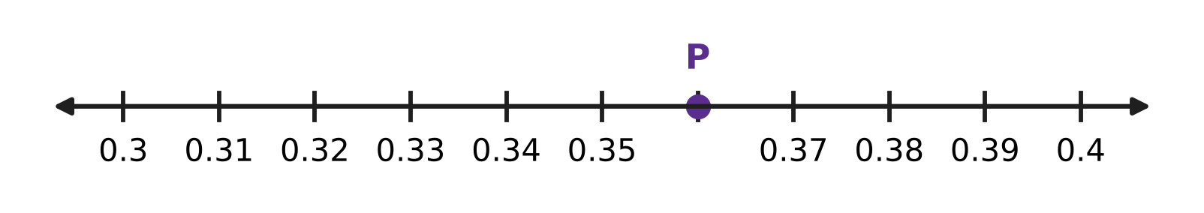
Q11. On the number line, the part from 0.3 to 0.4 is divided into 10 equal steps. Which decimal does point P show?
(A) 0.36 | (B) 0.34 | (C) 3.6 | (D) 0.6

Q12. What number goes in the blank?
0.04 = 1 ÷ ___
(A) 40 | (B) 25 | (C) 4 | (D) 400

Q13. A post office sorted 840 letters in the morning. Of these, 25% were for other cities. How many letters were for other cities?
(A) 420 | (B) 630 | (C) 84 | (D) 210

Q14. Which number goes in the blank?
2.75 + ___ = 4.1
(A) 1.45 | (B) 2.65 | (C) 1.35 | (D) 6.85

Q15. In a paper plane contest, $\frac{3}{5}$ of the planes flew more than 5 m. Half of these planes flew more than 10 m. What percentage of all the planes flew more than 10 m?
(A) 30% | (B) 60% | (C) 10% | (D) 50%

Q16. What number belongs in the blank?
___% of 60 = 15% of 200
(A) 45 | (B) 30 | (C) 15 | (D) 50

Part 4 — Geometry (Syllabus Chapter 5)
Q17. Look at the clock. The minute hand moves clockwise through a quarter turn (one right angle). What time will the clock show then? | 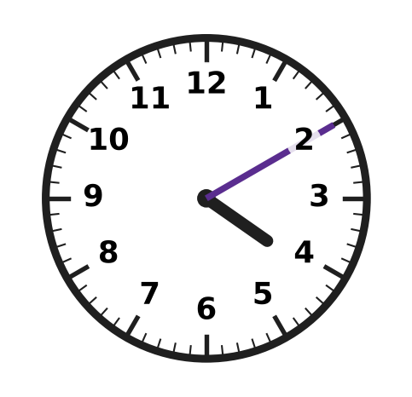
  (A) 4:25 | (B) 3:55 | (C) 4:40 | (D) 7:10

Q18. Look at the grid. Which ONE more square must be shaded so that the dashed line becomes a line of symmetry of the shaded design? | 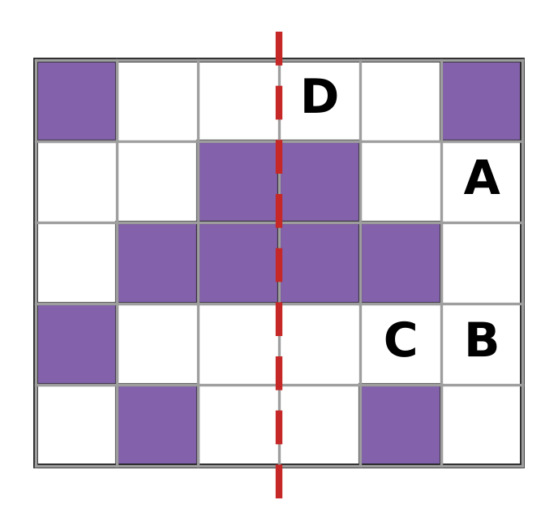
  (A) Square A | (B) Square B | (C) Square C | (D) Square D

Q19. Which statement about quadrilaterals is NOT true?
(A) Every rhombus is a parallelogram. | (B) Every rhombus is a square.
(C) Every rectangle is a parallelogram. | (D) Every square is a rhombus.

Q20. Two angles of a triangle are 35° and 55°. What is the third angle, and what type of triangle is it?
(A) 100°, obtuse-angled | (B) 90°, obtuse-angled
(C) 90°, right-angled | (D) 90°, acute-angled

Q21. The pinwheel in the picture has 6 blades of the same shape and size. It is turned about its centre dot. What is the smallest turn after which it looks exactly the same? | 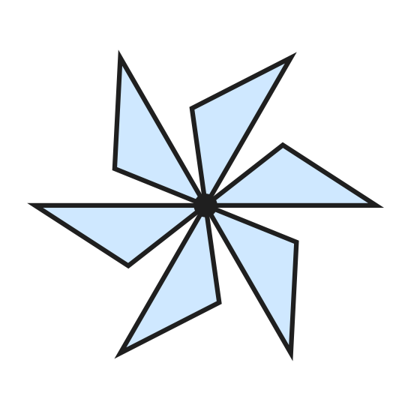
  (A) 180° | (B) 60° | (C) 90° | (D) 30°

Part 5 — Mensuration (Syllabus Chapter 6)
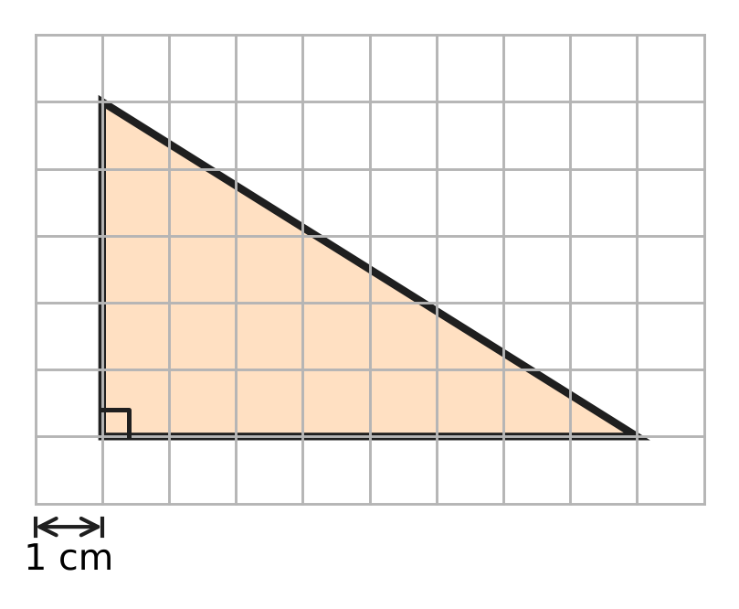
Q22. A right-angled triangle is drawn on a grid of 1 cm squares, as shown. Use the grid to find its area.
(A) 26 sq cm | (B) 40 sq cm | (C) 20 sq cm | (D) 13 sq cm

Q23. Vikram's pencil box is a cuboid 15 cm long, 8 cm wide and 4 cm high, as shown. What is the volume of the box? | 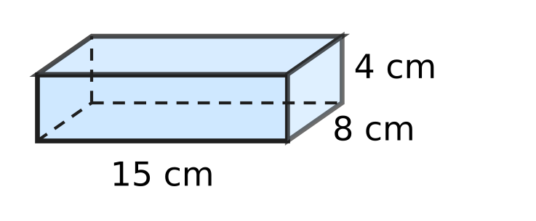
  (A) 480 cubic cm | (B) 120 cubic cm
  (C) 27 cubic cm | (D) 960 cubic cm

Q24. Roshni has four boxes with the measurements given below. Each box is filled to the top with sand. Which box holds the most sand?
(A) 10 cm × 3 cm × 2 cm | (B) 6 cm × 5 cm × 2 cm
(C) 7 cm × 3 cm × 3 cm | (D) 4 cm × 4 cm × 4 cm

Q25. A cuboid tank holds 72 litres of water when full. Inside, it is 60 cm long and 40 cm wide, as shown. How high is it inside? (1 litre = 1,000 cubic cm) | 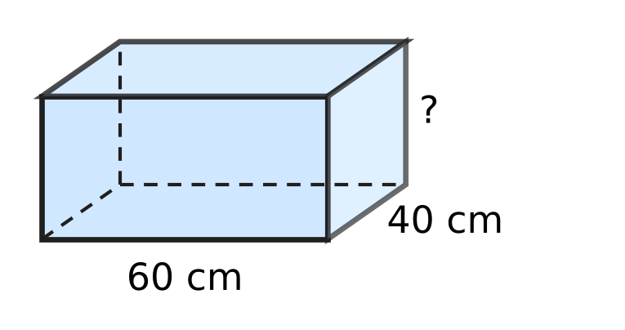
  (A) 300 cm | (B) 720 cm | (C) 3 cm | (D) 30 cm

Q26. The rectangle and the right-angled triangle in the picture have the same area. What is the height of the triangle, marked with a question mark? | 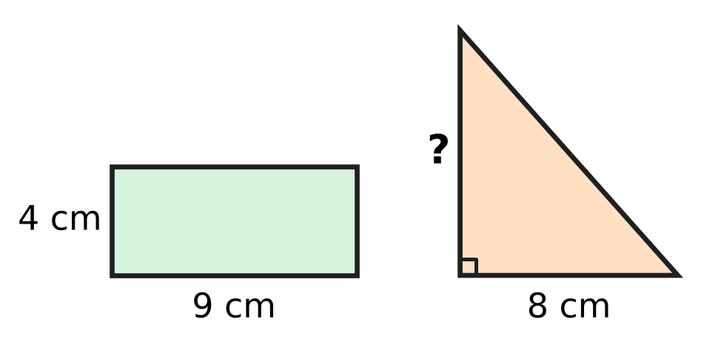
  (A) 9 cm | (B) 18 cm | (C) 6.5 cm | (D) 4.5 cm

Part 6 — Data Handling, Statistics & Probability (Syllabus Chapter 8)
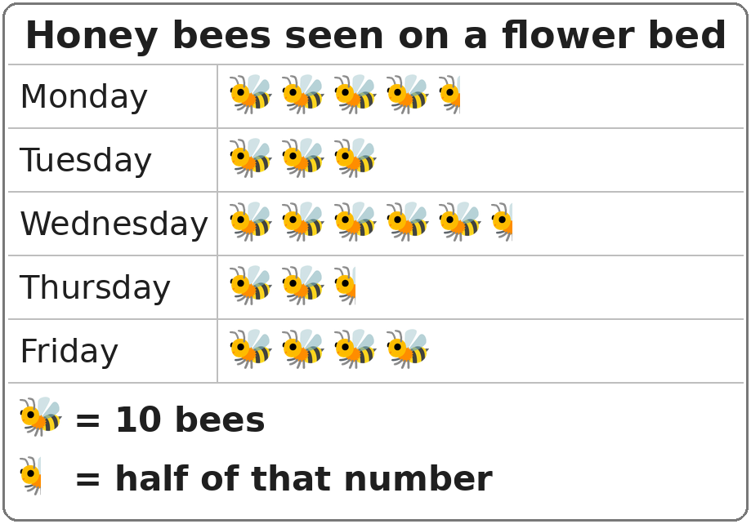
Q27. The pictograph shows the number of honey bees seen on a flower bed on five days. How many bees were seen on the five days altogether?
(A) 150 | (B) 195 | (C) 180 | (D) 210

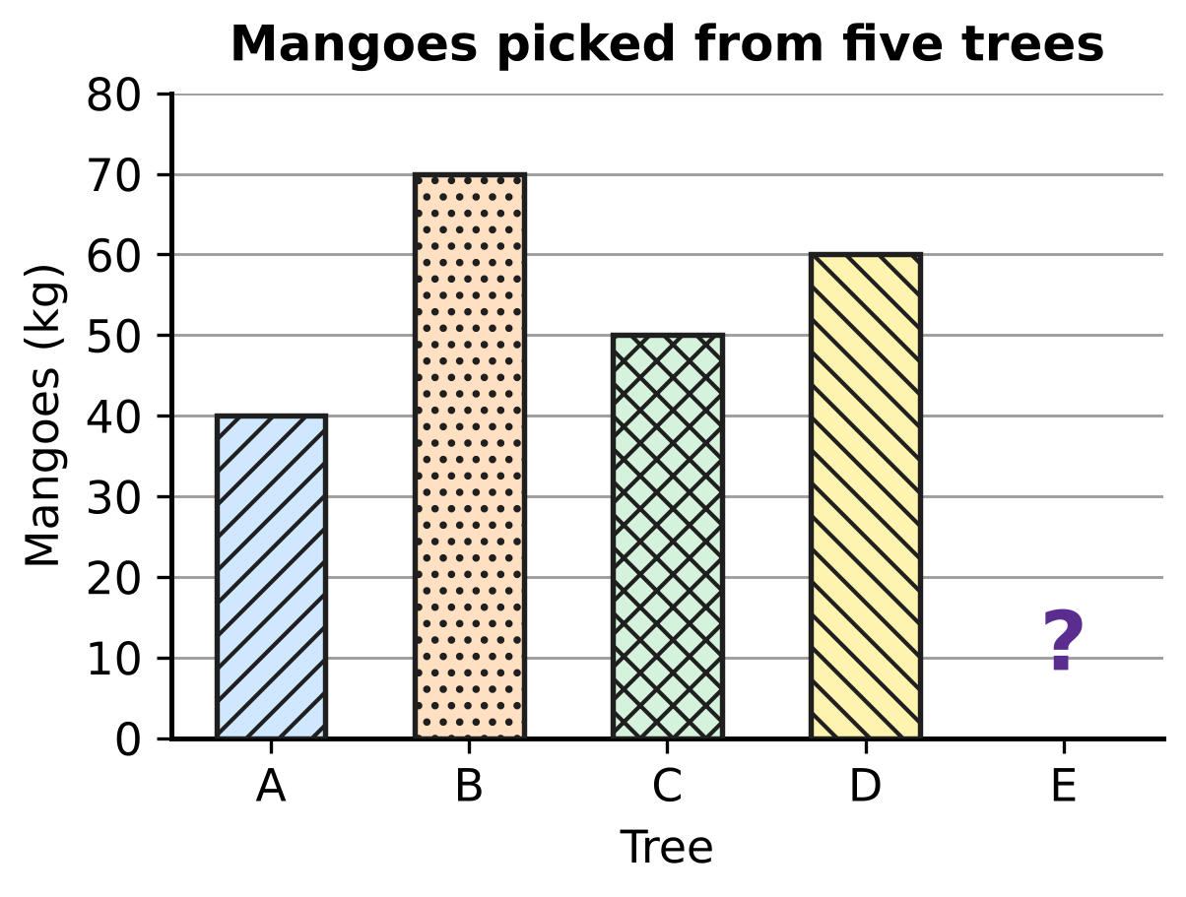
Q28. The bar graph shows the mangoes picked from five trees. The bar for Tree E is missing. Altogether 250 kg of mangoes were picked. How many kilograms of mangoes came from Tree E?
(A) 50 kg | (B) 20 kg | (C) 30 kg | (D) 220 kg

Part 7 — Applied Mathematics (Syllabus Chapter 9)
Q29. Charu's clay pots must dry in the shade for 5 weeks 4 days before they are baked. How many days is that?
(A) 9 days | (B) 39 days | (C) 35 days | (D) 54 days

Q30. Ankit cycles at a steady speed of 16 km/h for 3 hours. How far does he cycle?
(A) 48 km | (B) 19 km | (C) 13 km | (D) 32 km

Q31. How many seconds are there in a quarter of an hour?
(A) 1,500 seconds | (B) 3,600 seconds
(C) 15 seconds | (D) 900 seconds

Q32. Fill in the blank.
48 minutes = ___ hour
(A) 0.48 hour | (B) 0.2 hour
(C) 0.8 hour | (D) 1.25 hour

Q33. At a mill, a machine fills one sack of grain every 40 seconds. It works without a break for 2 hours. How many sacks does it fill?
(A) 180 | (B) 300 | (C) 3 | (D) 90

Q34. A wall clock in Harsh's shop gains 5 seconds every hour. How many minutes does it gain in 12 days?
(A) 1,440 minutes | (B) 24 minutes
(C) 1 minute | (D) 12 minutes

Part 8 — Mathematical Reasoning & Problem-Solving (Syllabus Chapter 10)
Q35. What is the 8th term of the series 6, 13, 20, 27, …?
(A) 48 | (B) 56 | (C) 55 | (D) 62

Q36. What is the missing first term of this series?
___, 15, 75, 375, 1,875
(A) 10 | (B) 5 | (C) 1 | (D) 3

Q37. Which number fits the blank?
"The sum of any ___ odd numbers is always an even number."
(A) 21 | (B) 16 | (C) 9 | (D) 13

Q38. A museum exhibition is open every day from 18 April to 7 June, both days included. For how many days is it open?
(A) 51 days | (B) 52 days | (C) 50 days | (D) 49 days

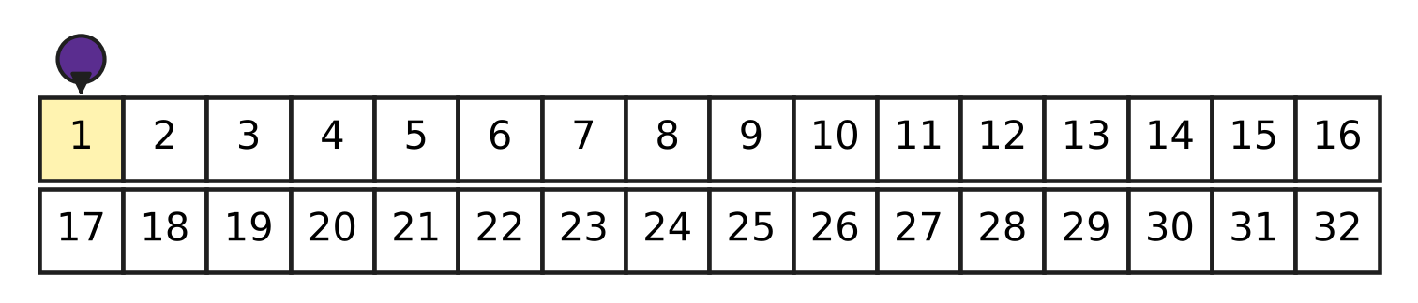
Q39. The picture shows the start of a board game. Veer's counter starts on square 1. In every turn it moves forward exactly 3 squares or exactly 5 squares. On which square could the counter be after 6 turns?
(A) 20 | (B) 30 | (C) 26 | (D) 27

Q40. Which of these numbers is a term of the series 5, 11, 17, 23, …?
(A) 91 | (B) 99 | (C) 89 | (D) 96

SECTION II — Star Questions 5 questions × 4 marks each
Q41. How many factors of 120 are even numbers that are NOT multiples of 4? [4 marks]
(A) 12 | (B) 16 | (C) 8 | (D) 4

Q42. Rhea's piggy bank has only ₹5 coins and ₹2 coins. Of all the coins, 35% are ₹5 coins. There are fewer than 50 coins. The number of ₹2 coins is odd. How much money is in the piggy bank? [4 marks]
(A) ₹35 | (B) ₹61 | (C) ₹122 | (D) ₹79

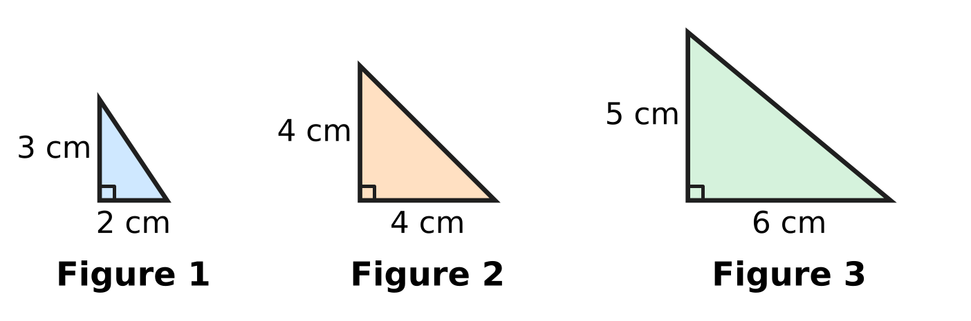
Q43. The picture shows the first three figures of a pattern of right-angled triangles. In each new figure the base is 2 cm longer and the height is 1 cm longer than in the figure before. Which is the first figure whose area is more than 100 sq cm? [4 marks]
(A) Figure 10 | (B) Figure 9
(C) Figure 7 | (D) Figure 8

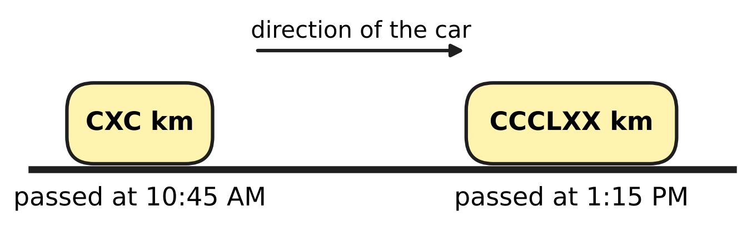
Q44. Nirav's family car drives along a highway at a steady speed. The stones beside the road show the distance from the same city in Roman numerals. The car passes the two stones at the times shown. What is the speed of the car? [4 marks]
(A) 90 km/h | (B) 60 km/h | (C) 72 km/h | (D) 64 km/h

Q45. A fishing boat is out of the harbour for 5 hours. For 20% of this time it stays still while the nets are down. For the rest of the time it moves at a steady speed and covers 48 km. How much greater is its moving speed than its average speed for the whole 5 hours? [4 marks]
(A) 9.6 km/h | (B) 2.4 km/h | (C) 12 km/h | (D) 2 km/h

Answer Sheet AMO Level 1 · Class 5 · Practice Paper 3
Name: | School: | Roll No.:
Shade or tick one circle for each question.
1. Ⓐ Ⓑ Ⓒ Ⓓ | 16. Ⓐ Ⓑ Ⓒ Ⓓ | 31. Ⓐ Ⓑ Ⓒ Ⓓ
2. Ⓐ Ⓑ Ⓒ Ⓓ | 17. Ⓐ Ⓑ Ⓒ Ⓓ | 32. Ⓐ Ⓑ Ⓒ Ⓓ
3. Ⓐ Ⓑ Ⓒ Ⓓ | 18. Ⓐ Ⓑ Ⓒ Ⓓ | 33. Ⓐ Ⓑ Ⓒ Ⓓ
4. Ⓐ Ⓑ Ⓒ Ⓓ | 19. Ⓐ Ⓑ Ⓒ Ⓓ | 34. Ⓐ Ⓑ Ⓒ Ⓓ
5. Ⓐ Ⓑ Ⓒ Ⓓ | 20. Ⓐ Ⓑ Ⓒ Ⓓ | 35. Ⓐ Ⓑ Ⓒ Ⓓ
6. Ⓐ Ⓑ Ⓒ Ⓓ | 21. Ⓐ Ⓑ Ⓒ Ⓓ | 36. Ⓐ Ⓑ Ⓒ Ⓓ
7. Ⓐ Ⓑ Ⓒ Ⓓ | 22. Ⓐ Ⓑ Ⓒ Ⓓ | 37. Ⓐ Ⓑ Ⓒ Ⓓ
8. Ⓐ Ⓑ Ⓒ Ⓓ | 23. Ⓐ Ⓑ Ⓒ Ⓓ | 38. Ⓐ Ⓑ Ⓒ Ⓓ
9. Ⓐ Ⓑ Ⓒ Ⓓ | 24. Ⓐ Ⓑ Ⓒ Ⓓ | 39. Ⓐ Ⓑ Ⓒ Ⓓ
10. Ⓐ Ⓑ Ⓒ Ⓓ | 25. Ⓐ Ⓑ Ⓒ Ⓓ | 40. Ⓐ Ⓑ Ⓒ Ⓓ
11. Ⓐ Ⓑ Ⓒ Ⓓ | 26. Ⓐ Ⓑ Ⓒ Ⓓ | 41. Ⓐ Ⓑ Ⓒ Ⓓ
12. Ⓐ Ⓑ Ⓒ Ⓓ | 27. Ⓐ Ⓑ Ⓒ Ⓓ | 42. Ⓐ Ⓑ Ⓒ Ⓓ
13. Ⓐ Ⓑ Ⓒ Ⓓ | 28. Ⓐ Ⓑ Ⓒ Ⓓ | 43. Ⓐ Ⓑ Ⓒ Ⓓ
14. Ⓐ Ⓑ Ⓒ Ⓓ | 29. Ⓐ Ⓑ Ⓒ Ⓓ | 44. Ⓐ Ⓑ Ⓒ Ⓓ
15. Ⓐ Ⓑ Ⓒ Ⓓ | 30. Ⓐ Ⓑ Ⓒ Ⓓ | 45. Ⓐ Ⓑ Ⓒ Ⓓ
Q41–Q45 are Section II Star Questions (4 marks each).
For the parent or teacher
Section I correct: ______ / 40 × 2 = ______ marks Section II correct: ______ / 5 × 4 = ______ marks
Correct: ______ / 45 Score: ______ / 100
Answer Key and Solutions AMO Level 1 · Class 5 · Practice Paper 3
Quick answers
1 C | 6 A | 11 A | 16 D | 21 B | 26 A | 31 D | 36 D | 41 D
2 D | 7 D | 12 B | 17 A | 22 C | 27 B | 32 C | 37 B | 42 B
3 C | 8 C | 13 D | 18 B | 23 A | 28 C | 33 A | 38 A | 43 A
4 D | 9 A | 14 C | 19 B | 24 D | 29 B | 34 B | 39 D | 44 C
5 B | 10 B | 15 A | 20 C | 25 D | 30 A | 35 C | 40 C | 45 B
Solutions
Q | Part · level | Answer | Why?
1 | Part 1 · Ch1 · Easy | (C) 30,000 | In 4,36,053 the digit 3 is in the ten-thousands place, so the missing part is 30,000.
2 | Part 1 · Ch1 · Easy | (D) XC | Split 990 as 900 + 90. Then 900 is CM and 90 is 100 − 10 = XC, so 990 = CMXC.
3 | Part 1 · Ch1 · Easy | (C) 7 | Since 2 × 2 × 5 = 20 and 140 ÷ 20 = 7, the blank is 7. It is a prime number, so 140 = 2 × 2 × 7 × 5.
4 | Part 1 · Ch1 · Medium | (D) 42 | HCF × LCM = product of the two numbers. So LCM = 294 ÷ 7 = 42.
5 | Part 1 · Ch1 · Medium | (B) 1,02,345 | The first digit must be 1 (it cannot be 0). Then use the smallest unused digits in order: 0, 2, 3, 4, 5, giving 1,02,345.
6 | Part 2 · Ch2 · Easy | (A) 1,200 | Rounding gives 289 → 300, 312 → 300, 198 → 200 and 405 → 400. The estimate is 300 + 300 + 200 + 400 = 1,200.
7 | Part 2 · Ch2 · Easy | (D) 2 | Since 98 = 100 − 2, we get 63 × 98 = 63 × 100 − 63 × 2.
8 | Part 2 · Ch2 · Easy | (C) 100 − (3 × 18 + 2 × 15) | He spends 3 × 18 + 2 × 15 = 54 + 30 = ₹84. The change is 100 − (3 × 18 + 2 × 15) = ₹16.
9 | Part 2 · Ch2 · Medium | (A) + | [24 ÷ (6 ___ 2)] must be 12 ÷ 4 = 3, so (6 ___ 2) must be 8. Only 6 + 2 = 8.
10 | Part 2 · Ch2 · Medium | (B) 30 × 25 + 6 × 5 | Option B gives 30 × 25 + 6 × 5 = 750 + 30 = 780, but 36 × 25 = 900. The 6 must also be multiplied by 25, not by 5.
11 | Part 3 · Ch3 · Easy | (A) 0.36 | Each step is 0.01. P is 6 steps after 0.3, so P shows 0.3 + 0.06 = 0.36.
12 | Part 3 · Ch3 · Easy | (B) 25 | Write 0.04 as 4/100 = 1/25, and 1/25 = 1 ÷ 25.
13 | Part 3 · Ch3 · Easy | (D) 210 | Since 25% = 1/4, the answer is 840 ÷ 4 = 210.
14 | Part 3 · Ch3 · Easy | (C) 1.35 | The blank is 4.10 − 2.75 = 1.35. Check: 2.75 + 1.35 = 4.10.
15 | Part 3 · Ch3 · Medium | (A) 30% | Half of 3/5 is 3/10, and 3/10 = 30/100 = 30%.
16 | Part 3 · Ch3 · Medium | (D) 50 | First, 15% of 200 = 30. Then 30 out of 60 is one half, which is 50%.
17 | Part 4 · Ch5 · Easy | (A) 4:25 | A right angle is a quarter of a full turn. A quarter of 60 minutes is 15 minutes, so 4:10 becomes 4:25.
18 | Part 4 · Ch5 · Easy | (B) Square B | The shaded square in the first column, second row from the bottom, has no partner on the right. Its mirror image across the dashed line is Square B.
19 | Part 4 · Ch5 · Easy | (B) Every rhombus is a square. | A rhombus has four equal sides but its angles need not be right angles, so a rhombus need not be a square. The other three statements are true.
20 | Part 4 · Ch5 · Medium | (C) 90°, right-angled | The third angle is 180° − 35° − 55° = 90°. A triangle with a 90° angle is right-angled.
21 | Part 4 · Ch5 · Medium | (B) 60° | The order of rotational symmetry is 6, so the smallest turn is 360° ÷ 6 = 60°.
22 | Part 5 · Ch6 · Easy | (C) 20 sq cm | The sides at the right angle are 8 cm and 5 cm on the grid. Area = 1/2 × 8 × 5 = 20 sq cm.
23 | Part 5 · Ch6 · Easy | (A) 480 cubic cm | Volume = length × width × height = 15 × 8 × 4 = 480 cubic cm.
24 | Part 5 · Ch6 · Easy | (D) 4 cm × 4 cm × 4 cm | The volumes are 10 × 3 × 2 = 60, 6 × 5 × 2 = 60, 7 × 3 × 3 = 63 and 4 × 4 × 4 = 64 cubic cm. The 4 cm cube holds the most sand.
25 | Part 5 · Ch6 · Medium | (D) 30 cm | The tank holds 72 litres = 72,000 cubic cm. The base is 60 × 40 = 2,400 sq cm, so the height is 72,000 ÷ 2,400 = 30 cm.
26 | Part 5 · Ch6 · Medium | (A) 9 cm | Rectangle area = 9 × 4 = 36 sq cm. For the triangle, 1/2 × 8 × height = 36, so 4 × height = 36 and height = 9 cm.
27 | Part 6 · Ch8 · Easy | (B) 195 | There are 18 whole symbols and 3 half symbols, which make 18 + 1½ = 19½ symbols. So there are 19½ × 10 = 195 bees.
28 | Part 6 · Ch8 · Medium | (C) 30 kg | Trees A to D give 40 + 70 + 50 + 60 = 220 kg. Tree E gave 250 − 220 = 30 kg.
29 | Part 7 · Ch9 · Easy | (B) 39 days | One week has 7 days, so 5 weeks 4 days = 5 × 7 + 4 = 39 days.
30 | Part 7 · Ch9 · Easy | (A) 48 km | Distance = speed × time = 16 × 3 = 48 km.
31 | Part 7 · Ch9 · Easy | (D) 900 seconds | A quarter of an hour is 15 minutes, and 15 × 60 = 900 seconds.
32 | Part 7 · Ch9 · Easy | (C) 0.8 hour | An hour has 60 minutes, so 48 minutes = 48/60 hour = 4/5 hour = 0.8 hour.
33 | Part 7 · Ch9 · Medium | (A) 180 | Two hours = 2 × 60 × 60 = 7,200 seconds. So it fills 7,200 ÷ 40 = 180 sacks.
34 | Part 7 · Ch9 · Medium | (B) 24 minutes | In one day it gains 5 × 24 = 120 seconds. In 12 days it gains 120 × 12 = 1,440 seconds = 1,440 ÷ 60 = 24 minutes.
35 | Part 8 · Ch10 · Easy | (C) 55 | The terms go up by 7. The 8th term is 6 + 7 × 7 = 55.
36 | Part 8 · Ch10 · Easy | (D) 3 | Each term is 5 times the one before (15 × 5 = 75, 75 × 5 = 375). So the first term is 15 ÷ 5 = 3.
37 | Part 8 · Ch10 · Easy | (B) 16 | Odd numbers pair up: odd + odd = even. So an even count of odd numbers, such as 16, always gives an even sum.
38 | Part 8 · Ch10 · Medium | (A) 51 days | April 18 to 30 is 13 days, May has 31 days and June 1 to 7 is 7 days. The total is 13 + 31 + 7 = 51 days.
39 | Part 8 · Ch10 · Medium | (D) 27 | Each move is odd and six odd numbers add up to an even number, so the counter always moves forward an even number of squares and lands on 1 + even = an odd square. Square 27 is odd and can be reached: 3 + 3 + 5 + 5 + 5 + 5 = 26, and 1 + 26 = 27.
40 | Part 8 · Ch10 · Medium | (C) 89 | The terms go up by 6, so every term is 5 more than a multiple of 6. For 89, 89 − 5 = 84 = 6 × 14, so 89 is a term. For 91, 96 and 99, subtracting 5 gives 86, 91 and 94, which are not multiples of 6.
41 | Section II · Ch1 + Ch10 · Hard | (D) 4 | Such a factor is 2 × an odd number. The odd factors of 120 are 1, 3, 5 and 15, so the factors are 2, 6, 10 and 30: four of them.
42 | Section II · Ch3 + Ch10 · Hard | (B) ₹61 | As 35% = 7/20, the number of coins is a multiple of 20: 20 or 40. With 40 coins there are 26 ₹2 coins (even), so there are 20 coins: 7 of ₹5 and 13 of ₹2. Money = 35 + 26 = ₹61.
43 | Section II · Ch6 + Ch10 · Hard | (A) Figure 10 | The bases go 2, 4, 6, … cm and the heights go 3, 4, 5, … cm. Figure 9 has base 18 cm and height 11 cm, so its area is 1/2 × 18 × 11 = 99 sq cm. Figure 10 has base 20 cm and height 12 cm, so its area is 120 sq cm. Figure 10 is the first above 100 sq cm.
44 | Section II · Ch1 + Ch9 · Hard | (C) 72 km/h | CXC = 190 and CCCLXX = 370, so the car went 370 − 190 = 180 km. From 10:45 AM to 1:15 PM is 2 hours 30 minutes = 2.5 hours. Speed = 180 ÷ 2.5 = 72 km/h.
45 | Section II · Ch3 + Ch9 · Hard | (B) 2.4 km/h | The boat is still for 20% of 5 hours = 1 hour, so it moves for 4 hours at 48 ÷ 4 = 12 km/h. Average speed = 48 ÷ 5 = 9.6 km/h. Difference = 12 − 9.6 = 2.4 km/h.

