UNLOCK IQ INSTITUTE
Realize Your True Potential
Aryabhatta Maths Olympiad (AMO)
Level 1 — Practice Paper 4
CLASS 5

Questions | 45 multiple-choice questions
Marks | 100
Time | 60 minutes
Section I | 40 questions × 2 marks = 80 marks
Section II | 5 Star Questions × 4 marks = 20 marks
Negative marking | No negative marking
Calculator | Not allowed
Chapters | Number System · Operations · Fractions, Decimals & Percentages · Geometry · Mensuration · Data Handling · Applied Mathematics · Mathematical Reasoning

Hello, friend!
• Every question has four answer choices: (A), (B), (C) and (D). Only one is correct.
• Read each question and look at its picture carefully. Then mark your answer on the answer sheet at the end.
• Section I has 40 questions of 2 marks each. Section II has 5 Star Questions of 4 marks each.
• There is no negative marking, so try every question.
• Do not use a calculator. You may do rough work on a separate sheet.
• All figures are not necessarily drawn to scale unless stated.

For parents and teachers
Print or view this paper in colour. Pictures are part of the questions.
Parts follow the AMO syllabus chapters. Chapters 4 and 7 are not part of the Class 5 syllabus, so the chapter numbers shown in the Part headings have gaps.
The answer sheet and the answer key are at the end. Remove only the answer key before the child begins.

Name: | School: | Roll No.:

SECTION I 40 questions × 2 marks each
Part 1 — Number System (Syllabus Chapter 1)
Q1. Which of these is the number eight lakh six thousand forty, written in figures?
(A) 8,60,040 | (B) 8,06,040 | (C) 8,00,640 | (D) 8,06,400

Q2. Which of these Roman numerals stands for the greatest number?
(A) DCCCLXXX | (B) CMIV | (C) DCCCXCIX | (D) CMXL

Q3. Which of these numbers is a prime number?
(A) 83 | (B) 57 | (C) 91 | (D) 87

Q4. Kriti writes down all the factors of 28 except 28 itself. Then she adds them. What total does she get?
(A) 21 | (B) 56 | (C) 27 | (D) 28

Q5. Two lamps on a gate are switched on at the same moment, and they both flash at once. After that, one lamp flashes every 9 seconds and the other every 12 seconds. Do not count the first flash. How many times do they flash together in the next $2\frac{1}{2}$ minutes?
(A) 4 | (B) 1 | (C) 5 | (D) 7

Part 2 — Operations & Number Properties (Syllabus Chapter 2)
Q6. Which of these statements is true?
(A) 18 − 6 = 6 − 18 | (B) 18 × 6 = 6 × 18
(C) 18 ÷ 6 = 6 ÷ 18 | (D) (18 ÷ 6) ÷ 3 = 18 ÷ (6 ÷ 3)

Q7. An egg farm sends 389 trays of eggs to shops. Each tray holds 30 eggs. Which is the best estimate of the number of eggs sent?
(A) 1,200 | (B) 12,000 | (C) 9,000 | (D) 1,20,000

Q8. Using the correct order of operations, work out 30 − 12 ÷ 3 × 2.
(A) 22 | (B) 12 | (C) 3 | (D) 28

Q9. In the school assembly, the children stand in 8 rows of 24. Then 3 children leave each row. The children who stay are put into 12 equal rows. How many children are in each new row?
(A) 21 | (B) 168 | (C) 16 | (D) 14

Q10. Use a property of numbers to work out 99 × 37 + 37 quickly. What is the answer?
(A) 3,700 | (B) 3,663 | (C) 3,737 | (D) 3,626

Part 3 — Fractions, Decimals & Percentages (Syllabus Chapter 3)
Q11. Look at the picture. The circle is divided into 8 equal slices. How much of the circle is shaded, written as a percentage? | 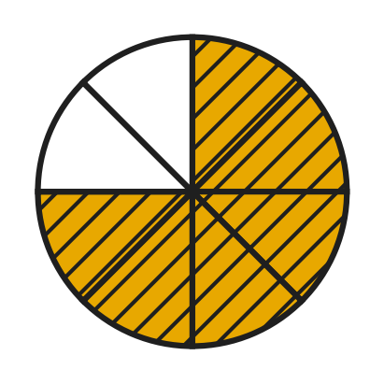
  (A) 60% | (B) 75% | (C) 6% | (D) 25%

Q12. Noor's cake recipe needs $\frac{4}{5}$ kg of flour. Her kitchen scale shows weights as decimals. What reading should she look for?
(A) 0.45 kg | (B) 0.08 kg | (C) 0.8 kg | (D) 0.4 kg

Q13. What is the value of the digit 7 in the number 46.07?
(A) 0.7 | (B) 70 | (C) 7 | (D) 0.07

Q14. A rope is 1 m long. Sanjay paints 35% of its length red. How long is the red part?
(A) 3.5 cm | (B) 35 cm | (C) 350 cm | (D) 65 cm

Q15. In a bookshop sale, the price of every storybook is reduced by 25%. A storybook cost ₹240 before the sale. What is its price in the sale?
(A) ₹180 | (B) ₹300 | (C) ₹60 | (D) ₹215

Q16. A small zoo has 80 animals. Of these, 30% are birds, and 0.45 of all the animals are mammals. All the others are reptiles. How many reptiles are there?
(A) 44 | (B) 25 | (C) 56 | (D) 20

Part 4 — Geometry (Syllabus Chapter 5)
Q17. The clock shows 5 o'clock. What kind of angle do the two hands make? | 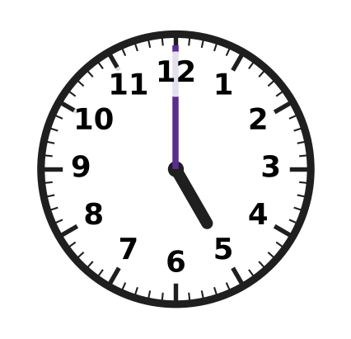
  (A) Acute angle | (B) Right angle
  (C) Obtuse angle | (D) Straight angle

Q18. The picture shows a rectangle 6 cm long and 3 cm wide. How many lines of symmetry does it have? | 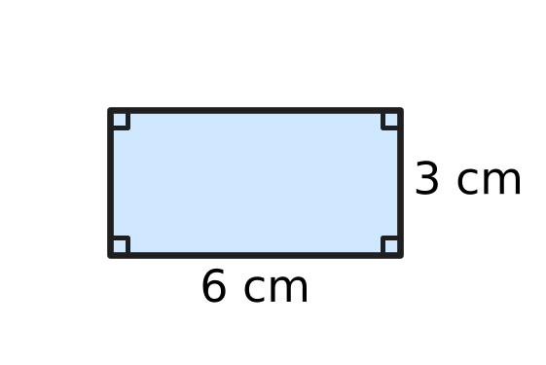
  (A) 0 | (B) 1 | (C) 2 | (D) 4

Q19. In the quadrilateral ABCD shown in the picture, three of the angles are marked. What is the size of angle x? | 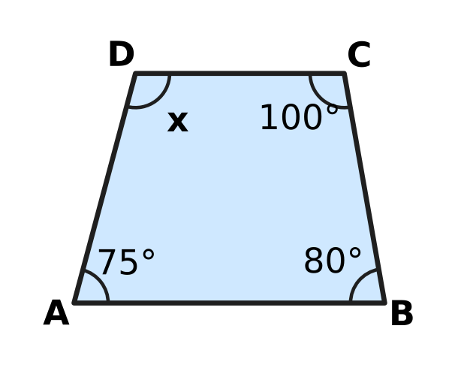
  (A) 255° | (B) 105° | (C) 95° | (D) 205°

Q20. The picture shows an open umbrella seen from above. Its 8 ribs are equally spaced around the centre. What is the smaller angle between rib P and rib Q? | 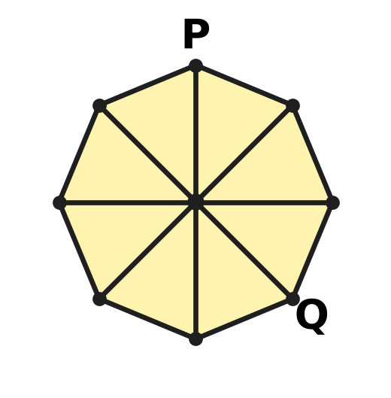
  (A) 90° | (B) 180° | (C) 135° | (D) 45°

Q21. In triangle ABC in the picture, the tick marks show that AB = AC. Angle B is 70°. What is the size of angle A? | 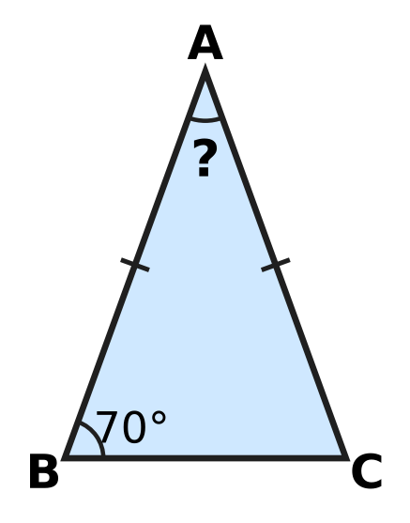
  (A) 70° | (B) 110° | (C) 55° | (D) 40°

Part 5 — Mensuration (Syllabus Chapter 6)
Q22. A paper label is cut in the shape shown in the picture. Its 6 cm and 8 cm edges meet at a right angle. What is the area of the label? | 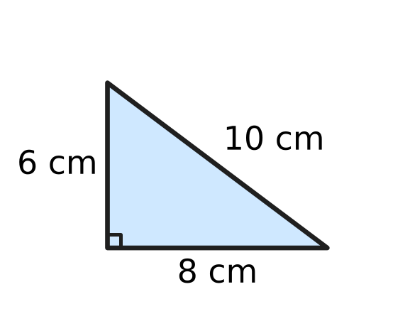
  (A) 30 sq cm | (B) 40 sq cm | (C) 24 sq cm | (D) 48 sq cm

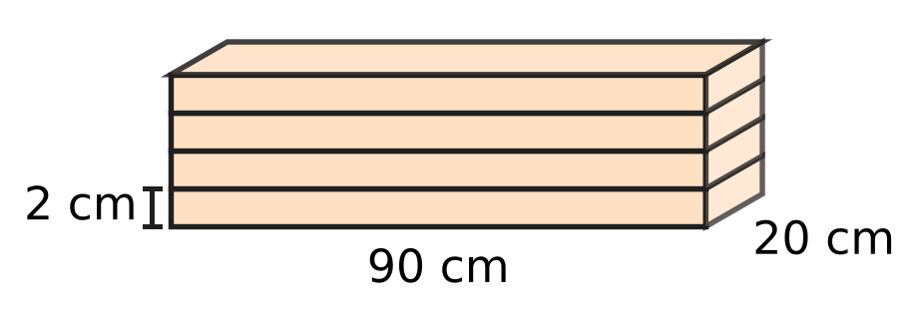
Q23. Four wooden shelf boards are stacked flat, one on top of another, as shown. Each board is 90 cm long, 20 cm wide and 2 cm thick. What is the volume of the whole stack?
(A) 14,400 cubic cm | (B) 1,800 cubic cm
(C) 7,200 cubic cm | (D) 3,600 cubic cm

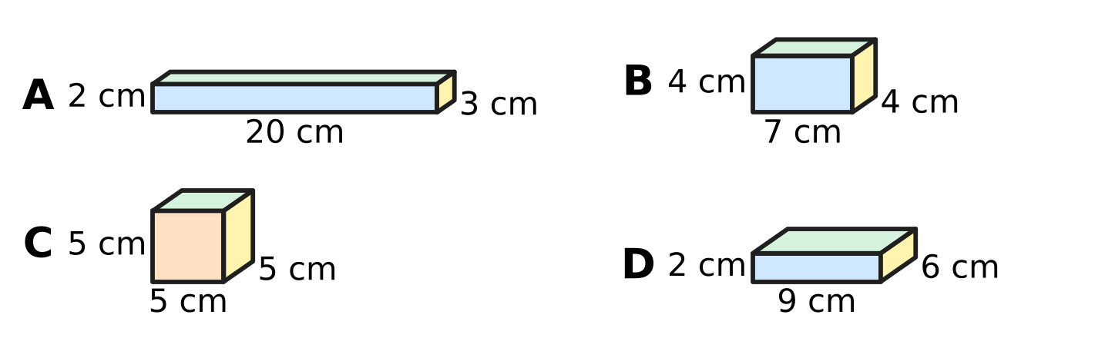
Q24. Zara has the four solid wooden blocks shown, with their lengths, widths and heights. Which block has the greatest volume?
(A) Block A | (B) Block B | (C) Block C | (D) Block D

Q25. The picture shows two solid cubes of clay. The small cube has edges of 3 cm and the big cube has edges of 6 cm. How many times as much clay as the small cube does the big cube have? | 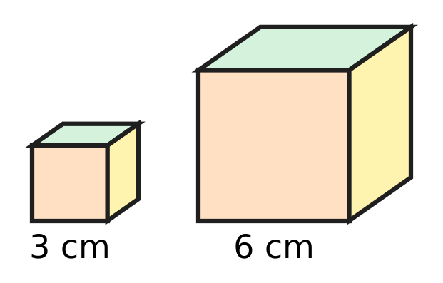
  (A) 6 times | (B) 8 times | (C) 4 times | (D) 2 times

Q26. In art class, Kiara cuts a rectangular card 12 cm long and 8 cm wide into identical right-angled triangles like the shaded one in the picture. The sides at the right angle are 3 cm and 4 cm. No card is wasted. How many triangles does she get? | 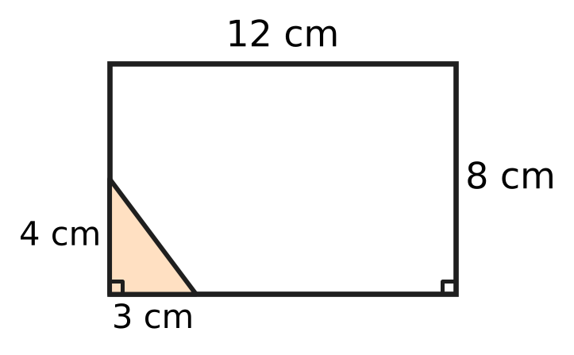
  (A) 16 | (B) 8 | (C) 32 | (D) 96

Part 6 — Data Handling, Statistics & Probability (Syllabus Chapter 8)
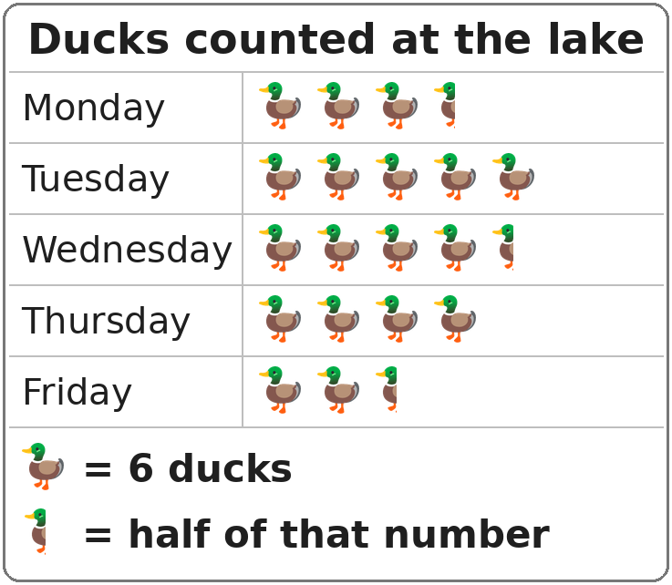
Q27. The pictograph shows the ducks counted at a lake on five mornings. On which morning were 27 ducks counted?
(A) Thursday | (B) Monday
(C) Wednesday | (D) Tuesday

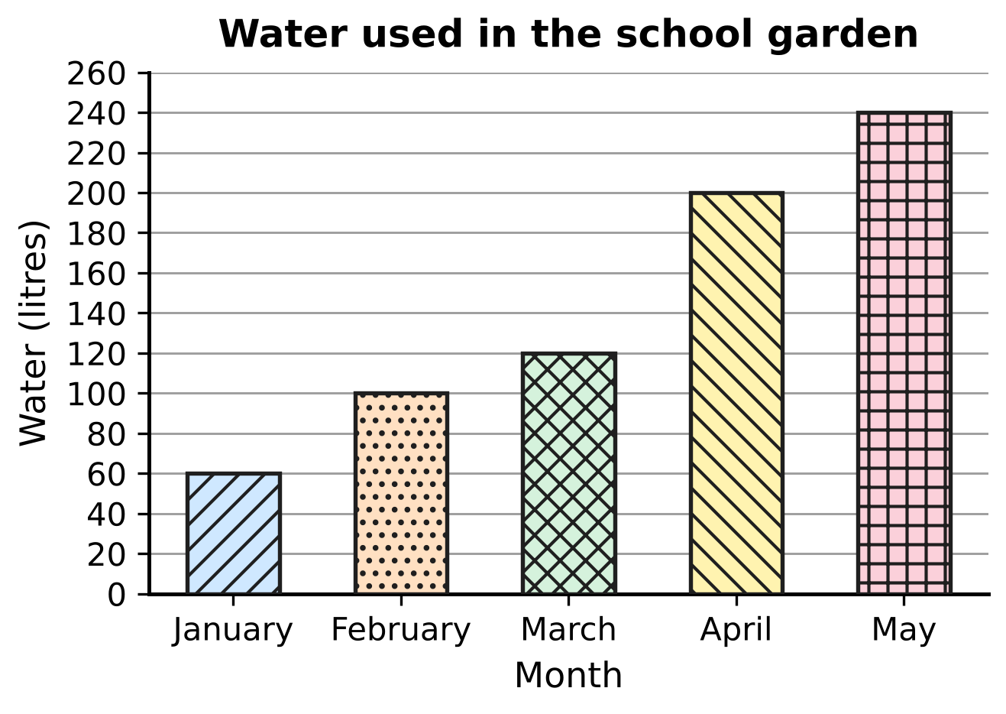
Q28. The bar graph shows the water used in a school garden in five months. How much more water was used in the month with the most water than in January and February together?
(A) 140 litres | (B) 400 litres
(C) 180 litres | (D) 80 litres

Part 7 — Applied Mathematics (Syllabus Chapter 9)
Q29. How many hours are there in 2 weeks?
(A) 48 hours | (B) 168 hours
(C) 336 hours | (D) 140 hours

Q30. A class visit to a science park lasts 2.5 hours. How many minutes is that?
(A) 150 minutes | (B) 120 minutes
(C) 170 minutes | (D) 250 minutes

Q31. Which of these is the same speed as 30 km/h?
(A) 30 km every minute | (B) 1 km every 2 minutes
(C) 1 km every 30 minutes | (D) 2 km every minute

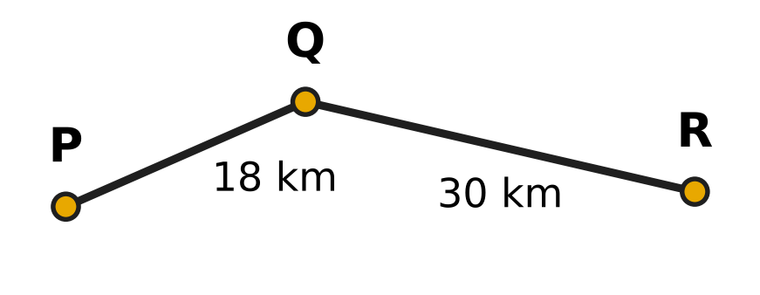
Q32. The picture shows a cycle route from village P to village R through village Q. Rehan cycles from P to R along this route at a steady 12 km/h. How long does he take?
(A) 2 hours 30 minutes | (B) 5 hours
(C) 1 hour 30 minutes | (D) 4 hours

Q33. A boat on a still lake goes 24 km from Jetty A to Jetty B at a steady 12 km/h. It then comes back the same way to Jetty A. For the whole round trip, its average speed must be 16 km/h. At what steady speed must it come back?
(A) 8 km/h | (B) 24 km/h | (C) 48 km/h | (D) 20 km/h

Q34. Tia's robot lawn mower moves forward 6 m every 5 minutes while it cuts the grass. At this speed, how long does it take to cut a strip 90 m long?
(A) 18 minutes | (B) 1 hour 30 minutes
(C) 1 hour 15 minutes | (D) 15 minutes

Part 8 — Mathematical Reasoning & Problem-Solving (Syllabus Chapter 10)
Q35. In a badminton knockout contest, 64 players play in Round 1. After each round, half of the players are out. How many players play in Round 5?
(A) 4 | (B) 16 | (C) 8 | (D) 2

Q36. Chetan thinks of an odd number. Which of these steps ALWAYS gives an even number?
(A) Multiply it by 5 | (B) Add 4 to it
(C) Double it and then add 1 | (D) Add 7 to it

Q37. In which list is each number found by multiplying the number before it by the same fixed number each time?
(A) 7, 21, 35, 49, 63 | (B) 7, 21, 63, 189, 567
(C) 7, 21, 42, 70, 105 | (D) 7, 21, 63, 105, 147

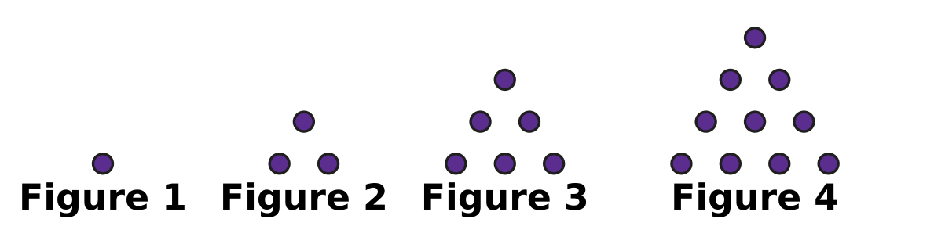
Q38. Look at the pattern of dots. Each figure has one more row than the figure before it. How many dots are there in Figure 8?
(A) 22 | (B) 28 | (C) 36 | (D) 45

Q39. Rupa writes the numbers 1 to 9 in order in a row. She puts a + sign or a − sign in every gap between two numbers, and then works out the answer. Which of these could her answer be?
(A) 10 | (B) 0 | (C) 20 | (D) 15

Q40. In a year of 365 days, 1 January is a Monday. Which other month of that year also begins on a Monday?
(A) October | (B) August | (C) March | (D) July

SECTION II — Star Questions 5 questions × 4 marks each
Q41. There are 100 cards numbered 1 to 100. Vihaan picks out every card whose number is odd and is a multiple of 3 or 5 (or both). How many cards does he pick out? [4 marks]
(A) 21 | (B) 24 | (C) 47 | (D) 27

Q42. At a plant nursery, saplings are set out in 8 rows. Row 1 has 6 saplings, row 2 has 10, row 3 has 14, and each row has 4 more saplings than the row before it. Of all the saplings, 25% are mango saplings. How many mango saplings are there? [4 marks]
(A) 40 | (B) 44 | (C) 12 | (D) 120

Q43. A cuboid 10 cm long, 6 cm wide and 6 cm high is built from dark and light cubes with edges of 2 cm. Any two cubes that share a face have different colours. The picture shows the bottom layer. The colours alternate in this way through all three layers. What is the total volume of all the dark cubes? [4 marks] | 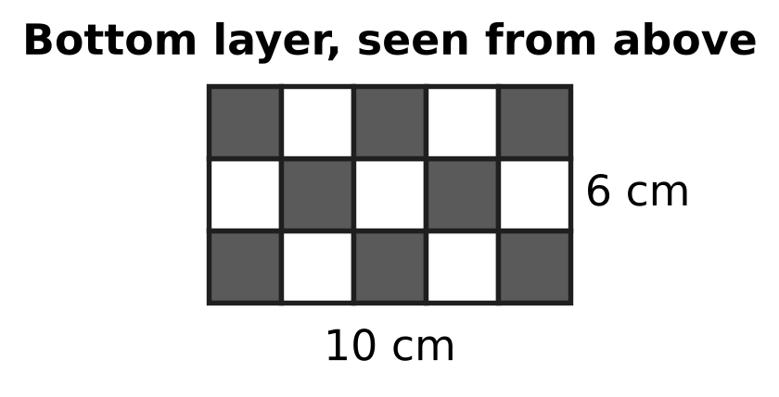
  (A) 176 cubic cm | (B) 180 cubic cm
  (C) 23 cubic cm | (D) 184 cubic cm

Q44. A mountain trail is 20 km long. There is a marker at every kilometre, numbered 1, 2, 3, …, 20 from the start. Omar walks the trail at a steady 4 km/h. He rests for 10 minutes at every marker with a prime number, and nowhere else. How long does he take to walk the whole trail? [4 marks]
(A) 5 hours | (B) 6 hours 10 minutes
(C) 6 hours 20 minutes | (D) 6 hours 30 minutes

Q45. A milk van leaves the dairy at 5:45 a.m. on its 48 km delivery route. It drives at a steady speed without stopping. At 6:30 a.m. it has covered $\frac{5}{8}$ of the route. At what time does it finish the route? [4 marks]
(A) 7:42 a.m. | (B) 6:57 a.m.
(C) 7:45 a.m. | (D) 7:15 a.m.

Answer Sheet AMO Level 1 · Class 5 · Practice Paper 4
Name: | School: | Roll No.:
Shade or tick one circle for each question.
1. Ⓐ Ⓑ Ⓒ Ⓓ | 16. Ⓐ Ⓑ Ⓒ Ⓓ | 31. Ⓐ Ⓑ Ⓒ Ⓓ
2. Ⓐ Ⓑ Ⓒ Ⓓ | 17. Ⓐ Ⓑ Ⓒ Ⓓ | 32. Ⓐ Ⓑ Ⓒ Ⓓ
3. Ⓐ Ⓑ Ⓒ Ⓓ | 18. Ⓐ Ⓑ Ⓒ Ⓓ | 33. Ⓐ Ⓑ Ⓒ Ⓓ
4. Ⓐ Ⓑ Ⓒ Ⓓ | 19. Ⓐ Ⓑ Ⓒ Ⓓ | 34. Ⓐ Ⓑ Ⓒ Ⓓ
5. Ⓐ Ⓑ Ⓒ Ⓓ | 20. Ⓐ Ⓑ Ⓒ Ⓓ | 35. Ⓐ Ⓑ Ⓒ Ⓓ
6. Ⓐ Ⓑ Ⓒ Ⓓ | 21. Ⓐ Ⓑ Ⓒ Ⓓ | 36. Ⓐ Ⓑ Ⓒ Ⓓ
7. Ⓐ Ⓑ Ⓒ Ⓓ | 22. Ⓐ Ⓑ Ⓒ Ⓓ | 37. Ⓐ Ⓑ Ⓒ Ⓓ
8. Ⓐ Ⓑ Ⓒ Ⓓ | 23. Ⓐ Ⓑ Ⓒ Ⓓ | 38. Ⓐ Ⓑ Ⓒ Ⓓ
9. Ⓐ Ⓑ Ⓒ Ⓓ | 24. Ⓐ Ⓑ Ⓒ Ⓓ | 39. Ⓐ Ⓑ Ⓒ Ⓓ
10. Ⓐ Ⓑ Ⓒ Ⓓ | 25. Ⓐ Ⓑ Ⓒ Ⓓ | 40. Ⓐ Ⓑ Ⓒ Ⓓ
11. Ⓐ Ⓑ Ⓒ Ⓓ | 26. Ⓐ Ⓑ Ⓒ Ⓓ | 41. Ⓐ Ⓑ Ⓒ Ⓓ
12. Ⓐ Ⓑ Ⓒ Ⓓ | 27. Ⓐ Ⓑ Ⓒ Ⓓ | 42. Ⓐ Ⓑ Ⓒ Ⓓ
13. Ⓐ Ⓑ Ⓒ Ⓓ | 28. Ⓐ Ⓑ Ⓒ Ⓓ | 43. Ⓐ Ⓑ Ⓒ Ⓓ
14. Ⓐ Ⓑ Ⓒ Ⓓ | 29. Ⓐ Ⓑ Ⓒ Ⓓ | 44. Ⓐ Ⓑ Ⓒ Ⓓ
15. Ⓐ Ⓑ Ⓒ Ⓓ | 30. Ⓐ Ⓑ Ⓒ Ⓓ | 45. Ⓐ Ⓑ Ⓒ Ⓓ
Q41–Q45 are Section II Star Questions (4 marks each).
For the parent or teacher
Section I correct: ______ / 40 × 2 = ______ marks Section II correct: ______ / 5 × 4 = ______ marks
Correct: ______ / 45 Score: ______ / 100
Answer Key and Solutions AMO Level 1 · Class 5 · Practice Paper 4
Quick answers
1 B | 6 B | 11 B | 16 D | 21 D | 26 A | 31 B | 36 D | 41 B
2 D | 7 B | 12 C | 17 C | 22 C | 27 C | 32 D | 37 B | 42 A
3 A | 8 A | 13 D | 18 C | 23 A | 28 D | 33 B | 38 C | 43 D
4 D | 9 D | 14 B | 19 B | 24 C | 29 C | 34 C | 39 D | 44 C
5 A | 10 A | 15 A | 20 C | 25 B | 30 A | 35 A | 40 A | 45 B
Solutions
Q | Part · level | Answer | Why?
1 | Part 1 · Ch1 · Easy | (B) 8,06,040 | Eight lakh = 8,00,000, six thousand = 6,000 and forty = 40. Together they make 8,06,040.
2 | Part 1 · Ch1 · Easy | (D) CMXL | CMXL = 900 + 40 = 940, CMIV = 904, DCCCXCIX = 899 and DCCCLXXX = 880. The greatest is 940.
3 | Part 1 · Ch1 · Easy | (A) 83 | 91 = 7 × 13, 87 = 3 × 29 and 57 = 3 × 19 are composite. 83 has no factor other than 1 and 83, so it is prime.
4 | Part 1 · Ch1 · Medium | (D) 28 | The factors of 28 are 1, 2, 4, 7, 14 and 28. Leaving out 28: 1 + 2 + 4 + 7 + 14 = 28.
5 | Part 1 · Ch1 · Medium | (A) 4 | The LCM of 9 and 12 is 36, so they flash together every 36 seconds. 2½ minutes = 150 seconds, and 36, 72, 108, 144 are 4 times.
6 | Part 2 · Ch2 · Easy | (B) 18 × 6 = 6 × 18 | Numbers can be swapped in a multiplication (18 × 6 = 6 × 18 = 108), but not in a subtraction or a division. A division also cannot be regrouped: (18 ÷ 6) ÷ 3 = 1, but 18 ÷ (6 ÷ 3) = 9.
7 | Part 2 · Ch2 · Easy | (B) 12,000 | The number 389 is about 400, and 400 × 30 = 12,000. (The exact number, 11,670, is close to this.)
8 | Part 2 · Ch2 · Easy | (A) 22 | ÷ and × are done from left to right before −: 12 ÷ 3 = 4, 4 × 2 = 8, and 30 − 8 = 22.
9 | Part 2 · Ch2 · Medium | (D) 14 | [8 × (24 − 3)] ÷ 12 = [8 × 21] ÷ 12 = 168 ÷ 12 = 14 children in each new row.
10 | Part 2 · Ch2 · Medium | (A) 3,700 | 99 × 37 + 37 = 99 × 37 + 1 × 37 = (99 + 1) × 37 = 100 × 37 = 3,700.
11 | Part 3 · Ch3 · Easy | (B) 75% | Here 6 of the 8 equal parts are shaded: 6/8 = 3/4 = 75/100 = 75%.
12 | Part 3 · Ch3 · Easy | (C) 0.8 kg | 4/5 = 8/10 = 0.8, so the scale should show 0.8 kg.
13 | Part 3 · Ch3 · Easy | (D) 0.07 | In 46.07 the 0 is in the tenths place and the 7 is in the hundredths place, so its value is 7/100 = 0.07.
14 | Part 3 · Ch3 · Easy | (B) 35 cm | 1 m = 100 cm, and 35% means 35 out of every 100. So 35 cm of the rope is red.
15 | Part 3 · Ch3 · Medium | (A) ₹180 | 25% of ₹240 = ₹60 (one quarter). The sale price is ₹240 − ₹60 = ₹180.
16 | Part 3 · Ch3 · Medium | (D) 20 | Birds: 30% of 80 = 24. Mammals: 0.45 × 80 = 36. Reptiles: 80 − 24 − 36 = 20.
17 | Part 4 · Ch5 · Easy | (C) Obtuse angle | Each hour mark is 30°, so at 5 o'clock the hands make 5 × 30° = 150°. This is more than 90° and less than 180°, so it is obtuse.
18 | Part 4 · Ch5 · Easy | (C) 2 | Folding along the line through the middles of the long sides, or of the short sides, makes the halves match. A diagonal fold does not, so there are 2 lines.
19 | Part 4 · Ch5 · Easy | (B) 105° | The angles of a quadrilateral add up to 360°. x = 360° − (75° + 80° + 100°) = 360° − 255° = 105°.
20 | Part 4 · Ch5 · Medium | (C) 135° | The 8 equal gaps make 360°, so each gap is 360° ÷ 8 = 45°. From P to Q there are 3 gaps: 3 × 45° = 135°.
21 | Part 4 · Ch5 · Medium | (D) 40° | AB = AC, so the angles opposite them, B and C, are equal: both are 70°. Angle A = 180° − 70° − 70° = 40°.
22 | Part 5 · Ch6 · Easy | (C) 24 sq cm | Use the two sides that meet at the right angle: ½ × 8 × 6 = 24 sq cm. The 10 cm side is not needed.
23 | Part 5 · Ch6 · Easy | (A) 14,400 cubic cm | The stack is a cuboid 90 cm long, 20 cm wide and 4 × 2 = 8 cm high. Volume = 90 × 20 × 8 = 14,400 cubic cm.
24 | Part 5 · Ch6 · Easy | (C) Block C | Volumes: A = 20 × 3 × 2 = 120, B = 7 × 4 × 4 = 112, C = 5 × 5 × 5 = 125 and D = 9 × 6 × 2 = 108 cubic cm. The cube C has the greatest volume.
25 | Part 5 · Ch6 · Medium | (B) 8 times | Small cube: 3 × 3 × 3 = 27 cubic cm. Big cube: 6 × 6 × 6 = 216 cubic cm. 216 ÷ 27 = 8 times.
26 | Part 5 · Ch6 · Medium | (A) 16 | Card: 12 × 8 = 96 sq cm. One triangle: ½ × 3 × 4 = 6 sq cm. 96 ÷ 6 = 16 triangles. They really fit: the card holds 4 × 2 = 8 rectangles of 3 cm by 4 cm, and each rectangle splits into 2 triangles.
27 | Part 6 · Ch8 · Easy | (C) Wednesday | Each symbol stands for 6 ducks, so half a symbol is 3. 27 = 4 × 6 + 3, which is 4½ symbols: Wednesday.
28 | Part 6 · Ch8 · Medium | (D) 80 litres | The most water was used in May: 240 litres. January and February together: 60 + 100 = 160 litres. 240 − 160 = 80 litres.
29 | Part 7 · Ch9 · Easy | (C) 336 hours | 2 weeks = 14 days, and 14 × 24 = 336 hours.
30 | Part 7 · Ch9 · Easy | (A) 150 minutes | 1 hour = 60 minutes, so 2.5 hours = 2 × 60 + 30 = 150 minutes.
31 | Part 7 · Ch9 · Easy | (B) 1 km every 2 minutes | Going 30 km in 60 minutes is the same as 1 km in 60 ÷ 30 = 2 minutes.
32 | Part 7 · Ch9 · Easy | (D) 4 hours | The route is 18 + 30 = 48 km. Time = 48 ÷ 12 = 4 hours.
33 | Part 7 · Ch9 · Medium | (B) 24 km/h | The round trip is 48 km, so at 16 km/h it must take 48 ÷ 16 = 3 hours. Going took 24 ÷ 12 = 2 hours, so coming back takes 1 hour: 24 ÷ 1 = 24 km/h.
34 | Part 7 · Ch9 · Medium | (C) 1 hour 15 minutes | 90 ÷ 6 = 15, so the mower needs 15 lots of 5 minutes = 75 minutes = 1 hour 15 minutes.
35 | Part 8 · Ch10 · Easy | (A) 4 | 64 → 32 → 16 → 8 → 4. Round 5 has 4 players.
36 | Part 8 · Ch10 · Easy | (D) Add 7 to it | Odd + odd = even, so adding 7 always gives an even number. Odd + 4 is odd, odd × 5 is odd, and an even number + 1 is odd.
37 | Part 8 · Ch10 · Easy | (B) 7, 21, 63, 189, 567 | 7 × 3 = 21, 21 × 3 = 63, 63 × 3 = 189, 189 × 3 = 567: each number is 3 times the one before. The other lists add at some step.
38 | Part 8 · Ch10 · Medium | (C) 36 | The dots are 1, 3, 6, 10, … and Figure n adds a row of n dots. Figure 8: 10 + 5 + 6 + 7 + 8 = 36.
39 | Part 8 · Ch10 · Medium | (D) 15 | 1 + 2 + … + 9 = 45 is odd. Changing a + into a − takes away twice that number, which is even, so the answer is always odd. Only 15 is odd (for example, 1 + 2 + 3 + 4 + 5 − 6 + 7 + 8 − 9 = 15).
40 | Part 8 · Ch10 · Medium | (A) October | From 1 January to 1 October there are 31 + 28 + 31 + 30 + 31 + 30 + 31 + 31 + 30 = 273 days = 39 weeks exactly, so 1 October is also a Monday. No other month gives a whole number of weeks.
41 | Section II · Ch1 + Ch10 · Hard | (B) 24 | Odd multiples of 3: 3, 9, …, 99 = 17. Odd multiples of 5: 5, 15, …, 95 = 10. Odd multiples of both (15, 45, 75) are counted twice, so 17 + 10 − 3 = 24.
42 | Section II · Ch3 + Ch10 · Hard | (A) 40 | The rows have 6, 10, 14, 18, 22, 26, 30 and 34 saplings, which add up to 160. 25% of 160 = 40 mango saplings.
43 | Section II · Ch6 + Ch10 · Hard | (D) 184 cubic cm | There are 5 × 3 × 3 = 45 cubes. The layers have 8, 7 and 8 dark cubes (the colours swap in the middle layer), so 23 are dark. Each cube is 2 × 2 × 2 = 8 cubic cm: 23 × 8 = 184 cubic cm.
44 | Section II · Ch1 + Ch9 · Hard | (C) 6 hours 20 minutes | Walking: 20 ÷ 4 = 5 hours. The prime markers are 2, 3, 5, 7, 11, 13, 17 and 19, so 8 rests of 10 minutes = 1 hour 20 minutes. Total 6 hours 20 minutes.
45 | Section II · Ch3 + Ch9 · Hard | (B) 6:57 a.m. | From 5:45 to 6:30 is 45 minutes, and 5/8 of 48 km = 30 km, so the speed is 40 km/h. The other 18 km takes 18 ÷ 40 = 0.45 hour = 27 minutes, so it finishes at 6:57 a.m.

