UNLOCK IQ INSTITUTE
Realize Your True Potential
Aryabhatta Maths Olympiad (AMO)
Level 1 — Practice Paper 5
CLASS 5

Questions | 45 multiple-choice questions
Marks | 100
Time | 60 minutes
Section I | 40 questions × 2 marks = 80 marks
Section II | 5 Star Questions × 4 marks = 20 marks
Negative marking | No negative marking
Calculator | Not allowed
Chapters | Number System · Operations · Fractions, Decimals & Percentages · Geometry · Mensuration · Data Handling · Applied Mathematics · Mathematical Reasoning

Hello, friend!
• Every question has four answer choices: (A), (B), (C) and (D). Only one is correct.
• Read each question and look at its picture carefully. Then mark your answer on the answer sheet at the end.
• Section I has 40 questions of 2 marks each. Section II has 5 Star Questions of 4 marks each.
• There is no negative marking, so try every question.
• Do not use a calculator. You may do rough work on a separate sheet.
• All figures are not necessarily drawn to scale unless stated.

For parents and teachers
Print or view this paper in colour. Pictures are part of the questions.
Parts follow the AMO syllabus chapters. Chapters 4 and 7 are not part of the Class 5 syllabus, so the chapter numbers shown in the Part headings have gaps.
The answer sheet and the answer key are at the end. Remove only the answer key before the child begins.

Name: | School: | Roll No.:

SECTION I 40 questions × 2 marks each
Part 1 — Number System (Syllabus Chapter 1)
Q1. When 1,000 is added to a number, the answer is 5,00,560. What is the number?
(A) 4,99,560 | (B) 5,00,460 | (C) 5,01,560 | (D) 4,90,560

Q2. What is the smallest whole number that must be added to 247 so that the answer is a multiple of 9?
(A) 5 | (B) 2 | (C) 13 | (D) 4

Q3. The picture shows a card 20 cm long and 15 cm wide. Many such cards are laid side by side, all the same way round, with no gaps or overlaps, to make a square. What is the side of the smallest such square? | 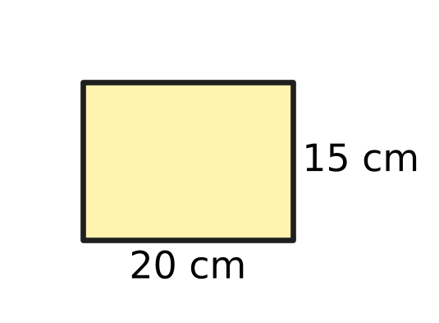
  (A) 35 cm | (B) 300 cm | (C) 60 cm | (D) 5 cm

Q4. Nakul has the four cards shown. He uses all four cards, each once, to make a correct Roman numeral. What is the smallest number he can make? | 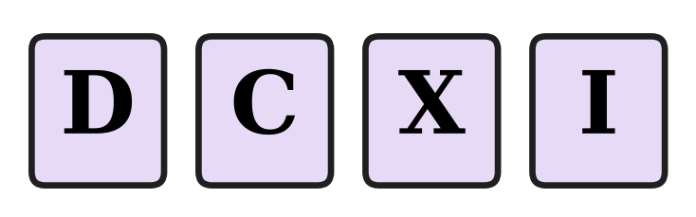
  (A) 611 | (B) 609 | (C) 411 | (D) 409

Q5. Which of these numbers has the greatest number of factors?
(A) 36 | (B) 49 | (C) 48 | (D) 42

Part 2 — Operations & Number Properties (Syllabus Chapter 2)
Q6. Tarun worked out 40 − 4 × 5 + 3 from left to right and got 183. What is the correct value?
(A) 17 | (B) 180 | (C) 8 | (D) 23

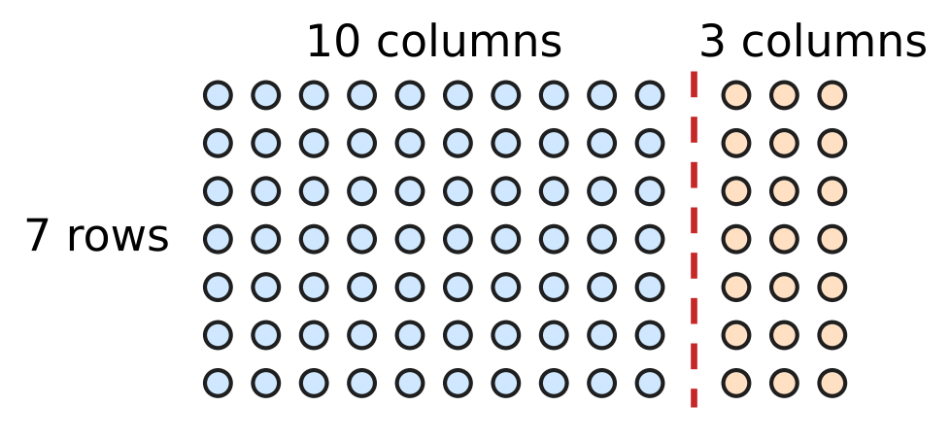
Q7. Deepa wants to find 7 × 13. She splits the dots along the dashed line, as shown. Which expression matches her picture?
(A) 7 × 10 + 7 × 3 | (B) 7 + 10 × 3
(C) 7 × 10 × 3 | (D) 7 × 10 + 3

Q8. The number of visitors to a science exhibition, rounded to the nearest hundred, was 4,700. Which of these could be the exact number of visitors?
(A) 4,605 | (B) 4,649 | (C) 4,651 | (D) 4,760

Q9. The numbers 2, 5 and 8 are written in the three boxes shown, one number in each box. What is the greatest value the expression can have? | 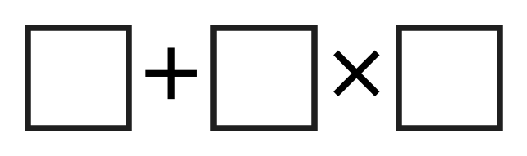
  (A) 42 | (B) 80 | (C) 56 | (D) 21

Q10. Two classes collected 46 kg and 37 kg of waste paper. Ivan rounds each amount to the nearest ten and then adds. Pari adds first and then rounds the total to the nearest ten. How much greater is Ivan's estimate than Pari's?
(A) 3 kg | (B) 10 kg | (C) 0 kg | (D) 7 kg

Part 3 — Fractions, Decimals & Percentages (Syllabus Chapter 3)
Q11. A slide in the playground is 2.4 m long. Which mixed number shows this length?
(A) $2\frac{1}{25}$ m | (B) $2\frac{1}{4}$ m | (C) $2\frac{4}{5}$ m | (D) $2\frac{2}{5}$ m

Q12. In a music class test, 0.4 of the marks are for singing. What percentage of the marks are for singing?
(A) 40% | (B) 60% | (C) 4% | (D) 0.4%

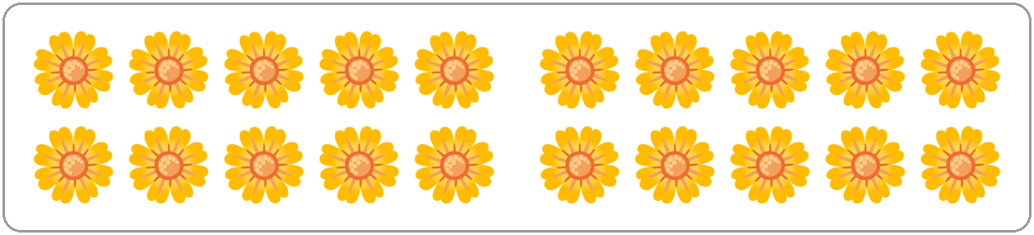
Q13. Usha's flower shop has the flowers shown in the picture. She uses 30% of them in a bouquet. How many flowers does she use?
(A) 14 | (B) 10 | (C) 3 | (D) 6

Q14. A tea stall uses 0.15 L of milk for each cup of tea. How much milk does it use for 20 cups?
(A) 30 L | (B) 3 L | (C) 1.5 L | (D) 0.3 L

Q15. In one week, 28 mm of rain fell in a town. This was 40% of the rain that fell in the whole month. How much rain fell in the whole month?
(A) 11.2 mm | (B) 112 mm | (C) 70 mm | (D) 68 mm

Q16. Which fraction is greater than 0.6 and less than 0.7?
(A) $\frac{3}{5}$ | (B) $\frac{7}{10}$ | (C) $\frac{11}{20}$ | (D) $\frac{13}{20}$

Part 4 — Geometry (Syllabus Chapter 5)
Q17. The picture shows a five-sided shape with the size of each of its angles. How many of these angles are obtuse? | 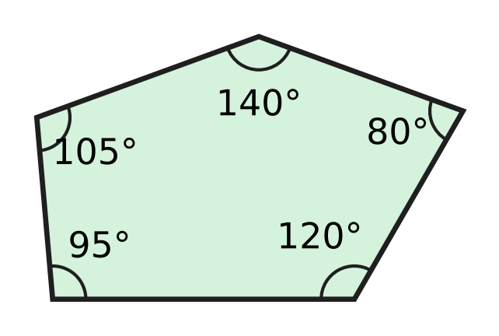
  (A) 1 | (B) 3 | (C) 4 | (D) 5

Q18. Kian cuts a square card along the dashed diagonal, as shown. What kind of triangle is each piece? | 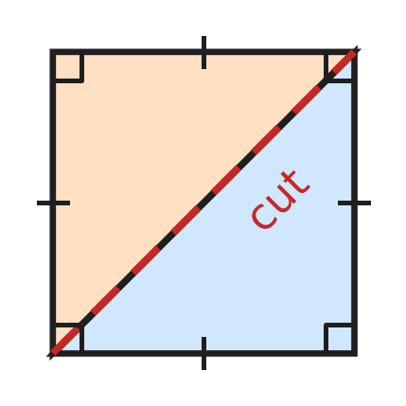
  (A) Right-angled and isosceles | (B) Obtuse-angled and isosceles
  (C) Right-angled and scalene | (D) Acute-angled and equilateral

Q19. Look at the map of a school. North is at the top. In which direction is the car park from the hall? | 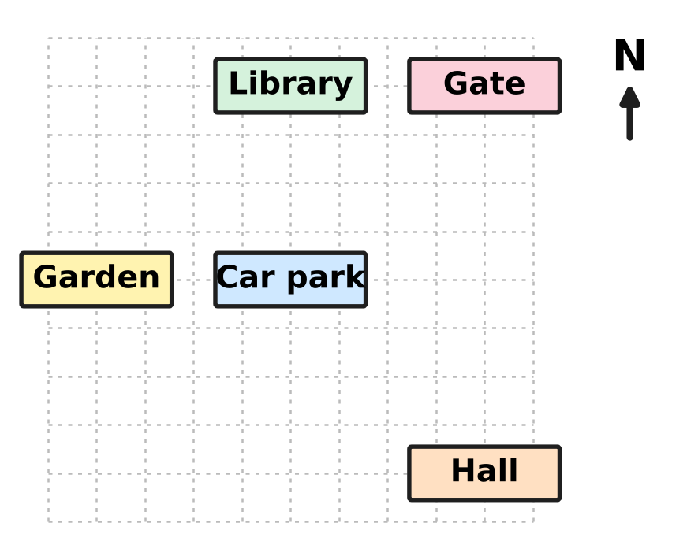
  (A) South-East | (B) North-West
  (C) North-East | (D) West

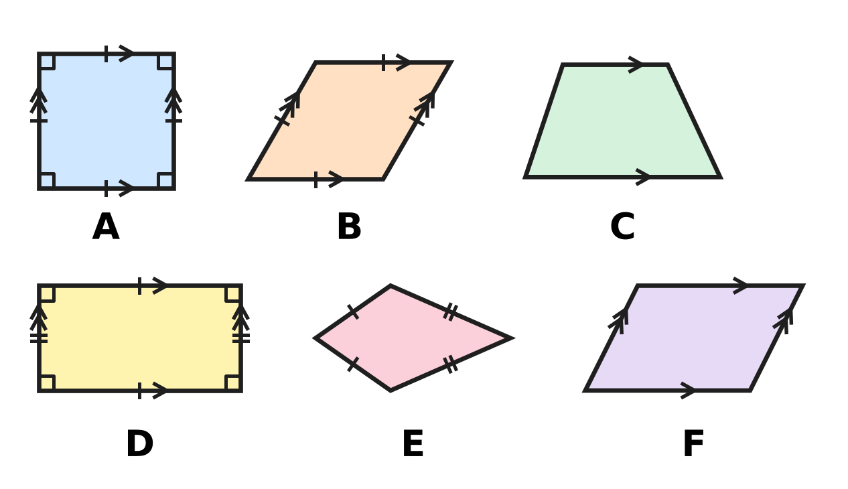
Q20. Look at the six shapes. Arrows show parallel sides, ticks show equal sides and small squares show right angles. A parallelogram is any four-sided shape with two pairs of parallel sides. How many of the shapes are parallelograms?
(A) 1 | (B) 2 | (C) 3 | (D) 4

Q21. A floor is tiled with regular octagons and squares, as shown. At each corner point, like the dot, two octagons and one square meet with no gaps. What is the size of each angle of a regular octagon? | 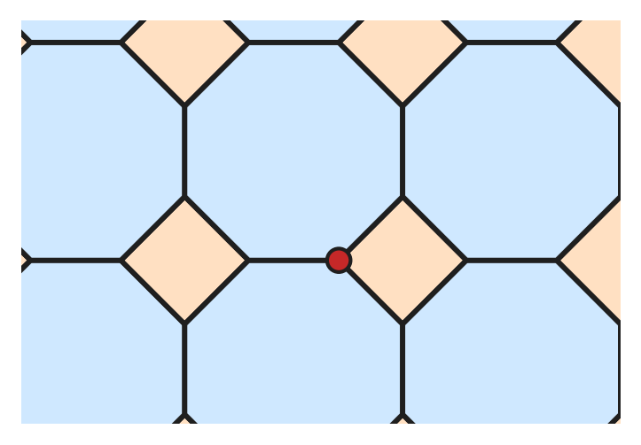
  (A) 270° | (B) 108° | (C) 135° | (D) 120°

Part 5 — Mensuration (Syllabus Chapter 6)
Q22. At Parth's ice-cream stall, a brick of ice cream is a cuboid 15 cm long and 10 cm wide, as shown. It holds 1,200 cubic cm of ice cream. How tall is it? | 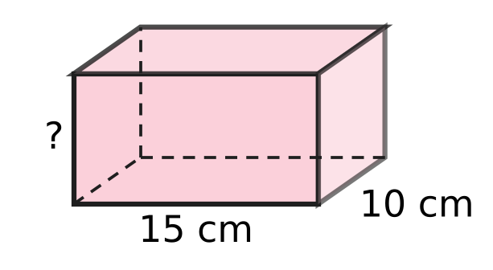
  (A) 80 cm | (B) 8 cm | (C) 120 cm | (D) 48 cm

Q23. Box A is a cuboid with a volume of 640 cubic cm. Box B has the same length and the same width as Box A, but it is twice as tall. What is the volume of Box B?
(A) 640 cubic cm | (B) 1,280 cubic cm
(C) 2,560 cubic cm | (D) 5,120 cubic cm

Q24. Which of these calculations finds how many sq cm the triangle in the picture covers? | 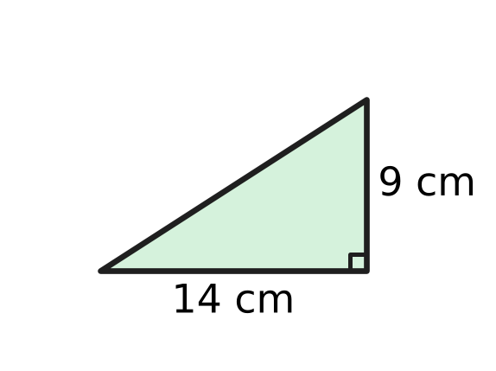
  (A) ½ × (14 + 9) | (B) 2 × (14 + 9)
  (C) ½ × 14 × 9 | (D) 14 × 9

Q25. The picture shows the sail of a model boat. Its two shorter edges measure 0.5 m and 30 cm. Find the area of the sail in sq cm. | 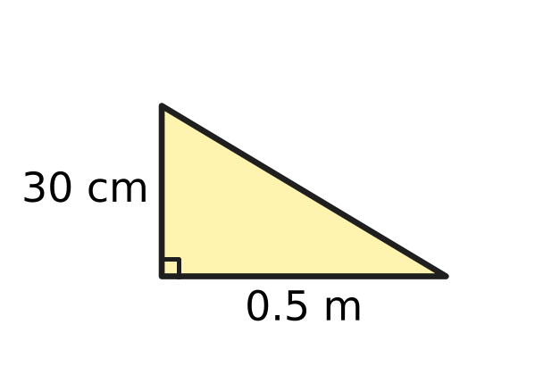
  (A) 750 sq cm | (B) 7.5 sq cm
  (C) 75 sq cm | (D) 1,500 sq cm

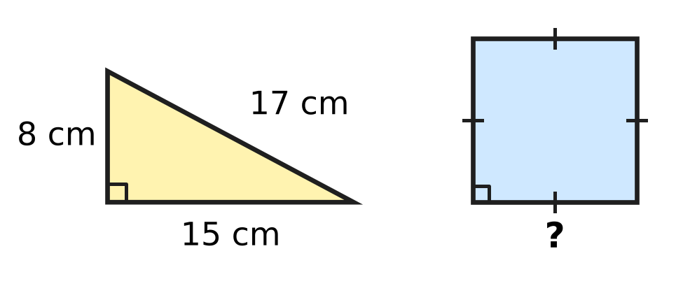
Q26. A piece of wire is bent to make the right-angled triangle shown. It is then straightened and bent to make the square. How much greater is the area of the square than the area of the triangle?
(A) 100 sq cm | (B) 20 sq cm
(C) 60 sq cm | (D) 40 sq cm

Part 6 — Data Handling, Statistics & Probability (Syllabus Chapter 8)
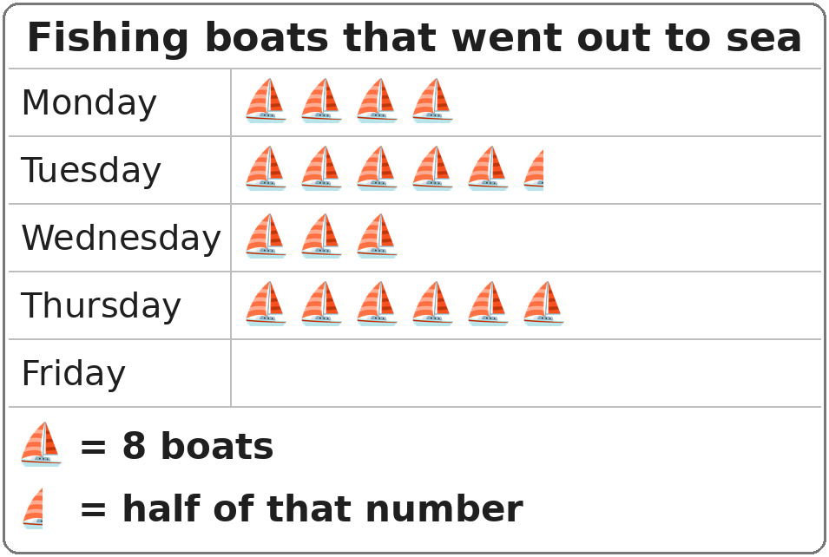
Q27. In the pictograph, the row for Friday has not been drawn yet. On Friday, 28 fishing boats went out. How many symbols should be drawn for Friday?
(A) 7 symbols | (B) $3\frac{1}{2}$ symbols
(C) 4 symbols | (D) 3 symbols

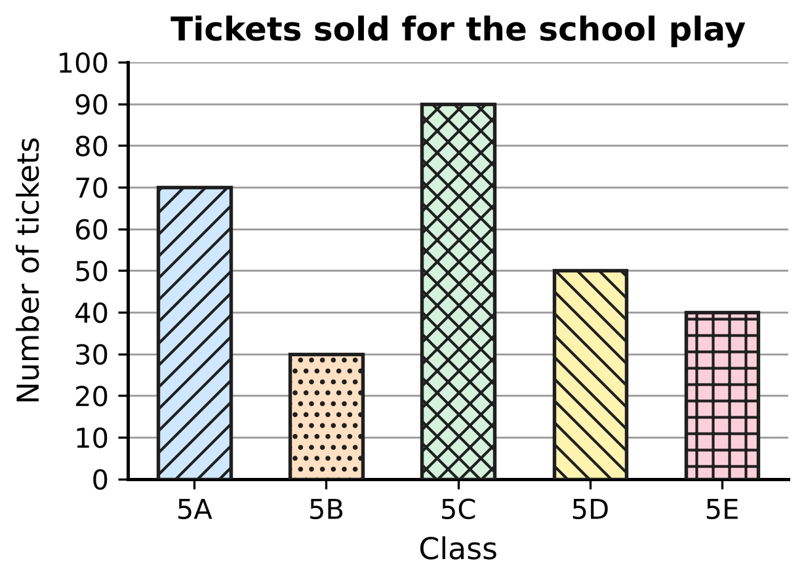
Q28. The bar graph shows the tickets sold by five classes for the school play. Which two classes together sold exactly as many tickets as Class 5C?
(A) 5D and 5E | (B) 5A and 5E
(C) 5A and 5B | (D) 5B and 5D

Part 7 — Applied Mathematics (Syllabus Chapter 9)
Q29. A torch battery lasts for 1,000 hours. How long is that in days and hours?
(A) 42 days | (B) 41 days 6 hours
(C) 16 days 40 hours | (D) 41 days 16 hours

Q30. Four cars each make one journey at a steady speed. Which journey takes the longest time?
(A) 150 km at 60 km/h | (B) 90 km at 45 km/h
(C) 120 km at 40 km/h | (D) 54 km at 36 km/h

Q31. Which of these is NOT the same length of time as half a day?
(A) 12 hours | (B) 43,200 seconds
(C) 1,200 minutes | (D) 720 minutes

Q32. A plane takes off at 9:50 p.m. and lands at 6:15 a.m. the next morning. How long is the flight?
(A) 3 hours 35 minutes | (B) 8 hours 25 minutes
(C) 7 hours 25 minutes | (D) 8 hours 35 minutes

Q33. A lift moves at a steady speed of 2 m per second. Without stopping, it goes up from a floor 6 m above the ground to a floor 54 m above the ground. How long does this take?
(A) 30 seconds | (B) 96 seconds
(C) 27 seconds | (D) 24 seconds

Q34. A school bus makes a trip in two parts. The whole trip takes 1 hour 30 minutes at an average speed of 40 km/h. The first part is 36 km long. How long is the second part?
(A) 24 km | (B) 4 km | (C) 96 km | (D) 16 km

Part 8 — Mathematical Reasoning & Problem-Solving (Syllabus Chapter 10)
Q35. In this series, each number from the 3rd on is the sum of the two numbers just before it. Which number is missing?
4, 6, 10, 16, ___, 42
(A) 24 | (B) 26 | (C) 29 | (D) 32

Q36. When two whole numbers that are next to each other (like 6 and 7) are multiplied, which of these can NEVER be the answer?
(A) 132 | (B) 105 | (C) 90 | (D) 56

Q37. Look at the series 1, 5, 25, 125, 600 and 3,125. Each number should be the number before it multiplied by the same number. One number is wrong. Which is it?
(A) 600 | (B) 125 | (C) 3,125 | (D) 25

Q38. In an arithmetic series, the same number is added each time. The 3rd term is 20 and the 7th term is 44. What is the 1st term?
(A) 12 | (B) 14 | (C) 8 | (D) 2

Q39. A month has 31 days. It has five Fridays, five Saturdays and five Sundays. On which day of the week does the month begin?
(A) Thursday | (B) Saturday | (C) Sunday | (D) Friday

Q40. Yash has eleven cards numbered 1 to 11. He takes away one card. He then puts the other ten cards into two groups with equal totals. How many different cards could he have taken away?
(A) 1 | (B) 5 | (C) 6 | (D) 11

SECTION II — Star Questions 5 questions × 4 marks each
Q41. Lata uses each of the digits 0, 2, 4, 5, 7 and 9 exactly once to make 6-digit numbers. She makes the greatest possible ODD number and the smallest possible EVEN number. What is the difference between these two numbers? [4 marks]
(A) 7,70,841 | (B) 7,48,413 | (C) 7,69,626 | (D) 7,68,411

Q42. A water plant grows on a pond. Each day, the part of the pond it covers doubles. The pond is fully covered on day 24. On which day was 12.5% of the pond covered? [4 marks]
(A) Day 16 | (B) Day 22 | (C) Day 21 | (D) Day 3

Q43. Clara stacks cubes to make a tower. The top cube has edges of 1 cm, and each cube below has edges 1 cm longer than the cube on it. The picture shows a tower of 3 cubes, which is 6 cm tall. Clara builds such a tower that is 15 cm tall. What is its total volume? [4 marks] | 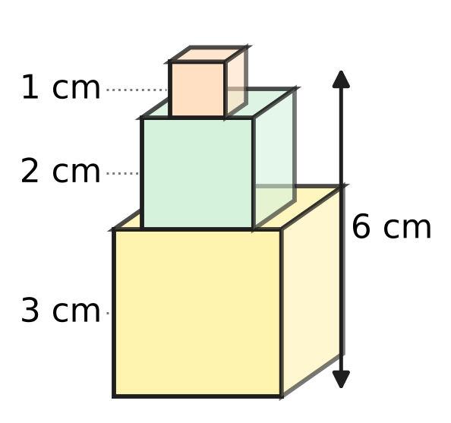
  (A) 225 cubic cm | (B) 100 cubic cm
  (C) 3,375 cubic cm | (D) 55 cubic cm

Q44. The dashboard in the picture shows the total distance a car has travelled. This number reads the same from left to right and from right to left. The car then drives at a steady speed. Exactly 2 hours later, the dashboard first shows another number that reads the same both ways. What is the car's speed? [4 marks] | 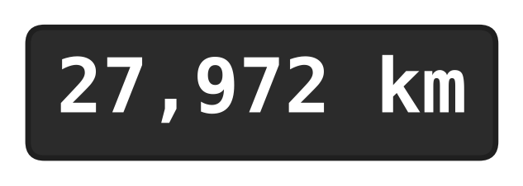
  (A) 110 km/h | (B) 55 km/h | (C) 5 km/h | (D) 50 km/h

Q45. Before a hot-air balloon flight, its fuel tank is $\frac{3}{10}$ full. A pump adds 5% of a full tank every 6 minutes. How long does it take to fill the tank to the top? [4 marks]
(A) 1 hour 24 minutes | (B) 1 hour 40 minutes
(C) 2 hours | (D) 36 minutes

Answer Sheet AMO Level 1 · Class 5 · Practice Paper 5
Name: | School: | Roll No.:
Shade or tick one circle for each question.
1. Ⓐ Ⓑ Ⓒ Ⓓ | 16. Ⓐ Ⓑ Ⓒ Ⓓ | 31. Ⓐ Ⓑ Ⓒ Ⓓ
2. Ⓐ Ⓑ Ⓒ Ⓓ | 17. Ⓐ Ⓑ Ⓒ Ⓓ | 32. Ⓐ Ⓑ Ⓒ Ⓓ
3. Ⓐ Ⓑ Ⓒ Ⓓ | 18. Ⓐ Ⓑ Ⓒ Ⓓ | 33. Ⓐ Ⓑ Ⓒ Ⓓ
4. Ⓐ Ⓑ Ⓒ Ⓓ | 19. Ⓐ Ⓑ Ⓒ Ⓓ | 34. Ⓐ Ⓑ Ⓒ Ⓓ
5. Ⓐ Ⓑ Ⓒ Ⓓ | 20. Ⓐ Ⓑ Ⓒ Ⓓ | 35. Ⓐ Ⓑ Ⓒ Ⓓ
6. Ⓐ Ⓑ Ⓒ Ⓓ | 21. Ⓐ Ⓑ Ⓒ Ⓓ | 36. Ⓐ Ⓑ Ⓒ Ⓓ
7. Ⓐ Ⓑ Ⓒ Ⓓ | 22. Ⓐ Ⓑ Ⓒ Ⓓ | 37. Ⓐ Ⓑ Ⓒ Ⓓ
8. Ⓐ Ⓑ Ⓒ Ⓓ | 23. Ⓐ Ⓑ Ⓒ Ⓓ | 38. Ⓐ Ⓑ Ⓒ Ⓓ
9. Ⓐ Ⓑ Ⓒ Ⓓ | 24. Ⓐ Ⓑ Ⓒ Ⓓ | 39. Ⓐ Ⓑ Ⓒ Ⓓ
10. Ⓐ Ⓑ Ⓒ Ⓓ | 25. Ⓐ Ⓑ Ⓒ Ⓓ | 40. Ⓐ Ⓑ Ⓒ Ⓓ
11. Ⓐ Ⓑ Ⓒ Ⓓ | 26. Ⓐ Ⓑ Ⓒ Ⓓ | 41. Ⓐ Ⓑ Ⓒ Ⓓ
12. Ⓐ Ⓑ Ⓒ Ⓓ | 27. Ⓐ Ⓑ Ⓒ Ⓓ | 42. Ⓐ Ⓑ Ⓒ Ⓓ
13. Ⓐ Ⓑ Ⓒ Ⓓ | 28. Ⓐ Ⓑ Ⓒ Ⓓ | 43. Ⓐ Ⓑ Ⓒ Ⓓ
14. Ⓐ Ⓑ Ⓒ Ⓓ | 29. Ⓐ Ⓑ Ⓒ Ⓓ | 44. Ⓐ Ⓑ Ⓒ Ⓓ
15. Ⓐ Ⓑ Ⓒ Ⓓ | 30. Ⓐ Ⓑ Ⓒ Ⓓ | 45. Ⓐ Ⓑ Ⓒ Ⓓ
Q41–Q45 are Section II Star Questions (4 marks each).
For the parent or teacher
Section I correct: ______ / 40 × 2 = ______ marks Section II correct: ______ / 5 × 4 = ______ marks
Correct: ______ / 45 Score: ______ / 100
Answer Key and Solutions AMO Level 1 · Class 5 · Practice Paper 5
Quick answers
1 A | 6 D | 11 D | 16 D | 21 C | 26 D | 31 C | 36 B | 41 D
2 A | 7 A | 12 A | 17 C | 22 B | 27 B | 32 B | 37 A | 42 C
3 C | 8 C | 13 D | 18 A | 23 B | 28 A | 33 D | 38 C | 43 A
4 D | 9 A | 14 B | 19 B | 24 C | 29 D | 34 A | 39 D | 44 B
5 C | 10 B | 15 C | 20 D | 25 A | 30 C | 35 B | 40 B | 45 A
Solutions
Q | Part · level | Answer | Why?
1 | Part 1 · Ch1 · Easy | (A) 4,99,560 | Work backwards: 5,00,560 − 1,000 = 4,99,560.
2 | Part 1 · Ch1 · Easy | (A) 5 | Since 247 = 27 × 9 + 4, the next multiple of 9 is 28 × 9 = 252. So 5 must be added.
3 | Part 1 · Ch1 · Easy | (C) 60 cm | The side must be a multiple of both 20 and 15. The smallest common multiple (LCM) is 60, so the square is 60 cm.
4 | Part 1 · Ch1 · Medium | (D) 409 | Putting a smaller symbol before a bigger one subtracts: CD = 400 and IX = 9. So CDIX = 409 is the smallest; the other correct numerals are CDXI = 411, DXCI = 591, DCIX = 609 and DCXI = 611.
5 | Part 1 · Ch1 · Medium | (C) 48 | Count the factors: 36 has 9, 42 has 8, 48 has 10 (1, 2, 3, 4, 6, 8, 12, 16, 24, 48) and 49 has 3. So 48 has the most.
6 | Part 2 · Ch2 · Easy | (D) 23 | Multiply first: 4 × 5 = 20. Then from left to right: 40 − 20 + 3 = 23.
7 | Part 2 · Ch2 · Easy | (A) 7 × 10 + 7 × 3 | The left part has 7 × 10 dots and the right part has 7 × 3 dots, so 7 × 13 = 7 × 10 + 7 × 3 = 91.
8 | Part 2 · Ch2 · Easy | (C) 4,651 | Numbers from 4,650 to 4,749 round to 4,700. Only 4,651 is in this range.
9 | Part 2 · Ch2 · Medium | (A) 42 | Multiplication is done first, so the two larger numbers should be multiplied: 2 + 5 × 8 = 2 + 40 = 42.
10 | Part 2 · Ch2 · Medium | (B) 10 kg | Ivan: 50 + 40 = 90 kg. Pari: 46 + 37 = 83, which rounds to 80 kg. The difference is 10 kg.
11 | Part 3 · Ch3 · Easy | (D) $2\frac{2}{5}$ m | Here, 0.4 = 4/10 = 2/5, so 2.4 m = 2 2/5 m.
12 | Part 3 · Ch3 · Easy | (A) 40% | Here, 0.4 = 40/100 = 40%.
13 | Part 3 · Ch3 · Easy | (D) 6 | There are 20 flowers, and 30% of 20 = 20 × 30/100 = 6 flowers.
14 | Part 3 · Ch3 · Easy | (B) 3 L | Milk used = 0.15 × 20 = 0.15 × 2 × 10 = 0.3 × 10 = 3 L.
15 | Part 3 · Ch3 · Medium | (C) 70 mm | Here, 40% is 28 mm, so 10% is 28 ÷ 4 = 7 mm and 100% is 7 × 10 = 70 mm.
16 | Part 3 · Ch3 · Medium | (D) $\frac{13}{20}$ | As a decimal, 13/20 = 65/100 = 0.65, which is between 0.6 and 0.7. The others are 0.6, 0.7 and 0.55.
17 | Part 4 · Ch5 · Easy | (C) 4 | An obtuse angle is more than 90° and less than 180°: 95°, 105°, 120° and 140° are obtuse; 80° is acute. That is 4.
18 | Part 4 · Ch5 · Easy | (A) Right-angled and isosceles | Each piece keeps one corner of the square (a right angle) and two equal sides of the square. So it is right-angled and isosceles.
19 | Part 4 · Ch5 · Easy | (B) North-West | From the hall, the car park is up (North) and to the left (West) by the same amount, so it is to the North-West.
20 | Part 4 · Ch5 · Medium | (D) 4 | A parallelogram has two pairs of parallel sides. The square (A), the rhombus (B), the rectangle (D) and shape F all do, so 4 shapes are parallelograms.
21 | Part 4 · Ch5 · Medium | (C) 135° | The angles at a point add up to 360°. The square gives 90°, so the two octagon angles make 360° − 90° = 270°, and each is 270° ÷ 2 = 135°.
22 | Part 5 · Ch6 · Easy | (B) 8 cm | Volume = length × width × height, so height = 1,200 ÷ (15 × 10) = 1,200 ÷ 150 = 8 cm.
23 | Part 5 · Ch6 · Easy | (B) 1,280 cubic cm | Volume = length × width × height. Only the height is doubled, so the volume doubles: 640 × 2 = 1,280 cubic cm.
24 | Part 5 · Ch6 · Easy | (C) ½ × 14 × 9 | Area of a right-angled triangle = ½ × the two sides at the right angle = ½ × 14 × 9 (= 63 sq cm).
25 | Part 5 · Ch6 · Medium | (A) 750 sq cm | First, 0.5 m = 50 cm. Then area = ½ × 50 × 30 = 750 sq cm.
26 | Part 5 · Ch6 · Medium | (D) 40 sq cm | Perimeter = 8 + 15 + 17 = 40 cm, so the square's side is 10 cm and its area is 100 sq cm. The triangle's area is ½ × 8 × 15 = 60 sq cm. Difference = 40 sq cm.
27 | Part 6 · Ch8 · Easy | (B) $3\frac{1}{2}$ symbols | Each symbol stands for 8 boats. Then 28 ÷ 8 = 3 remainder 4, and 4 boats is half a symbol. So 3½ symbols.
28 | Part 6 · Ch8 · Medium | (A) 5D and 5E | Class 5C sold 90 tickets. Class 5D sold 50 and Class 5E sold 40, and 50 + 40 = 90. No other pair makes 90.
29 | Part 7 · Ch9 · Easy | (D) 41 days 16 hours | One day = 24 hours. Then 1,000 ÷ 24 = 41 remainder 16, so 1,000 hours = 41 days 16 hours.
30 | Part 7 · Ch9 · Easy | (C) 120 km at 40 km/h | Time = distance ÷ speed: 120 ÷ 40 = 3 hours, 150 ÷ 60 = 2½ hours, 54 ÷ 36 = 1½ hours and 90 ÷ 45 = 2 hours. The longest is 3 hours.
31 | Part 7 · Ch9 · Easy | (C) 1,200 minutes | Half a day is 12 hours, which is 12 × 60 = 720 minutes, or 720 × 60 = 43,200 seconds. But 1,200 minutes is 20 hours.
32 | Part 7 · Ch9 · Easy | (B) 8 hours 25 minutes | From 9:50 p.m. to midnight is 2 hours 10 minutes, and from midnight to 6:15 a.m. is 6 hours 15 minutes. Total 8 hours 25 minutes.
33 | Part 7 · Ch9 · Medium | (D) 24 seconds | Distance = 54 − 6 = 48 m. Time = 48 ÷ 2 = 24 seconds.
34 | Part 7 · Ch9 · Medium | (A) 24 km | Whole distance = average speed × time = 40 × 1½ = 60 km. Second part = 60 − 36 = 24 km.
35 | Part 8 · Ch10 · Easy | (B) 26 | The missing number is 10 + 16 = 26, and the check 16 + 26 = 42 works.
36 | Part 8 · Ch10 · Easy | (B) 105 | Of two numbers next to each other, one is always even, so the product is always even. The number 105 is odd, so it can never be the answer.
37 | Part 8 · Ch10 · Easy | (A) 600 | Each number is 5 times the one before: 1, 5, 25, 125, 625, 3,125. So 600 is wrong; it should be 625.
38 | Part 8 · Ch10 · Medium | (C) 8 | From the 3rd to the 7th term there are 4 jumps: (44 − 20) ÷ 4 = 6. Going back two jumps from the 3rd term: 20 − 12 = 8.
39 | Part 8 · Ch10 · Medium | (D) Friday | A month of 31 days = 4 weeks + 3 days, so the first three days of the month each come five times. These are Friday, Saturday and Sunday, so the month begins on a Friday.
40 | Part 8 · Ch10 · Medium | (B) 5 | The total 1 + 2 + … + 11 = 66 is even. Taking away an odd card leaves an odd total, which cannot be split equally. Each even card (2, 4, 6, 8, 10) leaves an even total that can be split (for example, without 2: 11 + 10 + 8 + 3 = 32), so 5 cards.
41 | Section II · Ch1 + Ch10 · Hard | (D) 7,68,411 | Greatest odd: the ones digit must be 5, 7 or 9; use the smallest, 5, and keep 9, 7, 4, 2, 0 in front: 9,74,205. Smallest even: start 2, 0 and end in 4: 2,05,794. Difference = 7,68,411.
42 | Section II · Ch3 + Ch10 · Hard | (C) Day 21 | Here, 12.5% = 1/8. Going back one day halves the cover: day 24 full, day 23 half, day 22 a quarter, day 21 one-eighth. So day 21.
43 | Section II · Ch6 + Ch10 · Hard | (A) 225 cubic cm | Since 1 + 2 + 3 + 4 + 5 = 15, there are 5 cubes. Volume = 1 + 8 + 27 + 64 + 125 = 225 cubic cm.
44 | Section II · Ch1 + Ch9 · Hard | (B) 55 km/h | The next number after 27,972 that reads the same both ways is 28,082. The car went 110 km in 2 hours, so its speed is 110 ÷ 2 = 55 km/h.
45 | Section II · Ch3 + Ch9 · Hard | (A) 1 hour 24 minutes | $\frac{3}{10}$ = 30%, so 70% is still needed. That is 70 ÷ 5 = 14 lots of 6 minutes = 84 minutes = 1 hour 24 minutes.

