UNLOCK IQ INSTITUTE
Realize Your True Potential
Aryabhatta Maths Olympiad (AMO)
Level 1 — Practice Paper 1
CLASS 6

Questions | 45 multiple-choice questions
Marks | 100
Time | 60 minutes
Section I | 40 questions × 2 marks = 80 marks
Section II | 5 Star Questions × 4 marks = 20 marks
Negative marking | No negative marking
Calculator | Not allowed
Chapters | Number System · Operations · Fractions, Decimals & Percentages · Algebra · Geometry · Mensuration · Data Handling · Applied Mathematics · Mathematical Reasoning

Hello, friend!
• Every question has four answer choices: (A), (B), (C) and (D). Only one is correct.
• Read each question and look at its picture carefully. Then mark your answer on the answer sheet at the end.
• Section I has 40 questions of 2 marks each. Section II has 5 Star Questions of 4 marks each.
• There is no negative marking, so try every question.
• Do not use a calculator. You may do rough work on a separate sheet.
• All figures are not necessarily drawn to scale unless stated.

For parents and teachers
Print or view this paper in colour. Pictures are part of the questions.
Parts follow the AMO syllabus chapters. Chapter 7 is not part of the Class 6 syllabus, so the chapter numbers shown in the Part headings have gaps.
The answer sheet and the answer key are at the end. Remove only the answer key before the child begins.

Name: | School: | Roll No.:

SECTION I 40 questions × 2 marks each
Part 1 — Number System (Syllabus Chapter 1)
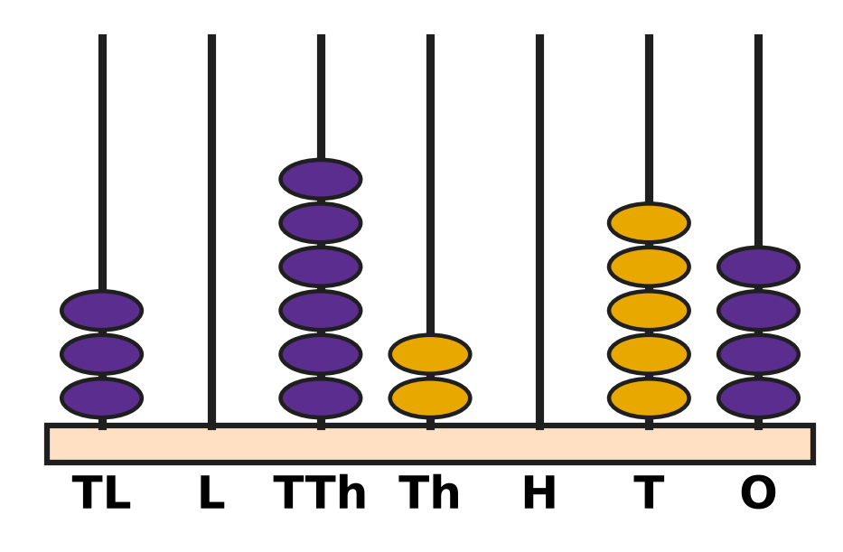
Q1. Look at the abacus. TL stands for ten lakhs, L for lakhs, TTh for ten thousands, Th for thousands, H for hundreds, T for tens and O for ones. Which number does it show?
(A) 36,254 | (B) 3,62,054
(C) 30,26,054 | (D) 30,62,054

Q2. Look at the factor tree of 1,980. The circled numbers are primes. Which of these is the prime factorisation of 1,980? | 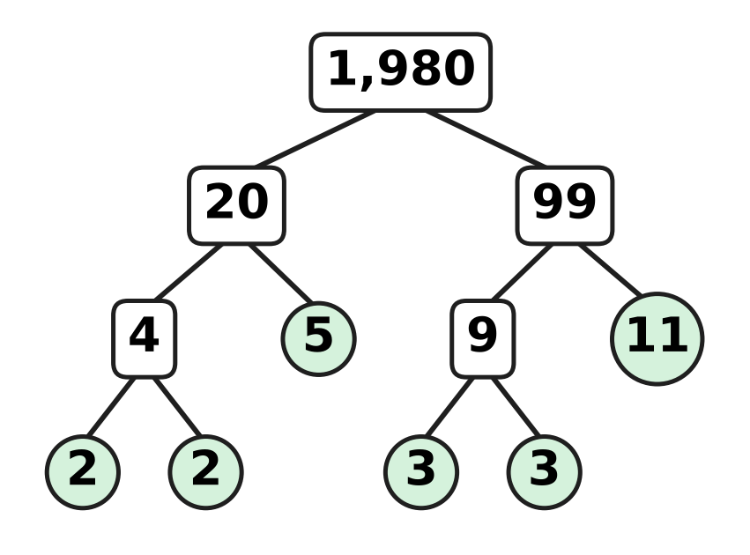
  (A) 2² × 3² × 5 × 11 | (B) 4 × 9 × 5 × 11
  (C) 2² × 3 × 5 × 11 | (D) 2 × 3² × 5 × 11

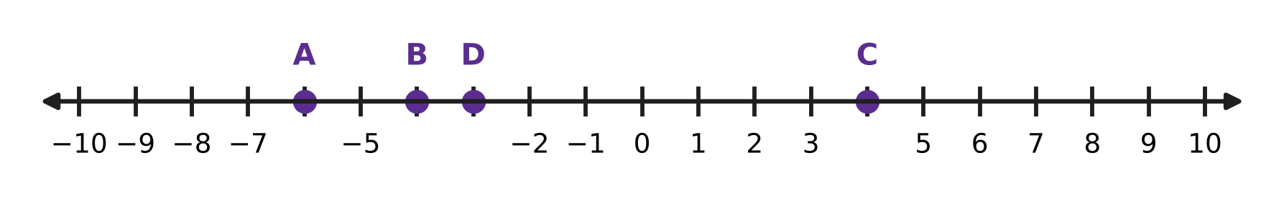
Q3. Look at the number line. The marks are 1 apart. Four of the marks are lettered instead of numbered. Which point shows the integer −4?
(A) Point A | (B) Point B | (C) Point C | (D) Point D

Q4. Kartik can put all his marbles into glass jars of 15 marbles each with none left over. He can also put them all into jars of 20 marbles each with none left over. He has more than 100 and fewer than 150 marbles. How many marbles does he have?
(A) 140 | (B) 135 | (C) 60 | (D) 120

Q5. A number N = 2³ × 3² × 7. Which of these is NOT a factor of N?
(A) 72 | (B) 56 | (C) 63 | (D) 48

Part 2 — Operations & Number Properties (Syllabus Chapter 2)
Q6. "Subtract 4 from 9. Multiply the result by 3. Then subtract this answer from 30." Which expression matches these steps?
(A) 30 − [(9 − 4) × 3] | (B) 30 − [(4 − 9) × 3]
(C) [30 − (9 − 4)] × 3 | (D) 30 − 9 − 4 × 3

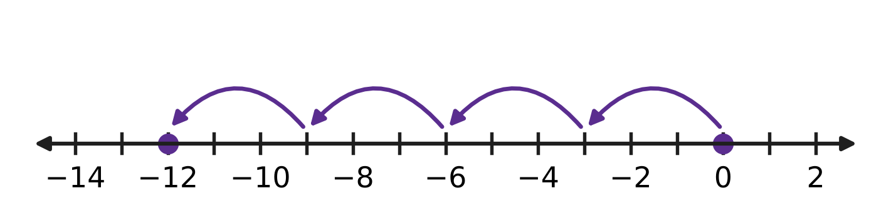
Q7. Look at the number line. Four equal jumps start at 0. Which multiplication do the jumps show?
(A) 4 × 3 = 12 | (B) (−4) × (−3) = 12
(C) 3 × (−4) = −12 | (D) 4 × (−3) = −12

Q8. What is the value of (−8) × 37 + (−8) × 63?
(A) −800 | (B) −504 | (C) −296 | (D) 800

Q9. Which number goes in the blank to make this true?
60 − {5 × [ ___ − (8 − 3)]} = 10
(A) 5 | (B) 10 | (C) 15 | (D) 19

Q10. In a quiz, a correct answer gets +4 marks, a wrong answer gets −2 marks and a question left blank gets 0. Navya answered 17 questions correctly and 6 wrongly, and left 2 blank. What was her total score?
(A) 52 | (B) 56 | (C) 68 | (D) 80

Part 3 — Fractions, Decimals & Percentages (Syllabus Chapter 3)
Q11. The big square in the picture is made of 100 equal small squares. Which pair shows the shaded part correctly as a decimal and as a percentage? | 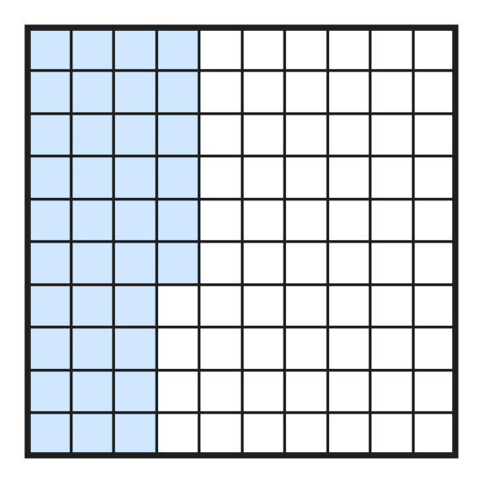
  (A) 0.36 and 36% | (B) 0.036 and 36%
  (C) 0.36 and 3.6% | (D) 3.6 and 36%

Q12. Look at these six numbers: 0.6, 6%, 60%, $\frac{12}{20}$, 0.35, $\frac{3}{50}$. How many of them are equal to $\frac{3}{5}$?
(A) 2 | (B) 3 | (C) 4 | (D) 5

Q13. A rainwater tank holds 2,500 litres when it is full. Today it is 64% full. How many litres of water are in the tank?
(A) 160 L | (B) 900 L | (C) 1,600 L | (D) 2,436 L

Q14. Which of these statements is TRUE?
(A) 0.45 > $\frac{4}{9}$ | (B) 56% < 0.506
(C) $\frac{3}{8}$ > 0.4 | (D) $\frac{2}{25}$ = 0.8

Q15. A school library has 640 books. Of these books, $\frac{3}{8}$ are storybooks and 45% are science books. All the other books are maths books. How many maths books are there?
(A) 112 | (B) 288 | (C) 352 | (D) 400

Part 4 — Algebra (Syllabus Chapter 4)
A number machine
IN (n) | 1 | 2 | 3 | 4
OUT | 5 | 8 | 11 | 14

Q16. The table shows what a number machine gives out (OUT) for each number n put in (IN). Which expression gives OUT for every number n in the table?
(A) n + 4 | (B) 4n + 1 | (C) 2n + 3 | (D) 3n + 2

Q17. What is the value of p² − 2q when p = −3 and q = 4?
(A) −17 | (B) −14 | (C) 1 | (D) 17

Q18. A bakery bakes n trays of cookies with 24 cookies on each tray. It packs all the cookies into boxes of 6. It keeps 5 boxes and sells the rest. Which expression gives the number of boxes it sells?
(A) 4n − 30 | (B) 4(n − 5) | (C) 24n − 5 | (D) 4n − 5

Part 5 — Geometry (Syllabus Chapter 5)
Q19. In the figure, the smaller angle between the two arms is 130°. What is the size of the angle marked "?", and what type of angle is it? | 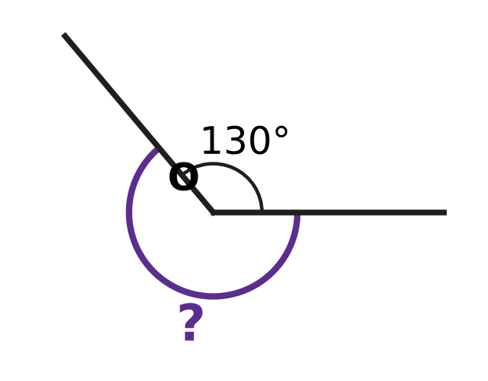
  (A) 230°, reflex | (B) 130°, obtuse
  (C) 50°, acute | (D) 230°, obtuse

Q20. In triangle PQR in the figure, the tick marks show that PQ = PR, and angle P is 120°. Which description fits this triangle exactly? | 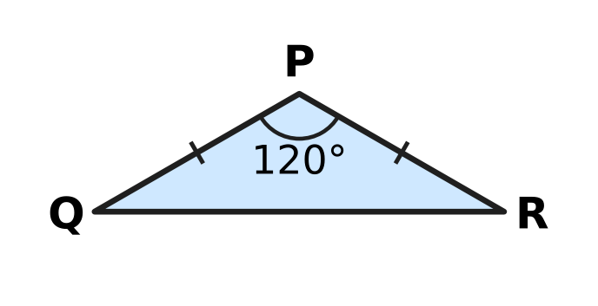
  (A) acute-angled and isosceles | (B) obtuse-angled and scalene
  (C) right-angled and isosceles | (D) obtuse-angled and isosceles

Q21. In the figure, AOB is a straight line. Angle AOC is 48° and angle DOB is 65°. What is angle COD? | 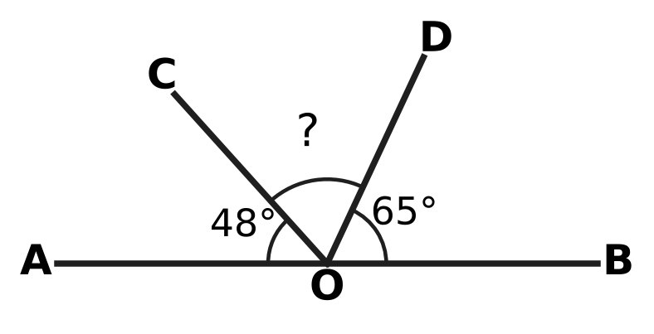
  (A) 17° | (B) 67° | (C) 113° | (D) 132°

Q22. The figure shows a polygon with 9 sides. All the diagonals from vertex A are drawn as dashed lines. What is the sum of all the interior angles of this polygon? | 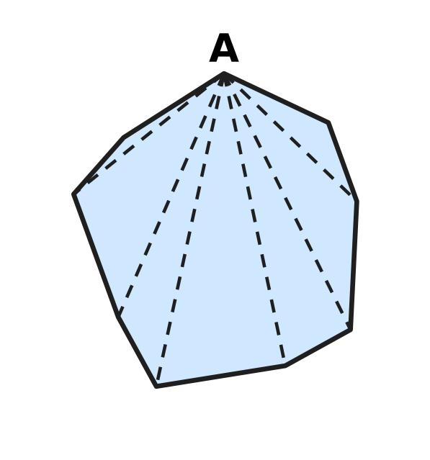
  (A) 1,080° | (B) 1,260° | (C) 1,440° | (D) 1,620°

Q23. In the figure, AB = AC and side BC is extended to D. Angle ACD is 115°. What is angle BAC? | 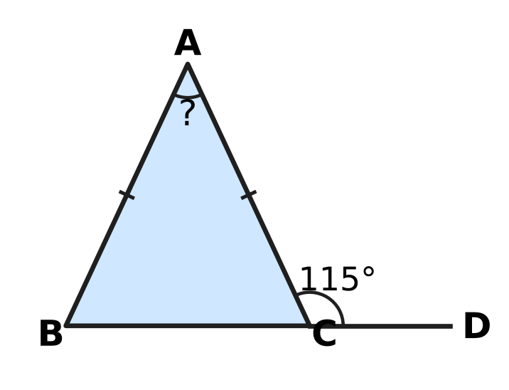
  (A) 50° | (B) 57.5° | (C) 65° | (D) 130°

Part 6 — Mensuration (Syllabus Chapter 6)
Q24. A rectangular card 20 cm by 14 cm has a rectangular window 6 cm by 4 cm cut out of it, as shown in the figure. What is the area of the card that is left? | 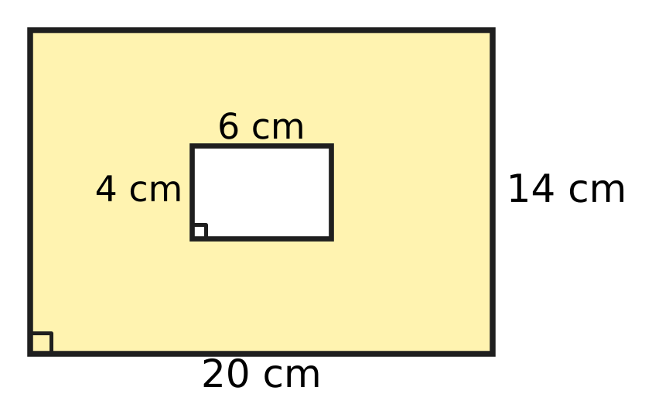
  (A) 48 cm² | (B) 256 cm² | (C) 280 cm² | (D) 304 cm²

Q25. The figure shows the net of a cube. Each square in the net has a side of 8 cm. The net is folded to make the cube. What is the volume of the cube? | 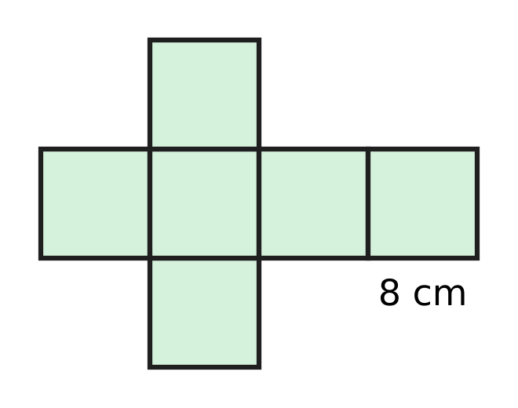
  (A) 48 cm³ | (B) 64 cm³ | (C) 384 cm³ | (D) 512 cm³

Q26. A classroom notice board is a rectangle 1 m 20 cm long and 90 cm wide. A ribbon is fixed once all around its edge. How long is the ribbon?
(A) 4 m 20 cm | (B) 4 m 2 cm
(C) 2 m 10 cm | (D) 3 m 80 cm

Q27. A vegetable garden is a rectangle 20 m long and 15 m wide. A path of the same width runs along two sides of the garden, inside it, as shown in the figure. The rest of the garden is a rectangle of beds with an area of 234 m². How wide is the path? | 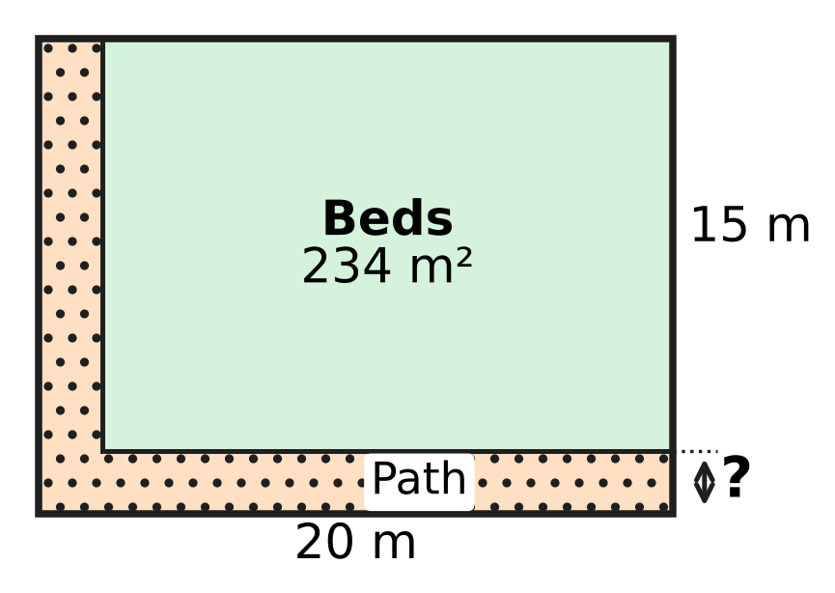
  (A) 1 m | (B) 2 m | (C) 3 m | (D) 4 m

Q28. A swimming pool has a rectangular floor 20 m long and 8 m wide, and its sides are vertical. Then 32,000 litres of water are pumped into it. By how many centimetres does the water level rise? Use 1 cubic metre = 1,000 litres.
(A) 2 cm | (B) 20 cm | (C) 50 cm | (D) 200 cm

Part 7 — Data Handling, Statistics & Probability (Syllabus Chapter 8)
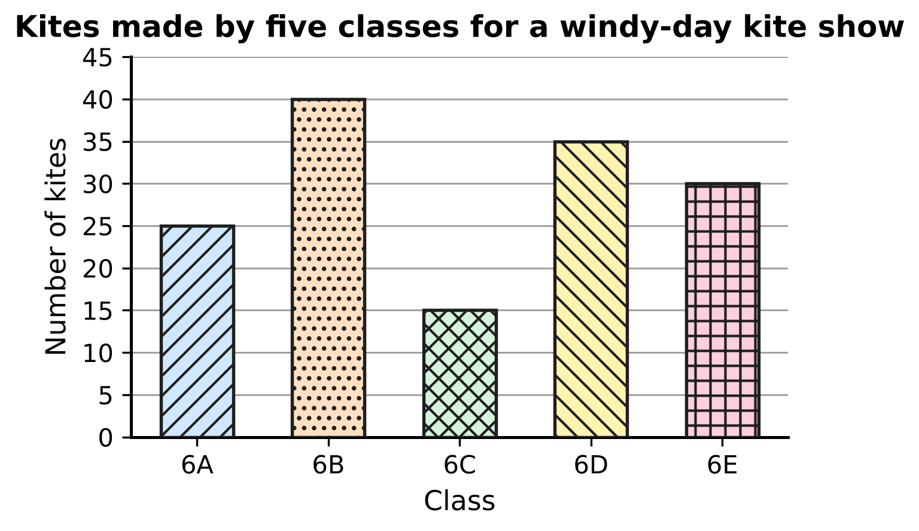
Q29. The bar graph shows the number of kites made by five classes. How many more kites did the class that made the most kites make than the class that made the fewest?
(A) 10 | (B) 15 | (C) 25 | (D) 55

A survey of 30 students
Number of brothers and sisters | 0 | 1 | 2 | 3 | 4
Number of students (frequency) | 4 | 11 | ? | 5 | 2

Q30. Each of 30 students in a class told how many brothers and sisters they have. The table shows the results, but the frequency for 2 is missing. How many students have 2 or more brothers and sisters?
(A) 7 | (B) 8 | (C) 15 | (D) 26

Part 8 — Applied Mathematics (Syllabus Chapter 9)
Q31. The picture shows a floor made of equal square tiles. Some tiles are dark and the rest are white. What is the ratio of dark tiles to white tiles, in its simplest form? | 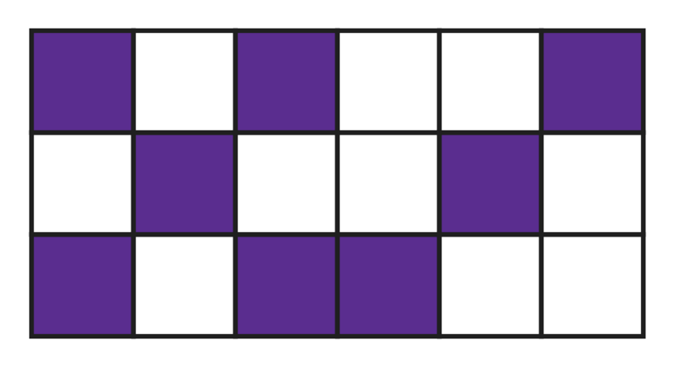
  (A) 4 : 9 | (B) 9 : 5 | (C) 5 : 4 | (D) 4 : 5

Q32. In an orchard, $\frac{3}{8}$ of the trees are apple trees and all the others are pear trees. What is the ratio of apple trees to pear trees?
(A) 3 : 8 | (B) 8 : 5 | (C) 3 : 5 | (D) 5 : 3

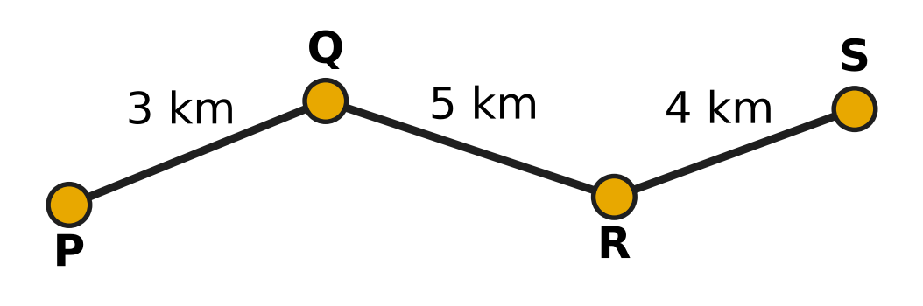
Q33. The map shows the route of a school bus from stop P to stop S, with the distances between stops. The bus takes 36 minutes from P to S. What is its average speed?
(A) 3 km/h | (B) 12 km/h | (C) 20 km/h | (D) 24 km/h

Q34. Two delivery vans leave the same depot at the same time and drive along the same straight road in the same direction. One goes at 36 km/h and the other at 54 km/h. After how many minutes are they 6 km apart?
(A) 4 minutes | (B) 10 minutes
(C) 18 minutes | (D) 20 minutes

Q35. The numbers of stamps in Ira's and Uday's collections are in the ratio 7 : 3. Ira gives 10 stamps to Uday. Now they both have the same number of stamps. How many stamps did Ira have at first?
(A) 15 | (B) 25 | (C) 35 | (D) 70

Part 9 — Mathematical Reasoning & Problem-Solving (Syllabus Chapter 10)
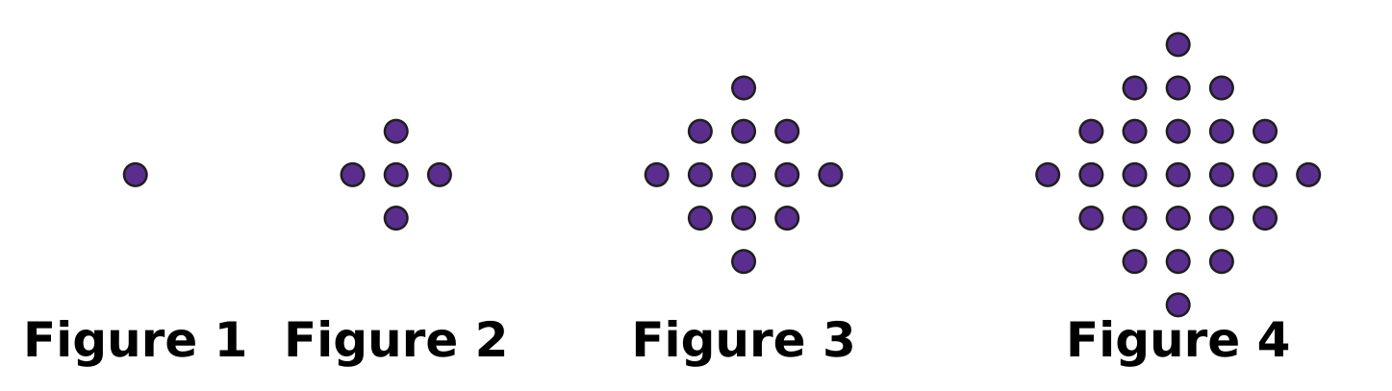
Q36. Look at the pattern of dot figures. Figure 1 has 1 dot, and the pattern keeps growing in the same way. How many dots will Figure 5 have?
(A) 37 | (B) 41 | (C) 45 | (D) 50

Q37. The two clocks show a start time and an end time on the same morning. Through what angle does the minute hand turn from the start time to the end time? | 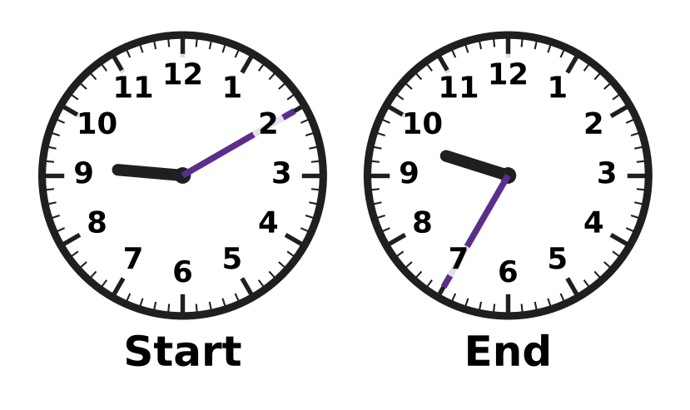
  (A) 150° | (B) 12.5° | (C) 25° | (D) 125°

Q38. A stationery shop had some notebooks. On Monday it sold half of them and 3 more. Then 9 notebooks were left. How many notebooks did the shop have at first?
(A) 18 | (B) 12 | (C) 15 | (D) 24

Q39. A farm has only cows and hens. There are 20 animals in all. Advait counted all the legs of all the animals correctly. Which of these could be his total?
(A) 36 | (B) 96 | (C) 66 | (D) 57

Q40. The counting numbers 1, 2, 3, 4, … are written in rows of five under the columns A, B, C, D and E, as shown. The first row goes from left to right, the next row from right to left, and so on in turn. In which column will the number 139 be written? | 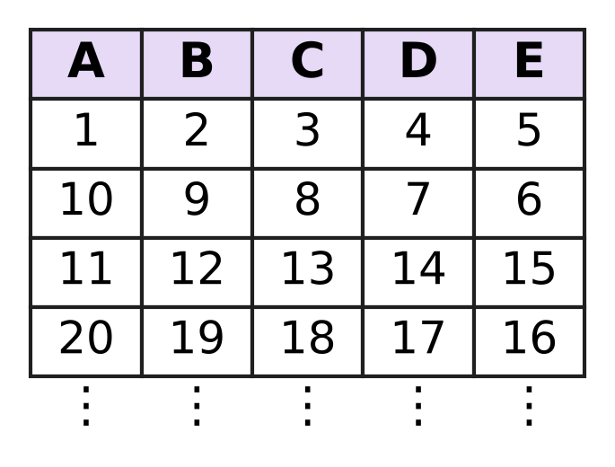
  (A) Column D | (B) Column B | (C) Column A | (D) Column C

SECTION II — Star Questions 5 questions × 4 marks each
Q41. In this question, n stands for any whole number (0, 1, 2, 3, …). Which of these expressions has an odd value for EVERY whole number n? [4 marks]
(A) n² + 3n + 1 | (B) n² + 2n + 1
(C) n² + 4n + 2 | (D) 3n + 5

Q42. Farhan plays a game with a counter on the integer number line. In each move, he doubles the number the counter is on and subtracts the result from 5. The counter goes to that new number. After three moves the counter is on 39. On which integer did it start? [4 marks]
(A) −17 | (B) −3 | (C) 3 | (D) 11

Q43. On a bicycle trip, Swati rides for 2 hours at 12 km/h. She has then covered 40% of the whole trip. She wants to finish the whole trip 4 hours after she started. At what speed must she ride for the rest of the trip? [4 marks]
(A) 9 km/h | (B) 12 km/h | (C) 18 km/h | (D) 30 km/h

Q44. The figure shows a shape made of a rectangle 12 cm by 7 cm with a triangle on top. The dashed line is the top of the rectangle. The two sloping sides of the triangle are equal, and the angle at the top is 60°. What is the perimeter of the whole shape? [4 marks] | 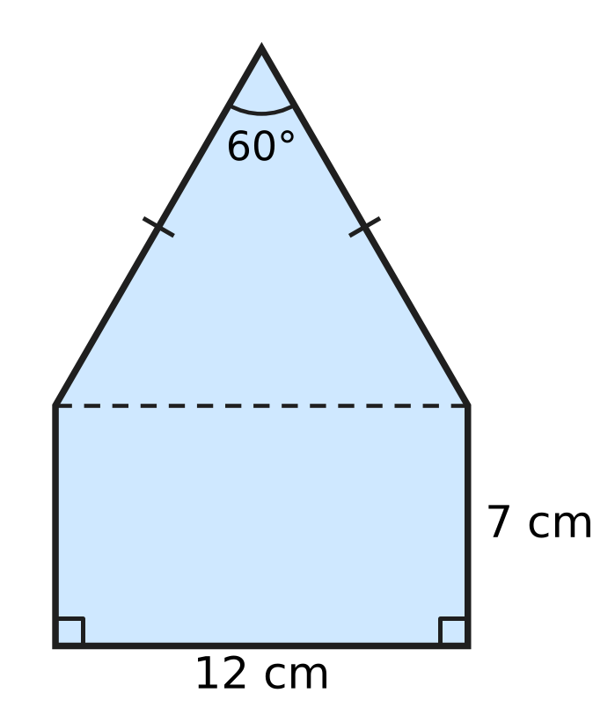
  (A) 38 cm | (B) 40 cm | (C) 50 cm | (D) 62 cm

Q45. A car travels for 4 hours at x km/h and then for 2 hours at (x − 12) km/h. Which expression gives its average speed, in km/h, for the whole journey? [4 marks]
(A) 6x − 24 | (B) x − 4 | (C) x − 6 | (D) x − 2

Answer Sheet AMO Level 1 · Class 6 · Practice Paper 1
Name: | School: | Roll No.:
Shade or tick one circle for each question.
1. Ⓐ Ⓑ Ⓒ Ⓓ | 16. Ⓐ Ⓑ Ⓒ Ⓓ | 31. Ⓐ Ⓑ Ⓒ Ⓓ
2. Ⓐ Ⓑ Ⓒ Ⓓ | 17. Ⓐ Ⓑ Ⓒ Ⓓ | 32. Ⓐ Ⓑ Ⓒ Ⓓ
3. Ⓐ Ⓑ Ⓒ Ⓓ | 18. Ⓐ Ⓑ Ⓒ Ⓓ | 33. Ⓐ Ⓑ Ⓒ Ⓓ
4. Ⓐ Ⓑ Ⓒ Ⓓ | 19. Ⓐ Ⓑ Ⓒ Ⓓ | 34. Ⓐ Ⓑ Ⓒ Ⓓ
5. Ⓐ Ⓑ Ⓒ Ⓓ | 20. Ⓐ Ⓑ Ⓒ Ⓓ | 35. Ⓐ Ⓑ Ⓒ Ⓓ
6. Ⓐ Ⓑ Ⓒ Ⓓ | 21. Ⓐ Ⓑ Ⓒ Ⓓ | 36. Ⓐ Ⓑ Ⓒ Ⓓ
7. Ⓐ Ⓑ Ⓒ Ⓓ | 22. Ⓐ Ⓑ Ⓒ Ⓓ | 37. Ⓐ Ⓑ Ⓒ Ⓓ
8. Ⓐ Ⓑ Ⓒ Ⓓ | 23. Ⓐ Ⓑ Ⓒ Ⓓ | 38. Ⓐ Ⓑ Ⓒ Ⓓ
9. Ⓐ Ⓑ Ⓒ Ⓓ | 24. Ⓐ Ⓑ Ⓒ Ⓓ | 39. Ⓐ Ⓑ Ⓒ Ⓓ
10. Ⓐ Ⓑ Ⓒ Ⓓ | 25. Ⓐ Ⓑ Ⓒ Ⓓ | 40. Ⓐ Ⓑ Ⓒ Ⓓ
11. Ⓐ Ⓑ Ⓒ Ⓓ | 26. Ⓐ Ⓑ Ⓒ Ⓓ | 41. Ⓐ Ⓑ Ⓒ Ⓓ
12. Ⓐ Ⓑ Ⓒ Ⓓ | 27. Ⓐ Ⓑ Ⓒ Ⓓ | 42. Ⓐ Ⓑ Ⓒ Ⓓ
13. Ⓐ Ⓑ Ⓒ Ⓓ | 28. Ⓐ Ⓑ Ⓒ Ⓓ | 43. Ⓐ Ⓑ Ⓒ Ⓓ
14. Ⓐ Ⓑ Ⓒ Ⓓ | 29. Ⓐ Ⓑ Ⓒ Ⓓ | 44. Ⓐ Ⓑ Ⓒ Ⓓ
15. Ⓐ Ⓑ Ⓒ Ⓓ | 30. Ⓐ Ⓑ Ⓒ Ⓓ | 45. Ⓐ Ⓑ Ⓒ Ⓓ
Q41–Q45 are Section II Star Questions (4 marks each).
For the parent or teacher
Section I correct: ______ / 40 × 2 = ______ marks Section II correct: ______ / 5 × 4 = ______ marks
Correct: ______ / 45 Score: ______ / 100
Answer Key and Solutions AMO Level 1 · Class 6 · Practice Paper 1
Quick answers
1 D | 6 A | 11 A | 16 D | 21 B | 26 A | 31 D | 36 B | 41 A
2 A | 7 D | 12 B | 17 C | 22 B | 27 B | 32 C | 37 A | 42 B
3 B | 8 A | 13 C | 18 D | 23 A | 28 B | 33 C | 38 D | 43 C
4 D | 9 C | 14 A | 19 A | 24 B | 29 C | 34 D | 39 C | 44 C
5 D | 10 B | 15 A | 20 D | 25 D | 30 C | 35 C | 40 B | 45 B
Solutions
Q | Part · level | Answer | Why?
1 | Part 1 · Ch1 · Easy | (D) 30,62,054 | Reading the spikes from TL to O gives 3, 0, 6, 2, 0, 5, 4. The empty spikes stand for 0, so the number is 30,62,054.
2 | Part 1 · Ch1 · Easy | (A) 2² × 3² × 5 × 11 | The primes at the ends of the branches are 2, 2, 5, 3, 3 and 11. So 1,980 = 2 × 2 × 3 × 3 × 5 × 11 = 2² × 3² × 5 × 11.
3 | Part 1 · Ch1 · Easy | (B) Point B | The integer −4 is one step to the right of −5. That mark is Point B. (Point A is −6, Point D is −3 and Point C is 4.)
4 | Part 1 · Ch1 · Medium | (D) 120 | The number must be a common multiple of 15 and 20, that is a multiple of their LCM 60: 60, 120, 180, … Only 120 is more than 100 and fewer than 150.
5 | Part 1 · Ch1 · Medium | (D) 48 | Since 48 = 2⁴ × 3, it needs four 2s, but N has only three 2s. Also 56 = 2³ × 7, 72 = 2³ × 3² and 63 = 3² × 7 all divide N.
6 | Part 2 · Ch2 · Easy | (A) 30 − [(9 − 4) × 3] | "Subtract 4 from 9" is (9 − 4). Multiplying by 3 gives [(9 − 4) × 3]. Subtracting this from 30 gives 30 − [(9 − 4) × 3] = 15.
7 | Part 2 · Ch2 · Easy | (D) 4 × (−3) = −12 | There are 4 jumps, each of 3 to the left, that is −3. They end at −12, so the picture shows 4 × (−3) = −12.
8 | Part 2 · Ch2 · Easy | (A) −800 | By the distributive property, (−8) × 37 + (−8) × 63 = (−8) × (37 + 63) = (−8) × 100 = −800.
9 | Part 2 · Ch2 · Medium | (C) 15 | The curly bracket must be 60 − 10 = 50, so the square bracket is 50 ÷ 5 = 10. The blank minus 5 is 10, so the blank is 15.
10 | Part 2 · Ch2 · Medium | (B) 56 | Score = 17 × 4 + 6 × (−2) + 2 × 0 = 68 − 12 + 0 = 56.
11 | Part 3 · Ch3 · Easy | (A) 0.36 and 36% | There are 36 shaded squares out of 100. So the shaded part is 36 out of 100 = 0.36 = 36%.
12 | Part 3 · Ch3 · Easy | (B) 3 | $\frac{3}{5}$ = 0.6 = 60%, and $\frac{12}{20}$ = $\frac{3}{5}$ too. 6% = 0.06, 0.35 and $\frac{3}{50}$ = 0.06 are different. So 3 of them are equal to $\frac{3}{5}$.
13 | Part 3 · Ch3 · Easy | (C) 1,600 L | Water in the tank = 64% of 2,500 L = 64 × 25 = 1,600 L.
14 | Part 3 · Ch3 · Medium | (A) 0.45 > $\frac{4}{9}$ | As a decimal, 4/9 = 0.444…, which is less than 0.45. The others are false: 3/8 = 0.375 < 0.4, 2/25 = 0.08, and 56% = 0.56 > 0.506.
15 | Part 3 · Ch3 · Medium | (A) 112 | Storybooks = 3/8 of 640 = 240. Science books = 45% of 640 = 288. Maths books = 640 − 240 − 288 = 112.
16 | Part 4 · Ch4 · Easy | (D) 3n + 2 | OUT goes up by 3 each time IN goes up by 1, so the rule starts with 3n. Check: 3 × 1 + 2 = 5, 3 × 2 + 2 = 8, 3 × 3 + 2 = 11 and 3 × 4 + 2 = 14, so OUT = 3n + 2.
17 | Part 4 · Ch4 · Easy | (C) 1 | p² = (−3) × (−3) = 9 and 2q = 8. So p² − 2q = 9 − 8 = 1.
18 | Part 4 · Ch4 · Medium | (D) 4n − 5 | There are 24n cookies, which fill 24n ÷ 6 = 4n boxes. After keeping 5 boxes, 4n − 5 boxes are sold.
19 | Part 5 · Ch5 · Easy | (A) 230°, reflex | The marked angle goes the long way round: 360° − 130° = 230°. An angle greater than 180° and less than 360° is a reflex angle.
20 | Part 5 · Ch5 · Easy | (D) obtuse-angled and isosceles | Angle P is 120°, which is more than 90°, so the triangle is obtuse-angled. Two sides are equal, so it is isosceles.
21 | Part 5 · Ch5 · Easy | (B) 67° | Angles on a straight line add up to 180°. So angle COD = 180° − 48° − 65° = 67°.
22 | Part 5 · Ch5 · Medium | (B) 1,260° | The 6 diagonals from A cut the polygon into 7 triangles. Their angles make up the polygon's angles, so the sum is 7 × 180° = 1,260°.
23 | Part 5 · Ch5 · Medium | (A) 50° | Angle ACB = 180° − 115° = 65°. Since AB = AC, angle ABC = 65° too. So angle BAC = 180° − 65° − 65° = 50°.
24 | Part 6 · Ch6 · Easy | (B) 256 cm² | Area left = 20 × 14 − 6 × 4 = 280 − 24 = 256 cm².
25 | Part 6 · Ch6 · Easy | (D) 512 cm³ | The cube has edge 8 cm, so its volume = 8 × 8 × 8 = 512 cm³.
26 | Part 6 · Ch6 · Easy | (A) 4 m 20 cm | Perimeter = 2 × (120 cm + 90 cm) = 420 cm = 4 m 20 cm.
27 | Part 6 · Ch6 · Medium | (B) 2 m | If the path is w m wide, the beds are (20 − w) m by (15 − w) m. With w = 2 the beds are 18 m by 13 m, and 18 × 13 = 234 m², so the path is 2 m wide.
28 | Part 6 · Ch6 · Medium | (B) 20 cm | Volume of water = 32,000 L = 32 cubic metres. Floor area = 20 × 8 = 160 m². Rise = 32 ÷ 160 = 0.2 m = 20 cm.
29 | Part 7 · Ch8 · Easy | (C) 25 | The most is 40 kites (6B) and the fewest is 15 kites (6C). So the difference is 40 − 15 = 25.
30 | Part 7 · Ch8 · Medium | (C) 15 | The missing frequency = 30 − (4 + 11 + 5 + 2) = 8. Students with 2 or more = 8 + 5 + 2 = 15.
31 | Part 8 · Ch9 · Easy | (D) 4 : 5 | There are 8 dark tiles and 10 white tiles. So the ratio is 8 : 10 = 4 : 5.
32 | Part 8 · Ch9 · Easy | (C) 3 : 5 | For every 8 trees, 3 are apple trees and 8 − 3 = 5 are pear trees. So the ratio is 3 : 5.
33 | Part 8 · Ch9 · Easy | (C) 20 km/h | Distance = 3 + 5 + 4 = 12 km. Time = 36 minutes = 36/60 hour. Speed = 12 ÷ (36/60) = 12 × 60 ÷ 36 = 20 km/h.
34 | Part 8 · Ch9 · Medium | (D) 20 minutes | The faster van gains 54 − 36 = 18 km every hour. To be 6 km apart takes 6 ÷ 18 = 1/3 hour = 20 minutes.
35 | Part 8 · Ch9 · Medium | (C) 35 | Ira had 7 − 3 = 4 parts more than Uday. After she gives 10, they are equal, so the 4 parts are 10 + 10 = 20 and 1 part = 5. Ira had 7 × 5 = 35 stamps.
36 | Part 9 · Ch10 · Easy | (B) 41 | The counts are 1, 5, 13, 25. The jumps are 4, 8, 12, so the next jump is 16. Figure 5 has 25 + 16 = 41 dots.
37 | Part 9 · Ch10 · Easy | (A) 150° | From 9:10 to 9:35 is 25 minutes. The minute hand turns 6° every minute, so it turns 25 × 6° = 150°.
38 | Part 9 · Ch10 · Easy | (D) 24 | Before the 3 extra were sold there were 9 + 3 = 12 notebooks. These 12 were the half that was left, so at first there were 12 × 2 = 24.
39 | Part 9 · Ch10 · Medium | (C) 66 | Each animal has 2 or 4 legs, so the total is even and lies between 20 × 2 = 40 and 20 × 4 = 80. Only 66 is even and between 40 and 80 (13 cows and 7 hens).
40 | Part 9 · Ch10 · Medium | (B) Column B | Every 10 numbers fill two rows, A to E and then E to A. The number 139 is 9 more than 130, so it sits where 9 sits. The number 9 is in Column B, so 139 is in Column B.
41 | Section II · Ch4 + Ch10 · Hard | (A) n² + 3n + 1 | n² + 3n = n × (n + 3). One of n and n + 3 is even, so n² + 3n is always even and n² + 3n + 1 is always odd. The others fail: n = 1 gives 4 and 8, and n = 0 gives 2.
42 | Section II · Ch1 + Ch10 · Hard | (B) −3 | A move takes p to 5 − 2p, so to undo it, take (5 − new number) ÷ 2. From 39: (5 − 39) ÷ 2 = −17; then (5 + 17) ÷ 2 = 11; then (5 − 11) ÷ 2 = −3. Check: −3 → 11 → −17 → 39.
43 | Section II · Ch3 + Ch9 · Hard | (C) 18 km/h | She covers 12 × 2 = 24 km, which is 40% of the trip, so the trip is 24 ÷ 40 × 100 = 60 km. Then 36 km is left for the last 2 hours, so she needs 36 ÷ 2 = 18 km/h.
44 | Section II · Ch5 + Ch6 · Hard | (C) 50 cm | The base angles of the triangle are (180° − 60°) ÷ 2 = 60° each, so all its angles are 60° and it is equilateral: each sloping side is 12 cm. Perimeter = 12 + 7 + 7 + 12 + 12 = 50 cm.
45 | Section II · Ch4 + Ch9 · Hard | (B) x − 4 | Distance = 4x + 2(x − 12) = 6x − 24 km. Time = 4 + 2 = 6 hours. Average speed = (6x − 24) ÷ 6 = x − 4 km/h.

