UNLOCK IQ INSTITUTE
Realize Your True Potential
Aryabhatta Maths Olympiad (AMO)
Level 1 — Practice Paper 2
CLASS 6

Questions | 45 multiple-choice questions
Marks | 100
Time | 60 minutes
Section I | 40 questions × 2 marks = 80 marks
Section II | 5 Star Questions × 4 marks = 20 marks
Negative marking | No negative marking
Calculator | Not allowed
Chapters | Number System · Operations · Fractions, Decimals & Percentages · Algebra · Geometry · Mensuration · Data Handling · Applied Mathematics · Mathematical Reasoning

Hello, friend!
• Every question has four answer choices: (A), (B), (C) and (D). Only one is correct.
• Read each question and look at its picture carefully. Then mark your answer on the answer sheet at the end.
• Section I has 40 questions of 2 marks each. Section II has 5 Star Questions of 4 marks each.
• There is no negative marking, so try every question.
• Do not use a calculator. You may do rough work on a separate sheet.
• All figures are not necessarily drawn to scale unless stated.

For parents and teachers
Print or view this paper in colour. Pictures are part of the questions.
Parts follow the AMO syllabus chapters. Chapter 7 is not part of the Class 6 syllabus, so the chapter numbers shown in the Part headings have gaps.
The answer sheet and the answer key are at the end. Remove only the answer key before the child begins.

Name: | School: | Roll No.:

SECTION I 40 questions × 2 marks each
Part 1 — Number System (Syllabus Chapter 1)
Q1. In which of these numbers does the digit 5 stand for 5 lakh (5,00,000)?
(A) 26,53,041 | (B) 26,35,041
(C) 25,63,041 | (D) 52,63,041

Q2. Which of these numbers has no prime factor greater than 3?
(A) 150 | (B) 126 | (C) 102 | (D) 108

Q3. In an aquarium, heights are measured from the water surface: above the surface is positive and below it is negative. A lamp hangs at +35 cm. A snail sits on the bottom at −48 cm. How much higher than the snail is the lamp?
(A) 48 cm | (B) 35 cm | (C) 13 cm | (D) 83 cm

Q4. Jai is putting up a fence along two sides of a garden that meet at a corner. One side is 84 m long and the other is 60 m long. He puts posts the same distance apart all along the fence, with a post at each end and one at the corner. The gap between posts must be as large as possible. How many posts does he need?
(A) 12 | (B) 13 | (C) 14 | (D) 25

Q5. Which of these pairs of numbers has HCF 12 and LCM 180?
(A) 36 and 60 | (B) 24 and 90
(C) 45 and 48 | (D) 40 and 54

Part 2 — Operations & Number Properties (Syllabus Chapter 2)
Q6. Which of these has the greatest value?
(A) 48 ÷ [4 × (2 + 4)] | (B) 48 ÷ {(4 × 2) + 4}
(C) [48 ÷ 4] × (2 + 4) | (D) 48 ÷ 4 × 2 + 4

Q7. In the grid in the figure, the numbers in each row, each column and each diagonal add up to the same total. Which integer goes in the shaded box? | 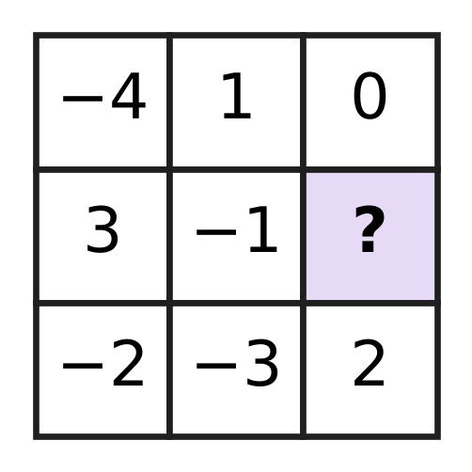
  (A) −7 | (B) 5 | (C) −5 | (D) 1

Q8. Which of these is equal to (−6) × 47?
(A) (−6) × 50 − (−6) × 3 | (B) (−6) × 50 − 3
(C) (−6) × 50 + (−6) × 3 | (D) (−6) × 40 + 7

Q9. What is the value of {(−36) ÷ [4 − (−5)]} × (−3) − 8?
(A) −20 | (B) 44 | (C) −116 | (D) 4

Q10. The sum of five integers is −6. Four of them are 8, −15, 3 and −9. What is the fifth integer?
(A) 19 | (B) −7 | (C) 7 | (D) −19

Part 3 — Fractions, Decimals & Percentages (Syllabus Chapter 3)
Q11. In which of these sets are all three numbers equal?
(A) 0.04, 4%, $\frac{1}{25}$ | (B) 0.375, 37.5%, $\frac{3}{5}$
(C) 0.25, 25%, $\frac{1}{5}$ | (D) 0.4, 4%, $\frac{2}{5}$

Q12. Which of these lists is in order from the smallest to the largest?
(A) $\frac{7}{20}$, 0.3, 38%, $\frac{2}{5}$ | (B) $\frac{2}{5}$, 0.3, $\frac{7}{20}$, 38%
(C) 0.3, 38%, $\frac{2}{5}$, $\frac{7}{20}$ | (D) 0.3, $\frac{7}{20}$, 38%, $\frac{2}{5}$

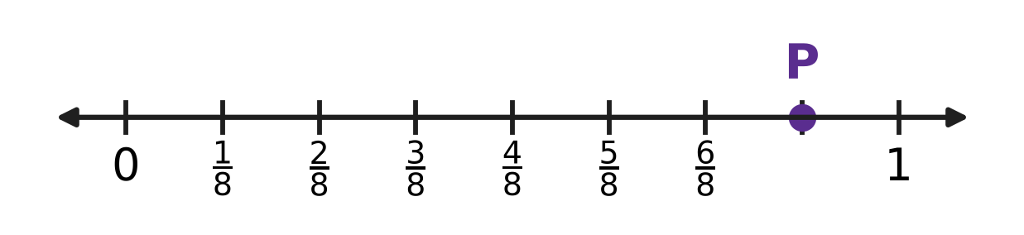
Q13. On the number line, the part from 0 to 1 is divided into equal parts, and point P is marked. What percentage does point P show?
(A) 12.5% | (B) 78% | (C) 70% | (D) 87.5%

Q14. Veena used 35% of a roll of cloth to make curtains. Now 52 m of cloth is left on the roll. How long was the roll at first?
(A) 70.2 m | (B) 87 m | (C) 80 m | (D) 28 m

Q15. Mira's bottle holds 1.2 L of juice when full. She starts with a full bottle and pours out 0.45 L. What percentage of the juice is still in the bottle?
(A) 62.5% | (B) 37.5% | (C) 75% | (D) 55%

Part 4 — Algebra (Syllabus Chapter 4)
Q16. Which of these expressions has the value 20 when n = 4?
(A) n² + 12 | (B) 6n − 4 | (C) 2(n + 7) | (D) 3n + 4

Q17. Look at the triangle. Its sides are x cm, (x + 4) cm and (2x − 1) cm long. Which expression gives its perimeter in cm? | 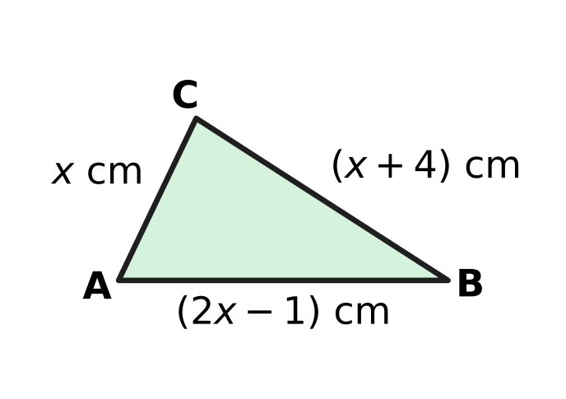
  (A) 4x − 3 | (B) 4x + 5 | (C) 3x + 3 | (D) 4x + 3

Q18. A shoe rack has x shelves. Each shelf holds 6 pairs of shoes, except the top shelf, which holds 4 pairs fewer than each of the others. All the shelves are full. Which expression gives the number of single shoes on the rack, counting each shoe of a pair separately?
(A) 12x − 4 | (B) 12x − 10 | (C) 12x − 8 | (D) 6x − 4

Part 5 — Geometry (Syllabus Chapter 5)
Q19. Which of these could be the three angles of a triangle that is both obtuse-angled and isosceles?
(A) 110°, 35°, 35° | (B) 120°, 30°, 40°
(C) 50°, 50°, 80° | (D) 100°, 50°, 30°

Q20. The figure shows a hexagon. The sizes of five of its angles are given. What is the size of the angle marked x? | 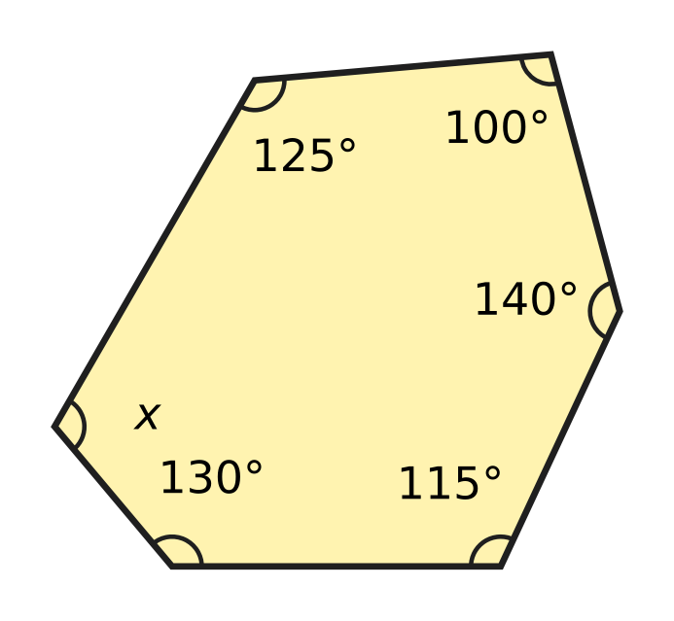
  (A) 250° | (B) 70° | (C) 290° | (D) 110°

Q21. How many of these angles are obtuse?
95°, 180°, 89°, 270°, 135°, 91°, 190°
(A) 2 | (B) 3 | (C) 4 | (D) 5

Q22. Nitya has two sticks, 6 cm and 13 cm long. She wants a third stick, a whole number of centimetres long, so that the three sticks make a triangle. How many different lengths could the third stick have?
(A) 10 | (B) 11 | (C) 12 | (D) 13

Q23. ABCDEF is a regular hexagon, and AC is joined. What is the size of angle FAC, marked "?" in the figure? | 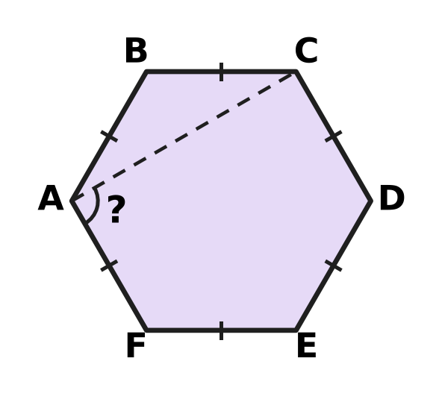
  (A) 120° | (B) 60° | (C) 90° | (D) 30°

Part 6 — Mensuration (Syllabus Chapter 6)
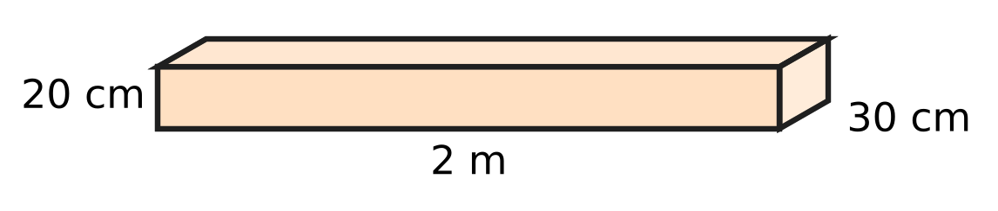
Q24. The figure shows a wooden plank shaped like a cuboid. It is 2 m long, 30 cm wide and 20 cm thick. What is its volume?
(A) 1,200 cm³ | (B) 12,000 cm³
(C) 1,20,000 cm³ | (D) 12,00,000 cm³

Q25. Three different faces of a cuboid have areas 35 cm², 20 cm² and 28 cm². What is the total surface area of the cuboid?
(A) 83 cm² | (B) 166 cm² | (C) 332 cm² | (D) 140 cm²

Q26. Which of these rectangles has the same area as a square of side 12 cm?
(A) 16 cm by 9 cm | (B) 18 cm by 6 cm
(C) 13 cm by 11 cm | (D) 14 cm by 10 cm

Q27. The figure shows three squares of sides 8 cm, 5 cm and 3 cm placed side by side, with their bottom edges on one straight line. What is the perimeter of the whole shape? | 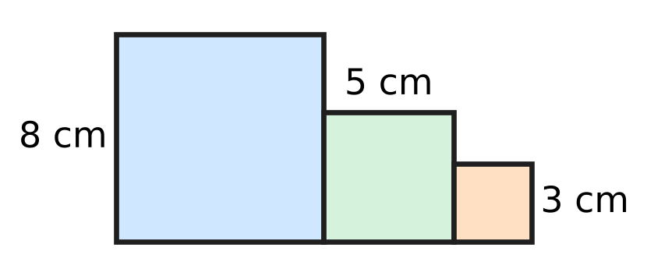
  (A) 64 cm | (B) 48 cm | (C) 40 cm | (D) 56 cm

Q28. Two cubes, each of edge 5 cm, are glued face to face to make a cuboid, as shown in the figure. What is the total surface area of the cuboid? | 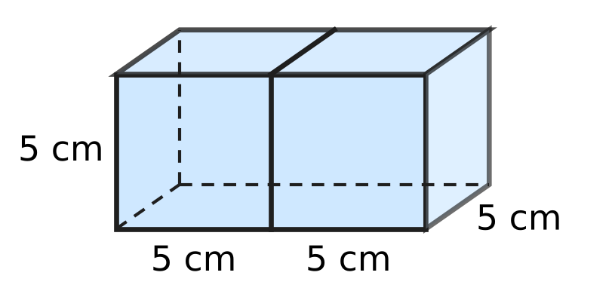
  (A) 250 cm² | (B) 150 cm² | (C) 275 cm² | (D) 300 cm²

Part 7 — Data Handling, Statistics & Probability (Syllabus Chapter 8)
Q29. A school team played 20 matches. Its goals in the 20 matches are listed below.
1, 3, 1, 3, 0, 2, 2, 0, 2, 2, 2, 3, 4, 2, 1, 3, 1, 0, 1, 4
In how many matches did it score more than 2 goals?
(A) 4 | (B) 6 | (C) 12 | (D) 14

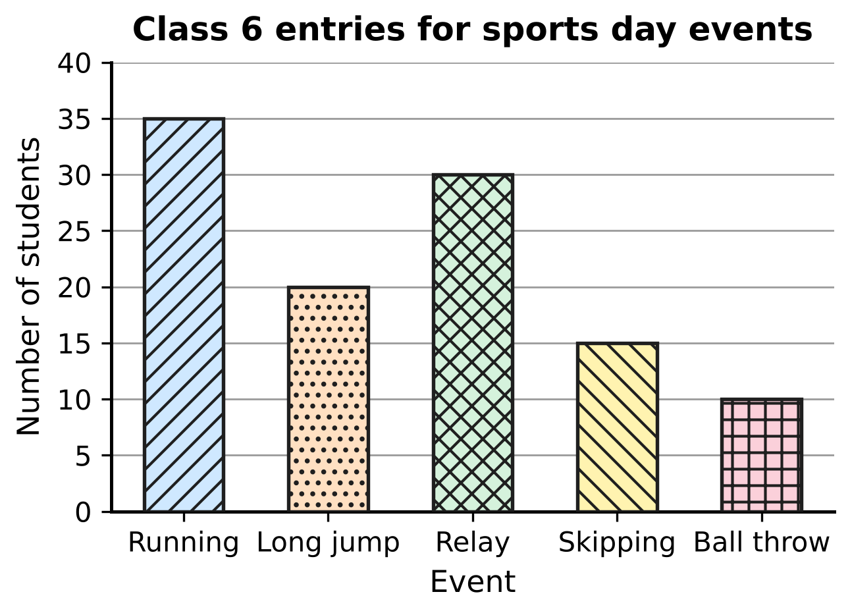
Q30. The bar graph shows how many Class 6 students entered each sports day event. How many more students entered running than ball throw and skipping together?
(A) 10 | (B) 20 | (C) 25 | (D) 60

Part 8 — Applied Mathematics (Syllabus Chapter 9)
Q31. At a fruit market, the ratio of apples to oranges on Rekha's stall is 4 : 5. Which of these could be the numbers of apples and oranges on her stall?
(A) 60 apples and 48 oranges | (B) 48 apples and 60 oranges
(C) 44 apples and 45 oranges | (D) 50 apples and 60 oranges

Q32. At a toy shop, Akash finds that 8 identical toy trains cost ₹360. How much do 5 of these toy trains cost?
(A) ₹576 | (B) ₹45 | (C) ₹225 | (D) ₹135

Q33. A bird flies 600 m in 40 seconds. At the same speed, how far does it fly in 2 minutes?
(A) 30 m | (B) 3,000 m | (C) 1,200 m | (D) 1,800 m

Q34. Bina makes a necklace with red, blue and white beads in the ratio 2 : 3 : 5. It has 12 more white beads than red beads. How many beads does the necklace have in all?
(A) 40 | (B) 120 | (C) 20 | (D) 60

Part of a train timetable
Station | Distance from P (km) | Arrives (am) | Leaves (am)
P | 0 | — | 6:00
R | 150 | 8:30 | 8:40
S | 205 | 9:30 | 9:35
T | 275 | 10:35 | 10:50
U | 311 | 11:20 | —

Q35. The table shows part of a train's timetable for one morning. Each part of the journey runs from leaving one station to arriving at the next. On which part did the train have the greatest average speed?
(A) From P to R | (B) From R to S
(C) From S to T | (D) From T to U

Part 9 — Mathematical Reasoning & Problem-Solving (Syllabus Chapter 10)
Q36. The triangular numbers are 1, 3, 6, 10, 15, … (add 2, then 3, then 4, and so on). Which of these is a triangular number?
(A) 60 | (B) 72 | (C) 64 | (D) 66

Q37. A wall clock gains 4 minutes every day. It is set to the correct time at 6:00 pm on a Monday. What time does this clock show when the correct time is 6:00 pm on the next Monday?
(A) 6:32 pm | (B) 6:24 pm | (C) 6:28 pm | (D) 5:32 pm

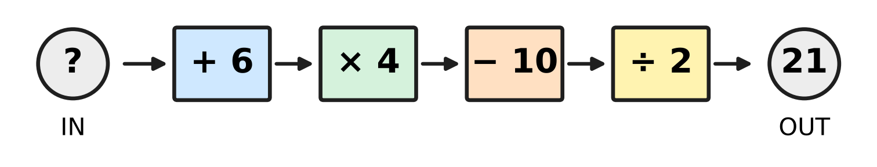
Q38. Tejas puts a number into the machine in the picture. The machine does the four steps in order, from left to right, and gives out 21. What number did Tejas put in?
(A) 49 | (B) 7 | (C) 2 | (D) 13

Q39. A counter starts at 0 on a number line. In each move it jumps exactly 1 unit, either to the left or to the right. Which of these could be its position after exactly 25 moves?
(A) −7 | (B) 0 | (C) 8 | (D) 27

Q40. The pattern 2, 5, 10, 17, 26, … goes on in the same way. Which term of the pattern is 401?
(A) the 19th term | (B) the 20th term
(C) the 21st term | (D) the 200th term

SECTION II — Star Questions 5 questions × 4 marks each
Q41. A clock shows 5 o'clock now. Here n stands for a whole number (0, 1, 2, 3, …). Which of these numbers of hours, counted from now, ALWAYS brings the clock to 1 o'clock, whatever whole number n is? [4 marks]
(A) 12n + 20 | (B) 4n + 8 | (C) 12n + 4 | (D) 20n + 12

Q42. In a park, fountain A sprays water every 8 minutes, fountain B every 12 minutes and fountain C every 18 minutes. One day all three sprayed together at 4:30 pm for the 5th time that day, counting the first time. At what time did all three first spray together that day? [4 marks]
(A) 12:54 pm | (B) 2:54 pm | (C) 11:42 am | (D) 10:30 am

Q43. Mihir's family drove to another town at a steady speed of 60 km/h. At 8:45 am they had covered 15% of the distance. At 10:15 am they had covered 40% of the distance. What is the total distance of the journey? [4 marks]
(A) 600 km | (B) 90 km | (C) 225 km | (D) 360 km

Q44. In the figure, ABCD is a rectangle with AB = 20 cm and AD = 12 cm. A straight cut from A to a point E on DC makes angle DAE = 45°. Triangle ADE is cut off. What is the area of the shaded piece ABCE that is left? [4 marks] | 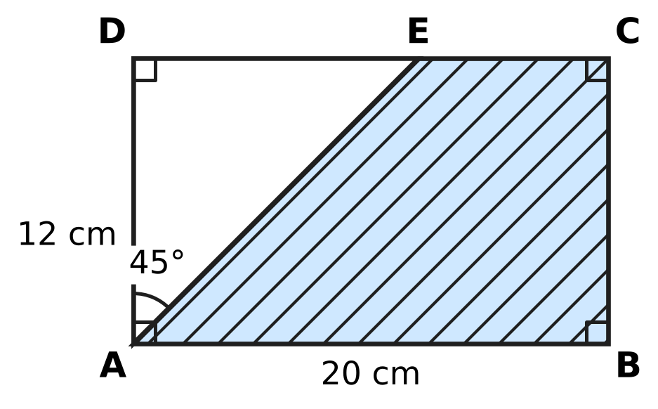
  (A) 192 cm² | (B) 168 cm² | (C) 72 cm² | (D) 96 cm²

Q45. Two towns are 40 km apart. Pallavi cycles from one town towards the other at x km/h. At the same time, Irfan cycles from the other town towards her at a speed 3 km/h less than hers (so x is greater than 3). They have not met after 2 hours. Which expression gives the distance between them, in km, at that time? [4 marks]
(A) 34 − 4x | (B) 46 − 4x | (C) 43 − 2x | (D) 40 − 4x

Answer Sheet AMO Level 1 · Class 6 · Practice Paper 2
Name: | School: | Roll No.:
Shade or tick one circle for each question.
1. Ⓐ Ⓑ Ⓒ Ⓓ | 16. Ⓐ Ⓑ Ⓒ Ⓓ | 31. Ⓐ Ⓑ Ⓒ Ⓓ
2. Ⓐ Ⓑ Ⓒ Ⓓ | 17. Ⓐ Ⓑ Ⓒ Ⓓ | 32. Ⓐ Ⓑ Ⓒ Ⓓ
3. Ⓐ Ⓑ Ⓒ Ⓓ | 18. Ⓐ Ⓑ Ⓒ Ⓓ | 33. Ⓐ Ⓑ Ⓒ Ⓓ
4. Ⓐ Ⓑ Ⓒ Ⓓ | 19. Ⓐ Ⓑ Ⓒ Ⓓ | 34. Ⓐ Ⓑ Ⓒ Ⓓ
5. Ⓐ Ⓑ Ⓒ Ⓓ | 20. Ⓐ Ⓑ Ⓒ Ⓓ | 35. Ⓐ Ⓑ Ⓒ Ⓓ
6. Ⓐ Ⓑ Ⓒ Ⓓ | 21. Ⓐ Ⓑ Ⓒ Ⓓ | 36. Ⓐ Ⓑ Ⓒ Ⓓ
7. Ⓐ Ⓑ Ⓒ Ⓓ | 22. Ⓐ Ⓑ Ⓒ Ⓓ | 37. Ⓐ Ⓑ Ⓒ Ⓓ
8. Ⓐ Ⓑ Ⓒ Ⓓ | 23. Ⓐ Ⓑ Ⓒ Ⓓ | 38. Ⓐ Ⓑ Ⓒ Ⓓ
9. Ⓐ Ⓑ Ⓒ Ⓓ | 24. Ⓐ Ⓑ Ⓒ Ⓓ | 39. Ⓐ Ⓑ Ⓒ Ⓓ
10. Ⓐ Ⓑ Ⓒ Ⓓ | 25. Ⓐ Ⓑ Ⓒ Ⓓ | 40. Ⓐ Ⓑ Ⓒ Ⓓ
11. Ⓐ Ⓑ Ⓒ Ⓓ | 26. Ⓐ Ⓑ Ⓒ Ⓓ | 41. Ⓐ Ⓑ Ⓒ Ⓓ
12. Ⓐ Ⓑ Ⓒ Ⓓ | 27. Ⓐ Ⓑ Ⓒ Ⓓ | 42. Ⓐ Ⓑ Ⓒ Ⓓ
13. Ⓐ Ⓑ Ⓒ Ⓓ | 28. Ⓐ Ⓑ Ⓒ Ⓓ | 43. Ⓐ Ⓑ Ⓒ Ⓓ
14. Ⓐ Ⓑ Ⓒ Ⓓ | 29. Ⓐ Ⓑ Ⓒ Ⓓ | 44. Ⓐ Ⓑ Ⓒ Ⓓ
15. Ⓐ Ⓑ Ⓒ Ⓓ | 30. Ⓐ Ⓑ Ⓒ Ⓓ | 45. Ⓐ Ⓑ Ⓒ Ⓓ
Q41–Q45 are Section II Star Questions (4 marks each).
For the parent or teacher
Section I correct: ______ / 40 × 2 = ______ marks Section II correct: ______ / 5 × 4 = ______ marks
Correct: ______ / 45 Score: ______ / 100
Answer Key and Solutions AMO Level 1 · Class 6 · Practice Paper 2
Quick answers
1 C | 6 C | 11 A | 16 B | 21 B | 26 A | 31 B | 36 D | 41 A
2 D | 7 C | 12 D | 17 D | 22 B | 27 B | 32 C | 37 C | 42 C
3 D | 8 A | 13 D | 18 C | 23 C | 28 A | 33 D | 38 B | 43 D
4 B | 9 D | 14 C | 19 A | 24 C | 29 B | 34 A | 39 A | 44 B
5 A | 10 C | 15 A | 20 D | 25 B | 30 A | 35 D | 40 B | 45 B
Solutions
Q | Part · level | Answer | Why?
1 | Part 1 · Ch1 · Easy | (C) 25,63,041 | In 25,63,041 the places are: 2 ten lakhs, 5 lakhs, 6 ten thousands, 3 thousands, so the 5 stands for 5,00,000.
2 | Part 1 · Ch1 · Easy | (D) 108 | Here 108 = 2 × 2 × 3 × 3 × 3 = 2² × 3³. The others have another prime factor: 102 = 2 × 3 × 17, 126 = 2 × 3² × 7, 150 = 2 × 3 × 5².
3 | Part 1 · Ch1 · Easy | (D) 83 cm | From +35 down to 0 is 35 cm and from 0 down to −48 is 48 cm, so the distance is 35 + 48 = 83 cm.
4 | Part 1 · Ch1 · Medium | (B) 13 | The largest gap is the HCF of 84 and 60, which is 12 m. The 84 m side needs 7 + 1 = 8 posts and the 60 m side 5 + 1 = 6 posts; the corner post is shared, so 8 + 6 − 1 = 13.
5 | Part 1 · Ch1 · Medium | (A) 36 and 60 | Here 36 = 2² × 3² and 60 = 2² × 3 × 5, so HCF = 2² × 3 = 12 and LCM = 2² × 3² × 5 = 180. The other pairs have the same product 2,160, but their HCF is not 12.
6 | Part 2 · Ch2 · Easy | (C) [48 ÷ 4] × (2 + 4) | The values are: [48 ÷ 4] × (2 + 4) = 12 × 6 = 72; 48 ÷ 4 × 2 + 4 = 28; 48 ÷ {(4 × 2) + 4} = 4; 48 ÷ [4 × (2 + 4)] = 2. The greatest is 72.
7 | Part 2 · Ch2 · Easy | (C) −5 | The top row gives the total: −4 + 1 + 0 = −3. In the middle row 3 + (−1) = 2, so the missing number is −3 − 2 = −5.
8 | Part 2 · Ch2 · Easy | (A) (−6) × 50 − (−6) × 3 | Since 47 = 50 − 3, (−6) × 47 = (−6) × 50 − (−6) × 3 by the distributive property (−300 + 18 = −282).
9 | Part 2 · Ch2 · Medium | (D) 4 | First, 4 − (−5) = 9, so (−36) ÷ 9 = −4. Then (−4) × (−3) = 12, and 12 − 8 = 4.
10 | Part 2 · Ch2 · Medium | (C) 7 | The four integers add up to 8 − 15 + 3 − 9 = −13. The fifth is −6 − (−13) = −6 + 13 = 7.
11 | Part 3 · Ch3 · Easy | (A) 0.04, 4%, $\frac{1}{25}$ | In (A), 1/25 = 4/100 = 0.04 = 4%, so all three are equal. In the other sets 0.4 = 40%, 1/5 = 0.2 and 3/5 = 0.6 do not match.
12 | Part 3 · Ch3 · Easy | (D) 0.3, 7/20, 38%, 2/5 | As decimals: 0.3, 7/20 = 0.35, 38% = 0.38, 2/5 = 0.4. So the order is 0.3, 7/20, 38%, 2/5.
13 | Part 3 · Ch3 · Easy | (D) 87.5% | There are 8 equal parts and P is at the 7th mark, so P shows 7/8 = 0.875 = 87.5%.
14 | Part 3 · Ch3 · Medium | (C) 80 m | The 52 m left is 65% of the roll. So 1% is 52 ÷ 65 = 0.8 m, and 100% is 80 m.
15 | Part 3 · Ch3 · Medium | (A) 62.5% | Juice left = 1.2 − 0.45 = 0.75 L. 0.75 ÷ 1.2 = 0.625 = 62.5%.
16 | Part 4 · Ch4 · Easy | (B) 6n − 4 | When n = 4: 6n − 4 = 24 − 4 = 20. The others give n² + 12 = 28, 3n + 4 = 16 and 2(n + 7) = 22.
17 | Part 4 · Ch4 · Easy | (D) 4x + 3 | x + (x + 4) + (2x − 1) = x + x + 2x + 4 − 1 = 4x + 3.
18 | Part 4 · Ch4 · Medium | (C) 12x − 8 | Pairs: 6 on each shelf, minus 4 on the top one, gives 6x − 4 pairs. Each pair is 2 shoes, so 2(6x − 4) = 12x − 8 shoes.
19 | Part 5 · Ch5 · Easy | (A) 110°, 35°, 35° | In (A), 110° + 35° + 35° = 180°, one angle is obtuse and two angles are equal. In the others, 120° + 30° + 40° = 190° is not possible, 50°, 50°, 80° is acute and 100°, 50°, 30° is scalene.
20 | Part 5 · Ch5 · Easy | (D) 110° | The angle sum of a hexagon is (6 − 2) × 180° = 720°. The five marked angles add up to 610°, so x = 720° − 610° = 110°.
21 | Part 5 · Ch5 · Easy | (B) 3 | An obtuse angle is more than 90° and less than 180°. Only 95°, 135° and 91° are obtuse, so there are 3.
22 | Part 5 · Ch5 · Medium | (B) 11 | The third side must be more than 13 − 6 = 7 cm and less than 13 + 6 = 19 cm. The whole numbers 8, 9, …, 18 give 11 lengths.
23 | Part 5 · Ch5 · Medium | (C) 90° | Each angle of a regular hexagon is 720° ÷ 6 = 120°. In triangle ABC, AB = BC, so angles BAC and BCA are (180° − 120°) ÷ 2 = 30° each. So angle FAC = 120° − 30° = 90°.
24 | Part 6 · Ch6 · Easy | (C) 1,20,000 cm³ | Since 2 m = 200 cm, the volume is 200 × 30 × 20 = 1,20,000 cm³.
25 | Part 6 · Ch6 · Easy | (B) 166 cm² | A cuboid has three pairs of equal faces, so the surface area is 2 × (35 + 20 + 28) = 2 × 83 = 166 cm².
26 | Part 6 · Ch6 · Easy | (A) 16 cm by 9 cm | The square has area 12 × 12 = 144 cm², and 16 × 9 = 144 cm². The other three have the same perimeter as the square, 48 cm, but smaller areas.
27 | Part 6 · Ch6 · Medium | (B) 48 cm | Walking round the outline: 16 cm along the bottom, 3 cm up, 3 + 5 + 8 = 16 cm along the tops, 2 + 3 = 5 cm of steps and 8 cm down. That is 16 + 3 + 16 + 5 + 8 = 48 cm.
28 | Part 6 · Ch6 · Medium | (A) 250 cm² | Two cubes have 2 × 6 × 25 = 300 cm² of surface, but the two glued faces (2 × 25 = 50 cm²) are hidden. So the cuboid has 300 − 50 = 250 cm².
29 | Part 7 · Ch8 · Easy | (B) 6 | Making a frequency table: 0 goals 3 matches, 1 goal 5, 2 goals 6, 3 goals 4, 4 goals 2. More than 2 goals means 3 or 4 goals: 4 + 2 = 6 matches.
30 | Part 7 · Ch8 · Medium | (A) 10 | Ball throw and skipping together: 10 + 15 = 25 students. Running has 35 students, and 35 − 25 = 10 more.
31 | Part 8 · Ch9 · Easy | (B) 48 apples and 60 oranges | Here 48 : 60 = (4 × 12) : (5 × 12) = 4 : 5. The others simplify to 5 : 4, 44 : 45 and 5 : 6.
32 | Part 8 · Ch9 · Easy | (C) ₹225 | One train costs 360 ÷ 8 = ₹45, so 5 trains cost 5 × 45 = ₹225.
33 | Part 8 · Ch9 · Easy | (D) 1,800 m | The speed is 600 ÷ 40 = 15 m per second. In 2 minutes = 120 seconds, the bird flies 15 × 120 = 1,800 m.
34 | Part 8 · Ch9 · Medium | (A) 40 | White is 5 parts and red is 2 parts, so 3 parts = 12 beads and 1 part = 4. All 10 parts give 40 beads.
35 | Part 8 · Ch9 · Medium | (D) From T to U | Using leaving and arriving times: P to R 150 km in 150 min = 60 km/h; R to S 55 km in 50 min = 66 km/h; S to T 70 km in 60 min = 70 km/h; T to U 36 km in 30 min = 72 km/h. The greatest is from T to U.
36 | Part 9 · Ch10 · Easy | (D) 66 | The triangular numbers go 1, 3, 6, 10, 15, 21, 28, 36, 45, 55, 66, … (66 = 11 × 12 ÷ 2). The numbers 60, 64 and 72 are not in the list.
37 | Part 9 · Ch10 · Easy | (C) 6:28 pm | From Monday 6:00 pm to the next Monday 6:00 pm is 7 days. The clock gains 7 × 4 = 28 minutes, so it shows 6:28 pm.
38 | Part 9 · Ch10 · Easy | (B) 7 | Undo the steps from the right: 21 × 2 = 42, 42 + 10 = 52, 52 ÷ 4 = 13, 13 − 6 = 7.
39 | Part 9 · Ch10 · Medium | (A) −7 | Each move changes the position by 1, so it switches between even and odd. After 25 moves (an odd number) the position is odd and at most 25 away from 0. Only −7 fits (for example, 9 moves right and 16 moves left).
40 | Part 9 · Ch10 · Medium | (B) the 20th term | Each term is one more than a square number: 2 = 1² + 1, 5 = 2² + 1, 10 = 3² + 1, … Since 401 = 400 + 1 = 20² + 1, it is the 20th term.
41 | Section II · Ch4 + Ch10 · Hard | (A) 12n + 20 | From 5 o'clock to 1 o'clock is 8 hours, and the clock repeats every 12 hours, so the number of hours must be 8 more than a multiple of 12. So 12n + 20 = 12(n + 1) + 8 always works; 4n + 8 fails for n = 1, 12n + 4 always gives 9 o'clock and 20n + 12 gives 5 o'clock when n = 0.
42 | Section II · Ch1 + Ch10 · Hard | (C) 11:42 am | They spray together every LCM(8, 12, 18) = 72 minutes. From the 1st to the 5th time there are 4 gaps, that is 4 × 72 = 288 minutes = 4 h 48 min. So the first time was 4:30 pm − 4 h 48 min = 11:42 am.
43 | Section II · Ch3 + Ch9 · Hard | (D) 360 km | From 8:45 am to 10:15 am is 1 h 30 min, so they drove 60 × 1.5 = 90 km. That is 40% − 15% = 25% of the journey, so the whole journey is 90 × 4 = 360 km.
44 | Section II · Ch5 + Ch6 · Hard | (B) 168 cm² | In triangle ADE, angle D = 90° and angle DAE = 45°, so angle AED = 45° and DE = AD = 12 cm. Triangle ADE has area 12 × 12 ÷ 2 = 72 cm², so the piece left is 20 × 12 − 72 = 168 cm².
45 | Section II · Ch4 + Ch9 · Hard | (B) 46 − 4x | Together they close the gap by x + (x − 3) = 2x − 3 km every hour. In 2 hours that is 2(2x − 3) = 4x − 6 km, so the gap is 40 − (4x − 6) = 46 − 4x km.

