UNLOCK IQ INSTITUTE
Realize Your True Potential
Aryabhatta Maths Olympiad (AMO)
Level 1 — Practice Paper 3
CLASS 6

Questions | 45 multiple-choice questions
Marks | 100
Time | 60 minutes
Section I | 40 questions × 2 marks = 80 marks
Section II | 5 Star Questions × 4 marks = 20 marks
Negative marking | No negative marking
Calculator | Not allowed
Chapters | Number System · Operations · Fractions, Decimals & Percentages · Algebra · Geometry · Mensuration · Data Handling · Applied Mathematics · Mathematical Reasoning

Hello, friend!
• Every question has four answer choices: (A), (B), (C) and (D). Only one is correct.
• Read each question and look at its picture carefully. Then mark your answer on the answer sheet at the end.
• Section I has 40 questions of 2 marks each. Section II has 5 Star Questions of 4 marks each.
• There is no negative marking, so try every question.
• Do not use a calculator. You may do rough work on a separate sheet.
• All figures are not necessarily drawn to scale unless stated.

For parents and teachers
Print or view this paper in colour. Pictures are part of the questions.
Parts follow the AMO syllabus chapters. Chapter 7 is not part of the Class 6 syllabus, so the chapter numbers shown in the Part headings have gaps.
The answer sheet and the answer key are at the end. Remove only the answer key before the child begins.

Name: | School: | Roll No.:

SECTION I 40 questions × 2 marks each
Part 1 — Number System (Syllabus Chapter 1)
Q1. Which number goes in the blank?
52,30,000 = ___ thousands
(A) 30 | (B) 523 | (C) 5,230 | (D) 52,300

Q2. Which number goes in the blank?
2³ × ___ × 11 = 792
(A) 3 | (B) 9 | (C) 12 | (D) 99

Q3. Which of these integers is the greatest?
(A) −11 | (B) −110 | (C) −101 | (D) −1,001

Q4. Vikram has 168 kg of rice and 252 kg of wheat. He fills sacks so that every sack is full and holds the same mass, as large as possible. Rice and wheat are not mixed. How many sacks does he fill?
(A) 5 sacks | (B) 10 sacks | (C) 30 sacks | (D) 84 sacks

Q5. On a number line, −3 is exactly halfway between −13 and ___. Which integer goes in the blank?
(A) 3 | (B) 7 | (C) 10 | (D) 13

Part 2 — Operations & Number Properties (Syllabus Chapter 2)
Q6. For every integer a, a ÷ ___ = −a. Which number goes in the blank?
(A) −1 | (B) 1 | (C) 0 | (D) −a

Q7. Which integer goes in the blank?
(−72) ÷ ___ = 8
(A) −9 | (B) −80 | (C) −576 | (D) 9

Q8. Which of these products is positive?
(A) (−3) × 4 × (−5) × (−1) | (B) 7 × (−8) × (−2) × (−1)
(C) (−2) × (−6) × (−1) | (D) (−9) × (−4) × (−3) × (−1) × 2

Q9. Which sign goes in the blank to make this true?
[(−48) ___ (6 − 18)] × (−2) + 3 = −5
(A) ÷ | (B) + | (C) × | (D) −

Q10. Sneha simplified 50 − [4 × {9 − (6 − 2)}] like this:
Step 1: 50 − [4 × {9 − 4}]
Step 2: 50 − [4 × 9 − 4]
Step 3: 50 − [36 − 4]
Step 4: 50 − 32 = 18
At which step did Sneha first make a mistake?
(A) Step 1 | (B) Step 2 | (C) Step 3 | (D) Step 4

Part 3 — Fractions, Decimals & Percentages (Syllabus Chapter 3)
Q11. Which number goes in the blank?
$\frac{9}{40}$ = ___%
(A) 0.225 | (B) 2.25 | (C) 22.5 | (D) 225

Q12. Which fraction in its lowest terms is equal to 6.25%?
(A) $\frac{5}{8}$ | (B) $\frac{25}{4}$ | (C) $\frac{1}{4}$ | (D) $\frac{1}{16}$

Q13. Which of these is the greatest?
(A) $\frac{18}{25}$ | (B) 0.71 | (C) 0.709 | (D) 69%

Q14. On Monday, 250 students came to the school canteen. Of these students, 60% bought lunch. Of the students who bought lunch, 40% chose rice. How many students chose rice?
(A) 50 | (B) 60 | (C) 100 | (D) 150

Q15. Which number goes in the blank?
___% of 80 is the same as 30% of 120.
(A) 4.5 | (B) 20 | (C) 36 | (D) 45

Part 4 — Algebra (Syllabus Chapter 4)
Q16. Nora has p paper planes. Her brother has 9 fewer than 4 times as many planes as Nora. Which expression gives the number of paper planes her brother has?
(A) 4p − 9 | (B) 9p − 4 | (C) 4(p − 9) | (D) 9 − 4p

Q17. What is the value of 2(a − b) − ab when a = 3 and b = −2?
(A) −4 | (B) 4 | (C) 8 | (D) 16

Q18. A bus ticket for an adult costs ₹x. A ticket for a child costs ₹15 less than an adult ticket. Which expression gives the total cost, in rupees, of tickets for 2 adults and 3 children?
(A) 5x − 30 | (B) 5x − 45 | (C) 2x − 45 | (D) 5x − 15

Part 5 — Geometry (Syllabus Chapter 5)
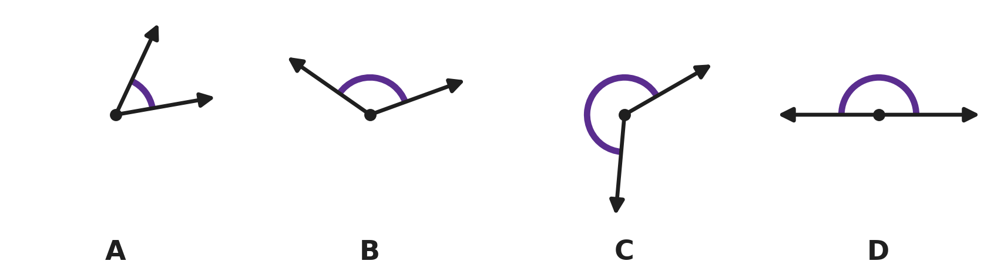
Q19. In each picture, the marked angle is shown by the curved arc. In which picture is the marked angle a reflex angle?
(A) Picture A | (B) Picture B
(C) Picture C | (D) Picture D

Q20. In the figure, four angles meet at the point O. Three of them are 80°, 125° and 60°. Which number goes in the blank?  x = ___° | 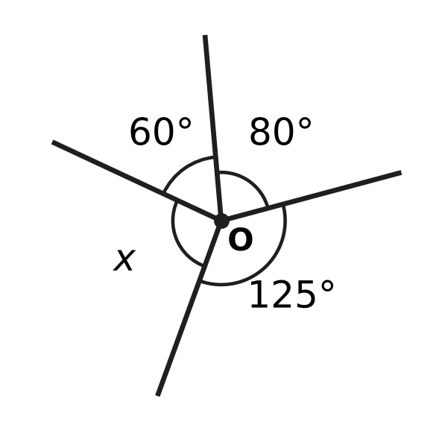
  (A) 90 | (B) 95 | (C) 105 | (D) 265

Q21. A decagon is a polygon with 10 sides. How many diagonals can be drawn from one vertex of a decagon?
(A) 7 | (B) 8 | (C) 10 | (D) 35

Q22. Two angles of a triangle add up to 88°. Which statement about the triangle is correct?
(A) It is acute-angled, and its third angle is 88°.
(B) It is acute-angled, and its third angle is 92°.
(C) It is obtuse-angled, and its third angle is 272°.
(D) It is obtuse-angled, and its third angle is 92°.

Q23. In the figure, ABCD is a square and ABE is an equilateral triangle drawn inside it. E is joined to D. What is the size of the marked angle AED? | 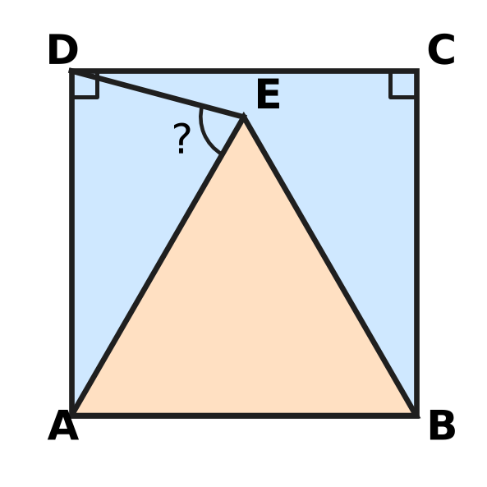
  (A) 30° | (B) 60° | (C) 75° | (D) 105°

Part 6 — Mensuration (Syllabus Chapter 6)
Q24. The figure shows a T-shape made of two rectangles. All its corners are right angles. What is its area? | 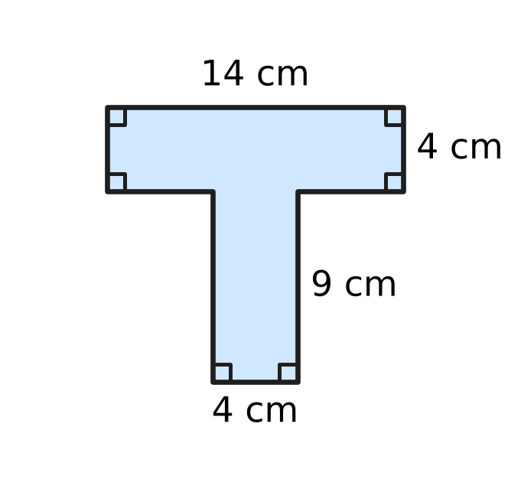
  (A) 54 cm² | (B) 56 cm² | (C) 92 cm² | (D) 182 cm²

Q25. The cuboid in the figure has a volume of 840 cm³. Its length is 14 cm and its breadth is 6 cm. Which number goes in the blank?  Its height is ___ cm. | 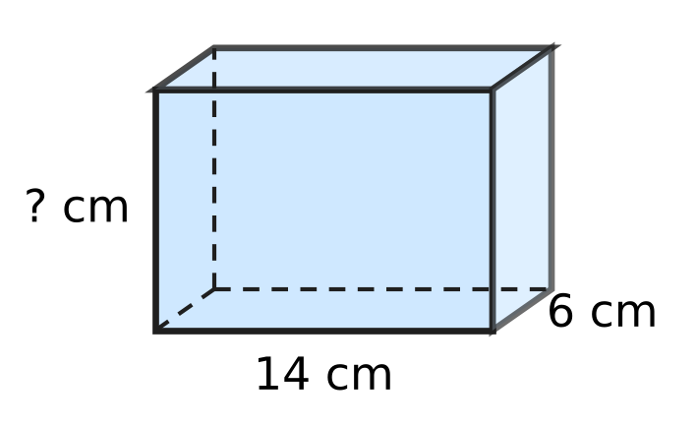
  (A) 10 | (B) 42 | (C) 60 | (D) 140

Q26. The closed box in the figure is a cuboid 10 cm long, 8 cm wide and 5 cm high. How much paper is needed to cover all its faces exactly, with no overlap? | 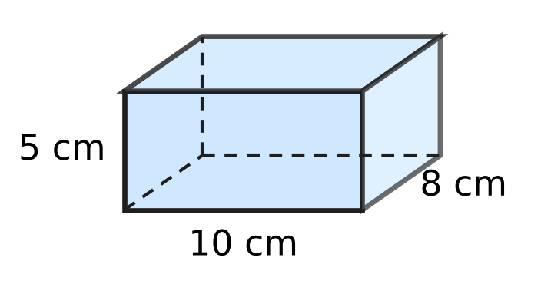
  (A) 170 cm² | (B) 180 cm² | (C) 340 cm² | (D) 400 cm²

Q27. A rectangle 15 cm long and 8 cm high has a notch cut out of its top edge, as shown. The notch is 5 cm wide, and all the corners are right angles. The perimeter of the new shape is 58 cm. How deep is the notch marked in the figure? | 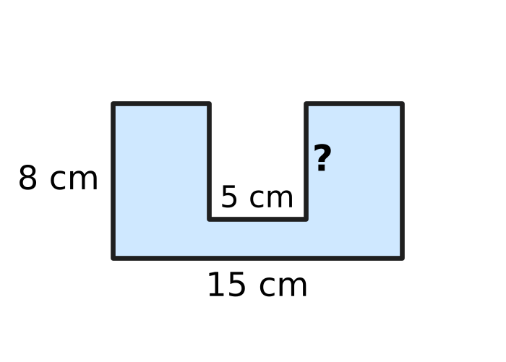
  (A) 3 cm | (B) 3.5 cm | (C) 6 cm | (D) 12 cm

Q28. In a workshop that makes clay pots, the water tank in the figure is a cuboid 1.2 m long, 50 cm wide and 40 cm deep. It is filled to the top with buckets that hold 12 litres each. How many buckets are needed? (1,000 cm³ = 1 litre) | 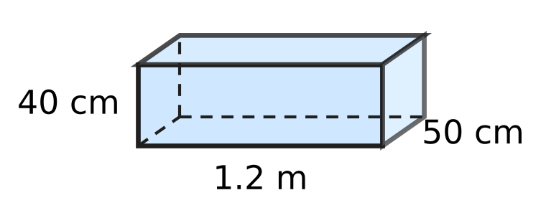
  (A) 2 | (B) 20 | (C) 200 | (D) 240

Part 7 — Data Handling, Statistics & Probability (Syllabus Chapter 8)
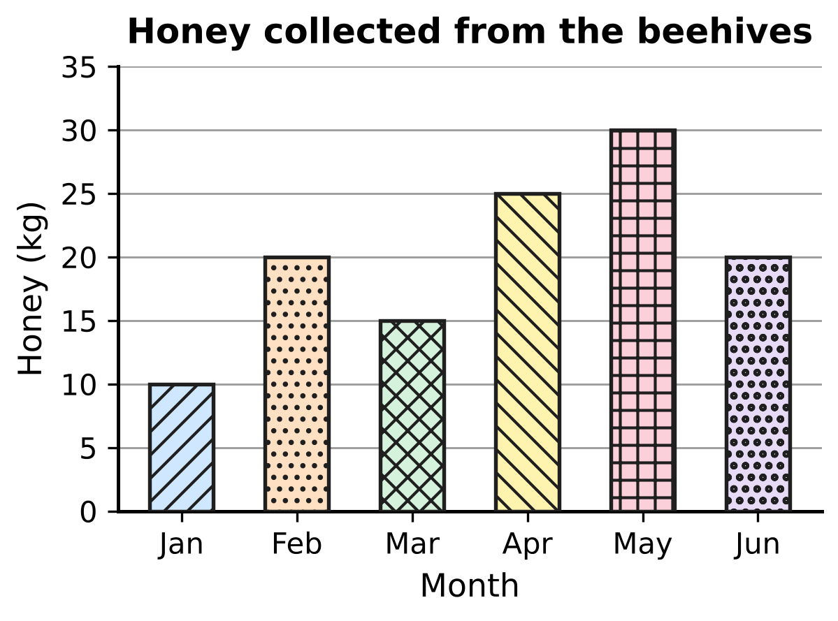
Q29. The bar graph shows how much honey a beekeeper collected from her beehives in six months. In how many of these months did she collect MORE than 20 kg of honey?
(A) 1 | (B) 2 | (C) 3 | (D) 4

Letters delivered to 30 houses on one day
Number of letters received | 0 | 1 | 2 | 3 | 4
Number of houses | 4 | 9 | 8 | 6 | 3

Q30. Sakshi works at the post office. She made this frequency table of the letters delivered to 30 houses on one day. How many letters were delivered to these houses in all?
(A) 10 | (B) 30 | (C) 55 | (D) 59

Part 8 — Applied Mathematics (Syllabus Chapter 9)
Q31. Which number goes in the blank so that the two ratios are equal?
3 : 8 = ___ : 56
(A) 7 | (B) 21 | (C) 24 | (D) 51

Q32. A boat leaves the harbour at 9:40 am. It travels 30 km to an island at a steady speed of 24 km/h. At what time does it reach the island?
(A) 10:55 am | (B) 11:05 am | (C) 10:28 am | (D) 11:10 am

Q33. Roshni and Kavin open their shared piggy bank and find ₹84. They share it in the ratio 3 : 4 (Roshni : Kavin). How much does Kavin get?
(A) ₹12 | (B) ₹21 | (C) ₹36 | (D) ₹48

Q34. In a 4 × 100 m relay race on the school running track, four runners each run 100 m, one after another. They take 12 s, 13 s, 11 s and 14 s. What is the average speed of the team for the whole race?
(A) 0.125 m/s | (B) 2 m/s
(C) 8 m/s | (D) 12.5 m/s

Q35. For three numbers x, y and z, x : y = 2 : 3 and y : z = 4 : 5. What is x : z?
(A) 2 : 5 | (B) 5 : 6 | (C) 3 : 10 | (D) 8 : 15

Part 9 — Mathematical Reasoning & Problem-Solving (Syllabus Chapter 10)
Q36. The jumps between the numbers in this pattern grow in the same way each time. Which number goes in the blank?
___, 11, 18, 27, 38, 51
(A) 2 | (B) 4 | (C) 5 | (D) 6

Q37. A digital clock uses the 24-hour system. It now shows 03:15. Which time goes in the blank?
Nine hours earlier, the clock showed ___.
(A) 15:15 | (B) 18:15 | (C) 12:15 | (D) 06:15

Q38. In a board game, Daksh rolls an ordinary die, numbered 1 to 6, four times. He multiplies the four numbers he rolls, and the product is an odd number. Which of these numbers can NOT be one of his four rolls?
(A) 1 | (B) 3 | (C) 5 | (D) 6

Q39. Look at this pattern:
3, 20, 6, 17, 12, 14, 24, 11, …
The terms in the 1st, 3rd, 5th, … places follow one rule. The terms in the 2nd, 4th, 6th, … places follow another rule. Which term is the first negative number?
(A) the 8th term | (B) the 14th term
(C) the 15th term | (D) the 16th term

Q40. Ella and Ken have some picture cards. First, Ella gives Ken as many cards as Ken already has. Then Ken gives Ella as many cards as Ella has at that moment. Now they each have 24 cards. How many cards did Ella have at the start?
(A) 12 | (B) 18 | (C) 30 | (D) 36

SECTION II — Star Questions 5 questions × 4 marks each
Q41. The nth term of a pattern is 6n − 1, for n = 1, 2, 3, … (so the pattern is 5, 11, 17, …). Lalit picks two DIFFERENT terms of the pattern and adds them. Which of these could be his total? [4 marks]
(A) 10 | (B) 57 | (C) 58 | (D) 60

Q42. In how many ways can 50 be written as the sum of three DIFFERENT prime numbers? (The order does not matter: 2 + 5 + 43 and 43 + 5 + 2 count as the same way.) [4 marks]
(A) 0 | (B) 4 | (C) 5 | (D) 10

Q43. On a museum visit day, 40% of all the visitors were children. Among the children, the ratio of boys to girls was 3 : 5. There were 36 more girls than boys. How many visitors were there in all? [4 marks]
(A) 144 | (B) 720 | (C) 90 | (D) 360

Q44. A piece of wire is bent to make a regular polygon with sides of 4 cm. All the interior angles of the polygon add up to 2,340°. The wire is then straightened and bent to make a square, using all of it. What is the area of the square? [4 marks]
(A) 3,600 cm² | (B) 225 cm²
(C) 900 cm² | (D) 169 cm²

Q45. Sahil runs for t minutes at 12 km/h. Then he walks for twice as long at 3 km/h. Which expression gives the total distance he covers, in metres? [4 marks]
(A) 300t | (B) 18t | (C) 15t | (D) 250t

Answer Sheet AMO Level 1 · Class 6 · Practice Paper 3
Name: | School: | Roll No.:
Shade or tick one circle for each question.
1. Ⓐ Ⓑ Ⓒ Ⓓ | 16. Ⓐ Ⓑ Ⓒ Ⓓ | 31. Ⓐ Ⓑ Ⓒ Ⓓ
2. Ⓐ Ⓑ Ⓒ Ⓓ | 17. Ⓐ Ⓑ Ⓒ Ⓓ | 32. Ⓐ Ⓑ Ⓒ Ⓓ
3. Ⓐ Ⓑ Ⓒ Ⓓ | 18. Ⓐ Ⓑ Ⓒ Ⓓ | 33. Ⓐ Ⓑ Ⓒ Ⓓ
4. Ⓐ Ⓑ Ⓒ Ⓓ | 19. Ⓐ Ⓑ Ⓒ Ⓓ | 34. Ⓐ Ⓑ Ⓒ Ⓓ
5. Ⓐ Ⓑ Ⓒ Ⓓ | 20. Ⓐ Ⓑ Ⓒ Ⓓ | 35. Ⓐ Ⓑ Ⓒ Ⓓ
6. Ⓐ Ⓑ Ⓒ Ⓓ | 21. Ⓐ Ⓑ Ⓒ Ⓓ | 36. Ⓐ Ⓑ Ⓒ Ⓓ
7. Ⓐ Ⓑ Ⓒ Ⓓ | 22. Ⓐ Ⓑ Ⓒ Ⓓ | 37. Ⓐ Ⓑ Ⓒ Ⓓ
8. Ⓐ Ⓑ Ⓒ Ⓓ | 23. Ⓐ Ⓑ Ⓒ Ⓓ | 38. Ⓐ Ⓑ Ⓒ Ⓓ
9. Ⓐ Ⓑ Ⓒ Ⓓ | 24. Ⓐ Ⓑ Ⓒ Ⓓ | 39. Ⓐ Ⓑ Ⓒ Ⓓ
10. Ⓐ Ⓑ Ⓒ Ⓓ | 25. Ⓐ Ⓑ Ⓒ Ⓓ | 40. Ⓐ Ⓑ Ⓒ Ⓓ
11. Ⓐ Ⓑ Ⓒ Ⓓ | 26. Ⓐ Ⓑ Ⓒ Ⓓ | 41. Ⓐ Ⓑ Ⓒ Ⓓ
12. Ⓐ Ⓑ Ⓒ Ⓓ | 27. Ⓐ Ⓑ Ⓒ Ⓓ | 42. Ⓐ Ⓑ Ⓒ Ⓓ
13. Ⓐ Ⓑ Ⓒ Ⓓ | 28. Ⓐ Ⓑ Ⓒ Ⓓ | 43. Ⓐ Ⓑ Ⓒ Ⓓ
14. Ⓐ Ⓑ Ⓒ Ⓓ | 29. Ⓐ Ⓑ Ⓒ Ⓓ | 44. Ⓐ Ⓑ Ⓒ Ⓓ
15. Ⓐ Ⓑ Ⓒ Ⓓ | 30. Ⓐ Ⓑ Ⓒ Ⓓ | 45. Ⓐ Ⓑ Ⓒ Ⓓ
Q41–Q45 are Section II Star Questions (4 marks each).
For the parent or teacher
Section I correct: ______ / 40 × 2 = ______ marks Section II correct: ______ / 5 × 4 = ______ marks
Correct: ______ / 45 Score: ______ / 100
Answer Key and Solutions AMO Level 1 · Class 6 · Practice Paper 3
Quick answers
1 C | 6 A | 11 C | 16 A | 21 A | 26 C | 31 B | 36 D | 41 C
2 B | 7 A | 12 D | 17 D | 22 D | 27 C | 32 A | 37 B | 42 C
3 A | 8 D | 13 A | 18 B | 23 C | 28 B | 33 D | 38 D | 43 D
4 A | 9 A | 14 B | 19 C | 24 C | 29 B | 34 C | 39 D | 44 B
5 B | 10 B | 15 D | 20 B | 25 A | 30 C | 35 D | 40 C | 45 A
Solutions
Q | Part · level | Answer | Why?
1 | Part 1 · Ch1 · Easy | (C) 5,230 | 1 thousand = 1,000, so 52,30,000 ÷ 1,000 = 5,230. (52 lakh = 5,200 thousands, and 30 thousands more.)
2 | Part 1 · Ch1 · Easy | (B) 9 | 792 = 2 × 2 × 2 × 3 × 3 × 11 = 2³ × 3² × 11, so the blank is 3² = 9 (check: 8 × 9 × 11 = 792).
3 | Part 1 · Ch1 · Easy | (A) −11 | On the number line, −11 lies to the right of −101, −110 and −1,001, because it is closest to 0. So −11 is the greatest.
4 | Part 1 · Ch1 · Medium | (A) 5 sacks | The largest sack size is the HCF of 168 and 252, which is 84 kg. Rice fills 168 ÷ 84 = 2 sacks and wheat 252 ÷ 84 = 3 sacks, so 5 sacks.
5 | Part 1 · Ch1 · Medium | (B) 7 | From −13 to −3 is 10 steps to the right. Going 10 more steps to the right from −3 reaches 7.
6 | Part 2 · Ch2 · Easy | (A) −1 | Dividing by −1 changes only the sign: for example 7 ÷ (−1) = −7 and (−5) ÷ (−1) = 5.
7 | Part 2 · Ch2 · Easy | (A) −9 | The divisor must be negative so that the answer is positive: (−72) ÷ (−9) = 8.
8 | Part 2 · Ch2 · Easy | (D) (−9) × (−4) × (−3) × (−1) × 2 | A product is positive when the number of negative factors is even. Only (−9) × (−4) × (−3) × (−1) × 2 has four negative factors; its value is 216.
9 | Part 2 · Ch2 · Medium | (A) ÷ | 6 − 18 = −12. With ÷: (−48) ÷ (−12) = 4, then 4 × (−2) + 3 = −8 + 3 = −5.
10 | Part 2 · Ch2 · Medium | (B) Step 2 | In Step 2 she removed the curly brackets before working out 9 − 4 = 5. Correctly: 50 − [4 × 5] = 50 − 20 = 30.
11 | Part 3 · Ch3 · Easy | (C) 22.5 | $\frac{9}{40}$ = 9 ÷ 40 = 0.225, and 0.225 × 100 = 22.5, so the blank is 22.5.
12 | Part 3 · Ch3 · Easy | (D) $\frac{1}{16}$ | 6.25% = 6.25 ÷ 100 = 0.0625, which is 625 ten-thousandths. Dividing 625 and 10,000 by 625 gives $\frac{1}{16}$.
13 | Part 3 · Ch3 · Easy | (A) $\frac{18}{25}$ | As decimals: 0.71, 0.69, $\frac{18}{25}$ = 0.72 and 0.709. The greatest is 0.72, which is $\frac{18}{25}$.
14 | Part 3 · Ch3 · Medium | (B) 60 | Lunch: 60% of 250 = 150 students. Rice: 40% of 150 = 60 students.
15 | Part 3 · Ch3 · Medium | (D) 45 | First, 30% of 120 = 36. Then 36 out of 80 = 36 ÷ 80 × 100 = 45%, so the blank is 45.
16 | Part 4 · Ch4 · Easy | (A) 4p − 9 | Four times as many as Nora is 4p; 9 fewer than that is 4p − 9.
17 | Part 4 · Ch4 · Easy | (D) 16 | a − b = 3 − (−2) = 5, so 2(a − b) = 10. ab = 3 × (−2) = −6, so −ab = 6. The value is 10 + 6 = 16.
18 | Part 4 · Ch4 · Medium | (B) 5x − 45 | Adults: 2x. Children: 3(x − 15) = 3x − 45. Total: 2x + 3x − 45 = 5x − 45.
19 | Part 5 · Ch5 · Easy | (C) Picture C | A reflex angle is more than 180° and less than 360°. Only the arc in Picture C goes more than half-way round the point.
20 | Part 5 · Ch5 · Easy | (B) 95 | Angles around a point add up to 360°. 80 + 125 + 60 = 265, so x = 360 − 265 = 95.
21 | Part 5 · Ch5 · Easy | (A) 7 | From one vertex, no diagonal goes to the vertex itself or to its 2 neighbours, so 10 − 3 = 7 diagonals.
22 | Part 5 · Ch5 · Medium | (D) It is obtuse-angled, and its third angle is 92°. | The third angle is 180° − 88° = 92°. An angle between 90° and 180° is obtuse, so the triangle is obtuse-angled.
23 | Part 5 · Ch5 · Medium | (C) 75° | Angle DAE = 90° − 60° = 30°. AD = AB = AE, so triangle ADE is isosceles and angle AED = (180° − 30°) ÷ 2 = 75°.
24 | Part 6 · Ch6 · Easy | (C) 92 cm² | Top rectangle: 14 × 4 = 56 cm². Lower rectangle: 4 × 9 = 36 cm². Total: 56 + 36 = 92 cm².
25 | Part 6 · Ch6 · Easy | (A) 10 | Volume = length × breadth × height, so height = 840 ÷ (14 × 6) = 840 ÷ 84 = 10 cm.
26 | Part 6 · Ch6 · Easy | (C) 340 cm² | Surface area = 2 × (10 × 8 + 8 × 5 + 10 × 5) = 2 × (80 + 40 + 50) = 2 × 170 = 340 cm².
27 | Part 6 · Ch6 · Medium | (C) 6 cm | The floor of the notch makes up for the 5 cm taken from the top edge, so the perimeter is 2 × (15 + 8) = 46 cm plus the two sides of the notch. 58 − 46 = 12, so each side of the notch is 12 ÷ 2 = 6 cm deep.
28 | Part 6 · Ch6 · Medium | (B) 20 | Volume = 120 × 50 × 40 = 2,40,000 cm³ = 240 litres. 240 ÷ 12 = 20 buckets.
29 | Part 7 · Ch8 · Easy | (B) 2 | Only April (25 kg) and May (30 kg) are more than 20 kg. February and June are exactly 20 kg, which is not more than 20 kg.
30 | Part 7 · Ch8 · Medium | (C) 55 | Total = 0 × 4 + 1 × 9 + 2 × 8 + 3 × 6 + 4 × 3 = 0 + 9 + 16 + 18 + 12 = 55 letters.
31 | Part 8 · Ch9 · Easy | (B) 21 | Since 56 = 8 × 7, the first term must also be multiplied by 7: 3 × 7 = 21.
32 | Part 8 · Ch9 · Easy | (A) 10:55 am | Time = 30 ÷ 24 = 1.25 hours = 1 hour 15 minutes. 9:40 am + 1 hour 15 minutes = 10:55 am.
33 | Part 8 · Ch9 · Easy | (D) ₹48 | 3 + 4 = 7 parts, so one part = 84 ÷ 7 = ₹12. Kavin gets 4 parts = 4 × 12 = ₹48.
34 | Part 8 · Ch9 · Medium | (C) 8 m/s | Total distance = 400 m and total time = 12 + 13 + 11 + 14 = 50 s. Average speed = 400 ÷ 50 = 8 m/s.
35 | Part 8 · Ch9 · Medium | (D) 8 : 15 | Make the y parts equal: x : y = 8 : 12 and y : z = 12 : 15. So x : y : z = 8 : 12 : 15 and x : z = 8 : 15.
36 | Part 9 · Ch10 · Easy | (D) 6 | The jumps are 7, 9, 11, 13, growing by 2. So the jump before 7 is 5, and 11 − 5 = 6.
37 | Part 9 · Ch10 · Easy | (B) 18:15 | Going back 3 h 15 min from 03:15 reaches midnight (00:00). The other 5 h 45 min go back from 24:00, and 24:00 − 5 h 45 min = 18:15.
38 | Part 9 · Ch10 · Easy | (D) 6 | If even one roll were even, the product would be even. So every roll is odd: 1, 3 or 5, and 6 can never be rolled.
39 | Part 9 · Ch10 · Medium | (D) the 16th term | Odd places double (3, 6, 12, 24, …) and stay positive. Even places go down by 3: 20, 17, 14, 11, 8, 5, 2, −1. The number −1 is the 8th even-place term, which is the 16th term.
40 | Part 9 · Ch10 · Medium | (C) 30 | Undo the last step: Ella had 24 ÷ 2 = 12 and Ken had 24 + 12 = 36. Undo the first step: Ken had 36 ÷ 2 = 18 and Ella had 12 + 18 = 30.
41 | Section II · Ch4 + Ch10 · Hard | (C) 58 | Two terms add to (6m − 1) + (6n − 1) = 6(m + n) − 2, an even number 2 less than a multiple of 6, with m + n at least 3. 58 = 6 × 10 − 2 works, for example 17 + 41.
42 | Section II · Ch1 + Ch10 · Hard | (C) 5 | Three odd primes add to an odd number, so 2 must be one of them. The other two are different odd primes adding to 48: 5 + 43, 7 + 41, 11 + 37, 17 + 31, 19 + 29. The other odd pairs fail: 3 + 45, 13 + 35 and 23 + 25 each use a number that is not prime. That is 5 ways.
43 | Section II · Ch3 + Ch9 · Hard | (D) 360 | Girls − boys = 5 − 3 = 2 parts = 36, so one part = 18 and the children are 8 × 18 = 144. These 144 children are 40% of the visitors, so the total is 144 ÷ 40 × 100 = 360.
44 | Section II · Ch5 + Ch6 · Hard | (B) 225 cm² | The angle sum is (number of sides − 2) × 180°, and 2,340 ÷ 180 = 13, so the polygon has 13 + 2 = 15 sides. The wire is 15 × 4 = 60 cm long. The square has side 60 ÷ 4 = 15 cm and area 15 × 15 = 225 cm².
45 | Section II · Ch4 + Ch9 · Hard | (A) 300t | A speed of 12 km/h = 12,000 m in 60 min = 200 m per minute, and 3 km/h = 50 m per minute. Distance = 200 × t + 50 × 2t = 200t + 100t = 300t metres.

