UNLOCK IQ INSTITUTE
Realize Your True Potential
Aryabhatta Maths Olympiad (AMO)
Level 1 — Practice Paper 4
CLASS 6

Questions | 45 multiple-choice questions
Marks | 100
Time | 60 minutes
Section I | 40 questions × 2 marks = 80 marks
Section II | 5 Star Questions × 4 marks = 20 marks
Negative marking | No negative marking
Calculator | Not allowed
Chapters | Number System · Operations · Fractions, Decimals & Percentages · Algebra · Geometry · Mensuration · Data Handling · Applied Mathematics · Mathematical Reasoning

Hello, friend!
• Every question has four answer choices: (A), (B), (C) and (D). Only one is correct.
• Read each question and look at its picture carefully. Then mark your answer on the answer sheet at the end.
• Section I has 40 questions of 2 marks each. Section II has 5 Star Questions of 4 marks each.
• There is no negative marking, so try every question.
• Do not use a calculator. You may do rough work on a separate sheet.
• All figures are not necessarily drawn to scale unless stated.

For parents and teachers
Print or view this paper in colour. Pictures are part of the questions.
Parts follow the AMO syllabus chapters. Chapter 7 is not part of the Class 6 syllabus, so the chapter numbers shown in the Part headings have gaps.
The answer sheet and the answer key are at the end. Remove only the answer key before the child begins.

Name: | School: | Roll No.:

SECTION I 40 questions × 2 marks each
Part 1 — Number System (Syllabus Chapter 1)
Q1. In the Indian system, the digit 2 in 62,50,000 is in the lakhs place. The same number is now written in the international system. In which place is the digit 2 now?
(A) Millions | (B) Lakhs
(C) Ten thousands | (D) Hundred thousands

Q2. Which of these numbers is divisible by 11?
(A) 5,37,284 | (B) 2,54,812 | (C) 3,58,477 | (D) 3,11,452

Q3. Which integer is 10 less than −95?
(A) 105 | (B) −85 | (C) 85 | (D) −105

Q4. Two gear wheels turn together, tooth against tooth. The smaller wheel has 24 teeth and the larger wheel has 36 teeth. One tooth on each wheel is marked, and the two marked teeth are touching now. How many full turns does the smaller wheel make before the two marked teeth touch again for the first time?
(A) 2 turns | (B) 3 turns | (C) 12 turns | (D) 72 turns

Q5. Neel uses each of the seven digits 6, 0, 3, 9, 0, 4, 7 exactly once to make a 7-digit number. He wants the smallest 7-digit number possible. Which number should he make?
(A) 30,04,679 | (B) 30,04,697
(C) 34,67,900 | (D) 97,64,300

Part 2 — Operations & Number Properties (Syllabus Chapter 2)
Q6. What is the additive inverse of (−7) + 3?
(A) −10 | (B) −4 | (C) 4 | (D) 10

Q7. Which of these divisions does NOT give an integer as the answer?
(A) (−45) ÷ (−6) | (B) 72 ÷ (−24)
(C) 0 ÷ (−9) | (D) (−56) ÷ 8

Q8. Which of these has the same value as 15 − (−9)?
(A) 9 − 15 | (B) 15 + 9 | (C) 15 − 9 | (D) −15 − 9

Q9. A science laboratory freezer shows −4°C. It is switched to a colder setting. After that, its temperature falls by 3°C every hour. What does it show after 5 hours?
(A) −15°C | (B) 11°C | (C) −35°C | (D) −19°C

Q10. By how much is 60 ÷ [10 − (2 × 3)] greater than 60 ÷ 10 − 2 × 3?
(A) −15 | (B) 0 | (C) 3 | (D) 15

Part 3 — Fractions, Decimals & Percentages (Syllabus Chapter 3)
Q11. A box in the art class has 25 crayons. Of these, 14 are blunt. Which decimal shows the fraction of the crayons that are blunt?
(A) 0.14 | (B) 0.44 | (C) 0.56 | (D) 5.6

Q12. Each fraction is written as a decimal. Which one has exactly three decimal places?
(A) $\frac{11}{40}$ | (B) $\frac{7}{25}$ | (C) $\frac{2}{3}$ | (D) $\frac{13}{20}$

Q13. There were 75 students on a school trip. Of these, 27 wore caps. What percentage of the students wore caps?
(A) 27% | (B) 0.36% | (C) 64% | (D) 36%

Badminton matches this season
Player | Matches played | Matches won
Komal | 20 | 13
Sanjay | 25 | 17
Rupa | 50 | 33
Vivek | 30 | 21

Q14. The table shows the badminton matches played and won by four players. Who won the greatest fraction of the matches they played?
(A) Vivek | (B) Sanjay | (C) Komal | (D) Rupa

Q15. For a cake recipe, Nidhi mixes 250 g of flour, 150 g of sugar and 100 g of butter. Nothing else goes into the mixture. What percentage of the mixture is sugar?
(A) 15% | (B) 20% | (C) 30% | (D) 60%

Part 4 — Algebra (Syllabus Chapter 4)
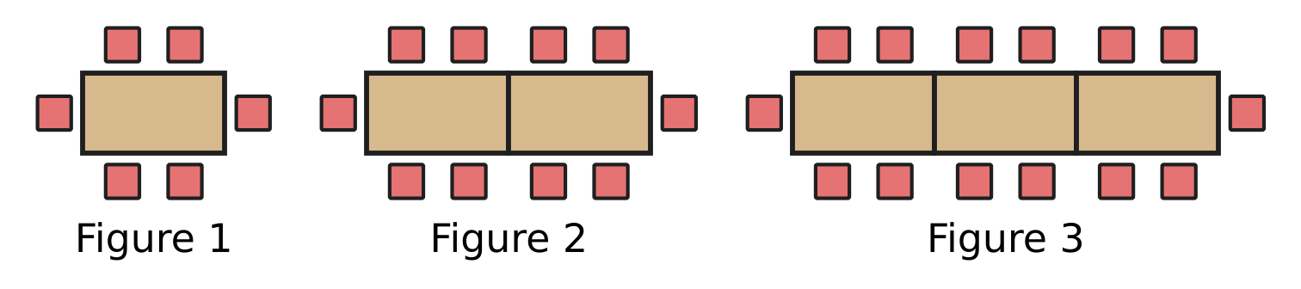
Q16. The pictures show tables joined end to end, with chairs placed round them. Each new figure has one more table, joined on the right. Which expression gives the number of chairs round n tables?
(A) 4n | (B) 4n + 2 | (C) 6n | (D) 4n + 4

Q17. Indu has a wooden plank that is L cm long. She cuts off 3 pieces, each 45 cm long, to make shelves. Which expression gives the length of the plank that is left, in cm?
(A) 3L − 45 | (B) L − 45 | (C) 135 − L | (D) L − 135

Q18. At the river jetty, hiring a ferry boat for h hours costs ₹(150 + 80h). Imran hires a boat for 3 hours. Chitra hires a boat for 5 hours. How much more does Chitra pay than Imran?
(A) ₹160 | (B) ₹310 | (C) ₹550 | (D) ₹940

Part 5 — Geometry (Syllabus Chapter 5)
Q19. The picture shows an open umbrella seen from directly above. Its 10 ribs meet at the centre, and the angles between neighbouring ribs are all equal. Find the size of the angle marked "?". | 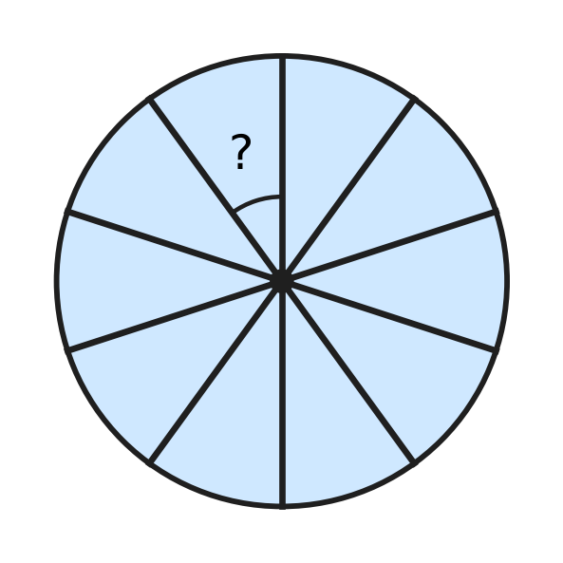
  (A) 40° | (B) 36° | (C) 30° | (D) 18°

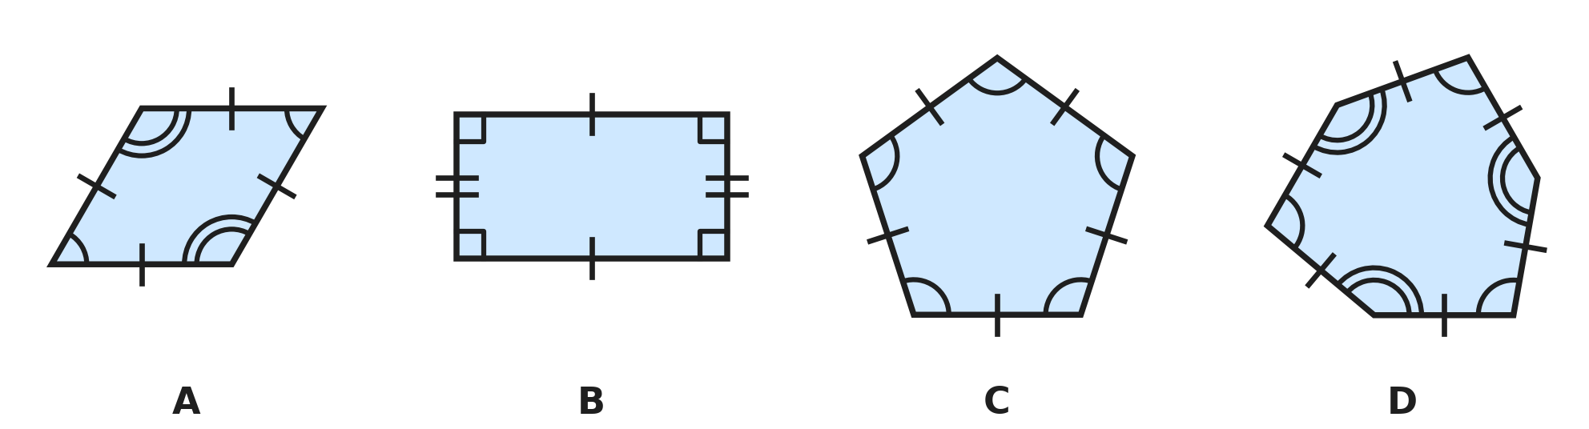
Q20. In each picture, sides with the same number of tick marks are equal, and angles with the same number of arcs are equal. Marks that differ show sides or angles that are not equal. Which picture shows a REGULAR polygon?
(A) Picture A | (B) Picture B
(C) Picture C | (D) Picture D

Q21. In the figure, ABD and BCD are equilateral triangles that share the side BD. Together they make the shape ABCD. Find the size of angle ABC, which is marked "?". | 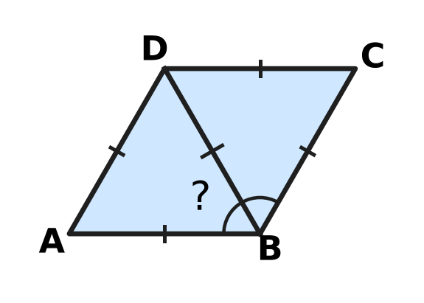
  (A) 120° | (B) 240° | (C) 60° | (D) 90°

Q22. In triangle ABC, AB = AC and angle BAC = 50°. BE is drawn from B, perpendicular to AC, as shown. Find the size of angle EBC, which is marked "?". | 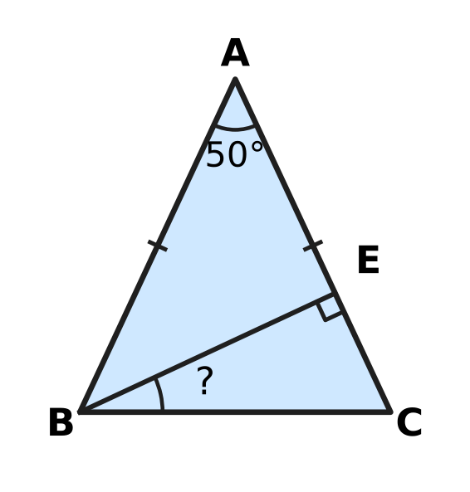
  (A) 25° | (B) 40° | (C) 50° | (D) 65°

Q23. The figure shows a regular pentagon with an equilateral triangle drawn on one of its sides, outside it. What is the size of the reflex angle marked "?" at the point P? | 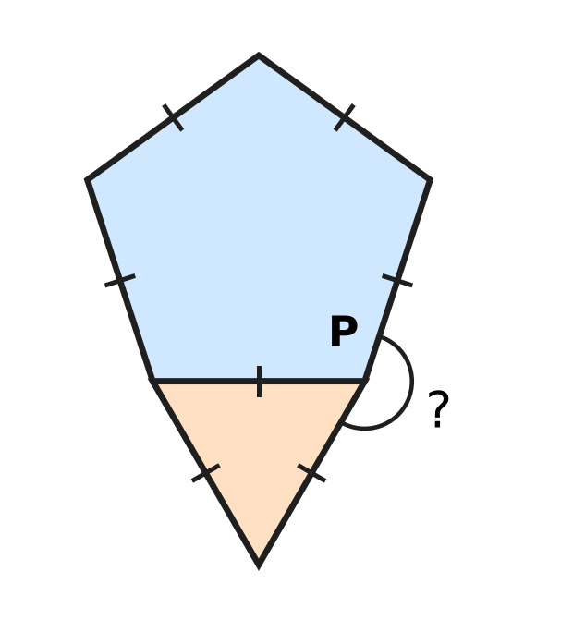
  (A) 132° | (B) 168° | (C) 192° | (D) 252°

Part 6 — Mensuration (Syllabus Chapter 6)
Q24. The shaded shape is drawn on a grid of 1 cm squares. What is the perimeter of the shaded shape? | 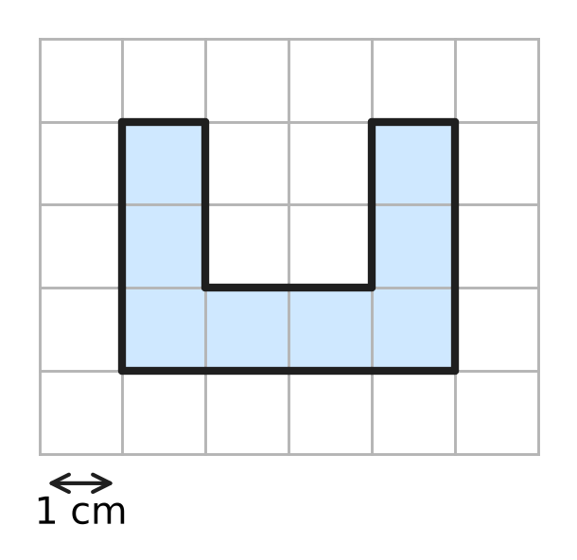
  (A) 8 cm | (B) 14 cm | (C) 16 cm | (D) 18 cm

Q25. At a bookshop, a gift box is a cuboid 30 cm long, 20 cm wide and 10 cm high. Ribbon is stuck along all 12 edges of the box, with no overlap. How much ribbon is used? | 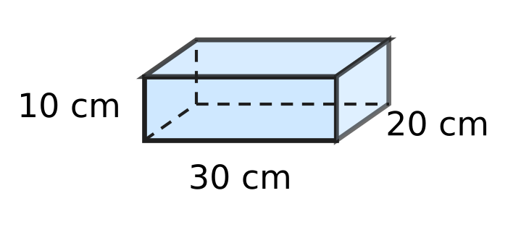
  (A) 200 cm | (B) 360 cm | (C) 60 cm | (D) 240 cm

Inside measurements of four boxes
Box | Length (cm) | Width (cm) | Height (cm)
Box K | 10 | 10 | 10
Box L | 12 | 10 | 9
Box M | 16 | 9 | 7
Box N | 20 | 6 | 8

Q26. The table gives the inside measurements of four cuboid boxes. Which box has the greatest volume?
(A) Box K | (B) Box L | (C) Box M | (D) Box N

Q27. Six equal square tiles are placed in 2 rows of 3, as shown, to make a rectangle. The perimeter of the rectangle is 60 cm. What is the area of the rectangle? | 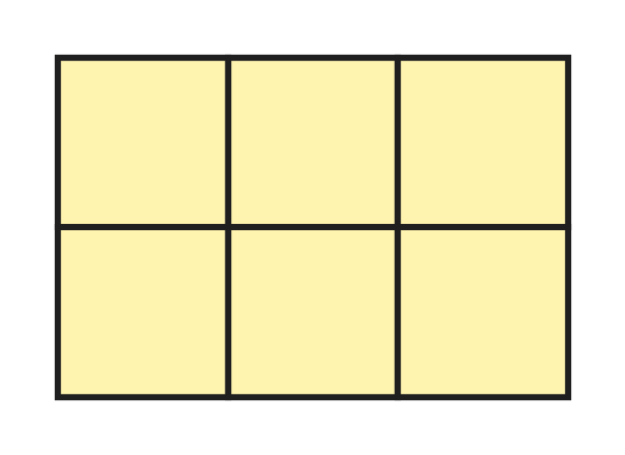
  (A) 36 cm² | (B) 216 cm² | (C) 225 cm² | (D) 864 cm²

Q28. The figure shows a room shaped like a cuboid, 6 m long, 4 m wide and 3 m high. Only its four walls are painted; the floor and the ceiling are not. Ignore doors and windows. What area is painted? | 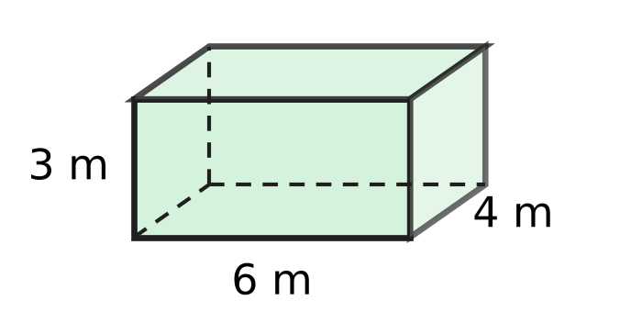
  (A) 30 m² | (B) 60 m² | (C) 84 m² | (D) 108 m²

Part 7 — Data Handling, Statistics & Probability (Syllabus Chapter 8)
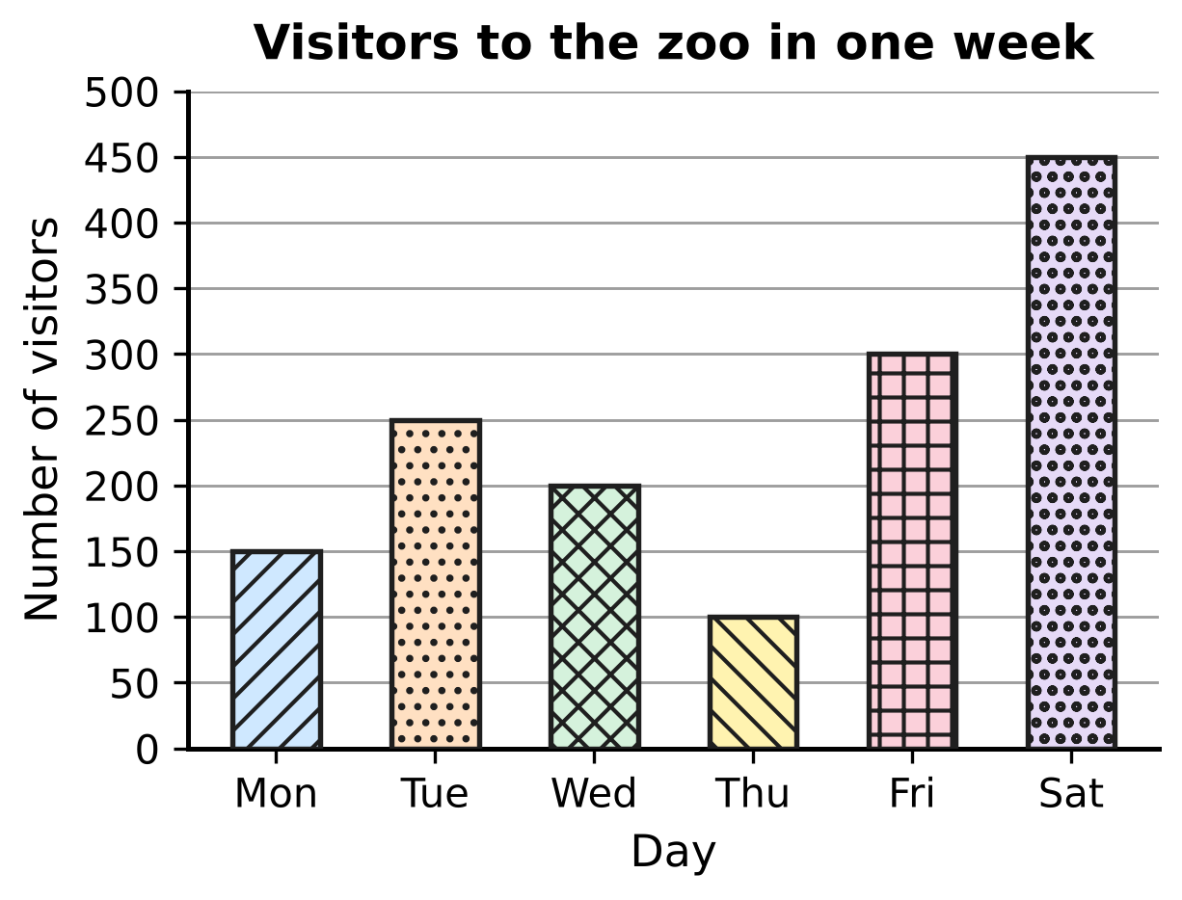
Q29. The bar graph shows the number of visitors to a zoo on six days of one week. On which day were there exactly twice as many visitors as on Monday?
(A) Friday | (B) Saturday
(C) Wednesday | (D) Tuesday

Shoe sizes of the students in a class
Shoe size | 3 | 4 | 5 | 6 | 7
Number of students | 5 | 7 | 10 | 8 | 3

Q30. The table shows the shoe sizes of the students in a class. How many students wear a size larger than the size worn by the most students?
(A) 10 | (B) 11 | (C) 12 | (D) 21

Part 8 — Applied Mathematics (Syllabus Chapter 9)
Q31. For a short time, a cheetah can run at 30 m/s. What is this speed in km/h?
(A) 1.8 km/h | (B) 10.8 km/h
(C) 108 km/h | (D) 1,800 km/h

Q32. At the school assembly, the girls stand in 9 rows and the boys stand in 12 rows. Every row has 16 children. What is the ratio of the number of girls to the number of ALL the children, in its simplest form?
(A) 7 : 3 | (B) 3 : 7 | (C) 4 : 7 | (D) 3 : 4

Q33. Prateek cycles to school at a steady speed of 12 km/h. The ride takes 25 minutes. How far is his school from home?
(A) 3 km | (B) 4 km | (C) 5 km | (D) 6 km

Q34. Vinay walks from home to school. If he walks at 4 km/h, he reaches school 6 minutes after the bell. If he walks at 6 km/h, he reaches school 4 minutes before the bell. How far is his school from home?
(A) 0.4 km | (B) 0.8 km | (C) 1.2 km | (D) 2 km

Q35. At a milk dairy, a tank holds 640 litres of cow milk and buffalo milk mixed in the ratio 5 : 3. Then 40 litres more buffalo milk is poured in. What is the ratio of cow milk to buffalo milk now?
(A) 5 : 4 | (B) 9 : 7 | (C) 10 : 7 | (D) 5 : 3

Part 9 — Mathematical Reasoning & Problem-Solving (Syllabus Chapter 10)
Q36. The jumps between the terms of this pattern follow a rule. Which number comes next?
3, 4, 8, 17, 33, ___
(A) 49 | (B) 56 | (C) 58 | (D) 66

Q37. In the school hall, three fans X, Y and Z are all switched off. Each press of a fan's switch turns it on if it is off, and off if it is on. Yamini presses the switch of fan X 15 times, of fan Y 32 times and of fan Z 27 times. Which fans are on at the end?
(A) X, Y and Z | (B) X and Y only
(C) Y only | (D) X and Z only

Q38. A candle burns down by 3 cm every hour. Tia lights it, and after 5 hours it is 8 cm long. How long was the candle before Tia lit it?
(A) 7 cm | (B) 11 cm | (C) 15 cm | (D) 23 cm

Q39. At a plant nursery, Ayaan waters a new sapling for the first time on a Monday. After that he waters it every 4 days. On which day of the week does he water it for the 10th time?
(A) Friday | (B) Tuesday | (C) Saturday | (D) Monday

Q40. Rosa writes the numbers 1, 2, 3, …, 10 on the board. In each move, she rubs out any two of the numbers and writes their difference (the larger minus the smaller) in their place. She keeps doing this until only one number is left. Which of these could be the last number?
(A) 0 | (B) 7 | (C) 10 | (D) 55

SECTION II — Star Questions 5 questions × 4 marks each
Q41. Zayan picks two whole numbers a and b. He works out the value of the expression 5a + 9b and finds that it is even. Which of these MUST be true? [4 marks]
(A) a × b is even | (B) a and b are both even
(C) a + b is even | (D) a and b are both odd

Q42. Manu keeps eggs in a cold store. In the morning he took out 4 trays of 30 eggs each. In the afternoon he put in 25 new eggs. Now the eggs in the store can be packed exactly into trays of 12 with none over, and also exactly into trays of 18 with none over. There are more than 100 and fewer than 140 eggs in the store now. How many eggs were in the store at the start of the day? [4 marks]
(A) 203 | (B) 131 | (C) 253 | (D) 113

Q43. Garima goes on a mountain hike along a trail 30 km long. She walks the first $\frac{1}{5}$ of the trail at 3 km/h. She walks the next 40% of the trail at 4 km/h. She walks the rest of the trail, downhill, at 6 km/h. How long does she take to walk the whole trail, not counting any stops? [4 marks]
(A) 5 hours | (B) 6 hours | (C) 7 hours | (D) 8 hours

Q44. A garden bed is the triangle PQR. Angle P and angle Q add up to 90°. The sides are PQ = 15 m, QR = 9 m and PR = 12 m. Grass costs ₹20 for each square metre. What is the cost of covering the whole bed with grass? [4 marks]
(A) ₹1,080 | (B) ₹1,350 | (C) ₹1,800 | (D) ₹2,160

Q45. A bus leaves a depot and travels at a steady x km/h. Two hours later, a motorbike leaves the same depot along the same road at a steady (x + 15) km/h. Three hours after the motorbike starts, it has still not caught up with the bus. Which expression gives how many kilometres the bus is ahead of the motorbike at that moment? [4 marks]
(A) x − 45 | (B) 2x + 45 | (C) 2x − 15 | (D) 2x − 45

Answer Sheet AMO Level 1 · Class 6 · Practice Paper 4
Name: | School: | Roll No.:
Shade or tick one circle for each question.
1. Ⓐ Ⓑ Ⓒ Ⓓ | 16. Ⓐ Ⓑ Ⓒ Ⓓ | 31. Ⓐ Ⓑ Ⓒ Ⓓ
2. Ⓐ Ⓑ Ⓒ Ⓓ | 17. Ⓐ Ⓑ Ⓒ Ⓓ | 32. Ⓐ Ⓑ Ⓒ Ⓓ
3. Ⓐ Ⓑ Ⓒ Ⓓ | 18. Ⓐ Ⓑ Ⓒ Ⓓ | 33. Ⓐ Ⓑ Ⓒ Ⓓ
4. Ⓐ Ⓑ Ⓒ Ⓓ | 19. Ⓐ Ⓑ Ⓒ Ⓓ | 34. Ⓐ Ⓑ Ⓒ Ⓓ
5. Ⓐ Ⓑ Ⓒ Ⓓ | 20. Ⓐ Ⓑ Ⓒ Ⓓ | 35. Ⓐ Ⓑ Ⓒ Ⓓ
6. Ⓐ Ⓑ Ⓒ Ⓓ | 21. Ⓐ Ⓑ Ⓒ Ⓓ | 36. Ⓐ Ⓑ Ⓒ Ⓓ
7. Ⓐ Ⓑ Ⓒ Ⓓ | 22. Ⓐ Ⓑ Ⓒ Ⓓ | 37. Ⓐ Ⓑ Ⓒ Ⓓ
8. Ⓐ Ⓑ Ⓒ Ⓓ | 23. Ⓐ Ⓑ Ⓒ Ⓓ | 38. Ⓐ Ⓑ Ⓒ Ⓓ
9. Ⓐ Ⓑ Ⓒ Ⓓ | 24. Ⓐ Ⓑ Ⓒ Ⓓ | 39. Ⓐ Ⓑ Ⓒ Ⓓ
10. Ⓐ Ⓑ Ⓒ Ⓓ | 25. Ⓐ Ⓑ Ⓒ Ⓓ | 40. Ⓐ Ⓑ Ⓒ Ⓓ
11. Ⓐ Ⓑ Ⓒ Ⓓ | 26. Ⓐ Ⓑ Ⓒ Ⓓ | 41. Ⓐ Ⓑ Ⓒ Ⓓ
12. Ⓐ Ⓑ Ⓒ Ⓓ | 27. Ⓐ Ⓑ Ⓒ Ⓓ | 42. Ⓐ Ⓑ Ⓒ Ⓓ
13. Ⓐ Ⓑ Ⓒ Ⓓ | 28. Ⓐ Ⓑ Ⓒ Ⓓ | 43. Ⓐ Ⓑ Ⓒ Ⓓ
14. Ⓐ Ⓑ Ⓒ Ⓓ | 29. Ⓐ Ⓑ Ⓒ Ⓓ | 44. Ⓐ Ⓑ Ⓒ Ⓓ
15. Ⓐ Ⓑ Ⓒ Ⓓ | 30. Ⓐ Ⓑ Ⓒ Ⓓ | 45. Ⓐ Ⓑ Ⓒ Ⓓ
Q41–Q45 are Section II Star Questions (4 marks each).
For the parent or teacher
Section I correct: ______ / 40 × 2 = ______ marks Section II correct: ______ / 5 × 4 = ______ marks
Correct: ______ / 45 Score: ______ / 100
Answer Key and Solutions AMO Level 1 · Class 6 · Practice Paper 4
Quick answers
1 D | 6 C | 11 C | 16 B | 21 A | 26 B | 31 C | 36 C | 41 C
2 A | 7 A | 12 A | 17 D | 22 A | 27 B | 32 B | 37 D | 42 A
3 D | 8 B | 13 D | 18 A | 23 C | 28 B | 33 C | 38 D | 43 C
4 B | 9 D | 14 A | 19 B | 24 D | 29 A | 34 D | 39 B | 44 A
5 A | 10 D | 15 C | 20 C | 25 D | 30 B | 35 C | 40 B | 45 D
Solutions
Q | Part · level | Answer | Why?
1 | Part 1 · Ch1 · Easy | (D) Hundred thousands | The digit 2 stands for 2,00,000, which is 200 thousand. In the international system 62,50,000 is six million two hundred fifty thousand, so the 2 is in the hundred thousands place.
2 | Part 1 · Ch1 · Easy | (A) 5,37,284 | For 5,37,284 the alternating digit sums are 4 + 2 + 3 = 9 and 8 + 7 + 5 = 20. They differ by 11, so 5,37,284 is divisible by 11 (it is 11 × 48,844).
3 | Part 1 · Ch1 · Easy | (D) −105 | Taking 10 away means 10 steps to the left on the number line: −95 − 10 = −105.
4 | Part 1 · Ch1 · Medium | (B) 3 turns | The marked teeth meet again after LCM(24, 36) = 72 teeth have passed. The smaller wheel then makes 72 ÷ 24 = 3 full turns.
5 | Part 1 · Ch1 · Medium | (A) 30,04,679 | The first digit cannot be 0, so it is the smallest other digit, 3. Then come both zeros and then 4, 6, 7, 9: 30,04,679.
6 | Part 2 · Ch2 · Easy | (C) 4 | (−7) + 3 = −4. The additive inverse of −4 is 4, because (−4) + 4 = 0.
7 | Part 2 · Ch2 · Easy | (A) (−45) ÷ (−6) | (−45) ÷ (−6) = 7.5, which is not an integer. The others give −7, 0 and −3. Integers are not closed under division.
8 | Part 2 · Ch2 · Easy | (B) 15 + 9 | Subtracting −9 is the same as adding 9, so 15 − (−9) = 15 + 9 = 24.
9 | Part 2 · Ch2 · Medium | (D) −19°C | The total fall is 5 × 3 = 15°C. So the temperature is −4 + (−15) = −19°C.
10 | Part 2 · Ch2 · Medium | (D) 15 | 60 ÷ [10 − 6] = 60 ÷ 4 = 15. Without brackets, 60 ÷ 10 − 2 × 3 = 6 − 6 = 0. The difference is 15.
11 | Part 3 · Ch3 · Easy | (C) 0.56 | The fraction 14 out of 25 is $\frac{14}{25}$ = $\frac{56}{100}$ = 0.56.
12 | Part 3 · Ch3 · Easy | (A) $\frac{11}{40}$ | $\frac{11}{40}$ = $\frac{275}{1000}$ = 0.275, which has three decimal places. The others are 0.666…, 0.65 and 0.28.
13 | Part 3 · Ch3 · Easy | (D) 36% | $\frac{27}{75}$ = $\frac{36}{100}$ = 36%.
14 | Part 3 · Ch3 · Medium | (A) Vivek | As percentages: Komal 13/20 = 65%, Sanjay 17/25 = 68%, Rupa 33/50 = 66%, Vivek 21/30 = 70%. Vivek has the greatest.
15 | Part 3 · Ch3 · Medium | (C) 30% | The mixture weighs 250 + 150 + 100 = 500 g. Sugar is $\frac{150}{500}$ = $\frac{30}{100}$ = 30% of it.
16 | Part 4 · Ch4 · Easy | (B) 4n + 2 | The figures have 6, 10 and 14 chairs. Each table has 2 chairs on each long side, which is 4n chairs, and there is 1 chair at each end. So the rule is 4n + 2.
17 | Part 4 · Ch4 · Easy | (D) L − 135 | The 3 pieces use 3 × 45 = 135 cm, so the length left is L − 135 cm.
18 | Part 4 · Ch4 · Medium | (A) ₹160 | Imran pays 150 + 80 × 3 = ₹390. Chitra pays 150 + 80 × 5 = ₹550. The difference is ₹160.
19 | Part 5 · Ch5 · Easy | (B) 36° | The 10 equal angles go all the way round the centre, so together they make 360°. Each is 360° ÷ 10 = 36°.
20 | Part 5 · Ch5 · Easy | (C) Picture C | A regular polygon has all sides equal AND all angles equal. Only the pentagon in Picture C has both.
21 | Part 5 · Ch5 · Easy | (A) 120° | Angle ABC is made of angle ABD and angle DBC, each 60° in an equilateral triangle. So it is 60° + 60° = 120°.
22 | Part 5 · Ch5 · Medium | (A) 25° | The base angles are (180° − 50°) ÷ 2 = 65° each, so angle C = 65°. In triangle BEC, angle EBC = 180° − 90° − 65° = 25°.
23 | Part 5 · Ch5 · Medium | (C) 192° | Each angle of a regular pentagon is (5 − 2) × 180° ÷ 5 = 108°, and each angle of an equilateral triangle is 60°. The reflex angle is 360° − 108° − 60° = 192°.
24 | Part 6 · Ch6 · Easy | (D) 18 cm | Walking round the boundary: outside 4 + 3 + 4 + 3 = 14 cm, plus 2 cm down and 2 cm up inside the gap, so 18 cm.
25 | Part 6 · Ch6 · Easy | (D) 240 cm | A cuboid has 4 edges of each length: 4 × (30 + 20 + 10) = 4 × 60 = 240 cm.
26 | Part 6 · Ch6 · Easy | (B) Box L | Volumes: K = 1,000 cm³, L = 12 × 10 × 9 = 1,080 cm³, M = 1,008 cm³, N = 960 cm³. Box L holds the most.
27 | Part 6 · Ch6 · Medium | (B) 216 cm² | The perimeter is made of 10 tile sides (3 + 2 + 3 + 2), so each side is 60 ÷ 10 = 6 cm. The rectangle is 18 cm by 12 cm, so its area is 216 cm².
28 | Part 6 · Ch6 · Medium | (B) 60 m² | The four walls are two of 6 m × 3 m and two of 4 m × 3 m: 2 × 18 + 2 × 12 = 60 m².
29 | Part 7 · Ch8 · Easy | (A) Friday | Monday had 150 visitors. Twice 150 is 300, and only Friday had 300 visitors.
30 | Part 7 · Ch8 · Medium | (B) 11 | Size 5 is worn by the most students (10). Larger sizes are 6 and 7: 8 + 3 = 11 students.
31 | Part 8 · Ch9 · Easy | (C) 108 km/h | 30 m/s = 30 × 3,600 m in an hour = 1,08,000 m = 108 km. So the speed is 108 km/h (or 30 × 18/5 = 108).
32 | Part 8 · Ch9 · Easy | (B) 3 : 7 | Girls : all = (9 × 16) : (21 × 16) = 9 : 21 = 3 : 7. The 16 in each row cancels.
33 | Part 8 · Ch9 · Easy | (C) 5 km | The time is 25 minutes = 25/60 hour. Distance = 12 × 25 ÷ 60 = 5 km.
34 | Part 8 · Ch9 · Medium | (D) 2 km | Each km takes 15 minutes at 4 km/h and 10 minutes at 6 km/h, so the faster walk saves 5 minutes on every km. The two walks differ by 6 + 4 = 10 minutes, so the distance is 10 ÷ 5 = 2 km.
35 | Part 8 · Ch9 · Medium | (C) 10 : 7 | Cow milk = 5/8 × 640 = 400 L and buffalo milk = 240 L. After adding, buffalo milk is 280 L. 400 : 280 = 10 : 7.
36 | Part 9 · Ch10 · Easy | (C) 58 | The jumps are 1, 4, 9, 16 (the square numbers 1², 2², 3², 4²). The next jump is 5² = 25, so the next term is 33 + 25 = 58.
37 | Part 9 · Ch10 · Easy | (D) X and Z only | After an even number of presses a fan is back to off; after an odd number it is on. The numbers 15 and 27 are odd and 32 is even, so fans X and Z are on.
38 | Part 9 · Ch10 · Easy | (D) 23 cm | In 5 hours the candle burned 5 × 3 = 15 cm. Before lighting it was 8 + 15 = 23 cm long.
39 | Part 9 · Ch10 · Medium | (B) Tuesday | From the 1st to the 10th watering there are 9 gaps of 4 days = 36 days. As 36 = 5 × 7 + 1, it is 1 day after Monday: Tuesday.
40 | Part 9 · Ch10 · Medium | (B) 7 | Replacing a and b by a − b lowers the total by 2b, an even number, so the total always stays odd or always stays even. The starting total 1 + 2 + … + 10 = 55 is odd, so the last number is odd. It is also never more than 10, the largest number on the board, so 55 is impossible: only 7 is left. The number 7 can really be reached: 2 − 1, 5 − 4, 7 − 6 and 9 − 8 give four 1s; 1 − 1 twice gives two 0s, and 0 − 0 = 0; then 10 − 3 = 7 and 7 − 0 = 7.
41 | Section II · Ch4 + Ch10 · Hard | (C) a + b is even | 5a is odd or even exactly as a is, and 9b exactly as b is (odd × odd is odd, odd × even is even). So 5a + 9b is even exactly when a + b is even, that is when a and b are both even or both odd.
42 | Section II · Ch1 + Ch10 · Hard | (A) 203 | The eggs now are a common multiple of 12 and 18, that is a multiple of LCM 36, between 100 and 140: so 108. Before the 25 new eggs there were 108 − 25 = 83, and before the 4 trays (120 eggs) were taken out there were 83 + 120 = 203.
43 | Section II · Ch3 + Ch9 · Hard | (C) 7 hours | First part: 1/5 of 30 = 6 km, 2 h. Next part: 40% of 30 = 12 km, 3 h. The rest is 2/5 = 12 km at 6 km/h, 2 h. Total 7 hours.
44 | Section II · Ch5 + Ch6 · Hard | (A) ₹1,080 | Angles P and Q add up to 90°, so angle R = 180° − 90° = 90°. The sides around R are QR = 9 m and PR = 12 m, so the area is 9 × 12 ÷ 2 = 54 m². Cost = 54 × ₹20 = ₹1,080.
45 | Section II · Ch4 + Ch9 · Hard | (D) 2x − 45 | The bus has travelled for 2 + 3 = 5 hours: 5x km. The motorbike has travelled 3(x + 15) = 3x + 45 km. The bus is ahead by 5x − 3x − 45 = 2x − 45 km.

