UNLOCK IQ INSTITUTE
Realize Your True Potential
Aryabhatta Maths Olympiad (AMO)
Level 1 — Practice Paper 5
CLASS 6

Questions | 45 multiple-choice questions
Marks | 100
Time | 60 minutes
Section I | 40 questions × 2 marks = 80 marks
Section II | 5 Star Questions × 4 marks = 20 marks
Negative marking | No negative marking
Calculator | Not allowed
Chapters | Number System · Operations · Fractions, Decimals & Percentages · Algebra · Geometry · Mensuration · Data Handling · Applied Mathematics · Mathematical Reasoning

Hello, friend!
• Every question has four answer choices: (A), (B), (C) and (D). Only one is correct.
• Read each question and look at its picture carefully. Then mark your answer on the answer sheet at the end.
• Section I has 40 questions of 2 marks each. Section II has 5 Star Questions of 4 marks each.
• There is no negative marking, so try every question.
• Do not use a calculator. You may do rough work on a separate sheet.
• All figures are not necessarily drawn to scale unless stated.

For parents and teachers
Print or view this paper in colour. Pictures are part of the questions.
Parts follow the AMO syllabus chapters. Chapter 7 is not part of the Class 6 syllabus, so the chapter numbers shown in the Part headings have gaps.
The answer sheet and the answer key are at the end. Remove only the answer key before the child begins.

Name: | School: | Roll No.:

SECTION I 40 questions × 2 marks each
Part 1 — Number System (Syllabus Chapter 1)
Q1. A number is made of 3 ten lakhs, 15 thousands and 6 hundreds, and nothing else. Which number is it?
(A) 30,15,600 | (B) 30,15,060
(C) 3,15,600 | (D) 31,50,600

Q2. The picture shows the division ladder Pari made to find the prime factors of a number. Ink has hidden the number at the top and the numbers on the right, except the 1 at the bottom. The primes she divided by can still be read. What was the number at the top? | 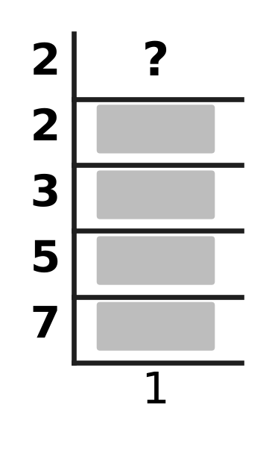
  (A) 210 | (B) 19 | (C) 84 | (D) 420

Q3. I am an integer. I am greater than −11 and less than −1. I am a multiple of 3. My opposite is an even number. Which integer am I?
(A) −12 | (B) −6 | (C) −4 | (D) −3

Q4. At her flower shop, Ana has 105 roses, 75 lilies and 60 carnations. She makes the greatest possible number of identical bouquets, using all the flowers. Each bouquet has the same number of roses, the same number of lilies and the same number of carnations. How many flowers are there in each bouquet?
(A) 48 | (B) 7 | (C) 15 | (D) 16

Q5. How many factors of 360 are odd numbers?
(A) 6 | (B) 2 | (C) 24 | (D) 5

Part 2 — Operations & Number Properties (Syllabus Chapter 2)
Q6. What is the value of [(−9) + 6 + (−12) + 5 + 0] ÷ 5?
(A) 2 | (B) −2 | (C) −2.5 | (D) −10

Q7. Which of these has the value 0 for EVERY integer n?
(A) n − (−n) | (B) (−n) − n | (C) n + (−n) | (D) n × (−n)

Q8. What is the value of (−48) ÷ 6 × (−2)?
(A) 4 | (B) −16 | (C) −4 | (D) 16

Q9. Without brackets, 36 ÷ 6 − 3 × 2 + 4 = 4. One pair of brackets is put in to make the value 10. Which of these is correct?
(A) (36 ÷ 6 − 3) × 2 + 4 | (B) 36 ÷ (6 − 3) × 2 + 4
(C) 36 ÷ 6 − 3 × (2 + 4) | (D) 36 ÷ (6 − 3 × 2 + 4)

Q10. What is the sum of all the integers from −15 to 12, including −15 and 12?
(A) 0 | (B) −3 | (C) −42 | (D) 42

Part 3 — Fractions, Decimals & Percentages (Syllabus Chapter 3)
Q11. I am a fraction with denominator 40. Written as a percentage, I am 17.5%. What is my numerator?
(A) 70 | (B) 7 | (C) 14 | (D) 35

Q12. Which number goes in the blank so that each number in the list is greater than the one before it? 0.4, ___, 45%, $\frac{1}{2}$
(A) $\frac{3}{8}$ | (B) $\frac{12}{25}$ | (C) $\frac{21}{50}$ | (D) $\frac{9}{20}$

Q13. Usha is running a 2 km race. She has run 35% of it. How many metres does she still have to run?
(A) 1,965 m | (B) 700 m | (C) 650 m | (D) 1,300 m

Q14. Which of these quantities has the largest value?
(A) $\frac{3}{8}$ of 72 | (B) 0.35 of 80
(C) $\frac{5}{8}$ of 44 | (D) 45% of 62

Q15. At an ice-cream stall, the price of a cone went up by 20%. A cone now costs ₹60. What did a cone cost before the price went up?
(A) ₹50 | (B) ₹72 | (C) ₹40 | (D) ₹48

Part 4 — Algebra (Syllabus Chapter 4)
Q16. Kian wrote the expression 2(m + 6). Which sentence describes his expression?
(A) Multiply m by 6, then add 2 to the result.
(B) Add 2 to m, then multiply the result by 6.
(C) Double m, then add 6 to the result.
(D) Add 6 to m, then double the result.

Q17. In the hall for the school play, the rows of seats are numbered 1, 2, 3, … from the stage. Row number n has (2n + 10) seats. How many seats are there in row 15?
(A) 40 | (B) 25 | (C) 50 | (D) 27

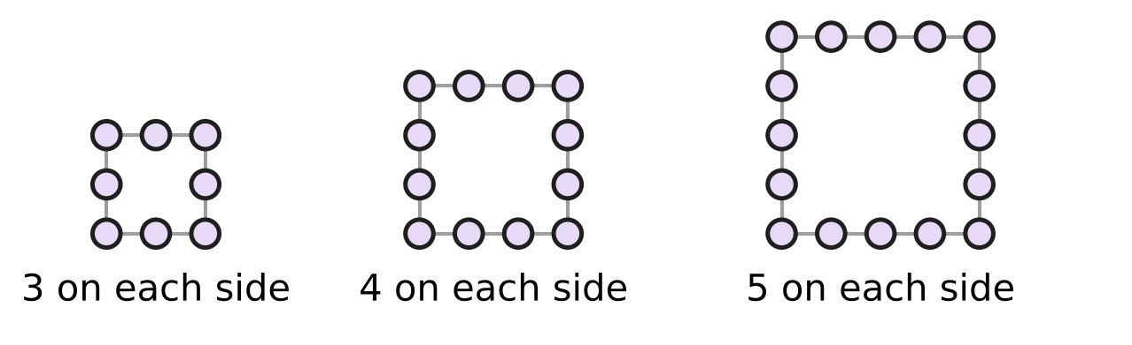
Q18. Look at the square bead frames. A frame with n beads on each side, counting the corner beads, uses (4n − 4) beads in all. Myra has 50 beads. She makes ONE frame like these, as big as she can. How many beads are on each side of her frame?
(A) 7 | (B) 11 | (C) 13 | (D) 12

Part 5 — Geometry (Syllabus Chapter 5)
Q19. The figure shows the slide in Zoya's school playground. The ladder stands at right angles to the ground. The slide makes an angle of 36° with the ground. What is the angle marked "?" between the ladder and the slide? | 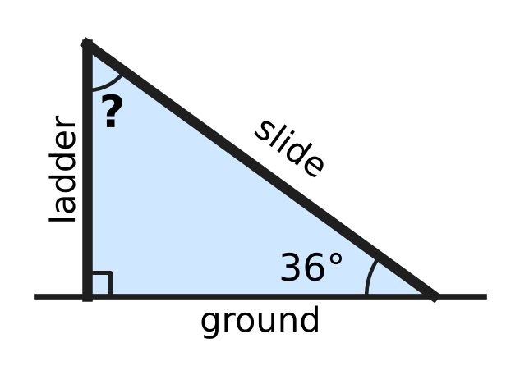
  (A) 36° | (B) 54° | (C) 144° | (D) 126°

Q20. A floor is covered with tiles shaped like regular octagons and squares, as in the picture. At every corner point where tiles meet, two octagons and one square meet with no gaps. What is the size of the angle marked x inside one of the octagons? | 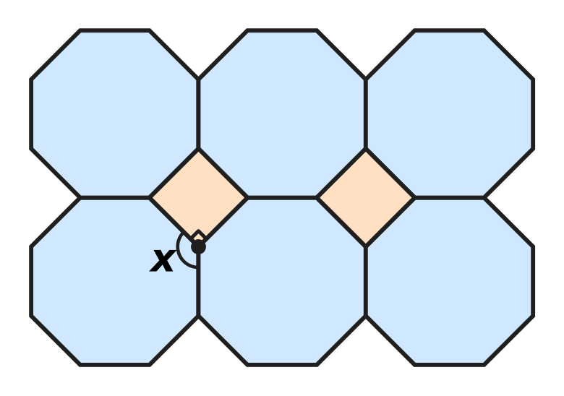
  (A) 135° | (B) 120° | (C) 270° | (D) 108°

Q21. Part of a fishing net is shown. Every hole in the net is a rhombus: all four sides are equal. In the shaded hole, one angle is 64°. What is the size of the angle marked x in the same hole? | 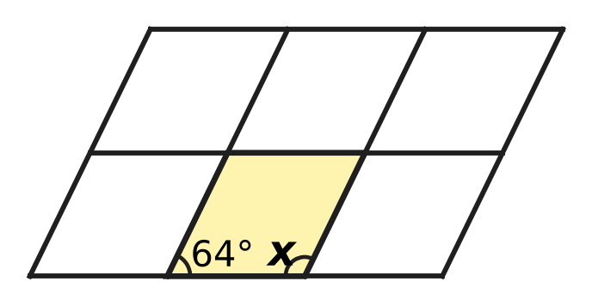
  (A) 26° | (B) 296° | (C) 116° | (D) 64°

Q22. The figure shows an arrowhead shape ABCD with four straight sides. Angle A is 50°, angle B is 30° and angle D is 30°. What is the reflex angle marked "?" at C, inside the shape? | 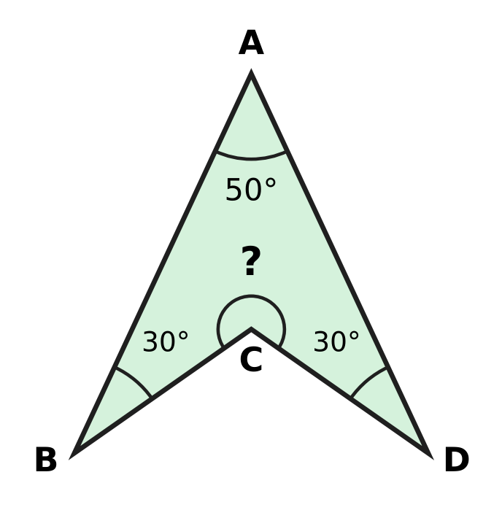
  (A) 70° | (B) 280° | (C) 110° | (D) 250°

Q23. An isosceles triangle has an angle of 40°. Which of these could be the size of its largest angle?
(A) 140° | (B) 70° | (C) 50° | (D) 80°

Part 6 — Mensuration (Syllabus Chapter 6)
Q24. A rectangular car park is 45 m long and 30 m wide. A fence goes all the way round it, except for a gate 6 m wide, as shown. How long is the fence? | 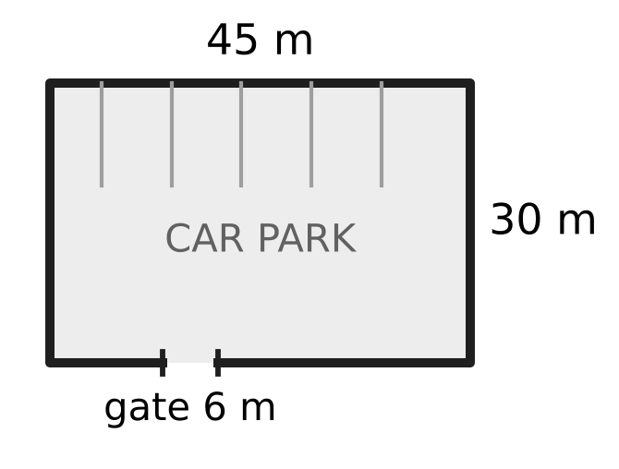
  (A) 69 m | (B) 150 m | (C) 144 m | (D) 156 m

Q25. At his tea stall, Nakul keeps sugar cubes in the box shown. The inside of the box is 8 cm long, 5 cm wide and 3 cm high. The box is exactly full of sugar cubes with edges of 1 cm, with no gaps. How many sugar cubes are in the box? | 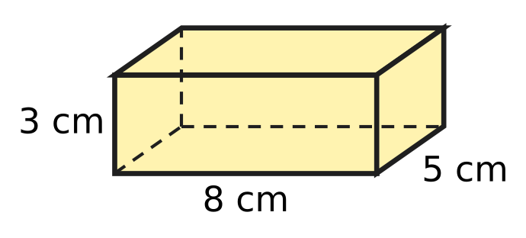
  (A) 40 | (B) 120 | (C) 16 | (D) 158

Q26. A block of clay is a cuboid 9 cm long, 8 cm wide and 3 cm high, as shown. All of it is pressed into the shape of a cube, with no clay left over. What is the length of each edge of the cube? | 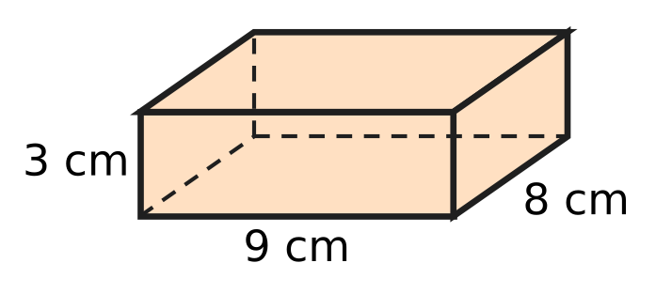
  (A) 6 cm | (B) 72 cm | (C) 36 cm | (D) 18 cm

Q27. Deepa makes an open box shaped like a cube from thin card. The box has no lid, so it has only five square faces. These five faces use 320 cm² of card in all, with no overlap. What is the volume of the box?
(A) 384 cm³ | (B) 64 cm³ | (C) 320 cm³ | (D) 512 cm³

Q28. Yash has a rectangular card 18 cm long and 10 cm wide. He cuts it along the dashed line into two equal rectangles, as shown. How much greater is the total perimeter of the two pieces than the perimeter of the whole card? | 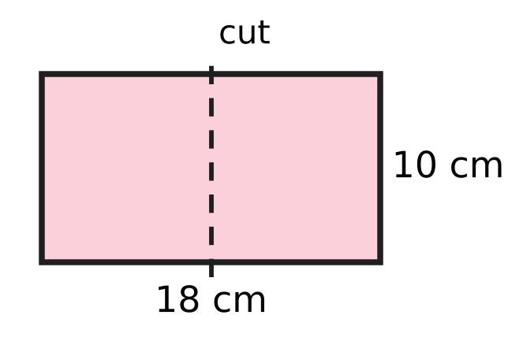
  (A) 20 cm | (B) 18 cm | (C) 0 cm | (D) 10 cm

Part 7 — Data Handling, Statistics & Probability (Syllabus Chapter 8)
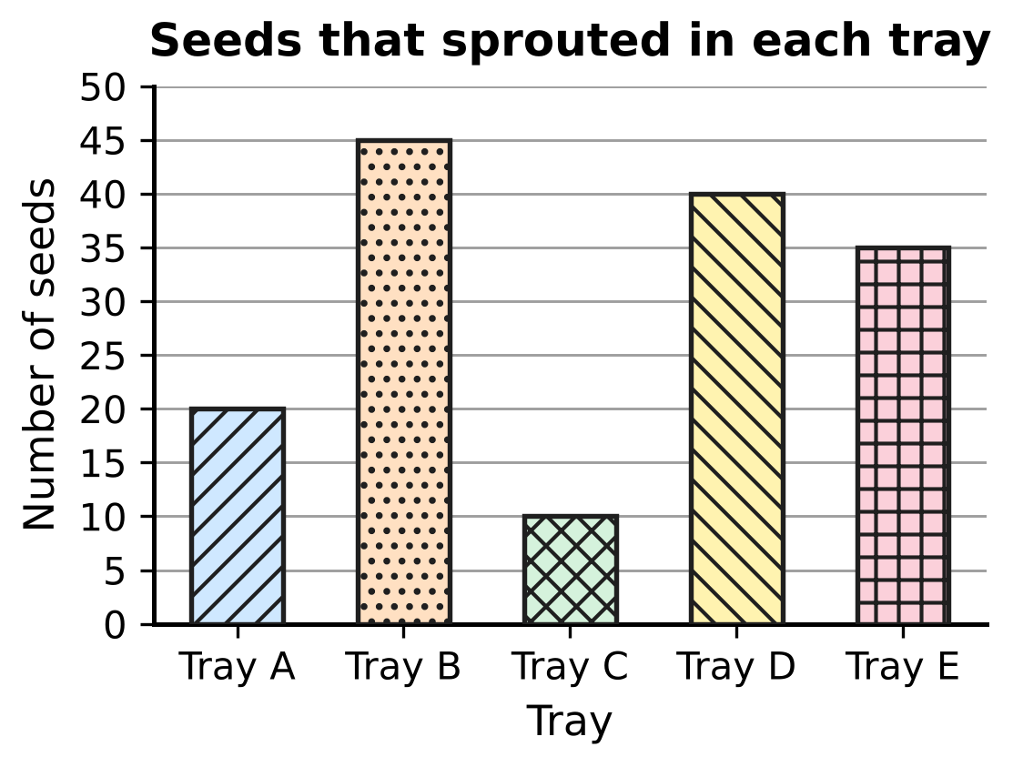
Q29. The bar graph shows how many seeds sprouted in each of five trays. How many seeds sprouted in all five trays together?
(A) 155 | (B) 145 | (C) 150 | (D) 130

Marks in a music class test
Mark (out of 10) | 5 | 6 | 7 | 8 | 9
Number of students | 4 | 7 | 9 | 6 | 4

Q30. The table shows the marks of 30 students in a music class test. Some students who missed the test take it later, and every one of them scores 6. What is the smallest number of these students needed so that 6 becomes the mark scored by more students than any other mark?
(A) 9 | (B) 10 | (C) 2 | (D) 3

Part 8 — Applied Mathematics (Syllabus Chapter 9)
Q31. Shalu makes a mango drink with 2 cups of mango pulp and 5 cups of water. Tanmay wants a drink that tastes exactly the same, and he uses 6 cups of mango pulp. How many cups of water should he use?
(A) 30 cups | (B) 15 cups | (C) 10 cups | (D) 9 cups

Q32. During a storm, Lata sees a flash of lightning. She hears its thunder 5 seconds later. Take the speed of sound as 340 m per second. The light reaches her at once. How far away from Lata was the lightning?
(A) 850 m | (B) 68 m | (C) 1,700 m | (D) 345 m

Q33. Zubin's tortoise walks at a steady speed of 4 m per minute. How long would it take to walk 1 km?
(A) 41 h 40 min | (B) 2 h 50 min
(C) 25 min | (D) 4 h 10 min

Q34. Which of these speeds is the greatest?
(A) 20 m/s | (B) 66 km/h
(C) 1 km per minute | (D) 1,150 m per minute

Q35. For the science exhibition, Dhruv built a model of a plane. Every length on the model and the same length on the real plane are in the ratio 1 : 40. The wings of the model measure 85 cm from tip to tip. What is this length on the real plane?
(A) 340 m | (B) 34 m | (C) 1.25 m | (D) 3.4 m

Part 9 — Mathematical Reasoning & Problem-Solving (Syllabus Chapter 10)
Q36. What is the 9th term of this pattern? Each term after the second is made from the two terms just before it: 4, −1, 3, 2, 5, 7, …
(A) 31 | (B) 26 | (C) 50 | (D) 19

Q37. Every odd number can be written as 2k + 1, where k is a whole number. Which expression gives the next odd number after 2k + 1?
(A) 4k + 2 | (B) 2k + 3 | (C) 2k + 2 | (D) 2k − 1

Q38. A patch of weed on a pond doubles in area every day. On day 24 it covers the whole pond for the first time. On which day did it cover exactly half of the pond?
(A) Day 25 | (B) Day 22 | (C) Day 12 | (D) Day 23

Q39. The clock in the school hall strikes once at 1 o'clock, twice at 2 o'clock, and so on, up to 12 times at 12 o'clock. It also strikes once at half past every hour. How many times does it strike from 10:00 am to 3:00 pm, counting the strikes at 10:00 am and at 3:00 pm?
(A) 39 | (B) 80 | (C) 44 | (D) 34

Q40. Eleven whole numbers are written around a circle. Two numbers next to each other make a "mixed pair" if one of them is odd and the other is even. What is the greatest possible number of mixed pairs?
(A) 5 | (B) 9 | (C) 11 | (D) 10

SECTION II — Star Questions 5 questions × 4 marks each
Q41. Which of these numbers can be written as the sum of two consecutive whole numbers, AND as the sum of three consecutive whole numbers, AND as the sum of five consecutive whole numbers? [4 marks]
(A) 75 | (B) 60 | (C) 65 | (D) 63

Q42. The number of views of a school video on any day (views on that day only, not the running total) is 3 times the number on the day before. On Day 11 it has 59,04,900 views. On which day did the number of views go above 1 lakh for the first time? [4 marks]
(A) Day 6 | (B) Day 7 | (C) Day 8 | (D) Day 9

Q43. At an airport, a moving walkway 300 m long carries people at 3 km/h. Hana walks at 5 km/h. She walks 300 m once on the floor beside the walkway, and once on the moving walkway, walking at her usual speed in the direction it moves. By what percentage is her time on the walkway less than her time on the floor? [4 marks]
(A) 62.5% | (B) 81% | (C) 37.5% | (D) 60%

Q44. Varsha has a square card of side 20 cm. She cuts off each of its four corners with one straight cut, as in the figure. Each cut starts on a side, 4 cm from the corner, and makes an angle of 135° with that side, inside the shape that is left. All four cuts are made in the same way. What is the area of the eight-sided shape that is left? [4 marks] | 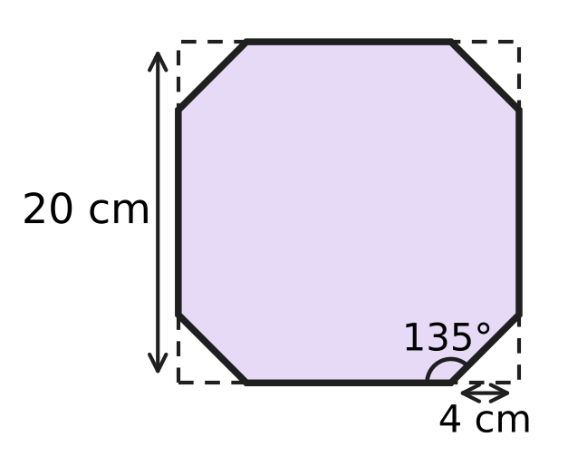
  (A) 336 cm² | (B) 368 cm² | (C) 384 cm² | (D) 392 cm²

Q45. In a building, the floors are 4 m apart. A lift moves at 2 m/s. It leaves floor 2 and goes up to floor n (n is greater than 3). It stops for 10 seconds at every floor in between, but not at floor n. Which expression gives the time, in seconds, from leaving floor 2 to arriving at floor n? [4 marks]
(A) 12n − 24 | (B) 18n − 46 | (C) 12n − 34 | (D) 12n − 30

Answer Sheet AMO Level 1 · Class 6 · Practice Paper 5
Name: | School: | Roll No.:
Shade or tick one circle for each question.
1. Ⓐ Ⓑ Ⓒ Ⓓ | 16. Ⓐ Ⓑ Ⓒ Ⓓ | 31. Ⓐ Ⓑ Ⓒ Ⓓ
2. Ⓐ Ⓑ Ⓒ Ⓓ | 17. Ⓐ Ⓑ Ⓒ Ⓓ | 32. Ⓐ Ⓑ Ⓒ Ⓓ
3. Ⓐ Ⓑ Ⓒ Ⓓ | 18. Ⓐ Ⓑ Ⓒ Ⓓ | 33. Ⓐ Ⓑ Ⓒ Ⓓ
4. Ⓐ Ⓑ Ⓒ Ⓓ | 19. Ⓐ Ⓑ Ⓒ Ⓓ | 34. Ⓐ Ⓑ Ⓒ Ⓓ
5. Ⓐ Ⓑ Ⓒ Ⓓ | 20. Ⓐ Ⓑ Ⓒ Ⓓ | 35. Ⓐ Ⓑ Ⓒ Ⓓ
6. Ⓐ Ⓑ Ⓒ Ⓓ | 21. Ⓐ Ⓑ Ⓒ Ⓓ | 36. Ⓐ Ⓑ Ⓒ Ⓓ
7. Ⓐ Ⓑ Ⓒ Ⓓ | 22. Ⓐ Ⓑ Ⓒ Ⓓ | 37. Ⓐ Ⓑ Ⓒ Ⓓ
8. Ⓐ Ⓑ Ⓒ Ⓓ | 23. Ⓐ Ⓑ Ⓒ Ⓓ | 38. Ⓐ Ⓑ Ⓒ Ⓓ
9. Ⓐ Ⓑ Ⓒ Ⓓ | 24. Ⓐ Ⓑ Ⓒ Ⓓ | 39. Ⓐ Ⓑ Ⓒ Ⓓ
10. Ⓐ Ⓑ Ⓒ Ⓓ | 25. Ⓐ Ⓑ Ⓒ Ⓓ | 40. Ⓐ Ⓑ Ⓒ Ⓓ
11. Ⓐ Ⓑ Ⓒ Ⓓ | 26. Ⓐ Ⓑ Ⓒ Ⓓ | 41. Ⓐ Ⓑ Ⓒ Ⓓ
12. Ⓐ Ⓑ Ⓒ Ⓓ | 27. Ⓐ Ⓑ Ⓒ Ⓓ | 42. Ⓐ Ⓑ Ⓒ Ⓓ
13. Ⓐ Ⓑ Ⓒ Ⓓ | 28. Ⓐ Ⓑ Ⓒ Ⓓ | 43. Ⓐ Ⓑ Ⓒ Ⓓ
14. Ⓐ Ⓑ Ⓒ Ⓓ | 29. Ⓐ Ⓑ Ⓒ Ⓓ | 44. Ⓐ Ⓑ Ⓒ Ⓓ
15. Ⓐ Ⓑ Ⓒ Ⓓ | 30. Ⓐ Ⓑ Ⓒ Ⓓ | 45. Ⓐ Ⓑ Ⓒ Ⓓ
Q41–Q45 are Section II Star Questions (4 marks each).
For the parent or teacher
Section I correct: ______ / 40 × 2 = ______ marks Section II correct: ______ / 5 × 4 = ______ marks
Correct: ______ / 45 Score: ______ / 100
Answer Key and Solutions AMO Level 1 · Class 6 · Practice Paper 5
Quick answers
1 A | 6 B | 11 B | 16 D | 21 C | 26 A | 31 B | 36 A | 41 A
2 D | 7 C | 12 C | 17 A | 22 D | 27 D | 32 C | 37 B | 42 C
3 B | 8 D | 13 D | 18 C | 23 B | 28 A | 33 D | 38 D | 43 C
4 D | 9 A | 14 B | 19 B | 24 C | 29 C | 34 A | 39 C | 44 B
5 A | 10 C | 15 A | 20 A | 25 B | 30 D | 35 B | 40 D | 45 C
Solutions
Q | Part · level | Answer | Why?
1 | Part 1 · Ch1 · Easy | (A) 30,15,600 | Here, 3 ten lakhs = 30,00,000, 15 thousands = 15,000 and 6 hundreds = 600. Together: 30,00,000 + 15,000 + 600 = 30,15,600.
2 | Part 1 · Ch1 · Easy | (D) 420 | The number is the product of all the primes on the left: 2 × 2 × 3 × 5 × 7 = 420.
3 | Part 1 · Ch1 · Easy | (B) −6 | The multiples of 3 greater than −11 and less than −1 are −9, −6 and −3. Their opposites are 9, 6 and 3; only 6 is even. So the integer is −6.
4 | Part 1 · Ch1 · Medium | (D) 16 | HCF(105, 75, 60) = 15, so she makes 15 bouquets. Each has 105 ÷ 15 = 7 roses, 75 ÷ 15 = 5 lilies and 60 ÷ 15 = 4 carnations: 7 + 5 + 4 = 16 flowers.
5 | Part 1 · Ch1 · Medium | (A) 6 | We have 360 = 2³ × 3² × 5. An odd factor has no 2 in it, so it is a factor of 3² × 5 = 45: 1, 3, 5, 9, 15 and 45. That is 6 odd factors.
6 | Part 2 · Ch2 · Easy | (B) −2 | Work inside the bracket first: (−9) + 6 + (−12) + 5 + 0 = −10. Then (−10) ÷ 5 = −2.
7 | Part 2 · Ch2 · Easy | (C) n + (−n) | Every integer added to its opposite gives 0, so n + (−n) = 0. For n = 3 the others give 6, −6 and −9.
8 | Part 2 · Ch2 · Easy | (D) 16 | ÷ and × are done from left to right: (−48) ÷ 6 = −8, then (−8) × (−2) = 16.
9 | Part 2 · Ch2 · Medium | (A) (36 ÷ 6 − 3) × 2 + 4 | (36 ÷ 6 − 3) × 2 + 4 = (6 − 3) × 2 + 4 = 3 × 2 + 4 = 10. The other placements give 28, 9 and −12.
10 | Part 2 · Ch2 · Medium | (C) −42 | Each of 1 to 12 cancels with its opposite −1 to −12, and 0 adds nothing. Left over: (−13) + (−14) + (−15) = −42.
11 | Part 3 · Ch3 · Easy | (B) 7 | Here, 17.5% = 0.175 = $\frac{175}{1000}$ = $\frac{7}{40}$. So the numerator is 7.
12 | Part 3 · Ch3 · Easy | (C) $\frac{21}{50}$ | $\frac{21}{50}$ = 0.42, and 0.4 < 0.42 < 0.45. The others are (A) 0.375, (B) 0.48 and (D) 0.45.
13 | Part 3 · Ch3 · Easy | (D) 1,300 m | She still has 100% − 35% = 65% to run. 65% of 2,000 m = 1,300 m.
14 | Part 3 · Ch3 · Medium | (B) 0.35 of 80 | Here, 0.35 of 80 = 28. The others are 45% of 62 = 27.9, $\frac{5}{8}$ of 44 = 27.5 and $\frac{3}{8}$ of 72 = 27.
15 | Part 3 · Ch3 · Medium | (A) ₹50 | The new price is 120% of the old price. 120% → ₹60, so 100% → ₹60 ÷ 120 × 100 = ₹50. Check: 20% of ₹50 is ₹10, and ₹50 + ₹10 = ₹60.
16 | Part 4 · Ch4 · Easy | (D) Add 6 to m, then double the result. | In 2(m + 6) the bracket is worked first: add 6 to m, then multiply the result by 2.
17 | Part 4 · Ch4 · Easy | (A) 40 | Put n = 15: 2 × 15 + 10 = 30 + 10 = 40 seats.
18 | Part 4 · Ch4 · Medium | (C) 13 | With 13 beads on each side the frame uses 4 × 13 − 4 = 48 beads, which is not more than 50. With 14 on each side it would need 52 beads, which is too many. So the answer is 13.
19 | Part 5 · Ch5 · Easy | (B) 54° | The three angles of the triangle add up to 180°: 180° − 90° − 36° = 54°.
20 | Part 5 · Ch5 · Easy | (A) 135° | The angles at a point add up to 360°. The square gives 90°, so the two equal octagon angles share 270°: x = 270° ÷ 2 = 135°.
21 | Part 5 · Ch5 · Easy | (C) 116° | Opposite angles of a rhombus are equal, so 64° + x + 64° + x = 360°. Then 2x = 232° and x = 116°.
22 | Part 5 · Ch5 · Medium | (D) 250° | The four angles of a quadrilateral add up to 360°, even when one of them is reflex: 360° − (50° + 30° + 30°) = 250°.
23 | Part 5 · Ch5 · Medium | (B) 70° | If 40° is the angle between the equal sides, the other two are (180° − 40°) ÷ 2 = 70° each, and 70° is the largest. (If 40° is one of the two equal angles, the angles are 40°, 40° and 100°.) Of the answer choices, only 70° is possible.
24 | Part 6 · Ch6 · Easy | (C) 144 m | Perimeter = 2 × (45 + 30) = 150 m. The gate has no fence: 150 − 6 = 144 m.
25 | Part 6 · Ch6 · Easy | (B) 120 | Each layer has 8 × 5 = 40 cubes, and there are 3 layers: 40 × 3 = 120 cubes.
26 | Part 6 · Ch6 · Easy | (A) 6 cm | Volume of clay = 9 × 8 × 3 = 216 cm³. The cube has the same volume, and 6 × 6 × 6 = 216, so each edge is 6 cm.
27 | Part 6 · Ch6 · Medium | (D) 512 cm³ | One face has area 320 ÷ 5 = 64 cm², so each edge is 8 cm (8 × 8 = 64). Volume = 8 × 8 × 8 = 512 cm³.
28 | Part 6 · Ch6 · Medium | (A) 20 cm | Each piece is 9 cm by 10 cm, with perimeter 38 cm, so together 76 cm. The whole card has perimeter 56 cm. The difference is 76 − 56 = 20 cm: the cut makes two new edges of 10 cm.
29 | Part 7 · Ch8 · Easy | (C) 150 | Total = 20 + 45 + 10 + 40 + 35 = 150 seeds.
30 | Part 7 · Ch8 · Medium | (D) 3 | Now 9 students have mark 7 and 7 students have mark 6. Mark 6 needs at least 10 students, so 10 − 7 = 3 more students are needed.
31 | Part 8 · Ch9 · Easy | (B) 15 cups | Tanmay uses 3 times as much pulp (2 × 3 = 6 cups), so he needs 3 times as much water: 5 × 3 = 15 cups.
32 | Part 8 · Ch9 · Easy | (C) 1,700 m | The sound travels for 5 seconds at 340 m per second: 340 × 5 = 1,700 m.
33 | Part 8 · Ch9 · Easy | (D) 4 h 10 min | 1 km = 1,000 m. Time = 1,000 ÷ 4 = 250 minutes = 240 min + 10 min = 4 h 10 min.
34 | Part 8 · Ch9 · Medium | (A) 20 m/s | Change all to km/h: 20 m/s = 20 × 18 ÷ 5 = 72 km/h; 1,150 m per minute = 69 km/h; 1 km per minute = 60 km/h. The greatest is 20 m/s.
35 | Part 8 · Ch9 · Medium | (B) 34 m | The real length is 40 times the model length: 85 × 40 = 3,400 cm = 34 m.
36 | Part 9 · Ch10 · Easy | (A) 31 | Each term is the sum of the two before it: 4, −1, 3, 2, 5, 7, 12, 19, 31. The 9th term is 31.
37 | Part 9 · Ch10 · Easy | (B) 2k + 3 | Odd numbers go up in steps of 2, so the next odd number is (2k + 1) + 2 = 2k + 3.
38 | Part 9 · Ch10 · Easy | (D) Day 23 | Going back one day halves the area. The whole pond on day 24 means half the pond on day 23.
39 | Part 9 · Ch10 · Medium | (C) 44 | On the hours it strikes 10 + 11 + 12 + 1 + 2 + 3 = 39 times. At 10:30, 11:30, 12:30, 1:30 and 2:30 it strikes 5 more times. Total 39 + 5 = 44.
40 | Part 9 · Ch10 · Medium | (D) 10 | Going once round the circle, each mixed pair is a switch between odd and even. We end where we started, so the number of switches is even. So 11 is impossible. But 10 is possible: write odd, even, odd, even, … and end with odd, so only the last odd and the first odd sit together.
41 | Section II · Ch4 + Ch10 · Hard | (A) 75 | n + (n + 1) = 2n + 1 is odd; n + (n + 1) + (n + 2) = 3(n + 1) is a multiple of 3; five consecutive numbers add to 5(n + 2), a multiple of 5. Only 75 is odd and a multiple of both 3 and 5: 75 = 37 + 38 = 24 + 25 + 26 = 13 + 14 + 15 + 16 + 17.
42 | Section II · Ch1 + Ch10 · Hard | (C) Day 8 | Divide by 3 going back: Day 10 has 19,68,300, Day 9 has 6,56,100, Day 8 has 2,18,700, Day 7 has 72,900. Day 7 is below 1,00,000 and Day 8 is above it, so the first day is Day 8.
43 | Section II · Ch3 + Ch9 · Hard | (C) 37.5% | On the floor: 300 m at 5 km/h = 0.06 h = 216 s. On the walkway her speed is 5 + 3 = 8 km/h: 300 m takes 135 s. She saves 81 s, and 81 ÷ 216 = 0.375 = 37.5%.
44 | Section II · Ch5 + Ch6 · Hard | (B) 368 cm² | Inside each cut-off corner, the cut makes 180° − 135° = 45° with the side, and the corner is 90°, so the third angle is 45°. The triangle is isosceles, so both short sides are 4 cm and its area is 4 × 4 ÷ 2 = 8 cm². Area left = 400 − 4 × 8 = 368 cm².
45 | Section II · Ch4 + Ch9 · Hard | (C) 12n − 34 | The lift rises 4(n − 2) m at 2 m/s, which takes 2(n − 2) s. It stops at floors 3 to n − 1, which is n − 3 stops of 10 s. There is no stop at floor 2 (the lift is leaving it) or at floor n (it arrives there). Time = 2(n − 2) + 10(n − 3) = 12n − 34. Check, n = 5: 6 s + 20 s = 26 s.

