UNLOCK IQ INSTITUTE
Realize Your True Potential
Aryabhatta Maths Olympiad (AMO)
Level 1 — Practice Paper 1
CLASS 7

Questions | 45 multiple-choice questions
Marks | 100
Time | 60 minutes
Section I | 40 questions × 2 marks = 80 marks
Section II | 5 Star Questions × 4 marks = 20 marks
Negative marking | No negative marking
Calculator | Not allowed
Chapters | Number System · Operations · Fractions, Decimals & Percentages · Algebra · Geometry · Mensuration · Data Handling · Applied Mathematics · Mathematical Reasoning

Instructions to candidates
• This paper has 45 multiple-choice questions. Each question has four answer choices, of which exactly one is correct.
• Section I (Q1–Q40) carries 2 marks per question. Section II (Q41–Q45) carries 4 marks per question.
• There is no negative marking. Unanswered questions score zero.
• Calculators are not permitted. Rough work may be done on a separate sheet.
• Mark your answers on the answer sheet at the end of the paper.
• All figures are not necessarily drawn to scale unless stated.

For parents and teachers
Print or view this paper in colour. Pictures are part of the questions.
Parts follow the AMO syllabus chapters. Chapter 7 is not part of the Class 7 syllabus, so the chapter numbers shown in the Part headings have gaps.
The answer sheet and the answer key are at the end. Remove only the answer key before the student begins.

Name: | School: | Roll No.:

SECTION I 40 questions × 2 marks each
Part 1 — Number System (Syllabus Chapter 1)
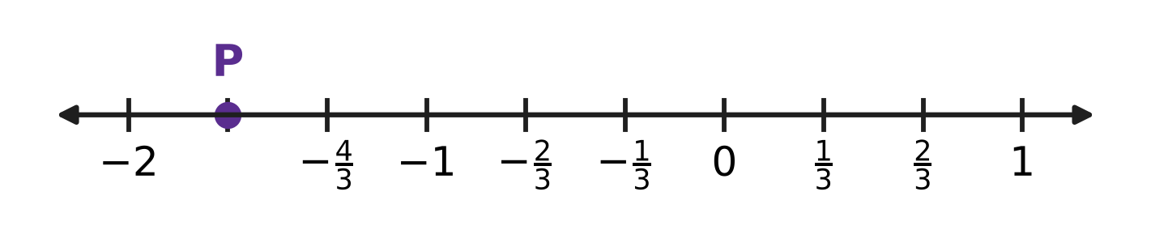
Q1. Look at the number line. Each unit from one whole number to the next is divided into equal parts. Which rational number does the point P show?
(A) $−\frac{5}{3}$ | (B) $−\frac{3}{2}$ | (C) $−\frac{1}{3}$ | (D) $−\frac{7}{3}$

Q2. A rational number is in standard form when its denominator is positive and its numerator and denominator have no common factor other than 1. Which of these is in standard form?
(A) $\frac{12}{−18}$ | (B) $\frac{−10}{15}$ | (C) $\frac{4}{−7}$ | (D) $\frac{−9}{14}$

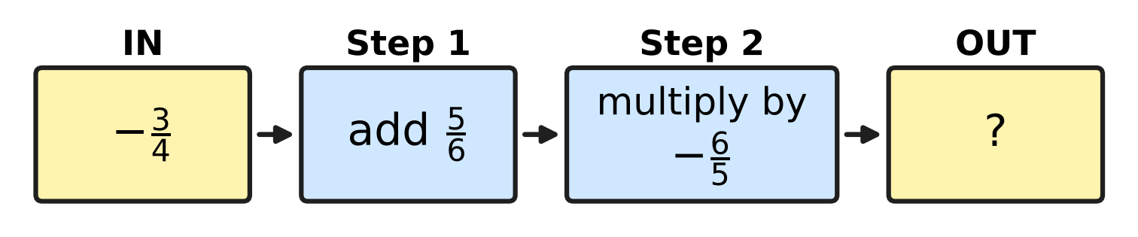
Q3. Look at the number machine. The number that goes IN passes through Step 1 and then Step 2. What number comes OUT?
(A) $\frac{26}{15}$ | (B) $−\frac{6}{25}$ | (C) $\frac{1}{10}$ | (D) $−\frac{1}{10}$

Q4. Let x = $−\frac{3}{4}$ and y = $\frac{2}{5}$. Which of these has the greatest value?
(A) x + y | (B) x − y | (C) x × y | (D) x ÷ y

Part 2 — Operations & Number Properties (Syllabus Chapter 2)
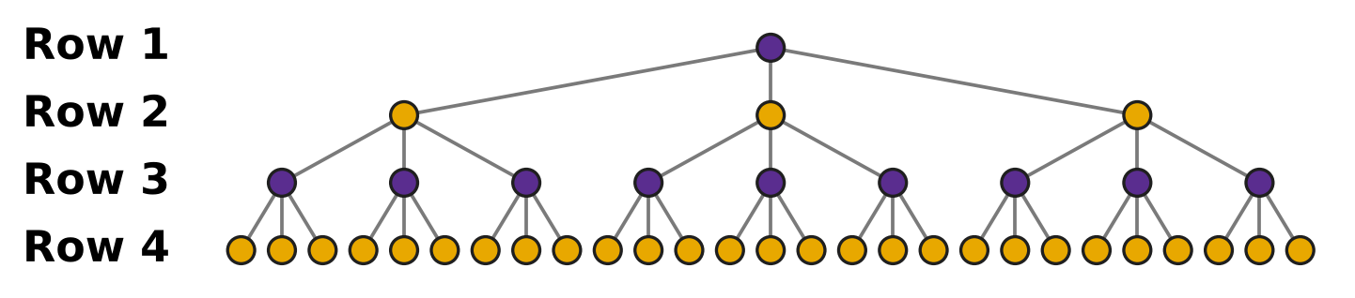
Q5. In the picture, every dot splits into 3 new dots in the next row. The pattern goes on in the same way. How many dots will there be in Row 6?
(A) 3⁵ | (B) 3⁶ | (C) 3 × 6 | (D) 6³

Q6. Which of these is NOT equal to 64?
(A) 8² | (B) 2⁵ × 2 | (C) 2³ + 2³ | (D) 4³

Q7. The number 7.05 × 10⁵ is written in the usual form, without a power of 10. How many zeros does the number have?
(A) 6 | (B) 3 | (C) 5 | (D) 4

Part 3 — Fractions, Decimals & Percentages (Syllabus Chapter 3)
Q8. A stationery shop puts the tag shown in the picture on a school bag. How much money does a buyer save because of the discount? | 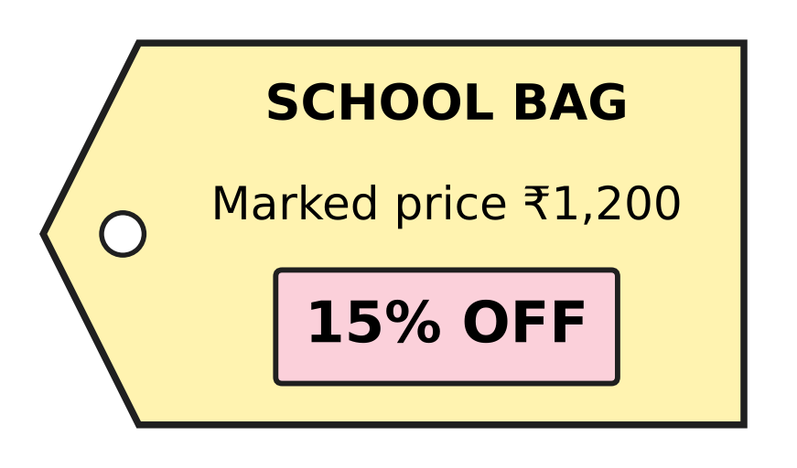
  (A) ₹180 | (B) ₹18 | (C) ₹80 | (D) ₹1,020

Q9. A school stores rainwater in the tank shown in the picture. The scale on its side shows how full the tank is, as a percentage of its capacity. How many litres of water are in the tank now? | 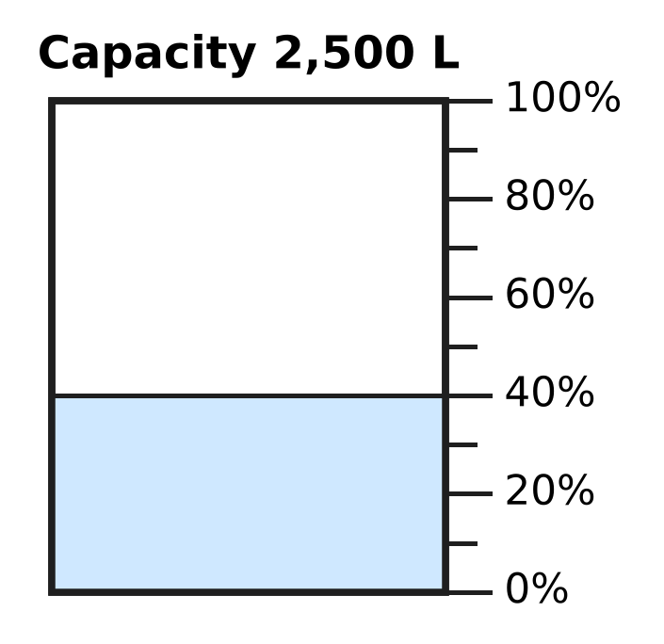
  (A) 1,500 L | (B) 1,000 L | (C) 625 L | (D) 400 L

Q10. A shopkeeper sold a chair and made a loss of ₹144. This loss was 18% of the cost price. What was the cost price of the chair?
(A) ₹2,592 | (B) ₹800 | (C) ₹656 | (D) ₹944

Cost and selling prices of four items
Item | Cost price (₹) | Selling price (₹)
K | 200 | 250
L | 400 | 480
M | 150 | 195
N | 500 | 640

Q11. A trader sold the four items in the table. On which item did the trader make the greatest profit percent?
(A) Item K | (B) Item L | (C) Item M | (D) Item N

Q12. In a school library, 45% of the books are story books and $\frac{1}{5}$ of the books are science books. The remaining 1,400 books are on other subjects. How many books does the library have in all?
(A) 1,800 | (B) 2,800 | (C) 490 | (D) 4,000

Part 4 — Algebra (Syllabus Chapter 4)
Q13. Which expression is equal to 3(2k − 5) − 4k?
(A) 10k − 15 | (B) 2k − 5 | (C) 2k − 15 | (D) 6k − 19

Q14. How many of these terms are like terms of 3pq?
−pq, 3p, 7qp, pq², −2qp, 5p²q
(A) 3 | (B) 4 | (C) 2 | (D) 1

Q15. For which equation is x = 3 the solution?
(A) 5x − 9 = x + 4 | (B) 4x − 5 = 2x + 1
(C) 2(x − 1) = x + 2 | (D) 3x + 2 = 5x − 2

Q16. Shreya has 4 times as many stamps as Kartik. If Shreya gives 15 stamps to Kartik, they will have the same number of stamps. How many stamps does Shreya have now?
(A) 10 | (B) 25 | (C) 40 | (D) 20

Q17. In the figure, the perimeter of the triangle is (9x + 4) cm. What length should replace the "?" | 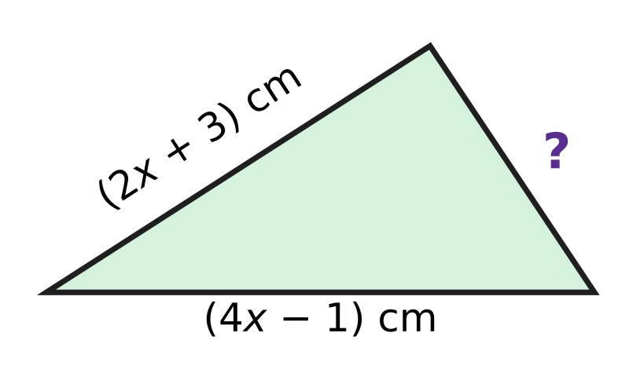
  (A) (3x + 2) cm | (B) 3x cm
  (C) (15x + 6) cm | (D) (3x + 8) cm

Part 5 — Geometry (Syllabus Chapter 5)
Q18. In the figure, line l is parallel to line m. What is the value of x? | 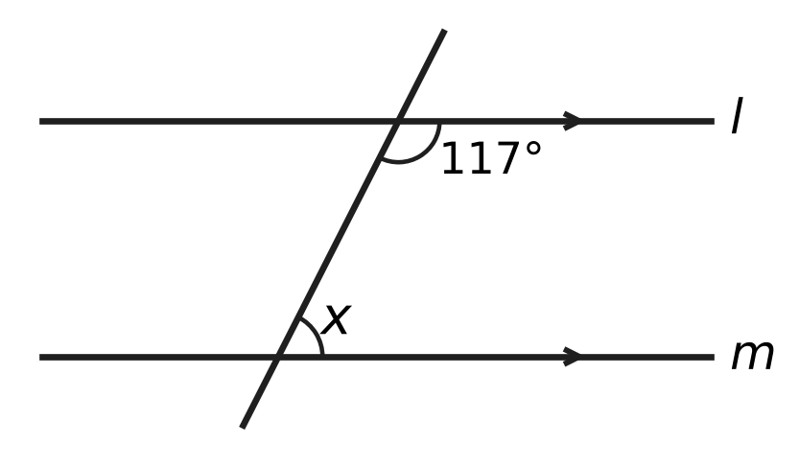
  (A) 27° | (B) 243° | (C) 117° | (D) 63°

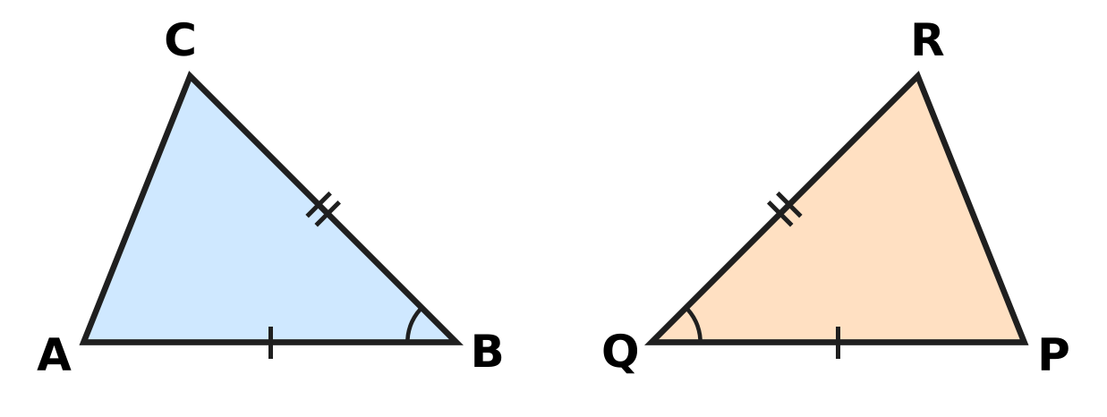
Q19. In the figure, sides with the same marks are equal, and the two marked angles are equal. By which rule is △ABC congruent to △PQR?
(A) SSS | (B) SAS | (C) ASA | (D) AAA

Q20. In the figure, side BC of △ABC is extended to D. Here is a proof that ∠4 = ∠1 + ∠2.  Step 1: ∠3 + ∠4 = 180°.  Step 2: ∠1 + ∠2 + ∠3 = 180° (angle sum of a triangle).  Step 3: So ∠4 = ∠1 + ∠2.  Which reason supports Step 1? | 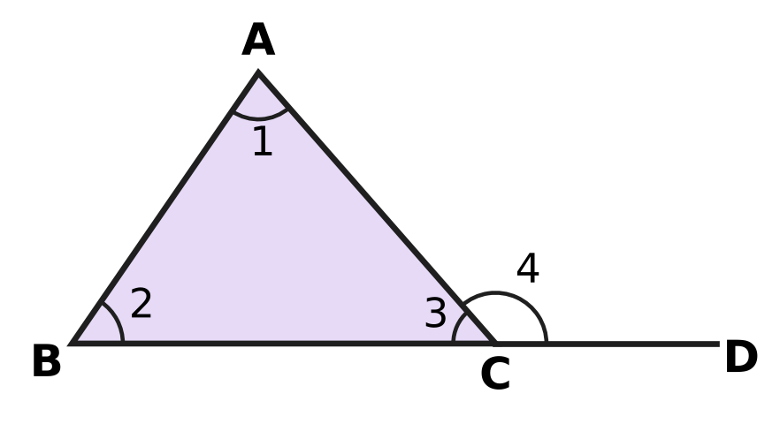
  (A) Vertically opposite angles are equal.
  (B) Alternate angles are equal.
  (C) Angles on a straight line add up to 180°.
  (D) The angles of a triangle add up to 180°.

Q21. In the figure, AB = AC in △ABC and ∠A = 44°. D is on AB and E is on AC, and DE is parallel to BC. What is the value of x (that is, ∠BDE)? | 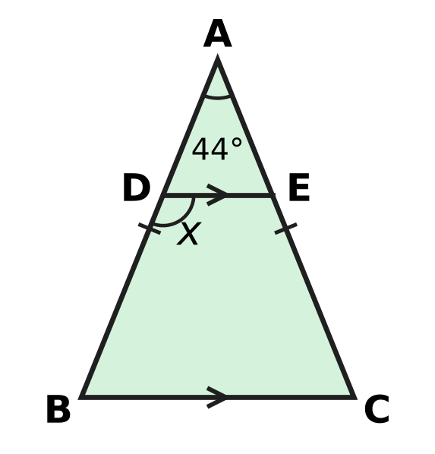
  (A) 136° | (B) 22° | (C) 68° | (D) 112°

Q22. In the figure, line l is parallel to line m. A is on l, B is on m, and O lies between the two lines. What is the value of x? | 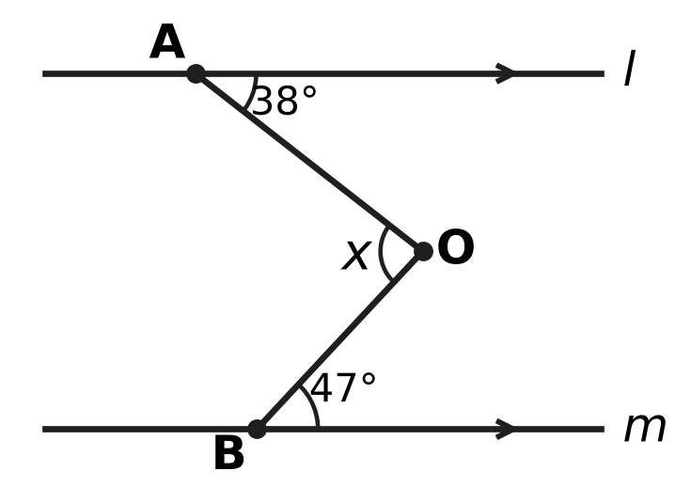
  (A) 85° | (B) 95° | (C) 9° | (D) 47°

Part 6 — Mensuration (Syllabus Chapter 6)
Q23. The picture shows the net of a closed cuboid box that is 7 cm long, 4 cm wide and 2 cm high. What is the total surface area of the box? | 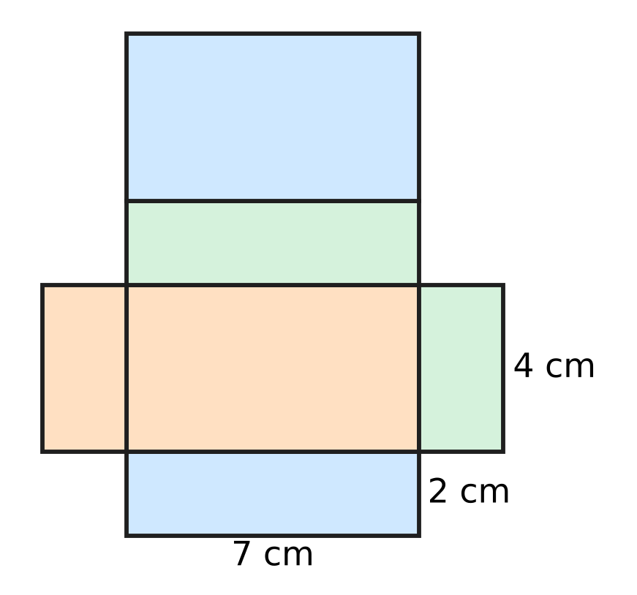
  (A) 128 cm² | (B) 100 cm² | (C) 92 cm² | (D) 50 cm²

Q24. The cylindrical jar in the figure has a radius of 7 cm. It holds 1,386 cm³ when full. How tall is the jar? Use π = $\frac{22}{7}$. | 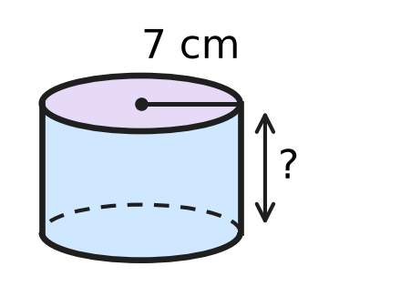
  (A) 9 cm | (B) 31.5 cm | (C) 63 cm | (D) 2.25 cm

Q25. A tape is wrapped once round the curved side of the cylindrical tin in the figure. The tape measures 50 cm. The tin is 12 cm tall. What is the area of the curved surface of the tin? | 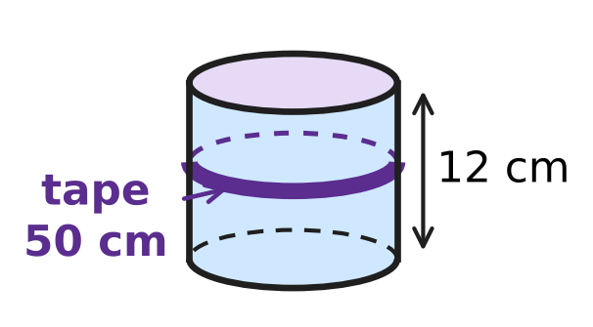
  (A) 1,200 cm² | (B) 600 cm²
  (C) 300 cm² | (D) 62 cm²

Q26. The swimming pool in the figure is a cuboid 20 m long, 8 m wide and 2 m deep, open at the top. Its floor and its four walls are covered with tiles on the inside. What area is tiled? | 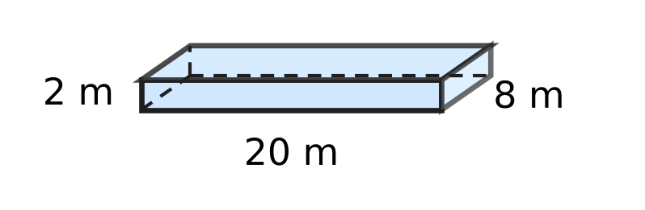
  (A) 432 m² | (B) 240 m² | (C) 112 m² | (D) 272 m²

Q27. Two cubes, each of edge 4 cm, are joined face to face to make a cuboid, as shown. What is the total surface area of the cuboid? | 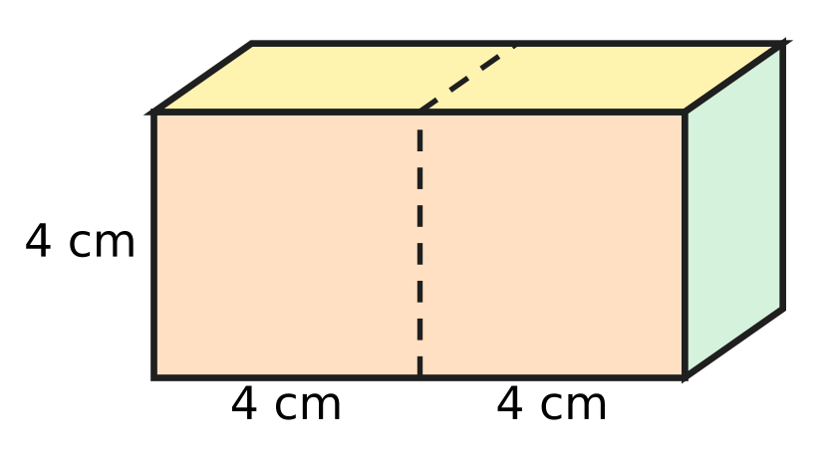
  (A) 176 cm² | (B) 192 cm² | (C) 160 cm² | (D) 96 cm²

Part 7 — Data Handling, Statistics & Probability (Syllabus Chapter 8)
Q28. The pie chart shows the trees in an orchard. There are 300 trees in all. How many pear trees are there? | 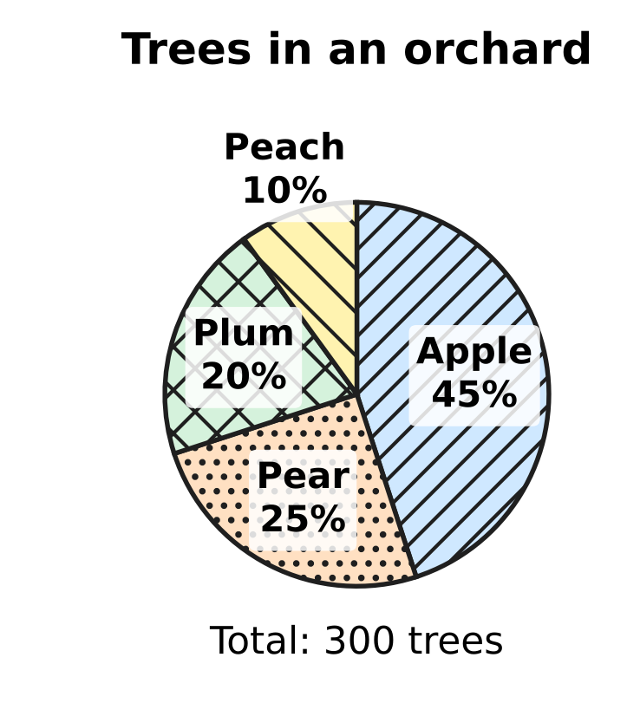
  (A) 75 | (B) 90 | (C) 25 | (D) 225

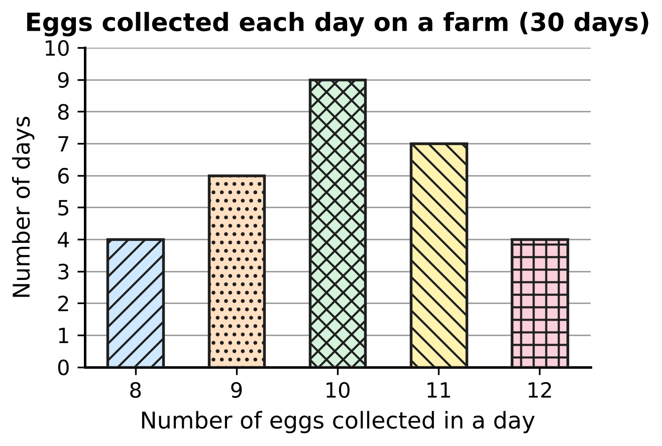
Q29. A farmer collects the eggs laid by her hens every day for 30 days. The bar graph shows on how many days each number of eggs was collected. What is the mode of the number of eggs collected in a day?
(A) 12 eggs | (B) 9 eggs | (C) 11 eggs | (D) 10 eggs

Q30. Arnav got these marks in five tests: 12, 20, 9, 16 and m. The mean of the five marks is 14. What is the median of the five marks?
(A) 14 | (B) 12 | (C) 13 | (D) 9

Part 8 — Applied Mathematics (Syllabus Chapter 9)
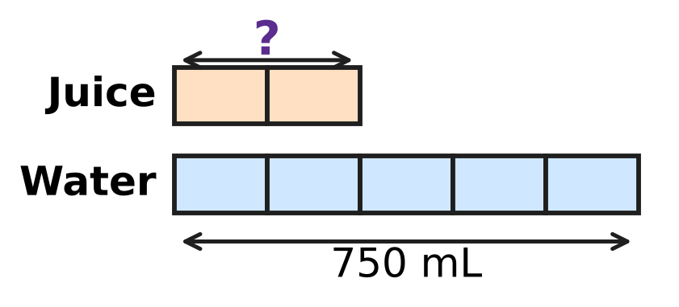
Q31. Juice and water are mixed in the ratio 2 : 5. The bar model shows the mix. All the boxes are of equal size. If 750 mL of water is used, how much juice is needed?
(A) 1,050 mL | (B) 300 mL | (C) 1,875 mL | (D) 150 mL

Seedlings in a vegetable garden (same number in every row)
Number of rows | 3 | 5 | 8
Number of seedlings | 54 | 90 | ?

Q32. In a vegetable garden, every row has the same number of seedlings. What number should replace the "?" in the table?
(A) 144 | (B) 126 | (C) 108 | (D) 162

Q33. Esha has a roll of string. It is just enough to fly 12 kites if each kite gets 30 m of string. On a windy day she gives each kite 40 m of string instead. How many kites can she fly with the same roll?
(A) 16 | (B) 9 | (C) 6 | (D) 12

Q34. On a bicycle trip, Viraj rides at a steady speed. He covers 15 km in 50 minutes. How far does he ride in 2 hours at the same speed?
(A) 45 km | (B) 30 km | (C) 18 km | (D) 36 km

Q35. Mei shares her marbles among three glass jars in the ratio 2 : 3 : 5. The third jar has 36 more marbles than the first jar. How many marbles does Mei have in all?
(A) 60 | (B) 360 | (C) 120 | (D) 180

Part 9 — Mathematical Reasoning & Problem-Solving (Syllabus Chapter 10)
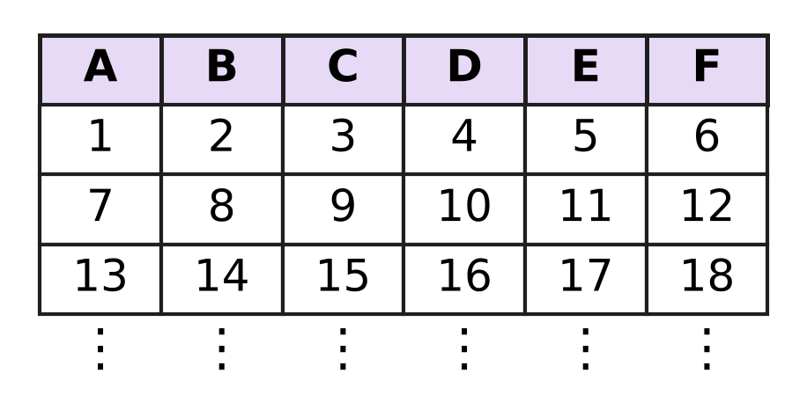
Q36. The counting numbers are written in rows of six under the columns A to F, as shown. The pattern goes on in the same way. In which column will 100 be written?
(A) Column C | (B) Column D | (C) Column E | (D) Column F

Q37. In the multiplication shown, A, B and C stand for three different digits, and A and C are not 0. What is the two-digit number AB? | 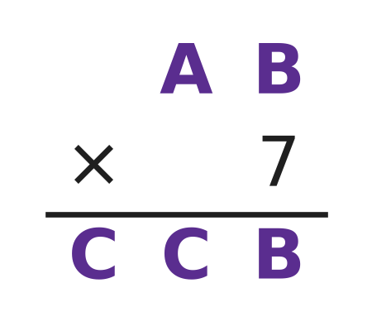
  (A) 75 | (B) 95 | (C) 85 | (D) 65

Q38. Look at these lines.
2² − 1² = 3
3² − 2² = 5
4² − 3² = 7
5² − 4² = 9
The lines go on in the same way. What is the answer in the 20th line?
(A) 400 | (B) 39 | (C) 40 | (D) 41

Q39. How many three-digit numbers have digits whose product is 12? (For example, 162 is one such number, because 1 × 6 × 2 = 12.)
(A) 18 | (B) 12 | (C) 15 | (D) 3

Q40. A whole number n leaves a remainder of 3 when it is divided by 7. What is the remainder when 2n + 5 is divided by 7?
(A) 4 | (B) 6 | (C) 3 | (D) 1

SECTION II — Star Questions 5 questions × 4 marks each
Q41. AB is a two-digit number. Writing the digit 6 at its right end gives the three-digit number AB6. Writing 6 at its left end gives the three-digit number 6AB. AB6 is 189 more than 6AB. What is the number AB? [4 marks]
(A) 21 | (B) 27 | (C) 45 | (D) 87

Q42. Ruhi baked some buns in her bakery. In the morning she sold 20% of them. At noon she sold 25% of the buns that were left. In the evening she sold 30 more buns. She then had 36 buns left. How many buns did she bake? [4 marks]
(A) 60 | (B) 120 | (C) 110 | (D) 99

Q43. On a school bus, the ratio of boys to girls is 3 : 2. At a stop, 4 boys get off and 8 girls get on. Now the ratio of boys to girls is 5 : 6. How many children were on the bus before the stop? [4 marks]
(A) 44 | (B) 40 | (C) 36 | (D) 24

Q44. The figure shows a rectangular sheet of paper PQRS with PQ = 44 cm. Its diagonal PR makes an angle of 45° with PQ. The sheet is rolled so that PQ goes once round the circular base, with no overlap, to make a hollow cylinder of height QR. What is the volume of the cylinder? Use π = $\frac{22}{7}$. [4 marks] | 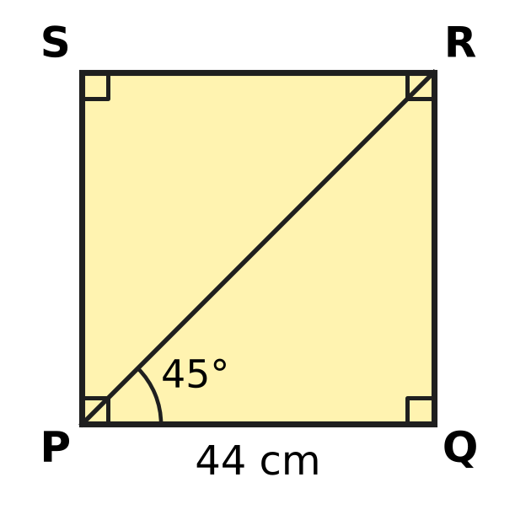
  (A) 6,776 cm³ | (B) 968 cm³
  (C) 13,552 cm³ | (D) 27,104 cm³

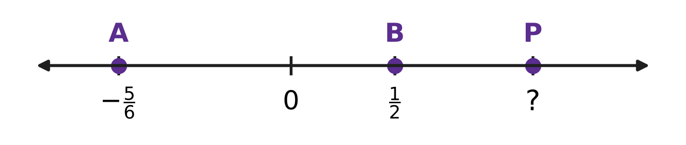
Q45. Ishan marks A at $−\frac{5}{6}$ and B at $\frac{1}{2}$ on a number line. He then marks a point P to the right of B so that the distance from A to P is 3 times the distance from B to P. Which number does P show? [4 marks]
(A) $\frac{17}{18}$ | (B) $\frac{7}{6}$ | (C) $\frac{2}{3}$ | (D) $\frac{11}{6}$

Answer Sheet AMO Level 1 · Class 7 · Practice Paper 1
Name: | School: | Roll No.:
Shade or tick one circle for each question.
1. Ⓐ Ⓑ Ⓒ Ⓓ | 16. Ⓐ Ⓑ Ⓒ Ⓓ | 31. Ⓐ Ⓑ Ⓒ Ⓓ
2. Ⓐ Ⓑ Ⓒ Ⓓ | 17. Ⓐ Ⓑ Ⓒ Ⓓ | 32. Ⓐ Ⓑ Ⓒ Ⓓ
3. Ⓐ Ⓑ Ⓒ Ⓓ | 18. Ⓐ Ⓑ Ⓒ Ⓓ | 33. Ⓐ Ⓑ Ⓒ Ⓓ
4. Ⓐ Ⓑ Ⓒ Ⓓ | 19. Ⓐ Ⓑ Ⓒ Ⓓ | 34. Ⓐ Ⓑ Ⓒ Ⓓ
5. Ⓐ Ⓑ Ⓒ Ⓓ | 20. Ⓐ Ⓑ Ⓒ Ⓓ | 35. Ⓐ Ⓑ Ⓒ Ⓓ
6. Ⓐ Ⓑ Ⓒ Ⓓ | 21. Ⓐ Ⓑ Ⓒ Ⓓ | 36. Ⓐ Ⓑ Ⓒ Ⓓ
7. Ⓐ Ⓑ Ⓒ Ⓓ | 22. Ⓐ Ⓑ Ⓒ Ⓓ | 37. Ⓐ Ⓑ Ⓒ Ⓓ
8. Ⓐ Ⓑ Ⓒ Ⓓ | 23. Ⓐ Ⓑ Ⓒ Ⓓ | 38. Ⓐ Ⓑ Ⓒ Ⓓ
9. Ⓐ Ⓑ Ⓒ Ⓓ | 24. Ⓐ Ⓑ Ⓒ Ⓓ | 39. Ⓐ Ⓑ Ⓒ Ⓓ
10. Ⓐ Ⓑ Ⓒ Ⓓ | 25. Ⓐ Ⓑ Ⓒ Ⓓ | 40. Ⓐ Ⓑ Ⓒ Ⓓ
11. Ⓐ Ⓑ Ⓒ Ⓓ | 26. Ⓐ Ⓑ Ⓒ Ⓓ | 41. Ⓐ Ⓑ Ⓒ Ⓓ
12. Ⓐ Ⓑ Ⓒ Ⓓ | 27. Ⓐ Ⓑ Ⓒ Ⓓ | 42. Ⓐ Ⓑ Ⓒ Ⓓ
13. Ⓐ Ⓑ Ⓒ Ⓓ | 28. Ⓐ Ⓑ Ⓒ Ⓓ | 43. Ⓐ Ⓑ Ⓒ Ⓓ
14. Ⓐ Ⓑ Ⓒ Ⓓ | 29. Ⓐ Ⓑ Ⓒ Ⓓ | 44. Ⓐ Ⓑ Ⓒ Ⓓ
15. Ⓐ Ⓑ Ⓒ Ⓓ | 30. Ⓐ Ⓑ Ⓒ Ⓓ | 45. Ⓐ Ⓑ Ⓒ Ⓓ
Q41–Q45 are Section II Star Questions (4 marks each).
For the parent or teacher
Section I correct: ______ / 40 × 2 = ______ marks Section II correct: ______ / 5 × 4 = ______ marks
Correct: ______ / 45 Score: ______ / 100
Answer Key and Solutions AMO Level 1 · Class 7 · Practice Paper 1
Quick answers
1 A | 6 C | 11 C | 16 C | 21 D | 26 D | 31 B | 36 B | 41 D
2 D | 7 D | 12 D | 17 A | 22 A | 27 C | 32 A | 37 B | 42 C
3 D | 8 A | 13 C | 18 D | 23 B | 28 A | 33 B | 38 D | 43 B
4 C | 9 B | 14 A | 19 B | 24 A | 29 D | 34 D | 39 C | 44 A
5 A | 10 B | 15 B | 20 C | 25 B | 30 C | 35 C | 40 A | 45 B
Solutions
Q | Part · level | Answer | Why?
1 | Part 1 · Ch1 · Easy | (A) $−\frac{5}{3}$ | Each unit is cut into 3 equal parts, so each part is 1/3. P is one part to the right of −2, so P = −2 + 1/3 = −5/3.
2 | Part 1 · Ch1 · Easy | (D) $\frac{−9}{14}$ | In −9/14, the denominator is positive and 9 and 14 have no common factor. But 4/−7 has a negative denominator, 10 and 15 share 5, and 12/−18 fails both tests.
3 | Part 1 · Ch1 · Medium | (D) $−\frac{1}{10}$ | Step 1: −3/4 + 5/6 = −9/12 + 10/12 = 1/12. Step 2: 1/12 × (−6/5) = −6/60 = −1/10.
4 | Part 1 · Ch1 · Medium | (C) x × y | x + y = −7/20, x − y = −23/20, x × y = −3/10 and x ÷ y = −15/8. All four are negative; the one closest to 0 is −3/10 (−6/20 > −7/20), so x × y is the greatest.
5 | Part 2 · Ch2 · Easy | (A) 3⁵ | Row 1 has 1 dot, Row 2 has 3, Row 3 has 3², Row 4 has 3³. Each row multiplies by 3 once more, so Row 6 has 3⁵ = 243 dots.
6 | Part 2 · Ch2 · Easy | (C) 2³ + 2³ | Here 4³ = 64, 8² = 64 and 2⁵ × 2 = 2⁶ = 64. But 2³ + 2³ = 8 + 8 = 16; the product law works only for multiplication.
7 | Part 2 · Ch2 · Medium | (D) 4 | Moving the decimal point 5 places to the right gives 705,000. Its digits are 7, 0, 5, 0, 0, 0, so it has 4 zeros.
8 | Part 3 · Ch3 · Easy | (A) ₹180 | Saving = 15% of ₹1,200 = 15/100 × 1,200 = ₹180.
9 | Part 3 · Ch3 · Easy | (B) 1,000 L | The water is at the 40% mark, and 40% of 2,500 L = 40/100 × 2,500 = 1,000 L.
10 | Part 3 · Ch3 · Easy | (B) ₹800 | The loss, 18% of the cost price, is ₹144, so 1% is ₹8 and 100% is ₹800.
11 | Part 3 · Ch3 · Medium | (C) Item M | Profit percents: K 50/200 = 25%, L 80/400 = 20%, M 45/150 = 30%, N 140/500 = 28%. The greatest is 30%, on Item M.
12 | Part 3 · Ch3 · Medium | (D) 4,000 | Science books are 1/5 = 20%. The other books are 100% − 45% − 20% = 35%. So 35% is 1,400, 1% is 40 and 100% is 4,000.
13 | Part 4 · Ch4 · Easy | (C) 2k − 15 | First, 3(2k − 5) = 6k − 15. Then 6k − 15 − 4k = 2k − 15.
14 | Part 4 · Ch4 · Easy | (A) 3 | Like terms have exactly the same letters with the same powers. −pq, 7qp and −2qp are like 3pq; 3p, pq² and 5p²q are not. So there are 3.
15 | Part 4 · Ch4 · Easy | (B) 4x − 5 = 2x + 1 | Put x = 3: 4 × 3 − 5 = 7 and 2 × 3 + 1 = 7, so both sides are equal. In each other equation the two sides are different.
16 | Part 4 · Ch4 · Medium | (C) 40 | Let Kartik have k stamps. Then 4k − 15 = k + 15, so 3k = 30 and k = 10. Shreya has 4 × 10 = 40 stamps.
17 | Part 4 · Ch4 · Medium | (A) (3x + 2) cm | Third side = (9x + 4) − (2x + 3) − (4x − 1) = 9x + 4 − 2x − 3 − 4x + 1 = 3x + 2.
18 | Part 5 · Ch5 · Easy | (D) 63° | The two angles are co-interior angles between the parallel lines, so they add to 180°. x = 180° − 117° = 63°.
19 | Part 5 · Ch5 · Easy | (B) SAS | AB = PQ and BC = QR, and the marked angles B and Q lie between these sides. Two sides and the included angle are equal, so the rule is SAS.
20 | Part 5 · Ch5 · Easy | (C) Angles on a straight line add up to 180°. | ∠3 and ∠4 lie together on the straight line BD, so they add up to 180°. That is the reason for Step 1.
21 | Part 5 · Ch5 · Medium | (D) 112° | The base angles are (180° − 44°) ÷ 2 = 68°. ∠BDE and ∠B are co-interior angles between DE and BC, so x = 180° − 68° = 112°.
22 | Part 5 · Ch5 · Medium | (A) 85° | Draw a line through O parallel to l and m. It splits x into two parts equal to 38° and 47° (alternate angles). So x = 38° + 47° = 85°.
23 | Part 6 · Ch6 · Easy | (B) 100 cm² | TSA = 2(7 × 4 + 4 × 2 + 2 × 7) = 2(28 + 8 + 14) = 2 × 50 = 100 cm².
24 | Part 6 · Ch6 · Easy | (A) 9 cm | Volume = πr²h, so 1,386 = 22/7 × 7 × 7 × h = 154 × h. h = 1,386 ÷ 154 = 9 cm.
25 | Part 6 · Ch6 · Easy | (B) 600 cm² | Opened out, the curved surface is a rectangle 50 cm long (the distance round) and 12 cm wide (the height). Area = 50 × 12 = 600 cm².
26 | Part 6 · Ch6 · Medium | (D) 272 m² | Floor = 20 × 8 = 160 m². Walls = 2 × 2 × (20 + 8) = 112 m². Tiled area = 160 + 112 = 272 m².
27 | Part 6 · Ch6 · Medium | (C) 160 cm² | The cuboid is 8 cm × 4 cm × 4 cm. TSA = 2(8 × 4 + 4 × 4 + 4 × 8) = 2 × 80 = 160 cm². (Each cube shows 5 faces: 10 × 16 = 160.)
28 | Part 7 · Ch8 · Easy | (A) 75 | Pear trees are 25% of 300 = 25/100 × 300 = 75.
29 | Part 7 · Ch8 · Easy | (D) 10 eggs | The mode is the value that occurs most often. The tallest bar (9 days) is at 10 eggs, so the mode is 10 eggs.
30 | Part 7 · Ch8 · Medium | (C) 13 | Total = 5 × 14 = 70, so m = 70 − 57 = 13. In order: 9, 12, 13, 16, 20. The middle mark is 13.
31 | Part 8 · Ch9 · Easy | (B) 300 mL | Water is 5 boxes = 750 mL, so 1 box = 150 mL. Juice is 2 boxes = 300 mL.
32 | Part 8 · Ch9 · Easy | (A) 144 | There are 54 seedlings in 3 rows, so 1 row has 18. Then 8 rows have 8 × 18 = 144 seedlings.
33 | Part 8 · Ch9 · Easy | (B) 9 | The roll is 12 × 30 = 360 m long. With 40 m for each kite, she can fly 360 ÷ 40 = 9 kites.
34 | Part 8 · Ch9 · Medium | (D) 36 km | In 1 minute he covers 15/50 = 0.3 km. In 2 hours, or 120 minutes, he covers 120 × 0.3 = 36 km.
35 | Part 8 · Ch9 · Medium | (C) 120 | The difference between the third and the first jar is 5 − 2 = 3 parts = 36, so 1 part = 12. In all: 10 parts = 120 marbles.
36 | Part 9 · Ch10 · Easy | (B) Column D | Column F holds the multiples of 6. Since 100 = 6 × 16 + 4, the number 100 comes 4 places after 96, so it is in column D.
37 | Part 9 · Ch10 · Easy | (B) 95 | 7 × B ends in B only for B = 0 or 5; B = 0 makes the first two digits of the product differ, so B = 5. Trying A5 × 7, only 95 × 7 = 665 has its first two digits equal. So AB = 95.
38 | Part 9 · Ch10 · Easy | (D) 41 | The answer in each line is the sum of its two numbers: 2 + 1 = 3, 3 + 2 = 5, and so on. The 20th line is 21² − 20² = 21 + 20 = 41.
39 | Part 9 · Ch10 · Medium | (C) 15 | The digit sets are 1, 2, 6 (6 orders), 1, 3, 4 (6 orders) and 2, 2, 3 (3 orders). Total = 6 + 6 + 3 = 15.
40 | Part 9 · Ch10 · Medium | (A) 4 | Write n = 7q + 3. Then 2n + 5 = 14q + 6 + 5 = 14q + 11 = 7(2q + 1) + 4. So the remainder is 4.
41 | Section II · Ch4 + Ch10 · Hard | (D) 87 | Let AB = n. Then AB6 = 10n + 6 and 6AB = 600 + n. So (10n + 6) − (600 + n) = 189, which gives 9n − 594 = 189, 9n = 783 and n = 87. Check: 876 − 687 = 189.
42 | Section II · Ch3 + Ch10 · Hard | (C) 110 | Before the evening she had 36 + 30 = 66 buns. These were 75% of the buns left after the morning, so that number was 66 ÷ 0.75 = 88. These 88 buns are 80% of the buns baked, so she baked 88 ÷ 0.8 = 110 buns.
43 | Section II · Ch4 + Ch9 · Hard | (B) 40 | Let there be 3k boys and 2k girls. Then (3k − 4) : (2k + 8) = 5 : 6, so 6(3k − 4) = 5(2k + 8), 18k − 24 = 10k + 40 and k = 8. Before the stop there were 5k = 40 children.
44 | Section II · Ch5 + Ch6 · Hard | (A) 6,776 cm³ | In △PQR, ∠Q = 90° and ∠QPR = 45°, so ∠PRQ = 45°. Equal angles face equal sides, so QR = PQ = 44 cm. The base circumference is 44 cm, so 2 × 22/7 × r = 44 and r = 7 cm. Volume = 22/7 × 7 × 7 × 44 = 6,776 cm³.
45 | Section II · Ch1 + Ch4 · Hard | (B) $\frac{7}{6}$ | Let P be x. The distance from A to P is x − (−5/6) = x + 5/6, and from B to P it is x − 1/2. So x + 5/6 = 3(x − 1/2) = 3x − 3/2, which gives 2x = 5/6 + 3/2 = 7/3 and x = 7/6.

