UNLOCK IQ INSTITUTE
Realize Your True Potential
Aryabhatta Maths Olympiad (AMO)
Level 1 — Practice Paper 2
CLASS 7

Questions | 45 multiple-choice questions
Marks | 100
Time | 60 minutes
Section I | 40 questions × 2 marks = 80 marks
Section II | 5 Star Questions × 4 marks = 20 marks
Negative marking | No negative marking
Calculator | Not allowed
Chapters | Number System · Operations · Fractions, Decimals & Percentages · Algebra · Geometry · Mensuration · Data Handling · Applied Mathematics · Mathematical Reasoning

Instructions to candidates
• This paper has 45 multiple-choice questions. Each question has four answer choices, of which exactly one is correct.
• Section I (Q1–Q40) carries 2 marks per question. Section II (Q41–Q45) carries 4 marks per question.
• There is no negative marking. Unanswered questions score zero.
• Calculators are not permitted. Rough work may be done on a separate sheet.
• Mark your answers on the answer sheet at the end of the paper.
• All figures are not necessarily drawn to scale unless stated.

For parents and teachers
Print or view this paper in colour. Pictures are part of the questions.
Parts follow the AMO syllabus chapters. Chapter 7 is not part of the Class 7 syllabus, so the chapter numbers shown in the Part headings have gaps.
The answer sheet and the answer key are at the end. Remove only the answer key before the student begins.

Name: | School: | Roll No.:

SECTION I 40 questions × 2 marks each
Part 1 — Number System (Syllabus Chapter 1)
Q1. Which of these rational numbers lies between $−\frac{1}{2}$ and $−\frac{1}{3}$?
(A) $−\frac{1}{6}$ | (B) $−\frac{5}{6}$ | (C) $−\frac{7}{12}$ | (D) $−\frac{5}{12}$

Q2. Which of these has a positive value?
(A) $(−\frac{3}{8})×(−\frac{2}{5})$
(B) $(−\frac{1}{2})×(−\frac{3}{5})×(−\frac{4}{7})$
(C) $(−\frac{5}{6})÷\frac{2}{3}$
(D) $(−\frac{2}{3})×\frac{5}{4}$

Q3. At 6 a.m. the temperature on a hill was $−2\frac{1}{4}$ °C. By noon it had risen by $3\frac{1}{2}$ °C. By evening it had fallen by $1\frac{3}{4}$ °C from the noon value. What was the temperature in the evening?
(A) $3$ °C | (B) $\frac{1}{2}$ °C | (C) $−\frac{1}{2}$ °C | (D) $−7\frac{1}{2}$ °C

Q4. Which rational number lies exactly halfway between $−\frac{3}{4}$ and $\frac{1}{6}$ on the number line?
(A) $−\frac{7}{12}$ | (B) $\frac{7}{24}$ | (C) $−\frac{7}{24}$ | (D) $\frac{11}{24}$

Part 2 — Operations & Number Properties (Syllabus Chapter 2)
Q5. Which of these is a negative number?
(A) (−1)⁵ × (−4)³ | (B) (−7)³
(C) (−2)⁴ | (D) (−5)⁰

Q6. A city supplies 2,750,000 litres of water every day. How is this number written in standard form?
(A) 2.75 × 10⁶ | (B) 2.75 × 10⁴
(C) 2.75 × 10⁷ | (D) 2.75 × 10⁵

Q7. It is given that 2ˣ = 32 and 3ʸ = 81. What is the value of xʸ?
(A) 20 | (B) 1,024 | (C) 9 | (D) 625

Part 3 — Fractions, Decimals & Percentages (Syllabus Chapter 3)
Q8. Which of these is the greatest?
(A) 58% of 50 | (B) 45% of 60
(C) 12% of 250 | (D) 35% of 80

Q9. The picture shows the seating plan of a classroom. Each rectangle is a desk, and a dot marks a desk with a student at it. What percentage of the desks are empty? | 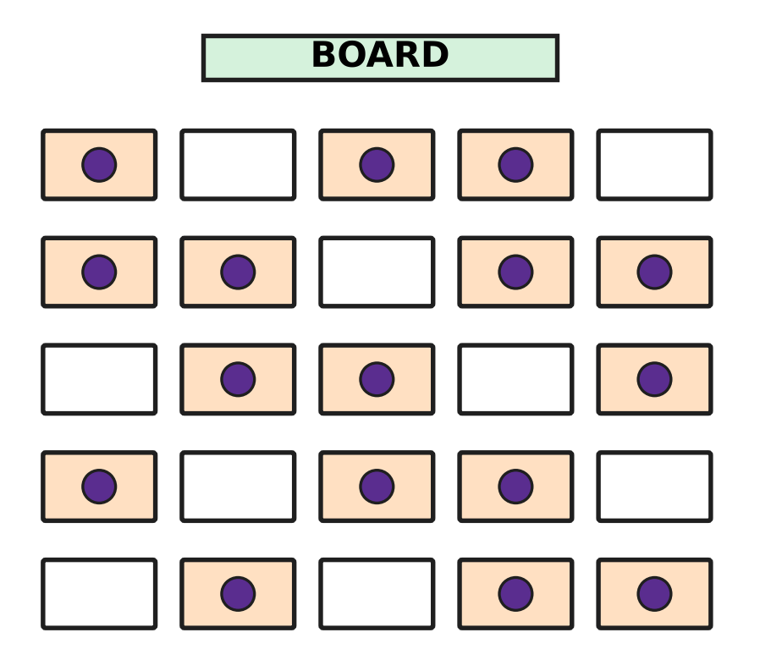
  (A) 36% | (B) 64% | (C) 9% | (D) 45%

Q10. Mira wants a toy train set marked ₹800 in a toy shop. The shop could give one of these four offers. Which offer gives her the biggest discount?
(A) ₹150 off the price | (B) Pay 85% of the price
(C) 20% off the price | (D) Price cut to ₹620

Q11. Irfan buys 50 kg of oranges at the fruit market for ₹40 per kg. He pays ₹500 to bring them to his shop. He sells all the oranges at ₹60 per kg. What is his profit percent?
(A) 25% | (B) 20% | (C) 120% | (D) 50%

Q12. A bead necklace is marked ₹750. The seller gives a discount of 12% on it and still makes a profit of 10%. What did the necklace cost the seller?
(A) ₹726 | (B) ₹594 | (C) ₹675 | (D) ₹600

Part 4 — Algebra (Syllabus Chapter 4)
Q13. Which of these expressions has exactly three terms after it is simplified?
(A) 7pq − 2qp + p | (B) 3p + 2q − p + 6
(C) 2p² + 5p − p² − 5p | (D) 4p + 3q − 4p + 2

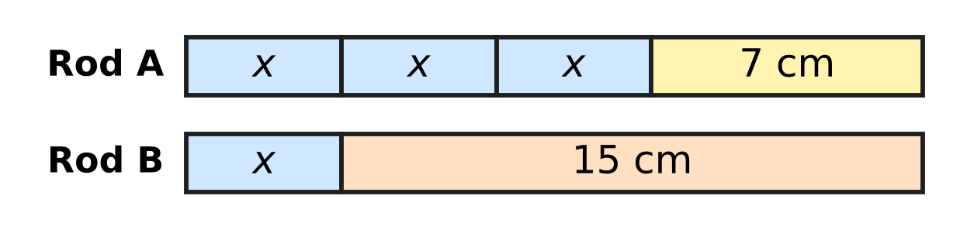
Q14. Rod A and Rod B in the picture have the same length. Each part marked x has the same length. What is the length of each part marked x?
(A) 2 cm | (B) 11 cm | (C) 4 cm | (D) 8 cm

Q15. What must be added to 4a − 3b to get 7a + 2b?
(A) 3a + 5b | (B) 11a − b | (C) 3a − b | (D) −3a − 5b

Q16. Some birds come to rest on the branches of a tree. If 6 birds sit on each branch, 4 birds find no place. If 7 birds sit on each branch, 2 branches stay empty. How many birds are there?
(A) 18 | (B) 126 | (C) 108 | (D) 112

Q17. On a train journey, Anya travels the first one-third of the distance through plains and then half of the whole distance through hills. The remaining 18 km runs along the coast. How long is the whole journey?
(A) 54 km | (B) 108 km | (C) 30 km | (D) 36 km

Part 5 — Geometry (Syllabus Chapter 5)
Q18. In the figure, line l is parallel to line m, and t crosses both lines. Which of these angles must be equal to ∠c? | 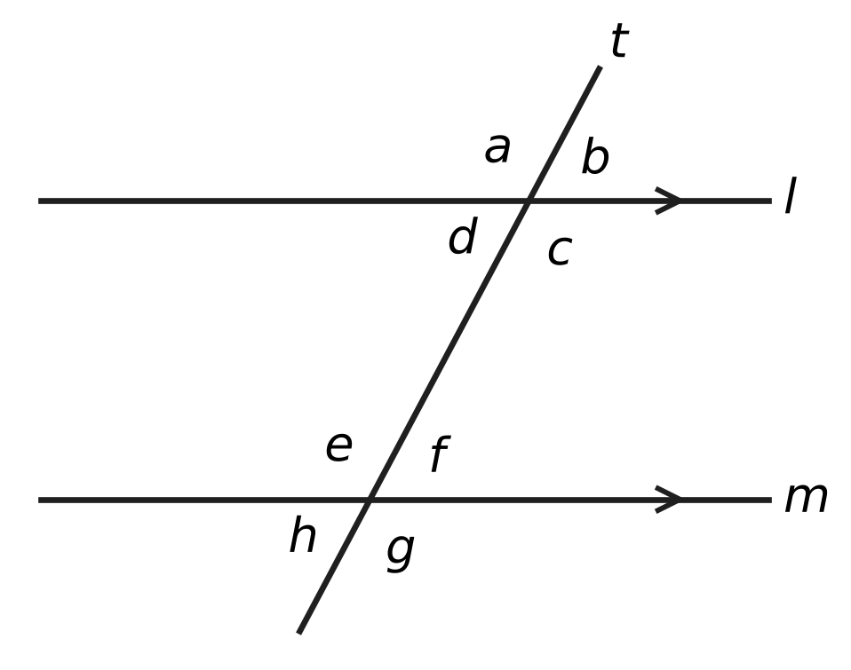
  (A) ∠e | (B) ∠d | (C) ∠f | (D) ∠h

Q19. The four angles of a quadrilateral are listed in order as you go round it. Which of these lists could be the angles of a parallelogram?
(A) 65°, 115°, 75°, 105° | (B) 75°, 75°, 105°, 105°
(C) 75°, 105°, 75°, 105° | (D) 70°, 110°, 70°, 100°

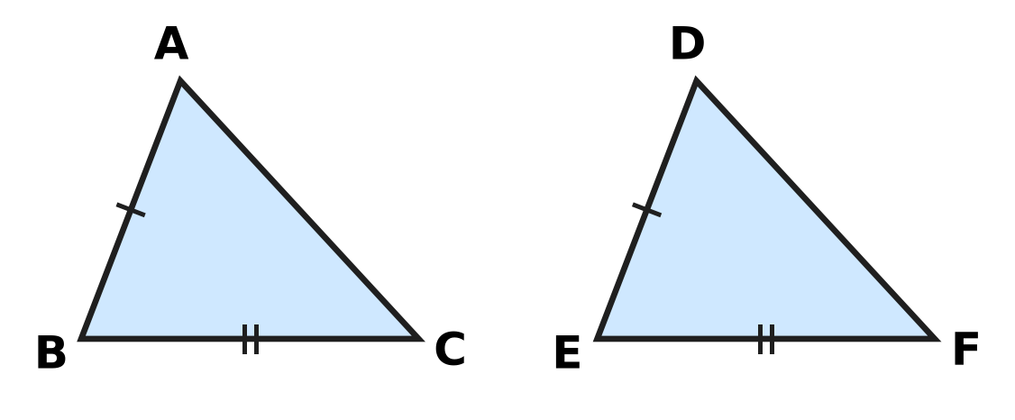
Q20. In the figure, sides with the same marks are equal: AB = DE and BC = EF. Which ONE more fact would make △ABC ≅ △DEF by the SAS rule?
(A) ∠C = ∠F | (B) AC = DF | (C) ∠B = ∠E | (D) ∠A = ∠D

Q21. In the figure, ABCD is a parallelogram with ∠ADC = 110°. The line AE cuts ∠DAB into two equal parts and meets DC at E. What is the size of ∠AED, marked "?" | 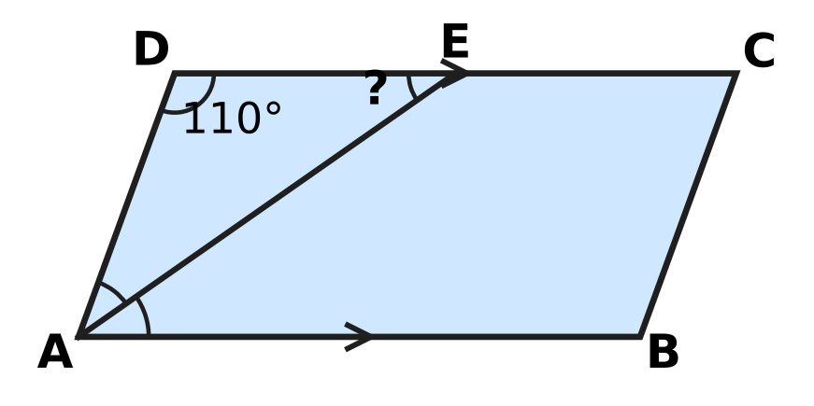
  (A) 145° | (B) 35° | (C) 70° | (D) 55°

Q22. In the figure, three straight lines meet at the point O. What is the value of x? | 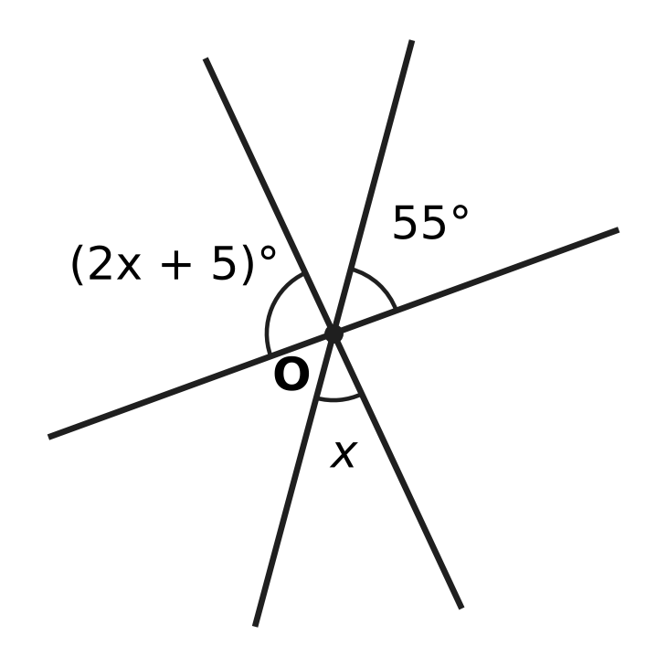
  (A) 40 | (B) 85 | (C) 100 | (D) 25

Part 6 — Mensuration (Syllabus Chapter 6)
Shoe box | Length (cm) | Breadth (cm) | Height (cm)
Box W | 30 | 18 | 10
Box X | 32 | 16 | 11
Box Y | 28 | 20 | 10
Box Z | 35 | 15 | 10

Q23. Tejas has four cuboid shoe boxes on his shoe rack. Their inside measurements are given in the table. Which box has the greatest volume?
(A) Box W | (B) Box X | (C) Box Y | (D) Box Z

Q24. The juice can in the figure is a cylinder of radius 3.5 cm and height 10 cm. How much juice can it hold when full? Use π = $\frac{22}{7}$. | 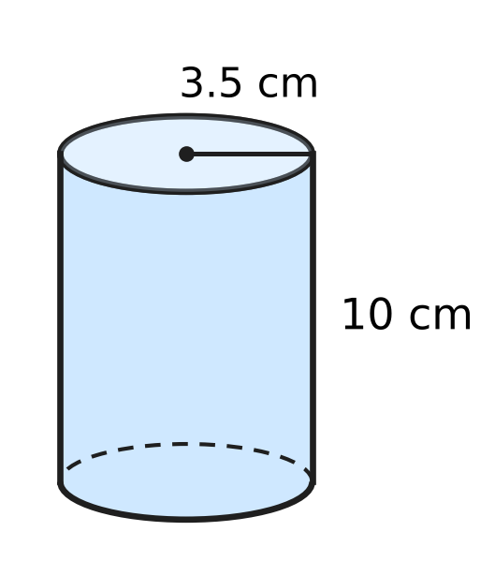
  (A) 110 cm³ | (B) 1,540 cm³
  (C) 220 cm³ | (D) 385 cm³

Q25. A gate pillar is a cuboid with a base 40 cm long and 30 cm wide, as in the figure. Only its four side faces are painted, and the painted area is 28,000 cm². How tall is the pillar, marked "?" | 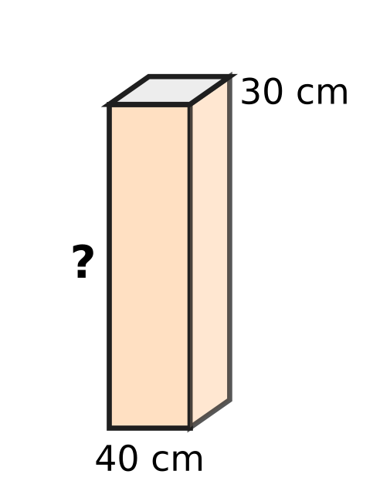
  (A) 350 cm | (B) 400 cm | (C) 700 cm | (D) 200 cm

Q26. Pihu's aquarium in the figure is a cuboid 60 cm long, 25 cm wide and 40 cm tall. She fills it with water to a depth of 30 cm. How many litres of water are in it? (1 litre = 1,000 cm³) | 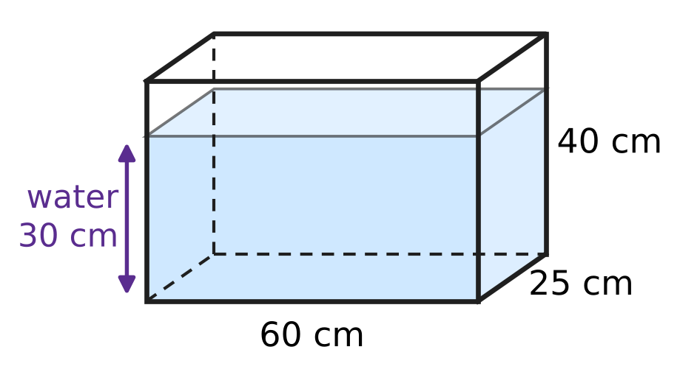
  (A) 4.5 litres | (B) 450 litres
  (C) 45 litres | (D) 60 litres

Q27. A playground roller is a cylinder of radius 35 cm and length 1.2 m, as in the figure. It rolls 25 full turns in a straight line. What area of ground does it level? Use π = $\frac{22}{7}$. | 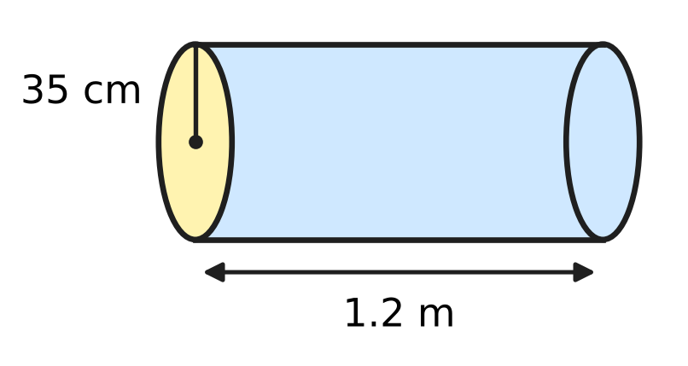
  (A) 2.64 m² | (B) 66 m² | (C) 132 m² | (D) 33 m²

Part 7 — Data Handling, Statistics & Probability (Syllabus Chapter 8)
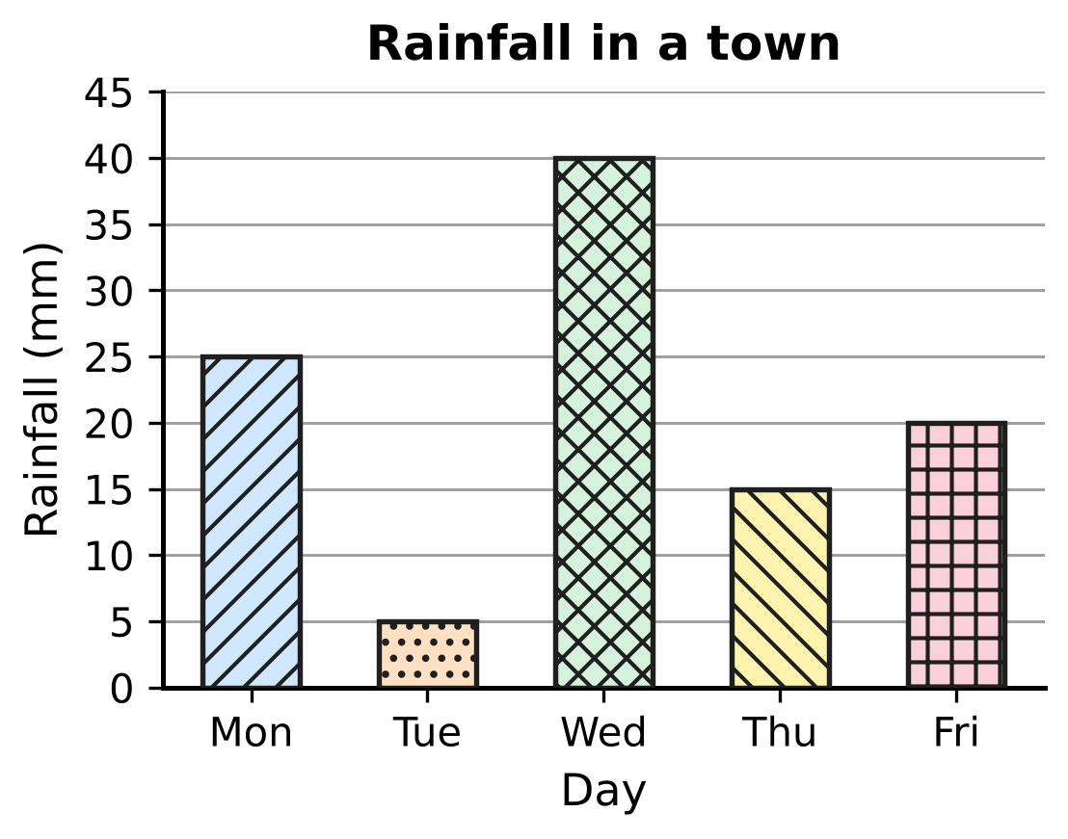
Q28. The bar graph shows the rainfall in a town on five days. What is the median rainfall of the five days?
(A) 20 mm | (B) 21 mm | (C) 40 mm | (D) 25 mm

Q29. Which of these sets of numbers has a mean of 12?
(A) 8, 12, 12, 18 | (B) 6, 13, 14, 19
(C) 9, 11, 16 | (D) 10, 12, 15

Q30. On sports day, each student chose one event. The pie chart shows the percentage of students who chose each event. 36 students chose Shot put. How many students chose Running? | 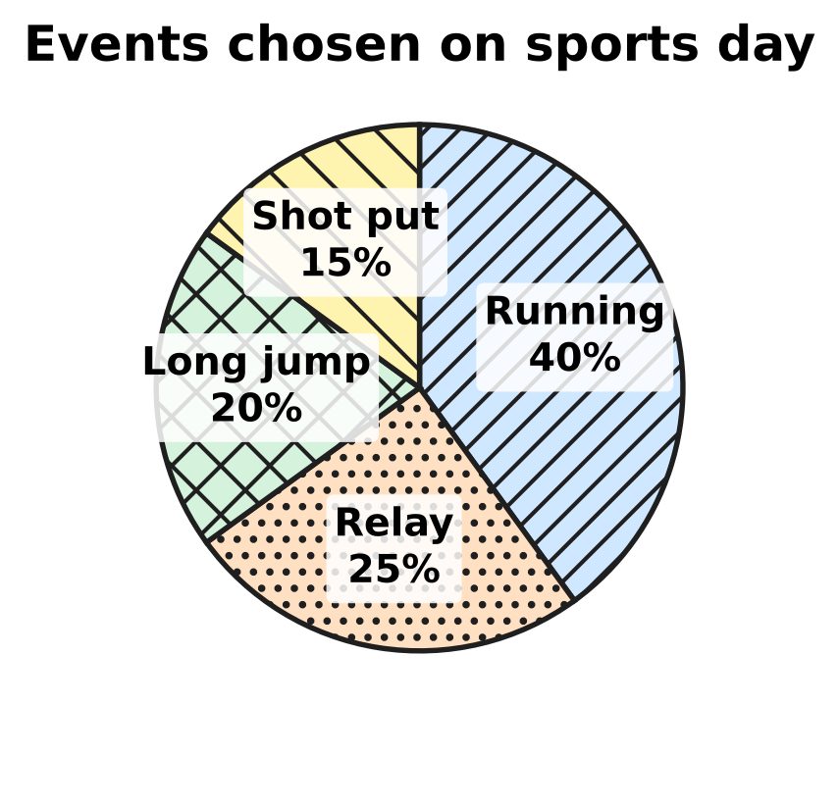
  (A) 144 | (B) 96 | (C) 61 | (D) 240

Part 8 — Applied Mathematics (Syllabus Chapter 9)
Q31. Which of these sets of four numbers, taken in the order given, are in proportion?
(A) 5, 8, 10, 15 | (B) 6, 9, 15, 21
(C) 4, 6, 10, 12 | (D) 3, 5, 12, 20

Q32. Gita has a red ribbon 75 cm long and a blue ribbon 2 m long. What is the ratio of the length of the red ribbon to the length of the blue ribbon, in its simplest form?
(A) 3 : 8 | (B) 75 : 2 | (C) 8 : 3 | (D) 3 : 80

Q33. In the school garden, 6 children fill 15 flower pots with soil in one hour. Each child works at the same rate. How many pots can 10 children fill in one hour?
(A) 9 | (B) 25 | (C) 19 | (D) 150

Q34. Each set below gives three pairs of values (x, y). In which set does y vary inversely as x?
(A) (2, 15), (3, 10), (6, 4) | (B) (2, 12), (3, 18), (5, 30)
(C) (2, 30), (3, 25), (5, 15) | (D) (2, 30), (3, 20), (5, 12)

Q35. In a school band, two-thirds of the boys is the same number as three-quarters of the girls. What is the ratio of the number of boys to the number of girls?
(A) 4 : 3 | (B) 2 : 3 | (C) 9 : 8 | (D) 8 : 9

Part 9 — Mathematical Reasoning & Problem-Solving (Syllabus Chapter 10)
Q36. In the addition shown, A and B stand for two different digits. What is the value of A + B? | 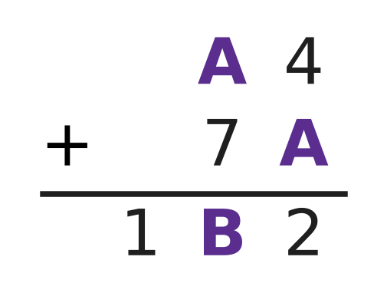
  (A) 14 | (B) 15 | (C) 10 | (D) 13

Q37. Which of these numbers leaves a remainder of 1 when it is divided by 2, when it is divided by 3 and when it is divided by 4?
(A) 29 | (B) 31 | (C) 37 | (D) 33

Q38. For a picnic in a park, Kush makes sandwiches. Each sandwich has one kind of bread and one kind of filling. He has 4 kinds of bread and 6 kinds of filling. How many different sandwiches can he make?
(A) 10 | (B) 24 | (C) 6 | (D) 48

Q39. The number 9 has exactly three factors: 1, 3 and 9. How many whole numbers from 1 to 100 have exactly three factors?
(A) 4 | (B) 10 | (C) 25 | (D) 3

Q40. The sum of 25 consecutive odd numbers is 1,875. What is the smallest of these numbers?
(A) 27 | (B) 75 | (C) 63 | (D) 51

SECTION II — Star Questions 5 questions × 4 marks each
Q41. In the sum ABC + AB + A = 300, the letters A, B and C stand for three different digits, and A is a non-zero digit. Here ABC is read as a three-digit number and AB as a two-digit number. Which three-digit number is ABC? [4 marks]
(A) 172 | (B) 263 | (C) 280 | (D) 271

Q42. A school chess club has fewer than 60 members. Exactly 45% of the members are girls. Exactly $\frac{3}{8}$ of the members wear glasses. How many members of the club are boys? [4 marks]
(A) 22 | (B) 11 | (C) 33 | (D) 18

Q43. A team of 9 workers can lay the floor tiles of a school hall in 16 days. They start the work. After some days, 3 more workers join them, and the whole floor is finished 14 days after the start. All workers work at the same rate. After how many days did the 3 workers join? [4 marks]
(A) 12 days | (B) 8 days | (C) 2 days | (D) 6 days

Q44. A cake is a cylinder of radius 14 cm and height 9 cm. The figure shows its top. Two straight vertical cuts through the centre O make four pieces. A piece is the same fraction of the cake as its angle at O is of 360°. Two of the angles at O are (4x)° and (5x)°. What is the volume of one of the two larger pieces? Use π = $\frac{22}{7}$. [4 marks] | 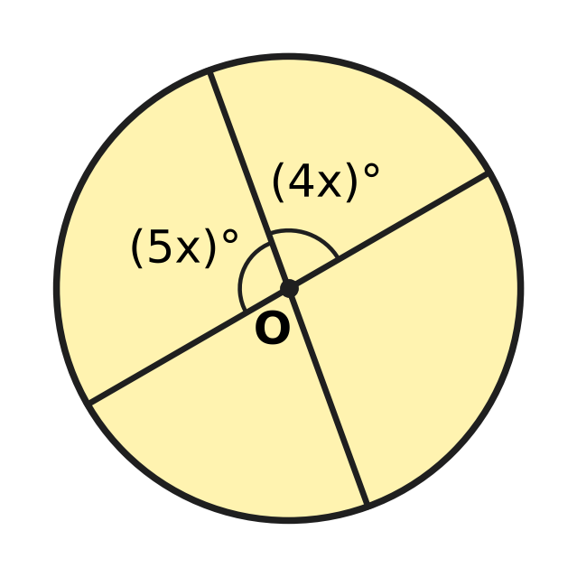
  (A) 2,772 cm³ | (B) 1,386 cm³
  (C) 1,540 cm³ | (D) 1,232 cm³

Q45. Depths below the sea surface are written as negative numbers. Lena is at $−13\frac{1}{2}$ m and rises $1\frac{1}{4}$ m every minute. At the same moment Dan is at $−2\frac{1}{4}$ m and goes down 1 m every minute. At what depth are they at the same level? [4 marks]
(A) $−8\frac{1}{2}$ m | (B) $−7\frac{1}{4}$ m | (C) $−7\frac{7}{8}$ m | (D) $−6\frac{1}{4}$ m

Answer Sheet AMO Level 1 · Class 7 · Practice Paper 2
Name: | School: | Roll No.:
Shade or tick one circle for each question.
1. Ⓐ Ⓑ Ⓒ Ⓓ | 16. Ⓐ Ⓑ Ⓒ Ⓓ | 31. Ⓐ Ⓑ Ⓒ Ⓓ
2. Ⓐ Ⓑ Ⓒ Ⓓ | 17. Ⓐ Ⓑ Ⓒ Ⓓ | 32. Ⓐ Ⓑ Ⓒ Ⓓ
3. Ⓐ Ⓑ Ⓒ Ⓓ | 18. Ⓐ Ⓑ Ⓒ Ⓓ | 33. Ⓐ Ⓑ Ⓒ Ⓓ
4. Ⓐ Ⓑ Ⓒ Ⓓ | 19. Ⓐ Ⓑ Ⓒ Ⓓ | 34. Ⓐ Ⓑ Ⓒ Ⓓ
5. Ⓐ Ⓑ Ⓒ Ⓓ | 20. Ⓐ Ⓑ Ⓒ Ⓓ | 35. Ⓐ Ⓑ Ⓒ Ⓓ
6. Ⓐ Ⓑ Ⓒ Ⓓ | 21. Ⓐ Ⓑ Ⓒ Ⓓ | 36. Ⓐ Ⓑ Ⓒ Ⓓ
7. Ⓐ Ⓑ Ⓒ Ⓓ | 22. Ⓐ Ⓑ Ⓒ Ⓓ | 37. Ⓐ Ⓑ Ⓒ Ⓓ
8. Ⓐ Ⓑ Ⓒ Ⓓ | 23. Ⓐ Ⓑ Ⓒ Ⓓ | 38. Ⓐ Ⓑ Ⓒ Ⓓ
9. Ⓐ Ⓑ Ⓒ Ⓓ | 24. Ⓐ Ⓑ Ⓒ Ⓓ | 39. Ⓐ Ⓑ Ⓒ Ⓓ
10. Ⓐ Ⓑ Ⓒ Ⓓ | 25. Ⓐ Ⓑ Ⓒ Ⓓ | 40. Ⓐ Ⓑ Ⓒ Ⓓ
11. Ⓐ Ⓑ Ⓒ Ⓓ | 26. Ⓐ Ⓑ Ⓒ Ⓓ | 41. Ⓐ Ⓑ Ⓒ Ⓓ
12. Ⓐ Ⓑ Ⓒ Ⓓ | 27. Ⓐ Ⓑ Ⓒ Ⓓ | 42. Ⓐ Ⓑ Ⓒ Ⓓ
13. Ⓐ Ⓑ Ⓒ Ⓓ | 28. Ⓐ Ⓑ Ⓒ Ⓓ | 43. Ⓐ Ⓑ Ⓒ Ⓓ
14. Ⓐ Ⓑ Ⓒ Ⓓ | 29. Ⓐ Ⓑ Ⓒ Ⓓ | 44. Ⓐ Ⓑ Ⓒ Ⓓ
15. Ⓐ Ⓑ Ⓒ Ⓓ | 30. Ⓐ Ⓑ Ⓒ Ⓓ | 45. Ⓐ Ⓑ Ⓒ Ⓓ
Q41–Q45 are Section II Star Questions (4 marks each).
For the parent or teacher
Section I correct: ______ / 40 × 2 = ______ marks Section II correct: ______ / 5 × 4 = ______ marks
Correct: ______ / 45 Score: ______ / 100
Answer Key and Solutions AMO Level 1 · Class 7 · Practice Paper 2
Quick answers
1 D | 6 A | 11 B | 16 D | 21 B | 26 C | 31 D | 36 A | 41 D
2 A | 7 D | 12 D | 17 B | 22 A | 27 B | 32 A | 37 C | 42 A
3 C | 8 C | 13 B | 18 A | 23 B | 28 A | 33 B | 38 B | 43 B
4 C | 9 A | 14 C | 19 C | 24 D | 29 C | 34 D | 39 A | 44 C
5 B | 10 D | 15 A | 20 C | 25 D | 30 B | 35 C | 40 D | 45 B
Solutions
Q | Part · level | Answer | Why?
1 | Part 1 · Ch1 · Easy | (D) $−\frac{5}{12}$ | With denominator 12, −1/2 = −6/12 and −1/3 = −4/12. Only −5/12 lies between them; −7/12 and −10/12 are less than −6/12, and −1/6 = −2/12 is greater than −4/12.
2 | Part 1 · Ch1 · Easy | (A) (−3/8) × (−2/5) | Two negative factors give a positive product: (−3/8) × (−2/5) = 6/40 = 3/20. Three negative factors, or one negative and one positive, give a negative result.
3 | Part 1 · Ch1 · Medium | (C) $−\frac{1}{2}$ °C | In quarters: −9/4 + 14/4 = 5/4 at noon; 5/4 − 7/4 = −2/4 = −1/2 °C in the evening.
4 | Part 1 · Ch1 · Medium | (C) $−\frac{7}{24}$ | The halfway point is (−3/4 + 1/6) ÷ 2 = (−9/12 + 2/12) ÷ 2 = (−7/12) ÷ 2 = −7/24.
5 | Part 2 · Ch2 · Easy | (B) (−7)³ | (−7)³ = −343 is negative. (−2)⁴ = 16, (−1)⁵ × (−4)³ = (−1) × (−64) = 64 and (−5)⁰ = 1 are all positive.
6 | Part 2 · Ch2 · Easy | (A) 2.75 × 10⁶ | Put the point after the first digit: 2.75. The point moves 6 places, so 2,750,000 = 2.75 × 10⁶.
7 | Part 2 · Ch2 · Medium | (D) 625 | Since 32 = 2⁵, x = 5, and since 81 = 3⁴, y = 4. Then xʸ = 5⁴ = 625.
8 | Part 3 · Ch3 · Easy | (C) 12% of 250 | Here 12% of 250 = 30, 58% of 50 = 29, 35% of 80 = 28 and 45% of 60 = 27. The greatest is 12% of 250.
9 | Part 3 · Ch3 · Easy | (A) 36% | There are 25 desks and 9 of them are empty. 9/25 = 36/100 = 36%.
10 | Part 3 · Ch3 · Easy | (D) Price cut to ₹620 | The discounts are ₹150, 20% of 800 = ₹160, 800 − 620 = ₹180 and 15% of 800 = ₹120. The biggest discount is the price cut to ₹620.
11 | Part 3 · Ch3 · Medium | (B) 20% | Cost price = 50 × 40 + 500 = ₹2,500. Selling price = 50 × 60 = ₹3,000. Profit = ₹500, and 500/2,500 × 100 = 20%.
12 | Part 3 · Ch3 · Medium | (D) ₹600 | Selling price = 88% of ₹750 = ₹660. This is 110% of the cost price, so the cost price = 660 × 100/110 = ₹600.
13 | Part 4 · Ch4 · Easy | (B) 3p + 2q − p + 6 | Simplified, 3p + 2q − p + 6 = 2p + 2q + 6, which has three terms. The others become 3q + 2, p² and 5pq + p.
14 | Part 4 · Ch4 · Easy | (C) 4 cm | From the rods, 3x + 7 = x + 15, so 2x = 8 and x = 4 cm. Both rods are then 19 cm long.
15 | Part 4 · Ch4 · Easy | (A) 3a + 5b | (7a + 2b) − (4a − 3b) = 7a + 2b − 4a + 3b = 3a + 5b.
16 | Part 4 · Ch4 · Medium | (D) 112 | Let there be b branches. Then 6b + 4 = 7(b − 2), so 6b + 4 = 7b − 14 and b = 18. There are 6 × 18 + 4 = 112 birds.
17 | Part 4 · Ch4 · Medium | (B) 108 km | Let the journey be x km. Then x/3 + x/2 + 18 = x, so x − 5x/6 = 18, x/6 = 18 and x = 108 km.
18 | Part 5 · Ch5 · Easy | (A) ∠e | ∠c and ∠e lie between the two parallel lines on opposite sides of t, so they are alternate angles and are equal.
19 | Part 5 · Ch5 · Easy | (C) 75°, 105°, 75°, 105° | In a parallelogram opposite angles are equal and neighbouring angles add up to 180°. Only 75°, 105°, 75°, 105° does both.
20 | Part 5 · Ch5 · Easy | (C) ∠B = ∠E | SAS needs the angle between the two equal sides. The angle between AB and BC is ∠B, and between DE and EF it is ∠E, so ∠B = ∠E is needed.
21 | Part 5 · Ch5 · Medium | (B) 35° | Neighbouring angles of a parallelogram add up to 180°, so ∠DAB = 70° and ∠DAE = 35°. In △ADE, ∠AED = 180° − 110° − 35° = 35°.
22 | Part 5 · Ch5 · Medium | (A) 40 | The angle vertically opposite x is also x, and it sits between 55° and (2x + 5)° on a straight line. So 55 + x + 2x + 5 = 180, 3x = 120 and x = 40.
23 | Part 6 · Ch6 · Easy | (B) Box X | Volumes: W = 5,400 cm³, X = 32 × 16 × 11 = 5,632 cm³, Y = 5,600 cm³ and Z = 5,250 cm³. Box X has the greatest volume.
24 | Part 6 · Ch6 · Easy | (D) 385 cm³ | Volume = πr²h = 22/7 × 3.5 × 3.5 × 10 = 11 × 3.5 × 10 = 385 cm³.
25 | Part 6 · Ch6 · Easy | (D) 200 cm | Area of the four side faces = 2h(l + b) = 2 × h × (40 + 30) = 140h. So 140h = 28,000 and h = 200 cm.
26 | Part 6 · Ch6 · Medium | (C) 45 litres | Volume of water = 60 × 25 × 30 = 45,000 cm³. Since 1,000 cm³ = 1 litre, this is 45 litres.
27 | Part 6 · Ch6 · Medium | (B) 66 m² | In one turn the roller levels an area equal to its curved surface: 2πrh = 2 × 22/7 × 0.35 × 1.2 = 2.64 m². In 25 turns: 2.64 × 25 = 66 m².
28 | Part 7 · Ch8 · Easy | (A) 20 mm | In order the rainfall values are 5, 15, 20, 25, 40 mm. The middle (third) value is 20 mm.
29 | Part 7 · Ch8 · Easy | (C) 9, 11, 16 | For C, 9 + 11 + 16 = 36 and 36 ÷ 3 = 12. The other means are 50 ÷ 4 = 12.5, 37 ÷ 3 and 52 ÷ 4 = 13.
30 | Part 7 · Ch8 · Medium | (B) 96 | Shot put is 15%, so 1% stands for 36 ÷ 15 = 2.4 students and the total is 240. Running is 40% of 240 = 96 students.
31 | Part 8 · Ch9 · Easy | (D) 3, 5, 12, 20 | Here 3 : 5 = 12 : 20 because 3 × 20 = 60 = 5 × 12. In the other sets the product of the outer numbers is not equal to the product of the middle numbers.
32 | Part 8 · Ch9 · Easy | (A) 3 : 8 | First, 2 m = 200 cm. Then 75 : 200 = 3 : 8 (dividing both by 25).
33 | Part 8 · Ch9 · Easy | (B) 25 | One child fills 15 ÷ 6 = 2.5 pots in an hour, so 10 children fill 2.5 × 10 = 25 pots.
34 | Part 8 · Ch9 · Medium | (D) (2, 30), (3, 20), (5, 12) | For inverse variation x × y must stay the same. Only 2 × 30 = 3 × 20 = 5 × 12 = 60.
35 | Part 8 · Ch9 · Medium | (C) 9 : 8 | (2/3) × boys = (3/4) × girls, so boys ÷ girls = (3/4) ÷ (2/3) = 9/8. The ratio is 9 : 8.
36 | Part 9 · Ch10 · Easy | (A) 14 | Units: 4 + A ends in 2, so A = 8 with a carry of 1. Tens: 8 + 7 + 1 = 16, so B = 6. Check: 84 + 78 = 162. A + B = 14.
37 | Part 9 · Ch10 · Easy | (C) 37 | Such a number is 1 more than a common multiple of 2, 3 and 4, that is 1 more than a multiple of 12. So 37 = 36 + 1 works; 31, 33 and 29 each fail one test.
38 | Part 9 · Ch10 · Easy | (B) 24 | Each of the 4 kinds of bread can go with each of the 6 fillings. So there are 4 × 6 = 24 different sandwiches.
39 | Part 9 · Ch10 · Medium | (A) 4 | A number has exactly three factors only when it is the square of a prime: 4, 9, 25 and 49. So there are 4 such numbers.
40 | Part 9 · Ch10 · Medium | (D) 51 | The middle (13th) number equals the mean: 1,875 ÷ 25 = 75. There are 12 odd numbers below it, so the smallest is 75 − 24 = 51.
41 | Section II · Ch4 + Ch10 · Hard | (D) 271 | ABC + AB + A = 111A + 11B + C = 300. A = 1 would need 11B + C = 189, which is impossible, so A = 2 and 11B + C = 78. B = 7 and C = 1 is the only choice, so ABC = 271.
42 | Section II · Ch3 + Ch10 · Hard | (A) 22 | Here 45% of n is whole only if n is a multiple of 20, and 3/8 of n is whole only if n is a multiple of 8. The only common multiple below 60 is 40. Girls = 18, so boys = 40 − 18 = 22.
43 | Section II · Ch4 + Ch9 · Hard | (B) 8 days | The work is 9 × 16 = 144 worker-days. If the 3 joined after d days, 9d + 12(14 − d) = 144, so 168 − 3d = 144 and d = 8.
44 | Section II · Ch5 + Ch6 · Hard | (C) 1,540 cm³ | The two marked angles make a straight line, so 9x = 180 and x = 20; the larger angle is 100°. Cake volume = 22/7 × 14 × 14 × 9 = 5,544 cm³, and 100/360 of it is 1,540 cm³.
45 | Section II · Ch1 + Ch4 · Hard | (B) $−7\frac{1}{4}$ m | After t minutes Lena is at −27/2 + 5t/4 and Dan at −9/4 − t. Setting them equal: 9t/4 = 45/4, so t = 5. The depth is −9/4 − 5 = −29/4 = −7 1/4 m.

