UNLOCK IQ INSTITUTE
Realize Your True Potential
Aryabhatta Maths Olympiad (AMO)
Level 1 — Practice Paper 3
CLASS 7

Questions | 45 multiple-choice questions
Marks | 100
Time | 60 minutes
Section I | 40 questions × 2 marks = 80 marks
Section II | 5 Star Questions × 4 marks = 20 marks
Negative marking | No negative marking
Calculator | Not allowed
Chapters | Number System · Operations · Fractions, Decimals & Percentages · Algebra · Geometry · Mensuration · Data Handling · Applied Mathematics · Mathematical Reasoning

Instructions to candidates
• This paper has 45 multiple-choice questions. Each question has four answer choices, of which exactly one is correct.
• Section I (Q1–Q40) carries 2 marks per question. Section II (Q41–Q45) carries 4 marks per question.
• There is no negative marking. Unanswered questions score zero.
• Calculators are not permitted. Rough work may be done on a separate sheet.
• Mark your answers on the answer sheet at the end of the paper.
• All figures are not necessarily drawn to scale unless stated.

For parents and teachers
Print or view this paper in colour. Pictures are part of the questions.
Parts follow the AMO syllabus chapters. Chapter 7 is not part of the Class 7 syllabus, so the chapter numbers shown in the Part headings have gaps.
The answer sheet and the answer key are at the end. Remove only the answer key before the student begins.

Name: | School: | Roll No.:

SECTION I 40 questions × 2 marks each
Part 1 — Number System (Syllabus Chapter 1)
Q1. What number should go in the box □ to make this statement true?
$(−\frac{5}{6})$ × □ = 1
(A) $\frac{11}{6}$ | (B) $\frac{5}{6}$ | (C) $\frac{6}{5}$ | (D) $−\frac{6}{5}$

Q2. Which of these is NOT equal to $−\frac{5}{6}$?
(A) $\frac{−10}{−12}$ | (B) $\frac{−20}{24}$ | (C) $\frac{15}{−18}$ | (D) $\frac{−35}{42}$

Q3. What number should go in the box □?
$−\frac{2}{3}$ + $\frac{5}{6}$ − □ = $−\frac{1}{4}$
(A) $−\frac{1}{12}$ | (B) $\frac{5}{12}$ | (C) $−\frac{5}{12}$ | (D) $\frac{1}{12}$

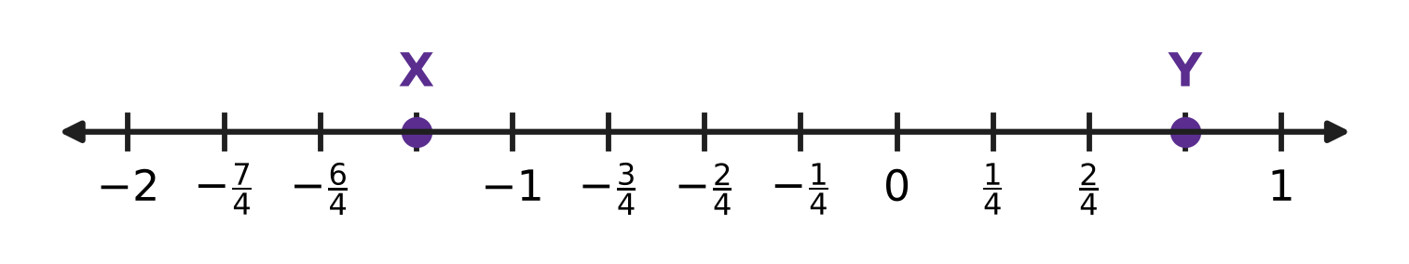
Q4. X and Y are marked on the number line. The gap between two whole numbers next to each other is split into quarters. Work out X ÷ Y.
(A) $−\frac{5}{3}$ | (B) $\frac{5}{3}$ | (C) $−\frac{3}{5}$ | (D) $−\frac{15}{16}$

Part 2 — Operations & Number Properties (Syllabus Chapter 2)
Q5. In the statement 7⁴ × 7ⁿ ÷ 7³ = 7⁶, the letter n stands for a missing whole number. What is n?
(A) 9 | (B) 2 | (C) 5 | (D) 13

Q6. What is the value of (−2)³ × 3⁰ + (−1)⁵?
(A) 7 | (B) −7 | (C) −1 | (D) −9

Q7. A large sorting centre of the post office handles 6 × 10⁴ letters every day. How many letters does it handle in 30 days? Give the answer in standard form.
(A) 1.8 × 10⁴ letters | (B) 1.8 × 10⁵ letters
(C) 1.8 × 10⁶ letters | (D) 1.8 × 10⁷ letters

Part 3 — Fractions, Decimals & Percentages (Syllabus Chapter 3)
Q8. The bus fare from a village to the town went up by 20%. The new fare is ₹42. What was the fare before the rise?
(A) ₹22 | (B) ₹35 | (C) ₹33.60 | (D) ₹50.40

Q9. What number should go in the box?
$□\%$ of 80 = 30% of 120
(A) 20 | (B) 45 | (C) 30 | (D) 36

Q10. Hema makes clay pots. One pot costs her ₹160 to make. She sells it at a profit of 25%. What is the selling price of the pot?
(A) ₹185 | (B) ₹40 | (C) ₹120 | (D) ₹200

Q11. The school canteen sells a cup of milk for ₹20. Its offer is: "Buy 4 cups, get 1 cup free." Charu takes 5 cups under this offer. What percentage discount does she get on the marked price of the 5 cups?
(A) 20% | (B) 25% | (C) 5% | (D) 80%

Q12. A maths quiz has 60 questions. To win a badge, Juhi must get at least 70% of all the questions right. She has done the first 40 questions and got 29 of them right. What is the least number of the remaining 20 questions she must get right to win the badge?
(A) 11 questions | (B) 2 questions
(C) 13 questions | (D) 14 questions

Part 4 — Algebra (Syllabus Chapter 4)
Q13. What is the value of a²b − 2ab² when a = −2 and b = 3?
(A) 48 | (B) 24 | (C) −48 | (D) −24

Q14. The expression 6ab − 3a²b + 2ba − a²b + 7 is simplified. What is the coefficient of a²b in the simplified expression?
(A) −3 | (B) −2 | (C) −4 | (D) 8

Q15. The equation 4x − □ = 2x + 9 has the solution x = 7. What number is in the box □?
(A) 23 | (B) 5 | (C) 19 | (D) −5

Q16. Vikram's piggy bank has only ₹5 coins and ₹10 coins. There are 40 coins, and together they are worth ₹290. How many ₹10 coins are in the piggy bank?
(A) 58 | (B) 22 | (C) 29 | (D) 18

Q17. In the brick pyramid shown, the expression in each brick is the sum of the expressions in the two bricks just below it. The two middle bricks are left empty. The top brick is 31. What is the value of x? | 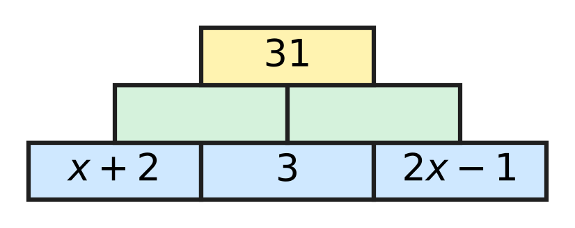
  (A) 9 | (B) 8 | (C) 24 | (D) 10

Part 5 — Geometry (Syllabus Chapter 5)
Q18. In the figure, side BC of △ABC is extended to D. ∠BAC = x°, ∠ABC = 70° and the exterior angle ∠ACD = (2x − 10)°. What is the value of x? | 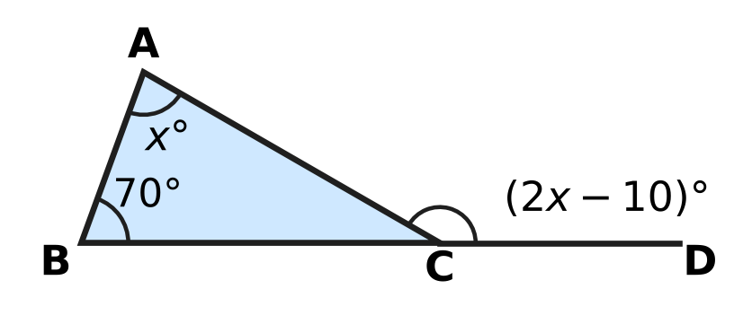
  (A) 40 | (B) 60 | (C) 80 | (D) 70

Q19. In the figure, the line t crosses the lines l and m. The two marked angles lie between l and m, on opposite sides of t. For which value of x will l be parallel to m? | 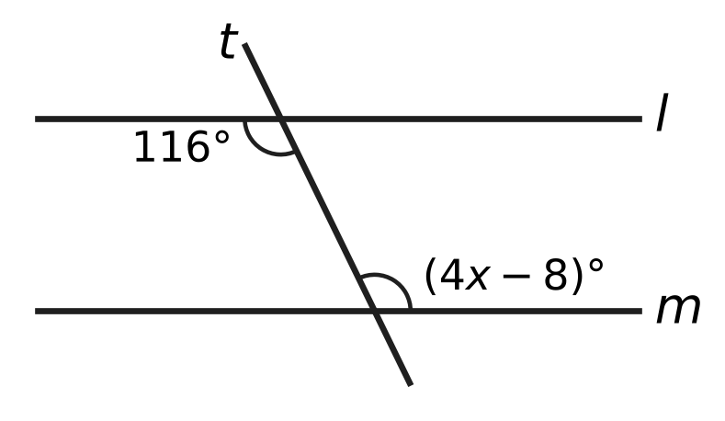
  (A) 29 | (B) 18 | (C) 27 | (D) 31

Q20. Lalit proves that the angles of the quadrilateral ABCD add up to 360°. The diagonal AC is drawn, and the angles 1, 2, 3, 4 are marked.  Step 1: AC divides ABCD into △ABC and △ACD.  Step 2: ∠1 + ∠B + ∠3 = 180° and ∠2 + ∠D + ∠4 = 180°.  Step 3: Adding, ∠1 + ∠2 + ∠B + ∠3 + ∠4 + ∠D = 360°.  Step 4: ∠1 + ∠2 = ∠A and ∠3 + ∠4 = ∠C, so ∠A + ∠B + ∠C + ∠D = 360°.  Which of these facts does the proof NOT use? | 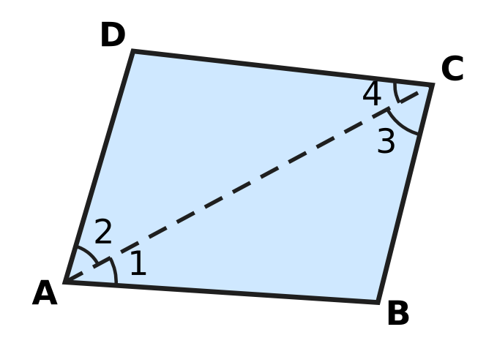
  (A) Angles on a straight line add up to 180°.
  (B) The angles of a triangle add up to 180°.
  (C) A diagonal splits a quadrilateral into two triangles.
  (D) An angle split into two parts equals the sum of the parts.

Q21. It is given that △PQR ≅ △LMN. In △PQR, ∠Q = 64°. In △LMN, ∠N = 51°. What is the size of ∠L?
(A) 51° | (B) 65° | (C) 115° | (D) 64°

Q22. In the quadrilateral ABCD shown, ∠A = 98° and ∠B = 84°. Side BC is extended beyond C, and the angle between this extension and CD is 116°. What is the size of ∠D? | 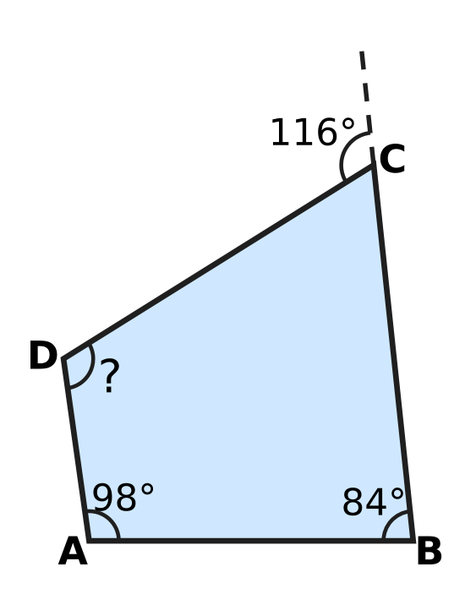
  (A) 114° | (B) 62° | (C) 178° | (D) 66°

Part 6 — Mensuration (Syllabus Chapter 6)
Q23. The wooden block shown is a cuboid. Its volume is 840 cm³. It is 14 cm long and 6 cm wide. What is its height, marked "?" | 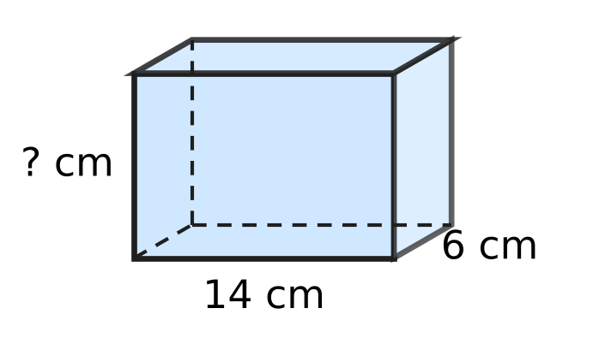
  (A) 140 cm | (B) 42 cm | (C) 60 cm | (D) 10 cm

Q24. A closed tin is a cylinder of radius 3.5 cm and height 6.5 cm, as shown. How much metal sheet is needed to make it, including the top and the bottom? Use π = $\frac{22}{7}$. | 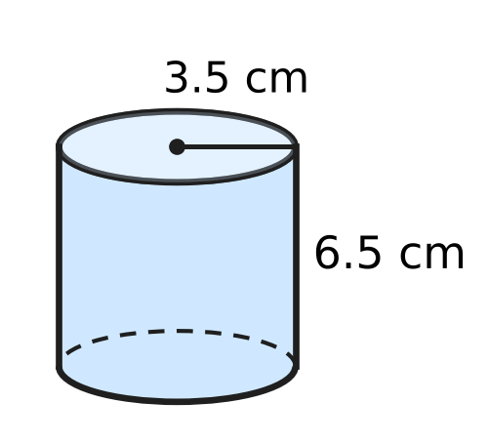
  (A) 181.5 cm² | (B) 594 cm²
  (C) 220 cm² | (D) 143 cm²

Q25. A wooden cube of edge 16 cm is cut into small cubes, each of edge 4 cm. No wood is wasted. How many small cubes are made?
(A) 16 | (B) 64 | (C) 4 | (D) 1,024

Q26. Sahil cuts a wire of length 96 cm into 12 equal pieces and uses them as the 12 edges of a cube. He then covers all six faces of the cube with paper. What area of paper does he use?
(A) 384 cm² | (B) 1,536 cm²
(C) 864 cm² | (D) 256 cm²

Q27. The curved surface area of the cylindrical container shown is 1,320 cm². Its height is 15 cm. What is its volume? Use π = $\frac{22}{7}$. | 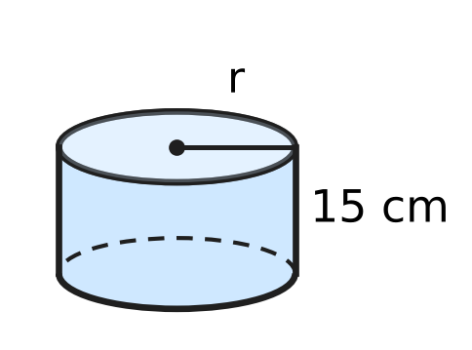
  (A) 18,480 cm³ | (B) 2,310 cm³
  (C) 9,240 cm³ | (D) 36,960 cm³

Part 7 — Data Handling, Statistics & Probability (Syllabus Chapter 8)
Q28. The pie chart shows how 240 students voted for their favourite board game. Each student voted once. What is the angle of the sector for Carrom? | 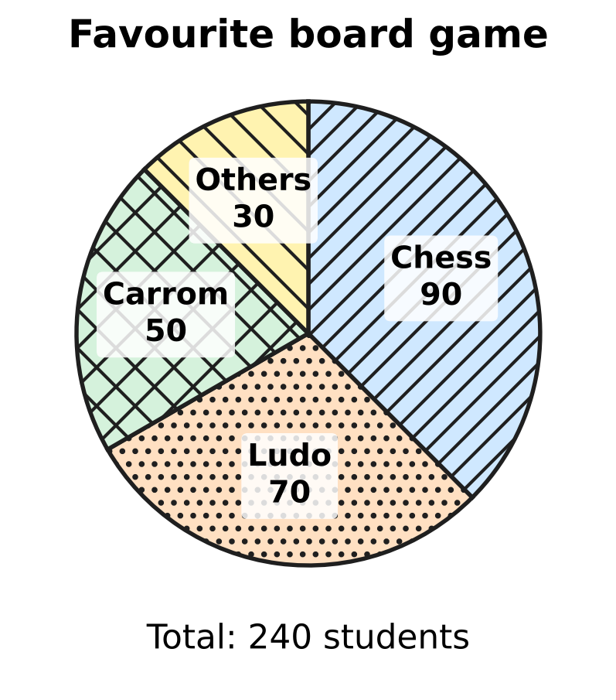
  (A) 37.5° | (B) 105° | (C) 50° | (D) 75°

Q29. Sneha ran six laps of the school running track. Her lap times, in seconds, were 58, 64, 61, 55, 67 and 60. What is the median lap time?
(A) 60.5 seconds | (B) 58 seconds
(C) 60 seconds | (D) 61 seconds

Q30. Avni counted the honey bees that visited each of five flower beds in one hour. The pictograph shows her counts. Half a symbol stands for 5 bees. What is the mean number of bees per flower bed? | 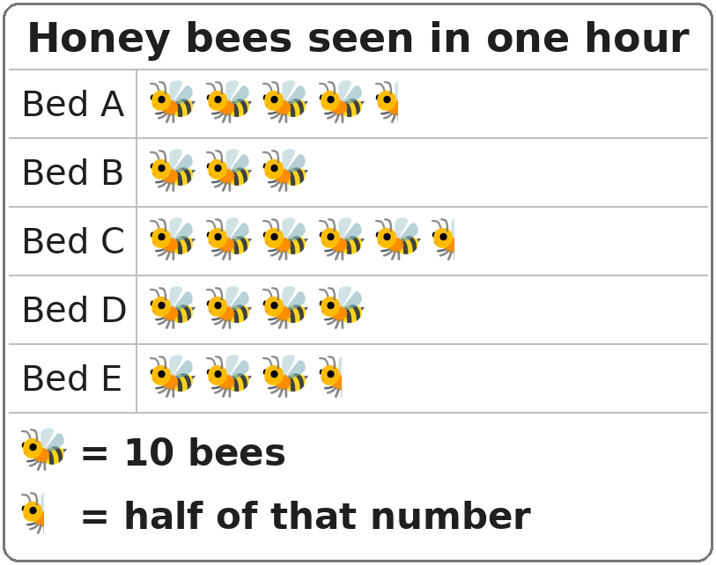
  (A) 55 bees | (B) 41 bees | (C) 40 bees | (D) 205 bees

Part 8 — Applied Mathematics (Syllabus Chapter 9)
Q31. On Rhea's map, 2 cm stands for 15 km. Two towns are 7 cm apart on the map. What is the actual distance between them?
(A) 30 km | (B) 22 km | (C) 105 km | (D) 52.5 km

Q32. A pile of 15 identical textbooks weighs 9 kg. What do 25 of these textbooks weigh?
(A) 225 kg | (B) 5.4 kg | (C) 15 kg | (D) 19 kg

Q33. In a harbour, $\frac{3}{8}$ of the boats are fishing boats. All the other boats are sailing boats. What is the ratio of fishing boats to sailing boats?
(A) 3 : 5 | (B) 5 : 3 | (C) 3 : 8 | (D) 3 : 11

Q34. Ken repairs clocks in a clock shop. Inside one clock, a gear with 40 teeth turns a smaller gear with 24 teeth. The teeth of the two gears fit together, so the same number of teeth pass the meeting point on each gear. When the large gear makes 15 full turns, how many full turns does the small gear make?
(A) 600 | (B) 9 | (C) 25 | (D) 31

Folding 60 paper planes
Number of children | 4 | 5 | ___
Planes folded by each child | 15 | ___ | 6

Q35. Some children share the work of folding 60 paper planes equally. The table shows the number of planes each child folds for different numbers of children. Which numbers fill the two blanks? (Give the blank in the first row first.)
(A) 12 and 10 | (B) 10 and 14
(C) 13 and 14 | (D) 10 and 12

Part 9 — Mathematical Reasoning & Problem-Solving (Syllabus Chapter 10)
Q36. The factors of 6 other than 6 itself are 1, 2 and 3, and 1 + 2 + 3 = 6. Which of these numbers is also equal to the sum of its factors other than itself?
(A) 20 | (B) 28 | (C) 24 | (D) 12

Q37. Daksh has three number cards: 0, 4 and 7. He puts all three cards in a row to make a three-digit number. A three-digit number cannot start with 0. How many different three-digit numbers can he make?
(A) 4 | (B) 18 | (C) 6 | (D) 27

Q38. The five-digit number $4□152$ is divisible by 9. Which digit is in the box?
(A) 7 | (B) 1 | (C) 3 | (D) 6

Q39. Which of these numbers has 1 as its units digit?
(A) 9³⁵ | (B) 7⁴⁴ | (C) 2⁴⁰ | (D) 3⁴²

Q40. The counting numbers from 1 onwards are added in order, and the sum is exactly 210. What is the last number added?
1 + 2 + 3 + … + □ = 210
(A) 14 | (B) 21 | (C) 20 | (D) 105

SECTION II — Star Questions 5 questions × 4 marks each
Q41. Some two-digit numbers are equal to the product of their two digits added to the sum of their two digits. For example, 25 does not have this property, because 2 × 5 + 2 + 5 = 17. How many two-digit numbers have this property? [4 marks]
(A) 1 | (B) 10 | (C) 9 | (D) 0

Q42. Nirav grows mangoes. It costs him ₹AB to grow 1 kg of mangoes, and he sells 1 kg at a profit of 20% for ₹BA. Here AB and BA are two-digit numbers made from two different non-zero digits A and B. What is the selling price of 1 kg? [4 marks]
(A) ₹9 | (B) ₹45 | (C) ₹63 | (D) ₹54

Q43. On one day, a museum sold 160 tickets. Adult tickets and child tickets were sold in the ratio 3 : 5. An adult ticket costs ₹20 more than a child ticket. The museum collected ₹6,000 from these tickets. What is the price of an adult ticket? [4 marks]
(A) ₹50 | (B) ₹30 | (C) ₹45 | (D) ₹25

Q44. A cuboid has a volume of 72 cm³. Its length, breadth and height are three different whole numbers of centimetres. A triangle can be made whose three sides have the same lengths as these three edges. What is the total surface area of the cuboid? [4 marks]
(A) 124 cm² | (B) 108 cm² | (C) 178 cm² | (D) 120 cm²

Q45. The sum of two rational numbers is $−\frac{1}{6}$. One of them is $\frac{3}{4}$ more than twice the other. What is the larger of the two numbers? [4 marks]
(A) $\frac{5}{36}$ | (B) $\frac{41}{36}$ | (C) $−\frac{11}{36}$ | (D) $\frac{7}{36}$

Answer Sheet AMO Level 1 · Class 7 · Practice Paper 3
Name: | School: | Roll No.:
Shade or tick one circle for each question.
1. Ⓐ Ⓑ Ⓒ Ⓓ | 16. Ⓐ Ⓑ Ⓒ Ⓓ | 31. Ⓐ Ⓑ Ⓒ Ⓓ
2. Ⓐ Ⓑ Ⓒ Ⓓ | 17. Ⓐ Ⓑ Ⓒ Ⓓ | 32. Ⓐ Ⓑ Ⓒ Ⓓ
3. Ⓐ Ⓑ Ⓒ Ⓓ | 18. Ⓐ Ⓑ Ⓒ Ⓓ | 33. Ⓐ Ⓑ Ⓒ Ⓓ
4. Ⓐ Ⓑ Ⓒ Ⓓ | 19. Ⓐ Ⓑ Ⓒ Ⓓ | 34. Ⓐ Ⓑ Ⓒ Ⓓ
5. Ⓐ Ⓑ Ⓒ Ⓓ | 20. Ⓐ Ⓑ Ⓒ Ⓓ | 35. Ⓐ Ⓑ Ⓒ Ⓓ
6. Ⓐ Ⓑ Ⓒ Ⓓ | 21. Ⓐ Ⓑ Ⓒ Ⓓ | 36. Ⓐ Ⓑ Ⓒ Ⓓ
7. Ⓐ Ⓑ Ⓒ Ⓓ | 22. Ⓐ Ⓑ Ⓒ Ⓓ | 37. Ⓐ Ⓑ Ⓒ Ⓓ
8. Ⓐ Ⓑ Ⓒ Ⓓ | 23. Ⓐ Ⓑ Ⓒ Ⓓ | 38. Ⓐ Ⓑ Ⓒ Ⓓ
9. Ⓐ Ⓑ Ⓒ Ⓓ | 24. Ⓐ Ⓑ Ⓒ Ⓓ | 39. Ⓐ Ⓑ Ⓒ Ⓓ
10. Ⓐ Ⓑ Ⓒ Ⓓ | 25. Ⓐ Ⓑ Ⓒ Ⓓ | 40. Ⓐ Ⓑ Ⓒ Ⓓ
11. Ⓐ Ⓑ Ⓒ Ⓓ | 26. Ⓐ Ⓑ Ⓒ Ⓓ | 41. Ⓐ Ⓑ Ⓒ Ⓓ
12. Ⓐ Ⓑ Ⓒ Ⓓ | 27. Ⓐ Ⓑ Ⓒ Ⓓ | 42. Ⓐ Ⓑ Ⓒ Ⓓ
13. Ⓐ Ⓑ Ⓒ Ⓓ | 28. Ⓐ Ⓑ Ⓒ Ⓓ | 43. Ⓐ Ⓑ Ⓒ Ⓓ
14. Ⓐ Ⓑ Ⓒ Ⓓ | 29. Ⓐ Ⓑ Ⓒ Ⓓ | 44. Ⓐ Ⓑ Ⓒ Ⓓ
15. Ⓐ Ⓑ Ⓒ Ⓓ | 30. Ⓐ Ⓑ Ⓒ Ⓓ | 45. Ⓐ Ⓑ Ⓒ Ⓓ
Q41–Q45 are Section II Star Questions (4 marks each).
For the parent or teacher
Section I correct: ______ / 40 × 2 = ______ marks Section II correct: ______ / 5 × 4 = ______ marks
Correct: ______ / 45 Score: ______ / 100
Answer Key and Solutions AMO Level 1 · Class 7 · Practice Paper 3
Quick answers
1 D | 6 D | 11 A | 16 D | 21 B | 26 A | 31 D | 36 B | 41 C
2 A | 7 C | 12 C | 17 B | 22 A | 27 C | 32 C | 37 A | 42 D
3 B | 8 B | 13 A | 18 C | 23 D | 28 D | 33 A | 38 D | 43 A
4 A | 9 B | 14 C | 19 D | 24 C | 29 A | 34 C | 39 B | 44 B
5 C | 10 D | 15 B | 20 A | 25 B | 30 B | 35 D | 40 C | 45 A
Solutions
Q | Part · level | Answer | Why?
1 | Part 1 · Ch1 · Easy | (D) $−\frac{6}{5}$ | A number times its reciprocal is 1. The reciprocal of −5/6 is −6/5, since (−5/6) × (−6/5) = 30/30 = 1.
2 | Part 1 · Ch1 · Easy | (A) $\frac{−10}{−12}$ | −10/−12 = 10/12 = 5/6, which is positive. The other three all simplify to −5/6.
3 | Part 1 · Ch1 · Medium | (B) $\frac{5}{12}$ | −2/3 + 5/6 = −4/6 + 5/6 = 1/6. Then 1/6 − □ = −1/4, so □ = 1/6 + 1/4 = 2/12 + 3/12 = 5/12.
4 | Part 1 · Ch1 · Medium | (A) $−\frac{5}{3}$ | X is 5 quarter-steps left of 0, so X = −5/4. Y = 3/4. X ÷ Y = (−5/4) × (4/3) = −5/3.
5 | Part 2 · Ch2 · Easy | (C) 5 | The left side is 7 to the power 4 + n − 3 = n + 1. So n + 1 = 6 and n = 5.
6 | Part 2 · Ch2 · Easy | (D) −9 | (−2)³ = −8 and 3⁰ = 1, so the product is −8. (−1)⁵ = −1. The value is −8 − 1 = −9.
7 | Part 2 · Ch2 · Medium | (C) 1.8 × 10⁶ letters | 6 × 10⁴ × 30 = 180 × 10⁴ = 1.8 × 10² × 10⁴ = 1.8 × 10⁶ letters (1,800,000).
8 | Part 3 · Ch3 · Easy | (B) ₹35 | The new fare is 120% of the old fare. So the old fare = 42 × 100 ÷ 120 = ₹35. Check: 20% of ₹35 is ₹7, and ₹35 + ₹7 = ₹42.
9 | Part 3 · Ch3 · Easy | (B) 45 | 30% of 120 = 36. 36 is 36/80 × 100 = 45% of 80.
10 | Part 3 · Ch3 · Easy | (D) ₹200 | Profit = 25% of ₹160 = ₹40. Selling price = ₹160 + ₹40 = ₹200.
11 | Part 3 · Ch3 · Medium | (A) 20% | Marked price of 5 cups = ₹100. She pays for 4 cups = ₹80. Discount = ₹20 on ₹100 = 20%.
12 | Part 3 · Ch3 · Medium | (C) 13 questions | 70% of 60 = 42 right answers are needed. She already has 29, so she needs at least 42 − 29 = 13 of the remaining 20.
13 | Part 4 · Ch4 · Easy | (A) 48 | a²b = 4 × 3 = 12. 2ab² = 2 × (−2) × 9 = −36, so −2ab² = +36. The value is 12 + 36 = 48.
14 | Part 4 · Ch4 · Easy | (C) −4 | The like terms in a²b are −3a²b and −a²b. Together they make −4a²b, so the coefficient is −4.
15 | Part 4 · Ch4 · Easy | (B) 5 | Put x = 7: the left side is 28 − □ and the right side is 14 + 9 = 23. So □ = 28 − 23 = 5.
16 | Part 4 · Ch4 · Medium | (D) 18 | Let the ₹10 coins be t. Then 10t + 5(40 − t) = 290, so 5t + 200 = 290 and t = 18.
17 | Part 4 · Ch4 · Medium | (B) 8 | Middle bricks: (x + 2) + 3 = x + 5 and 3 + (2x − 1) = 2x + 2. Top: 3x + 7 = 31, so 3x = 24 and x = 8.
18 | Part 5 · Ch5 · Easy | (C) 80 | The exterior angle equals the sum of the two interior opposite angles: 2x − 10 = x + 70, so x = 80. Check: ∠ACD = 150° = 80° + 70°.
19 | Part 5 · Ch5 · Easy | (D) 31 | Between the lines and on opposite sides of t, the angles are alternate angles. The lines are parallel when they are equal: 4x − 8 = 116, so 4x = 124 and x = 31.
20 | Part 5 · Ch5 · Easy | (A) Angles on a straight line add up to 180°. | Steps 1, 2 and 4 use the diagonal, the angle sum of a triangle and the parts of an angle. No straight-line angles appear anywhere in the proof.
21 | Part 5 · Ch5 · Medium | (B) 65° | The order of the letters gives P ↔ L, Q ↔ M, R ↔ N, so ∠R = ∠N = 51°. ∠P = 180° − 64° − 51° = 65°, and ∠L = ∠P = 65°.
22 | Part 5 · Ch5 · Medium | (A) 114° | Inside angle at C = 180° − 116° = 64°. The angles of a quadrilateral add up to 360°, so ∠D = 360° − 98° − 84° − 64° = 114°.
23 | Part 6 · Ch6 · Easy | (D) 10 cm | Height = volume ÷ (length × breadth) = 840 ÷ 84 = 10 cm.
24 | Part 6 · Ch6 · Easy | (C) 220 cm² | Total surface area = 2πr(r + h) = 2 × 22/7 × 3.5 × (3.5 + 6.5) = 22 × 10 = 220 cm².
25 | Part 6 · Ch6 · Easy | (B) 64 | Volume of the big cube = 16 × 16 × 16 = 4,096 cm³. Volume of a small cube = 4 × 4 × 4 = 64 cm³. So 4,096 ÷ 64 = 64 small cubes.
26 | Part 6 · Ch6 · Medium | (A) 384 cm² | Each edge = 96 ÷ 12 = 8 cm. Each face = 64 cm², and six faces = 384 cm².
27 | Part 6 · Ch6 · Medium | (C) 9,240 cm³ | 2πrh = 1,320 gives 2 × 22/7 × r × 15 = 1,320, so r = 14 cm. Volume = 22/7 × 14 × 14 × 15 = 9,240 cm³.
28 | Part 7 · Ch8 · Easy | (D) 75° | Angle = 50/240 × 360° = 75°.
29 | Part 7 · Ch8 · Easy | (A) 60.5 seconds | In order: 55, 58, 60, 61, 64, 67. The two middle values are 60 and 61, so the median is (60 + 61) ÷ 2 = 60.5 seconds.
30 | Part 7 · Ch8 · Medium | (B) 41 bees | The counts are 45, 30, 55, 40 and 35. Their total is 205, and 205 ÷ 5 = 41 bees.
31 | Part 8 · Ch9 · Easy | (D) 52.5 km | 1 cm stands for 15 ÷ 2 = 7.5 km. So 7 cm stands for 7 × 7.5 = 52.5 km.
32 | Part 8 · Ch9 · Easy | (C) 15 kg | One textbook weighs 9 ÷ 15 = 0.6 kg. So 25 textbooks weigh 25 × 0.6 = 15 kg.
33 | Part 8 · Ch9 · Easy | (A) 3 : 5 | If there are 8 parts in all, 3 parts are fishing boats and 5 parts are sailing boats. So the ratio is 3 : 5.
34 | Part 8 · Ch9 · Medium | (C) 25 | Teeth × turns is the same for both gears: 40 × 15 = 600 = 24 × turns. So the small gear makes 600 ÷ 24 = 25 turns.
35 | Part 8 · Ch9 · Medium | (D) 10 and 12 | The number of children × planes per child is always 4 × 15 = 60. So 60 ÷ 6 = 10 children, and 60 ÷ 5 = 12 planes each.
36 | Part 9 · Ch10 · Easy | (B) 28 | For 28: 1 + 2 + 4 + 7 + 14 = 28. For 12 the sum is 16, for 20 it is 22 and for 24 it is 36.
37 | Part 9 · Ch10 · Easy | (A) 4 | With 4 first: 407, 470. With 7 first: 704, 740. So there are 4 numbers.
38 | Part 9 · Ch10 · Easy | (D) 6 | 4 + 1 + 5 + 2 = 12. The digit sum must be a multiple of 9, so 12 + □ = 18 and □ = 6.
39 | Part 9 · Ch10 · Medium | (B) 7⁴⁴ | Units digits of powers of 7 repeat 7, 9, 3, 1. 44 is a multiple of 4, so 7⁴⁴ ends in 1. 3⁴² ends in 9, 9³⁵ ends in 9 and 2⁴⁰ ends in 6.
40 | Part 9 · Ch10 · Medium | (C) 20 | 1 + 2 + … + n = n × (n + 1) ÷ 2. We need n × (n + 1) = 420 = 20 × 21, so the last number is 20.
41 | Section II · Ch4 + Ch10 · Hard | (C) 9 | Write the number as 10a + b. Then 10a + b = ab + a + b gives 9a = ab, so b = 9 (a is not 0). The numbers are 19, 29, …, 99: there are 9.
42 | Section II · Ch3 + Ch10 · Hard | (D) ₹54 | 120% of AB = BA, so 120(10A + B) = 100(10B + A). This gives 1,100A = 880B, that is 5A = 4B. With single digits, A = 4 and B = 5. Cost ₹45, selling price ₹54 (20% of ₹45 is ₹9).
43 | Section II · Ch4 + Ch9 · Hard | (A) ₹50 | Adult tickets = 3/8 of 160 = 60 and child tickets = 100. With child price c: 60(c + 20) + 100c = 6,000, so 160c = 4,800 and c = 30. Adult price = ₹50.
44 | Section II · Ch5 + Ch6 · Hard | (B) 108 cm² | Three different whole numbers with product 72: (1, 2, 36), (1, 3, 24), (1, 4, 18), (1, 6, 12), (1, 8, 9), (2, 3, 12), (2, 4, 9), (3, 4, 6). Only 3, 4, 6 make a triangle (3 + 4 > 6). TSA = 2(12 + 24 + 18) = 108 cm².
45 | Section II · Ch1 + Ch4 · Hard | (A) $\frac{5}{36}$ | Let the other number be x. Then x + (2x + 3/4) = −1/6, so 3x = −1/6 − 3/4 = −11/12 and x = −11/36. The first is −22/36 + 27/36 = 5/36, which is the larger.

