UNLOCK IQ INSTITUTE
Realize Your True Potential
Aryabhatta Maths Olympiad (AMO)
Level 1 — Practice Paper 4
CLASS 7

Questions | 45 multiple-choice questions
Marks | 100
Time | 60 minutes
Section I | 40 questions × 2 marks = 80 marks
Section II | 5 Star Questions × 4 marks = 20 marks
Negative marking | No negative marking
Calculator | Not allowed
Chapters | Number System · Operations · Fractions, Decimals & Percentages · Algebra · Geometry · Mensuration · Data Handling · Applied Mathematics · Mathematical Reasoning

Instructions to candidates
• This paper has 45 multiple-choice questions. Each question has four answer choices, of which exactly one is correct.
• Section I (Q1–Q40) carries 2 marks per question. Section II (Q41–Q45) carries 4 marks per question.
• There is no negative marking. Unanswered questions score zero.
• Calculators are not permitted. Rough work may be done on a separate sheet.
• Mark your answers on the answer sheet at the end of the paper.
• All figures are not necessarily drawn to scale unless stated.

For parents and teachers
Print or view this paper in colour. Pictures are part of the questions.
Parts follow the AMO syllabus chapters. Chapter 7 is not part of the Class 7 syllabus, so the chapter numbers shown in the Part headings have gaps.
The answer sheet and the answer key are at the end. Remove only the answer key before the student begins.

Name: | School: | Roll No.:

SECTION I 40 questions × 2 marks each
Part 1 — Number System (Syllabus Chapter 1)
Q1. On a number line, the point $−\frac{5}{8}$ is marked. Which of these points is to the left of it?
(A) $−\frac{5}{6}$ | (B) $−\frac{1}{2}$ | (C) $−\frac{3}{8}$ | (D) $−\frac{2}{5}$

Q2. Two points on a number line show $−\frac{5}{6}$ and $\frac{3}{8}$. How far apart are the two points?
(A) $\frac{29}{24}$ | (B) $\frac{4}{7}$ | (C) $\frac{11}{24}$ | (D) $−\frac{29}{24}$

Q3. At a ferry jetty, a marked pole shows the water level of the river. During a dry spell, the level changes by $−\frac{3}{8}$ m every day. After how many days will the total change in the level be $−2\frac{1}{4}$ m?
(A) 12 days | (B) 3 days | (C) 6 days | (D) 18 days

Q4. How many numbers of the form $\frac{p}{10}$, where p is an integer, are greater than $−\frac{2}{5}$ and less than $\frac{3}{10}$?
(A) 5 | (B) 6 | (C) 7 | (D) 8

Part 2 — Operations & Number Properties (Syllabus Chapter 2)
Q5. Which of these numbers is the greatest?
(A) 2.5 × 10⁶ | (B) 9.8 × 10⁵
(C) 1.9 × 10⁶ | (D) 6.4 × 10⁵

Q6. The number 3⁵ is how many times the number 3²?
(A) 3 | (B) 9 | (C) 234 | (D) 27

Q7. What is (3.5 × 10⁴) + (2.5 × 10³), written in standard form?
(A) 2.85 × 10³ | (B) 3.75 × 10⁴
(C) 6 × 10⁴ | (D) 6 × 10⁷

Part 3 — Fractions, Decimals & Percentages (Syllabus Chapter 3)
Q8. A shop receives 450 eggs packed in egg trays. On the way, 6% of the eggs crack. How many eggs do NOT crack?
(A) 444 eggs | (B) 27 eggs | (C) 423 eggs | (D) 405 eggs

Q9. A shopkeeper bought an umbrella stand for ₹1,250. He sold it for ₹1,000. What was his loss percent?
(A) 2.5% | (B) 80% | (C) 20% | (D) 25%

Q10. In a bookshop sale, every book is sold at 20% off its marked price. Komal buys two books marked ₹250 and ₹350. How much does she pay in all?
(A) ₹480 | (B) ₹550 | (C) ₹580 | (D) ₹120

Q11. There were two candidates in a school council election. Every student voted for exactly one of them. The winner got 58% of the votes and won by 112 votes. How many students voted?
(A) 294 | (B) 700 | (C) 1,400 | (D) 406

Q12. Imran's savings are 25% more than Zara's savings. By what percentage are Zara's savings less than Imran's savings?
(A) 75% | (B) 25% | (C) 80% | (D) 20%

Part 4 — Algebra (Syllabus Chapter 4)
Q13. In an art class, Ojas has n crayons. Rima has 5 fewer than three times as many crayons as Ojas. How many crayons do they have together?
(A) 4n − 15 | (B) 4n + 5 | (C) 3n − 5 | (D) 4n − 5

Q14. A wooden plank is (5x + 3) cm long. Two pieces, each (x − 1) cm long, are cut from it to make a shelf. What length of the plank is left?
(A) (3x + 5) cm | (B) (3x + 1) cm
(C) (7x + 1) cm | (D) (4x + 4) cm

Q15. Vivek solved the equation 4x − 7 = 2x + 9 as shown.
Step 1: 4x − 2x − 7 = 9
Step 2: 2x − 7 = 9
Step 3: 2x = 9 − 7
Step 4: x = 1
In which step did he make his first mistake?
(A) Step 1 | (B) Step 2 | (C) Step 3 | (D) Step 4

Q16. Three classes collected 102 kg of old paper for recycling. Class 7B collected 6 kg more than Class 7A. Class 7C collected twice as much as Class 7A. How much paper did Class 7C collect?
(A) 54 kg | (B) 48 kg | (C) 30 kg | (D) 24 kg

Q17. Vihaan thinks of a number. He multiplies it by 5 and then subtracts 12. Chitra takes the same number, multiplies it by 3 and then adds 10. They both get the same answer. What is the number?
(A) −1 | (B) 43 | (C) 11 | (D) 22

Part 5 — Geometry (Syllabus Chapter 5)
Q18. The sides of a triangle are 7 cm, 12 cm and x cm, where x is a whole number. What is the smallest possible value of x?
(A) 18 | (B) 19 | (C) 6 | (D) 5

Q19. In the figure, ABCD is a parallelogram. Its diagonals AC and BD meet at O. AC = 16 cm, BD = 12 cm and AB = 9 cm. What is the perimeter of △AOB? | 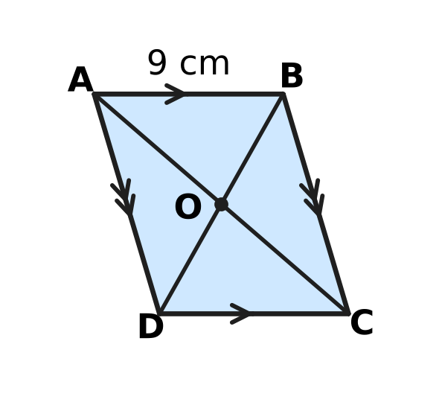
  (A) 14 cm | (B) 23 cm | (C) 29 cm | (D) 37 cm

Q20. In the figure, ABCD is a square and BCE is an equilateral triangle drawn outside the square on the side BC. What is the size of ∠ABE (marked "?")? | 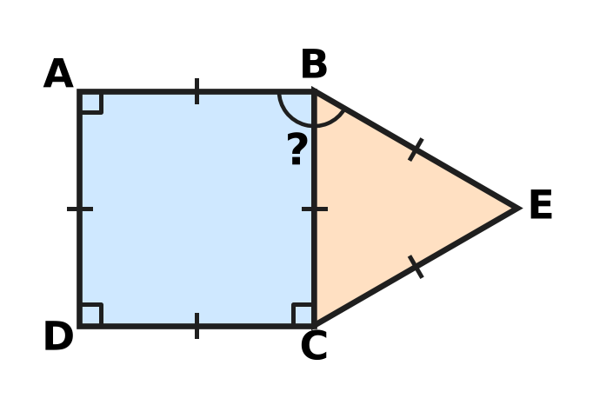
  (A) 150° | (B) 120° | (C) 135° | (D) 30°

Q21. In the figure, line l is parallel to line m. A is on l, and B, C and D are on m. AB makes an angle of 48° with l, and ∠ACD = 115°. What is the value of x? | 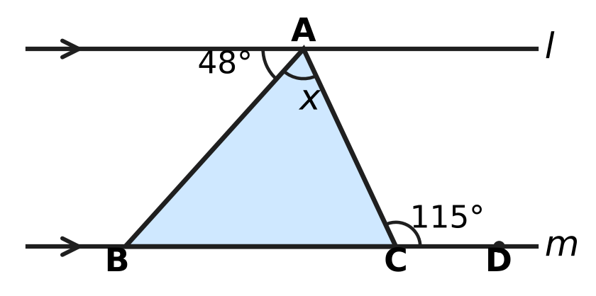
  (A) 65° | (B) 132° | (C) 17° | (D) 67°

Q22. In the quadrilateral ABCD shown, AB = AD and CB = CD, as marked. ∠BAD = 64° and ∠BCD = 52°. What is the value of x, the size of ∠ABC? | 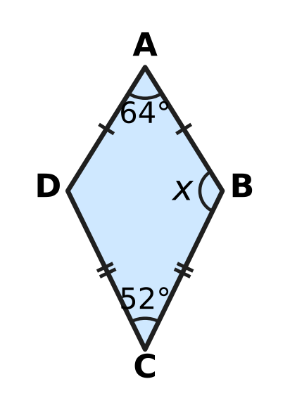
  (A) 122° | (B) 32° | (C) 116° | (D) 244°

Part 6 — Mensuration (Syllabus Chapter 6)
Q23. A cuboid of modelling clay measures 16 cm × 4 cm × 1 cm. All of it is reshaped into one cube, with no clay left over. What is the length of an edge of the cube?
(A) 8 cm | (B) 7 cm | (C) 4 cm | (D) 16 cm

Container | Radius of base (cm) | Height (cm)
Cylinder A | 3 | 8
Cylinder B | 5 | 3
Cylinder C | 2 | 16
Cylinder D | 4 | 5

Q24. The table gives the radius and height of four cylindrical containers. Which container holds the most water when full?
(A) Cylinder A | (B) Cylinder B
(C) Cylinder C | (D) Cylinder D

Q25. A cuboid tank has a base 20 cm long and 15 cm wide, and holds some water. A stone is put in the tank. It sinks fully and the water level rises by 2 cm, as shown. No water spills out. What is the volume of the stone? | 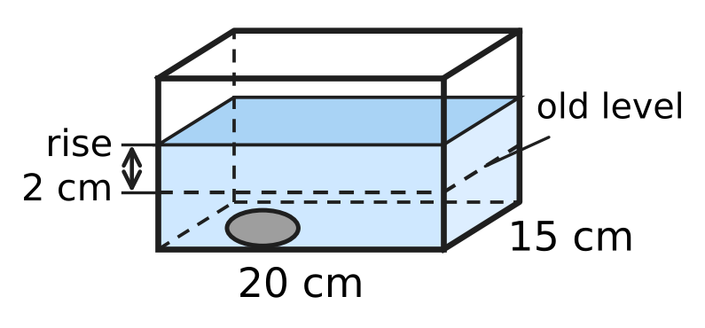
  (A) 300 cm³ | (B) 600 cm³ | (C) 40 cm³ | (D) 30 cm³

Q26. A sheet of card is 30 cm long and 20 cm wide. A square of side 5 cm is cut from each corner, as shown. The sides are folded up along the dashed lines to make an open box. What is the volume of the box? | 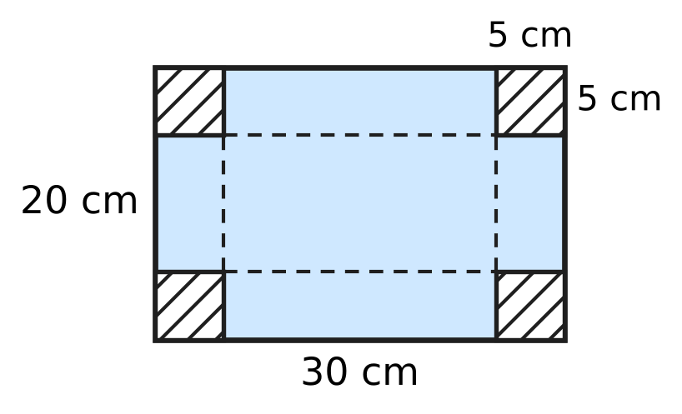
  (A) 1,500 cm³ | (B) 1,875 cm³
  (C) 3,000 cm³ | (D) 1,000 cm³

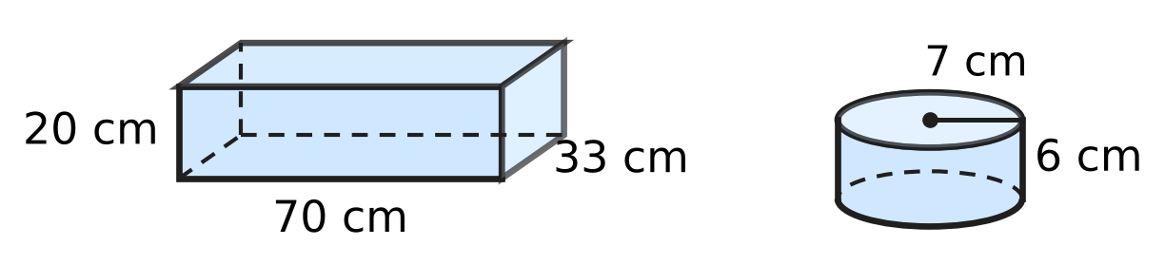
Q27. At a milk dairy, the cuboid container shown, 70 cm long, 33 cm wide and 20 cm high, is full of milk. All the milk is poured into cylindrical tubs like the one shown, of radius 7 cm and height 6 cm. How many tubs can be filled completely? Use π = $\frac{22}{7}$.
(A) 200 | (B) 300 | (C) 175 | (D) 50

Part 7 — Data Handling, Statistics & Probability (Syllabus Chapter 8)
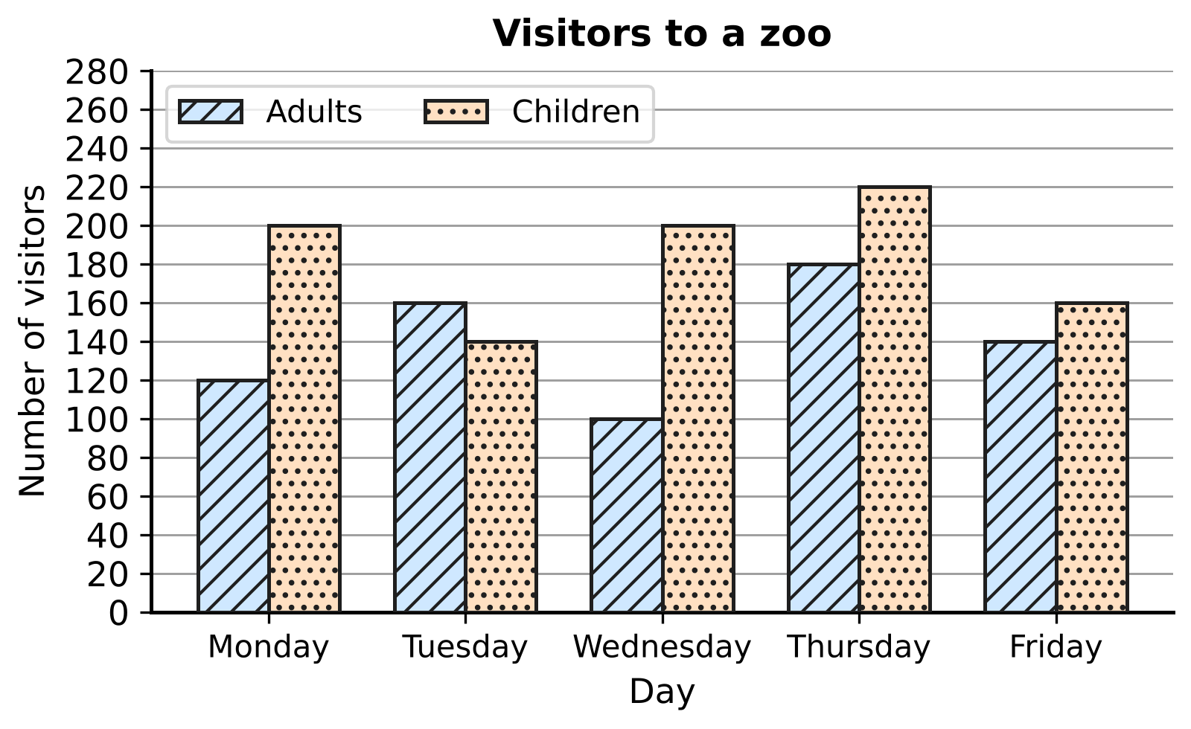
Q28. The double bar graph shows the number of adults and children who visited a zoo on five days. On which day was the difference between the number of children and the number of adults the greatest?
(A) Monday | (B) Wednesday
(C) Thursday | (D) Friday

Number of pets | 0 | 1 | 2 | 3 | 4
Number of students | 9 | 14 | 10 | 5 | 2

Q29. Each of the 40 students of a class wrote down how many pets they have. The table shows the results. What is the mode of the number of pets?
(A) 2 | (B) 4 | (C) 1 | (D) 14

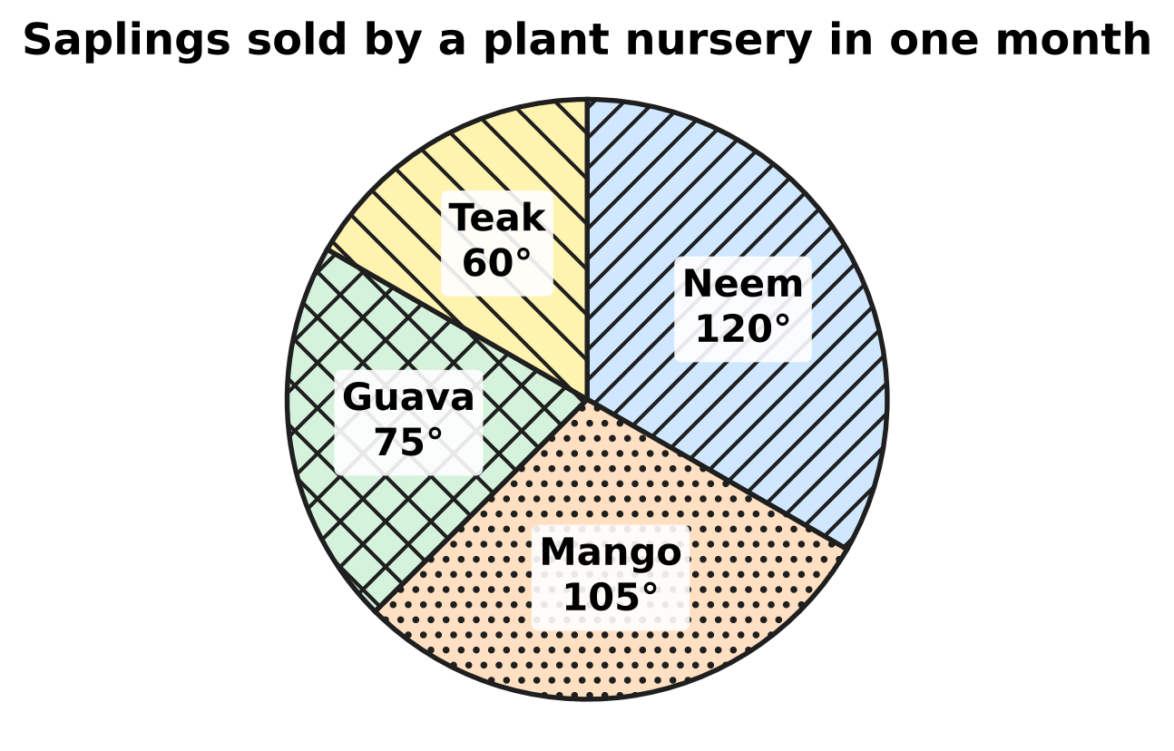
Q30. The pie chart shows the saplings sold by a plant nursery in one month. The angle of each sector is marked. The nursery sold 40 more mango saplings than guava saplings. How many saplings did it sell in all?
(A) 480 | (B) 270 | (C) 140 | (D) 360

Part 8 — Applied Mathematics (Syllabus Chapter 9)
Q31. Kriti's recipe for a rice dish uses 450 g of rice for 6 people. How much rice does she need to make the same dish for 10 people?
(A) 75 g | (B) 750 g | (C) 4,500 g | (D) 270 g

Q32. At a school assembly, the students stand in 36 rows with 20 students in each row. The next day the same students stand in rows of 30. How many rows are there now?
(A) 26 | (B) 54 | (C) 30 | (D) 24

Pack | Mass | Price
Pack P | 500 g | ₹60
Pack Q | 750 g | ₹84
Pack R | 1 kg | ₹110
Pack S | 2 kg | ₹210

Q33. The table shows four packs of the same washing powder. Which pack has the lowest price for each kilogram?
(A) Pack P | (B) Pack Q | (C) Pack R | (D) Pack S

Q34. On a mountain hike, 12 hikers need 18 kg of food for 5 days. Every hiker eats the same amount each day. How much food do 8 hikers need for 6 days?
(A) 32.4 kg | (B) 14.4 kg | (C) 10 kg | (D) 12 kg

Q35. For a school picnic, a teacher buys apples at ₹150 per kg and pears at ₹120 per kg. The masses of apples and pears are in the ratio 4 : 3. She pays ₹2,880 in all. What mass of pears does she buy?
(A) 12 kg | (B) 21 kg | (C) 9 kg | (D) 3 kg

Part 9 — Mathematical Reasoning & Problem-Solving (Syllabus Chapter 10)
Q36. Look at this pattern.
1 × 8 + 1 = 9
12 × 8 + 2 = 98
123 × 8 + 3 = 987
1,234 × 8 + 4 = 9,876
The pattern goes on in the same way. What is 123,456 × 8 + 6?
(A) 987,654 | (B) 987,648
(C) 9,876,543 | (D) 98,765

Q37. A palindrome is a number that reads the same from left to right and from right to left, such as 363. How many three-digit palindromes are divisible by 5?
(A) 10 | (B) 9 | (C) 20 | (D) 90

Q38. Look at this list of numbers: 2, 5, 10, 17, 26, … The pattern goes on in the same way. Which term of the list is 101?
(A) 11th term | (B) 10th term
(C) 9th term | (D) 50th term

Q39. The figure shows the straight paths in a park. Tia walks along the paths from A to B. At every step she goes either to the right or up, never left or down. How many different routes can she take? | 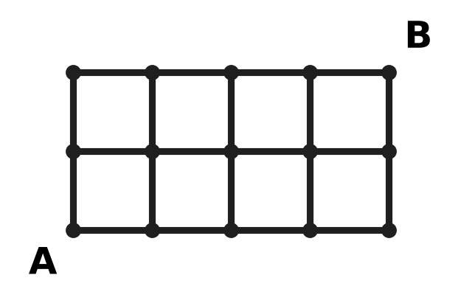
  (A) 10 | (B) 6 | (C) 15 | (D) 8

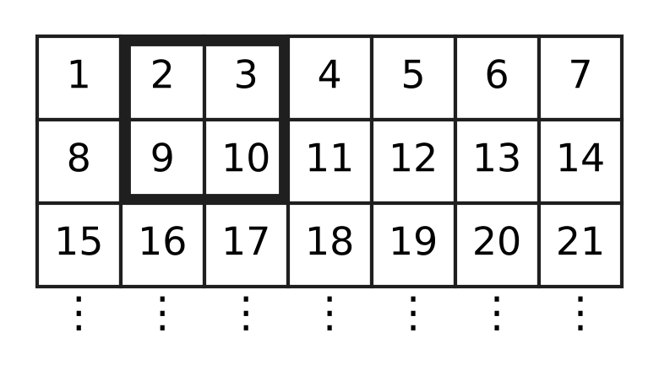
Q40. The counting numbers are written in rows of 7, as shown. The grid goes on in the same way. The four numbers inside a 2 × 2 square are added, for example 2 + 3 + 9 + 10 = 24. For another 2 × 2 square, the total is 116. What is the smallest number in that square?
(A) 33 | (B) 29 | (C) 26 | (D) 25

SECTION II — Star Questions 5 questions × 4 marks each
Q41. A bag holds only red counters and blue counters. The number of red counters is 5 more than twice the number of blue counters. There are more than 30 and fewer than 40 counters in the bag. All the counters can be shared equally among 4 children, with none left over. How many red counters are in the bag? [4 marks]
(A) 9 | (B) 23 | (C) 25 | (D) 27

Q42. A wall clock is marked ₹250. The shop may give a discount of a whole-number percentage that is greater than 10% and less than 30%. For how many of these discounts is the sale price a whole number of rupees? [4 marks]
(A) 19 | (B) 3 | (C) 9 | (D) 10

Q43. Garima makes big candles and small candles from the same wax. The mass of 3 big candles is the same as the mass of 5 small candles. A small candle has a mass of 60 g. She packs a box with big and small candles. The box has twice as many small candles as big candles. Together they have a mass of 2,640 g. How many candles are in the box? [4 marks]
(A) 24 | (B) 44 | (C) 12 | (D) 36

Q44. The figure shows the side view of a folding stool. The legs AC and BD are straight and cross at O. Equal marks show OA = OC and OB = OD. The lower ends C and D of the legs are 35 cm apart. The seat is a cylinder 6 cm thick, and AB is a diameter of the seat. What is the volume of the seat? Use π = $\frac{22}{7}$. [4 marks] | 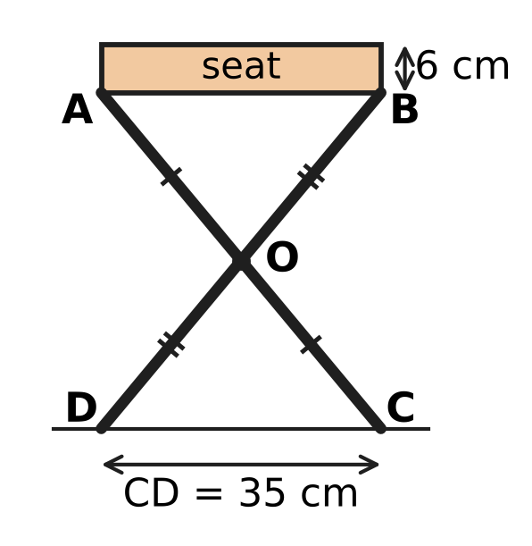
  (A) 5,775 cm³ | (B) 660 cm³
  (C) 11,550 cm³ | (D) 23,100 cm³

Q45. A rational number x is greater than $−\frac{2}{3}$ and less than $−\frac{1}{3}$. On the number line, x and $4x+\frac{5}{2}$ are at the same distance from 0. What is the value of x? [4 marks]
(A) $−\frac{2}{5}$ | (B) $−\frac{5}{8}$ | (C) $−\frac{5}{6}$ | (D) $−\frac{1}{2}$

Answer Sheet AMO Level 1 · Class 7 · Practice Paper 4
Name: | School: | Roll No.:
Shade or tick one circle for each question.
1. Ⓐ Ⓑ Ⓒ Ⓓ | 16. Ⓐ Ⓑ Ⓒ Ⓓ | 31. Ⓐ Ⓑ Ⓒ Ⓓ
2. Ⓐ Ⓑ Ⓒ Ⓓ | 17. Ⓐ Ⓑ Ⓒ Ⓓ | 32. Ⓐ Ⓑ Ⓒ Ⓓ
3. Ⓐ Ⓑ Ⓒ Ⓓ | 18. Ⓐ Ⓑ Ⓒ Ⓓ | 33. Ⓐ Ⓑ Ⓒ Ⓓ
4. Ⓐ Ⓑ Ⓒ Ⓓ | 19. Ⓐ Ⓑ Ⓒ Ⓓ | 34. Ⓐ Ⓑ Ⓒ Ⓓ
5. Ⓐ Ⓑ Ⓒ Ⓓ | 20. Ⓐ Ⓑ Ⓒ Ⓓ | 35. Ⓐ Ⓑ Ⓒ Ⓓ
6. Ⓐ Ⓑ Ⓒ Ⓓ | 21. Ⓐ Ⓑ Ⓒ Ⓓ | 36. Ⓐ Ⓑ Ⓒ Ⓓ
7. Ⓐ Ⓑ Ⓒ Ⓓ | 22. Ⓐ Ⓑ Ⓒ Ⓓ | 37. Ⓐ Ⓑ Ⓒ Ⓓ
8. Ⓐ Ⓑ Ⓒ Ⓓ | 23. Ⓐ Ⓑ Ⓒ Ⓓ | 38. Ⓐ Ⓑ Ⓒ Ⓓ
9. Ⓐ Ⓑ Ⓒ Ⓓ | 24. Ⓐ Ⓑ Ⓒ Ⓓ | 39. Ⓐ Ⓑ Ⓒ Ⓓ
10. Ⓐ Ⓑ Ⓒ Ⓓ | 25. Ⓐ Ⓑ Ⓒ Ⓓ | 40. Ⓐ Ⓑ Ⓒ Ⓓ
11. Ⓐ Ⓑ Ⓒ Ⓓ | 26. Ⓐ Ⓑ Ⓒ Ⓓ | 41. Ⓐ Ⓑ Ⓒ Ⓓ
12. Ⓐ Ⓑ Ⓒ Ⓓ | 27. Ⓐ Ⓑ Ⓒ Ⓓ | 42. Ⓐ Ⓑ Ⓒ Ⓓ
13. Ⓐ Ⓑ Ⓒ Ⓓ | 28. Ⓐ Ⓑ Ⓒ Ⓓ | 43. Ⓐ Ⓑ Ⓒ Ⓓ
14. Ⓐ Ⓑ Ⓒ Ⓓ | 29. Ⓐ Ⓑ Ⓒ Ⓓ | 44. Ⓐ Ⓑ Ⓒ Ⓓ
15. Ⓐ Ⓑ Ⓒ Ⓓ | 30. Ⓐ Ⓑ Ⓒ Ⓓ | 45. Ⓐ Ⓑ Ⓒ Ⓓ
Q41–Q45 are Section II Star Questions (4 marks each).
For the parent or teacher
Section I correct: ______ / 40 × 2 = ______ marks Section II correct: ______ / 5 × 4 = ______ marks
Correct: ______ / 45 Score: ______ / 100
Answer Key and Solutions AMO Level 1 · Class 7 · Practice Paper 4
Quick answers
1 A | 6 D | 11 B | 16 B | 21 D | 26 D | 31 B | 36 A | 41 B
2 A | 7 B | 12 D | 17 C | 22 A | 27 D | 32 D | 37 A | 42 C
3 C | 8 C | 13 D | 18 C | 23 C | 28 B | 33 D | 38 B | 43 D
4 B | 9 C | 14 A | 19 B | 24 D | 29 C | 34 B | 39 C | 44 A
5 A | 10 A | 15 C | 20 A | 25 B | 30 A | 35 C | 40 D | 45 D
Solutions
Q | Part · level | Answer | Why?
1 | Part 1 · Ch1 · Easy | (A) $−\frac{5}{6}$ | Points to the left are smaller. −3/8, −1/2 and −2/5 all lie between −5/8 and 0. −5/6 is less than −5/8 (the same 5 parts, but sixths are bigger than eighths), so only −5/6 is to the left.
2 | Part 1 · Ch1 · Easy | (A) $\frac{29}{24}$ | Distance = 3/8 − (−5/6) = 3/8 + 5/6 = 9/24 + 20/24 = 29/24.
3 | Part 1 · Ch1 · Medium | (C) 6 days | Number of days = (−9/4) ÷ (−3/8) = (−9/4) × (−8/3) = 72/12 = 6.
4 | Part 1 · Ch1 · Medium | (B) 6 | −2/5 = −4/10. The numbers p/10 with −4 < p < 3 have p = −3, −2, −1, 0, 1, 2. That is 6 numbers.
5 | Part 2 · Ch2 · Easy | (A) 2.5 × 10⁶ | Numbers with 10⁶ are greater than numbers with 10⁵. Of 2.5 × 10⁶ and 1.9 × 10⁶, the greater is 2.5 × 10⁶ (2,500,000).
6 | Part 2 · Ch2 · Easy | (D) 27 | We need 3⁵ ÷ 3² = 3⁵⁻² = 3³ = 27. Check: 243 ÷ 9 = 27.
7 | Part 2 · Ch2 · Medium | (B) 3.75 × 10⁴ | Write 2.5 × 10³ as 0.25 × 10⁴. So the sum is (3.5 + 0.25) × 10⁴ = 3.75 × 10⁴ (that is, 35,000 + 2,500 = 37,500).
8 | Part 3 · Ch3 · Easy | (C) 423 eggs | The cracked eggs are 6% of 450 = 450 × 6/100 = 27. So 450 − 27 = 423 eggs do not crack.
9 | Part 3 · Ch3 · Easy | (C) 20% | Loss = 1,250 − 1,000 = ₹250. Loss percent = 250/1,250 × 100 = 20%.
10 | Part 3 · Ch3 · Easy | (A) ₹480 | Total marked price = 250 + 350 = ₹600. Discount = 20% of 600 = ₹120. She pays 600 − 120 = ₹480.
11 | Part 3 · Ch3 · Medium | (B) 700 | The other candidate got 42%. The winning margin is 58% − 42% = 16% of the votes = 112. So 1% is 7 votes and the total is 700.
12 | Part 3 · Ch3 · Medium | (D) 20% | If Zara has ₹100, Imran has ₹125. Zara has ₹25 less, and 25/125 × 100 = 20%.
13 | Part 4 · Ch4 · Easy | (D) 4n − 5 | Rima has 3n − 5 crayons. Together they have n + (3n − 5) = 4n − 5.
14 | Part 4 · Ch4 · Easy | (A) (3x + 5) cm | Left = (5x + 3) − 2(x − 1) = 5x + 3 − 2x + 2 = (3x + 5) cm.
15 | Part 4 · Ch4 · Easy | (C) Step 3 | From 2x − 7 = 9, adding 7 to both sides gives 2x = 16, not 9 − 7. So Step 3 is wrong; the correct answer is x = 8.
16 | Part 4 · Ch4 · Medium | (B) 48 kg | Let Class 7A collect x kg. Then x + (x + 6) + 2x = 102, so 4x = 96 and x = 24. Class 7C collected 2 × 24 = 48 kg.
17 | Part 4 · Ch4 · Medium | (C) 11 | Let the number be n. Then 5n − 12 = 3n + 10, so 2n = 22 and n = 11. Check: 55 − 12 = 43 and 33 + 10 = 43.
18 | Part 5 · Ch5 · Easy | (C) 6 | The sum 7 + x must be greater than 12, so x is greater than 5. The smallest whole number greater than 5 is 6 (and 6, 7, 12 do make a triangle).
19 | Part 5 · Ch5 · Easy | (B) 23 cm | The diagonals of a parallelogram bisect each other, so AO = 8 cm and BO = 6 cm. Perimeter = 8 + 6 + 9 = 23 cm.
20 | Part 5 · Ch5 · Easy | (A) 150° | ∠ABC = 90° (angle of a square) and ∠CBE = 60° (angle of an equilateral triangle). ∠ABE = 90° + 60° = 150°.
21 | Part 5 · Ch5 · Medium | (D) 67° | ∠ABC = 48° (alternate angles, l ∥ m). The exterior angle ∠ACD equals ∠ABC + x, so x = 115° − 48° = 67°.
22 | Part 5 · Ch5 · Medium | (A) 122° | △ABC ≅ △ADC by SSS (AB = AD, CB = CD, AC common), so ∠ABC = ∠ADC. These two add up to 360° − 64° − 52° = 244°, so x = 122°.
23 | Part 6 · Ch6 · Easy | (C) 4 cm | Volume = 16 × 4 × 1 = 64 cm³. The cube has the same volume, and 4 × 4 × 4 = 64, so its edge is 4 cm.
24 | Part 6 · Ch6 · Easy | (D) Cylinder D | Volume = πr²h, so compare r × r × h: A 72, B 75, C 64, D 80 (each times π). Cylinder D holds the most.
25 | Part 6 · Ch6 · Easy | (B) 600 cm³ | The stone pushes up a layer of water 20 cm × 15 cm × 2 cm. Its volume = 20 × 15 × 2 = 600 cm³.
26 | Part 6 · Ch6 · Medium | (D) 1,000 cm³ | The base of the box is (30 − 10) cm by (20 − 10) cm = 20 cm by 10 cm, and the height is 5 cm. Volume = 20 × 10 × 5 = 1,000 cm³.
27 | Part 6 · Ch6 · Medium | (D) 50 | Milk = 70 × 33 × 20 = 46,200 cm³. One tub holds 22/7 × 7 × 7 × 6 = 924 cm³. Number of tubs = 46,200 ÷ 924 = 50.
28 | Part 7 · Ch8 · Easy | (B) Wednesday | Differences: Monday 80, Tuesday 20, Wednesday 100, Thursday 40, Friday 20. The greatest is on Wednesday.
29 | Part 7 · Ch8 · Easy | (C) 1 | The mode is the value that occurs most often. There are 14 students with 1 pet, more than for any other value, so the mode is 1.
30 | Part 7 · Ch8 · Medium | (A) 480 | The difference between the sectors is 105° − 75° = 30°, which stands for 40 saplings. So 360° stands for 40 × 12 = 480 saplings.
31 | Part 8 · Ch9 · Easy | (B) 750 g | Rice for 1 person = 450 ÷ 6 = 75 g. For 10 people: 75 × 10 = 750 g.
32 | Part 8 · Ch9 · Easy | (D) 24 | Number of students = 36 × 20 = 720. In rows of 30: 720 ÷ 30 = 24 rows.
33 | Part 8 · Ch9 · Easy | (D) Pack S | Price per kg: P ₹120, Q ₹112, R ₹110, S ₹105. Pack S is the cheapest for each kilogram.
34 | Part 8 · Ch9 · Medium | (B) 14.4 kg | Food for 1 hiker for 1 day = 18 ÷ (12 × 5) = 0.3 kg. For 8 hikers for 6 days: 0.3 × 8 × 6 = 14.4 kg.
35 | Part 8 · Ch9 · Medium | (C) 9 kg | Then 4 kg of apples and 3 kg of pears cost 4 × 150 + 3 × 120 = ₹960. Since ₹2,880 ÷ ₹960 = 3, she buys 3 × 3 = 9 kg of pears (and 12 kg of apples).
36 | Part 9 · Ch10 · Easy | (A) 987,654 | In each line the answer counts down from 9, with as many digits as the first number has. The number 123,456 has six digits, so the answer is 987,654.
37 | Part 9 · Ch10 · Easy | (A) 10 | A number divisible by 5 ends in 0 or 5. A palindrome ending in 0 would start with 0, so it must be 5_5. The middle digit can be 0 to 9: 10 palindromes.
38 | Part 9 · Ch10 · Easy | (B) 10th term | Each term is one more than a square: 1² + 1, 2² + 1, 3² + 1, … Since 101 = 10² + 1, it is the 10th term.
39 | Part 9 · Ch10 · Medium | (C) 15 | Write at each corner the number of ways to reach it: it is the sum of the numbers just to the left and just below. The bottom row and left column are all 1; the top row becomes 1, 3, 6, 10, 15. So there are 15 routes.
40 | Part 9 · Ch10 · Medium | (D) 25 | If the smallest number is n, the square holds n, n + 1, n + 7 and n + 8, with total 4n + 16. So 4n + 16 = 116 and n = 25 (square 25, 26, 32, 33).
41 | Section II · Ch4 + Ch10 · Hard | (B) 23 | With b blue counters there are 2b + 5 red ones, so 3b + 5 in all. Between 30 and 40 this gives b = 9, 10 or 11 (totals 32, 35, 38). Only 32 is divisible by 4, so b = 9 and there are 23 red counters.
42 | Section II · Ch3 + Ch10 · Hard | (C) 9 | A discount of d% of ₹250 is 250 × d/100 = 5d/2 rupees. This is a whole number only when d is even. The even values greater than 10 and less than 30 are 12, 14, …, 28: 9 discounts.
43 | Section II · Ch4 + Ch9 · Hard | (D) 36 | A big candle has mass 5 × 60 ÷ 3 = 100 g. With x big and 2x small candles: 100x + 120x = 2,640, so 220x = 2,640 and x = 12. The box has 12 + 24 = 36 candles.
44 | Section II · Ch5 + Ch6 · Hard | (A) 5,775 cm³ | ∠AOB = ∠COD (vertically opposite), OA = OC and OB = OD, so △AOB ≅ △COD (SAS) and AB = CD = 35 cm. The radius is 17.5 cm. Volume = 22/7 × 17.5 × 17.5 × 6 = 5,775 cm³.
45 | Section II · Ch1 + Ch4 · Hard | (D) $−\frac{1}{2}$ | Numbers at the same distance from 0 are equal or opposite. If 4x + 5/2 = x, then x = −5/6, which is less than −2/3, so it does not fit. If 4x + 5/2 = −x, then 5x = −5/2, so x = −1/2, which is between −2/3 and −1/3.

