UNLOCK IQ INSTITUTE
Realize Your True Potential
Aryabhatta Maths Olympiad (AMO)
Level 1 — Practice Paper 5
CLASS 7

Questions | 45 multiple-choice questions
Marks | 100
Time | 60 minutes
Section I | 40 questions × 2 marks = 80 marks
Section II | 5 Star Questions × 4 marks = 20 marks
Negative marking | No negative marking
Calculator | Not allowed
Chapters | Number System · Operations · Fractions, Decimals & Percentages · Algebra · Geometry · Mensuration · Data Handling · Applied Mathematics · Mathematical Reasoning

Instructions to candidates
• This paper has 45 multiple-choice questions. Each question has four answer choices, of which exactly one is correct.
• Section I (Q1–Q40) carries 2 marks per question. Section II (Q41–Q45) carries 4 marks per question.
• There is no negative marking. Unanswered questions score zero.
• Calculators are not permitted. Rough work may be done on a separate sheet.
• Mark your answers on the answer sheet at the end of the paper.
• All figures are not necessarily drawn to scale unless stated.

For parents and teachers
Print or view this paper in colour. Pictures are part of the questions.
Parts follow the AMO syllabus chapters. Chapter 7 is not part of the Class 7 syllabus, so the chapter numbers shown in the Part headings have gaps.
The answer sheet and the answer key are at the end. Remove only the answer key before the student begins.

Name: | School: | Roll No.:

SECTION I 40 questions × 2 marks each
Part 1 — Number System (Syllabus Chapter 1)
Q1. The rational number $\frac{21}{−56}$ is written in standard form as $\frac{p}{q}$, where q is positive. What is the value of p + q?
(A) 11 | (B) −5 | (C) 5 | (D) 77

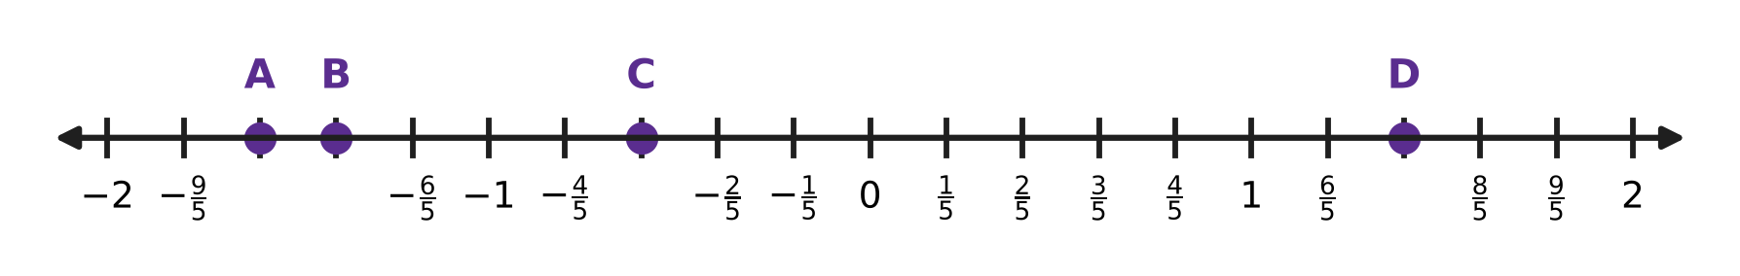
Q2. On the number line, each unit is divided into 5 equal parts. Which point shows the rational number $−\frac{7}{5}$?
(A) Point A | (B) Point B | (C) Point C | (D) Point D

Q3. A number is added to $−\frac{2}{3}$. The result is greater than 0 and less than $\frac{1}{4}$. Which of these could the number be?
(A) 1 | (B) $\frac{1}{2}$ | (C) $\frac{11}{12}$ | (D) $\frac{3}{4}$

Q4. What is the value of $(\frac{1}{2}−1)×(\frac{1}{3}−1)×(\frac{1}{4}−1)×…×(\frac{1}{11}−1)$?
(A) $\frac{1}{11}$ | (B) $−\frac{1}{11}$ | (C) $\frac{1}{10}$ | (D) $\frac{10}{11}$

Part 2 — Operations & Number Properties (Syllabus Chapter 2)
Q5. How many digits does the number 2⁴ × 5⁴ × 7 have?
(A) 5 | (B) 4 | (C) 8 | (D) 6

Q6. What is the value of (−1)¹ + (−1)² + (−1)³ + … + (−1)⁹?
(A) 0 | (B) −9 | (C) −1 | (D) 1

Q7. What number must 2³ × 3² be multiplied by to give 6⁴?
(A) 6 | (B) 2 | (C) 9 | (D) 18

Part 3 — Fractions, Decimals & Percentages (Syllabus Chapter 3)
Q8. An ice-cream stall sells a cone for ₹60. The stall makes a profit of ₹12 on each cone. What is the profit percent?
(A) 12% | (B) 80% | (C) 20% | (D) 25%

Q9. A cook uses 300 g of rice from a 2 kg bag. What percentage of the bag of rice does she use?
(A) 0.15% | (B) 150% | (C) 15% | (D) 30%

Q10. In a music class, 40% of the students play the flute. One quarter of the flute players also play the guitar. What percentage of the whole class plays both the flute and the guitar?
(A) 10% | (B) 25% | (C) 15% | (D) 65%

Q11. Deepak sold a study lamp for ₹760 and made a loss of 20%. At what price should he have sold it to make a profit of 10%?
(A) ₹950 | (B) ₹836 | (C) ₹1,045 | (D) ₹988

Q12. A company runs hot-air balloon rides. It raises the price of each ride by 20%. After that, the number of rides it sells in a month falls by 10%. By what percentage does the money it collects in a month change?
(A) It goes up by 8%. | (B) It goes up by 108%.
(C) It goes up by 10%. | (D) It goes up by 2%.

Part 4 — Algebra (Syllabus Chapter 4)
Q13. Solve the equation 7 − 3y = 2y + 22.
(A) y = 15 | (B) y = −3 | (C) y = −15 | (D) y = 3

Q14. Ana simplified 7a − (3a − 5) and wrote 4a − 5. Her answer is wrong. What is the correct simplified expression?
(A) 10a + 5 | (B) 10a − 5 | (C) −4a + 5 | (D) 4a + 5

Q15. The figure shows the plan of a playground. Its sides meet at right angles, and the length of each side is marked. What is the perimeter of the playground? | 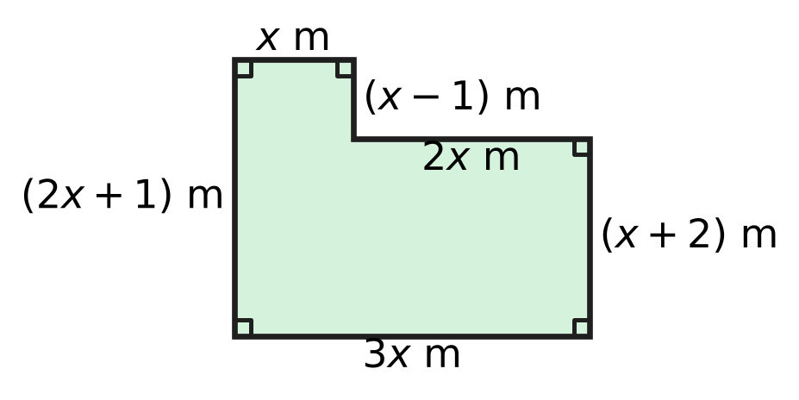
  (A) (8x + 3) m | (B) (10x + 4) m
  (C) (10x + 2) m | (D) 10x m

Q16. Parth gets into a lift and goes up 7 floors. The floor number where he gets out is 3 more than twice the floor number where he got in. On which floor does he get out?
(A) Floor 14 | (B) Floor 17 | (C) Floor 4 | (D) Floor 11

Q17. Two-thirds of a number is 12 more than two-fifths of the same number. What is the number?
(A) 18 | (B) 45 | (C) 90 | (D) 30

Part 5 — Geometry (Syllabus Chapter 5)
Q18. In △ABC and △PQR, three pairs of parts are known to be equal. Which of these sets of equal parts does NOT guarantee that △ABC ≅ △PQR?
(A) AB = PQ, BC = QR, ∠A = ∠P | (B) AB = PQ, BC = QR, CA = RP
(C) AB = PQ, ∠B = ∠Q, BC = QR | (D) ∠A = ∠P, AB = PQ, ∠B = ∠Q

Q19. Three angles of a quadrilateral are equal. The fourth angle is 105°. What is the size of each of the three equal angles?
(A) 255° | (B) 85° | (C) 75° | (D) 25°

Q20. In the figure, the line t crosses the three straight lines l, m and n. Three of the angles are marked. Which two lines are parallel? | 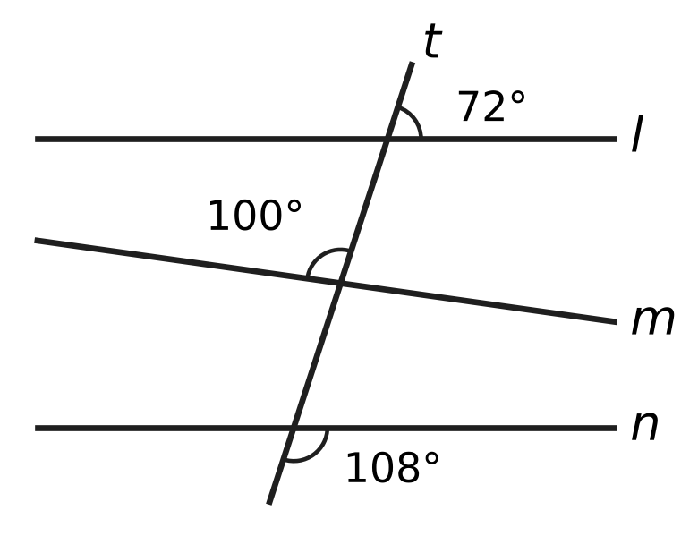
  (A) l and m | (B) l and n
  (C) m and n | (D) all three lines

Q21. In the figure, ∠BAC = 70°. The line BI cuts ∠ABC into two equal parts, and the line CI cuts ∠ACB into two equal parts. What is the value of x, the size of ∠BIC? | 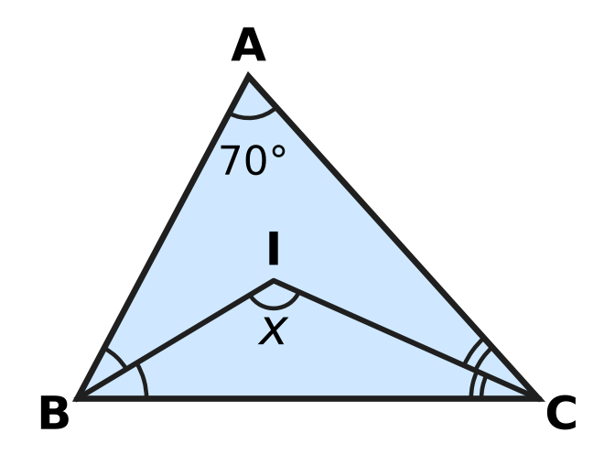
  (A) 125° | (B) 145° | (C) 110° | (D) 55°

Q22. In △PQR, ∠P = ∠Q + ∠R and ∠Q = 2 × ∠R. What is the size of ∠Q?
(A) 45° | (B) 90° | (C) 30° | (D) 60°

Part 6 — Mensuration (Syllabus Chapter 6)
Q23. The total surface area of a small cube is 54 cm². The total surface area of a large cube is 864 cm². The edge of the large cube is how many times the edge of the small cube?
(A) 8 times | (B) 64 times | (C) 4 times | (D) 16 times

Q24. The closed drum in the figure is a cylinder of radius 21 cm and height 40 cm. Only its two circular ends are painted. What area is painted? Use π = $\frac{22}{7}$. | 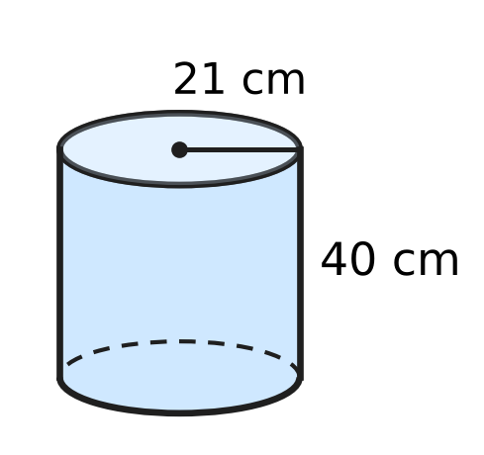
  (A) 1,386 cm² | (B) 2,772 cm²
  (C) 8,052 cm² | (D) 5,280 cm²

Q25. A cube has edges of 6 cm. Which of these cuboids has the same volume as the cube?
(A) 12 cm × 6 cm × 3 cm | (B) 9 cm × 4 cm × 5 cm
(C) 8 cm × 6 cm × 4 cm | (D) 12 cm × 3 cm × 4 cm

Q26. The edges of the cuboid in the figure are whole numbers of centimetres. The areas of three of its faces are 20 cm², 15 cm² and 12 cm², as marked. What is the volume of the cuboid? | 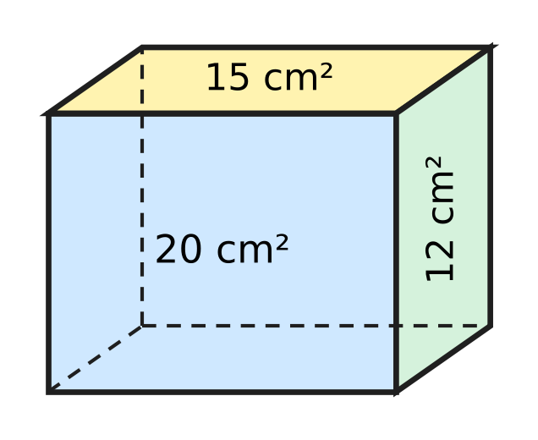
  (A) 94 cm³ | (B) 3,600 cm³
  (C) 47 cm³ | (D) 60 cm³

Q27. During a shower, 2 cm of rain falls on a flat roof that is 10 m long and 6 m wide. All of this water flows into a tank. How many litres of water reach the tank? (1 m³ = 1,000 litres)
(A) 12,000 litres | (B) 120 litres
(C) 1,200 litres | (D) 120,000 litres

Part 7 — Data Handling, Statistics & Probability (Syllabus Chapter 8)
Q28. Yash counted the cars in a car park at noon on five days: 42, 38, 51, 45 and 44. Later he found that the count 38 should have been 58. By how much does the mean number of cars increase?
(A) 20 | (B) 48 | (C) 44 | (D) 4

Q29. Six numbers are written in increasing order: 4, 7, x, 12, 15, 20. Their median is 10. What is the value of x?
(A) 13 | (B) 8 | (C) 2 | (D) 10

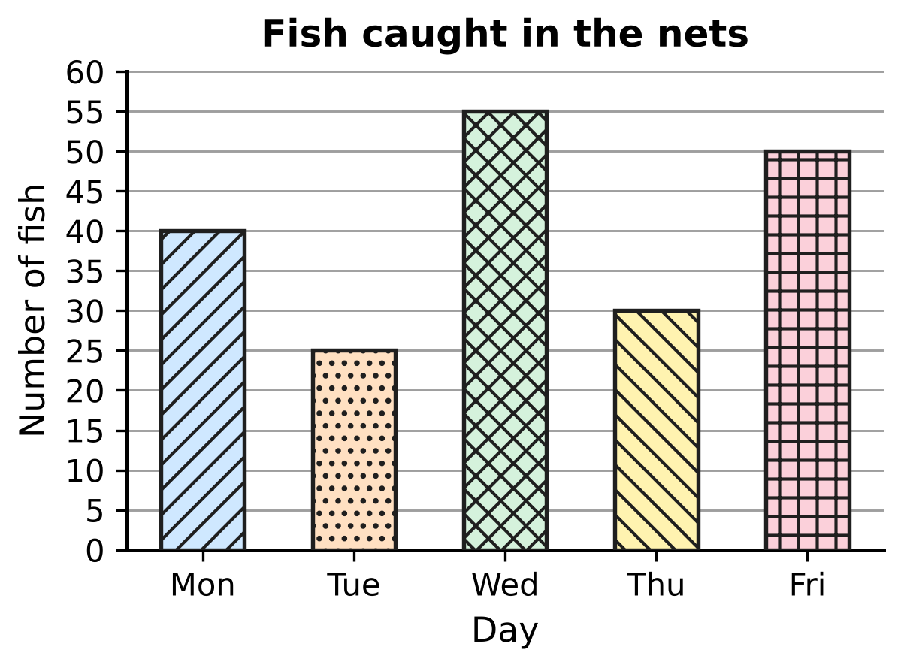
Q30. A fishing boat drops its nets once a day. The bar graph shows the number of fish caught on five days. On how many of these days was the catch MORE than the mean catch of the five days?
(A) 2 | (B) 4 | (C) 3 | (D) 1

Part 8 — Applied Mathematics (Syllabus Chapter 9)
Q31. A plane flies between two airports at a steady speed of 600 km per hour, and the trip takes 2 hours. On a new timetable the same trip must take 1 hour 30 minutes. At what steady speed must the plane fly?
(A) 1,200 km per hour | (B) 450 km per hour
(C) 800 km per hour | (D) 750 km per hour

Q32. Which of these ratios is the greatest?
(A) 7 : 12 | (B) 2 : 3 | (C) 3 : 5 | (D) 5 : 8

Q33. A necklace has only red, blue and green beads. The numbers of red, blue and green beads are in the ratio 5 : 4 : 2. Which of these could be the total number of beads?
(A) 77 | (B) 80 | (C) 75 | (D) 60

Q34. Kian and Zoya share ₹900 in the ratio 4 : 5. Then Zoya gives ₹50 of her share to Kian. What is the ratio of Kian's money to Zoya's money now?
(A) 7 : 11 | (B) 4 : 5 | (C) 1 : 1 | (D) 9 : 10

Q35. The quantity y varies directly as x. When x increases by 8, y increases by 12. What is the value of y when x = 18?
(A) 22 | (B) 12 | (C) 216 | (D) 27

Part 9 — Mathematical Reasoning & Problem-Solving (Syllabus Chapter 10)
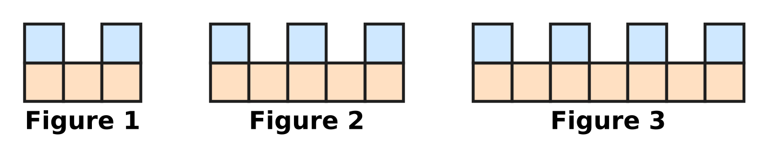
Q36. Square floor tiles are laid to make the figures shown. The pattern goes on in the same way. Which figure uses exactly 92 tiles?
(A) Figure 46 | (B) Figure 30
(C) Figure 31 | (D) Figure 29

Q37. I am a two-digit number. I am a multiple of 7. My two digits add up to 10. My tens digit is smaller than my units digit. Who am I?
(A) 37 | (B) 35 | (C) 28 | (D) 91

Q38. In how many different ways can 30 be written as the sum of two prime numbers? The order does not matter, so 7 + 23 and 23 + 7 are the same way.
(A) 4 | (B) 6 | (C) 2 | (D) 3

Q39. A staircase has 6 steps. Usha climbs it by going up either 1 step or 2 steps at a time. For example, 2 + 1 + 1 + 2 and 1 + 1 + 2 + 2 are two different ways. In how many different ways can she climb from the bottom to the top?
(A) 13 | (B) 11 | (C) 64 | (D) 4

Q40. The list 1 × 2, 2 × 3, 3 × 4, 4 × 5, … goes on in the same way. How many of the first 20 numbers in this list are multiples of 3?
(A) 6 | (B) 7 | (C) 13 | (D) 14

SECTION II — Star Questions 5 questions × 4 marks each
Q41. At a science exhibition, Isha's three stalls have numbers that are consecutive multiples of 6, such as 30, 36 and 42. The three stall numbers add up to a three-digit number whose three digits are all the same. What is the largest of Isha's three stall numbers? [4 marks]
(A) 216 | (B) 234 | (C) 222 | (D) 228

Bouquet | P | Q | R | S
Cost price (₹) | 120 | 180 | 280 | 320

Q42. Heena's flower shop made the four bouquets in the table. She sold some of them at a profit of 25% and all the others at a loss of 20%. Taking all four together, she made neither a profit nor a loss. Which bouquets did she sell at a loss? [4 marks]
(A) P and R | (B) Q and S
(C) R and S | (D) P, Q and R

Q43. Tarun's tea stall has a can with 60 litres of milk and water, mixed in the ratio 2 : 1. He takes out some of the mixture and puts in the same amount of water. Now the ratio of milk to water is 1 : 1. How many litres of the mixture did he take out? [4 marks]
(A) 20 litres | (B) 15 litres
(C) 30 litres | (D) 10 litres

Q44. The figure shows a cylindrical storage bin from the side. ABCD is the rectangle through its centre: AB is a diameter of the base and AD is the height. The base radius is 21 cm. Two straight sticks AE and ED rest inside, with E on BC. ∠EAB = 15°, ∠DEC = 30° and ED = 84 cm. What is the volume of the bin? Use π = $\frac{22}{7}$. [4 marks] | 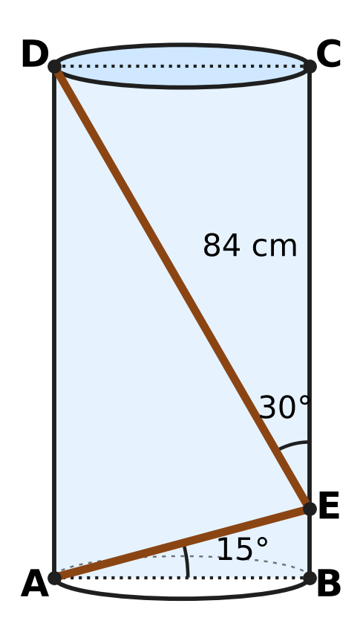
  (A) 116,424 cm³ | (B) 58,212 cm³
  (C) 465,696 cm³ | (D) 232,848 cm³

Q45. x is a negative rational number. When $(3x−\frac{1}{2})$ is multiplied by itself, the result is $\frac{49}{16}$. What is the value of x? [4 marks]
(A) $−\frac{3}{4}$ | (B) $−\frac{5}{4}$ | (C) $−\frac{5}{12}$ | (D) $−\frac{1}{12}$

Answer Sheet AMO Level 1 · Class 7 · Practice Paper 5
Name: | School: | Roll No.:
Shade or tick one circle for each question.
1. Ⓐ Ⓑ Ⓒ Ⓓ | 16. Ⓐ Ⓑ Ⓒ Ⓓ | 31. Ⓐ Ⓑ Ⓒ Ⓓ
2. Ⓐ Ⓑ Ⓒ Ⓓ | 17. Ⓐ Ⓑ Ⓒ Ⓓ | 32. Ⓐ Ⓑ Ⓒ Ⓓ
3. Ⓐ Ⓑ Ⓒ Ⓓ | 18. Ⓐ Ⓑ Ⓒ Ⓓ | 33. Ⓐ Ⓑ Ⓒ Ⓓ
4. Ⓐ Ⓑ Ⓒ Ⓓ | 19. Ⓐ Ⓑ Ⓒ Ⓓ | 34. Ⓐ Ⓑ Ⓒ Ⓓ
5. Ⓐ Ⓑ Ⓒ Ⓓ | 20. Ⓐ Ⓑ Ⓒ Ⓓ | 35. Ⓐ Ⓑ Ⓒ Ⓓ
6. Ⓐ Ⓑ Ⓒ Ⓓ | 21. Ⓐ Ⓑ Ⓒ Ⓓ | 36. Ⓐ Ⓑ Ⓒ Ⓓ
7. Ⓐ Ⓑ Ⓒ Ⓓ | 22. Ⓐ Ⓑ Ⓒ Ⓓ | 37. Ⓐ Ⓑ Ⓒ Ⓓ
8. Ⓐ Ⓑ Ⓒ Ⓓ | 23. Ⓐ Ⓑ Ⓒ Ⓓ | 38. Ⓐ Ⓑ Ⓒ Ⓓ
9. Ⓐ Ⓑ Ⓒ Ⓓ | 24. Ⓐ Ⓑ Ⓒ Ⓓ | 39. Ⓐ Ⓑ Ⓒ Ⓓ
10. Ⓐ Ⓑ Ⓒ Ⓓ | 25. Ⓐ Ⓑ Ⓒ Ⓓ | 40. Ⓐ Ⓑ Ⓒ Ⓓ
11. Ⓐ Ⓑ Ⓒ Ⓓ | 26. Ⓐ Ⓑ Ⓒ Ⓓ | 41. Ⓐ Ⓑ Ⓒ Ⓓ
12. Ⓐ Ⓑ Ⓒ Ⓓ | 27. Ⓐ Ⓑ Ⓒ Ⓓ | 42. Ⓐ Ⓑ Ⓒ Ⓓ
13. Ⓐ Ⓑ Ⓒ Ⓓ | 28. Ⓐ Ⓑ Ⓒ Ⓓ | 43. Ⓐ Ⓑ Ⓒ Ⓓ
14. Ⓐ Ⓑ Ⓒ Ⓓ | 29. Ⓐ Ⓑ Ⓒ Ⓓ | 44. Ⓐ Ⓑ Ⓒ Ⓓ
15. Ⓐ Ⓑ Ⓒ Ⓓ | 30. Ⓐ Ⓑ Ⓒ Ⓓ | 45. Ⓐ Ⓑ Ⓒ Ⓓ
Q41–Q45 are Section II Star Questions (4 marks each).
For the parent or teacher
Section I correct: ______ / 40 × 2 = ______ marks Section II correct: ______ / 5 × 4 = ______ marks
Correct: ______ / 45 Score: ______ / 100
Answer Key and Solutions AMO Level 1 · Class 7 · Practice Paper 5
Quick answers
1 C | 6 C | 11 C | 16 D | 21 A | 26 D | 31 C | 36 B | 41 D
2 B | 7 D | 12 A | 17 B | 22 D | 27 C | 32 B | 37 C | 42 B
3 D | 8 D | 13 B | 18 A | 23 C | 28 D | 33 A | 38 D | 43 B
4 A | 9 C | 14 D | 19 B | 24 B | 29 B | 34 C | 39 A | 44 A
5 A | 10 A | 15 C | 20 B | 25 A | 30 A | 35 D | 40 C | 45 C
Solutions
Q | Part · level | Answer | Why?
1 | Part 1 · Ch1 · Easy | (C) 5 | HCF(21, 56) = 7, so 21/−56 = −3/8 in standard form (denominator positive). p + q = −3 + 8 = 5.
2 | Part 1 · Ch1 · Easy | (B) Point B | −7/5 = −1 2/5, so it is 2 parts to the LEFT of −1, that is 7 parts to the left of 0. That is point B.
3 | Part 1 · Ch1 · Medium | (D) $\frac{3}{4}$ | Add each to −2/3 = −8/12: 3/4 gives 1/12, which is between 0 and 3/12. 1/2 gives −1/6, 11/12 gives exactly 1/4 and 1 gives 1/3.
4 | Part 1 · Ch1 · Medium | (A) $\frac{1}{11}$ | The brackets are −1/2, −2/3, −3/4, …, −10/11. Each numerator cancels the denominator before it, leaving 1/11. There are 10 negative factors, an even number, so the product is +1/11.
5 | Part 2 · Ch2 · Easy | (A) 5 | Here 2⁴ × 5⁴ = (2 × 5)⁴ = 10⁴, so the number is 7 × 10⁴ = 70,000. It has 5 digits.
6 | Part 2 · Ch2 · Easy | (C) −1 | Odd powers of −1 are −1 and even powers are +1. The terms pair off as (−1 + 1) four times, leaving (−1)⁹ = −1.
7 | Part 2 · Ch2 · Medium | (D) 18 | Write 6⁴ = 2⁴ × 3⁴. Dividing by 2³ × 3² leaves 2¹ × 3² = 2 × 9 = 18.
8 | Part 3 · Ch3 · Easy | (D) 25% | Cost price = 60 − 12 = ₹48. Profit % = 12 ÷ 48 × 100 = 25%.
9 | Part 3 · Ch3 · Easy | (C) 15% | There are 2,000 g in 2 kg. So she uses 300 ÷ 2,000 × 100 = 15%.
10 | Part 3 · Ch3 · Easy | (A) 10% | One quarter of 40% is 40 ÷ 4 = 10% of the class.
11 | Part 3 · Ch3 · Medium | (C) ₹1,045 | 80% of the cost price is ₹760, so the cost price is 760 × 100 ÷ 80 = ₹950. A 10% profit gives 950 + 95 = ₹1,045.
12 | Part 3 · Ch3 · Medium | (A) It goes up by 8%. | For every ₹100 collected before, the price becomes 120% and the rides 90%: 1.2 × 0.9 = 1.08, so ₹108 is collected now. That is an increase of 8%.
13 | Part 4 · Ch4 · Easy | (B) y = −3 | Move the y terms to one side and the numbers to the other: −3y − 2y = 22 − 7, so −5y = 15 and y = −3. Check: 7 + 9 = 16 = −6 + 22.
14 | Part 4 · Ch4 · Easy | (D) 4a + 5 | A minus sign before a bracket changes every sign inside it: 7a − 3a + 5 = 4a + 5.
15 | Part 4 · Ch4 · Easy | (C) (10x + 2) m | Add all six sides: 3x + (x + 2) + 2x + (x − 1) + x + (2x + 1) = 10x + 2 metres.
16 | Part 4 · Ch4 · Medium | (D) Floor 11 | Say he gets in on floor f. Then f + 7 = 2f + 3, so f = 4. He gets out on floor 4 + 7 = 11 (check: 2 × 4 + 3 = 11).
17 | Part 4 · Ch4 · Medium | (B) 45 | (2/3)n − (2/5)n = 12, so (10/15 − 6/15)n = 12, (4/15)n = 12 and n = 45. Check: 30 is 12 more than 18.
18 | Part 5 · Ch5 · Easy | (A) AB = PQ, BC = QR, ∠A = ∠P | The first three sets are SSS, SAS and ASA. In "AB, BC and ∠A" the angle is not between the two sides (SSA), so congruence is not guaranteed.
19 | Part 5 · Ch5 · Easy | (B) 85° | The angles of a quadrilateral add up to 360°. The three equal angles add up to 360° − 105° = 255°, and 255° ÷ 3 = 85°.
20 | Part 5 · Ch5 · Easy | (B) l and n | Compare the angle above each line, to the right of t: at l it is 72°, at m it is 180° − 100° = 80°, at n it is 180° − 108° = 72°. Corresponding angles are equal only for l and n.
21 | Part 5 · Ch5 · Medium | (A) 125° | ∠ABC + ∠ACB = 180° − 70° = 110°, so their halves add up to 55°. In △BIC, x = 180° − 55° = 125°.
22 | Part 5 · Ch5 · Medium | (D) 60° | ∠P + (∠Q + ∠R) = 180° and ∠P = ∠Q + ∠R, so ∠P = 90° and ∠Q + ∠R = 90°. With ∠Q = 2∠R, ∠R = 30° and ∠Q = 60°.
23 | Part 6 · Ch6 · Easy | (C) 4 times | One face of the small cube is 54 ÷ 6 = 9 cm², so its edge is 3 cm. One face of the large cube is 864 ÷ 6 = 144 cm², so its edge is 12 cm. So the answer is 12 ÷ 3 = 4.
24 | Part 6 · Ch6 · Easy | (B) 2,772 cm² | Area of one end = 22/7 × 21 × 21 = 1,386 cm². Two ends = 2 × 1,386 = 2,772 cm².
25 | Part 6 · Ch6 · Easy | (A) 12 cm × 6 cm × 3 cm | The cube holds 6 × 6 × 6 = 216 cm³. 12 × 6 × 3 = 216 cm³; the others give 180, 192 and 144 cm³.
26 | Part 6 · Ch6 · Medium | (D) 60 cm³ | The edges must be 5 cm, 4 cm and 3 cm (5 × 4 = 20, 5 × 3 = 15, 3 × 4 = 12). Volume = 5 × 3 × 4 = 60 cm³.
27 | Part 6 · Ch6 · Medium | (C) 1,200 litres | First, 2 cm = 0.02 m. Volume = 10 × 6 × 0.02 = 1.2 m³ = 1.2 × 1,000 = 1,200 litres.
28 | Part 7 · Ch8 · Easy | (D) 4 | The total goes up by 58 − 38 = 20, so the mean goes up by 20 ÷ 5 = 4 (from 44 to 48).
29 | Part 7 · Ch8 · Easy | (B) 8 | With six numbers, the median is the mean of the 3rd and 4th: (x + 12) ÷ 2 = 10, so x + 12 = 20 and x = 8.
30 | Part 7 · Ch8 · Medium | (A) 2 | Total = 40 + 25 + 55 + 30 + 50 = 200, so the mean is 40 fish. Only Wednesday (55) and Friday (50) are more than 40.
31 | Part 8 · Ch9 · Easy | (C) 800 km per hour | The distance is 600 × 2 = 1,200 km. Less time needs more speed: 1,200 ÷ 1.5 = 800 km per hour.
32 | Part 8 · Ch9 · Easy | (B) 2 : 3 | Write each as a fraction with denominator 120: 2/3 = 80/120, 5/8 = 75/120, 3/5 = 72/120, 7/12 = 70/120. The greatest is 2 : 3.
33 | Part 8 · Ch9 · Easy | (A) 77 | There are 5 + 4 + 2 = 11 parts, so the total must be a multiple of 11. Only 77 is: 35 red, 28 blue, 14 green.
34 | Part 8 · Ch9 · Medium | (C) 1 : 1 | Kian gets 4/9 × 900 = ₹400 and Zoya ₹500. After the gift, Kian has ₹450 and Zoya ₹450, so the ratio is 1 : 1.
35 | Part 8 · Ch9 · Medium | (D) 27 | y = kx, so a change of 8 in x gives a change of 8k in y. 8k = 12, so k = 3/2 and y = 3/2 × 18 = 27.
36 | Part 9 · Ch10 · Easy | (B) Figure 30 | The figures use 5, 8, 11, … tiles: 3 more each time, so Figure n uses 3n + 2 tiles. Then 3n + 2 = 92 gives n = 30.
37 | Part 9 · Ch10 · Easy | (C) 28 | Multiples of 7 with digit sum 10 are 28 and 91. Only in 28 is the tens digit smaller than the units digit.
38 | Part 9 · Ch10 · Easy | (D) 3 | List the smaller prime: 7 + 23, 11 + 19 and 13 + 17 work, while 2, 3 and 5 give 28, 27 and 25, which are not prime. So there are 3 ways.
39 | Part 9 · Ch10 · Medium | (A) 13 | Sort by the number of 2-step moves. None: 1 way. One: 5 moves, the 2 can be in 5 places. Two: 4 moves, 6 ways to place the two 2s. Three: 1 way. Total 1 + 5 + 6 + 1 = 13.
40 | Part 9 · Ch10 · Medium | (C) 13 | n × (n + 1) is a multiple of 3 when n or n + 1 is. Among n = 1 to 20, n is a multiple of 3 six times and n + 1 is a multiple of 3 seven times, so 13 terms.
41 | Section II · Ch4 + Ch10 · Hard | (D) 228 | If the smallest is 6k, the sum is 6k + 6(k + 1) + 6(k + 2) = 18k + 18, a multiple of 18. A number like 111, 222, …, 999 is 111 × d = 3 × 37 × d, and it is a multiple of 18 only when d = 6. So 18k + 18 = 666, k = 36, and the numbers are 216, 222 and 228.
42 | Section II · Ch3 + Ch10 · Hard | (B) Q and S | The 25% profit must equal the 20% loss, so (cost of loss bouquets) = 25/20 × (cost of profit bouquets). The total is ₹900, so the profit group costs ₹400 and the loss group ₹500. Only Q + S = 180 + 320 = 500 (and P + R = 400) works.
43 | Section II · Ch4 + Ch9 · Hard | (B) 15 litres | At first: 40 L milk, 20 L water. Taking out m litres removes 2m/3 L of milk. At the end milk = water = 30 L, so 40 − 2m/3 = 30, giving m = 15.
44 | Section II · Ch5 + Ch6 · Hard | (A) 116,424 cm³ | In △ABE, ∠AEB = 90° − 15° = 75°, so ∠AED = 180° − 75° − 30° = 75°. Also ∠DAE = 90° − 15° = 75°. So △ADE has two equal angles and AD = ED = 84 cm, the height. Volume = 22/7 × 21 × 21 × 84 = 116,424 cm³.
45 | Section II · Ch1 + Ch4 · Hard | (C) $−\frac{5}{12}$ | Both 7/4 × 7/4 and (−7/4) × (−7/4) equal 49/16. If 3x − 1/2 = 7/4, then x = 3/4, which is not negative. So 3x − 1/2 = −7/4, 3x = −5/4 and x = −5/12.

