UNLOCK IQ INSTITUTE
Realize Your True Potential
Aryabhatta Maths Olympiad (AMO)
Level 1 — Practice Paper 1
CLASS 8

Questions | 45 multiple-choice questions
Marks | 100
Time | 60 minutes
Section I | 40 questions × 2 marks = 80 marks
Section II | 5 Star Questions × 4 marks = 20 marks
Negative marking | No negative marking
Calculator | Not allowed
Chapters | Number System · Operations · Fractions, Decimals & Percentages · Algebra · Geometry · Mensuration · Data Handling · Applied Mathematics · Mathematical Reasoning

Instructions to candidates
• This paper has 45 multiple-choice questions. Each question has four answer choices, of which exactly one is correct.
• Section I (Q1–Q40) carries 2 marks per question. Section II (Q41–Q45) carries 4 marks per question.
• There is no negative marking. Unanswered questions score zero.
• Calculators are not permitted. Rough work may be done on a separate sheet.
• Mark your answers on the answer sheet at the end of the paper.
• All figures are not necessarily drawn to scale unless stated.

For parents and teachers
Print or view this paper in colour. Pictures are part of the questions.
Parts follow the AMO syllabus chapters. Chapter 7 is not part of the Class 8 syllabus, so the chapter numbers shown in the Part headings have gaps.
The answer sheet and the answer key are at the end. Remove only the answer key before the student begins.

Name: | School: | Roll No.:

SECTION I 40 questions × 2 marks each
Part 1 — Number System (Syllabus Chapter 1)
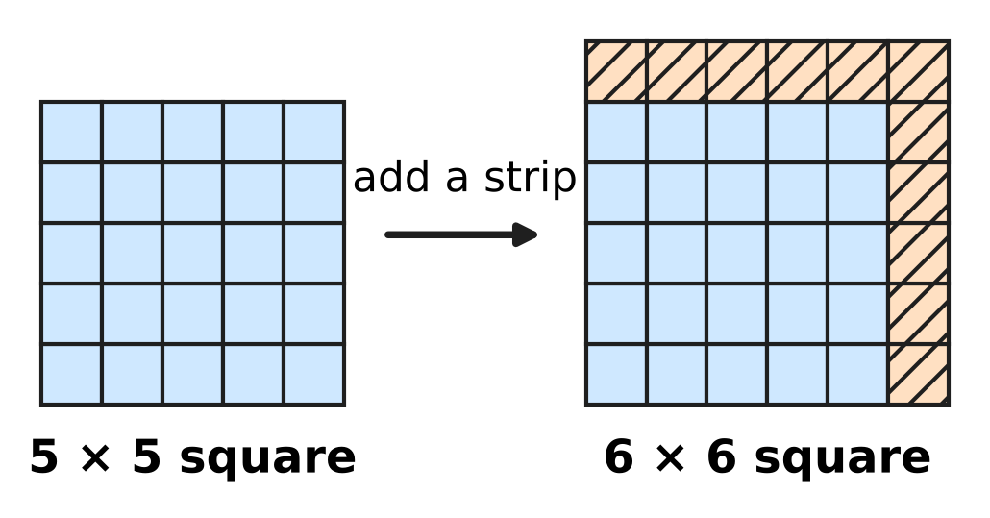
Q1. The picture shows a 5 × 5 square of tiles made into a 6 × 6 square by adding a strip of shaded tiles along two sides. In the same way, a 24 × 24 square of tiles is made into a 25 × 25 square. How many tiles are added?
(A) 48 | (B) 49 | (C) 50 | (D) 625

Q2. Which of these numbers lies between √3 and √5?
(A) 1.7 | (B) 1.9 | (C) 2.3 | (D) 4

Q3. Arun has many wooden blocks like the one in the picture, each 4 cm × 2 cm × 2 cm. He wants to put some of them together, without gaps or cutting, to make one solid cube. What is the least number of blocks he needs? | 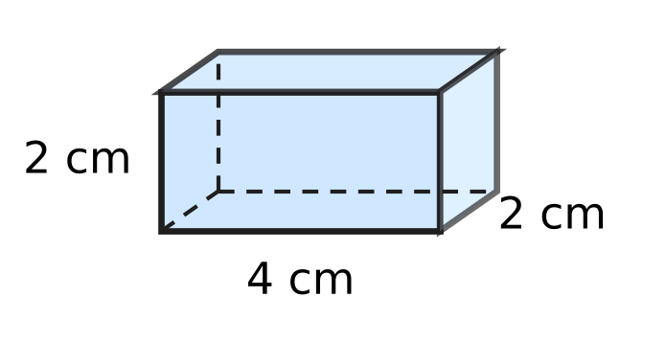
  (A) 2 | (B) 4 | (C) 16 | (D) 32

Part 2 — Operations & Number Properties (Syllabus Chapter 2)
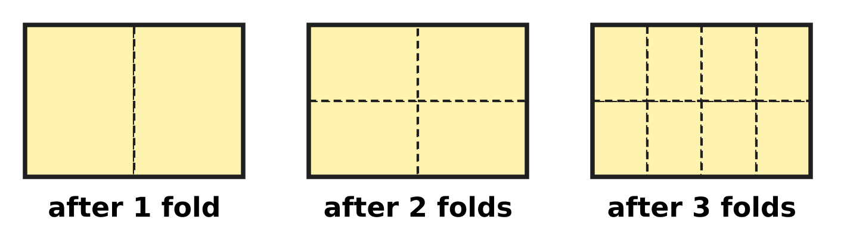
Q4. A sheet of paper is folded in half again and again. The picture shows the sheet opened out after 1, 2 and 3 folds; the dashed lines are the creases. The sheet is folded in half 6 times and opened out. What fraction of the whole sheet is each small part?
(A) 2⁶ | (B) 6⁻² | (C) 12⁻¹ | (D) 2⁻⁶

Q5. A fine grain of sand is 0.000075 m wide. How is this width written in standard form?
(A) 7.5 × 10⁻⁵ m | (B) 7.5 × 10⁻⁶ m
(C) 7.5 × 10⁻⁴ m | (D) 7.5 × 10⁵ m

Q6. How many of these six numbers are equal to $\frac{1}{16}$?
2⁻⁴, 4⁻², (−4)⁻², 8⁻², ${(\frac{1}{4})}^{−2}$, (−2)⁻⁴
(A) 2 | (B) 3 | (C) 4 | (D) 5

Part 3 — Fractions, Decimals & Percentages (Syllabus Chapter 3)
Q7. At a stationery shop, Asha sees the price tag in the picture. The price was cut twice, and each crossed-out price was the price before the next cut. The first cut was a 20% discount. What percentage was the second discount? | 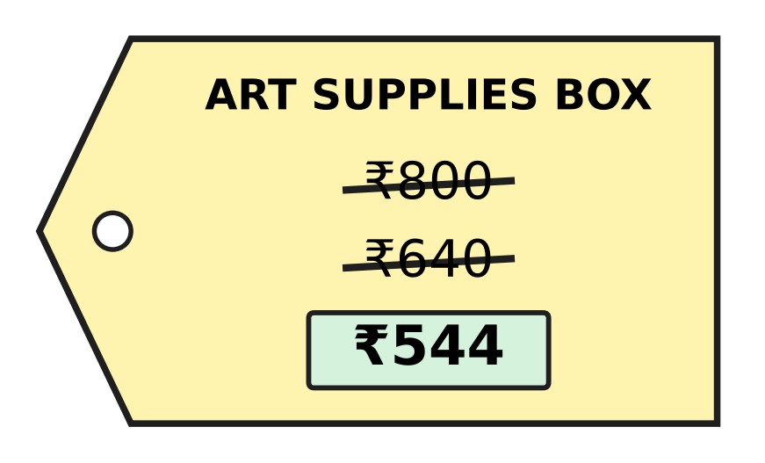
  (A) 32% | (B) 85% | (C) 12% | (D) 15%

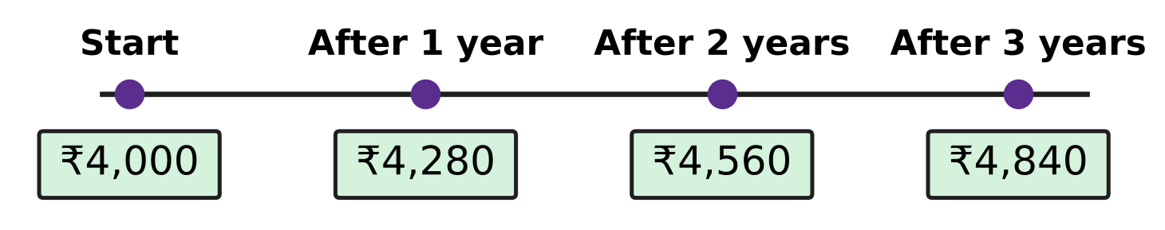
Q8. Navya puts some money in a savings scheme that pays simple interest. The picture shows the amount she has at the start and after each year. What is the rate of interest per year?
(A) 7% | (B) 14% | (C) 21% | (D) 28%

Q9. In the school vegetable garden, Ishan measures a bean plant. It is 50 cm tall. In the next week its height increases by 10%. In the week after that, its new height increases by 20%. How tall is the plant now?
(A) 55 cm | (B) 60 cm | (C) 65 cm | (D) 66 cm

Q10. At simple interest, a sum of money becomes $\frac{7}{4}$ of itself in 10 years. What is the rate of interest per year?
(A) 7.5% | (B) $13\frac{1}{3}$% | (C) 17.5% | (D) 75%

Q11. The number of books in a school library went up by 40% in one year. In the next year, old books were removed and the new number went down by 15%. The library now has 4,760 books. How many books did it have at the start?
(A) 4,000 | (B) 3,808 | (C) 5,600 | (D) 3,360

Part 4 — Algebra (Syllabus Chapter 4)
Q12. A rectangle is cut into four parts as shown in the picture. Its length is (x + 7) and its width is (x + 4). Which expression gives the area of the whole rectangle? | 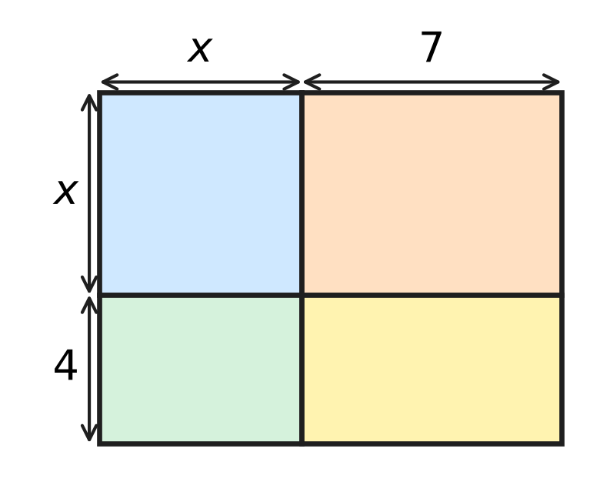
  (A) $x^{2}+28$ | (B) $2x+11$
  (C) $x^{2}+28x+11$ | (D) $x^{2}+11x+28$

Q13. Three consecutive multiples of 8 add up to 264. What is the largest of the three?
(A) 80 | (B) 88 | (C) 96 | (D) 104

Q14. Which of these is a factor of $x^{2}−x−30$?
(A) $x−6$ | (B) $x+6$ | (C) $x−10$ | (D) $x−5$

Q15. Four identical rectangular tiles are placed round a square hole to make a big square, as in the picture. The big square has area 196 cm². Each tile has area 45 cm². What is the side of the square hole? | 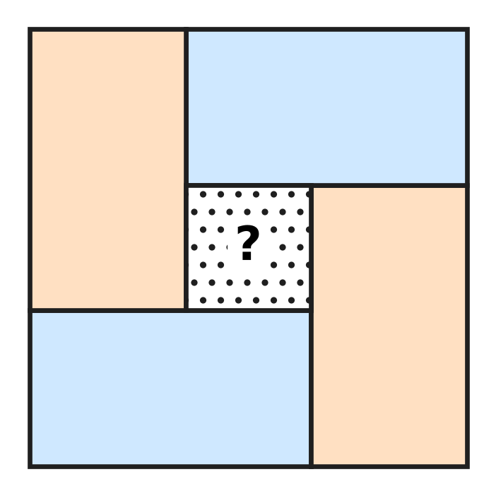
  (A) 9 cm | (B) 5 cm | (C) 16 cm | (D) 4 cm

Q16. For a school bus outing, the fare for each child is ₹30 less than the fare for each adult. A group of 4 adults and 8 children pays ₹1,320 in all. What is the fare for one child?
(A) ₹100 | (B) ₹130 | (C) ₹110 | (D) ₹120

Part 5 — Geometry (Syllabus Chapter 5)
Q17. On a windy day, Uday ties his kite string to a peg in flat ground. The string is 50 m long and stretched straight. The kite is directly above a point 30 m from the peg, as in the picture. How high is the kite above the ground? | 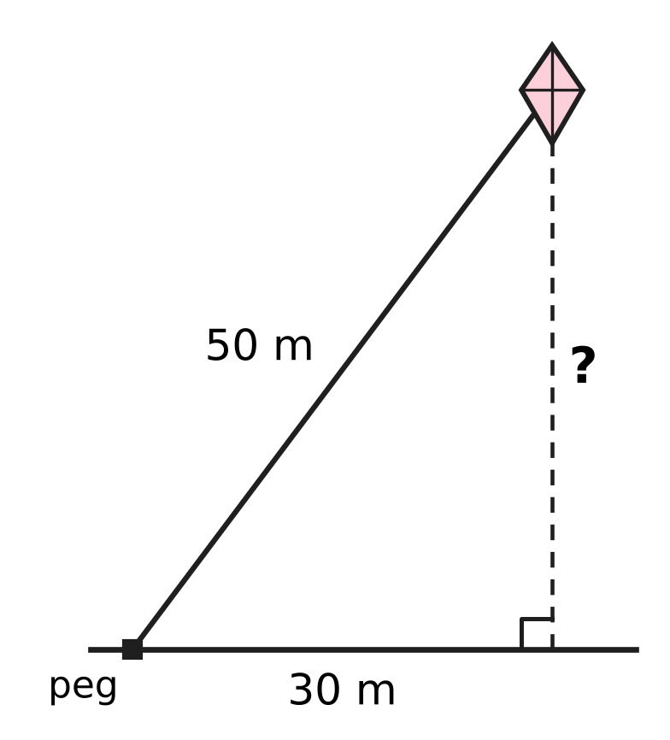
  (A) 25 m | (B) 20 m | (C) 80 m | (D) 40 m

Q18. ABCD is a rectangle. Its diagonals AC and BD meet at O. ∠OAB = 32°, as in the picture. What is ∠AOB? | 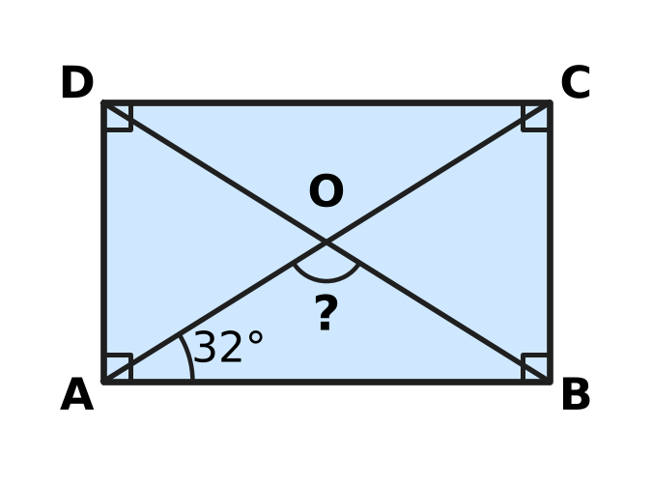
  (A) 148° | (B) 64° | (C) 58° | (D) 116°

Q19. The picture shows a net made of one regular pentagon and five identical triangles. It is folded to make a closed solid. How many edges does the solid have? | 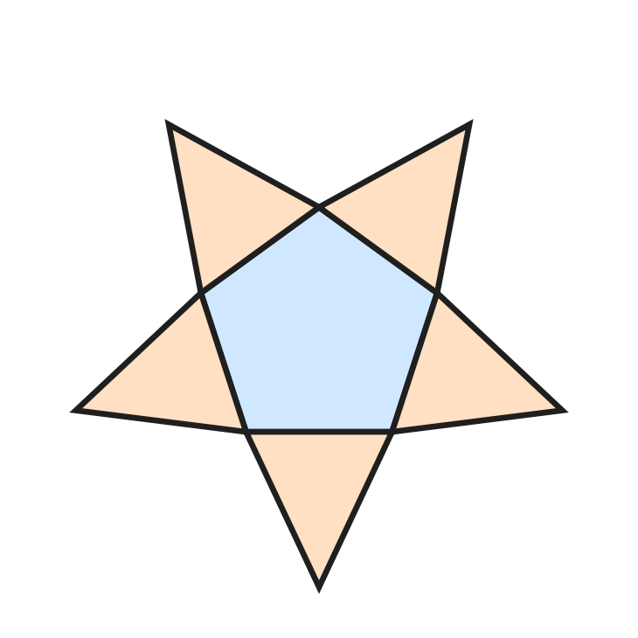
  (A) 6 | (B) 10 | (C) 15 | (D) 20

Q20. In △ABC, D is on AB and E is on AC, with DE ∥ BC. AD = 4 cm, DB = 6 cm and DE = 6 cm, as in the picture. What is the length of BC? | 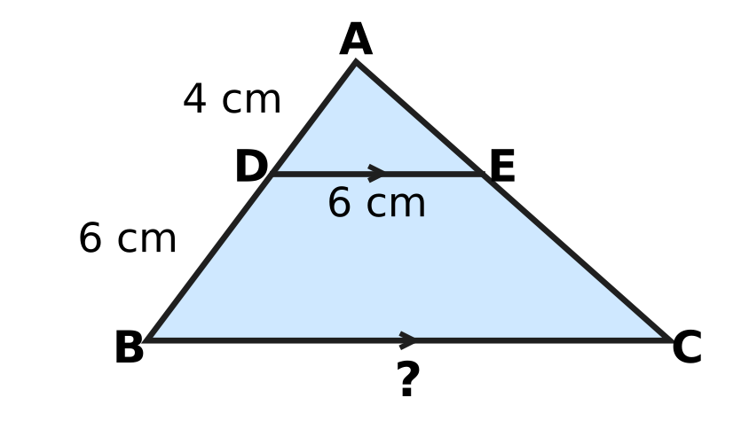
  (A) 15 cm | (B) 9 cm | (C) 12 cm | (D) 10 cm

Q21. ABCD is a trapezium with DC ∥ AB, as in the picture. DC = 8 cm, AB = 26 cm, and the slanting sides AD and BC are both 15 cm. DM is perpendicular to AB. What is the height h = DM? | 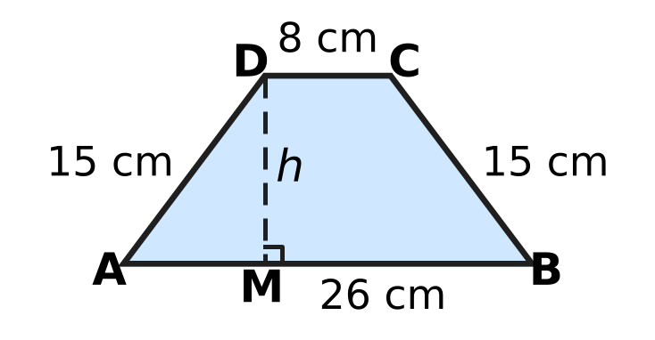
  (A) 9 cm | (B) 6 cm | (C) 12 cm | (D) √306 cm

Part 6 — Mensuration (Syllabus Chapter 6)
Q22. Bela makes a cone-shaped paper cup, open at the top. Its top has radius 3.5 cm and its slant height is 8 cm, as in the picture. How much paper is needed for the cup? (Use π = $\frac{22}{7}$.) | 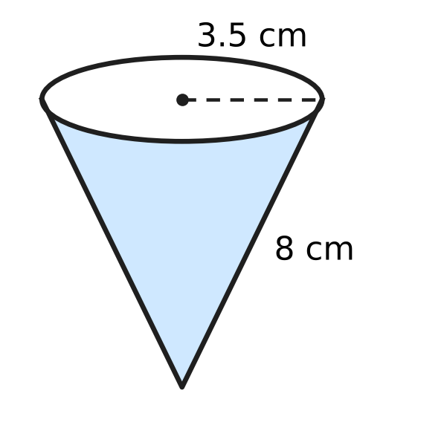
  (A) 88 cm² | (B) 126.5 cm²
  (C) 176 cm² | (D) 308 cm²

Q23. A classroom notice board is a rectangle 1.5 m long and 0.8 m wide. What is its area in square centimetres?
(A) 120 cm² | (B) 1,200 cm²
(C) 12,000 cm² | (D) 120,000 cm²

Q24. A solid wooden cylinder has volume 840 cm³. A cone with the same base and the same height as the cylinder is carved out of it, as shown by the dashed lines in the picture. What is the volume of the wood that is left? | 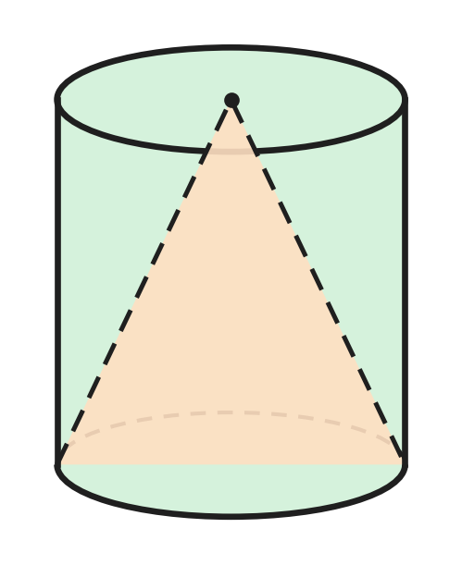
  (A) 280 cm³ | (B) 420 cm³ | (C) 560 cm³ | (D) 630 cm³

Q25. A rainwater tank is a cylinder with radius 1.4 m. Some water is taken out and the water level falls by 15 cm, as in the picture. How many litres of water were taken out? (Use π = $\frac{22}{7}$; 1 m³ = 1,000 litres.) | 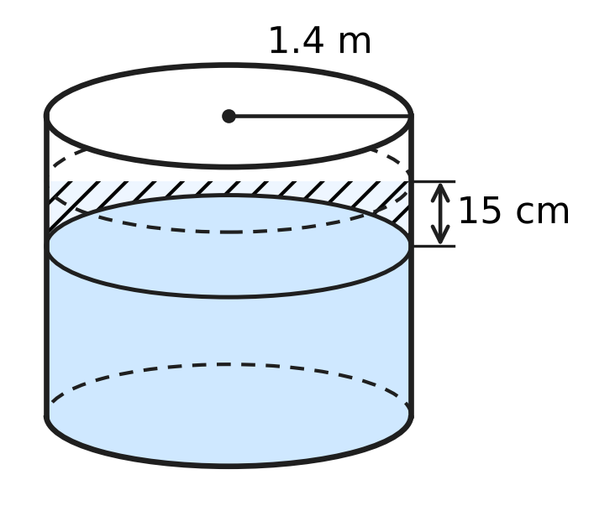
  (A) 92.4 litres | (B) 3,696 litres
  (C) 9,240 litres | (D) 924 litres

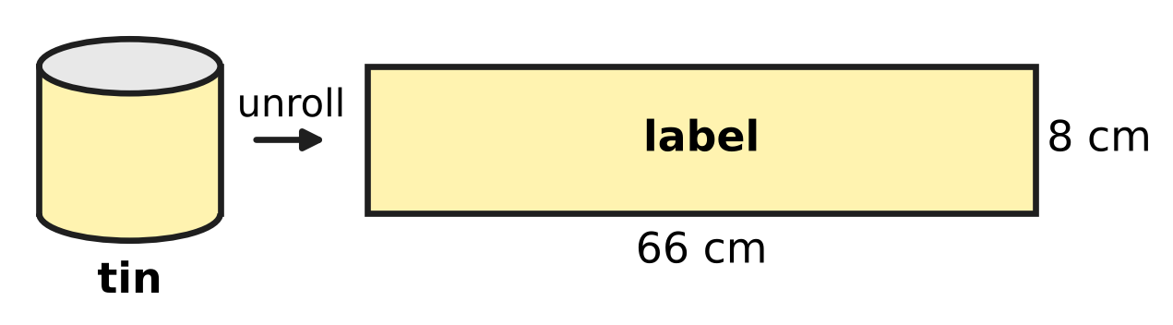
Q26. A paper label covers the whole curved surface of a closed cylindrical tin, with no overlap. When the label is taken off and laid flat, it is a rectangle 66 cm long and 8 cm wide, as in the picture. What is the volume of the tin? (Use π = $\frac{22}{7}$.)
(A) 2,772 cm³ | (B) 264 cm³
(C) 528 cm³ | (D) 11,088 cm³

Part 7 — Data Handling, Statistics & Probability (Syllabus Chapter 8)
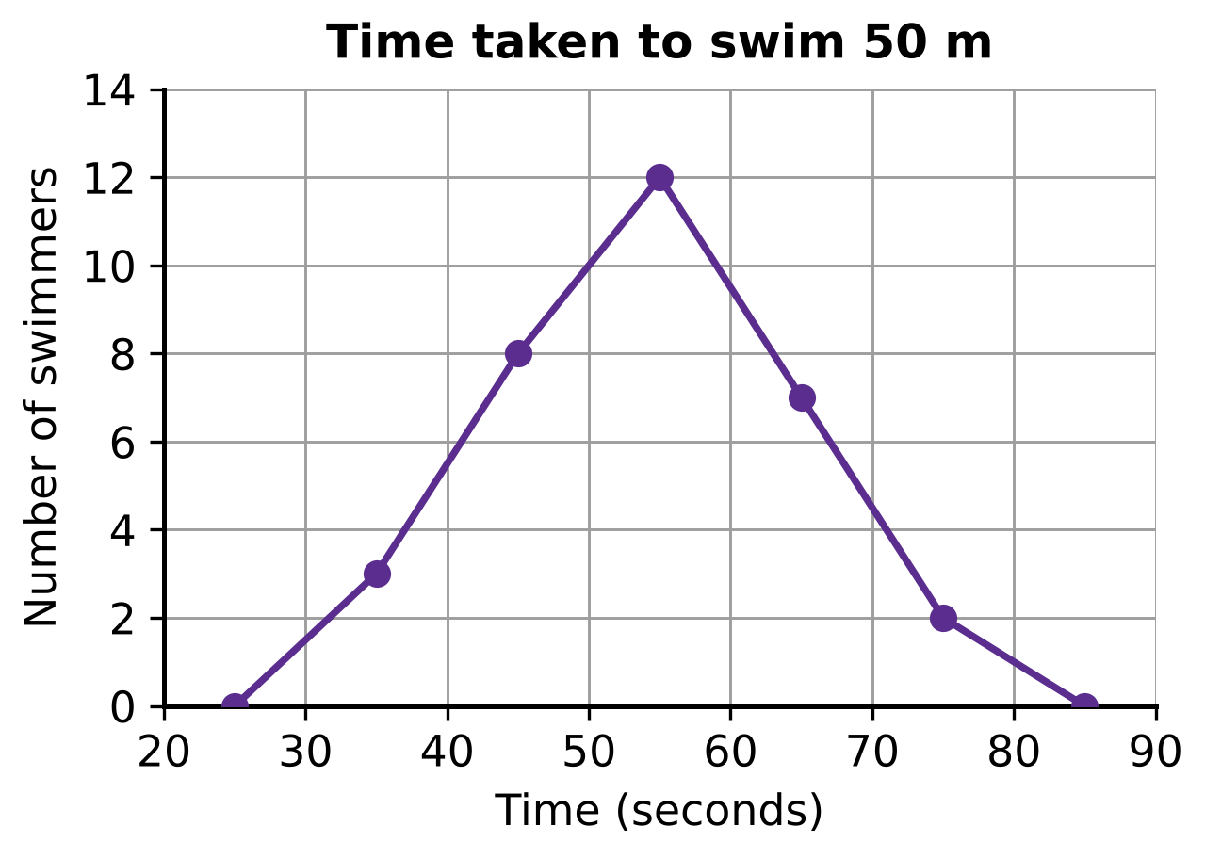
Q27. The swimmers at a swimming pool were timed over 50 m. Their times were grouped in classes 30–40, 40–50, 50–60, 60–70 and 70–80 seconds, where 30–40 means 30 or more but less than 40. The frequency polygon in the picture shows the number of swimmers in each class, plotted at the middle of the class. How many swimmers took 60 seconds or more?
(A) 7 | (B) 9 | (C) 12 | (D) 21

Q28. The pie chart shows how the 540 students of a school come to school. The angle of each sector is marked. How many more students walk to school than come by bicycle? | 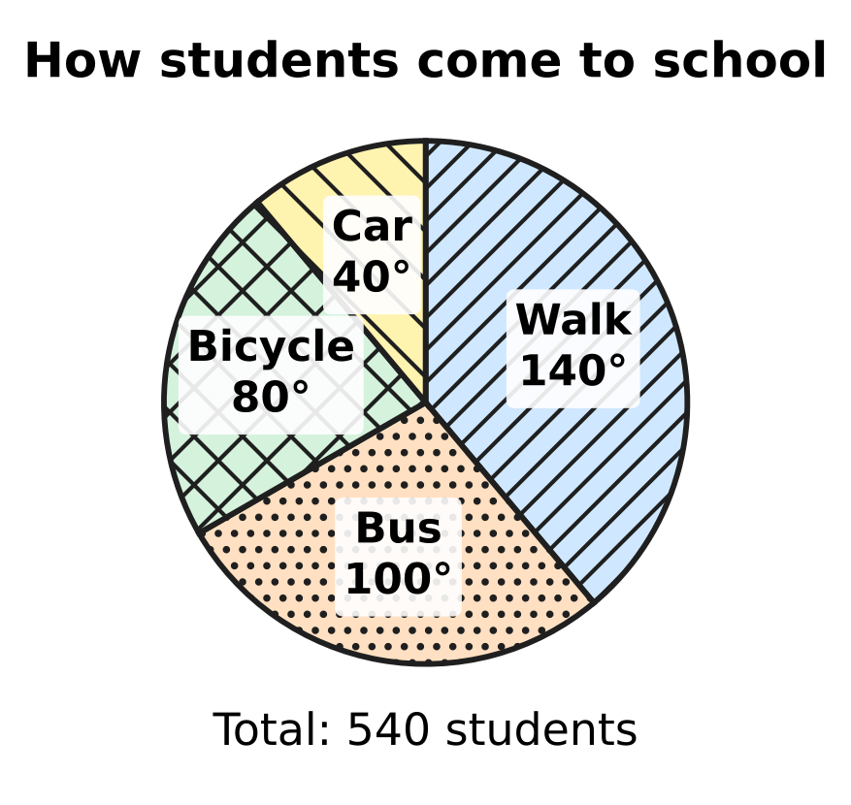
  (A) 60 | (B) 90 | (C) 120 | (D) 210

Goals scored by a school team in 25 matches
Goals in a match | 0 | 1 | 2 | 3 | 4 | 5
Number of matches | 4 | 7 | 6 | 4 | 3 | 1

Q29. The table shows how many goals a school team scored in each of its 25 matches. What is the median number of goals scored in a match?
(A) 1 | (B) 2 | (C) 2.5 | (D) 4

Part 8 — Applied Mathematics (Syllabus Chapter 9)
Q30. Kartik buys a used bicycle for ₹2,400 and spends ₹600 on repairs. He then sells it for ₹3,600. What is his profit percent?
(A) 25% | (B) $16\frac{2}{3}$% | (C) 20% | (D) 50%

Q31. A sum of money earns ₹540 as simple interest in 3 years. How much simple interest will the same sum earn in 5 years at the same rate?
(A) ₹720 | (B) ₹900 | (C) ₹1,080 | (D) ₹2,700

Q32. Leela sells a glass jar full of marbles for ₹780 and makes a profit of 20%. What did the jar of marbles cost her?
(A) ₹624 | (B) ₹936 | (C) ₹130 | (D) ₹650

Q33. Farhan buys 50 kg of apples from an orchard at ₹80 per kg. Of these, 10% rot and are thrown away. He sells the rest at ₹100 per kg. What is his profit percent?
(A) 10% | (B) 12.5% | (C) 15% | (D) 25%

Q34. For her stamp collection club, Swati buys 50 stamps at ₹12 each and 50 stamps at ₹18 each. She sells the cheaper stamps at a profit of 25% and the costlier stamps at a loss of 10%. What is her overall profit or loss percent?
(A) 4% profit | (B) 4% loss
(C) 7.5% profit | (D) 15% profit

Part 9 — Mathematical Reasoning & Problem-Solving (Syllabus Chapter 10)
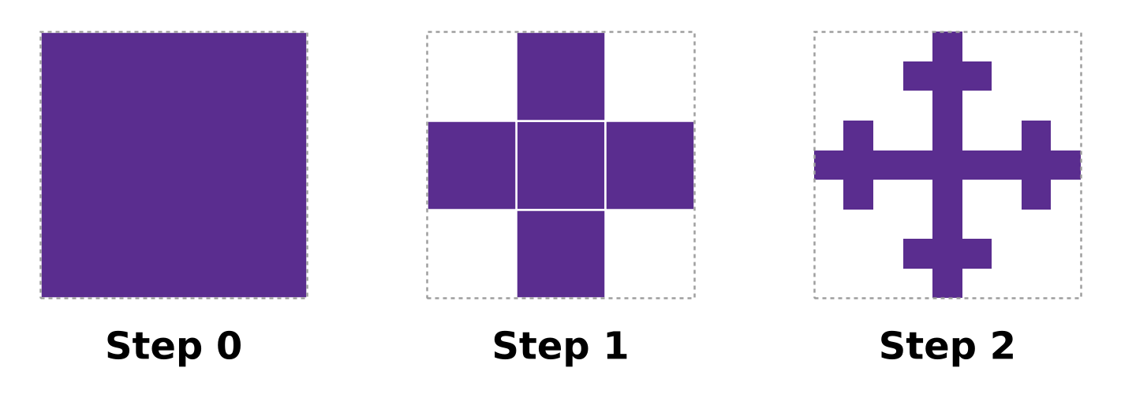
Q35. The picture shows the first steps of a fractal. At each step, every filled square is cut into 9 equal small squares, and only the middle one and the four touching its sides are kept. How many filled squares will there be at Step 3?
(A) 25 | (B) 45 | (C) 125 | (D) 625

Q36. In the number 74,3d6, the letter d stands for one digit. Which of these values of d makes the number divisible by 8?
(A) 1 | (B) 5 | (C) 7 | (D) 9

Q37. A 4-digit palindrome reads the same from left to right and from right to left, like 2,662. Which number divides EVERY 4-digit palindrome?
(A) 7 | (B) 11 | (C) 13 | (D) 101

Q38. In the multiplication shown in the picture, each letter stands for a digit. Different letters stand for different digits, and no number starts with 0. What is the two-digit number AB? | 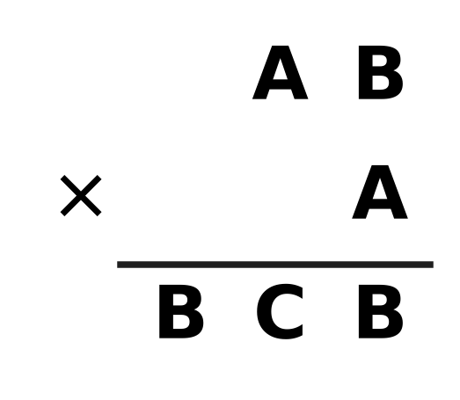
  (A) 95 | (B) 57 | (C) 75 | (D) 35

Q39. In the picture, three lines are drawn from the top corner of a big triangle to its base, and one more line is drawn across it from side to side. How many triangles of all sizes are there in the picture? | 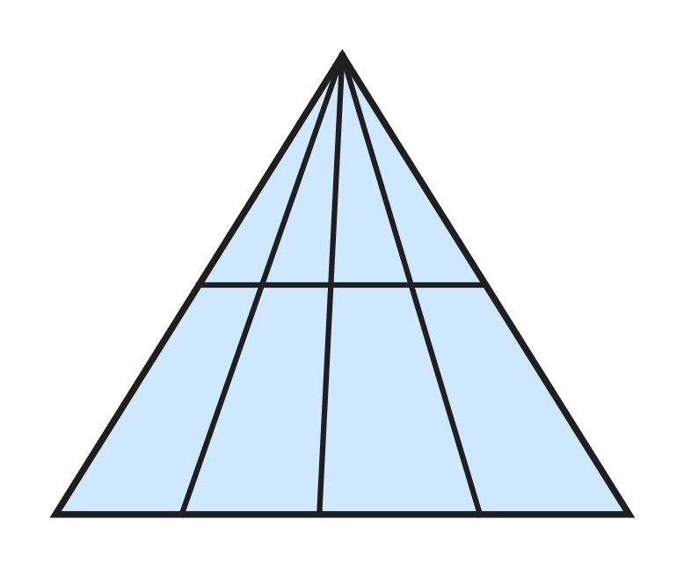
  (A) 8 | (B) 10 | (C) 14 | (D) 20

Q40. Advait's farm has some cows and some hens, at least one of each. Together they have 35 heads. Which of these could be the total number of their legs?
(A) 64 | (B) 67 | (C) 98 | (D) 142

SECTION II — Star Questions 5 questions × 4 marks each
Q41. A square floor is made of n × n square tiles. A smaller square of m × m tiles is removed from one corner, as in the picture, where m is at least 1. Exactly 96 tiles are left. How many different pairs of whole numbers (n, m) are possible? [4 marks] | 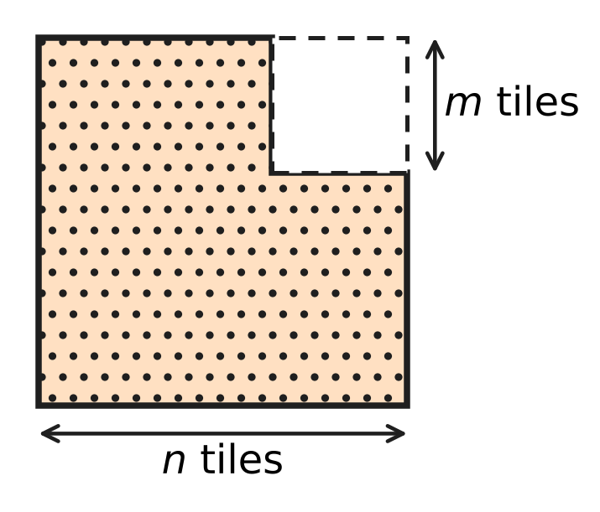
  (A) 4 | (B) 6 | (C) 8 | (D) 12

Q42. A solid has flat faces and no holes, so F + V − E = 2 for its faces F, vertices V and edges E. Every face is a triangle or a square. Every edge joins two vertices and is shared by exactly two faces. The solid has 24 vertices, and exactly 4 edges meet at every vertex. How many of its faces are squares? [4 marks]
(A) 8 | (B) 13 | (C) 18 | (D) 24

Q43. PQRS is a rhombus with perimeter 100 cm. Its diagonals PR and QS, shown in the picture, differ in length by 34 cm. What is the area of the rhombus? [4 marks] | 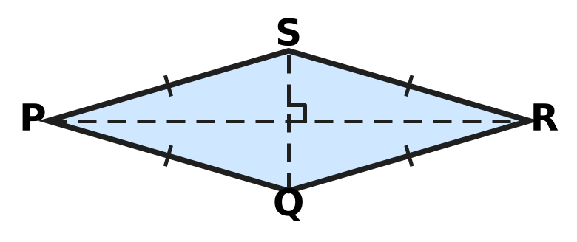
  (A) 168 cm² | (B) 336 cm² | (C) 625 cm² | (D) 672 cm²

Q44. Samar borrows ₹20,000 at 9% per year simple interest and uses it all to buy school bags. He marks the bags 25% above his cost and sells all of them at a discount of 8% on the marked price. After 8 months he repays the loan with its interest. What is his profit as a percentage of ₹20,000? [4 marks]
(A) 6% | (B) 9% | (C) 11% | (D) 15%

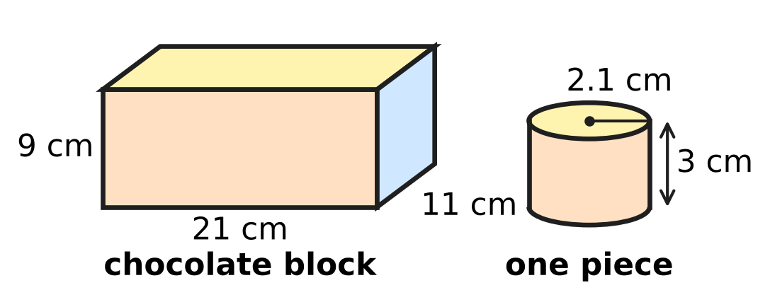
Q45. At a bakery, Reena melts a cuboid block of chocolate and pours all of it into cylindrical moulds. Each mould makes one piece, and no chocolate is lost. The sizes are shown in the picture. The block costs ₹1,600 and each piece is wrapped in a paper that costs ₹4. She wants a profit of 25% on her total cost. At what price should she sell each wrapped piece? (Use π = $\frac{22}{7}$.) [4 marks]
(A) ₹36 | (B) ₹40 | (C) ₹44 | (D) ₹45

Answer Sheet AMO Level 1 · Class 8 · Practice Paper 1
Name: | School: | Roll No.:
Shade or tick one circle for each question.
1. Ⓐ Ⓑ Ⓒ Ⓓ | 16. Ⓐ Ⓑ Ⓒ Ⓓ | 31. Ⓐ Ⓑ Ⓒ Ⓓ
2. Ⓐ Ⓑ Ⓒ Ⓓ | 17. Ⓐ Ⓑ Ⓒ Ⓓ | 32. Ⓐ Ⓑ Ⓒ Ⓓ
3. Ⓐ Ⓑ Ⓒ Ⓓ | 18. Ⓐ Ⓑ Ⓒ Ⓓ | 33. Ⓐ Ⓑ Ⓒ Ⓓ
4. Ⓐ Ⓑ Ⓒ Ⓓ | 19. Ⓐ Ⓑ Ⓒ Ⓓ | 34. Ⓐ Ⓑ Ⓒ Ⓓ
5. Ⓐ Ⓑ Ⓒ Ⓓ | 20. Ⓐ Ⓑ Ⓒ Ⓓ | 35. Ⓐ Ⓑ Ⓒ Ⓓ
6. Ⓐ Ⓑ Ⓒ Ⓓ | 21. Ⓐ Ⓑ Ⓒ Ⓓ | 36. Ⓐ Ⓑ Ⓒ Ⓓ
7. Ⓐ Ⓑ Ⓒ Ⓓ | 22. Ⓐ Ⓑ Ⓒ Ⓓ | 37. Ⓐ Ⓑ Ⓒ Ⓓ
8. Ⓐ Ⓑ Ⓒ Ⓓ | 23. Ⓐ Ⓑ Ⓒ Ⓓ | 38. Ⓐ Ⓑ Ⓒ Ⓓ
9. Ⓐ Ⓑ Ⓒ Ⓓ | 24. Ⓐ Ⓑ Ⓒ Ⓓ | 39. Ⓐ Ⓑ Ⓒ Ⓓ
10. Ⓐ Ⓑ Ⓒ Ⓓ | 25. Ⓐ Ⓑ Ⓒ Ⓓ | 40. Ⓐ Ⓑ Ⓒ Ⓓ
11. Ⓐ Ⓑ Ⓒ Ⓓ | 26. Ⓐ Ⓑ Ⓒ Ⓓ | 41. Ⓐ Ⓑ Ⓒ Ⓓ
12. Ⓐ Ⓑ Ⓒ Ⓓ | 27. Ⓐ Ⓑ Ⓒ Ⓓ | 42. Ⓐ Ⓑ Ⓒ Ⓓ
13. Ⓐ Ⓑ Ⓒ Ⓓ | 28. Ⓐ Ⓑ Ⓒ Ⓓ | 43. Ⓐ Ⓑ Ⓒ Ⓓ
14. Ⓐ Ⓑ Ⓒ Ⓓ | 29. Ⓐ Ⓑ Ⓒ Ⓓ | 44. Ⓐ Ⓑ Ⓒ Ⓓ
15. Ⓐ Ⓑ Ⓒ Ⓓ | 30. Ⓐ Ⓑ Ⓒ Ⓓ | 45. Ⓐ Ⓑ Ⓒ Ⓓ
Q41–Q45 are Section II Star Questions (4 marks each).
For the parent or teacher
Section I correct: ______ / 40 × 2 = ______ marks Section II correct: ______ / 5 × 4 = ______ marks
Correct: ______ / 45 Score: ______ / 100
Answer Key and Solutions AMO Level 1 · Class 8 · Practice Paper 1
Quick answers
1 B | 6 C | 11 A | 16 A | 21 C | 26 A | 31 B | 36 C | 41 A
2 B | 7 D | 12 D | 17 D | 22 A | 27 B | 32 D | 37 B | 42 C
3 B | 8 A | 13 C | 18 D | 23 C | 28 B | 33 B | 38 C | 43 B
4 D | 9 D | 14 A | 19 B | 24 C | 29 B | 34 A | 39 D | 44 B
5 A | 10 A | 15 D | 20 A | 25 D | 30 C | 35 C | 40 C | 45 D
Solutions
Q | Part · level | Answer | Why?
1 | Part 1 · Ch1 · Easy | (B) 49 | Tiles added = 25² − 24² = 625 − 576 = 49 (that is, 24 + 24 + 1 for the corner).
2 | Part 1 · Ch1 · Easy | (B) 1.9 | Square each number: 1.9² = 3.61 lies between 3 and 5, so √3 < 1.9 < √5. But 1.7² = 2.89, 2.3² = 5.29 and 4² = 16 do not.
3 | Part 1 · Ch1 · Medium | (B) 4 | Volume of a block = 16 cm³. The smallest cube whose volume is a multiple of 16 and whose edge can hold a 4 cm length is 4 cm × 4 cm × 4 cm = 64 cm³, and 64 ÷ 16 = 4 blocks.
4 | Part 2 · Ch2 · Easy | (D) 2⁻⁶ | Each fold doubles the number of parts: 2, 4, 8, … so 6 folds give 2⁶ = 64 parts. One part is 1/2⁶ = 2⁻⁶ of the sheet.
5 | Part 2 · Ch2 · Easy | (A) 7.5 × 10⁻⁵ m | Move the decimal point 5 places to the right to get 7.5, so 0.000075 = 7.5 × 10⁻⁵ m.
6 | Part 2 · Ch2 · Medium | (C) 4 | Here 2⁻⁴ = 1/16, 4⁻² = 1/16, (−4)⁻² = 1/16 and (−2)⁻⁴ = 1/16. But 8⁻² = 1/64 and (1/4)⁻² = 16. So 4 of them equal 1/16.
7 | Part 3 · Ch3 · Easy | (D) 15% | The second cut is 640 − 544 = ₹96 on a price of ₹640. As a percentage, 96/640 × 100 = 15%.
8 | Part 3 · Ch3 · Easy | (A) 7% | The amount grows by ₹280 every year, so the interest is ₹280 per year on ₹4,000. Rate = 280/4,000 × 100 = 7% per year.
9 | Part 3 · Ch3 · Easy | (D) 66 cm | After week 1: 50 × 1.1 = 55 cm. After week 2: 55 × 1.2 = 66 cm.
10 | Part 3 · Ch3 · Medium | (A) 7.5% | Interest = 7/4 − 1 = 3/4 of the sum in 10 years, so 3/40 of the sum each year. Rate = 3/40 × 100 = 7.5% per year.
11 | Part 3 · Ch3 · Medium | (A) 4,000 | A rise of 40% then a fall of 15% multiply the number by 1.4 × 0.85 = 1.19. So the start = 4,760 ÷ 1.19 = 4,000 books.
12 | Part 4 · Ch4 · Easy | (D) $x^{2}+11x+28$ | The four parts are x², 7x, 4x and 4 × 7 = 28. Together: x² + 11x + 28.
13 | Part 4 · Ch4 · Easy | (C) 96 | Let them be 8k − 8, 8k and 8k + 8. Their sum is 24k = 264, so k = 11. The numbers are 80, 88 and 96; the largest is 96.
14 | Part 4 · Ch4 · Easy | (A) $x−6$ | Two numbers with product −30 and sum −1 are −6 and 5. So x² − x − 30 = (x − 6)(x + 5), and x − 6 is a factor.
15 | Part 4 · Ch4 · Medium | (D) 4 cm | If a tile is a by b, the big square has side a + b and the hole has side a − b. (a − b)² = (a + b)² − 4ab = 196 − 4 × 45 = 16, so the side is 4 cm.
16 | Part 4 · Ch4 · Medium | (A) ₹100 | Let a child pay ₹c, so an adult pays ₹(c + 30). Then 4(c + 30) + 8c = 1,320, so 12c = 1,200 and c = 100.
17 | Part 5 · Ch5 · Easy | (D) 40 m | The string is the hypotenuse: height² = 50² − 30² = 2,500 − 900 = 1,600, so the height is 40 m.
18 | Part 5 · Ch5 · Easy | (D) 116° | The diagonals of a rectangle are equal and bisect each other, so OA = OB and ∠OBA = ∠OAB = 32°. Then ∠AOB = 180° − 32° − 32° = 116°.
19 | Part 5 · Ch5 · Easy | (B) 10 | The net folds into a pentagonal pyramid: 5 edges round the base and 5 edges up to the top, so 10 edges. (Check: F + V − E = 6 + 6 − 10 = 2.)
20 | Part 5 · Ch5 · Medium | (A) 15 cm | DE ∥ BC gives equal corresponding angles, so △ADE ∼ △ABC. AB = 4 + 6 = 10 cm, so BC/DE = AB/AD = 10/4 and BC = 6 × 10/4 = 15 cm.
21 | Part 5 · Ch5 · Medium | (C) 12 cm | The two slanting sides are equal, so AM = (26 − 8) ÷ 2 = 9 cm. In right △AMD, h² = 15² − 9² = 225 − 81 = 144, so h = 12 cm.
22 | Part 6 · Ch6 · Easy | (A) 88 cm² | Paper = curved surface = πrl = 22/7 × 3.5 × 8 = 88 cm².
23 | Part 6 · Ch6 · Easy | (C) 12,000 cm² | Area = 1.5 × 0.8 = 1.2 m². Since 1 m² = 100 cm × 100 cm = 10,000 cm², the area is 12,000 cm².
24 | Part 6 · Ch6 · Easy | (C) 560 cm³ | A cone with the same base and height has 1/3 of the cylinder's volume: 840 ÷ 3 = 280 cm³. Wood left = 840 − 280 = 560 cm³.
25 | Part 6 · Ch6 · Medium | (D) 924 litres | Water taken out = πr²h = 22/7 × 1.4 × 1.4 × 0.15 = 0.924 m³ = 924 litres.
26 | Part 6 · Ch6 · Medium | (A) 2,772 cm³ | The 66 cm side goes round the tin, so 2πr = 66 and r = 10.5 cm. The height is 8 cm. Volume = 22/7 × 10.5 × 10.5 × 8 = 2,772 cm³.
27 | Part 7 · Ch8 · Easy | (B) 9 | Taking 60 seconds or more means the classes 60–70 and 70–80. Their points (at 65 and 75) are at 7 and 2, so 7 + 2 = 9 swimmers.
28 | Part 7 · Ch8 · Easy | (B) 90 | The difference in angle is 140° − 80° = 60°. That is 60/360 of 540 students = 90 students.
29 | Part 7 · Ch8 · Medium | (B) 2 | With 25 matches, the median is the 13th value in order. The first 4 values are 0 and the next 7 are 1 (11 values so far); the 12th to 17th values are 2. So the median is 2.
30 | Part 8 · Ch9 · Easy | (C) 20% | Cost price = 2,400 + 600 = ₹3,000. Profit = 3,600 − 3,000 = ₹600. Profit percent = 600/3,000 × 100 = 20%.
31 | Part 8 · Ch9 · Easy | (B) ₹900 | Simple interest is the same every year: ₹540 ÷ 3 = ₹180 per year. For 5 years: 180 × 5 = ₹900.
32 | Part 8 · Ch9 · Easy | (D) ₹650 | Selling price = 120% of the cost price. So the cost price = 780 × 100/120 = ₹650.
33 | Part 8 · Ch9 · Medium | (B) 12.5% | Cost = 50 × 80 = ₹4,000. He sells 45 kg for 45 × 100 = ₹4,500. Profit = ₹500, which is 500/4,000 × 100 = 12.5%.
34 | Part 8 · Ch9 · Medium | (A) 4% profit | Cost = 600 + 900 = ₹1,500. Selling price = 600 × 1.25 + 900 × 0.9 = 750 + 810 = ₹1,560. Profit = ₹60, which is 60/1,500 × 100 = 4%.
35 | Part 9 · Ch10 · Easy | (C) 125 | Each filled square becomes 5 filled squares, so the number is multiplied by 5 at every step: 1, 5, 25, 125. At Step 3 there are 5³ = 125 squares.
36 | Part 9 · Ch10 · Easy | (C) 7 | A number is divisible by 8 when the number made by its last three digits is. Of the options, only 376 = 8 × 47 works; 316, 356 and 396 are not multiples of 8. So d = 7.
37 | Part 9 · Ch10 · Easy | (B) 11 | The example 2,662 = 2 × 11 × 11 × 11 is not a multiple of 7, 13 or 101, so only 11 can work. It always does: abba = 1,001a + 110b = 11 × (91a + 10b).
38 | Part 9 · Ch10 · Medium | (C) 75 | B × A must end in B. A = 1 gives a two-digit product, so either A = 6 with B even, or B = 5 with A odd. A = 6 gives 62 × 6 = 372, 64 × 6 = 384, 68 × 6 = 408: none fits. B = 5 gives 35 × 3 = 105, 75 × 7 = 525, 95 × 9 = 855; only 525 has the form BCB, so AB = 75.
39 | Part 9 · Ch10 · Medium | (D) 20 | Every triangle has the top corner and two of the 5 lines from it, with its base on the cross line or on the bottom line. Choosing 2 of the 5 lines gives 10 ways, and there are 2 bases: 2 × 10 = 20.
40 | Part 9 · Ch10 · Medium | (C) 98 | Each animal has 2 or 4 legs, so the total is even. The fewest legs come from 1 cow and 34 hens: 4 + 68 = 72. The most come from 34 cows and 1 hen: 136 + 2 = 138. The total 98 works: 14 cows and 21 hens have 56 + 42 = 98 legs.
41 | Section II · Ch4 + Ch10 · Hard | (A) 4 | n² − m² = (n − m)(n + m) = 96. The two factors differ by 2m, so both are even: 2 × 48, 4 × 24, 6 × 16, 8 × 12. These give (n, m) = (25, 23), (14, 10), (11, 5), (10, 2): 4 pairs.
42 | Section II · Ch5 + Ch10 · Hard | (C) 18 | Counting edge ends at the vertices, E = 24 × 4 ÷ 2 = 48, so F = 2 − 24 + 48 = 26. Counting edges round the faces, 3 × (triangles) + 4 × (squares) = 2 × 48 = 96; with 26 faces this gives 8 triangles and 18 squares. (Such a solid really exists: the rhombicuboctahedron has exactly these faces.)
43 | Section II · Ch4 + Ch5 · Hard | (B) 336 cm² | Side = 25 cm. The diagonals bisect at right angles; let the half-diagonals be a and b, so a² + b² = 625 and a − b = 17. Then 2ab = 625 − 17² = 336. The area is 4 × ½ab = 2ab = 336 cm².
44 | Section II · Ch3 + Ch9 · Hard | (B) 9% | Selling price = 20,000 × 1.25 × 0.92 = ₹23,000. Interest = 20,000 × 9/100 × 8/12 = ₹1,200. Profit = 23,000 − 20,000 − 1,200 = ₹1,800, which is 9% of ₹20,000.
45 | Section II · Ch6 + Ch9 · Hard | (D) ₹45 | Block = 21 × 11 × 9 = 2,079 cm³. One piece = 22/7 × 2.1 × 2.1 × 3 = 41.58 cm³, so 2,079 ÷ 41.58 = 50 pieces. Total cost = 1,600 + 50 × 4 = ₹1,800. With 25% profit she needs ₹2,250, that is ₹45 per piece.

