UNLOCK IQ INSTITUTE
Realize Your True Potential
Aryabhatta Maths Olympiad (AMO)
Level 1 — Practice Paper 2
CLASS 8

Questions | 45 multiple-choice questions
Marks | 100
Time | 60 minutes
Section I | 40 questions × 2 marks = 80 marks
Section II | 5 Star Questions × 4 marks = 20 marks
Negative marking | No negative marking
Calculator | Not allowed
Chapters | Number System · Operations · Fractions, Decimals & Percentages · Algebra · Geometry · Mensuration · Data Handling · Applied Mathematics · Mathematical Reasoning

Instructions to candidates
• This paper has 45 multiple-choice questions. Each question has four answer choices, of which exactly one is correct.
• Section I (Q1–Q40) carries 2 marks per question. Section II (Q41–Q45) carries 4 marks per question.
• There is no negative marking. Unanswered questions score zero.
• Calculators are not permitted. Rough work may be done on a separate sheet.
• Mark your answers on the answer sheet at the end of the paper.
• All figures are not necessarily drawn to scale unless stated.

For parents and teachers
Print or view this paper in colour. Pictures are part of the questions.
Parts follow the AMO syllabus chapters. Chapter 7 is not part of the Class 8 syllabus, so the chapter numbers shown in the Part headings have gaps.
The answer sheet and the answer key are at the end. Remove only the answer key before the student begins.

Name: | School: | Roll No.:

SECTION I 40 questions × 2 marks each
Part 1 — Number System (Syllabus Chapter 1)
Q1. Which of these numbers is rational?
(A) √2 + √2 | (B) √0.9 | (C) (√5)³ | (D) √3 × √12

Q2. Simran spreads a square mat for a picnic in the park. The mat has an area of 2.89 m². How long is each side of the mat?
(A) 0.7225 m | (B) 0.17 m | (C) 17 m | (D) 1.7 m

Q3. Which of these has the greatest value?
(A) 0.9² | (B) √0.64 | (C) ∛0.729 | (D) ∛0.343

Part 2 — Operations & Number Properties (Syllabus Chapter 2)
Q4. Which of these numbers is negative?
(A) (−3)⁻² | (B) (−2)⁻³ | (C) 2⁻³ | (D) (−1)⁻⁴

Q5. $8^{−2}=2^{x}$. What is the value of x?
(A) −6 | (B) −4 | (C) 6 | (D) 1

Q6. A drop of water has a volume of 5 × 10⁻² mL. A water bottle holds 1.5 × 10³ mL. How many such drops are needed to fill the bottle?
(A) 75 | (B) 30,000 | (C) 300,000 | (D) 3,000

Part 3 — Fractions, Decimals & Percentages (Syllabus Chapter 3)
Q7. Which of these deposits earns exactly ₹600 as simple interest?
(A) ₹1,000 at 10% a year for 6 months | (B) ₹4,000 at 6% a year for 2 years
(C) ₹2,000 at 7.5% a year for 4 years | (D) ₹3,000 at 4% a year for 4 years

Q8. Jaya puts ₹8,000 in a bank that pays simple interest. After 9 months she gets ₹480 as interest. What is the rate of interest per year?
(A) 6% | (B) 4.5% | (C) 12% | (D) 8%

Q9. On sports day, 60% of the 400 students of a school run in races. Of the students who run, 25% win a medal. How many students win a medal?
(A) 60 | (B) 140 | (C) 100 | (D) 240

Q10. An item is marked ₹2,000. A shop can give two successive discounts in one of the four ways below. The second discount is on the reduced price. Which way makes the final price the lowest?
(A) 25% and then 15% | (B) 35% and then 5%
(C) 20% and then 20% | (D) 30% and then 10%

Q11. The length of a rectangle is increased by 20% and its width is decreased by 10%. What happens to its area?
(A) It increases by 8%. | (B) It increases by 2%.
(C) It decreases by 12%. | (D) It increases by 10%.

Part 4 — Algebra (Syllabus Chapter 4)
Q12. Which of these expressions is NOT a perfect square?
(A) $9x^{2}+24x+16$ | (B) $x^{2}+10x+25$
(C) $4x^{2}−12x+9$ | (D) $x^{2}+6x+36$

Q13. For two numbers x and y, $x^{2}−y^{2}=45$ and x + y = 9. What is the value of x − y?
(A) 36 | (B) 3 | (C) 5 | (D) 405

Q14. Mira cuts a ribbon 250 cm long into two pieces. One piece is 40 cm longer than twice the other piece. How long is the longer piece?
(A) 180 cm | (B) 145 cm | (C) 105 cm | (D) 70 cm

Q15. The expression $x^{2}+kx+24$ can be written as (x + a)(x + b), where a and b are positive whole numbers. Which of these can NOT be the value of k?
(A) 14 | (B) 12 | (C) 11 | (D) 10

Q16. On a train journey, a coach had some passengers. At one station, $\frac{3}{5}$ of them got off and 12 new passengers got on. The coach then had 44 passengers. How many passengers were in the coach before the station?
(A) 110 | (B) 32 | (C) 80 | (D) 140

Part 5 — Geometry (Syllabus Chapter 5)
Q17. In the picture, △ABC has AB = AC = 17 cm and BC = 16 cm. AD is perpendicular to BC, so D is the midpoint of BC. What is the height h = AD? | 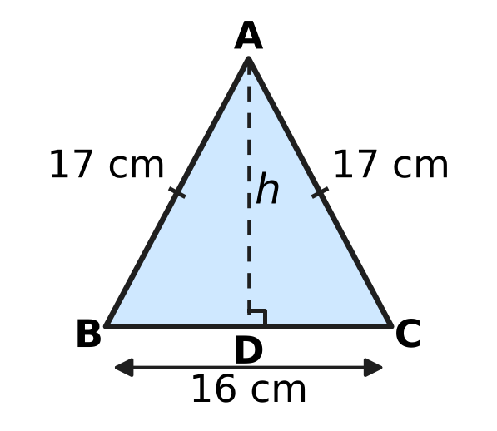
  (A) 25 cm | (B) 8 cm | (C) 9 cm | (D) 15 cm

Q18. ABCD is a parallelogram. Which of these facts is enough to prove that ABCD is a rectangle?
(A) One of its angles is 90°. | (B) Its opposite angles are equal.
(C) Two of its adjacent sides are equal. | (D) Its diagonals are perpendicular.

Q19. Which of these solids has exactly 30 edges?
(A) a prism whose base has 8 sides | (B) a prism whose base has 10 sides
(C) a pyramid whose base has 10 sides | (D) a prism whose base has 15 sides

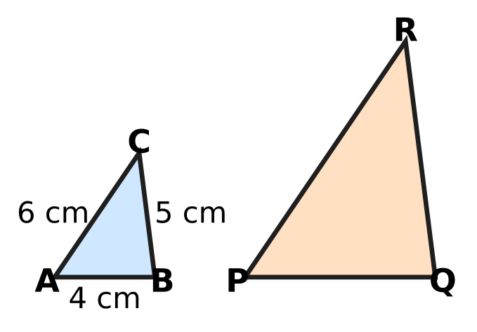
Q20. In the picture, △ABC ∼ △PQR, with AB = 4 cm, BC = 5 cm and CA = 6 cm. The perimeter of △PQR is 45 cm. What is the length of the longest side of △PQR?
(A) 36 cm | (B) 15 cm | (C) 12 cm | (D) 18 cm

Q21. Two upright poles stand on level ground 12 m apart. They are 4 m and 9 m tall, as in the picture. A bird flies in a straight line from the top of the shorter pole to its nest on top of the taller pole. How far does it fly? | 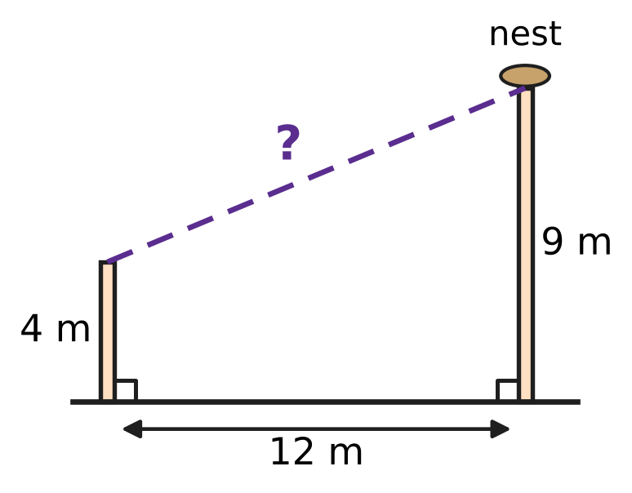
  (A) 17 m | (B) 15 m | (C) 13 m | (D) 5 m

Part 6 — Mensuration (Syllabus Chapter 6)
Cone | K | L | M | N
Radius (cm) | 6 | 5 | 2 | 3
Height (cm) | 2 | 3 | 15 | 8

Q22. The table gives the radius and the height of four solid cones. Which cone has the greatest volume?
(A) Cone K | (B) Cone L | (C) Cone M | (D) Cone N

Q23. Cylinder A has radius r and height h. Cylinder B has radius 2r and height h ÷ 2, as in the picture. The volume of B is how many times the volume of A? | 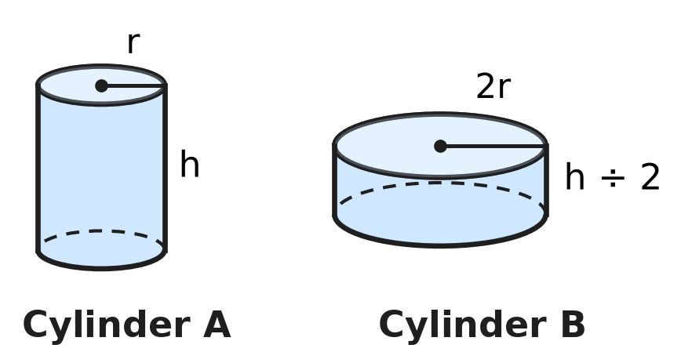
  (A) 4 | (B) 8 | (C) 2 | (D) 1

Q24. A solid cone of candle wax, shown in the picture, has a base diameter of 4.2 cm and a height of 50 mm. What is its volume? (Use π = $\frac{22}{7}$.) | 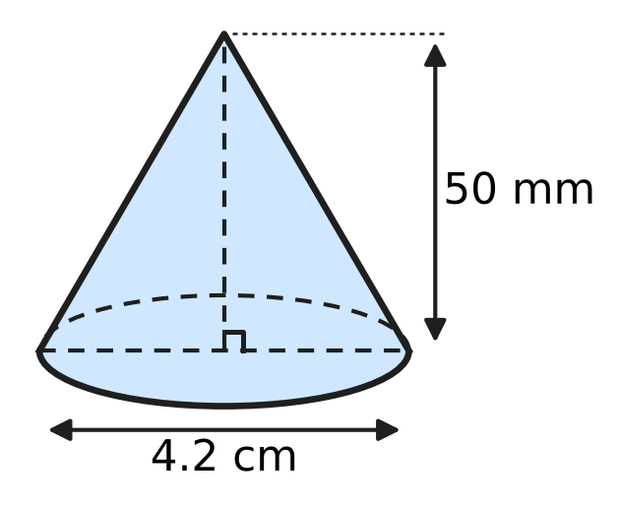
  (A) 231 cm³ | (B) 23.1 cm³ | (C) 69.3 cm³ | (D) 11 cm³

Q25. Lena fills an empty aquarium tank, a cuboid 60 cm × 40 cm × 40 cm as in the picture, using a jug that holds 1.2 litres. How many full jugs of water does she need to fill the tank? (1 litre = 1,000 cm³.) | 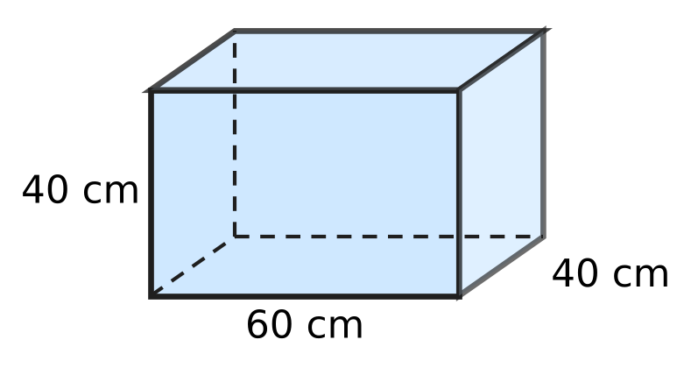
  (A) 80 | (B) 800 | (C) 8 | (D) 96

Q26. Anya buys a solid wooden toy rocket from a toy shop. It is a cylinder with a cone of the same radius on top, as in the picture. The radius is 3.5 cm and the cylinder is 10 cm tall. The whole rocket has a volume of 500.5 cm³. How tall is the cone, h? (Use π = $\frac{22}{7}$.) | 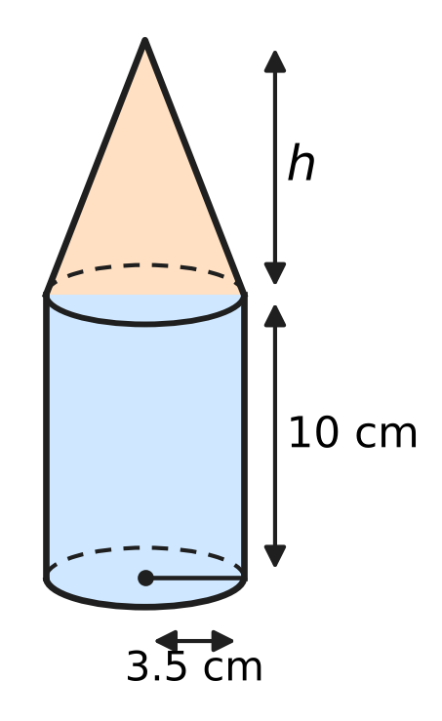
  (A) 19 cm | (B) 39 cm | (C) 3 cm | (D) 9 cm

Part 7 — Data Handling, Statistics & Probability (Syllabus Chapter 8)
Favourite subject | Maths | Science | English | Art
Number of students | 120 | 160 | 90 | 110

Q27. The table shows the favourite subjects of 480 students. The data is to be shown in a pie chart. Which subject will have a sector of 90°?
(A) Maths | (B) Science | (C) English | (D) Art

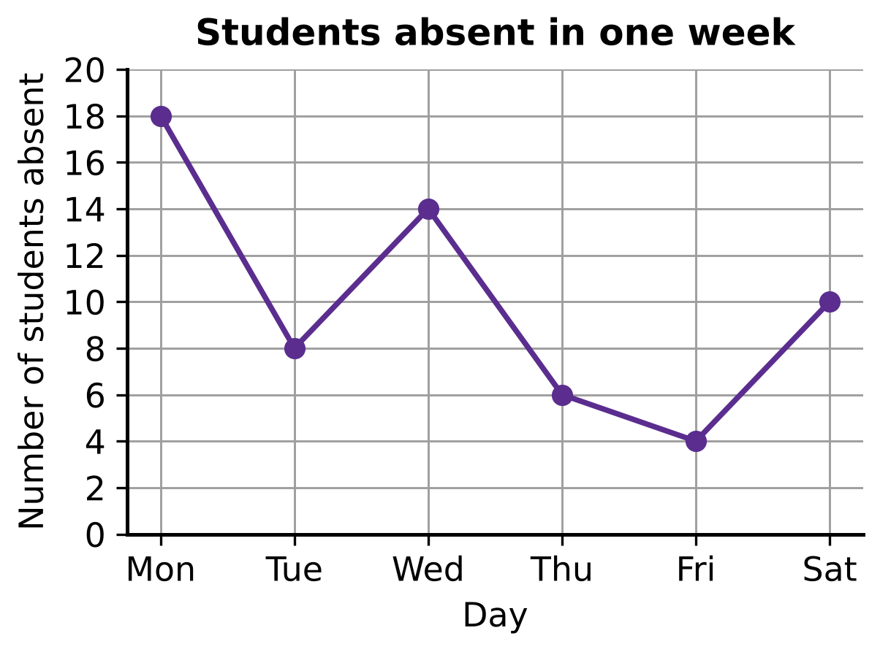
Q28. The line graph shows the number of students absent from a school on each day of one week, Monday to Saturday. What is the mean number of students absent per day?
(A) 11 | (B) 10 | (C) 9 | (D) 12

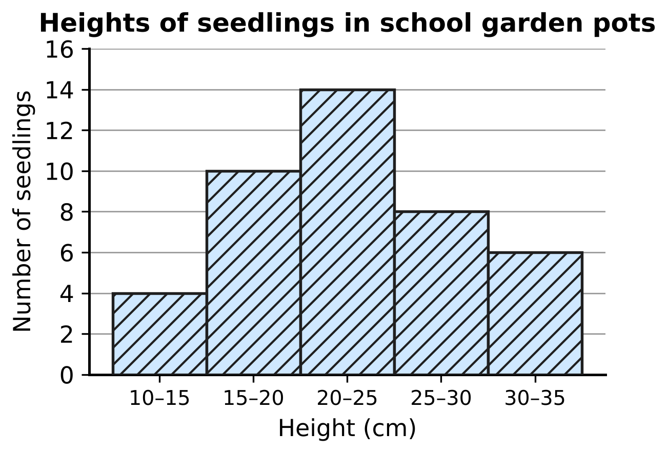
Q29. The histogram shows the heights of the seedlings in the school garden pots. The class 10–15 means 10 cm or more but less than 15 cm. A frequency polygon is drawn for this histogram. Which of these points (height in cm, number of seedlings) lies on the frequency polygon?
(A) (15, 10) | (B) (17.5, 14)
(C) (17.5, 10) | (D) (20, 10)

Part 8 — Applied Mathematics (Syllabus Chapter 9)
Item | A | B | C | D
Cost price (₹) | 80 | 150 | 50 | 200
Selling price (₹) | 100 | 180 | 65 | 236

Q30. The table shows the cost price and the selling price of four items. Which item gives the greatest profit percent?
(A) Item A | (B) Item B | (C) Item C | (D) Item D

Q31. Ashok borrows ₹36,000 at 8% per year simple interest. How much interest does he pay for each month?
(A) ₹240 | (B) ₹288 | (C) ₹3,000 | (D) ₹2,880

Q32. Rekha sells a table and makes a profit of ₹180. This profit is 15% of her cost price. What is her selling price?
(A) ₹1,020 | (B) ₹1,200 | (C) ₹2,700 | (D) ₹1,380

Q33. At the fruit market, Irfan buys 30 kg of oranges at ₹60 per kg and 20 kg of bigger oranges at ₹90 per kg. He mixes them and sells all 50 kg at ₹81 per kg. What is his profit percent?
(A) 35% | (B) 12.5% | (C) 9% | (D) 8%

Q34. Pavan sells a wall clock. His profit is one-fifth of the selling price. What is his profit percent on the cost price?
(A) 125% | (B) 80% | (C) 20% | (D) 25%

Part 9 — Mathematical Reasoning & Problem-Solving (Syllabus Chapter 10)
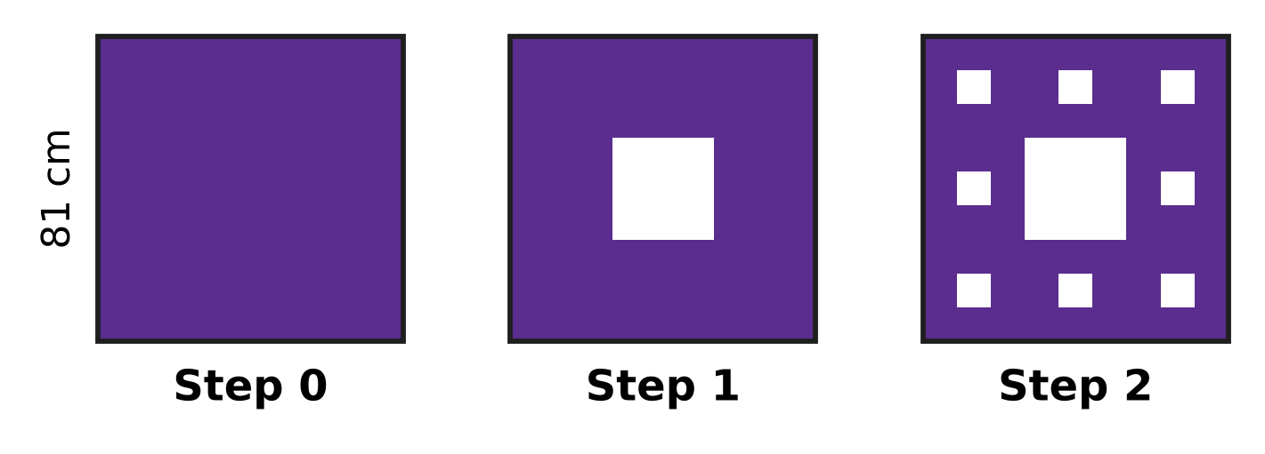
Q35. The picture shows the first steps of the Sierpiński carpet. It starts at Step 0 with a filled square of side 81 cm. At each step, every filled square is cut into 9 equal squares and the middle one is removed. What is the side of each smallest filled square at Step 3?
(A) 3 cm | (B) 1 cm | (C) 9 cm | (D) 27 cm

Q36. How many two-digit numbers have digits that differ by 7?
(A) 4 | (B) 6 | (C) 5 | (D) 3

Q37. Beads are threaded on a closed necklace in the colours red, blue, green, yellow, red, blue, green, yellow, … all the way round. The pattern never breaks, even where the last bead meets the first. Which of these could be the number of beads?
(A) 42 | (B) 50 | (C) 54 | (D) 48

Q38. In the multiplication ABCD × 4 = DCBA, each letter stands for a digit. Different letters stand for different digits, and neither A nor D is 0. What is the four-digit number ABCD?
(A) 1,089 | (B) 2,178 | (C) 2,198 | (D) 2,187

Q39. Tejas puts 10 pairs of shoes on a shoe rack with a top, a middle and a bottom shelf. Each shelf gets at least 1 pair and at most 5 pairs. In how many ways can he choose how many pairs go on each shelf?
(A) 18 | (B) 21 | (C) 36 | (D) 4

Q40. Which of these numbers is divisible by 36?
(A) 6,354 | (B) 5,736 | (C) 5,832 | (D) 5,382

SECTION II — Star Questions 5 questions × 4 marks each
Q41. Take a two-digit number. Add its two digits, multiply its two digits, and add these two results and 12. For some numbers the answer is the number itself. For example, 23 works, because (2 + 3) + (2 × 3) + 12 = 23. How many two-digit numbers work, 23 included? [4 marks]
(A) 6 | (B) 3 | (C) 9 | (D) 4

Q42. The picture shows 25 dots in a 5 × 5 square pattern, 1 cm apart. A square is drawn with all four corners on dots; its sides need not be along the rows of dots. How many different squares of area exactly 5 cm² can be drawn? [4 marks] | 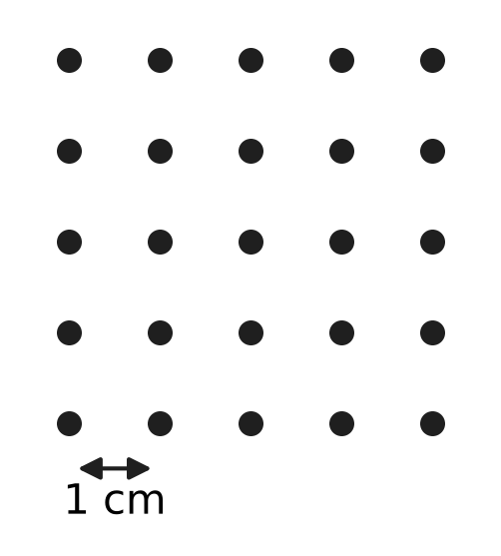
  (A) 16 | (B) 0 | (C) 8 | (D) 4

Q43. In the picture, △LMN has a right angle at M, LM = 12 cm and MN = 6 cm. A rectangle MDEF is drawn with D on LM, F on MN and E on LN. The area of the rectangle is 16 cm², and its sides MD and MF have different lengths. What is the perimeter of the rectangle? [4 marks] | 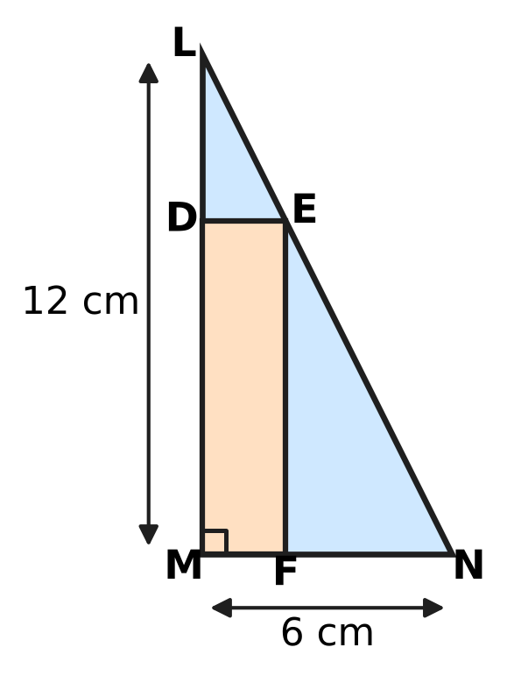
  (A) 20 cm | (B) 16 cm | (C) 24 cm | (D) 10 cm

Q44. The list price of a classroom desk is ₹3,000. Vijay, a dealer, buys desks from the maker at successive discounts of 25% and 20% on the list price. He sells them to a school at 10% off the list price, and gives 1 desk free with every 4 desks the school pays for. What is Vijay's profit percent? [4 marks]
(A) $16\frac{2}{3}$% | (B) 20% | (C) $33\frac{1}{3}$% | (D) 50%

Q45. Gaurav paints the curved surfaces of 25 cylindrical fence posts. Each post has radius 7 cm and height 1.6 m, as in the picture. The owner pays him ₹50 for every square metre painted. The paint costs Gaurav ₹704 in all. What is his profit percent on the cost of the paint? (Use π = $\frac{22}{7}$.) [4 marks] | 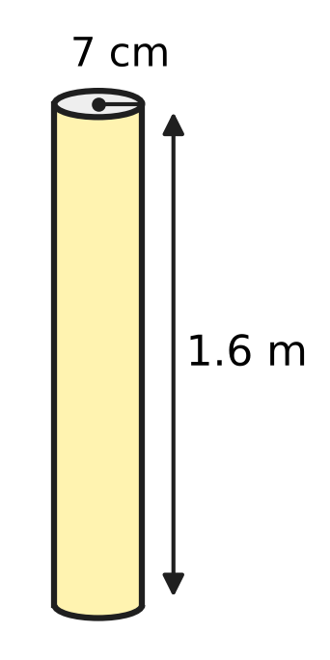
  (A) 80% | (B) 20% | (C) 25% | (D) 150%
Answer Sheet AMO Level 1 · Class 8 · Practice Paper 2
Name: | School: | Roll No.:
Shade or tick one circle for each question.
1. Ⓐ Ⓑ Ⓒ Ⓓ | 16. Ⓐ Ⓑ Ⓒ Ⓓ | 31. Ⓐ Ⓑ Ⓒ Ⓓ
2. Ⓐ Ⓑ Ⓒ Ⓓ | 17. Ⓐ Ⓑ Ⓒ Ⓓ | 32. Ⓐ Ⓑ Ⓒ Ⓓ
3. Ⓐ Ⓑ Ⓒ Ⓓ | 18. Ⓐ Ⓑ Ⓒ Ⓓ | 33. Ⓐ Ⓑ Ⓒ Ⓓ
4. Ⓐ Ⓑ Ⓒ Ⓓ | 19. Ⓐ Ⓑ Ⓒ Ⓓ | 34. Ⓐ Ⓑ Ⓒ Ⓓ
5. Ⓐ Ⓑ Ⓒ Ⓓ | 20. Ⓐ Ⓑ Ⓒ Ⓓ | 35. Ⓐ Ⓑ Ⓒ Ⓓ
6. Ⓐ Ⓑ Ⓒ Ⓓ | 21. Ⓐ Ⓑ Ⓒ Ⓓ | 36. Ⓐ Ⓑ Ⓒ Ⓓ
7. Ⓐ Ⓑ Ⓒ Ⓓ | 22. Ⓐ Ⓑ Ⓒ Ⓓ | 37. Ⓐ Ⓑ Ⓒ Ⓓ
8. Ⓐ Ⓑ Ⓒ Ⓓ | 23. Ⓐ Ⓑ Ⓒ Ⓓ | 38. Ⓐ Ⓑ Ⓒ Ⓓ
9. Ⓐ Ⓑ Ⓒ Ⓓ | 24. Ⓐ Ⓑ Ⓒ Ⓓ | 39. Ⓐ Ⓑ Ⓒ Ⓓ
10. Ⓐ Ⓑ Ⓒ Ⓓ | 25. Ⓐ Ⓑ Ⓒ Ⓓ | 40. Ⓐ Ⓑ Ⓒ Ⓓ
11. Ⓐ Ⓑ Ⓒ Ⓓ | 26. Ⓐ Ⓑ Ⓒ Ⓓ | 41. Ⓐ Ⓑ Ⓒ Ⓓ
12. Ⓐ Ⓑ Ⓒ Ⓓ | 27. Ⓐ Ⓑ Ⓒ Ⓓ | 42. Ⓐ Ⓑ Ⓒ Ⓓ
13. Ⓐ Ⓑ Ⓒ Ⓓ | 28. Ⓐ Ⓑ Ⓒ Ⓓ | 43. Ⓐ Ⓑ Ⓒ Ⓓ
14. Ⓐ Ⓑ Ⓒ Ⓓ | 29. Ⓐ Ⓑ Ⓒ Ⓓ | 44. Ⓐ Ⓑ Ⓒ Ⓓ
15. Ⓐ Ⓑ Ⓒ Ⓓ | 30. Ⓐ Ⓑ Ⓒ Ⓓ | 45. Ⓐ Ⓑ Ⓒ Ⓓ
Q41–Q45 are Section II Star Questions (4 marks each).
For the parent or teacher
Section I correct: ______ / 40 × 2 = ______ marks Section II correct: ______ / 5 × 4 = ______ marks
Correct: ______ / 45 Score: ______ / 100
Answer Key and Solutions AMO Level 1 · Class 8 · Practice Paper 2
Quick answers
1 D | 6 B | 11 A | 16 C | 21 C | 26 D | 31 A | 36 C | 41 D
2 D | 7 C | 12 D | 17 D | 22 B | 27 A | 32 D | 37 D | 42 C
3 C | 8 D | 13 C | 18 A | 23 C | 28 B | 33 B | 38 B | 43 A
4 B | 9 A | 14 A | 19 B | 24 B | 29 C | 34 D | 39 A | 44 B
5 A | 10 B | 15 B | 20 D | 25 A | 30 C | 35 A | 40 C | 45 C
Solutions
Q | Part · level | Answer | Why?
1 | Part 1 · Ch1 · Easy | (D) √3 × √12 | √3 × √12 = √36 = 6, which is rational. The others are 2√2, √0.9 and 5√5, which are irrational.
2 | Part 1 · Ch1 · Easy | (D) 1.7 m | Side = √2.89 = 1.7 m, because 1.7 × 1.7 = 2.89.
3 | Part 1 · Ch1 · Medium | (C) ∛0.729 | √0.64 = 0.8, ∛0.729 = 0.9, 0.9² = 0.81 and ∛0.343 = 0.7. The greatest is ∛0.729 = 0.9.
4 | Part 2 · Ch2 · Easy | (B) (−2)⁻³ | (−2)⁻³ = 1/(−2)³ = 1/(−8) = −1/8, which is negative. The others are 1/8, 1/9 and 1.
5 | Part 2 · Ch2 · Easy | (A) −6 | Since 8 = 2³, 8⁻² = (2³)⁻² = 2⁻⁶, because 3 × (−2) = −6. Check: 8⁻² = 1/64 = 2⁻⁶.
6 | Part 2 · Ch2 · Medium | (B) 30,000 | Number of drops = (1.5 × 10³) ÷ (5 × 10⁻²) = 0.3 × 10⁵ = 3 × 10⁴ = 30,000.
7 | Part 3 · Ch3 · Easy | (C) ₹2,000 at 7.5% a year for 4 years | SI = P × R × T ÷ 100: 2,000 × 7.5 × 4 ÷ 100 = ₹600. The others earn ₹50, ₹480 and ₹480.
8 | Part 3 · Ch3 · Easy | (D) 8% | Time = 9/12 = 3/4 year. R = 100 × 480 ÷ (8,000 × 3/4) = 48,000 ÷ 6,000 = 8% per year.
9 | Part 3 · Ch3 · Easy | (A) 60 | Students who run = 60% of 400 = 240. Medal winners = 25% of 240 = 60.
10 | Part 3 · Ch3 · Medium | (B) 35% and then 5% | Final prices: 2,000 × 0.7 × 0.9 = ₹1,260; 2,000 × 0.8 × 0.8 = ₹1,280; 2,000 × 0.75 × 0.85 = ₹1,275; 2,000 × 0.65 × 0.95 = ₹1,235. The lowest is with 35% and then 5%.
11 | Part 3 · Ch3 · Medium | (A) It increases by 8%. | New area = 1.2 × 0.9 = 1.08 times the old area, so the area increases by 8%.
12 | Part 4 · Ch4 · Easy | (D) $x^{2}+6x+36$ | (x + 6)² = x² + 12x + 36, not x² + 6x + 36. The others are (x + 5)², (2x − 3)² and (3x + 4)².
13 | Part 4 · Ch4 · Easy | (C) 5 | x² − y² = (x + y)(x − y), so 45 = 9 × (x − y) and x − y = 5.
14 | Part 4 · Ch4 · Easy | (A) 180 cm | Let the shorter piece be x cm. Then x + (2x + 40) = 250, so 3x = 210 and x = 70. The longer piece is 2 × 70 + 40 = 180 cm.
15 | Part 4 · Ch4 · Medium | (B) 12 | k = a + b where a × b = 24: the pairs 1 × 24, 2 × 12, 3 × 8, 4 × 6 give k = 25, 14, 11, 10. So k cannot be 12.
16 | Part 4 · Ch4 · Medium | (C) 80 | Let there be x passengers. Then $\frac{2}{5}$x + 12 = 44, so $\frac{2}{5}$x = 32 and x = 80.
17 | Part 5 · Ch5 · Easy | (D) 15 cm | BD = 8 cm. By the Baudhāyana–Pythagoras theorem, h² = 17² − 8² = 289 − 64 = 225, so h = 15 cm.
18 | Part 5 · Ch5 · Easy | (A) One of its angles is 90°. | Adjacent angles of a parallelogram add up to 180°, so if one angle is 90°, all four are 90° and ABCD is a rectangle.
19 | Part 5 · Ch5 · Easy | (B) a prism whose base has 10 sides | A prism with an n-sided base has n + n + n = 3n edges, so 3 × 10 = 30. The others have 24, 20 and 45 edges.
20 | Part 5 · Ch5 · Medium | (D) 18 cm | Perimeter of △ABC = 4 + 5 + 6 = 15 cm, so the scale factor is 45 ÷ 15 = 3. The longest side RP = 3 × 6 = 18 cm.
21 | Part 5 · Ch5 · Medium | (C) 13 m | The difference in heights is 9 − 4 = 5 m and the gap is 12 m. Distance = √(12² + 5²) = √169 = 13 m.
22 | Part 6 · Ch6 · Easy | (B) Cone L | Volume = ⅓πr²h, so compare r² × h: K 36 × 2 = 72, L 25 × 3 = 75, M 4 × 15 = 60, N 9 × 8 = 72. Cone L has the greatest volume.
23 | Part 6 · Ch6 · Easy | (C) 2 | Volume of B = π × (2r)² × (h ÷ 2) = π × 4r² × h ÷ 2 = 2πr²h, which is 2 times the volume of A (πr²h).
24 | Part 6 · Ch6 · Easy | (B) 23.1 cm³ | Radius = 4.2 ÷ 2 = 2.1 cm and height = 50 mm = 5 cm. Volume = ⅓ × 22/7 × 2.1 × 2.1 × 5 = 23.1 cm³.
25 | Part 6 · Ch6 · Medium | (A) 80 | Volume = 60 × 40 × 40 = 96,000 cm³ = 96 litres. Number of jugs = 96 ÷ 1.2 = 80.
26 | Part 6 · Ch6 · Medium | (D) 9 cm | Cylinder = 22/7 × 3.5 × 3.5 × 10 = 385 cm³, so the cone is 500.5 − 385 = 115.5 cm³. Then ⅓ × 38.5 × h = 115.5, so h = 9 cm.
27 | Part 7 · Ch8 · Easy | (A) Maths | An angle of 90° is one quarter of 360°, so the subject must have one quarter of 480 = 120 students: Maths (120/480 × 360° = 90°).
28 | Part 7 · Ch8 · Easy | (B) 10 | Total = 18 + 8 + 14 + 6 + 4 + 10 = 60 over 6 days. Mean = 60 ÷ 6 = 10.
29 | Part 7 · Ch8 · Medium | (C) (17.5, 10) | The frequency polygon joins the mid-points of the tops of the bars. The class 15–20 has mid-point 17.5 and frequency 10, so (17.5, 10) lies on it.
30 | Part 8 · Ch9 · Easy | (C) Item C | Profit percents: A 20/80 = 25%, B 30/150 = 20%, C 15/50 = 30%, D 36/200 = 18%. Item C gives the greatest profit percent.
31 | Part 8 · Ch9 · Easy | (A) ₹240 | Interest for a year = 36,000 × 8 ÷ 100 = ₹2,880. For each month = 2,880 ÷ 12 = ₹240.
32 | Part 8 · Ch9 · Easy | (D) ₹1,380 | 15% of cost = ₹180, so cost = 180 × 100 ÷ 15 = ₹1,200. Selling price = 1,200 + 180 = ₹1,380.
33 | Part 8 · Ch9 · Medium | (B) 12.5% | Cost = 30 × 60 + 20 × 90 = ₹3,600. Sale = 50 × 81 = ₹4,050. Profit = ₹450, and 450/3,600 × 100 = 12.5%.
34 | Part 8 · Ch9 · Medium | (D) 25% | If the selling price is 5 parts, the profit is 1 part and the cost is 4 parts. Profit percent = 1/4 × 100 = 25%.
35 | Part 9 · Ch10 · Easy | (A) 3 cm | Each step divides the side by 3: 81 → 27 → 9 → 3. At Step 3 each smallest square has side 3 cm.
36 | Part 9 · Ch10 · Easy | (C) 5 | The digit pairs are 1 and 8, 2 and 9, 0 and 7. They give 18, 81, 29, 92 and 70 (07 is not two-digit): 5 numbers.
37 | Part 9 · Ch10 · Easy | (D) 48 | The 4 colours repeat in full blocks all the way round, so the number of beads must be a multiple of 4. Only 48 = 4 × 12 is.
38 | Part 9 · Ch10 · Medium | (B) 2,178 | Four times the number still has 4 digits, so A is 1 or 2. A is the last digit of an even product, so A = 2. Then 4 × D ends in 2 and D ≥ 8, so D = 8. Checking gives 2,178 × 4 = 8,712.
39 | Part 9 · Ch10 · Medium | (A) 18 | Top shelf 1 → (4, 5), (5, 4): 2 ways; top 2 → 3 ways; top 3 → 4 ways; top 4 → 5 ways; top 5 → 4 ways. Total = 2 + 3 + 4 + 5 + 4 = 18.
40 | Part 9 · Ch10 · Medium | (C) 5,832 | Here 36 = 4 × 9, and 4 and 9 have no common factor. For 5,832, the last two digits 32 are divisible by 4, and 5 + 8 + 3 + 2 = 18 is divisible by 9. Each of the others fails one test.
41 | Section II · Ch4 + Ch10 · Hard | (D) 4 | Let the number be 10a + b. Then 10a + b = a + b + ab + 12 gives a(9 − b) = 12. As 9 − b ≤ 9, a × (9 − b) can be 2 × 6, 3 × 4, 4 × 3 or 6 × 2, giving 23, 35, 46 and 67 — 4 numbers.
42 | Section II · Ch5 + Ch10 · Hard | (C) 8 | Area 5 cm² needs a side √5 cm, which joins dots 1 across and 2 up (1² + 2² = 5). Such a square fills a 3 cm × 3 cm block; there are 4 such blocks, and each holds 2 tilted squares: 4 × 2 = 8.
43 | Section II · Ch4 + Ch5 · Hard | (A) 20 cm | Let MF = x and MD = y. △LDE ∼ △LMN gives (12 − y)/12 = x/6, so y = 12 − 2x. Then x(12 − 2x) = 16 gives x² − 6x + 8 = 0, that is (x − 2)(x − 4) = 0. x = 4 makes a square, so x = 2, y = 8 and the perimeter is 2 × (2 + 8) = 20 cm.
44 | Section II · Ch3 + Ch9 · Hard | (B) 20% | Cost of a desk = 3,000 × 0.75 × 0.8 = ₹1,800. Price to the school = ₹2,700. For 5 desks he spends 5 × 1,800 = ₹9,000 and receives 4 × 2,700 = ₹10,800. Profit = ₹1,800 = 20% of ₹9,000.
45 | Section II · Ch6 + Ch9 · Hard | (C) 25% | Curved surface of one post = 2 × 22/7 × 7 × 160 = 7,040 cm². For 25 posts: 176,000 cm² = 17.6 m². Payment = 17.6 × 50 = ₹880. Profit = 880 − 704 = ₹176, and 176/704 × 100 = 25%.

