UNLOCK IQ INSTITUTE
Realize Your True Potential
Aryabhatta Maths Olympiad (AMO)
Level 1 — Practice Paper 3
CLASS 8

Questions | 45 multiple-choice questions
Marks | 100
Time | 60 minutes
Section I | 40 questions × 2 marks = 80 marks
Section II | 5 Star Questions × 4 marks = 20 marks
Negative marking | No negative marking
Calculator | Not allowed
Chapters | Number System · Operations · Fractions, Decimals & Percentages · Algebra · Geometry · Mensuration · Data Handling · Applied Mathematics · Mathematical Reasoning

Instructions to candidates
• This paper has 45 multiple-choice questions. Each question has four answer choices, of which exactly one is correct.
• Section I (Q1–Q40) carries 2 marks per question. Section II (Q41–Q45) carries 4 marks per question.
• There is no negative marking. Unanswered questions score zero.
• Calculators are not permitted. Rough work may be done on a separate sheet.
• Mark your answers on the answer sheet at the end of the paper.
• All figures are not necessarily drawn to scale unless stated.

For parents and teachers
Print or view this paper in colour. Pictures are part of the questions.
Parts follow the AMO syllabus chapters. Chapter 7 is not part of the Class 8 syllabus, so the chapter numbers shown in the Part headings have gaps.
The answer sheet and the answer key are at the end. Remove only the answer key before the student begins.

Name: | School: | Roll No.:

SECTION I 40 questions × 2 marks each
Part 1 — Number System (Syllabus Chapter 1)
Q1. Complete the statement: √190 is closest to the whole number ___.
(A) 13 | (B) 14 | (C) 12 | (D) 15

Q2. Real numbers obey the distributive law. Fill the box so that the statement is true:
√2 × (3 + √2) = 3√2 + $□$
(A) 2√2 | (B) 4 | (C) 2 | (D) √2

Q3. The cube 5³ can be written as the sum of five consecutive odd numbers: 5³ = 21 + 23 + 25 + 27 + 29. In the same way, 6³ is the sum of six consecutive odd numbers. What is the first of these six numbers?
(A) 33 | (B) 35 | (C) 41 | (D) 31

Part 2 — Operations & Number Properties (Syllabus Chapter 2)
Q4. A sack holds about 1.5 × 10⁶ grains of wheat. Each grain has a mass of about 4 × 10⁻² g. Complete the statement: the wheat in the sack has a mass of about ___.
(A) 6 × 10⁴ g | (B) 6 × 10⁻¹² g
(C) 6 × 10³ g | (D) 6 × 10⁸ g

Q5. Find the missing number:
($□$)⁻³ = $\frac{125}{8}$
(A) $\frac{5}{2}$ | (B) $\frac{2}{5}$ | (C) $−\frac{2}{5}$ | (D) $\frac{8}{125}$

Q6. If 9ˣ × 27 = $\frac{1}{3}$, what is the value of x?
(A) 2 | (B) −1 | (C) −2 | (D) −4

Part 3 — Fractions, Decimals & Percentages (Syllabus Chapter 3)
Q7. Rhea takes ₹4,000 out of her piggy bank and puts it in a savings scheme that pays 7% per year simple interest. How much interest does she earn in the fourth year alone?
(A) ₹840 | (B) ₹4,280 | (C) ₹1,120 | (D) ₹280

Q8. Manav borrows ₹15,000 for 2 years at simple interest to repair his fishing boat in the harbour. The bank raises the rate from 8% to 9% per year before he signs. How much more interest will he pay over the 2 years?
(A) ₹300 | (B) ₹150 | (C) ₹2,400 | (D) ₹2,700

Q9. A clay pot is sold with a 10% discount followed by a further 25% discount on the reduced price. Which of these always gives the same final price?
(A) a 25% discount followed by a further 10% discount
(B) a single discount of 37.5%
(C) a 17.5% discount followed by a further 17.5% discount
(D) a single discount of 35%

Q10. The number of honey bees on a bee farm went up by the same percentage in each of two years, from 25,000 to 36,000. By what percentage did the number go up each year?
(A) 22% | (B) 44% | (C) 120% | (D) 20%

Q11. At a museum gift shop, Saira buys a book priced ₹1,000. She can use a ₹100-off coupon and a 10% member discount, one after the other, in either order. How much more does she pay if she uses the coupon first?
(A) ₹100 | (B) ₹0 | (C) ₹10 | (D) ₹90

Part 4 — Algebra (Syllabus Chapter 4)
Q12. The identity below has one term missing. Which term completes it?
(5p − $□$)² = 25p² − 30pq + 9q²
(A) 9q | (B) 3q | (C) 6q | (D) −3q

Q13. A square tile has an area of (9x² + 30x + 25) cm². What is its perimeter?
(A) (12x + 5) cm | (B) (6x + 10) cm
(C) (12x + 20) cm | (D) (3x + 5) cm

Q14. The school canteen sold some sandwiches on Monday. On Tuesday it sold 8 more than on Monday. On Wednesday it sold twice as many as on Monday. It sold 68 sandwiches in the three days. How many did it sell on Monday?
(A) 17 | (B) 23 | (C) 30 | (D) 15

Q15. Both x² − 25 and x² + 2x − 15 can be divided exactly by the same expression (x + k). Complete the statement: k = ___.
(A) −3 | (B) 5 | (C) 3 | (D) −5

Q16. On a classroom shelf, $\frac{1}{3}$ of the books are storybooks and $\frac{1}{4}$ are science books. The remaining 30 books are maths books. How many storybooks are there?
(A) 24 | (B) 18 | (C) 72 | (D) 20

Part 5 — Geometry (Syllabus Chapter 5)
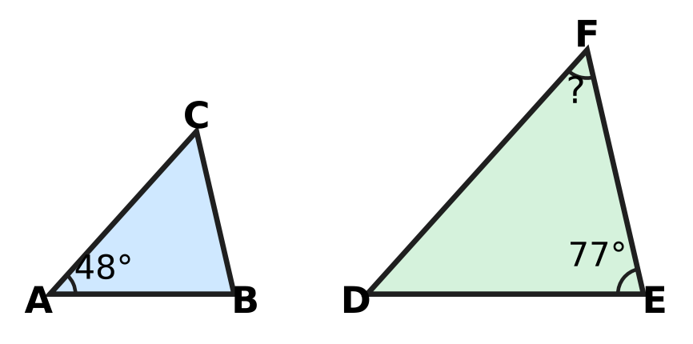
Q17. In the picture, △ABC ∼ △DEF, with the vertices in this order. ∠A = 48° and ∠E = 77°. Complete the statement: ∠F = ___.
(A) 77° | (B) 125° | (C) 48° | (D) 55°

Q18. PQRS is a rhombus, so all four of its sides are equal, as marked in the picture. The diagonal PR is drawn and ∠PQR = 116°. What is the angle x = ∠QPR? | 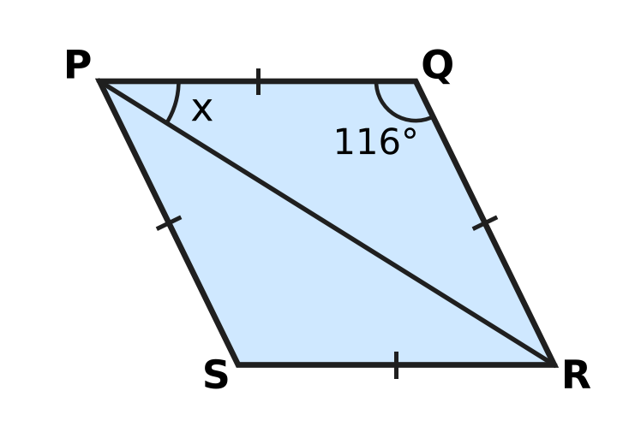
  (A) 64° | (B) 32° | (C) 36° | (D) 58°

Q19. In the picture, a square is drawn on each side of a right-angled triangle. The squares on the two shorter sides have areas 81 cm² and 144 cm². What is the area of the square marked "?" | 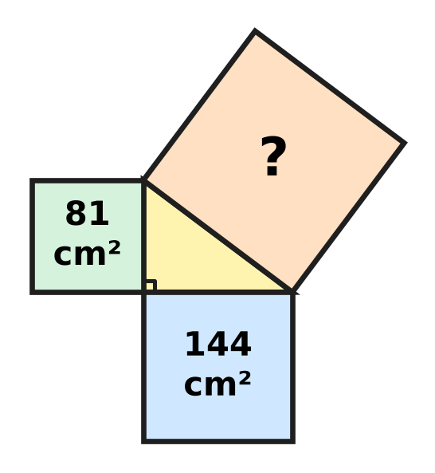
  (A) 225 cm² | (B) 21 cm² | (C) 63 cm² | (D) 15 cm²

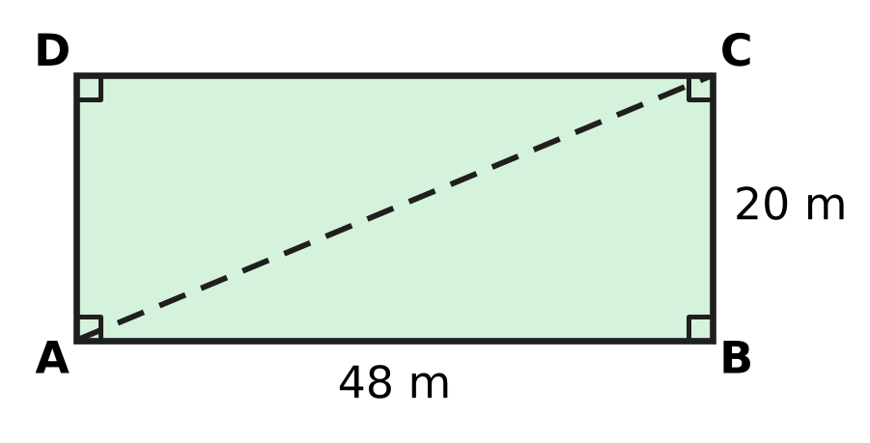
Q20. The picture shows a rectangular playground ABCD, 48 m long and 20 m wide. Nina usually walks from A to B and then to C. Today she walks straight from A to C along the dashed line. How much shorter is her walk today?
(A) 52 m | (B) 68 m | (C) 16 m | (D) 28 m

Q21. Sahil builds a solid from equal cubes on a 3 × 3 square base. The picture is the top view; each number tells how many cubes are stacked in that square. He then draws the view from the FRONT, as shown by the arrow. How many squares does the front view have? | 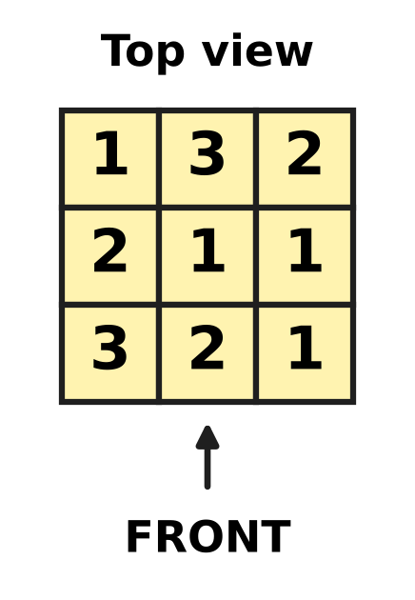
  (A) 6 | (B) 9 | (C) 8 | (D) 16

Part 6 — Mensuration (Syllabus Chapter 6)
Q22. A field of area 1.2 hectares is divided into equal square plots of side 20 m, with nothing left over. How many plots are there? (Use 1 hectare = 10,000 m².)
(A) 300 | (B) 30 | (C) 3 | (D) 600

Q23. A cylindrical pillar in the school hall is 3 m tall, as in the picture. Its curved surface has an area of 13.2 m². What is the diameter of the pillar? (Use π = $\frac{22}{7}$.) | 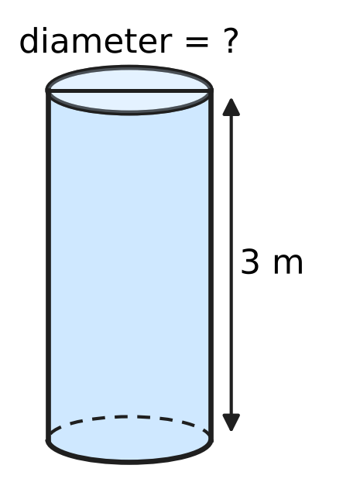
  (A) 0.7 m | (B) 2.8 m | (C) 4.4 m | (D) 1.4 m

Q24. A conical roof covers a round platform. The base of the roof has a diameter of 16 m and its slant height is 10 m, as in the picture. How high is the top of the roof above the base (h)? | 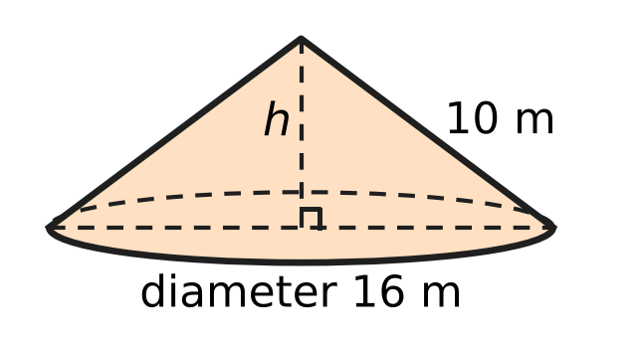
  (A) 6 m | (B) 18 m | (C) 2 m | (D) 8 m

Q25. A solid stand is made of two cylinders, one on top of the other, with their centres in a line. The bottom one has radius 14 cm and the top one has radius 7 cm; each is 10 cm tall, as in the picture. All of it is painted except the face it stands on. What area is painted? (Use π = $\frac{22}{7}$.) | 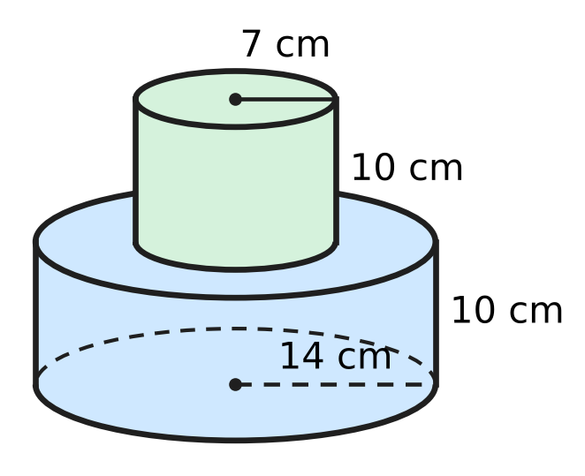
  (A) 2,552 cm² | (B) 1,936 cm²
  (C) 2,090 cm² | (D) 1,474 cm²

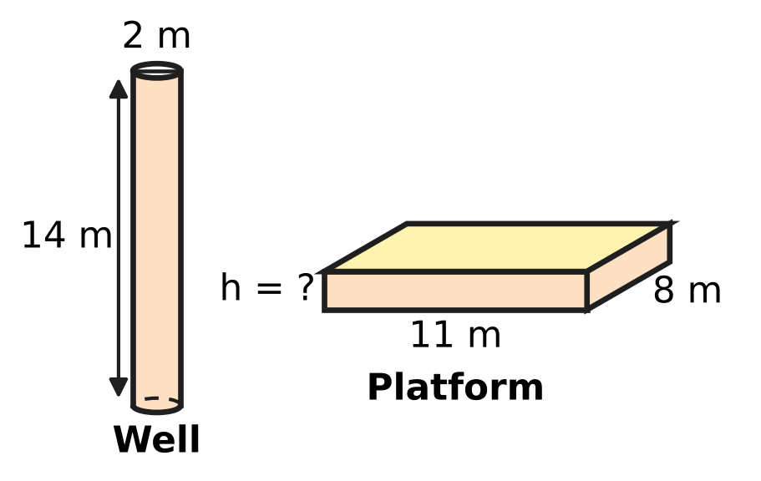
Q26. A well is dug in the shape of a cylinder, 2 m in diameter and 14 m deep. All the earth taken out is spread evenly to make a platform 11 m long and 8 m wide, as in the picture. Assume the earth keeps the same volume. How high is the platform, in centimetres? (Use π = $\frac{22}{7}$.)
(A) 200 cm | (B) 100 cm | (C) 5 cm | (D) 50 cm

Part 7 — Data Handling, Statistics & Probability (Syllabus Chapter 8)
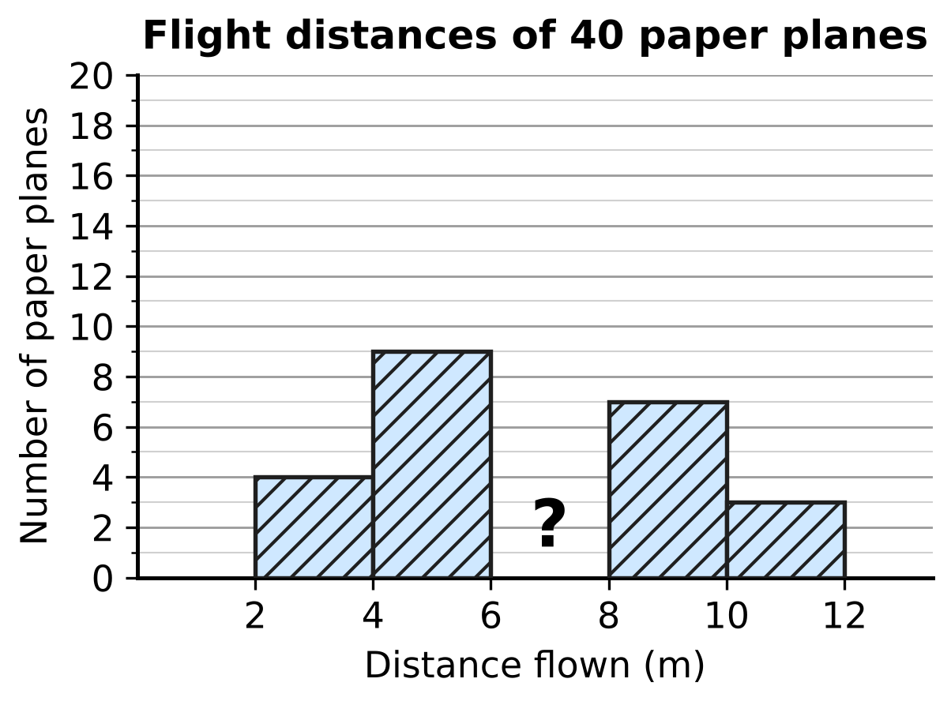
Q27. Students flew 40 paper planes and grouped the distances in classes 2–4, 4–6, 6–8, 8–10 and 10–12 m, where 6–8 means 6 m or more but less than 8 m. In the histogram, the bar for the class 6–8 m is missing (marked ?). Complete the statement: the bar for 6–8 m should show ___ planes.
(A) 17 | (B) 23 | (C) 9 | (D) 40

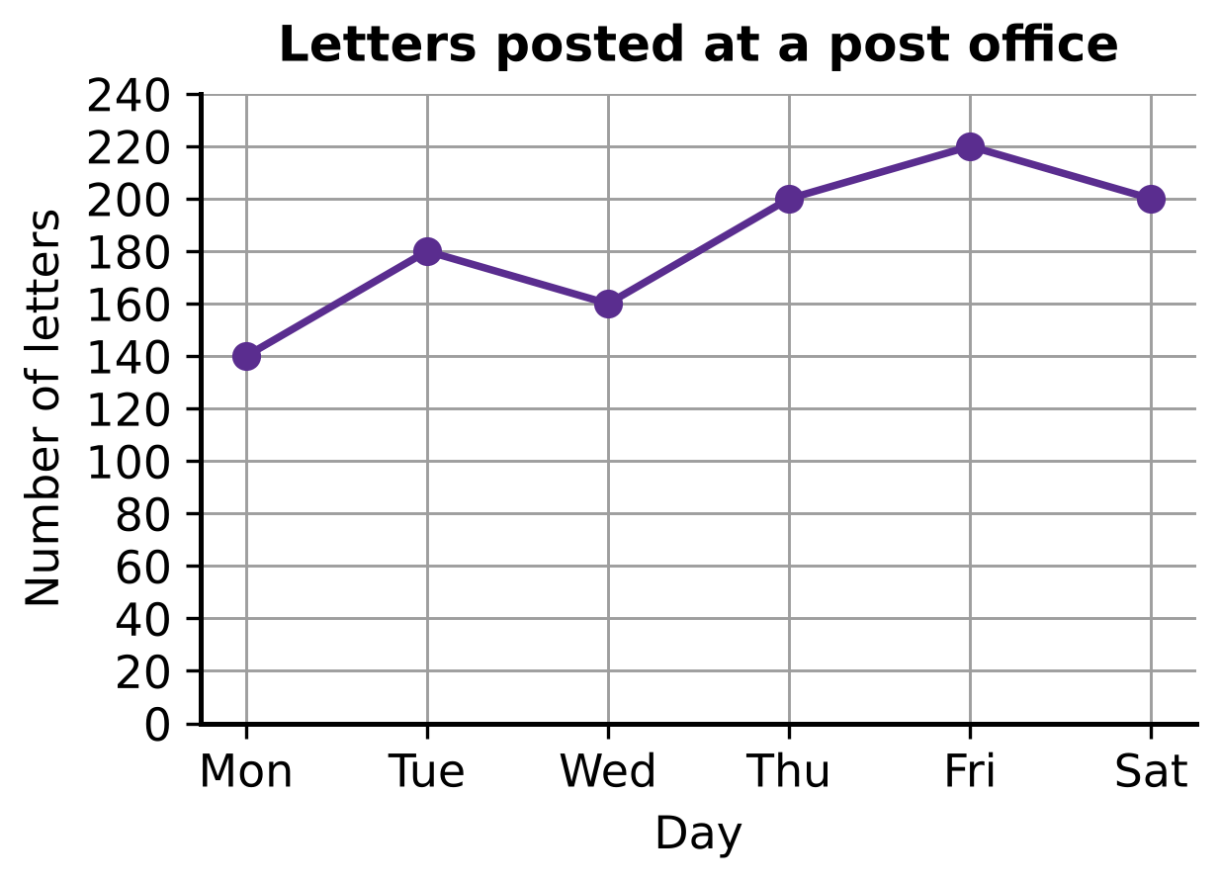
Q28. The line graph shows the number of letters posted at a post office on each day from Monday to Saturday. On how many of these days were more letters posted than on the day before?
(A) 5 | (B) 4 | (C) 3 | (D) 2

Q29. In a maths quiz, the 30 students of Section A have a mean score of 14. The 20 students of Section B have a mean score of 19. What is the mean score of all 50 students?
(A) 16.5 | (B) 17 | (C) 16 | (D) 15

Part 8 — Applied Mathematics (Syllabus Chapter 9)
Q30. Lalit pays ₹5,900 for a board game. This price includes a tax (GST) of 18% on the price before tax. What was the price before tax?
(A) ₹5,000 | (B) ₹4,838 | (C) ₹5,882 | (D) ₹6,962

Q31. In a clearance sale, Ken buys a bicycle marked ₹6,000 at a discount of 25%. Soon after, he sells it to a friend for ₹6,000. What is his profit percent?
(A) $133\frac{1}{3}$% | (B) $33\frac{1}{3}$% | (C) 75% | (D) 25%

Q32. Vinita borrows ₹12,000 for 1 year at 10% per year simple interest to buy a sewing machine. She repays the loan and the interest together in 12 equal monthly payments. How much is each payment?
(A) ₹1,000 | (B) ₹1,200 | (C) ₹100 | (D) ₹1,100

Q33. Kavin sells school bags at a profit of 20%. Then his supplier lowers the cost price of each bag by 20%, but Kavin keeps his selling price unchanged. What is his new profit percent?
(A) 20% | (B) 50% | (C) 40% | (D) 44%

Q34. Payal puts ₹2,000 in a savings scheme at the start of a year. At the start of the next year she puts in another ₹2,000. The scheme pays 10% per year simple interest. How much does she have at the end of the second year?
(A) ₹4,600 | (B) ₹4,400 | (C) ₹4,620 | (D) ₹4,800

Part 9 — Mathematical Reasoning & Problem-Solving (Syllabus Chapter 10)
Q35. Tushar marks five dots on a sheet, as in the picture. Three of the dots lie on one straight line (shown dashed), and no other three dots lie on a straight line. How many different triangles can he draw with all three corners at these dots? | 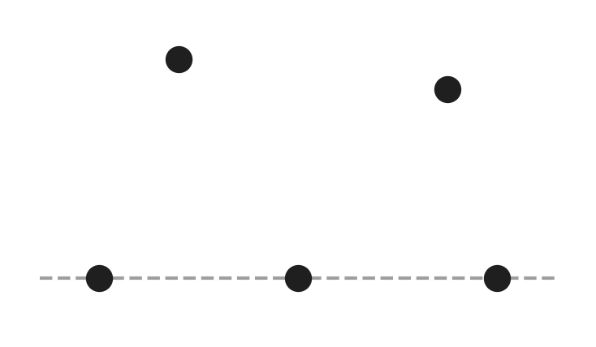
  (A) 10 | (B) 3 | (C) 9 | (D) 6

Q36. Fifteen whole numbers add up to an even number. At least how many of the fifteen numbers must be even?
(A) 8 | (B) 2 | (C) 0 | (D) 1

Q37. Ella claims: "Every number that is divisible by both 6 and 9 is also divisible by 54." Which of these numbers shows that her claim is false?
(A) 18 | (B) 24 | (C) 27 | (D) 108

Q38. In the sum AA + BB + CC = ABC, each letter stands for a digit. Different letters stand for different digits, and none of A, B, C is 0. (AA is a two-digit number with both digits A, and ABC is a three-digit number.) What is the number ABC?
(A) 189 | (B) 297 | (C) 891 | (D) 198

Q39. A spinner has three equal parts marked 1, 3 and 7. Harsh spins it three times and adds the three numbers he gets. How many different totals are possible?
(A) 21 | (B) 27 | (C) 9 | (D) 10

Q40. A number is made by writing the block 48 again and again: 48, 4848, 484848, … (the block is written k times). Complete the statement: the least value of k for which the number is divisible by 9 is ___.
(A) 6 | (B) 3 | (C) 9 | (D) 12

SECTION II — Star Questions 5 questions × 4 marks each
Q41. On a bus, a long-route ticket costs ₹12 and a short-route ticket costs ₹7. On one day, the conductor, Bhavna, collected exactly ₹200 from ticket sales. She sold at least one ticket of each kind, and she sold more long-route tickets than short-route tickets. How many tickets did she sell in all? [4 marks]
(A) 25 | (B) 16 | (C) 20 | (D) 12

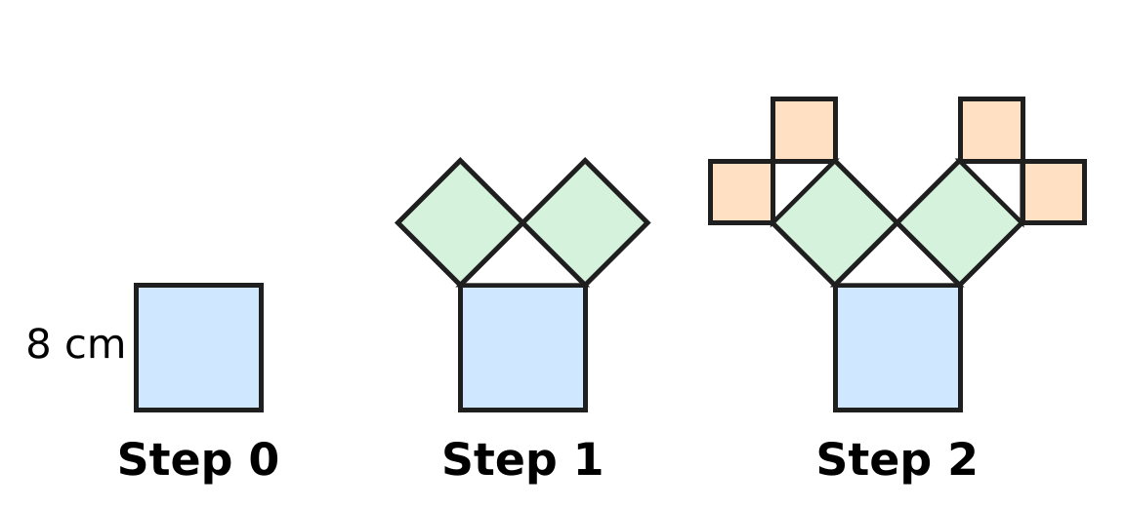
Q42. The picture shows a fractal "tree of squares". Step 0 is a square of side 8 cm. At each step, on the outer side of every square drawn in the step before (the top side in Step 0), a right-angled isosceles triangle is drawn with that side as its longest side. Then a new square is drawn outward on each of the two shorter sides of the triangle. What is the total area of all the squares drawn in Steps 0 to 4, counting each square separately? [4 marks]
(A) 124 cm² | (B) 320 cm² | (C) 64 cm² | (D) 256 cm²

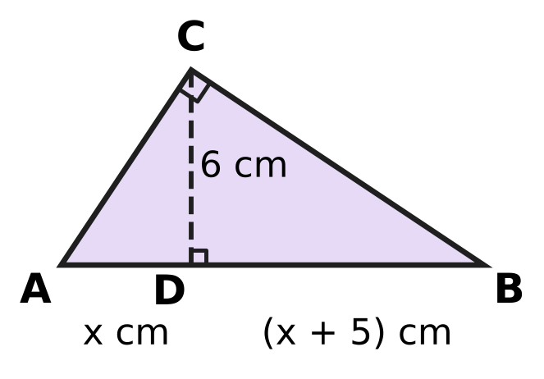
Q43. In the picture, triangle ABC has a right angle at C. CD is perpendicular to AB. AD = x cm, DB = (x + 5) cm and CD = 6 cm. What is the area of triangle ABC? [4 marks]
(A) 39 cm² | (B) 27 cm² | (C) 78 cm² | (D) 36 cm²

Q44. Vikram grows mangoes and sells them at ₹50 per kg, making a profit of 25% on his cost. Next season his cost per kg goes up by 20%, and he raises his selling price by 8%. What is his new profit percent? [4 marks]
(A) $11\frac{1}{9}$% | (B) 13% | (C) 20% | (D) 12.5%

Q45. A running track is the ring between two circles with the same centre O and radii 35 m and 42 m, as in the picture. A contractor resurfaces the whole track. He charges ₹500 per m² but gives a discount of 20% on the total bill. His own cost is ₹300 per m². What is his profit? (Use π = $\frac{22}{7}$.) [4 marks] | 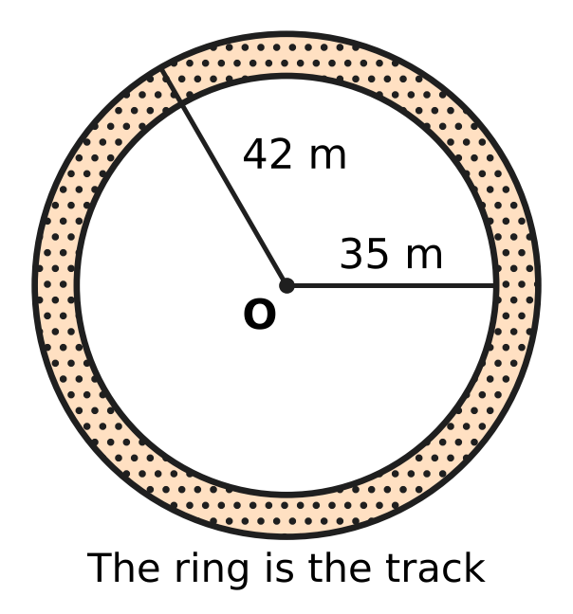
  (A) ₹15,400 | (B) ₹338,800 | (C) ₹169,400 | (D) ₹554,400
Answer Sheet AMO Level 1 · Class 8 · Practice Paper 3
Name: | School: | Roll No.:
Shade or tick one circle for each question.
1. Ⓐ Ⓑ Ⓒ Ⓓ | 16. Ⓐ Ⓑ Ⓒ Ⓓ | 31. Ⓐ Ⓑ Ⓒ Ⓓ
2. Ⓐ Ⓑ Ⓒ Ⓓ | 17. Ⓐ Ⓑ Ⓒ Ⓓ | 32. Ⓐ Ⓑ Ⓒ Ⓓ
3. Ⓐ Ⓑ Ⓒ Ⓓ | 18. Ⓐ Ⓑ Ⓒ Ⓓ | 33. Ⓐ Ⓑ Ⓒ Ⓓ
4. Ⓐ Ⓑ Ⓒ Ⓓ | 19. Ⓐ Ⓑ Ⓒ Ⓓ | 34. Ⓐ Ⓑ Ⓒ Ⓓ
5. Ⓐ Ⓑ Ⓒ Ⓓ | 20. Ⓐ Ⓑ Ⓒ Ⓓ | 35. Ⓐ Ⓑ Ⓒ Ⓓ
6. Ⓐ Ⓑ Ⓒ Ⓓ | 21. Ⓐ Ⓑ Ⓒ Ⓓ | 36. Ⓐ Ⓑ Ⓒ Ⓓ
7. Ⓐ Ⓑ Ⓒ Ⓓ | 22. Ⓐ Ⓑ Ⓒ Ⓓ | 37. Ⓐ Ⓑ Ⓒ Ⓓ
8. Ⓐ Ⓑ Ⓒ Ⓓ | 23. Ⓐ Ⓑ Ⓒ Ⓓ | 38. Ⓐ Ⓑ Ⓒ Ⓓ
9. Ⓐ Ⓑ Ⓒ Ⓓ | 24. Ⓐ Ⓑ Ⓒ Ⓓ | 39. Ⓐ Ⓑ Ⓒ Ⓓ
10. Ⓐ Ⓑ Ⓒ Ⓓ | 25. Ⓐ Ⓑ Ⓒ Ⓓ | 40. Ⓐ Ⓑ Ⓒ Ⓓ
11. Ⓐ Ⓑ Ⓒ Ⓓ | 26. Ⓐ Ⓑ Ⓒ Ⓓ | 41. Ⓐ Ⓑ Ⓒ Ⓓ
12. Ⓐ Ⓑ Ⓒ Ⓓ | 27. Ⓐ Ⓑ Ⓒ Ⓓ | 42. Ⓐ Ⓑ Ⓒ Ⓓ
13. Ⓐ Ⓑ Ⓒ Ⓓ | 28. Ⓐ Ⓑ Ⓒ Ⓓ | 43. Ⓐ Ⓑ Ⓒ Ⓓ
14. Ⓐ Ⓑ Ⓒ Ⓓ | 29. Ⓐ Ⓑ Ⓒ Ⓓ | 44. Ⓐ Ⓑ Ⓒ Ⓓ
15. Ⓐ Ⓑ Ⓒ Ⓓ | 30. Ⓐ Ⓑ Ⓒ Ⓓ | 45. Ⓐ Ⓑ Ⓒ Ⓓ
Q41–Q45 are Section II Star Questions (4 marks each).
For the parent or teacher
Section I correct: ______ / 40 × 2 = ______ marks Section II correct: ______ / 5 × 4 = ______ marks
Correct: ______ / 45 Score: ______ / 100
Answer Key and Solutions AMO Level 1 · Class 8 · Practice Paper 3
Quick answers
1 B | 6 C | 11 C | 16 A | 21 C | 26 D | 31 B | 36 D | 41 C
2 C | 7 D | 12 B | 17 D | 22 B | 27 A | 32 D | 37 A | 42 B
3 D | 8 A | 13 C | 18 B | 23 D | 28 C | 33 B | 38 D | 43 A
4 A | 9 A | 14 D | 19 A | 24 A | 29 C | 34 A | 39 C | 44 D
5 B | 10 D | 15 B | 20 C | 25 B | 30 A | 35 C | 40 B | 45 C
Solutions
Q | Part · level | Answer | Why?
1 | Part 1 · Ch1 · Easy | (B) 14 | Here 13² = 169 and 14² = 196. The number 190 is 21 more than 169 but only 6 less than 196, so √190 is closest to 14.
2 | Part 1 · Ch1 · Easy | (C) 2 | √2 × (3 + √2) = √2 × 3 + √2 × √2 = 3√2 + 2, because √2 × √2 = 2.
3 | Part 1 · Ch1 · Medium | (D) 31 | Here 6³ = 216. Six consecutive odd numbers with sum 216 have an average of 216 ÷ 6 = 36, so they are 31, 33, 35, 37, 39 and 41. The first is 31.
4 | Part 2 · Ch2 · Easy | (A) 6 × 10⁴ g | (1.5 × 4) × 10⁶ × 10⁻² = 6 × 10⁶⁻² = 6 × 10⁴ g, which is 60 kg.
5 | Part 2 · Ch2 · Easy | (B) $\frac{2}{5}$ | (2/5)⁻³ = (5/2)³ = 125/8. So the box holds 2/5.
6 | Part 2 · Ch2 · Medium | (C) −2 | Write everything with base 3: 3²ˣ × 3³ = 3⁻¹, so 2x + 3 = −1, 2x = −4 and x = −2.
7 | Part 3 · Ch3 · Easy | (D) ₹280 | Simple interest is the same every year: 4,000 × 7 ÷ 100 = ₹280. So the fourth year alone earns ₹280.
8 | Part 3 · Ch3 · Easy | (A) ₹300 | The rate goes up by 1% a year. Extra interest = 15,000 × 1 × 2 ÷ 100 = ₹300.
9 | Part 3 · Ch3 · Easy | (A) a 25% discount followed by a further 10% discount | Taking 10% off and then 25% off leaves 0.9 × 0.75 = 0.675 of the price. Taking 25% off and then 10% off leaves 0.75 × 0.9 = 0.675 too, because the order of multiplying does not matter. (A single 35% leaves 0.65, and 17.5% twice leaves about 0.68.)
10 | Part 3 · Ch3 · Medium | (D) 20% | Here 36,000 ÷ 25,000 = 1.44 = 1.2 × 1.2. Each year the number was multiplied by 1.2, which is an increase of 20%.
11 | Part 3 · Ch3 · Medium | (C) ₹10 | Coupon first: ₹1,000 − ₹100 = ₹900, then 10% off gives ₹810. Discount first: ₹900, then ₹100 off gives ₹800. She pays ₹10 more.
12 | Part 4 · Ch4 · Easy | (B) 3q | (a − b)² = a² − 2ab + b². Here a = 5p and 2 × 5p × b = 30pq, so b = 3q. Check: (3q)² = 9q².
13 | Part 4 · Ch4 · Easy | (C) (12x + 20) cm | Here 9x² + 30x + 25 = (3x + 5)², so each side is (3x + 5) cm. Perimeter = 4(3x + 5) = (12x + 20) cm.
14 | Part 4 · Ch4 · Easy | (D) 15 | Let Monday = x. Then x + (x + 8) + 2x = 68, so 4x = 60 and x = 15.
15 | Part 4 · Ch4 · Medium | (B) 5 | x² − 25 = (x − 5)(x + 5) and x² + 2x − 15 = (x + 5)(x − 3). The common factor is x + 5, so k = 5.
16 | Part 4 · Ch4 · Medium | (A) 24 | Let the total be n. The maths books are 1 − 1/3 − 1/4 = 5/12 of n, so 5n/12 = 30 and n = 72. Storybooks = 72 ÷ 3 = 24.
17 | Part 5 · Ch5 · Easy | (D) 55° | Similar triangles have equal corresponding angles: ∠D = ∠A = 48°. So ∠F = 180° − 48° − 77° = 55°.
18 | Part 5 · Ch5 · Easy | (B) 32° | PQ = QR, so △PQR is isosceles and ∠QPR = ∠QRP. So x = (180° − 116°) ÷ 2 = 32°.
19 | Part 5 · Ch5 · Easy | (A) 225 cm² | By the Baudhāyana–Pythagoras theorem, the square on the hypotenuse equals the sum of the other two squares: 81 + 144 = 225 cm².
20 | Part 5 · Ch5 · Medium | (C) 16 m | AC = √(48² + 20²) = √2,704 = 52 m. The usual walk is 48 + 20 = 68 m, so today is 68 − 52 = 16 m shorter.
21 | Part 5 · Ch5 · Medium | (C) 8 | From the front, each column shows its tallest stack: left column 3, middle column 3, right column 2. The front view has 3 + 3 + 2 = 8 squares.
22 | Part 6 · Ch6 · Easy | (B) 30 | The field is 1.2 hectares = 12,000 m². Each plot has area 20 × 20 = 400 m². Number of plots = 12,000 ÷ 400 = 30.
23 | Part 6 · Ch6 · Easy | (D) 1.4 m | Curved surface area = 2πrh = 13.2, so 2 × 22/7 × r × 3 = 13.2, giving r = 13.2 × 7 ÷ 132 = 0.7 m. The diameter is 2 × 0.7 = 1.4 m.
24 | Part 6 · Ch6 · Easy | (A) 6 m | Radius = 16 ÷ 2 = 8 m. Height, radius and slant height form a right triangle: h = √(10² − 8²) = √36 = 6 m.
25 | Part 6 · Ch6 · Medium | (B) 1,936 cm² | Curved surfaces: 2 × 22/7 × 14 × 10 = 880 and 2 × 22/7 × 7 × 10 = 440. The ring and the small top together make one circle of radius 14: 22/7 × 196 = 616. Total = 1,936 cm².
26 | Part 6 · Ch6 · Medium | (D) 50 cm | Volume of earth = 22/7 × 1 × 1 × 14 = 44 m³. Height = 44 ÷ (11 × 8) = 0.5 m = 50 cm.
27 | Part 7 · Ch8 · Easy | (A) 17 | The four bars shown add up to 4 + 9 + 7 + 3 = 23. The missing bar is 40 − 23 = 17.
28 | Part 7 · Ch8 · Easy | (C) 3 | The line goes up from Monday to Tuesday, from Wednesday to Thursday and from Thursday to Friday. That is 3 days.
29 | Part 7 · Ch8 · Medium | (C) 16 | Total of scores = 30 × 14 + 20 × 19 = 420 + 380 = 800. Mean = 800 ÷ 50 = 16.
30 | Part 8 · Ch9 · Easy | (A) ₹5,000 | Price before tax × 1.18 = 5,900, so the price before tax = 5,900 ÷ 1.18 = ₹5,000. Check: 18% of 5,000 = 900 and 5,000 + 900 = 5,900.
31 | Part 8 · Ch9 · Easy | (B) $33\frac{1}{3}$% | Cost price = 75% of ₹6,000 = ₹4,500. Profit = ₹1,500 on ₹4,500 = 1/3 = 33⅓%.
32 | Part 8 · Ch9 · Easy | (D) ₹1,100 | Interest = 12,000 × 10 ÷ 100 = ₹1,200. Total to repay = ₹13,200. Each payment = 13,200 ÷ 12 = ₹1,100.
33 | Part 8 · Ch9 · Medium | (B) 50% | Let the old cost be ₹100. The selling price is ₹120. The new cost is ₹80, so the profit is ₹40 on ₹80, which is 50%.
34 | Part 8 · Ch9 · Medium | (A) ₹4,600 | The first ₹2,000 earns interest for 2 years: ₹400. The second earns for 1 year: ₹200. Total = 4,000 + 400 + 200 = ₹4,600.
35 | Part 9 · Ch10 · Easy | (C) 9 | Five dots give 10 groups of three dots. The three dots on the line do not make a triangle, so there are 10 − 1 = 9 triangles.
36 | Part 9 · Ch10 · Easy | (D) 1 | The sum of an odd count of odd numbers is odd. So the fifteen numbers cannot all be odd; at most 14 can be odd. At least 1 must be even, and 14 odd numbers with one even number do give an even sum.
37 | Part 9 · Ch10 · Easy | (A) 18 | The number 18 is divisible by 6 and by 9, but not by 54. One such number is enough to show the claim is false.
38 | Part 9 · Ch10 · Medium | (D) 198 | AA + BB + CC = 11(A + B + C), which is at most 11 × 24 = 264, so the first digit A must be 1 or 2. Trying both cases, only 11 + 99 + 88 = 198 works: A = 1, B = 9, C = 8.
39 | Part 9 · Ch10 · Medium | (C) 9 | The groups are 1+1+1 = 3, 1+1+3 = 5, 1+3+3 = 7, 1+1+7 = 9, 3+3+3 = 9, 1+3+7 = 11, 3+3+7 = 13, 1+7+7 = 15, 3+7+7 = 17, 7+7+7 = 21. Since 9 appears twice, there are 9 different totals.
40 | Part 9 · Ch10 · Medium | (B) 3 | Each block adds 4 + 8 = 12 to the digit sum, so the digit sum is 12k. This is a multiple of 9 first when k = 3 (digit sum 36). So 484848 is the first one divisible by 9.
41 | Section II · Ch4 + Ch10 · Hard | (C) 20 | Let a long-route and c short-route tickets be sold: 12a + 7c = 200, so 200 − 12a must be a multiple of 7. Trying a = 1 to 16, this happens only for a = 5 (c = 20) and a = 12 (c = 8). Since a must be more than c, a = 12 and c = 8, so she sold 20 tickets.
42 | Section II · Ch5 + Ch10 · Hard | (B) 320 cm² | By the Baudhāyana–Pythagoras theorem, the two squares on the shorter sides together have the same area as the square on the longest side. So each step adds squares with total area 64 cm². Steps 0 to 4 give 5 × 64 = 320 cm².
43 | Section II · Ch4 + Ch5 · Hard | (A) 39 cm² | Triangles ACD and CBD are similar (each has a right angle, and ∠A = ∠BCD), so AD/CD = CD/DB, giving x(x + 5) = 36. Since 4 × 9 = 36, x = 4 and AB = 4 + 9 = 13 cm. Area = ½ × 13 × 6 = 39 cm².
44 | Section II · Ch3 + Ch9 · Hard | (D) 12.5% | Old cost = 50 ÷ 1.25 = ₹40 per kg. New cost = 40 × 1.2 = ₹48. New price = 50 × 1.08 = ₹54. Profit = ₹6 on ₹48 = 12.5%.
45 | Section II · Ch6 + Ch9 · Hard | (C) ₹169,400 | Area of ring = 22/7 × (42² − 35²) = 22/7 × 539 = 1,694 m². After the discount he charges ₹400 per m², so his profit is ₹100 per m². Profit = 1,694 × 100 = ₹169,400.

