UNLOCK IQ INSTITUTE
Realize Your True Potential
Aryabhatta Maths Olympiad (AMO)
Level 1 — Practice Paper 4
CLASS 8

Questions | 45 multiple-choice questions
Marks | 100
Time | 60 minutes
Section I | 40 questions × 2 marks = 80 marks
Section II | 5 Star Questions × 4 marks = 20 marks
Negative marking | No negative marking
Calculator | Not allowed
Chapters | Number System · Operations · Fractions, Decimals & Percentages · Algebra · Geometry · Mensuration · Data Handling · Applied Mathematics · Mathematical Reasoning

Instructions to candidates
• This paper has 45 multiple-choice questions. Each question has four answer choices, of which exactly one is correct.
• Section I (Q1–Q40) carries 2 marks per question. Section II (Q41–Q45) carries 4 marks per question.
• There is no negative marking. Unanswered questions score zero.
• Calculators are not permitted. Rough work may be done on a separate sheet.
• Mark your answers on the answer sheet at the end of the paper.
• All figures are not necessarily drawn to scale unless stated.

For parents and teachers
Print or view this paper in colour. Pictures are part of the questions.
Parts follow the AMO syllabus chapters. Chapter 7 is not part of the Class 8 syllabus, so the chapter numbers shown in the Part headings have gaps.
The answer sheet and the answer key are at the end. Remove only the answer key before the student begins.

Name: | School: | Roll No.:

SECTION I 40 questions × 2 marks each
Part 1 — Number System (Syllabus Chapter 1)
Q1. At the school assembly, 640 students stand in a square formation, with as many rows as there are students in each row. The square is made as large as possible, and the students who do not fit stand at the side. How many students stand at the side?
(A) 25 | (B) 64 | (C) 36 | (D) 15

Q2. Which of these is ALWAYS an irrational number?
(A) the product of two different irrational numbers
(B) the quotient of two different irrational numbers
(C) the product of a non-zero rational number and an irrational number
(D) the sum of two different irrational numbers

Q3. Three solid metal cubes have edges 1 cm, 6 cm and 8 cm. They are melted and made into one solid cube, with no metal lost. What is the edge of the new cube?
(A) 9 cm | (B) 5 cm | (C) 15 cm | (D) 10 cm

Part 2 — Operations & Number Properties (Syllabus Chapter 2)
Q4. Simplify ${(a^{−2}b^{3})}^{2}×a^{5}$, where a is not 0.
(A) $a^{3}b^{6}$ | (B) $ab^{6}$
(C) $ab^{5}$ | (D) $a^{9}b^{6}$

Q5. What is the value of (−1)⁻¹ + (−1)⁻² + (−1)⁻³ + (−1)⁻⁴?
(A) 0 | (B) 4 | (C) −4 | (D) −2

Q6. A sheet of paper is 1 × 10⁻⁴ m thick. A strand of spider silk is 2.5 × 10⁻⁶ m thick. How many times as thick as the silk is the paper?
(A) 0.025 | (B) 4 | (C) 40 | (D) 400

Part 3 — Fractions, Decimals & Percentages (Syllabus Chapter 3)
Q7. In a bookshop sale, every book is sold at 15% off its marked price. Members of the book club get a further 10% off the sale price. Kiara is a member. How much does she pay for a book marked ₹800?
(A) ₹600 | (B) ₹612 | (C) ₹188 | (D) ₹680

Q8. Komal deposits a sum of money in a bank at 5% per year simple interest. After 3 years the bank pays her ₹4,600 in all, that is, the sum together with the interest. What sum did she deposit?
(A) ₹690 | (B) ₹4,370 | (C) ₹3,910 | (D) ₹4,000

Q9. The fare for a river ferry went up from ₹30 to ₹40. A year later it came back down from ₹40 to ₹30. By what percentage did the fare go down?
(A) 10% | (B) 25% | (C) $33\frac{1}{3}$% | (D) 75%

Q10. Two equal sums of money are lent at simple interest, one at 6% per year and the other at 9% per year. After 4 years, the second sum has earned ₹720 more interest than the first. How much is each sum?
(A) ₹2,000 | (B) ₹24,000 | (C) ₹3,000 | (D) ₹6,000

Q11. A zoo cut its ticket price by 10%. Because of this, more people came, and the money collected from tickets went up by 17%. By what percent did the number of visitors go up?
(A) 30% | (B) 5.3% | (C) 27% | (D) 7%

Part 4 — Algebra (Syllabus Chapter 4)
Q12. Which number must be added to 4y² − 28y to make it a perfect square of the form (a − b)²?
(A) 7 | (B) 784 | (C) 49 | (D) 196

Q13. The area of the rectangle in the picture is (x² + 9x + 20) cm², and one of its sides is (x + 4) cm. How long is its other side? | 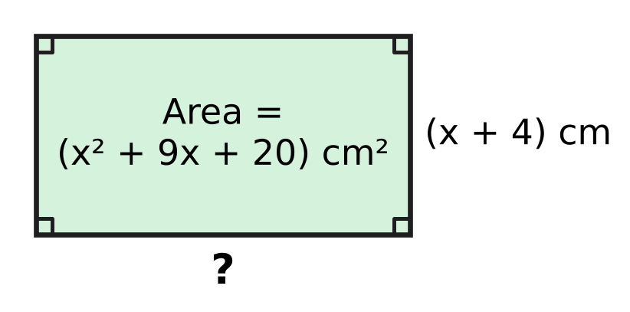
  (A) (x + 16) cm | (B) (x + 9) cm
  (C) (x + 20) cm | (D) (x + 5) cm

Q14. A badminton court is a rectangle. Its length is 7.3 m more than its width, and its perimeter is 39 m. How long is the court?
(A) 9.75 m | (B) 17.05 m | (C) 13.4 m | (D) 6.1 m

Q15. Manu packs all the eggs from his farm into trays that hold 12 eggs each, and every tray is full. If he used trays that hold 15 eggs each, he would need 5 fewer trays, and every tray would still be full. How many eggs are there?
(A) 25 | (B) 300 | (C) 375 | (D) 60

Q16. Ojas works out n² + 2n − 3 for every whole number n from 2 to 30. How many of his 29 answers are prime numbers?
(A) 1 | (B) 0 | (C) 15 | (D) 2

Part 5 — Geometry (Syllabus Chapter 5)
Q17. On a mountain hike, Trisha walks straight up a slope from A to B, as in the picture. B is 90 m higher than A, and 120 m away from A when measured level (along AC). How long is the slope AB? | 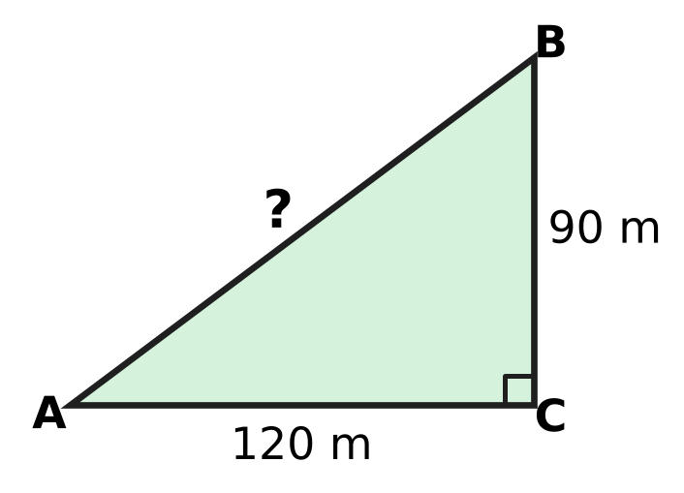
  (A) 105 m | (B) 210 m | (C) 150 m | (D) 30 m

Q18. Which of these is true for every rhombus but is NOT true for every rectangle?
(A) Its diagonals are perpendicular to each other.
(B) Its opposite sides are parallel.
(C) Its diagonals bisect each other.
(D) Its diagonals are equal in length.

Q19. The net in the picture is folded to make a cube. Which number is on the face opposite the face marked 1? | 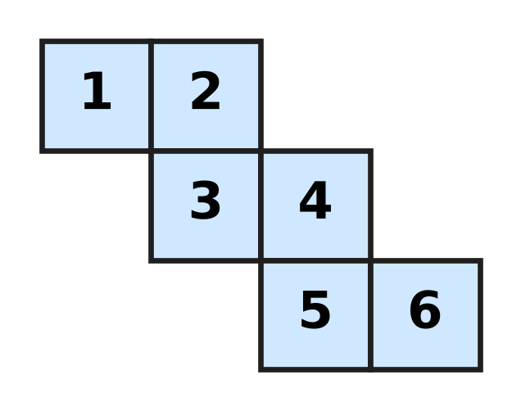
  (A) 3 | (B) 4 | (C) 2 | (D) 6

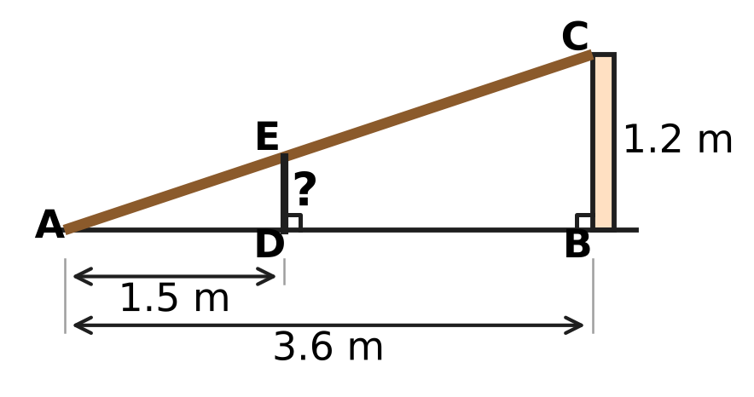
Q20. Vihaan leans a straight wooden plank AC from the ground at A to the top of a wall BC, which is 1.2 m high. A is 3.6 m from the bottom B of the wall. A vertical post DE stands 1.5 m from A and just touches the plank at E, as in the picture. How tall is the post?
(A) 4.5 m | (B) 0.6 m | (C) 0.7 m | (D) 0.5 m

Q21. KLMN is a rhombus with sides of 39 cm, as in the picture. Its diagonal KM is 72 cm long. How long is the other diagonal LN? | 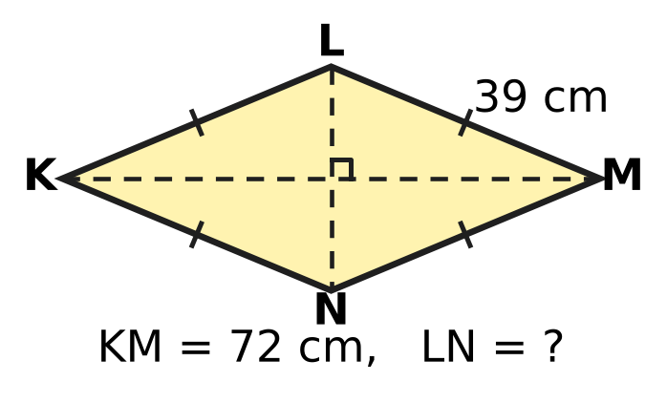
  (A) 33 cm | (B) 30 cm | (C) 15 cm | (D) 78 cm

Part 6 — Mensuration (Syllabus Chapter 6)
Q22. A tent is in the shape of a cone with base radius 3 m and height 3.5 m, as in the picture. How much air is inside the tent? (Use π = $\frac{22}{7}$.) | 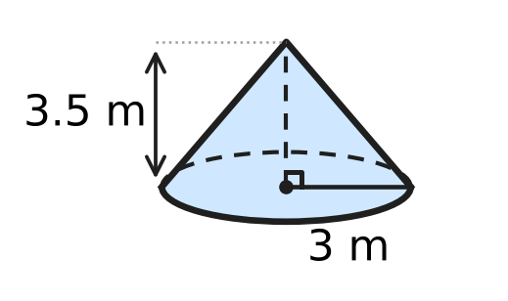
  (A) 33 m³ | (B) 99 m³ | (C) 132 m³ | (D) 11 m³

Q23. A lamp cover is the curved surface of a cone, as in the picture. Its base radius is 14 cm, and it uses 1,100 cm² of material. What is its slant height l? (Use π = $\frac{22}{7}$.) | 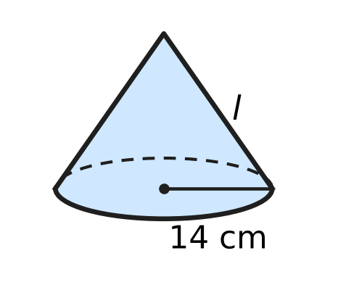
  (A) 5 cm | (B) 12.5 cm | (C) 50 cm | (D) 25 cm

Q24. A closed cylindrical can, shown in the picture, has an inside radius of 7 cm. It holds exactly 1.54 litres when full. What is its height h? (Use π = $\frac{22}{7}$; 1 litre = 1,000 cm³.) | 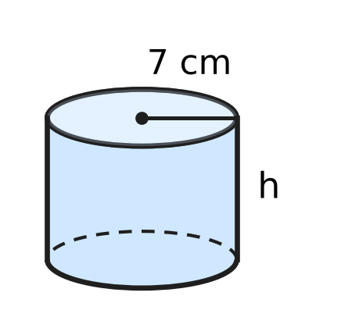
  (A) 2.5 cm | (B) 1 cm | (C) 10 cm | (D) 70 cm

Q25. An umbrella stand is a solid wooden cuboid 20 cm × 20 cm × 30 cm. A cylindrical hole of radius 7 cm and depth 25 cm is cut straight down into its top, as in the picture. What volume of wood is left? (Use π = $\frac{22}{7}$.) | 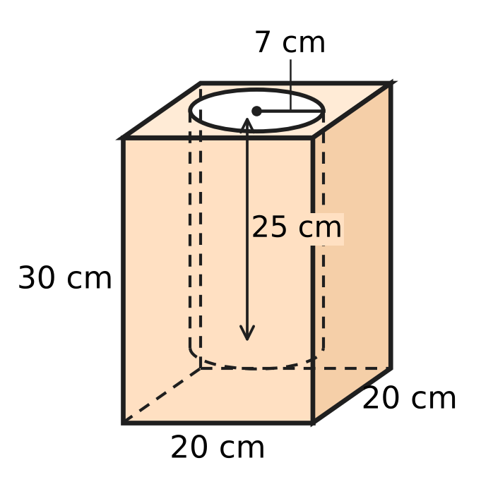
  (A) 15,850 cm³ | (B) 3,850 cm³
  (C) 10,900 cm³ | (D) 8,150 cm³

Q26. A cylindrical glass jar has an inside radius of 7 cm and is partly filled with water. Zara drops 22 identical marbles into it. All of them sink, and the water level rises by 1 cm, as in the picture. What is the volume of one marble? (Use π = $\frac{22}{7}$.) | 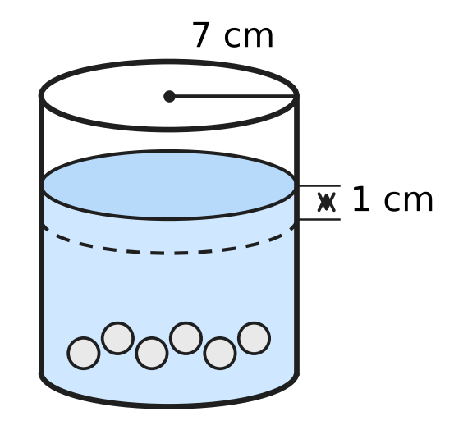
  (A) 7 cm³ | (B) 28 cm³ | (C) 154 cm³ | (D) 2 cm³

Part 7 — Data Handling, Statistics & Probability (Syllabus Chapter 8)
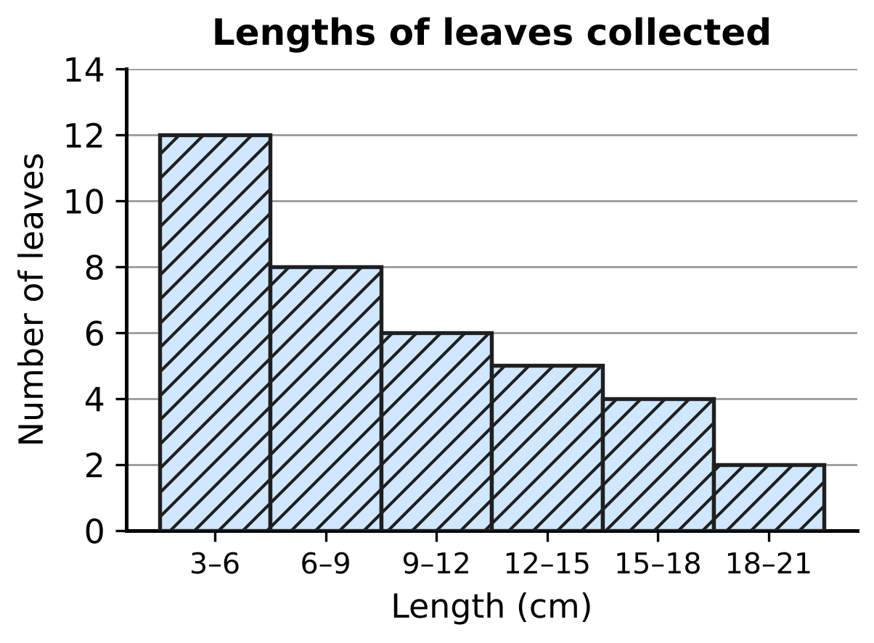
Q27. For a science project, a class measured 37 leaves. The histogram in the picture shows their lengths; the class 6–9 means 6 cm or more but less than 9 cm. The leaves are put in order from shortest to longest. In which class is the length of the middle (19th) leaf?
(A) 3–6 cm | (B) 6–9 cm | (C) 9–12 cm | (D) 12–15 cm

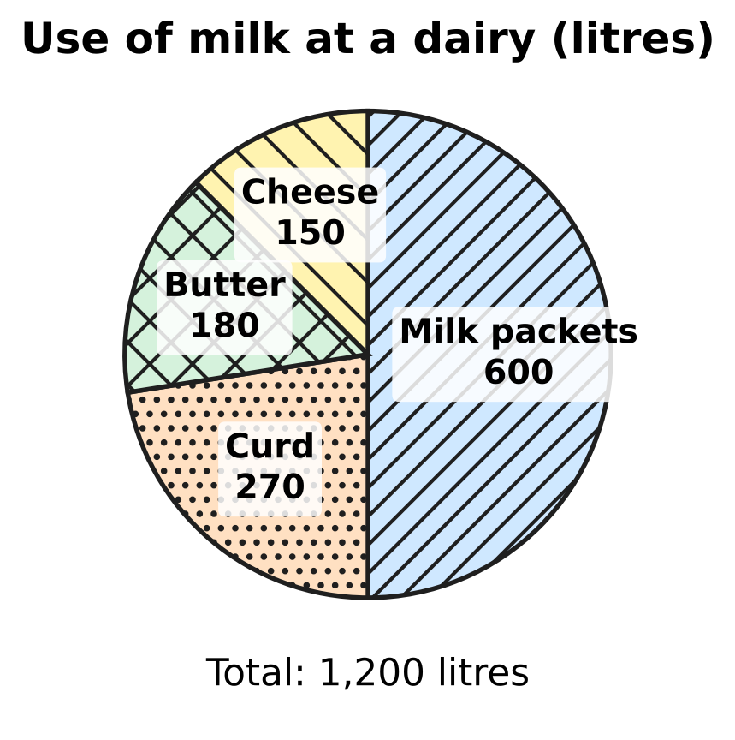
Q28. The pie chart shows how a milk dairy used the 1,200 litres of milk it collected one morning. What is the angle of the sector for butter?
(A) 45° | (B) 60° | (C) 54° | (D) 15°

Q29. The marks of six students, written in increasing order, are 5, 8, x, 14, 19 and 22. The median of the six marks is 12. What is the mean of the six marks?
(A) 12 | (B) 15.6 | (C) 13 | (D) 10

Part 8 — Applied Mathematics (Syllabus Chapter 9)
Q30. Imran borrows ₹40,000 at 6% per year simple interest. On the same day he lends all of it to a friend at 9% per year simple interest. How much does he gain in 3 years?
(A) ₹7,200 | (B) ₹3,600 | (C) ₹1,200 | (D) ₹10,800

Q31. Rupa bakes cakes at home from her own recipes. She buys an oven for ₹4,000. The ingredients for each cake cost ₹180, and she sells each cake for ₹280. How many cakes must she sell so that her profit pays back the cost of the oven?
(A) 23 | (B) 15 | (C) 9 | (D) 40

Q32. Chetan sells his old art-class easel at a loss of 20% on what he paid for it. If he had sold it for twice that price, what would his profit percent have been?
(A) 60% | (B) 20% | (C) 160% | (D) 40%

Q33. A plant nursery buys saplings, all at the same cost price. It sells $\frac{3}{4}$ of them at a profit of 20%. At what loss percent must it sell the rest so that its profit on all the saplings is 12%?
(A) 12% | (B) 3% | (C) 32% | (D) 8%

Q34. A shopkeeper wants to give a discount of 25% on the marked price and still make a profit of 20% on the cost price. By what percent above the cost price must he mark his goods?
(A) 45% | (B) $33\frac{1}{3}$% | (C) 60% | (D) 50%

Part 9 — Mathematical Reasoning & Problem-Solving (Syllabus Chapter 10)
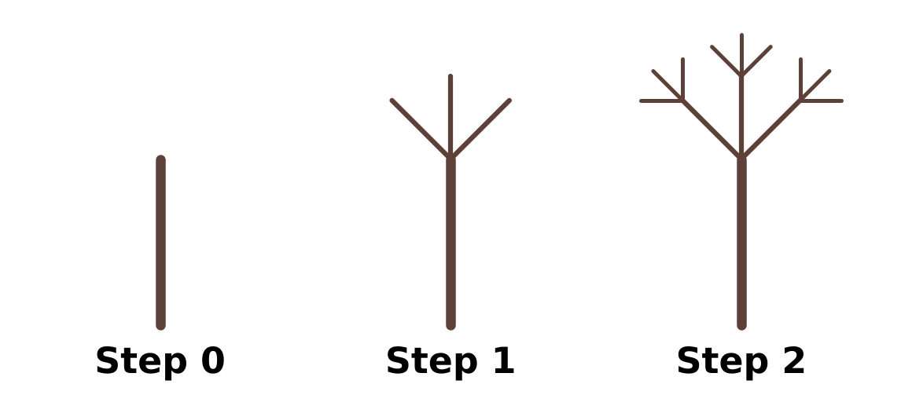
Q35. The picture shows Steps 0, 1 and 2 of a fractal tree. Step 0 is a single straight stem. At each new step, three new branches, each half as long, grow from the free end of every branch drawn in the step before. Counting the stem as a branch, how many branches does the whole tree have at Step 3?
(A) 27 | (B) 40 | (C) 39 | (D) 13

Q36. A whole number leaves a remainder of 5 when it is divided by 12. What remainder does it leave when it is divided by 4?
(A) 5 | (B) 3 | (C) 0 | (D) 1

Q37. Three-digit numbers are made using the digits 2, 4, 5, 7 and 9, with no digit used twice in a number. How many of these numbers are divisible by 5?
(A) 25 | (B) 12 | (C) 20 | (D) 60

Q38. Fifteen schools play a quiz league. They are split into 3 groups of 5. In each group, every school meets every other school of its group once. Then the 3 group winners meet each other once in a final round. How many matches are played in all?
(A) 105 | (B) 30 | (C) 63 | (D) 33

Q39. A, B and C are three different digits, and none of them is 0. Using them, the two-digit numbers AB and AC multiply to give the three-digit number CAB: AB × AC = CAB. What is the number CAB?
(A) 246 | (B) 264 | (C) 624 | (D) 625

Q40. Sonal writes the numbers 1, 2, 3, …, 10 in a row. In each of the 9 gaps between them she writes a + sign or a − sign, and then works out the total. With every sign +, the total is 55. What is the largest total less than 55 that she can get?
(A) 51 | (B) 53 | (C) 54 | (D) 45

SECTION II — Star Questions 5 questions × 4 marks each
Q41. For how many whole numbers n from 1 to 48 is n² + 5n + 6 divisible by 12? [4 marks]
(A) 32 | (B) 24 | (C) 16 | (D) 8

Q42. On squared paper, a rectangle 6 squares long and 4 squares wide is drawn, and a straight line is drawn from one corner to the opposite corner. The line passes through the inside of the 8 shaded squares in the picture. In the same way, a straight line is drawn from corner to opposite corner of a rectangle 20 squares long and 15 squares wide. Through the inside of how many squares does it pass? [4 marks] | 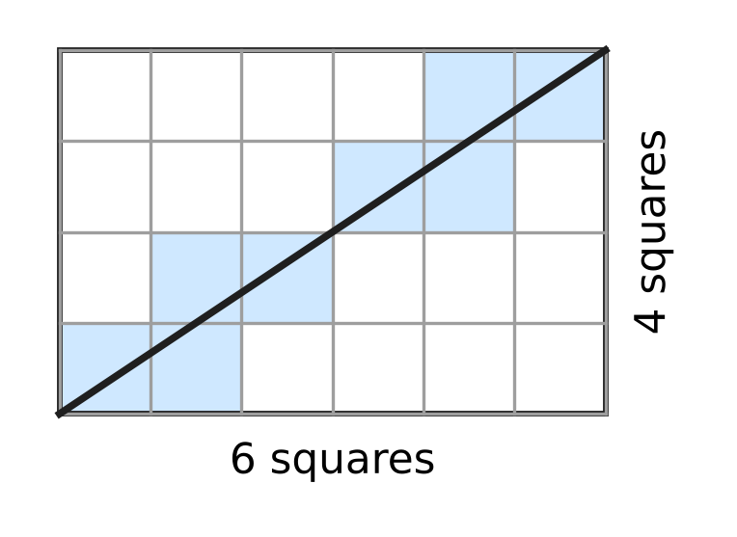
  (A) 35 | (B) 30 | (C) 31 | (D) 33

Q43. ABCD is a parallelogram. The line AE cuts ∠DAB into two equal angles and meets the side DC at E, as in the picture. AD = (x + 5) cm, DE = (2x − 3) cm and EC = (x − 1) cm. What is the perimeter of ABCD? [4 marks] | 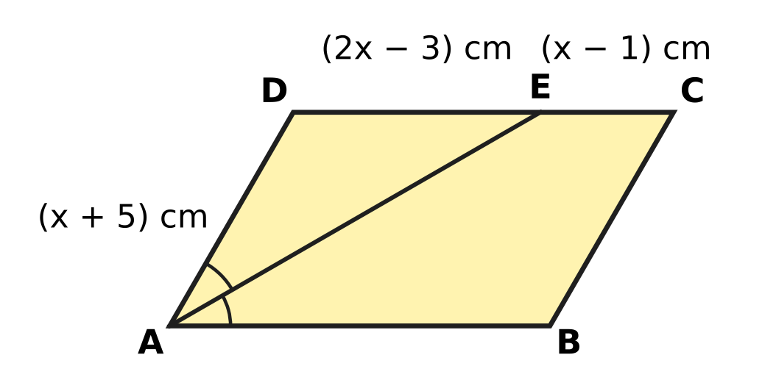
  (A) 80 cm | (B) 33 cm | (C) 52 cm | (D) 66 cm

Q44. A trader buys a cupboard for ₹2,500. He marks its price x% above his cost. Later he sells it at a discount of x% on the marked price, and so makes a loss of ₹100. What was the marked price? [4 marks]
(A) ₹3,000 | (B) ₹2,550 | (C) ₹2,600 | (D) ₹2,400

Q45. Jayesh builds an open cylindrical water tank with no lid. Inside, it has radius 3.5 m and depth 2 m, as in the picture. He lines the inside wall and the floor with tiles, which costs ₹120 for every square metre. He borrows the whole cost at 10% per year simple interest and repays the loan with interest after 2 years. How much does he repay in all? (Use π = $\frac{22}{7}$.) [4 marks] | 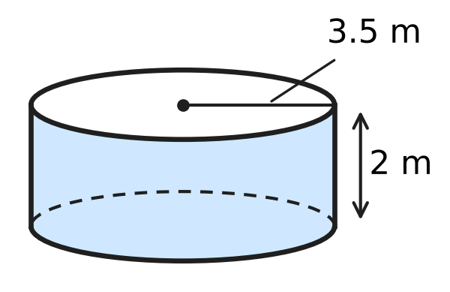
  (A) ₹9,900 | (B) ₹6,336 | (C) ₹17,424 | (D) ₹11,880
Answer Sheet AMO Level 1 · Class 8 · Practice Paper 4
Name: | School: | Roll No.:
Shade or tick one circle for each question.
1. Ⓐ Ⓑ Ⓒ Ⓓ | 16. Ⓐ Ⓑ Ⓒ Ⓓ | 31. Ⓐ Ⓑ Ⓒ Ⓓ
2. Ⓐ Ⓑ Ⓒ Ⓓ | 17. Ⓐ Ⓑ Ⓒ Ⓓ | 32. Ⓐ Ⓑ Ⓒ Ⓓ
3. Ⓐ Ⓑ Ⓒ Ⓓ | 18. Ⓐ Ⓑ Ⓒ Ⓓ | 33. Ⓐ Ⓑ Ⓒ Ⓓ
4. Ⓐ Ⓑ Ⓒ Ⓓ | 19. Ⓐ Ⓑ Ⓒ Ⓓ | 34. Ⓐ Ⓑ Ⓒ Ⓓ
5. Ⓐ Ⓑ Ⓒ Ⓓ | 20. Ⓐ Ⓑ Ⓒ Ⓓ | 35. Ⓐ Ⓑ Ⓒ Ⓓ
6. Ⓐ Ⓑ Ⓒ Ⓓ | 21. Ⓐ Ⓑ Ⓒ Ⓓ | 36. Ⓐ Ⓑ Ⓒ Ⓓ
7. Ⓐ Ⓑ Ⓒ Ⓓ | 22. Ⓐ Ⓑ Ⓒ Ⓓ | 37. Ⓐ Ⓑ Ⓒ Ⓓ
8. Ⓐ Ⓑ Ⓒ Ⓓ | 23. Ⓐ Ⓑ Ⓒ Ⓓ | 38. Ⓐ Ⓑ Ⓒ Ⓓ
9. Ⓐ Ⓑ Ⓒ Ⓓ | 24. Ⓐ Ⓑ Ⓒ Ⓓ | 39. Ⓐ Ⓑ Ⓒ Ⓓ
10. Ⓐ Ⓑ Ⓒ Ⓓ | 25. Ⓐ Ⓑ Ⓒ Ⓓ | 40. Ⓐ Ⓑ Ⓒ Ⓓ
11. Ⓐ Ⓑ Ⓒ Ⓓ | 26. Ⓐ Ⓑ Ⓒ Ⓓ | 41. Ⓐ Ⓑ Ⓒ Ⓓ
12. Ⓐ Ⓑ Ⓒ Ⓓ | 27. Ⓐ Ⓑ Ⓒ Ⓓ | 42. Ⓐ Ⓑ Ⓒ Ⓓ
13. Ⓐ Ⓑ Ⓒ Ⓓ | 28. Ⓐ Ⓑ Ⓒ Ⓓ | 43. Ⓐ Ⓑ Ⓒ Ⓓ
14. Ⓐ Ⓑ Ⓒ Ⓓ | 29. Ⓐ Ⓑ Ⓒ Ⓓ | 44. Ⓐ Ⓑ Ⓒ Ⓓ
15. Ⓐ Ⓑ Ⓒ Ⓓ | 30. Ⓐ Ⓑ Ⓒ Ⓓ | 45. Ⓐ Ⓑ Ⓒ Ⓓ
Q41–Q45 are Section II Star Questions (4 marks each).
For the parent or teacher
Section I correct: ______ / 40 × 2 = ______ marks Section II correct: ______ / 5 × 4 = ______ marks
Correct: ______ / 45 Score: ______ / 100
Answer Key and Solutions AMO Level 1 · Class 8 · Practice Paper 4
Quick answers
1 D | 6 C | 11 A | 16 A | 21 B | 26 A | 31 D | 36 D | 41 C
2 C | 7 B | 12 C | 17 C | 22 A | 27 B | 32 A | 37 B | 42 B
3 A | 8 D | 13 D | 18 A | 23 D | 28 C | 33 A | 38 D | 43 D
4 B | 9 B | 14 C | 19 B | 24 C | 29 C | 34 C | 39 C | 44 A
5 A | 10 D | 15 B | 20 D | 25 D | 30 B | 35 B | 40 A | 45 D
Solutions
Q | Part · level | Answer | Why?
1 | Part 1 · Ch1 · Easy | (D) 15 | 25² = 625 ≤ 640 < 676 = 26², so the largest square has 25 rows of 25 students. Then 640 − 625 = 15 students stand at the side.
2 | Part 1 · Ch1 · Easy | (C) the product of a non-zero rational number and an irrational number | √2 + (−√2) = 0, √2 × √8 = 4 and √8 ÷ √2 = 2 are rational. A non-zero rational times an irrational, such as 3√2, is always irrational.
3 | Part 1 · Ch1 · Medium | (A) 9 cm | Total volume = 1³ + 6³ + 8³ = 1 + 216 + 512 = 729 cm³. The new edge is ∛729 = 9 cm.
4 | Part 2 · Ch2 · Easy | (B) $ab^{6}$ | (a⁻²b³)² = a⁻⁴b⁶. Then a⁻⁴ × a⁵ = a¹, so the answer is ab⁶.
5 | Part 2 · Ch2 · Easy | (A) 0 | (−1)⁻¹ = −1, (−1)⁻² = 1, (−1)⁻³ = −1 and (−1)⁻⁴ = 1. The sum is −1 + 1 − 1 + 1 = 0.
6 | Part 2 · Ch2 · Medium | (C) 40 | (1 × 10⁻⁴) ÷ (2.5 × 10⁻⁶) = (1 ÷ 2.5) × 10⁻⁴⁺⁶ = 0.4 × 100 = 40.
7 | Part 3 · Ch3 · Easy | (B) ₹612 | Sale price = 800 × 0.85 = ₹680. Kiara pays 680 × 0.9 = ₹612.
8 | Part 3 · Ch3 · Easy | (D) ₹4,000 | In 3 years the interest is 15% of the money put in, so ₹4,600 is 115% of it. The sum is 4,600 ÷ 1.15 = ₹4,000.
9 | Part 3 · Ch3 · Easy | (B) 25% | The fall is ₹10 on the old fare of ₹40. So the fall is 10 ÷ 40 × 100 = 25%.
10 | Part 3 · Ch3 · Medium | (D) ₹6,000 | The extra interest is 3% per year for 4 years, which is 12% of the sum. 12% of the sum = ₹720, so the sum is 720 ÷ 0.12 = ₹6,000.
11 | Part 3 · Ch3 · Medium | (A) 30% | Money = price × visitors. The new price is 0.9 times the old, and the new money is 1.17 times the old, so visitors became 1.17 ÷ 0.9 = 1.3 times as many: a rise of 30%.
12 | Part 4 · Ch4 · Easy | (C) 49 | For 4y² − 28y + b² = (2y − b)² we need 2 × 2y × b = 28y, so b = 7 and b² = 49: 4y² − 28y + 49 = (2y − 7)².
13 | Part 4 · Ch4 · Easy | (D) (x + 5) cm | x² + 9x + 20 = (x + 4)(x + 5), because 4 + 5 = 9 and 4 × 5 = 20. So the other side is (x + 5) cm.
14 | Part 4 · Ch4 · Easy | (C) 13.4 m | Let the width be w m. Then 2(w + w + 7.3) = 39, so 2w + 7.3 = 19.5 and w = 6.1. The length is 6.1 + 7.3 = 13.4 m.
15 | Part 4 · Ch4 · Medium | (B) 300 | Let the number of 12-egg trays be t. Then 12t = 15(t − 5), so 3t = 75 and t = 25. There are 12 × 25 = 300 eggs.
16 | Part 4 · Ch4 · Medium | (A) 1 | n² + 2n − 3 = (n + 3)(n − 1). A product of two whole numbers is prime only if the smaller factor is 1, so n − 1 = 1 and n = 2, giving 5. Only 1 answer is prime.
17 | Part 5 · Ch5 · Easy | (C) 150 m | AB² = 90² + 120² = 8,100 + 14,400 = 22,500, so AB = 150 m.
18 | Part 5 · Ch5 · Easy | (A) Its diagonals are perpendicular to each other. | The diagonals of every rhombus cross at right angles. A rectangle that is not a square has diagonals that are not perpendicular.
19 | Part 5 · Ch5 · Easy | (B) 4 | Take face 3 as the base. Faces 2 and 4 fold up as the back and right walls, 5 folds up from 4 as the front wall, 1 folds down from 2 as the left wall and 6 is the top. So 1 (left) is opposite 4 (right).
20 | Part 5 · Ch5 · Medium | (D) 0.5 m | Triangles ADE and ABC are similar (same angle at A, right angles at D and B). So DE ÷ 1.2 = 1.5 ÷ 3.6, which gives DE = 0.5 m.
21 | Part 5 · Ch5 · Medium | (B) 30 cm | The diagonals of a rhombus bisect each other at right angles. Half of LN = √(39² − 36²) = √225 = 15 cm, so LN = 30 cm.
22 | Part 6 · Ch6 · Easy | (A) 33 m³ | V = ⅓πr²h = ⅓ × 22/7 × 9 × 3.5 = 33 m³.
23 | Part 6 · Ch6 · Easy | (D) 25 cm | Curved surface = πrl, so 22/7 × 14 × l = 1,100. That is 44 × l = 1,100, so l = 25 cm.
24 | Part 6 · Ch6 · Easy | (C) 10 cm | The volume is 1.54 litres = 1,540 cm³. πr² = 22/7 × 49 = 154 cm², so h = 1,540 ÷ 154 = 10 cm.
25 | Part 6 · Ch6 · Medium | (D) 8,150 cm³ | Cuboid = 20 × 20 × 30 = 12,000 cm³. Hole = 22/7 × 7² × 25 = 3,850 cm³. Wood left = 12,000 − 3,850 = 8,150 cm³.
26 | Part 6 · Ch6 · Medium | (A) 7 cm³ | The marbles push up a cylinder of water 1 cm high: 22/7 × 7² × 1 = 154 cm³. One marble = 154 ÷ 22 = 7 cm³.
27 | Part 7 · Ch8 · Easy | (B) 6–9 cm | Counting from the shortest: the 3–6 class holds leaves 1 to 12 and the 6–9 class holds leaves 13 to 20. So the 19th leaf is in the class 6–9 cm.
28 | Part 7 · Ch8 · Easy | (C) 54° | Angle = 180 ÷ 1,200 × 360° = 54°.
29 | Part 7 · Ch8 · Medium | (C) 13 | For six values the median is the average of the 3rd and 4th: (x + 14) ÷ 2 = 12, so x = 10. Mean = (5 + 8 + 10 + 14 + 19 + 22) ÷ 6 = 78 ÷ 6 = 13.
30 | Part 8 · Ch9 · Easy | (B) ₹3,600 | He gains 9% − 6% = 3% of ₹40,000 each year, which is ₹1,200. In 3 years he gains ₹3,600.
31 | Part 8 · Ch9 · Easy | (D) 40 | Each cake gives a profit of 280 − 180 = ₹100. To make ₹4,000 she must sell 4,000 ÷ 100 = 40 cakes.
32 | Part 8 · Ch9 · Easy | (A) 60% | Take the cost as ₹100. He sold it for ₹80, so twice that price is ₹160. The profit is ₹60 on ₹100, which is 60%.
33 | Part 8 · Ch9 · Medium | (A) 12% | Take the total cost as 100. The first part gives 75 × 20% = 15 profit; the target is 12. The other 25 must lose 3, which is 3 ÷ 25 = 12% loss.
34 | Part 8 · Ch9 · Medium | (C) 60% | Take the cost price as ₹100. The selling price must be ₹120, which is 75% of the marked price. Marked price = 120 ÷ 0.75 = ₹160, which is 60% above cost.
35 | Part 9 · Ch10 · Easy | (B) 40 | The steps add 1, 3, 9 and 27 branches, each step three times the one before. At Step 3 the tree has 1 + 3 + 9 + 27 = 40 branches.
36 | Part 9 · Ch10 · Easy | (D) 1 | The number is 12k + 5 = 4(3k + 1) + 1. So the remainder on division by 4 is 1.
37 | Part 9 · Ch10 · Easy | (B) 12 | The number must end in 5, since 0 is not available. The first digit then has 4 choices and the middle digit 3, so there are 4 × 3 = 12 numbers.
38 | Part 9 · Ch10 · Medium | (D) 33 | Each group of 5 has 5 × 4 ÷ 2 = 10 matches, so the groups have 3 × 10 = 30. The final round has 3 matches. Total 30 + 3 = 33.
39 | Part 9 · Ch10 · Medium | (C) 624 | CAB ends in B, so B × C ends in B, and A must be small to keep the product at three digits. Trying the cases, only 24 × 26 = 624 works.
40 | Part 9 · Ch10 · Medium | (A) 51 | Changing + k to − k lowers the total by 2k, and the smallest k with a sign in front of it is 2. So the largest total below 55 is 55 − 4 = 51.
41 | Section II · Ch4 + Ch10 · Hard | (C) 16 | n² + 5n + 6 = (n + 2)(n + 3), two consecutive numbers, so exactly one of them is even. It is divisible by 4 only when n + 2 or n + 3 is a multiple of 4, and by 3 only when n + 2 or n + 3 is a multiple of 3. In each block of 12 numbers both hold for 4 values of n (n = 1, 6, 9, 10), so from 1 to 48 there are 4 × 4 = 16.
42 | Section II · Ch5 + Ch10 · Hard | (B) 30 | The line enters a new square each time it crosses one of the 19 + 14 = 33 inside grid lines, except that it crosses two lines at once at a corner. By similar triangles it meets a corner (x, y) only when y : x = 15 : 20 = 3 : 4, at (4, 3), (8, 6), (12, 9) and (16, 12). So it passes through 1 + 33 − 4 = 30 squares.
43 | Section II · Ch4 + Ch5 · Hard | (D) 66 cm | AB ∥ DC, so ∠DEA = ∠EAB (alternate angles) = ∠DAE. So △ADE is isosceles with DE = AD: 2x − 3 = x + 5, x = 8. Then AD = 13 cm and DC = 13 + 7 = 20 cm, so the perimeter is 2 × (13 + 20) = 66 cm.
44 | Section II · Ch3 + Ch9 · Hard | (A) ₹3,000 | The selling price is 2,500 × (1 + x/100)(1 − x/100) = 2,400, so 1 − x²/10,000 = 0.96 and x² = 400, x = 20. Marked price = 2,500 × 1.2 = ₹3,000.
45 | Section II · Ch6 + Ch9 · Hard | (D) ₹11,880 | Wall = 2 × 22/7 × 3.5 × 2 = 44 m² and floor = 22/7 × 3.5 × 3.5 = 38.5 m², so 82.5 m² in all. Cost = 82.5 × 120 = ₹9,900. Interest = 20% of 9,900 = ₹1,980, so he repays ₹11,880.

