UNLOCK IQ INSTITUTE
Realize Your True Potential
Aryabhatta Maths Olympiad (AMO)
Level 1 — Practice Paper 5
CLASS 8

Questions | 45 multiple-choice questions
Marks | 100
Time | 60 minutes
Section I | 40 questions × 2 marks = 80 marks
Section II | 5 Star Questions × 4 marks = 20 marks
Negative marking | No negative marking
Calculator | Not allowed
Chapters | Number System · Operations · Fractions, Decimals & Percentages · Algebra · Geometry · Mensuration · Data Handling · Applied Mathematics · Mathematical Reasoning

Instructions to candidates
• This paper has 45 multiple-choice questions. Each question has four answer choices, of which exactly one is correct.
• Section I (Q1–Q40) carries 2 marks per question. Section II (Q41–Q45) carries 4 marks per question.
• There is no negative marking. Unanswered questions score zero.
• Calculators are not permitted. Rough work may be done on a separate sheet.
• Mark your answers on the answer sheet at the end of the paper.
• All figures are not necessarily drawn to scale unless stated.

For parents and teachers
Print or view this paper in colour. Pictures are part of the questions.
Parts follow the AMO syllabus chapters. Chapter 7 is not part of the Class 8 syllabus, so the chapter numbers shown in the Part headings have gaps.
The answer sheet and the answer key are at the end. Remove only the answer key before the student begins.

Name: | School: | Roll No.:

SECTION I 40 questions × 2 marks each
Part 1 — Number System (Syllabus Chapter 1)
Q1. A gift box is a cube. Its volume is 512 cm³. What is the area of one face of the box?
(A) 8 cm² | (B) 64 cm² | (C) 384 cm² | (D) 128 cm²

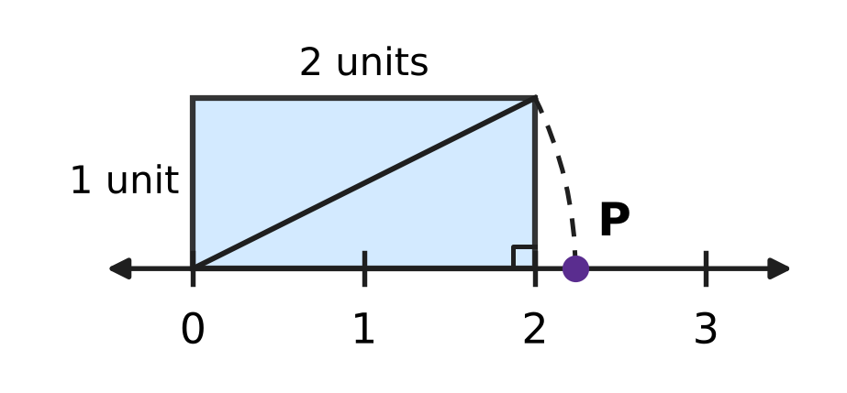
Q2. In the picture, a rectangle 2 units long and 1 unit high stands on the number line with one corner at 0. An arc with centre 0 passes through the opposite corner of the rectangle and meets the number line at P. Which number does P show?
(A) √3 | (B) 3 | (C) 5 | (D) √5

Q3. The odd numbers 1, 3, 5, 7, … are added in order, starting from 1, and the adding stops at the odd number k. The total is 324. What is k?
(A) 37 | (B) 18 | (C) 35 | (D) 33

Part 2 — Operations & Number Properties (Syllabus Chapter 2)
Q4. I am a number. When I am raised to the power −2, the answer is $\frac{1}{49}$. My cube is a negative number. Who am I?
(A) −7 | (B) $−\frac{1}{7}$ | (C) 7 | (D) $\frac{1}{7}$

Q5. Which of these is NOT equal to 0.0006?
(A) 60 × 10⁻⁵ | (B) 6 × 10⁻³
(C) 6 × 10⁻⁴ | (D) 0.6 × 10⁻³

Q6. Parth simplified (2³)⁻² × 2⁸ like this: (2³)⁻² × 2⁸ = 2³⁻²⁺⁸ = 2⁹ = 512. His answer is wrong. What is the correct value?
(A) 16,384 | (B) $\frac{1}{4}$ | (C) 4 | (D) 512

Part 3 — Fractions, Decimals & Percentages (Syllabus Chapter 3)
Q7. Lata's savings are 60% more than Zoya's savings. By what percentage are Zoya's savings less than Lata's?
(A) 62.5% | (B) 40% | (C) 60% | (D) 37.5%

Q8. Dhruv puts ₹10,000 in a bank that pays simple interest. The rate is 6% per year for the first 2 years and 8% per year for the next 3 years. How much interest does he earn in the 5 years?
(A) ₹3,600 | (B) ₹3,000 | (C) ₹4,000 | (D) ₹3,500

Q9. A plane takes off with a full fuel tank. In the first hour it uses 40% of the fuel. In the second hour it uses 30% of the fuel that is left. After two hours, 8,400 litres of fuel are left. How many litres does the full tank hold?
(A) 28,000 litres | (B) 20,000 litres
(C) 12,000 litres | (D) 14,000 litres

Q10. Last week, 40% of the ice creams sold at an ice-cream stall were mango. This week the stall sold 25% more ice creams in all, and 50% more mango ice creams than last week. What percentage of this week's ice creams were mango?
(A) 48% | (B) 50% | (C) 32% | (D) 60%

Q11. On the same day, Hana puts ₹8,000 in a bank at 5% per year simple interest, and Ivan puts ₹6,000 in another bank at 10% per year simple interest. After how many years will they have the same amount?
(A) 20 years | (B) 2 years | (C) 5 years | (D) 10 years

Part 4 — Algebra (Syllabus Chapter 4)
Q12. One factor of xy − 4x + 3y − 12 is (y − 4). What is the other factor?
(A) x − 4 | (B) y + 3 | (C) x + 3 | (D) x − 3

Q13. Hot-air balloon A is 150 m above the ground and rises 15 m every minute. At the same moment, balloon B is 690 m above the ground and comes down 12 m every minute. After how many minutes will the two balloons be at the same height?
(A) 180 minutes | (B) 45 minutes
(C) 20 minutes | (D) 36 minutes

Q14. For two numbers a and b, a − b = 4 and a² + b² = 40. What is the value of ab?
(A) 24 | (B) 18 | (C) 36 | (D) 12

Q15. In a music class, there are 4 more girls than boys. Then 6 girls move to another class and 6 new boys join. Now there are twice as many boys as girls. How many children were in the music class at the start?
(A) 24 | (B) 10 | (C) 14 | (D) 12

Q16. The product of two consecutive odd numbers is 399. What is their sum?
(A) 42 | (B) 40 | (C) 38 | (D) 20

Part 5 — Geometry (Syllabus Chapter 5)
Q17. ABCD is a kite with AB = AD and CB = CD, as marked in the picture. ∠DAB = 70° and ∠BCD = 50°. What is x, the size of ∠ABC? | 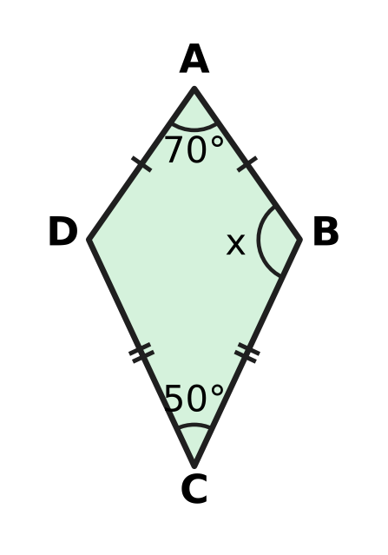
  (A) 60° | (B) 120° | (C) 110° | (D) 240°

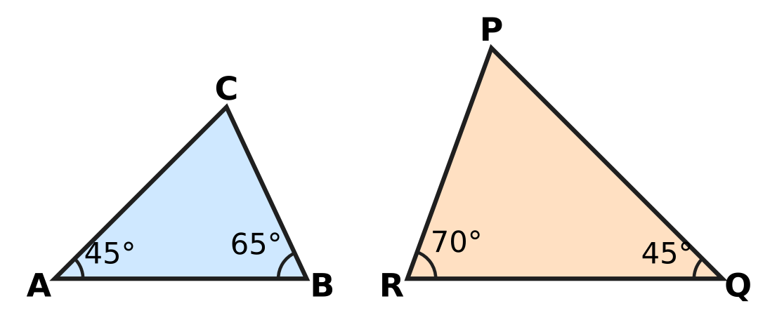
Q18. Look at the two triangles in the picture, with the angles marked. Which of these statements is correct?
(A) △ABC ∼ △QRP | (B) △ABC ∼ △PQR
(C) △ABC ∼ △QPR | (D) △ABC ∼ △RPQ

Q19. A square floor tile has a diagonal of 30 cm, as in the picture. What is the area of the tile? | 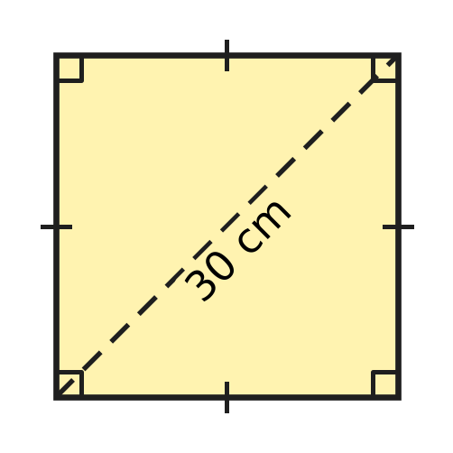
  (A) 225 cm² | (B) 441 cm² | (C) 900 cm² | (D) 450 cm²

Q20. A playground swing hangs from a bar on straight chains 2.5 m long. The seat is pulled back, with the chains kept straight, until it is 1.5 m sideways from where it hangs at rest, as in the picture. How much higher is the seat now than at rest? | 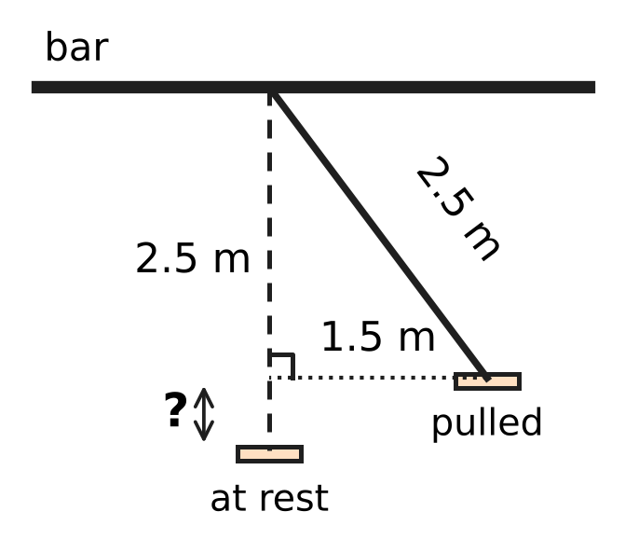
  (A) 0.5 m | (B) 1 m | (C) 2 m | (D) 1.5 m

Q21. PQRS is a rhombus. Its diagonal PR is exactly as long as each side, as marked in the picture. What is ∠QPS? | 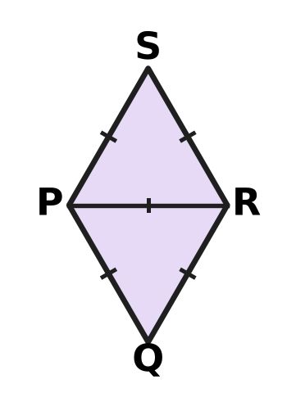
  (A) 60° | (B) 90° | (C) 120° | (D) 30°

Part 6 — Mensuration (Syllabus Chapter 6)
Q22. A steel container is a cylinder that is open at the top. Its radius is 7 cm and its height is 9 cm, as in the picture. What is the area of its outside surface (the curved surface and the base)? (Use π = $\frac{22}{7}$.) | 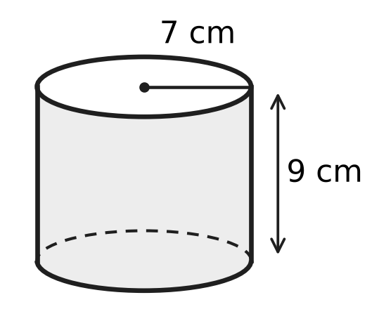
  (A) 396 cm² | (B) 550 cm²
  (C) 1,386 cm² | (D) 704 cm²

Q23. Cylinder A has radius 7 cm and height 10 cm. Cylinder B has radius 10 cm and height 7 cm, as in the picture. Their curved surfaces have the same area. How much greater is the volume of B than the volume of A? (Use π = $\frac{22}{7}$.) | 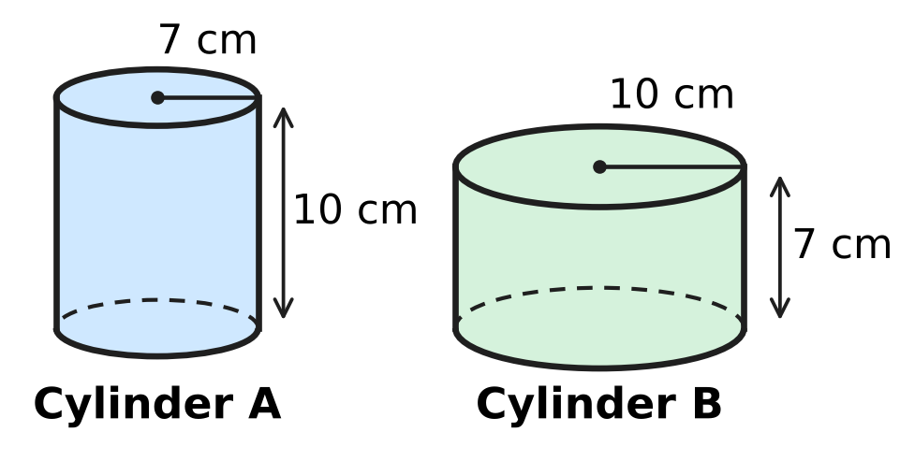
  (A) 1,540 cm³ | (B) 0 cm³
  (C) 2,200 cm³ | (D) 660 cm³

Q24. In a storm, 2 cm of rain falls on the flat roof of Deepa's house. The roof is a rectangle 15 m long and 8 m wide. All the rain that falls on the roof is collected. How many litres is this? (1 m³ = 1,000 litres.)
(A) 2,400 litres | (B) 240,000 litres
(C) 24,000 litres | (D) 240 litres

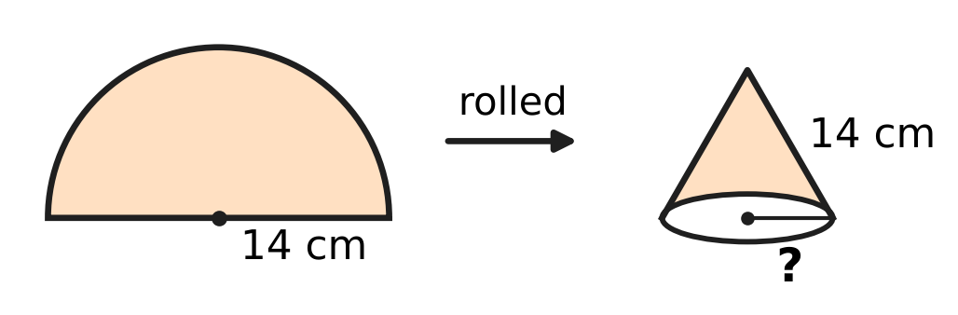
Q25. A semicircular sheet of paper has radius 14 cm. It is rolled into an open cone so that its two straight edges just meet, with no overlap, as in the picture. What is the radius of the base of the cone?
(A) 14 cm | (B) 7 cm | (C) 3.5 cm | (D) 22 cm

Q26. A closed cylinder has a curved surface area of 880 cm² and a total surface area of 1,188 cm². What is its radius? (Use π = $\frac{22}{7}$.)
(A) 49 cm | (B) 14 cm | (C) 7 cm | (D) 20 cm

Part 7 — Data Handling, Statistics & Probability (Syllabus Chapter 8)
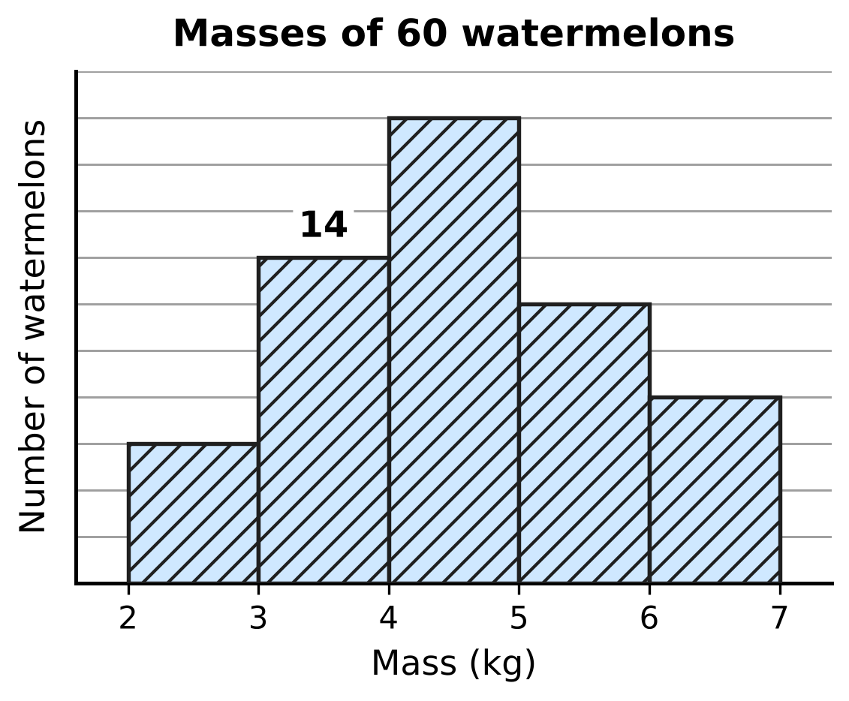
Q27. The histogram in the picture shows the masses of 60 watermelons. The class 3–4 means 3 kg or more but less than 4 kg. The numbers on the vertical scale are missing, but the bar for 3–4 kg is marked: it stands for 14 watermelons. How many watermelons have a mass of 5 kg or more but less than 6 kg?
(A) 6 | (B) 20 | (C) 8 | (D) 12

Q28. The pie chart shows the bouquets a flower shop sold in one week. The angle of each sector is marked. The shop sold 48 more bouquets of roses than bouquets of lilies. How many bouquets did it sell in all that week? | 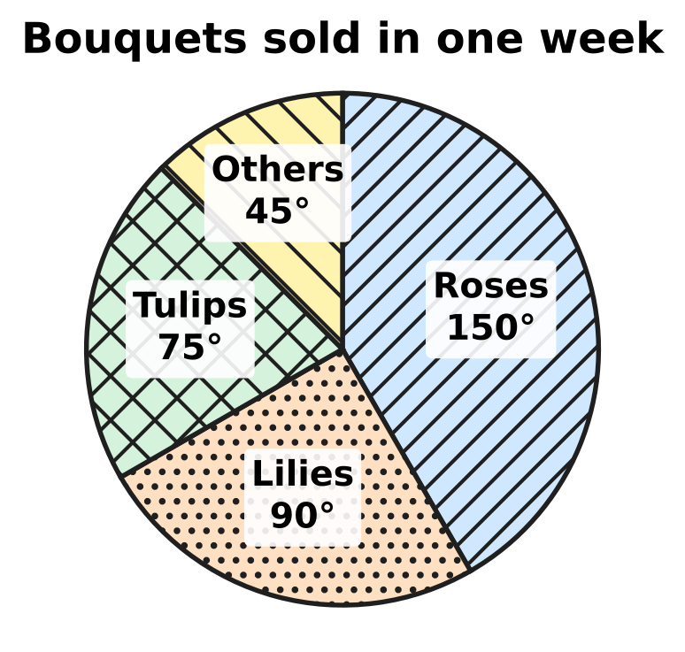
  (A) 288 | (B) 72 | (C) 80 | (D) 120

Q29. Five whole numbers have a mean of 7 and a median of 6. Their only mode is 4. What is the greatest possible value of the largest of the five numbers?
(A) 21 | (B) 14 | (C) 15 | (D) 17

Part 8 — Applied Mathematics (Syllabus Chapter 9)
Q30. If Usha sells her old study table for ₹1,140, she makes a loss. If she sells it for ₹1,260, she makes a profit equal to that loss. What did the table cost her?
(A) ₹1,200 | (B) ₹1,320 | (C) ₹1,080 | (D) ₹60

Q31. Zubin needs to borrow ₹50,000 for 3 years. Bank X charges 8% per year simple interest. Bank Y charges 7% per year simple interest and also a one-time fee of ₹1,000. How much does Zubin save by choosing the cheaper bank?
(A) ₹1,500 | (B) ₹1,000 | (C) ₹2,500 | (D) ₹500

Q32. A school spent ₹7,500 on its play. It sold 300 tickets at ₹30 each. What was its profit percent?
(A) 120% | (B) 15% | (C) 20% | (D) $16\frac{2}{3}$%

Q33. At a tea stall, each cup of tea costs ₹6 to make, and the rent for the day is ₹600. One day the stall sells 300 cups at ₹10 each. What is its profit percent for that day?
(A) $66\frac{2}{3}$% | (B) 25% | (C) 20% | (D) $33\frac{1}{3}$%

Q34. Kian sells a camera at a profit of 10%. If he had bought it for 10% less and sold it for ₹30 less, he would have made a profit of 20%. What did the camera cost him?
(A) ₹300 | (B) ₹3,000 | (C) ₹1,500 | (D) ₹750

Part 9 — Mathematical Reasoning & Problem-Solving (Syllabus Chapter 10)
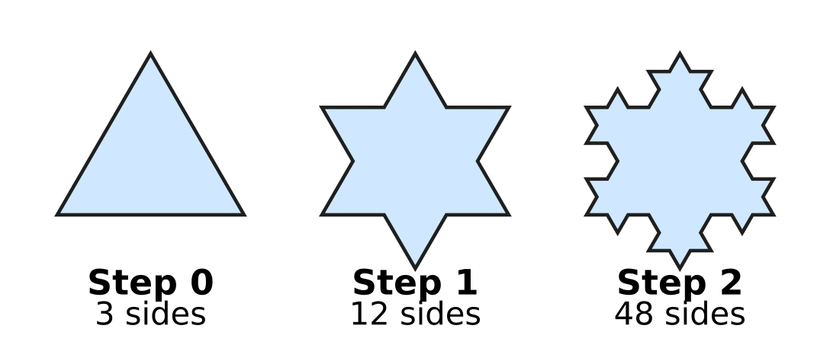
Q35. The picture shows Steps 0, 1 and 2 of the Koch snowflake. At each step, every side is replaced by 4 sides, each one-third as long. At which step does the snowflake first have more than 500 sides?
(A) Step 3 | (B) Step 8 | (C) Step 5 | (D) Step 4

Q36. A toy robot moves along the lines of the grid in the picture, from corner S to corner T. At every step it moves one side of a small square to the right or one side up, never left or down. How many different routes can it take from S to T? | 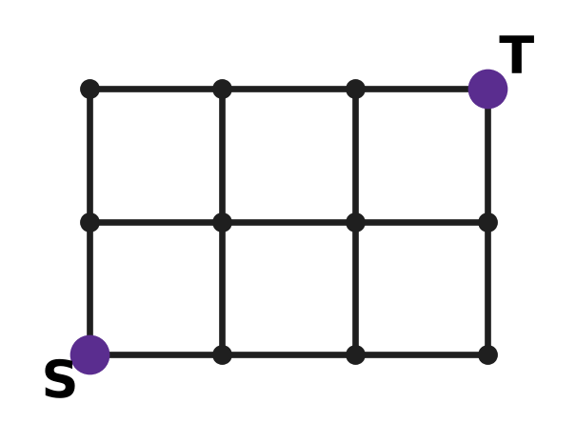
  (A) 10 | (B) 5 | (C) 6 | (D) 20

Q37. Look at this pattern: 3 × 4 × 5 × 6 + 1 = 361 = 19², 4 × 5 × 6 × 7 + 1 = 841 = 29², and 5 × 6 × 7 × 8 + 1 = 1,681 = 41². In the same way, 10 × 11 × 12 × 13 + 1 is a perfect square. What is its square root?
(A) 133 | (B) 131 | (C) 130 | (D) 143

Q38. ABB is a three-digit perfect square. A and B are different digits, and B ≠ 0. What is A + B?
(A) 5 | (B) 1 | (C) 9 | (D) 4

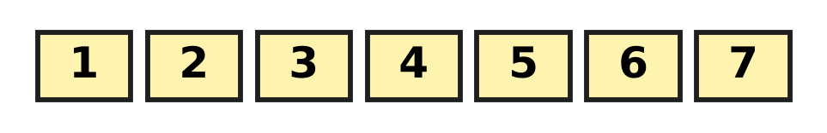
Q39. At a science exhibition, there are 7 stalls in a row, numbered 1 to 7 as in the picture. Three of the stalls are to be chosen for robot models. No two of the chosen stalls may be next to each other. In how many ways can the three stalls be chosen?
(A) 25 | (B) 15 | (C) 35 | (D) 10

Q40. A building has floors numbered 0 to 30. Its lift starts at floor 0. Each time the lift moves, it goes exactly 3 floors up or exactly 3 floors down. What is the highest floor the lift can be on after exactly 15 moves?
(A) 29 | (B) 30 | (C) 27 | (D) 45

SECTION II — Star Questions 5 questions × 4 marks each
Q41. ABCD is a four-digit number. AB and CD are the two-digit numbers made by its first two and its last two digits. Different letters stand for different digits, and neither A nor C is 0. If ABCD = (AB + CD)², what is AB + CD? [4 marks]
(A) 99 | (B) 45 | (C) 30 | (D) 55

Q42. The triangle ABC in the picture has sides 4 cm, 6 cm and 9 cm. Another triangle is similar to triangle ABC, and two of its sides are 12 cm and 18 cm long. What is the greatest possible perimeter of this triangle? [4 marks] | 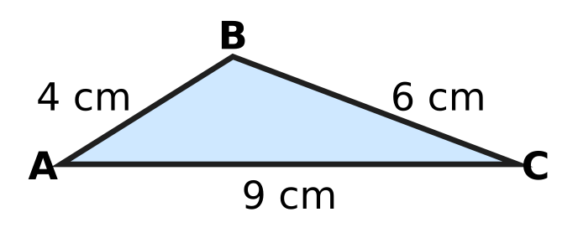
  (A) 57 cm | (B) 95 cm | (C) 85.5 cm | (D) 38 cm

Q43. In the trapezium ABCD in the picture, AB ∥ DC, AB = 10 cm and DC = 15 cm. The diagonals AC and BD meet at O. BO = (x + 1) cm and OD = (2x − 4) cm. How long is the diagonal BD? [4 marks] | 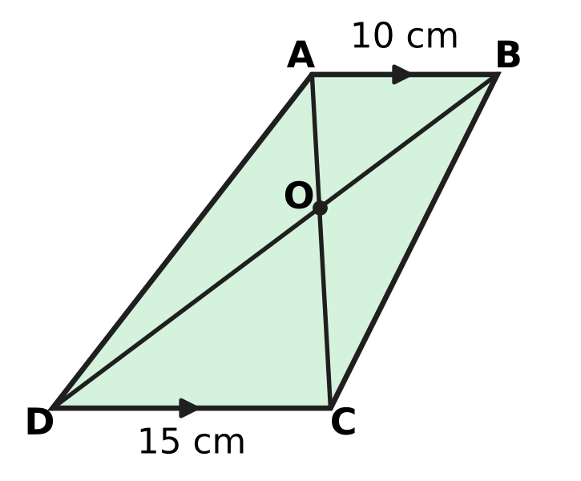
  (A) 7.5 cm | (B) 12 cm | (C) 30 cm | (D) 18 cm

Q44. Nakul has ₹60,000 and wants to buy a fishing net priced ₹60,000. The seller offers two ways to pay. Way 1: pay now and get a 5% discount. Way 2: pay the full price after one year. Any money that Nakul keeps stays in his bank for that year at 6% per year simple interest. At the end of the year, after paying for the net, which way leaves him with more money, and by how much? [4 marks]
(A) Way 1, by ₹3,000 | (B) Way 2, by ₹420
(C) Way 2, by ₹600 | (D) Way 2, by ₹3,420

Q45. Isha makes hollow plastic traffic cones for a car park. Each one is the curved surface of a cone with base radius 14 cm and height 48 cm, as in the picture. The plastic costs her ₹5 for every 100 cm², and this is her only cost. She marks each cone 50% above her cost. Then she gives the car park a discount of 20% on the marked price. What is her total profit on 150 cones? (Use π = $\frac{22}{7}$.) [4 marks] | 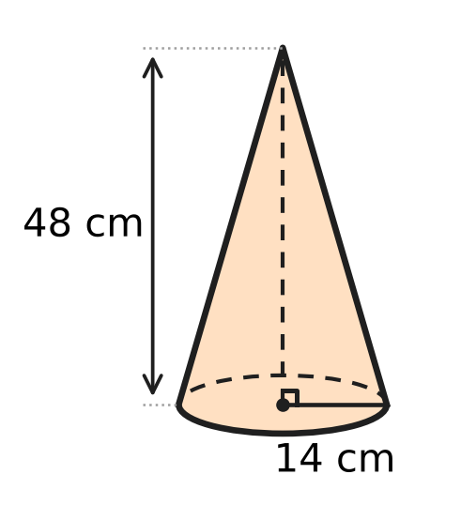
  (A) ₹3,168 | (B) ₹4,950 | (C) ₹8,250 | (D) ₹3,300
Answer Sheet AMO Level 1 · Class 8 · Practice Paper 5
Name: | School: | Roll No.:
Shade or tick one circle for each question.
1. Ⓐ Ⓑ Ⓒ Ⓓ | 16. Ⓐ Ⓑ Ⓒ Ⓓ | 31. Ⓐ Ⓑ Ⓒ Ⓓ
2. Ⓐ Ⓑ Ⓒ Ⓓ | 17. Ⓐ Ⓑ Ⓒ Ⓓ | 32. Ⓐ Ⓑ Ⓒ Ⓓ
3. Ⓐ Ⓑ Ⓒ Ⓓ | 18. Ⓐ Ⓑ Ⓒ Ⓓ | 33. Ⓐ Ⓑ Ⓒ Ⓓ
4. Ⓐ Ⓑ Ⓒ Ⓓ | 19. Ⓐ Ⓑ Ⓒ Ⓓ | 34. Ⓐ Ⓑ Ⓒ Ⓓ
5. Ⓐ Ⓑ Ⓒ Ⓓ | 20. Ⓐ Ⓑ Ⓒ Ⓓ | 35. Ⓐ Ⓑ Ⓒ Ⓓ
6. Ⓐ Ⓑ Ⓒ Ⓓ | 21. Ⓐ Ⓑ Ⓒ Ⓓ | 36. Ⓐ Ⓑ Ⓒ Ⓓ
7. Ⓐ Ⓑ Ⓒ Ⓓ | 22. Ⓐ Ⓑ Ⓒ Ⓓ | 37. Ⓐ Ⓑ Ⓒ Ⓓ
8. Ⓐ Ⓑ Ⓒ Ⓓ | 23. Ⓐ Ⓑ Ⓒ Ⓓ | 38. Ⓐ Ⓑ Ⓒ Ⓓ
9. Ⓐ Ⓑ Ⓒ Ⓓ | 24. Ⓐ Ⓑ Ⓒ Ⓓ | 39. Ⓐ Ⓑ Ⓒ Ⓓ
10. Ⓐ Ⓑ Ⓒ Ⓓ | 25. Ⓐ Ⓑ Ⓒ Ⓓ | 40. Ⓐ Ⓑ Ⓒ Ⓓ
11. Ⓐ Ⓑ Ⓒ Ⓓ | 26. Ⓐ Ⓑ Ⓒ Ⓓ | 41. Ⓐ Ⓑ Ⓒ Ⓓ
12. Ⓐ Ⓑ Ⓒ Ⓓ | 27. Ⓐ Ⓑ Ⓒ Ⓓ | 42. Ⓐ Ⓑ Ⓒ Ⓓ
13. Ⓐ Ⓑ Ⓒ Ⓓ | 28. Ⓐ Ⓑ Ⓒ Ⓓ | 43. Ⓐ Ⓑ Ⓒ Ⓓ
14. Ⓐ Ⓑ Ⓒ Ⓓ | 29. Ⓐ Ⓑ Ⓒ Ⓓ | 44. Ⓐ Ⓑ Ⓒ Ⓓ
15. Ⓐ Ⓑ Ⓒ Ⓓ | 30. Ⓐ Ⓑ Ⓒ Ⓓ | 45. Ⓐ Ⓑ Ⓒ Ⓓ
Q41–Q45 are Section II Star Questions (4 marks each).
For the parent or teacher
Section I correct: ______ / 40 × 2 = ______ marks Section II correct: ______ / 5 × 4 = ______ marks
Correct: ______ / 45 Score: ______ / 100
Answer Key and Solutions AMO Level 1 · Class 8 · Practice Paper 5
Quick answers
1 B | 6 C | 11 D | 16 B | 21 C | 26 C | 31 D | 36 A | 41 D
2 D | 7 D | 12 C | 17 B | 22 B | 27 D | 32 C | 37 B | 42 A
3 C | 8 A | 13 C | 18 C | 23 D | 28 A | 33 B | 38 A | 43 C
4 A | 9 B | 14 D | 19 D | 24 A | 29 B | 34 C | 39 D | 44 B
5 B | 10 A | 15 A | 20 A | 25 B | 30 A | 35 D | 40 C | 45 D
Solutions
Q | Part · level | Answer | Why?
1 | Part 1 · Ch1 · Easy | (B) 64 cm² | Edge = ∛512 = 8 cm, because 8 × 8 × 8 = 512. One face is a square of area 8 × 8 = 64 cm².
2 | Part 1 · Ch1 · Easy | (D) √5 | The slanting line from 0 to the far corner is √(2² + 1²) = √5 units long. The arc keeps this length, so P shows √5.
3 | Part 1 · Ch1 · Medium | (C) 35 | The sum of the first n odd numbers is n². n² = 324 gives n = 18, and the 18th odd number is 2 × 18 − 1 = 35.
4 | Part 2 · Ch2 · Easy | (A) −7 | Here (−7)⁻² = 1 ÷ (−7)² = 1/49, and (−7)³ = −343 is negative. The number 7 also gives 1/49 but its cube is positive.
5 | Part 2 · Ch2 · Easy | (B) 6 × 10⁻³ | The numbers 6 × 10⁻⁴, 60 × 10⁻⁵ and 0.6 × 10⁻³ all equal 0.0006. But 6 × 10⁻³ = 0.006, which is ten times as large.
6 | Part 2 · Ch2 · Easy | (C) 4 | A power of a power multiplies the indices: (2³)⁻² = 2⁻⁶. Then 2⁻⁶ × 2⁸ = 2⁻⁶⁺⁸ = 2² = 4.
7 | Part 3 · Ch3 · Easy | (D) 37.5% | If Zoya has 100, Lata has 160. Zoya has 60 less, and 60 ÷ 160 × 100 = 37.5%.
8 | Part 3 · Ch3 · Easy | (A) ₹3,600 | First 2 years: 10,000 × 6% × 2 = ₹1,200. Next 3 years: 10,000 × 8% × 3 = ₹2,400. Total = ₹3,600.
9 | Part 3 · Ch3 · Medium | (B) 20,000 litres | After two hours 70% of 60% = 42% of the tank is left. So 42% of the tank is 8,400 litres, and the full tank is 8,400 ÷ 0.42 = 20,000 litres.
10 | Part 3 · Ch3 · Medium | (A) 48% | Say 100 were sold last week, 40 of them mango. This week 125 were sold and 40 × 1.5 = 60 were mango. So the answer is 60 ÷ 125 × 100 = 48%.
11 | Part 3 · Ch3 · Medium | (D) 10 years | Hana gets ₹400 a year and Ivan ₹600, so Ivan closes the gap of ₹2,000 by ₹200 each year. It takes 2,000 ÷ 200 = 10 years (both then have ₹12,000).
12 | Part 4 · Ch4 · Easy | (C) x + 3 | Group the terms: x(y − 4) + 3(y − 4) = (y − 4)(x + 3). The other factor is x + 3.
13 | Part 4 · Ch4 · Easy | (C) 20 minutes | After t minutes: 150 + 15t = 690 − 12t, so 27t = 540 and t = 20. Both are then 450 m high.
14 | Part 4 · Ch4 · Easy | (D) 12 | (a − b)² = a² + b² − 2ab, so 16 = 40 − 2ab. Then 2ab = 24 and ab = 12.
15 | Part 4 · Ch4 · Medium | (A) 24 | Let there be b boys and b + 4 girls. Then b + 6 = 2(b + 4 − 6), so b + 6 = 2b − 4 and b = 10. There were 10 + 14 = 24 children.
16 | Part 4 · Ch4 · Medium | (B) 40 | Call the numbers n − 1 and n + 1. Then (n − 1)(n + 1) = n² − 1 = 399, so n² = 400 and n = 20. The numbers are 19 and 21, and their sum is 40.
17 | Part 5 · Ch5 · Easy | (B) 120° | △ABC ≅ △ADC (SSS: AB = AD, CB = CD, AC common), so ∠B = ∠D. The angles of ABCD add to 360°, so 2x = 360° − 70° − 50° = 240° and x = 120°.
18 | Part 5 · Ch5 · Easy | (C) △ABC ∼ △QPR | ∠C = 180° − 45° − 65° = 70° and ∠P = 180° − 45° − 70° = 65°. So A ↔ Q (45°), B ↔ P (65°) and C ↔ R (70°): △ABC ∼ △QPR.
19 | Part 5 · Ch5 · Easy | (D) 450 cm² | If the side is s, then s² + s² = 30² = 900 (Baudhāyana–Pythagoras). So 2s² = 900 and the area s² = 450 cm².
20 | Part 5 · Ch5 · Medium | (A) 0.5 m | The pulled seat is √(2.5² − 1.5²) = √4 = 2 m below the bar. At rest it is 2.5 m below the bar, so it is now 2.5 − 2 = 0.5 m higher.
21 | Part 5 · Ch5 · Medium | (C) 120° | PQ = QR = PR, so △PQR is equilateral and ∠QPR = 60°. In the same way △PSR is equilateral and ∠RPS = 60°. So ∠QPS = 60° + 60° = 120°.
22 | Part 6 · Ch6 · Easy | (B) 550 cm² | Curved surface = 2 × 22/7 × 7 × 9 = 396 cm². Base = 22/7 × 7 × 7 = 154 cm². Total = 550 cm².
23 | Part 6 · Ch6 · Easy | (D) 660 cm³ | Volume of A = 22/7 × 7 × 7 × 10 = 1,540 cm³. Volume of B = 22/7 × 10 × 10 × 7 = 2,200 cm³. The difference is 660 cm³.
24 | Part 6 · Ch6 · Easy | (A) 2,400 litres | Here 2 cm = 0.02 m. Volume = 15 × 8 × 0.02 = 2.4 m³ = 2.4 × 1,000 = 2,400 litres.
25 | Part 6 · Ch6 · Medium | (B) 7 cm | The curved edge of the semicircle, π × 14, becomes the rim of the base, 2πr. So 2πr = 14π and r = 7 cm.
26 | Part 6 · Ch6 · Medium | (C) 7 cm | The two circular ends make up 1,188 − 880 = 308 cm². So 2 × 22/7 × r² = 308, r² = 49 and r = 7 cm.
27 | Part 7 · Ch8 · Easy | (D) 12 | The 3–4 kg bar is 7 squares tall and stands for 14 watermelons, so each square is 2 watermelons. The 5–6 kg bar is 6 squares tall: 6 × 2 = 12.
28 | Part 7 · Ch8 · Easy | (A) 288 | Roses minus lilies is 150° − 90° = 60°, and 60° stands for 48 bouquets. The full 360° is 6 times 60°, so the total is 6 × 48 = 288.
29 | Part 7 · Ch8 · Medium | (B) 14 | The total is 5 × 7 = 35. The middle number is 6, and 4 must appear twice, below it: 4, 4, 6, d, e with d + e = 21. d cannot be 6 (6 would also be a mode), so the least d is 7 and e = 14.
30 | Part 8 · Ch9 · Easy | (A) ₹1,200 | The cost price is exactly halfway between the two prices: (1,140 + 1,260) ÷ 2 = ₹1,200. The loss and the profit are both ₹60.
31 | Part 8 · Ch9 · Easy | (D) ₹500 | Bank X: 50,000 × 8% × 3 = ₹12,000. Bank Y: 50,000 × 7% × 3 + 1,000 = ₹11,500. Bank Y is cheaper by ₹500.
32 | Part 8 · Ch9 · Easy | (C) 20% | Ticket money = 300 × 30 = ₹9,000. Profit = 9,000 − 7,500 = ₹1,500. Profit percent = 1,500 ÷ 7,500 × 100 = 20%.
33 | Part 8 · Ch9 · Medium | (B) 25% | Cost = 300 × 6 + 600 = ₹2,400. Money taken = 300 × 10 = ₹3,000. Profit = ₹600, and 600 ÷ 2,400 × 100 = 25%.
34 | Part 8 · Ch9 · Medium | (C) ₹1,500 | Let the cost be C. Then 1.1C − 30 = 1.2 × 0.9C = 1.08C, so 0.02C = 30 and C = ₹1,500. Check: 1,650 − 30 = 1,620 = 1.2 × 1,350.
35 | Part 9 · Ch10 · Easy | (D) Step 4 | The numbers of sides are 3, 12, 48, 192, 768, … (×4 each step). Step 3 has 192 and Step 4 has 768, so Step 4 is the first above 500.
36 | Part 9 · Ch10 · Easy | (A) 10 | Every route has 3 moves right and 2 moves up, 5 moves in all. By where the first up move comes: 4 + 3 + 2 + 1 = 10 routes.
37 | Part 9 · Ch10 · Easy | (B) 131 | In the pattern, 19 = 3 × 6 + 1, 29 = 4 × 7 + 1 and 41 = 5 × 8 + 1: first × last + 1. So the root is 10 × 13 + 1 = 131. Check: 131² = 17,161 = 17,160 + 1.
38 | Part 9 · Ch10 · Medium | (A) 5 | The three-digit squares ending in two equal digits are 100, 144, 400 and 900. Only 144 = 12² has B ≠ 0, so A + B = 1 + 4 = 5.
39 | Part 9 · Ch10 · Medium | (D) 10 | First stall 1: the other two from 3 to 7 with a gap: 6 ways. First stall 2: 3 ways. First stall 3: 1 way (3, 5, 7). Total 6 + 3 + 1 = 10.
40 | Part 9 · Ch10 · Medium | (C) 27 | The floor is 3 × (ups − downs), and ups + downs = 15 is odd, so ups − downs is odd. The highest such floor up to 30 is 3 × 9 = 27 (12 ups and 3 downs).
41 | Section II · Ch4 + Ch10 · Hard | (D) 55 | Let s = AB + CD. Then 100 × AB + CD = s², so s² − s = 99 × AB and s(s − 1) is a multiple of 9 and of 11. With s from 32 to 99 this gives s = 45, 55 or 99, i.e. 2025, 3025, 9801. Only 3025 = (30 + 25)² follows the rules, so AB + CD = 55.
42 | Section II · Ch5 + Ch10 · Hard | (A) 57 cm | Case 1: 12 and 18 match 4 and 6 (scale 3): sides 12, 18, 27, perimeter 57 cm. Case 2: 12 and 18 match 6 and 9 (scale 2): sides 8, 12, 18, perimeter 38 cm. No other pair works. The greatest perimeter is 57 cm.
43 | Section II · Ch4 + Ch5 · Hard | (C) 30 cm | ∠OAB = ∠OCD and ∠OBA = ∠ODC (alternate angles), so △OAB ∼ △OCD and BO ÷ OD = AB ÷ DC = 10 ÷ 15. So 3(x + 1) = 2(2x − 4), giving x = 11. Then BO = 12 cm, OD = 18 cm and BD = 30 cm.
44 | Section II · Ch3 + Ch9 · Hard | (B) Way 2, by ₹420 | Way 1: he pays ₹57,000 and the ₹3,000 left grows to 3,000 × 1.06 = ₹3,180. Way 2: ₹60,000 grows to ₹63,600; after paying he has ₹3,600. Way 2 is better by ₹420.
45 | Section II · Ch6 + Ch9 · Hard | (D) ₹3,300 | Slant height = √(14² + 48²) = 50 cm. Curved surface = 22/7 × 14 × 50 = 2,200 cm², so each cone costs ₹110. Marked price = ₹165 and selling price = 80% of 165 = ₹132. Profit = 150 × (132 − 110) = ₹3,300.

