UNLOCK IQ INSTITUTE
Realize Your True Potential
Aryabhatta Maths Olympiad (AMO)
Level 1 — Practice Paper 1
CLASS 9

Questions | 45 multiple-choice questions
Marks | 100
Time | 60 minutes
Section I | 40 questions × 2 marks = 80 marks
Section II | 5 Star Questions × 4 marks = 20 marks
Negative marking | No negative marking
Calculator | Not allowed
Chapters | Number System · Fractions, Decimals & Percentages · Algebra · Geometry · Mensuration · Data Handling · Applied Mathematics · Mathematical Reasoning

Instructions to candidates
• This paper has 45 multiple-choice questions. Each question has four answer choices, of which exactly one is correct.
• Section I (Q1–Q40) carries 2 marks per question. Section II (Q41–Q45) carries 4 marks per question.
• There is no negative marking. Unanswered questions score zero.
• Calculators are not permitted. Rough work may be done on a separate sheet.
• Mark your answers on the answer sheet at the end of the paper.
• All figures are not necessarily drawn to scale unless stated.

For parents and teachers
Print or view this paper in colour. Pictures are part of the questions.
Parts follow the AMO syllabus chapters. Chapters 2 and 7 are not part of the Class 9 syllabus, so the chapter numbers shown in the Part headings have gaps.
The answer sheet and the answer key are at the end. Remove only the answer key before the student begins.

Name: | School: | Roll No.:

SECTION I 40 questions × 2 marks each
Part 1 — Number System (Syllabus Chapter 1)
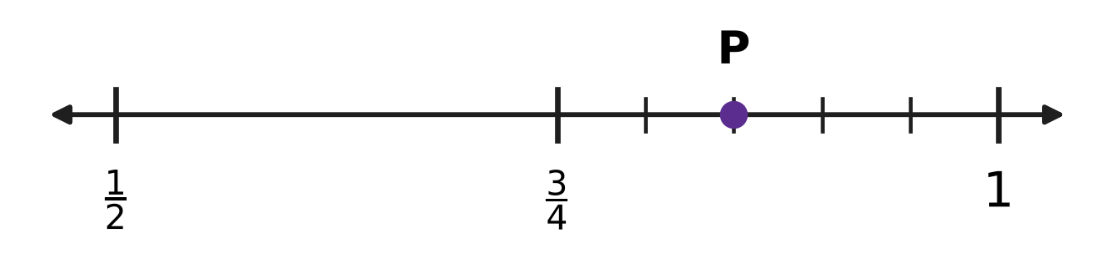
Q1. On the number line, the part from $\frac{3}{4}$ to 1 is divided into 5 equal parts. Which rational number is at the point P?
(A) $\frac{17}{20}$ | (B) $\frac{4}{5}$ | (C) $\frac{19}{20}$ | (D) $\frac{23}{20}$

Q2. Which of these fractions has a non-terminating recurring decimal expansion?
(A) $\frac{27}{150}$ | (B) $\frac{14}{45}$ | (C) $\frac{13}{64}$ | (D) $\frac{21}{56}$

Q3. The square-root spiral in the picture starts with OA = 1 unit. Each outer side AB, BC, CD, … is 1 unit long, with AB at right angles to OA, BC at right angles to OB, and so on. How many of the nine lengths OB, OC, OD, …, OJ are rational numbers? | 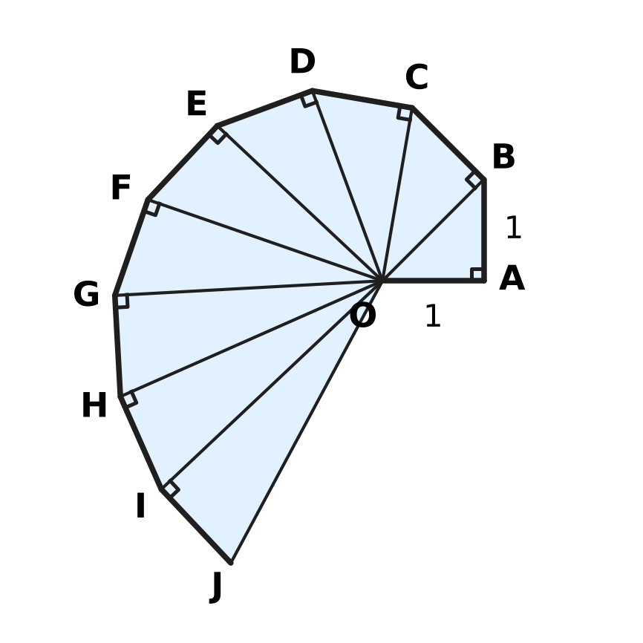
  (A) 2 | (B) 0 | (C) 3 | (D) 1

Part 2 — Fractions, Decimals & Percentages (Syllabus Chapter 3)
Stamp collection
Year | Year 1 | Year 2 | Year 3 | Year 4
Stamps in the collection | 1,000 | 1,200 | 1,440 | ?

Q4. A stamp collection grows by the same percentage every year. The table shows the number of stamps at the end of each year. How many stamps will there be at the end of Year 4?
(A) 1,640 | (B) 1,680 | (C) 1,720 | (D) 1,728

Q5. In a swimming test, 64% of the 25 boys and 80% of the 15 girls of a class passed. What percentage of the whole class passed?
(A) 28% | (B) 70% | (C) 72% | (D) 74%

Q6. A stationery shop buys a delivery van for ₹250,000. After 2 years the van is worth ₹90,000. It lost the same percentage of its value in each of the 2 years. What was the van worth after 1 year?
(A) ₹150,000 | (B) ₹170,000 | (C) ₹100,000 | (D) ₹160,000

Part 3 — Algebra (Syllabus Chapter 4)
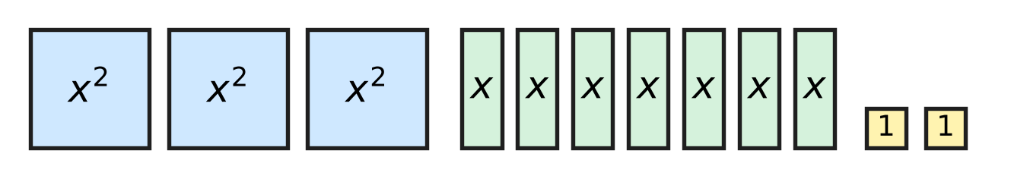
Q7. The picture shows 3 large square tiles (each of area $x^{2}$), 7 strip tiles (each of area $x$) and 2 small square tiles (each of area 1). All 12 tiles are put together, without gaps or overlaps, to make one rectangle. What are the length and breadth of the rectangle?
(A) (3x + 4) and (x + 1) | (B) (x + 1) and (x + 2)
(C) (3x + 2) and (x + 1) | (D) (3x + 1) and (x + 2)

Q8. The straight line drawn on the grid passes through the two marked points. Which equation does the line have? | 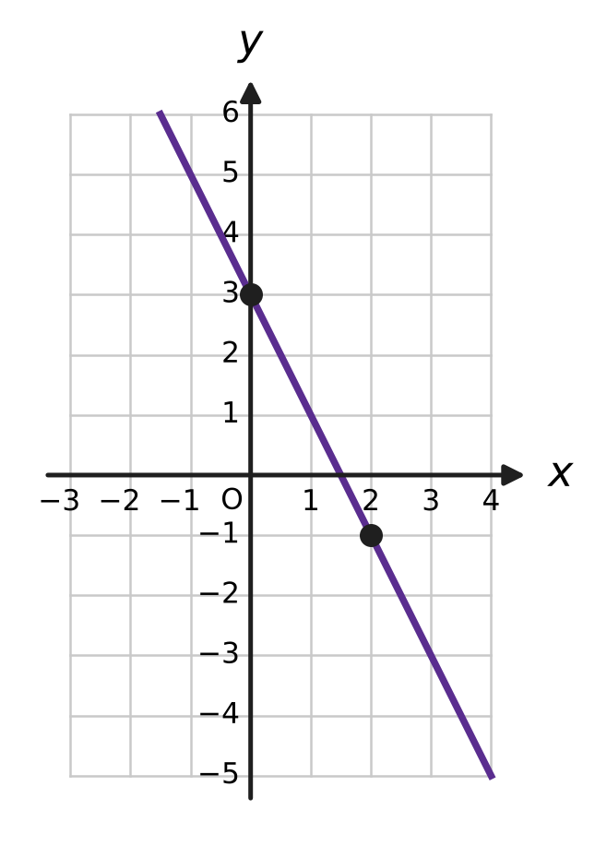
  (A) $y=3x−2$ | (B) $y=−2x+3$
  (C) $y=2x+3$ | (D) $y=−\frac{1}{2}x+3$

Q9. Ishan lays marbles in rows to make a triangle, as in the picture: 1 marble in Row 1, 2 in Row 2, 3 in Row 3, and so on. How many marbles does he need for a triangle with 24 rows? | 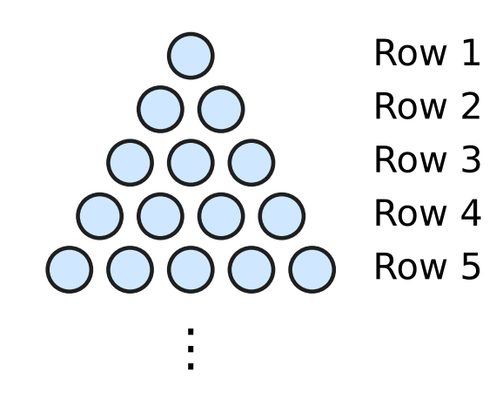
  (A) 276 | (B) 600 | (C) 300 | (D) 576

Q10. Which equation, taken together with 3x − 5y = 4, gives a pair of linear equations with infinitely many solutions?
(A) 9x − 15y = 4 | (B) 3x + 5y = 4
(C) 5x − 3y = 4 | (D) 9x − 15y = 12

Q11. Swati has a wooden cube of edge 13 cm. She makes three flat cuts, as shown by the dashed lines, each 10 cm from the same corner along an edge, so the cube splits into 8 blocks. Two of the blocks are cubes. What is the total volume of the other six blocks? | 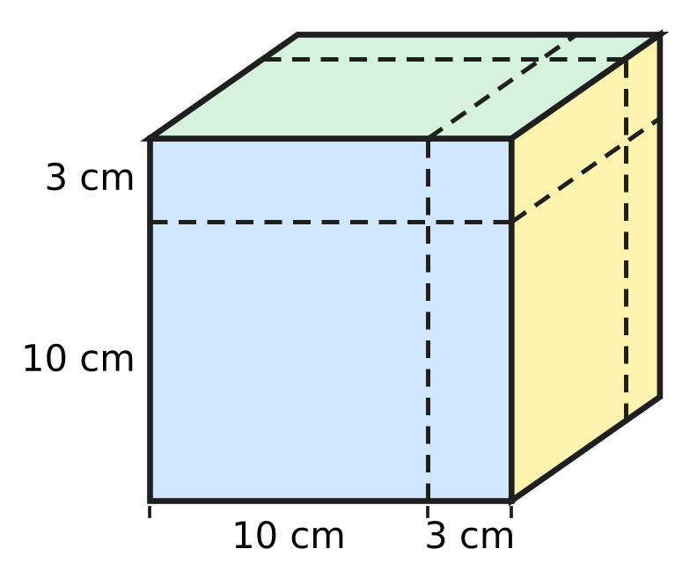
  (A) 1,197 cm³ | (B) 1,170 cm³
  (C) 1,027 cm³ | (D) 900 cm³

Q12. What is the value of $\frac{x^{2}−16}{x^{2}−2x−8}$ when x = 98?
(A) $\frac{51}{50}$ | (B) $\frac{47}{50}$ | (C) $\frac{47}{48}$ | (D) 2

Q13. In a geometric progression, the 2nd term is 12 and the 5th term is 324. What is the 1st term?
(A) −92 | (B) 3 | (C) 4 | (D) 6

Part 4 — Geometry (Syllabus Chapter 5)
Q14. M is the midpoint of the segment PQ drawn on the grid. What are the coordinates of M? | 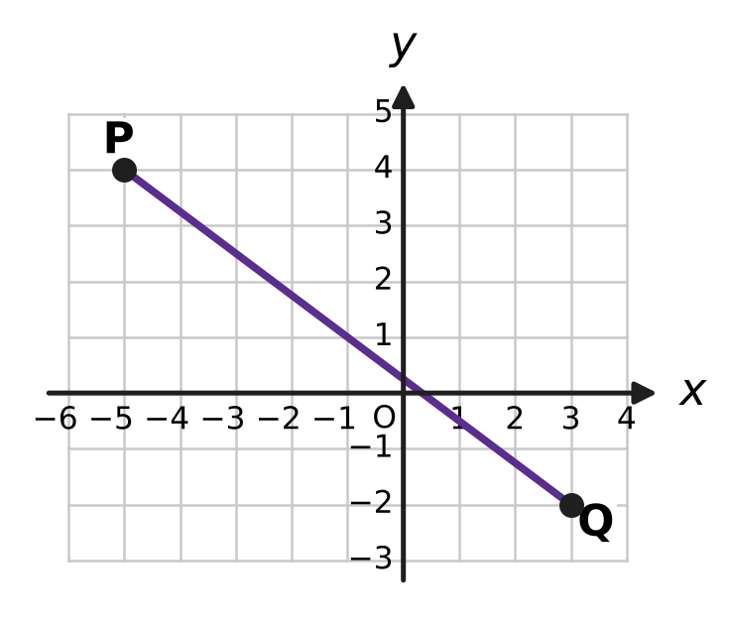
  (A) (−1, 1) | (B) (−2, 2) | (C) (1, −1) | (D) (4, −3)

Q15. ABCD is a cyclic quadrilateral. Side BC is extended to E, and ∠DCE = 84°, as shown. What is ∠BAD, marked x? | 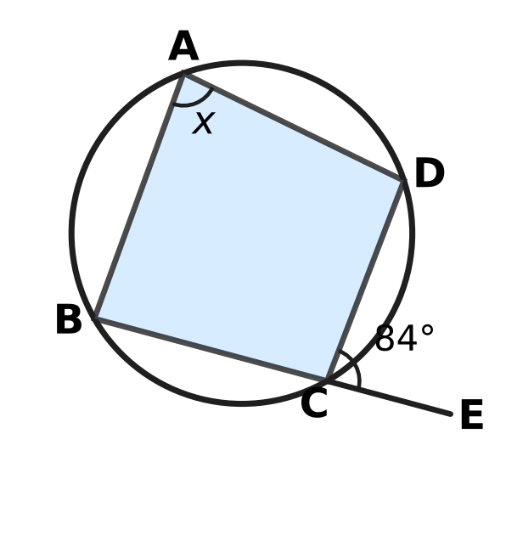
  (A) 168° | (B) 42° | (C) 96° | (D) 84°

Q16. In the figure, the circle has centre O and radius OA = 29 cm. OM is perpendicular to the chord AB and OM = 20 cm. How long is the chord AB? | 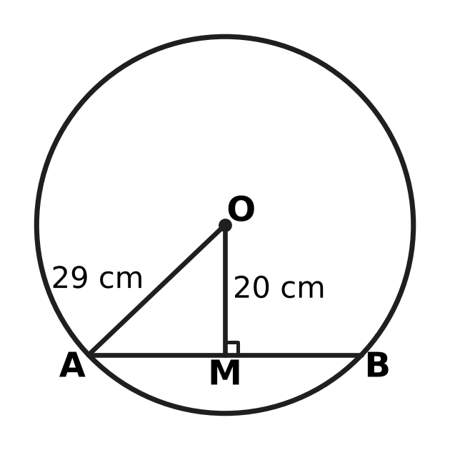
  (A) 21 cm | (B) 49 cm | (C) 42 cm | (D) 18 cm

Q17. In the figure, AB = AD and CB = CD, as shown by the marks. The diagonal AC is drawn. Which rule shows that △ABC ≅ △ADC? | 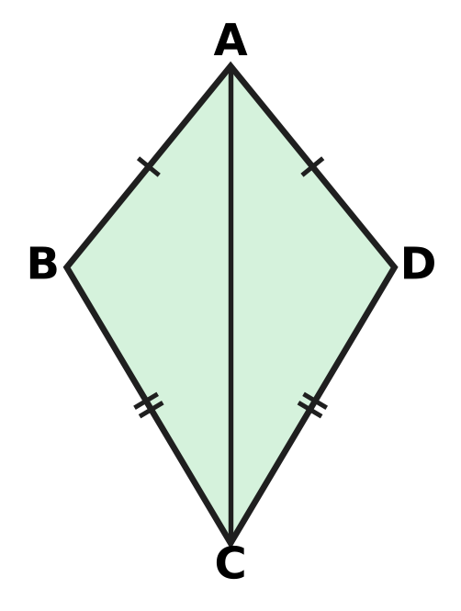
  (A) RHS | (B) SSS | (C) ASA | (D) SAS

Q18. The points A(−1, 5), B(2, 3) and C(k, −3) lie on one straight line. What is the value of k?
(A) −7 | (B) 5 | (C) 6 | (D) 11

Q19. In the figure, P, Q, R and S are the midpoints of the sides AB, BC, CD and DA of the quadrilateral ABCD. The diagonals are AC = 10 cm and BD = 14 cm. What is the perimeter of PQRS? | 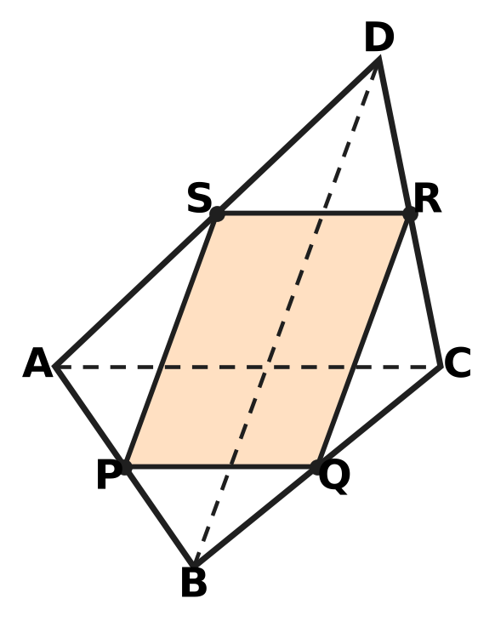
  (A) 12 cm | (B) 48 cm | (C) 20 cm | (D) 24 cm

Q20. AB is a diameter of the circle with centre O. C and D are points on the circle, and ∠CAB = 28°, as shown. What is ∠ADC, marked x? | 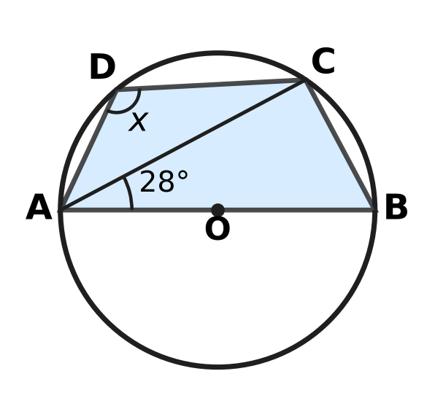
  (A) 90° | (B) 62° | (C) 118° | (D) 152°

Part 5 — Mensuration (Syllabus Chapter 6)
Q21. The wheel of Mei's bicycle has a diameter of 70 cm. How many complete turns does the wheel make in going 1.1 km? (Use π = $\frac{22}{7}$.)
(A) 250 | (B) 500 | (C) 50 | (D) 1,000

Q22. Farhan's vegetable plot is a triangle with sides 11 m, 13 m and 20 m, as shown. What is the area of the plot? | 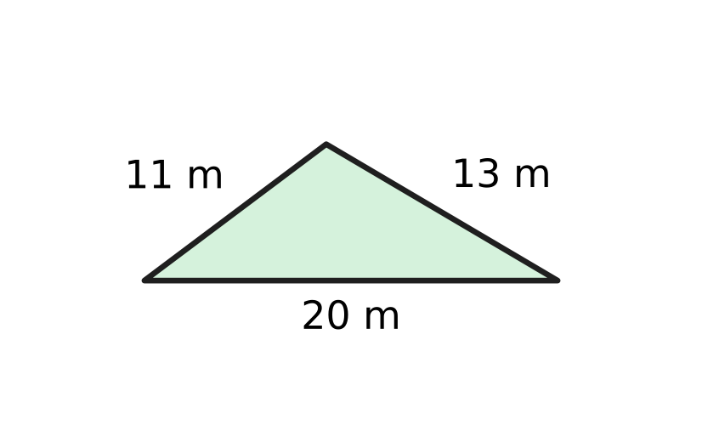
  (A) 66 m² | (B) 71.5 m² | (C) 130 m² | (D) 110 m²

Q23. A glass paperweight is a pyramid with a square base of side 12 cm and a height of 8 cm, as shown. What is its volume? | 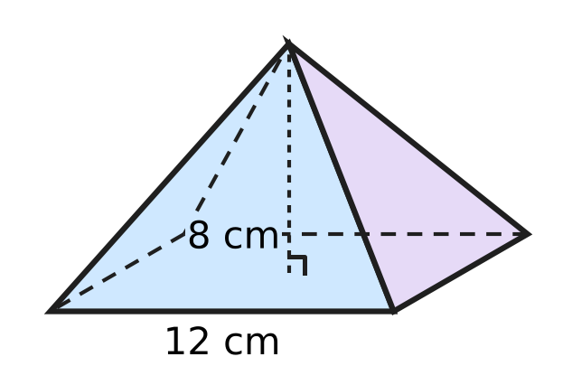
  (A) 576 cm³ | (B) 384 cm³
  (C) 32 cm³ | (D) 1,152 cm³

Q24. The figure shows a sector of a circle of radius 21 cm cut from paper. Its perimeter (two radii and the arc) is 75 cm. What is the angle θ of the sector? (Use π = $\frac{22}{7}$.) | 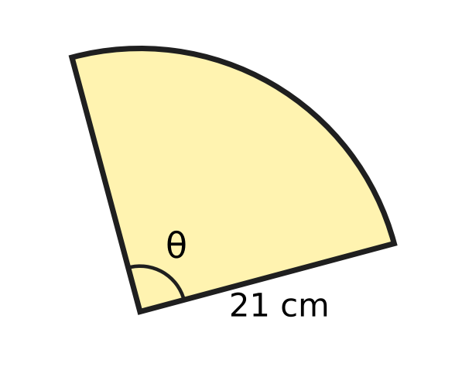
  (A) 120° | (B) 180° | (C) 90° | (D) 45°

Q25. A ball fits exactly inside a closed cylindrical tin: it touches the base, the lid and the curved side, as shown. What fraction of the tin's volume does the ball fill? | 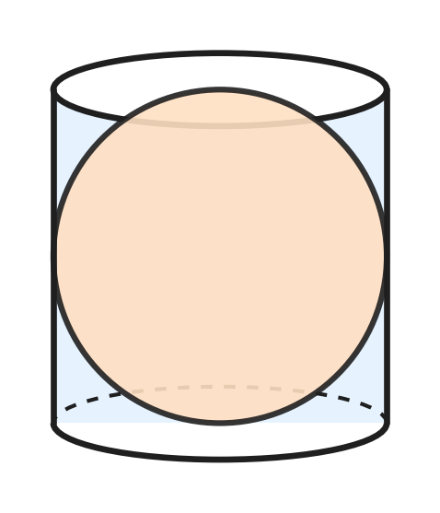
  (A) $\frac{2}{3}$ | (B) $\frac{3}{4}$ | (C) $\frac{1}{3}$ | (D) $\frac{1}{2}$

Part 6 — Data Handling, Statistics & Probability (Syllabus Chapter 8)
Picture for Q26 and Q29
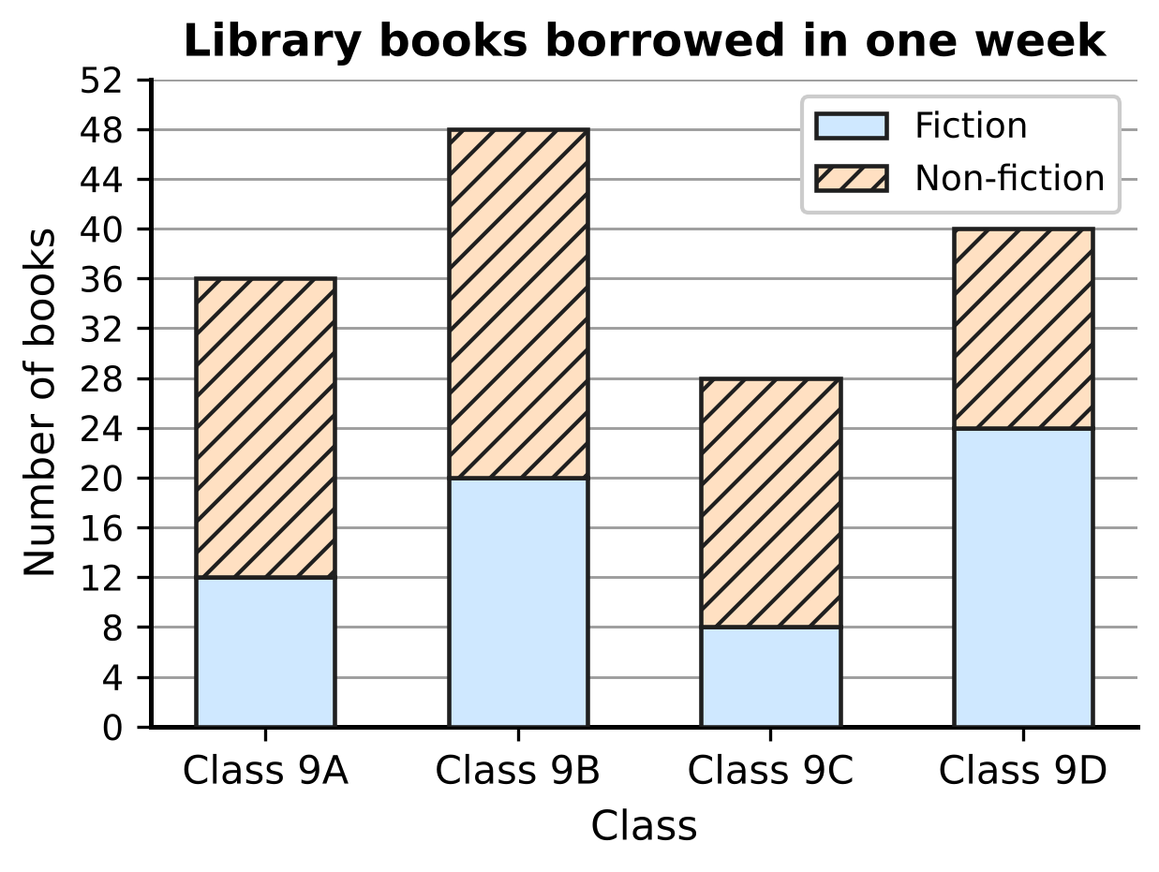
Q26. The stacked bar graph shows the fiction and non-fiction books borrowed from the school library by four classes in one week. How many non-fiction books did the four classes borrow altogether?
(A) 152 | (B) 80 | (C) 64 | (D) 88

Q27. The school bus was late on 18 of the last 60 school days. Use this record to estimate the probability that the bus is late. On about how many of the next 40 school days can the bus be expected to be late?
(A) 20 | (B) 12 | (C) 28 | (D) 18

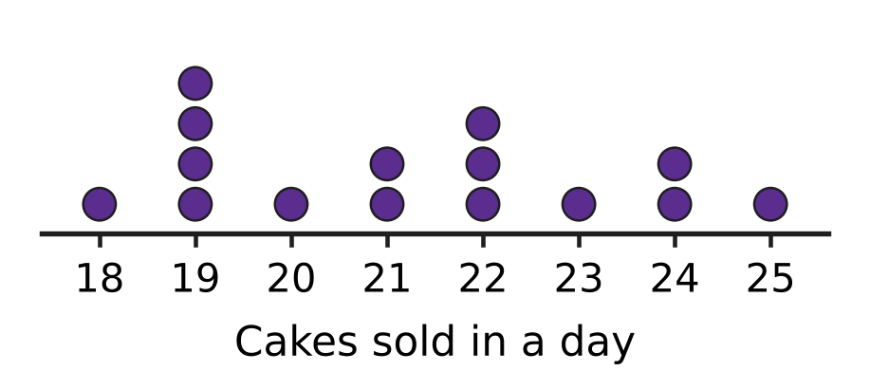
Q28. A bakery recorded the number of cakes it sold on each of 15 days. Each dot in the dot plot in the picture stands for one day. What is the median number of cakes sold in a day?
(A) 21 | (B) 21.5 | (C) 19 | (D) 22

Picture for Q26 and Q29
Q29. Use the same stacked bar graph of library books. In which class was the FRACTION of non-fiction books (out of all books borrowed by that class) the greatest?
(A) Class 9A | (B) Class 9B | (C) Class 9C | (D) Class 9D

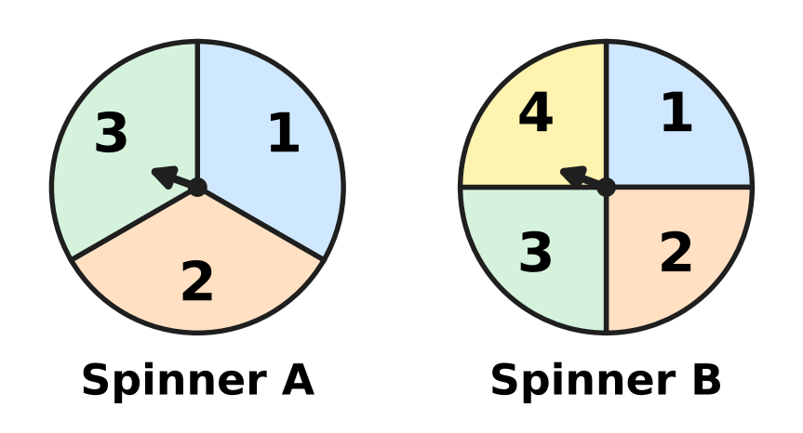
Q30. Spinner A has 3 equal parts and Spinner B has 4 equal parts, numbered as shown. Both are spun once and the two numbers are multiplied. What is the probability that the product is greater than 6?
(A) $\frac{3}{4}$ | (B) $\frac{5}{12}$ | (C) $\frac{3}{7}$ | (D) $\frac{1}{4}$

Part 7 — Applied Mathematics (Syllabus Chapter 9)
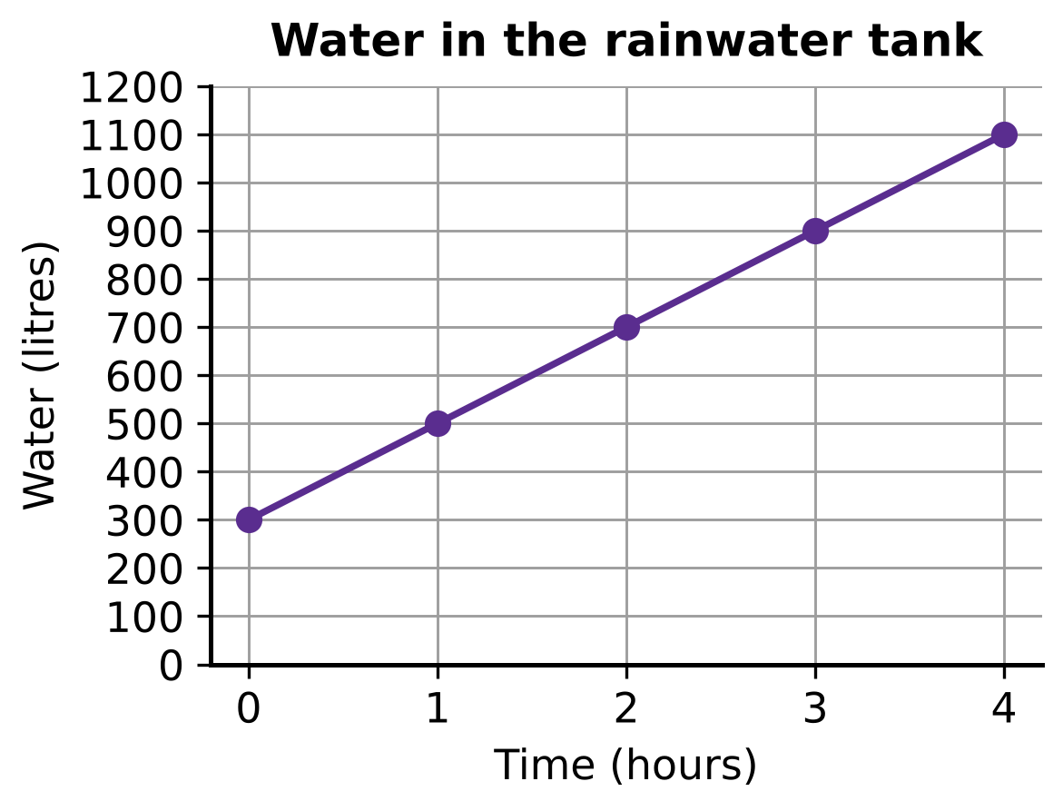
Q31. During steady rain, the water in a rainwater tank rises as shown in the graph. If it keeps rising at the same rate, how many litres of water will be in the tank after 10 hours? (The tank does not overflow.)
(A) 3,000 L | (B) 2,500 L | (C) 2,300 L | (D) 2,000 L

Q32. On the map of an apple orchard, F and G are two trees, and each unit on the grid stands for 40 m. What is the straight-line distance between the two trees? | 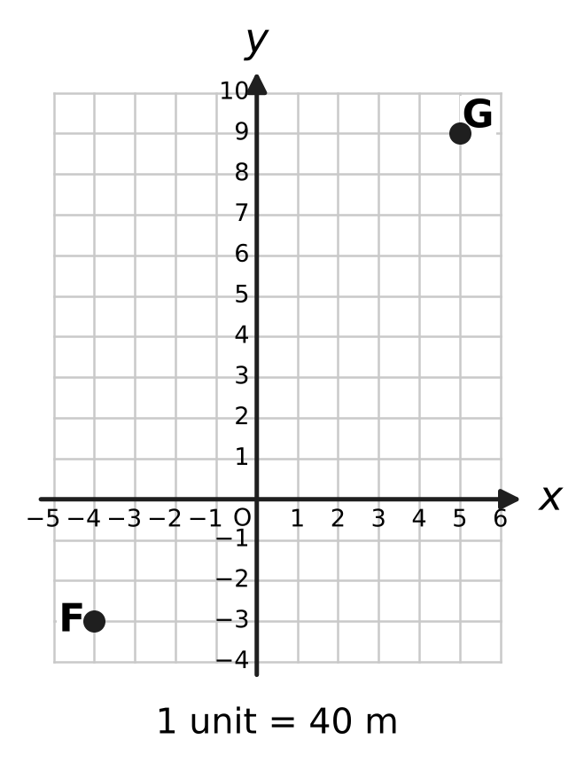
  (A) 360 m | (B) 480 m | (C) 600 m | (D) 840 m

Q33. The ages of Uday and his mother add up to 48 years. Six years ago, his mother was 5 times as old as Uday was then. How old is Uday now?
(A) 12 years | (B) 13 years | (C) 36 years | (D) 8 years

Q34. Vanya saves ₹50 in the first week. Each week after that she saves ₹15 more than in the week before. In which week does she first save more than ₹400 in that single week?
(A) Week 24 | (B) Week 23 | (C) Week 27 | (D) Week 25

Part 8 — Mathematical Reasoning & Problem-Solving (Syllabus Chapter 10)
Q35. What is the converse of the statement "If two angles form a linear pair, then they add up to 180°"?
(A) If two angles do not form a linear pair, then they do not add up to 180°.
(B) If two angles add up to 180°, then they form a linear pair.
(C) If two angles do not add up to 180°, then they do not form a linear pair.
(D) If two angles form a linear pair, then they are equal.

Q36. Which number is a counterexample to the statement "If a number is a multiple of 4, then it is a multiple of 8"?
(A) 28 | (B) 56 | (C) 14 | (D) 48

Q37. Follow the flowchart. What number does it print? | 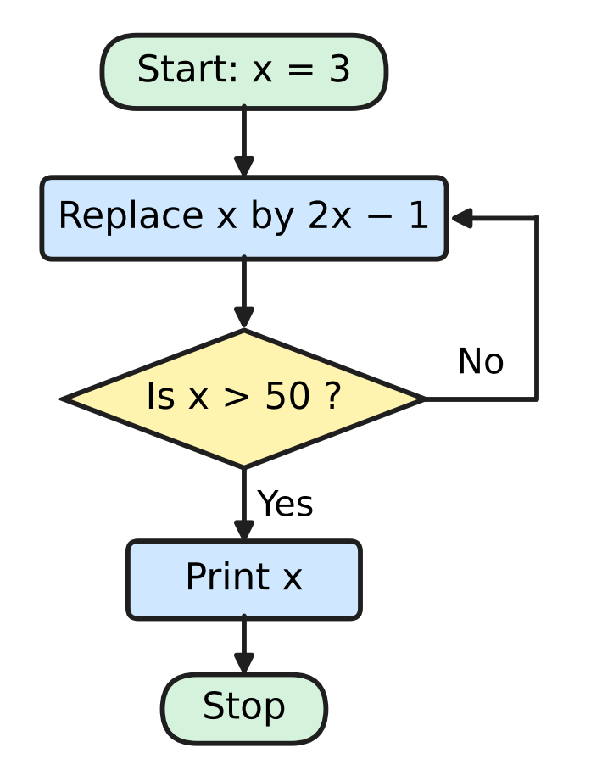
  (A) 33 | (B) 64 | (C) 65 | (D) 129

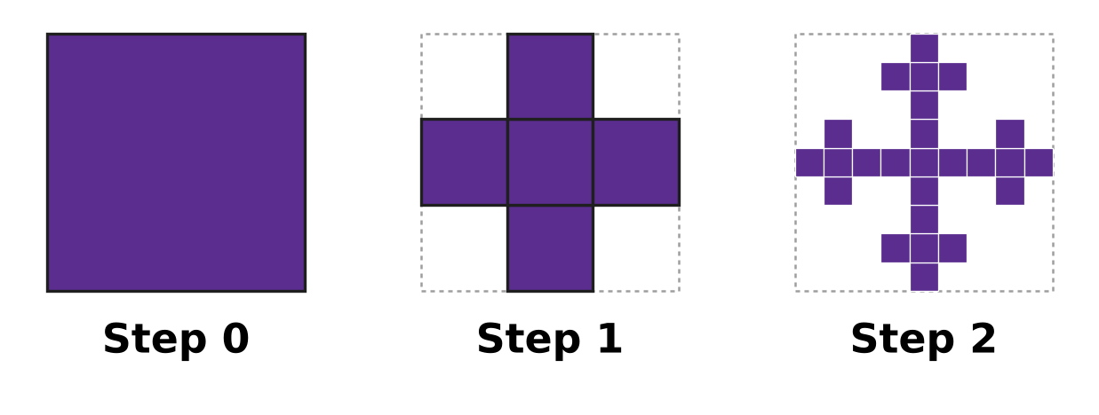
Q38. A fractal is built from a square. At each step, every shaded square is cut into 9 equal squares, and only the middle one and the four that share a side with it are kept shaded. The picture shows Steps 0, 1 and 2. How many small shaded squares are there at Step 4?
(A) 3,125 | (B) 20 | (C) 625 | (D) 125

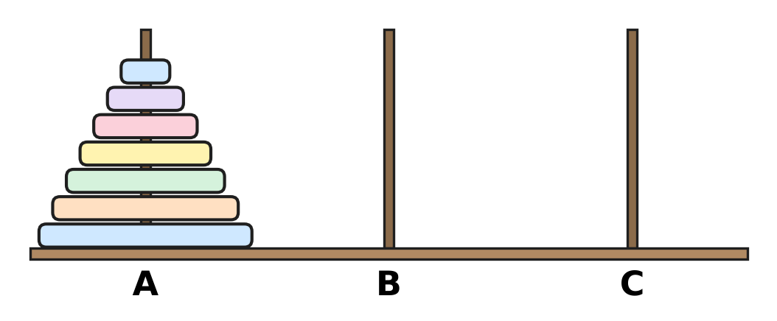
Q39. Seven discs of different sizes are on peg A, as shown. They are moved to peg C in the least possible number of moves: one disc at a time, never a larger disc on a smaller one. How many times does the third-smallest disc move?
(A) 32 | (B) 16 | (C) 4 | (D) 8

Q40. Leela wants to prove by contradiction: "If n² is a multiple of 3, then n is a multiple of 3", where n is a whole number. What should she assume at the start?
(A) n is a multiple of 3, so n² is a multiple of 3.
(B) n is a multiple of 3 but n² is not a multiple of 3.
(C) n² is not a multiple of 3 and n is not a multiple of 3.
(D) n² is a multiple of 3 but n is not a multiple of 3.

SECTION II — Star Questions 5 questions × 4 marks each
Q41. Kartik runs this algorithm.
Step 1: Put a = 7 and k = 1.
Step 2: Replace a by a × (k + 1) ÷ k.
Step 3: Replace k by k + 1.
Step 4: If k = 40, print a and stop. Otherwise go back to Step 2.
What number does the algorithm print? [4 marks]
(A) 280 | (B) 287 | (C) 273 | (D) 40

Q42. A, B, C and D lie on a circle with centre O and radius 5 cm. AC is a diameter, AB = 6 cm, and D is on the other side of AC with AD = DC, as shown. What is the area of the shaded part of the circle outside ABCD? (Use π = 3.14.) [4 marks] | 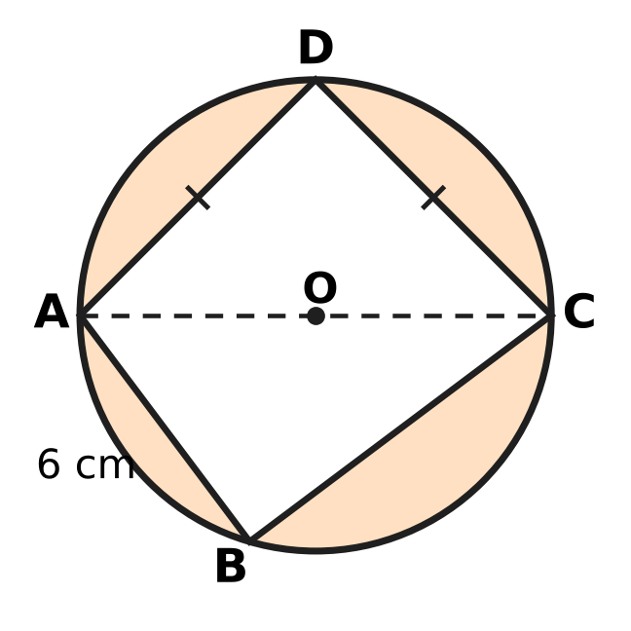
  (A) 54.5 cm² | (B) 265 cm² | (C) 29.5 cm² | (D) 53.5 cm²

Q43. ABCD is a parallelogram with vertices A(6, 1), B(−1, 6) and C(−3, 1), taken in that order. At which point does the diagonal BD cross the y-axis? [4 marks]
(A) (0, 8) | (B) (0, 1) | (C) (0, 6) | (D) (0, 4)

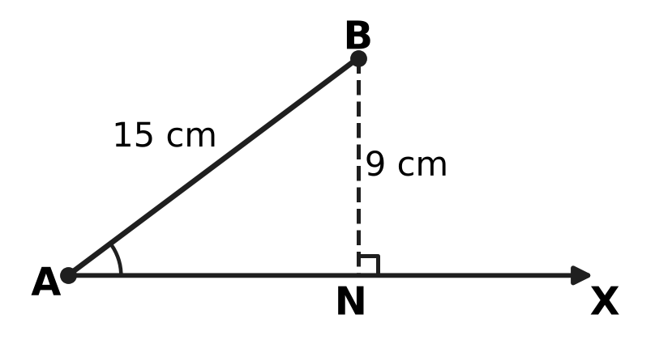
Q44. In the picture, AB = 15 cm and BN = 9 cm, where BN is perpendicular to the ray AX. A point C is placed on the ray AX, not at A, so that BC = r cm. AB and ∠A stay the same; only r changes. A whole number r is chosen at random from 1 to 20. What is the probability that C can be placed at exactly two different points on the ray, giving two different triangles ABC? [4 marks]
(A) $\frac{3}{10}$ | (B) $\frac{1}{4}$ | (C) $\frac{11}{20}$ | (D) $\frac{7}{20}$

Q45. Arnav puts ₹30,000 into two accounts. Account P pays 10% per year simple interest. Account Q pays 10% per year compounded annually. After 2 years the two accounts have earned ₹6,120 interest in total. How much did he put into Account Q? [4 marks]
(A) ₹1,200 | (B) ₹18,000 | (C) ₹15,000 | (D) ₹12,000

Answer Sheet AMO Level 1 · Class 9 · Practice Paper 1
Name: | School: | Roll No.:
Shade or tick one circle for each question.
1. Ⓐ Ⓑ Ⓒ Ⓓ | 16. Ⓐ Ⓑ Ⓒ Ⓓ | 31. Ⓐ Ⓑ Ⓒ Ⓓ
2. Ⓐ Ⓑ Ⓒ Ⓓ | 17. Ⓐ Ⓑ Ⓒ Ⓓ | 32. Ⓐ Ⓑ Ⓒ Ⓓ
3. Ⓐ Ⓑ Ⓒ Ⓓ | 18. Ⓐ Ⓑ Ⓒ Ⓓ | 33. Ⓐ Ⓑ Ⓒ Ⓓ
4. Ⓐ Ⓑ Ⓒ Ⓓ | 19. Ⓐ Ⓑ Ⓒ Ⓓ | 34. Ⓐ Ⓑ Ⓒ Ⓓ
5. Ⓐ Ⓑ Ⓒ Ⓓ | 20. Ⓐ Ⓑ Ⓒ Ⓓ | 35. Ⓐ Ⓑ Ⓒ Ⓓ
6. Ⓐ Ⓑ Ⓒ Ⓓ | 21. Ⓐ Ⓑ Ⓒ Ⓓ | 36. Ⓐ Ⓑ Ⓒ Ⓓ
7. Ⓐ Ⓑ Ⓒ Ⓓ | 22. Ⓐ Ⓑ Ⓒ Ⓓ | 37. Ⓐ Ⓑ Ⓒ Ⓓ
8. Ⓐ Ⓑ Ⓒ Ⓓ | 23. Ⓐ Ⓑ Ⓒ Ⓓ | 38. Ⓐ Ⓑ Ⓒ Ⓓ
9. Ⓐ Ⓑ Ⓒ Ⓓ | 24. Ⓐ Ⓑ Ⓒ Ⓓ | 39. Ⓐ Ⓑ Ⓒ Ⓓ
10. Ⓐ Ⓑ Ⓒ Ⓓ | 25. Ⓐ Ⓑ Ⓒ Ⓓ | 40. Ⓐ Ⓑ Ⓒ Ⓓ
11. Ⓐ Ⓑ Ⓒ Ⓓ | 26. Ⓐ Ⓑ Ⓒ Ⓓ | 41. Ⓐ Ⓑ Ⓒ Ⓓ
12. Ⓐ Ⓑ Ⓒ Ⓓ | 27. Ⓐ Ⓑ Ⓒ Ⓓ | 42. Ⓐ Ⓑ Ⓒ Ⓓ
13. Ⓐ Ⓑ Ⓒ Ⓓ | 28. Ⓐ Ⓑ Ⓒ Ⓓ | 43. Ⓐ Ⓑ Ⓒ Ⓓ
14. Ⓐ Ⓑ Ⓒ Ⓓ | 29. Ⓐ Ⓑ Ⓒ Ⓓ | 44. Ⓐ Ⓑ Ⓒ Ⓓ
15. Ⓐ Ⓑ Ⓒ Ⓓ | 30. Ⓐ Ⓑ Ⓒ Ⓓ | 45. Ⓐ Ⓑ Ⓒ Ⓓ
Q41–Q45 are Section II Star Questions (4 marks each).
For the parent or teacher
Section I correct: ______ / 40 × 2 = ______ marks Section II correct: ______ / 5 × 4 = ______ marks
Correct: ______ / 45 Score: ______ / 100
Answer Key and Solutions AMO Level 1 · Class 9 · Practice Paper 1
Quick answers
1 A | 6 A | 11 B | 16 C | 21 B | 26 D | 31 C | 36 A | 41 A
2 B | 7 D | 12 A | 17 B | 22 A | 27 B | 32 C | 37 C | 42 C
3 A | 8 B | 13 C | 18 D | 23 B | 28 A | 33 A | 38 C | 43 D
4 D | 9 C | 14 A | 19 D | 24 C | 29 C | 34 D | 39 B | 44 B
5 B | 10 D | 15 D | 20 C | 25 A | 30 D | 35 B | 40 D | 45 D
Solutions
Q | Part · level | Answer | Why?
1 | Part 1 · Ch1 · Easy | (A) $\frac{17}{20}$ | The gap from 3/4 to 1 is 1/4, so each part is 1/4 ÷ 5 = 1/20. P is 2 parts after 3/4: 15/20 + 2/20 = 17/20.
2 | Part 1 · Ch1 · Easy | (B) $\frac{14}{45}$ | 27/150 = 9/50 = 0.18, 13/64 = 0.203125 and 21/56 = 3/8 = 0.375 all terminate: each can be written over a power of 10. Dividing, 14/45 = 0.3111…, which recurs.
3 | Part 1 · Ch1 · Medium | (A) 2 | By Pythagoras OB = √2, OC = √3, OD = √4, …, OJ = √10. Only √4 = 2 and √9 = 3 are rational, so 2 of the lengths are rational.
4 | Part 2 · Ch3 · Easy | (D) 1,728 | Each year the number is multiplied by 1,200 ÷ 1,000 = 1.2 (a 20% rise). Year 4: 1,440 × 1.2 = 1,728.
5 | Part 2 · Ch3 · Easy | (B) 70% | Boys passed: 64% of 25 = 16. Girls passed: 80% of 15 = 12. So 28 of the 40 children passed, which is 70%.
6 | Part 2 · Ch3 · Medium | (A) ₹150,000 | In 2 years the value is multiplied by 90,000 ÷ 250,000 = 0.36 = 0.6 × 0.6, so it keeps 0.6 of its value each year (a 40% loss). After 1 year: ₹250,000 × 0.6 = ₹150,000.
7 | Part 3 · Ch4 · Easy | (D) (3x + 1) and (x + 2) | The area is 3x² + 7x + 2 = 3x² + 6x + x + 2 = 3x(x + 2) + 1(x + 2) = (3x + 1)(x + 2).
8 | Part 3 · Ch4 · Easy | (B) $y=−2x+3$ | The line cuts the y-axis at 3. From (0, 3) to (2, −1) it goes 4 down for 2 across, so the slope is −4 ÷ 2 = −2: y = −2x + 3.
9 | Part 3 · Ch4 · Easy | (C) 300 | Total = 1 + 2 + … + 24 = 24 × 25 ÷ 2 = 300.
10 | Part 3 · Ch4 · Easy | (D) 9x − 15y = 12 | Infinitely many solutions need the same line: every term multiplied by the same number. 3 × (3x − 5y) = 3 × 4 gives 9x − 15y = 12.
11 | Part 3 · Ch4 · Medium | (B) 1,170 cm³ | By (a + b)³ = a³ + b³ + 3ab(a + b), the six blocks have volume 3 × 10 × 3 × (10 + 3) = 1,170 cm³ (also 2,197 − 1,000 − 27).
12 | Part 3 · Ch4 · Medium | (A) $\frac{51}{50}$ | x² − 16 = (x − 4)(x + 4) and x² − 2x − 8 = (x − 4)(x + 2), so the expression is (x + 4)/(x + 2) = 102/100 = 51/50.
13 | Part 3 · Ch4 · Medium | (C) 4 | From the 2nd to the 5th term we multiply by r three times: r³ = 324 ÷ 12 = 27, so r = 3. The 1st term is 12 ÷ 3 = 4.
14 | Part 4 · Ch5 · Easy | (A) (−1, 1) | P is (−5, 4) and Q is (3, −2). M = ((−5 + 3) ÷ 2, (4 − 2) ÷ 2) = (−1, 1).
15 | Part 4 · Ch5 · Easy | (D) 84° | ∠BCD = 180° − 84° = 96°. Opposite angles of a cyclic quadrilateral add to 180°, so ∠BAD = 180° − 96° = 84°.
16 | Part 4 · Ch5 · Easy | (C) 42 cm | The perpendicular from the centre bisects the chord. AM = √(29² − 20²) = √441 = 21 cm, so AB = 2 × 21 = 42 cm.
17 | Part 4 · Ch5 · Easy | (B) SSS | AB = AD, CB = CD and AC is common to both triangles: three pairs of equal sides, so the triangles are congruent by SSS.
18 | Part 4 · Ch5 · Medium | (D) 11 | From A to B the line falls 2 for every 3 across. From B (y = 3) to C (y = −3) it falls 6, so it goes 9 across: k = 2 + 9 = 11.
19 | Part 4 · Ch5 · Medium | (D) 24 cm | By the midpoint theorem PQ = SR = ½AC = 5 cm and QR = PS = ½BD = 7 cm. Perimeter = 5 + 7 + 5 + 7 = 24 cm.
20 | Part 4 · Ch5 · Medium | (C) 118° | ∠ACB = 90° (angle in a semicircle), so ∠ABC = 90° − 28° = 62°. ABCD is cyclic, so ∠ADC = 180° − 62° = 118°.
21 | Part 5 · Ch6 · Easy | (B) 500 | One turn covers the circumference πd = 22/7 × 70 = 220 cm. Then 1.1 km = 110,000 cm, and 110,000 ÷ 220 = 500 turns.
22 | Part 5 · Ch6 · Easy | (A) 66 m² | s = (11 + 13 + 20) ÷ 2 = 22. Area = √(22 × 11 × 9 × 2) = √4,356 = 66 m².
23 | Part 5 · Ch6 · Easy | (B) 384 cm³ | Volume = ⅓ × base area × height = ⅓ × 12 × 12 × 8 = 384 cm³.
24 | Part 5 · Ch6 · Medium | (C) 90° | Arc = 75 − 2 × 21 = 33 cm. The full circumference is 2 × 22/7 × 21 = 132 cm, so θ = 33/132 × 360° = 90°.
25 | Part 5 · Ch6 · Medium | (A) $\frac{2}{3}$ | The tin has radius r and height 2r, so its volume is πr² × 2r = 2πr³. The ball's volume is (4/3)πr³, and (4/3) ÷ 2 = 2/3.
26 | Part 6 · Ch8 · Easy | (D) 88 | Non-fiction = top of the bar − top of the fiction part: 9A 36 − 12 = 24, 9B 48 − 20 = 28, 9C 28 − 8 = 20, 9D 40 − 24 = 16. Total = 88.
27 | Part 6 · Ch8 · Easy | (B) 12 | Empirical probability of being late = 18/60 = 0.3. Expected late days = 0.3 × 40 = 12.
28 | Part 6 · Ch8 · Easy | (A) 21 | There are 15 values, so the median is the 8th in order. Counting dots from the left: 1 + 4 + 1 = 6 up to 20, then the 7th and 8th are 21. Median = 21.
29 | Part 6 · Ch8 · Medium | (C) Class 9C | Non-fiction shares: 9A 24/36 = 2/3, 9B 28/48 = 7/12, 9C 20/28 = 5/7, 9D 16/40 = 2/5. The greatest is 5/7, for Class 9C.
30 | Part 6 · Ch8 · Medium | (D) $\frac{1}{4}$ | There are 3 × 4 = 12 equally likely pairs. Products greater than 6: 2 × 4 = 8, 3 × 3 = 9, 3 × 4 = 12, so 3 pairs. Probability = 3/12 = 1/4.
31 | Part 7 · Ch9 · Easy | (C) 2,300 L | The tank starts with 300 L and gains 200 L each hour: water = 300 + 200 × hours. After 10 hours: 300 + 2,000 = 2,300 L.
32 | Part 7 · Ch9 · Easy | (C) 600 m | F is (−4, −3) and G is (5, 9). The gaps are 9 and 12 units, so FG = √(9² + 12²) = 15 units = 15 × 40 = 600 m.
33 | Part 7 · Ch9 · Medium | (A) 12 years | Let Uday be u and his mother m years old: u + m = 48 and m − 6 = 5(u − 6). Then 48 − u − 6 = 5u − 30, so 6u = 72 and u = 12.
34 | Part 7 · Ch9 · Medium | (D) Week 25 | Saving in week n = 50 + 15(n − 1). Week 24: 50 + 345 = ₹395; week 25: 50 + 360 = ₹410. So week 25 is the first.
35 | Part 8 · Ch10 · Easy | (B) If two angles add up to 180°, then they form a linear pair. | The converse of "If P, then Q" is "If Q, then P". Here P is "the angles form a linear pair" and Q is "they add up to 180°".
36 | Part 8 · Ch10 · Easy | (A) 28 | A counterexample must make the "if" part true and the "then" part false: 28 is a multiple of 4 (4 × 7) but not of 8.
37 | Part 8 · Ch10 · Easy | (C) 65 | x goes 3 → 5 → 9 → 17 → 33 → 65. The first value more than 50 is 65, so 65 is printed.
38 | Part 8 · Ch10 · Easy | (C) 625 | Each step multiplies the number of shaded squares by 5: 1, 5, 25, 125, 625. At Step 4 there are 5⁴ = 625.
39 | Part 8 · Ch10 · Medium | (B) 16 | The least number of moves is 127. The smallest disc moves on every other move: 64 times. Each larger disc moves half as often: 64, 32, 16, … So the third-smallest moves 16 times.
40 | Part 8 · Ch10 · Medium | (D) n² is a multiple of 3 but n is not a multiple of 3. | To prove "If P, then Q" by contradiction, assume P is true and Q is false: n² is a multiple of 3 but n is not, and show this is impossible.
41 | Section II · Ch4 + Ch10 · Hard | (A) 280 | a goes 7 → 7 × 2/1 = 14 → 14 × 3/2 = 21 → 21 × 4/3 = 28, so after each round a = 7 × k. The fractions cancel, so when k = 40, a = 7 × 40 = 280.
42 | Section II · Ch5 + Ch6 · Hard | (C) 29.5 cm² | ∠ABC = 90° (angle in a semicircle), so BC = √(10² − 6²) = 8 cm and △ABC = 24 cm². D is the midpoint of arc AC, so its height above AC is the radius: △ADC = ½ × 10 × 5 = 25 cm². Shaded area = 3.14 × 25 − 49 = 78.5 − 49 = 29.5 cm².
43 | Section II · Ch4 + Ch5 · Hard | (D) (0, 4) | The diagonals bisect each other, so D = A + C − B = (6 − 3 + 1, 1 + 1 − 6) = (4, −4). Line BD: slope (−4 − 6) ÷ (4 + 1) = −2, so y = −2x + 4. It crosses the y-axis at (0, 4).
44 | Section II · Ch8 + Ch10 · Hard | (B) $\frac{1}{4}$ | The circle of radius r about B meets the ray at two points only when 9 < r < 15. At r = 9 it touches at N, and for r ≥ 15 the second point is at A or behind it. So r = 10, 11, 12, 13, 14: probability 5/20 = 1/4.
45 | Section II · Ch3 + Ch9 · Hard | (D) ₹12,000 | In 2 years ₹100 earns ₹20 simple interest but ₹21 compound interest. If all ₹30,000 earned simple interest the total would be ₹6,000; the extra ₹120 is 1% of Account Q, so Q = ₹12,000 (and P = ₹18,000).

