UNLOCK IQ INSTITUTE
Realize Your True Potential
Aryabhatta Maths Olympiad (AMO)
Level 1 — Practice Paper 2
CLASS 9

Questions | 45 multiple-choice questions
Marks | 100
Time | 60 minutes
Section I | 40 questions × 2 marks = 80 marks
Section II | 5 Star Questions × 4 marks = 20 marks
Negative marking | No negative marking
Calculator | Not allowed
Chapters | Number System · Fractions, Decimals & Percentages · Algebra · Geometry · Mensuration · Data Handling · Applied Mathematics · Mathematical Reasoning

Instructions to candidates
• This paper has 45 multiple-choice questions. Each question has four answer choices, of which exactly one is correct.
• Section I (Q1–Q40) carries 2 marks per question. Section II (Q41–Q45) carries 4 marks per question.
• There is no negative marking. Unanswered questions score zero.
• Calculators are not permitted. Rough work may be done on a separate sheet.
• Mark your answers on the answer sheet at the end of the paper.
• All figures are not necessarily drawn to scale unless stated.

For parents and teachers
Print or view this paper in colour. Pictures are part of the questions.
Parts follow the AMO syllabus chapters. Chapters 2 and 7 are not part of the Class 9 syllabus, so the chapter numbers shown in the Part headings have gaps.
The answer sheet and the answer key are at the end. Remove only the answer key before the student begins.

Name: | School: | Roll No.:

SECTION I 40 questions × 2 marks each
Part 1 — Number System (Syllabus Chapter 1)
Q1. Which of these numbers is irrational?
(A) 0.1011111… (the digit 1 repeats for ever)
(B) 0.1011011101111 (the decimal ends after the last 1 shown)
(C) 0.101101101… (the block 101 repeats for ever)
(D) 0.1011011101111… (each group of 1s has one more 1 than the group before it)

Q2. The fraction $\frac{13}{160}$ is written as a decimal. How many digits does it have after the decimal point?
(A) 1 | (B) 4 | (C) 5 | (D) 6

Q3. $\frac{3}{7}$ = 0.428571428571…, where the block 428571 repeats for ever. What is the 50th digit after the decimal point?
(A) 1 | (B) 2 | (C) 4 | (D) 8

Part 2 — Fractions, Decimals & Percentages (Syllabus Chapter 3)
Q4. The number of birds nesting on an island falls by 10% every year. By what percentage does the number fall over 2 years altogether?
(A) 1% | (B) 19% | (C) 20% | (D) 81%

Q5. On a train journey, the train runs for 2 hours at 60 km/h and then for 3 hours at 80 km/h. What is its average speed for the whole journey?
(A) 68 km/h | (B) 70 km/h | (C) 72 km/h | (D) 75 km/h

Q6. Vijay wants to put ₹10,000 into a savings scheme for 2 years. Which of these schemes gives him the most money at the end of the 2 years?
(A) 15% per year, simple interest | (B) 14% per year, compounded annually
(C) 16% per year, simple interest | (D) 15% per year, compounded annually

Part 3 — Algebra (Syllabus Chapter 4)
Q7. Which of these is a polynomial of degree 3?
(A) $(2x−1)(x^{2}+4)$ | (B) $x^{2}(x^{2}+x)$
(C) $x(x^{2}−3)−x^{3}+5$ | (D) $x^{3}+\frac{2}{x}$

Q8. Using an identity, find the value of 1,001² − 999².
(A) 4 | (B) 2,000 | (C) 4,000 | (D) 8,000

Q9. The linear polynomial p(x) = ax + b has p(0) = 5 and p(2) = −1. What is p(4)?
(A) −13 | (B) −7 | (C) −3 | (D) 11

Q10. Which of these numbers is NOT a term of the geometric progression 3, −6, 12, −24, …?
(A) −96 | (B) 48 | (C) 192 | (D) 96

Q11. Which of these is a factor of $6x^{2}+x−15$?
(A) $x+3$ | (B) $3x−5$ | (C) $2x+3$ | (D) $2x−3$

Q12. At a toy shop, a kite costs ₹30 and a ball costs ₹50. Jai spends exactly ₹600 on kites and balls, and he buys at least one of each. In how many different ways can he do this?
(A) 2 | (B) 3 | (C) 4 | (D) 5

Q13. Which term of the arithmetic progression 100, 93, 86, 79, … is its first negative term?
(A) the 14th term | (B) the 15th term
(C) the 16th term | (D) the 17th term

Part 4 — Geometry (Syllabus Chapter 5)
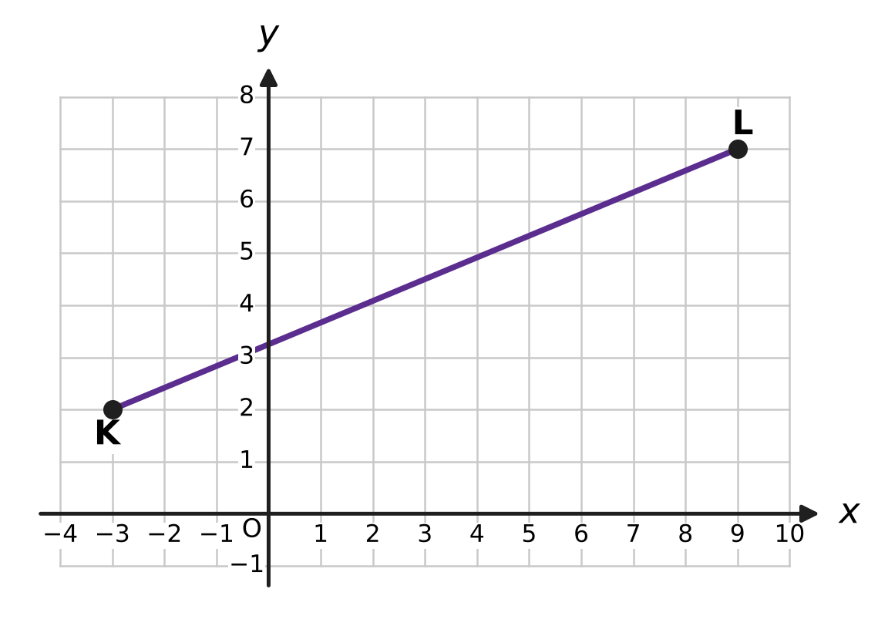
Q14. The points K and L are marked on the grid. What is the length of the segment KL? (Each square of the grid is 1 unit by 1 unit.)
(A) 7 units | (B) 13 units
(C) 17 units | (D) 169 units

Q15. In the figure of △ABC, D is the midpoint of AB and E is the midpoint of AC, as the marks show. ∠ADE = 64° and ∠AED = 50°. What is ∠ABC, marked x? | 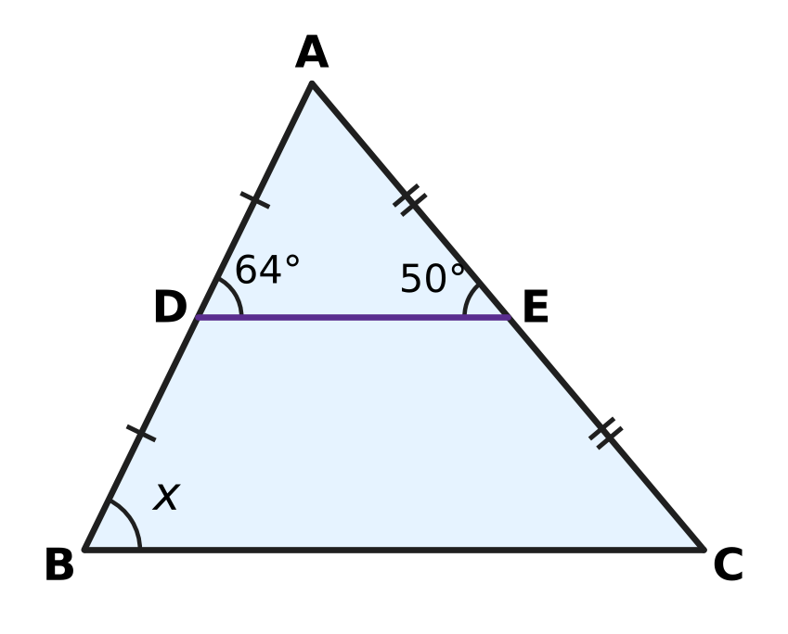
  (A) 64° | (B) 66° | (C) 50° | (D) 116°

Q16. Which of these quadrilaterals must be a parallelogram?
(A) a quadrilateral in which both pairs of opposite angles are equal
(B) a quadrilateral whose diagonals are perpendicular
(C) a quadrilateral whose diagonals are equal
(D) a quadrilateral in which one pair of opposite sides is parallel and the other pair is equal

Q17. The angles ∠A, ∠B, ∠C, ∠D of a quadrilateral ABCD are listed in that order. For which of these can A, B, C and D all lie on one circle?
(A) 85°, 95°, 85°, 95° | (B) 100°, 80°, 70°, 110°
(C) 60°, 120°, 110°, 70° | (D) 75°, 115°, 105°, 65°

Q18. A, B and C lie on a circle with centre O. C is on the minor arc AB and ∠ACB = 118°, as shown. What is ∠AOB, marked x? | 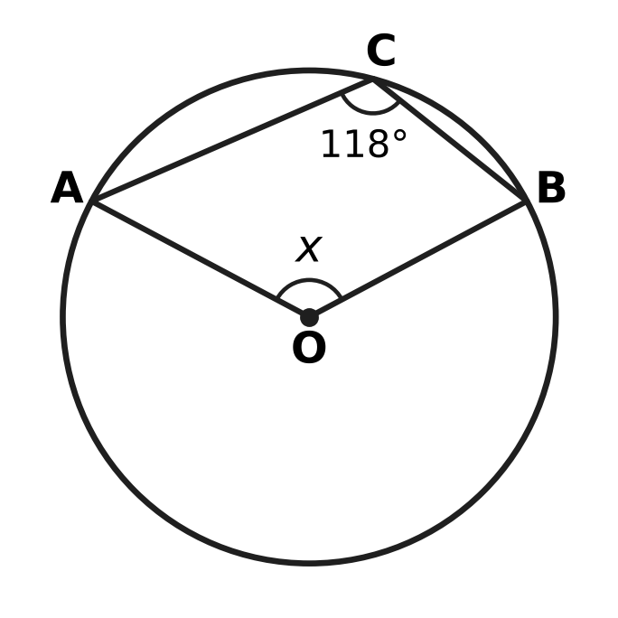
  (A) 124° | (B) 236° | (C) 59° | (D) 118°

Q19. The side lengths of four triangles are given. For which of these triangles does the circumcentre lie OUTSIDE the triangle?
(A) 7 cm, 8 cm, 10 cm | (B) 10 cm, 10 cm, 14 cm
(C) 8 cm, 15 cm, 17 cm | (D) 9 cm, 12 cm, 16 cm

Q20. ABCD is a parallelogram with ∠DAB = 76°. The bisector of ∠DAB meets the side DC at P, as shown. What is ∠APC, marked x? | 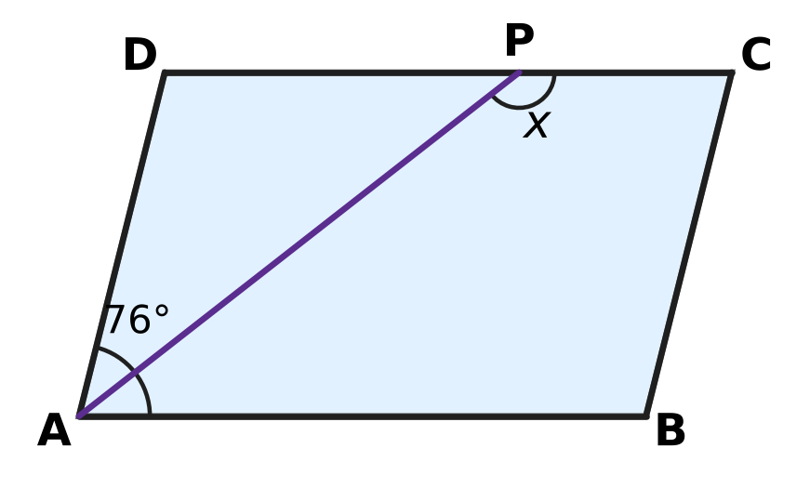
  (A) 142° | (B) 114° | (C) 104° | (D) 38°

Part 5 — Mensuration (Syllabus Chapter 6)
Q21. Which of these shapes has the same area as a circle of radius 14 cm? (Use π = $\frac{22}{7}$.)
(A) a square of side 25 cm
(B) a rectangle 88 cm long and 14 cm wide
(C) a triangle with base 44 cm and height 14 cm
(D) a rectangle 44 cm long and 14 cm wide

Q22. Simran's juice can is a closed cylinder with radius 3.5 cm and height 10 cm, as shown. How much juice can it hold when full? (Use π = $\frac{22}{7}$.) | 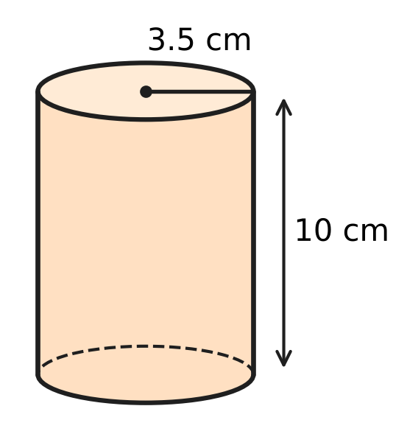
  (A) 110 cm³ | (B) 220 cm³
  (C) 385 cm³ | (D) 1,540 cm³

Q23. A curved stretch of road is an arc of a circle of radius 630 m. The arc makes an angle of 40° at the centre of the circle. How long is the curved stretch? (Use π = $\frac{22}{7}$.)
(A) 220 m | (B) 440 m | (C) 880 m | (D) 3,960 m

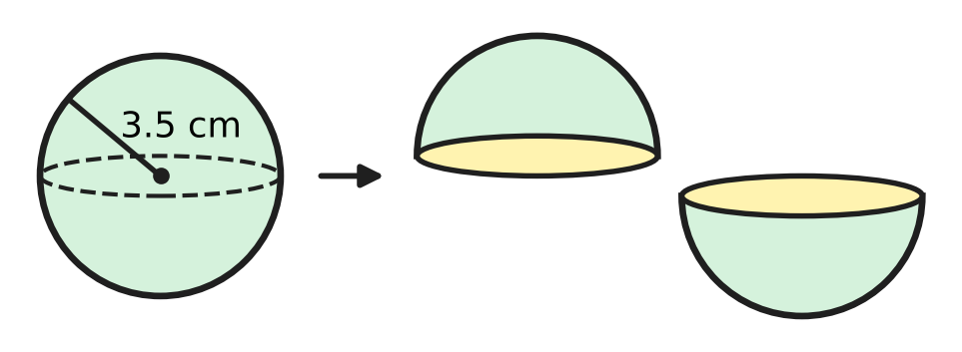
Q24. Kush has a solid wooden ball of radius 3.5 cm. He cuts it into two equal halves, as shown. By how much is the total surface area of the two halves more than the surface area of the ball? (Use π = $\frac{22}{7}$.)
(A) 38.5 cm² | (B) 77 cm²
(C) 115.5 cm² | (D) 154 cm²

Q25. A triangular plot ABC has sides 13 m, 20 m and 21 m, as shown. A straight fence runs from A to M, the midpoint of BC. What is the area of each of the two parts? | 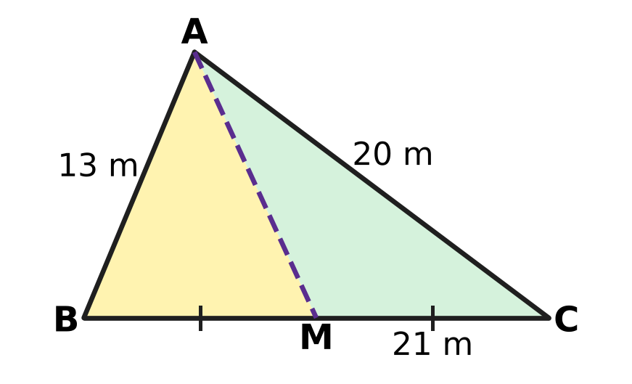
  (A) 42 m² | (B) 63 m² | (C) 65 m² | (D) 126 m²

Part 6 — Data Handling, Statistics & Probability (Syllabus Chapter 8)
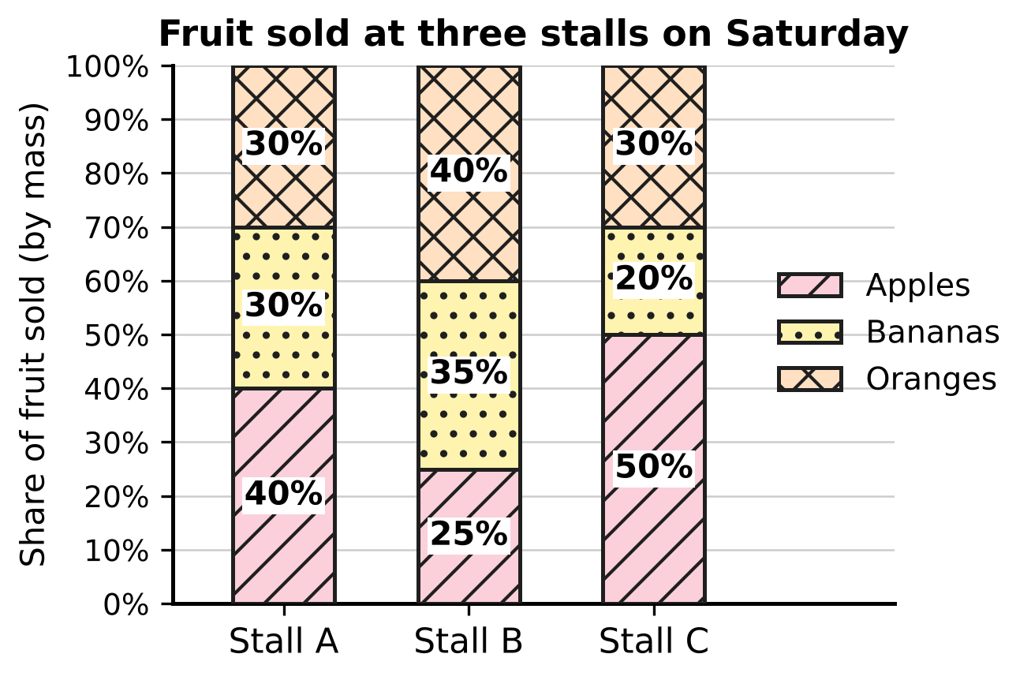
Q26. The 100% stacked bar graph shows how the fruit sold at three stalls of a fruit market on Saturday was shared among apples, bananas and oranges. Stall B sold 400 kg of fruit in all. How many kilograms of bananas did Stall B sell?
(A) 35 kg | (B) 100 kg | (C) 140 kg | (D) 160 kg

Pihu's 200 throws
Number on the die | 1 | 2 | 3 | 4 | 5 | 6
Number of times | 30 | 36 | 28 | 40 | 32 | 34

Q27. Pihu throws a die 200 times and records the results in the table. Based on her results, what is the empirical probability of getting a number greater than 4?
(A) 0.17 | (B) 0.33 | (C) 0.53 | (D) 0.66

Q28. Which of these events has a probability of exactly one half?
(A) a fair die shows a number greater than 2
(B) two fair coins tossed together show at least one tail
(C) a card drawn at random from cards numbered 1 to 12 shows a factor of 12
(D) a card drawn at random from cards numbered 1 to 20 shows a prime number

Q29. Mahi has a bag with 1 red bead and 3 green beads for a necklace. She takes a bead at random, notes its colour and puts it back. Then she takes a bead at random again. What is the probability that both beads are the same colour?
(A) $\frac{5}{8}$ | (B) $\frac{1}{2}$ | (C) $\frac{9}{16}$ | (D) $\frac{3}{8}$

Q30. A teacher worked out the mean of 10 test scores as 24. Later she found that a score of 47 had been copied as 74. What is the correct mean of the 10 scores?
(A) 21 | (B) 21.3 | (C) 23.7 | (D) 26.7

Part 7 — Applied Mathematics (Syllabus Chapter 9)
Q31. On a floor plan of a classroom, 1 unit stands for 50 cm. The teacher's table is at the origin (0, 0). Which of these desks is exactly 2.5 m (in a straight line) from the teacher's table?
(A) Desk L at (2, 3) | (B) Desk M at (2.5, 0)
(C) Desk K at (3, 4) | (D) Desk N at (5, 5)

Q32. Before sports day, four children practise penalty kicks. Their records are given below. Using these records, which child is the most likely to score with the next kick?
(A) Jaya: 20 goals from 30 kicks | (B) Mihir: 26 goals from 40 kicks
(C) Geeta: 33 goals from 50 kicks | (D) Pavan: 17 goals from 25 kicks

Q33. At a picnic in the park, every sandwich has the same price and every juice has the same price. Veena says, "3 sandwiches and 2 juices cost ₹130, and 6 sandwiches and 4 juices cost ₹250." Which of these is true?
(A) A sandwich costs ₹30 and a juice costs ₹20.
(B) Any prices that fit the first statement also fit the second.
(C) A sandwich costs ₹20 and a juice costs ₹35.
(D) Veena's two statements cannot both be correct.

Q34. Gaurav paints a fence 65 m long. He paints 2 m on the first day, 3 m on the second day, and each day after that 1 m more than on the day before. On which day does he finish the fence?
(A) Day 9 | (B) Day 10 | (C) Day 11 | (D) Day 33

Part 8 — Mathematical Reasoning & Problem-Solving (Syllabus Chapter 10)
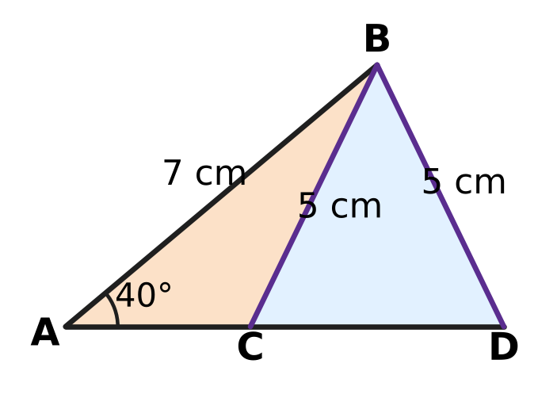
Q35. Yuvan drew the figure. In △ABC and △ABD, AB = 7 cm is common, the angle at A is 40° in both, and BC = BD = 5 cm. The two triangles are clearly different. Which of these does the figure show?
(A) Two sides and the included angle do not always fix a triangle.
(B) Three sides do not always fix a triangle.
(C) Two sides and a non-included angle do not always fix a triangle.
(D) Two triangles with one equal side and one equal angle are always congruent.

Q36. Which of these is a special case of the result "The diagonals of a parallelogram bisect each other"?
(A) The diagonals of a rectangle bisect each other.
(B) If the diagonals of a quadrilateral bisect each other, it is a parallelogram.
(C) The diagonals of any quadrilateral bisect each other.
(D) The diagonals of a rectangle are equal.

Q37. Atharv follows this algorithm. Step 1: Write down 79,868. Step 2: Replace the number by the sum of its digits. Step 3: If the number has more than one digit, go back to Step 2; otherwise print it and stop. What number is printed?
(A) 2 | (B) 9 | (C) 11 | (D) 38

Q38. A sequence has the recursive rule $a_{1}=2$ and $a_{n}=2a_{n−1}+1$. Which of these explicit rules gives the same sequence?
(A) $a_{n}=3n−1$ | (B) $a_{n}=n^{2}+1$
(C) $a_{n}=3×2^{n−1}−1$ | (D) $a_{n}=\frac{n(n+3)}{2}$

Q39. An algorithm starts with a whole number. In each step, if the number is even it is halved, and if it is odd 1 is subtracted from it. The algorithm stops when the number becomes 1. Which of these starting numbers needs the most steps?
(A) 63 | (B) 64 | (C) 96 | (D) 100

Q40. Which of these statements is TRUE but has a FALSE converse?
(A) If a triangle has two equal sides, then it has two equal angles.
(B) If x² = 49, then x = 7.
(C) If a whole number ends in 0 or 5, then it is divisible by 5.
(D) If a quadrilateral is a rhombus, then its diagonals are perpendicular to each other.

SECTION II — Star Questions 5 questions × 4 marks each
Q41. Tanya's algorithm builds a list of whole numbers.
(1) Write 7 as the first number of the list.
(2) Add 6 to the last number in the list. If the result is less than 1,000, write it in the list and repeat instruction (2); if not, stop.
How many numbers in the finished list are perfect squares? [4 marks]
(A) 10 | (B) 5 | (C) 15 | (D) 11

Q42. A, B, C and D lie in that order on a circle with centre O and radius 42 cm. In the cyclic quadrilateral ABCD, ∠ABC = 5 × ∠ADC. The chord AC cuts off the shaded minor segment, as shown. Take π = $\frac{22}{7}$. What is the perimeter of the shaded segment? [4 marks] | 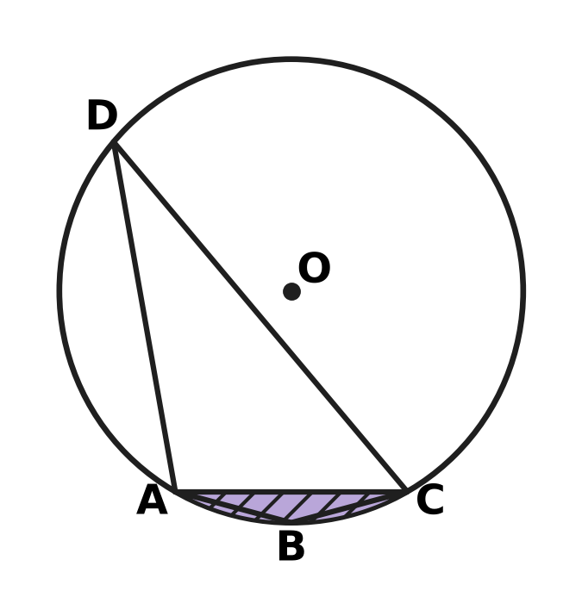
  (A) 44 cm | (B) 86 cm | (C) 128 cm | (D) 262 cm

Q43. The lines y = 2x + 1 and x + 2y = 12 meet at the point P. The first line cuts the y-axis at A and the second line cuts the y-axis at B. Which of these is the centre of the circle that passes through P, A and B? [4 marks]
(A) $(\frac{2}{3},4)$ | (B) (1, 5.5) | (C) (0, 3.5) | (D) (1, 3)

Q44. Lena starts with the number 1 and tosses a fair coin three times. After each toss she changes her number: for heads (H) she multiplies it by 3, and for tails (T) she adds 5 to it. The tree diagram shows the 8 equally likely ways the three tosses can fall. What is the probability that her final number is greater than 25? [4 marks] | 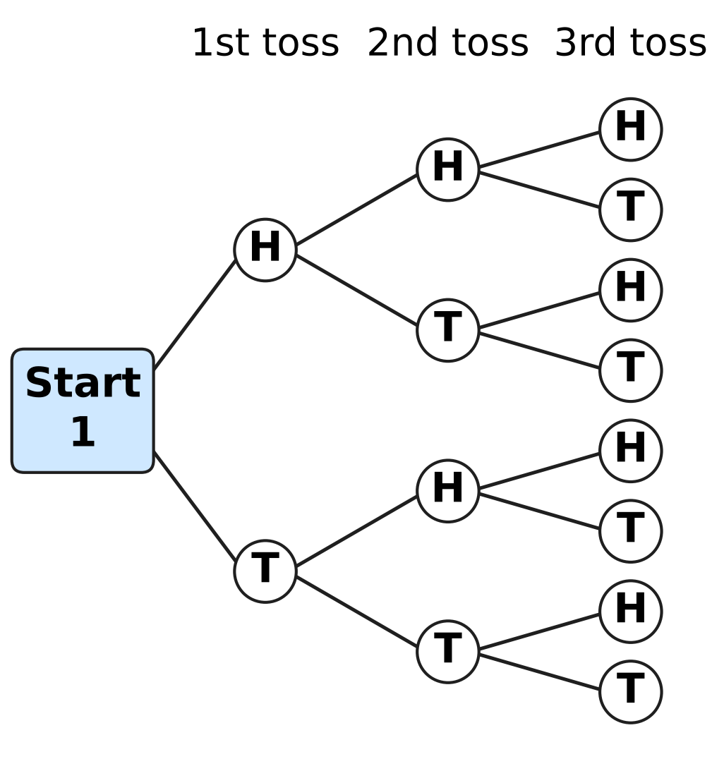
  (A) $\frac{3}{8}$ | (B) $\frac{5}{8}$ | (C) $\frac{1}{8}$ | (D) $\frac{1}{2}$

Q45. A fish farm has 2,000 fish at the start. During each year the number of fish grows by 50%. At the end of each of the 2 years, Umesh sells the same number of fish. Just after the second sale there are 3,000 fish. How many fish does he sell each year? [4 marks]
(A) 500 | (B) 600 | (C) 750 | (D) 1,500

Answer Sheet AMO Level 1 · Class 9 · Practice Paper 2
Name: | School: | Roll No.:
Shade or tick one circle for each question.
1. Ⓐ Ⓑ Ⓒ Ⓓ | 16. Ⓐ Ⓑ Ⓒ Ⓓ | 31. Ⓐ Ⓑ Ⓒ Ⓓ
2. Ⓐ Ⓑ Ⓒ Ⓓ | 17. Ⓐ Ⓑ Ⓒ Ⓓ | 32. Ⓐ Ⓑ Ⓒ Ⓓ
3. Ⓐ Ⓑ Ⓒ Ⓓ | 18. Ⓐ Ⓑ Ⓒ Ⓓ | 33. Ⓐ Ⓑ Ⓒ Ⓓ
4. Ⓐ Ⓑ Ⓒ Ⓓ | 19. Ⓐ Ⓑ Ⓒ Ⓓ | 34. Ⓐ Ⓑ Ⓒ Ⓓ
5. Ⓐ Ⓑ Ⓒ Ⓓ | 20. Ⓐ Ⓑ Ⓒ Ⓓ | 35. Ⓐ Ⓑ Ⓒ Ⓓ
6. Ⓐ Ⓑ Ⓒ Ⓓ | 21. Ⓐ Ⓑ Ⓒ Ⓓ | 36. Ⓐ Ⓑ Ⓒ Ⓓ
7. Ⓐ Ⓑ Ⓒ Ⓓ | 22. Ⓐ Ⓑ Ⓒ Ⓓ | 37. Ⓐ Ⓑ Ⓒ Ⓓ
8. Ⓐ Ⓑ Ⓒ Ⓓ | 23. Ⓐ Ⓑ Ⓒ Ⓓ | 38. Ⓐ Ⓑ Ⓒ Ⓓ
9. Ⓐ Ⓑ Ⓒ Ⓓ | 24. Ⓐ Ⓑ Ⓒ Ⓓ | 39. Ⓐ Ⓑ Ⓒ Ⓓ
10. Ⓐ Ⓑ Ⓒ Ⓓ | 25. Ⓐ Ⓑ Ⓒ Ⓓ | 40. Ⓐ Ⓑ Ⓒ Ⓓ
11. Ⓐ Ⓑ Ⓒ Ⓓ | 26. Ⓐ Ⓑ Ⓒ Ⓓ | 41. Ⓐ Ⓑ Ⓒ Ⓓ
12. Ⓐ Ⓑ Ⓒ Ⓓ | 27. Ⓐ Ⓑ Ⓒ Ⓓ | 42. Ⓐ Ⓑ Ⓒ Ⓓ
13. Ⓐ Ⓑ Ⓒ Ⓓ | 28. Ⓐ Ⓑ Ⓒ Ⓓ | 43. Ⓐ Ⓑ Ⓒ Ⓓ
14. Ⓐ Ⓑ Ⓒ Ⓓ | 29. Ⓐ Ⓑ Ⓒ Ⓓ | 44. Ⓐ Ⓑ Ⓒ Ⓓ
15. Ⓐ Ⓑ Ⓒ Ⓓ | 30. Ⓐ Ⓑ Ⓒ Ⓓ | 45. Ⓐ Ⓑ Ⓒ Ⓓ
Q41–Q45 are Section II Star Questions (4 marks each).
For the parent or teacher
Section I correct: ______ / 40 × 2 = ______ marks Section II correct: ______ / 5 × 4 = ______ marks
Correct: ______ / 45 Score: ______ / 100
Answer Key and Solutions AMO Level 1 · Class 9 · Practice Paper 2
Quick answers
1 D | 6 D | 11 D | 16 A | 21 D | 26 C | 31 C | 36 A | 41 A
2 C | 7 A | 12 B | 17 D | 22 C | 27 B | 32 D | 37 A | 42 B
3 B | 8 C | 13 C | 18 A | 23 B | 28 C | 33 D | 38 C | 43 C
4 B | 9 B | 14 B | 19 D | 24 B | 29 A | 34 B | 39 A | 44 A
5 C | 10 D | 15 A | 20 A | 25 B | 30 B | 35 C | 40 D | 45 B
Solutions
Q | Part · level | Answer | Why?
1 | Part 1 · Ch1 · Easy | (D) 0.1011011101111… | A rational number has a decimal that ends or repeats a fixed block. 0.1011011101111… never ends and, because the groups of 1s keep getting longer, no block repeats, so it is irrational.
2 | Part 1 · Ch1 · Easy | (C) 5 | Since 160 = 2⁵ × 5, multiply top and bottom by 5⁴: 13/160 = 8,125/100,000 = 0.08125, which has 5 digits after the point.
3 | Part 1 · Ch1 · Medium | (B) 2 | The block has 6 digits. Since 50 = 6 × 8 + 2, after 8 full blocks the 50th digit is the 2nd digit of 428571, which is 2.
4 | Part 2 · Ch3 · Easy | (B) 19% | Each year the number is multiplied by 0.9, so after 2 years it is 0.9 × 0.9 = 0.81 of the start. It has fallen by 19%.
5 | Part 2 · Ch3 · Easy | (C) 72 km/h | Distance = 2 × 60 + 3 × 80 = 360 km in 5 hours, so the average speed is 360 ÷ 5 = 72 km/h.
6 | Part 2 · Ch3 · Medium | (D) 15% per year, compounded annually | After 2 years: 15% compound gives 10,000 × 1.15 × 1.15 = ₹13,225; 16% simple gives ₹13,200; 15% simple gives ₹13,000; 14% compound gives ₹12,996. So 15% compound is the most.
7 | Part 3 · Ch4 · Easy | (A) $(2x−1)(x^{2}+4)$ | (2x − 1)(x² + 4) = 2x³ − x² + 8x − 4, of degree 3. The others are −3x + 5 (degree 1), x⁴ + x³ (degree 4) and x³ + 2/x (not a polynomial).
8 | Part 3 · Ch4 · Easy | (C) 4,000 | a² − b² = (a + b)(a − b) = (1,001 + 999) × (1,001 − 999) = 2,000 × 2 = 4,000.
9 | Part 3 · Ch4 · Easy | (B) −7 | b = p(0) = 5 and 2a + 5 = −1, so a = −3. Then p(4) = −3 × 4 + 5 = −7.
10 | Part 3 · Ch4 · Easy | (D) 96 | The terms are 3 × (−2)ⁿ⁻¹: 3, −6, 12, −24, 48, −96, 192, … The term with 2⁵ is 3 × (−32) = −96, so 96 never appears.
11 | Part 3 · Ch4 · Medium | (D) $2x−3$ | Split x as 10x − 9x (10 × (−9) = 6 × (−15)): 6x² + 10x − 9x − 15 = 2x(3x + 5) − 3(3x + 5) = (2x − 3)(3x + 5).
12 | Part 3 · Ch4 · Medium | (B) 3 | For k kites and b balls, 30k + 50b = 600, so 3k + 5b = 60 and k must be a multiple of 5. With k, b ≥ 1: (5, 9), (10, 6), (15, 3) — 3 ways.
13 | Part 3 · Ch4 · Medium | (C) the 16th term | The nth term is 100 − 7(n − 1). The 15th term is 100 − 98 = 2 and the 16th term is 100 − 105 = −5, so the 16th term is the first negative one.
14 | Part 4 · Ch5 · Easy | (B) 13 units | Across: 9 − (−3) = 12. Up: 7 − 2 = 5. KL = √(12² + 5²) = √169 = 13 units.
15 | Part 4 · Ch5 · Easy | (A) 64° | By the midpoint theorem DE ∥ BC, so ∠ABC and ∠ADE are corresponding angles. ∠ABC = 64°.
16 | Part 4 · Ch5 · Easy | (A) both pairs of opposite angles equal | If both pairs of opposite angles are equal, each pair of adjacent angles adds up to 180°, so both pairs of opposite sides are parallel. A kite fits (B) and an isosceles trapezium fits (C) and (D), but neither is a parallelogram.
17 | Part 4 · Ch5 · Easy | (D) 75°, 115°, 105°, 65° | A quadrilateral is cyclic exactly when its opposite angles add up to 180°. Only 75° + 105° = 180° and 115° + 65° = 180° works.
18 | Part 4 · Ch5 · Medium | (A) 124° | ∠ACB stands on the major arc AB, so the reflex angle AOB = 2 × 118° = 236°. The marked angle is 360° − 236° = 124°.
19 | Part 4 · Ch5 · Medium | (D) 9 cm, 12 cm, 16 cm | The circumcentre is outside only for an obtuse triangle, where the square of the longest side is more than the sum of the other two squares. 9² + 12² = 225 < 16² = 256, so that triangle is obtuse.
20 | Part 4 · Ch5 · Medium | (A) 142° | ∠PAB = 76° ÷ 2 = 38°. DC ∥ AB, so ∠DPA = ∠PAB = 38° (alternate angles). ∠APC = 180° − 38° = 142°.
21 | Part 5 · Ch6 · Easy | (D) a rectangle 44 cm long and 14 cm wide | Area of the circle = $\frac{22}{7}$ × 14 × 14 = 616 cm². A rectangle 44 cm × 14 cm (half the circumference × the radius) also has area 616 cm².
22 | Part 5 · Ch6 · Easy | (C) 385 cm³ | Volume = πr²h = $\frac{22}{7}$ × 3.5 × 3.5 × 10 = 385 cm³.
23 | Part 5 · Ch6 · Easy | (B) 440 m | Circumference = 2 × $\frac{22}{7}$ × 630 = 3,960 m. The arc is $\frac{40}{360}$ = $\frac{1}{9}$ of it: 3,960 ÷ 9 = 440 m.
24 | Part 5 · Ch6 · Medium | (B) 77 cm² | Cutting makes two new flat circles, each of area πr² = $\frac{22}{7}$ × 3.5 × 3.5 = 38.5 cm². The increase is 2 × 38.5 = 77 cm².
25 | Part 5 · Ch6 · Medium | (B) 63 m² | Heron: s = 27, area = √(27 × 14 × 7 × 6) = √(3⁴ × 2² × 7²) = 9 × 2 × 7 = 126 m². The median AM splits the triangle into two parts of equal area, 126 ÷ 2 = 63 m².
26 | Part 6 · Ch8 · Easy | (C) 140 kg | Bananas are 35% of Stall B's 400 kg: 35% of 400 = 140 kg.
27 | Part 6 · Ch8 · Easy | (B) 0.33 | Numbers greater than 4 are 5 and 6: 32 + 34 = 66 of the 200 throws. Empirical probability = 66 ÷ 200 = 0.33.
28 | Part 6 · Ch8 · Easy | (C) a factor of 12 (cards 1 to 12) | The factors of 12 are 1, 2, 3, 4, 6 and 12: 6 of the 12 cards, so the probability is 6/12 = 1/2. The others are 2/3, 3/4 and 2/5.
29 | Part 6 · Ch8 · Medium | (A) $\frac{5}{8}$ | Red–red: 1/4 × 1/4 = 1/16. Green–green: 3/4 × 3/4 = 9/16. Both the same colour: 1/16 + 9/16 = 10/16 = 5/8.
30 | Part 6 · Ch8 · Medium | (B) 21.3 | The wrong total is 10 × 24 = 240. The correct total is 240 − 74 + 47 = 213, so the correct mean is 213 ÷ 10 = 21.3.
31 | Part 7 · Ch9 · Easy | (C) Desk K at (3, 4) | The distance 2.5 m = 250 cm = 5 units. Desk K is √(3² + 4²) = 5 units = 2.5 m from the origin. The others are √13, 2.5 and √50 units away.
32 | Part 7 · Ch9 · Easy | (D) Pavan: 17 goals from 25 kicks | Compare the fractions of kicks scored: 17/25 = 68%, 33/50 = 66%, 26/40 = 65% and 20/30 ≈ 66.7%. Pavan's 68% is the highest.
33 | Part 7 · Ch9 · Medium | (D) Veena's two statements cannot both be correct. | If 3s + 2j = 130, then 6s + 4j = 2 × 130 = 260, not 250. The two equations give parallel lines, so no prices fit both statements.
34 | Part 7 · Ch9 · Medium | (B) Day 10 | After n days he has painted 2 + 3 + … + (n + 1) = (1 + 2 + … + (n + 1)) − 1. For n = 10 this is 66 − 1 = 65 m, so he finishes on Day 10.
35 | Part 8 · Ch10 · Easy | (C) Two sides and a non-included angle do not always fix a triangle. | The data AB, BC (or BD) and ∠A are two sides and an angle that is not between them (SSA). Both △ABC and △ABD fit the data, so SSA does not fix a triangle.
36 | Part 8 · Ch10 · Easy | (A) The diagonals of a rectangle bisect each other. | A rectangle is a particular kind of parallelogram, so "the diagonals of a rectangle bisect each other" is the same result applied to a special case.
37 | Part 8 · Ch10 · Easy | (A) 2 | The number changes as 79,868 → 7 + 9 + 8 + 6 + 8 = 38 → 3 + 8 = 11 → 1 + 1 = 2. The number 2 has one digit, so 2 is printed.
38 | Part 8 · Ch10 · Easy | (C) aₙ = 3 × 2ⁿ⁻¹ − 1 | The recursive rule gives 2, 5, 11, 23, 47, … The rule 3 × 2ⁿ⁻¹ − 1 gives 2, 5, 11, 23, 47, …; the other rules give 8, 10 and 9 for the third term.
39 | Part 8 · Ch10 · Medium | (A) 63 | Starting from 63: 63 → 62 → 31 → 30 → 15 → 14 → 7 → 6 → 3 → 2 → 1 takes 10 steps. The number 64 takes 6, 96 takes 7 and 100 takes 8 steps.
40 | Part 8 · Ch10 · Medium | (D) If a quadrilateral is a rhombus, then its diagonals are perpendicular. | Every rhombus has perpendicular diagonals, so the statement is true. Its converse is false: a kite that is not a rhombus also has perpendicular diagonals.
41 | Section II · Ch4 + Ch10 · Hard | (A) 10 | The list is the AP 7, 13, 19, …, 997, whose terms are 6k + 1, so a square m² appears when m² − 1 = (m − 1)(m + 1) is a multiple of 6, that is, when m is odd and not a multiple of 3. Since 1 is not in the list, these are m = 5, 7, 11, 13, 17, 19, 23, 25, 29 and 31 (31² = 961), so the list has 10 squares.
42 | Section II · Ch5 + Ch6 · Hard | (B) 86 cm | ∠ABC + ∠ADC = 180°, so 6∠ADC = 180° and ∠ADC = 30°. Then ∠AOC = 60°, so △AOC is equilateral and AC = 42 cm. Arc AC = $\frac{60}{360}$ × 2 × $\frac{22}{7}$ × 42 = 44 cm. Perimeter = 44 + 42 = 86 cm.
43 | Section II · Ch4 + Ch5 · Hard | (C) (0, 3.5) | Solving gives P(2, 5); A = (0, 1) and B = (0, 6). PA² + PB² = 20 + 5 = 25 = AB², so ∠APB = 90°. The circumcentre of a right triangle is the midpoint of its hypotenuse AB: (0, 3.5).
44 | Section II · Ch8 + Ch10 · Hard | (A) $\frac{3}{8}$ | Tracing the 8 paths gives HHH 27, HHT 14, HTH 24, HTT 13, THH 54, THT 23, TTH 33, TTT 16. The order of the tosses matters; only 27, 54 and 33 are greater than 25, so the probability is 3/8.
45 | Section II · Ch3 + Ch9 · Hard | (B) 600 | After year 1: 2,000 × 1.5 − x = 3,000 − x. After year 2: (3,000 − x) × 1.5 − x = 4,500 − 2.5x = 3,000, so 2.5x = 1,500 and x = 600.

