UNLOCK IQ INSTITUTE
Realize Your True Potential
Aryabhatta Maths Olympiad (AMO)
Level 1 — Practice Paper 3
CLASS 9

Questions | 45 multiple-choice questions
Marks | 100
Time | 60 minutes
Section I | 40 questions × 2 marks = 80 marks
Section II | 5 Star Questions × 4 marks = 20 marks
Negative marking | No negative marking
Calculator | Not allowed
Chapters | Number System · Fractions, Decimals & Percentages · Algebra · Geometry · Mensuration · Data Handling · Applied Mathematics · Mathematical Reasoning

Instructions to candidates
• This paper has 45 multiple-choice questions. Each question has four answer choices, of which exactly one is correct.
• Section I (Q1–Q40) carries 2 marks per question. Section II (Q41–Q45) carries 4 marks per question.
• There is no negative marking. Unanswered questions score zero.
• Calculators are not permitted. Rough work may be done on a separate sheet.
• Mark your answers on the answer sheet at the end of the paper.
• All figures are not necessarily drawn to scale unless stated.

For parents and teachers
Print or view this paper in colour. Pictures are part of the questions.
Parts follow the AMO syllabus chapters. Chapters 2 and 7 are not part of the Class 9 syllabus, so the chapter numbers shown in the Part headings have gaps.
The answer sheet and the answer key are at the end. Remove only the answer key before the student begins.

Name: | School: | Roll No.:

SECTION I 40 questions × 2 marks each
Part 1 — Number System (Syllabus Chapter 1)
Q1. On the number line, the point exactly halfway between $−\frac{1}{2}$ and $\frac{2}{3}$ stands for the rational number ___. Which number fills the blank?
(A) $\frac{1}{5}$ | (B) $\frac{1}{12}$ | (C) $\frac{7}{12}$ | (D) $\frac{1}{6}$

Q2. How many fractions of the form $\frac{n}{15}$, where n is a whole number, are greater than $\frac{1}{3}$ and less than $\frac{4}{5}$?
(A) 8 | (B) 7
(C) infinitely many | (D) 6

Q3. The fraction $\frac{k}{84}$ can be written as a decimal with exactly 2 decimal places, and k is a positive whole number. What is the smallest possible value of k?
(A) 3 | (B) 7 | (C) 21 | (D) 42

Part 2 — Fractions, Decimals & Percentages (Syllabus Chapter 3)
Q4. A fishing boat in a harbour loses 20% of its value every year. At the end of one year it is worth ₹360,000. What was it worth at the start of that year?
(A) ₹432,000 | (B) ₹1,800,000
(C) ₹288,000 | (D) ₹450,000

Q5. A trader empties a 3 kg sack of grain costing ₹40 per kg and a 2 kg sack of another grain into one bin. The mixture is worth ₹46 per kg. What is the price per kg of the grain in the 2 kg sack?
(A) ₹110 | (B) ₹55 | (C) ₹50 | (D) ₹52

Q6. The number of visitors to a museum rose by 25% from April to May. From May to June it fell by ___, and June had exactly the same number of visitors as April. Which number fills the blank?
(A) 20% | (B) 80% | (C) 12.5% | (D) 25%

Part 3 — Algebra (Syllabus Chapter 4)
Q7. Which expression goes in the box to make this true for every value of x?
$x^{2}−x−42=(x+6)$ × $□$
(A) $x−6$ | (B) $x−7$ | (C) $x−1$ | (D) $x+7$

Q8. When $(x+2)(x^{2}−3x+5)$ is multiplied out and simplified, what is the coefficient of x?
(A) 11 | (B) −6 | (C) −1 | (D) 5

Q9. The pair x = 4, y = $□$ is a solution of the equation 3x − 4y = 20. Which number goes in the box?
(A) 2 | (B) −8 | (C) 8 | (D) −2

Q10. The four numbers 7, $□$, $□$, 25 are consecutive terms of an arithmetic progression. What is the number in the first box?
(A) 13 | (B) 19 | (C) 16 | (D) 11.5

Q11. The large square in the figure has side 9 cm. It is cut into two shaded squares and two equal rectangles marked R. The two shaded squares have a total area of 45 cm². What is the area of ONE rectangle R? | 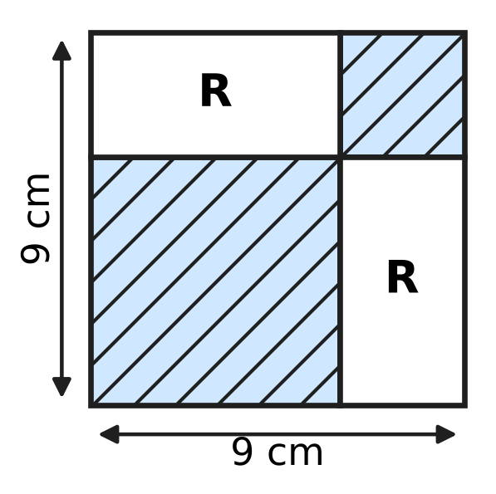
  (A) 22.5 cm² | (B) 36 cm² | (C) 27 cm² | (D) 18 cm²

Q12. The line $y=(k−2)x+5$ is parallel to the line through the points (1, 3) and (4, 12). What is the value of k?
(A) 11 | (B) 1 | (C) 5 | (D) 3

Q13. The numbers k, k + 6 and 4k, in that order, are three consecutive terms of a geometric progression whose terms are all positive. What is the next term of the progression?
(A) 22 | (B) 48 | (C) 24 | (D) 96

Part 4 — Geometry (Syllabus Chapter 5)
Q14. A circle has its centre at C(1, −2) and passes through the point A(4, 2). Which of these points also lies on the circle?
(A) (−2, 2) | (B) (−1, 1) | (C) (5, −1) | (D) (3, 1)

Q15. The vertices of △ABC lie on a circle, and its side AB passes through the centre O, as in the figure. AC = 9 cm and BC = 12 cm. What is the radius of the circle? | 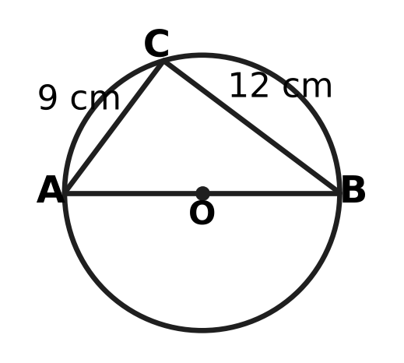
  (A) 10.5 cm | (B) 6 cm | (C) 15 cm | (D) 7.5 cm

Q16. In how many different ways can a circle be drawn so that A(−1, 2), B(1, 3) and C(5, 5) all lie on it?
(A) in no way at all | (B) in exactly one way
(C) in exactly two ways | (D) in infinitely many ways

Q17. Which of these quadrilaterals has rotational symmetry of order 2 but NO line of symmetry?
(A) a kite whose four sides are not all equal
(B) a parallelogram with unequal adjacent sides and no right angle
(C) a rectangle whose length and breadth are unequal
(D) a rhombus none of whose angles is a right angle

Q18. The points are A(2, 3), B(6, 5) and C(4, k). For which value of k is ∠ABC = 90°?
(A) 9 | (B) 7 | (C) −1 | (D) 1

Q19. In the figure, the chord AB and the radii OA and OB are drawn, and C is a point on the major arc AB. ∠OAB = 25°. What is ∠ACB, marked x? | 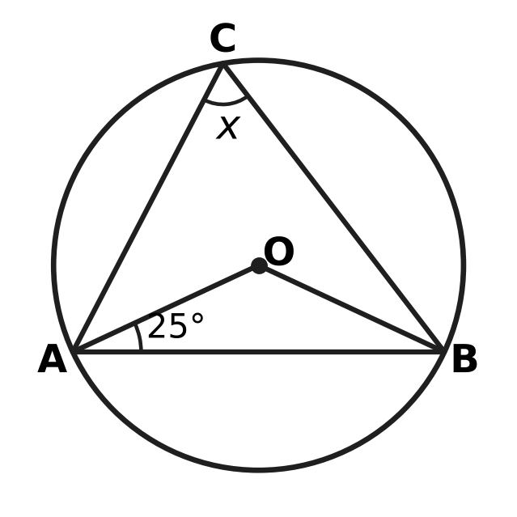
  (A) 50° | (B) 25° | (C) 65° | (D) 130°

Q20. In △ABC in the figure, AB = AC and ∠BAC = 40°. D is a point on AC such that BD = BC, as the marks show. What is ∠ABD, marked x? | 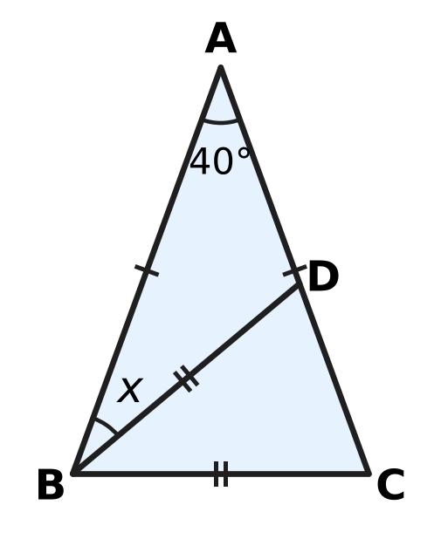
  (A) 30° | (B) 70° | (C) 40° | (D) 35°

Part 5 — Mensuration (Syllabus Chapter 6)
Q21. ABCD is a cyclic quadrilateral with AB = 8 cm, BC = 10 cm, CD = 15 cm and DA = 3 cm, as shown. Use Brahmagupta's formula to find its area. | 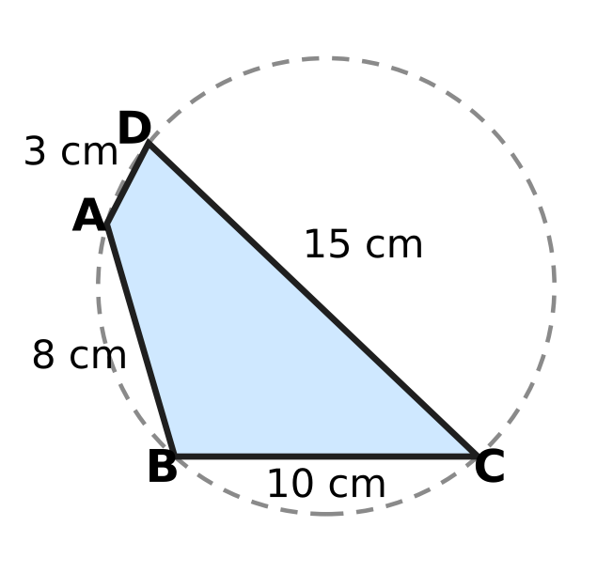
  (A) 30 cm² | (B) 60 cm²
  (C) 36 cm² | (D) 3,600 cm²

Q22. The minute hand of Hema's wall clock is 21 cm long. How far does its tip travel from 3:00 to 3:20? (Use π = $\frac{22}{7}$.)
(A) 66 cm | (B) 22 cm | (C) 132 cm | (D) 44 cm

Q23. Kavin, a potter, makes a solid clay cone and a solid clay cylinder with the same base radius. Both use exactly the same amount of clay. The cylinder is 8 cm tall. How tall is the cone?
(A) 16 cm | (B) $\frac{8}{3}$ cm | (C) 24 cm | (D) 8 cm

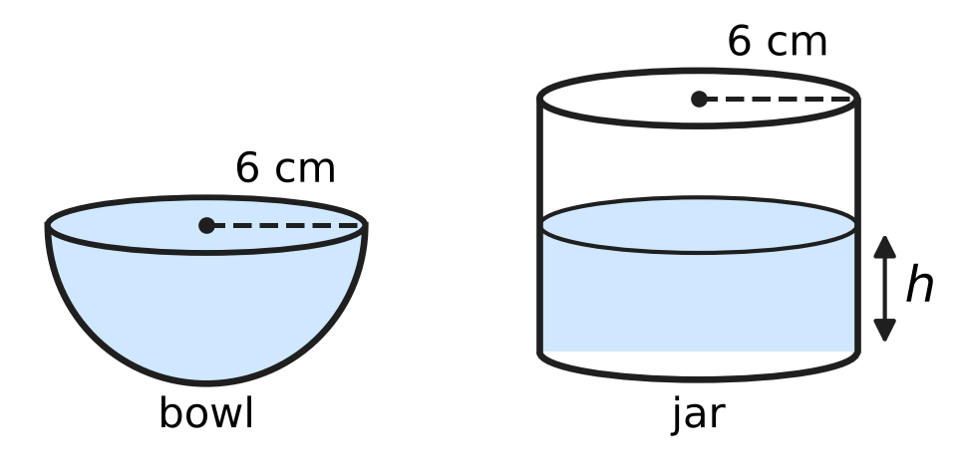
Q24. Charu's hemispherical bowl has an inner radius of 6 cm and is full of water. She pours all the water into an empty cylindrical jar whose inner radius is also 6 cm, as shown. How deep, h, is the water in the jar?
(A) 8 cm | (B) 6 cm | (C) 12 cm | (D) 4 cm

Q25. Manav makes a cuboid box with NO lid from card. Its base is 12 cm by 6 cm, and he uses exactly 360 cm² of card. What is the height h of the box? | 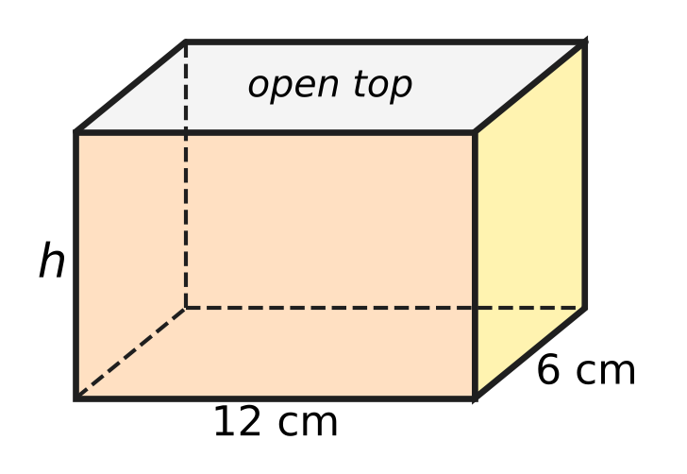
  (A) 16 cm | (B) 6 cm | (C) 8 cm | (D) 10 cm

Part 6 — Data Handling, Statistics & Probability (Syllabus Chapter 8)
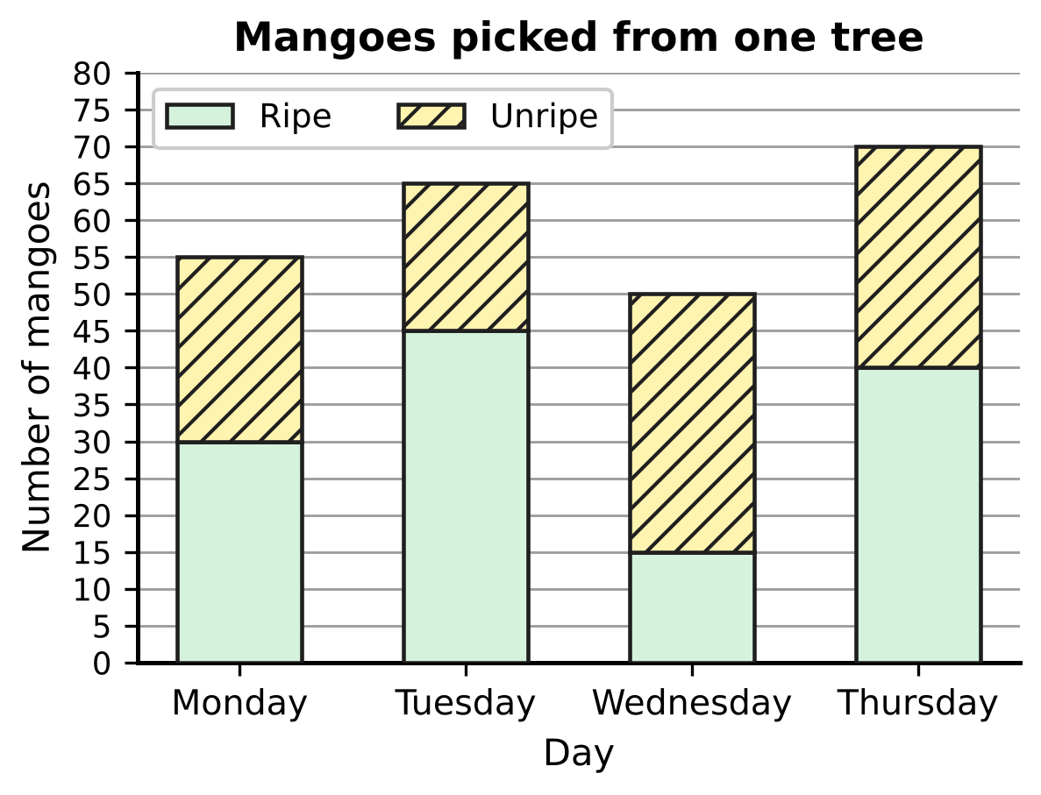
Q26. The stacked bar graph shows the ripe and unripe mangoes picked from one mango tree on four days. On which day were the MOST unripe mangoes picked?
(A) Monday | (B) Tuesday
(C) Wednesday | (D) Thursday

Q27. In a board game, Rhea rolls an ordinary fair die once. Which of these events is more likely to happen than not to happen, but is NOT certain?
(A) the die shows an odd number | (B) the die shows a number less than 5
(C) the die shows a number greater than 4 | (D) the die shows a number less than 7

Drinks chosen at the school canteen
Students | Tea | Juice | Milk | Total
Juniors | 10 | 20 | 10 | 40
Seniors | 14 | 16 | 10 | 40
All students | 24 | 36 | 20 | 80

Q28. The table shows the drinks chosen by 80 students at the school canteen. Each student chose exactly one drink. One of the 80 students is chosen at random. What is the probability that this student is a senior who chose juice?
(A) $\frac{1}{5}$ | (B) $\frac{9}{20}$ | (C) $\frac{1}{4}$ | (D) $\frac{2}{5}$

Q29. Six friends count the money in their piggy banks. The median amount is ₹40. Which of these MUST be true?
(A) The mean amount is ₹40.
(B) At least three of the friends have ₹40 or less.
(C) Exactly three of the friends have more than ₹40.
(D) One of the friends has exactly ₹40.

Q30. Two ordinary fair dice are rolled together. What is the probability that the larger number shown is exactly twice the smaller number?
(A) $\frac{1}{6}$ | (B) $\frac{1}{3}$ | (C) $\frac{1}{9}$ | (D) $\frac{1}{12}$

Part 7 — Applied Mathematics (Syllabus Chapter 9)
Mass of parcel (kg) | 2 | 5 | 8 | 12
Charge (₹) | 70 | 130 | 190 | ?

Q31. At a post office, the charge for sending a parcel follows a linear rule: a fixed amount plus the same amount for every kilogram. The table shows some charges. How much does Vikram pay to send a 12 kg parcel?
(A) ₹420 | (B) ₹240 | (C) ₹270 | (D) ₹250

Q32. On a plan of the school running track, Sneha marks the start at S(−4, 5) and a water stall at W(2, 1). The water stall is exactly halfway between the start and the finish F. What are the coordinates of F?
(A) (6, −4) | (B) (−10, 9) | (C) (−1, 3) | (D) (8, −3)

Q33. On a bus, 3 adult tickets and 2 child tickets cost ₹190, and 2 adult tickets and 5 child tickets cost ₹200. Lalit buys 1 adult ticket and 1 child ticket. How much does he pay?
(A) ₹50 | (B) ₹78 | (C) ₹70 | (D) ₹20

Q34. The number of honey bees in a hive grows by the same percentage every month. There were 1,600 bees on 1 June and 3,600 bees on 1 August. How many bees were there on 1 July?
(A) 5,400 | (B) 2,000 | (C) 2,600 | (D) 2,400

Part 8 — Mathematical Reasoning & Problem-Solving (Syllabus Chapter 10)
Q35. Consider the statement: "If a fraction in lowest terms has an odd denominator, then its decimal expansion does NOT terminate." Which fraction is a counterexample to this statement?
(A) $\frac{4}{9}$ | (B) $\frac{7}{25}$ | (C) $\frac{3}{8}$ | (D) $\frac{5}{21}$

Q36. The theorem "The opposite angles of a cyclic quadrilateral add up to 180°" has this special case: "If all four vertices of a parallelogram lie on a circle, then the parallelogram must be a ___." Which word fills the blank?
(A) rectangle | (B) kite
(C) square | (D) rhombus

Q37. The sequence 4, 7, 12, 19, 28, … has the recursive rule $a_{1}=4$ and $a_{n}=a_{n−1}+□$ for n ≥ 2. What goes in the box?
(A) $n+1$ | (B) 3 | (C) $2n−1$ | (D) $2n+1$

Q38. Naina is proving that √3 is irrational. She assumes √3 = $\frac{p}{q}$, where p and q are positive whole numbers with no common factor other than 1. Squaring gives $p^{2}=3q^{2}$, so p is a multiple of 3. She writes p = 3m. Then $q^{2}$ = ___. What fills the blank?
(A) $3m$ | (B) $9m^{2}$ | (C) $m^{2}$ | (D) $3m^{2}$

Q39. The statement "If a quadrilateral is a square, then its diagonals are equal and perpendicular" is true. Tushar wants a quadrilateral that shows its CONVERSE is false. Which quadrilateral should he draw?
(A) diagonals 8 cm and 8 cm, crossing at right angles, one cut into 2 cm and 6 cm
(B) diagonals 8 cm and 8 cm, crossing at 60° at their midpoints
(C) diagonals 8 cm and 6 cm, crossing at right angles at their midpoints
(D) diagonals 8 cm and 8 cm, crossing at right angles at their midpoints

Q40. Juhi thinks of a whole number from 1 to 100. Ankit finds it by asking questions of the form "Is your number greater than k?", and Juhi answers each one truthfully with yes or no. Each time, Ankit chooses k so that the numbers still possible are split into two groups as equal as possible. What is the least number of questions that is always enough for Ankit to be sure of the number?
(A) 6 | (B) 7 | (C) 50 | (D) 10

SECTION II — Star Questions 5 questions × 4 marks each
Q41. Daksh writes a list of numbers by following these instructions.
Step 1: Start with a = $□$ and d = 4.
Step 2: Write a in the list.
Step 3: Replace a by a + d, then replace d by d + 2.
Step 4: If the list has 10 numbers, stop. Otherwise go back to Step 2.
The last number in the list is 150. What number was in the box? [4 marks]
(A) 114 | (B) 62 | (C) 42 | (D) 20

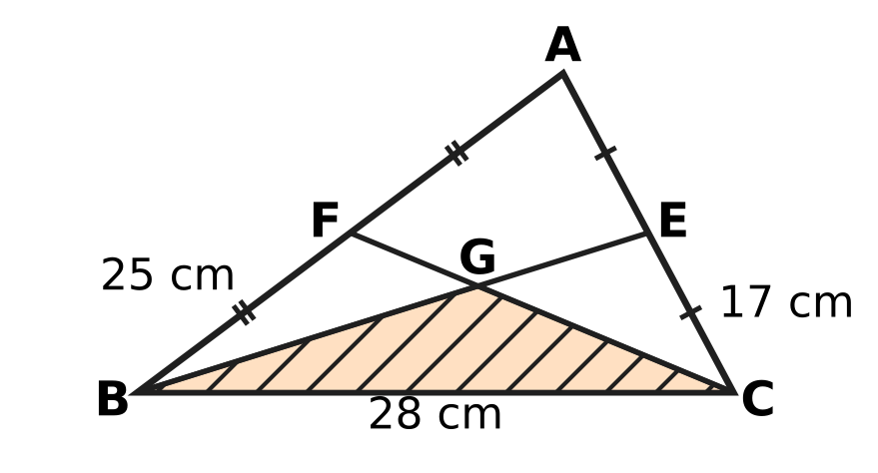
Q42. In △ABC, AB = 25 cm, BC = 28 cm and CA = 17 cm. E and F are the midpoints of CA and AB, and the medians BE and CF meet at G, as shown. What is the area of the shaded triangle GBC? [4 marks]
(A) 140 cm² | (B) 105 cm² | (C) 35 cm² | (D) 70 cm²

Q43. P(−3, 4) and Q(7, 0) are two points. The line L passes through the midpoint of PQ and is parallel to the line through R(−1, 1) and S(2, 7). L cuts the x-axis at one point and the y-axis at another. What is the length of the part of L between these two points? [4 marks]
(A) √5 units | (B) √3 units | (C) 5 units | (D) 3 units

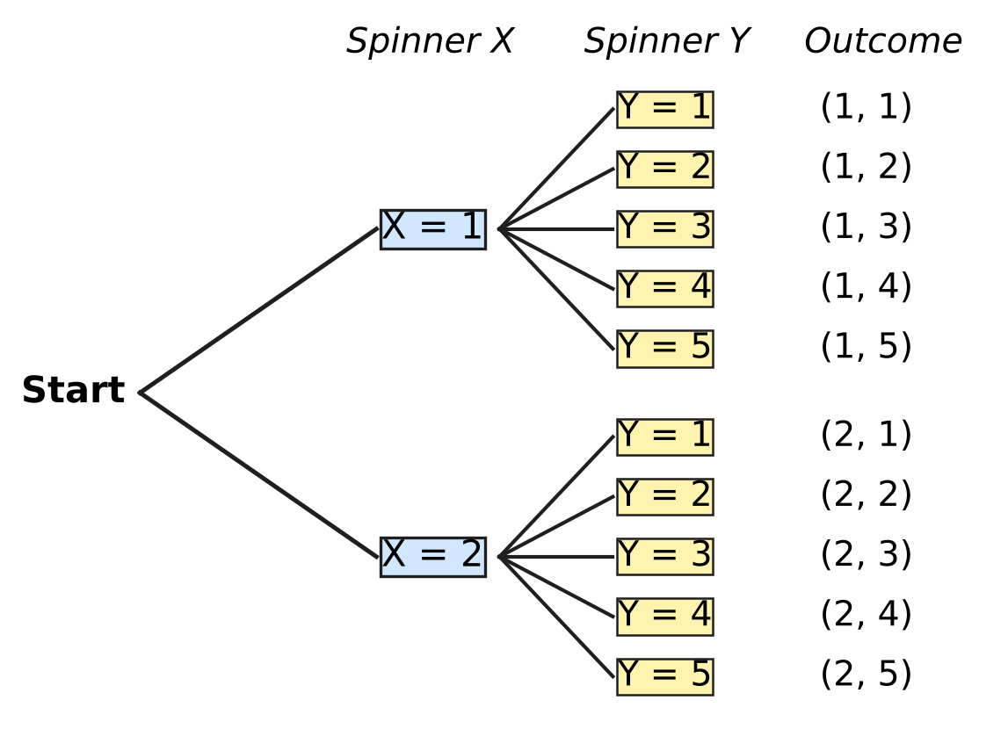
Q44. Spinner X has 2 equal parts numbered 1, 2. Spinner Y has 5 equal parts numbered 1 to 5. Avni spins both once; the tree diagram shows all 10 equally likely outcomes (X, Y). Statement S says: "If X shows 2, then X + Y is greater than 5." An outcome is a counterexample to an if-then statement when its "if" part is true but its "then" part is false. What is the probability that Avni's outcome is a counterexample to NEITHER S nor the converse of S? [4 marks]
(A) $\frac{2}{5}$ | (B) $\frac{3}{5}$ | (C) $\frac{1}{5}$ | (D) $\frac{7}{10}$

Q45. Park X and Park Y start with the same number of rabbits. In Park X the number grows by 25% every year, each year on the number at the start of that year. In Park Y the number grows by 450 every year. At the end of Year 2, Park X has 540 more rabbits than Park Y. How many rabbits did each park start with? [4 marks]
(A) 3,960 | (B) 2,560 | (C) 2,880 | (D) 1,600

Answer Sheet AMO Level 1 · Class 9 · Practice Paper 3
Name: | School: | Roll No.:
Shade or tick one circle for each question.
1. Ⓐ Ⓑ Ⓒ Ⓓ | 16. Ⓐ Ⓑ Ⓒ Ⓓ | 31. Ⓐ Ⓑ Ⓒ Ⓓ
2. Ⓐ Ⓑ Ⓒ Ⓓ | 17. Ⓐ Ⓑ Ⓒ Ⓓ | 32. Ⓐ Ⓑ Ⓒ Ⓓ
3. Ⓐ Ⓑ Ⓒ Ⓓ | 18. Ⓐ Ⓑ Ⓒ Ⓓ | 33. Ⓐ Ⓑ Ⓒ Ⓓ
4. Ⓐ Ⓑ Ⓒ Ⓓ | 19. Ⓐ Ⓑ Ⓒ Ⓓ | 34. Ⓐ Ⓑ Ⓒ Ⓓ
5. Ⓐ Ⓑ Ⓒ Ⓓ | 20. Ⓐ Ⓑ Ⓒ Ⓓ | 35. Ⓐ Ⓑ Ⓒ Ⓓ
6. Ⓐ Ⓑ Ⓒ Ⓓ | 21. Ⓐ Ⓑ Ⓒ Ⓓ | 36. Ⓐ Ⓑ Ⓒ Ⓓ
7. Ⓐ Ⓑ Ⓒ Ⓓ | 22. Ⓐ Ⓑ Ⓒ Ⓓ | 37. Ⓐ Ⓑ Ⓒ Ⓓ
8. Ⓐ Ⓑ Ⓒ Ⓓ | 23. Ⓐ Ⓑ Ⓒ Ⓓ | 38. Ⓐ Ⓑ Ⓒ Ⓓ
9. Ⓐ Ⓑ Ⓒ Ⓓ | 24. Ⓐ Ⓑ Ⓒ Ⓓ | 39. Ⓐ Ⓑ Ⓒ Ⓓ
10. Ⓐ Ⓑ Ⓒ Ⓓ | 25. Ⓐ Ⓑ Ⓒ Ⓓ | 40. Ⓐ Ⓑ Ⓒ Ⓓ
11. Ⓐ Ⓑ Ⓒ Ⓓ | 26. Ⓐ Ⓑ Ⓒ Ⓓ | 41. Ⓐ Ⓑ Ⓒ Ⓓ
12. Ⓐ Ⓑ Ⓒ Ⓓ | 27. Ⓐ Ⓑ Ⓒ Ⓓ | 42. Ⓐ Ⓑ Ⓒ Ⓓ
13. Ⓐ Ⓑ Ⓒ Ⓓ | 28. Ⓐ Ⓑ Ⓒ Ⓓ | 43. Ⓐ Ⓑ Ⓒ Ⓓ
14. Ⓐ Ⓑ Ⓒ Ⓓ | 29. Ⓐ Ⓑ Ⓒ Ⓓ | 44. Ⓐ Ⓑ Ⓒ Ⓓ
15. Ⓐ Ⓑ Ⓒ Ⓓ | 30. Ⓐ Ⓑ Ⓒ Ⓓ | 45. Ⓐ Ⓑ Ⓒ Ⓓ
Q41–Q45 are Section II Star Questions (4 marks each).
For the parent or teacher
Section I correct: ______ / 40 × 2 = ______ marks Section II correct: ______ / 5 × 4 = ______ marks
Correct: ______ / 45 Score: ______ / 100
Answer Key and Solutions AMO Level 1 · Class 9 · Practice Paper 3
Quick answers
1 B | 6 A | 11 D | 16 A | 21 B | 26 C | 31 C | 36 A | 41 C
2 D | 7 B | 12 C | 17 B | 22 D | 27 B | 32 D | 37 C | 42 D
3 C | 8 C | 13 B | 18 A | 23 C | 28 A | 33 C | 38 D | 43 A
4 D | 9 D | 14 A | 19 C | 24 D | 29 B | 34 D | 39 A | 44 B
5 B | 10 A | 15 D | 20 A | 25 C | 30 A | 35 B | 40 B | 45 B
Solutions
Q | Part · level | Answer | Why?
1 | Part 1 · Ch1 · Easy | (B) $\frac{1}{12}$ | The halfway point is the average: (−1/2 + 2/3) ÷ 2 = (1/6) ÷ 2 = 1/12.
2 | Part 1 · Ch1 · Easy | (D) 6 | Write 1/3 = 5/15 and 4/5 = 12/15. The fractions strictly between are 6/15, 7/15, …, 11/15, which is 6 fractions.
3 | Part 1 · Ch1 · Medium | (C) 21 | If k/84 = m/100, then k = 84m/100 = 21m/25, so k must be a multiple of 21. The smallest is k = 21, and 21/84 = 1/4 = 0.25.
4 | Part 2 · Ch3 · Easy | (D) ₹450,000 | After a 20% fall, 80% of the value is left, so 0.8 × (value) = ₹360,000. The value was ₹360,000 ÷ 0.8 = ₹450,000.
5 | Part 2 · Ch3 · Easy | (B) ₹55 | The mixture is worth 5 × ₹46 = ₹230. The 3 kg sack is worth 3 × ₹40 = ₹120, so the 2 kg sack is worth ₹110, which is ₹55 per kg.
6 | Part 2 · Ch3 · Medium | (A) 20% | May = 1.25 × April. To get back, June = May ÷ 1.25 = 0.8 × May, which is a fall of 20%.
7 | Part 3 · Ch4 · Easy | (B) $x−7$ | The second factor is x + c with 6c = −42, so c = −7. Check: (x + 6)(x − 7) = x² − 7x + 6x − 42 = x² − x − 42.
8 | Part 3 · Ch4 · Easy | (C) −1 | The x terms come from x × 5 = 5x and 2 × (−3x) = −6x. Together 5x − 6x = −x, so the coefficient is −1.
9 | Part 3 · Ch4 · Easy | (D) −2 | With x = 4: 12 − 4y = 20, so −4y = 8 and y = −2.
10 | Part 3 · Ch4 · Easy | (A) 13 | From 7 to 25 there are 3 equal steps, so the common difference is 18 ÷ 3 = 6. The first box is 7 + 6 = 13.
11 | Part 3 · Ch4 · Medium | (D) 18 cm² | The large square has area 9² = 81 cm². The two rectangles together are 81 − 45 = 36 cm², so one rectangle is 18 cm². (This is (a + b)² = a² + b² + 2ab with a + b = 9.)
12 | Part 3 · Ch4 · Medium | (C) 5 | Slope of the line through (1, 3) and (4, 12) = (12 − 3) ÷ (4 − 1) = 3. Parallel lines have equal slopes, so k − 2 = 3 and k = 5.
13 | Part 3 · Ch4 · Medium | (B) 48 | In a GP the middle term squared equals the product of its neighbours: (k + 6)² = 4k². All terms are positive, so k + 6 = 2k and k = 6. The terms are 6, 12, 24 (ratio 2), so the next term is 48.
14 | Part 4 · Ch5 · Easy | (A) (−2, 2) | The radius is CA = √(3² + 4²) = 5. From C to (−2, 2) the steps are 3 and 4, so the distance is also 5. Points (B), (C) and (D) are √13, √17 and √13 from C.
15 | Part 4 · Ch5 · Easy | (D) 7.5 cm | The angle in a semicircle is 90°, so ∠ACB = 90° and AB = √(9² + 12²) = 15 cm. The radius is half of AB, 7.5 cm.
16 | Part 4 · Ch5 · Easy | (A) in no way at all | The slope of AB is (3 − 2) ÷ (1 + 1) = 1/2 and the slope of BC is (5 − 3) ÷ (5 − 1) = 1/2, so A, B, C lie on one straight line. A circle cannot pass through three points of a line, so there is no such circle.
17 | Part 4 · Ch5 · Easy | (B) a parallelogram with unequal adjacent sides and no right angle | Every parallelogram looks the same after a half turn about the point where its diagonals meet (order 2). Unless it is a rectangle or a rhombus, no fold line maps it onto itself.
18 | Part 4 · Ch5 · Medium | (A) 9 | ∠B = 90° when AB² + BC² = AC²: 20 + [4 + (k − 5)²] = 4 + (k − 3)². This gives 20 + 25 − 10k = 9 − 6k, so 4k = 36 and k = 9.
19 | Part 4 · Ch5 · Medium | (C) 65° | OA = OB (radii), so ∠OBA = 25° and ∠AOB = 180° − 50° = 130°. The angle at C on the remaining arc is half of that: 65°.
20 | Part 4 · Ch5 · Medium | (A) 30° | ∠ABC = ∠ACB = (180° − 40°) ÷ 2 = 70°. In △BCD, BD = BC, so ∠BDC = ∠BCD = 70° and ∠DBC = 40°. Then ∠ABD = 70° − 40° = 30°.
21 | Part 5 · Ch6 · Easy | (B) 60 cm² | s = (8 + 10 + 15 + 3) ÷ 2 = 18. Area = √[(18 − 8)(18 − 10)(18 − 15)(18 − 3)] = √(10 × 8 × 3 × 15) = √3,600 = 60 cm².
22 | Part 5 · Ch6 · Easy | (D) 44 cm | In 20 minutes the minute hand turns 20/60 = 1/3 of a full turn (120°). The tip travels 1/3 × 2 × 22/7 × 21 = 44 cm.
23 | Part 5 · Ch6 · Easy | (C) 24 cm | Cone: (1/3)πr²h; cylinder: πr² × 8. Equal volumes give (1/3)h = 8, so h = 24 cm.
24 | Part 5 · Ch6 · Medium | (D) 4 cm | Water = (2/3)π × 6³ = 144π cm³. In the jar π × 6² × h = 144π, so 36h = 144 and h = 4 cm.
25 | Part 5 · Ch6 · Medium | (C) 8 cm | Card = base + four sides = 12 × 6 + 2 × (12 + 6) × h = 72 + 36h. So 72 + 36h = 360, 36h = 288 and h = 8 cm.
26 | Part 6 · Ch8 · Easy | (C) Wednesday | Unripe = top of the bar − top of the ripe part: Monday 55 − 30 = 25, Tuesday 65 − 45 = 20, Wednesday 50 − 15 = 35, Thursday 70 − 40 = 30. Wednesday has the most.
27 | Part 6 · Ch8 · Easy | (B) the die shows a number less than 5 | "Less than 5" means 1, 2, 3 or 4: probability 4/6 = 2/3, which is more than 1/2 and less than 1. The others have probabilities 1/2, 1 and 1/3.
28 | Part 6 · Ch8 · Easy | (A) $\frac{1}{5}$ | There are 16 seniors who chose juice among the 80 students, so the probability is 16/80 = 1/5.
29 | Part 6 · Ch8 · Medium | (B) At least three of the friends have ₹40 or less. | With six amounts in order, the median is the average of the 3rd and 4th, so the 3rd amount is at most ₹40 and the three smallest amounts are ₹40 or less. The amounts ₹10, ₹20, ₹30, ₹50, ₹60, ₹70 have median ₹40, yet nobody has exactly ₹40 and the mean is not ₹40.
30 | Part 6 · Ch8 · Medium | (A) $\frac{1}{6}$ | There are 36 equally likely outcomes. The good ones are (1, 2), (2, 1), (2, 4), (4, 2), (3, 6), (6, 3): 6 outcomes, so the probability is 6/36 = 1/6.
31 | Part 7 · Ch9 · Easy | (C) ₹270 | Each 3 kg adds ₹60, so the rate is ₹20 per kg and the fixed amount is 70 − 40 = ₹30. For 12 kg: 30 + 20 × 12 = ₹270.
32 | Part 7 · Ch9 · Easy | (D) (8, −3) | The step from S to W is 6 across and 4 down. F is the same step on from W: (2 + 6, 1 − 4) = (8, −3).
33 | Part 7 · Ch9 · Medium | (C) ₹70 | Doubling the first and tripling the second: 6a + 4c = 380 and 6a + 15c = 600, so 11c = 220, c = ₹20 and a = ₹50. Together ₹70.
34 | Part 7 · Ch9 · Medium | (D) 2,400 | Two months multiply 1,600 by 3,600 ÷ 1,600 = 2.25 = 1.5 × 1.5, so each month multiplies by 1.5 (50% growth). On 1 July: 1,600 × 1.5 = 2,400.
35 | Part 8 · Ch10 · Easy | (B) $\frac{7}{25}$ | A counterexample must have an odd denominator AND a terminating decimal. 7/25 = 28/100 = 0.28 terminates, and 25 is odd.
36 | Part 8 · Ch10 · Easy | (A) rectangle | In a parallelogram opposite angles are equal; on a circle they also add up to 180°, so each is 90°. A parallelogram with right angles is a rectangle.
37 | Part 8 · Ch10 · Easy | (C) $2n−1$ | The differences are 3, 5, 7, 9 for n = 2, 3, 4, 5, and 2n − 1 gives exactly 3, 5, 7, 9. So aₙ = aₙ₋₁ + (2n − 1).
38 | Part 8 · Ch10 · Easy | (D) $3m^{2}$ | p² = (3m)² = 9m², and 9m² = 3q² gives q² = 3m². So q is also a multiple of 3, which contradicts "no common factor".
39 | Part 8 · Ch10 · Medium | (A) diagonals 8 cm and 8 cm, crossing at right angles, one cut into 2 cm and 6 cm | The converse is "If the diagonals are equal and perpendicular, then it is a square." A counterexample needs equal, perpendicular diagonals but must not be a square. Diagonals of 8 cm crossing at 90° but not bisecting each other give such a quadrilateral (not even a parallelogram).
40 | Part 8 · Ch10 · Medium | (B) 7 | Each answer at most halves the numbers left: 100 → 50 → 25 → 13 → 7 → 4 → 2 → 1, which takes 7 questions. Six questions can separate at most 2⁶ = 64 numbers, so 7 is the least.
41 | Section II · Ch4 + Ch10 · Hard | (C) 42 | Between the 1st and 10th numbers in the list there are 9 additions: 4 + 6 + 8 + … + 20 = 2 × (2 + 3 + … + 10) = 2 × 54 = 108. So the start was 150 − 108 = 42.
42 | Section II · Ch5 + Ch6 · Hard | (D) 70 cm² | Heron: s = 35 and area = √(35 × 7 × 18 × 10) = 210 cm². G divides each median 2 : 1 from the vertex, so G's height above BC is 1/3 of A's height. Area of GBC = 210 ÷ 3 = 70 cm².
43 | Section II · Ch4 + Ch5 · Hard | (A) √5 units | Midpoint of PQ = (2, 2). Slope of RS = (7 − 1) ÷ (2 + 1) = 2, so L is y − 2 = 2(x − 2), that is y = 2x − 2. L cuts the axes at (1, 0) and (0, −2); the length between them is √(1² + 2²) = √5 units.
44 | Section II · Ch8 + Ch10 · Hard | (B) $\frac{3}{5}$ | Counterexamples to S need X = 2 and X + Y not greater than 5: (2, 1), (2, 2), (2, 3). The converse is "If X + Y is greater than 5, then X shows 2"; its only counterexample is (1, 5). That leaves 10 − 4 = 6 outcomes, so the probability is 6/10 = 3/5.
45 | Section II · Ch3 + Ch9 · Hard | (B) 2,560 | Let each park start with N rabbits. After 2 years Park X has N × 5/4 × 5/4 = 25N/16 and Park Y has N + 900. So 25N/16 − N − 900 = 540, 9N/16 = 1,440 and N = 2,560 (check: 2,560 → 3,200 → 4,000 against 3,460).

