UNLOCK IQ INSTITUTE
Realize Your True Potential
Aryabhatta Maths Olympiad (AMO)
Level 1 — Practice Paper 4
CLASS 9

Questions | 45 multiple-choice questions
Marks | 100
Time | 60 minutes
Section I | 40 questions × 2 marks = 80 marks
Section II | 5 Star Questions × 4 marks = 20 marks
Negative marking | No negative marking
Calculator | Not allowed
Chapters | Number System · Fractions, Decimals & Percentages · Algebra · Geometry · Mensuration · Data Handling · Applied Mathematics · Mathematical Reasoning

Instructions to candidates
• This paper has 45 multiple-choice questions. Each question has four answer choices, of which exactly one is correct.
• Section I (Q1–Q40) carries 2 marks per question. Section II (Q41–Q45) carries 4 marks per question.
• There is no negative marking. Unanswered questions score zero.
• Calculators are not permitted. Rough work may be done on a separate sheet.
• Mark your answers on the answer sheet at the end of the paper.
• All figures are not necessarily drawn to scale unless stated.

For parents and teachers
Print or view this paper in colour. Pictures are part of the questions.
Parts follow the AMO syllabus chapters. Chapters 2 and 7 are not part of the Class 9 syllabus, so the chapter numbers shown in the Part headings have gaps.
The answer sheet and the answer key are at the end. Remove only the answer key before the student begins.

Name: | School: | Roll No.:

SECTION I 40 questions × 2 marks each
Part 1 — Number System (Syllabus Chapter 1)
Q1. The decimal expansion of $\frac{1}{37}$ is 0.027027…, with the three digits 027 repeating. Without dividing, which of these is the decimal expansion of $\frac{7}{37}$?
(A) 0.189 | (B) 0.0189189…
(C) 0.189027027… | (D) 0.189189…

Q2. Which of these numbers is NOT equal to 0.5?
(A) $\frac{9}{18}$ | (B) 0.4555… (the digit 5 repeats for ever)
(C) $\frac{4.5}{9}$ | (D) 0.4999… (the digit 9 repeats for ever)

Q3. The number a is rational and the number b is irrational. Which of these MUST be irrational, whatever the values of a and b?
(A) $a×b+b$ | (B) $a×b$
(C) $a+b$ | (D) $b×b$

Part 2 — Fractions, Decimals & Percentages (Syllabus Chapter 3)
Q4. At a zoo, there are 250 flamingos on the lake. The number of flamingos grows by 8% every year. Which expression gives the number of flamingos after n years?
(A) $250×{(1.08)}^{n}$ | (B) $250+20n$
(C) $250×{(0.08)}^{n}$ | (D) $250×{(1.8)}^{n}$

Q5. Rehan deposits ₹12,000 at 6% per year simple interest. The amounts in his account at the end of Year 1, Year 2, Year 3, … form an arithmetic progression. What is the amount at the end of Year 5?
(A) ₹14,880 | (B) ₹16,320 | (C) ₹15,600 | (D) ₹3,600

Q6. Sonal kept some money in a bank for 2 years at 20% per year compound interest, compounded annually, and it grew to ₹36,000. How much would the same money have grown to in the same 2 years at 20% per year simple interest?
(A) ₹10,000 | (B) ₹35,000 | (C) ₹30,000 | (D) ₹25,000

Part 3 — Algebra (Syllabus Chapter 4)
Q7. The numbers x and y satisfy $3x+2y=17$ and $2x+3y=13$. What is the value of $x−y$?
(A) 4 | (B) 5 | (C) 6 | (D) 30

Q8. If $x+y=7$ and $xy=10$, what is the value of $x^{2}+y^{2}$?
(A) 69 | (B) 49 | (C) 39 | (D) 29

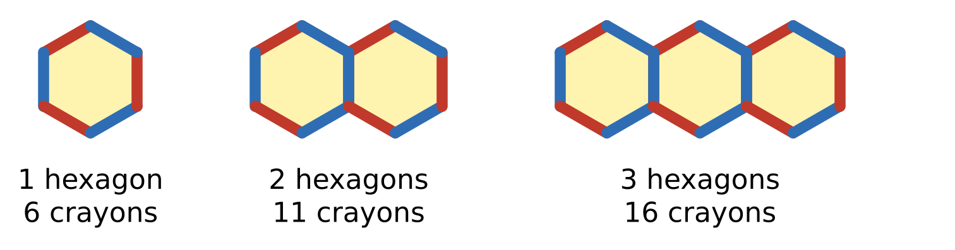
Q9. In art class, Kiara lays crayons end to end to make a row of hexagons, as shown. Neighbouring hexagons share one crayon. One hexagon needs 6 crayons, two need 11 and three need 16. How many hexagons are in a row made with exactly 151 crayons?
(A) 30 | (B) 25 | (C) 29 | (D) 31

Q10. What are the slope and the y-intercept of the line $6x−3y=9$?
(A) slope 6, y-intercept 9 | (B) slope 2, y-intercept −3
(C) slope 2, y-intercept 3 | (D) slope −2, y-intercept 3

Q11. Which of these is a factor of $x^{2}−y^{2}+6y−9$?
(A) $x+y+3$ | (B) $x+y−9$
(C) $x−y+3$ | (D) $x−y−3$

Q12. A rectangle has area $(3x^{2}+10x+8)$ cm² and length $(3x+4)$ cm. What is its perimeter?
(A) $(4x+6)$ cm | (B) $(x+2)$ cm
(C) $(6x+8)$ cm | (D) $(8x+12)$ cm

Q13. How many two-digit numbers leave a remainder of 5 when divided by 8?
(A) 12 | (B) 10 | (C) 11 | (D) 13

Part 4 — Geometry (Syllabus Chapter 5)
Q14. A circle has radius 6.5 cm. Which of these CANNOT be the length of a chord of this circle?
(A) 13 cm | (B) 14 cm | (C) 5 cm | (D) 12 cm

Q15. In △ABC in the figure, D is the midpoint of AB, and DE is parallel to BC with E on AC. AC = 13 cm and BC = 11 cm. How long is AE? | 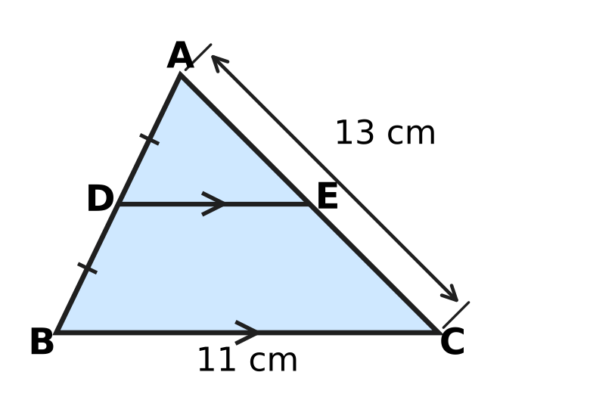
  (A) 6.5 cm | (B) 5.5 cm | (C) 3.25 cm | (D) 13 cm

Q16. Which of these quadrilaterals can ALWAYS be drawn with all four of its vertices on one circle? (An isosceles trapezium is a trapezium whose two non-parallel sides are equal.)
(A) a rhombus | (B) a kite
(C) a parallelogram | (D) an isosceles trapezium

Q17. Chetan wants to find the centre of a round wooden tabletop. He draws two chords AB and CD that are not parallel. Then he draws the perpendicular bisector of each chord. Where do the two perpendicular bisectors meet?
(A) at the centre of the tabletop
(B) halfway between the midpoints of AB and CD
(C) on the edge of the tabletop
(D) at the midpoint of chord AB

Q18. In the figure, A, B, C and D lie on a circle, and the chords AC and BD meet at E. ∠BAC = 35° and ∠ACD = 40°. What is ∠BEC, marked x? | 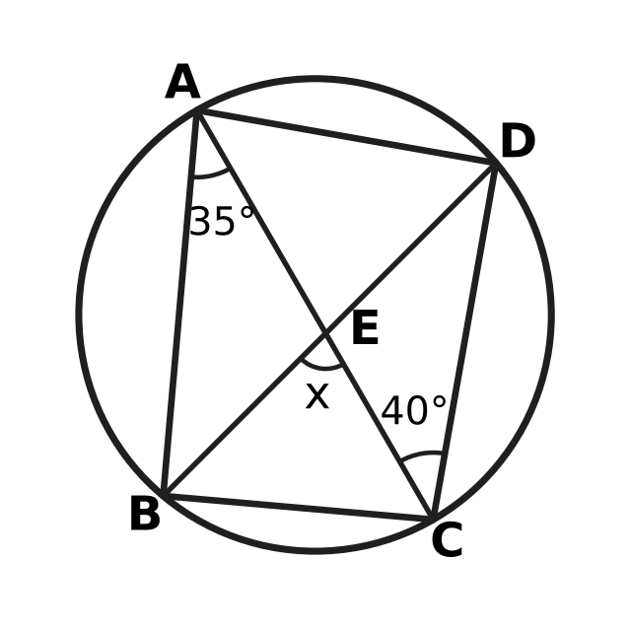
  (A) 105° | (B) 75° | (C) 80° | (D) 70°

Q19. In the figure, O is the centre of the circle, and the chords AB and CD are equal, as the marks show. ∠AOB = 70°. What is ∠OCD, marked x? | 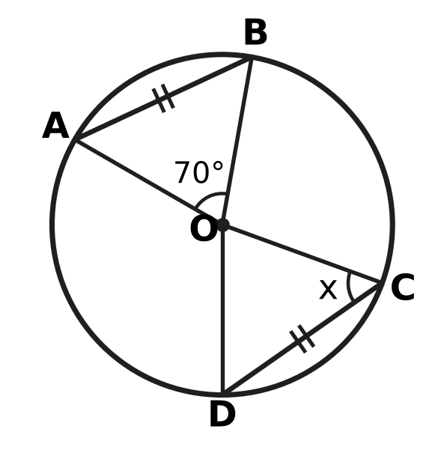
  (A) 110° | (B) 35° | (C) 70° | (D) 55°

Q20. The points A(1, 1), B(5, 2), C(6, 6) and D(2, 5) are joined in order to make the quadrilateral ABCD. Which of these best describes ABCD?
(A) a rectangle that is not a square | (B) a square
(C) a rhombus that is not a square | (D) a parallelogram that is not a rhombus

Part 5 — Mensuration (Syllabus Chapter 6)
Q21. Komal's round cake has radius 14 cm. She cuts it from the centre into 8 equal slices, as shown. What is the area of the top of one slice? (Use π = $\frac{22}{7}$.) | 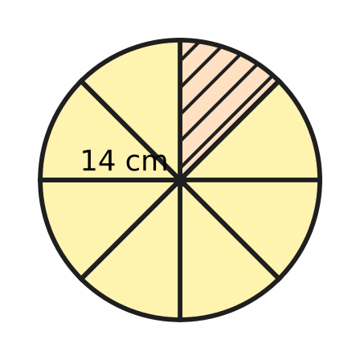
  (A) 19.25 cm² | (B) 154 cm²
  (C) 77 cm² | (D) 616 cm²

Q22. Imran's tent is a right circular cone with base radius 2.1 m and height 2.8 m, as shown. How much canvas covers its curved surface? (Use π = $\frac{22}{7}$.) | 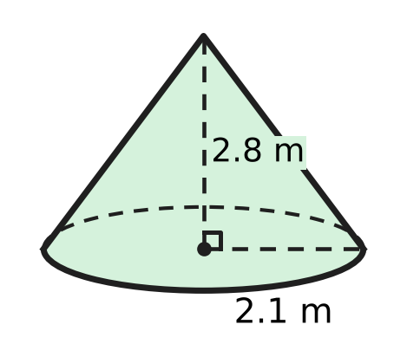
  (A) 23.1 m² | (B) 36.96 m² | (C) 46.2 m² | (D) 18.48 m²

Q23. The roof of a garden kiosk is a square pyramid. Its base is 6 m by 6 m and its vertical height is 4 m, as shown. What is the total area of its four sloping faces? | 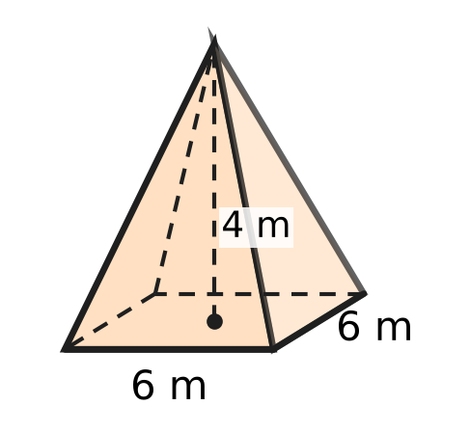
  (A) 48 m² | (B) 60 m² | (C) 96 m² | (D) 120 m²

Q24. A triangular field has sides 10 m, 17 m and 21 m, as shown. What is the shortest distance h from the corner opposite the 21 m side to that side? | 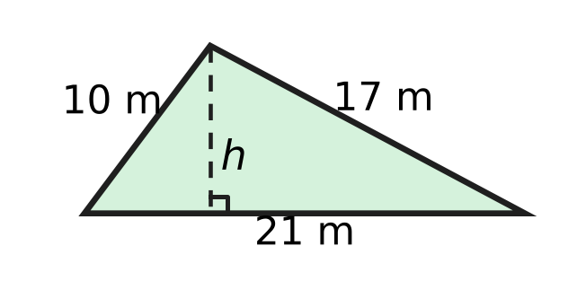
  (A) 3.5 m | (B) 16.8 m | (C) 4 m | (D) 8 m

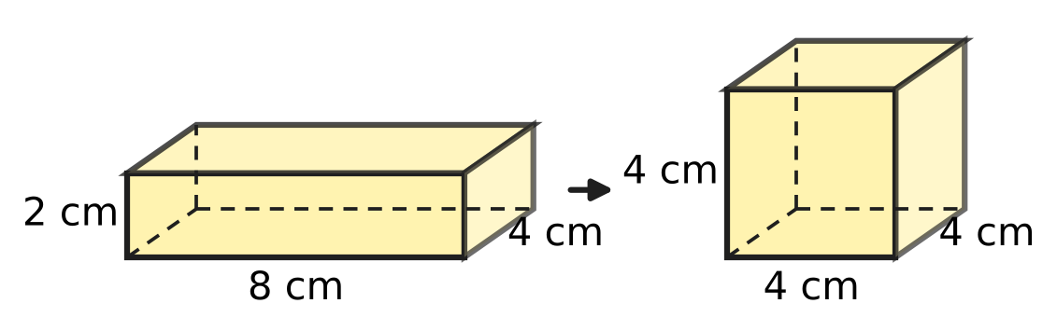
Q25. Nidhi has a cuboid slab of candle wax 8 cm × 4 cm × 2 cm. She melts it and uses all the wax to make one cube, as shown. By how much is the surface area of the cube less than the surface area of the slab?
(A) 0 cm² | (B) 48 cm² | (C) 112 cm² | (D) 16 cm²

Part 6 — Data Handling, Statistics & Probability (Syllabus Chapter 8)
Eggs in one tray
Mass of one egg (g) | Number of eggs
50 | 6
55 | 9
60 | 15

Q26. Use the table. A tray holds 30 eggs of three sizes. What is the mean mass of an egg in the tray?
(A) 55 g | (B) 60 g | (C) 56.5 g | (D) 57.5 g

Q27. The umbrella stand at a school gate holds 24 umbrellas: 9 black, 5 blue and the rest red. Leah picks one umbrella at random. What is the probability that it is NOT red?
(A) $\frac{5}{24}$ | (B) $\frac{7}{12}$ | (C) $\frac{5}{12}$ | (D) $\frac{3}{8}$

Q28. Which of these is a statistical question, that is, one that is answered by collecting data that vary?
(A) How many hours do Class 9 students sleep on a school night?
(B) How tall is the school flagpole?
(C) How many days are there in June?
(D) What is the sum of the angles of a triangle?

Q29. A whole number from 1 to 50 is chosen at random. What is the probability that it is a perfect square or a perfect cube (or both)?
(A) $\frac{9}{50}$ | (B) $\frac{7}{50}$ | (C) $\frac{1}{5}$ | (D) $\frac{4}{25}$

Q30. At the school assembly, the front row has 5 girls and 1 boy. On Monday one of these six students is chosen at random to lead the assembly. On Tuesday one is again chosen at random from all six, so the same student may be chosen twice. What is the probability that the boy leads on exactly one of the two days?
(A) $\frac{11}{36}$ | (B) $\frac{5}{36}$ | (C) $\frac{1}{3}$ | (D) $\frac{5}{18}$

Part 7 — Applied Mathematics (Syllabus Chapter 9)
Q31. At a milk dairy, the volume V litres of milk left in a tank t minutes after bottling starts is given by V = 1,200 − 75t. What does the number 75 stand for?
(A) the litres of milk left in the tank after 1 minute
(B) the litres of milk in the tank at the start
(C) the litres of milk taken out of the tank each minute
(D) the number of minutes the tank takes to empty

Q32. On the floor plan of a school hall, each unit of the grid stands for 3 m. The hall is the rectangle KLMN drawn on the grid. What is the real floor area of the hall? | 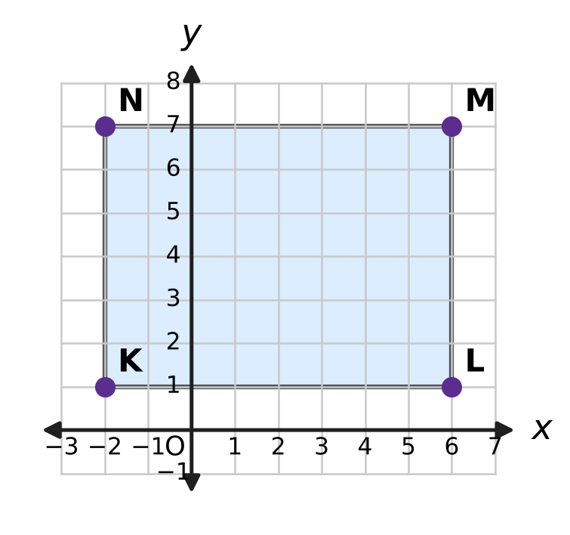
  (A) 144 m² | (B) 432 m² | (C) 1,296 m² | (D) 48 m²

Q33. A river ferry travels 36 km downstream in 2 hours. It comes back the same 36 km upstream in 3 hours. Its speed in still water and the speed of the current do not change. What is the speed of the current?
(A) 6 km/h | (B) 15 km/h | (C) 3 km/h | (D) 12 km/h

Q34. On a mountain hike, Trisha finds that the temperature falls steadily as she climbs. It is 22 °C at a height of 600 m and 17.2 °C at a height of 1,400 m. At the same rate, at what height will the temperature be 10 °C?
(A) 3,400 m | (B) 1,200 m | (C) 2,000 m | (D) 2,600 m

Part 8 — Mathematical Reasoning & Problem-Solving (Syllabus Chapter 10)
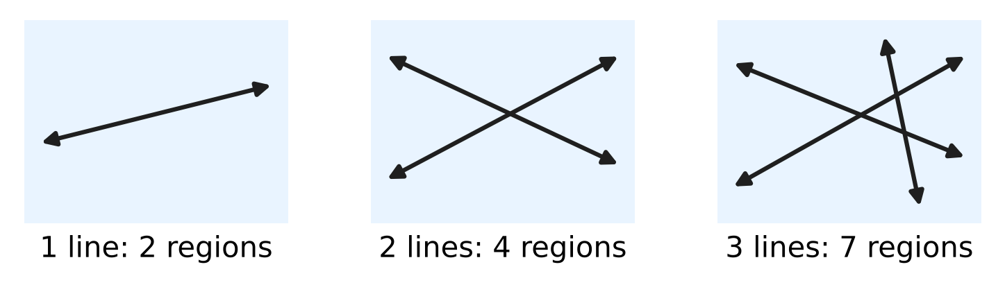
Q35. Straight lines are drawn so that no two are parallel and no three pass through one point. The picture shows that 1 line makes 2 regions, 2 lines make 4 and 3 lines make 7. The number of regions follows the rule $R(n)=R(n−1)+n$. How many regions do 6 such lines make?
(A) 64 | (B) 22 | (C) 29 | (D) 16

Q36. Prateek's algorithm tests whether a whole number n greater than 1 is prime. It divides n by 2, then by 3, then by 4, and so on. It stops as soon as a division leaves no remainder, or when the next divisor multiplied by itself is greater than n. How many divisions does it carry out for n = 91?
(A) 6 | (B) 7 | (C) 9 | (D) 5

Q37. A proposition is a sentence that is either true or false. Which of these is a proposition?
(A) Write 51 as a product of primes. | (B) What a big number 51 is!
(C) The number 51 is prime. | (D) Is 51 a prime number?

Q38. The statement "If a and b are both even whole numbers, then a + b is even" is true. Which pair of whole numbers is a counterexample to its CONVERSE?
(A) a = 6 and b = 9 | (B) a = 4 and b = 5
(C) a = 4 and b = 6 | (D) a = 3 and b = 5

Q39. Yamini climbs a staircase of 8 steps. Each time she moves, she climbs either 1 step or 2 steps. In how many different ways can she reach the top? (The same moves in a different order count as a different way.)
(A) 32 | (B) 34 | (C) 21 | (D) 55

Q40. Ojas has a Tower of Hanoi puzzle with 9 discs of different sizes on peg A, the largest at the bottom. He moves all of them to peg C in the least possible number of moves. He moves one disc at a time and never puts a larger disc on a smaller one. On which move does the largest disc move?
(A) 256 | (B) 511 | (C) 255 | (D) 128

SECTION II — Star Questions 5 questions × 4 marks each
Q41. Vivek's algorithm writes a list of numbers. Step 1: Write 3, then 7. Step 2: Write the last number minus the number before it. Step 3: Repeat Step 2 until 100 numbers have been written. (So $a_{1}=3$, $a_{2}=7$ and $a_{n}=a_{n−1}−a_{n−2}$.) What is the sum of all 100 numbers? [4 marks]
(A) 0 | (B) 11 | (C) −3 | (D) 14

Q42. In the quadrilateral ABCD, AB = AD = 15 cm and CB = CD = 20 cm. All four vertices lie on one circle, as shown. What is the circumference of the circle? (Use π = 3.14.) [4 marks] | 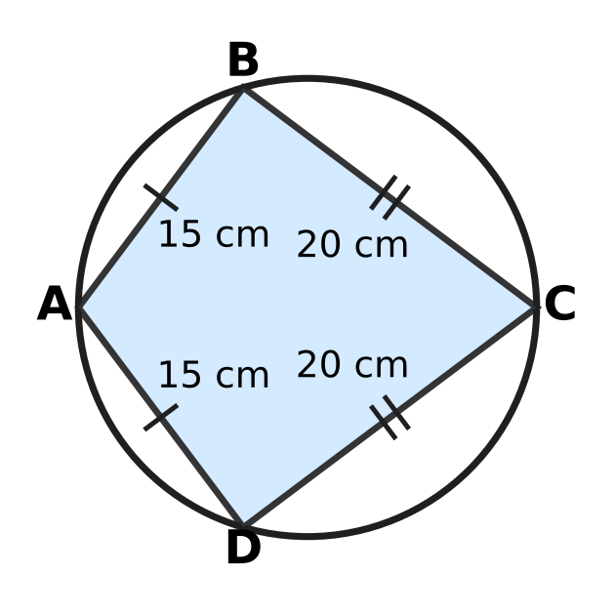
  (A) 78.5 cm | (B) 109.9 cm | (C) 62.8 cm | (D) 157 cm

Q43. A is the point (0, 3) and B is the point (4, 1). The point P lies on the line $y=3x−5$, and P is at the same distance from A as from B. What are the coordinates of P? [4 marks]
(A) (2, 1) | (B) (4, 7) | (C) (2, 2) | (D) (3, 4)

Q44. Eva rolls two fair dice and calls the numbers shown a and b. She then runs this algorithm. Step 1: If a = b, print a and stop. Step 2: Replace the larger of a and b by (larger − smaller), keep the other one, and go back to Step 1. What is the probability that the number printed is 1? [4 marks]
(A) $\frac{13}{36}$ | (B) $\frac{11}{36}$ | (C) $\frac{23}{36}$ | (D) $\frac{11}{18}$

Q45. A plant nursery had 3,000 saplings at the end of Year 1 and 4,320 at the end of Year 3. The count for the end of Year 2 was lost. Rupa assumes the number grew by the same AMOUNT every year. Neel assumes it grew by the same PERCENTAGE every year. By how many saplings do their two estimates for the end of Year 2 differ? [4 marks]
(A) 660 | (B) 600 | (C) 60 | (D) 720

Answer Sheet AMO Level 1 · Class 9 · Practice Paper 4
Name: | School: | Roll No.:
Shade or tick one circle for each question.
1. Ⓐ Ⓑ Ⓒ Ⓓ | 16. Ⓐ Ⓑ Ⓒ Ⓓ | 31. Ⓐ Ⓑ Ⓒ Ⓓ
2. Ⓐ Ⓑ Ⓒ Ⓓ | 17. Ⓐ Ⓑ Ⓒ Ⓓ | 32. Ⓐ Ⓑ Ⓒ Ⓓ
3. Ⓐ Ⓑ Ⓒ Ⓓ | 18. Ⓐ Ⓑ Ⓒ Ⓓ | 33. Ⓐ Ⓑ Ⓒ Ⓓ
4. Ⓐ Ⓑ Ⓒ Ⓓ | 19. Ⓐ Ⓑ Ⓒ Ⓓ | 34. Ⓐ Ⓑ Ⓒ Ⓓ
5. Ⓐ Ⓑ Ⓒ Ⓓ | 20. Ⓐ Ⓑ Ⓒ Ⓓ | 35. Ⓐ Ⓑ Ⓒ Ⓓ
6. Ⓐ Ⓑ Ⓒ Ⓓ | 21. Ⓐ Ⓑ Ⓒ Ⓓ | 36. Ⓐ Ⓑ Ⓒ Ⓓ
7. Ⓐ Ⓑ Ⓒ Ⓓ | 22. Ⓐ Ⓑ Ⓒ Ⓓ | 37. Ⓐ Ⓑ Ⓒ Ⓓ
8. Ⓐ Ⓑ Ⓒ Ⓓ | 23. Ⓐ Ⓑ Ⓒ Ⓓ | 38. Ⓐ Ⓑ Ⓒ Ⓓ
9. Ⓐ Ⓑ Ⓒ Ⓓ | 24. Ⓐ Ⓑ Ⓒ Ⓓ | 39. Ⓐ Ⓑ Ⓒ Ⓓ
10. Ⓐ Ⓑ Ⓒ Ⓓ | 25. Ⓐ Ⓑ Ⓒ Ⓓ | 40. Ⓐ Ⓑ Ⓒ Ⓓ
11. Ⓐ Ⓑ Ⓒ Ⓓ | 26. Ⓐ Ⓑ Ⓒ Ⓓ | 41. Ⓐ Ⓑ Ⓒ Ⓓ
12. Ⓐ Ⓑ Ⓒ Ⓓ | 27. Ⓐ Ⓑ Ⓒ Ⓓ | 42. Ⓐ Ⓑ Ⓒ Ⓓ
13. Ⓐ Ⓑ Ⓒ Ⓓ | 28. Ⓐ Ⓑ Ⓒ Ⓓ | 43. Ⓐ Ⓑ Ⓒ Ⓓ
14. Ⓐ Ⓑ Ⓒ Ⓓ | 29. Ⓐ Ⓑ Ⓒ Ⓓ | 44. Ⓐ Ⓑ Ⓒ Ⓓ
15. Ⓐ Ⓑ Ⓒ Ⓓ | 30. Ⓐ Ⓑ Ⓒ Ⓓ | 45. Ⓐ Ⓑ Ⓒ Ⓓ
Q41–Q45 are Section II Star Questions (4 marks each).
For the parent or teacher
Section I correct: ______ / 40 × 2 = ______ marks Section II correct: ______ / 5 × 4 = ______ marks
Correct: ______ / 45 Score: ______ / 100
Answer Key and Solutions AMO Level 1 · Class 9 · Practice Paper 4
Quick answers
1 D | 6 B | 11 C | 16 D | 21 C | 26 C | 31 C | 36 A | 41 B
2 B | 7 A | 12 D | 17 A | 22 A | 27 B | 32 B | 37 C | 42 A
3 C | 8 D | 13 C | 18 B | 23 B | 28 A | 33 C | 38 D | 43 D
4 A | 9 A | 14 B | 19 D | 24 D | 29 A | 34 D | 39 B | 44 C
5 C | 10 B | 15 A | 20 C | 25 D | 30 D | 35 B | 40 A | 45 C
Solutions
Q | Part · level | Answer | Why?
1 | Part 1 · Ch1 · Easy | (D) 0.189189… | Here 7/37 = 7 × 0.027027… and 7 × 027 = 189, so every block of three digits becomes 189: 7/37 = 0.189189…
2 | Part 1 · Ch1 · Easy | (B) 0.4555… (the digit 5 repeats for ever) | If x = 0.4555…, then 100x − 10x = 45.555… − 4.555… = 41, so x = 41/90, which is not 1/2. The same method gives 0.4999… = 45/90 = 1/2.
3 | Part 1 · Ch1 · Medium | (C) $a+b$ | If a + b were rational, then b = (a + b) − a would be rational, which it is not. The others can be rational: a = 0 makes a × b = 0, b = √2 makes b × b = 2, and a = −1 makes a × b + b = 0.
4 | Part 2 · Ch3 · Easy | (A) $250×{(1.08)}^{n}$ | Each year the number is multiplied by 1 + 8/100 = 1.08, so after n years it is 250 × (1.08)ⁿ, a geometric progression.
5 | Part 2 · Ch3 · Easy | (C) ₹15,600 | Each year adds the same interest, 6% of ₹12,000 = ₹720 (the common difference). After 5 years the amount is ₹12,000 + 5 × ₹720 = ₹15,600.
6 | Part 2 · Ch3 · Medium | (B) ₹35,000 | The money was multiplied by 1.2 × 1.2 = 1.44, so it was ₹36,000 ÷ 1.44 = ₹25,000. Simple interest for 2 years is 2 × ₹5,000 = ₹10,000, so the amount would be ₹35,000.
7 | Part 3 · Ch4 · Easy | (A) 4 | Subtracting the second equation from the first gives x − y = 17 − 13 = 4.
8 | Part 3 · Ch4 · Easy | (D) 29 | (x + y)² = x² + 2xy + y², so x² + y² = 7² − 2 × 10 = 49 − 20 = 29.
9 | Part 3 · Ch4 · Easy | (A) 30 | The numbers 6, 11, 16, … form an AP: n hexagons need 5n + 1 crayons. Then 5n + 1 = 151 gives n = 30.
10 | Part 3 · Ch4 · Easy | (B) slope 2, y-intercept −3 | Here 3y = 6x − 9, so y = 2x − 3. The slope is 2 and the y-intercept is −3.
11 | Part 3 · Ch4 · Medium | (C) $x−y+3$ | x² − y² + 6y − 9 = x² − (y² − 6y + 9) = x² − (y − 3)² = (x − y + 3)(x + y − 3).
12 | Part 3 · Ch4 · Medium | (D) $(8x+12)$ cm | Here 3x² + 10x + 8 = (3x + 4)(x + 2), so the breadth is (x + 2) cm. Perimeter = 2(3x + 4 + x + 2) = (8x + 12) cm.
13 | Part 3 · Ch4 · Medium | (C) 11 | The numbers are 13, 21, 29, …, 93, an AP with d = 8. Then 93 = 13 + (n − 1) × 8 gives n = 11.
14 | Part 4 · Ch5 · Easy | (B) 14 cm | The longest chord is a diameter, 2 × 6.5 = 13 cm. A chord of 14 cm would be longer than the diameter, so it is impossible.
15 | Part 4 · Ch5 · Easy | (A) 6.5 cm | A line through the midpoint of one side parallel to another side bisects the third side (converse of the midpoint theorem). So E is the midpoint of AC and AE = 13 ÷ 2 = 6.5 cm.
16 | Part 4 · Ch5 · Easy | (D) an isosceles trapezium | In an isosceles trapezium the two base angles at each parallel side are equal, so each pair of opposite angles adds up to 180°. By the converse of the cyclic-quadrilateral theorem its vertices lie on a circle.
17 | Part 4 · Ch5 · Easy | (A) at the centre of the tabletop | The perpendicular bisector of any chord passes through the centre. Two such lines that are not parallel meet at exactly one point, the centre.
18 | Part 4 · Ch5 · Medium | (B) 75° | ∠BDC = ∠BAC = 35° (angles in the same segment). ∠BEC is an exterior angle of △DEC, so x = 35° + 40° = 75°.
19 | Part 4 · Ch5 · Medium | (D) 55° | Equal chords subtend equal angles at the centre, so ∠COD = 70°. OC = OD (radii), so x = (180° − 70°) ÷ 2 = 55°.
20 | Part 4 · Ch5 · Medium | (C) a rhombus that is not a square | AB² = BC² = CD² = DA² = 17, so all four sides are equal. The diagonals are unequal (AC² = 50, BD² = 18), so it is a rhombus but not a square.
21 | Part 5 · Ch6 · Easy | (C) 77 cm² | Each slice is a sector of 360° ÷ 8 = 45°. Area = (1/8) × (22/7) × 14 × 14 = 616 ÷ 8 = 77 cm².
22 | Part 5 · Ch6 · Easy | (A) 23.1 m² | Slant height l = √(2.1² + 2.8²) = 3.5 m. Curved surface = πrl = (22/7) × 2.1 × 3.5 = 23.1 m².
23 | Part 5 · Ch6 · Easy | (B) 60 m² | Each sloping face has height √(3² + 4²) = 5 m (from the middle of a base edge to the top). Area = 4 × ½ × 6 × 5 = 60 m².
24 | Part 5 · Ch6 · Medium | (D) 8 m | s = (10 + 17 + 21) ÷ 2 = 24. Area = √(24 × 14 × 7 × 3) = √7,056 = 84 m². Then ½ × 21 × h = 84, so h = 8 m.
25 | Part 5 · Ch6 · Medium | (D) 16 cm² | Volume = 8 × 4 × 2 = 64 cm³, so the cube has edge 4 cm. Slab: 2(32 + 8 + 16) = 112 cm². Cube: 6 × 16 = 96 cm². Difference = 16 cm².
26 | Part 6 · Ch8 · Easy | (C) 56.5 g | Total mass = 6 × 50 + 9 × 55 + 15 × 60 = 300 + 495 + 900 = 1,695 g. Mean = 1,695 ÷ 30 = 56.5 g.
27 | Part 6 · Ch8 · Easy | (B) $\frac{7}{12}$ | There are 24 − 9 − 5 = 10 red umbrellas, so 14 are not red. P(not red) = 14/24 = 7/12.
28 | Part 6 · Ch8 · Easy | (A) How many hours do Class 9 students sleep on a school night? | Only the sleep question has answers that differ from student to student, so data must be collected and summarised.
29 | Part 6 · Ch8 · Medium | (A) $\frac{9}{50}$ | Squares: 1, 4, 9, 16, 25, 36, 49 (7). Cubes: 1, 8, 27; 1 is already counted, so 2 more. That gives 9 numbers, and the probability is 9/50.
30 | Part 6 · Ch8 · Medium | (D) $\frac{5}{18}$ | There are 6 × 6 = 36 equally likely (Monday, Tuesday) choices. The boy leads on exactly one day in 5 + 5 = 10 of them (girl then boy, or boy then girl), so the probability is 10/36 = 5/18.
31 | Part 7 · Ch9 · Easy | (C) the litres of milk taken out of the tank each minute | For every extra minute, V goes down by 75. So 75 is the number of litres of milk taken out each minute (the slope); 1,200 is the starting volume.
32 | Part 7 · Ch9 · Easy | (B) 432 m² | On the plan KL = 8 units and LM = 6 units. Really these are 24 m and 18 m, so the floor area is 24 × 18 = 432 m².
33 | Part 7 · Ch9 · Medium | (C) 3 km/h | Downstream speed = 36 ÷ 2 = 18 km/h and upstream speed = 36 ÷ 3 = 12 km/h. If the ferry goes at u and the current at v, then u + v = 18 and u − v = 12, so v = 3 km/h.
34 | Part 7 · Ch9 · Medium | (D) 2,600 m | The temperature falls 4.8 °C in 800 m, that is 0.6 °C every 100 m. From 22 °C to 10 °C is a fall of 12 °C, which needs 2,000 m more than 600 m: 2,600 m.
35 | Part 8 · Ch10 · Easy | (B) 22 | R(4) = 7 + 4 = 11, R(5) = 11 + 5 = 16, R(6) = 16 + 6 = 22.
36 | Part 8 · Ch10 · Easy | (A) 6 | It divides by 2, 3, 4, 5, 6 (each leaves a remainder) and then by 7, and 91 ÷ 7 = 13 with no remainder, so it stops after 6 divisions.
37 | Part 8 · Ch10 · Easy | (C) The number 51 is prime. | The sentence "The number 51 is prime" is a proposition; it happens to be false, since 51 = 3 × 17. A question, an instruction and an exclamation are not true or false.
38 | Part 8 · Ch10 · Easy | (D) a = 3 and b = 5 | The converse is "If a + b is even, then a and b are both even". For a = 3 and b = 5 the sum 8 is even, but neither number is even, so the converse is false.
39 | Part 8 · Ch10 · Medium | (B) 34 | Let W(n) be the number of ways for n steps. The last move is 1 or 2 steps, so W(n) = W(n − 1) + W(n − 2), with W(1) = 1, W(2) = 2. Then 3, 5, 8, 13, 21, 34, so W(8) = 34.
40 | Part 8 · Ch10 · Medium | (A) 256 | The largest disc can move only when the 8 smaller discs are all on peg B, which takes at least 2⁸ − 1 = 255 moves. So it moves on move 256 (and only once).
41 | Section II · Ch4 + Ch10 · Hard | (B) 11 | The list is 3, 7, 4, −3, −7, −4, 3, 7, … and repeats every 6 numbers; each block of 6 adds to 0. Since 100 = 16 × 6 + 4, the sum is 3 + 7 + 4 − 3 = 11.
42 | Section II · Ch5 + Ch6 · Hard | (A) 78.5 cm | △ABC ≅ △ADC (SSS), so ∠B = ∠D. In a cyclic quadrilateral ∠B + ∠D = 180°, so ∠B = 90°. Then AC is a diameter (angle in a semicircle) and AC = √(15² + 20²) = 25 cm. Circumference = 3.14 × 25 = 78.5 cm.
43 | Section II · Ch4 + Ch5 · Hard | (D) (3, 4) | PA² = PB² gives x² + (y − 3)² = (x − 4)² + (y − 1)², which simplifies to 2x − y = 2. With y = 3x − 5: 2x − 3x + 5 = 2, so x = 3 and y = 4. P is (3, 4).
44 | Section II · Ch8 + Ch10 · Hard | (C) $\frac{23}{36}$ | Subtracting the smaller number from the larger keeps the HCF, so the algorithm prints the HCF of a and b. Of the 36 outcomes, 13 have HCF more than 1 (equal pairs from 2 to 6, and (2, 4), (2, 6), (4, 6), (3, 6) both ways), so 23 print 1: 23/36.
45 | Section II · Ch3 + Ch9 · Hard | (C) 60 | Rupa: the increase of 1,320 over 2 years is 660 a year, so her estimate is 3,660. Neel: 4,320 ÷ 3,000 = 1.44 = 1.2 × 1.2, so the growth is 20% a year and his estimate is 3,600. They differ by 60 saplings.

