UNLOCK IQ INSTITUTE
Realize Your True Potential
Aryabhatta Maths Olympiad (AMO)
Level 1 — Practice Paper 5
CLASS 9

Questions | 45 multiple-choice questions
Marks | 100
Time | 60 minutes
Section I | 40 questions × 2 marks = 80 marks
Section II | 5 Star Questions × 4 marks = 20 marks
Negative marking | No negative marking
Calculator | Not allowed
Chapters | Number System · Fractions, Decimals & Percentages · Algebra · Geometry · Mensuration · Data Handling · Applied Mathematics · Mathematical Reasoning

Instructions to candidates
• This paper has 45 multiple-choice questions. Each question has four answer choices, of which exactly one is correct.
• Section I (Q1–Q40) carries 2 marks per question. Section II (Q41–Q45) carries 4 marks per question.
• There is no negative marking. Unanswered questions score zero.
• Calculators are not permitted. Rough work may be done on a separate sheet.
• Mark your answers on the answer sheet at the end of the paper.
• All figures are not necessarily drawn to scale unless stated.

For parents and teachers
Print or view this paper in colour. Pictures are part of the questions.
Parts follow the AMO syllabus chapters. Chapters 2 and 7 are not part of the Class 9 syllabus, so the chapter numbers shown in the Part headings have gaps.
The answer sheet and the answer key are at the end. Remove only the answer key before the student begins.

Name: | School: | Roll No.:

SECTION I 40 questions × 2 marks each
Part 1 — Number System (Syllabus Chapter 1)
Q1. Which of these numbers is the greatest?
(A) 0.67
(B) 0.666… (the digit 6 repeats for ever)
(C) 0.67777… (the digit 7 repeats for ever)
(D) 0.676767… (the block 67 repeats for ever)

Q2. Exactly one of these square roots is an irrational number. Which one is it?
(A) $\sqrt{0.04}$
(B) $\sqrt{0.4}$
(C) $\sqrt{0.444…}$ (the digit 4 repeats for ever)
(D) $\sqrt{1.21}$

Q3. Isha divides 7 by a whole number q and gets 0.31818…, where the block 18 repeats for ever after the digit 3. What is q?
(A) 22 | (B) 44 | (C) 220 | (D) 21

Part 2 — Fractions, Decimals & Percentages (Syllabus Chapter 3)
Q4. Usha invests a sum of money at simple interest. Two years later it has grown to ₹7,200, and one year after that it has grown to ₹7,800. What sum did she invest?
(A) ₹6,600 | (B) ₹5,400 | (C) ₹1,200 | (D) ₹6,000

Q5. The population of a town is 50,000. It grows by 4% every year. By how many people does it grow during the SECOND year?
(A) 2,080 | (B) 2,000 | (C) 54,080 | (D) 4,080

Q6. Anjali keeps part of her savings in Deposit A, which pays 6% per year simple interest. The rest is in Deposit B, which pays 10% per year simple interest. In one year her savings earn the same interest as they would if all of the money earned 7.5% per year. What percentage of her savings is in Deposit B?
(A) 62.5% | (B) 75% | (C) 25% | (D) 37.5%

Part 3 — Algebra (Syllabus Chapter 4)
Q7. What number must be added to $9x^{2}+24x$ to make it a perfect square, that is, the square of a linear polynomial?
(A) 144 | (B) 16 | (C) 64 | (D) 8

Q8. The 1st term of an arithmetic progression is 3 and its 15th term is 59. What is its 8th term?
(A) 27 | (B) 28 | (C) 31 | (D) 35

Q9. The numbers x and y satisfy $x^{2}−y^{2}=72$ and $x−y=4$. What is the value of x?
(A) 9 | (B) 7 | (C) 11 | (D) 18

Q10. For the polynomial $p(x)=x^{2}+kx−6$, the value $p(2)$ is 4. What is the value of k?
(A) 7 | (B) 3 | (C) −3 | (D) 1

Q11. The expression $\frac{x^{2}+3x−10}{x^{2}−4}$ simplifies to $\frac{x+5}{x+2}$. For which value of x does the simplified form have a value but the original expression does NOT?
(A) $x=2$ | (B) $x=5$ | (C) $x=−2$ | (D) $x=−5$

Q12. The expression $x^{2}+kx+24$ can be written as $(x+a)(x+b)$, where a and b are positive whole numbers. How many different values can k take?
(A) 5 | (B) 3 | (C) 8 | (D) 4

Q13. A sequence starts 2, 6, … . If it is an arithmetic progression, its 5th term is A. If it is a geometric progression, its 5th term is G. What is $G−A$?
(A) 148 | (B) 464 | (C) 144 | (D) 40

Part 4 — Geometry (Syllabus Chapter 5)
Q14. Four chords are drawn in the same circle of radius 10 cm. Their lengths are 10 cm, 12 cm, 16 cm and 18 cm. Which chord is at the shortest distance from the centre?
(A) the 12 cm chord | (B) the 18 cm chord
(C) the 16 cm chord | (D) the 10 cm chord

Q15. The point P(a, 3) is 5 units from the point Q(1, −1), and a is positive. What is the value of a?
(A) 4 | (B) 10 | (C) 3 | (D) 6

Q16. ABCD is a parallelogram, and its diagonals meet at O, as shown. AO = (3x − 2) cm and OC = (x + 8) cm. What is the length of the diagonal AC? | 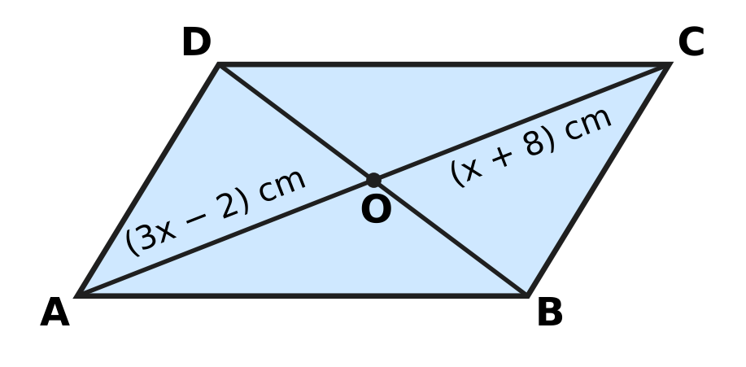
  (A) 52 cm | (B) 13 cm | (C) 5 cm | (D) 26 cm

Q17. In △ABC, AB = AC. The bisector of ∠BAC meets BC at D, as shown. BC = 16 cm and AD = 15 cm. What is the length of AB? | 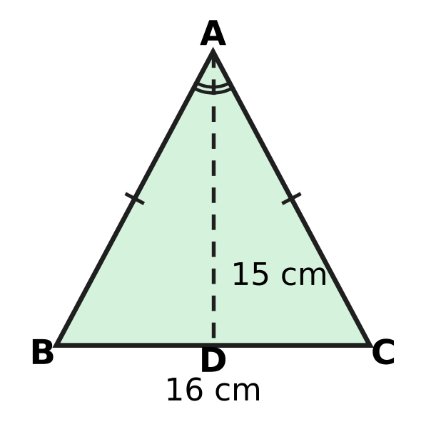
  (A) 23 cm | (B) 17 cm | (C) 31 cm | (D) 15 cm

Q18. ABCD is a cyclic quadrilateral with AB = AD, as the marks show. The diagonal BD is drawn, and ∠BCD = 104°. What is ∠ABD, marked x? | 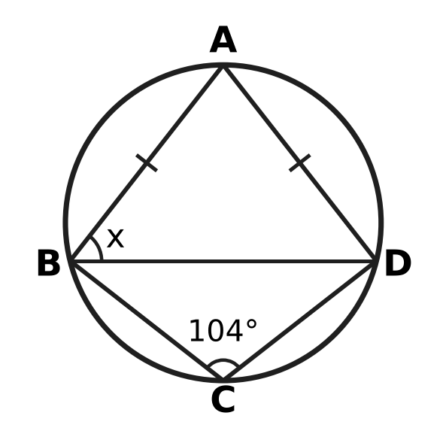
  (A) 104° | (B) 38° | (C) 76° | (D) 52°

Q19. A, B and C lie on a circle with centre O, as shown, and A is on the major arc BC. ∠BAC = 30° and the chord BC = 7 cm. What is the radius of the circle? | 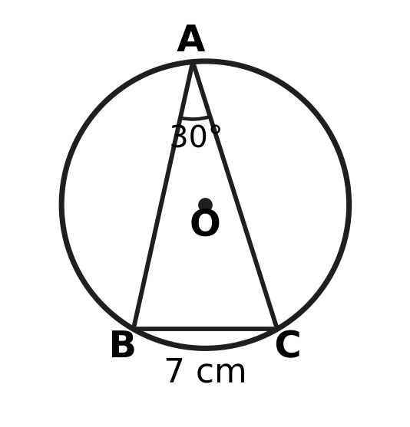
  (A) 14 cm | (B) 10.5 cm | (C) 7 cm | (D) 3.5 cm

Q20. In △ABC, the midpoint of AB is D(1, 5) and the midpoint of AC is E(5, 2). What is the length of BC?
(A) 10 units | (B) 5 units
(C) 2.5 units | (D) 14 units

Part 5 — Mensuration (Syllabus Chapter 6)
Q21. Kian's fishing net is a circle with a rim 8.8 m long. When it is spread out flat, what area of water does it cover? (Use π = $\frac{22}{7}$.)
(A) 24.64 m² | (B) 12.32 m² | (C) 3.08 m² | (D) 6.16 m²

Q22. For a science exhibition, Parth makes a model globe, a sphere of radius 7 cm. He then decides to make it bigger, with radius 14 cm. By how much does the surface area of the globe increase? (Use π = $\frac{22}{7}$.)
(A) 4,312 cm² | (B) 616 cm²
(C) 1,848 cm² | (D) 924 cm²

Q23. A window is a semicircle with a straight bottom edge 1.4 m long, as shown. A metal strip is fixed all the way round its edge (the curved part and the straight part). How long is the strip? (Use π = $\frac{22}{7}$.) | 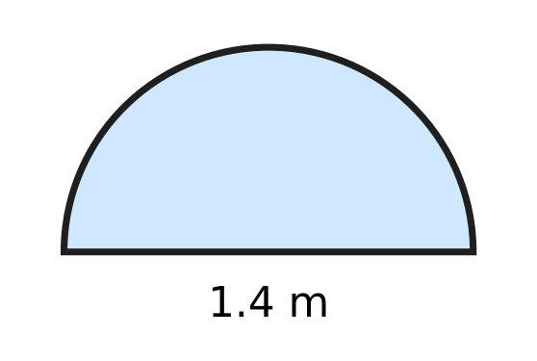
  (A) 3.6 m | (B) 5.8 m | (C) 2.2 m | (D) 2.9 m

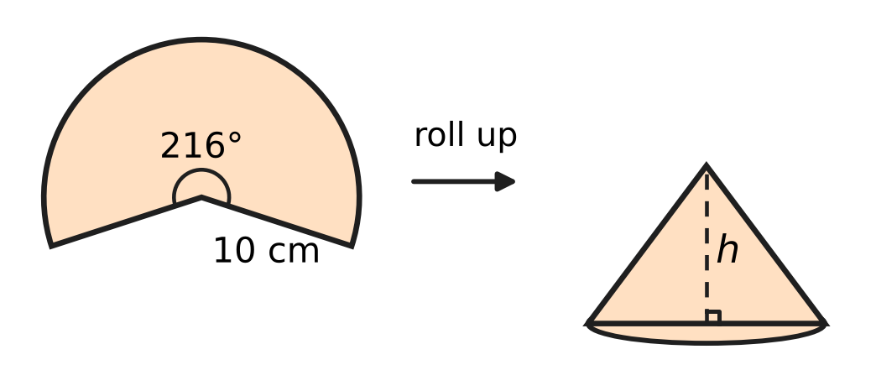
Q24. A paper sector has radius 10 cm and angle 216°. It is rolled up so that its two straight edges just meet, making the curved surface of a cone with no overlap, as shown. What is the height h of the cone?
(A) 4 cm | (B) 8 cm | (C) 6 cm | (D) 10 cm

Q25. Varsha cuts out a paper triangle with sides 25 cm, 25 cm and 14 cm, as shown. She wants a DIFFERENT triangle that also has two 25 cm sides and exactly the same area. How long must its third side be? | 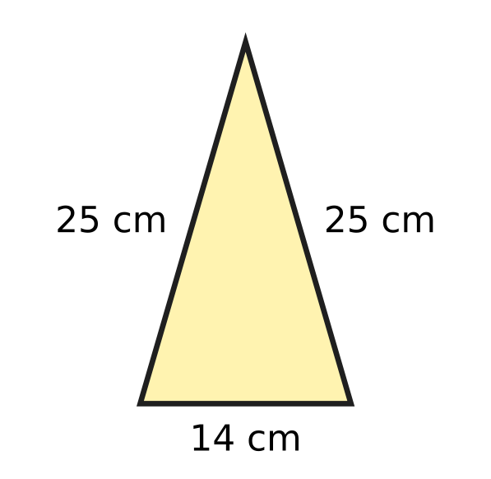
  (A) 24 cm | (B) 48 cm | (C) 7 cm | (D) 28 cm

Part 6 — Data Handling, Statistics & Probability (Syllabus Chapter 8)
Q26. In a course, the final mark is 30% of the Test A mark plus 70% of the Test B mark. Myra scored 60 in Test A. What must she score in Test B so that her final mark is 74?
(A) 56 | (B) 88 | (C) 80 | (D) 74

Q27. In a music class test, seven students scored 12, 15, 15, 18, 20, 22 and 26. Later the student who scored 26 was given 14 extra marks for a solo performance. Which of these is correct?
(A) The mean goes up by 14 and the median does NOT change.
(B) The median goes up by 2 and the mean does NOT change.
(C) The mean and the median both go up by 2.
(D) The mean goes up by 2 and the median does NOT change.

Q28. A fair eight-sided die has faces numbered 1 to 8. It is rolled once. What is the probability that the number shown is a factor of 24?
(A) $\frac{3}{4}$ | (B) $\frac{1}{4}$ | (C) $\frac{1}{2}$ | (D) $\frac{5}{8}$

Q29. At Heena's ice-cream stall, the freezer holds only mango cups and vanilla cups. A cup taken at random is mango with probability $\frac{2}{5}$. Heena then adds 6 more vanilla cups, and the probability of a mango cup becomes $\frac{1}{4}$. How many mango cups are in the freezer?
(A) 2 | (B) 6 | (C) 4 | (D) 10

Cups of tea sold at a tea stall
Day | Mon | Tue | Wed | Thu | Fri | Sat
Cups of tea sold | 40 | 90 | 60 | x | 70 | 90

Q30. Use the table. The data have exactly one mode, and the mean number of cups sold per day is equal to the mode. What is the value of x?
(A) 100 | (B) 70 | (C) 90 | (D) 190

Part 7 — Applied Mathematics (Syllabus Chapter 9)
Q31. The ladder of a playground slide has equally spaced rungs. The lowest rung is 30 cm above the ground, and each rung is 25 cm above the one below it. Which rung is 230 cm above the ground?
(A) the 9th rung | (B) the 8th rung
(C) the 10th rung | (D) the 7th rung

Battery readings
Time on the charger, t (minutes) | 10 | 20 | 40 | 50
Battery charge, c (%) | 27 | 42 | 72 | 87

Q32. A phone battery charges at a steady rate. The table shows its charge at some times after it was put on the charger. Which equation fits all the readings?
(A) c = 12t + 1.5 | (B) c = 1.5t + 12
(C) c = 1.5t + 27 | (D) c = 15t + 12

Q33. A hot-air balloon rises at a steady rate from the moment it leaves the ground. A timer was started before take-off. The timer shows the balloon 240 m above the ground at 10 minutes and 690 m above the ground at 25 minutes. At what timer reading did the balloon leave the ground?
(A) 0 minutes | (B) 2 minutes
(C) 8 minutes | (D) 5 minutes

Q34. In a building, Lift P starts at floor 20 and goes down steadily, 2 floors every 5 seconds. At the same moment, Lift Q starts at the ground floor (floor 0) and goes up steadily, 3 floors every 5 seconds. At which floor do the two lifts pass each other?
(A) floor 12 | (B) floor 4 | (C) floor 8 | (D) floor 10

Part 8 — Mathematical Reasoning & Problem-Solving (Syllabus Chapter 10)
Q35. Consider the statement: "If a whole number greater than 0 ends in 00, then it is a multiple of k." For which value of k is this statement true AND its converse also true?
(A) 25 | (B) 50 | (C) 200 | (D) 100

Q36. Lata multiplies 37 by 24 with this algorithm.
Step 1: Write 37 and 24 side by side as the first row.
Step 2: In the next row, write half of the left number (ignore any remainder) and double the right number. Repeat until the left number is 1.
Step 3: Cross out every row whose left number is even.
Step 4: Add the right-hand numbers that are left.
Which right-hand numbers does she add in Step 4?
(A) 96, 192 and 768 | (B) 24, 48 and 96
(C) 24, 96 and 768 | (D) 48, 192 and 384

Q37. Zoya wants to prove this statement by contradiction: "Among all the rational numbers that are less than 2, there is NO greatest one." She assumes that there is a greatest one and calls it r. Which number shows at once that her assumption is false?
(A) $r^{2}$ | (B) $2r$ | (C) $r−1$ | (D) $\frac{r+2}{2}$

Q38. Brahmagupta's formula, area = √((s − a)(s − b)(s − c)(s − d)), where a, b, c, d are the sides and s is half the perimeter, is true for every cyclic quadrilateral. Sarika uses it for the rhombus in the picture, whose sides are 13 cm and whose diagonals are 10 cm and 24 cm. What is the difference between her answer and the true area? | 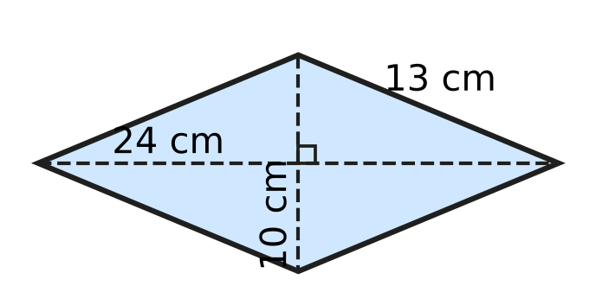
  (A) 49 cm² | (B) 109 cm² | (C) 0 cm² | (D) 71 cm²

Q39. Lata sorts the list 5, 1, 4, 2, 3 into increasing order. She goes along the list from left to right, swapping any two neighbours in the wrong order, and repeats this until no swap is needed. How many swaps does she make?
(A) 4 | (B) 6 | (C) 5 | (D) 10

Q40. The numbers 2 to 50 are written in a list.
Step 1: Circle 2, then cross out all the other multiples of 2 (that is, 4, 6, 8, …).
Step 2: Circle 3, then cross out every multiple of 3, other than 3 itself, that has NOT already been crossed out.
How many numbers are crossed out in Step 2?
(A) 15 | (B) 16 | (C) 7 | (D) 8

SECTION II — Star Questions 5 questions × 4 marks each
Q41. Jatin runs this algorithm.
Step 1: Put n = 1.
Step 2: If n leaves remainder 3 when divided by 7 AND remainder 1 when divided by 4, print n.
Step 3: Increase n by 1. If n is at most 500, go back to Step 2; otherwise stop.
How many numbers are printed? [4 marks]
(A) 18 | (B) 125 | (C) 72 | (D) 17

Q42. A ball rests in a circular hole of diameter 16 cm cut in a flat board. The lowest point of the ball is 4 cm below the top of the board, as the cross-section through the centre O shows. What is the surface area of the ball? (Use π = 3.14.) [4 marks] | 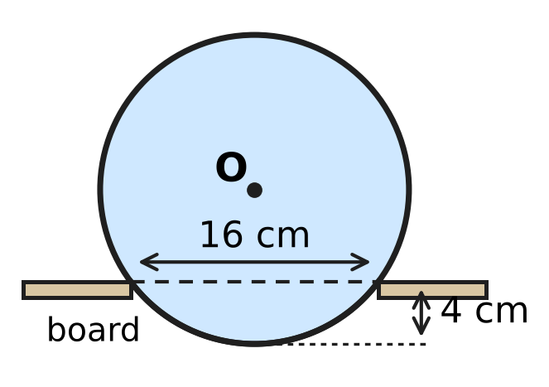
  (A) 628 cm² | (B) 1,004.8 cm²
  (C) 1,256 cm² | (D) 803.84 cm²

Q43. ABCD is a parallelogram in which A(1, 2) and C(7, 6) are opposite vertices. The vertex B lies on the x-axis, and the vertex D lies on the line $y=x+3$. What are the coordinates of D? [4 marks]
(A) (3, 0) | (B) (1, 4) | (C) (4, 7) | (D) (5, 8)

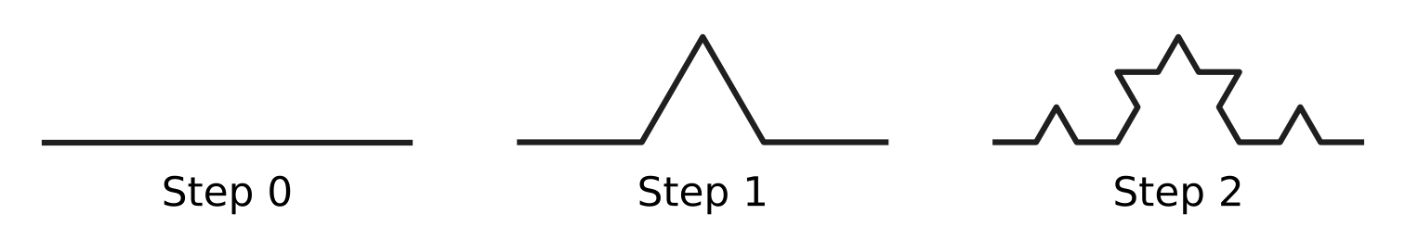
Q44. The picture shows Steps 0, 1 and 2 of the Koch curve. Step 0 is one horizontal segment. At each step, every segment is cut into 3 equal parts, and the middle part is replaced by the other two sides of an equilateral triangle, as shown. One segment of Step 3 is chosen at random, each segment being equally likely. What is the probability that it is horizontal on the page, like the Step 0 segment? [4 marks]
(A) $\frac{1}{8}$ | (B) $\frac{11}{32}$ | (C) $\frac{3}{8}$ | (D) $\frac{1}{3}$

Q45. Every year a school buys 100 roses and 25 lilies from a flower shop to decorate its hall. Each year the price of a rose goes up by 10% of the previous year's price, and the price of a lily goes up by 20% of the previous year's price. The flowers cost ₹1,625 in Year 1 and ₹2,110 in Year 3. What was the price of one lily in Year 1? [4 marks]
(A) ₹36 | (B) ₹10 | (C) ₹30 | (D) ₹25

Answer Sheet AMO Level 1 · Class 9 · Practice Paper 5
Name: | School: | Roll No.:
Shade or tick one circle for each question.
1. Ⓐ Ⓑ Ⓒ Ⓓ | 16. Ⓐ Ⓑ Ⓒ Ⓓ | 31. Ⓐ Ⓑ Ⓒ Ⓓ
2. Ⓐ Ⓑ Ⓒ Ⓓ | 17. Ⓐ Ⓑ Ⓒ Ⓓ | 32. Ⓐ Ⓑ Ⓒ Ⓓ
3. Ⓐ Ⓑ Ⓒ Ⓓ | 18. Ⓐ Ⓑ Ⓒ Ⓓ | 33. Ⓐ Ⓑ Ⓒ Ⓓ
4. Ⓐ Ⓑ Ⓒ Ⓓ | 19. Ⓐ Ⓑ Ⓒ Ⓓ | 34. Ⓐ Ⓑ Ⓒ Ⓓ
5. Ⓐ Ⓑ Ⓒ Ⓓ | 20. Ⓐ Ⓑ Ⓒ Ⓓ | 35. Ⓐ Ⓑ Ⓒ Ⓓ
6. Ⓐ Ⓑ Ⓒ Ⓓ | 21. Ⓐ Ⓑ Ⓒ Ⓓ | 36. Ⓐ Ⓑ Ⓒ Ⓓ
7. Ⓐ Ⓑ Ⓒ Ⓓ | 22. Ⓐ Ⓑ Ⓒ Ⓓ | 37. Ⓐ Ⓑ Ⓒ Ⓓ
8. Ⓐ Ⓑ Ⓒ Ⓓ | 23. Ⓐ Ⓑ Ⓒ Ⓓ | 38. Ⓐ Ⓑ Ⓒ Ⓓ
9. Ⓐ Ⓑ Ⓒ Ⓓ | 24. Ⓐ Ⓑ Ⓒ Ⓓ | 39. Ⓐ Ⓑ Ⓒ Ⓓ
10. Ⓐ Ⓑ Ⓒ Ⓓ | 25. Ⓐ Ⓑ Ⓒ Ⓓ | 40. Ⓐ Ⓑ Ⓒ Ⓓ
11. Ⓐ Ⓑ Ⓒ Ⓓ | 26. Ⓐ Ⓑ Ⓒ Ⓓ | 41. Ⓐ Ⓑ Ⓒ Ⓓ
12. Ⓐ Ⓑ Ⓒ Ⓓ | 27. Ⓐ Ⓑ Ⓒ Ⓓ | 42. Ⓐ Ⓑ Ⓒ Ⓓ
13. Ⓐ Ⓑ Ⓒ Ⓓ | 28. Ⓐ Ⓑ Ⓒ Ⓓ | 43. Ⓐ Ⓑ Ⓒ Ⓓ
14. Ⓐ Ⓑ Ⓒ Ⓓ | 29. Ⓐ Ⓑ Ⓒ Ⓓ | 44. Ⓐ Ⓑ Ⓒ Ⓓ
15. Ⓐ Ⓑ Ⓒ Ⓓ | 30. Ⓐ Ⓑ Ⓒ Ⓓ | 45. Ⓐ Ⓑ Ⓒ Ⓓ
Q41–Q45 are Section II Star Questions (4 marks each).
For the parent or teacher
Section I correct: ______ / 40 × 2 = ______ marks Section II correct: ______ / 5 × 4 = ______ marks
Correct: ______ / 45 Score: ______ / 100
Answer Key and Solutions AMO Level 1 · Class 9 · Practice Paper 5
Quick answers
1 C | 6 D | 11 A | 16 D | 21 D | 26 C | 31 A | 36 C | 41 A
2 B | 7 B | 12 D | 17 B | 22 C | 27 D | 32 B | 37 D | 42 C
3 A | 8 C | 13 C | 18 D | 23 A | 28 A | 33 B | 38 A | 43 D
4 D | 9 C | 14 B | 19 C | 24 B | 29 C | 34 A | 39 B | 44 B
5 A | 10 B | 15 A | 20 A | 25 B | 30 D | 35 D | 40 C | 45 D
Solutions
Q | Part · level | Answer | Why?
1 | Part 1 · Ch1 · Easy | (C) 0.67777… | Compare digit by digit: all start 0.6; the second digits are 7, 7, 7 and 6; the third digits are 7 for 0.6777…, 6 for 0.6767… and 0 for 0.67. So 0.67777… is the greatest.
2 | Part 1 · Ch1 · Easy | (B) $\sqrt{0.4}$ | √0.04 = 0.2, √1.21 = 1.1 and 0.444… = 4/9, so √0.444… = 2/3; all three are rational. But 0.4 = 2/5 is not the square of any rational, so √0.4 is irrational.
3 | Part 1 · Ch1 · Medium | (A) 22 | Let x = 0.31818…. Then 1,000x = 318.1818… and 10x = 3.1818…, so 990x = 315 and x = 315/990 = 7/22. So q = 22.
4 | Part 2 · Ch3 · Easy | (D) ₹6,000 | Simple interest adds the same amount each year: ₹7,800 − ₹7,200 = ₹600. Going back two years from Year 2: ₹7,200 − 2 × ₹600 = ₹6,000.
5 | Part 2 · Ch3 · Easy | (A) 2,080 | After Year 1 the population is 50,000 × 1.04 = 52,000. During Year 2 it grows by 4% of 52,000 = 2,080.
6 | Part 2 · Ch3 · Medium | (D) 37.5% | The 7.5% rate is the weighted average of 6% and 10%. It lies 1.5 above 6 out of the gap of 4 between 6 and 10, so the share in Deposit B is 1.5 ÷ 4 = 37.5%. Check: 0.625 × 6 + 0.375 × 10 = 7.5.
7 | Part 3 · Ch4 · Easy | (B) 16 | 9x² + 24x + 16 = (3x)² + 2 × 3x × 4 + 4² = (3x + 4)², so 16 must be added.
8 | Part 3 · Ch4 · Easy | (C) 31 | The common difference d satisfies 14d = 59 − 3 = 56, so d = 4. The 8th term is 3 + 7 × 4 = 31 (it is also the average of the 1st and 15th terms, since 8 is halfway between 1 and 15).
9 | Part 3 · Ch4 · Easy | (C) 11 | x² − y² = (x + y)(x − y), so 4(x + y) = 72 and x + y = 18. With x − y = 4, adding gives 2x = 22, so x = 11.
10 | Part 3 · Ch4 · Easy | (B) 3 | p(2) = 4 + 2k − 6 = 2k − 2. Setting 2k − 2 = 4 gives k = 3.
11 | Part 3 · Ch4 · Medium | (A) $x=2$ | x² + 3x − 10 = (x + 5)(x − 2) and x² − 4 = (x − 2)(x + 2). The common factor x − 2 was cancelled, so at x = 2 the original is 0/0 (undefined) while (x + 5)/(x + 2) = 7/4.
12 | Part 3 · Ch4 · Medium | (D) 4 | ab = 24 and k = a + b. The pairs are 1 × 24, 2 × 12, 3 × 8 and 4 × 6, giving k = 25, 14, 11 and 10: four values.
13 | Part 3 · Ch4 · Medium | (C) 144 | AP: d = 4, so A = 2 + 4 × 4 = 18. GP: r = 3, so G = 2 × 3⁴ = 162. G − A = 162 − 18 = 144.
14 | Part 4 · Ch5 · Easy | (B) the 18 cm chord | The distance from the centre is √(10² − (half-chord)²): 8.66 cm, 8 cm, 6 cm and about 4.4 cm. The longest chord, 18 cm, is the nearest.
15 | Part 4 · Ch5 · Easy | (A) 4 | (a − 1)² + (3 − (−1))² = 25, so (a − 1)² = 9 and a − 1 = 3 or −3. Since a is positive, a = 4.
16 | Part 4 · Ch5 · Easy | (D) 26 cm | The diagonals of a parallelogram bisect each other, so 3x − 2 = x + 8 and x = 5. Then AO = OC = 13 cm, and AC = 26 cm.
17 | Part 4 · Ch5 · Easy | (B) 17 cm | △ABD ≅ △ACD (SAS: AB = AC, equal angles at A, AD common), so BD = DC = 8 cm and ∠ADB = ∠ADC = 90°. Then AB = √(15² + 8²) = 17 cm.
18 | Part 4 · Ch5 · Medium | (D) 52° | Opposite angles of a cyclic quadrilateral add to 180°, so ∠BAD = 180° − 104° = 76°. In △ABD, AB = AD, so ∠ABD = ∠ADB = (180° − 76°) ÷ 2 = 52°.
19 | Part 4 · Ch5 · Medium | (C) 7 cm | ∠BOC = 2 × ∠BAC = 60°. Since OB = OC, △OBC is isosceles with a 60° angle between the equal sides, so it is equilateral. The radius OB = BC = 7 cm.
20 | Part 4 · Ch5 · Medium | (A) 10 units | DE = √((5 − 1)² + (2 − 5)²) = √(16 + 9) = 5 units. By the midpoint theorem, DE is half of BC, so BC = 10 units.
21 | Part 5 · Ch6 · Easy | (D) 6.16 m² | The rim is the circumference, so 2πr = 8.8 and r = 8.8 × 7 ÷ 44 = 1.4 m. Area = 22/7 × 1.4 × 1.4 = 6.16 m².
22 | Part 5 · Ch6 · Easy | (C) 1,848 cm² | The surface area 4πr² is 616 cm² for r = 7 and 2,464 cm² for r = 14 (four times as much). The increase is 2,464 − 616 = 1,848 cm².
23 | Part 5 · Ch6 · Easy | (A) 3.6 m | Curved part = half of π × 1.4 = ½ × 22/7 × 1.4 = 2.2 m. Strip = 2.2 + 1.4 = 3.6 m.
24 | Part 5 · Ch6 · Medium | (B) 8 cm | The arc, 216/360 × 2π × 10 = 12π cm, becomes the base circumference 2πr, so r = 6 cm. The slant height is 10 cm, so h = √(10² − 6²) = 8 cm.
25 | Part 5 · Ch6 · Medium | (B) 48 cm | Heron: s = 32, area = √(32 × 7 × 7 × 18) = 168 cm². The height on the 14 cm side is 24 cm, so the triangle is two 7-24-25 right triangles. Swapping their legs (half-base 24 cm, height 7 cm) gives the same area, so the third side is 48 cm. Check: s = 49, area = √(49 × 24 × 24 × 1) = 168 cm².
26 | Part 6 · Ch8 · Easy | (C) 80 | Test A gives 0.3 × 60 = 18, so 0.7 × B = 74 − 18 = 56 and B = 56 ÷ 0.7 = 80.
27 | Part 6 · Ch8 · Easy | (D) The mean goes up by 2 and the median does NOT change. | The total rises by 14, so the mean rises by 14 ÷ 7 = 2. The middle (4th) score is still 18, so the median does not change.
28 | Part 6 · Ch8 · Easy | (A) $\frac{3}{4}$ | The factors of 24 from 1 to 8 are 1, 2, 3, 4, 6 and 8: six of the eight equally likely outcomes. P = 6/8 = 3/4.
29 | Part 6 · Ch8 · Medium | (C) 4 | Let there be m mango cups and n cups in all. m/n = 2/5 and m/(n + 6) = 1/4. So 5m = 2n and 4m = n + 6, giving m = 4 and n = 10.
30 | Part 6 · Ch8 · Medium | (D) 190 | The mode must be 90 (x = 40, 60 or 70 would give two modes, and x = 90 gives a mean below 90). Mean = 90 means the total is 6 × 90 = 540, so x = 540 − 350 = 190.
31 | Part 7 · Ch9 · Easy | (A) the 9th rung | Rung n is 30 + 25(n − 1) cm high. Solving 30 + 25(n − 1) = 230 gives n − 1 = 8, so n = 9.
32 | Part 7 · Ch9 · Easy | (B) c = 1.5t + 12 | The charge rises by 15% every 10 minutes, that is 1.5% per minute. Going back 10 minutes from 27% gives 27 − 15 = 12% at t = 0, so c = 1.5t + 12.
33 | Part 7 · Ch9 · Medium | (B) 2 minutes | Rate = (690 − 240) ÷ (25 − 10) = 30 m per minute. Climbing 240 m takes 240 ÷ 30 = 8 minutes, so it left the ground at 10 − 8 = 2 minutes.
34 | Part 7 · Ch9 · Medium | (A) floor 12 | After k intervals of 5 seconds, P is at 20 − 2k and Q is at 3k. Solving 20 − 2k = 3k gives k = 4, so they pass at floor 3 × 4 = 12 (after 20 seconds).
35 | Part 8 · Ch10 · Easy | (D) 100 | The converse is "If a whole number greater than 0 is a multiple of k, then it ends in 00." A number greater than 0 ends in 00 exactly when it is a multiple of 100, so both are true only for k = 100 (25 and 50 fail the converse, 200 fails the statement).
36 | Part 8 · Ch10 · Easy | (C) 24, 96 and 768 | Rows: 37|24, 18|48, 9|96, 4|192, 2|384, 1|768. The left numbers 37, 9 and 1 are odd, so she adds 24 + 96 + 768 = 888, which is 37 × 24.
37 | Part 8 · Ch10 · Easy | (D) $\frac{r+2}{2}$ | (r + 2)/2 is the average of r and 2. It is rational, and since r < 2 it lies between r and 2. So it is a rational number less than 2 that is greater than r, which contradicts the assumption.
38 | Part 8 · Ch10 · Easy | (A) 49 cm² | Here s = 26, so the formula gives √(13 × 13 × 13 × 13) = 169 cm². The true area is (10 × 24) ÷ 2 = 120 cm². The difference is 49 cm², because a rhombus that is not a square is not cyclic.
39 | Part 8 · Ch10 · Medium | (B) 6 | First pass: 5 moves past 1, 4, 2 and 3, giving 1, 4, 2, 3, 5 (4 swaps). Second pass: 4 moves past 2 and 3, giving 1, 2, 3, 4, 5 (2 swaps). Third pass: no swaps. Total = 4 + 2 = 6.
40 | Part 8 · Ch10 · Medium | (C) 7 | After Step 1 only odd numbers are left, so Step 2 crosses out the odd multiples of 3 other than 3: 9, 15, 21, 27, 33, 39 and 45, which is 7 numbers.
41 | Section II · Ch4 + Ch10 · Hard | (A) 18 | The first number printed is 17. The next is 28 more (28 is the smallest number divisible by both 7 and 4), so the printed numbers form the AP 17, 45, 73, … with d = 28. Then 17 + 28(k − 1) ≤ 500 gives k ≤ 18.25, so 18 numbers.
42 | Section II · Ch5 + Ch6 · Hard | (C) 1,256 cm² | The edge of the hole is a chord of length 16 cm, and the perpendicular from O bisects it. If the radius is r cm, the centre is (r − 4) cm above the hole, so r² = 8² + (r − 4)², giving 8r = 80 and r = 10. Surface area = 4 × 3.14 × 10² = 1,256 cm².
43 | Section II · Ch4 + Ch5 · Hard | (D) (5, 8) | The diagonals bisect each other, so BD has the same midpoint as AC, namely (4, 4). If B = (b, 0), then D = (8 − b, 8). D is on y = x + 3, so 8 = 8 − b + 3, giving b = 3 and D = (5, 8).
44 | Section II · Ch8 + Ch10 · Hard | (B) $\frac{11}{32}$ | Each horizontal segment gives 2 horizontal pieces, and each slanted segment gives 1 horizontal piece. Step 2 has 6 horizontal and 10 slanted segments, so Step 3 has 2 × 6 + 10 = 22 horizontal segments out of 64, and P = 22/64 = 11/32.
45 | Section II · Ch3 + Ch9 · Hard | (D) ₹25 | Let a rose cost ₹r and a lily ₹l in Year 1. Then 100r + 25l = 1,625. In Year 3 the prices are 1.21r and 1.44l, so 121r + 36l = 2,110. From the first, l = 65 − 4r, so 121r + 2,340 − 144r = 2,110, giving r = 10 and l = 25.

