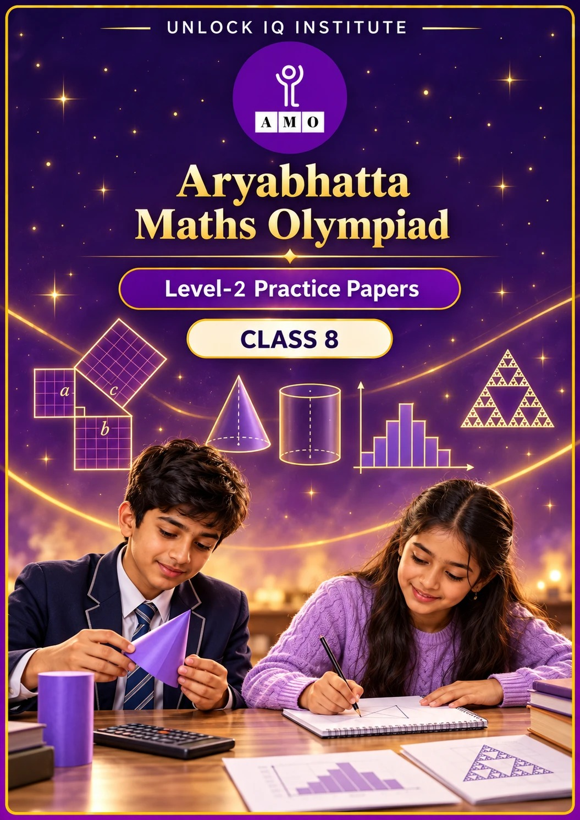
Set 1 · Practice Papers 1–5 · with answer keys & detailed solutions
Name: ____________________ | Class & Section: ________________
Roll No.: ________________ | School: ____________________
City: ____________________ | Date: ____________________

Published by Unlock IQ Institute Pvt. Ltd.
Register for Olympiads: www.aryabhattamathsolympiad.com/student-registration

ARYABHATTA MATHS OLYMPIAD
Level 2
PRACTICE PAPER-1
CLASS 8
Total Questions | 30 multiple-choice questions
Level | Level-2 (final round): every question is Hard
Time | 45 minutes
Arrangement | Parts by chapter; the last Part has mixed problems joining two chapters
Negative Marking | No negative marking
Calculator | Not allowed
Chapters | Number System · Operations · Fractions, Decimals & Percentages · Algebra · Geometry · Mensuration · Data Handling, Statistics & Probability · Applied Mathematics · Mathematical Reasoning

Instructions
• Each question has four options, (A) to (D), with exactly one correct answer.
• The questions are grouped in Parts by chapter. The last Part has mixed problems, each joining two chapters.
• Every question is at Level-2 (Hard) standard: expect several steps or a key insight.
• There is no negative marking. Calculators are not allowed; use a separate sheet for rough work.
• Figures are not necessarily drawn to scale unless stated.

For teachers
• Figures are part of the questions and work when printed in black and white.
• Parts follow the AMO syllabus chapters. Chapter 7 is not part of the Class 8 syllabus, so the chapter numbers shown in the Part headings have gaps.
• The answer sheet and the answer key are at the end. Remove the answer key before the paper is attempted.

Part 1 — Number System (Syllabus Chapter 1)
Q1. How many perfect squares lie between 50 and 400 and are also multiples of 3?
(A) 5 | (B) 4 | (C) 6 | (D) 3

Q2. Let x = √2 + 1. Which of these numbers is rational?
(A) x(x − 2) | (B) x² | (C) 2x − 1 | (D) x + √8

Part 2 — Operations (Syllabus Chapter 2)
Q3. Find x if 3²ˣ⁻¹ × 9⁻² = 27⁻¹.
(A) 2 | (B) −1 | (C) 3 | (D) 1

Q4. Light travels 3 × 10⁸ metres every second, and a year has about 3.15 × 10⁷ seconds. A light-year is the distance light travels in one year. A star is 1.89 × 10¹⁴ km away. How many light-years is that?
(A) 0.02 | (B) 2,000 | (C) 2 | (D) 20

Part 3 — Fractions, Decimals & Percentages (Syllabus Chapter 3)
Q5. A watch is marked ₹2,500. Shop P gives 20% off and then a further 10% off the reduced price. Shop Q gives a single 30% off. How much more does a buyer pay at shop P?
(A) ₹50 | (B) ₹0 | (C) ₹75 | (D) ₹25

Q6. At simple interest, a sum of money doubles itself in 8 years. In how many years will it become three times itself at the same rate?
(A) 24 | (B) 12 | (C) 20 | (D) 16

Q7. The price of a bicycle rises by 20%, then falls by 20%, and then rises by 25%. What is the overall change in the price?
(A) 20% increase | (B) 25% increase | (C) No change | (D) 4% decrease

Part 4 — Algebra (Syllabus Chapter 4)
Q8. Two numbers a and b, with a > b, have a + b = 9 and ab = 14. What is a² − b²?
(A) 53 | (B) 45 | (C) 25 | (D) 81

Q9. Without long multiplication, find (1001² − 999²) ÷ (51² − 49²).
(A) 2 | (B) 10 | (C) 20 | (D) 40

Q10. Kunal's father is now 4 times as old as Kunal. In 16 years he will be twice as old as Kunal. How old is Kunal now?
(A) 16 | (B) 12 | (C) 8 | (D) 6

Part 5 — Geometry (Syllabus Chapter 5)
Q11. A 13 m ladder leans against a wall with its foot 5 m from the wall. The foot slides out until it is 12 m from the wall. How far does the top of the ladder slide down?
(A) 7 m | (B) 5 m | (C) 12 m | (D) 1 m

Q12. A rhombus has a perimeter of 68 cm and one diagonal 30 cm long. What is its area?
(A) 480 cm² | (B) 240 cm² | (C) 255 cm² | (D) 120 cm²

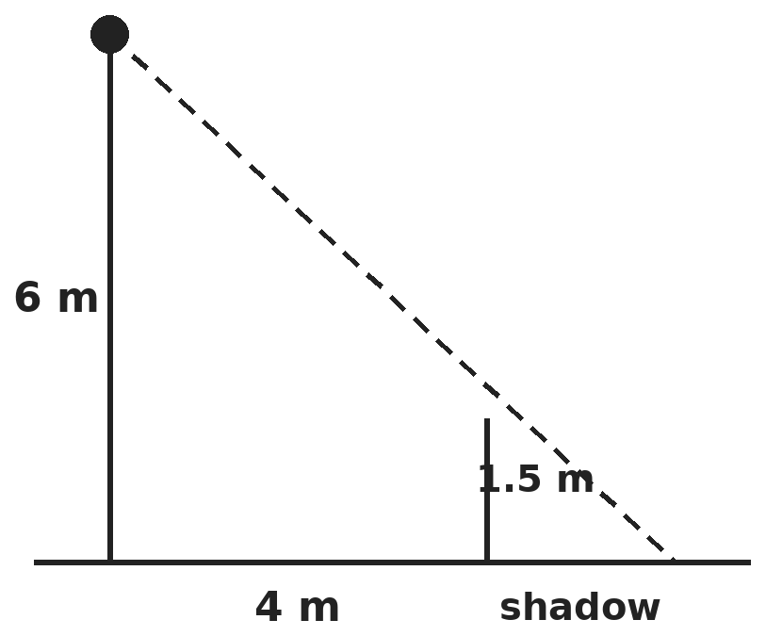
Q13. Riya, 1.5 m tall, stands 4 m from the foot of a 6 m lamp post, as shown. How long is her shadow?
(A) 4/3 m | (B) 1 m | (C) 3/4 m | (D) 16/3 m

Part 6 — Mensuration (Syllabus Chapter 6)
Q14. A closed cylindrical tin is 10 cm tall and its curved surface area is 440 cm². What is its total surface area? (Take π = 22/7.)
(A) 594 cm² | (B) 880 cm² | (C) 1,540 cm² | (D) 748 cm²

Q15. The curved surface area of a cone is 550 cm² and its base radius is 7 cm. What is its height? (Take π = 22/7.)
(A) 25 cm | (B) 24 cm | (C) 18 cm | (D) 32 cm

Q16. A tank 2 m long, 1.5 m wide and 1 m deep is filled by a pipe that delivers 50 litres a minute, but a leak at the bottom loses 10 litres a minute. How long does it take to fill the empty tank?
(A) 1 hour | (B) 1 hour 15 minutes
(C) 50 minutes | (D) 1 hour 40 minutes

Part 7 — Data Handling, Statistics & Probability (Syllabus Chapter 8)
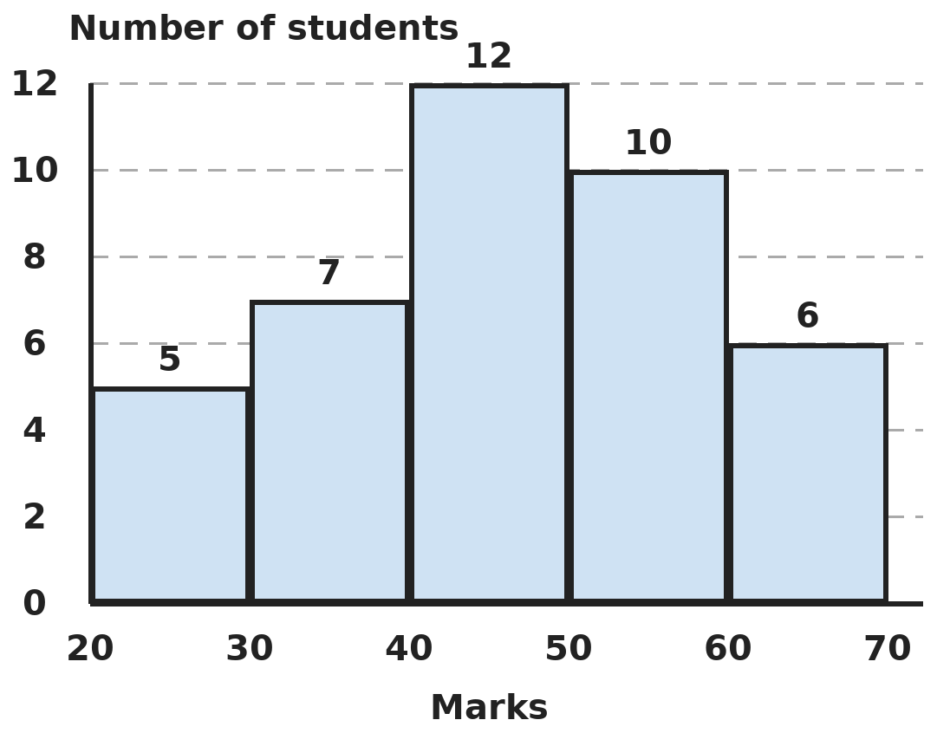
Q17. The histogram shows the marks of a class in a test (each class includes its lower mark, not its upper mark). What percentage of the class scored 50 marks or more?
(A) 16% | (B) 70% | (C) 40% | (D) 25%

Q18. The mean of six numbers is 15. If one number is removed, the mean of the rest is 14. If, instead, a different number is removed, the mean of the rest is 16. What is the difference between these two numbers?
(A) 2 | (B) 30 | (C) 10 | (D) 5

Part 8 — Applied Mathematics (Syllabus Chapter 9)
Q19. Gopal sells two chairs for ₹990 each. On one he gains 10% and on the other he loses 10%. What is his overall result?
(A) 1% loss | (B) No profit no loss
(C) 1% profit | (D) 2% loss

Q20. Meera invests ₹12,000, part at 8% and the rest at 10% simple interest a year. Her total interest for one year is ₹1,060. How much did she invest at 10%?
(A) ₹7,000 | (B) ₹6,000 | (C) ₹4,000 | (D) ₹5,000

Q21. A shopkeeper marks his goods 40% above cost price and then gives a discount of 15% on the marked price. What is his profit percent?
(A) 25% | (B) 21% | (C) 19% | (D) 15%

Part 9 — Mathematical Reasoning (Syllabus Chapter 10)
Q22. AB and BA are two-digit numbers made from digits A and B. AB + BA = 121 and AB − BA = 27. What is AB?
(A) 47 | (B) 74 | (C) 83 | (D) 65

Q23. How many three-digit numbers have digits that add up to 5?
(A) 21 | (B) 10 | (C) 15 | (D) 12

Q24. For every whole number n ≥ 2, the number n³ − n is divisible by a certain largest whole number. What is it?
(A) 3 | (B) 2 | (C) 12 | (D) 6

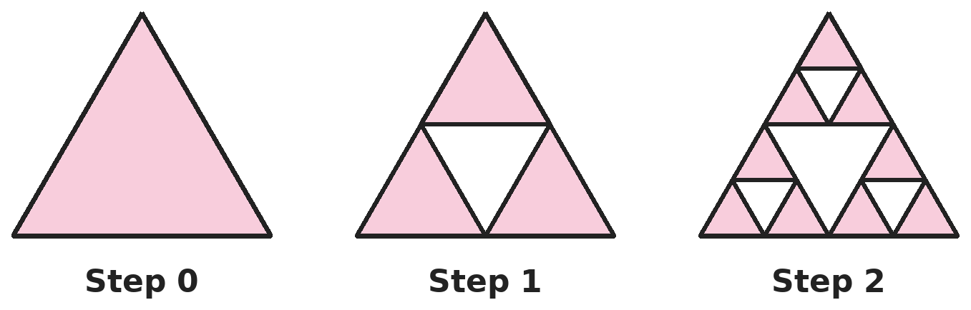
Q25. At each step, every shaded triangle is split into four equal triangles and the middle one is removed. Steps 0, 1 and 2 are shown. What fraction of the original triangle is still shaded after step 4?
(A) 3/16 | (B) 27/64 | (C) 81/256 | (D) 1/4

Part 10 — Mixed Problems (each joins two chapters)
Q26. Three consecutive odd numbers add up to 147. Using an identity rather than long multiplication, find the product of the smallest and the largest.
(A) 2,401 | (B) 2,397 | (C) 2,499 | (D) 2,352

Q27. How many different right-angled triangles have whole-number sides and a hypotenuse of exactly 25 cm?
(A) 1 | (B) 3 | (C) 2 | (D) 4

Q28. The length of a rectangle is 7 cm more than its width, and its perimeter is 34 cm. How long is a diagonal?
(A) 17 cm | (B) 12 cm | (C) 15 cm | (D) 13 cm

Q29. The simple interest on a sum for 3 years at 8% a year is ₹1,200 more than the simple interest on the same sum for 2 years at 9% a year. What is the sum?
(A) ₹20,000 | (B) ₹12,000 | (C) ₹15,000 | (D) ₹24,000

Q30. A cylindrical tank has radius 1.4 m and height 2 m. Water costs 5 paise per litre. What does it cost to fill the empty tank? (Take π = 22/7.)
(A) ₹616 | (B) ₹6,160 | (C) ₹308 | (D) ₹1,232

Answer Sheet AMO Level 2 · Class 8 · Practice Paper 1
Name: | School: | Roll No.:
Shade or tick one circle for each question.
1. | Ⓐ Ⓑ Ⓒ Ⓓ | 11. | Ⓐ Ⓑ Ⓒ Ⓓ | 21. | Ⓐ Ⓑ Ⓒ Ⓓ
2. | Ⓐ Ⓑ Ⓒ Ⓓ | 12. | Ⓐ Ⓑ Ⓒ Ⓓ | 22. | Ⓐ Ⓑ Ⓒ Ⓓ
3. | Ⓐ Ⓑ Ⓒ Ⓓ | 13. | Ⓐ Ⓑ Ⓒ Ⓓ | 23. | Ⓐ Ⓑ Ⓒ Ⓓ
4. | Ⓐ Ⓑ Ⓒ Ⓓ | 14. | Ⓐ Ⓑ Ⓒ Ⓓ | 24. | Ⓐ Ⓑ Ⓒ Ⓓ
5. | Ⓐ Ⓑ Ⓒ Ⓓ | 15. | Ⓐ Ⓑ Ⓒ Ⓓ | 25. | Ⓐ Ⓑ Ⓒ Ⓓ
6. | Ⓐ Ⓑ Ⓒ Ⓓ | 16. | Ⓐ Ⓑ Ⓒ Ⓓ | 26. | Ⓐ Ⓑ Ⓒ Ⓓ
7. | Ⓐ Ⓑ Ⓒ Ⓓ | 17. | Ⓐ Ⓑ Ⓒ Ⓓ | 27. | Ⓐ Ⓑ Ⓒ Ⓓ
8. | Ⓐ Ⓑ Ⓒ Ⓓ | 18. | Ⓐ Ⓑ Ⓒ Ⓓ | 28. | Ⓐ Ⓑ Ⓒ Ⓓ
9. | Ⓐ Ⓑ Ⓒ Ⓓ | 19. | Ⓐ Ⓑ Ⓒ Ⓓ | 29. | Ⓐ Ⓑ Ⓒ Ⓓ
10. | Ⓐ Ⓑ Ⓒ Ⓓ | 20. | Ⓐ Ⓑ Ⓒ Ⓓ | 30. | Ⓐ Ⓑ Ⓒ Ⓓ

For the parent or teacher
Correct: ______ / 30
Answer Key and Solutions AMO Level 2 · Class 8 · Practice Paper 1
Quick answers
1 B | 6 D | 11 A | 16 B | 21 C | 26 B
2 A | 7 A | 12 B | 17 C | 22 B | 27 C
3 D | 8 B | 13 A | 18 C | 23 C | 28 D
4 D | 9 C | 14 D | 19 A | 24 D | 29 A
5 A | 10 C | 15 B | 20 D | 25 C | 30 A
Solutions
Q | Part · level | Answer | Why?
1 | Part 1 · Ch1 · Hard | (B) 4 | Hint: A perfect square is a multiple of 3 only when its square root is a multiple of 3.  The squares between 50 and 400 are 8², 9², …, 19² (20² = 400 is not between). A square is a multiple of 3 exactly when its root is, so the roots are 9, 12, 15 and 18. That is 4 squares: 81, 144, 225 and 324.
2 | Part 1 · Ch1 · Hard | (A) x(x − 2) | Hint: x − 2 = √2 − 1. Multiply it by x = √2 + 1.  x(x − 2) = (√2 + 1)(√2 − 1) = 2 − 1 = 1, which is rational. x² = 3 + 2√2, 2x − 1 = 2√2 + 1 and x + √8 = 3√2 + 1 all contain √2, so they are irrational.
3 | Part 2 · Ch2 · Hard | (D) 1 | Hint: Write 9 and 27 as powers of 3.  9⁻² = 3⁻⁴ and 27⁻¹ = 3⁻³. So 3²ˣ⁻¹⁻⁴ = 3⁻³, which gives 2x − 5 = −3, so 2x = 2 and x = 1.
4 | Part 2 · Ch2 · Hard | (D) 20 | Hint: Find one light-year in metres, then change it to kilometres.  One light-year = 3 × 10⁸ × 3.15 × 10⁷ = 9.45 × 10¹⁵ m = 9.45 × 10¹² km. 1.89 × 10¹⁴ ÷ (9.45 × 10¹²) = 0.2 × 10² = 20 light-years. (0.02 forgets to change metres into kilometres.)
5 | Part 3 · Ch3 · Hard | (A) ₹50 | Hint: Successive discounts are applied one after the other, on the reduced price.  Shop P: 2,500 × 0.8 = 2,000, then 2,000 × 0.9 = ₹1,800. Shop Q: 2,500 × 0.7 = ₹1,750. Shop P costs ₹50 more. (20% + 10% is not the same as 30%.)
6 | Part 3 · Ch3 · Hard | (D) 16 | Hint: Doubling means the interest equals the sum once.  Doubling in 8 years means the interest in 8 years equals the principal, so the rate is 100 ÷ 8 = 12.5% a year. To triple, the interest must be twice the principal: 200% ÷ 12.5% = 16 years.
7 | Part 3 · Ch3 · Hard | (A) 20% increase | Hint: Multiply the factors: 1.2, 0.8 and 1.25.  1.2 × 0.8 = 0.96, a 4% fall after two changes. 0.96 × 1.25 = 1.2. So the price is 1.2 times the original: a 20% increase.
8 | Part 4 · Ch4 · Hard | (B) 45 | Hint: Find (a − b)² from (a + b)² − 4ab, then use a² − b² = (a + b)(a − b).  (a − b)² = (a + b)² − 4ab = 81 − 56 = 25, so a − b = 5 (a is larger). a² − b² = (a + b)(a − b) = 9 × 5 = 45. (53 is a² + b².)
9 | Part 4 · Ch4 · Hard | (C) 20 | Hint: Use a² − b² = (a + b)(a − b) on top and bottom.  1001² − 999² = (2000)(2) = 4,000. 51² − 49² = (100)(2) = 200. 4,000 ÷ 200 = 20.
10 | Part 4 · Ch4 · Hard | (C) 8 | Hint: Let Kunal be x years old. Write both ages in 16 years.  Now: x and 4x. In 16 years: x + 16 and 4x + 16. So 4x + 16 = 2(x + 16) = 2x + 32, giving 2x = 16 and x = 8. Check: 8 and 32 now; 24 and 48 later.
11 | Part 5 · Ch5 · Hard | (A) 7 m | Hint: Use Pythagoras twice: once for each position.  At first the top is √(13² − 5²) = √144 = 12 m high. Later it is √(13² − 12²) = √25 = 5 m high. It slides down 12 − 5 = 7 m.
12 | Part 5 · Ch5 · Hard | (B) 240 cm² | Hint: The diagonals of a rhombus bisect each other at right angles. Find the other diagonal first.  Each side is 68 ÷ 4 = 17 cm. Half of the known diagonal is 15 cm, so half of the other is √(17² − 15²) = √64 = 8 cm, and the other diagonal is 16 cm. Area = ½ × 30 × 16 = 240 cm². (480 forgets the ½.)
13 | Part 5 · Ch5 · Hard | (A) 4/3 m | Hint: The girl and the lamp post make two similar right triangles that share the tip of the shadow.  Let the shadow be s m. The small triangle (height 1.5, base s) is similar to the large one (height 6, base 4 + s). So 1.5/s = 6/(4 + s), giving 1.5(4 + s) = 6s, 6 + 1.5s = 6s, 4.5s = 6 and s = 4/3 m.
14 | Part 6 · Ch6 · Hard | (D) 748 cm² | Hint: Use 2πrh = 440 to find the radius first.  2πrh = 2 × 22/7 × r × 10 = 440 gives r = 7 cm. Each circular end = πr² = 154 cm². Total = 440 + 2 × 154 = 748 cm². (594 counts only one end.)
15 | Part 6 · Ch6 · Hard | (B) 24 cm | Hint: Curved surface = πrl gives the slant height l. Then use Pythagoras.  πrl = 22/7 × 7 × l = 22l = 550, so l = 25 cm. Height = √(25² − 7²) = √576 = 24 cm. (25 cm is the slant height.)
16 | Part 6 · Ch6 · Hard | (B) 1 hour 15 minutes | Hint: 1 m³ = 1,000 litres. Find how much the tank really gains each minute.  Volume = 2 × 1.5 × 1 = 3 m³ = 3,000 litres. The tank gains 50 − 10 = 40 litres a minute. Time = 3,000 ÷ 40 = 75 minutes = 1 hour 15 minutes. (1 hour ignores the leak.)
17 | Part 7 · Ch8 · Hard | (C) 40% | Hint: Add all the bars for the total, then add the bars from 50 onwards.  Total = 5 + 7 + 12 + 10 + 6 = 40 students. Scoring 50 or more: 10 + 6 = 16. 16 ÷ 40 = 40%.
18 | Part 7 · Ch8 · Hard | (C) 10 | Hint: Work with totals, not means.  Total of six = 90. Removing the first leaves 5 × 14 = 70, so it was 20. Removing the second leaves 5 × 16 = 80, so it was 10. Difference = 20 − 10 = 10.
19 | Part 8 · Ch9 · Hard | (A) 1% loss | Hint: Find each cost price first. They are not equal.  Cost of the first: 990 ÷ 1.1 = ₹900. Cost of the second: 990 ÷ 0.9 = ₹1,100. Total cost ₹2,000, total sale ₹1,980. Loss ₹20, which is 20/2,000 = 1%.
20 | Part 8 · Ch9 · Hard | (D) ₹5,000 | Hint: If all ₹12,000 were at 8%, the interest would be ₹960.  At 8% on everything, interest would be ₹960. The extra ₹100 comes from the part at 10%, which earns 2% more. 2% of that part = ₹100, so the part is ₹5,000. Check: 8% of 7,000 + 10% of 5,000 = 560 + 500 = ₹1,060.
21 | Part 8 · Ch9 · Hard | (C) 19% | Hint: Take the cost price as ₹100.  Cost ₹100, marked ₹140. Discount 15% of 140 = ₹21, so he sells for ₹119. Profit = 19%.
22 | Part 9 · Ch10 · Hard | (B) 74 | Hint: AB + BA = 11(A + B) and AB − BA = 9(A − B).  11(A + B) = 121 gives A + B = 11. 9(A − B) = 27 gives A − B = 3. So A = 7 and B = 4, and AB = 74. Check: 74 + 47 = 121 and 74 − 47 = 27.
23 | Part 9 · Ch10 · Hard | (C) 15 | Hint: Count by the hundreds digit, which can be 1 to 5.  Hundreds digit 1: tens + ones = 4, 5 ways. Digit 2: sum 3, 4 ways. Digit 3: 3 ways. Digit 4: 2 ways. Digit 5: 1 way. Total 5 + 4 + 3 + 2 + 1 = 15.
24 | Part 9 · Ch10 · Hard | (D) 6 | Hint: Factorise n³ − n into three consecutive numbers.  n³ − n = (n − 1)n(n + 1), three consecutive numbers. One is even and one is a multiple of 3, so the product is always divisible by 6. For n = 2 it equals 6, so no larger number works for every n.
25 | Part 9 · Ch10 · Hard | (C) 81/256 | Hint: Each step keeps 3 of every 4 equal parts.  Each step keeps 3/4 of the shaded area. After 4 steps: (3/4)⁴ = 81/256. (27/64 is the fraction after step 3.)
26 | Part 10 · Mixed · Ch4 + Ch10 · Hard | (B) 2,397 | Hint: The middle number is 147 ÷ 3. The outer numbers are 2 less and 2 more.  The middle number is 49, so the numbers are 47, 49 and 51. 47 × 51 = (49 − 2)(49 + 2) = 49² − 4 = 2,401 − 4 = 2,397.
27 | Part 10 · Mixed · Ch5 + Ch10 · Hard | (C) 2 | Hint: Look for whole numbers a < b with a² + b² = 625.  Try a from 1 to 17: 625 − a² is a perfect square only for a = 7 (576 = 24²) and a = 15 (400 = 20²). So the triangles are 7, 24, 25 and 15, 20, 25: 2 triangles.
28 | Part 10 · Mixed · Ch4 + Ch5 · Hard | (D) 13 cm | Hint: Length + width = 17. Find the sides, then use Pythagoras.  Width w, length w + 7, so 2(2w + 7) = 34, 2w + 7 = 17 and w = 5. The sides are 5 cm and 12 cm, and the diagonal is √(25 + 144) = √169 = 13 cm.
29 | Part 10 · Mixed · Ch3 + Ch9 · Hard | (A) ₹20,000 | Hint: Compare the total percentages: 3 × 8% and 2 × 9%.  3 years at 8% gives 24% of the sum; 2 years at 9% gives 18%. The difference, 6% of the sum, is ₹1,200. So the sum = 1,200 × 100 ÷ 6 = ₹20,000.
30 | Part 10 · Mixed · Ch6 + Ch9 · Hard | (A) ₹616 | Hint: Volume = πr²h; 1 m³ = 1,000 litres; 100 paise = ₹1.  Volume = 22/7 × 1.4 × 1.4 × 2 = 12.32 m³ = 12,320 litres. Cost = 12,320 × 5 paise = 61,600 paise = ₹616.

ARYABHATTA MATHS OLYMPIAD
Level 2
PRACTICE PAPER-2
CLASS 8
Total Questions | 30 multiple-choice questions
Level | Level-2 (final round): every question is Hard
Time | 45 minutes
Arrangement | Parts by chapter; the last Part has mixed problems joining two chapters
Negative Marking | No negative marking
Calculator | Not allowed
Chapters | Number System · Operations · Fractions, Decimals & Percentages · Algebra · Geometry · Mensuration · Data Handling, Statistics & Probability · Applied Mathematics · Mathematical Reasoning

Instructions
• Each question has four options, (A) to (D), with exactly one correct answer.
• The questions are grouped in Parts by chapter. The last Part has mixed problems, each joining two chapters.
• Every question is at Level-2 (Hard) standard: expect several steps or a key insight.
• There is no negative marking. Calculators are not allowed; use a separate sheet for rough work.
• Figures are not necessarily drawn to scale unless stated.

For teachers
• Figures are part of the questions and work when printed in black and white.
• Parts follow the AMO syllabus chapters. Chapter 7 is not part of the Class 8 syllabus, so the chapter numbers shown in the Part headings have gaps.
• The answer sheet and the answer key are at the end. Remove the answer key before the paper is attempted.

Part 1 — Number System (Syllabus Chapter 1)
Q1. Arjun multiplies 108 by the smallest whole number that makes it a perfect cube. What is that multiplier, and what is the cube root of the result?
(A) 4 and 6 | (B) 2 and 12 | (C) 2 and 6 | (D) 3 and 9

Q2. Which of these is a rational number lying between √5 and √8?
(A) 2.2 | (B) 2.9 | (C) √6 | (D) 2.5

Part 2 — Operations (Syllabus Chapter 2)
Q3. Find the value of (2⁻¹ + 3⁻¹)⁻¹ ÷ (4⁻¹ − 5⁻¹)⁻¹.
(A) 24 | (B) 50/3 | (C) 6/5 | (D) 3/50

Q4. A bacterium is 2.5 × 10⁻⁶ m long and a virus is 1.25 × 10⁻⁸ m long. How many viruses, placed end to end, make a line as long as 40 bacteria placed end to end?
(A) 8 × 10³ | (B) 2 × 10² | (C) 8 × 10² | (D) 8 × 10⁴

Part 3 — Fractions, Decimals & Percentages (Syllabus Chapter 3)
Q5. A shop gives three successive discounts of 25%, 20% and 10%. What single discount has the same effect?
(A) 55% | (B) 46% | (C) 50% | (D) 54%

Q6. At simple interest, a sum amounts to ₹9,800 in 3 years and to ₹11,000 in 5 years. What is the rate of interest per year?
(A) 7.5% | (B) 6% | (C) 8% | (D) 10%

Q7. The population of a town rose by 10% one year and fell by 10% the next. It is now 39,600. What was it two years ago?
(A) 39,600 | (B) 40,000 | (C) 36,000 | (D) 44,000

Part 4 — Algebra (Syllabus Chapter 4)
Q8. If x − 1/x = 3, what is x² + 1/x²?
(A) 9 | (B) 7 | (C) 11 | (D) 13

Q9. Using an identity, find 598 × 602 − 597 × 603.
(A) 1 | (B) −5 | (C) 5 | (D) 13

Q10. Leena has 30 coins, all ₹2 or ₹5, worth ₹102 in all. How many ₹5 coins does she have?
(A) 14 | (B) 16 | (C) 12 | (D) 18

Part 5 — Geometry (Syllabus Chapter 5)
Q11. In parallelogram ABCD, angle A is 30° less than twice angle B. What is angle C?
(A) 70° | (B) 110° | (C) 100° | (D) 80°

Q12. Every face of a polyhedron is a triangle, and it has 30 edges. How many vertices does it have?
(A) 12 | (B) 20 | (C) 10 | (D) 22

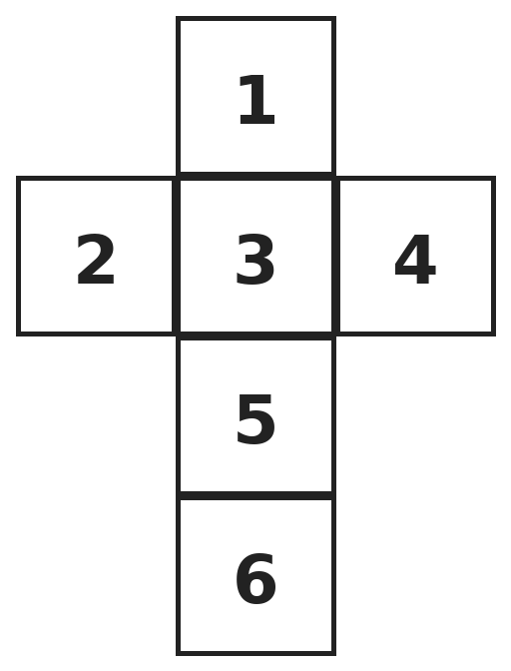
Q13. This net is folded into a cube. What is the sum of the numbers on the faces opposite the faces 1, 2 and 3?
(A) 12 | (B) 15 | (C) 9 | (D) 18

Part 6 — Mensuration (Syllabus Chapter 6)
Q14. A cylinder of radius 3 cm and height 14 cm is full of water. The water is poured into cones of radius 3 cm and height 7 cm. How many cones can be filled exactly?
(A) 3 | (B) 2 | (C) 12 | (D) 6

Q15. A solid is made of a cylinder (radius 14 cm, height 5 cm) with a cone of the same radius and height 48 cm on top. What is the total outer surface area, including the flat base? (Take π = 22/7.)
(A) 3,872 cm² | (B) 2,640 cm² | (C) 2,816 cm² | (D) 3,256 cm²

Q16. Rain 2.5 cm deep falls on a flat roof 22 m long and 14 m wide. All of it flows into a cylindrical tank of radius 70 cm that was empty. How high does the water rise in the tank? (Take π = 22/7.)
(A) 5 m | (B) 1.25 m | (C) 50 m | (D) 0.5 m

Part 7 — Data Handling, Statistics & Probability (Syllabus Chapter 8)
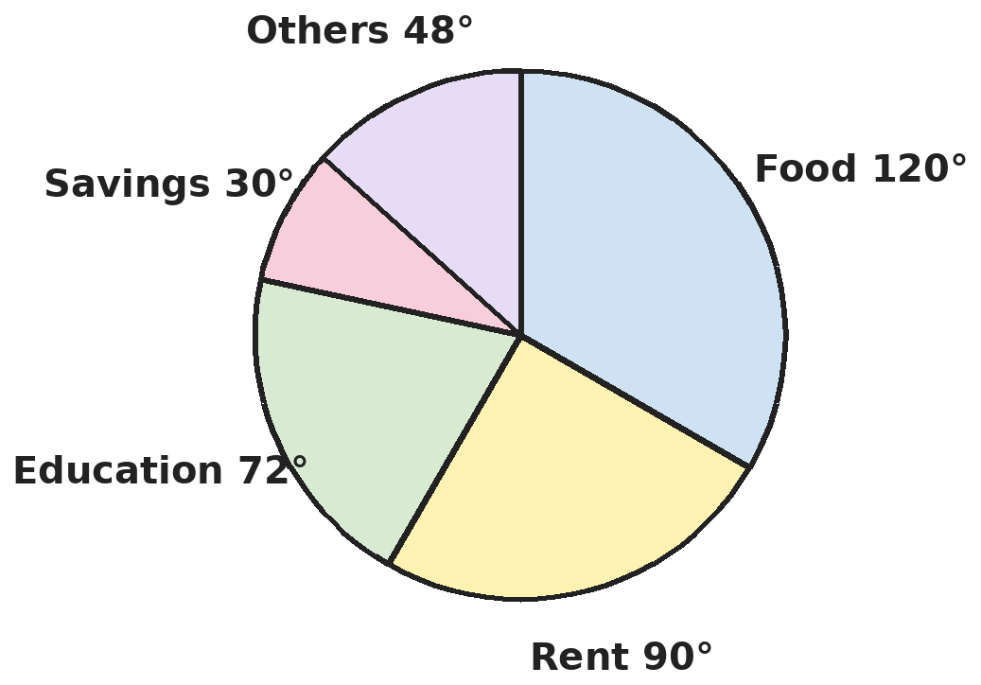
Q17. The pie chart shows how a family spends its monthly income of ₹36,000. How much more is spent on food than is saved?
(A) ₹12,000 | (B) ₹9,000 | (C) ₹3,000 | (D) ₹10,800

Q18. The mean of 12, 15, x, 9, 20, 18 and 11 is 15. What are the median and the mode of the seven numbers?
(A) Median 18, mode 20 | (B) Median 15, mode 18
(C) Median 15, mode 20 | (D) Median 15, no mode

Part 8 — Applied Mathematics (Syllabus Chapter 9)
Q19. By selling 33 m of cloth, a shopkeeper gains the selling price of 11 m. What is his gain percent?
(A) 33% | (B) 25% | (C) 50% | (D) 100%

Q20. Two sums of money differ by ₹3,000. The larger earns 8% simple interest and the smaller earns 10%, and in one year both earn the same interest. What is the larger sum?
(A) ₹15,000 | (B) ₹12,000 | (C) ₹18,000 | (D) ₹13,500

Q21. A dishonest shopkeeper claims to sell rice at cost price but uses a 900 g weight in place of 1 kg. What is his gain percent?
(A) 11 1/9% | (B) 10% | (C) 9 1/11% | (D) 11%

Part 9 — Mathematical Reasoning (Syllabus Chapter 10)
Q22. In the sum ABC + ABC + ABC = BBB, each letter is a different digit. What is A + B + C?
(A) 12 | (B) 14 | (C) 16 | (D) 13

Q23. In how many ways can ₹50 be paid using only ₹2 and ₹5 coins, with at least one coin of each kind?
(A) 5 | (B) 6 | (C) 3 | (D) 4

Q24. The five-digit number 23a4b, where a and b are non-zero digits, is divisible by 72. What is a × b?
(A) 18 | (B) 20 | (C) 24 | (D) 14

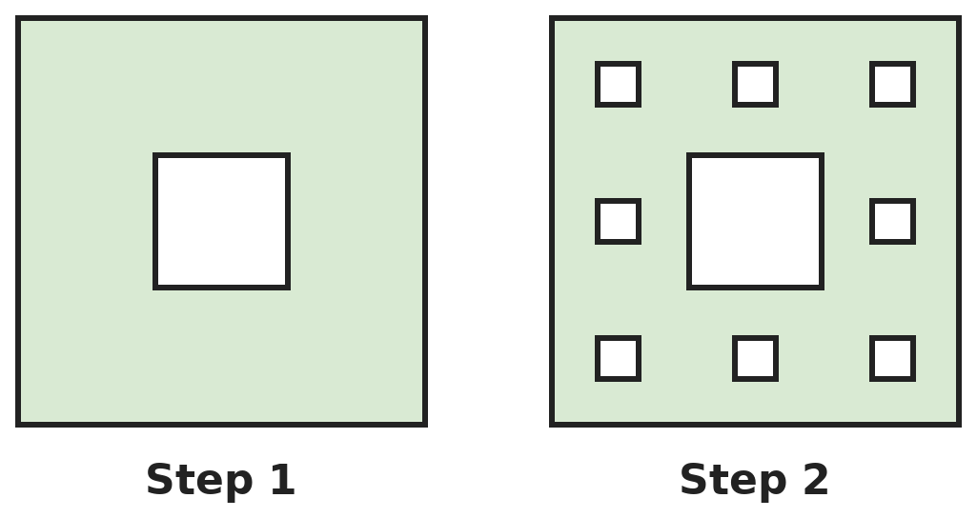
Q25. A square is cut into 9 equal squares and the middle one is removed (step 1). At each later step, every remaining small square is treated the same way. Steps 1 and 2 are shown. How many holes are there after step 3?
(A) 73 | (B) 64 | (C) 81 | (D) 72

Part 10 — Mixed Problems (each joins two chapters)
Q26. If x + 1/x = 5, what is x⁴ + 1/x⁴?
(A) 529 | (B) 527 | (C) 625 | (D) 623

Q27. How many diagonals does a 12-sided polygon have?
(A) 66 | (B) 108 | (C) 54 | (D) 48

Q28. When the side of a square is increased by 3 cm, its area increases by 81 cm². What was the original side?
(A) 9 cm | (B) 13.5 cm | (C) 15 cm | (D) 12 cm

Q29. An article marked ₹1,200 is sold after successive discounts of 10% and 5%. The seller still makes a profit of 14%. What did the article cost the seller?
(A) ₹1,000 | (B) ₹900 | (C) ₹880 | (D) ₹950

Q30. A conical tent has base radius 6 m and height 8 m. It is made of canvas 3 m wide that costs ₹50 per metre of length. What does the canvas cost? (Take π = 3.14.)
(A) ₹9,420 | (B) ₹2,512 | (C) ₹3,140 | (D) ₹1,570

Answer Sheet AMO Level 2 · Class 8 · Practice Paper 2
Name: | School: | Roll No.:
Shade or tick one circle for each question.
1. | Ⓐ Ⓑ Ⓒ Ⓓ | 11. | Ⓐ Ⓑ Ⓒ Ⓓ | 21. | Ⓐ Ⓑ Ⓒ Ⓓ
2. | Ⓐ Ⓑ Ⓒ Ⓓ | 12. | Ⓐ Ⓑ Ⓒ Ⓓ | 22. | Ⓐ Ⓑ Ⓒ Ⓓ
3. | Ⓐ Ⓑ Ⓒ Ⓓ | 13. | Ⓐ Ⓑ Ⓒ Ⓓ | 23. | Ⓐ Ⓑ Ⓒ Ⓓ
4. | Ⓐ Ⓑ Ⓒ Ⓓ | 14. | Ⓐ Ⓑ Ⓒ Ⓓ | 24. | Ⓐ Ⓑ Ⓒ Ⓓ
5. | Ⓐ Ⓑ Ⓒ Ⓓ | 15. | Ⓐ Ⓑ Ⓒ Ⓓ | 25. | Ⓐ Ⓑ Ⓒ Ⓓ
6. | Ⓐ Ⓑ Ⓒ Ⓓ | 16. | Ⓐ Ⓑ Ⓒ Ⓓ | 26. | Ⓐ Ⓑ Ⓒ Ⓓ
7. | Ⓐ Ⓑ Ⓒ Ⓓ | 17. | Ⓐ Ⓑ Ⓒ Ⓓ | 27. | Ⓐ Ⓑ Ⓒ Ⓓ
8. | Ⓐ Ⓑ Ⓒ Ⓓ | 18. | Ⓐ Ⓑ Ⓒ Ⓓ | 28. | Ⓐ Ⓑ Ⓒ Ⓓ
9. | Ⓐ Ⓑ Ⓒ Ⓓ | 19. | Ⓐ Ⓑ Ⓒ Ⓓ | 29. | Ⓐ Ⓑ Ⓒ Ⓓ
10. | Ⓐ Ⓑ Ⓒ Ⓓ | 20. | Ⓐ Ⓑ Ⓒ Ⓓ | 30. | Ⓐ Ⓑ Ⓒ Ⓓ

For the parent or teacher
Correct: ______ / 30
Answer Key and Solutions AMO Level 2 · Class 8 · Practice Paper 2
Quick answers
1 C | 6 A | 11 B | 16 A | 21 A | 26 B
2 D | 7 B | 12 A | 17 B | 22 D | 27 C
3 D | 8 C | 13 B | 18 C | 23 D | 28 D
4 A | 9 C | 14 D | 19 C | 24 B | 29 B
5 B | 10 A | 15 D | 20 A | 25 A | 30 C
Solutions
Q | Part · level | Answer | Why?
1 | Part 1 · Ch1 · Hard | (C) 2 and 6 | Hint: Write 108 as a product of primes and look at each power.  108 = 2² × 3³. The factor 2 needs one more 2 to make 2³. So multiply by 2: 216 = 2³ × 3³ = 6³. The multiplier is 2 and the cube root is 6.
2 | Part 1 · Ch1 · Hard | (D) 2.5 | Hint: Compare squares: a number lies between √5 and √8 if its square lies between 5 and 8.  2.5² = 6.25, which is between 5 and 8, and 2.5 is rational. 2.2² = 4.84 is too small and 2.9² = 8.41 is too large. √6 lies between them but is irrational.
3 | Part 2 · Ch2 · Hard | (D) 3/50 | Hint: Work inside each bracket first, then take the reciprocal.  2⁻¹ + 3⁻¹ = 1/2 + 1/3 = 5/6, so its inverse is 6/5. 4⁻¹ − 5⁻¹ = 1/4 − 1/5 = 1/20, so its inverse is 20. 6/5 ÷ 20 = 6/100 = 3/50.
4 | Part 2 · Ch2 · Hard | (A) 8 × 10³ | Hint: Find the length of 40 bacteria first.  40 bacteria = 40 × 2.5 × 10⁻⁶ = 10⁻⁴ m. Number of viruses = 10⁻⁴ ÷ (1.25 × 10⁻⁸) = 0.8 × 10⁴ = 8 × 10³. (2 × 10² compares only one bacterium.)
5 | Part 3 · Ch3 · Hard | (B) 46% | Hint: Multiply what is left after each discount: 0.75 × 0.8 × 0.9.  0.75 × 0.8 = 0.6 and 0.6 × 0.9 = 0.54. The buyer pays 54% of the marked price, so the single discount is 46%. (55% just adds the three.)
6 | Part 3 · Ch3 · Hard | (A) 7.5% | Hint: The extra amount for the two extra years is two years of interest.  Interest for 2 years = 11,000 − 9,800 = ₹1,200, so ₹600 a year. 3 years of interest = ₹1,800, so the sum = 9,800 − 1,800 = ₹8,000. Rate = 600 ÷ 8,000 × 100 = 7.5%.
7 | Part 3 · Ch3 · Hard | (B) 40,000 | Hint: A 10% rise then a 10% fall multiplies by 1.1 × 0.9.  1.1 × 0.9 = 0.99, so the population is 99% of the original. Original = 39,600 ÷ 0.99 = 40,000.
8 | Part 4 · Ch4 · Hard | (C) 11 | Hint: Square both sides of x − 1/x = 3.  (x − 1/x)² = x² − 2 + 1/x² = 9. So x² + 1/x² = 9 + 2 = 11.
9 | Part 4 · Ch4 · Hard | (C) 5 | Hint: Write each product as (600 − k)(600 + k).  598 × 602 = 600² − 2² and 597 × 603 = 600² − 3². The difference is (600² − 4) − (600² − 9) = 9 − 4 = 5.
10 | Part 4 · Ch4 · Hard | (A) 14 | Hint: Let the number of ₹5 coins be x.  ₹5 coins: x; ₹2 coins: 30 − x. 5x + 2(30 − x) = 102 gives 3x + 60 = 102, so x = 14. Check: 14 × 5 + 16 × 2 = 70 + 32 = 102.
11 | Part 5 · Ch5 · Hard | (B) 110° | Hint: Adjacent angles of a parallelogram add to 180°; opposite angles are equal.  A + B = 180° and A = 2B − 30°, so 3B − 30° = 180°, B = 70° and A = 110°. Angle C is opposite angle A, so C = 110°.
12 | Part 5 · Ch5 · Hard | (A) 12 | Hint: Each triangle has 3 edges, and each edge is shared by 2 faces. Then use Euler's formula.  Counting edges face by face counts each edge twice: 3F = 2 × 30, so F = 20. Euler: F + V − E = 2 gives V = 2 − 20 + 30 = 12. (20 is the number of faces.)
13 | Part 5 · Ch5 · Hard | (B) 15 | Hint: In a straight strip of the net, faces with one square between them are opposite.  In the column 1, 3, 5, 6: 1 is opposite 5 and 3 is opposite 6. In the row 2, 3, 4: 2 is opposite 4. The sum is 5 + 4 + 6 = 15.
14 | Part 6 · Ch6 · Hard | (D) 6 | Hint: A cone holds one third of a cylinder with the same base and height.  A cone of height 7 holds (1/3)πr² × 7. The cylinder holds πr² × 14 = 6 × (1/3)πr² × 7. So it fills 6 cones.
15 | Part 6 · Ch6 · Hard | (D) 3,256 cm² | Hint: Add the base circle, the cylinder's curved surface and the cone's curved surface. Find the slant height first.  Slant height = √(14² + 48²) = √2,500 = 50 cm. Cone curved surface = 22/7 × 14 × 50 = 2,200 cm². Cylinder curved surface = 2 × 22/7 × 14 × 5 = 440 cm². Base = 22/7 × 14 × 14 = 616 cm². Total = 2,200 + 440 + 616 = 3,256 cm².
16 | Part 6 · Ch6 · Hard | (A) 5 m | Hint: Work in metres: 2.5 cm = 0.025 m and 70 cm = 0.7 m.  Rain volume = 22 × 14 × 0.025 = 7.7 m³. Base of the tank = 22/7 × 0.7 × 0.7 = 1.54 m². Height = 7.7 ÷ 1.54 = 5 m. (1.25 m uses the diameter 1.4 m as the radius.)
17 | Part 7 · Ch8 · Hard | (B) ₹9,000 | Hint: Each degree stands for 36,000 ÷ 360 rupees.  Each degree is ₹100. Food − savings = 120° − 30° = 90°, which is ₹9,000.
18 | Part 7 · Ch8 · Hard | (C) Median 15, mode 20 | Hint: Find x from the total first.  Total = 7 × 15 = 105, and the six known numbers add to 85, so x = 20. In order: 9, 11, 12, 15, 18, 20, 20. Median = 15 (the 4th), mode = 20.
19 | Part 8 · Ch9 · Hard | (C) 50% | Hint: Gain = SP of 33 m − CP of 33 m.  SP(33 m) − CP(33 m) = SP(11 m), so CP(33 m) = SP(22 m). Gain = SP(11 m) on a cost of SP(22 m), which is 11/22 = 50%.
20 | Part 8 · Ch9 · Hard | (A) ₹15,000 | Hint: Let the larger sum be x; then 8% of x = 10% of (x − 3,000).  0.08x = 0.1(x − 3,000) gives 0.02x = 300, so x = ₹15,000. Check: 8% of 15,000 = 1,200 = 10% of 12,000.
21 | Part 8 · Ch9 · Hard | (A) 11 1/9% | Hint: He receives the price of 1,000 g for 900 g.  He gives 900 g but charges for 1,000 g, gaining 100 g on a cost of 900 g. Gain = 100/900 × 100 = 11 1/9%. (10% wrongly divides by 1,000.)
22 | Part 9 · Ch10 · Hard | (D) 13 | Hint: BBB = 111 × B = 3 × 37 × B, so ABC = 37 × B.  3 × ABC = 111 × B, so ABC = 37 × B. Its tens digit must be B: 37 × 4 = 148 works (37 × 1 = 37, × 2 = 74, × 3 = 111, × 5 = 185 … do not). So ABC = 148, BBB = 444, and A + B + C = 1 + 4 + 8 = 13.
23 | Part 9 · Ch10 · Hard | (D) 4 | Hint: The number of ₹5 coins must be even. Why?  The ₹2 coins make an even amount, so the ₹5 coins must also make an even amount: 2, 4, 6 or 8 coins (10 coins would leave no ₹2 coins). That gives 20, 15, 10 or 5 coins of ₹2: 4 ways.
24 | Part 9 · Ch10 · Hard | (B) 20 | Hint: 72 = 8 × 9. Use the tests for 8 and 9.  Divisible by 9: 2 + 3 + a + 4 + b = 9 + a + b, so a + b = 9 or 18. Divisible by 8: the last three digits a4b must be a multiple of 8. a + b = 18 gives 949, not a multiple of 8. Trying a + b = 9: 544 = 8 × 68 works (a = 5, b = 4); 148, 247, 346, 643, 742, 841 and 940 do not (b = 0 is not allowed). So a × b = 20. Check: 23,544 = 72 × 327.
25 | Part 9 · Ch10 · Hard | (A) 73 | Hint: Each step adds one hole in every square left from the step before.  Step 1: 1 hole, 8 squares left. Step 2 adds 8 holes (total 9), leaving 64 squares. Step 3 adds 64 holes: 9 + 64 = 73.
26 | Part 10 · Mixed · Ch4 + Ch10 · Hard | (B) 527 | Hint: Square twice, subtracting 2 each time.  x² + 1/x² = 5² − 2 = 23. x⁴ + 1/x⁴ = 23² − 2 = 529 − 2 = 527.
27 | Part 10 · Mixed · Ch5 + Ch10 · Hard | (C) 54 | Hint: From each corner, diagonals go to every corner except itself and its two neighbours.  Each of the 12 corners joins to 12 − 3 = 9 others by a diagonal: 12 × 9 = 108. Each diagonal is counted twice, so there are 54. (66 also counts the 12 sides.)
28 | Part 10 · Mixed · Ch4 + Ch5 · Hard | (D) 12 cm | Hint: (s + 3)² − s² = 6s + 9.  (s + 3)² − s² = 6s + 9 = 81, so 6s = 72 and s = 12 cm. Check: 15² − 12² = 225 − 144 = 81.
29 | Part 10 · Mixed · Ch3 + Ch9 · Hard | (B) ₹900 | Hint: Find the selling price first, then divide by 1.14.  Selling price = 1,200 × 0.9 × 0.95 = 1,080 × 0.95 = ₹1,026. Cost = 1,026 ÷ 1.14 = ₹900.
30 | Part 10 · Mixed · Ch6 + Ch9 · Hard | (C) ₹3,140 | Hint: Canvas area = curved surface = πrl. Length = area ÷ width.  Slant height = √(36 + 64) = 10 m. Curved surface = 3.14 × 6 × 10 = 188.4 m². Length = 188.4 ÷ 3 = 62.8 m. Cost = 62.8 × 50 = ₹3,140.

ARYABHATTA MATHS OLYMPIAD
Level 2
PRACTICE PAPER-3
CLASS 8
Total Questions | 30 multiple-choice questions
Level | Level-2 (final round): every question is Hard
Time | 45 minutes
Arrangement | Parts by chapter; the last Part has mixed problems joining two chapters
Negative Marking | No negative marking
Calculator | Not allowed
Chapters | Number System · Operations · Fractions, Decimals & Percentages · Algebra · Geometry · Mensuration · Data Handling, Statistics & Probability · Applied Mathematics · Mathematical Reasoning

Instructions
• Each question has four options, (A) to (D), with exactly one correct answer.
• The questions are grouped in Parts by chapter. The last Part has mixed problems, each joining two chapters.
• Every question is at Level-2 (Hard) standard: expect several steps or a key insight.
• There is no negative marking. Calculators are not allowed; use a separate sheet for rough work.
• Figures are not necessarily drawn to scale unless stated.

For teachers
• Figures are part of the questions and work when printed in black and white.
• Parts follow the AMO syllabus chapters. Chapter 7 is not part of the Class 8 syllabus, so the chapter numbers shown in the Part headings have gaps.
• The answer sheet and the answer key are at the end. Remove the answer key before the paper is attempted.

Part 1 — Number System (Syllabus Chapter 1)
Q1. The product of two consecutive even numbers is 288. What is their sum?
(A) 36 | (B) 34 | (C) 32 | (D) 30

Q2. Gita divides 3,087 by the smallest whole number that makes the result a perfect cube. What is that divisor, and what is the cube root of the result?
(A) 9 and 7 | (B) 3 and 7 | (C) 9 and 49 | (D) 7 and 9

Part 2 — Operations (Syllabus Chapter 2)
Q3. Find x if (5⁻¹ × 25²)³ ÷ 5ˣ = 1/25.
(A) 7 | (B) 9 | (C) 11 | (D) −11

Q4. The mass of the Earth is 5.97 × 10²⁴ kg and the mass of the Moon is 7.35 × 10²² kg. About how many times as heavy as the Moon is the Earth?
(A) About 8 | (B) About 810 | (C) About 0.8 | (D) About 81

Part 3 — Fractions, Decimals & Percentages (Syllabus Chapter 3)
Q5. After a 20% discount, a phone sells for ₹9,600. Later the shop raises the marked price by 10% and offers a 25% discount instead. What is the new selling price?
(A) ₹9,900 | (B) ₹9,600 | (C) ₹10,560 | (D) ₹9,240

Q6. At simple interest, a sum of money becomes 7/5 of itself in 5 years. In how many years will it become double itself?
(A) 10 years | (B) 12.5 years | (C) 15 years | (D) 8 years

Q7. The price of sugar rises by 25%. A family wants its spending on sugar to rise by only 10%. By what percentage must it cut the amount of sugar it buys?
(A) 12% | (B) 15% | (C) 10% | (D) 20%

Part 4 — Algebra (Syllabus Chapter 4)
Q8. Which of these is a factor of a² − b² + 2b − 1?
(A) a − b − 1 | (B) a + b − 1 | (C) a + b + 1 | (D) a − 2b + 1

Q9. If (x + y)² = 49 and (x − y)² = 9, what is x² + y² + xy?
(A) 29 | (B) 49 | (C) 40 | (D) 39

Q10. Ravi spent 1/3 of his money on books and then 1/4 of what was left on lunch. He had ₹300 left. How much money did he start with?
(A) ₹720 | (B) ₹900 | (C) ₹480 | (D) ₹600

Part 5 — Geometry (Syllabus Chapter 5)
Q11. Mohan walks 7 m north, 6 m east, 9 m north and then 6 m east. How far is he now from his starting point in a straight line?
(A) 28 m | (B) 20 m | (C) 16 m | (D) 25 m

Q12. In triangle ABC, D lies on AB and E lies on AC with DE parallel to BC. AD = 4 cm, DB = 6 cm and DE = 6 cm. How long is BC?
(A) 9 cm | (B) 10 cm | (C) 12 cm | (D) 15 cm

Q13. Convex kite ABCD has AB = AD = 10 cm and CB = CD = 17 cm. The diagonal BD is 16 cm long. How long is the diagonal AC?
(A) 19 cm | (B) 27 cm | (C) 21 cm | (D) 15 cm

Part 6 — Mensuration (Syllabus Chapter 6)
Q14. A metal pipe is 21 cm long. Its outer radius is 7 cm and its inner radius is 5 cm. What volume of metal is in the pipe? (Take π = 22/7.)
(A) 3,234 cm³ | (B) 1,650 cm³ | (C) 1,584 cm³ | (D) 528 cm³

Q15. A cone has radius 6 cm and height 8 cm. A cylinder with the same radius has the same volume as the cone. What is the height of the cylinder?
(A) 8/3 cm | (B) 8 cm | (C) 24 cm | (D) 4 cm

Q16. A swimming pool is 20 m long and 10 m wide. Its floor slopes evenly from 1 m deep at one end to 3 m deep at the other. How many litres of water does it hold when full?
(A) 6 × 10⁵ L | (B) 4 × 10⁵ L | (C) 2 × 10⁵ L | (D) 4 × 10⁴ L

Part 7 — Data Handling, Statistics & Probability (Syllabus Chapter 8)
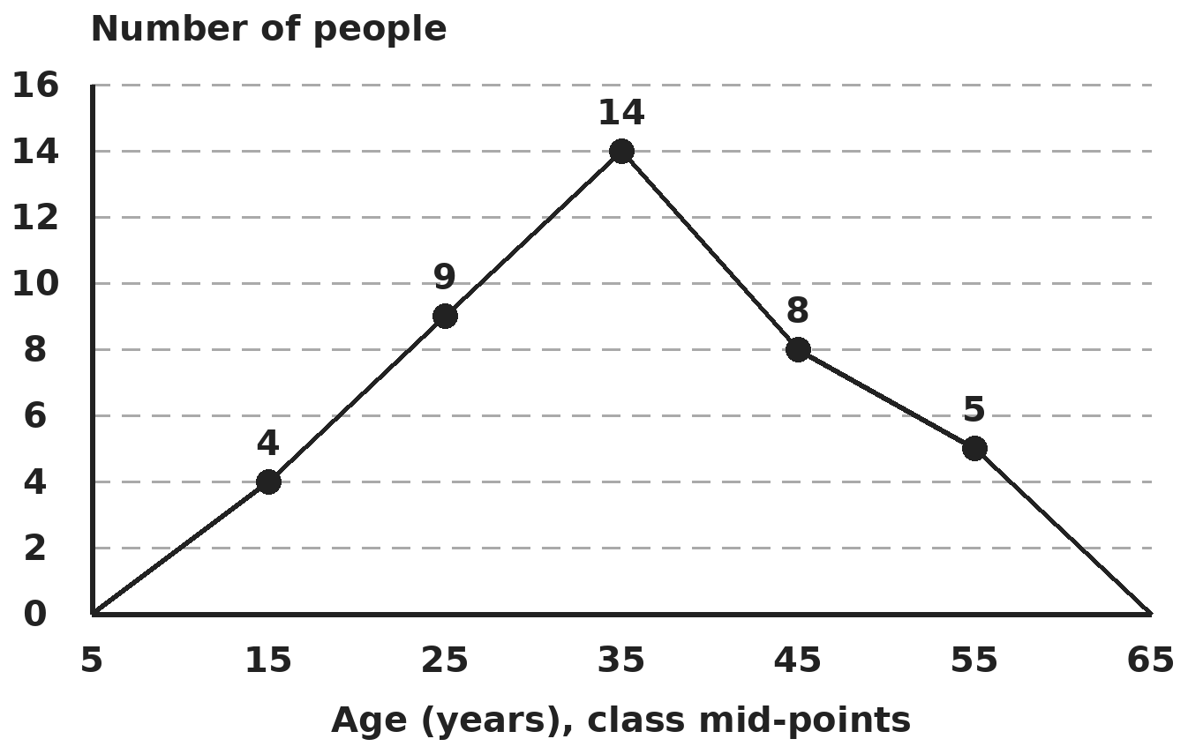
Q17. The frequency polygon shows the ages of 40 people in classes 10–20, 20–30, 30–40, 40–50 and 50–60, plotted at the class mid-points. How many people are aged 30 or more?
(A) 13 | (B) 22 | (C) 27 | (D) 14

Q18. The mean of 20 observations was found to be 35. Two values had been copied wrongly: 48 as 84 and 26 as 62. After correcting them, the observation 39 is removed. What is the mean of the remaining observations?
(A) 31 | (B) 31.4 | (C) 33.2 | (D) 29.6

Part 8 — Applied Mathematics (Syllabus Chapter 9)
Q19. A trader buys pens at 12 for ₹100 and sells them at 10 for ₹100. What is his gain percent?
(A) 16 2/3% | (B) 20% | (C) 2% | (D) 25%

Q20. A scooter costs ₹60,000. Nikhil pays ₹20,000 at once. The rest is charged simple interest at 10% a year for 2 years, and the total is paid in 24 equal monthly instalments. What is each instalment?
(A) ₹1,667 | (B) ₹2,200 | (C) ₹2,000 | (D) ₹1,800

Q21. Selling a lamp for ₹720 causes a loss of 10%. The shopkeeper wants a profit of 25% even after giving a discount of 20% on the marked price. What should the marked price be?
(A) ₹1,000 | (B) ₹1,200 | (C) ₹1,250 | (D) ₹1,125

Part 9 — Mathematical Reasoning (Syllabus Chapter 10)
Q22. In AB × AB = CAB, the letters A, B and C stand for different digits. What digit is C?
(A) 5 | (B) 2 | (C) 7 | (D) 6

Q23. How many four-digit numbers have digits that strictly increase from left to right and end in 6?
(A) 10 | (B) 20 | (C) 15 | (D) 6

Q24. Kavya puts a + or − sign in front of each of the numbers 1, 2, 3, …, 10 and adds them up. Which of these totals is possible?
(A) 0 | (B) 7 | (C) 2 | (D) 10

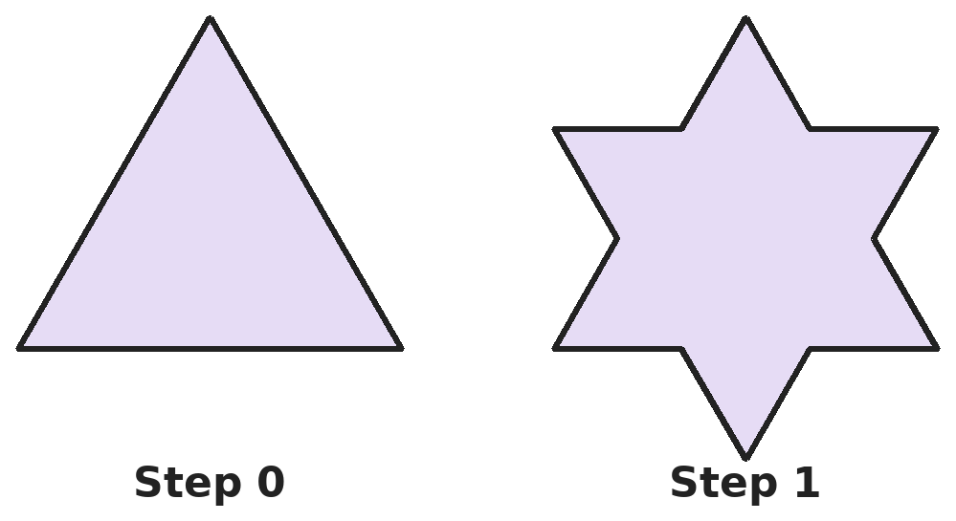
Q25. At each step, every side of the shape is split into three equal parts and a small equilateral triangle is built outward on the middle part, and that middle segment is then removed. Steps 0 and 1 are shown. If each side at step 0 is 27 cm, what is the perimeter after step 3?
(A) 192 cm | (B) 108 cm | (C) 256 cm | (D) 144 cm

Part 10 — Mixed Problems (each joins two chapters)
Q26. Using a² − b², find which of these numbers divides 2⁸ − 1: 7, 11, 13 or 17.
(A) 7 | (B) 11 | (C) 17 | (D) 13

Q27. A solid has 12 faces, each a pentagon, and exactly three faces meet at every corner. How many vertices does it have?
(A) 30 | (B) 12 | (C) 60 | (D) 20

Q28. Two squares have sides a and b, with a + b = 17 cm. Their areas add up to 145 cm². What is the difference between their areas?
(A) 1 cm² | (B) 17 cm² | (C) 145 cm² | (D) 72 cm²

Q29. Hema invests ₹10,000 at 10% simple interest for 3 years. She then invests the whole amount at 12% simple interest for 2 more years. How much does she have at the end?
(A) ₹15,400 | (B) ₹16,000 | (C) ₹15,600 | (D) ₹16,120

Q30. Ten cylindrical pillars, each of radius 35 cm and height 4 m, have their curved surfaces painted at ₹12.50 per m². What is the total cost? (Take π = 22/7.)
(A) ₹110 | (B) ₹2,200 | (C) ₹1,100 | (D) ₹1,155

Answer Sheet AMO Level 2 · Class 8 · Practice Paper 3
Name: | School: | Roll No.:
Shade or tick one circle for each question.
1. | Ⓐ Ⓑ Ⓒ Ⓓ | 11. | Ⓐ Ⓑ Ⓒ Ⓓ | 21. | Ⓐ Ⓑ Ⓒ Ⓓ
2. | Ⓐ Ⓑ Ⓒ Ⓓ | 12. | Ⓐ Ⓑ Ⓒ Ⓓ | 22. | Ⓐ Ⓑ Ⓒ Ⓓ
3. | Ⓐ Ⓑ Ⓒ Ⓓ | 13. | Ⓐ Ⓑ Ⓒ Ⓓ | 23. | Ⓐ Ⓑ Ⓒ Ⓓ
4. | Ⓐ Ⓑ Ⓒ Ⓓ | 14. | Ⓐ Ⓑ Ⓒ Ⓓ | 24. | Ⓐ Ⓑ Ⓒ Ⓓ
5. | Ⓐ Ⓑ Ⓒ Ⓓ | 15. | Ⓐ Ⓑ Ⓒ Ⓓ | 25. | Ⓐ Ⓑ Ⓒ Ⓓ
6. | Ⓐ Ⓑ Ⓒ Ⓓ | 16. | Ⓐ Ⓑ Ⓒ Ⓓ | 26. | Ⓐ Ⓑ Ⓒ Ⓓ
7. | Ⓐ Ⓑ Ⓒ Ⓓ | 17. | Ⓐ Ⓑ Ⓒ Ⓓ | 27. | Ⓐ Ⓑ Ⓒ Ⓓ
8. | Ⓐ Ⓑ Ⓒ Ⓓ | 18. | Ⓐ Ⓑ Ⓒ Ⓓ | 28. | Ⓐ Ⓑ Ⓒ Ⓓ
9. | Ⓐ Ⓑ Ⓒ Ⓓ | 19. | Ⓐ Ⓑ Ⓒ Ⓓ | 29. | Ⓐ Ⓑ Ⓒ Ⓓ
10. | Ⓐ Ⓑ Ⓒ Ⓓ | 20. | Ⓐ Ⓑ Ⓒ Ⓓ | 30. | Ⓐ Ⓑ Ⓒ Ⓓ

For the parent or teacher
Correct: ______ / 30
Answer Key and Solutions AMO Level 2 · Class 8 · Practice Paper 3
Quick answers
1 B | 6 B | 11 B | 16 B | 21 C | 26 C
2 A | 7 A | 12 D | 17 C | 22 D | 27 D
3 C | 8 B | 13 C | 18 A | 23 A | 28 B
4 D | 9 D | 14 C | 19 B | 24 B | 29 D
5 A | 10 D | 15 A | 20 C | 25 A | 30 C
Solutions
Q | Part · level | Answer | Why?
1 | Part 1 · Ch1 · Hard | (B) 34 | Hint: The two numbers lie on either side of √288.  √288 is a little less than 17 (17² = 289). The even numbers on either side are 16 and 18, and 16 × 18 = 288. Their sum is 34.
2 | Part 1 · Ch1 · Hard | (A) 9 and 7 | Hint: Write 3,087 as a product of primes.  3,087 = 3² × 7³. The 3² does not make a cube, so divide by 9: 3,087 ÷ 9 = 343 = 7³. The divisor is 9 and the cube root is 7.
3 | Part 2 · Ch2 · Hard | (C) 11 | Hint: Write everything as a power of 5. 1/25 = 5⁻².  5⁻¹ × 25² = 5⁻¹ × 5⁴ = 5³, and (5³)³ = 5⁹. So 5⁹⁻ˣ = 5⁻², giving 9 − x = −2 and x = 11.
4 | Part 2 · Ch2 · Hard | (D) About 81 | Hint: Divide the numbers and the powers of 10 separately.  5.97 ÷ 7.35 ≈ 0.81 and 10²⁴ ÷ 10²² = 10². So the ratio is about 0.81 × 100 = 81.
5 | Part 3 · Ch3 · Hard | (A) ₹9,900 | Hint: First find the original marked price.  Marked price = 9,600 ÷ 0.8 = ₹12,000. New marked price = 12,000 × 1.1 = ₹13,200. New selling price = 13,200 × 0.75 = ₹9,900.
6 | Part 3 · Ch3 · Hard | (B) 12.5 years | Hint: First find the interest as a fraction of the sum per year.  The interest in 5 years is 2/5 of the sum, so the rate is (2/5 ÷ 5) × 100 = 8% a year. To double, the interest must be 100%: 100 ÷ 8 = 12.5 years.
7 | Part 3 · Ch3 · Hard | (A) 12% | Hint: New amount = new spending ÷ new price.  New amount = 1.10 ÷ 1.25 = 0.88 of the old amount, so the family must buy 12% less. (15% just subtracts 25 − 10.)
8 | Part 4 · Ch4 · Hard | (B) a + b − 1 | Hint: −b² + 2b − 1 = −(b − 1)².  a² − b² + 2b − 1 = a² − (b − 1)² = (a − (b − 1))(a + (b − 1)) = (a − b + 1)(a + b − 1). So a + b − 1 is a factor.
9 | Part 4 · Ch4 · Hard | (D) 39 | Hint: Add the two squares to get x² + y²; subtract them to get xy.  Adding: 2(x² + y²) = 58, so x² + y² = 29. Subtracting: 4xy = 40, so xy = 10. x² + y² + xy = 39.
10 | Part 4 · Ch4 · Hard | (D) ₹600 | Hint: After the books he had 2/3 of his money; after lunch, 3/4 of that.  Let the money be x. After books: 2x/3. After lunch: 3/4 × 2x/3 = x/2. So x/2 = 300 and x = ₹600.
11 | Part 5 · Ch5 · Hard | (B) 20 m | Hint: Add all the northward parts and all the eastward parts.  North: 7 + 9 = 16 m. East: 6 + 6 = 12 m. Distance = √(16² + 12²) = √400 = 20 m. (28 m is the total walked.)
12 | Part 5 · Ch5 · Hard | (D) 15 cm | Hint: Triangle ADE is similar to triangle ABC. Use AB, not DB.  AB = 4 + 6 = 10 cm. Similar triangles give DE/BC = AD/AB = 4/10. So BC = 6 × 10/4 = 15 cm. (9 cm wrongly uses AD/DB.)
13 | Part 5 · Ch5 · Hard | (C) 21 cm | Hint: In a kite, the diagonal AC cuts BD in half at right angles.  AC meets BD at its midpoint M at right angles, so BM = 8 cm. AM = √(10² − 8²) = 6 cm and CM = √(17² − 8²) = 15 cm. AC = 6 + 15 = 21 cm.
14 | Part 6 · Ch6 · Hard | (C) 1,584 cm³ | Hint: Volume of metal = outer cylinder − inner cylinder = π(R² − r²)h.  π(R² − r²)h = 22/7 × (49 − 25) × 21 = 22/7 × 24 × 21 = 1,584 cm³. (3,234 is the whole outer cylinder.)
15 | Part 6 · Ch6 · Hard | (A) 8/3 cm | Hint: Volume of a cone = (1/3)πr²h.  (1/3)π × 36 × 8 = π × 36 × H gives H = 8/3 cm. (24 cm multiplies by 3 instead of dividing.)
16 | Part 6 · Ch6 · Hard | (B) 4 × 10⁵ L | Hint: With an even slope, use the average depth.  Average depth = (1 + 3) ÷ 2 = 2 m. Volume = 20 × 10 × 2 = 400 m³ = 4,00,000 L = 4 × 10⁵ L.
17 | Part 7 · Ch8 · Hard | (C) 27 | Hint: Mid-point 35 stands for the class 30–40.  The classes from 30 upwards have mid-points 35, 45 and 55, with frequencies 14, 8 and 5. Total = 27.
18 | Part 7 · Ch8 · Hard | (A) 31 | Hint: Correct the total first, then remove 39 and divide by 19.  Wrong total = 20 × 35 = 700. Correct total = 700 − 84 + 48 − 62 + 26 = 628. Removing 39 leaves 589 for 19 observations: 589 ÷ 19 = 31. (31.4 is 628 ÷ 20, before removing 39.)
19 | Part 8 · Ch9 · Hard | (B) 20% | Hint: Compare the cost and selling price of the same number of pens, say 60.  60 pens cost 5 × ₹100 = ₹500 and sell for 6 × ₹100 = ₹600. Gain = 100/500 = 20%.
20 | Part 8 · Ch9 · Hard | (C) ₹2,000 | Hint: Interest is charged only on the amount still owed.  Amount owed = ₹40,000. Interest = 40,000 × 10% × 2 = ₹8,000. Total to repay = ₹48,000. Each instalment = 48,000 ÷ 24 = ₹2,000.
21 | Part 8 · Ch9 · Hard | (C) ₹1,250 | Hint: ₹720 is 90% of the cost price. The selling price is 80% of the marked price.  Cost price = 720 ÷ 0.9 = ₹800. Selling price for 25% profit = 800 × 1.25 = ₹1,000. This is 80% of the marked price, so marked price = 1,000 ÷ 0.8 = ₹1,250. (₹1,200 adds 20% instead of dividing by 0.8.)
22 | Part 9 · Ch10 · Hard | (D) 6 | Hint: The square of AB must end in the digits AB.  A two-digit number whose square has three digits and ends in itself: 25² = 625 works (10² = 100 repeats a digit). So A = 2, B = 5 and C = 6.
23 | Part 9 · Ch10 · Hard | (A) 10 | Hint: The first three digits are chosen from 1 to 5 and then arranged in increasing order.  Choose 3 different digits from 1, 2, 3, 4, 5; they can go in only one order. Listing: 123, 124, 125, 134, 135, 145, 234, 235, 245, 345. That gives 10 numbers, such as 1236.
24 | Part 9 · Ch10 · Hard | (B) 7 | Hint: Changing one sign from + to − changes the total by an even number.  With all signs +, the total is 55, which is odd. Changing the sign of n lowers the total by 2n, so the total stays odd. Only 7 is odd, and it can be made: put − in front of 10, 9, 4 and 1 (which add to 24), giving 55 − 48 = 7.
25 | Part 9 · Ch10 · Hard | (A) 192 cm | Hint: Each step multiplies the number of sides by 4 and divides the side length by 3.  Sides: 3 → 12 → 48 → 192. Side length: 27 → 9 → 3 → 1 cm. Perimeter after step 3 = 192 × 1 = 192 cm. (144 cm is the perimeter after step 2.)
26 | Part 10 · Mixed · Ch4 + Ch10 · Hard | (C) 17 | Hint: 2⁸ − 1 = (2⁴)² − 1².  2⁸ − 1 = (2⁴ − 1)(2⁴ + 1) = 15 × 17 = 255 = 3 × 5 × 17. Of the four numbers, only 17 divides it.
27 | Part 10 · Mixed · Ch5 + Ch10 · Hard | (D) 20 | Hint: Count edges first: each edge is shared by two faces. Then use F + V − E = 2.  Edges = 12 × 5 ÷ 2 = 30. V = 2 − F + E = 2 − 12 + 30 = 20. (Check: 20 corners × 3 faces = 60 = 12 × 5 face corners.)
28 | Part 10 · Mixed · Ch4 + Ch5 · Hard | (B) 17 cm² | Hint: Find ab from (a + b)², then (a − b)².  (a + b)² = 289 = 145 + 2ab, so ab = 72. (a − b)² = 145 − 144 = 1, so a − b = 1. Difference of areas = a² − b² = (a + b)(a − b) = 17 cm².
29 | Part 10 · Mixed · Ch3 + Ch9 · Hard | (D) ₹16,120 | Hint: Find the amount after 3 years first. The second interest is on that amount.  After 3 years: 10,000 + 30% = ₹13,000. The next 2 years add 24% of 13,000 = ₹3,120. Total ₹16,120. (15,400 wrongly takes the 24% on ₹10,000.)
30 | Part 10 · Mixed · Ch6 + Ch9 · Hard | (C) ₹1,100 | Hint: Change 35 cm into metres before using 2πrh.  Curved surface of one pillar = 2 × 22/7 × 0.35 × 4 = 8.8 m². Ten pillars: 88 m². Cost = 88 × 12.50 = ₹1,100.

ARYABHATTA MATHS OLYMPIAD
Level 2
PRACTICE PAPER-4
CLASS 8
Total Questions | 30 multiple-choice questions
Level | Level-2 (final round): every question is Hard
Time | 45 minutes
Arrangement | Parts by chapter; the last Part has mixed problems joining two chapters
Negative Marking | No negative marking
Calculator | Not allowed
Chapters | Number System · Operations · Fractions, Decimals & Percentages · Algebra · Geometry · Mensuration · Data Handling, Statistics & Probability · Applied Mathematics · Mathematical Reasoning

Instructions
• Each question has four options, (A) to (D), with exactly one correct answer.
• The questions are grouped in Parts by chapter. The last Part has mixed problems, each joining two chapters.
• Every question is at Level-2 (Hard) standard: expect several steps or a key insight.
• There is no negative marking. Calculators are not allowed; use a separate sheet for rough work.
• Figures are not necessarily drawn to scale unless stated.

For teachers
• Figures are part of the questions and work when printed in black and white.
• Parts follow the AMO syllabus chapters. Chapter 7 is not part of the Class 8 syllabus, so the chapter numbers shown in the Part headings have gaps.
• The answer sheet and the answer key are at the end. Remove the answer key before the paper is attempted.

Part 1 — Number System (Syllabus Chapter 1)
Q1. What is √(0.0169 × 1.44) ÷ √0.000169?
(A) 1.2 | (B) 120 | (C) 0.12 | (D) 12

Q2. How many even numbers lie strictly between 15² and 16²?
(A) 16 | (B) 30 | (C) 15 | (D) 14

Part 2 — Operations (Syllabus Chapter 2)
Q3. What is (3⁰ + 3⁻¹)⁻¹ × (2⁻¹ + 2⁻²)⁻¹?
(A) 1 | (B) 9/16 | (C) 16/9 | (D) 0

Q4. How many of these numbers are greater than 2.5 × 10⁻³: 0.03 × 10⁻¹, 2.4 × 10⁻³, 290 × 10⁻⁵, 0.25 × 10⁻², 26 × 10⁻⁴?
(A) 2 | (B) 4 | (C) 1 | (D) 3

Part 3 — Fractions, Decimals & Percentages (Syllabus Chapter 3)
Q5. An item marked ₹5,000 is sold for ₹3,400 after two successive discounts. The first discount is 20%. What is the second?
(A) 12% | (B) 18% | (C) 15% | (D) 20%

Q6. A sum is lent at 6% simple interest for 2 years, and the same sum again at 9% for 3 years. The total interest from both is ₹1,560. What is the sum?
(A) ₹4,000 | (B) ₹3,900 | (C) ₹5,200 | (D) ₹2,600

Q7. A number is increased by 20% and the result is decreased by 25%. The final number is 54 less than the original. What was the original number?
(A) 600 | (B) 540 | (C) 216 | (D) 450

Part 4 — Algebra (Syllabus Chapter 4)
Q8. Positive numbers a and b satisfy a − b = 4 and ab = 21. What is a + b?
(A) 58 | (B) 100 | (C) 10 | (D) 8

Q9. x² + 5x − 24 is written as (x + p)(x + q). What is p² + q²?
(A) 25 | (B) 73 | (C) 64 | (D) 55

Q10. The denominator of a fraction is 5 more than its numerator. If 3 is added to both, the fraction becomes 3/4. What is the fraction?
(A) 9/14 | (B) 7/12 | (C) 12/17 | (D) 15/20

Part 5 — Geometry (Syllabus Chapter 5)
Q11. In triangle PQR, angle Q = 90°, PQ = 8 cm and QR = 15 cm. Point S lies on QR with QS = 6 cm. What is PR − PS?
(A) 7 cm | (B) 5 cm | (C) 9 cm | (D) 10 cm

Q12. The diagonals of rectangle ABCD meet at O, and angle AOB = 110°. What is angle OBC?
(A) 35° | (B) 55° | (C) 70° | (D) 45°

Q13. Two right-angled triangles are being compared. Which of these facts is NOT enough to prove them congruent?
(A) Hypotenuse and one leg are equal | (B) Both legs are equal
(C) Their two acute angles are equal | (D) One leg and the acute angle opposite it are equal

Part 6 — Mensuration (Syllabus Chapter 6)
Q14. Wheat lies in a conical heap of base radius 2.1 m and height 4 m. It is all moved into a cuboid bin with a base 2.2 m by 1.4 m. How deep is the wheat in the bin? (Take π = 22/7.)
(A) 6 m | (B) 18 m | (C) 2 m | (D) 12 m

Q15. A road roller is a cylinder of diameter 84 cm and length 1.2 m. How many square metres does it level in 500 complete turns? (Take π = 22/7.)
(A) 792 m² | (B) 1,584 m² | (C) 3,168 m² | (D) 158.4 m²

Q16. As many cubes of edge 4 cm as possible are packed, in the same direction, into a box measuring 1 m × 40 cm × 22 cm. How much space in the box is left empty?
(A) 0 cm³ | (B) 4,000 cm³ | (C) 6,400 cm³ | (D) 8,000 cm³

Part 7 — Data Handling, Statistics & Probability (Syllabus Chapter 8)
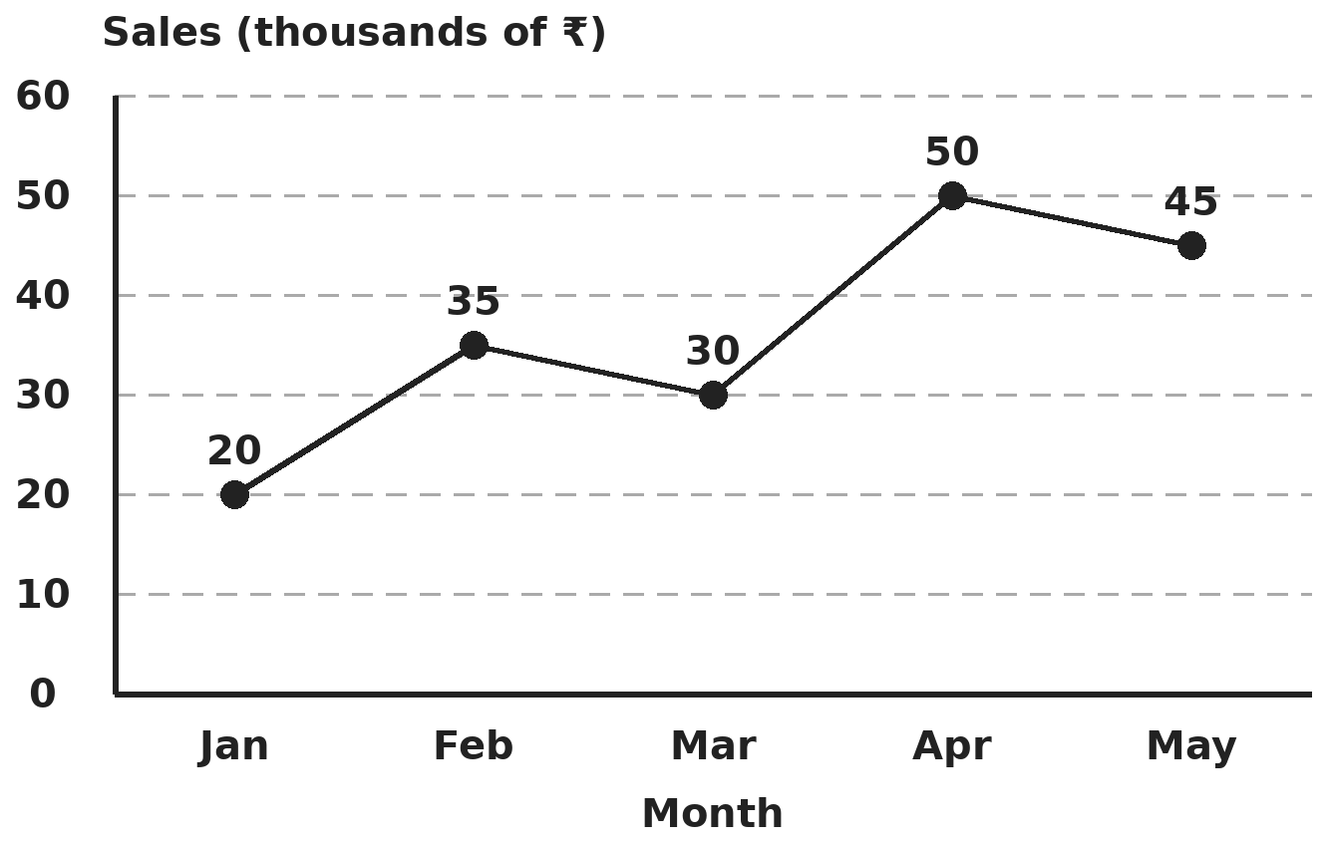
Q17. The line graph shows a shop's sales in thousands of rupees. In which month was the rise from the month before the greatest, and by how much?
(A) February, ₹15,000 | (B) April, ₹50,000
(C) May, ₹15,000 | (D) April, ₹20,000

Q18. The numbers 4, 7, x, x + 2, 15, 19 are in increasing order and their median is 10. What is their mean?
(A) 10 | (B) 11 | (C) 10 5/6 | (D) 10 1/2

Part 8 — Applied Mathematics (Syllabus Chapter 9)
Q19. Two items together cost ₹1,000. One is sold at 20% profit and the other at 10% loss, and the overall gain is ₹50. What did the first item cost?
(A) ₹600 | (B) ₹400 | (C) ₹500 | (D) ₹750

Q20. A sum lent at simple interest grows to ₹14,400 in 4 years. The interest each year is ₹1,100. What is the rate of interest?
(A) 11% | (B) 7.6% | (C) 12% | (D) 10%

Q21. A dealer buys a television at 20% below its list price and sells it at 10% above the list price. What is her profit percent?
(A) 37.5% | (B) 30% | (C) 25% | (D) 32%

Part 9 — Mathematical Reasoning (Syllabus Chapter 10)
Q22. In AA + BB + CC = ABC, the letters stand for different digits. What is A + B + C?
(A) 12 | (B) 15 | (C) 18 | (D) 20

Q23. How many numbers from 1 to 100 are divisible by 2 or by 3, but not by 6?
(A) 67 | (B) 83 | (C) 34 | (D) 51

Q24. What is the remainder when 2⁵⁰ is divided by 7?
(A) 4 | (B) 2 | (C) 1 | (D) 6

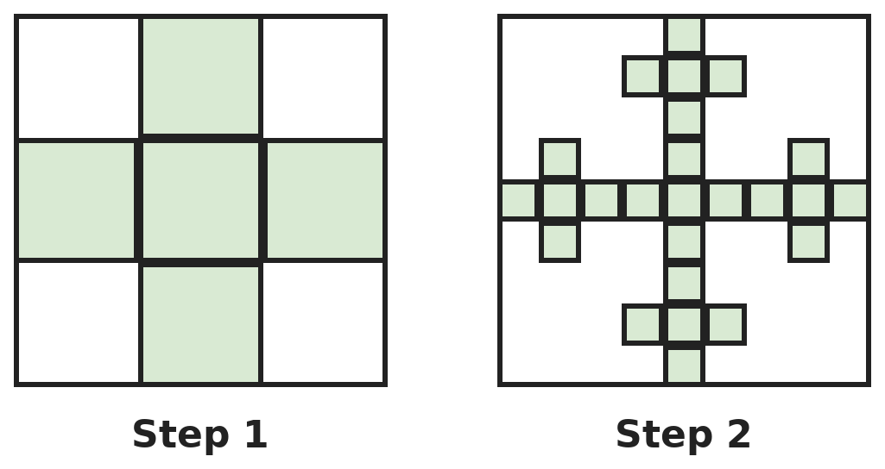
Q25. A square is split into 9 equal squares and only the centre and the four middle-edge squares are kept (step 1). Each kept square is then treated the same way. Steps 1 and 2 are shown. How many small squares are there after step 3?
(A) 45 | (B) 243 | (C) 25 | (D) 125

Part 10 — Mixed Problems (each joins two chapters)
Q26. Two numbers add up to 12 and the difference of their squares is 48. What is their product?
(A) 36 | (B) 32 | (C) 20 | (D) 48

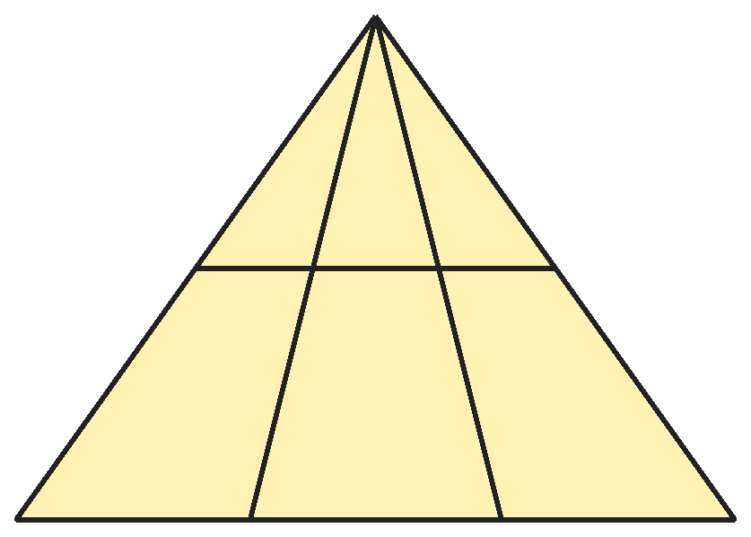
Q27. A triangle has two lines drawn from its top corner to the base and one line drawn across it, parallel to the base. How many triangles of all sizes are in the figure?
(A) 6 | (B) 12 | (C) 10 | (D) 8

Q28. The perimeters of two squares differ by 16 cm and their areas differ by 64 cm². What is the total area of the two squares?
(A) 64 cm² | (B) 160 cm² | (C) 100 cm² | (D) 136 cm²

Q29. The price of rice falls by 20%. Now ₹600 buys 5 kg more rice than before. What was the original price per kg?
(A) ₹24 | (B) ₹30 | (C) ₹25 | (D) ₹36

Q30. A cylindrical tank of radius 1.4 m and height 2.5 m is full. A family uses 616 litres of water a day. For how many days will the water last? (Take π = 22/7.)
(A) 20 days | (B) 25 days | (C) 2.5 days | (D) 250 days

Answer Sheet AMO Level 2 · Class 8 · Practice Paper 4
Name: | School: | Roll No.:
Shade or tick one circle for each question.
1. | Ⓐ Ⓑ Ⓒ Ⓓ | 11. | Ⓐ Ⓑ Ⓒ Ⓓ | 21. | Ⓐ Ⓑ Ⓒ Ⓓ
2. | Ⓐ Ⓑ Ⓒ Ⓓ | 12. | Ⓐ Ⓑ Ⓒ Ⓓ | 22. | Ⓐ Ⓑ Ⓒ Ⓓ
3. | Ⓐ Ⓑ Ⓒ Ⓓ | 13. | Ⓐ Ⓑ Ⓒ Ⓓ | 23. | Ⓐ Ⓑ Ⓒ Ⓓ
4. | Ⓐ Ⓑ Ⓒ Ⓓ | 14. | Ⓐ Ⓑ Ⓒ Ⓓ | 24. | Ⓐ Ⓑ Ⓒ Ⓓ
5. | Ⓐ Ⓑ Ⓒ Ⓓ | 15. | Ⓐ Ⓑ Ⓒ Ⓓ | 25. | Ⓐ Ⓑ Ⓒ Ⓓ
6. | Ⓐ Ⓑ Ⓒ Ⓓ | 16. | Ⓐ Ⓑ Ⓒ Ⓓ | 26. | Ⓐ Ⓑ Ⓒ Ⓓ
7. | Ⓐ Ⓑ Ⓒ Ⓓ | 17. | Ⓐ Ⓑ Ⓒ Ⓓ | 27. | Ⓐ Ⓑ Ⓒ Ⓓ
8. | Ⓐ Ⓑ Ⓒ Ⓓ | 18. | Ⓐ Ⓑ Ⓒ Ⓓ | 28. | Ⓐ Ⓑ Ⓒ Ⓓ
9. | Ⓐ Ⓑ Ⓒ Ⓓ | 19. | Ⓐ Ⓑ Ⓒ Ⓓ | 29. | Ⓐ Ⓑ Ⓒ Ⓓ
10. | Ⓐ Ⓑ Ⓒ Ⓓ | 20. | Ⓐ Ⓑ Ⓒ Ⓓ | 30. | Ⓐ Ⓑ Ⓒ Ⓓ

For the parent or teacher
Correct: ______ / 30
Answer Key and Solutions AMO Level 2 · Class 8 · Practice Paper 4
Quick answers
1 D | 6 A | 11 A | 16 D | 21 A | 26 B
2 C | 7 B | 12 B | 17 D | 22 C | 27 B
3 A | 8 C | 13 C | 18 C | 23 D | 28 D
4 D | 9 B | 14 A | 19 C | 24 A | 29 B
5 C | 10 C | 15 B | 20 A | 25 D | 30 B
Solutions
Q | Part · level | Answer | Why?
1 | Part 1 · Ch1 · Hard | (D) 12 | Hint: √(ab) = √a × √b. A square root has half as many decimal places.  √0.0169 = 0.13 and √1.44 = 1.2, so the top is 0.13 × 1.2 = 0.156. √0.000169 = 0.013. 0.156 ÷ 0.013 = 12.
2 | Part 1 · Ch1 · Hard | (C) 15 | Hint: There are 2n numbers strictly between n² and (n + 1)².  15² = 225 and 16² = 256. The numbers strictly between are 226 to 255: 30 numbers. The even ones are 226, 228, …, 254, which is (254 − 226) ÷ 2 + 1 = 15.
3 | Part 2 · Ch2 · Hard | (A) 1 | Hint: Work out each bracket as a fraction, then invert it.  3⁰ + 3⁻¹ = 1 + 1/3 = 4/3, whose inverse is 3/4. 2⁻¹ + 2⁻² = 1/2 + 1/4 = 3/4, whose inverse is 4/3. 3/4 × 4/3 = 1. (9/16 forgets to invert the brackets.)
4 | Part 2 · Ch2 · Hard | (D) 3 | Hint: Write each one as an ordinary decimal and compare with 0.0025.  0.03 × 10⁻¹ = 0.003, 2.4 × 10⁻³ = 0.0024, 290 × 10⁻⁵ = 0.0029, 0.25 × 10⁻² = 0.0025 and 26 × 10⁻⁴ = 0.0026. Greater than 0.0025: 0.003, 0.0029 and 0.0026, which is 3. (0.0025 is equal, not greater.)
5 | Part 3 · Ch3 · Hard | (C) 15% | Hint: Find the price after the first discount.  After 20% off: ₹4,000. The second discount takes it to ₹3,400, a cut of ₹600 on ₹4,000 = 15%. (12% wrongly uses ₹5,000 as the base.)
6 | Part 3 · Ch3 · Hard | (A) ₹4,000 | Hint: Add the percentages: 2 × 6% and 3 × 9%.  Total interest = 12% + 27% = 39% of the sum = ₹1,560. Sum = 1,560 × 100 ÷ 39 = ₹4,000.
7 | Part 3 · Ch3 · Hard | (B) 540 | Hint: 1.2 × 0.75 = ?  1.2 × 0.75 = 0.9, so the final number is 10% less than the original. 10% of the original is 54, so the original is 540.
8 | Part 4 · Ch4 · Hard | (C) 10 | Hint: (a + b)² = (a − b)² + 4ab.  (a + b)² = 16 + 84 = 100, so a + b = 10 (positive). The numbers are 7 and 3.
9 | Part 4 · Ch4 · Hard | (B) 73 | Hint: p + q = 5 and pq = −24.  Two numbers with sum 5 and product −24 are 8 and −3, so x² + 5x − 24 = (x + 8)(x − 3). p² + q² = 64 + 9 = 73. (Or (p + q)² − 2pq = 25 + 48 = 73.)
10 | Part 4 · Ch4 · Hard | (C) 12/17 | Hint: Let the numerator be n. Then (n + 3)/(n + 8) = 3/4.  4(n + 3) = 3(n + 8) gives 4n + 12 = 3n + 24, so n = 12. The fraction is 12/17. Check: 15/20 = 3/4.
11 | Part 5 · Ch5 · Hard | (A) 7 cm | Hint: Use Pythagoras in triangles PQR and PQS.  PR = √(64 + 225) = 17 cm. PS = √(64 + 36) = 10 cm. PR − PS = 7 cm.
12 | Part 5 · Ch5 · Hard | (B) 55° | Hint: The diagonals of a rectangle are equal and bisect each other, so OA = OB.  OA = OB, so triangle AOB is isosceles: angle OBA = (180° − 110°) ÷ 2 = 35°. Angle ABC = 90°, so angle OBC = 90° − 35° = 55°.
13 | Part 5 · Ch5 · Hard | (C) Their two acute angles are equal | Hint: Equal angles alone give the same shape, but not necessarily the same size.  Hypotenuse and leg is RHS; both legs is SAS; a leg and its opposite angle (with the right angle) is AAS. Equal angles only show the triangles are similar; one could be larger.
14 | Part 6 · Ch6 · Hard | (A) 6 m | Hint: Volume of a cone = (1/3)πr²h. The volume stays the same.  Cone volume = (1/3) × 22/7 × 2.1 × 2.1 × 4 = 18.48 m³. Bin base = 2.2 × 1.4 = 3.08 m². Depth = 18.48 ÷ 3.08 = 6 m. (18 m forgets the 1/3.)
15 | Part 6 · Ch6 · Hard | (B) 1,584 m² | Hint: In one turn it levels its curved surface area. Use r = 0.42 m.  Curved surface = 2πrh = 2 × 22/7 × 0.42 × 1.2 = 3.168 m². In 500 turns: 1,584 m². (3,168 wrongly uses the diameter as the radius.)
16 | Part 6 · Ch6 · Hard | (D) 8,000 cm³ | Hint: Count how many whole cubes fit along each edge.  Along 100 cm: 25. Along 40 cm: 10. Along 22 cm: 5 (with 2 cm spare). Cubes = 25 × 10 × 5 = 1,250, filling 1,250 × 64 = 80,000 cm³. Box = 100 × 40 × 22 = 88,000 cm³. Empty = 8,000 cm³. (0 assumes 22 ÷ 4 cubes fit exactly.)
17 | Part 7 · Ch8 · Hard | (D) April, ₹20,000 | Hint: Look at the change from each month to the next, not at the height.  Changes: Feb +15, Mar −5, Apr +20, May −5 (thousands). The greatest rise is in April: ₹20,000.
18 | Part 7 · Ch8 · Hard | (C) 10 5/6 | Hint: With six numbers, the median is the average of the 3rd and 4th.  Median = (x + x + 2) ÷ 2 = x + 1 = 10, so x = 9. The numbers are 4, 7, 9, 11, 15, 19 with total 65. Mean = 65 ÷ 6 = 10 5/6.
19 | Part 8 · Ch9 · Hard | (C) ₹500 | Hint: Let the first cost ₹a; then 0.2a − 0.1(1,000 − a) = 50.  0.2a − 100 + 0.1a = 50 gives 0.3a = 150, so a = ₹500. Check: gain 100, loss 50, net ₹50.
20 | Part 8 · Ch9 · Hard | (A) 11% | Hint: Subtract 4 years of interest to get the sum lent.  Interest for 4 years = ₹4,400, so the sum = 14,400 − 4,400 = ₹10,000. Rate = 1,100 ÷ 10,000 × 100 = 11%. (7.6% wrongly divides by ₹14,400.)
21 | Part 8 · Ch9 · Hard | (A) 37.5% | Hint: Take the list price as ₹100.  Cost = ₹80, selling price = ₹110. Profit = 30 on a cost of 80 = 37.5%. (30% wrongly uses the list price as the base.)
22 | Part 9 · Ch10 · Hard | (C) 18 | Hint: AA + BB + CC = 11(A + B + C), so ABC is a multiple of 11 of at most 11 × 24 = 264.  11(A + B + C) is a three-digit number ABC, at most 11 × 24 = 264, so A = 1 or 2. So ABC must equal 11 × (sum of its own digits). Checking the multiples of 11 from 110 to 264, only 198 works: 1 + 9 + 8 = 18 and 11 × 18 = 198. (For A = 2 the sum would have to be at least 19, giving 209, 220, …, 264, and none of them has that digit sum.) So A + B + C = 18 (11 + 99 + 88 = 198).
23 | Part 9 · Ch10 · Hard | (D) 51 | Hint: Multiples of 6 are counted among the multiples of 2 and also among the multiples of 3.  Multiples of 2: 50. Multiples of 3: 33. Multiples of 6: 16. Divisible by 2 but not 6: 50 − 16 = 34. By 3 but not 6: 33 − 16 = 17. Total 51.
24 | Part 9 · Ch10 · Hard | (A) 4 | Hint: Look at the remainders of 2¹, 2², 2³, … when divided by 7.  2¹, 2², 2³ leave remainders 2, 4, 1, and the pattern repeats every 3 powers because 2³ = 8 leaves 1. 50 = 3 × 16 + 2, so 2⁵⁰ leaves the same remainder as 2², which is 4.
25 | Part 9 · Ch10 · Hard | (D) 125 | Hint: Each step multiplies the number of squares by 5.  Each square becomes 5 smaller squares. Step 1: 5, step 2: 25, step 3: 125.
26 | Part 10 · Mixed · Ch4 + Ch10 · Hard | (B) 32 | Hint: a² − b² = (a + b)(a − b).  (a + b)(a − b) = 48 with a + b = 12, so a − b = 4. Then a = 8, b = 4 and the product is 32.
27 | Part 10 · Mixed · Ch5 + Ch10 · Hard | (B) 12 | Hint: Every triangle has the top corner and a base on one of the two horizontal lines.  From the top there are 4 lines going down. Any 2 of them, together with one horizontal line, make a triangle. Pairs of lines: 6. Horizontal lines: 2. Total 6 × 2 = 12.
28 | Part 10 · Mixed · Ch4 + Ch5 · Hard | (D) 136 cm² | Hint: Use a² − b² = (a + b)(a − b).  4(a − b) = 16, so a − b = 4. a² − b² = (a + b)(a − b) = 64, so a + b = 16. Then a = 10 and b = 6, and the total area is 100 + 36 = 136 cm².
29 | Part 10 · Mixed · Ch3 + Ch9 · Hard | (B) ₹30 | Hint: The ₹600 now buys as much as ₹750 would have bought before.  At 80% of the price, ₹600 buys what ₹750 bought before. So the extra 5 kg is worth ₹150 at the old price: ₹30 per kg. (₹24 is the new price.)
30 | Part 10 · Mixed · Ch6 + Ch9 · Hard | (B) 25 days | Hint: 1 m³ = 1,000 litres.  Volume = 22/7 × 1.4 × 1.4 × 2.5 = 15.4 m³ = 15,400 litres. 15,400 ÷ 616 = 25 days.

ARYABHATTA MATHS OLYMPIAD
Level 2
PRACTICE PAPER-5
CLASS 8
Total Questions | 30 multiple-choice questions
Level | Level-2 (final round): every question is Hard
Time | 45 minutes
Arrangement | Parts by chapter; the last Part has mixed problems joining two chapters
Negative Marking | No negative marking
Calculator | Not allowed
Chapters | Number System · Operations · Fractions, Decimals & Percentages · Algebra · Geometry · Mensuration · Data Handling, Statistics & Probability · Applied Mathematics · Mathematical Reasoning

Instructions
• Each question has four options, (A) to (D), with exactly one correct answer.
• The questions are grouped in Parts by chapter. The last Part has mixed problems, each joining two chapters.
• Every question is at Level-2 (Hard) standard: expect several steps or a key insight.
• There is no negative marking. Calculators are not allowed; use a separate sheet for rough work.
• Figures are not necessarily drawn to scale unless stated.

For teachers
• Figures are part of the questions and work when printed in black and white.
• Parts follow the AMO syllabus chapters. Chapter 7 is not part of the Class 8 syllabus, so the chapter numbers shown in the Part headings have gaps.
• The answer sheet and the answer key are at the end. Remove the answer key before the paper is attempted.

Part 1 — Number System (Syllabus Chapter 1)
Q1. What is the smallest perfect square that is divisible by each of 6, 8 and 15?
(A) 120 | (B) 3,600 | (C) 14,400 | (D) 900

Q2. Which of these numbers is the largest: √3, 1.7, 7/4, √3.1?
(A) 7/4 | (B) √3 | (C) √3.1 | (D) 1.7

Part 2 — Operations (Syllabus Chapter 2)
Q3. Find x if 3ˣ⁺¹ + 3ˣ⁻¹ = 270.
(A) 4 | (B) 5 | (C) 3 | (D) 6

Q4. A heart beats about 72 times a minute. About how many times does it beat in a year of 365 days? Give the answer in standard form.
(A) 3.78 × 10⁶ | (B) 3.78 × 10⁷ | (C) 6.3 × 10⁵ | (D) 2.6 × 10⁸

Part 3 — Fractions, Decimals & Percentages (Syllabus Chapter 3)
Q5. Shop A offers "buy 3, get 1 free" on identical shirts. Shop B offers 20% off followed by a further 5% off. For a buyer of 4 shirts, which shop gives the larger effective discount, and by how much?
(A) Shop B, by 1 percentage point | (B) Both are equal
(C) Shop A, by 1 percentage point | (D) Shop A, by 5 percentage points

Q6. Sahil borrows ₹8,000 at 9% simple interest and at once lends it at 12% simple interest. How much does he gain in 2.5 years?
(A) ₹240 | (B) ₹1,800 | (C) ₹2,400 | (D) ₹600

Q7. Nisha's salary is raised by 10%, then cut by 10%, and then raised by 20%. What is the overall percentage change from her original salary?
(A) 20% increase | (B) 10% increase
(C) 21% increase | (D) 18.8% increase

Part 4 — Algebra (Syllabus Chapter 4)
Q8. For numbers a > b, a + b = 10 and a² + b² = 58. What is (a − b)²?
(A) 4 | (B) 16 | (C) 42 | (D) 8

Q9. Which of these is a factor of 4x² − 12x + 9 − y²?
(A) 2x + 3 − y | (B) 2x − 9 + y | (C) 4x − 3 − y | (D) 2x − 3 + y

Q10. The digits of a two-digit number add up to 9. When the digits are reversed, the number increases by 27. What is the number?
(A) 36 | (B) 63 | (C) 45 | (D) 27

Part 5 — Geometry (Syllabus Chapter 5)
Q11. A 25 m pole breaks at some height, and its top touches the ground 15 m from the foot of the pole. The broken part stays joined at the break. At what height did it break?
(A) 8 m | (B) 10 m | (C) 12.5 m | (D) 17 m

Q12. In trapezium ABCD, AB is parallel to DC. Angle A is twice angle D, and angle B is 30° more than angle C. What is angle C?
(A) 60° | (B) 105° | (C) 75° | (D) 90°

Q13. A wooden cube is painted on all its faces and then cut into 64 equal small cubes. How many small cubes have paint on exactly one face?
(A) 8 | (B) 16 | (C) 24 | (D) 32

Part 6 — Mensuration (Syllabus Chapter 6)
Q14. A cylindrical jar of radius 7 cm contains water. 77 metal cubes, each of edge 2 cm, are dropped in and are fully covered by water. By how much does the water level rise? (Take π = 22/7.)
(A) 4 cm | (B) 2 cm | (C) 8 cm | (D) 0.4 cm

Q15. A solid cone is 24 cm tall and has a volume of 1,232 cm³. What is its total surface area? (Take π = 22/7.)
(A) 550 cm² | (B) 704 cm² | (C) 858 cm² | (D) 1,232 cm²

Q16. A room is 6 m long, 4 m wide and 3 m high, with a door 2 m × 1 m and a window 1.5 m × 1 m. The four walls (not the door or window) get one coat of paint and the ceiling gets two coats. Paint costs ₹20 per m² for each coat. What is the total cost?
(A) ₹2,090 | (B) ₹1,610 | (C) ₹2,160 | (D) ₹1,690

Part 7 — Data Handling, Statistics & Probability (Syllabus Chapter 8)
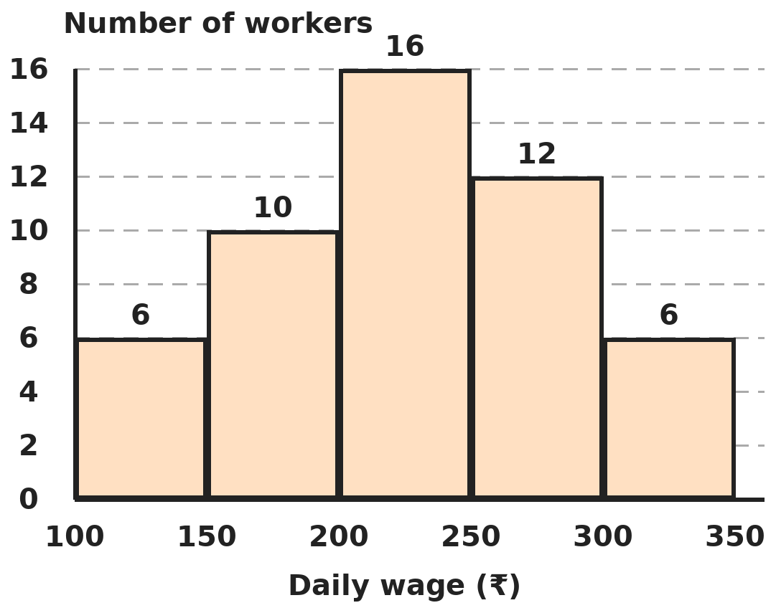
Q17. The histogram shows the daily wages of the workers in a factory (each class includes its lower value, not its upper value). In which class does the median wage lie?
(A) ₹150–200 | (B) ₹200–250 | (C) ₹250–300 | (D) ₹100–150

Q18. The average weight of 30 students is 40 kg. When their teacher is included, the average rises by 1 kg. When the teacher then leaves and the principal joins instead, the average of the 31 people rises by another 0.5 kg. What is the principal's weight?
(A) 71.5 kg | (B) 72 kg | (C) 101.5 kg | (D) 86.5 kg

Part 8 — Applied Mathematics (Syllabus Chapter 9)
Q19. A clock sold for ₹1,140 gives a loss of 5%. How much more should it have been sold for to gain 5%?
(A) ₹114 | (B) ₹60 | (C) ₹120 | (D) ₹126

Q20. Kiara deposits ₹2,000 at the start of each year for 3 years in a scheme paying 10% simple interest a year. How much interest has she earned in total at the end of the third year?
(A) ₹600 | (B) ₹1,800 | (C) ₹900 | (D) ₹1,200

Q21. An article costs a shopkeeper ₹600. She marks it so that even after a 10% discount she makes a 17% profit. What is the marked price?
(A) ₹702 | (B) ₹780 | (C) ₹770 | (D) ₹800

Part 9 — Mathematical Reasoning (Syllabus Chapter 10)
Q22. In ABCD × 4 = DCBA, each letter is a digit and ABCD is a four-digit number. What is ABCD?
(A) 1089 | (B) 2187 | (C) 2718 | (D) 2178

Q23. A rectangle is divided into a grid of 4 columns and 2 rows of equal squares. How many rectangles of all sizes (squares included) can be traced along the grid lines?
(A) 30 | (B) 8 | (C) 20 | (D) 18

Q24. What is the smallest number that leaves a remainder of 1 when divided by 2, 3, 4, 5 or 6, and is divisible by 7?
(A) 61 | (B) 421 | (C) 301 | (D) 181

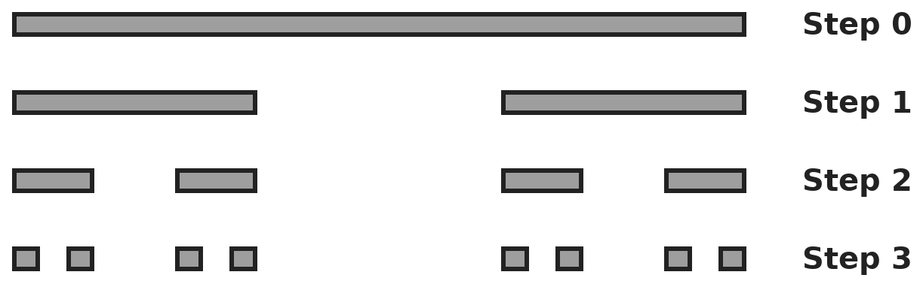
Q25. A line segment 81 cm long has its middle third removed (step 1). At each later step, the middle third of every remaining piece is removed. What is the total length remaining after step 4?
(A) 16 cm | (B) 27 cm | (C) 54 cm | (D) 24 cm

Part 10 — Mixed Problems (each joins two chapters)
Q26. How many pairs of positive whole numbers (x, y) satisfy x² − y² = 45?
(A) 2 | (B) 3 | (C) 4 | (D) 6

Q27. A football-shaped polyhedron has 12 pentagonal faces and 20 hexagonal faces. Exactly 3 faces meet at every vertex. How many vertices does it have?
(A) 60 | (B) 90 | (C) 32 | (D) 120

Q28. A rectangle has area (x² + 7x + 12) cm² and length (x + 4) cm. What is its perimeter when x = 5?
(A) 72 cm | (B) 34 cm | (C) 30 cm | (D) 17 cm

Q29. ₹12,000 is lent at simple interest: 8% a year for the first 2 years and 10% a year for the next 3 years. What is the total interest?
(A) ₹5,400 | (B) ₹6,000 | (C) ₹4,800 | (D) ₹5,520

Q30. An ice-cream seller fills cones of radius 3.5 cm and height 12 cm (inside measures) from a 7.7 litre tub that cost her ₹1,540. She sells every filled cone for ₹40. What is her profit on the tub? (Take π = 22/7; ignore the cost of the cones.)
(A) ₹2,000 | (B) ₹1,540 | (C) ₹460 | (D) ₹500

Answer Sheet AMO Level 2 · Class 8 · Practice Paper 5
Name: | School: | Roll No.:
Shade or tick one circle for each question.
1. | Ⓐ Ⓑ Ⓒ Ⓓ | 11. | Ⓐ Ⓑ Ⓒ Ⓓ | 21. | Ⓐ Ⓑ Ⓒ Ⓓ
2. | Ⓐ Ⓑ Ⓒ Ⓓ | 12. | Ⓐ Ⓑ Ⓒ Ⓓ | 22. | Ⓐ Ⓑ Ⓒ Ⓓ
3. | Ⓐ Ⓑ Ⓒ Ⓓ | 13. | Ⓐ Ⓑ Ⓒ Ⓓ | 23. | Ⓐ Ⓑ Ⓒ Ⓓ
4. | Ⓐ Ⓑ Ⓒ Ⓓ | 14. | Ⓐ Ⓑ Ⓒ Ⓓ | 24. | Ⓐ Ⓑ Ⓒ Ⓓ
5. | Ⓐ Ⓑ Ⓒ Ⓓ | 15. | Ⓐ Ⓑ Ⓒ Ⓓ | 25. | Ⓐ Ⓑ Ⓒ Ⓓ
6. | Ⓐ Ⓑ Ⓒ Ⓓ | 16. | Ⓐ Ⓑ Ⓒ Ⓓ | 26. | Ⓐ Ⓑ Ⓒ Ⓓ
7. | Ⓐ Ⓑ Ⓒ Ⓓ | 17. | Ⓐ Ⓑ Ⓒ Ⓓ | 27. | Ⓐ Ⓑ Ⓒ Ⓓ
8. | Ⓐ Ⓑ Ⓒ Ⓓ | 18. | Ⓐ Ⓑ Ⓒ Ⓓ | 28. | Ⓐ Ⓑ Ⓒ Ⓓ
9. | Ⓐ Ⓑ Ⓒ Ⓓ | 19. | Ⓐ Ⓑ Ⓒ Ⓓ | 29. | Ⓐ Ⓑ Ⓒ Ⓓ
10. | Ⓐ Ⓑ Ⓒ Ⓓ | 20. | Ⓐ Ⓑ Ⓒ Ⓓ | 30. | Ⓐ Ⓑ Ⓒ Ⓓ

For the parent or teacher
Correct: ______ / 30
Answer Key and Solutions AMO Level 2 · Class 8 · Practice Paper 5
Quick answers
1 B | 6 D | 11 A | 16 A | 21 B | 26 B
2 C | 7 D | 12 C | 17 B | 22 D | 27 A
3 A | 8 B | 13 C | 18 D | 23 A | 28 B
4 B | 9 D | 14 A | 19 C | 24 C | 29 D
5 C | 10 A | 15 B | 20 D | 25 A | 30 C
Solutions
Q | Part · level | Answer | Why?
1 | Part 1 · Ch1 · Hard | (B) 3,600 | Hint: Start from the LCM and make every prime power even.  LCM of 6, 8 and 15 = 120 = 2³ × 3 × 5. To make all powers even, multiply by 2 × 3 × 5 = 30: 120 × 30 = 3,600 = 60². (900 is a square but is not divisible by 8.)
2 | Part 1 · Ch1 · Hard | (C) √3.1 | Hint: Compare the squares of the numbers.  Squares: √3 → 3, 1.7 → 2.89, 7/4 → 3.0625, √3.1 → 3.1. The largest square is 3.1, so √3.1 is the largest.
3 | Part 2 · Ch2 · Hard | (A) 4 | Hint: 3ˣ⁺¹ = 3 × 3ˣ and 3ˣ⁻¹ = 3ˣ ÷ 3.  3 × 3ˣ + 3ˣ/3 = (10/3) × 3ˣ = 270, so 3ˣ = 81 = 3⁴ and x = 4.
4 | Part 2 · Ch2 · Hard | (B) 3.78 × 10⁷ | Hint: Minutes in a year = 60 × 24 × 365.  Minutes in a year = 5,25,600. 72 × 5,25,600 = 3,78,43,200 ≈ 3.78 × 10⁷. (6.3 × 10⁵ = 72 × 24 × 365 forgets the 60 minutes in each hour.)
5 | Part 3 · Ch3 · Hard | (C) Shop A, by 1 percentage point | Hint: Buy 3 get 1 free means paying for 3 out of 4.  Shop A: pay 3/4, a 25% discount. Shop B: 0.8 × 0.95 = 0.76, a 24% discount. Shop A is better by 1 percentage point.
6 | Part 3 · Ch3 · Hard | (D) ₹600 | Hint: He gains 3% of ₹8,000 each year.  Gain per year = 3% of 8,000 = ₹240. In 2.5 years: 240 × 2.5 = ₹600.
7 | Part 3 · Ch3 · Hard | (D) 18.8% increase | Hint: Multiply the three factors: 1.1, 0.9 and 1.2.  1.1 × 0.9 = 0.99 and 0.99 × 1.2 = 1.188. The salary is 118.8% of the original: an 18.8% increase.
8 | Part 4 · Ch4 · Hard | (B) 16 | Hint: (a − b)² + (a + b)² = 2(a² + b²).  (a + b)² = 100 = 58 + 2ab, so 2ab = 42. (a − b)² = a² + b² − 2ab = 58 − 42 = 16. (4 is a − b itself; 42 is 2ab.)
9 | Part 4 · Ch4 · Hard | (D) 2x − 3 + y | Hint: 4x² − 12x + 9 is a perfect square.  4x² − 12x + 9 = (2x − 3)². So the expression is (2x − 3)² − y² = (2x − 3 − y)(2x − 3 + y). A factor is 2x − 3 + y.
10 | Part 4 · Ch4 · Hard | (A) 36 | Hint: Reversing the digits of 10a + b changes the number by 9(b − a).  a + b = 9 and 9(b − a) = 27, so b − a = 3. Then b = 6, a = 3, and the number is 36. Check: 63 − 36 = 27.
11 | Part 5 · Ch5 · Hard | (A) 8 m | Hint: If it breaks at height h, the broken part is 25 − h long and is the hypotenuse.  (25 − h)² = h² + 15². 625 − 50h + h² = h² + 225, so 50h = 400 and h = 8 m. The broken part is 17 m: 8² + 15² = 17².
12 | Part 5 · Ch5 · Hard | (C) 75° | Hint: The angles along each slanted side add up to 180°.  A + D = 180° with A = 2D gives D = 60°, A = 120°. B + C = 180° with B = C + 30° gives 2C + 30° = 180°, so C = 75°.
13 | Part 5 · Ch5 · Hard | (C) 24 | Hint: The cube is 4 small cubes long on each edge. One-face cubes are in the middle of each face.  Each face is a 4 × 4 square of small cubes. The cubes with only that face painted form the inner 2 × 2 block: 4 per face. 6 faces × 4 = 24.
14 | Part 6 · Ch6 · Hard | (A) 4 cm | Hint: The volume of the cubes equals πr² × rise.  Volume of cubes = 77 × 8 = 616 cm³. Base area = 22/7 × 49 = 154 cm². Rise = 616 ÷ 154 = 4 cm.
15 | Part 6 · Ch6 · Hard | (B) 704 cm² | Hint: Find r from the volume, then the slant height from r and h.  (1/3) × 22/7 × r² × 24 = 1,232 gives r² = 49, so r = 7 cm. Slant height = √(7² + 24²) = 25 cm. Total surface = πr(l + r) = 22/7 × 7 × 32 = 704 cm². (550 is only the curved surface.)
16 | Part 6 · Ch6 · Hard | (A) ₹2,090 | Hint: Area of four walls = 2(l + b) × h.  Walls = 2(6 + 4) × 3 = 60 m², minus 2 + 1.5 = 56.5 m². Ceiling, two coats: 2 × 24 = 48 m². Total 104.5 m² × ₹20 = ₹2,090. (₹1,610 paints the ceiling only once.)
17 | Part 7 · Ch8 · Hard | (B) ₹200–250 | Hint: Find the total, then count bars from the left until you pass the middle worker.  Total = 6 + 10 + 16 + 12 + 6 = 50, so the median lies between the 25th and 26th workers. Running totals: 6, 16, 32. The 25th and 26th workers are in the third bar, ₹200–250.
18 | Part 7 · Ch8 · Hard | (D) 86.5 kg | Hint: Find the teacher's weight first. The principal adds 31 × 0.5 kg to the total.  Teacher = 31 × 41 − 30 × 40 = 1,271 − 1,200 = 71 kg. Replacing the teacher raises the total by 31 × 0.5 = 15.5 kg, so the principal weighs 71 + 15.5 = 86.5 kg. (71.5 adds only 0.5 kg.)
19 | Part 8 · Ch9 · Hard | (C) ₹120 | Hint: ₹1,140 is 95% of the cost price.  Cost = 1,140 ÷ 0.95 = ₹1,200. For 5% gain: ₹1,260. Extra = 1,260 − 1,140 = ₹120 (10% of the cost, not of ₹1,140).
20 | Part 8 · Ch9 · Hard | (D) ₹1,200 | Hint: The first deposit earns for 3 years, the second for 2 and the third for 1.  Interest = 2,000 × 10% × (3 + 2 + 1) = 200 × 6 = ₹1,200.
21 | Part 8 · Ch9 · Hard | (B) ₹780 | Hint: Selling price = 117% of ₹600, and it is 90% of the marked price.  Selling price = 600 × 1.17 = ₹702. Marked price = 702 ÷ 0.9 = ₹780.
22 | Part 9 · Ch10 · Hard | (D) 2178 | Hint: The product is still a four-digit number, so A is small. DCBA ends in A, so A must be even.  ABCD × 4 < 10,000, so A ≤ 2; DCBA ends in A, an even digit, so A = 2. D × 4 ends in 2 and D ≥ 8, so D = 8. Working through B and C gives 2178 × 4 = 8712.
23 | Part 9 · Ch10 · Hard | (A) 30 | Hint: A rectangle is fixed by choosing 2 of the vertical lines and 2 of the horizontal lines.  There are 5 vertical lines and 3 horizontal lines. Pairs of vertical lines: 10. Pairs of horizontal lines: 3. Rectangles = 10 × 3 = 30.
24 | Part 9 · Ch10 · Hard | (C) 301 | Hint: The number is 1 more than a multiple of the LCM of 2, 3, 4, 5 and 6.  LCM = 60, so the number is 60k + 1: 61, 121, 181, 241, 301, … Testing for 7: only 301 = 7 × 43 works first.
25 | Part 9 · Ch10 · Hard | (A) 16 cm | Hint: Each step keeps 2/3 of the length.  After 4 steps: 81 × (2/3)⁴ = 81 × 16/81 = 16 cm, in 16 pieces of 1 cm.
26 | Part 10 · Mixed · Ch4 + Ch10 · Hard | (B) 3 | Hint: (x − y)(x + y) = 45. Both factors must have the same parity.  Factor pairs of 45 with x − y < x + y: 1 × 45, 3 × 15, 5 × 9. All are odd-odd, so each gives whole x and y: (23, 22), (9, 6), (7, 2). That is 3 pairs.
27 | Part 10 · Mixed · Ch5 + Ch10 · Hard | (A) 60 | Hint: Count the corners of all the faces, then remember each vertex is shared by 3 faces.  The faces have 12 × 5 + 20 × 6 = 180 corners in all. Each vertex is shared by 3 faces, so V = 180 ÷ 3 = 60. Check with Euler: edges = 180 ÷ 2 = 90, faces = 32, and 32 + 60 − 90 = 2. (90 is the number of edges.)
28 | Part 10 · Mixed · Ch4 + Ch5 · Hard | (B) 34 cm | Hint: Factorise the area to find the width.  x² + 7x + 12 = (x + 3)(x + 4), so the width is (x + 3) cm. At x = 5 the sides are 9 cm and 8 cm, and the perimeter = 2(9 + 8) = 34 cm. (72 is the area.)
29 | Part 10 · Mixed · Ch3 + Ch9 · Hard | (D) ₹5,520 | Hint: Simple interest is always on the original sum.  First 2 years: 12,000 × 16% = ₹1,920. Next 3 years: 12,000 × 30% = ₹3,600. Total ₹5,520.
30 | Part 10 · Mixed · Ch6 + Ch9 · Hard | (C) ₹460 | Hint: Find the volume of one cone in cm³; 1 litre = 1,000 cm³.  One cone = (1/3) × 22/7 × 3.5 × 3.5 × 12 = 154 cm³. Number of cones = 7,700 ÷ 154 = 50. Takings = 50 × 40 = ₹2,000. Profit = 2,000 − 1,540 = ₹460.

