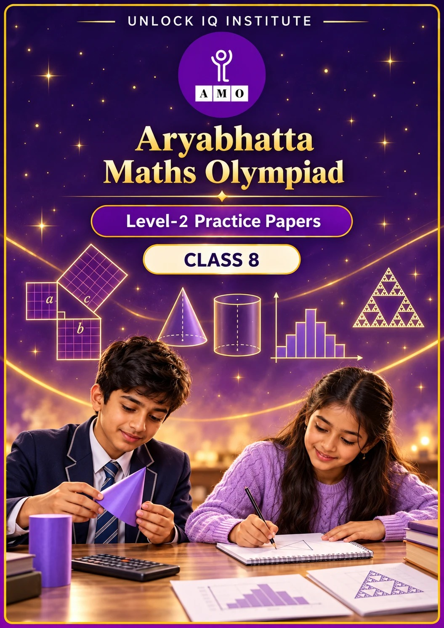
Set 2 · Practice Papers 6–10 · with answer keys & detailed solutions
Name: ____________________ | Class & Section: ________________
Roll No.: ________________ | School: ____________________
City: ____________________ | Date: ____________________

Published by Unlock IQ Institute Pvt. Ltd.
Register for Olympiads: www.aryabhattamathsolympiad.com/student-registration

ARYABHATTA MATHS OLYMPIAD
Level 2
PRACTICE PAPER-6
CLASS 8
Total Questions | 30 multiple-choice questions
Level | Level-2 (final round): every question is Hard
Time | 45 minutes
Arrangement | Parts by chapter; the last Part has mixed problems joining two chapters
Negative Marking | No negative marking
Calculator | Not allowed
Chapters | Number System · Operations · Fractions, Decimals & Percentages · Algebra · Geometry · Mensuration · Data Handling, Statistics & Probability · Applied Mathematics · Mathematical Reasoning

Instructions
• Each question has four options, (A) to (D), with exactly one correct answer.
• The questions are grouped in Parts by chapter. The last Part has mixed problems, each joining two chapters.
• Every question is at Level-2 (Hard) standard: expect several steps or a key insight.
• There is no negative marking. Calculators are not allowed; use a separate sheet for rough work.
• Figures are not necessarily drawn to scale unless stated.

For teachers
• Figures are part of the questions and work when printed in black and white.
• Parts follow the AMO syllabus chapters. Chapter 7 is not part of the Class 8 syllabus, so the chapter numbers shown in the Part headings have gaps.
• The answer sheet and the answer key are at the end. Remove the answer key before the paper is attempted.

Part 1 — Number System (Syllabus Chapter 1)
Q1. How many numbers between 1 and 1,000 (not counting 1 and 1,000) are both perfect squares and perfect cubes?
(A) 3 | (B) 1 | (C) 4 | (D) 2

Q2. What is √(6 1/4) − √(2 7/9)?
(A) 5/6 | (B) 1/6 | (C) 5/12 | (D) 7/6

Part 2 — Operations (Syllabus Chapter 2)
Q3. Find x if (−3)⁻² × 3ˣ = (1/3)⁻⁴ × 3⁻¹.
(A) 5 | (B) 3 | (C) 1 | (D) −5

Q4. A computer carries out 4.5 × 10⁹ operations every second. How long does it take to carry out 2.7 × 10¹³ operations?
(A) 6,000 minutes | (B) 10 minutes | (C) 100 minutes | (D) 60 minutes

Part 3 — Fractions, Decimals & Percentages (Syllabus Chapter 3)
Q5. A shop offers "buy 2, get the 3rd at half price" on identical bags. What is the effective discount on 3 bags?
(A) 50% | (B) 33 1/3% | (C) 16 2/3% | (D) 20%

Q6. Two equal sums are lent, one at 7% and the other at 9% simple interest a year. After 4 years the difference in their interest is ₹480. What is each sum?
(A) ₹3,000 | (B) ₹6,000 | (C) ₹12,000 | (D) ₹4,800

Q7. The length of a rectangle is increased by 25%. By what percentage must its breadth be reduced so that the area stays the same?
(A) 25% | (B) 15% | (C) 20% | (D) 80%

Part 4 — Algebra (Syllabus Chapter 4)
Q8. What is (2x + 3y)² − (2x − 3y)² when x = 1/2 and y = 1/3?
(A) 4 | (B) 24 | (C) 0 | (D) 2

Q9. Positive numbers x and y satisfy x² + y² = 74 and xy = 35. What is x + y?
(A) 2 | (B) 12 | (C) √74 | (D) 10

Q10. The perimeter of a rectangle is 64 cm. Its length is 4 cm less than three times its breadth. What is its area?
(A) 192 cm² | (B) 240 cm² | (C) 207 cm² | (D) 161 cm²

Part 5 — Geometry (Syllabus Chapter 5)
Q11. ABCD is a square of side 8 cm and E is the midpoint of AB. How long is CE?
(A) 4√5 cm | (B) 8√2 cm | (C) 12 cm | (D) 4√3 cm

Q12. In a parallelogram, one angle is 2/3 of the angle next to it. What is the largest angle of the parallelogram?
(A) 72° | (B) 120° | (C) 90° | (D) 108°

Q13. A rhombus has side 13 cm and one diagonal 24 cm. What is its area?
(A) 120 cm² | (B) 312 cm² | (C) 240 cm² | (D) 156 cm²

Part 6 — Mensuration (Syllabus Chapter 6)
Q14. A cone and a cylinder have equal volumes. The radius of the cone is twice the radius of the cylinder, and the cylinder is 6 cm tall. How tall is the cone?
(A) 18 cm | (B) 4.5 cm | (C) 9 cm | (D) 2 cm

Q15. A cylindrical well of diameter 3.5 m is dug 10 m deep. The earth taken out is spread evenly over a plot 22 m by 14 m. By how much is the level of the plot raised? (Take π = 22/7.)
(A) 3.125 cm | (B) 31.25 cm | (C) 62.5 cm | (D) 12.5 cm

Q16. Water flows into a cuboid tank with a base of 3 m by 2 m at 2 litres every second. How long does it take for the water level to rise by 5 cm?
(A) 25 minutes | (B) 15 minutes | (C) 2.5 minutes | (D) 150 minutes

Part 7 — Data Handling, Statistics & Probability (Syllabus Chapter 8)
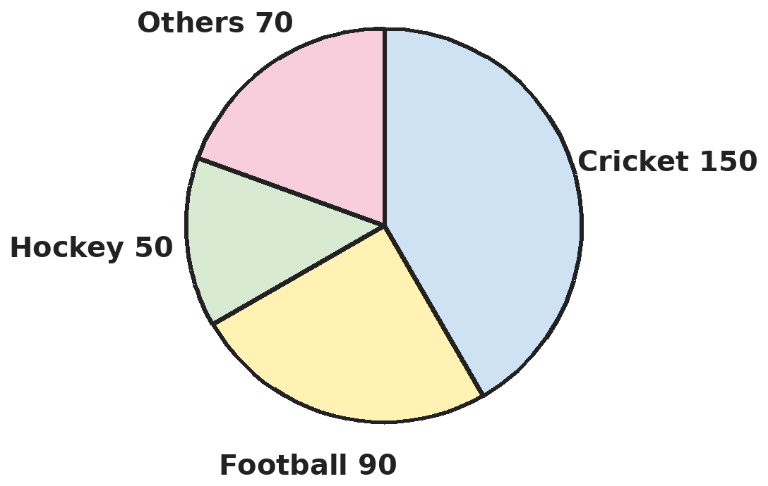
Q17. The pie chart shows the favourite sports of 720 students (angles in degrees). How many more students prefer football than hockey?
(A) 40 | (B) 100 | (C) 80 | (D) 60

Q18. The numbers 3, 5, 7, x, 11, 13 are in increasing order and their median is 8. What is their mean?
(A) 8.5 | (B) 7 | (C) 9 | (D) 8

Part 8 — Applied Mathematics (Syllabus Chapter 9)
Q19. The cost price of 20 identical lamps equals the selling price of 16 of them. The shop sells them after a 10% discount on the marked price. By what percentage above cost is the marked price?
(A) 38 8/9% | (B) 35% | (C) 25% | (D) 40%

Q20. Anand lends ₹5,000 to Gopal for 2 years and ₹3,000 to Hari for 4 years, both at the same rate of simple interest. He receives ₹2,200 in interest altogether. What is the rate?
(A) 11% | (B) 10% | (C) 12% | (D) 8%

Q21. A car is sold at a loss of 10%. If it had been bought for 20% less and sold for ₹45,000 more, the dealer would have gained 25%. What was the cost price?
(A) ₹3,00,000 | (B) ₹1,80,000 | (C) ₹4,50,000 | (D) ₹5,00,000

Part 9 — Mathematical Reasoning (Syllabus Chapter 10)
Q22. ABC and CBA are three-digit numbers. ABC − CBA = 297, the middle digit B is 8 and A + B + C = 17. What is ABC?
(A) 386 | (B) 593 | (C) 683 | (D) 674

Q23. In how many ways can 10 be written as a sum of three different positive whole numbers, if the order does not matter (1 + 2 + 7 is the same as 7 + 2 + 1)?
(A) 8 | (B) 4 | (C) 6 | (D) 36

Q24. A frog starts at 0 on a number line and makes exactly 7 jumps. Each jump is 3 or 5 steps, to the left or to the right. Which of these positions can it NOT be at after the 7 jumps?
(A) 1 | (B) 3 | (C) 35 | (D) 0

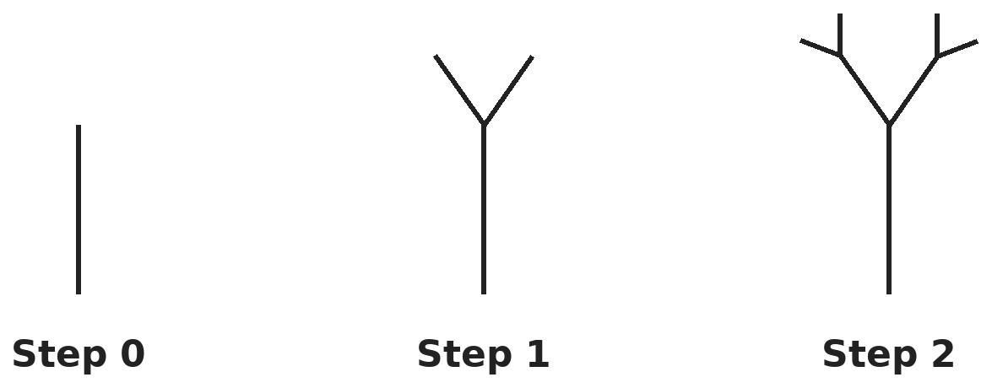
Q25. A tree is drawn from a 64 cm trunk (step 0). At each step, every branch tip grows two new branches, each half as long as the branch it grows from. Steps 0, 1 and 2 are shown. What is the total length of the drawing after step 5?
(A) 128 cm | (B) 2,048 cm | (C) 320 cm | (D) 384 cm

Part 10 — Mixed Problems (each joins two chapters)
Q26. For how many whole numbers n from 1 to 15 is n² − 20n + 96 a negative number?
(A) 5 | (B) 3 | (C) 4 | (D) 2

Q27. A polygon has 35 diagonals. How many sides does it have?
(A) 7 | (B) 10 | (C) 14 | (D) 12

Q28. A square garden has a path 2 m wide running round the inside of its edges. The area of the path is 176 m². What is the side of the garden?
(A) 22 m | (B) 26 m | (C) 20 m | (D) 24 m

Q29. A shop offers "buy 3, get 1 free" and then a further 10% off the bill. Bags are marked ₹400 each and cost the shop ₹200 each. A customer takes 8 bags. What percentage profit does the shop make on this sale?
(A) 35% | (B) 80% | (C) 44% | (D) 60%

Q30. A cylindrical milk can has inner radius 14 cm and inner height 50 cm. Milk costs ₹56 per litre. What is the value of a full can of milk? (Take π = 22/7.)
(A) ₹17,248 | (B) ₹172.48 | (C) ₹862.40 | (D) ₹1,724.80

Answer Sheet AMO Level 2 · Class 8 · Practice Paper 6
Name: | School: | Roll No.:
Shade or tick one circle for each question.
1. | Ⓐ Ⓑ Ⓒ Ⓓ | 11. | Ⓐ Ⓑ Ⓒ Ⓓ | 21. | Ⓐ Ⓑ Ⓒ Ⓓ
2. | Ⓐ Ⓑ Ⓒ Ⓓ | 12. | Ⓐ Ⓑ Ⓒ Ⓓ | 22. | Ⓐ Ⓑ Ⓒ Ⓓ
3. | Ⓐ Ⓑ Ⓒ Ⓓ | 13. | Ⓐ Ⓑ Ⓒ Ⓓ | 23. | Ⓐ Ⓑ Ⓒ Ⓓ
4. | Ⓐ Ⓑ Ⓒ Ⓓ | 14. | Ⓐ Ⓑ Ⓒ Ⓓ | 24. | Ⓐ Ⓑ Ⓒ Ⓓ
5. | Ⓐ Ⓑ Ⓒ Ⓓ | 15. | Ⓐ Ⓑ Ⓒ Ⓓ | 25. | Ⓐ Ⓑ Ⓒ Ⓓ
6. | Ⓐ Ⓑ Ⓒ Ⓓ | 16. | Ⓐ Ⓑ Ⓒ Ⓓ | 26. | Ⓐ Ⓑ Ⓒ Ⓓ
7. | Ⓐ Ⓑ Ⓒ Ⓓ | 17. | Ⓐ Ⓑ Ⓒ Ⓓ | 27. | Ⓐ Ⓑ Ⓒ Ⓓ
8. | Ⓐ Ⓑ Ⓒ Ⓓ | 18. | Ⓐ Ⓑ Ⓒ Ⓓ | 28. | Ⓐ Ⓑ Ⓒ Ⓓ
9. | Ⓐ Ⓑ Ⓒ Ⓓ | 19. | Ⓐ Ⓑ Ⓒ Ⓓ | 29. | Ⓐ Ⓑ Ⓒ Ⓓ
10. | Ⓐ Ⓑ Ⓒ Ⓓ | 20. | Ⓐ Ⓑ Ⓒ Ⓓ | 30. | Ⓐ Ⓑ Ⓒ Ⓓ

For the parent or teacher
Correct: ______ / 30
Answer Key and Solutions AMO Level 2 · Class 8 · Practice Paper 6
Quick answers
1 D | 6 B | 11 A | 16 C | 21 C | 26 B
2 A | 7 C | 12 D | 17 C | 22 C | 27 B
3 A | 8 A | 13 A | 18 D | 23 B | 28 D
4 C | 9 B | 14 B | 19 A | 24 D | 29 A
5 C | 10 C | 15 B | 20 B | 25 D | 30 D
Solutions
Q | Part · level | Answer | Why?
1 | Part 1 · Ch1 · Hard | (D) 2 | Hint: A number that is both a square and a cube is a sixth power.  Such numbers are n⁶: 2⁶ = 64 and 3⁶ = 729 lie between 1 and 1,000; 4⁶ = 4,096 is too large. So there are 2 (64 = 8² = 4³ and 729 = 27² = 9³).
2 | Part 1 · Ch1 · Hard | (A) 5/6 | Hint: Write each mixed number as an improper fraction first.  6 1/4 = 25/4, so its root is 5/2. 2 7/9 = 25/9, so its root is 5/3. 5/2 − 5/3 = 15/6 − 10/6 = 5/6.
3 | Part 2 · Ch2 · Hard | (A) 5 | Hint: (−3)⁻² = 1/9 = 3⁻² and (1/3)⁻⁴ = 3⁴.  (−3)⁻² = 1/(−3)² = 3⁻². The right side is 3⁴ × 3⁻¹ = 3³. So 3ˣ⁻² = 3³, x − 2 = 3 and x = 5. (−5 treats (−3)⁻² as negative.)
4 | Part 2 · Ch2 · Hard | (C) 100 minutes | Hint: Divide, then change seconds into minutes.  2.7 × 10¹³ ÷ 4.5 × 10⁹ = 0.6 × 10⁴ = 6,000 seconds = 100 minutes.
5 | Part 3 · Ch3 · Hard | (C) 16 2/3% | Hint: You pay for 2½ bags out of 3.  Paying for 2.5 bags instead of 3 saves 0.5 bag out of 3 = 1/6 = 16 2/3%.
6 | Part 3 · Ch3 · Hard | (B) ₹6,000 | Hint: The rates differ by 2% a year.  The difference is 2% a year for 4 years = 8% of the sum = ₹480. So the sum = 480 × 100 ÷ 8 = ₹6,000.
7 | Part 3 · Ch3 · Hard | (C) 20% | Hint: The new breadth must be 1 ÷ 1.25 of the old.  1 ÷ 1.25 = 0.8, so the breadth must become 80% of the old breadth: a 20% reduction. (25% would leave the area at 1.25 × 0.75 = 93.75%.)
8 | Part 4 · Ch4 · Hard | (A) 4 | Hint: Simplify with a² − b² before substituting.  (2x + 3y)² − (2x − 3y)² = 4 × 2x × 3y = 24xy. With x = 1/2 and y = 1/3: 24 × 1/6 = 4.
9 | Part 4 · Ch4 · Hard | (B) 12 | Hint: (x + y)² = x² + y² + 2xy.  (x + y)² = 74 + 70 = 144, so x + y = 12. (The numbers are 7 and 5.)
10 | Part 4 · Ch4 · Hard | (C) 207 cm² | Hint: Length + breadth = 32.  b + (3b − 4) = 32, so 4b = 36 and b = 9 cm; the length is 23 cm. Area = 9 × 23 = 207 cm².
11 | Part 5 · Ch5 · Hard | (A) 4√5 cm | Hint: Triangle EBC has a right angle at B.  EB = 4 cm and BC = 8 cm, with a right angle at B. CE = √(16 + 64) = √80 = 4√5 cm.
12 | Part 5 · Ch5 · Hard | (D) 108° | Hint: Neighbouring angles of a parallelogram add up to 180°.  x + 2x/3 = 180°, so 5x/3 = 180° and x = 108°. The angles are 108° and 72°; the largest is 108°.
13 | Part 5 · Ch5 · Hard | (A) 120 cm² | Hint: Half-diagonals and a side make a right triangle.  Half of the known diagonal is 12. The other half-diagonal is √(169 − 144) = 5, so the other diagonal is 10. Area = ½ × 24 × 10 = 120 cm².
14 | Part 6 · Ch6 · Hard | (B) 4.5 cm | Hint: (1/3)π(2r)²H = πr² × 6.  (1/3)π(2r)²H = (4/3)πr²H. Setting this equal to πr² × 6 gives (4/3)H = 6, so H = 4.5 cm. (18 cm ignores the doubled radius.)
15 | Part 6 · Ch6 · Hard | (B) 31.25 cm | Hint: Volume of earth = πr²h with r = 1.75 m.  Volume = 22/7 × 1.75 × 1.75 × 10 = 96.25 m³. Plot area = 308 m². Rise = 96.25 ÷ 308 = 0.3125 m = 31.25 cm.
16 | Part 6 · Ch6 · Hard | (C) 2.5 minutes | Hint: Volume needed = 3 × 2 × 0.05 m³; 1 m³ = 1,000 litres.  Volume = 3 × 2 × 0.05 = 0.3 m³ = 300 litres. Time = 300 ÷ 2 = 150 seconds = 2.5 minutes. (150 minutes forgets that the rate is per second.)
17 | Part 7 · Ch8 · Hard | (C) 80 | Hint: Each degree stands for 720 ÷ 360 students.  Each degree is 2 students. Football − hockey = 90° − 50° = 40°, which is 80 students.
18 | Part 7 · Ch8 · Hard | (D) 8 | Hint: With six numbers, the median is the average of the 3rd and 4th.  (7 + x) ÷ 2 = 8, so x = 9. Total = 3 + 5 + 7 + 9 + 11 + 13 = 48. Mean = 48 ÷ 6 = 8.
19 | Part 8 · Ch9 · Hard | (A) 38 8/9% | Hint: First find the profit percent; then undo the discount.  SP of 16 = CP of 20, so SP = 1.25 × CP (25% profit). SP = 0.9 × MP, so MP = 1.25 ÷ 0.9 × CP = 1.3888… × CP, which is 38 8/9% above cost.
20 | Part 8 · Ch9 · Hard | (B) 10% | Hint: Interest = principal × years × rate.  Interest = 5,000 × 2 × r% + 3,000 × 4 × r% = 22,000 × r% = 2,200, so r = 10.
21 | Part 8 · Ch9 · Hard | (C) ₹4,50,000 | Hint: Let the cost be C. Write both selling prices in terms of C.  Actual selling price = 0.9C. New cost = 0.8C and new selling price = 1.25 × 0.8C = C. So C = 0.9C + 45,000, giving 0.1C = 45,000 and C = ₹4,50,000.
22 | Part 9 · Ch10 · Hard | (C) 683 | Hint: ABC − CBA = 99(A − C).  99(A − C) = 297 gives A − C = 3. A + C = 17 − 8 = 9. So A = 6 and C = 3, and ABC = 683. Check: 683 − 386 = 297.
23 | Part 9 · Ch10 · Hard | (B) 4 | Hint: List them with the numbers in increasing order, a < b < c.  Smallest number 1: 1 + 2 + 7, 1 + 3 + 6, 1 + 4 + 5. Smallest number 2: 2 + 3 + 5. Smallest 3 is impossible (3 + 4 + 5 = 12). So there are 4 ways.
24 | Part 9 · Ch10 · Hard | (D) 0 | Hint: Each jump is an odd number of steps. What is the parity of the sum of seven odd numbers?  Every jump changes the position by an odd number, and 7 odd numbers add to an odd number. So the final position is odd and 0 is impossible. The others can be reached: 35 = 7 × 5; 3 = 3 + 3 + 3 + 3 − 3 − 3 − 3; 1 = 5 + 5 + 5 − 3 − 3 − 3 − 5.
25 | Part 9 · Ch10 · Hard | (D) 384 cm | Hint: At each step the number of new branches doubles and their length halves.  Step k adds 2ᵏ branches, each 64 ÷ 2ᵏ cm long, which is 64 cm in total. The trunk plus 5 steps gives 6 × 64 = 384 cm.
26 | Part 10 · Mixed · Ch4 + Ch10 · Hard | (B) 3 | Hint: Factorise n² − 20n + 96.  n² − 20n + 96 = (n − 8)(n − 12). This is negative only when one factor is negative and the other positive, that is 8 < n < 12. So n = 9, 10 or 11: 3 numbers.
27 | Part 10 · Mixed · Ch5 + Ch10 · Hard | (B) 10 | Hint: An n-sided polygon has n(n − 3) ÷ 2 diagonals.  n(n − 3) ÷ 2 = 35, so n(n − 3) = 70. Trying: 10 × 7 = 70. So n = 10.
28 | Part 10 · Mixed · Ch4 + Ch5 · Hard | (D) 24 m | Hint: The inner square has side s − 4.  Path area = s² − (s − 4)² = 8s − 16 = 176, so 8s = 192 and s = 24 m.
29 | Part 10 · Mixed · Ch3 + Ch9 · Hard | (A) 35% | Hint: The customer pays for only 6 of the 8 bags.  She pays for 6 bags: ₹2,400, then 10% off: ₹2,160. The 8 bags cost the shop ₹1,600. Profit = ₹560, which is 560 ÷ 1,600 = 35%.
30 | Part 10 · Mixed · Ch6 + Ch9 · Hard | (D) ₹1,724.80 | Hint: 1 litre = 1,000 cm³.  Volume = 22/7 × 14 × 14 × 50 = 30,800 cm³ = 30.8 litres. Value = 30.8 × 56 = ₹1,724.80.

ARYABHATTA MATHS OLYMPIAD
Level 2
PRACTICE PAPER-7
CLASS 8
Total Questions | 30 multiple-choice questions
Level | Level-2 (final round): every question is Hard
Time | 45 minutes
Arrangement | Parts by chapter; the last Part has mixed problems joining two chapters
Negative Marking | No negative marking
Calculator | Not allowed
Chapters | Number System · Operations · Fractions, Decimals & Percentages · Algebra · Geometry · Mensuration · Data Handling, Statistics & Probability · Applied Mathematics · Mathematical Reasoning

Instructions
• Each question has four options, (A) to (D), with exactly one correct answer.
• The questions are grouped in Parts by chapter. The last Part has mixed problems, each joining two chapters.
• Every question is at Level-2 (Hard) standard: expect several steps or a key insight.
• There is no negative marking. Calculators are not allowed; use a separate sheet for rough work.
• Figures are not necessarily drawn to scale unless stated.

For teachers
• Figures are part of the questions and work when printed in black and white.
• Parts follow the AMO syllabus chapters. Chapter 7 is not part of the Class 8 syllabus, so the chapter numbers shown in the Part headings have gaps.
• The answer sheet and the answer key are at the end. Remove the answer key before the paper is attempted.

Part 1 — Number System (Syllabus Chapter 1)
Q1. Let P be the smallest perfect square greater than 320, and Q the largest perfect square less than 320. What is P − Q?
(A) 31 | (B) 35 | (C) 37 | (D) 33

Q2. What is the cube root of −512 × 27/1,000?
(A) −2.4 | (B) 2.4 | (C) −24 | (D) −0.24

Part 2 — Operations (Syllabus Chapter 2)
Q3. Find x if 5²ˣ⁻¹ ÷ 25 = 125.
(A) 2 | (B) 4 | (C) 5/2 | (D) 3

Q4. A blood cell is about 0.000006 m across and a virus is about 0.00000003 m across. Using standard form, find how many times wider the blood cell is.
(A) 20 | (B) 2,000 | (C) 2 × 10⁻² | (D) 200

Part 3 — Fractions, Decimals & Percentages (Syllabus Chapter 3)
Q5. A ₹3,000 jacket is offered either at 30% off, or at 20% off followed by a further 20% off. Which offer is cheaper, and by how much?
(A) 30%, by ₹180 | (B) 20% then 20%, by ₹180
(C) 20% then 20%, by ₹300 | (D) Both cost the same

Q6. A sum of money amounts to ₹6,240 in 2 years at 15% simple interest a year. What is the simple interest on the same sum for 5 years at the same rate?
(A) ₹4,680 | (B) ₹2,400 | (C) ₹3,600 | (D) ₹3,120

Q7. A town had 50,000 people. Its population rose by 8% in the first year, fell by 5% in the second and rose by 10% in the third. What was the population at the end?
(A) 56,500 | (B) 55,000 | (C) 57,000 | (D) 56,430

Part 4 — Algebra (Syllabus Chapter 4)
Q8. Using an identity, find 1.02² − 0.98².
(A) 0.04 | (B) 0.0016 | (C) 0.08 | (D) 0.8

Q9. Which of these is NOT a factor of x⁴ − 81?
(A) x + 3 | (B) x² + 9 | (C) x + 9 | (D) x² − 9

Q10. A purse has ₹1, ₹2 and ₹5 coins in the ratio 3 : 4 : 5 by number. The total value is ₹180. How many ₹5 coins are there?
(A) 15 | (B) 20 | (C) 30 | (D) 25

Part 5 — Geometry (Syllabus Chapter 5)
Q11. The height of an equilateral triangle is 6√3 cm. Using Pythagoras, find its area.
(A) 72√3 cm² | (B) 36√3 cm² | (C) 18√3 cm² | (D) 36 cm²

Q12. At noon a 2 m stick casts a 1.5 m shadow and a tree casts a 24 m shadow. Later, the same stick casts a 2 m shadow. How long is the tree's shadow then?
(A) 24 m | (B) 18 m | (C) 36 m | (D) 32 m

Q13. A rhombus has side 8 cm and one angle of 120°. How long is its shorter diagonal?
(A) 8 cm | (B) 8√3 cm | (C) 4 cm | (D) 16 cm

Part 6 — Mensuration (Syllabus Chapter 6)
Q14. Water flows at 5 m per second through a pipe of internal diameter 14 cm. How many litres flow out in one minute? (Take π = 22/7.)
(A) 4,620 L | (B) 77 L | (C) 1,155 L | (D) 18,480 L

Q15. A conical tent with base radius 21 m holds 9,240 m³ of air. How much canvas is needed for its curved surface? (Take π = 22/7.)
(A) 1,386 m² | (B) 1,914 m² | (C) 1,320 m² | (D) 2,640 m²

Q16. How many bricks, each 25 cm × 12.5 cm × 7.5 cm, are needed to build a wall 10 m long, 30 cm thick and 2 m high (ignore mortar)?
(A) 25,600 | (B) 256 | (C) 2,560 | (D) 2,500

Part 7 — Data Handling, Statistics & Probability (Syllabus Chapter 8)
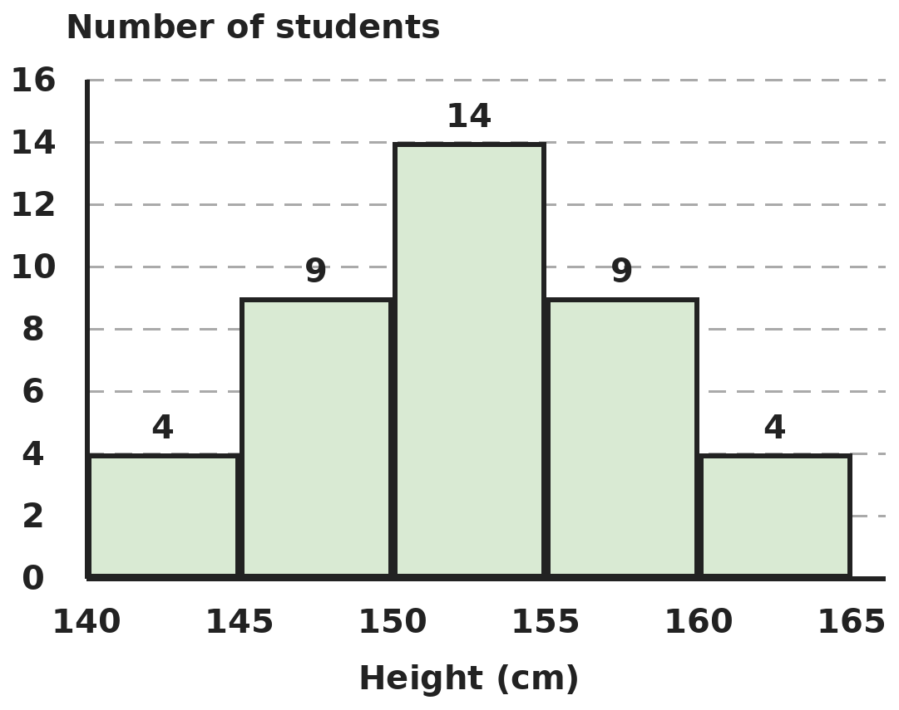
Q17. The histogram shows the heights of the students in a class (each class includes its lower value, not its upper value). What percentage of the students are 150 cm or taller?
(A) 67.5% | (B) 27% | (C) 57.5% | (D) 37.5%

Q18. Five whole numbers have mean 12, median 13 and a single mode, 15. What is the sum of the two smallest numbers?
(A) 17 | (B) 30 | (C) 13 | (D) 24

Part 8 — Applied Mathematics (Syllabus Chapter 9)
Q19. Aditi sells a sewing machine to Bharat at 20% profit. Bharat sells it to Charvi at a 10% loss for ₹5,400. What did it cost Aditi?
(A) ₹4,500 | (B) ₹5,400 | (C) ₹5,000 | (D) ₹4,800

Q20. ₹4,000 at 6% a year simple interest for 5 years earns the same interest as ₹2,500 does in 6 years at a certain rate. At that same rate, what sum earns ₹1,000 in 4 years?
(A) ₹2,500 | (B) ₹4,000 | (C) ₹3,125 | (D) ₹3,750

Q21. A shop sells a fan for ₹1,770, which includes 18% GST on its own selling price. Before GST, the shop makes a 25% profit on cost. What is the cost price?
(A) ₹1,500 | (B) ₹1,416 | (C) ₹1,280 | (D) ₹1,200

Part 9 — Mathematical Reasoning (Syllabus Chapter 10)
Q22. In the multiplication 2AB × 3 = 7A1, A and B are digits. What is A + B?
(A) 9 | (B) 13 | (C) 11 | (D) 7

Q23. How many three-digit numbers contain the digit 7 exactly once?
(A) 225 | (B) 243 | (C) 252 | (D) 200

Q24. What is the sum of all two-digit numbers that leave a remainder of 3 when divided by 7?
(A) 637 | (B) 715 | (C) 598 | (D) 676

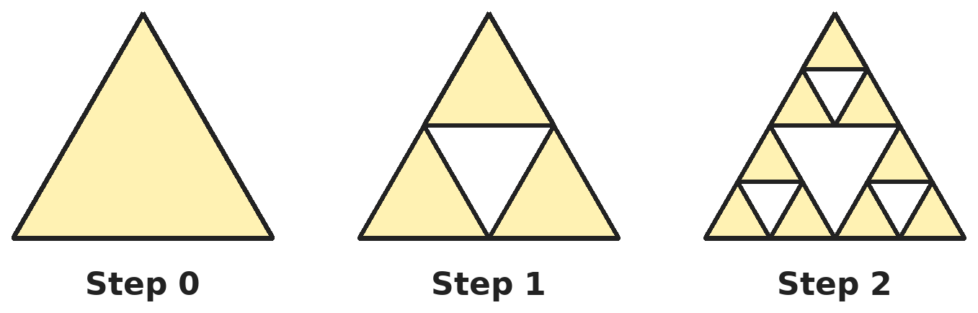
Q25. At each step, every shaded triangle is split into four equal triangles and the middle one is removed. Steps 0, 1 and 2 are shown. If the side at step 0 is 8 cm, what is the total perimeter of all the shaded triangles after step 3?
(A) 24 cm | (B) 81 cm | (C) 54 cm | (D) 108 cm

Part 10 — Mixed Problems (each joins two chapters)
Q26. What is 20² − 19² + 18² − 17² + … + 2² − 1²?
(A) 200 | (B) 190 | (C) 420 | (D) 210

Q27. A 3 × 3 × 3 cube is built from 27 small cubes. The small cube at the centre of each face and the one at the very centre are removed, leaving three square tunnels. How many small cubes are left?
(A) 20 | (B) 21 | (C) 18 | (D) 24

Q28. A right-angled triangle has hypotenuse 25 cm, and its two shorter sides add up to 31 cm. What is its area?
(A) 84 cm² | (B) 168 cm² | (C) 150 cm² | (D) 96 cm²

Q29. A table marked ₹1,000 is sold after successive discounts of 15% and 10%. The seller still makes a profit of 2%. What did the table cost the seller?
(A) ₹765 | (B) ₹750 | (C) ₹700 | (D) ₹800

Q30. A conical tank of base radius 3.5 m and height 6 m is full of oil worth ₹2 per litre. What is the value of the oil? (Take π = 22/7.)
(A) ₹4,62,000 | (B) ₹1,54,000 | (C) ₹15,400 | (D) ₹77,000

Answer Sheet AMO Level 2 · Class 8 · Practice Paper 7
Name: | School: | Roll No.:
Shade or tick one circle for each question.
1. | Ⓐ Ⓑ Ⓒ Ⓓ | 11. | Ⓐ Ⓑ Ⓒ Ⓓ | 21. | Ⓐ Ⓑ Ⓒ Ⓓ
2. | Ⓐ Ⓑ Ⓒ Ⓓ | 12. | Ⓐ Ⓑ Ⓒ Ⓓ | 22. | Ⓐ Ⓑ Ⓒ Ⓓ
3. | Ⓐ Ⓑ Ⓒ Ⓓ | 13. | Ⓐ Ⓑ Ⓒ Ⓓ | 23. | Ⓐ Ⓑ Ⓒ Ⓓ
4. | Ⓐ Ⓑ Ⓒ Ⓓ | 14. | Ⓐ Ⓑ Ⓒ Ⓓ | 24. | Ⓐ Ⓑ Ⓒ Ⓓ
5. | Ⓐ Ⓑ Ⓒ Ⓓ | 15. | Ⓐ Ⓑ Ⓒ Ⓓ | 25. | Ⓐ Ⓑ Ⓒ Ⓓ
6. | Ⓐ Ⓑ Ⓒ Ⓓ | 16. | Ⓐ Ⓑ Ⓒ Ⓓ | 26. | Ⓐ Ⓑ Ⓒ Ⓓ
7. | Ⓐ Ⓑ Ⓒ Ⓓ | 17. | Ⓐ Ⓑ Ⓒ Ⓓ | 27. | Ⓐ Ⓑ Ⓒ Ⓓ
8. | Ⓐ Ⓑ Ⓒ Ⓓ | 18. | Ⓐ Ⓑ Ⓒ Ⓓ | 28. | Ⓐ Ⓑ Ⓒ Ⓓ
9. | Ⓐ Ⓑ Ⓒ Ⓓ | 19. | Ⓐ Ⓑ Ⓒ Ⓓ | 29. | Ⓐ Ⓑ Ⓒ Ⓓ
10. | Ⓐ Ⓑ Ⓒ Ⓓ | 20. | Ⓐ Ⓑ Ⓒ Ⓓ | 30. | Ⓐ Ⓑ Ⓒ Ⓓ

For the parent or teacher
Correct: ______ / 30
Answer Key and Solutions AMO Level 2 · Class 8 · Practice Paper 7
Quick answers
1 B | 6 C | 11 B | 16 C | 21 D | 26 D
2 A | 7 D | 12 D | 17 A | 22 C | 27 A
3 D | 8 C | 13 A | 18 A | 23 A | 28 A
4 D | 9 C | 14 A | 19 C | 24 D | 29 B
5 B | 10 D | 15 B | 20 C | 25 B | 30 B
Solutions
Q | Part · level | Answer | Why?
1 | Part 1 · Ch1 · Hard | (B) 35 | Hint: Which two consecutive whole numbers have squares on either side of 320?  17² = 289 and 18² = 324, with 289 < 320 < 324. So P = 324, Q = 289 and P − Q = 35 (= 17 + 18).
2 | Part 1 · Ch1 · Hard | (A) −2.4 | Hint: Find the cube root of each part: −512, 27 and 1,000.  ∛(−512) = −8, ∛27 = 3 and ∛1,000 = 10. So the cube root is −8 × 3 ÷ 10 = −2.4.
3 | Part 2 · Ch2 · Hard | (D) 3 | Hint: Write 25 and 125 as powers of 5.  5²ˣ⁻¹ ÷ 5² = 5²ˣ⁻³ = 5³. So 2x − 3 = 3 and x = 3.
4 | Part 2 · Ch2 · Hard | (D) 200 | Hint: 0.000006 = 6 × 10⁻⁶ and 0.00000003 = 3 × 10⁻⁸.  (6 × 10⁻⁶) ÷ (3 × 10⁻⁸) = 2 × 10² = 200.
5 | Part 3 · Ch3 · Hard | (B) 20% then 20%, by ₹180 | Hint: 0.8 × 0.8 = 0.64.  30% off: ₹2,100. 20% then 20%: 3,000 × 0.64 = ₹1,920, an overall 36% off. The double discount is cheaper by ₹180.
6 | Part 3 · Ch3 · Hard | (C) ₹3,600 | Hint: ₹6,240 is the sum plus 30% of it.  Sum × 1.30 = 6,240, so the sum = ₹4,800. Interest for 5 years = 4,800 × 75% = ₹3,600. (₹4,680 wrongly takes 75% of ₹6,240.)
7 | Part 3 · Ch3 · Hard | (D) 56,430 | Hint: Multiply by 1.08, then 0.95, then 1.10.  50,000 × 1.08 = 54,000. × 0.95 = 51,300. × 1.10 = 56,430. (56,500 wrongly adds 8 − 5 + 10 = 13%.)
8 | Part 4 · Ch4 · Hard | (C) 0.08 | Hint: a² − b² = (a + b)(a − b).  (1.02 + 0.98)(1.02 − 0.98) = 2 × 0.04 = 0.08.
9 | Part 4 · Ch4 · Hard | (C) x + 9 | Hint: Use a² − b² twice.  x⁴ − 81 = (x² − 9)(x² + 9) = (x − 3)(x + 3)(x² + 9). So x + 3, x² + 9 and x² − 9 are factors, but x + 9 is not.
10 | Part 4 · Ch4 · Hard | (D) 25 | Hint: Let the numbers of coins be 3k, 4k and 5k.  Value = 3k × 1 + 4k × 2 + 5k × 5 = 36k = 180, so k = 5. There are 5k = 25 coins of ₹5.
11 | Part 5 · Ch5 · Hard | (B) 36√3 cm² | Hint: The height meets the base at its midpoint, so (side)² = (half side)² + (height)².  Let the side be s. s² = (s/2)² + (6√3)² gives (3/4)s² = 108, so s² = 144 and s = 12 cm. Area = ½ × 12 × 6√3 = 36√3 cm². (72√3 forgets the ½.)
12 | Part 5 · Ch5 · Hard | (D) 32 m | Hint: First find the height of the tree using similar triangles.  Tree height ÷ 24 = 2 ÷ 1.5, so the tree is 32 m tall. Later the shadow equals the height (2 m stick, 2 m shadow), so the tree's shadow is 32 m.
13 | Part 5 · Ch5 · Hard | (A) 8 cm | Hint: The angle next to the 120° angle is 60°.  The rhombus has angles 120° and 60°. The shorter diagonal joins the two 120° corners and cuts off a triangle with two sides of 8 cm and a 60° angle between them. That triangle is equilateral, so the diagonal is 8 cm.
14 | Part 6 · Ch6 · Hard | (A) 4,620 L | Hint: In one second a cylinder of water 5 m long comes out.  Per second: 22/7 × 0.07 × 0.07 × 5 = 0.077 m³ = 77 L. Per minute: 77 × 60 = 4,620 L. (18,480 uses the diameter as the radius.)
15 | Part 6 · Ch6 · Hard | (B) 1,914 m² | Hint: Find the height from the volume, then the slant height.  (1/3) × 22/7 × 21 × 21 × h = 462h = 9,240, so h = 20 m. Slant height = √(21² + 20²) = √841 = 29 m. Curved surface = 22/7 × 21 × 29 = 1,914 m². (1,386 is the base area; 1,320 uses the height instead of the slant height.)
16 | Part 6 · Ch6 · Hard | (C) 2,560 | Hint: Change the wall to centimetres and compare volumes.  Wall = 1,000 × 30 × 200 = 60,00,000 cm³. One brick = 25 × 12.5 × 7.5 = 2,343.75 cm³. Number = 60,00,000 ÷ 2,343.75 = 2,560.
17 | Part 7 · Ch8 · Hard | (A) 67.5% | Hint: Find the total first.  Total = 4 + 9 + 14 + 9 + 4 = 40. Height 150 cm or more: 14 + 9 + 4 = 27. 27 ÷ 40 = 67.5%.
18 | Part 7 · Ch8 · Hard | (A) 17 | Hint: In order, the 3rd number is 13 and the mode must appear at least twice.  Total = 60. In order: a, b, 13, d, e. The only mode is 15, so it appears at least twice and must be d and e. Then a + b = 60 − 13 − 30 = 17 (for example 8 and 9).
19 | Part 8 · Ch9 · Hard | (C) ₹5,000 | Hint: Work backwards: 5,400 = cost × 1.2 × 0.9.  1.2 × 0.9 = 1.08. Cost = 5,400 ÷ 1.08 = ₹5,000. Check: Bharat paid ₹6,000 and sold for ₹5,400.
20 | Part 8 · Ch9 · Hard | (C) ₹3,125 | Hint: Find the first interest, then the rate for ₹2,500.  Interest = 4,000 × 6% × 5 = ₹1,200. For ₹2,500 over 6 years: 2,500 × r × 6 = 1,200 gives r = 8%. The sum P with P × 8% × 4 = 1,000 is P = 1,000 ÷ 0.32 = ₹3,125.
21 | Part 8 · Ch9 · Hard | (D) ₹1,200 | Hint: Remove the GST first: ₹1,770 is 118% of the price before tax.  Price before GST = 1,770 ÷ 1.18 = ₹1,500. Cost = 1,500 ÷ 1.25 = ₹1,200.
22 | Part 9 · Ch10 · Hard | (C) 11 | Hint: B × 3 ends in 1.  3 × B ends in 1, so B = 7 (3 × 7 = 21). Then 2A7 × 3 = 621 + 30A must equal 7A1 = 701 + 10A, so 20A = 80 and A = 4. Check: 247 × 3 = 741. A + B = 11.
23 | Part 9 · Ch10 · Hard | (A) 225 | Hint: Count by the position of the 7. Remember the first digit cannot be 0.  7 in the hundreds place: the other two digits are any of 9 non-7 digits: 81. 7 in the tens place: hundreds digit 8 choices (1–9 except 7), ones 9: 72. 7 in the ones place: likewise 72. Total = 81 + 72 + 72 = 225.
24 | Part 9 · Ch10 · Hard | (D) 676 | Hint: The numbers are 10, 17, 24, …, 94. Pair the first with the last.  The numbers are 10, 17, …, 94: (94 − 10) ÷ 7 + 1 = 13 numbers. Pairing first and last gives 104 each, so the sum = 13 × 104 ÷ 2 = 676.
25 | Part 9 · Ch10 · Hard | (B) 81 cm | Hint: Each step triples the number of triangles and halves their side.  After step 3 there are 3³ = 27 shaded triangles, each with side 8 ÷ 2³ = 1 cm and perimeter 3 cm. Total = 27 × 3 = 81 cm. (54 cm is the total after step 2.)
26 | Part 10 · Mixed · Ch4 + Ch10 · Hard | (D) 210 | Hint: Each pair a² − b² with a = b + 1 equals a + b.  20² − 19² = 39, 18² − 17² = 35, …, 2² − 1² = 3. Each pair is the sum of its two numbers, so the total is 1 + 2 + … + 20 = 210.
27 | Part 10 · Mixed · Ch5 + Ch10 · Hard | (A) 20 | Hint: There are 6 face-centre cubes and 1 central cube.  Removed: 6 face centres + 1 centre = 7. Left: 27 − 7 = 20. (This is step 1 of the Menger sponge fractal.)
28 | Part 10 · Mixed · Ch4 + Ch5 · Hard | (A) 84 cm² | Hint: (a + b)² = a² + b² + 2ab, and a² + b² = 25².  961 = 625 + 2ab, so 2ab = 336 and ab = 168. Area = ½ab = 84 cm². (The sides are 7 cm and 24 cm.)
29 | Part 10 · Mixed · Ch3 + Ch9 · Hard | (B) ₹750 | Hint: Find the selling price, then divide by 1.02.  Selling price = 1,000 × 0.85 × 0.9 = ₹765. Cost = 765 ÷ 1.02 = ₹750.
30 | Part 10 · Mixed · Ch6 + Ch9 · Hard | (B) ₹1,54,000 | Hint: 1 m³ = 1,000 litres.  Volume = (1/3) × 22/7 × 3.5 × 3.5 × 6 = 77 m³ = 77,000 litres. Value = 77,000 × 2 = ₹1,54,000.

ARYABHATTA MATHS OLYMPIAD
Level 2
PRACTICE PAPER-8
CLASS 8
Total Questions | 30 multiple-choice questions
Level | Level-2 (final round): every question is Hard
Time | 45 minutes
Arrangement | Parts by chapter; the last Part has mixed problems joining two chapters
Negative Marking | No negative marking
Calculator | Not allowed
Chapters | Number System · Operations · Fractions, Decimals & Percentages · Algebra · Geometry · Mensuration · Data Handling, Statistics & Probability · Applied Mathematics · Mathematical Reasoning

Instructions
• Each question has four options, (A) to (D), with exactly one correct answer.
• The questions are grouped in Parts by chapter. The last Part has mixed problems, each joining two chapters.
• Every question is at Level-2 (Hard) standard: expect several steps or a key insight.
• There is no negative marking. Calculators are not allowed; use a separate sheet for rough work.
• Figures are not necessarily drawn to scale unless stated.

For teachers
• Figures are part of the questions and work when printed in black and white.
• Parts follow the AMO syllabus chapters. Chapter 7 is not part of the Class 8 syllabus, so the chapter numbers shown in the Part headings have gaps.
• The answer sheet and the answer key are at the end. Remove the answer key before the paper is attempted.

Part 1 — Number System (Syllabus Chapter 1)
Q1. How many perfect squares between 1 and 400 have digits that add up to exactly 9?
(A) 4 | (B) 5 | (C) 3 | (D) 6

Q2. Which of these numbers is irrational?
(A) √0.4 | (B) √0.09 | (C) √2.25 | (D) ∛0.008

Part 2 — Operations (Syllabus Chapter 2)
Q3. What is [(1/2)⁻² + (1/3)⁻² + (1/4)⁻²] × (1/29)⁰ − (1/5)⁻²?
(A) 29 | (B) 4 | (C) 54 | (D) 0

Q4. A star is 4.2 light years away. One light year is about 9.46 × 10¹² km. About how far away is the star, in standard form?
(A) 3.97 × 10¹² km | (B) 3.97 × 10¹³ km
(C) 3.97 × 10¹⁴ km | (D) 4.2 × 10¹³ km

Part 3 — Fractions, Decimals & Percentages (Syllabus Chapter 3)
Q5. A shopkeeper marks goods 50% above cost. He gives two successive discounts, 20% and then x%, and still makes a 2% profit. What is x?
(A) 15 | (B) 10 | (C) 18 | (D) 20

Q6. At simple interest a sum doubles in 10 years. In how many years will the interest be 3/5 of the sum?
(A) 5 years | (B) 8 years | (C) 6 years | (D) 4 years

Q7. The price of a book rises by 20%. By what percentage must the new price be cut to bring it back to the original price?
(A) 16 2/3% | (B) 20% | (C) 25% | (D) 15%

Part 4 — Algebra (Syllabus Chapter 4)
Q8. If a + 1/a = 6 and a > 1, what is a² − 1/a²?
(A) 32 | (B) 34 | (C) 24√2 | (D) 6√2

Q9. For x ≠ 3 and x ≠ −3, simplify (x² − 7x + 12)(x + 3) ÷ (x² − 9).
(A) x + 4 | (B) x − 3 | (C) x + 3 | (D) x − 4

Q10. One number is 25% more than another, and their difference is 18. What is the larger number?
(A) 72 | (B) 18 | (C) 90 | (D) 108

Part 5 — Geometry (Syllabus Chapter 5)
Q11. Two vertical poles stand 15 m apart on level ground. A rope from the top of one to the top of the other is 17 m long, and the shorter pole is 12 m tall. A bird flies straight from the top of the taller pole to the foot of the shorter pole. How far does it fly?
(A) 17 m | (B) 20 m | (C) 25 m | (D) 23 m

Q12. The diagonals of a parallelogram are 16 cm and 12 cm long and cross at right angles. What is its perimeter?
(A) 40 cm | (B) 28 cm | (C) 56 cm | (D) 20 cm

Q13. Rashmi, whose eyes are 1.6 m above the ground, stands 2 m from a small mirror lying on level ground. She sees the top of a tree in the mirror. The tree is 12 m beyond the mirror. How tall is the tree?
(A) 15 m | (B) 12 m | (C) 7.5 m | (D) 9.6 m

Part 6 — Mensuration (Syllabus Chapter 6)
Q14. A cylinder has curved surface area 264 m² and volume 924 m³. What is its diameter?
(A) 7 m | (B) 14 m | (C) 6 m | (D) 3.5 m

Q15. Cylindrical cans of radius 3.5 cm and height 10 cm are packed upright in a box 20 cm × 14 cm × 10 cm, as many as will fit. How much space in the box is left empty? (Take π = 22/7.)
(A) 1,540 cm³ | (B) 2,800 cm³ | (C) 700 cm³ | (D) 1,260 cm³

Q16. A wooden block 10 cm × 8 cm × 6 cm has a cylindrical hole of radius 1.4 cm drilled straight through it along the 6 cm height. What volume of wood is left? (Take π = 22/7.)
(A) 480 cm³ | (B) 516.96 cm³ | (C) 406.08 cm³ | (D) 443.04 cm³

Part 7 — Data Handling, Statistics & Probability (Syllabus Chapter 8)
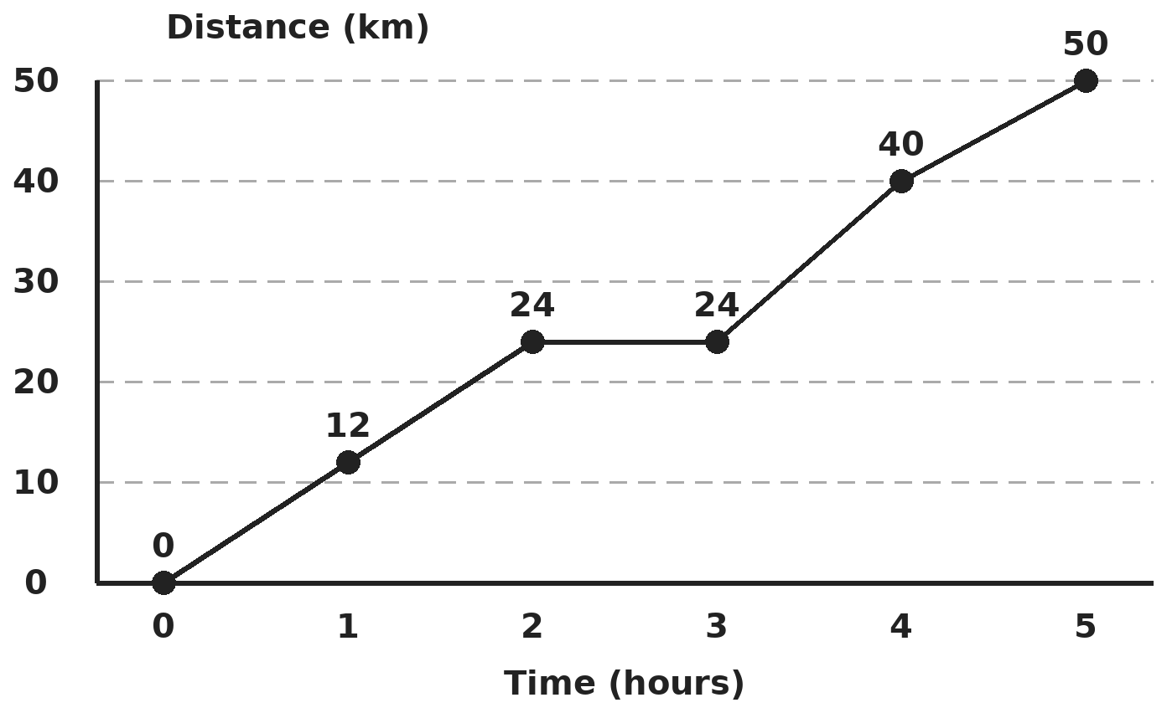
Q17. The line graph shows the distance (in km) a cyclist has covered after each hour. In which hour did the cyclist ride fastest, and at what speed?
(A) From hour 4 to 5, at 10 km/h | (B) From hour 3 to 4, at 16 km/h
(C) From hour 1 to 2, at 12 km/h | (D) From hour 3 to 4, at 40 km/h

Q18. The mean of 25 numbers is 40. The mean of the first 13 is 36 and the mean of the last 13 is 45. What is the 13th number?
(A) 53 | (B) 40 | (C) 36 | (D) 45

Part 8 — Applied Mathematics (Syllabus Chapter 9)
Q19. A grocer mixes 26 kg of rice costing ₹20 per kg with 30 kg costing ₹36 per kg, and sells the mixture at ₹30 per kg. What is his profit percent?
(A) 10% | (B) 4% | (C) 5% | (D) 6.25%

Q20. ₹1,550 is lent in two parts, one at 5% and the other at 8% simple interest a year. After 3 years the total interest is ₹300. How much was lent at 5%?
(A) ₹750 | (B) ₹800 | (C) ₹600 | (D) ₹950

Q21. A dealer gives 1 article free with every 5 bought, and still makes a 20% profit. By what percentage above cost does he mark the articles?
(A) 20% | (B) 44% | (C) 40% | (D) 50%

Part 9 — Mathematical Reasoning (Syllabus Chapter 10)
Q22. A four-digit number ABBA reads the same forwards and backwards. How many such numbers are divisible by 99?
(A) 10 | (B) 9 | (C) 8 | (D) 11

Q23. How many different triangles have whole-number sides and a perimeter of 15 cm?
(A) 5 | (B) 6 | (C) 8 | (D) 7

Q24. What is the last digit of 7²⁰²⁵?
(A) 9 | (B) 3 | (C) 7 | (D) 1

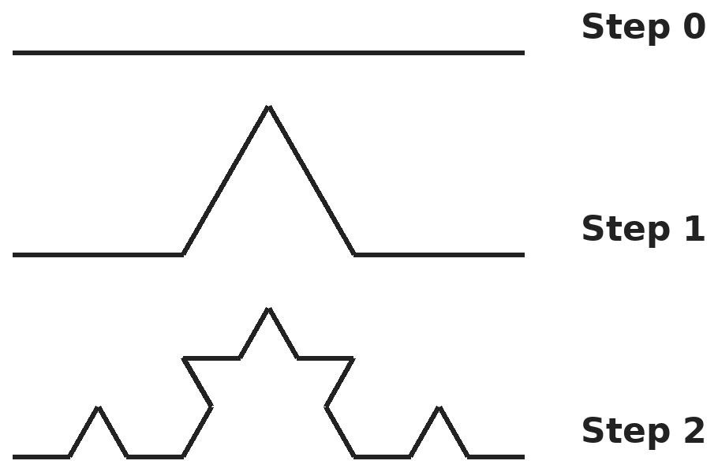
Q25. A 27 cm straight segment is changed step by step: every straight piece is split into three equal parts and the middle part is replaced by two sides of an equilateral triangle. Steps 0, 1 and 2 are shown. How long is the curve after step 3?
(A) 48 cm | (B) 81 cm | (C) 36 cm | (D) 64 cm

Part 10 — Mixed Problems (each joins two chapters)
Q26. Positive whole numbers x and y satisfy x² − y² = 31. What is x + y?
(A) 16 | (B) 31 | (C) 15 | (D) 1

Q27. A large cube is painted on all faces and cut into equal small cubes, with n small cubes along each edge. Exactly 96 small cubes have paint on just one face. What is n?
(A) 6 | (B) 4 | (C) 8 | (D) 5

Q28. A rectangle has a diagonal of 17 cm and a perimeter of 46 cm. What is its area?
(A) 120 cm² | (B) 240 cm² | (C) 132 cm² | (D) 60 cm²

Q29. An item is marked at ₹1,300. With a 10% discount the shopkeeper still makes a 17% profit. What would happen if he gave a 20% discount instead?
(A) 7% profit | (B) 4% profit | (C) 4% loss | (D) 3% profit

Q30. A cylindrical diesel tank of radius 7 m and height 3 m is full. A depot sells 3,080 litres a day. For how many days will the diesel last? (Take π = 22/7.)
(A) 15 days | (B) 1,500 days | (C) 150 days | (D) 50 days

Answer Sheet AMO Level 2 · Class 8 · Practice Paper 8
Name: | School: | Roll No.:
Shade or tick one circle for each question.
1. | Ⓐ Ⓑ Ⓒ Ⓓ | 11. | Ⓐ Ⓑ Ⓒ Ⓓ | 21. | Ⓐ Ⓑ Ⓒ Ⓓ
2. | Ⓐ Ⓑ Ⓒ Ⓓ | 12. | Ⓐ Ⓑ Ⓒ Ⓓ | 22. | Ⓐ Ⓑ Ⓒ Ⓓ
3. | Ⓐ Ⓑ Ⓒ Ⓓ | 13. | Ⓐ Ⓑ Ⓒ Ⓓ | 23. | Ⓐ Ⓑ Ⓒ Ⓓ
4. | Ⓐ Ⓑ Ⓒ Ⓓ | 14. | Ⓐ Ⓑ Ⓒ Ⓓ | 24. | Ⓐ Ⓑ Ⓒ Ⓓ
5. | Ⓐ Ⓑ Ⓒ Ⓓ | 15. | Ⓐ Ⓑ Ⓒ Ⓓ | 25. | Ⓐ Ⓑ Ⓒ Ⓓ
6. | Ⓐ Ⓑ Ⓒ Ⓓ | 16. | Ⓐ Ⓑ Ⓒ Ⓓ | 26. | Ⓐ Ⓑ Ⓒ Ⓓ
7. | Ⓐ Ⓑ Ⓒ Ⓓ | 17. | Ⓐ Ⓑ Ⓒ Ⓓ | 27. | Ⓐ Ⓑ Ⓒ Ⓓ
8. | Ⓐ Ⓑ Ⓒ Ⓓ | 18. | Ⓐ Ⓑ Ⓒ Ⓓ | 28. | Ⓐ Ⓑ Ⓒ Ⓓ
9. | Ⓐ Ⓑ Ⓒ Ⓓ | 19. | Ⓐ Ⓑ Ⓒ Ⓓ | 29. | Ⓐ Ⓑ Ⓒ Ⓓ
10. | Ⓐ Ⓑ Ⓒ Ⓓ | 20. | Ⓐ Ⓑ Ⓒ Ⓓ | 30. | Ⓐ Ⓑ Ⓒ Ⓓ

For the parent or teacher
Correct: ______ / 30
Answer Key and Solutions AMO Level 2 · Class 8 · Practice Paper 8
Quick answers
1 D | 6 C | 11 C | 16 D | 21 B | 26 B
2 A | 7 A | 12 A | 17 B | 22 A | 27 A
3 B | 8 C | 13 D | 18 A | 23 D | 28 A
4 B | 9 D | 14 B | 19 C | 24 C | 29 B
5 A | 10 C | 15 D | 20 B | 25 D | 30 C
Solutions
Q | Part · level | Answer | Why?
1 | Part 1 · Ch1 · Hard | (D) 6 | Hint: A number with digit sum 9 is a multiple of 9, so its square root is a multiple of 3.  Digit sum 9 means the square is a multiple of 9, so its root is a multiple of 3: 3, 6, 9, 12, 15, 18. Their squares 9, 36, 81, 144, 225, 324 all have digit sum 9. So there are 6.
2 | Part 1 · Ch1 · Hard | (A) √0.4 | Hint: Write each decimal as a fraction and check whether the top and bottom are perfect squares (or cubes).  √0.09 = 0.3, √2.25 = 1.5 and ∛0.008 = 0.2 are rational. √0.4 = √(4/10) = 2/√10, which is irrational. (Careful: √0.4 is not 0.2.)
3 | Part 2 · Ch2 · Hard | (B) 4 | Hint: (1/a)⁻² = a², and anything non-zero to the power 0 is 1.  (1/2)⁻² + (1/3)⁻² + (1/4)⁻² = 4 + 9 + 16 = 29. Times (1/29)⁰ = 1 gives 29. (1/5)⁻² = 25. 29 − 25 = 4.
4 | Part 2 · Ch2 · Hard | (B) 3.97 × 10¹³ km | Hint: 4.2 × 9.46 is about 39.7.  4.2 × 9.46 ≈ 39.73, so the distance ≈ 39.7 × 10¹² = 3.97 × 10¹³ km.
5 | Part 3 · Ch3 · Hard | (A) 15 | Hint: Take cost = 100. After marking up and the first discount, the price is 120.  Cost 100 → marked 150 → after 20% off: 120. The final price must be 102, so the second discount takes 18 off 120: 18/120 = 15%.
6 | Part 3 · Ch3 · Hard | (C) 6 years | Hint: Doubling in 10 years means 10% a year.  Interest equal to the sum in 10 years means 10% a year. 3/5 of the sum is 60%, which takes 6 years.
7 | Part 3 · Ch3 · Hard | (A) 16 2/3% | Hint: The cut is 20 on a new price of 120.  Take the original as 100; the new price is 120. To return to 100 the cut is 20 out of 120 = 1/6 = 16 2/3%.
8 | Part 4 · Ch4 · Hard | (C) 24√2 | Hint: a² − 1/a² = (a + 1/a)(a − 1/a). Find a − 1/a first.  (a − 1/a)² = (a + 1/a)² − 4 = 32, so a − 1/a = √32 = 4√2 (positive since a > 1). a² − 1/a² = 6 × 4√2 = 24√2.
9 | Part 4 · Ch4 · Hard | (D) x − 4 | Hint: Factorise both quadratics first.  x² − 7x + 12 = (x − 3)(x − 4) and x² − 9 = (x − 3)(x + 3). So the expression is (x − 3)(x − 4)(x + 3) ÷ [(x − 3)(x + 3)] = x − 4.
10 | Part 4 · Ch4 · Hard | (C) 90 | Hint: If the smaller is x, the larger is 1.25x.  1.25x − x = 0.25x = 18, so x = 72 and the larger number is 90.
11 | Part 5 · Ch5 · Hard | (C) 25 m | Hint: First find the difference in height from the rope.  The rope, the 15 m gap and the height difference form a right triangle: difference = √(17² − 15²) = 8 m, so the taller pole is 20 m. Bird's path = √(15² + 20²) = √625 = 25 m. (20 m is the taller pole.)
12 | Part 5 · Ch5 · Hard | (A) 40 cm | Hint: A parallelogram whose diagonals are perpendicular is a rhombus.  It is a rhombus. The half-diagonals 8 and 6 give a side of √(64 + 36) = 10 cm. Perimeter = 4 × 10 = 40 cm.
13 | Part 5 · Ch5 · Hard | (D) 9.6 m | Hint: The two right triangles on either side of the mirror are similar.  The angles at the mirror are equal, so the triangles are similar: 1.6/2 = h/12. So h = 12 × 0.8 = 9.6 m.
14 | Part 6 · Ch6 · Hard | (B) 14 m | Hint: Volume ÷ curved surface = πr²h ÷ 2πrh = r/2.  924 ÷ 264 = 3.5 = r/2, so r = 7 m and the diameter is 14 m.
15 | Part 6 · Ch6 · Hard | (D) 1,260 cm³ | Hint: Each can needs a 7 cm × 7 cm square of the floor.  Along 20 cm fit 2 cans (7 cm each) and along 14 cm fit 2, so 4 cans. One can holds 22/7 × 3.5 × 3.5 × 10 = 385 cm³, so 4 cans fill 1,540 cm³. The box holds 2,800 cm³, so 2,800 − 1,540 = 1,260 cm³ is empty.
16 | Part 6 · Ch6 · Hard | (D) 443.04 cm³ | Hint: Subtract the volume of the hole from the block.  Block = 480 cm³. Hole = 22/7 × 1.4 × 1.4 × 6 = 36.96 cm³. Left = 480 − 36.96 = 443.04 cm³.
17 | Part 7 · Ch8 · Hard | (B) From hour 3 to 4, at 16 km/h | Hint: Speed in each hour = rise in distance during that hour.  Rises: 12, 12, 0, 16, 10 km. The greatest is 16 km, from hour 3 to hour 4: 16 km/h. (40 is the total distance at hour 4.)
18 | Part 7 · Ch8 · Hard | (A) 53 | Hint: The 13th number is counted in both groups.  First 13 total 468; last 13 total 585. Together that is 1,053, which counts the 13th number twice. All 25 total 1,000. So the 13th number = 1,053 − 1,000 = 53.
19 | Part 8 · Ch9 · Hard | (C) 5% | Hint: Find the total cost and the total selling price of all 56 kg.  Cost = 26 × 20 + 30 × 36 = 520 + 1,080 = ₹1,600. Selling price = 56 × 30 = ₹1,680. Profit = 80 on 1,600 = 5%.
20 | Part 8 · Ch9 · Hard | (B) ₹800 | Hint: If all of it were at 8% for 3 years, the interest would be ₹372.  At 8% on everything for 3 years: 1,550 × 24% = ₹372. The actual ₹300 is ₹72 less. Each rupee at 5% earns 9% less over 3 years, so the part at 5% = 72 ÷ 0.09 = ₹800.
21 | Part 8 · Ch9 · Hard | (B) 44% | Hint: He receives the marked price of 5 articles for 6 articles.  For 6 articles he receives 5 × MP. This must be 1.2 × 6 × CP = 7.2 CP. So MP = 1.44 CP, which is 44% above cost.
22 | Part 9 · Ch10 · Hard | (A) 10 | Hint: ABBA = 1001A + 110B is always a multiple of 11. When is it a multiple of 9?  ABBA is always divisible by 11. It is divisible by 9 when its digit sum 2A + 2B is a multiple of 9, so A + B = 9 or 18. A + B = 9 with A from 1 to 9 gives 9 numbers (1881 … 9009), and A = B = 9 gives 9999. Total 10.
23 | Part 9 · Ch10 · Hard | (D) 7 | Hint: List sides a ≤ b ≤ c with a + b + c = 15 and a + b > c.  The longest side c must be less than 7.5 and at least 5. c = 7: (1,7,7), (2,6,7), (3,5,7), (4,4,7). c = 6: (3,6,6), (4,5,6). c = 5: (5,5,5). Total 7.
24 | Part 9 · Ch10 · Hard | (C) 7 | Hint: Find the pattern in the last digits of 7¹, 7², 7³, 7⁴, …  Last digits of powers of 7 repeat 7, 9, 3, 1 every 4 powers. 2025 = 4 × 506 + 1, so 7²⁰²⁵ ends in the same digit as 7¹, which is 7.
25 | Part 9 · Ch10 · Hard | (D) 64 cm | Hint: Each step multiplies the length by 4/3.  Each step replaces 3 parts by 4 parts of the same size, so the length is multiplied by 4/3. After 3 steps: 27 × (4/3)³ = 27 × 64/27 = 64 cm. (48 cm is after step 2.)
26 | Part 10 · Mixed · Ch4 + Ch10 · Hard | (B) 31 | Hint: 31 is prime, so it has only one factor pair.  (x − y)(x + y) = 31. Since 31 is prime and x + y > x − y, x − y = 1 and x + y = 31 (so x = 16, y = 15).
27 | Part 10 · Mixed · Ch5 + Ch10 · Hard | (A) 6 | Hint: Each face has (n − 2)² small cubes with only that face painted.  6(n − 2)² = 96, so (n − 2)² = 16 and n − 2 = 4. So n = 6.
28 | Part 10 · Mixed · Ch4 + Ch5 · Hard | (A) 120 cm² | Hint: l + w = 23 and l² + w² = 17². Use (l + w)².  (l + w)² = 529 = l² + w² + 2lw = 289 + 2lw, so 2lw = 240 and the area lw = 120 cm². (The sides are 15 cm and 8 cm.)
29 | Part 10 · Mixed · Ch3 + Ch9 · Hard | (B) 4% profit | Hint: Find the cost price from the first sale.  With 10% off the item sells for ₹1,170, which is 117% of the cost, so the cost is ₹1,000. With 20% off it sells for ₹1,040, a profit of ₹40 on ₹1,000: 4% profit.
30 | Part 10 · Mixed · Ch6 + Ch9 · Hard | (C) 150 days | Hint: 1 m³ = 1,000 litres.  Volume = 22/7 × 49 × 3 = 462 m³ = 4,62,000 litres. 4,62,000 ÷ 3,080 = 150 days.

ARYABHATTA MATHS OLYMPIAD
Level 2
PRACTICE PAPER-9
CLASS 8
Total Questions | 30 multiple-choice questions
Level | Level-2 (final round): every question is Hard
Time | 45 minutes
Arrangement | Parts by chapter; the last Part has mixed problems joining two chapters
Negative Marking | No negative marking
Calculator | Not allowed
Chapters | Number System · Operations · Fractions, Decimals & Percentages · Algebra · Geometry · Mensuration · Data Handling, Statistics & Probability · Applied Mathematics · Mathematical Reasoning

Instructions
• Each question has four options, (A) to (D), with exactly one correct answer.
• The questions are grouped in Parts by chapter. The last Part has mixed problems, each joining two chapters.
• Every question is at Level-2 (Hard) standard: expect several steps or a key insight.
• There is no negative marking. Calculators are not allowed; use a separate sheet for rough work.
• Figures are not necessarily drawn to scale unless stated.

For teachers
• Figures are part of the questions and work when printed in black and white.
• Parts follow the AMO syllabus chapters. Chapter 7 is not part of the Class 8 syllabus, so the chapter numbers shown in the Part headings have gaps.
• The answer sheet and the answer key are at the end. Remove the answer key before the paper is attempted.

Part 1 — Number System (Syllabus Chapter 1)
Q1. A square field has an area of 30 1/4 m². It is fenced with 4 rounds of wire. How much wire is needed?
(A) 22 m | (B) 88 m | (C) 121 m | (D) 44 m

Q2. Notice that 1³ + 2³ + 3³ = 36 = 6² and 1³ + 2³ + 3³ + 4³ = 100 = 10². For which n does 1³ + 2³ + … + n³ = 441?
(A) 7 | (B) 6 | (C) 21 | (D) 5

Part 2 — Operations (Syllabus Chapter 2)
Q3. Find x if (4⁻¹ − 8⁻¹)⁻¹ × 2⁻ˣ = 1/16.
(A) 7 | (B) 1 | (C) 4 | (D) −7

Q4. Write (0.00000525 × 4 × 10⁵) ÷ (7 × 10⁻²) in standard form.
(A) 3 × 10⁻¹ | (B) 3 × 10² | (C) 3 × 10¹ | (D) 2.1 × 10¹

Part 3 — Fractions, Decimals & Percentages (Syllabus Chapter 3)
Q5. A trader gives a 10% discount on the marked price and still gains 8%. What would his gain percent be if he sold at the marked price?
(A) 18% | (B) 10% | (C) 8% | (D) 20%

Q6. The simple interest on a sum is 4/9 of the sum. The rate percent per year equals the number of years. What is the rate?
(A) 4% | (B) 9% | (C) 6% | (D) 6 2/3%

Q7. A can holds 40 litres of milk that contain 10% water. How much water must be added so that water makes up 20% of the mixture?
(A) 5 L | (B) 4 L | (C) 8 L | (D) 10 L

Part 4 — Algebra (Syllabus Chapter 4)
Q8. Using identities, find 103 × 97 − 99².
(A) 198 | (B) 200 | (C) 190 | (D) −190

Q9. x + 3 is a factor of x² + kx + 18. What is k?
(A) 6 | (B) 3 | (C) 9 | (D) 21

Q10. A two-digit number is 4 times the sum of its digits. When 18 is added to it, the digits are reversed. What is the number?
(A) 24 | (B) 42 | (C) 12 | (D) 36

Part 5 — Geometry (Syllabus Chapter 5)
Q11. A rectangular field is 24 m long and 10 m wide. How much shorter is it to walk across the diagonal than along two sides from one corner to the opposite corner?
(A) 8 m | (B) 26 m | (C) 34 m | (D) 10 m

Q12. In rectangle ABCD, AB = 9 cm. The diagonals meet at O and OA = 7.5 cm. How long is BC?
(A) 6 cm | (B) 7.5 cm | (C) 15 cm | (D) 12 cm

Q13. A prism has 30 edges. How many faces does it have?
(A) 10 | (B) 12 | (C) 20 | (D) 32

Part 6 — Mensuration (Syllabus Chapter 6)
Q14. Two cylinders have radii in the ratio 2 : 3 and volumes in the ratio 20 : 27. What is the ratio of their curved surface areas?
(A) 20 : 27 | (B) 5 : 3 | (C) 4 : 9 | (D) 10 : 9

Q15. A solid cone has base radius 5 cm and height 12 cm. What is its total surface area? (Take π = 3.14.)
(A) 282.6 cm² | (B) 204.1 cm² | (C) 314 cm² | (D) 188.4 cm²

Q16. A cuboid tank 8 m × 6 m × 2 m is half full of water. The water is pumped out at 300 litres per minute. How long does it take to empty the tank?
(A) 5 h 20 min | (B) 2 h 40 min | (C) 16 min | (D) 1 h 36 min

Part 7 — Data Handling, Statistics & Probability (Syllabus Chapter 8)
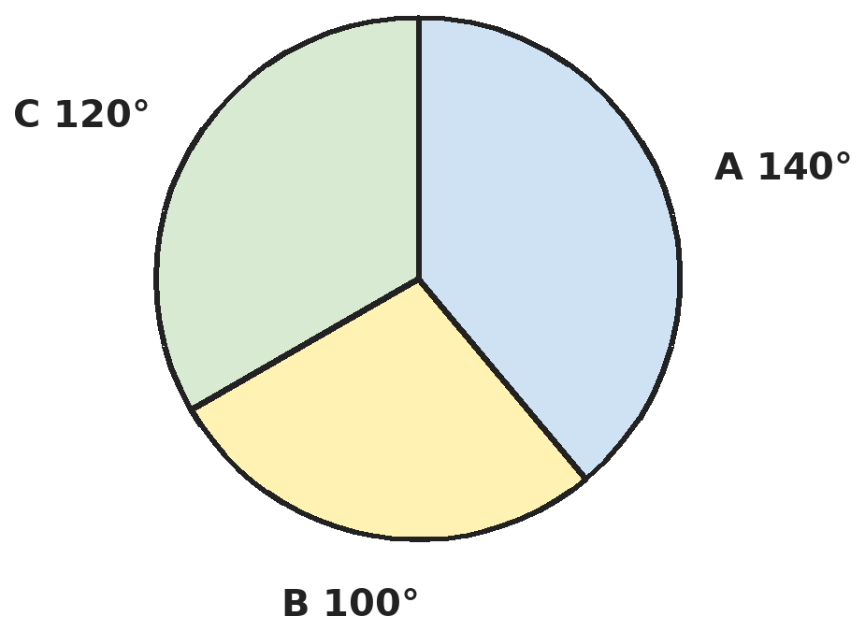
Q17. The pie chart shows how 900 saplings were planted by three schools A, B and C. Next month school B plants 100 more saplings and the others plant none. What fraction of all the saplings will then have been planted by B?
(A) 5/18 | (B) 1/3 | (C) 2/5 | (D) 7/20

Q18. The mean of 10 numbers is 25. Each number is increased by 4 and the result is doubled. Then one of the new numbers, 22, is removed. What is the mean of the remaining 9 numbers?
(A) 62 | (B) 58 | (C) 60 | (D) 55.8

Part 8 — Applied Mathematics (Syllabus Chapter 9)
Q19. A vendor buys 600 eggs at 5 for ₹16. Thirty eggs break, and he sells the rest at 4 for ₹16. What is his profit percent?
(A) 25% | (B) 20% | (C) 15% | (D) 18.75%

Q20. A sum earns simple interest at 6% a year for 3 years and then at 8% a year for 2 more years. At what single yearly rate would the same sum earn the same total interest in only 4 years?
(A) 6.8% | (B) 8.5% | (C) 7% | (D) 34%

Q21. A dealer gives one item free with every 4 items bought, at the marked price. He still makes a profit of 20%. By what percentage is the marked price above the cost price?
(A) 20% | (B) 50% | (C) 25% | (D) 45%

Part 9 — Mathematical Reasoning (Syllabus Chapter 10)
Q22. In TOO + TOO + TOO + TOO = GOOD, each letter stands for a different digit. What is GOOD?
(A) 1664 | (B) 1888 | (C) 1996 | (D) 1776

Q23. How many three-digit numbers have digits that strictly decrease from left to right (like 964 or 510)?
(A) 120 | (B) 84 | (C) 720 | (D) 100

Q24. How many numbers from 1 to 1,000 are divisible by 7 but not by 11?
(A) 142 | (B) 12 | (C) 130 | (D) 131

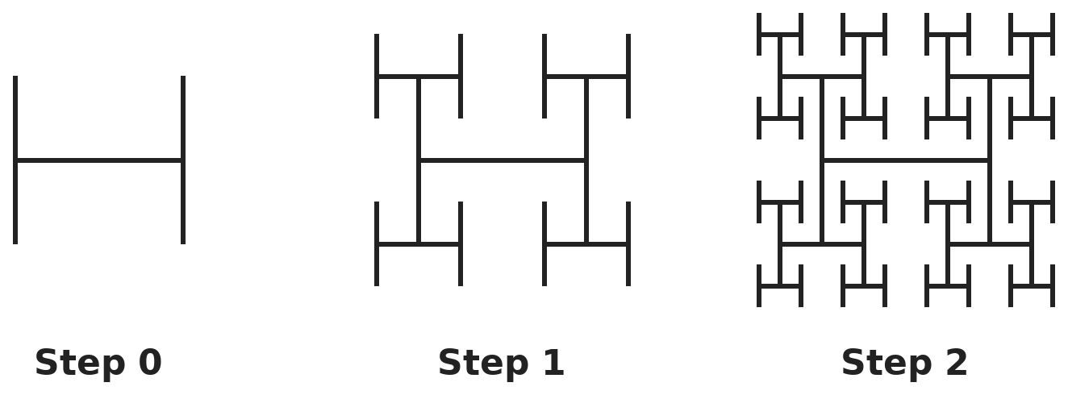
Q25. An H-shape is made of 3 line segments (step 0). At each step, a half-size H is added at each of the 4 tips of every H added in the step before. Steps 0, 1 and 2 are shown. How many line segments are there after step 3?
(A) 192 | (B) 85 | (C) 255 | (D) 256

Part 10 — Mixed Problems (each joins two chapters)
Q26. If a + b = 1 and ab = −2, what is a⁴ + b⁴?
(A) 17 | (B) 25 | (C) 21 | (D) 9

Q27. A football is stitched from 12 pentagons and 20 hexagons, with every edge shared by two patches. Using Euler's formula, how many vertices does it have?
(A) 90 | (B) 60 | (C) 32 | (D) 120

Q28. The sides of a right-angled triangle are x cm, (x + 7) cm and (x + 9) cm, where x is a whole number. What is its perimeter?
(A) 24 cm | (B) 30 cm | (C) 40 cm | (D) 56 cm

Q29. A shopkeeper buys a toy for ₹90 after getting 25% off its list price. She sells it at 10% off the list price. What is her profit percent?
(A) 15% | (B) 35% | (C) 25% | (D) 20%

Q30. The inside of an open cylindrical tank (walls and floor) is to be lined at ₹50 per m². The tank has radius 7 m and depth 4 m. What is the cost? (Take π = 22/7.)
(A) ₹8,800 | (B) ₹24,200 | (C) ₹23,600 | (D) ₹16,500

Answer Sheet AMO Level 2 · Class 8 · Practice Paper 9
Name: | School: | Roll No.:
Shade or tick one circle for each question.
1. | Ⓐ Ⓑ Ⓒ Ⓓ | 11. | Ⓐ Ⓑ Ⓒ Ⓓ | 21. | Ⓐ Ⓑ Ⓒ Ⓓ
2. | Ⓐ Ⓑ Ⓒ Ⓓ | 12. | Ⓐ Ⓑ Ⓒ Ⓓ | 22. | Ⓐ Ⓑ Ⓒ Ⓓ
3. | Ⓐ Ⓑ Ⓒ Ⓓ | 13. | Ⓐ Ⓑ Ⓒ Ⓓ | 23. | Ⓐ Ⓑ Ⓒ Ⓓ
4. | Ⓐ Ⓑ Ⓒ Ⓓ | 14. | Ⓐ Ⓑ Ⓒ Ⓓ | 24. | Ⓐ Ⓑ Ⓒ Ⓓ
5. | Ⓐ Ⓑ Ⓒ Ⓓ | 15. | Ⓐ Ⓑ Ⓒ Ⓓ | 25. | Ⓐ Ⓑ Ⓒ Ⓓ
6. | Ⓐ Ⓑ Ⓒ Ⓓ | 16. | Ⓐ Ⓑ Ⓒ Ⓓ | 26. | Ⓐ Ⓑ Ⓒ Ⓓ
7. | Ⓐ Ⓑ Ⓒ Ⓓ | 17. | Ⓐ Ⓑ Ⓒ Ⓓ | 27. | Ⓐ Ⓑ Ⓒ Ⓓ
8. | Ⓐ Ⓑ Ⓒ Ⓓ | 18. | Ⓐ Ⓑ Ⓒ Ⓓ | 28. | Ⓐ Ⓑ Ⓒ Ⓓ
9. | Ⓐ Ⓑ Ⓒ Ⓓ | 19. | Ⓐ Ⓑ Ⓒ Ⓓ | 29. | Ⓐ Ⓑ Ⓒ Ⓓ
10. | Ⓐ Ⓑ Ⓒ Ⓓ | 20. | Ⓐ Ⓑ Ⓒ Ⓓ | 30. | Ⓐ Ⓑ Ⓒ Ⓓ

For the parent or teacher
Correct: ______ / 30
Answer Key and Solutions AMO Level 2 · Class 8 · Practice Paper 9
Quick answers
1 B | 6 D | 11 A | 16 B | 21 B | 26 A
2 B | 7 A | 12 D | 17 D | 22 C | 27 B
3 A | 8 C | 13 B | 18 A | 23 A | 28 C
4 C | 9 C | 14 D | 19 D | 24 C | 29 D
5 D | 10 A | 15 A | 20 B | 25 C | 30 D
Solutions
Q | Part · level | Answer | Why?
1 | Part 1 · Ch1 · Hard | (B) 88 m | Hint: 30 1/4 = 121/4.  Side = √(121/4) = 11/2 = 5.5 m. Perimeter = 22 m. Four rounds = 88 m.
2 | Part 1 · Ch1 · Hard | (B) 6 | Hint: The sums are the squares of 1, 3, 6, 10, … = 1 + 2 + … + n.  1³ + … + n³ = (1 + 2 + … + n)². 441 = 21², and 1 + 2 + … + 6 = 21. So n = 6.
3 | Part 2 · Ch2 · Hard | (A) 7 | Hint: 4⁻¹ − 8⁻¹ = 1/4 − 1/8. Write everything as a power of 2.  1/4 − 1/8 = 1/8, so (1/8)⁻¹ = 8 = 2³. Then 2³⁻ˣ = 2⁻⁴, so 3 − x = −4 and x = 7.
4 | Part 2 · Ch2 · Hard | (C) 3 × 10¹ | Hint: 0.00000525 = 5.25 × 10⁻⁶.  5.25 × 10⁻⁶ × 4 × 10⁵ = 21 × 10⁻¹ = 2.1. 2.1 ÷ 0.07 = 30 = 3 × 10¹.
5 | Part 3 · Ch3 · Hard | (D) 20% | Hint: 0.9 × marked price = 1.08 × cost.  Marked price = 1.08 ÷ 0.9 × cost = 1.2 × cost. Selling at the marked price would give a 20% gain. (18% just adds 8 + 10.)
6 | Part 3 · Ch3 · Hard | (D) 6 2/3% | Hint: Interest/sum = R × T ÷ 100 = R² ÷ 100.  R² ÷ 100 = 4/9, so R² = 400/9 and R = 20/3 = 6 2/3%. (Also 6 2/3 years.)
7 | Part 3 · Ch3 · Hard | (A) 5 L | Hint: The amount of pure milk does not change.  Pure milk = 36 L. In the new mixture this is 80%, so the total is 36 ÷ 0.8 = 45 L. Water to add = 45 − 40 = 5 L.
8 | Part 4 · Ch4 · Hard | (C) 190 | Hint: 103 × 97 = 100² − 3² and 99² = (100 − 1)².  103 × 97 = 10,000 − 9 = 9,991. 99² = 10,000 − 200 + 1 = 9,801. Difference = 190.
9 | Part 4 · Ch4 · Hard | (C) 9 | Hint: The other factor is x + c with 3c = 18.  x² + kx + 18 = (x + 3)(x + c) with 3c = 18, so c = 6. Then k = 3 + 6 = 9.
10 | Part 4 · Ch4 · Hard | (A) 24 | Hint: 10a + b = 4(a + b) gives b = 2a.  10a + b = 4a + 4b gives 6a = 3b, so b = 2a. Reversing adds 9(b − a) = 18, so b − a = 2. Then a = 2, b = 4: the number is 24. Check: 24 + 18 = 42.
11 | Part 5 · Ch5 · Hard | (A) 8 m | Hint: Along two sides is 24 + 10 m.  Diagonal = √(576 + 100) = 26 m. Along the sides: 34 m. Saving = 8 m.
12 | Part 5 · Ch5 · Hard | (D) 12 cm | Hint: The diagonals of a rectangle bisect each other, so AC = 2 × OA.  AC = 15 cm. In right triangle ABC, BC = √(15² − 9²) = √144 = 12 cm.
13 | Part 5 · Ch5 · Hard | (B) 12 | Hint: A prism with an n-sided base has 3n edges.  3n = 30, so the base is a 10-sided polygon. Faces = 2 bases + 10 side faces = 12. Check with Euler: V = 20, and 12 + 20 − 30 = 2.
14 | Part 6 · Ch6 · Hard | (D) 10 : 9 | Hint: Volume = πr²h gives the ratio of heights; curved surface = 2πrh.  Volumes: (4h₁) : (9h₂) = 20 : 27, so h₁ : h₂ = 5 : 3. Curved surfaces: r₁h₁ : r₂h₂ = (2 × 5) : (3 × 3) = 10 : 9. (5 : 3 is the ratio of heights.)
15 | Part 6 · Ch6 · Hard | (A) 282.6 cm² | Hint: Total surface = curved surface πrl + base πr².  Slant height l = √(25 + 144) = 13 cm. Curved surface = 3.14 × 5 × 13 = 204.1 cm². Base = 3.14 × 25 = 78.5 cm². Total = 282.6 cm². (188.4 uses the height instead of l.)
16 | Part 6 · Ch6 · Hard | (B) 2 h 40 min | Hint: Only half the tank's volume has to be pumped.  Volume = 96 m³; half = 48 m³ = 48,000 litres. Time = 48,000 ÷ 300 = 160 minutes = 2 h 40 min.
17 | Part 7 · Ch8 · Hard | (D) 7/20 | Hint: Each degree stands for 900 ÷ 360 saplings.  Each degree is 2.5 saplings, so B planted 100 × 2.5 = 250. After 100 more, B has 350 out of 1,000 saplings: 7/20. (5/18 is B's share before the extra saplings.)
18 | Part 7 · Ch8 · Hard | (A) 62 | Hint: Find the new mean, then the new total, before removing 22.  Adding 4 makes the mean 29; doubling makes it 58. New total = 10 × 58 = 580. Removing 22 leaves 558 for 9 numbers: 558 ÷ 9 = 62. (58 is the mean before removing 22.)
19 | Part 8 · Ch9 · Hard | (D) 18.75% | Hint: Find the total cost and the total takings.  Cost = 600 × 3.20 = ₹1,920. He sells 570 eggs at ₹4 each: ₹2,280. Profit = 360 on 1,920 = 18.75%. (25% ignores the broken eggs.)
20 | Part 8 · Ch9 · Hard | (B) 8.5% | Hint: Add the percentages earned over the 5 years.  Total interest = 3 × 6% + 2 × 8% = 34% of the sum. Over 4 years this needs 34% ÷ 4 = 8.5% a year. (6.8% spreads it over 5 years.)
21 | Part 8 · Ch9 · Hard | (B) 50% | Hint: For every 5 items handed over, the customer pays for 4.  Let each item cost ₹C and be marked ₹M. For 5 items the dealer receives 4M and spends 5C. A 20% profit means 4M = 1.2 × 5C = 6C, so M = 1.5C. The marked price is 50% above cost.
22 | Part 9 · Ch10 · Hard | (C) 1996 | Hint: 4 × TOO is a four-digit number, so G = 1, and 4 × O must end in D.  G must be 1, so 4 × (100T + 11O) = 1000 + 110O + D, which gives 400T − 66O = 1000 + D, a number from 1000 to 1009. With T and O different, only T = 4, O = 9 works: 1600 − 594 = 1006, so D = 6. GOOD = 1996 (4 × 499).
23 | Part 9 · Ch10 · Hard | (A) 120 | Hint: Any three different digits can be arranged in decreasing order in exactly one way.  Each choice of 3 different digits from 0–9 gives exactly one such number, and 0 can only come last, so it is never first. There are 10 × 9 × 8 ÷ 6 = 120 choices. (84 wrongly leaves out 0.)
24 | Part 9 · Ch10 · Hard | (C) 130 | Hint: Take away the multiples of 77.  Multiples of 7: 1,000 ÷ 7 → 142. Multiples of both 7 and 11 are multiples of 77: 1,000 ÷ 77 → 12. Answer: 142 − 12 = 130.
25 | Part 9 · Ch10 · Hard | (C) 255 | Hint: Count the H-shapes added at each step: 1, 4, 16, …  H-shapes: step 0 has 1, step 1 adds 4, step 2 adds 16 and step 3 adds 64. Total 1 + 4 + 16 + 64 = 85 H-shapes, each of 3 segments: 85 × 3 = 255. (192 counts only the step-3 H-shapes; 85 counts H-shapes, not segments.)
26 | Part 10 · Mixed · Ch4 + Ch10 · Hard | (A) 17 | Hint: First find a² + b², then square it.  a² + b² = (a + b)² − 2ab = 1 + 4 = 5. a⁴ + b⁴ = (a² + b²)² − 2a²b² = 25 − 8 = 17. (The numbers are 2 and −1.)
27 | Part 10 · Mixed · Ch5 + Ch10 · Hard | (B) 60 | Hint: Edges = (12 × 5 + 20 × 6) ÷ 2.  Edges = (60 + 120) ÷ 2 = 90. Faces = 32. V = 2 − F + E = 2 − 32 + 90 = 60.
28 | Part 10 · Mixed · Ch4 + Ch5 · Hard | (C) 40 cm | Hint: The longest side is x + 9. Try whole-number values of x.  x² + (x + 7)² = (x + 9)². Trying x = 8: 64 + 225 = 289 = 17². So the sides are 8, 15 and 17 cm, and the perimeter is 40 cm.
29 | Part 10 · Mixed · Ch3 + Ch9 · Hard | (D) 20% | Hint: First find the list price.  List price = 90 ÷ 0.75 = ₹120. She sells at 120 × 0.9 = ₹108. Profit = 18 on 90 = 20%. (15% subtracts 10 from 25.)
30 | Part 10 · Mixed · Ch6 + Ch9 · Hard | (D) ₹16,500 | Hint: Area = curved surface + one circle (the tank is open at the top).  Curved surface = 2 × 22/7 × 7 × 4 = 176 m². Floor = 22/7 × 49 = 154 m². Total 330 m² × ₹50 = ₹16,500. (₹24,200 also lines a top that does not exist.)

ARYABHATTA MATHS OLYMPIAD
Level 2
PRACTICE PAPER-10
CLASS 8
Total Questions | 30 multiple-choice questions
Level | Level-2 (final round): every question is Hard
Time | 45 minutes
Arrangement | Parts by chapter; the last Part has mixed problems joining two chapters
Negative Marking | No negative marking
Calculator | Not allowed
Chapters | Number System · Operations · Fractions, Decimals & Percentages · Algebra · Geometry · Mensuration · Data Handling, Statistics & Probability · Applied Mathematics · Mathematical Reasoning

Instructions
• Each question has four options, (A) to (D), with exactly one correct answer.
• The questions are grouped in Parts by chapter. The last Part has mixed problems, each joining two chapters.
• Every question is at Level-2 (Hard) standard: expect several steps or a key insight.
• There is no negative marking. Calculators are not allowed; use a separate sheet for rough work.
• Figures are not necessarily drawn to scale unless stated.

For teachers
• Figures are part of the questions and work when printed in black and white.
• Parts follow the AMO syllabus chapters. Chapter 7 is not part of the Class 8 syllabus, so the chapter numbers shown in the Part headings have gaps.
• The answer sheet and the answer key are at the end. Remove the answer key before the paper is attempted.

Part 1 — Number System (Syllabus Chapter 1)
Q1. What is √(10 + √(25 + √(108 + √(154 + √225))))?
(A) 16 | (B) 4 | (C) 6 | (D) 2

Q2. A cube of volume 729 cm³ is cut into 27 equal small cubes. How many times the surface area of the big cube is the total surface area of all the small cubes?
(A) 27 | (B) 3 | (C) 9 | (D) 6

Part 2 — Operations (Syllabus Chapter 2)
Q3. Find x if (3/5)ˣ × (5/3)²ˣ = 125/27.
(A) −3 | (B) 1 | (C) 2 | (D) 3

Q4. About 1.42 × 10⁹ people each use about 1.5 × 10² litres of water a day. Roughly how much water is used in total each day?
(A) 2.13 × 10¹¹ L | (B) 2.13 × 10¹⁸ L | (C) 2.13 × 10⁹ L | (D) 1.42 × 10¹¹ L

Part 3 — Fractions, Decimals & Percentages (Syllabus Chapter 3)
Q5. A sum is lent at simple interest for 3 years. Had the rate been 2% higher, it would have earned ₹450 more. What is the sum?
(A) ₹7,500 | (B) ₹22,500 | (C) ₹15,000 | (D) ₹3,750

Q6. ₹7,500 at 12% a year simple interest for 3 years and a sum ₹x at 9% a year for 4 years earn interests in the ratio 4 : 3. What is x?
(A) ₹7,500 | (B) ₹10,000 | (C) ₹5,625 | (D) ₹4,219

Q7. Priya spends 25% of her salary on rent and 30% of what is left on food. She saves 20% of the remaining amount, which is ₹3,150. What is her salary?
(A) ₹21,000 | (B) ₹31,500 | (C) ₹15,000 | (D) ₹30,000

Part 4 — Algebra (Syllabus Chapter 4)
Q8. If (x + 3)² − (x − 3)² = 60, what is x² − 9?
(A) 25 | (B) 16 | (C) 12 | (D) 34

Q9. Which is the correct factorisation of a²b² − 2ab − 15?
(A) (ab + 5)(ab − 3) | (B) (ab − 15)(ab + 1)
(C) (a − 5)(b + 3) | (D) (ab − 5)(ab + 3)

Q10. ₹1,000 is shared among Ankit, Bela and Chirag. Bela gets ₹100 more than Ankit, and Chirag gets twice as much as Bela. How much does Chirag get?
(A) ₹275 | (B) ₹550 | (C) ₹175 | (D) ₹500

Part 5 — Geometry (Syllabus Chapter 5)
Q11. In parallelogram ABCD, angle A is 30° more than twice angle B. The bisectors of angles A and D meet at P. What is angle APD?
(A) 65° | (B) 115° | (C) 90° | (D) 100°

Q12. ABCD is a square. P lies on AB and Q lies on BC with AP = BQ. At what angle do the lines DP and AQ meet?
(A) 45° | (B) 60°
(C) It depends on where P is | (D) 90°

Q13. A cuboid 3 × 4 × 5 is built from unit cubes. The whole outer layer of cubes is removed. How many cubes are left?
(A) 6 | (B) 12 | (C) 24 | (D) 0

Part 6 — Mensuration (Syllabus Chapter 6)
Q14. The radius of a cylinder is doubled and its height is halved. Which statement is true?
(A) The volume stays the same; the curved surface doubles | (B) The volume doubles; the curved surface stays the same
(C) Both double | (D) Both stay the same

Q15. From a solid wooden cylinder of radius 3 cm and height 7 cm, two cones are carved out, one from each end. Each cone has the full end circle as its base and its tip at the centre of the cylinder. What volume of wood is left? (Take π = 22/7.)
(A) 66 cm³ | (B) 132 cm³ | (C) 99 cm³ | (D) 165 cm³

Q16. A pencil is a cylinder 14 cm long with a cone 1.2 cm long at one end; both have radius 0.35 cm. What is its total volume? (Take π = 22/7.)
(A) 5.544 cm³ | (B) 5.39 cm³ | (C) 5.852 cm³ | (D) 5.698 cm³

Part 7 — Data Handling, Statistics & Probability (Syllabus Chapter 8)
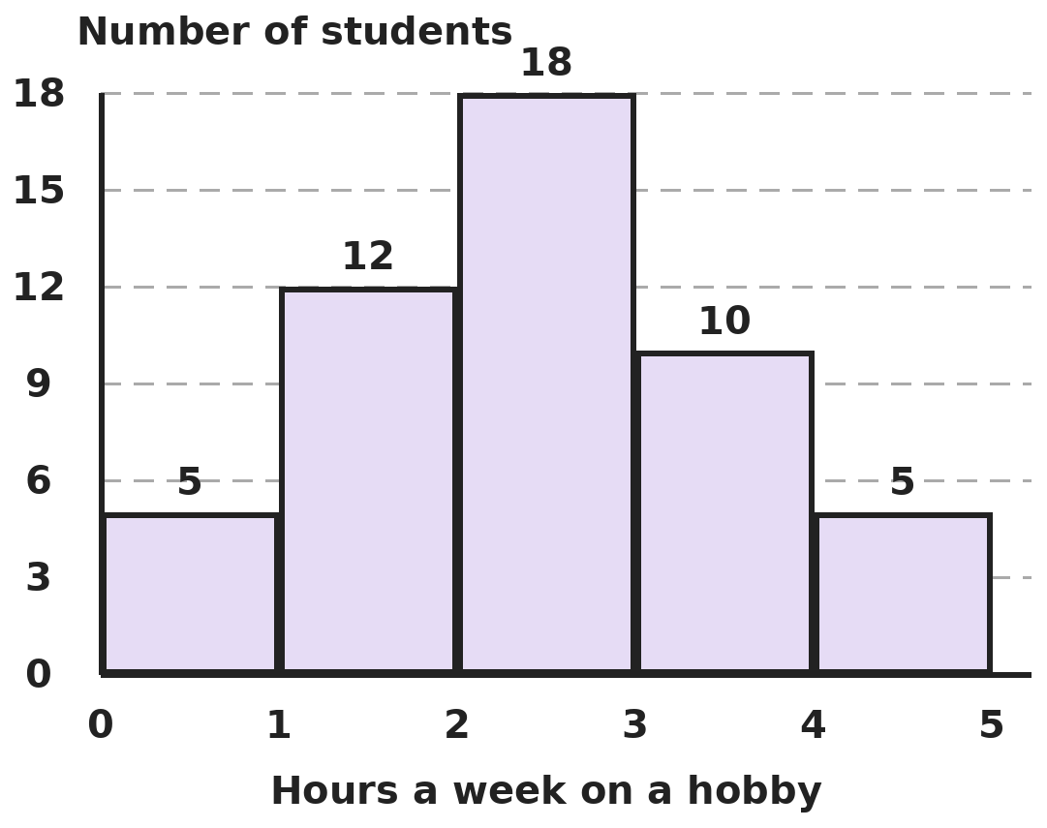
Q17. The histogram shows how many hours a week students spend on a hobby (each class includes its lower value, not its upper value). What is the ratio of students spending less than 2 hours to students spending 4 hours or more?
(A) 5 : 17 | (B) 17 : 5 | (C) 12 : 5 | (D) 17 : 10

Q18. The mean of 4, 7, 9, x, 9, 10, 12 is 9. What are the median and the mode(s) of these seven numbers?
(A) Median 9; modes 9 and 12 | (B) Median 10; mode 12
(C) Median 9; mode 9 | (D) Median 9; mode 12

Part 8 — Applied Mathematics (Syllabus Chapter 9)
Q19. A merchant's profit is 25% of the selling price. What is the profit as a percentage of the cost price?
(A) 25% | (B) 20% | (C) 33 1/3% | (D) 30%

Q20. A television costs ₹20,000 in cash. On the instalment plan, a buyer pays ₹4,000 at once and ₹18,400 after one year. What rate of simple interest is being charged?
(A) 12% | (B) 20% | (C) 15% | (D) 14.4%

Q21. After a 20% discount on the marked price, Kriti pays ₹1,180 for a lamp. This amount includes 18% GST charged on the discounted price. What was the marked price?
(A) ₹1,475 | (B) ₹1,200 | (C) ₹1,416 | (D) ₹1,250

Part 9 — Mathematical Reasoning (Syllabus Chapter 10)
Q22. A two-digit number AB multiplied by its reverse BA gives 2,268. What is A + B?
(A) 12 | (B) 7 | (C) 9 | (D) 11

Q23. Aarav climbs a staircase of 7 steps, taking either 1 or 2 steps at a time. In how many different ways can he reach the top?
(A) 13 | (B) 34 | (C) 21 | (D) 14

Q24. How many of the numbers 1, 2, …, 100 leave a remainder of 1 when divided by 3 and also when divided by 4?
(A) 9 | (B) 8 | (C) 16 | (D) 25

Q25. Lines are drawn in a plane so that no two are parallel and no three pass through one point. 1 line makes 2 regions, 2 lines make 4 and 3 lines make 7. How many regions do 10 lines make?
(A) 55 | (B) 46 | (C) 56 | (D) 64

Part 10 — Mixed Problems (each joins two chapters)
Q26. If x + y = 7 and x² + y² = 29, what is x⁴ + y⁴?
(A) 841 | (B) 441 | (C) 629 | (D) 641

Q27. Sixteen dots form a 4 × 4 square array, one unit apart. How many squares, including tilted ones, have all four corners on these dots?
(A) 20 | (B) 14 | (C) 16 | (D) 18

Q28. A square has area (x² + 10x + 25) cm². What is the length of its diagonal when x = 3?
(A) 64 cm | (B) 16 cm | (C) 8 cm | (D) 8√2 cm

Q29. At a simple-interest rate that doubles money in 8 years, ₹6,000 is invested for 5 years. Tax of 18% is then deducted from the interest. How much interest does the investor keep?
(A) ₹3,750 | (B) ₹3,075 | (C) ₹675 | (D) ₹9,075

Q30. An open cylindrical metal bucket (with a bottom but no lid) has radius 14 cm and height 30 cm. Metal sheet costs ₹10 per 100 cm². What does the metal cost? (Take π = 22/7.)
(A) ₹325.60 | (B) ₹264 | (C) ₹387.20 | (D) ₹3,256

Answer Sheet AMO Level 2 · Class 8 · Practice Paper 10
Name: | School: | Roll No.:
Shade or tick one circle for each question.
1. | Ⓐ Ⓑ Ⓒ Ⓓ | 11. | Ⓐ Ⓑ Ⓒ Ⓓ | 21. | Ⓐ Ⓑ Ⓒ Ⓓ
2. | Ⓐ Ⓑ Ⓒ Ⓓ | 12. | Ⓐ Ⓑ Ⓒ Ⓓ | 22. | Ⓐ Ⓑ Ⓒ Ⓓ
3. | Ⓐ Ⓑ Ⓒ Ⓓ | 13. | Ⓐ Ⓑ Ⓒ Ⓓ | 23. | Ⓐ Ⓑ Ⓒ Ⓓ
4. | Ⓐ Ⓑ Ⓒ Ⓓ | 14. | Ⓐ Ⓑ Ⓒ Ⓓ | 24. | Ⓐ Ⓑ Ⓒ Ⓓ
5. | Ⓐ Ⓑ Ⓒ Ⓓ | 15. | Ⓐ Ⓑ Ⓒ Ⓓ | 25. | Ⓐ Ⓑ Ⓒ Ⓓ
6. | Ⓐ Ⓑ Ⓒ Ⓓ | 16. | Ⓐ Ⓑ Ⓒ Ⓓ | 26. | Ⓐ Ⓑ Ⓒ Ⓓ
7. | Ⓐ Ⓑ Ⓒ Ⓓ | 17. | Ⓐ Ⓑ Ⓒ Ⓓ | 27. | Ⓐ Ⓑ Ⓒ Ⓓ
8. | Ⓐ Ⓑ Ⓒ Ⓓ | 18. | Ⓐ Ⓑ Ⓒ Ⓓ | 28. | Ⓐ Ⓑ Ⓒ Ⓓ
9. | Ⓐ Ⓑ Ⓒ Ⓓ | 19. | Ⓐ Ⓑ Ⓒ Ⓓ | 29. | Ⓐ Ⓑ Ⓒ Ⓓ
10. | Ⓐ Ⓑ Ⓒ Ⓓ | 20. | Ⓐ Ⓑ Ⓒ Ⓓ | 30. | Ⓐ Ⓑ Ⓒ Ⓓ

For the parent or teacher
Correct: ______ / 30
Answer Key and Solutions AMO Level 2 · Class 8 · Practice Paper 10
Quick answers
1 B | 6 C | 11 C | 16 A | 21 D | 26 D
2 B | 7 D | 12 D | 17 B | 22 C | 27 A
3 D | 8 B | 13 A | 18 A | 23 C | 28 D
4 A | 9 D | 14 B | 19 C | 24 A | 29 B
5 A | 10 B | 15 B | 20 C | 25 C | 30 A
Solutions
Q | Part · level | Answer | Why?
1 | Part 1 · Ch1 · Hard | (B) 4 | Hint: Start from the innermost root and work outwards.  √225 = 15. √(154 + 15) = √169 = 13. √(108 + 13) = √121 = 11. √(25 + 11) = √36 = 6. √(10 + 6) = √16 = 4.
2 | Part 1 · Ch1 · Hard | (B) 3 | Hint: Find the edges: ∛729 and then one third of it.  Big cube: edge 9 cm, surface 6 × 81 = 486 cm². Small cubes: edge 3 cm, each 6 × 9 = 54 cm², total 27 × 54 = 1,458 cm². 1,458 ÷ 486 = 3.
3 | Part 2 · Ch2 · Hard | (D) 3 | Hint: (3/5)ˣ = (5/3)⁻ˣ.  (3/5)ˣ × (5/3)²ˣ = (5/3)⁻ˣ⁺²ˣ = (5/3)ˣ. 125/27 = (5/3)³, so x = 3.
4 | Part 2 · Ch2 · Hard | (A) 2.13 × 10¹¹ L | Hint: Multiply the numbers and add the powers of 10.  1.42 × 1.5 = 2.13 and 10⁹ × 10² = 10¹¹. Total ≈ 2.13 × 10¹¹ litres. (10¹⁸ multiplies the powers instead of adding them.)
5 | Part 3 · Ch3 · Hard | (A) ₹7,500 | Hint: The extra interest comes only from the extra 2% each year.  Extra interest = P × 2 × 3 ÷ 100 = 6P/100. So 6P/100 = 450 and P = ₹7,500. (₹22,500 forgets the 3 years; ₹15,000 forgets that 2% is not 1%.)
6 | Part 3 · Ch3 · Hard | (C) ₹5,625 | Hint: Find the first interest, then the second from the ratio.  First interest = 7,500 × 36% = ₹2,700. The second is 3/4 of it: ₹2,025. x × 9% × 4 = x × 36% = 2,025, so x = ₹5,625. (₹10,000 swaps the ratio.)
7 | Part 3 · Ch3 · Hard | (D) ₹30,000 | Hint: After rent 0.75 is left; after food, 0.7 of that.  After rent and food she has 0.75 × 0.7 = 0.525 of her salary. She saves 20% of this, which is 0.105 of her salary. 3,150 ÷ 0.105 = ₹30,000.
8 | Part 4 · Ch4 · Hard | (B) 16 | Hint: Simplify the left side first.  (x + 3)² − (x − 3)² = 12x = 60, so x = 5. x² − 9 = 25 − 9 = 16.
9 | Part 4 · Ch4 · Hard | (D) (ab − 5)(ab + 3) | Hint: Treat ab as a single quantity: find two numbers with product −15 and sum −2.  With p = ab: p² − 2p − 15 = (p − 5)(p + 3). So the answer is (ab − 5)(ab + 3). Check at ab = 8: 64 − 16 − 15 = 33 = 3 × 11.
10 | Part 4 · Ch4 · Hard | (B) ₹550 | Hint: Let Ankit get ₹a. Then Bela gets a + 100 and Chirag 2(a + 100).  a + (a + 100) + 2(a + 100) = 4a + 300 = 1,000, so a = 175. Bela gets ₹275 and Chirag ₹550.
11 | Part 5 · Ch5 · Hard | (C) 90° | Hint: Angles A and D are next to each other on side AD. What do they add up to?  A + B = 180° and A = 2B + 30°, so B = 50° and A = 130°; D = B = 50°. In triangle APD the angles at A and D are half of 130° and half of 50°: 65° + 25° = 90°. So angle APD = 180° − 90° = 90°. (Adjacent angles of a parallelogram always add to 180°, so the bisectors always meet at 90°.)
12 | Part 5 · Ch5 · Hard | (D) 90° | Hint: Show that triangles DAP and ABQ are congruent.  DA = AB, AP = BQ and the angles at A and B are both 90°, so triangles DAP and ABQ are congruent (SAS). So angle ADP = angle BAQ. Let DP and AQ meet at X. In triangle ADX, angle ADX + angle DAX = angle BAQ + (90° − angle BAQ) = 90°, so angle AXD = 90° wherever P is.
13 | Part 5 · Ch5 · Hard | (A) 6 | Hint: Removing the outer layer takes 2 off each dimension.  The inner block is (3 − 2) × (4 − 2) × (5 − 2) = 1 × 2 × 3 = 6 cubes.
14 | Part 6 · Ch6 · Hard | (B) The volume doubles; the curved surface stays the same | Hint: Volume = πr²h and curved surface = 2πrh.  Volume: (2r)² × h/2 = 2r²h, so it doubles. Curved surface: 2π × 2r × h/2 = 2πrh, unchanged.
15 | Part 6 · Ch6 · Hard | (B) 132 cm³ | Hint: Each cone has radius 3 cm and height 3.5 cm.  Cylinder = 22/7 × 9 × 7 = 198 cm³. Each cone = (1/3) × 22/7 × 9 × 3.5 = 33 cm³, so both cones = 66 cm³. Wood left = 198 − 66 = 132 cm³ (the same as carving one full-height cone). (66 is the wood removed.)
16 | Part 6 · Ch6 · Hard | (A) 5.544 cm³ | Hint: Add the volume of the cylinder and one third of a cylinder for the tip.  Cylinder = 22/7 × 0.1225 × 14 = 5.39 cm³. Cone = (1/3) × 22/7 × 0.1225 × 1.2 = 0.154 cm³. Total = 5.544 cm³. (5.852 forgets the 1/3.)
17 | Part 7 · Ch8 · Hard | (B) 17 : 5 | Hint: Read the bars on each side carefully, using the class rule.  Less than 2 hours: 5 + 12 = 17. 4 hours or more: only the last bar, 5. Ratio 17 : 5. (17 : 10 wrongly includes the 3–4 bar.)
18 | Part 7 · Ch8 · Hard | (A) Median 9; modes 9 and 12 | Hint: Find x from the total, then sort the numbers.  Total = 63, so x = 63 − 51 = 12. In order: 4, 7, 9, 9, 10, 12, 12. Median = 9. Both 9 and 12 appear twice, so there are two modes.
19 | Part 8 · Ch9 · Hard | (C) 33 1/3% | Hint: Take the selling price as ₹100.  Selling price ₹100, profit ₹25, so cost = ₹75. Profit on cost = 25/75 = 33 1/3%.
20 | Part 8 · Ch9 · Hard | (C) 15% | Hint: Interest is charged only on the amount still owed after the down payment.  Amount owed = ₹16,000. Interest = 18,400 − 16,000 = ₹2,400. Rate = 2,400 ÷ 16,000 × 100 = 15%. (12% wrongly divides by ₹20,000.)
21 | Part 8 · Ch9 · Hard | (D) ₹1,250 | Hint: Remove the GST first, then undo the discount.  Price before GST = 1,180 ÷ 1.18 = ₹1,000. This is 80% of the marked price, so the marked price = 1,000 ÷ 0.8 = ₹1,250. (₹1,475 undoes the discount without removing the GST.)
22 | Part 9 · Ch10 · Hard | (C) 9 | Hint: 2,268 = 2² × 3⁴ × 7. Look for factor pairs that are reverses of each other.  2,268 = 36 × 63, and 36 and 63 are reverses. So A + B = 3 + 6 = 9. (Other factor pairs such as 28 × 81 are not reverses.)
23 | Part 9 · Ch10 · Hard | (C) 21 | Hint: The number of ways to reach step n = ways to reach step n − 1 + ways to reach step n − 2.  Ways for 1, 2, 3, … steps: 1, 2, 3, 5, 8, 13, 21. So 7 steps can be climbed in 21 ways.
24 | Part 9 · Ch10 · Hard | (A) 9 | Hint: Such numbers are 1 more than a multiple of 12.  n − 1 must be a multiple of both 3 and 4, so of 12. n = 1, 13, 25, …, 97: (97 − 1) ÷ 12 + 1 = 9 numbers.
25 | Part 9 · Ch10 · Hard | (C) 56 | Hint: The nth line crosses all the earlier lines, so it is cut into n pieces and adds n new regions.  Each new line adds as many regions as its number: 2, then +2, +3, +4, … So 10 lines make 1 + (1 + 2 + … + 10) = 1 + 55 = 56 regions. (55 forgets the starting region.)
26 | Part 10 · Mixed · Ch4 + Ch10 · Hard | (D) 641 | Hint: Find xy first, then use (x² + y²)².  49 = 29 + 2xy, so xy = 10. x⁴ + y⁴ = (x² + y²)² − 2x²y² = 841 − 200 = 641. (The numbers are 5 and 2: 625 + 16 = 641.)
27 | Part 10 · Mixed · Ch5 + Ch10 · Hard | (A) 20 | Hint: Count upright squares by size, then look for tilted ones inside 2 × 2 and 3 × 3 frames.  Upright squares: 9 of side 1, 4 of side 2, 1 of side 3 = 14. Tilted squares: each 2 × 2 frame holds 1 (4 frames) and the 3 × 3 frame holds 2. Total 14 + 4 + 2 = 20.
28 | Part 10 · Mixed · Ch4 + Ch5 · Hard | (D) 8√2 cm | Hint: x² + 10x + 25 is a perfect square.  x² + 10x + 25 = (x + 5)², so the side is x + 5 = 8 cm. Diagonal = √(8² + 8²) = 8√2 cm.
29 | Part 10 · Mixed · Ch3 + Ch9 · Hard | (B) ₹3,075 | Hint: Doubling in 8 years means 12.5% a year.  Rate = 100 ÷ 8 = 12.5%. Interest = 6,000 × 12.5% × 5 = ₹3,750. Tax = 18% of 3,750 = ₹675. Kept = ₹3,075.
30 | Part 10 · Mixed · Ch6 + Ch9 · Hard | (A) ₹325.60 | Hint: Metal = curved surface + bottom circle.  Curved surface = 2 × 22/7 × 14 × 30 = 2,640 cm². Bottom = 22/7 × 196 = 616 cm². Total 3,256 cm². Cost = 3,256 ÷ 100 × 10 = ₹325.60.

