UNLOCK IQ INSTITUTE
Realize Your True Potential
Aryabhatta Maths Olympiad (AMO)
Level 1 — Practice Paper 3
CLASS 11

Questions | 45 multiple-choice questions
Marks | 100
Time | 60 minutes
Section I | 40 questions × 2 marks = 80 marks
Section II | 5 Star Questions × 4 marks = 20 marks
Negative marking | No negative marking
Calculator | Not allowed
Chapters | Number System · Algebra · Geometry · Trigonometry · Data Handling · Applied Mathematics · Mathematical Reasoning

Instructions to candidates
• This paper has 45 multiple-choice questions. Each question has four answer choices, of which exactly one is correct.
• Section I (Q1–Q40) carries 2 marks per question. Section II (Q41–Q45) carries 4 marks per question.
• There is no negative marking. Unanswered questions score zero.
• Calculators are not permitted. Rough work may be done on a separate sheet.
• Mark your answers on the answer sheet at the end of the paper.
• All figures are not necessarily drawn to scale unless stated.

For parents and teachers
Print or view this paper in colour. Pictures are part of the questions.
Parts follow the AMO syllabus chapters. Chapters 2, 3 and 6 are not part of the Class 11 syllabus, so the chapter numbers shown in the Part headings have gaps.
The answer sheet and the answer key are at the end. Remove only the answer key before the student begins.

Name: | School: | Roll No.:

SECTION I 40 questions × 2 marks each
Part 1 — Number System (Syllabus Chapter 1)
Q1. What number goes in the box to make $(1+3i)×□=10$ true?
(A) −1 + 3i | (B) 1 − 3i | (C) 3 + i | (D) 1 + 3i

Q2. In the figure, the x-axis is the real axis and the y-axis is the imaginary axis of the Argand plane. The point A represents the complex number z₁ and the point B represents z₂. What is the product z₁ × z₂? | 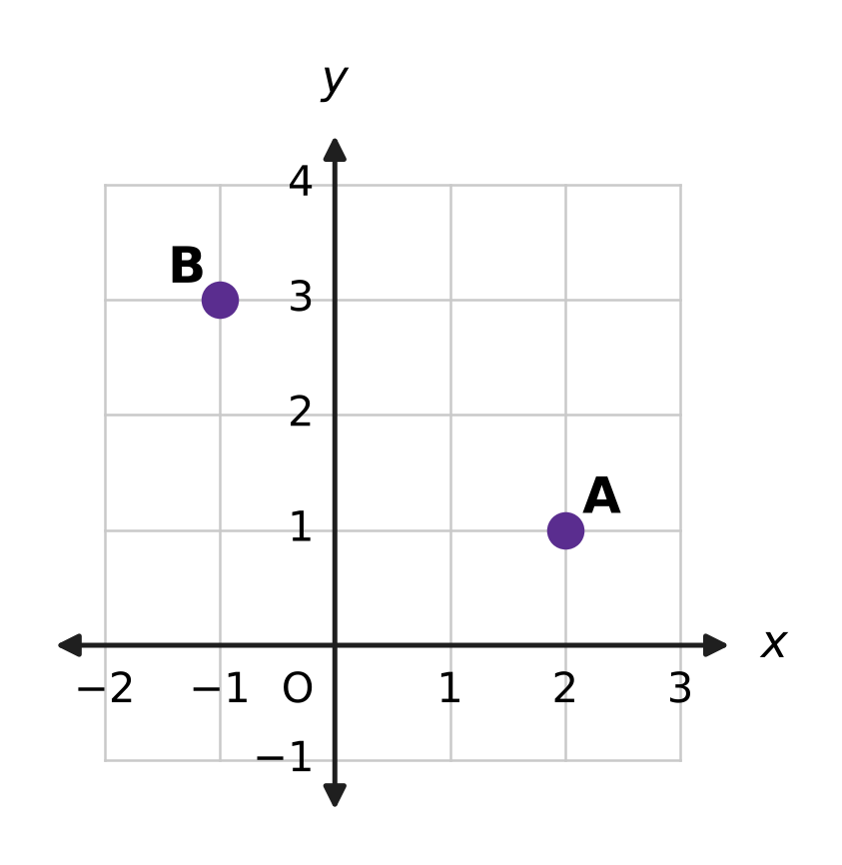
  (A) 1 + 4i | (B) −2 + 3i | (C) 1 + 5i | (D) −5 + 5i

Q3. What is the modulus of the complex number ${(2+i)}^{4}$?
(A) 16 | (B) 625 | (C) 5 | (D) 25

Q4. What is the value of ${(1−i)}^{6}$?
(A) 8i | (B) −8i | (C) 8 | (D) −8

Q5. The roots of the equation x² + 2x + 10 = 0 are α and β. What is the value of α² + β²?
(A) 24 | (B) −16 | (C) 20 | (D) 16

Part 2 — Algebra (Syllabus Chapter 4)
Q6. The expression ${(x+y)}^{10}+{(x−y)}^{10}$ is expanded and like terms are collected. The result has $□$ terms. What number goes in the box?
(A) 22 | (B) 5 | (C) 11 | (D) 6

Q7. The solution set of the inequality 4 − 3x ≥ $□$ is x ≤ −2. What number goes in the box?
(A) 10 | (B) −2 | (C) −6 | (D) 2

Q8. In an arithmetic progression, the 5th term and the 16th term add up to 40. The sum of the first 20 terms is $□$. What number goes in the box?
(A) 420 | (B) 400 | (C) 800 | (D) 200

Q9. The sum of the first $□$ terms of the geometric series 5 + 15 + 45 + … is 1,820. What number goes in the box?
(A) 5 | (B) 7 | (C) 6 | (D) 8

Q10. The geometric progression 27, 9, 3, … goes on for ever. What is the sum to infinity of its terms from the 4th term onward?
(A) $\frac{81}{2}$ | (B) $\frac{9}{2}$ | (C) $\frac{1}{2}$ | (D) $\frac{3}{2}$

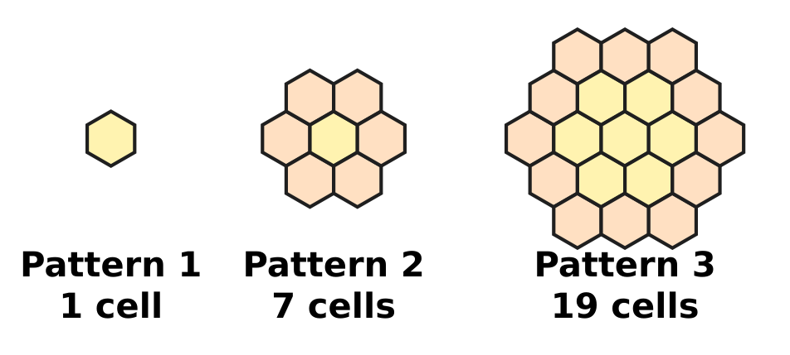
Q11. Honey bees build six-sided wax cells. The figure shows the first three patterns of a growing honeycomb, in which each pattern adds a ring of cells around the one before. Pattern n has 3n² − 3n + 1 cells. What is the total number of cells in patterns 1 to 10 taken together?
(A) 1,000 | (B) 271 | (C) 1,330 | (D) 990

Q12. In the expansion of ${(1+2x)}^{7}$, which power of x has the greatest coefficient?
(A) x³ | (B) x⁴ | (C) x⁵ | (D) x⁷

Q13. Every term of a geometric progression is positive, and each term is equal to the sum of the two terms that come right after it. What is the common ratio?
(A) $\frac{\sqrt{5}+1}{2}$ | (B) $\frac{1}{2}$
(C) $\frac{\sqrt{5}−1}{2}$ | (D) $\frac{3−\sqrt{5}}{2}$

Q14. In a harbour, boats are moored in rows. The first row has 3 boats, and each row has 4 boats more than the row before it. All the rows are full, and there are 300 boats in all. How many rows are there?
(A) 25 | (B) 12 | (C) 75 | (D) 47

Part 3 — Geometry (Syllabus Chapter 5)
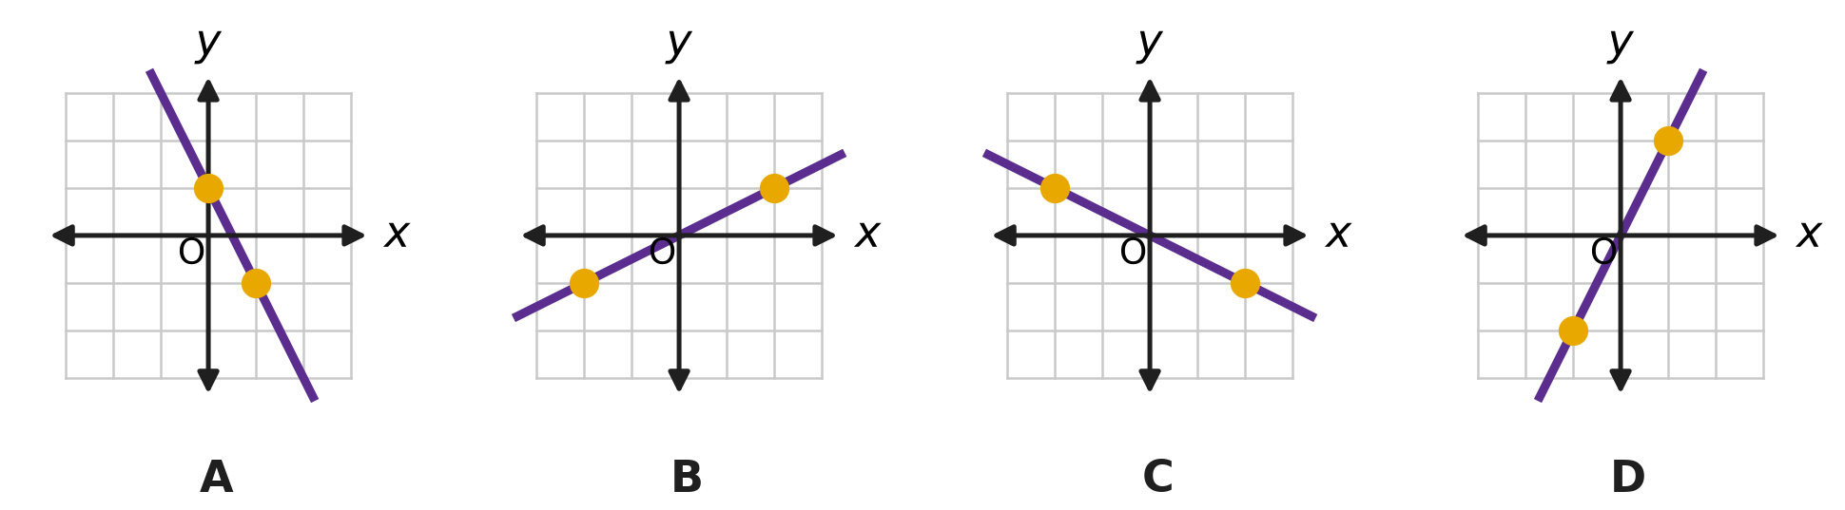
Q15. Four straight lines are drawn, one in each picture on a grid of unit squares. On each line, two points where grid lines cross are marked with dots. Which picture shows a line with slope $−\frac{1}{2}$?
(A) Picture A | (B) Picture B
(C) Picture C | (D) Picture D

Q16. In the figure, the lines $y=\sqrt{3} x+1$ and x = 2 meet, making the acute angle θ. What is θ? | 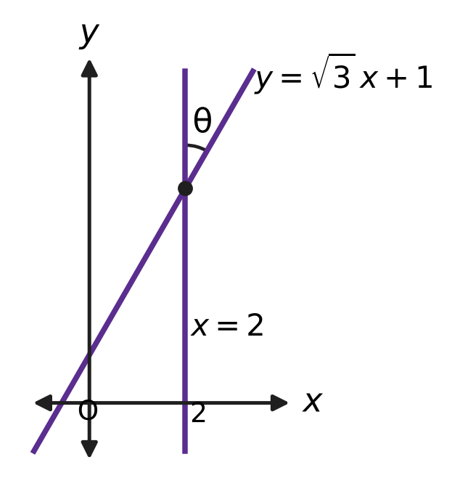
  (A) 90° | (B) 30° | (C) 60° | (D) 45°

Q17. The line $□$$x+3y=6$ cuts off intercepts on the x-axis and the y-axis that add up to 5. What number goes in the box?
(A) 2 | (B) $\frac{6}{5}$ | (C) $\frac{1}{2}$ | (D) 3

Q18. In the figure, A = (−1, 2) and B = (5, 6). Every point that is the same distance from A as from B lies on a certain straight line. What is the equation of that line? | 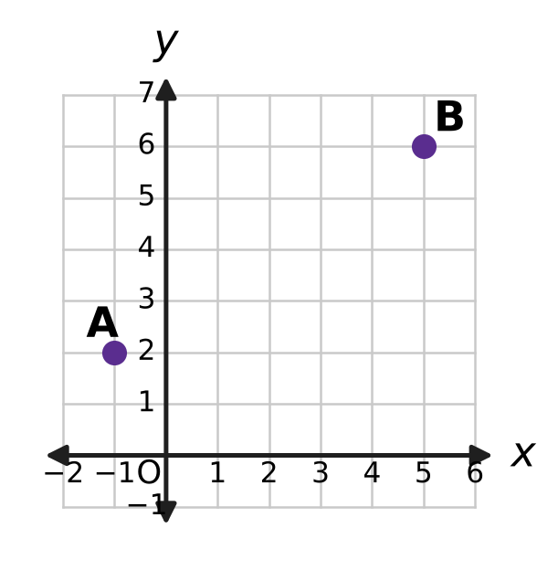
  (A) 3x + 2y = 1 | (B) 2x − 3y = −8
  (C) 3x + 2y = 14 | (D) 2x + 3y = 16

Q19. On a museum floor plan with coordinates in metres, a square display platform has one side along the line L₁: 8x + 15y + 34 = 0 and the opposite side along the line L₂: 8x + 15y − 17 = 0, as shown in the figure. What is the area of the platform? | 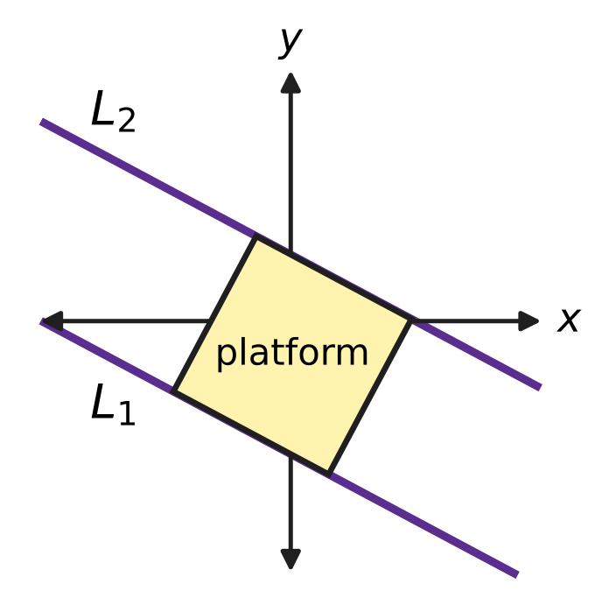
  (A) 3 m² | (B) 1 m² | (C) 4.5 m² | (D) 9 m²

Part 4 — Trigonometry & Heights and Distances (Syllabus Chapter 7)
Q20. In a wall clock shop, a clock is started at 3:00 and stopped at 3:40, as shown in the figure. Through how many radians does its minute hand turn? | 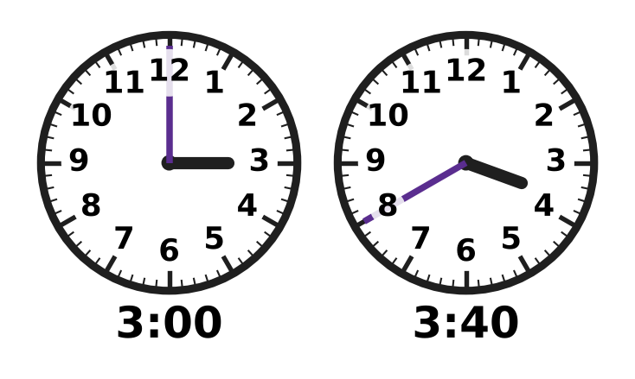
  (A) $\frac{2π}{3}$ | (B) $\frac{2π}{9}$ | (C) $\frac{4π}{3}$ | (D) $\frac{8π}{3}$

Q21. For every angle x, $sin(x+{30}^{∘})+sin(x−{30}^{∘})=□×sinx$. What number goes in the box?
(A) √3 | (B) 1
(C) $\frac{\sqrt{3}}{2}$ | (D) 2

Q22. For every angle A, $cos3A=cosA×□$. Which expression goes in the box?
(A) 1 − 4 sin²A | (B) 3 − 4 sin²A
(C) 4 sin²A − 3 | (D) 4 sin²A − 1

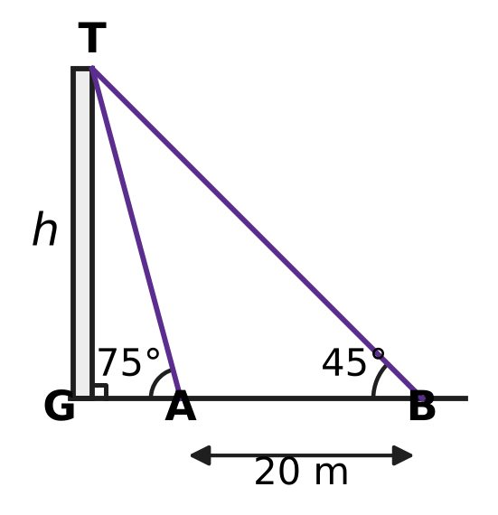
Q23. Vikram walks on level ground straight towards a tower GT. From point B, the angle of elevation of the top T is 45°. After walking 20 m to point A, the angle of elevation is 75°, as shown in the figure. What is the height h of the tower?
(A) 20(√3 + 1) m | (B) 10(√3 − 1) m
(C) 10(3 + √3) m | (D) 10(√3 + 1) m

Q24. What number goes in the box? $tan{70}^{∘}−tan{20}^{∘}=□×tan{50}^{∘}$
(A) √3 | (B) 2 | (C) 1 | (D) $\frac{1}{2}$

Part 5 — Data Handling, Statistics & Probability (Syllabus Chapter 8)
Q25. A bus route has 10 stops. Each ticket is printed with the stop where a journey starts and a different stop where it ends. How many different tickets are needed to cover every possible journey?
(A) 100 | (B) 45 | (C) 90 | (D) 81

Q26. At a board games club, every two players played exactly one game against each other. In all, 28 games were played. How many players were there?
(A) 14 | (B) 8 | (C) 28 | (D) 7

Daksh's 8 laps
Lap time (seconds) | Number of laps
62 | 4
70 | 4

Q27. Daksh runs 8 laps of a running track. The table shows his lap times. What is the standard deviation of the 8 lap times?
(A) 16 s | (B) 2 s | (C) 8 s | (D) 4 s

Q28. The school canteen has 6 different sandwich fillings. A sandwich may have any selection of these fillings, but it must have at least one. How many different sandwiches can be made, if sandwiches differ only in their fillings?
(A) 63 | (B) 21 | (C) 64 | (D) 720

Q29. Five cards show the digits 1, 2, 3, 4 and 5. All five cards are placed in a row to make a 5-digit number. How many of the numbers made in this way are divisible by 4?
(A) 48 | (B) 24 | (C) 12 | (D) 30

Q30. Avni throws paper planes at a hoop. Each throw goes through the hoop with the same probability p, independently of the other throws. In 4 throws, getting exactly 1 hit is just as likely as getting exactly 2 hits. What is p?
(A) $\frac{2}{5}$ | (B) $\frac{2}{3}$ | (C) $\frac{3}{5}$ | (D) $\frac{1}{2}$

Q31. Nine sacks of grain have a mean mass of 50 kg and a variance of 4 kg². A tenth sack, of mass exactly 50 kg, is added to them. What is the variance of the masses of the ten sacks?
(A) 4.4 kg² | (B) 4 kg² | (C) 3.6 kg² | (D) 3.24 kg²

Part 6 — Applied Mathematics (Syllabus Chapter 9)
Q32. Harsh sends a large parcel from a post office. The charge is ₹2,950, and this already includes GST at 18%. How much of the ₹2,950 is GST?
(A) ₹2,500 | (B) ₹531 | (C) ₹225 | (D) ₹450

Q33. Roshni makes clay pots. Her fixed costs are ₹4,500 a month, and each pot costs her ₹45 in clay and paint. She expects to sell 150 pots a month. What is the least price per pot at which she makes no loss?
(A) ₹30 | (B) ₹100 | (C) ₹45 | (D) ₹75

Q34. Kavin has ₹200 in his piggy bank. He puts in ₹35 at the end of every week and takes nothing out. After how many weeks will he first have at least ₹1,000 in it?
(A) 35 | (B) 22 | (C) 23 | (D) 29

Q35. Sneha borrows ₹15,000 from a cooperative society to buy a sewing machine. At the end of each year, 8% of what she owes at that time is added to her debt, and then she repays ₹6,000. How much does she owe just after her second repayment?
(A) ₹5,016 | (B) ₹3,720 | (C) ₹3,000 | (D) ₹5,400

Part 7 — Mathematical Reasoning & Problem-Solving (Syllabus Chapter 10)
Q36. The statement $3^{n}>n^{3}$ is true for every natural number n ≥ $□$, and this can be proved by induction. What is the least number that can go in the box?
(A) 2 | (B) 4 | (C) 3 | (D) 1

Q37. What is the least number of different whole numbers that must be chosen so that, however they are chosen, two of them always have a difference divisible by 9?
(A) 9 | (B) 10 | (C) 18 | (D) 11

Q38. A statement P(n) about natural numbers n has this property: whenever P(k) is true, P(k + 1) is also true. It is also known that P(5) is false. Which of these MUST be true?
(A) P(3) is false.
(B) P(n) is false for every natural number n.
(C) P(6) is false.
(D) P(3) is true.

Q39. A convex polygon has 9 sides. What is the greatest possible number of its interior angles that are acute?
(A) 9 | (B) 4 | (C) 3 | (D) 6

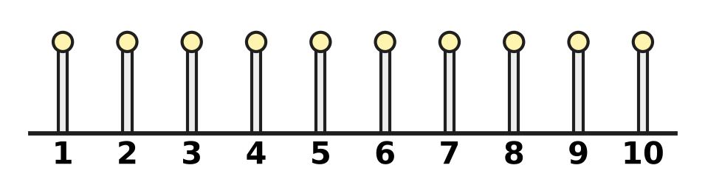
Q40. The figure shows 10 posts standing in a row, numbered 1 to 10. Three of the posts are to be painted so that no two painted posts are next to each other. In how many ways can the three posts be chosen?
(A) 48 | (B) 120 | (C) 35 | (D) 56

SECTION II — Star Questions 5 questions × 4 marks each
Q41. A sequence of whole numbers $a_{1},a_{2},a_{3},…$ has $a_{1}=1$. Every later term is greater than the term just before it, and is also at least as large as the sum of all the terms before it. What is the least possible value of $a_{10}$? [4 marks]
(A) 512 | (B) 768 | (C) 192 | (D) 384

Q42. Seven numbers form an arithmetic progression with a positive common difference. Their mean is 10 and their variance is 36. What is the largest of the seven numbers? [4 marks]
(A) 28 | (B) 19 | (C) 13 | (D) 16

Q43. Let $z=\frac{1+i}{2}$. On the Argand plane, a path goes in straight steps from the point 1 to the point z, then to z², then to z³, and so on for ever, as shown in the figure. What is the total length of the path? [4 marks] | 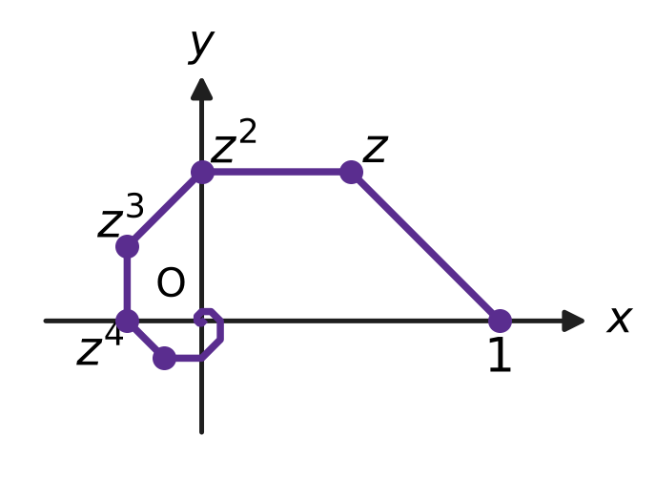
  (A) √2 + 1 | (B) √2 | (C) 1 | (D) 2 + √2

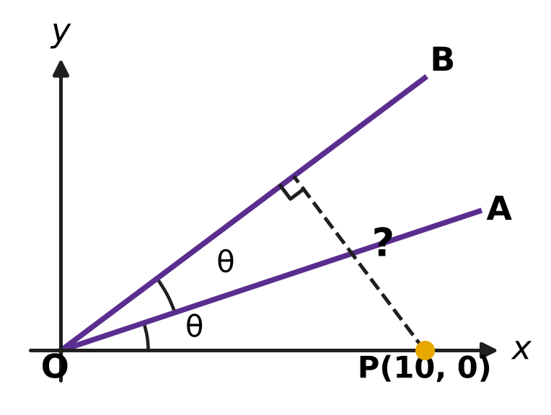
Q44. In the figure, O is the origin and P = (10, 0). The line OA has slope $\frac{1}{3}$, and the angle between the x-axis and OA equals the angle between OA and OB, as marked θ. What is the distance of P from the line OB? [4 marks]
(A) √10 | (B) 8 | (C) 6 | (D) 7.5

Q45. A school has 6 clubs. Every student joins either exactly 2 or exactly 3 of the clubs. What is the least number of students the school must have to be sure that at least three students have joined exactly the same set of clubs? [4 marks]
(A) 70 | (B) 36 | (C) 106 | (D) 71

Answer Sheet AMO Level 1 · Class 11 · Practice Paper 3
Name: | School: | Roll No.:
Shade or tick one circle for each question.
1. Ⓐ Ⓑ Ⓒ Ⓓ | 16. Ⓐ Ⓑ Ⓒ Ⓓ | 31. Ⓐ Ⓑ Ⓒ Ⓓ
2. Ⓐ Ⓑ Ⓒ Ⓓ | 17. Ⓐ Ⓑ Ⓒ Ⓓ | 32. Ⓐ Ⓑ Ⓒ Ⓓ
3. Ⓐ Ⓑ Ⓒ Ⓓ | 18. Ⓐ Ⓑ Ⓒ Ⓓ | 33. Ⓐ Ⓑ Ⓒ Ⓓ
4. Ⓐ Ⓑ Ⓒ Ⓓ | 19. Ⓐ Ⓑ Ⓒ Ⓓ | 34. Ⓐ Ⓑ Ⓒ Ⓓ
5. Ⓐ Ⓑ Ⓒ Ⓓ | 20. Ⓐ Ⓑ Ⓒ Ⓓ | 35. Ⓐ Ⓑ Ⓒ Ⓓ
6. Ⓐ Ⓑ Ⓒ Ⓓ | 21. Ⓐ Ⓑ Ⓒ Ⓓ | 36. Ⓐ Ⓑ Ⓒ Ⓓ
7. Ⓐ Ⓑ Ⓒ Ⓓ | 22. Ⓐ Ⓑ Ⓒ Ⓓ | 37. Ⓐ Ⓑ Ⓒ Ⓓ
8. Ⓐ Ⓑ Ⓒ Ⓓ | 23. Ⓐ Ⓑ Ⓒ Ⓓ | 38. Ⓐ Ⓑ Ⓒ Ⓓ
9. Ⓐ Ⓑ Ⓒ Ⓓ | 24. Ⓐ Ⓑ Ⓒ Ⓓ | 39. Ⓐ Ⓑ Ⓒ Ⓓ
10. Ⓐ Ⓑ Ⓒ Ⓓ | 25. Ⓐ Ⓑ Ⓒ Ⓓ | 40. Ⓐ Ⓑ Ⓒ Ⓓ
11. Ⓐ Ⓑ Ⓒ Ⓓ | 26. Ⓐ Ⓑ Ⓒ Ⓓ | 41. Ⓐ Ⓑ Ⓒ Ⓓ
12. Ⓐ Ⓑ Ⓒ Ⓓ | 27. Ⓐ Ⓑ Ⓒ Ⓓ | 42. Ⓐ Ⓑ Ⓒ Ⓓ
13. Ⓐ Ⓑ Ⓒ Ⓓ | 28. Ⓐ Ⓑ Ⓒ Ⓓ | 43. Ⓐ Ⓑ Ⓒ Ⓓ
14. Ⓐ Ⓑ Ⓒ Ⓓ | 29. Ⓐ Ⓑ Ⓒ Ⓓ | 44. Ⓐ Ⓑ Ⓒ Ⓓ
15. Ⓐ Ⓑ Ⓒ Ⓓ | 30. Ⓐ Ⓑ Ⓒ Ⓓ | 45. Ⓐ Ⓑ Ⓒ Ⓓ
Q41–Q45 are Section II Star Questions (4 marks each).
For the parent or teacher
Section I correct: ______ / 40 × 2 = ______ marks Section II correct: ______ / 5 × 4 = ______ marks
Correct: ______ / 45 Score: ______ / 100
Answer Key and Solutions AMO Level 1 · Class 11 · Practice Paper 3
Quick answers
1 B | 6 D | 11 A | 16 B | 21 A | 26 B | 31 C | 36 B | 41 D
2 D | 7 A | 12 C | 17 A | 22 A | 27 D | 32 D | 37 B | 42 B
3 D | 8 B | 13 C | 18 C | 23 D | 28 A | 33 D | 38 A | 43 A
4 A | 9 C | 14 B | 19 D | 24 B | 29 B | 34 C | 39 C | 44 C
5 B | 10 D | 15 C | 20 C | 25 C | 30 A | 35 A | 40 D | 45 D
Solutions
Q | Part · level | Answer | Why?
1 | Part 1 · Ch1 · Easy | (B) 1 − 3i | The number a + ib times its conjugate a − ib is a² + b². So (1 + 3i)(1 − 3i) = 1 + 9 = 10.
2 | Part 1 · Ch1 · Easy | (D) −5 + 5i | From the figure, z₁ = 2 + i and z₂ = −1 + 3i. Then (2 + i)(−1 + 3i) = −2 + 6i − i + 3i² = −2 + 5i − 3 = −5 + 5i.
3 | Part 1 · Ch1 · Easy | (D) 25 | The modulus of 2 + i is √(4 + 1) = √5. The modulus of a power is the power of the modulus: (√5)⁴ = 25.
4 | Part 1 · Ch1 · Medium | (A) 8i | First, (1 − i)² = 1 − 2i + i² = −2i. So (1 − i)⁶ = (−2i)³ = −8i³ = −8 × (−i) = 8i.
5 | Part 1 · Ch1 · Medium | (B) −16 | The roots are −1 ± 3i. Then α² + β² = (α + β)² − 2αβ = (−2)² − 2 × 10 = −16.
6 | Part 2 · Ch4 · Easy | (D) 6 | In (x − y)¹⁰ the terms with odd powers of y have a minus sign, so they cancel. The terms with y⁰, y², y⁴, y⁶, y⁸ and y¹⁰ remain: 6 terms.
7 | Part 2 · Ch4 · Easy | (A) 10 | At the end point x = −2, 4 − 3x = 4 + 6 = 10. Since 4 − 3x ≥ 10 gives −3x ≥ 6, that is x ≤ −2, the box is 10.
8 | Part 2 · Ch4 · Easy | (B) 400 | Since 5 + 16 = 1 + 20, the 1st and 20th terms also add up to 40. So S₂₀ = 20 × 40 ÷ 2 = 400.
9 | Part 2 · Ch4 · Easy | (C) 6 | The sum of n terms is 5(3^{n} − 1) ÷ 2 = 1,820, so 3^{n} − 1 = 728, 3^{n} = 729 and n = 6.
10 | Part 2 · Ch4 · Easy | (D) $\frac{3}{2}$ | The 4th term is 3 × 1/3 = 1, and the ratio is 1/3. So the sum from the 4th term onward is 1 ÷ (1 − 1/3) = 3/2.
11 | Part 2 · Ch4 · Medium | (A) 1,000 | Total = 3Σn² − 3Σn + 10 = 3 × 385 − 3 × 55 + 10 = 1,155 − 165 + 10 = 1,000.
12 | Part 2 · Ch4 · Medium | (C) x⁵ | The coefficient of xʳ is C(7, r) × 2ʳ: 280, 560, 672, 448, 128 for r = 3 to 7. The greatest, 672, belongs to x⁵.
13 | Part 2 · Ch4 · Medium | (C) $\frac{\sqrt{5}−1}{2}$ | a = ar + ar² gives r² + r − 1 = 0. The positive root is r = (√5 − 1)/2.
14 | Part 2 · Ch4 · Medium | (B) 12 | With n rows, the total is n/2 × (2 × 3 + 4(n − 1)) = n(2n + 1). Then n(2n + 1) = 300 gives n = 12, since 12 × 25 = 300.
15 | Part 3 · Ch5 · Easy | (C) Picture C | In Picture C the line goes from (−2, 1) to (2, −1): it falls 2 units over a run of 4, so the slope is −2/4 = −1/2.
16 | Part 3 · Ch5 · Easy | (B) 30° | The first line has slope √3, so it makes 60° with the x-axis. The line x = 2 is vertical and makes 90° with the x-axis, so θ = 90° − 60° = 30°.
17 | Part 3 · Ch5 · Easy | (A) 2 | The y-intercept is 6/3 = 2, so the x-intercept is 5 − 2 = 3. Then 6/k = 3 gives k = 2.
18 | Part 3 · Ch5 · Medium | (C) 3x + 2y = 14 | The line is perpendicular to AB through its midpoint (2, 4). AB has slope 4/6 = 2/3, so the line has slope −3/2: y − 4 = −3/2(x − 2), that is 3x + 2y = 14.
19 | Part 3 · Ch5 · Medium | (D) 9 m² | The distance between the parallel lines is (34 + 17) ÷ √(8² + 15²) = 51 ÷ 17 = 3 m. This is the side of the square, so the area is 3 × 3 = 9 m².
20 | Part 4 · Ch7 · Easy | (C) $\frac{4π}{3}$ | The minute hand turns 6° each minute, so 40 × 6° = 240°. In radians this is 240 × π/180 = 4π/3.
21 | Part 4 · Ch7 · Easy | (A) √3 | The cos x sin 30° terms cancel, leaving 2 sin x cos 30° = 2 × (√3/2) × sin x = √3 sin x.
22 | Part 4 · Ch7 · Easy | (A) 1 − 4 sin²A | Here cos 3A = 4 cos³A − 3 cos A = cos A (4 cos²A − 3). Since cos²A = 1 − sin²A, the bracket is 4 − 4 sin²A − 3 = 1 − 4 sin²A.
23 | Part 4 · Ch7 · Medium | (D) 10(√3 + 1) m | tan 75° = tan(45° + 30°) = 2 + √3. GB = h and GA = h ÷ (2 + √3) = h(2 − √3). So h − h(2 − √3) = 20, h(√3 − 1) = 20 and h = 10(√3 + 1) m.
24 | Part 4 · Ch7 · Medium | (B) 2 | Here tan 50° = (tan 70° − tan 20°)/(1 + tan 70° tan 20°). Since tan 70° = 1/tan 20°, the denominator is 1 + 1 = 2, so tan 70° − tan 20° = 2 tan 50°.
25 | Part 5 · Ch8 · Easy | (C) 90 | The start can be any of 10 stops and the end any of the other 9: 10 × 9 = 90.
26 | Part 5 · Ch8 · Easy | (B) 8 | The number of games is C(n, 2) = n(n − 1)/2. n(n − 1) = 56 gives n = 8.
27 | Part 5 · Ch8 · Easy | (D) 4 s | The mean is 66 s and every lap time is 4 s away from it. So the variance is 16 and the standard deviation is 4 s.
28 | Part 5 · Ch8 · Easy | (A) 63 | Each filling is either in or out: 2⁶ = 64 selections. Leaving out the empty one gives 63.
29 | Part 5 · Ch8 · Medium | (B) 24 | A number is divisible by 4 when its last two digits are. The possible endings are 12, 24, 32 and 52. For each, the other three digits can be arranged in 3! = 6 ways: 4 × 6 = 24.
30 | Part 5 · Ch8 · Medium | (A) $\frac{2}{5}$ | With q = 1 − p, the condition is 4pq³ = 6p²q². Dividing by 2pq² gives 2q = 3p, so 2(1 − p) = 3p and p = 2/5.
31 | Part 5 · Ch8 · Medium | (C) 3.6 kg² | The mean stays 50 kg. The sum of squared deviations is 9 × 4 = 36, and the new sack adds 0. The new variance is 36 ÷ 10 = 3.6 kg².
32 | Part 6 · Ch9 · Easy | (D) ₹450 | The charge before GST is 2,950 ÷ 1.18 = ₹2,500. The GST is 2,950 − 2,500 = ₹450.
33 | Part 6 · Ch9 · Easy | (D) ₹75 | The fixed cost per pot is 4,500 ÷ 150 = ₹30. Adding the ₹45 making cost, each pot must sell for at least ₹75.
34 | Part 6 · Ch9 · Easy | (C) 23 | After w weeks he has ₹(200 + 35w). Then 200 + 35w ≥ 1,000 gives w ≥ 800 ÷ 35 ≈ 22.9. The least whole number of weeks is 23.
35 | Part 6 · Ch9 · Medium | (A) ₹5,016 | Year 1: 15,000 + 1,200 − 6,000 = ₹10,200. Year 2: 10,200 + 816 − 6,000 = ₹5,016.
36 | Part 7 · Ch10 · Easy | (B) 4 | It holds at n = 1 and n = 2 (3 > 1, 9 > 8), but at n = 3 both sides equal 27, so it fails. From n = 4 on it holds (81 > 64), and the step 3k³ ≥ (k + 1)³ keeps it going. The least start is 4.
37 | Part 7 · Ch10 · Easy | (B) 10 | There are 9 possible remainders on division by 9. Among 10 numbers two share a remainder, and their difference is divisible by 9. The numbers 0 to 8 show that 9 are not enough.
38 | Part 7 · Ch10 · Easy | (A) P(3) is false. | If P(3) were true, the step would make P(4) and then P(5) true. Since P(5) is false, P(3) must be false. Nothing follows for P(6).
39 | Part 7 · Ch10 · Medium | (C) 3 | An acute interior angle has an exterior angle of more than 90°. The exterior angles add up to 360°, so at most 3 of them exceed 90°. Exterior angles 100°, 100°, 100° and six of 10° give a convex 9-sided polygon with 3 acute angles.
40 | Part 7 · Ch10 · Medium | (D) 56 | Picture the 7 unpainted posts in a row. The 3 painted posts go into 3 of the 8 gaps around them, one per gap: C(8, 3) = 56.
41 | Section II · Ch4 + Ch10 · Hard | (D) 384 | The least choices are 1, 2, 3, and then each term equal to the sum before it: 6, 12, 24, …, which doubles each time. By induction, aₖ ≥ 3 × 2ᵏ⁻³ for k ≥ 3, because the sum of the earlier terms is at least 3 × 2ᵏ⁻³. So a₁₀ ≥ 3 × 2⁷ = 384, and the sequence above reaches it.
42 | Section II · Ch4 + Ch8 · Hard | (B) 19 | The middle term is the mean, 10, and the deviations are −3d, −2d, …, 3d. The variance is 2(1² + 2² + 3²)d² ÷ 7 = 4d² = 36, so d = 3. The largest number is 10 + 3 × 3 = 19.
43 | Section II · Ch1 + Ch4 · Hard | (A) √2 + 1 | The step from zᵏ to zᵏ⁺¹ has length (modulus of zᵏ) × (modulus of 1 − z) = (1/√2)ᵏ × 1/√2, since 1 − z = (1 − i)/2. The steps form a GP with first term 1/√2 and ratio 1/√2, so the total is (1/√2) ÷ (1 − 1/√2) = 1 ÷ (√2 − 1) = √2 + 1.
44 | Section II · Ch5 + Ch7 · Hard | (C) 6 | OB makes the angle 2θ with the x-axis, where tan θ = 1/3. Then tan 2θ = (2/3)/(1 − 1/9) = 3/4, so OB is 3x − 4y = 0. The distance of P is (3 × 10 − 0)/5 = 6.
45 | Section II · Ch8 + Ch10 · Hard | (D) 71 | The possible sets number C(6, 2) + C(6, 3) = 15 + 20 = 35. With 70 students, each set could have exactly two. One more student forces a third: 2 × 35 + 1 = 71.

