UNLOCK IQ INSTITUTE
Realize Your True Potential
Aryabhatta Maths Olympiad (AMO)
Level 1 — Practice Paper 4
CLASS 11

Questions | 45 multiple-choice questions
Marks | 100
Time | 60 minutes
Section I | 40 questions × 2 marks = 80 marks
Section II | 5 Star Questions × 4 marks = 20 marks
Negative marking | No negative marking
Calculator | Not allowed
Chapters | Number System · Algebra · Geometry · Trigonometry · Data Handling · Applied Mathematics · Mathematical Reasoning

Instructions to candidates
• This paper has 45 multiple-choice questions. Each question has four answer choices, of which exactly one is correct.
• Section I (Q1–Q40) carries 2 marks per question. Section II (Q41–Q45) carries 4 marks per question.
• There is no negative marking. Unanswered questions score zero.
• Calculators are not permitted. Rough work may be done on a separate sheet.
• Mark your answers on the answer sheet at the end of the paper.
• All figures are not necessarily drawn to scale unless stated.

For parents and teachers
Print or view this paper in colour. Pictures are part of the questions.
Parts follow the AMO syllabus chapters. Chapters 2, 3 and 6 are not part of the Class 11 syllabus, so the chapter numbers shown in the Part headings have gaps.
The answer sheet and the answer key are at the end. Remove only the answer key before the student begins.

Name: | School: | Roll No.:

SECTION I 40 questions × 2 marks each
Part 1 — Number System (Syllabus Chapter 1)
Q1. In the figure, the horizontal axis is the real axis and the vertical axis is the imaginary axis. The point P represents z₁ and the point R represents z₂. What is the modulus of z₁ + z₂? | 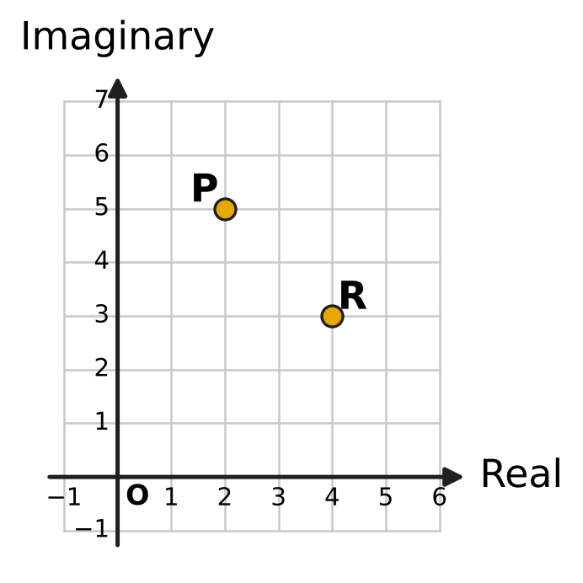
  (A) $2\sqrt{2}$ | (B) 10
  (C) 14 | (D) 100

Q2. Let z = 2 + 3i, and let $\overline{z}$ be its conjugate. What is the value of $z^{2}+{\overline{z}}^{2}$?
(A) −5 | (B) 26
(C) −10 | (D) −10 + 24i

Q3. What is the value of $i^{−1}+i^{−2}+i^{−3}+i^{−4}+i^{−5}$?
(A) −1 | (B) 0 | (C) i | (D) −i

Q4. Let z = 1 + 2i. What is the value of $z^{3}−3z^{2}+7z−5$?
(A) 0 | (B) 5
(C) 12 − 6i | (D) −18 + 24i

Q5. The complex number z = a + 4i, where a is a real number, has principal argument $\frac{3π}{4}$. What is z²?
(A) 0 | (B) −32i | (C) 32i | (D) 32 − 32i

Part 2 — Algebra (Syllabus Chapter 4)
Q6. Some arithmetic means are inserted between 3 and 43, so that 3, the means and 43 together form an arithmetic progression. The inserted means add up to 115. How many means are inserted?
(A) 4 | (B) 3 | (C) 5 | (D) 7

Q7. What is the greatest integer x for which $\frac{x}{2}−\frac{x−3}{5}<3$?
(A) 11 | (B) 8 | (C) −2 | (D) 7

Q8. In the expansion of ${(x+a)}^{6}$, where a is a non-zero number, the coefficient of x⁴ is equal to the coefficient of x³. What is a?
(A) $\frac{3}{4}$ | (B) $\frac{2}{3}$ | (C) 1 | (D) $\frac{4}{3}$

Q9. Small cubes of edge 1 cm are glued together to make 13 solid cubes, of edges 1 cm, 2 cm, 3 cm, …, 13 cm. How many small cubes are used in all?
(A) 819 | (B) 91 | (C) 8,281 | (D) 2,197

Q10. At the start of day 1, the water tank of Amrita's plant nursery holds 2,430 litres. No water is added. At the start of each later day, the tank holds $\frac{2}{3}$ of the water it held at the start of the day before. How many litres does it hold at the start of day 6?
(A) 480 litres | (B) 320 litres
(C) 10 litres | (D) 324 litres

Q11. In the figure, the largest square has side 8 cm. The corners of each next square are the midpoints of the sides of the square just outside it. The squares go on in this way forever. What is the total area of all the squares? | 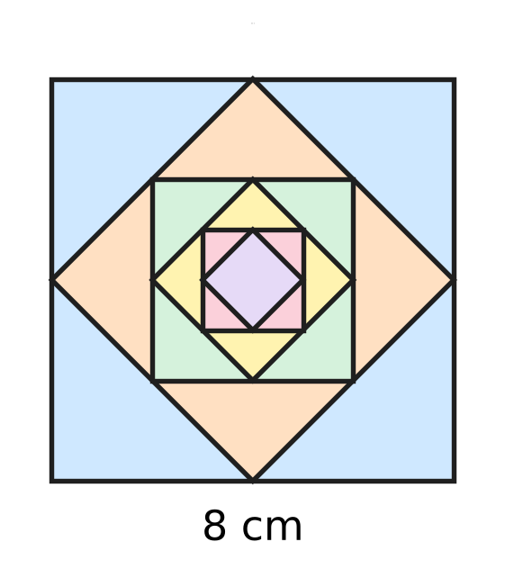
  (A) 112 cm² | (B) 128 cm² | (C) 256 cm² | (D) 64 cm²

Q12. The numbers a, ar, ar², ar³, … are all positive, and r ≠ 1. Adding the first six of them gives 28 times the total of the first three. What is r?
(A) 3 | (B) $\sqrt[3]{28}$
(C) $3\sqrt{3}$ | (D) 27

Q13. What is the sum of all the two-digit numbers that leave a remainder of 5 when they are divided by 8?
(A) 588 | (B) 530 | (C) 583 | (D) 684

Q14. The coefficients in the expansion of ${(1+3x)}^{n}$ add up to 4,096. What is the middle term of the expansion?
(A) 1,215x⁴ | (B) 180x³ | (C) 20x³ | (D) 540x³

Part 3 — Geometry (Syllabus Chapter 5)
Q15. In the figure, O is the origin. The perpendicular drawn from O to a straight line meets the line at N(2, −3). What is the equation of the line? | 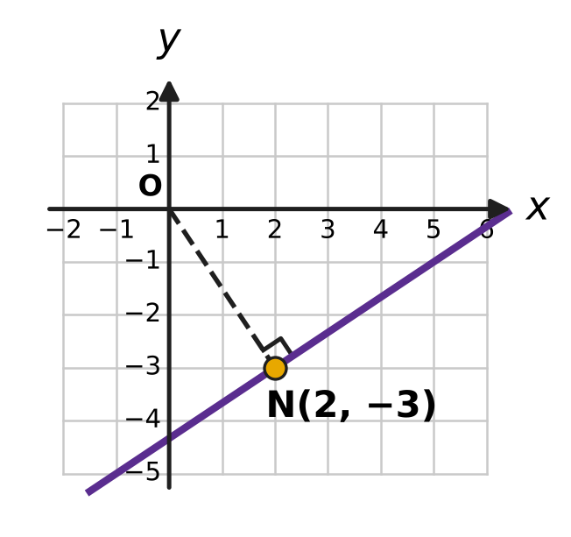
  (A) 2x − 3y = 13 | (B) 2x − 3y = −13
  (C) 3x + 2y = 0 | (D) 3x − 2y = 12

Q16. In the figure, the points A, B and C are grid points, and the drawn line passes through A and B. A second line is drawn through C, parallel to the line AB. At which point does this second line meet the y-axis? | 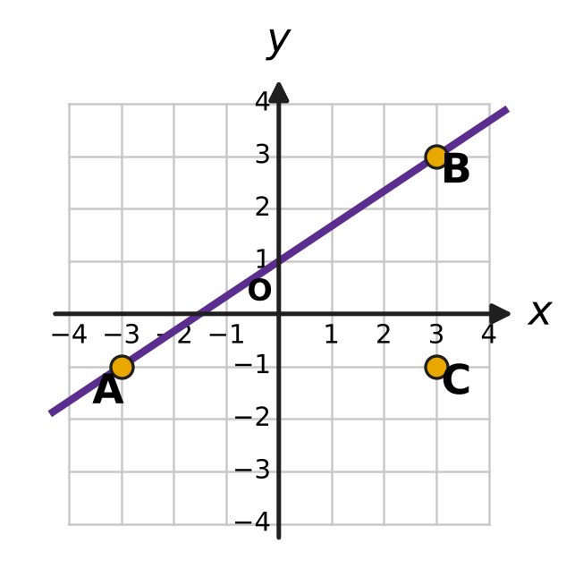
  (A) (0, −5.5) | (B) (0, 3.5)
  (C) (0, −3) | (D) (0, 1)

Q17. A straight line passes through the point (1, 3), and its y-intercept is equal to its slope. What is its equation?
(A) 3x − y = 0 | (B) x − y + 2 = 0
(C) 2x − 3y + 7 = 0 | (D) 3x − 2y + 3 = 0

Q18. The three lines x + y = 5, 2x − y = 4 and kx + 3y = 12 all pass through one point. What is the value of k?
(A) −2 | (B) 2 | (C) $\frac{3}{2}$ | (D) 4

Q19. On Vihaan's hiking map, one unit stands for 100 m on the ground. A straight trail runs along the line 4x − 3y + 12 = 0, and his camp is at the point (6, −2), as shown in the figure. What is the shortest distance on the ground from the camp to the trail? | 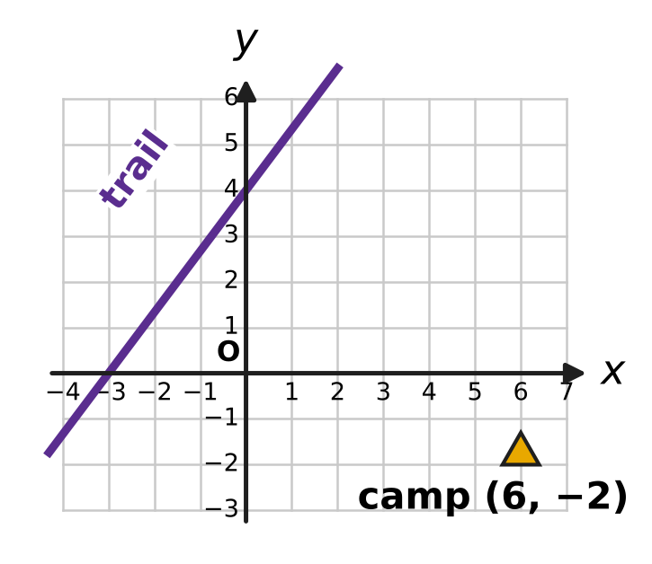
  (A) 4,200 m | (B) 600 m | (C) 1,050 m | (D) 840 m

Part 4 — Trigonometry & Heights and Distances (Syllabus Chapter 7)
Q20. For every angle θ, the expression sin(−θ) + sin(180° + θ) + sin(180° − θ) + sin(360° − θ) is equal to which of these?
(A) 2 sin θ | (B) −4 sin θ | (C) −2 sin θ | (D) 0

Q21. In the figure, the angle θ is measured anticlockwise from the positive x-axis to the ray OP, where P is the point (−12, −5). What is the value of sin θ + cos θ? | 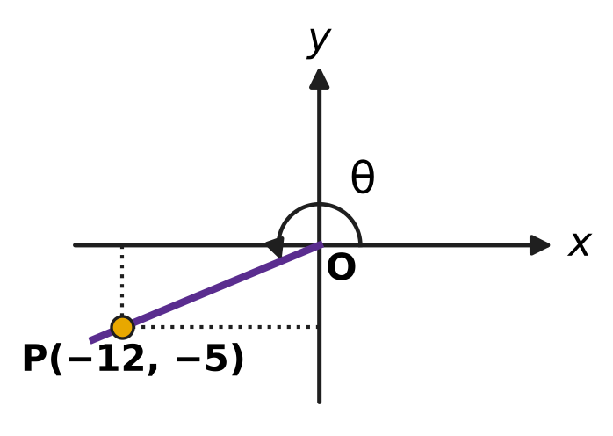
  (A) $−\frac{17}{13}$ | (B) $\frac{7}{13}$ | (C) $−\frac{7}{13}$ | (D) $\frac{17}{13}$

Q22. The angle A is acute and $cos2A=\frac{15}{17}$. What is tan A?
(A) 4 | (B) $\frac{1}{4}$ | (C) $\frac{8}{15}$ | (D) $\frac{1}{16}$

Q23. For two angles A and B, tan(A + B) = 3 and tan(A − B) = 2. What is the value of tan 2A?
(A) −1 | (B) 5 | (C) $\frac{5}{7}$ | (D) $\frac{1}{7}$

Q24. The angles A and B are acute and A + B = 45°. What is the value of (1 + tan A)(1 + tan B)?
(A) 4 | (B) 1 | (C) $\sqrt{2}$ | (D) 2

Part 5 — Data Handling, Statistics & Probability (Syllabus Chapter 8)
Q25. In art class, Kiara colours a flag that has 3 horizontal stripes. She has 7 crayons of different colours, and each stripe must be a different colour. Two flags are different if any stripe has a different colour. How many different flags can she make?
(A) 120 | (B) 35 | (C) 210 | (D) 343

Q26. A short quiz has 5 questions, and each question has 4 answer choices, of which exactly one is right. Sonal guesses every answer, choosing each answer choice with the same chance, independently. What is the probability that exactly 2 of her answers are right?
(A) $\frac{1}{16}$ | (B) $\frac{135}{512}$ | (C) $\frac{27}{1024}$ | (D) $\frac{45}{512}$

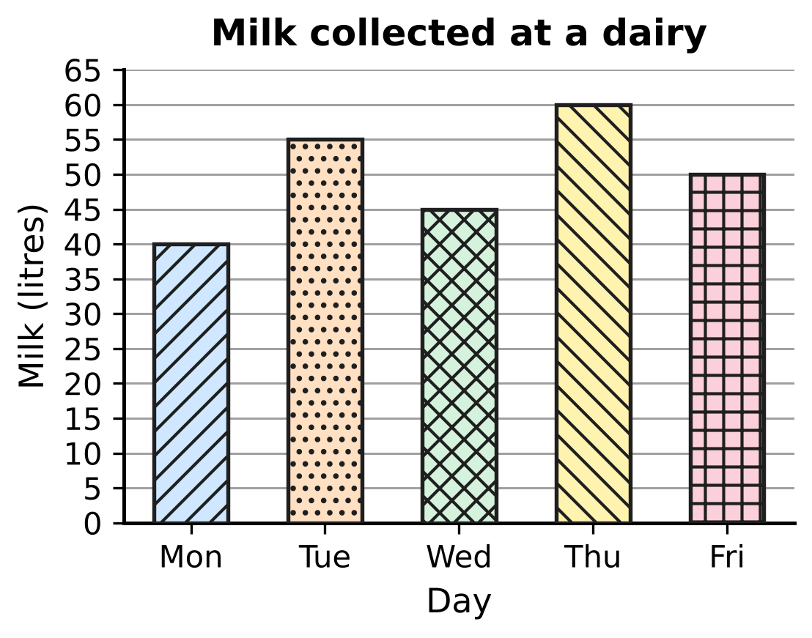
Q27. The bar graph in the figure shows the milk collected at a small dairy on five days. What is the standard deviation of the five amounts?
(A) $5\sqrt{2}$ litres | (B) 6 litres
(C) $5\sqrt{10}$ litres | (D) 50 litres

Q28. On a zoo visit, Noor will see 6 animal houses, one after another, visiting each house exactly once. She wants to see the lion house at some time before the tiger house, with or without other houses in between. In how many orders can she visit the 6 houses?
(A) 120 | (B) 360 | (C) 720 | (D) 240

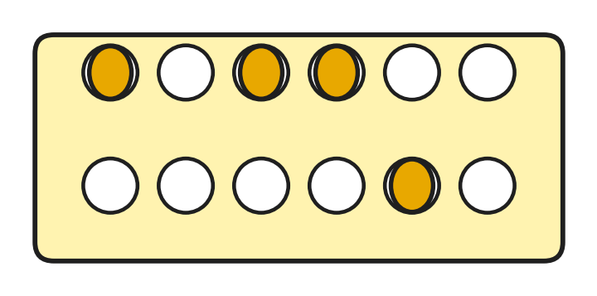
Q29. Zayan has an egg tray with 2 rows of 6 cups, as in the figure. He puts 4 identical eggs in the tray, one egg to a cup, so that neither row is left empty. The figure shows one way. In how many different ways can he place the 4 eggs?
(A) 225 | (B) 495 | (C) 480 | (D) 465

Q30. Trisha and 5 friends meet at a badminton court. A doubles match is played by two teams of 2 players each. Two matches are different if the two teams are different. How many different doubles matches can be chosen from these 6 players?
(A) 15 | (B) 30 | (C) 45 | (D) 90

Q31. Garima times how long candles burn. Her 10 small candles burn for a mean of 20 minutes with variance 4 min². Her 10 large candles burn for a mean of 30 minutes, also with variance 4 min². What is the variance of the burning times of all 20 candles together?
(A) 104 min² | (B) 29 min² | (C) 4 min² | (D) 8 min²

Part 6 — Applied Mathematics (Syllabus Chapter 9)
Q32. Rupa and Ojas open a bookshop. Rupa puts in ₹50,000 for the whole year. Ojas puts in ₹80,000, but only for the last 9 months of the year. They share the year's profit of ₹28,600 in the ratio of (money × time). What is Ojas's share?
(A) ₹15,600 | (B) ₹17,600 | (C) ₹13,000 | (D) ₹14,300

Q33. Eshan is cooking for a large group. When he peels potatoes, 20% of their weight is lost as peel, so the yield is 80%. His recipe needs 6 kg of peeled potatoes. What weight of unpeeled potatoes does he need?
(A) 7.2 kg | (B) 8 kg | (C) 4.8 kg | (D) 7.5 kg

Q34. Komal will need ₹17,640 in 2 years to buy wooden planks for new shelves. Her bank pays 5% a year, compounded yearly. How much must she deposit today so that it grows to exactly ₹17,640 in 2 years?
(A) ₹16,800 | (B) ₹15,876 | (C) ₹16,000 | (D) ₹16,758

Q35. Imran runs a river ferry that moves at 10 km/h in still water. One morning the ferry goes 24 km upstream and then comes 24 km back downstream. The round trip takes 5 hours of travel. What is the speed of the stream?
(A) 4 km/h | (B) 5.2 km/h | (C) 0.4 km/h | (D) 2 km/h

Part 7 — Mathematical Reasoning & Problem-Solving (Syllabus Chapter 10)
Q36. Points are marked inside or on the edge of a square of side 3 cm. What is the least number of points that makes it certain that some two of the points are at most √2 cm apart?
(A) 5 | (B) 10 | (C) 19 | (D) 9

Q37. One square (shaded) has been removed from the 8 × 8 board in the figure. An induction proof shows that such a board can be covered by L-shaped tiles of 3 squares. In the induction step, the board is cut into four 4 × 4 quarters, and one tile is put at the centre so that it covers one square from each quarter that has no removed square. Which of the four centre squares E, F, G and H is NOT covered by this tile? | 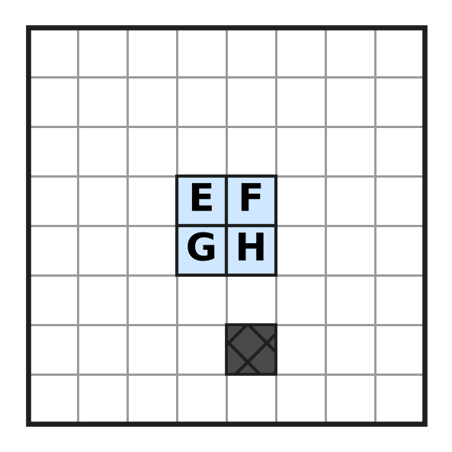
  (A) Square E | (B) Square F | (C) Square G | (D) Square H

Q38. By induction one can prove that (1 + x)ᵏ ≥ 1 + kx for every natural number k and every x > −1. Using this result, which of these statements is surely true?
(A) 1.01¹⁰⁰ ≥ 2 | (B) 1.1¹⁰ ≤ 2
(C) 0.99¹⁰⁰ ≥ 2 | (D) 1.05²⁰ ≥ 3

Q39. How many different numbers from the list 1, 2, 3, …, 20 must be picked to guarantee that one of the picked numbers is a factor of another picked number?
(A) 10 | (B) 9 | (C) 11 | (D) 21

Q40. Some squares of the 5 × 5 grid in the figure are to be shaded so that every 2 × 2 block of four squares inside the grid contains at least one shaded square. What is the least number of squares that must be shaded? | 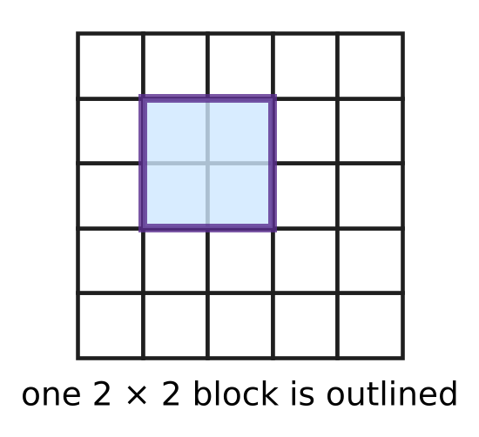
  (A) 4 | (B) 9 | (C) 5 | (D) 6

SECTION II — Star Questions 5 questions × 4 marks each
Q41. A sequence has $a_{1}=1$, $a_{2}=4$ and $a_{n+2}=4a_{n+1}−4a_{n}$ for every natural number n. What is the value of $a_{1}+a_{2}+a_{3}+…+a_{15}$? [4 marks]
(A) 491,521 | (B) 245,760 | (C) 458,753 | (D) 458,752

Q42. A bag holds 1 red ball and 3 blue balls. Chetan draws a ball at random, notes its colour and puts it back. He does this 8 times. What is the probability that he draws the red ball an even number of times? (If the red ball is never drawn, that counts as an even number of times.) [4 marks]
(A) $\frac{255}{512}$ | (B) $\frac{257}{512}$ | (C) $\frac{1}{256}$ | (D) $\frac{1}{2}$

Q43. What is the value of $1+2i+3i^{2}+4i^{3}+5i^{4}+…+20i^{19}$? [4 marks]
(A) 10 − 10i | (B) −20 − 20i
(C) −10 + 10i | (D) −10 − 10i

Q44. In the figure, the line x cos 22.5° + y sin 22.5° = 2 meets the x-axis at A and the y-axis at B. What is the length of AB? [4 marks] | 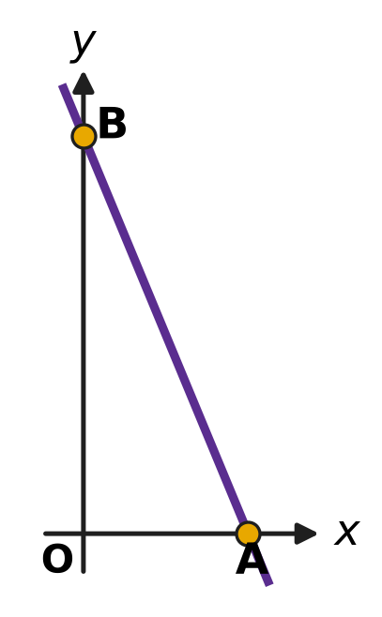
  (A) $4\sqrt{2}$ | (B) 4
  (C) $2\sqrt{2}$ | (D) 2

Q45. Ten different points are marked, and some pairs of them are joined by segments, so that no three of the points have all three of their segments drawn. The greatest possible number of segments is drawn. Two drawings are different if some segment is in one but not in the other. How many different drawings are possible? [4 marks]
(A) 252 | (B) 126 | (C) 25 | (D) 210

Answer Sheet AMO Level 1 · Class 11 · Practice Paper 4
Name: | School: | Roll No.:
Shade or tick one circle for each question.
1. Ⓐ Ⓑ Ⓒ Ⓓ | 16. Ⓐ Ⓑ Ⓒ Ⓓ | 31. Ⓐ Ⓑ Ⓒ Ⓓ
2. Ⓐ Ⓑ Ⓒ Ⓓ | 17. Ⓐ Ⓑ Ⓒ Ⓓ | 32. Ⓐ Ⓑ Ⓒ Ⓓ
3. Ⓐ Ⓑ Ⓒ Ⓓ | 18. Ⓐ Ⓑ Ⓒ Ⓓ | 33. Ⓐ Ⓑ Ⓒ Ⓓ
4. Ⓐ Ⓑ Ⓒ Ⓓ | 19. Ⓐ Ⓑ Ⓒ Ⓓ | 34. Ⓐ Ⓑ Ⓒ Ⓓ
5. Ⓐ Ⓑ Ⓒ Ⓓ | 20. Ⓐ Ⓑ Ⓒ Ⓓ | 35. Ⓐ Ⓑ Ⓒ Ⓓ
6. Ⓐ Ⓑ Ⓒ Ⓓ | 21. Ⓐ Ⓑ Ⓒ Ⓓ | 36. Ⓐ Ⓑ Ⓒ Ⓓ
7. Ⓐ Ⓑ Ⓒ Ⓓ | 22. Ⓐ Ⓑ Ⓒ Ⓓ | 37. Ⓐ Ⓑ Ⓒ Ⓓ
8. Ⓐ Ⓑ Ⓒ Ⓓ | 23. Ⓐ Ⓑ Ⓒ Ⓓ | 38. Ⓐ Ⓑ Ⓒ Ⓓ
9. Ⓐ Ⓑ Ⓒ Ⓓ | 24. Ⓐ Ⓑ Ⓒ Ⓓ | 39. Ⓐ Ⓑ Ⓒ Ⓓ
10. Ⓐ Ⓑ Ⓒ Ⓓ | 25. Ⓐ Ⓑ Ⓒ Ⓓ | 40. Ⓐ Ⓑ Ⓒ Ⓓ
11. Ⓐ Ⓑ Ⓒ Ⓓ | 26. Ⓐ Ⓑ Ⓒ Ⓓ | 41. Ⓐ Ⓑ Ⓒ Ⓓ
12. Ⓐ Ⓑ Ⓒ Ⓓ | 27. Ⓐ Ⓑ Ⓒ Ⓓ | 42. Ⓐ Ⓑ Ⓒ Ⓓ
13. Ⓐ Ⓑ Ⓒ Ⓓ | 28. Ⓐ Ⓑ Ⓒ Ⓓ | 43. Ⓐ Ⓑ Ⓒ Ⓓ
14. Ⓐ Ⓑ Ⓒ Ⓓ | 29. Ⓐ Ⓑ Ⓒ Ⓓ | 44. Ⓐ Ⓑ Ⓒ Ⓓ
15. Ⓐ Ⓑ Ⓒ Ⓓ | 30. Ⓐ Ⓑ Ⓒ Ⓓ | 45. Ⓐ Ⓑ Ⓒ Ⓓ
Q41–Q45 are Section II Star Questions (4 marks each).
For the parent or teacher
Section I correct: ______ / 40 × 2 = ______ marks Section II correct: ______ / 5 × 4 = ______ marks
Correct: ______ / 45 Score: ______ / 100
Answer Key and Solutions AMO Level 1 · Class 11 · Practice Paper 4
Quick answers
1 B | 6 C | 11 B | 16 C | 21 A | 26 B | 31 B | 36 B | 41 C
2 C | 7 D | 12 A | 17 D | 22 B | 27 A | 32 A | 37 D | 42 B
3 D | 8 A | 13 C | 18 B | 23 A | 28 B | 33 D | 38 A | 43 D
4 A | 9 C | 14 D | 19 D | 24 D | 29 D | 34 C | 39 C | 44 A
5 B | 10 B | 15 A | 20 C | 25 C | 30 C | 35 D | 40 A | 45 B
Solutions
Q | Part · level | Answer | Why?
1 | Part 1 · Ch1 · Easy | (B) 10 | z₁ = 2 + 5i and z₂ = 4 + 3i, so z₁ + z₂ = 6 + 8i. Its modulus is √(36 + 64) = √100 = 10.
2 | Part 1 · Ch1 · Easy | (C) −10 | z² = 4 + 12i + 9i² = −5 + 12i and the square of the conjugate is −5 − 12i. Their sum is −10.
3 | Part 1 · Ch1 · Easy | (D) −i | 1/i = −i, and the first four terms −i, −1, i, 1 add up to 0. So the sum is i⁻⁵ = i⁻¹ = −i.
4 | Part 1 · Ch1 · Medium | (A) 0 | z = 1 + 2i is a root of z² − 2z + 5 = 0 (roots 1 ± 2i). Since z³ − 3z² + 7z − 5 = (z² − 2z + 5)(z − 1), its value is 0.
5 | Part 1 · Ch1 · Medium | (B) −32i | An argument of 3π/4 puts z in the second quadrant with real part = −(imaginary part), so a = −4. Then z² = (−4 + 4i)² = 16 − 32i − 16 = −32i.
6 | Part 2 · Ch4 · Easy | (C) 5 | The means pair off from the ends, each pair adding to 3 + 43 = 46, so n means add up to 23n. Then 23n = 115 gives n = 5.
7 | Part 2 · Ch4 · Easy | (D) 7 | Multiply by 10: 5x − 2(x − 3) < 30, so 3x + 6 < 30 and x < 8. The greatest integer is 7.
8 | Part 2 · Ch4 · Easy | (A) $\frac{3}{4}$ | The x⁴ term is C(6, 2)a²x⁴ = 15a²x⁴ and the x³ term is C(6, 3)a³x³ = 20a³x³. So 15a² = 20a³, and a = 3/4.
9 | Part 2 · Ch4 · Easy | (C) 8,281 | A cube of edge k cm uses k³ small cubes. So the total is 1³ + 2³ + … + 13³ = (13 × 14 ÷ 2)² = 91² = 8,281.
10 | Part 2 · Ch4 · Easy | (B) 320 litres | The amounts form a GP with first term 2,430 and ratio 2/3. The 6th term is 2,430 × (2/3)⁵ = 2,430 × 32/243 = 320 litres.
11 | Part 2 · Ch4 · Medium | (B) 128 cm² | Each new square has half the area of the one before (its side is 1/√2 times as long). The areas 64, 32, 16, … form a GP with ratio 1/2, so the total is 64 ÷ (1 − 1/2) = 128 cm².
12 | Part 2 · Ch4 · Medium | (A) 3 | S₆ = S₃ + r³ × S₃, because terms 4 to 6 are terms 1 to 3 times r³. So 1 + r³ = 28, r³ = 27 and r = 3.
13 | Part 2 · Ch4 · Medium | (C) 583 | The numbers are 13, 21, 29, …, 93, an AP with common difference 8. There are (93 − 13) ÷ 8 + 1 = 11 of them, so the sum is 11 × (13 + 93) ÷ 2 = 583.
14 | Part 2 · Ch4 · Medium | (D) 540x³ | Putting x = 1, the coefficients add up to 4 to the power n, and 4,096 = 4⁶, so n = 6. The middle term is the 4th: C(6, 3)(3x)³ = 20 × 27x³ = 540x³.
15 | Part 3 · Ch5 · Easy | (A) 2x − 3y = 13 | ON has slope −3/2, so the line has slope 2/3. Through N: y + 3 = (2/3)(x − 2), which gives 2x − 3y = 13.
16 | Part 3 · Ch5 · Easy | (C) (0, −3) | AB has slope (3 + 1)/(3 + 3) = 2/3. Through C(3, −1): y = (2/3)x − 3, so it meets the y-axis at (0, −3).
17 | Part 3 · Ch5 · Easy | (D) 3x − 2y + 3 = 0 | Write y = mx + m. The point (1, 3) gives 3 = 2m, so m = 3/2 and y = (3/2)x + 3/2, that is 3x − 2y + 3 = 0.
18 | Part 3 · Ch5 · Medium | (B) 2 | The first two lines meet where 3x = 9, at (3, 2). Then 3k + 6 = 12, so k = 2.
19 | Part 3 · Ch5 · Medium | (D) 840 m | Distance = |4 × 6 − 3 × (−2) + 12| ÷ √(16 + 9) = 42 ÷ 5 = 8.4 units, and 8.4 × 100 m = 840 m.
20 | Part 4 · Ch7 · Easy | (C) −2 sin θ | sin(−θ) = −sin θ, sin(180° + θ) = −sin θ, sin(180° − θ) = sin θ and sin(360° − θ) = −sin θ. The total is −2 sin θ.
21 | Part 4 · Ch7 · Easy | (A) $−\frac{17}{13}$ | OP = √(144 + 25) = 13. So sin θ = −5/13 and cos θ = −12/13, and sin θ + cos θ = −17/13.
22 | Part 4 · Ch7 · Easy | (B) $\frac{1}{4}$ | tan²A = (1 − cos 2A)/(1 + cos 2A) = (2/17)/(32/17) = 1/16. A is acute, so tan A = 1/4.
23 | Part 4 · Ch7 · Medium | (A) −1 | 2A = (A + B) + (A − B), so tan 2A = (3 + 2) ÷ (1 − 3 × 2) = 5 ÷ (−5) = −1.
24 | Part 4 · Ch7 · Medium | (D) 2 | tan(A + B) = 1 gives tan A + tan B = 1 − tan A tan B. So (1 + tan A)(1 + tan B) = 1 + (tan A + tan B) + tan A tan B = 1 + 1 = 2.
25 | Part 5 · Ch8 · Easy | (C) 210 | The top stripe has 7 choices, the middle 6 and the bottom 5: P(7, 3) = 7 × 6 × 5 = 210.
26 | Part 5 · Ch8 · Easy | (B) $\frac{135}{512}$ | Each answer is right with probability 1/4. P(exactly 2) = C(5, 2)(1/4)²(3/4)³ = 10 × 27/1,024 = 135/512.
27 | Part 5 · Ch8 · Easy | (A) $5\sqrt{2}$ litres | The mean is 250 ÷ 5 = 50 L. The squared deviations are 100, 25, 25, 100 and 0, with mean 250 ÷ 5 = 50. So SD = √50 = 5√2 litres.
28 | Part 5 · Ch8 · Easy | (B) 360 | In exactly half of the 6! = 720 orders the lion house comes before the tiger house, so there are 360 orders.
29 | Part 5 · Ch8 · Medium | (D) 465 | Any 4 of the 12 cups: C(12, 4) = 495 ways. All 4 eggs in one row: 2 × C(6, 4) = 30 ways. So 495 − 30 = 465 ways leave neither row empty.
30 | Part 5 · Ch8 · Medium | (C) 45 | Choose the 4 players in C(6, 4) = 15 ways. Four players can be split into two pairs in 3 ways (partner of a fixed player). Total 15 × 3 = 45.
31 | Part 5 · Ch8 · Medium | (B) 29 min² | Mean of squares: small (4 + 400), large (4 + 900); together (404 + 904) ÷ 2 = 654. The combined mean is 25, so the variance is 654 − 625 = 29 min².
32 | Part 6 · Ch9 · Easy | (A) ₹15,600 | Rupa : Ojas = 50,000 × 12 : 80,000 × 9 = 600,000 : 720,000 = 5 : 6. Ojas gets 6/11 × ₹28,600 = ₹15,600.
33 | Part 6 · Ch9 · Easy | (D) 7.5 kg | Peeled weight = 0.8 × unpeeled weight. So the unpeeled weight is 6 ÷ 0.8 = 7.5 kg.
34 | Part 6 · Ch9 · Easy | (C) ₹16,000 | The deposit P grows to P × 1.05² = 1.1025P. So 1.1025P = 17,640 and P = ₹16,000.
35 | Part 6 · Ch9 · Medium | (D) 2 km/h | 24/(10 − s) + 24/(10 + s) = 5 gives 480 = 5(100 − s²), so s² = 4 and the stream flows at 2 km/h (8 km/h up for 3 h, 12 km/h down for 2 h).
36 | Part 7 · Ch10 · Easy | (B) 10 | Cut the square into 9 squares of side 1 cm; two points in one small square are at most √2 cm apart. With 10 points, two share a small square. But 9 points in a 3 × 3 grid, 1.5 cm apart, are all more than √2 cm apart, so 9 is too few.
37 | Part 7 · Ch10 · Easy | (D) Square H | The removed square is in the bottom-right quarter. The centre tile must cover one square of each of the other three quarters (E, F and G), so H, which belongs to the bottom-right quarter, stays uncovered.
38 | Part 7 · Ch10 · Easy | (A) 1.01¹⁰⁰ ≥ 2 | With x = 0.01 and n = 100: 1.01¹⁰⁰ ≥ 1 + 100 × 0.01 = 2. (The other three are false: 1.1¹⁰ ≈ 2.59, 0.99¹⁰⁰ < 1 and 1.05²⁰ ≈ 2.65.)
39 | Part 7 · Ch10 · Medium | (C) 11 | Write each number as 2ᵏ × (odd number). There are only 10 odd parts (1, 3, …, 19), so among 11 numbers two share an odd part, and the smaller divides the larger. The 10 numbers 11 to 20 show that 10 are not enough.
40 | Part 7 · Ch10 · Medium | (A) 4 | The four 2 × 2 blocks in the corners of the grid share no square, so at least 4 squares are needed. Shading the 4 squares in rows 2 and 4 and columns 2 and 4 meets every 2 × 2 block, so 4 is enough.
41 | Section II · Ch4 + Ch10 · Hard | (C) 458,753 | The terms 1, 4, 12, 32, 80, … are 1 × 1, 2 × 2, 3 × 4, 4 × 8, 5 × 16, so term k is k × 2ᵏ⁻¹; by induction, if it holds for k and k + 1 then the next term is 4(k + 1)2ᵏ − 4k × 2ᵏ⁻¹ = (k + 2)2ᵏ⁺¹. For S = 1 + 2 × 2 + 3 × 2² + … + 15 × 2¹⁴, 2S − S = 15 × 2¹⁵ − (1 + 2 + … + 2¹⁴) = 491,520 − 32,767 = 458,753.
42 | Section II · Ch4 + Ch8 · Hard | (B) $\frac{257}{512}$ | Expanding (3/4 + 1/4)⁸ = 1 and (3/4 − 1/4)⁸ = 1/256 by the binomial theorem, the terms for an odd number of reds cancel when the two are added. So the probability of an even number of reds is (1 + 1/256) ÷ 2 = 257/512.
43 | Section II · Ch1 + Ch4 · Hard | (D) −10 − 10i | Group the terms in fours: k + (k + 1)i − (k + 2) − (k + 3)i = −2 − 2i for k = 1, 5, 9, 13, 17. Five groups give 5 × (−2 − 2i) = −10 − 10i.
44 | Section II · Ch5 + Ch7 · Hard | (A) $4\sqrt{2}$ | The intercepts are OA = 2/cos 22.5° and OB = 2/sin 22.5°. So AB² = 4(sin²22.5° + cos²22.5°)/(sin 22.5° cos 22.5°)² = 4/(sin 22.5° cos 22.5°)², giving AB = 2/(sin 22.5° cos 22.5°) = 4/sin 45° = 4√2.
45 | Section II · Ch8 + Ch10 · Hard | (B) 126 | If a point with the most segments has d of them, its d partners are not joined to each other, so there are at most d(10 − d) ≤ 25 segments, with 25 only when the points split into two groups of 5 and every point is joined to all 5 points of the other group. Choosing the groups: C(10, 5) ÷ 2 = 126 drawings.

