UNLOCK IQ INSTITUTE
Realize Your True Potential
Aryabhatta Maths Olympiad (AMO)
Level 1 — Practice Paper 5
CLASS 11

Questions | 45 multiple-choice questions
Marks | 100
Time | 60 minutes
Section I | 40 questions × 2 marks = 80 marks
Section II | 5 Star Questions × 4 marks = 20 marks
Negative marking | No negative marking
Calculator | Not allowed
Chapters | Number System · Algebra · Geometry · Trigonometry · Data Handling · Applied Mathematics · Mathematical Reasoning

Instructions to candidates
• This paper has 45 multiple-choice questions. Each question has four answer choices, of which exactly one is correct.
• Section I (Q1–Q40) carries 2 marks per question. Section II (Q41–Q45) carries 4 marks per question.
• There is no negative marking. Unanswered questions score zero.
• Calculators are not permitted. Rough work may be done on a separate sheet.
• Mark your answers on the answer sheet at the end of the paper.
• All figures are not necessarily drawn to scale unless stated.

For parents and teachers
Print or view this paper in colour. Pictures are part of the questions.
Parts follow the AMO syllabus chapters. Chapters 2, 3 and 6 are not part of the Class 11 syllabus, so the chapter numbers shown in the Part headings have gaps.
The answer sheet and the answer key are at the end. Remove only the answer key before the student begins.

Name: | School: | Roll No.:

SECTION I 40 questions × 2 marks each
Part 1 — Number System (Syllabus Chapter 1)
Q1. The real numbers x and y are such that 3 + (x − 2)i is the conjugate of y + 5i. What is the value of x + y?
(A) −4 | (B) 0 | (C) 4 | (D) 10

Q2. The complex number z = x + 3i, where x is real, satisfies |z| = |z − 4|. What is the value of x?
(A) −2 | (B) 4 | (C) 8 | (D) 2

Q3. How many of the twenty numbers i, i², i³, …, i²⁰ are real numbers?
(A) 11 | (B) 5 | (C) 10 | (D) 15

Q4. A complex number z satisfies z + |z| = 2 + 8i. What is the value of |z|?
(A) 17 | (B) 15
(C) 8 | (D) $2\sqrt{17}$

Q5. The numbers p and q are real. In the figure, the points P and R on the Argand plane represent the two roots of the equation x² + px + q = 0. What is the value of p + q? | 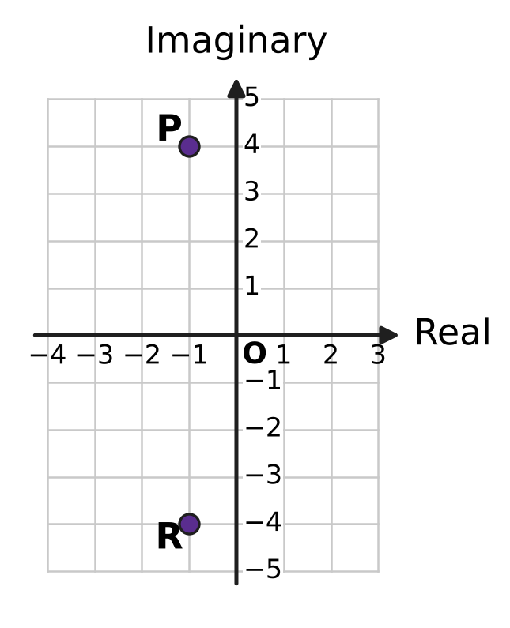
  (A) −13 | (B) 17 | (C) 15 | (D) 19

Part 2 — Algebra (Syllabus Chapter 4)
Q6. In a geometric progression, the second term is 6 and the fifth term is −48. What is the first term?
(A) −3 | (B) 3 | (C) 12 | (D) −12

Q7. The arithmetic progression 120, 116, 112, 108, … goes on for ever. Which term is its first negative term?
(A) the 30th term | (B) the 33rd term
(C) the 32nd term | (D) the 31st term

Q8. The five interior angles of a pentagon form an arithmetic progression. The smallest angle is 90°. What is the largest angle?
(A) 135° | (B) 126° | (C) 117° | (D) 108°

Q9. In the expansion of (1 + x)^{n}, where n is a natural number, the coefficient of x² is 36. What is n?
(A) 6 | (B) 18 | (C) 9 | (D) 72

Q10. A real number x satisfies both 3x + 2 > 14 and 13 − 2x ≥ −5. Which of these describes all such numbers x?
(A) 4 ≤ x ≤ 9 | (B) 4 < x ≤ 9
(C) x ≥ 9 | (D) $\frac{16}{3}$ < x ≤ 9

Q11. An arithmetic progression and a geometric progression of positive numbers both have first term 2 and third term 18. By how much is the second term of the arithmetic progression greater than the second term of the geometric progression?
(A) −4 | (B) 10 | (C) 6 | (D) 4

Q12. An infinite geometric progression has sum 3. The squares of its terms form another infinite geometric progression, whose sum is $\frac{9}{2}$. What is the first term of the first progression?
(A) 2 | (B) $\frac{1}{3}$ | (C) $\frac{3}{2}$ | (D) 3

Q13. What is the value of 1² − 2² + 3² − 4² + 5² − … − 28² + 29², where the signs of the squares alternate?
(A) 406 | (B) 434 | (C) 435 | (D) 841

Q14. The expansion of (2x + 3)⁵ in powers of x has two middle terms, one in x³ and one in x². What is the ratio of the coefficient of x³ to the coefficient of x²?
(A) 2 : 3 | (B) 1 : 1 | (C) 3 : 2 | (D) 4 : 9

Part 3 — Geometry (Syllabus Chapter 5)
Q15. A straight line meets the x-axis at (9, 0) and passes through the point (3, 4). At what value of y does it meet the y-axis?
(A) −6 | (B) $\frac{27}{5}$ | (C) 12 | (D) 6

Q16. In the figure, the line ℓ crosses the negative part of the x-axis and the positive part of the y-axis. Exactly one of these equations could be the equation of ℓ. Which one? | 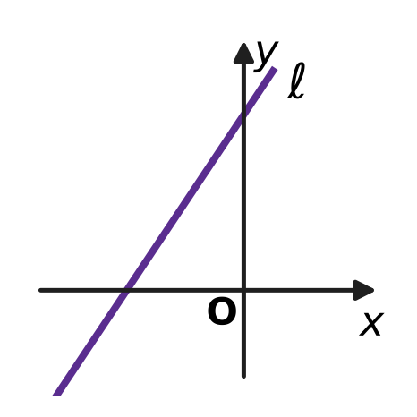
  (A) 3x − 2y − 6 = 0 | (B) 3x − 2y + 6 = 0
  (C) 3x + 2y + 6 = 0 | (D) 3x + 2y − 6 = 0

Q17. Two different points lie on the y-axis. Each of them is at a perpendicular distance of 12 units from the line 7x − 24y + 48 = 0. How far apart are the two points?
(A) 24 units | (B) 25 units
(C) 1 unit | (D) 12.5 units

Q18. In the figure, a flat mirror lies along the x-axis. A ray of light from A(2, 6) strikes the mirror at M and is reflected so that it passes through B(8, 3). The ray makes equal angles with the mirror before and after M. What are the coordinates of M? | 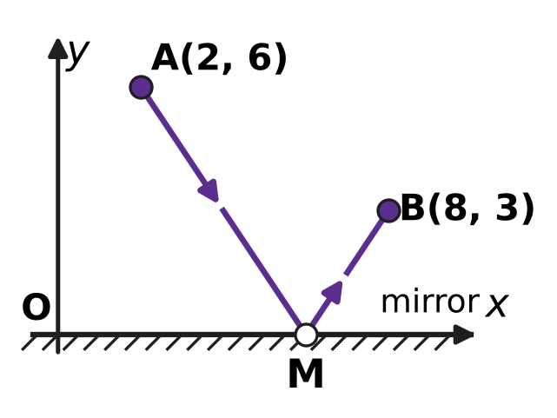
  (A) (14, 0) | (B) (4, 0) | (C) (5, 0) | (D) (6, 0)

Q19. For every real number k, the line (2 + k)x + (1 − k)y = 3 + 3k passes through one and the same point. What is that point?
(A) (1, 1) | (B) (−1, 2) | (C) (2, −1) | (D) (3, 0)

Part 4 — Trigonometry & Heights and Distances (Syllabus Chapter 7)
Q20. Which of these angles has the same sine as 200°?
(A) −20° | (B) 160° | (C) 380° | (D) 20°

Q21. In the figure, P$(\frac{3}{5},\frac{4}{5})$ and Q lie on a unit circle centred at the origin O. OP makes the angle θ with the positive x-axis, and OQ is OP turned anticlockwise through a right angle. What are the coordinates of Q? | 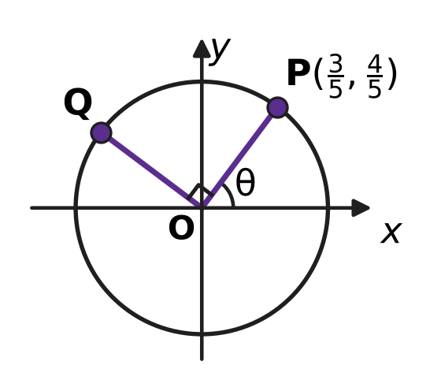
  (A) $(−\frac{4}{5},\frac{3}{5})$ | (B) $(\frac{4}{5},−\frac{3}{5})$
  (C) $(\frac{4}{5},\frac{3}{5})$ | (D) $(−\frac{3}{5},\frac{4}{5})$

Q22. What is the value of $\frac{sin{80}^{∘}−sin{20}^{∘}}{cos{50}^{∘}}$?
(A) $\frac{\sqrt{3}}{2}$ | (B) √3 tan 50°
(C) 1 | (D) 2

Q23. What is the exact value of tan 22.5°?
(A) −1 − √2 | (B) $\frac{1}{2}$ | (C) √2 + 1 | (D) √2 − 1

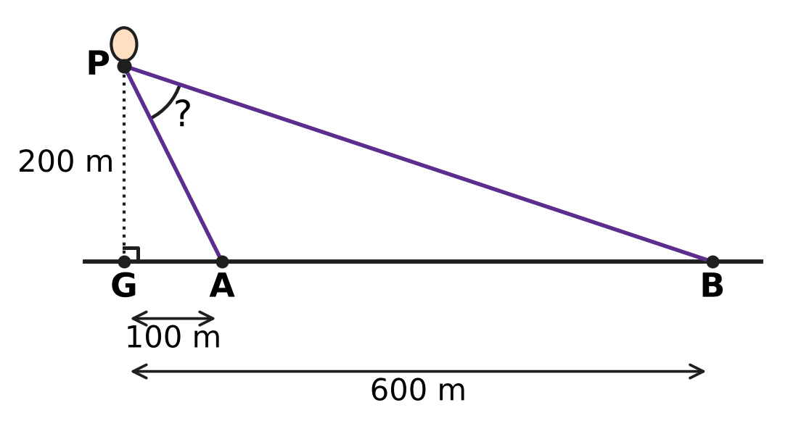
Q24. A hot-air balloon P is 200 m straight above the point G on level ground. Two observers stand at A and B on the ground, on the same side of G and in a straight line with it, with GA = 100 m and GB = 600 m, as in the figure. What is the angle APB between the two lines of sight at the balloon?
(A) 30° | (B) 45° | (C) 135° | (D) 60°

Part 5 — Data Handling, Statistics & Probability (Syllabus Chapter 8)
Q25. At an ice-cream stall, Kian chooses one of 3 kinds of cone and 2 scoops of different flavours from 6 flavours. The order of the two scoops is unimportant. In how many different ways can he choose his ice cream?
(A) 108 | (B) 18 | (C) 45 | (D) 90

Q26. In a music class, 7 students, including Myra, will each perform once, one after another. Myra must perform either first or last. In how many orders can the 7 performances take place?
(A) 240 | (B) 720 | (C) 5,040 | (D) 1,440

Q27. The weather office says that on each of the next 3 days the chance of rain is 0.3, and the days are independent of each other. What is the probability that it rains on at least one of the 3 days?
(A) 0.657 | (B) 0.343 | (C) 0.441 | (D) 0.973

Q28. At an airport, the numbers of planes that landed in each of five hours were recorded as 5, 8, 11, 14 and 17. The variance of these numbers is 18. Later it was found that the 17 was a mistake: the true number was 2. What is the variance of the corrected numbers?
(A) 33 | (B) 18 | (C) 22.5 | (D) 27

Q29. A team of 4 students is to be chosen from 10 students for a science exhibition. Two of the 10, Varsha and Jatin, are working on one model, so either both of them are in the team or neither of them is. How many different teams can be chosen?
(A) 112 | (B) 28 | (C) 98 | (D) 70

Q30. Each time Yash casts his fishing net, he catches a fish with the same probability, independently of the other casts. The probability that two casts both catch nothing is $\frac{4}{25}$. He now casts the net 3 times. What is the probability that he catches a fish on exactly 2 of the 3 casts?
(A) $\frac{81}{125}$ | (B) $\frac{54}{125}$ | (C) $\frac{36}{125}$ | (D) $\frac{18}{125}$

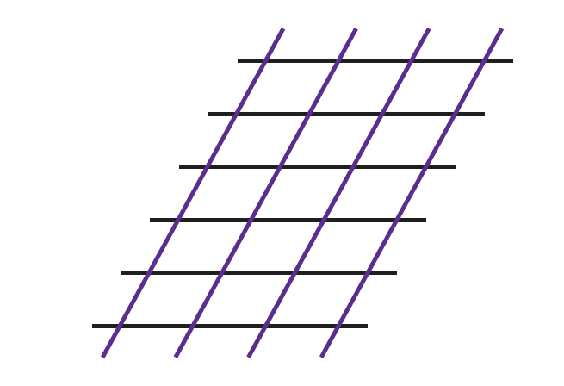
Q31. In the figure, 6 horizontal parallel lines are crossed by 4 slanting parallel lines. How many parallelograms of all sizes are formed whose four sides lie along these lines?
(A) 210 | (B) 15 | (C) 21 | (D) 90

Part 6 — Applied Mathematics (Syllabus Chapter 9)
Q32. Usha runs a tea stall. She buys a kettle for ₹2,000, on which GST is 5%, and paper cups for ₹1,000, on which GST is 18%. Both prices are before GST. How much does she pay in all?
(A) ₹3,280 | (B) ₹3,150 | (C) ₹3,540 | (D) ₹3,410

Q33. Anand puts money in a deposit that earns compound interest at a fixed yearly rate. The money doubles in 3 years. In how many years from the start will it become 8 times the money he put in?
(A) 21 years | (B) 24 years | (C) 12 years | (D) 9 years

Q34. The motor of a lift in a building is bought for ₹80,000. Each year it loses 10% of the value it had at the start of that year. What is its value after 3 years?
(A) ₹106,480 | (B) ₹64,800 | (C) ₹58,320 | (D) ₹56,000

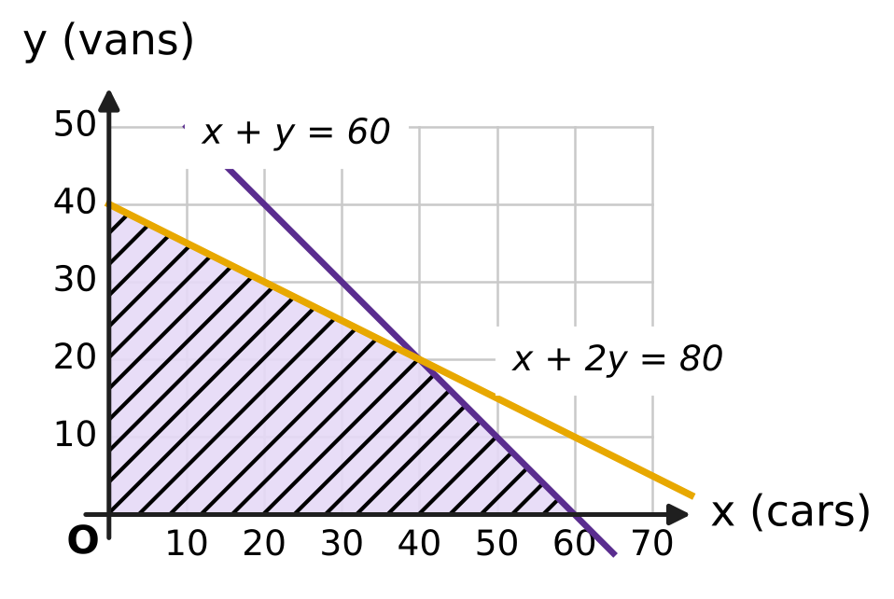
Q35. A car park can hold at most 60 vehicles. A car uses 1 unit of space and a van uses 2 units, and there are 80 units of space. With x cars and y vans, the shaded region in the figure shows all the allowed numbers. Each car pays ₹40 a day and each van pays ₹70 a day. What is the greatest possible income in a day?
(A) ₹2,400 | (B) ₹3,000 | (C) ₹4,200 | (D) ₹2,800

Part 7 — Mathematical Reasoning & Problem-Solving (Syllabus Chapter 10)
Q36. Nine students meet, and each pair of students shakes hands at most once. They want every student to shake hands with exactly k of the others. For which value of k is this impossible?
(A) k = 5 | (B) k = 4 | (C) k = 2 | (D) k = 6

Q37. In a game, a player scores either 3 points or 5 points at a time. A proof shows that every total of 8 or more points can be reached. It first checks some starting totals directly, and then uses this step: if a total n can be reached, so can n + 3. Which starting totals must it check?
(A) 8, 9 and 10 | (B) 8 and 9
(C) 8 only | (D) 3, 5 and 8

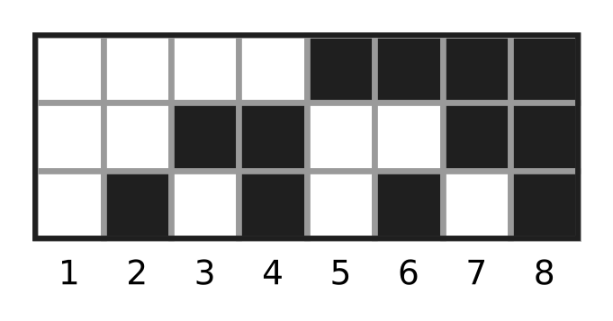
Q38. A board has 3 rows and some columns. Each square is painted black or white. The figure shows a board with 8 columns in which no two columns are painted alike. What is the least number of columns that makes sure that, however the squares are painted, some two columns are painted exactly alike?
(A) 7 | (B) 9 | (C) 4 | (D) 8

Q39. In a chess club, 7 players each play exactly one game against every other player, and no game is drawn. What is the greatest possible number of players who each win at least 5 games?
(A) 2 | (B) 4 | (C) 5 | (D) 3

Q40. How many 4-digit numbers have digits that strictly increase from left to right, such as 1358?
(A) 210 | (B) 252 | (C) 126 | (D) 3,024

SECTION II — Star Questions 5 questions × 4 marks each
Q41. In how many ways can 105 be written as a sum of two or more consecutive positive whole numbers? (For example, 105 = 52 + 53 is one way.) [4 marks]
(A) 3 | (B) 7 | (C) 14 | (D) 8

Q42. Three different numbers are chosen from the whole numbers 1 to 25, and the order of choosing is unimportant. In how many ways can they be chosen so that, written in increasing order, they form an arithmetic progression? [4 marks]
(A) 288 | (B) 222 | (C) 144 | (D) 132

Q43. The expression (x + 2i)⁶ is expanded in powers of x. Some of the coefficients are real numbers and the others are purely imaginary. What is the sum of the real coefficients? [4 marks]
(A) 365 | (B) 44 | (C) 161 | (D) 117

Q44. In the figure, OAB is an equilateral triangle, where O is the origin, the side OA lies along the line y = x, and B lies above that line. What is the sum of the slopes of OB and AB? [4 marks] | 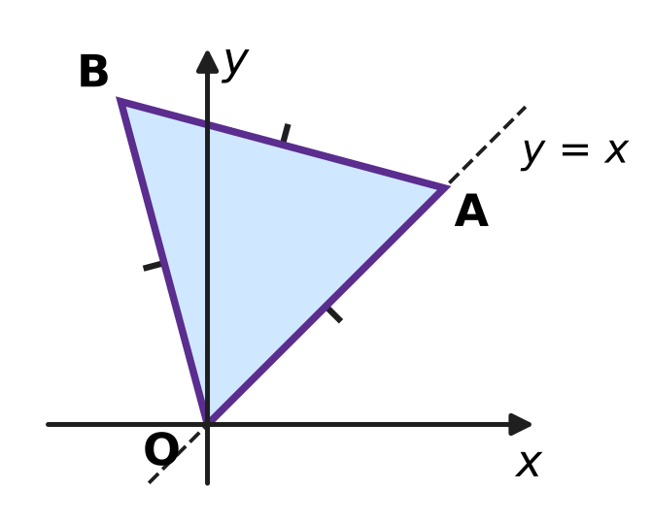
  (A) −4 | (B) −2√3 | (C) 2√3 | (D) 4

Q45. A school play has 7 actors. In every scene, exactly 3 of the actors are on stage. No two scenes have the same 3 actors, and no two actors are on stage together in more than one scene. What is the greatest possible number of scenes? [4 marks]
(A) 35 | (B) 21 | (C) 7 | (D) 2

Answer Sheet AMO Level 1 · Class 11 · Practice Paper 5
Name: | School: | Roll No.:
Shade or tick one circle for each question.
1. Ⓐ Ⓑ Ⓒ Ⓓ | 16. Ⓐ Ⓑ Ⓒ Ⓓ | 31. Ⓐ Ⓑ Ⓒ Ⓓ
2. Ⓐ Ⓑ Ⓒ Ⓓ | 17. Ⓐ Ⓑ Ⓒ Ⓓ | 32. Ⓐ Ⓑ Ⓒ Ⓓ
3. Ⓐ Ⓑ Ⓒ Ⓓ | 18. Ⓐ Ⓑ Ⓒ Ⓓ | 33. Ⓐ Ⓑ Ⓒ Ⓓ
4. Ⓐ Ⓑ Ⓒ Ⓓ | 19. Ⓐ Ⓑ Ⓒ Ⓓ | 34. Ⓐ Ⓑ Ⓒ Ⓓ
5. Ⓐ Ⓑ Ⓒ Ⓓ | 20. Ⓐ Ⓑ Ⓒ Ⓓ | 35. Ⓐ Ⓑ Ⓒ Ⓓ
6. Ⓐ Ⓑ Ⓒ Ⓓ | 21. Ⓐ Ⓑ Ⓒ Ⓓ | 36. Ⓐ Ⓑ Ⓒ Ⓓ
7. Ⓐ Ⓑ Ⓒ Ⓓ | 22. Ⓐ Ⓑ Ⓒ Ⓓ | 37. Ⓐ Ⓑ Ⓒ Ⓓ
8. Ⓐ Ⓑ Ⓒ Ⓓ | 23. Ⓐ Ⓑ Ⓒ Ⓓ | 38. Ⓐ Ⓑ Ⓒ Ⓓ
9. Ⓐ Ⓑ Ⓒ Ⓓ | 24. Ⓐ Ⓑ Ⓒ Ⓓ | 39. Ⓐ Ⓑ Ⓒ Ⓓ
10. Ⓐ Ⓑ Ⓒ Ⓓ | 25. Ⓐ Ⓑ Ⓒ Ⓓ | 40. Ⓐ Ⓑ Ⓒ Ⓓ
11. Ⓐ Ⓑ Ⓒ Ⓓ | 26. Ⓐ Ⓑ Ⓒ Ⓓ | 41. Ⓐ Ⓑ Ⓒ Ⓓ
12. Ⓐ Ⓑ Ⓒ Ⓓ | 27. Ⓐ Ⓑ Ⓒ Ⓓ | 42. Ⓐ Ⓑ Ⓒ Ⓓ
13. Ⓐ Ⓑ Ⓒ Ⓓ | 28. Ⓐ Ⓑ Ⓒ Ⓓ | 43. Ⓐ Ⓑ Ⓒ Ⓓ
14. Ⓐ Ⓑ Ⓒ Ⓓ | 29. Ⓐ Ⓑ Ⓒ Ⓓ | 44. Ⓐ Ⓑ Ⓒ Ⓓ
15. Ⓐ Ⓑ Ⓒ Ⓓ | 30. Ⓐ Ⓑ Ⓒ Ⓓ | 45. Ⓐ Ⓑ Ⓒ Ⓓ
Q41–Q45 are Section II Star Questions (4 marks each).
For the parent or teacher
Section I correct: ______ / 40 × 2 = ______ marks Section II correct: ______ / 5 × 4 = ______ marks
Correct: ______ / 45 Score: ______ / 100
Answer Key and Solutions AMO Level 1 · Class 11 · Practice Paper 5
Quick answers
1 B | 6 A | 11 D | 16 B | 21 A | 26 D | 31 D | 36 A | 41 B
2 D | 7 C | 12 A | 17 B | 22 C | 27 A | 32 A | 37 A | 42 C
3 C | 8 B | 13 C | 18 D | 23 D | 28 B | 33 D | 38 B | 43 D
4 A | 9 C | 14 A | 19 C | 24 B | 29 C | 34 C | 39 D | 44 A
5 D | 10 B | 15 D | 20 A | 25 C | 30 B | 35 B | 40 C | 45 C
Solutions
Q | Part · level | Answer | Why?
1 | Part 1 · Ch1 · Easy | (B) 0 | The conjugate of y + 5i is y − 5i. So y = 3 and x − 2 = −5, which gives x = −3, and x + y = 0.
2 | Part 1 · Ch1 · Easy | (D) 2 | x² + 9 = (x − 4)² + 9 gives x² = x² − 8x + 16, so 8x = 16 and x = 2.
3 | Part 1 · Ch1 · Easy | (C) 10 | i^{n} is real (1 or −1) exactly when n is even, and there are 10 even numbers from 1 to 20.
4 | Part 1 · Ch1 · Medium | (A) 17 | |z| is real, so z = a + 8i with a + √(a² + 64) = 2. Then a² + 64 = (2 − a)², so a = −15 and |z| = √(225 + 64) = 17.
5 | Part 1 · Ch1 · Medium | (D) 19 | The roots are −1 + 4i and −1 − 4i. Their sum is −2 = −p and their product is 1 + 16 = 17 = q. So p + q = 2 + 17 = 19.
6 | Part 2 · Ch4 · Easy | (A) −3 | r³ = −48 ÷ 6 = −8, so r = −2. The first term is 6 ÷ (−2) = −3.
7 | Part 2 · Ch4 · Easy | (C) the 32nd term | The nth term is 120 − 4(n − 1). The 31st term is 120 − 120 = 0, so the first negative term is the 32nd, which is −4.
8 | Part 2 · Ch4 · Easy | (B) 126° | The angles add up to 540°. So 5 × 90° + 10d = 540°, which gives d = 9°, and the largest angle is 90° + 4 × 9° = 126°.
9 | Part 2 · Ch4 · Easy | (C) 9 | The coefficient of x² is n(n − 1)/2 = 36, so n(n − 1) = 72 = 9 × 8, and n = 9.
10 | Part 2 · Ch4 · Easy | (B) 4 < x ≤ 9 | From 3x + 2 > 14, 3x > 12, so x > 4. From 13 − 2x ≥ −5, −2x ≥ −18, so x ≤ 9 (the sign turns round). Together, 4 < x ≤ 9.
11 | Part 2 · Ch4 · Medium | (D) 4 | The middle terms are the AM and the GM of 2 and 18: AM = 10 and GM = √36 = 6. The difference is 10 − 6 = 4.
12 | Part 2 · Ch4 · Medium | (A) 2 | a/(1 − r) = 3 and a²/(1 − r²) = 9/2. Dividing gives a/(1 + r) = 3/2, so 3(1 − r) = (3/2)(1 + r), r = 1/3 and a = 2.
13 | Part 2 · Ch4 · Medium | (C) 435 | Pair from the top: 29² − 28² = 57, 27² − 26² = 53, …, 3² − 2² = 5, and 1² = 1 is left. So the value is 1 + 5 + 9 + … + 57, an AP of 15 terms, which is 15 × 29 = 435.
14 | Part 2 · Ch4 · Medium | (A) 2 : 3 | The x³ term is C(5, 2) × 2³ × 3² = 720 and the x² term is C(5, 3) × 2² × 3³ = 1,080. So the ratio is 720 : 1,080 = 2 : 3.
15 | Part 3 · Ch5 · Easy | (D) 6 | In x/9 + y/b = 1, the point (3, 4) gives 1/3 + 4/b = 1, so 4/b = 2/3 and b = 6.
16 | Part 3 · Ch5 · Easy | (B) 3x − 2y + 6 = 0 | For 3x − 2y + 6 = 0, putting y = 0 gives x = −2 and putting x = 0 gives y = 3. The other three lines have an intercept of the wrong sign.
17 | Part 3 · Ch5 · Easy | (B) 25 units | For (0, b), the distance is |−24b + 48| ÷ 25 = 12, so −24b + 48 = 300 or −300. Then b = −10.5 or b = 14.5, and the points are 14.5 − (−10.5) = 25 units apart.
18 | Part 3 · Ch5 · Medium | (D) (6, 0) | Reflect B in the x-axis to B′(8, −3). The line AB′ has slope −9/6 = −3/2, so y − 6 = −(3/2)(x − 2). Putting y = 0 gives x = 6.
19 | Part 3 · Ch5 · Medium | (C) (2, −1) | Rewrite as (2x + y − 3) + k(x − y − 3) = 0. Both brackets are 0 when 2x + y = 3 and x − y = 3, that is x = 2, y = −1.
20 | Part 4 · Ch7 · Easy | (A) −20° | sin 200° = sin(180° + 20°) = −sin 20°, and sin(−20°) = −sin 20°. The other three angles have sine +sin 20°.
21 | Part 4 · Ch7 · Easy | (A) (−4/5, 3/5) | Q = (cos(θ + 90°), sin(θ + 90°)) = (−sin θ, cos θ) = (−4/5, 3/5).
22 | Part 4 · Ch7 · Easy | (C) 1 | sin 80° − sin 20° = 2 cos 50° sin 30° = cos 50°, so the value is 1.
23 | Part 4 · Ch7 · Medium | (D) √2 − 1 | With t = tan 22.5°, tan 45° = 2t/(1 − t²) = 1, so t² + 2t − 1 = 0 and t = −1 ± √2. As t > 0, t = √2 − 1.
24 | Part 4 · Ch7 · Medium | (B) 45° | The elevations at A and B have tangents 200/100 = 2 and 200/600 = 1/3. The angle at A is an exterior angle of triangle PAB, so angle APB is the difference of the two elevations, and tan(difference) = (2 − 1/3)/(1 + 2 × 1/3) = 1, so angle APB = 45°.
25 | Part 5 · Ch8 · Easy | (C) 45 | There are 3 cones and C(6, 2) = 15 pairs of flavours, so 3 × 15 = 45 ways.
26 | Part 5 · Ch8 · Easy | (D) 1,440 | Myra has 2 places, and the other 6 students fill the rest in 6! = 720 ways. So 2 × 720 = 1,440.
27 | Part 5 · Ch8 · Easy | (A) 0.657 | The chance that a day is dry is 0.7, so all 3 days are dry with chance 0.7³ = 0.343. At least one rainy day: 1 − 0.343 = 0.657.
28 | Part 5 · Ch8 · Easy | (B) 18 | The corrected numbers 2, 5, 8, 11, 14 are the old ones each reduced by 3. Shifting every value does not change the variance, so it is still 18.
29 | Part 5 · Ch8 · Medium | (C) 98 | Both in: choose 2 more from the other 8, C(8, 2) = 28. Neither in: choose all 4 from the other 8, C(8, 4) = 70. Total 28 + 70 = 98.
30 | Part 5 · Ch8 · Medium | (B) $\frac{54}{125}$ | The chance of no catch is √(4/25) = 2/5, so a catch has chance 3/5. Exactly 2 catches in 3 casts: 3 × (3/5)² × 2/5 = 54/125.
31 | Part 5 · Ch8 · Medium | (D) 90 | A parallelogram needs 2 of the 6 horizontal lines and 2 of the 4 slanting lines: C(6, 2) × C(4, 2) = 15 × 6 = 90.
32 | Part 6 · Ch9 · Easy | (A) ₹3,280 | GST is 5% of ₹2,000 = ₹100 and 18% of ₹1,000 = ₹180. Total = ₹3,000 + ₹280 = ₹3,280.
33 | Part 6 · Ch9 · Easy | (D) 9 years | Every 3 years the money is multiplied by 2. Since 8 = 2³, it takes 3 × 3 = 9 years.
34 | Part 6 · Ch9 · Easy | (C) ₹58,320 | Value = 80,000 × 0.9³ = 80,000 × 0.729 = ₹58,320.
35 | Part 6 · Ch9 · Medium | (B) ₹3,000 | The corners are (0, 0), (60, 0), (40, 20) and (0, 40), giving ₹0, ₹2,400, ₹3,000 and ₹2,800. The greatest is ₹3,000 at 40 cars and 20 vans.
36 | Part 7 · Ch10 · Easy | (A) k = 5 | Each handshake involves 2 students, so 9 × k must be even. That fails only for k = 5; for k = 2, 4, 6 seat them in a circle and shake with the nearest 1, 2 or 3 on each side.
37 | Part 7 · Ch10 · Easy | (A) 8, 9 and 10 | The step adds 3, so each starting total covers every third number. To cover all totals from 8 we need 8 = 3 + 5, 9 = 3 + 3 + 3 and 10 = 5 + 5.
38 | Part 7 · Ch10 · Easy | (B) 9 | A column can be painted in 2³ = 8 ways. With 9 columns, two must share a pattern, and the figure shows 8 columns are not enough.
39 | Part 7 · Ch10 · Medium | (D) 3 | If k players each win 5 or more, they win at least 5k games, but only C(k, 2) + k(7 − k) games involve them. This fails for k = 4 (20 > 18). For k = 3, let them beat each other in a cycle and beat all four others.
40 | Part 7 · Ch10 · Medium | (C) 126 | Any 4 different digits from 1 to 9 can be written in increasing order in exactly one way, and 0 cannot appear. So the count is C(9, 4) = 126.
41 | Section II · Ch4 + Ch10 · Hard | (B) 7 | n terms starting at a give n(2a + n − 1)/2 = 105, so n(2a + n − 1) = 210 with the two factors of opposite parity and n smaller. This gives n = 2, 3, 5, 6, 7, 10, 14: 7 ways.
42 | Section II · Ch4 + Ch8 · Hard | (C) 144 | With common difference d, the smallest number runs from 1 to 25 − 2d, giving 25 − 2d sets, for d = 1 to 12. Total = 23 + 21 + … + 1 = 144.
43 | Section II · Ch1 + Ch4 · Hard | (D) 117 | The real coefficients come from even powers of 2i: 1 + 15(2i)² + 15(2i)⁴ + (2i)⁶ = 1 − 60 + 240 − 64 = 117.
44 | Section II · Ch5 + Ch7 · Hard | (A) −4 | OB makes 45° + 60° = 105° and AB makes 45° + 120° = 165° with the x-axis. tan 105° = −(2 + √3) and tan 165° = −(2 − √3), so the sum is −4.
45 | Section II · Ch8 + Ch10 · Hard | (C) 7 | Each scene puts C(3, 2) = 3 pairs of actors together, and each of the C(7, 2) = 21 pairs can be together at most once, so there are at most 21 ÷ 3 = 7 scenes. Seven scenes are possible, for example with actors 1 to 7: 123, 145, 167, 246, 257, 347, 356.

