UNLOCK IQ INSTITUTE
Realize Your True Potential
Aryabhatta Maths Olympiad (AMO)
Level 1 — Practice Paper 2
CLASS 11

Questions | 45 multiple-choice questions
Marks | 100
Time | 60 minutes
Section I | 40 questions × 2 marks = 80 marks
Section II | 5 Star Questions × 4 marks = 20 marks
Negative marking | No negative marking
Calculator | Not allowed
Chapters | Number System · Algebra · Geometry · Trigonometry · Data Handling · Applied Mathematics · Mathematical Reasoning

Instructions to candidates
• This paper has 45 multiple-choice questions. Each question has four answer choices, of which exactly one is correct.
• Section I (Q1–Q40) carries 2 marks per question. Section II (Q41–Q45) carries 4 marks per question.
• There is no negative marking. Unanswered questions score zero.
• Calculators are not permitted. Rough work may be done on a separate sheet.
• Mark your answers on the answer sheet at the end of the paper.
• All figures are not necessarily drawn to scale unless stated.

For parents and teachers
Print or view this paper in colour. Pictures are part of the questions.
Parts follow the AMO syllabus chapters. Chapters 2, 3 and 6 are not part of the Class 11 syllabus, so the chapter numbers shown in the Part headings have gaps.
The answer sheet and the answer key are at the end. Remove only the answer key before the student begins.

Name: | School: | Roll No.:

SECTION I 40 questions × 2 marks each
Part 1 — Number System (Syllabus Chapter 1)
Q1. Which of these complex numbers has the greatest modulus?
(A) 5 + 2i | (B) −6 | (C) −4 + 4i | (D) 1 − 6i

Q2. In the Argand plane, in which quadrant does the point representing $\frac{2−i}{i}$ lie?
(A) the first quadrant | (B) the second quadrant
(C) the third quadrant | (D) the fourth quadrant

Q3. Which of these complex numbers has its square equal to 7 + 24i?
(A) 4 + 3i | (B) 3 + 4i | (C) 3 − 4i | (D) 4 − 3i

Q4. The roots of the equation x² − 2x + 26 = 0 are z₁ and z₂. What is the modulus of z₁ − z₂?
(A) 2 | (B) 26
(C) $\sqrt{26}$ | (D) 10

Q5. The complex number z satisfies $z+2\overset{‾}{z}=12+7i$, where $\overset{‾}{z}$ is the conjugate of z. What is z?
(A) −4 + 7i | (B) 4 − 7i | (C) 12 − 7i | (D) 4 + 7i

Part 2 — Algebra (Syllabus Chapter 4)
Q6. Which of these sequences is a geometric progression?
(A) 16, 24, 36, 54 | (B) 16, 24, 32, 40
(C) 16, 20, 25, 30 | (D) 16, 8, 4, 0

Q7. Two positive numbers have arithmetic mean (AM) and geometric mean (GM) as given. Which of these pairs is NOT possible?
(A) AM = 10 and GM = 6 | (B) AM = 5 and GM = 4
(C) AM = 7 and GM = 8 | (D) AM = 6 and GM = 6

Q8. Which of these numbers is a term of the arithmetic progression 200, 193, 186, …?
(A) −53 | (B) −56 | (C) −50 | (D) −52

Q9. Write 99 = 100 − 1 and use the binomial theorem. What is the value of 99⁴?
(A) 104,060,401 | (B) 96,059,601
(C) 96,059,599 | (D) 96,060,401

Q10. The sum to infinity of a geometric progression is 3 times its first term. What is its common ratio?
(A) $\frac{2}{3}$ | (B) −2 | (C) $\frac{1}{3}$ | (D) $\frac{3}{2}$

Q11. For a natural number n, 1³ + 2³ + 3³ + … + n³ = 4,356. What is n?
(A) 66 | (B) 10 | (C) 11 | (D) 12

Q12. What is the coefficient of x⁶ in the expansion of (1 + x)⁵(1 − x)⁵?
(A) 210 | (B) −10 | (C) 0 | (D) 10

Q13. The numbers x, x + 8 and x + 24 are three consecutive terms of a geometric progression. What is its common ratio?
(A) 4 | (B) 16 | (C) 8 | (D) 2

Q14. The sum of the first n terms of a sequence is $S_{n}=5^{n}−1$ for every natural number n. What is the 4th term of the sequence?
(A) 500 | (B) 124 | (C) 625 | (D) 624

Part 3 — Geometry (Syllabus Chapter 5)
Q15. Which of these lines is perpendicular to the line 3x − 4y + 7 = 0?
(A) 3x + 4y − 2 = 0 | (B) 4x + 3y − 1 = 0
(C) 4x − 3y + 5 = 0 | (D) 6x − 8y + 1 = 0

Q16. The points (−2, 1), (1, k) and (7, 13) lie on one straight line. What is the value of k?
(A) 9 | (B) 4 | (C) 7 | (D) 5

Q17. Which of these points is nearest to the line 4x − 3y + 2 = 0?
(A) (0, 2) | (B) (−1, 1) | (C) (2, 4) | (D) (1, 1)

Q18. In the figure, O is the origin, A = (3, 1) and B = (1, 3). What is the value of tan ∠AOB? | 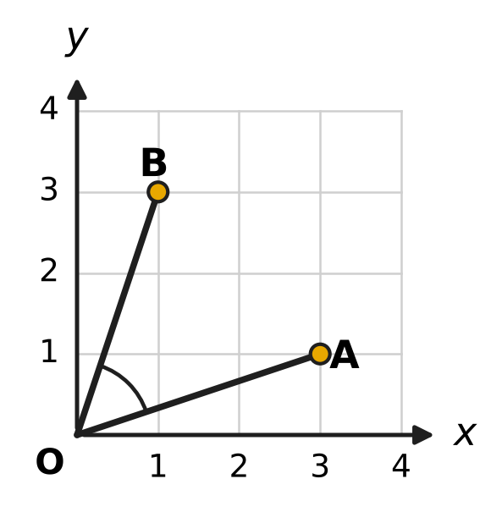
  (A) $\frac{4}{3}$ | (B) 1 | (C) $\frac{8}{3}$ | (D) $\frac{3}{4}$

Q19. In the figure, a line meets the x-axis at M and the y-axis at N. The point P(3, 4) is the midpoint of MN. What is the equation of the line? | 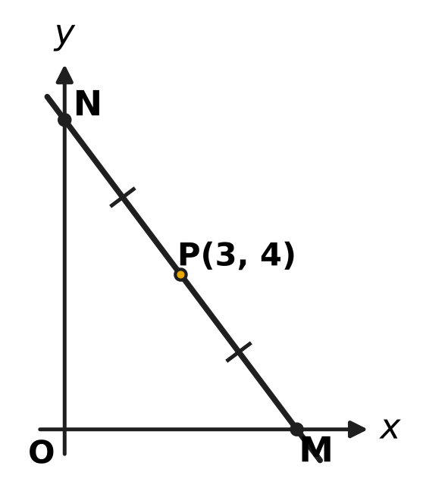
  (A) 4x + 3y = 12 | (B) 3x + 4y = 25
  (C) 3x + 4y = 24 | (D) 4x + 3y = 24

Part 4 — Trigonometry & Heights and Distances (Syllabus Chapter 7)
Q20. Which of these has a negative value?
(A) tan 225° | (B) sin 240°
(C) cos 300° | (D) sin(−330°)

Q21. Which of these is equal to sin 70° + sin 50°?
(A) √3 cos 10° | (B) √3 sin 10°
(C) cos 10° | (D) sin 120°

Q22. A ribbon is wound on a round spool of radius 3.5 cm. The spool turns through 270°, as shown in the figure, and the ribbon unwound equals the arc length. How much ribbon is unwound? (Use π = 22/7.) | 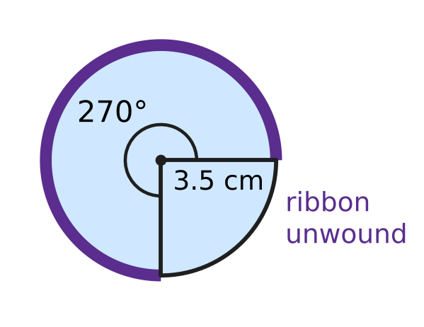
  (A) 33 cm | (B) 945 cm | (C) 16.5 cm | (D) 11 cm

Q23. If sin A − cos A = $\frac{1}{2}$, what is the value of sin 2A?
(A) $\frac{1}{4}$ | (B) $\frac{5}{4}$ | (C) $\frac{3}{4}$ | (D) $−\frac{3}{4}$

Q24. What is the value of 4 cos 52.5° cos 7.5°?
(A) 1 + √3 | (B) 2 + √2
(C) $\frac{1+\sqrt{2}}{2}$ | (D) 1 + √2

Part 5 — Data Handling, Statistics & Probability (Syllabus Chapter 8)
Q25. Here P(n, r) is the number of arrangements of r things chosen from n different things, and C(n, r) is the number of selections. Which of these has the greatest value?
(A) C(9, 6) | (B) P(6, 4) | (C) 4! × 3! | (D) C(10, 5)

Q26. At a picnic in a park, three friends sit on a bench that has 5 seats in a row, one friend to a seat. Two seats stay empty. In how many different ways can they sit?
(A) 60 | (B) 6 | (C) 10 | (D) 125

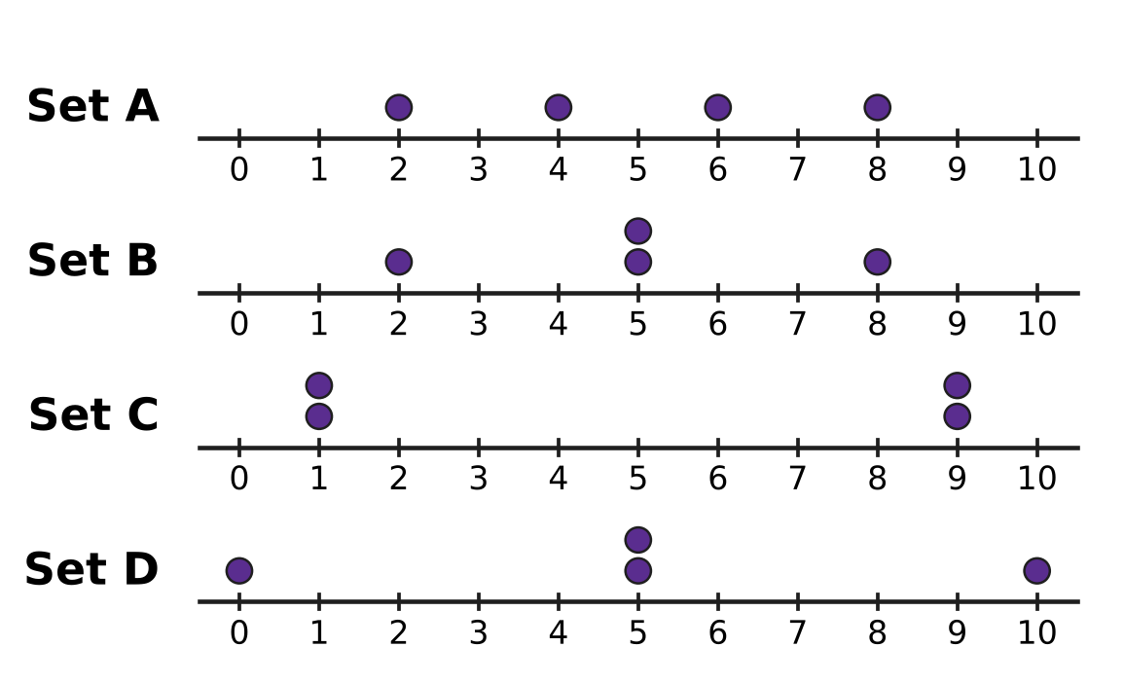
Q27. The dot plots in the figure show four data sets, each of four numbers with mean 5. Each dot stands for one number. Which data set has the greatest standard deviation?
(A) Set A | (B) Set B | (C) Set C | (D) Set D

Q28. On sports day, Akash scores each basketball free throw with probability $\frac{3}{4}$, independently of his other throws. He takes 3 free throws. What is the probability that he scores exactly 2 of them?
(A) $\frac{27}{64}$ | (B) $\frac{9}{16}$ | (C) $\frac{27}{32}$ | (D) $\frac{9}{64}$

Q29. A team of 4 students is to be chosen from 6 girls and 5 boys. The team must have at least 3 girls. How many different teams are possible?
(A) 160 | (B) 115 | (C) 330 | (D) 100

Q30. A bird has 6 eggs in its nest. Each egg hatches with probability 4/5, independently of the others. Which number of eggs hatching is the most likely?
(A) exactly 6 eggs | (B) exactly 5 eggs
(C) exactly 4 eggs | (D) exactly 3 eggs

Q31. The lengths of the 6 fish in an aquarium have mean 8 cm and variance 9 cm². What is the sum of the squares of the 6 lengths?
(A) 73 cm² | (B) 330 cm² | (C) 384 cm² | (D) 438 cm²

Part 6 — Applied Mathematics (Syllabus Chapter 9)
Q32. At a toy shop, a toy train is marked ₹2,000. Which of these offers gives the lowest price?
(A) 25% off, then a further 6% off | (B) 20% off, then a further 12% off
(C) a single discount of 30% | (D) 10% off, then a further 22% off

Q33. Mira deposits ₹25,000 in a bank. Interest is compounded yearly at 8% for the first year and 10% for the second year. What is the amount after 2 years?
(A) ₹29,160 | (B) ₹29,700 | (C) ₹29,500 | (D) ₹30,250

Q34. Jaya has ₹600 to buy water bottles at ₹25 each and juice packs at ₹40 each for a class trip. She must buy at least 6 juice packs. What is the greatest number of water bottles she can buy?
(A) 14 | (B) 24 | (C) 11 | (D) 15

Q35. Ashok wants ₹5,304 in his savings plan at the end of 2 years. He will put the same amount into the plan at the start of each of the 2 years. The plan pays 4% a year, compounded yearly. How much must he put in each year?
(A) ₹2,550 | (B) ₹2,652 | (C) ₹2,600 | (D) ₹2,500

Part 7 — Mathematical Reasoning & Problem-Solving (Syllabus Chapter 10)
Q36. Which of these statements is true for every natural number n?
(A) 2ⁿ > n² | (B) n² + n + 41 is a prime number
(C) 4ⁿ ≥ 3n + 1 | (D) n² + n is divisible by 4

Q37. At a fruit market, there are 50 baskets of mangoes. Each basket holds at least 20 and at most 26 mangoes. What is the largest number k for which we can be sure that some k baskets hold the same number of mangoes?
(A) 9 | (B) 7 | (C) 2 | (D) 8

Q38. To prove that $7^{n}−3^{n}$ is divisible by 4 for every natural number n, assume that $7^{k}−3^{k}$ is divisible by 4 and write $7^{k+1}−3^{k+1}=7(7^{k}−3^{k})+c×3^{k}$. What is the number c that makes this true?
(A) 10 | (B) 3 | (C) 4 | (D) −4

Q39. A row in the school garden has 20 spaces, numbered 1 to 20. Veena puts 5 pots in 5 different spaces. She wants the pots spread out, so that the smallest difference between the space numbers of any two of her pots is as large as possible. What is this greatest possible smallest difference?
(A) 3 | (B) 4 | (C) 6 | (D) 5

Q40. The desks in a classroom stand in 4 rows of 6 desks each, making 6 columns. The teacher picks 2 of the desks so that they are in different rows and in different columns. In how many ways can she pick them?
(A) 180 | (B) 90 | (C) 360 | (D) 276

SECTION II — Star Questions 5 questions × 4 marks each
Q41. A load is put on the left pan of a two-pan balance. Lena may choose 5 weights, each a whole number of grams, and may put any of them on either pan or leave them out. She wants to be able to balance every load of 1 g, 2 g, 3 g, … up to N g. What is the greatest possible value of N? [4 marks]
(A) 40 | (B) 242 | (C) 121 | (D) 31

Q42. A class has n students, where n ≥ 3. The number of ways of choosing 1 student, the number of ways of choosing 2 students and the number of ways of choosing 3 students, in that order, are in arithmetic progression. What is n? [4 marks]
(A) 7 | (B) 14 | (C) 9 | (D) 21

Q43. For how many whole numbers n from 1 to 30 (both included) is $i×i^{2}×i^{3}×…×i^{n}$ equal to 1? [4 marks]
(A) 14 | (B) 7 | (C) 8 | (D) 6

Q44. In the figure, the circle has centre O and radius 1. OA makes an angle of 20° and OB an angle of 100° with the positive x-axis, so A = (cos 20°, sin 20°) and B = (cos 100°, sin 100°). What is the slope of the line AB? [4 marks] | 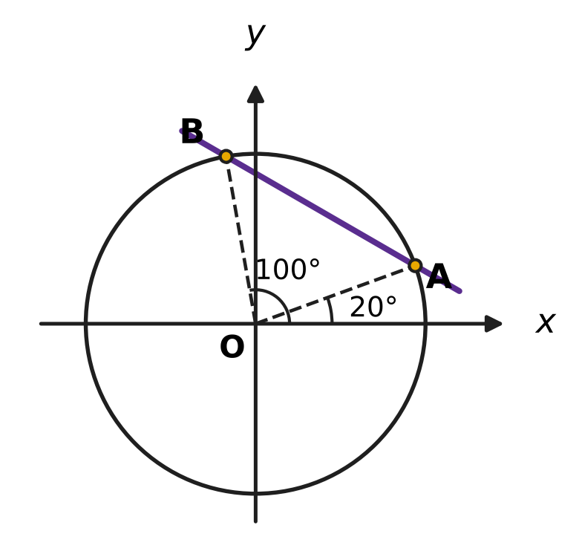
  (A) $\sqrt{3}$ | (B) $−\frac{1}{\sqrt{3}}$
  (C) $−\sqrt{3}$ | (D) $\frac{1}{\sqrt{3}}$

Q45. Six whole numbers are written down. Each is from 1 to 9 (both included), and numbers may repeat. What is the greatest possible variance of the six numbers? [4 marks]
(A) $\frac{128}{9}$ | (B) 4 | (C) 16 | (D) 64

Answer Sheet AMO Level 1 · Class 11 · Practice Paper 2
Name: | School: | Roll No.:
Shade or tick one circle for each question.
1. Ⓐ Ⓑ Ⓒ Ⓓ | 16. Ⓐ Ⓑ Ⓒ Ⓓ | 31. Ⓐ Ⓑ Ⓒ Ⓓ
2. Ⓐ Ⓑ Ⓒ Ⓓ | 17. Ⓐ Ⓑ Ⓒ Ⓓ | 32. Ⓐ Ⓑ Ⓒ Ⓓ
3. Ⓐ Ⓑ Ⓒ Ⓓ | 18. Ⓐ Ⓑ Ⓒ Ⓓ | 33. Ⓐ Ⓑ Ⓒ Ⓓ
4. Ⓐ Ⓑ Ⓒ Ⓓ | 19. Ⓐ Ⓑ Ⓒ Ⓓ | 34. Ⓐ Ⓑ Ⓒ Ⓓ
5. Ⓐ Ⓑ Ⓒ Ⓓ | 20. Ⓐ Ⓑ Ⓒ Ⓓ | 35. Ⓐ Ⓑ Ⓒ Ⓓ
6. Ⓐ Ⓑ Ⓒ Ⓓ | 21. Ⓐ Ⓑ Ⓒ Ⓓ | 36. Ⓐ Ⓑ Ⓒ Ⓓ
7. Ⓐ Ⓑ Ⓒ Ⓓ | 22. Ⓐ Ⓑ Ⓒ Ⓓ | 37. Ⓐ Ⓑ Ⓒ Ⓓ
8. Ⓐ Ⓑ Ⓒ Ⓓ | 23. Ⓐ Ⓑ Ⓒ Ⓓ | 38. Ⓐ Ⓑ Ⓒ Ⓓ
9. Ⓐ Ⓑ Ⓒ Ⓓ | 24. Ⓐ Ⓑ Ⓒ Ⓓ | 39. Ⓐ Ⓑ Ⓒ Ⓓ
10. Ⓐ Ⓑ Ⓒ Ⓓ | 25. Ⓐ Ⓑ Ⓒ Ⓓ | 40. Ⓐ Ⓑ Ⓒ Ⓓ
11. Ⓐ Ⓑ Ⓒ Ⓓ | 26. Ⓐ Ⓑ Ⓒ Ⓓ | 41. Ⓐ Ⓑ Ⓒ Ⓓ
12. Ⓐ Ⓑ Ⓒ Ⓓ | 27. Ⓐ Ⓑ Ⓒ Ⓓ | 42. Ⓐ Ⓑ Ⓒ Ⓓ
13. Ⓐ Ⓑ Ⓒ Ⓓ | 28. Ⓐ Ⓑ Ⓒ Ⓓ | 43. Ⓐ Ⓑ Ⓒ Ⓓ
14. Ⓐ Ⓑ Ⓒ Ⓓ | 29. Ⓐ Ⓑ Ⓒ Ⓓ | 44. Ⓐ Ⓑ Ⓒ Ⓓ
15. Ⓐ Ⓑ Ⓒ Ⓓ | 30. Ⓐ Ⓑ Ⓒ Ⓓ | 45. Ⓐ Ⓑ Ⓒ Ⓓ
Q41–Q45 are Section II Star Questions (4 marks each).
For the parent or teacher
Section I correct: ______ / 40 × 2 = ______ marks Section II correct: ______ / 5 × 4 = ______ marks
Correct: ______ / 45 Score: ______ / 100
Answer Key and Solutions AMO Level 1 · Class 11 · Practice Paper 2
Quick answers
1 D | 6 A | 11 C | 16 D | 21 A | 26 A | 31 D | 36 C | 41 C
2 C | 7 C | 12 B | 17 C | 22 C | 27 C | 32 C | 37 D | 42 A
3 A | 8 D | 13 D | 18 A | 23 C | 28 A | 33 B | 38 C | 43 D
4 D | 9 B | 14 A | 19 D | 24 D | 29 B | 34 A | 39 B | 44 B
5 B | 10 A | 15 B | 20 B | 25 B | 30 B | 35 D | 40 A | 45 C
Solutions
Q | Part · level | Answer | Why?
1 | Part 1 · Ch1 · Easy | (D) 1 − 6i | The moduli are √29, √32, √37 and √36 = 6 for 5 + 2i, −4 + 4i, 1 − 6i and −6. The greatest is √37, for 1 − 6i.
2 | Part 1 · Ch1 · Easy | (C) the third quadrant | Since 1/i = −i, the number is (2 − i)(−i) = −2i + i² = −1 − 2i. Both parts are negative, so the point is in the third quadrant.
3 | Part 1 · Ch1 · Easy | (A) 4 + 3i | (4 + 3i)² = 16 + 24i + 9i² = 16 − 9 + 24i = 7 + 24i.
4 | Part 1 · Ch1 · Medium | (D) 10 | The roots are (2 ± √(4 − 104))/2 = 1 ± 5i. Their difference is 10i, whose modulus is 10.
5 | Part 1 · Ch1 · Medium | (B) 4 − 7i | With z = a + ib, z + 2z̄ = 3a − ib. So 3a = 12 and −b = 7, giving a = 4 and b = −7: z = 4 − 7i.
6 | Part 2 · Ch4 · Easy | (A) 16, 24, 36, 54 | Each term of 16, 24, 36, 54 is 3/2 times the one before it. The other lists change ratio (or have a constant difference).
7 | Part 2 · Ch4 · Easy | (C) AM = 7 and GM = 8 | For positive numbers AM ≥ GM, so a GM of 8 with an AM of 7 is impossible. The other pairs come from 18 and 2, 8 and 2, and 6 and 6.
8 | Part 2 · Ch4 · Easy | (D) −52 | A term is 200 − 7k for a whole number k. 200 − (−52) = 252 = 7 × 36, so −52 is the 37th term; 256, 253 and 250 are not multiples of 7.
9 | Part 2 · Ch4 · Easy | (B) 96,059,601 | (100 − 1)⁴ = 100,000,000 − 4,000,000 + 60,000 − 400 + 1 = 96,059,601.
10 | Part 2 · Ch4 · Easy | (A) $\frac{2}{3}$ | a/(1 − r) = 3a gives 1 − r = 1/3, so r = 2/3.
11 | Part 2 · Ch4 · Medium | (C) 11 | 1³ + … + n³ = [n(n + 1)/2]². So n(n + 1)/2 = √4,356 = 66, n(n + 1) = 132 and n = 11.
12 | Part 2 · Ch4 · Medium | (B) −10 | (1 + x)⁵(1 − x)⁵ = (1 − x²)⁵. The x⁶ term is C(5, 3)(−x²)³ = −10x⁶.
13 | Part 2 · Ch4 · Medium | (D) 2 | (x + 8)² = x(x + 24) gives x² + 16x + 64 = x² + 24x, so x = 8. The terms are 8, 16, 32 and the ratio is 2.
14 | Part 2 · Ch4 · Medium | (A) 500 | The 4th term is S₄ − S₃ = (625 − 1) − (125 − 1) = 500.
15 | Part 3 · Ch5 · Easy | (B) 4x + 3y − 1 = 0 | The given line has slope 3/4. A perpendicular line has slope −4/3, and 4x + 3y − 1 = 0 has slope −4/3; (3/4) × (−4/3) = −1.
16 | Part 3 · Ch5 · Easy | (D) 5 | The slope from (−2, 1) to (7, 13) is 12/9 = 4/3. From x = −2 to x = 1 is 3 units, so k = 1 + 3 × 4/3 = 5.
17 | Part 3 · Ch5 · Easy | (C) (2, 4) | Distance = |4x − 3y + 2| ÷ 5. The four distances are 3/5 for (1, 1), 2/5 for (2, 4), 1 for (−1, 1) and 4/5 for (0, 2). The least is 2/5.
18 | Part 3 · Ch5 · Medium | (A) $\frac{4}{3}$ | Slope of OA = 1/3 and slope of OB = 3. tan ∠AOB = (3 − 1/3) ÷ (1 + 3 × 1/3) = (8/3) ÷ 2 = 4/3.
19 | Part 3 · Ch5 · Medium | (D) 4x + 3y = 24 | As P is the midpoint, M = (6, 0) and N = (0, 8). Intercept form: x/6 + y/8 = 1, that is 4x + 3y = 24.
20 | Part 4 · Ch7 · Easy | (B) sin 240° | sin 240° = sin(180° + 60°) = −sin 60° = −√3/2. The others are sin(−330°) = 1/2, cos 300° = 1/2 and tan 225° = 1.
21 | Part 4 · Ch7 · Easy | (A) √3 cos 10° | sin C + sin D = 2 sin((C + D)/2) cos((C − D)/2) = 2 sin 60° cos 10° = √3 cos 10°.
22 | Part 4 · Ch7 · Easy | (C) 16.5 cm | 270° = 3π/2 radians. Arc length = rθ = 3.5 × 3/2 × 22/7 = 16.5 cm.
23 | Part 4 · Ch7 · Medium | (C) $\frac{3}{4}$ | Square both sides: sin²A + cos²A − 2 sin A cos A = 1/4, so 1 − sin 2A = 1/4 and sin 2A = 3/4.
24 | Part 4 · Ch7 · Medium | (D) 1 + √2 | 4 cos A cos B = 2[cos(A + B) + cos(A − B)] = 2(cos 60° + cos 45°) = 2(1/2 + √2/2) = 1 + √2.
25 | Part 5 · Ch8 · Easy | (B) P(6, 4) | P(6, 4) = 6 × 5 × 4 × 3 = 360, C(10, 5) = 252, 4! × 3! = 144 and C(9, 6) = 84. The greatest is P(6, 4).
26 | Part 5 · Ch8 · Easy | (A) 60 | The first friend has 5 seats, the next 4 and the last 3: P(5, 3) = 5 × 4 × 3 = 60.
27 | Part 5 · Ch8 · Easy | (C) Set C | Variances (mean of squared deviations from 5): A = (9 + 1 + 1 + 9)/4 = 5, B = 4.5, C = (16 × 4)/4 = 16, D = (25 + 0 + 0 + 25)/4 = 12.5. Set C has the greatest variance and hence the greatest SD.
28 | Part 5 · Ch8 · Easy | (A) $\frac{27}{64}$ | P(exactly 2) = C(3, 2) × (3/4)² × (1/4) = 3 × 9/16 × 1/4 = 27/64.
29 | Part 5 · Ch8 · Medium | (B) 115 | Exactly 3 girls: C(6, 3) × C(5, 1) = 20 × 5 = 100. All 4 girls: C(6, 4) = 15. Total = 115.
30 | Part 5 · Ch8 · Medium | (B) exactly 5 eggs | P(5)/P(4) = (2/5) × 4 = 8/5 > 1 and P(6)/P(5) = (1/6) × 4 = 2/3 < 1, so the chances rise up to 5 eggs and then fall. Exactly 5 eggs is the most likely (6,144/15,625).
31 | Part 5 · Ch8 · Medium | (D) 438 cm² | Variance = Σx²/n − mean², so Σx² = n(variance + mean²) = 6 × (9 + 64) = 438 cm².
32 | Part 6 · Ch9 · Easy | (C) a single discount of 30% | Successive discounts multiply: the prices are ₹1,410 for (A), ₹1,408 for (B), ₹1,400 for (C) and ₹1,404 for (D). The single 30% discount is lowest.
33 | Part 6 · Ch9 · Easy | (B) ₹29,700 | Amount = 25,000 × 1.08 × 1.10 = 27,000 × 1.10 = ₹29,700.
34 | Part 6 · Ch9 · Easy | (A) 14 | Six juice packs cost ₹240, leaving ₹360. Then 25w ≤ 360 gives w ≤ 14.4, so at most 14 bottles.
35 | Part 6 · Ch9 · Medium | (D) ₹2,500 | The first deposit grows for 2 years and the second for 1 year: D × (1.0816 + 1.04) = 2.1216D = 5,304, so D = ₹2,500.
36 | Part 7 · Ch10 · Easy | (C) 4ⁿ ≥ 3n + 1 | 4ⁿ ≥ 3n + 1 holds at n = 1 (4 ≥ 4), and if 4ᵏ ≥ 3k + 1 then 4ᵏ⁺¹ ≥ 12k + 4 ≥ 3k + 4. The others fail at n = 2, n = 40 and n = 1.
37 | Part 7 · Ch10 · Easy | (D) 8 | There are 7 possible amounts (20 to 26). If no amount had 8 baskets, there would be at most 7 × 7 = 49 baskets. So some 8 baskets match, and 8, 7, 7, 7, 7, 7, 7 shows 9 is not forced.
38 | Part 7 · Ch10 · Easy | (C) 4 | 7(7ᵏ − 3ᵏ) = 7ᵏ⁺¹ − 7 × 3ᵏ. Adding 4 × 3ᵏ gives 7ᵏ⁺¹ − 3 × 3ᵏ = 7ᵏ⁺¹ − 3ᵏ⁺¹, and both parts are divisible by 4.
39 | Part 7 · Ch10 · Medium | (B) 4 | The 4 gaps between neighbouring pots add up to at most 20 − 1 = 19, so the smallest gap is at most 4 (as 4 × 5 = 20 > 19). Spaces 1, 5, 9, 13, 17 give gaps of 4.
40 | Part 7 · Ch10 · Medium | (A) 180 | The first desk can be any of 24; the second must avoid its row and column, leaving 3 × 5 = 15. Order does not matter: 24 × 15 ÷ 2 = 180.
41 | Section II · Ch4 + Ch10 · Hard | (C) 121 | Each weight is on the left, on the right or off: 3⁵ = 243 placements. One gives 0 and the rest come in ± pairs, so at most 121 positive loads. Weights 1, 3, 9, 27 and 81 reach every load up to 1 + 3 + 9 + 27 + 81 = (3⁵ − 1)/2 = 121.
42 | Section II · Ch4 + Ch8 · Hard | (A) 7 | 2C(n, 2) = C(n, 1) + C(n, 3) gives n(n − 1) = n + n(n − 1)(n − 2)/6. Dividing by n: 6n − 6 = 6 + (n − 1)(n − 2), so n² − 9n + 14 = 0, n = 2 or 7. As n ≥ 3, n = 7 (7, 21, 35).
43 | Section II · Ch1 + Ch4 · Hard | (D) 6 | The product is i raised to 1 + 2 + … + n = n(n + 1)/2. It equals 1 when n(n + 1)/2 is a multiple of 4, that is, when n leaves remainder 0 or 7 on division by 8: n = 7, 8, 15, 16, 23, 24. That is 6 values.
44 | Section II · Ch5 + Ch7 · Hard | (B) $−\frac{1}{\sqrt{3}}$ | Slope = (sin 100° − sin 20°)/(cos 100° − cos 20°) = (2 cos 60° sin 40°)/(−2 sin 60° sin 40°) = −cot 60° = −1/√3.
45 | Section II · Ch8 + Ch10 · Hard | (C) 16 | A number strictly between 1 and 9 can be moved to the end farther from the mean, which increases the variance; so the greatest variance uses only 1s and 9s. With k nines, variance = 64k(6 − k)/36, greatest at k = 3: three 1s and three 9s have mean 5 and variance 16.

