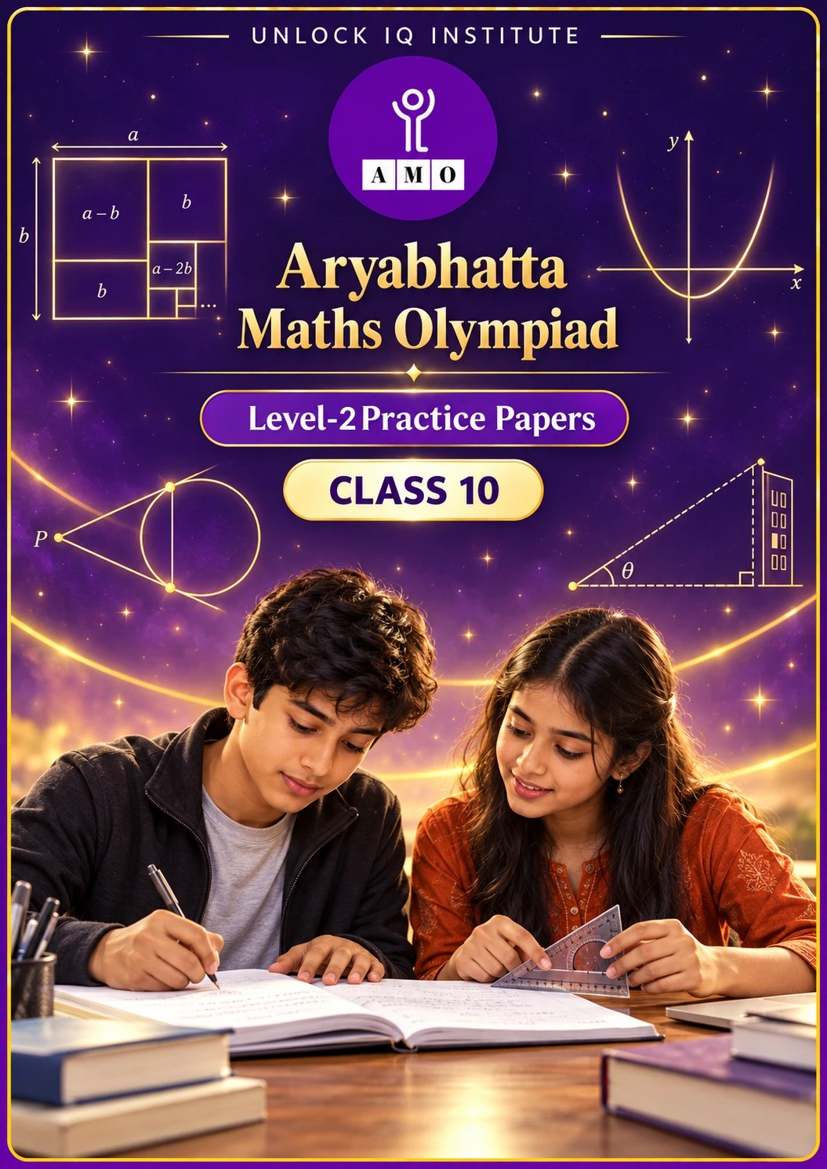
Set 1 · Practice Papers 1–5 · with answer keys & detailed solutions
Name: ____________________ | Class & Section: ________________
Roll No.: ________________ | School: ____________________
City: ____________________ | Date: ____________________

Published by Unlock IQ Institute Pvt. Ltd.
Register for Olympiads: www.aryabhattamathsolympiad.com/student-registration

ARYABHATTA MATHS OLYMPIAD
Level 2
PRACTICE PAPER-1
CLASS 10
Total Questions | 30 multiple-choice questions
Level | Level-2 (final round): every question is Hard
Time | 45 minutes
Arrangement | Parts by chapter; the last Part has mixed problems joining two chapters
Negative Marking | No negative marking
Calculator | Not allowed
Chapters | Number System · Fractions, Decimals & Percentages · Algebra · Geometry · Mensuration · Trigonometry · Data Handling, Statistics & Probability · Applied Mathematics · Mathematical Reasoning

Instructions
• Each question has four options, (A) to (D), with exactly one correct answer.
• The questions are grouped in Parts by chapter. The last Part has mixed problems, each joining two chapters.
• Every question is at Level-2 (Hard) standard: expect several steps or a key insight.
• There is no negative marking. Calculators are not allowed; use a separate sheet for rough work.
• Figures are not necessarily drawn to scale unless stated.

For teachers
• Figures are part of the questions and work when printed in black and white.
• Parts follow the AMO syllabus chapters. Chapter 2 is not part of the Class 10 syllabus, so the chapter numbers shown in the Part headings have gaps.
• The answer sheet and the answer key are at the end. Remove the answer key before the paper is attempted.

Part 1 — Number System (Syllabus Chapter 1)
Q1. Three traffic signals on a road change every 48 seconds, 72 seconds and 108 seconds. All three change together at 7:00:00 AM. At what time will they next change together?
(A) 7:03:36 AM | (B) 7:04:48 AM | (C) 7:07:12 AM | (D) 7:12:00 AM

Q2. How many of these numbers have a terminating decimal expansion: 77/210, 17/8, 64/455, 15/1600, 13/3125, 129/(2² × 5⁷ × 7⁵)?
(A) 3 | (B) 4 | (C) 2 | (D) 5

Part 2 — Fractions, Decimals & Percentages (Syllabus Chapter 3)
Q3. Ananya and Arjun each deposit the same sum for 1 year at 20% per annum. Ananya's interest is compounded half-yearly and Arjun's yearly. Ananya earns ₹150 more interest. How much did each deposit?
(A) ₹1,500 | (B) ₹7,500 | (C) ₹30,000 | (D) ₹15,000

Q4. Arjun starts a business with ₹30,000. Six months later Meera joins with ₹40,000. At the end of the year the profit is ₹26,000. What is Arjun's share?
(A) ₹11,143 | (B) ₹15,600 | (C) ₹10,400 | (D) ₹13,000

Q5. On a certain sum, the compound interest for 2 years at 10% per annum (compounded yearly) is ₹50 more than the simple interest. What is the sum?
(A) ₹500 | (B) ₹5,000 | (C) ₹50,000 | (D) ₹2,500

Part 3 — Algebra (Syllabus Chapter 4)
Q6. α and β are the zeros of 2x² − 7x + 3. Which quadratic polynomial has zeros α + 1/β and β + 1/α?
(A) 6x² + 35x + 25 | (B) 6x² − 25x + 35
(C) 3x² − 7x + 2 | (D) 6x² − 35x + 25

Q7. For which value of k does the pair kx + 3y = k − 3 and 12x + ky = k have no solution?
(A) −6 | (B) 6 | (C) ±6 | (D) 0

Q8. How many three-digit numbers are divisible by 7 but not by 3?
(A) 128 | (B) 43 | (C) 86 | (D) 85

Q9. A train covers 360 km at a uniform speed. If its speed were 5 km/h more, it would take 48 minutes less. What is its usual speed?
(A) 40 km/h | (B) 50 km/h | (C) 45 km/h | (D) 60 km/h

Part 4 — Geometry (Syllabus Chapter 5)
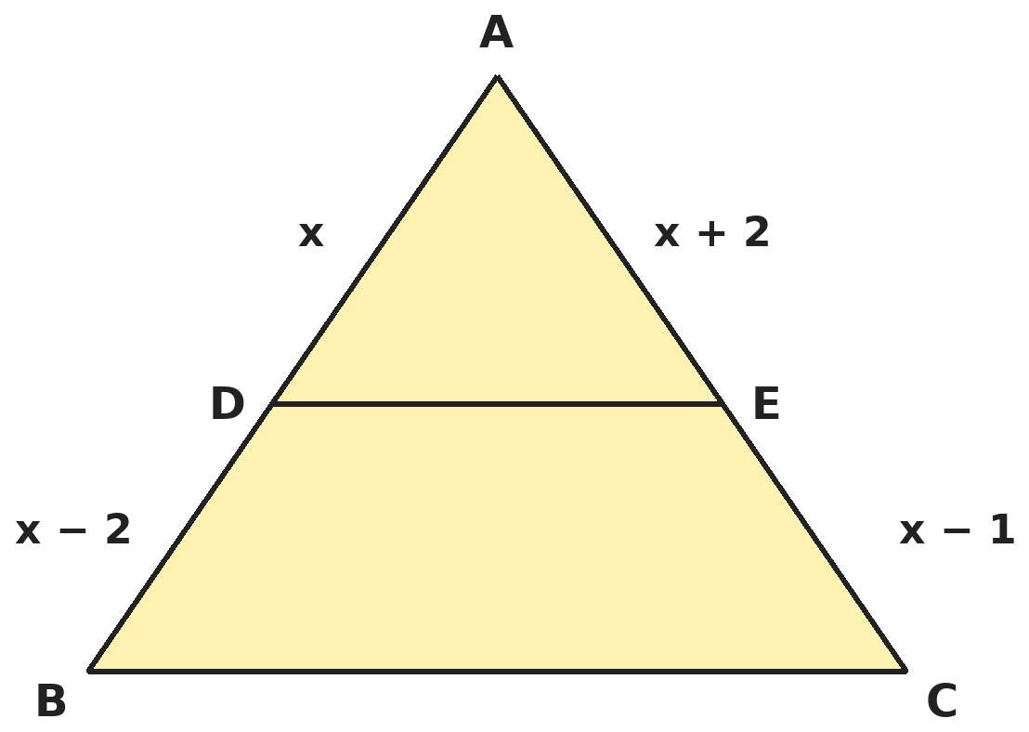
Q10. In triangle ABC, DE ∥ BC. AD = x, DB = x − 2, AE = x + 2 and EC = x − 1 (all in cm). What is the length of AB?
(A) 4 cm | (B) 7 cm | (C) 10 cm | (D) 6 cm

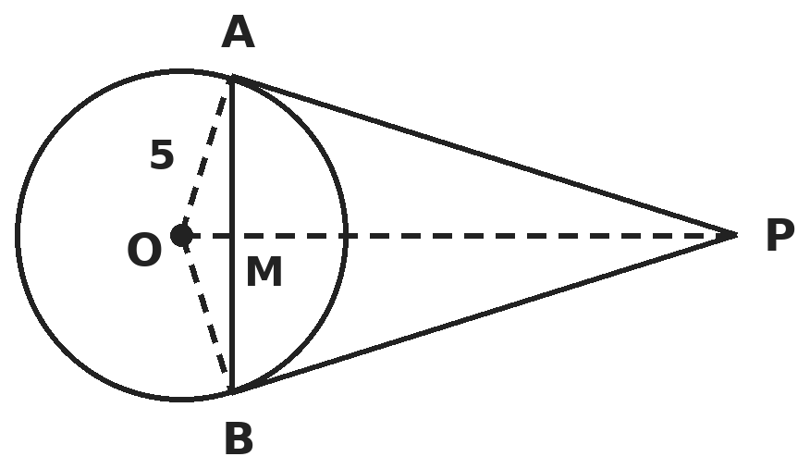
Q11. PA and PB are tangents from P to a circle with centre O and radius 5 cm, and OP = 13 cm. The chord AB meets OP at M. What is the length of AB?
(A) 60/13 cm | (B) 24 cm | (C) 120/13 cm | (D) 10 cm

Q12. The y-axis cuts the line segment joining A(−3, 5) and B(6, −1) at P. What are the coordinates of P?
(A) (0, 3) | (B) (0, 2) | (C) (0, 1) | (D) (0, 4)

Part 5 — Mensuration (Syllabus Chapter 6)
Q13. A bucket is a frustum of a cone with top radius 20 cm, bottom radius 10 cm and height 21 cm. Its water is poured into cylindrical tins of radius 7 cm and height 10 cm. How many tins can be filled completely? (Take π = 22/7.)
(A) 30 | (B) 9 | (C) 5 | (D) 10

Q14. A hollow metal sphere has outer radius 6 cm and inner radius 3 cm. The metal is melted and drawn into a wire of uniform radius 2 mm. How long is the wire?
(A) 72 m | (B) 63 m | (C) 6.3 m | (D) 81 m

Q15. The tip of the minute hand of a tower clock moves 44 cm in 20 minutes. What area does the minute hand sweep in those 20 minutes? (Take π = 22/7.)
(A) 231 cm² | (B) 924 cm² | (C) 154 cm² | (D) 462 cm²

Part 6 — Trigonometry (Syllabus Chapter 7)
Q16. If sec θ + tan θ = 3 for an acute angle θ, what is sin θ?
(A) 3/5 | (B) 4/5 | (C) 3/4 | (D) 5/3

Q17. From a point on level ground, the angle of elevation of the top of a tower is 30°. After walking 20 m towards the tower it becomes 60°. What is the height of the tower?
(A) 20√3 m | (B) 10√3 m | (C) 10 m | (D) 20 m

Part 7 — Data Handling, Statistics & Probability (Syllabus Chapter 8)
Q18. Two fair dice are thrown together. What is the probability that the product of the two numbers is a perfect square?
(A) 2/9 | (B) 1/6 | (C) 7/36 | (D) 1/4

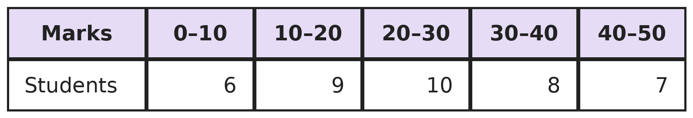
Q19. The table shows the marks of 40 students. What is the median mark?
(A) 24 | (B) 25 | (C) 26 | (D) 22.5

Part 8 — Applied Mathematics (Syllabus Chapter 9)
Q20. Rohan, a trader, buys a cycle for ₹5,000 plus 12% GST and sells it in the same state for ₹6,500 plus 12% GST. Using input tax credit, how much CGST does he pay to the government?
(A) ₹180 | (B) ₹390 | (C) ₹90 | (D) ₹780

Q21. A boat goes 24 km upstream and 36 km downstream in 6 hours. It goes 36 km upstream and 24 km downstream in 6 hours 30 minutes. What is the speed of the stream?
(A) 2 km/h | (B) 4 km/h | (C) 10 km/h | (D) 1 km/h

Q22. Kavya can finish a job in 12 days and Vikram in 18 days. They work together for 4 days, then Vikram leaves. In how many more days does Kavya finish the job?
(A) 4 days | (B) 6 days | (C) 4 2/3 days | (D) 5 1/3 days

Part 9 — Mathematical Reasoning (Syllabus Chapter 10)
Q23. A drawer has 10 red, 8 blue and 6 green socks. In the dark, what is the least number of socks you must take out to be sure of having at least 2 socks of every colour?
(A) 7 | (B) 19 | (C) 24 | (D) 20

Q24. How many three-digit numbers have their digits in strictly increasing order from left to right, like 147?
(A) 84 | (B) 120 | (C) 504 | (D) 168

Q25. The numbers 1, 2, 3, …, 10 are written on a board. Each step, Ishaan erases two numbers a and b and writes a + b − 1. After 9 steps one number is left. What is it?
(A) 55 | (B) 46 | (C) 45 | (D) 37

Part 10 — Mixed Problems (each joins two chapters)
Q26. How many pairs of positive integers (x, y) satisfy 3x + 5y = 100?
(A) 7 | (B) 5 | (C) 6 | (D) 20

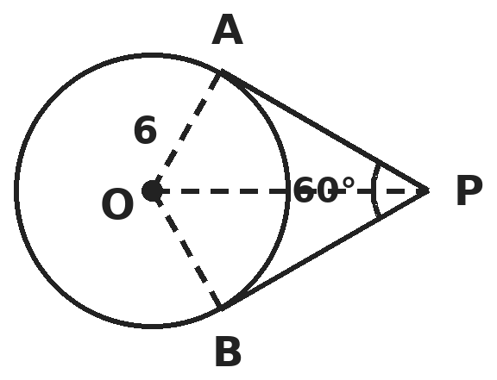
Q27. Tangents PA and PB from P touch a circle with centre O and radius 6 cm, and angle APB = 60°. What is the area of the region bounded by PA, PB and the minor arc AB?
(A) (36√3 − 12π) cm² | (B) (36√3 − 24π) cm²
(C) (18√3 − 12π) cm² | (D) (36√3 − 6π) cm²

Q28. The sides of a right-angled triangle are x cm, (x + 7) cm and (x + 8) cm, where x + 8 is the hypotenuse. What is the area of the triangle?
(A) 60 cm² | (B) 65 cm² | (C) 30 cm² | (D) 39 cm²

Q29. Kunal borrows ₹2,100 at 10% per annum compound interest. He repays it in two equal yearly instalments, the first one year after borrowing. What is each instalment?
(A) ₹1,155 | (B) ₹1,210 | (C) ₹1,050 | (D) ₹1,100

Q30. A cube of edge 4 cm is painted on all faces and cut into 64 cubes of edge 1 cm. How many small cubes have paint on exactly one face or exactly two faces?
(A) 24 | (B) 56 | (C) 48 | (D) 64

Answer Sheet AMO Level 2 · Class 10 · Practice Paper 1
Name: | School: | Roll No.:
Shade or tick one circle for each question.
1. | Ⓐ Ⓑ Ⓒ Ⓓ | 11. | Ⓐ Ⓑ Ⓒ Ⓓ | 21. | Ⓐ Ⓑ Ⓒ Ⓓ
2. | Ⓐ Ⓑ Ⓒ Ⓓ | 12. | Ⓐ Ⓑ Ⓒ Ⓓ | 22. | Ⓐ Ⓑ Ⓒ Ⓓ
3. | Ⓐ Ⓑ Ⓒ Ⓓ | 13. | Ⓐ Ⓑ Ⓒ Ⓓ | 23. | Ⓐ Ⓑ Ⓒ Ⓓ
4. | Ⓐ Ⓑ Ⓒ Ⓓ | 14. | Ⓐ Ⓑ Ⓒ Ⓓ | 24. | Ⓐ Ⓑ Ⓒ Ⓓ
5. | Ⓐ Ⓑ Ⓒ Ⓓ | 15. | Ⓐ Ⓑ Ⓒ Ⓓ | 25. | Ⓐ Ⓑ Ⓒ Ⓓ
6. | Ⓐ Ⓑ Ⓒ Ⓓ | 16. | Ⓐ Ⓑ Ⓒ Ⓓ | 26. | Ⓐ Ⓑ Ⓒ Ⓓ
7. | Ⓐ Ⓑ Ⓒ Ⓓ | 17. | Ⓐ Ⓑ Ⓒ Ⓓ | 27. | Ⓐ Ⓑ Ⓒ Ⓓ
8. | Ⓐ Ⓑ Ⓒ Ⓓ | 18. | Ⓐ Ⓑ Ⓒ Ⓓ | 28. | Ⓐ Ⓑ Ⓒ Ⓓ
9. | Ⓐ Ⓑ Ⓒ Ⓓ | 19. | Ⓐ Ⓑ Ⓒ Ⓓ | 29. | Ⓐ Ⓑ Ⓒ Ⓓ
10. | Ⓐ Ⓑ Ⓒ Ⓓ | 20. | Ⓐ Ⓑ Ⓒ Ⓓ | 30. | Ⓐ Ⓑ Ⓒ Ⓓ

For the parent or teacher
Correct: ______ / 30
Answer Key and Solutions AMO Level 2 · Class 10 · Practice Paper 1
Quick answers
1 C | 6 D | 11 C | 16 B | 21 A | 26 C
2 A | 7 A | 12 A | 17 B | 22 D | 27 A
3 D | 8 D | 13 D | 18 A | 23 D | 28 C
4 B | 9 C | 14 B | 19 B | 24 A | 29 B
5 B | 10 D | 15 D | 20 C | 25 B | 30 C
Solutions
Q | Part · level | Answer | Why?
1 | Part 1 · Ch1 · Hard | (C) 7:07:12 AM | Hint: Write each time as a product of primes and take the highest powers.  48 = 2⁴ × 3, 72 = 2³ × 3², 108 = 2² × 3³. LCM = 2⁴ × 3³ = 432 s = 7 min 12 s. So they next change together at 7:07:12 AM. (216 s is only the LCM of 72 and 108.)
2 | Part 1 · Ch1 · Hard | (A) 3 | Hint: Reduce each fraction to lowest terms first. Then look at the primes in the denominator.  77/210 = 11/30 has a factor 3 below: not terminating. 17/8 = 17/2³: terminating. 64/455 = 64/(5 × 7 × 13): not terminating. 15/1600 = 3/320 = 3/(2⁶ × 5): terminating. 13/3125 = 13/5⁵: terminating. The last has 7⁵ below and cannot cancel: not terminating. So 3.
3 | Part 2 · Ch3 · Hard | (D) ₹15,000 | Hint: Per ₹100, find the interest under each method.  Per ₹100: yearly gives ₹20; half-yearly gives 100 × 1.1 × 1.1 − 100 = ₹21. The difference is ₹1 per ₹100, that is 1% of the sum. 1% of the sum = ₹150, so the sum is ₹15,000.
4 | Part 2 · Ch3 · Hard | (B) ₹15,600 | Hint: Profit is shared in the ratio capital × time.  Arjun: 30,000 × 12 = 3,60,000. Meera: 40,000 × 6 = 2,40,000. Ratio 3 : 2. Arjun gets 3/5 × 26,000 = ₹15,600. (₹11,143 ignores time and uses 3 : 4.)
5 | Part 2 · Ch3 · Hard | (B) ₹5,000 | Hint: For 2 years, CI − SI = P × (r/100)².  CI − SI = P × (10/100)² = P/100. So P/100 = 50 and P = ₹5,000. (The extra ₹50 is the interest on the first year's interest.)
6 | Part 3 · Ch4 · Hard | (D) 6x² − 35x + 25 | Hint: Find the sum and the product of the new zeros using α + β and αβ only.  α + β = 7/2 and αβ = 3/2. New sum = (α + β) + (α + β)/(αβ) = 7/2 + 7/3 = 35/6. New product = αβ + 2 + 1/(αβ) = 3/2 + 2 + 2/3 = 25/6. So the polynomial is k(x² − 35x/6 + 25/6); with k = 6 it is 6x² − 35x + 25. (Check: the zeros are 3 and 1/2, giving 5 and 5/6.)
7 | Part 3 · Ch4 · Hard | (A) −6 | Hint: No solution: a₁/a₂ = b₁/b₂ ≠ c₁/c₂. Check both values that make the first two ratios equal.  k/12 = 3/k gives k² = 36, so k = 6 or −6. For k = 6 all three ratios are 1/2 (infinitely many solutions). For k = −6: a₁/a₂ = b₁/b₂ = −1/2 but c₁/c₂ = (−9)/(−6) = 3/2. So k = −6.
8 | Part 3 · Ch4 · Hard | (D) 85 | Hint: Count the three-digit multiples of 7, then remove the multiples of 21.  Multiples of 7: 105, 112, …, 994, an AP with 1 + (994 − 105)/7 = 128 terms. Multiples of 21: 105, 126, …, 987, with 1 + (987 − 105)/21 = 43 terms. 128 − 43 = 85.
9 | Part 3 · Ch4 · Hard | (C) 45 km/h | Hint: 48 minutes is 4/5 hour. Form a quadratic in the speed v.  360/v − 360/(v + 5) = 4/5 gives 1,800/(v(v + 5)) = 4/5, so v(v + 5) = 2,250, i.e. v² + 5v − 2,250 = 0 = (v − 45)(v + 50). So v = 45 km/h. Check: 8 h at 45 km/h and 7.2 h at 50 km/h differ by 0.8 h.
10 | Part 4 · Ch5 · Hard | (D) 6 cm | Hint: Basic Proportionality Theorem: AD/DB = AE/EC.  x/(x − 2) = (x + 2)/(x − 1). So x² − x = x² − 4, which gives x = 4. AB = AD + DB = 4 + 2 = 6 cm. (4 cm is x itself.)
11 | Part 4 · Ch5 · Hard | (C) 120/13 cm | Hint: OP is perpendicular to AB at M. Find AM using the area of the right triangle OAP.  PA = √(13² − 5²) = 12 cm, and angle OAP = 90°. AM is the altitude from A in triangle OAP, so AM × OP = OA × PA, giving AM = 5 × 12 / 13 = 60/13 cm. AB = 2 AM = 120/13 cm. (24 cm adds the two tangents.)
12 | Part 4 · Ch5 · Hard | (A) (0, 3) | Hint: Let P divide AB in the ratio k : 1. Its x-coordinate must be 0.  x-coordinate: (6k − 3)/(k + 1) = 0 gives k = 1/2, so the ratio is 1 : 2. y-coordinate: (1 × (−1) + 2 × 5)/3 = 9/3 = 3. P = (0, 3).
13 | Part 5 · Ch6 · Hard | (D) 10 | Hint: Frustum volume = (1/3)πh(R² + r² + Rr).  Bucket: (1/3) × 22/7 × 21 × (400 + 100 + 200) = 22 × 700 = 15,400 cm³. One tin: 22/7 × 49 × 10 = 1,540 cm³. 15,400 ÷ 1,540 = 10 tins. (30 forgets the 1/3.)
14 | Part 5 · Ch6 · Hard | (B) 63 m | Hint: Volume of metal = (4/3)π(R³ − r³). Work in cm: 2 mm = 0.2 cm.  Metal = (4/3)π(216 − 27) = 252π cm³. Wire: π × 0.2² × L = 0.04πL. So L = 252 ÷ 0.04 = 6,300 cm = 63 m. (72 m treats the sphere as solid; 81 m adds the cubes.)
15 | Part 5 · Ch6 · Hard | (D) 462 cm² | Hint: In 20 minutes the hand turns through one third of a full turn. Find its length first.  20 minutes is 120°, one third of a turn. Arc 44 = (1/3) × 2 × 22/7 × r, so r = 21 cm. Area = (1/3) × 22/7 × 21² = 462 cm². (Equivalently, area = ½ × arc × radius = ½ × 44 × 21.)
16 | Part 6 · Ch7 · Hard | (B) 4/5 | Hint: sec²θ − tan²θ = 1, so (sec θ − tan θ)(sec θ + tan θ) = 1.  sec θ − tan θ = 1/3. Adding: 2 sec θ = 10/3, so sec θ = 5/3 and cos θ = 3/5. Then tan θ = 3 − 5/3 = 4/3, and sin θ = tan θ × cos θ = 4/5.
17 | Part 6 · Ch7 · Hard | (B) 10√3 m | Hint: Let the height be h. Write the two distances from the foot using tan 30° and tan 60°.  Distances from the foot: h√3 and h/√3. Their difference is 20: h√3 − h/√3 = 2h/√3 = 20, so h = 10√3 m (about 17.3 m).
18 | Part 7 · Ch8 · Hard | (A) 2/9 | Hint: List the doubles first, then look for other pairs such as (1, 4).  Squares from two dice: the 6 doubles, plus (1, 4) and (4, 1). That is 8 of the 36 outcomes. 8/36 = 2/9. (1/6 counts only the doubles.)
19 | Part 7 · Ch8 · Hard | (B) 25 | Hint: Median = l + ((N/2 − cf)/f) × h.  N/2 = 20. Cumulative frequencies: 6, 15, 25, … so the median class is 20–30. Median = 20 + ((20 − 15)/10) × 10 = 25.
20 | Part 8 · Ch9 · Hard | (C) ₹90 | Hint: He pays GST only on the value he adds. Within a state, GST is split equally into CGST and SGST.  Value added = 6,500 − 5,000 = ₹1,500. GST on it = 12% × 1,500 = ₹180. CGST is half of this: ₹90.
21 | Part 8 · Ch9 · Hard | (A) 2 km/h | Hint: Let a = 1/(upstream speed) and b = 1/(downstream speed).  24a + 36b = 6 and 36a + 24b = 6.5. Adding: a + b = 5/24; subtracting: a − b = 1/24. So a = 1/8 and b = 1/12: upstream 8 km/h, downstream 12 km/h. Stream = (12 − 8)/2 = 2 km/h.
22 | Part 8 · Ch9 · Hard | (D) 5 1/3 days | Hint: Find the fraction of the job done in the first 4 days.  Together they do 1/12 + 1/18 = 5/36 per day. In 4 days: 20/36 = 5/9. Left: 4/9. Kavya needs (4/9) ÷ (1/12) = 16/3 = 5 1/3 days.
23 | Part 9 · Ch10 · Hard | (D) 20 | Hint: Think of the unluckiest order of drawing.  In the worst case you take all 10 red, all 8 blue and 1 green: 19 socks, still without 2 greens. The 20th sock must be green. So 20.
24 | Part 9 · Ch10 · Hard | (A) 84 | Hint: 0 cannot appear. Once three different digits are chosen, there is only one increasing order.  0 cannot be used, and each set of 3 different digits gives exactly one such number. Count by the first two digits: starting 12 there are 7 numbers (123 … 129), starting 13 there are 6, and so on, so first digit 1 gives 7 + 6 + … + 1 = 28. First digit 2 gives 6 + … + 1 = 21, then 15, 10, 6, 3 and 1. Total 28 + 21 + 15 + 10 + 6 + 3 + 1 = 84. (504 counts every order of the digits.)
25 | Part 9 · Ch10 · Hard | (B) 46 | Hint: Each step, how does the total of the numbers on the board change?  Each step lowers the total by exactly 1. The starting total is 55 and there are 9 steps, so the last number is 55 − 9 = 46, whatever the order.
26 | Part 10 · Mixed · Ch4 + Ch10 · Hard | (C) 6 | Hint: 3x must leave the same remainder as 100 when divided by 5.  100 and 5y are multiples of 5, so 3x is too, and x = 5k. Then 15k + 5y = 100 gives y = 20 − 3k. y ≥ 1 needs k ≤ 6, and k ≥ 1. So k = 1, 2, …, 6: 6 pairs.
27 | Part 10 · Mixed · Ch5 + Ch7 · Hard | (A) (36√3 − 12π) cm² | Hint: Find PA with tan 30°, then subtract the sector AOB from the kite OAPB.  Angle OPA = 30°, so PA = 6/tan 30° = 6√3 cm. Kite OAPB = 2 × ½ × 6 × 6√3 = 36√3 cm². Angle AOB = 180° − 60° = 120°, so the sector is (120/360) × π × 36 = 12π cm². Region = (36√3 − 12π) cm².
28 | Part 10 · Mixed · Ch4 + Ch5 · Hard | (C) 30 cm² | Hint: Use Pythagoras to get a quadratic in x.  (x + 8)² = x² + (x + 7)² gives x² − 2x − 15 = 0, so x = 5 (x = −3 is impossible). The legs are 5 and 12. Area = 1/2 × 5 × 12 = 30 cm².
29 | Part 10 · Mixed · Ch3 + Ch9 · Hard | (B) ₹1,210 | Hint: The present value of each instalment is the instalment divided by 1.1 for each year.  x/1.1 + x/1.21 = 2,100. Multiply by 1.21: 1.1x + x = 2.1x = 2,541, so x = ₹1,210. (₹1,050 ignores interest; ₹1,155 adds only one year of interest.)
30 | Part 10 · Mixed · Ch6 + Ch10 · Hard | (C) 48 | Hint: Count face-centre cubes and edge cubes separately.  Exactly one face: each of the 6 faces has a 2 × 2 middle, so 24. Exactly two faces: each of the 12 edges has 2 middle cubes, so 24. Total 48. (The other 16 are the 8 corners and the 8 hidden cubes.)

ARYABHATTA MATHS OLYMPIAD
Level 2
PRACTICE PAPER-2
CLASS 10
Total Questions | 30 multiple-choice questions
Level | Level-2 (final round): every question is Hard
Time | 45 minutes
Arrangement | Parts by chapter; the last Part has mixed problems joining two chapters
Negative Marking | No negative marking
Calculator | Not allowed
Chapters | Number System · Fractions, Decimals & Percentages · Algebra · Geometry · Mensuration · Trigonometry · Data Handling, Statistics & Probability · Applied Mathematics · Mathematical Reasoning

Instructions
• Each question has four options, (A) to (D), with exactly one correct answer.
• The questions are grouped in Parts by chapter. The last Part has mixed problems, each joining two chapters.
• Every question is at Level-2 (Hard) standard: expect several steps or a key insight.
• There is no negative marking. Calculators are not allowed; use a separate sheet for rough work.
• Figures are not necessarily drawn to scale unless stated.

For teachers
• Figures are part of the questions and work when printed in black and white.
• Parts follow the AMO syllabus chapters. Chapter 2 is not part of the Class 10 syllabus, so the chapter numbers shown in the Part headings have gaps.
• The answer sheet and the answer key are at the end. Remove the answer key before the paper is attempted.

Part 1 — Number System (Syllabus Chapter 1)
Q1. What is the largest number that divides 1251, 9377 and 15628, leaving remainders 1, 2 and 3 respectively?
(A) 625 | (B) 125 | (C) 3125 | (D) 250

Q2. Two numbers have HCF 16 and LCM 384. One of them is 48. What is the sum of the two numbers?
(A) 144 | (B) 176 | (C) 432 | (D) 208

Part 2 — Fractions, Decimals & Percentages (Syllabus Chapter 3)
Q3. At compound interest (compounded yearly), a sum of money becomes ₹8,820 in 2 years and ₹9,261 in 3 years. What is the sum?
(A) ₹8,000 | (B) ₹8,379 | (C) ₹7,938 | (D) ₹8,400

Q4. Aditi starts a business with ₹20,000 and withdraws ₹5,000 after 4 months. Rahul invests ₹25,000 for the whole year. Out of a year-end profit of ₹21,000, what is Aditi's share?
(A) ₹9,333 | (B) ₹7,000 | (C) ₹12,600 | (D) ₹8,400

Q5. A shopkeeper marks an article 40% above its cost price and then gives a discount of 25% on the marked price. He still makes a profit of ₹60. What is the cost price?
(A) ₹400 | (B) ₹1,200 | (C) ₹240 | (D) ₹1,260

Part 3 — Algebra (Syllabus Chapter 4)
Q6. If α and β are the roots of x² − 3x + 1 = 0, what is α⁴ + β⁴?
(A) 49 | (B) 45 | (C) 47 | (D) 81

Q7. Nakul notices that a pen and a notebook cost ₹50 together, a notebook and a bag cost ₹230, and a bag and a pen cost ₹200. What is the price of the bag?
(A) ₹180 | (B) ₹160 | (C) ₹240 | (D) ₹190

Q8. The sum of the first n terms of an AP is 3n² + 5n. What is its 10th term?
(A) 350 | (B) 58 | (C) 62 | (D) 65

Q9. For which positive value of k does (k + 1)x² − 2(k − 1)x + 1 = 0 have equal roots?
(A) 1 | (B) 2 | (C) 3 | (D) 4

Part 4 — Geometry (Syllabus Chapter 5)
Q10. Which point on the x-axis is equidistant from A(−2, 4) and B(4, 2)?
(A) (0, 0) | (B) (1, 0) | (C) (2, 0) | (D) (−1, 0)

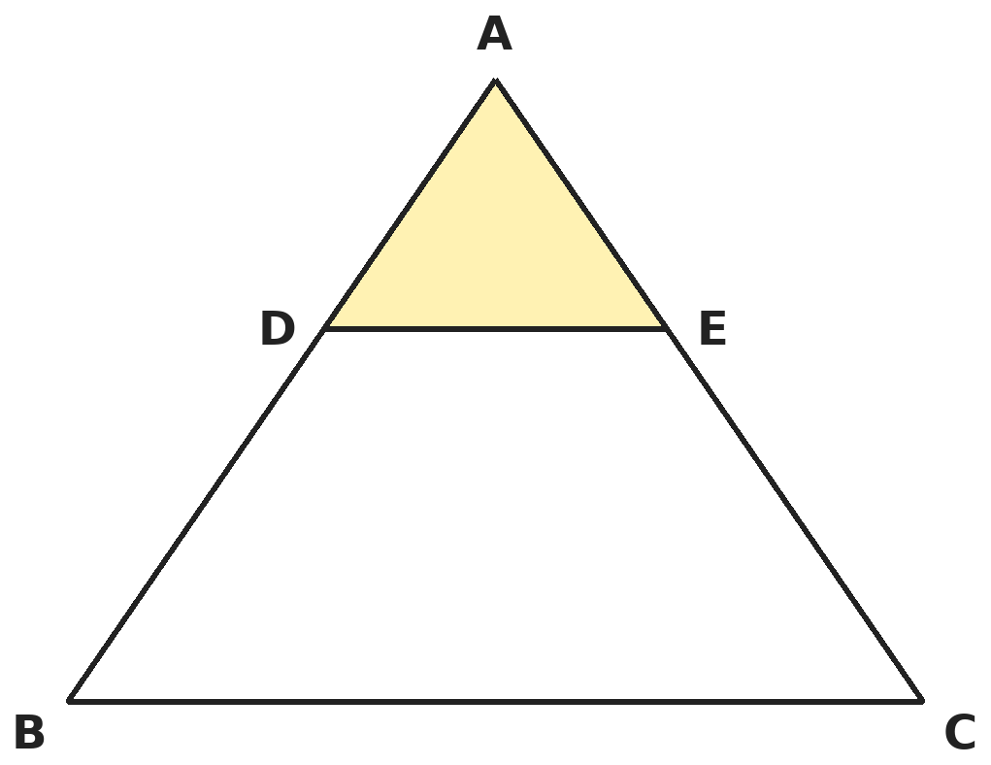
Q11. In triangle ABC, DE ∥ BC and AD : DB = 2 : 3. What is the ratio of the area of triangle ADE to the area of trapezium DBCE?
(A) 4 : 21 | (B) 4 : 25 | (C) 2 : 3 | (D) 4 : 9

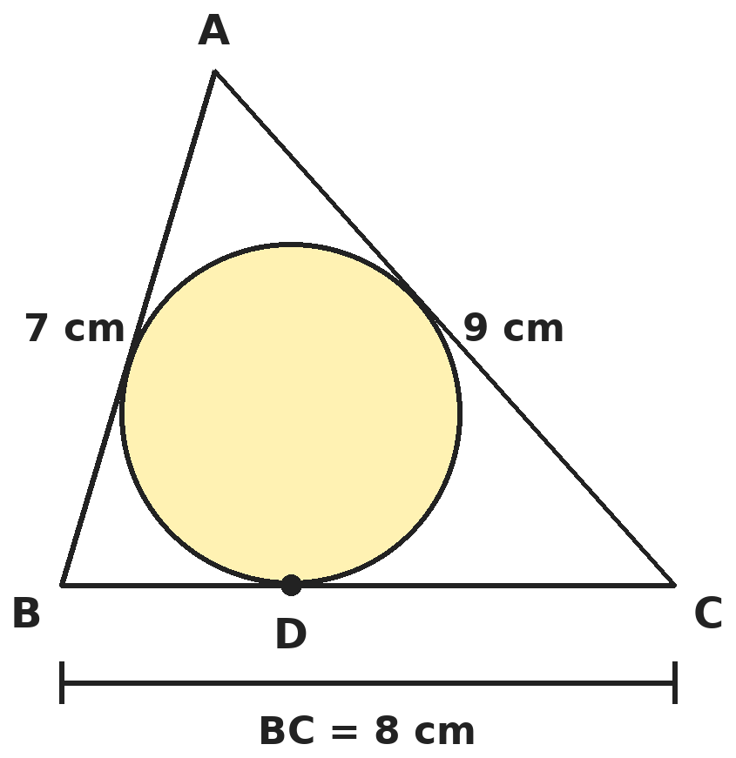
Q12. The incircle of triangle ABC touches BC at D. If AB = 7 cm, BC = 8 cm and CA = 9 cm, what is BD?
(A) 4 cm | (B) 3 cm | (C) 5 cm | (D) 3.5 cm

Part 5 — Mensuration (Syllabus Chapter 6)
Q13. A toy is a cone of radius 3.5 cm mounted on a hemisphere of the same radius. The total height of the toy is 15.5 cm. What is its total surface area? (Take π = 22/7.)
(A) 252.5 cm² | (B) 137.5 cm² | (C) 291.5 cm² | (D) 214.5 cm²

Q14. A solid metal cone of base radius 6 cm and height 24 cm is melted and recast into small solid spheres of radius 1.5 cm. How many spheres are made?
(A) 64 | (B) 48 | (C) 16 | (D) 192

Q15. A chord of a circle of radius 14 cm subtends a right angle at the centre. By how much does the area of the major segment exceed that of the minor segment? (Take π = 22/7.)
(A) 462 cm² | (B) 560 cm² | (C) 308 cm² | (D) 504 cm²

Part 6 — Trigonometry (Syllabus Chapter 7)
Q16. If tan θ = 1/√7, what is (cosec²θ − sec²θ)/(cosec²θ + sec²θ)?
(A) 5/7 | (B) 1/2 | (C) 4/3 | (D) 3/4

Q17. From the top of a 60 m building, the angles of depression of the top and bottom of a tower are 30° and 60°. What is the height of the tower?
(A) 20 m | (B) 40 m | (C) 30 m | (D) 20√3 m

Part 7 — Data Handling, Statistics & Probability (Syllabus Chapter 8)
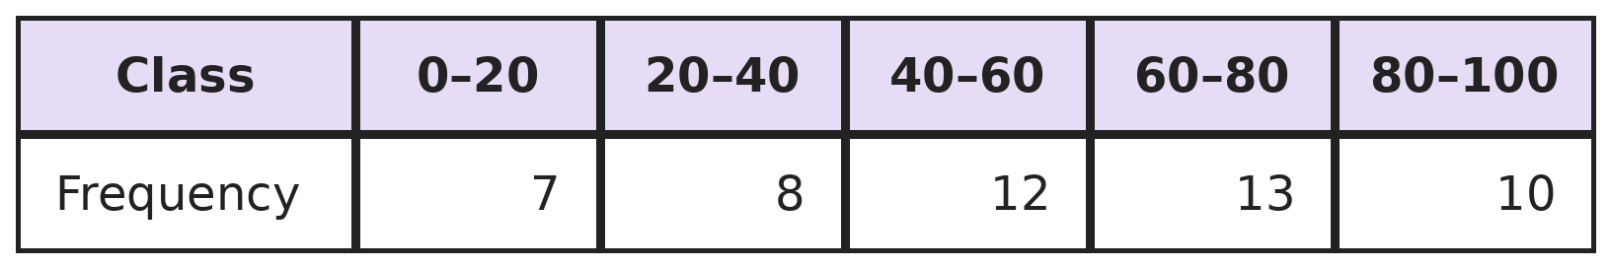
Q18. What is the mean of this frequency distribution?
(A) 50 | (B) 56.2 | (C) 52.8 | (D) 54.4

Q19. A card is drawn at random from 50 cards numbered 1 to 50. What is the probability that its number is a multiple of 3 or of 5?
(A) 23/50 | (B) 13/25 | (C) 1/2 | (D) 21/50

Part 8 — Applied Mathematics (Syllabus Chapter 9)
Q20. An article is marked ₹2,500. Shop P gives successive discounts of 20% and 10%. Shop Q gives a single discount of 30%. How much more does a buyer pay at shop P?
(A) ₹0 | (B) ₹75 | (C) ₹50 | (D) ₹25

Q21. Kartik borrows ₹10,000 at 12% per annum. Each month he pays ₹2,000 of the loan plus 1% interest on the amount still owed that month. How much interest does he pay in all?
(A) ₹600 | (B) ₹300 | (C) ₹500 | (D) ₹1,200

Q22. A factory has fixed costs of ₹36,000 a month, and each lamp costs ₹45 to make. To earn a profit of ₹12,000 a month, how many fewer lamps must it sell at ₹65 each than at ₹60 each?
(A) 600 | (B) 800 | (C) 1,000 | (D) 400

Part 9 — Mathematical Reasoning (Syllabus Chapter 10)
Q23. What is the least number of different numbers that must be chosen from 1 to 20 so that two of them are certain to add up to 21?
(A) 10 | (B) 12 | (C) 11 | (D) 21

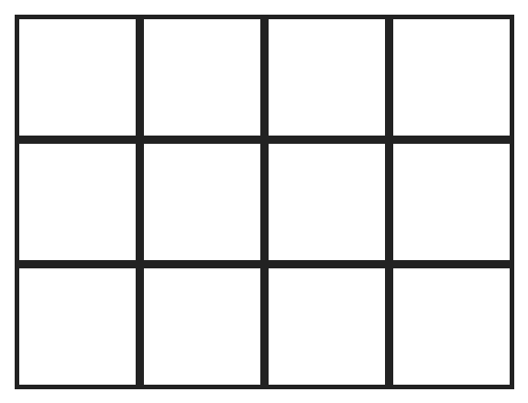
Q24. How many rectangles of all sizes (squares included) are there in this 4 by 3 grid?
(A) 30 | (B) 72 | (C) 60 | (D) 50

Q25. Five different positive integers add up to 100. What is the greatest possible value of the smallest of them?
(A) 20 | (B) 19 | (C) 17 | (D) 18

Part 10 — Mixed Problems (each joins two chapters)
Q26. How many pairs of positive integers (x, y) satisfy x² − y² = 45?
(A) 2 | (B) 3 | (C) 4 | (D) 6

Q27. In triangle ABC, angle B = 90°, angle A = 60° and AB = 6 cm. BD is drawn perpendicular to AC. What is the length of BD?
(A) 3 cm | (B) 6√3 cm | (C) 3√3 cm | (D) 2√3 cm

Q28. A(1, 2), B(4, y), C(x, 6) and D(3, 5) are the vertices of parallelogram ABCD, in order. What is x + y?
(A) 9 | (B) 8 | (C) 10 | (D) 11

Q29. Tanvi deposits ₹1,000 at the start of each month for 3 months, at 12% per annum compounded monthly. What is the value of her deposits at the end of the 3rd month?
(A) ₹3,030.00 | (B) ₹3,060.40 | (C) ₹3,000.00 | (D) ₹3,090.90

Q30. Whole cubes of edge 3 cm are cut from a solid block 10 cm × 8 cm × 7 cm, as many as possible. How much of the block (in cm³) is left over?
(A) 20 cm³ | (B) 0 cm³ | (C) 56 cm³ | (D) 236 cm³

Answer Sheet AMO Level 2 · Class 10 · Practice Paper 2
Name: | School: | Roll No.:
Shade or tick one circle for each question.
1. | Ⓐ Ⓑ Ⓒ Ⓓ | 11. | Ⓐ Ⓑ Ⓒ Ⓓ | 21. | Ⓐ Ⓑ Ⓒ Ⓓ
2. | Ⓐ Ⓑ Ⓒ Ⓓ | 12. | Ⓐ Ⓑ Ⓒ Ⓓ | 22. | Ⓐ Ⓑ Ⓒ Ⓓ
3. | Ⓐ Ⓑ Ⓒ Ⓓ | 13. | Ⓐ Ⓑ Ⓒ Ⓓ | 23. | Ⓐ Ⓑ Ⓒ Ⓓ
4. | Ⓐ Ⓑ Ⓒ Ⓓ | 14. | Ⓐ Ⓑ Ⓒ Ⓓ | 24. | Ⓐ Ⓑ Ⓒ Ⓓ
5. | Ⓐ Ⓑ Ⓒ Ⓓ | 15. | Ⓐ Ⓑ Ⓒ Ⓓ | 25. | Ⓐ Ⓑ Ⓒ Ⓓ
6. | Ⓐ Ⓑ Ⓒ Ⓓ | 16. | Ⓐ Ⓑ Ⓒ Ⓓ | 26. | Ⓐ Ⓑ Ⓒ Ⓓ
7. | Ⓐ Ⓑ Ⓒ Ⓓ | 17. | Ⓐ Ⓑ Ⓒ Ⓓ | 27. | Ⓐ Ⓑ Ⓒ Ⓓ
8. | Ⓐ Ⓑ Ⓒ Ⓓ | 18. | Ⓐ Ⓑ Ⓒ Ⓓ | 28. | Ⓐ Ⓑ Ⓒ Ⓓ
9. | Ⓐ Ⓑ Ⓒ Ⓓ | 19. | Ⓐ Ⓑ Ⓒ Ⓓ | 29. | Ⓐ Ⓑ Ⓒ Ⓓ
10. | Ⓐ Ⓑ Ⓒ Ⓓ | 20. | Ⓐ Ⓑ Ⓒ Ⓓ | 30. | Ⓐ Ⓑ Ⓒ Ⓓ

For the parent or teacher
Correct: ______ / 30
Answer Key and Solutions AMO Level 2 · Class 10 · Practice Paper 2
Quick answers
1 A | 6 C | 11 A | 16 D | 21 B | 26 B
2 B | 7 D | 12 B | 17 B | 22 B | 27 C
3 A | 8 C | 13 D | 18 D | 23 C | 28 A
4 D | 9 C | 14 A | 19 A | 24 C | 29 B
5 B | 10 A | 15 D | 20 C | 25 D | 30 D
Solutions
Q | Part · level | Answer | Why?
1 | Part 1 · Ch1 · Hard | (A) 625 | Hint: Subtract each remainder first. The divisor must divide all three results exactly.  1251 − 1 = 1250 = 2 × 5⁴, 9377 − 2 = 9375 = 3 × 5⁵, 15628 − 3 = 15625 = 5⁶. HCF = 5⁴ = 625. It is larger than every remainder, as it must be.
2 | Part 1 · Ch1 · Hard | (B) 176 | Hint: For two numbers, HCF × LCM = the product of the numbers.  Other number = 16 × 384 ÷ 48 = 128. Check: HCF(48, 128) = 16 and LCM = 384. Sum = 48 + 128 = 176.
3 | Part 2 · Ch3 · Hard | (A) ₹8,000 | Hint: The third year turns ₹8,820 into ₹9,261. That gives the rate.  9,261 ÷ 8,820 = 1.05, so the rate is 5%. Sum = 8,820 ÷ 1.05² = 8,820 ÷ 1.1025 = ₹8,000.
4 | Part 2 · Ch3 · Hard | (D) ₹8,400 | Hint: Add capital × months for each period.  Aditi: 20,000 × 4 + 15,000 × 8 = 2,00,000. Rahul: 25,000 × 12 = 3,00,000. Ratio 2 : 3. Aditi gets 2/5 × 21,000 = ₹8,400.
5 | Part 2 · Ch3 · Hard | (B) ₹1,200 | Hint: Take the cost price as ₹100 and find the profit percentage first.  On a cost of ₹100: marked ₹140, selling price 75% of 140 = ₹105, profit 5%. 5% of the cost is ₹60, so the cost is ₹1,200. (₹400 takes the profit as 40% − 25% = 15%.)
6 | Part 3 · Ch4 · Hard | (C) 47 | Hint: Find α² + β² first, then square it.  α + β = 3 and αβ = 1. α² + β² = 9 − 2 = 7. α⁴ + β⁴ = (α² + β²)² − 2α²β² = 49 − 2 = 47.
7 | Part 3 · Ch4 · Hard | (D) ₹190 | Hint: Add all three equations.  Adding: 2(pen + notebook + bag) = 480, so all three cost ₹240. Bag = 240 − (pen + notebook) = 240 − 50 = ₹190.
8 | Part 3 · Ch4 · Hard | (C) 62 | Hint: The 10th term is S₁₀ − S₉.  S₁₀ = 300 + 50 = 350 and S₉ = 243 + 45 = 288. a₁₀ = 350 − 288 = 62. (In general aₙ = 6n + 2.)
9 | Part 3 · Ch4 · Hard | (C) 3 | Hint: Equal roots: discriminant = 0.  4(k − 1)² − 4(k + 1) = 0 gives k² − 3k = 0, so k = 0 or k = 3. The positive value is 3.
10 | Part 4 · Ch5 · Hard | (A) (0, 0) | Hint: Let the point be (x, 0) and equate squared distances.  (x + 2)² + 16 = (x − 4)² + 4. So 4x + 20 = −8x + 20, giving x = 0. The point is the origin. Check: both distances are √20.
11 | Part 4 · Ch5 · Hard | (A) 4 : 21 | Hint: Triangles ADE and ABC are similar with ratio AD : AB.  AD : AB = 2 : 5, so areas ADE : ABC = 4 : 25. The trapezium is 25 − 4 = 21 parts. Ratio 4 : 21. (4 : 25 compares with the whole triangle.)
12 | Part 4 · Ch5 · Hard | (B) 3 cm | Hint: Tangents from a point to a circle are equal. Call the three tangent lengths x, y, z.  Let the tangent lengths from A, B, C be x, y, z. Then x + y = 7, y + z = 8, z + x = 9, so x + y + z = 12. BD = y = 12 − 9 = 3 cm.
13 | Part 5 · Ch6 · Hard | (D) 214.5 cm² | Hint: Cone height = 15.5 − 3.5. Only curved surfaces are on the outside.  Cone height 12 cm, slant √(144 + 12.25) = 12.5 cm. Cone CSA = 22/7 × 3.5 × 12.5 = 137.5. Hemisphere CSA = 2 × 22/7 × 3.5² = 77. Total = 214.5 cm².
14 | Part 5 · Ch6 · Hard | (A) 64 | Hint: Divide the volume of the cone by the volume of one sphere.  Cone = (1/3)π × 36 × 24 = 288π cm³. One sphere = (4/3)π × 1.5³ = 4.5π cm³. 288 ÷ 4.5 = 64 spheres. (192 forgets the 1/3 in the cone.)
15 | Part 5 · Ch6 · Hard | (D) 504 cm² | Hint: Find the minor segment, then the major segment = circle − minor segment.  Sector = ¼ × 22/7 × 196 = 154 cm²; triangle = ½ × 14 × 14 = 98 cm²; minor segment = 56 cm². Circle = 616 cm², so major segment = 616 − 56 = 560 cm². Difference = 560 − 56 = 504 cm². (462 cm² is the major sector.)
16 | Part 6 · Ch7 · Hard | (D) 3/4 | Hint: cosec²θ = 1 + cot²θ and sec²θ = 1 + tan²θ.  cot²θ = 7, so cosec²θ = 8. tan²θ = 1/7, so sec²θ = 8/7. Ratio = (8 − 8/7)/(8 + 8/7) = (48/7)/(64/7) = 3/4.
17 | Part 6 · Ch7 · Hard | (B) 40 m | Hint: Find the distance between the buildings from the 60° angle first.  Distance = 60/tan 60° = 20√3 m. The top of the tower is lower than the building by 20√3 × tan 30° = 20 m. Tower = 60 − 20 = 40 m.
18 | Part 7 · Ch8 · Hard | (D) 54.4 | Hint: Use class marks 10, 30, 50, 70, 90 (or step deviations from 50).  Step deviations from 50 with h = 20: −2, −1, 0, 1, 2. Σfu = −14 − 8 + 0 + 13 + 20 = 11. Mean = 50 + (11/50) × 20 = 54.4.
19 | Part 7 · Ch8 · Hard | (A) 23/50 | Hint: Do not count multiples of 15 twice.  Multiples of 3: 16. Multiples of 5: 10. Multiples of 15: 3. Total 16 + 10 − 3 = 23. Probability 23/50. (26/50 counts 15, 30, 45 twice.)
20 | Part 8 · Ch9 · Hard | (C) ₹50 | Hint: Successive discounts multiply: 0.8 × 0.9.  Shop P: 2,500 × 0.8 × 0.9 = ₹1,800. Shop Q: 2,500 × 0.7 = ₹1,750. P costs ₹50 more. (The effective discount at P is 28%, not 30%.)
21 | Part 8 · Ch9 · Hard | (B) ₹300 | Hint: The balances on which interest is charged are ₹10,000, ₹8,000, … .  Interest = 1% of (10,000 + 8,000 + 6,000 + 4,000 + 2,000) = 1% of 30,000 = ₹300. (₹600 charges interest on the full ₹10,000 every month.)
22 | Part 8 · Ch9 · Hard | (B) 800 | Hint: Lamps needed = (fixed costs + target profit) ÷ (price − cost per lamp).  Needed per month: 36,000 + 12,000 = ₹48,000 of contribution. At ₹60 each, contribution ₹15: 48,000 ÷ 15 = 3,200 lamps. At ₹65, contribution ₹20: 2,400 lamps. Difference 800.
23 | Part 9 · Ch10 · Hard | (C) 11 | Hint: Group the numbers into pairs that add up to 21.  The pairs (1, 20), (2, 19), …, (10, 11) make 10 boxes. With 10 numbers you can take one from each pair and avoid 21. An 11th number must complete a pair. So 11.
24 | Part 9 · Ch10 · Hard | (C) 60 | Hint: A rectangle is fixed by choosing 2 of the vertical lines and 2 of the horizontal lines.  A rectangle is fixed by choosing 2 of the 5 vertical lines and 2 of the 4 horizontal lines. Pairs of vertical lines: the first line pairs with 4 others, the second with 3 more, and so on: 4 + 3 + 2 + 1 = 10. Pairs of horizontal lines: 3 + 2 + 1 = 6. Rectangles = 10 × 6 = 60.
25 | Part 9 · Ch10 · Hard | (D) 18 | Hint: If the smallest is a, the total is at least a + (a + 1) + (a + 2) + (a + 3) + (a + 4).  5a + 10 ≤ 100 gives a ≤ 18. a = 18 works: 18 + 19 + 20 + 21 + 22 = 100. So 18. (20 would need all five equal.)
26 | Part 10 · Mixed · Ch4 + Ch10 · Hard | (B) 3 | Hint: x² − y² = (x − y)(x + y). Both factors must be odd here.  45 = 1 × 45 = 3 × 15 = 5 × 9 with x − y < x + y. These give (x, y) = (23, 22), (9, 6) and (7, 2). So 3 pairs.
27 | Part 10 · Mixed · Ch5 + Ch7 · Hard | (C) 3√3 cm | Hint: Look at the right triangle ABD.  Triangle ABD is right-angled at D with angle A = 60°. BD = AB sin 60° = 6 × √3/2 = 3√3 cm.
28 | Part 10 · Mixed · Ch4 + Ch5 · Hard | (A) 9 | Hint: The diagonals of a parallelogram bisect each other.  Midpoint of AC = midpoint of BD. (1 + x)/2 = (4 + 3)/2 gives x = 6. (2 + 6)/2 = (y + 5)/2 gives y = 3. x + y = 9.
29 | Part 10 · Mixed · Ch3 + Ch9 · Hard | (B) ₹3,060.40 | Hint: 12% per annum is 1% per month. The first deposit grows for 3 months, the last for 1.  Value = 1,000 × (1.01³ + 1.01² + 1.01) = 1,000 × (1.030301 + 1.0201 + 1.01) = ₹3,060.40 (to the nearest paisa).
30 | Part 10 · Mixed · Ch6 + Ch10 · Hard | (D) 236 cm³ | Hint: Count how many whole cubes fit along each edge of the block.  Along the edges: 10 ÷ 3 gives 3 cubes, 8 ÷ 3 gives 2, 7 ÷ 3 gives 2. So at most 3 × 2 × 2 = 12 cubes = 324 cm³. Block = 560 cm³. Left over = 560 − 324 = 236 cm³. (20 cm³ assumes 560 ÷ 27 ≈ 20 cubes fit.)

ARYABHATTA MATHS OLYMPIAD
Level 2
PRACTICE PAPER-3
CLASS 10
Total Questions | 30 multiple-choice questions
Level | Level-2 (final round): every question is Hard
Time | 45 minutes
Arrangement | Parts by chapter; the last Part has mixed problems joining two chapters
Negative Marking | No negative marking
Calculator | Not allowed
Chapters | Number System · Fractions, Decimals & Percentages · Algebra · Geometry · Mensuration · Trigonometry · Data Handling, Statistics & Probability · Applied Mathematics · Mathematical Reasoning

Instructions
• Each question has four options, (A) to (D), with exactly one correct answer.
• The questions are grouped in Parts by chapter. The last Part has mixed problems, each joining two chapters.
• Every question is at Level-2 (Hard) standard: expect several steps or a key insight.
• There is no negative marking. Calculators are not allowed; use a separate sheet for rough work.
• Figures are not necessarily drawn to scale unless stated.

For teachers
• Figures are part of the questions and work when printed in black and white.
• Parts follow the AMO syllabus chapters. Chapter 2 is not part of the Class 10 syllabus, so the chapter numbers shown in the Part headings have gaps.
• The answer sheet and the answer key are at the end. Remove the answer key before the paper is attempted.

Part 1 — Number System (Syllabus Chapter 1)
Q1. How many of the positive divisors of 720 are even?
(A) 30 | (B) 6 | (C) 20 | (D) 24

Q2. The decimal 0.2454545… (the digits 45 repeat for ever) is written as a fraction in lowest terms. What is it?
(A) 245/999 | (B) 9/40 | (C) 27/100 | (D) 27/110

Part 2 — Fractions, Decimals & Percentages (Syllabus Chapter 3)
Q3. What is the compound interest on ₹16,000 for 9 months at 20% per annum, compounded quarterly?
(A) ₹2,400 | (B) ₹2,522 | (C) ₹2,480 | (D) ₹3,200

Q4. A machine bought for ₹50,000 loses 10% of its value every year (on its value at the start of that year). What is it worth after 3 years?
(A) ₹36,450 | (B) ₹35,000 | (C) ₹40,500 | (D) ₹36,000

Q5. Three friends invest money in the ratio 1/2 : 1/3 : 1/4 for the same time. They make a profit of ₹39,000. What is the share of the friend who invested the least?
(A) ₹9,000 | (B) ₹13,000 | (C) ₹12,000 | (D) ₹18,000

Part 3 — Algebra (Syllabus Chapter 4)
Q6. When x³ − 3x² + 5x − 3 is divided by x² − 2, what is the remainder?
(A) 7x + 9 | (B) 3x − 9 | (C) x − 3 | (D) 7x − 9

Q7. If 2/x + 3/y = 13 and 5/x − 4/y = −2, what is x + y?
(A) 5/6 | (B) 5 | (C) 6/5 | (D) 1/6

Q8. The 4th term of an AP is 11 and its 10th term is 29. What is the sum of its first 20 terms?
(A) 590 | (B) 650 | (C) 610 | (D) 620

Q9. Five years ago, a father was 7 times as old as his son. Five years from now, he will be 3 times as old as his son. What is the sum of their present ages?
(A) 45 years | (B) 55 years | (C) 60 years | (D) 50 years

Part 4 — Geometry (Syllabus Chapter 5)
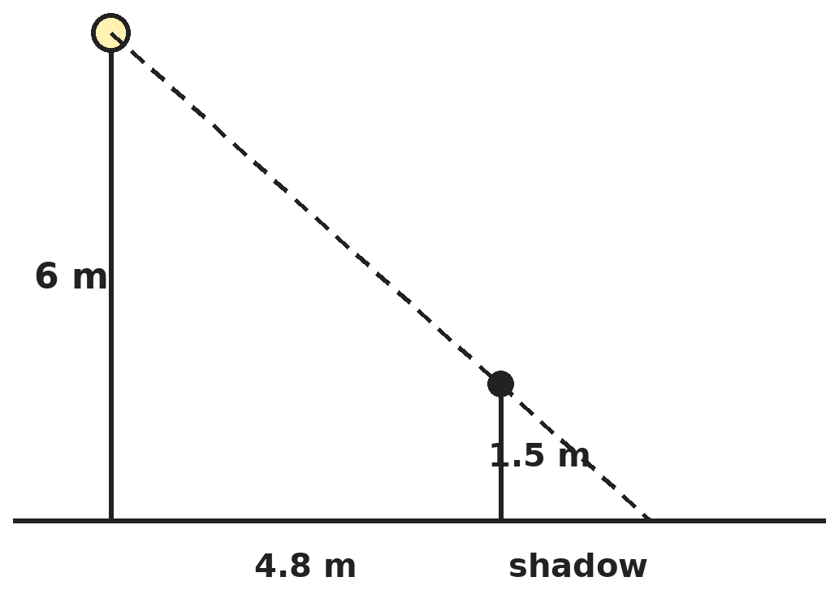
Q10. Ishita, 1.5 m tall, walks away from the foot of a 6 m lamp post at 1.2 m/s. How long is her shadow after 4 seconds?
(A) 1.2 m | (B) 1.6 m | (C) 4.8 m | (D) 2 m

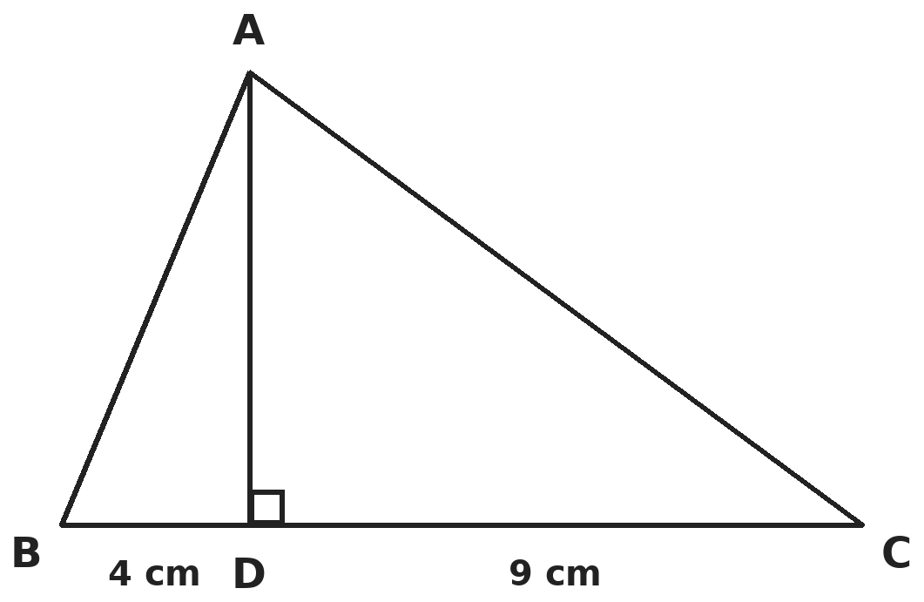
Q11. In triangle ABC, angle A = 90° and AD ⊥ BC. If BD = 4 cm and DC = 9 cm, what is AD?
(A) 6.5 cm | (B) √13 cm | (C) 5 cm | (D) 6 cm

Q12. There are two points of the form (k, 4) at a distance of 5 units from A(2, 0). Call them P and Q. What is the area of triangle APQ?
(A) 24 sq units | (B) 12 sq units | (C) 6 sq units | (D) 10 sq units

Part 5 — Mensuration (Syllabus Chapter 6)
Q13. A solid cone is cut by two planes parallel to its base so that its height is divided into three equal parts. What is the ratio of the volumes of the three pieces, from the top down?
(A) 1 : 7 : 19 | (B) 1 : 2 : 3 | (C) 1 : 4 : 9 | (D) 1 : 8 : 27

Q14. Lead balls of radius 1 cm are dropped into a cylindrical jar of radius 6 cm partly filled with water. How many balls are needed to raise the water level by 4 cm?
(A) 144 | (B) 36 | (C) 27 | (D) 108

Q15. A goat is tied at a corner of a large square field. Its rope is lengthened from 14 m to 21 m. How much extra area can it graze now? (Take π = 22/7.)
(A) 346.5 m² | (B) 192.5 m² | (C) 154 m² | (D) 770 m²

Part 6 — Trigonometry (Syllabus Chapter 7)
Q16. For an acute angle θ, tan θ = 1/√7. What is (cosec²θ − sec²θ) ÷ (cosec²θ + sec²θ)?
(A) 4/3 | (B) 1/2 | (C) 3/4 | (D) 5/7

Q17. Two poles of equal height stand on opposite sides of an 80 m wide road. From a point on the road between them, the angles of elevation of their tops are 60° and 30°. What is the height of each pole?
(A) 40√3 m | (B) 20 m | (C) 20√3 m | (D) 40 m

Part 7 — Data Handling, Statistics & Probability (Syllabus Chapter 8)
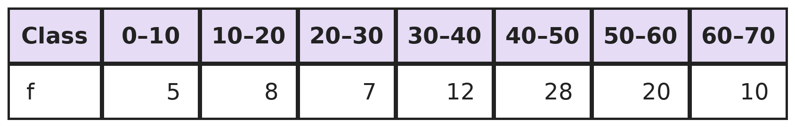
Q18. What is the mode of this grouped frequency distribution (correct to two decimal places)?
(A) 45.00 | (B) 48.00 | (C) 43.33 | (D) 46.67

Q19. Two fair dice are thrown. What is the probability that the sum of the numbers is a prime number?
(A) 5/12 | (B) 1/2 | (C) 7/18 | (D) 1/3

Part 8 — Applied Mathematics (Syllabus Chapter 9)
Q20. A Mumbai dealer buys goods within Maharashtra for ₹20,000 plus 18% GST. He sells them to a buyer in Goa for ₹25,000 plus 18% IGST. After using his input tax credit, how much IGST does he pay in cash?
(A) ₹4,500 | (B) ₹3,600 | (C) ₹450 | (D) ₹900

Q21. A motor boat whose speed in still water is 15 km/h goes 30 km downstream and comes back in a total of 4 hours 30 minutes. What is the speed of the stream?
(A) 3 km/h | (B) 2.5 km/h | (C) 5 km/h | (D) 4 km/h

Q22. Pipe P fills a tank in 10 hours and pipe Q in 15 hours. Pipe R empties the full tank in 12 hours. All three are opened on an empty tank, and after 4 hours R is closed. How long does the tank take to fill in all?
(A) 8 hours | (B) 12 hours | (C) 10 hours | (D) 6 hours

Part 9 — Mathematical Reasoning (Syllabus Chapter 10)
Q23. What is the least number of integers you must choose so that two of them are certain to have a difference divisible by 10?
(A) 10 | (B) 9 | (C) 11 | (D) 6

Q24. Ravi walks along the lines of a street grid from corner P to corner Q, which is 4 blocks east and 3 blocks north of P. He only goes east or north. How many different routes can he take?
(A) 35 | (B) 12 | (C) 70 | (D) 21

Q25. Two opposite corner squares are cut from an 8 × 8 chessboard, leaving 62 squares. Each domino covers two squares next to each other. How many dominoes are needed to cover the board exactly?
(A) 31 | (B) It cannot be covered
(C) 30 | (D) 32

Part 10 — Mixed Problems (each joins two chapters)
Q26. For how many integers k can x² + kx + 12 be written as (x + p)(x + q) with integers p and q?
(A) 3 | (B) 12 | (C) 6 | (D) 8

Q27. From the top of a 7 m high building, the angle of elevation of the top of a cable tower is 60° and the angle of depression of its foot is 45°. What is the height of the tower?
(A) 7√3 m | (B) 7(√3 + 1) m | (C) 14 m | (D) 7(√3 − 1) m

Q28. A quadrilateral ABCD is drawn around a circle so that all four sides touch it. AB = x + 2, BC = 2x − 1, CD = 3x − 4 and DA = x + 1 (in cm). What is its perimeter?
(A) 10 cm | (B) 12 cm | (C) 14 cm | (D) 16 cm

Q29. Plan A: invest ₹24,000 now for 2 years at 10% compound interest. Plan B: invest ₹12,000 now and ₹12,000 after 1 year, at the same rate, until the end of 2 years. How much more does plan A give?
(A) ₹1,200 | (B) ₹2,400 | (C) ₹1,320 | (D) ₹0

Q30. A rectangular sheet 44 cm × 20 cm is rolled into an open cylinder, without overlap, along either side. What is the largest volume the cylinder can have? (Take π = 22/7.)
(A) 3,080 cm³ | (B) 1,400 cm³ | (C) 1,680 cm³ | (D) 4,480 cm³

Answer Sheet AMO Level 2 · Class 10 · Practice Paper 3
Name: | School: | Roll No.:
Shade or tick one circle for each question.
1. | Ⓐ Ⓑ Ⓒ Ⓓ | 11. | Ⓐ Ⓑ Ⓒ Ⓓ | 21. | Ⓐ Ⓑ Ⓒ Ⓓ
2. | Ⓐ Ⓑ Ⓒ Ⓓ | 12. | Ⓐ Ⓑ Ⓒ Ⓓ | 22. | Ⓐ Ⓑ Ⓒ Ⓓ
3. | Ⓐ Ⓑ Ⓒ Ⓓ | 13. | Ⓐ Ⓑ Ⓒ Ⓓ | 23. | Ⓐ Ⓑ Ⓒ Ⓓ
4. | Ⓐ Ⓑ Ⓒ Ⓓ | 14. | Ⓐ Ⓑ Ⓒ Ⓓ | 24. | Ⓐ Ⓑ Ⓒ Ⓓ
5. | Ⓐ Ⓑ Ⓒ Ⓓ | 15. | Ⓐ Ⓑ Ⓒ Ⓓ | 25. | Ⓐ Ⓑ Ⓒ Ⓓ
6. | Ⓐ Ⓑ Ⓒ Ⓓ | 16. | Ⓐ Ⓑ Ⓒ Ⓓ | 26. | Ⓐ Ⓑ Ⓒ Ⓓ
7. | Ⓐ Ⓑ Ⓒ Ⓓ | 17. | Ⓐ Ⓑ Ⓒ Ⓓ | 27. | Ⓐ Ⓑ Ⓒ Ⓓ
8. | Ⓐ Ⓑ Ⓒ Ⓓ | 18. | Ⓐ Ⓑ Ⓒ Ⓓ | 28. | Ⓐ Ⓑ Ⓒ Ⓓ
9. | Ⓐ Ⓑ Ⓒ Ⓓ | 19. | Ⓐ Ⓑ Ⓒ Ⓓ | 29. | Ⓐ Ⓑ Ⓒ Ⓓ
10. | Ⓐ Ⓑ Ⓒ Ⓓ | 20. | Ⓐ Ⓑ Ⓒ Ⓓ | 30. | Ⓐ Ⓑ Ⓒ Ⓓ

For the parent or teacher
Correct: ______ / 30
Answer Key and Solutions AMO Level 2 · Class 10 · Practice Paper 3
Quick answers
1 D | 6 D | 11 D | 16 C | 21 C | 26 C
2 D | 7 A | 12 B | 17 C | 22 A | 27 B
3 B | 8 C | 13 A | 18 D | 23 C | 28 B
4 A | 9 D | 14 D | 19 A | 24 A | 29 C
5 A | 10 B | 15 B | 20 D | 25 B | 30 A
Solutions
Q | Part · level | Answer | Why?
1 | Part 1 · Ch1 · Hard | (D) 24 | Hint: 720 = 2⁴ × 3² × 5. An even divisor must use at least one 2.  A divisor is 2ᵃ × 3ᵇ × 5ᶜ. For it to be even, a can be 1 to 4 (4 ways), b can be 0 to 2 (3 ways), c can be 0 or 1 (2 ways). 4 × 3 × 2 = 24. (30 counts all divisors.)
2 | Part 1 · Ch1 · Hard | (D) 27/110 | Hint: Split it as 0.2 + 0.0454545… and write 0.454545… as 45/99.  0.0454545… = (1/10) × 45/99 = 1/22. So the number is 1/5 + 1/22 = 22/110 + 5/110 = 27/110.
3 | Part 2 · Ch3 · Hard | (B) ₹2,522 | Hint: Quarterly means 5% for each of 3 quarters.  Amount = 16,000 × 1.05³ = 16,000 × 1.157625 = ₹18,522. Interest = ₹2,522. (₹2,400 is the simple interest.)
4 | Part 2 · Ch3 · Hard | (A) ₹36,450 | Hint: Multiply by 0.9 once for every year.  50,000 × 0.9³ = 50,000 × 0.729 = ₹36,450. (₹35,000 takes 10% of the original price each year.)
5 | Part 2 · Ch3 · Hard | (A) ₹9,000 | Hint: Multiply each fraction by 12 to get a whole-number ratio.  1/2 : 1/3 : 1/4 = 6 : 4 : 3. Smallest share = 3/13 × 39,000 = ₹9,000.
6 | Part 3 · Ch4 · Hard | (D) 7x − 9 | Hint: The quotient is x − 3. Subtract (x − 3)(x² − 2).  (x − 3)(x² − 2) = x³ − 3x² − 2x + 6. Remainder = (x³ − 3x² + 5x − 3) − (x³ − 3x² − 2x + 6) = 7x − 9.
7 | Part 3 · Ch4 · Hard | (A) 5/6 | Hint: Put u = 1/x and v = 1/y.  2u + 3v = 13 and 5u − 4v = −2 give u = 2 and v = 3. So x = 1/2, y = 1/3 and x + y = 5/6. (5 is u + v.)
8 | Part 3 · Ch4 · Hard | (C) 610 | Hint: 6d = 29 − 11.  6d = 18 gives d = 3, and a = 11 − 9 = 2. S₂₀ = 20/2 × (2 × 2 + 19 × 3) = 10 × 61 = 610.
9 | Part 3 · Ch4 · Hard | (D) 50 years | Hint: Let the son be s and the father f years old now.  f − 5 = 7(s − 5) and f + 5 = 3(s + 5). Subtracting: 10 = 3s + 15 − 7s + 35, so 4s = 40 and s = 10. Then f = 40. Sum = 50 years.
10 | Part 4 · Ch5 · Hard | (B) 1.6 m | Hint: The two right triangles with the lamp and with Ishita are similar.  After 4 s she is 4.8 m from the post. If the shadow is s m, then s/(s + 4.8) = 1.5/6 = 1/4. So 4s = s + 4.8 and s = 1.6 m.
11 | Part 4 · Ch5 · Hard | (D) 6 cm | Hint: Triangles ABD and CAD are similar.  From the similar triangles, BD/AD = AD/DC, so AD² = BD × DC = 36 and AD = 6 cm. (6.5 cm is half of BC.)
12 | Part 4 · Ch5 · Hard | (B) 12 sq units | Hint: Use the distance formula to find both values of k.  (k − 2)² + 4² = 25 gives (k − 2)² = 9, so k = 5 or k = −1. P(5, 4) and Q(−1, 4) lie on the line y = 4, so PQ = 6 and the height from A(2, 0) to that line is 4. Area = ½ × 6 × 4 = 12 sq units.
13 | Part 5 · Ch6 · Hard | (A) 1 : 7 : 19 | Hint: The cones on top of each cut are similar to the whole cone. Volumes of similar solids go as the cube of the height.  The cones of heights h, 2h and 3h have volumes in the ratio 1 : 8 : 27. The pieces are 1, 8 − 1 = 7 and 27 − 8 = 19. Ratio 1 : 7 : 19. (1 : 8 : 27 compares whole cones, not the pieces.)
14 | Part 5 · Ch6 · Hard | (D) 108 | Hint: Volume of water displaced = volume of the balls.  Rise in volume = π × 6² × 4 = 144π. One ball = (4/3)π. Number = 144π ÷ (4/3)π = 108.
15 | Part 5 · Ch6 · Hard | (B) 192.5 m² | Hint: At a corner of a square the goat grazes a quarter circle.  Extra area = 1/4 × 22/7 × (21² − 14²) = 1/4 × 22/7 × 245 = 192.5 m². (770 m² uses a full circle.)
16 | Part 6 · Ch7 · Hard | (C) 3/4 | Hint: Use cosec²θ = 1 + cot²θ and sec²θ = 1 + tan²θ.  tan²θ = 1/7 and cot²θ = 7. So cosec²θ = 1 + 7 = 8 and sec²θ = 1 + 1/7 = 8/7. The ratio is (8 − 8/7) ÷ (8 + 8/7) = (48/7) ÷ (64/7) = 3/4.
17 | Part 6 · Ch7 · Hard | (C) 20√3 m | Hint: If the point is x m from the first pole, h = x tan 60° = (80 − x) tan 30°.  x√3 = (80 − x)/√3 gives 3x = 80 − x, so x = 20. Height = 20 tan 60° = 20√3 m (about 34.6 m).
18 | Part 7 · Ch8 · Hard | (D) 46.67 | Hint: Mode = l + ((f₁ − f₀)/(2f₁ − f₀ − f₂)) × h.  Modal class 40–50: l = 40, f₁ = 28, f₀ = 12, f₂ = 20, h = 10. Mode = 40 + (16/24) × 10 = 40 + 6.67 = 46.67.
19 | Part 7 · Ch8 · Hard | (A) 5/12 | Hint: The possible prime sums are 2, 3, 5, 7 and 11.  Ways: sum 2 → 1, sum 3 → 2, sum 5 → 4, sum 7 → 6, sum 11 → 2. Total 15 of 36. Probability 15/36 = 5/12.
20 | Part 8 · Ch9 · Hard | (D) ₹900 | Hint: Input credit = CGST + SGST paid on purchase. It can be set off against IGST.  Input tax = 18% of 20,000 = ₹3,600 (CGST 1,800 + SGST 1,800). Output IGST = 18% of 25,000 = ₹4,500. Cash paid = 4,500 − 3,600 = ₹900.
21 | Part 8 · Ch9 · Hard | (C) 5 km/h | Hint: 30/(15 + s) + 30/(15 − s) = 4.5.  The left side is 900/(225 − s²). So 225 − s² = 200, s² = 25 and s = 5 km/h.
22 | Part 8 · Ch9 · Hard | (A) 8 hours | Hint: Find how much is filled in the first 4 hours with all three pipes.  With all three: 1/10 + 1/15 − 1/12 = (6 + 4 − 5)/60 = 1/12 of the tank per hour. In 4 hours: 1/3. P and Q together fill 1/10 + 1/15 = 1/6 per hour, so the remaining 2/3 takes 4 hours. Total 8 hours. (12 hours keeps R open throughout.)
23 | Part 9 · Ch10 · Hard | (C) 11 | Hint: Two numbers differ by a multiple of 10 exactly when they have the same last digit.  There are 10 possible last digits. With 10 numbers they could all differ. With 11, two share a last digit, so their difference is divisible by 10.
24 | Part 9 · Ch10 · Hard | (A) 35 | Hint: Every route is an arrangement of 4 E's and 3 N's.  Write at each corner the number of routes reaching it: every corner on the bottom row or left edge has 1, and each other corner gets the sum of the corner to its left and the corner below it. Row by row the numbers are 1, 1, 1, 1, 1; then 1, 2, 3, 4, 5; then 1, 3, 6, 10, 15; then 1, 4, 10, 20, 35. So there are 35 routes to Q. (12 multiplies 4 × 3.)
25 | Part 9 · Ch10 · Hard | (B) It cannot be covered | Hint: Colour the board. Which colour are the two removed corners?  Opposite corners have the same colour, so 32 squares of one colour and 30 of the other remain. Every domino covers one square of each colour, so 31 dominoes would need 31 of each. It cannot be done.
26 | Part 10 · Mixed · Ch4 + Ch10 · Hard | (C) 6 | Hint: p × q = 12 and k = p + q. Do not forget negative pairs.  Pairs with product 12: (1, 12), (2, 6), (3, 4) and their negatives. k = 13, 8, 7, −13, −8, −7. So 6 values.
27 | Part 10 · Mixed · Ch5 + Ch7 · Hard | (B) 7(√3 + 1) m | Hint: The 45° angle gives the distance between the building and the tower.  Distance = 7/tan 45° = 7 m. Above the building level the tower rises 7 tan 60° = 7√3 m. Height = 7 + 7√3 = 7(√3 + 1) m.
28 | Part 10 · Mixed · Ch4 + Ch5 · Hard | (B) 12 cm | Hint: Equal tangents give AB + CD = BC + DA.  (x + 2) + (3x − 4) = (2x − 1) + (x + 1) gives 4x − 2 = 3x, so x = 2. Sides 4, 3, 2, 3. Perimeter = 12 cm.
29 | Part 10 · Mixed · Ch3 + Ch9 · Hard | (C) ₹1,320 | Hint: The second ₹12,000 earns interest for only 1 year.  A: 24,000 × 1.21 = ₹29,040. B: 12,000 × 1.21 + 12,000 × 1.1 = 14,520 + 13,200 = ₹27,720. Difference ₹1,320.
30 | Part 10 · Mixed · Ch6 + Ch10 · Hard | (A) 3,080 cm³ | Hint: Try both ways: the side that is rolled becomes the circumference.  Circumference 44: r = 7, h = 20, V = 22/7 × 49 × 20 = 3,080 cm³. Circumference 20: r = 35/11, h = 44, V = 1,400 cm³. The larger is 3,080 cm³.

ARYABHATTA MATHS OLYMPIAD
Level 2
PRACTICE PAPER-4
CLASS 10
Total Questions | 30 multiple-choice questions
Level | Level-2 (final round): every question is Hard
Time | 45 minutes
Arrangement | Parts by chapter; the last Part has mixed problems joining two chapters
Negative Marking | No negative marking
Calculator | Not allowed
Chapters | Number System · Fractions, Decimals & Percentages · Algebra · Geometry · Mensuration · Trigonometry · Data Handling, Statistics & Probability · Applied Mathematics · Mathematical Reasoning

Instructions
• Each question has four options, (A) to (D), with exactly one correct answer.
• The questions are grouped in Parts by chapter. The last Part has mixed problems, each joining two chapters.
• Every question is at Level-2 (Hard) standard: expect several steps or a key insight.
• There is no negative marking. Calculators are not allowed; use a separate sheet for rough work.
• Figures are not necessarily drawn to scale unless stated.

For teachers
• Figures are part of the questions and work when printed in black and white.
• Parts follow the AMO syllabus chapters. Chapter 2 is not part of the Class 10 syllabus, so the chapter numbers shown in the Part headings have gaps.
• The answer sheet and the answer key are at the end. Remove the answer key before the paper is attempted.

Part 1 — Number System (Syllabus Chapter 1)
Q1. What is the smallest number that leaves a remainder of 5 when divided by 12, by 15 and by 20, and is also divisible by 7?
(A) 65 | (B) 125 | (C) 245 | (D) 185

Q2. What is the last digit of 7²⁰²⁶?
(A) 9 | (B) 7 | (C) 1 | (D) 3

Part 2 — Fractions, Decimals & Percentages (Syllabus Chapter 3)
Q3. At what rate of compound interest per annum (compounded yearly) will ₹6,250 amount to ₹7,290 in 2 years?
(A) 8% | (B) 8.32% | (C) 9% | (D) 7%

Q4. On a sum at compound interest (compounded yearly), the interest for the 2nd year is ₹1,320 and for the 3rd year is ₹1,452. What is the sum?
(A) ₹13,200 | (B) ₹12,000 | (C) ₹10,000 | (D) ₹11,000

Q5. The population of a town rises by 10% in one year and by 20% the next year. In the third year it falls by 25%. What is the overall change over the three years?
(A) 5% increase | (B) No change | (C) 1% increase | (D) 1% decrease

Part 3 — Algebra (Syllabus Chapter 4)
Q6. The zeros of x² − 12x + k differ by 6. What is k?
(A) 35 | (B) 32 | (C) 27 | (D) 36

Q7. Anaya, Kabir and Riya scored 120 runs in all. Anaya scored 10 more than Kabir. Riya scored 20 fewer than Anaya and Kabir together. How many runs did Riya score?
(A) 40 | (B) 30 | (C) 50 | (D) 60

Q8. How many terms of the AP 24, 21, 18, … must be added to get a sum of 0?
(A) 16 | (B) 9 | (C) 8 | (D) 17

Q9. A positive number x exceeds its reciprocal by 24/5. What is x² + 1/x²?
(A) 576/25 | (B) 626/25 | (C) 526/25 | (D) 26

Part 4 — Geometry (Syllabus Chapter 5)
Q10. The areas of two similar triangles are 81 cm² and 49 cm². The sum of their perimeters is 64 cm. What is the perimeter of the larger triangle?
(A) 28 cm | (B) 36 cm | (C) 32 cm | (D) 40.5 cm

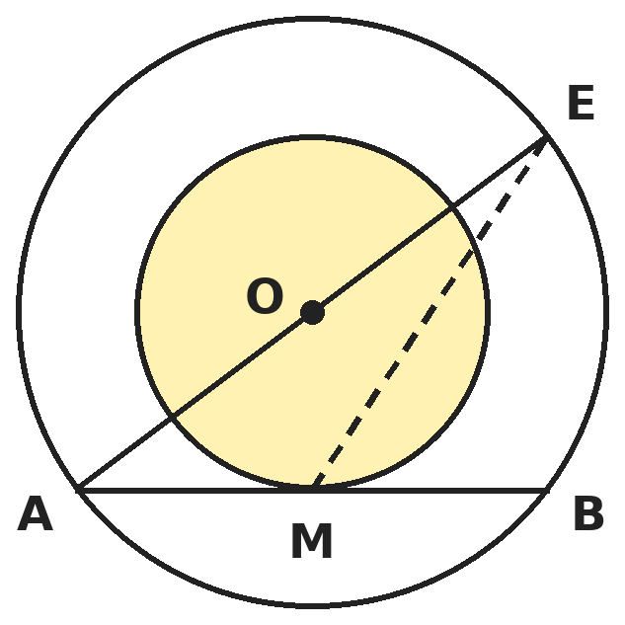
Q11. Two concentric circles with centre O have radii 5 cm and 3 cm. A chord AB of the larger circle touches the smaller circle at M. AO is extended to meet the larger circle again at E. What is the length ME?
(A) 2√13 cm | (B) 8 cm | (C) √34 cm | (D) 6 cm

Q12. The two points that divide the segment from (−2, 3) to (4, −3) into three equal parts are found. What is the sum of all four of their coordinates?
(A) 0 | (B) 1 | (C) 4 | (D) 2

Part 5 — Mensuration (Syllabus Chapter 6)
Q13. A medicine capsule is a cylinder with a hemisphere at each end. Its total length is 14 mm and its diameter is 5 mm. What is its surface area? (Take π = 22/7.)
(A) 141 mm² | (B) 220 mm² | (C) 298 mm² | (D) 176 mm²

Q14. A hemispherical bowl of inner radius 9 cm is full of juice. It is poured into cylindrical bottles of radius 1.5 cm and height 4 cm. How many bottles can be filled?
(A) 81 | (B) 27 | (C) 54 | (D) 108

Q15. A sector of a circle has an angle of 60° at the centre and a perimeter of 64 cm. What is its area? (Take π = 22/7.)
(A) 462 cm² | (B) 22 cm² | (C) 231 cm² | (D) 1386 cm²

Part 6 — Trigonometry (Syllabus Chapter 7)
Q16. For an acute angle θ, sin θ + cos θ = √2 cos θ. What is tan θ, and what is the value of tan θ + cot θ?
(A) √2 + 1 and 2√2 | (B) √2 − 1 and 2
(C) 1 and 2 | (D) √2 − 1 and 2√2

Q17. A kite is on a straight string 60 m long making 60° with the level ground. The wind changes and the string, still 60 m long, now makes 45°. By how much has the kite come down?
(A) 30√3 m | (B) 30√2 m | (C) 15 m | (D) 30(√3 − √2) m

Part 7 — Data Handling, Statistics & Probability (Syllabus Chapter 8)
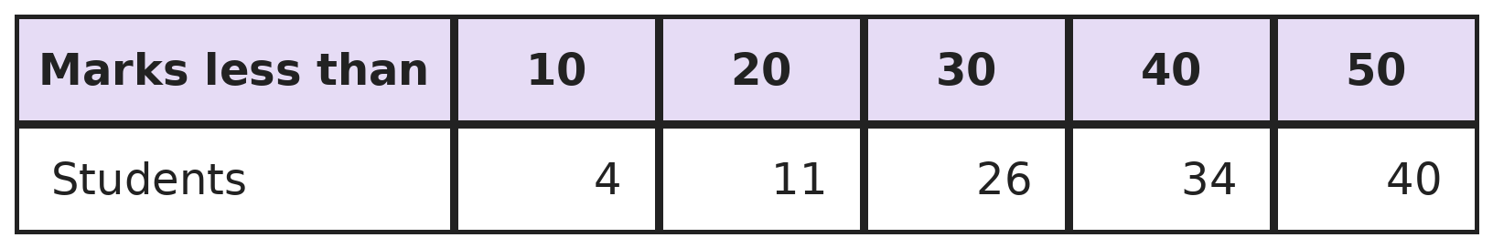
Q18. The table gives a cumulative frequency distribution of marks. What is the median mark?
(A) 25 | (B) 26 | (C) 27.5 | (D) 30

Q19. A bag has 5 red and 3 blue balls. Two balls are drawn one after the other without replacement. What is the probability that both are the same colour?
(A) 13/28 | (B) 17/32 | (C) 5/14 | (D) 1/2

Part 8 — Applied Mathematics (Syllabus Chapter 9)
Q20. A shop offers "buy 3, get 1 free" on shirts of the same price, and then 10% off the bill. What is the effective discount on 4 shirts?
(A) 35% | (B) 25% | (C) 40% | (D) 32.5%

Q21. Hema and Raghav can do a job in 12 days, Raghav and Sneha in 15 days, and Hema and Sneha in 20 days. How long would Hema take alone?
(A) 30 days | (B) 20 days | (C) 60 days | (D) 24 days

Q22. A dealer in Pune buys goods for ₹10,000 plus 18% GST and sells them in Mumbai for ₹12,000 plus 18% GST. Both deals are within the state. After input tax credit, how much CGST does the dealer pay to the government?
(A) ₹360 | (B) ₹1,080 | (C) ₹90 | (D) ₹180

Part 9 — Mathematical Reasoning (Syllabus Chapter 10)
Q23. Points are placed in a square of side 2 cm (inside it or on its edges). What is the least number of points that guarantees two of them are at most √2 cm apart?
(A) 4 | (B) 9 | (C) 5 | (D) 3

Q24. At a party there are 5 couples. Everyone shakes hands once with every other person except their own partner. How many handshakes take place?
(A) 45 | (B) 40 | (C) 35 | (D) 90

Q25. The number 10 is written as a sum of positive integers, such as 4 + 6 or 2 + 3 + 5. What is the largest possible product of the parts?
(A) 32 | (B) 30 | (C) 36 | (D) 25

Part 10 — Mixed Problems (each joins two chapters)
Q26. How many terms of the AP 3, 7, 11, 15, … that are less than 1000 are perfect squares?
(A) 15 | (B) 0 | (C) 16 | (D) 31

Q27. A chord of a circle of radius 10 cm subtends an angle of 120° at the centre. What is the length of the chord?
(A) 10 cm | (B) 5√3 cm | (C) 20 cm | (D) 10√3 cm

Q28. The point (3, a) divides the segment joining (1, 2) and (b, 8) in the ratio 1 : 2. What is a + b?
(A) 9 | (B) 11 | (C) 13 | (D) 10

Q29. Ankita needs a loan of ₹50,000 for 1 year. Bank P charges 10% per annum compounded half-yearly. Bank Q charges 10.2% per annum simple interest. Which bank is cheaper, and by how much?
(A) Bank Q, by ₹25 | (B) Bank P, by ₹25
(C) Bank Q, by ₹125 | (D) Both cost the same

Q30. A cuboid 3 cm × 4 cm × 5 cm is painted on all faces and cut into 1 cm cubes. How many of the small cubes have paint on exactly two faces?
(A) 24 | (B) 22 | (C) 8 | (D) 6

Answer Sheet AMO Level 2 · Class 10 · Practice Paper 4
Name: | School: | Roll No.:
Shade or tick one circle for each question.
1. | Ⓐ Ⓑ Ⓒ Ⓓ | 11. | Ⓐ Ⓑ Ⓒ Ⓓ | 21. | Ⓐ Ⓑ Ⓒ Ⓓ
2. | Ⓐ Ⓑ Ⓒ Ⓓ | 12. | Ⓐ Ⓑ Ⓒ Ⓓ | 22. | Ⓐ Ⓑ Ⓒ Ⓓ
3. | Ⓐ Ⓑ Ⓒ Ⓓ | 13. | Ⓐ Ⓑ Ⓒ Ⓓ | 23. | Ⓐ Ⓑ Ⓒ Ⓓ
4. | Ⓐ Ⓑ Ⓒ Ⓓ | 14. | Ⓐ Ⓑ Ⓒ Ⓓ | 24. | Ⓐ Ⓑ Ⓒ Ⓓ
5. | Ⓐ Ⓑ Ⓒ Ⓓ | 15. | Ⓐ Ⓑ Ⓒ Ⓓ | 25. | Ⓐ Ⓑ Ⓒ Ⓓ
6. | Ⓐ Ⓑ Ⓒ Ⓓ | 16. | Ⓐ Ⓑ Ⓒ Ⓓ | 26. | Ⓐ Ⓑ Ⓒ Ⓓ
7. | Ⓐ Ⓑ Ⓒ Ⓓ | 17. | Ⓐ Ⓑ Ⓒ Ⓓ | 27. | Ⓐ Ⓑ Ⓒ Ⓓ
8. | Ⓐ Ⓑ Ⓒ Ⓓ | 18. | Ⓐ Ⓑ Ⓒ Ⓓ | 28. | Ⓐ Ⓑ Ⓒ Ⓓ
9. | Ⓐ Ⓑ Ⓒ Ⓓ | 19. | Ⓐ Ⓑ Ⓒ Ⓓ | 29. | Ⓐ Ⓑ Ⓒ Ⓓ
10. | Ⓐ Ⓑ Ⓒ Ⓓ | 20. | Ⓐ Ⓑ Ⓒ Ⓓ | 30. | Ⓐ Ⓑ Ⓒ Ⓓ

For the parent or teacher
Correct: ______ / 30
Answer Key and Solutions AMO Level 2 · Class 10 · Practice Paper 4
Quick answers
1 C | 6 C | 11 A | 16 D | 21 A | 26 B
2 A | 7 C | 12 D | 17 D | 22 D | 27 D
3 A | 8 D | 13 B | 18 B | 23 C | 28 B
4 B | 9 B | 14 C | 19 A | 24 B | 29 A
5 D | 10 B | 15 C | 20 D | 25 C | 30 A
Solutions
Q | Part · level | Answer | Why?
1 | Part 1 · Ch1 · Hard | (C) 245 | Hint: Such numbers are 5 more than a multiple of LCM(12, 15, 20).  LCM = 60, so the number is 60k + 5: 65, 125, 185, 245, … Testing for 7: 65, 125 and 185 are not multiples of 7, but 245 = 7 × 35. So 245.
2 | Part 1 · Ch1 · Hard | (A) 9 | Hint: The last digits of 7¹, 7², 7³, 7⁴ repeat in a cycle.  Last digits go 7, 9, 3, 1, then repeat every 4. 2026 = 4 × 506 + 2, so the last digit is the 2nd in the cycle: 9.
3 | Part 2 · Ch3 · Hard | (A) 8% | Hint: 7,290/6,250 is a perfect square of a simple decimal.  (1 + r/100)² = 7,290/6,250 = 1.1664 = 1.08². So r = 8%. (8.32% is the simple-interest rate for the same gain.)
4 | Part 2 · Ch3 · Hard | (B) ₹12,000 | Hint: The 3rd year's interest is the 2nd year's interest plus interest on it.  1,452 ÷ 1,320 = 1.1, so the rate is 10%. Interest in year 2 = P × 1.1 × 0.1 = 0.11P = 1,320, so P = ₹12,000.
5 | Part 2 · Ch3 · Hard | (D) 1% decrease | Hint: Multiply the growth factors.  1.1 × 1.2 × 0.75 = 0.99. The population is 99% of the start: a 1% decrease. (Adding 10 + 20 − 25 = 5 is wrong.)
6 | Part 3 · Ch4 · Hard | (C) 27 | Hint: (α − β)² = (α + β)² − 4αβ.  α + β = 12 and αβ = k. (α − β)² = 144 − 4k = 36, so 4k = 108 and k = 27. The zeros are 9 and 3. (36 gives equal zeros; 32 gives zeros 8 and 4; 35 gives 7 and 5.)
7 | Part 3 · Ch4 · Hard | (C) 50 | Hint: Write each score in terms of Kabir's score k.  Anaya = k + 10 and Riya = (2k + 10) − 20 = 2k − 10. Total: k + 10 + k + 2k − 10 = 4k = 120, so k = 30. Riya = 50.
8 | Part 3 · Ch4 · Hard | (D) 17 | Hint: Sₙ = n/2 × (2a + (n − 1)d) = 0 with n ≠ 0.  2 × 24 + (n − 1)(−3) = 0 gives n − 1 = 16, so n = 17. The positive terms 24 to 3 cancel the negative terms −3 to −24 after the 0.
9 | Part 3 · Ch4 · Hard | (B) 626/25 | Hint: Square x − 1/x = 24/5 instead of solving for x.  (x − 1/x)² = x² − 2 + 1/x². So x² + 1/x² = (24/5)² + 2 = 576/25 + 50/25 = 626/25. (Check: x = 5 gives 25 + 1/25 = 626/25.)
10 | Part 4 · Ch5 · Hard | (B) 36 cm | Hint: The ratio of areas is the square of the ratio of sides.  Ratio of sides = √(81/49) = 9/7, and perimeters are in the same ratio. Larger = 64 × 9/16 = 36 cm.
11 | Part 4 · Ch5 · Hard | (A) 2√13 cm | Hint: O is the midpoint of AE and M is the midpoint of AB. Use the midpoint theorem in triangle ABE.  OM ⊥ AB, so AM = MB = √(25 − 9) = 4 cm. In triangle ABE, O and M are midpoints of AE and AB, so BE = 2 × OM = 6 cm and BE ∥ OM, making angle ABE = 90°. ME = √(MB² + BE²) = √(16 + 36) = √52 = 2√13 cm.
12 | Part 4 · Ch5 · Hard | (D) 2 | Hint: Use the section formula with ratios 1 : 2 and 2 : 1.  Ratio 1 : 2: ((4 − 4)/3, (−3 + 6)/3) = (0, 1). Ratio 2 : 1: ((8 − 2)/3, (−6 + 3)/3) = (2, −1). Sum = 0 + 1 + 2 − 1 = 2.
13 | Part 5 · Ch6 · Hard | (B) 220 mm² | Hint: The cylinder part is 14 − 5 = 9 mm long.  Cylinder CSA = 2 × 22/7 × 2.5 × 9 = 990/7. Two hemispheres = 4 × 22/7 × 2.5² = 550/7. Total = 1,540/7 = 220 mm².
14 | Part 5 · Ch6 · Hard | (C) 54 | Hint: Hemisphere volume = (2/3)πr³.  Bowl = (2/3)π × 729 = 486π cm³. One bottle = π × 2.25 × 4 = 9π cm³. 486 ÷ 9 = 54 bottles. (108 uses a full sphere.)
15 | Part 5 · Ch6 · Hard | (C) 231 cm² | Hint: Perimeter = 2r + arc length. Find r first.  Arc = (60/360) × 2 × 22/7 × r = 22r/21. So 2r + 22r/21 = 64r/21 = 64, giving r = 21 cm. Area = (1/6) × 22/7 × 441 = 231 cm². (1386 cm² is the whole circle.)
16 | Part 6 · Ch7 · Hard | (D) √2 − 1 and 2√2 | Hint: Divide both sides by cos θ.  Dividing by cos θ: tan θ + 1 = √2, so tan θ = √2 − 1. Then cot θ = 1/(√2 − 1) = √2 + 1. tan θ + cot θ = 2√2.
17 | Part 6 · Ch7 · Hard | (D) 30(√3 − √2) m | Hint: Height = 60 × sin of the angle.  Heights: 60 sin 60° = 30√3 m and 60 sin 45° = 30√2 m. Drop = 30√3 − 30√2 = 30(√3 − √2) m (about 9.5 m).
18 | Part 7 · Ch8 · Hard | (B) 26 | Hint: Turn the cumulative frequencies back into class frequencies.  Class frequencies: 4, 7, 15, 8, 6, with N = 40 and N/2 = 20. The median class is 20–30 (cf before it = 11, f = 15). Median = 20 + ((20 − 11)/15) × 10 = 26.
19 | Part 7 · Ch8 · Hard | (A) 13/28 | Hint: Add P(both red) and P(both blue).  P(both red) = 5/8 × 4/7 = 20/56. P(both blue) = 3/8 × 2/7 = 6/56. Total 26/56 = 13/28. (17/32 assumes the first ball is put back.)
20 | Part 8 · Ch9 · Hard | (D) 32.5% | Hint: Take each shirt as ₹100.  4 shirts worth ₹400 cost 3 × 100 = ₹300, then 10% off: ₹270. Discount = 130/400 = 32.5%. (35% adds 25% and 10%.)
21 | Part 8 · Ch9 · Hard | (A) 30 days | Hint: Adding all three pair rates counts each person twice.  2(H + R + S) = 1/12 + 1/15 + 1/20 = 1/5, so H + R + S = 1/10. H = 1/10 − (R + S) = 1/10 − 1/15 = 1/30. Hema takes 30 days.
22 | Part 8 · Ch9 · Hard | (D) ₹180 | Hint: Net GST = GST collected on the sale − GST paid on the purchase. CGST is half of it.  GST collected = 18% of 12,000 = ₹2,160. GST paid = 18% of 10,000 = ₹1,800. Net GST = ₹360, shared equally as CGST and SGST: CGST = ₹180. (₹360 is the total net GST.)
23 | Part 9 · Ch10 · Hard | (C) 5 | Hint: Cut the square into four 1 cm × 1 cm squares.  Each small square has diagonal √2, so two points in the same small square are at most √2 apart. With 5 points, two share a small square. With 4 points at the corners, all distances are at least 2.
24 | Part 9 · Ch10 · Hard | (B) 40 | Hint: Count how many people each person shakes hands with, then allow for double counting.  Each of the 10 people shakes hands with everyone except themselves and their partner, that is with 8 people. 10 × 8 = 80 counts every handshake twice (once for each person), so there are 40 handshakes. (45 forgets that partners do not shake hands.)
25 | Part 9 · Ch10 · Hard | (C) 36 | Hint: Parts of 4 or more can be split to increase the product; 1s never help.  Use as many 3s as possible: 10 = 3 + 3 + 2 + 2 gives 36 (3 + 3 + 4 also gives 36). Five 2s give 32 and 5 + 5 gives 25. So 36.
26 | Part 10 · Mixed · Ch4 + Ch10 · Hard | (B) 0 | Hint: What remainder does each term leave on division by 4? What remainders can squares leave?  Every term is 4k + 3, so it leaves remainder 3 on division by 4. A square leaves remainder 0 (even number) or 1 (odd number). So no term is a perfect square.
27 | Part 10 · Mixed · Ch5 + Ch7 · Hard | (D) 10√3 cm | Hint: The perpendicular from the centre bisects the chord and the angle.  Half the chord = 10 sin 60° = 5√3 cm. Chord = 10√3 cm (about 17.3 cm).
28 | Part 10 · Mixed · Ch4 + Ch5 · Hard | (B) 11 | Hint: By the section formula the point is ((1 × b + 2 × 1)/3, (1 × 8 + 2 × 2)/3).  x: (b + 2)/3 = 3 gives b = 7. y: (8 + 4)/3 = 4, so a = 4. a + b = 11.
29 | Part 10 · Mixed · Ch3 + Ch9 · Hard | (A) Bank Q, by ₹25 | Hint: Bank P charges 5% for each half-year.  Bank P: 50,000 × 1.05² − 50,000 = ₹5,125. Bank Q: 10.2% of 50,000 = ₹5,100. Bank Q is cheaper by ₹25.
30 | Part 10 · Mixed · Ch6 + Ch10 · Hard | (A) 24 | Hint: Such cubes lie along the edges of the cuboid but not at the corners.  A cuboid has 4 edges of each length. Leaving out the 2 corner cubes, the edges of length 3, 4 and 5 hold 1, 2 and 3 such cubes. Total 4 × (1 + 2 + 3) = 24. (8 cubes have three painted faces, 22 have one and 6 have none: 8 + 24 + 22 + 6 = 60.)

ARYABHATTA MATHS OLYMPIAD
Level 2
PRACTICE PAPER-5
CLASS 10
Total Questions | 30 multiple-choice questions
Level | Level-2 (final round): every question is Hard
Time | 45 minutes
Arrangement | Parts by chapter; the last Part has mixed problems joining two chapters
Negative Marking | No negative marking
Calculator | Not allowed
Chapters | Number System · Fractions, Decimals & Percentages · Algebra · Geometry · Mensuration · Trigonometry · Data Handling, Statistics & Probability · Applied Mathematics · Mathematical Reasoning

Instructions
• Each question has four options, (A) to (D), with exactly one correct answer.
• The questions are grouped in Parts by chapter. The last Part has mixed problems, each joining two chapters.
• Every question is at Level-2 (Hard) standard: expect several steps or a key insight.
• There is no negative marking. Calculators are not allowed; use a separate sheet for rough work.
• Figures are not necessarily drawn to scale unless stated.

For teachers
• Figures are part of the questions and work when printed in black and white.
• Parts follow the AMO syllabus chapters. Chapter 2 is not part of the Class 10 syllabus, so the chapter numbers shown in the Part headings have gaps.
• The answer sheet and the answer key are at the end. Remove the answer key before the paper is attempted.

Part 1 — Number System (Syllabus Chapter 1)
Q1. Kiara uses Euclid's division algorithm to find the HCF of 1071 and 462, stopping when a remainder is 0. What HCF does she get, and how many divisions does she do?
(A) 21, in 3 divisions | (B) 21, in 2 divisions
(C) 147, in 2 divisions | (D) 7, in 4 divisions

Q2. Which of these numbers is irrational?
(A) (3 + √2)(3 − √2) | (B) (√5 + √2)²
(C) √12 × √3 | (D) √8 × √2

Part 2 — Fractions, Decimals & Percentages (Syllabus Chapter 3)
Q3. Gauri invests ₹50,000 for 12 months. Nikhil invests for only 8 months. They share the profit in the ratio 5 : 3. How much did Nikhil invest?
(A) ₹30,000 | (B) ₹40,000 | (C) ₹50,000 | (D) ₹45,000

Q4. On a certain sum at 10% per annum, the compound interest (compounded yearly) exceeds the simple interest by ₹50 for 2 years. By how much does it exceed it for 3 years?
(A) ₹150 | (B) ₹75 | (C) ₹165.50 | (D) ₹155

Q5. A sum at compound interest (compounded yearly) amounts to ₹7,200 in 2 years and to ₹8,640 in 3 years. What was the sum?
(A) ₹4,800 | (B) ₹5,000 | (C) ₹6,000 | (D) ₹5,760

Part 3 — Algebra (Syllabus Chapter 4)
Q6. 2 + √3 is a zero of x² + px + q, where p and q are integers. What is p + q?
(A) 5 | (B) 3 | (C) −3 | (D) −5

Q7. If x + 1/x = 3, what is x⁵ + 1/x⁵?
(A) 126 | (B) 243 | (C) 123 | (D) 47

Q8. What is the sum of all the two-digit odd numbers?
(A) 2,450 | (B) 2,500 | (C) 4,950 | (D) 2,475

Q9. A two-digit number is 4 times the sum of its digits. If 18 is added to it, the digits are reversed. What is the number?
(A) 24 | (B) 42 | (C) 36 | (D) 48

Part 4 — Geometry (Syllabus Chapter 5)
Q10. The foot of a 25 m ladder is at a point in a street. Leaning one way, it reaches a window 24 m high. Turned the other way from the same point, it reaches a window 7 m high. How wide is the street?
(A) 17 m | (B) 24 m | (C) 25 m | (D) 31 m

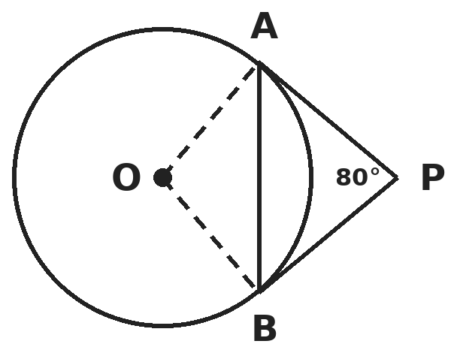
Q11. PA and PB are tangents to a circle with centre O, and angle APB = 80°. What is angle OAB?
(A) 50° | (B) 80° | (C) 40° | (D) 100°

Q12. What kind of triangle has vertices A(1, 1), B(5, 4) and C(8, 0)?
(A) Equilateral | (B) Scalene and acute-angled
(C) Right-angled and isosceles | (D) Obtuse-angled

Part 5 — Mensuration (Syllabus Chapter 6)
Q13. An open container is a frustum with top radius 10 cm, bottom radius 4 cm and height 8 cm. What is the area of metal used for its curved surface and its base?
(A) 140π cm² | (B) 156π cm² | (C) 256π cm² | (D) 116π cm²

Q14. Three metal cubes with edges 3 cm, 4 cm and 5 cm are melted and recast into a single cube. By what percentage does the total surface area change?
(A) 28% decrease | (B) 28% increase | (C) 16% decrease | (D) No change

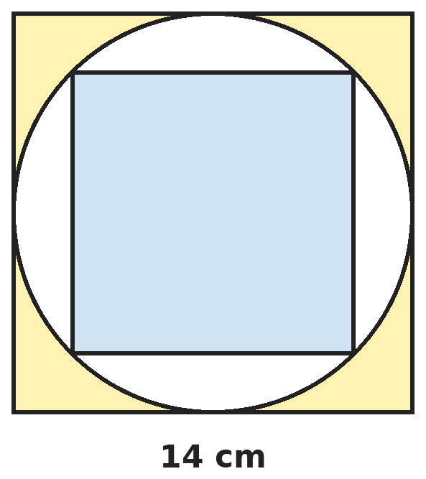
Q15. A circle just fits inside a square of side 14 cm. A smaller square is drawn inside the circle with its four corners on the circle. What is the area of the part of the circle outside the smaller square? (Take π = 22/7.)
(A) 42 cm² | (B) 98 cm² | (C) 14 cm² | (D) 56 cm²

Part 6 — Trigonometry (Syllabus Chapter 7)
Q16. For an acute angle θ, sin θ + cos θ = 7/5. What is tan θ + cot θ?
(A) 12/25 | (B) 7/5 | (C) 25/12 | (D) 5/7

Q17. The angle of elevation of the top of a tower from a point is 45°. After walking 20 m straight towards the tower it is 60°. What is the height of the tower?
(A) 10√3 m | (B) 10(3 + √3) m | (C) 20√3 m | (D) 10(3 − √3) m

Part 7 — Data Handling, Statistics & Probability (Syllabus Chapter 8)
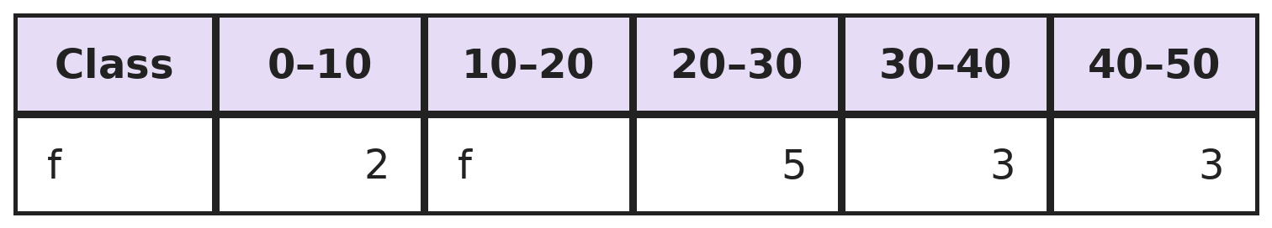
Q18. The mean of this frequency distribution is 24. What is the missing frequency f?
(A) 7 | (B) 5 | (C) 9 | (D) 6

Q19. Four fair coins are tossed together. What is the probability that there are more heads than tails?
(A) 1/2 | (B) 11/16 | (C) 3/8 | (D) 5/16

Part 8 — Applied Mathematics (Syllabus Chapter 9)
Q20. A boat moves at 12 km/h in still water. The stream flows at 4 km/h. The boat goes 32 km downstream and comes back. What is its average speed for the whole trip?
(A) 12 km/h | (B) 10 2/3 km/h | (C) 8 km/h | (D) 11 km/h

Q21. A restaurant bill has food worth ₹800, taxed at 5% GST, and packaged drinks worth ₹200, taxed at 18% GST. What is the total amount to pay?
(A) ₹1,076 | (B) ₹1,050 | (C) ₹1,180 | (D) ₹1,230

Q22. A tailor can buy a machine for ₹60,000 with ₹2,000 a year for upkeep, or rent one for ₹1,500 a month. Over 5 years, how much does buying save?
(A) ₹30,000 | (B) ₹10,000 | (C) ₹20,000 | (D) ₹0

Part 9 — Mathematical Reasoning (Syllabus Chapter 10)
Q23. What is the least number of students in a class that guarantees at least 3 of them were born in the same month?
(A) 24 | (B) 37 | (C) 25 | (D) 13

Q24. How many four-digit numbers with all different digits, using only the digits 1, 2, 3, 4 and 5, are divisible by 4?
(A) 48 | (B) 30 | (C) 12 | (D) 24

Q25. Seven glasses stand upside down on a table. In each move Varun turns over exactly two glasses. What is the least number of moves needed to make all seven stand upright?
(A) 4 moves | (B) It is impossible
(C) 3 moves | (D) 7 moves

Part 10 — Mixed Problems (each joins two chapters)
Q26. Three numbers are in AP. Their sum is 27 and their product is 504. What is the largest of them?
(A) 14 | (B) 13 | (C) 12 | (D) 15

Q27. An equilateral triangle is drawn inside a circle of radius 6 cm with all three corners on the circle. What is the area of the part of the circle outside the triangle?
(A) (36π − 27√3) cm² | (B) (36π − 9√3) cm²
(C) (36π − 108√3) cm² | (D) (12π − 9√3) cm²

Q28. A line parallel to side BC of triangle ABC cuts AB at D and AC at E so that triangle ADE has exactly half the area of triangle ABC. What is AD/AB?
(A) 1/2 | (B) 1/√2 | (C) 1/4 | (D) √2 − 1

Q29. Sneha invests ₹2,000 at the start of each year for 3 years at 10% per annum compound interest. What is her investment worth at the end of the 3rd year?
(A) ₹6,620 | (B) ₹6,000 | (C) ₹7,986 | (D) ₹7,282

Q30. The largest possible sphere is placed inside a closed cubical box of edge 14 cm. What fraction of the box is empty? (Take π = 22/7.)
(A) 11/21 | (B) 10/21 | (C) 1/2 | (D) 3/7

Answer Sheet AMO Level 2 · Class 10 · Practice Paper 5
Name: | School: | Roll No.:
Shade or tick one circle for each question.
1. | Ⓐ Ⓑ Ⓒ Ⓓ | 11. | Ⓐ Ⓑ Ⓒ Ⓓ | 21. | Ⓐ Ⓑ Ⓒ Ⓓ
2. | Ⓐ Ⓑ Ⓒ Ⓓ | 12. | Ⓐ Ⓑ Ⓒ Ⓓ | 22. | Ⓐ Ⓑ Ⓒ Ⓓ
3. | Ⓐ Ⓑ Ⓒ Ⓓ | 13. | Ⓐ Ⓑ Ⓒ Ⓓ | 23. | Ⓐ Ⓑ Ⓒ Ⓓ
4. | Ⓐ Ⓑ Ⓒ Ⓓ | 14. | Ⓐ Ⓑ Ⓒ Ⓓ | 24. | Ⓐ Ⓑ Ⓒ Ⓓ
5. | Ⓐ Ⓑ Ⓒ Ⓓ | 15. | Ⓐ Ⓑ Ⓒ Ⓓ | 25. | Ⓐ Ⓑ Ⓒ Ⓓ
6. | Ⓐ Ⓑ Ⓒ Ⓓ | 16. | Ⓐ Ⓑ Ⓒ Ⓓ | 26. | Ⓐ Ⓑ Ⓒ Ⓓ
7. | Ⓐ Ⓑ Ⓒ Ⓓ | 17. | Ⓐ Ⓑ Ⓒ Ⓓ | 27. | Ⓐ Ⓑ Ⓒ Ⓓ
8. | Ⓐ Ⓑ Ⓒ Ⓓ | 18. | Ⓐ Ⓑ Ⓒ Ⓓ | 28. | Ⓐ Ⓑ Ⓒ Ⓓ
9. | Ⓐ Ⓑ Ⓒ Ⓓ | 19. | Ⓐ Ⓑ Ⓒ Ⓓ | 29. | Ⓐ Ⓑ Ⓒ Ⓓ
10. | Ⓐ Ⓑ Ⓒ Ⓓ | 20. | Ⓐ Ⓑ Ⓒ Ⓓ | 30. | Ⓐ Ⓑ Ⓒ Ⓓ

For the parent or teacher
Correct: ______ / 30
Answer Key and Solutions AMO Level 2 · Class 10 · Practice Paper 5
Quick answers
1 A | 6 C | 11 C | 16 C | 21 A | 26 A
2 B | 7 C | 12 C | 17 B | 22 C | 27 A
3 D | 8 D | 13 B | 18 A | 23 C | 28 B
4 D | 9 A | 14 A | 19 D | 24 D | 29 D
5 B | 10 D | 15 D | 20 B | 25 B | 30 B
Solutions
Q | Part · level | Answer | Why?
1 | Part 1 · Ch1 · Hard | (A) 21, in 3 divisions | Hint: 1071 = 462 × 2 + 147. Continue with 462 and 147.  1071 = 462 × 2 + 147; 462 = 147 × 3 + 21; 147 = 21 × 7 + 0. Three divisions, and the last non-zero remainder is 21.
2 | Part 1 · Ch1 · Hard | (B) (√5 + √2)² | Hint: Expand each one.  (3 + √2)(3 − √2) = 9 − 2 = 7; √12 × √3 = √36 = 6; √8 × √2 = √16 = 4. But (√5 + √2)² = 7 + 2√10, and √10 is irrational. So only (√5 + √2)² = 7 + 2√10 is irrational.
3 | Part 2 · Ch3 · Hard | (D) ₹45,000 | Hint: Profit ratio = ratio of capital × months.  50,000 × 12 : C × 8 = 5 : 3. So 8C = 6,00,000 × 3/5 = 3,60,000 and C = ₹45,000. (₹30,000 ignores the months.)
4 | Part 2 · Ch3 · Hard | (D) ₹155 | Hint: For 2 years, CI − SI = P × (r/100)². Find P first.  P × 0.01 = 50, so P = ₹5,000. For 3 years: CI = 5,000 × (1.331 − 1) = ₹1,655 and SI = ₹1,500. Difference = ₹155. (₹150 simply triples the 2-year gap.)
5 | Part 2 · Ch3 · Hard | (B) ₹5,000 | Hint: The 3rd year's growth gives the rate.  8,640 ÷ 7,200 = 1.2, so the rate is 20%. Sum = 7,200 ÷ 1.2² = 7,200 ÷ 1.44 = ₹5,000. (₹6,000 divides by 1.2 only once.)
6 | Part 3 · Ch4 · Hard | (C) −3 | Hint: With integer coefficients, the other zero is 2 − √3.  The other zero is 2 − √3. Sum = 4 = −p, so p = −4. Product = 4 − 3 = 1 = q. p + q = −3. (5 uses p = +4.)
7 | Part 3 · Ch4 · Hard | (C) 123 | Hint: Find x² + 1/x² and x³ + 1/x³, then multiply them.  x² + 1/x² = 9 − 2 = 7. x³ + 1/x³ = 27 − 3 × 3 = 18. (x² + 1/x²)(x³ + 1/x³) = x⁵ + 1/x⁵ + x + 1/x, so x⁵ + 1/x⁵ = 7 × 18 − 3 = 123. (126 forgets to subtract x + 1/x.)
8 | Part 3 · Ch4 · Hard | (D) 2,475 | Hint: They form an AP 11, 13, …, 99. Count the terms first.  Number of terms = (99 − 11)/2 + 1 = 45. Sum = 45/2 × (11 + 99) = 45 × 55 = 2,475. (4,950 forgets to halve: 45 × 110.)
9 | Part 3 · Ch4 · Hard | (A) 24 | Hint: Let the number be 10a + b.  10a + b = 4(a + b) gives 6a = 3b, so b = 2a. 10a + b + 18 = 10b + a gives b − a = 2. So a = 2, b = 4: the number is 24. Check: 24 = 4 × 6 and 24 + 18 = 42.
10 | Part 4 · Ch5 · Hard | (D) 31 m | Hint: Find the distance from the foot of the ladder to each wall.  Distance to the first wall = √(25² − 24²) = 7 m. Distance to the second wall = √(25² − 7²) = 24 m. Width = 7 + 24 = 31 m.
11 | Part 4 · Ch5 · Hard | (C) 40° | Hint: OA ⊥ PA and OB ⊥ PB, so angle AOB = 180° − 80°.  In quadrilateral OAPB, angles A and B are 90°, so angle AOB = 360° − 180° − 80° = 100°. Triangle OAB is isosceles (OA = OB), so angle OAB = (180° − 100°)/2 = 40°.
12 | Part 4 · Ch5 · Hard | (C) Right-angled and isosceles | Hint: Find all three side lengths with the distance formula.  AB = √(16 + 9) = 5, BC = √(9 + 16) = 5, AC = √(49 + 1) = √50. AB = BC and AB² + BC² = 50 = AC². So it is right-angled (at B) and isosceles.
13 | Part 5 · Ch6 · Hard | (B) 156π cm² | Hint: Slant height l = √(h² + (R − r)²). Curved area = π(R + r)l.  l = √(64 + 36) = 10 cm. Curved area = π(10 + 4) × 10 = 140π. Base = π × 4² = 16π. Total 156π cm². (256π adds the top, which is open.)
14 | Part 5 · Ch6 · Hard | (A) 28% decrease | Hint: Find the edge of the new cube from the total volume.  Volume 27 + 64 + 125 = 216 cm³, so the new edge is 6 cm. Old surface area = 6(9 + 16 + 25) = 300 cm². New = 6 × 36 = 216 cm². Decrease = 84/300 = 28%.
15 | Part 5 · Ch6 · Hard | (D) 56 cm² | Hint: The diagonal of the small square is a diameter of the circle.  The circle has radius 7 cm and area 22/7 × 49 = 154 cm². The small square has diagonal 14 cm, so its area is 14² ÷ 2 = 98 cm². Area between them = 154 − 98 = 56 cm². (42 cm² is the big square minus the circle.)
16 | Part 6 · Ch7 · Hard | (C) 25/12 | Hint: Square the given equation and use sin²θ + cos²θ = 1.  (sin θ + cos θ)² = 1 + 2 sin θ cos θ = 49/25, so sin θ cos θ = 12/25. tan θ + cot θ = (sin²θ + cos²θ)/(sin θ cos θ) = 1 ÷ (12/25) = 25/12.
17 | Part 6 · Ch7 · Hard | (B) 10(3 + √3) m | Hint: The two distances from the foot are h and h/√3.  h − h/√3 = 20, so h(√3 − 1)/√3 = 20 and h = 20√3/(√3 − 1) = 10√3(√3 + 1) = 10(3 + √3) m (about 47.3 m).
18 | Part 7 · Ch8 · Hard | (A) 7 | Hint: Use class marks 5, 15, 25, 35, 45 and set Σfx/Σf = 24.  Σfx = 10 + 15f + 125 + 105 + 135 = 375 + 15f. Σf = 13 + f. 375 + 15f = 24(13 + f) = 312 + 24f, so 9f = 63 and f = 7.
19 | Part 7 · Ch8 · Hard | (D) 5/16 | Hint: More heads than tails means 3 or 4 heads. List the outcomes.  There are 2⁴ = 16 equally likely outcomes. 4 heads: 1 way (HHHH). 3 heads: 4 ways (the tail can be any one coin). P = 5/16. (1/2 ignores the 6 outcomes with 2 heads and 2 tails.)
20 | Part 8 · Ch9 · Hard | (B) 10 2/3 km/h | Hint: Average speed = total distance ÷ total time.  Downstream 16 km/h: 2 h. Upstream 8 km/h: 4 h. Average = 64 ÷ 6 = 10 2/3 km/h. (12 km/h averages the two speeds.)
21 | Part 8 · Ch9 · Hard | (A) ₹1,076 | Hint: Work out the tax on each item at its own rate.  GST = 5% of 800 + 18% of 200 = 40 + 36 = ₹76. Total = 1,000 + 76 = ₹1,076. (₹1,050 uses 5% for both; ₹1,180 uses 18% for both.)
22 | Part 8 · Ch9 · Hard | (C) ₹20,000 | Hint: Find the 5-year cost of each plan.  Buying: 60,000 + 5 × 2,000 = ₹70,000. Renting: 1,500 × 60 = ₹90,000. Buying saves ₹20,000.
23 | Part 9 · Ch10 · Hard | (C) 25 | Hint: Fill each month with as many students as possible without reaching 3.  24 students can be split 2 per month for 12 months. The 25th makes 3 in some month. (13 guarantees only 2.)
24 | Part 9 · Ch10 · Hard | (D) 24 | Hint: A number is divisible by 4 when its last two digits are.  Possible endings with different digits: 12, 24, 32, 52. For each, the first two digits come from the 3 remaining digits in 3 × 2 = 6 ways. 4 × 6 = 24.
25 | Part 9 · Ch10 · Hard | (B) It is impossible | Hint: Watch the number of upside-down glasses: is it odd or even after each move?  A move changes the number of upside-down glasses by −2, 0 or +2, so it stays odd. It starts at 7 (odd) and can never become 0. It is impossible.
26 | Part 10 · Mixed · Ch4 + Ch10 · Hard | (A) 14 | Hint: Write them as a − d, a, a + d.  3a = 27, so a = 9. (9 − d) × 9 × (9 + d) = 504 gives 81 − d² = 56, so d = 5. The numbers are 4, 9, 14. Largest 14.
27 | Part 10 · Mixed · Ch5 + Ch7 · Hard | (A) (36π − 27√3) cm² | Hint: Each side subtends 120° at the centre. Find a side using sin 60°.  Half a side = 6 sin 60° = 3√3, so a side is 6√3 cm. Triangle area = (√3/4) × 108 = 27√3 cm². Circle = 36π cm². Outside = (36π − 27√3) cm².
28 | Part 10 · Mixed · Ch4 + Ch5 · Hard | (B) 1/√2 | Hint: The ratio of areas of similar triangles is the square of the ratio of sides.  (AD/AB)² = 1/2, so AD/AB = 1/√2 (about 0.71). (1/2 would give only a quarter of the area.)
29 | Part 10 · Mixed · Ch3 + Ch9 · Hard | (D) ₹7,282 | Hint: The first ₹2,000 grows for 3 years, the second for 2, the third for 1.  2,000 × (1.331 + 1.21 + 1.1) = 2,000 × 3.641 = ₹7,282. (₹6,620 counts one year too few for each deposit.)
30 | Part 10 · Mixed · Ch6 + Ch10 · Hard | (B) 10/21 | Hint: The sphere's diameter equals the edge of the cube.  Sphere = 4/3 × 22/7 × 7³ = 4,312/3 cm³. Cube = 2,744 cm³. Sphere/cube = 4,312/8,232 = 11/21. Empty = 10/21.

