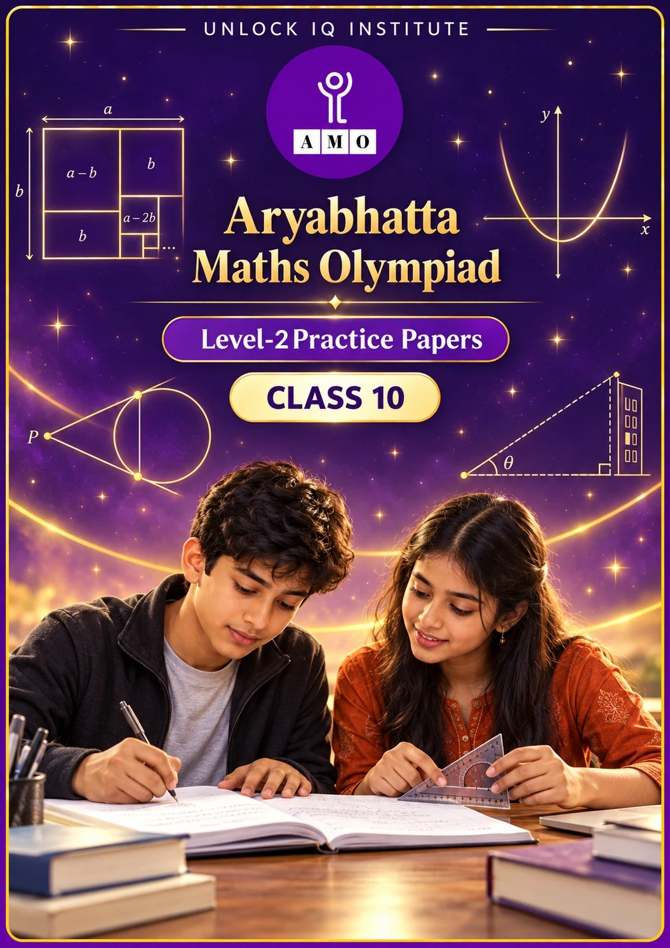
Set 2 · Practice Papers 6–10 · with answer keys & detailed solutions
Name: ____________________ | Class & Section: ________________
Roll No.: ________________ | School: ____________________
City: ____________________ | Date: ____________________

Published by Unlock IQ Institute Pvt. Ltd.
Register for Olympiads: www.aryabhattamathsolympiad.com/student-registration

ARYABHATTA MATHS OLYMPIAD
Level 2
PRACTICE PAPER-6
CLASS 10
Total Questions | 30 multiple-choice questions
Level | Level-2 (final round): every question is Hard
Time | 45 minutes
Arrangement | Parts by chapter; the last Part has mixed problems joining two chapters
Negative Marking | No negative marking
Calculator | Not allowed
Chapters | Number System · Fractions, Decimals & Percentages · Algebra · Geometry · Mensuration · Trigonometry · Data Handling, Statistics & Probability · Applied Mathematics · Mathematical Reasoning

Instructions
• Each question has four options, (A) to (D), with exactly one correct answer.
• The questions are grouped in Parts by chapter. The last Part has mixed problems, each joining two chapters.
• Every question is at Level-2 (Hard) standard: expect several steps or a key insight.
• There is no negative marking. Calculators are not allowed; use a separate sheet for rough work.
• Figures are not necessarily drawn to scale unless stated.

For teachers
• Figures are part of the questions and work when printed in black and white.
• Parts follow the AMO syllabus chapters. Chapter 2 is not part of the Class 10 syllabus, so the chapter numbers shown in the Part headings have gaps.
• The answer sheet and the answer key are at the end. Remove the answer key before the paper is attempted.

Part 1 — Number System (Syllabus Chapter 1)
Q1. Let x = 2³ × 3² × 5 and y = 2² × 3³ × 7. What is LCM(x, y) ÷ HCF(x, y)?
(A) 105 | (B) 420 | (C) 210 | (D) 70

Q2. What is the largest whole number that divides n² − 1 for every odd number n greater than 1?
(A) 4 | (B) 24 | (C) 2 | (D) 8

Part 2 — Fractions, Decimals & Percentages (Syllabus Chapter 3)
Q3. A sum at compound interest (compounded yearly) amounts to ₹6,050 in 2 years and ₹6,655 in 3 years. What would the simple interest on the same sum at the same rate be for 3 years?
(A) ₹1,655 | (B) ₹1,050 | (C) ₹1,500 | (D) ₹605

Q4. Harsh and Mansi invest in the ratio 3 : 2. Harsh runs the business and first takes 10% of the profit as salary; the rest is shared in the ratio of capital. Out of a profit of ₹50,000, how much does Harsh get in all?
(A) ₹32,000 | (B) ₹30,000 | (C) ₹27,000 | (D) ₹35,000

Q5. ₹8,000 is invested at compound interest: 5% for the first year, 10% for the second and 20% for the third. What is the amount after 3 years?
(A) ₹11,088 | (B) ₹10,800 | (C) ₹11,200 | (D) ₹11,000

Part 3 — Algebra (Syllabus Chapter 4)
Q6. One root of x² + px + 12 = 0 is 4. For the same p, the equation x² + px + q = 0 has equal roots. What is q?
(A) 7/2 | (B) 12 | (C) 49/2 | (D) 49/4

Q7. The pair (a − 1)x + 3y = 2 and 6x + (1 − 2b)y = 6 has infinitely many solutions. What is a + b?
(A) −1 | (B) 7 | (C) −5 | (D) 1

Q8. Riya saves ₹50 in the first month and ₹20 more each month than the month before. In which month does her total saving first go above ₹3,000?
(A) 15th | (B) 17th | (C) 16th | (D) 14th

Q9. A rectangular park has a perimeter of 28 m and an area of 40 m². How long is its diagonal?
(A) 2√29 m | (B) 14 m | (C) √29 m | (D) 2√21 m

Part 4 — Geometry (Syllabus Chapter 5)
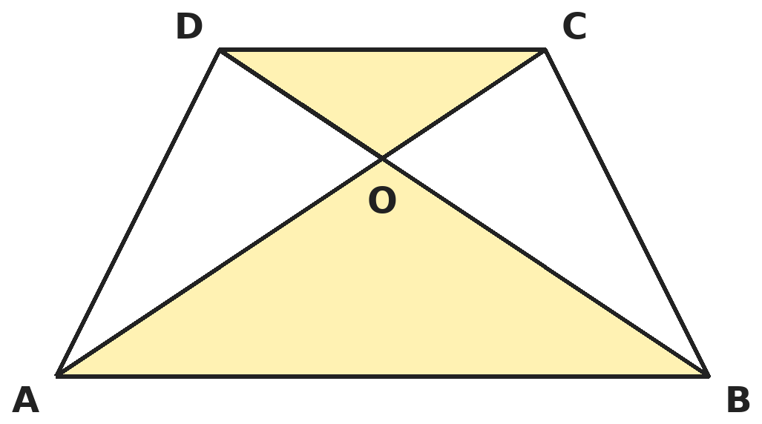
Q10. ABCD is a trapezium with AB ∥ DC and AB = 2 DC. Its diagonals meet at O. If the area of triangle AOB is 84 cm², what is the area of triangle COD?
(A) 42 cm² | (B) 168 cm² | (C) 21 cm² | (D) 28 cm²

Q11. A quadrilateral ABCD is drawn around a circle with centre O, all four sides touching it. If angle AOB = 110°, what is angle COD?
(A) 70° | (B) 110° | (C) 90° | (D) 55°

Q12. The points (3, 0), (4, 5), (−1, 4) and (−2, −1), taken in order, form a rhombus. What is its area?
(A) 48 square units | (B) 12 square units
(C) 26 square units | (D) 24 square units

Part 5 — Mensuration (Syllabus Chapter 6)
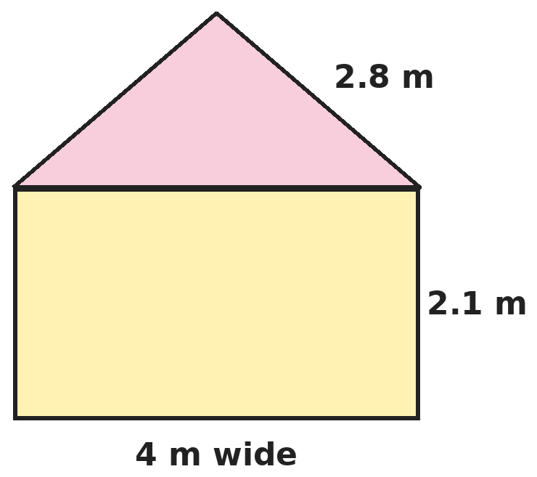
Q13. A tent is a cylinder 4 m wide and 2.1 m high with a cone on top of the same width and slant height 2.8 m. How much canvas is needed (no floor)? (Take π = 22/7.)
(A) 26.4 m² | (B) 44 m² | (C) 17.6 m² | (D) 56.6 m²

Q14. A well of diameter 7 m is dug 20 m deep. The earth is spread evenly to make a platform 22 m by 14 m. How high is the platform? (Take π = 22/7.)
(A) 2.5 m | (B) 5 m | (C) 1.25 m | (D) 3.5 m

Q15. A car's wheels have a diameter of 70 cm. How many revolutions per minute does each wheel make when the car moves at 66 km/h? (Take π = 22/7.)
(A) 250 | (B) 1,000 | (C) 300 | (D) 500

Part 6 — Trigonometry (Syllabus Chapter 7)
Q16. If cos θ + cos²θ = 1, what is sin²θ + sin⁴θ?
(A) 0 | (B) 1 | (C) 2 | (D) 1/2

Q17. The shadow of a tower is 40 m longer when the sun's altitude is 30° than when it is 45°. What is the height of the tower?
(A) 20√3 m | (B) 40 m | (C) 20(√3 + 1) m | (D) 20(√3 − 1) m

Part 7 — Data Handling, Statistics & Probability (Syllabus Chapter 8)
Q18. The "less than" and "more than" ogives of a distribution meet at the point (x, 25). The median class is 30–40, its frequency is 12, and the cumulative frequency of the class before it is 19. What is x?
(A) 35 | (B) 25 | (C) 30.5 | (D) 37.5

Q19. A leap year is chosen at random. What is the probability that it has 53 Sundays?
(A) 1/7 | (B) 2/7 | (C) 3/7 | (D) 53/366

Part 8 — Applied Mathematics (Syllabus Chapter 9)
Q20. Simran can do a job in 6 days and Payal in 8 days. With Chetan's help they finish it in 3 days and are paid ₹3,200, shared in proportion to the work done. What is Chetan's share?
(A) ₹800 | (B) ₹1,200 | (C) ₹400 | (D) ₹1,600

Q21. A jacket is marked ₹1,600. The shop gives 25% off, then a further ₹100 off with a coupon, and then adds 12% GST on the final price. How much does the buyer pay?
(A) ₹1,244 | (B) ₹1,232 | (C) ₹1,344 | (D) ₹1,120

Q22. Avni can row at 8 km/h in still water. It takes her twice as long to row a distance upstream as to row the same distance downstream. What is the speed of the current?
(A) 4 km/h | (B) 8/3 km/h | (C) 2 km/h | (D) 16/3 km/h

Part 9 — Mathematical Reasoning (Syllabus Chapter 10)
Q23. What is the least number of different numbers you must choose from 1 to 100 to be sure that two of them are consecutive?
(A) 50 | (B) 26 | (C) 100 | (D) 51

Q24. Six points are marked on a circle. How many different triangles have all three vertices among these points?
(A) 120 | (B) 15 | (C) 30 | (D) 20

Q25. Starting with 2²⁰²⁶, Lavanya replaces the number by the sum of its digits, again and again, until one digit is left. Which digit is it?
(A) 4 | (B) 1 | (C) 7 | (D) 8

Part 10 — Mixed Problems (each joins two chapters)
Q26. For how many integers n from 1 to 100 is n² + n + 1 divisible by 3?
(A) 34 | (B) 33 | (C) 67 | (D) 0

Q27. A rhombus has side 10 cm and one angle of 60°. A circle with its centre where the diagonals cross touches all four sides. What is its radius?
(A) 5√3 cm | (B) 5/2 cm | (C) 10√3 cm | (D) 5√3/2 cm

Q28. The centroid of triangle A(2, 4), B(k, 0), C(6, 2) lies on the y-axis. In what ratio does the y-axis divide AB?
(A) 4 : 1 | (B) 1 : 4 | (C) 1 : 3 | (D) 2 : 3

Q29. Ritesh borrows ₹40,000 at 10% per annum compound interest to start a stall. After 2 years the stall has made a total profit of ₹10,000, and he repays the loan with interest. What is his net gain?
(A) ₹2,000 | (B) ₹8,400 | (C) ₹1,600 | (D) ₹0

Q30. Spherical balls of radius 3 cm are stacked in a cylindrical tin of radius 3 cm and height 30 cm, as many as fit. What fraction of the tin's volume do the balls fill?
(A) 1/2 | (B) 2/3 | (C) 5/6 | (D) 3/4

Answer Sheet AMO Level 2 · Class 10 · Practice Paper 6
Name: | School: | Roll No.:
Shade or tick one circle for each question.
1. | Ⓐ Ⓑ Ⓒ Ⓓ | 11. | Ⓐ Ⓑ Ⓒ Ⓓ | 21. | Ⓐ Ⓑ Ⓒ Ⓓ
2. | Ⓐ Ⓑ Ⓒ Ⓓ | 12. | Ⓐ Ⓑ Ⓒ Ⓓ | 22. | Ⓐ Ⓑ Ⓒ Ⓓ
3. | Ⓐ Ⓑ Ⓒ Ⓓ | 13. | Ⓐ Ⓑ Ⓒ Ⓓ | 23. | Ⓐ Ⓑ Ⓒ Ⓓ
4. | Ⓐ Ⓑ Ⓒ Ⓓ | 14. | Ⓐ Ⓑ Ⓒ Ⓓ | 24. | Ⓐ Ⓑ Ⓒ Ⓓ
5. | Ⓐ Ⓑ Ⓒ Ⓓ | 15. | Ⓐ Ⓑ Ⓒ Ⓓ | 25. | Ⓐ Ⓑ Ⓒ Ⓓ
6. | Ⓐ Ⓑ Ⓒ Ⓓ | 16. | Ⓐ Ⓑ Ⓒ Ⓓ | 26. | Ⓐ Ⓑ Ⓒ Ⓓ
7. | Ⓐ Ⓑ Ⓒ Ⓓ | 17. | Ⓐ Ⓑ Ⓒ Ⓓ | 27. | Ⓐ Ⓑ Ⓒ Ⓓ
8. | Ⓐ Ⓑ Ⓒ Ⓓ | 18. | Ⓐ Ⓑ Ⓒ Ⓓ | 28. | Ⓐ Ⓑ Ⓒ Ⓓ
9. | Ⓐ Ⓑ Ⓒ Ⓓ | 19. | Ⓐ Ⓑ Ⓒ Ⓓ | 29. | Ⓐ Ⓑ Ⓒ Ⓓ
10. | Ⓐ Ⓑ Ⓒ Ⓓ | 20. | Ⓐ Ⓑ Ⓒ Ⓓ | 30. | Ⓐ Ⓑ Ⓒ Ⓓ

For the parent or teacher
Correct: ______ / 30
Answer Key and Solutions AMO Level 2 · Class 10 · Practice Paper 6
Quick answers
1 C | 6 D | 11 A | 16 B | 21 B | 26 A
2 D | 7 A | 12 D | 17 C | 22 B | 27 D
3 C | 8 C | 13 B | 18 A | 23 D | 28 B
4 A | 9 A | 14 A | 19 B | 24 D | 29 C
5 A | 10 C | 15 D | 20 C | 25 C | 30 B
Solutions
Q | Part · level | Answer | Why?
1 | Part 1 · Ch1 · Hard | (C) 210 | Hint: LCM takes the highest power of each prime, HCF the lowest.  LCM = 2³ × 3³ × 5 × 7 and HCF = 2² × 3². LCM ÷ HCF = 2 × 3 × 5 × 7 = 210.
2 | Part 1 · Ch1 · Hard | (D) 8 | Hint: n² − 1 = (n − 1)(n + 1) is a product of two consecutive even numbers. Test n = 3.  (n − 1)(n + 1) is a product of consecutive even numbers, one of which is a multiple of 4, so 8 always divides it. For n = 3 the value is 8 itself, so nothing larger works. (24 works only when 3 does not divide n.)
3 | Part 2 · Ch3 · Hard | (C) ₹1,500 | Hint: The growth from year 2 to year 3 gives the rate. Then find the sum.  6,655 ÷ 6,050 = 1.1, so the rate is 10%. Sum = 6,050 ÷ 1.21 = ₹5,000. Simple interest for 3 years = 5,000 × 10% × 3 = ₹1,500. (₹1,655 is the compound interest.)
4 | Part 2 · Ch3 · Hard | (A) ₹32,000 | Hint: First take out the salary, then share the remaining ₹45,000.  Salary = ₹5,000. Remaining ₹45,000 in the ratio 3 : 2 gives Harsh ₹27,000. Total = ₹32,000. (₹30,000 forgets the salary.)
5 | Part 2 · Ch3 · Hard | (A) ₹11,088 | Hint: Multiply by each year's growth factor in turn.  8,000 × 1.05 × 1.1 × 1.2 = 8,400 × 1.32 = ₹11,088. (₹10,800 adds the rates as simple interest: 35%.)
6 | Part 3 · Ch4 · Hard | (D) 49/4 | Hint: Put x = 4 in the first equation to find p.  16 + 4p + 12 = 0 gives p = −7. Equal roots of x² − 7x + q: 49 − 4q = 0, so q = 49/4.
7 | Part 3 · Ch4 · Hard | (A) −1 | Hint: Infinitely many solutions: all three ratios of coefficients are equal.  (a − 1)/6 = 3/(1 − 2b) = 2/6. So a − 1 = 2, a = 3, and 1 − 2b = 9, b = −4. a + b = −1.
8 | Part 3 · Ch4 · Hard | (C) 16th | Hint: Sₙ = n/2 × (100 + 20(n − 1)) = 10n² + 40n.  10n² + 40n > 3,000 means n² + 4n > 300. n = 15 gives 285 (total ₹2,850); n = 16 gives 320 (total ₹3,200). So the 16th month.
9 | Part 3 · Ch4 · Hard | (A) 2√29 m | Hint: The sides are the roots of x² − 14x + 40 = 0.  Sides 10 m and 4 m. Diagonal = √(100 + 16) = √116 = 2√29 m. (Or: d² = (l + b)² − 2lb = 196 − 80 = 116.)
10 | Part 4 · Ch5 · Hard | (C) 21 cm² | Hint: Triangles AOB and COD are similar.  Triangles AOB and COD are similar with ratio AB : CD = 2 : 1, so their areas are in the ratio 4 : 1. Area COD = 84 ÷ 4 = 21 cm². (42 uses the side ratio.)
11 | Part 4 · Ch5 · Hard | (A) 70° | Hint: Opposite sides of such a quadrilateral subtend supplementary angles at the centre.  O lies on all four angle bisectors. The angles at O for AB and CD together cover half of 360°: angle AOB + angle COD = 180°. So angle COD = 70°.
12 | Part 4 · Ch5 · Hard | (D) 24 square units | Hint: Area of a rhombus = half the product of its diagonals.  Diagonal from (3, 0) to (−1, 4) = √32 = 4√2. Diagonal from (4, 5) to (−2, −1) = √72 = 6√2. Area = 1/2 × 4√2 × 6√2 = 24.
13 | Part 5 · Ch6 · Hard | (B) 44 m² | Hint: Canvas = curved surface of cylinder + curved surface of cone.  Radius 2 m. Cylinder: 2 × 22/7 × 2 × 2.1 = 26.4 m². Cone: 22/7 × 2 × 2.8 = 17.6 m². Total 44 m².
14 | Part 5 · Ch6 · Hard | (A) 2.5 m | Hint: Volume of earth = volume of the cylinder dug out.  Earth = 22/7 × 3.5² × 20 = 770 m³. Height = 770 ÷ (22 × 14) = 770 ÷ 308 = 2.5 m.
15 | Part 5 · Ch6 · Hard | (D) 500 | Hint: Distance per minute ÷ circumference.  66 km/h = 1,100 m per minute = 1,10,000 cm. Circumference = 22/7 × 70 = 220 cm. Revolutions = 1,10,000 ÷ 220 = 500. (1,000 uses the radius in place of the diameter.)
16 | Part 6 · Ch7 · Hard | (B) 1 | Hint: The given equation says cos θ = 1 − cos²θ = sin²θ.  sin²θ = cos θ, so sin⁴θ = cos²θ. Then sin²θ + sin⁴θ = cos θ + cos²θ = 1.
17 | Part 6 · Ch7 · Hard | (C) 20(√3 + 1) m | Hint: Shadow lengths are h√3 and h.  h√3 − h = 40, so h = 40/(√3 − 1) = 20(√3 + 1) m (about 54.6 m).
18 | Part 7 · Ch8 · Hard | (A) 35 | Hint: The meeting point is (median, N/2).  The ogives meet at (median, N/2), so N/2 = 25 and N = 50. Median = 30 + (25 − 19)/12 × 10 = 30 + 5 = 35. So x = 35. (25 is N/2, not the median.)
19 | Part 7 · Ch8 · Hard | (B) 2/7 | Hint: 366 days = 52 weeks + 2 extra days.  The 2 extra days are one of 7 equally likely pairs: (Sun, Mon), (Mon, Tue), …, (Sat, Sun). Two of these contain a Sunday. Probability 2/7.
20 | Part 8 · Ch9 · Hard | (C) ₹400 | Hint: Find the fraction of the job each person does in 3 days.  Simran does 3/6 = 1/2, Payal does 3/8. Chetan does 1 − 1/2 − 3/8 = 1/8. Share = 1/8 × 3,200 = ₹400.
21 | Part 8 · Ch9 · Hard | (B) ₹1,232 | Hint: Apply each step in the order given.  After 25% off: ₹1,200. After the coupon: ₹1,100. With GST: 1,100 × 1.12 = ₹1,232. (₹1,244 subtracts the coupon after adding GST.)
22 | Part 8 · Ch9 · Hard | (B) 8/3 km/h | Hint: Twice the time means half the speed.  Downstream speed = 2 × upstream speed: 8 + c = 2(8 − c), so 3c = 8 and c = 8/3 km/h.
23 | Part 9 · Ch10 · Hard | (D) 51 | Hint: Pair the numbers as (1, 2), (3, 4), …, (99, 100).  The 50 odd numbers contain no consecutive pair. With 51 numbers, two fall in the same pair (2k − 1, 2k) and are consecutive. So 51.
24 | Part 9 · Ch10 · Hard | (D) 20 | Hint: No three points on a circle are in a straight line. The order of the vertices does not matter.  Ordered choices: 6 × 5 × 4 = 120. Each triangle is counted 3 × 2 × 1 = 6 times. 120 ÷ 6 = 20.
25 | Part 9 · Ch10 · Hard | (C) 7 | Hint: A number and its digit sum leave the same remainder on division by 9.  Powers of 2 leave remainders 2, 4, 8, 7, 5, 1 on division by 9, repeating every 6. 2026 = 6 × 337 + 4, so 2²⁰²⁶ leaves remainder 7. The final digit is 7.
26 | Part 10 · Mixed · Ch4 + Ch10 · Hard | (A) 34 | Hint: Check n = 3k, 3k + 1, 3k + 2.  n = 3k gives remainder 1; n = 3k + 1 gives 1 + 1 + 1 = 3 ≡ 0; n = 3k + 2 gives 4 + 2 + 1 = 7 ≡ 1. So n must be 1 more than a multiple of 3: 1, 4, …, 100, which is 34 numbers.
27 | Part 10 · Mixed · Ch5 + Ch7 · Hard | (D) 5√3/2 cm | Hint: The radius is the distance from the centre to a side. Use the area of the rhombus.  The 60° angle makes a height of 10 × sin 60° = 5√3 cm on a side of 10 cm, so area = 10 × 5√3 = 50√3 cm². The rhombus splits into 4 triangles with apex at the centre, each with base 10 and height r: 4 × ½ × 10 × r = 20r. So 20r = 50√3 and r = 5√3/2 cm.
28 | Part 10 · Mixed · Ch4 + Ch5 · Hard | (B) 1 : 4 | Hint: First find k. Then use the section formula with x = 0.  (2 + k + 6)/3 = 0 gives k = −8, so B = (−8, 0). If the y-axis divides AB in the ratio m : n, then (m × (−8) + n × 2)/(m + n) = 0, so 8m = 2n and m : n = 1 : 4.
29 | Part 10 · Mixed · Ch3 + Ch9 · Hard | (C) ₹1,600 | Hint: Interest for 2 years = 40,000 × (1.21 − 1).  Interest = ₹8,400. Net gain = 10,000 − 8,400 = ₹1,600. (₹2,000 uses simple interest of ₹8,000.)
30 | Part 10 · Mixed · Ch6 + Ch10 · Hard | (B) 2/3 | Hint: Each ball takes up 6 cm of height.  5 balls fit. Their volume = 5 × (4/3)π × 27 = 180π. Tin = π × 9 × 30 = 270π. Fraction = 2/3.

ARYABHATTA MATHS OLYMPIAD
Level 2
PRACTICE PAPER-7
CLASS 10
Total Questions | 30 multiple-choice questions
Level | Level-2 (final round): every question is Hard
Time | 45 minutes
Arrangement | Parts by chapter; the last Part has mixed problems joining two chapters
Negative Marking | No negative marking
Calculator | Not allowed
Chapters | Number System · Fractions, Decimals & Percentages · Algebra · Geometry · Mensuration · Trigonometry · Data Handling, Statistics & Probability · Applied Mathematics · Mathematical Reasoning

Instructions
• Each question has four options, (A) to (D), with exactly one correct answer.
• The questions are grouped in Parts by chapter. The last Part has mixed problems, each joining two chapters.
• Every question is at Level-2 (Hard) standard: expect several steps or a key insight.
• There is no negative marking. Calculators are not allowed; use a separate sheet for rough work.
• Figures are not necessarily drawn to scale unless stated.

For teachers
• Figures are part of the questions and work when printed in black and white.
• Parts follow the AMO syllabus chapters. Chapter 2 is not part of the Class 10 syllabus, so the chapter numbers shown in the Part headings have gaps.
• The answer sheet and the answer key are at the end. Remove the answer key before the paper is attempted.

Part 1 — Number System (Syllabus Chapter 1)
Q1. How many zeros are there at the end of the product 1 × 2 × 3 × … × 100?
(A) 20 | (B) 24 | (C) 21 | (D) 25

Q2. What is the 100th digit after the decimal point in the decimal expansion of 1/7?
(A) 8 | (B) 5 | (C) 2 | (D) 4

Part 2 — Fractions, Decimals & Percentages (Syllabus Chapter 3)
Q3. Sonal deposits ₹20,000 at 10% per annum compound interest. At the end of the first year she withdraws ₹7,000. How much is in the account at the end of the second year?
(A) ₹16,500 | (B) ₹15,730 | (C) ₹17,200 | (D) ₹16,200

Q4. Kunal invests ₹30,000 for a year. Lata invests ₹20,000 and doubles it after 6 months. Out of a year-end profit of ₹18,000, what is Lata's share?
(A) ₹12,000 | (B) ₹7,200 | (C) ₹9,000 | (D) ₹10,800

Q5. The price of petrol rises by 25%, and a family increases its monthly spending on petrol by 10%. By what percentage does the amount of petrol it uses change?
(A) 15% decrease | (B) 20% decrease | (C) 10% decrease | (D) 12% decrease

Part 3 — Algebra (Syllabus Chapter 4)
Q6. One zero of x² + kx + 8 is twice the other. What are the possible values of k?
(A) 6 only | (B) 6 or −6 | (C) 4 or −4 | (D) 12 or −12

Q7. If 1 is added to the numerator of a fraction and 1 is subtracted from its denominator, it becomes 1. If only 1 is added to its denominator, it becomes 1/2. What is the fraction?
(A) 2/3 | (B) 3/5 | (C) 3/4 | (D) 4/5

Q8. What is the 20th term from the end of the AP 3, 8, 13, …, 253?
(A) 98 | (B) 163 | (C) 158 | (D) 153

Q9. α and β are the roots of x² − 6x + 7 = 0. Which quadratic equation has roots α² and β²?
(A) x² − 22x + 49 = 0 | (B) x² − 36x + 49 = 0
(C) x² − 22x + 7 = 0 | (D) x² + 22x + 49 = 0

Part 4 — Geometry (Syllabus Chapter 5)
Q10. E and F lie on sides PQ and PR of triangle PQR. For which set of lengths (in cm) is EF parallel to QR?
(A) PE = 4, EQ = 4.5, PF = 8, FR = 8 | (B) PE = 3, EQ = 4, PF = 4, FR = 3
(C) PE = 5, EQ = 2, PF = 6, FR = 3 | (D) PE = 4, EQ = 4.5, PF = 8, FR = 9

Q11. In an equilateral triangle ABC, D is the point on BC with BD = BC/3. If 9AD² = k × AB², what is k?
(A) 8 | (B) 6 | (C) 9 | (D) 7

Q12. In what ratio does the point (−1, 6) divide the line segment joining (−3, 10) and (6, −8)?
(A) 2 : 7 | (B) 7 : 2 | (C) 1 : 3 | (D) 2 : 5

Part 5 — Mensuration (Syllabus Chapter 6)
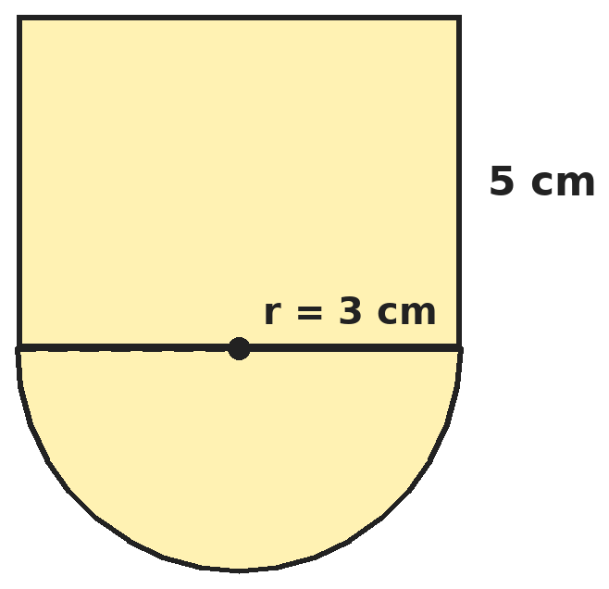
Q13. A vessel is a cylinder of radius 3 cm and height 5 cm standing on a hemisphere of the same radius. How much can it hold (in terms of π)?
(A) 81π cm³ | (B) 45π cm³ | (C) 63π cm³ | (D) 54π cm³

Q14. A hollow metal sphere has outer radius 8 cm and inner radius 4 cm. It is melted and recast into a solid cone of base radius 8 cm. What is the height of the cone?
(A) 14 cm | (B) 28 cm | (C) 7 cm | (D) 21 cm

Q15. A chord of a circle of radius 21 cm subtends 60° at the centre. What is the area of the major segment? (Take π = 22/7.)
(A) (1155 − 441√3/4) cm² | (B) (231 − 441√3/4) cm²
(C) (1155 + 441√3/4) cm² | (D) 1155 cm²

Part 6 — Trigonometry (Syllabus Chapter 7)
Q16. What is the value of tan 1° × tan 2° × tan 3° × … × tan 89°?
(A) 0 | (B) √3
(C) It is not defined | (D) 1

Q17. A plane flies level at a height of 1500√3 m. From a point on the ground its angle of elevation is 60°, and 15 seconds later it is 30°. What is its speed?
(A) 360 km/h | (B) 200 km/h | (C) 720 km/h | (D) 540 km/h

Part 7 — Data Handling, Statistics & Probability (Syllabus Chapter 8)
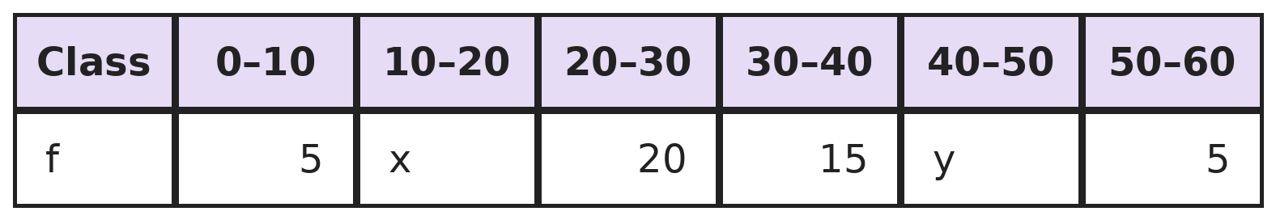
Q18. The total frequency is 60 and the median is 28.5. What are x and y?
(A) x = 7, y = 8 | (B) x = 8, y = 7 | (C) x = 10, y = 5 | (D) x = 6, y = 9

Q19. A two-digit number is chosen at random. What is the probability that both of its digits are even?
(A) 2/9 | (B) 1/4 | (C) 1/5 | (D) 5/18

Part 8 — Applied Mathematics (Syllabus Chapter 9)
Q20. A bank pays 10% per annum compounded half-yearly. What simple yearly rate would give the same interest over one year?
(A) 10% | (B) 10.5% | (C) 10.25% | (D) 20.25%

Q21. A bakery sells cakes at ₹250 each. Each cake costs ₹130 to make, and fixed costs are ₹54,000 a month. How many cakes must it sell in a month to make a profit of ₹18,000?
(A) 600 | (B) 450 | (C) 150 | (D) 288

Q22. Devika works twice as fast as Arnav. Working together they finish a job in 14 days. How long would Devika take alone?
(A) 42 days | (B) 21 days | (C) 28 days | (D) 7 days

Part 9 — Mathematical Reasoning (Syllabus Chapter 10)
Q23. What is the least number of different numbers you must choose from 1 to 30 to be sure that one of them divides another?
(A) 15 | (B) 11 | (C) 21 | (D) 16

Q24. How many four-digit numbers have digits that add up to 4?
(A) 20 | (B) 35 | (C) 10 | (D) 15

Q25. Gita puts a + or a − sign in front of each of the numbers 1, 2, 3, …, 10 and adds them up. In how many ways can she make the total exactly 0?
(A) 1 | (B) None | (C) 2 | (D) 10

Part 10 — Mixed Problems (each joins two chapters)
Q26. How many positive integers less than 1000 leave remainder 3 when divided by 7 and remainder 1 when divided by 5?
(A) 28 | (B) 27 | (C) 29 | (D) 35

Q27. A flagstaff stands on top of a 20 m building. From a point on the ground, the angles of elevation of the bottom and top of the flagstaff are 45° and 60°. How tall is the flagstaff?
(A) 20√3 m | (B) 20 m | (C) 20(√3 + 1) m | (D) 20(√3 − 1) m

Q28. A right-angled triangle has vertices (0, 0), (a, 0) and (0, b) with a, b > 0. Its perimeter is 24 units and its area is 24 square units. What is the length of its hypotenuse?
(A) 12 | (B) 8 | (C) 10 | (D) 13

Q29. A machine costs ₹33,100 in cash. It can also be bought in 3 equal yearly instalments, the first after one year, with interest at 10% per annum compounded yearly. What is each instalment?
(A) ₹11,033 | (B) ₹12,100 | (C) ₹14,641 | (D) ₹13,310

Q30. A cuboid 2 × 3 × 4 is built from unit cubes. A straight line is drawn from one corner of the cuboid to the opposite corner. How many unit cubes does it pass through (inside, not just touching)?
(A) 9 | (B) 6 | (C) 4 | (D) 7

Answer Sheet AMO Level 2 · Class 10 · Practice Paper 7
Name: | School: | Roll No.:
Shade or tick one circle for each question.
1. | Ⓐ Ⓑ Ⓒ Ⓓ | 11. | Ⓐ Ⓑ Ⓒ Ⓓ | 21. | Ⓐ Ⓑ Ⓒ Ⓓ
2. | Ⓐ Ⓑ Ⓒ Ⓓ | 12. | Ⓐ Ⓑ Ⓒ Ⓓ | 22. | Ⓐ Ⓑ Ⓒ Ⓓ
3. | Ⓐ Ⓑ Ⓒ Ⓓ | 13. | Ⓐ Ⓑ Ⓒ Ⓓ | 23. | Ⓐ Ⓑ Ⓒ Ⓓ
4. | Ⓐ Ⓑ Ⓒ Ⓓ | 14. | Ⓐ Ⓑ Ⓒ Ⓓ | 24. | Ⓐ Ⓑ Ⓒ Ⓓ
5. | Ⓐ Ⓑ Ⓒ Ⓓ | 15. | Ⓐ Ⓑ Ⓒ Ⓓ | 25. | Ⓐ Ⓑ Ⓒ Ⓓ
6. | Ⓐ Ⓑ Ⓒ Ⓓ | 16. | Ⓐ Ⓑ Ⓒ Ⓓ | 26. | Ⓐ Ⓑ Ⓒ Ⓓ
7. | Ⓐ Ⓑ Ⓒ Ⓓ | 17. | Ⓐ Ⓑ Ⓒ Ⓓ | 27. | Ⓐ Ⓑ Ⓒ Ⓓ
8. | Ⓐ Ⓑ Ⓒ Ⓓ | 18. | Ⓐ Ⓑ Ⓒ Ⓓ | 28. | Ⓐ Ⓑ Ⓒ Ⓓ
9. | Ⓐ Ⓑ Ⓒ Ⓓ | 19. | Ⓐ Ⓑ Ⓒ Ⓓ | 29. | Ⓐ Ⓑ Ⓒ Ⓓ
10. | Ⓐ Ⓑ Ⓒ Ⓓ | 20. | Ⓐ Ⓑ Ⓒ Ⓓ | 30. | Ⓐ Ⓑ Ⓒ Ⓓ

For the parent or teacher
Correct: ______ / 30
Answer Key and Solutions AMO Level 2 · Class 10 · Practice Paper 7
Quick answers
1 B | 6 B | 11 D | 16 D | 21 A | 26 A
2 A | 7 B | 12 A | 17 C | 22 B | 27 D
3 A | 8 C | 13 C | 18 B | 23 D | 28 C
4 C | 9 A | 14 B | 19 A | 24 A | 29 D
5 D | 10 D | 15 C | 20 C | 25 B | 30 B
Solutions
Q | Part · level | Answer | Why?
1 | Part 1 · Ch1 · Hard | (B) 24 | Hint: Each zero needs a factor 2 × 5. Count the factors of 5.  Multiples of 5 up to 100: 20. Multiples of 25 give one extra 5 each: 4 more. Factors of 2 are plentiful, so there are 20 + 4 = 24 zeros.
2 | Part 1 · Ch1 · Hard | (A) 8 | Hint: 1/7 = 0.142857142857…, repeating every 6 digits.  The block 142857 repeats. 100 = 6 × 16 + 4, so the 100th digit is the 4th digit of the block: 8.
3 | Part 2 · Ch3 · Hard | (A) ₹16,500 | Hint: Find the balance after the first year, subtract the withdrawal, then grow it again.  After year 1: ₹22,000. After withdrawing: ₹15,000. After year 2: 15,000 × 1.1 = ₹16,500. (₹15,730 takes the money out at the start.)
4 | Part 2 · Ch3 · Hard | (C) ₹9,000 | Hint: Lata: ₹20,000 for 6 months and ₹40,000 for 6 months.  Kunal: 30,000 × 12 = 3,60,000. Lata: 20,000 × 6 + 40,000 × 6 = 3,60,000. Equal shares: ₹9,000 each.
5 | Part 2 · Ch3 · Hard | (D) 12% decrease | Hint: Amount used = spending ÷ price.  New amount = old amount × 1.10 ÷ 1.25 = 0.88 × old amount, a 12% decrease. (15% simply subtracts 10 from 25.)
6 | Part 3 · Ch4 · Hard | (B) 6 or −6 | Hint: Let the zeros be α and 2α. Their product is 8.  2α² = 8 gives α = 2 or −2. Sum of zeros 3α = −k, so k = −6 (zeros 2, 4) or k = 6 (zeros −2, −4).
7 | Part 3 · Ch4 · Hard | (B) 3/5 | Hint: Let the fraction be x/y and write two equations.  x + 1 = y − 1 gives y = x + 2. 2x = y + 1 gives 2x = x + 3, so x = 3 and y = 5. The fraction is 3/5. Check: 4/4 = 1 and 3/6 = 1/2.
8 | Part 3 · Ch4 · Hard | (C) 158 | Hint: Read the AP backwards: first term 253, common difference −5.  20th term from the end = 253 + 19 × (−5) = 253 − 95 = 158. (98 is the 20th term from the start; 153 uses 20 steps.)
9 | Part 3 · Ch4 · Hard | (A) x² − 22x + 49 = 0 | Hint: Find α² + β² and α²β² from α + β and αβ.  α + β = 6, αβ = 7. α² + β² = 36 − 14 = 22 and α²β² = 49. The equation is x² − 22x + 49 = 0. (x² − 36x + 49 uses (α + β)² for the sum.)
10 | Part 4 · Ch5 · Hard | (D) PE = 4, EQ = 4.5, PF = 8, FR = 9 | Hint: Converse of BPT: EF ∥ QR exactly when PE/EQ = PF/FR.  4/4.5 = 8/9 and 8/9 = 8/9: equal, so EF ∥ QR. The others give 8/9 vs 1, 3/4 vs 4/3, and 5/2 vs 2.
11 | Part 4 · Ch5 · Hard | (D) 7 | Hint: Drop the altitude AM. Then DM = BC/2 − BC/3.  Let AB = a. The altitude AM has AM² = 3a²/4, and DM = a/2 − a/3 = a/6. AD² = 3a²/4 + a²/36 = 28a²/36 = 7a²/9. So 9AD² = 7a² and k = 7.
12 | Part 4 · Ch5 · Hard | (A) 2 : 7 | Hint: Let the ratio be k : 1 and use the x-coordinate.  (6k − 3)/(k + 1) = −1 gives 7k = 2, k = 2/7. Ratio 2 : 7. Check with y: (−16 + 70)/9 = 6.
13 | Part 5 · Ch6 · Hard | (C) 63π cm³ | Hint: Volume = πr²h + (2/3)πr³.  Cylinder = π × 9 × 5 = 45π. Hemisphere = (2/3)π × 27 = 18π. Total 63π cm³. (81π uses a full sphere.)
14 | Part 5 · Ch6 · Hard | (B) 28 cm | Hint: Metal = (4/3)π(8³ − 4³).  Metal = (4/3)π × 448. Cone = (1/3)π × 64 × h. So 64h = 4 × 448 and h = 28 cm.
15 | Part 5 · Ch6 · Hard | (C) (1155 + 441√3/4) cm² | Hint: Major segment = circle − minor segment, and minor segment = sector − equilateral triangle.  Circle = 1,386, sector = 231, triangle = (√3/4) × 441. Minor segment = 231 − 441√3/4. Major = 1,386 − 231 + 441√3/4 = (1155 + 441√3/4) cm² (about 1,346 cm²).
16 | Part 6 · Ch7 · Hard | (D) 1 | Hint: tan(90° − θ) = cot θ = 1/tan θ.  Pair tan θ with tan(90° − θ): each pair multiplies to 1. The middle term is tan 45° = 1. So the product is 1.
17 | Part 6 · Ch7 · Hard | (C) 720 km/h | Hint: Horizontal distances are h/tan 60° and h/tan 30°.  Distances: 1500√3/√3 = 1,500 m and 1500√3 × √3 = 4,500 m. It flies 3,000 m in 15 s: 200 m/s = 720 km/h. (200 is in m/s, not km/h.)
18 | Part 7 · Ch8 · Hard | (B) x = 8, y = 7 | Hint: The median lies in 20–30. Use Median = l + ((N/2 − cf)/f) × h.  28.5 = 20 + ((30 − (5 + x))/20) × 10 gives 8.5 = (25 − x)/2, so x = 8. Then y = 60 − 5 − 8 − 20 − 15 − 5 = 7.
19 | Part 7 · Ch8 · Hard | (A) 2/9 | Hint: The tens digit cannot be 0.  Tens digit: 2, 4, 6, 8 (4 ways). Units digit: 0, 2, 4, 6, 8 (5 ways). 20 of the 90 two-digit numbers. Probability 2/9. (1/4 forgets that 0 can be a units digit but not a tens digit.)
20 | Part 8 · Ch9 · Hard | (C) 10.25% | Hint: Grow ₹100 for two half-years at 5%.  100 × 1.05² = 110.25. The interest is ₹10.25 on ₹100, an effective rate of 10.25%.
21 | Part 8 · Ch9 · Hard | (A) 600 | Hint: Each cake contributes ₹120. The contributions must cover fixed costs and the profit.  (54,000 + 18,000) ÷ (250 − 130) = 72,000 ÷ 120 = 600 cakes. (450 is only the break-even number.)
22 | Part 8 · Ch9 · Hard | (B) 21 days | Hint: If Arnav does x of the job a day, Devika does 2x.  3x = 1/14, so x = 1/42. Devika does 2/42 = 1/21 a day: 21 days. (42 days is Arnav alone.)
23 | Part 9 · Ch10 · Hard | (D) 16 | Hint: Every number is (power of 2) × (an odd number from 1 to 29).  The 15 numbers 16 to 30 avoid it, since doubling any of them exceeds 30. There are 15 odd parts 1, 3, …, 29, so among 16 numbers two share an odd part, and the smaller divides the larger. So 16.
24 | Part 9 · Ch10 · Hard | (A) 20 | Hint: The first digit is at least 1. Share the remaining total among the four places.  Take 1 for the first digit; the remaining 3 is shared among 4 places. Patterns: (3) in one place: 4 ways; (2, 1): 4 × 3 = 12 ways; (1, 1, 1): 4 ways. Total 20.
25 | Part 9 · Ch10 · Hard | (B) None | Hint: Changing a sign changes the total by an even number.  With all + signs the total is 55, which is odd. Changing the sign of n changes the total by 2n, which keeps it odd. So 0 can never be reached: no way.
26 | Part 10 · Mixed · Ch4 + Ch10 · Hard | (A) 28 | Hint: Find the smallest such number. The rest form an AP with difference 35.  Numbers 3, 10, 17, 24, 31, … : 31 is the first that leaves remainder 1 on division by 5. The numbers are 31, 66, …, 31 + 35(n − 1) < 1000, so n − 1 ≤ 27 and n = 28.
27 | Part 10 · Mixed · Ch5 + Ch7 · Hard | (D) 20(√3 − 1) m | Hint: The 45° angle gives the distance from the building.  Distance = 20 m. Top is 20 tan 60° = 20√3 m high. Flagstaff = 20√3 − 20 = 20(√3 − 1) m (about 14.6 m).
28 | Part 10 · Mixed · Ch4 + Ch5 · Hard | (C) 10 | Hint: a + b = 24 − c and ab = 48. Square the first.  (24 − c)² = a² + b² + 2ab = c² + 96. So 576 − 48c = 96 and c = 10. (The legs are 6 and 8.)
29 | Part 10 · Mixed · Ch3 + Ch9 · Hard | (D) ₹13,310 | Hint: The present values x/1.1 + x/1.21 + x/1.331 add up to 33,100.  Multiply by 1.331: x(1.21 + 1.1 + 1) = 3.31x = 33,100 × 1.331 = 44,056.1. So x = ₹13,310. (₹11,033 ignores interest.)
30 | Part 10 · Mixed · Ch6 + Ch10 · Hard | (B) 6 | Hint: Each time the line crosses an inner face plane it enters a new cube, unless it crosses two planes at once.  Moving from start to end, it crosses x-planes at 1/2, y-planes at 1/3 and 2/3, and z-planes at 1/4, 1/2 and 3/4 of the way. The crossing times 1/4, 1/3, 1/2, 2/3, 3/4 are 5 different moments, so it passes through 5 + 1 = 6 cubes.

ARYABHATTA MATHS OLYMPIAD
Level 2
PRACTICE PAPER-8
CLASS 10
Total Questions | 30 multiple-choice questions
Level | Level-2 (final round): every question is Hard
Time | 45 minutes
Arrangement | Parts by chapter; the last Part has mixed problems joining two chapters
Negative Marking | No negative marking
Calculator | Not allowed
Chapters | Number System · Fractions, Decimals & Percentages · Algebra · Geometry · Mensuration · Trigonometry · Data Handling, Statistics & Probability · Applied Mathematics · Mathematical Reasoning

Instructions
• Each question has four options, (A) to (D), with exactly one correct answer.
• The questions are grouped in Parts by chapter. The last Part has mixed problems, each joining two chapters.
• Every question is at Level-2 (Hard) standard: expect several steps or a key insight.
• There is no negative marking. Calculators are not allowed; use a separate sheet for rough work.
• Figures are not necessarily drawn to scale unless stated.

For teachers
• Figures are part of the questions and work when printed in black and white.
• Parts follow the AMO syllabus chapters. Chapter 2 is not part of the Class 10 syllabus, so the chapter numbers shown in the Part headings have gaps.
• The answer sheet and the answer key are at the end. Remove the answer key before the paper is attempted.

Part 1 — Number System (Syllabus Chapter 1)
Q1. How many pairs of natural numbers (a, b) with a < b have HCF 12 and product 2160?
(A) 2 | (B) 4 | (C) 1 | (D) 3

Q2. What is the smallest number greater than 1 that leaves a remainder of 1 when divided by each of 2, 3, 4, 5, 6, 7, 8, 9 and 10?
(A) 2520 | (B) 5041 | (C) 2521 | (D) 3629

Part 2 — Fractions, Decimals & Percentages (Syllabus Chapter 3)
Q3. Isha borrows ₹10,000 at 8% per annum simple interest and lends it at once at 8% per annum compounded half-yearly. What does she gain in 1 year?
(A) ₹16 | (B) ₹0 | (C) ₹32 | (D) ₹816

Q4. Three partners invest ₹40,000 for 12 months, ₹60,000 for 8 months and ₹90,000 for 6 months. Out of a profit of ₹50,000, what does the third partner get?
(A) ₹16,000 | (B) ₹25,000 | (C) ₹20,000 | (D) ₹18,000

Q5. Kabir sells a cycle to Leena at a 20% profit. Leena sells it to Ojas at a 10% loss. Ojas pays ₹5,400. How much did the cycle cost Kabir?
(A) ₹5,000 | (B) ₹5,400 | (C) ₹4,500 | (D) ₹5,500

Part 3 — Algebra (Syllabus Chapter 4)
Q6. What must be subtracted from x⁴ + 2x³ + 8x² + 12x + 18 so that the result is exactly divisible by x² + 5?
(A) 2x − 3 | (B) x + 3 | (C) 12x + 18 | (D) 2x + 3

Q7. If x + y + z = 6, 2x − y + z = 3 and x + 2y − z = 2, what is x² + y² + z²?
(A) 6 | (B) 12 | (C) 9 | (D) 14

Q8. In an AP the p-th term is q and the q-th term is p, where p ≠ q. What is the (p + q)-th term?
(A) p + q | (B) 0 | (C) 1 | (D) p − q

Q9. Two pipes together fill a tank in 6 hours. Alone, the larger pipe takes 5 hours less than the smaller one. How long does the smaller pipe take alone?
(A) 10 hours | (B) 12 hours | (C) 20 hours | (D) 15 hours

Part 4 — Geometry (Syllabus Chapter 5)
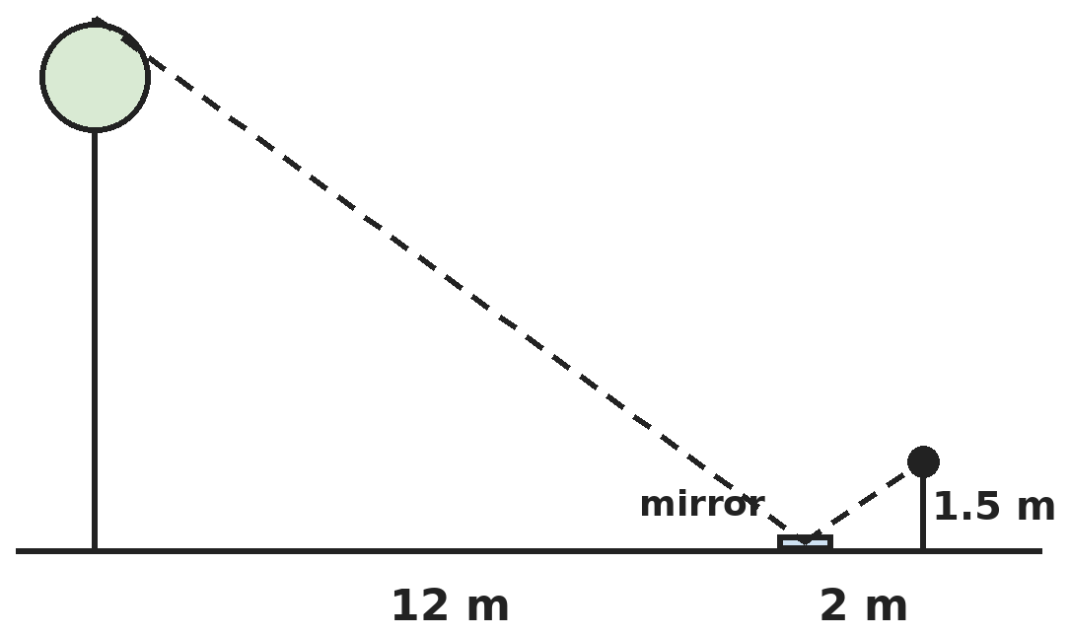
Q10. Ravi places a small mirror on level ground 12 m from the foot of a tree. Standing 2 m behind the mirror, he sees the top of the tree in it. His eyes are 1.5 m above the ground. How tall is the tree?
(A) 16 m | (B) 9 m | (C) 18 m | (D) 4.5 m

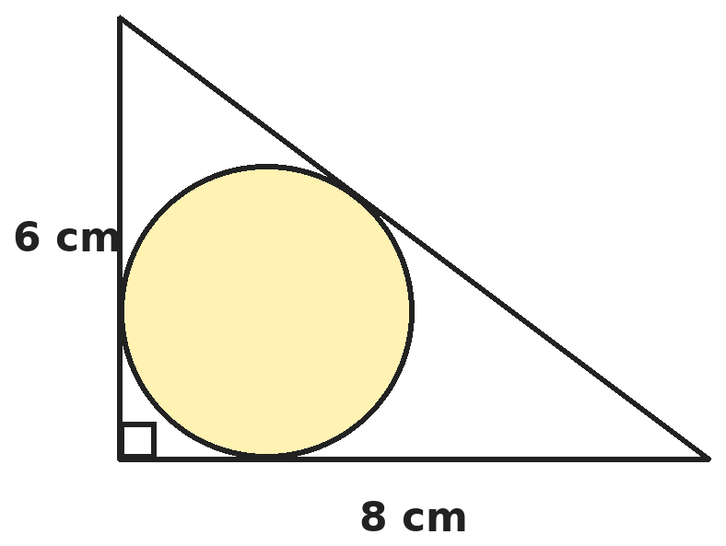
Q11. A circle touches all three sides of a right-angled triangle whose legs are 6 cm and 8 cm. What is its radius?
(A) 2.5 cm | (B) 2 cm | (C) 4 cm | (D) 3 cm

Q12. P lies on the line segment from A(1, 2) to B(7, 10), and AP = 4 units. What are the coordinates of P?
(A) (4.6, 6.8) | (B) (4, 6) | (C) (3.4, 5.2) | (D) (2.6, 4.4)

Part 5 — Mensuration (Syllabus Chapter 6)
Q13. A lampshade is the curved surface of a frustum with radii 20 cm and 8 cm and slant height 13 cm. How much cloth does it need? (Take π = 22/7.)
(A) 1,144 cm² | (B) 572 cm² | (C) 1,430 cm² | (D) 2,288 cm²

Q14. Water in a canal 6 m wide and 1.5 m deep flows at 10 km/h. How much land can it irrigate in 30 minutes if 8 cm of standing water is needed?
(A) 5.625 hectares | (B) 562.5 hectares
(C) 28.125 hectares | (D) 56.25 hectares

Q15. A flower bed is the part of a 60° sector of a circle of radius 14 m that lies outside the circle of radius 7 m with the same centre. What is its area? (Take π = 22/7.)
(A) 154 m² | (B) 462 m² | (C) 38.5 m² | (D) 77 m²

Part 6 — Trigonometry (Syllabus Chapter 7)
Q16. If 7 sin²θ + 3 cos²θ = 4 for an acute angle θ, what is tan θ?
(A) √3 | (B) 1/√3 | (C) 1 | (D) 1/3

Q17. From the top of a 100 m lighthouse, the angles of depression of two ships on the same side and in line with its foot are 45° and 30°. How far apart are the ships?
(A) 100√3 m | (B) 100 m | (C) 100(√3 − 1) m | (D) 100(√3 + 1) m

Part 7 — Data Handling, Statistics & Probability (Syllabus Chapter 8)
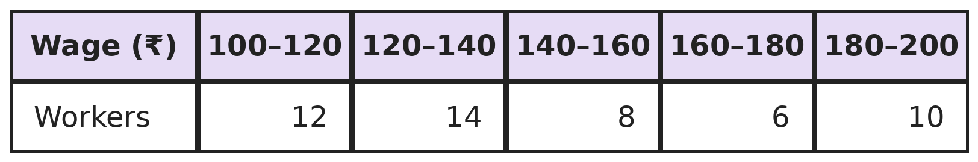
Q18. The table shows the daily wages of 50 workers. What is the mean daily wage?
(A) ₹145.20 | (B) ₹150.00 | (C) ₹142.80 | (D) ₹148.60

Q19. One card is drawn from a well-shuffled pack of 52 cards. What is the probability that it is neither a king nor a heart?
(A) 9/13 | (B) 3/4 | (C) 10/13 | (D) 35/52

Part 8 — Applied Mathematics (Syllabus Chapter 9)
Q20. Kriti rows to a place 48 km away and back in 14 hours. She can row 4 km downstream in the same time as 3 km upstream. What is the speed of the stream?
(A) 2 km/h | (B) 1 km/h | (C) 7 km/h | (D) 0.5 km/h

Q21. A manufacturer sells a fridge to a wholesaler for ₹10,000, the wholesaler to a retailer for ₹12,000, and the retailer to a customer for ₹15,000. GST is 12% at every stage, with input tax credit. How much GST does the retailer pay to the government?
(A) ₹1,800 | (B) ₹1,440 | (C) ₹360 | (D) ₹240

Q22. On an item marked ₹4,000, Shop A gives successive discounts of 20% and 10%, and Shop B gives 25% and then 5%. Which shop is cheaper, and by how much?
(A) Shop A, by ₹30 | (B) Both are the same
(C) Shop B, by ₹40 | (D) Shop B, by ₹30

Part 9 — Mathematical Reasoning (Syllabus Chapter 10)
Q23. What is the least number n such that among any n integers, there are always three whose sum is divisible by 3?
(A) 5 | (B) 4 | (C) 7 | (D) 9

Q24. Anaya climbs a staircase of 8 steps, taking 1 or 2 steps at a time. In how many different ways can she reach the top?
(A) 21 | (B) 55 | (C) 34 | (D) 256

Q25. What is the greatest number of regions into which 4 straight lines can divide a plane?
(A) 8 | (B) 10 | (C) 16 | (D) 11

Part 10 — Mixed Problems (each joins two chapters)
Q26. How many pairs of integers (x, y) satisfy xy = x + y?
(A) 1 | (B) 4 | (C) 2 | (D) 0

Q27. From a point P, a tangent PT of length 5√3 cm is drawn to a circle of radius 5 cm. A second tangent is drawn from P. What is the angle between the two tangents?
(A) 60° | (B) 30° | (C) 120° | (D) 90°

Q28. Triangle ABC with A(1, 5), B(k, −1) and C(5, 3) is right-angled at C. What is k?
(A) −3 | (B) 1 | (C) 3 | (D) 5

Q29. A scooter costs ₹80,000 and loses 20% of its value each year. Pankaj can buy it and sell it after 2 years at its value then, or rent one for ₹1,500 a month. Which option costs less over 2 years, and by how much?
(A) Renting, by ₹7,200 | (B) Buying, by ₹7,200
(C) Buying, by ₹4,000 | (D) Renting, by ₹3,600

Q30. A semicircular sheet of radius 14 cm is folded into a cone, with the two radii joined edge to edge. What is the height of the cone?
(A) 14 cm | (B) 7√3 cm | (C) 7 cm | (D) 14√3 cm

Answer Sheet AMO Level 2 · Class 10 · Practice Paper 8
Name: | School: | Roll No.:
Shade or tick one circle for each question.
1. | Ⓐ Ⓑ Ⓒ Ⓓ | 11. | Ⓐ Ⓑ Ⓒ Ⓓ | 21. | Ⓐ Ⓑ Ⓒ Ⓓ
2. | Ⓐ Ⓑ Ⓒ Ⓓ | 12. | Ⓐ Ⓑ Ⓒ Ⓓ | 22. | Ⓐ Ⓑ Ⓒ Ⓓ
3. | Ⓐ Ⓑ Ⓒ Ⓓ | 13. | Ⓐ Ⓑ Ⓒ Ⓓ | 23. | Ⓐ Ⓑ Ⓒ Ⓓ
4. | Ⓐ Ⓑ Ⓒ Ⓓ | 14. | Ⓐ Ⓑ Ⓒ Ⓓ | 24. | Ⓐ Ⓑ Ⓒ Ⓓ
5. | Ⓐ Ⓑ Ⓒ Ⓓ | 15. | Ⓐ Ⓑ Ⓒ Ⓓ | 25. | Ⓐ Ⓑ Ⓒ Ⓓ
6. | Ⓐ Ⓑ Ⓒ Ⓓ | 16. | Ⓐ Ⓑ Ⓒ Ⓓ | 26. | Ⓐ Ⓑ Ⓒ Ⓓ
7. | Ⓐ Ⓑ Ⓒ Ⓓ | 17. | Ⓐ Ⓑ Ⓒ Ⓓ | 27. | Ⓐ Ⓑ Ⓒ Ⓓ
8. | Ⓐ Ⓑ Ⓒ Ⓓ | 18. | Ⓐ Ⓑ Ⓒ Ⓓ | 28. | Ⓐ Ⓑ Ⓒ Ⓓ
9. | Ⓐ Ⓑ Ⓒ Ⓓ | 19. | Ⓐ Ⓑ Ⓒ Ⓓ | 29. | Ⓐ Ⓑ Ⓒ Ⓓ
10. | Ⓐ Ⓑ Ⓒ Ⓓ | 20. | Ⓐ Ⓑ Ⓒ Ⓓ | 30. | Ⓐ Ⓑ Ⓒ Ⓓ

For the parent or teacher
Correct: ______ / 30
Answer Key and Solutions AMO Level 2 · Class 10 · Practice Paper 8
Quick answers
1 A | 6 D | 11 B | 16 B | 21 C | 26 C
2 C | 7 D | 12 C | 17 C | 22 D | 27 A
3 A | 8 B | 13 A | 18 A | 23 A | 28 C
4 D | 9 D | 14 D | 19 A | 24 C | 29 B
5 A | 10 B | 15 D | 20 B | 25 D | 30 B
Solutions
Q | Part · level | Answer | Why?
1 | Part 1 · Ch1 · Hard | (A) 2 | Hint: Write a = 12m and b = 12n with HCF(m, n) = 1.  144mn = 2160 gives mn = 15. Co-prime pairs with m < n: (1, 15) and (3, 5). So (12, 180) and (36, 60): 2 pairs.
2 | Part 1 · Ch1 · Hard | (C) 2521 | Hint: The number minus 1 is a common multiple of 2, 3, …, 10.  LCM(2, 3, …, 10) = 2³ × 3² × 5 × 7 = 2520. The number is 2520 + 1 = 2521. (2520 leaves remainder 0, and 5041 is the next such number.)
3 | Part 2 · Ch3 · Hard | (A) ₹16 | Hint: Half-yearly means 4% for each half.  She earns 10,000 × (1.04² − 1) = ₹816. She pays 8% simple interest = ₹800. Gain ₹16.
4 | Part 2 · Ch3 · Hard | (D) ₹18,000 | Hint: Compare capital × months for each partner.  4,80,000 : 4,80,000 : 5,40,000 = 8 : 8 : 9. Third partner = 9/25 × 50,000 = ₹18,000. (₹25,000 ignores time.)
5 | Part 2 · Ch3 · Hard | (A) ₹5,000 | Hint: Work backwards: 5,400 = cost × 1.2 × 0.9.  Cost × 1.08 = 5,400, so cost = ₹5,000. (₹4,500 treats the net change as 20%.)
6 | Part 3 · Ch4 · Hard | (D) 2x + 3 | Hint: The answer is the remainder on division by x² + 5.  (x² + 5)(x² + 2x + 3) = x⁴ + 2x³ + 8x² + 10x + 15. The remainder is (12x + 18) − (10x + 15) = 2x + 3.
7 | Part 3 · Ch4 · Hard | (D) 14 | Hint: Add the first and third equations to remove z.  First + third: 2x + 3y = 8. Second − first: x − 2y = −3. So x = 1, y = 2, and z = 3. x² + y² + z² = 1 + 4 + 9 = 14.
8 | Part 3 · Ch4 · Hard | (B) 0 | Hint: Subtract the two term equations to find d.  (p − q)d = q − p, so d = −1. Then a = q + (p − 1) = p + q − 1. Term p + q = a + (p + q − 1)(−1) = 0.
9 | Part 3 · Ch4 · Hard | (D) 15 hours | Hint: 1/x + 1/(x − 5) = 1/6.  6(2x − 5) = x(x − 5) gives x² − 17x + 30 = 0, so x = 15 or 2. x = 2 is impossible (the other would take −3 hours). So 15 hours.
10 | Part 4 · Ch5 · Hard | (B) 9 m | Hint: The angles made with the ground at the mirror are equal, so the two triangles are similar.  Tree/12 = 1.5/2, so the tree is 12 × 0.75 = 9 m.
11 | Part 4 · Ch5 · Hard | (B) 2 cm | Hint: The tangent lengths from the right-angle corner are both equal to the radius r.  Hypotenuse = 10. The tangents from the other two corners are 6 − r and 8 − r, and they make up the hypotenuse: (6 − r) + (8 − r) = 10, so r = 2 cm.
12 | Part 4 · Ch5 · Hard | (C) (3.4, 5.2) | Hint: AB = 10, so P divides AB in the ratio 4 : 6.  AB = √(36 + 64) = 10. P divides AB in the ratio 2 : 3: x = (2 × 7 + 3 × 1)/5 = 3.4, y = (2 × 10 + 3 × 2)/5 = 5.2. (4.6, 6.8) is 4 units from B.
13 | Part 5 · Ch6 · Hard | (A) 1,144 cm² | Hint: Curved surface of a frustum = π(R + r)l.  π × (20 + 8) × 13 = 22/7 × 364 = 1,144 cm². (572 cm² uses half the sum of the radii; 2,288 cm² doubles it.)
14 | Part 5 · Ch6 · Hard | (D) 56.25 hectares | Hint: In 30 minutes the water travels 5 km. 1 hectare = 10,000 m².  Volume = 6 × 1.5 × 5,000 = 45,000 m³. Area = 45,000 ÷ 0.08 = 5,62,500 m² = 56.25 hectares.
15 | Part 5 · Ch6 · Hard | (D) 77 m² | Hint: Subtract the small sector from the big sector.  Area = 60/360 × 22/7 × (14² − 7²) = 1/6 × 22/7 × 147 = 77 m².
16 | Part 6 · Ch7 · Hard | (B) 1/√3 | Hint: Write 7 sin²θ + 3 cos²θ = 3 + 4 sin²θ.  3 + 4 sin²θ = 4 gives sin²θ = 1/4, sin θ = 1/2, θ = 30°. tan θ = 1/√3.
17 | Part 6 · Ch7 · Hard | (C) 100(√3 − 1) m | Hint: Distances of the ships from the foot are 100/tan 45° and 100/tan 30°.  Distances 100 m and 100√3 m. Gap = 100(√3 − 1) m (about 73.2 m).
18 | Part 7 · Ch8 · Hard | (A) ₹145.20 | Hint: Take an assumed mean of 150 and deviations −40, −20, 0, 20, 40.  Σfd = 12(−40) + 14(−20) + 0 + 6(20) + 10(40) = −480 − 280 + 120 + 400 = −240. Mean = 150 − 240/50 = ₹145.20.
19 | Part 7 · Ch8 · Hard | (A) 9/13 | Hint: Kings or hearts: 13 hearts + 3 other kings.  16 cards are kings or hearts. 52 − 16 = 36. Probability 36/52 = 9/13. (35/52 counts the king of hearts twice.)
20 | Part 8 · Ch9 · Hard | (B) 1 km/h | Hint: Let the speeds be 4k downstream and 3k upstream.  48/(4k) + 48/(3k) = 12/k + 16/k = 28/k = 14, so k = 2. Downstream 8 km/h, upstream 6 km/h. Stream = (8 − 6)/2 = 1 km/h.
21 | Part 8 · Ch9 · Hard | (C) ₹360 | Hint: Each trader pays GST only on the value he adds.  Retailer adds 15,000 − 12,000 = ₹3,000. GST = 12% of 3,000 = ₹360. (₹1,800 is the GST on the full final price, paid in parts by all three.)
22 | Part 8 · Ch9 · Hard | (D) Shop B, by ₹30 | Hint: Multiply the factors for each shop.  Shop A: 4,000 × 0.8 × 0.9 = ₹2,880. Shop B: 4,000 × 0.75 × 0.95 = ₹2,850. Shop B is cheaper by ₹30. ("Both are the same" adds the discounts: 30% each.)
23 | Part 9 · Ch10 · Hard | (A) 5 | Hint: Sort the integers by their remainders 0, 1, 2 on division by 3.  Four integers with remainders 0, 0, 1, 1 have no such three. With 5 integers, either all three remainders appear (0 + 1 + 2 = 3), or some remainder appears 3 times (3r is a multiple of 3). So 5.
24 | Part 9 · Ch10 · Hard | (C) 34 | Hint: The number of ways for n steps = ways for (n − 1) + ways for (n − 2).  Ways for 1, 2, 3, … steps: 1, 2, 3, 5, 8, 13, 21, 34. For 8 steps: 34.
25 | Part 9 · Ch10 · Hard | (D) 11 | Hint: The k-th line can cross all earlier lines and add k new regions.  Start with 1 region. Lines add 1, 2, 3 and 4 regions: 1 + 1 + 2 + 3 + 4 = 11. (16 doubles each time, which is not possible.)
26 | Part 10 · Mixed · Ch4 + Ch10 · Hard | (C) 2 | Hint: Rewrite the equation as (x − 1)(y − 1) = 1.  (x − 1)(y − 1) = 1 means both factors are 1 or both are −1. So (x, y) = (2, 2) or (0, 0): 2 pairs.
27 | Part 10 · Mixed · Ch5 + Ch7 · Hard | (A) 60° | Hint: In the right triangle OTP, tan(angle OPT) = OT/PT.  tan(angle OPT) = 5/(5√3) = 1/√3, so angle OPT = 30°. OP bisects the angle between the tangents, so it is 60°.
28 | Part 10 · Mixed · Ch4 + Ch5 · Hard | (C) 3 | Hint: Use Pythagoras: AB² = AC² + BC².  AB² = (k − 1)² + 36. AC² = 16 + 4 = 20. BC² = (k − 5)² + 16. So k² − 2k + 37 = k² − 10k + 61, giving 8k = 24 and k = 3.
29 | Part 10 · Mixed · Ch3 + Ch9 · Hard | (B) Buying, by ₹7,200 | Hint: Cost of buying = price − value after 2 years.  Value after 2 years = 80,000 × 0.8² = ₹51,200, so buying costs ₹28,800. Renting costs 1,500 × 24 = ₹36,000. Buying is cheaper by ₹7,200.
30 | Part 10 · Mixed · Ch6 + Ch10 · Hard | (B) 7√3 cm | Hint: The arc of the semicircle becomes the circumference of the base. The radius 14 becomes the slant height.  Arc = π × 14 = 2πr, so the base radius r = 7 cm. Slant = 14. Height = √(196 − 49) = 7√3 cm.

ARYABHATTA MATHS OLYMPIAD
Level 2
PRACTICE PAPER-9
CLASS 10
Total Questions | 30 multiple-choice questions
Level | Level-2 (final round): every question is Hard
Time | 45 minutes
Arrangement | Parts by chapter; the last Part has mixed problems joining two chapters
Negative Marking | No negative marking
Calculator | Not allowed
Chapters | Number System · Fractions, Decimals & Percentages · Algebra · Geometry · Mensuration · Trigonometry · Data Handling, Statistics & Probability · Applied Mathematics · Mathematical Reasoning

Instructions
• Each question has four options, (A) to (D), with exactly one correct answer.
• The questions are grouped in Parts by chapter. The last Part has mixed problems, each joining two chapters.
• Every question is at Level-2 (Hard) standard: expect several steps or a key insight.
• There is no negative marking. Calculators are not allowed; use a separate sheet for rough work.
• Figures are not necessarily drawn to scale unless stated.

For teachers
• Figures are part of the questions and work when printed in black and white.
• Parts follow the AMO syllabus chapters. Chapter 2 is not part of the Class 10 syllabus, so the chapter numbers shown in the Part headings have gaps.
• The answer sheet and the answer key are at the end. Remove the answer key before the paper is attempted.

Part 1 — Number System (Syllabus Chapter 1)
Q1. What is the smallest whole number n greater than 100 for which 1/n has a terminating decimal expansion with exactly 3 digits after the decimal point?
(A) 200 | (B) 125 | (C) 128 | (D) 1000

Q2. Which of these numbers can NOT be the square of a whole number?
(A) 5,329 | (B) 6,241 | (C) 7,421 | (D) 4,489

Part 2 — Fractions, Decimals & Percentages (Syllabus Chapter 3)
Q3. Ruhi deposits ₹25,000 for 1 year at 12% per annum. How much more interest does she get if it is compounded quarterly instead of half-yearly?
(A) ₹47.72 | (B) ₹90.00 | (C) ₹0 | (D) ₹137.72

Q4. Nandini invests ₹60,000 and Vikram ₹40,000. Each first gets 5% interest on his or her capital out of the profit, and the rest of the profit is shared equally. Out of ₹25,000 profit, how much does Nandini get?
(A) ₹13,000 | (B) ₹15,000 | (C) ₹12,500 | (D) ₹10,000

Q5. A town of 1,60,000 people grows by 5% each year, and at the end of each year 4,000 people move away. What is the population after 2 years?
(A) 1,68,400 | (B) 1,68,200 | (C) 1,76,400 | (D) 1,64,000

Part 3 — Algebra (Syllabus Chapter 4)
Q6. α and β are the zeros of x² − 4x + 3. Which quadratic polynomial (leading coefficient 1) has zeros 2α and 2β?
(A) x² − 8x + 12 | (B) x² − 8x + 6 | (C) x² − 4x + 12 | (D) x² − 8x + 3

Q7. A two-digit number added to the number formed by reversing its digits gives 121. Its digits differ by 3. How many such two-digit numbers are there?
(A) 1 | (B) 4 | (C) 0 | (D) 2

Q8. How many terms of the AP 9, 17, 25, … must be taken to get a sum of 636?
(A) 13 | (B) 11 | (C) 10 | (D) 12

Q9. A motor boat whose speed in still water is 18 km/h takes 1 hour more to go 24 km upstream than to come back downstream. What is the speed of the stream?
(A) 4 km/h | (B) 3 km/h | (C) 6 km/h | (D) 9 km/h

Part 4 — Geometry (Syllabus Chapter 5)
Q10. Triangles ABC and PQR are similar. The median AD of ABC is 6 cm and the corresponding median PS of PQR is 8 cm. If the area of ABC is 54 cm², what is the area of PQR?
(A) 72 cm² | (B) 128 cm² | (C) 96 cm² | (D) 40.5 cm²

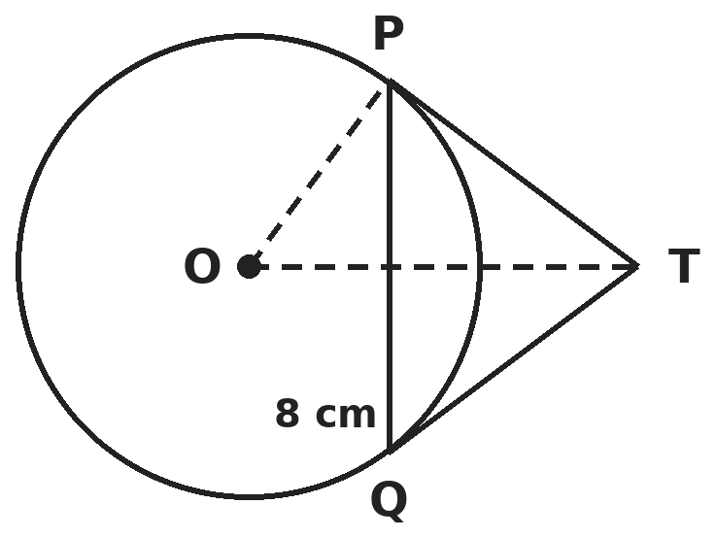
Q11. PQ is a chord of length 8 cm in a circle of radius 5 cm with centre O. The tangents at P and Q meet at T. What is the length TP?
(A) 16/3 cm | (B) 5 cm | (C) 4 cm | (D) 20/3 cm

Q12. The midpoints of the sides of a triangle are (3, 4), (4, 1) and (2, 0). Which of these is a vertex of the triangle?
(A) (1, 5) | (B) (3, 3) | (C) (5, 5) | (D) (5, 3)

Part 5 — Mensuration (Syllabus Chapter 6)
Q13. A hemispherical bowl is made of steel 0.25 cm thick. Its inner radius is 5 cm. What is its outer curved surface area? (Take π = 22/7.)
(A) 157.14 cm² | (B) 346.5 cm² | (C) 165.0 cm² | (D) 173.25 cm²

Q14. A cylindrical bucket 32 cm high with base radius 18 cm is full of sand. It is emptied on the ground into a conical heap 24 cm high. What is the radius of the base of the heap?
(A) 36 cm | (B) 18 cm | (C) 24 cm | (D) 72 cm

Q15. A car has two wipers that do not overlap. Each blade is 25 cm long and sweeps an angle of 115°. What total area do they clean? (Take π = 22/7.)
(A) 627.48 cm² | (B) 1,254.96 cm² | (C) 1,964.29 cm² | (D) 125.50 cm²

Part 6 — Trigonometry (Syllabus Chapter 7)
Q16. What is the least possible value of (sin θ + cosec θ)² + (cos θ + sec θ)² for an acute angle θ?
(A) 7 | (B) 9 | (C) 5 | (D) 8

Q17. Leena's eyes are 1.2 m above the ground. She sees a balloon, moving horizontally at a height of 88.2 m, at an angle of elevation of 60°. Some time later the angle is 30°. How far has the balloon moved?
(A) 58√3 m | (B) 87√3 m | (C) 29√3 m | (D) 58 m

Part 7 — Data Handling, Statistics & Probability (Syllabus Chapter 8)
Q18. For a moderately skewed distribution, the mean is 1.5 more than the median, and the mode is 24. Using the empirical relation, what is the mean?
(A) 27 | (B) 25.5 | (C) 28.5 | (D) 30

Q19. Discs numbered 1 to 25 are in a box. One is drawn at random. What is the probability that its number is a prime or a perfect square?
(A) 9/25 | (B) 1/2 | (C) 13/25 | (D) 14/25

Part 8 — Applied Mathematics (Syllabus Chapter 9)
Q20. A phone is marked ₹4,000. It is sold at 15% off, and the buyer then gets 5% cashback on the amount paid. What is the final cost to the buyer?
(A) ₹3,200 | (B) ₹3,230 | (C) ₹3,400 | (D) ₹3,240

Q21. Prachi can finish a job in 20 days and Mohit in 30 days. They start together, but Prachi leaves 5 days before the job is finished. How many days does the job take in all?
(A) 12 days | (B) 17 days | (C) 15 days | (D) 10 days

Q22. A workshop has fixed costs of ₹30,000 and a cost of ₹70 for each chair. It expects to sell 1,500 chairs. What is the lowest price per chair at which it does not make a loss?
(A) ₹70 | (B) ₹90 | (C) ₹110 | (D) ₹20

Part 9 — Mathematical Reasoning (Syllabus Chapter 10)
Q23. A bag holds 5 red, 7 blue and 9 green marbles. Without looking, what is the least number of marbles Arnav must take out to be sure of having 4 marbles of the same colour?
(A) 10 | (B) 4 | (C) 12 | (D) 13

Q24. Triangles are drawn using three corners of a regular octagon. How many of them have no side in common with the octagon?
(A) 56 | (B) 8 | (C) 24 | (D) 16

Q25. The numbers 1 to 10 are on a board. Each step, Sameer erases two numbers and writes their positive difference. At the end one number is left. What can be said about it?
(A) It is always even | (B) It is always odd
(C) It is always 1 | (D) It is always 0

Part 10 — Mixed Problems (each joins two chapters)
Q26. How many numbers are common to the APs 4, 7, 10, …, 301 and 3, 8, 13, …, 303?
(A) 19 | (B) 20 | (C) 21 | (D) 15

Q27. An isosceles triangle has base 12 cm and both base angles equal to 30°. What is its area?
(A) 36√3 cm² | (B) 6√3 cm² | (C) 12√3 cm² | (D) 24√3 cm²

Q28. Which point of the form (a, a) is equidistant from A(3, 4) and B(5, 2)?
(A) (3.5, 3.5) | (B) (4, 4)
(C) (2, 2) | (D) No such point exists

Q29. A shop lends ₹1,00,000 at 1% per month, compounded monthly. It is repaid in 2 equal monthly instalments, the first after one month. What is each instalment (to the nearest paisa)?
(A) ₹50,500.00 | (B) ₹51,000.00 | (C) ₹50,751.24 | (D) ₹50,000.00

Q30. A large cube is painted on all faces and cut into n × n × n unit cubes. The number of unit cubes with no paint equals the number with paint on exactly one face. What is n?
(A) 8 | (B) 6 | (C) 4 | (D) 10

Answer Sheet AMO Level 2 · Class 10 · Practice Paper 9
Name: | School: | Roll No.:
Shade or tick one circle for each question.
1. | Ⓐ Ⓑ Ⓒ Ⓓ | 11. | Ⓐ Ⓑ Ⓒ Ⓓ | 21. | Ⓐ Ⓑ Ⓒ Ⓓ
2. | Ⓐ Ⓑ Ⓒ Ⓓ | 12. | Ⓐ Ⓑ Ⓒ Ⓓ | 22. | Ⓐ Ⓑ Ⓒ Ⓓ
3. | Ⓐ Ⓑ Ⓒ Ⓓ | 13. | Ⓐ Ⓑ Ⓒ Ⓓ | 23. | Ⓐ Ⓑ Ⓒ Ⓓ
4. | Ⓐ Ⓑ Ⓒ Ⓓ | 14. | Ⓐ Ⓑ Ⓒ Ⓓ | 24. | Ⓐ Ⓑ Ⓒ Ⓓ
5. | Ⓐ Ⓑ Ⓒ Ⓓ | 15. | Ⓐ Ⓑ Ⓒ Ⓓ | 25. | Ⓐ Ⓑ Ⓒ Ⓓ
6. | Ⓐ Ⓑ Ⓒ Ⓓ | 16. | Ⓐ Ⓑ Ⓒ Ⓓ | 26. | Ⓐ Ⓑ Ⓒ Ⓓ
7. | Ⓐ Ⓑ Ⓒ Ⓓ | 17. | Ⓐ Ⓑ Ⓒ Ⓓ | 27. | Ⓐ Ⓑ Ⓒ Ⓓ
8. | Ⓐ Ⓑ Ⓒ Ⓓ | 18. | Ⓐ Ⓑ Ⓒ Ⓓ | 28. | Ⓐ Ⓑ Ⓒ Ⓓ
9. | Ⓐ Ⓑ Ⓒ Ⓓ | 19. | Ⓐ Ⓑ Ⓒ Ⓓ | 29. | Ⓐ Ⓑ Ⓒ Ⓓ
10. | Ⓐ Ⓑ Ⓒ Ⓓ | 20. | Ⓐ Ⓑ Ⓒ Ⓓ | 30. | Ⓐ Ⓑ Ⓒ Ⓓ

For the parent or teacher
Correct: ______ / 30
Answer Key and Solutions AMO Level 2 · Class 10 · Practice Paper 9
Quick answers
1 B | 6 A | 11 D | 16 B | 21 C | 26 B
2 C | 7 D | 12 C | 17 A | 22 B | 27 C
3 A | 8 D | 13 D | 18 C | 23 A | 28 D
4 A | 9 C | 14 A | 19 D | 24 D | 29 C
5 B | 10 C | 15 B | 20 B | 25 B | 30 A
Solutions
Q | Part · level | Answer | Why?
1 | Part 1 · Ch1 · Hard | (B) 125 | Hint: 1/n terminates after exactly 3 places when n = 2ᵃ × 5ᵇ and the larger of a and b is 3.  n must divide 1000 and need 3 places: n = 8, 40, 125, 200, 250, 500 or 1000. The smallest above 100 is 125 (1/125 = 0.008). 1/128 has 7 places.
2 | Part 1 · Ch1 · Hard | (C) 7,421 | Hint: By Euclid's lemma, every square leaves remainder 0 or 1 on division by 3. Use digit sums.  Digit sums: 7,421 → 14 (remainder 2 on division by 3), so it cannot be a square. The others are 73², 79² and 67².
3 | Part 2 · Ch3 · Hard | (A) ₹47.72 | Hint: Quarterly: 3% four times. Half-yearly: 6% twice.  Quarterly: 25,000 × 1.03⁴ = ₹28,137.72. Half-yearly: 25,000 × 1.06² = ₹28,090. Difference ₹47.72.
4 | Part 2 · Ch3 · Hard | (A) ₹13,000 | Hint: Take out the interest first: ₹3,000 and ₹2,000.  Interest: ₹3,000 and ₹2,000. Rest = ₹20,000, shared equally: ₹10,000 each. Nandini gets 3,000 + 10,000 = ₹13,000.
5 | Part 2 · Ch3 · Hard | (B) 1,68,200 | Hint: Apply growth, then subtract 4,000, for each year in turn.  Year 1: 1,68,000 − 4,000 = 1,64,000. Year 2: 1,72,200 − 4,000 = 1,68,200. (1,68,400 subtracts 8,000 at the end instead.)
6 | Part 3 · Ch4 · Hard | (A) x² − 8x + 12 | Hint: New sum = 2(α + β); new product = 4αβ.  α + β = 4 and αβ = 3. New sum 8, new product 12. Polynomial x² − 8x + 12. (Check: zeros 1, 3 become 2, 6.)
7 | Part 3 · Ch4 · Hard | (D) 2 | Hint: (10a + b) + (10b + a) = 11(a + b).  11(a + b) = 121 gives a + b = 11, and the digits differ by 3, so they are 7 and 4. Both 47 and 74 work: 2 numbers.
8 | Part 3 · Ch4 · Hard | (D) 12 | Hint: Sₙ = n/2 × (18 + 8(n − 1)) = n(4n + 5).  n(4n + 5) = 636 gives 4n² + 5n − 636 = 0 = (n − 12)(4n + 53). So n = 12.
9 | Part 3 · Ch4 · Hard | (C) 6 km/h | Hint: 24/(18 − s) − 24/(18 + s) = 1.  48s = 324 − s², so s² + 48s − 324 = 0 = (s − 6)(s + 54). s = 6 km/h.
10 | Part 4 · Ch5 · Hard | (C) 96 cm² | Hint: In similar triangles, corresponding medians are in the ratio of the sides.  Ratio of sides = 6 : 8 = 3 : 4, so areas are 9 : 16. Area PQR = 54 × 16/9 = 96 cm². (72 uses the side ratio.)
11 | Part 4 · Ch5 · Hard | (D) 20/3 cm | Hint: OT meets PQ at its midpoint M, with OM = 3. Triangles OMP and OPT are similar.  OM = √(25 − 16) = 3 cm, PM = 4 cm. From the similar right triangles OMP and OPT, TP/OP = PM/OM, so TP = 5 × 4/3 = 20/3 cm.
12 | Part 4 · Ch5 · Hard | (C) (5, 5) | Hint: Each vertex = sum of two midpoints − the third.  Vertices: (3, 4) + (4, 1) − (2, 0) = (5, 5); (3, 4) + (2, 0) − (4, 1) = (1, 3); (4, 1) + (2, 0) − (3, 4) = (3, −3). Only (5, 5) is in the list.
13 | Part 5 · Ch6 · Hard | (D) 173.25 cm² | Hint: Outer radius = 5 + 0.25.  Outer CSA = 2πR² = 2 × 22/7 × 5.25² = 173.25 cm². (157.14 uses the inner radius; 346.5 uses a full sphere.)
14 | Part 5 · Ch6 · Hard | (A) 36 cm | Hint: (1/3)πr² × 24 = π × 18² × 32.  8r² = 324 × 32, so r² = 1,296 and r = 36 cm.
15 | Part 5 · Ch6 · Hard | (B) 1,254.96 cm² | Hint: Each wiper sweeps a sector of radius 25 cm and angle 115°.  Two sectors: 2 × 115/360 × 22/7 × 625 = 1,58,125/126 ≈ 1,254.96 cm². (627.48 is one wiper.)
16 | Part 6 · Ch7 · Hard | (B) 9 | Hint: Expand and use the identities: the expression equals 7 + tan²θ + cot²θ.  Expanding gives 1 + 4 + cosec²θ + sec²θ = 5 + (1 + cot²θ) + (1 + tan²θ) = 7 + tan²θ + cot²θ. Since tan²θ + cot²θ ≥ 2 (equal at 45°), the least value is 9.
17 | Part 6 · Ch7 · Hard | (A) 58√3 m | Hint: Use 88.2 − 1.2 = 87 m as the height above her eyes.  Horizontal distances: 87/√3 and 87√3. Distance moved = 87√3 − 87/√3 = 87 × 2/√3 = 58√3 m (about 100.5 m).
18 | Part 7 · Ch8 · Hard | (C) 28.5 | Hint: Mode = 3 × median − 2 × mean. Write the mean as median + 1.5.  Let the median be m, so the mean is m + 1.5. 24 = 3m − 2(m + 1.5) = m − 3, so m = 27 and the mean is 28.5. (27 is the median.)
19 | Part 7 · Ch8 · Hard | (D) 14/25 | Hint: No number is both a prime and a perfect square.  Primes: 2, 3, 5, 7, 11, 13, 17, 19, 23 (9). Squares: 1, 4, 9, 16, 25 (5). Total 14. Probability 14/25. (13/25 forgets that 1 is a square.)
20 | Part 8 · Ch9 · Hard | (B) ₹3,230 | Hint: Cashback is 5% of the discounted price.  After 15% off: ₹3,400. Cashback = 5% of 3,400 = ₹170. Final cost ₹3,230. (₹3,200 treats it as a single 20% discount.)
21 | Part 8 · Ch9 · Hard | (C) 15 days | Hint: If the job takes T days, Prachi works T − 5 days and Mohit works T days.  (T − 5)/20 + T/30 = 1 gives 3T − 15 + 2T = 60, so T = 15 days.
22 | Part 8 · Ch9 · Hard | (B) ₹90 | Hint: Revenue must cover fixed costs plus all the per-chair costs.  Total cost = 30,000 + 70 × 1,500 = ₹1,35,000. Price = 1,35,000 ÷ 1,500 = ₹90. (₹20 is only the fixed cost per chair.)
23 | Part 9 · Ch10 · Hard | (A) 10 | Hint: In the worst case he gets 3 of each colour first.  He could take 3 red, 3 blue and 3 green (9 marbles) with no colour 4 times. The 10th marble makes 4 of some colour. So 10.
24 | Part 9 · Ch10 · Hard | (D) 16 | Hint: Fix one corner of the triangle and count the ways to choose the other two.  Number the corners 1 to 8 and fix corner 1. The other two corners must come from 3, 4, 5, 6, 7 and must not be next to each other: (3, 5), (3, 6), (3, 7), (4, 6), (4, 7), (5, 7), which is 6 ways. Each of the 8 corners gives 6, but every triangle is counted 3 times (once at each corner): 8 × 6 ÷ 3 = 16. (56 counts all triangles.)
25 | Part 9 · Ch10 · Hard | (B) It is always odd | Hint: a + b and a − b have the same parity. Watch the parity of the total.  Replacing a and b by a − b changes the total by 2b, an even number, so the parity of the total never changes. The start total is 55 (odd), so the last number is odd. (It can be 1, 3, 5, … depending on the moves.)
26 | Part 10 · Mixed · Ch4 + Ch10 · Hard | (B) 20 | Hint: Common terms leave remainder 1 on division by 3 and remainder 3 on division by 5.  The first common term is 13; after that they come every 15: 13, 28, …, 298. Number = (298 − 13)/15 + 1 = 20.
27 | Part 10 · Mixed · Ch5 + Ch7 · Hard | (C) 12√3 cm² | Hint: The altitude bisects the base.  Altitude = 6 tan 30° = 6/√3 = 2√3 cm. Area = 1/2 × 12 × 2√3 = 12√3 cm².
28 | Part 10 · Mixed · Ch4 + Ch5 · Hard | (D) No such point exists | Hint: Equate (a − 3)² + (a − 4)² and (a − 5)² + (a − 2)².  Expanding: 2a² − 14a + 25 = 2a² − 14a + 29, which says 25 = 29. This is never true, so no such point exists.
29 | Part 10 · Mixed · Ch3 + Ch9 · Hard | (C) ₹50,751.24 | Hint: x/1.01 + x/1.0201 = 1,00,000.  Multiply by 1.0201: 1.01x + x = 2.01x = 1,02,010. x = ₹50,751.24. (₹50,500 adds one month of interest on half the loan.)
30 | Part 10 · Mixed · Ch6 + Ch10 · Hard | (A) 8 | Hint: No paint: (n − 2)³. One face: 6(n − 2)².  (n − 2)³ = 6(n − 2)² gives n − 2 = 6 (n − 2 = 0 means no such cubes at all), so n = 8.

ARYABHATTA MATHS OLYMPIAD
Level 2
PRACTICE PAPER-10
CLASS 10
Total Questions | 30 multiple-choice questions
Level | Level-2 (final round): every question is Hard
Time | 45 minutes
Arrangement | Parts by chapter; the last Part has mixed problems joining two chapters
Negative Marking | No negative marking
Calculator | Not allowed
Chapters | Number System · Fractions, Decimals & Percentages · Algebra · Geometry · Mensuration · Trigonometry · Data Handling, Statistics & Probability · Applied Mathematics · Mathematical Reasoning

Instructions
• Each question has four options, (A) to (D), with exactly one correct answer.
• The questions are grouped in Parts by chapter. The last Part has mixed problems, each joining two chapters.
• Every question is at Level-2 (Hard) standard: expect several steps or a key insight.
• There is no negative marking. Calculators are not allowed; use a separate sheet for rough work.
• Figures are not necessarily drawn to scale unless stated.

For teachers
• Figures are part of the questions and work when printed in black and white.
• Parts follow the AMO syllabus chapters. Chapter 2 is not part of the Class 10 syllabus, so the chapter numbers shown in the Part headings have gaps.
• The answer sheet and the answer key are at the end. Remove the answer key before the paper is attempted.

Part 1 — Number System (Syllabus Chapter 1)
Q1. What is the HCF of 2¹² − 1 and 2⁸ − 1?
(A) 15 | (B) 255 | (C) 3 | (D) 1

Q2. For which natural numbers n does 12ⁿ end with the digit 0?
(A) Only n = 5 | (B) For no n | (C) Every even n | (D) Every n ≥ 10

Part 2 — Fractions, Decimals & Percentages (Syllabus Chapter 3)
Q3. Ashwin splits ₹10,000 into two parts. One part earns 10% and the other 20% per annum, both compounded yearly. After 2 years the total interest is ₹3,480. How much was invested at 20%?
(A) ₹6,000 | (B) ₹4,000 | (C) ₹5,000 | (D) ₹7,000

Q4. Three partners invested for 6, 8 and 12 months and shared the profit in the ratio 1 : 2 : 3. In what ratio were their capitals?
(A) 1 : 2 : 3 | (B) 3 : 2 : 2 | (C) 6 : 8 : 12 | (D) 2 : 3 : 3

Q5. A dishonest grocer uses a 900 g weight in place of 1 kg, and also charges 10% above the cost price. What is his real gain percent?
(A) 20% | (B) 10% | (C) 11 1/9% | (D) 22 2/9%

Part 3 — Algebra (Syllabus Chapter 4)
Q6. α and β are the zeros of x² + x − 6, with α > β. What is α − β?
(A) 1 | (B) 5 | (C) 25 | (D) 7

Q7. If 1/(x + y) + 2/(x − y) = 1 and 2/(x + y) − 1/(x − y) = 3/4, what is xy?
(A) 3 | (B) 2 | (C) −3 | (D) −2

Q8. What is the sum of all natural numbers less than 100 that are multiples of 3 or of 5?
(A) 2,633 | (B) 2,418 | (C) 2,003 | (D) 2,318

Q9. The sum of the ages of two friends is 20 years. Four years ago, the product of their ages was 48. What are their present ages?
(A) 12 and 8 years | (B) This is not possible
(C) 14 and 6 years | (D) 16 and 4 years

Part 4 — Geometry (Syllabus Chapter 5)
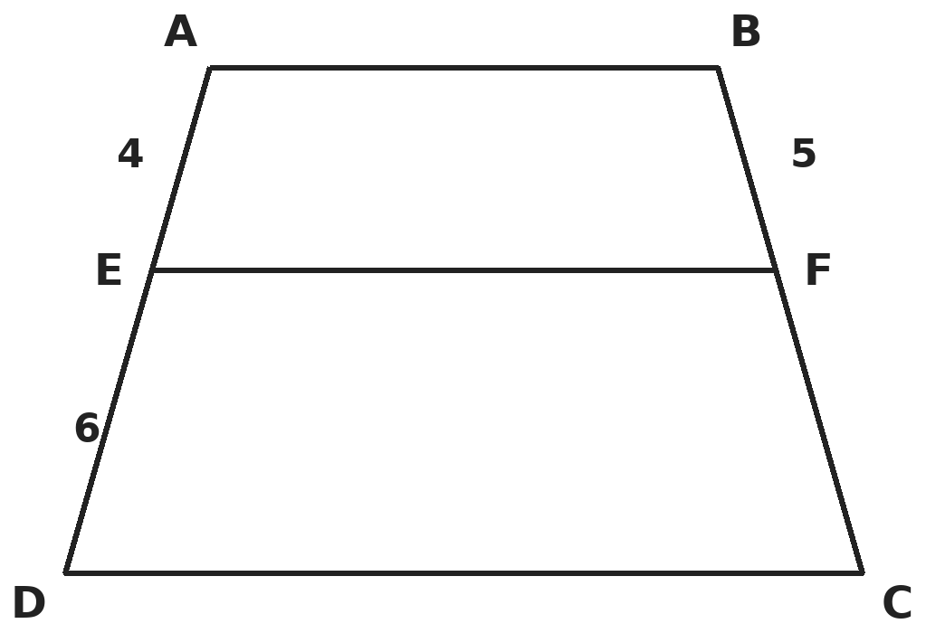
Q10. ABCD is a trapezium with AB ∥ DC. E and F lie on AD and BC so that EF ∥ AB. If AE = 4 cm, ED = 6 cm and BF = 5 cm, what is FC?
(A) 10/3 cm | (B) 6 cm | (C) 7.5 cm | (D) 5 cm

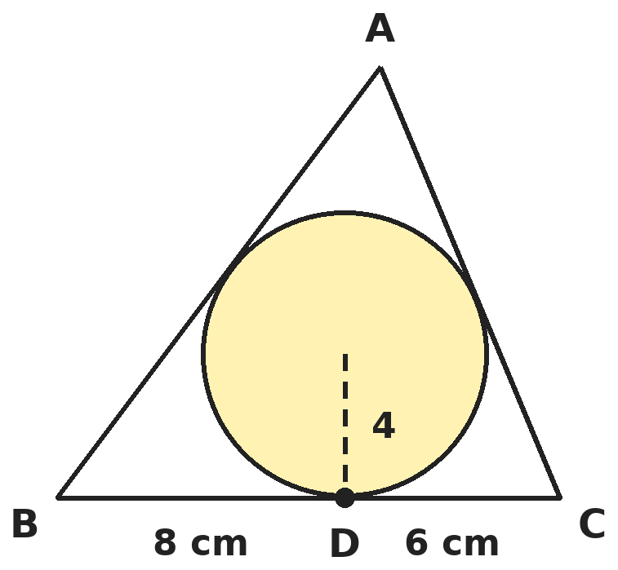
Q11. A circle of radius 4 cm touches all three sides of triangle ABC. It touches BC at D, with BD = 8 cm and DC = 6 cm. What is the length of AB?
(A) 13 cm | (B) 14 cm | (C) 15 cm | (D) 12 cm

Q12. A(1, 2) and C(5, 6) are opposite corners of a square ABCD. Which of these is another corner of the square?
(A) (5, 2) | (B) (3, 4) | (C) (6, 1) | (D) (2, 5)

Part 5 — Mensuration (Syllabus Chapter 6)
Q13. A milk container is a frustum of a cone with height 16 cm and radii 20 cm and 8 cm. What is its volume, in terms of π?
(A) 9,984π cm³ | (B) 3,328π cm³ | (C) 2,496π cm³ | (D) 4,992π cm³

Q14. A cylinder of radius 6 cm and height 15 cm is full of ice cream. It is filled into cones of radius 3 cm and height 12 cm, each with a hemispherical top of ice cream. How many such cones can be filled?
(A) 15 | (B) 20 | (C) 5 | (D) 10

Q15. A circular park has radius 21 m. A path 3.5 m wide runs all round it, just inside the edge. What is the area of the path? (Take π = 22/7.)
(A) 462 m² | (B) 385 m² | (C) 423.5 m² | (D) 231 m²

Part 6 — Trigonometry (Syllabus Chapter 7)
Q16. If x = a sec θ + b tan θ and y = a tan θ + b sec θ, what is x² − y²?
(A) a² − b² | (B) a² + b² | (C) b² − a² | (D) 1

Q17. A 1.5 m tall boy stands at some distance from a 30 m tall building. As he walks towards it, the angle of elevation of the top changes from 30° to 60°. How far did he walk?
(A) 28.5√3 m | (B) 19√3 m | (C) 10√3 m | (D) 19 m

Part 7 — Data Handling, Statistics & Probability (Syllabus Chapter 8)
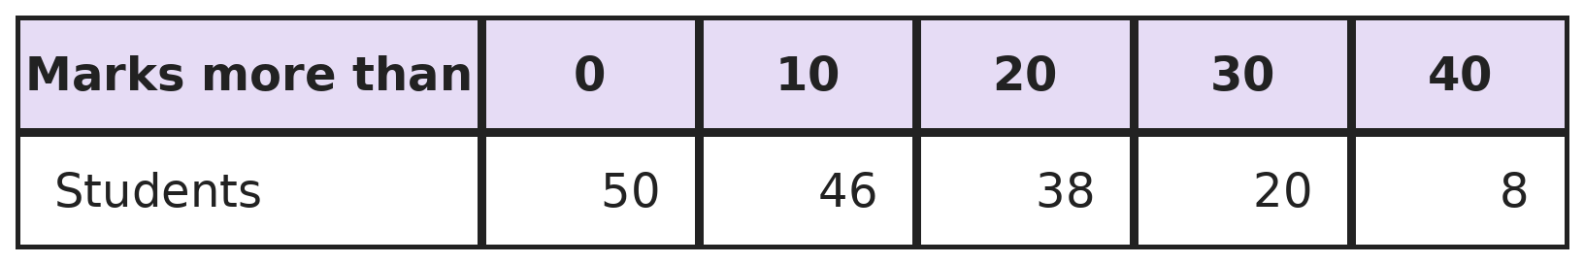
Q18. The table is a "more than" cumulative frequency distribution for marks out of 50. What is the mode?
(A) 25 | (B) 27.5 | (C) 26.25 | (D) 24

Q19. A die is thrown twice. What is the probability that the first number is greater than the second?
(A) 1/2 | (B) 7/12 | (C) 1/6 | (D) 5/12

Part 8 — Applied Mathematics (Syllabus Chapter 9)
Q20. A boat goes 30 km upstream and 44 km downstream in 10 hours. It goes 40 km upstream and 55 km downstream in 13 hours. What is the speed of the stream?
(A) 8 km/h | (B) 6 km/h | (C) 5 km/h | (D) 3 km/h

Q21. A deposit earns 8% per annum compounded quarterly. What is the effective annual rate, correct to two decimal places?
(A) 8.00% | (B) 8.16% | (C) 8.24% | (D) 32.47%

Q22. Pipe A fills a tank in 6 hours, but because of a leak it takes 8 hours. A second pipe B can fill the tank in 12 hours. If A and B are both opened on the empty tank with the leak still there, how long does it take to fill?
(A) 4 h | (B) 6 h | (C) 5 h 20 min | (D) 4 h 48 min

Part 9 — Mathematical Reasoning (Syllabus Chapter 10)
Q23. What is the least number n such that among any n integers there are always two whose sum or difference is divisible by 10?
(A) 6 | (B) 7 | (C) 11 | (D) 10

Q24. How many squares of all sizes are there on an 8 × 8 chessboard?
(A) 204 | (B) 64 | (C) 196 | (D) 256

Q25. What is the largest number of kings that can be placed on an 8 × 8 chessboard so that no two attack each other (no two on touching squares, even at a corner)?
(A) 32 | (B) 16 | (C) 64 | (D) 9

Part 10 — Mixed Problems (each joins two chapters)
Q26. How many three-digit numbers have digits that form an arithmetic progression from left to right, such as 123, 975 or 555?
(A) 40 | (B) 36 | (C) 45 | (D) 50

Q27. In triangle ABC, angle C = 90°, AC = 5 cm and BC = 12 cm. CD is perpendicular to AB. What is sin(angle ACD)?
(A) 5/13 | (B) 12/13 | (C) 5/12 | (D) 13/5

Q28. The point A(2, k) is equidistant from B(−1, 2) and C(3, 5). What is k?
(A) 13/6 | (B) 2 | (C) 7/2 | (D) 6/13

Q29. A machine costs ₹1,00,000 plus 18% GST. Jayesh pays nothing now and borrows the full amount at 10% per annum compound interest, repaying everything after 2 years. How much does he repay?
(A) ₹1,41,600 | (B) ₹1,42,780 | (C) ₹1,21,000 | (D) ₹1,45,200

Q30. The largest possible right circular cone is carved from a solid cube of edge 14 cm. What fraction of the cube does the cone fill? (Take π = 22/7.)
(A) 11/21 | (B) 1/3 | (C) 22/21 | (D) 11/42

Answer Sheet AMO Level 2 · Class 10 · Practice Paper 10
Name: | School: | Roll No.:
Shade or tick one circle for each question.
1. | Ⓐ Ⓑ Ⓒ Ⓓ | 11. | Ⓐ Ⓑ Ⓒ Ⓓ | 21. | Ⓐ Ⓑ Ⓒ Ⓓ
2. | Ⓐ Ⓑ Ⓒ Ⓓ | 12. | Ⓐ Ⓑ Ⓒ Ⓓ | 22. | Ⓐ Ⓑ Ⓒ Ⓓ
3. | Ⓐ Ⓑ Ⓒ Ⓓ | 13. | Ⓐ Ⓑ Ⓒ Ⓓ | 23. | Ⓐ Ⓑ Ⓒ Ⓓ
4. | Ⓐ Ⓑ Ⓒ Ⓓ | 14. | Ⓐ Ⓑ Ⓒ Ⓓ | 24. | Ⓐ Ⓑ Ⓒ Ⓓ
5. | Ⓐ Ⓑ Ⓒ Ⓓ | 15. | Ⓐ Ⓑ Ⓒ Ⓓ | 25. | Ⓐ Ⓑ Ⓒ Ⓓ
6. | Ⓐ Ⓑ Ⓒ Ⓓ | 16. | Ⓐ Ⓑ Ⓒ Ⓓ | 26. | Ⓐ Ⓑ Ⓒ Ⓓ
7. | Ⓐ Ⓑ Ⓒ Ⓓ | 17. | Ⓐ Ⓑ Ⓒ Ⓓ | 27. | Ⓐ Ⓑ Ⓒ Ⓓ
8. | Ⓐ Ⓑ Ⓒ Ⓓ | 18. | Ⓐ Ⓑ Ⓒ Ⓓ | 28. | Ⓐ Ⓑ Ⓒ Ⓓ
9. | Ⓐ Ⓑ Ⓒ Ⓓ | 19. | Ⓐ Ⓑ Ⓒ Ⓓ | 29. | Ⓐ Ⓑ Ⓒ Ⓓ
10. | Ⓐ Ⓑ Ⓒ Ⓓ | 20. | Ⓐ Ⓑ Ⓒ Ⓓ | 30. | Ⓐ Ⓑ Ⓒ Ⓓ

For the parent or teacher
Correct: ______ / 30
Answer Key and Solutions AMO Level 2 · Class 10 · Practice Paper 10
Quick answers
1 A | 6 B | 11 C | 16 A | 21 C | 26 C
2 B | 7 C | 12 A | 17 B | 22 D | 27 A
3 A | 8 D | 13 B | 18 C | 23 B | 28 A
4 D | 9 B | 14 D | 19 D | 24 A | 29 B
5 D | 10 C | 15 C | 20 D | 25 B | 30 D
Solutions
Q | Part · level | Answer | Why?
1 | Part 1 · Ch1 · Hard | (A) 15 | Hint: 2¹² − 1 = 4095 and 2⁸ − 1 = 255. Use Euclid's division algorithm.  4095 = 255 × 16 + 15 and 255 = 15 × 17 + 0. So the HCF is 15 = 2⁴ − 1. (In general HCF(2ᵐ − 1, 2ⁿ − 1) = 2^HCF(m, n) − 1.)
2 | Part 1 · Ch1 · Hard | (B) For no n | Hint: A number ending in 0 has 5 as a prime factor.  12ⁿ = 2²ⁿ × 3ⁿ. By the Fundamental Theorem of Arithmetic this factorisation is unique and has no 5, so 12ⁿ never ends in 0.
3 | Part 2 · Ch3 · Hard | (A) ₹6,000 | Hint: 2-year interest factors: 0.21 at 10% and 0.44 at 20%.  If x is at 10%: 0.21x + 0.44(10,000 − x) = 3,480, so 4,400 − 0.23x = 3,480 and x = 4,000. At 20%: ₹6,000.
4 | Part 2 · Ch3 · Hard | (D) 2 : 3 : 3 | Hint: Capital = profit share ÷ time.  Capitals are 1/6 : 2/8 : 3/12 = 1/6 : 1/4 : 1/4. Multiply by 12: 2 : 3 : 3.
5 | Part 2 · Ch3 · Hard | (D) 22 2/9% | Hint: He gives 900 g but charges 1.1 times the cost of 1,000 g.  Gain factor = 1.1 × 1000/900 = 11/9. Gain = 2/9 = 22 2/9%. (20% just adds 10% and 10%.)
6 | Part 3 · Ch4 · Hard | (B) 5 | Hint: (α − β)² = (α + β)² − 4αβ.  (α − β)² = 1 + 24 = 25, so α − β = 5. (The zeros are 2 and −3.)
7 | Part 3 · Ch4 · Hard | (C) −3 | Hint: Put u = 1/(x + y) and v = 1/(x − y).  u + 2v = 1 and 2u − v = 3/4 give u = 1/2, v = 1/4. So x + y = 2 and x − y = 4, giving x = 3, y = −1. xy = −3.
8 | Part 3 · Ch4 · Hard | (D) 2,318 | Hint: Add the multiples of 3 and of 5, then subtract the multiples of 15.  Multiples of 3: 3 + … + 99 = 33 × 51 = 1,683. Of 5: 5 + … + 95 = 19 × 50 = 950. Of 15: 15 + … + 90 = 6 × 52.5 = 315. Total 1,683 + 950 − 315 = 2,318. (2,633 forgets to subtract.)
9 | Part 3 · Ch4 · Hard | (B) This is not possible | Hint: Form a quadratic and look at its discriminant.  (x − 4)(16 − x) = 48 gives x² − 20x + 112 = 0. Discriminant = 400 − 448 < 0, so there is no real solution: the situation is not possible.
10 | Part 4 · Ch5 · Hard | (C) 7.5 cm | Hint: Join AC. Apply BPT in triangles ADC and CAB.  Let AC meet EF at G. In triangle ADC, EG ∥ DC gives AE/ED = AG/GC. In triangle CAB, GF ∥ AB gives AG/GC = BF/FC. So 4/6 = 5/FC and FC = 7.5 cm.
11 | Part 4 · Ch5 · Hard | (C) 15 cm | Hint: Let the tangent from A be x. Then area = r × s and also, by Heron, √(s(s − a)(s − b)(s − c)).  Sides: BC = 14, AB = x + 8, AC = x + 6, s = x + 14. r × s = 4(x + 14). Heron: √((x + 14) × x × 6 × 8). Squaring: 16(x + 14) = 48x, so x = 7. AB = 15 cm (and AC = 13 cm).
12 | Part 4 · Ch5 · Hard | (A) (5, 2) | Hint: The other two corners are equally far from A and C and from the centre (3, 4).  The centre is (3, 4). The other diagonal is perpendicular and of the same length, so the corners are (3, 4) ± (2, −2) = (5, 2) and (1, 6). Check: (5, 2) is 4 from both A and C.
13 | Part 5 · Ch6 · Hard | (B) 3,328π cm³ | Hint: V = (1/3)πh(R² + r² + Rr).  V = (1/3)π × 16 × (400 + 64 + 160) = (16/3) × 624π = 3,328π cm³. (9,984π forgets the 1/3.)
14 | Part 5 · Ch6 · Hard | (D) 10 | Hint: One cone with its top holds (1/3)π × 9 × 12 + (2/3)π × 27.  Each = 36π + 18π = 54π cm³. Cylinder = π × 36 × 15 = 540π. Number = 10. (15 ignores the hemispherical tops.)
15 | Part 5 · Ch6 · Hard | (C) 423.5 m² | Hint: Path = big circle − inner circle of radius 17.5 m.  Area = 22/7 × (21² − 17.5²) = 22/7 × 134.75 = 423.5 m². (462 uses an outer radius of 24.5 m.)
16 | Part 6 · Ch7 · Hard | (A) a² − b² | Hint: Expand both squares; the cross terms cancel.  x² = a² sec²θ + 2ab sec θ tan θ + b² tan²θ and y² = a² tan²θ + 2ab sec θ tan θ + b² sec²θ. x² − y² = a²(sec²θ − tan²θ) − b²(sec²θ − tan²θ) = a² − b².
17 | Part 6 · Ch7 · Hard | (B) 19√3 m | Hint: The height above his eyes is 30 − 1.5 = 28.5 m.  Distances: 28.5√3 and 28.5/√3. Walked = 28.5(√3 − 1/√3) = 28.5 × 2/√3 = 19√3 m (about 32.9 m).
18 | Part 7 · Ch8 · Hard | (C) 26.25 | Hint: Recover the class frequencies first: 50 − 46, 46 − 38, … .  Frequencies: 0–10: 4, 10–20: 8, 20–30: 18, 30–40: 12, 40–50: 8. Modal class 20–30. Mode = 20 + (18 − 8)/(36 − 8 − 12) × 10 = 20 + 6.25 = 26.25.
19 | Part 7 · Ch8 · Hard | (D) 5/12 | Hint: Remove the 6 doubles; the rest split evenly.  Of 36 outcomes, 6 are equal. The other 30 are split evenly between "first larger" and "second larger": 15. Probability 15/36 = 5/12.
20 | Part 8 · Ch9 · Hard | (D) 3 km/h | Hint: Let u and v be the upstream and downstream speeds. The equations are linear in 1/u and 1/v.  30/u + 44/v = 10 and 40/u + 55/v = 13. Solving for 1/u and 1/v gives u = 5 km/h and v = 11 km/h. Stream = (11 − 5)/2 = 3 km/h. (8 km/h is the boat's speed in still water.)
21 | Part 8 · Ch9 · Hard | (C) 8.24% | Hint: Grow ₹100 for four quarters at 2%.  100 × 1.02⁴ = 108.24. Effective rate 8.24%. (8.16% is the half-yearly figure, 1.04² − 1.)
22 | Part 8 · Ch9 · Hard | (D) 4 h 48 min | Hint: The leak empties 1/6 − 1/8 of the tank per hour.  Leak = 1/6 − 1/8 = 1/24 per hour. A + B − leak = 1/6 + 1/12 − 1/24 = (4 + 2 − 1)/24 = 5/24 per hour. Time = 24/5 hours = 4 h 48 min. (4 h ignores the leak.)
23 | Part 9 · Ch10 · Hard | (B) 7 | Hint: Group the last digits as {0}, {5}, {1, 9}, {2, 8}, {3, 7}, {4, 6}.  In each group, two numbers have a sum or a difference ending in 0. There are 6 groups, so 7 numbers force it. The 6 numbers 0, 1, 2, 3, 4, 5 do not work. So 7.
24 | Part 9 · Ch10 · Hard | (A) 204 | Hint: Count the k × k squares for k = 1 to 8.  There are (9 − k)² squares of size k × k. Total = 8² + 7² + … + 1² = 204.
25 | Part 9 · Ch10 · Hard | (B) 16 | Hint: Split the board into 2 × 2 blocks.  Each of the 16 blocks of 2 × 2 can hold at most one king, since all four squares touch. Kings on the top-left square of each block do not touch. So 16.
26 | Part 10 · Mixed · Ch4 + Ch10 · Hard | (C) 45 | Hint: Go through the common difference d = −4, …, 4 and count possible first digits.  d = 0: 9. d = 1, 2, 3, 4: 7, 5, 3, 1. d = −1, −2, −3, −4: 8, 6, 4, 2. Total 9 + 16 + 20 = 45.
27 | Part 10 · Mixed · Ch5 + Ch7 · Hard | (A) 5/13 | Hint: Angle ACD equals angle B.  In right triangle ACD, angle ACD = 90° − angle A = angle B. sin B = AC/AB = 5/13.
28 | Part 10 · Mixed · Ch4 + Ch5 · Hard | (A) 13/6 | Hint: Set AB² = AC².  9 + (k − 2)² = 1 + (k − 5)². So 13 − 4k = 26 − 10k, giving 6k = 13 and k = 13/6.
29 | Part 10 · Mixed · Ch3 + Ch9 · Hard | (B) ₹1,42,780 | Hint: First find the price including GST.  Price with GST = ₹1,18,000. After 2 years: 1,18,000 × 1.21 = ₹1,42,780. (₹1,41,600 uses simple interest; ₹1,21,000 forgets the GST.)
30 | Part 10 · Mixed · Ch6 + Ch10 · Hard | (D) 11/42 | Hint: The cone's base fits a face (radius 7) and its height is the edge (14).  Cone = (1/3) × 22/7 × 49 × 14 = 2,156/3 cm³. Cube = 2,744 cm³. Fraction = 2,156/8,232 = 11/42.

