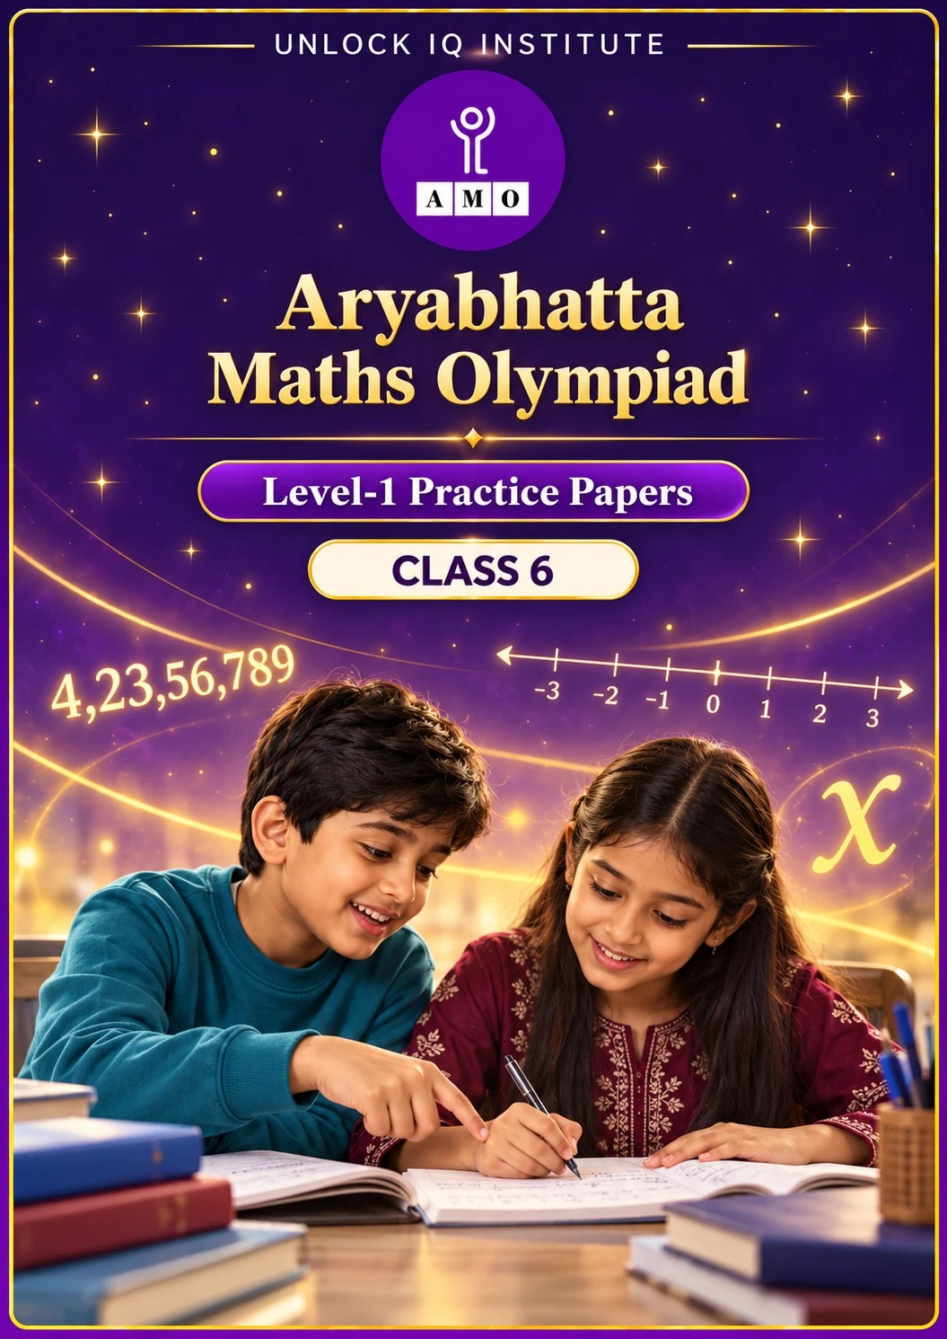
Five full practice papers · with answer keys & detailed solutions
Name: ____________________ | Class & Section: ________________
Roll No.: ________________ | School: ____________________
City: ____________________ | Date: ____________________

Published by Unlock IQ Institute Pvt. Ltd.
Register for Olympiads: www.aryabhattamathsolympiad.com/student-registration

ARYABHATTA MATHS OLYMPIAD
Level 1
PRACTICE PAPER-1
CLASS 6
Total Questions | 45 multiple-choice questions
Total Marks | 100
Time | 60 minutes
Section I | 40 questions × 2 marks = 80 marks
Section II | 5 Star Questions × 4 marks = 20 marks
Negative Marking | No negative marking
Calculator | Not allowed
Chapters | Number System · Operations · Fractions, Decimals & Percentages · Algebra · Geometry · Mensuration · Data Handling · Applied Mathematics · Mathematical Reasoning

👋 Hello, friend! How to do this paper:
⭐ Every question has four answer choices: (A), (B), (C) and (D). Only one is correct.
⭐ Read each question and look at its picture carefully. Then mark your answer on the answer sheet at the end.
⭐ Section I has 40 questions of 2 marks each. Section II has 5 Star Questions of 4 marks each.
⭐ There is no negative marking, so try every question.
⭐ Do not use a calculator. You may do rough work on a separate sheet.
⭐ All figures are not necessarily drawn to scale unless stated.

For parents and teachers
• Print or view this paper in colour. Pictures are part of the questions.
• Parts follow the AMO syllabus chapters. Chapter 7 is not part of the Class 6 syllabus, so the chapter numbers shown in the Part headings have gaps.
• The answer sheet and the answer key are at the end. Remove only the answer key before the child begins.

SECTION I 40 questions × 2 marks each
Part 1 — Number System (Syllabus Chapter 1)
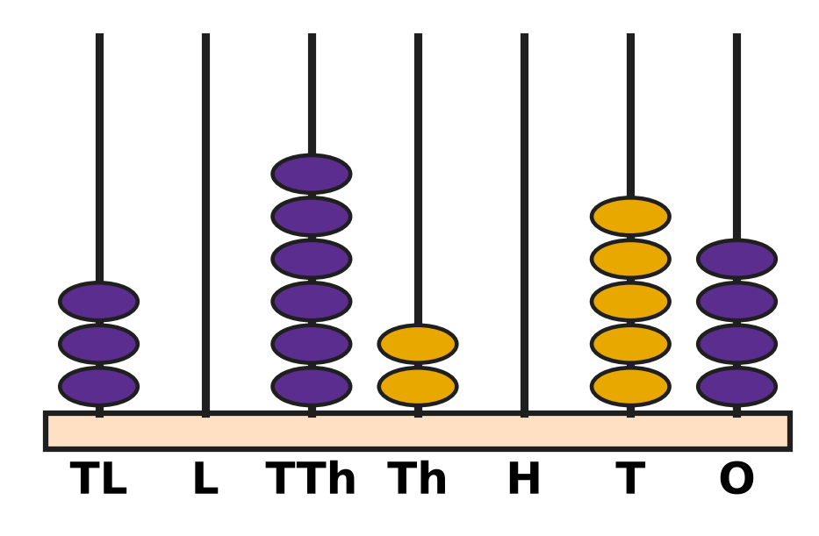
Q1. Look at the abacus. TL stands for ten lakhs, L for lakhs, TTh for ten thousands, Th for thousands, H for hundreds, T for tens and O for ones. Which number does it show?
(A) 36,254 | (B) 3,62,054
(C) 30,26,054 | (D) 30,62,054

Q2. Look at the factor tree of 1,980. The circled numbers are primes. Which of these is the prime factorisation of 1,980? | 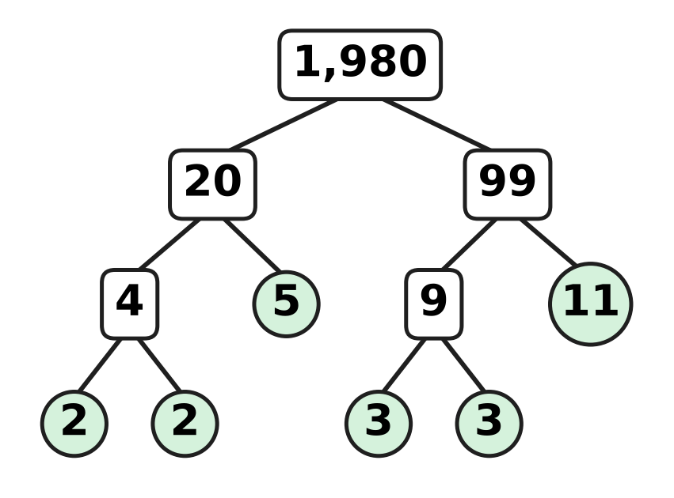
  (A) 2² × 3² × 5 × 11 | (B) 4 × 9 × 5 × 11
  (C) 2² × 3 × 5 × 11 | (D) 2 × 3² × 5 × 11

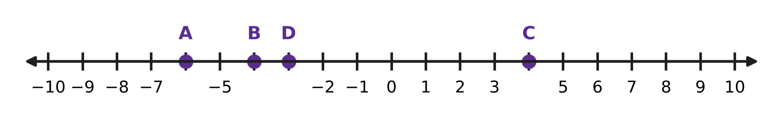
Q3. Look at the number line. The marks are 1 apart. Four of the marks are lettered instead of numbered. Which point shows the integer −4?
(A) Point A | (B) Point B | (C) Point C | (D) Point D

Q4. Kartik can put all his marbles into glass jars of 15 marbles each with none left over. He can also put them all into jars of 20 marbles each with none left over. He has more than 100 and fewer than 150 marbles. How many marbles does he have?
(A) 140 | (B) 135 | (C) 60 | (D) 120

Q5. A number N = 2³ × 3² × 7. Which of these is NOT a factor of N?
(A) 72 | (B) 56 | (C) 63 | (D) 48

Part 2 — Operations & Number Properties (Syllabus Chapter 2)
Q6. "Subtract 4 from 9. Multiply the result by 3. Then subtract this answer from 30." Which expression matches these steps?
(A) 30 − [(9 − 4) × 3] | (B) 30 − [(4 − 9) × 3]
(C) [30 − (9 − 4)] × 3 | (D) 30 − 9 − 4 × 3

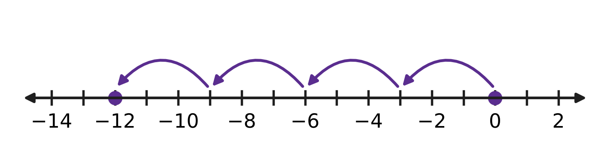
Q7. Look at the number line. Four equal jumps start at 0. Which multiplication do the jumps show?
(A) 4 × 3 = 12 | (B) (−4) × (−3) = 12
(C) 3 × (−4) = −12 | (D) 4 × (−3) = −12

Q8. What is the value of (−8) × 37 + (−8) × 63?
(A) −800 | (B) −504 | (C) −296 | (D) 800

Q9. Which number goes in the blank to make this true?
60 − {5 × [ ___ − (8 − 3)]} = 10
(A) 5 | (B) 10 | (C) 15 | (D) 19

Q10. In a quiz, a correct answer gets +4 marks, a wrong answer gets −2 marks and a question left blank gets 0. Navya answered 17 questions correctly and 6 wrongly, and left 2 blank. What was her total score?
(A) 52 | (B) 56 | (C) 68 | (D) 80

Part 3 — Fractions, Decimals & Percentages (Syllabus Chapter 3)
Q11. The big square in the picture is made of 100 equal small squares. Which pair shows the shaded part correctly as a decimal and as a percentage? | 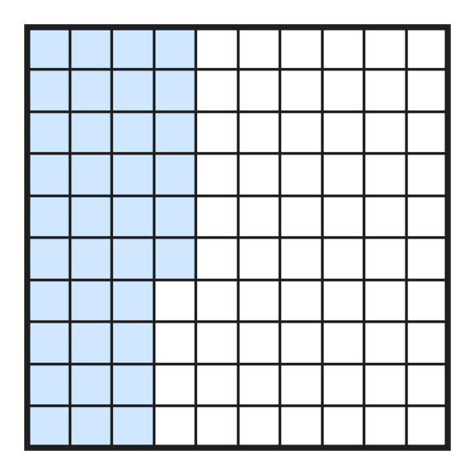
  (A) 0.36 and 36% | (B) 0.036 and 36%
  (C) 0.36 and 3.6% | (D) 3.6 and 36%

Q12. Look at these six numbers: 0.6, 6%, 60%, $\frac{12}{20}$, 0.35, $\frac{3}{50}$. How many of them are equal to $\frac{3}{5}$?
(A) 2 | (B) 3 | (C) 4 | (D) 5

Q13. A rainwater tank holds 2,500 litres when it is full. Today it is 64% full. How many litres of water are in the tank?
(A) 160 L | (B) 900 L | (C) 1,600 L | (D) 2,436 L

Q14. Which of these statements is TRUE?
(A) 0.45 > $\frac{4}{9}$ | (B) 56% < 0.506
(C) $\frac{3}{8}$ > 0.4 | (D) $\frac{2}{25}$ = 0.8

Q15. A school library has 640 books. Of these books, $\frac{3}{8}$ are storybooks and 45% are science books. All the other books are maths books. How many maths books are there?
(A) 112 | (B) 288 | (C) 352 | (D) 400

Part 4 — Algebra (Syllabus Chapter 4)
A number machine
IN (n) | 1 | 2 | 3 | 4
OUT | 5 | 8 | 11 | 14

Q16. The table shows what a number machine gives out (OUT) for each number n put in (IN). Which expression gives OUT for every number n in the table?
(A) n + 4 | (B) 4n + 1 | (C) 2n + 3 | (D) 3n + 2

Q17. What is the value of p² − 2q when p = −3 and q = 4?
(A) −17 | (B) −14 | (C) 1 | (D) 17

Q18. A bakery bakes n trays of cookies with 24 cookies on each tray. It packs all the cookies into boxes of 6. It keeps 5 boxes and sells the rest. Which expression gives the number of boxes it sells?
(A) 4n − 30 | (B) 4(n − 5) | (C) 24n − 5 | (D) 4n − 5

Part 5 — Geometry (Syllabus Chapter 5)
Q19. In the figure, the smaller angle between the two arms is 130°. What is the size of the angle marked "?", and what type of angle is it? | 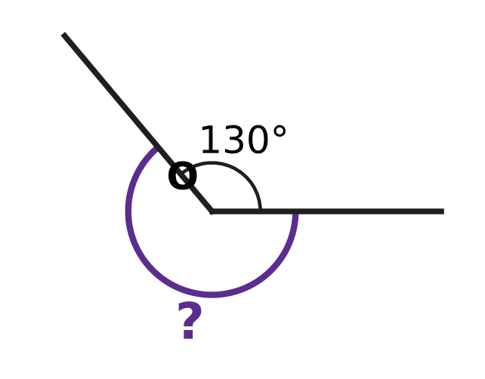
  (A) 230°, reflex | (B) 130°, obtuse
  (C) 50°, acute | (D) 230°, obtuse

Q20. In triangle PQR in the figure, the tick marks show that PQ = PR, and angle P is 120°. Which description fits this triangle exactly? | 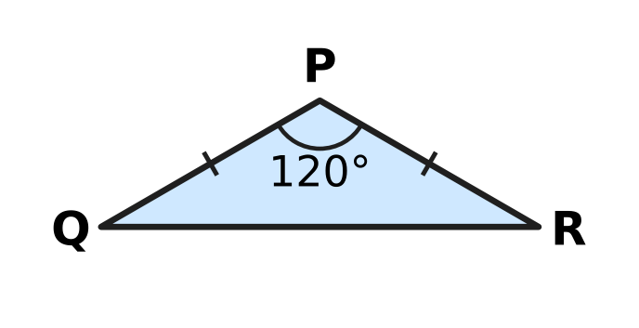
  (A) acute-angled and isosceles | (B) obtuse-angled and scalene
  (C) right-angled and isosceles | (D) obtuse-angled and isosceles

Q21. In the figure, AOB is a straight line. Angle AOC is 48° and angle DOB is 65°. What is angle COD? | 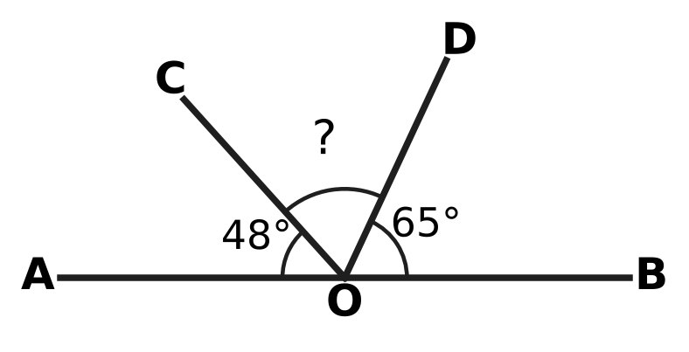
  (A) 17° | (B) 67° | (C) 113° | (D) 132°

Q22. The figure shows a polygon with 9 sides. All the diagonals from vertex A are drawn as dashed lines. What is the sum of all the interior angles of this polygon? | 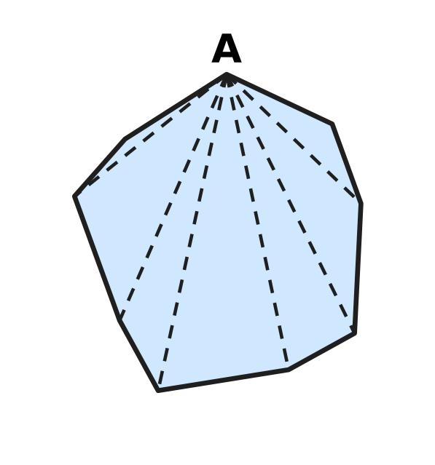
  (A) 1,080° | (B) 1,260° | (C) 1,440° | (D) 1,620°

Q23. In the figure, AB = AC and side BC is extended to D. Angle ACD is 115°. What is angle BAC? | 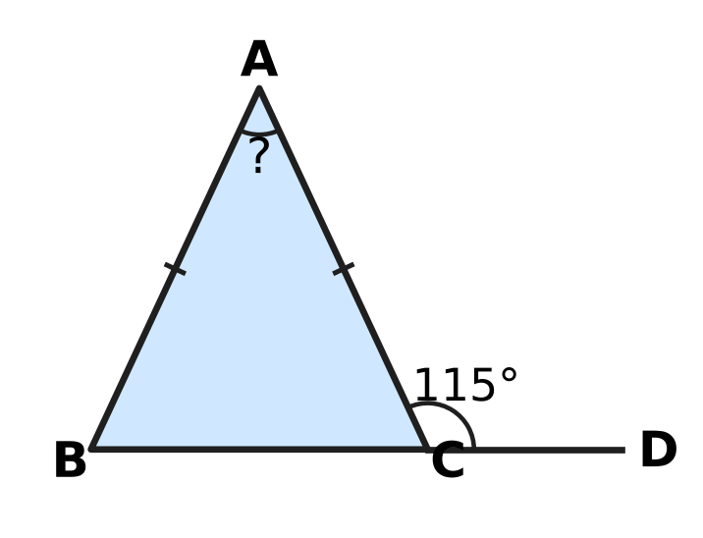
  (A) 50° | (B) 57.5° | (C) 65° | (D) 130°

Part 6 — Mensuration (Syllabus Chapter 6)
Q24. A rectangular card 20 cm by 14 cm has a rectangular window 6 cm by 4 cm cut out of it, as shown in the figure. What is the area of the card that is left? | 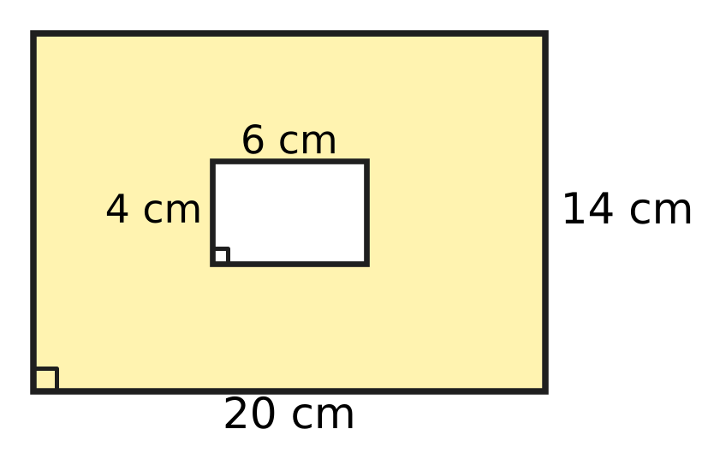
  (A) 48 cm² | (B) 256 cm² | (C) 280 cm² | (D) 304 cm²

Q25. The figure shows the net of a cube. Each square in the net has a side of 8 cm. The net is folded to make the cube. What is the volume of the cube? | 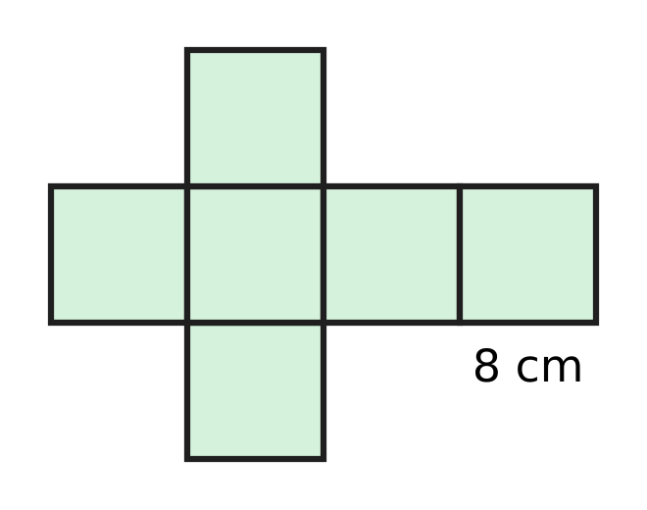
  (A) 48 cm³ | (B) 64 cm³ | (C) 384 cm³ | (D) 512 cm³

Q26. A classroom notice board is a rectangle 1 m 20 cm long and 90 cm wide. A ribbon is fixed once all around its edge. How long is the ribbon?
(A) 4 m 20 cm | (B) 4 m 2 cm
(C) 2 m 10 cm | (D) 3 m 80 cm

Q27. A vegetable garden is a rectangle 20 m long and 15 m wide. A path of the same width runs along two sides of the garden, inside it, as shown in the figure. The rest of the garden is a rectangle of beds with an area of 234 m². How wide is the path? | 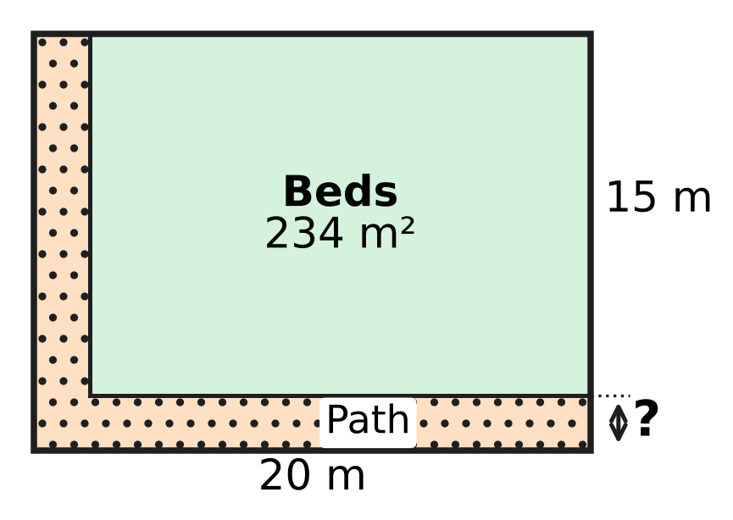
  (A) 1 m | (B) 2 m | (C) 3 m | (D) 4 m

Q28. A swimming pool has a rectangular floor 20 m long and 8 m wide, and its sides are vertical. Then 32,000 litres of water are pumped into it. By how many centimetres does the water level rise? Use 1 cubic metre = 1,000 litres.
(A) 2 cm | (B) 20 cm | (C) 50 cm | (D) 200 cm

Part 7 — Data Handling, Statistics & Probability (Syllabus Chapter 8)
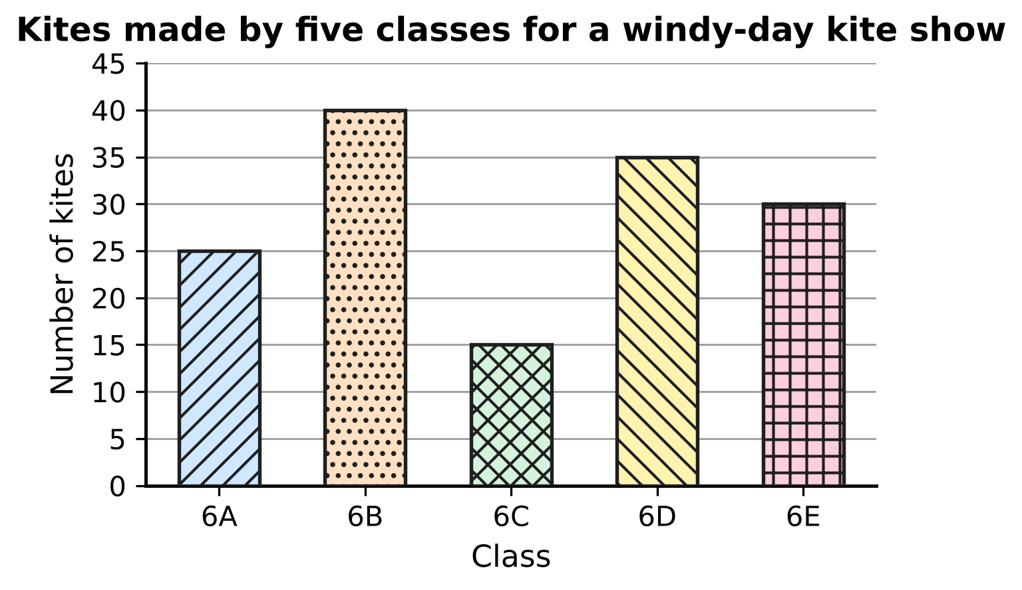
Q29. The bar graph shows the number of kites made by five classes. How many more kites did the class that made the most kites make than the class that made the fewest?
(A) 10 | (B) 15 | (C) 25 | (D) 55

A survey of 30 students
Number of brothers and sisters | 0 | 1 | 2 | 3 | 4
Number of students (frequency) | 4 | 11 | ? | 5 | 2

Q30. Each of 30 students in a class told how many brothers and sisters they have. The table shows the results, but the frequency for 2 is missing. How many students have 2 or more brothers and sisters?
(A) 7 | (B) 8 | (C) 15 | (D) 26

Part 8 — Applied Mathematics (Syllabus Chapter 9)
Q31. The picture shows a floor made of equal square tiles. Some tiles are dark and the rest are white. What is the ratio of dark tiles to white tiles, in its simplest form? | 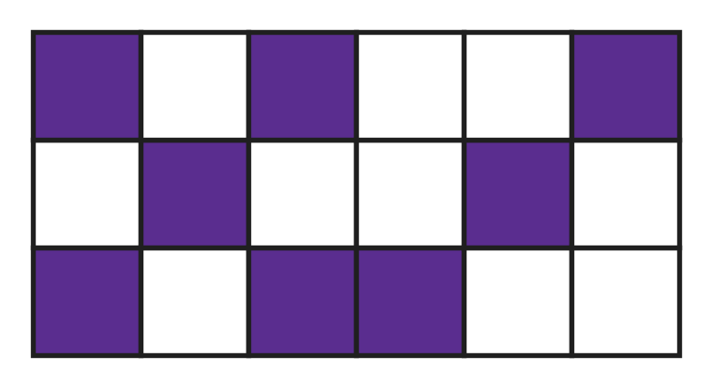
  (A) 4 : 9 | (B) 9 : 5 | (C) 5 : 4 | (D) 4 : 5

Q32. In an orchard, $\frac{3}{8}$ of the trees are apple trees and all the others are pear trees. What is the ratio of apple trees to pear trees?
(A) 3 : 8 | (B) 8 : 5 | (C) 3 : 5 | (D) 5 : 3

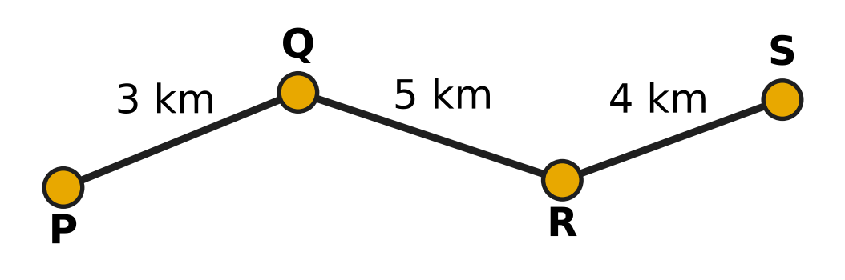
Q33. The map shows the route of a school bus from stop P to stop S, with the distances between stops. The bus takes 36 minutes from P to S. What is its average speed?
(A) 3 km/h | (B) 12 km/h | (C) 20 km/h | (D) 24 km/h

Q34. Two delivery vans leave the same depot at the same time and drive along the same straight road in the same direction. One goes at 36 km/h and the other at 54 km/h. After how many minutes are they 6 km apart?
(A) 4 minutes | (B) 10 minutes
(C) 18 minutes | (D) 20 minutes

Q35. The numbers of stamps in Ira's and Uday's collections are in the ratio 7 : 3. Ira gives 10 stamps to Uday. Now they both have the same number of stamps. How many stamps did Ira have at first?
(A) 15 | (B) 25 | (C) 35 | (D) 70

Part 9 — Mathematical Reasoning & Problem-Solving (Syllabus Chapter 10)
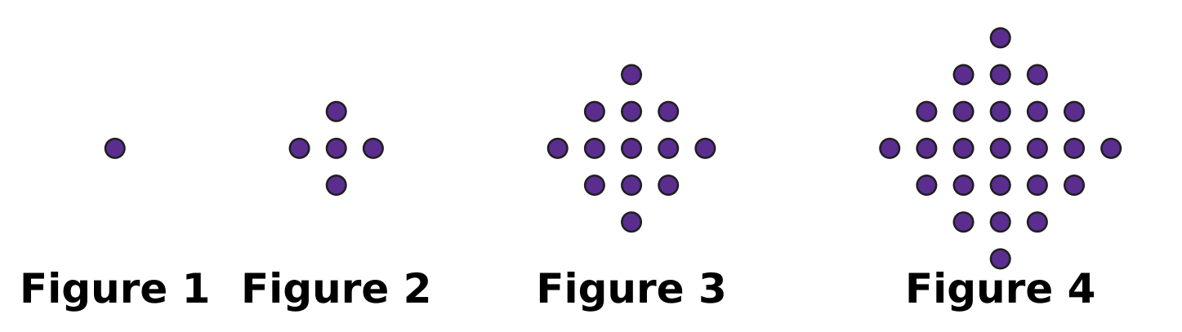
Q36. Look at the pattern of dot figures. Figure 1 has 1 dot, and the pattern keeps growing in the same way. How many dots will Figure 5 have?
(A) 37 | (B) 41 | (C) 45 | (D) 50

Q37. The two clocks show a start time and an end time on the same morning. Through what angle does the minute hand turn from the start time to the end time? | 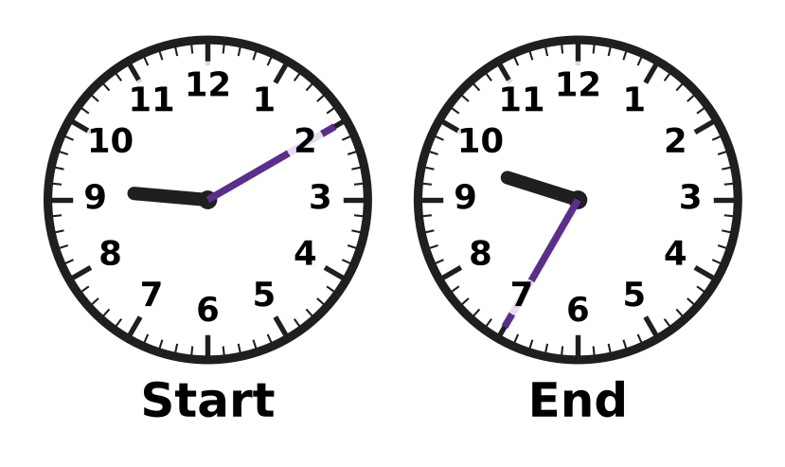
  (A) 150° | (B) 12.5° | (C) 25° | (D) 125°

Q38. A stationery shop had some notebooks. On Monday it sold half of them and 3 more. Then 9 notebooks were left. How many notebooks did the shop have at first?
(A) 18 | (B) 12 | (C) 15 | (D) 24

Q39. A farm has only cows and hens. There are 20 animals in all. Advait counted all the legs of all the animals correctly. Which of these could be his total?
(A) 36 | (B) 96 | (C) 66 | (D) 57

Q40. The counting numbers 1, 2, 3, 4, … are written in rows of five under the columns A, B, C, D and E, as shown. The first row goes from left to right, the next row from right to left, and so on in turn. In which column will the number 139 be written? | 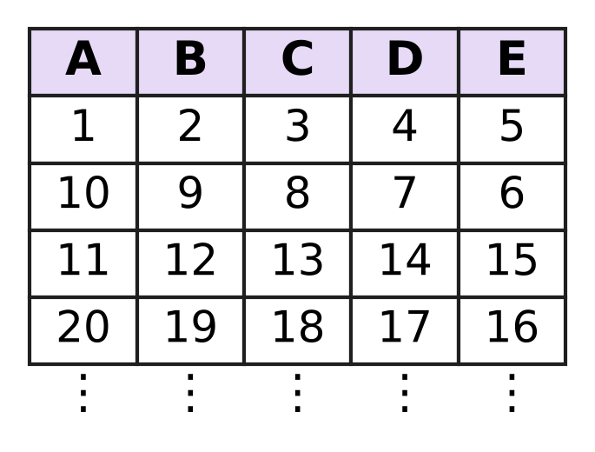
  (A) Column D | (B) Column B | (C) Column A | (D) Column C

SECTION II — Star Questions 5 questions × 4 marks each
Q41. In this question, n stands for any whole number (0, 1, 2, 3, …). Which of these expressions has an odd value for EVERY whole number n? [4 marks]
(A) n² + 3n + 1 | (B) n² + 2n + 1
(C) n² + 4n + 2 | (D) 3n + 5

Q42. Farhan plays a game with a counter on the integer number line. In each move, he doubles the number the counter is on and subtracts the result from 5. The counter goes to that new number. After three moves the counter is on 39. On which integer did it start? [4 marks]
(A) −17 | (B) −3 | (C) 3 | (D) 11

Q43. On a bicycle trip, Swati rides for 2 hours at 12 km/h. She has then covered 40% of the whole trip. She wants to finish the whole trip 4 hours after she started. At what speed must she ride for the rest of the trip? [4 marks]
(A) 9 km/h | (B) 12 km/h | (C) 18 km/h | (D) 30 km/h

Q44. The figure shows a shape made of a rectangle 12 cm by 7 cm with a triangle on top. The dashed line is the top of the rectangle. The two sloping sides of the triangle are equal, and the angle at the top is 60°. What is the perimeter of the whole shape? [4 marks] | 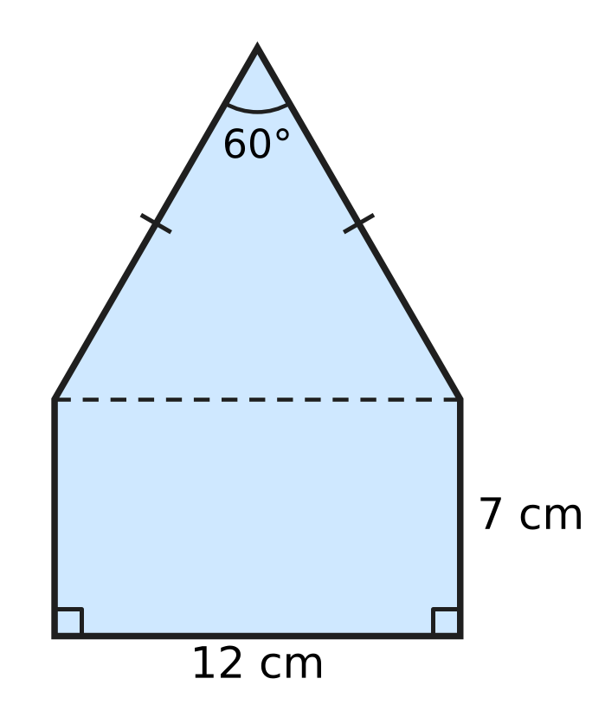
  (A) 38 cm | (B) 40 cm | (C) 50 cm | (D) 62 cm

Q45. A car travels for 4 hours at x km/h and then for 2 hours at (x − 12) km/h. Which expression gives its average speed, in km/h, for the whole journey? [4 marks]
(A) 6x − 24 | (B) x − 4 | (C) x − 6 | (D) x − 2

Answer Sheet AMO Level 1 · Class 6 · Practice Paper 1
Name: | School: | Roll No.:
Shade or tick one circle for each question.
1. Ⓐ Ⓑ Ⓒ Ⓓ | 16. Ⓐ Ⓑ Ⓒ Ⓓ | 31. Ⓐ Ⓑ Ⓒ Ⓓ
2. Ⓐ Ⓑ Ⓒ Ⓓ | 17. Ⓐ Ⓑ Ⓒ Ⓓ | 32. Ⓐ Ⓑ Ⓒ Ⓓ
3. Ⓐ Ⓑ Ⓒ Ⓓ | 18. Ⓐ Ⓑ Ⓒ Ⓓ | 33. Ⓐ Ⓑ Ⓒ Ⓓ
4. Ⓐ Ⓑ Ⓒ Ⓓ | 19. Ⓐ Ⓑ Ⓒ Ⓓ | 34. Ⓐ Ⓑ Ⓒ Ⓓ
5. Ⓐ Ⓑ Ⓒ Ⓓ | 20. Ⓐ Ⓑ Ⓒ Ⓓ | 35. Ⓐ Ⓑ Ⓒ Ⓓ
6. Ⓐ Ⓑ Ⓒ Ⓓ | 21. Ⓐ Ⓑ Ⓒ Ⓓ | 36. Ⓐ Ⓑ Ⓒ Ⓓ
7. Ⓐ Ⓑ Ⓒ Ⓓ | 22. Ⓐ Ⓑ Ⓒ Ⓓ | 37. Ⓐ Ⓑ Ⓒ Ⓓ
8. Ⓐ Ⓑ Ⓒ Ⓓ | 23. Ⓐ Ⓑ Ⓒ Ⓓ | 38. Ⓐ Ⓑ Ⓒ Ⓓ
9. Ⓐ Ⓑ Ⓒ Ⓓ | 24. Ⓐ Ⓑ Ⓒ Ⓓ | 39. Ⓐ Ⓑ Ⓒ Ⓓ
10. Ⓐ Ⓑ Ⓒ Ⓓ | 25. Ⓐ Ⓑ Ⓒ Ⓓ | 40. Ⓐ Ⓑ Ⓒ Ⓓ
11. Ⓐ Ⓑ Ⓒ Ⓓ | 26. Ⓐ Ⓑ Ⓒ Ⓓ | 41. Ⓐ Ⓑ Ⓒ Ⓓ
12. Ⓐ Ⓑ Ⓒ Ⓓ | 27. Ⓐ Ⓑ Ⓒ Ⓓ | 42. Ⓐ Ⓑ Ⓒ Ⓓ
13. Ⓐ Ⓑ Ⓒ Ⓓ | 28. Ⓐ Ⓑ Ⓒ Ⓓ | 43. Ⓐ Ⓑ Ⓒ Ⓓ
14. Ⓐ Ⓑ Ⓒ Ⓓ | 29. Ⓐ Ⓑ Ⓒ Ⓓ | 44. Ⓐ Ⓑ Ⓒ Ⓓ
15. Ⓐ Ⓑ Ⓒ Ⓓ | 30. Ⓐ Ⓑ Ⓒ Ⓓ | 45. Ⓐ Ⓑ Ⓒ Ⓓ
Q41–Q45 are Section II Star Questions (4 marks each).
For the parent or teacher
Section I correct: ______ / 40 × 2 = ______ marks Section II correct: ______ / 5 × 4 = ______ marks
Correct: ______ / 45 Score: ______ / 100
Answer Key and Solutions AMO Level 1 · Class 6 · Practice Paper 1
Quick answers
1 D | 6 A | 11 A | 16 D | 21 B | 26 A | 31 D | 36 B | 41 A
2 A | 7 D | 12 B | 17 C | 22 B | 27 B | 32 C | 37 A | 42 B
3 B | 8 A | 13 C | 18 D | 23 A | 28 B | 33 C | 38 D | 43 C
4 D | 9 C | 14 A | 19 A | 24 B | 29 C | 34 D | 39 C | 44 C
5 D | 10 B | 15 A | 20 D | 25 D | 30 C | 35 C | 40 B | 45 B
Solutions
Q | Part · level | Answer | Why?
1 | Part 1 · Ch1 · Easy | (D) 30,62,054 | Reading the spikes from TL to O gives 3, 0, 6, 2, 0, 5, 4. The empty spikes stand for 0, so the number is 30,62,054.
2 | Part 1 · Ch1 · Easy | (A) 2² × 3² × 5 × 11 | The primes at the ends of the branches are 2, 2, 5, 3, 3 and 11. So 1,980 = 2 × 2 × 3 × 3 × 5 × 11 = 2² × 3² × 5 × 11.
3 | Part 1 · Ch1 · Easy | (B) Point B | The integer −4 is one step to the right of −5. That mark is Point B. (Point A is −6, Point D is −3 and Point C is 4.)
4 | Part 1 · Ch1 · Medium | (D) 120 | The number must be a common multiple of 15 and 20, that is a multiple of their LCM 60: 60, 120, 180, … Only 120 is more than 100 and fewer than 150.
5 | Part 1 · Ch1 · Medium | (D) 48 | Since 48 = 2⁴ × 3, it needs four 2s, but N has only three 2s. Also 56 = 2³ × 7, 72 = 2³ × 3² and 63 = 3² × 7 all divide N.
6 | Part 2 · Ch2 · Easy | (A) 30 − [(9 − 4) × 3] | "Subtract 4 from 9" is (9 − 4). Multiplying by 3 gives [(9 − 4) × 3]. Subtracting this from 30 gives 30 − [(9 − 4) × 3] = 15.
7 | Part 2 · Ch2 · Easy | (D) 4 × (−3) = −12 | There are 4 jumps, each of 3 to the left, that is −3. They end at −12, so the picture shows 4 × (−3) = −12.
8 | Part 2 · Ch2 · Easy | (A) −800 | By the distributive property, (−8) × 37 + (−8) × 63 = (−8) × (37 + 63) = (−8) × 100 = −800.
9 | Part 2 · Ch2 · Medium | (C) 15 | The curly bracket must be 60 − 10 = 50, so the square bracket is 50 ÷ 5 = 10. The blank minus 5 is 10, so the blank is 15.
10 | Part 2 · Ch2 · Medium | (B) 56 | Score = 17 × 4 + 6 × (−2) + 2 × 0 = 68 − 12 + 0 = 56.
11 | Part 3 · Ch3 · Easy | (A) 0.36 and 36% | There are 36 shaded squares out of 100. So the shaded part is 36 out of 100 = 0.36 = 36%.
12 | Part 3 · Ch3 · Easy | (B) 3 | $\frac{3}{5}$ = 0.6 = 60%, and $\frac{12}{20}$ = $\frac{3}{5}$ too. 6% = 0.06, 0.35 and $\frac{3}{50}$ = 0.06 are different. So 3 of them are equal to $\frac{3}{5}$.
13 | Part 3 · Ch3 · Easy | (C) 1,600 L | Water in the tank = 64% of 2,500 L = 64 × 25 = 1,600 L.
14 | Part 3 · Ch3 · Medium | (A) 0.45 > $\frac{4}{9}$ | As a decimal, 4/9 = 0.444…, which is less than 0.45. The others are false: 3/8 = 0.375 < 0.4, 2/25 = 0.08, and 56% = 0.56 > 0.506.
15 | Part 3 · Ch3 · Medium | (A) 112 | Storybooks = 3/8 of 640 = 240. Science books = 45% of 640 = 288. Maths books = 640 − 240 − 288 = 112.
16 | Part 4 · Ch4 · Easy | (D) 3n + 2 | OUT goes up by 3 each time IN goes up by 1, so the rule starts with 3n. Check: 3 × 1 + 2 = 5, 3 × 2 + 2 = 8, 3 × 3 + 2 = 11 and 3 × 4 + 2 = 14, so OUT = 3n + 2.
17 | Part 4 · Ch4 · Easy | (C) 1 | p² = (−3) × (−3) = 9 and 2q = 8. So p² − 2q = 9 − 8 = 1.
18 | Part 4 · Ch4 · Medium | (D) 4n − 5 | There are 24n cookies, which fill 24n ÷ 6 = 4n boxes. After keeping 5 boxes, 4n − 5 boxes are sold.
19 | Part 5 · Ch5 · Easy | (A) 230°, reflex | The marked angle goes the long way round: 360° − 130° = 230°. An angle greater than 180° and less than 360° is a reflex angle.
20 | Part 5 · Ch5 · Easy | (D) obtuse-angled and isosceles | Angle P is 120°, which is more than 90°, so the triangle is obtuse-angled. Two sides are equal, so it is isosceles.
21 | Part 5 · Ch5 · Easy | (B) 67° | Angles on a straight line add up to 180°. So angle COD = 180° − 48° − 65° = 67°.
22 | Part 5 · Ch5 · Medium | (B) 1,260° | The 6 diagonals from A cut the polygon into 7 triangles. Their angles make up the polygon's angles, so the sum is 7 × 180° = 1,260°.
23 | Part 5 · Ch5 · Medium | (A) 50° | Angle ACB = 180° − 115° = 65°. Since AB = AC, angle ABC = 65° too. So angle BAC = 180° − 65° − 65° = 50°.
24 | Part 6 · Ch6 · Easy | (B) 256 cm² | Area left = 20 × 14 − 6 × 4 = 280 − 24 = 256 cm².
25 | Part 6 · Ch6 · Easy | (D) 512 cm³ | The cube has edge 8 cm, so its volume = 8 × 8 × 8 = 512 cm³.
26 | Part 6 · Ch6 · Easy | (A) 4 m 20 cm | Perimeter = 2 × (120 cm + 90 cm) = 420 cm = 4 m 20 cm.
27 | Part 6 · Ch6 · Medium | (B) 2 m | If the path is w m wide, the beds are (20 − w) m by (15 − w) m. With w = 2 the beds are 18 m by 13 m, and 18 × 13 = 234 m², so the path is 2 m wide.
28 | Part 6 · Ch6 · Medium | (B) 20 cm | Volume of water = 32,000 L = 32 cubic metres. Floor area = 20 × 8 = 160 m². Rise = 32 ÷ 160 = 0.2 m = 20 cm.
29 | Part 7 · Ch8 · Easy | (C) 25 | The most is 40 kites (6B) and the fewest is 15 kites (6C). So the difference is 40 − 15 = 25.
30 | Part 7 · Ch8 · Medium | (C) 15 | The missing frequency = 30 − (4 + 11 + 5 + 2) = 8. Students with 2 or more = 8 + 5 + 2 = 15.
31 | Part 8 · Ch9 · Easy | (D) 4 : 5 | There are 8 dark tiles and 10 white tiles. So the ratio is 8 : 10 = 4 : 5.
32 | Part 8 · Ch9 · Easy | (C) 3 : 5 | For every 8 trees, 3 are apple trees and 8 − 3 = 5 are pear trees. So the ratio is 3 : 5.
33 | Part 8 · Ch9 · Easy | (C) 20 km/h | Distance = 3 + 5 + 4 = 12 km. Time = 36 minutes = 36/60 hour. Speed = 12 ÷ (36/60) = 12 × 60 ÷ 36 = 20 km/h.
34 | Part 8 · Ch9 · Medium | (D) 20 minutes | The faster van gains 54 − 36 = 18 km every hour. To be 6 km apart takes 6 ÷ 18 = 1/3 hour = 20 minutes.
35 | Part 8 · Ch9 · Medium | (C) 35 | Ira had 7 − 3 = 4 parts more than Uday. After she gives 10, they are equal, so the 4 parts are 10 + 10 = 20 and 1 part = 5. Ira had 7 × 5 = 35 stamps.
36 | Part 9 · Ch10 · Easy | (B) 41 | The counts are 1, 5, 13, 25. The jumps are 4, 8, 12, so the next jump is 16. Figure 5 has 25 + 16 = 41 dots.
37 | Part 9 · Ch10 · Easy | (A) 150° | From 9:10 to 9:35 is 25 minutes. The minute hand turns 6° every minute, so it turns 25 × 6° = 150°.
38 | Part 9 · Ch10 · Easy | (D) 24 | Before the 3 extra were sold there were 9 + 3 = 12 notebooks. These 12 were the half that was left, so at first there were 12 × 2 = 24.
39 | Part 9 · Ch10 · Medium | (C) 66 | Each animal has 2 or 4 legs, so the total is even and lies between 20 × 2 = 40 and 20 × 4 = 80. Only 66 is even and between 40 and 80 (13 cows and 7 hens).
40 | Part 9 · Ch10 · Medium | (B) Column B | Every 10 numbers fill two rows, A to E and then E to A. The number 139 is 9 more than 130, so it sits where 9 sits. The number 9 is in Column B, so 139 is in Column B.
41 | Section II · Ch4 + Ch10 · Hard | (A) n² + 3n + 1 | n² + 3n = n × (n + 3). One of n and n + 3 is even, so n² + 3n is always even and n² + 3n + 1 is always odd. The others fail: n = 1 gives 4 and 8, and n = 0 gives 2.
42 | Section II · Ch1 + Ch10 · Hard | (B) −3 | A move takes p to 5 − 2p, so to undo it, take (5 − new number) ÷ 2. From 39: (5 − 39) ÷ 2 = −17; then (5 + 17) ÷ 2 = 11; then (5 − 11) ÷ 2 = −3. Check: −3 → 11 → −17 → 39.
43 | Section II · Ch3 + Ch9 · Hard | (C) 18 km/h | She covers 12 × 2 = 24 km, which is 40% of the trip, so the trip is 24 ÷ 40 × 100 = 60 km. Then 36 km is left for the last 2 hours, so she needs 36 ÷ 2 = 18 km/h.
44 | Section II · Ch5 + Ch6 · Hard | (C) 50 cm | The base angles of the triangle are (180° − 60°) ÷ 2 = 60° each, so all its angles are 60° and it is equilateral: each sloping side is 12 cm. Perimeter = 12 + 7 + 7 + 12 + 12 = 50 cm.
45 | Section II · Ch4 + Ch9 · Hard | (B) x − 4 | Distance = 4x + 2(x − 12) = 6x − 24 km. Time = 4 + 2 = 6 hours. Average speed = (6x − 24) ÷ 6 = x − 4 km/h.

ARYABHATTA MATHS OLYMPIAD
Level 1
PRACTICE PAPER-2
CLASS 6
Total Questions | 45 multiple-choice questions
Total Marks | 100
Time | 60 minutes
Section I | 40 questions × 2 marks = 80 marks
Section II | 5 Star Questions × 4 marks = 20 marks
Negative Marking | No negative marking
Calculator | Not allowed
Chapters | Number System · Operations · Fractions, Decimals & Percentages · Algebra · Geometry · Mensuration · Data Handling · Applied Mathematics · Mathematical Reasoning

👋 Hello, friend! How to do this paper:
⭐ Every question has four answer choices: (A), (B), (C) and (D). Only one is correct.
⭐ Read each question and look at its picture carefully. Then mark your answer on the answer sheet at the end.
⭐ Section I has 40 questions of 2 marks each. Section II has 5 Star Questions of 4 marks each.
⭐ There is no negative marking, so try every question.
⭐ Do not use a calculator. You may do rough work on a separate sheet.
⭐ All figures are not necessarily drawn to scale unless stated.

For parents and teachers
• Print or view this paper in colour. Pictures are part of the questions.
• Parts follow the AMO syllabus chapters. Chapter 7 is not part of the Class 6 syllabus, so the chapter numbers shown in the Part headings have gaps.
• The answer sheet and the answer key are at the end. Remove only the answer key before the child begins.

SECTION I 40 questions × 2 marks each
Part 1 — Number System (Syllabus Chapter 1)
Q1. In which of these numbers does the digit 5 stand for 5 lakh (5,00,000)?
(A) 26,53,041 | (B) 26,35,041
(C) 25,63,041 | (D) 52,63,041

Q2. Which of these numbers has no prime factor greater than 3?
(A) 150 | (B) 126 | (C) 102 | (D) 108

Q3. In an aquarium, heights are measured from the water surface: above the surface is positive and below it is negative. A lamp hangs at +35 cm. A snail sits on the bottom at −48 cm. How much higher than the snail is the lamp?
(A) 48 cm | (B) 35 cm | (C) 13 cm | (D) 83 cm

Q4. Jai is putting up a fence along two sides of a garden that meet at a corner. One side is 84 m long and the other is 60 m long. He puts posts the same distance apart all along the fence, with a post at each end and one at the corner. The gap between posts must be as large as possible. How many posts does he need?
(A) 12 | (B) 13 | (C) 14 | (D) 25

Q5. Which of these pairs of numbers has HCF 12 and LCM 180?
(A) 36 and 60 | (B) 24 and 90
(C) 45 and 48 | (D) 40 and 54

Part 2 — Operations & Number Properties (Syllabus Chapter 2)
Q6. Which of these has the greatest value?
(A) 48 ÷ [4 × (2 + 4)] | (B) 48 ÷ {(4 × 2) + 4}
(C) [48 ÷ 4] × (2 + 4) | (D) 48 ÷ 4 × 2 + 4

Q7. In the grid in the figure, the numbers in each row, each column and each diagonal add up to the same total. Which integer goes in the shaded box? | 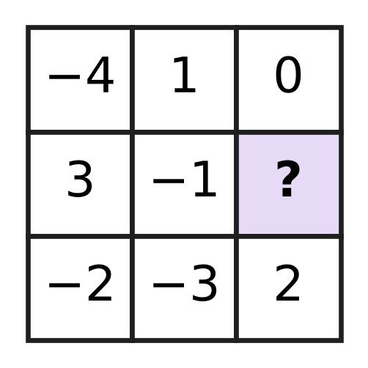
  (A) −7 | (B) 5 | (C) −5 | (D) 1

Q8. Which of these is equal to (−6) × 47?
(A) (−6) × 50 − (−6) × 3 | (B) (−6) × 50 − 3
(C) (−6) × 50 + (−6) × 3 | (D) (−6) × 40 + 7

Q9. What is the value of {(−36) ÷ [4 − (−5)]} × (−3) − 8?
(A) −20 | (B) 44 | (C) −116 | (D) 4

Q10. The sum of five integers is −6. Four of them are 8, −15, 3 and −9. What is the fifth integer?
(A) 19 | (B) −7 | (C) 7 | (D) −19

Part 3 — Fractions, Decimals & Percentages (Syllabus Chapter 3)
Q11. In which of these sets are all three numbers equal?
(A) 0.04, 4%, $\frac{1}{25}$ | (B) 0.375, 37.5%, $\frac{3}{5}$
(C) 0.25, 25%, $\frac{1}{5}$ | (D) 0.4, 4%, $\frac{2}{5}$

Q12. Which of these lists is in order from the smallest to the largest?
(A) $\frac{7}{20}$, 0.3, 38%, $\frac{2}{5}$ | (B) $\frac{2}{5}$, 0.3, $\frac{7}{20}$, 38%
(C) 0.3, 38%, $\frac{2}{5}$, $\frac{7}{20}$ | (D) 0.3, $\frac{7}{20}$, 38%, $\frac{2}{5}$

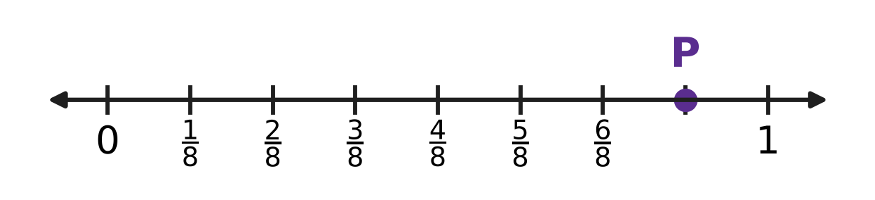
Q13. On the number line, the part from 0 to 1 is divided into equal parts, and point P is marked. What percentage does point P show?
(A) 12.5% | (B) 78% | (C) 70% | (D) 87.5%

Q14. Veena used 35% of a roll of cloth to make curtains. Now 52 m of cloth is left on the roll. How long was the roll at first?
(A) 70.2 m | (B) 87 m | (C) 80 m | (D) 28 m

Q15. Mira's bottle holds 1.2 L of juice when full. She starts with a full bottle and pours out 0.45 L. What percentage of the juice is still in the bottle?
(A) 62.5% | (B) 37.5% | (C) 75% | (D) 55%

Part 4 — Algebra (Syllabus Chapter 4)
Q16. Which of these expressions has the value 20 when n = 4?
(A) n² + 12 | (B) 6n − 4 | (C) 2(n + 7) | (D) 3n + 4

Q17. Look at the triangle. Its sides are x cm, (x + 4) cm and (2x − 1) cm long. Which expression gives its perimeter in cm? | 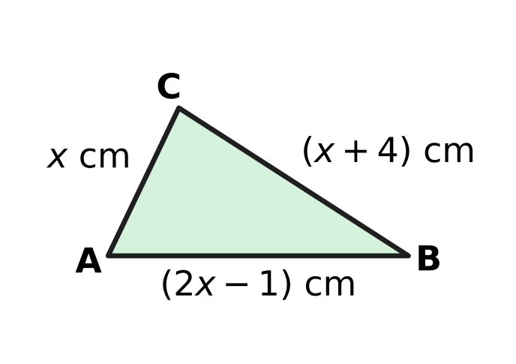
  (A) 4x − 3 | (B) 4x + 5 | (C) 3x + 3 | (D) 4x + 3

Q18. A shoe rack has x shelves. Each shelf holds 6 pairs of shoes, except the top shelf, which holds 4 pairs fewer than each of the others. All the shelves are full. Which expression gives the number of single shoes on the rack, counting each shoe of a pair separately?
(A) 12x − 4 | (B) 12x − 10 | (C) 12x − 8 | (D) 6x − 4

Part 5 — Geometry (Syllabus Chapter 5)
Q19. Which of these could be the three angles of a triangle that is both obtuse-angled and isosceles?
(A) 110°, 35°, 35° | (B) 120°, 30°, 40°
(C) 50°, 50°, 80° | (D) 100°, 50°, 30°

Q20. The figure shows a hexagon. The sizes of five of its angles are given. What is the size of the angle marked x? | 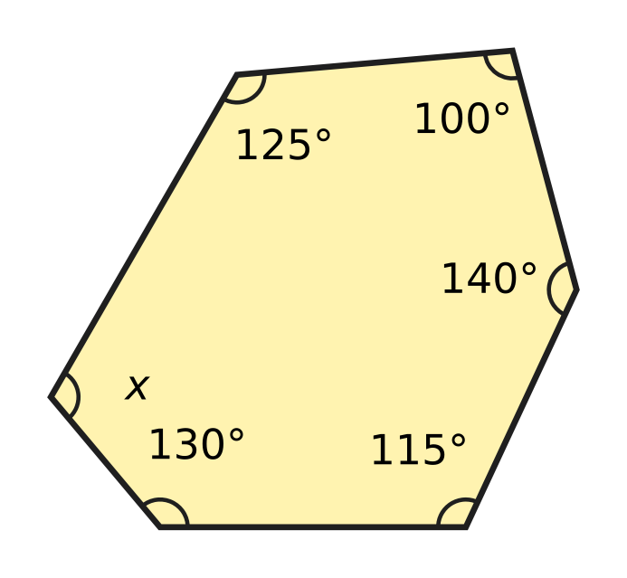
  (A) 250° | (B) 70° | (C) 290° | (D) 110°

Q21. How many of these angles are obtuse?
95°, 180°, 89°, 270°, 135°, 91°, 190°
(A) 2 | (B) 3 | (C) 4 | (D) 5

Q22. Nitya has two sticks, 6 cm and 13 cm long. She wants a third stick, a whole number of centimetres long, so that the three sticks make a triangle. How many different lengths could the third stick have?
(A) 10 | (B) 11 | (C) 12 | (D) 13

Q23. ABCDEF is a regular hexagon, and AC is joined. What is the size of angle FAC, marked "?" in the figure? | 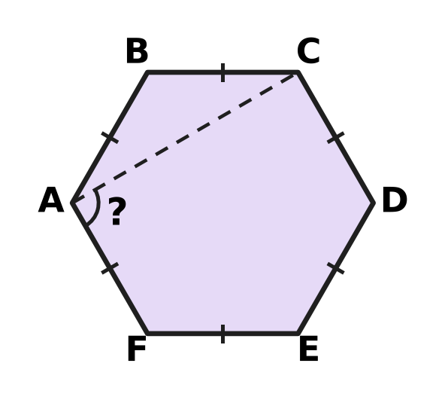
  (A) 120° | (B) 60° | (C) 90° | (D) 30°

Part 6 — Mensuration (Syllabus Chapter 6)
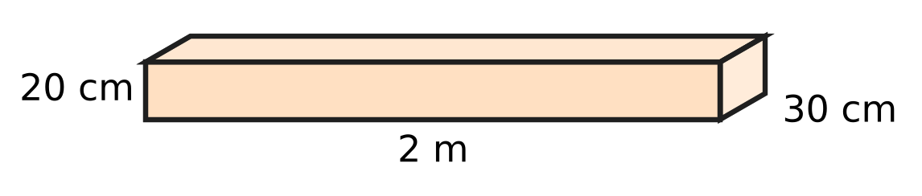
Q24. The figure shows a wooden plank shaped like a cuboid. It is 2 m long, 30 cm wide and 20 cm thick. What is its volume?
(A) 1,200 cm³ | (B) 12,000 cm³
(C) 1,20,000 cm³ | (D) 12,00,000 cm³

Q25. Three different faces of a cuboid have areas 35 cm², 20 cm² and 28 cm². What is the total surface area of the cuboid?
(A) 83 cm² | (B) 166 cm² | (C) 332 cm² | (D) 140 cm²

Q26. Which of these rectangles has the same area as a square of side 12 cm?
(A) 16 cm by 9 cm | (B) 18 cm by 6 cm
(C) 13 cm by 11 cm | (D) 14 cm by 10 cm

Q27. The figure shows three squares of sides 8 cm, 5 cm and 3 cm placed side by side, with their bottom edges on one straight line. What is the perimeter of the whole shape? | 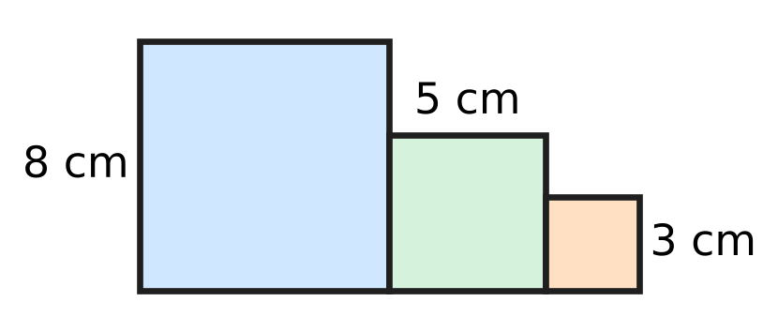
  (A) 64 cm | (B) 48 cm | (C) 40 cm | (D) 56 cm

Q28. Two cubes, each of edge 5 cm, are glued face to face to make a cuboid, as shown in the figure. What is the total surface area of the cuboid? | 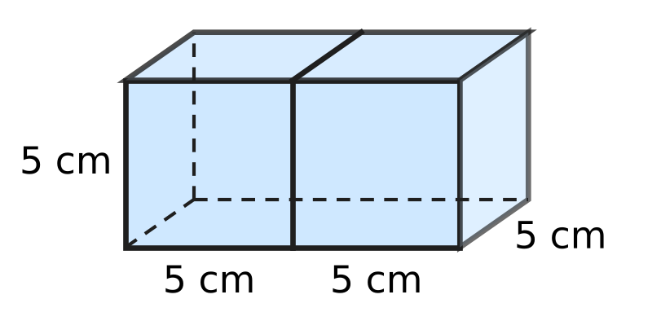
  (A) 250 cm² | (B) 150 cm² | (C) 275 cm² | (D) 300 cm²

Part 7 — Data Handling, Statistics & Probability (Syllabus Chapter 8)
Q29. A school team played 20 matches. Its goals in the 20 matches are listed below.
1, 3, 1, 3, 0, 2, 2, 0, 2, 2, 2, 3, 4, 2, 1, 3, 1, 0, 1, 4
In how many matches did it score more than 2 goals?
(A) 4 | (B) 6 | (C) 12 | (D) 14

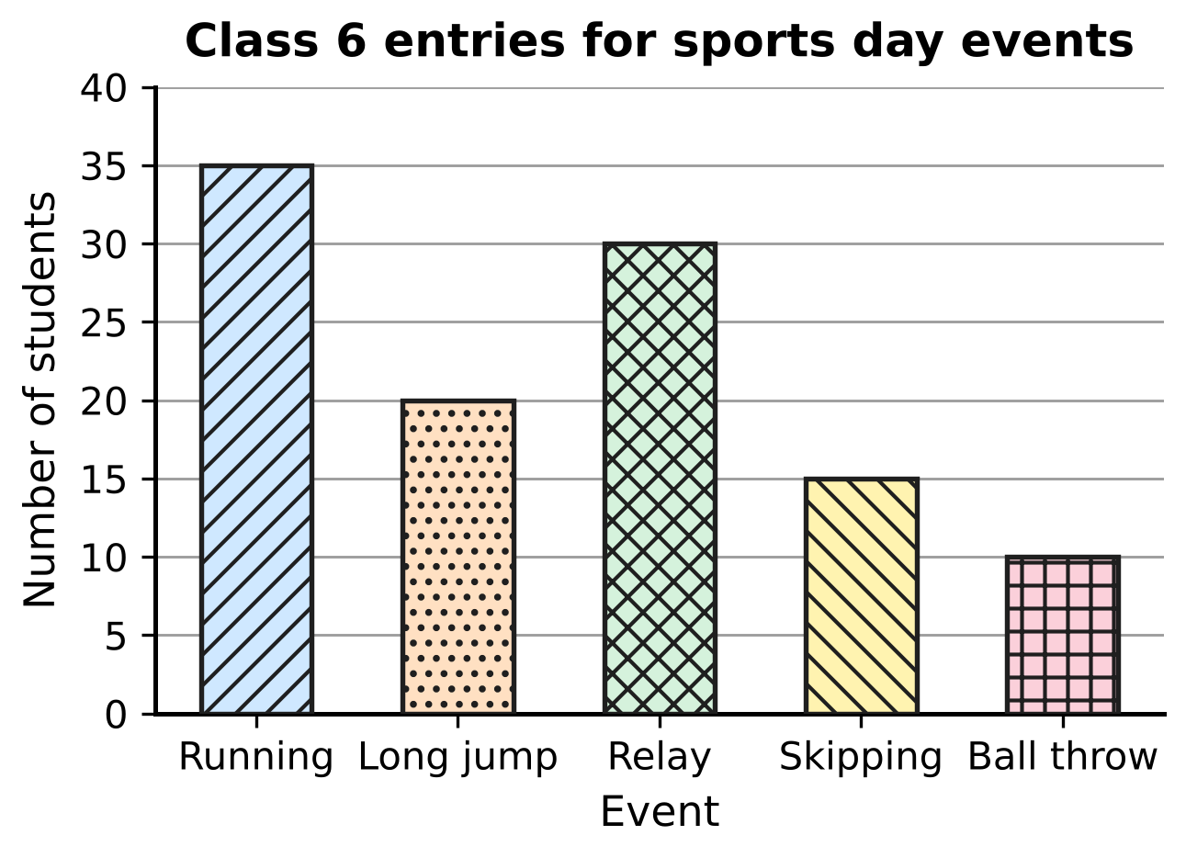
Q30. The bar graph shows how many Class 6 students entered each sports day event. How many more students entered running than ball throw and skipping together?
(A) 10 | (B) 20 | (C) 25 | (D) 60

Part 8 — Applied Mathematics (Syllabus Chapter 9)
Q31. At a fruit market, the ratio of apples to oranges on Rekha's stall is 4 : 5. Which of these could be the numbers of apples and oranges on her stall?
(A) 60 apples and 48 oranges | (B) 48 apples and 60 oranges
(C) 44 apples and 45 oranges | (D) 50 apples and 60 oranges

Q32. At a toy shop, Akash finds that 8 identical toy trains cost ₹360. How much do 5 of these toy trains cost?
(A) ₹576 | (B) ₹45 | (C) ₹225 | (D) ₹135

Q33. A bird flies 600 m in 40 seconds. At the same speed, how far does it fly in 2 minutes?
(A) 30 m | (B) 3,000 m | (C) 1,200 m | (D) 1,800 m

Q34. Bina makes a necklace with red, blue and white beads in the ratio 2 : 3 : 5. It has 12 more white beads than red beads. How many beads does the necklace have in all?
(A) 40 | (B) 120 | (C) 20 | (D) 60

Part of a train timetable
Station | Distance from P (km) | Arrives (am) | Leaves (am)
P | 0 | — | 6:00
R | 150 | 8:30 | 8:40
S | 205 | 9:30 | 9:35
T | 275 | 10:35 | 10:50
U | 311 | 11:20 | —

Q35. The table shows part of a train's timetable for one morning. Each part of the journey runs from leaving one station to arriving at the next. On which part did the train have the greatest average speed?
(A) From P to R | (B) From R to S
(C) From S to T | (D) From T to U

Part 9 — Mathematical Reasoning & Problem-Solving (Syllabus Chapter 10)
Q36. The triangular numbers are 1, 3, 6, 10, 15, … (add 2, then 3, then 4, and so on). Which of these is a triangular number?
(A) 60 | (B) 72 | (C) 64 | (D) 66

Q37. A wall clock gains 4 minutes every day. It is set to the correct time at 6:00 pm on a Monday. What time does this clock show when the correct time is 6:00 pm on the next Monday?
(A) 6:32 pm | (B) 6:24 pm | (C) 6:28 pm | (D) 5:32 pm

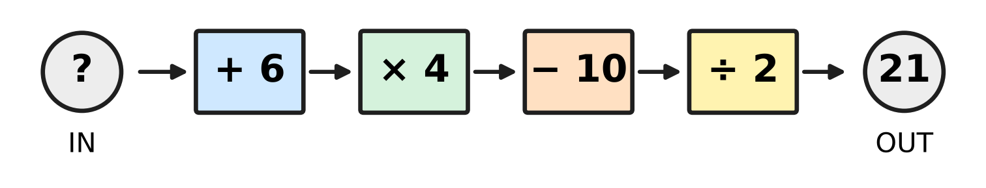
Q38. Tejas puts a number into the machine in the picture. The machine does the four steps in order, from left to right, and gives out 21. What number did Tejas put in?
(A) 49 | (B) 7 | (C) 2 | (D) 13

Q39. A counter starts at 0 on a number line. In each move it jumps exactly 1 unit, either to the left or to the right. Which of these could be its position after exactly 25 moves?
(A) −7 | (B) 0 | (C) 8 | (D) 27

Q40. The pattern 2, 5, 10, 17, 26, … goes on in the same way. Which term of the pattern is 401?
(A) the 19th term | (B) the 20th term
(C) the 21st term | (D) the 200th term

SECTION II — Star Questions 5 questions × 4 marks each
Q41. A clock shows 5 o'clock now. Here n stands for a whole number (0, 1, 2, 3, …). Which of these numbers of hours, counted from now, ALWAYS brings the clock to 1 o'clock, whatever whole number n is? [4 marks]
(A) 12n + 20 | (B) 4n + 8 | (C) 12n + 4 | (D) 20n + 12

Q42. In a park, fountain A sprays water every 8 minutes, fountain B every 12 minutes and fountain C every 18 minutes. One day all three sprayed together at 4:30 pm for the 5th time that day, counting the first time. At what time did all three first spray together that day? [4 marks]
(A) 12:54 pm | (B) 2:54 pm | (C) 11:42 am | (D) 10:30 am

Q43. Mihir's family drove to another town at a steady speed of 60 km/h. At 8:45 am they had covered 15% of the distance. At 10:15 am they had covered 40% of the distance. What is the total distance of the journey? [4 marks]
(A) 600 km | (B) 90 km | (C) 225 km | (D) 360 km

Q44. In the figure, ABCD is a rectangle with AB = 20 cm and AD = 12 cm. A straight cut from A to a point E on DC makes angle DAE = 45°. Triangle ADE is cut off. What is the area of the shaded piece ABCE that is left? [4 marks] | 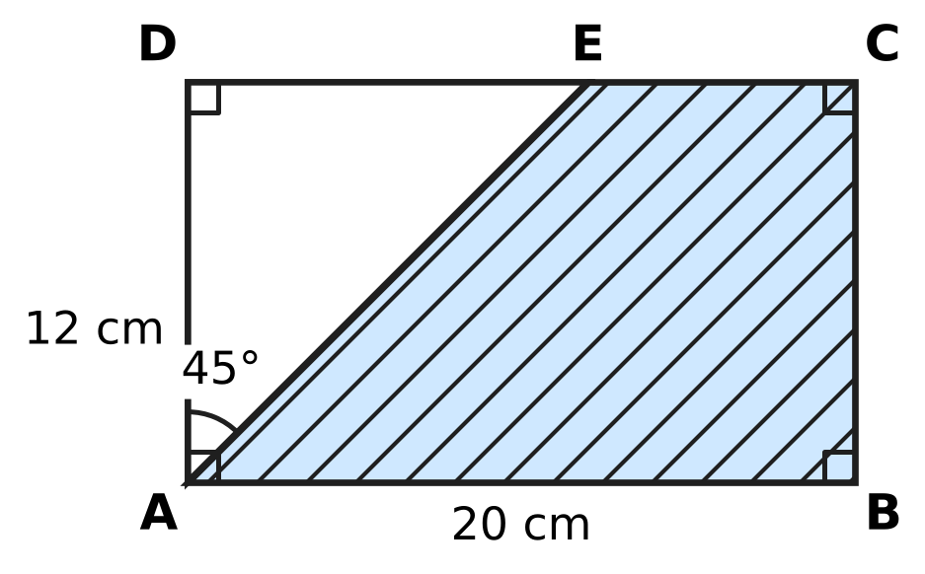
  (A) 192 cm² | (B) 168 cm² | (C) 72 cm² | (D) 96 cm²

Q45. Two towns are 40 km apart. Pallavi cycles from one town towards the other at x km/h. At the same time, Irfan cycles from the other town towards her at a speed 3 km/h less than hers (so x is greater than 3). They have not met after 2 hours. Which expression gives the distance between them, in km, at that time? [4 marks]
(A) 34 − 4x | (B) 46 − 4x | (C) 43 − 2x | (D) 40 − 4x

Answer Sheet AMO Level 1 · Class 6 · Practice Paper 2
Name: | School: | Roll No.:
Shade or tick one circle for each question.
1. Ⓐ Ⓑ Ⓒ Ⓓ | 16. Ⓐ Ⓑ Ⓒ Ⓓ | 31. Ⓐ Ⓑ Ⓒ Ⓓ
2. Ⓐ Ⓑ Ⓒ Ⓓ | 17. Ⓐ Ⓑ Ⓒ Ⓓ | 32. Ⓐ Ⓑ Ⓒ Ⓓ
3. Ⓐ Ⓑ Ⓒ Ⓓ | 18. Ⓐ Ⓑ Ⓒ Ⓓ | 33. Ⓐ Ⓑ Ⓒ Ⓓ
4. Ⓐ Ⓑ Ⓒ Ⓓ | 19. Ⓐ Ⓑ Ⓒ Ⓓ | 34. Ⓐ Ⓑ Ⓒ Ⓓ
5. Ⓐ Ⓑ Ⓒ Ⓓ | 20. Ⓐ Ⓑ Ⓒ Ⓓ | 35. Ⓐ Ⓑ Ⓒ Ⓓ
6. Ⓐ Ⓑ Ⓒ Ⓓ | 21. Ⓐ Ⓑ Ⓒ Ⓓ | 36. Ⓐ Ⓑ Ⓒ Ⓓ
7. Ⓐ Ⓑ Ⓒ Ⓓ | 22. Ⓐ Ⓑ Ⓒ Ⓓ | 37. Ⓐ Ⓑ Ⓒ Ⓓ
8. Ⓐ Ⓑ Ⓒ Ⓓ | 23. Ⓐ Ⓑ Ⓒ Ⓓ | 38. Ⓐ Ⓑ Ⓒ Ⓓ
9. Ⓐ Ⓑ Ⓒ Ⓓ | 24. Ⓐ Ⓑ Ⓒ Ⓓ | 39. Ⓐ Ⓑ Ⓒ Ⓓ
10. Ⓐ Ⓑ Ⓒ Ⓓ | 25. Ⓐ Ⓑ Ⓒ Ⓓ | 40. Ⓐ Ⓑ Ⓒ Ⓓ
11. Ⓐ Ⓑ Ⓒ Ⓓ | 26. Ⓐ Ⓑ Ⓒ Ⓓ | 41. Ⓐ Ⓑ Ⓒ Ⓓ
12. Ⓐ Ⓑ Ⓒ Ⓓ | 27. Ⓐ Ⓑ Ⓒ Ⓓ | 42. Ⓐ Ⓑ Ⓒ Ⓓ
13. Ⓐ Ⓑ Ⓒ Ⓓ | 28. Ⓐ Ⓑ Ⓒ Ⓓ | 43. Ⓐ Ⓑ Ⓒ Ⓓ
14. Ⓐ Ⓑ Ⓒ Ⓓ | 29. Ⓐ Ⓑ Ⓒ Ⓓ | 44. Ⓐ Ⓑ Ⓒ Ⓓ
15. Ⓐ Ⓑ Ⓒ Ⓓ | 30. Ⓐ Ⓑ Ⓒ Ⓓ | 45. Ⓐ Ⓑ Ⓒ Ⓓ
Q41–Q45 are Section II Star Questions (4 marks each).
For the parent or teacher
Section I correct: ______ / 40 × 2 = ______ marks Section II correct: ______ / 5 × 4 = ______ marks
Correct: ______ / 45 Score: ______ / 100
Answer Key and Solutions AMO Level 1 · Class 6 · Practice Paper 2
Quick answers
1 C | 6 C | 11 A | 16 B | 21 B | 26 A | 31 B | 36 D | 41 A
2 D | 7 C | 12 D | 17 D | 22 B | 27 B | 32 C | 37 C | 42 C
3 D | 8 A | 13 D | 18 C | 23 C | 28 A | 33 D | 38 B | 43 D
4 B | 9 D | 14 C | 19 A | 24 C | 29 B | 34 A | 39 A | 44 B
5 A | 10 C | 15 A | 20 D | 25 B | 30 A | 35 D | 40 B | 45 B
Solutions
Q | Part · level | Answer | Why?
1 | Part 1 · Ch1 · Easy | (C) 25,63,041 | In 25,63,041 the places are: 2 ten lakhs, 5 lakhs, 6 ten thousands, 3 thousands, so the 5 stands for 5,00,000.
2 | Part 1 · Ch1 · Easy | (D) 108 | Here 108 = 2 × 2 × 3 × 3 × 3 = 2² × 3³. The others have another prime factor: 102 = 2 × 3 × 17, 126 = 2 × 3² × 7, 150 = 2 × 3 × 5².
3 | Part 1 · Ch1 · Easy | (D) 83 cm | From +35 down to 0 is 35 cm and from 0 down to −48 is 48 cm, so the distance is 35 + 48 = 83 cm.
4 | Part 1 · Ch1 · Medium | (B) 13 | The largest gap is the HCF of 84 and 60, which is 12 m. The 84 m side needs 7 + 1 = 8 posts and the 60 m side 5 + 1 = 6 posts; the corner post is shared, so 8 + 6 − 1 = 13.
5 | Part 1 · Ch1 · Medium | (A) 36 and 60 | Here 36 = 2² × 3² and 60 = 2² × 3 × 5, so HCF = 2² × 3 = 12 and LCM = 2² × 3² × 5 = 180. The other pairs have the same product 2,160, but their HCF is not 12.
6 | Part 2 · Ch2 · Easy | (C) [48 ÷ 4] × (2 + 4) | The values are: [48 ÷ 4] × (2 + 4) = 12 × 6 = 72; 48 ÷ 4 × 2 + 4 = 28; 48 ÷ {(4 × 2) + 4} = 4; 48 ÷ [4 × (2 + 4)] = 2. The greatest is 72.
7 | Part 2 · Ch2 · Easy | (C) −5 | The top row gives the total: −4 + 1 + 0 = −3. In the middle row 3 + (−1) = 2, so the missing number is −3 − 2 = −5.
8 | Part 2 · Ch2 · Easy | (A) (−6) × 50 − (−6) × 3 | Since 47 = 50 − 3, (−6) × 47 = (−6) × 50 − (−6) × 3 by the distributive property (−300 + 18 = −282).
9 | Part 2 · Ch2 · Medium | (D) 4 | First, 4 − (−5) = 9, so (−36) ÷ 9 = −4. Then (−4) × (−3) = 12, and 12 − 8 = 4.
10 | Part 2 · Ch2 · Medium | (C) 7 | The four integers add up to 8 − 15 + 3 − 9 = −13. The fifth is −6 − (−13) = −6 + 13 = 7.
11 | Part 3 · Ch3 · Easy | (A) 0.04, 4%, $\frac{1}{25}$ | In (A), 1/25 = 4/100 = 0.04 = 4%, so all three are equal. In the other sets 0.4 = 40%, 1/5 = 0.2 and 3/5 = 0.6 do not match.
12 | Part 3 · Ch3 · Easy | (D) 0.3, 7/20, 38%, 2/5 | As decimals: 0.3, 7/20 = 0.35, 38% = 0.38, 2/5 = 0.4. So the order is 0.3, 7/20, 38%, 2/5.
13 | Part 3 · Ch3 · Easy | (D) 87.5% | There are 8 equal parts and P is at the 7th mark, so P shows 7/8 = 0.875 = 87.5%.
14 | Part 3 · Ch3 · Medium | (C) 80 m | The 52 m left is 65% of the roll. So 1% is 52 ÷ 65 = 0.8 m, and 100% is 80 m.
15 | Part 3 · Ch3 · Medium | (A) 62.5% | Juice left = 1.2 − 0.45 = 0.75 L. 0.75 ÷ 1.2 = 0.625 = 62.5%.
16 | Part 4 · Ch4 · Easy | (B) 6n − 4 | When n = 4: 6n − 4 = 24 − 4 = 20. The others give n² + 12 = 28, 3n + 4 = 16 and 2(n + 7) = 22.
17 | Part 4 · Ch4 · Easy | (D) 4x + 3 | x + (x + 4) + (2x − 1) = x + x + 2x + 4 − 1 = 4x + 3.
18 | Part 4 · Ch4 · Medium | (C) 12x − 8 | Pairs: 6 on each shelf, minus 4 on the top one, gives 6x − 4 pairs. Each pair is 2 shoes, so 2(6x − 4) = 12x − 8 shoes.
19 | Part 5 · Ch5 · Easy | (A) 110°, 35°, 35° | In (A), 110° + 35° + 35° = 180°, one angle is obtuse and two angles are equal. In the others, 120° + 30° + 40° = 190° is not possible, 50°, 50°, 80° is acute and 100°, 50°, 30° is scalene.
20 | Part 5 · Ch5 · Easy | (D) 110° | The angle sum of a hexagon is (6 − 2) × 180° = 720°. The five marked angles add up to 610°, so x = 720° − 610° = 110°.
21 | Part 5 · Ch5 · Easy | (B) 3 | An obtuse angle is more than 90° and less than 180°. Only 95°, 135° and 91° are obtuse, so there are 3.
22 | Part 5 · Ch5 · Medium | (B) 11 | The third side must be more than 13 − 6 = 7 cm and less than 13 + 6 = 19 cm. The whole numbers 8, 9, …, 18 give 11 lengths.
23 | Part 5 · Ch5 · Medium | (C) 90° | Each angle of a regular hexagon is 720° ÷ 6 = 120°. In triangle ABC, AB = BC, so angles BAC and BCA are (180° − 120°) ÷ 2 = 30° each. So angle FAC = 120° − 30° = 90°.
24 | Part 6 · Ch6 · Easy | (C) 1,20,000 cm³ | Since 2 m = 200 cm, the volume is 200 × 30 × 20 = 1,20,000 cm³.
25 | Part 6 · Ch6 · Easy | (B) 166 cm² | A cuboid has three pairs of equal faces, so the surface area is 2 × (35 + 20 + 28) = 2 × 83 = 166 cm².
26 | Part 6 · Ch6 · Easy | (A) 16 cm by 9 cm | The square has area 12 × 12 = 144 cm², and 16 × 9 = 144 cm². The other three have the same perimeter as the square, 48 cm, but smaller areas.
27 | Part 6 · Ch6 · Medium | (B) 48 cm | Walking round the outline: 16 cm along the bottom, 3 cm up, 3 + 5 + 8 = 16 cm along the tops, 2 + 3 = 5 cm of steps and 8 cm down. That is 16 + 3 + 16 + 5 + 8 = 48 cm.
28 | Part 6 · Ch6 · Medium | (A) 250 cm² | Two cubes have 2 × 6 × 25 = 300 cm² of surface, but the two glued faces (2 × 25 = 50 cm²) are hidden. So the cuboid has 300 − 50 = 250 cm².
29 | Part 7 · Ch8 · Easy | (B) 6 | Making a frequency table: 0 goals 3 matches, 1 goal 5, 2 goals 6, 3 goals 4, 4 goals 2. More than 2 goals means 3 or 4 goals: 4 + 2 = 6 matches.
30 | Part 7 · Ch8 · Medium | (A) 10 | Ball throw and skipping together: 10 + 15 = 25 students. Running has 35 students, and 35 − 25 = 10 more.
31 | Part 8 · Ch9 · Easy | (B) 48 apples and 60 oranges | Here 48 : 60 = (4 × 12) : (5 × 12) = 4 : 5. The others simplify to 5 : 4, 44 : 45 and 5 : 6.
32 | Part 8 · Ch9 · Easy | (C) ₹225 | One train costs 360 ÷ 8 = ₹45, so 5 trains cost 5 × 45 = ₹225.
33 | Part 8 · Ch9 · Easy | (D) 1,800 m | The speed is 600 ÷ 40 = 15 m per second. In 2 minutes = 120 seconds, the bird flies 15 × 120 = 1,800 m.
34 | Part 8 · Ch9 · Medium | (A) 40 | White is 5 parts and red is 2 parts, so 3 parts = 12 beads and 1 part = 4. All 10 parts give 40 beads.
35 | Part 8 · Ch9 · Medium | (D) From T to U | Using leaving and arriving times: P to R 150 km in 150 min = 60 km/h; R to S 55 km in 50 min = 66 km/h; S to T 70 km in 60 min = 70 km/h; T to U 36 km in 30 min = 72 km/h. The greatest is from T to U.
36 | Part 9 · Ch10 · Easy | (D) 66 | The triangular numbers go 1, 3, 6, 10, 15, 21, 28, 36, 45, 55, 66, … (66 = 11 × 12 ÷ 2). The numbers 60, 64 and 72 are not in the list.
37 | Part 9 · Ch10 · Easy | (C) 6:28 pm | From Monday 6:00 pm to the next Monday 6:00 pm is 7 days. The clock gains 7 × 4 = 28 minutes, so it shows 6:28 pm.
38 | Part 9 · Ch10 · Easy | (B) 7 | Undo the steps from the right: 21 × 2 = 42, 42 + 10 = 52, 52 ÷ 4 = 13, 13 − 6 = 7.
39 | Part 9 · Ch10 · Medium | (A) −7 | Each move changes the position by 1, so it switches between even and odd. After 25 moves (an odd number) the position is odd and at most 25 away from 0. Only −7 fits (for example, 9 moves right and 16 moves left).
40 | Part 9 · Ch10 · Medium | (B) the 20th term | Each term is one more than a square number: 2 = 1² + 1, 5 = 2² + 1, 10 = 3² + 1, … Since 401 = 400 + 1 = 20² + 1, it is the 20th term.
41 | Section II · Ch4 + Ch10 · Hard | (A) 12n + 20 | From 5 o'clock to 1 o'clock is 8 hours, and the clock repeats every 12 hours, so the number of hours must be 8 more than a multiple of 12. So 12n + 20 = 12(n + 1) + 8 always works; 4n + 8 fails for n = 1, 12n + 4 always gives 9 o'clock and 20n + 12 gives 5 o'clock when n = 0.
42 | Section II · Ch1 + Ch10 · Hard | (C) 11:42 am | They spray together every LCM(8, 12, 18) = 72 minutes. From the 1st to the 5th time there are 4 gaps, that is 4 × 72 = 288 minutes = 4 h 48 min. So the first time was 4:30 pm − 4 h 48 min = 11:42 am.
43 | Section II · Ch3 + Ch9 · Hard | (D) 360 km | From 8:45 am to 10:15 am is 1 h 30 min, so they drove 60 × 1.5 = 90 km. That is 40% − 15% = 25% of the journey, so the whole journey is 90 × 4 = 360 km.
44 | Section II · Ch5 + Ch6 · Hard | (B) 168 cm² | In triangle ADE, angle D = 90° and angle DAE = 45°, so angle AED = 45° and DE = AD = 12 cm. Triangle ADE has area 12 × 12 ÷ 2 = 72 cm², so the piece left is 20 × 12 − 72 = 168 cm².
45 | Section II · Ch4 + Ch9 · Hard | (B) 46 − 4x | Together they close the gap by x + (x − 3) = 2x − 3 km every hour. In 2 hours that is 2(2x − 3) = 4x − 6 km, so the gap is 40 − (4x − 6) = 46 − 4x km.

ARYABHATTA MATHS OLYMPIAD
Level 1
PRACTICE PAPER-3
CLASS 6
Total Questions | 45 multiple-choice questions
Total Marks | 100
Time | 60 minutes
Section I | 40 questions × 2 marks = 80 marks
Section II | 5 Star Questions × 4 marks = 20 marks
Negative Marking | No negative marking
Calculator | Not allowed
Chapters | Number System · Operations · Fractions, Decimals & Percentages · Algebra · Geometry · Mensuration · Data Handling · Applied Mathematics · Mathematical Reasoning

👋 Hello, friend! How to do this paper:
⭐ Every question has four answer choices: (A), (B), (C) and (D). Only one is correct.
⭐ Read each question and look at its picture carefully. Then mark your answer on the answer sheet at the end.
⭐ Section I has 40 questions of 2 marks each. Section II has 5 Star Questions of 4 marks each.
⭐ There is no negative marking, so try every question.
⭐ Do not use a calculator. You may do rough work on a separate sheet.
⭐ All figures are not necessarily drawn to scale unless stated.

For parents and teachers
• Print or view this paper in colour. Pictures are part of the questions.
• Parts follow the AMO syllabus chapters. Chapter 7 is not part of the Class 6 syllabus, so the chapter numbers shown in the Part headings have gaps.
• The answer sheet and the answer key are at the end. Remove only the answer key before the child begins.

SECTION I 40 questions × 2 marks each
Part 1 — Number System (Syllabus Chapter 1)
Q1. Which number goes in the blank?
52,30,000 = ___ thousands
(A) 30 | (B) 523 | (C) 5,230 | (D) 52,300

Q2. Which number goes in the blank?
2³ × ___ × 11 = 792
(A) 3 | (B) 9 | (C) 12 | (D) 99

Q3. Which of these integers is the greatest?
(A) −11 | (B) −110 | (C) −101 | (D) −1,001

Q4. Vikram has 168 kg of rice and 252 kg of wheat. He fills sacks so that every sack is full and holds the same mass, as large as possible. Rice and wheat are not mixed. How many sacks does he fill?
(A) 5 sacks | (B) 10 sacks | (C) 30 sacks | (D) 84 sacks

Q5. On a number line, −3 is exactly halfway between −13 and ___. Which integer goes in the blank?
(A) 3 | (B) 7 | (C) 10 | (D) 13

Part 2 — Operations & Number Properties (Syllabus Chapter 2)
Q6. For every integer a, a ÷ ___ = −a. Which number goes in the blank?
(A) −1 | (B) 1 | (C) 0 | (D) −a

Q7. Which integer goes in the blank?
(−72) ÷ ___ = 8
(A) −9 | (B) −80 | (C) −576 | (D) 9

Q8. Which of these products is positive?
(A) (−3) × 4 × (−5) × (−1) | (B) 7 × (−8) × (−2) × (−1)
(C) (−2) × (−6) × (−1) | (D) (−9) × (−4) × (−3) × (−1) × 2

Q9. Which sign goes in the blank to make this true?
[(−48) ___ (6 − 18)] × (−2) + 3 = −5
(A) ÷ | (B) + | (C) × | (D) −

Q10. Sneha simplified 50 − [4 × {9 − (6 − 2)}] like this:
Step 1: 50 − [4 × {9 − 4}]
Step 2: 50 − [4 × 9 − 4]
Step 3: 50 − [36 − 4]
Step 4: 50 − 32 = 18
At which step did Sneha first make a mistake?
(A) Step 1 | (B) Step 2 | (C) Step 3 | (D) Step 4

Part 3 — Fractions, Decimals & Percentages (Syllabus Chapter 3)
Q11. Which number goes in the blank?
$\frac{9}{40}$ = ___%
(A) 0.225 | (B) 2.25 | (C) 22.5 | (D) 225

Q12. Which fraction in its lowest terms is equal to 6.25%?
(A) $\frac{5}{8}$ | (B) $\frac{25}{4}$ | (C) $\frac{1}{4}$ | (D) $\frac{1}{16}$

Q13. Which of these is the greatest?
(A) $\frac{18}{25}$ | (B) 0.71 | (C) 0.709 | (D) 69%

Q14. On Monday, 250 students came to the school canteen. Of these students, 60% bought lunch. Of the students who bought lunch, 40% chose rice. How many students chose rice?
(A) 50 | (B) 60 | (C) 100 | (D) 150

Q15. Which number goes in the blank?
___% of 80 is the same as 30% of 120.
(A) 4.5 | (B) 20 | (C) 36 | (D) 45

Part 4 — Algebra (Syllabus Chapter 4)
Q16. Nora has p paper planes. Her brother has 9 fewer than 4 times as many planes as Nora. Which expression gives the number of paper planes her brother has?
(A) 4p − 9 | (B) 9p − 4 | (C) 4(p − 9) | (D) 9 − 4p

Q17. What is the value of 2(a − b) − ab when a = 3 and b = −2?
(A) −4 | (B) 4 | (C) 8 | (D) 16

Q18. A bus ticket for an adult costs ₹x. A ticket for a child costs ₹15 less than an adult ticket. Which expression gives the total cost, in rupees, of tickets for 2 adults and 3 children?
(A) 5x − 30 | (B) 5x − 45 | (C) 2x − 45 | (D) 5x − 15

Part 5 — Geometry (Syllabus Chapter 5)
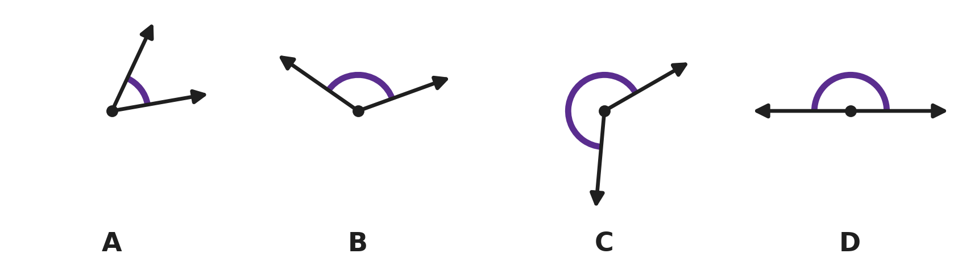
Q19. In each picture, the marked angle is shown by the curved arc. In which picture is the marked angle a reflex angle?
(A) Picture A | (B) Picture B
(C) Picture C | (D) Picture D

Q20. In the figure, four angles meet at the point O. Three of them are 80°, 125° and 60°. Which number goes in the blank?  x = ___° | 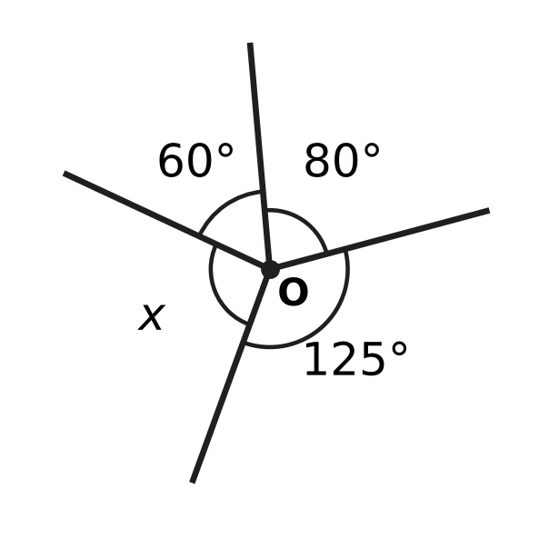
  (A) 90 | (B) 95 | (C) 105 | (D) 265

Q21. A decagon is a polygon with 10 sides. How many diagonals can be drawn from one vertex of a decagon?
(A) 7 | (B) 8 | (C) 10 | (D) 35

Q22. Two angles of a triangle add up to 88°. Which statement about the triangle is correct?
(A) It is acute-angled, and its third angle is 88°.
(B) It is acute-angled, and its third angle is 92°.
(C) It is obtuse-angled, and its third angle is 272°.
(D) It is obtuse-angled, and its third angle is 92°.

Q23. In the figure, ABCD is a square and ABE is an equilateral triangle drawn inside it. E is joined to D. What is the size of the marked angle AED? | 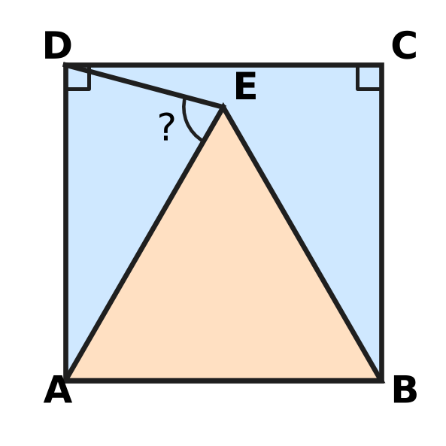
  (A) 30° | (B) 60° | (C) 75° | (D) 105°

Part 6 — Mensuration (Syllabus Chapter 6)
Q24. The figure shows a T-shape made of two rectangles. All its corners are right angles. What is its area? | 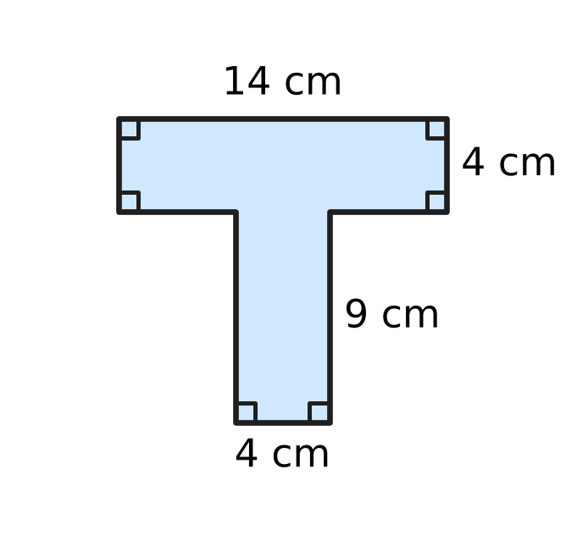
  (A) 54 cm² | (B) 56 cm² | (C) 92 cm² | (D) 182 cm²

Q25. The cuboid in the figure has a volume of 840 cm³. Its length is 14 cm and its breadth is 6 cm. Which number goes in the blank?  Its height is ___ cm. | 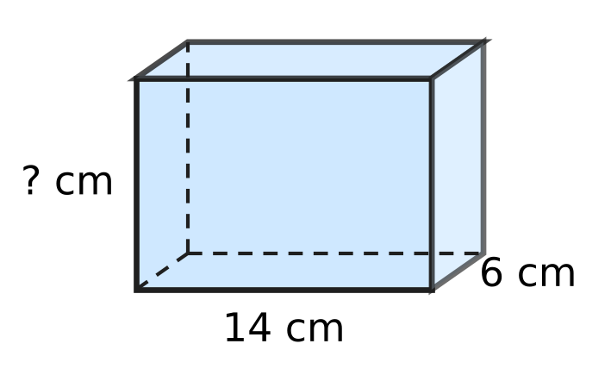
  (A) 10 | (B) 42 | (C) 60 | (D) 140

Q26. The closed box in the figure is a cuboid 10 cm long, 8 cm wide and 5 cm high. How much paper is needed to cover all its faces exactly, with no overlap? | 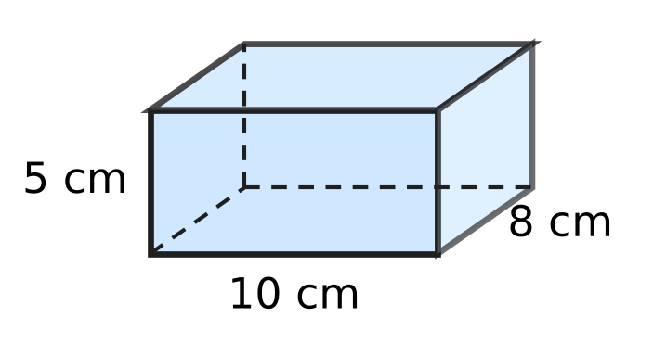
  (A) 170 cm² | (B) 180 cm² | (C) 340 cm² | (D) 400 cm²

Q27. A rectangle 15 cm long and 8 cm high has a notch cut out of its top edge, as shown. The notch is 5 cm wide, and all the corners are right angles. The perimeter of the new shape is 58 cm. How deep is the notch marked in the figure? | 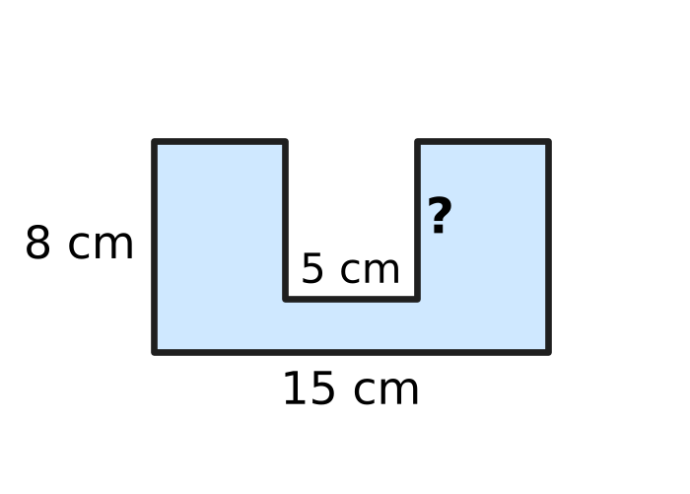
  (A) 3 cm | (B) 3.5 cm | (C) 6 cm | (D) 12 cm

Q28. In a workshop that makes clay pots, the water tank in the figure is a cuboid 1.2 m long, 50 cm wide and 40 cm deep. It is filled to the top with buckets that hold 12 litres each. How many buckets are needed? (1,000 cm³ = 1 litre) | 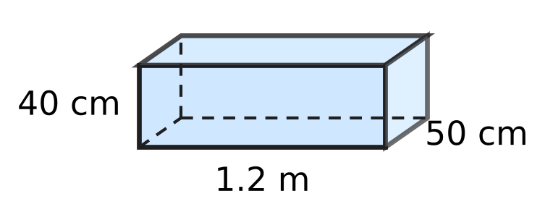
  (A) 2 | (B) 20 | (C) 200 | (D) 240

Part 7 — Data Handling, Statistics & Probability (Syllabus Chapter 8)
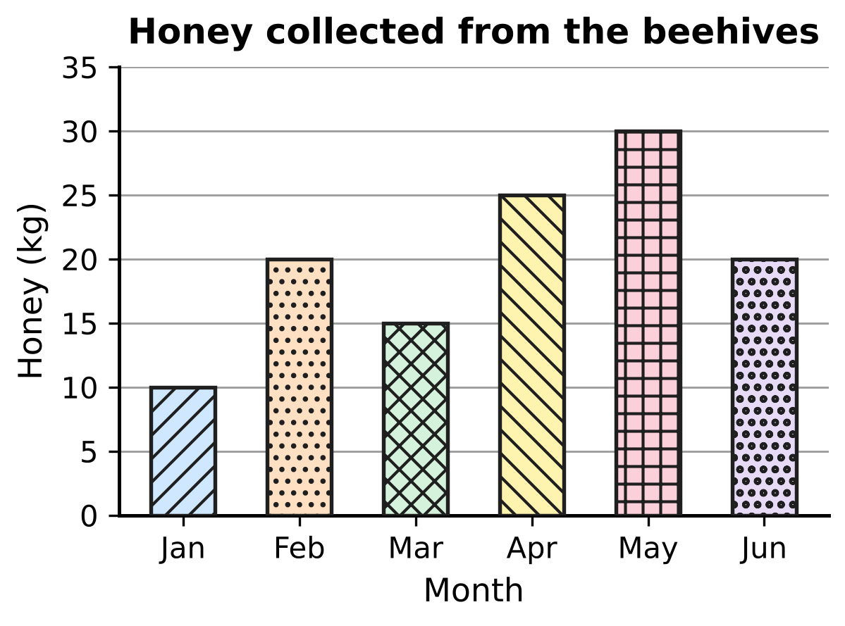
Q29. The bar graph shows how much honey a beekeeper collected from her beehives in six months. In how many of these months did she collect MORE than 20 kg of honey?
(A) 1 | (B) 2 | (C) 3 | (D) 4

Letters delivered to 30 houses on one day
Number of letters received | 0 | 1 | 2 | 3 | 4
Number of houses | 4 | 9 | 8 | 6 | 3

Q30. Sakshi works at the post office. She made this frequency table of the letters delivered to 30 houses on one day. How many letters were delivered to these houses in all?
(A) 10 | (B) 30 | (C) 55 | (D) 59

Part 8 — Applied Mathematics (Syllabus Chapter 9)
Q31. Which number goes in the blank so that the two ratios are equal?
3 : 8 = ___ : 56
(A) 7 | (B) 21 | (C) 24 | (D) 51

Q32. A boat leaves the harbour at 9:40 am. It travels 30 km to an island at a steady speed of 24 km/h. At what time does it reach the island?
(A) 10:55 am | (B) 11:05 am | (C) 10:28 am | (D) 11:10 am

Q33. Roshni and Kavin open their shared piggy bank and find ₹84. They share it in the ratio 3 : 4 (Roshni : Kavin). How much does Kavin get?
(A) ₹12 | (B) ₹21 | (C) ₹36 | (D) ₹48

Q34. In a 4 × 100 m relay race on the school running track, four runners each run 100 m, one after another. They take 12 s, 13 s, 11 s and 14 s. What is the average speed of the team for the whole race?
(A) 0.125 m/s | (B) 2 m/s
(C) 8 m/s | (D) 12.5 m/s

Q35. For three numbers x, y and z, x : y = 2 : 3 and y : z = 4 : 5. What is x : z?
(A) 2 : 5 | (B) 5 : 6 | (C) 3 : 10 | (D) 8 : 15

Part 9 — Mathematical Reasoning & Problem-Solving (Syllabus Chapter 10)
Q36. The jumps between the numbers in this pattern grow in the same way each time. Which number goes in the blank?
___, 11, 18, 27, 38, 51
(A) 2 | (B) 4 | (C) 5 | (D) 6

Q37. A digital clock uses the 24-hour system. It now shows 03:15. Which time goes in the blank?
Nine hours earlier, the clock showed ___.
(A) 15:15 | (B) 18:15 | (C) 12:15 | (D) 06:15

Q38. In a board game, Daksh rolls an ordinary die, numbered 1 to 6, four times. He multiplies the four numbers he rolls, and the product is an odd number. Which of these numbers can NOT be one of his four rolls?
(A) 1 | (B) 3 | (C) 5 | (D) 6

Q39. Look at this pattern:
3, 20, 6, 17, 12, 14, 24, 11, …
The terms in the 1st, 3rd, 5th, … places follow one rule. The terms in the 2nd, 4th, 6th, … places follow another rule. Which term is the first negative number?
(A) the 8th term | (B) the 14th term
(C) the 15th term | (D) the 16th term

Q40. Ella and Ken have some picture cards. First, Ella gives Ken as many cards as Ken already has. Then Ken gives Ella as many cards as Ella has at that moment. Now they each have 24 cards. How many cards did Ella have at the start?
(A) 12 | (B) 18 | (C) 30 | (D) 36

SECTION II — Star Questions 5 questions × 4 marks each
Q41. The nth term of a pattern is 6n − 1, for n = 1, 2, 3, … (so the pattern is 5, 11, 17, …). Lalit picks two DIFFERENT terms of the pattern and adds them. Which of these could be his total? [4 marks]
(A) 10 | (B) 57 | (C) 58 | (D) 60

Q42. In how many ways can 50 be written as the sum of three DIFFERENT prime numbers? (The order does not matter: 2 + 5 + 43 and 43 + 5 + 2 count as the same way.) [4 marks]
(A) 0 | (B) 4 | (C) 5 | (D) 10

Q43. On a museum visit day, 40% of all the visitors were children. Among the children, the ratio of boys to girls was 3 : 5. There were 36 more girls than boys. How many visitors were there in all? [4 marks]
(A) 144 | (B) 720 | (C) 90 | (D) 360

Q44. A piece of wire is bent to make a regular polygon with sides of 4 cm. All the interior angles of the polygon add up to 2,340°. The wire is then straightened and bent to make a square, using all of it. What is the area of the square? [4 marks]
(A) 3,600 cm² | (B) 225 cm²
(C) 900 cm² | (D) 169 cm²

Q45. Sahil runs for t minutes at 12 km/h. Then he walks for twice as long at 3 km/h. Which expression gives the total distance he covers, in metres? [4 marks]
(A) 300t | (B) 18t | (C) 15t | (D) 250t

Answer Sheet AMO Level 1 · Class 6 · Practice Paper 3
Name: | School: | Roll No.:
Shade or tick one circle for each question.
1. Ⓐ Ⓑ Ⓒ Ⓓ | 16. Ⓐ Ⓑ Ⓒ Ⓓ | 31. Ⓐ Ⓑ Ⓒ Ⓓ
2. Ⓐ Ⓑ Ⓒ Ⓓ | 17. Ⓐ Ⓑ Ⓒ Ⓓ | 32. Ⓐ Ⓑ Ⓒ Ⓓ
3. Ⓐ Ⓑ Ⓒ Ⓓ | 18. Ⓐ Ⓑ Ⓒ Ⓓ | 33. Ⓐ Ⓑ Ⓒ Ⓓ
4. Ⓐ Ⓑ Ⓒ Ⓓ | 19. Ⓐ Ⓑ Ⓒ Ⓓ | 34. Ⓐ Ⓑ Ⓒ Ⓓ
5. Ⓐ Ⓑ Ⓒ Ⓓ | 20. Ⓐ Ⓑ Ⓒ Ⓓ | 35. Ⓐ Ⓑ Ⓒ Ⓓ
6. Ⓐ Ⓑ Ⓒ Ⓓ | 21. Ⓐ Ⓑ Ⓒ Ⓓ | 36. Ⓐ Ⓑ Ⓒ Ⓓ
7. Ⓐ Ⓑ Ⓒ Ⓓ | 22. Ⓐ Ⓑ Ⓒ Ⓓ | 37. Ⓐ Ⓑ Ⓒ Ⓓ
8. Ⓐ Ⓑ Ⓒ Ⓓ | 23. Ⓐ Ⓑ Ⓒ Ⓓ | 38. Ⓐ Ⓑ Ⓒ Ⓓ
9. Ⓐ Ⓑ Ⓒ Ⓓ | 24. Ⓐ Ⓑ Ⓒ Ⓓ | 39. Ⓐ Ⓑ Ⓒ Ⓓ
10. Ⓐ Ⓑ Ⓒ Ⓓ | 25. Ⓐ Ⓑ Ⓒ Ⓓ | 40. Ⓐ Ⓑ Ⓒ Ⓓ
11. Ⓐ Ⓑ Ⓒ Ⓓ | 26. Ⓐ Ⓑ Ⓒ Ⓓ | 41. Ⓐ Ⓑ Ⓒ Ⓓ
12. Ⓐ Ⓑ Ⓒ Ⓓ | 27. Ⓐ Ⓑ Ⓒ Ⓓ | 42. Ⓐ Ⓑ Ⓒ Ⓓ
13. Ⓐ Ⓑ Ⓒ Ⓓ | 28. Ⓐ Ⓑ Ⓒ Ⓓ | 43. Ⓐ Ⓑ Ⓒ Ⓓ
14. Ⓐ Ⓑ Ⓒ Ⓓ | 29. Ⓐ Ⓑ Ⓒ Ⓓ | 44. Ⓐ Ⓑ Ⓒ Ⓓ
15. Ⓐ Ⓑ Ⓒ Ⓓ | 30. Ⓐ Ⓑ Ⓒ Ⓓ | 45. Ⓐ Ⓑ Ⓒ Ⓓ
Q41–Q45 are Section II Star Questions (4 marks each).
For the parent or teacher
Section I correct: ______ / 40 × 2 = ______ marks Section II correct: ______ / 5 × 4 = ______ marks
Correct: ______ / 45 Score: ______ / 100
Answer Key and Solutions AMO Level 1 · Class 6 · Practice Paper 3
Quick answers
1 C | 6 A | 11 C | 16 A | 21 A | 26 C | 31 B | 36 D | 41 C
2 B | 7 A | 12 D | 17 D | 22 D | 27 C | 32 A | 37 B | 42 C
3 A | 8 D | 13 A | 18 B | 23 C | 28 B | 33 D | 38 D | 43 D
4 A | 9 A | 14 B | 19 C | 24 C | 29 B | 34 C | 39 D | 44 B
5 B | 10 B | 15 D | 20 B | 25 A | 30 C | 35 D | 40 C | 45 A
Solutions
Q | Part · level | Answer | Why?
1 | Part 1 · Ch1 · Easy | (C) 5,230 | 1 thousand = 1,000, so 52,30,000 ÷ 1,000 = 5,230. (52 lakh = 5,200 thousands, and 30 thousands more.)
2 | Part 1 · Ch1 · Easy | (B) 9 | 792 = 2 × 2 × 2 × 3 × 3 × 11 = 2³ × 3² × 11, so the blank is 3² = 9 (check: 8 × 9 × 11 = 792).
3 | Part 1 · Ch1 · Easy | (A) −11 | On the number line, −11 lies to the right of −101, −110 and −1,001, because it is closest to 0. So −11 is the greatest.
4 | Part 1 · Ch1 · Medium | (A) 5 sacks | The largest sack size is the HCF of 168 and 252, which is 84 kg. Rice fills 168 ÷ 84 = 2 sacks and wheat 252 ÷ 84 = 3 sacks, so 5 sacks.
5 | Part 1 · Ch1 · Medium | (B) 7 | From −13 to −3 is 10 steps to the right. Going 10 more steps to the right from −3 reaches 7.
6 | Part 2 · Ch2 · Easy | (A) −1 | Dividing by −1 changes only the sign: for example 7 ÷ (−1) = −7 and (−5) ÷ (−1) = 5.
7 | Part 2 · Ch2 · Easy | (A) −9 | The divisor must be negative so that the answer is positive: (−72) ÷ (−9) = 8.
8 | Part 2 · Ch2 · Easy | (D) (−9) × (−4) × (−3) × (−1) × 2 | A product is positive when the number of negative factors is even. Only (−9) × (−4) × (−3) × (−1) × 2 has four negative factors; its value is 216.
9 | Part 2 · Ch2 · Medium | (A) ÷ | 6 − 18 = −12. With ÷: (−48) ÷ (−12) = 4, then 4 × (−2) + 3 = −8 + 3 = −5.
10 | Part 2 · Ch2 · Medium | (B) Step 2 | In Step 2 she removed the curly brackets before working out 9 − 4 = 5. Correctly: 50 − [4 × 5] = 50 − 20 = 30.
11 | Part 3 · Ch3 · Easy | (C) 22.5 | $\frac{9}{40}$ = 9 ÷ 40 = 0.225, and 0.225 × 100 = 22.5, so the blank is 22.5.
12 | Part 3 · Ch3 · Easy | (D) $\frac{1}{16}$ | 6.25% = 6.25 ÷ 100 = 0.0625, which is 625 ten-thousandths. Dividing 625 and 10,000 by 625 gives $\frac{1}{16}$.
13 | Part 3 · Ch3 · Easy | (A) $\frac{18}{25}$ | As decimals: 0.71, 0.69, $\frac{18}{25}$ = 0.72 and 0.709. The greatest is 0.72, which is $\frac{18}{25}$.
14 | Part 3 · Ch3 · Medium | (B) 60 | Lunch: 60% of 250 = 150 students. Rice: 40% of 150 = 60 students.
15 | Part 3 · Ch3 · Medium | (D) 45 | First, 30% of 120 = 36. Then 36 out of 80 = 36 ÷ 80 × 100 = 45%, so the blank is 45.
16 | Part 4 · Ch4 · Easy | (A) 4p − 9 | Four times as many as Nora is 4p; 9 fewer than that is 4p − 9.
17 | Part 4 · Ch4 · Easy | (D) 16 | a − b = 3 − (−2) = 5, so 2(a − b) = 10. ab = 3 × (−2) = −6, so −ab = 6. The value is 10 + 6 = 16.
18 | Part 4 · Ch4 · Medium | (B) 5x − 45 | Adults: 2x. Children: 3(x − 15) = 3x − 45. Total: 2x + 3x − 45 = 5x − 45.
19 | Part 5 · Ch5 · Easy | (C) Picture C | A reflex angle is more than 180° and less than 360°. Only the arc in Picture C goes more than half-way round the point.
20 | Part 5 · Ch5 · Easy | (B) 95 | Angles around a point add up to 360°. 80 + 125 + 60 = 265, so x = 360 − 265 = 95.
21 | Part 5 · Ch5 · Easy | (A) 7 | From one vertex, no diagonal goes to the vertex itself or to its 2 neighbours, so 10 − 3 = 7 diagonals.
22 | Part 5 · Ch5 · Medium | (D) It is obtuse-angled, and its third angle is 92°. | The third angle is 180° − 88° = 92°. An angle between 90° and 180° is obtuse, so the triangle is obtuse-angled.
23 | Part 5 · Ch5 · Medium | (C) 75° | Angle DAE = 90° − 60° = 30°. AD = AB = AE, so triangle ADE is isosceles and angle AED = (180° − 30°) ÷ 2 = 75°.
24 | Part 6 · Ch6 · Easy | (C) 92 cm² | Top rectangle: 14 × 4 = 56 cm². Lower rectangle: 4 × 9 = 36 cm². Total: 56 + 36 = 92 cm².
25 | Part 6 · Ch6 · Easy | (A) 10 | Volume = length × breadth × height, so height = 840 ÷ (14 × 6) = 840 ÷ 84 = 10 cm.
26 | Part 6 · Ch6 · Easy | (C) 340 cm² | Surface area = 2 × (10 × 8 + 8 × 5 + 10 × 5) = 2 × (80 + 40 + 50) = 2 × 170 = 340 cm².
27 | Part 6 · Ch6 · Medium | (C) 6 cm | The floor of the notch makes up for the 5 cm taken from the top edge, so the perimeter is 2 × (15 + 8) = 46 cm plus the two sides of the notch. 58 − 46 = 12, so each side of the notch is 12 ÷ 2 = 6 cm deep.
28 | Part 6 · Ch6 · Medium | (B) 20 | Volume = 120 × 50 × 40 = 2,40,000 cm³ = 240 litres. 240 ÷ 12 = 20 buckets.
29 | Part 7 · Ch8 · Easy | (B) 2 | Only April (25 kg) and May (30 kg) are more than 20 kg. February and June are exactly 20 kg, which is not more than 20 kg.
30 | Part 7 · Ch8 · Medium | (C) 55 | Total = 0 × 4 + 1 × 9 + 2 × 8 + 3 × 6 + 4 × 3 = 0 + 9 + 16 + 18 + 12 = 55 letters.
31 | Part 8 · Ch9 · Easy | (B) 21 | Since 56 = 8 × 7, the first term must also be multiplied by 7: 3 × 7 = 21.
32 | Part 8 · Ch9 · Easy | (A) 10:55 am | Time = 30 ÷ 24 = 1.25 hours = 1 hour 15 minutes. 9:40 am + 1 hour 15 minutes = 10:55 am.
33 | Part 8 · Ch9 · Easy | (D) ₹48 | 3 + 4 = 7 parts, so one part = 84 ÷ 7 = ₹12. Kavin gets 4 parts = 4 × 12 = ₹48.
34 | Part 8 · Ch9 · Medium | (C) 8 m/s | Total distance = 400 m and total time = 12 + 13 + 11 + 14 = 50 s. Average speed = 400 ÷ 50 = 8 m/s.
35 | Part 8 · Ch9 · Medium | (D) 8 : 15 | Make the y parts equal: x : y = 8 : 12 and y : z = 12 : 15. So x : y : z = 8 : 12 : 15 and x : z = 8 : 15.
36 | Part 9 · Ch10 · Easy | (D) 6 | The jumps are 7, 9, 11, 13, growing by 2. So the jump before 7 is 5, and 11 − 5 = 6.
37 | Part 9 · Ch10 · Easy | (B) 18:15 | Going back 3 h 15 min from 03:15 reaches midnight (00:00). The other 5 h 45 min go back from 24:00, and 24:00 − 5 h 45 min = 18:15.
38 | Part 9 · Ch10 · Easy | (D) 6 | If even one roll were even, the product would be even. So every roll is odd: 1, 3 or 5, and 6 can never be rolled.
39 | Part 9 · Ch10 · Medium | (D) the 16th term | Odd places double (3, 6, 12, 24, …) and stay positive. Even places go down by 3: 20, 17, 14, 11, 8, 5, 2, −1. The number −1 is the 8th even-place term, which is the 16th term.
40 | Part 9 · Ch10 · Medium | (C) 30 | Undo the last step: Ella had 24 ÷ 2 = 12 and Ken had 24 + 12 = 36. Undo the first step: Ken had 36 ÷ 2 = 18 and Ella had 12 + 18 = 30.
41 | Section II · Ch4 + Ch10 · Hard | (C) 58 | Two terms add to (6m − 1) + (6n − 1) = 6(m + n) − 2, an even number 2 less than a multiple of 6, with m + n at least 3. 58 = 6 × 10 − 2 works, for example 17 + 41.
42 | Section II · Ch1 + Ch10 · Hard | (C) 5 | Three odd primes add to an odd number, so 2 must be one of them. The other two are different odd primes adding to 48: 5 + 43, 7 + 41, 11 + 37, 17 + 31, 19 + 29. The other odd pairs fail: 3 + 45, 13 + 35 and 23 + 25 each use a number that is not prime. That is 5 ways.
43 | Section II · Ch3 + Ch9 · Hard | (D) 360 | Girls − boys = 5 − 3 = 2 parts = 36, so one part = 18 and the children are 8 × 18 = 144. These 144 children are 40% of the visitors, so the total is 144 ÷ 40 × 100 = 360.
44 | Section II · Ch5 + Ch6 · Hard | (B) 225 cm² | The angle sum is (number of sides − 2) × 180°, and 2,340 ÷ 180 = 13, so the polygon has 13 + 2 = 15 sides. The wire is 15 × 4 = 60 cm long. The square has side 60 ÷ 4 = 15 cm and area 15 × 15 = 225 cm².
45 | Section II · Ch4 + Ch9 · Hard | (A) 300t | A speed of 12 km/h = 12,000 m in 60 min = 200 m per minute, and 3 km/h = 50 m per minute. Distance = 200 × t + 50 × 2t = 200t + 100t = 300t metres.

ARYABHATTA MATHS OLYMPIAD
Level 1
PRACTICE PAPER-4
CLASS 6
Total Questions | 45 multiple-choice questions
Total Marks | 100
Time | 60 minutes
Section I | 40 questions × 2 marks = 80 marks
Section II | 5 Star Questions × 4 marks = 20 marks
Negative Marking | No negative marking
Calculator | Not allowed
Chapters | Number System · Operations · Fractions, Decimals & Percentages · Algebra · Geometry · Mensuration · Data Handling · Applied Mathematics · Mathematical Reasoning

👋 Hello, friend! How to do this paper:
⭐ Every question has four answer choices: (A), (B), (C) and (D). Only one is correct.
⭐ Read each question and look at its picture carefully. Then mark your answer on the answer sheet at the end.
⭐ Section I has 40 questions of 2 marks each. Section II has 5 Star Questions of 4 marks each.
⭐ There is no negative marking, so try every question.
⭐ Do not use a calculator. You may do rough work on a separate sheet.
⭐ All figures are not necessarily drawn to scale unless stated.

For parents and teachers
• Print or view this paper in colour. Pictures are part of the questions.
• Parts follow the AMO syllabus chapters. Chapter 7 is not part of the Class 6 syllabus, so the chapter numbers shown in the Part headings have gaps.
• The answer sheet and the answer key are at the end. Remove only the answer key before the child begins.

SECTION I 40 questions × 2 marks each
Part 1 — Number System (Syllabus Chapter 1)
Q1. In the Indian system, the digit 2 in 62,50,000 is in the lakhs place. The same number is now written in the international system. In which place is the digit 2 now?
(A) Millions | (B) Lakhs
(C) Ten thousands | (D) Hundred thousands

Q2. Which of these numbers is divisible by 11?
(A) 5,37,284 | (B) 2,54,812 | (C) 3,58,477 | (D) 3,11,452

Q3. Which integer is 10 less than −95?
(A) 105 | (B) −85 | (C) 85 | (D) −105

Q4. Two gear wheels turn together, tooth against tooth. The smaller wheel has 24 teeth and the larger wheel has 36 teeth. One tooth on each wheel is marked, and the two marked teeth are touching now. How many full turns does the smaller wheel make before the two marked teeth touch again for the first time?
(A) 2 turns | (B) 3 turns | (C) 12 turns | (D) 72 turns

Q5. Neel uses each of the seven digits 6, 0, 3, 9, 0, 4, 7 exactly once to make a 7-digit number. He wants the smallest 7-digit number possible. Which number should he make?
(A) 30,04,679 | (B) 30,04,697
(C) 34,67,900 | (D) 97,64,300

Part 2 — Operations & Number Properties (Syllabus Chapter 2)
Q6. What is the additive inverse of (−7) + 3?
(A) −10 | (B) −4 | (C) 4 | (D) 10

Q7. Which of these divisions does NOT give an integer as the answer?
(A) (−45) ÷ (−6) | (B) 72 ÷ (−24)
(C) 0 ÷ (−9) | (D) (−56) ÷ 8

Q8. Which of these has the same value as 15 − (−9)?
(A) 9 − 15 | (B) 15 + 9 | (C) 15 − 9 | (D) −15 − 9

Q9. A science laboratory freezer shows −4°C. It is switched to a colder setting. After that, its temperature falls by 3°C every hour. What does it show after 5 hours?
(A) −15°C | (B) 11°C | (C) −35°C | (D) −19°C

Q10. By how much is 60 ÷ [10 − (2 × 3)] greater than 60 ÷ 10 − 2 × 3?
(A) −15 | (B) 0 | (C) 3 | (D) 15

Part 3 — Fractions, Decimals & Percentages (Syllabus Chapter 3)
Q11. A box in the art class has 25 crayons. Of these, 14 are blunt. Which decimal shows the fraction of the crayons that are blunt?
(A) 0.14 | (B) 0.44 | (C) 0.56 | (D) 5.6

Q12. Each fraction is written as a decimal. Which one has exactly three decimal places?
(A) $\frac{11}{40}$ | (B) $\frac{7}{25}$ | (C) $\frac{2}{3}$ | (D) $\frac{13}{20}$

Q13. There were 75 students on a school trip. Of these, 27 wore caps. What percentage of the students wore caps?
(A) 27% | (B) 0.36% | (C) 64% | (D) 36%

Badminton matches this season
Player | Matches played | Matches won
Komal | 20 | 13
Sanjay | 25 | 17
Rupa | 50 | 33
Vivek | 30 | 21

Q14. The table shows the badminton matches played and won by four players. Who won the greatest fraction of the matches they played?
(A) Vivek | (B) Sanjay | (C) Komal | (D) Rupa

Q15. For a cake recipe, Nidhi mixes 250 g of flour, 150 g of sugar and 100 g of butter. Nothing else goes into the mixture. What percentage of the mixture is sugar?
(A) 15% | (B) 20% | (C) 30% | (D) 60%

Part 4 — Algebra (Syllabus Chapter 4)
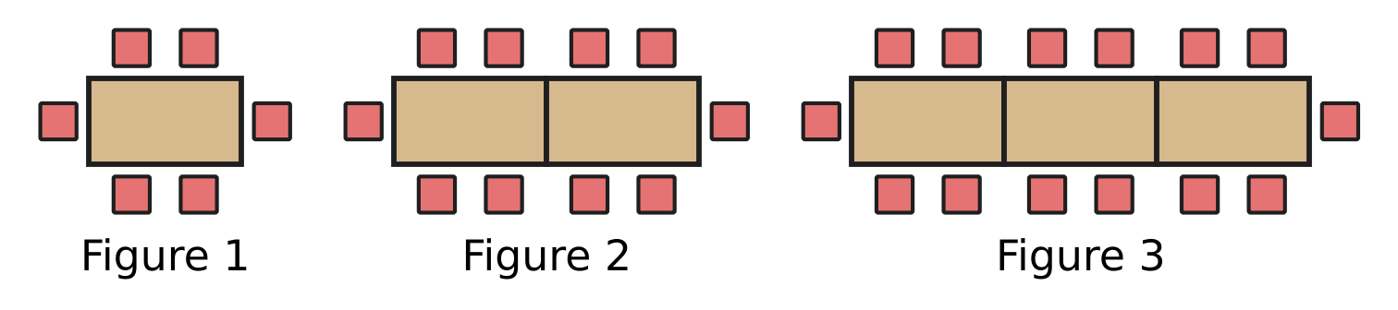
Q16. The pictures show tables joined end to end, with chairs placed round them. Each new figure has one more table, joined on the right. Which expression gives the number of chairs round n tables?
(A) 4n | (B) 4n + 2 | (C) 6n | (D) 4n + 4

Q17. Indu has a wooden plank that is L cm long. She cuts off 3 pieces, each 45 cm long, to make shelves. Which expression gives the length of the plank that is left, in cm?
(A) 3L − 45 | (B) L − 45 | (C) 135 − L | (D) L − 135

Q18. At the river jetty, hiring a ferry boat for h hours costs ₹(150 + 80h). Imran hires a boat for 3 hours. Chitra hires a boat for 5 hours. How much more does Chitra pay than Imran?
(A) ₹160 | (B) ₹310 | (C) ₹550 | (D) ₹940

Part 5 — Geometry (Syllabus Chapter 5)
Q19. The picture shows an open umbrella seen from directly above. Its 10 ribs meet at the centre, and the angles between neighbouring ribs are all equal. Find the size of the angle marked "?". | 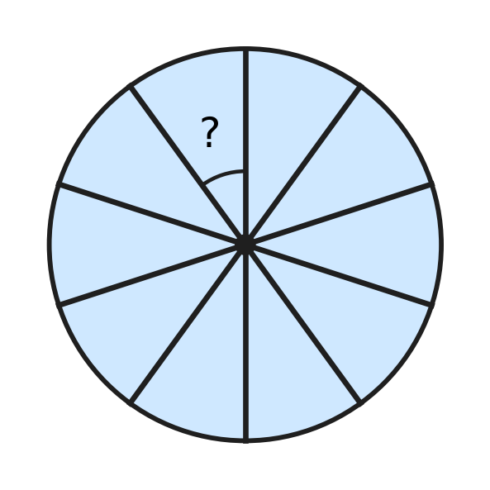
  (A) 40° | (B) 36° | (C) 30° | (D) 18°

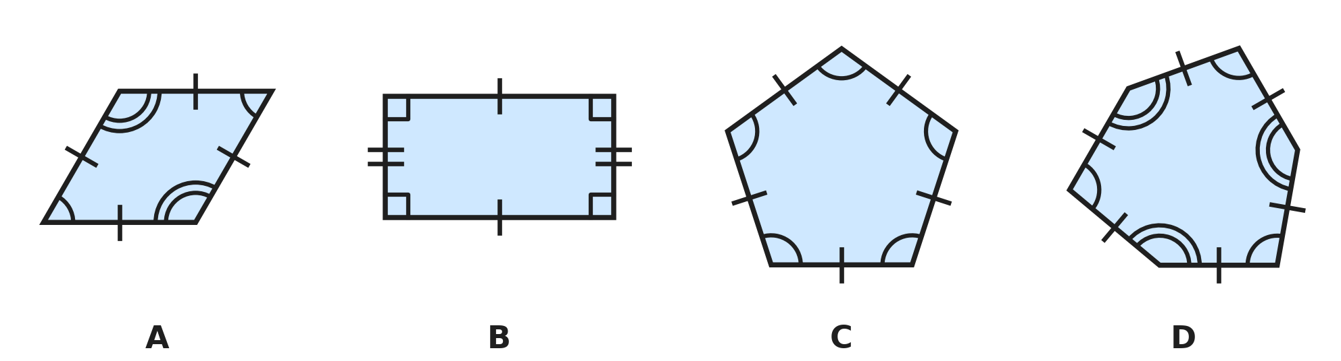
Q20. In each picture, sides with the same number of tick marks are equal, and angles with the same number of arcs are equal. Marks that differ show sides or angles that are not equal. Which picture shows a REGULAR polygon?
(A) Picture A | (B) Picture B
(C) Picture C | (D) Picture D

Q21. In the figure, ABD and BCD are equilateral triangles that share the side BD. Together they make the shape ABCD. Find the size of angle ABC, which is marked "?". | 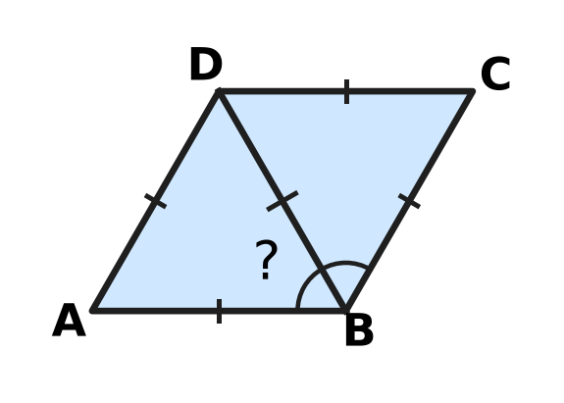
  (A) 120° | (B) 240° | (C) 60° | (D) 90°

Q22. In triangle ABC, AB = AC and angle BAC = 50°. BE is drawn from B, perpendicular to AC, as shown. Find the size of angle EBC, which is marked "?". | 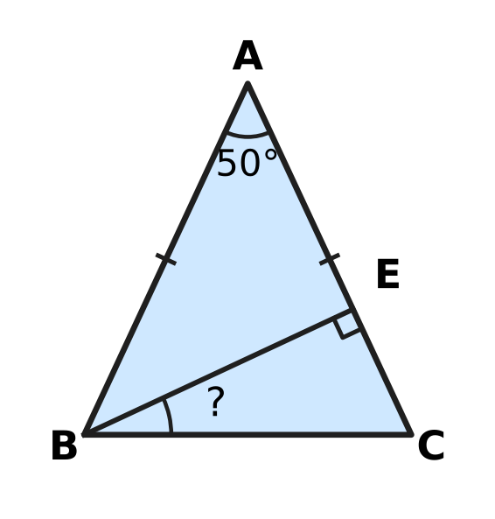
  (A) 25° | (B) 40° | (C) 50° | (D) 65°

Q23. The figure shows a regular pentagon with an equilateral triangle drawn on one of its sides, outside it. What is the size of the reflex angle marked "?" at the point P? | 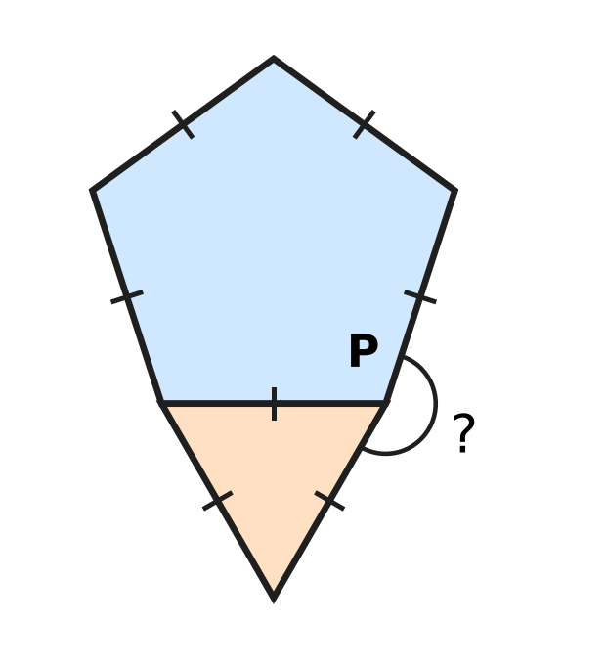
  (A) 132° | (B) 168° | (C) 192° | (D) 252°

Part 6 — Mensuration (Syllabus Chapter 6)
Q24. The shaded shape is drawn on a grid of 1 cm squares. What is the perimeter of the shaded shape? | 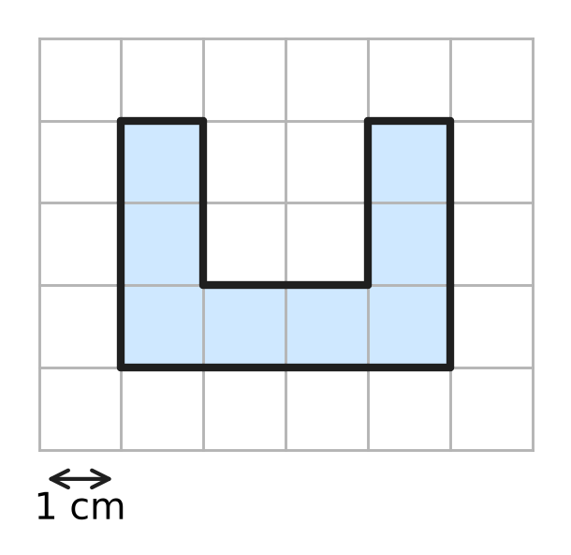
  (A) 8 cm | (B) 14 cm | (C) 16 cm | (D) 18 cm

Q25. At a bookshop, a gift box is a cuboid 30 cm long, 20 cm wide and 10 cm high. Ribbon is stuck along all 12 edges of the box, with no overlap. How much ribbon is used? | 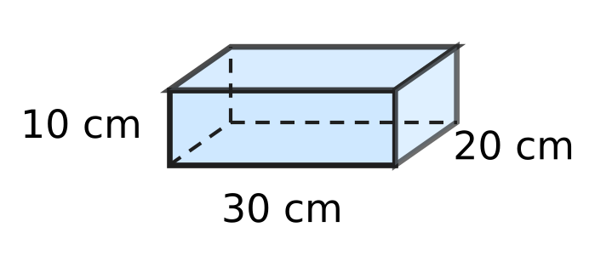
  (A) 200 cm | (B) 360 cm | (C) 60 cm | (D) 240 cm

Inside measurements of four boxes
Box | Length (cm) | Width (cm) | Height (cm)
Box K | 10 | 10 | 10
Box L | 12 | 10 | 9
Box M | 16 | 9 | 7
Box N | 20 | 6 | 8

Q26. The table gives the inside measurements of four cuboid boxes. Which box has the greatest volume?
(A) Box K | (B) Box L | (C) Box M | (D) Box N

Q27. Six equal square tiles are placed in 2 rows of 3, as shown, to make a rectangle. The perimeter of the rectangle is 60 cm. What is the area of the rectangle? | 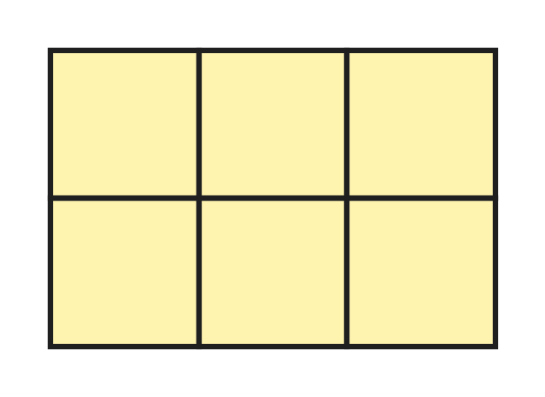
  (A) 36 cm² | (B) 216 cm² | (C) 225 cm² | (D) 864 cm²

Q28. The figure shows a room shaped like a cuboid, 6 m long, 4 m wide and 3 m high. Only its four walls are painted; the floor and the ceiling are not. Ignore doors and windows. What area is painted? | 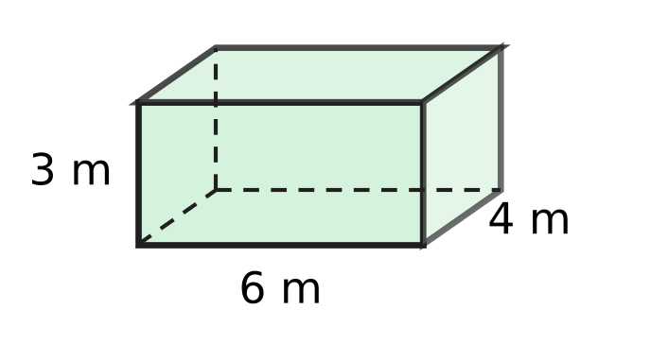
  (A) 30 m² | (B) 60 m² | (C) 84 m² | (D) 108 m²

Part 7 — Data Handling, Statistics & Probability (Syllabus Chapter 8)
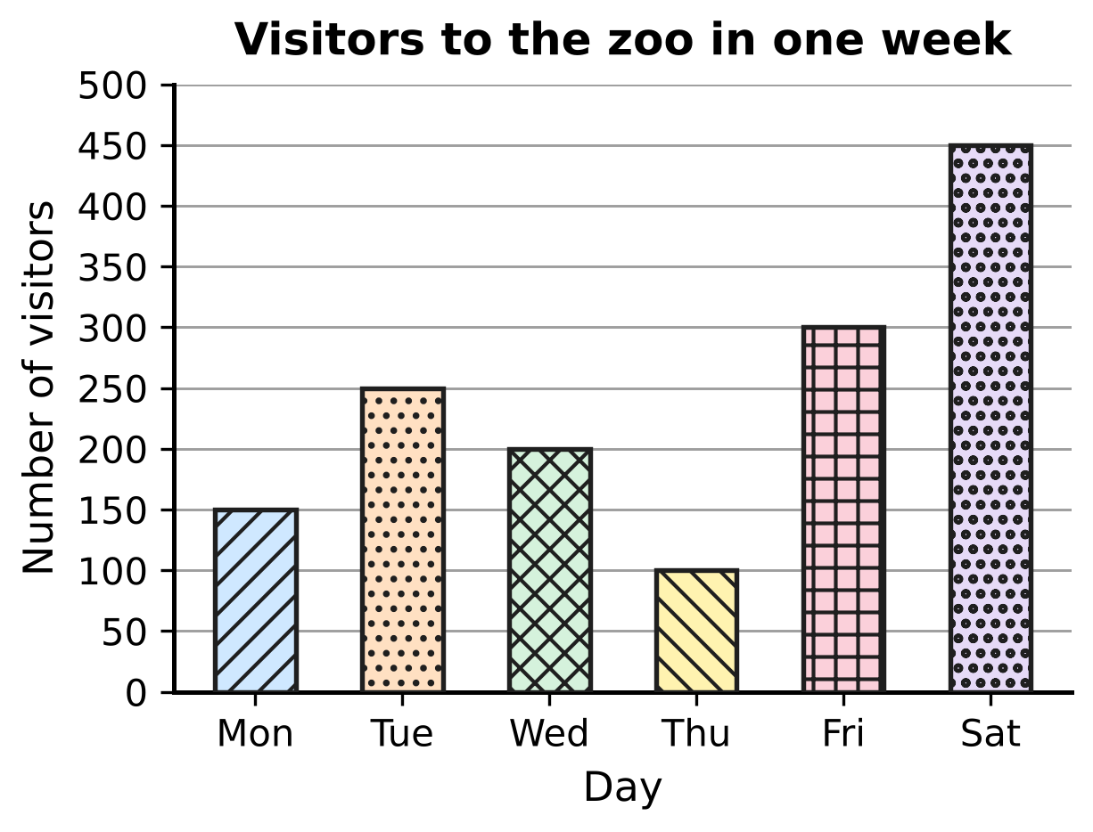
Q29. The bar graph shows the number of visitors to a zoo on six days of one week. On which day were there exactly twice as many visitors as on Monday?
(A) Friday | (B) Saturday
(C) Wednesday | (D) Tuesday

Shoe sizes of the students in a class
Shoe size | 3 | 4 | 5 | 6 | 7
Number of students | 5 | 7 | 10 | 8 | 3

Q30. The table shows the shoe sizes of the students in a class. How many students wear a size larger than the size worn by the most students?
(A) 10 | (B) 11 | (C) 12 | (D) 21

Part 8 — Applied Mathematics (Syllabus Chapter 9)
Q31. For a short time, a cheetah can run at 30 m/s. What is this speed in km/h?
(A) 1.8 km/h | (B) 10.8 km/h
(C) 108 km/h | (D) 1,800 km/h

Q32. At the school assembly, the girls stand in 9 rows and the boys stand in 12 rows. Every row has 16 children. What is the ratio of the number of girls to the number of ALL the children, in its simplest form?
(A) 7 : 3 | (B) 3 : 7 | (C) 4 : 7 | (D) 3 : 4

Q33. Prateek cycles to school at a steady speed of 12 km/h. The ride takes 25 minutes. How far is his school from home?
(A) 3 km | (B) 4 km | (C) 5 km | (D) 6 km

Q34. Vinay walks from home to school. If he walks at 4 km/h, he reaches school 6 minutes after the bell. If he walks at 6 km/h, he reaches school 4 minutes before the bell. How far is his school from home?
(A) 0.4 km | (B) 0.8 km | (C) 1.2 km | (D) 2 km

Q35. At a milk dairy, a tank holds 640 litres of cow milk and buffalo milk mixed in the ratio 5 : 3. Then 40 litres more buffalo milk is poured in. What is the ratio of cow milk to buffalo milk now?
(A) 5 : 4 | (B) 9 : 7 | (C) 10 : 7 | (D) 5 : 3

Part 9 — Mathematical Reasoning & Problem-Solving (Syllabus Chapter 10)
Q36. The jumps between the terms of this pattern follow a rule. Which number comes next?
3, 4, 8, 17, 33, ___
(A) 49 | (B) 56 | (C) 58 | (D) 66

Q37. In the school hall, three fans X, Y and Z are all switched off. Each press of a fan's switch turns it on if it is off, and off if it is on. Yamini presses the switch of fan X 15 times, of fan Y 32 times and of fan Z 27 times. Which fans are on at the end?
(A) X, Y and Z | (B) X and Y only
(C) Y only | (D) X and Z only

Q38. A candle burns down by 3 cm every hour. Tia lights it, and after 5 hours it is 8 cm long. How long was the candle before Tia lit it?
(A) 7 cm | (B) 11 cm | (C) 15 cm | (D) 23 cm

Q39. At a plant nursery, Ayaan waters a new sapling for the first time on a Monday. After that he waters it every 4 days. On which day of the week does he water it for the 10th time?
(A) Friday | (B) Tuesday | (C) Saturday | (D) Monday

Q40. Rosa writes the numbers 1, 2, 3, …, 10 on the board. In each move, she rubs out any two of the numbers and writes their difference (the larger minus the smaller) in their place. She keeps doing this until only one number is left. Which of these could be the last number?
(A) 0 | (B) 7 | (C) 10 | (D) 55

SECTION II — Star Questions 5 questions × 4 marks each
Q41. Zayan picks two whole numbers a and b. He works out the value of the expression 5a + 9b and finds that it is even. Which of these MUST be true? [4 marks]
(A) a × b is even | (B) a and b are both even
(C) a + b is even | (D) a and b are both odd

Q42. Manu keeps eggs in a cold store. In the morning he took out 4 trays of 30 eggs each. In the afternoon he put in 25 new eggs. Now the eggs in the store can be packed exactly into trays of 12 with none over, and also exactly into trays of 18 with none over. There are more than 100 and fewer than 140 eggs in the store now. How many eggs were in the store at the start of the day? [4 marks]
(A) 203 | (B) 131 | (C) 253 | (D) 113

Q43. Garima goes on a mountain hike along a trail 30 km long. She walks the first $\frac{1}{5}$ of the trail at 3 km/h. She walks the next 40% of the trail at 4 km/h. She walks the rest of the trail, downhill, at 6 km/h. How long does she take to walk the whole trail, not counting any stops? [4 marks]
(A) 5 hours | (B) 6 hours | (C) 7 hours | (D) 8 hours

Q44. A garden bed is the triangle PQR. Angle P and angle Q add up to 90°. The sides are PQ = 15 m, QR = 9 m and PR = 12 m. Grass costs ₹20 for each square metre. What is the cost of covering the whole bed with grass? [4 marks]
(A) ₹1,080 | (B) ₹1,350 | (C) ₹1,800 | (D) ₹2,160

Q45. A bus leaves a depot and travels at a steady x km/h. Two hours later, a motorbike leaves the same depot along the same road at a steady (x + 15) km/h. Three hours after the motorbike starts, it has still not caught up with the bus. Which expression gives how many kilometres the bus is ahead of the motorbike at that moment? [4 marks]
(A) x − 45 | (B) 2x + 45 | (C) 2x − 15 | (D) 2x − 45

Answer Sheet AMO Level 1 · Class 6 · Practice Paper 4
Name: | School: | Roll No.:
Shade or tick one circle for each question.
1. Ⓐ Ⓑ Ⓒ Ⓓ | 16. Ⓐ Ⓑ Ⓒ Ⓓ | 31. Ⓐ Ⓑ Ⓒ Ⓓ
2. Ⓐ Ⓑ Ⓒ Ⓓ | 17. Ⓐ Ⓑ Ⓒ Ⓓ | 32. Ⓐ Ⓑ Ⓒ Ⓓ
3. Ⓐ Ⓑ Ⓒ Ⓓ | 18. Ⓐ Ⓑ Ⓒ Ⓓ | 33. Ⓐ Ⓑ Ⓒ Ⓓ
4. Ⓐ Ⓑ Ⓒ Ⓓ | 19. Ⓐ Ⓑ Ⓒ Ⓓ | 34. Ⓐ Ⓑ Ⓒ Ⓓ
5. Ⓐ Ⓑ Ⓒ Ⓓ | 20. Ⓐ Ⓑ Ⓒ Ⓓ | 35. Ⓐ Ⓑ Ⓒ Ⓓ
6. Ⓐ Ⓑ Ⓒ Ⓓ | 21. Ⓐ Ⓑ Ⓒ Ⓓ | 36. Ⓐ Ⓑ Ⓒ Ⓓ
7. Ⓐ Ⓑ Ⓒ Ⓓ | 22. Ⓐ Ⓑ Ⓒ Ⓓ | 37. Ⓐ Ⓑ Ⓒ Ⓓ
8. Ⓐ Ⓑ Ⓒ Ⓓ | 23. Ⓐ Ⓑ Ⓒ Ⓓ | 38. Ⓐ Ⓑ Ⓒ Ⓓ
9. Ⓐ Ⓑ Ⓒ Ⓓ | 24. Ⓐ Ⓑ Ⓒ Ⓓ | 39. Ⓐ Ⓑ Ⓒ Ⓓ
10. Ⓐ Ⓑ Ⓒ Ⓓ | 25. Ⓐ Ⓑ Ⓒ Ⓓ | 40. Ⓐ Ⓑ Ⓒ Ⓓ
11. Ⓐ Ⓑ Ⓒ Ⓓ | 26. Ⓐ Ⓑ Ⓒ Ⓓ | 41. Ⓐ Ⓑ Ⓒ Ⓓ
12. Ⓐ Ⓑ Ⓒ Ⓓ | 27. Ⓐ Ⓑ Ⓒ Ⓓ | 42. Ⓐ Ⓑ Ⓒ Ⓓ
13. Ⓐ Ⓑ Ⓒ Ⓓ | 28. Ⓐ Ⓑ Ⓒ Ⓓ | 43. Ⓐ Ⓑ Ⓒ Ⓓ
14. Ⓐ Ⓑ Ⓒ Ⓓ | 29. Ⓐ Ⓑ Ⓒ Ⓓ | 44. Ⓐ Ⓑ Ⓒ Ⓓ
15. Ⓐ Ⓑ Ⓒ Ⓓ | 30. Ⓐ Ⓑ Ⓒ Ⓓ | 45. Ⓐ Ⓑ Ⓒ Ⓓ
Q41–Q45 are Section II Star Questions (4 marks each).
For the parent or teacher
Section I correct: ______ / 40 × 2 = ______ marks Section II correct: ______ / 5 × 4 = ______ marks
Correct: ______ / 45 Score: ______ / 100
Answer Key and Solutions AMO Level 1 · Class 6 · Practice Paper 4
Quick answers
1 D | 6 C | 11 C | 16 B | 21 A | 26 B | 31 C | 36 C | 41 C
2 A | 7 A | 12 A | 17 D | 22 A | 27 B | 32 B | 37 D | 42 A
3 D | 8 B | 13 D | 18 A | 23 C | 28 B | 33 C | 38 D | 43 C
4 B | 9 D | 14 A | 19 B | 24 D | 29 A | 34 D | 39 B | 44 A
5 A | 10 D | 15 C | 20 C | 25 D | 30 B | 35 C | 40 B | 45 D
Solutions
Q | Part · level | Answer | Why?
1 | Part 1 · Ch1 · Easy | (D) Hundred thousands | The digit 2 stands for 2,00,000, which is 200 thousand. In the international system 62,50,000 is six million two hundred fifty thousand, so the 2 is in the hundred thousands place.
2 | Part 1 · Ch1 · Easy | (A) 5,37,284 | For 5,37,284 the alternating digit sums are 4 + 2 + 3 = 9 and 8 + 7 + 5 = 20. They differ by 11, so 5,37,284 is divisible by 11 (it is 11 × 48,844).
3 | Part 1 · Ch1 · Easy | (D) −105 | Taking 10 away means 10 steps to the left on the number line: −95 − 10 = −105.
4 | Part 1 · Ch1 · Medium | (B) 3 turns | The marked teeth meet again after LCM(24, 36) = 72 teeth have passed. The smaller wheel then makes 72 ÷ 24 = 3 full turns.
5 | Part 1 · Ch1 · Medium | (A) 30,04,679 | The first digit cannot be 0, so it is the smallest other digit, 3. Then come both zeros and then 4, 6, 7, 9: 30,04,679.
6 | Part 2 · Ch2 · Easy | (C) 4 | (−7) + 3 = −4. The additive inverse of −4 is 4, because (−4) + 4 = 0.
7 | Part 2 · Ch2 · Easy | (A) (−45) ÷ (−6) | (−45) ÷ (−6) = 7.5, which is not an integer. The others give −7, 0 and −3. Integers are not closed under division.
8 | Part 2 · Ch2 · Easy | (B) 15 + 9 | Subtracting −9 is the same as adding 9, so 15 − (−9) = 15 + 9 = 24.
9 | Part 2 · Ch2 · Medium | (D) −19°C | The total fall is 5 × 3 = 15°C. So the temperature is −4 + (−15) = −19°C.
10 | Part 2 · Ch2 · Medium | (D) 15 | 60 ÷ [10 − 6] = 60 ÷ 4 = 15. Without brackets, 60 ÷ 10 − 2 × 3 = 6 − 6 = 0. The difference is 15.
11 | Part 3 · Ch3 · Easy | (C) 0.56 | The fraction 14 out of 25 is $\frac{14}{25}$ = $\frac{56}{100}$ = 0.56.
12 | Part 3 · Ch3 · Easy | (A) $\frac{11}{40}$ | $\frac{11}{40}$ = $\frac{275}{1000}$ = 0.275, which has three decimal places. The others are 0.666…, 0.65 and 0.28.
13 | Part 3 · Ch3 · Easy | (D) 36% | $\frac{27}{75}$ = $\frac{36}{100}$ = 36%.
14 | Part 3 · Ch3 · Medium | (A) Vivek | As percentages: Komal 13/20 = 65%, Sanjay 17/25 = 68%, Rupa 33/50 = 66%, Vivek 21/30 = 70%. Vivek has the greatest.
15 | Part 3 · Ch3 · Medium | (C) 30% | The mixture weighs 250 + 150 + 100 = 500 g. Sugar is $\frac{150}{500}$ = $\frac{30}{100}$ = 30% of it.
16 | Part 4 · Ch4 · Easy | (B) 4n + 2 | The figures have 6, 10 and 14 chairs. Each table has 2 chairs on each long side, which is 4n chairs, and there is 1 chair at each end. So the rule is 4n + 2.
17 | Part 4 · Ch4 · Easy | (D) L − 135 | The 3 pieces use 3 × 45 = 135 cm, so the length left is L − 135 cm.
18 | Part 4 · Ch4 · Medium | (A) ₹160 | Imran pays 150 + 80 × 3 = ₹390. Chitra pays 150 + 80 × 5 = ₹550. The difference is ₹160.
19 | Part 5 · Ch5 · Easy | (B) 36° | The 10 equal angles go all the way round the centre, so together they make 360°. Each is 360° ÷ 10 = 36°.
20 | Part 5 · Ch5 · Easy | (C) Picture C | A regular polygon has all sides equal AND all angles equal. Only the pentagon in Picture C has both.
21 | Part 5 · Ch5 · Easy | (A) 120° | Angle ABC is made of angle ABD and angle DBC, each 60° in an equilateral triangle. So it is 60° + 60° = 120°.
22 | Part 5 · Ch5 · Medium | (A) 25° | The base angles are (180° − 50°) ÷ 2 = 65° each, so angle C = 65°. In triangle BEC, angle EBC = 180° − 90° − 65° = 25°.
23 | Part 5 · Ch5 · Medium | (C) 192° | Each angle of a regular pentagon is (5 − 2) × 180° ÷ 5 = 108°, and each angle of an equilateral triangle is 60°. The reflex angle is 360° − 108° − 60° = 192°.
24 | Part 6 · Ch6 · Easy | (D) 18 cm | Walking round the boundary: outside 4 + 3 + 4 + 3 = 14 cm, plus 2 cm down and 2 cm up inside the gap, so 18 cm.
25 | Part 6 · Ch6 · Easy | (D) 240 cm | A cuboid has 4 edges of each length: 4 × (30 + 20 + 10) = 4 × 60 = 240 cm.
26 | Part 6 · Ch6 · Easy | (B) Box L | Volumes: K = 1,000 cm³, L = 12 × 10 × 9 = 1,080 cm³, M = 1,008 cm³, N = 960 cm³. Box L holds the most.
27 | Part 6 · Ch6 · Medium | (B) 216 cm² | The perimeter is made of 10 tile sides (3 + 2 + 3 + 2), so each side is 60 ÷ 10 = 6 cm. The rectangle is 18 cm by 12 cm, so its area is 216 cm².
28 | Part 6 · Ch6 · Medium | (B) 60 m² | The four walls are two of 6 m × 3 m and two of 4 m × 3 m: 2 × 18 + 2 × 12 = 60 m².
29 | Part 7 · Ch8 · Easy | (A) Friday | Monday had 150 visitors. Twice 150 is 300, and only Friday had 300 visitors.
30 | Part 7 · Ch8 · Medium | (B) 11 | Size 5 is worn by the most students (10). Larger sizes are 6 and 7: 8 + 3 = 11 students.
31 | Part 8 · Ch9 · Easy | (C) 108 km/h | 30 m/s = 30 × 3,600 m in an hour = 1,08,000 m = 108 km. So the speed is 108 km/h (or 30 × 18/5 = 108).
32 | Part 8 · Ch9 · Easy | (B) 3 : 7 | Girls : all = (9 × 16) : (21 × 16) = 9 : 21 = 3 : 7. The 16 in each row cancels.
33 | Part 8 · Ch9 · Easy | (C) 5 km | The time is 25 minutes = 25/60 hour. Distance = 12 × 25 ÷ 60 = 5 km.
34 | Part 8 · Ch9 · Medium | (D) 2 km | Each km takes 15 minutes at 4 km/h and 10 minutes at 6 km/h, so the faster walk saves 5 minutes on every km. The two walks differ by 6 + 4 = 10 minutes, so the distance is 10 ÷ 5 = 2 km.
35 | Part 8 · Ch9 · Medium | (C) 10 : 7 | Cow milk = 5/8 × 640 = 400 L and buffalo milk = 240 L. After adding, buffalo milk is 280 L. 400 : 280 = 10 : 7.
36 | Part 9 · Ch10 · Easy | (C) 58 | The jumps are 1, 4, 9, 16 (the square numbers 1², 2², 3², 4²). The next jump is 5² = 25, so the next term is 33 + 25 = 58.
37 | Part 9 · Ch10 · Easy | (D) X and Z only | After an even number of presses a fan is back to off; after an odd number it is on. The numbers 15 and 27 are odd and 32 is even, so fans X and Z are on.
38 | Part 9 · Ch10 · Easy | (D) 23 cm | In 5 hours the candle burned 5 × 3 = 15 cm. Before lighting it was 8 + 15 = 23 cm long.
39 | Part 9 · Ch10 · Medium | (B) Tuesday | From the 1st to the 10th watering there are 9 gaps of 4 days = 36 days. As 36 = 5 × 7 + 1, it is 1 day after Monday: Tuesday.
40 | Part 9 · Ch10 · Medium | (B) 7 | Replacing a and b by a − b lowers the total by 2b, an even number, so the total always stays odd or always stays even. The starting total 1 + 2 + … + 10 = 55 is odd, so the last number is odd. It is also never more than 10, the largest number on the board, so 55 is impossible: only 7 is left. The number 7 can really be reached: 2 − 1, 5 − 4, 7 − 6 and 9 − 8 give four 1s; 1 − 1 twice gives two 0s, and 0 − 0 = 0; then 10 − 3 = 7 and 7 − 0 = 7.
41 | Section II · Ch4 + Ch10 · Hard | (C) a + b is even | 5a is odd or even exactly as a is, and 9b exactly as b is (odd × odd is odd, odd × even is even). So 5a + 9b is even exactly when a + b is even, that is when a and b are both even or both odd.
42 | Section II · Ch1 + Ch10 · Hard | (A) 203 | The eggs now are a common multiple of 12 and 18, that is a multiple of LCM 36, between 100 and 140: so 108. Before the 25 new eggs there were 108 − 25 = 83, and before the 4 trays (120 eggs) were taken out there were 83 + 120 = 203.
43 | Section II · Ch3 + Ch9 · Hard | (C) 7 hours | First part: 1/5 of 30 = 6 km, 2 h. Next part: 40% of 30 = 12 km, 3 h. The rest is 2/5 = 12 km at 6 km/h, 2 h. Total 7 hours.
44 | Section II · Ch5 + Ch6 · Hard | (A) ₹1,080 | Angles P and Q add up to 90°, so angle R = 180° − 90° = 90°. The sides around R are QR = 9 m and PR = 12 m, so the area is 9 × 12 ÷ 2 = 54 m². Cost = 54 × ₹20 = ₹1,080.
45 | Section II · Ch4 + Ch9 · Hard | (D) 2x − 45 | The bus has travelled for 2 + 3 = 5 hours: 5x km. The motorbike has travelled 3(x + 15) = 3x + 45 km. The bus is ahead by 5x − 3x − 45 = 2x − 45 km.

ARYABHATTA MATHS OLYMPIAD
Level 1
PRACTICE PAPER-5
CLASS 6
Total Questions | 45 multiple-choice questions
Total Marks | 100
Time | 60 minutes
Section I | 40 questions × 2 marks = 80 marks
Section II | 5 Star Questions × 4 marks = 20 marks
Negative Marking | No negative marking
Calculator | Not allowed
Chapters | Number System · Operations · Fractions, Decimals & Percentages · Algebra · Geometry · Mensuration · Data Handling · Applied Mathematics · Mathematical Reasoning

👋 Hello, friend! How to do this paper:
⭐ Every question has four answer choices: (A), (B), (C) and (D). Only one is correct.
⭐ Read each question and look at its picture carefully. Then mark your answer on the answer sheet at the end.
⭐ Section I has 40 questions of 2 marks each. Section II has 5 Star Questions of 4 marks each.
⭐ There is no negative marking, so try every question.
⭐ Do not use a calculator. You may do rough work on a separate sheet.
⭐ All figures are not necessarily drawn to scale unless stated.

For parents and teachers
• Print or view this paper in colour. Pictures are part of the questions.
• Parts follow the AMO syllabus chapters. Chapter 7 is not part of the Class 6 syllabus, so the chapter numbers shown in the Part headings have gaps.
• The answer sheet and the answer key are at the end. Remove only the answer key before the child begins.

SECTION I 40 questions × 2 marks each
Part 1 — Number System (Syllabus Chapter 1)
Q1. A number is made of 3 ten lakhs, 15 thousands and 6 hundreds, and nothing else. Which number is it?
(A) 30,15,600 | (B) 30,15,060
(C) 3,15,600 | (D) 31,50,600

Q2. The picture shows the division ladder Pari made to find the prime factors of a number. Ink has hidden the number at the top and the numbers on the right, except the 1 at the bottom. The primes she divided by can still be read. What was the number at the top? | 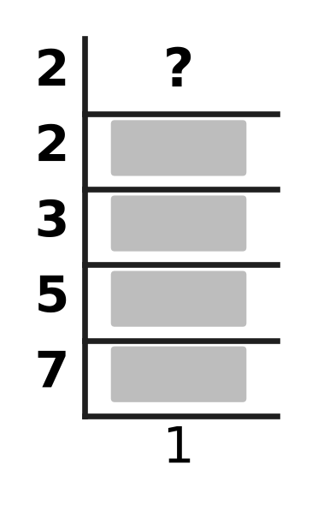
  (A) 210 | (B) 19 | (C) 84 | (D) 420

Q3. I am an integer. I am greater than −11 and less than −1. I am a multiple of 3. My opposite is an even number. Which integer am I?
(A) −12 | (B) −6 | (C) −4 | (D) −3

Q4. At her flower shop, Ana has 105 roses, 75 lilies and 60 carnations. She makes the greatest possible number of identical bouquets, using all the flowers. Each bouquet has the same number of roses, the same number of lilies and the same number of carnations. How many flowers are there in each bouquet?
(A) 48 | (B) 7 | (C) 15 | (D) 16

Q5. How many factors of 360 are odd numbers?
(A) 6 | (B) 2 | (C) 24 | (D) 5

Part 2 — Operations & Number Properties (Syllabus Chapter 2)
Q6. What is the value of [(−9) + 6 + (−12) + 5 + 0] ÷ 5?
(A) 2 | (B) −2 | (C) −2.5 | (D) −10

Q7. Which of these has the value 0 for EVERY integer n?
(A) n − (−n) | (B) (−n) − n | (C) n + (−n) | (D) n × (−n)

Q8. What is the value of (−48) ÷ 6 × (−2)?
(A) 4 | (B) −16 | (C) −4 | (D) 16

Q9. Without brackets, 36 ÷ 6 − 3 × 2 + 4 = 4. One pair of brackets is put in to make the value 10. Which of these is correct?
(A) (36 ÷ 6 − 3) × 2 + 4 | (B) 36 ÷ (6 − 3) × 2 + 4
(C) 36 ÷ 6 − 3 × (2 + 4) | (D) 36 ÷ (6 − 3 × 2 + 4)

Q10. What is the sum of all the integers from −15 to 12, including −15 and 12?
(A) 0 | (B) −3 | (C) −42 | (D) 42

Part 3 — Fractions, Decimals & Percentages (Syllabus Chapter 3)
Q11. I am a fraction with denominator 40. Written as a percentage, I am 17.5%. What is my numerator?
(A) 70 | (B) 7 | (C) 14 | (D) 35

Q12. Which number goes in the blank so that each number in the list is greater than the one before it? 0.4, ___, 45%, $\frac{1}{2}$
(A) $\frac{3}{8}$ | (B) $\frac{12}{25}$ | (C) $\frac{21}{50}$ | (D) $\frac{9}{20}$

Q13. Usha is running a 2 km race. She has run 35% of it. How many metres does she still have to run?
(A) 1,965 m | (B) 700 m | (C) 650 m | (D) 1,300 m

Q14. Which of these quantities has the largest value?
(A) $\frac{3}{8}$ of 72 | (B) 0.35 of 80
(C) $\frac{5}{8}$ of 44 | (D) 45% of 62

Q15. At an ice-cream stall, the price of a cone went up by 20%. A cone now costs ₹60. What did a cone cost before the price went up?
(A) ₹50 | (B) ₹72 | (C) ₹40 | (D) ₹48

Part 4 — Algebra (Syllabus Chapter 4)
Q16. Kian wrote the expression 2(m + 6). Which sentence describes his expression?
(A) Multiply m by 6, then add 2 to the result.
(B) Add 2 to m, then multiply the result by 6.
(C) Double m, then add 6 to the result.
(D) Add 6 to m, then double the result.

Q17. In the hall for the school play, the rows of seats are numbered 1, 2, 3, … from the stage. Row number n has (2n + 10) seats. How many seats are there in row 15?
(A) 40 | (B) 25 | (C) 50 | (D) 27

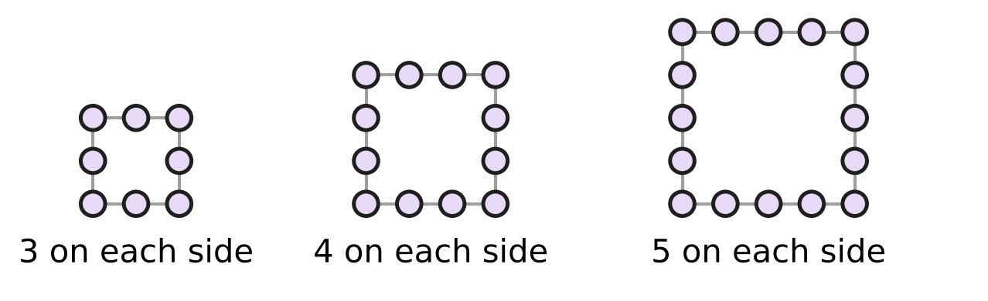
Q18. Look at the square bead frames. A frame with n beads on each side, counting the corner beads, uses (4n − 4) beads in all. Myra has 50 beads. She makes ONE frame like these, as big as she can. How many beads are on each side of her frame?
(A) 7 | (B) 11 | (C) 13 | (D) 12

Part 5 — Geometry (Syllabus Chapter 5)
Q19. The figure shows the slide in Zoya's school playground. The ladder stands at right angles to the ground. The slide makes an angle of 36° with the ground. What is the angle marked "?" between the ladder and the slide? | 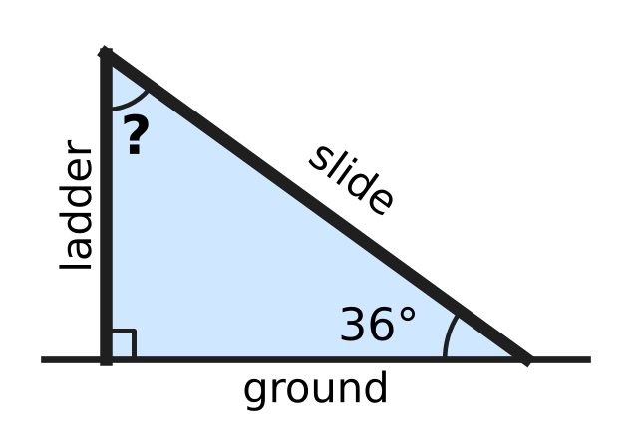
  (A) 36° | (B) 54° | (C) 144° | (D) 126°

Q20. A floor is covered with tiles shaped like regular octagons and squares, as in the picture. At every corner point where tiles meet, two octagons and one square meet with no gaps. What is the size of the angle marked x inside one of the octagons? | 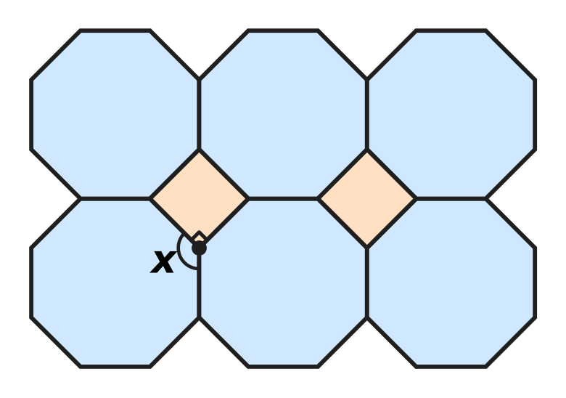
  (A) 135° | (B) 120° | (C) 270° | (D) 108°

Q21. Part of a fishing net is shown. Every hole in the net is a rhombus: all four sides are equal. In the shaded hole, one angle is 64°. What is the size of the angle marked x in the same hole? | 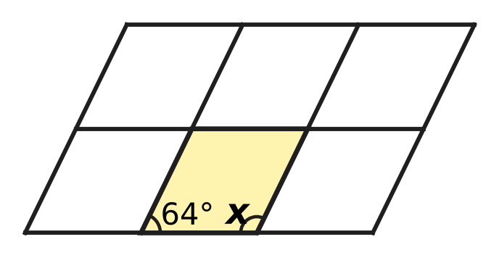
  (A) 26° | (B) 296° | (C) 116° | (D) 64°

Q22. The figure shows an arrowhead shape ABCD with four straight sides. Angle A is 50°, angle B is 30° and angle D is 30°. What is the reflex angle marked "?" at C, inside the shape? | 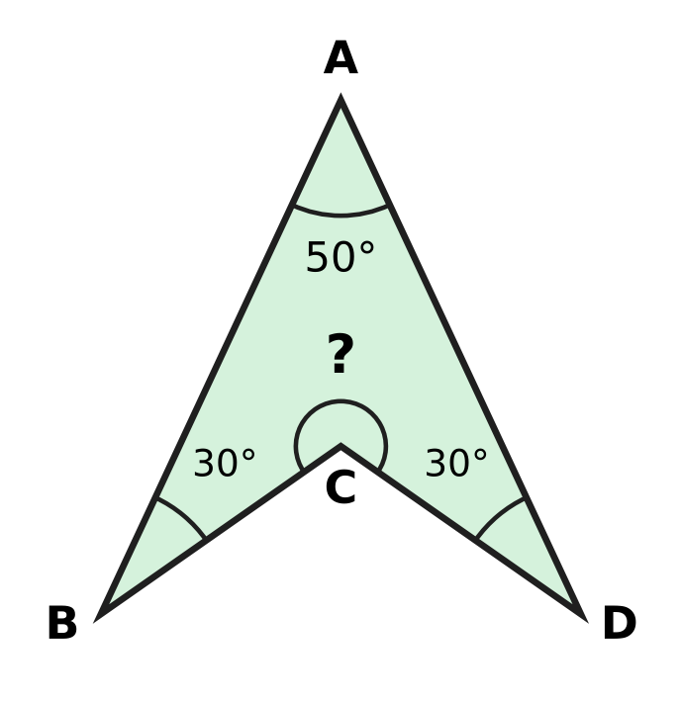
  (A) 70° | (B) 280° | (C) 110° | (D) 250°

Q23. An isosceles triangle has an angle of 40°. Which of these could be the size of its largest angle?
(A) 140° | (B) 70° | (C) 50° | (D) 80°

Part 6 — Mensuration (Syllabus Chapter 6)
Q24. A rectangular car park is 45 m long and 30 m wide. A fence goes all the way round it, except for a gate 6 m wide, as shown. How long is the fence? | 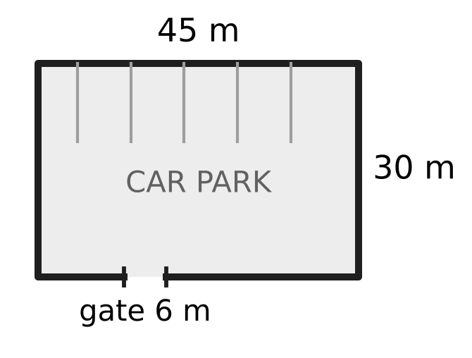
  (A) 69 m | (B) 150 m | (C) 144 m | (D) 156 m

Q25. At his tea stall, Nakul keeps sugar cubes in the box shown. The inside of the box is 8 cm long, 5 cm wide and 3 cm high. The box is exactly full of sugar cubes with edges of 1 cm, with no gaps. How many sugar cubes are in the box? | 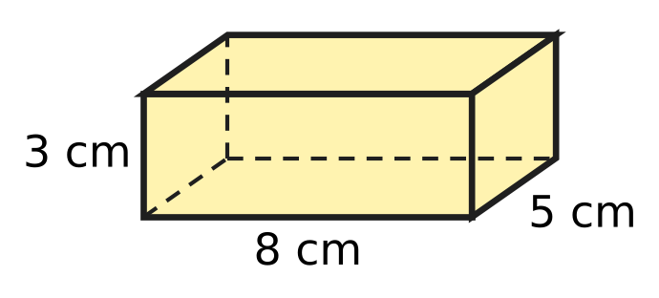
  (A) 40 | (B) 120 | (C) 16 | (D) 158

Q26. A block of clay is a cuboid 9 cm long, 8 cm wide and 3 cm high, as shown. All of it is pressed into the shape of a cube, with no clay left over. What is the length of each edge of the cube? | 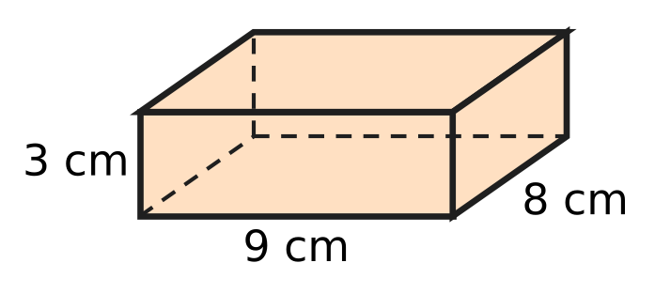
  (A) 6 cm | (B) 72 cm | (C) 36 cm | (D) 18 cm

Q27. Deepa makes an open box shaped like a cube from thin card. The box has no lid, so it has only five square faces. These five faces use 320 cm² of card in all, with no overlap. What is the volume of the box?
(A) 384 cm³ | (B) 64 cm³ | (C) 320 cm³ | (D) 512 cm³

Q28. Yash has a rectangular card 18 cm long and 10 cm wide. He cuts it along the dashed line into two equal rectangles, as shown. How much greater is the total perimeter of the two pieces than the perimeter of the whole card? | 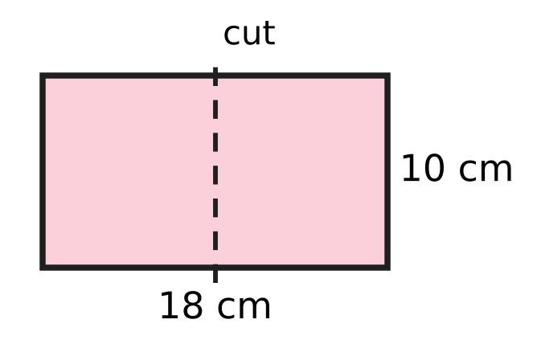
  (A) 20 cm | (B) 18 cm | (C) 0 cm | (D) 10 cm

Part 7 — Data Handling, Statistics & Probability (Syllabus Chapter 8)
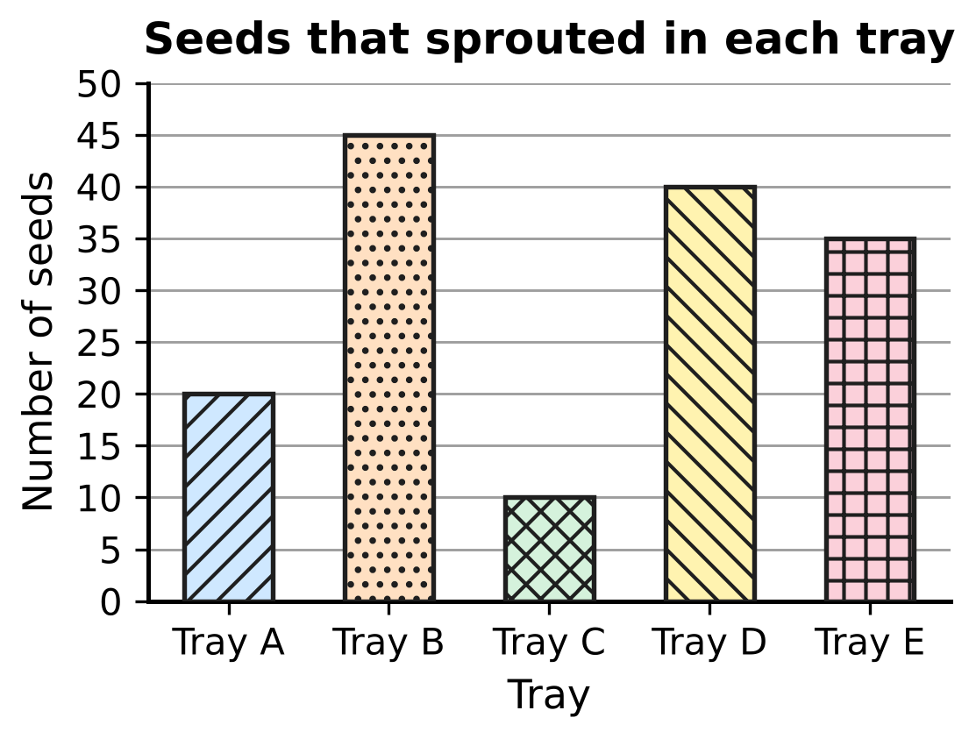
Q29. The bar graph shows how many seeds sprouted in each of five trays. How many seeds sprouted in all five trays together?
(A) 155 | (B) 145 | (C) 150 | (D) 130

Marks in a music class test
Mark (out of 10) | 5 | 6 | 7 | 8 | 9
Number of students | 4 | 7 | 9 | 6 | 4

Q30. The table shows the marks of 30 students in a music class test. Some students who missed the test take it later, and every one of them scores 6. What is the smallest number of these students needed so that 6 becomes the mark scored by more students than any other mark?
(A) 9 | (B) 10 | (C) 2 | (D) 3

Part 8 — Applied Mathematics (Syllabus Chapter 9)
Q31. Shalu makes a mango drink with 2 cups of mango pulp and 5 cups of water. Tanmay wants a drink that tastes exactly the same, and he uses 6 cups of mango pulp. How many cups of water should he use?
(A) 30 cups | (B) 15 cups | (C) 10 cups | (D) 9 cups

Q32. During a storm, Lata sees a flash of lightning. She hears its thunder 5 seconds later. Take the speed of sound as 340 m per second. The light reaches her at once. How far away from Lata was the lightning?
(A) 850 m | (B) 68 m | (C) 1,700 m | (D) 345 m

Q33. Zubin's tortoise walks at a steady speed of 4 m per minute. How long would it take to walk 1 km?
(A) 41 h 40 min | (B) 2 h 50 min
(C) 25 min | (D) 4 h 10 min

Q34. Which of these speeds is the greatest?
(A) 20 m/s | (B) 66 km/h
(C) 1 km per minute | (D) 1,150 m per minute

Q35. For the science exhibition, Dhruv built a model of a plane. Every length on the model and the same length on the real plane are in the ratio 1 : 40. The wings of the model measure 85 cm from tip to tip. What is this length on the real plane?
(A) 340 m | (B) 34 m | (C) 1.25 m | (D) 3.4 m

Part 9 — Mathematical Reasoning & Problem-Solving (Syllabus Chapter 10)
Q36. What is the 9th term of this pattern? Each term after the second is made from the two terms just before it: 4, −1, 3, 2, 5, 7, …
(A) 31 | (B) 26 | (C) 50 | (D) 19

Q37. Every odd number can be written as 2k + 1, where k is a whole number. Which expression gives the next odd number after 2k + 1?
(A) 4k + 2 | (B) 2k + 3 | (C) 2k + 2 | (D) 2k − 1

Q38. A patch of weed on a pond doubles in area every day. On day 24 it covers the whole pond for the first time. On which day did it cover exactly half of the pond?
(A) Day 25 | (B) Day 22 | (C) Day 12 | (D) Day 23

Q39. The clock in the school hall strikes once at 1 o'clock, twice at 2 o'clock, and so on, up to 12 times at 12 o'clock. It also strikes once at half past every hour. How many times does it strike from 10:00 am to 3:00 pm, counting the strikes at 10:00 am and at 3:00 pm?
(A) 39 | (B) 80 | (C) 44 | (D) 34

Q40. Eleven whole numbers are written around a circle. Two numbers next to each other make a "mixed pair" if one of them is odd and the other is even. What is the greatest possible number of mixed pairs?
(A) 5 | (B) 9 | (C) 11 | (D) 10

SECTION II — Star Questions 5 questions × 4 marks each
Q41. Which of these numbers can be written as the sum of two consecutive whole numbers, AND as the sum of three consecutive whole numbers, AND as the sum of five consecutive whole numbers? [4 marks]
(A) 75 | (B) 60 | (C) 65 | (D) 63

Q42. The number of views of a school video on any day (views on that day only, not the running total) is 3 times the number on the day before. On Day 11 it has 59,04,900 views. On which day did the number of views go above 1 lakh for the first time? [4 marks]
(A) Day 6 | (B) Day 7 | (C) Day 8 | (D) Day 9

Q43. At an airport, a moving walkway 300 m long carries people at 3 km/h. Hana walks at 5 km/h. She walks 300 m once on the floor beside the walkway, and once on the moving walkway, walking at her usual speed in the direction it moves. By what percentage is her time on the walkway less than her time on the floor? [4 marks]
(A) 62.5% | (B) 81% | (C) 37.5% | (D) 60%

Q44. Varsha has a square card of side 20 cm. She cuts off each of its four corners with one straight cut, as in the figure. Each cut starts on a side, 4 cm from the corner, and makes an angle of 135° with that side, inside the shape that is left. All four cuts are made in the same way. What is the area of the eight-sided shape that is left? [4 marks] | 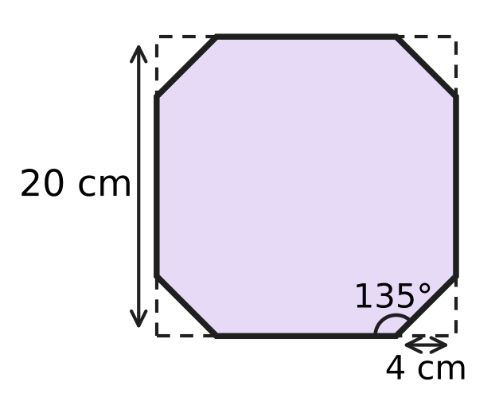
  (A) 336 cm² | (B) 368 cm² | (C) 384 cm² | (D) 392 cm²

Q45. In a building, the floors are 4 m apart. A lift moves at 2 m/s. It leaves floor 2 and goes up to floor n (n is greater than 3). It stops for 10 seconds at every floor in between, but not at floor n. Which expression gives the time, in seconds, from leaving floor 2 to arriving at floor n? [4 marks]
(A) 12n − 24 | (B) 18n − 46 | (C) 12n − 34 | (D) 12n − 30

Answer Sheet AMO Level 1 · Class 6 · Practice Paper 5
Name: | School: | Roll No.:
Shade or tick one circle for each question.
1. Ⓐ Ⓑ Ⓒ Ⓓ | 16. Ⓐ Ⓑ Ⓒ Ⓓ | 31. Ⓐ Ⓑ Ⓒ Ⓓ
2. Ⓐ Ⓑ Ⓒ Ⓓ | 17. Ⓐ Ⓑ Ⓒ Ⓓ | 32. Ⓐ Ⓑ Ⓒ Ⓓ
3. Ⓐ Ⓑ Ⓒ Ⓓ | 18. Ⓐ Ⓑ Ⓒ Ⓓ | 33. Ⓐ Ⓑ Ⓒ Ⓓ
4. Ⓐ Ⓑ Ⓒ Ⓓ | 19. Ⓐ Ⓑ Ⓒ Ⓓ | 34. Ⓐ Ⓑ Ⓒ Ⓓ
5. Ⓐ Ⓑ Ⓒ Ⓓ | 20. Ⓐ Ⓑ Ⓒ Ⓓ | 35. Ⓐ Ⓑ Ⓒ Ⓓ
6. Ⓐ Ⓑ Ⓒ Ⓓ | 21. Ⓐ Ⓑ Ⓒ Ⓓ | 36. Ⓐ Ⓑ Ⓒ Ⓓ
7. Ⓐ Ⓑ Ⓒ Ⓓ | 22. Ⓐ Ⓑ Ⓒ Ⓓ | 37. Ⓐ Ⓑ Ⓒ Ⓓ
8. Ⓐ Ⓑ Ⓒ Ⓓ | 23. Ⓐ Ⓑ Ⓒ Ⓓ | 38. Ⓐ Ⓑ Ⓒ Ⓓ
9. Ⓐ Ⓑ Ⓒ Ⓓ | 24. Ⓐ Ⓑ Ⓒ Ⓓ | 39. Ⓐ Ⓑ Ⓒ Ⓓ
10. Ⓐ Ⓑ Ⓒ Ⓓ | 25. Ⓐ Ⓑ Ⓒ Ⓓ | 40. Ⓐ Ⓑ Ⓒ Ⓓ
11. Ⓐ Ⓑ Ⓒ Ⓓ | 26. Ⓐ Ⓑ Ⓒ Ⓓ | 41. Ⓐ Ⓑ Ⓒ Ⓓ
12. Ⓐ Ⓑ Ⓒ Ⓓ | 27. Ⓐ Ⓑ Ⓒ Ⓓ | 42. Ⓐ Ⓑ Ⓒ Ⓓ
13. Ⓐ Ⓑ Ⓒ Ⓓ | 28. Ⓐ Ⓑ Ⓒ Ⓓ | 43. Ⓐ Ⓑ Ⓒ Ⓓ
14. Ⓐ Ⓑ Ⓒ Ⓓ | 29. Ⓐ Ⓑ Ⓒ Ⓓ | 44. Ⓐ Ⓑ Ⓒ Ⓓ
15. Ⓐ Ⓑ Ⓒ Ⓓ | 30. Ⓐ Ⓑ Ⓒ Ⓓ | 45. Ⓐ Ⓑ Ⓒ Ⓓ
Q41–Q45 are Section II Star Questions (4 marks each).
For the parent or teacher
Section I correct: ______ / 40 × 2 = ______ marks Section II correct: ______ / 5 × 4 = ______ marks
Correct: ______ / 45 Score: ______ / 100
Answer Key and Solutions AMO Level 1 · Class 6 · Practice Paper 5
Quick answers
1 A | 6 B | 11 B | 16 D | 21 C | 26 A | 31 B | 36 A | 41 A
2 D | 7 C | 12 C | 17 A | 22 D | 27 D | 32 C | 37 B | 42 C
3 B | 8 D | 13 D | 18 C | 23 B | 28 A | 33 D | 38 D | 43 C
4 D | 9 A | 14 B | 19 B | 24 C | 29 C | 34 A | 39 C | 44 B
5 A | 10 C | 15 A | 20 A | 25 B | 30 D | 35 B | 40 D | 45 C
Solutions
Q | Part · level | Answer | Why?
1 | Part 1 · Ch1 · Easy | (A) 30,15,600 | Here, 3 ten lakhs = 30,00,000, 15 thousands = 15,000 and 6 hundreds = 600. Together: 30,00,000 + 15,000 + 600 = 30,15,600.
2 | Part 1 · Ch1 · Easy | (D) 420 | The number is the product of all the primes on the left: 2 × 2 × 3 × 5 × 7 = 420.
3 | Part 1 · Ch1 · Easy | (B) −6 | The multiples of 3 greater than −11 and less than −1 are −9, −6 and −3. Their opposites are 9, 6 and 3; only 6 is even. So the integer is −6.
4 | Part 1 · Ch1 · Medium | (D) 16 | HCF(105, 75, 60) = 15, so she makes 15 bouquets. Each has 105 ÷ 15 = 7 roses, 75 ÷ 15 = 5 lilies and 60 ÷ 15 = 4 carnations: 7 + 5 + 4 = 16 flowers.
5 | Part 1 · Ch1 · Medium | (A) 6 | We have 360 = 2³ × 3² × 5. An odd factor has no 2 in it, so it is a factor of 3² × 5 = 45: 1, 3, 5, 9, 15 and 45. That is 6 odd factors.
6 | Part 2 · Ch2 · Easy | (B) −2 | Work inside the bracket first: (−9) + 6 + (−12) + 5 + 0 = −10. Then (−10) ÷ 5 = −2.
7 | Part 2 · Ch2 · Easy | (C) n + (−n) | Every integer added to its opposite gives 0, so n + (−n) = 0. For n = 3 the others give 6, −6 and −9.
8 | Part 2 · Ch2 · Easy | (D) 16 | ÷ and × are done from left to right: (−48) ÷ 6 = −8, then (−8) × (−2) = 16.
9 | Part 2 · Ch2 · Medium | (A) (36 ÷ 6 − 3) × 2 + 4 | (36 ÷ 6 − 3) × 2 + 4 = (6 − 3) × 2 + 4 = 3 × 2 + 4 = 10. The other placements give 28, 9 and −12.
10 | Part 2 · Ch2 · Medium | (C) −42 | Each of 1 to 12 cancels with its opposite −1 to −12, and 0 adds nothing. Left over: (−13) + (−14) + (−15) = −42.
11 | Part 3 · Ch3 · Easy | (B) 7 | Here, 17.5% = 0.175 = $\frac{175}{1000}$ = $\frac{7}{40}$. So the numerator is 7.
12 | Part 3 · Ch3 · Easy | (C) $\frac{21}{50}$ | $\frac{21}{50}$ = 0.42, and 0.4 < 0.42 < 0.45. The others are (A) 0.375, (B) 0.48 and (D) 0.45.
13 | Part 3 · Ch3 · Easy | (D) 1,300 m | She still has 100% − 35% = 65% to run. 65% of 2,000 m = 1,300 m.
14 | Part 3 · Ch3 · Medium | (B) 0.35 of 80 | Here, 0.35 of 80 = 28. The others are 45% of 62 = 27.9, $\frac{5}{8}$ of 44 = 27.5 and $\frac{3}{8}$ of 72 = 27.
15 | Part 3 · Ch3 · Medium | (A) ₹50 | The new price is 120% of the old price. 120% → ₹60, so 100% → ₹60 ÷ 120 × 100 = ₹50. Check: 20% of ₹50 is ₹10, and ₹50 + ₹10 = ₹60.
16 | Part 4 · Ch4 · Easy | (D) Add 6 to m, then double the result. | In 2(m + 6) the bracket is worked first: add 6 to m, then multiply the result by 2.
17 | Part 4 · Ch4 · Easy | (A) 40 | Put n = 15: 2 × 15 + 10 = 30 + 10 = 40 seats.
18 | Part 4 · Ch4 · Medium | (C) 13 | With 13 beads on each side the frame uses 4 × 13 − 4 = 48 beads, which is not more than 50. With 14 on each side it would need 52 beads, which is too many. So the answer is 13.
19 | Part 5 · Ch5 · Easy | (B) 54° | The three angles of the triangle add up to 180°: 180° − 90° − 36° = 54°.
20 | Part 5 · Ch5 · Easy | (A) 135° | The angles at a point add up to 360°. The square gives 90°, so the two equal octagon angles share 270°: x = 270° ÷ 2 = 135°.
21 | Part 5 · Ch5 · Easy | (C) 116° | Opposite angles of a rhombus are equal, so 64° + x + 64° + x = 360°. Then 2x = 232° and x = 116°.
22 | Part 5 · Ch5 · Medium | (D) 250° | The four angles of a quadrilateral add up to 360°, even when one of them is reflex: 360° − (50° + 30° + 30°) = 250°.
23 | Part 5 · Ch5 · Medium | (B) 70° | If 40° is the angle between the equal sides, the other two are (180° − 40°) ÷ 2 = 70° each, and 70° is the largest. (If 40° is one of the two equal angles, the angles are 40°, 40° and 100°.) Of the answer choices, only 70° is possible.
24 | Part 6 · Ch6 · Easy | (C) 144 m | Perimeter = 2 × (45 + 30) = 150 m. The gate has no fence: 150 − 6 = 144 m.
25 | Part 6 · Ch6 · Easy | (B) 120 | Each layer has 8 × 5 = 40 cubes, and there are 3 layers: 40 × 3 = 120 cubes.
26 | Part 6 · Ch6 · Easy | (A) 6 cm | Volume of clay = 9 × 8 × 3 = 216 cm³. The cube has the same volume, and 6 × 6 × 6 = 216, so each edge is 6 cm.
27 | Part 6 · Ch6 · Medium | (D) 512 cm³ | One face has area 320 ÷ 5 = 64 cm², so each edge is 8 cm (8 × 8 = 64). Volume = 8 × 8 × 8 = 512 cm³.
28 | Part 6 · Ch6 · Medium | (A) 20 cm | Each piece is 9 cm by 10 cm, with perimeter 38 cm, so together 76 cm. The whole card has perimeter 56 cm. The difference is 76 − 56 = 20 cm: the cut makes two new edges of 10 cm.
29 | Part 7 · Ch8 · Easy | (C) 150 | Total = 20 + 45 + 10 + 40 + 35 = 150 seeds.
30 | Part 7 · Ch8 · Medium | (D) 3 | Now 9 students have mark 7 and 7 students have mark 6. Mark 6 needs at least 10 students, so 10 − 7 = 3 more students are needed.
31 | Part 8 · Ch9 · Easy | (B) 15 cups | Tanmay uses 3 times as much pulp (2 × 3 = 6 cups), so he needs 3 times as much water: 5 × 3 = 15 cups.
32 | Part 8 · Ch9 · Easy | (C) 1,700 m | The sound travels for 5 seconds at 340 m per second: 340 × 5 = 1,700 m.
33 | Part 8 · Ch9 · Easy | (D) 4 h 10 min | 1 km = 1,000 m. Time = 1,000 ÷ 4 = 250 minutes = 240 min + 10 min = 4 h 10 min.
34 | Part 8 · Ch9 · Medium | (A) 20 m/s | Change all to km/h: 20 m/s = 20 × 18 ÷ 5 = 72 km/h; 1,150 m per minute = 69 km/h; 1 km per minute = 60 km/h. The greatest is 20 m/s.
35 | Part 8 · Ch9 · Medium | (B) 34 m | The real length is 40 times the model length: 85 × 40 = 3,400 cm = 34 m.
36 | Part 9 · Ch10 · Easy | (A) 31 | Each term is the sum of the two before it: 4, −1, 3, 2, 5, 7, 12, 19, 31. The 9th term is 31.
37 | Part 9 · Ch10 · Easy | (B) 2k + 3 | Odd numbers go up in steps of 2, so the next odd number is (2k + 1) + 2 = 2k + 3.
38 | Part 9 · Ch10 · Easy | (D) Day 23 | Going back one day halves the area. The whole pond on day 24 means half the pond on day 23.
39 | Part 9 · Ch10 · Medium | (C) 44 | On the hours it strikes 10 + 11 + 12 + 1 + 2 + 3 = 39 times. At 10:30, 11:30, 12:30, 1:30 and 2:30 it strikes 5 more times. Total 39 + 5 = 44.
40 | Part 9 · Ch10 · Medium | (D) 10 | Going once round the circle, each mixed pair is a switch between odd and even. We end where we started, so the number of switches is even. So 11 is impossible. But 10 is possible: write odd, even, odd, even, … and end with odd, so only the last odd and the first odd sit together.
41 | Section II · Ch4 + Ch10 · Hard | (A) 75 | n + (n + 1) = 2n + 1 is odd; n + (n + 1) + (n + 2) = 3(n + 1) is a multiple of 3; five consecutive numbers add to 5(n + 2), a multiple of 5. Only 75 is odd and a multiple of both 3 and 5: 75 = 37 + 38 = 24 + 25 + 26 = 13 + 14 + 15 + 16 + 17.
42 | Section II · Ch1 + Ch10 · Hard | (C) Day 8 | Divide by 3 going back: Day 10 has 19,68,300, Day 9 has 6,56,100, Day 8 has 2,18,700, Day 7 has 72,900. Day 7 is below 1,00,000 and Day 8 is above it, so the first day is Day 8.
43 | Section II · Ch3 + Ch9 · Hard | (C) 37.5% | On the floor: 300 m at 5 km/h = 0.06 h = 216 s. On the walkway her speed is 5 + 3 = 8 km/h: 300 m takes 135 s. She saves 81 s, and 81 ÷ 216 = 0.375 = 37.5%.
44 | Section II · Ch5 + Ch6 · Hard | (B) 368 cm² | Inside each cut-off corner, the cut makes 180° − 135° = 45° with the side, and the corner is 90°, so the third angle is 45°. The triangle is isosceles, so both short sides are 4 cm and its area is 4 × 4 ÷ 2 = 8 cm². Area left = 400 − 4 × 8 = 368 cm².
45 | Section II · Ch4 + Ch9 · Hard | (C) 12n − 34 | The lift rises 4(n − 2) m at 2 m/s, which takes 2(n − 2) s. It stops at floors 3 to n − 1, which is n − 3 stops of 10 s. There is no stop at floor 2 (the lift is leaving it) or at floor n (it arrives there). Time = 2(n − 2) + 10(n − 3) = 12n − 34. Check, n = 5: 6 s + 20 s = 26 s.

